###### Adipose Tissue: PHysiology to Metabolic Dysfunction

**Allison J. Richard, PhD,** Instructor, Pennington Biomedical Researcher Center, Baton Rouge, LA. Allison.Richard@pbrc.edu

**Ursula White, PhD,** Assistant Professor, Pennington Biomedical Researcher Center, Baton Rouge, LA. Ursula.White@pbrc.edu

**Carrie M. Elks, PhD, RD,** Assistant Professor, Pennington Biomedical Researcher Center, Baton Rouge, LA. Carrie.Elks@pbrc.edu

**Jacqueline M. Stephens, PhD,** Claude B. Pennington, Jr. Endowed Chair in Biomedical Research, Pennington Biomedical Researcher Center Professor, Department of Biological Sciences, Louisiana State University, Baton Rouge, LA. jsteph1@lsu.edu

**Received April 1, 2020**

**Abstract**

Like the obesity epidemic, our understanding of adipocytes and adipose tissue is expanding. Just in the past decade, substantial advances have led to new insights into the contributions of adipose tissue to normal physiology and obesity-related complications, which places adipocyte biology at the epicenter of a global pandemic of metabolic diseases. In addition to detailing the types, locations, and functions of different adipose tissue depots, this chapter will review the secretory capacities of adipose tissue. Arguably one of the most significant discoveries in the last two decades of adipocyte research is that not only do adipocytes release endocrine hormones, but fat cells and adipose tissue secrete a variety of effectors, including exosomes, miRNA, lipids, inflammatory cytokines, and peptide hormones that act in both paracrine and endocrine capacities to impact local and systemic metabolic responses. The origins of adipocytes via progenitor cells and the process of adipocyte development are discussed. Inflammation, metabolically healthy fat, and adipose tissue expansion are also considered. Finally, several emerging research areas in fat cell biology with therapeutic potential in the management patients who are overweight and have obesity are summarized.

**introduction: AN Historical Perspective on Adipose Tissue biology**

The first published citation referencing adipose tissue (AT) dates to 1837. Subsequent sporadic single AT citations appeared in in the literature until the 1940’s, including a 1933 publication in Biochemical Journal examining the degree of fatty acid unsaturation in human AT in relation to its depth from the skin surface (1). The first year in which two AT-related citations were recorded was in 1942. In 1947, nearly ten AT citations appeared. Adipose tissue remained understudied for decades due to the misconception that it was simply an inert energy storage depot, but recent discoveries of AT’s wider role in cell and whole-body signaling have created a scientific renaissance in this field. As of early 2019, over 139,000 citations involving adipocytes or AT are now discoverable.

The earliest recognized function of adipocytes was the storage of energy in the form of triacylglycerols (TAGs). It was not until the mid-1980s that the secretory functions of AT and the production of adipocyte-specific proteins were revealed. At that time, a serine protease named adipsin was shown to be secreted from cultured adipocytes and reported to be reduced in mouse models of obesity compared to lean littermates (2). Acylation stimulating protein, a member of the alternative complement family, was also revealed to be produced by AT (3) and implicated in lipid storage (4). Although the functions of these AT secretory products remain poorly understood, their discovery revealed adipocytes and AT to be significant sources of a variety of protein products, including many endocrine hormones. Arguably one of the most important of these discoveries was leptin (5), a bona-fide adipocyte-derived hormone that clearly acts not only as an afferent “adipostat” signal of fat mass to central brain centers in the regulation of body weight (5) but also has peripheral actions that impact glucose metabolism (6) and immune function (7).

In addition, adipocytes are also highly sensitive to insulin and involved in the regulation of blood glucose levels. Insulin action on fat cells stimulates glucose uptake and modulates lipid metabolism by increasing the accumulation and decreasing the breakdown of TAGs (and subsequent release of free fatty acids into the circulation) within the adipocyte. The importance of each of these 3 fat cell functions (Figure 1) – lipid storage, secretory function, and insulin sensitivity – is underscored by the demonstration that disruption of any one role has profound systemic ramifications in mice and man that can contribute to a variety of obesity-related metabolic disease states (8).

The first CDC statistics reporting obesity rates over 20% in many US states also appeared in the late 1990’s, as did literature from a variety of disciplines showing that obesity, or excess adipose tissue, enhanced the risk of metabolic diseases, particularly type 2 diabetes (T2D). This was a substantial shift in thinking from the previous two decades when AT was not considered to have much importance or relevance to T2D. In addition to metabolic diseases, obesity is associated with increased risk of 13 types of cancer that account for ~40% of all cancers diagnosed in the United States (9).

Today, obesity and accompanying epidemics of co-morbidities have become global problems. While in 2015–2016 the prevalence of obesity was 39.8% in adults and 18.5% in youth in the USA (10), the World Health Organization (WHO) reports that obesity has nearly tripled across the world since 1975, and in 2016 more than 1.9 billion adults were overweight and over 650 million were obese. Today, with most of the world's population living in countries where overweight and obesity account for more deaths than malnutrition (underweight), excess AT presents a major challenge to chronic disease prevention and health across the planet. This global epidemic can be attributed to advancing economies and the adoption of mechanized transport, urbanization, commercial growth, industrialization, a progressively more sedentary lifestyle, and a nutritional transition to processed foods and high calorie diets over the last 30 years (11). Besides preventing obesity by promoting a healthy lifestyle through diet and exercise, one of the best ways for modern-day physicians and scientists to combat the global menace of obesity is to better understand AT.

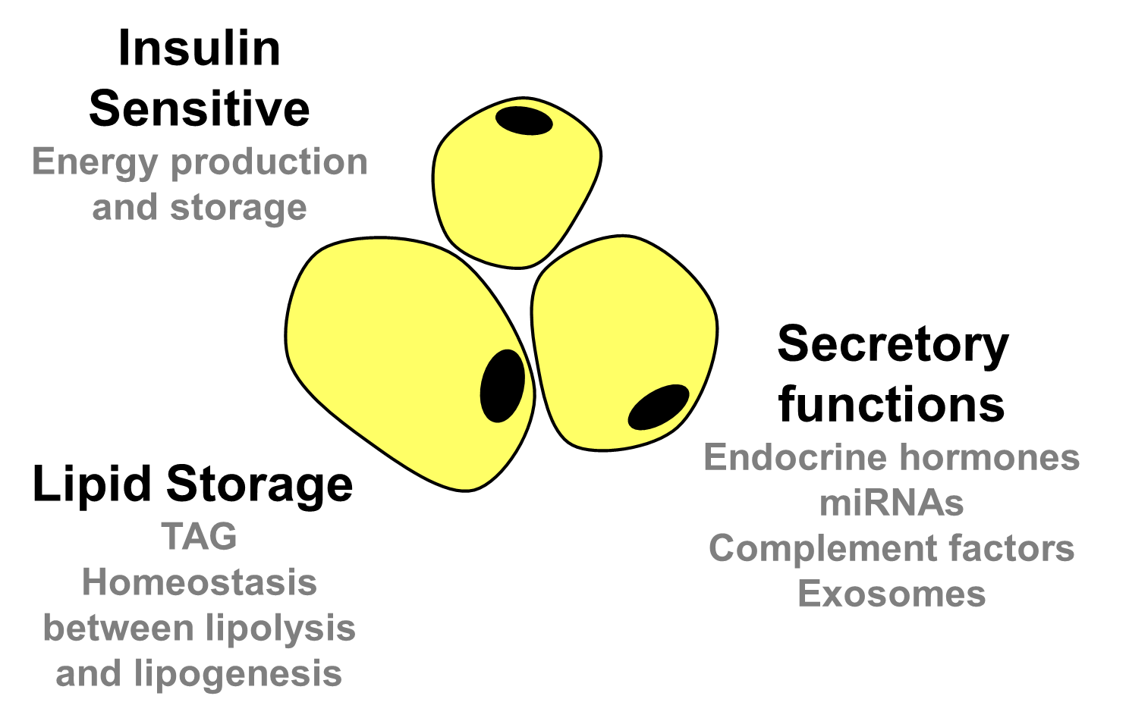

**Figure 1. Physiological characteristics of adipocytes. Disruption of any one of these fat cell functions may lead to the development of systemic metabolic dysfunction.**

**adipocyte physiology**

**Adipocyte Hues – White, Brown, Beige and Pink**

Adipose tissue has historically been classified into two types, white adipose tissue (WAT) and brown adipose tissue (BAT), which are visibly distinguishable based on tissue color. The white and brown adipocytes comprising these depots exhibit physiological differences, which give rise to specialized tissue functions. White adipose tissue, which is critical for energy storage, endocrine communication, and insulin sensitivity, comprises the largest AT volume in most mammals including humans. In contrast, BAT is largely present in mammals postnatally and during hibernation. Brown adipose tissue uses energy for non-shivering heat production, which is critical for body temperature maintenance. While BAT was originally thought to only be present in infant humans, imaging studies have revealed metabolically active BAT in the supraclavicular and thoracic regions of adults (12–14). Although women have increased BAT mass and activity over men (14,15), the chance of detecting BAT activity in either sex has been shown to be inversely correlated with age and body mass index (BMI) (14). Seasonal correlations have also been observed with BAT activity being higher in the winter and lower in the summer, possibly due to either the temperature or, more likely, the photoperiod (14,15). In healthy humans, BAT activity contributes to whole-body fat oxidation and diet-induced thermogenesis (16), supporting a physiological role for this AT depot in adults.

Brown and white adipocytes differ in shape, size, and the intracellular structure of their organelles (Figure 2). White adipocytes are generally spherical in shape and each contains a large, single lipid droplet that pushes all other organelles, including the nucleus, to the cell’s periphery. Brown adipocytes contain multiple lipid droplets dispersed throughout a more ellipsoidal-shaped cell that is enriched with iron-containing mitochondria, giving the cell (and the BAT as a whole) a brownish hue. The thermogenic activity of brown adipocytes is conferred by the presence of its numerous mitochondria containing uncoupling protein 1 (UCP-1), a proton transporter that short-circuits the ATP (energy)-generating proton gradient and allows for concurrent heat production as protons flow back into the mitochondrial matrix (17). Brown fat cells typically grow to 15 to 50 µm, while white fat cells have a larger capacity for lipid storage and can expand to nearly 100 µm in diameter (18). The capacity of white adipocytes to expand in number and size is depot-dependent and is discussed in more detail in the Adipose Tissue Expandability and Metabolic Health section.

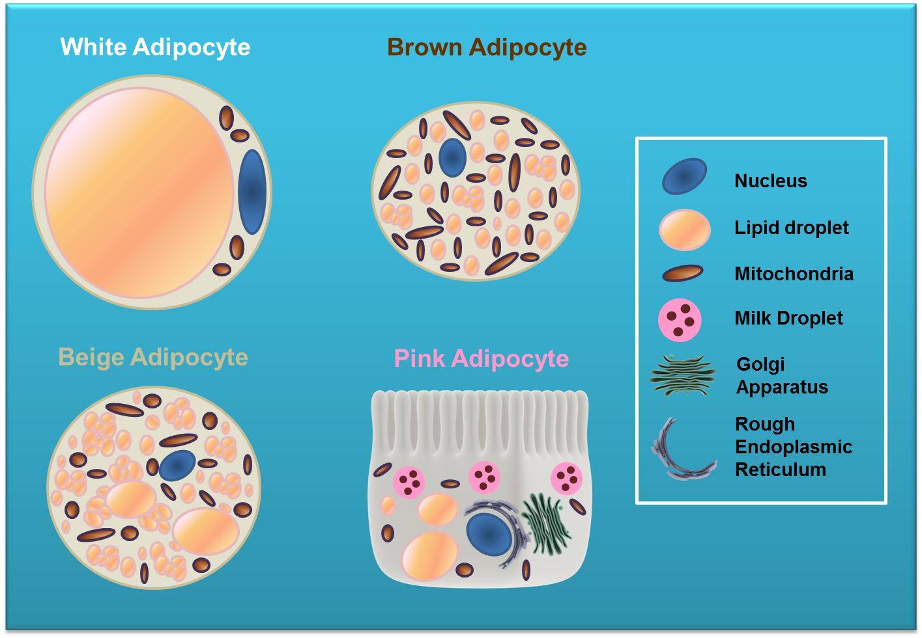

**Figure 2. Adipocyte types are described by color hues. The primary characteristic of an adipocyte is its ability to store lipid; white, brown, beige, and pink adipocytes all share this property. However, each type of fat cell is somewhat specialized and has a distinct intracellular distribution of organelles and gene expression profile. All fat cells have Golgi and endoplasmic reticulum, but these organelles make up a more significant portion of pink adipocytes than other adipocyte types.**

Recently, two additional adipocyte hues – beige and pink – have been described. Beige adipocytes display characteristics of both brown and white fat cells (Figure 2) and typically develop within subcutaneous WAT from a distinct subset of preadipocytes (19) or via the

transdifferentiation of existing white adipocytes (20,21). However, gene expression analyses indicate that beige fat cells represent a distinct type of thermogenic fat cell (19). Beige adipocytes were originally observed to arise in response to cold exposure in rodents (22,23); however, many studies have since identified that diet (24), exercise (25), pre- and post-biotics (26), pharmaceutical agents, numerous plant-based bioactives, and even adipokines (27) can also induce “beiging” or “browning” of WAT, which may protect against obesity and associated metabolic dysfunction. The “beiging” of WAT is inducible in both mice and humans (28), but this process is more highly observed in mice.

Pink adipocytes were first described in 2014, arising in the subcutaneous WAT of female mice during days 17-18 of pregnancy and persisting throughout lactation. These fat cells appear to derive from white adipocytes that take on epithelial-like features to form milk-secreting alveoli, giving the tissue a pink hue (29). Pink adipocytes are characterized by compartmentalized lipid droplets, cytoplasmic projections, and abundant organelles including mitochondria, peroxisomes, and rough endoplasmic reticulum, that show a structure more typical of epithelial cells. While reversible transdifferentiation appears to be responsible for the development and disappearance of pink adipocytes during pregnancy, lactation, and post-lactation in rodents (30), it remains uncertain whether or not pink adipocytes form in humans. Notably, loss of a key adipogenic transcription factor within the mammary secretory epithelium creates a pro-breast tumorigenic environment and indicates that the reversible white-to-pink transition might reveal insights into breast cancer biology (29,31). Further investigations into adipocyte plasticity might therefore identify novel therapeutic targets to combat obesity and its pathological consequences, as well as cancer. However, since WAT makes up the largest AT volume in the human body and undergoes the most expansion during obesity, in this chapter we will focus on the roles that white adipocytes and WAT play in normal physiology and metabolic dysfunction.

**Adipose Tissue in the Regulation of Lipid Metabolism**

Adipose tissue stores body fat as neutral TAGs and represents the chief energy reservoir within mammals. Although many diverse cell types are found in whole AT, adipocytes constitute the largest cell volumes and are the defining AT cell type. White adipocytes are characterized by their large unilocular central lipid droplets (cLDs). However, the biogenesis of unilocular LDs in adipocytes is poorly understood due to the fragile nature of WAT.

Using live-cell imaging combined with fluorescent labeling techniques, the cytoarchitecture of unilocular adipocytes **(**Figure 3) and spatiotemporal dynamics of lipid droplet formation have been investigated (32). As shown in Figure 3, cytoplasmic nodules containing micro LDs (mLDs; small green fluorescent protein (GFP)-negative spheres within the cytoplasm) appear on the surface of fat cells, pushed to the edges by the large cLD. Surprisingly, the cytoplasm and organelles do not distribute uniformly around the edge of the cell, but instead form numerous, discrete cytoplasmic nodules connected via a thin layer of GFP-positive cytoplasm. The largest nodule also contains the nucleus, which is surrounded by a thicker layer of cytoplasm. The electron micrograph (Figure 3F) shows the close contacts between mLDs and mitochondria. Furthermore, additional nascent lipid droplets can be visualized budding off from the smooth ER (sER). Studies using a fluorescent-labeled free fatty acid (FFA) analog revealed that exogenously added lipids were rapidly taken up by the fat cell and concurrently esterified to TAG and absorbed by mLDs prior to packaging within the cLD. The lipid transfer followed a unidirectional path from mLD to cLD and provides insight into adipose tissue growth via fat cell hypertrophy (32).

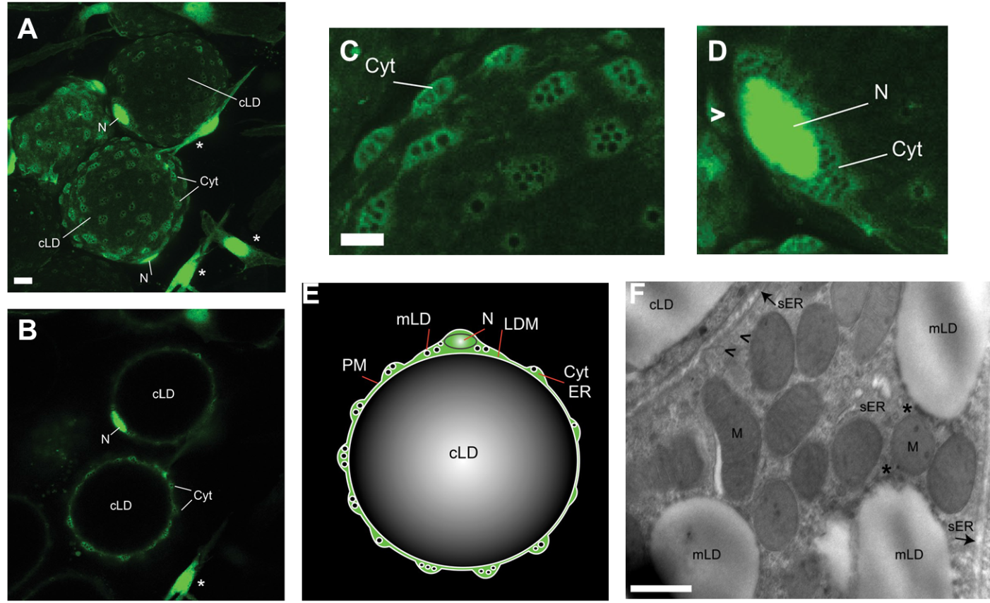

**Figure 3.** **Architecture of primary unilocular adipocytes. Figure adapted from (32). The cytoplasm and nuclei of adipocytes and stromovascular cells were labeled by infecting visceral WAT explants from nonhuman primates with an adenoviral vector encoding enhanced green fluorescent protein (eGFP). Two days after infection, live explants were examined by for GFP expression using confocal microscopy. Cellular and subcellular features are labeled: cLD, central lipid droplet; Cyt, cytoplasm; LDM, lipid droplet membrane; mLD, micro-LD; N, nucleus; PM, plasma membrane; sER, smooth ER. (A) GFP-positive unilocular adipocytes (spheres) and stromovascular cells (asterisks) residing in WAT. The image represents the sum of all confocal slices. Bar, 10 um. (B) Single confocal section of the image in A. Enhanced magnification of adipocytes containing cytoplasmic nodules (C) and perinuclear cytoplasm (D). (E) Schematic representation a unilocular adipocyte demonstrates that the cLD is a sphere tightly fitted within the cell, whereas the cytoplasm collects in multiple organelle- and mLD-containing nodules. (F) Electron micrograph of a unilocular adipocyte from a visceral WAT explant that was fixed and processed for electron microscopy. Asterisks mark contact sites between mitochondria and mLDs, whereas arrowheads point towards vesicles budding off the ER tubules. Bar, 500 nm.**

Adipocytes store TAG under conditions of energy surplus and release fatty acids to supply to other tissues during fasting or times of high energy demand. As such, AT is central to the regulation of systemic lipid metabolism, and nutritional and hormonal cues serve to balance lipid storage and breakdown within the fat cell (Figure 4).

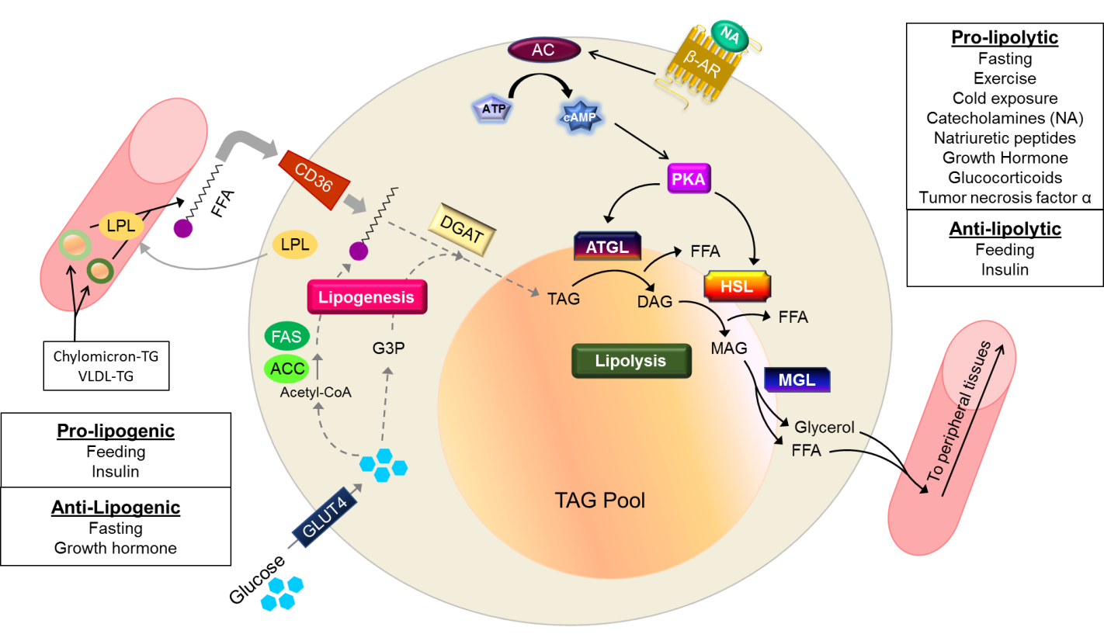

**Figure 4. A critical balance between lipogenesis and lipolysis within adipocytes must be established to maintain whole body insulin sensitivity and energy homeostasis. Lipogenesis is shown on the left (gray arrows mark the pathway), whereas lipolysis is shown on the right and is marked by black arrows. Nutritional and hormonal cues regulate both processes. Lipid droplet associated proteins, such as perilipin and comparative gene identification-58 (CGI-58) are not shown but play important roles in lipolysis. CD36 (cluster of differentiation 36) is a fatty acid transporter that facilitates entry of free fatty acids (FFAs) into the cell. Insulin stimulates glucose uptake into fat cells by increasing the localization of the insulin responsive glucose transporter, GLUT4, within the plasma membrane. Other abbreviations: VLDL-TG – triglyceride-containing very low density lipoprotein; LPL – lipoprotein lipase; ACC - acetyl-CoA carboxylase 1; FAS – fatty acid synthase; G3P – glycerol 3 phosphate; DGAT - diacylglycerol acyltransferase; β-AR – β-adrenergic receptor; NA – noradrenaline; AC – adenylyl cyclase; PKA – protein kinase A; ATGL - adipocyte triglyceride lipase; HSL - hormone sensitive lipase; MGL - monoacylglycerol lipase; TAG – triacylglycerol; DAG – diacylglycerol; MAG – monoacylglycerol.**

LIPOGENESIS

Adipocytes accumulate lipid via one of two processes (Figure 4). In the first process, under normal daily feeding conditions adipocytes take up dietary lipids from the circulation in the form of FFA’s liberated from circulating TAGs via the action of lipoprotein lipase (LPL) (33). Adipocytes secrete LPL, which is transported to the adjacent capillary lumen to catalyze the hydrolysis of FFA’s from circulating triglyceride-containing lipoproteins (34,35), such as chylomicrons produced in the small intestine and very low density lipoproteins (VLDLs) synthesized by the liver (36). Adipocytes also take up glucose, which is converted to glycerol and serves as the backbone for the sequential esterification of fatty acids for form TAG. The final step in TAG synthesis, re-esterification of circulating free fatty acids, mediated by diacylglycerol acyltransferase (DGAT) (37,38). The second process is by *de novo* lipogenesis (DNL) within the adipocytes themselves. Lipogenesis comprises both *de novo* synthesis of fatty acids from acetyl-coenzyme A (acetyl-CoA) and the esterification of these fatty acids to a glycerol backbone producing TAGs (Figure 4**)**.*De novo* lipogenesis can occur in the fasting and fed states (36). Following a meal, especially one high in carbohydrates, excess glucose oxidation yields elevated levels of acetyl-CoA that become substrate to generate fatty acids. This occurs through actions of the DNL enzymes acetyl-CoA carboxylase 1 (ACC1) and fatty acid synthase (FAS) to convert acetyl-CoA to palmitate, which can then be elongated and desaturated to form other fatty acid species (39).

Surprisingly, in rodents DNL is relatively low in WAT compared to BAT and liver, and it plays an even lesser role in WAT lipid storage in humans under physiological conditions (40,41). Typically, hepatic DNL activity exceeds that of AT and is a more substantial contributor DNL-generated circulating lipids. However, in humans fed high-carbohydrate diets, liver DNL contributes only a small portion of total *de novo* fat biosynthesis, suggesting that AT contributes significantly to whole body DNL when there is a carbohydrate surplus (39,42). Under this condition, adipocyte DNL is usually quite low but has been shown to be important for whole body substrate metabolism (43,44) as inhibition of WAT DNL is associated with insulin resistance (45).

A primary transcriptional regulator of adipocyte DNL is carbohydrate response element-binding protein (ChREBP) (39). Mice lacking AT ChREBP have decreased DNL and insulin resistance (46). The other major DNL regulator in AT is sterol regulatory element-binding protein 1 (SREBP1). Mice with whole body knockout of SREBP1 do not display decreased lipogenic gene expression in AT (45,47), thus supporting ChREBP as the primary lipogenic transcription factor driving AT DNL. However, a new mouse model of inducible, overexpression of insulin-induced gene 1 (Insig1), an inhibitor of SREBP1 activation and transcriptional activity, demonstrated that several acute and chronic white adipocyte-specific compensatory mechanisms are activated to restore adipocyte DNL in the absence of SREBP1 activity (44). Decreased SREBP1 activity prior to this compensation and during conditions where compensation was inactivated result in decreased lipogenic gene expression, impaired whole body glucose tolerance, and elevated lipid clearance (44) suggesting that both SREBP1 and ChREBP play important roles in adipocyte DNL.

Enhanced AT DNL can produce favorable lipid species that may be therapeutically advantageous in the context of obesity and insulin resistance (48). Adipocytes synthesize and secrete a novel family of bioactive lipids, known as the branched fatty acid esters of hydroxyl fatty acids (FAHFAs). Although FAHFAs are found in many tissues, the highest levels are in white and brown AT, and their production is likely dependent on AT lipogenesis as disruption of adipocyte DNL impairs their synthesis (39,49). Over 1000 structurally distinct FAHFAs have been predicted based on *in silico* analyses and at least 20 FAHFA families have already been identified in mammalian tissues (50). The serum and subcutaneous AT levels of one FAHFA family, palmitic acid esters of hydroxyl steric acids (PAHSAs) have been shown to be higher in insulin-sensitive compared to insulin-resistant individuals (51). In animal models, PAHSAs have been shown to decrease inflammation and enhance whole body insulin sensitivity (39,49). Recent evidence from a mouse model of high-fat diet (HFD)-induced insulin resistance demonstrates that PAHSAs act via both direct and indirect mechanisms to improve insulin sensitivity in multiple metabolic tissues, such glycolytic skeletal muscle, heart, liver, and AT. In WAT explants, PAHSAs directly inhibit lipolysis and enhance insulin’s ability to suppress lipolysis. While PASHAs can also directly inhibit endogenous glucose production (EGP) in isolated hepatocytes, the decreased AT lipolysis indirectly attenuates EGP because of reduced glycerol (gluconeogenic substrate) delivery to the liver (50).

Additional evidence from humans support a role for increased DNL and ChREBP activity in maintaining metabolic health. These include restoration of DNL in WAT following as bariatric surgery-induced weight loss (52) and reported observations of elevated WAT DNL in other metabolically favorable states including caloric restriction and adaptive thermogenesis (53,54). Collectively, these studies in mice and man support a potential role of WAT DNL in metabolic health.

LIPOLYSIS

Under physiological conditions when metabolic fuels are low and/or energy demand is high, such as fasting, exercise, and cold exposure, adipocytes mobilize their TAG stores via the catabolic process of lipolysis to supply fuel to peripheral tissues (55). Lipolysis is a highly regulated biochemical process that generates glycerol and FFAs from the enzymatic cleavage of TAGs by lipases (36) and can occur in all tissues, although it is most prevalent in AT where the bulk of TAG is stored. As shown in Figure 4, TAGs are broken down into diacylglycerols (DAGs) and monoacylglycerols (MAGs) by the sequential action of adipocyte triglyceride lipase (ATGL), hormone sensitive lipase (HSL), and monoacylglycerol lipase (MGL). At each step a single FFA is released, and in the final step MGL releases the glycerol backbone from the last FFA. These breakdown products can be re-esterified within the adipocyte or released into circulation to be used by other tissues (36,55), including by the liver for gluconeogenesis (glycerol) and for oxidative phosphorylation by muscle or other oxidative tissues (56).

Lipolysis is controlled by sympathetic nervous system (SNS) input as well as a variety of hormones (55). The best understood of these regulators is the catecholamine, noradrenaline (NA), also known as norepinephrine. Noradrenaline stimulates β-adrenergic receptors (Figure 4), which, in turn, stimulate protein kinase A (PKA) via adenylyl cylase (AC)-mediated production of cyclic AMP (cAMP). PKA activates the lipolytic action of ATGL and HSL by different mechanisms. Several lipid droplet-associated proteins, such as perilipin 1 (PLIN1) and comparative gene identification-58 (CGI-58) are also important in regulating lipolysis (57,58). Whereas PKA can directly phosphorylate and activate HSL (59–62), it primarily stimulates ATGL activity indirectly by phosphorylating PLIN1. This phosphorylation releases CGI-58 to potently activate ATGL (58,63,64). Non-adrenergic lipolytic stimuli include glucocorticoids, natriuretic peptides, growth hormone, and tumor necrosis factor alpha (TNFα) (58). These hormones are typically less potent lipolytic inducers than β-adrenergic stimulation and the molecular mechanisms responsible for their lipolytic abilities have not been clearly elucidated. However, some of these hormones clearly utilize different pathways than β-adrenergic signaling with additive or synergistic affects to increase lipolysis (55,58).

After a meal, the post-prandial increase in circulating insulin readily suppresses lipolysis (65) by increasing the activity of phosphodiesterase 3 (PDE3B) and decreasing cAMP levels (58). In the fasting state, insulin levels drop and NA is released, thus promoting lipolysis (66). Physiologically, exercise is another major pro-lipolytic stimulus in humans (58). Growth hormone, along with NA, adrenaline, and cortisol increase with exercise intensity, while insulin levels decrease. These changes culminate in an overall lipolytic response, the magnitude of which depends on exercise intensity and duration (58,67).

When AT becomes insulin resistant, as occurs in patients with diabetes and may also be present in patients with obesity, insulin’s ability to inhibit adipocyte lipolysis and reduce serum levels of FFA and glycerol are impaired. As a result, excessive lipolysis leads to increased FFA levels in both the fasted and fed state. Constant exposure of the liver and muscle to these high FFA levels is thought to promote the uptake and ectopic storage of lipids in these tissues (68). Ectopic lipids have been shown to impair insulin signaling, and thus insulin resistance at the level of adipocyte via increased lipolysis may be a major contributor to whole body insulin resistance (69). In addition to impaired insulin responsiveness in fat cells, elevated lipolysis in obesity may be mediated by decreased expression of adipocyte lipid droplet proteins such as PLIN1 and Fsp27/Cidec (fat-specific protein 27/cell death-inducing DFFA-like effector c) (70). These proteins coat the lipid droplet and promote TAG retention via the inhibition of lipolysis, and mice or humans deficient for PLIN1 (71) or Fsp27 (72,73) exhibit lipodystrophy and insulin resistance (70). Interestingly, adipocyte-selective gene deletions or transgenic overexpression mouse models of proteins involved in insulin signaling, glucose and lipid metabolism demonstrate parallel modulation of adipocyte insulin action and systemic insulin sensitivity or glucose tolerance.

In addition to potent anti-lipolytic action (58), insulin also stimulates lipogenesis (74) by activating LPL (activation) and increasing the transcription of lipogenic enzymes (74). Growth hormone antagonizes insulin by promoting lipolysis and inhibiting lipogenesis (36,58). The insulin-sensitizing, anti-inflammatory lipids (PAHSAs) generated during AT DNL and the excess basal lipolysis associated with ectopic lipid deposition and insulin resistance make both AT lipogenesis and lipolysis attractive targets for pharmaceutical intervention. On the other hand, the balance between lipid storage, mobilization, and utilization is homeostatically regulated through a complex interaction of often redundant hormonal signaling, neurological input, and nutrient flow. These intricacies complicate attempts to develop therapies targeting one aspect of lipid metabolism since disrupting the balance between lipolysis and lipogenesis may, in turn, have unanticipated effects on insulin sensitivity and whole-body energy homeostasis.

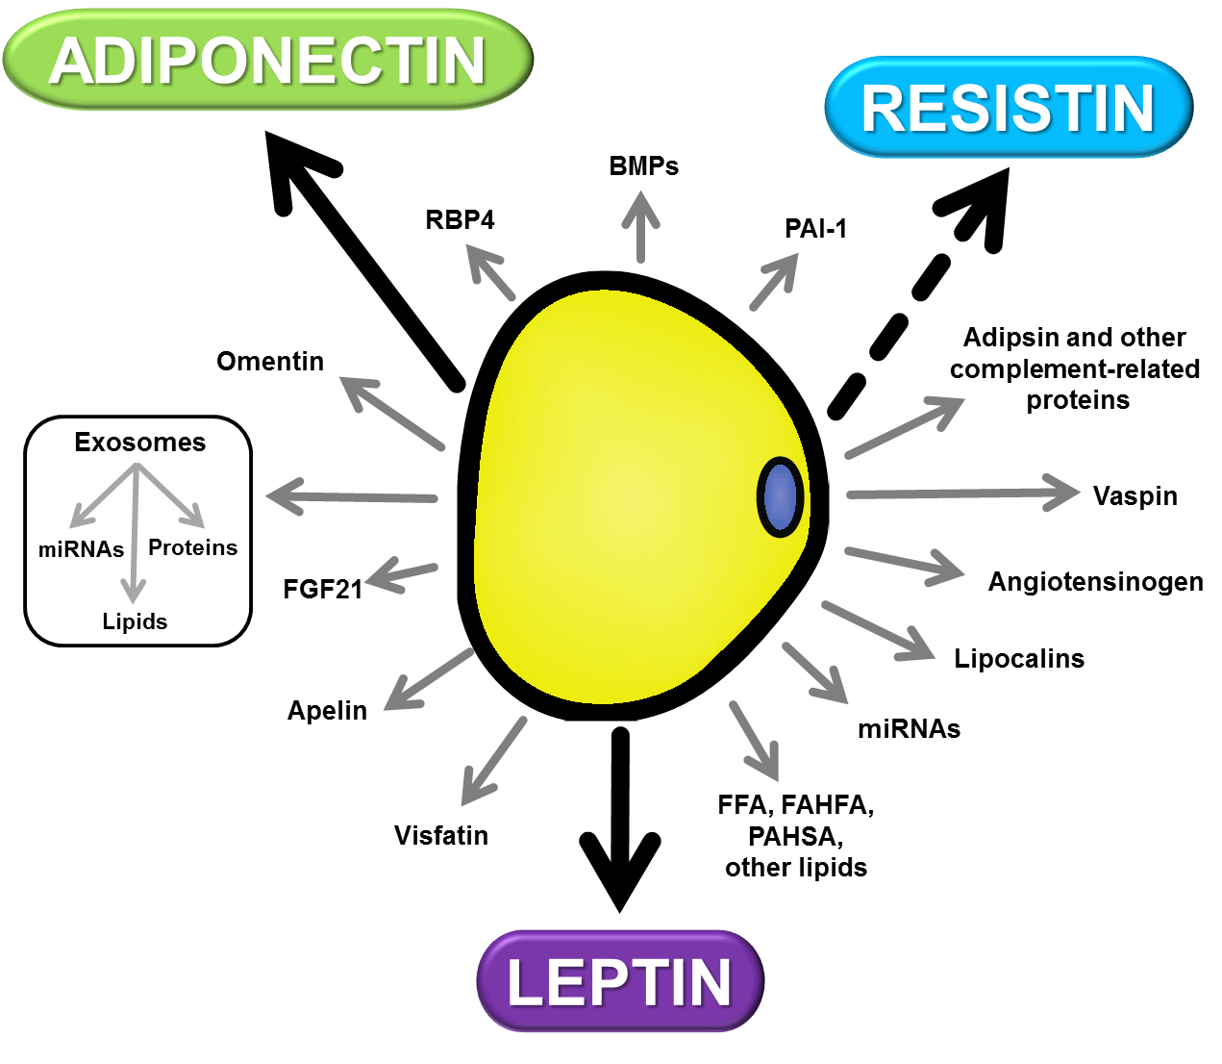

**Figure 5. The Adipocyte Secretome. Fat cells express and release numerous protein, lipid, and nucleic acid factors that can act on other nearby or distant tissues within the body in a paracrine or endocrine manner. Leptin, adiponectin, and resistin are highlighted here because they are exclusively secreted from mouse adipocytes, while the other factors can also be secreted from other cell types. The arrow-headed line representing secretion of resistin is dashed since in humans, macrophages, and not adipocytes, primarily produce this adipokine. Abbreviations are RBP4 – retinol binding protein 4, BMPs – bone morphogenetic proteins, PAI-1 – plasminogen activator inhibitor 1, miRNA – microRNA, FFA – free fatty acid, FAHFA - fatty acid esters of hydroxyl fatty acids, PAHSA – palmitic-acid-hydroxy-steric-acid, FGF21 – fibroblast growth factor 21.**

**Endocrine Properties of Adipose Tissue**

Adipocytes and other AT cells secrete a variety of mediators, including exosomes, miRNA, lipids, inflammatory cytokines, and peptide hormones that act in both paracrine and endocrine modes (Figure 5) (75). Although adipocytes secrete a large variety of bioactive molecules with widespread systemic effects contributing to numerous physiological and pathological processes, the autocrine and paracrine actions of these molecules are highly complex, and our understanding of these processes is likely rudimentary. However, substantial progress has been made studying three endocrine hormones that are almost exclusively produced in adipocytes and function to regulate food intake, the reproductive axis, insulin sensitivity, and immune responses. These hormones are leptin, adiponectin, and resistin, and we review their expression in obesity, their receptors, and effects in target tissues including metabolic actions (Figure 6). While not produced in human adipocytes directly but secreted instead by AT macrophages, resistin has similar functions in mouse and man. The dysregulation of any one of these hormones can contribute to systemic metabolic dysfunction, as well as to the pathogenesis of chronic metabolic diseases and some types of cancer.

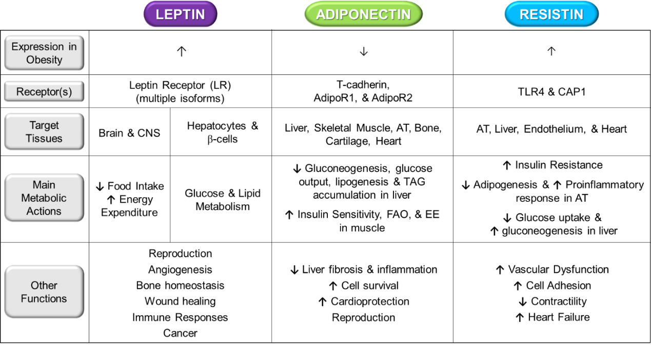

**Figure 6. Summary of adipocyte-specific adipokines, and their actions on other tissues. Abbreviations: TLR4 - Toll-like receptor 4; CAP1 - adenylyl cyclase-associated protein 1; AdipoR1 & R2 - Adiponectin receptors 1 and 2; CNS - Central nervous system; FAO – fatty acid oxidation; EE – energy expenditure.**

Leptin

The first discovered endocrine hormone of adipocyte origin was leptin (5). In 1949 spontaneously occurring obese offspring in a Jackson Laboratories’ non-obese mouse colony were determined to be homozygous for a recessive mutation, termed “obese” (*ob*) (76). These *ob/ob* mice appear normal at birth, but soon begin gaining excess fat mass and displaying hyperglycemia and hyperinsulinemia (77). In the 1950s, *ob/ob* mice and their non-obese littermates underwent parabiosis experiments, where two animals are surgically joined (usually by peritoneum or a long bone of the leg) to allow for the exchange of whole blood between them (78). Weight gain was inhibited in *ob/ob* mice parabiosed with non-obese littermates, providing evidence that the *ob/ob* gene product was a circulating factor transferred from the blood of the lean littermate. In 1972, a similar study demonstrated that parabiosis with lean animals not only reduced weight gain in *ob/ob* mice, but also improved hyperglycemia, hyperinsulinemia, and insulin sensitivity (6). Finally, in the 1990s, positional cloning studies identified the product of the *ob* gene, dubbed leptin, which was derived from the Greek word “leptos” meaning to be thin. Further characterization of leptin revealed that adipocytes were its predominant source (5). Following this discovery, the first directly observed function of leptin was its effect on food intake (79) followed shortly thereafter by demonstration that leptin levels in mice and men strongly correlate with fat mass and play a key role in body-weight (energy) homeostasis as described below.

*Leptin Receptor and Signaling*

Another spontaneously arising mutant mouse that developed obesity and type 2 diabetes is the diabetes or *db/db* mouse (80). In contrast to *ob/ob* mice, parabiosis of *db/db* mice to wild type littermates did not improve body weight or diabetes, but instead resulted in unhealthy weight loss in the lean littermates, leading investigators to deduce that mice with the *db* mutation lacked a functioning receptor for the *ob* gene but still manufactured a circulating protein that crossed over to the lean littermates to induce anorexia (81). Further confirmation of these hypotheses came when parabiosis of *ob/ob* with *db/db* mice induced weight loss in the *ob/ob* mouse while the obese state was preserved in the *db/db* mouse (81–83). Although the *db* gene was cloned in 1990 (84), it was not until almost 5 years later (85) following the identification of leptin that the *db* gene was identified to encode the leptin receptor (LR).

The LR is a class 1 cytokine receptor with substantial homology to glycoprotein 130, a plasma membrane receptor that mediates the actions of many cytokines. Unlike other plasma membrane receptors, such as the insulin receptor, the LR lacks intrinsic kinase activity and signals via Janus kinases (JAKs). Six LR isoforms exist, designated LRa-LRf, with LRb being the best characterized. It is the longest LR isoform that is capable of full signaling via the JAK/STAT pathway (86).

Leptin-regulated circuits involved in energy homeostasis have been mapped to distinct yet diverse brain regions (87) expressing the long form of the LR (88). Increased central leptin signaling inhibits food intake and elevates energy expenditure, while leptin deficiency (such as during fasting or starvation) has opposite effects. Expression of the LR has also been detected in peripheral tissues, but the exclusivity of the central leptin circuits to modulate energy intake and expenditure is supported by studies showing that deletion of the long form LR in peripheral tissues had no effects on these processes (89). Leptin levels strongly correlate with fat mass in mice and men (90,91), and as such leptin acts as a sensor of energy stores signaling the availability of body fat to the brain and regulating adipose reserves. However, during obesity the negative feedback loop between increasing leptin levels that signal high energy availability and inhibit food intake becomes disrupted due to the development of leptin resistance (92) — the inability to respond to leptin despite having sufficient or excess levels in circulation during accumulation of excess adipose stores. Although the physiological causes of leptin resistance are not well understood, it has been shown that hyperleptinemia is required for the development of leptin resistance during obesity. When leptin levels of mice are clamped to low levels (similar to lean mice), these clamped mice still develop obesity on HFD, but they do not become leptin resistant (93). The inability to overcome leptin resistance by giving supplemental doses has precluded leptin’s use as an anti-obesity therapeutic. Interestingly, leptin resistance that accompanies obesity appears to result from selective impairment of leptin’s ability to reduce food intake, while preserving its other capacity to raise energy expenditure (94). The molecular basis for this phenomenon has not yet been elucidated and remains under active investigation.

Leptin also has central nervous system effects not directly related to energy balance, including modulation of reproduction and thermoregulation. Additionally, research into the role of leptin to mediate anxiety and depression is currently ongoing (95). Leptin can also act peripherally on hepatocytes and pancreatic β-cells to regulate glucose and lipid metabolism independently of its central effects (96). Leptin has also been shown to affect innate and adaptive immunity (7), bone formation (97), bone metabolism (98,99), angiogenesis, and wound healing (88). Skeletal muscle, liver, and intestines have been described as targets for leptin action (100), and some evidence suggests that leptin may also act in an autocrine manner on AT (101). How leptin mediates responses in peripheral tissues is poorly understood and complicated by the existence of its six receptor isoforms, their differential expression across tissues, the pleiotropic nature of leptin’s effects, the demonstration of “selective” or tissue-specific leptin resistance, and the complexity of the signaling pathways involved.

*Leptin and Cancer*

Given the elevated risk for many cancers in patients with obesity in whom leptin levels are also high, it is not surprising that leptin has been implicated in tumorigenesis. Indeed, leptin levels or leptin signaling has been found to be dysregulated in breast, thyroid, endometrial, and gastrointestinal malignancies (102). Ectopic leptin expression in colorectal adenomas increases during the progression to colorectal cancer (103,104) yet associates with a favorable prognosis of the cancer (103). In papillary thyroid cancer, increased circulating leptin levels occur independently of body mass index (BMI), coincide with elevated LR expression on the tumor cells, and associate with aggressive carcinogenesis and poor prognosis (105,106). In contrast, reported associations between leptin levels and endometrial cancer are not maintained when adjusted for BMI, suggesting that leptin is not likely a causative factor in the development of this cancer (107–109).

Studies show that postmenopausal women with obesity have a 20-40% greater risk of developing breast cancer compared to normal weight women (110). In breast cancer, particularly in high-grade tumors, overexpression of both leptin and LR is associated with cancer progression and poor patient survival. Leptin’s ability to stimulate angiogenesis, regulate endothelial cell proliferation, and crosstalk with insulin and human epidermal growth factor receptor 2 (HER2) signaling pathways represent a few of the possible mechanisms by which leptin plays a role in breast cancer (111). As obesity rates continue to rise, it is likely that studies examining the relationship between leptin and cancer will become even more relevant.

Adiponectin

Adiponectin is a unique and extensively studied adipocyte-derived hormone with complex biology. Efforts to identify genes regulated during adipogenesis led to the discovery of adiponectin in 1995 (112) and 1996 by three separate research groups employing different approaches (113–115). Secreted by adipocytes, adiponectin is characterized by its remarkably high circulating levels reaching plasma concentrations in humans of 2-20 ug/ml (116), values that are more than 1000-fold higher than most other secreted factors (Figure 7). Unlike leptin, adiponectin levels decease as a function of increasing fat mass in both rodents and humans with obesity (115); thus, they are lower in patients with obesity than those who are lean. Adiponectin’s widely reported anti-hyperglycemic, anti-atherogenic, and anti-inflammatory effects have made it an attractive therapeutic target for the treatment of obesity and insulin resistance. However, efforts to develop therapies targeting adiponectin function have been impeded by its complex structure and regulation (117).

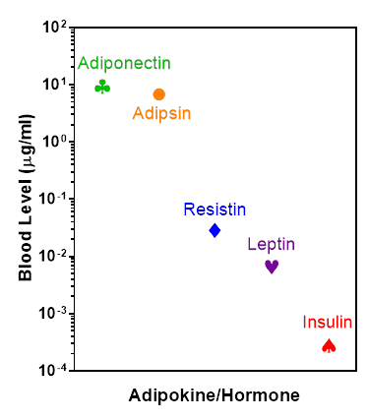

**Figure 7. Typical circulating concentrations of select adipokines and insulin for normal weight, healthy humans. Adipokine levels in the blood are several orders of magnitude higher than that of insulin.**

Adipocytes secrete different forms of adiponectin: low-molecular weight (LMW) trimers (the most basic form), medium-molecular weight (MMW) hexamers, and high-molecular weight (HMW) oligomers (118), as well as globular adiponectin, a proteolytic fragment of the protein (119,120). In humans, the MMW and HMW oligomers make up most of the circulating adiponectin while the LMW trimer constitutes less than 30% of serum adiponectin. The HMW oligomer is most closely associated with enhanced insulin sensitivity and reduced glucose levels (121).

Adiponectin signaling is complex and incompletely understood. Three adiponectin receptors have been identified. Adiponectin receptor-1 and -2, referred to as AdipoR1 and AdipoR2, bind the LMW and globular forms (122). T-cadherin binds HMW adiponectin (123). Both AdipoR1 and AdipoR2 can modulate insulin sensitivity and metabolic gene expression in insulin-responsive tissues, and both receptors have demonstrated roles in the pathophysiology of insulin resistance and T2D (124,125). T-cadherin, which is expressed in a variety of tissues including the liver (126), belongs to a family of cell surface proteins involved in cell-cell interactions (127). Mice lacking T-cadherin accumulate adiponectin in circulation and have a similar cardiovascular phenotype to adiponectin knockout mice (128), suggesting that T-cadherin is the primary effector of cardioprotection by adiponectin (129–131).

Adiponectin enhances fatty acid oxidation through activation of AMP-activated kinase **(AMPK)** (132,133), a cellular energy sensor, which then inhibits acetyl CoA carboxylase, a rate limiting enzyme in DNL(134). This, in turn, reduces malonyl-CoA production and enhances fatty acid oxidation. Adiponectin can activate AMPK through two independent pathways, and can also modulate lipid metabolism by increasing mitochondrial density and mitochondrial DNA content (135,136). Adiponectin has diverse effects in many tissues, including bone and cartilage (137), and can act in an autocrine or paracrine manner in AT and other tissues (138). Adiponectin also appears to modulate a wide range of biological processes, including reproduction and embryonic development (139,140). The heart, liver, and skeletal muscle are considered the primary targets for adiponectin action, and adiponectin’s prominent insulin-sensitizing effects have been most fully characterized at the mechanistic level in liver and muscle (117) (Figure 6).

The liver performs a critical function in maintaining normal blood glucose levels by releasing glucose (i.e. hepatic glucose output) into circulation in conditions such as fasting, exercise, and pregnancy. Conversely, the ability of the liver to reduce its glucose output when demand is low, as in the fed state, is also crucial to preventing hyperglycemia, and this process is often impaired with obesity and insulin resistance. Adiponectin can robustly reduce plasma glucose levels predominantly by inhibition of hepatic glucose production as opposed to effects on whole-body glucose uptake into cells and glycolysis (141). The importance of adiponectin in regulating glucose output in the liver is underscored by studies showing that mouse models with genetic deletion (142) or overexpression (143) of adiponectin have impaired or enhanced hepatic insulin sensitivity, respectively. Adiponectin levels are increased by thiazolidinediones (TZDs), which is thought to be the predominant mechanism of action that improves insulin sensitivity and glucose tolerance with this class of medications (142–144). Adiponectin also promotes hepatocyte survival, inhibits hepatic fibrosis and inflammation, stimulates fatty acid oxidation (133,145) and modulates fatty acid uptake and metabolism (146). In patients with nonalcoholic fatty liver disease (NAFLD) who are insulin resistant, low plasma adiponectin levels are associated with the progression of NAFLD and non-alcoholic steatohepatitis (147,148). In summary, adiponectin has beneficial effects in the liver, where it protects against metabolic dysfunction and hepatic diseases (Figure 6).

Skeletal muscle is responsible for up to 80% of insulin-mediated glucose uptake in healthy individuals (149,150). Adiponectin can promote glucose uptake (151,152), enhance fatty acid oxidation (152,153), and enhance insulin sensitivity (154) in cultured muscle cell lines and mouse skeletal muscle. Adiponectin administration to obese, insulin-resistant adiponectin-knockout mice improves skeletal muscle insulin sensitivity (146,155,156). In human myotubes, adiponectin promotes fat oxidation via AMPK activation; this response is impaired in myotubes from patients with T2D and obesity (157). Thus, adiponectin has an important role in skeletal muscle metabolism in humans as well as rodents, and defective adiponectin signaling in skeletal muscle may contribute to insulin resistance.

Finally, in addition to its insulin-sensitizing and glucose-lowering effects in liver and skeletal muscle, adiponectin is also cardioprotective. Low circulating adiponectin levels correlate significantly and independently with coronary artery disease (158), and are considered a risk factor for cardiovascular diseases (CVD) such as hypertension, coronary artery disease, and restenosis (159). The vascular endothelium is believed to mediate some of the cardioprotective effects of adiponectin via AMPK activation and subsequent activation of eNOS (endothelial nitric oxide synthase) (160).

In light of these beneficial functions, adiponectin has significant therapeutic potential in the treatment of T2D, CVD, and NAFLD. Several years ago, small molecule screening efforts produced the first small molecule AdipoR agonist. “AdipoRon”, as it was named, not only recapitulated adiponectin’s effects on AdipoR signaling pathways but also had profound anti-hyperglycemia effects in both diet-induced obese mice and a genetic mouse model for diabetes (161). A more recent study has now shown that AdipoRon can also decrease ceramides and lipotoxicity, and mitigate diabetic nephropathy (162). Hence, small molecule activators of adiponectin signaling show promise in the management of obesity-associated metabolic diseases like insulin resistance, NAFLD, and T2D.

Resistin

Resistin, the most recently discovered of the major adipocyte-derived hormones, was independently identified by two laboratories. In one case, the gene coding for this novel endocrine factor was identified in a screen for genes inhibited by TZD drugs and was named “resistin” because it induced insulin resistance (163). Another group identified the same gene in a screen for genes expressed exclusively in adipocytes and induced during adipogenesis; they named it ADSF, for adipose tissue-specific secretory factor. In this study, the product of the gene was shown to inhibit differentiation of adipocytes *in vitro* (164), later confirmed in a separate study (165).

Elucidating resistin’s role in physiology has been challenging. While resistin is expressed in both white and brown fat in mice, the various WAT depots (inguinal, gonadal, retroperitoneal, and mesenteric) and BAT exhibit distinct patterns of resistin expression (166). In addition, circulating levels of resistin are directly proportional to its gene expression in some conditions, but inversely proportional in others (167,168). Remarkably, while resistin produces similar metabolic and inflammatory effects in humans and mice, human resistin is predominantly secreted from macrophages, not adipocytes (169–171). The complex regulation of resistin expression and the fundamental differences in resistin biology between species are significant obstacles to fully understanding this hormone’s functions and mechanisms of action in humans.

Resistin interacts with two known receptors: the toll-like receptor 4 (TLR4) and adenylyl cyclase-associated protein 1 (CAP1) (172,173). Resistin signaling through TLR4 contributes to monocyte recruitment and chemokine expression, and is involved in inflammatory responses in atherosclerosis and acute lung injury (135,174). Both knockout and overexpression studies of CAP1 indicate that this receptor can also mediate proinflammatory effects of resistin (173). Overall, the similarities, differences, and tissue specificity of resistin signaling through TLR4 versus CAP1 remains poorly understood.

Resistin has also been shown to regulate fasting blood glucose levels in mice (175). Elevated levels of circulating resistin are reported in genetic and diet-induced mouse models of obesity (163). Anti-resistin antibody administration improves insulin sensitivity in diet-induced obese mice, and conversely, resistin injection impairs glucose tolerance in normal mice; supporting a causative role of resistin in mediating insulin resistance in mouse models (176). Moreover, both human and mouse resistin have been shown to impair insulin-stimulated glucose uptake in cultured murine myocytes *in vitro* (177). Other studies have shown similar insulin desensitizing effects of resistin in liver and brain (178,179).

The finding that human resistin originates not in adipocytes but in mononuclear lymphocytes raised the possibility that the hormone may have distinct roles in the two species. An elegant mouse model was generated to address this issue, the so-called humanized resistin mouse. In these mice, the endogenous resistin gene (normally expressed in adipocytes) was deleted, and the macrophage-expressed human resistin gene was inserted (180). Data from this study revealed that like murine adipocyte-derived resistin, the humanized resistin induced systemic insulin resistance, adipose tissue inflammation, and elevated circulating free fatty acids in high-fat diet (HFD)-fed mice.

In humans, epidemiological, genetic, and clinical data support a role for resistin in dysfunctional metabolism and related pathologies (181). As in mouse models, serum resistin levels are elevated during human obesity (182,183). Furthermore, high circulating resistin concentrations in humans have been associated with atherosclerosis, coronary heart disease, congestive heart failure, as well as inflammatory conditions including systemic lupus erythematosus, inflammatory bowel disease, and rheumatoid arthritis (184–188). Whether the relationship between resistin and insulin resistant states is merely correlative and whether interventions to antagonize resistin action will be of therapeutic value in the treatment of metabolic or cardiovascular disease in humans remains undetermined.

**Cell Types in Adipose Tissue**

Besides adipocytes, AT is comprised of endothelial cells, blood cells, fibroblasts, pericytes, preadipocytes, macrophages, and several types of immune cells (189). These non-adipocyte cell types are commonly referred to as the AT stromal vascular fraction (SVF) (Figure 8). Our understanding of the complexity of the cell types present in the SVF and how this milieu is altered by metabolic disease states is an area of active investigation. Cells in the SVF produce hormones and cytokines that can act in a paracrine manner on adjacent adipocytes. In the early 1990s, it was shown that TNF alpha production was increased in AT during metabolic disease states, in particular, T2D (190). Yet, it wasn’t for another ten years that adipose tissue macrophages (ATMs) were identified as the primary cellular source of AT TNF alpha (191). It is now largely accepted that in conditions of obesity and T2D, TNF alpha is produced in ATMs and acts on adjacent adipocytes within AT to promote insulin resistance. Hence, it is important to consider the presence and dynamic interactions of the SVF cells, especially when determining the cellular sources of AT-derived paracrine and endocrine hormones.

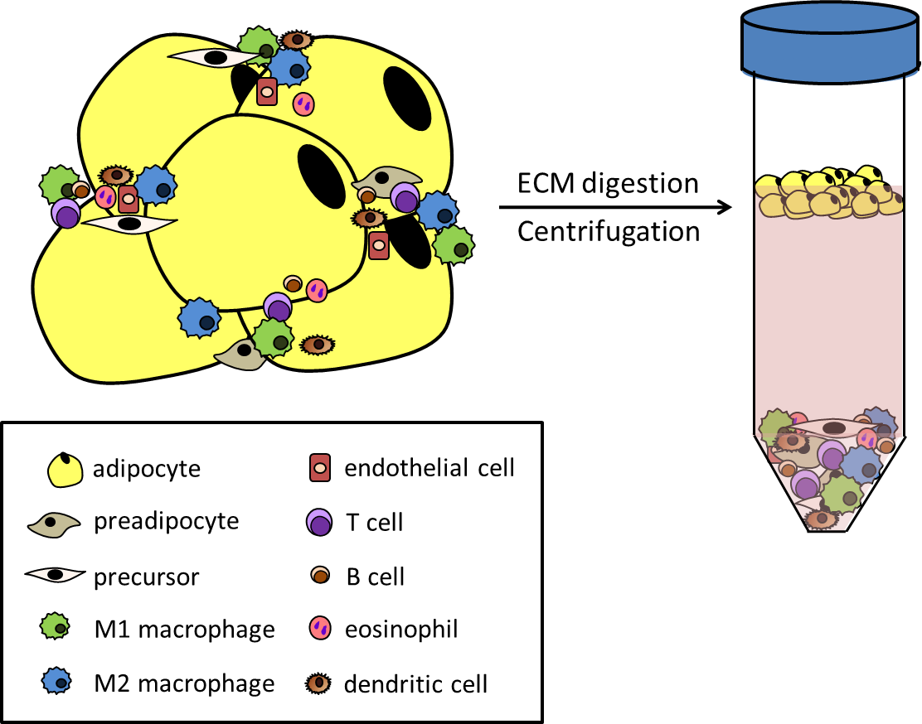

**Figure 8. Constituents of adipose tissue (AT). Left: Along with mature, functional adipocytes and precursor cells, many cell types related to vasculature and immune function reside within AT. They perform both physiological and pathophysiological functions by communicating with the adipocytes via secreted factors and scavenging lipid from dying fat cells. The number and diversity of these cell types increases with developing obesity and metabolic dysfunction. Right: The non-adipocyte cells are collectively referred to as the stromal vascular fraction (SVF), and the SVF can be separated from lipid-containing adipocytes by digesting the extracellular matrix (ECM) and centrifuging the cellular mixture. The SVF will form a pellet at the bottom of the tube, while the adipocytes will float and form a visible lipid layer at the top of the aqueous medium. This separation technique is critical to studying the cellular composition of adipose tissue and gaining insight regarding the individual functions of these diverse and distinct cell types under physiological and pathophysiological conditions.**

**Adipogenesis**

To understand how adipocytes contribute to systemic metabolic regulation, it is important to understand their development. Adipogenesis refers to the process by which precursor cells differentiate and become committed to storing lipid and maintaining energy homeostasis as adipocytes. Adipogenesis is regulated by hundreds of factors, including nutrients, cellular signaling pathways, miRNAs, cytoskeletal proteins, and endocrine hormones such as growth hormone, insulin-like growth factor 1, insulin, and several steroid hormones, as well as cytokines. Generally, pro-inflammatory cytokines inhibit adipogenesis (192), although some cytokines within the same family exert opposing effects (192). Cytoskeletal proteins (193), ECM proteins and their regulators (194), microRNAs (miRNAs) (195), and long noncoding RNAs (lncRNAs) (196) differentially modulate adipogenesis. Dozens of different transcription factors, briefly described below, also regulate adipogenesis (Figure 9).

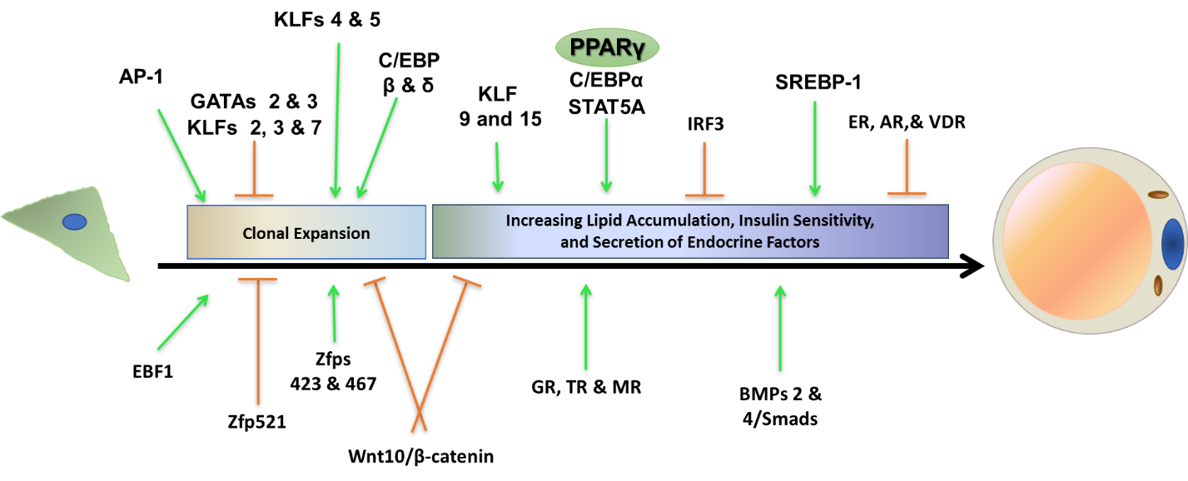

**Figure 9. Transcriptional regulation of adipogenesis as determined *in vitro* in a fibroblast-like preadipocyte clonal cell line. Preadipocytes are grown to confluence and become growth arrested. Following induction of differentiation, they re-enter the cell cycle and undergo several rounds of proliferation, a process known as mitotic clonal expansion. At the end of this short proliferative phase, preadipocytes terminally differentiate into adipocytes as they begin synthesizing lipid and assume characteristics of mature fat cells. Numerous transcription factors have been determined to promote (green arrows) or inhibit (orange horizontal ended line) adipogenesis either during clonal expansion or at later stages of terminal differentiation. The timing of activation (i.e. when each transcription factor is turned on and off) is critical to the progression of adipocyte differentiation.**

Promotors of Adipogenesis

The transcription factor peroxisome proliferator activated receptor gamma (PPARg) is considered the principal adipogenesis regulator (197). Its discovery substantially enhanced our understanding of the adipocyte and its role in metabolic disease. For example, mice with adipocyte-specific PPARg deletion have decreased AT mass and are insulin resistant (198). In humans, PPARg gene mutations can also cause lipodystrophy (partial or generalized loss of fat in the body) and severe insulin resistance (199–201). The discovery of PPARg as the functional receptor for the insulin-sensitizing TZDs resulted in a significant effort to understand PPARg action and identify additional agonists. Synthetic TZDs induce weight gain in humans and rodents by increasing fat mass, more so in the subcutaneous adipose depot, which is associated with improved metabolic outcomes. However, this weight gain is also considered as a negative side effect of TZD treatment, especially in the typical patient who has pre-existing obesity. Other adverse side effects of TZDs, such as bone fractures and heart failure, have spawned the search for structurally distinct PPARg ligands capable of inducing unique receptor-ligand conformations with signature affinities for diverse co-regulators (202). Several selective PPARg modulators (SPPARMs) with fewer side effects have been identified. These act as partial PPARg agonists, alter specific post-translational modifications of PPARg, and preserve anti-hyperglycemia effects while minimizing or eliminating the adipogenic effect that leads to increased fat mass via activation of distinct gene profiles that may be cell and tissue specific (203,204). Interestingly, the TZD, rosiglitazone, is capable of improving glucose homeostasis even in the absence of PPARg in mature adipocytes (205), suggesting that its adipogenic effects (in addition to its non-adipogenic ones) may also be important for its anti-hyperglycemic action.

In addition to TZDs, PPARg binds endogenous lipophilic molecules, including: long chain fatty acids (LCFAs), oxidized or nitrated FAs, prostaglandins, and arachidonic acid derivatives (206). Interestingly, serotonin (5-hydroxytryptamine, 5-HT) has also been shown to be a high affinity agonist for PPARg(207). Many of the endogenous PPARg ligands enhance adipocyte differentiation and regulate fat cell functions such as lipolysis, glucose uptake, and lipogenesis through PPARg-dependent and independent methods (208–214). Overall, these endogenous ligands have low affinity and limited subtype selectivity for PPARg relative to other PPARs, suggesting that much remains to be understood regarding this critical adipogenesis regulator. While there is no question that PPARg is essential for adipogenesis and lipid accumulation within fat cells, a better mapping of its gene expression profiles in discrete cell and tissue types and with endogenous and synthetic ligands will improve our understanding of AT development and function under both physiological and pathophysiological conditions.

The CCAAT/enhancer-binding proteins (C/EBPs) are widely expressed transcription factors that regulate proliferation and differentiation of various cell types in mammals. Studies *in vivo* and *in vitro* have identified C/EBP isoforms α, β and δ as important regulators of adipogenesis (215). C/EBPs β and δ work together in early adipogenesis to promote fat cell differentiation by inducing expression of C/EBPα and PPARg (216). Additionally, the transcription factors Krox20 and ZNF638 can modulate adipogenesis by affecting C/EBPβ function (217,218).

The Signal Transducer and Activator of Transcription (STAT) family of transcription factors was first identified over 20 years ago (219). Both the protein expression of STATs and their ability to regulate gene expression are tissue-specific (220). In AT, STATs regulate gene expression during adipogenesis, and the expression of STATs 1, 3, 5A, and 5B is induced during differentiation of murine and human preadipocytes (221,222). Notably, the ability of STAT5 proteins to promote adipogenesis has been documented by over a dozen independent laboratories using both *in vitro* and *in vivo* approaches (17).

Of the three isoforms of Sterol Response Element Binding Proteins (SREBP-1a, SREBP-1c, and SREBP-2), SREBP-1c is the predominant form expressed in white AT (223,224) and is an important regulator of lipogenesis genes, while SREBP-2 regulates the expression of cholesterol biosynthesis genes (225). Intriguingly, two miRNAs (miR-33a and miR-33b) located within the SREBP genes are highly induced during adipogenesis (226). Although SREBP-1 clearly plays a promoting role in adipogenesis *in vitro*, *in vivo* studies suggest that SREBP-1 is not critical for AT development and/or expansion, perhaps due to compensatory SREBP-2 overexpression (47,227).

Members of the early B-cell factor (EBF) family of transcription factors are characterized for their ability to modulate islet beta-cell maturation and neural development. Three primary members of this family (EBFs 1, 2, and 3) are expressed in fat cells. EBFs 1 and 2 can promote adipogenesis (228,229), and EBF2 can also play roles in determining brown versus white adipocyte identity *in vivo* (230) and the beiging process of adipose tissue in mice (231).

Inhibitors of Adipogenesis

The interferon-regulatory factor (IRF) family of transcription factors has functionally diverse roles in the immune system, but also plays a role in adipocyte development. All nine IRF family members are regulated to different degrees during adipogenesis *in vitro*, and some members can repress adipogenesis (232) and contribute to insulin resistance (233). For example, knockdown of IRF3, whose is expression is elevated in visceral and subcutaneous AT of obese mice as well as in subcutaneous AT from humans with obesity and diabetes decreases fat mass and prevents insulin resistance in high fat diet-fed mice (233).

Wingless-related integration site (Wnt) proteins regulate development and cell fate through both autocrine and paracrine signaling (234) by using three well-characterized pathways: the canonical Wnt signaling and the planar cell polarity and Wnt/calcium pathways, which are non-canonical. The canonical pathway is dependent upon the transcription factor, β-catenin (235). Wnt10b is the best studied member of the Wnt signaling family in terms of adipocyte development. In the presence of Wnt10b, β-catenin translocates to the nucleus where it inhibits PPARγ and C/EBPα activity, thereby impeding adipogenesis (236,237). On the other hand, extracellular antagonists of Wnt/β-catenin signaling have been reported to promote adipocyte differentiation (238,239).

The GATA family of transcription factors were named based on their ability to bind the DNA sequence GATA (240). Only GATAs 2 and 3 are expressed in preadipocytes residing in white AT (241), and both are repressed during adipogenesis. In fact, GATA2 can directly bind to the PPARγ promoter to suppress its activity (241). In addition to inhibition of PPARγ expression, GATAs 2 and 3 can also associate with C/EBPs to disrupt their transcriptional activity (242). GATA3 expression is driven by the canonical Wnt signaling pathway (243,244). Collectively, these studies demonstrate that two GATA proteins can attenuate adipocyte development via multiple transcriptional and signaling pathways.

Transcription Factor Families that can either Promote or Inhibit Adipogenesis

The Krüppel-like transcription factors (KLFs) include 17 members that can either activate or repress transcription. In relation to adipocyte development, KLFs 4, 5, 6, 9 and 15 can promote adipogenesis, while KLFs 2, 3 and 7 repress adipocyte development. Most studies on the roles of KLFs in adipogenesis have been performed *in vitro* using a variety of cell culture models, and have demonstrated that KLFs act in concert with other transcription factors modulate adipogenesis (245).

The transcription factor activator protein 1 (AP-1) consists of Jun proteins (c-Jun, JunB, and JunD), Fos proteins (c-Fos, FosB, Fra1, and Fra2), ATF and JDP family members, several of which are induced during adipogenesis (222). In humans, a mutation in the c-fos gene that is associated with lipodystrophy has been shown to reduce c-fos activity and adipocyte development (246). Many *in vitro* and *in vivo* studies demonstrate that, like KLFs, AP-1 transcription factors can positively and negatively regulate adipogenesis.

Many of the zinc finger proteins (ZFPs) function as transcription factors with several contributing to adipocyte determination and/or adipogenesis. Zfp423 and Zfp467 can promote adipocyte differentiation by enhancing PPARγ expression and activity (247,248). In addition to stimulating adipogenesis, Zfp423 can suppress ‘beige-like’ properties in white adipocytes that are typically associated with improved metabolic health (249). Zfp521 can inhibit Zfp423 to reduce adipocyte development and is also considered a critical regulator of the commitment to either osteogenic or adipogenic lineages (250,251).

The transforming growth factor beta (TGF-β) superfamily encompasses a large number of proteins, including bone morphogenetic proteins (BMPs) (252). BMPs and TGF-β have been reported to be involved in both adipocyte commitment and differentiation (253–255). Specifically, BMPs 2 and BMP4 can promote adipogenesis via the Smad signaling pathway (256) to regulate transcription of target genes such as PPARγ (257,258). While BMPs are known to promote adipogenesis, *in vitro* and *in vivo* studies demonstrated that TGF-β primarily inhibits fat cell differentiation.

Hormonal Regulation of Adipogenesis

Steroids are prominent regulators of AT development and distribution, and adipocytes express high levels of many steroid hormone receptors. These lipophilic hormones diffuse through plasma membranes, dimerize, and bind to their specific receptors to impart both genomic and non-genomic responses (259,260). Since steroid-bound receptors act as transcription factors, their capabilities should be fully considered in the transcriptional regulation of adipogenesis.

Two types of estrogen receptors, ERα and ERβ, are expressed in rat and human preadipocytes, mature adipocytes, and in other AT cells (261–263). Although many studies describing the role of estrogens in AT are contradictory, most investigations indicate that estrogen inhibits adipocyte differentiation (245) and the adipogenic action of PPARγ (264). Aromatase is an enzyme found in several tissues, including AT, that aromatizes [androgens](https://en.wikipedia.org/wiki/Androgen) into [estrogens](https://en.wikipedia.org/wiki/Estrogen). Both ERα- and aromatase-knockout mice have increased adiposity, suggesting that both estrogen and its receptor can reduce adipocyte development (265,266). Mice lacking ERα have enhanced visceral AT deposition and increased weight gain compared with wild-type mice (267).

Androgen receptors (AR) are also expressed in rodent (268,269) and human AT (270). Similar to estrogen, many studies report contradictory actions of androgens on the differentiation and function of adipocytes. These inconsistent results highlight the importance of accounting for sex-, depot- and organism-specific effects. In studies of human AT, testosterone and the non-aromatizable androgen, dihydrotestosterone, inhibit differentiation of preadipocytes obtained from subcutaneous and omental depots of both men and women, although the magnitude of the inhibitory effect may differ between the sexes (271,272). Overall, most studies indicate that androgens exert inhibitory effects on adipogenesis.

Glucocorticoids (GCs) are well-known promoters of adipocyte development. GCs also promote adipocyte hypertrophy and differentiation of central fat depots that can lead to abdominal obesity and insulin resistance (273). *In vitro* adipogenesis studies include the wide use of the synthetic GC, dexamethasone. Although the mechanisms of action and target genes of GCs involved in adipocyte differentiation are not completely clear, it is known that GCs induce expression of C/EBPs beta and δ and that GC-induced C/EBPδ coordinates with C/EBPβ to induce PPARg expression and adipogenesis (274).

To understand the actions of GCs via the glucocorticoid receptor (GR), it is important consider the enzyme that affects circulating levels of cortisol, the active form of GR’s endogenous ligand. 11β-hydroxysteroid dehydrogenase type 1 (11 beta HSD1) is an [enzyme](https://en.wikipedia.org/wiki/Enzyme) highly expressed in AT and [liver](https://en.wikipedia.org/wiki/Liver) that in AT converts inactive [cortisone](https://en.wikipedia.org/wiki/Cortisone) to the active hormone [cortisol](https://en.wikipedia.org/wiki/Cortisol). Hence, it is not surprising that 11 beta HSD1 mRNA expression and activity is essential for the induction of human adipogenesis and that adipocyte development can be blocked with a 11 beta HSD1 specific inhibitor (275). In addition to inducing the expression of early adipogenic transcription factors, GCs promote adipocyte development by mechanisms that include suppression of anti-adipogenic factors (Pref-1 and Runx2); anti-proliferative effects on preadipocytes; and sensitizing or ‘priming’ of human preadipocytes to insulin action (276). Recent attention has focused on the potential contributions of environmental pollutants known as endocrine disrupting chemicals (EDCs) in the development of metabolic diseases. Studies reveal that EDCs can promote adipogenesis through GR activation (277), thereby implicating these compounds in the rising rates of obesity and diabetes.

In addition to regulating water and salt homeostasis, the mineralocorticoid aldosterone and its receptor (MR) have also been shown to play a role in the regulation of adipocyte development. This is important since MR is a high-affinity receptor for both mineralocorticoids and GCs. Aldosterone promotes adipogenesis in an MR-dependent manner (278) and a MR antagonist can inhibit adipogenesis (279). Although GRs and MRs are expressed in AT and thought to mediate cortisol’s actions on AT, the levels of GR are several hundred-fold higher than MR in both human preadipocytes and adipocytes (280). Loss of GR, but not MR, blocks the adipogenic capabilities of cortisol in human preadipocytes (280). However, MR expression is higher in omental than in subcutaneous AT, so there could potentially be depot differences in the relative importance of MR and GR in cortisol-induced adipogenesis (280). There could also be differences in the contribution of MR to adipogenesis during obesity when MR and 11 beta HSD1 expression levels are increased, while the GR and 11 beta HSD2 (the enzyme that deactivates cortisol) levels do not increase accordingly (280). Most of the current evidence suggests that the ability of aldosterone to modulate adipogenesis *in vitro* is largely dependent on MR. Additional studies are needed to determine if MR plays a role in adipocyte development *in vivo*.

Vitamin D is another steroid hormone with strong experimental evidence that it can regulate adipogenesis. Unlike most of the water-soluble vitamins that are excreted via urine when in excess, Vitamin D, along with the other fat-soluble vitamins (A, E, and K), can be stored within fat-laden adipose tissue. The vitamin D receptor (VDR) and 1α-hydroxylase (CYP27B1), the enzyme that activates vitamin D, are expressed in human AT, primary preadipocytes, and newly-differentiated adipocytes (281). The most active form of Vitamin D, 1, 25-Dihydroxyvitamin D, represses adipocyte differentiation (282,283) and the VDR can block adipogenesis by inhibiting C/EBPβ expression (284). Vitamin D-induced inhibition of adipogenesis also involves direct suppression of C/EBPα and PPARg (285). Vitamin D and VDR also play a role in the inhibition of adipogenesis of bone marrow stromal cells (286), in part by suppressing the expression of inhibitors of the canonical Wnt/β-catenin signaling pathway (287). Although vitamin D inhibits adipogenesis in the widely used murine and bone marrow-derived cells, both 25-hydroxyvitamin D and 1,25-dihydroxyvitamin D3 can promote the differentiation of human subcutaneous preadipocytes (281). Overall, a case could be made that concentrations of vitamin D as well as the type of adipocyte precursor determine whether this hormone exerts pro- or anti-adipogenic actions via the VDR.

On the other hand, evidence regarding Vitamin D’s role in adipocyte development in humans is controversial and contradictory. According to a systematic review and meta-analysis of 23 studies between 2002 and 2014, overweight or obese subjects exhibit a higher prevalence of Vitamin D deficiency (288). In two double-blind, placebo-controlled randomized clinical trials, Vitamin D-supplemented individuals with healthy overweight or obesity lost significantly more fat mass than the placebo group when fed either a calorie-restriction (289) or weight-maintenance (290) diet for 12 weeks. While decreased fat mass may result from Vitamin-D induced inhibition of adipogenesis, this hypothesis was not directly tested in the studies, and two other longer term studies demonstrated no change in fat mass with Vitamin D supplementation between 14,000 and 20,000 IU per week (291,292).

The relationship between adipocyte development and thyroid hormones has been recognized since 1888 when a report on myxedema proposed that obesity was a requirement for a diagnosis of hypothyroidism (293). The most biologically active form of thyroid hormone, T3, can induce brown adipocyte differentiation (294). Hyperthyroidism in rodents induces adipocyte hyperplasia, whereas hypothyroidism impedes AT development (295). Overall, studies on the involvement of thyroid hormones in AT development are controversial. While the induction of adipogenesis is differentially regulated by various thyroid hormone receptor (TR) isoforms, studies largely indicate that TRs promote adipogenesis in the majority of model systems (245).

**Adipocyte Progenitors**

In AT, pools of adipose stem/progenitor cells (APs) exist that can differentiate into mature adipocytes (296,297). At least two distinct progenitor populations give rise to adipocytes: developmental APs and adult APs (296,298). Our understanding of the molecular characteristics of APs has dramatically increased in recent years as discussed below.

APs in Adipose Development

AT organogenesis in mice and humans begins during embryogenesis, and ends in the postnatal period for mice and just before birth in humans (296,297,299). AT is widely accepted to be of mesodermal origin (297). However, some of the spatiotemporal and molecular differences observed in formation of different AT depots suggest diverse developmental origins (297,300). Further, white and brown adipocytes, once considered to have common APs are now known to have different origins (297,301,302).

In the generation of white adipocytes, developmental APs express the master adipogenesis regulator PPARg but have distinct functional and molecular properties compared to adult APs (298,302). Developmental APs do not contain lipid but express the mature adipocyte markers perilipin and adiponectin, are able to replicate, and are located along the vasculature in developing white adipose tissue (298,302,303). Brown adipocytes can arise from myogenic Myf5-expressing precursors that also give rise to skeletal myocytes (297,302,304). Interestingly, brown-like adipocytes, known as beige adipocytes, emerge in white adipose from Myf5-negative precursors in response to cold or adrenergic stimuli, which suggests that the developmental origins of brown adipocytes and beige adipocytes are different (297,304). Collectively, these findings highlight the complex developmental heterogeneity of APs observed among adipose tissue depots in animals and humans.

APs in Adult Adipose Tissue

The notion that we are born with all the fat cells we will ever have is now considered archaic and inaccurate. Adipose tissue continues to generate new adipocytes throughout the lifespan, with a median adipocyte turnover rate of 8.3 years (302,305). Adult APs have been found in the SVF of AT depots in both rodents and humans (302,306–308) and are thought to represent an AP pool that contributes to this adipocyte renewal. Flow cytometry techniques that use a variety of cell surface and stem cell markers, have helped identify stromal cells that can undergo adipogenesis (302,306,307,309). These adult APs arise from tissue-resident mesenchymal stem cells, and are a major source of new adipocytes in AT (297,310). Bone marrow-derived APs from the myeloid lineage can also be recruited to AT where they become adipocytes (Figure 10). Bone marrow-derived adipocytes (BMDAs) are more abundant in female mice and are more frequent in visceral depots (297,311,312). Though BMDAs have been observed in human AT and are increased in patients with obesity, the processes and factors involved in BMDA recruitment to AT remain unclear. Compared to normal adipocytes, BMDAs have reduced expression of lipid metabolism genes and increased pro-inflammatory gene expression, suggesting that they may have negative metabolic effects (297,311,313).

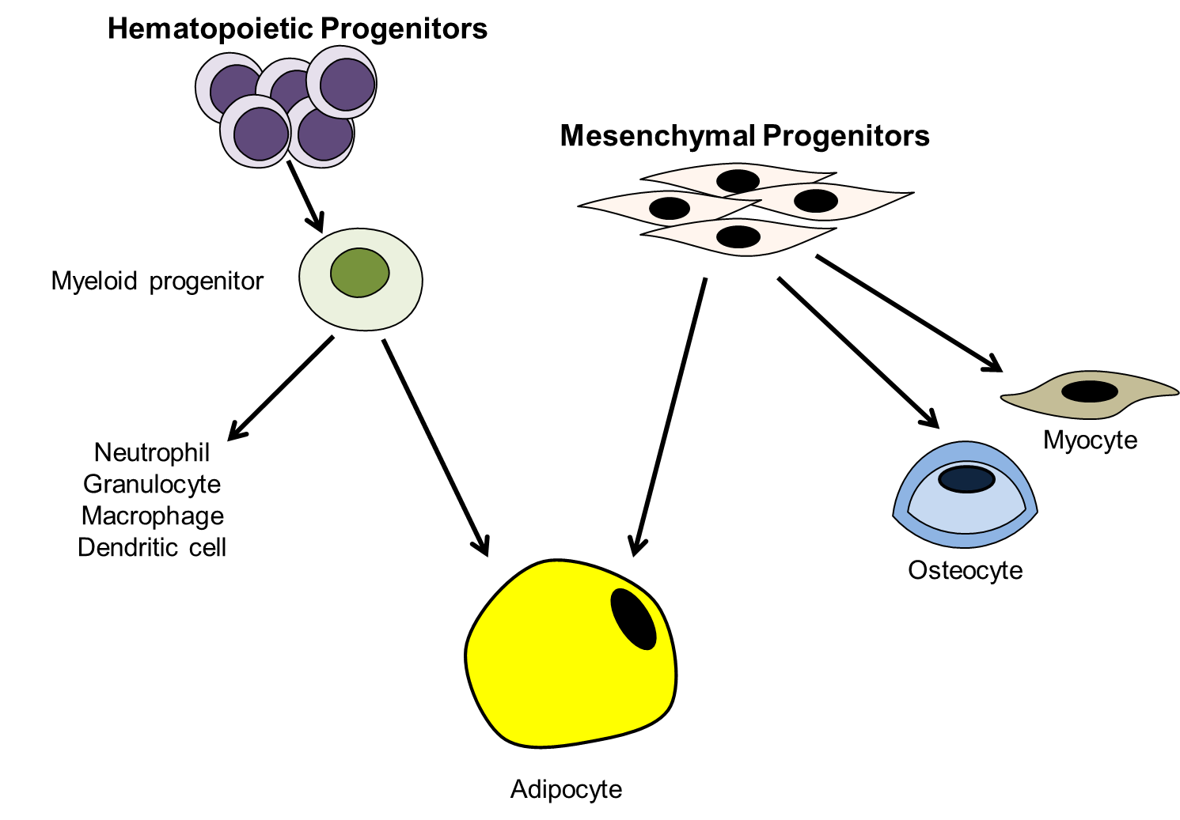

**Figure 10. Adipocytes are derived from both resident mesenchymal cells in the stromal-vascular fraction of adipose tissue and hematopoietic progenitors that reside in the bone marrow. In addition to adipocytes, mesenchymal progenitors can form other connective tissue cells, such as myocytes and osteocytes. Myeloid progenitors derived from hematopoietic progenitors in bone marrow give rise to adipocytes as well as neutrophils, macrophages, dendritic cells, and granulocytes.**

Most of the information regarding AP proliferation in obesity comes from rodent models. In mice fed high-fat diets to induce obesity, APs form new adipocytes primarily in the visceral depot (299,302). Although limited data report decreased AP proliferation and differentiation capacity from humans with obesity compared to lean individuals (314), convincing evidence for depot-specific AP populations in humans has emerged. Subcutaneous APs were shown to have a higher growth rate and adipogenic potential than visceral APs, giving rise to more functional adipocytes (315,316). Increasingly sophisticated methods for assessing APs in mice will help facilitate the identification of the origins of all APs for each adipose depot as well as the niches in which they reside.

**Adipose Extracellular Matrix: From Normal Development to Fibrosis**

An underappreciated influence on AT physiology is the adipose extracellular matrix (ECM). The dynamics and composition of the ECM are critical for proper adipocyte development and function (317). During adipogenesis, there is increased synthesis of laminar ECM constituents and maintenance of peri-adipocyte fibrillar collagens that ultimately allows the adipocyte to embed itself in the basal lamina (317). In the growth phase of adipogenesis, adipocytes require ECM-mediated traction forces to properly accumulate lipids and increase in size. A number of inhibitors, enzymes, and modifiers contribute to adipocyte ECM maintenance and renewal; these reactions consume a large amount of energy in the mature fat cell (317). In obesity, the ECM expands to accommodate the adipocyte hypertrophy and hyperplasia, and subsequent tissue growth, induced by the increased demand for lipid storage (317–321). This process appears to occur in a similar fashion in both animal models and humans.

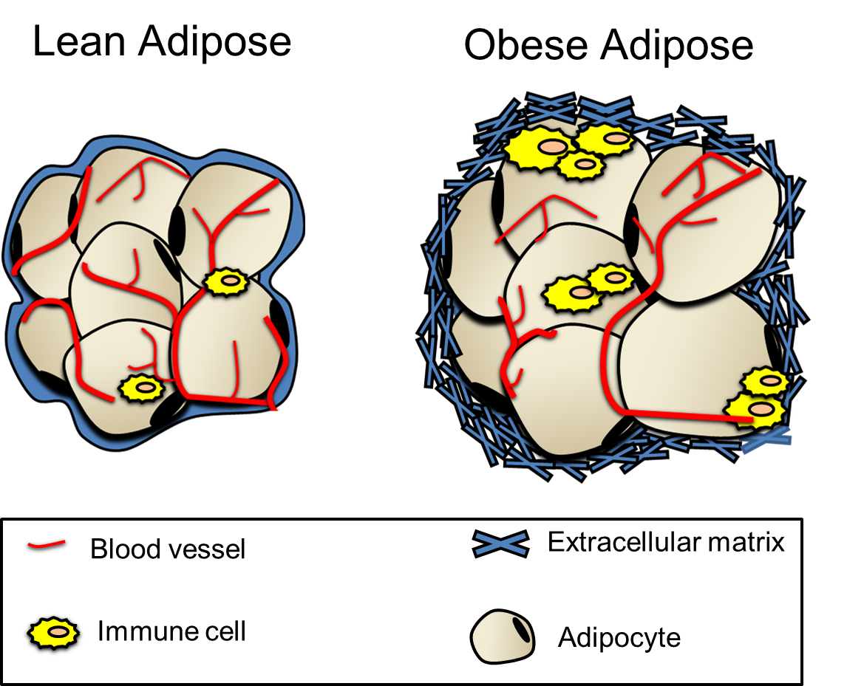

**Figure 11. Differences in AT between lean and obese mammals. The AT extracellular matrix (ECM) is important for normal tissue function but can also contribute to its dysfunction. In obesity, accumulation of ECM components can restrict AT expansion, promote inflammation by recruiting immune cells, and impair adipogenesis. These combined effects can worsen insulin resistance.**

Adipose tissue expansion during obesity, coupled with immune cell accumulation and hypoxia, can lead to AT fibrosis (Figure 11) (317,319,322). Fibrosis is the excessive accumulation of ECM components, such as collagens, that typically results from an imbalance of the synthesis and degradation of ECM components (319,323). Ultimately, adipocyte dysfunction will result from the decreased ECM flexibility conferred by the accumulation of fibrillar ECM components (317,320,323). Abnormal ECM collagen deposition is associated with immune cell infiltration, which can worsen fibrosis and contribute to AT dysfunction that often occurs in obesity (319,323). The removal of collagen VI, a major AT ECM component, improves adipocyte function and metabolism in obese mice by both decreasing AT immune cell infiltration and “weakening” the ECM, which allows uninhibited adipocyte hypertrophy (317,318,323). In humans, AT collagen VI expression is increased in obesity, and subjects with higher collagen VI have increased macrophage content and AT inflammation (324). Endotrophin, an adipocyte-derived cleavage product of collagen VI, directly stimulates AT fibrosis and macrophage accumulation, and can lead to systemic insulin resistance (325). Endotrophin can also cause fibrosis and endothelial cell migration in mammary tumors, leading to tumor expansion and the enhancement of metastatic growth (325,326).

Accumulation of ECM components and increased ECM-receptor signaling are associated with insulin resistance in obesity thought to be mediated by several possible mechanisms. In addition to physically restricting AT expansion, excess ECM components can also increase AT inflammation by interactions with their cell surface receptors (CD44, CD36, and integrins) (320). These ECM-receptor interactions can induce adipocyte death, inhibit angiogenesis, and promote macrophage infiltration and inflammation in adipose tissue, thereby driving insulin resistance (320). Interestingly, these downstream effector pathways of ECM-receptor signaling are similar to those involved in tumor growth and pulmonary fibrosis development.

The ECM has clear roles in the normal development and function of adipocytes, but in excess can also play roles in obesity development and metabolic dysfunction. Our understanding of the adipose ECM has deepened in recent years, but more research is necessary to better delineate how ECM components and their interactions can directly influence AT physiology and pathophysiology. Since many AT cell types produce ECM components, studies to determine the specific contributions of adipocyte-derived ECM components to normal AT function as well as dysfunction will be required.

**Rodent versus Human Adipose Depots**

Much of the knowledge about the depot-specific characteristics and metabolic profiles of AT has been obtained from rodents. However, the validity of translating studies conducted in rodent fat to humans remains controversial. Relative to humans, rodents have substantially more BAT and rely heavily on this highly-inducible depot to stimulate thermogenesis (327). While BAT activation in rodents has been shown to elicit beneficial effects, including improvements in glucose and lipid metabolism (328,329), BAT function in humans is more controversial. Overall, the majority of studies have reported that the amount of active BAT in humans appears insufficient to induce meaningful changes in energy metabolism and, thus, is not thought to impact whole-body physiology and metabolic control in humans (330) as described in rodents.

With regard to white AT, notable differences exist with respect to fat depot structure and function between species (18). Humans have subcutaneous depots primarily in the abdominal and gluteal-femoral regions; whereas rodents have subcutaneous fat pads located anteriorly and posteriorly (Figure 12). With regards to location, the inguinal (posterior) fat pad in rodents is considered comparable to the gluteal and femoral depots in humans. Human subcutaneous

abdominal AT can be categorized as superficial SAT or deep SAT (331), which are morphologically and metabolically different. Deep SAT has been reported to be closely related to the pathophysiology of obesity-related metabolic complications, while superficial SAT is more closely related to the protective lower-body SAT (332–334). However, these subcutaneous layers are not present in rodents. In humans, intra-abdominal fat refers to visceral AT, which surrounds the inner organs, and includes omental, mesenteric, retroperitoneal, gonadal, and pericardial depots (335). For most purposes, however, when used in reference to human studies, visceral AT refers to omental and mesenteric depots that are quantified by abdominal computed tomography or MRI scans. On the other hand, visceral fat pads in rodents are classified as perigonadal (epididymal in males and periovarian in females), retroperitoneal, and mesenteric. While the mesenteric fat pad is most analogous to abdominal (visceral) AT in humans, it is not often studied in rodents due to surgical limitations. The perigonadal fat pads are the largest and most the readily assessable fat in rodents; hence, they are most frequently used in mouse studies and cited the most often in the literature as surrogates for human visceral AT. However, humans do not have an AT depot analogous to the rodent perigonadal fat pads. In addition, the omental depot is clearly defined in humans, but in mice it is difficult to detect. Overall, striking anatomical differences in AT distribution exist between rodents and humans, and these differences should be considered when interpreting rodent studies and potentially translating these observations to humans.

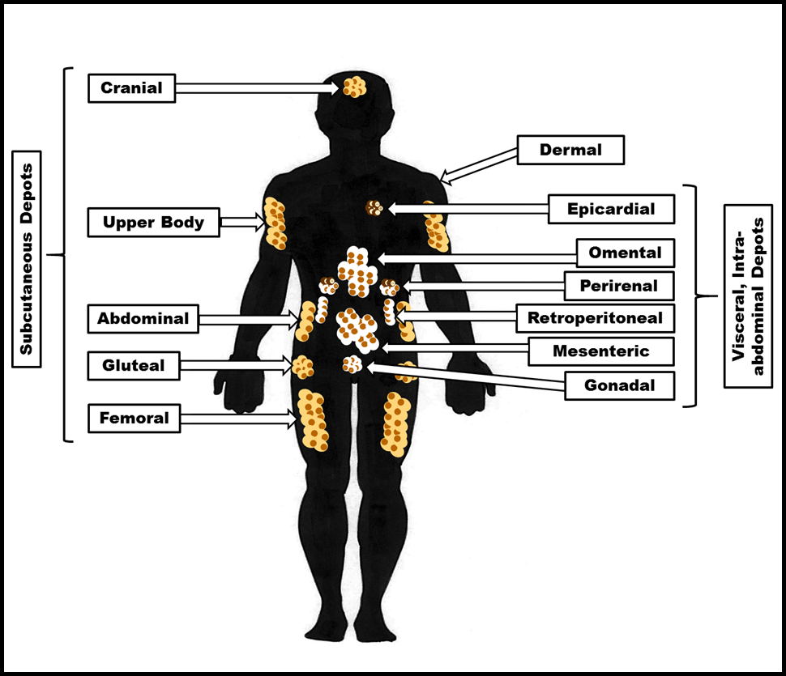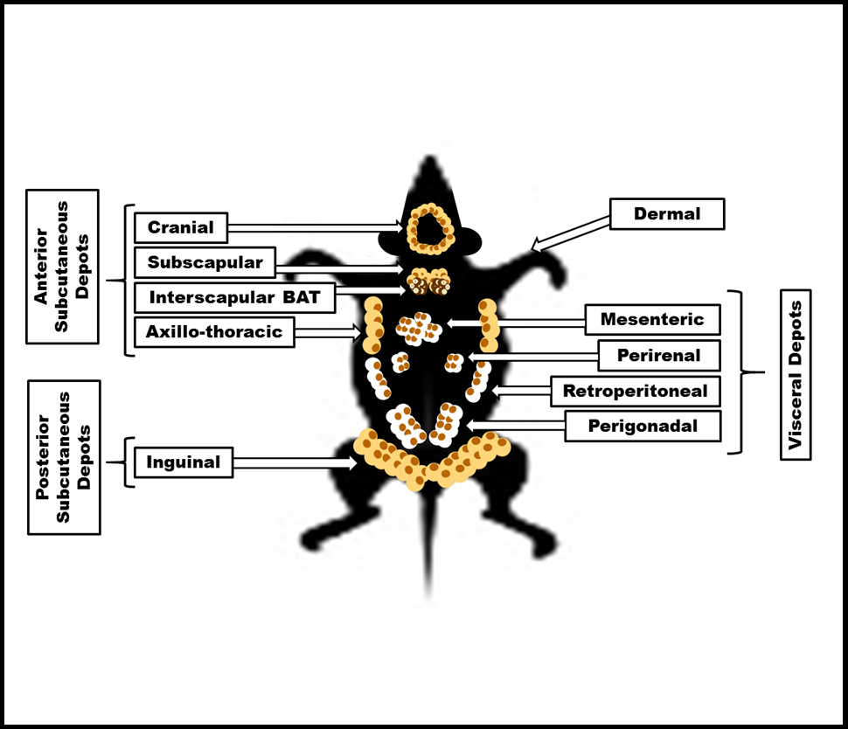

**Figure 12. Rodent versus Human AT depots. Several differences exist between rodent and human subcutaneous (SubQ) and visceral AT depots. In the figure SubQ depots are colored as beige, while visceral depots are white, and BAT or BAT-like depots are brown.**

It is well-established that the various adipose depots display metabolic heterogeneity and are intrinsically different within each species. In humans, fat deposition in the upper body, mainly the visceral but also the subcutaneous abdominal depot, is linked to a higher risk of metabolic dysfunction; while lower body adiposity in the subcutaneous gluteal and femoral regions is associated with lower risk and may even be protective (336). Rodent studies reveal that surgical removal of visceral fat pads improves insulin action, glucose tolerance, and longevity (337,338), while the removal of subcutaneous fat pads can cause metabolic syndrome (339). In addition, subcutaneous, but not visceral, donor AT transplanted into the visceral region of recipient mice improves glucose metabolism (340). In contrast, human studies have shown that the removal of small amounts of omental AT in individuals with obesity provided no metabolic health benefits (341). Likewise, liposuction (~10 kg) of subcutaneous AT in humans neither harmed nor improved the cardio-metabolic profile (342,343). Nevertheless, fat is redistributed from the subcutaneous to visceral depots during aging (344) in conjunction with increasing prevalence of chronic diseases such as hypertension, T2DM, and cardiovascular disease, suggesting that subcutaneous AT may be metabolically beneficial in humans as has been extensively reported in rodents.

Studies of depot-specific expression patterns have enhanced our understanding of the mechanisms underlying abdominal versus gluteal and femoral adiposity (345–347). Unique expression patterns in different adipose tissue depots in mice indicate substantial difference in the expression of homeobox (HOX) developmental genes (348). Not surprisingly, HOX genes exhibit differential expression patterns in human compared to mouse fat depots (346,347). In contrast, structural and hormonal regulators, including collagen VI (349,350) and glucocorticoids (351,352), respectively, that influence fat distribution are similarly associated with AT expansion in both rodents and humans.

Similar to humans (353), female rodents have a higher percentage fat mass relative to males, yet remain more insulin sensitive (354). However, there are many notable sex differences in rodent versus human depots. The inguinal depots of female mice contain mammary glands and the gonadal fat pad is near reproductive tissue, which is not the case in humans. In addition, high-fat diet-induced obesity affect men and women alike, but in many strains of mice females are resistant HFD obesity, unlike male mice (355,356). Furthermore, the periovarian (visceral) fat pad in female mice has been shown to be more insulin sensitive than the inguinal fat pad (354), which is contrary to human data that indicates in women the gluteal and femoral depots are more insulin sensitive relative to the visceral AT (357).

Current literature suggests that the secretion patterns of adipokines (including leptin, interleukin-6, and tumor necrosis factor α) in the visceral versus subcutaneous depots of humans are relatively similar to that of rodents. Interestingly, lower body AT has been shown to secrete more metabolically favorable adipokines such as adiponectin (358). These observations are similar in rodents studies (340).

While lipolysis can be stimulated in rodents and humans under similar physiological conditions, important biological differences in AT lipolysis among these species have been suggested. The β1 and β2 adrenergic receptors (AR) are ubiquitously expressed in rodents and humans, while β3-AR expression is confined to white AT in rodents and only marginally expressed in human adipocytes (359). The α2-ARs are highly expressed in the subcutaneous AT of humans and act to inhibit lipolysis (360), but are absent in rodent adipocytes. Though common factors, including catecholamines, growth hormone, and cortisol, are similar among species in regulating lipolysis, differences in the response to other lipolytic agents have also been reported. Natriuretic peptide induces lipolysis in humans, but not in rodents (361), while adrenocorticotropic hormone and alpha-melanocyte-stimulating hormone modulate lipolysis in rodent but not human adipocytes (362,363). Therefore, it is important to account for these differences and commonalities in AT lipolysis among species.

Rodent studies are essential to expand our understanding of pathways underlying the associations between fat distribution and metabolic health and disease. Fortunately, there are many shared traits among rodent fat pads and human fat depots. However, given the clear differences in adipose depot location and physiology between the species, interpretation of experimental data and the extrapolation of conclusions drawn from rodent data to humans should be conducted with appropriate caution and caveats.

**Dermal Adipose Tissue**

A thick layer of adipocytes, historically referred to as subcutaneous AT, underlies the reticular dermis in both rodents and humans (364). Recent studies have revealed major differences between the adipocytes from this dermal layer and more typical subcutaneous adipocytes found in other locations (364–366). Today, dermal adipose tissue (dWAT) is considered a separate adipose depot that is distinguishable from subcutaneous fat (364). Two unique features of dermal adipocytes in this regard are that they can alter their cellular characteristics and have high turnover rates (366). An additional distinguishing factor for dWAT is its organization. In rodents, dWAT forms several adipocyte layers between the dermis and muscle layer (panniculus carnosus) (367). Human dWAT is present as individual units referred to as dermal cones. These cones are concentrated around pilosebaceous units that functionally interact with each other to form the dWAT structure (366,368). Interestingly, only body regions prone to scarring contain dermal cones (368), indicating a potential role for dWAT in scarring and wound healing. Also, dWAT can regenerate after injury. Following injury, adipogenesis is activated in the proliferative phase of wound healing and dermal adipocytes repopulate the wound (366,367). This is a critical event, as mouse models lacking mature adipocytes cannot recruit the fibroblasts required for wound healing (369–371).

Other identified roles for dWAT include insulation (372), barrier protection from skin infection (373), and hair follicle cycling (374). It is well known that brown adipose tissue (BAT) rapidly responds to cold temperature challenges by mobilizing lipids for heat generation (adaptive thermogenesis), yet dWAT slowly responds to these challenges by thickening/expanding over days to provide an effective layer of insulation (367,372). Mouse models lacking adequate dWAT undergo chronic activation of BAT since the dWAT cannot provide adequate mitigation of body temperature (367). Conversely, obese mice with excess dWAT undergo minimal adaptive thermogenesis (367). The dWAT thickening observed with cold exposure also occurs with bacterial exposure. Adipocytes in dWAT differentiate and become hypertrophic and result in a thicker dWAT layer in response to epidermal *Staphylococcus aureus.* This dWAT adipocyte reaction is also critical for immune response to bacterial invasion (373). Hair follicles go through repeated rounds of death and regrowth, referred to as the hair follicle cycle (367). Robust dWAT expansion is characterized by increased adipogenesis and dermal adipocyte hypertrophy that accompanies the regrowth of hair follicles (374). Conversely, inhibiting adipogenesis impedes hair follicle regeneration. In several species of mammals, a thickening of the hair coat accompanies dWAT expansion in response to cold exposure (367). In summary, dWAT has distinct roles from subcutaneous AT. Thus far, unlike other AT depots, the contribution of dWAT to metabolic health has not been investigated. Nonetheless, there is clear evidence that dWAT has distinct structures and functions and plays a role in variety of physiological processes.

**Epicardial AT**

Epicardial AT (EAT) has recently emerged as an important player in the development of cardiovascular disorders (375,376). Notably, EAT is distinct from pericardial fat. While pericardial AT surrounds the pericardium, EAT lies between the visceral pericardium and the myocardium and shares a blood supply with the coronary arteries (375–378). The adipocytes in EAT are smaller than those in other visceral or subcutaneous depots and are outnumbered by preadipocytes; this is thought to be related to the high energy requirement of the heart, which normally favors oxidation of fatty acids over other substrates (376,379). Furthermore, the gene expression and adipokine secretion profiles of EAT are unique from those of other depots (376,380,381).

In normal physiological conditions, EAT behaves like BAT and serves to protect the coronary vessels and myocardium against hypothermia (376,382). In pathologies such as coronary artery disease and type 2 diabetes, EAT can display an extensive pro-inflammatory signature (383–385). Macrophages and mast cells have been shown to infiltrate EAT, undergo activation, and through a cascade of signaling events facilitate lipid accumulation in atherosclerotic plaques (376,384). Pro-inflammatory adipokine secretion from EAT has also been shown to induce atrial fibrosis (381). Further, insulin sensitivity and EAT thickness are inversely correlated, whereas fasting glucose and EAT size are positively correlated, with enlarged EAT depots often found in individuals with type 2 diabetes (376,386,387). These data suggest that EAT functions as a distinct fat depot with important physiological and pathological roles.

**Metabolic dysfunction associated with Adipose Tissue**

**Adipose Tissue Expandability and Metabolic Health**

White AT retains the ability to expand during adult life to accommodate chronic excess caloric intake. AT expansion is characterized by adipocytes accumulating lipid and growing in size (hypertrophy) or number (hyperplasia or adipogenesis) or increasing in both size and number. Evidence suggests that the capacity of subcutaneous AT to expand as well as the manner of expansion (hypertrophy vs. hyperplasia) can influence cardiometabolic health. This mechanism is thought to underlie the benefits of thiazolidinedione (TZD) medications, which are approved for the treatment of type 2 diabetes (388,389). These PPARγ agonists stimulate preadipocyte differentiation and the proliferation of adipocytes (390,391), especially in subcutaneous depots as compared to visceral adipose tissue (392), which leads to increased adiponectin levels and improved insulin sensitivity (393,394). Hence, there is a clear rationale to further characterize the mechanisms of AT expansion through adipocyte proliferation in humans that may inform future effective drug therapies.

On the other hand, the presence of enlarged, hypertrophic adipocytes, a lack of hyperplasia, and development of AT inflammation and fibrosis reflect impaired AT expansion and is associated with metabolic derangements (395–398). These observations support the “AT expandability hypothesis”, which postulates that a lack of adipogenesis (or hyperplasia) results in the limited capacity of AT to expand and store lipid, causing ectopic fat accretion and “lipotoxicity” in non-adipose tissues such as skeletal muscle and liver (399–401). The degree of ectopic lipid deposition in the liver and skeletal muscle is a significant determinant of metabolic syndrome (MetS) and the development of T2D and CVD (402).

Other findings do not support the AT expandability hypothesis and indicate that higher adipogenesis does not necessarily denote improvements in metabolic health. These studies report a higher population of small adipocytes (a measure of hyperplasia) in the AT of individuals with insulin resistance and T2D (403–406) and in those with more visceral AT and liver fat (406,407). Experimental overfeeding intervention studies have shown that individuals with smaller adipocytes at baseline have poorer metabolic health outcomes (i.e. impaired insulin sensitivity) in response to substantial weight gain than those with larger adipocytes (408,409). In addition, one *in vivo* analysis in humans demonstrated that increased hyperplastic expansion correlated with an increased number of metabolic syndrome components (410). Collectively, these data imply an alternative model of impaired AT expansion, as compared to the mechanisms proposed by the AT expandability hypothesis, and suggest that there is not a deficiency in hyperplasia but an abundance of adipocytes with a limited capacity to adequately expand and accommodate lipid, whether large or small. This inability to store excess lipid in AT is thought to be a key feature that leads to metabolic dysfunction.

Although the mechanisms of adipose expansion and its precise role in promoting glucolipid dysregulation remain a matter of debate, all of the aforementioned studies support the view that AT’s capacity to expand is intimately related to metabolic homeostasis, as the failure to store excess lipid appropriately in AT can contribute to many obesity-related complications.

**AT Inflammation**

A variety of cell types from both the innate and adaptive immune systems have been found in AT (411–413). Though resident AT immune cells are critical to normal adipocyte function in healthy individuals, AT inflammation, as mentioned in several preceding sections, is considered a major contributor to the metabolic dysfunction associated with obesity (413,414).

During nutrient excess as AT expandability reaches its limit, a strong association exists between adipocyte size and adipocyte death (415). In response to adipocyte death, pro-inflammatory macrophages surround dead and dying cells and remove debris from the damaged area. During this process, macrophages acutely produce inflammatory cytokines (413,416). In obesity, this cytokine production often fails to resolve, becomes chronic, and leads to impaired adipocyte insulin signaling, further inflammation, and a continued worsening of AT dysfunction (413,416,417). In a field that is rapidly changing, it is worth mentioning that some degree of inflammatory signaling might be required for normal AT function. The pro-inflammatory cytokines TNF alpha and oncostatin M have been shown to be required for proper AT expansion and maintenance of insulin sensitivity in mice (414,418–420). Although AT inflammation clearly has detrimental effects in obesity, evidence also indicates adaptive and homeostatic roles for pro-inflammatory signaling in AT expansion and function.

**Metabolically Healthy (MHO) versus Metabolically Unhealthy (MUO) Obesity**

An estimated 10-30% of individuals with obesity are considered to have “metabolically healthy obesity” (MHO) with favorable metabolic profiles (421). Although there is currently no consensus for parameters used to classify MHO, these individuals are characterized by normal insulin sensitivity, normal fasting glucose levels, low incidence of hypertension, and blood lipid profiles in the healthy range (422,423) (Figure 13). In contrast, individuals with “metabolically unhealthy obesity” (MUO) have comparable body mass indices (BMI) but develop metabolic aberrations. Factors that distinguish individuals with MHO from MUO (Figure 13) highlight the premise that metabolic health risk is not solely dependent on body weight and are described in more detail below. Understanding these characteristics and potential mechanisms underlying the MHO and the perceived healthy metabolic state of these individuals is an important area of ongoing research.

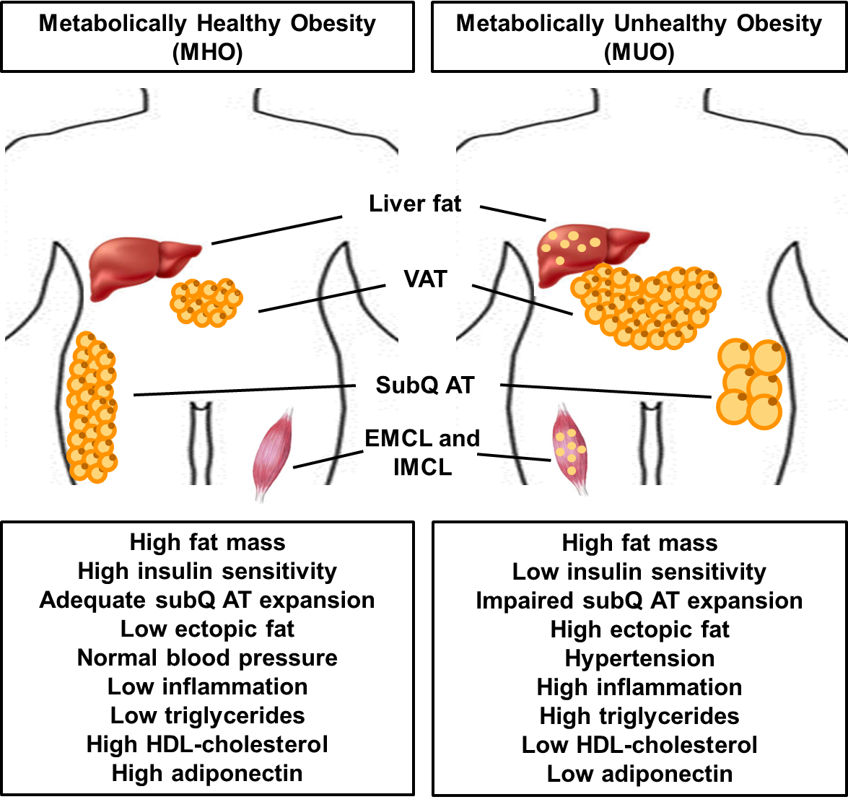

**Figure 13. Clinical and biological factors thought to distinguish metabolically healthy obesity (MHO) from metabolically unhealthy obesity (MUO). Abbreviations: VAT – Visceral AT, SubQ AT – Subcutaneous AT, EMCL - extramyocellular lipid; IMCL – intramyocellular lipid; HDL – high density lipoprotein.**

Evidence suggests that WAT plays a critical role in the development of MHO vs MUO, as its properties, location, and function are closely linked with cardiometabolic risk. Fat distribution (422), as well as changes associated with AT expansion, including the capacity for adipocyte differentiation (403) and parameters related to ECM remodeling (424), may also contribute to the MHO phenotype. In addition, adipose-derived circulating factors that impact whole-body metabolism have been implicated in MHO vs MUO differences (425). However, studies have shown that the location of AT, rather than overall obesity, may be a stronger predictor of metabolic health risks (336). The accumulation of upper-body fat, namely visceral AT (VAT) but also subcutaneous abdominal (scABD) adipose tissue, confers a higher risk of obesity-related disorders (426), while lower-body fat (subcutaneous gluteal and femoral) may be metabolically protective (427). The preserved metabolic function of individuals with MHO may be attributed to significantly lower accumulation of VAT relative to MUO (422,428,429). As described in the previous section, enlarged adipocyte size, independent of adiposity, is positively correlated with the development of insulin resistance and impaired metabolic health (396). MUO individuals have been shown to have larger adipocytes than their MHO counterparts (430,431). Hypertrophic adipocytes may represent the failure of subcutaneous AT to expand and store excess fat, which can ultimately lead to ectopic lipid deposition in non-adipose tissues such as the liver and skeletal muscle (402).

Ectopic lipid accumulation in both the liver and skeletal muscle is of pathophysiological significance as part of the “lipotoxicity” hypothesis and may also impact the varying health risk of MHO vs MUO. Extramyocellular lipid (EMCL) and intramyocellular lipid (IMCL) are postulated to cause defects in insulin signaling and reduce insulin-stimulated skeletal muscle glucose uptake (432). These lipid stores are strong correlates of insulin resistance and are increased in individuals with T2D (402). Paradoxically, increased IMCL is also observed in ‘insulin sensitive’ athletes, which may be attributed to the oxidative capacity of skeletal muscle (433) and increased glucose transport in trained muscle (434). Intrahepatic lipid accumulation strongly associates with impaired insulin-induced suppression of hepatic glucose production, even independently of visceral AT amount, and the development of T2D (435). Ectopic fat in both the liver and skeletal muscle has been shown to be lower in MHO than MUO individuals (422,436,437) (refer to Figure 13).

The differential secretion of pro-inflammatory adipokines has also been proposed as a mechanism underlying the MHO phenotype (438–440) by some investigators, although others have reported conflicting results (441). Nevertheless, studies show reduced macrophage infiltration in MHO (442,443), supporting a reduced inflammatory state in these individuals. Intriguing data implicating potential genetic differences among MHO vs. MUO indicate that specific polymorphisms in genes, including the adiponectin receptor 1 and hepatic lipase, may be associated with the MHO phenotype (436). In addition, genes encoding some proinflammatory cytokines can be more highly expressed in the adipose tissue of MUO compared with MHO individuals (444,445).

A lingering question that remains unanswered is whether MHO subjects will sustain a healthy metabolic state throughout their lifespan or if they will eventually become MUO. An additional question is if a healthy lifestyle can help to maintain a favorable profile and prevent the transition to MUO. Indeed, longitudinal data clearly show that not all MHO individuals remain metabolically healthy, as up to 30% progress to MUO over a 5-10 year time frame (446–448). Of note, the length of time for follow-up assessments of MHO individuals is an important factor that may have considerable effects on the observed outcomes, because the total number of years as obese and aging can independently increase mortality risk. A major obstacle in advancing the understanding of the MHO phenotype is the manner by which metabolic health is described, including the parameters used to define insulin sensitivity and metabolic syndrome (449). Defining metabolic outcomes based on differing criteria can result in a broad range of reported prevalence, discrepancies regarding the observed characteristics, varied interpretations of health and mortality risks, and disagreement concerning the implications of therapeutic interventions. In addition, the use of the “healthy” descriptor may be misrepresentative of the true medical risks to these individuals, as long-term adverse health outcomes have been observed in individuals with MHO during follow-up years, thus no longer characterizing them as “metabolically healthy” (450,451). Additional long-term prospective studies are necessary to assess features of the MHO phenotype and to observe how the factors discussed above are altered over time. In addition, these studies may reveal if WAT function is a cause or consequence of the MHO and MUO phenotypes.

**Lipodystrophy**

While excessive adiposity, or obesity, can have adverse health consequences, deficiency of AT mass, as seen in lipodystrophy, can also lead to derangements in glucolipid metabolism. Lipodystrophy encompasses a group of rare, heterogeneous, genetic or acquired disorders characterized by varying degrees of severe reduction or absence of body fat (452) . Anatomically, this disease can present as a partial (i.e. localized to certain body areas) or generalized lack of AT. The combined overall prevalence of lipodystrophy is estimated to be 1 in 1,000,000 individuals, with ~1000 patients reported with genetic forms (453). Lipodystrophy associated with highly active antiretroviral therapy for HIV is one of the most common acquired forms worldwide (454). The diagnosis of this disorder mostly relies on clinical criteria. In most cases of generalized lipodystrophy, standard physical examination is sufficient to establish this diagnosis. In contrast, partial lipodystrophy may be represented by mild physical abnormalities and can sometimes be misdiagnosed as common forms of central (abdominal) obesity, suggesting that this form of lipodystrophy may be an underestimated condition (455). Although the pathological basis of most lipodystrophies remains unclear, it is well-accepted that AT dysfunction is a primary determinant of the resulting health consequences in these patients. Limited development and non-expandability of AT and failure of AT to accommodate excess lipid leads to the redistribution and storage of fat ectopically in the liver and skeletal muscle and the development of non-alcoholic fatty liver disease, often severe insulin resistance and type 2 diabetes, hypertriglyceridemia, and associated diseases (456–458).

Markedly reduced levels of leptin and adiponectin may also contribute to the pathology of lipodystrophy. As described above, leptin plays an important role in the regulation of body weight and energy metabolism, and leptin deficiency is common in lipodystrophic patients, due to the lack of AT (452). Low leptin levels can not only impact glucose metabolism (459) but also contribute to increased appetite and excessive caloric intake in these patients (460). Transgenic animal models shed light on the pathology of lipodystrophy and confirm the importance of AT in normal physiology. Fatless rodents, created via AT ablation, display hypertriglyceridemia and ectopic lipid accumulation, along with severe insulin resistance (457,461). In addition, several groups have successfully treated the metabolic derangements in these fatless mice by transplanting AT from wild-type animals (461–464). However, transplantation of AT from leptin-deficient mice did not improve the metabolic abnormalities in fatless mice (465), while leptin administration in the fatless mice ameliorated insulin resistance and hepatic steatosis (466). In humans with total lipodystrophy, leptin treatment also markedly improves the severe hypertriglyceridemia and insulin resistance that accompanies this disorder (467). These studies confirm that both AT and leptin deficiency play a central role in lipodystrophy-associated pathologies.

Adiponectin has insulin-sensitizing and anti-inflammatory effects, and low levels of this adipokine have also been observed in patients with lipodystrophies (468). Recombinant adiponectin, adiponectin analogues (i.e. osmotin), and compounds that upregulate endogenous adiponectin (i.e. TZDs) have all been proposed as treatment approaches for lipodystrophy (469). In a fatless mouse model, treatment with the globular domain of adiponectin significantly improved the hyperglycemia and hyperinsulinemia characteristic of these lipoatrophic diabetic mice (146). Interestingly, the insulin resistance observed in these mice was completely ameliorated by treatment with both adiponectin and leptin, but only partially by either adiponectin or leptin alone (146), suggesting that both adiponectin and leptin deficiency may contribute to the insulin resistance in humans with lipodystrophy.

Studies to date support the premise that too little AT, as seen in lipodystrophy, appears to be just as deleterious as too much AT. Emerging data reveal that patients with lipodystrophy may have reduced survival and high mortality at an early age, predominantly due to cardiometabolic complications (470–472). Lipodystrophy has no cure; therefore, the primary treatment option is to improve metabolic outcomes via physical activity and dietary and pharmacological interventions. Conventional insulin-sensitizing agents, such as metformin and TZDs, are often used (453,473), and leptin replacement is also an approved therapy for total congenital lipodystrophy (467). Future investigations to better understand the pathogenesis and the clinical manifestation of lipodystrophy syndromes are essential for the development of improved therapeutics.

**Adipose Tissue and Reproduction**

While many studies have primarily examined the influence of white AT on the metabolic consequences associated with obesity, less frequently mentioned is the interplay between AT and reproductive health. Nevertheless, it is well established that AT is important for the normal function of the reproductive system, including the production and regulation of sex and reproductive hormones, pubertal development, and the maintenance of pregnancy and lactation (474).

Leptin and adiponectin are the most investigated adipokines as mediators of reproductive health and pathology. Receptors for both leptin and adiponectin have been identified in all major reproductive tissues, including the testes, placenta, ovaries, oviducts and endometrium (475). Obese mice that are deficient in leptin or the leptin receptor are unable to reproduce (476). Although rare, humans with leptin mutations have been identified, and studies in these individuals have validated the infertility findings in rodents (477).

Leptin administration in rodents was shown to increase luteinizing hormone (LH), follicle stimulating hormone (FSH), and ovarian and uterine weights in females, and testosterone, testicular weights and sperm counts in males (478,479). During human pubertal development, there is a steady increase in leptin, stimulating a rise in testosterone levels and fat-free mass in boys and in estradiol and fat mass in girls (480,481). Adiponectin administration was shown to inhibit gonadotrophin releasing hormone (GnRH), LH, and FSH (482,483) in pigs and increase estrogen and progesterone (484) in rats, while circulating levels in humans have been shown to be associated with serum levels of sex hormones (primarily estrogens), though this correlation was largely mediated by body weight (485).

In humans, leptin levels increase during pregnancy and rapidly fall in the post-partum period (486), and other reports have suggested that adiponectin may influence the amount of gestational weight gain and weight maintenance post-partum, even after adjusting for the sum of skinfold thickness and BMI (487,488). The effects of leptin on fetal development continue to be investigated, and have been suggested to correlate with fetal growth, birth weight, and organogenesis (489). Adiponectin plasma levels were shown to be significantly lower in overweight patients than normal weight women during pregnancy and negatively correlated with progressive gestational age and weight gain (490). In addition, women with low adiponectin concentrations experienced a significantly increased risk of gestational diabetes mellitus (491,492), and large reductions in adiponectin levels during pregnancy may also predict large-for-gestational-age offspring and increased birth weight (493). Interestingly, several studies have shown that higher adiponectin levels are associated with increased conception success in women undergoing assisted reproduction approaches (494). Overall, these studies are consistent with adipose-derived leptin and adiponectin having critical roles in reproductive function.

Many lines of evidence also demonstrate that either insufficient or excessive AT can have detrimental effects on reproductive health. Women with lipodystrophy disorders (see above), are characterized by AT and leptin deficiency and are frequently infertile (495,496). Anorexia nervosa is an eating disorder characterized by very low AT mass that is often accompanied by amenorrhea (absence of at least three menstrual periods in a row) (497). It is estimated that ~38% of women affected by anorexia experience infertility (498). Leptin deficiency is common in these patients (499) and may lead to disruptions in downstream neuroendocrine signaling (500). This was tested when leptin replacement to women with hypogonadotrophic hypogonadism due to anorexia nervosa or excessive exercise was found to restore normal periods (501). Estrogen deficiency in these women results in major implications for bone health, ultimately contributing to increased osteopenia or osteoporosis (502).

Body weight has been shown to predict testosterone levels in men (503); and obesity, specifically central adiposity, is associated with low testosterone levels (504). Increased AT also leads to elevated estradiol, resulting in reduced circulating testosterone through feed-back inhibition of gonadotrophs (504,505). A common medical condition in women at the crossroads of dysfunctional AT and reproduction is polycystic ovary syndrome (PCOS), which in roughly 50% of affected women is associated with increased central obesity and metabolic health risk. PCOS is commonly defined using the consensus of Rotterdam, which requires two of three criteria: polycystic ovaries on ultrasonography, hyperandrogenism, or amenorrhea. Studies of PCOS generally show that adiponectin levels are lower in these patients (506). Another burgeoning area of research is the study of excessive AT and reproductive malignancies, as obesity is known to increase the risk of breast, uterine, cervical, and prostate cancers (507). Studies have reported inverse relationships between leptin and adiponectin levels with breast, endometrial, ovarian, and prostate cancers (508,509).

**EMERGING AREAS IN ADIPOCYTE BIOLOGY**

Critical considerations in the study of fat tissue are its cellular complexity and heterogeneity. AT depots can exist in close association with other organs and act physiologically as metabolic “sinks” that store excess energy as lipid in a protective manner, or they can promote systemic metabolic dysfunction by secreting excess lipid or inflammatory adipokines. As the recognition of distinct AT depots increases, so does our understanding of their diversity. A recent review considers the locations and functions of several depots, ranging from facial AT to cardiovascular AT as well as the presence of adipocytes in bone marrow, within and between muscle beds, and joints (510). Currently, we are experiencing a new and exciting period in AT research with the focus shifting toward recognizing neglected AT depots, the expanding types of adipocytes, and the complex developmental and sex-regulated origins of adipocytes. Adipocytes are critical secretory cells that contribute a variety of circulating proteins, including endocrine hormones. Of course, adipocytes also produce lipids and can release genetic material that can have profound systemic functions.

Much remains to be discovered about the types of nerves present in fat tissue and how they vary according to AT type and location. How these AT nerves act to regulate metabolic homeostasis is a current focus of fat cell biology. Recent advances in whole tissue AT imaging and studies on brain-adipose communication suggest we are just beginning to uncover the capabilities and function of AT nerves, and there are many unanswered questions in this field (511). Research on the molecular pathways that connect AT innervation to insulin action in obesity and diabetes may provide insight into our understanding of the pathogenesis of metabolic disease states.

Another developing area of fat cell biology is the effects of exercise on adipocyte function. Recent studies have shown that transplantation of subcutaneous AT from exercise-trained mice improves glucose tolerance and insulin sensitivity in recipient, non-exercised mice (512), and strongly suggest that exercise favorably remodels AT to improve systemic metabolic health. Recently, an AT-derived lipid was shown to increase fatty acid uptake in skeletal muscle (513). The importance of AT to whole-body energy metabolism is well established; yet, the impacts of different types of endurance or resistance exercise on adipose tissue dynamics remains largely understudied, particularly in the context of obesity and other metabolic disease states.

A newly discovered pathway shows that lipids can be released by adipocytes in the form of exosome-sized, lipid-filled vesicles (514). This process occurs independently of canonical lipolytic pathways, and adipocyte exosomes deliver excess lipid to local macrophages in obesity (514). Other novel pathways of paracrine regulation have also been demonstrated in AT. These paradigm-shifting observations demonstrated that extracellular vesicles (EV) from endothelial cells in adipose tissue can provide lipids and proteins to adjacent adipocytes. This EV communication between endothelial cells and adipocytes within AT is bi-directional and is regulated by fasting/refeeding and in conditions of obesity (515). These very recent observations reveal the highly complex signaling mechanisms that exist in AT.

Though it was once considered a mere energy storage site, AT is now considered an important endocrine organ and site of inflammatory cell signaling that governs not only survival but also plays critical roles in reproduction and in glucometabolic homeostasis. As scientific methods for the study of AT continue to rapidly evolve, so does our understanding regarding the metabolic, biomechanical, immune, and secretory functions of AT in normal physiology and metabolic disease.

**Acknowledgements**

The authors are grateful to Anik Boudreau and Christina Zunica for their assistance in editing and referencing the chapter. This work was supported by National Institutes of Health Grant R01 DK052968.

**References**

1. Cuthbertson D, Tompsett S. The degree of unsaturation of the fats of human adipose tissue in relation to depth from skin surface. Biochem. J. 1933;27(4):1103–1106.

2. Cook KS, Min HY, Johnson D, Chaplinsky RJ, Flier JS, Hunt CR, Spiegelman BM. Adipsin: a circulating serine protease homolog secreted by adipose tissue and sciatic nerve. Science 1987;237(4813):402–405.

3. Cianflone K, Maslowska M, Sniderman AD. Acylation stimulating protein (ASP), an adipocyte autocrine: new directions. Semin. Cell Dev. Biol. 1999;10(1):31–41.

4. Saleh J, Al-Wardy N, Farhan H, Al-Khanbashi M, Cianflone K. Acylation stimulating protein: a female lipogenic factor? Obes. Rev. 2011;12(6):440–448.

5. Zhang Y, Proenca R, Maffei M, Barone M, Leopold L, Friedman JM. Positional cloning of the mouse obese gene and its human homologue. Nature 1994;372(6505):425–432.

6. Chlouverakis C. Insulin resistance of parabiotic obese-hyperglycemic mice (obob). Horm. Metab. Res. 1972;4(3):143–148.

7. Cava A La, Matarese G. The weight of leptin in immunity. Nat. Rev. Immunol. 2004;4(5):371–379.

8. Carobbio S, Pellegrinelli V, Vidal-Puig A. Adipose tissue function and expandability as determinants of lipotoxicity and the metabolic syndrome. In: Obesity and Lipotoxicity. Springer, Cham; 2017:161–196.

9. Cancers Associated with Overweight and Obesity Make up 40 percent of Cancers Diagnosed in the United States | CDC Online Newsroom | CDC. Available at: https://www.cdc.gov/media/releases/2017/p1003-vs-cancer-obesity.html. Accessed January 21, 2019.

10. Hales CM, Carroll MD, Fryar CD, Ogden CL. Prevalence of obesity among adults and youth: United States, 2015-2016. NCHS data brief, no 288. Hyattsville, MD: National Center for Health Statistics; 2017. Available at: https://www.cdc.gov/nchs/products/databriefs/db288.htm. Accessed February 27, 2019.

11. Hruby A, Hu FB. The epidemiology of obesity: A big picture. Pharmacoeconomics 2015;33(7):673–689.

12. Nedergaard J, Bengtsson T, Cannon B. Unexpected evidence for active brown adipose tissue in adult humans. Am. J. Physiol. Metab. 2007;293(2):E444–E452.

13. Zingaretti MC, Crosta F, Vitali A, Guerrieri M, Frontini A, Cannon B, Nedergaard J, Cinti S. The presence of UCP1 demonstrates that metabolically active adipose tissue in the neck of adult humans truly represents brown adipose tissue. FASEB J. 2009;23(9):3113–3120.

14. Cypess AM, Lehman S, Williams G, Tal I, Rodman D, Goldfine AB, Kuo FC, Palmer EL, Tseng Y-H, Doria A, Kolodny GM, Kahn CR. Identification and importance of brown adipose tissue in adult humans. N. Engl. J. Med. 2009;360(15):1509–1517.

15. Au-Yong ITH, Thorn N, Ganatra R, Perkins AC, Symonds ME. Brown adipose tissue and seasonal variation in humans. Diabetes 2009;58(11):2583–7.

16. Hibi M, Oishi S, Matsushita M, Yoneshiro T, Yamaguchi T, Usui C, Yasunaga K, Katsuragi Y, Kubota K, Tanaka S, Saito M. Brown adipose tissue is involved in diet-induced thermogenesis and whole-body fat utilization in healthy humans. Int. J. Obes. (Lond). 2016;40(11):1655–1661.

17. de Sá PM, Richard AJ, Hang H, Stephens JM. Transcriptional regulation of adipogenesis. In: Comprehensive Physiology.Vol 7. Hoboken, NJ, USA: John Wiley & Sons, Inc.; 2017:635–674.

18. Cinti S. The adipose organ at a glance. Dis. Model. Mech. 2012;5(5):588–594.

19. Wu J, Boström P, Sparks LM, Ye L, Choi JH, Giang A-H, Khandekar M, Virtanen KA, Nuutila P, Schaart G, Huang K, Tu H, van Marken Lichtenbelt WD, Hoeks J, Enerbäck S, Schrauwen P, Spiegelman BM. Beige adipocytes are a distinct type of thermogenic fat cell in mouse and human. Cell 2012;150(2):366–376.

20. Barbatelli G, Murano I, Madsen L, Hao Q, Jimenez M, Kristiansen K, Giacobino JP, De Matteis R, Cinti S. The emergence of cold-induced brown adipocytes in mouse white fat depots is determined predominantly by white to brown adipocyte transdifferentiation. Am. J. Physiol. Metab. 2010;298(6):E1244–E1253.

21. Himms-Hagen J, Melnyk A, Zingaretti MC, Ceresi E, Barbatelli G, Cinti S. Multilocular fat cells in WAT of CL-316243-treated rats derive directly from white adipocytes. Am. J. Physiol. Physiol. 2000;279(3):C670–C681.

22. Young P, Arch JRS, Ashwell M. Brown adipose tissue in the parametrial fat pad of the mouse. FEBS Lett. 1984;167(1):10–14.

23. Loncar D, Afzelius BA, Cannon B. Epididymal white adipose tissue after cold stress in rats. I. Nonmitochondrial changes. J. Ultrastruct. Mol. Struct. Res. 1988;101(2–3):109–122.

24. Wang S, Pan M-H, Hung W-L, Tung Y-C, Ho C-T. From white to beige adipocytes: therapeutic potential of dietary molecules against obesity and their molecular mechanisms. Food Funct. 2019;10:1263–1279.

25. Mika A, Macaluso F, Barone R, Di Felice V, Sledzinski T. Effect of exercise on fatty acid metabolism and adipokine secretion in adipose tissue. Front. Physiol. 2019;10(26):1–7.

26. Reynés B, Palou M, Rodríguez AM, Palou A. Regulation of adaptive thermogenesis and browning by prebiotics and postbiotics. Front. Physiol. 2018;9:1–15.

27. Kaisanlahti A, Glumoff T. Browning of white fat: agents and implications for beige adipose tissue to type 2 diabetes. J. Physiol. Biochem. 2019;75(1):1–10.

28. Ikeda K, Maretich P, Kajimura S. The common and distinct features of brown and beige adipocytes. Trends Endocrinol. Metab. 2018;29(3):191–200.

29. Giordano A, Smorlesi A, Frontini A, Barbatelli G, Cinti S. MECHANISMS IN ENDOCRINOLOGY: White, brown and pink adipocytes: the extraordinary plasticity of the adipose organ. Eur. J. Endocrinol. 2014;170(5):R159–R171.

30. Cinti S. Pink Adipocytes. Trends Endocrinol. Metab. 2018:1–16.

31. Apostoli AJ, Skelhorne-Gross GEA, Rubino RE, Peterson NT, Di Lena MA, Schneider MM, SenGupta SK, Nicol CJB. Loss of PPARγ expression in mammary secretory epithelial cells creates a pro-breast tumorigenic environment. Int. J. Cancer 2014;134(5):1055–1066.

32. Chu M, Sampath H, Cahana DY, Kahl CA, Somwar R, Cornea A, Roberts CT, Varlamov O. Spatiotemporal dynamics of triglyceride storage in unilocular adipocytes. Gruenberg JE, ed. Mol. Biol. Cell 2014;25(25):4096–4105.

33. Kersten S. Physiological regulation of lipoprotein lipase. Biochim. Biophys. Acta - Mol. Cell Biol. Lipids 2014;1841(7):919–933.

34. Fielding BA, Frayn KN. Lipoprotein lipase and the disposition of dietary fatty acids. Br. J. Nutr. 1998;80(6):495–502.

35. Frayn K. Adipose tissue as a buffer for daily lipid flux. Diabetologia 2002;45(9):1201–1210.

36. Luo L, Liu M. Adipose tissue in control of metabolism. J. Endocrinol. 2016;231(3):R77–R99.

37. Harris CA, Haas JT, Streeper RS, Stone SJ, Kumari M, Yang K, Han X, Brownell N, Gross RW, Zechner R, Farese R V, Jr. DGAT enzymes are required for triacylglycerol synthesis and lipid droplets in adipocytes. J. Lipid Res. 2011;52(4):657–667.

38. Smith SJ, Cases S, Jensen DR, Chen HC, Sande E, Tow B, Sanan DA, Raber J, Eckel RH, Farese R V. Obesity resistance and multiple mechanisms of triglyceride synthesis in mice lacking Dgat. Nat. Genet. 2000;25(1):87–90.

39. Song Z, Xiaoli AM, Yang F. Regulation and metabolic significance of de novo lipogenesis in adipose tissues. Nutrients 2018;10(1383):1–22.

40. Swierczynski J, Goyke E, Wach L, Pankiewicz A, Kochan Z, Adamonis W, Sledzinski Z, Aleksandrowicz Z. Comparative study of the lipogenic potential of human and rat adipose tissue. Metabolism. 2000;49(5):594–599.

41. Letexier D, Pinteur C, Large V, Fréring V, Beylot M. Comparison of the expression and activity of the lipogenic pathway in human and rat adipose tissue. J. Lipid Res. 2003;44(11):2127–2134.

42. Aarsland A, Chinkes D, Wolfe RR. Hepatic and whole-body fat synthesis in humans during carbohydrate overfeeding. Am. J. Clin. Nutr. 1997;65(6):1774–1782.

43. Kawahito S, Kitahata H, Oshita S. Problems associated with glucose toxicity: Role of hyperglycemia-induced oxidative stress. World J. Gastroenterol. 2009;15(33):4137.

44. Crewe C, Zhu Y, Paschoal VA, Joffin N, Ghaben AL, Gordillo R, Oh DY, Liang G, Horton JD, Scherer PE. SREBP-regulated adipocyte lipogenesis is dependent on substrate availability and redox modulation of mTORC1. JCI Insight 2019;4(15). doi:10.1172/JCI.INSIGHT.129397.

45. Herman MA, Peroni OD, Villoria J, Schön MR, Abumrad NA, Blüher M, Klein S, Kahn BB. A novel ChREBP isoform in adipose tissue regulates systemic glucose metabolism. Nature 2012;484(7394):333–338.

46. Vijayakumar A, Aryal P, Wen J, Syed I, Vazirani RP, Moraes-Vieira PM, Camporez JP, Gallop MR, Perry RJ, Peroni OD, Shulman GI, Saghatelian A, McGraw TE, Kahn BB. Absence of carbohydrate response element binding protein in adipocytes causes systemic insulin resistance and impairs glucose transport. Cell Rep. 2017;21(4):1021–1035.

47. Shimano H, Shimomura I, Hammer RE, Herz J, Goldstein JL, Brown MS, Horton JD. Elevated levels of SREBP-2 and cholesterol synthesis in livers of mice homozygous for a targeted disruption of the SREBP-1 gene. J. Clin. Invest. 1997;100(8):2115–2124.

48. Lodhi IJ, Wei X, Semenkovich CF. Lipoexpediency: de novo lipogenesis as a metabolic signal transmitter. Trends Endocrinol. Metab. 2011;22(1):1–8.

49. Smith U, Kahn BB. Adipose tissue regulates insulin sensitivity: role of adipogenesis, de novo lipogenesis and novel lipids. J. Intern. Med. 2016;280(5):465–475.

50. Zhou P, Santoro A, Peroni OD, Nelson AT, Saghatelian A, Siegel D, Kahn BB. PAHSAs enhance hepatic and systemic insulin sensitivity through direct and indirect mechanisms. J. Clin. Invest. 2019;129(10):4138–4150.

51. Yore MM, Syed I, Moraes-Vieira PM, Zhang T, Herman MA, Homan EA, Patel RT, Lee J, Chen S, Peroni OD, Dhaneshwar AS, Hammarstedt A, Smith U, McGraw TE, Saghatelian A, Kahn BB. Discovery of a class of endogenous mammalian lipids with anti-diabetic and anti-inflammatory effects. Cell 2014;159(2):318–32.

52. Eissing L, Scherer T, Tödter K, Knippschild U, Greve JW, Buurman WA, Pinnschmidt HO, Rensen SS, Wolf AM, Bartelt A, Heeren J, Buettner C, Scheja L. De novo lipogenesis in human fat and liver is linked to ChREBP-β and metabolic health. Nat. Commun. 2013;4:1528.

53. Bruss MD, Khambatta CF, Ruby MA, Aggarwal I, Hellerstein MK. Calorie restriction increases fatty acid synthesis and whole body fat oxidation rates. Am. J. Physiol. Metab. 2010;298(1):E108–E116.

54. Mottillo EP, Balasubramanian P, Lee Y-H, Weng C, Kershaw EE, Granneman JG. Coupling of lipolysis and de novo lipogenesis in brown, beige, and white adipose tissues during chronic β3-adrenergic receptor activation. J. Lipid Res. 2014;55(11):2276–2286.

55. Braun K, Oeckl J, Westermeier J, Li Y, Klingenspor M. Non-adrenergic control of lipolysis and thermogenesis in adipose tissues. J. Exp. Biol. 2018;221:1–14.

56. Kuriyama H, Shimomura I, Kishida K, Kondo H, Furuyama N, Nishizawa H, Maeda N, Matsuda M, Nagaretani H, Kihara S, Nakamura T, Tochino Y, Funahashi T, Matsuzawa Y. Coordinated regulation of fat-specific and liver-specific glycerol channels, aquaporin adipose and aquaporin 9. Diabetes 2002;51(10):2915–2921.

57. Sztalryd C, Brasaemle DL. The perilipin family of lipid droplet proteins: Gatekeepers of intracellular lipolysis. Biochim. Biophys. acta. Mol. cell Biol. lipids 2017;1862(10 Pt B):1221–1232.

58. Nielsen TS, Jessen N, Jorgensen JOL, Moller N, Lund S. Dissecting adipose tissue lipolysis: molecular regulation and implications for metabolic disease. J. Mol. Endocrinol. 2014;52(3):R199–R222.

59. Greenberg AS, Egan JJ, Wek SA, Garty NB, Blanchette-Mackie EJ, Londos C. Perilipin, a major hormonally regulated adipocyte-specific phosphoprotein associated with the periphery of lipid storage droplets. J. Biol. Chem. 1991;266(17):11341–11346.

60. Strålfors P, Björgell P, Belfrage P. Hormonal regulation of hormone-sensitive lipase in intact adipocytes: identification of phosphorylated sites and effects on the phosphorylation by lipolytic hormones and insulin. Proc. Natl. Acad. Sci. U. S. A. 1984;81(11):3317–3321.

61. Garton AJ, Campbell DG, Cohen P, Yeaman SJ. Primary structure of the site on bovine hormone-sensitive lipase phosphorylated by cyclic AMP-dependent protein kinase. FEBS Lett. 1988;229(1):68–72.

62. Anthonsen MW, Rönnstrand L, Wernstedt C, Degerman E, Holm C. Identification of novel phosphorylation sites in hormone-sensitive lipase that are phosphorylated in response to isoproterenol and govern activation properties in vitro. J. Biol. Chem. 1998;273(1):215–221.

63. Lass A, Zimmermann R, Haemmerle G, Riederer M, Schoiswohl G, Schweiger M, Kienesberger P, Strauss JG, Gorkiewicz G, Zechner R. Adipose triglyceride lipase-mediated lipolysis of cellular fat stores is activated by CGI-58 and defective in Chanarin-Dorfman Syndrome. Cell Metab. 2006;3(5):309–319.

64. Granneman JG, Moore H-PH, Krishnamoorthy R, Rathod M. Perilipin controls lipolysis by regulating the interactions of AB-hydrolase containing 5 (Abhd5) and adipose triglyceride lipase (Atgl). J. Biol. Chem. 2009;284(50):34538–34544.

65. Jensen MD. Gender differences in regional fatty acid metabolism before and after meal ingestion. J. Clin. Invest. 1995;96(5):2297–303.

66. Gjedsted J, Gormsen LC, Nielsen S, Schmitz O, Djurhuus CB, Keiding S, Ørskov H, Tønnesen E, Møller N. Effects of a 3-day fast on regional lipid and glucose metabolism in human skeletal muscle and adipose tissue. Acta Physiol. 2007;191(3):205–216.

67. Moro C, Pillard F, de Glisezinski I, Crampes F, Thalamas C, Harant I, Marques M-A, Lafontan M, Berlan M. Sex differences in lipolysis-regulating mechanisms in overweight subjects: effect of exercise intensity*. Obesity 2007;15(9):2245–2255.

68. Morigny P, Houssier M, Mouisel E, Langin D. Adipocyte lipolysis and insulin resistance. Biochimie 2016;125:259–266.

69. Czech MP. Mechanisms of insulin resistance related to white, beige and brown adipocytes. Mol. Metab. 2020;in press. doi:https://doi.org/10.1016/j.molmet.2019.12.014.

70. Czech MP. Insulin action and resistance in obesity and type 2 diabetes. Nat. Med. 2017;23(7):804–814.

71. Gandotra S, Le Dour C, Bottomley W, Cervera P, Giral P, Reznik Y, Charpentier G, Auclair M, Delépine M, Barroso I, Semple RK, Lathrop M, Lascols O, Capeau J, O’Rahilly S, Magré J, Savage DB, Vigouroux C. Perilipin deficiency and autosomal dominant partial lipodystrophy. N. Engl. J. Med. 2011;364(8):740–8.

72. Rubio-Cabezas O, Puri V, Murano I, Saudek V, Semple RK, Dash S, Hyden CSS, Bottomley W, Vigouroux C, Magré J, Raymond-Barker P, Murgatroyd PR, Chawla A, Skepper JN, Chatterjee VK, Suliman S, Patch A-M, Agarwal AK, Garg A, Barroso I, Cinti S, Czech MP, Argente J, O’Rahilly S, Savage DB, LD Screening Consortium LS. Partial lipodystrophy and insulin resistant diabetes in a patient with a homozygous nonsense mutation in CIDEC. EMBO Mol. Med. 2009;1(5):280–7.

73. Zhou L, Park S-Y, Xu L, Xia X, Ye J, Su L, Jeong K-H, Hur JH, Oh H, Tamori Y, Zingaretti CM, Cinti S, Argente J, Yu M, Wu L, Ju S, Guan F, Yang H, Choi CS, Savage DB, Li P. Insulin resistance and white adipose tissue inflammation are uncoupled in energetically challenged Fsp27-deficient mice. Nat. Commun. 2015;6:5949.

74. Czech MP, Tencerova M, Pedersen DJ, Aouadi M. Insulin signalling mechanisms for triacylglycerol storage. Diabetologia 2013;56(5):949–964.

75. Fasshauer M, Blüher M. Adipokines in health and disease. Trends Pharmacol. Sci. 2015;36(7):461–470.

76. INGALLS AM, DICKIE MM, SNELL GD. Obese, a new mutation in the house mouse. J. Hered. 1950;41(12):317–318.

77. Lindström P. The physiology of obese-hyperglycemic mice [ob/ob mice]. ScientificWorldJournal. 2007;7:666–85.

78. Hausberger FX. Parabiosis and transplantation experiments in hereditary obese mice. Anat Rec 1958;130:313 abstr.

79. Friedman JM, Halaas JL. Leptin and the regulation of body weight in mammals. Nature 1998;395(6704):763–770.

80. Hummel KP, Dickie MM, Coleman DL. Diabetes, a new mutation in the mouse. Science 1966;153(3740):1127–1128.

81. Coleman DL. Obese and diabetes: two mutant genes causing diabetes-obesity syndromes in mice. Diabetologia 1978;14(3):141–148.

82. Harris RB. Loss of body fat in lean parabiotic partners of ob/ob mice. Am. J. Physiol. 1997;272(6 Pt 2):R1809–R1815.

83. Harris RBS. Parabiosis between db/db and ob/ob or db/+ mice. Endocrinology 1999;140(1):138–145.

84. Bahary N, Leibel RL, Joseph L, Friedman JM. Molecular mapping of the mouse db mutation. Proc. Natl. Acad. Sci. U. S. A. 1990;87(21):8642–8646.

85. Tartaglia LA, Dembski M, Weng X, Deng N, Culpepper J, Devos R, Richards GJ, Campfield LA, Clark FT, Deeds J, Muir C, Sanker S, Moriarty A, Moore KJ, Smutko JS, Mays GG, Wool EA, Monroe CA, Tepper RI. Identification and expression cloning of a leptin receptor, OB-R. Cell 1995;83(7):1263–1271.

86. Peelman F, Zabeau L, Moharana K, Savvides SN, Tavernier J. 20 years of leptin: insights into signaling assemblies of the leptin receptor. J. Endocrinol. 2014;223(1):T9-23.

87. Münzberg H, Morrison CD. Structure, production and signaling of leptin. Metabolism. 2015;64(1):13–23.

88. Wauman J, Tavernier J. Leptin receptor signaling: pathways to leptin resistance. Front. Biosci. (Landmark Ed. 2011;16:2771–2793.

89. Guo K, McMinn JE, Ludwig T, Yu Y-H, Yang G, Chen L, Loh D, Li C, Chua S, Zhang Y. Disruption of peripheral leptin signaling in mice results in hyperleptinemia without associated metabolic abnormalities. Endocrinology 2007;148(8):3987–3997.

90. Frederich RC, Hamann A, Anderson S, Löllmann B, Lowell BB, Flier JS. Leptin levels reflect body lipid content in mice: Evidence for diet-induced resistance to leptin action. Nat. Med. 1995;1(12):1311–1314.

91. Maffei M, Halaas J, Ravussin E, Pratley RE, Lee GH, Zhang Y, Fei H, Kim S, Lallone R, Ranganathan S, Kern PA, Friedman JM. Leptin levels in human and rodent: Measurement of plasma leptin and ob RNA in obese and weight-reduced subjects. Nat. Med. 1995;1(11):1155–1161.

92. Enriori PJ, Evans AE, Sinnayah P, Jobst EE, Tonelli-Lemos L, Billes SK, Glavas MM, Grayson BE, Perello M, Nillni EA, Grove KL, Cowley MA. Diet-induced obesity causes severe but reversible leptin resitance in arcuate melanocortin neurons. Cell Metab. 2007;5(3):181–194.

93. Knight ZA, Hannan KS, Greenberg ML, Friedman JM. Hyperleptinemia Is Required for the Development of Leptin Resistance. Stadler K, ed. PLoS One 2010;5(6):e11376.

94. Balland E, Cowley MA. New insights in leptin resistance mechanisms in mice. Front. Neuroendocrinol. 2015;39:59–65.

95. Friedman J. 20 years of leptin: leptin at 20: an overview. J. Endocrinol. 2014;223(1):T1-8.

96. Denroche HC, Huynh FK, Kieffer TJ. The role of leptin in glucose homeostasis. J. Diabetes Investig. 2012;3(2):115–129.

97. Ducy P, Amling M, Takeda S, Priemel M, Schilling AF, Beil FT, Shen J, Vinson C, Rueger JM, Karsenty G. Leptin inhibits bone formation through a hypothalamic relay: a central control of bone mass. Cell 2000;100(2):197–207.

98. Dalamaga M, Chou SH, Shields K, Papageorgiou P, Polyzos SA, Mantzoros CS. Leptin at the intersection of neuroendocrinology and metabolism: current evidence and therapeutic perspectives. Cell Metab. 2013;18(1):29–42.

99. Chen XX, Yang T. Roles of leptin in bone metabolism and bone diseases. J. Bone Miner. Metab. 2015;33(5):474–485.

100. Sáinz N, Barrenetxe J, Moreno-Aliaga MJ, Martínez JA. Leptin resistance and diet-induced obesity: central and peripheral actions of leptin. Metabolism 2015;64(1):35–46.

101. Harris RBS. Direct and indirect effects of leptin on adipocyte metabolism. Biochim. Biophys. Acta 2014;1842(3):414–423.

102. Ghosh S, Mukhopadhyay P, Pandit K, Chowdhury S, Dutta D. Leptin and cancer: pathogenesis and modulation. Indian J. Endocrinol. Metab. 2012;16(9):596.

103. Paik SS, Jang S-M, Jang K-S, Lee KH, Choi D, Jang SJ. Leptin expression correlates with favorable clinicopathologic phenotype and better prognosis in colorectal adenocarcinoma. Ann. Surg. Oncol. 2009;16(2):297–303.

104. Kim HH, Kim YS, Kang YK, Moon JS. Leptin and peroxisome proliferator-activated receptor γ expression in colorectal adenoma. World J. Gastroenterol. 2012;18(6):557–562.

105. Akinci M, Kosova F, Cetin B, Aslan S, Ari Z, Cetin A. Leptin levels in thyroid cancer. Asian J. Surg. 2009;32(4):216–223.

106. Uddin S, Bavi P, Siraj AK, Ahmed M, Al-Rasheed M, Hussain AR, Ahmed M, Amin T, Alzahrani A, Al-Dayel F, Abubaker J, Bu R, Al-Kuraya KS. Leptin-R and its association with PI3K/AKT signaling pathway in papillary thyroid carcinoma. Endocr. Relat. Cancer 2010;17(1):191–202.

107. Petridou E, Belechri M, Dessypris N, Koukoulomatis P, Diakomanolis E, Spanos E, Trichopoulos D. Leptin and body mass index in relation to endometrial cancer risk. Ann. Nutr. Metab. 2002;46(3–4):147–151.

108. Yuan S-SF, Tsai K-B, Chung Y-F, Chan T-F, Yeh Y-T, Tsai L-Y, Su J-H. Aberrant expression and possible involvement of the leptin receptor in endometrial cancer. Gynecol. Oncol. 2004;92(3):769–775.

109. Cymbaluk A, Chudecka-Głaz A, Rzepka-Górska I. Leptin levels in serum depending on body mass index in patients with endometrial hyperplasia and cancer. Eur. J. Obstet. Gynecol. Reprod. Biol. 2008;136(1):74–77.

110. Munsell MF, Sprague BL, Berry DA, Chisholm G, Trentham-Dietz A. Body mass index and breast cancer risk according to postmenopausal estrogen-progestin use and hormone receptor status. Epidemiol. Rev. 2014;36(1):114–136.

111. Artac M, Altundag K. Leptin and breast cancer: an overview. Med. Oncol. 2012;29(3):1510–1514.

112. Scherer PE, Williams S, Fogliano M, Baldini G, Lodish HF. A novel serum protein similar to C1q, produced exclusively in adipocytes. J. Biol. Chem. 1995;270(45):26746–26749.

113. Nakano Y, Tobe T, Choi-Miura N-H, Mazda T, Tomita M. Isolation and characterization of GBP28, a novel gelatin-binding protein purified from human plasma. J. Biochem. 1996;120(4):803–812.

114. Maeda K, Okubo K, Shimomura I, Funahashi T, Matsuzawa Y, Matsubara K. cDNA cloning and expression of a novel adipose specific collagen-like factor, apM1 (adiposemost abundant gene transcript 1). Biochem. Biophys. Res. Commun. 1996;221(2):286–289.

115. Hu E, Liang P, Spiegelman BM. AdipoQ is a novel adipose-specific gene dysregulated in obesity. J. Biol. Chem. 1996;271(18):10697–10703.

116. Turer AT, Scherer PE. Adiponectin: Mechanistic insights and clinical implications. Diabetologia 2012;55(9):2319–2326.

117. Ruan H, Dong LQ. Adiponectin signaling and function in insulin target tissues. J. Mol. Cell Biol. 2016;8(2):101–109.

118. Wang Z V., Scherer PE. Adiponectin, the past two decades. J. Mol. Cell Biol. 2016;8(2):93–100.

119. Waki H, Yamauchi T, Kamon J, Kita S, Ito Y, Hada Y, Uchida S, Tsuchida A, Takekawa S, Kadowaki T. Generation of globular fragment of adiponectin by leukocyte elastase secreted by monocytic cell line THP-1. Endocrinology 2005;146(2):790–796.

120. Fruebis J, Tsao TS, Javorschi S, Ebbets-Reed D, Erickson MR, Yen FT, Bihain BE, Lodish HF. Proteolytic cleavage product of 30-kDa adipocyte complement-related protein increases fatty acid oxidation in muscle and causes weight loss in mice. Proc. Natl. Acad. Sci. 2001;98(4):2005–2010.

121. Pajvani UB, Hawkins M, Combs TP, Rajala MW, Doebber T, Berger JP, Wagner JA, Wu M, Knopps A, Xiang AH, Utzschneider KM, Kahn SE, Olefsky JM, Buchanan TA, Scherer PE. Complex distribution, not absolute amount of adiponectin, correlates with thiazolidinedione-mediated improvement in insulin sensitivity. J. Biol. Chem. 2004;279(13):12152–12162.

122. Yamauchi T, Kamon J, Ito Y, Tsuchida A, Yokomizo T, Kita S, Sugiyama T, Miyagishi M, Hara K, Tsunoda M, Murakami K, Ohteki T, Uchida S, Takekawa S, Waki H, Tsuno NH, Shibata Y, Terauchi Y, Froguel P, Tobe K, Koyasu S, Taira K, Kitamura T, Shimizu T, Nagai R, Kadowaki T. Cloning of adiponectin receptors that mediate antidiabetic metabolic effects. Nature 2003;423(6941):762–769.

123. Hug C, Wang J, Ahmad NS, Bogan JS, Tsao T-S, Lodish HF. T-cadherin is a receptor for hexameric and high-molecular-weight forms of Acrp30/adiponectin. Proc. Natl. Acad. Sci. 2004;101(28):10308–10313.

124. Yamauchi T, Nio Y, Maki T, Kobayashi M, Takazawa T, Iwabu M, Okada-Iwabu M, Kawamoto S, Kubota N, Kubota T, Ito Y, Kamon J, Tsuchida A, Kumagai K, Kozono H, Hada Y, Ogata H, Tokuyama K, Tsunoda M, Ide T, Murakami K, Awazawa M, Takamoto I, Froguel P, Hara K, Tobe K, Nagai R, Ueki K, Kadowaki T. Targeted disruption of AdipoR1 and AdipoR2 causes abrogation of adiponectin binding and metabolic actions. Nat. Med. 2007;13(3):332–339.

125. Yamauchi T, Iwabu M, Okada-Iwabu M, Kadowaki T. Adiponectin receptors: a review of their structure, function and how they work. Best Pract. Res. Clin. Endocrinol. Metab. 2014;28(1):15–23.

126. Chan DW, Lee JMF, Chan PCY, Ng IOL. Genetic and epigenetic inactivation of T‐cadherin in human hepatocellular carcinoma cells. Int. J. Cancer 2008;123(5):1043–1052.

127. Vestal DJ, Ranscht B. Glycosyl phosphatidylinositol--anchored T-cadherin mediates calcium-dependent, homophilic cell adhesion. J. Cell Biol. 1992;119(2):451–461.

128. Matsuda K, Fujishima Y, Maeda N, Mori T, Hirata A, Sekimoto R, Tsushima Y, Masuda S, Yamaoka M, Inoue K, Nishizawa H, Kita S, Ranscht B, Funahashi T, Shimomura I. Positive feedback regulation between adiponectin and t-cadherin Iimpacts adiponectin levels in tissue and Plasma of male mice. Endocrinology 2015;156(3):934–946.

129. Fujishima Y, Maeda N, Matsuda K, Masuda S, Mori T, Fukuda S, Sekimoto R, Yamaoka M, Obata Y, Kita S, Nishizawa H, Funahashi T, Ranscht B, Shimomura I. Adiponectin association with T-cadherin protects against neointima proliferation and atherosclerosis. FASEB J. 2017;31(4):1571–1583.

130. Denzel MS, Scimia M-C, Zumstein PM, Walsh K, Ruiz-Lozano P, Ranscht B. T-cadherin is critical for adiponectin-mediated cardioprotection in mice. J. Clin. Invest. 2010;120(12):4342–4352.

131. Parker-Duffen JL, Nakamura K, Silver M, Kikuchi R, Tigges U, Yoshida S, Denzel MS, Ranscht B, Walsh K. T-cadherin Is Essential for Adiponectin-mediated Revascularization. J. Biol. Chem. 2013;288(34):24886–24897.

132. Brooks NL, Trent CM, Raetzsch CF, Flurkey K, Boysen G, Perfetti MT, Jeong Y-C, Klebanov S, Patel KB, Khodush VR, Kupper LL, Carling D, Swenberg JA, Harrison DE, Combs TP. Low utilization of circulating glucose after food withdrawal in Snell dwarf mice. J. Biol. Chem. 2007;282(48):35069–35077.

133. Combs TP, Marliss EB. Adiponectin signaling in the liver. Rev. Endocr. Metab. Disord. 2014;15(2):137–147.

134. Towler MC, Hardie DG. AMP-activated protein kinase in metabolic control and insulin signaling. Circ. Res. 2007;100(3):328–341.

135. Pirvulescu MM, Gan AM, Stan D, Simion V, Calin M, Butoi E, Manduteanu I. Subendothelial resistin enhances monocyte transmigration in a co-culture of human endothelial and smooth muscle cells by mechanisms involving fractalkine, MCP-1 and activation of TLR4 and Gi/o proteins signaling. Int. J. Biochem. Cell Biol. 2014;50:29–37.

136. Kadowaki T, Yamauchi T, Waki H, Iwabu M, Okada-Iwabu M, Nakamura M. Adiponectin, adiponectin receptors, and epigenetic regulation of adipogenesis. Cold Spring Harb. Symp. Quant. Biol. 2011;76(0):257–265.

137. Ruscica M, Steffani L, Magni P. Adiponectin interactions in bone and cartilage biology and disease. In: Vitamins and hormones.Vol 90.; 2012:321–339.

138. Dadson K, Liu Y, Sweeney G. Adiponectin action: a combination of endocrine and autocrine/paracrine effects. Front. Endocrinol. (Lausanne). 2011;2. doi:10.3389/fendo.2011.00062.

139. Santos E Dos, Pecquery R, Mazancourt P de, Dieudonné M-N. Adiponectin and Reproduction. In: Vitamins and hormones.Vol 90.; 2012:187–209.

140. Čikoš Š. Adiponectin and its receptors in preimplantation embryo development. In: Vitamins and hormones.Vol 90.; 2012:211–238.

141. Combs TP, Berg AH, Obici S, Scherer PE, Rossetti L. Endogenous glucose production is inhibited by the adipose-derived protein Acrp30. J. Clin. Invest. 2001;108(12):1875–1881.

142. Nawrocki AR, Rajala MW, Tomas E, Pajvani UB, Saha AK, Trumbauer ME, Pang Z, Chen AS, Ruderman NB, Chen H, Rossetti L, Scherer PE. Mice lacking adiponectin show decreased hepatic insulin sensitivity and reducedresponsiveness to proliferator-activated receptor γ agonists. J. Biol. Chem. 2006;281(5):2654–2660.

143. Combs TP, Pajvani UB, Berg AH, Lin Y, Jelicks LA, Laplante M, Nawrocki AR, Rajala MW, Parlow AF, Cheeseboro L, Ding Y-Y, Russell RG, Lindemann D, Hartley A, Baker GRC, Obici S, Deshaies Y, Ludgate M, Rossetti L, Scherer PE. A transgenic mouse with a deletion in the collagenous domain of adiponectin displays elevated circulating adiponectin and improved insulin sensitivity. Endocrinology 2004;145(1):367–383.

144. Kubota N, Terauchi Y, Kubota T, Kumagai H, Itoh S, Satoh H, Yano W, Ogata H, Tokuyama K, Takamoto I, Mineyama T, Ishikawa M, Moroi M, Sugi K, Yamauchi T, Ueki K, Tobe K, Noda T, Nagai R, Kadowaki T. Pioglitazone ameliorates insulin resistance and diabetes by b adiponectin-dependent and -independent pathways. J. Biol. Chem. 2006;281(13):8748–8755.

145. Yan W, Zhang H, Liu P, Wang H, Liu J, Gao C, Liu Y, Lian K, Yang L, Sun L, Guo Y, Zhang L, Dong L, Lau WB, Gao E, Gao F, Xiong L, Wang H, Qu Y, Tao L. Impaired mitochondrial biogenesis due to dysfunctional adiponectin-AMPK-PGC-1α signaling contributing to increased vulnerability in diabetic heart. Basic Res. Cardiol. 2013;108(3):329.

146. Yamauchi T, Kamon J, Waki H, Terauchi Y, Kubota N, Hara K, Mori Y, Ide T, Murakami K, Tsuboyama-Kasaoka N, Ezaki O, Akanuma Y, Gavrilova O, Vinson C, Reitman ML, Kagechika H, Shudo K, Yoda M, Nakano Y, Tobe K, Nagai R, Kimura S, Tomita M, Froguel P, Kadowaki T. The fat-derived hormone adiponectin reverses insulin resistance associated with both lipoatrophy and obesity. Nat. Med. 2001;7(8):941–946.

147. Pagano C, Soardo G, Esposito W, Fallo F, Basan L, Donnini D, Federspil G, Sechi LA, Vettor R. Plasma adiponectin is decreased in nonalcoholic fatty liver disease. Eur. J. Endocrinol. 2005;152(1):113–118.

148. Buechler C, Wanninger J, Neumeier M. Adiponectin, a key adipokine in obesity related liver diseases. World J. Gastroenterol. 2011;17(23):2801–2811.

149. Thiebaud D, Jacot E, DeFronzo RA, Maeder E, Jequier E, Felber JP. The effect of graded doses of insulin on total glucose uptake, glucose oxidation, and glucose storage in man. Diabetes 1982;31(11):957–963.

150. Pendergrass M, Bertoldo A, Bonadonna R, Nucci G, Mandarino L, Cobelli C, DeFronzo RA. Muscle glucose transport and phosphorylation in type 2 diabetic, obese nondiabetic, and genetically predisposed individuals. Am. J. Physiol. Metab. 2007;292(1):E92–E100.

151. Ceddia RB, Somwar R, Maida A, Fang X, Bikopoulos G, Sweeney G. Globular adiponectin increases GLUT4 translocation and glucose uptake but reduces glycogen synthesis in rat skeletal muscle cells. Diabetologia 2005;48(1):132–139.

152. Yamauchi T, Kamon J, Minokoshi Y, Ito Y, Waki H, Uchida S, Yamashita S, Noda M, Kita S, Ueki K, Eto K, Akanuma Y, Froguel P, Foufelle F, Ferre P, Carling D, Kimura S, Nagai R, Kahn BB, Kadowaki T. Adiponectin stimulates glucose utilization and fatty-acid oxidation by activating AMP-activated protein kinase. Nat. Med. 2002;8(11):1288–1295.

153. Yoon MJ, Lee GY, Chung J-J, Ahn YH, Hong SH, Kim JB. Adiponectin increases fatty acid oxidation in skeletal muscle cells by sequential activation of AMP-activated protein kinase, p38 mitogen-activated protein kinase, and peroxisome proliferator-activated receptor alpha. Diabetes 2006;55(9):2562–2570.

154. Wang C, Mao X, Wang L, Liu M, Wetzel MD, Guan K-L, Dong LQ, Liu F. Adiponectin sensitizes insulin signaling by reducing p70 S6 kinase-mediated serine phosphorylation of IRS-1. J. Biol. Chem. 2007;282(11):7991–7996.

155. Yano W, Kubota N, Itoh S, Kubota T, Awazawa M, Moroi M, Sugi K, Takamoto I, Ogata H, Tokuyama K, Noda T, Terauchi Y, Ueki K, Kadowaki T. Molecular mechanism of moderate insulin resistance in adiponectin-knockout mice. Endocr. J. 2008;55(3):515–522.

156. Kandasamy AD, Sung MM, Boisvenue JJ, Barr AJ, Dyck JRB. Adiponectin gene therapy ameliorates high-fat, high-sucrose diet-induced metabolic perturbations in mice. Nutr. Diabetes 2012;2(9):e45–e45.

157. Chen MB, McAinch AJ, Macaulay SL, Castelli LA, O’Brien PE, Dixon JB, Cameron-Smith D, Kemp BE, Steinberg GR. Impaired activation of AMP-kinase and fatty acid oxidation by globular adiponectin in cultured human skeletal muscle of obese Type 2 diabetics. J. Clin. Endocrinol. Metab. 2005;90(6):3665–3672.

158. Kumada M, Kihara S, Sumitsuji S, Kawamoto T, Matsumoto S, Ouchi N, Arita Y, Okamoto Y, Shimomura I, Hiraoka H, Nakamura T, Funahashi T, Matsuzawa Y, Osaka CAD Study Group. Coronary artery disease. Association of hypoadiponectinemia with coronary artery disease in men. Arterioscler. Thromb. Vasc. Biol. 2003;23(1):85–89.

159. Ding M, Rzucidlo EM, Davey JC, Xie Y, Liu R, Jin Y, Stavola L, Martin KA. Adiponectin in the heart and vascular system. In: Vitamins and hormones.Vol 90.; 2012:289–319.

160. Nanayakkara G, Kariharan T, Wang L, Zhong J, Amin R. The cardio-protective signaling and mechanisms of adiponectin. Am. J. Cardiovasc. Dis. 2012;2(4):253–266.

161. Okada-Iwabu M, Yamauchi T, Iwabu M, Honma T, Hamagami K, Matsuda K, Yamaguchi M, Tanabe H, Kimura-Someya T, Shirouzu M, Ogata H, Tokuyama K, Ueki K, Nagano T, Tanaka A, Yokoyama S, Kadowaki T. A small-molecule AdipoR agonist for type 2 diabetes and short life in obesity. Nature 2013;503(7477):493–499.

162. Choi SR, Lim JH, Kim MY, Kim EN, Kim Y, Choi BS, Kim Y-S, Kim HW, Lim K-M, Kim MJ, Park CW. Adiponectin receptor agonist AdipoRon decreased ceramide, and lipotoxicity, and ameliorated diabetic nephropathy. Metabolism 2018. doi:10.1016/j.metabol.2018.02.004.

163. Steppan CM, Bailey ST, Bhat S, Brown EJ, Banerjee RR, Wright CM, Patel HR, Ahima RS, Lazar MA. The hormone resistin links obesity to diabetes. Nature 2001;409(6818):307–312.

164. Kim KH, Lee K, Moon YS, Sul HS. A cysteine-rich adipose tissue-specific secretory factor inhibits adipocyte differentiation. J. Biol. Chem. 2001;276(14):11252–11256.

165. Blagoev B, Kratchmarova I, Nielsen MM, Fernandez MM, Voldby J, Andersen JS, Kristiansen K, Pandey A, Mann M. Inhibition of adipocyte differentiation by resistin-like molecule α. J. Biol. Chem. 2002;277(44):42011–42016.

166. Oliver P, Picó C, Serra F, Palou A. Resistin expression in different adipose tissue depots during rat development. Mol. Cell. Biochem. 2003;252(1/2):397–400.

167. Rajala MW, Qi Y, Patel HR, Takahashi N, Banerjee R, Pajvani UB, Sinha MK, Gingerich RL, Scherer PE, Ahima RS. Regulation of resistin expression and circulating levels in obesity, diabetes, and fasting. Diabetes 2004;53(7):1671–1679.

168. Lefterova MI, Mullican SE, Tomaru T, Qatanani M, Schupp M, Lazar MA. Endoplasmic reticulum stress regulates adipocyte resistin expression. Diabetes 2009;58(8):1879–1886.

169. Patel L, Buckels AC, Kinghorn IJ, Murdock PR, Holbrook JD, Plumpton C, Macphee CH, Smith SA. Resistin is expressed in human macrophages and directly regulated by PPARγ activators. Biochem. Biophys. Res. Commun. 2003;300(2):472–476.

170. Qatanani M, Szwergold NR, Greaves DR, Ahima RS, Lazar MA. Macrophage-derived human resistin exacerbates adipose tissue inflammation and insulin resistance in mice. J. Clin. Invest. 2009;119(3):531–539.

171. Savage DB, Sewter CP, Klenk ES, Segal DG, Vidal-Puig A, Considine R V, O’Rahilly S. Resistin / Fizz3 expression in relation to obesity and peroxisome proliferator-activated receptor-gamma action in humans. Diabetes 2001;50(10):2199–2202.

172. Tarkowski A, Bjersing J, Shestakov A, Bokarewa MI. Resistin competes with lipopolysaccharide for binding to toll-like receptor 4. J. Cell. Mol. Med. 2010;14(6B):1419–1431.

173. Lee S, Lee HC, Kwon YW, Lee SE, Cho Y, Kim J, Lee S, Kim JY, Lee J, Yang HM, Mook-Jung I, Nam KY, Chung J, Lazar MA, Kim HS. Adenylyl cyclase-associated protein 1 is a receptor for human resistin and mediates inflammatory actions of human monocytes. Cell Metab. 2014;19(3):484–497.

174. Jiang S, Park DW, Tadie J-M, Gregoire M, Deshane J, Pittet JF, Abraham E, Zmijewski JW. Human resistin promotes neutrophil proinflammatory activation and neutrophil extracellular trap formation and increases severity of acute lung injury. J. Immunol. 2014;192(10):4795–4803.

175. Banerjee RR, Rangwala SM, Shapiro JS, Rich AS, Rhoades B, Qi Y, Wang J, Rajala MW, Pocai A, Scherer PE, Steppan CM, Ahima RS, Obici S, Rossetti L, Lazar MA. Regulation of fasted blood glucose by resistin. Science 2004;303(5661):1195–1198.

176. Steppan CM, Brown EJ, Wright CM, Bhat S, Banerjee RR, Dai CY, Enders GH, Silberg DG, Wen X, Wu GD, Lazar MA. A family of tissue-specific resistin-like molecules. Proc. Natl. Acad. Sci. 2001;98(2):502–506.

177. Graveleau C, Zaha VG, Mohajer A, Banerjee RR, Dudley-Rucker N, Steppan CM, Rajala MW, Scherer PE, Ahima RS, Lazar MA, Abel ED. Mouse and human resistins impair glucose transport in primary mouse cardiomyocytes, and oligomerization Is required for this biological action. J. Biol. Chem. 2005;280(36):31679–31685.

178. Qi Y, Nie Z, Lee Y-S, Singhal NS, Scherer PE, Lazar MA, Ahima RS. Loss of resistin improves glucose homeostasis in leptin deficiency. Diabetes 2006;55(11):3083–3090.

179. Singhal NS, Lazar MA, Ahima RS. Central resistin induces hepatic insulin resistance via neuropeptide Y. J. Neurosci. 2007;27(47):12924–12932.

180. Qatanani M, Szwergold NR, Greaves DR, Ahima RS, Lazar MA. Macrophage-derived human resistin exacerbates adipose tissue inflammation and insulin resistance in mice. J Clin Invest 2009;119(3):531–539.

181. Schwartz DR, Lazar MA. Human resistin: found in translation from mouse to man. Trends Endocrinol. Metab. 2011;22(7):259–265.

182. Silha J V., Murphy LJ. Serum resistin (FIZZ3) protein is increased in obese humans. J. Clin. Endocrinol. Metab. 2004;89(4):1977–1977.

183. Degawa-Yamauchi M, Bovenkerk JE, Juliar BE, Watson W, Kerr K, Jones R, Zhu Q, Considine R V. Serum resistin (FIZZ3) protein is increased in obese humans. J. Clin. Endocrinol. Metab. 2003;88(11):5452–5455.

184. BAKER JF, MORALES M, QATANANI M, CUCCHIARA A, NACKOS E, LAZAR MA, TEFF K, VON FELDT JM. Resistin levels in lupus and associations with disease-specific measures, insulin resistance, and coronary calcification. J. Rheumatol. 2011;38(11):2369–2375.

185. Reilly MP, Lehrke M, Wolfe ML, Rohatgi A, Lazar MA, Rader DJ. Resistin is an inflammatory marker of atherosclerosis in humans. Circulation 2005;111(7):932–939.

186. Filková M, Haluzík M, Gay S, Šenolt L. The role of resistin as a regulator of inflammation: Implications for various human pathologies. Clin. Immunol. 2009;133(2):157–170.

187. Ding Q, White SP, Ling C, Zhou W. Resistin and cardiovascular disease. Trends Cardiovasc. Med. 2011;21(1):20–27.

188. Lee SE, Kim H-S. Human resistin in cardiovascular disease. J. Smooth Muscle Res. 2012;48(1):27–35.

189. Saetang J, Sangkhathat S. Role of innate lymphoid cells in obesity and metabolic disease (review). Mol. Med. Rep. 2018;17(1):1403–1412.

190. Hotamisligil GS, Shargill NS, Spiegelman BM. Adipose expression of tumor necrosis factor-alpha: direct role in obesity-linked insulin resistance. Science 1993;259(5091):87–91.

191. Weisberg SP, McCann D, Desai M, Rosenbaum M, Leibel RL, Ferrante AW. Obesity is associated with macrophage accumulation in adipose tissue. J. Clin. Invest. 2003;112(12):1796–1808.

192. Sarjeant K, Stephens JM. Adipogenesis. Cold Spring Harb. Perspect. Biol. 2012;4(9):1–19.

193. Mathieu PS, Loboa EG. Cytoskeletal and focal adhesion influences on mesenchymal stem cell shape, mechanical properties, and differentiation down osteogenic, adipogenic, and chondrogenic pathways. Tissue Eng. Part B. Rev. 2012;18(6):436–444.

194. Poulos SP, Dodson M V, Culver MF, Hausman GJ. The increasingly complex regulation of adipocyte differentiation. Exp. Biol. Med. (Maywood). 2016;241(5):449–456.

195. Engin A. The pathogenesis of obesity-associated adipose tissue inflammation. In: Advances in experimental medicine and biology.Vol 960.; 2017:221–245.

196. Chen C, Cui Q, Zhang X, Luo X, Liu Y, Zuo J, Peng Y. Long non-coding RNAs regulation in adipogenesis and lipid metabolism: Emerging insights in obesity. Cell. Signal. 2018;51:47–58.

197. Rosen ED, Sarraf P, Troy AE, Bradwin G, Moore K, Milstone DS, Spiegelman BM, Mortensen RM. PPARγ is required for the differentiation of adipose tissue in vivo and in vitro. Mol. Cell 1999;4(4):611–617.

198. He W, Barak Y, Hevener A, Olson P, Liao D, Le J, Nelson M, Ong E, Olefsky JM, Evans RM. Adipose-specific peroxisome proliferator-activated receptor gamma knockout causes insulin resistance in fat and liver but not in muscle. Proc. Natl. Acad. Sci. U. S. A. 2003;100(26):15712–15717.

199. Barroso I, Gurnell M, Crowley VEF, Agostini M, Schwabe JW, Soos MA, Maslen GL, Williams TDM, Lewis H, Schafer AJ, Chatterjee VKK, O’Rahilly S. Dominant negative mutations in human PPARγ associated with severe insulin resistance, diabetes mellitus and hypertension. Nature 1999;402(6764):880–883.

200. Doney ASF, Fischer B, Leese G, Morris AD, Palmer CNA. Cardiovascular risk in type 2 diabetes is associated with variation at the PPARG locus. Arterioscler. Thromb. Vasc. Biol. 2004;24(12):2403–2407.

201. Monajemi H, Zhang L, Li G, Jeninga EH, Cao H, Maas M, Brouwer CB, Kalkhoven E, Stroes E, Hegele RA, Leff T. Familial partial lipodystrophy phenotype resulting from a single-base mutation in deoxyribonucleic acid-binding domain of peroxisome proliferator-activated receptor-γ. J. Clin. Endocrinol. Metab. 2007;92(5):1606–1612.

202. Ahmadian M, Suh JM, Hah N, Liddle C, Atkins AR, Downes M, Evans RM. PPARγ signaling and metabolism: the good, the bad and the future. Nat. Med. 2013;19(5):557–566.

203. Rangwala SM, Lazar MA. The dawn of the SPPARMs? Sci. STKE 2002;2002(121):pe9.

204. Higgins LS, Depaoli AM. Selective peroxisome proliferator-activated receptor γ (PPARγ) modulation as a strategy for safer therapeutic PPARγ activation. In: American Journal of Clinical Nutrition.; 2010. doi:10.3945/ajcn.2009.28449E.

205. Wang QA, Zhang F, Jiang L, Ye R, An Y, Shao M, Tao C, Gupta RK, Scherer PE. Peroxisome Proliferator-Activated Receptor γ and Its Role in Adipocyte Homeostasis and Thiazolidinedione-Mediated Insulin Sensitization. Mol. Cell. Biol. 2018;38(10). doi:10.1128/MCB.00677-17.

206. Itoh T, Fairall L, Amin K, Inaba Y, Szanto A, Balint BL, Nagy L, Yamamoto K, Schwabe JWR. Structural basis for the activation of PPARgamma by oxidized fatty acids. Nat. Struct. Mol. Biol. 2008;15(9):924–931.

207. Waku T, Shiraki T, Oyama T, Maebara K, Nakamori R, Morikawa K. The nuclear receptor PPARγ individually responds to serotonin- and fatty acid-metabolites. EMBO J. 2010;29(19):3395–3407.

208. Yanting C, Yang QY, Ma GL, Du M, Harrison JH, Block E. Dose- and type-dependent effects of long-chain fatty acids on adipogenesis and lipogenesis of bovine adipocytes. J. Dairy Sci. 2018;101(2):1601–1615.

209. Kobayashi T, Fujimori K. Very long-chain-fatty acids enhance adipogenesis through coregulation of Elovl3 and PPARγ in 3T3-L1 cells. Am. J. Physiol. Metab. 2012;302(12):E1461–E1471.

210. Lee Y-H, Kim S-N, Kwon H-J, Maddipati KR, Granneman JG. Adipogenic role of alternatively activated macrophages in β-adrenergic remodeling of white adipose tissue. Am. J. Physiol. Regul. Integr. Comp. Physiol. 2016;310(1):R55-65.

211. Baker PRS, Lin Y, Schopfer FJ, Woodcock SR, Groeger AL, Batthyany C, Sweeney S, Long MH, Iles KE, Baker LMS, Branchaud BP, Chen YE, Freeman BA. Fatty acid transduction of nitric oxide signaling: multiple nitrated unsaturated fatty acid derivatives exist in human blood and urine and serve as endogenous peroxisome proliferator-activated receptor ligands. J. Biol. Chem. 2005;280(51):42464–75.

212. Fujimori K, Urade Y. Transcriptional Regulation in Adipogenesis Through PPARγ-Dependent and -Independent Mechanisms by Prostaglandins. In: Humana Press, New York, NY; 2014:177–196.

213. Fujimori K. Prostaglandins as PPARγ Modulators in Adipogenesis. PPAR Res. 2012;2012:527607.

214. Madsen L, Petersen RK, Kristiansen K. Regulation of adipocyte differentiation and function by polyunsaturated fatty acids. Biochim. Biophys. Acta - Mol. Basis Dis. 2005;1740(2):266–286.

215. Hamm JK, Park BH, Farmer SR. A role for C/EBPβ in regulating peroxisome proliferator-activated receptor γ activity during adipogenesis in 3T3-L1 preadipocytes. J. Biol. Chem. 2001;276(21):18464–18471.

216. Cao Z, Umek RM, McKnight SL. Regulated expression of three C/EBP isoforms during adipose conversion of 3T3-L1 cells. Genes Dev. 1991;5(9):1538–1352.

217. Chen Z, Torrens JI, Anand A, Spiegelman BM, Friedman JM. Krox20 stimulates adipogenesis via C/EBPβ-dependent and -independent mechanisms. Cell Metab. 2005;1(2):93–106.

218. Du C, Ma X, Meruvu S, Hugendubler L, Mueller E. The adipogenic transcriptional cofactor ZNF638 interacts with splicing regulators and influences alternative splicing. J. Lipid Res. 2014;55(9):1886–1896.

219. Stark GR, Darnell JE, Jr. The JAK-STAT pathway at twenty. Immunity 2012;36(4):503–514.

220. Darnell JE. STATs and gene regulation. Science 1997;277(5332):1630–1635.

221. Harp JB, Franklin D, Vanderpuije AA, Gimble JM. Differential expression of signal transducers and activators of transcription during human adipogenesis. Biochem. Biophys. Res. Commun. 2001;281(4):907–912.

222. Stephens JM, Morrison RF, Pilch PF. The expression and regulation of STATs during 3T3-L1 adipocyte differentiation. J. Biol. Chem. 1996;271(18):10441–104444.

223. Hua X, Wu J, Goldstein JL, Brown MS, Hobbs HH. Structure of the human gene encoding sterol regulatory element binding protein-1 (SREBF1) and localization of SREBF1 and SREBF2 to chromosomes 17p11.2 and 22q13. Genomics 1995;25(3):667–673.

224. Shimomura I, Shimano H, Horton JD, Goldstein JL, Brown MS. Differential expression of exons 1a and 1c in mRNAs for sterol regulatory element binding protein-1 in human and mouse organs and cultured cells. J. Clin. Invest. 1997;99(5):838–845.

225. Horton JD, Shimomura I, Brown MS, Hammer RE, Goldstein JL, Shimano H. Activation of cholesterol synthesis in preference to fatty acid synthesis in liver and adipose tissue of transgenic mice overproducing sterol regulatory element-binding protein-2. J. Clin. Invest. 1998;101(11):2331–2339.

226. Price NL, Holtrup B, Kwei SL, Wabitsch M, Rodeheffer M, Bianchini L, Suárez Y, Fernández-Hernando C. SREBP-1c/MicroRNA 33b genomic loci control adipocyte differentiation. Mol. Cell. Biol. 2016;36(7):1180–1193.

227. Yahagi N, Shimano H, Hasty AH, Matsuzaka T, Ide T, Yoshikawa T, Amemiya-Kudo M, Tomita S, Okazaki H, Tamura Y, Iizuka Y, Ohashi K, Osuga J-I, Harada K, Gotoda T, Nagai R, Ishibashi S, Yamada N. Absence of sterol regulatory element-binding protein-1 (SREBP-1) ameliorates fatty livers but not obesity or insulin resistance in Lep(ob)/Lep(ob) mice. J. Biol. Chem. 2002;277(22):19353–19357.

228. Åkerblad P, Månsson R, Lagergren A, Westerlund S, Basta B, Lind U, Thelin A, Gisler R, Liberg D, Nelander S, Bamberg K, Sigvardsson M. Gene expression analysis suggests that EBF-1 and PPARγ2 induce adipogenesis of NIH-3T3 cells with similar efficiency and kinetics. Physiol. Genomics 2005;23(2):206–216.

229. Jimenez MA, Akerblad P, Sigvardsson M, Rosen ED. Critical role for Ebf1 and Ebf2 in the adipogenic transcriptional cascade. Mol. Cell. Biol. 2007;27(2):743–757.

230. Rajakumari S, Wu J, Ishibashi J, Lim H-W, Giang A-H, Won K-J, Reed RR, Seale P. EBF2 determines and maintains brown adipocyte identity. Cell Metab. 2013;17(4):562–574.

231. Stine RR, Shapira SN, Lim H-W, Ishibashi J, Harms M, Won K-J, Seale P. EBF2 promotes the recruitment of beige adipocytes in white adipose tissue. Mol. Metab. 2016;5(1):57–65.

232. Eguchi J, Yan Q-W, Schones DE, Kamal M, Hsu C-H, Zhang MQ, Crawford GE, Rosen ED. Interferon regulatory factors are transcriptional regulators of adipogenesis. Cell Metab. 2008;7(1):86–94.

233. Kumari M, Wang X, Lantier L, Lyubetskaya A, Eguchi J, Kang S, Tenen D, Roh HC, Kong X, Kazak L, Ahmad R, Rosen ED. IRF3 promotes adipose inflammation and insulin resistance and represses browning. J. Clin. Invest. 2016;126(8):2839–54.

234. Kennell JA, MacDougald OA. Wnt signaling inhibits adipogenesis through beta-catenin-dependent and -independent mechanisms. J. Biol. Chem. 2005;280(25):24004–24010.

235. Rao TP, Kühl M. An updated overview on wnt signaling pathways. Circ. Res. 2010;106(12):1798–1806.

236. Cadigan KM, Nusse R. Wnt signaling: a common theme in animal development. Genes Dev. 1997;11(24):3286–2305.

237. Chen N, Wang J. Wnt/β-catenin signaling and obesity. Front. Physiol. 2018;9:792.

238. Christodoulides C, Scarda A, Granzotto M, Milan G, Dalla Nora E, Keogh J, De Pergola G, Stirling H, Pannacciulli N, Sethi JK, Federspil G, Vidal-Puig A, Farooqi IS, O’Rahilly S, Vettor R. WNT10B mutations in human obesity. Diabetologia 2006;49(4):678–684.

239. Lagathu C, Christodoulides C, Virtue S, Cawthorn WP, Franzin C, Kimber WA, Nora ED, Campbell M, Medina-Gomez G, Cheyette BNR, Vidal-Puig AJ, Sethi JK. Dact1, a nutritionally regulated preadipocyte gene, controls adipogenesis by coordinating the Wnt/beta-catenin signaling network. Diabetes 2009;58(3):609–19.

240. Weiss MJ, Orkin SH. GATA transcription factors: key regulators of hematopoiesis. Exp. Hematol. 1995;23(2):99–107.

241. Tong Q, Dalgin G, Xu H, Ting CN, Leiden JM, Hotamisligil GS. Function of GATA transcription factors in preadipocyte-adipocyte transition. Science 2000;290(5489):134–138.

242. Tong Q, Tsai J, Tan G, Dalgin G, Hotamisligil GS. Interaction between GATA and the C/EBP family of transcription factors is critical in GATA-mediated suppression of adipocyte differentiation. Mol. Cell. Biol. 2005;25(2):706–715.

243. Chen C, Xiang H, Peng Y, Peng J, Jiang S. Mature miR-183, negatively regulated by transcription factor GATA3, promotes 3T3-L1 adipogenesis through inhibition of the canonical Wnt/β-catenin signaling pathway by targeting LRP6. Cell. Signal. 2014;26(6):1155–1165.

244. Wang L, Di L. Wnt/β-Catenin mediates AICAR effect to increase GATA3 expression and inhibit adipogenesis. J. Biol. Chem. 2015;290(32):19458–19468.

245. de Sá PM, Richard AJ, Hang H, Stephens JM. Transcriptional regulation of adipogenesis. In: Comprehensive Physiology.Vol 7. Hoboken, NJ, USA: John Wiley & Sons, Inc.; 2017:635–674.

246. Knebel B, Kotzka J, Lehr S, Hartwig S, Avci H, Jacob S, Nitzgen U, Schiller M, März W, Hoffmann MM, Seemanova E, Haas J, Muller-Wieland D. A mutation in the c-fos gene associated with congenital generalized lipodystrophy. Orphanet J. Rare Dis. 2013;8:11–12.

247. Gupta RK, Arany Z, Seale P, Mepani RJ, Ye L, Conroe HM, Roby YA, Kulaga H, Reed RR, Spiegelman BM. Transcriptional control of preadipocyte determination by Zfp423. Nature 2010;464(7288):619–623.

248. Quach JM, Walker EC, Allan E, Solano M, Yokoyama A, Kato S, Sims NA, Gillespie MT, Martin TJ. Zinc finger protein 467 is a novel regulator of osteoblast and adipocyte commitment. J. Biol. Chem. 2011;286(6):4186–4198.

249. Shao M, Ishibashi J, Kusminski CM, Wang QA, Hepler C, Vishvanath L, MacPherson KA, Spurgin SB, Sun K, Holland WL, Seale P, Gupta RK. Zfp423 maintains white adipocyte identity through suppression of the beige cell thermogenic gene program. Cell Metab. 2016;23(6):1167–1184.

250. Kang S, Akerblad P, Kiviranta R, Gupta RK, Kajimura S, Griffin MJ, Min J, Baron R, Rosen ED. Regulation of early adipose commitment by Zfp521. PLoS Biol. 2012;10(11):1–9.

251. Correa D, Hesse E, Seriwatanachai D, Kiviranta R, Saito H, Yamana K, Neff L, Atfi A, Coillard L, Sitara D, Maeda Y, Warming S, Jenkins NA, Copeland NG, Horne WC, Lanske B, Baron R. Zfp521 is a target gene and key effector of parathyroid hormone-related peptide signaling in growth plate chondrocytes. Dev. Cell 2010;19(4):533–546.

252. Zamani N, Brown CW. Emerging roles for the transforming growth factor-{beta} superfamily in regulating adiposity and energy expenditure. Endocr. Rev. 2011;32(3):387–403.

253. Wang EA, Israel DI, Kelly S, Luxenberg DP. Bone morphogenetic protein-2 causes commitment and differentiation in C3H10T1/2 and 3T3 cells. Growth Factors 1993;9(1):57–71.

254. Butterwith SC, Wilkie RS, Clinton M. Treatment of pluripotential C3H 10T1/2 fibroblasts with bone morphogenetic protein-4 induces adipocyte commitment. Biochem. Soc. Trans. 1996;24(2):163S.

255. Ignotz RA, Massagué J. Type beta transforming growth factor controls the adipogenic differentiation of 3T3 fibroblasts. Proc. Natl. Acad. Sci. U. S. A. 1985;82(24):8530–8534.

256. Huang H, Song T-J, Li X, Hu L, He Q, Liu M, Lane MD, Tang Q-Q. BMP signaling pathway is required for commitment of C3H10T1/2 pluripotent stem cells to the adipocyte lineage. Proc. Natl. Acad. Sci. U. S. A. 2009;106(31):12670–12675.

257. Hata K, Nishimura R, Ikeda F, Yamashita K, Matsubara T, Nokubi T, Yoneda T. Differential roles of Smad1 and p38 kinase in regulation of peroxisome proliferator-activating receptor gamma during bone morphogenetic protein 2-induced adipogenesis. Mol. Biol. Cell 2003;14(2):545–55.

258. Margoni A, Fotis L, Papavassiliou AG. The transforming growth factor-beta/bone morphogenetic protein signalling pathway in adipogenesis. Int. J. Biochem. Cell Biol. 2012;44(3):475–479.

259. Björntorp P. Adipose tissue distribution and function. Int. J. Obes. 1991;15 Suppl 2:67–81.

260. Wade GN, Gray JM, Bartness TJ. Gonadal influences on adiposity. Int. J. Obes. 1985;9 Suppl 1:83–92.

261. Price TM, O’Brien SN. Determination of estrogen receptor messenger ribonucleic acid (mRNA) and cytochrome P450 aromatase mRNA levels in adipocytes and adipose stromal cells by competitive polymerase chain reaction amplification. J. Clin. Endocrinol. Metab. 1993;77(4):1041–1045.

262. Crandall DL, Busler DE, Novak TJ, Weber R V., Kral JG. Identification of estrogen receptor β RNA in human breast and abdominal subcutaneous adipose tissue. Biochem. Biophys. Res. Commun. 1998;248(3):523–526.

263. Dieudonné MN, Leneveu MC, Giudicelli Y, Pecquery R. Evidence for functional estrogen receptors α and β in human adipose cells: regional specificities and regulation by estrogens. Am. J. Physiol. Physiol. 2004;286(3):C655–C661.

264. Jeong S, Yoon M. 17β-Estradiol inhibition of PPARγ-induced adipogenesis and adipocyte-specific gene expression. Acta Pharmacol. Sin. 2011;32(2):230.

265. Heine PA, Taylor JA, Iwamoto GA, Lubahn DB, Cooke PS. Increased adipose tissue in male and female estrogen receptor-alpha knockout mice. Proc. Natl. Acad. Sci. U. S. A. 2000;97(23):12729–12734.

266. Jones MEE, Thorburn AW, Britt KL, Hewitt KN, Wreford NG, Proietto J, Oz OK, Leury BJ, Robertson KM, Yao S, Simpson ER. Aromatase-deficient (ArKO) mice have a phenotype of increased adiposity. Proc. Natl. Acad. Sci. 2000;97(23):12735–12740.

267. Pedram A, Razandi M, Blumberg B, Levin ER. Membrane and nuclear estrogen receptor α collaborate to suppress adipogenesis but not triglyceride content. FASEB J. 2016;30(1):230–240.

268. De Pergola G, Xu XF, Yang SM, Giorgino R, Bjorntorp P. Up-regulation of androgen receptor binding in male rat fat pad adipose precursor cells exposed to testosterone: study in a whole cell assay system. J. Steroid Biochem. Mol. Biol. 1990;37(4):553–558.

269. Dieudonne M-N, Pecquery R, Leneveu M-C, Jaubert A-M, Giudicelli Y. Androgen receptors in cultured rat adipose precursor cells during proliferation and differentiation: regional specificities and regulation by testosterone. Endocrine 1995;3(7):537–541.

270. Dieudonne MN, Pecquery R, Boumediene A, Leneveu MC, Giudicelli Y. Androgen receptors in human preadipocytes and adipocytes: regional specificities and regulation by sex steroids. Am. J. Physiol. 1998;274(6 Pt 1):C1645–C1652.

271. Blouin K, Veilleux A, Luu-The V, Tchernof A. Androgen metabolism in adipose tissue: Recent advances. Mol. Cell. Endocrinol. 2009;301(1–2):97–103.

272. Blouin K, Nadeau M, Perreault M, Veilleux A, Drolet R, Marceau P, Mailloux J, Luu-The V, Tchernof A. Effects of androgens on adipocyte differentiation and adipose tissue explant metabolism in men and women. Clin. Endocrinol. (Oxf). 2010;72(2):176–188.

273. Vegiopoulos A, Herzig S. Glucocorticoids, metabolism and metabolic diseases. Mol. Cell. Endocrinol. 2007;275(1–2):43–61.

274. Wu Z, Bucher NL, Farmer SR. Induction of peroxisome proliferator-activated receptor gamma during the conversion of 3T3 fibroblasts into adipocytes is mediated by C/EBPbeta, C/EBPdelta, and glucocorticoids. Mol. Cell. Biol. 1996;16(8):4128–4136.

275. Bujalska IJ, Gathercole LL, Tomlinson JW, Darimont C, Ermolieff J, Fanjul AN, Rejto PA, Stewart PM. A novel selective 11beta-hydroxysteroid dehydrogenase type 1 inhibitor prevents human adipogenesis. J. Endocrinol. 2008;197(2):297–307.

276. Lee M-J, Pramyothin P, Karastergiou K, Fried SK. Deconstructing the roles of glucocorticoids in adipose tissue biology and the development of central obesity. Biochim. Biophys. Acta 2014;1842(3):473–81.

277. Sargis RM, Johnson DN, Choudhury RA, Brady MJ. Environmental endocrine disruptors promote adipogenesis in the 3T3-L1 cell line through glucocorticoid receptor activation. Obesity (Silver Spring). 2010;18(7):1283–1288.

278. Caprio M, Fève B, Claës A, Viengchareun S, Lombès M, Zennaro M-C. Pivotal role of the mineralocorticoid receptor in corticosteroid-induced adipogenesis. FASEB J. 2007;21(9):2185–2194.

279. Caprio M, Antelmi A, Chetrite G, Muscat A, Mammi C, Marzolla V, Fabbri A, Zennaro M-C, Fève B. Antiadipogenic effects of the mineralocorticoid receptor antagonist drospirenone: potential implications for the treatment of metabolic syndrome. Endocrinology 2011;152(1):113–125.

280. Lee M-J, Fried SK. The glucocorticoid receptor, not the mineralocorticoid receptor, plays the dominant role in adipogenesis and adipokine production in human adipocytes. Int. J. Obes. (Lond). 2014;38(9):1228–1233.

281. Nimitphong H, Holick MF, Fried SK, Lee M-J. 25-hydroxyvitamin D₃ and 1,25-dihydroxyvitamin D₃ promote the differentiation of human subcutaneous preadipocytes. Makishima M, ed. PLoS One 2012;7(12):e52171.

282. Ji S, Doumit ME, Hill RA. Correction: regulation of adipogenesis and key adipogenic gene expression by 1, 25-dihydroxyvitamin D in 3T3-L1 cells. PLoS One 2015;10(7):e0134199.

283. Ji S, Doumit ME, Hill RA. Regulation of adipogenesis and key adipogenic gene expression by 1, 25-dihydroxyvitamin D in 3T3-L1 cells. PLoS One 2015;10(6):1–29.

284. Blumberg JM, Tzameli I, Astapova I, Lam FS, Flier JS, Hollenberg AN. Complex role of the vitamin D receptor and its ligand in adipogenesis in 3T3-L1 cells. J. Biol. Chem. 2006;281(16):11205–11213.

285. Kong J, Li YC. Molecular mechanism of 1,25-dihydroxyvitamin D 3 inhibition of adipogenesis in 3T3-L1 cells. Am. J. Physiol. Metab. 2006;290(5):E916–E924.

286. Kelly KA, Gimble JM. 1,25-Dihydroxy vitamin D 3 inhibits adipocyte differentiation and gene expression in murine bone marrow stromal cell clones and primary cultures. Endocrinology 1998;139(5):2622–2628.

287. Cianferotti L, Demay MB. VDR-mediated inhibition of DKK1 and SFRP2 suppresses adipogenic differentiation of murine bone marrow stromal cells. J. Cell. Biochem. 2007;101(1):80–88.

288. Pereira-Santos M, Costa PRF, Assis AMO, Santos CAST, Santos DB. Obesity and vitamin D deficiency: a systematic review and meta-analysis. Obes. Rev. 2015;16(4):341–349.

289. Lotfi-Dizaji L, Mahboob S, Aliashrafi S, Vaghef-Mehrabany E, Ebrahimi-Mameghani M, Morovati A. Effect of vitamin D supplementation along with weight loss diet on meta-inflammation and fat mass in obese subjects with vitamin D deficiency: A double-blind placebo-controlled randomized clinical trial. Clin. Endocrinol. (Oxf). 2019;90(1):94–101.

290. Salehpour A, Hosseinpanah F, Shidfar F, Vafa M, Razaghi M, Dehghani S, Hoshiarrad A, Gohari M. A 12-week double-blind randomized clinical trial of vitamin D3supplementation on body fat mass in healthy overweight and obese women. Nutr. J. 2012;11(1):78.

291. Mason C, Xiao L, Imayama I, Duggan C, Wang C-Y, Korde L, McTiernan A. Vitamin D3 supplementation during weight loss: a double-blind randomized controlled trial. Am. J. Clin. Nutr. 2014;99(5):1015–1025.

292. Sneve M, Figenschau Y, Jorde R. Supplementation with cholecalciferol does not result in weight reduction in overweight and obese subjects. Eur. J. Endocrinol. 2008;159(6):675–684.

293. Mariash CN. Thyroid hormone and the adipocyte. J. Clin. Endocrinol. Metab. 2003;88(12):5603–5604.

294. Klaus S, Choy L, Champigny O, Cassard-Doulcier AM, Ross S, Spiegelman B, Ricquier D. Characterization of the novel brown adipocyte cell line HIB 1B. Adrenergic pathways involved in regulation of uncoupling protein gene expression. J. Cell Sci. 1994;107 ( Pt 1:313–319.

295. Levacher C, Sztalryd C, Kinebanyan MF, Picon L. Effects of thyroid hormones on adipose tissue development in Sherman and Zucker rats. Am. J. Physiol. 1984;246(1 Pt 1):C50–C56.

296. Berry DC, Jiang Y, Graff JM. Emerging roles of adipose progenitor cells in tissue development, homeostasis, expansion and thermogenesis. Trends Endocrinol. Metab. 2016;27(8):574–585.

297. Lee Y-H, Mottillo EP, Granneman JG. Adipose tissue plasticity from WAT to BAT and in between. Biochim. Biophys. Acta 2014;1842(3):358–369.

298. Yuwei Jiang, Daniel C. Berry WT, Graff JM. Independent stem cell lineages regulate adipose organogenesis and adipose homeostasis. Cell Rep. 2014;9(3):1007–1022.

299. Wang QA, Tao C, Gupta RK, Scherer PE. Tracking adipogenesis during white adipose tissue development, expansion and regeneration. Nat. Med. 2013;19(10):1338–1344.

300. Macotela Y, Emanuelli B, Mori MA, Gesta S, Schulz TJ, Tseng Y-H, Kahn CR. Intrinsic differences in adipocyte precursor cells from different white fat depots. Diabetes 2012;61(7):1691–1699.

301. Sarjeant K, Stephens JM. Adipogenesis. Cold Spring Harb. Perspect. Biol. 2012;4(9):a008417–a008417.

302. Wang W, Seale P. Control of brown and beige fat development. Nat. Rev. Mol. Cell Biol. 2016;17(11):691–702.

303. Hong KY, Bae H, Park I, Park D-Y, Kim KH, Kubota Y, Cho E-S, Kim H, Adams RH, Yoo O-J, Koh GY. Perilipin+ embryonic preadipocytes actively proliferate along growing vasculatures for adipose expansion. Development 2015;142(15):2623–2632.

304. Seale P, Bjork B, Yang W, Kajimura S, Chin S, Kuang S, Scimè A, Devarakonda S, Conroe HM, Erdjument-Bromage H, Tempst P, Rudnicki MA, Beier DR, Spiegelman BM. PRDM16 controls a brown fat/skeletal muscle switch. Nature 2008;454(7207):961–967.

305. Spalding KL, Arner E, Westermark PO, Bernard S, Buchholz BA, Bergmann O, Blomqvist L, Hoffstedt J, Näslund E, Britton T, Concha H, Hassan M, Rydén M, Frisén J, Arner P. Dynamics of fat cell turnover in humans. Nature 2008;453(7196):783–787.

306. Rodeheffer MS, Birsoy K, Friedman JM. Identification of white adipocyte progenitor cells in vivo. Cell 2008;135(2):240–249.

307. Tang W, Zeve D, Suh JM, Bosnakovski D, Kyba M, Hammer RE, Tallquist MD, Graff JM. White fat progenitor cells reside in the adipose vasculature. Science 2008;322(5901):583–586.

308. Zimmerlin L, Donnenberg VS, Pfeifer ME, Meyer EM, Péault B, Rubin JP, Donnenberg AD. Stromal vascular progenitors in adult human adipose tissue. Cytom. Part A 2009;9999A(1):NA-NA.

309. Berry R, Rodeheffer MS. Characterization of the adipocyte cellular lineage in vivo. Nat. Cell Biol. 2013;15(3):302–308.

310. Cawthorn WP, Scheller EL, MacDougald OA. Adipose tissue stem cells meet preadipocyte commitment: going back to the future. J. Lipid Res. 2012;53(2):227–246.

311. Majka SM, Fox KE, Psilas JC, Helm KM, Childs CR, Acosta AS, Janssen RC, Friedman JE, Woessner BT, Shade TR, Varella-Garcia M, Klemm DJ. De novo generation of white adipocytes from the myeloid lineage via mesenchymal intermediates is age, adipose depot, and gender specific. Proc. Natl. Acad. Sci. 2010;107(33):14781–14786.

312. Majka SM, Miller HL, Sullivan T, Erickson PF, Kong R, Weiser-Evans M, Nemenoff R, Moldovan R, Morandi SA, Davis JA, Klemm DJ. Adipose lineage specification of bone marrow-derived myeloid cells. Adipocyte 2012;1(4):215–229.

313. Rydén M, Uzunel M, Hård JL, Borgström E, Mold JE, Arner E, Mejhert N, Andersson DP, Widlund Y, Hassan M, Jones C V., Spalding KL, Svahn B-M, Ahmadian A, Frisén J, Bernard S, Mattsson J, Arner P. Transplanted bone marrow-derived cells contribute to human adipogenesis. Cell Metab. 2015;22(3):408–417.

314. Roldan M, Macias-Gonzalez M, Garcia R, Tinahones FJ, Martin M. Obesity short-circuits stemness gene network in human adipose multipotent stem cells. FASEB J. 2011;25(12):4111–4126.

315. Tchkonia T, Giorgadze N, Pirtskhalava T, Tchoukalova Y, Karagiannides I, Forse RA, DePonte M, Stevenson M, Guo W, Han J, Waloga G, Lash TL, Jensen MD, Kirkland JL. Fat depot origin affects adipogenesis in primary cultured and cloned human preadipocytes. Am. J. Physiol. Integr. Comp. Physiol. 2002;282(5):R1286–R1296.

316. Baglioni S, Cantini G, Poli G, Francalanci M, Squecco R, Di Franco A, Borgogni E, Frontera S, Nesi G, Liotta F, Lucchese M, Perigli G, Francini F, Forti G, Serio M, Luconi M. Functional differences in visceral and subcutaneous fat pads originate from differences in the adipose stem cell. Gimble JM, ed. PLoS One 2012;7(5):e36569.

317. Mariman ECM, Wang P. Adipocyte extracellular matrix composition, dynamics and role in obesity. Cell. Mol. Life Sci. 2010;67(8):1277–1292.

318. Khan T, Muise ES, Iyengar P, Wang Z V, Chandalia M, Abate N, Zhang BB, Bonaldo P, Chua S, Scherer PE. Metabolic dysregulation and adipose tissue fibrosis: role of collagen VI. Mol. Cell. Biol. 2009;29(6):1575–1591.

319. Sun K, Tordjman J, Clément K, Scherer PE. Fibrosis and adipose tissue dysfunction. Cell Metab. 2013;18(4):470–477.

320. Lin D, Chun T-H, Kang L. Adipose extracellular matrix remodelling in obesity and insulin resistance. Biochem. Pharmacol. 2016;119:8–16.

321. Halberg N, Wernstedt-Asterholm I, Scherer PE. The adipocyte as an endocrine cell. Endocrinol. Metab. Clin. North Am. 2008;37(3):753–768, x–xi.

322. Rutkowski JM, Davis KE, Scherer PE. Mechanisms of obesity and related pathologies: the macro- and microcirculation of adipose tissue. FEBS J. 2009;276(20):5738–5746.

323. Sun K, Kusminski CM, Scherer PE. Adipose tissue remodeling and obesity. J. Clin. Invest. 2011;121(6):2094–2101.

324. Pasarica M, Gowronska-Kozak B, Burk D, Remedios I, Hymel D, Gimble J, Ravussin E, Bray GA, Smith SR. Adipose tissue collagen VI in obesity. J. Clin. Endocrinol. Metab. 2009;94(12):5155–5162.

325. Sun K, Park J, Gupta OT, Holland WL, Auerbach P, Zhang N, Goncalves Marangoni R, Nicoloro SM, Czech MP, Varga J, Ploug T, An Z, Scherer PE. Endotrophin triggers adipose tissue fibrosis and metabolic dysfunction. Nat. Commun. 2014;5:3485.

326. Park J, Scherer PE. Adipocyte-derived endotrophin promotes malignant tumor progression. J. Clin. Invest. 2012;122(11):4243–4256.

327. Nedergaard J, Bengtsson T, Cannon B. New Powers of Brown Fat: Fighting the Metabolic Syndrome. Cell Metab. 2011;13(3):238–240.

328. Bartelt A, Bruns OT, Reimer R, Hohenberg H, Ittrich H, Peldschus K, Kaul MG, Tromsdorf UI, Weller H, Waurisch C, Eychmüller A, Gordts PLSM, Rinninger F, Bruegelmann K, Freund B, Nielsen P, Merkel M, Heeren J. Brown adipose tissue activity controls triglyceride clearance. Nat. Med. 2011;17(2):200–206.

329. Ravussin Y, Xiao C, Gavrilova O, Reitman ML. Effect of Intermittent Cold Exposure on Brown Fat Activation, Obesity, and Energy Homeostasis in Mice. Aguila MB, ed. PLoS One 2014;9(1):e85876.

330. Marlatt KL, Ravussin E. Brown Adipose Tissue: an Update on Recent Findings. Curr. Obes. Rep. 2017;6(4):389–396.

331. Johnson D, Dixon AK, Abrahams PH. The abdominal subcutaneous tissue: computed tomographic, magnetic resonance, and anatomical observations. Clin. Anat. 1996;9(1):19–24.

332. Kelley DE, Thaete FL, Troost F, Huwe T, Goodpaster BH. Subdivisions of subcutaneous abdominal adipose tissue and insulin resistance. Am. J. Physiol. Metab. 2000;278(5):E941–E948.

333. Smith SR, Lovejoy JC, Greenway F, Ryan D, deJonge L, de la Bretonne J, Volafova J, Bray GA. Contributions of total body fat, abdominal subcutaneous adipose tissue compartments, and visceral adipose tissue to the metabolic complications of obesity. Metabolism 2001;50(4):425–435.

334. Golan R, Shelef I, Rudich A, Gepner Y, Shemesh E, Chassidim Y, Harman-Boehm I, Henkin Y, Schwarzfuchs D, Ben Avraham S, Witkow S, Liberty IF, Tangi-Rosental O, Sarusi B, Stampfer MJ, Shai I. Abdominal superficial subcutaneous fat: a putative distinct protective fat subdepot in type 2 diabetes. Diabetes Care 2012;35(3):640–7.

335. Bjørndal B, Burri L, Staalesen V, Skorve J, Berge RK. Different adipose depots: their role in the development of metabolic syndrome and mitochondrial response to hypolipidemic agents. J. Obes. 2011;2011:490650.

336. Karpe F, Pinnick KE. Biology of upper-body and lower-body adipose tissue—link to whole-body phenotypes. Nat. Rev. Endocrinol. 2015;11(2):90–100.

337. Gabriely I, Ma XH, Yang XM, Atzmon G, Rajala MW, Berg AH, Scherer P, Rossetti L, Barzilai N. Removal of visceral fat prevents insulin resistance and glucose intolerance of aging: an adipokine-mediated process? Diabetes 2002;51(10):2951–2958.

338. Muzumdar R, Allison DB, Huffman DM, Ma X, Atzmon G, Einstein FH, Fishman S, Poduval AD, McVei T, Keith SW, Barzilai N. Visceral adipose tissue modulates mammalian longevity. Aging Cell 2008;7(3):438–440.

339. Weber R V, Buckley MC, Fried SK, Kral JG. Subcutaneous lipectomy causes a metabolic syndrome in hamsters. Am. J. Physiol. Regul. Integr. Comp. Physiol. 2000;279(3):R936–R943.

340. Tran TT, Yamamoto Y, Gesta S, Kahn CR. Beneficial effects of subcutaneous fat transplantation on metabolism. Cell Metab. 2008;7(5):410–420.

341. Fabbrini E, Tamboli RA, Magkos F, Marks-Shulman PA, Eckhauser AW, Richards WO, Klein S, Abumrad NN. Surgical removal of omental fat does not improve insulin sensitivity and cardiovascular risk factors in obese adults. Gastroenterology 2010;139(2):448–455.

342. Klein S, Fontana L, Young VL, Coggan AR, Kilo C, Patterson BW, Mohammed BS. Absence of an effect of liposuction on insulin action and risk factors for coronary heart disease. N. Engl. J. Med. 2004;350(25):2549–2557.

343. Mohammed BS, Cohen S, Reeds D, Young VL, Klein S. Long-term effects of large-volume liposuction on metabolic risk factors for coronary heart disease. Obesity (Silver Spring). 2008;16(12):2648–2651.

344. Tchkonia T, Morbeck DE, Von Zglinicki T, Van Deursen J, Lustgarten J, Scrable H, Khosla S, Jensen MD, Kirkland JL. Fat tissue, aging, and cellular senescence. Aging Cell 2010;9(5):667–684.

345. Vohl M-C, Sladek R, Robitaille J, Gurd S, Marceau P, Richard D, Hudson TJ, Tchernof A. A survey of genes differentially expressed in subcutaneous and visceral adipose tissue in men. Obes. Res. 2004;12(8):1217–1222.

346. Gesta S, Blüher M, Yamamoto Y, Norris AW, Berndt J, Kralisch S, Boucher J, Lewis C, Kahn CR. Evidence for a role of developmental genes in the origin of obesity and body fat distribution. Proc. Natl. Acad. Sci. U. S. A. 2006;103(17):6676–6681.

347. Karastergiou K, Fried SK, Xie H, Lee M-J, Divoux A, Rosencrantz MA, Chang RJ, Smith SR. Distinct developmental signatures of human abdominal and gluteal subcutaneous adipose tissue depots. J. Clin. Endocrinol. Metab. 2013;98(1):362–371.

348. Yamamoto Y, Gesta S, Lee KY, Tran TT, Saadatirad P, Ronald Kahn C. Adipose depots possess unique developmental gene signatures. Obesity 2010;18(5):872–878.

349. Khan T, Muise ES, Iyengar P, Wang Z V, Chandalia M, Abate N, Zhang BB, Bonaldo P, Chua S, Scherer PE. Metabolic dysregulation and adipose tissue fibrosis: role of collagen VI. Mol. Cell. Biol. 2009;29(6):1575–1591.

350. Chandalia M, Lin P, Seenivasan T, Livingston EH, Snell PG, Grundy SM, Abate N. Insulin resistance and body fat distribution in South Asian men compared to Caucasian men. Maedler K, ed. PLoS One 2007;2(8):e812.

351. Masuzaki H, Paterson J, Shinyama H, Morton NM, Mullins JJ, Seckl JR, Flier JS. A transgenic model of visceral obesity and the metabolic syndrome. Science 2001;294(5549):2166–2170.

352. Rask E, Olsson T, Söderberg S, Andrew R, Livingstone DE, Johnson O, Walker BR. Tissue-specific dysregulation of cortisol metabolism in human obesity. J. Clin. Endocrinol. Metab. 2001;86(3):1418–1421.

353. Sjöström L, Smith U, Krotkiewski M, Björntorp P. Cellularity in different regions of adipose tissue in young men and women. Metabolism. 1972;21(12):1143–1153.

354. Macotela Y, Boucher J, Tran TT, Kahn CR. Sex and depot differences in adipocyte insulin sensitivity and glucose metabolism. Diabetes 2009;58(4):803–82.

355. Nishikawa S, Yasoshima A, Doi K, Nakayama H, Uetsuka K. Involvement of sex, strain and age factors in high fat diet-induced obesity in C57BL/6J and BALB/cA mice. Exp. Anim. 2007;56(4):263–272.

356. Hwang L-L, Wang C-H, Li T-L, Chang S-D, Lin L-C, Chen C-P, Chen C-T, Liang K-C, Ho I-K, Yang W-S, Chiou L-C. Sex differences in high-fat diet-induced obesity, metabolic alterations and learning, and synaptic plasticity deficits in mice. Obesity (Silver Spring). 2010;18(3):463–469.

357. Goodpaster BH, Thaete FL, Simoneau JA, Kelley DE. Subcutaneous abdominal fat and thigh muscle composition predict insulin sensitivity independently of visceral fat. Diabetes 1997;46(10):1579–1585.

358. Pinnick KE, Neville MJ, Fielding BA, Frayn KN, Karpe F, Hodson L. Gluteofemoral adipose tissue plays a major role in production of the lipokine palmitoleate in humans. Diabetes 2012;61(6):1399–1403.

359. Jaworski K, Sarkadi-Nagy E, Duncan RE, Ahmadian M, Sul HS. Regulation of triglyceride metabolism. IV. Hormonal regulation of lipolysis in adipose tissue. Am. J. Physiol. Gastrointest. Liver Physiol. 2007;293(1):G1–G4.

360. Langin D. Adipose tissue lipolysis as a metabolic pathway to define pharmacological strategies against obesity and the metabolic syndrome. Pharmacol. Res. 2006;53(6):482–491.

361. Sengenès C, Zakaroff-Girard A, Moulin A, Berlan M, Bouloumié A, Lafontan M, Galitzky J. Natriuretic peptide-dependent lipolysis in fat cells is a primate specificity. Am. J. Physiol. Integr. Comp. Physiol. 2002;283(1):R257–R265.

362. Kiwaki K, Levine JA. Differential effects of adrenocorticotropic hormone on human and mouse adipose tissue. J. Comp. Physiol. B Biochem. Syst. Environ. Physiol. 2003;173(8):675–678.

363. Bousquet-Mélou A, Galitzky J, Lafontan M, Berlan M. Control of lipolysis in intra-abdominal fat cells of nonhuman primates: comparison with humans. J. Lipid Res. 1995;36(3):451–461.

364. Driskell RR, Jahoda CAB, Chuong C-M, Watt FM, Horsley V. Defining dermal adipose tissue. Exp. Dermatol. 2014;23(9):629–631.

365. Wojciechowicz K, Gledhill K, Ambler CA, Manning CB, Jahoda CAB. Development of the mouse dermal adipose layer occurs independently of subcutaneous adipose tissue and is marked by restricted early expression of FABP4. Schneider MR, ed. PLoS One 2013;8(3):e59811.

366. Kruglikov IL, Scherer PE. Dermal adipocytes: from irrelevance to metabolic targets? Trends Endocrinol. Metab. 2016;27(1):1–10.

367. Alexander CM, Kasza I, Yen C-LE, Reeder SB, Hernando D, Gallo RL, Jahoda CAB, Horsley V, MacDougald OA. Dermal white adipose tissue: a new component of the thermogenic response. J. Lipid Res. 2015;56(11):2061–2069.

368. Matsumura H, Engrav LH, Gibran NS, Yang TM, Grant JH, Yunusov MY, Fang P, Reichenbach DD, Heimbach DM, Isik FF. Cones of skin occur where hypertrophic scar occurs. Wound Repair Regen. 2001;9(4):269–277.

369. Driskell RR, Lichtenberger BM, Hoste E, Kretzschmar K, Simons BD, Charalambous M, Ferron SR, Herault Y, Pavlovic G, Ferguson-Smith AC, Watt FM. Distinct fibroblast lineages determine dermal architecture in skin development and repair. Nature 2013;504(7479):277–281.

370. Schmidt BA, Horsley V. Intradermal adipocytes mediate fibroblast recruitment during skin wound healing. Development 2013;140(7):1517–1527.

371. Stepp MA, Gibson HE, Gala PH, Iglesia DDS, Pajoohesh-Ganji A, Pal-Ghosh S, Brown M, Aquino C, Schwartz AM, Goldberger O, Hinkes MT, Bernfield M. Defects in keratinocyte activation during wound healing in the syndecan-1-deficient mouse. J. Cell Sci. 2002;115(Pt 23):4517–4531.

372. Kasza I, Suh Y, Wollny D, Clark RJ, Roopra A, Colman RJ, MacDougald OA, Shedd TA, Nelson DW, Yen M-I, Yen C-LE, Alexander CM. Syndecan-1 is required to maintain intradermal fat and prevent cold stress. Barsh GS, ed. PLoS Genet. 2014;10(8):e1004514.

373. Zhang L -j., Guerrero-Juarez CF, Hata T, Bapat SP, Ramos R, Plikus M V., Gallo RL. Dermal adipocytes protect against invasive Staphylococcus aureus skin infection. Science 2015;347(6217):67–71.

374. Festa E, Fretz J, Berry R, Schmidt B, Rodeheffer M, Horowitz M, Horsley V. Adipocyte lineage cells contribute to the skin stem cell niche to drive hair cycling. Cell 2011;146(5):761–771.

375. Suffee N, Moore-Morris T, Farahmand P, Rücker-Martin C, Dilanian G, Fradet M, Sawaki D, Derumeaux G, LePrince P, Clément K, Dugail I, Puceat M, Hatem SN. Atrial natriuretic peptide regulates adipose tissue accumulation in adult atria. Proc. Natl. Acad. Sci. U. S. A. 2017;114(5):E771–E780.

376. Iacobellis G, Barbaro G. Epicardial adipose tissue feeding and overfeeding the heart. Nutrition 2019;59:1–6.

377. Iacobellis G. Epicardial and pericardial fat: close, but very different. Obesity 2012;17(4):625–625.

378. Pabon MA, Manocha K, Cheung JW, Lo JC. Linking arrhythmias and adipocytes: insights, mechanisms, and future directions. Front. Physiol. 2018;9:1–12.

379. Marchington JM, Mattacks CA, Pond CM. Adipose tissue in the mammalian heart and pericardium: Structure, foetal development and biochemical properties. Comp. Biochem. Physiol. Part B Comp. Biochem. 1989;94(2):225–232.

380. McAninch EA, Fonseca TL, Poggioli R, Panos AL, Salerno TA, Deng Y, Li Y, Bianco AC, Iacobellis G. Epicardial adipose tissue has a unique transcriptome modified in severe coronary artery disease. Obesity 2015;23(6):1267–1278.

381. Venteclef N, Guglielmi V, Balse E, Gaborit B, Cotillard A, Atassi F, Amour J, Leprince P, Dutour A, Clément K, Hatem SN. Human epicardial adipose tissue induces fibrosis of the atrial myocardium through the secretion of adipo-fibrokines. Eur. Heart J. 2015;36(13):795–805.

382. Sacks HS, Fain JN, Holman B, Cheema P, Chary A, Parks F, Karas J, Optican R, Bahouth SW, Garrett E, Wolf RY, Carter RA, Robbins T, Wolford D, Samaha J. Uncoupling protein-1 and related messenger ribonucleic acids in human epicardial and other adipose tissues: epicardial fat functioning as brown fat. J. Clin. Endocrinol. Metab. 2009;94(9):3611–3615.

383. Greulich S, Maxhera B, Vandenplas G, de Wiza DH, Smiris K, Mueller H, Heinrichs J, Blumensatt M, Cuvelier C, Akhyari P, Ruige JB, Ouwens DM, Eckel J. Secretory products from epicardial adipose tissue of patients with type 2 diabetes mellitus induce cardiomyocyte dysfunction. Circulation 2012;126(19):2324–2334.

384. Mazurek T, Zhang L, Zalewski A, Mannion JD, Diehl JT, Arafat H, Sarov-Blat L, O’Brien S, Keiper EA, Johnson AG, Martin J, Goldstein BJ, Shi Y. Human epicardial adipose tissue is a source of inflammatory mediators. Circulation 2003;108(20):2460–2466.

385. Packer M. Epicardial adipose tissue may mediate deleterious effects of obesity and inflammation on the myocardium. J. Am. Coll. Cardiol. 2018;71(20):2360–2372.

386. Cetin M, Cakici M, Polat M, Suner A, Zencir C, Ardic I. Relation of epicardial fat thickness with carotid intima-media thickness in patients with type 2 diabetes mellitus. Int. J. Endocrinol. 2013;2013:769175.

387. Iacobellis G, Barbaro G, Gerstein HC. Relationship of epicardial fat thickness and fasting glucose. Int. J. Cardiol. 2008;128(3):424–426.

388. Inzucchi SE, Bergenstal RM, Buse JB, Diamant M, Ferrannini E, Nauck M, Peters AL, Tsapas A, Wender R, Matthews DR. Management of hyperglycaemia in type 2 diabetes, 2015: a patient-centred approach. Update to a Position Statement of the American Diabetes Association and the European Association for the Study of Diabetes. Diabetologia 2015;58(3):429–442.

389. Palmer SC, Mavridis D, Nicolucci A, Johnson DW, Tonelli M, Craig JC, Maggo J, Gray V, De Berardis G, Ruospo M, Natale P, Saglimbene V, Badve S V., Cho Y, Nadeau-Fredette A-C, Burke M, Faruque L, Lloyd A, Ahmad N, Liu Y, Tiv S, Wiebe N, Strippoli GFM. Comparison of Clinical Outcomes and Adverse Events Associated With Glucose-Lowering Drugs in Patients With Type 2 Diabetes. JAMA 2016;316(3):313.

390. Sandouk T, Reda D, Hofmann C. Antidiabetic agent pioglitazone enhances adipocyte differentiation of 3T3-F442A cells. Am. J. Physiol. 1993;264(6 Pt 1):C1600-8.

391. Hallakou S, Doaré L, Foufelle F, Kergoat M, Guerre-Millo M, Berthault MF, Dugail I, Morin J, Auwerx J, Ferré P. Pioglitazone induces in vivo adipocyte differentiation in the obese Zucker fa/fa rat. Diabetes 1997;46(9):1393–9.

392. Smith SR, de Jonge L, Volaufova J, Li Y, Xie H, Bray GA. Effect of pioglitazone on body composition and energy expenditure: a randomized controlled trial. Metabolism 2005;54(1):24–32.

393. Chiquette E, Ramirez G, DeFronzo R. A Meta-analysis Comparing the Effect of Thiazolidinediones on Cardiovascular Risk Factors. Arch. Intern. Med. 2004;164(19):2097.

394. McLaughlin TM, Liu T, Yee G, Abbasi F, Lamendola C, Reaven GM, Tsao P, Cushman SW, Sherman A. Pioglitazone Increases the Proportion of Small Cells in Human Abdominal Subcutaneous Adipose Tissue. Obesity 2010;18(5):926–931.

395. Paolisso G, Tataranni PA, Foley JE, Bogardus C, Howard B V, Ravussin E. A high concentration of fasting plasma non-esterified fatty acids is a risk factor for the development of NIDDM. Diabetologia 1995;38(10):1213–1217.

396. Weyer C, Foley JE, Bogardus C, Tataranni PA, Pratley RE. Enlarged subcutaneous abdominal adipocyte size, but not obesity itself, predicts Type II diabetes independent of insulin resistance. Diabetologia 2000;43(12):1498–1506.

397. Okuno A, Tamemoto H, Tobe K, Ueki K, Mori Y, Iwamoto K, Umesono K, Akanuma Y, Fujiwara T, Horikoshi H, Yazaki Y, Kadowaki T. Troglitazone increases the number of small adipocytes without the change of white adipose tissue mass in obese Zucker rats. J. Clin. Invest. 1998;101(6):1354–1361.

398. Arner E, Westermark PO, Spalding KL, Britton T, Rydén M, Frisén J, Bernard S, Arner P. Adipocyte turnover: relevance to human adipose tissue morphology. Diabetes 2010;59(1):105–109.

399. Danforth E. Failure of adipocyte differentiation causes type II diabetes mellitus? Nat. Genet. 2000;26(1):13–13.

400. Slawik M, Vidal-Puig AJ. Adipose tissue expandability and the metabolic syndrome. Genes Nutr. 2007;2(1):41–45.

401. Virtue S, Vidal-Puig A. Adipose tissue expandability, lipotoxicity and the Metabolic Syndrome — An allostatic perspective. Biochim. Biophys. Acta - Mol. Cell Biol. Lipids 2010;1801(3):338–349.

402. Heilbronn L, Smith SR, Ravussin E. Failure of fat cell proliferation, mitochondrial function and fat oxidation results in ectopic fat storage, insulin resistance and type II diabetes mellitus. Int. J. Obes. Relat. Metab. Disord. 2004;28 Suppl 4(S4):S12-521.

403. McLaughlin T, Sherman A, Tsao P, Gonzalez O, Yee G, Lamendola C, Reaven GM, Cushman SW. Enhanced proportion of small adipose cells in insulin-resistant vs insulin-sensitive obese individuals implicates impaired adipogenesis. Diabetologia 2007;50(8):1707–1715.

404. Pasarica M, Xie H, Hymel D, Bray G, Greenway F, Ravussin E, Smith SR. Lower total adipocyte number but no evidence for small adipocyte depletion in patients with type 2 diabetes. Diabetes Care 2009;32(5):900–902.

405. McLaughlin T, Lamendola C, Coghlan N, Liu TC, Lerner K, Sherman A, Cushman SW. Subcutaneous adipose cell size and distribution: relationship to insulin resistance and body fat. Obesity (Silver Spring). 2014;22(3):673–680.

406. Michaud A, Laforest S, Pelletier M, Nadeau M, Simard S, Daris M, Lebœuf M, Vidal H, Géloën A, Tchernof A. Abdominal adipocyte populations in women with visceral obesity. Eur. J. Endocrinol. 2016;174(2):227–239.

407. Kursawe R, Eszlinger M, Narayan D, Liu T, Bazuine M, Cali AMG, D’Adamo E, Shaw M, Pierpont B, Shulman GI, Cushman SW, Sherman A, Caprio S. Cellularity and adipogenic profile of the abdominal subcutaneous adipose tissue from obese adolescents: association with insulin resistance and hepatic steatosis. Diabetes 2010;59(9):2288–2296.

408. Johannsen DL, Tchoukalova Y, Tam CS, Covington JD, Xie W, Schwarz J-M, Bajpeyi S, Ravussin E. Effect of 8 weeks of overfeeding on ectopic fat deposition and insulin sensitivity: testing the “adipose tissue expandability” hypothesis. Diabetes Care 2014;37(10):2789–2797.

409. McLaughlin T, Craig C, Liu L-F, Perelman D, Allister C, Spielman D, Cushman SW. Adipose Cell Size and Regional Fat Deposition as Predictors of Metabolic Response to Overfeeding in Insulin-Resistant and Insulin-Sensitive Humans. Diabetes 2016;65(5):1245–1254.

410. White UA, Fitch MD, Beyl RA, Hellerstein MK, Ravussin E. Association of in vivo adipose tissue cellular kinetics with markers of metabolic health in humans. J. Clin. Endocrinol. Metab. 2017;102(7):2171–2178.

411. Winer DA, Winer S, Shen L, Wadia PP, Yantha J, Paltser G, Tsui H, Wu P, Davidson MG, Alonso MN, Leong HX, Glassford A, Caimol M, Kenkel JA, Tedder TF, McLaughlin T, Miklos DB, Dosch H-M, Engleman EG. B cells promote insulin resistance through modulation of T cells and production of pathogenic IgG antibodies. Nat. Med. 2011;17(5):610–617.

412. Schipper HS, Prakken B, Kalkhoven E, Boes M. Adipose tissue-resident immune cells: key players in immunometabolism. Trends Endocrinol. Metab. 2012;23(8):407–415.

413. Crewe C, An YA, Scherer PE. The ominous triad of adipose tissue dysfunction: inflammation, fibrosis, and impaired angiogenesis. J. Clin. Invest. 2017;127(1):74.

414. DiSpirito JR, Mathis D. Immunological contributions to adipose tissue homeostasis. Semin. Immunol. 2015;27(5):1–17.

415. Strissel KJ, Stancheva Z, Miyoshi H, Perfield JW, DeFuria J, Jick Z, Greenberg AS, Obin MS. Adipocyte death, adipose tissue remodeling, and obesity complications. Diabetes 2007;56(12):2910–2918.

416. Cinti S, Mitchell G, Barbatelli G, Murano I, Ceresi E, Faloia E, Wang S, Fortier M, Greenberg AS, Obin MS. Adipocyte death defines macrophage localization and function in adipose tissue of obese mice and humans. J. Lipid Res. 2005;46(11):2347–2355.

417. Lumeng CN, Deyoung SM, Saltiel AR. Macrophages block insulin action in adipocytes by altering expression of signaling and glucose transport proteins. Am. J. Physiol. Endocrinol. Metab. 2007;292(1):E166–E174.

418. Wernstedt Asterholm I, Tao C, Morley TS, Wang QA, Delgado-Lopez F, Wang Z V, Scherer PE. Adipocyte inflammation is essential for healthy adipose tissue expansion and remodeling. Cell Metab. 2014;20(1):103–118.

419. Elks CM, Zhao P, Grant RW, Hang H, Bailey JL, Burk DH, McNulty MA, Mynatt RL, Stephens JM. Loss of oncostatin M signaling in adipocytes induces insulin resistance and adipose tissue inflammation in vivo. J. Biol. Chem. 2016;291(33):17066–17076.

420. Stephens JM, Bailey JL, Hang H, Rittell V, Dietrich MA, Mynatt RL, Elks CM. Adipose tissue dysfunction occurs independently of obesity in adipocyte‐specific oncostatin receptor knockout mice. Obesity 2018;26(9):1439–1447.

421. Smith GI, Mittendorfer B, Klein S. Metabolically healthy obesity: facts and fantasies. J. Clin. Invest. 2019;129(10):3978–3989.

422. Primeau V, Coderre L, Karelis AD, Brochu M, Lavoie M-E, Messier V, Sladek R, Rabasa-Lhoret R. Characterizing the profile of obese patients who are metabolically healthy. Int. J. Obes. 2011;35(7):971–981.

423. Magkos F. Metabolically healthy obesity: what’s in a name? Am. J. Clin. Nutr. 2019;110(3):533–539.

424. Lackey DE, Burk DH, Ali MR, Mostaedi R, Smith WH, Park J, Scherer PE, Seay SA, McCoin CS, Bonaldo P, Adams SH. Contributions of adipose tissue architectural and tensile properties toward defining healthy and unhealthy obesity. Am. J. Physiol. Endocrinol. Metab. 2014;306(3):E233–E246.

425. Karelis AD, Rabasa-Lhoret R. Can inflammatory status define metabolic health? Nat. Rev. Endocrinol. 2013;9(12):694–695.

426. Tchernof A, Després J-P. Pathophysiology of human visceral obesity: An update. Physiol. Rev. 2013;93(1):359–404.

427. Manolopoulos KN, Karpe F, Frayn KN. Gluteofemoral body fat as a determinant of metabolic health. Int. J. Obes. 2010;34(6):949–959.

428. Brochu M, Tchernof A, Dionne IJ, Sites CK, Eltabbakh GH, Sims EAH, Poehlman ET. What are the physical characteristics associated with a normal metabolic profile despite a high level of obesity in postmenopausal women? J. Clin. Endocrinol. Metab. 2001;86(3):1020–1025.

429. Messier V, Karelis AD, Prud’homme D, Primeau V, Brochu M, Rabasa-Lhoret R. Identifying metabolically healthy but obese individuals in sedentary postmenopausal women. Obesity 2010;18(5):911–917.

430. Klöting N, Fasshauer M, Dietrich A, Kovacs P, Schön MR, Kern M, Stumvoll M, Blüher M. Insulin-sensitive obesity. Am. J. Physiol. Metab. 2010;299(3):E506–E515.

431. O’Connell J, Lynch L, Cawood TJ, Kwasnik A, Nolan N, Geoghegan J, McCormick A, O’Farrelly C, O’Shea D. The relationship of omental and subcutaneous adipocyte size to metabolic disease in severe obesity. PLoS One 2010;5(4):e9997.

432. Shulman GI. Cellular mechanisms of insulin resistance. J. Clin. Invest. 2000;106(2):171–176.

433. Goodpaster BH, He J, Watkins S, Kelley DE. Skeletal Muscle Lipid Content and Insulin Resistance: Evidence for a Paradox in Endurance-Trained Athletes. J. Clin. Endocrinol. Metab. 2001;86(12):5755–5761.

434. Etgen GJ, Jensen J, Wilson CM, Hunt DG, Cushman SW, Ivy JL. Exercise training reverses insulin resistance in muscle by enhanced recruitment of GLUT-4 to the cell surface. Am. J. Physiol. 1997;272(5 Pt 1):E864-9.

435. Seppälä-Lindroos A, Vehkavaara S, Häkkinen A-M, Goto T, Westerbacka J, Sovijärvi A, Halavaara J, Yki-Järvinen H. Fat accumulation in the liver is associated with defects in insulin suppression of glucose production and serum free fatty acids independent of obesity in normal men. J. Clin. Endocrinol. Metab. 2002;87(7):3023–3028.

436. Stefan N, Kantartzis K, Machann J, Schick F, Thamer C, Rittig K, Balletshofer B, Machicao F, Fritsche A, Häring H-U. Identification and characterization of metabolically benign obesity in humans. Arch. Intern. Med. 2008;168(15):1609.

437. Ogorodnikova AD, Khan UI, McGinn AP, Zeb I, Budoff MJ, Harman SM, Miller VM, Brinton EA, Manson JE, Hodis HN, Merriam GR, Cedars MI, Taylor HS, Naftolin F, Lobo RA, Santoro N, Wildman RP. Ectopic fat and adipokines in metabolically benign overweight/obese women: the kronos early estrogen prevention study. Obesity (Silver Spring). 2013;21(8):1726–1733.

438. Shin M-J, Hyun YJ, Kim OY, Kim JY, Jang Y, Lee JH. Weight loss effect on inflammation and LDL oxidation in metabolically healthy but obese (MHO) individuals: low inflammation and LDL oxidation in MHO women. Int. J. Obes. 2006;30(10):1529–1534.

439. Koster A, Stenholm S, Alley DE, Kim LJ, Simonsick EM, Kanaya AM, Visser M, Houston DK, Nicklas BJ, Tylavsky FA, Satterfield S, Goodpaster BH, Ferrucci L, Harris TB, Health ABC Study. Body fat distribution and inflammation among obese older adults with and without metabolic syndrome. Obesity (Silver Spring). 2010;18(12):2354–2361.

440. Phillips CM, Perry IJ. Does inflammation determine metabolic health status in obese and nonobese adults? J. Clin. Endocrinol. Metab. 2013;98(10):E1610–E1619.

441. Wildman RP, Kaplan R, Manson JE, Rajkovic A, Connelly SA, Mackey RH, Tinker LF, Curb JD, Eaton CB, Wassertheil-Smoller S. Body size phenotypes and inflammation in the women’s health initiative observational study. Obesiity 2011;19(7):1482–1491.

442. Blüher M. The distinction of metabolically “healthy” from “unhealthy” obese individuals. Curr. Opin. Lipidol. 2010;21(1):38–43.

443. van Beek L, Lips MA, Visser A, Pijl H, Ioan-Facsinay A, Toes R, Berends FJ, Willems van Dijk K, Koning F, van Harmelen V. Increased systemic and adipose tissue inflammation differentiates obese women with T2DM from obese women with normal glucose tolerance. Metabolism 2014;63(4):492–501.

444. Xu XJ, Gauthier M-S, Hess DT, Apovian CM, Cacicedo JM, Gokce N, Farb M, Valentine RJ, Ruderman NB. Insulin sensitive and resistant obesity in humans: AMPK activity, oxidative stress, and depot-specific changes in gene expression in adipose tissue. J. Lipid Res. 2012;53(4):792–801.

445. Hardy OT, Perugini RA, Nicoloro SM, Gallagher-Dorval K, Puri V, Straubhaar J, Czech MP. Body mass index-independent inflammation in omental adipose tissue associated with insulin resistance in morbid obesity. Surg. Obes. Relat. Dis. 2011;7(1):60–67.

446. Appleton SL, Seaborn CJ, Visvanathan R, Hill CL, Gill TK, Taylor AW, Adams RJ, North West Adelaide Health Study Team on behalf of the NWAHS. Diabetes and cardiovascular disease outcomes in the metabolically healthy obese phenotype: a cohort study. Diabetes Care 2013;36(8):2388–2394.

447. Chang Y, Ryu S, Suh B-S, Yun KE, Kim C-W, Cho S-I. Impact of BMI on the incidence of metabolic abnormalities in metabolically healthy men. Int. J. Obes. 2012;36(9):1187–1194.

448. Soriguer F, Gutiérrez-Repiso C, Rubio-Martín E, García-Fuentes E, Almaraz MC, Colomo N, Esteva de Antonio I, de Adana MSR, Chaves FJ, Morcillo S, Valdés S, Rojo-Martínez G. Metabolically healthy but obese, a matter of time? Findings from the prospective pizarra study. J. Clin. Endocrinol. Metab. 2013;98(6):2318–2325.

449. Samocha-Bonet D, Dixit VD, Kahn CR, Leibel RL, Lin X, Nieuwdorp M, Pietiläinen KH, Rabasa-Lhoret R, Roden M, Scherer PE, Klein S, Ravussin E. Metabolically healthy and unhealthy obese--the 2013 Stock Conference report. Obes. Rev. 2014;15(9):697–708.

450. Lin H, Zhang L, Zheng R, Zheng Y. The prevalence, metabolic risk and effects of lifestyle intervention for metabolically healthy obesity: a systematic review and meta-analysis: A PRISMA-compliant article. Medicine (Baltimore). 2017;96(47):e8838.

451. Mongraw-Chaffin M, Foster MC, Anderson CAM, Burke GL, Haq N, Kalyani RR, Ouyang P, Sibley CT, Tracy R, Woodward M, Vaidya D. Metabolically Healthy Obesity, Transition to Metabolic Syndrome, and Cardiovascular Risk. J. Am. Coll. Cardiol. 2018;71(17):1857–1865.

452. Akinci B, Sahinoz M, Oral E. Lipodystrophy Syndromes: Presentation and Treatment. MDText.com, Inc.; 2000. Available at: http://www.ncbi.nlm.nih.gov/pubmed/29989768. Accessed March 20, 2020.

453. Garg A. Lipodystrophies: genetic and acquired body fat disorders. J. Clin. Endocrinol. Metab. 2011;96(11):3313–3325.

454. Villarroya F, Domingo P, Giralt M. Lipodystrophy associated with highly active anti-retroviral therapy for HIV infection: the adipocyte as a target of anti-retroviral-induced mitochondrial toxicity. Trends Pharmacol. Sci. 2005;26(2):88–93.

455. Rother KI, Brown RJ. Novel forms of lipodystrophy: why should we care? Diabetes Care 2013;36(8):2142–2145.

456. Huang-Doran I, Sleigh A, Rochford JJ, O’Rahilly S, Savage DB. Lipodystrophy: metabolic insights from a rare disorder. J. Endocrinol. 2010;207(3):245–255.

457. Savage DB. Mouse models of inherited lipodystrophy. Dis. Model. Mech. 2009;2(11–12):554–562.

458. Vernochet C, Damilano F, Mourier A, Bezy O, Mori MA, Smyth G, Rosenzweig A, Larsson N-G, Kahn CR. Adipose tissue mitochondrial dysfunction triggers a lipodystrophic syndrome with insulin resistance, hepatosteatosis, and cardiovascular complications. FASEB J. 2014;28(10):4408–4419.

459. Oral E, Chan J. Rationale for leptin-replacement therapy for severe lipodystrophy. Endocr. Pract. 2010;16(2):324–333.

460. McDuffie JR, Riggs PA, Calis KA, Freedman RJ, Oral EA, DePaoli AM, Yanovski JA. Effects of exogenous leptin on satiety and satiation in patients with lipodystrophy and leptin insufficiency. J. Clin. Endocrinol. Metab. 2004;89(9):4258–4263.

461. Moitra J, Mason MM, Olive M, Krylov D, Gavrilova O, Marcus-Samuels B, Feigenbaum L, Lee E, Aoyama T, Eckhaus M, Reitman ML, Vinson C. Life without white fat: a transgenic mouse. Genes Dev. 1998;12(20):3168–3181.

462. Reitman ML, Mason MM, Moitra J, Gavrilova O, Marcus-Samuels B, Eckhaus M, Vinson C. Transgenic mice lacking white fat: models for understanding human lipoatrophic diabetes. Ann. N. Y. Acad. Sci. 1999;892:289–296.

463. Gavrilova O, Marcus-Samuels B, Graham D, Kim JK, Shulman GI, Castle AL, Vinson C, Eckhaus M, Reitman ML. Surgical implantation of adipose tissue reverses diabetes in lipoatrophic mice. J. Clin. Invest. 2000;105(3):271–278.

464. Zhang Z, Turer E, Li X, Zhan X, Choi M, Tang M, Press A, Smith SR, Divoux A, Moresco EMY, Beutler B. Insulin resistance and diabetes caused by genetic or diet-induced KBTBD2 deficiency in mice. Proc. Natl. Acad. Sci. U. S. A. 2016;113(42):E6418–E6426.

465. Colombo C, Cutson JJ, Yamauchi T, Vinson C, Kadowaki T, Gavrilova O, Reitman ML. Transplantation of adipose tissue lacking leptin is unable to reverse the metabolic abnormalities associated with lipoatrophy. Diabetes 2002;51(9):2727–2733.

466. Shimomura I, Hammer RE, Ikemoto S, Brown MS, Goldstein JL. Leptin reverses insulin resistance and diabetes mellitus in mice with congenital lipodystrophy. Nature 1999;401(6748):73–76.

467. Oral EA, Simha V, Ruiz E, Andewelt A, Premkumar A, Snell P, Wagner AJ, DePaoli AM, Reitman ML, Taylor SI, Gorden P, Garg A. Leptin-replacement therapy for lipodystrophy. N. Engl. J. Med. 2002;346(8):570–578.

468. Haque WA, Shimomura I, Matsuzawa Y, Garg A. Serum Adiponectin and Leptin Levels in Patients with Lipodystrophies. J. Clin. Endocrinol. Metab. 2002;87(5):2395–2395.

469. Polyzos SA, Perakakis N, Mantzoros CS. Fatty liver in lipodystrophy: A review with a focus on therapeutic perspectives of adiponectin and/or leptin replacement. Metabolism. 2019;96:66–82.

470. Akinci B, Onay H, Demir T, Ozen S, Kayserili H, Akinci G, Nur B, Tuysuz B, Nuri Ozbek M, Gungor A, Yildirim Simsir I, Altay C, Demir L, Simsek E, Atmaca M, Topaloglu H, Bilen H, Atmaca H, Atik T, Cavdar U, Altunoglu U, Aslanger A, Mihci E, Secil M, Saygili F, Comlekci A, Garg A. Natural history of congenital generalized lipocity: A nationwide study from turkey. J. Clin. Endocrinol. Metab. 2016;101(7):2759–2767.

471. Akinci B, Onay H, Demir T, Savas-Erdeve Ş, Gen R, Simsir IY, Keskin FE, Erturk MS, Uzum AK, Yaylali GF, Ozdemir NK, Atik T, Ozen S, Yurekli BS, Apaydin T, Altay C, Akinci G, Demir L, Comlekci A, Secil M, Oral EA. Clinical presentations, metabolic abnormalities and end-organ complications in patients with familial partial lipodystrophy. Metabolism 2017;72:109–119.

472. Lima JG, Nobrega LHC, Lima NN, Dos Santos MCF, Silva PHD, Baracho M de FP, Lima DN, de Melo Campos JTA, Ferreira LC, Freire Neto FP, Mendes-Aguiar C de O, Jeronimo SMB. Causes of death in patients with Berardinelli-Seip congenital generalized lipodystrophy. PLoS One 2018;13(6):e0199052.

473. Simha V, Rao S, Garg A. Prolonged thiazolidinedione therapy does not reverse fat loss in patients with familial partial lipodystrophy, Dunnigan variety. Diabetes, Obes. Metab. 2008;10(12):1275–1276.

474. Farooqi IS. Leptin and the onset of puberty: insights from rodent and human genetics. Semin. Reprod. Med. 2002;20(2):139–144.

475. Kawwass JF, Summer R, Kallen CB. Direct effects of leptin and adiponectin on peripheral reproductive tissues: a critical review. Mol. Hum. Reprod. 2015;21(8):617–632.

476. Moschos S, Chan JL, Mantzoros CS. Leptin and reproduction: a review. Fertil. Steril. 2002;77(3):433–444.

477. O’Rahilly S, Farooqi IS, Yeo GSH, Challis BG. Minireview: human obesity—lessons from monogenic disorders. Endocrinology 2003;144(9):3757–3764.

478. Hausman GJ, Barb CR. Adipose tissue and the reproductive axis: biological aspects. In: Adipose Tissue Development.Vol 19. Basel: KARGER; 2010:31–44.

479. Barash IA, Cheung CC, Weigle DS, Ren H, Kabigting EB, Kuijper JL, Clifton DK, Steiner RA. Leptin is a metabolic signal to the reproductive system. Endocrinology 1996;137(7):3144–3147.

480. Mantzoros CS, Moschos S, Avramopoulos I, Kaklamani V, Liolios A, Doulgerakis DE, Griveas I, Katsilambros N, Flier JS. Leptin concentrations in relation to body mass index and the tumor necrosis factor-α system in humans 1. J. Clin. Endocrinol. Metab. 1997;82(10):3408–3413.

481. APTER D. The role of leptin in female adolescence. Ann. N. Y. Acad. Sci. 2003;997(1):64–76.

482. Wen J-P, Lv W-S, Yang J, Nie A-F, Cheng X-B, Yang Y, Ge Y, Li X-Y, Ning G. Globular adiponectin inhibits GnRH secretion from GT1-7 hypothalamic GnRH neurons by induction of hyperpolarization of membrane potential. Biochem. Biophys. Res. Commun. 2008;371(4):756–761.

483. Kiezun M, Smolinska N, Maleszka A, Dobrzyn K, Szeszko K, Kaminski T. Adiponectin expression in the porcine pituitary during the estrous cycle and its effect on LH and FSH secretion. Am. J. Physiol. Metab. 2014;307(11):E1038–E1046.

484. Chabrolle C, Tosca L, Dupont J. Regulation of adiponectin and its receptors in rat ovary by human chorionic gonadotrophin treatment and potential involvement of adiponectin in granulosa cell steroidogenesis. Reproduction 2007;133(4):719–731.

485. Tworoger SS, Mantzoros C, Hankinson SE. Relationship of plasma adiponectin with sex hormone and insulin-like growth factor levels*. Obesity 2007;15(9):2217–2224.

486. Henson MC, Castracane VD. Leptin in pregnancy: an update. Biol. Reprod. 2006;74(2):218–229.

487. Stein TP, Scholl TO, Schluter MD, Schroeder CM. Plasma leptin influences gestational weight gain and postpartum weight retention. Am. J. Clin. Nutr. 1998;68(6):1236–1240.

488. Sámano R, Martínez-Rojano H, Chico-Barba G, Godínez-Martínez E, Sánchez-Jiménez B, Montiel-Ojeda D, Tolentino M. Serum concentration of leptin in pregnant adolescents correlated with gestational weight gain, postpartum weight retention and newborn weight/length. Nutrients 2017;9(10):1–16.

489. Schubring C, Englaro P, Siebler T, Blum WF, Demirakca T, Kratzsch J, Kiess W. Longitudinal analysis of maternal serum leptin levels during pregnancy, at birth and up to six weeks after birth: relation to body massindex, skinfolds, sex steroids and umbilical cord blood leptin levels. Horm. Res. Paediatr. 1998;50(5):276–283.

490. Nien JK, Mazaki-Tovi S, Romero R, Erez O, Kusanovic JP, Gotsch F, Pineles BL, Gomez R, Edwin S, Mazor M, Espinoza J, Yoon BH, Hassan SS. Plasma adiponectin concentrations in non-pregnant, normal and overweight pregnant women. J. Perinat. Med. 2007;35(6):522–531.

491. Williams MA, Qiu C, Muy-Rivera M, Vadachkoria S, Song T, Luthy DA. Plasma adiponectin concentrations in early pregnancy and subsequent risk of gestational diabetes mellitus. J. Clin. Endocrinol. Metab. 2004;89(5):2306–2311.

492. Thyfault JP, Hedberg EM, Anchan RM, Thorne OP, Isler CM, Newton ER, Dohm GL, DeVente JE. Gestational diabetes is associated with depressed adiponectin levels. J. Soc. Gynecol. Investig. 2005;12(1):41–45.

493. Lekva T, Roland MCP, Michelsen AE, Friis CM, Aukrust P, Bollerslev J, Henriksen T, Ueland T. Large reduction in adiponectin during pregnancy is associated with large-for-gestational-age newborns. J. Clin. Endocrinol. Metab. 2017;102(7):2552–2559.

494. Michalakis KG, Segars JH. The role of adiponectin in reproduction: from polycystic ovary syndrome to assisted reproduction. Fertil. Steril. 2010;94(6):1949–1957.

495. Musso C, Cochran E, Javor E, Young J, Depaoli AM, Gorden P. The long-term effect of recombinant methionyl human leptin therapy on hyperandrogenism and menstrual function in female and pituitary function in male and female hypoleptinemic lipodystrophic patients. Metabolism. 2005;54(2):255–263.

496. Maguire M, Lungu A, Gorden P, Cochran E, Stratton P. Pregnancy in a woman with congenital generalized lipodystrophy: leptin’s vital role in reproduction. Obstet. Gynecol. 2012;119(2 Pt 2):452–455.

497. Ahima RS. Body fat, leptin, and hypothalamic amenorrhea. N. Engl. J. Med. 2004;351(10):959–962.

498. Mathew H, Castracane VD, Mantzoros C. Adipose tissue and reproductive health. Metabolism 2018;86:18–32.

499. Ruscica M, Macchi C, Gandini S, Morlotti B, Erzegovesi S, Bellodi L, Magni P. Free and bound plasma leptin in anorexia nervosa patients during a refeeding program. Endocrine 2016;51(2):380–383.

500. Mantzoros CS, Magkos F, Brinkoetter M, Sienkiewicz E, Dardeno TA, Kim S-Y, Hamnvik O-PR, Koniaris A. Leptin in human physiology and pathophysiology. Am. J. Physiol. Endocrinol. Metab. 2011;301(4):E567–E584.

501. Welt CK, Chan JL, Bullen J, Murphy R, Smith P, DePaoli AM, Karalis A, Mantzoros CS. Recombinant Human Leptin in Women with Hypothalamic Amenorrhea. N. Engl. J. Med. 2004;351(10):987–997.

502. Lambrinoudaki I, Papadimitriou D. Pathophysiology of bone loss in the female athlete. Ann. N. Y. Acad. Sci. 2010;1205(1):45–50.

503. Mantzoros CS, Georgiadis EI. Body mass and physical activity are important predictors of serum androgen concentrations in young healthy men. Epidemiology 1995;6(4):432–5.

504. Kelly DM, Jones TH. Testosterone and obesity. Obes. Rev. 2015;16(7):581–606.

505. Cohen PG. The hypogonadal-obesity cycle: role of aromatase in modulating the testosterone-estradiol shunt--a major factor in the genesis of morbid obesity. Med. Hypotheses 1999;52(1):49–51.

506. Toulis KA, Goulis DG, Farmakiotis D, Georgopoulos NA, Katsikis I, Tarlatzis BC, Papadimas I, Panidis D. Adiponectin levels in women with polycystic ovary syndrome: a systematic review and a meta-analysis. Hum. Reprod. Update 2009;15(3):297–307.

507. Calle EE, Kaaks R. Overweight, obesity and cancer: epidemiological evidence and proposed mechanisms. Nat. Rev. Cancer 2004;4(8):579–591.

508. Nagaraju GP, Rajitha B, Aliya S, Kotipatruni RP, Madanraj AS, Hammond A, Park D, Chigurupati S, Alam A, Pattnaik S. The role of adiponectin in obesity-associated female-specific carcinogenesis. Cytokine Growth Factor Rev. 2016;31:37–48.

509. Mantzoros C, Petridou E, Dessypris N, Chavelas C, Dalamaga M, Alexe DM, Papadiamantis Y, Markopoulos C, Spanos E, Chrousos G, Trichopoulos D. Adiponectin and breast cancer risk. J. Clin. Endocrinol. Metab. 2004;89(3):1102–1107.

510. Zwick RK, Guerrero-Juarez CF, Horsley V, Plikus M V. Anatomical, physiological, and functional diversity of adipose tissue. Cell Metab. 2018;27(1):68–83.

511. Blaszkiewicz M, Willows JW, Johnson CP, Townsend KL, Blaszkiewicz M, Willows JW, Johnson CP, Townsend KL. The importance of peripheral nerves in adipose tissue for the regulation of energy balance. Biology (Basel). 2019;8(1):10.

512. Stanford KI, Middelbeek RJW, Townsend KL, Lee M-Y, Takahashi H, So K, Hitchcox KM, Markan KR, Hellbach K, Hirshman MF, Tseng Y-H, Goodyear LJ. A novel role for subcutaneous adipose tissue in exercise-induced improvements in glucose homeostasis. Diabetes 2015;64(6):2002–2014.

513. Stanford KI, Lynes MD, Takahashi H, Baer LA, Arts PJ, May FJ, Lehnig AC, Middelbeek RJW, Richard JJ, So K, Chen EY, Gao F, Narain NR, Distefano G, Shettigar VK, Hirshman MF, Ziolo MT, Kiebish MA, Tseng Y-H, Coen PM, Goodyear LJ. 12,13-diHOME: an exercise-induced lipokine that increases skeletal muscle fatty acid uptake. Cell Metab. 2018;27(5):1111–1120.

514. Flaherty SE, Grijalva A, Xu X, Ables E, Nomani A, Ferrante AW. A lipase-independent pathway of lipid release and immune modulation by adipocytes. Science 2019;363(6430):989–993.

515. Crewe C, Joffin N, Rutkowski JM, Kim M, Zhang F, Towler DA, Gordillo R, Scherer PE. An endothelial-to-adipocyte extracellular vesicle axis governed by metabolic state. Cell 2018;175(3):695–708.