Chapter 1. ADRENAL CORTEX; DEVELOPMENT, ANATOMY, PHYSIOLOGY

Holger S. Willenberg,
Ilias Vrezas,
Department of Endocrinology, Diabetes and Rheumatology, University Hospital, Duesseldorf, Germany

Stefan R. Bornstein,
Technical University of Dresden, Medical Department, Fetscherstraße, Dresden, Germany

INTRODUCTION
The adrenal gland was first described by Eustachius in 1563 and its importance was later recognized by the work of Thomas Addison in 1855 and Brown-Sιquard in 1856. The latter performed a series of bilateral adrenalectomies in dogs, demonstrating that these endocrine glands were necessary for life. In the midst of the 19th century, newly emerged histochemical techniques showed that the adrenal consists of a cortex and medulla and have divergent albeit interdependent cellular and functional properties.

DEVELOPMENT
The adrenal gland is composed of two embryologically distinct tissues, the cortex and medulla, arising from the mesoderm and neuroectoderm, respectively. An isolated clump of cells appears within the urogenital ridge, known as the adrenal-gonadal primordium. This tissue gives rise to the fetal adrenal cortex and to Lyedig cells. At 7 weeks of gestation, sympatho-adrenal cells migrate into the adrenal primordium. In later stages of embryonic development, the cortex engulfs, and ultimately encapsulates the entire medulla.
The human fetal adrenal cortex consists of two parts, the fetal and the definitive adult zones. After birth, shrinkage of the fetal zone due to increased apoptotic activity occurs. In contrast, the definitive adult cortex arises from cellular hyperplasia associated with decreased apoptosis. The development of the adrenal cortex is dependent on blood supply, paracrine adrenal factors, hormonal factors, and adrenocortical innervation. A number of factor were described to be essential for adrenal development on a molecular level, among them steroidogenic factor-1, CITED-2, β-catenin, and others (1,2).

ANATOMY AND PHYSIOLOGY
In contrast to the fetal cortex, which is constructed from primarily the zona fetalis, the adult adrenal cortex consists of three anatomically distinct zones (Fig. 1):
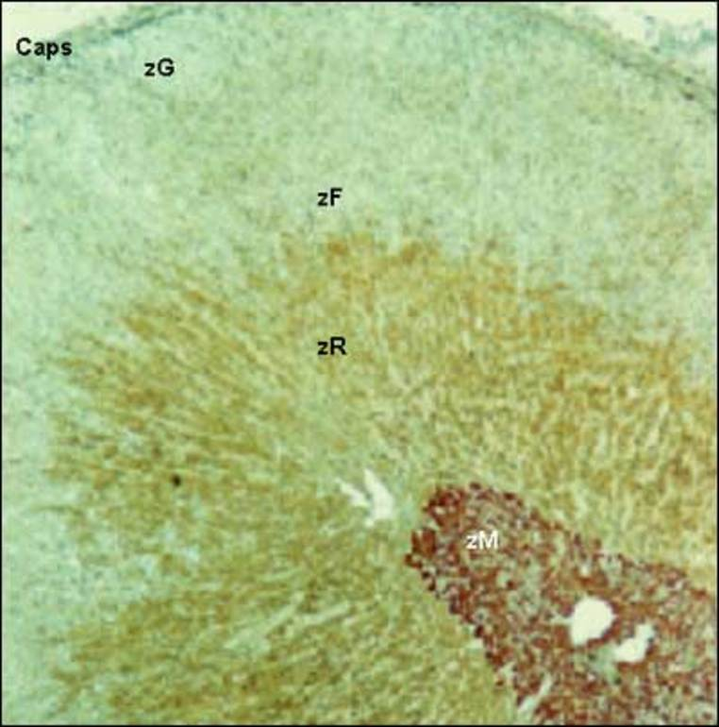
Figure 1. Double immunostained cross-section of a human adrenal gland for 17-α-Hydroxylase and chromogranin A. zM = adrenal medulla, zR = zona reticularis, zF = zona fasciculata, zG = zona glomerulosa, Caps = adrenal capsule
1. The outer zona glomerulosa, site of mineralocorticoid production (e.g. aldosterone), mainly regulated by angiotensin II, potassium, and ACTH. In addition, dopamine, atrial natriuretic peptide (ANP) and other neuropeptides modulate adrenal zona glomerulosa function.
2. The central zona fasciculata, responsible mainly for glucocorticoid synthesis, is regulated by ACTH. In addition, several cytokines (IL-1, IL-6, TNF), neuropeptides and catecholamines influence the biosynthesis of glucocorticoids.
3. The inner zona reticularis, site of adrenal androgen (predominantly dehydroepiandrostenedione [DHEA], DHEA sulfate and androstenedione) secretion, as well as some glucocorticoid production (cortisol and corticosterone).
Adrenocortical cells are arranged in a cord-like manner, extending from the adrenal capsule to the medulla, and are embedded within a widespread capillary network. Zona glomerulosa cells are round and smaller than the polyhedral cells of the zona fasciculata, which gradually extend into the zona reticularis. The latter zone contains cells morphologically identical to zona fasciculata cells, as well as a smaller cell type.
In some rat species, a fourth zone can further be distinguished, the zona intermedia, between the glomerulosa and the fasciculata currently postulated to be a site of initiation of adrenocyte proliferation and differentiation and a zone containing the adrenal cortical stem cells.
However, recent work suggests that adrenocortical cells arise within or underneath the capsule under the influence of sonic hedghog signalling and move centripedally along gradients towards the border to the adrenal medulla where they form cortical islets and / or undergo apoptosis (1,3,4).
It may even be possible that cortical cells adopt different functional states as they "wander" from their origin somwhere in the outer cortex and pass along blood vessels into the direction of the innermorst cortex through the different zones.
Adrenal steroidogenesis is regulated by two endocrine feedback circuits, that are the hypothalamic pituitary adrenal axis (mainly glucocorticoids and sex steroids) and the renin-angiotensin-aldosterone system (mineralocorticoids). Among other important functions, they both upregulate osmolality via glucose production and salt retention and thus maintain blood volume. High cortisol blood concentrations suppress the activities of the hypothalamus and the pituitary gland, and high intravascular blood volume suppresses renin action and lowers angiotensin levels.
Adrenocortical cells are rich in mitochondria and smooth endoplasmic reticulum, that form an extended network of anastomosing tubules.
Utilizing cholesterol as a precursor molecule, the adrenal cortex specializes in the exclusive synthesis of steroid hormones. Glucocorticoids bind to glucocorticoid receptors that are present in every cell single cell of the body and influence cell energy balance. During resting and stress, glucocorticoids are secreted and regulate cardiovascular, metabolic and immune homeostasis. Mineralocorticoids on the other hand primarily regulate blood volume through salt and water homeostasis. Finally, intermediate steroids androgens serve as precursors of the more potent androgens and estrogens. In addition to its role in classic adrenal hormone production, the adrenal cortex has the ability to synthesize over fifty steroids. Not all of these steroidal hormones are secreted into the blood stream, and many are biologically inactive. Additionally, adrenocortical cells are able to secrete cytokines, active peptides and other hormones.
With regard to function, there is no strict separation between the steroid-producing adrenal cortex and the catecholamine-producing medulla. Recent studies have provided evidence that chromaffin cells once thought to be located exclusively in the medulla, are found in all zones of the adult adrenal cortex, and that cortical cells are found in the medulla [5, 6]. This close anatomical co-localization is a prerequisite for paracrine interactions [7] (Fig. 2).
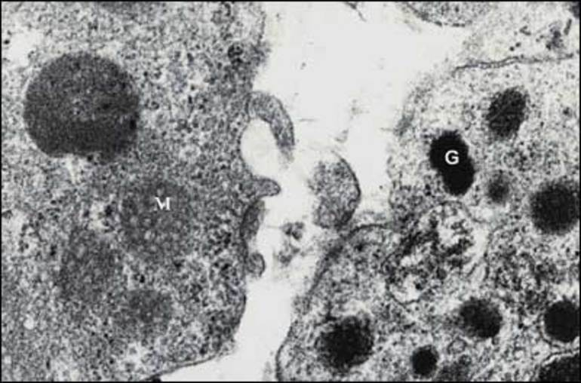
Figure 2. Electromicrograph of rat adrenal gland. Chromafine cell with characteristic granules (G) in direct contact with adrenal cortical cell with characteristic mitochondria (M)

BLOOD SUPPLY
With an estimated flow rate of about 5 ml per minute, though small in size, the adrenal glands are among the most extensively vascularized organs (Fig. 3). Blood supply is maintained by up to fifty arterial branches for each adrenal gland, that arise directly from the aorta, the renal arteries and the inferior phrenic arteries. Blood is channeled into the subcapsular arteriolar plexus, and subsequently distributed to the sinusoids, that then supply the adrenal cortex and medulla.
Endothelial cells were demonstrated to interfere with adrenocortical cells through specific factors and the vasculature seems to play a crucial role for the zonation and function of the adrenal cortex.
A direct blood supply of the medulla is maintained by shunt arerioles [3, 8]. After supplying the cortex and medulla, blood collects at the cortico-medullary junction and drains through the central adrenal vein to the renal vein or directly into the inferior vena cava.

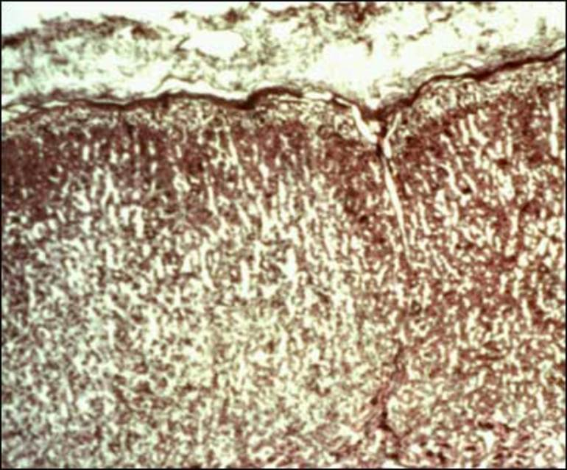
Figure 3. Extensively vascularized adrenal cortex

INNERVATION
The adrenal cortex receives afferent and efferent innervation (Fig 4). A direct contact of nerve terminals with adrenocortical cells has been suggested [9] and chemoreceptors and baroreceptors present in the adrenal cortex infer efferent innervation [10, 11]. Diurnal variation in cortisol secretion and compensatory adrenal hypertrophy are influenced by adrenal innervation [12, 13]. Splanchnic nerve innervation has an effect in the regulation of adrenal steroid release [13].
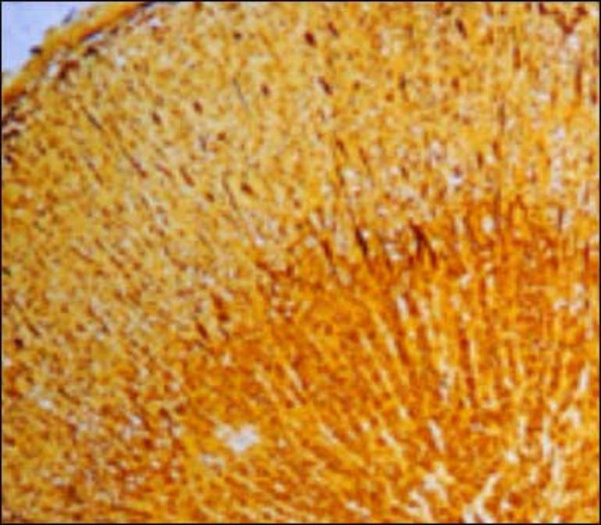
Figure 4. Silverstained nerve cells (dark spots) and fibers (dark lines)

IMMUNE CELLS
Macrophages are distributed throughout the adrenal cortex [14]. In addition to their phagocytic activity, they produce and secrete cytokines (TNFb, IL-1, IL-6) and peptides (VIP), which interact with adrenocortical cells and influence their functions [15, 16, 17]. Lymphocytes are scattered in the adrenal cortex (Fig. 5), and have been shown to produce ACTH-like substances [18]. It has also been shown, that immuno-endocrine interactions between lymphocytes and adrenal zona reticularis cells can stimulate dehydroepiandrosterone production [19, 20].
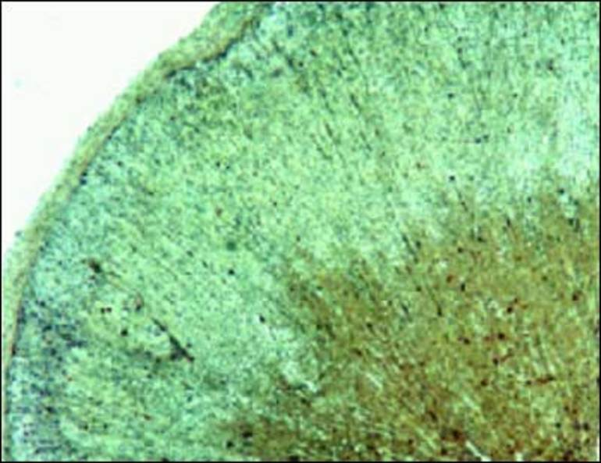
Figure 5. Lymphocytes (dark spots), immunostained for CD 45
Thus, close cellular contacts between adrenocortical chromaffin, vascular and immune cells orchestrate the intraadrenal stress response to external stimuli.

References
1. Wood MA, Hammer GD (2011) Adrenocortical stem and progenitor cells: unifying model of two proposed origins. Mol Cell Endocrinol 336:206-212
2. Kempná P, Flück CE (2008) Adrenal gland development and defects. Best Pract Res Clin Endocrinol Metab 22:77-93
3. Hornsby PJ (2012) Adrenarche: a cell biological perspective. J Endocrinol 214:113-119
4. Dringenberg T, Schwitalla M, Haase M, Scherbaum WA, Willenberg HS (2013) Control of CYP11B2/CYP11B1 Expression Ratio and Consequences for the Zonation of the Adrenal Cortex. Horm Metab Res 45:81-85
5. Bornstein SR, Ehrhart-Bornstein M, Usadel H, Bockmann M, Scherbaum WA (1991) Morphological evidence for a close interaction of chromaffin cells with cortical cells within the adrenal gland. Cell Tissue Res 265:1-9
6. Bornstein SR, Gonzαlez-Hernαndez JA, Ehrhart-Bornstein M, Adler G, Scherbaum WA (1994) Intimate contact of chromaffin and cortical cells within the human adrenal gland forms the cellular basis for important intraadrenal interactions. J Clin Endocrinol Metab 78:225-232
7. Ehrhart-Bornstein M, Hinson JP, Bornstein SR, Scherbaum WA, Vinson GP (1998) Intraadrenal interactions in the regulation of adrenocortical steroidogenesis. Endocrine Reviews 19(2):101-143
8. Vinson GP, Pudney JA, Whitehouse BJ (1985) The mammalian adrenal circulation and the relationship between adrenal blood flow and steroidogenesis. J Endocrinol 105:285-294
9. Vinson GP, Hinson JP, Tσth IE (1994) The neuroendocrinology of the adrenal cortex. J Neuroendocrinol 6:235-246
10. Niijima A, Winter DL (1967) Chemosensitive receptors in the adrenal gland. Fed Proc 26: 544
11. Niijima A, Winter DL (1968) Baroreceptors in the adrenal gland. Science 159:434-435
12. Dallman MF, Engeland WC, McBride MH (1977) The neural regulation of compensatory adrenal growth. Ann NY Acad Sci 297:373-392
13. Dijkstra I, Binnekade R, Tilders FJH (1996) Diurnal variation in resting levels of corticosterone is not mediated by variation in adrenal responsiveness to adrenocorticotropin but involves splanchnic nerve integrity. Endocrinology 137:540-547
14. Gonzαlez-Hernαndez JA, Bornstein SR, Ehrhart-Bornstein M, Geschwend JE, Adler G, Scherbaum WA (1994) Macrophages within the human adrenal gland. Morphological data for a possible local immune-neuroendocrine interaction. Cell Tissue Res 278:201-205
15. Dinarello CA (1992) The biology of interleukin 1. In: Kishimoto T (ed) Interleukins: Molecular Biology and Immunology. Karger, Basel, pp 1-32
16. Ottaway CA (1991) Vasoactive intestinal peptide and immune function. In: Ader R, Felten DL, Cohen N (eds) Psychoneuroimmunology. Academic Press, San Diego, CA, pp 225-262
17. Woloski BMRNJ, Smith EM, Meyer III WJ, Fuller GM, Blalock JE (1985) Corticotropin-releasing activity of monokines. Science 230:1035-1037
18. Bornstein SR, Ehrhart-Bornstein M, Scherbaum WA, Pfeiffer EF, Holst JJ (1990) Effects of splanchnic nerve stimulation on the adrenal cortex may be mediated by chromaffin cells in a paracrine manner. Endocrinology 127:900-906
19. Wolkersdorfer GW, Lohmann T, Marx C, Schrφder S, Pfeiffer R, Stahl H-D, Scherbaum WA, Chrousos GP, Bornstein SR (1999) Lymphocytes stimulate dehydroepiandrosterone production through direct cellular contact with adrenal zona reticularis cells: a novel mechanism of immune-endocrine interaction. J Clin Endocrinol Metab 84:4220-4227
20. Bornstein SR, Chrousos GP (1999) Adrenocorticotropin ACTH- and Non-ACTH-Mediated Regulation of the Adrenal Cortex: Neural and Immune Inputs. J Clin Endo Metab 84:1729-1736.

