ADRENAL CORTEX: EMBRYONIC DEVELOPMENT, ANATOMY, HISTOLOGY AND PHYSIOLOGY

Nicolas C. Nicolaides, M.D., Ph.D., First Department of Pediatrics, National and Kapodistrian University of Athens Medical School, "Aghia Sophia" Children's Hospital, Athens, 11527, Greece. Email: nnicolaides@bioacademy.gr

Holger S. Willenberg, M.D., Ph.D., Professor, Department of Endocrinology, Diabetes and Rheumatology, University Hospital, Duesseldorf, Germany. E-mail: Holger.Willenberg@uni-duesseldorf.de

Stefan R. Bornstein, M.D., Ph.D., Professor, Technical University of Dresden, Medical Department, Fetscherstraße, Dresden, Germany. E-mail: Stefan.Bornstein@uniklinikum-dresden.de

George P. Chrousos, M.D., Ph.D., Professor, University Research Institute of Maternal and Child Health and Precision Medicine and UNESCO Chair of Adolescent Health Care, National and Kapodistrian University of Athens Medical School, "Aghia Sophia" Children's Hospital, Athens, 11527, Greece. E-mail: chrousos@gmail.com

Updated June 11, 2023

ABSTRACT

The adrenal glands consist of the adrenal cortex and medulla, which have distinct, albeit interdependent functional properties. The adrenal cortex contains the zona glomerulosa that produces mineralocorticoids, the zona fasciculata that is the site of glucocorticoid biosynthesis, and the zona reticularis, which is responsible for the production of adrenal androgens. In this chapter, we discuss the embryonic development, anatomy, histology and physiology of the adrenal cortex.

INTRODUCTION

The adrenal gland was first described by Eustachius in 1563 and its importance was later recognized by the work of Thomas Addison in 1855 and Brown-Sequard in 1856 (1-3). The latter performed a series of bilateral adrenalectomies in dogs, demonstrating that these endocrine glands were necessary for life (2, 3). In the midst of the 19th century, newly emerged histochemical techniques showed that the adrenal consists of a cortex and medulla and have divergent albeit interdependent cellular and functional properties. Indeed, the adrenal cortex consists of the zona glomerulosa, the zona fasciculata, and the zona reticularis, which respectively produce mineralocorticoids (aldosterone), glucocorticoids (cortisol in man and corticosterone in rodents), and adrenal androgens (4, 5). On the other hand, the adrenal medulla contains chromaffin cells, which are responsible for the biosynthesis and secretion of the catecholamines epinephrine and norepinephrine. Adrenal cortex hormones are steroid molecules, which are derived from cholesterol through serial conversions catalyzed by specific enzymes, the “steroid hydroxylases” that belong to the cytochrome P450 (CYP) superfamily. This biochemical process is known as “adrenal steroidogenesis” (4, 5). At the molecular and cellular level, adrenal cortex hormones mediate their pleiotropic actions through binding to their cognate receptors, which are nuclear receptors that function as ligand-activated transcription factors, influencing gene expression in a positive or negative fashion (4, 5).

EMBRYONIC DEVELOPMENT OF ADRENAL CORTEX

The adrenal gland is composed of two embryologically distinct tissues, the cortex and medulla, arising from the mesoderm of the urogenital ridge and ectodermal neural chromaffin cells, respectively (6, 7). An isolated clump of cells appears within the urogenital ridge, known as the adrenal-gonadal primordium, at 28-30 days post conception. These cells express the transcription factor steroidogenic factor-1 (SF1 or Ad4BP or NR5A1), which contributes substantially to adrenal development and steroidogenesis. Adrenal-gonadal primordium gives rise to the fetal adrenal cortex and to Leydig cells. At 7-8 weeks of gestation, the adrenal cortex consists of a large inner zone, the fetal zone (FZ), and a small outer zone, the definitive zone (DZ) (8, 9). At the end of the 9th week of gestation, adrenals become fully encapsulated (10). The main steroid of the FZ is dehydroepiandrosterone (DHEA), as cells within this zone express the enzyme cytochrome P450 17α (CYP17A1) (7). Corticotropin-releasing hormone (CRH) secreted by the human placenta and the chromaffin cells of the adrenal medulla stimulates DHEA secretion by the FZ (11). DHEA is converted into 16-hydroxy-DHEA by the fetal liver and is converted into estriol by the placenta (12).

After birth, shrinkage of the fetal zone due to increased apoptotic activity occurs, leading to a decrease of the weight of adrenal glands by 50% (13). In the next three years, cells of the DZ and, to a lesser extent, cellular remnants of the FZ differentiate into the three functionally and histologically distinct zones: the outer zona glomerulosa, the intermediate zona fasciculata, and the inner zona reticularis (4, 5).

ANATOMY OF THE ADRENAL CORTEX

The adrenal glands are located in the retroperitoneum on the top of the kidneys. They are surrounded by a stroma of connective tissue that maintains adrenal structure, termed the “capsule” (4, 5).

Blood Supply

With an estimated flow rate of about 5 ml per minute, though small in size, the adrenal glands are among the most extensively vascularized organs (Fig. 1). Blood supply is maintained by up to fifty arterial branches for each adrenal gland, which arise directly from the aorta, the renal arteries, and the inferior phrenic arteries. Blood is channeled into the subcapsular arteriolar plexus, and subsequently distributed to the sinusoids, that then supply the adrenal cortex and medulla.

Endothelial cells were demonstrated to interfere with adrenocortical cells through specific factors and the vasculature seems to play a crucial role for the zonation and function of the adrenal cortex.

A direct blood supply of the medulla is maintained by shunt arterioles (14, 15). After supplying the cortex and medulla, blood collects at the cortico-medullary junction and drains through the central adrenal vein to the renal vein or directly into the inferior vena cava.

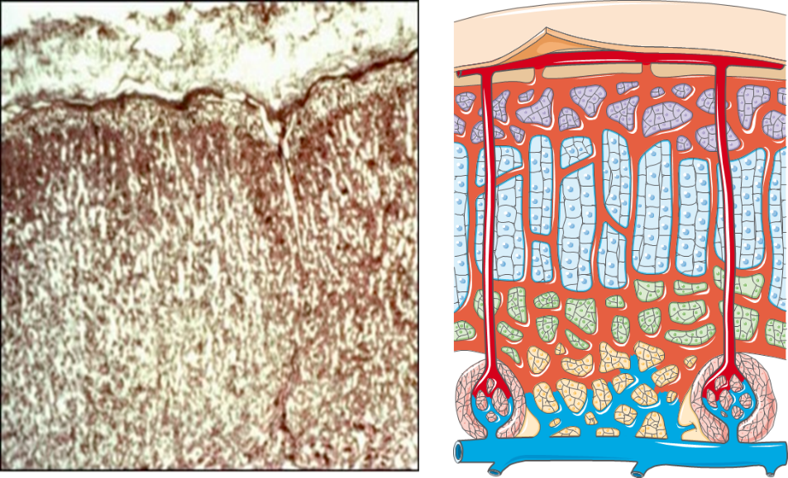
Figure 1. Extensively vascularized adrenal cortex.

Innervation

The adrenal cortex receives afferent and efferent innervation (Fig 2). A direct contact of nerve terminals with adrenocortical cells has been suggested (16) and chemoreceptors and baroreceptors present in the adrenal cortex infer efferent innervation (17, 18). Diurnal variation in cortisol secretion and compensatory adrenal hypertrophy are influenced by adrenal innervation (19, 20). Splanchnic nerve innervation has an effect in the regulation of adrenal steroid release (20).

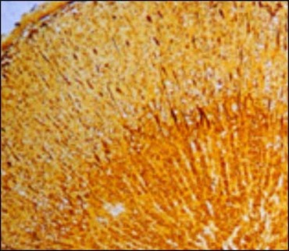
Figure 2. Silver-stained nerve cells (dark spots) and fibers (dark lines).

HISTOLOGY OF THE ADRENAL CORTEX

In contrast to the fetal cortex, which is constructed from primarily the zona fetalis, the adult adrenal cortex consists of three anatomically distinct zones (Fig. 3):
- The outer zona glomerulosa, site of mineralocorticoid production (e.g., aldosterone), mainly regulated by angiotensin II, potassium, and ACTH. In addition, dopamine, atrial natriuretic peptide (ANP) and other neuropeptides modulate adrenal zona glomerulosa function.
- The central zona fasciculata, responsible mainly for glucocorticoid synthesis, is regulated by ACTH. In addition, several cytokines (IL-1, IL-6, TNF), neuropeptides, and catecholamines influence the biosynthesis of glucocorticoids.
- The inner zona reticularis, site of adrenal androgen (predominantly dehydroepiandrostenedione [DHEA], DHEA sulfate [DHEA-S] and Δ4-androstenedione) secretion, as well as some glucocorticoid production (cortisol and corticosterone).

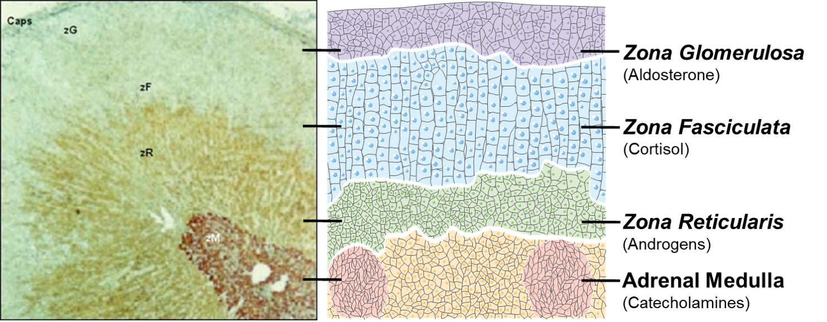
Figure 3. Double immunostained cross-section of a human adrenal gland for 17-α-Hydroxylase and chromogranin A. zM = adrenal medulla, zR = zona reticularis, zF = zona fasciculata, zG = zona glomerulosa, Caps = adrenal capsule.

Adrenocortical cells are arranged in a cord-like manner, extending from the adrenal capsule to the medulla, and are embedded within a widespread capillary network. These cells are rich in mitochondria and smooth endoplasmic reticulum, which form an extended network of anastomosing tubules. Zona glomerulosa cells are scattered and produce and secrete aldosterone (5). The zona fasciculata contains large cells replete with lipids, the “clear cells”, which synthesize and release cortisol (5). The zona reticularis consists of cells containing lipofuscin granules, termed “compact” cells that are responsible for adrenal androgen biosynthesis and secretion. This cellular zone develops at the age of 5 years in females and 6 years in males, a physiologic process termed as “adrenarche” (5).

In some rat species, a fourth zone can further be distinguished, the zona intermedia, between the glomerulosa and the fasciculata currently postulated to be a site of initiation of adrenocyte proliferation and differentiation and a zone containing the adrenal cortical stem cells.

However, evidence suggests that adrenocortical cells arise within or underneath the capsule under the influence of sonic hedghog signaling and move centripetally along gradients towards the border to the adrenal medulla where they form cortical islets and / or undergo apoptosis (14, 21, 22). It may even be possible that cortical cells adopt different functional states as they “wander” from their origin somewhere in the outer cortex and pass along blood vessels into the direction of the innermost cortex through the different zones.

In addition to adrenocortical cells, macrophages are distributed throughout the adrenal cortex (23). In addition to their phagocytic activity, they produce and secrete cytokines (TNFb, IL-1, IL-6) and peptides (VIP), which interact with adrenocortical cells and influence their functions (24-26). Lymphocytes are scattered in the adrenal cortex (Fig. 4), and have been shown to produce ACTH-like substances (27). It has also been shown, that immuno-endocrine interactions between lymphocytes and adrenal zona reticularis cells can stimulate dehydroepiandrosterone production (28, 29).

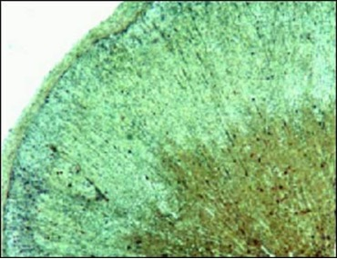
Figure 4. Lymphocytes (dark spots), immunostained for CD 45.

PHYSIOLOGY OF THE ADRENAL CORTEX

The most important function of the adrenal cortex is adrenal steroidogenesis that occurs in all three cellular zones (5). This physiologic process is regulated by distinct systems, depending on steroid type produced. Aldosterone production by the zona glomerulosa depends on the activity of the renin-angiotensin system and serum potassium concentrations, and, to a lesser extent on plasma ACTH concentrations. Cortisol biosynthesis by the zona fasciculata is triggered by ACTH. Adrenal androgens are produced by the zona reticularis, which is also regulated by ACTH and other as yet unknown factors (5).

All adrenal steroids are biosynthesized from cholesterol molecules, which are derived primarily from low-density lipoprotein (LDL) or from cholesterol esters hydrolyzed in adrenocortical cells (Fig. 5). To initiate steroidogenesis, adrenocortical cells are stimulated by several signals to increase their uptake of lipoproteins from the systemic circulation to provide the appropriate concentrations of cholesterol (30, 31). The latter is then converted into steroid molecules in serial biochemical reactions that are mediated by the “steroid hydroxylases” (5). The first and rate-limiting step in steroidogenesis begins when ACTH and/or other signals increase the expression of the “steroidogenic acute regulatory protein” (StAR), which facilitates the import of cholesterol to the inner mitochondrial membrane (30, 32, 33). Within the mitochondria, the C27 cholesterol loses six carbons and is converted into the C21 pregnenolone through the enzyme CYP11A or cholesterol desmolase (P450scc) (34). Pregnenolone moves to the cytoplasm to undergo further enzymatic conversions.

In the zona glomerulosa, pregnenolone is converted to progesterone by 3β-hydroxysteroid dehydrogenase (3β-HSD) (35). Progesterone is converted to deoxycorticosterone (DOC) through 21-hydroxylation by CYP21 or 21-hydroxylase (P450c21). DOC is then11β-hydroxylated to form corticosterone, which is converted to aldosterone through 18-hydroxylation and 18-oxidation. The last three reactions are catalyzed by the P450 enzyme CYP11B2 or aldosterone synthase (P450aldo) (Fig. 5) (36).

In the zona fasciculata, pregnenolone is converted to 17α-hydroxypregnenolone in the endoplasmic reticulum by the enzyme CYP17 or 17α-hydroxylase/17,20-lyase (P450c17) (37). 17α-Hydroxypregnenolone is then converted to 17α-hydroxyprogesterone by 3β-HSD, and the latter steroid molecule is 21-hydroxylated to form 11-deoxycortisol by CYP21. Finally, 11-deoxycortisol is enzymatically converted to cortisol by CYP11B1 or 11β-hydroxylase (P450c11), a reaction that occurs within the mitochondria (5) (Fig. 5).

In the zona reticularis, both pregnenolone and progesterone are 17α-hydroxylated (5). 17α-Hydroxypregnenolone forms dehydroepiandrosterone (DHEA) by the enzyme CYP17. DHEA is converted to Delta4-androstenedione by 3β-HSD. Importantly, DHEA may become sulfonated to form DHEAS by the enzyme sulfotransferase SULT2A1. In the gonads, Delta4-androstenedione is converted to testosterone by 17β-hydroxysteroid dehydrogenase (38). In the ovaries of pubertal girls, CYP19 or aromatase (P450c19) catalyzes the conversion of both Delta4-androstenedione to estrone, and testosterone to 17β-estradiol (39). In androgen-target tissues, testosterone is converted to dihydrotestosterone by 5α-reductase (40) (Fig. 5).

The adrenal glands also biosynthesize 11-oxyandrogens, which are androgens that share an oxygen atom on carbon position 11 (41-44). Among them, 11- hydroxyandrostenedione is the most abundant. The C11-oxy biochemical pathway begins when Delta4-androstenedione and testosterone are converted to 11β-hydroxyandrostenedione and 11β-hydroxytestosterone, respectively, by CYP11B1 (Fig. 5). 11β-Hydroxy-testosterone is converted to 11β-hydroxy-dihydrotestosterone by the enzyme SRD5A1. 11β-Hydroxy-androstenedione forms 11-ketoandrostenedione by HSD11B. 11-Ketoandrostenedione forms 11-ketotestosterone by ACR1C3, and, then, 11-ketodihydrotestosterone by SRD5A (Fig. 5). Moreover, 11OH-dihydrotestosterone can be converted to 11-ketodihydrotestosterone by HSD11B (Fig.5) (41-44).

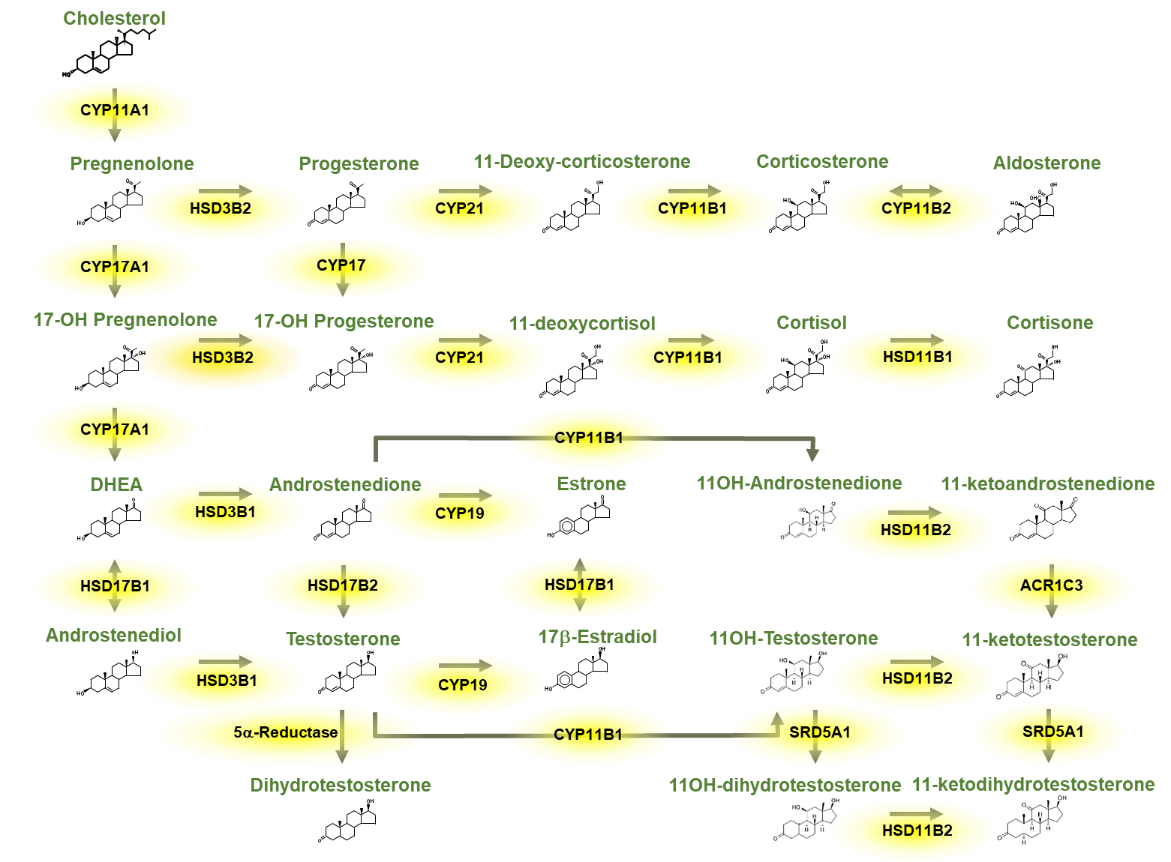
Figure 5. Schematic presentation of adrenal steroidogenesis.

Adrenal cortex hormones bind onto specific steroid receptors that belong to the nuclear receptor superfamily of transcription factors, and play fundamental roles in all physiologic functions. Indeed, glucocorticoids bind onto the glucocorticoid receptor (GR) (45), mineralocorticoids signal through the mineralocorticoid receptor (MR) (46), and adrenal androgens may bind onto the androgen receptor (AR), or, following aromatization, onto the estrogen receptor (ER) (47).

ADRENAL CORTEX-MEDULLA INTERACTIONS

With regard to function, there is no strict separation between the steroid-producing adrenal cortex and the catecholamine-producing medulla. Several studies have provided evidence that chromaffin cells once thought to be located exclusively in the medulla, are found in all zones of the adult adrenal cortex, and that cortical cells are found in the medulla (48-50). This close anatomical co-localization is a prerequisite for paracrine interactions (Fig. 6). The interaction between adrenal cortex and medulla is also supported by clinical data (reviewed in 51). Patients with congenital adrenal hyperplasia or Addison’s disease display dysfunction of the adrenal medulla (52-54).

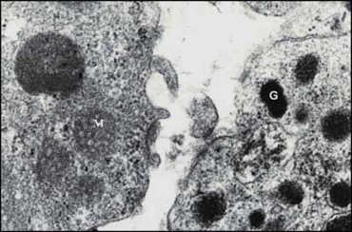
Figure 6. Electromicrograph of rat adrenal gland. Chromafine cell with characteristic granules (G) in direct contact with adrenal cortical cell with characteristic mitochondria (M).

REFERENCES

- Hiatt JR, Hiatt N. The conquest of Addison's disease. Am J Surg. 1997;174(3):280-283.
- Brown-Sequard E. Recherches experimentales sur le physiologie et la pathologie des capsules surrénales. Arch Gen de Med. 1856;8:385-401.
- Brown-Sequard E. Recherches experimentales sur le physiologie et la pathologie des capsules surrénales. Arch Gen de Med. 1856;8:572-598.
- Nicolaides NC, Charmandari E, Chrousos GP. Adrenal Steroid Hormone Secretion: Physiologic and Endocrine Aspects. In Reference Module in Biomedical Sciences. Elsevier; 2014.
- Nicolaides NC, Chrousos GP. Adrenal cortex hormones. In: Hormonal Signaling in Biology and Medicine (2019) Academic Press. pp 619-633.
- Xing Y, Lerario AM, Rainey W, Hammer GD. Development of adrenal cortex zonation. Endocrinol Metab Clin North Am. 2015;44(2):243-274.
- Pitsava G, Stratakis CA. Adrenal hyperplasias in childhood: An update. Front Endocrinol (Lausanne). 2022;13:937793.
- Hanley NA, Rainey WE, Wilson DI, Ball SG, Parker KL. Expression profiles of SF-1, DAX1, and CYP17 in the human fetal adrenal gland: potential interactions in gene regulation. Mol Endocrinol. 2001;15(1):57-68.
- Goto M, Hanley KP, Marcos J, Wood PJ, Wright S, Postle AD, et al.. In humans, early cortisol biosynthesis provides a mechanism to safeguard female sexual development. J Clin Invest. 2006;116(4):953-960.
- Keegan CE, Hammer GD. Recent insights into organogenesis of the adrenal cortex. Trends Endocrinol Metab. 2002;13(5):200-208.
- Smith R, Mesiano S, Chan EC, Brown S, Jaffe RB. Corticotropin-releasing hormone directly and preferentially stimulates dehydroepiandrosterone sulfate secretion by human fetal adrenal cortical cells. J Clin Endocrinol Metab. 1998;83(8):2916-2920.
- Kitada M, Kamataki T, Itahashi K, Rikihisa T, Kanakubo Y. P-450 HFLa, a form of cytochrome P-450 purified from human fetal livers, is the 16 alphahydroxylase of dehydroepiandrosterone 3-sulfate, J. Biol. Chem. 262 (1987) 13534–13537.
- Fuqua JS. Adrenal tumors in childhood. Adv Pediatr. 2021;68:227-244.
- Hornsby PJ. Adrenarche: a cell biological perspective. J Endocrinol. 2012;214:113-119.
- Vinson GP, Pudney JA, Whitehouse BJ. The mammalian adrenal circulation and the relationship between adrenal blood flow and steroidogenesis. J Endocrinol. 1985; 105:285-294.
- Vinson GP, Hinson JP, Tσth IE. The neuroendocrinology of the adrenal cortex. J Neuroendocrinol. 1994;6:235-246.
- Niijima A, Winter DL. Chemosensitive receptors in the adrenal gland. Fed Proc. 1967;26: 544.
- Niijima A, Winter DL. Baroreceptors in the adrenal gland. Science 1968;159:434-435.
- Dallman MF, Engeland WC, McBride MH. The neural regulation of compensatory adrenal growth. Ann NY Acad Sci. 1977;297:373-392.
- Dijkstra I, Binnekade R, Tilders FJH. Diurnal variation in resting levels of corticosterone is not mediated by variation in adrenal responsiveness to adrenocorticotropin but involves splanchnic nerve integrity. Endocrinology 1996;137:540-547.
- Wood MA, Hammer GD. Adrenocortical stem and progenitor cells: unifying model of two proposed origins. Mol Cell Endocrinol. 2011;336:206-222.
- Dringenberg T, Schwitalla M, Haase M, Scherbaum WA, Willenberg HS. Control of CYP11B2/CYP11B1 Expression Ratio and Consequences for the Zonation of the Adrenal Cortex. Horm Metab Res. 2013;45:81-85.
- Gonzαlez-Hernαndez JA, Bornstein SR, Ehrhart-Bornstein M, Geschwend JE, Adler G, Scherbaum WA. Macrophages within the human adrenal gland. Morphological data for a possible local immune-neuroendocrine interaction. Cell Tissue Res. 1994;278:201-205.
- Dinarello CA. The biology of interleukin 1. In: Kishimoto T (ed) Interleukins: Molecular Biology and Immunology. Karger, (1992) Basel, pp 1-32.
- Ottaway CA. Vasoactive intestinal peptide and immune function. In: Ader R, Felten DL, Cohen N (eds) Psychoneuroimmunology. Academic Press, (1991), San Diego, CA, pp 225-262.
- Woloski BMRNJ, Smith EM, Meyer III WJ, Fuller GM, Blalock JE. Corticotropin-releasing activity of monokines. Science. 1985;230:1035-1037.
- Bornstein SR, Ehrhart-Bornstein M, Scherbaum WA, Pfeiffer EF, Holst JJ. Effects of splanchnic nerve stimulation on the adrenal cortex may be mediated by chromaffin cells in a paracrine manner. Endocrinology 1990;127:900-906.
- Wolkersdorfer GW, Lohmann T, Marx C, Schrφder S, Pfeiffer R, Stahl H-D, Scherbaum WA, Chrousos GP, Bornstein SR. Lymphocytes stimulate dehydroepiandrosterone production through direct cellular contact with adrenal zona reticularis cells: a novel mechanism of immune-endocrine interaction. J Clin Endocrinol Metab. 1999;84:4220-4227.
- Bornstein SR, Chrousos GP. Adrenocorticotropin ACTH- and Non-ACTH-Mediated Regulation of the Adrenal Cortex: Neural and Immune Inputs. J Clin Endo Metab. 1999; 84:1729-1736.
- Simpson ER, Waterman MR. Steroid biosynthesis in the adrenal cortex and its regulation by adrenocorticotropin. In DeGroote, L.J., Besser, M., Burger, H.G., Jameson, J.L., Loriaux, D.L., Marshall, J.C., Odell, W.D., Potts, J.T.Jr & Rubenstein, A.H. (eds) Endocrinology, 1995, pp 1630-1641. Philadelphia: W. B. Saunders.
- Stewart PM and Newell-Price JDC. The adrenal cortex. In Williams Textbook of Endocrinology, Larsen PR, Kronenberg HM, Melmed S, Polansky KS (Eds), 13th edition. Elsevier Science (USA). 2016; Chapter 15, pages 489-555.
- Arakane F, Kallen CB, Watari H, Foster JA, Sepuri NB, Pain D, Stayrook SE, Lewis M, Gerton GL, Strauss JF. The mechanism of action of steroidogenic acute regulatory protein (StAR). StAR acts on the outside of mitochondria to stimulate steroidogenesis. J Biol Chem. 1998;273:16339 – 16345.
- Stocco DM, Clark BJ. Regulation of the acute production of steroids in steroidogenic cells. Endocr Rev. 1996;17:221-244.
- Nebert DW, Nelson DR, Coon MJ, Estabrook RW, Feyereisen R, Fujii – Kuriyama Y, Gonzalez FJ, Guengerich FP, Gunsalus IC, Johnson EF, Loper JC, Sato R, Waterman MR, Waxman DJ. The P450 superfamily: update on new sequences, gene mapping, and recommended nomenclature. DNA Cell Biol 1991;10:1-14.
- Cherradi N, Rossier MF, Vallotton MB, Timberg R, Friedberg I, Orly J, Wang XJ, Stocco DM, Capponi AM. Submitochondrial distribution of three key steroidogenic proteins (steroidogenic acute regulatory protein and cytochrome P450 scc and 3β-hydroxysteroid dehydrogenase isomerase enzymes) upon stimulation by intracellular calcium in adrenal glomerulosa cells. J Biol Chem. 1997;272:7899-7909.
- White PC, Curnow KM, Pascoe L. Disorders of steroid 11β-hydroxylase isozymes. Endocr Rev. 1994;15:421-438.
- Yanase T, Simpson ER, Waterman MR. 17α-hydroxylase/17,20-lyase deficiency: from clinical investigation to molecular definition. Endocr Rev. 1991;12:91-108.
- Penning TM. Molecular endocrinology of hydroxysteroid dehydrogenases. Endocr Rev. 1997;18:281-305.
- Simpson ER, Mahendroo MS, Means GD, Kilgore MW, Hinshelwood MM, Graham-Lorence S, Amarneh B, Ito Y, Fisher CR, Michael MD, Mendelson CR, Bulun SE. Aromatase cytochrome P450, the enzyme responsible for estrogen biosynthesis. Endocr Rev. 1994;15:342-355.
- Wilson JD, Griffin JE, Russell DW. Steroid 5α-reductase 2 deficiency. Endocr Rev. 1993;14:577-593.
- Turcu AF, Rege J, Auchus RJ, Rainey WE. 11-Oxygenated androgens in health and disease. Nat Rev Endocrinol. 2020;16(5):284-296.
- Elzenaty RN, du Toit T, Flück CE. Basics of androgen synthesis and action. Best Pract Res Clin Endocrinol Metab. 2022;36(4):101665.
- Fukami M. 11-Oxyandrogens from the viewpoint of pediatric endocrinology. Clin Pediatr Endocrinol. 2022;31(3):110-115.
- Storbeck KH, O'Reilly MW. The clinical and biochemical significance of 11-oxygenated androgens in human health and disease. Eur J Endocrinol. 2023;188(4):R98-R109.
- Nicolaides NC, Chrousos G, Kino T. Glucocorticoid Receptor. 2020 Nov 21. In: Feingold KR, Anawalt B, Blackman MR, Boyce A, Chrousos G, Corpas E, de Herder WW, Dhatariya K, Dungan K, Hofland J, Kalra S, Kaltsas G, Kapoor N, Koch C, Kopp P, Korbonits M, Kovacs CS, Kuohung W, Laferrère B, Levy M, McGee EA, McLachlan R, New M, Purnell J, Sahay R, Shah AS, Singer F, Sperling MA, Stratakis CA, Trence DL, Wilson DP, editors. Endotext [Internet]. South Dartmouth (MA): MDText.com, Inc.; 2000–.
- Lother A, Jaisser F, Wenzel UO. Emerging fields for therapeutic targeting of the aldosterone-mineralocorticoid receptor signaling pathway. Br J Pharmacol. 2022;179(13):3099-3102.
- Chaturvedi AP, Dehm SM. Androgen receptor dependence. Adv Exp Med Biol. 2019; 1210:333e50.
- Bornstein SR, Ehrhart-Bornstein M, Usadel H, Bockmann M, Scherbaum WA (1991) Morphological evidence for a close interaction of chromaffin cells with cortical cells within the adrenal gland. Cell Tissue Res 265:1-9.
- Bornstein SR, Gonzαlez-Hernαndez JA, Ehrhart-Bornstein M, Adler G, Scherbaum WA (1994) Intimate contact of chromaffin and cortical cells within the human adrenal gland forms the cellular basis for important intraadrenal interactions. J Clin Endocrinol Metab 78:225-232.
- Ehrhart-Bornstein M, Hinson JP, Bornstein SR, Scherbaum WA, Vinson GP (1998) Intraadrenal interactions in the regulation of adrenocortical steroidogenesis. Endocrine Reviews 19(2):101-143.
- Bechmann N, Berger I, Bornstein SR, Steenblock C. Adrenal medulla development and medullary-cortical interactions. Mol Cell Endocrinol. 2021;528:111258.
- Bornstein SR, Allolio B, Arlt W, Barthel A, Don-Wauchope A, Hammer GD, Husebye ES, Merke DP, Murad MH, Stratakis CA, et al., Diagnosis and treatment of primary adrenal insufficiency: an endocrine society clinical practice guideline. J. Clin. Endocrinol. Metab. 2016;101:364-389.
- Merke DP, Chrousos GP, Eisenhofer G, Weise M, Keil MF, Rogol AD, Van Wyk JJ, Bornstein SR. Adrenomedullary dysplasia and hypofunction in patients with classic 21-hydroxylase deficiency. N. Engl. J. Med. 2000;343:1362-1368.
- Merke DP, Bornstein SR. 2005. Congenital adrenal hyperplasia. Lancet 2005;365:2125-2136.

