Adrenal Incidentalomas

Eleftherios Chatzellis, MD
Consultant Endocrinologist. 251 Hellenic Air Force & VA General Hospital
Gregory Kaltsas, MD, FRCP
Professor in Endocrinology, Department of Pathophysiology, National University of Athens, Greece
Revised 5 Feb 2016

ABSTRACT
Wider application and technical improvement of abdominal imaging procedures in recent years, has led to the discovery of unsuspected adrenal tumors in an increasing frequency. These serendipitously detected lesions, also called adrenal incidentalomas, have become a common clinical problem that need to be investigated for evidence of hormonal hypersecretion and/or malignancy. In this chapter, information on the prevalence, etiology, radiological features, and appropriate biochemical evaluation are discussed in order to delineate the nature and hormonal status of adrenal incidentalomas. Despite the flurry of data accumulated, controversies are still present regarding the accuracy of diagnostic tests and cut-offs utilized to establish hormonal hypersecretion, potential long-term sequelae, indications for surgical treatment as well as duration and intensity of conservative management and follow-up. Based on available data from literature, a diagnostic and therapeutic algorithm is proposed to guide clinical practice until further studies generate widely accepted and evidence-based recommendations, especially in certain currently debatable areas.

INTRODUCTION
Following the introduction of abdominal computed tomography (CT) in the late 1970’s, this modality has proven to be an excellent tool for identifying pathology in patients with suspected adrenal disease. Even at that time it was predicted that the ability of CT to image both adrenal glands could lead to the occasional discovery of asymptomatic adrenal disease (1). Moreover, further technological advances and broader availability of other imaging modalities such as Ultrasonography (US), CT, Magnetic Resonance Imaging (MRI) and Positron Emission Tomography (PET) have made the detection of unexpected lesions in adrenal and other endocrine glands a common finding (2). Although earlier detection of adrenal disease may be important in certain cases, it is now recognized that diagnostic evaluation and follow-up of clinically inapparent adrenal masses, or so-called “adrenal incidentalomas” may put a significant burden on patient’s anxiety and health and produce increasing financial consequences for the health system (3). It is therefore important to develop cost-effective strategies to diagnose and manage patients with adrenal incidentalomas.

DEFINITION
According to the NIH State-of-the-Science Statement (4), adrenal incidentalomas (AIs) are defined as clinically inapparent adrenal masses discovered inadvertently in the course of diagnostic testing or treatment for conditions not related to the adrenals. Although an arbitrary cut-off of 1 cm or more has been employed to define an adrenal lesion as AI (5,6), this cut-off might be challenged following the higher resolution that modern imaging modalities offer, mainly MRI and CT. By definition patients harboring an AI should not have any history, signs or symptoms of adrenal disease prior to the imaging procedure that led to its discovery. This strict definition excludes cases in which symptomatic adrenal-dependent syndromes are “missed” during history taking οr physical examination (6), but is also subject to some controversy regarding the ‘‘a priori’’ suspicion (7). In this context, an adrenal tumor detected in a patient undergoing abdominal imaging for staging and work-up of extra-adrenal malignancy should not be considered an AI, since adrenal metastases are a common finding in this setting, with a prevalence ranging from 3 to 40% and from 6 to 20% in autopsy and radiological series respectively (8).

EPIDEMIOLOGY
The precise prevalence and incidence of AI is difficult to be defined since data from population-based studies are lacking. Most data are derived from autopsy or radiological studies that are relatively difficult to interpret due to their retrospective nature, insufficient clinical information provided, referral bias and different patient selection criteria.
In autopsy studies the prevalence of AIs varies, depending on patient’s age and the size of the tumors. The mean prevalence in a total of 71,206 cases was found to be 2.3%, ranging from 1 to 8.7% (9-21), without any significant gender difference. The prevalence of AIs increases with age, being 0.2% in young subjects compared to 6.9% in subjects older than 70 years of age (22), and is higher in white, obese, diabetic, and hypertensive patients (8). The variability of the reported prevalence in different series also reflects the difficulty in distinguishing small nodules from adenomas, as in some post-mortem series, small nodules (<1 cm) were detected in more than half of the patients examined (21).
In radiological studies, the prevalence of AIs differs depending on the imaging modality used. Transabdominal US during a routine health examination identified AIs in 0.1% of those screened (23), while studies using CT reported a mean prevalence of 0.64% ranging from 0.35 to 1.9% in a total of 82,483 scans published in the literature between 1982 and 1994 (19,24-28). However, two recent studies utilizing high-resolution CT scanning technology, have reported a prevalence of 4.4% and 5% which are similar to that observed at autopsy (29,30). This increase in detection frequency paralleled by the technological advances in imaging modalities, can explain why AIs are considered a “disease of modern technology”. Age has also been found to affect AI detection rates, as these lesions are found in 0.2% of individuals younger than 30 years, in 3% in the age of 50 years and up to 10% in individuals above 70 years of age (22,29,31). The prevalence of AIs is very low in childhood and adolescence accounting for 0.3-0.4% of all tumors in children (32). Adrenal incidentalomas appear to be slightly more frequent in women in radiological series, in discordance with autopsy studies, probably because women undergo abdominal imaging more frequently than men (31). Adrenal masses are located bilaterally in 10-15% of cases (33), while distribution between the two adrenals appears to be similar in post-mortem and CT studies (8,31).

DIFFERENTIAL DIAGNOSIS
Adrenal Incidentalomas are not a single pathological entity, but rather comprise a spectrum of different entities that share the same path of discovery and include both benign and malignant lesions arising from the adrenal cortex, the medulla or being of extra-adrenal origin (Table 1).

Table 1: The spectrum of lesions presenting as AIs, modified from (34)
Adrenal Cortex lesions
- Adenoma (non-functioning)
- Adenoma (functioning)
- Cortisol-secreting
- Aldosterone-secreting
- Nodular hyperplasia (primary bilateral macronodular adrenal hyperplasia)*
- Adrenocortical Carcinoma (secreting or non-secreting)
Adrenal Medulla lesions
- Pheochromocytoma (benign or malignant)*
- Ganglioneuroma
- Neuroblastoma, ganglioneuroblastoma
Other adrenal lesions
- Myelolipoma, lipoma
- Hemangioma, angiosarcoma
- Cyst
- Hamartoma, teratoma
Metastases (lung, breast, kidney, melanoma, lymphoma)*
Infiltration*
- Amyloidosis
- Sarcoidosis
- Lymphoma
Infections*
- Abscess

- Fungal/parasitic (histoplasmosis, coccidiomycosis, tuberculosis)
- Cytomegalovirus
Adrenal hemorrhage or hematomas*
Adrenal pseudotumors
Congenital Adrenal Hyperplasia (CAH)*
* can present with bilateral adrenal lesions
In general, the vast majority (80-90%) of AIs are benign adrenal adenomas, as shown by accumulated follow-up data from their natural history, even in the absence of pathological confirmation, since adrenal adenomas are rarely excised (5). However, a number of these lesions may still be malignant and/or related to autonomous hormonal secretion that is not clinically detected due to subtle secretory pattern or periodical secretion. Therefore, the question a physician faces when dealing with an AI is to exclude pathology other than an adrenal adenoma, particularly an adrenocortical carcinoma (ACC), and evaluate its secretory potential.
Autonomous cortisol secretion is the most frequent endocrine dysfunction detected in patients with AIs, with a prevalence ranging from 5 to 30%, depending on the study design, work-up protocols and mainly diagnostic criteria used (5). This condition exclusively identified in the setting of AIs, termed subclinical Cushing’s syndrome (SCS) or subclinical hypercortisolism (SH), is characterized by the absence of the typical clinical phenotype of hypercortisolism and by the presence of subtle alterations of the hypothalamic-pituitary-adrenal (HPA) axis. Pheochromocytomas, albeit rare in the general population, are discovered in approximately 5% of patients with AIs (35), while more than 30% of pheochromocytomas are diagnosed as AIs (36). Clinical manifestations are highly variable and the classic clinical triad (headache, palpitations and diaphoresis) is not present in the majority of patients. In addition, several patients harbor ‘‘silent pheochromocytomas’’, being totally asymptomatic or having intermittent and subtle symptoms. In a large multicentric study, approximately half of the patients with pheochromocytomas presenting as AIs were normotensive, whereas the remaining had mild to moderate hypertension (31). Primary aldosteronism (PA) has a median prevalence of 2% (range 1.1-10%) among patients with AIs (37). After excluding cases with severe hypertension and hypokalaemia a retrospective study found that 16 out of 1004 subjects with AIs (1.5%) had PA (31). This figure is relatively low when compared to the prevalence of PA in unselected hypertensive populations which ranges from 4.6 to 16.6% (38) and may be related to the different investigational protocols and cut-offs indicative of autonomous aldosterone secretion used (38). The absence of hypokalaemia does not exclude this condition but absence of hypertension makes PA unlikely, although normotensive patients with PA have occasionally been reported (39). A recent study using a new diagnostic approach, considering the stimulatory effect that adrenocorticotropin (ACTH) could exert on aldosterone secretion, revealed a 12% prevalence of PA in normotensive and normokalaemic patients with AIs (40).
Combining studies that used the broadest definitions of incidentaloma and those that reported descriptions of individual cases, Mansmann et al found 41% of AIs to be adenomas, 19% metastases, 10% ACCs, 9% myelolipomas, and 8% pheochromocytomas, with other benign lesions, such as adrenal cysts, ganglioneuromas, hematomas and infectious or infiltrative lesions representing rare pathologies (41). However, the relative prevalence of any pathology depends on the inclusion criteria used and referral basis of the various studies. Surgical series tend to overestimate the prevalence of malignant and secretory tumors, because the suspicion of a carcinoma and a functioning or large tumor are considered as indications for surgery. The reported prevalence of ACCs in these studies is also misleading, as it is derived from highly selected patient populations and does not reflect the prevalence seen in population-based studies. Presence of primary adrenal malignancy is more related to mass size, as ACCs represent 2% of all tumors ≤4 cm in diameter, 6% of tumors with size 4.1-6 cm and 25% of the tumors >6 cm (42). On the other hand, benign adenomas comprise 65% of masses ≤4 cm, and 18% of masses >6 cm (43). Similarly, metastatic lesions are much more common when patients with known extra-adrenal cancer are included. Among patients with extra-adrenal malignancies (most commonly carcinomas of the lung, breast, kidney, and melanoma), up to 70% of AIs are metastases (22,44). In contrast, the probability of a serendipitously discovered adrenal lesion in a patient without a history of cancer to be metastatic is as low as 0.4% (27). Studies utilizing more strict inclusion criteria may identify a greater number of small masses and biochemically silent tumors. In a comprehensive review, Cawood et al. (3) concluded that the prevalence of malignant and functioning lesions among AIs is likely to have been overestimated. By applying strict inclusion and exclusion criteria for selection of studies, these authors identified 9 studies that more accurately simulated the clinical scenario of a patient referred for assessment of an AI. By analyzing these studies, they reported a mean prevalence of 88.1% (range 86.4-93%) for non-functioning benign adrenal adenomas (NFAIs), 6% (range 4-8.3%) for SCS, 1.2% for aldosterinomas, 1.4% (range 0.8-3%) for ACCs, 0.2% (range 0-1.4%) for metastases and 3% (range 1.8-4.3%) for pheochromocytomas. These low rates for clinically significant tumors compared to those noted from previous studies, that did not use such a narrow definition of AI (6,8,41), highlighted the limitations of epidemiological data due to inherent bias and raised significant questions concerning the appropriate diagnostic and follow-up protocols.
In the case of bilateral AIs, a broader spectrum of diagnoses needs to be considered, particularly in a relevant clinical setting, including metastatic or infiltrative diseases of the adrenals, hemorrhage, congenital adrenal hyperplasia (CAH), bilateral pheochromocytomas, bilateral cortical adenomas, and primary bilateral macronodular adrenal hyperplasia (PBMAH) (45). Occasionally, adrenal tumors of different nature may simultaneously be present in the same patient (46-48). Adrenal pseudotumor is a term used to describe radiological images of masses that seem to be of adrenal origin, but arise from adjacent structures, such as the kidney, spleen, pancreas, vessels and lymph nodes or are results of technical artifacts.

PATHOGENESIS
The pathogenesis of AIs is largely unknown. Early observations in autopsy studies which revealed that AIs are more frequent in older patients, led to the notion that these tumors are a manifestation of the ageing adrenal and could represent focal hyperplasia in response to ischemic injury, a concept that was supported by histopathological findings of capsular arteriopathy (49). Clonal analysis of adrenal tumors later revealed that the vast majority are of monoclonal origin and only a few arise from polyclonal focal nodular hyperplasia under the putative effect of local or extra-adrenal growth factors (50,51). In this sense, it has been postulated that hyperinsulinemia associated with the insulin resistance in individuals with the metabolic syndrome, which frequently coexists in patients harboring AIs, could contribute to the development of these tumors, through the mitogenic action of insulin on the adrenal cortex (52,53). However, the opposite causal relationship, that subtle autonomous cortisol production from AIs results in insulin resistance, has also been proposed (54). Another interesting hypothesis, involves alterations in the glucocorticoid feedback sensitivity of the HPA axis. In a recent study, unexpected ACTH and cortisol responses to the combined dexamethasone-CRH (corticotropin-releasing hormone) test were found, in about half of the patients with bilateral AIs, when compared to control and unilateral adenoma cases (55). Such a dysregulated ACTH secretion during lifetime may lead to subtle but chronic trophic stimulation of the adrenals by repeatedly inappropriately higher ACTH levels, particularly in response to stress, favouring nodular adrenal hyperplasia.
Although several genetic syndromes are known to be associated with adrenal tumors, germline or somatic genetic alterations are identified only in subgroups of sporadic tumors that are mainly functioning (56,57). Elucidation of specific signalling pathways involved in these familial syndromes has led to the identification of several mutations in genes not previously described in ACCs, cortisol- and aldosterone-secreting adenomas as well as pheochromocytomas, creating new insights in adrenal tumorigenesis (Figure 1). However, the genetics of benign NFAIs that account for the majority of AIs are poorly understood.
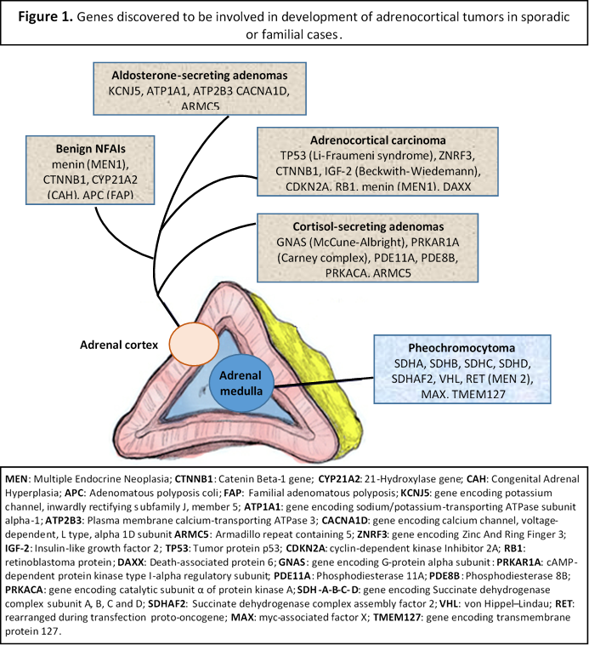

DIAGNOSTIC APPROACH
Although the prevalence of potentially life threatening disorders associated with AIs is relatively low, the question of whether a lesion is malignant (mainly an ACC) or functioning needs to be addressed in patients with an incidentally discovered adrenal mass. A careful clinical examination and a detailed medical history, evaluation of the imaging characteristics of the adrenal tumor(s) and biochemical evaluation to exclude hormonal excess can help clinicians identify the few cases that pose a significant risk to the patient’s health.

CLINICAL EVALUATION
Per definition, patients with AIs should have no signs or symptoms implying adrenal dysfunction before the radiological detection of the adrenal tumor(s). In everyday clinical practice though, physicians who are not familiar with endocrine diseases may overlook mild signs of hormone excess and pursue evaluation of adrenal function following the incidental discovery of an adrenal mass. In this setting, such cases should not be designated as AIs and highlight the need for detailed and careful clinical history and examination (58).

IMAGING EVALUATION
Current morphological imaging modalities with CT or MRI have proven to be reliable means to predict with high diagnostic accuracy the nature of the lesion and its malignant potential. The size of the lesion has been considered as indicative of malignancy as most ACCs are large or significantly larger than adenomas at the time of diagnosis (31). In a meta-analysis, ACCs represented 2% of all tumors ≤4 cm in diameter, but the risk of malignancy increased significantly with tumor size greater than 4 cm, being 6% in tumors with size 4.1-6 cm and 25% in tumors >6 cm (42). However, size alone has low specificity in distinguishing benign from malignant lesions, since ACCs can also be relatively small during early stages of development and exhibit subsequent progressive growth (5). Other than size, findings suggestive of malignancy include irregular shape and borders, tumor heterogeneity with central necrosis or hemorrhage and invasion into surrounding structures. Benign adenomas are usually small (<4 cm), homogenous, with well-defined margins. Slow growth rate or stable size of an adrenal mass have also been proposed as indicators of benign nature (4). However, studies on the natural history of AIs suggest that up to 25% of benign adenomas can display increase in size by almost 1 cm, while adrenal metastases with no change in CT appearance over a period of 36 months have been described, not allowing for the introduction of a safe cut-off of absolute growth or growth rate to distinguish benign from malignant lesions (59).
Depending on the modality used, certain imaging properties of AIs can provide helpful tools for the differential diagnosis between benign and malignant adrenal lesions, summarized in Table 2.
Table 2: Imaging findings differentiating common adrenal pathologies in AIs
FINDING | Benign adenoma | ACC | Pheochromocytoma | Metastases
Size | Usually <4cm | Usually >4cm | Variable | Variable
Growth rate | Stable or <0.8cm/year | Significant growth (>1cm/year) | Slow growth | Significant growth (>1cm/year)
Shape & margins | Round or oval with well-defined margins | Irregular shape and margins. Invasion to surrounding tissues | Variable | Variable
Composition | Homogenous | Heterogeneous (hemorrhage, necrosis) | Heterogeneous (necrosis) | Heterogeneous (hemorrhage, necrosis)
CT Unenhanced attenuation | ≤10 HU (or >10 HU for lipid-poor adenomas) | >10 HU | >10 HU | >10 HU
CT Percent Washout (PW) | APW >60%  RPW>40% | APW<60%, RPW<40% | APW<60%  RPW<40% | APW<60%, RPW<40%
MRI - CSI  (out-of phase) | Signal loss  (except in lipid-poor adenomas) | No change in signal intensity | No change in signal intensity | No change in signal intensity
FDG uptake (PET) | Low (some can have low to moderate uptake) | High | Low (malignant pheochromocytomas show high uptake) | High
NP-59 uptake | Present | Absent (except in some secreting tumors) | Absent | Absent
ACC: Adrenocortical carcinoma; HU: Hounsfield Units; APW: Absolute PW; RPW: Relative PW; CSI: Chemical-shift Imaging; FDG: fluoro-deoxyglucose; NP-59: 131I-6-b-iodomethyl-norcholesterol

Computed Tomography (CT)
CT has a high spatial and contrast resolution, which allows assessment of tissue density by measuring X-ray absorption compared to water (attenuation) that is expressed in Hounsfield Units (HU). Water and air are conventionally allocated a HU value of 0 and -1000 respectively, while fat is usually characterized by a HU value of -40 to -100. Because there is an inverse linear relation between the fat content of a lesion and attenuation, lipid-rich adenomas express lower HU in unenhanced (without contrast medium) CT images compared to malignant lesions, which are usually lipid-poor (60). A value of 10 HU in unenhanced CT images is the most widely used and accepted attenuation value threshold for the diagnosis of a lipid-rich, benign adrenal adenoma (61). In several studies a density of ≤10 HU was found to be superior to size in differentiating benign from malignant masses, displaying a sensitivity of 96-100% and a specificity of 50-100% (62). In this context, the risk of malignancy in a homogeneous 5 cm adrenal mass with a CT attenuation value of 10 HU is close to 0% (45). On the other hand, up to 30-40% of benign adenomas are considered lipid-poor and have an attenuation value of >10 HU on non-contrast CT, which is considered indeterminate since it overlaps with those found in malignant lesions and pheochromocytomas. Hence, unenhanced CT attenuation is a useful screening tool to identify a lesion as benign and exclude malignancy but is less reliable in diagnosing a malignant mass with certainty. Attenuation values in non-contrast CT can also reliably identify typical myelolipomas that have a density lower than -40 HU (45).
For these indeterminate adrenal lesions (>10HU) intravenous contrast administration reveals their hemodynamic and perfusion properties that can be utilized to distinguish benign from malignant lesions. The percentage contrast washout on delayed images (10-15 min post contrast administration) decreases more quickly in adenomas because they exhibit rapid uptake and clearance compared to malignant lesions that usually enhance rapidly but demonstrate a slower washout of contrast medium (63). There are two methods of estimating percentage washout (PW): absolute PW (APW) and relative PW (RPW) and can be calculated from values of pre-contrast (PA), enhanced (EA, 60-70 seconds after contrast medium administration) and delayed (DA, 10-15 mins after contrast medium administration) attenuation values according to the formulas below:
APW=100 x (EA-DA) / (EA-PA)
RPW=100 x (EA-DA) / EA

Lipid-poor adenomas demonstrate rapid washout with APW >60% (sensitivity of 86-100%, specificity 83-92%) and a RPW >40% (sensitivity of 82-97%, specificity 92-100%) (64). The use of APW and RPW criteria can effectively discriminate benign from malignant adrenal masses. Metastases usually demonstrate slower washout on delayed images (APW<60%, RPW<40%) than adenomas and ACCs typically have a RPW of <40%. Furthermore, contrast-enhanced washout CT studies may not suffice for characterization of lesions such as pheochromocytomas, cysts, and myelolipomas; in these cases further biochemical, anatomical and/or functional imaging may be required. Findings consistent, but not diagnostic, of pheochromocytoma on CT include high attenuation values, prominent vascularity, and delayed washout of contrast medium (65).
Figure 2.
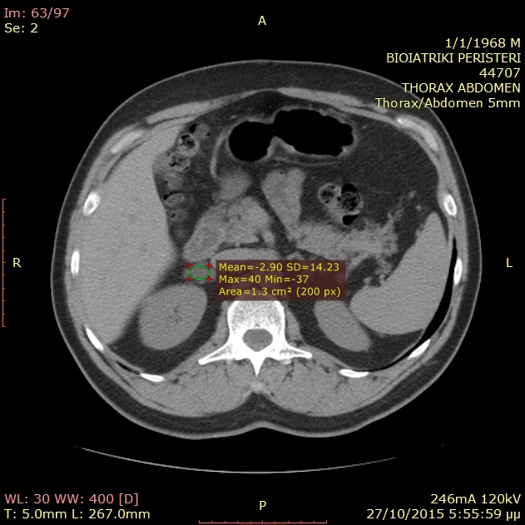
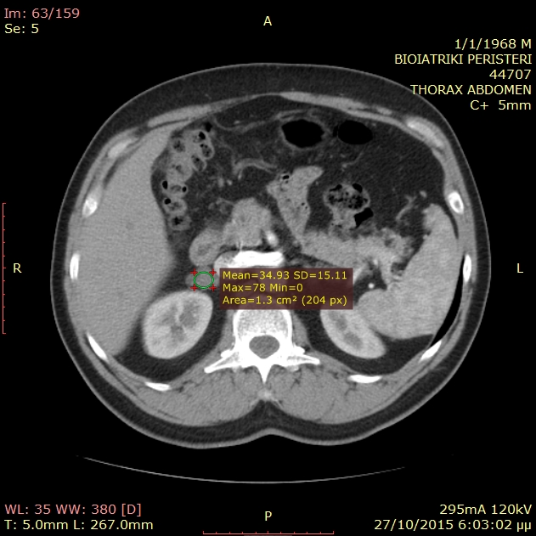
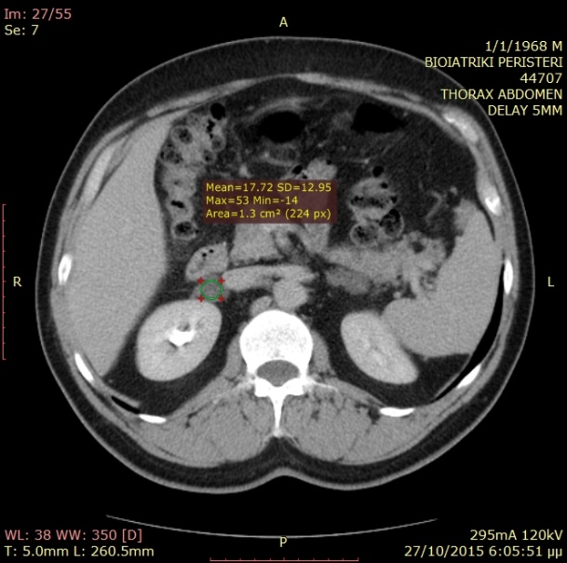
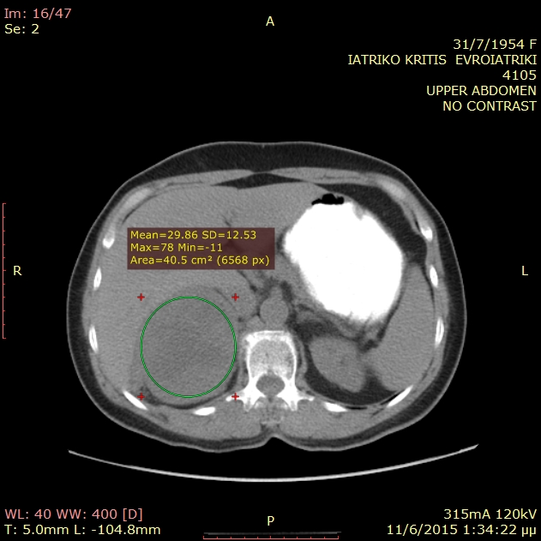
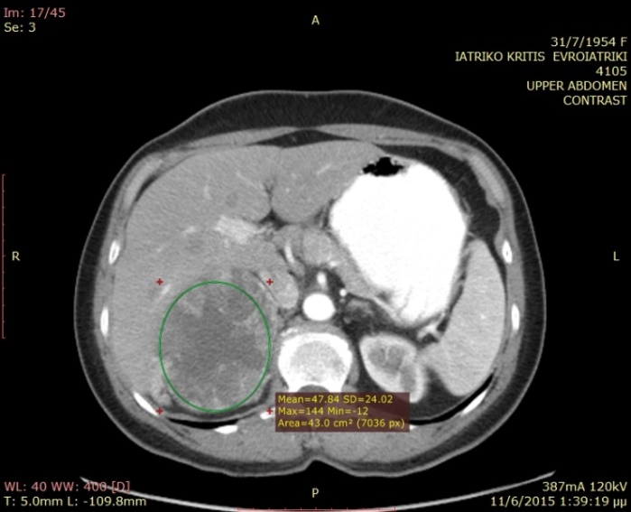
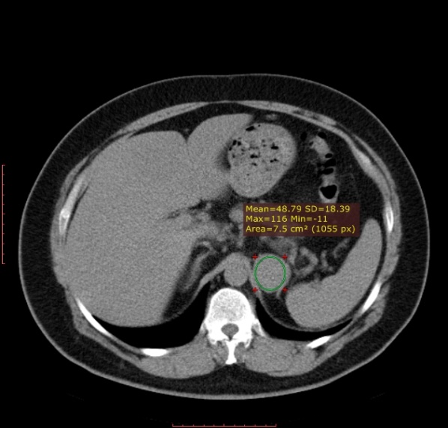
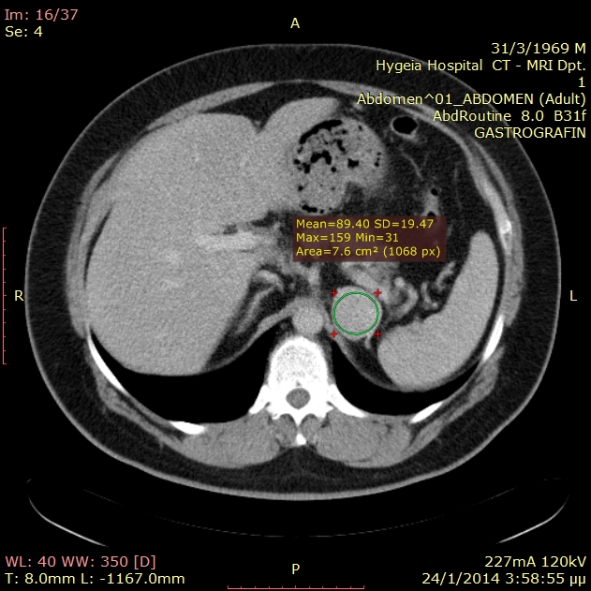
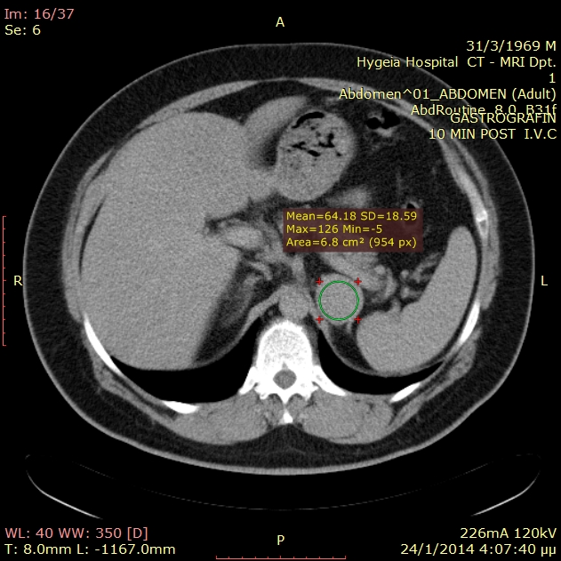
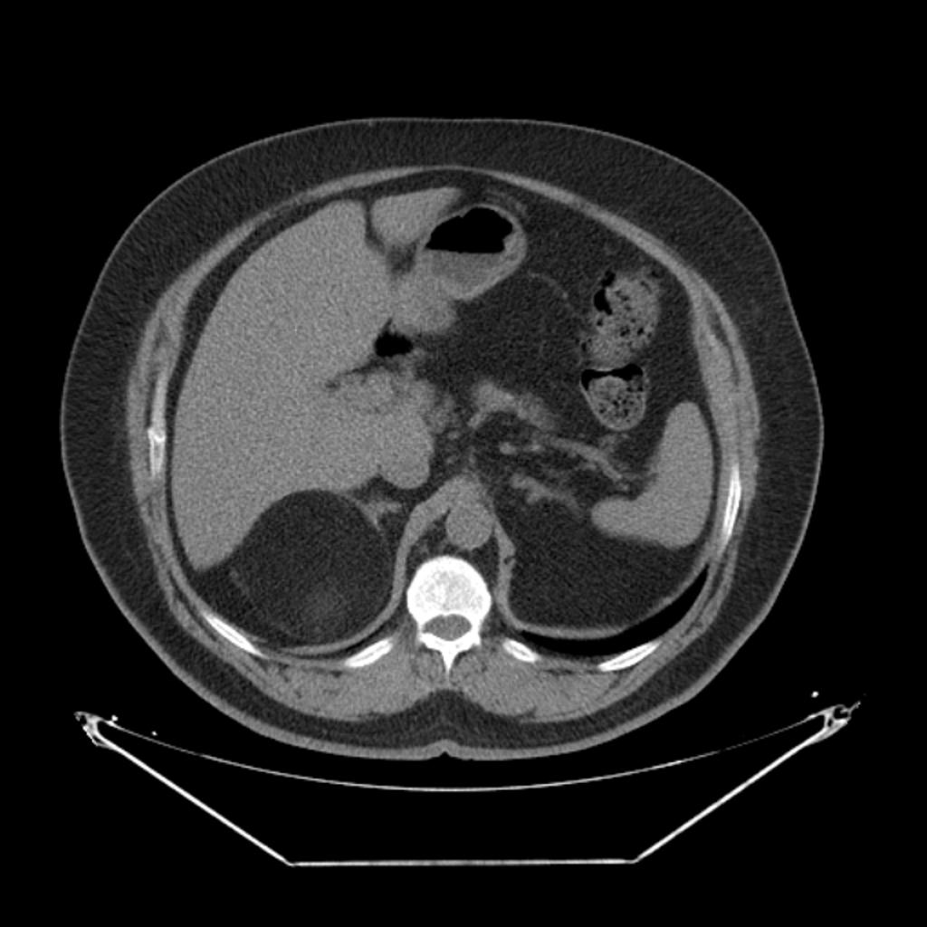
Figure 2: CT images of adrenal pathologies presenting as adrenal incidentalomas. a,b,c: A patient with a benign (lipid-rich) adrenal adenoma with unenhanced attenuation value - 3 HU (a), early attenuation (60 seconds after i.v. contrast medium administration) 35 HU (b) and delayed attenuation (10 min post-contrast administration) 18 HU. ARW = 45% and RPW=49%. Absolute washout (APW) less than 60% is indeterminate. However, the low pre-contrast attenuation is suggestive of an adenoma. Relative washout (RPW) of 40% or higher is consistent with an adenoma; d,e,f: Biochemically and histologically proven pheochromocytoma with unenhanced attenuation of 49 HU (d), early attenuation 90 HU (e) and delayed attenuation 64 HU. ARW = 63% and RPW=29%. Absolute washout >60% is suggestive of an adenoma, however relative washout less than 40% and unenhanced attenuation >10 HU are indeterminate; g,h: A patient with a primary adrenocortical carcinoma characterized by heterogeneity an unenhanced attenuation value >10 HU (g) and inhomogeneous contrast medium uptake due to central areas of necrosis; i: Typical myelolipoma.
a
b
c
d
e
f
g
h
i

It is important to note that the aforementioned figures of sensitivity and specificity were produced in studies with limitations and high risk of bias because of lack of definitive pathological diagnosis, different timing in acquiring post-contrast images and the use of broad inclusion criteria, including not only AIs but also clinically overt adrenal masses. In agreement with this statement, a recent study (66), showed that only a minority (21%) of cortisol-secreting adenomas has the typical unenhanced attenuation value of <10 HU, because cortisol secretion is associated with decreased intra-cytoplasmic lipid droplets containing cholesterol esters which are necessary for cortisol synthesis. Nevertheless, among the adenomas with high pre-contrast density (>10 HU), washout analysis after contrast administration was consistent with the benign nature of the tumor in 60% of the cases.
Another crucial key point in clinical practice is that most abdominal and chest CT scans leading to the unexpected discovery of an adrenal mass are obtained with the use of intravenous contrast that may not fulfill current technical recommendations for an optimal CT study of the adrenal glands, such as analysis on contiguous 3-5 mm-thick CT slices, preferentially on multiple sections using multidetector (MDCT) row protocols (67). In such cases, it may be worthwhile to obtain a new CT scan, specifically aimed for the study of the adrenal glands, including PW protocols in order to avoid the radiation exposure of a subsequent third CT scan in case of indeterminate unenhanced attenuation values.
Magnetic Resonance Imaging (MRI)
Adrenal imaging with MRI can also aid in the differential diagnosis between benign and malignant adrenal pathology. Benign adrenal adenomas appear hypotense or isotense compared to the liver on T1-weighted images and have low signal intensity on T2-weighted images. The majority of pheochromocytomas show high signal intensity on T2-weighted imaging (“light bulb sign”) which is a non-specific finding; however, a wide range of imaging features of pheochromocytomas mimicking both benign and malignant adrenal lesions have also been described (65). Primary ACCs are characterized by intermediate to high signal intensity on T1- and T2-weighted images and heterogeneity (mainly on T2- sequence due to hemorrhage and/or necrosis) as well as avid enhancement with delayed washout. However, these features are not specific and display significant overlap between benign and malignant lesions. The MRI technique of chemical-shift imaging (CSI) exploits the different resonance frequencies of protons in water and triglyceride molecules oscillating in- or out-of-phase to each other under the effect of specific magnetic field sequences, to identify high lipid content in adrenal lesions (68). Adrenal adenomas with a high content of intracellular lipid usually lose signal intensity on out-of-phase images compared to in-phase images, whereas lipid-poor adrenal adenomas, malignant lesions and pheochromocytomas remain unchanged. Signal intensity loss can be assessed qualitatively by simple visual comparison or by quantitative analysis using the adrenal-to-spleen signal ratio and can identify adenomas with a sensitivity of 84-100% and a specificity of 92-100% (69). It must be remembered however, that ACC and clear renal cell cancer metastases may sometimes also show signal loss (70)
Overall, MRI is probably as effective as CT in distinguishing benign from malignant lesions. Although quality of data is not optimal and there are no randomized studies comparing the two conventional imaging modalities, a few studies have concluded that for lipid-rich adenomas, there is no apparent difference, but MRI with CSI might be superior when evaluating lipid-poor adenomas with an attenuation value up to 30 HU (71). Hence, CT is considered to be the primary radiological procedure for evaluating AIs because it is more easily available and cost-effective, whereas MRI should be employed when a CT is less desirable (as in pregnant women and in children), for lipid-poor adenomas with relatively high attenuation values, and for other suspected lesions such as pheochromocytomas (72). When MRI is the examination that revealed the AI, additional imaging with CT (unenhanced and/or PW studies) should be done on an individual basis if the imaging phenotype is equivocal.

Figure 3

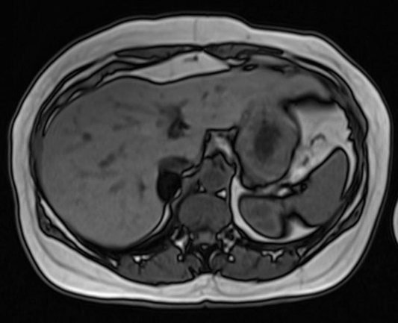
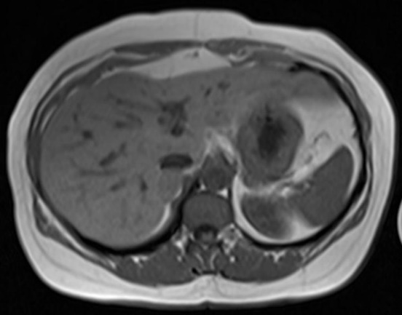

a
b
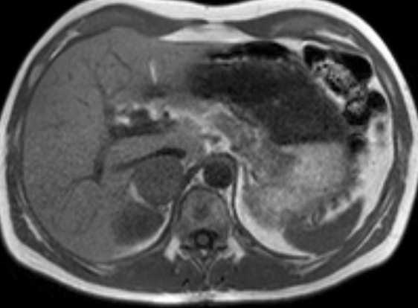
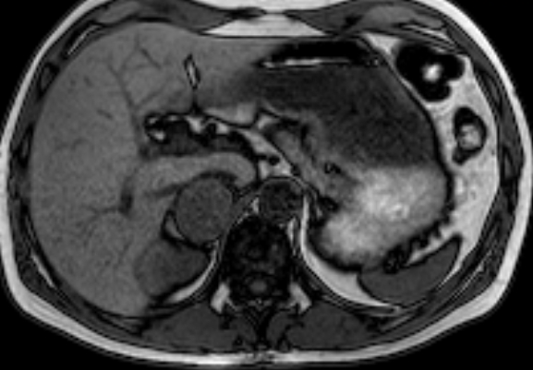

c
d
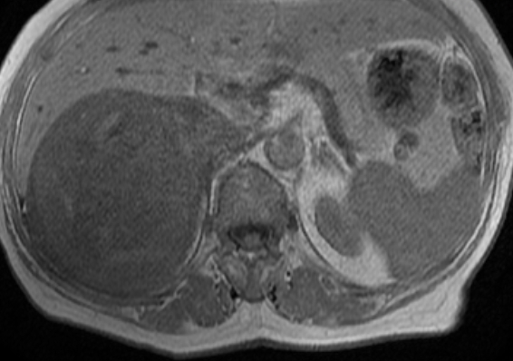
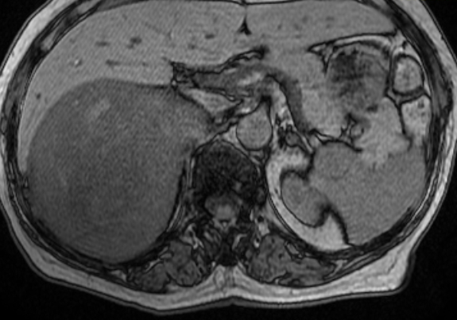

e
f

Figure 3: MRI images of different adrenal lesions presenting as incidentalomas, using the chemical shift imaging (CSI) technique. The loss of signal in out of phase images is typical in benign lipid-rich adenomas (a, b) in contrast with pheochromocytomas (c, d) and adrenocortical carcinomas (e, f) which do not display any signal loss.

Scintigraphy
In recent years, positron emission tomography (PET) using 18-fluoro-deoxyglucose (¹⁸F-FDG) has emerged as an effective tool in identifying malignant adrenal lesions. By utilizing the increased glucose uptake properties of cancer cells, ¹⁸F-FDG-PET combined with a CT scan (¹⁸F-FDG-PET/CT) achieves a sensitivity and specificity in identifying malignancy of 93-100% and 80-100% respectively (73,74). Both quantitative analysis of FDG uptake using maximum standardized uptake values (SUVmax) and qualitative assessment using a mass/liver SUV ratio have been used as a criterion, with the latter displaying better performance (75). A SUV ratio <1.45–1.6 between the adrenal and the liver is highly predictive of a benign lesion (76). Caveats concerning the utility of ¹⁸F-FDG-PET/CT include cost and availability, risk of false negative results in case of necrotic or hemorrhagic malignant lesions, lesions <1cm in size, extra-adrenal malignancies with low uptake (such as metastases from renal cell cancer or low-grade lymphoma) and false positive results in cases of sarcoidosis, tuberculosis, other inflammatory or infiltrative lesions and some adrenal adenomas and pheochromocytomas that show moderate FDG uptake (77). Because of its excellent negative predictive value, ¹⁸F-FDG-PET may help in avoiding unnecessary surgery in patients with non-secreting tumors with equivocal features in CT demonstrating low FDG uptake. Moreover, ¹⁸F-FDG-PET/CT may favour surgical removal of tumors with elevated uptake and no biochemical evidence of a pheochromocytoma (73). Newer tracers such as ¹⁸F-fluorodihydroxyphenylalanine (F-DOPA) and ¹⁸F-fluorodopamine (FDA) for detection of pheochromocytomas on PET have also been developed but their availability is limited (78).
Conventional adrenal scintigraphy using radiolabeled cholesterol molecules such as ¹³¹I-6-b-iodomethyl-norcholesterol (NP-59) and ⁷⁵Se-selenomethyl-19-norcholesterol has been used in the past to discriminate benign from malignant lesions. These tracers enter adrenal hormone synthetic pathways and act as precursor-like compounds, providing information regarding the function of target tissue. Typically, benign hypersecreting tumors, and non-secreting adenomas, show tracer uptake, whereas primary and secondary adrenal malignancies, space-occupying or infiltrative etiologies of AIs appear as ‘cold’ masses, providing an overall sensitivity of 71-100% and a specificity of 50-100% (79). However, some benign adrenal tumors such as myelolipomas and some functioning ACCs, may also be visualized with these modalities. Several additional limitations of adrenal scintigraphy such as insufficient spatial resolution, lack of widespread expertise, limited availability of the tracer, being a time-consuming procedure (which requires serial scanning over 5-7 days), and high radiation doses received by the patient, have limited its value in routine clinical practice, especially when conventional imaging can provide more reliable information. Recently, ¹²³I-iodometomidate has been introduced as a tracer because it binds specifically to adrenocortical enzymes, but its application is hampered by its limited availability and heterogeneous uptake by ACCs (80). Scintigraphy with ¹²³I-meta-iodo-benzyl-guanidine (MIBG) is the preferred method for identifying pheochromocytomas when clinical, biochemical, and imaging features are not conclusive, or when multiple or malignant lesions need to be excluded (35).

Hormonal Evaluation
Patients with AIs should be screened at presentation for evidence of excess catecholamine or cortisol secretion and, if hypertensive and/or hypokalemic, for aldosterone excess. As already discussed, the definition of AI per se implies the absence of clinical symptoms/signs related to these entities, however subtle hormonal hypersecretion not leading to the full clinical phenotype of a related syndrome may be present in patients with an AI. The size of AI does not preclude recommendations for biochemical testing for these entities (6).
Screening for cortisol excess
According to the Endocrine Society’s Clinical Guidelines for the diagnosis of Cushing’s syndrome and the AACE/AAES Medical Guidelines for the management of AIs, all patients with an incidentally discovered adrenal mass should be tested for the presence of hypercortisolism (58,81). Signs and symptoms of overt Cushing’s syndrome if present in a thorough clinical evaluation should prompt the physician to proceed with the recommended diagnostic approach described in the relevant Endocrine Society’s Clinical Guidelines (81). In this case, as discussed earlier, the validity of the term “incidentaloma” is debated.
In the absence of overt disease, biochemical investigation frequently reveals subtle cortisol hypersecretion and abnormalities of the HPA axis, a state regarded as SCS (6). Although SCS is poorly defined, and its natural history is largely unknown (3), the prevalence of hypertension, diabetes, obesity, other features of the metabolic syndrome, and osteoporosis has been found to be increased in such patients (5,82). Because standard biochemical tests used to screen for Cushing’s syndrome were not designed to reveal the subtle changes encountered in SCS, and since a definitive clinical phenotype to ascertain the presence of this condition is missing, a combination of various parameters used to assess the integrity of the HPA axis have been employed. Alterations of the HPA axis suggestive of autonomous cortisol secretion in AIs include reduced ACTH levels, increased mean serum cortisol and urinary free cortisol (UFC) levels, response to CRH and altered dexamethasone suppression (DST) (31). Reduced dehydroepiandrosterone sulfate (DHEA-S) is a less reliable marker, whereas the incorporation of midnight salivary cortisol as a means to diagnose SCS has produced inconsistent results (83,84). Currently, the 1 mg overnight DST, remains the most reliable and reproducible method and is easy to perform in clinical practice (5).
Different cortisol cut-off values following the 1 mg DST have been advocated from different authors and were adopted by several authorities, ranging from 50 to 138 nmol/l (1.8 to 5 μg/dl) (58,85). Higher thresholds increase the specificity of the test but lower its sensitivity (86). The formal low dose dexamethasone suppression test (LDDST) can be used to confirm and quantify the degree of autonomous cortisol secretion or to exclude a false positive test (87,88). The post 1 mg DST cortisol cutoff of >5 μg/dl (138 nmol/l) approach was substantiated by studies showing that all patients with such a cortisol value had uptake only on the side of the adenoma on adrenal scintigraphy (89). On the other hand, studies that used post-surgical hypoadrenalism as indicative of autonomous cortisol secretion suggested that lower cortisol cut-offs may be needed to identify these cases (90-92). Although two or more abnormal tests are conventionally required to establish the diagnosis of SCS (58), the 1 mg DST should be the initial screening test based on pathophysiological reasoning and the fact that it represents the most common HPA axis abnormality described in the majority of studies (45). A negative DST using a cortisol cut-off value of 1.8 μg/dl (50 nmol/l) virtually excludes SCS. Furthermore, a number of studies have found that patients with post DST cortisol values >1.8 μg/dl (50 nmol/l) have increased morbidity or mortality (93,94). A value of >5 μg/dl (138 nmol/l) on the other hand, is highly suggestive of the presence of SCS (5). In the case of a positive test with intermediate cortisol values (1.8-5 μg/dl), consideration of further parameters, such as the presence of other abnormalities of the HPA axis and/or comorbidities, employment of a higher cortisol cut-off level, and re-testing after 3-6 months, has been suggested (95). In our opinion, the post-LDDST cortisol value should be considered in patients with such intermediate cortisol values following the 1 mg DST because, in addition to its high specificity, it correlates well with other indices of cortisol excess and the size of the adenoma, thus providing a quantitative measure of the degree of cortisol production from the adenoma and a more robust means for further follow-up (88,96).
Screening for Pheochromocytoma
Because catecholamine secretion can be intermittent, and there are cases of ‘silent’ pheochromocytomas, screening should be performed even in normotensive patients with AIs in order to prevent the morbidity and mortality that may accompany this tumor (97). The initial recommended biochemical screening test is measurement of plasma free (from blood drawn in the supine position) or urinary fractionated metanephrines using liquid chromatography with mass spectrometric or electrochemical detection methods (35). This approach has a sensitivity and specificity of 99% and 97% respectively and has proven to be superior to measurement of plasma or urine catecholamines and vanillylmandelic acid (VMA) (98). Some studies have suggested higher specificity of the plasma than the urine test albeit without head-to-head comparisons using mass spectrometric-based methods. Thus, until data directly comparing plasma and urinary measurements are produced, urinary free fractionated metanephrines can be used as an alternative, if plasma free metanephrines measurement is not available (99). Sane et al suggested that routine biochemical screening for pheochromocytoma in small (<2cm) homogenous AIs characterized by attenuation values <10 HU may not be necessary, since none of the 115 patients in his cohort with lipid-rich tumors (<10 HU) had constantly elevated 24-hour urinary metanephrines or normetanephrines, whereas all 10 histologically proven pheochromocytomas were larger than 2cm and were characterized by >10 HU in unenhanced CT scans (100).
A recent study (101) comparing the clinical, hormonal, histological and molecular features of normotensive incidentally discovered pheochromocytomas (previously referred as “silent”) with tumors causing overt symptoms, revealed lower diagnostic sensitivity (75%) for plasma and urinary metanephrines irrespective of tumor size, while genetic and histological studies showed decreased expression of genes and proteins associated with catecholamine production and increased cellularity and mitotic activity in “silent” tumors. It was suggested that asymptomatic incidentally discovered pheochromocytomas do not represent an early stage of development of pheochromocytomas but rather correspond to a distinct entity characterized by cellular defects in chromaffin machinery resulting in lower efficiency to produce or release catecholamines. It is, therefore, crucial to consider that normotensive patients with an AI and normal values of metanephrines, may indeed harbor a pheochromocytoma. In such instance, the CT and MRI scan features of the tumor if suspicious for pheochromocytoma, should alert the clinician to perform complementary investigations, such as plasma chromogranin A measurement, MIBG scintigraphy, ¹⁸F-FDG-PET/CT or other alternative functional imaging (F-DOPA/PET or FDA/PET) to rule out this possibility.
Screening for aldosterone excess
According to published guidelines from the Endocrine Society, all patients with an AI and hypertension, irrespective of serum potassium levels, should be tested for PA using the plasma aldosterone/renin ratio (ARR) as a screening test (37). However, the knowledge that PA can be diagnosed in normotensive patients with hypokalemia necessitates testing of all patients with hypertension or hypokalemia (39). Although there is no current consensus regarding the most diagnostic ARR cut-off, values >20-40 (plasma aldosterone expressed as ng/dl and plasma renin activity [PRA] as ng/ml/h) obtained in the morning from a seated patient are highly suggestive. However, the plasma aldosterone level also needs to be considered because extremely low PRA, even in the presence of normal aldosterone levels, will result in a high ARR; an aldosterone level less than 9 ng/dl makes the diagnosis of PA unlikely, whereas a level in excess of 15 ng/dl is suggestive (45). Attention should also be given in certain technical aspects required for the prompt interpretation of the ARR such as unrestricted dietary salt intake, corrected potassium levels and washout of interfering antihypertensive medication. Patients may be treated with a non-dihydropyridine calcium channel blocker (verapamil slow release) as a single agent or in combination with α-adrenergic blockers (such as doxazosin) and hydralazine for blood pressure control during the washout period, if needed. When suspected based on the ARR, PA should be verified with one of the commonly used confirmatory tests (oral sodium loading, saline infusion, fludrocortisone suppression, and captopril challenge). Admittedly, the extent that patients with AI should be investigated to exclude PA is still not known. Although PA has been reported with a low prevalence between patients with AIs (1-10%), substantially higher rates (24%) have recently been described using a recumbent post-low dose dexamethasone suppression (LDDST)-saline infusion test (PD-SIT) (40). Further studies evaluating the optimal biochemical diagnostic approach of PA in patients with AIs are required by comparing established versus evolving investigational protocols.
Screening for androgen/estrogen excess
Measurement of sex hormones is not recommended in patients with an AI on a routine basis (58). Elevated levels of serum DHEA-S, androstenedione, 17-OH progesterone as well as testosterone in women and estradiol in men and postmenopausal women can be found in more than half of patients with ACCs (102). Although cases of androgen or estrogen excess have been rarely described in patients with benign adrenocortical adenomas (103-106), they are usually accompanied by symptoms or signs of virilization in women (acne, hirsutism) or feminization in men (gynecomastia), and therefore such lesions cannot be considered as true AIs. Thus the usefulness of measuring sex hormones and steroid precursors is limited in cases of adrenal lesions with indeterminate or suspicious for malignancy imaging characteristics, where elevated levels can point towards the adrenocortical origin of the tumor and suggest the presence of an ACC. Additionally, increased basal or after consytropin stimulation levels of 17-OH progesterone can also indicate CAH in patients with bilateral AIs (6).
Screening for hypoadrenalism
Bilateral AIs caused by metastases of extra-adrenal malignancies or infiltrative diseases can rarely cause adrenal insufficiency (107). Therefore in all patients with bilateral adrenal masses, adrenal insufficiency should be considered and evaluated clinically and if likely, diagnosis should be established using the standard 250μg consytropin stimulation test according to the Endocrine Society’s recently published clinical guidelines (108).

FINE-NEEDLE ASPIRATION BIOPSY (FNAB)
The previously used percutaneous fine-needle aspiration biopsy (FNAB) as a mean to clarify the nature of an AI has now been surpassed by the non-invasive radiological methods because they have better diagnostic accuracy and are devoid of potential side effects (109). It should be noted that FNAB is not considered an accurate method in differentiating benign from malignant primary adrenal tumors but can be helpful in the diagnosis of metastases from extra-adrenal malignancies with a sensitivity of 73-100% and a specificity of 86-100% using variable population inclusion criteria, reference standards and biopsy techniques (110-112). Therefore, in patients with suspicion of a rare tumor or a history of an underlying extra-adrenal malignancy and/or inconclusive imaging features of an AI (non-contrast CT attenuation value >10 HU and a RPW<40%), FNAB could be performed, but only if management would be altered by the histologic findings. FNAB has significant procedural risk with complications such as pneumothorax, bleeding, infection, pancreatitis, and seeding of tumor cells along the needle track reported at a rate up to 14% by some, but not all available studies (109). To avoid the risk of a potentially lethal hypertensive crisis, pheochromocytoma should always be excluded biochemically before FNA of an adrenal mass is attempted (113).

NATURAL HISTORY OF AIS
Since AIs do not represent a single clinical entity, their natural history varies depending on the underlying etiology. Primary malignant adrenal tumors typically display rapid growth (>2 cm/year) and a poor outcome with an overall 5-year survival of 47%. It is not known whether prognosis of patients with incidentally discovered ACCs is different from symptomatic cases, although detection of the tumor at an early stage provides the possibility of definitive surgical cure (114). Patients bearing adrenal metastases have a clinical course depending on stage, grade, and site of the primary tumor (4). Pheochromocytomas grow slowly and are mostly benign, but if untreated are potentially lethal displaying high cardiovascular mortality and morbidity, whereas 10-17% of the cases can be malignant (35). This is further emphasized by the fact that pheochromocytomas detected in autopsy series had not been suspected in 75% of the patients while they were alive, although they contributed to their death in approximately 55% of cases (115).
In benign adrenal tumors, which constitute the majority of AIs, the major concerns about their natural history revolve around their progressive growth, the possibility of malignant transformation and the risk of evolution towards overt hypersecretion. Several cohort studies, despite their limitations, have shown that the majority of benign tumors remain stable in size; only 5-20% show a >1 cm increase in size, mostly within the first three years after prolonged follow-up (116,117), whereas occasional shrinkage, or even complete disappearance, of an adrenal mass have also been reported in about 4% of cases (8,117). Although there is as yet no specific growth rate cut-off indicative of a benign nature, ACCs initially diagnosed as AIs, are invariably characterized by a rapid growth within months (at least > 0.8cm/year). The risk that an AI considered to be benign will become malignant has been estimated at <1/1000 (3,8). Cawood et al found only two reports of a malignancy detected during the follow-up of AIs thought to be benign at diagnosis; the first was a renal carcinoma metastasis in a patient with a known history of renal carcinoma and the other was a non-Hodgkin’s lymphoma that showed a mass enlargement after 6 months (3). These findings highlight the low risk of malignant transformation of AIs and the adequacy of current imaging to ascertain the diagnosis and influence follow-up recommendations.
The appearance of hormonal hypersecretion over time in initially NFAIs varies in different series. New-onset catecholamine or aldosterone overproduction is extremely rare (<0.3%), whereas development of overt hypercortisolism during follow-up is found in <1% (8). The most common disorder observed during follow-up is the occurrence of autonomous cortisol secretion eventually leading to SCS, reported with a frequency of up to 10% (118). This risk is higher for lesions >3 cm in size and during the first 2 years of follow-up but seems to plateau after 3-4 years, even if it does not subside completely (119). On the other hand, subtle hormonal alterations discovered at initial screening may also improve over time, indicating possible cyclical cortisol secretion from AIs and/or highlighting the inherent difficulty in biochemical confirmation of this condition (117).
Another issue of debate regarding the natural history of AIs that has attracted research, producing frequently conflicting data, is the sequelae of SCS on cardiovascular risk and subsequent mortality and morbidity. Several cross-sectional and cohort studies have reported a clustering of unfavorable cardiovascular risk factors in patients with AIs similar to those found in patients with overt Cushing’s syndrome (120,121). It is biologically plausible to anticipate that the presence of even mild to minimal cortisol excess may lead to some extent to the classic long-term consequences of overt hypercortisolism, such as hypertension, obesity, impaired glucose tolerance or frank diabetes, dyslipidemia and osteoporosis. Because these metabolic derangements are common in the general and particularly the elderly population, in whom AIs are more frequently found, it is difficult to extrapolate whether there is a causal relationship between them. Whether these metabolic abnormalities in patients with AIs result in increased cardiovascular mortality and morbidity has not as yet been fully clarified. Although, some recent retrospective studies (93,94,122) have shown higher rates of cardiovascular events and mortality in patients with higher cortisol levels after the 1 mg DST, data from patients who underwent adrenalectomy are contradictory, regarding the outcome on metabolic and cardiovascular profile, whereas there are relatively few data on the risk of major cardiovascular events or mortality (92,123-125). Similarly, evidence on the detrimental effects of SCS on bone metabolism, such as lower bone density and high prevalence of vertebral fractures (43-72%) in postmenopausal women and eugonadal male patients with AIs (126-128) are conflicting with studies not showing reversal of these effects following surgical treatment (123,129).
Moreover, there is growing evidence that even NFAIs may be associated with similar metabolic disturbances and manifestations of the metabolic syndrome that are considered cardiovascular risk factors (130-132). Compared with controls, patients with NFAIs exhibit subtle indices of atherosclerosis such as increased carotid intima-media thickness (IMT) (133), impaired flow-mediated vasodilatation (FMD) (134) and left ventricular hypertrophy (135). A recent study excluding patients with traditional risk factors (diabetes, hypertension or dyslipidemia) reported similar findings in patients harboring NFAIs, with increased insulin resistance and endothelial dysfunction that correlated with subtle but not autonomous cortisol excess (136)

MANAGEMENT
All published guidelines and expert reviews agree that patients with unilateral adrenal masses causing unambiguous hormonal overactivity, and those with suspected malignancy (mainly ACC), are candidates for surgical interventions (5,6,35,37,58,85,137,138). There is also broad consensus that the majority of AIs with clearly benign imaging phenotype in unenhanced CT and no relevant clinical activity do not require surgery. However, some authors have also advocated considering size as an indication for surgery. The 2002 NIH state-of-the-science report recommended surgical excision of all AIs greater than 6 cm and to use clinical judgment, based on the results of the initial or follow-up evaluations, when assessing masses between 4 and 6 cm for surgery (4). Considering the high prevalence of ACC in tumors >4cm, some have proposed lowering the size cut-off to 4 cm (139). Despite the paucity of data regarding the natural history of such large tumors, an attenuation value of ≤10 HU in unenhanced CT combined with PW properties consistent with a benign tumor and absence of significant growth over time, can be reassuring. Non-functioning lesions <4cm with indeterminate imaging features on unenhanced CT should be investigated further with contrast-washout studies, MRI-CSI, or ¹⁸F-FDG-PET/CT. If uncertainty still remains, immediate surgery or repeat imaging after 3-6 months could be offered. It would also be prudent to exclude the possibility of a “silent” pheochromocytoma in patients with an indeterminate lesion, before proceeding to surgery because hemodynamic instability during surgical excision may ensue.
The management of patients harboring AIs who have SCS is debatable and the beneficial effect of adrenalectomy has not been proven adequately in the literature. Some, but not all, predominantly retrospective studies have shown a beneficial effect in hypertension and diabetes mellitus in patients with AIs who underwent an adrenalectomy, compared to those who did not undergo such a procedure (92,123,125). In one prospective study with a 8-year follow-up, operated patients with SCS had an improvement in features of the metabolic syndrome, but not of osteoporosis, compared to those who were conservatively managed; however, no control group was included in the study (123). In a recent retrospective study an improvement of blood pressure and blood glucose was noted in adrenalectomized patients with SCS, whereas these indices worsened in non-operated patients; even so, some patients apparently with NFAI also showed an improvement in some of these parameters (92). Until results from randomized prospective trials, reporting outcome on metabolic and bone comorbidities as well as overall mortality and major cardiovascular events, become available, adrenalectomy should be considered only in young patients with SCS and in those with new onset and/or rapidly worsening comorbidities resistant to medical treatment (6,140). A proposed algorithm for diagnostic approach and management of AIs is presented in Figure 4.
Before proceeding to surgical therapy, appropriate medical therapy must be given to all functioning lesions, aiming at symptom control. Apart from patients with Cushing’s syndrome, post-surgical adrenal insufficiency may ensue in SCS patients (141). Because the need for glucocorticoid coverage cannot be predicted before surgery, patients should be covered by steroids post-operatively until the HPA-axis can be formally assessed (90). Low morning cortisol levels the day after surgery, and before glucocorticoid replacement, provide evidence for post-surgical hypoadrenalism (92). All patients diagnosed with pheochromocytoma, including normotensive patients with “silent” tumors should receive preoperative α-adrenergic blockade for 7 to 14 days to prevent perioperative cardiovascular complications. Treatment should also include a high-sodium diet and fluid intake to reverse catecholamine-induced blood volume contraction preoperatively and prevent severe hypotension after tumor removal (35). Finally, patients diagnosed with PA and bilateral tumors or a unilateral AI (if older than 40 years of age) who seek a potential surgical cure, should be considered for adrenal venous sampling (AVS) before proceeding to surgery, to confirm lateralization of the source of the excessive aldosterone secretion.
According to AACE/AAES Medical Guidelines for the management of adrenal incidentalomas, patients with AIs not elected for surgery after the initial diagnostic work-up, should undergo re-imaging 3-6 months after the initial diagnosis and then annually for the next 1-2 years, while annual biochemical testing is advised for up to 4-5 years following the diagnosis (58). As the natural history of AIs remains largely unknown, a widely accepted follow-up imaging and hormonal protocol has not as yet been formulated. It has been suggested by some (3,142,143) that given the low probability of the transformation of a benign and non-functioning adrenal mass to a malignant or functioning one, the routine application of the current strategies in all patients with AIs is likely to result in a number of unnecessary biochemical and radiological investigations. Such an approach is costly and it does not take into account harmful consequences of diagnostic evaluation such as patients’ anxiety associated with repeated clinical visits and a high rate of false positive results leading to further testing or unnecessary adrenalectomy. Moreover, exposure to ionizing radiation from repeated CT scans increases the future cancer risk to the level that is similar to the risk of the adrenal lesion becoming malignant (3,144).
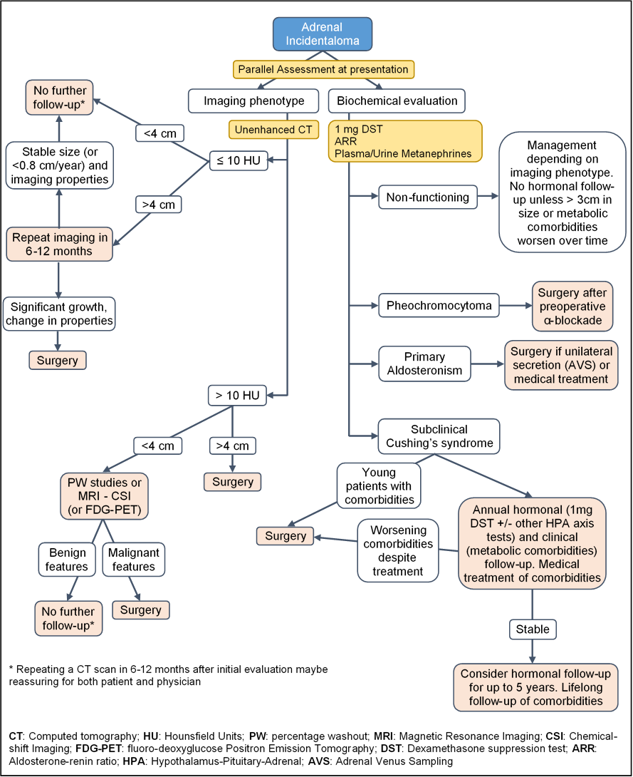
Figure 4: Proposed algorithm for diagnosis and management of AIs

Based on available data, it is safe to conclude that lesions <2 cm in size, and with an attenuation value <10 HU, have the lowest possibility of growth and thus long-term imaging follow-up is probably unnecessary. For larger tumors despite the high sensitivity and adequate specificity of unenhanced CT for identifying adenomas, the lack of prospective studies precludes suggesting stringent recommendations regarding optimal radiological follow-up (5). It is our practice for large lesions, particularly those >4 cm with attenuation values <10 HU, to repeat a CT scan after 6-12 months and if there is no increase in size and the imaging features remain unaltered, to defer further radiological follow-up. It is thought that an one-time follow-up scan in 6-12 months may be reassuring to the physician and the patient (45). A 25% increase in tumor size per year, or an absolute increase by >0.8 cm over 12 months (59), probably warrant further follow-up and re-evaluation of radiological features.
The appropriate hormonal follow-up of patients not elected for surgery is also not established. Patients without any biochemical abnormalities at presentation could be spared the burden of repeated testing, since the risk of developing clinically overt hormonal excess is extremely low. Clinical follow-up with assessment of cardiovascular risk factors that have been associated with the presence of AIs may be adequate to detect the reported ~10% of the cases of new-onset SCS (5). Patients with worsening of their metabolic parameters should be retested with the 1mg DST and be advised to apply lifestyle changes and effective medical treatment to reduce cardiovascular risk. If biochemical abnormalities suggesting SCS are present during the initial screening, annual clinical follow-up including evaluation of potentially cortisol excess-related comorbidities, as well as periodic testing of the HPA axis, is advisable. Patients with SCS who do not reach the treatment goals despite an adequate medical therapy could be offered surgery. Duration of follow-up is also under debate, however based on available data, annual hormonal evaluation may be suggested for up to five years, and especially for lesions >3 cm (58).

CONCLUSION
AIs are increasingly being recognized, particularly in the aging population. Adrenal CT and MRI, can reliably distinguish benign lesions, while ¹⁸F-FDG-PET/CT scan can be helpful in identifying tumors with malignant potential. SCS is the most common hyperfunctional state that is best substantiated using the 1 mg DST; urinary/plasma metanephrines and ARR are used to screen for pheochromocytomas and hyperaldosteronism. Adrenal lesions with suspicious radiological findings, pheochromocytomas and tumors causing overt clinical syndromes, as well as those with considerable growth during follow-up, should be treated with surgical resection. Although there is no consensus, the interval for diagnostic follow-up testing relies on the radiological and hormonal features of the tumors at presentation. The benefit of surgical resection in patients with substantial comorbidities and associated subclinical adrenal hyperfunction, mainly in the form of SCS, is still under investigation.

REFERENCES

1. Korobkin M, White EA, Kressel HY, Moss AA, Montagne JP. Computed tomography in the diagnosis of adrenal disease. AJR American journal of roentgenology 1979; 132:231-238
2. Vassiliadi DA, Tsagarakis S. Endocrine incidentalomas--challenges imposed by incidentally discovered lesions. Nature reviews Endocrinology 2011; 7:668-680
3. Cawood TJ, Hunt PJ, O'Shea D, Cole D, Soule S. Recommended evaluation of adrenal incidentalomas is costly, has high false-positive rates and confers a risk of fatal cancer that is similar to the risk of the adrenal lesion becoming malignant; time for a rethink? European journal of endocrinology / European Federation of Endocrine Societies 2009; 161:513-527
4. Grumbach MM, Biller BM, Braunstein GD, Campbell KK, Carney JA, Godley PA, Harris EL, Lee JK, Oertel YC, Posner MC, Schlechte JA, Wieand HS. Management of the clinically inapparent adrenal mass ("incidentaloma"). Annals of internal medicine 2003; 138:424-429
5. Terzolo M, Stigliano A, Chiodini I, Loli P, Furlani L, Arnaldi G, Reimondo G, Pia A, Toscano V, Zini M, Borretta G, Papini E, Garofalo P, Allolio B, Dupas B, Mantero F, Tabarin A, Italian Association of Clinical E. AME position statement on adrenal incidentaloma. European journal of endocrinology / European Federation of Endocrine Societies 2011; 164:851-870
6. Young WF, Jr. Clinical practice. The incidentally discovered adrenal mass. N Engl J Med 2007; 356:601-610
7. Nawar R, Aron D. Adrenal incidentalomas -- a continuing management dilemma. Endocrine-related cancer 2005; 12:585-598
8. Barzon L, Sonino N, Fallo F, Palu G, Boscaro M. Prevalence and natural history of adrenal incidentalomas. European journal of endocrinology / European Federation of Endocrine Societies 2003; 149:273-285
9. Rineheart JF WOCW. Adenomatous hyperplasia of the adrenal cortex associated with essential hypertension. Archives of pathology 1941; 34:1031–1034
10. Russi S, Blumenthal HT, Gray SH. Small adenomas of the adrenal cortex in hypertension and diabetes. Arch Intern Med (Chic) 1945; 76:284-291
11. Commons RR, Callaway CP. Adenomas of the adrenal cortex. Arch Intern Med (Chic) 1948; 81:37-41
12. Schroeder. Clinical types – the endocrine hypertensive syndrome. In: Schroeder, ed. Hypertensive Diseases: Causes and Control. Philadelphia: Lea & Febiger; 1953.
13. Devenyi I. Possibility of normokalaemic primary aldosteronism as reflected in the frequency of adrenal cortical adenomas. Journal of clinical pathology 1967; 20:49-51
14. Kokko JP, Brown TC, Berman MM. Adrenal adenoma and hypertension. Lancet 1967; 1:468-470
15. Hedeland H, Ostberg G, Hokfelt B. On the prevalence of adrenocortical adenomas in an autopsy material in relation to hypertension and diabetes. Acta medica Scandinavica 1968; 184:211-214
16. Yamada EY, Fukunaga FH. Adrenal adenoma and hypertension. A study in the Japanese in Hawaii. Japanese heart journal 1969; 10:11-19
17. Granger P, Genest J. Autopsy study of adrenals in unselected normotensive and hypertensive patients. Canadian Medical Association journal 1970; 103:34-36
18. Russell RP, Masi AT, Richter ED. Adrenal cortical adenomas and hypertension. A clinical pathologic analysis of 690 cases with matched controls and a review of the literature. Medicine 1972; 51:211-225
19. Abecassis M, McLoughlin MJ, Langer B, Kudlow JE. Serendipitous adrenal masses: prevalence, significance, and management. American journal of surgery 1985; 149:783-788
20. Meagher AP, Hugh TB, Casey JH, Chisholm DJ, Farrell JC, Yeates M. Primary adrenal tumours--a ten-year experience. The Australian and New Zealand journal of surgery 1988; 58:457-462
21. Reinhard C, Saeger W, Schubert B. Adrenocortical nodules in post-mortem series. Development, functional significance, and differentiation from adenomas. General & diagnostic pathology 1996; 141:203-208
22. Kloos RT, Gross MD, Francis IR, Korobkin M, Shapiro B. Incidentally discovered adrenal masses. Endocrine reviews 1995; 16:460-484
23. Masumori N, Adachi H, Noda Y, Tsukamoto T. Detection of adrenal and retroperitoneal masses in a general health examination system. Urology 1998; 52:572-576
24. Glazer HS, Weyman PJ, Sagel SS, Levitt RG, McClennan BL. Nonfunctioning adrenal masses: incidental discovery on computed tomography. AJR American journal of roentgenology 1982; 139:81-85
25. Prinz RA, Brooks MH, Churchill R, Graner JL, Lawrence AM, Paloyan E, Sparagana M. Incidental asymptomatic adrenal masses detected by computed tomographic scanning. Is operation required? JAMA : the journal of the American Medical Association 1982; 248:701-704
26. Belldegrun A, Hussain S, Seltzer SE, Loughlin KR, Gittes RF, Richie JP. Incidentally discovered mass of the adrenal gland. Surgery, gynecology & obstetrics 1986; 163:203-208
27. Herrera MF, Grant CS, van Heerden JA, Sheedy PF, Ilstrup DM. Incidentally discovered adrenal tumors: an institutional perspective. Surgery 1991; 110:1014-1021
28. Caplan RH, Strutt PJ, Wickus GG. Subclinical hormone secretion by incidentally discovered adrenal masses. Archives of surgery 1994; 129:291-296
29. Bovio S, Cataldi A, Reimondo G, Sperone P, Novello S, Berruti A, Borasio P, Fava C, Dogliotti L, Scagliotti GV, Angeli A, Terzolo M. Prevalence of adrenal incidentaloma in a contemporary computerized tomography series. Journal of endocrinological investigation 2006; 29:298-302
30. Song JH, Chaudhry FS, Mayo-Smith WW. The incidental adrenal mass on CT: prevalence of adrenal disease in 1,049 consecutive adrenal masses in patients with no known malignancy. AJR American journal of roentgenology 2008; 190:1163-1168
31. Mantero F, Terzolo M, Arnaldi G, Osella G, Masini AM, Ali A, Giovagnetti M, Opocher G, Angeli A. A survey on adrenal incidentaloma in Italy. Study Group on Adrenal Tumors of the Italian Society of Endocrinology. The Journal of clinical endocrinology and metabolism 2000; 85:637-644
32. Mayer SK, Oligny LL, Deal C, Yazbeck S, Gagné N, Blanchard H. Childhood adrenocortical tumors: Case series and reevaluation of prognosis&#x2014;A 24-year experience. Journal of pediatric surgery 1997; 32:911-915
33. Angeli A, Osella G, Ali A, Terzolo M. Adrenal incidentaloma: an overview of clinical and epidemiological data from the National Italian Study Group. Hormone research 1997; 47:279-283
34. Aron D, Terzolo M, Cawood TJ. Adrenal incidentalomas. Best practice & research Clinical endocrinology & metabolism 2012; 26:69-82
35. Lenders JW, Duh QY, Eisenhofer G, Gimenez-Roqueplo AP, Grebe SK, Murad MH, Naruse M, Pacak K, Young WF, Jr., Endocrine S. Pheochromocytoma and paraganglioma: an endocrine society clinical practice guideline. The Journal of clinical endocrinology and metabolism 2014; 99:1915-1942
36. Kopetschke R, Slisko M, Kilisli A, Tuschy U, Wallaschofski H, Fassnacht M, Ventz M, Beuschlein F, Reincke M, Reisch N, Quinkler M. Frequent incidental discovery of phaeochromocytoma: data from a German cohort of 201 phaeochromocytoma. European journal of endocrinology / European Federation of Endocrine Societies 2009; 161:355-361
37. Funder JW, Carey RM, Fardella C, Gomez-Sanchez CE, Mantero F, Stowasser M, Young WF, Jr., Montori VM, Endocrine S. Case detection, diagnosis, and treatment of patients with primary aldosteronism: an endocrine society clinical practice guideline. The Journal of clinical endocrinology and metabolism 2008; 93:3266-3281
38. Piaditis G, Markou A, Papanastasiou L, Androulakis, II, Kaltsas G. Progress in aldosteronism: a review of the prevalence of primary aldosteronism in pre-hypertension and hypertension. European journal of endocrinology / European Federation of Endocrine Societies 2015; 172:R191-203
39. Medeau V, Moreau F, Trinquart L, Clemessy M, Wemeau JL, Vantyghem MC, Plouin PF, Reznik Y. Clinical and biochemical characteristics of normotensive patients with primary aldosteronism: a comparison with hypertensive cases. Clinical endocrinology 2008; 69:20-28
40. Piaditis GP, Kaltsas GA, Androulakis, II, Gouli A, Makras P, Papadogias D, Dimitriou K, Ragkou D, Markou A, Vamvakidis K, Zografos G, Chrousos G. High prevalence of autonomous cortisol and aldosterone secretion from adrenal adenomas. Clinical endocrinology 2009; 71:772-778
41. Mansmann G, Lau J, Balk E, Rothberg M, Miyachi Y, Bornstein SR. The clinically inapparent adrenal mass: update in diagnosis and management. Endocrine reviews 2004; 25:309-340
42. Lau J, Balk E, Rothberg M, Ioannidis JP, DeVine D, Chew P, Kupelnick B, Miller K. Management of clinically inapparent adrenal mass. Evidence report/technology assessment 2002:1-5
43. Vierhapper H, Heinze G, Gessl A, Exner M. Adrenocortical tumors: prevalence of impaired glucose tolerance and of "Paradoxical Rise" of cortisol during an oral glucose tolerance test. Experimental and clinical endocrinology & diabetes : official journal, German Society of Endocrinology [and] German Diabetes Association 2003; 111:415-420
44. Piga A, Bracci R, Porfiri E, Cellerino R. Metastatic tumors of the adrenals. Minerva endocrinologica 1995; 20:79-83
45. Zeiger MA, Siegelman SS, Hamrahian AH. Medical and surgical evaluation and treatment of adrenal incidentalomas. The Journal of clinical endocrinology and metabolism 2011; 96:2004-2015
46. Fallo F, Barzon L, Boscaro M, Sonino N. Coexistence of aldosteronoma and contralateral nonfunctioning adrenal adenoma in primary aldosteronism. American journal of hypertension 1997; 10:476-478
47. Satoh F, Murakami O, Takahashi K, Ueno J, Nishikawa T, Abe K, Mouri T, Sasano H. Double adenomas with different pathological and hormonal features in the left adrenal gland of a patient with Cushing's syndrome. Clinical endocrinology 1997; 46:227-234
48. Morimoto S, Sasaki S, Moriguchi J, Miki S, Kawa T, Nakamura K, Fujita H, Itoh H, Nakata T, Takeda K, Nakagawa M. Unique association of pheochromocytoma with contralateral nonfunctioning adrenal cortical adenoma. American journal of hypertension 1998; 11:117-121
49. Dobbie JW. Adrenocortical nodular hyperplasia: the ageing adrenal. The Journal of pathology 1969; 99:1-18
50. Beuschlein F, Reincke M, Karl M, Travis WD, Jaursch-Hancke C, Abdelhamid S, Chrousos GP, Allolio B. Clonal composition of human adrenocortical neoplasms. Cancer research 1994; 54:4927-4932
51. Gicquel C, Leblond-Francillard M, Bertagna X, Louvel A, Chapuis Y, Luton JP, Girard F, Le Bouc Y. Clonal analysis of human adrenocortical carcinomas and secreting adenomas. Clinical endocrinology 1994; 40:465-477
52. Pillion DJ, Arnold P, Yang M, Stockard CR, Grizzle WE. Receptors for insulin and insulin-like growth factor-I in the human adrenal gland. Biochemical and biophysical research communications 1989; 165:204-211
53. Reincke M, Fassnacht M, Vath S, Mora P, Allolio B. Adrenal incidentalomas: a manifestation of the metabolic syndrome? Endocrine research 1996; 22:757-761
54. Angeli A, Terzolo M. Adrenal incidentaloma--a modern disease with old complications. The Journal of clinical endocrinology and metabolism 2002; 87:4869-4871
55. Vassiliadi DA, Tzanela M, Tsatlidis V, Margelou E, Tampourlou M, Mazarakis N, Piaditis G, Tsagarakis S. Abnormal Responsiveness to Dexamethasone-Suppressed CRH Test in Patients With Bilateral Adrenal Incidentalomas. The Journal of clinical endocrinology and metabolism 2015; 100:3478-3485
56. Bertagna X. Genetics of adrenal diseases in 2014: Genetics improves understanding of adrenocortical tumours. Nature reviews Endocrinology 2015; 11:77-78
57. Lerario AM, Moraitis A, Hammer GD. Genetics and epigenetics of adrenocortical tumors. Molecular and cellular endocrinology 2014; 386:67-84
58. Zeiger MA, Thompson GB, Duh QY, Hamrahian AH, Angelos P, Elaraj D, Fishman E, Kharlip J. American Association of Clinical Endocrinologists and American Association of Endocrine Surgeons Medical Guidelines for the Management of Adrenal Incidentalomas: executive summary of recommendations. Endocrine practice : official journal of the American College of Endocrinology and the American Association of Clinical Endocrinologists 2009; 15:450-453
59. Pantalone KM, Gopan T, Remer EM, Faiman C, Ioachimescu AG, Levin HS, Siperstein A, Berber E, Shepardson LB, Bravo EL, Hamrahian AH. Change in adrenal mass size as a predictor of a malignant tumor. Endocrine practice : official journal of the American College of Endocrinology and the American Association of Clinical Endocrinologists 2010; 16:577-587
60. Kaltsas G, Chrisoulidou A, Piaditis G, Kassi E, Chrousos G. Current status and controversies in adrenal incidentalomas. Trends in endocrinology and metabolism: TEM 2012; 23:602-609
61. Blake MA, Holalkere NS, Boland GW. Imaging techniques for adrenal lesion characterization. Radiologic clinics of North America 2008; 46:65-78, vi
62. Hamrahian AH, Ioachimescu AG, Remer EM, Motta-Ramirez G, Bogabathina H, Levin HS, Reddy S, Gill IS, Siperstein A, Bravo EL. Clinical utility of noncontrast computed tomography attenuation value (hounsfield units) to differentiate adrenal adenomas/hyperplasias from nonadenomas: Cleveland Clinic experience. The Journal of clinical endocrinology and metabolism 2005; 90:871-877
63. Korobkin M, Brodeur FJ, Francis IR, Quint LE, Dunnick NR, Londy F. CT time-attenuation washout curves of adrenal adenomas and nonadenomas. AJR American journal of roentgenology 1998; 170:747-752
64. Caoili EM, Korobkin M, Francis IR, Cohan RH, Platt JF, Dunnick NR, Raghupathi KI. Adrenal masses: characterization with combined unenhanced and delayed enhanced CT. Radiology 2002; 222:629-633
65. Motta-Ramirez GA, Remer EM, Herts BR, Gill IS, Hamrahian AH. Comparison of CT findings in symptomatic and incidentally discovered pheochromocytomas. AJR American journal of roentgenology 2005; 185:684-688
66. Chambre C, McMurray E, Baudry C, Lataud M, Guignat L, Gaujoux S, Lahlou N, Guibourdenche J, Tissier F, Sibony M, Dousset B, Bertagna X, Bertherat J, Legmann P, Groussin L. The 10 Hounsfield units unenhanced computed tomography attenuation threshold does not apply to cortisol secreting adrenocortical adenomas. European journal of endocrinology / European Federation of Endocrine Societies 2015; 173:325-332
67. Blake MA, Kalra MK, Sweeney AT, Lucey BC, Maher MM, Sahani DV, Halpern EF, Mueller PR, Hahn PF, Boland GW. Distinguishing benign from malignant adrenal masses: multi-detector row CT protocol with 10-minute delay. Radiology 2006; 238:578-585
68. Korobkin M, Francis IR, Kloos RT, Dunnick NR. The incidental adrenal mass. Radiologic clinics of North America 1996; 34:1037-1054
69. Boland GW. Adrenal imaging: why, when, what, and how? Part 3. The algorithmic approach to definitive characterization of the adrenal incidentaloma. AJR American journal of roentgenology 2011; 196:W109-111
70. McDermott S, O'Connor OJ, Cronin CG, Blake MA. Radiological evaluation of adrenal incidentalomas: current methods and future prospects. Best practice & research Clinical endocrinology & metabolism 2012; 26:21-33
71. Israel GM, Korobkin M, Wang C, Hecht EN, Krinsky GA. Comparison of unenhanced CT and chemical shift MRI in evaluating lipid-rich adrenal adenomas. AJR American journal of roentgenology 2004; 183:215-219
72. Elsayes KM, Menias CO, Siegel CL, Narra VR, Kanaan Y, Hussain HK. Magnetic resonance characterization of pheochromocytomas in the abdomen and pelvis: imaging findings in 18 surgically proven cases. Journal of computer assisted tomography 2010; 34:548-553
73. Nunes ML, Rault A, Teynie J, Valli N, Guyot M, Gaye D, Belleannee G, Tabarin A. 18F-FDG PET for the identification of adrenocortical carcinomas among indeterminate adrenal tumors at computed tomography scanning. World journal of surgery 2010; 34:1506-1510
74. Tessonnier L, Sebag F, Palazzo FF, Colavolpe C, De Micco C, Mancini J, Conte-Devolx B, Henry JF, Mundler O, Taieb D. Does 18F-FDG PET/CT add diagnostic accuracy in incidentally identified non-secreting adrenal tumours? European journal of nuclear medicine and molecular imaging 2008; 35:2018-2025
75. Boland GW, Blake MA, Holalkere NS, Hahn PF. PET/CT for the characterization of adrenal masses in patients with cancer: qualitative versus quantitative accuracy in 150 consecutive patients. AJR American journal of roentgenology 2009; 192:956-962
76. Groussin L, Bonardel G, Silvera S, Tissier F, Coste J, Abiven G, Libe R, Bienvenu M, Alberini JL, Salenave S, Bouchard P, Bertherat J, Dousset B, Legmann P, Richard B, Foehrenbach H, Bertagna X, Tenenbaum F. 18F-Fluorodeoxyglucose positron emission tomography for the diagnosis of adrenocortical tumors: a prospective study in 77 operated patients. The Journal of clinical endocrinology and metabolism 2009; 94:1713-1722
77. Sharma P, Singh H, Dhull VS, Suman KS, Kumar A, Bal C, Kumar R. Adrenal masses of varied etiology: anatomical and molecular imaging features on PET-CT. Clinical nuclear medicine 2014; 39:251-260
78. Havekes B, King K, Lai EW, Romijn JA, Corssmit EP, Pacak K. New imaging approaches to phaeochromocytomas and paragangliomas. Clinical endocrinology 2010; 72:137-145
79. Gross MD, Shapiro B, Francis IR, Glazer GM, Bree RL, Arcomano MA, Schteingart DE, McLeod MK, Sanfield JA, Thompson NW. Scintigraphic evaluation of clinically silent adrenal masses. Journal of nuclear medicine : official publication, Society of Nuclear Medicine 1994; 35:1145-1152
80. Hahner S, Stuermer A, Kreissl M, Reiners C, Fassnacht M, Haenscheid H, Beuschlein F, Zink M, Lang K, Allolio B, Schirbel A. [123 I]Iodometomidate for molecular imaging of adrenocortical cytochrome P450 family 11B enzymes. The Journal of clinical endocrinology and metabolism 2008; 93:2358-2365
81. Nieman LK, Biller BM, Findling JW, Newell-Price J, Savage MO, Stewart PM, Montori VM. The diagnosis of Cushing's syndrome: an Endocrine Society Clinical Practice Guideline. The Journal of clinical endocrinology and metabolism 2008; 93:1526-1540
82. Chiodini I. Clinical review: Diagnosis and treatment of subclinical hypercortisolism. The Journal of clinical endocrinology and metabolism 2011; 96:1223-1236
83. Masserini B, Morelli V, Bergamaschi S, Ermetici F, Eller-Vainicher C, Barbieri AM, Maffini MA, Scillitani A, Ambrosi B, Beck-Peccoz P, Chiodini I. The limited role of midnight salivary cortisol levels in the diagnosis of subclinical hypercortisolism in patients with adrenal incidentaloma. European journal of endocrinology / European Federation of Endocrine Societies 2009; 160:87-92
84. Bencsik Z, Szabolcs I, Kovacs Z, Ferencz A, Voros A, Kaszas I, Bor K, Gonczi J, Goth M, Kovacs L, Dohan O, Szilagyi G. Low dehydroepiandrosterone sulfate (DHEA-S) level is not a good predictor of hormonal activity in nonselected patients with incidentally detected adrenal tumors. The Journal of clinical endocrinology and metabolism 1996; 81:1726-1729
85. Tabarin A, Bardet S, Bertherat J, Dupas B, Chabre O, Hamoir E, Laurent F, Tenenbaum F, Cazalda M, Lefebvre H, Valli N, Rohmer V, French Society of Endocrinology C. Exploration and management of adrenal incidentalomas. French Society of Endocrinology Consensus. Annales d'endocrinologie 2008; 69:487-500
86. Morelli V, Masserini B, Salcuni AS, Eller-Vainicher C, Savoca C, Viti R, Coletti F, Guglielmi G, Battista C, Iorio L, Beck-Peccoz P, Ambrosi B, Arosio M, Scillitani A, Chiodini I. Subclinical hypercortisolism: correlation between biochemical diagnostic criteria and clinical aspects. Clinical endocrinology 2010; 73:161-166
87. Theodoraki A, Khoo B, Hamda A, Schwappach A, Perera S, Vanderpump MP, Bouloux PM. Outcomes in 125 individuals with adrenal incidentalomas from a single centre. a retrospective assessment of the 1 mg overnight and low dose dexamethasone suppression tests. Hormone and metabolic research = Hormon- und Stoffwechselforschung = Hormones et metabolisme 2011; 43:962-969
88. Tsagarakis S, Vassiliadi D, Thalassinos N. Endogenous subclinical hypercortisolism: Diagnostic uncertainties and clinical implications. Journal of endocrinological investigation 2006; 29:471-482
89. Barzon L, Scaroni C, Sonino N, Fallo F, Paoletta A, Boscaro M. Risk factors and long-term follow-up of adrenal incidentalomas. The Journal of clinical endocrinology and metabolism 1999; 84:520-526
90. Eller-Vainicher C, Morelli V, Salcuni AS, Torlontano M, Coletti F, Iorio L, Cuttitta A, Ambrosio A, Vicentini L, Carnevale V, Beck-Peccoz P, Arosio M, Ambrosi B, Scillitani A, Chiodini I. Post-surgical hypocortisolism after removal of an adrenal incidentaloma: is it predictable by an accurate endocrinological work-up before surgery? European journal of endocrinology / European Federation of Endocrine Societies 2010; 162:91-99
91. Eller-Vainicher C, Morelli V, Salcuni AS, Battista C, Torlontano M, Coletti F, Iorio L, Cairoli E, Beck-Peccoz P, Arosio M, Ambrosi B, Scillitani A, Chiodini I. Accuracy of several parameters of hypothalamic-pituitary-adrenal axis activity in predicting before surgery the metabolic effects of the removal of an adrenal incidentaloma. European journal of endocrinology / European Federation of Endocrine Societies 2010; 163:925-935
92. Chiodini I, Morelli V, Salcuni AS, Eller-Vainicher C, Torlontano M, Coletti F, Iorio L, Cuttitta A, Ambrosio A, Vicentini L, Pellegrini F, Copetti M, Beck-Peccoz P, Arosio M, Ambrosi B, Trischitta V, Scillitani A. Beneficial metabolic effects of prompt surgical treatment in patients with an adrenal incidentaloma causing biochemical hypercortisolism. The Journal of clinical endocrinology and metabolism 2010; 95:2736-2745
93. Di Dalmazi G, Vicennati V, Garelli S, Casadio E, Rinaldi E, Giampalma E, Mosconi C, Golfieri R, Paccapelo A, Pagotto U, Pasquali R. Cardiovascular events and mortality in patients with adrenal incidentalomas that are either non-secreting or associated with intermediate phenotype or subclinical Cushing's syndrome: a 15-year retrospective study. The Lancet Diabetes & Endocrinology 2014; 2:396-405
94. Debono M, Bradburn M, Bull M, Harrison B, Ross RJ, Newell-Price J. Cortisol as a marker for increased mortality in patients with incidental adrenocortical adenomas. The Journal of clinical endocrinology and metabolism 2014; 99:4462-4470
95. Stewart PM. Is subclinical Cushing's syndrome an entity or a statistical fallout from diagnostic testing? Consensus surrounding the diagnosis is required before optimal treatment can be defined. The Journal of clinical endocrinology and metabolism 2010; 95:2618-2620
96. Tsagarakis S, Roboti C, Kokkoris P, Vasiliou V, Alevizaki C, Thalassinos N. Elevated post-dexamethasone suppression cortisol concentrations correlate with hormonal alterations of the hypothalamo-pituitary adrenal axis in patients with adrenal incidentalomas. Clinical endocrinology 1998; 49:165-171
97. Grozinsky-Glasberg S, Szalat A, Benbassat CA, Gorshtein A, Weinstein R, Hirsch D, Shraga-Slutzky I, Tsvetov G, Gross DJ, Shimon I. Clinically silent chromaffin-cell tumors: Tumor characteristics and long-term prognosis in patients with incidentally discovered pheochromocytomas. Journal of endocrinological investigation 2010; 33:739-744
98. Lenders JW, Pacak K, Walther MM, Linehan WM, Mannelli M, Friberg P, Keiser HR, Goldstein DS, Eisenhofer G. Biochemical diagnosis of pheochromocytoma: which test is best? JAMA : the journal of the American Medical Association 2002; 287:1427-1434
99. Boyle JG, Davidson DF, Perry CG, Connell JM. Comparison of diagnostic accuracy of urinary free metanephrines, vanillyl mandelic Acid, and catecholamines and plasma catecholamines for diagnosis of pheochromocytoma. The Journal of clinical endocrinology and metabolism 2007; 92:4602-4608
100. Sane T, Schalin-Jantti C, Raade M. Is biochemical screening for pheochromocytoma in adrenal incidentalomas expressing low unenhanced attenuation on computed tomography necessary? The Journal of clinical endocrinology and metabolism 2012; 97:2077-2083
101. Haissaguerre M, Courel M, Caron P, Denost S, Dubessy C, Gosse P, Appavoupoulle V, Belleannee G, Jullie ML, Montero-Hadjadje M, Yon L, Corcuff JB, Fagour C, Mazerolles C, Wagner T, Nunes ML, Anouar Y, Tabarin A. Normotensive incidentally discovered pheochromocytomas display specific biochemical, cellular, and molecular characteristics. The Journal of clinical endocrinology and metabolism 2013; 98:4346-4354
102. Else T, Kim AC, Sabolch A, Raymond VM, Kandathil A, Caoili EM, Jolly S, Miller BS, Giordano TJ, Hammer GD. Adrenocortical carcinoma. Endocrine reviews 2014; 35:282-326
103. Rodriguez-Gutierrez R, Bautista-Medina MA, Teniente-Sanchez AE, Zapata-Rivera MA, Montes-Villarreal J. Pure androgen-secreting adrenal adenoma associated with resistant hypertension. Case reports in endocrinology 2013; 2013:356086
104. Fukushima A, Okada Y, Tanikawa T, Kawahara C, Misawa H, Kanda K, Morita E, Sasano H, Tanaka Y. Virilizing adrenocortical adenoma with Cushing's syndrome, thyroid papillary carcinoma and hypergastrinemia in a middle-aged woman. Endocrine journal 2003; 50:179-187
105. Goto T, Murakami O, Sato F, Haraguchi M, Yokoyama K, Sasano H. Oestrogen producing adrenocortical adenoma: clinical, biochemical and immunohistochemical studies. Clinical endocrinology 1996; 45:643-648
106. Phornphutkul C, Okubo T, Wu K, Harel Z, Tracy TF, Jr., Pinar H, Chen S, Gruppuso PA, Goodwin G. Aromatase p450 expression in a feminizing adrenal adenoma presenting as isosexual precocious puberty. The Journal of clinical endocrinology and metabolism 2001; 86:649-652
107. Charmandari E, Nicolaides NC, Chrousos GP. Adrenal insufficiency. The Lancet 2014; 383:2152-2167
108. Bornstein SR, Allolio B, Arlt W, Barthel A, Don-Wauchope A, Hammer GD, Husebye ES, Merke DP, Murad MH, Stratakis CA, Torpy DJ. Diagnosis and Treatment of Primary Adrenal Insufficiency: An Endocrine Society Clinical Practice Guideline. The Journal of clinical endocrinology and metabolism 2016:jc20151710
109. Quayle FJ, Spitler JA, Pierce RA, Lairmore TC, Moley JF, Brunt LM. Needle biopsy of incidentally discovered adrenal masses is rarely informative and potentially hazardous. Surgery 2007; 142:497-502; discussion 502-494
110. Harisinghani MG, Maher MM, Hahn PF, Gervais DA, Jhaveri K, Varghese J, Mueller PR. Predictive value of benign percutaneous adrenal biopsies in oncology patients. Clinical radiology 2002; 57:898-901
111. Welch TJ, Sheedy PF, 2nd, Stephens DH, Johnson CM, Swensen SJ. Percutaneous adrenal biopsy: review of a 10-year experience. Radiology 1994; 193:341-344
112. Lumachi F, Borsato S, Tregnaghi A, Marino F, Fassina A, Zucchetta P, Marzola MC, Cecchin D, Bui F, Iacobone M, Favia G. High risk of malignancy in patients with incidentally discovered adrenal masses: accuracy of adrenal imaging and image-guided fine-needle aspiration cytology. Tumori 2007; 93:269-274
113. Vanderveen KA, Thompson SM, Callstrom MR, Young WF, Jr., Grant CS, Farley DR, Richards ML, Thompson GB. Biopsy of pheochromocytomas and paragangliomas: potential for disaster. Surgery 2009; 146:1158-1166
114. Fassnacht M, Allolio B. Clinical management of adrenocortical carcinoma. Best practice & research Clinical endocrinology & metabolism 2009; 23:273-289
115. Sutton MG, Sheps SG, Lie JT. Prevalence of clinically unsuspected pheochromocytoma. Review of a 50-year autopsy series. Mayo Clinic proceedings 1981; 56:354-360
116. Bulow B, Jansson S, Juhlin C, Steen L, Thoren M, Wahrenberg H, Valdemarsson S, Wangberg B, Ahren B. Adrenal incidentaloma - follow-up results from a Swedish prospective study. European journal of endocrinology / European Federation of Endocrine Societies 2006; 154:419-423
117. Bernini GP, Moretti A, Oriandini C, Bardini M, Taurino C, Salvetti A. Long-term morphological and hormonal follow-up in a single unit on 115 patients with adrenal incidentalomas. British journal of cancer 2005; 92:1104-1109
118. Terzolo M, Bovio S, Reimondo G, Pia A, Osella G, Borretta G, Angeli A. Subclinical Cushing's syndrome in adrenal incidentalomas. Endocrinology and metabolism clinics of North America 2005; 34:423-439, x
119. Libe R, Dall'Asta C, Barbetta L, Baccarelli A, Beck-Peccoz P, Ambrosi B. Long-term follow-up study of patients with adrenal incidentalomas. European journal of endocrinology / European Federation of Endocrine Societies 2002; 147:489-494
120. Androulakis, II, Kaltsas G, Piaditis G, Grossman AB. The clinical significance of adrenal incidentalomas. European journal of clinical investigation 2011; 41:552-560
121. Terzolo M, Pia A, Ali A, Osella G, Reimondo G, Bovio S, Daffara F, Procopio M, Paccotti P, Borretta G, Angeli A. Adrenal incidentaloma: a new cause of the metabolic syndrome? The Journal of clinical endocrinology and metabolism 2002; 87:998-1003
122. Morelli V, Reimondo G, Giordano R, Della Casa S, Policola C, Palmieri S, Salcuni AS, Dolci A, Mendola M, Arosio M, Ambrosi B, Scillitani A, Ghigo E, Beck-Peccoz P, Terzolo M, Chiodini I. Long-term follow-up in adrenal incidentalomas: an Italian multicenter study. The Journal of clinical endocrinology and metabolism 2014; 99:827-834
123. Toniato A, Merante-Boschin I, Opocher G, Pelizzo MR, Schiavi F, Ballotta E. Surgical versus conservative management for subclinical Cushing syndrome in adrenal incidentalomas: a prospective randomized study. Annals of surgery 2009; 249:388-391
124. Sereg M, Szappanos A, Toke J, Karlinger K, Feldman K, Kaszper E, Varga I, Glaz E, Racz K, Toth M. Atherosclerotic risk factors and complications in patients with non-functioning adrenal adenomas treated with or without adrenalectomy: a long-term follow-up study. European journal of endocrinology / European Federation of Endocrine Societies 2009; 160:647-655
125. Tsuiki M, Tanabe A, Takagi S, Naruse M, Takano K. Cardiovascular risks and their long-term clinical outcome in patients with subclinical Cushing's syndrome. Endocrine journal 2008; 55:737-745
126. Chiodini I, Viti R, Coletti F, Guglielmi G, Battista C, Ermetici F, Morelli V, Salcuni A, Carnevale V, Urbano F, Muscarella S, Ambrosi B, Arosio M, Beck-Peccoz P, Scillitani A. Eugonadal male patients with adrenal incidentalomas and subclinical hypercortisolism have increased rate of vertebral fractures. Clinical endocrinology 2009; 70:208-213
127. Tauchmanova L, Pivonello R, De Martino MC, Rusciano A, De Leo M, Ruosi C, Mainolfi C, Lombardi G, Salvatore M, Colao A. Effects of sex steroids on bone in women with subclinical or overt endogenous hypercortisolism. European journal of endocrinology / European Federation of Endocrine Societies 2007; 157:359-366
128. Chiodini I, Mascia ML, Muscarella S, Battista C, Minisola S, Arosio M, Santini SA, Guglielmi G, Carnevale V, Scillitani A. Subclinical hypercortisolism among outpatients referred for osteoporosis. Annals of internal medicine 2007; 147:541-548
129. Guerrieri M, Campagnacci R, Patrizi A, Romiti C, Arnaldi G, Boscaro M. Primary adrenal hypercortisolism: minimally invasive surgical treatment or medical therapy? A retrospective study with long-term follow-up evaluation. Surgical endoscopy 2010; 24:2542-2546
130. Fernandez-Real JM, Engel WR, Simo R, Salinas I, Webb SM. Study of glucose tolerance in consecutive patients harbouring incidental adrenal tumours. Study Group of Incidental Adrenal Adenoma. Clinical endocrinology 1998; 49:53-61
131. Garrapa GG, Pantanetti P, Arnaldi G, Mantero F, Faloia E. Body composition and metabolic features in women with adrenal incidentaloma or Cushing's syndrome. The Journal of clinical endocrinology and metabolism 2001; 86:5301-5306
132. Peppa M, Boutati E, Koliaki C, Papaefstathiou N, Garoflos E, Economopoulos T, Hadjidakis D, Raptis SA. Insulin resistance and metabolic syndrome in patients with nonfunctioning adrenal incidentalomas: a cause-effect relationship? Metabolism: clinical and experimental 2010; 59:1435-1441
133. Yener S, Genc S, Akinci B, Secil M, Demir T, Comlekci A, Ertilav S, Yesil S. Carotid intima media thickness is increased and associated with morning cortisol in subjects with non-functioning adrenal incidentaloma. Endocrine 2009; 35:365-370
134. Yener S, Baris M, Secil M, Akinci B, Comlekci A, Yesil S. Is there an association between non-functioning adrenal adenoma and endothelial dysfunction? Journal of endocrinological investigation 2011; 34:265-270
135. Ermetici F, Dall'Asta C, Malavazos AE, Coman C, Morricone L, Montericcio V, Ambrosi B. Echocardiographic alterations in patients with non-functioning adrenal incidentaloma. Journal of endocrinological investigation 2008; 31:573-577
136. Androulakis, II, Kaltsas GA, Kollias GE, Markou AC, Gouli AK, Thomas DA, Alexandraki KI, Papamichael CM, Hadjidakis DJ, Piaditis GP. Patients with apparently nonfunctioning adrenal incidentalomas may be at increased cardiovascular risk due to excessive cortisol secretion. The Journal of clinical endocrinology and metabolism 2014; 99:2754-2762
137. Nieman LK, Biller BM, Findling JW, Murad MH, Newell-Price J, Savage MO, Tabarin A, Endocrine S. Treatment of Cushing's Syndrome: An Endocrine Society Clinical Practice Guideline. The Journal of clinical endocrinology and metabolism 2015; 100:2807-2831
138. Nieman LK. Approach to the patient with an adrenal incidentaloma. The Journal of clinical endocrinology and metabolism 2010; 95:4106-4113
139. Mantero F, Arnaldi G. Management approaches to adrenal incidentalomas. A view from Ancona, Italy. Endocrinology and metabolism clinics of North America 2000; 29:107-125, ix
140. Terzolo M, Bovio S, Pia A, Reimondo G, Angeli A. Management of adrenal incidentaloma. Best practice & research Clinical endocrinology & metabolism 2009; 23:233-243
141. Di Dalmazi G, Berr CM, Fassnacht M, Beuschlein F, Reincke M. Adrenal function after adrenalectomy for subclinical hypercortisolism and Cushing's syndrome: a systematic review of the literature. The Journal of clinical endocrinology and metabolism 2014; 99:2637-2645
142. Yeomans H, Calissendorff J, Volpe C, Falhammar H, Mannheimer B. Limited value of long-term biochemical follow-up in patients with adrenal incidentalomas-a retrospective cohort study. BMC endocrine disorders 2015; 15:6
143. Kastelan D, Kraljevic I, Dusek T, Knezevic N, Solak M, Gardijan B, Kralik M, Poljicanin T, Skoric-Polovina T, Kastelan Z. The clinical course of patients with adrenal incidentaloma: is it time to reconsider the current recommendations? European journal of endocrinology / European Federation of Endocrine Societies 2015; 173:275-282
144. Muth A, Taft C, Hammarstedt L, Bjorneld L, Hellstrom M, Wangberg B. Patient-reported impacts of a conservative management programme for the clinically inapparent adrenal mass. Endocrine 2013; 44:228-236

