ANATOMY AND ULTRASTRUCTURE OF BONE- HISTOGENESIS, GROWTH, AND REMODELING

**Carolina A. Moreira, MD, PhD,** Professor of Medicine, Federal University of Paraná, Curitiba, Brazil

**David W. Dempster, PhD., Professor of Clinical Pathology and Cell Biology, Columbia University**

**Roland Baron, DDS, PhD.,** Professor, Harvard School of Medicine, and Professor and Chair, Harvard School of Dental Medicine

Updated May 26, 2019

**ABSTRACT**

Bones have three major functions: to serve as mechanical support, sites of muscle insertion and as a reserve of calcium and phosphate for the organism. Recently, a fourth function has been attributed to the skeleton: an endocrine organ. The organic matrix of bone is formed mostly of collagen, but also non-collagenous proteins. Hydroxyapatite crystals bind to both types of proteins. Most components of the bone matrix are synthesized and secreted by osteoblasts. Resorption of the bone matrix is required for adaptation to growth, repair and mineral mobilization. This process is performed by the macrophage-related osteoclast. Bone is remodeled throughout life through a coordinated sequence of events which involve the sequential actions of osteoclasts and osteoblasts, replacing old bone with new bone. In the normal adult skeleton, remodeling is coupled such that the level of resorption is equal to the level of formation and bone density remains constant. Intramembranous ossification is the process by which flat bones are formed. For this process, osteoblasts differentiate directly from mesenchymal cells to form the bone matrix. Long bones are formed by endochondral ossification, which is characterized by the presence of a cartilaginous model in which chondrocytes differentiate and mineralized cartilage is replaced with bone through remodeling.

**INTRODUCTION**

Bone, a specialized and mineralized connective tissue, makes up, with cartilage, the skeletal system, which serves three main functions: A mechanical function as support and site of muscle attachment for locomotion; a protective function for vital organs and bone marrow; and finally a metabolic function as a reserve of calcium and phosphate used for the maintenance of serum homeostasis, which is essential to life. Recently, a fourth important function has been attributed to bone tissue – that of an endocrine organ. Bone cells produce fibroblast growth factor 23 (FGF23) and osteocalcin. FGF23 regulates phosphate handling in the kidney and osteocalcin regulates energy and glucose metabolism (see below) (1,2).

In this chapter the anatomy and cell biology of bone is described as well as the mechanisms of bone remodeling, development, and growth. Remodeling is the process by which bone is turned-over, allowing the maintenance of the shape, quality, and amount of the skeleton. This process is characterized by the coordinated actions of osteoclasts and osteoblasts, organized in bone multicellular units (BMUs) which follow an Activation-Resorption-Formation sequence of events. During embryonic development, bone formation occurs by two different means: intramembranous ossification and endochondral ossification. Bone Growth is a term used to describe the changes in bone structure once the skeleton is formed and during the period of skeletal growth and maturation.

**BONE AS AN ORGAN: MACROSCOPIC ORGANIZATION**

Two types of bones are found in the skeleton: flat bones (skull bones, scapula, mandible, and ileum) and long bones (tibia, femur, humerus, etc.). These are derived by two distinct types of development: intramembranous and endochondral, respectively, although the development and growth of long bones actually involve both cellular processes. The main difference between intramembranous and endochondral bone formation is the presence of a cartilaginous model, or anlage, in the latter.

Long bones have two wider extremities (the epiphyses), a cylindrical hollow portion in the middle (the midshaft or diaphysis), and a transition zone between them (the metaphysis). The epiphysis on the one hand and the metaphysis and midshaft on the other hand originate from two independent ossification centers, and are separated by a layer of cartilage, the epiphyseal cartilage (which also constitutes the growth plate) during the period of development and growth. This layer of proliferative cells and expanding cartilage matrix is responsible for the longitudinal growth of bones; it progressively mineralizes and is later remodeled and replaced by bone tissue by the end of the growth period (see section on Skeletal Development). The external part of the bones is formed by a thick and dense layer of calcified tissue, the cortex (compact bone) which, in the diaphysis, encloses the medullary cavity where the hematopoietic bone marrow is housed. Toward the metaphysis and the epiphysis, the cortex becomes progressively thinner and the internal space is filled with a network of thin, calcified trabeculae forming the cancellous or trabecular bone. The spaces enclosed by these thin trabeculae are also filled with hematopoietic bone marrow and are continuous with the diaphyseal medullary cavity. The outer cortical bone surfaces at the epiphyses are covered with a layer of articular cartilage that does not calcify.

Bone is consequently in contact with the soft tissues along two surfaces: an external surface (the periosteal surface) and an internal surface (the endosteal surface). These surfaces are lined with osteogenic cells along the periosteum and the endosteum, respectively.

Cortical and trabecular bone are made up of the same cells and the same matrix elements, but there are structural and functional differences. The primary structural difference is quantitative: 80% to 90% of the volume of compact bone is calcified, whereas only 15% to 25% of the trabecular volume is calcified (the remainder being occupied by bone marrow, blood vessels, and connective tissue). The result is that 70% to 85% of the interface with soft tissues is at the endosteal bone surface, including all trabecular surfaces, leading to the functional difference: the cortical bone fulfills mainly a mechanical and protective function and the trabecular bone mainly a metabolic function, albeit trabeculae definitively participate in the biomechanical function of bones, particularly in bones like the vertebrae.

Recently, more attention has been given to cortical bone structure since cortical porosity is intimately linked to the remodeling process as well as to bone strength. Indeed, an increase in cortical porosity is associated with an increase in fragility fractures (3).

**BONE AS A TISSUE: BONE MATRIX AND MINERAL**

Bone matrix consists mainly of type I collagen fibers (approximately 90%) and non-collagenous proteins. Within lamellar bone, the fibers are forming arches for optimal bone strength. This fiber organization allows the highest density of collagen per unit volume of tissue. The lamellae can be parallel to each other if deposited along a flat surface (trabecular bone and periosteum), or concentric if deposited on a surface surrounding a channel centered on a blood vessel (cortical bone Haversian system). Spindle- or plate-shaped crystals of hydroxyapatite [3Ca 3 (PO 4) 2 ·(OH) 2] are found on the collagen fibers, within them, and in the matrix around. They tend to be oriented in the same direction as the collagen fibers.

When bone is formed very rapidly during development and fracture healing, or in tumors and some metabolic bone diseases, there is no preferential organization of the collagen fibers. They are then not as tightly packed and found in somewhat randomly oriented bundles: this type of bone is called woven bone, as opposed to lamellar bone. Woven bone is characterized by irregular bundles of collagen fibers, large and numerous osteocytes, and delayed, disorderly calcification which occurs in irregularly distributed patches. Woven bone is progressively replaced by mature lamellar bone during the remodeling process that follows normally development or healing (see below).

Numerous non-collagenous proteins present in bone matrix have been purified and sequenced, but their role has been only partially characterized (Table 1) (4). Most non-collagenous proteins within the bone matrix are synthesized by osteoblasts, but not all: approximately a quarter of the bone non-collagenous proteins are plasma proteins which are preferentially absorbed by the bone matrix, such as a 2-HS-glycoprotein, which is synthesized in the liver. The major non-collagenous protein produced is osteocalcin, which makes up 1% of the matrix, and may play a role in calcium binding and stabilization of hydroxyapatite in the matrix and/or regulation of bone formation, as suggested by increased bone mass in osteocalcin knockout mice. Another negative regulator of bone formation found in the matrix is matrix gla protein, which appears to inhibit premature or inappropriate mineralization, as demonstrated in a knockout mouse model. In contrast to this, biglycan, a proteoglycan, is expressed in the bone matrix, and positively regulates bone formation, as demonstrated by reduced bone formation and bone mass in biglycan knockout mice. Osteocalcin has recently been shown to have an important endocrine function acting on the pancreatic beta cell. Its hormonally active form (undercarboxylated osteocalcin, stimulates insulin secretion and enhances insulin sensitivity in adipose tissues and muscle, improving glucose utilization in peripheral tissues (2).

|  |  |  |
| --- | --- | --- |
| **Table 1. Non-Collagenous Proteins in Bone (4)** | | |
| **PROTEIN** | **MW** | **ROLE** |
| Osteonectin (SPARC) | 32K | Calcium, apatite and matrix protein binding  Modulates cell attachment |
| α-2-HS-Glycoprotein | 46-67K | Chemotactic for monocytes  Mineralization via matrix vesicles |
| Osteocalcin (Bone GLA protein) | 6K | Involved in stabilization of hydroxyapatite  Binding of calcium  Chemotactic for monocytes  Regulation of bone formation |
| Matrix-GLA-protein | 9K | Inhibits matrix mineralization |
| Osteopontin  (Bone Sialoprotein I) | 50K | Cell attachment (via RGD sequence)  Calcium binding |
| Bone Sialoprotein II | 75K | Cell attachment (via RGD sequence)  Calcium binding |
| 24K Phosphoprotein  (α-1(I) procollagen N-propeptide) | 24K | Residue from collagen processing |
| Biglycan (Proteoglycan I) | 45K core | Regulation of collagen fiber growth  Mineralization and bone formation  Growth factor binding |
| Decorin (Proteoglycan II) | 36K core + side chains | Collagen fibrillogenesis  Growth factor binding |
| Thrombospondin & Fibronectin |  | Cell attachment (via RGD sequence)  Growth factor binding  Hydroxyapatite formation |
| Others (including proteolipids |  | Mineralization |
| Growth Factors  IGFI & IGFII  TGFβ  Bone morphogenetic proteins (BMPs) |  | Differentiation, proliferation and activity of osteoblasts  Induction of bone and cartilage in osteogenesis and fracture repair |

**CELLULAR ORGANIZATION WITHIN THE BONE MATRIX: OSTEOCYTES**

The calcified bone matrix is not metabolically inert, and cells (osteocytes) are found embedded deep within the bone in small lacunae (Figure 1). All osteocytes are derived from bone forming cells (osteoblasts) which have been trapped in the bone matrix that they produced and which became calcified. Even though the metabolic activity of the osteoblast decreases dramatically once it is fully encased in bone matrix, now becoming an osteocyte, these cells still produce matrix proteins.

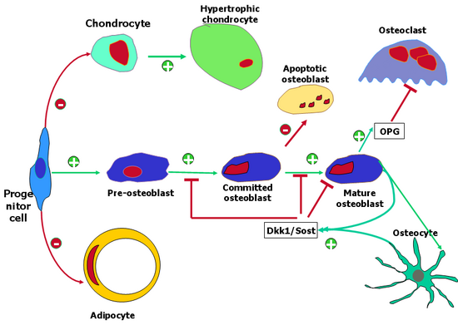

**Figure 1. Wnt signaling determines the cell fate of mesenchymal progenitor cells and regulates bone formation and resorption. The Wnt canonical pathway represses adipocyte differentiation and chondrocyte differentiation from progenitor cells, whereas it is required for the transition of chondrocytes to hypertrophy. In contrast, Wnt pathway activation promotes the osteoblast cell lineage by controlling proliferation, maturation, terminal differentiation, and bone formation. Differentiated osteoblasts and/or osteocytes produce Wnt inhibitors such as Dickkopf (Dkk1) and sclerostin (Sost) proteins as a negative feedback control of osteoblast differentiation and function. Wnt signaling also induces osteoblasts to produce more osteoprotegerin (OPG), increasing the ratio of OPG to receptor activator of NF-κB ligand (RANKL) to decrease osteoclast differentiation and bone resorption.**

Osteocyte morphology varies according to cell age and functional activity. A young osteocyte has most of the ultrastructural characteristics of the osteoblast from which it was derived, except that there has been a decrease in cell volume and in the importance of the organelles involved in protein synthesis (rough endoplasmic reticulum, Golgi). An older osteocyte, located deeper within the calcified bone, shows a further decrease in cell volume and organelles, and an accumulation of glycogen in the cytoplasm. These cells synthesize small amounts of new bone matrix at the surface of the osteocytic lacunae, which can subsequently calcify. Osteocytes express, in low levels, a number of osteoblast markers, including osteocalcin, osteopontin, osteonectin and the osteocyte marker E11.

Osteocytes have numerous long cell processes rich in microfilaments, which are in contact with cell processes from other osteocytes (there are frequent gap junctions), or with processes from the cells lining the bone surface (osteoblasts or flat lining cells). These processes are organized during the formation of the matrix and before its calcification; they form a network of thin canaliculi permeating the entire bone matrix. Osteocytic canaliculi are not distributed evenly around the cell, but are mainly directed toward the bone surface. Between the osteocyte's plasma membrane and the bone matrix itself is the periosteocytic space. This space exists both in the lacunae and in the canaliculi, and it is filled with extracellular fluid (ECF), the only source of nutrients, cytokines and hormones for the osteocyte. ECF flow through the canalicular network is altered during bone matrix compression and tension and is believed not only to allow exchanges with the extracellular fluids in the surrounding tissues but also to create shear forces that are directly involved in mechanosensing and regulation of bone remodeling. Current understanding of mechanotransduction is based upon the presence of a mechanosensing cilium at the level of the osteocyte’s cell body, capable of detecting the changes in fluid flow determined by mechanical loading of bone. In turn, the activation of the mechanosensing cilium may determine the local concentration of cytokines capable of regulating bone formation and/or bone resorption, such as RANKL, OPG or sclerostin (see below).

Indeed, given the structure of the network and the location of osteocytes within lacunae where ECF flow can be detected, it is likely that osteocytes respond to bone tissue strain and influence bone remodeling activity by recruiting osteoclasts to sites where bone remodeling is required. Osteocyte cellular activity is increased after bone loading; studies in cell culture have demonstrated increased calcium influx and prostaglandin production by osteocytes after mechanical stimulation, but there is no direct evidence for osteocytes signaling to cells on the bone surface in response to bone strain or microdamage to date. Osteocytes can become apoptotic and their programmed cell death may be one of the critical signals for induction of bone remodeling. Ultimately, the fate of the osteocyte is to be phagocytosed and digested together with the other components of bone during osteoclastic bone resorption. The recent ability to isolate and culture osteocytes, as well as the creation of immortalized osteocytic cell lines now allows the study of these cells at the molecular level and this is expected to significantly further our understanding of their role in bone biology and disease.(5) In particular, the discoveries that osteocytes can secrete the Wnt antagonist sclerostin and that this secretion is inhibited both by PTH treatment and by mechanical loading establishes the first direct link between biomechanics, endocrine hormones, bone formation and osteocytes. Similarly, osteocytes can secrete RANKL and OPG, contributing also to the regulation of bone resorption. Thus, osteocytes are emerging as the critical cell type linking mechanical forces in bone to the regulation of bone mass and shape through remodeling.

**THE OSTEOBLAST AND BONE FORMATION**

The osteoblast is the bone lining cell responsible for the production of the bone matrix constituents, collagen and non-collagenous proteins (Figure 2). Osteoblasts never appear or function individually but are always found in clusters of cuboidal cells along the bone surface (~100–400 cells per bone-forming site).

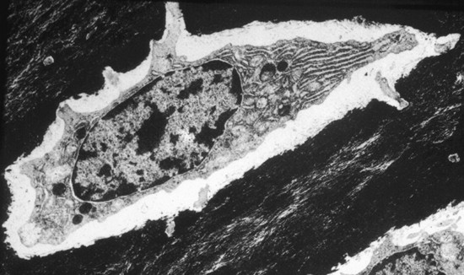

**Figure 2. Osteocyte. Electron micrograph of an osteocyte within a lacuna in calcified bone matrix. The cell has a basal nucleus, cytoplasmic extensions, and well-developed Golgi and endoplasmic reticulum.**

Osteoblasts do not operate in isolation and gap junctions are often found between osteoblasts working together on the bone surface. Osteoblasts also appear to communicate with the osteocyte network within the bone matrix (see above), since cytoplasmic processes on the secreting side of the osteoblast extend deep into the osteoid matrix and are in contact with processes of the osteocytes dwelling there.

At the light microscope level, the osteoblast is characterized morphologically by a round nucleus at the base of the cell (away from the bone surface), an intensely basophilic cytoplasm, and a prominent Golgi complex located between the nucleus and the apex of the cell. Osteoblasts are always found lining the layer of bone matrix that they are producing, but before it is calcified (osteoid tissue). Osteoid tissue exists because of a time lag of approximately 10 days between matrix formation and its subsequent calcification. Behind the osteoblast can usually be found one or two layers of cells: activated mesenchymal cells and preosteoblasts (see below). A mature osteoblast does not divide.

At the ultrastructural level, the osteoblast is characterized by the presence of a well-developed rough endoplasmic reticulum with dilated cisternae and a dense granular content, and the presence of a large circular Golgi complex comprising multiple Golgi stacks. These organelles are involved in the major activity of the osteoblast: the production and secretion of collagenous and non-collagenous bone matrix proteins, including type I collagen. Osteoblasts also produce a range of growth factors under a variety of stimuli, including the insulin-like growth factors (IGFs), platelet-derived growth factors (PDGFs), basic fibroblast growth factor (bFGF), transforming growth factor-beta (TGFβ), a range of cytokines, the bone morphogenetic proteins (BMPs and Wnts.(3) Osteoblast activity is regulated in an autocrine and paracrine manner by these growth factors, whose receptors can be found on osteoblasts, as well as receptors for a range of endocrine hormones. Classic endocrine receptors include receptors for parathyroid hormone/ parathyroid hormone related protein receptor, thyroid hormone, growth hormone, insulin, progesterone and prolactin. Osteoblastic nuclear steroid hormone receptors include receptors for estrogens, androgens, vitamin D 3 and retinoids. Receptors for paracrine and autocrine effectors include those for epidermal growth factor (EGF), IGFs, PDGF, TGFβ, interleukins, FGFs, BMPs and Wnts (LRP5/6 and Frizzled) (6,7) Osteoblasts also have receptors for several adhesion molecules (integrins) involved in cell attachment to the bone surface.

Among the cytokines secreted by the osteoblast are the main regulators of osteoclast differentiation, i.e. M-CSF, RANKL and osteoprotegerin (OPG) (8,9). M-CSF is essential in inducing the commitment of monocytes to the osteoclast lineage whereas RANKL promotes the differentiation and activity of osteoclasts (see below).

Osteoblasts originate from local pluripotent mesenchymal stem cells, either bone marrow stromal stem cells (endosteum) or connective tissue mesenchymal stem cells (periosteum). These precursors, with the right stimulation, undergo proliferation and differentiate into preosteoblasts, at which point they are committed to differentiate into mature osteoblasts.

The committed preosteoblast is located in apposition to the bone surface, and usually present in layers below active mature osteoblasts. They are elliptical cells, with an elongated nucleus, and are still capable of proliferation. Preosteoblasts lack the well-developed protein synthesizing capability of the mature osteoblast, and do not have the characteristically localized, mature rough endoplasmic reticulum or Golgi apparatus of the mature cell.

The development of the osteoblast phenotype is gradual, with a defined sequence of gene expression and cell activity during development and maturation, controlled by a sequence of transcription factors and cytokines (Figure 3).

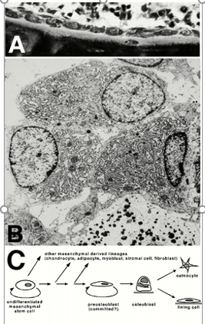

**Figure 3. Osteoblasts and Osteoid Tissue. A: Light micrograph of a group of osteoblasts producing osteoid; note the newly embedded osteocyte. B: Electron micrograph of 3 osteoblasts covering a layer of mineralizing osteoid tissue. Note the prominent Golgi and endoplasmic reticulum characteristic of active osteoblasts. The black clusters in the osteoid tissue are deposits of mineral. C: Osteoblast Lineage. Osteoblasts originate from undifferentiated mesenchymal cells which are capable of proliferation and which may differentiate into one of a range of cell types. The preosteoblast is also capable of proliferation and may be already committed to an osteoblast phenotype. The mature osteoblast no longer proliferates, but can differentiate further into an osteocyte once embedded in the bone matrix, or to a lining cell on the bone surface.**

Two transcription factors, Runx2 and Osterix (Osx), which is downstream of Runx2, are absolutely required for osteoblast differentiation. Runx2 is expressed in mesenchymal condensations and chondrocytes, in addition to osteoblasts. Runx2 target genes include several genes expressed by the mature osteoblast including osteocalcin, bone sialoprotein, osteopontin and collagen a1(I), as well as the Runx2 gene itself. Osx may be mostly important for pushing precursors cells away from the chondrocyte and into the osteoblast lineage.

The most important breakthrough in the understanding of the regulation of bone formation in recent years, is the finding of a clear link between LRP5, a co-receptor for Wnts, and bone mass in humans and in mice. Loss of function in LRP5 leads to the Osteoporosis Pseudo-Glioma syndrome (OPPG), with extremely low bone mass, whereas gain of function leads to the High Bone Mass (HBM) phenotype in humans. In addition, deletion mutations in the gene encoding sclerostin (Sost), another endogenous inhibitor of the Wnt pathway, also lead to osteosclerotic phenotypes (Sclerosteosis, Van Buchem syndrome).(7) These findings have opened a whole new field of investigation both in terms of understanding the mechanism that regulate osteoblasts and their bone-matrix secreting activity and in terms of drug discovery in the hope to target one component of the Wnt signaling pathway and thereby increase bone mass in osteoporotic patients. Of note, in 2019, the FDA approved romosozumab, a monoclonal antibody to sclerostin, for the treatment of postmenopausal women with osteoporosis at high risk for fracture.

Toward the end of the matrix secreting period, a further step is involved in osteoblast maturation. Approximately 15% of the mature osteoblasts become encapsulated in the new bone matrix and differentiate into osteocytes. In contrast, some cells remain on the bone surface, becoming flat lining cells.

**Mechanism of Bone Formation**

Bone formation occurs by three coordinated processes: the production of osteoid matrix, its maturation, and the subsequent mineralization of the matrix. In normal adult bone, these processes occur at the same rate, so that the balance between matrix production and mineralization is equal. Initially, osteoblasts deposit collagen rapidly, without mineralization, producing a thickening osteoid seam. This is followed by an increase in the mineralization rate to equal the rate of collagen synthesis. In the final stage, the rate of collagen synthesis decreases, and mineralization continues until the osteoid seam is fully mineralized. This time lag (termed the mineralization lag time or osteoid maturation period) appears to be required for osteoid to be modified so it is able to support mineralization. While this delay is not yet understood, it is likely that either collagen cross-linking occurs or an inhibitor of mineralization, such as matrix gla protein, is removed during this time, thus allowing mineralization to proceed.

To initiate mineralization in woven bone, or in growth plate cartilage, high local concentrations of Ca2+ and PO43- ions must be reached in order to induce their precipitation into amorphous calcium phosphate, leading to hydroxyapatite crystal formation. This is achieved by membrane-bound matrix vesicles, which originate by budding from the cytoplasmic processes of the chondrocyte or the osteoblast and are deposited within the matrix during its formation. In the matrix, these vesicles are the first structure wherein hydroxyapatite crystals are observed. The membranes are very rich in alkaline phosphatases and in acidic phospholipids, which hydrolyze inhibitors of calcification in the matrix including pyrophosphate and ATP allowing condensation of apatite crystals. Once the crystals are in the matrix environment, they will grow in clusters which later coalesce to completely calcify the matrix, filling the spaces between and within the collagen fibers. In adult lamellar bone, matrix vesicles are not present, and mineralization occurs in an orderly manner through progression of the mineralization front into the osteoid tissue.

**THE OSTEOCLAST AND BONE RESORPTION**

The osteoclast is the bone lining cell responsible for bone resorption (Figure 4). The osteoclast is a giant multinucleated cell, up to 100mm in diameter and containing four to 20 nuclei. It is usually found in contact with a calcified bone surface and within a lacuna (Howship's lacunae) that is the result of its own resorptive activity. It is possible to find up to four or five osteoclasts in the same resorptive site, but there are usually only one or two. Under the light microscope, the nuclei appear to vary within the same cell: some are round and euchromatic, and some are irregular in contour and heterochromatic, possibly reflecting asynchronous fusion of mononuclear precursors. The cytoplasm is "foamy" with many vacuoles. The zone of contact with the bone is characterized by the presence of a ruffled border with dense patches on each side (the sealing zone).

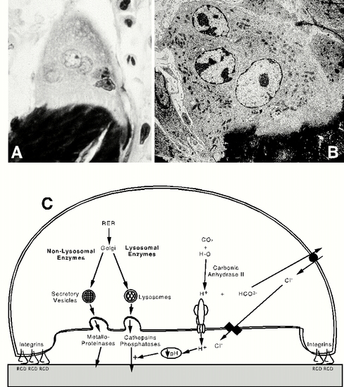

**Figure 4. Osteoclasts and the Mechanism of Bone Resorption. A: Light micrograph and B: electron micrograph of an osteoclast, demonstrating the ruffled border and numerous nuclei. C: Osteoclastic resorption. The osteoclast forms a sealing zone via integrin mediated attachment to specific peptide sequences within the bone matrix, forming a sealed compartment between the cell and the bone surface. This compartment is acidified such that an optimal pH is reached for lysosomal enzyme activity and bone resorption.**

Characteristic ultrastructural features of this cell are abundant Golgi complexes around each nucleus, mitochondria, and transport vesicles loaded with lysosomal enzymes. The most prominent features of the osteoclast are, however, the deep foldings of the plasma membrane in the area facing the bone matrix (ruffled border) and the surrounding zone of attachment (sealing zone). The sealing zone is formed by a ring of focal points of adhesion (podosomes) with a core of actin and several cytoskeletal and regulatory proteins around it, that attach the cell to the bone surface, thus sealing off the subosteoclastic bone-resorbing compartment. The attachment of the cell to the matrix is performed via integrin receptors, which bind to specific RGD (Arginine-Glycine-Aspartate) sequences found in matrix proteins (see Table 1). The plasma membrane in the ruffled border area contains proteins that are also found at the limiting membrane of lysosomes and related organelles, and a specific type of electrogenic vacuolar proton ATPase involved in acidification. The basolateral plasma membrane of the osteoclast is specifically enriched in Na+, K+-ATPase (sodium pumps), HCO 3 - /Cl -exchangers, and Na+/H+ exchangers and numerous ion channels (10).

Lysosomal enzymes such as tartrate resistant acid phosphatase and cathepsin K are actively synthesized by the osteoclast and are found in the endoplasmic reticulum, Golgi, and many transport vesicles. The enzymes are secreted, via the ruffled border, into the extracellular bone-resorbing compartment where they reach a sufficiently high extracellular concentration because this compartment is sealed off. The transport and targeting of these enzymes for secretion at the apical pole of the osteoclast involves mannose-6-phosphate receptors. Furthermore, the cell secretes several metalloproteinases such as collagenase (MMP-13) and gelatinase B (MMP-9) which appear to be involved in preosteoclast migration to the bone surface as well as bone matrix digestion. Among the key enzymes being synthesized and secreted by the osteoclast is cathepsin K, an enzyme capable or degrading collagen at low pH and a target for inhibition of bone resorption. (11)

Attachment of the osteoclast to the bone surface is essential for bone resorption. This process involves transmembrane adhesion receptors of the integrin. Integrins attach to specific amino acid sequences (mostly RGD sequences) within proteins in or at the surface of the bone matrix. In the osteoclast, αvβ3 (vitronectin receptor), α2β1 (collagen receptor) and αvβ5 integrins are predominantly expressed. Without cell attachment the acidified microenvironment cannot be established and the osteoclast cannot be highly mobile, a functional property associated with the formation of podosomes.

After osteoclast adhesion to the bone matrix, αvβ3 binding activates cytoskeletal reorganization within the osteoclast, including cell spreading and polarization. In most cells, cell attachment occurs via focal adhesions, where stress fibers (bundles of microfilaments) anchor the cell to the substrate. In osteoclasts, attachment occurs via podosomes. Podosomes are more dynamic structures than focal adhesions, and occur in cells that are highly motile. It is the continual assembly and disassembly of podosomes that allows osteoclast movement across the bone surface during bone resorption. Integrin signaling and subsequent podosome formation is dependent on a number of adhesion kinases including the proto-oncogene src, which, while not required for osteoclast maturation, is required for osteoclast function, as demonstrated by osteopetrosis in the src knockout mouse. Pyk2, another member of the focal adhesion kinase family is also activated by αvβ3 during osteoclast attachment, and is required for bone resorption.(10) Several actin-regulatory proteins have also been shown to be present in podosomes and required for bone resorption, again pointing to the importance of integrin signaling and podosome assembly and disassembly in the function of osteoclasts. (12)

Osteoclasts resorb bone by acidification and proteolysis of the bone matrix and hydroxyapatite crystals encapsulated within the sealing zone. Carbonic anhydrase type II produces hydrogen ions within the cell, which are then pumped across the ruffled border membrane via proton pumps located in the basolateral membrane, thereby acidifying the extracellular compartment. The protons are highly concentrated in the cytosol of the osteoclast; ATP and CO2 are provided by the mitochondria. The basolateral membrane activity exchanges bicarbonate for chloride, thereby avoiding alkalization of the cytosol. K+ channels in the basolateral domain and Cl - channels in the apical ruffled border ensure dissipation of the electrogenic gradients generated by the vacuolar H+-ATPase The basolateral sodium pumps might be involved in secondary active transport of calcium and/or protons in association with a Na + /Ca 2+ exchanger and/or a Na+/H+ antiport. Genetic mutations in several of these components of the acidification and ion transport systems have been shown to be associated with osteopetrosis (defective bone resorption by osteoclasts) in humans and in mice.

The first process during bone matrix resorption is mobilization of the hydroxyapatite crystals by digestion of their link to collagen via the non-collagenous proteins and the low pH dissolves the hydroxyapatite crystals, exposing the bone matrix. Then the residual collagen fibers are digested by cathepsin K, now at optimal pH. The residues from this extracellular digestion are either internalized, or transported across the cell and released at the basolateral domain. Residues may also be released during periods of sealing zone relapse, as probably occurs during osteoclast motility, and possibly induced by a calcium sensor responding to the rise of extracellular calcium in the bone-resorbing compartment.

The regulation of bone resorption is mostly mediated by the action of hormones on stromal cells, osteoblasts and osteocytes. For example, PTH can stimulate osteoblastic production of M-CSF, RANKL, OPG or IL-6, which then act directly on the osteoclast (5,6).

**Origin and Fate of the Osteoclast (6)**

The osteoclast derives from cells in the mononuclear phagocyte lineage (Figure 5). Their differentiation requires the transcription factors PU-1 and MiTf at early stages, committing the precursors into the myeloid lineage. M-CSF is then required to engage the cells in the monocyte lineage and ensure their proliferation and the expression of the RANK receptor. At that stage, the cells require the presence of RANKL, a member of the TNF family of cytokines produced by stromal cells, to truly commit to the osteoclast lineage and progress in their differentiation program. This step also requires expression of TRAF6, NFκB, c-Fos and NFAT c1, all downstream effectors of RANK signaling. Although this differentiation occurs at the early promonocyte stage, monocytes and macrophages already committed to their own lineage might still be able to form osteoclasts under the right stimuli. Despite its mononuclear phagocytic origin, the osteoclast membrane express distinct markers: it is devoid of Fc and C 3 receptors, as well as of several other macrophage markers; like mononuclear phagocytes, however, the osteoclast is rich in nonspecific esterases, synthesizes lysozyme, and expresses CSF-1 receptors. Monoclonal antibodies have been produced that recognize osteoclasts but not macrophages. The osteoclast, unlike macrophages, also expresses, millions of copies of the RANK, calcitonin, and vitronectin (integrin αvβ3) receptors. Whether it expresses receptors for parathyroid hormone, estrogen, or vitamin D is still controversial. Dendritic cell-specific transmembrane protein (DC-STAMP) is currently considered to be the master regulator of osteoclastogenesis. Knock out of DC-STAMP completely abrogates cell-cell fusion during osteoclastogenesis; osteoclasts isolated from DC-STAMP knock-out mice are mononucleated. (13) Another important factor involved in cell fusion is Pin 1, an enzyme that specifically recognizes the peptide bond between phosphorylated serine or threonine and proline. Pin 1 regulates cell fusion during osteoclastogeneis by suppressing DC-STAMP. (14,15) Recent evidence suggest that the osteoclast undergoes apoptosis after a cycle of resorption, a process favored by estrogens, possibly explaining the increased bone resorption after gonadectomy or menopause.

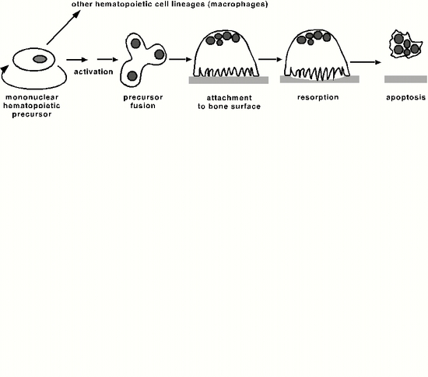

**Figure 5. Osteoclast Life Cycle. The osteoclast is derived from a mononuclear hematopoietic precursor cell which, upon activation, fuses with other precursors to form a multinucleated osteoclast. The osteoclast first attaches to the bone surface then commences resorption. After a cycle of bone resorption, the osteoclast undergoes apoptosis.**

**Relations to the Immune System (Osteoimmunology)**

In the last few years it has been recognized that, in part due to the link between the osteoclast, macrophages and dendritic cells (all three belong to the same cell lineage), osteoclasts are regulated by and share regulatory mechanisms with cells of the immune system. For instance, T cells can produce locally RANKL, activating osteoclastogenesis. B cells may share a common precursor with and regulate osteoclast precursors. RANKL signaling and “immunoreceptor tyrosine-based activation motif” (ITAM) signals cooperate in osteoclastogenesis (16).

**BONE REMODELING**

Bone remodeling is the process by which bone is turned over; it is the result of the activity of the bone cells at the surfaces of bone, mainly the endosteal surface (which includes all trabecular surfaces). Remodeling is traditionally classified into two distinct types: Haversian remodeling within the cortical bone and endosteal remodeling along the trabecular bone surface. This distinction is more morphological than physiological because the Haversian surface is an extension of the endosteal surface and the cellular events during these two remodeling processes follow exactly the same sequence.

**The Remodeling Sequence**

Bone formation and bone resorption do not occur along the bone surface at random: they are coordinated as part of the turnover mechanism by which old bone is replaced by new bone, providing an opportunity to change the shape, architecture or density of the skeleton. In the normal adult skeleton, bone formation only occurs, for the most part, where bone resorption has already occurred. This basic principle of cellular activity at the remodeling site constitutes the Activation-Resorption-Reversal-Formation (ARRF) sequence (Figure 6).

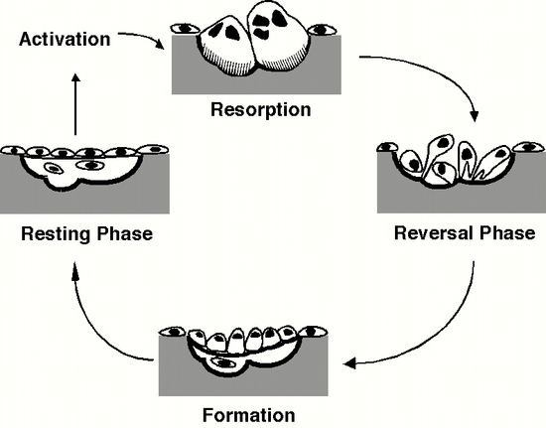

**Figure 6. The Bone Remodeling Sequence. The Activation-Resorption-Reversal-Formation cycle of bone remodeling as it occurs in trabecular bone. See text for details.**

Under some signal, today considered to emanate from osteocytes, a locally acting factor released by lining cells, osteocytes, marrow cells, or in response to bone deformation or fatigue-related microfracture, a group of preosteoclasts are activated. These mononuclear cells attach to the bone via αvβ3 integrins and fuse to form a multi-nucleated osteoclast which will, in a definite area of the bone surface, resorb the bone matrix. After resorption of the bone, and osteoclast detachment, uncharacterized mononuclear cells cover the surface and a cement line is formed. The cement line marks the limit of bone resorption, and acts to cement together the old and the new bone. This is termed the reversal phase, and is followed by a period of bone formation. Preosteoblasts are activated, proliferate and differentiate into osteoblasts, which move onto the bone surface, forming an initial matrix (osteoid), which becomes mineralized after a time lag (the osteoid maturation period). The basic remodeling sequence is therefore Activation-Resorption-Formation; it is performed by a group of cells called the Basic Multicellular Unit (BMU). The complete remodeling cycle takes about 3 months in humans (Figure 7).

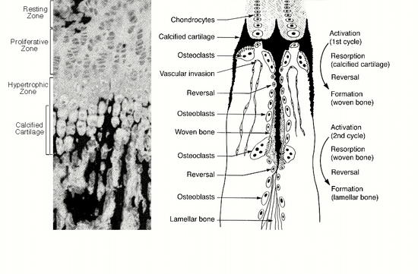

**Figure 7. Bone Growth and Remodeling at the Growth Plate. The light micrograph demonstrates the zones of chondrocyte differentiation, as well as mineralization (black). The schematic representation shows the cellular events occurring at the growth plate in long bones. Note that bone formation in this process occurs by repeated Activation-Resorption-Formation cycles of bone remodeling beginning with the calcified cartilage matrix.**

For decades, the reversal phase of the remodeling cycle was the least well understood. It was recognized that during this phase, the resorption cavity was occupied by mononucleated cells, but the nature of these cells was unknown (17). Recent work by Delaisse and colleagues (18) has definitively identified the reversal cells as belonging to the osteogenic lineage, expressing classic osteoblast markers: Runx2, ALP, and Col3. By applying immunocytochemistry and histomorphometry to femur and fibula samples harvested from teenagers and adults, these investigators have provided a much more complete picture of the temporal sequence of cellular events that occur between the start of resorption and the onset of formation. In order to visualize the entire sequence of events, they analyzed longitudinal sections of evolving Haversian systems. They observed osteoclasts at two distinct locations: at the cutting cone (referred to as primary osteoclasts) and close to the reversal cells (referred to as secondary osteoclasts). The presence of secondary osteoclasts in the reversal phase suggests that bone resorption continues during this phase, which has been renamed the resorption-reversal phase. The authors have concluded that the primary osteoclasts are responsible for drilling the tunnel (initial resorption) and the secondary osteoclasts work to increase its diameter by radial resorption. This radial resorption was shown to be a major contributor to the overall amount of bone resorbed in each BMU. This new and more complete model of the resorption-reversal phase will lead to enhanced understanding of the delicate and all-important balance between resorption and formation (Figure 8).

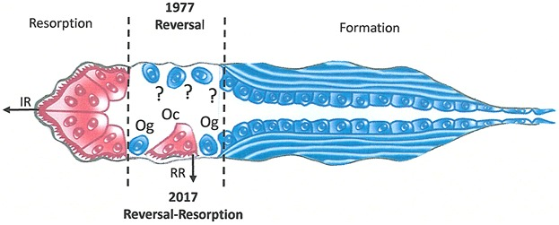

**Figure 8. Cartoon of a bone remodeling unit in cortical bone, showing the change in the designation of the reversal phase as a result of recent new findings. IR = initial resorption; RR = radial resorption; Og = osteoprogenitor cell; Oc = osteoclast. (17)**

For many years it has been accepted that bone resorption and formation are coupled in the same way that bone matrix formation and calcification are linked. In other words, in the normal adult skeleton, the coupling of bone resorption and formation in remodeling results in equal levels of cellular activity so that bone turnover is balanced: the volume of bone resorbed is equal to the volume formed. This paradigm implies that, for example, a reduction in osteoblast activity would affect a similar reduction in osteoclast activity such that bone volume is maintained. Conversely, an increase in osteoclast activity should be compensated by an increase in osteoblasts and bone formation, resulting in a maintained bone mass with a high turnover, as in hyperparathyroidism for instance. Similarly, decreased osteoclast numbers or bone resorption activity should be associated with a decrease in bone formation, maintaining bone mass but with a decreased turnover rate.

Although this “coupling” may indeed function in most cases, there are multiple examples of dysfunctions, such as in osteoporosis or osteopetrosis for instance. It now appears that the number of osteoclasts rather than their strict activity is a key determinant of subsequent bone formation. This suggests that factors generated locally by the osteoclast, either directly or through resorption of the bone matrix, are capable of stimulating bone formation (19).

**Haversian vs Endosteal Bone Remodeling**

As previously mentioned, although cortical bone is anatomically different to trabecular bone, its remodeling occurs following the same sequence of events. The major difference is that while the average thickness of a trabecula is 150-200 microns, the average thickness of the cortex is of the order of 1-10 mm. There are no blood vessels in the trabeculae but the bone envelope system and the osteocyte network are able to carry out enough gaseous exchange, being always relatively close to the surface and the highly vascularized marrow. Consequently, bone remodeling in the trabecular bone will take place along the trabecular surface. On the other hand, the cortical bone itself needs to be vascularized. Blood vessels are first embedded during the histogenesis of cortical bone; the blood vessel and the bone which surrounds it is then called a primary osteon. Later, cortical bone remodeling will be initiated either along the surface of these vascular channels, or from the endosteal surface of the cortex. The remodeling process in cortical bone also follows the ARF sequence. Osteoclasts excavate a tunnel, creating a cutting cone. Again, there is a reversal phase, where mononuclear cells attach and lay down a cement line. Osteoblasts are then responsible for closing the cone, leaving a central canal, centered on blood vessels and surrounded by concentric bone lamellae. For mechanical reasons, all these Haversian systems are oriented along the longitudinal axis of the bone.

**Bone Turnover and Skeletal Homeostasis**

In a normal young adult, about 30% of the total skeletal mass is renewed every year (half-life = 20 months). In each remodeling unit, osteoclastic bone resorption lasts about 3 days, the reversal 14 days, and bone formation 70 days (total = 87 days). The linear bone formation rate is 0.5mm/day. During this process, about 0.01mm of bone is renewed in one given remodeling unit. Theoretically, with balanced matrix deposition and calcification as well as a balance between osteoclast and osteoblast activity, the amount of bone formed in each remodeling unit (and therefore in the total skeleton) equals the amount of bone which was previously resorbed. Thus, the total skeletal mass remains constant. This skeletal homeostasis relies upon a normal remodeling activity. The rate of activation of new remodeling units would then determine only the turnover rate.

**SKELETAL DEVELOPMENT-HISTOGENESIS**

Bone development is achieved through the use of two distinct processes, intramembranous and endochondral bone formation. In the first, mesenchymal cells differentiate directly into osteoblasts whereas in the second mesenchymal cells differentiate into chondrocytes and it is only secondarily that osteoblasts appear and form bone around the cartilage model. Through a process that involves bone resorption by osteoclasts, vascular invasion and resorption of calcified cartilage, the cartilage model is progressively replaced by osteoblast-derived bone matrix. Bone is then remodeled through continuous cycles of bone resorption and formation, thereby allowing shape changes and adaptation to the local and systemic environment.

**Intramembranous Ossification**

During intramembranous ossification, a group of mesenchymal cells within a highly vascularized area of the embryonic connective tissue proliferates, forming early mesenchymal condensations within which cells differentiate directly into osteoblasts. Bone Morphogenetic Proteins, as well as FGFs appear to be essential in the process of mesenchymal cell condensation. The newly differentiated osteoblasts will synthesize a woven bone matrix, while at the periphery, mesenchymal cells continue to differentiate into osteoblasts. Blood vessels are incorporated between the woven bone trabeculae and will form the hematopoietic bone marrow. Later this woven bone will be remodeled through the classical remodeling process, resorbing woven bone and progressively replacing it with mature lamellar bone.

**Endochondral Ossification**

Development of long bones begins with the formation of a cartilage anlage (model) from a mesenchymal condensation, as in intramembranous ossification. (Figure 9). But here, under the influence of a different set of factors and local conditions, mesenchymal cells undergo division and differentiate into prechondroblasts and then into chondroblasts rather than directly into osteoblasts. These cells secrete the cartilaginous matrix, where the predominant collagen type is collagen type II. Like osteoblasts, the chondroblasts become progressively embedded within their own matrix, where they lie within lacunae, and they are then called chondrocytes. Unlike osteocytes however, chondrocytes continue to proliferate for some time, this being allowed in part by the gel-like consistency of cartilage. At the periphery of this cartilage (the perichondrium), the mesenchymal cells continue to proliferate and differentiate through appositional growth. Another type of growth is observed in the cartilage by cell proliferation and synthesis of new matrix between the chondrocytes (interstitial growth).

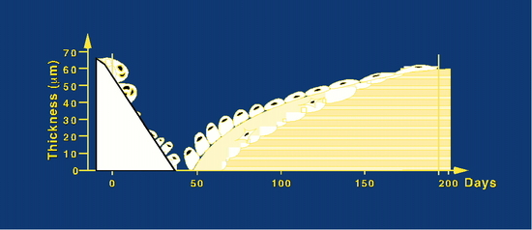

**Figure 9. Duration and depth of the phases of the normal cancellous bone remodeling sequence, calculated from histomorphometric analysis of bone biopsy samples from young individuals (Adapted from: Eriksen EF, Axelrod DW, Melsen F. Bone Histomorphometry. Raven Press, New York, pp13-20, 1994).**

Beginning in the center of the cartilage model, at what is to become the primary ossification center, chondrocytes continue to differentiate and become hypertrophic. During this process, hypertrophic cells deposit a mineralized matrix, where cartilage calcification is initiated by matrix vesicles. Once this matrix is calcified, it is partially resorbed by osteoclasts. After resorption and a reversal phase, osteoblasts differentiate in this area and form a layer of woven bone on top of the remaining cartilage. This woven bone will later be remodeled into lamellar bone.

Chondrocyte differentiation is regulated by a number of factors which have recently been described. The first factor shown to control chondrocyte differentiation was parathyroid hormone related peptide (PTHrP) acting on PTH receptors mostly found in prehypertrophic chondrocytes. This factor prolongs chondrocyte proliferation, and in PTHrP knockout mice, the main phenotype is bone shortening caused by premature chondrocyte hypertrophy. Targeted overexpression of PTHrP results in the opposite phenotype, with prolonged delay in chondrocyte maturation. PTHrP is part of a genetic signaling cascade, where not only is it regulated by factors expressed earlier in chondrocyte differentiation, such as Indian hedgehog (Ihh), but it also regulates chondrocyte differentiation itself, and alters gene expression in more mature chondrocytes. Other factors which regulate chondrocyte differentiation include the FGFs and bone morphogenetic proteins (BMPs). The transcription factors Runx2 and Sox9, together with the Wnt signaling pathway, control the commitment and differentiation within the chondrocytic lineage (20).

The embryonic cartilage is avascular. During its early development, a ring of woven bone is formed, the bone collar, at the periphery by intramembranous ossification in the future midshaft area under the perichondrium (which becomes periosteum). Following calcification of this woven bone, blood vessels, preceded by osteoclasts enter the primary ossification center, penetrate the bone collar and the calcified cartilage, to form the blood supply and allow seeding of the hematopoietic bone marrow. The osteoclast invasion and its concomitant wave of resorbing activity leads to the removal of the calcified cartilage and its replacement by woven bone in the primary spongiosa, as described above.

Secondary ossification centers begin to form at the epiphyseal ends of the cartilaginous model, and by a similar process, trabecular bone and a marrow space are formed. Between the primary and secondary ossification centers, epiphyseal cartilage (growth plates) remain until adulthood. The continued differentiation of chondrocytes, cartilage mineralization and subsequent remodeling cycles allow longitudinal bone growth to occur, such that as new bone is formed the bone will reach its final adult shape. There is, however, a progressive decrease in chondrocyte proliferation so that the growth plate becomes progressively thinner, allowing mineralization and resorption to catch up. It is at this point that the growth plates are completely remodeled and longitudinal growth is arrested.

The growth plate demonstrates, from the epiphyseal area to the diaphyseal area, the different stages of chondrocyte differentiation involved in endochondral bone formation (Figure 10). Firstly, a proliferative zone, where the chondroblasts divide actively, forming isogenous groups, and actively synthesizing the matrix. These cells become progressively larger, enlarging their lacunae in the pre-hypertrophic and hypertrophic zones. Lower in this area, the matrix of the longitudinal cartilage septa selectively calcifies (zone of provisional calcification). The chondrocytes become highly vacuolated and then die through programmed cell death (apoptosis). Once calcified, the cartilage matrix is resorbed, but only partially, by osteoclasts, leaving the calcified longitudinal septae and blood vessels appear in the zone of invasion. After resorption, osteoblasts differentiate and form a layer of woven bone on top of the cartilaginous remnants of the longitudinal septa. Thus, the first remodeling sequence is complete: the cartilage has been remodeled and replaced by woven bone. The resulting trabeculae are called the primary spongiosa. Still lower in the growth plate, this woven bone is subjected to further remodeling (a second ARF sequence) in which the woven bone and the cartilaginous remnants are replaced with lamellar bone, resulting in the mature trabecular bone called secondary spongiosum.

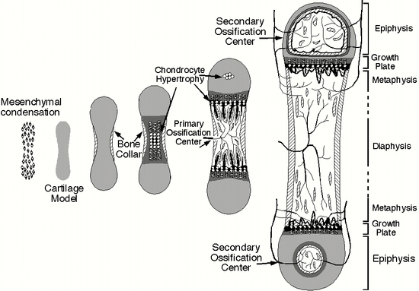

**Figure 10. Bone Development. Schematic diagram showing the initial stages of endochondral ossification. Bone development begins with mesenchymal condensation to form a cartilage model of the bone to be formed. Following chondrocyte hypertrophy and cartilage matrix mineralization, osteoclast activity and vascularization result in the formation of the primary, and then secondary ossification centers. In mature adult bones, the growth plate is fully resorbed, so that one marrow cavity extends the full length of the bone. See text for details.**

**GROWTH IN BONE SHAPE AND DIAMETER (MODELING)**

During longitudinal growth, and due to the fact that the midshaft is narrower than the metaphysis, the growth of a long bone progressively destroys the lower part of the metaphysis and transforms it into a diaphysis, a process accomplished by continuous resorption by osteoclasts beneath the periosteum.

In contrast, growth in the diameter of the metaphysis is the result of a deposition of new membranous bone beneath the periosteum that will continue throughout life. In this case, resorption does not immediately precede formation. Recently, more attention has been focusing on this type of bone formation inasmuch as periosteal bone formation seems to respond differently and/or independently from endosteal bone formation activity to different stimuli such as PTH or biomechanical loading. This is particularly important in the context of osteoporosis where it has been demonstrated that growth in diameter in the midshaft is a more important contributor to the decrease in the fracture risk than trabecular bone density and/or cortical thickness.

**REFERENCES**

1. Fukumoto S, Martin TJ. Bone as an endocrine organ. Trends Endocrinol Metab. 2009 Jul;20(5):230-6.

2. Zanatta LC, Boguszewski CL, Borba VZ, Kulak CA. Osteocalcin, energy and glucose metabolism. Arq Bras Endocrinol Metabol. 2014 Jul;58(5):444-51

3. Ahmed LA, Shigdel R, Joakimsen RM, Eldevik OP, Eriksen EF, Ghasem-Zadeh A, Bala Y, Zebaze R, Seeman E, Bjørnerem Å. Measurement of cortical porosity of the proximal femur improves identification of women with nonvertebral fragility fractures. Osteoporos Int. 2015 Aug;26(8):2137-46.

4. Robey P.G., Bone Matrix Proteoglycans and Glycoproteins, In Principles of Bone Biology, J.P. Bilezikian, L.G. Raisz and G.A. rodan Editors, Academic Press Publishers, Chapter 14, 225-238, 2002.

5. Bonewald L.F., Transforming Growth Factor-β, In Principles of Bone Biology, J.P. Bilezikian, L.G. Raisz and G.A. rodan Editors, Academic Press Publishers, Chapter 49, 903-918, 2002.

6. Harada S. and Rodan G.A., Control of osteoblast function and regulation of bone mass, Nature 423, 349-355, 2003.

7. Baron R. and Rawadi G., Targeting the Wnt/β-catenin Pathway to Regulate Bone Formation in the Adult Skeleton, Endocrinology 148, 2635-43.

8. Boyle W.J., Simonet W.S., Lacey D.L., Osteoclast differentiation and activation, Nature 423, 337 – 342, 2003.

96. Asagiri M. and Takayanagi H., The molecular understanding of osteoclast differentiation, Bone, 40:251-264, 2007.

10. Teitelbaum, S.L. & Ross, F.P., Genetic regulation of osteoclast development and function, Nature Reviews Genetics, 4, 638-649, 2003

11. Bruzzaniti A. and Baron R. Molecular regulation of osteoclast activity. Rev. Endocr. Metab. Disord. 2007, 7:123-39.

12. Destaing O., Saltel F., Geminard J.C., Jurdic P. and Bard F. Podosomes display actin turn-over and dynamic self-organization in osteoclasts expressing actin-GFP. Mol. Biol. Cell, 14, 407-416, 2003.

13. Courtial N, Smink JJ, Kuvardina ON, Leutz A, Göthert JR, Lausen J. Tal1 regulates osteoclast differentiation through suppression of the master regulator of cell fusion DC-STAMP. FASEB J. 2012 Feb;26(2):523-32.

14. Islam R, Bae HS, Yoon WJ, Woo KM, Baek JH, Kim HH, Uchida T, Ryoo HM. Pin1 regulates osteoclast fusion through suppression of the master regulator of cell fusion DC-STAMP. J Cell Physiol. 2014 Dec;229(12):2166-74.

15. Islam R, Yoon WJ, Ryoo HM. Pin1, the Master Orchestrator of Bone Cell Differentiation. J Cell Physiol. 2017 Sep;232(9):2339-2347.

16. Takayanagi H., Osteoimmunology: shared mechanisms and crosstalk between the immune and bone systems, Nature Reviews Immunology 7, 292 – 304, 2007.

17. Dempster DW. Tethering Formation to Resorption: Reversal Revisited. J Bone Miner Res. 2017 Jul;32(7):1389-1390.

18. Lassen NE, Andersen TL, Pløen GG, Søe K, Hauge EM, Harving S, Eschen GET, Delaisse JM. Coupling of Bone Resorption and Formation in Real Time: New Knowledge Gained From Human Haversian BMUs. J Bone Miner Res. 2017 Jul;32(7):1395-1405.

19. Sims NA, Martin TJ. Coupling Signals between the Osteoclast and Osteoblast: How are Messages Transmitted between These Temporary Visitors to the Bone Surface? Front Endocrinol (Lausanne). 2015 Mar 24; 6:41.

20.. Kronenberg H.M., Developmental regulation of the growth plate, Nature 332-336, 2003.