**AUTOIMMUNE POLYGLANDULAR SYNDROMES**

**MARK A SPERLING,** Professorial Lecturer, Division of Pediatric Endocrinology and Diabetes, Icahn School of Medicine at Mount Sinai, New York, NY 10029, Emeritus Professor and Chair, Department of Pediatrics, University of Pittsburgh

**MABEL YAU,** Assistant Professor of Pediatrics, Division of Pediatric Endocrinology and Diabetes, Icahn School of Medicine at Mount Sinai, New York, NY 10029

Received 27 October 2017

## ABSTRACT

The autoimmune polyglandular syndromes are clusters of endocrine abnormalities that occur in discreet patterns in subjects with immune dysregulation and that permit treatment and anticipation of associated systemic or other hormonal deficiencies. Three major entities are recognized, APS1, APS2 and APS3. An additional category occurs in patients treated with immunoregulatory agents for cancer, by which the tumor’s blockade of immune regulatory checkpoints is inhibited, so that tumor antigens that have evaded recognition can now be attacked, but at the expense of activating autoimmunity. APS1 is a syndrome characterized by chronic muco-cutaneous candidiasis, hypoparathyroidism, and primary adrenal insufficiency, as well as ectodermal dystrophy and a host of other endocrine and non-endocrine tissue involvement in autoimmune destructive processes. The underlying cause is homozygous inactivating mutation in the autoimmune regulator gene *AIRE* which permits the intra-thymic expression of ectopic antigens normally expressed only in specific peripheral tissues (e.g. insulin), so that T-cells as they mature within the thymus and acquire a receptor for the self-antigen are eliminated (negative selection), thereby avoiding autoimmunity. Recent studies demonstrate that in addition to the classical homozygous mutations, single gene dominant mutations in *AIRE* play an important role in autoimmune regulation and its disorders. APS2 and APS3 are both due to mutations in the HLA DQ/DR regions which regulate antigen presentation to T-cell receptors; APS2 is characterized by T1DM, Addison Disease, and Hypothyroidism, whereas APS3 is similar but without Addison disease. In keeping with other autoimmune disorders, these entities are more frequent in females, whereas APS1 has no sexual predominance. The recent emergence of autoimmune endocrinopathies in patients treated with immunoregulatory agents for cancer adds a new dimension to considerations of autoimmune polyendocrinopathy syndromes.

## AUTOIMMUNE POLYGLANDULAR SYNDROMES

The autoimmune polyglandular syndromes are clusters of endocrine abnormalities that occur in discreet patterns in subjects with immune dysregulation and that permit treatment and anticipation of associated systemic or other hormonal deficiencies. [1-8] Three major entities are recognized, APS1, APS2 and APS3. An additional category occurs in patients treated with immunoregulatory agents for cancer, by which the tumor’s blockade of immune regulatory checkpoints is inhibited, so that tumor antigens that have evaded recognition can now be attacked, but at the expense of activating autoimmunity.

APS1 results from a failure to eliminate T-cells that have acquired receptors to auto-antigens, as these T-cells mature and traverse the thymic epithelium during their development. Normally, such T-cells are prevented from entering the periphery because of the ectopic expression of multiple antigens within the thymus that usually are expressed only in discrete tissues, e.g. insulin in pancreatic β-cells. A developing T-cell that acquires and expresses a receptor for insulin will be bound to the ectopically expressed insulin antigen within the thymus, undergo apoptosis and be excluded from entering the periphery to initiate auto-immunity (Fig1). This ectopic expression of antigens within the thymus is mediated by the **A**uto-**I**mmune **RE**gulator gene (*AIRE*) located on chromosome 21. Discovered in 1997 as the gene whose variable inactivation is responsible for the clinical entity APS1 [1, 2, 4, 6], this gene is now known to be an essential component of the adaptive immune response cascade, and the spectrum of disorders ascribed to mutations in this gene extend beyond the APS1 syndrome. [2, 4] Moreover, although APS1 is a rare entity with predilection for particular populations, the increased incidence of autoimmunity in persons with trisomy 21, a relatively common genetic abnormality, may be due to abnormal function of the AIRE gene. [9] In addition, it is becoming apparent that mutations in AIRE can have autosomal dominant effects and become manifest as autoimmune disorders later in life in patterns that differ from the classical APS1. [2, 4] Since the incidence of such autosomal mutations may be as high as 1:1000, whereas the incidence of APS1 is much rarer (1:9000 in Iranian Jews; 1:14500 in Sardinia; 1:25000 in Finland), the influence of the *AIRE* gene on autoimmune processes and diseases may be far wider than hitherto appreciated, especially since Treg cells (regulatory T cells) also are now implicated in the abnormalities induced by AIRE deficiency. [2, 4] Both T-cell and B-cell abnormalities are observed in APS1, so that circulating antibodies to various hormonal, connective tissues, and protein antigens such as enzymes in the steroidogenic or thyroid synthesis cascades are evident in the serum of affected patients with APS1, and indeed in all forms of the autoimmune polyglandular syndromes. Figure 1 summarizes these concepts.

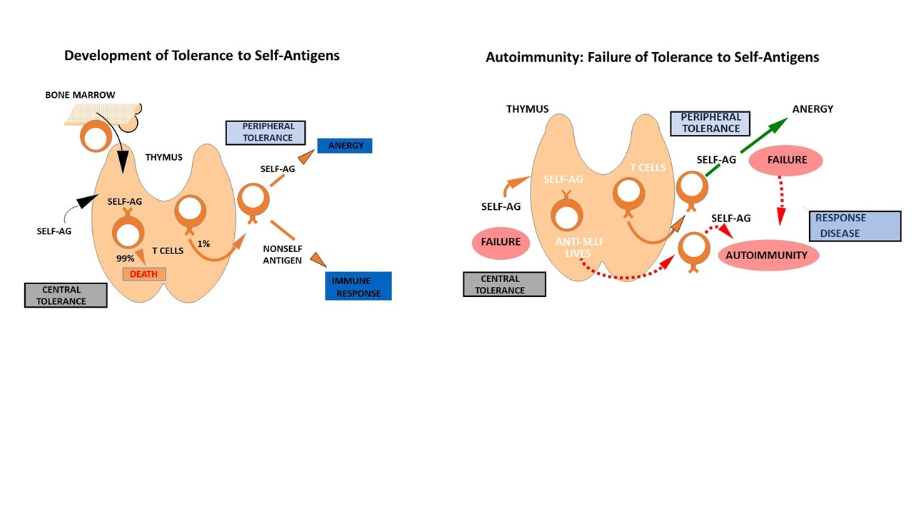

**Legend to Figure1.**

Left panel: Modified from *Autoimmune Polyglandular Syndromes* in Pediatric Endocrinology 4th Edition, Ed. Sperling MA. (with permission of the authors Drs. Michael Haller, William Winter, Desmond Schatz) A developing T-cell migrates from its origins in the bone marrow to the thymus where it acquires its repertoire of receptors. The expression of self-antigens, including ectopic expression of antigens mediated via the *AIRE* gene, results in apoptosis of the T-cell possessing the complementary receptor, and prevention of the T-cell entering the periphery, a fate of almost all T-cells. A small fraction of T-cells do enter the periphery where they remain anergic to self-antigens, but can mount an immune response to non-self-antigens.

Right panel: Failure of self-tolerance, due to non-expression of self-antigens as would occur with inactivating mutations of the *AIRE* gene, results in failure of central tolerance as well as failure of recognition of self-antigens that leads to an auto-immune response.

APS2 is characterized by the triad of type1 diabetes, adreno-cortical insufficiency, and hypothyroidism as a result of autoimmunity to components of the pancreatic β-cell, adrenal cortex and thyroid synthesizing machinery. APS3 is essentially identical to APS2 except that adreno-cortical insufficiency is absent. This similarity has led some investigators to label the former as APS2a and the latter as APS2b. Whereas APS2a is rare, APS2b is relatively common, as approximately 20% of patient s with T1DM harbor circulating antibodies to thyroid synthesis components, namely thyroid peroxidase (TPO) and thyroglobulin (TGB), markers associated with Hashimoto thyroiditis. Note however that the presence of autoantibodies is not necessarily predictive of glandular failure and its clinical manifestations. The genes responsible for the disordered immunity in APS2 and APS3 are in the DQ and DR regions of the HLA complex on the short arm of chromosome 6; specific alleles or mutations facilitate the presentation of antigens co-expressed with the particular HLA complex by antigen presenting cells such as dendritic cells and macrophages. This facilitated presentation of self-antigens, along with other regulatory factors such as lower expression of T-regulatory cells, initiate auto-immunity. Consistent with the generally heightened immune responses in females, these forms of autoimmune endocrine disorders are significantly more prevalent in women, whereas in APS1 the sex distribution is equal.

## AUTOIMMUNE POLYGLANDULAR SYNDRME 1 (APS1-APECED)

APS1 is characterized by 3 classical features; muco-cutaneous candidiasis, hypoparathyroidism with hypocalcemia hyperphosphatemia and low PTH concentrations, and Addison disease with cortisol deficiency, occasional aldosterone deficiency, and marked elevations in ACTH. Clinical manifestations of primary adrenal insufficiency include hyperpigmentation, abdominal pain, vomiting, weight loss and electrolyte disturbances, as well as hypoglycemia with fasting. Two of the 3 classical features are required to make a diagnosis of APS1.Other manifestations include periodic rash with fever, kerato-conjunctivitis, chronic diarrhea, primary gonadal failure occurring pre-or post-puberty, Hashimoto thyroiditis with hypothyroidism, Vitamin B12 deficiency, chronic active hepatitis, type1 diabetes, and ectodermal dystrophy-hence the term **APECED** (**A**utoimmune **P**oly **E**ndocrinopathy, **C**andidiasis, **E**ctodermal **D**ystrophy).The features of ectodermal dystrophy include enamel hypoplasia affecting only the permanent teeth, pitted nail dystrophy unrelated to candidiasis of the nails, and visible alterations in the tympanic membranes characterized by calcium deposits. Iritis, optic atrophy and skin changes termed keratopathy, as well as alopecia and vitiligo also are reported.[1] Most affected patients manifest their problem(s) by 5 years of age; non-endocrine manifestations precede the endocrine manifestations in about 75% of cases, with mucocutaneous, including oral, candidiasis as the first manifestation in about 60% and malabsorption in about 10%, and vitiligo, alopecia, hepatitis and keratopathy in about 5% of affected subjects (see table 1). Mucocutaneous candidiasis, the most common nonendocrine manifestation, occurs due to defective receptor- mediated internalization of Candida by monocytes as well as decreased kinase activation.[10] In these subjects, the median interval to an endocrine manifestation is about 4 years with a range from 0.1-33 years.

When an endocrine disorder is the first manifestation it is almost invariably hypoparathyroidism; overall about 70%-80% develop hypoparathyroidism, and in those who develop hypoparathyroidism first, about 60% develop Addison disease. If Addison disease is the first manifestation, about a third also develop hypoparathyroidism. The manifestations vary in sequence and age at onset; the description of all known Finnish cases in 2006 by Peerhentupa [1] remains the most detailed series description, and indicates the remarkable heterogenous pattern with the 3 most common being muco-cutaneous candidiasis(~80%), followed by hypoparathyroidism(~80%) and Addison disease(~70%).Ovarian failure occurs in about 60% of affected females but testicular failure only occurs in about 15% of males; parietal cell atrophy with atrophic gastritis and B12 deficiency, and type 1 diabetes mellitus occur in only about 12% of patients, with diabetes a late complication in comparison to the early manifestations of parathyroid and adrenal deficiency; although anti-thyroid antibodies are common, hypothyroidism only develops in about 5% of affected patients. Rare manifestations include diabetes insipidus, growth hormone deficiency secondary to hypophysitis, and infertility due to sperm antibodies in males and ovarian failure in females.

Circulating antibodies against components of the parathyroid, adrenal and thyroid glands as well as those of the pancreatic islets are hallmarks of this disease which affects T-cell as well as B-cell function. Although lymphocytic infiltration of the parathyroid glands is frequent, the protein NALP5 that serves as the antigen for the immune response was not discovered until 2008. [5] Antibodies to NALP5 (NACHT leucine-rich-repeat protein 5) were found to be highly specific and present only in those with hypoparathyroidism as part of APS1, but absent in other forms of autoimmune syndromes [5] or patients with APS1 but without hypoparathyroidism. Antibodies against adrenal cytochrome P450 enzymes such as Cyp21, Cyp17 and Cyp11A1 are present in many patients but wane with glucocorticoid treatment. Circulating antibodies to GAD 65 and IA2 may be present but are not strong predictors for the development of T1DM. Thyroid peroxidase and anti-thyroglobulin antibodies also are common but not predictive for development of hypothyroidism. Antibodies against liver microsomal proteins, against parietal cells (α & β subunits of H+/K+ ATPase), and against intrinsic factor also are reported. A unique feature is the presence of autoantibodies that neutralize type1 interferon, mostly interferon1α and 1ω; these antibodies appear to be specific for this entity and therefore have clinical diagnostic utility.[11] Indeed, it has been proposed that evaluating the presence of these interferon antibodies should be part of the diagnostic evaluation of patients suspected of harboring APS1.In addition, patients with *AIRE* mutationspossess high-affinity disease-ameliorating autoantibodies, which may explain the low incidence and late appearance of T1 diabetes in patients with APS1. [12] The cause of this autoimmunity are inactivating mutations in the autoimmune regulator gene (***AIRE***) on chromosome 21q22.3, which normally acts to permit ectopic expression in the thymus of numerous tissue restricted hormonal and other peripheral antigens, so that developing T-cells that acquire receptors for these antigens as the developing T-cell traverses the thymic epithelium are eliminated and do not enter the periphery to cause auto-immunity.[2, 4, 6, 7] For the classic case, this is an autosomal recessive inherited disorder; however, point mutations resulting in an autosomal dominant form have been reported, albeit this autosomal dominant form seems less severe than the classic autosomal recessive disease, suggesting that this genetic disorder may be more prevalent in various immune disorders hitherto not considered to be due to *AIRE* mutations. [2, 4, 13] The structure of the *AIRE* gene, the sites of autosomal dominant and autosomal recessive mutations, their influence on expression and function of the gene and its consequences are elegantly discussed in recent reviews. [2, 4] The peri-post pubertal period is a common time for presentation of some manifestations, although initial presentation may occur as early as the first year of life. [3] The classic disorder is rare, and altogether it is estimated that there were only several hundred cases worldwide. However, the syndrome is more common in certain populations; 1: 25,000 in Finns, 1:14500 Sardinians, 1:9000 Iranian Jews, all examples of past “isolated” populations that demonstrate a founder effect. Surprisingly, however, diabetes mellitus is uncommon and generally appears as a late manifestation in the third and fourth decades of life. [1-4] Unusual features include chronic kidney disease, apparent mineralocorticoid excess, asplenia and oral or esophageal malignancy. The frequency, patterns and long-term outcomes of this syndrome vary in different populations that harbor different mutations; recent reviews of the patterns and outcomes in cohorts from Sardinia[14], Norway[15] and India[16] highlight these unique patterns. The classic features based on the Finnish cohort are summarized in Table1.

### Treatment of APS1

Treatment guidelines for this condition have been proposed [17]; they are based on immune suppression and modulation with agents including glucocorticoids such as prednisone, cyclosporin, the calcineurin inhibitors tacrolimus and sirolimus, methotrexate, mycophenolate mofetil and rituximab, a CD20 inhibitor; these are especially used for auto-immune hepatitis, enteropathy, tubulo-interstitial nephritis, interstitial lung disease and keratoconjunctivitis, and are detailed in a recent review.[4] Hormonal and vitamin (Vitamin D, B12) replacement should be implemented for the known hormonal deficiencies, and other deficiencies should be anticipated and screened for periodically, especially in those with circulating antibodies for components of adrenal steroidogenesis (21-hydroxyase,17-hydroxylase), thyroid (TPO, TG antibodies) and calcium, phosphate, or parathyroid hormone levels as indicated. Periodic assessment of HbA1c, fasting glucose, liver function via ALT and AST should complement careful clinical assessment at 6 month-1year intervals in affected patients. When hypoparathyroidism and chronic mucocutaneous candidiasis are the initial manifestations, screening for primary adrenal insufficiency via an afternoon ACTH concentration is suggested to be performed every 6 months and at least annually. A level of ACTH greater than 80pg/ml is highly suggestive and a level exceeding 100pg/ml is virtually diagnostic. Whereas some recommend performing an ACTH-stimulation test to document adrenal reserve, others recommend starting cortisol replacement therapy and ongoing monitoring of sodium and potassium levels to exclude evolving aldosterone deficiency, as well as checking supine and standing blood pressure. Anti-candida drugs such as ketoconazole when used to treat the candidiasis should alert the treating physicians to exclude possibility of adrenal insufficiency since these agents are known to interfere with cortisol synthesis and hence may accelerate the appearance of adrenal insufficiency or worsen manifestations of existing adrenal deficiency. Cortisol should initially be given in stress dosage, commonly 2-3 times the daily maintenance of ~10mg/m2/d for several days once initial diagnosis is established; thereafter, normal replacement doses of ~8-10mg/M2/day may be given in 3 divided oral doses daily. When initial diagnosis is established during an inpatient admission, or at a subsequent hospital stay, consideration should be given to administer the hydrocortisone via parenteral means, intravenously or via intramuscular injection. This precaution is advised as oral medication may be less absorbed due to the concomitant presence of candidiasis of the esophagus and lower GI tract which might impair absorption. Patients should also be advised to wear a Medic-Alert bracelet, necklace or key chain, so that cortisol treatment is not delayed should a patient be involved in a motor vehicle accident or be in coma due to adrenal crisis or hypoglycemia. There is evidence that the predilection for autoimmunity in persons with trisomy 21 (Downs syndrome) may also be due to abnormality in the *AIRE* gene. [9] Absent the classic triad of hypoparathyroidism, chronic mucocutaneous candidiasis, and primary adrenal insufficiency, or 2 of these three manifestations, it is likely that many cases are missed; the wide spectrum of potential presentations suggest that genetic testing via *AIRE* mutational analysis be considered in patients with hepatitis, chronic diarrhea, and periodic rash with fever.[1] Recent reviews also raise the possibility of genetic manipulation of certain mutations to restore thymic surveillance at some future date. [2]

|  |  |
| --- | --- |
| **Table 1: Clinical Features of APS1** | |
| Symptom | Percentage of patients |
| Mucocutaneous candidiasis | 80% |
| Hypoparathyroidism | 70-80% |
| Adrenal Insufficiency | 60% |
| Type 1 Diabetes Mellitus | 12% |
| Hypothyroidism | 4% |
| Ovarian Failure in Affected Females | 60% |
| Testicular Failure in Affected Males | 14% |
| Gastric Parietal Cell Failure | 15% |
| Hepatitis | 13% |
| Ectodermal Dysplasia | 33% |
| Keratopathy | 22% |
| Alopecia | 27% |
| Vitiligo | 13% |

Based on references [1-4]

## AUTOIMMUNE POLYGLANDULAR SYNDROME 2 (APS2a; SCHMIDT SYNDROME)

APS2 is characterized by the triad of T1DM, Addison disease, and thyroid autoimmunity with hypothyroidism, hyperthyroidism, or Hashimoto thyroiditis; T1DM and Addison disease are obligatory components, but thyroid autoimmunity is not and a host of other autoimmune entities can also be associated. These entities include celiac disease, vitiligo, alopecia, myasthenia gravis, pernicious anemia, IgA deficiency, hepatitis and hypogonadism. Peak prevalence is in the range of 20-40 years of age. In keeping with an autoimmune basis, the syndrome is more prevalent in females and associated with specific HLA DR3 and DR4 haplotypes and with the class II HLA alleles DQ2 and DQ8, also strongly linked to celiac disease. Autoantibodies to islet cell components (GAD65, IA2, ZnT8), thyroid (anti thyroglobulin TG, anti-thyroid peroxidase TPO), adrenal leading to Addison disease (anti-21-hydroxylase or anti 17-hydroxylase), and celiac disease (tissue transglutaminase and gliadin) are commonly present and should be periodically sought in those with one or more autoimmune endocrinopathies such as Addison disease and T1DM. Specific treatment for each entity should be continued in the hospital, with cortisol dosage adjusted for stress.[8] A mechanism by which viral disease may trigger autoimmunity in the gut leading to celiac disease has recently been proposed and may have relevance to the other auto-immune diseases that form this entity.[18]

**Illustrative Case**

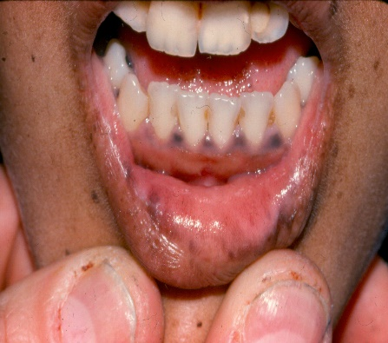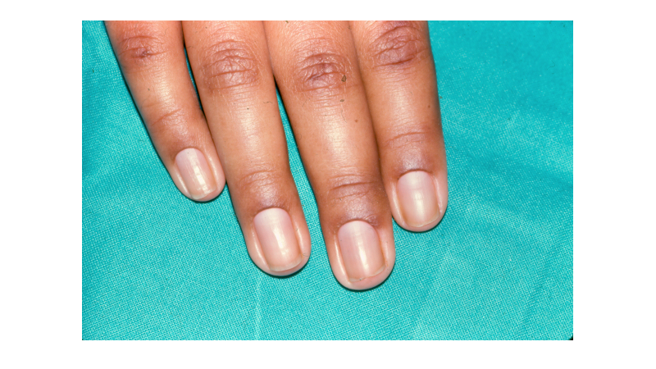

**Figure 2 Figure 3**

A 16 year old girl was admitted to the hospital in coma and found to have profound hypoglycemia. Her physical findings were striking for pigmented patches on her tongue, gums, and lips and her skin was deeply suntanned (see figure 2 and 3). The mother related that her daughter has T1DM since age 12 and had been experiencing numerous hypoglycemic episodes unrelated to food intake or exercise. Accordingly, the dose of insulin had been reduced to about 50% of what it had been 3 months previously. She responded to glucose infusion and recovered full consciousness. Laboratory tests documented a marked elevation of ACTH, low morning cortisol, elevated antibodies to 21OH, and markedly elevated TSH with a low T4. Thus, this patient fulfills all criteria for APS2. The hypoglycemia was due to a combination of deficient hormonal counter-regulation (cortisol deficiency) as well as the delayed clearance of insulin as a result of hypothyroidism.

## AUTOIMMUNE POLYGLANDULAR SYNDROME 3 (APS2b)

APS-3 also known as APS2b, is sometimes referred to as Carpenter’s syndrome, and has the same array of endocrine tissue autoimmune abnormalities as APS2, but without Addison disease. Almost 20% of patients with T1DM have thyroglobulin (TG) and thyroid peroxidase (TPO) antibodies, but only a minority progress to clinical or biochemical hypothyroidism, so APS3 (APS2b) could be considered as a relatively common disorder. [9]

|  |  |
| --- | --- |
| **Table 2: Clinical features of APS2 and APS3** | |
| **APS2** | **APS3** |
| Type 1 Diabetes Mellitus | Type 1 Diabetes Mellitus |
| Thyroid autoimmunity | Thyroid autoimmunity |
| Adrenal Insufficiency |  |

**ADRENAL INSUFFICIENCY**

Since adrenal insufficiency is a hallmark feature of APS1 and 2a syndromes, and since it is the most life threatening, we briefly review the crucial role of the adrenal in metabolic homeostasis. During stress, cortisol produced by the zona fasciculata of the adrenal gland is required to maintain normoglycemia and hemodynamic stability. Cortisol regulates carbohydrate metabolism to maintain normoglycemia, decreases capillary permeability to maintain a normal blood pressure, and is required for activating enzymatic activity to convert norepinephrine to epinephrine. Cortisol production is under the regulation of the hypothalamus and pituitary. The hypothalamic-pituitary-adrenal (HPA) axis is mediated through the circulating level of plasma cortisol by negative feedback of cortisol on corticotropin releasing factor (CRF) and adrenocorticotropic hormone (ACTH) secretion. Aldosterone produced by the zona glomerulosa is predominantly regulated by the renin-angiotensin system. Aldosterone stimulates the kidneys to reabsorb sodium and water and excrete potassium. At high concentrations, cortisol can also act on the mineralocorticoid receptor to increase sodium and water retention as the activity of 11β-hydroxysteroid-dehydrogenase 2 which inactivates cortisol to cortisone is overwhelmed. Presentation of adrenal insufficiency is often chronic, presenting with fatigue, anorexia and weight loss; hyperpigmentation of the buccal mucosa and skin creases or generalized tanning of the skin occur with primary adrenal insufficiency from the excess of melanocyte stimulating hormone produced as a byproduct in the formation of excess ACTH.

Adrenal insufficiency can be caused by primary adrenal disease or dysfunction of the HPA axis (secondary adrenal insufficiency). The most common etiologies of primary adrenal disease in children, adolescents and young adults include autoimmune disease, retroperitoneal trauma and rare genetic syndromes involving the formation of the adrenal gland, the biosynthetic formation of cortisol and the ability of the adrenal gland to respond to ACTH. Severe defects may present in the neonatal period or may be unmasked later in life by the requirement for higher secretion during a physiological stress situation such as sepsis or trauma. Secondary adrenal insufficiency is most commonly caused by damage to the hypothalamus or pituitary gland by trauma or neurological surgery or impingement on these structures by a tumor or mass; congenital defects of isolated ACTH formation or action also may occur. More commonly, suppression of the HPA axis can occur in patients chronically treated with potent glucocorticoid steroids.

Patients with adrenal insufficiency can present acutely in a severe life-threatening event termed adrenal crisis, particularly if there is an inciting event such as a septic illness, surgical procedure, anesthesia, or trauma. These patients have symptoms of nausea, vomiting, abdominal pain, dehydration, altered mental status, hypotension, hypoglycemia, or shock. [19] Hypotension may be unresponsive to fluid resuscitation alone due to deficiency of cortisol required to activate β-adrenergic receptors and vascular tone. Salt wasting (hyponatremia, hyperkalemia) results from aldosterone deficiency. A cardinal feature of primary adrenal insufficiency is hyperpigmentation owing to concurrent rise in melanocyte stimulating hormone (MSH) associated with elevated ACTH production. Darkening of the skin is most prominent at the axillae, palmer creases, areolae, genitalia, and pigmentary lines of the gums (see Fig 2 above). This hyperpigmentation does not occur in secondary adrenal insufficiency as there is no rise in ACTH. Secondary causes of adrenal insufficiency, and certain forms of primary adrenal insufficiency that do not affect aldosterone production, do not present with salt-wasting and Addisonian crisis.

Because of the circadian rhythm and diurnal variation in ACTH and cortisol production, early morning serum cortisol and ACTH concentrations provide the best assessment of endogenous adrenal function. An early morning serum cortisol of <10 mcg/dl is suspicious for adrenal insufficiency. The corresponding ACTH concentration is elevated in primary adrenal insufficiency; a low ACTH concentration is suspicious for secondary adrenal insufficiency. However, a randomly timed cortisol measurement of <15 mcg/dl, in the setting of an acute illness has been proposed as concerning for adrenal insufficiency in adults. [19]

In the absence of clinical clues suggesting primary adrenal insufficiency, such as hyperpigmentation, stimulation with ACTH is the best diagnostic test for identifying those with adrenal insufficiency. At baseline, ACTH and cortisol blood levels are obtained and 250 mcg of synthetic ACTH (cosyntropin) is administered either via the intravenous (IV) or intramuscular (IM) route. The test is considered diagnostic of adrenal insufficiency if the peak cortisol level is less than 18 mcg/dl, 60 minutes following cosyntropin administration. [20] Such a supra-physiologic dose of ACTH may overcome a defect in the hypothalamic-pituitary-adrenal axis to produce the rise in serum cortisol. If there is a high suspicion for secondary adrenal insufficiency in the face of a normal cortisol response to high dose ACTH, early morning serum cortisol and ACTH concentrations may be more informative. The causes of adrenal insufficiency as well as that of thyroid dysfunction and their management are described elsewhere in Endotext. [21, 22]

## AUTO-IMMUNITY ASSOCIATED WITH CANCER IMMUNOTHERAPY

An increasingly important and frequent cause of endocrine-autoimmune syndromes is their appearance in association with the increasing use of immunotherapy as a front line or back-up therapy in various cancers. Indeed, the variety and severity of endocrine autoimmune syndromes associated with the use of inhibitors of CTLA4 (cytotoxic T-lymphocyte-associated protein 4) such as ipilimumab, and immune checkpoint blockade of programmed death 1(PD-1) and its ligands PDL1 and PDL2, has recently been termed “the Achilles heel of cancer immunotherapy”.[23] The range of autoimmune endocrine manifestations includes hypophysitis with disturbances in anterior pituitary hormones, hypo-and hyperthyroidism, adrenal insufficiency and type1 diabetes.[23-25] Key checkpoints by which autoimmunity is regulated in normal individuals are also exploited by tumors to evade recognition and elimination via the immune system; employing immuno-regulatory agents that block these checkpoints facilitates the recognition of tumor antigens as foreign and activates their destruction, but at the same time stimulates autoimmune responses to self-antigens. Clinicians should be aware of these autoimmune manifestations and screen for involvement of endocrine tissues or their clinical manifestations. Notably, some of these endocrine autoimmune manifestations may appear months to years after initiation of immune therapy for cancer.[24]

## REFERENCES

1. Perheentupa, J., *Autoimmune polyendocrinopathy-candidiasis-ectodermal dystrophy.* J Clin Endocrinol Metab, 2006. **91**(8): p. 2843-50.

2. Anderson, M.S. and M.A. Su, *AIRE expands: new roles in immune tolerance and beyond.* Nat Rev Immunol, 2016. **16**(4): p. 247-58.

3. Fierabracci, A., *Type 1 Diabetes in Autoimmune Polyendocrinopathy-Candidiasis-Ectodermal Dystrophy Syndrome (APECED): A "Rare" Manifestation in a "Rare" Disease.* Int J Mol Sci, 2016. **17**(7).

4. Kisand, K. and P. Peterson, *Autoimmune polyendocrinopathy candidiasis ectodermal dystrophy.* J Clin Immunol, 2015. **35**(5): p. 463-78.

5. Alimohammadi, M., et al., *Autoimmune polyendocrine syndrome type 1 and NALP5, a parathyroid autoantigen.* N Engl J Med, 2008. **358**(10): p. 1018-28.

6. Finnish-German, A.C., *An autoimmune disease, APECED, caused by mutations in a novel gene featuring two PHD-type zinc-finger domains.* Nat Genet, 1997. **17**(4): p. 399-403.

7. Anderson, M.S., et al., *Projection of an immunological self shadow within the thymus by the aire protein.* Science, 2002. **298**(5597): p. 1395-401.

8. Kakleas, K., et al., *Associated autoimmune diseases in children and adolescents with type 1 diabetes mellitus (T1DM).* Autoimmun Rev, 2015. **14**(9): p. 781-97.

9. Gimenez-Barcons, M., et al., *Autoimmune predisposition in Down syndrome may result from a partial central tolerance failure due to insufficient intrathymic expression of AIRE and peripheral antigens.* J Immunol, 2014. **193**(8): p. 3872-9.

10. Brannstrom, J., et al., *Defect internalization and tyrosine kinase activation in Aire deficient antigen presenting cells exposed to Candida albicans antigens.* Clin Immunol, 2006. **121**(3): p. 265-73.

11. Meager, A., et al., *Anti-interferon autoantibodies in autoimmune polyendocrinopathy syndrome type 1.* PLoS Med, 2006. **3**(7): p. e289.

12. Meyer, S., et al., *AIRE-Deficient Patients Harbor Unique High-Affinity Disease-Ameliorating Autoantibodies.* Cell, 2016. **166**(3): p. 582-595.

13. Sahoo, S.K., et al., *Identification of autoimmune polyendocrine syndrome type 1 in patients with isolated hypoparathyroidism.* Clin Endocrinol (Oxf), 2016. **85**(4): p. 544-50.

14. Meloni, A., et al., *Autoimmune polyendocrine syndrome type 1: an extensive longitudinal study in Sardinian patients.* J Clin Endocrinol Metab, 2012. **97**(4): p. 1114-24.

15. Bruserud, O., et al., *A Longitudinal Follow-up of Autoimmune Polyendocrine Syndrome Type 1.* J Clin Endocrinol Metab, 2016. **101**(8): p. 2975-83.

16. Zaidi, G., et al., *Autoimmune polyendocrine syndrome type 1 in an Indian cohort: a longitudinal study.* Endocr Connect, 2017. **6**(5): p. 289-296.

17. Husebye, E.S., et al., *Clinical manifestations and management of patients with autoimmune polyendocrine syndrome type I.* J Intern Med, 2009. **265**(5): p. 514-29.

18. Verdu, E.F. and A. Caminero, *How infection can incite sensitivity to food.* Science, 2017. **356**(6333): p. 29-30.

19. Cooper, M.S. and P.M. Stewart, *Corticosteroid insufficiency in acutely ill patients.* N Engl J Med, 2003. **348**(8): p. 727-34.

20. Bornstein, S.R., et al., *Diagnosis and Treatment of Primary Adrenal Insufficiency: An Endocrine Society Clinical Practice Guideline.* J Clin Endocrinol Metab, 2016. **101**(2): p. 364-89.

21. Weetman, A. and L.J. DeGroot, *Autoimmunity to the Thyroid Gland*, in *Endotext*, L.J. De Groot, et al., Editors. 2000: South Dartmouth (MA).

22. Nicolaides, N.C., Chrousos, and E. Charmandari, *Adrenal Insufficiency*, in *Endotext*, L.J. De Groot, et al., Editors. 2000: South Dartmouth (MA).

23. June, C.H., J.T. Warshauer, and J.A. Bluestone, *Is autoimmunity the Achilles' heel of cancer immunotherapy?* Nat Med, 2017. **23**(5): p. 540-547.

24. Ryder, M., et al., *Endocrine-related adverse events following ipilimumab in patients with advanced melanoma: a comprehensive retrospective review from a single institution.* Endocr Relat Cancer, 2014. **21**(2): p. 371-81.

25. Pedoeem, A., et al., *Programmed death-1 pathway in cancer and autoimmunity.* Clin Immunol, 2014. **153**(1): p. 145-52.