CARCINOID TUMORS

Aaron I Vinik, MD, PhD, FCP, MACP, FACE, Murray Waitzer Endowed Chair for Diabetes Research, Professor of Medicine/Pathology/Neurobiology, Director Neuroendocrine Unit, Division of Endocrine and Metabolic Disorders, Eastern Virginia Medical School, Norfolk, VA
Marybeth Hughes, MD, FACS, Chief, Division of Surgical Oncology, Eastern Virginia Medical School, Norfolk, VA
Eric Feliberti, MD, FACS, Associate Professor, Division of Surgical Oncology, Eastern Virginia Medical School, Norfolk, VA
Roger R Perry, MD, FACS, Robert L. Payne, Jr. Professor of Surgery, Division of Surgical Oncology, Eastern Virginia Medical School, Norfolk, VA
Carolina M Casellini, MD, Research Associate & Clinical Study Coordinator, Division of Endocrine and Metabolic Disorders, Eastern Virginia Medical School, Norfolk, VA
Mark Sinesi, MD, PhD, Chairman, Department of Radiation Oncology & Biophysics, Eastern Virginia Medical School, Norfolk, VA
Harlan Vingan, MD, Assistant Professor, Department of Radiology, Eastern Virginia Medical School, Norfolk, VA
Lester Johnson, MD, Professor, Department Radiology, Eastern Virginia Medical School, Norfolk, VA

Updated- January 1, 2018

ABSTRACT

The incidence of carcinoid tumors is rising. Their expression of hormones or amines is variable and rate of growth slow, which may make diagnosis erroneous or late. Major clinical features remain diarrhea, flushing, bronchospasm, and carcinoid heart disease. There are new and emerging syndromes such as pigmentation, myopathy, neuropathy and other paraneoplastic syndromes. Important biomarkers include 5HIAA, Chromogranin A(CgA), Neurokinin A(NKA), and pancreastatin. Targeted therapies and aggressive debulking are effective methods of controlling tumor burden. Octreotide and Lanreotide are effective at controlling symptoms. Escape can occur but is minimized by targeting drug plasma levels known to saturate the somatostatin receptors. Addition of telotristat, which works by a different mechanism, is effective in patients with refractory diarrhea. Newer biologics, including sunitinib and mTOR inhibitors, are effective based upon solid clinical trial data. Other advances including Gallium DOTATOC scanning and peptide receptor radiation therapy (PRRT) have now become a reality in the USA. For complete coverage of this and all related areas of Endocrinology, please visit our FREE on-line web-textbook, www.endotext.org.

INTRODUCTION

Carcinoid tumors are the most commonly occurring gut neuroendocrine tumors(NETs).
The peak incidence occurs in the sixth and seventh decades of life, but patients as young as 10 years of age and people in their ninth decade are also seen. Carcinoid tumors derive from primitive stem cells and are generally found in the gut wall. Carcinoids may, however, occur in the pancreas, rectum, ovary, lung, and elsewhere. The tumors grow slowly and often are clinically silent for many years before becoming manifest after metastases have occurred. They frequently metastasize to the regional lymph nodes, liver, and, less commonly, to bone. The likelihood of metastases relates to tumor size. The incidence of metastases is less than 15% with a carcinoid tumor smaller than 1 cm but rises to 95% with tumors larger than 2 cm. These tumors may be symptomatic only episodically, and their existence may go unrecognized for many years. The median time from onset of symptoms attributable to the tumor and diagnosis is 9.2 years, and diagnosis is usually made only after the carcinoid syndrome occurs(1).

In recent years, NETs have grown to be appreciated for the malignant neoplasms they really are. They account for 13 to 34% of all tumors of the small bowel and 17 to 46% of all malignant tumors of the small bowel (2). The incidence previously has been estimated to be approximately 1.5 cases per 100,000 of the general population (i.e., approximately 2,500 cases/year in the United States). Recently, the annual incidence of NETs has risen to 40-50 cases per million due to better diagnosis, the availability of highly specific and sensitive ways to measure tumor products, and improved immunohistochemistry techniques for tumor detection (1) (3). A review of the SEER database showed an increase in the incidence of NETS from 1973 (1.09/100,000) to 2004 (5.25/100,000), with an estimated prevalence of 103,312 cases in the United States (4) (5) (6). The incidence rate of NETs has steadily been on the rise, with a 6.4x increase from 1973 to 2004 (7), (8). This is twice the prevalence of gastric and pancreatic cancers combined (4).

NETs are often associated with debilitating symptoms that can at times be lifethreatening, thus imposing a significant burden on patient’s quality of life (9) and severely compromising overall health (10) (9) (4) . The measurement of health-related quality of life (HRQOL) has become essential for evaluating the impact of NETs on symptoms and social, emotional, psychological, and physical functioning of patients who harbor these tumors (11). In a 2012 study by Beaumont et al (9) the daily burden upon patients with NETS showed that carcinoid syndrome had a significant impact on overall health assessed using the PROMIS -29 inventory of symptoms related to physical functioning, with detrimental effects on social role, increased anxiety, depression, fatigue, pain interference and sleep disturbance. The great majority (56%) of these tumors were carcinoid with the remainder mostly pancreatic neuroendocrine tumors (pNETS). Disease specific instruments (the Norfolk QOLNET) have been developed to capture the spectrum of symptoms and the impact of the disease on their overall well-being (11). Moreover, this tool is able to demonstrate the relationship of its various domains and total scores with serotonin production and in treated patients correlates with progression free survival (11).The authors discuss the importance of adequate sensitivity, specificity, and reproducibility and the value of psychometric factor analysis to explore the domains that embrace the manifestations of these tumors as well as aspects of the instruments that reflect tumor burden, biochemical, and hormonal status (11).

Of the carcinoid tumors, the most common organ source is the small intestine (12). These tumors are either referred to as small intestinal neuroendocrine tumors (SI-NETs) or midgut carcinoids (MGC). It has been estimated that as many as 71% of patients with MGC have metastatic disease at presentation (4). One of the more clinically useful classifications of carcinoid tumors is according to the division of the primitive gut from which the tumor cells arise and the vascular supply of the digestive tract: the foregut, midgut, and hindgut (Table 1). The foregut includes tumors arising from the lungs, stomach, liver, biliary tract, pancreas, and first portion of the duodenum. The midgut includes the distal duodenum, the small intestines, the appendix, the right colon, and the proximal transverse colon. The hindgut includes the distal transverse colon, the left colon, and the rectum.

This distinction assists in distinguishing a number of important biochemical and clinical differences between carcinoid tumors because the presentation, histochemistry, and secretory products are quite different (Table 1). It should be noted that the carcinoid syndrome occurs in less than 10% of patients with carcinoid tumors (13). Carcinoid syndrome is especially common in tumors of the ileum and jejunum but also occurs with bronchial, ovarian, and other carcinoids (14).

Table 1. Clinical and Biochemical Characteristics of Carcinoid Neuroendocrine Tumors
Location | Clinical | Biochemical | Metastatic
Gastric  Secondary to achlorhydria  (Type I)  ZE/MEN-I (Type II)  Primary (Type III) | Pernicious anemia, atrophic gastritis, gastric polyps, gastrin >1000 pg/ml  Gastrin elevated, low gastric pH  nl gastrin, nl gastric pH | Same as foregut | Rare  10%  30-70%
Foregut | Atypical carcinoid, ZE, acromegaly, Cushing’s, etc. | 5HTP, histamine, peptide | 30%
Midgut | Classic carcinoid | 5HT, SP, CGRP, kinins and peptides | 70%
Hindgut | Silent | Non-secretory | 14%

Figure 1. Incidence of NETs and Carcinoid Syndrome (Top panel). Proportion of NET patients with Carcinoid Syndrome (bottom panel) (from Halperin et al, with permission).

Halperin et al reported that a search of PubMed between Jan 1, 2000, and Oct 15, 2016, with the Medical Education Subject Headings “malignant carcinoid syndrome/epidemiology” and “carcinoid tumor”, with no language restrictions, revealed 44 publications. Two studies included more than 150 patients. One study included 2001 patients and the other included 3379 patients with pancreatic neuroendocrine tumours (NETs) and 8088 patients with gastrointestinal NETs. Carcinoid syndrome was estimated to occur in 3·2% of patients in the larger study using retrospective questionnaires and 21·4% of patients in the other study (15). The relative increase in carcinoid syndrome to the rise in incidence of NETS is shown in Figure 1 (Halperin et al with permission). The Halperin study used prospective databases to identify 9512 patients with extrapancreatic NETs and used claims data to identify those with carcinoid syndrome. This study is the largest, most rigorous analysis of the epidemiology of carcinoid syndrome and associated clinicopathological factors reported to date. Between April 1, 2000, and Dec 31, 2011, 9512 eligible patients were diagnosed with NETs, of whom 1786 (19%) had carcinoid syndrome. Of note is the dramatic rise in the incidence of NETS, many of which are discovered incidentally. The number of patients with NETs and carcinoid syndrome increased from 50 (11%) of 465 patients in 2000 to 160 (19%) of 854 in 2011 (p<0·0001). The proportion of patients with carcinoid syndrome compared with those without did not differ significantly with respect to age at diagnosis (p=0·65), geographical region (p=0·054), or urban versus rural status (p=0·53). Patients with carcinoid syndrome were more frequently female than male (p=0·0003). Race was associated with a significant difference in the reported incidence of carcinoid syndrome (p<0·0001), as was tumour grade, stage, and primary tumour site (all p<0·0001). Patients with carcinoid syndrome had a shorter overall survival (median 5 years [95% CI 4·5–5·4]) than did those without carcinoid syndrome (5·6 years [5·4–5·9]; hazard ratio 1·102 [1·016–1·194]; p=0·019). Use of octreotide (p<0·0001) and chemotherapy (p=0·003) were more common in patients with carcinoid syndrome than in those without it, whereas surgery was used more frequently in patients without carcinoid syndrome (p=0·009); use of radiotherapy was not significantly associated with the presence of carcinoid syndrome at diagnosis (p=0·07).

To summarize, this population-based analysis revealed that carcinoid syndrome is significantly associated with tumour grade, stage, and primary tumour site, and leads to shorter survival compared with those patients without carcinoid syndrome. An improved understanding of the heterogeneity of presenting symptoms among patients with NETs might permit more tailored assessment and management than at present and enable future research into the effect of carcinoid syndrome control on patient survival. No doubt with the advent of precision management of many endocrine syndromes (16) this understanding and the role of not only serotonin and its metabolites will greatly enhance our capacity for improving quality of life and prognosis in carcinoid patients. The frequency of carcinoid syndrome in various presentations of carcinoid tumors is shown in Table 2 & 3 (15).

Table 2. Factors Determining the Prevalence of Carcinoid Syndrome

Table 2 continues next page

Treatments

Data are n (%). SEER=Surveillance, Epidemiology, and End Results. *Masked as per SEER-Medicare user agreement for confidentiality

Table 3. Frequency of Carcinoid Syndrome in Patients with Well Differentiated (grade I-II) Neuroendocrine Tumors
The natural history of carcinoid tumors is obscured by ignorance of health keepers on the clinical features of these tumors and their appropriate biomarkers. Indeed, almost all patients have the diagnosis of irritable bowel or vague abdominal symptoms for a median time from onset to diagnosis of 9.2 years (Figure 2).
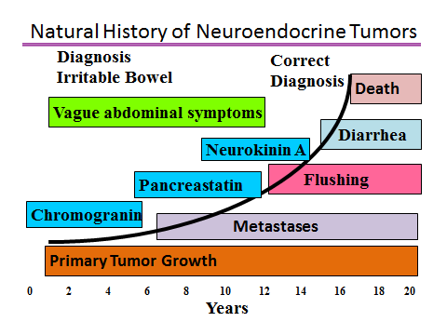
Neurokinin

Figure 2. For up to 9.2 years patients may present with a variety of symptoms including abdominal pain and are often diagnosed as irritable bowel (1). The incidence rate of NETs has steadily been on the rise, with a 6.4x increase from 1973 to 2004 (10) (4) (1).

Vinik, A. et al. Pancreas 2009 38(8):876-889

Perhaps the earliest biomarker is Chromogranin A. The tumor continues to grow and metastasize and produce the constellation of clinical features of carcinoid syndrome. Pancreastatin is a marker of tumor growth as well as a means of monitoring successful reduction in tumor bulk with therapy (8). Neurokinin levels are a good marker for prediction of long term survival (17).

There are impediments to the diagnosis of these tumors. First, they comprise <2% of gastrointestinal malignancies and are therefore not the first diagnosis considered. Symptoms are often nonspecific and do not lend themselves to identifying the specific underlying tumor. The manifestations are protean and mimic a variety of disorders. The natural history of this disease is invariably attended by a long course of vague abdominal symptoms, recurrent visits to primary care practitioners, and referral to a gastroenterologist, with a misdiagnosis of irritable bowel syndrome (IBS). The median latency to correct diagnosis is 9.2 years by which time the tumor has often metastasized, causing symptoms like flushing and diarrhea and progressing slowly until the patient dies (Figure 2). Thus, greater index of suspicion and a carcinoid tumor profile screen is warranted for all patients presenting with “traditional IBS symptoms.” Midgut carcinoids are associated with mesenteric fibrosis, which can compress mesenteric vessels and cause bowel ischemia and malabsorption, even in the absence of an obvious abdominal mass. The diagnosis of metastases to the liver often takes place after a delay of many years. Even then, an incorrect diagnosis is not uncommon. Unless biopsy material is examined for the secretory peptides chromogranin, synaptophysin, or neuron-specific enolase (NSE), tumors may be labeled erroneously as adenocarcinoma, impacting management and underestimation of prospects for survival (18).

Although carcinoids classically are tumors of enterochromaffin and argentaffin cells of the digestive tract, the term carcinoid tumor can be expanded to cover gut tumors of paracrine- and endocrine-like cells of unknown function (19) (20). It now is established that these tumors are of neuroendocrine origin and derive from a primitive stem cell. They may differentiate into any one of a variety of adult endocrine secreting cells: β cell and insulinoma, α cell and glucagonoma, δ cell and somatostatinoma, and the PP cell and PPoma, or cells capable of producing ACTH, growth hormone-releasing hormone, VIP, SP, gastrin-releasing factor, calcitonin, Ghrelin and the EC cell, with its ability to co-secrete amines such as serotonin and the peptide motilin. At any one point in time, these cells may secrete one humor, whereas at others, the peptide or amine secreted may differ and yield an entirely different clinical syndrome. Indeed, metastases are known to secrete hormones that differ from the parent tumor, and different metastases may secrete different hormones. Symptoms may derive from secretion of one or more of the hormones secreted (17).

MOLECULAR GENETICS

The genetics of neuroendocrine tumorigenesis have yet to be elucidated. Although small familial clusters of midgut carcinoids have been described, there are no known genetic cancer syndromes associated with them. Carcinoid tumors may occur as part of complex familial endocrine cancer syndromes, such as multiple endocrine neoplasia type 1 (MEN1), although the majority occur as non-familial (i.e. sporadic) isolated tumors. Molecular genetic studies have revealed that the development of NETs may involve different genes, each of which may be associated with several different abnormalities that include point mutations, gene deletions, DNA methylation, chromosomal losses and chromosomal gains. Indeed, the foregut, midgut and hindgut NETs develop via different molecular pathways. For example, foregut NETs have frequent deletions and mutations of the MEN1 gene, whereas midgut NETs have losses of chromosome 18, 11q and 16q and hindgut NETs express transforming growth factor-alpha and the epidermal growth factor receptor. Furthermore, in lung NETs, a loss of chromosome 3p is the most frequent change and p53 mutations and chromosomal loss of 5q21 are associated with more aggressive tumours and poor survival. In addition, methylation frequencies of retinoic acid receptor-beta, E-cadherin and RAS-associated domain family genes increase with the severity of lung NETs. Thus the development and progression of NETs is associated with specific genetic abnormalities that indicate the likely involvement of different molecular pathways (21) (22) (23).

Tumors have clustered in several small families without MEN I, and multiplicity of tumors is a feature in one quarter of isolated cases. Among sporadic midgut carcinoids, several studies using comparative genomic hybridization or microsatellite markers have shown frequent allelic deletion of chromosome 18 (24) (25). On an epigenetic level, midgut NETS have been found to have global hypomethylation (26). There is little data about genetic aspects in NETs of the appendix or cecum. Tumor multiplicity is much less frequent in the appendix and cecum than the ileum.

CLINICAL CLASSIFICATION

Table 4. The Clinical Presentations, Syndromes, Tumor Types, Sites and Hormones (18).

Clinical Presentation | Syndrome | Tumor Type | Sites | Hormones
Flushing | Carcinoid  Medullary  Carcinoma of Thyroid  Pheochmocytoma | Carcinoid  C cell tumor  Tumor of Chromaffin cells | Mid/foregut Adrenal medulla Gastric  Thyroid C cells  Adrenal and Sympathetic Nervous system | Serotonin, CGRP, Calcitonin  Metanephrine and Normetanephrine
Diarrhea  Abdominal pain  and dyspepsia | Carcinoid, WDHHA, ZE, PP, MCT | Carcinoid, VIPoma, Gastrinoma, PPoma, Medullary carcinoma thyroid, mastocytoma | As above, pancreas, mast cells, thyroid | As above, VIP, gastrin, PP, calcitonin
Diarrhea/steatorrhea/polycythemia | Somatostatin  Bleeding GI tract | Somatostatinoma, neurofibromatosis | Pancreas  Duodenum | Somatostatin
Wheezing | Carcinoid | Carcinoid | Gut/pancreas/lung | SP, CGRP, serotonin
Ulcer/dyspepsia | Zollinger-Ellison | Gastrinoma | Pancreas/duodenum | Gastrin
Hypoglycemia | Whipple’s triad | Insulinoma, sarcoma, hepatoma | Pancreas, retroperitoneal liver | Insulin, IGF1, IGF11
Dermatitis | Sweet Syndrome  Pellagra | Glucagonoma  Carcinoid | Pancreas  Midgut | Glucagon  Serotonin
Dementia | Sweet syndrome | Glucagonoma | Pancreas | Glucagon
Diabetes | Glucagonoma  Somatostatin | Glucagonoma  Somatostatinoma | Pancreas  Pancreas | Glucagon  Somatostatin
DVT, Steatorrhea, Cholelithiasis  Neurofibromatosis | Somatostatins | Somatostatinoma | Pancreas  Duodenum | Somatostatin
Silent, liver mets | Silent | PPOMA | Pancreas | PP

Table 4 summarizes the suggested approach to diagnose a NET based upon the clinical presentation, the tumor type, their sites of origin, the possible means of diagnosis, and the biochemical markers that should be measured. Abbreviation: CGRP: Calcitonin gene-related peptide

Foregut Carcinoids

Foregut carcinoids are argentaffin negative. They have a low content of serotonin (5- hydroxytryptamine [5-HT]). They often secrete the serotonin precursor 5-hydroxytryptophan (5- HTP), histamine, and a multitude of polypeptide hormones. Their functional manifestations include carcinoid syndrome, gastrinoma syndrome, acromegaly, Cushing’s disease, and a number of other endocrine disorders. Furthermore, they are unusual in that the flush tends to be of protracted duration, is often of a purplish or violaceous hue as contrasted with the usual pink or red, and frequently results in telangiectasia and hypertrophy of the skin of the face and upper neck. The face may assume a “leonine” characteristic after repeated episodes. It is not unusual for these tumors to metastasize to bone (Serotonin, gastrin, and other peptide assays available at Inter Science Institute (800-255-2873). A further point of interest is that if a carcinoid tumor co-exists with MEN-1, more than two-thirds of the time in males the tumor is in the thymus, whereas in females, it is in the lung over 75% of the time.

Gastric Carcinoids

There are three types of gastric carcinoid tumors. Type I gastric carcinoid tumors represent approximately 70 to 80 % and are associated with hypergastrinemia due to chronic atrophic gastritis and pernicious anemia (27). These are typically multiple small lesions which arise from the gastric enterochromaffin-like (ECL) cell and are less likely to metastasize. The achlorhydria is usually caused by atrophic gastritis that accompanies pernicious anemia wherein there is loss of gastric acid secretion and thereby impairment of the normal restraint mechanism suppressing gastrin production. Gastrin is trophic to the enterochromaffin cells in the stomach and when levels arise above 1000pg/ml this constitutes a threshold for the induction of gastric carcinoid polyps and tumors (28) (29). The association between hypergastrinemia and the development of gastric carcinoids supports the hypothesis that growth factors are important in the genesis of endocrine tumors. The clinical picture is invariably a patient with evidence of pernicious anemia, premature graying of the hair, and associated autoimmune disorders. Antibodies to gastric parietal cells and intrinsic factor are found and there is achlorhydria or hypochlorhydria and sampling of gastric content reveals near neutral instead of the normal highly acidic pH. In this setting measurement of serum gastrin usually suffices to herald the threat of development of carcinoid tumors and periodic gastroscopy and enucleation of the lesions is advisable. When gastrin levels exceed 1000pg/ml it may occasionally be appropriate to carry out an antrectomy to remove the source of the gastrin. In animal models this clinical condition has been duplicated by long-term administration of proton pump inhibitors, but this does not appear to be the case in humans since gastrin levels may rise but seldom if ever reach the critical level for induction of dysplasia

An illustrative case is presented. Mr. JW was first seen here 11 years ago when he was 67. He complained of dyspepsia and reflux, was tired and fatigued and found to have a macrocytic anemia with hemoglobin of 8.0. A routine colonoscopy and upper endoscopy were done and he was found to have a 1cm carcinoid tumor in the stomach with a mitotic index of <2% and a Ki 67 index of <2.0%. He had no diarrhea, wheezing or flushing.

On exam BP 157/86, Pulse 54, Weight 154 lb no myopathy but he had some loss of vibration detection threshold in the feet, loss of ankle jerks. Biochemistries: Serotonin 1119, CgA 69, CA19-9 2.5 CEA 0.6, Histamine 0.27, Gastrin 1551, Calcitonin 7, Somatostatin 128, 5HIAA urine 375, insulin 3.4, Prolactin 6.5, PTH 39.2,Ca 9.9,Cortisol 26.8, gastric parietal antibodies 38.9 (0-20) ACTH 13. The gastric carcinoids are shown below in Figure 3 by arrows.

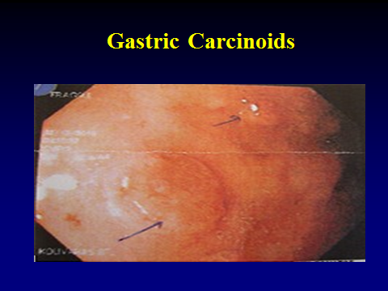
Figure 3. The arrows point to two gastric carinoids which are well circumscribed, raised papillary tumors which show no invasion, are comprised of ECC cells and have low mitotic & Ki67 indices.

The pathways of negative feedback on gastrin stimulation of ECL cell proliferation are shown in Figure 4. Based upon the likely role of antral gastrin in stimulating the growth and proliferation of ECL cells we performed an antrectomy. The follow -up biochemistires are shown: Substance P - 243; Chromogranin A - 8 (0-5) (was 4 on 12/12/11); Glucagon - 75; Histamine - 0.33; Neurokinin A - <5.0; Pancreatic Polypeptide - 186.5; Serotonin - 104; VIP - 81.4 (0.0-58.8) (was 70 on 1/3/12 and 76.5 on 12/12/11); Calcitonin - <2.0; Gastrin - 14; Pancreastatin - 77 (was 93 on 1/3/12). 1/9/12 - Urine 24-Hour 5-HIAA 2014.

He has had some dyspepsia and reflux, has become tired and lethargic, his skin is dry, hair is falling out and his voice is croaky. All NET markers normal, B12 1951, VIP 61.9 (0-58.8), histamine 0.46, Gastrin <10. 5-HIAA <10 , T4, F 1.4 T3T3 80, TSH 7.0, EKG low voltage and his resting heart rate is 54. He clearly has Hashimoto’s hypothyroidism and has recovered completely on replacement of thyroid hormone. He has not had a recurrence of a gastric carcinoid.

The case illustrates the complex pathways of endocrine /exocrine control of hormone/acid regulation and the consequence of unbrideled gastrin production and its growth potential with regard to ECL cells in the stomach. The case also illustrates that with this version of carcinoid the focus must be on the offensive agent stimulating the growth and proliferation of ECL cells and not on the tumor per se. Finally, this case also illustrates that this syndrome is part of a polyendocrine autoimmune condition in which one must not neglect the other components of autoimmunity- in this case the hypothyroidism.

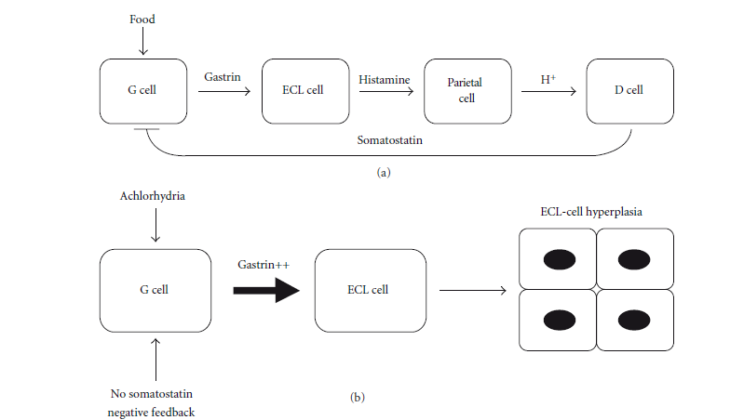
Figure 4.

Type II gastric carcinoid tumors are much less common, representing approximately 5 % and are associated with hypergastrinemia due to Zollinger-Ellison syndrome and multiple endocrine neoplasia (MEN) Type I. These lesions also are typically multiple and small, although the risk of metastasis appears to be slightly higher than for Type I (30). Type III gastric carcinoid tumors account for approximately 20 % of lesions, and are sporadic. There is no known association with hypergastrinemia, chronic atrophic gastritis or Zollinger- Ellison syndrome. These typically present as large solitary lesions. They may be associated with atypical carcinoid syndrome mediated by histamine. These have the highest risk of metastasis, and are sometimes metastatic upon initial diagnosis.

Fasting serum gastrin levels are important to differentiate types I and II gastric carcinoids from type III. Gastrin levels are elevated in both type I and type II gastric carcinoids but not in type III. It is important to note that patients with type I gastric carcinoid are hypochlorhydric or achlorhydric while patients with type II gastric carcinoids have high acid levels. 5-HIAA levels are generally not elevated because development of the carcinoid syndrome is uncommon (31). Nonetheless as our case illustrates elevation of 5-HIAA levels can occur and may even be responsible for carcinoid syndrome. Measurement of plasma chromogranin A (CGA) levels are recommended because CGA is frequently elevated in patients with all 3 types of gastric carcinoid tumors (32) and changes in CGA levels may be helpful in follow-up (32). In patients treated with somatostatin analogs, CGA levels should be interpreted cautiously, since these agents significantly reduce plasma CGA levels (32) (33). In patients on stable doses of somatostatin analogs, consistent increases in plasma CGA levels over time may reflect loss of secretory control and/or tumor growth. Plasma CGA levels also have prognostic value in patients with metastatic disease (32) (34).

Midgut Carcinoids

Midgut carcinoids, in contrast, are argentaffin positive, have high 5-HT content, rarely secrete 5- HTP, and often produce a number of other vasoactive compounds, such as kinins, prostaglandins, and SP. The clinical picture that results is the classic carcinoid syndrome of flushing and diarrhea with or without wheezing. These tumors may produce adrenocorticotropic hormone (ACTH) on rare occasions and infrequently metastasize to bone (35). The prevailing syndrome is that of carcinoid syndrome but recently it has been established that the former notion that the prevailing features are flushing, diarrhea, bronchospasm and heart disease are insufficient to capture the spectrum of the disease (Figure 5).

Figure 5.

Neurohumoral Syndromes

- Major Clinical manifestations
  - Flushing 84%
  - Diarrhea 79%
  - Heart Disease 37%
  - Bronchoconstriction 17%

- Seldom Discussed
  - Diabetes, Metabolic Syndrome,
NASH 37%
  - Hypertension 50%
  - NeuroMyopathy 7%
  - Pigmentation, arthropathy 5%
  - Hyper-hypoglycemia (NIHHPS) <1%
  - Ulcer disease, Skin rashes <1%
  - Psychological Disturbances <1%

- Tumor production of cytokins (TNF α, IL6, NFαb)
  - Fever, fatigue, weight loss, cachexia

- Tumor stimulation of antibody formation (CA Channels, P, Q) Ach receptor, CANCA, PANCA, HU
  - Neurological syndromes, Peripheral Neuropathy, Autonomic Neuropathy, Cerebellar Ataxia, Eaton Lambert, Myaesthemia, CIDP

HINDGUT CARCINOIDS

Hindgut Carcinoids

Hindgut carcinoids are argentaffin negative, rarely contain 5-HT, rarely secrete 5-HTP or other peptides, and usually are silent in their presentation. They may be discovered on rectal exam, flexible sigmoidoscopy, or colonoscopy. They may metastasize to bone.

CLINICAL PRESENTATION

Carcinoid tumors are slow growing and may be present for years without overt symptoms, thus escaping attention. During the early stages, vague abdominal pain goes undiagnosed and invariably is ascribed to irritable bowel or spastic colon. Fully one-third of patients with carcinoid tumors present with years of intermittent abdominal pain. Carcinoid tumors can present in a variety of ways. For example, duodenal tumors are known to produce gastrin and may present with the gastrinoma syndrome.

An interesting association between pernicious anemia, atrophic gastritis, chronic thyroiditis, and gastric carcinoid tumors has been previously discussed in detail above (27). Patients with carcinoid tumors of the thymus most often manifest ectopic Cushing’s syndrome or hypercalcemia. Bronchial carcinoids may be associated with MEN-1.

The major clinical manifestations of carcinoid tumors are based on mechanical complications (pain, obstruction, bleeding) or due to the secreted bioactive factors (1). The carcinoid syndrome is a constellation of signs and symptoms associated with hypersecretion of vasoactive substances (e.g., serotonin, histamine, tachykinins, and prostaglandins) by the carcinoid tumor. The extent of these signs and symptoms are a function of the degree and type of substances that are secreted. Because the liver can inactivate these substances, hepatic metastases are typically present in the case of midgut carcinoids but are not essential in foregut carcinoids. Since hindgut carcinoids do not secrete vasoactive amines their presentation is invariably pain, bleeding from the GI tract, intestinal obstruction, or symptoms from distant metastases.

The clinical presentation and work-up of the various neurohumoral syndromes (Figure 5) are given in Table 4. These include cutaneous flushing, which occurs in 84% of patients, gastrointestinal (GI) hypermotility with diarrhea (70%), heart disease (37%), bronchial constriction (17%), myopathy (7%), and an abnormal increase in skin pigmentation (5%) (1). More recently it has come to be recognized that carcinoid tumors can be associated with myopathy, skin pigmentation which is a pellagra like eruption, a paraneoplastic neuropathy, arthropathy and peripheral edema (36) (Figures 5 and 6). When co-existence of the major symptoms of flushing and diarrhea is sought, it emerges that flushing and diarrhea occur simultaneously in 58%, diarrhea without flushing in 15%, flushing without diarrhea in 5%, and neither flushing nor diarrhea as a symptom complex in 22%. The natural history of these tumors is illustrated in Figure 2. Invariably there has been a long history of vague abdominal symptoms, a series of visits to the primary care practitioner and referral to a gastroenterologist and the diagnosis of irritable bowel syndrome (IBS) made. In a review of our own experience with midgut carcinoid patients, the diagnosis of IBS at some point in time could always be found in the patient record. With a median latency to diagnosis of 9.2 years by the time the diagnosis is made the tumor has often metastasized, causing flushing and diarrhea and progressing on its slow but relentless course to demise. Clearly a greater index of suspicion is warranted in all patients presenting with “traditional irritable bowel symptoms” (37).

Carcinoid tumors may metastasize to various sites, but especially the liver (Figure 8).
The frequency of metastatic disease based on primary tumor location is shown in Table 5, and incidence based on primary tumor size is shown in Figure 7, With metastases to the liver, the correct diagnosis generally is arrived at, but often with a delay of many years. Even then, mistaken identity is not uncommon, and unless biopsy material is examined for the secretory peptide chromogranin, (38) synaptophysin, (39) or NSE, (40) tumors may be labeled erroneously as adenocarcinoma, with a negative impact on attitudes toward management and underestimation of prospects for survival.

Figure 6.

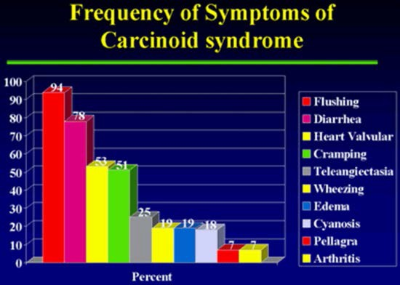

Table 5. Tumor Location and Frequency of Metastases n = 5468
 | Tumor Location (%) | Incidence of Metastases (%)
Foregut  Stomach  Duodenum  Lung | 38  21  32.5 | 31  33  27
Midgut  Jejunum  Lleum  Appendix  Colon | 2.3  17.6  7.6  6.3 | 70  70  35  71
Hindgut | 10 | 14

Jensen, Current Opinions Oncology, 2000

Figure 7. Incidence of metastases stratified by primary tumor size in two analysis: single-center database of 165 cases [Moertel (10); left] and literature review [Rorstad (15); right]

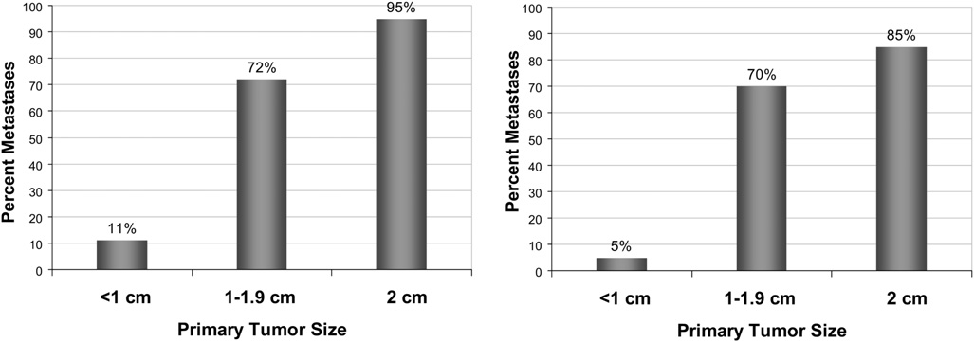

Figure 8. Shows the distribution of the primary tumors in carcinoid and the common sites of metastases to the lymph nodes, the liver and to bones.

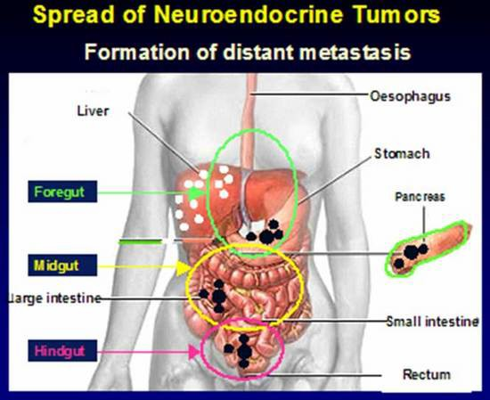

CARCINOID SYNDROME

Carcinoid syndrome occurs in less than 10% of patients with carcinoid tumors. Principal features include flushing, sweating, wheezing, diarrhea, abdominal pain, endomyocardial fibrosis, and pellagra. Diarrhea is found in 76-83% of cases, flushing in 94%, (41), heart valvular disease and abdominal cramping each in about 50%, dyspnea in 20%, and bronchospasm in 6%. A variety of other symptoms such as wheezing, edema, cyanosis, pellagra and arthropathy occur much less frequently (Figure 6). The relationship between diarrhea and flushing is variable. One can occur without the other, and there may be no temporal relationship between the two. The specific etiologic agent or agents for each of the protean manifestations of the carcinoid tumors are not known. Serotonin, (41) (42) prostaglandins, (42) 5-HTP, (43) (44) SP, (45) (46), kallikrein, (47) histamine, (48) dopamine, (49) and neuropeptide K (50) are thought to be involved in the clinical manifestations of carcinoid tumors. In addition, symptoms may relate to overproduction of peptides in the pro-opiomelanocortin family (e.g., endorphin and enkephalin). Pancreatic polypeptide and motilin levels often are raised, (51) and may be important markers of tumor activity, and may provide a means of monitoring tumor growth and response to therapy rather than contributing to specific symptomatology.

Feldman and O’Dorisio (52) (53) examined the proportion of 43 patients with carcinoid tumor having increased levels of serotonin and various other vasoactive peptides (53). Serotonin, measured either as its urinary metabolite 5-HIAA (54) or whole-blood serotonin (55) (56), was raised in 84% of patients with carcinoid tumors and within normal limits in patients having other tumors and miscellaneous illnesses. Urinary 5-HIAA alone had 73% sensitivity and 100% specificity. Seven of these patients had normal urinary 5-HIAA levels but other elevated indices of serotonin production. Neurotensin and SP were raised in 43 and 32% of patients and had specificity values of 60 and 85%, respectively. False-positive results occurred in 23 and 26%, respectively, of patients with conditions other than carcinoid tumors. Motilin and somatostatin were raised in 14 and 50%, respectively.

Flushing

Flushing, a cardinal symptom of carcinoid tumors occurs in a variety of other conditions that need to be distinguished. The differential diagnosis of flushing includes the postmenopausal state, simultaneous ingestion of chlorpropamide and alcohol, panic attacks, medullary carcinoma of the thyroid, autonomic epilepsy, autonomic neuropathy, and mastocytosis (Table 6). A good rule of thumb is that if the flushing is wet it is due to a cause other than carcinoid. Table 6 lists the variety of causes that are confounding and the features that help distinguish them from flushing due to carcinoid.

Table 6. Tests to Identify Cause of Flushing

CLINICAL CONDITION | TESTS
Carcinoid | Urine 5HIAA, 5HTP, SP, CGRP, CGA
Medullary Carcinoma Thyroid | Calcitonin, Calcium Infusion, Ret Proto- oncogene
Pheochromocytoma | Plasma free metanephrines, Urine metanephrines, VMA, Epi, Norepi, glucagon stim, MIBG
Diabetic AN | HRV, 2 h PP glucose
Menopause | FSH
Epilepsy | EEG
Panic | Pentagastrin/ACTH
Mastocytosis | Plasma histamine, urine tryptase
Hypomastia, Mitral prolapse | Cardiac echo

AN=autonomic neuropathy, 5HIAA=5 hydroxyindole acetic acide, 5HTP=5hydroxy tryptophan, SP=substance P, CGRP=calcitnonin gene realted peptide, CGA=chromogranin A, VMA=vanillyl mandelic acid, Epi=epinephrine, Norepi=norepinephrine, stim=stimulation, MIBG=metiodobenzylguanidine, HRV=heart rate variability, PP=postprandial, FSH=follicle stimulating hormone, EEG-electroencephalogram, ACTH=adrencorticotrophic hormone

Flushing in carcinoid syndrome is of two varieties. First, with midgut carcinoid, the flush usually is of a faint pink to red color and involves the face and upper trunk as far as the nipple line. The flush is initially provoked by alcohol and food containing tyramines (e.g., blue cheese, chocolate, red sausage, and red wine). With time, the flush may occur spontaneously and without provocation. It usually is ephemeral, lasting only a few minutes, and may occur many times per day but generally does not leave permanent discoloration.

In contrast, in the second type, the flush of foregut tumors often is more intense, of longer duration, purplish in hue, frequently followed by telangiectasia, and involves not only the upper trunk but may also affect the limbs. The limbs may become acrocyanotic, and the nose resembles that of rhinophyma. The skin of the face often thickens, with the appearance of a leonine facies resembling that seen in leprosy and acromegaly.

A more recently described cause of flushing is the non-insulinoma pancreatogenous hypoglycemia syndrome (NIPHS). Several recent reports describing this syndrome are shown in Table 7. Typical findings on immunohistochemistry are shown in Figure 9 and 10. This syndrome is likely to become more common with the increasing number of patients undergoing bariatric surgery.

Table 7. Non Insulinoma Pancreatogenous Hypoglycemia Syndrome (NIPHS)

- Service
  - Six cases developed postprandial hypoglycemia after Roux en Y gastric bypass surgery
- Patti
  - 3 cases developed postprandial hypoglycemia after Roux en Y gastric bypass surgery
- Won, Pittenger, Vinik et al
  - 10 sporadic cases of postprandial hypoglycemia, 5 after Roux en Y procedure

Symptoms: Flushing, sweating, palpitations, tingling, confusion even coma

Figure 9. Immunohistochemistry of Islets in NIPHS (57)

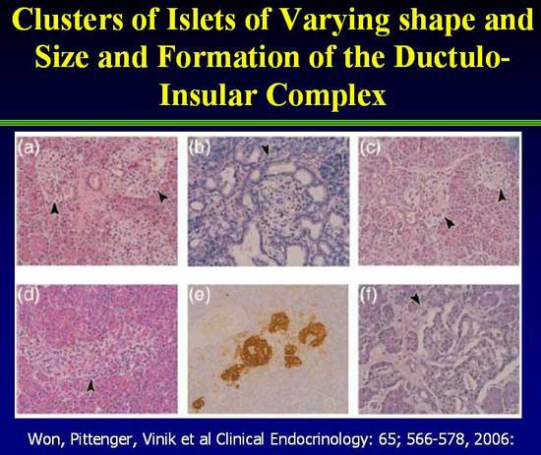

Figure 10. Immunohistochemistry of Islets in NIPHS demonstrating presence of Insulin, Pro-Insulin, Amylin plus transcription factors PDX, NKX 6.1 as well as cell proliferation factor Ki-67 (57)
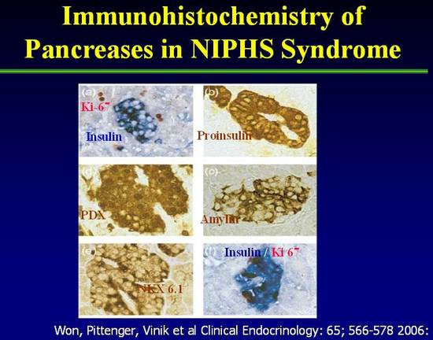

Flushing in carcinoid syndrome has been ascribed to prostaglandins, kinins, and serotonin (5- HT). With the advent of sophisticated radioimmunoassay methods and region-specific antisera, a number of neurohumors now are thought to be secreted by carcinoid tumors, including serotonin, (41) dopamine, (49) histamine, and 5-HIAA, (48) kallikrein, (44) SP, (43) neurotensin, (52) motilin, (45) (52) SRIF, (58) VIP, (59) prostaglandins, (60) neuropeptide K, (50) and gastrin-releasing peptide (GRP) (52).

Feldman and O’Dorisio have previously reported the incidence of elevated levels of plasma neuropeptide concentrations (52). Despite the elevated basal concentrations of SP and neurotensin, these authors were able to document further increases in these neuropeptides during ethanol-induced facial flushing. We support this contention and hasten to add that neuropeptide abnormalities frequently occur in patients with other forms of flushing and may be of pathogenetic significance (61).

Several provocative tests have been developed for to identify the cause of flushing in carcinoid syndrome (Table 6). These tests are based upon the need to distinguish the flushing from that found in a host of other conditions particularly in panic syndrome in which the associate anxiety and phobias usually establish the cause but frequently the physician and patient need reassurance that there is no underlying malignancy. The treatment of the various causes of flushing are summarized in Table 8.

Ahlman and colleagues (62) reported the results of pentagastrin (PG) provocation in 16 patients with midgut carcinoid tumors and hepatic metastases. All patients tested had elevated urinary 5- HIAA levels, and 12 had profuse diarrhea requiring medication. PG uniformly induced facial flushing and GI symptoms in patients with liver metastases, but it had no effect in healthy control patients. All patients with PG-induced GI symptoms demonstrated elevated serotonin levels in peripheral blood. Administration of a serotonin-receptor antagonist had no effect on serotonin release but completely aborted the GI symptoms. The authors emphasized the improved reliability of PG compared with calcium infusion, another provocative test popularized by Kaplan and colleagues, (63) and pointed out that PG provocation occasionally can be falsely negative in patients with subclinical disease. Our own experience is that PG uniformly induced flushing in 11 patients with gastric carcinoid tumors that was associated with a rise in circulating levels of SP in 80% (29). Thus, SP is one neurohumor that may be involved in the flushing of carcinoid syndrome.

Table 8. Treatment of Flushing Syndromes

Flushing Syndrome | Treatment
Carcinoid | Octreotide
Medullary carcinoma thyroid | Thyroid tumor removal
Pheochromocytoma | Surgical removal, α1 and β blockers
Diabetic Neuropathy | Scopolamine, Botox
Menopause | Estrogen, clonidine
Epilepsy | Antiepileptic drugs
Panic syndrome | Alprazolam, sertraline
Mastocytosis | Histamine 1 and 2 blockers
Hypomastia | Beta Blockers
Idiopathic | Octreotide

Diarrhea

The diarrhea syndrome that occurs with carcinoid tumors usually is of a secretory nature (Table 9). In fact, all endocrine diarrheas are secretory in nature. In the absence of this feature the usual cause is gastroenterological. Secretory diarrhea is diarrhea that persists with fasting or fails to disappear when feeding has been curtailed and sustenance given by the intravenous route.

Table 9.

Character of Secretory and Osmotic Diarrhea
- Secretory
- Large volume stools
- Persists during fasting
- 2X [stool Na⁺ + K⁺] = stool osmolality

- Osmotic
- Small volume <11 liter/d
- Disappears with fasting
- 2X [stool Na⁺ + K⁺] < stool osmolality i.e. osmotic gap
Search for idiogenic osmoles

Causes of secretory diarrhea include the Watery Diarrhea, Hypokalemia, Hypochlorhydria, Acidosis syndrome (WDHHA syndrome), medullary carcinoma of the thyroid, and gastrinoma syndrome. A history of improvement in the diarrhea with administration of H 2 -receptor antagonists is strongly suggestive of the gastrinoma syndrome. Hypercalcemia is frequent with VIP-secreting tumors and steatorrhea, for all intents and purposes, occurs only with the Zollinger-Ellison syndrome. Figure 11 illustrates the essential differences in the mechanisms involved in generation of diarrhea that occurs in the VIPoma, PPoma, Medullary Carcinoma of the thyroid tumors and the Zollinger Ellison (Gastrinoma) syndrome. In essence the humors that stimulate gastrointestinal secretions such as VIP increase the rate of fluid delivery from the proximal to the distal small intestine that exceed the absorptive capacity of the distal intestine. The diarrhea is watery in nature and there is great loss of bicarbonate and potassium ions. Hence, the term: Watery Diarrhea, Hypokalemia, Hypochlorhydria, Acidosis syndrome (WDHHA). This form of diarrhea persists with fasting and in the absence of a history to support this contention placing the patient on NPO while giving fluids IV rapidly establishes whether the diarrhea is secretory in nature or malabsorptive. In contrast the gastrinoma diarrhea is due to stimulation of gastric acid secretion by the tumor. Acid in the duodenum and small intestine inactivates lipase, amylase and trypsin, damages the mucosa of the small bowel precipitates the succus entericus thereby decreasing absorption of nutrients and impairing digestion leading to a secretory diarrhea with elements of malabsorptiuon and or steatorrhea. Clinically this can be distinguished by asking what happens to the diarrhea with the use of a proton pump inhibitor or an H 2 blocker. Also demonstration of the very acidic nature of gastric acid secretion can be helpful. Marked metabolic acidosis with bicarbonate wasting usually is only a characteristic of VIP-secreting tumors.

Figure 11.

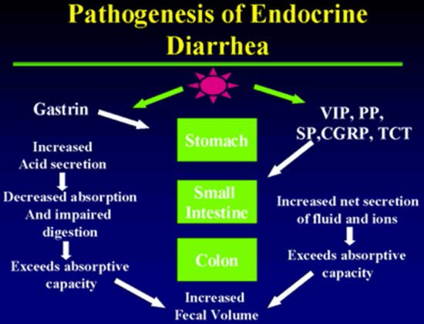

The villous adenoma of the rectum causing secretory diarrhea is notoriously rare, and although it is referred to in many texts, most physicians have yet to see a case. Perhaps one the most vexing problems is to exclude factitious diarrhea induced by for example laxative abuse. In this case measurement of stool osmolarity and electrolytes can be very revealing. An osmolar gap (i.e. there are stool osmoles not accounted for by the stool electrolytes) (Table 7) suggests the presence of laxatives which can then be readily identified in the stool using KOH. Measurement of intestinal secretion by passing a multilumen tube and quantifying electrolytes and water transport, in addition to the measurement of stool electrolytes, which should account for the total osmolarity, will also help to exclude laxative abuse.

C-CELL HYPERPLASIA SYNDROME

A recently described cause of secretory diarrhea is the C-cell Hyperplasia Syndrome, occurring in the absence of medullary thyroid cancer. Three cases of C-cell hyperplasia syndrome presented with longstanding flushing, abdominal pain, diarrhea and facial telangiectasia (2-20 years). The only biochemical abnormalities were elevated calcitonin levels and positive Pentagastrin and calcium stimulation tests. Venous sampling localized the overproduction to the thyroid. Histology of the thyroid showed C cell hyperplasia without evidence of medullary thyroid cancer. Symptoms improved to a large extend after subtotal thyroidectomy in one case and resolved in other two cases after total thyroidectomy. The condition may be a gene mutation but so far the site has not been identified. Ret Proto-oncogene evaluation can be negative. All cases of flushing and diarrhea should have a calcitonin measurement. Total thyroidectomy is the treatment of choice for this syndrome. Histology of the thyroid of those cases can be seen with C cell hyperplasia shown by arrows in Figure 12.

Figure 12. C Cell Staining with H&E and Immunohistochemical Method.
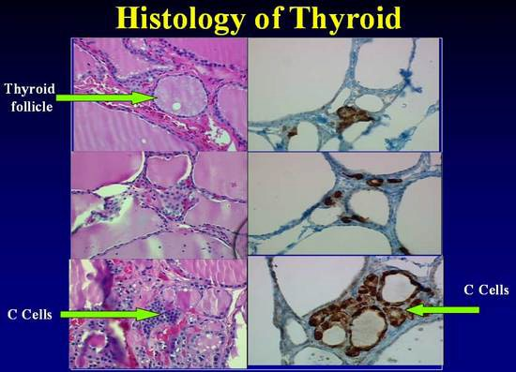

C cells are identified with difficulty in sections stained with hematoxylin and eosin, where they appear polygonal and with a granular weakly eosinophilic cytoplasm that is larger and paler than that of follicular cells (see arrow). When compared with sections from the same patients using immunohistochemical
staining, C cells as more readily identified part of the follicular epithelium and as isolated cluster between follicles. More recently we have reported on a patient with C cell overproduction by a pancreatic neoplasm which was responsive to management with the tyrosine kinase inhibitor sunitinib (64).

DIAGNOSIS

There are two ways that these patients are typically diagnosed. One way is in the asymptomatic patient who undergoes imaging or endoscopy for another reason and a lesion is incidentally discovered. The other way is in patients with long standing often vague gastrointestinal complaints that have eluded correct diagnosis for many years. A generalized evaluation scheme is shown in Table 10.

The diagnosis of carcinoid tumors in these patients is challenging. The diagnosis often rests on a strong clinical suspicion in patients who present with flushing, diarrhea, wheezing, myopathy, and right heart disease. Diagnosis requires appropriate biochemical studies (Tables 10 and 11), localization studies, pathologic, and immunohistochemical studies.

Table 10.

Tissue: CGA/Ki-67,
Synaptophysin, specific hormone
Evaluation of Neuroendocrine Tumors
Clinical Syndrome
Flushing, diarrhea, wheezing Myopathy, right heart disease Hypoglycemia, ulcer, rash
Biochemical and Tissue Diagnosis
Exclude other causes
Secretory vs. non-secretory Wet vs. dry
Carcinoma, thyrotox, Cushing’s GBP, MCT, C cell hyperplasia
Urine: 5HT, 5HTP
Blood: serotonin, TCT Pancreastatin, CGA, NKA
Insulin, gastrin, glucagon IGF2, PThrp
ALK Phos, NTx etc
Negative
Symptomatic
Treatment

BIOCHEMICAL MARKERS

The rate-limiting step in carcinoid tumors for the synthesis of serotonin is the conversion of tryptophan into 5-HTP, catalyzed by the enzyme tryptophan hydroxylase. In midgut tumors, 5- HTP is rapidly converted to 5-HT by the enzyme aromatic amino acid decarboxylase (dopa-decarboxylase). 5-HT is either stored in the neurosecretory granules or may be secreted directly into the vascular compartment. Most of the secreted 5-HT is taken up by platelets and stored in their secretory granules. The rest remains free in the plasma, and circulating 5-HT is then largely converted into the urinary metabolite 5-hydroxyindoleacetic acid (5-HIAA) by the enzyme monoamine oxidase and by aldehyde dehydrogenase. These enzymes are abundant in the kidney, and the urine typically contains large amounts of 5-HIAA.

Urinary 5-HIAA (24-hour collection) is a useful laboratory marker for carcinoid tumors (15). It is a surrogate measure of serotonin metabolism and is perhaps more useful than the direct measurement of serotonin as serum serotonin values vary considerably during the day according to activity and stress level. The specificity of this test has been reported to be 88% (65). However, certain foods and medications can increase urinary 5-HIAA levels and should be avoided during specimen collection (66). High serotonin concentrations occur with the ingestion of bananas, kiwis, pineapple, plantains, plums and tomatoes. Moderate elevations are found with avocado, black olives, spinach, broccoli, cauliflower, eggplant, cantaloupe, dates, figs, grapefruit and honeydew melon. Drugs that can increase 5HIAA are: acetanalid, phenacetin, reserpine, glyceryl guiacolate (found in many cough syrups) and methocarbamol. Drugs that can decrease 5HIAA levels include: chlorpromazine, heparin, imipramine, isoniazid, levodopa, MAOIs, methenamine, methyldopa, phenothiazines, promethazine and tricyclic antidepressants. In addition foregut carcinoids do not produce 5-HIAA but rather only 5-HTP, limiting the usefulness of these measures as a diagnostic or screening tool. The utility of 5-HIAA as a prognostic marker for patients with NETs has, however, been controversial. Elevated urinary 5-HIAA has been correlated with more severe carcinoid symptoms and with worse survival in this patient population. In patients with midgut NETs, increases in 5-HIAA >5000 μg/L was predictive of shorter survival. However, multivariate analyses have indicated that 5-HIAA is not a significant predictor when compared to age and other tumor markers (CgA, neuron-specific enolase, and neurokinin A). CgA is considered a more general tumor marker. Post-surgical reductions of CgA levels by ≥80% are predictive of better outcomes (Vinik, 2016 140000 /id), and ≥30% decreases in CgA level in response to long-acting octreotide have been correlated with complete response, partial response, or stable disease according to Italian Trials in Medical Oncology criteria Bajetta 1993 (23). Recently an assay has been developed which measures plasma 5-HIAA with equivalent sensitivity and specificity as the urine assay but without the inconvenience of collecting urinary specimens (67).

In patients with foregut tumors, the urine contains relatively little 5-HIAA but large amounts of 5- HTP. It is presumed that these tumors are deficient in dopa-decarboxylase, which therefore impairs the conversion of 5-HTP into 5-HT, leading to 5-HTP secretion into the vascular compartment. Some 5-HTP, however, is converted to 5-HT and 5-HIAA—thus, the modest increase in these metabolites. The normal range for 5-HIAA secretion is 2 to 8 mg per 24 hours, and the quantitation of serotonin and all of its metabolites usually permit the detection of 84% of patients with carcinoid tumors. No single measurement detects all cases of carcinoid syndrome, although the urine or the plasma 5-HIAA appear to be the best screening procedure (67).

Several circulating tumor markers have been evaluated for the follow-up and management of NETs (Table 11). However, isolated elevation of marker levels is generally not sufficient for diagnosis without tissue confirmation. An important characteristic of these markers is that they are not only secreted by functional tumors but also by those less well-differentiated NETs that do not secrete known hormones (68). The general principle of biomarker measurement is to identify a few biomarkers that are elevated in the particular patient in question and follow these overtime.

The most important of these markers, chromogranin A (CgA) (68), is a 49-kDa acidic polypeptide that is present in the secretory granules of neuroendocrine cells. Plasma CgA is elevated in 50% to 100% of patients with either functioning or nonfunctioning NETs (69). The likelihood of detecting elevated CgA levels depends upon the primary tumor type (gastrinomas 100%, pheochromocytomas 89%, carcinoid tumors 80%, nonfunctioning tumors of the endocrine pancreas 69% and medullary thyroid carcinomas 50%). The sensitivities and specificities of CgA for the detection of NETs range between 70% and 100% (70), (71), (72), (69). CgA level may correlate with tumor volume or disease progression, but this should be interpreted carefully (73) (74). For example, small tumors may be associated with normal CgA levels. In addition, since somatostatin analogs affect blood levels of CgA, serial CgA levels should be measured at approximately the same interval from injection of long-acting somatostatin analogs. Stridsberg et al 2007 (73) reported common conditions that can spuriously increase the levels of this marker and give false positive measurements including: decreased renal function and treatment with proton pump inhibitors (73), liver failure, chronic gastritis, and even essential hypertension (74); these problems are not seen with Chromogranin B (CgB), with complementary measurement so proposed (73).

Table 11. CURRENT MONOANALYTE NET BIOMARKERS
Biomarker | Sensitivity | Specificity
Substance P | 32% | 85%
Pancreatic Polypeptide | 50-80% | No data
Pancreastatin | 64% | 58-100%
Neuron-specific Enolase | 33% | Up to 100%
Neurokinin Aª | 88% | No data
CgB | 99% | No data
ProGRP | 99% | 43%
NT-BNP^{b} | 87% | 80%
CTGF^{c} | 88% | 69%
Chromogranin A (CgA) | 43-100% | 10-96%
U 5-HIAA | 35% | Up to 100%
CgB = chromogranin B, CTGF = connective tissue growth factor, NT-BNP = N-terminal brain natriuretic peptide, ProGRP = progastrin releasing peptide, u 5-HIAA = urinary 5-hydroxy-indole acetic acid.
ªMidgut NETs
^{b}In Carcinoid Heart Disease CHD
^{c}For right ventricular dysfunction
Modlin IM et al. Best Practice & Research Clinical Endocrinology & Metabolism 30 (2016) 59

Sensitivity and specificity of CgA depends on many factors. For example, sensitivity varies from77 to 84% and specificity from 71.3 to 85.3% depending on the assay used, and of great importance is to establish the cutoff value that gives the highest sensitivity without compromising the specificity (75). Another utility of CgA is to discriminate between patients with or without metastasis, which also depends on the assay and the cut-off values used, with a sensitivity of 57-63.3% and specificity 55.6-71.4% (75). The concentration of CGA in plasma is thought to reflect the neuroendocrine differentiation of the tumor and the total tumor burden. Thus, measuring CGA is useful as a means of measuring response to treatment. Using nude mice with engrafted human ileal carcinoid tumors (76) a direct correlation between tumor weight and CGA levels was found. Octreotide treated animals had a significant reduction in plasma levels indicating that CGA does correspond with tumor burden and may be useful for monitoring the course of the disease. Unfortunately, the study did not define the action of Octreotide on secretion versus change in tumor bulk. To determine the usefulness of CGA for diagnosis and follow up of neuroendocrine tumors Nehar et al (72) measured CGA levels using an immunoradiometric assay in 124 sporadic neuroendocrine tumors, 34 MEN-1 tumors, and 127 controls. Serial measurements were done in 56 patients (212 visits). In secretory tumors the sensitivity was 62.9% with specificity of 98.4%. It was higher in secreting vs. non-secreting tumors (73 vs. 45%) and related to the extent of metastases. In non-secreting tumors the positive predictive value (PPV) for the presence of metastases was 100% but the negative predictive value was only 50%. In MEN-1 a high value predicted the presence of a pancreatic tumor with 100% specificity but the sensitivity was only 59%. During follow up the concordance of tumor growth and CGA was 80%, indeed better than serotonin (81 vs. 54%). Thus, due to its high specificity, CGA determination may help to discriminate the endocrine character of a neuroendocrine tumor and to establish a pancreatic tumor in MEN-1 syndrome. Serial measurements are also useful for following responses to treatment. CGA is positive 80-100% of the time in fore-, mid- and hind-gut tumors whereas 5-HIAA detects a little over 70% of midgut tumors, only 30% of foregut and fails to recognize the presence of a hindgut carcinoid tumor.

Pancreastatin is one of the post-translational processing products of CgA and is an indicator of poor outcome when its concentration in plasma is elevated before treatment in patients with NETs. A level > 500pmol/L is an independent indicator of poor outcome. This marker is also known to correlate with the number of liver metastases, so it would be appropriate to use it in the follow-up of NET patients. Table 12 shows the specificity of CGA, 5-HIAA, and other markers used for the various carcinoid tumor types.

The “Pearls” and “Pitfalls” on the use of CgA are shown in Table 13.

Another useful blood marker, neuron specific enolase (NSE), is a dimer of the glycolytic enzyme enolase. NSE is mainly present in the cytoplasmic compartment of cells of neuronal and neuroectodermal origin. The serum level of NSE is thought to be unrelated to the secretory activity of the tumor (69). NSE has been found in thyroid and prostatic carcinomas, neuroblastomas, small-cell lung carcinoma, carcinoids, GEP NETs and pheochromocytomas. Despite its high sensitivity (100%), its use is limited as a blood biochemical marker for neuroendocrine tumors due to its very low specificity (32.9%) (69). Although it is less specific than CGA, it maybe a useful marker for follow-up of patients with known diagnosis of NETs.

A variety of other secreted molecules can be measured among patients with midgut NETs. These include other chromogranins such as chromogranin B and C, pancreastatin, neuropeptide K, pancreatic polypepetide (PP), and substance P (SP). These substances are stored in neurosecretory vesicles together with CgA (66). Current monoanalyte markers are shown in Table 11.

Table 12. Specific Biochemical Markers for each Carcinoid Tumor Type (77)
Site | Tumor Type | Marker | Specificity
All |  | CgA and B  P PP, NSE, Neurokinin, Neurotensin  HCG α and ß | High  Intermediate  Low
Thymus | Foregut Carcinoid | ACTH | Intermediate
Bronchus | Foregut Carcinoid, Small Cell Lung Carcinoma. | ACTH, ADH, Serotonin, 5- HIAA, Histamine, GRP, GHRH, VIP, PTHrp | Intermediate  Low
Stomach | Foregut Carcinoid, Gastrinoma, Ghrelinoma. | Histamine, Gastrin Ghrelin | Intermediate  Low
Pancreas | Gastrinoma, Insulinoma, Glucagonoma, Somatostatinoma, PPoma, VIPoma. | Gastrin, Insulin, Proinsulin, Glucagon, Somatostatin  C-peptide, Neurotensin, VIP, PTHrp, Calcitonin | High  Low
Duodenum | Gastrinoma, Somatostatinoma. | Somatostatin, Gastrin, pancreastatin | High
Ileum | Midgut Carcinoid | Serotonin, 5-HIAA  Neurokinin A, Pancreastatin, Neuropeptide K, Substance P | High  Intermediate
Colon and Rectum | Hindgut Carcinoid | Peptide YY, Somatostatin | Intermediate
Bone | Metastasis | Bone Alkaline Phosphatase, N- Telopeptide  PTHrp | High (blastic lesions), Modest (lytic lesions)  Intermediate
Cardiac Involvement | Carcinoid | BNP | Intermediate

Table 12 shows the specific biochemical markers used for each tumor type and their specificity. CgA and B: Chromogranin A and B; PP: pancreatic polypeptide; NSE: neuron-specific Enolase; HCG: human chorionic gonadotropin; ACTH: adrenocorticotropic hormone; ADH: anti diuretic hormone; 5-HIAA: 5- hydroxyindoleacetic acid; GRP: gastrin releasing peptide; GHRH: growth hormone releasing hormone; VIP: vasointestinal peptide; PTHrp: parathyroid hormone related peptide; BNP: brain natriuretic peptide.

Pancreatic Polypeptide (PP) is considered another non-specific biochemical marker. In a study conducted by Panzuto et al. in Rome, Italy in 2004, PP sensitivity was 54% in functioning tumors, 57% in non-functioning, 63% in pancreatic tumors and 53% in gastrointestinal tumors. Specificity was 81% compared with disease free patients, and 67% compared to non-endocrine tumors’ patients. But when combined with CgA the sensitivity increased compared to either of the markers alone. When used in combination, the sensitivity of these markers is: for gastro- entero-pancreatic neuroendocrine tumors (GEP NETs) 96%; for non-functioning tumors 95% and for pancreatic tumors 94% (78).

The combined use of CGA and PP may further enhance sensitivity. Both markers were measured in 68 patients, 28 functioning and 40 nonfunctioning tumors. CGA sensitivity was 96% in functioning tumors, 75% in non functioning, and 74% in pancreatic and 91 % in gastrointestinal tumors. Specificity was 89%. In contrast PP sensitivity for these tumors was approximately 50% but combining the two markers increased sensitivity for all tumors to >95%. More specifically the gain in pancreatic tumors was 93% vs. 68% using the one marker alone. It seems not unreasonable to recommend using both markers under these circumstances. There are however always caveats. Pelckmans and colleagues (79) examined the possibility that gastric parietal cell antibodies, which neutralize acid secretion, thereby unbridling the G cell to produce gastrin, which in turn is trophic to the gastric ECL cell, which can transform into the gastric carcinoid. Measurement of gastrin and CGA, but not NSE and 5HIAA is a means of evaluating the ECL mass. This is particularly useful in decision making with regard to doing an antrectomy or simply following conservatively and removing the carcinoid polyps as they arise. Of course this raises the issue of whether or not the reported elevations in CGA in people taking proton pump inhibitors are truly false positive or reflect ECL hyperplasia! Nonetheless all evidence point to the combined measurement of CGA, PP and gastrin as being a very effective means of discovering a neuroendocrine tumor, identifying its probable site of origin and monitoring response to intervention.

Table 13. Pearls and Pitfalls on Chromogranin A (CgA) (8)

“Pearls” and “Pitfalls” on Chromogranin A (CgA)

- Try and stay with the same lab
- Very different levels e.g. <30 ng/ml-<5 mol/L
- Is very helpful when you know you have a N/E tumor
- May be elevated when there is no actual N/E tumor
- Severe hypertension
- Gastric acid suppression (PPI’s)
- Renal insufficiency
- May be a good marker of response to therapy
- Does not correlate with Symptoms
Is not as good as Pancreastatin in midgut tumors. Elevated Plasma Pancreastatin, but Not
Chromogranin A, Predicts Survival in Neuroendocrine Tumors of the Duodenum

In carcinoid tumors, neurotensin is elevated in 43%, SP in 32%, motilin in 14%, somatostatin in 5%, and VIP rarely. In miscellaneous illnesses, there may be elevation of the following hormones: neurotensin, SP, and motilin in 35, 7, and 5%, respectively. Up to one-third of people with idiopathic flushing who do not have carcinoid syndrome, however, have elevated levels of a number of neuropeptides. Furthermore, we have examined the relationship between the products of the preprotachykinin gene, SP, and neurokinin A in healthy subjects and in patients with carcinoid tumors. SP was elevated 80% of the time in patients with carcinoid tumors, whereas neurokinin A was raised in all patients. Why there should be a discrepancy in these two peptides that derive from a common precursor gene product remains unclear.

Table 14. Value of Measurement of Neurokinin A (7) (80)

Neurokinin A (NKA)

- Developed highly sensitive and specific radioimmunoassay
- Found very high levels of NKA-like activity in tumor tissue from four patients with mid-gut carcinoids
- Regul Pept. 1986 Jan; 13(2):183-96

- Patients in whom NKA levels continue to rise despite treatment with somatostatin analogs have poorer prognosis( Figure 37)
- (1y survival 40% vs. 87%)
- Turner et al. Gut. 2006 Nov; 55(11):1586-91

Conclusion:
NKA should be considered another of the substances secreted by mid-gut carcinoid (serotonin, substance P, calcitonin) and is an important marker for prognosis

Substance P has been found in tumor extracts and plasma from patients with carcinoid tumors and, in one reported case, was useful for tumor localization (38). Neurokinin A, its amino- terminally extended form, neuropeptide K, and SP are a group of peptides (i.e., tachykinins) with common biologic properties (81) (82). Norheim and colleagues (82) measured peptide responses to PG or ingestion of food or alcohol in 16 patients with metastatic carcinoid tumors and demonstrated two-fold or greater increases in neurokinin A and neuropeptide K in 75% of patients, as well as variable increases in SP in approximately 20% of patients (83). Additional information on neurokinin A is shown in Table 14.

Conlon and colleagues (81) used region-specific antisera to SP and neurokinin A to measure circulating tachykinins during a meal-induced flush in10 patients with metastatic carcinoid tumors. Five patients had undetectable levels of neurokinin A and SP after stimulation, thus suggesting that elevated tachykinin concentrations are not a constant feature of such patients. The authors also studied the effect of somatostatin-analogue administration on meal-induced tachykinin responses in three patients with carcinoid tumors. Flushing was aborted in two patients, but tachykinin levels were only partially suppressed, indicating that these peptides cannot be solely responsible for the carcinoid flush.

A summary of biochemical markers which may be useful for each carcinoid tumor type is shown in Table 12.

PATHOLOGY

Neuroendocrine tumors (NETs) arising throughout the body share basic characteristics. They are classified according to site, differentiation (well vs. poorly differentiated), a marker of cell proliferation e.g. Ki-67, grade and stage, the hormones or amines produced, and markers of behavior such as chromogranin A and synaptophysin . Tumor differentiation refers to the extent of resemblance to the normal cellular counterpart or loss of this resemblance. Tumor grade refers to the degree of biological aggressiveness. Tumor stage refers to the extent of spread of the tumor. The extent of invasion into the organ of origin and involvement of nodes or distant sites are critical factors. There are a number of different systems to classify, grade, and stage neuroendocrine tumors (Table s 15-17). Although the criteria differ among systems, the underlying basic data are similar. A review of nomenclature, grading, and staging system has been summarized in previous articles on the pathologic classification of neuroendocrine tumors adapted by the development of the NANETS, ENETS, and WHO Consensus Guidelines.

Table 15. WHO Pathologic Classification of Gastroenteropancreatic tumors

Site | Well- differentiated endocrine tumor (Benign behavior) | Well differentiated endocrine tumor (Uncertain behavior) | Well differentiated endocrine carcinoma (Low grade malignant) | Poorly differentiated endocrine carcinoma (High grade malignant)
Pancreas | Confined to pancreas <2 cm  <2 mitosis per HPF  <2% Ki67 index No vascular invasion | Confined to pancreas >-2 cm  >2 mitosis per HPF  >2% Ki67 index or vascular invasion | Well to moderately differentiated.  Gross local invasion and metastasis,2-10 mitosis per HPF  >5% Ki67 index | Small cell carcinoma Necrosis common  >10 mitosis per HPF  >15% Ki67  index. Prominent vascular and/or perineural invasion
Stomach | Confined to mucosa- submucosa <-1 cm No vascular invasion | Confined to mucosa- submucosa >1 cm or vascular invasion | Well to moderately differentiated. Invasion to muscularis propia or beyond or metastasis | Small cell carcinoma
Duodenum, upper Jejunum | Confined to mucosa- submucosa <-1 cm. No vascular invasion | Confined to mucosa- submucosa >1 cm or vascular invasion | Well to moderately differentiated. Invasion to muscularis propia or beyond or metastasis | Small cell carcinoma
Ileum, colon, rectum | Confined to mucosa- submucosa <-1 cm (small intestine)  Confined to mucosa- submucosa <-2 cm (large intestine)  No vascular invasion | Confined to mucosa- submucosa >1 cm (small intestine)  Confined to mucosa- submucosa >2 cm (large intestine)  Vascular invasion | Well to moderately differentiated. Invasion to muscularis propia or beyond or metastasis | Small cell carcinoma
Appendix | Non-functioning  Confined to appendiceal wall | Enteroglucagon producing  Confined to subserosa | Well to moderately differentiated  Invasion to mesoappendix or beyond or metastasis | Small cell carcinoma

HPF – high power fiel
In addition to classic NETs, mixed histology tumors having neuroendocrine as well as glandular features, such as goblet cell carcinoids and adenocarcinoids, also occur. Mixed histology tumors are more frequent in the appendix and cecum. For example, mixed histology tumors accounts for 1% of jejunal/ileal NETs and 7.3% of cecal NETs (P < 0.001) (84). While the number or fraction of appendiceal NETs having mixed histology tumors in the SEER registry is even higher, the exact percentage is difficult to ascertain. This is due to the fact that small appendiceal carcinoids are often considered benign and not reported to the registries, and mixed histology tumors such as goblet cell carcinoids are generally considered malignant and more like to be reported.

Similarly, the distribution of poorly differentiated NETs among midgut sites is variable. Poorly differentiated NETs accounts for only 0.9% and 1.1% of appendiceal and jejunal/ileal NETs respectively. They however account for 14.2% of NETs arising from the cecum (84).

These pathologic descriptors provide important information for patient management as mixed histology tumors such as goblet cell can be more aggressive and prone to peritoneal dissemination. Poorly differentiated NETs are often rapidly progressive and may require cytotoxic chemotherapy.

In 2007, The European Neuroendocrine Tumor Society (ENETS) proposed a formal TNM staging system for tumors of the lower jejunum and ileum (Table 17), a system that was subsequently adopted by American Joint Committee on Cancer (85) (86).

Table 16. Pathological Grading of Neuroendocrine Tumors

Differentiation Grade Criteria

Well differentiated Low (Typical) <2 mitoses/10 HPF and <=2% Ki67 index
Intermediate 2–20 mitoses/10 HPF or 3%–20%Ki67 ind.
(Atypical)
Ki67 index
Poorly differentiated High >20 mitoses/10 HPF or >20% Ki67 index

Table 17. ENETs/AJCC TNM Staging Classification of Small Bowel NETs

T1 Tumor invades lamina propria or submucosa and size one cm or less
T2 Tumor invades muscularis propria or size >one cm
T3 Tumor invades through the muscularis propria into the subserosa or into the nonperitonealized tissue
T4 Tumor invades the visceral peritoneum (serosa) or any other organs or structures
N0 No regional LN metastasis
N1 Regional LN metastasis
M0 No distant metastasis
M1 Distant metastasis

Stage | T | N | M
I | T1 | N0 | M0
IIA | T2 | N0 | M0
IIB | T3 | N0 | M0
IIIA | T4 | N0 | M0
IIIB | Any T | N1 | M0
IV | Any T | Any N | M1

All carcinoid tumors should be stained for chromogranin A and synaptophysin (Table 16, Figure 13). While most agree that a mitotic rate or Ki-67 is necessary in specific cases, whether Ki-67 staining is needed in all cases remains hotly debated (Table 18). An experienced pathologist familiar with NETs will likely be able to determine the tumor’s grade in the majority of resected specimens and a Ki-67 can be obtained as needed in difficult cases (Table 16). In small biopsy specimens, there may not be sufficient material to differentiate between grade 1 versus 2 neuroendocrine carcinomas with or without Ki-67.

Figure 13. Immunohistochemistry of Gastric Mucosa with Synaptophysin, Chromogranin and Ki-67 Antigen in a Gastric Neuroendocrine Tumor

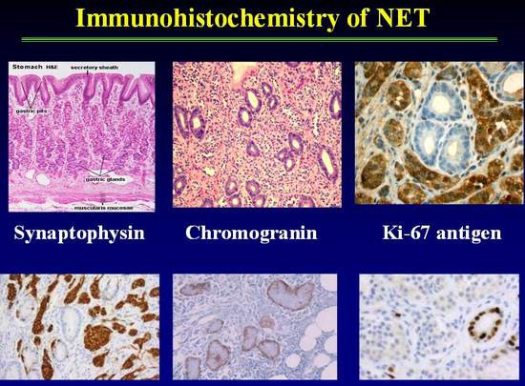

Table 18.

Ki67 Tissue Staining

- Considered a cellular proliferation marker
- A High molecular weight nuclear protein associated with cellular proliferation
- Proliferation index refers to percentage (%) of cells (+) in a tumor section

Index proposal by The World Health Organization (WHO)

- Well-differentiated carcinoid
- <2% Ki-67 (+)
- Well-differentiated endocrine carcinoma
- 2-15% Ki-67 (+) (“malignant carcinoid”)
- Well-differentiated endocrine ca
- >15% Ki-67 (+) (“small cell carcinoma”)
Positive:
- May assist in planning therapy (high index may justify more aggressive therapy)
- A Chaudry, K. Oberg, E. Wilander, Tumor Biol 1992; 13:27-35
Limitations:
- Ki67 staining % may vary from tumor slice to tumor slice (not standardized)

TUMOR LOCALIZATION OF CARCINOIDS

General Overview

A number of techniques have been used to identify the primary site of the tumor and to evaluate the extent of the disease and presence of metastases (Table 18 below). Chest radiography or computed tomography (CT) usually suffices to detect bronchial carcinoids. Bronchoscopy is usually required for confirmation. In contrast, carcinoids of the cecum, right colon, and hindgut carcinoids usually are demonstrable by endoscopy or barium enema examination. The greatest problems encountered are in localizing small bowel carcinoids, which may be small, and in localizing carcinoids in extra-intestinal sites. These tumors usually are not identified by upper endoscopy or GI roentgenographic studies. The ability of abdominal CT scans to detect midgut carcinoids has improved, however many primary tumors are below the resolution capacity of even the most sophisticated scanning apparatus. Capsule endoscopy and double balloon push-pull enteroscopy have occasionally been useful in cases of midgut based NETs. Endoscopic ultrasound (EUS) combined with biopsy is the most sensitive method to detect pancreatic NETS.

Table 18. Different Modalities of Localization of NET

Localization of Neuroendocrine Tumors
- Localization Procedures
  - Ultrasound and Endoscopy
  - Barium contrast studies
  - CT
  - MRI
  - Octreoscan
  - PET (including Gallium DOTATOC scanning)
  - MIBG
  - Angiography

The preliminary work-up of a neuroendocrine tumor often starts in the emergency department with plain abdominal Xrays done to work up an abdominal pain syndrome. Any abnormal finding leads to CT scanning .The discovery of liver metastasis inevitably leads to CT guided liver biopsy. These tests are often used non-specifically because of the presence of vague symptom complexes. Once the NET diagnosis is suspected, more specific means of imaging are typically employed. For detecting the primary NET tumor, a multimodality approach is best . The specific approach will depend upon the suspected tumor location and may include CT, MRI, somatostatin receptor scintigraphy (SRS), endoscopic ultrasound (EUS) , endoscopy, and less commonly digital selective angiography or venous sampling. CT is probably superior for localizing the primary tumor, mesenteric invasion, and thoracic lesions, whereas gadolinium enhanced MRI may be superior in characterizing liver lesions. Technique is critical and meticulous attention to detail is necessary. While some investigators in Europe advocate the use of enteroclysis with CT imaging, this techniques is used less often in the US.

Gastric Carcinoid Tumors

Most gastric carcinoid tumors are directly visualized and diagnosed during upper endoscopy. For larger lesions, endoscopic ultrasound may be performed to assit with staging and whether the gastric carcinoid is invasive. This technique, when used with tattooing of the gastric lesion, offers the endoscopist the opportunity to observe the lesion in a serial fashion. This is highly valuable in the case of type I gastric carcinoids which rarely need a formal gastric resection. In patients with more aggressive gastric carcinoids such as type II and type III gastric carcinoids, EUS offers the endoscopist the opportunity to access and stage nearby nodes(N) as well as the depth of tumor invasion(T). Cross-sectional imaging with CT or MRI is recommended to assess for metastases in patients with type I or type II gastric carcinoids more than 2 cm in diameter, and in patients with type III gastric carcinoids in whom metastatic risk is a significant concern (32). The predominant site of distant metastatic spread in patients with gastric carcinoid tumors is the liver. Carcinoid liver metastases are often hypervascular, and may become isodense relative to the liver with the administration of intravenous contrast. CT scans should thus be performed both before and after the administration of intravenous contrast agents (87). Somatostatin receptor scintigraphy provides a second useful imaging modality for the detection of metastatic disease in patients with malignant gastric carcinoids (32), (87), (88).

Midgut NETS

Imaging studies for NETs are generally done for initial staging and subsequent follow-up. Goals of initial staging include identification of primary tumor, assessment of extent of disease, and treatment planning. Subsequent follow-up imaging studies are done for surveillance following complete resection or during periods of stability, and evaluation of response following treatment.

Imaging studies generally recommended at time of initial staging includes plain film chest xray, cross-sectional imaging (CT or MRI) of the abdomen and pelvis, and [111In-DTPA0] octreotide scintigraphy. In cases where a midgut primary is suspected but not directly identified (for example a mesenteric mass in the ileal mesentery), small bowel series, enteroclysis, or multiphasic CT of abdomen and pelvis with thin section non-ionic oral constrast can be used to locate the primary tumor. Alternatively, capsule enteroscopy may prove useful in these cases. Despite the advances in imaging, some midgut tumors remain occult, and are not identified until operative exploration.

Computed Tomography (CT)

Multidetector CT has greatly improved the ability to diagnose midgut carcinoid tumors and is the primary diagnostic procedure for tumor staging. CT allows assessment of the extent of tumor spread to the mesentery and bowel wall as well as metastases to the lymph nodes and liver.
The strengths of CT imaging for carcinoid are the wide field of view in the abdomen and pelvis and accuracy (89). When planning surgery, it is particularly helpful for determining carcinomatosis and the vascular relationship of mesenteric metastases - both major causes of morbidity and mortality. It is also useful in detecting liver metastases. CT remains the most useful roentgenographic method for localization of metastatic carcinoid tumors and evaluation of the response of metastatic carcinoid tumors to therapy.

NETs are generally vascular tumors that enhance intensely with intravenous contrast during early arterial phases of imaging with washout during the delayed portal venous phase. The key to detecting small NETs on CT is to maximize the contrast between the tumor and the adjacent normal parenchyma. For abdominal and pelvic imaging we recommend multiphasic CT that includes the arterial phase (beginning 25-30 seconds after the start of contrast injection) and the portal venous phase (beginning approximately 60 seconds after the start of contrast injection).
Rapid intravenous bolus of contrast at 4-5 cc per second is also recommended. Thin sectioning and the use of a non-ionic oral contrast agent also may be helpful in detecting small primary tumors in the small-bowel that may not otherwise be seen. The typical appearance of mesenteric invasion by carcinoid tumor on CT is a mesenteric mass with radiating linear densities representing thickened neurovascular bundles (Figure 14). Liver metastases appear as focal, hypodense lesions on non-enhanced CT scanning (90).

Figure 14. CT scan of abdomen and pelvis showing liver metastases of carcinoid tumor and desmoplastic reaction with spiculae of surrounding mesenteric fat and central calcification

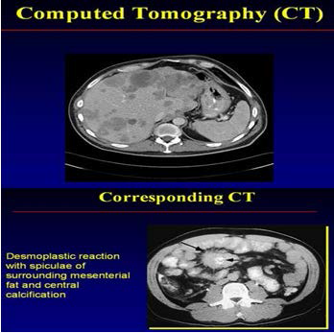

Metastatic NETs are particularly sensitive to the timing of the administration of the contrast used. When evaluating the liver, metastases are most visible on the arterial phase, difficult to visualize on the venous phase, and not visible on non-contrast phases (Figure 15). More importantly, the resolution of the borders of the carcinoid metastasis can be difficult for the radiologist to discern, making determination of progression inaccurate. It is also relatively insensitive in detecting small liver lesions. Also, given the relatively long survival of patients with carcinoid cancer, the repeated radiation exposure from frequent imaging can be a concern. Other modifications of CT, especially enterography, can be helpful in the evaluation of small intestine primary tumors (91). In the setting of emergent situations, such as small bowel obstruction, it still remains the exam of choice.

Figure 15. Arterial and venous phase CT scans in two patients illustrating that multi-phase imaging maximizes sensitivity for detection of liver metastases (92)
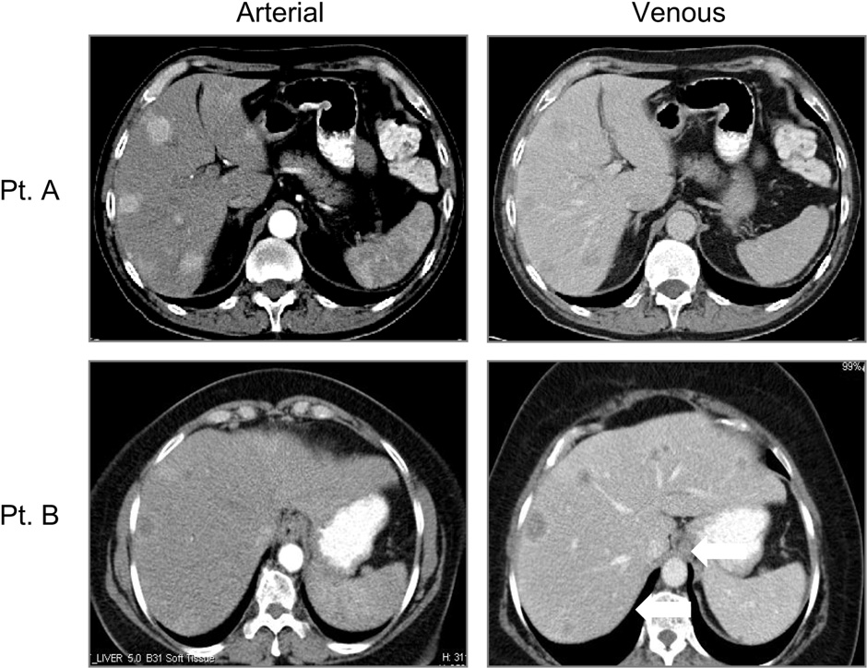

Magnetic Resonance Imaging (MRI)

The wider availability of MRI and the development of new contrast agents have made MRI a powerful tool in the evaluation of NET. Like CT, the information from the MRI must be used in the context of the strengths and weaknesses of the test.

MRI is preferred over CT for patients with a history of allergy to iodine contrast material or for those with renal insufficiency. NETs can have variable appearances on non-contrast MRI. They can be hypo- or iso-intense on T1-weighted images. Metastases to the liver typically are usually high signal on T2 weighted images (93). Because T2-weighted images are obtained without intravenous contrast, they do not have the problems of variations in the timing of phases of contrast enhancement. T2 weighted imaging can be especially useful for patients unable to receive contrast. However, these metastases, especially when cystic or necrotic, can mimic the appearance of other T2 high signal intensity lesions, such as hemangiomas and occasionally cysts (94). Dynamic contrast enhanced imaging can provide additional information about the nature of the lesions, and may help to detect smaller lesions. We recommend T1-, T2-weighted imaging, and multiphasic (arterial, portal venous, and delayed) dynamic MRI for NETs (93) (95), which can improve the detection of small lesions not appreciated on CT.

Neuroendocrine metastases are uniquely vascular which makes evaluation of water motion by MRI highly sensitive. Moreover, with the introduction of hepatocyte specific contrast agents (e.g. gadoxetic acid or gadopentetic acid based gadolinium), NETs can be seen with great detail and measured accurately. This information is particularly important for patients potentially undergoing liver resection. While CT may only show disease in one area of the liver, bilobar disease detected on MRI may change the course of treatment. In one study of 64 patients with metastatic gastrointestinal NETs, MRI scans detected significantly more hepatic lesions than SRS or CT scans (96). Outside of the liver, the MRI is not particularly strong in evaluating the small intestines or the mesentery because of movement artifact.

In summary, some have reported that MRI may be more sensitive than CT is for the detection of small liver metastases (96) (97) (98). However, CT may be better for the evaluation of extra hepatic disease including peritoneal and mesenteric disease. Whether CT or MRI is better overall for NETs will continue to be debated and may vary depending on the expertise of the local center. MRI needs further evaluation before it is used as primary modality for the diagnosis and staging of carcinoid tumor (99) but, overall, it appears to have little advantage over CT.

Ultrasound Endoscopy

Ultrasonography is an excellent technique for NET, but its role in midgut carcinoid is more limited. In general, ultrasound liver guided biopsy of suspected metastases is the best use. Ultrasound is a common method of diagnosing the disease as the patient is undergoing an evaluation for abdominal pain and will have an abdominal ultrasound for biliary examination. It is also highly effective in evaluating liver lesions intra-operatively. Endoscopic ultrasound (EUS) with FNA biopsy is very useful for diagnosing pancreatic NETs. Echocardiography is very useful to detect carcinoid heart disease. In those patients with symptoms or elevated biological markers, evaluation of the right-sided heart valves is critical prior to initiating a treatment plan. Right heart failure can be difficult for the patient’s quality of life as well as add significant morbidity to anyone being evaluated for surgery.

Endoscopy is a valuable diagnostic tool as well. Many of the tumors originate in the terminal ileum and can be seen on intubation of the small bowel during standard colonoscopy. However, small bowel enteroscopy and pill-cam endoscopy may be necessary to see lesions beyond the reach of the standard endoscope and colonoscope (100) (93). Upper endoscopy may identify gastric carcinoid tumors.

Functional Imaging- Somatostatin Receptor Scintigraphy (SRS, Octreoscan)

The most sensitive imaging modality for detecting widespread metastatic disease in NET’s is somatostatin receptor scintigraphy (SRS; OctreoScan®). Octreoscans are extremely useful in confirming the diagnosis and evaluating tumor distribution and burden.

Somatostatin receptors have been identified on most endocrine tumors, including carcinoid tumors, which generally express a high density of the receptors (Figure 16). Five human somatostatin receptor subtypes have been cloned so far, and the binding affinity of octreotide may depend on the subtype(s) expressed (101).

Figure 16. Summary of the expression of the SSTR subtypes analyzed by Reverse transcription Polymerase Chain Reaction (RT-PCR) SSTR 2 are expressed in majority or neuroendocrine tumors and shows high binding affinity to somatostatin analogues. SSTR5 are rarely expressed by neuroendocrine tumors (101).
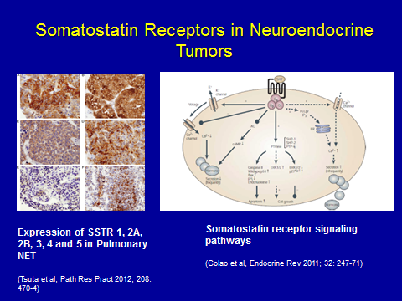

Tumors that express sst 2 or sst 5 can be visualized in vivo after injection of the radio-labeled compound (102). Several different imaging agents that bind to the receptors have been studied (103). I-Tyr3-octreotide was the agent initially used, but it has several disadvantages, including a short half-life, biliary excretion with liver accumulation obscuring potential tumor sites, and difficulties with conjugation. The most widely used analogue for scintigraphy is currently [111] In- DTPA 0 octreotide, (Octreoscan, Tyco healthcare, Mallinckrodt, St Louis USA (104). This agent has a half-life of 3 days, and is renally excreted , obviating many of these difficulties . Apart from this, In pentreotide [In-DOTA 0] lanreotide can also be used (105) (106). SOM- 230 is a new somatostatin analogue with potency to bind SSTR2, SSTR3 and SSTR5.

Regardless of the peptide used, the tracer binds to tumors and full body imaging can be performed. In most centers single photo emission tomography (SPECT) imaging can be fused with CT to combine the functional information of the tumor with anatomic cross-sectional imaging (Figure 17). The other strength of Octreoscan is that the whole body is usually imaged, so that distant metastases not normally in the field of view on CT or MRI can be detected (107). The overall sensitivity of [111In-DTPA0] octreotide scintigraphy appears to be about 80% to 90% (102).

Figure 17.

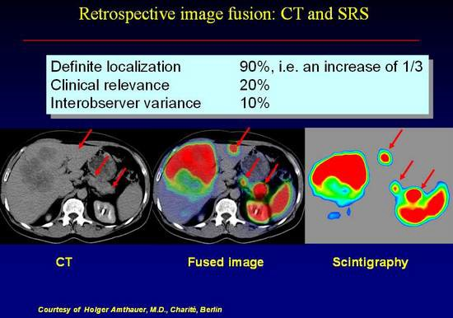

The efficacy of somatostatin receptor scintigraphy with [111] In-DTPA octreotide was evaluated in a European Multicenter Trial (EMT) in 350 patients with a histologically or biochemically proven neuroendocrine GEP tumor (106). Tumor sites were detected by conventional imaging methods in 88%, whereas somatostatin receptor scintigraphy was positive in 80%. The highest success rates of somatostatin receptor scintigraphy were observed with glucagonomas (100%), Vipomas (88%), carcinoids (87%), and nonfunctioning islet cell tumors (82%). The low detection rate (46%) noted for insulinomas is related to the lower incidence of sst 2 somatostatin receptors on insulinoma cells. However, the overall 80% sensitivity found is somewhat lower than the 88% obtained by Krenning’s group (82) in Rotterdam, who studied 130 patients with GEP tumors. This may be related to important differences in scanning procedures such as the amount of radioligand administered (minimal dose of In of 200 MBq and at least 10 mg of peptide by the Rotterdam group), the duration of the acquisition, and the use of single photon emission computed tomography (SPECT) (with a triple-head camera by (98). The fact that abdominal SPECT was not systematically performed in all patients of the EMT may explain that only 73% of gastrinoma patients had a positive scan compared to the 90 to 100% sensitivity reported in other studies. In the EMT, a total of 388 sites were visualized with conventional imaging methods in 308 of the 350 patients. In addition to 297 known localizations, somatostatin receptor scintigraphy revealed another 166 unsuspected lesions. Forty percent of these unsuspected lesions were subsequently confirmed as true positive findings based on the results of additional imaging procedures or histology obtained during the 1-year follow-up period. The clinical relevance of detecting additional tumor localizations is very dependent on the clinical status of the patient. The demonstration of an unsuspected lesion in a patient with known metastatic spread usually has little impact on the management. In contrast, the detection of unsuspected tumor sites in patients with a single known lesion or without any known lesions is important in that it may affect patient selection for curative surgery, which remains the treatment of choice for patients with this type of tumor. In the cohort of 350 patients studied, 42 had no lesion detected by conventional imaging modalities (CIM) and 178 were known to have a single tumor localization prior to the study. Somatostatin receptor scintigraphy was positive in 11 of the 42 patients (25%), and 12 of 16 lesions revealed by somatostatin receptor scintigraphy were further confirmed as true positive. Somatostatin receptor scintigraphy demonstrated multiple tumor sites in 62 of the 178 patients (35%); 60% of these lesions were confirmed by follow-up (1-year) procedures. A reply to an impact questionnaire was obtained for 235 patients. Overall, the scintigraphic findings led to management changes in 40% of the 235 patients. One center extended their number of patients and reported the results separately in more detail (108-110).

Knowledge of the fact that other processes can be somatostatin receptor positive is crucial for interpretation of these scintigrams (111). This has been re-emphasized recently by Gibril et al. (112). They report on the sensitivity of this technique and the importance of (1) having a thorough understanding of diseases or circumstances that result in false-positive localization and (2) including the clinical context at the time of reading and interpretation. Unjustified alteration in management can be reduced to below 3% of all 111 In-DTPA octreotide scintigraphy studies in this way.

Shown in Figure 18 is an abdominal CT scan in a patient with a malignant metastatic neuroendocrine tumor producing predominantly pancreatic polypeptide. The tumor metastases are not evident in the CT scan, however they were clearly visible on Octreoscan. T2 weighted MRI images may also have revealed the tumors because of their vascular nature.

Figure 18.

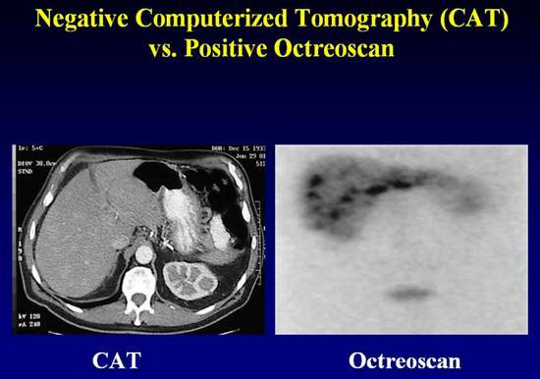

Thus, octreotide scintigraphy has benefit in identifying small primary tumors and liver metastases. This imaging technique is also valuable in identifying metastatic disease to extra- abdominal sites Figure 21 demonstrates the Octreoscan finding in a patient with malignant metastatic disease to the base of the brain, sternum, clavicles and ribs. This turns out to be helpful from at least two points of view. Firstly, the fact that the metastases take up the tracer suggest responsiveness to treatment with octreotide. Secondly, the recognition that there are bony metastases using octreotide tracer suggests treatment with bisphosphonates, which as in other malignancies involving bone appear to have a salutary effect on symptoms and may, although this has not been studied in detail, abrogate the rate of tumor growth in this site.

In addition to tumor imaging, octreotide scanning may be useful in predicting responses to octreotide. One recent study showed that 22 of 27 patients with carcinoid tumor and positive scans responded to octreotide, whereas all three patients with negative scans failed to respond (113). Other investigators have shown similar results (114).

Octreoscan is severely limited by two major aspects: the requirement that the tumor express SSTR and sensitivity. For midgut carcinoid, up to 80% of tumors will express SSTR2, the receptor with the stronger binding affinity for the labelled ligand, and therefore be detectable. However, in some cases of carcinoid, if the primary tumor is already resected and a baseline octreoscan is not obtained, it may be difficult to know if the octreoscan is negative because there is no evidence of disease or if the tumor did not originally express SSTR. Also, because of the nature of SPECT, it is relatively insensitive for lesions < 1 cm. Also, physiological activity in the kidney, spleen, liver, and bowel can obscure the tumors and reduce sensitivity. The test itself is somewhat cumbersome for the patient requiring an initial intravenous injection of the tracer, a scan 4-6 hours and 96 hours later. At 4-6 hours, some lesions may be obscured by relatively high background activity; however, bowel activity is limited. Imaging at 96 hours provides better contrast due to lower background activity. However, there is often physiologic bowel activity that may produce false positive results. Shown in Figure 19 and 20 are the importance of delayed 96 hour imaging.

Figure 19.

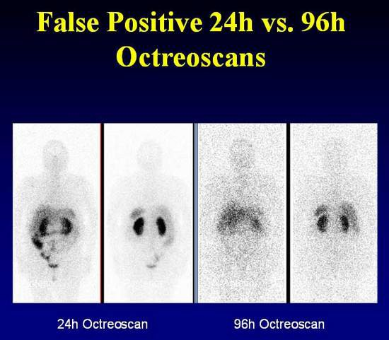

Figure 20.

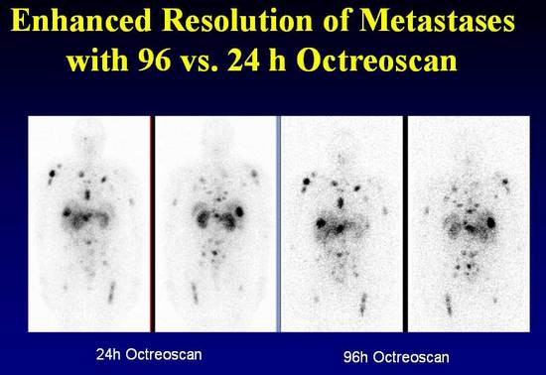

[111In-DTPA0] Octreotide scintigraphy can be performed for patients on long-acting Octreotide but is best performed 3-6 weeks after the last dose. While [111In-DTPA0] octreotide scintigraphy can provide useful information about site of disease, it dose not give information about size. Also, some agents such as interferon may up-regulate somatostatin receptors and thus can lead to increased uptake without disease progression.

Functional Imaging – Positron Emission Tomography (PET)

PET with tracers based upon metabolic features (5 HTP) and receptor characteristics (DOTATOC) have shown promising results in a limited number of studies.

Conventional PET [18F]-fluorodeoxyglucose (FDG) imaging, while successful for many solid tumors, has not been helpful for NETs because of their generally lower proliferative activity. Only tumors with high proliferative activity and dedifferentiation show FDG-PET uptake. Most patients who have been studied had classical midgut tumors and the carcinoid syndrome. PET has been shown to be capable of identifying midgut carcinoid tumors that have metastasized to a variety of sites, and it may be of value in monitoring the effects of treatment (115). The use of PET scanning in undifferentiated tumors or small cell like lesions of the bronchus or thymus is highly effective.

The next generation of functional imaging for neuroendocrine tumors utilizes a different imaging technology to evaluate these tumors. Positron emitters used in NETs include 11-carbon which has been used in most studies to date and the emerging new technology 68-gallium. Both
tryptophan and 5-HTP have been used as tracer substances, but initial studies showed that only 11C-5-HTP was taken up in serotonin-producing tumors (116). While still binding to the SSTR, the PET technique offers greater sensitivity and resolution of images, especially for distant extra-abdominal metastases or difficult to locate abdominal lesions (117) (Figure 21). The technique is also simpler, requiring the patient to only wait approximately one hour prior to a single imaging session. 68-Ga-somatostatin analog imaging is currently being evaluated in clinical trials in the United States and is only available at a few specialty centers (Figure 22). Prior studies have shown 11C-5-HTP PET to be a promising imaging modality for the detection of NETs (118). The serotonin precursor 5-HTP labeled with 11C was used and showed an increased uptake and irreversible trapping of this tracer in NETs (118). [11C]-5-HTP-PET proved better than somatostatin receptor scintigraphy for tumor visualization. However, the short half- life of 11C (t1/2=20min) makes it difficult to apply in clinical practice and is not available in the US.

Figure 21. Fusion PET/CT scan of abdomen and pelvis showing metastases of carcinoid tumor to multiple sites including liver, sternum, ribs.

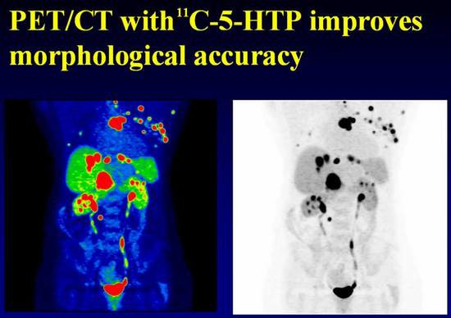

Figure 22. Positron Emission Tomography (PET) Scan
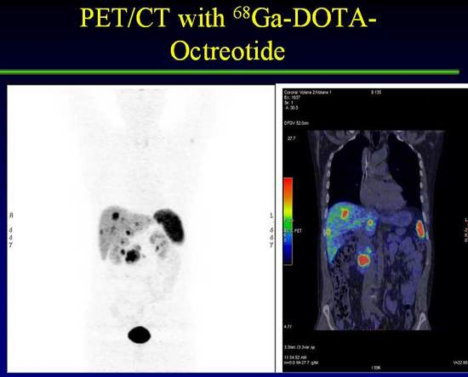

Appropriate Use Criteria for Somatostatin Receptor PET Imaging in Neuroendocrine Tumors

Representatives from the Society of Nuclear Medicine and Molecular Imaging (SNMMI), the American College of Radiology (ACR), the American Society of Clinical Oncology (ASCO), the North American Neuroendocrine Tumor Society (NANETS), the European Association of Nuclear Medicine (EANM), the Endocrine Society, the Society of SurgicalOncology, the National Comprehensive Cancer Network(NCCN), the American College of Physicians (ACP), the American Gastroenterological Association (AGA), and the World Conference on Interventional Oncology(WCIO) assembled under the auspices of an autonomous workgroup to develop the appropriate use criteria (AUC) and came up with specific recommendations. . Somatostatin receptor positron emission tomography (SSTR-PET) is an imaging modality for patients with neuroendocrine tumors (NETs) that has demonstrated a significant improvement over conventional imaging (CI). SSTR-PET should replace In-111 pentetreotide scintigraphy (OctreoScan) in all indications in which SSTR scintigraphy is currently being used. These appropriate use criteria (AUC) are intended to aid referring medical practitioners in the appropriate use of SSTR-PET for imaging of patients with NETs, and the indications were evaluated in well-differentiated NETs. Of the 12 clinical scenarios evaluated, nine were graded as appropriate: initial staging after the histologic diagnosis of NET, evaluation of an unknown primary, evaluation of a mass suggestive of NET not amenable to endoscopic or percutaneous biopsy, staging of NET prior to planned surgery, monitoring of NET seen predominantly on SSTR-PET, evaluation of patients with biochemical evidence and symptoms of a NET, evaluation of patients with biochemical evidence of a NET without evidence on CI or a prior histologic diagnosis, restaging at time of clinical or laboratory progression without progression on CI, and new indeterminate lesion on CI with unclear progression.

Summary of Recommendations

SSTR-PET should replace In-111 pentetreotide in all indications in which In-111 pentetreotide is currently being used. SSTR-PET has demonstrated better sensitivity and specificity than CI and In-111 pentetreotide. There are specific instances in which SSTR-PET is clearly preferred: at initial diagnosis, when selecting patients for PRRT, and for localization of unknown primaries. For patients in which the tumor is readily seen on CI, SSTR-PET is not needed for routine monitoring. Specific details on the tumors appropriate for this approach are being developed. SNMMI has been working with several other medical specialty societies to develop broad-based multidisciplinary clinical guidance documents. This collaboration should foster the acceptance and adoption of this guidance by other specialties including AACE. SNMMI has developed a multipronged approach to disseminate the AUC for SSTR-PET in NETs to all relevant stakeholders—referring physicians, nuclear medicine physicians, and patients. The dissemination and implementation tactics will be a mix of outreach and educational activities and will be targeted to each of these audiences. SNMMI will create detailed case studies for its members and for referring physicians and make them available via online modules and webinars. These cases will cover the appropriate clinical scenarios for the use of SSRTPET, as well as some cases in which the results of SSRTPET are equivocal. Related resources such as the systematic review supporting the development of these AUC, a list of upcoming education events on the AUC, factsheets, and other didactic materials will be made available on the SNMMI webpage dedicated to the SSRT-PET AUC (119) (120) (121) .

MIBG Scanning

The first report of 131 I-MIBG for the imaging of a carcinoid tumor was that of Fischer and colleagues in 1984, in which hepatic metastases that were seen as photopenic areas on a 99mTc-phytate liver scan concentrated (122) 131 I-MIBG (123). Since this initial description, there have been a number of reports of successful imaging of carcinoid tumors using 131 I-MIBG. The number studied are far less than those reported for pheochromocytomas or neuroblastoma but it probably is fair to say that the sensitivity is significantly lower (124) (125) (126). The overall sensitivity is calculated to be 55%. Because MIBG is taken up by a wide variety of neuroendocrine tumors, specificity depends on the certainty of the clinical and biochemical diagnosis. In the correct clinical context, this is well over 95% for pheochromocytomas (127) and neuroblastoma, (128-130) but it is clearly less for carcinoid tumors. 131 I-MIBG scanning offers information that is additive to the information gained by SRS imaging. In some patients SRS scanning is negative and other lesions light up on MIBG scanning. In other patients SRS imaging and MIBG scans both are positive or negative. In the case where both scans are positive patients may be candidates for future therapy with 131 I-MIBG or PRRT with radiolabeled somatostatin analogs.

Other Diagnostic Methods

Several other diagnostic methods have been evaluated for the diagnosis of carcinoid tumors, including barium examinations, angiography, and venous sampling with radioimmunoassay of hormones. Barium examinations rarely are diagnostic, but they may demonstrate fixation, separation, thickening, and angulations of bowel loops.

The role of angiography in the diagnosis of carcinoid tumor has decreased due to the availability of the newer imaging methods. Diagnostic angiography generally is employed when noninvasive imaging studies are equivocal and surgery or chemoembolization is contemplated (Figure 23).

Figure 23. Positive angiogram with Negative CAT scan in a patient with NET
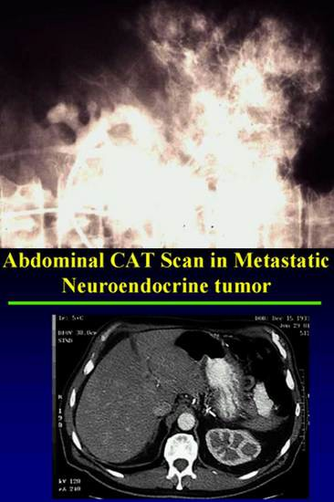

Liver metastases from carcinoid tumors vary in size and usually are vascular, with abundant neovascularity demonstrable on angiography. Figure 23 illustrates the highly vascular nature of neuroendocrine tumor metastases to the liver. It is this hypervascularity of the tumor that distinguish it from other non-endocrine tumors that metastasize to the liver as well as providing insight into the availability of “feeder vessels” for chemoembolization for the reduction of tumor burden. This is particularly helpful in restoring responsiveness to octreotide, reducing tumor load and lessening the biochemical deviations, which in the case of serotonin for example may reduce the risk of development of carcinoid heart disease. In the remaining cases, in whom the tumor has not been identified by the above techniques, total-body venous sampling with measurement of a peptide hormone that is produced may be considered. Measurements of serotonin may be misleading, but those of SP may well direct attention to the source of overproduction of the peptide. This has proved useful in SP-producing tumors (45).

Percutaneous transhepatic portal and systemic venous sampling with hormone assay is generally not a very useful technique for the localization of carcinoid tumors. Such data must be used cautiously. In one report, whole-body venous sampling with measurements of plasma serotonin erroneously localized the tumor to the neck, for which a negative exploration was carried out; however, SP levels correctly localized certain of these tumors (45).

Summary of Imaging for NETS

A major aspect in the evaluation of patients with suspected MGC is diagnostic imaging (34). The modalities typically used include both standard cross-sectional techniques as well as nuclear functional imaging with the following diagnostic goals:

    - making the diagnosis,
    - determining the total tumor burden,
    - determining the potential for resection and debulking,
    - establishing disease prognosis, and
    - determining the potential for non-conventional therapies, especially for systemic or inoperable disease.
    - Pearls on Imaging:
    - CT scan is limited in its evaluation of the liver and requires multiphase
contrast evaluation
    - MRI is an excellent examination of the liver
    - Ultrasound is a highly effective method when used intraoperatively to evaluate
liver lesions
    - Octreoscan is a specific test for carcinoid, but can have false negative results
    - 68Ga-somatostatin PET imaging is the emerging new technology for
functional imaging

SPECIAL CLINICAL SITUATIONS

Carcinoid Heart Disease

Table 19. Distinguishing Carcinoid from Cardiac Failure Symptoms

- Right Heart Failure  - Dyspnea  - Fatigue  - Ascites  - Anorexia  - Edema | - Carcinoid Symptoms  - Flushing  - Diarrhea  - Bronchospasm  - Hypotension  - Tachycardia

With the advent of modern therapy for carcinoid tumors, increasing survival is unveiling a higher incidence of carcinoid heart disease. Carcinoid heart disease is a unique heart disease associated with this cancer and may be seen in up to 60% of patients with metastatic carcinoid. Valvular disease is the most common pathologic feature. Carcinoid heart disease is the only condition in which both right-sided valves are involved and the combination of pulmonary stenosis and tricuspid regurgitation occur. Tricuspid damage is found in 97% and pulmonary valve disease in 88%, with 88% displaying insufficiency and 49% stenosis. The distinctive carcinoid lesion consists of deposits of fibrous tissue devoid of elastic fibers known as carcinoid plaque. The deposits are found on the endocardial surface on the ventricular aspect of the tricuspid leaflet and on the arterial aspect of the pulmonary valve cusps (131). Most patients have the distinctive lesions on the right side of the heart ( Figure 24). In the setting of bronchial carcinoid, the left-sided lesions on the mitral valve may be so extensive as to cause mitral stenosis.

Table 19 indicates the difference in symptomtology between right heart failure and carcinoid symptoms. While there should be no mistaking these conditions it is not surprising that faced with a patient who is suffering from flushing, wheezing and bronchospasm the occurrence of dyspnea, fatigue and edema might go unnoticed. This can be particularly devastating since the advent of heart failure heralds a very poor prognosis. Its occurrence does not appear to be predicated by the bulk of the tumor, the duration of symptoms, or the location of the primary tumor but rather the level of serotonin in the blood (Table 20). Values greater than1000pg/ml correlate with the development of carcinoid heart disease. Possibly for this reason alone, in treating these patients all attempts should be made to keep serotonin levels down in addition to relieving symptoms and slowing or abrogating tumor growth. Ovarian carcinoids are the rare variety in which cardiac involvement occurs without metastases to the liver, no doubt because of the direct drainage of the ovarian veins into the systemic circulation.

The condition can be diagnosed clinically. In approximately 20% of patients with carcinoid disease the presenting symptom may be attributable to heart failure (132). Ninety five percent of patients have the diastolic murmur of tricuspid incompetence and 13% the precordial systolic murmur of pulmonary stenosis. The chest radiograph may show an increase in the cardiothoracic ratio in 38% of cases and is not a sensitive measure (131). The electrocardiograph characteristically shows low voltage in that the sum of the QRS voltage in the standard leads I, II, and III is less than 15 mm, but evidence of right ventricular hypertrophy is rare. Pro-brain natriuretic peptide (NT-pro-BNP) can be used as a biomarker for the detection of carcinoid heart disease with high specificity and sensitivity and used as an adjunct to deciding who requires Echocardiography (133).

Transthoracic echocardiography, both M-mode and cross-sectional may show dilated right ventricular cavity and abnormal movement of the ventricular septum as well as thickened and retracted tricuspid leaflets with a fixed orifice. However, is not very sensitive, being positive only in only two thirds of (15/20) patients with clinical evidence of carcinoid heart disease (134).

Transesophageal echocardiography may be more sensitive than transthoracic (71% vs 57% of 31 patients with ileal carcinoid) and allows for measurement of the thickness of the A-V valves (135). Doppler echocardiography was examined by Pellika and colleagues (136) in 132 patients with carcinoid syndrome. They found 74 (56%) with Doppler echocardiographic features of carcinoid heart. Ninety seven percent had thickened and shortened tricuspid leaflets and 100% had tricuspid regurgitation. A dagger-shape spectral profile with an early peak pressure and rapid decline was characteristic. The pulmonary valves were thickened, retracted and immobile in 59% and of these regurgitation was present in 81% and stenosis in 53%. Left-sided lesions were found in patients with patent foramen ovale in 7%, metastasis to the myocardium in 4% and small pericardial effusions in 14%. The 3-year survival in their series was reduced from 68% to 31% in those with carcinoid heart disease. Hemodynamic tests showed the expected pulmonary stenosis and tricuspid valve regurgitation and are only indicated for decision making with regard to possible valvulotomy. A Doppler gradient of >10mm Hg is considered by one group to indicate a need for pulmonary valvulotomy (137).

The pathogenesis of the plaque is not completely understood. The plaque is composed of smooth muscle cells, myofibroblasts and an overlying endothelial cell layer. The smooth muscle cells and the myofibrils are surrounded by an extracellular matrix of microfibrils, acid mucopolysaccharides, collagen fibers and basement membrane. Serotonin infusion in the presence of hepatic injury or tryptophan or niacin deficiency in animals leads to similar lesions (131). A similar condition is also observed in Uganda, with large consumption of the Cassava plant which is rich in tryptophan, the precursor of serotonin. The recent discovery of an analogous heart condition in obese patients taking Fenfluramine and dexfenfluramine (Phentermine) known as phen/fen for weight reduction is thought to be due to the enhanced release of serotonin and decreased serotonin reuptake exposing the heart valves to much higher concentrations of 5 hydroxytryptamine (137). These appetite suppressants were in widespread use in the United States. On July 8th 1997, 24 cases of valvular heart disease were reported in women who had been treated with the combination for about one year. Regurgitation was found in all cases. Both right and left-sided heart valves were involved. Eight women developed pulmonary hypertension. Cardiac surgical intervention was required in 5 patients at the time of reporting. The histological features were similar to those observed in carcinoid-induced valvular disease. Based on these observations the FDA issued a public health advisory and sent letters to 700,000 US health care practitioners advocating the immediate cessation of further prescriptions. The rarity of the syndrome in patients with bronchial carcinoids may be ascribable to the production only of 5 hydroxytryptophan rather than the amine, serotonin.

Lundin (138) and colleagues (1988) reported on 68 patients with midgut tumors 50 of whom had carcinoid syndrome. Eighty nine percent had elevated 5HIAA and the patients with severe right sided heart disease had significantly higher mean values (9800 vs 2190 umol/day). Pellika et al (136) reporting on the Mayo experience found higher urinary 5HIAA in their 84 patients with carcinoid heart compared with the remainder of the 132 patients studied (270 vs 131 mg/day). Robolio et al (139) reported on the Duke carcinoid database of 604 patients found strikingly higher plasma serotonin (1130 vs 426 pmol/ml) and urinary 5HIAA (219 vs 55 mg/day) in 119 patients with carcinoid heart than in 585 patients without carcinoid heart. Thus there is considerable circumstantial evidence to implicate serotonin per se in the pathogenesis of carcinoid heart. Our own experience is that treatment of patients with carcinoid syndrome with Octreotide often ameliorates the clinical syndrome but does little to lower serotonin levels and the heart disease progresses while the condition appears to regress (140). The finding by Lundin et al (138) in (1988) of higher levels of neuropeptide K and substance P in patients with midgut carcinoids and heart disease may simply reflect the advanced stage of the disease since these are potent vasodilators and are not known to be able to influence the development of the characteristic plaque. Similarly their report (141) of higher levels of Atrial Natriuretic Peptide (ANP) in patients with carcinoid heart may only reflect upon the development of failure, a known cause of increases levels of ANP.

Table 20.

Carcinoid Heart Disease

- No obvious relation to:
- Duration of disease
- Tumor bulk
- Location of primary
- Progression of disease
- Significant difference
- Survival
- Serotonin (5HIAA) values >1000 pg/ml

Figure 24.

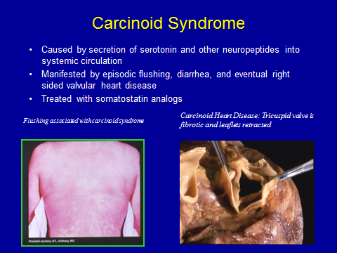

The dismal prognosis of patients with carcinoid heart disease with less than 20% 5 year survival even with Octreotide treatment, compared with greater than 66% 5 year survival in patients without carcinoid heart disease dictates a much more aggressive approach to management. Up to 1995, a total of 38 patients had been reported with either single case studies or small series of patients who had undergone valve replacement. There were no significant differences in survival of patients with bioprosthesis vs a mechanical prosthesis in the tricuspid valve position. The 4 year survival was improved to 48±13% (137). In the Mayo and Duke experience (142) in 26 and 8 patients respectively, up to 30% die within the first 30 days of operation. Predictors of operative mortality are low voltage in the standard EKG leads (QRS in leads I,II,III <15mm), high preoperative serotonin and age > 60 years (>56% mortality). Long term survival was predicated by low serotonin values and none of the patients less than 60 years old died early. All who survived had symptomatic improvement. Balloon valvulotomy has had mixed results. Somewhat surprisingly Rayson and colleagues report four patients with severe carcinoid heart disease who had regression of their metastatic tumors postoperatively (143). Further descriptions of tumor status in patients who have had cardiac surgery to confirm or refute this observation are clearly necessary and it would be of considerable interest and therapeutic potential to determine the possible mechanism involved.

Thus if the distinctions between carcinoid symptoms and symptoms due to cardiac disease are recognized early, before there is marked elevation of the serotonin levels, especially in patients under the age of 60 years and without EKG evidence of low voltage, it is probably prudent today to aggressively replace the tricuspid and pulmonary valves. Since the long-term durability of bioprosthetic valves is greater than the 20% 5 year survival of untreated patients this is not an issue. Prolongation of life can be achieved and more importantly the quality of life is greatly enhanced for the remaining years.

Carcinoid Bone Metastasis

NETs are renowned for their production of a host of peptides and amines as well as many cytokines, which may foster tumor growth as well as metastases to bone (Figures 25 and 26). Symptoms of bone metastases include pain, fractures, and spinal cord compression. Carcinoid bone metastases are being identified more frequently. A possible explanation for the increasing
rate of bone metastases could be due the therapeutic use of various somatostatin analogs and interferon-α. These agents relieve symptoms mediated by amines secreted by the tumor (144) but have only a limited effect on tumor growth (145). Improvements in medical management can lead to prolonged survival in patients with advanced disease with more patients developing boney metastases. Finally the increasing use of imaging techniques like Octreotide scintigraphy reveals asymptomatic bone metastases, leading to diagnosis of higher rate of bone metastases.

Figure 25. NETs with Osteolytic and Osteoblastic Lesions. OCL:osteoclasts; OB:osteoblasts


Figure 26. Bone metastases mechanism in neuroendocrine tumors showing the spread of neoplastic cells from the primary tumor invading blood vessels and spreading as emboli to distant regions like bone. Malignant tumor cells adhere to blood vessel at the distant capillary bed in bone
to enter the bone matrix through extravasations and then they proliferate inside the bone matrix.

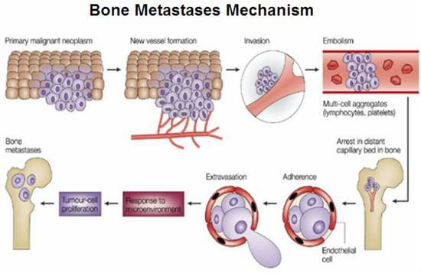

Figure 27. A vicious cycle, interaction between the tumor cells and bone cells.Osteoclastic resorption and osteoblast deposition of bone during mineralization causes stimulation of Bone derived Growth Factors which in turn stimulate the cancer cells which have capability to stimulate both osteoblast and osteoclast through osteoblatic and osteolytic chemokines and thus causing a vicious cycle. TGFβ: Tissue growth factor beta, PTHrP: Parathyroid hormone-related protein, IL: Interleukin, TNF: Tumor necrosis factor, ET: endothelin -1, PDGF: Platelet derived growth factor.

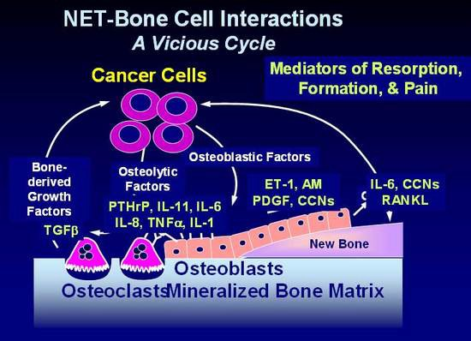

Shown in the Figure 27 are some of the proposed mechanisms whereby NETs affect bone turnover. NETs cells are capable of producing both osteoblastic and osteolytic chemokines. Thus both types of metastases are observed. The figure shows a partial listing of chemokines involved which include immunoreactive Parathyroid hormone related protein or PTHrp, endothelin -1 (ET-1) shown to bind to Endothlein A and B receptor mediating osteolysis, and various cytokines such as tumor necrosis factor (TNF a) and interleukins 6 and 11. Perhaps the most significant of these is RANK which binds to its ligand RANKL, thereby promoting osteoclastic activity. The natural antagonist is osteoprotegrin (OPG) which binds to RANK and precludes its binding to RANKL, inhibiting osteocalstic activity.

Diagnosis of Bone Metastases:

While the standard means of detecting bone metastases is radiological (e.g. X-ray, bone scan, Octreoscan) bone metastases can be sought with measurement of bone alkaline phosphatase, N telopeptide, and 25-OH Vitamin D, 1-25-OH Vitamin D. Bone alkaline phosphatase is an indicator of osteoblast function. Urinary N –telopeptide reflects osteoclast activity or bone resorption (Figure 28). Somewhat paradoxically only blastic metastases show an increase in both markers as indicated in Figure 28 (27). A more complete listing of bone markers that may aid in diagnosis, management, and response to therapy are shown in Table 21.

Table 21. Bone Metastases Screening Using Bone Formation Markers & Assays, Bone resorption markers, Markers of malignancy, Markers of cytokine excess and Vit D metabolism. IGF: Insulin like Growth Factor, IL:Interleukin, PTHrP: Parathyroid hormone-related protein, NTX: N-Telopeptide; TGFβ: Tissue growth factor beta.

- Bone formation markers:  - Serum PINP  - Serum Bone specific Alkaline Phosphatase  - Serum Osteocalcin  - Osteoprotegrin (OPG) | - Screening:  - Bone Alkaline phosphatase  - N telopeptide  - Vitamin D25, 1:25 OHD
- Bone resorbtion markers:  - Urine NTX  - Serum CTX  - Serum NTX  - Serum RankL | - Markers of malignancy:  - PTHrP in blood  - Perhaps IGF1  - Calcitonin  - TGF  - Endothelin 1
- Markers of cytokine excess  - Serum IL1 and IL6 | - Vitamin D metabolism  - Serum 25 hydroxy Vitamin D (25OH D)  - Ionized calcium

Several studies have shown bone markers to be elevated in carcinoid patients who have documented evidence of metastatic bone disease. Increased levels are also observed in some patients without clinical evidence of bone metastases, when compared with normal subjects (146). Rises in such markers may be the first indication of bone involvement and therefore may potentially be useful in early diagnosis of progression. Preliminary data suggest bone marker levels correlate with the extent of metastatic disease and the number of skeletal sites involved. Markers of bone turnover may be helpful in identifying those patients who are likely to respond to bisphosphonate treatment (146) (Figure 28).

Figure 28. Bone Markers in Patients with Lytic and Blastic Metastases. Note here that markers for bone formation-Alkaline Phosphatase and Bone lysis-N-telopeptide are both increased in blastic lesions (146).

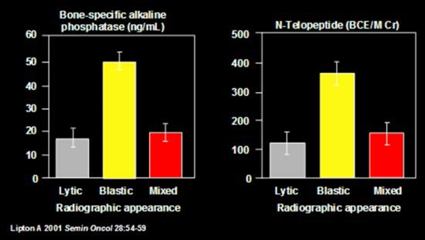

Treatment of Bone Metastases (BM):

Therapeutic options include drugs, chemotherapy, surgery, and radiation therapy. Bisphosphonates, anti TGF beta, anti endothelin acting drugs, Denusumab human monoclonal antibody and antibody that binds RankL are major non invasive options. Surgery may be required to treat or prevent pathologic fractures. External beam radiation therapy is effective in treating painful boney metastases.

Bisphosphonates are effective for the prevention of skeletal complications secondary to bone metastases. The direct in vitro effects of bispohosphonates on bone include: Inhibition of growth, (147), invasiveness (148) (149), apoptosis (150) (151), adhesion to bone (152) (153), inflammatory effects on T cells, and Anti-angiogenic effects (Figure 29). None the less the clinical impression is that although symptoms (pain) may be relieved, little is done to inhibit growth of the tumor.

IV pamidronate and zoledronic acid are FDA-approved for other malignancies but are in extensive clinical use in NET. There is however, a need for safer and effective therapies. Renal toxicity and osteonecrosis of the jaw are potential complications associated with bisphosphonates and are of considerable concern in patients with NET (154-160). All patients embarking on treatment with bisphosphonates should have an evaluation for possible complications. While we have used pamidronate exclusively, a recent report (161) suggests that Zoledronate is the more preferred agent.

Symptoms of possible osteonecrosis of the jaw from biophosphonates include a dull aching sensation, with the feeling that the jaw is “heavy”, numbness and tingling of the jaw, tooth pain, and undiagnosed oral pain. Signs of possible osteonecrosis include rough area on the jawbone, soft tissue swelling, drainage or infection, exposed bone in the oral cavity, sudden change of health in periodontal tissue, failure of oral lesions to heal, and loosening of the teeth.

Figure 29. Different Mechanisms of Action of Bisphosphonates. They inhibit osteoclast formation, migration, osteolytic activity and promote apoptosis. They also modulate signalling from osteoblasts to osteoclasts.

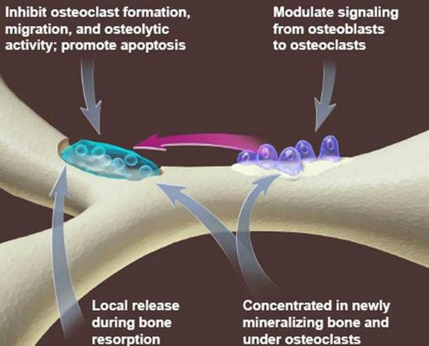

Prospects for alternative therapies are a major area of research. One such area is inhibitors of TGF β. TGF β is a multifunctional cytokine with widespeard effects, including antiproliferation, apoptosis, extracellular matrix production, angiogenesis, immune function, and epithelial to mesenchymal transition. The effects of TGF β on bone are complex, but it appears to be intimately involved with bone metastasis and osteolysis. Studies have shown that inhibition of TGFβ kinases in vitro have an effect on osteolyic and prometastatic factors including PTHrP, IL- 11 and CTGF. In vitro studies have shown effects on osteolysis, tumor burden and survival.

Another promising area of research is the novel target endothelin Receptor ET-1. Endothelin Receptors are responsible for a number of effects on bone including vasoconstriction and cell proliferation. Phase II trials with Endothelin A Receptor (ETAR) antagonist, Atrasentan, in metastatic hormone resistant prostate cancer to bone, showed increased time for clinical progression of the disease as well as slow rise in PSA levels (162). In another Phase II trial with Atrasentan, they showed decreases in marker levels for bone remodeling after treatment with Atrasentan (163). Treatment with an orally active Endothelin A receptor antagonist dramatically decreased bone metastases and tumor burden in mice inoculated with ZR-75-1 cells (164). Tumor-produced endothelin-1 may have a major role in the establishment of osteoblastic bone metastases, and endothelin A receptor blockade represents effective treatment (164). Whether or not these agents have activity in carcinoid boney metastases is not known.

Prognosis of Bone Metastases:

Brown (2005) evaluated the outcome of patients with tumor metastases to bone (165). Increased osteoclast activity predicts a poor outcome, with high N–telopeptide levels (> 100 nmol BCE/mM creatinine)associated with a Relative Risk (RR) of skeletal related events RR: 3.3 (p<0.001) disease progression RR: 2.0 (p<0.001) and death RR: 4.6 (p<0.001) (165).

TREATMENT OVERVIEW

Surgery

Surgical removal of the primary tumor is the treatment of choice for small and localized tumors as well as for the alleviation of any obstructive symptoms (Figure 30). Surgical cure of carcinoid tumor is almost impossible in the presence of intra-abdominal and widespread hepatic metastases.

Figure 30.

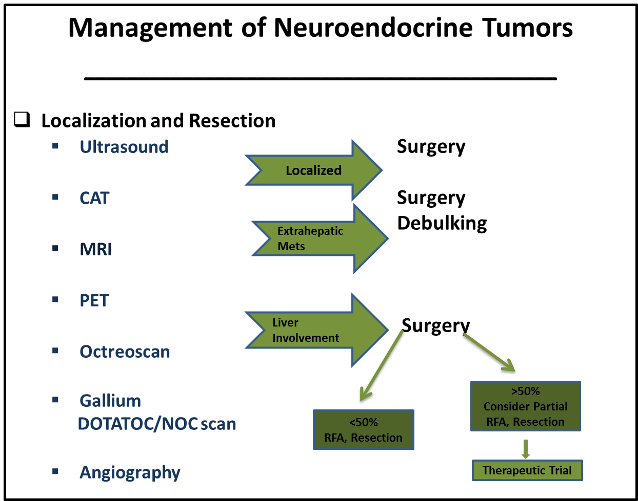

Resection of NETS in the absence of metastases is a sine qua non. NETs may present several unique challenges for the surgeon. The primary tumor is often small and may be occult. It may be difficult to identify on preoperative imaging and in the operating room. Indeed, sometimes the primary cannot be located, with the only findings a mesenteric mass. An occult primary should not deter attempts at resection since the majority of these tumors are found intra- operatively after diligent and thorough inspection of the small bowel using open or laparoscopic techniques. NETs are characterized by small ileal, occasionally multiple, submucosal tumors, regularly associated with a larger mesenteric mass and intense fibrosis (166). The mesenteric lymph node involvement can be bulky and involving major mesenteric arterial and venous branches. This may make it difficult or impossible to completely remove the mass.

The aim of surgical treatment for small intestinal - NETs, when possible, should be the complete curative en block resection of the primary tumor and its mesenteric lymph node metastases/mass. Surgeons must be aware of the predilection of these tumors for spread along the bowel lymphatics hence mimicking multiple small bowel primaries. Loco-regional resection aims to remove the small bowel primary and other small bowel tumor deposits with an extensive mesenteric lymph node dissection. Resection often includes a right hemi-colectomy and extensive small bowel resection while respecting the blood supply to the remaining bowel and avoiding short bowel syndrome. Fibrosis is the hallmark of NETs and release of fibrotic bands can relieve obstructive symptoms.

Even in the presence of distant metastases, resection of the primary and mesenteric mass is increasingly being advocated (167). The median and 5 year overall survival after loco-regional resection and selective systemic therapy of NETs shows a survival benefit. Debulking of liver metastasis by resection in combination with ablative therapies and other liver directed modalities may help decrease hormonal over production and palliate symptoms in carefully selected patients.

The hormonal effects of the tumor can be extreme. When the carcinoid syndrome is present or suspected, the surgeon and the anesthesia team should be prepared for the possibility of a carcinoid crisis with resulting hemodynamic instability, hyperthermia, shock, arrhythmia, flushing or bronchial obstruction (168). Prior to a surgical procedure, patients with carcinoid syndrome should be evaluated for the presence of carcinoid valve disease, and undergo valve repair prior to abdominal surgery for the primary and/or metstatic disease. Patients at high risk for carcinoid crisis, those with flushing and/or large bulky tumors, should be given peri-operative continuous intravenous octreotide (169). In the past, it was deemed unwise to submit a patient to anesthesia or operation without premedication using a combination of adrenergic blockade, steroids, thorazine, and aspirin. Currently, however, preoperative use of octreotide is the most important drug to prevent carcinoid crisis. Kvols and colleagues (169) presented data on one such patient, who, soon after the induction of anesthesia, had a fall in blood pressure that was unresponsive to intravenous fluid, calcium, Neo-Synephrine, or epinephrine administration. Within 1 minute of 100 meg of octreotide given intravenously, blood pressure rose, and the patient made an uneventful recovery. Lastly, since somatostatin analogs are known to cause biliary stasis, and the majority of patients with small intestinal -NET will be treated with such agents at some point during their treatment course, cholecystectomy should be performed at the time of first operation for midgut carcinoids.

Carcinoids of the appendix are often found incidentally during appendectomy. The majority of appendiceal carcinoids are small (<1cm), located at the tip of the appendix and often cured with appendectomy. A right hemicolectomy with removal of the draining lymphatics is recommended when the primary tumor is ≥2cm, incompletely resected, invades the base of the appendix or meso-appendix, displays lymphovascular invasion or lymph node metastases and unfavorable histology or grade (goblet cell, adenocarcinoid). The need for right hemicolectomy in appendiceal carcinoid of 1-2 cm in size remains controversial. Most are decided on a case by case basis looking at patient factors such as age and health, and pathological factors that suggest possible aggressive behavior. Cecal carcinoids usually present as a bulky mass causing intestinal obstruction or hemorrhage. Complete resection of the tumor and its draining lymphatics is recommended (170).

Treatment of Metastatic Disease

Figure 31. Management of Metastatic Tumor

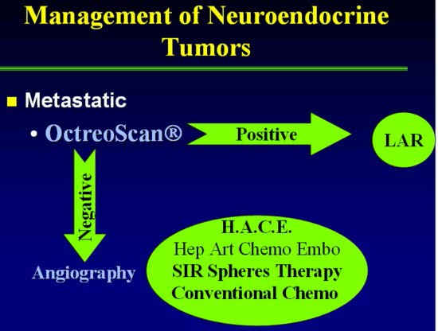

General management schemes for patients with metastatic disease are shown in Figures 31 and 38. Because carcinoid is a slow-growing tumor, even patients with extensive metastatic disease can enjoy a normal quality of life so long as the endocrine syndrome is controlled. The mainstay of treatment is octreotide (Figure 34). Different chemotherapeutic agents (171) and surgery or arterial embolization (172) have been used with variable success, but eventual relapse with increasing resistance to the drugs is encountered (173). Various agents such as parachlorophenylalanine, methotrimeprazine, aprotinin, methysergide, cyproheptadine, heparin, phenothiazines, a-adrenergic antagonists, corticosteroids, H 1 and H 2 antihistamine blockers and numerous antineoplastic agents have been used in carcinoid syndrome with variable success (59) (174). These medications either inhibit serotonin synthesis, act as a systemic antagonist of serotonin, or block kallikrein release. Symptomatic treatment of diarrhea with opioids, and codeine have been tried with variable results (173). Because somatostatin has very broad inhibitory effects, somatostatin-14 has been used successfully to suppress diarrhea and flushing in patients with carcinoid tumors (175) but, its clinical use is limited by its short half-life (176) and the resulting need for continuous intravenous infusion. The advent of the long-acting somatostatin analogue octreotide, has resolved problems with short half life time and it has been used in the treatment of different neuroendocrine tumors, including carcinoid (175) (169) (177) (19) as discussed in more detail below. More recently, tyrosine kinase (TK) inhibitors, mammalian target of rapamycin (mTOR) inhibitors, growth factor inhibitors, angiogenesis inhibitors, and various biologics have shown activity in this disease. The medical and radiologic treatment of carcinoid tumors is discussed in more detail below. The evolution of available treatments is shown in Figure 32.

Figure 32. Evolution of the Treatment of NET

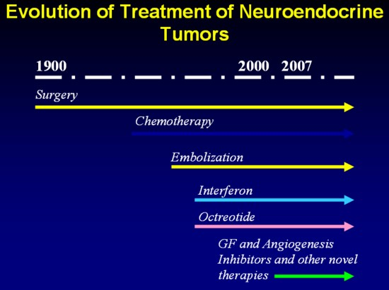

Medical Treatment of Carcinoid Symptoms

Somatostatin analogs (SAs) are the mainstay of treatment of the carcinoid symptom complex. There are 5 somatostatin receptors present on these tumors as discussed in more detail earlier in the chapter (178) (179). The commonly used SAs, octreotide and lanreotide, bind to SSTR-2 and 5 and are useful in reducing the diarrhea, flushing, and wheezing in at least 80% of patients (180), As a palliative agent, octreotide can control flushing, diarrhea, and wheezing, with improvement in their general condition . Response is often dose dependent (Figure 43).

In a review of 15 studies including 481 patients, the slow-release formulations octreotide LAR (long acting release) and lanreotide Autogel achieved symptomatic improvement in 74% and 68%, biochemical response in 51% and 39%, and tumor response in 70% and 64%, respectively (181). Overall, octreotide and lanreotide have similar efficacy in symptom control and reducing tumor markers and serotonin levels (182). The recent ELECT study (58) evaluated rescue use as a measure of lanreotide autogel efficacy in patients who were SA naïve. This was a 16-week randomized double- blind phase 3 trial (lanreotide Autogel 120 mg [n=59] vs. placebo [n=56] every 4 weeks), followed by a 32-week open label Lanreotide autogel extension. Patients had access to octreotide s.c. as rescue for breakthrough symptoms. The primary endpoint was the percentage of days rescue was used during the double-blind phase. Complete/partial responses were more common in the autogel arm (58). The starting dose of lanreotide autogel is usually 90-120 mg subcutaneously monthly, whereas octreotide LAR is 30-120 mg intramuscularly monthly. SAs control growth of well differentiated NETs as well.

Pasireotide is a novel SA that has high affinity for SSTR-1, 2, 3, and 5 and displays a 30- to 40- fold higher affinity for SSTR-1 and SSTR-5 than octreotide or lanreotide. Pasireotide has been approved by the FDA for use in Cushing’s disease and has demonstrated efficacy in patients with acromegaly (183) (184) (39) (40) and is generally well tolerated (183). Kvols et al. administered pasireotide as depot monthly injections to 45 subjects with carcinoid syndrome who had lost octreotide responsiveness. In this study, pasireotide controlled diarrhea and flushing in 27% of patients (185). Tumors remained stable in 13 (57%) and progressed in ten. This study suggested a role for pasireotide in patients resistant to currently available somatostatin analogs. In a more recent study, pasireotide administered as a monthly IM injection to 42 subjects with primary or metastatic GEP NET was well tolerated (186). Further study will help elucidate the role of pasireotide in patients with carcinoid tumors.

More recently Telotristat, a novel inhibitor of tryptophan hydroxylase ( the rate liming step enzyme in serotonin synthesis), has been shown to be effective in controlling diarrhea even when unresponsive to conventioinal treatment including somatostatin analogs (Figure 33). Moreover there was a clear dose dependent reduction in urinary 5HIAA excretion (Figure 34).

Figure 33
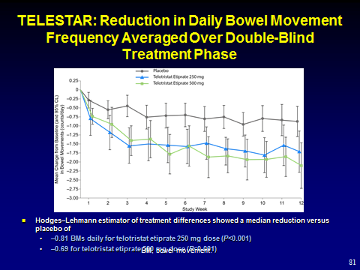

Figure 34

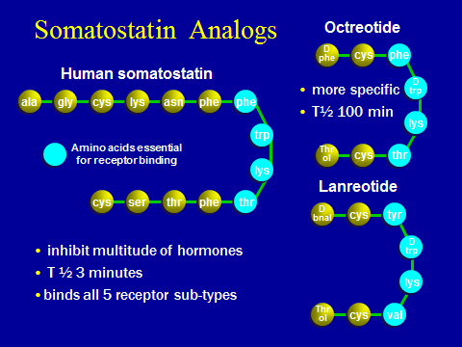

Figure 35
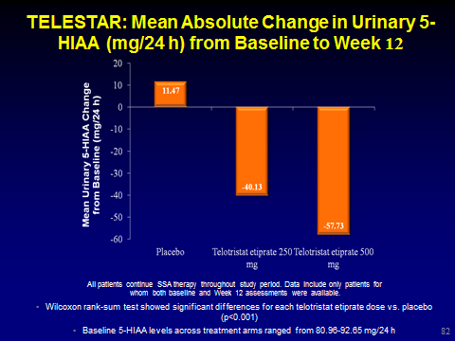

Figure 36

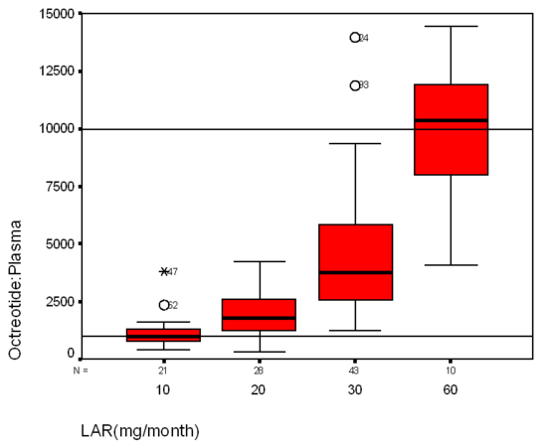

In general, SAs are well tolerated (Table 22), but patients may note nausea, abdominal discomfort, bloating and/or steatorrhea, often during the first several weeks of therapy after which the symptoms subside. Pancreatic malabsorption should be monitored and alleviated with pancreatic enzyme supplementation.

Although patients may be controlled with SAs for a number of years, refractory symptoms requiring dose escalation, increased dose frequency, or use of subcutaneous octreotide shots may occur in up to 40% of patients within 6-18 months (187) (188) (189). Slow progression over time of midgut tumors may contribute to reduction in SA efficacy within months to years (181).

Woltering et al, (190) found that the mean +/- SD plasma octreotide levels for patients receiving 20, 30, or 60 mg LAR/mo were 2518 +/- 1020, 5241 +/- 3004, and 10,925 +/- 5330 pg/mL, respectively (Figure 36). There was a significant correlation between plasma octreotide levels and octreotide levels measured in urine, saliva, and serum. Frequent measurement of octreotide levels may be useful to guide octreotide therapy in patients with poorly controlled symptoms or those patients experiencing tumor growth (190).

Table 22

Somatostatin in NETS

- Somatostatin analogs are safe and effective
- Long-term administration of somatostatin analogs is safe and effective
- In NETs, these analogs control symptoms and some tumor markers, and are effective in controlling tumor growth; symptomatic escape may require short-acting analogs
- Radioactive analogs are promising but have yet to fulfill their promise
- New and better drugs are needed

Figure 37

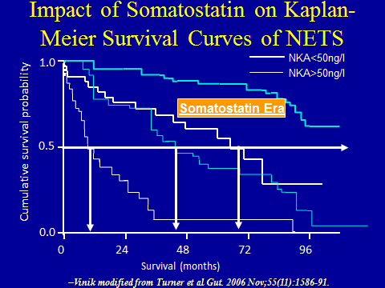

Other agents such as Interferon alpha and Everolimus may also be combined with SA’s. Use of these agents is discussed in detail later in this chapter.

Figure 38.

Management of Metastatic Tumors
______________________________________________

LAR or Lanreotide + Octreotide for escape

Arrest or Reversal Progression

Check Octreotide or Lanreotide
Plasma level
Continue LAR+ >10,000 pg/ml
Octreotide Chemo/Interferon α
Radiation Infarction
<10,000 pg/ml Pamidronate for
Increase LAR+ Bone Metastases
Octreotide

Responses to Octreotide and Lanreotide

The PROMID trial was a double blind, placebo controlled phase 3b study, with octreotide LAR 30 mg monthly compared to placebo in 85 subjects (Figure 39) (185). The median time to tumor progression was 6 months for placebo and 14 months for octreotide subjects (187). In this study, an effect on survival analysis was not confirmatory given the low number of observed deaths. More recently, lanreotide autogel was evaluated as an antiproliferative agent in 30 subjects (including 12 with MGC) (191). In this open label, phase 2 study involving lanreotide autogel at a dose of 120 mg every 4 weeks, the median progression free survival (PFS) was 12.9 months, though there was no control group. The CLARINET trial is a multicenter global 96 week study on 204 patients with NETS randomized to lanreotide(Somatuline) or placebo with primary endpoints of time to progression using CT or death with a multitude of secondary endpoints (Clin Trials .gov NCT 00353496). (Figure 41, 42, ). These data for both LAR and Somatuline suggest that SAs significantly extend the time to tumor progression.

Figure 39.
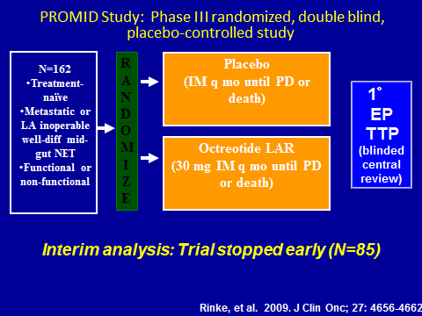

Figure 40

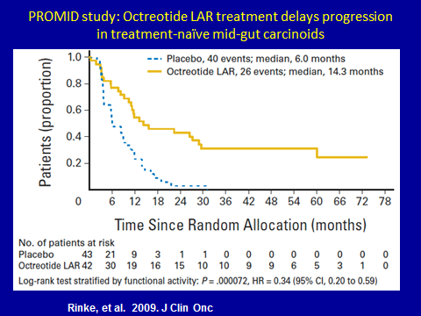

Figure 41

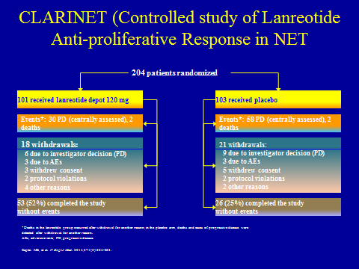

Figure 42

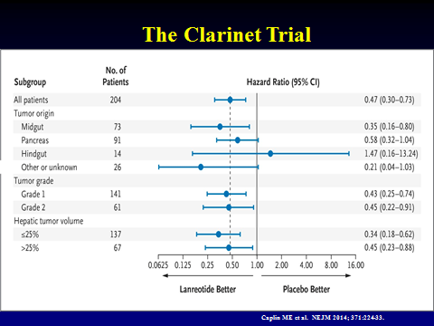

Biochemical Reponses

The ability of various biochemical markers to predict response to therapy and prognosis has been examined in numerous studies. Many of these results on first glance appear confusing and contradictrory. But in looking at these studies together, some trends may be discerned.

A strong positive linear relationship is noted between serum and plasma CGA levels. No correlation exists between plasma octreotide levels or LAR dose and the static, absolute plasma/serum CGA levels. A statistically significant inverse relationship was found between the frequency of flushing and the CGA levels (P = 0.0372) (8).

An earlier study in 139 patients with midgut carcinoid tumors showed on multivariate analysis that NKA was the best marker of prognosis (Figure 37) (11). Urinary 5-HIAA was significant on univariate but not multivariate analysis. Richter and colleagues (196) reported a significant drop in 5-HT levels in eight patients treated with 150 mcg/d of octreotide but no changes in urinary 5-HIAA; others have found a drop in urinary 5-HIAA (26). Despite prolonging treatment of patients from 15 to 30 weeks, blood serotonin remained unchanged (199).

In our patients, urinary 5-HIAA dropped in almost all patients treated with octreotide and normalized in one-third, and 50% of patients normalized their 24-hour 5-HIAA. Although few of our patients had a fall in their blood serotonin level, the overall post-octreotide values were not significantly lower than the pretreatment values.

There were no clinical correlations between the clinical responses and either urinary 5-HIAA or the blood serotonin level. In contrast, for patients in whom urinary 5-HIAA fell, there was clinical improvement in one or more of the symptoms. This may reflect that multiple etiologic factors are involved in the symptomatology of carcinoid tumors. In our patients, those who responded clinically required no more than 500 mcg/d of octreotide to control their symptoms, although we have examined the response to higher doses in certain instances.

Later studies such as CLARINET (18,194), ELECT (19) , and others, have shown poor correlation between presence of symptoms and 5-HIAA levels. Paradoxically, studies have also shown that reduction of 5-HIAA levels correlates with response to therapy.

For example, a large portion (87%) of CLARINET NET patients with no carcinoid syndrome produced 5-HIAA, and nearly 50% of those patients had elevated baseline 5-HIAA. This is similar to the proportion of patients in ELECT (with history of carcinoid syndrome) with elevated baseline 5-HIAA. Thus, one would conclude from these two studies that there is a poor correlation between the presence or absence of symtoms and 5-HIAA levels. Interestingly, the CLARINET trial also noted that asymptomatic patients with PanNETs also produced 5-HIAA. However, in view of evidence that NET tumors, regardless of the presence of clinical syndromes, share many characteristics at the cellular, biologic, and morphologic levels, these observations should not be surprising but rather reflective of such similarities. These findings are also in agreement with previously reported results in nonsymptomatic GEP-NETs (192)

Despite the poor corretion between presence or abscence of symptoms and 5-HIAA levels, many studies have shown that a decrease in 5-HIAA and other markers correlates with response to therapy. In the Telotristat trial( telotristat ethyl), substantial reductions in 5-HIAA (defined as ≥30% decrease) were observed in the active treatment arms compared with placebo arm (193) further supporting the relationship between symptom relief and 5-HIAA reduction (194). Telotristat selectively inhibits serotonin secretion and controls diarrhea, suggesting serotonin is the major agent causing diarrhea. Furthermore, in a retrospective analysis of NET patients, correlations were noted between serotonin levels and quality of life (QoL) scales, including the gastrointestinal symptom domain (195).The CLARINET trial still reserves the possibility that agents other than serotonin e.g. CGRP and Substance P may be implicated..

Our recent report (17) examined 319 pooled patients, from the CLARINET (18,194) and ELECT (19) studies. 86% and 95% of patients had baseline 5-HIAA and CgA data, respectively, with 47% and 74% having levels >upper limit of normal (ULN). Lanreotide induced greater median reductions from baseline values in both biomarkers vs placebo at Weeks 12-96 (all P<0.05). More patients with baseline levels >ULN experienced biochemical responses (≥50% biomarker decrease from baseline) at Week 12 with lanreotide vs placebo (43% vs 13%, P≤0.0012). CLARINET biochemical responders with baseline levels >ULN had significantly longer median progression-free survival than nonresponders (not reached vs 17.0 months, P<0.0001, for 5-HIAA; not reached vs 15.0 months, P=0.0036, for CgA). Among 5-HIAA biochemical responders during ELECT open-label treatment, patients initially randomized to lanreotide had a greater reduction in symptom (diarrhea and/or flushing) frequency and severity than patients initially on placebo. Furthermore, there was only a modest correlation between the prognostic value of the two biomarkers and a weak correlation with the response to treatment.

To summarize, these pooled data (17) suggest that 5-HIAA and CgA are modestly useful as surrogate markers for favorable response to therapy and progression-free survival, regardless of the presence of symptomatic disease. Additional investigation with more recently developed plasma and serum 5-HIAA assays (8) that eliminate the requirement for 24-hour urine collection (67) and investigation of an ever increasing cadre of biomarkers will also be useful. Clearly much work remains to be done.

Flushing

Frolich and colleagues (196) reported on the value of native somatostatin given by continuous infusion to reverse the prostaglandin (PG)-induced flushing in patients with carcinoid tumors. The initial patients treated with octreotide were a heterogeneous group with advanced carcinoid tumors refractory to conventional therapy who were tried on the somatostatin analogue with variable clinical and biochemical responses. Kvols and colleagues (180) found that 19 of 24 patients with carcinoid tumors treated with octreotide had a 50% reduction in flushing, but 3 had only a minor response, and 2 failed to respond. Richter and colleagues (197) showed that six of eight patients treated with octreotide had improved symptoms.

Flushing was the major presenting symptom in 64% of Vinik’s patients (177) . In all instances, the symptom complex improved, with a clear decrease in the frequency of symptoms using doses of octreotide in the range of 450 to 1500 µg/d. In no instance was there resistance to the drug. Tachyphylaxis did not occur, and withdrawal of the drug (or substitution with distilled water) was always followed by recurrence of the symptom complex. In contrast to another report (197), relapse of flushing did not occur with continued treatment once it was under control. (179). However, in contrast to the reduction in a number of episodes, the severity in certain patients decreased only slightly, and the duration of each episode was essentially unchanged179).

Figure 43.

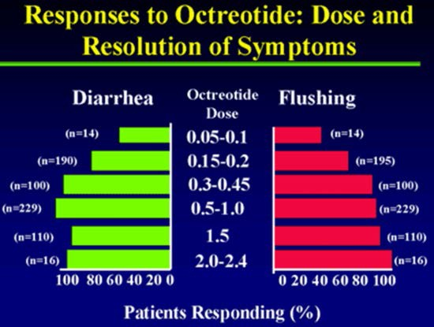

Thus, although the mechanism of action by octreotide and the factors mediating flushing and vasodilatation are unclear, octreotide no doubt is a potent antidote to the vasoactive humors participating in the flush and hypotension. The drug is a useful adjunct in the preparation of patients for operative procedures as discussed earlier in this chapter and should be available as a standby for the management of carcinoid crisis.

Diarrhea

Diarrhea occurred in 86% of Vinik’s (177) patients and responded variably to octreotide. Acute administration of octreotide normalized the water and electrolyte transport across the proximal intestine, as has been shown in patients with the watery diarrhea hypokalemia hypochlorhydria and acidosis (WDHHA) syndrome (177) (198). The acute reduction in electrolyte secretion did not, however, predict the long-term response of diarrhea to octreotide therapy, but this needs to be further examined in a larger number of patients. Only 58% of his patients with diarrhea had complete remission, which differs from the improvement in 19 of 25 patients (76%) reported by Kvols and colleagues (180). This could result from the fact that diarrhea in patients with carcinoid tumors has multiple etiologies (i.e., secretory, increased motility, malabsorption, partial luminal lymphatic obstruction, bacterial overgrowth, and short bowel syndrome because of surgical resection). The diarrhea may even seem to worsen with the appearance of steatorrhea, and the physician not infrequently is faced with the confounding situation of not knowing to what to attribute the symptom. Although octreotide does inhibit exocrine pancreatic secretion, (199), addition of pancreatic enzyme supplementation has not uniformly decreased the frequency or improved the consistency of bowel movements in octreotide-induced steatorrhea (200). This finding is compatible with the notion that the steatorrhea has a complex pathogenesis and may be contributed to by alterations in bile flow, the direct effects of octreotide on nutrient absorption, and intestinal motility (201).

In addition to use of somatostatin analogs, antidiarrheal agents such as loperamide and/or diphenoxylate/atropine, and the opiates paregoric and tincture of opium may be useful. The serotonin-3-receptor antagonist ondansetron has been shown to be useful in reducing diarrhea in a small series of patients uncontrolled on a SA (202). If the diarrhea changes its character to a steatorrhea and the stools become foul-smelling, floating in the toilet bowl and do not flush enzyme replacement therapy is in order. We favor large doses of Zenpep.

As discussed earlier, Telotristat has been shown very effective at improving carcinoid-related diarrhea that is refractory to somatostain analogs and other agents and the uupdated NANETs guidelines endorse it as the first choice when somatosataitn fails rather than escalating the dose of the somatostatin analog (203).

Efects of Octreotide on Pulmonary Function

All of our patients with wheezing had clinical improvement, and spirometric improvement was documented. Pulmonary function did not improve further after 3 months of treatment, indicating an irreversible component or small airway disease secondary to longstanding smoking (204).

Efects of Octreotide on Myopathy

One patient in our series presented with severe proximal muscle weakness and normal muscle enzymes and nerve conduction studies, but electromyographic features of a proximal myopathy. Although a neurologic deficit secondary to metastatic carcinoid has been reported, (205) metabolic-induced neuromuscular disease is very rare (206-208). Although our patient had a history of hypokalemia, his potassium was normal at the time of admission, with no biochemical evidence of thyrotoxicosis, ectopic ACTH production, or osteomalacia. We believe that his severe myopathy was caused by his carcinoid tumor, although it might have been aggravated by severe diarrhea, weight loss, and poor nutrition. Histologic changes can be induced in the skeletal muscle of mice by intraperitoneal injection of 5-HT (103). Three months after octreotide therapy, the patient had no clinical evidence of myopathy, with improvement in electromyographic features (204).

Efects of Octreotide on Tumor Growth, Metastases, and Survival

Because of the slow growth of carcinoid tumors, it is difficult to assess the effect of octreotide on tumor growth or regression. Shrinkage of liver metastases in patients with carcinoid (177) (163) (180) and other functioning pancreatic neuroendocrine tumors (209) has been reported. We have had variable experiences. The relationship between tumor size and growth and the biochemistry is not a simple one. In one patient, the tumor clearly shrank, but ACTH levels rose to the 2,000 to 3,000 pg/mL range. On molecular sieve chromatography, the ACTH coeluted with native ACTH, but the patient has no clinical features of Cushing’s syndrome, is gaining weight, and has no diarrhea or flushing. Another patient had progression of tumor growth after 18 months of octreotide therapy, yet there was a dramatic fall in blood serotonin values and the patient is entirely asymptomatic. The opposite also is not unusual, wherein there is no change in tumor size, a very well patient, and hormonal levels that are unaffected by octreotide even at doses as high as 1,000 µg/d (72).

Longitudinal follow-up CT data for our patients showed some tumor regression in only two cases and, in one case, the tumor infarcted. One third of the patients showed progression and half the cases showed no changes on CT scan when followed for up to 2 to 5 years. Overall itappears that cessation or reversal of growth occurs in about two-thirds of patients with carcinoid tumors who are treated with octreotide.

Octreotide increases the median survival of patients with metastatic carcinoid tumor from 11 to 33 months. Higher doses of octreotide may yield even better outcomes. A recent phase II study of apudomas showed no major tumor regressions but a 50% disease stabilization rate (210). A study of 14 patients with neuroendocrine tumor who received doses of octreotide of up to 9,000 µg/d showed partial responses in four patients (31%) and disease stabilization in two patients (16%) (211). Radiographic evidence of tumor necrosis was seen in five patients, but this did not correlate with response. A larger study of 55 patients showed an objective response rate of 37% (212). It is reasonable to offer octreotide at initial doses of 150 µg subcutaneously t.i.d. for control of symptoms and palliation. Escalation of the dose to 250 or even 1000 µg t.i.d. may be necessary in patients with a large tumor burden, but there is no evidence that higher doses have a greater likelihood of inducing actual tumor regression. When there is clear evidence that tumor growth is not contained by octreotide, alternative forms of treatment should be considered (142). Other therapeutic options are discussed in more detail below.

Internal Radiotherapy Delivered by Meta Lodo Benzyl Guanidine (MIBG) and Other Agents

There is the potential to deliver therapeutic doses of radiation to those tumors in which there is intense and prolonged tumor uptake of tracer doses of MIBG. At present, therapy for carcinoid tumor with MIBG is considered to be highly experimental. Based on the experience with other neuroendocrine tumors, situations in which this therapy may be considered include carcinoid lesions not readily treatable by alternative modalities, and patients with life expectancies sufficient to permit beneficial effects to become apparent (e.g., > 6 months or 1 year).

Target-to-background ratios with tracer doses that achieve diagnostic imaging may not, however, always permit the delivery of therapeutic radiation when large doses of activity are administered (213) (214) (208-210). Prior to considering such treatment, it is critical to undertake dosimetric studies for whole-body and blood-absorbed radiation dose using tracer doses to guide the size of therapeutic administrations (122)(108) (213) (194) (214)(195) (208-210). The bone marrow and, especially, the platelets appear to be the dose-limiting tissues for MIBG therapy. Typical doses to date have been in the range of 100 to 250 mCi per administration, with cumulative doses sometimes exceeding 600 mCi. In addition, if at all possible, the absorbed radiation dose to one or more representative tumors should be determined from serial scintigraphic images. From these, the initial uptake and biologic reaction time of retention can be determined; the use of conjugate view technique with the inclusion of standard sources may be especially helpful (40). Tumor volume also must be determined by CT or another modality. This can be used with Medical Internal Radiation Dose (MIRD) formulas to calculate the radiation-absorbed dose (215).

The ability of somatostatin analogues to bind to GEP tumors has suggested other novel therapeutic approaches. Conjugating somatostatin with high energy gamma-emitters, short- acting alpha-particle emitters, or tumoricidal toxins such as ricin or modified diphtheria toxin has been proposed (216) (217). Although similar strategies have been used to deliver tumoricidal agents to other types of tumors, there are few data thus far on the therapeutic effectiveness of such an approach in GEP tumors. One study did show that high dose 111In-pentetreotide therapy is effective in stabilizing progression of disseminated neuroendocrine tumors (218).

Interventional Radiologic Technique

For those with advanced liver dominant disease, liver directed therapy through interventional radiologic techniques is part of the treatment paradigm. Liver directed therapy may include bland embolization, chemo-embolization, or radio-embolization. Hepatic artery embolization has proved to be a relatively safe procedure for the palliation of carcinoid syndrome related to excessive hormone production from hepatic carcinoid metastases (219) (Figure 44 ). Generally such patients have extensive hepatic metastases not amendable to surgical approaches.

Figure 44.

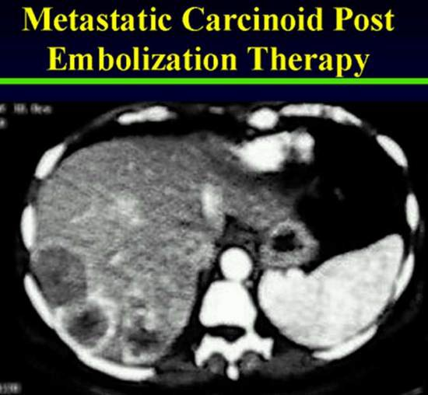

This method usually is beneficial to the patients whose hepatic metastases have failed to respond to chemotherapy and other pharmacologic therapy (103). Gelfoam powder (particle sizes, 80–200µM) and Ivalon particles (sizes, 149–250 µM) are the agents frequently used for devascularization of the hepatic metastases.

Several authors have described their experience with hepatic artery ligation or embolization in patients with malignant carcinoid tumors (220) (221). In one study, the former procedure resulted in objective tumor responses in 9 of 19 patients, stable disease in 5 of 19 patients, and progressive disease in 4 of 19 patients when they were assessed 6 and 12 months after the procedure (221). Two patients died 1 and 3 months postoperatively from complications including liver abscesses, and the remainder of patients experienced mild abdominal pain, fever, and fatigue that was self-limiting. Hepatic artery gelfoam embolization performed in eight patients resulted in three objective responses and five with stable disease. Toxicity from this procedure included fever, abdominal pain, nausea, and elevation of serum hepatic enzymes, which returned to normal within 12 days. Overall, the duration of palliation tends to be short-lived (171). Hepatic arterial occlusion combined with sequential chemotherapy has resulted in an 80% response rate, with a median duration of 18 months (222). Although hepatic artery occlusion may produce subjective and objective responses in the majority of highly selected patients, the toxicity and duration of responses resulting from this therapy generally do not support its routine use (171).

External Beam Radiation Therapy

External beam radiation therapy is relegated to a palliative role in patients with carcinoid. Those who develop symptomatic lesions inclusive of bone metastases, spinal cord compression, or bronchial obstruction are amenable to this modality of treatment. Therapeutic regimens based on conventional CT target delineation as well as hypofractionated treatments with stereotactic guidance are designed to optimize quality of life with attention to time efficiency and comfort considerations.

Radiochemoembolization

There are two components: embolization and brachytherapy. The embolization procedure is defined with the angiographic endpoints of embolization and stasis with the need to modify the delivery according to angiographic findings under fluoroscopy. Brachytherapy is defined as the administration and delivery of internal radiation with modification of dose based on tumor and target volume (223).

Currently two different 90Yttrium microsphere products, glass microsphere and resin microsphere are available. Resin microspheres have received FDA premarket approval for hepatic metastasis from colorectal cancer, concurrent with flurodeoxyuridine (FUDR). There has been no direct comparision of the efficacy of the two microsphere products (224). There is only anecdotal experience with use of these agents in carcinoid patients.

90Yttrium microsphere therapy is a complex procedure that requires a multidisciplinary approach for safety and success as shown in Figure 45 (223). The benefits of internal radiation to the liver include low toxicity, low amount of radiation used, and ability to retreat the liver for new lesions or incompletely destroyed original lesions. Extensive prior systemic and non-radioactive hepatic therapy does not interfere with the successful delivery of 90Yttrium microspheres (224).

Figure 45. Treatment Algorithm for ⁹⁰Ytrium Microsphere Brachytherapy (223)

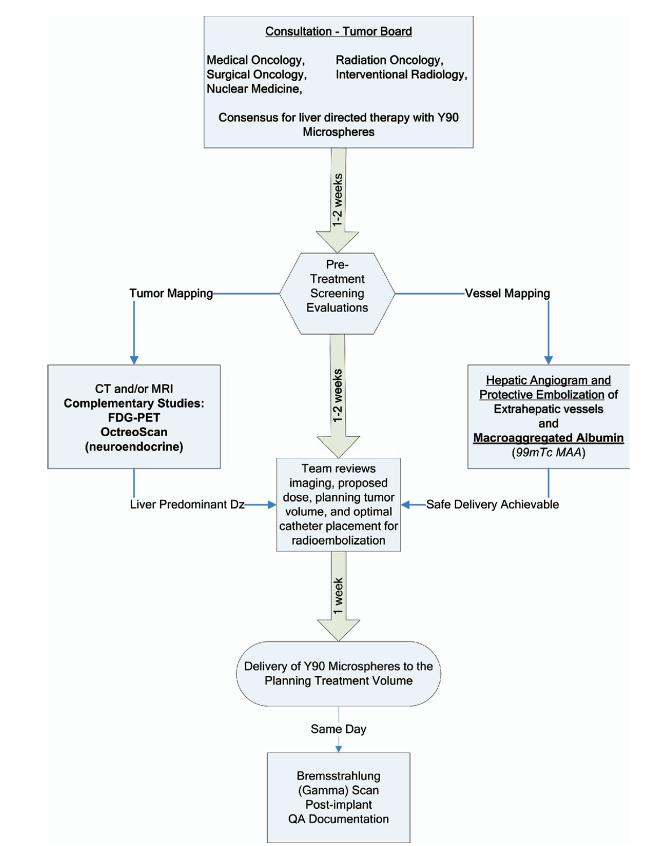

Kennedy A et al. Int J. Radiation Oncology Biol. Phys. 2007 (223)

⁹⁰Yttrium based therapy is effective at controlling carcinoid symptoms, but has not been shown to improve survival (225). In general, these patients undergo the procedure in three stages:
1. Mapping stage when the arterial anatomy of the liver is evaluated and potential shunting to the lung and foregut is identified and minimized by selective coiling of involved vessels
2.Treatment of individual lesions or disease dominant liver lobe.
3.Treatment of remaining liver as needed.
In general, these procedures are performed as an outpatient and are well tolerated with pain or peptic ulceration as the major complications. Patients with poor hepatic synthetic function are not candidates.

Peptide Receptor Radiotherapy (PRRT)

Figure 46

NETTER-1 Phase III Study of ¹⁷⁷Lu-DOTA, Tyr3-Octreotide vs Octreotide LAR in Patients with Inoperable, Progressive, Somatostatin Receptor Positive Midgut Carcinoid Tumors

Presented at ECCO/ESMO 2015

200
Patients with
Midgut

Primary endpoint: Progression-Free Survival

Secondary endpoints: Response rate, TTP, Overall
Survival

177Lu-DOTA-Tyr3-Octreotate
4 administration of 200 mCI every 8-16 weeks plus best supportive care

200
Patients with
Midgut Carcinoid

High-dose Octreotide LAR: 60 mg IM every 4 weeks

A new emerging technology for treating systemic carcinoid is peptide receptor radiotherapy (PRRT) (226). Like nuclear functional imaging, this treatment modality uses the somatostatin receptor as a target of treatment. However, instead of carrying an imaging isotope, the somatostatin analogue is chelated to a beta-emitting cytotoxic isotope, ⁹⁰-Yttrium or ¹⁷⁷- Lutetium. These therapies can have both rapid and delayed activity. Survival for this therapy has been reported to be as great as 44 months. ¹⁷⁷-Lutetium-somatostatin analogue was evaluated in a Phase 3 clinical trial in the United States, and the results recently reported (121). In the NETTER-1 Phase III Trial, a randomized prospective study, researchers focused on advanced somaotostain-receptor positive midgut NETs and reviewed the efficacy and safety following treatment with lutetium-177 (¹⁷⁷Lu)-octreotate PRRT, also known as ¹⁷⁷Lu-DOTATATE--brand name Lutathera( Figure 46). At 20 months progression- free survival in the Lutathera group was 65.2% compared to 10.8% in the control LAR arm( Figure 47). The response rate was significantly higher in the Lutathera group(18%) compared to the control group(3%, P<0.004). At interim analysis , a significant overall survival advantage was also noted in the Lutathera arm.

In a companion quality of life study, researchers compared feedback provided in patient questionnaires for two groups of patients: one received Lutathera treatment and the control group received a high-dose somatostatin analog therapy (60 mg of Octreotide LAR). Results showed that, on average, 28% of patients reported a significant improvement in the Global Health metric of their quality-of-life questionnaire after Lutathera. On average, only 15 percent of control-group patients reported an improvement of quality of life. An average of 39 percent of patients who took Lutathera also reported an improvement in diarrhea symptoms compared to 23 percent of controls. The authors note “… patient quality of life is increasingly viewed as highly relevant to cancer research. Ideally, new drugs should not only prolong survival, but also maintain patient quality of life. What is relatively unique in this study is that quality of life not only appears to be maintained, but is actually improved in certain aspects with the investigational drug," (227)

Figure 47. Progression Free and Overall Survival in reponse to ¹⁷⁷Lu-Dotatate Radiation (PRRT) therapy) in the NETTER 1 Phase 3 Trial including the Subgroup Comparison with High Dose Octreotide (60mg/month) as Control.
Strosberg et al. NEJM 2017 (121)

Chemotherapy

In malignant carcinoid tumor, chemotherapy has not been shown to be effective for most patients, and this approach should still be considered investigational. The single agent most studied in carcinoid tumor is 5-fluorouracil, which accounted for observed response rates of 26 and 18% in single-institution and multi-institutional trials, respectively (228) (229). Melia and colleagues (230) reported a high complication rate with little benefit when 5-fluorouracil was administered by intra-arterial, portal, or peripheral intravenous routes. Few responses were observed following intravenous doxorubicin, 60 mg/m 2 , every 3 to 4 weeks (173) (171) (231). Despite well-established activity in other GEP cancers, streptozotocin has not demonstrated significant efficacy in patients with carcinoid tumor (199) (173). Among other single agents, there have been anecdotal reports of objective responses to dacarbazine and dactinomycin (231) (232), however, a study of 32 patients demonstrated that dactinomycin or dacarbazine had little activity against metastatic carcinoid tumor (233). A larger, more recent study confirmed the ineffectiveness of dacarbazine in carcinoid tumor. Phase II studies in evaluable patients with carcinoid tumor have shown rare objective responses to either cisplatin or etoposide (228) (234) (235). No responses to carboplatinum were seen in a series of 20 patients.

Initial experience with combination chemotherapy suggested that this modality might be effective against malignant carcinoid tumor. Early, nonrandomized studies of combinations of cyclophosphamide plus methotrexate, streptozotocin plus 5-fluorouracil, or weekly
streptozotocin plus doxorubicin reported response rates in excess of 50%; however, rigid criteria for response were not always employed and complete responses were not seen (2) (173) (229) (235) (236). Based on these observations, the Eastern Cooperative Oncology Group conducted a series of multi-institutional, randomized trials of combinations that all contained streptozotocin, despite the low activity of this drug when used alone. In two studies of 170 evaluable patients, the response rates ranged from 23 to 33%, and there was no evidence for any difference between streptozotocin administered every 6 weeks or every 10 weeks plus 5- fluorouracil versus streptozotocin plus cyclophosphamide versus single-agent doxorubicin (173) (229) (237). In a prospective trial, the Southwest Oncology Group reported similar response rates of brief duration following a combination of 5-fluorouracil, cyclophosphamide, and streptozotocin with or without doxorubicin (238). Only 10% of 31 patients had objective response following streptozotocin and 5-fluorouracil in another prospective clinical trial reported by Oberg and colleagues (239).

Feldman (240) suggested that streptozotocin alone or in combination with 5-fluorouracil may be beneficial for patients with foregut carcinoid tumors, in contrast to patients with midgut carcinoid tumors. This contrasts with the Eastern Cooperative Oncology Group experience, (229) however, and remains unsubstantiated. Thus, in the absence of randomized trials that contain a no-treatment arm, there is no persuasive evidence that single-agent or combination chemotherapy provides any significant impact on disease progression or on survival in patients with malignant carcinoid tumor.

Combined Modality Therapy

Combined modality therapy, such as the use of adjuvant chemotherapy either before or following surgery, remains undefined. In the absence of well-established activity for chemotherapy in metastatic carcinoid, there is no rationale to support the use of adjuvant chemotherapy. In contrast, preliminary results of the prospective experience of sequential hepatic artery occlusion and alternating combination chemotherapy at the Mayo Clinic are of considerable interest (171) (231) (241). Following hepatic artery occlusion by surgical ligation or percutaneous embolization, 21 patients were treated with dacarbazine, 250 mg/m 2 daily for 5 days, plus doxorubicin, 60 mg/m 2, alternating every 4 to 5 weeks with 5-fluorouracil, 400 mg/m 2 daily for 5 days, plus streptozotocin, 500 mg/m 2 daily for 5 days until maximum response was observed. Using this combined-modality approach, Moertel (171) reported a hormonal response rate of 86%, with a median duration of response of 2 years. The toxicity of this approach notwithstanding, and pending publication of the Mayo Clinic experience or other confirmatory experience, sequential hepatic artery occlusion and combination chemotherapy may be considered for selective patients with symptomatic metastatic carcinoid refractory to somatostatin therapy. Temodar and Xeloda may have a slight benefit in patients with neuroendocrine tumors but more controlled trials are needed to determine the role and benefits of them in NET.

Biologic Therapy

Interferon:

Interferon may be useful in patients with refractory symptoms of carcinoid syndrome despite SA treatment. In one study, 17 of 36 patients (47%) with metastatic carcinoid tumor who were treated with human leukocyte interferon, 3 to 6 million units per day subcutaneously, had objective hormonal responses for a median duration of 34 months (239). Four patients had significant tumor regression, and two complete responses were noted. A second study randomized 20 patients to treatment with either a combination of streptozotocin and 5-fluorouracil or human leukocyte interferon, 6 million units five times per week (242). After 6 months, 50% of the patients treated with interferon had an objective hormonal response, and no patients treated with chemotherapy responded. Finally, Oberg and colleagues (239) conducted a study in 20 patients with malignant carcinoid tumor that suggested recombinant human interferon-α- 2b , 5 X 10 6 U/m 2 three times a week subcutaneously for 6 months, was as active as leukocyte interferon, and that the two agents may not be cross-resistant. In this study, the development of neutralizing interferon antibodies correlated with a lack of response to interferon in three patients.

Additional positive outcomes using recombinant human interferon- α – 2b have been reported by several additional groups after small prospective trials (243) (244). Hanssen and colleagues (243) also gave interferon following hepatic artery embolization, and they observed five of seven patients with objective tumor and hormonal responses after 12 months. A recent review by Oberg (245) of 300 patients with carcinoid tumor treated with interferon-α for a median of 2.5 years concluded that this agent has significant antitumor effects in 70 to 80% of patients, as manifested by biochemical control and inhibition of tumor growth. Tumor progression generally occurred within 3 to 9 months after cessation of the drug. IFNa may reduce flushing and diarrhea in 40-50% refractory to SAs, although objective tumor regression is less common (246). However, benefits are usually transient and there are limiting side effects including fatigue, depression, and flu-like symptoms.

These encouraging results with interferon must be interpreted with caution, however, considering the results from another prospective study using interferon reported by Moertel and colleagues (247). In this study, 27 previously treated patients with malignant carcinoid tumors were treated with recombinant human interferon- α -2a, 12–24 X 10 6 U/m 2 subcutaneously three times weekly for 8 weeks. Nine of 23 patients (39%) with elevated 5-HIAA had objective responses for a median of 40 weeks (range, 23–127 weeks), and 4 of 20 patients (20%) had objective tumor responses for a median of 7 weeks (range, 4–26 weeks). The flu-like syndrome and fatigue side effects from interferon were common in this study, requiring dose reduction in 10 patients and causing deterioration of performance status in 50% of all patients. In addition to differences in dose and observed toxicities, the variable response rates found in these reported studies may relate to the use of different recombinant interferon subtypes (alpha-2a vs. alpha- 2b) and the subsequent development of neutralizing antibodies (248). The role for the combination of recombinant human interferon- α -2a and doxorubicin in patients with advanced pancreatic endocrine or carcinoid tumors currently is under investigation (249). A series of 19 patients treated with interferon- α combined with octreotide showed a 92% median biochemical response rate for a period of 10 months (212)
.
Growth Factors (figure 48):

Insulin-like Growth Factor (IGF)-I is a potent growth factor, exerting its actions by both endocrine and paracrine/autocrine mechanisms. The action of the IGFs in both the circulation and tissues is tightly regulated by a family of high-affinity IGF binding proteins (IGFBPs) (250). The synthesis of the IGFBPs in various tissues is under partial control of IGF-I. IGF-I exerts its biological effect by binding to the transmembrane type 1 IGF receptor, whose activation leads to the extensive tyrosyl-phosphorylation of insulin receptor substrate-1, which acts as a docking protein for the downstream signal transduction pathways (250).

Angiogenesis, the formation of new blood capillaries, is an important component of embryonic vascular development, wound healing, and organ regeneration, as well as pathological
processes such as diabetic retinopathies, atherosclerosis and tumor growth (251). Vascular endothelial growth factor (VEGF) is essential for many angiogenic processes both in normal and pathological conditions. The binding of VEGF to its cognate receptors induces dimerization and subsequent phosphorylation of the receptors leading to the activation of several intracellular signaling pathways. In particular, the angiogenic signals triggered by VEGF are mediated through the activation of phospholipase Cã (PLCã) (251), protein kinase C (PKC), and subsequently the extracellular regulated kinases 1 and 2 (ERK1/2) (251).

VEGF also regulates vascular permeability and endothelial cell migration by stimulating the Src family kinases, in particular c-Src, and the phosphatidylinositol 3’OH-kinase (PI3K)/Akt pathway- dependent endothelial nitric oxide synthase (eNOS) activation. The importance of VEGF- induced signaling is demonstrated in that the genetic inactivation of either receptor leads to a complete lack of development of blood vessels in the embryo, and inactivation of VEGFR2 function dramatically impairs the growth of cancer cells in vivo (251).

Figure 48

The RTK/P13-K/AKT/mTOR Pathway in Neuroendocrine Tumors

Inherited syndrome Therapeutic Agents

Associated with NET in NET

Growth Factors:

VEGF Bevacizumab

Growth Factor Receptors:

PDGFR Sunitinib

P13-K VEGFR Sorafenib

MEN2 RET Pazopanib

AKT

TSC 1/2

mTOR Everolimus

Temsirolimus

Cell Growth & Survival

Tyrosine Kinase (TK) Inhibitors

Receptor tyrosine kinases (RTKs) are transmembrane proteins containing extracellular ligand- binding domains and intracellular catalytic domains (Figures 48, 49 ). RTKs are activated following binding of their cognate ligands and many of the processes involved in tumor growth, progression, and metastases are mediated by signaling molecules acting downstream from these proteins

Several members of the split-kinase domain family of RTKs are implicated in deregulated/ autocrine proliferation and survival of solid and hematologic cancer cells. These include the platelet-derived growth factor receptors (PDGFRα and β); vascular endothelial growth factor receptors (VEGFR) Type 1 and 2 (FLT1 and FLK1/KDR); the stem cell factor (SCF) receptor, KIT; and the FLT3-ligand receptor. In addition, PDGFR and VEGFR are implicated in tumor- dependent angiogenesis (252).

Neuroendocrine tumors are characterized by abundant vasculature. Inhibition of angiogenesis would therefore be expected to result in growth inhibition and regression of these tumors. A number of tumors, including NET, aberrantly express both the vascular endothelial growth factor (VEGF) ligand and its Flk-1/KDR receptor (VEGFR), both of which play critical roles in tumor angiogenesis. Investigation of novel angiogenesis inhibitors such as sunitinib in patients with pancreatic islet cell tumors is therefore of great interest. Tyrosine kinase inhibitors like sutent acts through the receptors for VEGF and PDGF, and also blocks signalling through the KIT, FLT3 and RET pathways.

Figure 49. Actions of Tyrosine Kinase (TK) and Potential Inhibitors

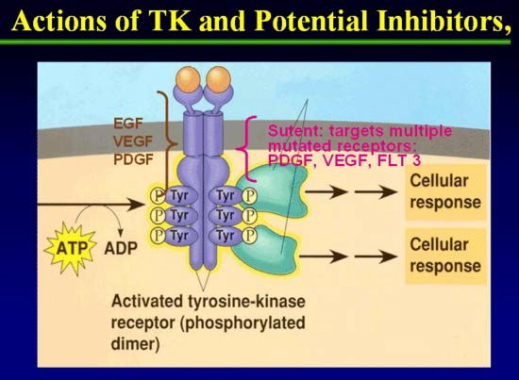

Mammalian Target of Rapamycin (mTOR) Pathway in Neuroendocrine Tumors

The mTOR pathway is a key regulator of proliferation and growth of cells (Figure 48 ). mTOR is a threonine kinase that mediates downstream signaling from IGFi/SSA, VEGFi and VEGF TKIs signaling pathways implicated in neuroendocrine tumor growth (253). Activation of PI3K/AKT/mTOR pathways has been shown to increase translation of proteins regulating cell cycle progression (Figures 50-52).

The mTOR pathway integrates signals from growth factors to regulate metabolism and ribosome synthesis. Deregulation of mTOR is associated with diverse human diseases including cancer and diabetes (254). Rapamycin binds to the FKBP12 protein to form a drug–receptor complex that then interacts with and perturbs a large protein kinase called TOR (target of rapamycin) (254). Although the function of TOR is far from well understood, it is increasingly clear that TOR is the central component of a complex signaling network that regulates cell growth and proliferation. Rapamycin does not perturb all mTOR functions because mTOR exists in two distinct multi-protein complexes and only one binds to FKBP12–rapamycin (Figure 50 ). This complex is composed of mTOR as well as the GbL and raptor proteins, and rapamycin inhibits its kinase activity in vitro (254). The rapamycin-insensitive complex also contains mTOR and GbL, but, instead of raptor, a different protein called rictor.

FKBP12–rapamycin binds to a region adjacent to GbL and the mTOR kinase domain but >1000 amino acids away from where raptor binds to mTOR (254). Perhaps FKBP12–rapamycin induces a conformational change in mTOR that weakens the binding of raptor and perturbs its capacity to recruit substrates (see below). It is also unclear why FKBP12–rapamycin does not bind the rictor-containing mTOR complex. Rictor or an unidentified component of the complex may block or occupy the FKBP12–rapamycin binding site or allosterically destroy the FKBP12–rapamycin binding pocket. As the rictor–mTOR complex cannot bind FKBP12– rapamycin, it is unlikely to mediate mTOR functions discovered through their sensitivity to acute treatment with the drug. Akt/PKB is a key component of the insulin/PI3K signaling pathway and modulates cell survival and proliferation by acting downstream. Thus, through the rictor- and raptor-containing complexes, mTOR affects cell size, shape and number (254)

Figure 50. A model of the mTOR and PI3K/Akt signaling pathways and their interconnections.

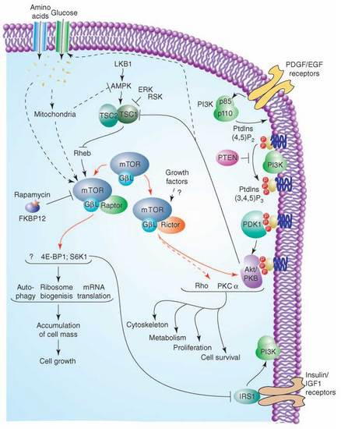

Two mTOR-interacting proteins, raptor and rictor, define distinct branches of the mTOR pathway. The raptor– mTOR pathway regulates cell growth (accumulation of cell mass) through S6K1 and 4E-BP1 as well as unknown effectors. It responds to nutrients and growth factors in part through the upstream regulators TSC1/2 and rheb. The rapamycin-insensitive rictor–mTOR pathway regulates Akt/PKB, PKCa, Rho/Rac to control cell survival, proliferation, metabolism and the cytoskeleton. The binding of growth factors to cell surface receptors activates PI3K to generate PtdIns P3 and recruits the PDK1 kinase and Akt/PKB to the plasma membrane. Akt/PKB is activated by its phosphorylation on two different sites. The rictor–mTOR complex phosphorylates Akt/PKB on Ser473 in the hydrophobic motif which may facilitate the phosphorylation by PDK1 of the activation loop of Akt/PKB on Thr308. How the rictor–mTOR complex is regulated is unknown. Dashed lines indicate interactions that are likely not direct (254).

Figure 51. PI3K/Akt/mTOR Pathway

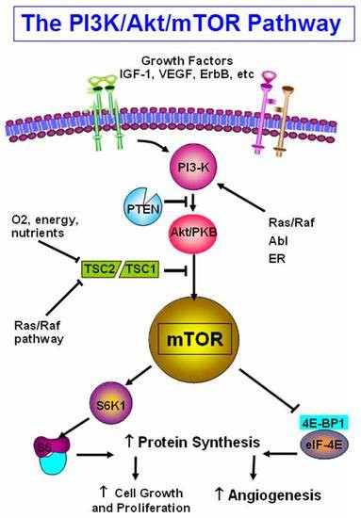

PI3K/Akt/mTOR pathway integrates signals from growth factor receptors, stress and available nutrients. mTOR, an intracellular serine-threonine kinase is centrally located downstream of PI3K.mTOR is a master regulator involved in translation of proteins critical for cell growth, proliferation and angiogenesis in response to upstream signals.

Figure 52. Rational for mTOR Inactivation

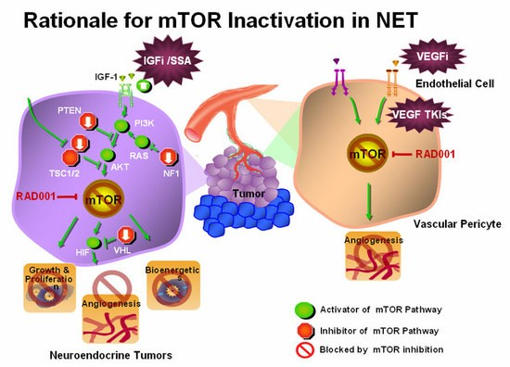

mTOR mediates downstreaming signaling from IGFi/SSA, VEGFi and VEGF TKIs which is responsible for angiogenesis, bioenergy, growth and proliferation of cell. Activation of mTOR pathway occurs through PI3K/AKT/RAS. While inhibitors of mTOR pathway includes PTEN/NF1. Inactivation of mTOR pathway alone or combined with RAD001 therapy is implicated in inhibition of neuroendocrine.

Inhibitors of mTOR have shown early activity in number of cancers including neuroendocrine tumors (255). The mechanism whereby everolimus (RAD001) inhibit growth NETS is shown in Figure 52.

Thirty seven patients with progressive neuroendocrine tumors were treated with mTOR inhibitor temsirolimus in one phase II study. The response rate was 5.6% with 63.9% of patients showing partial response or stable disease (256). RAD001 (everolimus) is a novel agent that is being studied in the treatment of neuro-endocrine tumours, and is known to interact with mTOR. Everolimus,( Afinitor, RAD001) is an oral inhibitor of the mammalian target of rapamycin (mTOR). Everolimus has been studied as an adjuvant to SAs in patients with advanced NET, although it has not been FDA approved for this indication. The combined effect of mTOR inhibitors RAD001 (everolimus;5mg/day) and depot octreotide (30mg/4weeks) showed a partial response rate of 12% in carcinoid patiets while 37% of patients had > 50% reduction in chromogranin A (257). A Phase I study by Awada (2008) showed that daily therapy with RAD001 plus letrozole exhibited anti-tumor activity in breast cancers (258).

Grozonsky-Glasberg (2007) found that treatment with octreotide and RAD001 inhibited proliferation and attenuated phosphorylation of all downstream targets of Akt: TSC2, mTOR, and p70S6K (248). Octreotide and RAD001 appear to act through a similar pathway and inhibit the Akt-mTOR-p70S6 kinase pathway downstream of Akt G (248).

The RADIANT-2 trial was a phase III, double blind placebo controlled study in patients with advanced NETs and carcinoid syndrome. In the initial study which included 429 patients with carcinoid syndrome, the median progression free survival improved by 5.1 months in the everolimus/octreotide arm compared with octreotide alone, however this just missed statistical significance. Unfortunately there were randomization imbalances in the study. A subsequent reanalysis looked at treatment imbalances, and prognostic factors that may have affected outcomes in the original analysis. When adjusted for prognostic imbalances, the reanalysis found that everolimus plus octreotide resulted in a 38% reduction of risk of disease progression, and this was significantly different (P=0.003).

Indeed, everolimus alone appears to have activity as a single agent. The RADIANT- 3 trial was a phase III trial examining everolimus as first line therapy in patients with PNETS. A total of 410 patients were randomized to everolimus 10 ml once daily or placebo. The median progression free survival was 11 months with everolimus compared 4.6 months with placebo.The proportion of patients alive and progression free at 18 months was 34% with everolimus compared with 9% with placebo. Toxicity was mostly grade I or II (259).

Management Summary

Any suspected case of carcinoid needs proper evaluation for the diagnosis and management of the patient. The schematic presentation of evaluation and treatment of carcinoid is described as follows in Figure 53.

Figure 53. Norfolk Algorithm for Management of Neuroendocrine Tumors

Clinical Syndrome
+ve
Biochemical and Tissue Diagnosis
Negative Sympomatic Treatment

Immunohistochemistryy
Urine: 5HT, 5HTP, Metanephrines, tryptase, Blood: serotonin, CGRP, CGP, NKA Catecholamine, Calcitonin, Histamine, Pancreastatin, Chromogranin A
+ve
+ve +ve

Ultrasound
CAT
MRI
PET
Octreoscan or
Gallium 68 scan
MIBG
Angiography
Scintigraphy
Venous sampling
- Chromogranin A
- Synaptophysin
- Neuron Specific Enolase
- Ki-67
- Individual hormones – insulin, glucagon, PP somatostatin, INGAP, etc.

TUMOR
+ve +ve

Managementnnt
Managemen
GF and Angiogenesis Inhibitors
and other novel therapies

Surgery Octreotide or Lanreotide

Chemotherapy Interferon
Embolization

PROGNOSIS

The general prognosis in carcinoid tumor is excellent compared with that of other visceral cancers. A summary of many of the prognostic factors for carcinoid tumors is shown in Table 23.
Based on a world literature of some 2,837 cases, the median 5-year survival rate for all cases is 82% (173).

Table 23. Less Favorable Prognostic Factors for Carcinoid Tumors
- Age >50y  - Male gender  - Tumor site e.g. pancreas, colorectum  - Size and depth of penetration  - Lymph node metastases  - Hepatic metastases | - Symptomatic mode of discovery  - Nonsurgical curative likelihood  - Presence of the carcinoid syndrome  - Increased Chromogranin A, urinary 5-HIAA, TCT, gastrin and ACTH  - Proliferation indices

If, however, the tumor is localized, then the 5-year survival is 94%, decreasing to 64% with regional lymph node involvement and 18% with distant metastases. A single-institution analysis of overall survival stratified by TNM stage revealed that 5-year survival rates were 100% for stage I and II tumors vs. 91% for stage III (locoregionally advanced) and 72% for stage IV tumors. The median overall survival for stage IV tumors was 103 months. Among stage III patients, survival differed significantly between patients with resectable mesenteric tumors (95% 5-year survival) vs. unresectable (78% 5-year survival) (260). Another analysis of 270 NETs (which included a combination of midgut and hindgut tumors) reported a 5-year disease-specific survival rate of 100% for patients with stage I and II tumors vs. 97% for stage III and 83% for stage IV tumors (261).

Davis and colleagues (14) reported a mean survival of 38 months from the first episode of flushing, with 25% of patients living for more than 6 years. With regional lymph node involvement, the figure falls to approximately 14 months, (262) and with urinary 5-HIAA in excess of 150 mg per 24 hours or inoperable tumors, median survival is only 11 months (173).

Some of the biochemical markers previously discussed are useful in determining prognosis. CgA is one such useful marker. Jensen et al. found that a reduction on CgA levels > 80% after cytoreductive surgery for carcinoid tumors predicts symptom relief and disease control; it is associated with improved patient outcomes, even after incomplete cytoreduction (263).

Pancreastatin is one of the post-translational processing products of CgA and is an indicator of poor outcome when its concentration in plasma is elevated before treatment in patients with
NETs. A level > 500pmol/L is an independent indicator of poor outcome. This marker is also known to correlate with the number of liver metastases, so it would be appropriate to use it in the follow-up of NET patients. Furthermore Stronge et al. found that an increase in pancreastatin levels following somatostatin analogue therapy is associated with a poor survival (264). Other studies have shown that pancreastatin should be measured prior to, during, and after treatment. Plasma levels of this marker above 5000 pg/ml pre-treatment were associated with increased peri-procedure mortality in patients with NETs that underwent hepatic artery chemoembolization (TACE) (265). These observations suggest that pancreastatin is potentially a very useful marker not only for diagnosis but more importantly for monitoring treatment response.

Neurokinin A has been shown to have strong prognostic value. Turner et al. in 2006 showed that in patients with midgut carcinoid that have raised plasma NKA, a reduction of this biochemical marker after somatostatin analog (SSA) therapy was associated with an 87% survival at one year compared with 40% if it increased. They also concluded that any alteration in NKA predicts improved or worsening survival (7).

SUMMARY AND CONCLUSIONS

Table 24.

Carcinoid Tumors
____________________________________________________________________

- Summary and Conclusions
  - Small slow growing, episodic expression of markers makes diagnosis difficult, erroneous and late, need high index of suspicion
  - Diagnosis complex with no single foolproof measure
  - Major Clinical features are:
    - Flushing
    - Diarrhea
    - EMERGING NEW SYNDROMES that cause flushing such as NIPHS may lead to confusion; neuropathy, myopathy, pigmentation may be paraneoplastic syndromes
- Causes of symptoms not understood entirely
- Symptomatic therapy effective
- Always seek targeted primary therapy
- Monitor
  - Tumor burden
  - Clinical responses
  - Biochemistry
- Be aggressive. Use tumor debulking procedures judiciously – aim for normalization of pancreastatin, NKA and CgA
- Tumor growth can be arrested
  - Carcinoids, Vipomas, Ppomas
  - ACTH, Calcitonin and Gastrin may be resistant
  - May require ancillary measures
- Octreotide/lanreotide/telotristat controls symptoms and may cause biochemical and tumor burden improvement
- Must treat to target Octreotide/Lanreotide Plasma Levels
- New therapies with specific TK inhibitors sunitinib, mTOR inhibitors Afinitor and somatostatin analogs octreotide/lanreotide are in current use

REFERENCES

1. Vinik AI, Woltering EA, Warner RR et al. NANETS consensus guidelines for the diagnosis of neuroendocrine tumor. Pancreas 2010; 39(6):713-734.
2. Buchanan KD, Johnston CF, O'Hare MM et al. Neuroendocrine tumors. A European view. Am J Med 1986; 81(6B):14-22.
3. Vinik AI, Anthony L, Boudreaux JP et al. Neuroendocrine tumors: a critical appraisal of management strategies. Pancreas 2010; 39(6):801-818.
4. Yao JC, Hassan M, Phan A et al. One hundred years after "carcinoid": epidemiology of and prognostic factors for neuroendocrine tumors in 35,825 cases in the United States. J Clin Oncol 2008; 26(18):3063-3072.
5. Ito T, Igarashi H, Nakamura K et al. Epidemiological trends of pancreatic and gastrointestinal neuroendocrine tumors in Japan: a nationwide survey analysis. J Gastroenterol 2015; 50(1):58-64.
6. Lawrence B, Gustafsson BI, Chan A, Svejda B, Kidd M, Modlin IM. The epidemiology of gastroenteropancreatic neuroendocrine tumors. Endocrinol Metab Clin North Am 2011; 40(1):1-18, vii.
7. Turner GB, Johnston BT, McCance DR et al. Circulating markers of prognosis and response to treatment in patients with midgut carcinoid tumours. Gut 2006; 55(11):1586-1591.
8. Woltering EA, Hilton RS, Zolfoghary CM et al. Validation of serum versus plasma measurements of chromogranin a levels in patients with carcinoid tumors: lack of correlation between absolute chromogranin a levels and symptom frequency. Pancreas 2006; 33(3):250-254.
9. Beaumont JL, Cella D, Phan AT, Choi S, Liu Z, Yao JC. Comparison of health-related quality of life in patients with neuroendocrine tumors with quality of life in the general US population. Pancreas 2012; 41(3):461-466.
10. Hallet J, Law CH, Cukier M, Saskin R, Liu N, Singh S. Exploring the rising incidence of neuroendocrine tumors: a population-based analysis of epidemiology, metastatic presentation, and outcomes. Cancer 2015; 121(4):589-597.
11. Vinik E, Carlton CA, Silva MP, Vinik AI. Development of the norfolk quality of life tool for assessing patients with neuroendocrine tumors. Pancreas 2009; 38(3):e87-e95.
12. Modlin IM, Lye KD, Kidd M. A 5-decade analysis of 13,715 carcinoid tumors. Cancer 2003; 97(4):934-959.
13. Biorck G, Axen O, Thorson A. Unusual cyanosis in a boy with congenital pulmonary stenosis and tricuspid insufficiency. Fatal outcome after angiocardiography. Am Heart J 1952; 44(1):143-148.
14. Davis Z, Moertel CG, McIlrath DC. The malignant carcinoid syndrome. Surg Gynecol Obstet 1973; 137(4):637-644.
15. Halperin DM, Shen C, Dasari A et al. Frequency of carcinoid syndrome at neuroendocrine tumour diagnosis: a population-based study. Lancet Oncol 2017; 18(4):525-534.
16. Ghayee HK, Vinik AI, Pacak K. PRECISION MEDICINE IN ADRENAL DISORDERS: THE NEXT GENERATION. Endocr Pract 2017; 23(6):672-679.
17. Vinik A, Woltering E, O'Dorisio T, Go V, Mamikunian G. Neuroendocrine Tumors: A Comprehensive Guide to Diagnosis and Management. 5th ed. InterScience Institute, 2012.
18. Vinik A, O'Dorisio T, Woltering E, Go VL. Neuroendocrine Tumors: A Comprehensive Guide to Diagnosis and Management. Interscience Institute, 2006.
19. Solcia E, Capella C BR. Morphological and functional classification of endocrine cells and related growths in the gastrointestinal tract. Gastrointestinal Hormones 1980; 1.
20. Weil C. Gastroenteropancreatic endocrine tumors. Klin Wochenschr 1985; 63(10):433-459.
21. Leotlela PD, Jauch A, Holtgreve-Grez H, Thakker RV. Genetics of neuroendocrine and carcinoid tumours. Endocr Relat Cancer 2003; 10(4):437-450.
22. Oberg K. Genetics and molecular pathology of neuroendocrine gastrointestinal and pancreatic tumors (gastroenteropancreatic neuroendocrine tumors). Curr Opin Endocrinol Diabetes Obes 2009; 16(1):72-78.
23. Oberg K, Krenning E, Sundin A et al. A Delphic consensus assessment: imaging and biomarkers in gastroenteropancreatic neuroendocrine tumor disease management. Endocr Connect 2016; 5(5):174-187.
24. Wang GG, Yao JC, Worah S et al. Comparison of genetic alterations in neuroendocrine tumors: frequent loss of chromosome 18 in ileal carcinoid tumors. Mod Pathol 2005; 18(8):1079-1087.
25. Kytola S, Hoog A, Nord B et al. Comparative genomic hybridization identifies loss of 18q22-qter as an early and specific event in tumorigenesis of midgut carcinoids. Am J Pathol 2001; 158(5):1803-1808.
26. Choi IS, Estecio MR, Nagano Y et al. Hypomethylation of LINE-1 and Alu in well-differentiated neuroendocrine tumors (pancreatic endocrine tumors and carcinoid tumors). Mod Pathol 2007; 20(7):802-810.
27. Carney JA, Go VL, Fairbanks VF, Moore SB, Alport EC, Nora FE. The syndrome of gastric argyrophil carcinoid tumors and nonantral gastric atrophy. Ann Intern Med 1983; 99(6):761-766.
28. Wynick D, Williams SJ, Bloom SR. Symptomatic secondary hormone syndromes in patients with established malignant pancreatic endocrine tumors. N Engl J Med 1988; 319(10):605-607.
29. Eckhauser FE, Lloyd RV, Thompson NW, Raper SE, Vinik AI. Antrectomy for multicentric, argyrophil gastric carcinoids: a preliminary report. Surgery 1988; 104(6):1046-1053.
30. Akerstrom G. Management of carcinoid tumors of the stomach, duodenum, and pancreas. World J Surg 1996; 20(2):173-182.
31. Rindi G, Bordi C, Rappel S, La RS, Stolte M, Solcia E. Gastric carcinoids and neuroendocrine carcinomas: pathogenesis, pathology, and behavior. World J Surg 1996; 20(2):168-172.
32. Ruszniewski P, Delle FG, Cadiot G et al. Well-differentiated gastric tumors/carcinomas. Neuroendocrinology 2006; 84(3):158-164.
33. Oberg K, Kvols L, Caplin M et al. Consensus report on the use of somatostatin analogs for the management of neuroendocrine tumors of the gastroenteropancreatic system. Ann Oncol 2004; 15(6):966-973.
34. Janson ET, Holmberg L, Stridsberg M et al. Carcinoid tumors: analysis of prognostic factors and survival in 301 patients from a referral center. Ann Oncol 1997; 8(7):685-690.
35. Liu EH, Solorzano CC, Katznelson L, Vinik AI, Wong R, Randolph G. AACE Endocrine Surgery Scientific Committee Disease Review Statement: Diagnosis and Management of Midgut Carcinoids. Endoc Pract 2015; In Press.
36. Vinik AI, Gonzales MR. New and emerging syndromes due to neuroendocrine tumors. Endocrinol Metab Clin North Am 2011; 40(1):19-63, vii.
37. Vinik AI, Silva MP, Woltering EA, Go VL, Warner R, Caplin M. Biochemical testing for neuroendocrine tumors. Pancreas 2009; 38(8):876-889.
38. Cameron SJ, Doig A. Cerebellar tumours presenting with clinical features of phaeochromocytoma. Lancet 1970; 1(7645):492-494.
39. Wiedenmann B, Franke WW, Kuhn C, Moll R, Gould VE. Synaptophysin: a marker protein for neuroendocrine cells and neoplasms. Proc Natl Acad Sci U S A 1986; 83:3500-3504.
40. Simpson S, Vinik AI, Marangos PJ, Lloyd RV. Immunohistochemical localization of neuron-specific enolase in gastroenteropancreatic neuroendocrine tumors. Correlation with tissue and serum levels of neuron-specific enolase. Cancer 1984; 54:1364-1369.
41. Feldman JM. Urinary serotonin in the diagnosis of carcinoid tumors. Clin Chem 1986; 32(5):840-844.
42. Melmon KL, Sjoerdsma A, Oates JA, Laster L. TREATMENT OF MALABSORPTION AND DIARRHEA OF THE CARCINOID SYNDROME WITH METHYSERGIDE. Gastroenterology 1965; 48:18-24.
43. Alumets J, Hakanson R, Ingemansson S, Sundler F. Substance P and 5-HT in granules isolated from an intestinal argentaffin carcinoid. Histochemistry 1977; 52(3):217-222.
44. Oates JA, Pettinger WA, Doctor RB. Evidence for the release of bradykinin in carcinoid syndrome. J Clin Invest 1966; 45(2):173-178.
45. Strodel WE, Vinik AI, Jaffe BM, Eckhauser FE, Thompson NW. Substance P in the localization of a carcinoid tumor. J Surg Oncol 1984; 27:106-111.
46. Wilander E, Grimelius L, Portela-Gomes G, Lundqvist G, Skoog V, Westermark P. Substance P and enteroglucagon-like immunoreactivity in argentaffin and argyrophil midgut carcinoid tumours. Scand J Gastroenterol Suppl 1979; 53:19-25.
47. Lucas KJ, Feldman JM. Flushing in the carcinoid syndrome and plasma kallikrein. Cancer 1986; 58(10):2290-2293.
48. Pernow B, Waldenstrom J. Determination of 5-hydroxytryptamine, 5-hydroxyindole acetic acid and histamine in thirty-three cases of carcinoid tumor (argentaffinoma). Am J Med 1957; 23(1):16-25.
49. Feldman JM. Increased dopamine production in patients with carcinoid tumors. Metabolism 1985; 34(3):255-260.
50. Theodorsson-Norheim E, Norheim I, Oberg K et al. Neuropeptide K: a major tachykinin in plasma and tumor tissues from carcinoid patients. Biochem Biophys Res Commun 1985; 131(1):77-83.
51. Strodel WE, Vinik AI, Lloyd RV et al. Pancreatic polypeptide-producing tumors. Silent lesions of the pancreas? Arch Surg 1984; 119:508-514.
52. Feldman JM, O'Dorisio TM. Role of neuropeptides and serotonin in the diagnosis of carcinoid tumors. Am J Med 1986; 81(6B):41-48.
53. Vinik AI, Achem-Karam S, Owyang C. Gastrointestinal hormones in clinical medicine. Spec Top Endocrinol Metab 1982; 4:93-138.
54. Udenfriend S, Titus E, Weissbach H. The identification of 5-hydroxy-3-indoleacetic acid in normal urine and a method for its assay. J Biol Chem 1955; 216(2):499-505.
55. Das ML. A rapid, sensitive method for direct estimation of serotonin in whole blood. Biochem Med 1972; 6(4):299-309.
56. Waalkes T P. The determination of serotonin (5-hydroxtryptamine. in human blood. J Lab Clin Med 1959; 55:824-829.
57. Won JG, Tseng HS, Yang AH et al. Clinical features and morphological characterization of 10 patients with noninsulinoma pancreatogenous hypoglycaemia syndrome (NIPHS). Clin Endocrinol (Oxf) 2006; 65(5):566-578.
58. Vinik AI, Wolin EM, Liyanage N, Gomez-Panzani E, Fisher GA. EVALUATION OF LANREOTIDE DEPOT/AUTOGEL EFFICACY AND SAFETY AS A CARCINOID SYNDROME TREATMENT (ELECT): A RANDOMIZED, DOUBLE-BLIND, PLACEBO-CONTROLLED TRIAL. Endocr Pract 2016; 22(9):1068-1080.
59. Modlin IM. Carcinoid syndrome. J Clin Gastroenterol 1980; 2(4):349-354.
60. Sandler M, Karim SM, Williams ED. Prostaglandins in amine-peptide-secreting tumours. Lancet 1968; 2(7577):1053-1054.
61. Aldrich LB, Moattari AR, Vinik AI. Distinguishing features of idiopathic flushing and carcinoid syndrome. Arch Intern Med 1988; 148:2614-2610.
62. Ahlman H, Dahlstrom A, Gronstad K et al. The pentagastrin test in the diagnosis of the carcinoid syndrome. Blockade of gastrointestinal symptoms by ketanserin. Ann Surg 1985; 201(1):81-86.
63. Kaplan EL, Jaffe BM, Peskin GW. A new provocative test for the diagnosis of the carcinoid syndrome. Am J Surg 1972; 123(2):173-179.
64. Bourcier ME, Vinik AI. Sunitinib for the treatment of metastatic paraganglioma and vasoactive intestinal polypeptide-producing tumor (VIPoma). Pancreas 2013; 42(2):348-352.
65. Tormey WP, FitzGerald RJ. The clinical and laboratory correlates of an increased urinary 5-hydroxyindoleacetic acid. Postgrad Med J 1995; 71(839):542-545.
66. Feldman JM, Lee EM. Serotonin content of foods: effect on urinary excretion of 5-hydroxyindoleacetic acid. Am J Clin Nutr 1985; 42(4):639-643.
67. Tellez MR, Mamikunian G, O'Dorisio TM, Vinik AI, Woltering EA. A single fasting plasma 5-HIAA value correlates with 24-hour urinary 5-HIAA values and other biomarkers in midgut neuroendocrine tumors (NETs). Pancreas 2013; 42(3):405-410.
68. Eriksson B, Oberg K, Stridsberg M. Tumor markers in neuroendocrine tumors. Digestion 2000; 62 Suppl 1:33-38.
69. Bajetta E, Ferrari L, Martinetti A et al. Chromogranin A, neuron specific enolase, carcinoembryonic antigen, and hydroxyindole acetic acid evaluation in patients with neuroendocrine tumors. Cancer 1999; 86(5):858-865.
70. Goebel SU, Serrano J, Yu F, Gibril F, Venzon DJ, Jensen RT. Prospective study of the value of serum chromogranin A or serum gastrin levels in the assessment of the presence, extent, or growth of gastrinomas. Cancer 1999; 85(7):1470-1483.
71. Bernini GP, Moretti A, Ferdeghini M et al. A new human chromogranin 'A' immunoradiometric assay for the diagnosis of neuroendocrine tumours. Br J Cancer 2001; 84(5):636-642.
72. Nehar D, Lombard-Bohas C, Olivieri S et al. Interest of Chromogranin A for diagnosis and follow-up of endocrine tumours. Clin Endocrinol (Oxf) 2004; 60(5):644-652.
73. Stridsberg M, Eriksson B, Fellstrom B, Kristiansson G, Tiensuu JE. Measurements of chromogranin B can serve as a complement to chromogranin A. Regul Pept 2007; 139(1-3):80-83.
74. Takiyyuddin MA, Cervenka JH, Hsiao RJ, Barbosa JA, Parmer RJ, O'Connor DT. Chromogranin A. Storage and release in hypertension. Hypertension 1990; 15(3):237-246.
75. Zatelli MC, Torta M, Leon A et al. Chromogranin A as a marker of neuroendocrine neoplasia: an Italian Multicenter Study. Endocr Relat Cancer 2007; 14(2):473-482.
76. Kolby L, Bernhardt P, Sward C et al. Chromogranin A as a determinant of midgut carcinoid tumour volume. Regul Pept 2004; 120(1-3):269-273.
77. Modlin IM, Oberg K, Chung DC et al. Gastroenteropancreatic neuroendocrine tumours. Lancet Oncol 2008; 9(1):61-72.
78. Panzuto F, Severi C, Cannizzaro R et al. Utility of combined use of plasma levels of chromogranin A and pancreatic polypeptide in the diagnosis of gastrointestinal and pancreatic endocrine tumors. J Endocrinol Invest 2004; 27(1):6-11.
79. De Block CE, Colpin G, Thielemans K et al. Neuroendocrine tumor markers and enterochromaffin-like cell hyper/dysplasia in type 1 diabetes. Diabetes Care 2004; 27(6):1387-1393.
80. Ardill JE, Armstrong L, Smye M, Doherty R, McCance DR, Johnston BT. Neuroendocrine tumours of the small bowel: interpretation of raised circulating chromogranin A, urinary 5 hydroxy indole acetic acid and circulating neurokinin A. QJM 2016; 109(2):111-115.
81. Conlon JM, Deacon CF, Richter G, Stockmann F, Creutzfeldt W. Circulating tachykinins (substance P, neurokinin A, neuropeptide K) and the carcinoid flush. Scand J Gastroenterol 1987; 22(1):97-105.
82. Norheim I, Theodorsson-Norheim E, Brodin E, Oberg K. Tachykinins in carcinoid tumors: their use as a tumor marker and possible role in the carcinoid flush. J Clin Endocrinol Metab 1986; 63(3):605-612.
83. Voute PA, Hoefnagel CA, Marcuse HR, de KJ. Detection of neuroblastoma with 131I-meta-iodobenzylguanidine. Prog Clin Biol Res 1985; 175:389-398.
84. National Cancer Institute. Surveillance, Epidemiology, and End Results (SEER) Program (www.seer.cancer.gov) SEER*Stat Database: SEER 17 Regs Nov 2006 sub (1973-2004), ed released April 2006, National Cancer Institute, DCCPS, Surveillance Research Program, Cancer Statistic Branch. National Cancer I . 2006. National Cancer Institute.
85. Rindi G, Kloppel G, Couvelard A et al. TNM staging of midgut and hindgut (neuro) endocrine tumors: a consensus proposal including a grading system. Virchows Arch 2007; 451(4):757-762.
86. AJCC. Cancer Staging Manual. 7th edition ed. Chicago: Springer, 2010.
87. Rockall AG, Reznek RH. Imaging of neuroendocrine tumours (CT/MR/US). Best Pract Res Clin Endocrinol Metab 2007; 21(1):43-68.
88. Gibril F, Reynolds JC, Lubensky IA et al. Ability of somatostatin receptor scintigraphy to identify patients with gastric carcinoids: a prospective study. J Nucl Med 2000; 41(10):1646-1656.
89. Kumbasar B, Kamel IR, Tekes A, Eng J, Fishman EK, Wahl RL. Imaging of neuroendocrine tumors: accuracy of helical CT versus SRS. Abdom Imaging 2004; 29(6):696-702.
90. Gould M, Johnson RJ. Computed tomography of abdominal carcinoid tumour. Br J Radiol 1986; 59(705):881-885.
91. Pilleul F, Penigaud M, Milot L, Saurin JC, Chayvialle JA, Valette PJ. Possible small-bowel neoplasms: contrast-enhanced and water-enhanced multidetector CT enteroclysis. Radiology 2006; 241(3):796-801.
92. Strosberg J. Neuroendocrine tumours of the small intestine. Best Pract Res Clin Gastroenterol 2012; 26(6):755-773.
93. Semelka RC, Custodio CM, Cem BN, Woosley JT. Neuroendocrine tumors of the pancreas: spectrum of appearances on MRI. J Magn Reson Imaging 2000; 11(2):141-148.
94. Pamuklar E, Semelka RC. MR imaging of the pancreas. Magn Reson Imaging Clin N Am 2005; 13(2):313-330.
95. Kelekis NL, Semelka RC. MRI of pancreatic tumors. Eur Radiol 1997; 7(6):875-886.
96. Dromain C, de BT, Lumbroso J et al. Detection of liver metastases from endocrine tumors: a prospective comparison of somatostatin receptor scintigraphy, computed tomography, and magnetic resonance imaging. J Clin Oncol 2005; 23(1):70-78.
97. Dromain C, de BT, Baudin E et al. MR imaging of hepatic metastases caused by neuroendocrine tumors: comparing four techniques. AJR Am J Roentgenol 2003; 180(1):121-128.
98. Debray MP, Geoffroy O, Laissy JP et al. Imaging appearances of metastases from neuroendocrine tumours of the pancreas. Br J Radiol 2001; 74(887):1065-1070.
99. Kressel HY. Strategies for magnetic resonance imaging of focal liver disease. Radiol Clin North Am 1988; 26(3):607-615.
100. Cangemi DJ, Patel MK, Gomez V, Cangemi JR, Stark ME, Lukens FJ. Small bowel tumors discovered during double-balloon enteroscopy: analysis of a large prospectively collected single-center database. J Clin Gastroenterol 2013; 47(9):769-772.
101. Kubota A, Yamada Y, Kagimoto S et al. Identification of somatostatin receptor subtypes and an implication for the efficacy of somatostatin analogue SMS 201-995 in treatment of human endocrine tumors. J Clin Invest 1994; 93(3):1321-1325.
102. Krenning EP, Kooij PP, Bakker WH et al. Radiotherapy with a radiolabeled somatostatin analogue, [111In-DTPA-D-Phe1]-octreotide. A case history. Ann N Y Acad Sci 1994; 733:496-506.
103. O'Steen WK, Barnard JL, Jr., Yates RD. Morphologic changes in skeletal muscle induced by serotonin treatment: a light- and electron-microscope study. Exp Mol Pathol 1967; 7(2):145-155.
104. Krenning EP, Kwekkeboom DJ, Bakker WH et al. Somatostatin receptor scintigraphy with [111In-DTPA-D-Phe1]- and [123I-Tyr3]-octreotide: the Rotterdam experience with more than 1000 patients. Eur J Nucl Med 1993; 20(8):716-731.
105. Krenning EP, Kwekkeboom DJ, Oei HY et al. Somatostatin-receptor scintigraphy in gastroenteropancreatic tumors. An overview of European results. Ann N Y Acad Sci 1994; 733:416-424.
106. Virgolini I, Patri P, Novotny C et al. Comparative somatostatin receptor scintigraphy using in-111-DOTA-lanreotide and in-111-DOTA-Tyr3-octreotide versus F-18-FDG-PET for evaluation of somatostatin receptor-mediated radionuclide therapy. Ann Oncol 2001; 12 Suppl 2:S41-S45.
107. Chiti A, Fanti S, Savelli G et al. Comparison of somatostatin receptor imaging, computed tomography and ultrasound in the clinical management of neuroendocrine gastro-entero-pancreatic tumours. Eur J Nucl Med 1998; 25(10):1396-1403.
108. Lebtahi R, Cadiot G, Sarda L et al. Clinical impact of somatostatin receptor scintigraphy in the management of patients with neuroendocrine gastroenteropancreatic tumors. J Nucl Med 1997; 38(6):853-858.
109. Lebtahi R, Cadiot G, Mignon M, Le GD. Somatostatin receptor scintigraphy: a first-line imaging modality for gastroenteropancreatic neuroendocrine tumors. Gastroenterology 1998; 115(4):1025-1027.
110. Gibril F, Reynolds JC, Doppman JL et al. Somatostatin receptor scintigraphy: its sensitivity compared with that of other imaging methods in detecting primary and metastatic gastrinomas. A prospective study. Ann Intern Med 1996; 125(1):26-34.
111. Krenning EP, Kwekkeboom DJ PSKLRJ. Somatostatin receptor scintigraphy. Nuclear Medicine Annual 1995;1-50.
112. Gibril F, Reynolds JC, Chen CC et al. Specificity of somatostatin receptor scintigraphy: a prospective study and effects of false-positive localizations on management in patients with gastrinomas. J Nucl Med 1999; 40(4):539-553.
113. Janson ET, Westlin JE, Eriksson B, Ahlstrom H, Nilsson S, Oberg K. [111In-DTPA-D-Phe1]octreotide scintigraphy in patients with carcinoid tumours: the predictive value for somatostatin analogue treatment. Eur J Endocrinol 1994; 131(6):577-581.
114. Kvols LK, Reubi JC, Horisberger U, Moertel CG, Rubin J, Charboneau JW. The presence of somatostatin receptors in malignant neuroendocrine tumor tissue predicts responsiveness to octreotide. Yale J Biol Med 1992; 65(5):505-518.
115. Eriksson B, Lilja A, Ahlstrom H et al. Positron-emission tomography as a radiological technique in neuroendocrine gastrointestinal tumors. Ann N Y Acad Sci 1994; 733:446-452.
116. Eriksson B, Bergstrom M, Lilja A, Ahlstrom H, Langstrom B, Oberg K. Positron emission tomography (PET) in neuroendocrine gastrointestinal tumors. Acta Oncol 1993; 32(2):189-196.
117. Gabriel M, Decristoforo C, Kendler D et al. 68Ga-DOTA-Tyr3-octreotide PET in neuroendocrine tumors: comparison with somatostatin receptor scintigraphy and CT. J Nucl Med 2007; 48(4):508-518.
118. Orlefors H, Sundin A, Garske U et al. Whole-body (11)C-5-hydroxytryptophan positron emission tomography as a universal imaging technique for neuroendocrine tumors: comparison with somatostatin receptor scintigraphy and computed tomography. J Clin Endocrinol Metab 2005; 90(6):3392-3400.
119. Menda Y, O'Dorisio TM, Howe JR et al. Localization of Unknown Primary Site with (68)Ga-DOTATOC PET/CT in Patients with Metastatic Neuroendocrine Tumor. J Nucl Med 2017; 58(7):1054-1057.
120. Sadowski SM, Neychev V, Millo C et al. Prospective Study of 68Ga-DOTATATE Positron Emission Tomography/Computed Tomography for Detecting Gastro-Entero-Pancreatic Neuroendocrine Tumors and Unknown Primary Sites. J Clin Oncol 2016; 34(6):588-596.
121. Strosberg J, El-Haddad G, Wolin E et al. Phase 3 Trial of 177Lu-Dotatate for Midgut Neuroendocrine Tumors. N Engl J Med 2017; 376(2):125-135.
122. Sisson J, Shapiro B, Beierwaltes WH et al. Treatment of malignant pheochromocytoma with a new radiopharmaceutical. Trans Assoc Am Physicians 1983; 96:209-217.
123. Fischer M, Kamanabroo D, Sonderkamp H, Proske T. Scintigraphic imaging of carcinoid tumours with 131I-metaiodobenzylguanidine. Lancet 1984; 2(8395):165.
124. Shapiro B. MIBG in the diagnosis and therap of neuroblastoma and pheochromocytoma. In: Cattaruiz E, Englaro E, Geatti O, editors. Proceedings of the International Symposium on Recent Advances in Nuclear Medicine. Surin Biomedica, 1987.
125. Sinzinger H, Renner F, Granegger S. Unsuccessful iodine-131 MIBG imaging of carcinoid tumors and apudomas. J Nucl Med 1986; 27(7):1221-1222.
126. Von ML, McEwan AJ, Shapiro B et al. Iodine-131 MIBG scintigraphy of neuroendocrine tumors other than pheochromocytoma and neuroblastoma. J Nucl Med 1987; 28(6):979-988.
127. Marx SJ, Vinik AI, Santen RJ, Floyd JC, Jr., Mills JL, Green J. Multiple endocrine neoplasia type I: assessment of laboratory tests to screen for the gene in a large kindred. Medicine (Baltimore) 1986; 65:226-241.
128. Geatti O, Shapiro B, Sisson JC et al. Iodine-131 metaiodobenzylguanidine scintigraphy for the location of neuroblastoma: preliminary experience in ten cases. J Nucl Med 1985; 26(7):736-742.
129. Lumbroso J, Guermazi F, Hartmann O et al. [Sensitivity and specificity of meta-iodobenzylguanidine (mIBG) scintigraphy in the evaluation of neuroblastoma: analysis of 115 cases]. Bull Cancer 1988; 75(1):97-106.
130. Treuner J, Feine U, Niethammer D et al. Scintigraphic imaging of neuroblastoma with [131-I]iodobenzylguanidine. Lancet 1984; 1(8372):333-334.
131. Roberts WC. A unique heart disease associated with a unique cancer: carcinoid heart disease. Am J Cardiol 1997; 80(2):251-256.
132. Anderson AS, Krauss D, Lang R. Cardiovascular complications of malignant carcinoid disease. Am Heart J 1997; 134(4):693-702.
133. Bhattacharyya S, Toumpanakis C, Caplin ME, Davar J. Usefulness of N-terminal pro-brain natriuretic peptide as a biomarker of the presence of carcinoid heart disease. Am J Cardiol 2008; 102(7):938-942.
134. Callahan JA, Wroblewski EM, Reeder GS, Edwards WD, Seward JB, Tajik AJ. Echocardiographic features of carcinoid heart disease. Am J Cardiol 1982; 50(4):762-768.
135. Lundin L, Landelius A, Oberg K. Transesophageal echocardiography improves the diagnostic value of cardiac ultrasound in patients with carcinoid heart disease. Br Heart J 64 , 190-194. 1991.
136. Pellikka PA, Tajik AJ, Khandheria BK et al. Carcinoid heart disease. Clinical and echocardiographic spectrum in 74 patients. Circulation 1993; 87(4):1188-1196.
137. Connolly HM, Nishimura RA, Smith HC, Pellikka PA, Mullany CJ, Kvols LK. Outcome of cardiac surgery for carcinoid heart disease. J Am Coll Cardiol 1995; 25(2):410-416.
138. Lundin L, Norheim I, Landelius J, Oberg K, Theodorsson-Norheim E. Carcinoid heart disease: relationship of circulating vasoactive substances to ultrasound-detectable cardiac abnormalities. Circulation 1988; 77(2):264-269.
139. Ribiolio P, Wilson J, Harrison J, Sanders L, Bashore T, Feldman J. Carcinoid heart disease. Correlation of high serotonin levels with valvular abnormalities detected by cardiac catheterization and echocardiography. Circulation 92 , 790-795. 1998.
140. Perry RR, Vinik AI. Endocrine tumors of the gastrointestinal tract. Annu Rev Med 1996; 47:57-68.
141. Lundin L, Oberg K, Landelius J, Hansson HE, Wilander E, Theodorsson E. Plasma atrial natriuretic peptide in carcinoid heart disease. Am J Cardiol 1989; 63(13):969-972.
142. Kvols LK. Therapy of the malignant carcinoid syndrome. Endocrinol Metab Clin North Am 1989; 18(2):557-568.
143. Rayson D, Pitot HC, Kvols LK. Regression of metastatic carcinoid tumor after valvular surgery for carcinoid heart disease. Cancer 1997; 79(3):605-611.
144. Jacobsen MB, Hanssen LE. Clinical effects of octreotide compared to placebo in patients with gastrointestinal neuroendocrine tumours. Report on a double-blind, randomized trial. J Intern Med 1995; 237(3):269-275.
145. Eriksson B, Oberg K. Summing up 15 years of somatostatin analog therapy in neuroendocrine tumors: future outlook. Ann Oncol 1999; 10 Suppl 2:S31-S38.
146. Lipton A, Costa L, Ali S, Demers L. Use of markers of bone turnover for monitoring bone metastases and the response to therapy. Semin Oncol 2001; 28(4 Suppl 11):54-59.
147. Lee MV, Fong EM, Singer FR, Guenette RS. Bisphosphonate treatment inhibits the growth of prostate cancer cells. Cancer Res 2001; 61(6):2602-2608.
148. Boissier S, Ferreras M, Peyruchaud O et al. Bisphosphonates inhibit breast and prostate carcinoma cell invasion, an early event in the formation of bone metastases. Cancer Res 2000; 60(11):2949-2954.
149. Virtanen SS, Vaananen HK, Harkonen PL, Lakkakorpi PT. Alendronate inhibits invasion of PC-3 prostate cancer cells by affecting the mevalonate pathway. Cancer Res 2002; 62(9):2708-2714.
150. Derenne S, Amiot M, Barille S et al. Zoledronate is a potent inhibitor of myeloma cell growth and secretion of IL-6 and MMP-1 by the tumoral environment. J Bone Miner Res 1999; 14(12):2048-2056.
151. Senaratne SG, Pirianov G, Mansi JL, Arnett TR, Colston KW. Bisphosphonates induce apoptosis in human breast cancer cell lines. Br J Cancer 2000; 82(8):1459-1468.
152. van der PG, Vloedgraven H, van BE, van dW-P, Lowik C, Papapoulos S. Bisphosphonates inhibit the adhesion of breast cancer cells to bone matrices in vitro. J Clin Invest 1996; 98(3):698-705.
153. Boissier S, Magnetto S, Frappart L et al. Bisphosphonates inhibit prostate and breast carcinoma cell adhesion to unmineralized and mineralized bone extracellular matrices. Cancer Res 1997; 57(18):3890-3894.
154. Rosen LS, Gordon D, Kaminski M et al. Zoledronic acid versus pamidronate in the treatment of skeletal metastases in patients with breast cancer or osteolytic lesions of multiple myeloma: a phase III, double-blind, comparative trial. Cancer J 2001; 7(5):377-387.
155. Berenson JR, Lichtenstein A, Porter L et al. Efficacy of pamidronate in reducing skeletal events in patients with advanced multiple myeloma. Myeloma Aredia Study Group. N Engl J Med 1996; 334(8):488-493.
156. Hortobagyi GN, Theriault RL, Porter L et al. Efficacy of pamidronate in reducing skeletal complications in patients with breast cancer and lytic bone metastases. Protocol 19 Aredia Breast Cancer Study Group. N Engl J Med 1996; 335(24):1785-1791.
157. Theriault RL, Lipton A, Hortobagyi GN et al. Pamidronate reduces skeletal morbidity in women with advanced breast cancer and lytic bone lesions: a randomized, placebo-controlled trial. Protocol 18 Aredia Breast Cancer Study Group. J Clin Oncol 1999; 17(3):846-854.
158. Hortobagyi GN, Theriault RL, Lipton A et al. Long-term prevention of skeletal complications of metastatic breast cancer with pamidronate. Protocol 19 Aredia Breast Cancer Study Group. J Clin Oncol 1998; 16(6):2038-2044.
159. Body JJ, Dumon JC, Piccart M, Ford J. Intravenous pamidronate in patients with tumor-induced osteolysis: a biochemical dose-response study. J Bone Miner Res 1995; 10(8):1191-1196.
160. Saad F, Gleason DM, Murray R et al. A randomized, placebo-controlled trial of zoledronic acid in patients with hormone-refractory metastatic prostate carcinoma. J Natl Cancer Inst 2002; 94(19):1458-1468.
161. Calis KA, Pucino F. Zoledronic acid and secondary prevention of fractures. N Engl J Med 2007; 357(18):1861-1862.
162. Carducci MA, Padley RJ, Breul J et al. Effect of endothelin-A receptor blockade with atrasentan on tumor progression in men with hormone-refractory prostate cancer: a randomized, phase II, placebo-controlled trial. J Clin Oncol 2003; 21(4):679-689.
163. Nelson JB, Nabulsi AA, Vogelzang NJ et al. Suppression of prostate cancer induced bone remodeling by the endothelin receptor A antagonist atrasentan. J Urol 2003; 169(3):1143-1149.
164. Yin JJ, Mohammad KS, Kakonen SM et al. A causal role for endothelin-1 in the pathogenesis of osteoblastic bone metastases. Proc Natl Acad Sci U S A 2003; 100(19):10954-10959.
165. Brown JE, Cook RJ, Major P et al. Bone turnover markers as predictors of skeletal complications in prostate cancer, lung cancer, and other solid tumors. J Natl Cancer Inst 2005; 97(1):59-69.
166. Boudreaux JP, Putty B, Frey DJ et al. Surgical treatment of advanced-stage carcinoid tumors: lessons learned. Ann Surg 2005; 241(6):839-845.
167. Givi B, Pommier SJ, Thompson AK, Diggs BS, Pommier RF. Operative resection of primary carcinoid neoplasms in patients with liver metastases yields significantly better survival. Surgery 2006; 140(6):891-897.
168. Kahil ME, Brown H, Fred HL. THE CARCINOID CRISIS. Arch Intern Med 1964; 114:26-28.
169. Kvols LK, Martin JK, Marsh HM, Moertel CG. Rapid reversal of carcinoid crisis with a somatostatin analogue. N Engl J Med 1985; 313(19):1229-1230.
170. Kunz PL, Reidy-Lagunes D, Anthony LB et al. Consensus guidelines for the management and treatment of neuroendocrine tumors. Pancreas 2013; 42(4):557-577.
171. Moertel CG. Karnofsky memorial lecture. An odyssey in the land of small tumors. J Clin Oncol 1987; 5(10):1502-1522.
172. Maton PN, Camilleri M, Griffin G, Allison DJ, Hodgson HJ, Chadwick VS. Role of hepatic arterial embolisation in the carcinoid syndrome. Br Med J (Clin Res Ed) 1983; 287(6397):932-935.
173. Moertel CG. Treatment of the carcinoid tumor and the malignant carcinoid syndrome. J Clin Oncol 1983; 1(11):727-740.
174. Strodel WE, Strodel WE OT. Small bowel carcinoid tumors and the carcinoid syndrome. Endocrine Surgery Update 1983;293.
175. Gyr NE, Kayasseh L, Keller U. Somatostatin as a therapeutic agetn. In: Bloom SR, Polak JM, editors. Gut Hormones. 2nd Ed. Edinburgh: Churchill Livingstone, 1981: 581-585.
176. Sheppard M, Shapiro B, Pimstone B, Kronheim S, Berelowitz M, Gregory M. Metabolic clearance and plasma half-disappearance time of exogenous somatostatin in man. J Clin Endocrinol Metab 1979; 48(1):50-53.
177. Vinik AI, Tsai ST, Moattari AR, Cheung P, Eckhauser FE, Cho K. Somatostatin analogue (SMS 201-995) in the management of gastroenteropancreatic tumors and diarrhea syndromes. Am J Med 1986; 81:23-40.
178. Kulaksiz H, Eissele R, Rossler D et al. Identification of somatostatin receptor subtypes 1, 2A, 3, and 5 in neuroendocrine tumours with subtype specific antibodies. Gut 2002; 50(1):52-60.
179. Papotti M, Croce S, Bello M et al. Expression of somatostatin receptor types 2, 3 and 5 in biopsies and surgical specimens of human lung tumours. Correlation with preoperative octreotide scintigraphy. Virchows Arch 2001; 439(6):787-797.
180. Kvols LK, Moertel CG, O'Connell MJ, Schutt AJ, Rubin J, Hahn RG. Treatment of the malignant carcinoid syndrome. Evaluation of a long-acting somatostatin analogue. N Engl J Med 1986; 315(11):663-666.
181. Modlin IM, Pavel M, Kidd M, Gustafsson BI. Review article: somatostatin analogues in the treatment of gastroenteropancreatic neuroendocrine (carcinoid) tumours. Aliment Pharmacol Ther 2010; 31(2):169-188.
182. O'Toole D, Ducreux M, Bommelaer G et al. Treatment of carcinoid syndrome: a prospective crossover evaluation of lanreotide versus octreotide in terms of efficacy, patient acceptability, and tolerance. Cancer 2000; 88(4):770-776.
183. Colao A, Petersenn S, Newell-Price J et al. A 12-month phase 3 study of pasireotide in Cushing's disease. N Engl J Med 2012; 366(10):914-924.
184. Petersenn S, Farrall AJ, Block C et al. Long-term efficacy and safety of subcutaneous pasireotide in acromegaly: results from an open-ended, multicenter, Phase II extension study. Pituitary 2014; 17(2):132-140.
185. Kvols LK, Oberg KE, O'Dorisio TM et al. Pasireotide (SOM230) shows efficacy and tolerability in the treatment of patients with advanced neuroendocrine tumors refractory or resistant to octreotide LAR: results from a phase II study. Endocr Relat Cancer 2012; 19(5):657-666.
186. Wolin EM, Hu K, Hughes G, Bouillaud E, Giannone V, Resendiz KH. Safety, tolerability, pharmacokinetics, and pharmacodynamics of a long-acting release (LAR) formulation of pasireotide (SOM230) in patients with gastroenteropancreatic neuroendocrine tumors: results from a randomized, multicenter, open-label, phase I study. Cancer Chemother Pharmacol 2013; 72(2):387-395.
187. Rinke A, Muller HH, Schade-Brittinger C et al. Placebo-controlled, double-blind, prospective, randomized study on the effect of octreotide LAR in the control of tumor growth in patients with metastatic neuroendocrine midgut tumors: a report from the PROMID Study Group. J Clin Oncol 2009; 27(28):4656-4663.
188. Hofland LJ, Lamberts SW. The pathophysiological consequences of somatostatin receptor internalization and resistance. Endocr Rev 2003; 24(1):28-47.
189. Rubin J, Ajani J, Schirmer W et al. Octreotide acetate long-acting formulation versus open-label subcutaneous octreotide acetate in malignant carcinoid syndrome. J Clin Oncol 1999; 17(2):600-606.
190. Woltering E, Mamikunian P, Zietz S et al. Effect of Octreotide LAR Dose and Weight on Octreotide Blood Levels in Patients with Neuroendocrine Tumors. Pancreas 31 [4], 392-400. 2005.
191. Martin-Richard M, Massuti B, Pineda E et al. Antiproliferative effects of lanreotide autogel in patients with progressive, well-differentiated neuroendocrine tumours: a Spanish, multicentre, open-label, single arm phase II study. BMC Cancer 2013; 13:427.
192. Formica V, Wotherspoon A, Cunningham D et al. The prognostic role of WHO classification, urinary 5-hydroxyindoleacetic acid and liver function tests in metastatic neuroendocrine carcinomas of the gastroenteropancreatic tract. Br J Cancer 2007; 96(8):1178-1182.
193. Kulke MH, Caplin ME, Anthony LB, Bergland E, Oberg K, et al. Telotristate Ethyl, a Tryptophan Hydroxylase Inhibitor for the Treatment of Carcinoid Syndrome. J Clin Oncol 2017; 35(1):14-23.
194. Kulke MH, O'Dorisio T, Phan A et al. Telotristat etiprate, a novel serotonin synthesis inhibitor, in patients with carcinoid syndrome and diarrhea not adequately controlled by octreotide. Endocr Relat Cancer 2014; 21(5):705-714.
195. Vinik E, Silva MP, Vinik AI. Measuring the relationship of quality of life and health status, including tumor burden, symptoms, and biochemical measures in patients with neuroendocrine tumors. Endocrinol Metab Clin North Am 2011; 40(1):97-109, viii.
196. Frolich JC, Bloomgarden ZT, Oates JA, McGuigan JE, Rabinowitz D. The carcinoid flush. Provocation by pentagastrin and inhibition by somatostatin. N Engl J Med 1978; 299(19):1055-1057.
197. Richter G, Stockman F LBCJCW. Short-term administration of somatostatin analogue SMS-201-995 in patients with carcinoid tumors. Scand J Gastroenterol 1986; 21:193.
198. Santangelo WC, O'Dorisio TM, Kim JG, Severino G, Krejs GJ. Pancreatic cholera syndrome: effect of a synthetic somatostatin analog on intestinal water and ion transport. Ann Intern Med 1985; 103(3):363-367.
199. Arnold R, Lankisch PG. Somatostatin and the gastrointestinal tract. Clin Gastroenterol 1980; 9(3):733-753.
200. Stockmann F, Richter G LBCJCW. Long-term treatment of patients with endocrine gastrointestinal tumors with the somatostatin analogue SMS 201-995. Scand J Gastroenterol 1986; 21:230.
201. Hengl G, Prager J, Pointner H. The influence of somatostatin on the absorption of triglycerides in partially gastrectomized subjects. Acta Hepatogastroenterol (Stuttg) 1979; 26(5):392-395.
202. Kiesewetter B, Raderer M. Ondansetron for diarrhea associated with neuroendocrine tumors. N Engl J Med 2013; 368(20):1947-1948.
203. Strosberg JR, Halfdanarson TR, Bellizzi AM et al. The North American Neuroendocrine Tumor Society Consensus Guidelines for Surveillance and Medical Management of Midgut Neuroendocrine Tumors. Pancreas 2017; 46(6):707-714.
204. Vinik A, Moattari AR. Use of somatostatin analog in management of carcinoid syndrome. Dig Dis Sci 1989; 34:14S-27S.
205. Poole CJ. Myelopathy secondary to metastatic carcinoid tumour. J Neurol Neurosurg Psychiatry 1984; 47(12):1359-1360.
206. Berry EM, Maunder C, Wilson M. Carcinoid myopathy and treatment with cyproheptadine (Periactin). Gut 1974; 15(1):34-38.
207. Green D, Joynt RJ, Vanallen MW. NEUROMYOPATHY ASSOCIATED WITH A MALIGNANT CARCINOID TUMOR. A CASE REPORT. Arch Intern Med 1964; 114:494-496.
208. Wroe SJ, Ardron M, Bowden AN. Myasthenia gravis associated with a hormone producing malignant carcinoid tumour. J Neurol Neurosurg Psychiatry 1985; 48(7):719-720.
209. Kraenzlin ME, Ch'ng JL, Wood SM, Carr DH, Bloom SR. Long-term treatment of a VIPoma with somatostatin analogue resulting in remission of symptoms and possible shrinkage of metastases. Gastroenterology 1985; 88(1 Pt 1):185-187.
210. Saltz L, Trochanowski B, Buckley M et al. Octreotide as an antineoplastic agent in the treatment of functional and nonfunctional neuroendocrine tumors. Cancer 1993; 72(1):244-248.
211. Anthony L, Johnson D, Hande K et al. Somatostatin analogue phase I trials in neuroendocrine neoplasms. Acta Oncol 1993; 32(2):217-223.
212. Janson ET, Oberg K. Long-term management of the carcinoid syndrome. Treatment with octreotide alone and in combination with alpha-interferon. Acta Oncol 1993; 32(2):225-229.
213. McEwan AJ, Shapiro B, Sisson JC, Beierwaltes WH, Ackery DM. Radio-iodobenzylguanidine for the scintigraphic location and therapy of adrenergic tumors. Semin Nucl Med 1985; 15(2):132-153.
214. Sisson JC, Shapiro B, Beierwaltes WH et al. Radiopharmaceutical treatment of malignant pheochromocytoma. J Nucl Med 1984; 25(2):197-206.
215. Sninsky CA, Wolfe MM, Martin JL et al. Myoelectric effects of vasoactive intestinal peptide on rabbit small intestine. Am J Physiol 1983; 244(1):G46-G51.
216. Lamberts SW, Krenning EP, Klijn JG, Reubi JC. The clinical use of somatostatin analogues in the treatment of cancer. Baillieres Clin Endocrinol Metab 1990; 4(1):29-49.
217. Schubert ML. In vivo somatostatin receptor imaging in the detection and treatment of gastrointestinal cancer. Gastroenterology 1991; 100(4):1143-1144.
218. Delpassand ES, Sims-Mourtada J, Saso H et al. Safety and efficacy of radionuclide therapy with high-activity In-111 pentetreotide in patients with progressive neuroendocrine tumors. Cancer Biother Radiopharm 2008; 23(3):292-300.
219. Carrasco CH, Charnsangavej C, Ajani J, Samaan NA, Richli W, Wallace S. The carcinoid syndrome: palliation by hepatic artery embolization. AJR Am J Roentgenol 1986; 147(1):149-154.
220. Mekhjian HS, O'Dorisio TM. VIPoma syndrome. Semin Oncol 1987; 14(3):282-291.
221. Nobin A, Mansson B, Lunderquist A. Evaluation of temporary liver dearterialization and embolization in patients with metastatic carcinoid tumour. Acta Oncol 1989; 28(3):419-424.
222. Moertel CG, Johnson CM, McKusick MA et al. The management of patients with advanced carcinoid tumors and islet cell carcinomas. Ann Intern Med 1994; 120(4):302-309.
223. Kennedy A, Nag S, Salem R et al. Recommendations for radioembolization of hepatic malignancies using yttrium-90 microsphere brachytherapy: a consensus panel report from the radioembolization brachytherapy oncology consortium. Int J Radiat Oncol Biol Phys 2007; 68(1):13-23.
224. Kennedy AS, Warner R. Radioembolisation for neuroendocrine hepatic metastases. Cancer Investigation 2007; 25(S1):55-56.
225. Kennedy AS, Dezarn WA, McNeillie P et al. Radioembolization for unresectable neuroendocrine hepatic metastases using resin 90Y-microspheres: early results in 148 patients. Am J Clin Oncol 2008; 31(3):271-279.
226. Kwekkeboom DJ, Krenning EP, Lebtahi R et al. ENETS Consensus Guidelines for the Standards of Care in Neuroendocrine Tumors: peptide receptor radionuclide therapy with radiolabeled somatostatin analogs. Neuroendocrinology 2009; 90(2):220-226.
227. Strosberg J, Wolin E, Chasen B et al. QOL improvements in NETTER-1 phase III trial in patients with progressive midgut neuroendocrine tumors. NANETS 2017 Annual Symposium Philadelphia, October 19-21, 2017. 2017.
228. van Hazel GA, Rubin J, Moertel CG. Treatment of metastatic carcinoid tumor with dactinomycin or dacarbazine. Cancer Treat Rep 1983; 67(6):583-585.
229. Moertel CG, Hanley JA. Combination chemotherapy trials in metastatic carcinoid tumor and the malignant carcinoid syndrome. Cancer Clin Trials 1979; 2(4):327-334.
230. Melia WM, Nunnerley HB, Johnson PJ, Williams R. Use of arterial devascularization and cytotoxic drugs in 30 patients with the carcinoid syndrome. Br J Cancer 1982; 46(3):331-339.
231. Kvols LK, Buck M. Chemotherapy of endocrine malignancies: a review. Semin Oncol 1987; 14(3):343-353.
232. Kessinger A, Foley JF, Lemon HM. Therapy of malignant APUD cell tumors. Effectiveness of DTIC. Cancer 1983; 51(5):790-794.
233. Bukowski RM, Tangen CM, Peterson RF et al. Phase II trial of dimethyltriazenoimidazole carboxamide in patients with metastatic carcinoid. A Southwest Oncology Group study. Cancer 1994; 73(5):1505-1508.
234. Moertel CG, Rubin J, O'Connell MJ. Phase II study of cisplatin therapy in patients with metastatic carcinoid tumor and the malignant carcinoid syndrome. Cancer Treat Rep 1986; 70(12):1459-1460.
235. Kelsen D, Fiore J HRCEMG. Phase II trial of etoposide in APUD tumors. Cancer Treat Rep 1987; 71(3):305-307.
236. Mengel C E, Shaffer RD. The carcinoid syndrome. In Cancer Medicine 1973.
237. Engstrom PF, Lavin PT, Moertel CG, Folsch E, Douglass HO, Jr. Streptozocin plus fluorouracil versus doxorubicin therapy for metastatic carcinoid tumor. J Clin Oncol 1984; 2(11):1255-1259.
238. Bukowski RM, Johnson KG, Peterson RF et al. A phase II trial of combination chemotherapy in patients with metastatic carcinoid tumors. A Southwest Oncology Group Study. Cancer 1987; 60(12):2891-2895.
239. Oberg K, Norheim I, Alm G. Treatment of malignant carcinoid tumors: a randomized controlled study of streptozocin plus 5-FU and human leukocyte interferon. Eur J Cancer Clin Oncol 1989; 25(10):1475-1479.
240. Feldman JM. Carcinoid tumors and the carcinoid syndrome. Curr Probl Surg 1989; 26(12):835-885.
241. Moertel C G, May GR MJRJSA. Sequential hepatic artery occlusion (HAO. and chemotherapy for metastic carcinoid tumor and islet cell carcinoma. Proc Am Soc Clin Oncol 1985; 4:80.
242. Oberg K, Eriksson B. Medical treatment of neuroendocrine gut and pancreatic tumors. Acta Oncol 1989; 28(3):425-431.
243. Hanssen LE, Schrumpf E, Kolbenstvedt AN, Tausjo J, Dolva LO. Treatment of malignant metastatic midgut carcinoid tumours with recombinant human alpha2b interferon with or without prior hepatic artery embolization. Scand J Gastroenterol 1989; 24(7):787-795.
244. Sisson J C, Hutchinson RJ JJ. Acute toxicity of therapeutic I-131-MIBG relates more to whole body than to blood radiation dosimetry. J Nucl Med 1987; 23:618.
245. Oberg K. The action of interferon alpha on human carcinoid tumours. Semin Cancer Biol 1992; 3(1):35-41.
246. Frank M, Klose KJ, Wied M, Ishaque N, Schade-Brittinger C, Arnold R. Combination therapy with octreotide and alpha-interferon: effect on tumor growth in metastatic endocrine gastroenteropancreatic tumors. Am J Gastroenterol 1999; 94(5):1381-1387.
247. Moertel CG, Rubin J, Kvols LK. Therapy of metastatic carcinoid tumor and the malignant carcinoid syndrome with recombinant leukocyte A interferon. J Clin Oncol 1989; 7(7):865-868.
248. Grozinsky-Glasberg S, Franchi G, Teng M et al. Octreotide and the mTOR Inhibitor RAD001 (Everolimus) Block Proliferation and Interact with the Akt-mTOR-p70S6K Pathway in a Neuro-Endocrine Tumour Cell Line. Neuroendocrinology 2007.
249. Ajani J, Carrasco C CC. Islet cell tumors metastatic to the liver: effective palliation by seuential hepatic artery embolization. Proc Am Soc Clin Oncol 1989; 4:80.
250. Kiepe D, Ciarmatori S, Hoeflich A, Wolf E, Tonshoff B. Insulin-like growth factor (IGF)-I stimulates cell proliferation and induces IGF binding protein (IGFBP)-3 and IGFBP-5 gene expression in cultured growth plate chondrocytes via distinct signaling pathways. Endocrinology 2005; 146(7):3096-3104.
251. Ha CH, Bennett AM, Jin ZG. A novel role of vascular endothelial cadherin in modulating c-Src activation and downstream signaling of vascular endothelial growth factor. J Biol Chem 2008.
252. Abrams TJ, Lee LB, Murray LJ, Pryer NK, Cherrington JM. SU11248 inhibits KIT and platelet-derived growth factor receptor beta in preclinical models of human small cell lung cancer. Mol Cancer Ther 2003; 2(5):471-478.
253. Vignot S, Faivre S, Aguirre D, Raymond E. mTOR-targeted therapy of cancer with rapamycin derivatives. Ann Oncol 2005; 16(4):525-537.
254. Sarbassov DD, Ali SM, Sabatini DM. Growing roles for the mTOR pathway. Curr Opin Cell Biol 2005; 17(6):596-603.
255. Smolewski P. Recent developments in targeting the mammalian target of rapamycin (mTOR) kinase pathway. Anticancer Drugs 2006; 17(5):487-494.
256. Duran I, Kortmansky J, Singh D et al. A phase II clinical and pharmacodynamic study of temsirolimus in advanced neuroendocrine carcinomas. Br J Cancer 2006; 95(9):1148-1154.
257. Yao JC, Phan A, Chang DZ et al. Phase II study of RAD001 (everolimus) and depot octreotide (sandostatin LAR) in patients with advanced low grade neuroendocrine carcinoma (LGNET). Journal of Clinical Oncology 2007; 25(18S).
258. Awada A, Cardoso F, Fontaine C et al. The oral mTOR inhibitor RAD001 (everolimus) in combination with letrozole in patients with advanced breast cancer: Results of a phase I study with pharmacokinetics. Eur J Cancer 2008; 44(1):84-91.
259. Yao JC, Shah MH, Ito T et al. Everolimus for advanced pancreatic neuroendocrine tumors. N Engl J Med 2011; 364(6):514-523.
260. Strosberg JR, Weber JM, Feldman M, Coppola D, Meredith K, Kvols LK. Prognostic validity of the American Joint Committee on Cancer staging classification for midgut neuroendocrine tumors. J Clin Oncol 2013; 31(4):420-425.
261. Jann H, Roll S, Couvelard A et al. Neuroendocrine tumors of midgut and hindgut origin: tumor-node-metastasis classification determines clinical outcome. Cancer 2011; 117(15):3332-3341.
262. Godwin JD. Carcinoid tumors. An analysis of 2,837 cases. Cancer 1975; 36(2):560-569.
263. Jensen EH, Kvols L, McLoughlin JM et al. Biomarkers predict outcomes following cytoreductive surgery for hepatic metastases from functional carcinoid tumors. Ann Surg Oncol 2007; 14(2):780-785.
264. Stronge RL, Turner GB, Johnston BT et al. A rapid rise in circulating pancreastatin in response to somatostatin analogue therapy is associated with poor survival in patients with neuroendocrine tumours. Ann Clin Biochem 2008; 45(Pt 6):560-566.
265. Bloomston M, Al-Saif O, Klemanski D et al. Hepatic artery chemoembolization in 122 patients with metastatic carcinoid tumor: lessons learned. J Gastrointest Surg 2007; 11(3):264-271.

