CHAPTER 7: CLINICAL MANAGEMENT OF MALE INFERTILITY
Shlomi Barak MD FRANZCOG
Senior Lecturer, University of Melbourne Department of Obstetrics and Gynaecology, Melbourne IVF and The Royal Women’s Hospital,Suite 4, Epworth Freemasons, 320 Victoria Parade, East Melbourne 3002
Email: shlomi.barak@mivf.com.au
HWG Baker MD PhD FRACP
Honorary Professoral Fellow, University of Melbourne Department of Obstetrics and Gynaecology
Parkville 3052 Victoria, Australia Email: g.baker@unimelb.edu.au
Revisesx 2/2/2016
ABSTRACT
This chapter provides a comprehensive overview of the clinical, "hands-on" approach to the diagnosis and treatment of male infertility. It is a resource of evidence-based information for those who are practicing in this fascinating field as reproductive endocrinologists, fertility specialists, urologists, gynecologists and general practitioners. This chapter has been revised with a particular focus on current challenges in the management of severe male infertility. The chapter gives an overview of the genetic and chromosomal contribution to abnormal sperm production and covers the latest advances in the investigation of the topical DNA fragmentation and newest sperm selections strategies. Therapeutic interventions are presented in detail, mainly in the areas of sperm retrieval, varicocele repair and intra-cytoplasmic sperm injection, including potential complications and extreme challenges as complete failed fertilization. Various approaches to fertility preservation are described, including advances in prepubertal fertility preservation. The current chapter is a resource for those who wish to familiarize themselves with multiple aspects of donor sperm usage. For complete coverage of this and all related areas of Endocrinology, please visit our FREE web-book, www.endotext.org.

NATURE AND CAUSES OF MALE INFERTILITY
Definitions
Infertility is the inability to produce a pregnancy or failure to do so within a reasonable period of trying, usually 6 to 12 months. Sterility is a total inability to produce a pregnancy, and this may be reversible or irreversible. Subfertility is infertility without an absolute barrier to reproduction that would cause sterility, such as azoospermia. Hypogonadism is a nonspecific term for decreased testicular or ovarian function that could include a disorder of gamete production or function or a disorder of sex hormone production or action. Usually male hypogonadism indicates testicular failure associated with androgen deficiency. Primary hypogonadism results from disorders that affect the gonads directly, and secondary hypogonadism results from defective pituitary gonadotropin secretion.

Incidence and Distribution
Of couples planning a pregnancy up to 50% conceive in the first cycle and in the remainder, the percentage who conceive in each successive month declines as the proportion of subfertile couples left continuing to try increases. Approximately 85% conceive a first pregnancy by 6 to 12 months.[1-3] The 6- to 12-month period used to define infertility means that it afflicts approximately 15% of couples.[4] Infertility is thus common and the male contribution is substantial.[5] Infertility results from female disorders (anovulation, tubal obstruction, or other pathology) in approximately 30%, a male disorder in 30%, and disorders in both partners in 30%. No abnormalities are found in approximately 10%. Because male and female factors frequently coexist, both partners of the infertile couple are investigated and managed together.[6]

Trends in Male Infertility
Controversial reports were published with regard to declining sperm count in some regions of the world, highlighting the potential adverse environment effect on infertility [7-10]. Other reports could not show this effect [11-13].

ETIOLOGY AND CLASSIFICATION OF INFERTILITY
At present, the precise cause cannot be determined in most men investigated for infertility.[6, 14] Relationships between testicular damage, semen quality, and fertility are not strong.[15-17] Even genetic disorders may have marked phenotypic variation. For example, with microdeletions in the long arm of the Y chromosome, testicular histology may show Sertoli-cell-only syndrome, germ cell arrest, or hypospermatogenesis.[18, 19] There are many suggestions for the causes of the common forms of male infertility, but new genetic causes are being found with the use of more efficient DNA sequencing technologies and large clinical databases (table 4). There are many other suggested etiological or contributory factors for which data is lacking or circumstantial including minor hormonal disturbances, dietary deficiencies of vitamins and minerals, disturbed scrotal thermoregulation with or without varicocele and accessory sex gland inflammation.[20] Currently the testicular dysgenesis syndrome and reactive oxygen species (ROS) damage are topical (see chapter 12 by Giwercman and Giwercman) [21, 22]. The concept of the testicular dysgenesis syndrome arose from concerns that toxins in the environment, acting in concert with genetic predisposition, are affecting testicular development. It encompasses hormonal inhibition (“endocrine disruption”) of the proliferation of Sertoli cell precursors, Leydig cells and germ cells during fetal life via adverse environmental, dietary, lifestyle or other influences affecting the mother and resulting in increased risks of cryptorchidism, hypospadias, primary spermatogenic defects, and testicular cancer.[21] Despite the attractively unifying nature of the TDS hypothesis for these disease association, the actual disease mechanism remain unknown and it remains unproven. ROS are believed to be causal in the relationship between abnormal spermatozoa in semen, DNA strand breaks in sperm heads and markers of apoptosis in sperm.[22] The importance of these pathogenetic mechanisms in male infertility remains to be determined.[23, 24]

A classification of causes of male infertility based on the effectiveness of treatment is shown in Table 1. In this classification, effective treatment means medical intervention known or proved by clinical trial to improve the chances of the man producing a conception by coitus or artificial insemination and does not include the use of in vitro fertilization (IVF) or intracytoplasmic sperm injection (ICSI) to bypass the impairment.

Table 1. Classification Of Male Infertility By Effectiveness Of Medical Intervention To Improve Natural Conception Rate
TYPE OF INFERTILITY | FREQUENCY (%)
Untreatable sterility | 12%
Primary seminiferous tubule failure | 12%
Treatable conditions | 18%
Sperm autoimmunity | 7%
Obstructive azoospermia | 10%
Gonadotropin deficiency | 0.5%
Disorders of sexual function | 0.5%
Reversible toxin effects | 0.02%
Untreatable subfertility | 70%
Oligospermia | 35%
Asthenospermia and teratozoospermia | 30%
Normospermia with functional defects | 5%

CLINICAL EVALUATION
Patients with irreversible sterility can be separated from those with potentially treatable conditions or subfertility usually by standard clinical evaluation (Table 2) and some simple investigations (Table 3).

Table 2 Clinical Evaluation of the Infertile Man
History:
- illness or injury affecting testes,
- pubertal development
- sexual performance
- fertility exposures
- occupation, habits
Physical examination:
- general
- virilization
- gynecomastia
- body proportions and BMI
  - scrotal examination
testicular size
epididymides
vasa
varicocele
Table 3 Basic Investigation of the Infertile Man
Semen analysis:
Semen volume, sperm concentration, motility, morphology, and sperm antibodies
Hormone measurements:
Luteinizing hormone, follicle-stimulating hormone, prolactin, testosterone, sex hormone–binding globulin
Imaging:
Scrotal ultrasound, transrectal ultrasound of prostate and seminal vesicles, magnetic resonance imaging of pituitary
Testis biopsy:
Needle aspiration: cells or tissue, open
History
It cannot be overemphasized that both members of the couple need to be involved in the assessment and discussion of the results. The emotional reaction of the couple to the diagnosis of infertility may interfere with clinical evaluation and management. Intimate information may not be disclosed while the couple is embarrassed, hostile, or confused. Previous sexually transmissible infections or pregnancy may be concealed from the partner.
Nature and Duration of Infertility
Previous pregnancies and time taken to conceive each pregnancy and duration of infertility are important prognostic factors. The couple may be aware of an infertility-related problem, such as previous undescended testes or orchitis. Some who present with a short duration of infertility may be unaware of the normal human pregnancy rates. The plan for investigation depends on the possibility of finding remediable abnormalities and on the age of the female partner.
Family History
The family history should be considered but may not be known because infertility is often not discussed openly.[25, 26] Increasing numbers of chromosomal and genetic causes for male infertility are being discovered (Table 4).[27-29] Some of these cause sterility and are recessive disorders or de novo mutations. Others may only affect fertility slightly so that there may be no family history of infertility. The most important include Kallmann syndrome, myotonic dystrophy, androgen receptor defects, gonadotropin and gonadotropin receptor defects, cystic fibrosis and bilateral congenital absence of the vasa, and chromosomal rearrangements / aneuploides and Yq microdeletions.[18, 19, 27, 30-37] However, collectively they explain less than 10% of male infertility.
There are many pediatric syndromes that involve hypogonadism or undescended testes in association with ambiguous genitalia, multiple malformations, obesity, or mental retardation, but patients with these generally do not present for management of infertility. Other genetic diseases may be associated with infertility, for example, congenital adrenal hyperplasia, hemoglobinopathy, Huntington’s disease, polycystic kidneys, and mitochondrial disorders.[27, 38-41] Predispositions to some conditions may also have a genetic basis such as the anatomic variant of the tunica vaginalis which predisposes to testicular torsion, the association of Young’s syndrome with mercury poisoning in infancy and the familial aspects of sperm autoimmunity. Men with sperm autoimmunity have increased frequencies of both family histories of organ-specific autoimmune diseases and autoantibodies to thyroid and gastric parietal cells in their serum.[42] Furthermore, brothers of men with poor semen analysis results are more often infertile than expected.[25, 26] Thus, it is postulated that genetic causes or predispositions will be found for most male infertility. However, genetic factors remain unclear for the common types or associations of male infertility: idiopathic oligospermia, asthenospermia, teratospermia and undescended testes.

Table 4. Genetic And Chromosomal Defects In Infertile Men: Known Or Suspected
Function | Defect | Phenotype  (Approximate frequency)
Hormonal regulation | KALIG 1  Prokineticin-2  FGFR1 | Kallmann syndrome, isolated gonadotropin
Hormonal regulation | GnRH receptor | deficiency (1/10,000)
Hormonal regulation | DAX 1 | Adrenal hypoplasia congenita (rare)
Hormonal regulation | Steroidogenic enzymes | Congenital adrenal hyperplasia (rare)
Hormonal regulation | Haemochromatosis | iron deposition in gonadotroph: (1/1000)
Hormonal regulation | FSHβ  T allele of rs10835638 | oligospermia (rare)
Hormonal regulation | FSH receptor | oligospermia (rare)
Hormonal regulation | Androgen receptor  CAG/CGG polymorphism | oligospermia (1/20,000)  asthenozoospermia(?)
Spermatogenesis | XXY and variants | Klinefelter syndrome (1/800)
Spermatogenesis | XYY | oligospermia (1/5000)
Spermatogenesis | Translocations | oligospermia (1/3000)
Spermatogenesis | Yq microdeletions (AZF regions, CDY) | Sertoli cell only, oligospermia (1/500)
Spermatogenesis | ETV5 gene variants | Sertoli cell-only syndrome
Spermatogenesis | TSPY gene (short arm of Y chromosome – Yp) | oligospermia
Spermatogenesis | DMPK CTG ext. | myotonic dystrophy (1/8000)
Spermatogenesis | INSL3 | undescended testes (?)
 | Sex hormone binding globulin (SHBG) gene | Oligoasthenoteratozoospermia?
 | Estrogen receptors (ESR1, ESR2) | undescended testes (?)
 | MTHFR | oligospermia
 | USP26 de-ubiquitinating enzyme family | Spermatogenic failure?
 | TAF7L | Spermatogenic failure?
 | PRM1-PRM2 (protamines responsible for chromatin compaction)
 | TNP1-TNP2 (transition nuclear protein)
Meiosis | Translocations | germ cell arrest (rare)
Meiosis | ?CREM | germ cell arrest (?)
 | SYCP3 | Azoospermia
 | DAZL (T54A) | germ cell arrest (?)
Spermiogenesis | Fibrous sheath or | dysplasia (1/50,000)
Spermiogenesis | DNAI1,DNAI2 DNAH5, DNAH11, DNAAF2 (dynein arm)  RSPH4A, RSPH9 (radial spoke)  TXNDC3 (thioredoxin-nucleoside diphosphate kinase) | immotile cilia (1/50,000)
Spermiogenesis | ? | absent acrosomes (rare)
Spermiogenesis | ? | decapitate sperm (rare)
Spermiogenesis | protamine II | teratozoospermia(?)
Spermiogenesis | LDH-x | asthenozoospermia(?)
Genital tract | CFTR | BCAV (1/2000)
Genital tract | ? | Other obstructions (rare)
Genital tract | ? | Necrozoospermia (rare)
Sperm-oocyte interaction | ZPBP1 | Disordered zona pellucida induced acrosome reaction (1/4000)
Sperm-oocyte interaction | ? | Defective sperm-zona binding with normal sperm morphology (rare)

Coital Adequacy and Timing
Information on impotence and ejaculatory disturbances is important because intravaginal deposition of semen near the time of ovulation is crucial for fertility. Infrequent coitus is common in couples seen for infertility. Low libido may result from androgen deficiency, general illness, or a psychological reaction to the infertility.

Childhood and Pubertal Development
Treatment in childhood for penile or scrotal disorders (e.g. hypospadias, epispadias, urethral valves, undescended testes, inguinal hernia, hydroceles) could be relevant (see chapter by Hutson). Sexual maturation may be delayed and incomplete with primary or secondary hypogonadism. There may have been associated growth problems that required treatment. Early puberty and growth resulting in short stature suggest congenital adrenal hyperplasia.[38, 39]General Health: Any illness, acute or chronic, can impair sperm production in a nonspecific manner.[43] Acute critical illness, such as severe trauma, surgery, myocardial infarction, burns, liver failure, intoxication, and starvation, is often accompanied by suppression of gonadotropin secretion and secondary hypogonadism. In contrast, a primary testicular disorder with elevated gonadotropin levels may occur with chronic illnesses. Increased peripheral conversion of androgens to estrogens may produce some features of feminization such as gynecomastia. The association of hypogonadism and feminization with chronic liver disease is well known. Similar primary, secondary or mixed hypogonadism may occur with other chronic illnesses such as chronic anemia, chronic renal failure, rheumatoid arthritis, chronic spinal cord injury, thyroid diseases, Cushing’s syndrome, obesity, human immunodeficiency virus (HIV) infection, and neoplasia. Sex hormone–binding globulin levels are increased with some conditions such as cirrhosis and thyrotoxicosis but suppressed with others such as obesity, hypercortisolism, and hypothyroidism.[43] Numerous drugs have side effects on the reproductive system.[43] Heroin addiction and intrathecal narcotic infusions to control chronic pain suppress luteinizing hormone secretion.[44] Fever can cause transient declines of a few months’ duration.[43, 45, 46] Diabetes mellitus may be associated with impotence in early uncontrolled stages, ejaculatory disorders with autonomic neuropathy, sperm autoimmunity and ROS damaged sperm.[47] Men with renal disease may have infertility of multifactorial origin, including testicular failure from chronic illness, cytotoxic drug exposure, zinc deficiency, and damage to the vasa or penile blood supply during kidney transplantation. However, as with cirrhosis, provided that metabolic decompensation is not severe, semen quality often is adequate for fertility.[43] Epididymal obstruction associated with chronic sinopulmonary disease (Young’s syndrome) was diagnosed frequently in Australia and the United Kingdom in the past yet is rare elsewhere.[48] Some cases of Young’s syndrome may have been caused by mercury poisoning in childhood from calomel-containing teething powders.[49] These were withdrawn from the market in the mid-1950s when it was found that they caused pink disease, and Young’s syndrome is seen rarely. Fetal rubella may result in defective development of the vasa. Bronchiectasis and sinusitis are common in men with immotile sperm from cilial defects.[50] Situs inversus may also be present.
Testicular Symptoms
Previously undescended testes are common in men being investigated for infertility.[14, 51, 52] Undescended testes may be associated with other congenital malformations and disorders of testicular hormone production or action during fetal development, such as Kallmann syndrome, insulin-like factor 3 receptor mutations, androgen receptor mutations or defects of androgen metabolism, and diethylstilbestrol exposure in utero. In Western countries, this condition is usually treated in early childhood, but whether early surgery reduces the severity of the subsequent spermatogenic disorder is unclear.

A randomized controlled trial of orchiopexy for unilateral palpable maldescended testis at 9 months versus 3 years of age showed that surgery at 9 months was followed by significant growth of the testis up to age 4 years but there was no change in testis size in those treated at age 3 [53]. This has led to clinical guidelines for treatment of maldescended testes that recommend orchiopexy for congenital forms between 6 and 12 months of age and as soon as possible for those discovered later and for acquired maldescent. Hopefully this will reduce the frequency of subsequent testicular tumours and spermatogenic defects. A testicular dystrophy may cause both the failure of descent and defective sperm production in adult life despite early surgery. It is difficult to explain otherwise how men with unilateral undescended testes are so frequent in the infertile population. Bilateral undescended testes carry a poorer outlook for fertility than unilateral undescended testes. Infertility after bilateral orchiopexy is approximately six times more common than in the general population and occurs in approximately half of the men, whereas after unilateral orchiopexy, infertility is increased by a factor of two and affects approximately 10%.[51] There may be associated malformation of the epididymides.[54] Rarely the testes may atrophy after surgery because of interference with the blood supply or coincidental torsion.

Episodes of severe testicular pain and swelling may result from torsion, orchitis, or epididymo-orchitis and may be followed by loss or atrophy of the testis. Post-inflammatory atrophy is particularly frequent with mumps orchitis but rare with other illnesses such as glandular fever and brucellosis.[55] Epididymo-orchitis of bacterial origin is commonly associated with urethritis or urinary tract infections and may follow straining with heavy lifting. Sexually transmitted diseases are important, particularly if there was associated epididymal pain or swelling. Some patients have post-gonococcal obstructions in the tails of the epididymides without clear or admitted histories of epididymitis.
Failure of development and a decrease in size of one or both testes are important symptoms of spermatogenic defects. Torsion of the testes may cause atrophy. The vasa may be damaged during hernia repairs and kidney transplantation. Testicular biopsy may inadvertently damage the epididymis, especially if retroversion of the testis is not recognized and the biopsy is performed without taking the testis out of the tunica. Similarly, surgery for torsion, hydroceles, or epididymal cysts may result in the obstruction of the epididymis. Hematomas in the scrotum and infarction of the testes may follow interference with the vascular supply of the testes. Rarely, autoimmune orchitis results from testicular injury or inflammation. Testicular tumors and carcinoma in situ occur with increased frequency in infertile men, even without a history of undescended testes.[21, 56]
Iatrogenic Infertility
Vasectomy and Sertoli-cell-only syndrome caused by cytotoxic chemotherapy and radiation therapy for malignant tumors of the testes, leukemia, lymphoma, and serious autoimmune diseases are the most common forms of medically induced infertility.[57, 58] Although some treatment regimens only suppress spermatogenesis temporarily, recovery of fertility is unpredictable. Alkylating agents, such as cyclophosphamide and busulfan, destroy spermatogonia.[58] Antimetabolites may be used to treat psoriasis, rheumatoid arthritis, or xenograft rejection and can have transient adverse effects on spermatogenesis.[43, 59] Treatment with sulfasalazine for inflammatory bowel disease or arthritis causes a reversible impairment of semen quality.[43] Cessation of sulfasalazine often results in a marked improvement in semen quality over several months. Many other drugs have real or potential adverse effects on spermatogenesis or sexual performance, including androgens, anabolic agents, estrogens, glucocorticoids, cimetidine, spironolactone, antibacterials (especially nitrofurantoin), antihypertensive drugs, and psychotropic agents. However, in practice these are not common causes of infertility.[43]

Anti-spermatogenic Factors
Occupational and environmental exposures may affect reproduction.[60, 61] Exposure to heat from frequent sauna baths, vehicle driving, furnaces, and perhaps working outdoors in summer may cause a decline in spermatogenesis. Impaired testicular heat exchange from obesity and varicoceles may accentuate the effect. Exposure to chemicals in the workplace or elsewhere, particularly nematocides; organophosphates; estrogens; benzene; and welding, zinc, lead, cadmium, and mercury fumes, may have anti-spermatogenic effects. Various social drugs, including tobacco, alcohol, marijuana, and narcotics, are potentially anti-spermatogenic, but these usually require heavy use for an adverse effect.[43, 62, 63] Some addicts have other organ damage, such as cirrhosis, which may further impair testicular function.[43]
Physical Examination
A general physical examination is performed (see Table 2) and specific abnormalities are sought in particular circumstances, for example, of the respiratory system with suspected genital tract obstructions or immotile sperm, the prostate for ejaculatory duct obstruction or prostatitis, the endocrine system for hypopituitarism or other defects associated with testicular failure, the nervous system for autonomic neuropathy with coital disorders, optic field defects with pituitary tumors, and hyposmia with Kallmann syndrome.
Virilization
Hair distribution varies markedly between men. The loss or reduced growth of facial, pubic, axillary, and body hair is an important feature of androgen deficiency but is often unrecognized by patients. Men may note a reduced frequency of the need to shave. The stages of genital and pubic hair development can be recorded according to the method of Tanner. Eunuchoidal proportions (arm span 6 cm greater than height or pubis-to-floor measurement greater than 6 cm longer than one half the height) result from delayed fusion of the epiphyses and are a sign of delayed or incomplete puberty in whites or Asians but can be found with normal testicular function.
Gynecomastia
Gynecomastia of mild degree is common in men with testicular failure of any cause.[43] Marked gynecomastia may be associated with Klinefelter’s syndrome, cirrhosis, androgen receptor defects, estrogen-producing tumors, or anabolic steroid and human chorionic gonadotropin abuse. Galactorrhea is rare in men and usually but not always associated with hyperprolactinemia.[64]
External Genitalia
Examination of the penis for the position of the meatus, phimosis, urethral strictures, and Peyronie’s disease is important because these may influence the adequacy or completeness of ejaculation. Inadequate penile size appears to be an exceptionally rare cause of infertility.[65]

Examination of the scrotal contents is critical in the evaluation of male infertility. A general approach to the examination is outlined in Figure 172-1. This examination should be performed with the man lying and standing.The body of the testes, the head, the body, and the tail of the epididymis and vas are palpated on both sides as shown. Sometimes it is difficult to examine the scrotum thoroughly because of ticklishness or because the scrotum is very tight. Testes may retract into the superficial inguinal region, especially if small. Testes not present in the scrotum may be palpable in the subcutaneous tissue in the groin or, occasionally, in the inguinal canal. Palpable remnants of the vas and epididymis in the scrotum suggest the testis has atrophied completely—the vanishing testis.[66]
Orchiometry
The volume of the testis is determined by comparison with an orchiometer (normal: 15–35 mL).[67] In the absence of varicoceles, the right and left testes are approximately equal in size. Testicular volume is related to body size and number of sperm per ejaculate. As seminiferous tubules occupy more than 90% of the volume of the testes, impairment of spermatogenesis is commonly associated with reduced testicular size. Testicular atrophy suggests severe impairment of spermatogenesis.
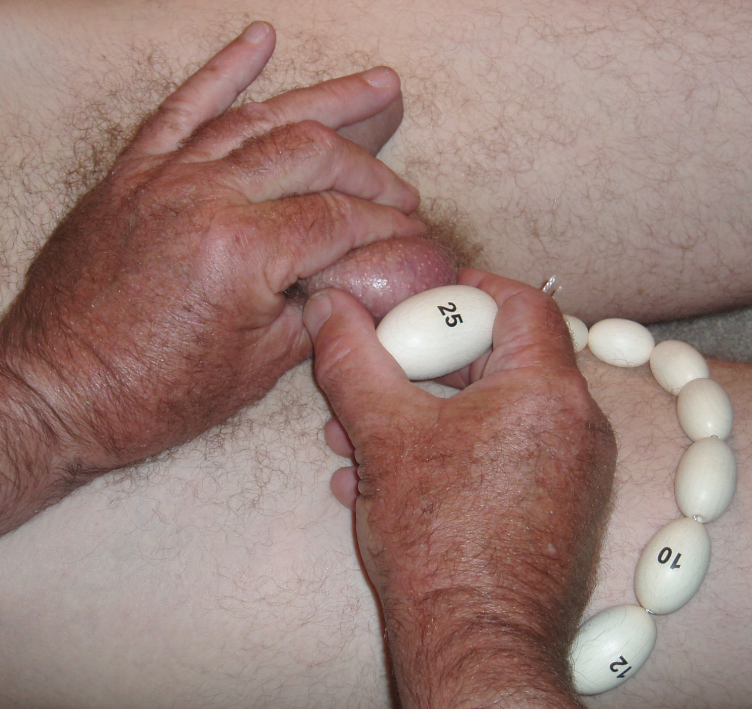

Figure 1. . Prader orchiometer for measuring testis volume.

Testicular Abnormalities
Pain on palpation or excessive tenderness suggests inflammation. Loss of normal testicular sensation may occur with chronic inflammations, neuropathy, or neoplasia. Reduced consistency or softness of the testes is a feature of reduced spermatogenesis. Abnormalities of shape and hard lumps suggest tumors or scars.
Epididymal Abnormalities
Palpable abnormalities include congenital absence of the vas or other failures of development, enlargements of the heads or nodules in the tails of the epididymides with obstruction, spermatoceles, and other cysts and tumors. In men with very small testes (<5 mL), small epididymides suggest severe androgen deficiency, and normal-size epididymides suggest postpubertal testicular atrophy or a severe seminiferous epithelial disorder, such as Klinefelter’s syndrome.
Vasal Abnormalities
Abnormalities of the vas include absence, nodules and gaps with vasectomy, and thickening or beading of the vas with severe post-inflammatory scarring as from tuberculosis.
Miscellaneous Abnormalities
Incidental scrotal findings include scars from surgery, scrotal dermatitis, and pubic fat pads around the genitals in extreme obesity. Inguinal hernias and lipomas and encysted hydroceles of the cord are palpated above and behind the epididymis. Cysts “hydatids” of the appendix testis or epididymis are typically anterior to the head of the epididymis. Spermatoceles and cysts of the paradidymis are in the head or body of the epididymis. Retroversion of the testes, where the vas and epididymis are anterior rather than posterior to the testes is common. Hydroceles of mild degree are common. A tense hydrocele may hide a testicular tumor. Unilateral absence of the vas may be associated with ipsilateral agenesis of the kidney and ureter on the same side. Many of these anomalies have little relationship with infertility.
Checking for Varicocele
With the man standing up, the scrotum can be inspected for swelling of the pampiniform plexus and a cough or Valsalva impulse seen or palpated by holding the spermatic cords between the thumb and index finger of each hand and elevating the testes toward the external inguinal ring. This maneuver reduces the risk of confusing contractions of the cremaster muscles with venous impulses. Varicocele size is graded: cough impulse without palpable enlargement of the spermatic cord (grade 1), palpable enlargement (grade 2), and visible enlargement (grade 3). Although predominantly a left-sided condition, varicoceles may occasionally be on the right side.

The accuracy and reproducibility of clinical examination, even for structures as accessible as those in the scrotum, may not be high. Varicoceles may vary in size from day to day. Even absence of the vasa may be overlooked. With practice, orchiometry can be repeated to within one orchiometer size.
SEMEN ANALYSIS AND OTHER INVESTIGATIONS
Investigations are outlined in Table 3.

Semen Analysis
The most important laboratory investigation in male infertility is semen analysis. The variables assessed and the methods are in the World Health Organization’s laboratory manual.[68] Automation of semen analysis is in progress and should be used in most specialized laboratories soon.[17]

It is crucial that the laboratory is experienced in the performance of semen analyses, and participates in quality assurance activities.[69] There should be a room nearby for the collection of semen. Semen may be obtained by masturbation or coitus using a special nontoxic condom. Ordinary latex contraceptive condoms are unsatisfactory because the rubber usually immobilizes the sperm.[70] If these methods of collection are not possible, postcoital examination of midcycle cervical mucus may give some information about the likelihood of adequate semen quality if many motile sperm are found. In contrast, a negative postcoital test on its own is of little diagnostic value because conception can occur in the same cycle.[71]

The man should be provided with a wide-mouth, sterile, and nontoxic collection jar and written instructions about collection and delivery to the laboratory. A period of abstinence from ejaculation from 2 to 5 (preferably 2) days, delivery of the sample to the laboratory within 1 hour of collection, and avoidance of exposure to lubricants or extremes of temperature are specified.

Because of the variability of results, several semen analyses at intervals of 2 or more weeks are necessary in a man with an abnormality in the first test. Even with complete collection of samples, there is variability caused by counting error, other technical errors, and differences in the ejaculate from day to day (Fig. 2).[68, 72] These large variations need to be remembered when interpreting results of semen analysis.

To check for retrograde ejaculation, urine collected immediately after ejaculation is centrifuged and the pellet examined for sperm.
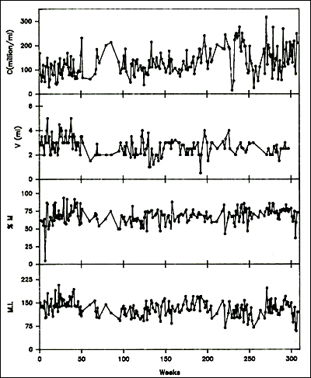
Figure 2. Variability of semen analysis results in a fertile sperm donor. C, sperm concentration; V, semen volume; M, total motility; MI, motility index-product of grade and percentage of sperm with progressive motility graded 0 to 3. (Mallidis C et al: Variation of semen quality in normal men. Int J Androl 14:99-107, 1991. Used by permission Blackwell Scientific Publications.)

Assays of semen constituents from the accessory glands and testis are available: zinc and acid phosphatase from the prostate, fructose from the seminal vesicles, neutral α-glucosidase, glycerophosphocholine, and l-carnitine from the epididymis and inhibin B from the Sertoli cells. Prostatic fluid is acid (pH approximately 6.0), but the ejaculate is alkaline because of the admixture with seminal vesicle fluid. Semen biochemistry is of limited usefulness in clinical practice. Some examples are given in Table 5.

Table 5. Common or Characteristic Patterns of Semen Abnormality
Volume (mL) >1.5* | Concentration (10⁶/mL) >15* | Motility (%) >40* | Normal Morphology (%) >4* | Comment | Cause
0.4 | 0 | - | - | Fructose 1 nmol/L (low)  pH 6.5 (low) | Congenital absence of vasa  Ejaculatory duct obstruction  Partial retrograde ejaculation  Testicular failure with androgen deficiency  (Spill or incomplete collection)
4.0 | 0 | - | - | Fructose 15 nmol/L | Genital tract obstruction  Primary seminiferous tubule failure  Secondary seminiferous tubule failure with androgen treatment
3.0 | 100 | 0 | 35 | Live 70% | (Contamination or condom collection)  Immotile cilia
3.0 | 100 | 5 | 35 | Live 20% | (Contamination or delayed examination)  Necrospermia  Sperm autoimmunity
3.0 | 100 | 65 | 0 | Small round heads | Total teratospermia: absent acrosomes
3.0 | 100 | 25 | 10 | Liquefaction delayed  Sperm aggregation 2+Live 40% Polymorphs 1 x 106/mL | Idiopathic asthenospermia Sperm autoimmunity  Prostatitis  (Delayed examination)
3.0 | 4 | 30 | 3 | Mixed abnormal morphology | Oligospermia of specific or nonspecific causes
3.0 | <1 | - | - | Motile sperm present | Severe oligospermia of specific or nonspecific causes  Primary seminiferous tubule failure  Partial genital tract obstruction
* WHO Reference Value (5%centile for fertile men)
Immunobead Test
Tests for sperm antibodies should be done routinely on all men being evaluated for infertility despite some clinical guidelines suggesting it is not necessary, because no semen analysis pattern is characteristic of sperm autoimmunity.[42, 68] The immunobead test (IBT) with beads binding to more than 50% of motile sperm is regarded as positive, but there is usually more than 70% to 80% immunoglobulin A (IgA) bead binding with clinically significant sperm autoimmunity. Tail tip–only IBT binding is not significant.[73] The mixed antiglobulin reaction test is an alternative to the IBT.[68] The indirect IBT, in which normal donor sperm are exposed to test serum or seminal plasma, can be used when there are too few motile sperm for the direct IBT. An alternative screening method for sperm autoimmunity in men with sperm in the semen would be to perform a sperm-mucus penetration test.[68]

Sperm-mucus penetration tests can be performed by postcoital examination of sperm in cervical mucus collected at mid-cycle or after estrogen treatment (ethinyl estradiol, 50 g twice daily for 4 days) to produce mucus of equivalent quality.[68] In vitro capillary mucus penetration (Kremer) tests are particularly important for evaluating the significance of sperm autoantibodies; failure of sperm to penetrate more than 2 cm in 1 hour indicates severe sperm autoimmunity with a poor prognosis and a high likelihood of failed fertilization with standard IVF.[42, 73]
Sperm Function Tests
A number of tests of sperm function are available to examine the human fertilization process (Fig. 3). These are only performed in specialist laboratories. If simpler approaches or active preparations of zona pellucida (ZP) or sperm receptor proteins become available, they will be widely used to improve the assessment of human sperm. IVF has permitted many conventional and new tests of sperm function to be examined. Groups of sperm variables that are independently significantly related to the proportion of oocytes that fertilize in vitro can be determined by regression analysis.[74] This approach has confirmed the importance of sperm morphology in the ability of sperm to interact with the coverings of the oocyte.

Human Sperm-Oocyte Interaction
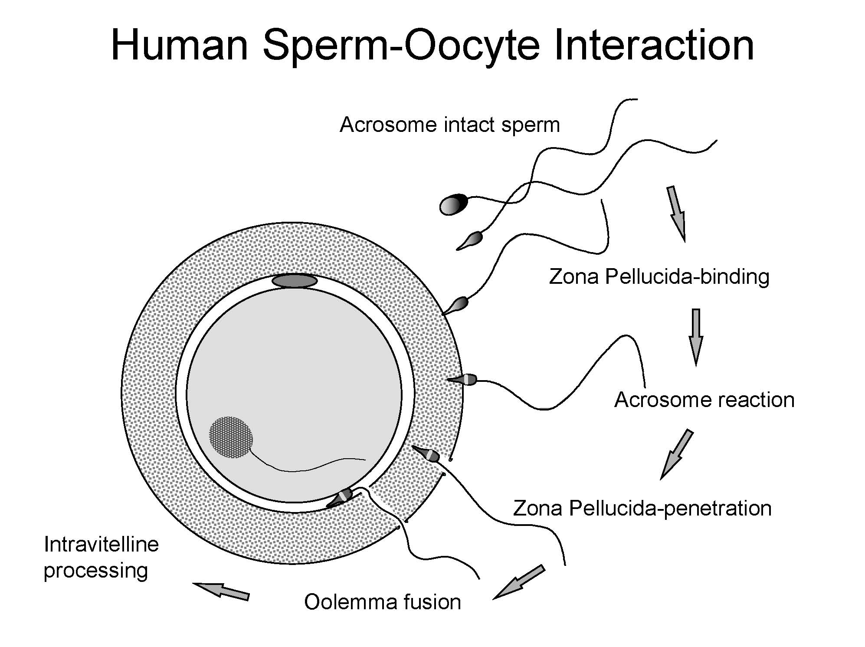

Figure 3. Stages of human fertilization. Spermatozoa swim through the surrounding medium and cumulus mass (not shown) and bind to the surface of the zona pellucida. The acrosome reaction is stimulated by zona proteins and the acrosome reacted sperm penetrates the zona, enters the perivitelline space and binds to the oolemma via the equatorial segment. Oocyte processes surround the sperm head and it enters the ooplasm and decondenses. Infertility could result from defects of any of these processes. For example, abnormal sperm particularly with defective head morphology bind poorly to the zona. (From Baker, H.W.G., Male Infertility. Chapter 141 In Endocrinology, 6th edition, Jameson J. L. and DeGroot L.J. (Chief Eds.), Saunders Elsevier Philadelphia PA. pp 2556-2579, 2010)

Human Sperm–Zona Pellucida Binding Ratio Test
Because the number of sperm bound to the ZP is strongly related to the fertilization rate, human sperm–ZP interaction tests have been developed using oocytes that failed to fertilize in vitro.[74] These oocytes can be used either fresh or after storage in concentrated salt solutions. Because the ZP binding capacity is variable, control (fertile donor) and test sperm are labeled with different fluorochromes (fluorescein and rhodamine). After incubation with equal numbers of control and test sperm, the oocytes are aspirated through a wide bore pipette to dislodge loosely adherent sperm and the numbers of sperm tightly bound to the ZP are counted with a fluorescence microscope. Results are expressed as a ratio of the number of test and control sperm bound to the ZP of four oocytes. An alternative method is to cut the zona and expose one half to test and the other to control sperm (Hemizona assay).[75]
Human Sperm–Zona Pellucida Penetration Test
It is difficult to determine the number of sperm penetrating the ZP when many sperm are bound to the surface. The sperm bound to the surface of the ZP can be sheared off by repeatedly aspirating the oocyte with a pipette with an internal diameter less than the diameter of the oocyte (120 m). The sperm penetrating the ZP or perivitelline space can then be counted easily, and the results of this test are the most predictive of fertilization rates with standard IVF.[74]
Zona Pellucida–Induced Acrosome Reaction Test
Sperm dislodged from the ZP can be stained with a fluorescein-labeled lectin such as pisum sativum agglutinin or an antibody specific for the acrosomal contents to determine the proportion that are acrosome reacted. This test is useful for diagnosis of disordered ZP-induced acrosome reaction.[74]
Human Sperm–Oolemma Binding Ratio Test
Sperm-oolemma binding has been studied in a similar way to the sperm-ZP binding test, using oocytes that have had the ZP removed. [74]
Interpretation of Semen Analysis Results
Table 5 shows various patterns of abnormality of semen quality and their common causes. It is always important to consider whether the result is spurious. Repeated tests are necessary to establish an average and to determine the variability within an individual man (see Fig. 2).
Variations in Semen Volume and Appearance
Low semen volume suggests incomplete collection, short duration of abstinence from ejaculation before the test, absence or obstruction of the seminal vesicles, or androgen deficiency. High semen volume (>8 mL) may be seen in association with oligospermia but is of little practical significance. Hemospermia is usually the result of minor bleeding from the urethra, but serious conditions, such as genital tract tumors, must be excluded. Other discoloration of the semen may indicate inflammation of accessory sex organs. The semen may be yellow with jaundice or salazopyrine administration. Defects of liquefaction and viscosity are relatively common and presumably result from malfunction of the accessory sex organs. Although these may cause problems with semen analysis and preparation of sperm for assisted reproductive technology (ART), they are probably of little relevance to fertility. Sperm agglutination is common with sperm autoimmunity but can also occur for other reasons.
Azoospermia
The total absence of sperm from the semen needs to be confirmed in repeated tests with vigorous centrifugation of the semen and careful examination of the pellet.[68] Cooper and others have shown that sperm maybe found in apparently azoospermic samples using more sensitive sperm-counting methods (e.g. fluorescence microscopy).[76] Rarely, an illness or difficulty with collection will cause transient azoospermia; however, this can also occur for unexplained reasons. With severe spermatogenic disorders and some obstructions, sperm may be present in the semen intermittently. If any live sperm can be found, these can be cryopreserved for intracytoplasmic sperm injection (ICSI).
Oligospermia
Sperm concentrations of less than 15 million/mL or preferably total number (concentration X volume) less than 39 million are classified as oligospermic.[68] This figure represents the 5th percentile derived from analysis of semen analyses preformed using WHO methods in about 1900 healthy volunteers whose partners had a time-to-pregnancy of ≤12 months and is used in the 5th edition of the WHO semen analysis manual .[77] There is a correlation between sperm concentration and other aspects of semen quality. Both motility and morphology are usually poor with oligospermia.
Asthenospermia
Asthenospermia is defined as less than 40% sperm motility or less than 32% with rapid progressive motility.[68] Spurious asthenospermia caused by exposure of sperm to rubber (particularly condoms), spermicides, extremes of temperature, or long delays between collection and examination, should be excluded. Low sperm motility is a frequent accompaniment of oligospermia, and is often also associated with a mixed picture of morphologic defects suggesting defective spermiogenesis.

Specific ultrastructural defects of the sperm can be evaluated by electron microscopy when there is zero sperm motility or extreme asthenospermia (less than 5% motile sperm).[50, 78] Absent dynein arms, other axonemal defects, mitochondrial abnormalities, disorganized fibrous sheath or outer dense fibers, or normal ultrastructure may be found. Standard semen analyses usually show normal sperm concentrations and morphology but there may be tail abnormalities: short, straight, or thick tails, or midpiece defects. Viability tests help to distinguish this group of patients from those with necrospermia.[79] Patients with structural defects in the sperm may be able to be treated by ICSI. Asthenospermia may also be associated with sperm autoimmunity. The causes of other motility defects of moderate degree are unidentified.
Absolute asthenospermia (the condition in which only immotile spermatozoa can be retrieved) is reported at a frequency of 1 in 5000 men and it implies a very poor fertility prognosis. Selection methods currently used to choose a viable sperm for ICSI in the case of absolute asthenospermia are based on chemical substances added to the sample before the procedure or biophysical approaches accomplished during the procedure. [80]
Immotile sperm treatment with pentoxifylline, a nonselective inhibitor of phosphodiesterase has been investigated and proved to be an efficient approach. [81, 82]
Theophylline, a nonselective inhibitor of phosphodiesterase with an increased half-life compared to pentoxifylline was also investigated, recently, [83] in a prospective study on thawed testicular sperm selected for ICSI. Theophylline-treated thawed sperm compared
with untreated sperm showed a significant improvement in searching time, increased fertilization and blastulation rates and higher implantation and clinical pregnancy rates. In a recent case report [84], theophylline has been demonstrated to be an efficient agent for stimulating immotile spermatozoa also in a patient with retrograde ejaculation and total sperm asthenospermia, and a healthy live birth was reported.
Other sperm selection methods as the sperm tail flexibility test (STFT) [85], the hypo-osmotic swelling test (HOS)[86, 87] and laser shot system [88] were reported to be useful.

Necrospermia
It is important to distinguish necrospermia from other types of severe asthenospermia because some patients with necrospermia produce pregnancies despite the low sperm motility.[40, 79, 89, 90] Necrospermia is characterized by usually less than 20% to 30% total motility, less than 5% progressive motility, and a viability test less than 30% to 40%, indicating a high proportion of dead sperm. Other causes of severe asthenospermia such as sperm autoimmunity and collection problems must be excluded. Necrospermia may fluctuate in severity, particularly with changes in coital frequency.[79, 90] Characteristic of necrospermia is an improvement of sperm motility with increased frequency of ejaculation. The condition may be caused by defective storage of sperm in the tails of the epididymides or stasis in the genital tract, and it also occurs with chronic spinal cord injury and with adult polycystic kidney disease associated with cysts in the region of the ejaculatory ducts.[40, 89] There are ultrastructural features of degeneration in the ejaculated sperm but normal structure of late spermatids in testicular biopsies.[79, 89] Treatment with antibiotics may have a beneficial effect, but this is not proved. The couple should have intercourse once or twice every day for 3 to 4 days up to the time of ovulation.
Teratospermia
Teratospermia is a reduced percentage (<4%) of sperm with normal morphology assessed by light microscopy.[68] It is important to distinguish mixed abnormalities of sperm morphology from those in which all or the majority of sperm show a single uniform defect, such as spherical heads with absence of the acrosomes (globospermia) and pinhead sperm. Pinhead sperm result when the centrioles from which the sperm tails develop are not correctly aligned opposite the developing acrosome. On spermiation, the sperm heads are disconnected from the tails and absorbed during epididymal transit so that there are only sperm tails in the ejaculate, the cytoplasmic droplet on the midpiece giving the pinhead appearance.[91] Both these conditions cause sterility but are extremely rare.

In general, human spermatozoa are very variable in appearance and the microscopic assessment of sperm morphology is highly subjective and difficult to standardize between laboratories. Only a small proportion (<25%) of the motile sperm from fertile men are capable of binding the ZP in vitro, and this zona binding capacity is closely related to the morphology of the sperm head.[92] The morphometric characteristics of the sperm that bind to the ZP may be useful as a standard for sperm morphology.[17, 93] Various histological assessments of morphology have been used. The simplest is to record as normal only those sperm that have no shape defects in head, midpiece or tail, regions.[68] In the strict morphology approach, although size measurements are set, the sperm are assessed by eye and those marginally abnormal are assigned abnormal. Automated methods involving image analysis by computer have been developed that could overcome the between-laboratory variability and greatly improve the predictive value of semen analysis for natural conception.[17, 93]

Before the introduction of ICSI, the percentage of sperm with normal morphology assessed by strict criteria after washing the sperm and adjusting the concentration to 80 million/mL, provided one of the most useful predictors of fertilization rates with standard IVF. There was a progressive reduction in oocytes fertilized from 60% to 20% as abnormal morphology increased from less than 70% to more than 95%.[94] Patients with high proportions of sperm with abnormal morphology are now treated by ICSI because of the risk of failure of fertilization with standard IVF. ICSI results are independent of sperm morphology.

Sperm chromatin and abnormal DNA assays
A variety of flow cytometric and other assays to measure sperm chromatin integrity, DNA fragmentation, sperm apoptosis or nuclear integrity have been developed. [95, 96] The usefulness of these tests for prediction of fertility remains controversial [97]
Hormone Assessment
It is not necessary to perform hormone measurements routinely. Follicle-stimulating hormone (FSH) levels in patients with azoospermia, normal testicular volume, and normal virilization may help distinguish genital tract obstruction from a spermatogenic disorder. The most useful FSH value for the upper limit in reproductively normal young men is ~8 IU/L.[98, 99] However, some men with primary seminiferous tubule failure have normal FSH levels. Normal FSH is common with germ cell arrest at the primary spermatocyte stage. Rarely, high FSH levels are seen with normal spermatogenesis.[100] Measurement of FSH, luteinizing hormone, and testosterone is useful in men with reduced testicular volume and signs of androgen deficiency, to distinguish primary from secondary hypogonadism. Inhibin B measurement may provide additional information about the state of spermatogenesis.[101] but is rarely used in routine practice.

Prolactin should be measured in men with galactorrhea or androgen deficiency and loss of libido.[102] Other hormone investigations are occasionally required, such as thyroid function tests with hyperprolactinemia, 17-hydroxyprogesterone measurements with congenital adrenal hyperplasia, estradiol with liver disease or tumors, iron studies to exclude hemochromatosis, human chorionic gonadotropin with tumors and estrogen excess, and pituitary function tests for panhypopituitarism.[43]
Chromosome and Genetic Studies
Chromosomal anomalies are 8-10X more common in infertile than fertile populations, and in many cases there are no other phenotypic changes. The prevalence is inversely correlated to the sperm density, being 14% of azoospermia.[103, 104] Accordingly a routine assessment is recommended in men with unexplained infertility and sperm densities < 5-10 million/ml. A karyotypes is performed in men with clinical evidence of primary testicular failure and small testes to confirm a clinical diagnosis of Klinefelter syndrome. Usually the karyotype is 47,XXY, but there may be higher numbers of X chromosomes or a sex-reversal 46,XX karyotype.[105-107] Although most men with Klinefelter syndrome produce no sperm in the semen, some are oligospermic and very rarely fertile.[105] Also, sperm for ICSI may be obtained by testicular biopsy in about 50% of patients.[106, 107] Defective spermatogenesis may occur with 47,XYY, but the clinical picture is much less uniform than it is for Klinefelter syndrome. The extra Y chromosome is deleted early in gametogenesis because the sperm, embryos, and children generally have normal karyotypes. However, an increased rate of sex chromosomal and autosomal aneuploidy has been noted in studies of sperm from XXY and XYY men.[107, 108] Some Y chromosome abnormalities, such as an isochromosome of two short arms, are associated with absences of spermatogenesis.

Infertile men have much higher rate of aneuploidies compared to fertile men and most of them have no other phenotypic features. An increased frequency of autosomal abnormalities is found with defective spermatogenesis, particularly balanced autosomal translocations (reciprocal and Robertsonian), which may be transmitted in unbalanced form to their offspring.[109] As part of their infertility investigation, it is imperative to screen severely oligospermic men as the result may affect treatment outcome.

Cystic fibrosis gene studies are important for evaluation of patients with congenital absence of the vas and their partners.[110] If the woman has a cystic fibrosis gene mutation, preimplantation genetic diagnosis of their embryos can be offered. Microdeletions in the long arm of the Y chromosome (AZF regions) have been found in 3% to 15% of men with severe primary spermatogenic disorders.[18, 19, 27, 36, 37] Sons of men with these microdeletions have the same microdeletions.[111]

Another gene involved in spermatogenesis (histones replacement) and different from the AZF regions Yq deletions is CDY. ([112] TSPY gene is located on the short arm of Y chromosome and may regulate the timing of spermatogenesis by signaling spermatogonia to enter meiosis. [29]

The sex hormone-binding globulin (SHBG) gene has been studied for possible role in spermatogenesis.[113] Other genes that have been investigated for a possible involvement in fertility are DAZL (sperm count) MTHFR and the estrogen receptors genes (ESR1 and ESR2). Polymorphisms of the promoter region of the estrogen receptor gene have been shown to be related to sperm production. Men with higher numbers of TA repeats have lower sperm counts. [29]

Androgen receptor defects have also been found in some men with unexplained primary spermatogenic disorders. Mutations in the gene impairing androgen receptor activity produce androgen insensitivity, which has a variable phenotypic expression from testicular feminization to otherwise normal males with gynecomastia or hypospermatogenesis and oligospermia.[33] Increases in the number of CAG repeats in exon 1 over approximately 40 are associated with Kennedy disease (progressive spinobulbar atrophy) and men with this condition may be infertile.

The field of epigenetic errors has also been studied for its possible contribution to male infertility. [114] (Table 4)

Other specific genetic tests and family studies may be indicated on clinical grounds (see Table 4).

At present, it is reasonable to screen all infertile men with otherwise unexplained primary spermatogenic defects with average sperm concentrations less than 5-15 million/mL by karyotype and Yq microdeletion testing.[115] All patients should be counseled about the possibility of transmitting known and unknown genetic defects.

Testicular Biopsy
Testicular biopsies are necessary to assess spermatogenesis in men with presumed genital tract obstruction. A significant proportion of men with azoospermia, normal testicular size, and normal FSH are found to have severe spermatogenic disorders.[14] Some severe spermatogenic defects may be incomplete, and because ICSI can be performed if sperm can be obtained from the testes, diagnostic testicular biopsies should be offered to men with severe primary spermatogenic tubule disorders with persistent azoospermia. If any elongated spermatids can be found, it should be possible to perform ICSI. However, if no elongated spermatids are seen in the diagnostic biopsies it still may be possible to find spermatids by more extensive sampling of testicular tissue with open biopsies (see later).

It is most important that tissue for histology is removed from the testes with minimal damage and placed in a suitable fixative, such as Bouin’s or Steive’s solution. Standard formalin fixatives destroy the cytoarchitecture.

Testis biopsies may be performed under local or general anesthesia. Needle biopsy many obtain only isolated cells but these may be sufficient for diagnosis based on cytology or for flow cytometry. The technique shown in Fig. 4 usually provides sufficient material for a histologic diagnosis of the state of the seminiferous epithelium despite some deformation artifacts.[116] It is also useful for obtaining testicular sperm for ICSI.[117] Complications are rare and include minor bleeding in the skin and testis, and rarely hematoma or reactions to the local anesthetic. Failure to obtain tissue occurs particularly with fibrosed or small (<5mL) testes

In the presence of azoospermia, an open testicular biopsy might not just be a therapeutic approach in the way of sperm retrieval, but also the only way of excluding early testicular germ cell neoplasia or even an overt testicular cancer.

Infertile men are more likely to develop testicular cancer compared to men with normal fertility.[118] Testicular intra-tubular germ cell neoplasia of the unclassified type (ITGCNU) also called carcinoma in situ (see below) is the precursor of testicular germ cell tumors in which the neoplastic cells are confined within the seminiferous tubules. This makes it a non-invasive stage of the disease. It can be found in testicular tissue adjacent to germ cell tumours in more than 90 percent of adult cases. [119, 120]

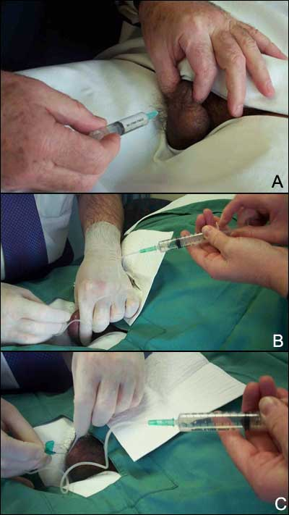
The incidence of ITGCNU in men undergoing fertility evaluation ranges between 0.4 - 1.1 percent.[121, 122] As ITGCNU is asymptomatic, patients remain undiagnosed until an overt tumour can be identified usually by palpation. A sample from a sperm retrieval open biopsy should be sent to histopathology routinely.

Figure 4. (A) Fine-needle tissue aspiration biopsy of the testis. Local anesthetic is injected around the vas to block testicular sensation. (B) Fine-needle tissue aspiration biopsy of the testis A 21 gauge butterfly needle is inserted into the testis. An assistant applies suction to the needle tubing via a 10mL syringe and the operator makes thrusting movements of the needle into the substance of the testis. (C) Fine-needle tissue aspiration biopsy of the testis while maintaining the suction the needle is removed carefully and any seminiferous tubules protruding from the needle are grasped with fine forceps to avoid them falling back into the puncture hole. With this technique seminiferous tubule sections are sucked into the needle and these are expelled into some culture medium. Portions can be sent for histology and the remainder used for extraction of sperm in the IVF laboratory by stripping the seminiferous tissue out of the connective tissue membrane of the seminiferous tubule.

For clinical purposes, testicular histology is classified as follows: normal or hypospermatogenesis (all the cellular elements of spermatogenesis are present but in reduced numbers), germ cell arrest (the earlier cellular elements of spermatogenesis are present but at a certain stage, the process stops, most often at the primary spermatocytes), Sertoli-cell-only syndrome or germ cell aplasia (the tubules contain Sertoli cells but no germ cells), hyalinization (the cellular elements have disappeared, leaving only thickened seminiferous tubule walls as in Klinefelter syndrome), and immature testis (no gonadotropin stimulation, prepubertal appearance).[123] Examples are shown in Figure 5. Other classifications such as partial or incomplete maturation arrest and partial germ cell aplasia cause confusion in the literature and should not be used.[124]

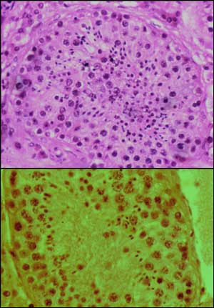
Figure 5A. Testicular histology from fine-needle aspiration samples. Normal.

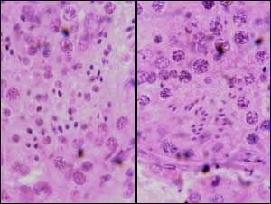
Figure 5B. Testicular histology from fine-needle aspiration samples. Left mild hypospermatogenesis with elongated spermatids with poor head morphology: right normal.

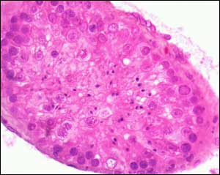
Figure 5C. Testicular histology from fine-needle aspiration samples. Mild-moderate hypospermatogenesis.

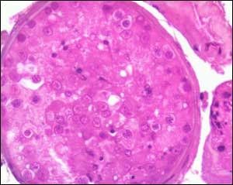
Figure 5D. Testicular histology from fine-needle aspiration samples. Moderate-severe hypospermatogenesis.

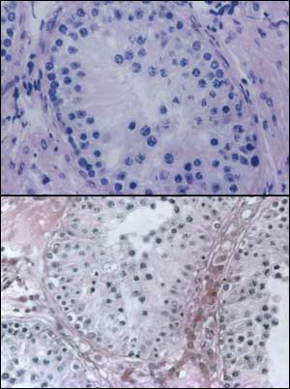
Figure 5E. Testicular histology from fine-needle aspiration samples. Germ cell arrest at the primary spermatocyte stage.

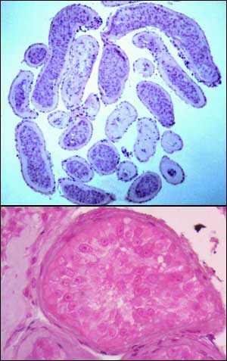
Figure 5F. Testicular histology from fine-needle aspiration samples. Sertoli cell-only syndrome: low and high power.

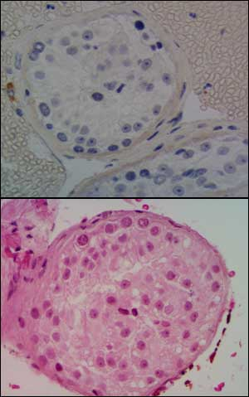
Figure 5G. Testicular histology from fine-needle aspiration samples. Germ cell arrest at the spermatogonial stage from gonadotropin deficiency. Upper panel atrophic Leydig cell stained brown with anti-testosterone antibody.

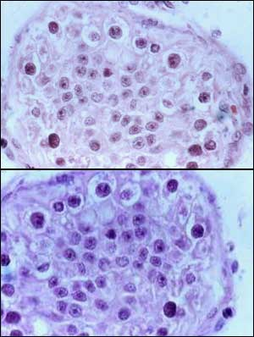
Figure 5H. Testicular histology from fine-needle aspiration samples. Carcinoma in situ, only transformed spermatogonia and Sertoli cells present.

Other Investigations
Ultrasonography is useful to check for tumors in the testes, particularly when the testes are difficult to palpate because of a tense hydrocele.[125] Other abnormalities may also be found (Figs 6-8). It can also be used to measure testicular size and confirm the presence and nature of cysts or other abnormalities in the scrotum. Some argue scrotal ultrasound should be performed routinely in infertile men to measure testicular volume, assessing the texture and exclude impalpable malignant tumors in the testes.[126] However, some clinical guidelines do not support this. [127] Doppler blood flow assessment is valuable in assessing a painful swollen testis for torsion or inflammation and for evaluating varicoceles. Other tests of a varicocele, including thermography, technetium scans, and venography may be performed but, as pointed out later, the value of treating varicoceles to improve fertility is uncertain. Rectal ultrasound may demonstrate cysts in the prostate, enlarged seminal vesicles, or dilated ejaculatory ducts associated with distal genital tract obstructions (Figure 8).[128] Clinical suspicion of the presence of a pituitary tumor should be followed up by appropriate radiology. Abdominal imaging is necessary to check the position of impalpable testes.

A
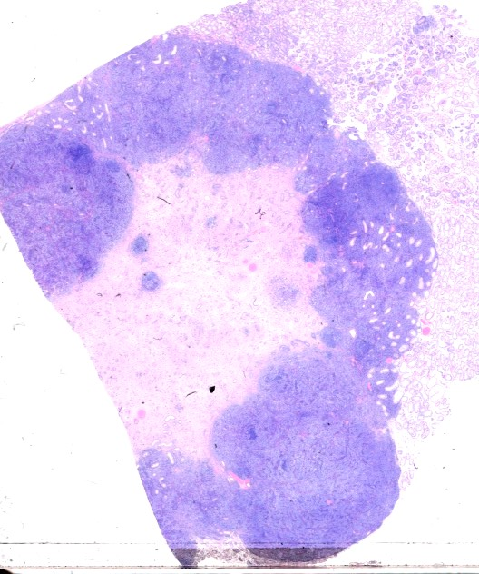
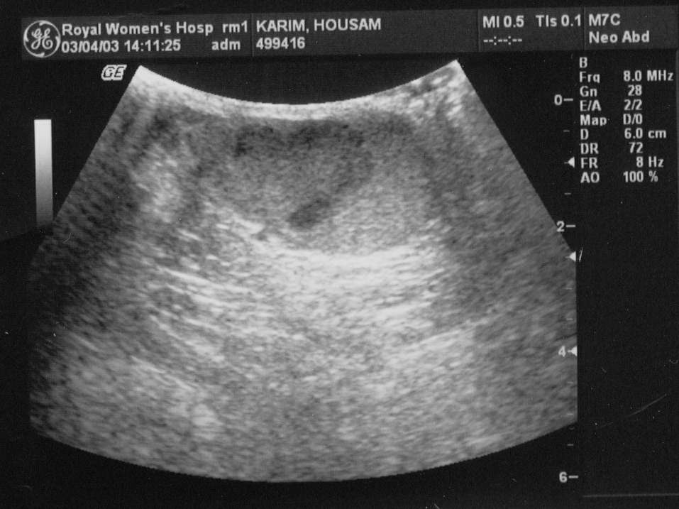
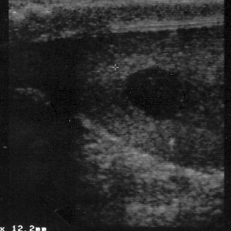
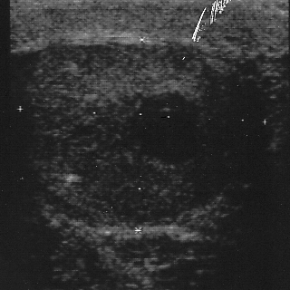

B

A

C

D

FIGURE 6. Ultrasounds of testes with tumours. A Longitudinal, testis with seminoma in a man presenting with infertility, severe oligospermia and a large hard right testis; B Low power histological section of radical orchiectomy specimen with active tumour stained blue, and necrotic centre and seminiferous tubules stained red; C, Londitudinal and D transverse of impalpable 1cm diameter seminoma in the upper pole of the right testis in a man presenting with severe oligospermia and normal sized testes.

FIGURE 6. Ultrasounds of testes with tumours. A Longitudinal, testis with seminoma in a man presenting with infertility, severe oligospermia and a large hard right testis; B Low power histological section of radical orchiectomy specimen with active tumour stained blue, and necrotic centre and seminiferous tubules stained red; C, Londitudinal and D transverse of impalpable 1cm diameter seminoma in the upper pole of the right testis in a man presenting with severe oligospermia and normal sized testes.

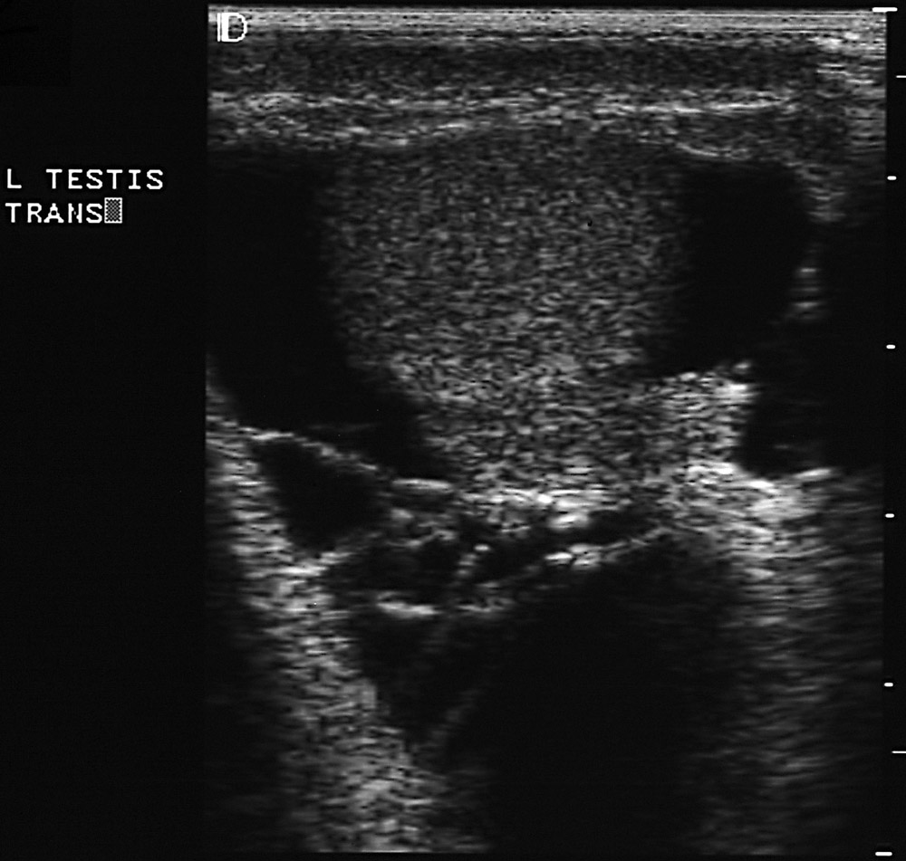
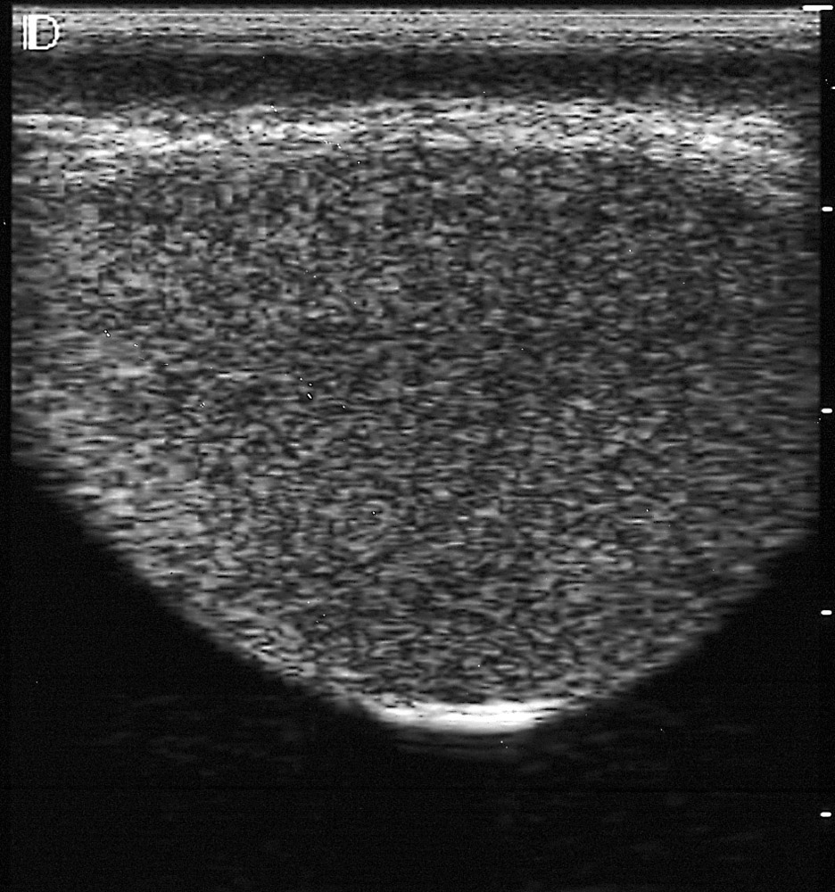
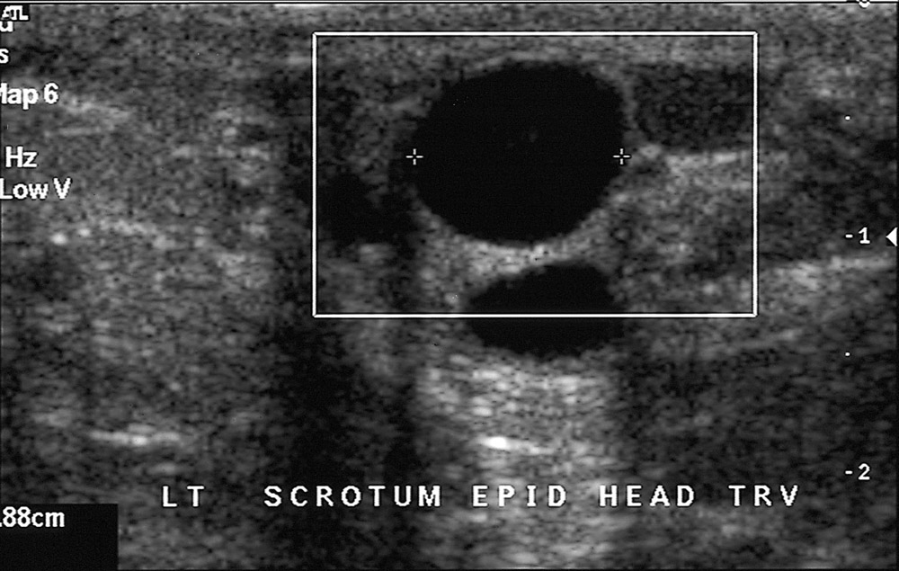
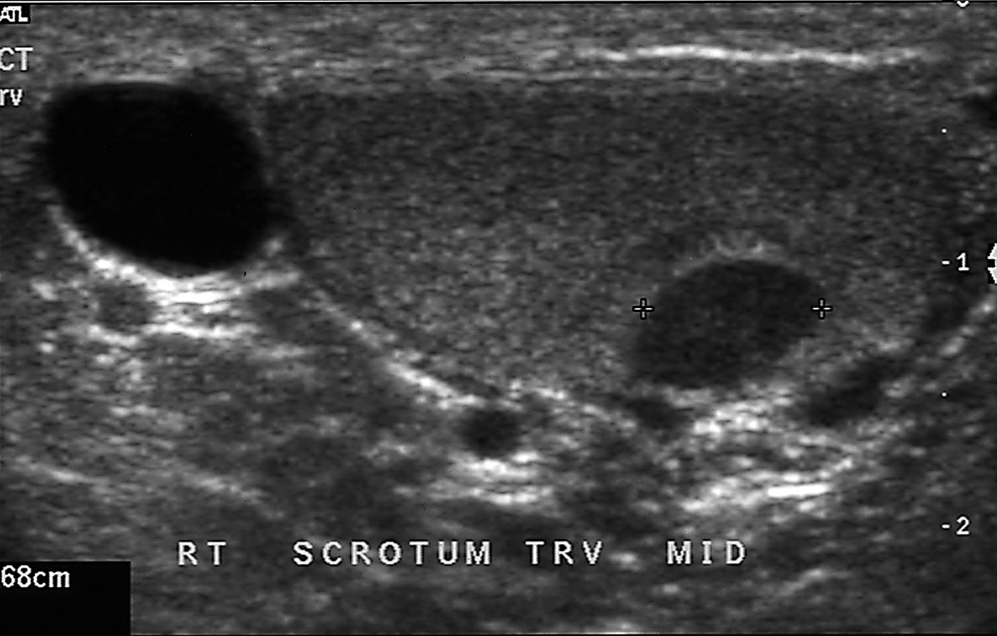
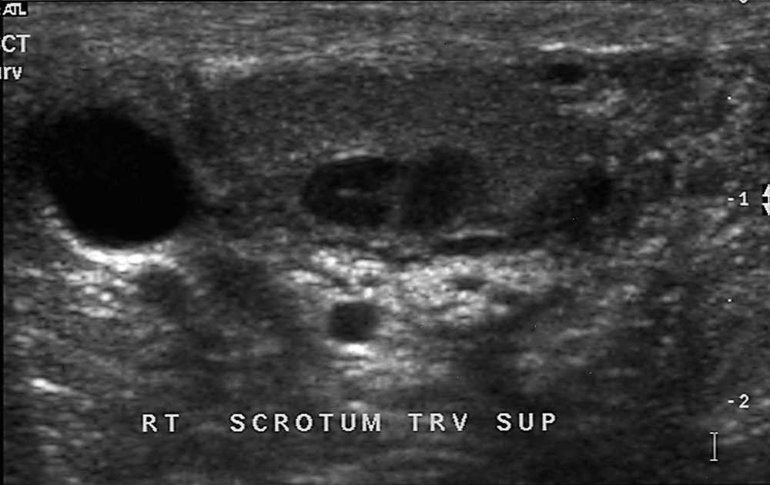
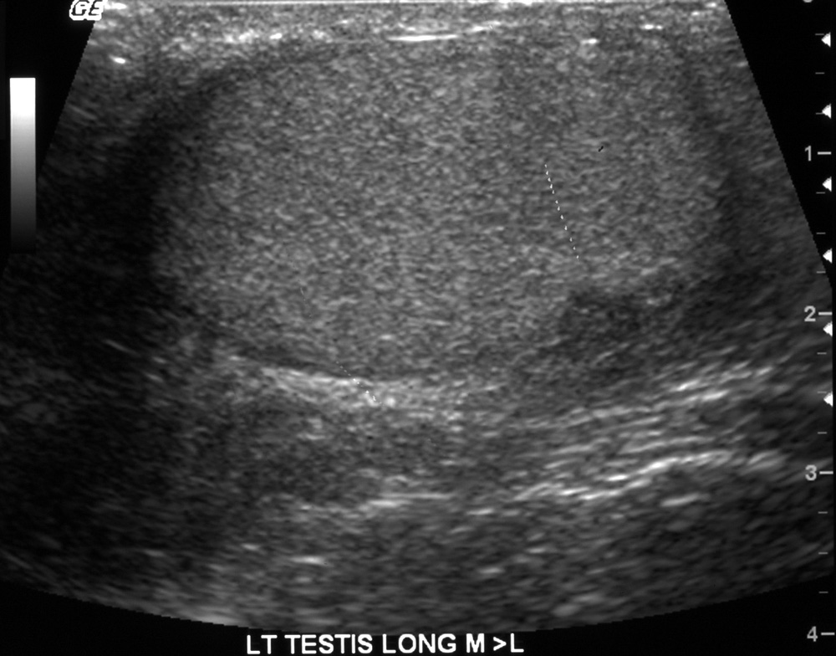
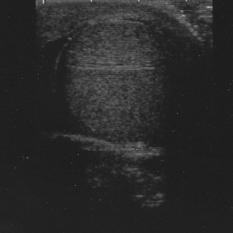
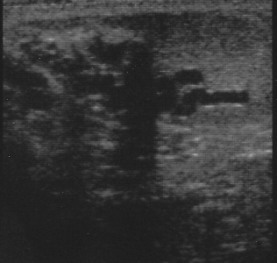
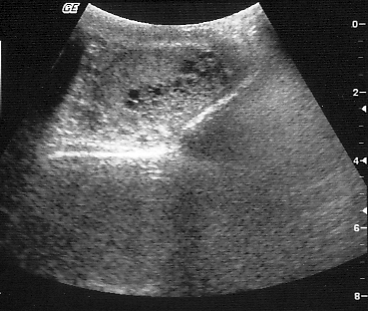
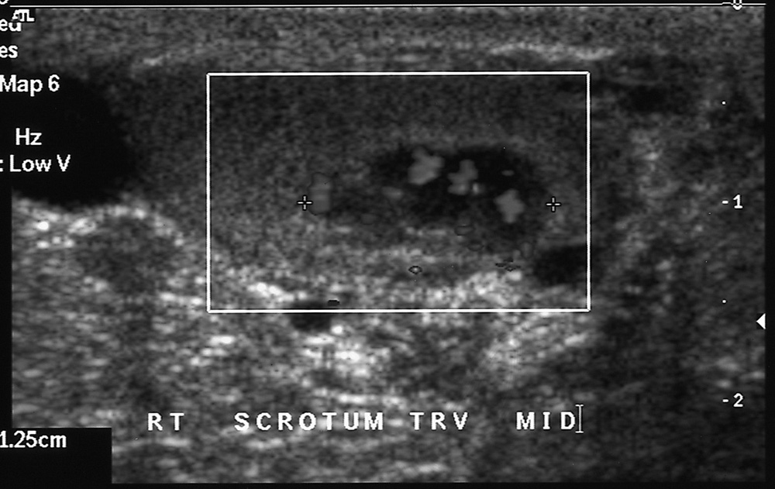
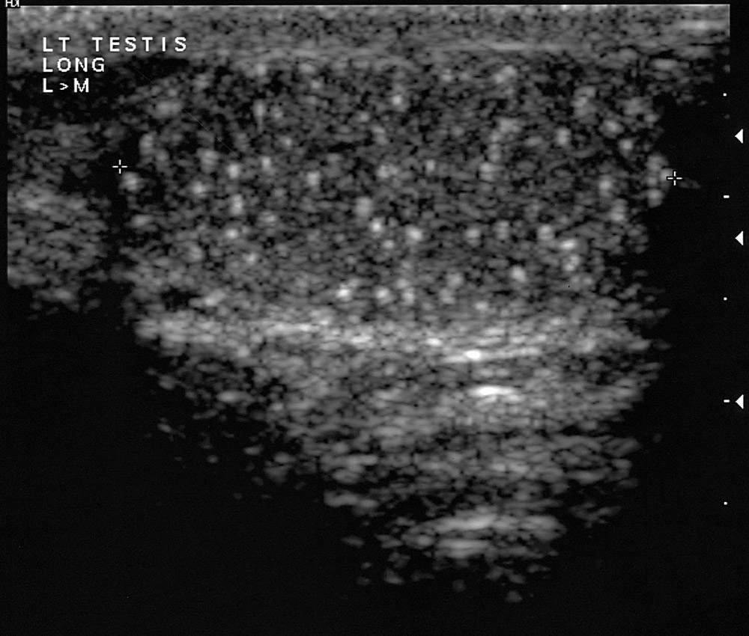

A

B

C

D

E

G

F

H

I

J

K

FIGURE 7. Miscellaneous findings on scrotal ultrasound. A,B multiple epididymal and intratesticular cysts in a man with von Hippel Lindau syndrome; C Simple hydrocele; D Multiloculated hydrocele; E Simple cysts in head of the epididymis; F Ectasia of the rete testis; G Hypoechoic area in periphery of testis of uncertain significance; H Microlithiasis in a severely atrophic testis; I Transverse blood vessel; J Intratesticular varicocele; K Blood flow in intratesticular varicocele.

A

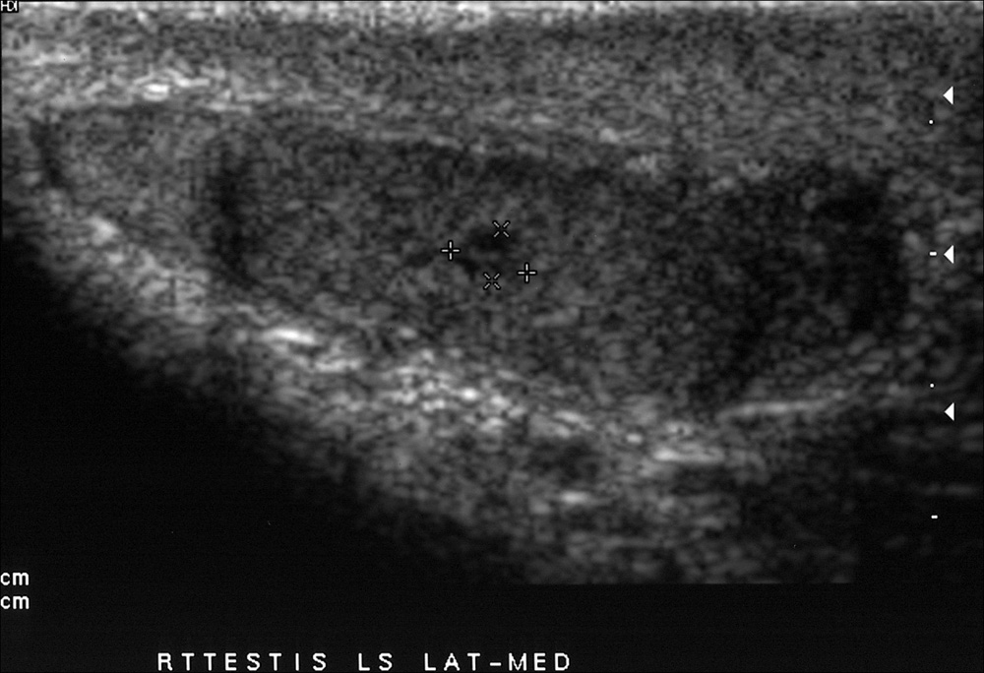
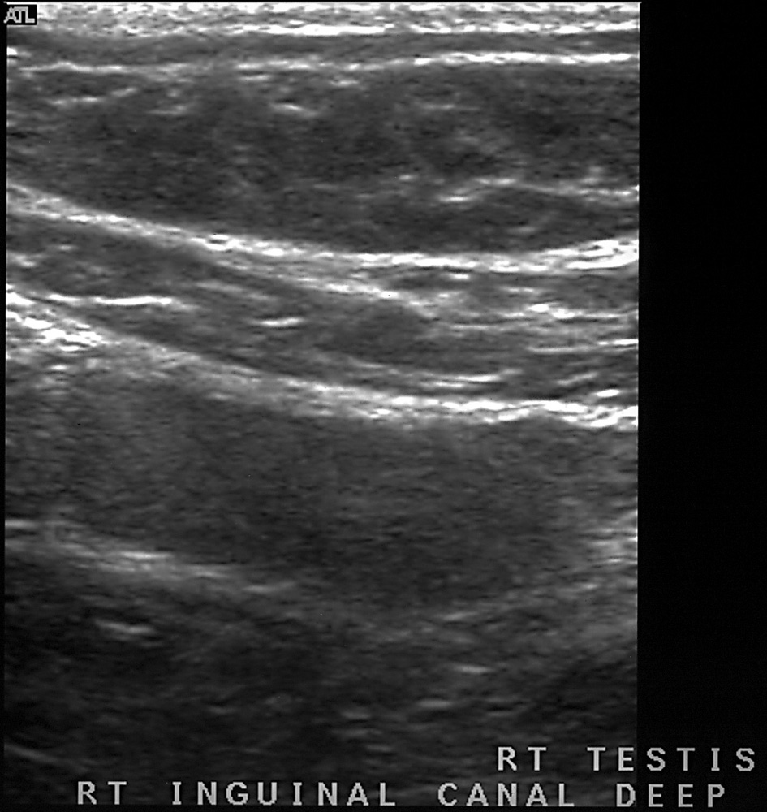
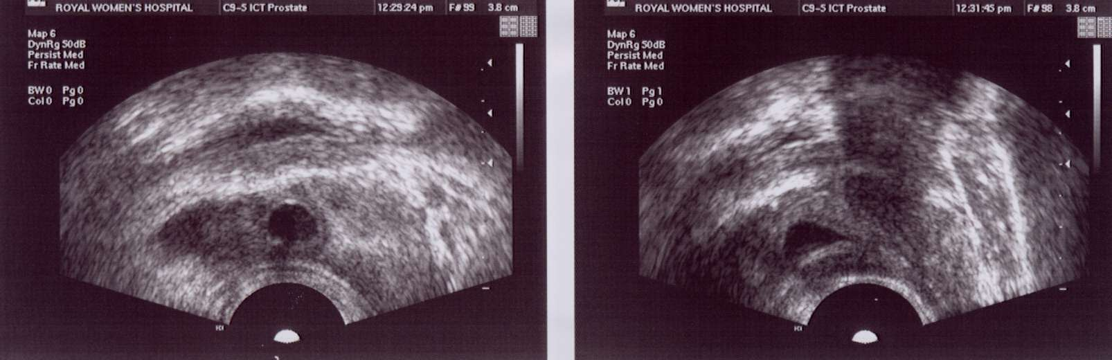
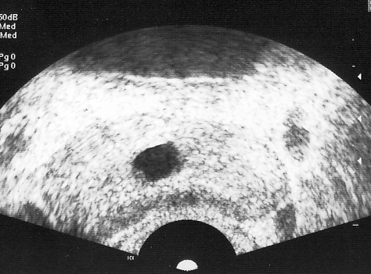
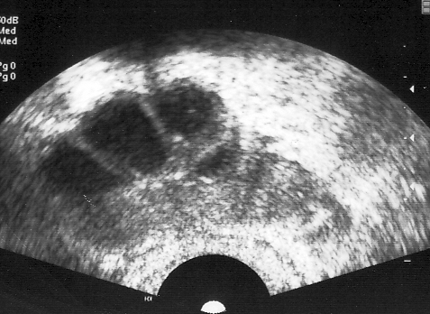
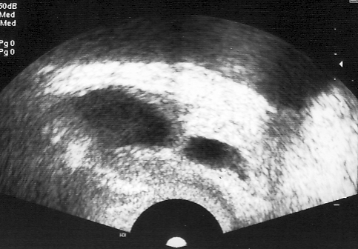

B

D

C

I

E

F

G

FIGURE 8 Ultrasound of undescended testes. A - In neck of scrotum at external inguinal ring with small tumour; B - In inguinal canal; Incidental prostatic cyst in a healthy man: C - transverse, D - sagittal; Ejaculatory duct obstruction: E - prostate transverse - dilated ejaculatory duct; F - transverse, dilated seminal vesicle; G - sagittal, dilated duct and seminal vesicle.

MANAGEMENT OF SPECIFIC CONDITIONS
This section addresses the management of sperm autoimmunity, male genital tract obstructions, coital disorders, genital tract inflammation, and varicocele. Treatment of gonadotropin deficiency and androgen replacement therapy are covered in Chapters by Hayes and Pitteloud, and Handelsman.
Sperm Autoimmunity
Sperm autoimmunity is present in 6% to 10% of infertile men.[42] They have sperm coated with antibodies to the extent that sperm function is impaired, particularly sperm - mucus penetration and sperm zona-pellucida binding, resulting in severe infertility. Natural pregnancy rates without treatment are very low and fertilisation rates with standard IVF are low or zero. Other men have positive IBT, sometimes with only to tail tip binding and normal or only marginally impaired mucus penetration.[73] These low-level sperm autoantibodies are irrelevant to the infertility and other causes of the couple’s infertility should be sought. Sperm autoimmunity can be treated by glucocorticoids in immunosuppressive doses. Antibody levels fall and semen quality improves in about 50% of patients and about 25% produce natural conceptions during a 4-6 month course of treatment.[42] There are significant risks of severe side effects particularly aseptic necrosis of bone. The superior results of ICSI make this treatment obsolete and only useful in exceptional circumstances.
Genital Tract Obstruction
Clinical Characteristics
Most men with genital tract obstruction have azoospermia, normal testicular size, normal virilization, and normal serum FSH levels. However, some have combined obstruction and spermatogenic disorders or partial obstructions and severe oligospermia. There may be a history of an event that caused the obstruction, such as epididymitis with gonorrhea or associated respiratory disease. Because a few men with normal spermatogenesis have elevated FSH levels and some spermatogenesis may occur in association with a severe spermatogenic disorder, all patients should be offered further investigation. The presence of sperm antibodies in blood serum by indirect IBT indicates sperm are being formed but is an adverse prognostic factor for natural conception after surgery. With bilateral congenital absence of the vasa or ejaculatory duct obstruction, semen volume, pH, and fructose levels are low. The semen also does not have its characteristic smell and does not form a gel after ejaculation because it contains only prostatic and urethral fluid. Rectal ultrasound shows absent or atrophic seminal vesicles with bilateral congenital absence of the vasa but with ejaculatory duct obstruction the seminal vesicles and ejaculatory ducts are dilated and the cause of the obstruction may be obvious such as a cyst of the prostatic utricle.[128] Testicular biopsy is usually normal but there may be some reduction in spermatogenesis either as a coincidence or as a result of the obstruction, particularly after vasectomy.[129]
Pathophysiology
Degeneration of the Wolffian duct structures occurs with cystic fibrosis gene mutations but can be of variable extent. Although most often only the heads of the epididymides are palpable, some men with bilateral congenital absence of the vasa have parts or all of the epididymides and scrotal vasa present with absent or atrophic pelvic vasa and seminal vesicles. Other conditions may cause defective development of the vasa such as congenital rubella. Young’s syndrome which is now rare is not related to cystic fibrosis gene mutations. The pathology shows inspissated material in the head of the epididymis, and there are lipid inclusions in the epithelial cells.[48, 49] As some men with this syndrome have fathered children, the blockage may develop in adulthood.

Post-inflammatory obstructions after gonorrhea typically occur in the tail of the epididymis, whereas nonspecific bacterial inflammation produces more widespread destruction, and tuberculosis usually causes multiple obstructions in the epididymides and vasa or destruction of the prostate and seminal vesicles. Back pressure ‘blowout’ obstructions in the epididymis are frequent after vasectomy. Iatrogenic causes of genital tract obstruction include inadvertent epididymectomy during testicular biopsy, vasal damage during hernia repair or pelvic or lower abdominal surgery such as renal transplantation, and ejaculatory duct obstruction from prostatectomy or complicated bladder catheterization.
Differential Diagnosis
Men with persistent azoospermia, normal testicular size, normal virilization, and normal FSH levels can be assumed to have obstruction until proved otherwise. As many as one third of men with this clinical picture are found to have a serious spermatogenic disorder on testicular biopsy despite the normal serum FSH level.[14] There are rare instances of normal men who show azoospermia on single occasions or over a short period.[6, 20] This “spurious azoospermia” must be excluded before surgery is contemplated. Once diagnosis of obstruction is confirmed, it is necessary to determine the feasibility of surgery. Intratesticular and caput-epididymal obstructions have a poor prognosis, but cauda-epididymal and vasal obstructions can often be treated successfully with surgery.[130] Distal obstructions are important to diagnose because they may be reversed at transurethral endoscopy.[128] It is important to test for sperm in urine after ejaculation in patients with possible ejaculatory duct obstruction as partial retrograde ejaculation can produce the same the semen characteristics as ejaculatory duct obstruction (Table 5). Also large cysts causing ejaculatory duct obstruction can affect the bladder neck and cause retrograde ejaculation.

Treatment
General Management
Patients in whom one or both vasa deferentia are not palpable have congenital unilateral or bilateral absence of the vas deferens. Fifty to eighty-two percent of healthy men with CBAVD harbor detectable mutations in one or both alleles of the CFTR gene . These men should all be tested for CFTR abnormalities. CFTR testing is also indicated in azoospermic patients with normal testis volume, normal serum FSH, and palpable vasa deferentia, who have low semen volume (<1.5 ml). Female partners of carriers should be screened for cystic fibrosis gene mutations and the couple counseled accordingly. Although most consider genetic testing unnecessary, high proportion of men with idiopathic epididymal obstruction were shown to be carriers of CFTR mutations.[131] Preimplantation or prenatal genetic diagnosis may be performed if mutations are found in both partners. The woman should be investigated in detail to ensure her potential fertility before surgery is contemplated in the man. The prognosis of the procedure and the availability of other forms of treatment, including donor insemination, should be discussed with the couple. Sperm retrieval for ICSI, either from the testis or other parts of the genital tract, is an alternative to surgery.[117] ICSI is also used when reconstructive surgery is not possible, the female partner has an infertility problem, or the couple cannot wait 6 to 12 months to have a reasonable attempt at conceiving naturally after surgery. For ICSI, sperm may be obtained by testicular biopsy or percutaneous sperm aspiration from the epididymis under local anesthesia. If a spermatocele is present, usable sperm may be obtained by direct puncture through the scrotal skin. It may be possible to combine vasoepididymostomy with sperm aspiration for cryopreservation or ICSI.
Epididymal and Vasal Surgery
Treatment of male genital tract obstructions is best undertaken by specialist microsurgeons.[130] The testis is exposed and the most proximal (to the testis) level of obstruction determined. The patency of the vas is determined by syringing with saline or by vasography. The vas or epididymal tubule is opened proximal to the obstruction, and, if possible, the presence of motile sperm is demonstrated by microscopy. Microsurgical anastomosis between the ends of the vas or between the vas and the epididymal tubule is then undertaken.
Results
Vasovasostomy and vasoepididymostomy for caudal blocks produce relatively good results, with 50% to 80% of patients having sperm present in the semen. However, less than half of these produce a pregnancy within the first year.[130] There may be continuing obstruction, sperm autoimmunity, or coexisting spermatogenic disorders. The results of vasoepididymostomy for proximal blocks are poor. Although sperm may appear in the semen, pregnancies are extremely uncommon after vasoepididymostomy for caput epididymal blocks. In contrast, the results of ICSI with testicular or epididymal sperm, fresh or after cryopreservation, are similar to those obtained with sperm from semen.[117]

Gonadotrophin deficiency and suppression
Clinical Characteristics
Most men seeking treatment for infertility associated with gonadotropin deficiency have been treated with androgens, following presentation in adolescence with delayed puberty. The main diagnoses are Kallmann’s syndrome, other isolated gonadotropin deficiencies, combined gonadotropin and growth hormone deficiency and rarely pituitary tumours, trauma or craniopharyngiomas treated in childhood. [30] Occasionally men with previously undiagnosed prepubertal gonadotropin deficiency present with infertility. The clinical features are usually very small testes (<4mL) and severe androgen deficiency. There may be a child like appearance with lack of secondary sex hair development, failure of male pattern scalp hair recession and balding and eunuchoidal proportions. Gonadotropin deficiency may develop after puberty because of tumours, surgery or trauma of the pituitary or hemochromatosis. These men usually note loss of libido and may note reduced beard and body hair growth, low ejaculate volume and decreased testicular size. General lethargy, muscular weakness and hot flushes are also common but non-specific symptoms. Physical examination may show testicular atrophy, reduced secondary sex hair and dry finely wrinkled skin on the face. Gynaecomastia may be present. Features of underlying or associated conditions may be present for example: headache, visual disturbance and hormone excess or deficiency with pituitary tumours, or pigmentation, liver disease or diabetes with haemochromatosis.
Hyperprolactinemia is uncommon in men.[132, 133] It usually presents with loss of libido and impotence, low testosterone levels and variable semen analysis results from azoospermia to relatively normal. Galactorrhea may occur, sometimes with only minimal gynaecomastia. There is usually a pituitary tumour. Hyperprolactinemia associated with a pituitary macroadenoma is rare but important: as well as loss of libido there is usually progressively severe headache and visual field impairment. A number of paediatric syndromes include mental deficiency and gonadotropin deficiency but the patients rarely seek treatment for infertility as adults. Mutations of DAX1 cause adrenal hypoplasia and gonadotropin deficiency.
Gonadotropin suppression may occur in a variety of circumstances. The most common now appears to be the illicit use of anabolic and androgenic steroids or chorionic gonadotropin or opioid for chronic pain. [6, 14] [43, 134]Other hormones and drugs can cause gonadotropin suppression. Rarely men are seen with hormone producing tumours for example adrenal adenomas, Leydig cell tumours or hCG producing teratomas which will suppress gonadotropins, usually there are features of marked hyperestrogenization with progressive gynecomastia. Very rarely men are seen with congenital adrenal hyperplasia with gonadotropin suppression and azoospermia who can be treated successfully by glucocorticoid suppression of ACTH. [38, 39]
Spermatogenesis may occur despite severe androgen deficiency - the so-called fertile eunuch syndrome. This is believed to be due to predominant LH deficiency or partial gonadotropin deficiency. There may be normal sperm concentrations but usually there is low ejaculate volume and sperm motility. The fertile eunuch syndrome commonly occurs with hyperprolactinemia, hemochromatosis, starvation, illness or in athletes in negative energy balance. It is also seen with partial or mild Kallmann syndrome.
Pathophysiology
Commonly gonadotropin deficiency is caused by genetic disorders of gonadotropin releasing hormone production or the GnRH receptor, loss of function of gonadotrophs, or suppression of gonadotropin secretion by extraneous steroids, other drugs or illness. There is usually a combined defect of androgen and gamete production. If the underlying cause cannot be corrected life-long androgen replacement therapy is required. This is usually in the form of testosterone but when fertility is desired, treatment must be changed to gonadotropins. While experimental conditions may be found to indicate that either FSH or LH alone may be able to initiate spermatogenesis in humans, for practical clinical purposes treatment with LH alone (as hCG) is effective for fertile eunuch syndrome and may be effective where spermatogenesis has been stimulated before, either by natural puberty or previous gonadotropin therapy. In other situations both FSH and LH are required (see chapter by Hayes and Pitteloud).
Differential Diagnosis
In men with gonadotropin deficiency it is necessary to determine the cause of the disorder, or if this is not possible to exclude a serious underlying cause such as a pituitary tumour. With Kallmann syndrome there is hyposmia or anosmia from malformations of the rhinencephalon. Other abnormalities may also be present including colour blindness, cleft lip and cerebellar ataxia. [14] [30] Except where the diagnosis is obvious, detailed radiological examination of the pituitary and hypothalamic area is necessary, together with full pituitary function tests to determine if there are other hormone deficiencies.
Treatment
Gonadotropin suppression from administration of steroids or other agents is treated by withdrawal of the agents, and starvation induced gonadotropin suppression by refeeding. Hyperprolactinemia can be treated with bromocriptine or other dopamine agonist. [20] [102]
Gonadotropin deficiency caused by of gonadotrophe destruction or abnormalities of the GnRH receptor require treatment with gonadotropins. [20, 135] Some men with gonadotropin releasing hormone deficits can be treated successfully with pulsatile GnRH administration. For details of the gonadotropin and GnRH treatment, see chapter by Hayes and Pitteloud.
Coital Disorders
Male coital disorders impacting fertility include erectile dysfunction (impotence), failure of ejaculation, and retrograde ejaculation. Many men have problems with sexual performance after first learning about their infertility, but this usually ameliorates with time. Infrequent and poorly timed intercourse may result from incorrect advice, low libido, or the psychological reaction to infertility.[6]
Erectile dysfunction
Erectile dysfunction may be associated with low libido from androgen deficiency with primary or secondary hypogonadism. (This topic is considered in detail in Chapter 8 by Bochinski et al.) Erectile dysfunction related to vascular or neurologic abnormalities (diabetic autonomic neuropathy or pelvic nerve damage) is uncommon in men presenting with infertility.[14] Selective impotence at the time of ovulation may indicate psychological problems and ambivalence about having children.
Failure of Ejaculation
Failure of ejaculation is usual with chronic spinal cord injury and may also be caused by antihypertensive and psychotropic drugs but otherwise is an infrequent cause of infertility in most societies.[89, 136] Healthy men who cannot ejaculate with intercourse may be able to produce semen by masturbation, with a vibrator, or other stimulation.
Retrograde Ejaculation
Retrograde ejaculation occurs when the bladder neck fails to contract at the time of ejaculation so that all or most of the semen passes into the bladder. Usually, there is an obvious cause: prostatic surgery, diabetic neuropathy, pelvic nerve damage, or spinal cord injury. Retrograde ejaculation is diagnosed by the finding of sperm in urine passed after ejaculation.
Differential Diagnosis
Recognition of a coital disorder is crucial and thus all infertile patients must discuss their sexual history in detail. Once recognized, the contribution of organic and psychological factors needs to be evaluated.
General Treatment
An optimistic prognosis can be given provided that live sperm can be obtained. The couple is advised about the various techniques that might be used for collecting the sperm for artificial insemination or other ART. The woman’s potential fertility must be evaluated.
Specific Treatment
A drug, such as an antihypertensive or a tranquilizer, that may be contributing to the sexual disorder should be stopped temporarily or permanently.[43] Erectile dysfunction may respond to sex behavioral therapy, administration of phosphodiesterase 5 inhibitors, intrapenile injections of vasodilators and physical approaches with pumps and rubber occlusion devices to initiate and maintain erections or penile implants, but these are seldom needed in men with infertility. Some men with failure of ejaculation or retrograde ejaculation may be able to ejaculate during intercourse with a full bladder or after the administration of phosphodiesterase 5 inhibitors, imipramine, or cholinergic antihistamines, such as brompheniramine or ephedrine.[136] Others require more powerful stimulation with vibrators or electroejaculation.[89] If these are unsuccessful, sperm may be collected by needle biopsy of the testis.[137]
Use of Collected Semen
If semen can be obtained by masturbation or by wearing nontoxic condoms to collect nocturnal emissions, the couple can be taught to inseminate samples at home. The timing of ovulation can be determined by calendar and either symptoms of ovulation or luteinizing hormone surge detected with a urinary luteinizing hormone dipstick kit. Cryopreservation of samples for AIH or ICSI may also be possible.
Assisted Ejaculation
Ejaculation may be stimulated by applying a vibrator to the underside of the penis near the frenulum of the glans. Vibrators with a 2-mm pitch and frequency of 60 Hz or more are most effective. Men with complete spinal cord injuries below T10 are unlikely to respond and will require electroejaculation. Modern electroejaculation equipment is safe. The probe includes a thermal sensor and proctoscopy is performed before and after the procedure to ensure there are no burns or other damage to the rectum. A balloon catheter in the bladder is used to prevent retrograde ejaculation.[89]

Semen obtained by assisted ejaculation from able-bodied men or in the acute stages of spinal cord injuries is often normal.[89] In contrast, with chronic spinal cord injury, there is frequently low volume, high sperm concentration, and poor motility.[89] As with necrospermia, repeated ejaculation over several days can improve sperm motility. If the semen quality is too poor for AIH or the risks associated with electroejaculation are considered unacceptable, aspiration of sperm from the testis and ICSI produces good results. Assisted ejaculation may cause autonomic hyperreflexia with chronic spinal cord injuries above T6.[89] The resulting uncontrolled hypertension may cause cerebral hemorrhage. Careful monitoring of blood pressure and prophylactic nifedipine treatment usually prevents serious problems. Men without complete sensory deprivation require general anesthesia for electroejaculation.
Retrieval of Sperm with Retrograde Ejaculation
Motile sperm may be obtained from the urine after retrograde ejaculation.[138] Urinary pH is adjusted to above 7 and osmolality to between 200 and 400 mOsm/kg by administration of 80 g of sodium bicarbonate and 2.0 to 2.5 L of water daily for 3 days before the expected time of ovulation. On the day of ovulation, the man ejaculates and passes urine. Sperm are recovered from the urine by centrifugation, washed, and resuspended in an IVF culture medium. The final pellet is resuspended in approximately 0.5 mL of culture medium for insemination. It is also possible to cryopreserve the sample obtained. If this method fails, electroejaculation and catheterization of the bladder could be considered.
Effects of Systemic Illness and Reversible Exposures to Toxins or Drugs
A very large number of exposures to agents in the environment, drugs, and illnesses can adversely affect testicular function, but it is rare to find patients in whom such exposures can be confirmed as contributing to male infertility. However, this should always be considered during clinical evaluation. The most commonly encountered problems clinically are impairment of spermatogenesis by salazopyrine used for treatment of inflammatory bowel disease or arthritis, testosterone administration, anabolic steroid abuse, long-term high-dose opiate use, and febrile illnesses causing transient reduction of spermatogenesis.[43] Workplace exposures may be implicated in some patients, but the association is rarely clear-cut enough to advise change of occupation.[60, 61]
Acute Illnesses
Fever
The adverse effect of acute febrile illness on the semen quality is well known but only occasionally seen.[43, 45, 46] Frequent hot baths or saunas may also have a similar effect. There is a temporary suppression of spermatogenesis that recovers over 3 to 6 months. Whether increased scrotal temperature because of clothing, varicocele, obesity, or environmental temperature contributes to male infertility is controversial.
Critical Conditions
Suppression of gonadotropin secretion can occur with critical illness such as hepatic failure, myocardial infarction, head injury, stroke, respiratory failure, congestive cardiac failure, sepsis, burns, starvation, general anesthesia and severe stress, both psychological and physical.[43] Transient decreases occur after drug or alcohol intoxication, anesthesia, and surgery. The reduction in testosterone is proportional to the severity of some of the critical conditions and may predict the likelihood of recovery. There may also be direct effects on the testes and alterations in sex hormone–binding globulin levels. The shutdown of testicular function may be a useful adaptation to illness or starvation. During recovery from the critical condition, pulsatile secretion of gonadotropins increases in a manner reminiscent of the changes with puberty, and gynecomastia may develop.[43]
Nutritional Aspects
Starvation is associated with gonadotropin suppression. Specific deficiencies of vitamins and minerals such as B₁₂, C, folate, and zinc may affect testicular function, but these are rare in Western countries.[139] Simple obesity may be associated with alterations in the hypothalamic-pituitary-testicular axis and impaired scrotal thermoregulation. The most common changes are increased conversion of androgens to estrogens in peripheral tissues and low sex hormone–binding globulin levels related to insulin resistance. Total testosterone, sex hormone–binding globulin levels and gonadotropin levels may be low and estrogen levels elevated. There are reports of hypogonadotrophic hypogonadism associated with gross obesity and indications that it can be treated with aromatase inhibitors.[140, 141] However, clinical androgen deficiency, estrogen excess, and abnormal semen analysis are not regularly seen in moderately obese men and the cause and effect relationship is not clear. It may be reduced testicular function predisposes to or aggravates obesity.

Obesity
Obesity in men is associated with low serum gonadotropin, total testosterone, and free testosterone concentrations. The low serum total testosterone concentrations is attributed to associated decrease in serum sex hormone binding globulin (SHBG)
Free testosterone concentrations appear to be inversely related to BMI, independent of changes in SHBG [142, 143] Other factors contributing to the hypogonadotropic hypogonadism seen with obesity include an increase in estrogens through aromatization in adipose tissue, insulin resistance, metabolic syndrome, diabetes mellitus, and sleep apnea [144-146]
Sperm quality has been reported to be inversely related to BMI. [147] U shaped relationship with lower sperm numbers was shown with both low and high BMI [148] Reversibility of obesity-associated male infertility with weight loss should be further investigated.[149]

Chronic Illnesses
Impairment of testicular function is common in uncontrolled or poorly controlled chronic diseases.[43] There are usually elevated gonadotropin levels, indicating a primary testicular defect, but impaired gonadotropin secretion, hyperprolactinemia, changes in sex hormone–binding globulin, and increased aromatization of androgens to estrogens may occur. Although this pattern of abnormal testicular function is a common nonspecific response to chronic illness, the mechanism is obscure. There may be symptoms and signs of androgen deficiency and estrogen excess. Hepatic cirrhosis is one of the classic conditions known to have a profound adverse effect on the male reproductive function. Testicular function may recover after liver transplantation. Similar primary hypogonadism may occur with non-cirrhotic liver disease, chronic alcoholism without liver disease, and a variety of chronic diseases without alcoholism: chronic anemias, chronic renal failure, thyroid hyper- or hypofunction, HIV infection, lymphoma, leukemia, advanced metastatic cancers, rheumatoid arthritis, severe cardiac disease, and chronic respiratory disease.
Effects of drugs
Drugs may contribute to male infertility by affecting gonadotropin (e.g., steroids, opiates) or prolactin secretion (psychotropic agents), or spermatogenesis (salazopyrine, alkylating agents) or by reducing sexual performance (psychotropic and antihypertensive drugs). Some drugs may also cause gynecomastia (antiandrogens, estrogens).[43, 134]

There is currently no place for testosterone treatment of infertile men, either continuously for low testosterone levels resulting from primary or secondary testicular failure, or as “testosterone rebound” therapy because testosterone suppresses gonadotropin secretion and reduces spermatogenesis. Abuse of androgens is widespread in people hoping to enhance athletic performance or bodybuilding. Some men are seen for infertility with azoospermia or oligospermia as a result. Others have sexual performance problems after stopping drug use. The patient may conceal the abuse. Normal virilization but low testosterone, low sex hormone–binding globulin, and low, normal, or transiently high gonadotropin levels may be seen. Recovery can take several months sometimes longer than 12 months, particularly after depot anabolic steroids.

Salazopyrine used for bowel disease and arthritis commonly causes spermatogenic defects. Usually, there is poor sperm motility and morphology or oligospermia. The semen may be stained yellow. The antispermatogenic effect is caused by the sulfapyridine in the drug. Stopping the drug results in a recovery of sperm output within a few months provided the patient’s health remains good and he does not have an underlying defect of spermatogenesis.
Other drugs and toxins are claimed to have adverse effects on spermatogenesis such as colchicine and anticonvulsants, and some antihypertensive drugs, calcium-channel blockers, and antiparasitic chemotherapeutic drugs may impair sperm motility, capacitation, or the acrosome reaction.[43, 134]

Smoking
A meta-analysis of 20 observational studies showed that men who smoked cigarettes were more likely to have low sperm counts.[150]
In utero exposure to smoking was studied in 1770 young, healthy, potential military recruits and results showed the possibility of a small effect. [151] Exposure to smoking in utero was associated with mean sperm concentrations which were 20 percent lower when compared with unexposed men. In another study, there were no significant differences in mean sperm concentrations in men whose mothers either smoked or did not smoke during pregnancy. [152] However, men whose mothers had smoked ≥10 cigarettes per day while pregnant were at higher risk of having oligospermia (sperm concentration <20 x 10(6)/mL)
Genital Tract Inflammation
Specific inflammations of the genital tract such as mumps orchitis or gonococcal epididymitis may cause sterility. Nonspecific inflammations in the accessory sex organs are more common in men with infertility than in fertile men.[6, 153-156] Also, male accessory sex organ inflammation and infertility may be more important in some countries than in others.[6] Symptoms include chronic low back pain, intermittent dysuria, discharges from the penis on straining, and discomfort in the pelvic region or testes after ejaculation or prolonged sexual abstinence. The prostate may be enlarged and tender. The semen may show discoloration, variations in volume, increased viscosity, delayed liquefaction, high pH, sperm agglutination, bacteriospermia, and pyospermia. The bacteria in semen are frequently not pathogens but the commensals of the urethra or skin.[153]

To have more than 1 million polymorphs per milliliter in semen, as determined by peroxidase reaction or monoclonal antibodies to leukocyte antigens, is considered abnormal.[68] Although inflammatory cells could damage sperm by releasing oxygen free radicals or cytokines, bacteria could impair sperm motility, and inflammation could also cause partial genital tract obstruction, the actual contribution of nonspecific genital tract inflammation to male infertility is contentious.[155, 156] Routine cultures of semen are not warranted except for sperm donors.
General Management
Men with clinical evidence of prostatitis require full urologic assessment.[157] Specific infections with pathogenic agents are treated with appropriate agents. It remains unclear what should be done about the very common issue of asymptomatic pyospermia and nonspecific male accessory gland inflammation. Therapeutic trials generally show no benefit from antibacterial therapy on semen quality.[158, 159] Antibiotics or other agents may be used if it is thought that the pyospermia compromises semen quality or that bacteria might contaminate the IVF culture media. Because the organisms commonly implicated in nonspecific genital tract inflammation include chlamydia, mycoplasma, and various bacteria, broad-spectrum antimicrobial therapy is required if treatment it is to be given. Also, many of the standard drugs do not enter inflamed accessory sex organs. Trimethoprim, erythromycin, doxycycline, and norfloxacin are potentially effective.[158, 159] Increased frequency of ejaculation to facilitate drainage of the accessory glands and stress management may also help.
Varicocele
The mechanism by which varicoceles cause infertility and the effectiveness of treatment in improving semen quality and natural fertility are controversial.[6, 15, 160-162]

Varicoceles are found in approximately 25% of men being examined for infertility. An additional 15% may have a subclinical left varicocele indicated by a faint cough impulse in the spermatic cord or increase in diameter of the veins on ultrasound.[6, 15, 160] Varicoceles are also found in fertile men. Varicoceles are more common in tall men and in men with larger testes.[14] They are less frequent in men with severe testicular atrophy, for example, in Kallmann and Klinefelter syndromes. When there is a moderate to large left varicocele, the left testis is usually smaller than the right testis.
Pathophysiology
Men with varicoceles generally have poorer semen quality than those without varicoceles.[160, 163] Thus, varicoceles can have an adverse effect on testicular function. Various theories have been advanced for the effect, including vascular stasis, back pressure, interference with oxygenation, reflux of renal or adrenal products into the pampiniform plexus, ROS generation and interference with the heat exchange function of the pampiniform plexus.[160] Varicoceles are usually first noticed at puberty and thereafter may increase in size but remain relatively stable in size throughout the man’s lifetime. Symptoms, including swelling and a dragging sensation in the scrotum, are infrequent, and many men with a large varicocele are unaware of its presence. The sudden appearance of a varicocele in an adult should be taken seriously because it may be a feature of a renal carcinoma with extension into the left renal vein.
Differential Diagnosis
The semen quality in men with varicoceles varies from azoospermic to normal. There is no specific pattern of abnormality with varicocele. Testicular histology is also variable, the only common feature being that the defect in spermatogenesis is more severe on the left side than on the right. Varicocele may be an association rather than the cause of a couple’s infertility. Therefore, full evaluation of other aspects of male and of the female partner is necessary.
Treatment
The value of treatment of varicocele for infertility is particularly contentious.[160-162] One view is that treating varicoceles may not improve fertility; therefore, the varicoceles should only be treated for other reasons, such as symptoms.[15, 161] The other extreme is the belief that varicocele is the most important treatable cause of male infertility, therefore all varicoceles should be treated even if small.[162] In the middle are those who would select cases. When there is an absent, obstructed, or atrophic right testis and all sperm in the semen come from the left testis, treatment of the varicocele may produce a reasonable result.[164]
Treatment of the varicocele involves embolization of the incompetent veins or surgery to prevent venous back flow from the abdomen to the pampiniform plexus. Radiographic techniques involve placement of a sclerosant, glue, or coils that promotes clotting in the veins. They have lower morbidity than surgery. A variety of operations can be performed for varicocele. In the past, retroperitoneal ligation and division of the testicular veins with or without preservation of the testicular artery and lymphatics was performed. Inguinal and scrotal microsurgical approaches have lower failure, recurrence, and hydrocele rates. Successful venous occlusion will relieve pain and reduce the size of large varicoceles. Whether semen quality and fertility are improved is not certain.
Results
Because varicoceles are so frequent, treatment of varicocele for infertility became common and several large series were published with claims of high success rates for improving semen and fertility. Floating numerator pregnancy rates averaging 35% (range, 20%–60%) were commonly reported. Regression toward the mean in semen variables, the nature of subfertility, and the need to include time in the denominator of pregnancy rates were ignored.[165] Although there are reports of successful treatment of azoospermic men by varicocelectomy, transient azoospermia may follow a minor illness or occur for unknown reasons, and, thus, such examples do not prove the value of treatment. Most exponents of varicocele treatment regard azoospermia as a bad prognostic sign, especially if the FSH level is elevated.
Follow-Up Studies and Controlled Trials
Follow-up studies of groups of treated and untreated patients with varicoceles suggest pregnancies are as frequent without treatment as with treatment of the varicocele.[15, 161] Attempts have been made to conduct randomized, controlled clinical trials of varicocele treatment. Such trials are difficult because the ideal design with sham operations and blinding, which is so important in controlling for outcomes affected by psychological factors, is not possible. Large trials are also needed. For example, approximately 250 pregnancies are required to have a high chance of finding a 25% increase in pregnancy rate after treatment significant at the 5% level.[20]

So far, the trials have produced conflicting results and meta-analysis does not support varicocelectomy improves fertility.[161] But the trials are generally small and have problems. For example, the World Health Organization set up a multicenter controlled trial of Palomo ligation in men with infertility of more than 1-year duration, abnormal semen analyses, a moderate to large left varicocele, and a potentially fertile female partner. Volunteers were randomized to immediate operation or operation delayed for 12 months to provide an untreated control group. One of the participating centers reported their results separately.[166] There was a substantial effect on pregnancy rate. Two pregnancies occurred in 20 couples during the 1 year of observation without treatment compared with 15 pregnancies in 20 couples in the year after the operation. During the year after the operation in the remaining 18 control patients, there were 8 pregnancies. Semen analysis results also improved after the operation. There were another 248 couples in 12 countries in the trial, and there was a less marked but significant improvement, the life table pregnancy rates at 1 year being 35% for the operated group and 17% for the un-operated group (relative pregnancy rate, 2.7; 95% confidence interval, 1.6–4.4). Semen analysis results also improved over the first year in the operated group. In the control patients having the delayed operation, the life table pregnancy rate at 1 year after the operation was 21%. However, there were possible irregularities of randomization in some centers early in the trial and high dropout rates, and the results were not published in detail.[160] Also, the pregnancy rates in the control group are lower than expected for untreated subfertile men with varicoceles: approximately 30% produce a pregnancy in 12 months.[15, 167]

Thus, although some people remain convinced of the value of treating varicoceles for infertility, it is not easy to demonstrate this unequivocally and the apparent improvements in semen quality and fertility may result from random fluctuations and regression toward the mean. Although better trials are needed, meta-analyses do not support treatment of varicocele for infertility. It is clear that normal fertility is not achieved in a high proportion of patients treated for varicocele. ART is a realistic alternative for most couples who have not conceived after a reasonable time.
GENERAL MANAGEMENT
This section covers aspects of the management of couples with male infertility not amenable to specific treatment (Table 6). A number will conceive during investigation. Others will decide not to continue with medical intervention. Some patients with treatable conditions may choose ICSI instead of treatment or after a treatment has been unsuccessful. However, most couples with male infertility have conditions for which there is no clearly defined and certainly effective treatment. In these cases, it is important to discuss the prognosis for a natural pregnancy occurring, the ineffectiveness of treatments, and the availability of IVF and ICSI, donor insemination, and adoption. The investigation of the female partner should be reviewed and abnormalities treated when possible. Patients should be acquainted with the physiology of the menstrual cycle and symptoms of ovulation to help time sexual intercourse over the fertile phase of the cycle.[168] Good health practices should be promoted, particularly cessation of smoking because it reduces fertility in women. The psychological upheaval experienced by the couple should be discussed and additional help offered if necessary. Specialist infertility counselors and patient support groups are particularly valuable in this area.

Table 6 Current Management of Subfertility
Estimate prognosis for natural conception
Discuss doubtful value of “empirical therapies”
Advise of alternatives: donor insemination, adoption, childlessness
Review coital timing
Review female partner’s potential fertility
Consider artificial reproductive technology: in vitro fertilization/intracytoplasmic sperm injection
Prognosis for Natural Pregnancy
A number of factors in addition to semen quality affect the likelihood of natural pregnancies occurring. [1, 2, 4, 17, 169, 170] Some are obvious, such as female disorders and coital dysfunction. Female age is important because fertility declines after approximately 35 years of age. Duration of infertility is a major factor in most studies: The longer the infertility, the worse the outlook. The prognostic factors found in a study to determine the effect of varicocele surgery were duration of infertility (negative), mean sperm concentration (positive), untreated sperm autoimmunity (negative), ovulatory disorders (negative), occupational group (farmers doing better than other occupations), female age (negative), and previous fertility in the couple (positive).[15] Interestingly, varicocele presence and size were positive prognostic factors even though varicocele surgery was not significant. The pregnancy rate curves for different sperm concentration groups are shown in Figure 9. Subfertile patients seen in the late 1990s had similar natural conception rates.[17] Such factors can be used to advise patients about their chances of producing a natural pregnancy over time. The accuracy of prediction is low because the statistically significant factors only explain a small part of the variability of the pregnancy rates. New studies using automated methods for semen analysis reveal the percentage of sperm with characteristics conforming to morphometrics preferred for binding to the ZP, and the straight line velocity, may have better predictive value.[17] However, other factors currently not assessable, such as gamete transport, may have an important bearing on conception and may explain the occurrence of pregnancies in some couples despite severely abnormal semen analysis results. Patients should not be told natural conception is impossible unless there is an absolute barrier to fertility.
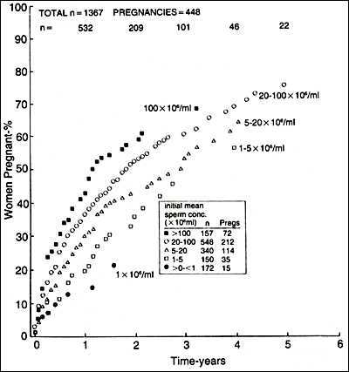
Figure 9. Pregnancy rate curves grouped according to average pretreatment sperm concentration. The number (n)of patients followed each year is shown. The numbers of men and pregnancies in each sperm concentration group are shown in the inset table (From Baker, H.W.G., Male Infertility. Chapter 141 In Endocrinology, 6th edition, Jameson J. L. and DeGroot L.J. (Chief Eds.), Saunders Elsevier Philadelphia PA. pp 2556-2579, 2010)

Psychological Aspects
Infertility causes major trauma to the ego of most patients, but few suffer serious psychological disorders. Many undergo a grief reaction with initial denial of the problem followed by a tendency to blame others and a period of depression before final acceptance of the infertility. The reaction may take years to resolve, and it can threaten the stability of the partnership, interfere with investigation and management of infertility, and lead to futile involvement in expensive “cures” offered by the unscrupulous. Participation in unsuccessful treatments during this phase is often particularly difficult emotionally for the patients. Stresses of ordinary existence are unlikely to influence semen quality.[171] An empathetic approach and involvement of independent counselors or self-help infertility groups may assist some couples. In most, the unpleasantness of the psychological reaction subsides with time.
Timing of Coitus
A practical approach is to advise intercourse each day when ovulation might occur. Ovulation can be predicted to occur approximately 14±2 days before a period is due. Knowing the range of menstrual cycle length allows calculation of the days when ovulation is most likely to occur. Symptoms of ovulation including mittelschmerz and mid-cycle mucus changes also help identify the fertile time.[168] Temperature charts may be used to indicate the end of the fertile time as the basal body temperature rises after ovulation. Ovulation timing by measurement of estrogen and progesterone metabolites in urine, urine or serum LH levels, or ovarian ultrasonography may also be used.
General Health Aspects
Although correction of adverse lifestyle factors in the most men seen for infertility is unlikely to produce normal fertility, healthy living has positive long-term benefits. The following are advised: weight reduction for the obese, reduced alcohol intake for the moderate to heavy drinker, avoidance of social drugs including tobacco, avoidance of heat from frequent sauna and spa baths, and management of stress in the workplace, in their relationship, and that engendered by the infertility.
Empirical Treatments: Evidence-Based Versus Unconfirmed Treatments
Treatments of some causes of male infertility are available as discussed previously, but for the majority of patients with abnormal semen analyses, there are no methods of proved effectiveness.[20, 135] A medical or surgical treatment may become established because it is logical and obviously effective, for example, gonadotropin treatment for Kallmann syndrome or vasoepididymostomies for postinflammatory obstructions of the tails of the epididymides. However, in other situations in which semen quality is reduced and there is subfertility rather than absolute sterility, it is necessary to demonstrate that the treatment increases semen analysis results and pregnancy rates by a clinically meaningful amount. This evidence-based medicine approach generally requires controlled clinical trials of promising methods. These trials are usually designed to detect a certain magnitude of difference in the primary responses and thus a positive result supports the use of the method. However, if the trial is negative, it merely does not confirm the magnitude of benefit tested; it does not prove the method is of no value. In time, the results of several trials can be combined by meta-analysis to get better estimates of the overall effects of the method.

In the past, many treatments were used in an uncontrolled fashion for defects of sperm production.[20, 135] Androgens have been given to suppress spermatogenesis in the hope that there would be “rebound” improvement after the treatment is stopped. Low-dose testosterone or weak androgens, such as mesterolone, have been given in the hope of improving epididymal maturation of sperm. Human chorionic gonadotropin has been given for similar reasons. Antiestrogens have been used to increase gonadotropin secretion or gonadotropins (FSH and human chorionic gonadotropin) given to “stimulate” spermatogenesis. Antibiotics and anti-inflammatory drugs have been given for subtle infections or inflammations in the accessory sex organs. Antioxidants, amino acids, vitamins, herbs, and minerals such as zinc, cold baths, and testicular coolers have been used. There are difficulties with the interpretation of the results of these treatments.[20] Marked improvements in semen quality can occur spontaneously (Fig. 10). Semen analysis results also display the phenomenon of regression to the mean. That is, on average, repeated semen analyses improve in men with initially abnormal results.[165] Pregnancy rate data were not analyzed effectively in many early studies. Floating numerator pregnancy rates, in which a percentage of patients pregnant is given without regard for time of exposure, have caused confusion in the infertility literature. Statistical methods for life table analysis and regression analysis with censored data are especially useful for assessing the impact of groups of variables on pregnancy rates, for analysis of prognostic factors, and for testing results of therapeutic trials.[20]
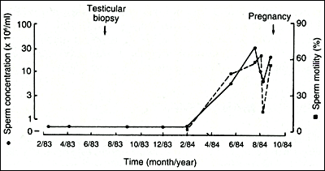
Figure 10. Sperm concentration and motility in a man with severe oligospermia and severe hypospermatogenesis included in a therapeutic trial of clomiphene. Semen quality improved and his wife conceived. He was given the placebo! (Baker HWG: Requirements for controlled therapeutic trials in male infertility. Clin Reprod Fertil 4:13-25, 1986.)

The empirical treatments either have not been submitted to adequately controlled clinical trials, or when they have, the trials have not shown consistently positive results. Meta-analyses have also produced conflicting results, probably because of the variable quality of the trials included in the analyses. Until there is sound evidence of the value of a drug or procedure from controlled therapeutic trials, patients should be advised that none of the empirical methods meet the requirements of evidence-based medicine.

AIH is widely practiced with dubious evidence of efficacy in patients who do not have coital difficulties. Ovulation induction with intrauterine artificial insemination probably does increase the pregnancy rates by increasing the number of oocytes exposed to the sperm.[172, 173]Results are lower with timed intercourse and multiple ovulation induction. Generally, the results are poor when the semen analysis is abnormal. Although this may be acceptable in countries where ART is expensive, the risk of multiple pregnancy is substantial. IVF or ICSI would be preferable because the number of embryos placed in the uterus can be controlled and high multiple pregnancies avoided.[172]

In Vitro Fertilization/Intracytoplasmic Sperm Injection for Male Infertility

ICSI has revolutionized the management of male infertility. It involves the injection of a single sperm into the ooplasm (Fig. 11).[174, 175] ICSI can be used with almost any live sperm with an expectation of results similar to those obtained with standard IVF using normal sperm. ICSI may not be needed with mild semen disorders. Provided that more than approximately 2 million motile sperm can be harvested from an ejaculate, IVF can be attempted with an expectation of success close to that of IVF for other indications. The outcome depends particularly on sperm morphology and the ability of the sperm to bind to and penetrate the ZP. ICSI should be offered if there is a chance of failure of fertilization with IVF: less than 2 million motile sperm per ejaculate, less than 4% of sperm with normal morphology, less than 5% of sperm with progressive motility, sperm autoimmunity, and defects of sperm-oocyte interaction.
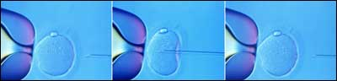
Figure 11. Intracytoplasmic sperm injection.

Preparation of the Patients
The couple needs to be counseled carefully about the procedures, predicted chance of a live birth, and the possible complications. Special arrangements for the collection of semen, or for its preparation, may be required. Trial-run sperm preparations help to identify those patients who have difficulty collecting semen. These patients should practice collections before attending for the IVF procedure. Men with many inflammatory cells in the semen could be treated with antibiotics. Those with low motility or sperm autoimmunity may have better sperm motility with short, 1- to 2-day durations of abstinence. Cryopreserved semen can be used as backup if the fresh semen is particularly poor on the day of ICSI in patients with fluctuating semen abnormalities. This is particularly useful when sperm are present in the semen only intermittently. Those patients who produce an unexpectedly poor sample on the day of IVF should provide a second sample later to supplement the first sample. Electroejaculation or needle biopsy of the testes can be used if the man is unexpectedly unable to collect semen. Patients with genital tract obstruction can have sperm retrieved from the testis or epididymis by needle aspiration.

ICSI also allows patients with severe primary spermatogenic disorders to be treated provided some live sperm or elongated spermatids can be recovered from the semen, testes, or genital tract (Table 172-7). If no sperm can be found in the semen, the likelihood of finding elongated spermatids in the testicular tissue can be estimated by the clinical situation and testicular histology. Sperm can be found by biopsies in approximately 50% of men with Klinefelter syndrome. Results are good if any tubules with complete spermatogenesis can be seen in diagnostic biopsies. However, if there are no elongated spermatids, the success rate with open biopsies is low: approximately 25% with Sertoli-cell-only syndrome and rarely with germ cell arrest at the primary spermatocyte stage.[117, 176] Yq microdeletions in the AZFa and b regions are also associated with a complete absence of spermatogenesis. Other factors such as hormone levels and testicular size do not seem to be predictive. The use of donor sperm should be discussed during preparation of the couple if the outlook is poor.

Testicular biopsy techniques should maximize the chance of finding sperm while minimizing damage. Microsurgery with examination of exposed testicular tissue under the operating microscope may allow selection of the larger diameter tubules, which are more likely to contain more advanced spermatogenesis.[176, 177] Alternatively, multiple sampling through small holes in the tunica may be used.[178] Large biopsies, particularly at multiple sites, have higher complication rates and will further impair testicular function (future androgen deficiency). Generally, repeat open biopsies for sperm collection should be performed only after the patient and testes have recovered from the previous surgery, and this may take 4-6 months.
Approaches
The standard approach is to stimulate multiple ovarian follicular development with FSH and collect the oocytes by ultrasound-guided transvaginal needle puncture of the ovaries after administration of human chorionic gonadotropin to mature the oocytes. ICSI or IVF is performed, and the resulting embryos are transferred into the uterine cavity, usually at the four- (day 2) to eight-cell (day 3) or blastocyst (day 5 or 6) stage with cryopreservation of remaining embryos. Although cryopreservation reduces the implantation potential frozen embryos produce good pregnancy outcomes.[179]

Biopsy of blastomeres for detection of chromosomal and genetic abnormalities is used to avoid transmission of serious hereditary diseases or to select embryos with higher cnances of implantation.[180]
Sperm Preparation
Various procedures have been developed for sperm preparation for IVF. Most popular is centrifugation on gradients of colloidal silica because this can be performed with high reproducibility.[181] Cryopreserved samples require especially gentle handling, particularly with dilution of the semen cryoprotectant medium with culture medium. Motility, even just an occasional slight twitch of the tail, is required in selecting sperm for ICSI. The morphology of the sperm cannot be assessed in detail at the magnification used, but obviously grossly abnormal sperm are excluded. If no motile sperm can be found, motility stimulation with pentoxifylline or hypoosmotic swelling can be used to show that the sperm are alive.[181]
Results
With IVF and ICSI, 60% of oocytes fertilize and cleave normally over the first 48 hours. For women younger than 35 years of age, the clinical pregnancy rate (fetal heart positive ultrasound at 6 weeks gestation) for transfer of one fresh 2-day old embryo is approximately 30% and for transfer of two 2 day old embryos 40%. Pregnancy rates are approximately 25% lower with cryopreserved embryos. The cumulative live birth rates with transfer of fresh and cryopreserved embryos from the first oocyte collection are approximately 50% and 80% by the third oocyte collection in women under 35 years of age. Approximately 25% of the births resulting from transfer of two 2-day old embryos are twins. Multiple pregnancy is more frequent if three or more cleave stage embryos or two or more blastocysts are transferred. Many clinics are transferring single embryos (elective single embryo transfer) in patients with good prognosis to minimize the multiple pregnancies. A number of other factors influence the results of ART, including embryo quality and particularly female age. Implantation and pregnancy rates decrease and pregnancy losses increase after age 35, mostly due to increasing abnormalities in the oocytes. For women aged 36-39 years the live birth rate is about 70% of that for women under 36 and for those 40 years and over using their own oocytes, about 30% that for women under 36.
Evaluation of Failed Fertilization
When most or all oocytes fail to fertilize in IVF, the cause is usually defective sperm. Oocytes may not fertilize because of immaturity or abnormality, but this is an unusual cause of total failure of fertilization of all the oocytes retrieved from a woman.[74] Unexpected failures of fertilization should be evaluated by examination of the number of sperm bound on the ZP and penetrating the ZP. Low numbers usually indicate sperm defects.[74] Low fertilization rates may also result from undiagnosed sperm autoimmunity, infected semen, or technical problems in the IVF laboratory. Careful evaluation of the semen quality and screening patients with idiopathic infertility for defects of sperm-oocyte interaction before IVF should allow most couples likely to have low fertilization with standard IVF to be directed to ICSI.[74, 182] ICSI of unfertilized oocytes with the man’s sperm 12 to 24 hours after standard IVF insemination may result in fertilization and pregnancy, but, overall, the results are poor and many clinics do not perform this “ICSI rescue” procedure. Re-insemination of failed fertilization oocytes with donor sperm is also possible for diagnostic or therapeutic purposes. This procedure is not permitted in some countries.

Individual oocytes may not fertilize with ICSI. In these, the sperm head is often only partially decondensed. Failure of fertilization of all oocytes with ICSI is rare. Globospermic, immotile and rarely sperm from patients with severe oligospermia may produce low or zero fertilization rates with ICSI. In these cases there may be a deficiency of an oocyte-activating factor from the sperm. Modified ICSI techniques (assisted activation) may be successful in artificially activating the oocytes in some of these cases.[91]
Complications of In Vitro Fertilization/Intracytoplasmic Sperm Injection
Potential adverse effects of ART include well-understood conditions in the woman and a variety of possible issues for the offspring. In general, the outcome and complications of ART are the same for standard IVF and ICSI.[183, 184] The implantation rate, pregnancy wastage, pregnancy complications, perinatal mortality, and risk of congenital abnormalities are no greater for ICSI than with IVF. Recent results for ART for male infertility are compared with those for infertility of other causes in Table 7.[185] The pregnancy, miscarriage and other outcomes are if anything better not worse for male infertility.

Table 7
Comparison of results of fresh and cryopreserved embryo transfers for male infertility versus other causes of infertility in Australia and New Zealand 2005.[185]
Type of infertility | Male only | Other
Fresh embryo transfers  Clinical pregnancy (fetal heart(s))  Live birth | 7880  26.1%  21.0% | 20115  23.2%  18.4%
Cryopreserved embryo transfers  Clinical pregnancy (fetal heart(s))  Live birth | 4708  20.2%  15.8% | 12051  19.5%  14.6%
Clinical pregnancies (fetal heart(s))  Spontaneous abortion  Induced abortion  Ectopic pregnancy  Stillbirth  Preterm (<37 weeks gestation) | 3008  17.6%  0.5%  1.0%  0.8%  16.0% | 7013  19.4%  0.7%  1.7%  0.7%  18.3%

In 2005 48% of embryo transfers were with single embryos and the multiple pregnancy rates were for fresh embryo transfers following IVF: 16.2%, ICSI 14.7% and thawed cryopreserved embryo transfers (FET) 10.9%. The perinatal mortality (stillbirth and neonatal deaths within 28 days of life) was for IVF 18.2, ICSI 15.3 and FET 11.8 per 1000 births. The perinatal mortality for ART singletons was 9.6 and for the general population in 2004: 10.2.
Risks for the Woman
The ovarian hyperstimulation syndrome is a major risk with gonadotropin stimulation of multiple follicular development.[186] Careful monitoring of the patients is necessary. If many follicles develop, embryo freezing rather than transfer avoids pregnancy and allows the ovaries to recover, reducing the risk of severe complications such as thromboembolism, renal failure, and death. Surgical complications including bleeding and infection from the oocyte collection procedure are rare. There is also a small risk of complications from anesthesia and sedation. Maternal complications of pregnancy increase in frequency with multiple pregnancy. Cesarean section is more frequent for singleton ART births than in the general community. There are also concerns about the ovarian stimulation drugs predisposing to breast or gynecologic cancers.[187]
Risks for the Child
Multiple Pregnancy
The risks of multiple pregnancy for the child, prematurity, low birth weight, increased perinatal mortality and morbidity, less parental attention during childhood, are well known and can be controlled by reducing the numbers of embryos transferred together.[183, 186, 188, 189]
Transmission of Genetic and Chromosomal Disorders
The known genetic risks were covered previously (see Table 4). For conditions such as cystic fibrosis and myotonic dystrophy, pre-implantation genetic diagnosis can be used so that only unaffected embryos are transferred. Balanced chromosomal translocations may become unbalanced in embryos and result in miscarriage or rarely in the birth of an abnormal child. Pre-implantation genetic diagnosis may also be used to detect unbalanced chromosomal constitution in the pre-implantation embryo.[180]
Defects Possibly Associated with Abnormal Spermatogenesis
There is a correlation between the production of abnormal sperm with poor morphology and motility and abnormal sperm DNA measured by a variety of techniques including acridine orange fluorescence, sperm chromatin structure assay, chromomycin staining, and comet assays. [22] Abnormal sperm produce reactive oxygen species that could damage sperm DNA and result in defects of implantation or pregnancy loss. [22] However, the results of ART do not reveal such problems (see Table 7).[24] A number of mechanisms reduce the likelihood such abnormal sperm would be involved in natural or assisted fertilization such as sperm aggregation caused by heavy coating with clusterin, poor motility, and limited ability to bind to the zona pellucida.[190, 191]

An increase in de novo sex chromosomal aneuploidy and structural autosomal defects reported with ICSI related to increased rates of chromosomal nondisjunction as a general association with abnormal spermatogenesis has not been confirmed by all studies.[109, 192-194]
Embryo Defects Possibly Caused by Laboratory Conditions
Laboratory conditions or procedures on gametes could affect embryo development and health of the child. In domestic animal IVF, there is a syndrome of large offspring that results from stress-induced changes in gene expression that may involve changes in DNA methylation and gene imprinting in embryos cultured to blastocysts.[195] Increased frequencies of rare conditions caused by disorders of imprinting such as Beckwith-Weidemann syndrome and Angelman’s syndrome have been reported in children born from ART procedures.[196] Increased frequencies of tumors in children born after ART have also been claimed, for example, retinoblastoma, but other studies do not support a general increase in childhood cancer rates.[197]
Surveillance Studies
In most studies the fertilization, implantation, and pregnancy failure rates and congenital malformation rates are no greater with ICSI than with standard IVF.[183, 184] However, overall results are different from those in the general population: preterm birth (6%), low birth weight (5%), major congenital malformations (2%), and perinatal mortality (1%)(see Table 7). The differences are partly explained by the high multiple pregnancy rate with IVF and ICSI, and perhaps female age and infertility factors. Closer surveillance and more accurate reporting may also contribute. The lower birth weight also affects singletons and there is a difference between the results of fresh and cryopreserved embryo transfers the low birth weight being more frequent in babies born after fresh embryo transfers.[179]

Studies of children born as a result of ART have not revealed any consistently associated congenital malformations, but there is data suggesting generally increased congenital malformation rates.[198-200] However, these studies may be biased. For example, if IVF and ICSI babies are examined more thoroughly and reporting to health registers is more complete, the malformation rates may appear higher than for naturally conceived children who are less carefully examined and reported. A higher uptake of prenatal screening for Down syndrome and other triploids in ART patients may also influence the reported rates of birth defects. Even with perfect reporting, differences in malformation rates could be caused by other factors, such as age, parity or health of the mothers, which have not been adequately allowed for in the statistical analysis.
USE OF DONOR SPERM
Donor insemination is a common method of managing male sterility.[201-204] Donor sperm may be involved in approximately 1 in 200 births in countries where it is permitted. The main indications for donor insemination are untreatable sterility in the man or when treatments and ICSI for severe or chronic subfertility have failed. The couple may choose donor insemination as the primary method of managing their infertility. Donor insemination is also used to avoid transmission of a severe genetic or infectious disease in the man. Women without a male partner may use donor insemination to have children. Donor sperm may also be used in IVF when there is a combination of female infertility and male sterility. Because of the higher pregnancy rates, IVF with donor sperm may be used if donor insemination fails.[203] Donor sperm may also be used in IVF procedures as a backup, for example, when there is a high risk of failure with of sperm extraction with a severe spermatogenic defect.
Cryopreservation of Semen
Donor insemination can be performed in the setting of a specialist infertility clinic with all donor and patient management available. Alternatively, the sperm bank may only supply semen for the patient and be separate from the clinics or physicians performing the artificial insemination. Because of the risk of transmission of infectious diseases, particularly HIV, and also for convenience, donor insemination services now use only cryopreserved semen.[201, 203] Semen cryopreservation with glycerol–egg yolk cryoprotectant and either vapor freezing or controlled-rate freezing in plastic straws or vials produces pregnancy rates equal to those with fresh semen. Importantly, cryopreservation allows the semen to be quarantined for 6 months for donors to be recalled and retested for infectious diseases before it is used.
Selection of Donors
Prospective donors have their medical and family histories evaluated and a physical examination to exclude the possibility of transmitting serious genetic diseases such as hemoglobinopathies or sexually transmissible infections. Donors sign a lifestyle declaration to indicate that they are not involved in any practices that might expose them to serious infections, such as HIV. There usually is an upper age limit of 40 to 45 years because of the increasing frequency of genetic abnormalities in sperm with age. Semen quality is selected to be in the upper part of the normal range, particularly for concentration and motility.[201, 202] The semen is cultured for bacteria and blood is tested for hepatitis and HIV antibodies. Genetic screening for hemoglobinopathies and cystic fibrosis or other conditions may be included depending on their prevalence in the community. The freezing of semen does not appear to cause any increase in the frequency of congenital abnormalities.[201, 203, 205]

It is usual to match the physical characteristics of the recipient’s husband and the donor including race, complexion, build, height, and hair and eye color. In addition, blood groups may be matched. In some programs, the recipient couple may be able to choose the donor on other information such as occupation and education. Known donors may also be used; these may be friends or relatives of the infertile couple. In this situation, special counseling of the donors and recipients is necessary. Also, there should be a full workup of the known donor as for an anonymous donor, including cryopreservation and quarantining of the semen.

Donor factors relevant to the success of donor insemination are mainly to do with the quality of the semen. Post-thaw motility has the strongest predictive value for high fertilization rates, but sperm morphology, motility, and concentration are also significant.[201, 203] Despite selection of high-quality semen, there remains considerable variability in the pregnancy rates between donors. A policy to discard semen from a donor who produces no pregnancy after a certain number (e.g., 20–40) of inseminations is necessary.[202]
Counseling
The special nature of the use of donor sperm is discussed in detail with the couple so that they are fully aware of the implications for the child and their family. Donor insemination is forbidden in some religions. There may be local legislation or regulations to control the use of donated gametes. In some countries, special laws have been enacted that may either allow or prevent the child from obtaining identifying information about the donor. The legal status of the child may also be specified in various ways. The couple needs to decide how and when to disclose the child’s donor sperm origin. What and how much they should tell their friends and relatives about their infertility treatment should also be discussed, as should their reaction to acquaintances questioning the paternity of the child. The possibility that in the future half-siblings may unwittingly find each other and attempt to have children is of concern to some prospective parents and donors. This needs to be discussed carefully and the risks explained in view of the number of pregnancies permitted per donor by the clinic. Studies of donor families in which there has been expert pretreatment counseling indicate no physical or emotional problems with the children, and greater marital stability than average.[205]
Procedures and Results
The prospective recipients are screened for HIV, hepatitis B and C, rubella immunity, blood group, and genetic conditions if necessary. Tests of tubal patency are performed if the history suggests pelvic pathology. The inseminations are timed to coincide with natural ovulation. Careful monitoring of ovulation and timing of intrauterine insemination of prepared motile sperm suspensions (as for IVF) appear to increase the pregnancy rate. Pregnancy rates are approximately 10% to 25% per month for the first 4 to 6 months and then 5% to 10% thereafter, so that approximately 50% of women are pregnant by 4 to 6 months.[201, 203, 204] Female age affects the pregnancy rates.[201, 204] Women with subfertile male partners have on average lower pregnancy rates than those with sterile male partners, indicating the presence of female factors contributing to the infertility when the male partner is subfertile.[201, 204] Cumulative pregnancy rates for women who have had more than one pregnancy by donor insemination indicate higher conception rates over the first few months for the second pregnancy, approximately 33% pregnant in the first cycle and 55% by the second cycle.[201]

Multiple ovulation induction and intrauterine insemination may increase the pregnancy rates but at the risk of multiple pregnancy.[201, 204] IVF may be used if no pregnancy has occurred after a reasonable number of inseminations (e.g., 4–6).[203] Live birth pregnancy rates with IVF in such patients are high, and women in good health can be advised that they have an 80% chance of having a child within 2 years.
PREVENTION OF INFERTILITY
Prevention is difficult because of the lack of understanding of the causes of most types of male infertility. Mumps orchitis was an uncommon cause of infertility, and childhood immunization for this disease should make it very rare. It is important to recognize that subfertility often is a couple problem, with both partners contributing. Therefore, general factors that would change a society’s attitude to child bearing could have an important impact on the frequency of infertility, for example, a trend toward having children at earlier ages. On the other hand, toxins and environmental factors known to cause defects of sperm production, such as heat, dibromochlorobenzine, lead, benzene, ionizing radiation, and microwaves, are probably well controlled by environmental health measures.
Preventable Diseases and Conditions
Sexually Transmissible Infections
Post-gonococcal epididymal obstructions appear to be the most important cause of infertility from sexually transmitted diseases. In countries where gonorrhea is treated promptly, post-gonococcal epididymal obstruction is rare. On the other hand, it remains a common preventable cause of infertility in other countries.
Undescended Testes
Although undescended testes have been sought and treated aggressively over the past 50 years, previously undescended testes remain a common association of male infertility, affecting approximately 7% of the men seen. It is therefore uncertain whether early surgery for undescended testes has any impact on subsequent fertility. It is possible that the failure of normal descent is a feature of testicular dystrophy and that the sperm production will be poor whether or not the testes are placed in the scrotum.

A randomized controlled trial of orchiopexy for unilateral palpable maldescended testis at 9 months versus 3 years of age showed that surgery at 9 months was followed by significant growth of the testis up to age 4 years but there was no change in testis size in those treated at age 3 [50]. This has led to clinical guidelines for treatment of maldescended testes that recommend orchiopexy for congenital forms between 6 and 12 months of age and as soon as possible for those discovered later and for acquired maldescent. Hopefully this will reduce the frequency of subsequent testicular tumours and spermatogenic defects.
Varicocele
The effectiveness of varicocelectomy for sperm defects is controversial. Varicoceles are common and usually appear about the time of puberty. Although some groups believe that varicoceles should be sought actively and treated in adolescence to prevent infertility, this approach could pose a major burden on the health resources because at least 15% of men have varicoceles. Long-term prospective trials are needed.
Vasectomy
Vasectomy reversal and treatment for continuing infertility after attempted vasectomy reversal are now common. Better counseling about the limited effectiveness of vasectomy reversal is needed and cryopreservation of semen before vasectomy in men who are uncertain about their need for future fertility should be promoted.

Androgen deficiency
In patients with symptomatic androgen deficiency, testosterone therapy should be deferred until fertility issues have been addressed. Alternatively, Human chorionic gonadotropin (hCG) preparation can be given in order to stimulate testosterone production without inhibition of spermatogenesis.
If fertility is not immediately sought, sperm cryopreservation allows testosterone replacement to be commenced.
Options for fertility preservation in males
Advances in the treatment of cancer in young patients have led to great improvements in life expectancy which approaches 80% 5-year survival rate. As a result, fertility preservation and desire for paternity have become a significant issue in this group. A major concern is the negative impact of chemo and radiotherapy on fertility. Up to two thirds of patients are azoospermic following chemotherapy. Recovery of spermatogenesis is strongly dependent upon the chemotherapy and radiation regimen and the patient’s baseline reproductive function. Alkylating agents seem to have the most profound reproductive effects. Thus men about to have treatment for malignant conditions may have sperm cryopreserved before commencing chemotherapy or radiotherapy.[206] Although pretreatment semen quality may be too poor for AIH, ICSI now has improved the outlook for successful pregnancies. Semen collected during chemotherapy or radiotherapy must not be used because of the likelihood of induced mutations.[207]
Infertile men with conditions such as orchitis or severe primary spermatogenic disorders that might involve progressively declining semen quality such as Klinefelter syndrome, when sperm can be recovered, should also store any live sperm that can be obtained as insurance for the future. A similar approach could be extended to adolescents with risk factors for infertility such as undescended testes in childhood, testicular torsion, and possibly a family history of infertility or a father with a Yq microdeletion. Semen may also be stored after treatment of gonadotropin deficiency or surgery for genital tract obstruction in case of re-stenosis. Storage of sperm before premature death or after a sudden unexpected death is also possible. Although the use of gametes from a dead person is surrounded by complex ethical and legal issues it is permissible in some countries. Semen cryopreservation can also be offered to adolescents. Sperm may be obtainable from the semen or testis after mid puberty. Although only a small proportion of men who store semen may use the frozen sperm, the service provides insurance for future fertility.
Methods of Collection
Sperm for fertility preservation may be collected in a variety of ways. Ejaculated sperm cryopreservation is the most common technique used as enough sperm is usually found for freezing in majority of men. Unfortunately, some men with testicular and other malignancies may present initially with oligospermia or even azoospermia. This may be related to a basic infertility condition which puts them under higher risk to develop testicular cancer or the stress effect of the disease on spermatogenesis. Some patients will not be able to produce a sample. Some patients are unable to ejaculate for social, religious or medical reasons or may be unfamiliar with masturbation for example peri-pubertal boys. For them, sperm can be retrieved by penile vibratory stimulation, electroejaculation or surgically from the epididymis or the testis as discussed above.
Fertility Preservation in Prepubertal Boys
Preserving fertility in postpubertal boys facing chemotherapy can be achieve similar success rates to those in adults. However fertility preservation in prepubertal boys presents a great challenge as sperm banking is not possible. Alternative strategies have been developed but all are currently experimental. These strategies are based on immature spermatogenic cell cryopreservation as cell suspensions or whole testicular tissue for future fertility restoration using autografting, xenografting or in-vitro spermatogenesis. [208] More research is needed to establish the best approach to generate spermatozoa from immature stem cells via in-vivo or in-vitro maturation. In the meantime, prepubertal tissue preservation should be discussed with the boys and their parents and samples should be banked only after careful counseling emphasizing the experimental nature of this approach.

Post Chemotherapy Sperm Recovery
Various barriers to sperm banking such as prepubertal age, under-referral or inadequate understanding of the sterilizing effect of chemotherapy and defective spermatogenesis before the treatment may have prevented sperm banking.[209, 210] In these patients an approach similar to that used for men with severe primary spermatogenic disorders can be used as recovery of spermatogenesis after gonadotoxic treatments is highly variable. Men with persistent azoospermia following chemotherapy or radiotherapy can be offered microsurgical testicular sperm extraction (TESE) and ICSI as there is some chance of success. Schlegel et al. reported 84 microdissection TESE procedures performed in 73 patients with 43% having sperm retrieved and these produced an average 57% fertilization rate with ICSI and 42% had live births.[211]
DNA FRAGMENTATION
The study of sperm DNA fragmentation has become topical in recent years. It has been proposed that DNA damage may contribute to infertility in a way that is not revealed by simple morphological evaluation of spermatozoa. Sperm showing a high proportion of fragmented DNA has been blamed for a lower fertilization rate [212], poorer embryo development and reduced implantation rates. [213-215]. It is now assumed that a significant proportion of infertile men have clinically important levels of DNA damage in their spermatozoa. [216]
Basically, once a sperm nucleus has been introduced into the oocyte, a rapid de condensation should occur to allow the DNA formation of the paternal pronucleus. Abnormalities in the structural DNA organization can cause delays and errors in the paternal DNA delivery. Animal studies demonstrated that sperm DNA damage can cause embryo development compromise.[217, 218].

Apoptosis plays a key role and is considered to be the main pathway leading to DNA breakage in sperm.[219] The known main external inducers of sperm DNA fragmentation are chemotherapy [220], advanced age [216], environmental factors such as cigarette smoking [221], genital tract inflammation and varicoceles [222-224] and the presence of leukocytes in the semen [225]

Three main mechanisms have been proposed as contributors to the generation of DNA fragmentation; 1) DNA nicks occurring to promote the remodeling of sperm chromatin are not completely repaired due to an impairment of the sperm maturation process, [226]; 2) DNA cleavage produced by a process of apoptosis first triggered and later interrupted [227, 228] and; 3) reactive oxygen species (ROS) , acting both in testis and in posttesticular sites [229]

Based on the above understanding, strategies to identify fragmented sperm gained popularity.[230] Novel sperm selection techniques like annexin V–magnetic activated cell sorting (annexin V–MACS), zeta potential selection, electrophoretic systems for the rapid isolation of sperm exhibiting high levels of DNA integrity and hyaluronic acid binding techniques, have been recently described.[231] Currently, the evidence is insufficient to recommend one specific method of sperm selection in the case of high sperm DNA fragmentation.

REFERENCES
1. Leridon, H., Human Fertility: The Basic Components. 1977, Chicago: University of Chicago Press.
2. Greenhall, E. and M. Vessey, The prevalence of subfertility: a review of the current confusion and a report of two new studies. Fertil Steril, 1990. 54(6): p. 978-83.
3. Joffe, M., Time trends in biological fertility in Britain. Lancet, 2000. 355(9219): p. 1961-5.
4. Gnoth, C., et al., Definition and prevalence of subfertility and infertility. Hum Reprod, 2005. 20(5): p. 1144-7.
5. Holden, C.A., et al., Sexual activity, fertility and contraceptive use in middle-aged and older men: Men in Australia, Telephone Survey (MATeS). Hum Reprod, 2005. 20(12): p. 3429-34.
6. Comhaire, F.H., et al., Towards more objectivity in diagnosis and management of male infertility. International Journal of Andrology, 1987. Suppl 7: p. 1-53.
7. Carlsen, E., et al., Evidence for decreasing quality of semen during past 50 years. BMJ, 1992. 305(6854): p. 609-13.
8. Irvine, D.S., Falling sperm quality. BMJ, 1994. 309(6952): p. 476.
9. Auger, J., et al., Decline in semen quality among fertile men in Paris during the past 20 years. N Engl J Med, 1995. 332(5): p. 281-5.
10. Irvine, S., et al., Evidence of deteriorating semen quality in the United Kingdom: birth cohort study in 577 men in Scotland over 11 years. BMJ, 1996. 312(7029): p. 467-71.
11. Povey, A.C. and S.J. Stocks, Epidemiology and trends in male subfertility. Hum Fertil (Camb), 2010. 13(4): p. 182-8.
12. Itoh, N., et al., Have sperm counts deteriorated over the past 20 years in healthy, young Japanese men? Results from the Sapporo area. J Androl, 2001. 22(1): p. 40-4.
13. Fisch, H., Declining worldwide sperm counts: disproving a myth. Urol Clin North Am, 2008. 35(2): p. 137-46, vii.
14. Baker, H.W.G., et al., Relative incidence of etiologic disorders in male infertility., in Male Reproductive Dysfunction: Diagnosis and Management of Hypogonadism, Infertility and Impotence., R.J. Santen, Swerdloff, R. S., Editor. 1986, Marcel Dekker Inc.: New York. p. 341-372.
15. Baker, H.W.G., et al., Testicular vein ligation and fertility in men with varicoceles. British Medical Journal (Clin Res Ed), 1985. 291(6510): p. 1678-80.
16. Guzick, D.S., et al., Sperm morphology, motility, and concentration in fertile and infertile men. N Engl J Med, 2001. 345(19): p. 1388-93.
17. Garrett, C., et al., Automated semen analysis: 'zona pellucida preferred' sperm morphometry and straight-line velocity are related to pregnancy rate in subfertile couples. Hum Reprod, 2003. 18(8): p. 1643-9.
18. Krausz, C. and S. Degl'Innocenti, Y chromosome and male infertility: update, 2006. Front Biosci, 2006. 11: p. 3049-61.
19. Vogt, P.H., et al., The AZF proteins. Int J Androl, 2008. 31(4): p. 383-94.
20. Baker, H.W.G., Medical treatment for idiopathic male infertility: is it curative or palliative? Baillieres Clin Obstet Gynaecol, 1997. 11(4): p. 673-89.
21. Olesen, I.A., et al., Environment, testicular dysgenesis and carcinoma in situ testis. Best Pract Res Clin Endocrinol Metab, 2007. 21(3): p. 462-78.
22. Aitken, R.J. and G.N. De Iuliis, Origins and consequences of DNA damage in male germ cells. Reprod Biomed Online, 2007. 14(6): p. 727-33.
23. Phillips, K.P. and N. Tanphaichitr, Human exposure to endocrine disrupters and semen quality. J Toxicol Environ Health B Crit Rev, 2008. 11(3-4): p. 188-220.
24. Collins, J.A., K.T. Barnhart, and P.N. Schlegel, Do sperm DNA integrity tests predict pregnancy with in vitro fertilization? Fertil Steril, 2008. 89(4): p. 823-31.
25. Lilford, R., A. Jones, and D. Bishop, Case-control study of whether subfertility in men is familial. BMJ, 1994. 309: p. 570-573.
26. Van der Avoort, I.A., et al., Underestimation of subfertility among relatives when using a family history: taboo bias. J Androl, 2003. 24(2): p. 285-8.
27. Baker, H.W.G., Clinical approach to molecular genetic diagnosis in andrology., in Andrology in the 21st century, B. Robaire, Chemes, H., Morales, CR., Editor. 2001, Medimond: Englewood NJ. p. 373-382.
28. O'Bryan, M.K. and D. de Kretser, Mouse models for genes involved in impaired spermatogenesis. Int J Androl, 2006. 29(1): p. 76-89; discussion 105-8.
29. Nuti, F. and C. Krausz, Gene polymorphisms/mutations relevant to abnormal spermatogenesis. Reprod Biomed Online, 2008. 16(4): p. 504-13.
30. Fechner, A., S. Fong, and P. McGovern, A review of Kallmann syndrome: genetics, pathophysiology, and clinical management. Obstet Gynecol Surv, 2008. 63(3): p. 189-94.
31. Huhtaniemi, I. and M. Alevizaki, Mutations along the hypothalamic-pituitary-gonadal axis affecting male reproduction. Reprod Biomed Online, 2007. 15(6): p. 622-32.
32. Tuttelmann, F., et al., Gene polymorphisms and male infertility--a meta-analysis and literature review. Reprod Biomed Online, 2007. 15(6): p. 643-58.
33. Rajender, S., L. Singh, and K. Thangaraj, Phenotypic heterogeneity of mutations in androgen receptor gene. Asian J Androl, 2007. 9(2): p. 147-79.
34. Kaplan, E., et al., Reproductive failure in males with cystic fibrosis. N Engl J Med, 1968. 279(2): p. 65-9.
35. Anguiano A, O.R., Amos JA, Dean M, Gerrard B, Stewart C, et al., Congenital bilateral absence of the vas deferens: a primary genital form of cystic fibrosis. JAMA, 1992(267): p. 1794-7.
36. Reijo, R., et al., Diverse spermatogenic defects in humans caused by Y chromosome deletions encompassing a novel RNA-binding protein gene. Nat Genet, 1995. 10(4): p. 383-93.
37. Najmabadi, H., et al., Substantial prevalence of microdeletions of the Y-chromosome in infertile men with idiopathic azoospermia and oligozoospermia detected using a sequence-tagged site-based mapping strategy. J Clin Endocrinol Metab, 1996. 81(4): p. 1347-52.
38. Wischusen, J., H.W.G. Baker, and B. Hudson, Reversible male infertility due to congenital adrenal hyperplasia. Clin Endocrinol (Oxf), 1981. 14(6): p. 571-7.
39. New, M.I., Extensive clinical experience: nonclassical 21-hydroxylase deficiency. J Clin Endocrinol Metab, 2006. 91(11): p. 4205-14.
40. Fang, S. and H.W.G. Baker, Male infertility and adult polycystic kidney disease are associated with necrospermia. Fertil Steril, 2003. 79(3): p. 643-4.
41. St John, J.C., R.P. Jokhi, and C.L. Barratt, The impact of mitochondrial genetics on male infertility. Int J Androl, 2005. 28(2): p. 65-73.
42. Baker, H. and G. Clarke, Management of immunological factors in male infertility, in Male reproductive dysfunction pathophysiology and treatemnt, K. FR, Editor. 2007, Informa: New York. p. 419-430.
43. Baker, H.W.G., Reproductive effects of nontesticular illness. Endocrinology & Metabolism Clinics of North America, 1998. 27(4): p. 831-50.
44. Pedrazzoni, M., et al., Effects of chronic heroin abuse on bone and mineral metabolism. Acta Endocrinol (Copenh), 1993. 129(1): p. 42-5.
45. MacLeod, J. and R. Hotchkiss, The effect of hyperpyrexia on spermatozoa counts in men. Endocrinology, 1941. 28: p. 780.
46. Carlsen, E., et al., History of febrile illness and variation in semen quality. Hum Reprod, 2003. 18(10): p. 2089-92.
47. Mallidis, C., et al., Advanced glycation end products accumulate in the reproductive tract of men with diabetes. Int J Androl, 2008.
48. Handelsman, D.J., et al., Young's syndrome. Obstructive azoospermia and chronic sinopulmonary infections. N Engl J Med, 1984. 310(1): p. 3-9.
49. Hendry, W.F., R.P. A'Hern, and P.J. Cole, Was Young's syndrome caused by exposure to mercury in childhood? British Medical Journal, 1993. 307(6919): p. 1579-82.
50. Chemes, E.H. and Y.V. Rawe, Sperm pathology: a step beyond descriptive morphology. Origin, characterization and fertility potential of abnormal sperm phenotypes in infertile men. Hum Reprod Update, 2003. 9(5): p. 405-28.
51. Lee, P.A., M.F. Bellinger, and M.T. Coughlin, Correlations among hormone levels, sperm parameters and paternity in formerly unilaterally cryptorchid men. Journal of Urology, 1998. 160(3 Pt 2): p. 1155-7; discussion 1178.
52. Hutson, J.M. and M.C. Clarke, Current management of the undescended testicle. Semin Pediatr Surg, 2007. 16(1): p. 64-70.
53. Kollin, C., et al., Surgical treatment of unilaterally undescended testes: testicular growth after randomization to orchiopexy at age 9 months or 3 years. J Urol, 2007. 178(4 Pt 2): p. 1589-93; discussion 1593.
54. Barthold, J.S. and J.F. Redman, Association of epididymal anomalies with patent processus vaginalis in hernia, hydrocele and cryptorchidism. Journal of Urology, 1996. 156(6): p. 2054-6.
55. Masarani, M., H. Wazait, and M. Dinneen, Mumps orchitis. J R Soc Med, 2006. 99(11): p. 573-5.
56. Pasqualotto, F.F., et al., Detection of testicular cancer in men presenting with infertility. Rev Hosp Clin Fac Med Sao Paulo, 2003. 58(2): p. 75-80.
57. Sandeman, T., The effects of X-irradiation on male human fertility. Br J Radiol, 1966. 39: p. 901-907.
58. Fairley, K.F., J.U. Barrie, and W. Johnson, Sterility and testicular atrophy related to cyclophosphamide therapy. Lancet, 1972. 1(7750): p. 568-9.
59. Janssen, N.M. and M.S. Genta, The effects of immunosuppressive and anti-inflammatory medications on fertility, pregnancy, and lactation. Arch Intern Med, 2000. 160(5): p. 610-9.
60. Henderson, J., H.W.G. Baker, and P.J. Hanna, Occupation-related male infertility: a review. Clinical Reproduction and Fertility, 1986. 4(2): p. 87-106.
61. Sheiner, E.K., et al., Effect of occupational exposures on male fertility: literature review. Ind Health, 2003. 41(2): p. 55-62.
62. Ramlau-Hansen, C.H., et al., Is smoking a risk factor for decreased semen quality? A cross-sectional analysis. Hum Reprod, 2007. 22(1): p. 188-96.
63. Dorfman, S.F., Tobacco and fertility: our responsibilities. Fertil Steril, 2008. 89(3): p. 502-4.
64. Baker, H.W.G. and R.J. Pepperell, Lack of effect of bromocriptine on semen quality in men with normal or slightly elevated prolactin levels. Aust N Z J Obstet Gynaecol, 1980. 20(3): p. 158-61.
65. Gebhard, P. and A. Johnson, The Kinsey data: Marginal tabulations of the 1938-1963. 1979, interviews conducted by the Institute for Sex Research: Philadelphia. p. 116-120.
66. Smith, N.M., R.W. Byard, and A.J. Bourne, Testicular regression syndrome--a pathological study of 77 cases. Histopathology, 1991. 19(3): p. 269-72.
67. Prader, A., Testicular size: Assessment and clinical importance. Triangle, 1966. 7: p. 240-243.
68. WHO, World Health Organization laboratory manual for the exmination of human semen and sperm-cervical mucus interaction. 1999, Cambridge: Cambridge University Press.
69. McLachlan, R.I., et al., Semen analysis: its place in modern reproductive medical practice. Pathology, 2003. 35(1): p. 25-33.
70. Jones, D.M., et al., Immobilization of sperm by condoms and their components. Clinical Reproduction and Fertility, 1986. 4(6): p. 367-72.
71. Kovacs, G.T., G.B. Newman, and G.L. Henson, The postcoital test: what is normal? British Medical Journal, 1978. 1(6116): p. 818.
72. Mallidis, C., E.J. Howard, and H.W.G. Baker, Variation of semen quality in normal men. International Journal of Andrology, 1991. 14(2): p. 99-107.
73. Clarke, G. and H. Baker, Immunological evaluation of male infertility, in Male reproductive function pathophysiology and treatment, F. Kandeel, Editor. 2007, Informa: New York. p. 293-300.
74. Liu, D.Y., C. Garrett, and H.W. Baker, Clinical application of sperm-oocyte interaction tests in in vitro fertilization--embryo transfer and intracytoplasmic sperm injection programs. Fertil Steril, 2004. 82(5): p. 1251-63.
75. Burkman, L.J., et al., The hemizona assay (HZA): development of a diagnostic test for the binding of human spermatozoa to the human hemizona pellucida to predict fertilization potential. Fertil Steril, 1988. 49(4): p. 688-97.
76. Cooper, T.G., et al., Azoospermia: virtual reality or possible to quantify? J Androl, 2006. 27(4): p. 483-90.
77. Cooper, T.G., et al., World Health Organization reference values for human semen characteristics. Human Reproduction Update, 2010. 16(3): p. 231-45.
78. Zariwala, M.A., M.R. Knowles, and H. Omran, Genetic defects in ciliary structure and function. Annu Rev Physiol, 2007. 69: p. 423-50.
79. Wilton, L.J., et al., Human male infertility caused by degeneration and death of sperm in the epididymis. Fertility and Sterility, 1988. 49(6): p. 1052-8.
80. Ortega, C., et al., Absolute asthenozoospermia and ICSI: what are the options? Hum Reprod Update, 2011. 17(5): p. 684-92.
81. Kovacic, B., V. Vlaisavljevic, and M. Reljic, Clinical use of pentoxifylline for activation of immotile testicular sperm before ICSI in patients with azoospermia. J Androl, 2006. 27(1): p. 45-52.
82. Mangoli, V., et al., Selection of viable spermatozoa from testicular biopsies: a comparative study between pentoxifylline and hypoosmotic swelling test. Fertil Steril, 2011. 95(2): p. 631-4.
83. Ebner, T., et al., Pharmacological stimulation of sperm motility in frozen and thawed testicular sperm using the dimethylxanthine theophylline. Fertil Steril, 2011. 96(6): p. 1331-6.
84. Ebner, T., et al., Healthy live birth using theophylline in a case of retrograde ejaculation and absolute asthenozoospermia. Fertil Steril, 2014. 101(2): p. 340-3.
85. Nordhoff, V., How to select immotile but viable spermatozoa on the day of intracytoplasmic sperm injection? An embryologist's view. Andrology, 2015. 3(2): p. 156-62.
86. Check, J.H., A. Tubman, and C. Wilson, Intracytoplasmic sperm injection allows normal pregnancy rates for males 40 with low hypoosmotic swelling test scores even when complicated by very low motility percentage. Clin Exp Obstet Gynecol, 2013. 40(1): p. 18-9.
87. Check, J.H., et al., Low hypoosmotic swelling test scores correlate better with lower percent motility than any other abnormal semen parameters. Clin Exp Obstet Gynecol, 2012. 39(2): p. 137-8.
88. Nordhoff, V., et al., Optimizing TESE-ICSI by laser-assisted selection of immotile spermatozoa and polarization microscopy for selection of oocytes. Andrology, 2013. 1(1): p. 67-74.
89. Brown, D.J., S.T. Hill, and H.W. Baker, Male fertility and sexual function after spinal cord injury. Prog Brain Res, 2006. 152: p. 427-39.
90. Correa-Perez, J.R., et al., Clinical management of men producing ejaculates characterized by high levels of dead sperm and altered seminal plasma factors consistent with epididymal necrospermia. Fertil Steril, 2004. 81(4): p. 1148-50.
91. Francavilla, S., et al., Isolated teratozoospermia: a cause of male sterility in the era of ICSI? Front Biosci, 2007. 12: p. 69-88.
92. Liu, D.Y., C. Garrett, and H.W.G. Baker, Low proportions of sperm can bind to the zona pellucida of human oocytes. Hum Reprod, 2003. 18(11): p. 2382-9.
93. Garrett, C. and H.W.G. Baker, New Fully Automated System For the Morphometric Analysis of Human Sperm Heads. Fertility & Sterility, 1995. 63(6): p. 1306-1317.
94. Liu, D.Y. and H.W.G. Baker, Tests of human sperm function and fertilization in vitro. Fertil.Steril., 1992. 58: p. 465-83.
95. Larson, K.L., et al., Sperm chromatin structure assay parameters as predictors of failed pregnancy following assisted reproductive techniques. Human Reproduction, 2000. 15(8): p. 1717-22.
96. Chohan, K.R., et al., Comparison of chromatin assays for DNA fragmentation evaluation in human sperm. J Androl, 2006. 27(1): p. 53-9.
97. Collins, J.A., K.T. Barnhart, and P.N. Schlegel, Do sperm DNA integrity tests predict pregnancy with in vitro fertilization? Fertility and Sterility, 2008. 89(4): p. 823-31.
98. Sikaris, K., et al., Reproductive hormone reference intervals for healthy fertile young men: evaluation of automated platform assays. J Clin Endocrinol Metab, 2005. 90(11): p. 5928-36.
99. Schoor, R.A., et al., The role of testicular biopsy in the modern management of male infertility. J Urol, 2002. 167(1): p. 197-200.
100. Karpas, A.E., et al., Elevated serum follicle-stimulating hormone levels in men with normal seminal fluid analyses. Fertility and Sterility, 1983. 39(3): p. 333-6.
101. de Kretser, D.M., et al., Inhibins, activins and follistatin in reproduction. Hum Reprod Update, 2002. 8(6): p. 529-41.
102. Strachan, M.W., et al., Clinical and radiological features of patients with macroprolactinaemia. Clin Endocrinol (Oxf), 2003. 59(3): p. 339-46.
103. McLachlan, R.I. and M.K. O'Bryan, Clinical Review#: State of the art for genetic testing of infertile men. J Clin Endocrinol Metab, 2010. 95(3): p. 1013-24.
104. Johnson, M.D., Genetic risks of intracytoplasmic sperm injection in the treatment of male infertility: recommendations for genetic counseling and screening. Fertility and Sterility, 1998. 70(3): p. 397-411.
105. Bourne, H., et al., Delivery of Normal Twins Following the Intracytoplasmic Injection of Spermatozoa From a Patient With 47,XXY Klinefelters-Syndrome. Human Reproduction, 1997. 12(11): p. 2447-2450.
106. Tournaye, H., et al., Testicular sperm recovery in nine 47,XXY Klinefelter patients. Human Reproduction, 1996. 11(8): p. 1644-9.
107. Wikstrom, A.M. and L. Dunkel, Testicular function in Klinefelter syndrome. Horm Res, 2008. 69(6): p. 317-26.
108. Staessen, C., et al., PGD in 47,XXY Klinefelter's syndrome patients. Hum Reprod Update, 2003. 9(4): p. 319-30.
109. Martin, R.H., Cytogenetic determinants of male fertility. Hum Reprod Update, 2008. 14(4): p. 379-90.
110. Claustres, M., Molecular pathology of the CFTR locus in male infertility. Reprod Biomed Online, 2005. 10(1): p. 14-41.
111. Silber, S.J. and S. Repping, Transmission of male infertility to future generations: lessons from the Y chromosome. Hum Reprod Update, 2002. 8(3): p. 217-29.
112. Vogt, P.H., Azoospermia factor (AZF) in Yq11: towards a molecular understanding of its function for human male fertility and spermatogenesis. Reprod Biomed Online, 2005. 10(1): p. 81-93.
113. Lazaros, L., et al., Evidence for association of sex hormone-binding globulin and androgen receptor genes with semen quality. Andrologia, 2008. 40(3): p. 186-91.
114. O'Flynn O'Brien, K.L., A.C. Varghese, and A. Agarwal, The genetic causes of male factor infertility: a review. Fertility and Sterility, 2010. 93(1): p. 1-12.
115. Sigman M, Kolettis PN, Lipshultz LR, McClure RD , Nangia AK NC, Prins GS, Sandlow J 2010 The Optimal Evaluation of the Infertile Male: Best Practice Statement Revised (2010). American Urological Association Education and Research, Inc
116. Mallidis, C. and H.W.G. Baker, Fine Needle Tissue Aspiration Biopsy of the Testis. Fertility & Sterility, 1994. 61(2): p. 367-375.
117. Watkins, W., et al., Testicular and Epididymal Sperm in a Microinjection Program - Methods of Retrieval and Results. Fertility & Sterility, 1997. 67(3): p. 527-535.
118. Bettocchi, C., et al., A review of testicular intratubular germ cell neoplasia in infertile men. J Androl, 1994. 15 Suppl: p. 14S-16S.
119. Jacobsen, G.K., O.B. Henriksen, and H. von der Maase, Carcinoma in situ of testicular tissue adjacent to malignant germ-cell tumors: a study of 105 cases. Cancer, 1981. 47(11): p. 2660-2.
120. Huyghe, E., et al., Conservative management of small testicular tumors relative to carcinoma in situ prevalence. J Urol, 2005. 173(3): p. 820-3.
121. Pryor, J.P., et al., Carcinoma in situ in testicular biopsies from men presenting with infertility. Br J Urol, 1983. 55(6): p. 780-4.
122. Giwercman, A., et al., Prevalence of carcinoma in situ of the testis in 207 oligozoospermic men from infertile couples: prospective study of testicular biopsies. BMJ, 1997. 315(7114): p. 989-91.
123. de Kretser, D.M., H.G. Burger, and B. Hudson, The relationship between germinal cells and serum FSH levels in males with infertility. J Clin Endocrinol Metab, 1974. 38(5): p. 787-93.
124. McLachlan, R.I., et al., Histological evaluation of the human testis--approaches to optimizing the clinical value of the assessment: mini review. Hum Reprod, 2007. 22(1): p. 2-16.
125. Ragheb, D. and J.L. Higgins, Jr., Ultrasonography of the scrotum: technique, anatomy, and pathologic entities. J Ultrasound Med, 2002. 21(2): p. 171-85.
126. Pierik, F.H., et al., Is routine scrotal ultrasound advantageous in infertile men? J Urol, 1999. 162(5): p. 1618-20.
127. The Optimal Evaluation of the Infertile Male: AUA Best Practice Statement.Revised,2010.http://www.auanet.org/content/media/optimalevaluation2010.pdf
128. Heshmat, S. and K.C. Lo, Evaluation and treatment of ejaculatory duct obstruction in infertile men. Can J Urol, 2006. 13 Suppl 1: p. 18-21.
129. Hirsch, I.H., et al., Objective assessment of spermatogenesis in men with functional and anatomic obstruction of the genital tract. International Journal of Andrology, 1994. 17(1): p. 29-34.
130. Heidenreich, A., P. Altmann, and U.H. Engelmann, Microsurgical vasovasostomy versus microsurgical epididymal sperm aspiration/testicular extraction of sperm combined with intracytoplasmic sperm injection. A cost-benefit analysis. Eur Urol, 2000. 37(5): p. 609-14.
131. Mak, V., et al., Proportion of cystic fibrosis gene mutations not detected by routine testing in men with obstructive azoospermia. JAMA, 1999. 281(23): p. 2217-24.
132. De Rosa, M., et al., Hyperprolactinemia in men: clinical and biochemical features and response to treatment. Endocrine, 2003. 20(1-2): p. 75-82.
133. Buvat, J., Hyperprolactinemia and sexual function in men: a short review. Int J Impot Res, 2003. 15(5): p. 373-7.
134. Nudell, D.M., M.M. Monoski, and L.I. Lipshultz, Common medications and drugs: how they affect male fertility. Urol Clin North Am, 2002. 29(4): p. 965-73.
135. Liu, P.Y. and D.J. Handelsman, The present and future state of hormonal treatment for male infertility. Hum Reprod Update, 2003. 9(1): p. 9-23.
136. Kamischke, A. and E. Nieschlag, Update on medical treatment of ejaculatory disorders. Int J Androl, 2002. 25(6): p. 333-44.
137. Watkins, W., et al., Testicular Aspiration of Sperm For Intracytoplasmic Sperm Injection - an Alternative Treatment to Electro-Emission - Case Report. Spinal Cord, 1996. 34(11): p. 696-698.
138. Mahadevan, M., J.F. Leeton, and A.O. Trounson, Noninvasive method of semen collection for successful artificial insemination in a case of retrograde ejaculation. Fertil Steril, 1981. 36(2): p. 243-7.
139. Wong, W.Y., et al., Male factor subfertility: possible causes and the impact of nutritional factors. Fertil Steril, 2000. 73(3): p. 435-42.
140. Roth, M.Y., J.K. Amory, and S.T. Page, Treatment of male infertility secondary to morbid obesity. Nat Clin Pract Endocrinol Metab, 2008. 4(7): p. 415-9.
141. Pauli, E.M., et al., Diminished paternity and gonadal function with increasing obesity in men. Fertil Steril, 2008. 90(2): p. 346-51.
142. Jensen, T.K., et al., Body mass index in relation to semen quality and reproductive hormones among 1,558 Danish men. Fertility and Sterility, 2004. 82(4): p. 863-70.
143. Gapstur, S.M., et al., Serum androgen concentrations in young men: a longitudinal analysis of associations with age, obesity, and race. The CARDIA male hormone study. Cancer Epidemiol Biomarkers Prev, 2002. 11(10 Pt 1): p. 1041-7.
144. Hammoud, A.O., et al., Obesity and male reproductive potential. J Androl, 2006. 27(5): p. 619-26.
145. Isidori, A.M., et al., Leptin and androgens in male obesity: evidence for leptin contribution to reduced androgen levels. J Clin Endocrinol Metab, 1999. 84(10): p. 3673-80.
146. Tsai, E.C., et al., Association of bioavailable, free, and total testosterone with insulin resistance: influence of sex hormone-binding globulin and body fat. Diabetes Care, 2004. 27(4): p. 861-8.
147. Kort, H.I., et al., Impact of body mass index values on sperm quantity and quality. J Androl, 2006. 27(3): p. 450-2.
148. Stewart, T.M., et al., Associations between andrological measures, hormones and semen quality in fertile Australian men: inverse relationship between obesity and sperm output. Human Reproduction, 2009. 24(7): p. 1561-8.
149. Hammoud, A.O., et al., Impact of male obesity on infertility: a critical review of the current literature. Fertility and Sterility, 2008. 90(4): p. 897-904.
150. Vine, M.F., et al., Cigarette smoking and sperm density: a meta-analysis. Fertility and Sterility, 1994. 61(1): p. 35-43.
151. Jensen, T.K., et al., Association of in utero exposure to maternal smoking with reduced semen quality and testis size in adulthood: a cross-sectional study of 1,770 young men from the general population in five European countries. Am J Epidemiol, 2004. 159(1): p. 49-58.
152. Jensen, M.S., et al., Lower sperm counts following prenatal tobacco exposure. Human Reproduction, 2005. 20(9): p. 2559-66.
153. McGowan, M.P., et al., The incidence of non-specific infection in the semen in fertile and sub- fertile males. International Journal of Andrology, 1981. 4(6): p. 657-62.
154. Jennings, M.G., M.P. McGowan, and H.W.G. Baker, Is conventional bacteriology useful in the management of male infertility? Clinical Reproduction and Fertility, 1986. 4(6): p. 359-66.
155. Aitken, R.J. and H.W.G. Baker, Seminal Leukocytes - Passengers, Terrorists or Good Samaritans. Human Reproduction, 1995. 10(7): p. 1736-1739.
156. Alvarez, J.G., et al., Increased DNA damage in sperm from leukocytospermic semen samples as determined by the sperm chromatin structure assay. Fertil Steril, 2002. 78(2): p. 319-29.
157. Meares, E. and T. Stamey, Bacteriologic localisation patterns in bacterial prostatis and urethritis. Invest Urol, 1968. 5: p. 492-518.
158. Baker, H.W.G., et al., A controlled trial of the use of erythromycin for men with asthenospermia. International Journal of Andrology, 1984. 7(5): p. 383-8.
159. Comhaire, F.H., P.J. Rowe, and T.M. Farley, The effect of doxycycline in infertile couples with male accessory gland infection: a double blind prospective study. Int J Androl, 1986. 9(2): p. 91-8.
160. Hargreave, T.B., Varicocele: overview and commentary on the results of the World Health Organisation varicocele trial., in Current advances in andrology, G.M.H. Waites, J. Frick, and H.W.G. Baker, Editors. 1997, Monduzzi Editore: Bologna. p. 31-44.
161. Evers, J.L. and J.A. Collins, Surgery or embolisation for varicocele in subfertile men. Cochrane Database Syst Rev, 2004(3): p. CD000479.
162. Ficarra, V., et al., Treatment of varicocele in subfertile men: The Cochrane Review--a contrary opinion. Eur Urol, 2006. 49(2): p. 258-63.
163. WHO, The influence of varicocele on parameters of fertility in a large group of men presenting to infertility clinics. World Health Organization. Fertility and Sterility, 1992. 57(6): p. 1289-93.
164. Asci, R., et al., The outcome of varicocelectomy in subfertile men with an absent or atrophic right testis. Br Journal of Urology, 1998. 81(5): p. 750-2.
165. Baker, H.W.G. and G.T. Kovacs, Spontaneous improvement in semen quality: regression towards the mean. International Journal of Andrology, 1985. 8(6): p. 421-6.
166. Madgar, I., et al., Controlled trial of high spermatic vein ligation for varicocele in infertile men. Fertility and Sterility, 1995. 63(1): p. 120-4.
167. Bostofte, E., et al., Fertility prognosis for infertile men: results of follow-up study of semen analysis in infertile men from two different populations evaluated by the Cox regression model. Fertil Steril, 1990. 54(6): p. 1100-6.
168. Billings, E.L., et al., Symptoms and hormonal changes accompanying ovulation. Lancet, 1972. 1(7745): p. 282-4.
169. Zinaman, M.J., et al., Semen quality and human fertility: a prospective study with healthy couples. J Androl, 2000. 21(1): p. 145-53.
170. Rowe, T., Fertility and a woman's age. J Reprod Med, 2006. 51(3): p. 157-63.
171. Hjollund, N.H., et al., Reproductive effects of male psychologic stress. Epidemiology, 2004. 15(1): p. 21-7.
172. Duran, H.E., et al., Intrauterine insemination: a systematic review on determinants of success. Hum Reprod Update, 2002. 8(4): p. 373-84.
173. Akanji Tijani, H. and S. Bhattacharya, The role of intrauterine insemination in male infertility. Hum Fertil (Camb), 2010. 13(4): p. 226-32.
174. Palermo, G., et al., Pregnancies after intracytoplasmic injection of single spermatozoon into an oocyte. Lancet, 1992. 340(8810): p. 17-8.
175. Harari, O., et al., Intracytoplasmic Sperm Injection - a Major Advance in the Management of Severe Male Subfertility. Fertility & Sterility, 1995. 64(2): p. 360-368.
176. Goldstein, M. and C. Tanrikut, Microsurgical management of male infertility. Nat Clin Pract Urol, 2006. 3(7): p. 381-91.
177. Donoso, P., H. Tournaye, and P. Devroey, Which is the best sperm retrieval technique for non-obstructive azoospermia? A systematic review. Hum Reprod Update, 2007. 13(6): p. 539-49.
178. Shah, R.S., Surgical and non-surgical methods of sperm retrieval., in Advanced Infertility Management., M. Hansotia, Desai, S and Parihar, M, Editor. 2002, Jaypee Brothers: New Delhi. p. 253-8.
179. Shih, W., et al., Factors affecting low birthweight after assisted reproduction technology: difference between transfer of fresh and cryopreserved embryos suggests an adverse effect of oocyte collection. Hum Reprod, 2008. 23: p. 1644-53.
180. Ogilvie, C.M., P.R. Braude, and P.N. Scriven, Preimplantation genetic diagnosis--an overview. J Histochem Cytochem, 2005. 53(3): p. 255-60.
181. Bourne, H., D.H. Edgar, and H.W.G. Baker, Sperm preparation techniques., in Textbook of Assisted Reproductive Techniques Laboratory and Clinical Perspectives., G. D.K., et al., Editors. 2004, Taylor and Francis: London. p. 79-92.
182. Liu, D.Y. and H.W.G. Baker, Disordered acrosome reaction of sperm bound to the zona pellucida: a newly discovered sperm defect with reduced sperm-zona pellucida penetration and reduced fertilization in vitro. Hum Reprod, 1994. 9: p. 1694-700.
183. Hurst, T. and P. Lancaster, Assisted conception Australia and New Zealand 1999 and 2000. Assisted Conception Series no. 6. Vol. 6. 2001, Sydney: Australian Institute of Health and Welfare National Perinatal Statistics Unit. 73.
184. Verpoest, W. and H. Tournaye, ICSI: hype or hazard? Hum Fertil (Camb), 2006. 9(2): p. 81-92.
185. Wang, Y.A., J.H. Dean, and E.A.Sullivan, Assisted reproduction technology in Australia and New Zealand 2005., in Assisted reproduction technology series no. 11. Cat. No. PER 36. 2007, AIHW National Perinatal Statistics Unit.: Sydney.
186. Van Voorhis, B.J., Outcomes from assisted reproductive technology. Obstet Gynecol, 2006. 107(1): p. 183-200.
187. Venn, A., et al., Risk of cancer after use of fertility drugs with in-vitro fertilisation [see comments]. Lancet, 1999. 354(9190): p. 1586-90.
188. Niederberger, C., Cryptorchidism, fertility, and cancer. J Androl, 2003. 24(1): p. 19-20.
189. Min, J.K., et al., What is the most relevant standard of success in assisted reproduction? The singleton, term gestation, live birth rate per cycle initiated: the BESST endpoint for assisted reproduction. Hum Reprod, 2004. 19(1): p. 3-7.
190. O'Bryan, M.K., et al., Human seminal clusterin (SP-40,40). Isolation and characterization. J Clin Invest, 1990. 85(5): p. 1477-86.
191. Liu, D.Y. and H.W. Baker, Human sperm bound to the zona pellucida have normal nuclear chromatin as assessed by acridine orange fluorescence. Hum Reprod, 2007. 22(6): p. 1597-602.
192. Bonduelle, M., et al., Incidence of Chromosomal Aberrations in Children Born After Assisted Reproduction Through Intracytoplasmic Sperm Injection. Human Reproduction, 1998. 13(4): p. 781-782.
193. Egozcue, J., et al., Meiotic abnormalities in infertile males. Cytogenet Genome Res, 2005. 111(3-4): p. 337-42.
194. Halliday, J., Outcomes for offspring of men having ICSI for male factor infertility. Asian J Androl, 2012. 14(1): p. 116-20.
195. Sinclair, K.D., et al., In-utero overgrowth in ruminants following embryo culture: lessons from mice and a warning to men. Hum Reprod, 2000. 15 Suppl 5: p. 68-86.
196. Paoloni-Giacobino, A., Epigenetics in reproductive medicine. Pediatr Res, 2007. 61(5 Pt 2): p. 51R-57R.
197. Bruinsma, F., et al., Incidence of cancer in children born after in-vitro fertilization. Hum Reprod, 2000. 15(3): p. 604-7.
198. Hansen, M., et al., Assisted reproductive technologies and the risk of birth defects--a systematic review. Hum Reprod, 2005. 20(2): p. 328-38.
199. Halliday, J., Outcomes of IVF conceptions: are they different? Best practive and research clinical obstertics and gynaecology, 2007. 21: p. 67-81.
200. Davies, M.J., et al., Reproductive technologies and the risk of birth defects. N Engl J Med, 2012. 366(19): p. 1803-13.
201. Barratt, C. and I.D. Cooke, Donor Insemination. 1993, Cambridge: Cambridge University Press.
202. McGowan, M.P., et al., Selection of high fertility donors for artificial insemination programmes. Clinical Reproduction and Fertility, 1983. 2(4): p. 269-74.
203. Clarke, G.N., et al., Artificial Insemination and in-Vitro Fertilization Using Donor Spermatozoa - a Report On 15 Years of Experience. Human Reproduction, 1997. 12(4): p. 722-726.
204. Ferrara, I., R. Balet, and J.G. Grudzinskas, Intrauterine insemination with frozen donor sperm. Pregnancy outcome in relation to age and ovarian stimulation regime. Hum Reprod, 2002. 17(9): p. 2320-4.
205. Lansac, J. and D. Royere, Follow-up studies of children born after frozen sperm donation. Hum Reprod Update, 2001. 7(1): p. 33-7.
206. Tournaye, H., et al., Preserving the reproductive potential of men and boys with cancer: current concepts and future prospects. Hum Reprod Update, 2004. 10(6): p. 525-32.
207. Arnon, J., et al., Genetic and teratogenic effects of cancer treatments on gametes and embryos. Hum Reprod Update, 2001. 7(4): p. 394-403.
208. Wyns, C., et al., Options for fertility preservation in prepubertal boys. Human Reproduction Update, 2010. 16(3): p. 312-28.
209. Holoch, P. and M. Wald, Current options for preservation of fertility in the male. Fertility and Sterility, 2011. 96(2): p. 286-90.
210. Stahl, P.J., et al., Indications and strategies for fertility preservation in men. Clin Obstet Gynecol, 2010. 53(4): p. 815-27.
211. Hsiao, W., et al., Successful treatment of postchemotherapy azoospermia with microsurgical testicular sperm extraction: the Weill Cornell experience. J Clin Oncol, 2011. 29(12): p. 1607-11.
212. Simon, L., et al., Sperm DNA damage has a negative association with live-birth rates after IVF. Reprod Biomed Online, 2013. 26(1): p. 68-78.
213. Zini, A., et al., Sperm DNA damage is associated with an increased risk of pregnancy loss after IVF and ICSI: systematic review and meta-analysis. Hum Reprod, 2008. 23(12): p. 2663-8.
214. Zini, A., O. Albert, and B. Robaire, Assessing sperm chromatin and DNA damage: clinical importance and development of standards. Andrology, 2014. 2(3): p. 322-5.
215. Aitken, R.J., G.N. De Iuliis, and R.I. McLachlan, Biological and clinical significance of DNA damage in the male germ line. Int J Androl, 2009. 32(1): p. 46-56.
216. Palermo, G.D., et al., Perspectives on the assessment of human sperm chromatin integrity. Fertil Steril, 2014. 102(6): p. 1508-17.
217. Gawecka, J.E., et al., Mouse zygotes respond to severe sperm DNA damage by delaying paternal DNA replication and embryonic development. PLoS One, 2013. 8(2): p. e56385.
218. Gawecka, J.E., et al., A model for the control of DNA integrity by the sperm nuclear matrix. Asian J Androl, 2015. 17(4): p. 610-5.
219. Muratori, M., et al., Investigation on the Origin of Sperm DNA Fragmentation: Role of Apoptosis, Immaturity and Oxidative Stress. Mol Med, 2015. 21: p. 109-22.
220. Morris, I.D., Sperm DNA damage and cancer treatment. Int J Androl, 2002. 25(5): p. 255-61.
221. Kunzle, R., et al., Semen quality of male smokers and nonsmokers in infertile couples. Fertil Steril, 2003. 79(2): p. 287-91.
222. Saleh, R.A., et al., Evaluation of nuclear DNA damage in spermatozoa from infertile men with varicocele. Fertil Steril, 2003. 80(6): p. 1431-6.
223. Esteves, S.C., M. Roque, and A. Agarwal, Outcome of assisted reproductive technology in men with treated and untreated varicocele: systematic review and meta-analysis. Asian J Androl, 2015.
224. Moazzam, A., R. Sharma, and A. Agarwal, Relationship of spermatozoal DNA fragmentation with semen quality in varicocele-positive men. Andrologia, 2015. 47(8): p. 935-44.
225. Aitken, R.J. and M.A. Baker, Oxidative stress, spermatozoa and leukocytic infiltration: relationships forged by the opposing forces of microbial invasion and the search for perfection. J Reprod Immunol, 2013. 100(1): p. 11-9.
226. Sakkas, D., et al., Relationship between the presence of endogenous nicks and sperm chromatin packaging in maturing and fertilizing mouse spermatozoa. Biol Reprod, 1995. 52(5): p. 1149-55.
227. Sakkas, D., et al., The presence of abnormal spermatozoa in the ejaculate: did apoptosis fail? Hum Fertil (Camb), 2004. 7(2): p. 99-103.
228. Sakkas, D., et al., Abnormal spermatozoa in the ejaculate: abortive apoptosis and faulty nuclear remodelling during spermatogenesis. Reprod Biomed Online, 2003. 7(4): p. 428-32.
229. Wright, C., S. Milne, and H. Leeson, Sperm DNA damage caused by oxidative stress: modifiable clinical, lifestyle and nutritional factors in male infertility. Reprod Biomed Online, 2014. 28(6): p. 684-703.
230. Sakkas, D., Novel technologies for selecting the best sperm for in vitro fertilization and intracytoplasmic sperm injection. Fertil Steril, 2013. 99(4): p. 1023-9.
231. Rubino, P., et al., The ICSI procedure from past to future: a systematic review of the more controversial aspects. Hum Reprod Update, 2015.

