**CONTROL OF ENERGY EXPENDITURE IN HUMANS**

**Klaas R. Westerterp**, Chair of Human Energetics, NUTRIM School of Nutrition & Translational Research in Metabolism, Maastricht University Medical Centre, 6200 MD Maastricht, The Netherlands. K.Westerterp@maastrichtuniversity.nl

**Updated March 20, 2022**

**ABSTRACT**

Resting and meal-related energy requirements can be assessed by measuring energy expenditure with indirect calorimetry. The indicated method to assess free-living energy expenditure is the doubly labelled water technique. Variation in energy expenditure is mainly a function of body size and composition (resting energy expenditure) and of physical activity (activity energy expenditure). Thus, energy expenditure can be calculated with a prediction equation for resting energy expenditure, based on height, age, weight and sex, in combination with the measurement of the physical activity level of a subject with a doubly labelled water validated accelerometer for movement registration. Energy balance in humans is maintained by adjusting energy intake to energy expenditure. Over- and underfeeding induces changes in activity-induced and maintenance energy expenditure as a function of changes in body weight and body composition. Additionally, underfeeding causes a metabolic adaptation as reflected in a reduction of maintenance energy expenditure below predicted values and defined as adaptive thermogenesis. When intake exceeds energy requirements, the excess is primarily stored as body fat. As a substrate for energy metabolism, fat is less likely to be oxidized for fuel than carbohydrate or protein. Consumed fat is mostly stored before oxidation, especially in heavier people, increasing the likelihood of creating a positive energy balance. An activity-induced increase in energy requirement is typically followed by an increase in energy intake, whereas a reduction in physical activity does not result in an equivalent reduction of energy intake. Thus, preventing weight gain is more effectively reached by eating less than by moving more.

**MEASURING ENERGY EXPENDITURE**

Living can be regarded as a combustion process. The metabolism of an organism requires energy production by the combustion of fuel in the form of carbohydrate, protein, fat, or alcohol. In this process oxygen is consumed and carbon dioxide produced. Measuring energy expenditure means measuring heat production or heat loss, and this is known as *direct calorimetry*. The measurement of heat production by measuring oxygen consumption and/or carbon dioxide production is called *indirect calorimetry*.

Early calorimeters for the measurement of energy expenditure were direct calorimeters. At the end of the 18th century Lavoisier constructed one of the first calorimeters, measuring energy expenditure in a guinea pig. The animal was placed in a wire cage, which occupied the center of an apparatus. The surrounding space was filled with chunks of ice (Figure 1). As the ice melted from the animal's body heat, the water was collected in a container, and weighed. The ice cavity was surrounded by a space filled with snow to maintain a constant temperature. Thus, no heat could dissipate from the surroundings to the inner ice jacket. Today, heat loss is measured in a calorimeter by removing the heat with a cooling stream of air or water or measuring the heat flow through the wall. In the first case, heat conduction through the wall of the calorimeter is prevented and the flow of heat is measured by the product of temperature difference between inflow and outflow and the rate of flow of the cooling medium. In the latter case instead of preventing heat flow through the wall, the rate of this flow is measured from differences in temperature over the wall. This method is known as *gradient layer calorimetry*.

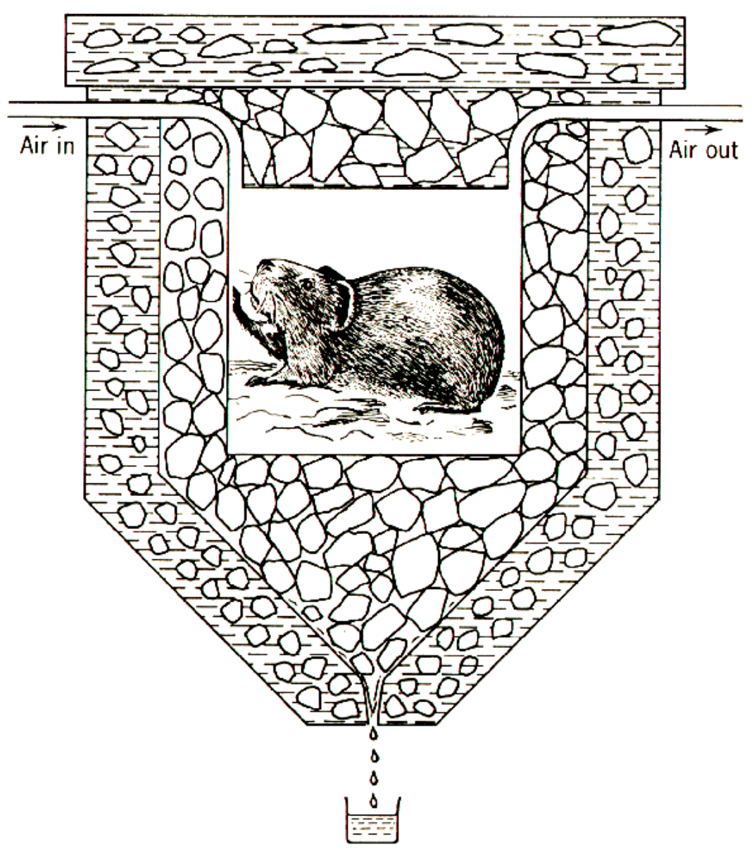

**Figure 1. Lavoisier’s calorimeter. Heat expended by the animal melts the ice in the inner jacket. Snow in the outer jacket prevents heat exchange with the surrounding environment (From reference (1)).**

In indirect calorimetry, heat production is calculated from chemical processes. Knowing, for example, that the oxidation of 1 mol glucose requires 6 mol oxygen and produces 6 mol water, 6 mol carbon dioxide and 2.8 MJ heat, the heat production can be calculated from oxygen consumption or carbon dioxide production. Heat production and the energy equivalent of oxygen and carbon dioxide varies with the nutrient oxidized (Tables 1 and 2).

|  |  |  |  |
| --- | --- | --- | --- |
| **Table 1. Gaseous Exchange and Heat Production of Metabolized Nutrients** | | | |
| **Nutrient** | **Consumption oxygen (l/g)** | **Production carbon dioxide (l/g)** | **Heat (kJ/g)** |
| Carbohydrate | 0.829 | 0.829 | 17.5 |
| Protein | 0.967 | 0.775 | 18.1 |
| Fat | 2.019 | 1.427 | 39.6 |

Brouwer (2) drew up simple formulae for calculating the heat production and the quantities of carbohydrate (C), protein (P) and fat (F) oxidized from oxygen consumption, carbon dioxide production and urine-nitrogen loss. The principle of the calculation consists of three equations with the mentioned three measured variables:

Oxygen consumption              = 0.829 C + 0.967 P + 2.019 F

Carbon dioxide production      = 0.829 C + 0.775 P + 1.427 F

Heat production                       = 21.1 C + 18.7 P + 19.6 F

Usually, only urine nitrogen is measured when information on the contribution of C, P, and F to energy production is needed. Protein oxidation (g) is calculated as 6.25 x urine-nitrogen (g), and subsequently oxygen consumption and carbon dioxide production can be corrected for protein oxidation to allow calculation of carbohydrate and fat oxidation. The general formula for the calculation of energy production (E) derived from these figures is:

E = 16.20 * oxygen consumption + 5.00 * carbon dioxide production - 0.95 P.

In this formula the contribution of protein (P) to energy production (E), the so-called protein correction, is very small. In the case of a normal protein oxidation of 10-15 per cent of the daily energy production, the protein correction for the calculation of *E* is about one per cent. For this reason, in the calculation of energy production, the protein correction is often neglected.

Metabolizable energy is available for energy production in the form of heat and for external work. At present, the state of the art for assessing total energy expenditure is with indirect calorimetry. With indirect calorimetry, the energy expenditure is calculated from gaseous exchange of oxygen and carbon dioxide. The result is the total energy expenditure of the body for heat production and work output. With direct calorimetry, only heat loss is measured. At rest, total energy expenditure is converted to heat. During physical activity, there is work output as well. The proportion of energy expenditure for external work is the work efficiency. At rest, indirect calorimetry-assessed energy expenditure matches heat loss as measured with direct calorimetry. During physical activity, heat loss is systematically lower than indirect calorimetry-assessed energy expenditure and can be up to 25% lower than total energy expenditure during endurance exercise. The difference increases with exercise intensity. For example, during cycling, indirect calorimetry assessed energy expenditure matches the sum of heat loss and power output (3) and work efficiency during cycling, the power output divided by energy expenditure, is in the range of 15 to 25%.

Current techniques utilizing indirect calorimetry for the measurement of energy expenditure in humans include a facemask or ventilated hood, respiration chamber (whole room calorimeter), and the doubly labelled water method. A facemask is typically used to measure energy expenditure during standardized activities on a treadmill or a cycle ergometer. A ventilated hood is used to measure resting energy expenditure and energy expenditure during nutrient processing and absorption (diet-induced energy expenditure). A respiration chamber is an airtight room that is ventilated with fresh air, with the only difference between a usually, ventilated hood system and respiration chamber being size. In a respiration chamber the subject is fully enclosed instead of enclosing the head only, allowing physical activity depending on the size of the chamber. For measurements under a hood or in a respiration chamber, air is pumped through the system and blown into a mixing chamber where a sample is taken for analysis. Measurements taken are those of the airflow and of the oxygen and carbon dioxide concentrations of the air flowing in and out. The most common device to measure the airflow is a dry gas meter comparable to that used to measure natural gas consumption at home. The oxygen and carbon dioxide concentrations are commonly measured with a paramagnetic oxygen analyzer and an infrared carbon dioxide analyzer respectively. The airflow is adjusted to keep differences in oxygen and carbon dioxide concentrations between inlet and outlet within a range of 0.5 to 1.0%. For adults, this means airflow rates around 50 l/min at rest under a hood, 50-100 l/min when sedentary in a respiration chamber, while in exercising subjects the flow has to be increased to over 100 l/min. In the latter situation, one has to choose a compromise for the flow rate when measurements are to be continued over 24 hours that include active and inactive intervals. During exercise bouts, the 1% carbon dioxide level should not be surpassed for long. During times of rest, like an overnight sleep, the level should not fall too far below the optimal measuring range of 0.5-1.0%. Changing the flow rate during an observation interval reduces the accuracy of the measurements due to the response time of the system. Though the flow rate of a hood and a chamber system is comparable, the volume of a respiration chamber is more than 20 times the volume of a ventilated hood. Consequently, the minimum length of an observation period under a hood is about 0.5 hours and in a respiration chamber in the order of 5-10 hours.

The doubly labelled water method is an innovative variant on indirect calorimetry based on the discovery that oxygen in the respiratory carbon dioxide is in isotopic equilibrium with the oxygen in body water. This technique involves enriching the body water with an isotope of oxygen and an isotope of hydrogen and then determining the washout kinetics of both isotopes. Doubly labelled water provides an excellent method to measure total energy expenditure in unrestrained humans in their normal surroundings over a time period of one to four weeks. After enriching the body water with labelled oxygen and hydrogen by drinking doubly labelled water, most of the oxygen isotope is lost as water, but some is also lost as carbon dioxide because CO2 in body fluids is in isotopic equilibrium with body water due to exchange in the bicarbonate pools (4). The hydrogen isotope is lost as water only. Thus, the washout for the oxygen isotope is faster than for the hydrogen isotope, and the difference represents the CO2 production. The isotopes of choice are the stable, heavy, isotopes of oxygen and hydrogen, oxygen-18 (18O) and deuterium (2H), since these avoid the need to use radioactivity and can be used safely. Both isotopes naturally occur in drinking water and thus in body water. The CO2 production, calculated from the difference in elimination between the two isotopes, is a measure of metabolism. In practice, the observation duration is set by the biological half-life of the isotopes as a function of the level of the energy expenditure. The minimum observation duration is about three days in subjects with high energy turnover like premature infants or endurance athletes. The maximum duration is 30 days or about 4 weeks in elderly (sedentary) subjects. An observation period begins with collection of a baseline sample. Then, a weighed isotope dose is administered, usually a mixture of 10% 18O and 6% 2H in water. For a 70 kg adult, between 100-150 cc water would be used. Subsequently, the isotopes equilibrate with the body water and the initial sample is collected. The equilibration time is dependent on body size and metabolic rate. For an adult the equilibration would take between 4-8 hours. During equilibration, the subject usually does not consume any food or drink. After collecting the initial sample, the subject performs routines according to the instructions of the experimenter. Body water samples (blood, saliva or urine) are collected at regular intervals until the end of the observation period. The doubly labelled water method gives precise and accurate information on carbon dioxide production. Converting carbon dioxide production to energy expenditure needs information on the energy equivalent of CO2 (Table 2), which can be calculated with additional information on the substrate mixture being oxidized. One option is the calculation of the energy equivalent from the macronutrient composition of the diet. In energy balance, substrate intake and substrate utilization are assumed to be identical.

|  |  |  |
| --- | --- | --- |
| **Table 2. Energy Equivalents of Oxygen and Carbon Dioxide** | | |
| **Nutrient** | **Oxygen (kJ/l)** | **Carbon dioxide (kJ/l)** |
| Carbohydrate | 21.1 | 21.1 |
| Protein | 18.7 | 23.4 |
| Fat | 19.6 | 27.8 |

**ENERGY EXPENDITURE AND COMPONENTS**

Daily energy expenditure consists of four components: 1) sleeping metabolic rate, 2) the energy cost of arousal, 3) the thermic effect of food (or diet-induced energy expenditure (DEE)), and 4) the energy cost of physical activity or activity-induced energy expenditure (AEE). Usually, sleeping metabolic rate and the energy cost of arousal are combined and referred to as resting energy expenditure (REE). Overnight when one sleeps quietly, food intake and physical activity are generally low or absent and energy expenditure gradually decreases to a daily minimum before increasing upon awakening (Figure 2). Then, increases in energy expenditure during arousal are primarily the result of activity-induced energy expenditure as well as diet-induced energy expenditure. Thus, energy expenditure varies throughout a day as a function of body size and body composition (the major components determining REE), physical activity as determinant of AEE, and food intake as determinant of DEE.

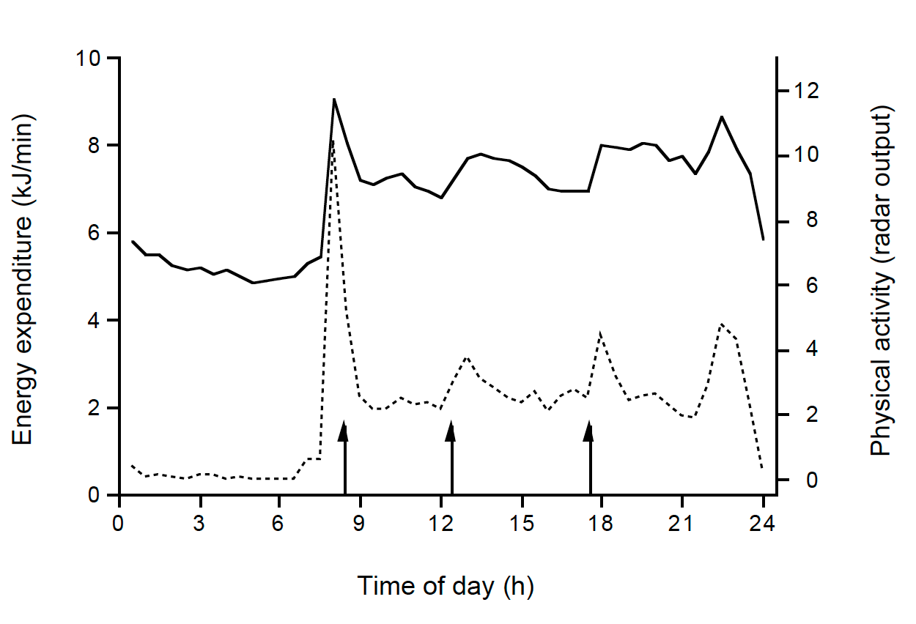

**Figure 2. Average energy expenditure (upper line) and physical activity (lower line) as measured over a 24-h interval in a respiration chamber. Arrows denote meal times. Data are the average of 37 subjects, 17 women and 20 men, age 20-35 y and body mass index 20-30 kg/m2 (5).**

Resting energy expenditure is defined as the metabolic rate required to maintain vital physiological functions of an individual that is in rest, awake, in a fasted state, and in a thermoneutral environment. To perform an accurate measurement of REE, a subject is instructed not to exercise the day before, to fast overnight, transported to a laboratory after waking up in the morning and habituated for 15-30 min to the testing procedure under a ventilated hood, before the actual measurement of 20-30 min, at a comfortable room temperature of 22-24 0C (6).

Standardizing to fat-free mass as an estimate of metabolic body size is most commonly used in the literature to compare REE between individuals. However, although fat-free body mass is a strong predictor of REE, energy expenditure should not be solely divided by the absolute fat-free mass value as the relationship between energy expenditure and fat-free mass has an Y-intercept (the value for energy expenditure when fat-free mass is theoretically absent) that is not zero (Figure 3). For example, fat-free adjusted REE is significantly different between women and men (Figure 3, 0.143±0.012 and 0.128±0.080 MJ/kg for women and men, respectively, *P* < 0.0001). The smaller the fat-free mass, the higher the REE/ fat-free mass ratio and thus the REE per kg fat-free mass is on average higher in women than men. Instead, a more accurate approach for comparing REE data is by regression analysis that includes both fat-free mass and fat mass as covariates.

REE (MJ/d) = 1.39 + 0.93 fat-free mass (kg) + 0.039 fat mass (kg), r2 = 0.93.

Using this equation, gender no longer comes out as a significant contributor to the explained variation in the group of women and men (Figure 3).

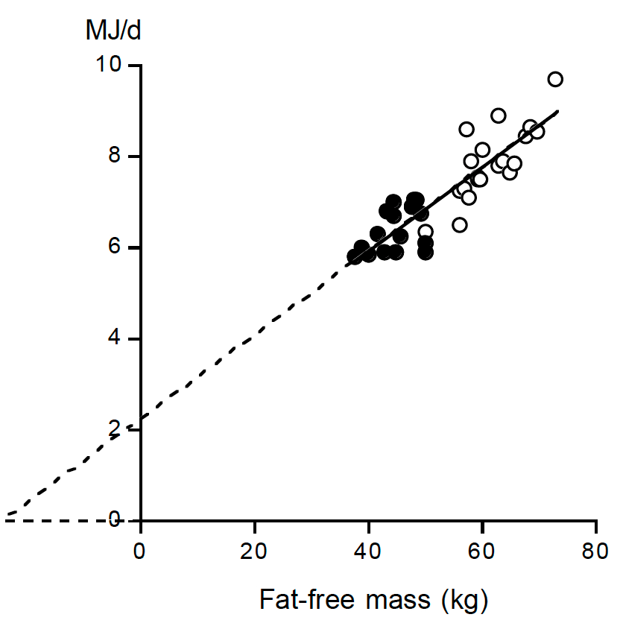

**Figure 3. Resting energy expenditure (REE) plotted as a function of fat-free mass for the subjects from reference 5 as described in Figure (2) (17 women: closed symbols; 20 men: open symbols) with the calculated linear regression line (REE (MJ/d) = 2.27 + 0.091 fat-free mass (kg), r2 = 0.78).**

Diet-induced energy expenditure is defined as the energy-required for intestinal absorption of nutrients, the initial steps of their metabolism and the storage of the absorbed but not immediately oxidized nutrients during the post-prandial period. As such, the amount of food ingested quantified as the energy content of the food is a determinant of DEE. The most common way to express DEE is derived from the difference between energy expenditure after food consumption and REE, divided by the rate of nutrient energy administration. Theoretically, based on the amount of ATP required for the initial steps of metabolism and storage, the DEE is different for each nutrient. Reported DEE values for separate nutrients are 0 to 3% for fat, 5 to 10% for carbohydrate, and 20 to 30% for protein (7). In healthy subjects in energy balance with a mixed diet, DEE represents about 10% of the total amount of energy ingested over 24 hours.

A typical mean pattern of DEE throughout the day is presented in Figure 4. Data are from a study where DEE was calculated by plotting the residual of the individual relationship between energy expenditure and physical activity in time, as measured over 30-min intervals from a 24-h observation in a respiration chamber. The level of REE after waking up in the morning, and directly before the first meal, was defined as basal metabolic rate. Resting metabolic rate had still not returned to basal metabolic rate before lunch four hours after breakfast, or before dinner at five hours after lunch. Instead, basal metabolic rate was restored overnight, approximately eight hours after dinner consumption.

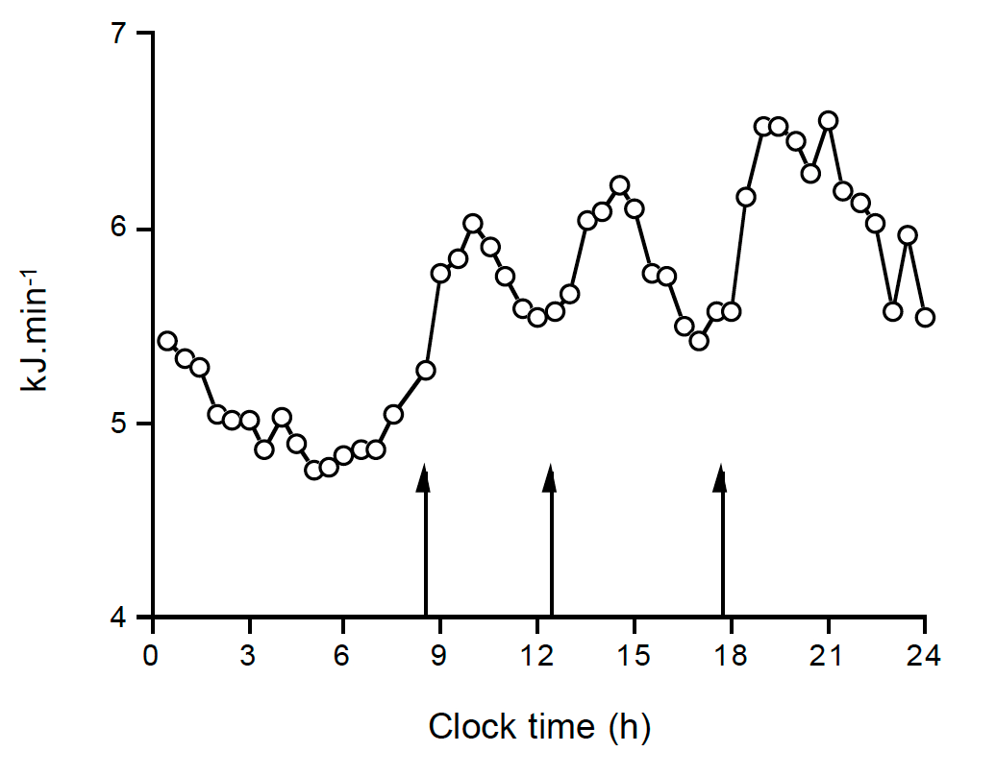

**Figure 4. The mean pattern of resting energy expenditure throughout the day, where arrows denote meal times (adapted from reference (8)).**

Activity-induced energy expenditure, the most variable component of daily energy expenditure, is derived from total energy expenditure (TEE) minus resting energy expenditure and diet-induced energy expenditure.

AEE = TEE – REE – DEE.

Total energy expenditure is measured with doubly labelled water as described above. When diet induced energy expenditure is assumed to be 10% of TEE in subjects consuming the average mixed diet and being in energy balance, AEE can be calculated as: AEE = 0.9 TEE – REE.

A frequently used method to quantify the physical activity level (PAL) of a subject is to express TEE as a multiple of REE:

PAL = TEE/REE.

This assumes that the variation in total energy expenditure is due to body size and physical activity. The effect of body size is corrected for by expressing TEE as a multiple of REE. Data on daily energy expenditure, as measured with doubly labelled water, permit the evaluation of limits to the physical activity level. In our site, data were compiled for more than 500 subjects, where energy expenditure was measured over an interval of two weeks with the same protocol. The sample excludes individuals aged less than 18 years, involved in interventions of restricted or forced excess energy intake, whose physical activity including athletic performance, who were pregnant or lactating, and with an acute or chronic illness. The sample includes similar numbers of women and men, with a wide range for age, height, weight, and body mass index. Despite the wide variation in subject characteristics, a narrow range of the physical activity level (between 1.1 and 2.75) amongst the subjects was found (Figure 5) with no sex differences (9).

The physical activity level of a subject can be classified in three categories as defined by the last Food and Agriculture Organization/World Health (FAO/WHO/UNU) expert consultation on human energy requirements (10). The physical activity for sedentary and light activity lifestyles ranges between 1.40 and 1.69, for moderately active or active lifestyles between 1.70 and 1.99, and for vigorously active lifestyles between 2.00 and 2.40. An active lifestyle improves heath parameters like insulin sensitivity (11). Higher PAL values, while difficult to maintain over a long period, generally result in weight loss.

An alternative for the measurement of energy expenditure with indirect calorimetry is a prediction equation for resting energy expenditure, in combination with an estimation of activity energy expenditure from measurement of body movement with an accelerometer. Typically, prediction equations for resting energy expenditure can explain 70-80% of the variation from race, height, age, weight and gender of a subject (12). Doubly labelled water studies show the best accelerometers for movement registration so far can explain 50-70% of variation in activity energy expenditure (13).

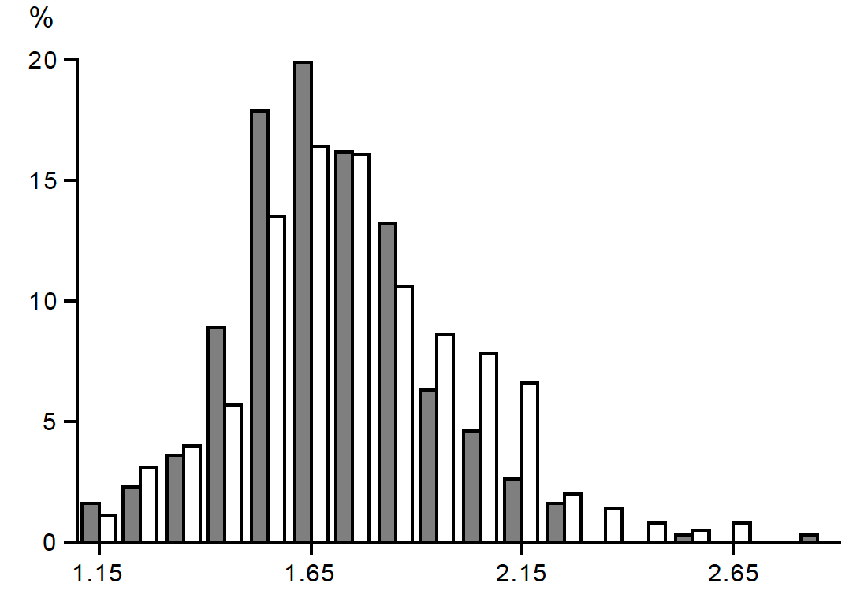

**Figure 5. Frequency distribution of the value of the physical activity level (PAL) calculated as the total energy expenditure / resting energy expenditure, in a group of 556 healthy adults, women closed bars and men open bars (data from reference (9)).**

**DETERMINANTS OF ENERGY EXPENDITURE**

The main determinants of energy expenditure are body size and body composition, food intake, and physical activity. Additional determinants are ambient temperature and health. As most people are able to live in a thermoneutral environment or prevent heat loss with appropriate clothing, energy expenditure is not affected by ambient temperature for longer time intervals.

Body size and body composition determine REE, the largest component of daily energy expenditure (Figure 6). Energy expenditure is generally higher in men than in women because men generally have a larger metabolic body size. They are on average heavier than women and for the same weight men have relatively more fat-free mass. For similar reasons, gaining weight implicates gaining fat mass and fat-free mass, and daily energy expenditure is generally higher in people who are overweight and have obesity compared with people who are lean matched for age, height and gender. This higher energy expenditure in people with obesity is mainly a consequence of higher resting energy expenditure than people who are lean (Figure 6).

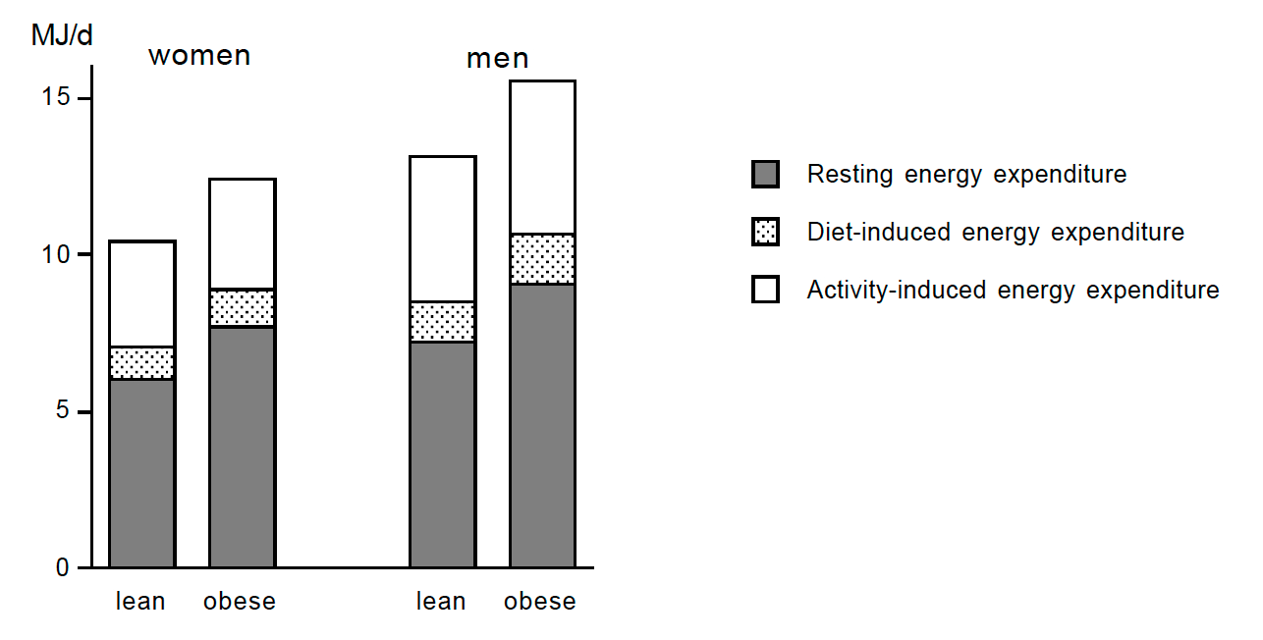

**Figure 6. The three components of energy expenditure: resting energy expenditure (closed bar), diet-induced energy expenditure (stippled bar), and activity-induced energy expenditure (open bar) as observed in subjects who are lean and who have obesity. In the lean group, women and men weighed 61 kg and 74 kg with 29% and 17% body fat, respectively. In the group with obesity, subjects were, on average, 40 kg heavier, where 70% of the additional weight was fat mass and 30% fat-free mass. The figure illustrates the higher energy expenditure (primarily in resting energy expenditure) in men than women and in those with obesity compared to those who are lean. (After reference (14)).**

Food intake affects all three components of daily (total) energy expenditure: REE, DEE and AEE. The most obvious effect is on DEE, which represents about 10% of the amount of daily energy ingested. Thus, changing energy intake changes total energy expenditure accordingly. Overeating induces an additional increase for storage of excess energy, estimated at about 10 % of the energy surplus (15). When overfeeding is lower than twice the maintenance requirements, there does not seem to be an effect of this overfeeding on physical activity (16). Undereating induces a decrease in REE, DEE and AEE. Undereating induces weight loss accompanied by adaptive thermogenesis, a disproportional or greater than expected reduction of REE. The reduction in REE is sustained even while weight loss is maintained (17). Weight loss due to a negative energy balance is accompanied by a decrease in AEE as well. Here, the decrease is due to less body movement and a lower cost to move a smaller body mass. The reduction in body movement recovers to baseline values or higher when weight loss in maintained (18). A classic example of the effect of undereating on energy expenditure is the Minnesota Experiment from the 1950’s (19). Energy intake of normal-weight men was reduced for 24 weeks from 14.6 MJ/d to 6.6 MJ/d. The subjects reached a new energy balance by saving 8 MJ/d (Table 3). Of the total saving of 8 MJ/d the main part stemmed from reduced AEE, which was mainly due to moving less.

|  |  |  |  |
| --- | --- | --- | --- |
| **Table 3. Energy Saved by 24 Weeks Underfeeding in the Minnesota Experiment (19)** | | | |
|  | **MJ/d** | **% of saving** | **Explanation** |
| Resting energy expenditure | 2.6 | 32 | 65% for a decreased bodyweight  35% for a lowered tissue metabolism |
| Diet-induced expenditure | 0.8 | 10 |  |
| Activity-induced expenditure | 4.7 | 58 | 40% for a decreased bodyweight  60% for less body movement |
| **Total** | **8.0** |  |  |

Activity induced energy expenditure is the most variable component of daily expenditure and can be increased through exercise. Variation in energy expenditure between subjects is a function of body size and physical activity, where AEE is an important contributor. Most of the variation in AEE is accounted for by genetic factors. Genes determine for a large part whether a person is prone to engage in activities and how much energy is expended for these activities (20). Exercise training can increase AEE. However, under some conditions the added exercise expenditure is compensated for by a reduction of non-training activity. Examples are non-ad libitum food intake and older age (Figure 7).

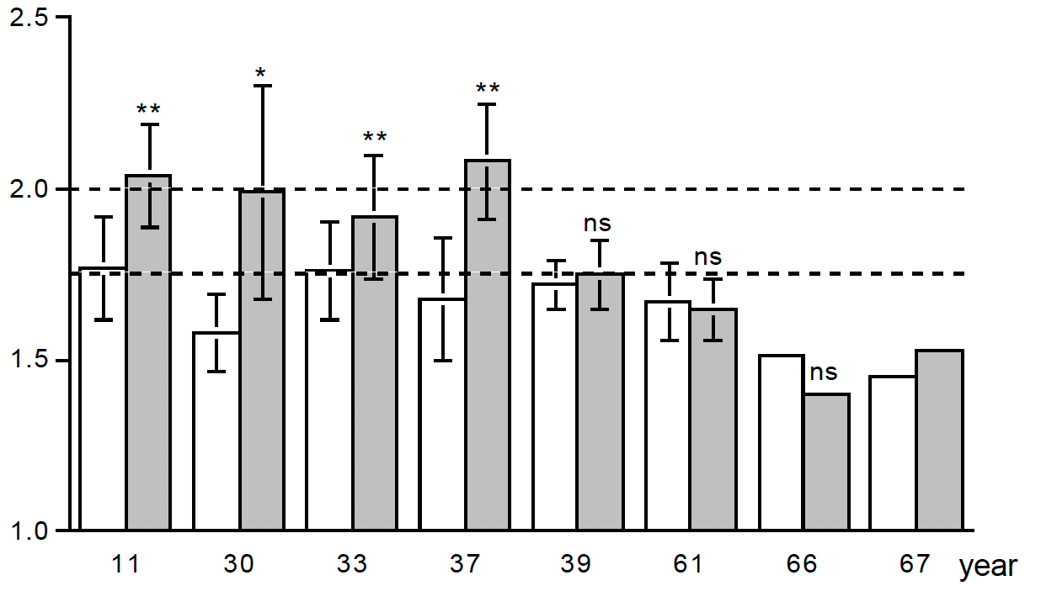

**Figure 7. The physical activity level, total energy expenditure as a multiple of resting energy expenditure, before (open bar) and at the end of a training program (closed bar), for eight studies displayed in a sequence of age of the participants as displayed on the horizontal axis (After reference (21)).**

Activity-induced energy expenditure does not increase linearly with increasing physical activity. For example, novice runners training to run a half marathon could increase the training amount without a change in AEE (22). In the selected group of sedentary subjects, the initial training-induced increase in AEE was twice as high as predicted from the training load. However, subsequent training allowed a doubling of the training load for the same AEE, probably through an improvement of exercise economy. Similarly, exercise training has been shown to decrease the energetic cost of walking in older adults (23).

Physical activity level reaches a maximum value of 2.0-2.4 (Figure 7). Higher values can be reached over shorter time intervals. For example, runners in a 140-day transcontinental race across the USA showed an initial increase in PAL from a pre-race value of 1.76 to 3.76 over the first five days of running (24). In the final week (week 20) of running, PAL had decreased to a mean value of 2.81. This subsequent decrease in PAL during sustained physical activity was hypothesized to have resulted from a limit in alimentary energy supply.

During negative energy balance, additional exercise is compensated by a reduction of non-training activity. In elderly subjects, exercise training has a similar compensatory effect on spontaneous physical activity, even under ad-libitum food conditions. Despite the absence of an effect of exercise training on total energy expenditure in elderly people, there are many beneficial effects of exercise training like aerobic capacity, endurance, flexibility, and range of motion.

**ENERGY BALANCE**

Adult humans maintain weight stability through a balance between energy intake and energy expenditure. When weight is stable, the energy store of the body does not fluctuate much, as evident by constancy in body weight and body composition. This weight constancy can be achieved through the balanced control of energy intake and expenditure. This balance does not, however, take place on an immediate basis. For example, on days with high energy expenditure, energy intake is usually normal or even below normal. The 'matching' increase in energy intake comes several days afterwards (25). Energy intake can change by at least a factor of three when adapting to changes in energy expenditure. Under sedentary living conditions the energy balance is maintained at about 1.5 times basal metabolic rate (BMR), while during sustained exercise levels of 4.5 times BMR are reached (26).

Humans are discontinuous eaters and continuous metabolizers. An animal that takes its food in meals, such as a human, periodically consumes more than their physiological needs even when in (daily) energy balance. During meal-related hyperphagia, metabolites are initially stored then mobilized during inter-meal intervals of energy deficiency. This pattern of intermittent feeding and fasting has consequences for energy expenditure (Figure 4). During and after a meal, expended energy increases to process the ingested food, while energy deficiency before a new meal is started can lead to a reduction of energy expenditure. The latter probably does not occur during short-term energy deficiency. However, people tend to be less energetic during prolonged inter-meal intervals or extended fasts.

Disturbances of energy balance result in energy mobilization from, or energy storage in, body reserves. Energy intake occurs via macronutrients consumed in meals in the form of carbohydrate, protein, fat and alcohol. During positive energy balance, excess energy is stored as carbohydrate in glycogen, primarily in the liver, and as fat in adipose depots. The storage capacity for carbohydrate is small, typically covering energy needs during the overnight fast that accompanies sleep. Longer-term shortages are mainly covered by mobilization of the larger energy stores in fat. On days with a positive energy balance, protein and carbohydrate intake match protein and carbohydrate oxidation and the difference between energy intake and energy expenditure shows up in a positive fat balance (27). In the early morning, at arousal, carbohydrate oxidation goes up and continues to increase at the first food intake of the day (28). After awakening, initial energy (‘fast’) requirements are met by glycogen reserves. Subsequently, carbohydrate requirement is higher at breakfast, and one eats relatively more fat at the evening dinner (29,30).

Energy balance does not equate to substrate balance, and when in substrate balance one does not produce energy just from the foods consumed. Fat, as a substrate for energy metabolism is at the bottom of the oxidation hierarchy that determines fuel selection and studies show a direct link between macronutrient balance for fat and energy balance. Changes in alcohol, protein, and carbohydrate intake elicit auto regulatory adjustments in oxidation whereas a change in fat intake fails to elicit such a response, or only in the long term (31).

One explanation for this macronutrient oxidation disparity is the routing of dietary fat. Fat metabolism can be traced with isotope-labelled fatty acids. Oxidation and adipose tissue uptake of dietary fat can be measured by adding fatty acid labelled with heavy hydrogen (2H) to meals. Upon oxidation, these deuterated fatty acids enrich the body water with deuterium, which is subsequently detectable in urine. Therefore, the urine enrichment for deuterium is a measure of dietary fat oxidation. The first label appears in the urine in about two hours and the peak concentration is reached after 12-24h (Figure 8). After 24 hours, 5-30% of the fat from a meal is oxidized and the remaining part partitioned to the reserves. The percentage of dietary fat oxidation is independent of the composition of the meal with respect to protein, carbohydrate and fat. However, there is a clear relation of dietary fat oxidation with the body fat content. The larger the fat mass, the lower the fractional oxidation of the fat consumed on the same day (32). The observed reduction in dietary fat oxidation in subjects with greater body fat may therefore play a role in expression and maintenance of human obesity. This low dietary fat oxidation makes subjects prone to weight gain.

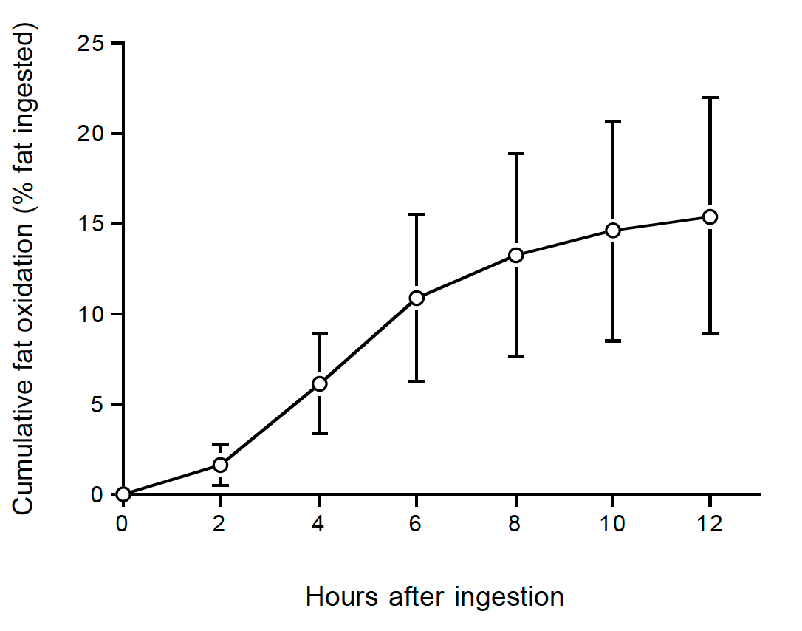

**Figure 8. Cumulative oxidation (mean ± standard deviation) of dietary fat as a percentage of intake, over time after ingestion, as calculated from tracer recovery in urine produced at two-hour intervals (From reference (32)).**

**REFERENCES**

1. Kleiber M. The fire of life; an introduction to animal energetics. New York,: Wiley.

2. Brouwer E. On simple formulae for calculating the heat expenditure and the quantities of carbohydrate and fat oxidized in metabolism of men and animals, from gaseous exchange (Oxygen intake and carbonic acid output) and urine-N. Acta Physiol Pharmacol Neerl. 1957;6:795-802.

3. Webb P, Saris WH, Schoffelen PF, Van Ingen Schenau GJ, Ten Hoor F. The work of walking: a calorimetric study. Med Sci Sports Exerc. 1988;20(4):331-337.

4. Speakman JR. The history and theory of the doubly labeled water technique. Am J Clin Nutr. 1998;68(4):932S-938S.

5. Westerterp KR, Verboeket-van de Venne WP, Bouten CV, de Graaf C, van het Hof KH, Weststrate JA. Energy expenditure and physical activity in subjects consuming full-or reduced-fat products as part of their normal diet. Br J Nutr. 1996;76(6):785-795.

6. Adriaens MP, Schoffelen PF, Westerterp KR. Intra-individual variation of basal metabolic rate and the influence of daily habitual physical activity before testing. Br J Nutr. 2003;90(2):419-423.

7. Tappy L. Thermic effect of food and sympathetic nervous system activity in humans. Reprod Nutr Dev. 1996;36(4):391-397.

8. Westerterp KR. Diet induced thermogenesis. Nutr Metab (Lond). 2004;1(1):5.

9. Speakman JR, Westerterp KR. Associations between energy demands, physical activity, and body composition in adult humans between 18 and 96 y of age. Am J Clin Nutr. 2010;92(4):826-834.

10. Human energy requirements: report of a joint FAO/ WHO/UNU Expert Consultation. Food Nutr Bull. 2005;26(1):166.

11. Camps SG, Verhoef SP, Westerterp KR. Physical activity and weight loss are independent predictors of improved insulin sensitivity following energy restriction. Obesity (Silver Spring). 2016;24(2):291-296.

12. Sabounchi NS, Rahmandad H, Ammerman A. Best-fitting prediction equations for basal metabolic rate: informing obesity interventions in diverse populations. Int J Obes (Lond). 2013;37(10):1364-1370.

13. Westerterp KR. Reliable assessment of physical activity in disease: an update on activity monitors. Curr Opin Clin Nutr Metab Care. 2014;17(5):401-406.

14. Ekelund U, Aman J, Yngve A, Renman C, Westerterp K, Sjostrom M. Physical activity but not energy expenditure is reduced in obese adolescents: a case-control study. Am J Clin Nutr. 2002;76(5):935-941.

15. Westerterp KR, Donkers JH, Fredrix EW, Boekhoudt P. Energy intake, physical activity and body weight: a simulation model. Br J Nutr. 1995;73(3):337-347.

16. Westerterp KR. Physical activity, food intake, and body weight regulation: insights from doubly labeled water studies. Nutr Rev. 2010;68(3):148-154.

17. Camps SG, Verhoef SP, Westerterp KR. Weight loss, weight maintenance, and adaptive thermogenesis. Am J Clin Nutr. 2013;97(5):990-994.

18. Camps SG, Verhoef SP, Westerterp KR. Weight loss-induced reduction in physical activity recovers during weight maintenance. Am J Clin Nutr. 2013;98(4):917-923.

19. Taylor HL, Keys A. Adaptation to caloric restriction. Science. 1950;112(2904):215-218.

20. Joosen AM, Gielen M, Vlietinck R, Westerterp KR. Genetic analysis of physical activity in twins. Am J Clin Nutr. 2005;82(6):1253-1259.

21. Westerterp KR, Plasqui G. Physical activity and human energy expenditure. Curr Opin Clin Nutr Metab Care. 2004;7(6):607-613.

22. Westerterp KR, Meijer GA, Janssen EM, Saris WH, Ten Hoor F. Long-term effect of physical activity on energy balance and body composition. Br J Nutr. 1992;68(1):21-30.

23. Valenti G, Bonomi AG, Westerterp KR. Multicomponent Fitness Training Improves Walking Economy in Older Adults. Med Sci Sports Exerc. 2016;48(7):1365-1370.

24. Thurber C, Dugas LR, Ocobock C, Carlson B, Speakman JR, Pontzer H. Extreme events reveal an alimentary limit on sustained maximal human energy expenditure. Sci Adv. 2019;5(6):eaaw0341.

25. Edholm OG, Fletcher JG, Widdowson EM, McCance RA. The energy expenditure and food intake of individual men. Br J Nutr. 1955;9(3):286-300.

26. Westerterp KR. Limits to sustainable human metabolic rate. J Exp Biol. 2001;204(Pt 18):3183-3187.

27. Schrauwen P, Lichtenbelt WD, Saris WH, Westerterp KR. Fat balance in obese subjects: role of glycogen stores. Am J Physiol. 1998;274(6):E1027-1033.

28. Verboeket-van de Venne WP, Westerterp KR. Influence of the feeding frequency on nutrient utilization in man: consequences for energy metabolism. Eur J Clin Nutr. 1991;45(3):161-169.

29. Westerterp-Plantenga MS, MJ IJ, Wijckmans-Duijsens NE. The role of macronutrient selection in determining patterns of food intake in obese and non-obese women. Eur J Clin Nutr. 1996;50(9):580-591.

30. Almoosawi S, Prynne CJ, Hardy R, Stephen AM. Time-of-day and nutrient composition of eating occasions: prospective association with the metabolic syndrome in the 1946 British birth cohort. Int J Obes (Lond). 2013;37(5):725-731.

31. Schrauwen P, van Marken Lichtenbelt WD, Saris WH, Westerterp KR. Changes in fat oxidation in response to a high-fat diet. Am J Clin Nutr. 1997;66(2):276-282.

32. Westerterp KR, Smeets A, Lejeune MP, Wouters-Adriaens MP, Westerterp-Plantenga MS. Dietary fat oxidation as a function of body fat. Am J Clin Nutr. 2008;87(1):132-135.