CRYPTORCHIDISM AND HYPOSPADIAS

John M Hutson, AO, BS, M.D. (Monash), M.D. DSc (Melb), FRACS, FAAP (Hon), FCAPS (Hon), Chair of Pediatric Surgery, University of Melbourne, The Royal Children’s Hospital, and Murdoch Childrens Research Institute, Victoria, Australia

Updated June 6, 2018

ABSTRACT

Undescended testis (UDT) is a common abnormality, affecting about 1/20 males at birth. Half of these have delayed testicular descent, with the testis in the scrotum by 10-12 weeks after term. Beyond this spontaneous descent is rare. Current treatment recommendations are that UDT beyond 3 months need surgery between 6-12 months of age. Some children have scrotal testes in infancy but develop UDT later in childhood because the spermatic cord does not elongate with age, leaving the testis behind as the scrotum moves further from the groin. This is now known as ascending/acquired cryptorchidism, and orchidopexy is controversial. Many authors recommend surgery once the testis no longer resides spontaneously in the scrotum, but some groups recommend conservative treatment. The fetal testis descends in 2 separate hormonal and anatomical steps, with the first step occurring between 8-15 weeks’ gestation. Insulin-like hormone 3 (INSL3) from developing Leydig cells stimulates the genito-inquinal ligament, or gubernaculum, to enlarge. This holds the testis near the inguinal canal as the fetal abdomen enlarges. By contrast, in female fetuses’ lack of INSL3 allows the gubernaculum to elongate into a round ligament and lets the ovary move away from the groin. The second or inguinoscrotal phase occurs between 25-35 weeks’ gestation, where the gubernaculum and testis migrate to the scrotum. Androgens guide this complex process, both directly and indirectly via a neurotransmitter, calcitonin gene-related peptide (CGRP), released from the genitofemoral nerve. After migration is complete the proximal processus vaginalis closes (preventing inguinal hernia) and then disappears, allowing the spermatic ford to elongate with age, to keep the testis scrotal. The transabdominal phase is a simple mechanical process, and abnormalities are uncommon, with intra-abdominal testes found in 5-10% of boys with UDT. Anomalies of the complex inguinoscrotal phase account for most UDT seen clinically. The maldescended testis suffers heat stress when not at the lower scrotal temperature (33 degrees Celsius), interfering with testicular physiology and development of germ cells into spermatogonia. UDT interrupts transformation of neonatal gonocytes into type-A spermatogonia, the putative spermatogenic stem cells at 3-9 months of age. Recent evidence suggests orchidopexy between 6-12 months improves germ cell development, with early reports of improved fertility, but no evidence yet for changes in malignancy prognosis. Hypospadias is also a common abnormality in newborn males, affecting about 1/150 boys. Androgens control masculinization of the genital tubercle into penis between 8-12 weeks’ gestation, with tubularization of the urethra from the perineum to the tip of the glans. If this process is disrupted hypospadias occurs, with a variable proximal urethral meatus, failed ventral preputial development producing a dorsal hood, and discrepancy in the ventral versus dorsal penile length, causing a ventral bend in the penis, known as chordee. Surgery to correct hypospadias is recommended between 6-18 months, as technical advances now allow operation to be done before long-term memory of the surgery. Severe hypospadias overlaps with disorders of sex development (DSD), so that babies without a fused scrotum containing 2 testes and who present with ‘hypospadias’ need full DSD investigations at birth. For complete coverage of this and related aspects of Endocrinology, please visit our FREE web-book, www.endotext.org.

INTRODUCTION

Undescended testis, or "cryptorchidism", is a very common anomaly in male infants and pre-adolescent boys, with about 1 in 20 boys undergoing treatment by the time they reach puberty. Not only is it prevalent, but also there remain unresolved questions about prognosis in adult life. It is not known yet whether the dramatic changes in the recommended age for surgery (from 15 years of age in the 1950’s, to six months old now) will decrease the risk of infertility or testicular cancer. However, current treatment is based on the assumption that early surgery will prevent germ cell degeneration during childhood, leading to improved fertility and fewer tumors .

Our understanding of the embryology has advanced rapidly in recent years, with new theories and experimental evidence supporting a complex anatomical process controlled directly and indirectly by hormones . The classification of cryptorchidism also is changing, with the recent recognition of acquired anomalies . With so much change in the way we view and treat cryptorchidism, endocrinologists will need to keep checking on the evolving controversies described in this chapter.

EMBRYOLOGY

The testes descend prenatally from their initial intra-abdominal location on the urogenital ridge into the low-temperature environment of the scrotum via a complex multi-stage mechanism . Prior to 7-8 weeks of development, the gonadal position is similar in both sexes. With the onset of sexual differentiation, the fetal testis begins producing anti-Müllerian hormone (AMH; also called Müllerian inhibiting substance (MIS)) from the Sertoli cells, as well as androgen and insulin-like hormone 3 (INSL3) from the Leydig cells. These hormones are involved in controlling descent of the male gonad, which is held by two thickenings in the mesentery, the cranial suspensory ligament at the upper pole, and the genito-inguinal ligament, or “gubernaculum”, at the lower pole .

During the initial (transabdominal) phase of descent, regression of the cranial ligament and thickening of the gubernaculum allows the testis to be held near the inguinal region . By contrast, in the female the cranial ligament persists while the gubernaculum remains thin and elongates, which together hold the ovary higher on the posterior abdominal wall as the fetal abdomen enlarges. The inguinal canal forms by the abdominal wall muscles developing around the caudal, gelatinous end of the gubernaculum, which initially ends at the future external inguinal ring. By 15 weeks the testis is attached by a short, stout and gelatinous gubernaculum to the future internal inguinal ring, while the ovary is higher in the pelvis .

In mid gestation a diverticulum of the peritoneal membrane, known as the processus vaginalis, begins to elongate within the gubernaculum, which retains a central connection (known as the gubernacular cord) with the epididymal tail and the lower pole of the testis. The caudal end of the gubernaculum grows out of the abdominal wall and elongates towards the scrotum, extending the processus vaginalis eventually to the scrotum. Between 25-30 weeks’ gestation the testis descends rapidly through the inguinal canal, and then more slowly across the pubic region and into the scrotum, with descent within this peritoneal diverticulum complete by 35 weeks. After the testis reaches the scrotum, two further anatomical events complete the inguinoscrotal phase, the first of which is obliteration of the proximal processus vaginalis . The second event is involution of the gelatinous gubernacular bulb and its anchoring to the inside of the scrotum. The former process prevents inguinal hernia or hydrocele and the latter process prevents extravaginal or perinatal torsion of the testis .

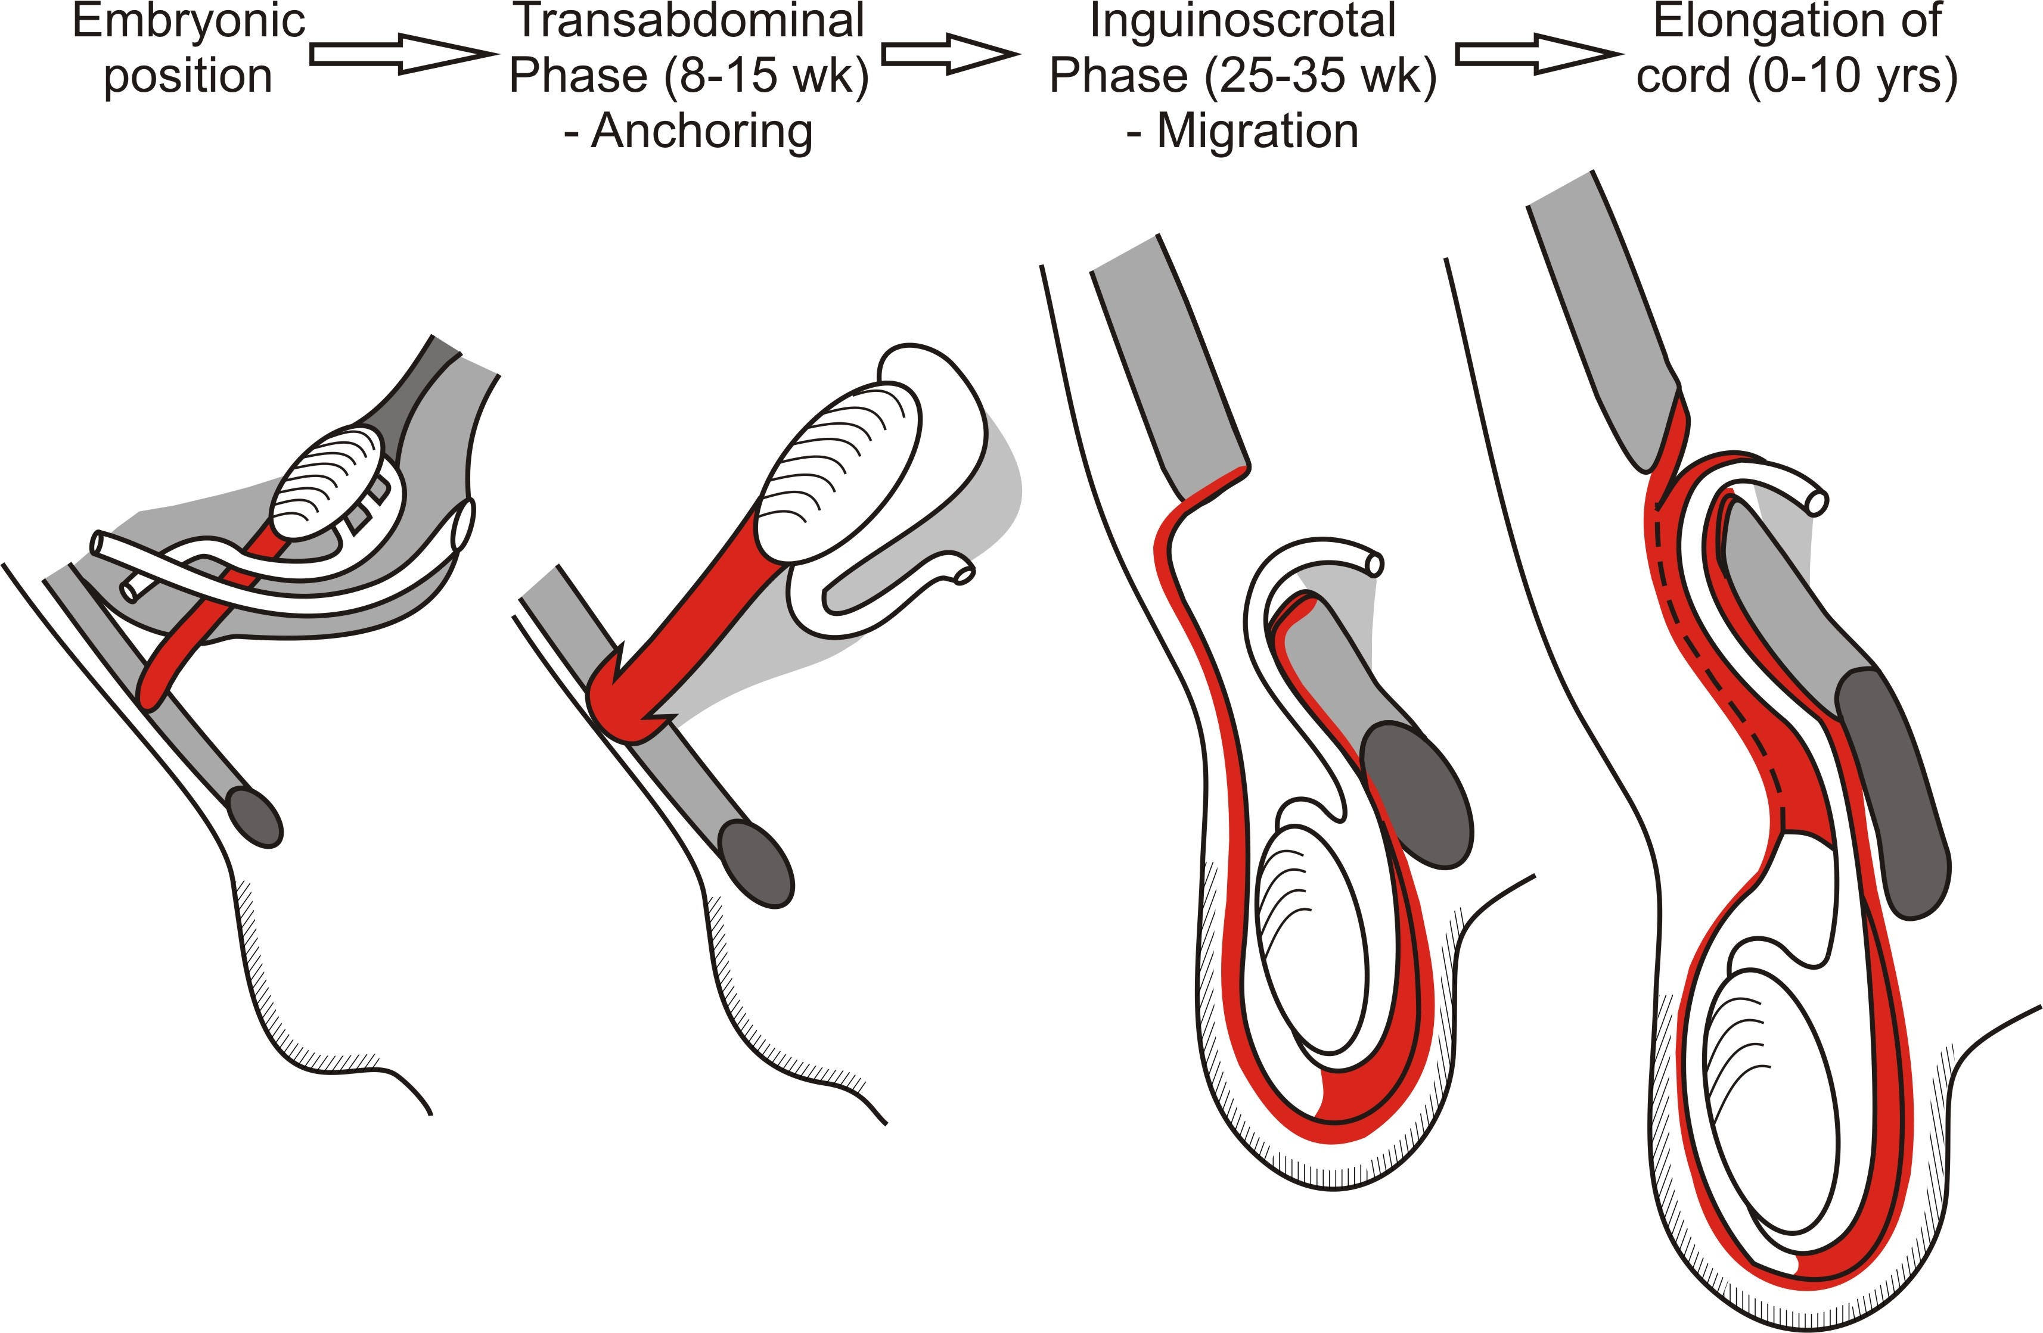

Figure 1. The embryological stages of testicular descent and the postnatal growth required to keep the testis in the scrotum.

The two main phases of descent appear to be controlled independently by hormones. (Fig. 1). INSL3 is the major factor controlling gubernacular enlargement and androgen, particularly DHT, and AMH appear to play minor roles in this "swelling reaction" of the gubernaculum . Under the influence of the hormones mentioned above, the caudal end of the gubernaculum, where it attaches to the inguinal abdominal wall, enlarges by proliferation of the embryonic mesenchyme and deposition of extracellular matrix. Androgens also are responsible for regression of the cranial suspensory ligament, but they are not sufficient alone for transabdominal descent. The phase of gubernacular migration is controlled both directly and indirectly by androgens, with the aid of the genitofemoral nerve (GFN) releasing calcitonin gene-related peptide (CGRP) . Androgens act during a critical time window to regulate gubernacular development . Recent evidence suggests that the androgen receptors controlling this masculinization of the GFN may not be in the nerve itself, but in the target organ, the inguinoscrotal fat pad in the mammary line . The number of sensory neurons and the amount of CGRP in the genitofemoral nerve of rats are significantly less after exposure to the anti-androgen, flutamide, consistent with androgens stimulating structural and functional changes in the nerve. The nerve is proposed to orient the direction of gubernacular migration, while the physical force needed for elongation of the processus vaginalis is probably provided by intra-abdominal pressure . CGRP released from the nerve stimulates mitosis and cremaster muscle development in the gubernacular tip, enabling elongation to the scrotum . Estrogens have a minor inhibitory role in normal gubernacular development, but estrogenic endocrine disruptors may be responsible in larger doses for cryptorchidism secondary to suppression of the "swelling reaction" by inhibition of INSL3.

The trigger that initiates active migration of the caudal tip of the gubernaculum may come from the inguinoscrotal fat pad in the mammary line , as the androgen receptors are present in the mammary line mesenchyme but not in the adjacent gubernaculum during the critical window of androgenic programming in rodents . The gubernaculum has a surprisingly close link with the embryonic breast in normal marsupials as well as in eutherian animal models, such as the rat and mouse, especially after they have been exposed to the antiandrogen, flutamide .

The primitive mammary line is in continuity with the apical ectodermal ridges of the upper and lower limb buds, and hence is likely to contain similar activated signaling systems as seen in limb bud development . These signals are likely to initiate outgrowth of the gubernaculum from the abdominal wall, so that it can migrate to the scrotum.

ETIOLOGY

Any anomaly in either the hormonal control or the anatomical processes in normal testicular descent will cause cryptorchidism . Hormonal defects in INSL3, AMH or androgenic action are identified only rarely, suggesting that mechanical anomalies may be more common. Those patients with hormonal defects may present with rare disorders of sexual development (DSD) with cryptorchidism as part of the complex genital anomaly. The first or transabdominal phase involves little movement of the testis and this may explain the low frequency (5-10%) of intra-abdominal testes. As the gubernacular swelling reaction holds the testis close to the inguinal canal while other structures grow further away, the transabdominal phase is only relative movement of the testis and hence less likely to be abnormal. By contrast, the inguinoscrotal migration phase requires very significant mechanical and anatomical re-arrangements, and consequently, anomalies are common: over 60% of testes are found just outside the external inguinal ring, consistent with anomalous or arrested gubernacular migration. Transient deficiency of androgen production in utero, perhaps related to deficiency of gonadotropin production by the fetal pituitary or the placenta , may account for some, particularly where there is intra-uterine growth retardation. Anomalies of the genitofemoral nerve also may cause undescended testes. For example, perineal testes may be caused by an anomalous location of the genitofemoral nerve .

Inherited syndromes frequently are associated with cryptorchidism. Hypothalamic dysfunction, connective tissue disorders, neurogenic (e.g. spina bifida) and mechanical anomalies (e.g. arthrogryposis multiplex congenita) may all cause disruption in testicular descent . Cryptorchidism is also common in infants with abdominal wall defects, such as exomphalos or omphalocele, gastroschisis and exstrophy of the bladder .

There is much current interest in the potential adverse effects of environmental estrogenic endocrine disruptors on the incidence of both cryptorchidism and hypospadias . In addition, there are data on the effect of diethylstilbestrol (DES) on cryptorchidism in male offspring of exposed mothers . In the latter case there is supporting evidence from animal models , although in the former, the cause-and-effect relationship is more tenuous, because the level of exposure is less clear, and the epidemiology may not have allowed for changes in diagnostic criteria over recent decades. More work is needed before we can ascertain a proven cause-and-effect link with synthetic molecules in the environment.

The body of the epididymis is hypoplastic and frequently is not tightly adherent to the cryptorchid testis . This is more common in high intra-abdominal testes and probably indicates significantly decreased androgen production. Whether epididymal-testicular separation is the cause or the result of cryptorchidism is not known . In addition, its effect on fertility is uncertain, even though the rete testis is nearly always still connected to the head of the epididymis. Recent studies show a strong link between maternal smoking and cryptorchidism in male offspring .

CLINICAL PRESENTATION

Up to 4-5% of newborn males show cryptorchidism, but this fall to 1-2% by 12 weeks after term, following normal (but postnatal) descent in premature infants, and delayed postnatal descent in some term babies. Beyond 12 weeks, spontaneous testicular descent is rare . Geographic differences in prevalence of cryptorchidism have been reported, with 9% of Danish boys with undescended testes at birth, compared with only 2% of males from Finland. Some of these apparent differences, however, may be related to the definitions used for ‘cryptorchidism’ in these studies. An undescended testis is best defined as a testis that cannot be manipulated into the bottom of the scrotum (without excess tension on the spermatic cord) by 12 weeks of age. Most testes (about 85%) are near the neck of the scrotum, or just lateral to the external inguinal ring, described by Denis Browne as the "superficial inguinal pouch” .

A few cryptorchid testes are within the inguinal canal, making them impalpable unless they can be squeezed out of the external inguinal ring by compression. Ten percent of testes are intra-abdominal or absent (presumed to be secondary to prenatal torsion). Ectopic cryptorchid testes are rare (< 5%), and occur in the perineum, prepubic region, thigh, or the contralateral inguinal canal (transverse testicular ectopia) .

ENDOCRINE EFFECTS OF CRYPTORCHIDISM

In infants with undescended testes, the testosterone and gonadotropin levels are diminished compared with normal infants between one and four months of age , which is during the normal, transient hormonal surge, known as ‘minipuberty’ . Whether this is a sign of primary endocrinopathy or secondary dysfunction of the testis, caused by heat stress when the gonad is not in the low temperature environment of the scrotum, is unknown. Postnatal increase in testosterone production is also diminished in premature infants, perhaps secondary to inadequate stimulation by chorionic gonadotropin in utero . HCG is low compared with early pregnancy and may be of functional significance. Despite lower than normal androgen levels between 1 and 4 months of age, there is no apparent anomaly in androgen receptors from gonadal or skin biopsies collected at orchidopexy .

The postnatal secretion of both AMH and inhibin-B in cryptorchid infants is also deranged. Production of AMH from Sertoli cells normally increases between 4-12 months, but this surge is blunted in undescended testes . Inhibin-B normally increases at minipuberty and remains elevated into the second year of life , but levels in infants with cryptorchidism are lower .

GERM CELL MATURATION IN CRYPTORCHIDISM

Germ cells mature postnatally from a primitive gonocyte through a series of steps to primary spermatocytes by 3-4 years. This process is perturbed in cryptorchid testes, with failure of transformation of gonocytes into type-A spermatogonia between 4-12 months . These observations suggest that germ cell deficiency may be at least partly secondary to early postnatal dysfunction, rather than being congenital, as proposed by some authors .

Lack of germ cell transformation has been proposed to be secondary to postnatal androgen deficiency or low AMH levels . Recent studies, however, suggest that transformation is normal in both infants and mice with complete androgen insensitivity syndrome (CAIS), and may be mediated by activin or another TGF-family factor . Abnormal postnatal maturation of gonocytes could lead to both infertility and malignancy ), although some authors propose that there may be congenital carcinoma in-situ-cells in the cryptorchid testis .

There is now a consensus that type-A spermatogonia are likely to be the stem cells for future spermatogenesis, and that their appearance between 3 and 12 months of age, as neonatal gonocytes transform, is the key step in postnatal germ cell development . Should this be confirmed, it implies that early surgical intervention should lead to an excellent prognosis, as long as the subsequent germ cell deficiency is secondary to postnatal heat stress of the maldescended testis, and therefore reversible. Failure of the totipotential gonocytes to transform into unipotential spermatogenic stem cells may leave some persisting gonocytes in the undescended testis, which is speculated to be the origin of subsequent tumors.

DIAGNOSIS

The aim of clinical examination is to locate the gonad, if palpable, and determine its lowest position without causing painful traction on the spermatic cord (which probably corresponds to the caudal limit of the tunica vaginalis) . In infants, the diagnosis is straightforward because the scrotum is thin and pendulous. Hypoplasia of the hemiscrotum indicates it does not contain a testis. The inguinal testis is within its tunica vaginalis which gives it significant mobility. Ultrasonography has become more frequently used for diagnosis of the impalpable testis, but generally is not contributory for true intra-abdominal testes. This is because absence of the testis (secondary to possible perinatal torsion) is common, and also because intra-abdominal testes are often concealed by the bowel and other viscera . In addition, the mobility of the undescended testis within its tunica vaginalis may make location by ultrasonography difficult. An ultrasound scan can be justified in bilateral impalpable testes, to confirm the presence of a testis. In addition AMH and inhibin-B should be measured to confirm the presence of functioning Sertoli cells . A simple and reliable approach is to use laparoscopy, which readily locates the testis itself (or blind-ending gonadal vessels), and allows orchidopexy in experienced hands .

TREATMENT

Newborn and Infant

Hormone therapy has become extremely controversial as it was based on the two assumptions that cryptorchidism is not only secondary to a deficiency of the hypothalamic-pituitary-gonadal axis, but also the mechanical processes were simple. Both hCG and GnRH therapy have been tried, with success rates ranging from 10-50%. Randomized, double-blind, placebo-controlled studies have not shown more than marginal benefit with either hCG or GnRH . Despite proven endocrine control of descent, the mechanical factors appear to be too complex for this simple approach to be successful except for acquired undescended testes . Because of its poor efficacy and possible side effects, a consensus meeting in Scandinavia several years ago recommended that hormone treatment be abandoned completely .

Surgical treatment is based on the premise that early intervention will prevent secondary testicular degeneration caused by high temperature (35-37ºC) as the lower temperature of the scrotum (33ºC) is essential for normal postnatal germ cell maturation . Evidence of progressive germ cell loss in the cryptorchid testis after six months of age has accumulated over the last 50 years and now suggests that orchidopexy should be considered between 6 and 12 months of age . The first signs of abnormal germ cell development can be seen between 4-12 months of age , and intervention is based on the premise that these changes are secondary to high temperature and should be reversible. Certainly in animal models, early intervention prevents germ cell loss . A prospective study of children randomized to early (9 months) or late (3 years) surgery is showing improved testicular development with early intervention, as measured by ultrasonography at 4 years of age . Surgery at this very early age ideally needs a trained pediatric surgeon, as the technique is quite different from that for a 5-10 year-old boy

All baby boys need examination at birth to document gonadal position. Those infants without two fully descended testes should be re-examined at 12 weeks of age and, if a testis is still undescended, the child should be referred to a pediatric surgeon for possible surgical treatment. Orchidopexy is done as an ambulatory procedure, with discharge home a few hours after operation. General anesthesia is supplemented with local/regional analgesia, which will provide pain relief for the first few hours postoperatively.

Prognosis

The complication rate after orchidopexy is less than 5% in experienced hands . Wound infection is common in infants secondary to external contamination of the wound, although there is a low risk of atrophy of the testis which is greatest when intra-abdominal testes are pulled down under tension. Laparoscopy, with or without ligation of the testicular vessels (Fowler-Stephens procedure) , shows increasing success for high intra-abdominal gonads . The prognosis for fertility, the primary aim of orchidopexy, remains uncertain ,. However, extensive review of the recent literature suggests improved outcomes with very early surgery . Now that early germ cell maturation in the first year is known to be deranged, improved fertility is to be expected with very early orchidopexy . Unfortunately, it will be a few more years before the long-term outcome of this new consensus policy is known.

The risk of malignancy was previously calculated to be 5 -10 times greater than normal for a man with a history of unilateral cryptorchidism when surgery was performed in mid-childhood. The risk in a future generation for men who underwent orchidopexy in infancy is unknown at present, but is anticipated to be much lower than in the past, as supported by preliminary evidence .

Some clinical features are associated with statistically better outcomes, and include testes near the neck of the scrotum, and ascending or retractile testes (see below), where malignancy risk is now thought to be similar to men without cryptorchidism in childhood . Poor prognostic factors are primary testicular or epididymal dysplasia, intra-abdominal or intra-canalicular position, associated strangulated inguinal hernia and (possibly) surgery late in childhood or adolescence .

ACQUIRED CRYPTORCHIDISM

Retractile Testes

Retraction of the testis out of the scrotum secondary to reflex contraction of the cremaster muscle is both normal and common and is involved in temperature control and protecting the testis from trauma. The reflex is absent or weak at birth and becomes more active after one year, reaching a peak in 5-10 year-old boys .

Many testes are erroneously described as "retractile" when they can be pulled down into the scrotum during the physical examination but retract back out of the scrotum on release. This retractability is assumed to be secondary to cremasteric activity, but an alternative explanation has been proposed recently, which is that the malposition may be caused by failure of the spermatic cord to elongate with age . Since the distance from external inguinal ring to the bottom of the scrotum increases from 5 cm at birth to 8-10 cm at 10 years of age, the spermatic cord must double in length to keep the testis in the scrotum during the first decade. Preliminary evidence suggests that failure of complete obliteration of the processus vaginalis may prevent normal postnatal elongation of the vas and vessels (Fig. 2).

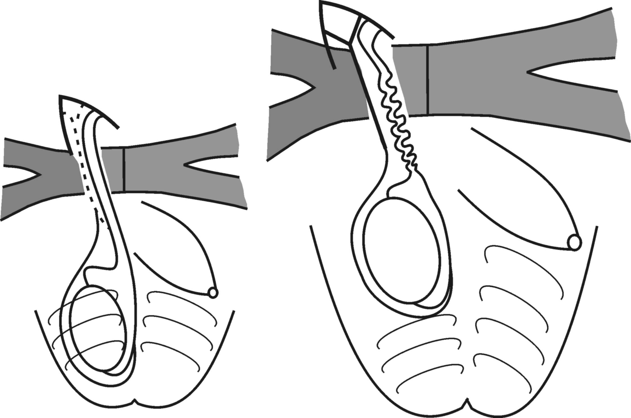
This figure shows what happens between birth and 5-10 years of age when the spermatic cord does not elongate with age.

Figure 2. Acquired cryptorchidism occurs when the spermatic cord fails to elongate in proportion to growth between birth and late childhood.

Ascending Testes

The ascending testis is a special variant of acquired maldescent, in which there is delayed postnatal descent of the testis in the first three months after birth , . Follow-up studies suggest that subsequent "ascent" of the testis is common later in childhood ). The cause for ascending testes is not resolved, with the only well-documented cause being neuronal dysfunction as seen in children with cerebral palsy and spastic diplegia . In normal children, the explanation is likely to be persistence of the processus vaginalis, either patent or as a fibrous remnant .

Management of Acquired Cryptorchidism

Both “retractile” and ascending testes are likely to be different names for what is, in effect, acquired cryptorchidism caused by persistence of the processus vaginalis . The normal spermatic cord elongates gradually with growth, and hence acquired cryptorchidism develops insidiously, presenting mostly between 5 and 10 years of age . Orchidopexy is recommended by some authors once the testis can no longer reside spontaneously in the scrotum, and can be performed in the standard manner or by a scrotal approach . Once the fibrous remnant of the processus vaginalis is divided, the testis can reach the scrotum easily. In The Netherlands recently there has been a consensus to treat acquired cryptorchidism conservatively , with follow-up suggesting a poor outcome for fertility . However, whether early treatment by orchidopexy will improve the prognosis for fertility is not yet known.

The prognosis for this special group is probably much better than for congenital cryptorchidism, as the testis is normally located in the scrotum during infancy , , when germ cell maturation is occurring. Unfortunately, previous studies of outcome for fertility and malignancy have not discriminated between congenital and acquired cryptorchidism, but recent studies suggest a mild suppression of fertility and little risk of malignancy ,. The frequency of acquired cryptorchidism, may account for up to half of all children coming to orchidopexy ,.

HYPOSPADIAS

The primitive phallus begins to enlarge at 8 weeks of development in the male, in response to fetal androgens. The inner genital folds fuse in the midline in association with elongation and canalization of the endodermal urethral plate on the penile shaft, to create the anterior urethra up to the coronal groove by about 12 weeks’ gestation, while the urethra within the glans forms in mid-gestation by canalization of the endoderm forming the distal urethral plate . The preputial skin forms from low folds on the dorsum of the shaft at the corona, eventually covering the entire glans . Recent evidence suggests that some of the effects of androgen in penile development may be mediated by aromatization to estrogen, and estrogen receptors (ERα and ERβ) are located in the developing prepuce, glans and urethral plate .

Failure of urethral canalization and fusion leads to hypospadias (Greek for "hole underneath"), with secondary deficiency of the ventral prepuce ("dorsal hood") and relative deficiency in growth of the peri-urethral tissues compared with the corpora cavernosa, leading to "chordee", or ventral curvature of the penis , (Fig. 3).

a) b)
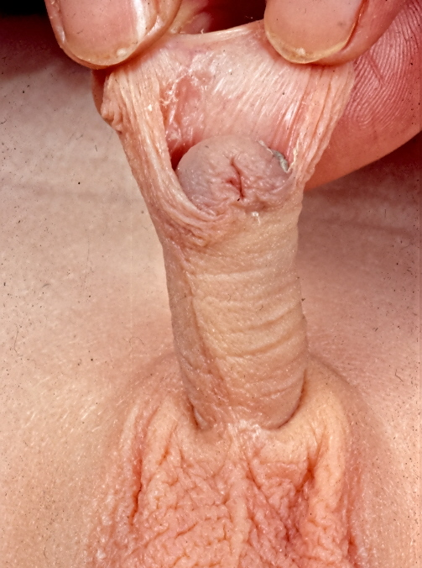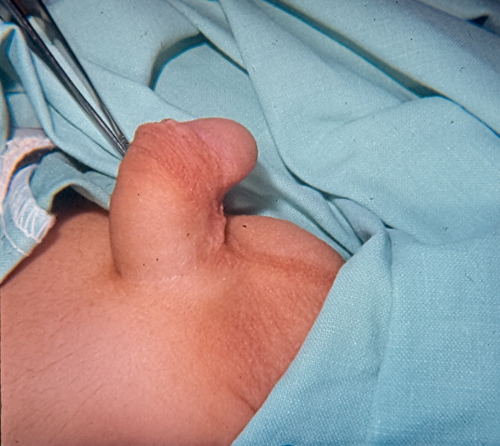
Figure 3. Hypospadias is associated with a) failure of the urethral meatus to be located on the tip of the glans, and failed ventral fusion of the prepuce, causing a ‘dorsal hood’; and b) inadequate growth of the ventral shaft around the urethra, leading to bend, known as chordee.

Hypospadias occurs in one in every 100-300 boys, depending on the criteria used for diagnosis . About 10% of patients with hypospadias have a sibling or father with the anomaly, suggesting a polygenic inheritance pattern . The severity of the anomaly varies widely, from a perineal opening to an opening on the proximal glans, or even chordee with a normal urethral meatus.

Care is needed in diagnosis, as some infants with a disorder of sex development (DSD) and ambiguous genitalia may be diagnosed as "simple hypospadias” . Since hypospadias is an anatomical anomaly of anterior urethral development, the rest of the external (and also internal) genitalia should be normal. Patients with DSD, by contrast, have a more extensive genital anomaly, reflecting the failure of all androgen-dependent development.

A useful rule-of-thumb is to assume that any baby with "hypospadias", as well as an undescended testis and/or bifid scrotum, should be investigated for DSD, with immediate hormonal, chromosomal and anatomical studies. Immediate gender assignment as male is only safe when the scrotum is fused and both testes are descended fully (i.e. androgen-dependent genital development is normal).

Surgical treatment is required to reconstruct the penis in hypospadias . Despite numerous different operative techniques available, there are a few principles of management: a). Create an extension to the urethra to bring it to the tip of the glans, allowing normal micturition; b) Correct the chordee to create a straight shaft for normal sexual function; c) Finally, repair the dorsal hood for cosmetic reasons. In severe cases the skin is moved ventrally to create the urethra and elongate the ventral surface; in mild cases the dorsal hood can be repaired to restore the normal appearance of the foreskin. Surgery is best between 6-18 months, and this is the recommended age, as this avoids much psychological stress but the operation should be completed at the latest in infants or young children prior to school entry. The operation may be done as day surgery, but may need admission with urinary diversion, depending on the severity of the anomaly and the surgeon’s preference.

The prognosis for micturition and sexual function is good, with improving cosmetic appearance with newer procedures . However, wound infection, hematoma, urethral breakdown to create a fistula, and stricture, continue to be serious problems, as the surgery requires significant skill .
REFERENCES

1. Lee P.A. and Houk C.P., Cryptorchidism. Current opinion in endocrinology, diabetes, and obesity, 2013. 20(3): p. 210-16.
2. Kolon T.F., Herndon C.D., Baker L.A., et al., Evaluation and treatment of cryptorchidism: AUA guideline. J Urol, 2014. 192(2): p. 337-45.
3. Pastuszak A.W. and Lipshultz L.I., AUA guideline on the diagnosis and treatment of cryptorchidism. J Urol, 2014. 192(2): p. 346-9.
4. Steinbrecher H., The undescended testis: working towards a unified care pathway for 2014. Archives of Disease in Childhood, 2014. 99(5): p. 397-8.
5. Mouriquand P.D., Undescended testes in children: the paediatric urologist's point of view. Eur J Endocrinol, 2008. 159 Suppl 1: p. S83-6.
6. Hutson J.M. and Thorup J., Evaluation and management of the infant with cryptorchidism. Curr Opin Pediatr, 2015. 26(4): p. 520-4.
7. Foresta C., Zuccarello D., Garolla A., et al., Role of hormones, genes, and environment in human cryptorchidism. Endocr Rev, 2008. 29(5): p. 560-80.
8. Hughes I.A. and Acerini C.L., Factors controlling testis descent. Eur J Endocrinol, 2008. 159 Suppl 1: p. S75-82.
9. Guven A. and BA K., Undescended testis in older boys: further evidence that ascending testes are common. J Pediatr Surg, 2008. 43(9): p. 1700-4.
10. van der Plas E.M., Zijp G.W., Froeling F.M., et al., Long-term testicular volume after orchiopexy at diagnosis of acquired undescended testis. The Journal of Urology, 2013. 190(1): p. 257-62.
11. Hutson J.M., Southwell B.R., Li R., et al., The Regulation of Testicular Descent and the Effects of Cryptorchidism. Endocr Rev, 2013. 134(5): p. 725-52.
12. Backhouse K.M., The natural history of testicular descent and maldescent. Proc R Soc Med, 1966. 59(4): p. 357-60.
13. van der Schoot P., The name cranial ovarian suspensory ligaments in mammalian anatomy should only be used to indicate the structures derived from the foetal cranial mesonephric and gonadal ligaments. Anat. Rec., 1993. 237: p. 434-8.
14. England M., A colour atlas of life before birth, in Normal fetal development, W. Medical, Editor. 1983: The Netherlands.
15. Heyns C.F., The gubernaculum during testicular descent in the human fetus. Journal of Anatomy., 1987. 153: p. 93-112.
16. Hutson J. and Hasthorpe S., Testicular descent and cryptorchidism: the state of the art in 2004. J Pediatr Surg, 2005. 40: p. 297-302.
17. Park J.I., Semyonov J., Chang C.L., et al., Origin of INSL3-mediated testicular descent in therian mammals. Genome Res, 2008. 18(6): p. 974-85.
18. Feng S., Ferlin A., Truong A., et al., INSL3/RXFP2 signaling in testicular descent. Ann N Y Acad Sci, 2009. 1160: p. 197-204.
19. Zimmermann S., Steding G., Emmen J.M., et al., Targeted disruption of the Insl3 gene causes bilateral cryptorchidism. Mol Endocrinol, 1999. 13(5): p. 681-91.
20. Nef S. and Parada L.F., Cryptorchidism in mice mutant for Insl3. Nat Genet, 1999. 22(3): p. 295-9.
21. Emmen J.M., McLuskey A., Adham I.M., et al., Hormonal control of gubernaculum development during testis descent: gubernaculum outgrowth in vitro requires both insulin-like factor and androgen. Endocrinology, 2000. 141(12): p. 4720-7.
22. Kubota Y., Temelcos C., Bathgate R.A., et al., The role of insulin 3, testosterone, Mullerian inhibiting substance and relaxin in rat gubernacular growth. Mol Hum Reprod, 2002. 8(10): p. 900-5.
23. Yamanaka J., Metcalfe S.A., Hutson J.M., et al., Testicular descent. II. Ontogeny and response to denervation of calcitonin gene-related peptide receptors in neonatal rat gubernaculum. Endocrinology, 1993. 132(1): p. 280-4.
24. Momose Y., Griffiths A.L. and Hutson J.M., Testicular descent. III. The neonatal mouse gubernaculum shows rhythmic contraction in organ culture in response to calcitonin gene-related peptide. Endocrinology, 1992. 131(6): p. 2881-4.
25. Welsh M., Saunders P.T., Fisken M., et al., Identification in rats of a programming window for reproductive tract masculinization, disruption of which leads to hypospadias and cryptorchidism. J Clin Invest, 2008. 118(4): p. 1479-1490.
26. Nation T., Balic A., Buraundi S., et al., The antiandrogen flutamide perturbs inguinoscrotal testicular descent in the rat and suggests a link with mammary development. Journal of Pediatric Surgery, 2009. 44(12): p. 2330-2334.
27. Tomiyama H., Sasaki Y., Huynh J., et al., Testicular descent, cryptorchidism and inguinal hernia: the Melbourne perspective. J Pediatr Urol, 2005. 1(1): p. 11-25.
28. Balic A., Nation T., Buraundi S., et al., Hidden in plain sight: the mammary line in males may be the missing link regulating inguinoscrotal testicular descent. J Pediatr Surg. 45(2): p. 414-8; discussion 418.
29. Nation T.R., Buraundi S., Balic A., et al., The effect of flutamide on expression of androgen and estrogen receptors in the gubernaculum and surrounding structures during testicular descent. Journal of Pediatric Surgery, 2011. 46(12): p. 2358-62.
30. Balic A., Hidden in plain sight: the mammary line in males may be the missing link regulating inguinoscrotal testicular descent. J Pediatr Surg, 2009. in press.
31. Nightingale S.S., Western P. and Hutson J.M., The migrating gubernaculum grows like a "limb bud". J Pediatr Surg, 2008. 43(2): p. 387-90.
32. Tickle C., Patterning systems--from one end of the limb to the other. Dev Cell, 2003. 4(4): p. 449-58.
33. Hutson J. and Beasley S., Descent of the Testis. Edward Arnold, London, 1992: p. 1-87.
34. Husmann D.A. and Levy J.B., Current concepts in the pathophysiology of testicular undescent. Urology, 1995. 46(2): p. 267-76.
35. Hutson J.M., Hasthorpe S. and Heyns C.F., Anatomical and functional aspects of testicular descent and cryptorchidism. Endocr Rev, 1997. 18(2): p. 259-80.
36. Hadziselimovic F., Duckett J.W., Snyder H.M., 3rd, et al., Omphalocele, cryptorchidism, and brain malformations. J Pediatr Surg, 1987. 22(9): p. 854-6.
37. Fallat M., Hersh J. and JM H., Theories on the relationship between cryptorchidism and arthrogryposos. Pediatr Surg Int, 1992. 7(271).
38. Hutson J., Cryptorchidism in spina bifida and spinal cord transection: a clue to the mechanism of transinguinal descent of the testis. J Pediatr Surg, 1988. 23: p. 275-277.
39. Kaplan L.M., Koyle M.A., Kaplan G.W., et al., Association between abdominal wall defects and cryptorchidism. J Urol, 1986. 136(3): p. 645-7.
40. Sharpe R.M. and Skakkebaek N.E., Are oestrogens involved in falling sperm counts and disorders of the male reproductive tract? Lancet, 1993. 341(8857): p. 1392-5.
41. Block K., Kardana A., Igarashi P., et al., In utero diethylstilbestrol (DES) exposure alters Hox gene expression in the developing mullerian system. Faseb J, 2000. 14(9): p. 1101-8.
42. Bergh A. and Soder O., Studies of cryptorchidism in experimental animal models. Acta Paediatr, 2007. 96(5): p. 617-21.
43. Johansen T., Non-union of testis and epididymis. Scand J Urol Nephrol., 1988. 22: p. 165-70.
44. Gill B., Kogan S., Starr S., et al., Significance of epididymal and ductal anomalies associated with testicular maldescent. J Urol, 1989. 142(2 Pt 2): p. 556-8; discussion 572.
45. Hakonsen L.B., Ernst A. and Ramlau-Hansen C.H., Maternal cigarette smoking during pregnancy and reproductive health in children: a review of epidemiological studies. Asian Journal of Andrology, 2014. 16(1): p. 39-49.
46. Hackshaw A., Rodeck C. and Boniface S., Maternal smoking in pregnancy and birth defects: a systematic review based on 173 687 malformed cases and 11.7 million controls. Hum Reprod Update, 2011. 17(5): p. 589-604.
47. Virtanen H.E. and Toppari J., Embryology and physiology of testicular development and descent. Pediatric endocrinology reviews : PER, 2014. 11 Suppl 2: p. 206-13.
48. Browne D., The diagnosis of undescended testicle. British Medical Journal, 1938. 11: p. 92-7.
49. Dogruyol H. and Balkan E., Perineal ectopic testis. Br J Urol, 1992. 69(5): p. 547.
50. Gendrel D., Roger M. and Job J.C., Plasma gonadotropin and testosterone values in infants with cryptorchidism. J Pediatr, 1980. 97(2): p. 217-20.
51. Job J.C., Toublanc J.E., Chaussain J.L., et al., Endocrine and immunological findings in cryptorchid infants. Horm Res, 1988. 30(4-5): p. 167-72.
52. Hadziselimovic F. and Hoecht B., Testicular histology related to fertility outcome and postpubertal hormone status in cryptorchidism. Klinische Pädiatrie, 2008. 220(5): p. 302-307.
53. Baker B.A., Morley R. and Lucas A., Plasma testosterone in preterm infants with cryptorchidism. Arch Dis Child, 1988. 63(10): p. 1198-200.
54. Brown T., Berkovits G. and Gearheart J., Androgen receptors in boys with isolated bilateral cryptorchidism. Am J Dis Child, 1988. 142: p. 933.
55. Baker M., Metcalfe S. and Hutson J., Serum levels of Mullerian inhibiting substance in boys from birth to 18 years, as determined by enzyme immunoassay. Clin Endocr Metab 1990. 70: p. 11-15.
56. Yamanaka J., Baker M., Metcalfe S., et al., Serum levels of Mullerian inhibiting substance in boys with cryptorchidism. J Pediatr Surg, 1991. 26(5): p. 621-3.
57. Thorup J., Clasen-Linde E., Thorup S.C., et al., Pre- and postoperative status of gonadotropins (FSH and LH) and inhibin-B in relation to testicular histopathology at orchiopexy in infant boys with unilateral undescended testes. J Pediatr Urol, 2015. 11(1): p. 25 e1-5.
58. Huff D.S., Hadziselimovic F., Snyder H.M., 3rd, et al., Postnatal testicular maldevelopment in unilateral cryptorchidism. J Urol, 1989. 142(2 Pt 2): p. 546-8; discussion 572.
59. Huff D.S., Hadziselimovic F., Snyder H.M., 3rd, et al., Early postnatal testicular maldevelopment in cryptorchidism. J Urol, 1991. 146(2 ( Pt 2)): p. 624-6.
60. Huff D.S., Hadziselimovic F., Snyder H.M., 3rd, et al., Histologic maldevelopment of unilaterally cryptorchid testes and their descended partners. Eur J Pediatr, 1993. 152 Suppl 2: p. S11-4.
61. Virtanen H.E., Bjerknes R., Cortes D., et al., Cryptorchidism: classification, prevalence and long-term consequences. Acta Paediatr, 2007. 96(5): p. 611-6.
62. Sharpe R.M., Perinatal determinants of adult testis size and function. J Clin Endocrinol Metab, 2006. 91(7): p. 2503-5.
63. Zhou B., Watts L.M. and Hutson J.M., Germ cell development in neonatal mouse testes in vitro requires mullerian inhibiting substance. J Urol, 1993. 150(2 Pt 2): p. 613-6.
64. Su S., Szarek M., Vooght A., et al., Gonocyte transformation to spermatogonial stem cells occurs earlier in patients with undervirilisation syndromes. Journal of Pediatric Surgery, 2014. 49(2): p. 323-7.
65. Hutson J., Undescended testes, in Pediatric Surgery and Urology: Longterm outcomes, M.P. Oldham K, Editor. 2006, University Press: Cambridge. p. 652-663.
66. Giwercman A., Bruun E., Frimodt-Moller C., et al., Prevalence of carcinoma in situ and other histopathological abnormalities in testes of men with a history of cryptorchidism. J Urol, 1989. 142(4): p. 998-1001: discussion 1001-2.
67. Giwercman A., Muller J. and Skakkebaek N.E., Carcinoma in situ of the testis: possible origin, clinical significance, and diagnostic methods. Recent Results Cancer Res, 1991. 123: p. 21-36.
68. Hutson J.M., Li R., Southwell B.R., et al., Germ cell development in the postnatal testis: the key to prevent malignancy in cryptorchidism? Frontiers in endocrinology, 2012. 3: p. 176.
69. Vikraman J., Hutson J.M., Li R., et al., The undescended testis: clinical management and scientific advances. unpublished, 2015.
70. Beltran-Brown F. and Villegas-Alvarez F., Clinical classification for undescended testes: experience in 1,010 orchidopexies. J Pediatr Surg, 1988. 23(5): p. 444-7.
71. Hrebinko R.L. and Bellinger M.F., The limited role of imaging techniques in managing children with undescended testes. J Urol, 1993. 150(2 Pt 1): p. 458-60.
72. Cortes D., Thorup J.M., Lenz K., et al., Laparoscopy in 100 consecutive patients with 128 impalpable testes. Br J Urol, 1995. 75(3): p. 281-7.
73. Thorsson A.V., Christiansen P. and Ritzen M., Efficacy and safety of hormonal treatment of cryptorchidism: current state of the art. Acta Paediatr, 2007. 96(5): p. 628-30.
74. Ritzen E.M., Bergh A., Bjerknes R., et al., Nordic consensus on treatment of undescended testes. Acta Paediatr, 2007. 96(5): p. 638-43.
75. Rajfer J., Handelsman D.J., Swerdloff R.S., et al., Hormonal therapy of cryptorchidism. A randomized, double-blind study comparing human chorionic gonadotropin and gonadotropin-releasing hormone. N Engl J Med, 1986. 314(8): p. 466-70.
76. deMuinck Keizer-Schrama S., Hazebroek F.W., Matroos A.W., et al., Double-blind, placebo-controlled study of luteinising-hormone-releasing-hormone nasal spray in treatment of undescended testes. Lancet, 1986. 1(8486): p. 876-80.
77. Bica D.T. and Hadziselimovic F., Buserelin treatment of cryptorchidism: a randomized, double-blind, placebo-controlled study. J Urol, 1992. 148(2 Pt 2): p. 617-21.
78. Mieusset R., Fonda P., Vaysse P., et al., Increase in testicular temperature in case of cryptorchidism in boys. Fertility and Sterility, 1993. 59: p. 1319-1321.
79. Zhou B., Hutson J.M. and Hasthorpe S., Efficacy of orchidopexy on spermatogenesis in the immature mutant 'trans-scrotal' rat as a cryptorchid model by quantitative cytological analysis. Br J Urol, 1998. 81(2): p. 290-4.
80. Kollin C., Hesser U., Ritzen E.M., et al., Testicular growth from birth to two years of age, and the effect of orchidopexy at age nine months: a randomized, controlled study. Acta Paediatr, 2006. 95(3): p. 318-24.
81. Kollin C. and Ritzen E.M., Cryptorchidism: a clinical perspective. Pediatric endocrinology reviews : PER, 2014. 11 Suppl 2: p. 240-50.
82. Wilson-Storey D., McGenity K. and Dickson J.A., Orchidopexy: the younger the better? J R Coll Surg Edinb, 1990. 35(6): p. 362-4.
83. Ein S.H., Nasr A., Wales P.W., et al., Testicular atrophy after attempted pediatric orchidopexy for true undescended testis. J Pediatr Surg, 2014. 49(2): p. 317-22.
84. Elder J.S., Two-stage Fowler-Stephens orchiopexy in the management of intra-abdominal testes. J Urol, 1992. 148(4): p. 1239-41.
85. Pintus C., Coppola R., Talamo M., et al., Laparoscopic approach for nonpalpable abdominal testis. Surg Laparosc Endosc, 1997. 7(2): p. 156-8.
86. Samadi A.A., Palmer L.S. and Franco I., Laparoscopic orchiopexy: report of 203 cases with review of diagnosis, operative technique, and lessons learned. J Endourol, 2003. 17(6): p. 365-8.
87. Lee P.A., O'Leary L.A., Songer N.J., et al., Paternity after bilateral cryptorchidism. A controlled study. Arch Pediatr Adolesc Med, 1997. 151(3): p. 260-3.
88. Lee P.A., O'Leary L.A., Songer N.J., et al., Paternity after unilateral cryptorchidism: a controlled study. Pediatrics, 1996. 98(4 Pt 1): p. 676-9.
89. Thorup J., Haugen S., Kollin C., et al., Surgical treatment of undescended testes. Acta Paediatr, 2007. 96(5): p. 631-7.
90. Feyles F., Peiretti V., Mussa A., et al., Improved sperm count and motility in young men surgically treated for cryptorchidism in the first year of life. Eur J Pediatr Surg, 2014. 24(5): p. 376-80.
91. Chilvers C., Dudley N.E., Gough M.H., et al., Undescended testis: the effect of treatment on subsequent risk of subfertility and malignancy. J Pediatr Surg, 1986. 21(8): p. 691-6.
92. Moller H. and Skakkebaek N.E., Risks of testicular cancer and cryptorchidism in relation to socio-economic status and related factors: case-control studies in Denmark. Int J Cancer, 1996. 66(3): p. 287-93.
93. Moller H., Prener A. and Skakkebaek N.E., Testicular cancer, cryptorchidism, inguinal hernia, testicular atrophy, and genital malformations: case-control studies in Denmark. Cancer Causes Control, 1996. 7(2): p. 264-74.
94. Muller J. and NE S., Cryptorchidism. Current Therapy in Endocrinology and Metabolism, 1997. 6: p. 363-6.
95. Swerdlow A.J., Higgins C.D. and Pike M.C., Risk of testicular cancer in cohort of boys with cryptorchidism. Bmj, 1997. 314(7093): p. 1507-11.
96. Stone J.M., Cruickshank D.G., Sandeman T.F., et al., Laterality, maldescent, trauma and other clinical factors in the epidemiology of testis cancer in Victoria, Australia. Br J Cancer, 1991. 64(1): p. 132-8.
97. Farrington G., The position and retractibility of the normal testis in childhood with reference to the diagnosis and treatment of cryptorchidism. J.Pediatr.Surg, 1968. 3: p. 53.
98. Hutson J.M. and Goh D.W., Can undescended testes be acquired? Lancet, 1993. 341(8843): p. 504.
99. Clarnette T.D., Rowe D., Hasthorpe S., et al., Incomplete disappearance of the processus vaginalis as a cause of ascending testis. J Urol, 1997. 157(5): p. 1889-91.
100. Mayr J., Rune G.M., Holas A., et al., Ascent of the testis in children. Eur J Pediatr, 1995. 154(11): p. 893-5.
101. John Radcliffe Hospital Cryptorchidism Study Group, Boys with late ascending testes: The source of patients with "rectractile" testes undergoing orchidopexy. BMJ, 1986. 293: p. 789.
102. Hutson J.M., Treatment of undescended testes--time for a change in European traditions. Acta Paediatr, 2007. 96(5): p. 608-10.
103. Fenton E., Woodward A. and Hutson J., The ascending testis. Pediatr Surg Int, 1990. 5: p. 6-9.
104. Davey R.B., Undescended testes: early versus late maldescent. Pediatr Surg Int, 1997. 12(2/3): p. 165-7.
105. Smith A., Hutson J., Beasley S., et al., The relationship between cerebral palsy and cryptorchidism. J. Pediatr. Surg., 1989. 24: p. 1303-1305.
106. Clarnette T.D. and Hutson J.M., Is the ascending testis actually 'stationary'? Normal elongation of the spermatic cord is prevented by a fibrous remnant of the processus vaginalis. Pediatr Surg Int, 1997. 12(2/3): p. 155-7.
107. Myers N. and CB O., Undescended testes: congenital or acquired? Aust.Paediatr.J, 1975. 11: p. 76-80.
108. Schiffer K.A., Kogan S.J., Reda E.F., et al., Acquired undescended testes. Am J Dis Child, 1987. 141(1): p. 106-7.
109. Atwell J.D., Ascent of the testis: fact or fiction. Br J Urol, 1985. 57(4): p. 474-7.
110. Robertson J.F., Azmy A.F. and Cochran W., Assent to ascent of the testis. Br J Urol, 1988. 61(2): p. 146-7.
111. Donaldson K.M., Tong S.Y. and Hutson J.M., Prevalence of late orchidopexy is consistent with some undescended testes being acquired. Indian J Pediatr, 1996. 63(6): p. 725-9.
112. Bianchi A. and Squire B., Trans-scrotal orchidopexy: Orchidopexy revisited. Pediatr. Surg. Int, 1989. 4: p. 189.
113. Hack W.W., Goede J., van der Voort-Doedens L.M., et al., Acquired undescended testis: putting the pieces together. Int J Androl, 2011. 35(1): p. 41-5.
114. van Brakel J., Kranse R., de Muinck Keizer-Schrama S.M., et al., Fertility potential in a cohort of 65 men with previously acquired undescended testes. J Pediatr Surg, 2014. 49(4): p. 599-605.
115. Puri P. and O'Donnell B., Semen analysis of patients who had orchidopexy at or after seven years of age. Lancet, 1988. 2(8619): p. 1051-2.
116. Nistal M. and Paniagua R., Infertility in adult males with retractile testes. Fertil Steril, 1984. 41(3): p. 395-403.
117. Pike M.C., Boys with late descending testes. Br Med J (Clin Res Ed), 1986. 293(6557): p. 1307-8.
118. Penington E.C. and Hutson J.M., The urethral plate--does it grow into the genital tubercle or within it? BJU Int, 2002. 89(7): p. 733-9.
119. Baskin L., Hypospadias and urethral development. The Journal of Urology, 2000. 163(3): p. 951-960.
120. Rodriguez E., Jr., Weiss D.A., Ferretti M., et al., Specific morphogenetic events in mouse external genitalia sex differentiation are responsive/dependent upon androgens and/or estrogens. Differentiation, 2012. 84(3): p. 269-79.
121. Stephens F.D., Smith E. and Hutson J., Congenital anomalies of the kidney, urinary and genitral tracts. 2nd ed. 2002, London: Martin Dunitz. 410-429.
122. Baskins L., Hypospadias, in Pediatric Surgery 6th ed., O.N.J. Grosfeld JL, Fonkalsrud EW, Coran AG, Editor. 2006, Mosby Elsevier: Philadelphia. p. 1870-1898.
123. Bauer S.B., Retik A.B. and Colodny A.H., Genetic aspects of hypospadias. Urol Clin North Am, 1981. 8(3): p. 559-64.
124. Tong S.Y., Donaldson K. and Hutson J.M., When is hypospadias not hypospadias? Med J Aust, 1996. 164(3): p. 153-4.
125. Belman A.B., De-epithelialized skin flap coverage in hypospadias repair. J Urol, 1988. 140(5 Pt 2): p. 1273-6.
126. Keating M.A., Cartwright P.C. and Duckett J.W., Bladder mucosa in urethral reconstructions. J Urol, 1990. 144(4): p. 827-34.
127. Mollard P., Mouriquand P. and Felfela T., Application of the onlay island flap urethroplasty to penile hypospadias with severe chordee. Br J Urol, 1991. 68(3): p. 317-9.
128. Jones B.C., O'Brien M., Chase J., et al., Early hypospadias surgery may lead to a better long-term psychosexual outcome. J Urol, 2009. 182(4 Suppl): p. 1744-9.
129. Schultz J.R., Klykylo W.M. and Wacksman J., Timing of elective hypospadias repair in children. Pediatrics, 1983. 71(3): p. 342-51.
130. Baskins L., Hypospadias, in Pediatric Surgery and Urology: Long term outcomes, O.K. Stringer MD, Mouriquand PDE., Editor. 2006, University Press: Cambridge. p. 611-620.
131. Secrest C.L., Jordan G.H., Winslow B.H., et al., Repair of the complications of hypospadias surgery. J Urol, 1993. 150(5 Pt 1): p. 1415-8.
132. Scherz H.C., Kaplan G.W., Packer M.G., et al., Post-hypospadias repair urethral strictures: a review of 30 cases. J Urol, 1988. 140(5 Pt 2): p. 1253-5.

