DEFECTS OF THYROID HORMONE TRANSPORT IN SERUM

Samuel Refetoff MD, Departments of Medicine, Pediatrics and Committees on Genetics, The University of Chicago, Chicago, Illinois 60637-1470. srefetoff@uchicago.edu

Updated March 3, 2023

ABSTRACT

Inherited abnormalities of thyroid hormone-binding proteins are not uncommon and can predominate in some ethnic groups. They alter the number of iodothyronines present in serum and, although the concentration of free hormones remains unaltered, routine measurement can give erroneous results. With a single exception, inherited defects in thyroxine-binding globulin (TBG), are X-chromosome linked and thus, the full phenotype is expressed mostly in males. Partial TBG deficiency is more common than complete deficiency. High frequency of variants TBGs have been identified in African Blacks, Australian Aborigine, and Eskimos. Most defects producing TBG deficiency are caused by mutations in the structural gene. However, inherited X-linked partial deficiency can occur as the consequence of mutations of a gene enhancer. Inherited forms of TBG excess are all caused by gene duplication or triplication. Mutations in the transthyretin (TTR) gene producing a molecule with increased affinity for T4 are relatively rare. A variant TTR produces transient hyperthyroxinemia during non-thyroidal illness. Mutations of the human serum albumin (HSA) gene produce increased concentration of serum T4, a condition known as familial dysalbuminemic hyperthyroxinemia (FDH). They are relatively more common in individuals of Hispanic origin. They cause an increase in serum T4 owing to increased affinity for this iodothyronine but high concentrations in free T4 observed in direct measurement by some commercial methods are erroneous. A variant with increased affinity for T3 has been also identified.

INTRODUCTION

Abnormalities in the serum proteins that transport thyroid hormone do not alter the metabolic state and do not cause thyroid disease. However, they do produce alterations in thyroid hormone concentration in serum and when unrecognized have led to inappropriate treatment. When the abnormality is the consequence of altered synthesis, secretion or stability of the variant serum protein, the free thyroid hormone level estimated by most of the clinically available techniques remains within the range of normal. In contrast, when the defect results in a significant alteration of the affinity of the variant protein for the hormone, estimates of the free thyroid hormone level often give erroneous results and thus, it is prudent to measure the free hormone concentration by more direct methods such as equilibrium dialysis or ultrafiltration. This is also true in cases of complete TBG deficiency, in whom the estimation of free thyroid hormone level in serum by indirect methods, or using iodothyronine analogs as tracers, can also give erroneous results.

The existence of inherited defects of serum transport of thyroid hormone was first recognized in 1959 with the report of TBG-excess by Beierwaltes and Robbins (1). Genetic variants for each of the three major thyroid hormone transport proteins have since been described and in subsequent years, the molecular basis of a number of these defects has been identified (2). Clinically, these defects usually manifest as either euthyroid hyperthyroxinemia or hypothyroxinemia and more rarely, isolated hypertriiodothyroninemia (3). Associated abnormalities such as thyrotoxicosis, hypothyroidism, goiter, and familial hyperlipidemia are usually coincidental (4). However, individuals with thyroid disorders are more likely to undergo thyroid testing leading to the fortuitous detection of a thyroid hormone transport defect.

THYROXINE-BINDING GLOBULIN (TBG) DEFECTS

Familial TBG abnormalities are inherited as X-chromosome linked traits (5, 6), compatible with the location of the TBG (SERPINA7) gene on the long arm of the X-chromosome (Xq22.2) (7, 8). This mode of inheritance also suggests that the defects involve the TBG gene proper, rather than the rate of TBG disposal, as long ago postulated (5). The normal, common type TBG (TBG-N or TBG-C), has a high affinity for iodothyronines [affinity constants (Ka): 10-10 M-1 for T4 and 10-9 M-1 for T3] and binds 75% of the total T4 and T3 circulating in blood. Thus, with a single exception [HSA R218P and R218S (9-11), see below], among the inherited abnormalities of thyroid hormone transport proteins, those involving the TBG molecule produce usually more profound alterations of thyroid hormone concentration in serum.

Clinically TBG defects are classified according to the level of TBG in serum of affected hemizygotes (XY males or XO females, that express only the mutant allele): complete TBG deficiency (TBG-CD), partial TBG deficiency (TBG-PD) and TBG excess (TBG-E). In families with TBG-CD, affected males have no detectable TBG and carrier females (mothers or daughters) have on the average half the normal TBG concentration (4). In families with partially TBG deficient males, the mean TBG concentration in heterozygous females is usually above half the normal. Serum TBG concentration in males with TBG-E is 2 to 4-fold the normal mean and that in the corresponding carrier females, is slightly higher than half that of the affected males. These observations indicate an equal contribution of cells expressing the normal and mutant TBG genes. On rare occasions, selective inactivation of the X-chromosome has been the cause of manifestations of the complete defect (hemizygous phenotype) in heterozygous females (12, 13).

Inherited TBG defects can be further characterized by the level of denatured TBG (dnTBG) in serum and the physicochemical properties of the molecule. The latter can be easily determined without the need of purification. These properties are: (a) immunologic identity; (b) isoelectric focusing (IEF) pattern; (c) rate of inactivation when exposed to various temperatures and pH; and (d) affinity for the ligands, T4 and T3. More precise identification of TBG defects requires sequencing of the TBG gene.

MiP a Subject With TBG-CD

The proposita, a phenotypic female, was 13 years old when first seen because of retarded growth, amenorrhea and absence of secondary sexual traits. She was the first sibling of a second marriage for both parents. The family included a younger brother and four older half-siblings, two maternal and two paternal. The proposita was born to her 30-year-old mother after full-term, uncomplicated pregnancy. Infancy and early childhood development were normal until 4 years of age when it became apparent that she was shorter than her peers. She was 12 years of age when a low protein bound iodine (PBI, then a measure of T4) of 2.2 µg/dl (normal range 4.0-8.0) was noted and treatment with 120 mg of desiccated thyroid (equivalent to 200µg L-T4) daily was initiated. Since, during the ensuing 6 months, no change in her growth rate occurred and because PBI remained unchanged (2.0 µg/dl), the dose of desiccated thyroid was increased to 180 mg/day. This produced restlessness, perturbed sleep and deterioration of school performance necessitating discontinuation of thyroid hormone treatment. No family history of thyroid disease or short stature was elicited and the parents’ denied consanguinity.

On physical examination, the patient appeared younger than her chronological age, was short (137 cm) and showed no signs of sexual development. She had a webbed neck, low nuchal hairline, bilateral eyelid ptosis, shield-shaped chest, increased carrying angle and short 4th metacarpals and metatarsals. The thyroid gland was normal in size and consistency.

Buccal smear was negative for Barr bodies and karyotyping revealed 45 chromosomes consistent with XO Turner's syndrome. No chromosomal abnormalities were found in lymphocytes from the mother and father. Bone age was 12 years and X-ray of the scull showed a mild degree of hypertelorism. PBI and butanol extractable iodine were low at 2.0 and 1.8 µg/dl, respectively. Resin-T3 uptake was high at 59.9% (normal range 25-35%) indicating reduced TBG-binding capacity. A 24-hour thyroidal radioiodide uptake was normal at 29%, basal metabolic rate was +20% (normal range -10 to +20) and TG autoantibodies were not present. Serum cortisol was normal as were the responses to ACTH and metyrapone. Basal growth hormone concentration was normal at 8.0 ng/ml which rose to 32 ng/ml following insulin hypoglycemia.

Studies were carried out in all first-degree relatives and the proposita was treated cyclically with diethylstilbestrol which produced withdrawal uterine bleeding and gradual breast development.

Five family members, in addition to the proposita had thyroid function tests abnormalities. Two were males and three females. The two males (maternal grandfather and maternal half-brother) and the proposita had the lowest PBI levels and undetectable T4-binding to serum TBG. In contrast, the three females (mother, maternal aunt and maternal half-sister) had a lesser reduction of their PBI and T4-binding capacity to TBG approximately one-half the normal mean value. The two sons of the affected grandfather (maternal uncles to the proposita) had normal PBI and T4-binding to TBG. No interference with T4-binding to TBG or other serum protein abnormalities were found in affected members of the family. In vivo T4 kinetic studies revealed a rapid extrathyroidal turnover rate but normal daily secretion and degradation, compatible with their eumetabolic state.

INTERPRETATION

The incidental identification of thyroid tests abnormalities in the proposita is typical for most subjects with TBG deficiency as well as TBG excess. So is the initial unnecessary treatment; though less frequent with the routine measurement or estimation of free T4. The inherited nature of the defect is suspected by exclusion of factors known to cause acquired TBG abnormalities and should be confirmed by the presence of similar abnormalities in members of the family. The absence of male-to-male transmission and the carrier state of all female offspring of the affected males is a typical pattern of X-chromosome linked inheritance. This is further supported by the complete TBG deficiency in individuals having a single X chromosome (males and the XO female) and only partial TBG deficiency in carrier XX females.

Since the publication of this family in 1968 (14), the cause of the TBG defect was identified. From the mutation identified in the TBG gene of this family [TBG Harwichport (TBG-CD H)], it can be deduced that the molecule is truncated, missing 12 amino acids at the carboxyl terminus (15).

Fifty six TBG variants have been so far identified and in 50 the precise defect has been determined by gene analysis. Their primary structure defect, some of their physical and chemical properties and the resulting serum T4 concentrations are summarized in Table 1 and figure 1.

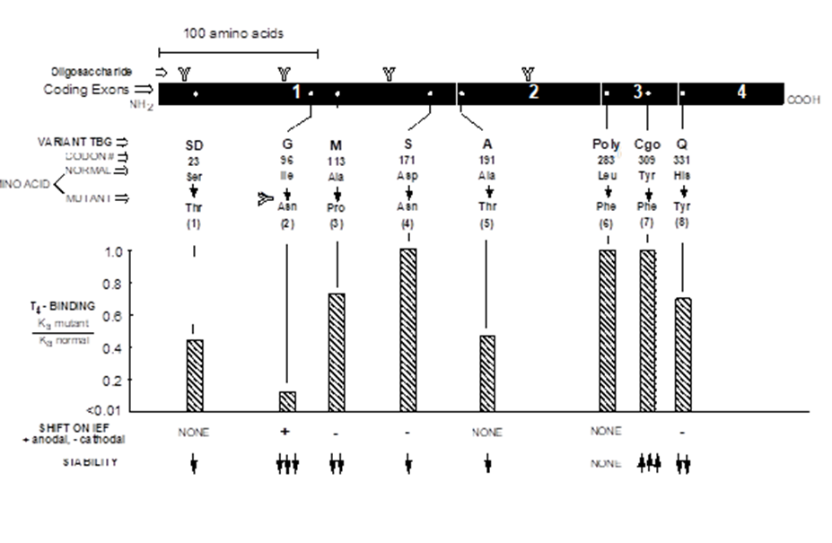
Figure 1. Properties of some TBG variants causing partial TBG deficiency (TBG-PD). The TBG variants are: -SD, San Diego; -G, Gary; -M, Montreal, -S, slow; -A, Aborigine; -Poly, polymorphic; -Cgo, Chicago; and -Q, Quebec. For detailed description, see (1) Sarne et al (39) and Bertenshaw et al (37); (2) Murata et al (34), Mori et al (43) and Kambe et al (60); (3) Takamatsu et al (44) and Janssen et al (45); (4) Takamatsu et al (55) and Waltz et al (56); (5) Murata et al (61) and Takeda et al (47); (6) Mori et al (26) and Takeda et al (57); (7) Takamatsu et al (59) and (58); (8) Takamatsu et al (44) and Bertenshaw et al (49). [Modified from Refetoff et al (62)].

Table 1. TBG Variants and Gene Mutations
TBG NAME | Abbreviated  name | Intron  Exon | CODON* | AMINO ACID |  | NUCLEOTIDE |  | References
 |  |  |  | WT | Variant | WT | Variant | References
Complete Deficiency (CD)
Milano (fam A) | CDMi† | IVS 1 | fs | 5' DSS | unknown | gtaagt | gttaagt | (16)
Andrews | CDAN | IVS 1 | fs | 5' DSS | unknown | gtaagt | gcaagt | (17)
Portuguese 1 (pt A) | CDP1 | 1 | 23 | S (Ser) | X (OCH) | TCA | TAA | (18)
Yonago | CDY | 1 | 28-29fs-51 | D F | X (OPA) | GA(CT)TT | GAATT | (19)
Negev (Bedouin | CDN | 1 | 38fs-51 | T (Thr) | X (OPA) | ACT | T del | (20, 21)
Nikita (fam B) | CDNi | 1 | 50fs-51 | P (Pro) | X (OPA) | CCT | T del | (16)
Taiwanese 1 | CDT1† | 1 | 52 | S (Ser) | N (Asn) | AGC | AAC | (22)
Parana | CDPa† | 1 | 61 | S (Ser) | C (Cys) | TCC | TGC | a
No name | CD6 | 1 | 165fs-168 | V (Val) | X (OCH) | GTT | T del | (23)
Kankakee | CDK | IVS 2 | 188fs-195 | 3' ASS | X (OPA) | agCC | ggCC | (24)
Poland | CDPL | 2 | 201fs-206 | D (Asp) | X (OCH) | GAC | G del | (25)
Portuguese 2 (pt B) | CDP2 | 2 | 223 | Q (Gln) | X (OCH) | CAA | TAA | (18)
No name | CD5† | 2 | 227 | L (Leu) | P (Pro) | CTA | CCA | (26)
Portuguese 3§ | CDP3 | 2 | 233 | N (Asn) | I (Ile) | ACC | ATC | (27)
Berlin | CDBn | IVS 3+3 | fs | intronic | unknown | intronic | 79nt del | (17)
Houston | CDH | IVS 3 | 279fs-374 | 3’ ASS | X (OPA) | agAT | aaAT | (28)
Buffalo | CDB | 3 | 280 | W (Trp) | X (AMB) | TGG | TAG | (29)
Taiwanese 2 | CDT2 | 3 | 280 | W (Trp) | X (OPA) | TGG | TGA | (22)
Lisle | CDL | IVS 4 | 280fs-325 | 5' DSS | X (OPA) | gtaaa | ggaaa | b
Jackson (fam K) | CDJa | IVS 4 | 280fs-325 | 5' DSS | X (OPA) | gtaaa | gtaag | (30)
No name | CD7 | 3 | 283fs-301 | L (Leu) | X (OPA) | TGT | G del | (15)
No name | CD8† | 4 | 329fs-374 | A (Ala) | X (OPA) | GCT | G del | (15)
Japan | CDJ | 4 | 352fs-374 | L (Leu) | X (OPA) | CTT | C del | (31, 32)
Penapolis | CDPe | 4 | 332fs-374 | K (Lys) | X (OPA) | AAG | A del | a
Kyoto§ | CDKo | 4 | 370 | S (Ser) | F (Phe) | TCT | TTT | (33)
Harwichport | CDH | 4 | 381fs-396 | Y (Tyr) | X (OPA) | AGG | 19nt del | (14, 15, 34)
NeuIsenburg | CDNl | 4 | 384fs-402 | L (Leu) | 7 aa add | CTC | TC del | (35)
Partial Deficiency (PD)
Allentown | PDAT | 1 | -2 | H (His) | Y (Tyr) | CAC | TAC | (36)
San Diego | PDSD† | 1 | 23 | S (Ser) | T (Thr) | TCA | ACA | (37-39)
Brasilia | PDB | 1 | 35 | R (Arg) | W (Trp) | CGG | TGG | (40)
Wanne-Eickel | PDWE | 1 | 35 | R (Arg) | E (Glu) | CGG | CAG | (41)
No name |  | 1 | 35 | R (Arg) | Q (Gln) | CGG | TGG | (41)
No name | ? | 1 | 52 | S (Ser) | R (Arg) | AGT | AGA | c
No name | ? | 1 | 64 | A (Ala) | D (Asp) | GCC | GAC | (42)
Korea | PDKa | 1 | 74 | E (Glu) | K (Lys) | GAG | AAG | a
Gary | PDG | 1 | 96 | I (Ile) | N (Asn) | ATC | AAC | (43)
No name |  | 1 | 112 | N (Asn) | L (Lys) | AAT | AAG | c
Montréal | PDM | 1 | 113 | A (Ala) | P (Pro) | GCC | CCC | (44, 45)
Berlin2 | Bn2 | 1 | 161 | T (Thr) | N (Asn) | ACC | AAC | a.
Aborigine | PDA† | 2 | 191 | A (Ala) | T (Thr) | GCA | ACA | (46, 47)
Glencoe | PDGe | 2 | 215 | V (Val) | G (Gly) | GTG | GGG | (48)
Quebec | PDQ† | 4 | 331 | H (His) | Y (Tyr) | CAT | TAT | (44, 49)
Japan (Kumamoto) | PDJ | 4 | 363 | P (Pro) | L (Leu) | CCT | CTT | (50, 51)
Heidelberg | PDHg | 4 | 368 | D (Asp) | G (Gly) | GAT | GGT | (52)
No name | ? | 4 | 381 | R (Arg) | G (Gly) | AGG | GGG | c
No name | ? | 4 | 382 | S (Ser) | R (Arg) | AGT | CGT | c
No name |  | enhancer |  | - | - | G | A | (53)
Other Variants
Slow | S | 1 | 171 | D (Asp) | N (Asn) | GAC | AAC | (54-56)
Polymorphism | Poly | 3 | 283 | L (Leu) | F (Phe) | TTG | TTT | (26, 57)
Chicago | CH or Cgo | 3 | 309 | Y (Tyr) | F (Phe) | TAT | TTT | (58, 59)
* Codon numbering from fist amino acid of the mature protein. The 20 amino acids of the signal peptide are numbered -1 to -20, from N- to C-terminus. The codon at the site of mutation is followed by the codon at the site of termination of translation.
† Coexistence of TBG Poly
§ complete deficiency is uncertain as the TBG assay used was unable to detect values <10% the mean normal
¶ Also a silent mutation at codon 55: GCA -> GCG
a Personal communication
b Personal observation
c Communicated by Pia Hermanns and Joachim Pohlenz, University of Mainz, Germany
del, delete; add, addition; aa, amino acid; fs, frame shift
Pt, patent; fam, family
IVS, intervening sequence or intron; ASS, acceptor splice site; DSS, donor splice site

Complete Deficiency of TBG (TBG-CD)

TBG-CD is defined as undetectable TBG in serum of affected hemizygous subjects or a value lesser than 0.03% the normal mean; the current limits of detection using the most sensitive radioimmunoassay (RIA) being 5ng/dl (26). The prevalence is approximately 1:15,000 newborn males. Twenty-seven TBG variants having this phenotype have been characterized at the gene level. These are shown in table 1 that also contains references to the original publications. Twenty two of the 27 TBG-CDs have truncated molecules. Early termination of translation of these variants is caused in 4 by a single nucleotide substitution (TBG-CDP1, TBG-CDP2, CD5, TBG-CDB and TBG-CDT2) or by a frame shift due to one nucleotide deletion (TBG-CDY, TBG-CDN, TBG-CDNi, TBG-CD6, CD-PL, TBG-CD7, TBG-CD8, and TBG-CDJ, TBG-CDPe) or deletion of 19 nucleotides (TBG-CDH). In 7 variants mutations occurred in introns, 6 of which are close to splice sites (TBG-CDMi, TBG-CDAN, TBG-CDK, TBGBn, TBG-CDH, TBG-CDL and TBG-CDJa). A mutation at the acceptor splice junction caused also a frame shift producing early termination of translation in TBG-CDK (24). In contrast a nucleotide substitutions in the 5' donor splice site of intron IV (TBG-CDL and TBG-CDJa), resulted in a complete splicing of exon 3, also producing a truncated molecule (30) and personal observation. A similar mechanism is likely responsible for CD in TBG-CDMi, though direct experimental prove was not provided (16). Single amino acid substitution was the cause of CD in five families (TBG-CDT1, TBG-CDPa, TBG-CD5, TBG-CDP3 and TBG-CDKo). In TBG-CD5 Leucine-227 with a proline was shown to cause aberrant post-translational processing (45). One TBG variant (TBG-CDNI), with two nucleotides deleted close to the carboxyl terminus, the resulting frame shift predicts an extension of the molecule by the addition of 7 nonsense residues (35). TBG-CDJ has been so far identified only in Japanese but its allele frequency in the population remains unknown (32, 57) (Table. 1).

Partial Deficiency of TBG (TBG-PD)

This is the most common form of inherited TBG deficiency having a prevalence of 1:4,000 newborn. Identification of heterozygous females by serum TBG measurement may be difficult because levels often overlap the normal range. In contrast to variants with complete TBG deficiency, all TBG-PDs have missense mutations. It is possible that three of the five variants with single amino acid substitutions included in the category of TBG-CD have also partial deficiency which was not identified owing to the low sensitivity of routine assays for the measurement of TBG. Twenty-one different mutations, producing a variable degree of reduction of TBG concentration in serum, have been identified, 20 of which involve mutations in the TBG gene proper. They are listed in table 1. In addition, some of these variants are unstable (TBG-PDG, TBG-PDA, TBG-PDSD, TBG-PDM TBG-PDQ and TBG-PDJ) or have lower binding affinity for T4 and T3 (TBG-PDG, TBG-PDA, TBG-PDS TBG-PDSD, TBG-PDM and TBG-PDQ), impaired intracellular transport and secretion (TBG-PDJ and TBG-CDJ) and some exhibit an abnormal migration pattern on IEF electrophoresis (TBG-PDG, TBG-PDM, and TBG-PDQ) (Fig. 1). Variants with decreased affinity for T4 and T3 have a disproportionate reduction in hormone concentration relative to the corresponding serum TBG level (Fig. 2) and estimations of the free hormone levels by any of the index methods gives erroneous results (39, 64). One of these variants, TBG-PDA, is found with high frequency (allele frequency of 51%) in Australian Aborigines (47).

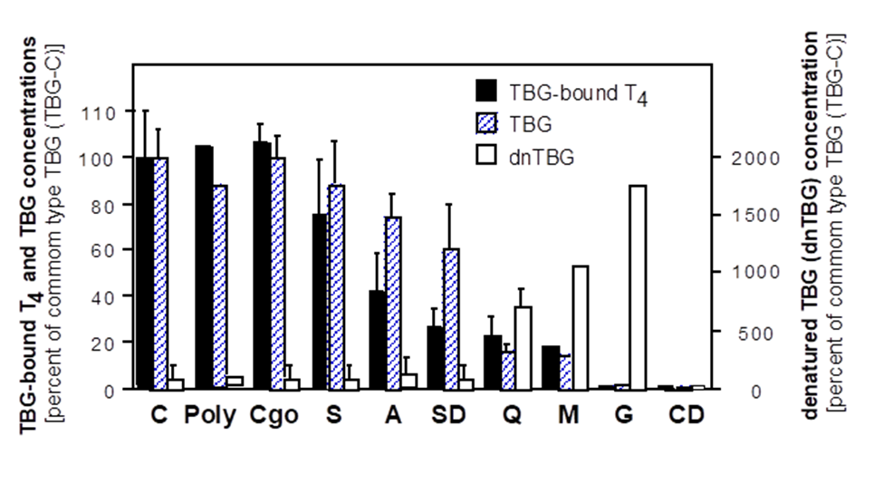
Figure 2. Serum T4-bound to TBG and the concentration of TBG and denatured TBG (dnTBG) in hemizygous subjects expressing the different TBG variants. Results, graphed as mean ± SD, were normalized by expressing them as % of those for the common type TBG (TBG-C). For abbreviations used in the nomenclature of the TBG variants, see legend to figure 1. [Adapted from Janssen et al (63)].

A unique family with TBG-PD has been described in which inheritance of the partial deficiency was autosomal dominant with transmission of the phenotype from father to son (65). The concentration of TBG in affected males and females was about one half the normal mean value. The TBG had normal affinity for T4. normal IEF and heat lability. No sequence changes were found in the entire coding arias of the gene or in the promoter region. Although the mechanism of TBG-CD in this family is unknown an abnormality in one of the factors regulating TBG gene transcription is a distinct possibility. Further studies to determine the genetic defect have been hampered by lack of subjects’ cooperation.

In 5% (4 or 74) families with X-chromosome lined TBG deficiency, studied in the author’s laboratory, no mutations were identified in the entire TBG gene, including all exons, introns, untranslated regions and the promoter region of the gene, covering a total of 9.2 kb. Next-generation sequencing identified a novel single nucleotide substitution 20 kb downstream of the TBG gene in all four families. In silico analysis predicted that the variant resides within a liver-specific enhancer. In vitro studies confirmed the enhancer activity of a 2.2-kb fragment of genomic DNA containing the novel variant and showed that the mutation reduces the activity of this enhancer. The affected subjects share a haplotype of 8 Mb surrounding the mutation. Three were of known Arab ethnicity and in all four families the most recent common ancestor was estimated to be 19.5 generations ago (95% confidence intervals). This is first report of an inherited endocrine disorder caused by a mutation in an enhancer region (53).

TBG Excess (TBG-E)

TBG-E has a lower prevalence than TBG deficiency, with values obtained from neonatal screening programs from 1:6,000 to 1:40,000 (66, 67). Considering that some newborn may have non-inherited, transient TBG excess, a conservative overall estimate of inherited TBG-E would be 1:25,000 (68). Early sequencing of the coding and promoter regions of subjects with TBG-E failed to show any defects (69). However, in 1995, Mori et al (70) found that gene amplification was the cause of TBG-E in two families. Gene triplication and duplication were demonstrated by gene dosage studies using HPLC measurements of the PCR -amplified product. As expected, hemizygous affected males had approximately 3- and 2-fold the average normal serum TBG concentration, respectively. The presence of multiple TBG gene copies in tandem was confirmed by in situ hybridization of prometaphase and interphase chromosomes from an affected male (Fig. 3).

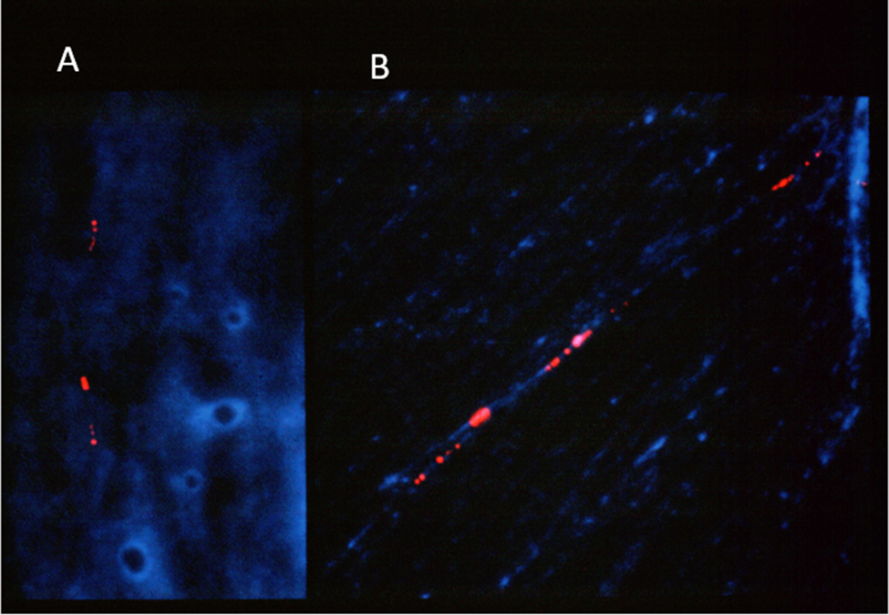
Figure 3. Hybridization in prometaphase chromosomes of cultured skin fibroblasts obtained from an affected male with TBG-E. A complete TBG cDNA was used as a probe. Three TBG gene copies are seen in tandem with each exon clearly identified in the starched chromosome shown in panel B.

TBG Variants with Unaltered TBG Concentrations in Serum

Five TBG variants have been identified that present with normal or slight and clinically insignificant alterations in their concentration in serum. Four occur with high frequency in some population groups and thus, can be considered as polymorphic. TBG-Poly (Fig. 1), with no alterations of its physical or biological properties, has been detected in 16% and 20% of the French Canadian and Japanese populations, respectively (26, 57). TBG-S exhibits a slower mobility on polyacrylamide gel electrophoresis and cathodal shift on IEF (54, 55), owing to the loss of a negative change due to the replacement of the normal Asp171 by Asn (56) (Figs. 1 and 4). It has an allele frequency of 5 to 16% in Black populations of African origin and 2 to 10% in Pacific Islanders. The molecular structure of two other polymorphic TBG variants has not been identified. TBG-F has an allele frequency of 3.2% in Eskimos residing on the Kodiac and St. Lawrence islands. It has a slight anodal (fast) mobility on IEF (71). TBG-C1 has been identified in subjects inhabiting two Mali village (72). It has a small cathodal shift on IEF and an allele frequency of 5.1%. TBG-Cgo, resistant to high temperatures (59), has normal affinity for T4 and T3. All SERPINs except human TBG have a Phe at a position corresponding to Tyr309. Structure modeling suggests that the replacement of the normal Tyr309 by Phe in TBG-Cgo, ties the internal α-helix hI1 to the molecule, thus stabilizing its tertiary structure (58). Studies using recombinant TBG–Cgo showed that the molecule exists in loop expelled conformation. However, when exposed at 37°C, the protein readily converts to a more stable loop inserted conformation explaining its subsequent enhanced heat stability, as observed in vivo (73).

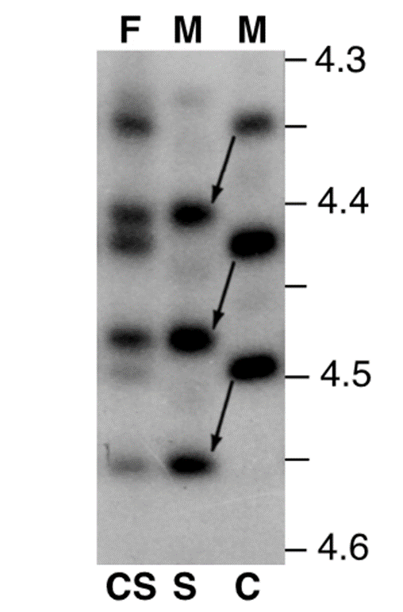
Figure 4. Microheterogeneity of TBG. Tracer amounts of l25I-T4 were added to serum prior to submission to isoelectric focusing and radioautography. TBG-C (common type) exhibits 6 bands spanning from pH 4.18 to 4.58. Three of the six are major and shown here between pH 4.35 and 4.50. TBG-Slow (TBG-S) from a hemizygous male shows a cathodally shifted pattern. A mixed pattern occurs in heterozygous females expressing both TBG-C and TBG-S. [Reproduced from Waltz et al (56)].

Biological Consequences of Structural Changes Caused by Mutations in the TBG Gene

The mechanisms whereby structural abnormalities of the TBG molecule produce the variant phenotypes have been investigated by expression of some of these molecules in living cells. Contrary to earlier speculation, increased extracellular degradation due to instability is a rare cause reduced concentration of the variant TBG in serum (38). More commonly, intracellular retention and degradation of the defective TBG molecules is responsible for their presence in low concentrations in serum (45, 51, 60, 74). Of note is the full intracellular retention of TBG-CD5 despite synthesis in normal quantities. A single amino acid substitution in TBG-CD5 is sufficient to alter its tertiary structure and thus prevent export. The same finding in the case of TBG-CDJ has been traced to its retention within the endoplasmic reticulum. Furthermore, the increased amount of GRP78 mRNA in cells transfected with TBG-PDJ suggests that association of this TBG variant with the GRP78 molecular chaperon is responsible for its impaired secretion (51). The variant TBG-AL is unique and important as it provides information about the function of the signal peptide. The resulting variable decrease in the serum TBG concentration associated with diminished in vitro secretion is compatible with impaired cotranslational processing (36).

Several speculations regarding the properties of variant TBGs have been confirmed based on the elucidation of the TBG structure by X-ray crystallography (75). The reduced ligand-binding of TBG-SD (38, 39) can be explained by the direct proximity of the amino acid substitution to the binding pocket. Indeed, the methyl group of the side chain of Thr23, replacing the normal Ser, will sterically hinder the binding of T4. Similarly, in TBG-A, the replacement of Ala191 by Thr (47) perturbs the H-bounds that stabilizes the binding pocket, leading to the reduced T4 binding. In contrast, the loss of His331 in TBG-Q (H331Y) (44, 49) allows unrestricted loop insertion in the upper half of the A-sheet, accounting for the increased in serum denatured (dn)TBG and reduced T4 binding.

TBG deficiency was found to coexist in the same family with resistance to thyroid hormone beta (RTHß) (76). Both TBG (P50fs51X) and THRB (P453A) gene mutations have been previously described in unrelated families (16, 77) but not in the same family. The mother harbored both gene mutations, whereas the proband and his sister had only the THRB gene mutation and a brother only the TBG gene mutation. This family illustrates the difficulty that might be encountered in the interpretation of thyroid function tests when different genetic defects, having opposite effect on thyroid function tests, coexist in the same family, and especially the same individual.

TRANSTHYRETIN (TTR) DEFECTS

Sequencing of the TTR gene, formerly known as thyroxine-binding prealbumin (TBPA) on chromosome 18 (18q11.2-q12.1), has uncovered mutations that produce variant TTR molecules with or without alterations in the binding affinity for iodothyronines (2, 78). Only those known to affect iodothyronine binding are listed in table 2. Some of the TTR variants are responsible for the dominantly inherited familial amyloidotic polyneuropathy (FAP), causing multiple organ failure and death in early adulthood.(78). Because TTR has a relatively lower affinity for T4 (about 100-fold lesser than that of TBG), it plays a minor role in thyroid hormone transport in blood. Accordingly, changes in the TTR concentration in serum and variant TTRs with reduced affinity for T4 have little effect on the concentration of serum T4 (79, 91). Only variant TTRs with a substantially increased affinity for iodothyronines produce significant elevation in serum T4 and rT3 concentrations and account for 2% of subjects with euthyroid hyperthyroxinemia (90).

Table 2. TTR Variants with Altered Affinity for T4 and Potentially an Effect on Tests of Thyroid Function in Serum
AFFINITY FOR T4  Mutant / Normal |  | TTR  CONCENTRATION | CODON  Number | AMINO ACID  (Normal - Variant) | REFERENCES
HOMO* | HETERO*
DECREASED
<0.1 | 0.17 - 0.41 | N | 30 | Val - Met | (79, 80)
 | 0.54 |  | 58 | Leu - His | (80)
 | 0.45 |  | 77 | Ser - Tyr | (80)
 | 0.19 – 0.46 | N | 84 | Ile - Ser | (79, 80)
~1.0 | 0.44 |  |  | Val - Ile | (80)
INCREASED
 | 3.5† | N | 6 | Gly - Ser | (81-83)
8.3-9.8 | 3.2 - 4.1‡ | N | 109 | Ala - Thr | (80, 84-86)
 |  | N | 109 | Ala - Val | (85)
 |  | Inc or N | 119 | Thr - Met | (87-90)
* HOMO, homozygous; HETERO, heterozygous.
† Probably overestimated since the subjects harboring this TTR variant have normal serum TT4 concentrations.
‡ Affinity of recombinant TTR Thr109 is 9-fold that of the normal TTR (86).
Variant TTR tested and shown not to have altered affinity to T4 are: Ala60, (hetero) (79, 80).
N, normal; Inc, increased
Endonucleases useful in the identification of TTR variants: Msp I -ve for Ser6 in exon 2 associated PHA; BsoFI -ve and Fnu 4H +ve for Thr109; BsoFI -ve for Val109 and Nco I +ve for Met119, all in exon 4.

A family with elevated total T4 concentration which was predominantly bound to TTR was first described in 1982 by Moses et al (92). The inheritance was autosomal dominant and affected members were clinically euthyroid with normal free T4 levels measured by equilibrium dialysis. The variant TTR has a single nucleotide substitution replacing the normal Ala109 with a Thr which increases its affinity for T4, rT3 and tetraiodothyroacetic acid and to a lesser extend T3 and triiodothyroacetic acid (84, 86). Crystallographic analysis of this variant TTR revealed an alteration in the size of the T4-binding pocket (93). Another TTR gene mutation involving the same codon has been subsequently described (85). This mutant TTR with Val109 has an increased affinity for T4 that is of similar magnitude as TTR Thr109, about 10-fold higher than that of wild-type TTR.

A more common defect found in subjects with prealbumin associated hyperthyroxinemia (PAH) is a point mutation in exon 4 of the TTR gene replacing the normal Thr119 with Met (90). First described in a single individual with normal serum total and free T4 levels (89), the majority of subsequently identified heterozygous subjects harboring the TTR Met119 had an increase in the fraction of T4 and rT3 associated with TTR, but only few had serum T4 levels above the upper limit of normal. Furthermore, their hyperthyroxinemia appears to be transient, usually in association with non-thyroidal illness (90). The variant TTRs associated with PAH are not amyloidogenic.

The unique occurrence in an Argentinian family of TTR A109T, known to have increased affinity for T4, in association with TGB-PD A64D mitigated the phenotype of the latter mutation (42)

Variant TTRs without Known Biological Effects

Several TTR variants have been found that do not alter the properties of the molecule, nor cause FAP, and are thus of no clinical significance. Of interest is a TTR variant found in the rhesus monkey, Macaca mulatta, but not in man (94, 95)[. This variant has a slower electrophoretic mobility resulting in three phenotypes which exhibit: (a) a single rapidly migrating band similar to that found in human and other primates (PAFF); (b) a single slowly migrating band cathodal to albumin (PASS); and (c) a five banded form corresponding to the various tetrameric recombinants present in the heterozygous state possessing the two different subunits (PAFS). This finding was important because the variant rhesus PA-S could be hybridized in vitro with human TTR yielding a five-banded pattern hence, demonstrating that human TTR is also a tetramer. All naturally occurring and hybrid polymorphic variants show no detectable alteration in the binding of either T4 or retinol binding protein (96).

HUMAN SERUM ALBUMIN (HSA) DEFECTS

Another form of dominantly inherited euthyroid hyperthyroxinemia, later to be linked to the albumin gene on chromosome 4 (4q11-q13), was first described in 1979 (97, 98). Known as familial dysalbuminemic hyperthyroxinemia (FDH) (99), it is the most common cause of inherited increase in total T4 in serum in the Caucasian population, producing on the average a 2-fold increase in the serum total T4 concentration. In a study of 430 subjects suspected of having euthyroid hyperthyroxinemia 12% were proven to have FDH (90). The prevalence varies from 0.01 to 1.8%, depending on the ethnic origin, with the highest prevalence in Hispanics (100-103). This form of FDH has not been reported in subjects of African origin and the isolated occurrence in a Chinese (104) was possibly brought by Hispanic travelers (see below). The euthyroid status of subjects with FDH has been confirmed by normal TSH response to TRH, normal free T4 concentration measured by equilibrium dialysis using appropriate buffer systems, normal T4 production rate and normal serum sex hormone-binding globulin concentration (97, 99, 105, 106). Nevertheless, the falsely elevated free T4 values, when estimated by standard clinical laboratory techniques, has often resulted in inappropriate thyroid gland ablative or drug therapy (107-109). A recent survey of commonly used commercial tests for measurement of free T4 indicates that equilibrium or symmetric dialysis are the only tests that will consistently provide accurate values in subjects with FDH (110), in particular one using dialysis in combination with tandem mass spectrometry (111).

FDH is suspected when serum total T4 concentration is increased without proportional elevation in total T3 level and non-suppressed serum TSH. Half of affected subjects have also rT3 values above the normal range (112) (Table 3). Since the same combination of test results are found in subjects with the Thr109 TTR variant, the diagnosis of FDH should be confirmed by the demonstration that an increased proportion of the total serum T4 migrates with HSA on non-denaturing electrophoresis or precipitates with anti-HSA serum.

Table 3. Albumin Variants with Increased Affinities for Iodothyronines, Their Effect on the Serum Concentrations of and Affinities to these Hormones
VARIANT | SERUM CONCENTRATION |  |  |  |  | BINDING AFFINITY (Ka)  of the variant albumins |  | Reference
VARIANT | T4  µg/dl | T3  ng/dl | rT3  ng/dl | N |  | T4 | T3
 | (Fold the normal mean) |  |  |  |  | (Fold the normal mean)
WT | 8.0 ± 0.2 | 125 ± 4 | 22.5 ± 0.9 | 83 |  | 1 | 1 | A
R218H | 16.0 ± 0.5  (2.0) | 154 ± 3  (1.2) | 33.1 ± 1.1  (1.5) | 83 |  | (10 – 15) | (4) | a,(113, 114)
R218P | 135 ± 17  (16.8) | 241 ± 25  (1.9) | 136 ± 13  (6.1) | 8 |  | (11-13*) | (1.1*) | (9, 10)
R218S | 70  (8.8) | 159  (1.3) | 55.7  (2.6) | 1 |  | NM | NM | (11)
R222I | 21±1.4  (2.6) | 135±18  (1.2) | 1417±107  (86) | 8 |  | NM | NM | a, (115)
L66P | 8.7  (1.1) | 320  (3.3) | 22.3  (1) | 6 |  | (1.5) | (40) | (3)
Values reported are means ± standard error, and the number of subjects per genotype are indicated under ‘‘N.’’
* Determined at saturation. Affinities are higher at the concentrations of T4 and T3 found in serum.
NM, not measured
a, Personal observation
All data were generated in the Chicago laboratory except for 4 of the 8 individuals with ALB R218P and hose with ALB R222I, provided by Nadia Schoenmakers, University of Cambridge, UK.

A tight linkage between FDH and the HSA gene (lod score 5.25) was found in a large Swiss-Amish family using two polymorphic markers (112). This was followed by the identification of a missense mutation in codon 218 of the HSA gene replacing the normal arginine with a histidine (R218H) (113, 116). Furthermore, the same mutation was present in all subjects with FDH from 11 unrelated families. Its association with a Sac I+ polymorphism, suggest a founder effect and is compatible with ethnic predilection of FDH (113). The coexistence of FDH and a TTR variant with increased affinity for T4 in the same individual (82, 83) and FDH with TBG-PD in another (117) have been reported. In both instances these individuals were the product of parents each heterozygous for of one of the two defects.

Another mutation in codon 218, with increased affinity to iodothyronines, was first identified by Wada et al (9). The mutation, a replacement of the normal Arg218 with a Pro (R218P), initially believed to be unique for Japanese was also identified in a Swiss family with no Asian ancestry (Fig. 5) (10). In this form of FDH, serum total T4 levels are 14-20-fold the normal mean, a level confirmed by measurements in serum extracts by HPLC. Total rT3 and T3 concentrations are 7- and 2-fold above the mean, respectively. Thus, in order to maintain a normal free T4 level, the calculated affinity constant (Ka) of HSA R218P should be about 16-fold higher than that of HSA R218H. Surprisingly, the Kas measured at saturation were similar, 5.4 x 106 M-1 and 6.4 x 106 M-1 for HSA R218H, respectively (10, 118, 119) (Table 3). However, at T4 concentrations equivalent to those found in subjects with HSA R218P, the dialyzable FT4 concentration was 11-fold higher in serum of subjects with HSA R218H and 49-fold higher in serum with the common type HSA only (10).

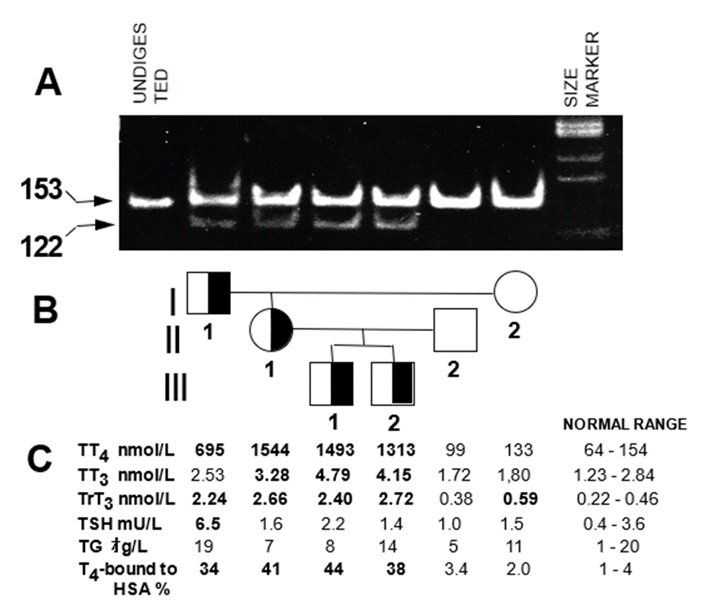
Figure 5. A Swiss family with HSA R218P: genotyping, pedigree and thyroid function tests. A, Genotyping for the mutation HSA R218P. Results are aligned with each subject depicted on the pedigree in B. Amplification of a segment of the HSA gene containing the mutation with a mismatched oligonucleotide primer creates a new restriction site for Ava II only in the presence of the mutant nucleotide (CGC -> CCC). Affected subjects expressing proline 218 (CCC) show a 122 bp DNA fragment produced by enzymatic digestion of the mutant allele. Note that all affected subjects are heterozygous and that the 153 bp fragment amplified from DNA of the two normal subjects, expressing arginine 218 (CGC) only, resists enzymatic digestion. B, Pedigree of the family. Roman numerals indicate each generation and numbers below each symbol identify the subject. Individuals expressing the FDH phenotype are indicated by half-filled symbols. C, Thyroid function tests. Results are aligned with each symbol. Values outside the normal range are in bold numbers. Note the disproportionate increase in serum T4 concentration as compared to that of T3 in the affected individuals. Subject I-1, a year old man, had diabetes mellitus with multiple organ complications and mild subclinical hypothyroidism, explaining the relatively lower serum T4 and T3 but not rT3 levels. [Adapted from Pannain et al (10)].

More recently two additional HSA gene mutations have been identified. One in the same codon resulting in a different amino acid substitution (R218S) (11) and another in a different amino acid (R222I) (115) in the proximity of the same iodothyronine-binding pocket (Fig. 6). While both manifest increased affinity for T4 and rT3, it is considerably higher for T4 in the former and for rT3 in the latter (Table 3). It is of note that the two amino acids, 218 and 222, involved in the gain-of-function mutations are located in the main predominantly hydrophobic pocket where T4 is bound in a cisoid conformation (120).

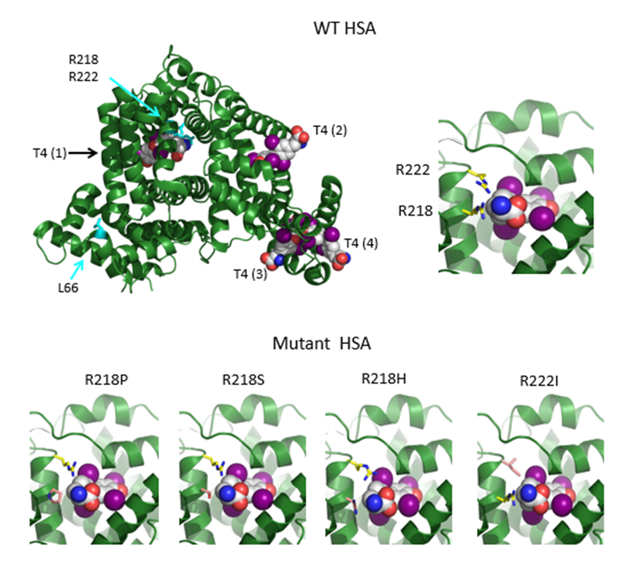
Figure 6. The structures of HSA in the presence of T4 as modeled on the structures 1BM0, 1HK1, 1HK3 in the Protein Data Bank (http://www.rcsb.org/pdb/home/home.do). Top panel shows on the left the entire WT HSA molecule (in green) with its four T4 binding sites [T4(1) to T4(4)] according to Petitpas et al (120) and to the right a close up of the binding pocket, T4 (1) containing arginine’s 218 and 222 along with the T4 molecule (carbons are in white, nitrogen’s in blue, oxygens in red and iodine in magenta). In the bottom panel are represented the structures of the T4 (1) binding pockets of the four mutant HSA showing, a better accommodation of T4 than in the WT HSA and thus, resulting in enhanced binding (From Erik Schoenmakers, University of Cambridge, UK).

A fifth gain-of-function mutation, a replacement of the normal Leu66 with a Pro (L66P) has been identified in a single Thai family (3). It produces a 40-fold increase in the affinity for T3 but only 1.5-fold increase in the affinity for T4 (Table 3). As a consequence, patients have hypertriiodothyroninemia but not hyperthyroxinemia. In this FDH-T3, serum T3 concentrations are falsely low, or even undetectable, when T3 is measured using an analog of T3 as a tracer rather than a radioisotope. It has resulted in the inappropriate treatment with thyroid hormone (3).

Bisalbuminemia and Analbuminemia

Variant albumins, with altered electrophoretic mobility produce "bisalbuminemia" in the heterozygotes (121). T4 binding has been studied in subjects from unrelated families with a slow HSA variant. In two studies only the slow moving HSA bound T4 (122, 123) and in another, both (124). The differential binding of T4 to one of the components of bisalbumin may be due to enhanced binding to the variant component with charged amino acid sequence. Bisalbuminemia does not seem to be associated with gross alterations in thyroid hormone concentration in serum.

Analbuminemia is extremely rare, occurring in less than 1 in a million individuals (125). The first case was reported in 1954 (126) but the HSA gene mutation was identified 56 years later (127). The less than 50 cases so far reported have nonsense mutations causing premature termination of translation or splicing defects (128). Despite the complete lack of such an important substance, symptoms are remarkably mild owing to the compensation by an increase in non-albumin serum proteins. Studies with respect to T4-transport showed no clear effect or slight increase total serum iodothyronines, associated with increased levels of TBG and TTR. (128, 129). The latter two normalized when serum HSA was restored to normal by multiple transfusions (129).

ACKNOWLEDGMENTS

Supported in part by grants DK-15070 from the National Institutes of Health (USA).

REFERENCES

1. Beierwaltes WH, Robbins J 1959 Familial increase in the thyroxine-binding sites in serum alpha globulin. J Clin Invest 38:1683-1688.
2. Pappa T, Ferrara AM, Refetoff S 2015 Inherited defects of thyroxine-binding proteins. Best Pract Res Clin Endocrinol Metab 29:735-747.
3. Sunthornthepvarakul T, Likitmaskul S, Ngowngarmratana S, Angsusingha K, Sureerat K, Scherberg NH, Refetoff S 1998 Familial dysalbuminemic hypertriiodothyroninemia: a new dominantly inherited albumin defect. J Clin Endocrinol Metab 83:1448-1454.
4. Refetoff S 1989 Inherited thyroxine-binding globulin (TBG) abnormalities in man. Endocr Rev 10:275-293.
5. Refetoff S, Robin NI, Alper CA 1972 Study of four new kindreds with inherited thyroxine-binding globulin abnormalities: Possible mutations of a single gene locus. J Clin Invest 51:848-867.
6. Burr WA, Ramsden DB, Hoffenberg R 1980 Hereditary abnormalities of thyroxine-binding globulin concentration. Quart J Med 49:295-313.
7. Trent JM, Flink IL, Morkin E, Van Tuinen P, Ledbetter DH 1987 Localization of the human thyroxine-binding globulin gene to the long arm of the X chromosome (Xq21-22). Am J Hum Genet 41:428-435.
8. Mori Y, Miura Y, Oiso Y, Seo H, Takazumi K 1995 Precise localization of the human thyroxine-binding globulin gene to chromosome Xq22.2 by fluorescence in situ hybridization. Hum Genet 96:481-482.
9. Wada N, H. C, Shimizu C, Kijima H, Kubo M, Koike T 1997 A novel misssense mutation in codon 218 of the albumin gene in a distinct phenotype of familial dysalbuminemic hyperthyroxinemia in a Japanese kindred. J Clin Endocriol Metab 82:3246-3250.
10. Pannain S, Feldman M, Eiholzer U, Weiss RE, Scherberg NH, Refetoff S 2000 Familial dysalbuminemic hyperthyroxinemia in a Swiss family caused by a mutant albumin (R218P) shows an apparent discrepancy between serum concentration and affinity for thyroxine. J Clin Endocrinol Metab 85:2786-2792.
11. Greenberg SM, Ferrara AM, Nicholas ES, Dumitrescu AM, Cody V, Weiss RE, Refetoff S 2014 A Novel Mutation in the Albumin Gene (R218S) Causing Familial Dysalbuminemic Hyperthyroxinemia in a Family of Bangladeshi Extraction. Thyroid 24:945-950.
12. Okamoto H, Mori Y, Tani Y, Nakagomi Y, Sano T, Ohyama K, Saito H, Oiso Y 1996 Molecular analysis of females manifesting thyroxine-binding globulin (TBG) deficiency: selective X-chromosome inactivation responsible for the difference between phenotype and genotype in TBG-deficient females. J Clin Endocrinol Metab 81:2204-2208.
13. Gawandi S, Jothivel K, Kulkarni S 2022 Identification of a novel mutation in thyroxine-binding globulin (TBG) gene associated with TBG-deficiency and its effect on the thyroid function. J Endocrinol Invest 45:731-739.
14. Refetoff S, Selenkow HA 1968 Familial thyroxine-binding globulin deficiency in a patient with Turner's syndrome (X0): Genetic study of a kindred. N Engl J Med 278:1081-1087.
15. Reutrakul S, Janssen OE, Refetoff S 2001 Three novel mutations causing complete T₄-binding globulin deficiency. J Clin Endocrinol Metab 86:5039-5044.
16. Mannavola D, Vannucchi G, Fugazzola L, Cirello V, Campi I, Radetti G, Persani L, Refetoff S, Beck-Peccoz P 2006 TBG deficiency: description of two novel mutations associated with complete TBG deficiency and review of the literature. J Mol Med 84:864-871.
17. Moeller LC, Appiagyei-Dankah Y, Kohler B, Biebermann H, Janssen OE, Fuhrer D 2015 Two Novel Mutations in the Serpina7 Gene Are Associated with Complete Deficiency of Thyroxine-Binding Globulin. Eur Thyroid J 4:108-112.
18. Domingues R, Bugalho MJ, Garrão A, Boavida JM, Sobrinho L 2002 Two novel variants in thyroxine-binding globulin (TBG) gene behind the diagnosis of TBG deficiency. Eur J Endocrinol 146:485-490.
19. Ueta Y, Mitani Y, Yoshida A, Taniguchi S, Mori A, Hattori K, Hisatome I, Manabe I, Takeda K, Sato R, Ahmmed GU, Tsuboi M, Ohtahara A, Hiroe K, Tanaka Y, Shigemasa C 1997 A novel mutation causing complete deficiency of thyroxine binding globulin. Clin Endocrinol (Oxf) 47:1-5.
20. Hershkovitz E, Leiberman E, Refetoff S, Pilpell D, Phillip M 1995 High prevalence of thyroxine-binding globulin deficiency among Bedouin infants in southern Israel. Isr J Med Sci 31:500-502.
21. Miura Y, Hershkovitz E, Inagaki A, Parvari R, Oiso Y, Phillip M 2000 A novel mutation causing complete thyroxine-binding globulin deficiency (TBG-CD-Negev) among the Bedouins in southern Israel. J Clin Endocrinol Metab 85:3687-3689.
22. Su CC, Wu YC, Chiu CY, Won JG, Jap TS 2003 Two novel mutations in the gene encoding thyroxine-binding globulin (TBG) as a cause of complete TBG deficiency in Taiwan. Clin Endocrinol (Oxf) 58:409-414.
23. Li P, Janssen OE, Takeda K, Bertenshaw RH, Refetoff S 1991 Complete thyroxine-binding globulin (TBG) deficiency caused by a single nucleotide deletion in the TBG gene. Metabolism 40:1231-1234.
24. Carvalho GA, Weiss RE, Refetoff S 1998 Complete thyroxine-binding globulin (TBG) deficiency produced by a mutation in the acceptor splice site causing frameshift and early termination of translation (TBG-Kankakee). J Clin Endocrinol Metab 83:3604-3608.
25. Lacka K, Nizankowska T, Ogrodowicz A, Lacki JK 2007 A Novel Mutation (del 1711 G) in the TBG Gene as a Cause of Complete TBG Deficiency. Thyroid 17:1143-1146.
26. Mori Y, Takeda K, Charbonneau M, Refetoff S 1990 Replacement of Leu²²⁷ by Pro in thyroxine-binding globulin (TBG) is associated with complete TBG deficiency in three of eight families with this inherited defect. J Clin Endocrinol Metab 70:804-809.
27. Domingues R, Font P, Sobrinho L, Bugalho MJ 2009 A novel variant in Serpina7 gene in a family with thyroxine-binding globulin deficiency. Endocrine 36:83-86.
28. Personal-Observation.
29. Carvalho GA, Weiss RE, Vladutiu AO, Refetoff S 1998 Complete deficiency of thyroxine-binding globulin (TBG-CD Buffalo) caused by a new nonsense mutation in the thyroxine-binding globulin gene. Thyroid 8:161-165.
30. Reutrakul S, Dumitrescu A, Macchia P, Moll GWJ, Vierhapper H, Refetoff S 2002 Complete thyroxine-binding globulin (TBG) deficiency in two families without mutations in coding or promoter regions of the TBG gene: in vitro demonstration of exon skipping. J Clin Endocrinol Metab 87:1045-1051.
31. Yamamori I, Mori Y, Seo H, Hirooka Y, Imamura S, Miura Y, Matsui N, Oiso Y 1991 Nucleotide deletion resulting in frameshift as a possible cause of complete thyroxine-binding globulin deficiency in six Japanese families. J Clin Endocrinol Metab 73:262-267.
32. Yamamori I, Mori Y, Miura Y, Tani Y, Imamura S, Oiso Y, Seo H 1993 Gene screening of 23 Japanese families with complete thyroxine-binding globulin deficiency: Identification of a nucleotide deletion at codon 352 as a common cause. Endocr J 40:563-569.
33. Yorifuji T, Muroi J, Uematsu A, Momoi T, Furusho K 1998 Identification of a novel variant of the thyroxine-binding globulin (TBG) in a Japanese patient with TBG deficiency (abstract). Horm Res 50 (suppl 3):68.
34. Murata Y, Takamatsu J, Refetoff S 1986 Inherited abnormality of thyroxine-binding globulin with no demonstrable thyroxine-binding activity and high serum levels of denatured thyroxine-binding globulin. N Engl J Med 314:694-699.
35. Moeller LC, Fingerhut A, Lahner H, Grasberger H, Weimer B, Happ J, Mann K, Janssen OE 2006 C-Terminal Amino Acid Alteration rather than Late Termination Causes Complete Deficiency of Thyroxine-Binding Globulin CD-NeuIsenburg. J Clin Endocrinol Metab 91:3215-3218.
36. Fingerhut A, Reutrakul S, Knuedeler SD, Moeller LC, Greenlee C, Refetoff S, Janssen OE 2004 Partial deficiency of thyroxine-binding globulin-allentown is due to a mutation in the signal Peptide. J Clin Endocrinol Metab 89:2477-2483.
37. Bertenshaw R, Sarne D, Tornari J, Weinberg M, Refetoff S 1992 Sequencing of the variant thyroxine-binding globulin (TBG)-San Diego reveals two nucleotide substitutions. Biochim Biophys Acta 1139:307-310.
38. Janssen OE, Astner ST, Grasberger H, Gunn SK, Refetoff S 2000 Identification of thyroxine-binding globulin-San Diego in a family from Houston and its characterization by in vitro expression using Xenopus oocytes. J Clin Endocrinol Metab 85:368-372.
39. Sarne DH, Refetoff S, Nelson JC, Dussault J 1989 A new inherited abnormality of thyroxine-binding globulin (TBG-San Diego) with decreased affinity for thyroxine and triiodothyronine. J Clin Endocrinol Metab 68:114-119.
40. Gomes Lima CJ, de Olivera Andrada M, Santos daCunha V, Linhares Maciel AAF, Lofrano-Porto A 2015 A novel variant in the SERPINA7 gene is associated with TBG partial deficiency in a woman and her two male siblings ENDO 2015, San Diego CA, FRI-068.
41. Moeller LC, Vinzelberg P, Jaeger A, Fingerhut A, Mann K, Janssen OE 2008 Two novel mutations leading to partial and complete thyroxine-binding globulin deficiency Symposium of the German Society for Endocrinology, Salzburg, Austria
.
42. Sklate RT, Olcese MC, Maccallini GC, Sarmiento RG, Targovnik HM, Rivolta CM 2014 Novel mutation p.A64D in the Serpina7 gene as a cause of partial thyroxine-binding globulin deficiency associated with increases affinity in transthyretin by a known p.A109T mutation in the TTR gene. Horm Metab Res 46:100-108.
43. Mori Y, Seino S, Takeda K, Flink IL, Murata Y, Bell GI, Refetoff S 1989 A mutation causing reduced biological activity and stability of thyroxine-binding globulin probably as a result of abnormal glycosylation of the molecule. Mol Endocrinol 3:575-579.
44. Takamatsu J, Refetoff S, Charbonneau M, Dussault JH 1987 Two new inherited defects of the thyroxine-binding globulin (TBG) molecule presenting as partial TBG deficiency. J Clin Invest 79:833-840.
45. Janssen OE, Refetoff S 1992 In-vitro expression of thyroxine-binding globulin (TBG) variants: Impaired secretion of TBG^{PRO-227} but not TBG^{PRO-113}. J Biol Chem 267:13998-14004.
46. Refetoff S, Murata Y 1985 X-chromosome-linked inheritance of the variant thyroxine-binding globulin in serum of Australian Aborigines: Its physical, chemical and biological properties. J Clin Endocrinol Metab 60:356-360.
47. Takeda K, Mori Y, Sobieszczyk S, Seo H, Dick M, Watson F, Flink IL, Seino S, Bell GI, Refetoff S 1989 Sequence of the variant thyroxine-binding globulin of Australian Aborigines: Only one of two amino acid replacements is responsible for its altered properties. J Clin Invest 83:1344-1348.
48. Moeller LC, Edidin DV, Jaeger A, Mann K, Refetoff S 2010 A novel mutation leading to familial partial thyroxine-binding globulin deficiency (TBG Glencoe) 14th International Thyroid Congress, Paris, France.
49. Bertenshaw R, Takeda K, Refetoff S 1991 Sequencing of the variant thyroxine-binding globulin (TBG)-Quebec reveals two nucleotide substitutions. Am J Hum Genet 48:741-744.
50. Miura Y, Mori Y, Yamamori I, Tani Y, Murata Y, Yoshimoto M, Kinoshita E, Matsumoto T, Oiso Y, Seo H 1993 Sequence of a variant thyroxine-binding globulin (TBG) in a family with partial TBG deficiency in Japanese (TBG-PDJ). Endocr J 40:127-132.
51. Miura Y, Mori Y, Kambe F, Tani Y, Oiso Y, Seo H 1994 Impaired intracellular transport contributes to partial thyroxine-binding globulin (TBG) deficiency in a Japanese family. J Clin Endocrinol Metab 79:740-744.
52. Not Published.
53. Ferrara AM, Pappa T, Fu J, Brown CD, Peterson A, Moeller LC, Wyne K, White KP, Pluzhnikov A, Trubetskoy V, Nobrega M, Weiss RE, Dumitrescu AM, Refetoff S 2015 A novel mechanism of inherited TBG deficiency: mutation in a liver-specific enhancer. J Clin Endocrinol Metab 100:E173-181.
54. Daiger SP, Rummel DP, Wang L, Cavalli-Sforza LL 1981 Detection of genetic variation with radioactive ligands. IV. X-linked, polymorphic genetic variation of thyroxin-binding globulin (TBG). Am J Hum Genet 33:640-648.
55. Takamatsu J, Ando M, Weinberg M, Refetoff S 1986 Isoelectric focusing variant thyroxine-binding globulin (TBG-S) in American Blacks: Increased heat lability and reduced concentration in serum. J Clin Endocrinol Metab 63:80-87.
56. Waltz MR, Pullman TN, Takeda K, Sobieszczyk P, Refetoff S 1990 Molecular basis for the properties of the thyroxine-binding globulin-slow variant in American Blacks. J Endocrinol Invest 13:343-349.
57. Takeda K, Iyota K, Mori Y, Tamura Y, Suehiro T, Kubo Y, Refetoff S, Hashimoto K 1994 Gene screening in Japanese families with complete deficiency of thyroxine-binding globulin demonstrates that a nucleotide deletion at codon 352 may be a race specific mutation. Clin Endocrinol (Oxf) 40:221-226.
58. Janssen EO, Chen B, Büttner C, Refetoff S, Scriba PC 1995 Molecular and structural characterization of the heat-resistant thyroxine-binding globulin-Chicago. J Biol Chem 270:28234-28238.
59. Takamatsu J, Refetoff S 1986 Inherited heat stable variant thyroxine-binding globulin (TBG-Chicago). J Clin Endocrinol Metab 63:1140-1144.
60. Kambe F, Seo H, Mori Y, Murata Y, Janssen OE, Refetoff S, Matsui N 1992 An additional carbohydrate chain in the variant thyroxine-binding globulin-Gary (TBG^{Asn-96}) impairs its secretion. Mol Endocrinol 6:443-449.
61. Murata Y, Refetoff S, Sarne DH, Dick M, Watson F 1985 Variant thyroxine-binding globulin in serum of Australian Aborigines: Its physical, chemical and biological properties. J Endocrinol Invest 8:225-232.
62. Refetoff S, Dumont JE, Vassart G 2000 Thyroid disorders. In: Scriver CR, Beaudet AL, Sly WS, Valle D, Childs B, Vogeldstein B, (eds) The Metabolic and Molecular Basis of Inherited Disease.The Metabolic and Molecular Basis of Inherited Disease. 8 ed. Vol 3. MacGraw-Hill, New York, 4029-4075.
63. Janssen OE, Bertenshaw R, Takeda K, Weiss R, Refetoff S 1992 Molecular basis of inherited thyroxine-binding globulin defects. Trends Endocrinol Metab 3:49-53.
64. Sarne DH, Refetoff S, Murata Y, Dick M, Watson F 1985 Variant thyroxine-binding globulin in serum of Australian Aborigines. A comparison with familial TBG deficiency in Caucasians and American Blacks. J Endocrinol Invest 8:217-224.
65. Kobayashi H, Sakurai A, Katai M, Hashizume K 1999 Autosomally transmited low concentration of thyroxine-binding globuline. Thyroid 9:159-163.
66. Griffiths KD, Virdi NK, Rayner PHW, Green A 1985 Neonatal screening for congenital hypothyroidism by measurement of plasma thyroxine and thyroid stimulating hormone concentrations. Brit Med J 291:117-120.
67. Brown SK, Bellisario R 1986 Measurement of thyroxine-binding globulin (TBG) levels from dried blood spot specimens: Detection of TBG deficiency and TBG excess in infants. In: Carter TP, Wiley AH, (eds) Genetic Disease: Screening and Management. Vol. Alan R. Liss, Inc., 373-384.
68. Refetoff S, Charbonneau M, Sarne DH, Takamatsu J, Dussault JH 1989 Resistance to thyroid hormones and screening for high thyroxine at birth. Research for Congenital Hypothyroidism. Vol. Plenum Publishing Corp., 165-172.
69. Hayashi Y, Mori Y, Janssen OE, Sunthornthepvarakul T, Weiss RE, Takeda K, Weinberg M, Seo H, Bell GI, Refetoff S 1993 Human thyroxine-binding globulin gene: Complete sequence and transcriptional regulation. Mol Endocrinol 7:1049-1060.
70. Mori Y, Miura Y, Takeuchi H, Igarashi Y, Sugiura J, Oiso Y 1995 Gene amplification as a cause for inherited thyroxine-binding globulin excess in two Japanese families. J Clin Endocrinol Metab 80:3758-3762.
71. Kamboh MI, Ferrell RE 1986 A sensitive immunoblotting technique to identify thyroxine-binding globulin protein heterogeneity after isoelectric focusing. Biochem Genet 24:273-280.
72. Constans J, Ribouchon MT, Gouaillard C, Chaventré A, Clayton J 1992 A new polymorphism of thyroxin-binding globulin in three African groups (Mali) with endemic nodular goitre. Hum Genet 89:199-203.
73. Duhan U, Patston P 2010 Explanation for the high heat stability of thyroxine binding globulin-Chicago. Endocr Regul 44:43-47.
74. Miura Y, Kambe F, Yamamori I, Mori Y, Tani Y, Murata Y, Oiso Y, Seo H 1994 A truncated thyroxine-binding globulin due to a frameshift mutation is retained within the rough endoplasmic reticulum: A possible mechanism of complete thyroxine-binding globulin deficiency in Japanese. J Clin Endocrinol Metab 78:283-287.
75. Zhou A, Wei Z, Read RJ, Carrell RW 2006 Structural mechanism for the carriage and release of thyroxine in the blood. Proc Natl Acad Sci U S A 103:13321-13326.
76. Ferrara AM, Cakir M, Henry PH, Refetoff S 2013 Coexistence of THRB and TBG Gene Mutations in a Turkish Family. J Clin Endocrinol Metab 98:E1148-1151.
77. Adams M, Matthews C, Collingwood TN, Tone Y, Beck-Peccoz P, Chatterjee KK 1994 Genetic analysis of 29 kindreds with generalized and pituitary resistance to thyroid hormone. Identification of thirteen novel mutations in the thyroid hormone receptor beta gene. J Clin Invest 94:506-515.
78. Benson MD 1995 Amyloidosis (Chapter131). In: Scriver CR, Beaudet AL, Sly WS, Valle D, (eds) The Metabolic and Molecular Basis of Inherited Disease. Vol. McGraw Hill Inc., New York.
79. Refetoff S, Dwulet FE, Benson MD 1986 Reduced affinity for thyroxine in two of three structural thyroxine-binding prealbumin variants associated with familial amyloidotic polyneuropathy. J Clin Endocrinol Metab 63:1432-1437.
80. Rosen HN, Moses AC, Murrell JR, Liepnieks JJ, Benson MD 1993 Thyroxine interactions with transthyretin: a comparison of 10 naturally occurring human transthyretin variants. J Clin Endocrinol Metab 77:370-374.
81. Akbari MT, Fitch NJ, Farmer M, Docherty K, Sheppard MC, Ramsden DB 1990 Thyroxine-binding prealbumin gene: a population study. Clin Endocrinol (Oxf) 33:155-160.
82. Fitch NJS, Akbary MT, Ramsden DB 1991 An inherited non-amyloidogenic transthyretin variant, [Ser⁶]-TTR, with increased thyroxine-binding affinity, characterized by DNA sequencing. J Endocrinol 129:309-313.
83. Lalloz MR, Byfield PG, Goel KM, Loudon MM, Thomson JA, Himsworth RL 1987 Hyperthyroxinemia due to the coexistence of two raised affinity thyroxine-binding proteins (albumin and prealbumin) in one family. J Clin Endocrinol Metab 64:346-352.
84. Moses C, Rosen HN, Moller DE, Tsuzaki S, Haddow JE, Lawlor J, Liepnieks JJ, Nichols WC, Benson MD 1990 A point mutation in transthyretin increases affinity for thyroxine and produces euthyroid hyperthyroxinemia. J Clin Invest 86:2025-2033.
85. Refetoff S, Marinov VSZ, Tunca H, Byrne MM, Sunthornthepvarakul T, Weiss RE 1996 A new family with hyperthyroxinemia due to transthyretin Val¹⁰⁹ misdiagnosed as thyrotoxicosis and resistance to thyroid hormone. J Clin Endocrinol Metab 81:3335-3340.
86. Rosen HN, Murrell JR, Liepnieks JL, Benson MD, Cody V, Moses AC 1994 Threonine for alanine substitution at position 109 of transthyretin differentially alters human transthyretin's affinity for iodothyronines. J Clin Endocrinol Metab 134:27-34.
87. Alves IL, Divino CM, Schussler GC, Altland K, Almeida MR, Palha JA, Coelho T, Costa PP, Saraiva MJM 1993 Thyroxine binding in a TTR met 119 kindred. J Clin Endocrinol Metab 76:484-488.
88. Curtis AL, Scrimshaw BL, Topliss DJ, Stockigt JR, George PM, Barlow JW 1994 Thyroxine binding by human transthyretin variants: mutations at position 119, but not 54, increase thyroxine binding affinity. J Clin Endocrinol Metab 78:459-462.
89. Harrison HH, Gordon ED, Nichols WC, Benson MD 1991 Biochemical and clinical characterization of prealbumin^{CHICAGO}:An apparently benign variant of serum prealbumin (transthyretin) discovered with high-resolution two-dimensional electrophoresis. Am J Med Gen 39:442-452.
90. Scrimshaw BJ, Fellowes AP, Palmer BN, Croxson MS, Stockigt JR, George PM 1992 A novel variant of transthyretin (prealbumin), Thr¹¹⁹ to Met, associated with increased thyroxine binding. Thyroid 2:21-26.
91. Woeber KA, Ingbar SH 1968 The contribution of thyroxine-binding prealbumin to the binding of thyroxine in human serum, as assessed by immunoadsorption. J Clin Invest 47:1710-1721.
92. Moses AC, Lawlor J, Haddow J, Jackson IMD 1982 Familial euthyroid hyperthyroxinemia resulting from increased thyroxine binding to thyroxine-binding prealbumin. N Engl J Med 306:966-969.
93. Steinrauf LK, Hamilton JA, Braden BC, Murrell JR, Benson MD 1993 X-ray crystal structure of the Ala-109 -> Thr variant of human transthyretin which produces euthyroid hyperthyroxinemia. J Biol Chem 268:2425-2430.
94. Alper CA, Robin NI, Refetoff S 1969 Genetic polymorphism of Rhesus thyroxine-binding prealbumin: Evidence for tetrameric structure in primates. Proc Natl Acad Sci U S A 63:775-781.
95. Bernstein RS, Robbins J, Rall JE 1970 Polymorphism of monkey thyroxine-binding prealbumin (TBPA): Mode of inheritance and hybridization. Endocrinol 86:383-390.
96. van Jaarsveld PP, Branch WT, Edelhoch H, Robbins J 1973 Polymorphism of Rhesus monkey serum prealbumin. Molecular properties and binding of thyroxine and retinol-binding protein. J Biol Chem 248:4706-44712.
97. Henneman G, Krenning EP, Otten M, Docter R, Bos G, Visser TJ 1979 Raised total thyroxine and free thyroxine index but normal free thyroxine. A serum abnormality due to inherited increased affinity of iodothyronines for serum binding protein. Lancet 1:639-642.
98. Lee WNP, Golden MP, Van Herle AJ, Lippe BM, Kaplan SA 1979 Inherited abnormal thyroid hormone-binding protein causing selective increase of total serum thyroxine. J Clin Endocrinol Metab 49:292-299.
99. Ruiz M, Rajatanavin R, Young RA, Taylor C, Brown R, Braverman LE, Ingbar S 1982 Familial dysalbuminemic hyperthyroxinemia: A syndrome that can be confused with thyrotoxicosis. N Engl J Med 306:635-639.
100. DeCosimo DR, Fang SL, Braverman LE 1987 Prevalence of familial dysalbuminemic hyperthyroxinemia in Hispanics. Ann Intern Med 107:780-781.
101. Jensen IW, Faber J 1988 Familial dysalbuminaemic hyperthyroxinemia: a review. J Royal Soc Med 81:34-37.
102. Sapin R, Gasser F, Chambron J 1989 Hyperthyroxinémie familiale avec dysalbuminémie: Dépistage sur 21 000 patients a l'occasion d'un bilan thyroïden. Pathol Biol (Paris) 37:785-789.
103. Arevalo G 1991 Prevalence of familial dysalbuminemic hyperthyroxinemia in serum samples received for thyroid testing. Clin Chem 37:1430-1431.
104. Tang KT, Yang HJ, Choo KB, Lin HD, Fang SL, Braverman LE 1999 A point mutation in the albumin gene in a Chinese patient with familial dysalbuminemic hyperthyroxinemia. Eur J Endocrinol 141:374-378.
105. DeNayer P, Malvaux P 1982 Hyperthyroxinemia associated with high thyroxine binding to albumin in euthyroid subjects. J Endocrinol Invest 5:383-386.
106. Mendel CM, Cavalieri RR 1984 Thyroxine distribution and metabolism in familial dysalbuminemic hyperthyroxinemia. J Clin Endocrinol Metab 59:499-504.
107. Fleming SJ, Applegate GF, Beardwell CG 1987 Familial dysalbuminemic hyperthyroxinemia. Postgrad Med J 63:273-275.
108. Wood DF, Zalin AM, Ratcliffe WA, Sheppard MC 1987 Elevation of free thyroxine measurement in patients with thyrotoxicosis. Quart J Med 65:863-870.
109. Croxson MS, Palmer BN, Holdaway IM, Frengley PA, Evans MC 1985 Detection of familial dysalbuminaemic hyperthyroxinaemia. Br Med J 290:1099-1102.
110. Cartwright D, O'Shea P, Rajanayagam O, Agostini M, Barker P, Moran C, Macchia E, Pinchera A, John R, Agha A, Ross HA, Chatterjee VK, Halsall DJ 2009 Familial dysalbuminemic hyperthyroxinemia: a persistent diagnostic challenge. Clin Chem 55:1044-1046.
111. Refetoff S, Scherberg NH, Yuan C, Wu W, Wu Z, McPhaul MJ 2020 Free Thyroxine Concentrations in Sera of Individuals with Familial Dysalbuminemic Hyperthyroxinemia: A Comparison of Three Methods of Measurement. Thyroid 30:37-41.
112. Weiss RE, Angkeow P, Sunthornthepvarakul T, Marcus-Bagley D, Cox N, Alper CP, Refetoff S 1995 Linkage of familial dysalbuminemic hyperthyroxinemia to the albumin gene in a large Amish family. J Clin Endocrinol Metab 80:116-121.
113. Sunthornthepvarakul T, Angkeow P, Weiss RE, Hayashi Y, Refetoff S 1994 A identiucal missense mutation in the albumin gene produces familial disalbuminemic hyperthyroxinemia in 8 unrelated families. Biochem Biophys Res Commun 202:781-787.
114. Petersen CE, Scottolini AG, Cody LR, Mandel M, Reimer N, Bhagavan NV 1994 A point mutation in the human serum albumin gene results in familial dysalbuminaemic hyperthyroxinaemia. J Med Genet 31:355-359.
115. Schoenmakers N, Moran C, Campi I, Agostini M, Bacon O, Rajanayagam O, Schwabe J, Bradbury S, Barrett T, Geoghegan F, Druce M, Beck-Peccoz P, O'Toole A, Clark P, Bignell M, Lyons G, Halsall D, Gurnell M, Chatterjee K 2014 A novel albumin gene mutation (R222I) in familial dysalbuminemic hyperthyroxinemia. J Clin Endocrinol Metab 99:E1381-1386.
116. Petersen CE, Ha C-E, Jameson DM, Bhagavan NV 1996 Mutations in a specific human serum albumin thyroxine binding site define the structural basis of familial dysalbuminemic hyperthyroxinemia. J Biol Chem 271:19110-19117.
117. Langsteger W, Stockigt JR, Docter R, Költringer P, Lorenz O, Eber O 1994 Familial disalbuminaemic hyperthyroxinaemia and inherited partial TBG deficiency: fist report. Clin Endocrinol (Oxf) 40:751-758.
118. Petersen CE, Ha CE, Harohalli K, Park DS, Feix JB, Isozaki O, Bhagavan NV 1999 Structural investigations of a new familial dysalbuminemic hyperthyroxinemia genotype. Clin Chem 45:1248-1254.
119. Petersen CE, Ha CE, Harohalli K, Park DS, Bhagavan NV 2000 Familial dysalbuminemic byperthyroxinemia may result in altered warfarin pharmacokinetics. Chem Biol Interact 124:161-172.
120. Petitpas I, Petersen CE, Ha CE, Bhattacharya AA, Zunszain PA, Ghuman J, Bhagavan NV, Curry S 2003 Structural basis of albumin-thyroxine interactions and familial dysalbuminemic hyperthyroxinemia. Proc Natl Acad Sci USA 100:6440-6445.
121. Peters T, Jr. 1985 Serum albumin. Adv Prot Chem 37:161-245.
122. Sarcione EJ, Aungst CW 1962 Bisalbuminemia associated with albumin thyroxine-binding defect. Clin Chim Acta 7:297-298.
123. Tarnoky AL, Lestas AN 1964 A new type of bisalbuminemia. Clin Chim Acta 9:551-558.
124. Andreoli M, Robbins J 1962 Serum proteins and thyroxine-protein interaction in early human fetuses. J Clin Invest 41:1070-1077.
125. Watkins S, Madison J, Galliano M, Minchiotti L, Putnam FW 1994 A nucleotide insertion and frameshift cause analbuminemia in an Italian family. Proc Natl Acad Sci U S A 91:2275-2279.
126. Bennhold H, Peters H, Roth E 1954 Uber einen Fall von kompletter Analbuminaemie ohne wesentliche klinische Krankheitszichen. Verh Dtsch Gesellsch Inn Med 60:630-634.
127. Ruhoff MS, Greene MW, Peters T 2010 Location of the mutation site in the first two reported cases of analbuminemia. Clin Biochem 43:525-527.
128. Koot BG, Houwen R, Pot DJ, Nauta J 2004 Congenital analbuminaemia: biochemical and clinical implications. A case report and literature review. Eur J Pediatr 163:664-670.
129. Hollander CS, Bernstein G, Oppenheimer JH 1968 Abnormalities of thyroxine binding in analbuminemia. J Clin Endocrinol Metab 28:1064-1066.

