**Definitions, Classification, and epidemiology of Obesity**

**Jonathan Q. Purnell, MD,** Professor, Director of the Center for Preventive Cardiology, Department of Medicine, Knight Cardiovascular Institute, Division of Endocrinology, Diabetes, and Clinical Nutrition, Oregon Health & Science University, Portland, OR, purnellj@ohsu.edu

**Updated March 3, 2023**

**ABSTRACT**

Recent research has established the physiology of weight regulation, the pathophysiology that leads to unwanted weight gain with establishment of a higher body-weight set point, and the defense of the overweight and obese state even when reasonable attempts in lifestyle improvement are made. This knowledge has informed our approach to obesity as a chronic disease. The assessment of adiposity risk for the foreseeable future will continue to rely on cost-effective and easily available measures of height, weight, and waist circumference. This risk assessment then informs implementation of appropriate treatment plans and weight management goals. Within the United States, prevalence rates for generalized obesity (BMI > 30 kg/m2), extreme obesity (BMI > 40 kg/m2), and central obesity continue to rise in children and adults with peak obesity rates occurring in the 5th-6th decades. Women may have equal or greater obesity rates than men depending on race, but less central obesity than men. Obesity disproportionately affects people by race and ethnicity, with the highest prevalence rates reported in Black women and Hispanic men and women. Increasing obesity rates in youth (ages 2-19 years) are especially concerning. This trend will likely continue to fuel the global obesity epidemic for decades to come, worsening population health, creating infrastructural challenges as countries attempt to meet the additional health-care demands, and greatly increasing health-care expenditures world-wide. To meet this challenge, societal and economic innovations will be necessary that focus on strategies to prevent further increases in overweight and obesity rates.

**Introduction**

Unwanted weight gain leading to overweight and obesity has become a significant driver of the global rise in chronic, non-communicable diseases and is itself now considered a chronic disease. Because of the psychological and social stigmata that accompany developing overweight and obesity, those affected by these conditions are also vulnerable to discrimination in their personal and work lives, low self-esteem, and depression (1). These medical and psychological sequelae of obesity contribute to a major share of health-care expenditures and generate additional economic costs through loss of worker productivity, increased disability, and premature loss of life (2-4).

The recognition that being overweight or having obesity is a chronic disease and not simply due to poor self-control or a lack of will power comes from the past 70 years of research that has been steadily gaining insight into the *physiology* that governs body weight (homeostatic mechanisms involved in sensing and adapting to changes in the body’s internal metabolism, food availability, and activity levels so as to maintain fat content and body weight stability), the *pathophysiology* that leads to unwanted weight gain maintenance, and the roles that excess weight and fat maldistribution (adiposity) play in contributing to diabetes, dyslipidemia, heart disease, non-alcoholic fatty liver disease, obstructive sleep apnea, and many other chronic diseases (5,6).

Expression of overweight and obesity results from an interaction between an individual’s genetic predisposition to weight gain and environmental influences. Gene discovery in the field of weight regulation and obesity has identified several major monogenic defects resulting in hyperphagia accompanied by severe and early-onset obesity (7) as well as many more minor genes with more variable impact on weight and fat distribution, including age-of-onset and severity. Several of these major obesity genes now have a specific medication approved to treat affected individuals (8). However, currently known major and minor genes explain only a small portion of body weight variations in the population(7). Environmental contributors to obesity have also been identified (9) but countering these will likely require initiatives that fall far outside of the discussions taking place in the office setting between patient and provider since they involve making major societal changes regarding food quality and availability, work-related and leisure-time activities, and social and health determinants including disparities in socio-economic status, race, and gender.

Novel discoveries in the fields of neuroendocrine (6) and gastrointestinal control (10) of appetite and energy expenditure have led to an emerging portfolio of medications that, when added to behavioral and lifestyle improvements, can help restore appetite control and allow modest weight loss maintenance (8). They have also led to novel mechanisms that help to explain the superior outcomes, both in terms of meaningful and sustained weight loss as well as improvements or resolution of co-morbid conditions, following metabolic-bariatric procedures such as laparoscopic sleeve gastrectomy and gastric bypass(11,12).

Subsequent chapters in this section of Endotext will delve more deeply into these determinants and scientific advances, providing a greater breadth of information regarding mechanisms, clinical manifestations, treatment options, and prevention strategies for those with overweight or obesity.

**Definition of OVERWEIGHT AND Obesity**

Overweight and obesity occur when *excess fat accumulation* (globally, regionally, and in organs as ectopic lipids) *increases risk for adverse health outcomes*. Like other chronic diseases, this definition does not require manifistation of an obesity-related complication, simply that the risk for one is increased. This allows for implementation of weight management strategies targeting treatment and prevention of these related conditions. It is important to point out that thresholds of excess adiposity can occur at different body weights and fat distributions depending on the person or population being referenced.

Ideally, an obesity classification system would be based on a practical measurement widely available to providers regardless of their setting, would accurately predict health risk (prognosis), and could be used to assign treatment stategies and goals. The most accurate measures of body fat adiposity such as underwater weighing, dual-energy x-ray absorptiometry (DEXA) scanning, computed tomograpy (CT), and magnetic resonance imaging (MRI) are impractical for use in everyday clinical encounters. Estimates of body fat, including body mass index (BMI, calculated by dividing the body weight in kilograms by height in meters squared) and waist circumference, have limitations compared to these imaging methods, but still provide relevant information and are easily obtained in a variety of practice settings.

It is worth pointing out two important caveats regarding cuurent thresholds used to diagnose overweight and obesity. The first is that although we favor the assignement of specific BMI cut-offs and increasing risk (Table 1), relationships between body weight or fat distribution and conditions that impair health actually represent a continum. For example, increased risk for type 2 diabetes and premature mortality occur well below a BMI of 30 kg/m2 (the threshold to define obesity in populations of European extraction) (13). It is in these earlier stages that preventative strategies to limit further weight gain and/or allow weight loss will have their greatest health benefits. The second is that historic relationships between increasing BMI thresholds and the precense and severity of co-morbidities have been disrupted as better treatments for obesity-complications become available. For example, in the past several decades, atherosclerotic cardiovascular (ASCVD) mortality has steadily declined in the US population (14) even as obesity rates have risen (see below). Although it is generally accepted that this decline in ASCVD deaths is due to better care outside the hospital during a coronary event (e.g., better coordination of “first responders” services such as ambulances and more widespread use by the public of cardiopulmonary resusitation and defibrillator units), advances in intensive care, smoking cessation, and in the office (increased use of aspirin, statins, PCSK9 inhibitors, and blood pressure medications) (15), these data have also been cited to support the claim that being overweight might actually protect against heart disease (16). In this regard, updated epidemiological data on the health outcomes related to being overweight or having obesity should include not just data on morbidity and mortality, but also health care metrics such as utilization and costs, medications used, and the number of treatment-related procedures performed.

**Classification of OVERWEIGHT, Obesity, and CENTRAL OBESITY**

**Fat Mass and Percent Body Fat**

Fat mass can be directly measured by one of several imaging modalities, including DEXA, CT, and MRI, but these systems are impractical and cost prohibitive for general clinical use. Instead, they are mostly used for research. Fat mass can be measured indirectly using water (underwater weighing) or air displacement (BODPOD), or bioimpedance analysis (BIA). Each of these methods estimates the proportion of fat or non-fat mass and allows calcutation of percent body fat. Of these, BODPOD and BIA are often offered through fitness centers and clinics run by obesity medicine specialists. However, their general use in the care of patients who are overweight and with obesity is still limited. Interpretation of results from these procedures may be confounded by common conditions that accompany obesity, especially when fluid status is altered such as in congenstive heart failure, liver disease, or chronic kidney disease. Also, ranges for normal and abnormal are not well established for these methods and, in practical terms, knowing them will not change current recommendations to help patients achieve sustained weight loss.

**Body Mass Index**

Body mass index allows comparison of weights independently of stature across populations. Except in persons who have increased lean weight as a result of intense exercise or resistance training (e.g., bodybuilders), BMI correlates well with percentage of body fat, although this relationship is independently influenced by sex, age, and race (17). This is especially true for South Asians in whom evidence suggests that BMI-adjusted percent body fat is greater than other populations (18). In the United States, data from the second National Health and Nutrition Examination Survey (NHANES II) were used to define obesity in adults as a BMI of 27.3 kg/m2 or more for women and a BMI of 27.8 kg/m2 or more for men (19). These definitions were based on the gender-specific 85th percentile values of BMI for persons 20 to 29 years of age. In 1998, however, the National Institutes of Health (NIH) Expert Panel on the Identification, Evaluation, and Treatment of Overweight and Obesity in Adults adopted the World Health Organization (WHO) classification for overweight and obesity (Table 1) (20). The WHO classification, which predominantly applied to people of European ancestry, assigns increasing risk for comorbid conditions—including hypertension, type 2 diabetes mellitus, and cardiovascular disease—to persons with higher a BMI relative to persons of normal weight (BMI of 18.5 - 25 kg/m2) (Table 1). However, Asian populations are known to be at increased risk for diabetes and hypertension at lower BMI ranges than those for non-Asian groups due largely to predominance of central fat distribution and higer percentage fat mass (see below). Consequently, the WHO has suggested lower cutoff points for consideration of therapeutic intervention in Asians: a BMI of 18.5 to 23 kg/m2 represents acceptable risk, 23 to 27.5 kg/m2 confers increased risk, and 27.5 kg/m2 or higher represents high risk (21,22).

|  |  |  |  |  |
| --- | --- | --- | --- | --- |
| **Table 1 Classification of Overweight and Obesity by BMI, Waist Circumference, and Associated Disease Risk. Adapted from reference (20).** | | | | |
|  | **BMI (kg/m2)** | **Obesity Class** | **Disease Risk* (Relative to Normal Weight and Waist Circumference)** | |
|  |  |  | Men ≤40 inches (≤ 102 cm) Women ≤ 35 inches (≤ 88 cm) | > 40 in (> 102 cm)  > 35 in (> 88 cm) |
| Underweight | < 18.5 |  | - | - |
| Normal† | 18.5–24.9 |  | - | - |
| Overweight | 25.0–29.9 |  | Increased | High |
| Obesity | 30.0–34.9  35.0–39.9 | 1  2 | High  Very High | Very High  Very High |
| Extreme Obesity | ≥ 40 | 3 | Extremely High | Extremely High |

*Disease risk for type 2 diabetes, hypertension, and cardiovascular disease.

†Increased waist circumference can also be a marker for increased risk even in persons of normal weight.

**Fat Distribution (Central Obesity)**

In addition to an increase in total body weight, a proportionally greater amount of fat in the abdomen or trunk compared with the hips and lower extremities has been associated with increased risk for metabolic syndrome, type 2 diabetes mellitus, hypertension, and heart disease in both men and women (23,24). Abdominal obesity is commonly reported as a waist-to-hip ratio, but it is most easily quantified by a single circumferential measurement obtained at the level of the superior iliac crest (20). For the practioner, waist circumference should be measured in a standardized way (20) at each patient’s visit along with body weight. The original US national guidelines on overweight and obesity categorized men at increased relative risk for co-morbidities such as diabetes and cardiovascular disease if they have a waist circumference greater than 102 cm (40 inches) and women if their waist circumference exceeds 88 cm (35 inches) (Table 1) (20). These waist circumference thresholds are also used to define the “metabolic syndrome” by the most recent guidelines from the American Heart Association and the National Lipid Association (e.g., triglyceride levels > 150 mg/dL, hypertension, elevated fasting glucose (100 – 125 mg/dL)) or prediabetes (hemoglobin A1c between 5.7 and 6.4%) (25,26). Thus, an overweight person with predominantly abdominal fat accumulation would be considered “high” risk for these diseases even if that person does not meet BMI criteria for obesity. Such persons would have “central obesity.” It is commonly accepted that the predictive value for increased health risk by waist circumference is in patients at lower BMI’s (< 35 kg/m2) since those with class 2 obesity or higher will nearly universally have waist circumferences that exceed disease risk cut-offs.

However, the relationships between central adiposity with co-morbidities are also a continuum and vary by race and ethnicity. For example, in those of Asian descent, abdominal (central) obesity has long been recognized to be a better disease risk predictor than BMI, especially for type 2 diabetes (27). As endorsed by the International Diabetes Federation (28) and summarized in a WHO report in 2008 (29), different countries and health organizations have adopted differing sex- and population-specific cut offs for waist circumference thresholds predictive of increased comorbidity risk. In addition to the US criteria, alternative thresholds for central obesity as measured by waist circumference include > 94 cm (37 inches) and > 80 cm (31.5 inches) for men and women of European anscestry and > 90 cm (35.5 inches) and > 80 cm (31.5 inches) for men and women of South Asian, Japanese, and Chinese origin (28,29), respectively.

**EPIDEMIOLOGY OF OVERWEIGHT AND OBESITY IN THE UNITED STATES**

In the United States (US), data from the National Health and Nutrition Examination Survey using measured heights and weights shows that the steady increase in obesity prevalence in both children and adults over the past several decades has not waned, although there are exceptions among subpopulations as described in greater detail below. In the most recently published US report (2017-2020), 42.4% of adults (BMI ≥ 30 kg/m2) (30) and 20.9% of youth (BMI ≥ 95th percentile of age- and sex-specific growth charts) (31) have obesity, and the age-adjusted

prevalence of severe obesity (BMI ≥ 40 kg/m2) was 9.2% (30) (Figure 1).

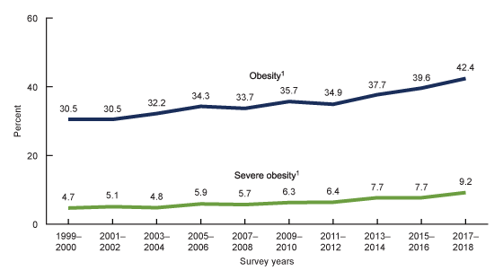

**Figure 1.** **Trends in age-adjusted obesity (BMI ≥ 30 kg/m2) and severe obesity (BMI ≥ 40 kg/m2) prevalence among adults aged 20 and over: United States, 1999–2000 through 2017–2018. Taken from reference (30).**

**Obesity and Severe Obesity in Adults: Relationships with Age, Sex, and Demographics**

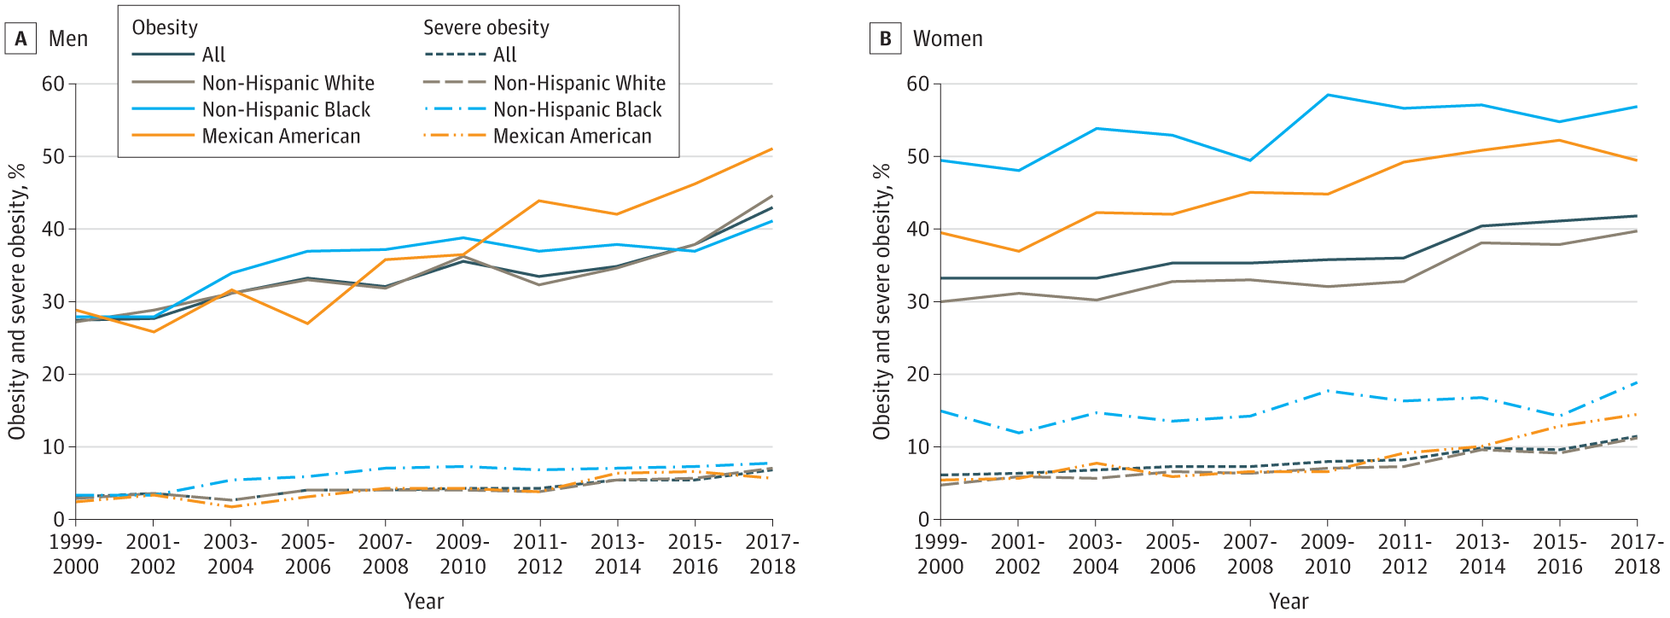

**Figure 2. Age-Adjusted Prevalence of Obesity and Severe Obesity in US Adults. National Health and Nutrition Examination Survey data, prevalence estimates are weighted and age-adjusted to the projected 2000 Census population using age groups 20-39, 40-59, and 60 or older. Significant linear trends (P < .001) for all groups except for obesity among non-Hispanic Black men, which increased from 1999-2000 to 2005-2006 and then leveled after 2005-2006. Data taken from reference (31).**

On average, the obesity rate in US adults has nearly tripled since the 1960’s (Reference (32) and Figure 2). These large increases in the number of people with obesity and severe obesity, while at the same time the level of overweight has remained steady (32,33), suggests that the “obesogenic” environment is disproportionately affecting those portions of the population with

the greatest genetic potential for weight gain (34). This currently leaves slightly less than 30% of the US adult population as having a healthy weight (BMI between 18.5 and 25 kg/m2).

Men and women now have similar rates of obesity and the peak rates of obesity for both men and women in the US occur between the ages of 40 and 60 years (Figures 2 and 3). In studies that have measured body composition, fat mass also peaks just past middle age in both men and women, but percent body fat continues to increase past this age, particularly in men

because of a proportionally greater loss in lean mass (35-37). The menopausal period has also been associated with an increase in percent body fat and propensity for central (visceral) fat distribution, even though total body weight may change very little during this time (38-41).

The rise in obesity prevalence rates has disproportionately affected US minority populations (Figure 2). The highest prevelance rates of obesity by race and ethnicity are currently reported in Black women, native americans, and Hispanics (Figure 2 and reference (42)). In general, women and men who did not go to college were more likely to have obesity than those who did, but for both groups these relationships varied depending on race and ethnicity (see below). Amongst women, obesity prevelance rates decreased with increasing income in women (from 45.2% to 29.7%), but there was no difference in obesity prevalence between the lowest (31.5%) and highest (32.6%) income groups among men (43).

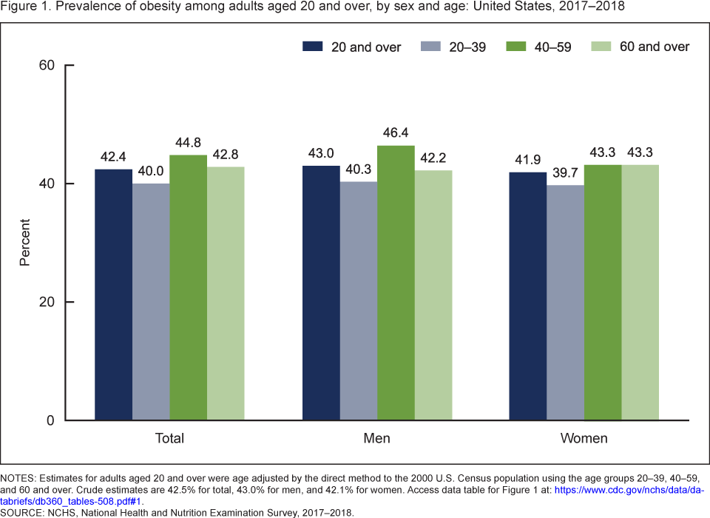

**Figure 3.** **Prevalence of obesity among adults aged 20 and over, by sex and age: United States, 2017–2018. Taken from reference (30).**

The interactions of socieconomic status and obesity rates varied based on race and ethnicity (43). For example, the expected inverse relationship between obesity and income group did not hold for non-Hispanic Black men and women in whom obesity prevelance was actually higher in the highest compared to lowest income group (men) or showed no relationship to income by racial group at all (women) (43). Obesity prevalence was lower among college graduates than among persons with less education for non-Hispanic White women and men, Black women, and Hispanic women, but not for Black and Hispanic men. Asian men and women have the lowest obesity prevelance rates, which did not vary by eduction or income level (43).

**Central Obesity**

As discussed above, central weight distribution occurs more commonly in men than women and increases in both men and women with age. In one of the few datasets that have published time-trends in waist circumference, it has been shown that over the past 20 years, age-adjusted waist circumferences have tracked upward in both US men and women (Figure 4). Much of this likely reflects the population increases in obesity prevelance since increasing fat mass and visceral fat track together (52).

**Figure 4. Age-adjusted mean waist circumference among adults in the National Health and Nutrition Examination Survey 1999-2012. Adapted from (51)**.

**Pediatrics**

Childhood obesity is a risk factor for adulthood obesity (44-46). In this regard, the similar tripling of obesity rates in US youth (ages 2-19 years old) (Figure 5) to 20.9% in 2018 (31) is worrisome and will contribute to the already dismal projections of the US adult population approaching 50% obesity prevelance by the year 2030 (47). Obesity prevalence was 26.2% among Hispanic children, 24.8% among non-Hispanic Black children, 16.6% among non-Hispanic White children, and 9.0% among non-Hispanic Asian children (48). Like adults, obesity rates in children are greater when they are live in households with lower incomes and less education of the head of the household (49). In this regard, these obesity gaps have been steadily widening in girls, whereas the differences between boys has been relatively stable (49).

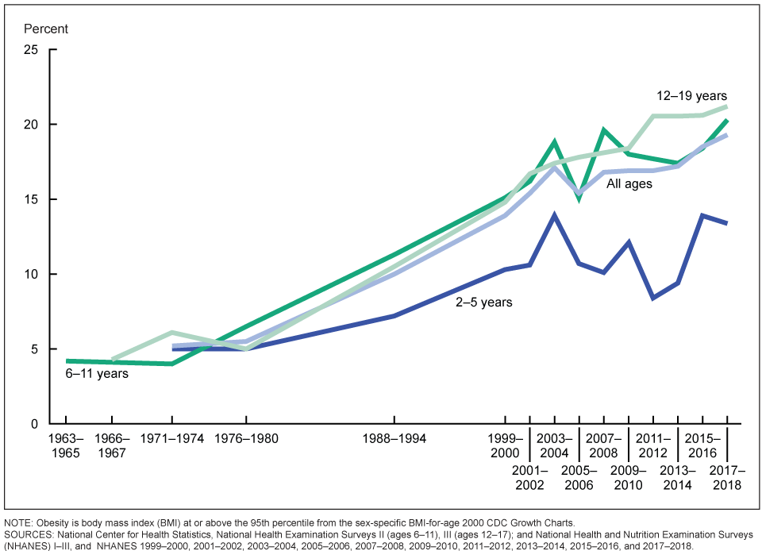

**Figure 5.** **Trends in obesity among children and adolescents aged 2–19 years, by age: United States, 1963–1965 through 2017–2018. Obesity is defined as body mass index (BMI) greater than or equal to the 95th percentile from the sex-specific BMI-for-age 2000 CDC Growth Charts. Taken from reference (50).**

With regard to socieconomic status, the inverse trends for lower obesity rates and higher income and education (of households) held in all race and ethnic origin groups with the following exceptions: obesity prevalence was lower in the highest income group only in Hispanic and Asian boys and did not differ by income among non-Hispanic Black girls (49).

**INTERNATIONAL TRENDS IN OBESITY**

Historically, international obesity rates have been lower than in the US, and most developing countries considered undernutrition to be their topmost health priority (53). However, international rates of overweight and obesity have been rising steadily for the past several decades and, in many countries, are now meeting or exceeding those of the US (Figure 6) (54,55). In 2016, 1.3 billion adults were overweight worldwide and, between 1975 to 2016, the number of adults with obesity increased over six-fold, from 100 million to 671 million (69 to 390 million women, 31 to 281 million men) (54). Especially worrisome have been similar trends in the youth around the world (Figure 6), from 5 million girls and 6 million boys with obesity in 1975 to 50 million girls and 74 million boys in 2016 (54), as this means the rise in obesity rates will continue for decades as they mature into adults.

The growth in the wordwide prelance of overweight and obesity is thought to be primarily driven by economic and technological advancements in all developing societies (56,57). These forces have been ongoing in the US and other Western countries for many decards but are being experienced by many developing countries on a compressed timescale. Greater worker productivity in advancing economies means more time spent in sedentary work (less in manual labor) and less time spent in leisure activity. Greater wealth allows the purchase of televisions, cars, processed foods, and more meals eaten out of the house, all of which have been associated with greater rates of obesity in children and adults. More details and greater discussion of these issues can be found in Endotext Chapters on Non-excercise Activity Thermogenesis (58) and Obesity and the Environment (9).

Regardless of the causes, these trends in global weight gain and obesity are quickly creating a tremendous burden on health-care systems and cost to countries attempting to respond to the increased treatment demands (59). They are also feuling a rise in global morbity and mortality for chronic (non-communicable) diseases, especially for cardiovascular disease and type 2 diabetes mellitus, and especially in Asian and South Asian populations where rates of type 2 diabetes are currently exploding (15,60-63). Efforts need to be made to deliver adequate health care to those currently with obesity and, at the same time, find innovative and alternative solutions that allow economies to prosper and to incorporate technologies that will reverse current trends in obesity and obesity-related complications.

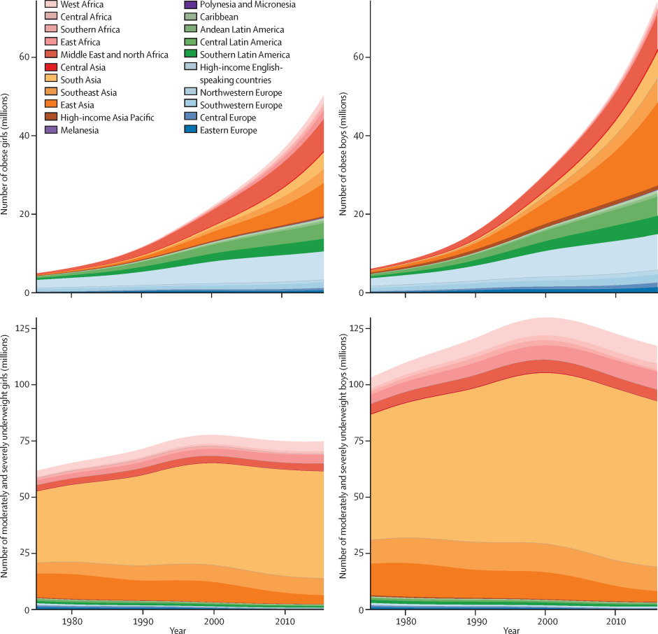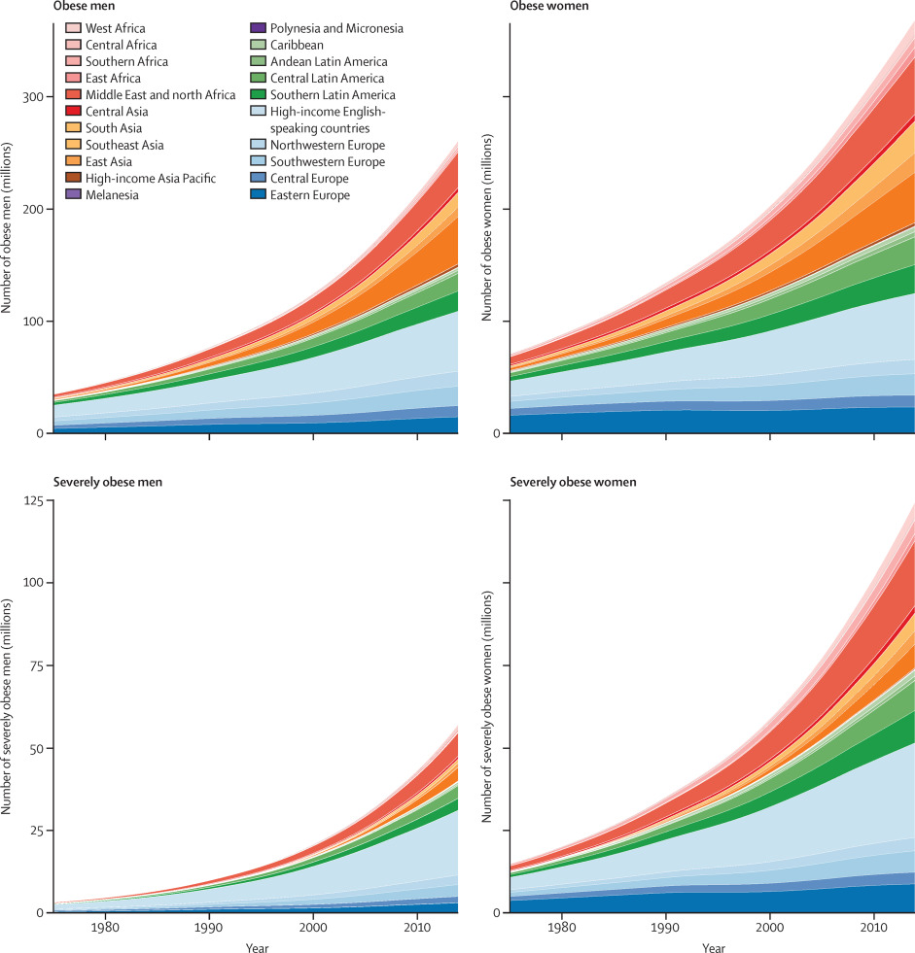

**Figure 6:** **Trends in the number of adults, children, and adolescents with obesity and with moderate and severe underweight by region. Children and adolescents were aged 5–19 years. (Taken from (54)).**

**Summary**

Obesity is both a chronic disease in its own right and a primary contributor to other leading chronic diseases such as type 2 diabetes, dyslipidemia, hypertension, and cardiovascular diseases. In the clinic, obesity is still best defined using commonly available tools, including BMI and waist circumference; although it is hoped that newer imaging modalities allowing more precise quantification of amount and distribution of excess lipid depots will improve obesity risk assessment. The general rise in obesity taking place in the US over the past 50 years is now occurring globally. In the US, the prevalence rates of obesity in adult men and women are now similar at 40%, and minorities are disproportionately affected, including Blacks, Native Americans, and Hispanics, with obesity rates of 50% or higher. Particularly worrisome is the global increase in obesity prevalence in children and adolescents as these groups will continue to contribute to a rising adult obesity rates for several decades to come. As important as finding solutions that address the global logistical and financial challenges facing health-care systems attempting to meet current demands of obesity and weight-related co-morbidities will be finding innovative solutions that prevent and reverse current population weight gain trends.

**References**

1. Rubino F, Puhl RM, Cummings DE, Eckel RH, Ryan DH, Mechanick JI, Nadglowski J, Ramos Salas X, Schauer PR, Twenefour D, Apovian CM, Aronne LJ, Batterham RL, Berthoud HR, Boza C, Busetto L, Dicker D, De Groot M, Eisenberg D, Flint SW, Huang TT, Kaplan LM, Kirwan JP, Korner J, Kyle TK, Laferrere B, le Roux CW, McIver L, Mingrone G, Nece P, Reid TJ, Rogers AM, Rosenbaum M, Seeley RJ, Torres AJ, Dixon JB. Joint international consensus statement for ending stigma of obesity. *Nature medicine*.2020;26(4):485-497.

2. Ramasamy A, Laliberté F, Aktavoukian SA, Lejeune D, DerSarkissian M, Cavanaugh C, Smolarz BG, Ganguly R, Duh MS. Direct and Indirect Cost of Obesity Among the Privately Insured in the United States: A Focus on the Impact by Type of Industry. *J Occup Environ Med*.2019;61(11):877-886.

3. Ward ZJ, Bleich SN, Long MW, Gortmaker SL. Association of body mass index with health care expenditures in the United States by age and sex. *PloS one*.2021;16(3):e0247307.

4. Hammond RA, Levine R. The economic impact of obesity in the United States. *Diabetes, metabolic syndrome and obesity : targets and therapy*.2010;3:285-295.

5. Schwartz MW, Seeley RJ, Zeltser LM, Drewnowski A, Ravussin E, Redman LM, Leibel RL. Obesity Pathogenesis: An Endocrine Society Scientific Statement. *Endocr Rev*.2017;38(4):267-296.

6. Affinati AH, Myers MG, Jr. Neuroendocrine Control of Body Energy Homeostasis. In: Feingold KR, Anawalt B, Boyce A, Chrousos G, de Herder WW, Dhatariya K, Dungan K, Hershman JM, Hofland J, Kalra S, Kaltsas G, Koch C, Kopp P, Korbonits M, Kovacs CS, Kuohung W, Laferrere B, Levy M, McGee EA, McLachlan R, Morley JE, New M, Purnell J, Sahay R, Singer F, Sperling MA, Stratakis CA, Trence DL, Wilson DP, eds. Endotext. South Dartmouth (MA): MDText.com, Inc. Copyright © 2000-2022, MDText.com, Inc.; 2000.

7. Farooqi IS, O'Rahilly S. The Genetics of Obesity in Humans. In: Feingold KR, Anawalt B, Boyce A, Chrousos G, de Herder WW, Dhatariya K, Dungan K, Hershman JM, Hofland J, Kalra S, Kaltsas G, Koch C, Kopp P, Korbonits M, Kovacs CS, Kuohung W, Laferrere B, Levy M, McGee EA, McLachlan R, Morley JE, New M, Purnell J, Sahay R, Singer F, Sperling MA, Stratakis CA, Trence DL, Wilson DP, eds. Endotext. South Dartmouth (MA): MDText.com, Inc. Copyright © 2000-2022, MDText.com, Inc.; 2000.

8. Tchang BG, Aras M, Kumar RB, Aronne LJ. Pharmacologic Treatment of Overweight and Obesity in Adults. In: Feingold KR, Anawalt B, Boyce A, Chrousos G, de Herder WW, Dhatariya K, Dungan K, Hershman JM, Hofland J, Kalra S, Kaltsas G, Koch C, Kopp P, Korbonits M, Kovacs CS, Kuohung W, Laferrere B, Levy M, McGee EA, McLachlan R, Morley JE, New M, Purnell J, Sahay R, Singer F, Sperling MA, Stratakis CA, Trence DL, Wilson DP, eds. Endotext. South Dartmouth (MA)2000.

9. Lee A, Cardel M, Donahoo WT. Social and Environmental Factors Influencing Obesity. In: Feingold KR, Anawalt B, Blackman MR, Boyce A, Chrousos G, Corpas E, de Herder WW, Dhatariya K, Dungan K, Hofland J, Kalra S, Kaltsas G, Kapoor N, Koch C, Kopp P, Korbonits M, Kovacs CS, Kuohung W, Laferrere B, Levy M, McGee EA, McLachlan R, New M, Purnell J, Sahay R, Shah AS, Singer F, Sperling MA, Stratakis CA, Trence DL, Wilson DP, eds. Endotext. South Dartmouth (MA): MDText.com, Inc. Copyright © 2000-2022, MDText.com, Inc.; 2000.

10. Pucci A, Batterham RL. Endocrinology of the Gut and the Regulation of Body Weight and Metabolism. In: Feingold KR, Anawalt B, Boyce A, Chrousos G, de Herder WW, Dhatariya K, Dungan K, Hershman JM, Hofland J, Kalra S, Kaltsas G, Koch C, Kopp P, Korbonits M, Kovacs CS, Kuohung W, Laferrere B, Levy M, McGee EA, McLachlan R, Morley JE, New M, Purnell J, Sahay R, Singer F, Sperling MA, Stratakis CA, Trence DL, Wilson DP, eds. Endotext. South Dartmouth (MA)2000.

11. O'Brien P. Surgical Treatment of Obesity. In: Feingold KR, Anawalt B, Boyce A, Chrousos G, de Herder WW, Dhatariya K, Dungan K, Hershman JM, Hofland J, Kalra S, Kaltsas G, Koch C, Kopp P, Korbonits M, Kovacs CS, Kuohung W, Laferrere B, Levy M, McGee EA, McLachlan R, Morley JE, New M, Purnell J, Sahay R, Singer F, Sperling MA, Stratakis CA, Trence DL, Wilson DP, eds. Endotext. South Dartmouth (MA)2000.

12. Kim TY, Kim S, Schafer AL. Medical Management of the Postoperative Bariatric Surgery Patient. In: Feingold KR, Anawalt B, Boyce A, Chrousos G, de Herder WW, Dhatariya K, Dungan K, Hershman JM, Hofland J, Kalra S, Kaltsas G, Koch C, Kopp P, Korbonits M, Kovacs CS, Kuohung W, Laferrere B, Levy M, McGee EA, McLachlan R, Morley JE, New M, Purnell J, Sahay R, Singer F, Sperling MA, Stratakis CA, Trence DL, Wilson DP, eds. Endotext. South Dartmouth (MA)2000.

13. Willett WC, Dietz WH, Colditz GA. Guidelines for healthy weight. *N Engl J Med*.1999;341(6):427-434.

14. Mozaffarian D, Benjamin EJ, Go AS, Arnett DK, Blaha MJ, Cushman M, Das SR, de Ferranti S, Despres JP, Fullerton HJ, Howard VJ, Huffman MD, Isasi CR, Jimenez MC, Judd SE, Kissela BM, Lichtman JH, Lisabeth LD, Liu S, Mackey RH, Magid DJ, McGuire DK, Mohler ER, 3rd, Moy CS, Muntner P, Mussolino ME, Nasir K, Neumar RW, Nichol G, Palaniappan L, Pandey DK, Reeves MJ, Rodriguez CJ, Rosamond W, Sorlie PD, Stein J, Towfighi A, Turan TN, Virani SS, Woo D, Yeh RW, Turner MB, American Heart Association Statistics C, Stroke Statistics S. Heart Disease and Stroke Statistics-2016 Update: A Report From the American Heart Association. *Circulation*.2016;133(4):e38-e360.

15. Collaborators GBDO, Afshin A, Forouzanfar MH, Reitsma MB, Sur P, Estep K, Lee A, Marczak L, Mokdad AH, Moradi-Lakeh M, Naghavi M, Salama JS, Vos T, Abate KH, Abbafati C, Ahmed MB, Al-Aly Z, Alkerwi A, Al-Raddadi R, Amare AT, Amberbir A, Amegah AK, Amini E, Amrock SM, Anjana RM, Arnlov J, Asayesh H, Banerjee A, Barac A, Baye E, Bennett DA, Beyene AS, Biadgilign S, Biryukov S, Bjertness E, Boneya DJ, Campos-Nonato I, Carrero JJ, Cecilio P, Cercy K, Ciobanu LG, Cornaby L, Damtew SA, Dandona L, Dandona R, Dharmaratne SD, Duncan BB, Eshrati B, Esteghamati A, Feigin VL, Fernandes JC, Furst T, Gebrehiwot TT, Gold A, Gona PN, Goto A, Habtewold TD, Hadush KT, Hafezi-Nejad N, Hay SI, Horino M, Islami F, Kamal R, Kasaeian A, Katikireddi SV, Kengne AP, Kesavachandran CN, Khader YS, Khang YH, Khubchandani J, Kim D, Kim YJ, Kinfu Y, Kosen S, Ku T, Defo BK, Kumar GA, Larson HJ, Leinsalu M, Liang X, Lim SS, Liu P, Lopez AD, Lozano R, Majeed A, Malekzadeh R, Malta DC, Mazidi M, McAlinden C, McGarvey ST, Mengistu DT, Mensah GA, Mensink GBM, Mezgebe HB, Mirrakhimov EM, Mueller UO, Noubiap JJ, Obermeyer CM, Ogbo FA, Owolabi MO, Patton GC, Pourmalek F, Qorbani M, Rafay A, Rai RK, Ranabhat CL, Reinig N, Safiri S, Salomon JA, Sanabria JR, Santos IS, Sartorius B, Sawhney M, Schmidhuber J, Schutte AE, Schmidt MI, Sepanlou SG, Shamsizadeh M, Sheikhbahaei S, Shin MJ, Shiri R, Shiue I, Roba HS, Silva DAS, Silverberg JI, Singh JA, Stranges S, Swaminathan S, Tabares-Seisdedos R, Tadese F, Tedla BA, Tegegne BS, Terkawi AS, Thakur JS, Tonelli M, Topor-Madry R, Tyrovolas S, Ukwaja KN, Uthman OA, Vaezghasemi M, Vasankari T, Vlassov VV, Vollset SE, Weiderpass E, Werdecker A, Wesana J, Westerman R, Yano Y, Yonemoto N, Yonga G, Zaidi Z, Zenebe ZM, Zipkin B, Murray CJL. Health Effects of Overweight and Obesity in 195 Countries over 25 Years. *N Engl J Med*.2017;377(1):13-27.

16. Schenkeveld L, Magro M, Oemrawsingh RM, Lenzen M, de Jaegere P, van Geuns RJ, Serruys PW, van Domburg RT. The influence of optimal medical treatment on the 'obesity paradox', body mass index and long-term mortality in patients treated with percutaneous coronary intervention: a prospective cohort study. *BMJ Open*.2012;2(1):e000535.

17. Jackson AS, Stanforth PR, Gagnon J, Rankinen T, Leon AS, Rao DC, Skinner JS, Bouchard C, Wilmore JH. The effect of sex, age and race on estimating percentage body fat from body mass index: The Heritage Family Study. *Int J Obes Relat Metab Disord*.2002;26(6):789-796.

18. Jackson AS, Ellis KJ, McFarlin BK, Sailors MH, Bray MS. Body mass index bias in defining obesity of diverse young adults: the Training Intervention and Genetics of Exercise Response (TIGER) study. *Br J Nutr*.2009;102(7):1084-1090.

19. Najjar MF, Rowland M. Anthropometric reference data and prevalence of overweight, United States, 1976-80. *Vital Health Stat 11*.1987(238):1-73.

20. Clinical Guidelines on the Identification, Evaluation, and Treatment of Overweight and Obesity in Adults--The Evidence Report. National Institutes of Health. *Obes Res*.1998;6 Suppl 2:51S-209S.

21. WHO Expert Consultation. Appropriate body-mass index for Asian populations and its implications for policy and intervention strategies. *Lancet*.2004;363(9403):157-163.

22. S VM, Nitin K, Sambit D, Nishant R, Sanjay K. ESI Clinical Practice Guidelines for the Evaluation and Management of Obesity In India. *Indian J Endocrinol Metab*.2022;26(4):295-318.

23. Janssen I, Katzmarzyk PT, Ross R. Waist circumference and not body mass index explains obesity-related health risk. *Am J Clin Nutr*.2004;79(3):379-384.

24. Balkau B, Deanfield JE, Despres JP, Bassand JP, Fox KA, Smith SC, Jr., Barter P, Tan CE, Van Gaal L, Wittchen HU, Massien C, Haffner SM. International Day for the Evaluation of Abdominal Obesity (IDEA): a study of waist circumference, cardiovascular disease, and diabetes mellitus in 168,000 primary care patients in 63 countries. *Circulation*.2007;116(17):1942-1951.

25. Grundy SM. Metabolic syndrome scientific statement by the American Heart Association and the National Heart, Lung, and Blood Institute. *Arterioscler Thromb Vasc Biol*.2005;25(11):2243-2244.

26. Jacobson TA, Ito MK, Maki KC, Orringer CE, Bays HE, Jones PH, McKenney JM, Grundy SM, Gill EA, Wild RA, Wilson DP, Brown WV. National lipid association recommendations for patient-centered management of dyslipidemia: part 1--full report. *J Clin Lipidol*.2015;9(2):129-169.

27. Fujimoto WY, Bergstrom RW, Boyko EJ, Leonetti DL, Newell-Morris LL, Wahl PW. Susceptibility to development of central adiposity among populations. *Obes Res*.1995;3 Suppl 2:179S-186S.

28. Alberti KG, Zimmet P, Shaw J. Metabolic syndrome--a new world-wide definition. A Consensus Statement from the International Diabetes Federation. *Diabetic medicine : a journal of the British Diabetic Association*.2006;23(5):469-480.

29. Waist circumference and waist–hip ratio: report of a WHO expert consultation. Geneva, Switzerland: World Health Organization; 2008:1-39.

30. Hales C, Carroll M, Fryar C, Ogden C. Data from: Prevalence of obesity and severe obesity among adults: United States, 2017–2018. NCHS Data Brief, no 360. Hyattsville, MD: National Center for Health Statistics. 2020.

31. Ogden CL, Fryar CD, Martin CB, Freedman DS, Carroll MD, Gu Q, Hales CM. Trends in Obesity Prevalence by Race and Hispanic Origin-1999-2000 to 2017-2018. *JAMA*.2020;324(12):1208-1210.

32. Fryar CD, Carroll MD, Ogden CL. Prevalence of Overweight, Obesity, and Extreme Obesity Among Adults: United States, 1960–1962 Through 2011–2012. National Center for Health Statistics; 2014.

33. Friedman JM. A war on obesity, not the obese. *Science*.2003;299(5608):856-858.

34. Prentice AM. Obesity--the inevitable penalty of civilisation? *Br Med Bull*.1997;53(2):229-237.

35. Mott JW, Wang J, Thornton JC, Allison DB, Heymsfield SB, Pierson RN, Jr. Relation between body fat and age in 4 ethnic groups. *Am J Clin Nutr*.1999;69(5):1007-1013.

36. Gallagher D, Ruts E, Visser M, Heshka S, Baumgartner RN, Wang J, Pierson RN, Pi-Sunyer FX, Heymsfield SB. Weight stability masks sarcopenia in elderly men and women. *American journal of physiology Endocrinology and metabolism*.2000;279(2):E366-375.

37. Hughes VA, Frontera WR, Roubenoff R, Evans WJ, Singh MA. Longitudinal changes in body composition in older men and women: role of body weight change and physical activity. *Am J Clin Nutr*.2002;76(2):473-481.

38. Ley CJ, Lees B, Stevenson JC. Sex- and menopause-associated changes in body-fat distribution. *Am J Clin Nutr*.1992;55:950-954.

39. Svendsen OL, Hassager C, Christiansen C. Age- and menopause-associated variations in body composition and fat distribution in healthy women as measured by dual-energy X-ray absorptiometry. *Metabolism*.1995;44(3):369-373.

40. Panotopooulos G, Ruiz JC, Raison J, Guygrand B, Basdevant B, Basdevant A. Menopause, fat and lean distribution in obese women. *Maturitas*.1996;25:11-19.

41. Lovejoy JC, Champagne CM, de Jonge L, Xie H, Smith SR. Increased visceral fat and decreased energy expenditure during the menopausal transition. *Int J Obes (Lond)*.2008;32(6):949-958.

42. Data from: Summary Health Statistics Tables: National Health Interview Survey. Table A-15. Body mass index among adults aged 18 and over, by selected characteristics: United States, 2016. National Center for Health Statistics. Deposited 2016. <https://ftp.cdc.gov/pub/Health_Statistics/NCHS/NHIS/SHS/2016_SHS_Table_A-15.pdf>.

43. Ogden CL, Fakhouri TH, Carroll MD, Hales CM, Fryar CD, Li X, Freedman DS. Prevalence of Obesity Among Adults, by Household Income and Education - United States, 2011-2014. *MMWR Morb Mortal Wkly Rep*.2017;66(50):1369-1373.

44. Singh AS, Mulder C, Twisk JW, van Mechelen W, Chinapaw MJ. Tracking of childhood overweight into adulthood: a systematic review of the literature. *Obes Rev*.2008;9(5):474-488.

45. Rosenbaum M. Special Considerations Relevant to Pediatric Obesity. In: Feingold KR, Anawalt B, Boyce A, Chrousos G, de Herder WW, Dhatariya K, Dungan K, Hershman JM, Hofland J, Kalra S, Kaltsas G, Koch C, Kopp P, Korbonits M, Kovacs CS, Kuohung W, Laferrere B, Levy M, McGee EA, McLachlan R, Morley JE, New M, Purnell J, Sahay R, Singer F, Sperling MA, Stratakis CA, Trence DL, Wilson DP, eds. Endotext. South Dartmouth (MA)2000.

46. Ward ZJ, Long MW, Resch SC, Giles CM, Cradock AL, Gortmaker SL. Simulation of Growth Trajectories of Childhood Obesity into Adulthood. *N Engl J Med*.2017;377(22):2145-2153.

47. Ward ZJ, Bleich SN, Cradock AL, Barrett JL, Giles CM, Flax C, Long MW, Gortmaker SL. Projected U.S. State-Level Prevalence of Adult Obesity and Severe Obesity. *N Engl J Med*.2019;381(25):2440-2450.

48. Stierman B, Afful J, Carroll MD, Chen T-C, Davy O, Fink S, Fryar CD, Gu Q, Hales CM, Hughes JP, Ostchega Y, Storandt RJ, Akinbami LJ. National Health and Nutrition Examination Survey 2017–March 2020 Prepandemic Data Files Development of Files and Prevalence Estimates for Selected Health Outcomes. *National Health Statistics Reports*. Hyattsville, MD: National Center for Health Statistics2021.

49. Ogden CL, Carroll MD, Fakhouri TH, Hales CM, Fryar CD, Li X, Freedman DS. Prevalence of Obesity Among Youths by Household Income and Education Level of Head of Household - United States 2011-2014. *MMWR Morb Mortal Wkly Rep*.2018;67(6):186-189.

50. Fryar CD, Carroll MD, Afful J. Prevalence of overweight, obesity, and severe obesity among children and adolescents aged 2–19 years: United States, 1963–1965 through 2017–2018. NCHS Health E-Stats. 2020.

51. Ford ES, Maynard LM, Li C. Trends in mean waist circumference and abdominal obesity among US adults, 1999-2012. *JAMA*.2014;312(11):1151-1153.

52. Lemieux S, Prud'homme D, Bouchard C, Tremblay A, Despres JP. Sex differences in the relation of visceral adipose tissue accumulation to total body fatness. *Am J Clin Nutr*.1993;58(4):463-467.

53. York DA, Rossner S, Caterson I, Chen CM, James WP, Kumanyika S, Martorell R, Vorster HH, American Heart A. Prevention Conference VII: Obesity, a worldwide epidemic related to heart disease and stroke: Group I: worldwide demographics of obesity. *Circulation*.2004;110(18):e463-470.

54. NCD Risk Factor Collaboration (NCD-RisC). Worldwide trends in body-mass index, underweight, overweight, and obesity from 1975 to 2016: a pooled analysis of 2416 population-based measurement studies in 128.9 million children, adolescents, and adults. *Lancet*.2017;390(10113):2627-2642.

55. Finucane MM, Stevens GA, Cowan MJ, Danaei G, Lin JK, Paciorek CJ, Singh GM, Gutierrez HR, Lu Y, Bahalim AN, Farzadfar F, Riley LM, Ezzati M, Global Burden of Metabolic Risk Factors of Chronic Diseases Collaborating G. National, regional, and global trends in body-mass index since 1980: systematic analysis of health examination surveys and epidemiological studies with 960 country-years and 9.1 million participants. *Lancet*.2011;377(9765):557-567.

56. Popkin BM, Horton S, Kim S, Mahal A, Shuigao J. Trends in diet, nutritional status, and diet-related noncommunicable diseases in China and India: the economic costs of the nutrition transition. *Nutr Rev*.2001;59(12):379-390.

57. Levine JA, Kotz CM. NEAT--non-exercise activity thermogenesis--egocentric & geocentric environmental factors vs. biological regulation. *Acta Physiol Scand*.2005;184(4):309-318.

58. von Loeffelholz C, Birkenfeld AL. Non-Exercise Activity Thermogenesis in Human Energy Homeostasis. In: Feingold KR, Anawalt B, Boyce A, Chrousos G, de Herder WW, Dhatariya K, Dungan K, Hershman JM, Hofland J, Kalra S, Kaltsas G, Koch C, Kopp P, Korbonits M, Kovacs CS, Kuohung W, Laferrere B, Levy M, McGee EA, McLachlan R, Morley JE, New M, Purnell J, Sahay R, Singer F, Sperling MA, Stratakis CA, Trence DL, Wilson DP, eds. Endotext. South Dartmouth (MA)2000.

59. Withrow D, Alter DA. The economic burden of obesity worldwide: a systematic review of the direct costs of obesity. *Obes Rev*.2011;12(2):131-141.

60. Bragg F, Tang K, Guo Y, Iona A, Du H, Holmes MV, Bian Z, Kartsonaki C, Chen Y, Yang L, Sun Q, Dong C, Chen J, Collins R, Peto R, Li L, Chen Z, China Kadoorie Biobank Collaborative G. Associations of General and Central Adiposity With Incident Diabetes in Chinese Men and Women. *Diabetes Care*.2018;41(3):494-502.

61. Global BMIMC, Di Angelantonio E, Bhupathiraju Sh N, Wormser D, Gao P, Kaptoge S, Berrington de Gonzalez A, Cairns BJ, Huxley R, Jackson Ch L, Joshy G, Lewington S, Manson JE, Murphy N, Patel AV, Samet JM, Woodward M, Zheng W, Zhou M, Bansal N, Barricarte A, Carter B, Cerhan JR, Smith GD, Fang X, Franco OH, Green J, Halsey J, Hildebrand JS, Jung KJ, Korda RJ, McLerran DF, Moore SC, O'Keeffe LM, Paige E, Ramond A, Reeves GK, Rolland B, Sacerdote C, Sattar N, Sofianopoulou E, Stevens J, Thun M, Ueshima H, Yang L, Yun YD, Willeit P, Banks E, Beral V, Chen Z, Gapstur SM, Gunter MJ, Hartge P, Jee SH, Lam TH, Peto R, Potter JD, Willett WC, Thompson SG, Danesh J, Hu FB. Body-mass index and all-cause mortality: individual-participant-data meta-analysis of 239 prospective studies in four continents. *Lancet*.2016;388(10046):776-786.

62. Ogurtsova K, da Rocha Fernandes JD, Huang Y, Linnenkamp U, Guariguata L, Cho NH, Cavan D, Shaw JE, Makaroff LE. IDF Diabetes Atlas: Global estimates for the prevalence of diabetes for 2015 and 2040. *Diabetes Res Clin Pract*.2017;128:40-50.

63. Wang Y, Zhao L, Gao L, Pan A, Xue H. Health policy and public health implications of obesity in China. *The lancet Diabetes & endocrinology*.2021;9(7):446-461.