**Development and MICROSCOPIC anatomy of the pituitary gland**

**Ian S. Scott,** Neuropathology Laboratory, The Walton Centre NHS Foundation Trust, Lower Lane, Fazakerley, Liverpool L9 7LJ, UK. [ian.scott10@nhs.net](mailto:ian.scott10@nhs.net). Molecular and Clinical Cancer Medicine, Faculty of Health & Life Sciences, University of Liverpool, Brownlow Hill, Liverpool, L69 3GB, UK. ian.scott@liverpool.ac.uk

**Arpita Chattopadhyay**, Department of Neuroradiology, Queen’s Medical Centre Campus, Nottingham University Hospitals NHS Trust, Nottingham, NG7 2UH, UK. arpita.chattopadhyay@nuh.nhs.uk

**Olaf Ansorge**, Academic Unit of Neuropathology, Nuffield Department of Clinical Neurosciences, University of Oxford, Level 1, West Wing, John Radcliffe Hospital, OX3 9DU. [olaf.ansorge@ndcn.ox.ac.uk](mailto:olaf.ansorge@ndcn.ox.ac.uk)

**Updated September 27, 2024**

## **ABSTRACT**

The pituitary gland is an organ of dual origin. The anterior part (adenohypophysis) arises from embryonic buccal mucosa, whereas the posterior part (neurohypophysis) derives from neural ectoderm. Precise spatial and temporal co-ordination of transcription factor expression in both structures is critical for pituitary gland formation and the differentiation of hormone-producing cells. Disruption of this regulation, for instance by transcription factor mutation, can lead to numerous developmental disorders and disturbances in endocrine function and regulation. We provide an overview of the molecular drivers of pituitary organogenesis and illustrate the anatomy and histology of the mature pituitary gland, comprising adenohypophysis (anterior lobe), neurohypophysis (posterior lobe), pars intermedia (intermediate lobe), and infundibulum (pituitary stalk).

## **PITUITARY ORGANOGENESIS**

The pituitary is an organ of dual origin. The anterior part (adenohypophysis) is derived from oral ectoderm and is epithelial in origin, whereas the posterior part (neurohypophysis) derives from neural ectoderm. The mixed embryological derivation of the pituitary gland requires that developmental signals from both the neural and oral ectoderm must interact temporally and spatially to control maturation of the pituitary gland and the cellular differentiation of the various hormone-producing cell types within the adenohypophysis. The expression of transcription factors that control cell lineage commitment in the developing adenohypophysis must be regulated precisely to ensure correct differentiation of hormone-producing cell types; the iterative and cumulative nature of this regulation renders it extremely sensitive to perturbation. Disruption of this process, for instance by mutation, can lead to numerous developmental disorders from congenital forms of hypopituitarism to pituitary tumors (1) (2).

Pituitary organogenesis begins during week 4 of fetal development. A thickening of cells in the oral ectoderm forms the hypophyseal placode which gives rise to Rathke’s pouch; an upward evagination of the buccal ectoderm that extends towards the neural ectoderm. At the same time, a downward extension of the ventral diencephalon forms the posterior lobe, and the two nascent lobes connect to form the bilobed structure of the adult pituitary gland. Rathke’s pouch constricts at its base and eventually separates altogether from the oral epithelium during gestational week 6-8. The cells of the anterior wall of Rathke’s pouch undergo extensive proliferation to form the anterior lobe. In humans, the posterior wall proliferates more slowly to form the vestigial intermediate lobe (3). Cell patterning and terminal differentiation occurs within the anterior lobe to form the five principal specialized endocrine cell types of the pituitary gland; the somatotrophs, adrenocorticotrophs, gonadotrophs, thyrotrophs, and lactotrophs.

### **TRANSCRIPTIONAL CONTROL OF PITUITARY ORGANOGENESIS**

Development of the pituitary occurs broadly in three stages:

1. Initiation of pituitary organogenesis and formation of Rathke’s pouch (Blue in Table 1).
2. Evagination of Rathke’s pouch and cell proliferation (Green in Table 1).
3. Lineage determination and cellular differentiation (Yellow in Table 1).

|  |  |  |  |  |  |  |
| --- | --- | --- | --- | --- | --- | --- |
| **Table 1. Signalling Molecules Controlling Pituitary Organogenesis and Associated Dysfunction** | | | | | | |
| **Developmental Stage** | **Factor** | | **Function** | **Dysfunction** | **Comments** | **Reference** |
| Initiation of pituitary organogenesis and formation of Rathke’s pouch | SIX homeo-domain proteins | Six1-Six6 | Family of six transcriptional activators/ inhibitors  Functional role difficult to determine due to redundancy and severity of mutations |  | Expression persists in adult pituitary; may mediate plasticity | (52) (53) |
| Paired-like homeobox proteins | Hesx1 | Transcriptional repressor  Early marker of Rathke’s pouch  Downregulation essential for endocrine cell differentiation | Mutations in patients with hypopituitarism including septo-optic dysplasia, combined pituitary hormone deficiency (CPHD) and isolated growth hormone deficiency (IGHD) | Expression activated by LIM homeodomain proteins | (54) |
| Otx2 | Transcription factor that regulates Hesx1 | Mutations found in patients with ocular disorders (e.g. anophthalmia, microphthalmia) with or without hypopituitarism. In mice, deficiency results in craniofacial  defects and pituitary gland dysmorphology, but normal pituitary cell specification |  | (55) (56) |
| Pitx1/2/3 | Interacts with various other factors to determine cell lineage | Mutations in Pitx2 (R91P) found in patients with Axenfeld-Rieger syndrome. Blocks expression of LH β and FSHβ | Expressed throughout oral ectoderm and Rathke’s pouch.  Some functional redundancy, but all required for proper development  Expression maintained in the adult gland | (57) |
| LIM homeodomain transcription factors | Isl1 | Involved in cell lineage specification | No human mutations identified. Null mice do not develop Rathke’s pouch | First LIM protein to be expressed  Expressed in cells destined to become thyrotrophs | Reviewed in (6) |
| Lhx3 | Expression gradient required for differentiation of endocrine cell types | Heritable mutation in patients with CPHD with short, stiff neck and sensorineural hearing loss | Broad temporal and spatial expression pattern with many target genes | (58) (59) |
| Lhx4 | Expression gradient required for differentiation of endocrine cell types | Heterozygous mutations in patients with CPHD. Associated with pituitary hypoplasia, small sella and Arnold-Chiari malformation | Not critical for endocrine cell differentiation | (60) (61) (59) |
| SOX2 |  | Expressed throughout developing Rathke’s pouch  Downregulation essential for endocrine cell differentiation | Mutations found in patients with an- or microphthalmia, hypogonadotrophic hypogonadism, and growth hormone deficiency (GHD)  Both duplications and loss of function mutations associated with hypopituitarism | Some expression retained in adult pituitary, confined to pituitary progenitor/stem cells | (62) (6) |
| β-catenin |  | Signalling activates Pitx2 expression promoting pituitary precursor proliferation. Required for Pit1 lineage determination and anterior pituitary formation | Premature activation of β-catenin results in Hesx1 repression and pituitary gland agenesis in mouse  Activating mutation of β-catenin leads to pituitary progenitor proliferation, loss of Pit1 lineage cells and adamantinomatous cranyiopharyngioma | High degree of interaction with other signalling pathways e.g. Notch. Not required for cell lineage determination | (63) (7) |
| Notch |  | Mediates lateral inhibition and cell lineage determination  Activates Hes1 expression | Dysregulaiton of the pathway associated with premature corticotroph differentiation and pituitary hypoplasia in mice | Expression in the adult gland co-localises with SOX2 | (64) |
| Migration of Rathke’s pouch cells and proliferation | Bone morphogenic proteins | BMP4 | Expressed in ventral diencephalon  Required for hypophyseal placode formation | Downregulation results in arrested development of Rathke’s pouch in mice |  | Reviewed in (5) |
| BMP2 | Induces Isl1 expression  Downregulation required for cell differentiation | Prolonged expression results in hyperplastic pituitary and lack of terminal differentiation |  | (65) |
| Fibroblast growth factors | FGF 8, 10, 18 | Expressed in the posterior pituitary  Required for Lhx3 and Lhx4 expression and cell differentiation | In humans, mutations of FGF8 and its receptor are associated with Kallmann syndrome, resulting in isolated hypogonadotrophic hypogonadism |  | (66) (67) (68) |
| Shh |  | Expressed in oral ectoderm and ventral diencephalon  Induces Lhx3 expression | Antagonism in mouse oral ectoderm results in hypoplastic Rathke’s pouch |  | (69) |
| Lineage determination and cellular differentiation | Prop1 |  | Transcriptional activator and suppressor depending on context  Activates POU1F1 expression and switches developmental process from proliferation to differentiation | Mutations are most common cause of CPHD in humans |  | Reviewed in (6) and (70) (71) (72) (73) (74) |
| POU1F1 (Pit1) |  | Expressed in cells committed to somatotroph, lactotroph and thyrotroph lineage  Inhibits GATA2 and prevents gonadotroph cell fate | Mutations in humans associated with GH PRL, TSH deficiency and small anterior pituitary. Mutations rarely present in sporadic CPHD and more common in familial CPHD | Required for GH PRL, TSHβ expression | (73) (75) (76) (77) |
| GATA2 |  | Specifies gonadotroph and thyrotroph lineages  Induces expression of Nr5a1 | In mice, overexpression associated with gonadotroph and thyrotroph hypoplasia. | Expression persists in adult gland | (75) |
| Nr5a1 (SF1) |  | Expressed throughout adrenal and reproductive axes  Regulates expression of GnRHR, LH, FSH and αGSU.  Expression necessary for gonadotroph differentiation | Mutations associated with 46XY sex reversal with adrenal failure, 46XY gonadal dysgenesis and 46XX ovarian insufficiency and premature ovarian failure in humans |  | (18) (78) |
| Tbx19 (TPIT) |  | Activates POMC expression in association with PITX1 | Mutations are commonest cause of isolated ACTH deficiency in humans | Antagonists to Nr5a1 can prevent gonadotroph cell fate | (79) (80) |

Much of our understanding of the process of pituitary organogenesis comes from mouse studies (4) (5), but the phenotypes associated with human disorders often share aspects with mouse models of defective pituitary development. Various transcription factors that are involved are presented in Figure 1 and summarized in Table 1 (6), (7), (8) & (9).

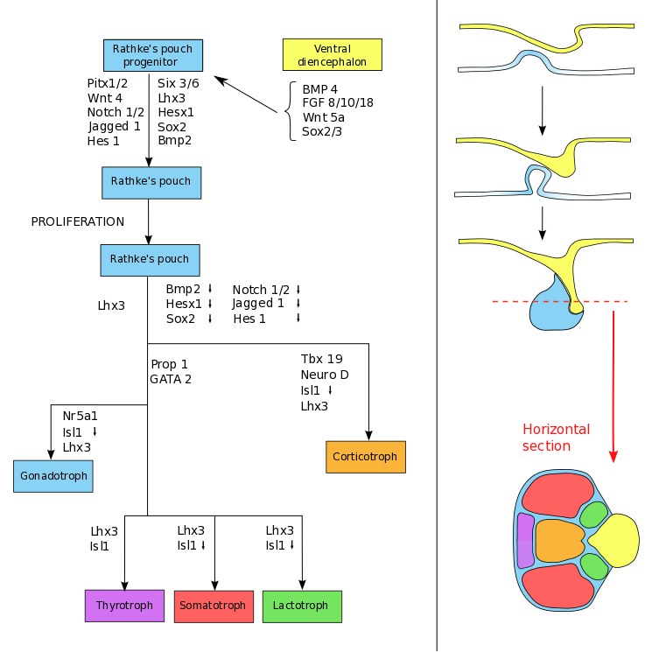

t-Pit

SF-1

Pit-1

**Figure 1.** **Signaling molecules and transcription factors control pituitary development. Arrows represent regulation of expression in the direction indicated (See Table 1). The clinically used transcription factors are in blue.**

**Transcriptional Control of Pituitary Organogenesis: Lineage Determination and Cellular Differentiation**

Significant advances have been made in recent years in elucidating the molecular mechanisms underlying the commitment and differentiation of Rathke’s pouch progenitors and the role of endocrine stem cells in the adenohypophysis (8) (10). Many factors are involved in pituitary differentiation, but a few later acting transcription factors have pituitary-specific effects and have become clinically relevant (11). In clinical terms, cells of the adenohypophysis can be divided into those of the Pit-1 lineage (somatotrophs, lactotrophs, somatomammotrophs, and thyrotrophs), those of t-PIT lineage (corticotrophs and melanotrophs), and those of SF-1 lineage (Gonadotrophs).

PIT-1 (POU1F1)

PIT-1 was first identified as a trans-activating factor of the growth hormone and prolactin genes. It is a member of the POU homeodomain family of transcription factors (5). Inactivating mutations produce recessive hypopituitarism characterized by a congenital lack of growth hormone, prolactin and TSH (12). Two naturally occurring recessive mouse mutants have *Pit-1* defects; the Snell Dwarf (*dw*) mouse and the Jackson dwarf (*dwJ*). Homozygous recessive variants of these mice both exhibit post-natal, but not embryonic, anterior pituitary hypoplasia with GH, PRL and TSH deficiencies.

T-PIT

t-PIT (TBX19) is a member of the T-Box family of transcription factors. The T-Box represents the DNA binding domain of these factors. *T-Pit* is expressed in the developing pituitary and expression generally persists into the adult gland. *T-Pit* depletion in mice induces severe ACTH and glucocorticoid deficiencies in addition to adrenal hypoplasia and pigmentation defects. The phenotype of *t-Pit* -/- mice suggests that T-PIT promotes the development of corticotrophs but can also actively repress gonadotroph formation (13).

STEROIDOGENIC FACTOR (SF-1)

SF-1is a nuclear receptor encoded by the gene *Nr5a1* or steroidogenic factor 1 (*SF-1*). It is an orphan nuclear receptor involved as a transactivating factor in steroid biosynthesis. *SF-1* is expressed throughout the adrenal and reproductive axes during development and postnatal life (14) (15). Mutations of *SF-1* in humans are associated with 46XY sex reversal with adrenal failure, 46XY gonadal dysgenesis and 46XX ovarian insufficiency and premature ovarian failure (16) (17).

In some cases, transcription factor deficiency does not result in the complete absence of a cell type. SF-1 deficient mice do not spontaneously produce gonadotrophins but hyperstimulation with GnRH can induce hormone production suggesting that SF-1 is not essential for gonadotroph differentiation (18). Similarly, *t-Pit* expression is not essential for corticotroph development, but POMC synthesis is delayed if they are deficient (19). The failure to promote differentiation along a particular lineage can be permissive for other pathways and the idea that single transcription factors direct cell differentiation is overly simplistic. Nevertheless, these differentiation markers (colored blue in Figure 1) have proven to be extremely useful in diagnostic pituitary pathology, particularly in demonstrating the cell lineage of silent or non-expressing pituitary adenomas, and their expression can be detected in histological samples of pituitary tissue removed at trans-sphenoidal adenohypophysectomy by immunohistochemistry (Figure 2).

**Figure 2. Pituitary transcription factor expression in the normal pituitary gland.**

## **ANATOMY AND HISTOLOGY OF THE MATURE PITUITARY GLAND**

**Hypophysis Cerebri**

The mature pituitary gland, or hypophysis cerebri, is a small, oval body weighing approximately 0.5g. The adenohypophysis of the pituitary is generally smaller in men than women and, within the female population, the gland in nulliparous women is generally smaller than that seen in multiparous women (20) (21). Indeed, during pregnancy, the gland may increase by approximately 30% due to a combination of lactotroph hyperplasia and vascular engorgement. The hypophysis is connected to the brain via the infundibulum, a tubular structure arising from the tuber cinereum and median eminence of the hypothalamus. The gland rests in the sella turcica (pituitary fossa) of the sphenoid bone and is covered superiorly by the diaphragma sellae (a thin film of dura), laterally by the walls of the cavernous sinus, and antero-inferiorly by the posterior wall of the sphenoid sinus; the latter used as the standard route for pituitary surgery or transsphenoidal adenectomy (Figure 3). Antero-superiorly, the pituitary lies in close proximity to the optic chiasm and bilateral, inferomedial compression of the chiasm by the expanding gland explains why space-occupying lesions of the pituitary commonly present with bitemporal hemianopia. Inferiorly, the adenohypophysis is separated from the floor of the sella turcica by a large, loculated venous sinus that communicates with the circular sinus.

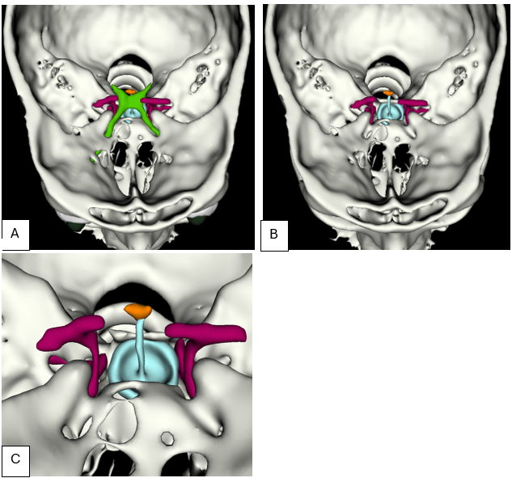

**Figure 3. High resolution 3D imaging reconstruction of the sella turcica in a volunteer (courtesy of Prof Mark Gurnell, Cambridge, UK). These detailed scans are proving invaluable in planning the surgical approach for transsphenoidal adenectomy, especially where vascular anomalies are expected.**

**A) Section across the roof of the sella with the optic nerves and chiasm (green) in situ revealing the intimate relationship between the chiasm and the pituitary gland (turquoise).**

**B) A similar level with the optic nerve and chiasm removed.**

**C) Detail of the sella region showing the relationship between the pituitary gland and stalk (turquoise), base of hypothalamus (orange), and internal carotid arteries (red).**

**The Hypothalamus**

The structure of the hypothalamus and its complex connections are well known and have been described in detail elsewhere (22) (23) (24). The hypothalamic nuclei that give rise to the neurohypophysis arise from the preoptic, supraoptic, lateral, tuberal and mamillary regions (3) and hypothalamic regulatory neurons have their cell bodies in the supraoptic, paraventricular, infundibular and ventromedial nuclei of the hypothalamus. These hypothalamic nuclei have projections that terminate throughout the median eminence, infundibulum, and the posterior lobe (Figure 4). Neurons derived from hypothalamic nuclei produce peptidergic “releasing hormones” that are transported along axons and released into the portal system from where they are carried to the dense capillary plexus of the adenohypophysis to influence hormone synthesis and release. The parvocellular neurosecretory pathway of the tuberoinfundibular tract is proposed as the main route for the synthesis of releasing hormones and of transmission to portal blood. The major trophic factors originating in the hypothalamic nuclei include growth hormone releasing factor (GRF), corticotrophin releasing factor (CRF), thyrotropin releasing factor (TRF), gonadotrophin releasing hormone (GnRH) and other peptides such as somatostatin (SS). Other trophic and inhibitory factors are also released in this region including dopaminergic compounds.

**Figure 4. Sagittal T1-weighted image of the pituitary fossa demonstrates normal pituitary anatomy. The T1-weighted study is particularly helpful in identifying the posterior pituitary bright spot (white arrow)- a focus of T1 signal hyperintensity posteriorly in the sella, which corresponds with the neurohypophysis. The intrinsic T1 signal shortening through the posterior pituitary is thought to be due to the presence of vasopressin. The zoomed image of the pituitary gland, consisting of the anterior (A) and posterior (P) lobes, sits within the sella turcica, a “saddle”-shaped depression in the sphenoid bone, with the tuberculum sellae anteriorly, and the dorsum sellae posteriorly. Superior to the pituitary gland is CSF within the hypophyseal and suprasellar cisterns. The pituitary stalk (S), also known as the infundibulum or infundibular stalk, extends through the suprasellar cistern, extending between the hypothalamus and the superior surface of the pituitary gland. The optic chiasm (C) can be seen in the suprasellar space more superiorly. Anteroinferior to the pituitary gland is the sphenoid sinus (SS). (B)- brainstem, (M)- mammillary bodies, (3V)- third ventricle.**

In addition to nerve fibers, the long and short portal blood vessels (distributed between sinusoids in the median eminence, infundibulum, and the adenohypophysis) are also of major importance to this region. The adenohypophysis receives no major nerve supply and almost all of its blood comes from hypothalamic-hypophysial portal vessels. The predominant direction of blood flow is from the tufts of sinusoids in the median eminence and infundibulum via the portal vessels to sinusoids between glandular cells in the anterior lobe. This neurovascular arrangement is of vital importance to understand the mechanism by which the hypothalamus regulates the neuroendocrine function of the gland.

Neurosecretion is the physiological process involved in the production and release of posterior lobe oxytocin and vasopressin and their related proteins: including the precursor neurophysins. In terms of these magnocellular neurosecretory pathways, both the supraoptic and paraventricular nuclei are involved in the production both of vasopressin and oxytocin, however, vasopressin originates predominantly from the supraoptic nucleus and oxytocin originates predominantly from the paraventricular nucleus.

**Infundibulum (Pituitary Stalk)**

The infundibular stalk is a tubular, funnel-shaped structure divided into the anterior *pars tuberalis* and posterior *pars infundibularis*. The *pars tuberalis* is considered to be part of the adenohypophysis (see below) and contains a few scattered gonadotroph or corticotroph cells. Anteriorly and superficially, it surrounds the *pars infundibularis* (infundibular stem), which contains the unmyelinated axons of the magnocellular supraoptic and paraventricular neurons. The neurons contain large intra-axonal accumulations of oxytocin and vasopressin that may be seen as eosinophilic ovoid granular swellings along the trajectory of these axons in the infundibular stem. These ovoid swellings are known as “Herring bodies” named after Percy Theodore Herring who first described them (figure 4). It also contains the neural connections of the hypophysis that are continuous with the median eminence of the tuber cinereum.

**The Adenohypophysis**

The adenohypophysis comprises the vast majority of the pituitary gland by volume and is composed of three parts: the *pars distalis*, the *pars intermedia* and the *pars tuberalis*. The *pars distalis* forms the majority of the adenohypophysis, the *pars intermedia* is rudimentary in the human but represents the vestigial posterior limb of Rathke’s pouch and the *pars tuberalis* is an upward extension of the adenohypophysis that surrounds the lower regions of the hypophysial stalk. The anatomy of this region is shown in figure 5.

**Figure 5. Coronal T2-weighted image demonstrates normal sellar and parasellar anatomy and delineates the local anatomical boundaries of the pituitary fossa. The pituitary gland (P) is sited within the sella turcica, with the sphenoid sinus (SS) demonstrated inferiorly. The pituitary stalk (S) is seen extending vertically through the suprasellar space in the midline. Superior to this is the optic chiasm (C). The lateral borders of the pituitary fossa are formed by the cavernous sinuses. On this coronal image, the T2 flow voids through the cavernous segments of the ICAs occupy the cavernous sinuses.**

**Pars Distalis**

The *pars distalis* of the adenohypophysis is a highly vascular structure, consisting of epithelial cells of varying size and shape arranged in cords, irregular masses or follicles, separated by thin-walled vascular sinusoids and supported by a complex network of reticular tissue best appreciated in reticulin preparations (Figure 6). This region of the adenohypophysis contains several cell types, generally divided into acidophils and basophils (depending on their staining properties with mixed acidic and basic dyes such as Orange-G/aldehyde fuchsin, (figure 7). These cells release trophic hormones including growth hormone (GH), prolactin (PRL), adrenocorticotrophic hormone (ACTH), thyroid stimulating hormone (TSH), follicle stimulating hormone (FSH) and luteinizing hormone (LH). The regulation and production of these trophic hormones is complex and is thought to be the result of a combination of the release of hypothalamic releasing factors into the median eminence, the regulation of portal blood flow by vascular systems, feedback by systemic hormones, autocrine interactions and complex paracrine interactions within the gland (25) (26) (27).

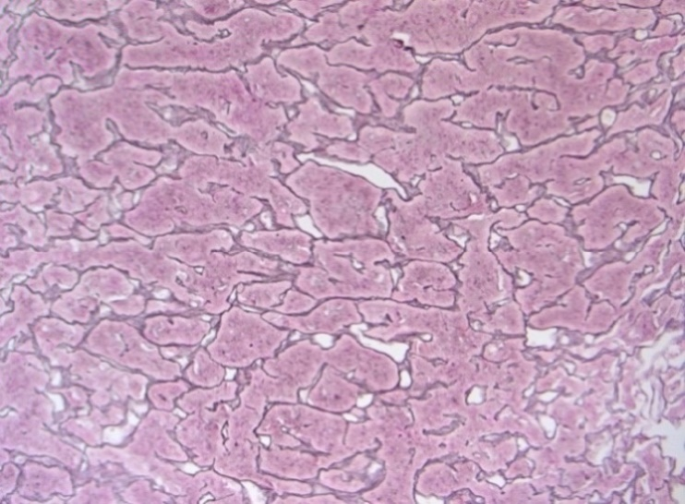

**Figure 6. Section of adenohypophysis stained with reticulin showing nested acini of adenohypophysial cells.**

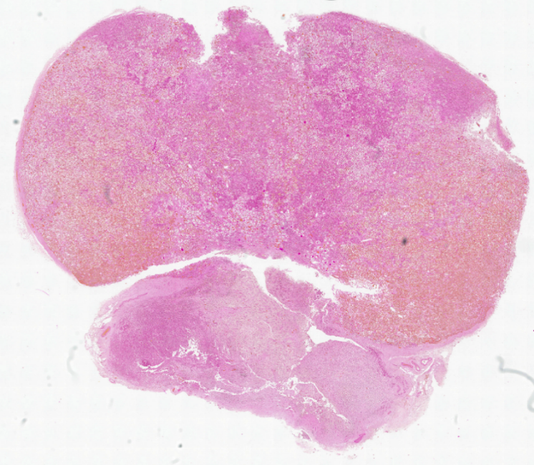

**Figure 7. Section of adenohypophysis stained with PAS/Orange G showing the distribution of acidophils (Orange) and basophils (Purple).**

The cellular heterogeneity within acini may be demonstrated tinctorially in PAS-OG preparations (Figures 7, 8) which were widely used before the adoption of antibody-based stains (Figure 9). Corticotroph cells are generally strongly basophilic (PAS-positive), somatotroph and lactotroph cells mostly acidophilic (orangeophilic), whilst gonadotrophs and thyrotrophs may be basophilic or chromophobic (reacting with neither acid nor basic stains). There is no perfect match of hormone-expression and type or degree of chromophilia; some chromophobe cells may represent degranulated chromophil cells or precursor cells. In a normal adult adenohypophysis, approximately 10% of endocrine cells are basophils, 40% acidophils and 50% chromophobes.

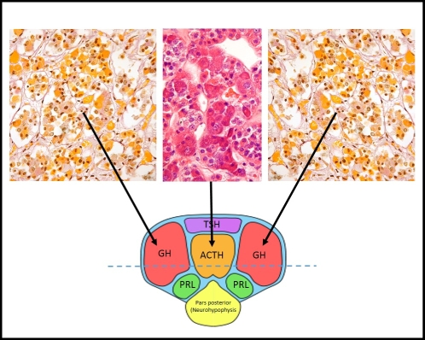

**Figure 8. The axial section of the adenohypophysis of the human pituitary gland at the level indicated by the dashed blue line in the diagram. Although there is a mixture of different hormone producing cells in most pituitary acini, the distribution of cells is not random: this is most pronounced in the ‘lateral wings’, which contain mostly somatotroph cells and the central ‘mucoid wedge’, which contains the majority of the corticotrophs. This is easily appreciated in periodic acid-Schiff / orange-G (PAS-OG) histochemistry, which stains somatotrophs yellow-orange (OG-positive) and corticotrophs purple (PAS-positive).**

The PAS-OG stain is still a useful supplementary method in the differential diagnosis of some pituitary lesions (hyperplasia, corticotroph microadenoma, Crooke’s cell changes or adenoma) but these tinctorial stains have all largely been replaced by immunohistochemical methods (Figure 9). Although most acini contain a mixture of different hormone-producing cells, there is evidence of zonation (Figure 8). The lateral wings of the gland mostly contain somatotrophs and lactotrophs, whilst corticotrophs are concentrated in the median mucoid wedge, which at its anterior border (the rostral tip) harbors clusters of thyrotrophs. Gonadotroph (LH/FSH) cells are diffusely scattered throughout the gland.

**Figure 9. Examples of immunohistochemistry. It can be seen that although growth hormone (GH) is generally enriched in the wings, the distribution is more diffuse. Corticotrophs (ACTH) are more obviously restricted to the central “mucoid wedge”. Compare this with tinctorial stains in Figures 7 & 8.**

**Cell Types of the Adenohypophysis**

SOMATOTROPHS

Somatotrophs represent about 50% of cells in the adenohypophysis and are located predominantly, but not exclusively, in the lateral wings. They are readily identified by the expression of growth hormone. A subset of somatotrophs also express the common glycoprotein hormone alpha-subunit. They are the second cell type to form during fetal development and are detected by 8 weeks of gestation.

LACTOTROPHS

Lactotrophs express prolactin. The number of prolactin-secreting cells varies widely between the sexes and with parity. The Golgi apparatus is well developed in lactotrophs and contains immature, pleomorphic secretory granules. Granule extrusions are common in lactotrophs, not only at the basal cell surface, but also on the lateral cell borders; the latter is a distinctive feature of lactotrophs seen on electron microscopy and is known as “misplaced exocytosis”. Lactotrophs appear to arise from mammosomatotroph cells and pure lactotrophs appear late in gestation (24 weeks). The expansion and secretion of lactotrophs is controlled by exogenous hormones including estrogen, paracrine effects from adjacent adenohypophysial cells and inhibitory substances from the hypothalamus.

MAMMOSOMATOTROPHS

These bihormonal cells contain both growth hormone and prolactin. Mammosomatotrophs are the precursors of lactotrophs and, as in lactotrophs, misplaced exocytosis can be seen on electron microscopy (figure 10). These cells are thought to be the source of lactotroph increases during pregnancy (28).

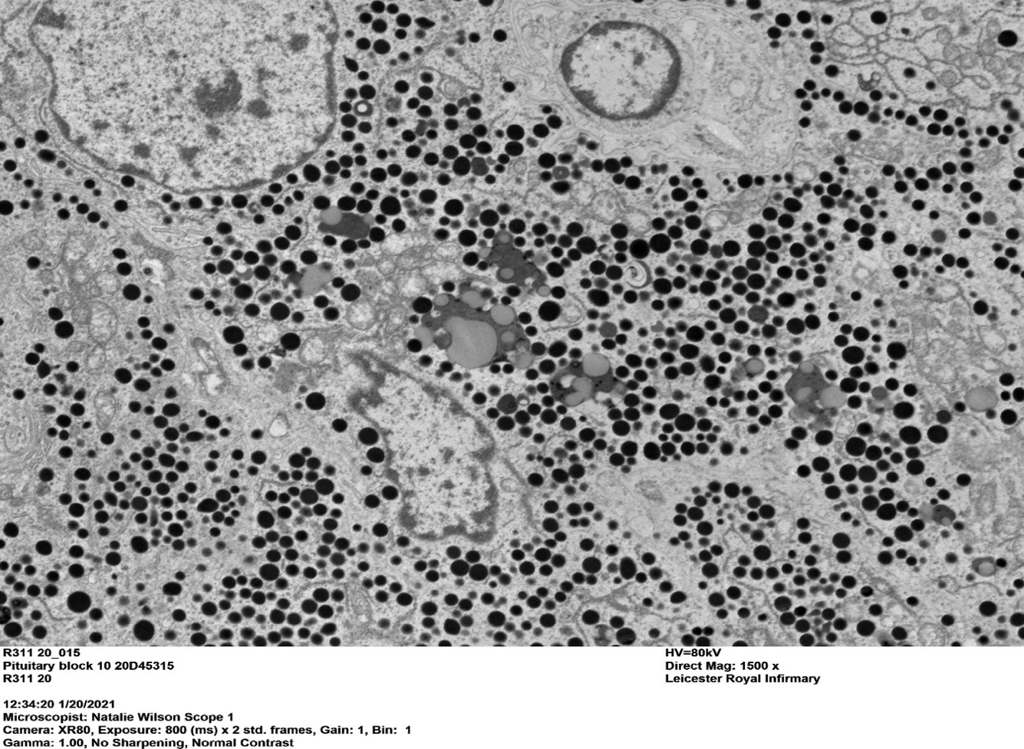

**Figure 10. Electron micrograph of a mammosomatotroph adenoma displaying misplaced exocytosis. This feature is seen as the extrusion of secretory granules into the extracellular spaces or from intercellular extensions of the basement membrane.**

CORTICOTROPHS

Corticotrophs synthesis the molecule pro-opiomelanocrortin (POMC) which is cleaved post-transcriptionally to produce bioactive peptides including adrenocorticotrophic hormone (ACTH), melanotrophin (MSH) lipotrophic hormone (LPH) and endorphins (29). These cells comprise about 15-20% of the cell component of the adenohypophysis and the cells are concentrated in the central mucoid wedge. They are best identified histologically by using antibodies raised against ACTH. Corticotrophs are the first cell type to differentiate in the fetal pituitary gland at 6 weeks of gestation and ACTH can be detected at 7 weeks. Exposure to glucocorticoid access, either by exogenous corticosteroid administration or any cause of endogenous glucocorticoid hypersecretion, including ectopic secretion of ACTH, causes corticotrophs to undergo a distinctive, but reversible, morphological alteration known as Crooke hyaline change (30).

THYROTROPHS

These are the most infrequent cell type within the adenohypophysis and are detected by the expression of the glycoprotein hormone common alpha-subunit and the beta-subunit of TSH. This can be demonstrated by immunohistochemical double labelling for both subunits. Thyrotrophs are detectable at about 12 weeks of gestation.

GONADOTROPHS

Gonadotrophs produce both luteinizing hormone (LH) and follicle stimulating hormone (FSH) and both hormone specific beta-subunits and the common alpha-subunit can be detected in these cells. Gonadotrophs are scattered throughout the pars distalis and are the major constituent of the pars tuberalis. Gonadotrophs are intimately associated with lactotrophs and electron microscopy reveals gap junctions between them. The synthesis and release of the gonadotrophins is differentially regulated by the hormonal milieu, paracrine interactions and the pulsatile frequency of GnRH (31) (26,32).

There is growing evidence that the precise control of pituitary gland secretion also involves a contribution from cells with the capacity to demonstrate plasticity with self-renewal and it is likely that the pituitary contains a pool of stem cells (33) (34) (35) (36). It is possible that these stem cells, possibly expressing Nestin, Lhx3 and Sox2, may exhibit self-renewal properties and have the ability to differentiate into different hormone-producing cell types in response to differing physiological demands (36) (37) (38).

FOLLICULOSTELLATE CELLS

Folliculostellate (FS) cells are (in the adult human pituitary) an agranular (non-hormone-producing) parenchymal component of the pars anterior. It has been postulated that they represent a stem cell capable of trans-differentiation into endocrine cells (39), but whether this is true in humans is not certain. FS cells are small, chromophobe, with slender processes that extend between the endocrine cells. They form small follicles at the center of acini, comprised of apical tips of multiple FS cells. They may be visualized with antibodies raised against the S100 protein and GFAP, but their expression pattern is not always overlapping and may reflect different stages of maturation or function. In our hands, annexin-1 immunohistochemistry is a robust marker of FS cells (Figure 11). Annexin 1 (ANXA1) is a member of the annexin family of phospholipid- and calcium-binding proteins. ANXA1-positive FS cells may modulate glucocorticoid feedback loops in the anterior gland (40) or act as antigen-presenting cells. FS cells are also postulated to play a role in paracrine regulation (26,41).

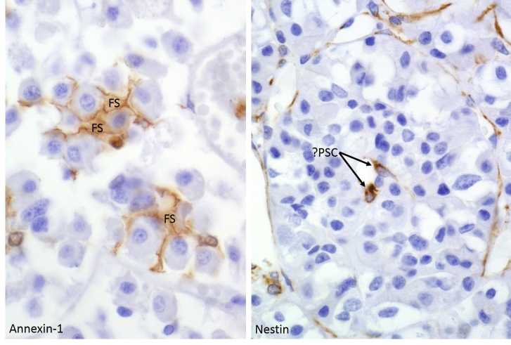

**Figure 11. Non-endocrine cells of the anterior lobe include small folliculo-stellate (FS) cells with delicately branching processes that invest endocrine cells (left, annexin-1 staining) and (on the right) very rare cells that are postulated to represent adult pituitary stem cells (PSC, nestin staining).**

**Pars Tuberalis**

The pars tuberalis is characterized by a large number of traversing vessels. Between these are cords or balls of undifferentiated cells admixed with acidophilic and basophilic cells. The secretion of adenohypophyseal hormones into the circulation appears to occur by exocytosis of the vesicular contents into the perivascular spaces of the sinusoids, the latter being lined with a fenestrated endothelium which facilitates diffusion into the bloodstream. The signal for secretion is the liberation of chemical releasing factors from neurons in the median eminence, and other hypothalamic centers, into the portal system of veins by which they are carried and distributed within the adenohypophysis.

**Pars Intermedia**

In contrast to rodents, the pars intermedia is rudimentary in adult humans (Figure 12). It represents a narrow zone between the adeno- and neurohypophysis often containing microscopic remnants of Rathke’s cleft. This zone may also contain scattered intensely PAS-positive corticotrophs, which may extend from the mucoid wedge of the adenohypophysis into the neurohypophysis. This so-called “basophil invasion” must not be confused with corticotroph microadenomas; it is believed to increase with age, and it has been suggested that these basophil cells are functionally distinct from classical ACTH-producing cells of the adenohypophysis and do not respond with hyaline degeneration (“Crooke’s cell change”) in the setting of systemic hypercortisolemia. Secretory cells of the pars intermedia have granules containing either alpha- or beta-endorphin; these cells have been shown to contain various peptide hormones including ACTH and alpha-MSH (melanocyte stimulating hormone).

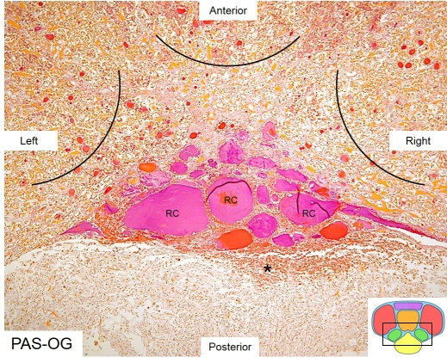

**Figure 12. The axial section of the human pituitary gland at the level of the vestigial intermediate lobe (approximately representing the boxed area in the diagram). Note the cluster of remnants of Rathke’s pouch / cleft (RC). The arcs indicate the posterior (center) and postero-medial (left and right) edges of the mucoid wedge (with scattered basophils) and pituitary wings (with scattered somatotrophs), respectively. The asterisk indicates basophil corticotrophs ‘spilling’ into the neurohypophysis (‘basophil invasion’, see figure 13).**

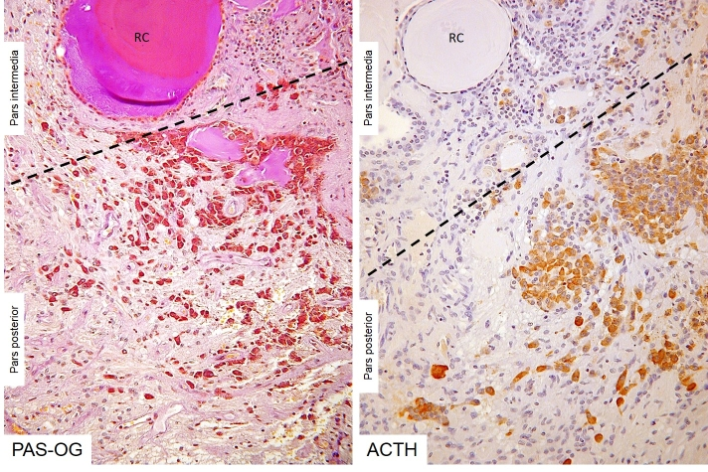

**Figure 13. ‘Basophil invasion’ of corticotrophs from the vestigial pars intermedia into the neurohypophysis (pars posterior of the pituitary gland). The dashed line represents the border between pars intermedia and pars posterior.**

**Neurohypophysis**

The neurohypophysis does not contain neuroendocrine epithelial cells. Instead, it is composed of the axons arising from groups of hypothalamic neurons, most prominently those originating from magnocellular neurons of the supraoptic and paraventricular nuclei (Figure 14). Some of these axons are short and terminate in the median eminence and infundibular stem among the superior capillary beds of the venous portal circulation. Longer axons pass into the main neurohypophysis thereby forming the neurosecretory hypothalamo-hypophyseal tract with their terminals ending near the sinusoids of the posterior lobe. These neurosecretory granules mostly contain oxytocin or vasopressin and form axonal beads close to their termini. Whilst it is believed that normal astrocytes may populate (at least partially) the infundibulum, the axon terminals in the neurohypophysis are supported by so-called pituicytes, which are characterized by the expression of the TTF-1 transcription factor (absent in classic GFAP-positive astrocytes) (42) (43) (44). These cells show elongated processes often running in parallel with axons and demonstrate only patchy GFAP and S100 expression.

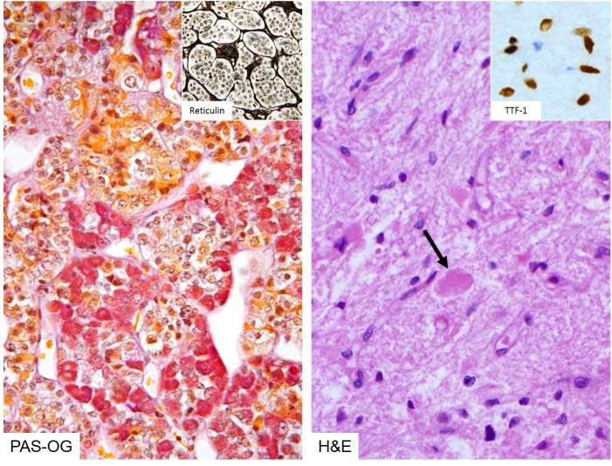

**Figure 14. The cytoarchitecture of the neurophypophysis (right) is strikingly different from the adenohypophysis, which contains the nested (inset, left) collections of neuroendocrine cells (left). The neurohypophysis does not contain neurosecretory cell bodies; instead, it is composed of specialized glial cells (pituicytes) that – unique in the human brain – express the TTF-1 (thyroid transcription factor 1) protein in their nuclei (inset, top right). The neurohypophysis contains nerve endings of the oxytocin and vasopressin producing cells of the hypothalamus. Their large, distended nerve endings can be identified on routine stains as so-called Herring-bodies (arrow), named after Percy Theodore Herring (University of Edinburgh) who described them in 1908 as the ‘physiologically active principle’ of the posterior gland.**

**The Vessels of the Hypophysis & Hypothalamic-Hypophysial Portal System**

The vessels of the hypophysis cerebri have been extensively described and reviewed (45) (46) (47) (48). The arteries of the hypophysis arise from the internal carotids via a single inferior and multiple superior hypophysial arteries. The arteries of the median eminence and infundibulum end in sprays of capillaries. In the median eminence, these form the external (mantle) plexus and the internal (deep) plexus that are both drained by the long portal vessels some of which terminate in the adenohypophysis. Short portal vessels run from the lower infundibulum to the pars anterior. Both types of portal vessel open into the vascular sinusoids lying between the secretory cords in the adenohypophysis, providing most of the blood; there is no direct arterial supply to this region (49) (50). The portal system is considered to carry hormone-secreting factors from the hypothalamus (46) (45) (49). Another notable feature of the rostral portion of the stalk are tortuous capillary loops surrounding a central capillary, termed gomitoli (51). These structures are composed of a central muscular artery surrounded by a spiral of capillaries. Although their function is unknown, the complexity of these gomitoli suggests that they may regulate the rate of blood flow to the adenohypophysis thereby regulating the flow of trophic factors.

The venous drainage of the neurohypophysis is by three possible routes: to the adenohypophysis via the long and short portal vessels, via the large inferior hypophyseal veins into the dural venous sinuses or to the hypothalamus via capillaries passing to the median eminence. The venous drainage carries hypophysial hormones from the gland to their target tissues and also facilitates feedback of secretions. In contrast, the venous drainage of the adenohypophysis appears restricted. It is possible that flow in the short postal vessels could be reversed explaining the postulated “short feedback loop”. These models of hypophysial blood flow are of importance to the mechanism of hormone secretion. It is not certain whether the median eminence represents the final common pathway for neural control of the adenohypophysis or the entire neurohypophysis may be involved; its capillary bed may selectively determine the destination of both hypothalamic and pituitary secretions, conveying some to the glandular pituitary, others to distant target organs and yet others to the brain (48).

**REFERENCES**

1. Davis SW, Potok MA, Brinkmeier ML, Carninci P, Lyons RH, MacDonald JW, Fleming MT, Mortensen AH, Egashira N, Ghosh D, Steel KP, Osamura RY, Hayashizaki Y, Camper SA. Genetics, gene expression and bioinformatics of the pituitary gland. Horm Res 2009;71 Suppl 2:101–15.

2. Srirangam Nadhamuni V, Korbonits M. Novel Insights into Pituitary Tumorigenesis: Genetic and Epigenetic Mechanisms. Endocr Rev 2020 12 01;41(6):bnaa006.

3. Asa SL Kovacs. Functional morphology of the human fetal pituitary. Pathol. Ann. 1984;19(Pt.1):275–315.

4. Rizzoti K. Genetic regulation of murine pituitary development. J Mol Endocrinol 2015;54(2):R55-73.

5. Kelberman D, Rizzoti K, Lovell-Badge R, Robinson IC, Dattani MT. Genetic regulation of pituitary gland development in human and mouse. Endocr Rev 2009;30(7):790–829.

6. Kelberman D, Rizzoti K, Avilion A, Bitner-Glindzicz M, Cianfarani S, Collins J, Chong WK, Kirk JM, Achermann JC, Ross R, Carmignac D, Lovell-Badge R, Robinson IC, Dattani MT. Mutations within Sox2/SOX2 are associated with abnormalities in the hypothalamo-pituitary-gonadal axis in mice and humans. J Clin Invest 2006;116(9):2442–55.

7. Gaston-Massuet C, Andoniadou CL, Signore M, Sajedi E, Bird S, Turner JM, Martinez-Barbera JP. Genetic interaction between the homeobox transcription factors HESX1 and SIX3 is required for normal pituitary development. Dev Biol 2008;324(2):322–33.

8. Davis SW, Castinetti F, Carvalho LR, Ellsworth BS, Potok MA, Lyons RH, Brinkmeier ML, Raetzman LT, Carninci P, Mortensen AH, Hayashizaki Y, Arnhold IJ, Mendonça BB, Brue T, Camper SA. Molecular mechanisms of pituitary organogenesis: In search of novel regulatory genes. Mol Cell Endocrinol 2010;323(1):4–19.

9. Zhu X, Gleiberman AS, Rosenfeld MG. Molecular physiology of pituitary development: signaling and transcriptional networks. Physiol Rev 2007;87(3):933–63.

10. Drouin J, Bilodeau S, Roussel-Gervais A. Stem cells, differentiation and cell cycle control in pituitary. Front Horm Res 2010;38:15–24.

11. Davis SW, Ellsworth BS, Peréz Millan MI, Gergics P, Schade V, Foyouzi N, Brinkmeier ML, Mortensen AH, Camper SA. Pituitary gland development and disease: from stem cell to hormone production. Curr Top Dev Biol 2013;106:1–47.

12. Li S, Crenshaw EB, Rawson EJ, Simmons DM, Swanson LW, Rosenfeld MG. Dwarf locus mutants lacking three pituitary cell types result from mutations in the POU-domain gene pit-1. Nature 1990;347(6293):528–33.

13. Pulichino AM, Vallette-Kasic S, Tsai JP, Couture C, Gauthier Y, Drouin J. Tpit determines alternate fates during pituitary cell differentiation. Genes Dev 2003;17(6):738–47.

14. Barnhart KM, Mellon PL. The orphan nuclear receptor, steroidogenic factor-1, regulates the glycoprotein hormone alpha-subunit gene in pituitary gonadotropes. Mol Endocrinol 1994;8(7):878–85.

15. Ngan ES, Cheng PK, Leung PC, Chow BK. Steroidogenic factor-1 interacts with a gonadotrope-specific element within the first exon of the human gonadotropin-releasing hormone receptor gene to mediate gonadotrope-specific expression. Endocrinology 1999;140(6):2452–62.

16. Lin L, Achermann JC. Steroidogenic factor-1 (SF-1, Ad4BP, NR5A1) and disorders of testis development. Sex Dev 2008;2(4–5):200–9.

17. Lourenço D, Brauner R, Lin L, De Perdigo A, Weryha G, Muresan M, Boudjenah R, Guerra-Junior G, Maciel-Guerra AT, Achermann JC, McElreavey K, Bashamboo A. Mutations in NR5A1 associated with ovarian insufficiency. N Engl J Med 2009;360(12):1200–10.

18. Ingraham HA, Lala DS, Ikeda Y, Luo X, Shen WH, Nachtigal MW, Abbud R, Nilson JH, Parker KL. The nuclear receptor steroidogenic factor 1 acts at multiple levels of the reproductive axis. Genes Dev 1994;8(19):2302–12.

19. Lamolet B, Poulin G, Chu K, Guillemot F, Tsai MJ, Drouin J. Tpit-independent function of NeuroD1(BETA2) in pituitary corticotroph differentiation. Mol Endocrinol 2004;18(4):995–1003.

20. Elster AD Sanders. Size and shape of the pituitary gland during pregnancy and post-partum: measurement with MR imaging. . Radiology 1991;181:531–535.

21. Bergland RM Ray. Anatomical variations in the pituitary gland and adjacent structures in 225 human autopsy cases. J. Neurosurg. 1968;28:93–99.

22. LeGros Clark W. The topography and homologies of the hypothalamic nuclei in man. J. Anat. 1936;70:203–214.

23. Harris GW. Neural control of the pituitary gland. London: Arnold; 1955.

24. Watts AG. 60 YEARS OF NEUROENDOCRINOLOGY: The structure of the neuroendocrine hypothalamus: the neuroanatomical legacy of Geoffrey Harris. J Endocrinol 2015;226(2):T25-39.

25. Stojilkovic SS, Tabak J, Bertram R. Ion channels and signaling in the pituitary gland. Endocr Rev 2010;31(6):845–915.

26. Denef C. Paracrinicity: the story of 30 years of cellular pituitary crosstalk. J Neuroendocrinol 2008;20(1):1–70.

27. Santiago-Andres Y, Golan M, Fiordelisio T. Functional Pituitary Networks in Vertebrates. Front Endocrinol (Lausanne) 2020;11:619352.

28. Stefaneanu L, Kovacs K, Lloyd RV, Scheithauer BW, Young WF, Sano T, Jin L. Pituitary lactotrophs and somatotrophs in pregnancy: a correlative in situ hybridization and immunocytochemical study. Virchows Arch B Cell Pathol Incl Mol Pathol 1992;62(5):291–6.

29. Smith AI Funder. Proopiomelanocortin processing in the pituitary, central nervous system, and peripheral tissues. Endocr. Reviews 1988;9:159–179.

30. Crooke AC. A change in the basophil cells of the pituitary gland common to conditions which exhibit the syndrome attributed to basophil adenoma. J. Pathol. Bacteriol. 1935;41:339–349.

31. Charlton HM, Halpin DM, Iddon C, Rosie R, Levy G, McDowell IF, Megson A, Morris JF, Bramwell A, Speight A, Ward BJ, Broadhead J, Davey-Smith G, Fink G. The effects of daily administration of single and multiple injections of gonadotropin-releasing hormone on pituitary and gonadal function in the hypogonadal (hpg) mouse. Endocrinology 1983;113(2):535–44.

32. Scott IS, Bennett MK, Porter-Goff AE, Harrison CJ, Cox BS, Grocock CA, O’Shaughnessy PJ, Clayton RN, Craven R, Furr BJ. Effects of the gonadotrophin-releasing hormone agonist “Zoladex” upon pituitary and gonadal function in hypogonadal (hpg) male mice: a comparison with normal male and testicular feminized (tfm) mice. J Mol Endocrinol 1992;8(3):249–58.

33. Childs GV, MacNicol AM, MacNicol MC. Molecular Mechanisms of Pituitary Cell Plasticity. Front Endocrinol (Lausanne) 2020;11:656.

34. Laporte E, Vennekens A, Vankelecom H. Pituitary Remodeling Throughout Life: Are Resident Stem Cells Involved? Front Endocrinol (Lausanne) 2020;11:604519.

35. Camilletti MA, Martinez Mayer J, Vishnopolska SA, Perez-Millan MI. From Pituitary Stem Cell Differentiation to Regenerative Medicine. Front Endocrinol (Lausanne) 2020;11:614999.

36. Perez-Castro C, Renner U, Haedo MR, Stalla GK, Arzt E. Cellular and molecular specificity of pituitary gland physiology. Physiol Rev 2012;92(1):1–38.

37. Florio T. Adult pituitary stem cells: from pituitary plasticity to adenoma development. Neuroendocrinology 2011;94(4):265–77.

38. Gleiberman AS, Michurina T, Encinas JM, Roig JL, Krasnov P, Balordi F, Fishell G, Rosenfeld MG, Enikolopov G. Genetic approaches identify adult pituitary stem cells. Proc Natl Acad Sci U S A 2008;105(17):6332–7.

39. Horvath E, Kovacs K. Folliculo-stellate cells of the human pituitary: a type of adult stem cell. Ultrastruct Pathol 2002;26(4):219–28.

40. John CD, Theogaraj E, Christian HC, Morris JF, Smith SF, Buckingham JC. Time-specific effects of perinatal glucocorticoid treatment on anterior pituitary morphology, annexin 1 expression and adrenocorticotrophic hormone secretion in the adult female rat. J Neuroendocrinol 2006;18(12):949–59.

41. Baes M Allaerts. Evidence for functional communication between folliculostellate cells and hormone-secreting cells in perfused anterior pituitary aggregates. Endocrinology 1987;120:685–691.

42. Roncaroli F, Chatterjee D, Giannini C, Pereira M, La Rosa S, Brouland JP, Gnanalingham K, Galli C, Fernandes B, Lania A, Radotra B. Primary papillary epithelial tumour of the sella: expanding the spectrum of TTF-1-positive sellar lesions. Neuropathol Appl Neurobiol 2020;46(5):493–505.

43. Lee EB, Tihan T, Scheithauer BW, Zhang PJ, Gonatas NK. Thyroid transcription factor 1 expression in sellar tumors: a histogenetic marker? J Neuropathol Exp Neurol 2009;68(5):482–8.

44. Hagel C, Buslei R, Buchfelder M, Fahlbusch R, Bergmann M, Giese A, Flitsch J, Lüdecke DK, Glatzel M, Saeger W. Immunoprofiling of glial tumours of the neurohypophysis suggests a common pituicytic origin of neoplastic cells. Pituitary 2017;20(2):211–217.

45. Popa GT; F U. A portal circulation from the pituitary to the hypothalamic region. J. Anat. 1930;65:88–91.

46. Harris GW. Blood vessels of rabbit’s pituitary gland, and significance of pars and zona tuberalis. J. Anat. 1947;81:343–351.

47. Green JD; H GW. Observations of hypophysioportal vessels of living rat. J. Physiol. 1949;108:359–361.

48. Page RB; B RM. Pituitary Vasculature. In: Allen MB; M VB, ed. The Pituitary: a current review. New York: Academic Press; 1977:9–17.

49. Bergland RM Page RB. Pituitary-brain vascular relations: a new paradigm. Science 1979;204:18–24.

50. Bergland RM Page. Can the pituitary secrete directly to the brain? Endocrinology 1978;102:1325–1338.

51. Coates PJ. The distribution of immunoreactive corticotrophin-releasing factor in the human pituitary stalk. Acta Endocrinol (Copenh) 1985;109(4):433–9.

52. Gaston-Massuet C, Andoniadou CL, Signore M, Jayakody SA, Charolidi N, Kyeyune R, Vernay B, Jacques TS, Taketo MM, Le Tissier P, Dattani MT, Martinez-Barbera JP. Increased Wingless (Wnt) signaling in pituitary progenitor/stem cells gives rise to pituitary tumors in mice and humans. Proc Natl Acad Sci U S A 2011;108(28):11482–7.

53. Aijaz S, Clark BJ, Williamson K, van Heyningen V, Morrison D, Fitzpatrick D, Collin R, Ragge N, Christoforou A, Brown A, Hanson I. Absence of SIX6 mutations in microphthalmia, anophthalmia, and coloboma. Invest Ophthalmol Vis Sci 2004;45(11):3871–6.

54. Durmaz B, Cogulu O, Dizdarer C, Stobbe H, Pfaeffle R, Ozkinay F. A novel homozygous HESX1 mutation causes panhypopituitarism without midline defects and optic nerve anomalies. J Pediatr Endocrinol Metab 2011;24(9–10):779–82.

55. Mortensen AH, Schade V, Lamonerie T, Camper SA. Deletion of OTX2 in neural ectoderm delays anterior pituitary development. Hum Mol Genet 2015;24(4):939–53.

56. Tajima T, Ishizu K, Nakamura A. Molecular and Clinical Findings in Patients with LHX4 and OTX2 Mutations. Clin Pediatr Endocrinol 2013;22(2):15–23.

57. Suh H, Gage PJ, Drouin J, Camper SA. Pitx2 is required at multiple stages of pituitary organogenesis: pituitary primordium formation and cell specification. Development 2002;129(2):329–37.

58. Pfaeffle RW, Savage JJ, Hunter CS, Palme C, Ahlmann M, Kumar P, Bellone J, Schoenau E, Korsch E, Brämswig JH, Stobbe HM, Blum WF, Rhodes SJ. Four novel mutations of the LHX3 gene cause combined pituitary hormone deficiencies with or without limited neck rotation. J Clin Endocrinol Metab 2007;92(5):1909–19.

59. Mullen RD, Colvin SC, Hunter CS, Savage JJ, Walvoord EC, Bhangoo AP, Ten S, Weigel J, Pfäffle RW, Rhodes SJ. Roles of the LHX3 and LHX4 LIM-homeodomain factors in pituitary development. Mol Cell Endocrinol 2007;265–266:190–5.

60. Machinis K, Pantel J, Netchine I, Léger J, Camand OJ, Sobrier ML, Dastot-Le Moal F, Duquesnoy P, Abitbol M, Czernichow P, Amselem S. Syndromic short stature in patients with a germline mutation in the LIM homeobox LHX4. Am J Hum Genet 2001;69(5):961–8.

61. Pfaeffle RW, Hunter CS, Savage JJ, Duran-Prado M, Mullen RD, Neeb ZP, Eiholzer U, Hesse V, Haddad NG, Stobbe HM, Blum WF, Weigel JF, Rhodes SJ. Three novel missense mutations within the LHX4 gene are associated with variable pituitary hormone deficiencies. J Clin Endocrinol Metab 2008;93(3):1062–71.

62. Kelberman D, de Castro SC, Huang S, Crolla JA, Palmer R, Gregory JW, Taylor D, Cavallo L, Faienza MF, Fischetto R, Achermann JC, Martinez-Barbera JP, Rizzoti K, Lovell-Badge R, Robinson IC, Gerrelli D, Dattani MT. SOX2 plays a critical role in the pituitary, forebrain, and eye during human embryonic development. J Clin Endocrinol Metab 2008;93(5):1865–73.

63. Kioussi C, Briata P, Baek SH, Rose DW, Hamblet NS, Herman T, Ohgi KA, Lin C, Gleiberman A, Wang J, Brault V, Ruiz-Lozano P, Nguyen HD, Kemler R, Glass CK, Wynshaw-Boris A, Rosenfeld MG. Identification of a Wnt/Dvl/beta-Catenin --> Pitx2 pathway mediating cell-type-specific proliferation during development. Cell 2002;111(5):673–85.

64. Kita A, Imayoshi I, Hojo M, Kitagawa M, Kokubu H, Ohsawa R, Ohtsuka T, Kageyama R, Hashimoto N. Hes1 and Hes5 control the progenitor pool, intermediate lobe specification, and posterior lobe formation in the pituitary development. Mol Endocrinol 2007;21(6):1458–66.

65. Treier M, Gleiberman AS, O’Connell SM, Szeto DP, McMahon JA, McMahon AP, Rosenfeld MG. Multistep signaling requirements for pituitary organogenesis in vivo. Genes Dev 1998;12(11):1691–704.

66. Falardeau J, Chung WC, Beenken A, Raivio T, Plummer L, Sidis Y, Jacobson-Dickman EE, Eliseenkova AV, Ma J, Dwyer A, Quinton R, Na S, Hall JE, Huot C, Alois N, Pearce SH, Cole LW, Hughes V, Mohammadi M, Tsai P, Pitteloud N. Decreased FGF8 signaling causes deficiency of gonadotropin-releasing hormone in humans and mice. J Clin Invest 2008;118(8):2822–31.

67. McCabe MJ, Gaston-Massuet C, Tziaferi V, Gregory LC, Alatzoglou KS, Signore M, Puelles E, Gerrelli D, Farooqi IS, Raza J, Walker J, Kavanaugh SI, Tsai PS, Pitteloud N, Martinez-Barbera JP, Dattani MT. Novel FGF8 mutations associated with recessive holoprosencephaly, craniofacial defects, and hypothalamo-pituitary dysfunction. J Clin Endocrinol Metab 2011;96(10):E1709-18.

68. Dodé C, Levilliers J, Dupont JM, De Paepe A, Le Dû N, Soussi-Yanicostas N, Coimbra RS, Delmaghani S, Compain-Nouaille S, Baverel F, Pêcheux C, Le Tessier D, Cruaud C, Delpech M, Speleman F, Vermeulen S, Amalfitano A, Bachelot Y, Bouchard P, Cabrol S, Carel JC, Delemarre-van de Waal H, Goulet-Salmon B, Kottler ML, Richard O, Sanchez-Franco F, Saura R, Young J, Petit C, Hardelin JP. Loss-of-function mutations in FGFR1 cause autosomal dominant Kallmann syndrome. Nat Genet 2003;33(4):463–5.

69. Treier M, O’Connell S, Gleiberman A, Price J, Szeto DP, Burgess R, Chuang PT, McMahon AP, Rosenfeld MG. Hedgehog signaling is required for pituitary gland development. Development 2001;128(3):377–86.

70. Kelberman D, Dattani MT. Role of transcription factors in midline central nervous system and pituitary defects. Endocr Dev 2009;14:67–82.

71. Cogan JD, Wu W, Phillips JA, Arnhold IJ, Agapito A, Fofanova OV, Osorio MG, Bircan I, Moreno A, Mendonca BB. The PROP1 2-base pair deletion is a common cause of combined pituitary hormone deficiency. J Clin Endocrinol Metab 1998;83(9):3346–9.

72. Deladoëy J, Flück C, Büyükgebiz A, Kuhlmann BV, Eblé A, Hindmarsh PC, Wu W, Mullis PE. “Hot spot” in the PROP1 gene responsible for combined pituitary hormone deficiency. J Clin Endocrinol Metab 1999;84(5):1645–50.

73. Turton JP, Mehta A, Raza J, Woods KS, Tiulpakov A, Cassar J, Chong K, Thomas PQ, Eunice M, Ammini AC, Bouloux PM, Starzyk J, Hindmarsh PC, Dattani MT. Mutations within the transcription factor PROP1 are rare in a cohort of patients with sporadic combined pituitary hormone deficiency (CPHD). Clin Endocrinol (Oxf) 2005;63(1):10–8.

74. Vieira TC, Boldarine VT, Abucham J. Molecular analysis of PROP1, PIT1, HESX1, LHX3, and LHX4 shows high frequency of PROP1 mutations in patients with familial forms of combined pituitary hormone deficiency. Arq Bras Endocrinol Metabol 2007;51(7):1097–103.

75. Dasen JS, O’Connell SM, Flynn SE, Treier M, Gleiberman AS, Szeto DP, Hooshmand F, Aggarwal AK, Rosenfeld MG. Reciprocal interactions of Pit1 and GATA2 mediate signaling gradient-induced determination of pituitary cell types. Cell 1999;97(5):587–98.

76. McLennan K, Jeske Y, Cotterill A, Cowley D, Penfold J, Jones T, Howard N, Thomsett M, Choong C. Combined pituitary hormone deficiency in Australian children: clinical and genetic correlates. Clin Endocrinol (Oxf) 2003;58(6):785–94.

77. Snabboon T, Plengpanich W, Buranasupkajorn P, Khwanjaipanich R, Vasinanukorn P, Suwanwalaikorn S, Khovidhunkit W, Shotelersuk V. A novel germline mutation, IVS4+1G>A, of the POU1F1 gene underlying combined pituitary hormone deficiency. Horm Res 2008;69(1):60–4.

78. Shinoda K, Lei H, Yoshii H, Nomura M, Nagano M, Shiba H, Sasaki H, Osawa Y, Ninomiya Y, Niwa O. Developmental defects of the ventromedial hypothalamic nucleus and pituitary gonadotroph in the Ftz-F1 disrupted mice. Dev Dyn 1995;204(1):22–9.

79. Pulichino AM, Vallette-Kasic S, Couture C, Gauthier Y, Brue T, David M, Malpuech G, Deal C, Van Vliet G, De Vroede M, Riepe FG, Partsch CJ, Sippell WG, Berberoglu M, Atasay B, Drouin J. Human and mouse TPIT gene mutations cause early onset pituitary ACTH deficiency. Genes Dev 2003;17(6):711–6.

80. Vallette-Kasic S, Brue T, Pulichino AM, Gueydan M, Barlier A, David M, Nicolino M, Malpuech G, Déchelotte P, Deal C, Van Vliet G, De Vroede M, Riepe FG, Partsch CJ, Sippell WG, Berberoglu M, Atasay B, de Zegher F, Beckers D, Kyllo J, Donohoue P, Fassnacht M, Hahner S, Allolio B, Noordam C, Dunkel L, Hero M, Pigeon B, Weill J, Yigit S, Brauner R, Heinrich JJ, Cummings E, Riddell C, Enjalbert A, Drouin J. Congenital isolated adrenocorticotropin deficiency: an underestimated cause of neonatal death, explained by TPIT gene mutations. J Clin Endocrinol Metab 2005;90(3):1323–31.