DIABETES INSIPIDUS

Stephen Ball, FRCP, Professor of Medicine & Endocrinology, Manchester University Foundation Trust & Manchester Academic Health Science Centre, Manchester M13 9WL, UK. s.ball@manchester.ac.uk

Updated August 11, 2022

CLINICAL RECOGNITION

Diabetes Insipidus (DI) is the excess production of dilute urine. Diagnosis requires a targeted history, examination and confirmation through appropriate laboratory and radiological investigations. DI presents with polyuria and polydipsia. Urine output is more than 40 ml/kg /24 hours in adults and more than 100 ml/kg/24 hours in children. DI reflects either the lack of production or action of the posterior pituitary hormone vasopressin (AVP). There are three subtypes.

- Cranial or hypothalamic DI (HDI): due to relative or absolute lack of AVP.
- Nephrogenic DI (NDI): due to partial or total resistance to the renal antidiuretic effects of AVP.
- Dipsogenic DI (DDI, primary polydipsia): where polyuria is secondary to excessive, inappropriate fluid intake.

All forms of DI are rare. HDI has an estimated prevalence of 1/25,000. While presentation is more common in adults, familial forms of both HDI and NDI characteristically present in childhood.

PATHOPHYSIOLOGY

The Physiology of AVP

AVP is a nine-amino acid peptide made within magnocellular neurones of the paraventricular (PVN) and supraoptic (SON) nuclei of the hypothalamus that project through the hypophyseal portal tract to terminate in the posterior pituitary, where AVP is released into the circulation. Together, the PVN, SON and posterior pituitary form an anatomical and functional unit- the neurohypophysis (Figure 1).

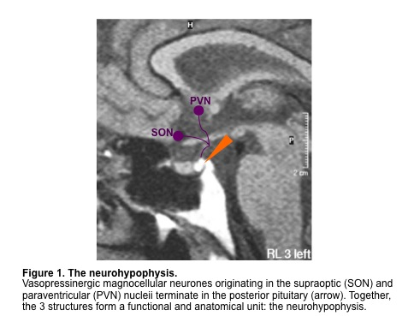

AVP is produced from a large precursor that undergoes extensive post-translational processing (figure 2).

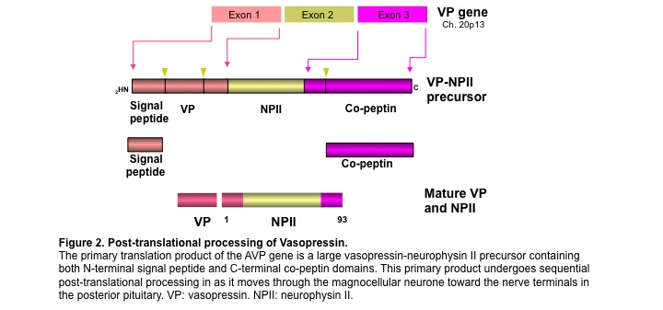
The major action of AVP is in the regulation of renal water excretion. AVP increases expression of the AVP-dependent water channel Aquaporin 2, which is expressed in the renal collecting duct, facilitating water reabsorption. This action of AVP is mediated by the type 2 AVP receptor (V2-R), expressed exclusively on the interstitial surface of target cells in the distal nephron. AVP release is regulated by osmoreceptors within the lamina terminalis. There is a linear relationship between plasma osmolality and plasma AVP concentration. Not unexpectedly, thirst perception regulated in a parallel manner (Figure 3).

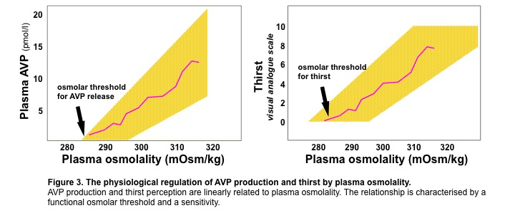

Hypothalamic DI

Presentation with HDI implies loss of 80%-90% of AVP production from the posterior pituitary. This, in turn, reflects either destruction of vasopressinergic magnocellular neurons in the hypothalamus or interruption of intra-axonal transport/processing of AVP. Some 50% of children and young adults with HDI have an underlying tumor or CNS malformation (e.g., craniopharyngioma, germinoma, septo-optic dysplasia). Familial HDI comprises 5% of cases.

Acute HDI can occur in up to 22% of non-selected patients presenting with traumatic brain injury (TBI), persisting in some 30% of these on long term follow up. HDI may follow trauma to the pituitary or hypothalamus. HDI following surgery to the pituitary or neurohypophysis presents within 24-48h after surgery and is often transient, resolving within 10 days. Pituitary stalk trauma (including that following surgery) may lead to a tri-phasic disturbance in water balance; an immediate polyuria due to HDI followed by a more prolonged period of antidiuresis suggestive of AVP excess. The antidiuretic phase may last several weeks and can be followed by reversion to HDI or recovery. DI presenting with a pituitary mass should raise concerns about a diagnosis other than pituitary adenoma. HDI can worsen in pregnancy due to increased degradation of AVP by placental enzyme activity

Table 1. Etiology of HDI
Primary
Genetic | Wolfram syndrome  Autosomal dominant  Autosomal recessive
Developmental syndromes | Septo-optic dysplasia
Idiopathic
Secondary/acquired
Trauma | Head injury,  Post-surgery
Tumor | Craniopharyngioma  Germinoma  Metastases  Pituitary macroadenoma
Inflammatory | Sarcoidosis, Histiocytosis, Meningitis, Encephalitis, Infundibuloneurohypophysitis, Guillain–Barré syndrome, Autoimmune

Nephrogenic DI

Renal resistance to AVP may reflect a toxic renal tubulopathy secondary to metabolic (e.g., hypokalemia; hypercalcemia) or drug effects (e.g., lithium). Prolonged polyuria of any cause can result in partial NDI through disruption of the intra-renal solute gradients and reduced tubular concentrating capacity.

X-linked familial NDI results from loss-of-function mutations in the renal AVP receptor (Figure 4). Autosomal recessive NDI is caused by loss-of-function mutations in the AVP-dependent renal water channel aquaporin-2.

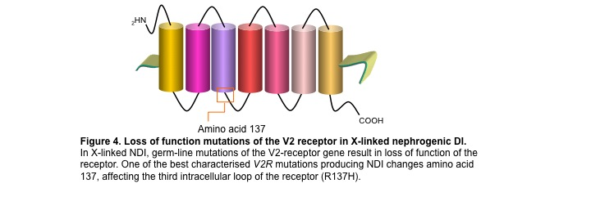

Dipsogenic DI

Persistent high fluid intake leads to appropriate polyuria. If intake exceeds the limit of renal free water excretion, hyponatremia may result. DDI can be associated with abnormalities in thirst perception.

• Low threshold for thirst
• Exaggerated thirst response to osmotic challenge
• Inability to suppress thirst at low plasma osmolalities

Neuroimaging is normal in most cases. DDI is associated with affective disorders.

DIAGNOSIS AND DIFFERENTIAL

History and examination may reveal important clinical information

-Features of systemic disease
-Associated endocrinopathy: suggestive of additional hypothalamic or pituitary dysfunction
-Neuro-ophthalmic problems suggestive of structural disease
-Evidence of drug toxicity (e.g., lithium, phenytoin)

There should be a standard initial diagnostic approach.

-Confirmation of true polyuria, distinct from simple frequency without excess urine volume
-Exclusion of common differentials such as drug (diuretics) and metabolic causes (hyperglycemia, hypercalcemia hypokalemia)

If polyuria is confirmed and simple causes are excluded, the clinician should proceed to a diagnostic Water Deprivation Test (Table 2)

Definitive diagnosis of DI requires testing of AVP production and action in response to osmolar stress. The water deprivation test is an indirect assessment of the AVP axis, measuring renal concentrating capacity in response to dehydration. It can be followed by assessment of renal response to the synthetic AVP analogue DDAVP, to determine whether any defect identified in urine concentrating ability can be corrected with AVP-replacement.

Table 2. Water Deprivation Test
Step 1 - Dehydration phase
Aim | Differentiate HDI and NDI from DDI
Procedure | Restrict all fluids between 8am-4pm in a controlled environment. Take baseline and 2 hourly measurements of weight, urine volume, urine osmolality, and plasma osmolality. Abandon test if thirst becomes unbearable or if patient loses >5% initial weight.
Analysis | HDI and NDI:  Urine osmolality <300mOsm/kg  Plasma osmolality >290mOsm/kg  DDI:  Urine and plasma osmolality normal
Step 2 – DDAVP (desmopressin) response phase
Aim | Differentiate HDI from NDI
Procedure | At 4pm, administer desmopressin bolus (1mcg, intramuscular). Allow fluid intake up to 2x the volume of urine output in step 1. Continue to measure urine volume, urine osmolality and plasma osmolality every hour until 8pm.  Measure plasma osmolality and plasma sodium at 9am the next morning.
Interpretation | HDI:  Urine osmolality >750 mOsm/kg  NDI:  Urine osmolality remains low

Further Investigations

Water deprivation test results may be indeterminate. If HDI is suspected but water deprivation test data are inconclusive, a reasonable approach is a therapeutic trial of 10-20 mcg intranasal DDAVP per day with close monitoring of plasma Na⁺. Patients with HDI note improved symptoms without significant dilutional hyponatremia. In the future, basal or stimulated measurement of copeptin may be the most useful investigation, when generally available.

Confirmation of HDI should lead to further pituitary function testing and cranial MRI. MRI may reveal the absence of posterior pituitary bright spot on T1- weighted sequences (Figure 5), or a pituitary mass. In the absence of structural problem, the MRI should be repeated 12 months after presentation to exclude slow growing mass lesion. NDI requires renal tract imaging and additional renal studies.
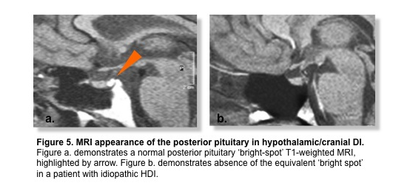
Diabetes Insipidus Combined with Defects in Thirst (Adipsic DI)

While the regulation of thirst and AVP are discrete, the close neuroanatomical relationship of the structures responsible for osmoregulation of both processes means that some structural, neurovascular and neuro-developmental lesions are associated with combined defects. Absent or reduced thirst (adipsia) in association with HDI predisposes to hypernatremic dehydration. Diagnosis follows that outlined for HDI, with parallel assessment of thirst perception.

TREATMENT

Mild forms of HDI may not require treatment. Significant polyuria and polydipsia are treated effectively with DDAVP in divide doses: nasal spray 5-100 mcg per day; tablets 100-1000 mcg/day; or parenterally 0.1-2.0 mcg/day. Hyponatremia from plasma dilution can be avoided by omitting treatment for a short period on a regular basis (e.g., one dose per week).

NDI may respond to removal of the causal agent (such as correction of hypokalemia or cessation of Lithium). However, drug-induced NDI may persist. Symptoms may respond partly to high-dose DDAVP (e.g., 4 mcg i.m. bid.) Hydrochlorothiazide (25 mg/day) either alone or in combination with Ibuprofen (200 mg/day) may be of some help. Urine output should not be expected to normalize.

The approach to DDI is reduction in fluid intake. DDAVP treatment must be avoided because of the risk of significant hyponatremia.

Patients with adipsic DI require careful management. Absence of normal thirst perception and/or regulation means that they may continue to drink at low plasma osmolalities that would normally suppress fluid intake. The combination of an obligate antidiuresis produced by DDAVP treatment, together with the potential for spontaneous fluid intake in excess of that required for maintenance of plasma volume and normal plasma osmolality, means they are at risk of fluid overload and dilutional hyponatremia. The same group of patients are also at risk of dehydration and hypernatremia if total body water loss is higher than a spontaneous fluid intake that is, by definition, uncoupled from normal osmo-regulatory control. In patients with adipsic DI, managing fluid balance to maintain normal plasma sodium is therefore challenging. One approach is to combine a fixed DDAVP-dependent antidiuresis (giving urine output of some 2 L/day) with a variable daily fluid intake that aims to maintain the patient’s body weight at that which is known to be associated with normal plasma volume and normal plasma sodium (the ‘target’ weight, see below).

e.g. Fluid intake for given day (L) = 2 L (i.e., urine output from fixed dose DDAVP) - (weight on given day in kg - target weight in kg)

FOLLOW-UP

Following initiation of DDAVP, patients require review for dose titration. When stable, they can be seen annually to assess symptom control and to check plasma Na⁺ levels to avoid over-treatment. Adipsic DI requires meticulous follow-up in a specialist service.

GUIDELINES

Baldeweg SE, Ball S, Brooke A, Gleeson HK, Levy MJ, Prentice M, Wass J. In-patient management of Cranial Diabetes Insipidus. Endocrine Connections 2018;

REFERENCES

Ball SG. The Neurohypophysis: Endocrinology of Vasopressin and Oxytocin. In: De Groot LJ, Chrousos G, Dungan K, Feingold KR, Grossman A, Hershman JM, Koch C, Korbonits M, McLachlan R, New M, Purnell J, Rebar R, Singer F, Vinik A, editors. Endotext [Internet]. South Dartmouth (MA): MDText.com, Inc.; 2000-2017 Apr 22. PMID: 25905380

Gubbi S, Hannah-Shmouni F, Koch CA, Verbalis JG. Diagnostic Testing for Diabetes Insipidus. 2019 Feb 10. In: Feingold KR, Anawalt B, Boyce A, Chrousos G, de Herder WW, Dhatariya K, Dungan K, Hershman JM, Hofland J, Kalra S, Kaltsas G, Koch C, Kopp P, Korbonits M, Kovacs CS, Kuohung W, Laferrère B, Levy M, McGee EA, McLachlan R, Morley JE, New M, Purnell J, Sahay R, Singer F, Sperling MA, Stratakis CA, Trence DL, Wilson DP, editors. Endotext [Internet]. South Dartmouth (MA): MDText.com, Inc.; 2000–. PMID: 30779536

Ball S 2013. Diabetes Insipidus. Medicine 41: 519-521. 10.1016/j.mpmed.2013.06.001
http://www.sciencedirect.com/science/article/pii/S1357303913001783

Refardt J, Winzeler B, Christ-Crain M. Endocrinol Metab Clin North Am. 2020 Sep;49(3):517-531. doi: 10.1016/j.ecl.2020.05.012. Epub 2020 Jul 15. PMID: 32741486

Garrahy A, Thompson CJ. Management of central diabetes insipidus. Best Pract Res Clin Endocrinol Metab. 2020 Sep;34(5):101385. doi: 10.1016/j.beem.2020.101385. Epub 2020 Jan 31. PMID: 32169331

