**DIABETES MELLITUS AND TUBERCULOSIS**

**Sudeep Krishna, MD (Med), Dip. Diabetology, DNB (Endocrinology),** Associate Professor and Head, Department of Endocrinology, DM and Metabolism, Father Muller Medical College Hospital, Mangalore, 575002. Karnataka, India. drsudeepmd@rediffmail.com

**Jubbin Jagan Jacob, MD (Med), DNB (Endocrinology), MNAMS, FRCP Edin,** Professor and Head, Department of Endocrinology, Christian Medical College and Hospital, Ludhiana 141008, Punjab, India. jubbin.jacob@gmail.com

**Received April 16, 2021**

**ABSTRACT**

The converging epidemics of non-communicable disease like DM (DM) and an infectious disease like tuberculosis (TB) is a double burden. DM is increasing in the same population that is at high risk for developing TB. There is a two-to-four-fold higher risk of active TB in individuals with DM and up to 30% of individuals with TB are likely to have DM. Immune deficiency either in absolute or relative quantities are sufficient for re-activation of latent TB. From a 10% risk of reactivation over the whole lifetime of an immunocompetent individual, the risk of reactivation increases to 10% every year in immune-deficient individuals. DM impairs cell mediated immunity and poor glycemic control affects cytokine response and alters the defenses in the alveolar macrophages. Fever, hemoptysis, extensive parenchymal lesions, and lung cavities are more common in those with DM particularly heavier and older males. DM increases the risk of treatment failure, death, and relapse. Evidence collected from meta-analysis conclude that DM can increase the odds of developing Multi Drug resistant TB (MDR-TB). The synergism between DM and TB necessitates bi-directional screening. Sputum examination for Ziehl-Neelsen staining is both a sensitive and specific screening test. Rapid molecular diagnostic tests like cartridge based nucleic acid amplification tests (CB-NAAT) are useful in cases where there is a high-index of suspicion and difficulty in arriving at a definitive diagnosis exists. Random plasma glucose and HbA1c (glycosylated Hemoglobin) measurements are convenient tests for DM screening that can be done in non-fasting individuals. Screening for DM more than once during the course of illness is sensible so that transient DM and new-onset DM can be identified. Anti-TB drugs affect glycemic control as they interact with anti-diabetic drugs by either stimulating or inhibiting the metabolizing enzymes. They may also aggravate metabolic, ocular, and neuropathic complications of DM. Insulin is the preferred drug in most instances. The presence of renal and hepatic dysfunction affects TB and hyperglycemic management.

**INTRODUCTION**

Tuberculosis (TB) and diabetes mellitus (DM) are two diverse conditions of immense public health importance existing for centuries. TB was traditionally identified with poverty while DM was considered as an entity associated with prosperity. TB is today one of the commonest and widespread communicable infectious diseases largely but not necessarily confined to low-economic groups. DM on the other hand spearheads the group of chronic non-communicable diseases affecting people across all socio-economic strata. Contrary to previous beliefs, a larger number of people with DM are living in middle- and low-income countries. Unfortunately, these are the countries where DM is expected to increase in the near future (1). Both DM and TB have been associated with significant morbidity and mortality from time immemorial. Advancements in modern medical science over the years has definitely improved the outcome in both these conditions. But the magnitude of these two diseases has not waned and both are collaborative in worsening each other. In fact, the increase in the population affected with DM is sustaining the TB epidemic.

TB is associated with the endocrine system in different ways. The effects of TB on the endocrine system are discussed in detail in another Endotext chapter (2). The interaction of TB and DM is discussed in this chapter.

**TUBERCULOSIS**

TB is a global health threat, particularly to the poor and the susceptible. It is estimated that on average approximately 9 to 10 million people are affected by TB and around 1 to 2 million succumb to it annually (3). In 2019, 1.3 million people died due to TB. In developed countries, TB has slipped down in ranking among the global list of top 10 diseases causing mortality. However, in the underdeveloped regions it still remains among the top 10 diseases with high mortality (up to 30%). When in concurrence with retroviral infections, the risk of active TB is 12 to 20 times higher and the mortality is higher even in developed countries (4). Multi drug resistant TB is another rising problem which requires expensive second line drugs and a longer duration of treatment. A large proportion of the global population is at risk and the true prevalence and the annual incidence also depends on access to health care facilities and the laboratory-based testing capacity of the regions. Individuals who are in close contact with affected individuals, people living in crowded places, immigration to a country or area with a high prevalence of TB, and children less than 5 years of age are considered vulnerable to getting infected by the TB bacilli(Table 1). Bacillary load in the sputum of the infectious individual and close proximity to the infectious persons are two important external determinants for infection in any individual after exposure.

|  |  |  |
| --- | --- | --- |
| **Table 1. Risk Factors for TB Infection, Disease, and Outcome** | | |
| **Stage of TB** | **Intrinsic Factors** | **Extrinsic factors** |
| **Exposure to infection** | Closeness of contact  Duration of contact  Load of Bacilli | Overcrowding and lack of ventilation  Indoor pollution  Community prevalence of TB  Tobacco Use, Drug abuse  Alcohol  Migration |
| **Infection to disease progression** | Altered Immune status (disease or drug induced)  Lack of BCG vaccination  Nourishment  **DM**  Malignancy  Respiratory diseases like Silicosis  Age  Male |
| **Disease Outcome** | Female sex, Social Stigma, Immune status, Malnourishment, **DM,** Malignancy, Age, MDR-TB, | **Barriers to health care access:** Cultural, Geographical, Economical, Weak social support, Weak health care support |

**Latent Tuberculosis**

In most of the exposed individuals the infection is quelled by the immune system and the bacilli are fenced inside a granuloma or tubercle, immunologically aborting an active disease. This is a subclinical disease (*LTBI – Latent TB infection*) which doesn’t have symptoms and can last for weeks or decades. This latent infection is seen in nearly one third of the world population. Even though non-infectious, they carry the risk (about 10%) of re-activation into active TB later (primary progressive TB) (5). Such re-activation occurs in immunocompromised as in HIV infection, those on immunosuppressive agents (such as post organ transplant, autoimmune diseases, and allergic diseases), conditions like DM, alcoholism, substance abuse, silicosis, malnutrition, steroid therapy, renal failure, malignancies, indoor air pollution, and smoking. The World Health Organization (WHO) has guidelines on the approach to latent TB especially in countries where the burden of TB is low (an incidence of < 100 / 1, 00,000 per year). It strongly recommends screening and treatment of latent TB in high-risk individuals in these countries (6).

TB is an airborne infectious disease which spreads by droplets. TB affects the lungs primarily (Pulmonary TB) and when it affects the pleura, bones/joints, abdominal organs, lymph nodes, and meninges it is called extra-pulmonary TB. Mycobacterium tuberculosis, the causative agent has a thick mycolic acid cell wall that enables its survival in the environment and in its host. External to its cell membrane it has a peptidoglycan polymer which makes it impermeable. Its cell wall also contains lipoarabinomannan which enables its phagocytosis by macrophages and facilitates its survival inside macrophages in airways especially alveoli (7). The ability of the host’s defense system then determines whether the outcome is a progressive primary pulmonary disease or a latent state.

**DIABETES MELLITUS**

The prevalence of DM is rapidly increasing to justify it to be termed as an epidemic disease. According to WHO, the global prevalence of DM has doubled from 4.7 % in 1980 to 8.5% in 2014 (8). From an estimated prevalence of 463 million in 2019, it is estimated to increase to 578 million in 2030, and 700 million in 2045. For every diagnosed individual with DM there is another undiagnosed person with DM (9). The differences in the prevalence of DM between high and middle-income countries and similarly between rural and urban population are decreasing.

According to WHO, non-communicable diseases constitute 7 out of the top 10 leading causes of death and DM is prominent among them. In 2019 the estimated number of deaths to have occurred due to DM globally is approximately 4 million (10). DM is associated with significant morbidity due to its microvascular and macrovascular complications and high cardiovascular mortality. DM is a major cause of cardiac ischemia, stroke, renal failure, blindness, and amputations.

**THE DIABETES-TUBERCULOSIS EPIDEMIOLOGY: THE BIDIRECTIONAL LINK**

The high prevalence of DM and TB being in epidemic proportions has rightly earned them the names ‘the converging epidemics’ and ‘double burden’ (11,12). Due to rapid changes in lifestyle, urbanization, and epidemiological changes, DM is increasingly seen in low- and medium-income groups, and in younger individuals more frequently than before. The prevalence of DM is increasing faster where TB is endemic already. Unfortunately, these are the regions in the world where health care facilities are less common. According to International Diabetes Federation, the 50-55% increase in the prevalence of DM over the next 2 decades will occur predominantly in the continent of Africa (10). A longitudinal, multi-national study involving low-income countries concluded that an odds ratio of 4.7 for prevalence and 8.1 for incidence of TB is highly likely in those counties where DM has increased over the last decade (13). The WHO states that younger age group individuals are three times more likely to get infected with TB (14). There is a two-to four-fold higher risk of active TB in individuals with DM compared to non-diabetic individuals (15). According to a meta-analysis by Wilkinson et al, around 4 % of people with type 2 DM develop TB (16). Since the number of individuals with undiagnosed DM in the world is expected to be more than 50%, the proportion of TB in DM also should be much higher. Analytical models that try to project the future burden of TB in DM predict that the increase in DM counteracts the decreasing incidence of TB by at least 3% over the next 15 years (17).

Increased chances of finding undetected and uncontrolled hyperglycemia in close household contacts of subjects with TB have been mentioned in studies from Asian counties. In fact, a systemic analysis of a group of heterogenous studies on bi-directional screening i.e., screening for TB in DM affected individuals and vice versa has shown some evidence to support active screening for both DM and TB in the affected individuals and family members (18). Up to 35% of TB patients may have DM and the quoted figures are variable in literature (19). Jean Jacques Noubiap et al in their systematic review and meta-analysis of data from 2.3 million people with TB world-wide estimated that the prevalence of DM in patients with TB is around 15 % and was twice that of the general population (20). These data clearly give epidemiological evidence for the co-existence of DM and TB as a syndemic. A potentially lethal combination of a communicable disease and a non-communicable disease having a synergistic effect is a challenge on the public health system.

**Epidemiology of Diabetes Among Patients with Active Tuberculosis**

The WHO collaborative framework recommends for a joint plan for DM and TB related activities which have to be reflected in the national plans on non-communicable diseases and TB respectively (21). As per the WHO approximately15% of TB cases in the world are associated with DM. Of these 15%, India accounts for more than 40% of the cases (19). Estimates of the burden of DM and TB co-existence has primarily come from studies looking at prevalence of DM and glucose intolerance among newly diagnosed patients with TB diagnosed in TB clinics. The community prevalence of these two disorders co-existing are not clear. Many of these studies have been done in hospitals where sicker patients with TB are treated which would probably account for a higher percentage of patients having glucose intolerance and DM. In a study from five randomly selected TB care clinics in the southern state of Tamil Nadu, around 25% of patients with TB had coexisting DM. Around 10% of these patients had newly diagnosed DM. Risk factors for having DM in this group of patients included older age, higher basal metabolic index (BMI), family history of DM among first degree relatives, and following a sedentary lifestyle (22). Close to Tamil Nadu in the southern state of Kerala, the prevalence of DM in patients with TB was nearly double that observed in the previous study. Among the patients with TB in Kerala, 44% had DM. Among them about half (21%) had newly diagnosed DM (23). The risk of DM was higher among those with sputum positive TB in both of these studies. In a study from Odisha on the Eastern part of India, 13.9% of tribal patients with TB had DM suggestive of a significant burden of disease even among poorer regions of the country (24). In a retrospective study, among 1000 patients with TB from the northern state of Punjab, 11.6% had DM and TB coexistence (25). In the same state the authors found 30% of patients with TB diagnosed in a tertiary referral hospital had DM (26).

To better understand the prevalence of DM among newly diagnosed patients with TB a large multicentric study involving five centers is in progress (GIANT Study - Glucose Intolerance Among New patients with TB - Clinical Trial Registry India - CTRI/2019/05/019396). This study incorporates simultaneous OGTT and HbA1c determinations at three different time points to ascertain if HbA1c can replace the standard oral glucose tolerance test (OGTT) in this population and avoid the inconvenience of performing an OGTT.

A recent systemic review and meta-analysis ascertained the worldwide prevalence of DM among active cases of TB. This meta-analysis involved over 200 studies that included a little under 2.3 million patients with active TB. The overall pooled prevalence was similar to the WHO estimate of 15% prevalence of DM in patients with active TB. However, this varied from 0.1% in Latvia to 45% in the Marshall Islands. The high prevalence areas as per the International Diabetes Federation included North America, Western Pacific (which includes Australia and China), South East Asia, North Africa, and Middle East Asia (27). Figure 1 summarizes the information on the prevalence of DM and active TB in 7 regions of the world.

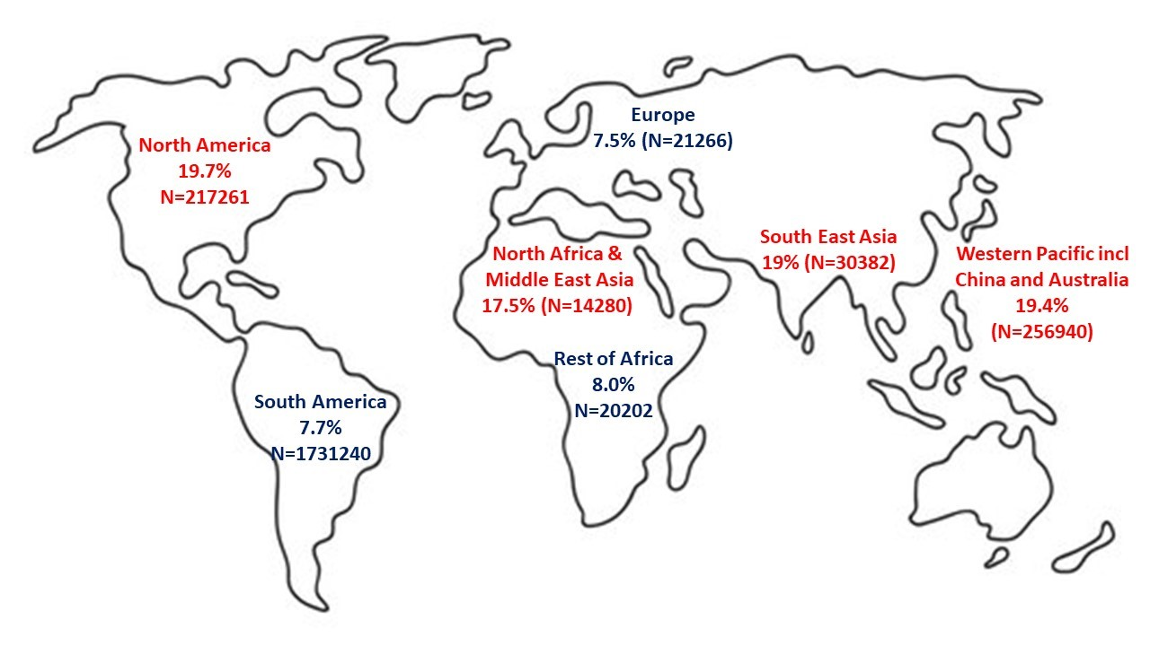

**Figure 1.****Prevalence of DM among patients with active TB in the seven International Diabetes Federation (IDF) regions of the world. The areas in red have the high burden of DM co-existing with active TB. The low burden areas are marked in blue. (adapted from ref 27)**

**DIABETES PREDISPOSING TO TUBERCULOSIS**

Absolute or relative immune deficiency is sufficient for re-activation of latent TB. The association of increased prevalence of TB in immune deficient diseases like HIV is well established. The wider prevalence of DM makes DM a more important risk factor for developing TB than retroviral diseases. The higher incidence of multi-drug resistant TB reported to be significant in some studies (Odds Ratio of 2.1) reiterates the role of immune dysregulation in DM (28). The immune response in DM to TB is supposed to be hyper-reactive but ineffective and even deleterious as it may produce pulmonary tissue damage.

Chronic hyperglycemia impairs immunity (both innate and adaptive). DM impairs cell mediated immunity and poor glycemic control affects cytokine response and alters the defenses in the alveolar macrophages. Hyperglycemia disrupts the recruitment of neutrophils, chemotactic movement of monocytes, and phagocytic action of alveolar macrophages. Also, the antigen-specific interferon-gamma release is affected as the T-helper cell activation is ineffective. In addition, altered pulmonary microvasculature and micronutrient deficiency facilitate the invasion and establishment of TB as surveillance and nutrition is compromised. The chronic immunosuppression or ineffective immune response predisposes the individual for TB infection and with a higher bacilli load. This is summarized in Figure 2.

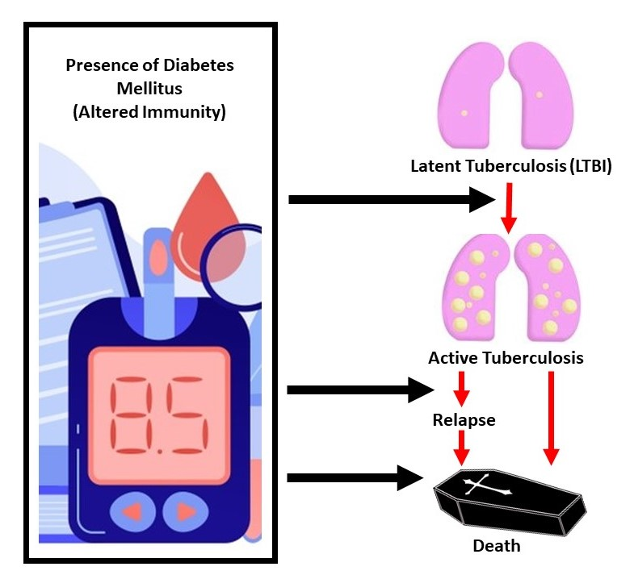

**Figure 2. DM is associated with increase in active TB and relapse in TB which both may be a result of the direct effect of diabetes. There is increased death in DM and TB which may be secondary to TB or due to the inherent excess mortality of DM due to cardiovascular disease**

**CLINICAL PRESENTATION**

The manifestations of tuberculous infection in patients with DM have been documented to be different from those without diabetes. Fever and hemoptysis in diabetic population is more common compared to the general population. Radiographic differences include higher than usual parenchymal lesions and lung cavities (30). There are reports of a higher incidence of lower lobe involvement in individuals with DM in contrast to the classical upper lobe involvement in the general population. Also, a higher rate of other atypical presentations like a reduced rate of sputum conversion (low quality evidence), higher probability of treatment failure and death (moderate quality evidences) is known to occur when DM occurs with TB. A higher rate of recurrence and reactivation of latent TB infection (OR=1.83) has been documented (31). Subjects affected with TB and DM are found to be heavier and older males compared to those without diabetes. More pulmonary than extra-pulmonary involvement is seen in TB with DM (32).

**Outcome**

Negative smear or culture on two separate occasions while on treatment and on completion of treatment defines a cured TB (Table 2). Apart from being a risk factor for increased incidence of active TB, co-existence of DM worsens the outcome even in treated patients. In the pre-insulin era, the commonest cause of death in DM apart from diabetic coma was the co-affection with TB (33). DM increases the risk of treatment failure, death and relapse. The risks are likely to be an underestimation as loss of follow-up or unreported death has been a major problem in data collection on outcome in TB management. In a systematic review and meta-analysis by Baker et al, the risk ratio for combined treatment failure and death was 1.69. The risk ratio for death was 1.89 when unadjusted and went up to 4.95 when adjusted for age and other confounding factors.

|  |  |
| --- | --- |
| **Table 2. Terminology and Definitions** | |
| Terminology | Definitions |
| Treatment completed | Bacteriologically confirmed TB patient who has completed treatment without evidence of failure, but not yet completed sputum test to prove negative result in the last month of treatment and on at least one previous occasion |
| Cured | Bacteriologically confirmed TB in whom smear- or culture-was negative in the last month of treatment and on at least one previous occasion |
| Treatment Success | The sum of cured and treatment completed |
| Treatment Failed | Sputum smear or culture positive at or beyond 5th month of treatment |
| Died | A proven patient who dies for any reason before or during the course of treatment |
| Lost to follow-up | A proven patient who did not start treatment or who has interrupted treatment for 2 or more consecutive months |
| Not Evaluated | A proven patient for whom no treatment outcome is assigned. Includes cases “transferred out” to another treatment unit as well as cases for which the treatment outcome is unknown to the reporting unit |

Terminology and Definitions adopted from RNTCP, Revised National TB Control Programme, Training Course for Programme Manager (Modules 1-4), 2011.Training modules. Central TB Division. <https://tbcindia.gov.in>.

The risk ratio for relapse was 3.89 but no additional risk of TB relapse in those with multidrug resistant TB was demonstrated. In their analysis, Baker et al found that the effect of co-existing DM on sputum conversion 2 to 3 months after treatment was variable (0.79 to 3.25) and wide (34). Persistence of sputum positivity i.e., delay in sputum conversion has been shown in a few studies. The authors conclude that advancing age and underlying co-morbidity contribute to death and is not due to drug resistant TB or severity of hyperglycemia (35).

**BI-DIRECTIONAL SCREENING FOR DIABETES AND TUBERCULOSIS**

The synergism between DM and TB in terms of epidemiology and outcome necessitates bi-directional screening for the presence of either TB or DM in the presence of the other disorder. The Collaborative Framework for Care and Control of TB and DM proposed by the World Health Organization (WHO) along with the International Union against TB and Lung is an effort towards bi-directional screening and management of both these conditions (36). Studies implementing bi-directional screening point towards its feasibility and effectiveness (18).

**Screening for Active TB Among Patients with Diabetes**

The diagnosis and treatment of TB is affected by substantial delay which occurs at multiple levels a) between the onset of symptoms and clinical presentation b) clinical presentation and suspicion of TB c) Clinical suspicion of TB and its confirmation. This is due to variability in symptoms, host immunity, lack of knowledge, paucity of access to medical care, and lack of rapid and reliable diagnostic tools. The average delay even in resource- rich countries after presentation to heath care system is 3 weeks (37). According to WHO, patients with suspected TB should be promptly sent to TB diagnostic and treatment centers and evaluated accordingly.

The higher risk of TB in diabetic population compels intensive screening for detection of TB at the earliest time so as to reduce transmission, morbidity, and mortality. WHO recommends for TB surveillance among patients with DM in settings with medium to high TB burdens. The practical difficulties are the non-availability of TB screening tools in all DM clinics. Also, in areas of low TB burden, the cost-effectiveness is low. The number needed to screen to detect one case of active TB depends on the prevalence in that area. Screening of all patients with clinical history during their visit to diabetic clinic and additional testing in symptomatic and high-risk patients should be undertaken. Also screening for TB whenever there is unexplained worsening of metabolic control would help detect occult cases. Different modalities (clinical, radiological, sputum microbiology) alone or in combination are used for screening individuals with DM for the presence of active TB.

**Clinical Assessment**

It is inexpensive and requires minimum time. Fever, cough of more than 2 weeks duration, hemoptysis, weight loss, night sweats, and exposure to a case of active TB are the clinical clues to suspect pulmonary TB. Lymphadenopathy, fever with altered sensorium, neck stiffness, abdominal symptoms like ascites, intestinal obstruction etc. all favor the possibilities of extra-pulmonary TB. But clinical symptoms lack both sensitivity and specificity as it excludes asymptomatic patients and relies on the presence of symptoms.

**Radiography of the Chest**

It has good sensitivity to pick up asymptomatic pulmonary cases, but there can be false positive results. Inconsistent evidence exists on the presence of atypical findings of TB in the chest x-rays of individuals with diabetes. The presence of clinical symptoms of fever, cough, hemoptysis, and weight loss with an abnormal chest-x-ray helps in the presumptive diagnosis of TB.Figure 3, 4, and 5show different radiological presentations of pulmonary TB.

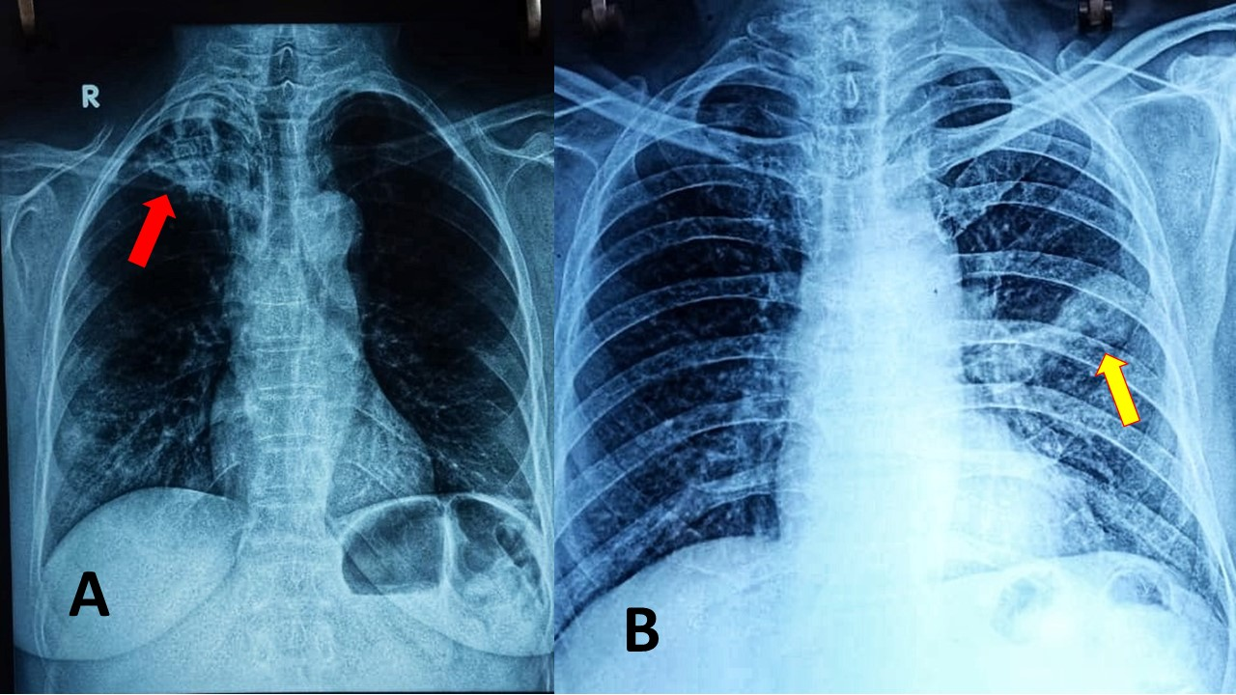

**Figure 3. Chest Radiographs suggesting fibrocavitatory lesions. Post primary infections and reactivation of pulmonary TB are more likely to cavitate. They are most common in the posterior segments of the upper lobes (85%) as seen in Picture A.** **Red arrow pointing to the cavity. The other common site is the superior segment of the lower lobe (Picture B) Yellow arrow pointing to the cavity (Picture courtesy- Prof Mary John, Christian Medical College and Hospital, Ludhiana)**

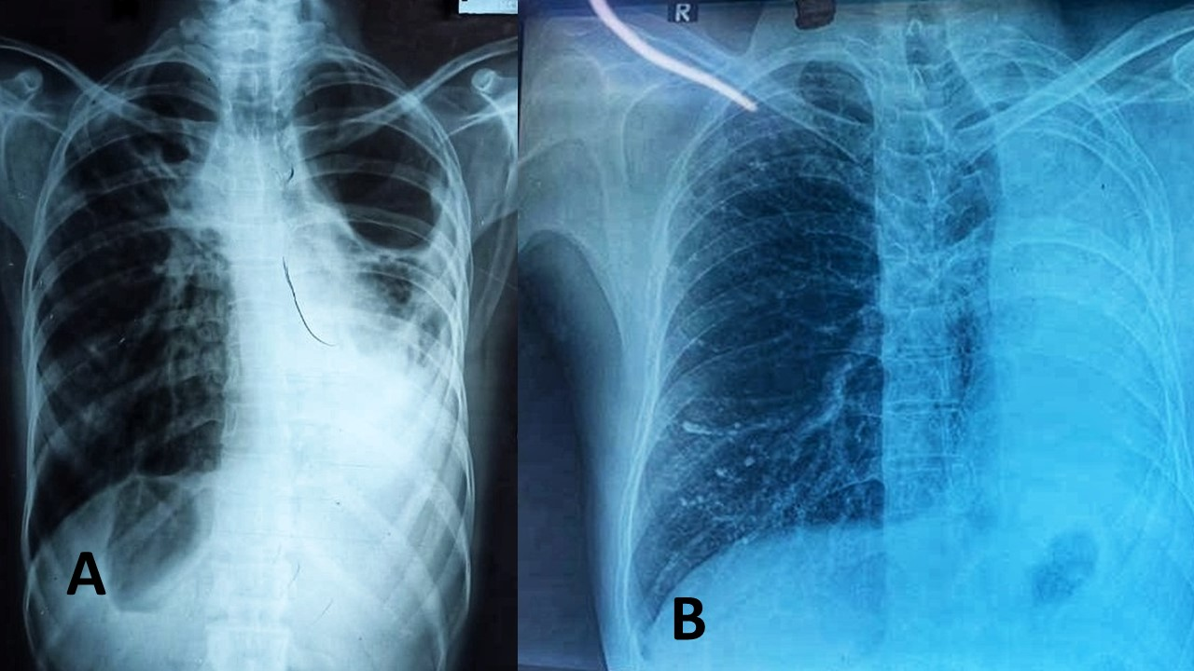

**Figure 4.****Chest Radiographs suggesting lobar consolidation.** **(Picture courtesy- Prof Mary John& Dr Neeru Mittal, Christian Medical College and Hospital, Ludhiana)**

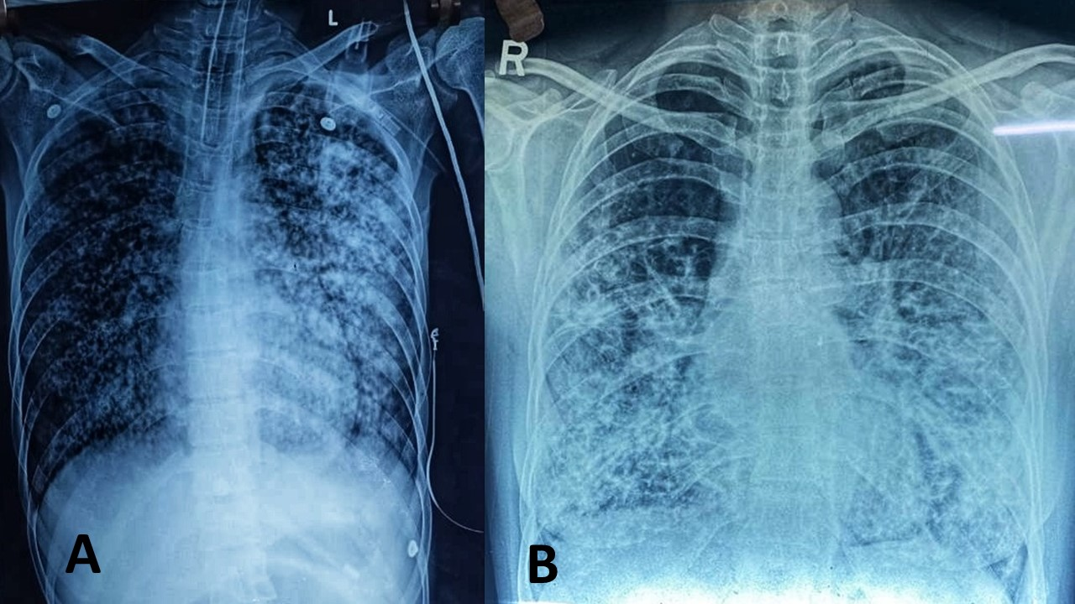

**Figure 5. Chest Radiographs suggesting miliary TB. It represents hematogenous dissemination of an uncontrolled tuberculous infection. Although implants are seen throughout the body, the lungs are usually the easiest location to image. Miliary deposits appear as 1-3 mm diameter nodules uniformly distributed in the lung parenchyma. (Picture courtesy- Prof Mary John & Dr Neeru Mittal, Christian Medical College and Hospital, Ludhiana)**

**Microscopic Examination**

Sputum collected for Ziehl-Neelsen staining and examination for acid -fast bacilli is both sensitive and specific. Even-though they are the commonly used confirmatory tests, most diabetes-oriented clinics are unlikely to have standard laboratory facilities for sputum tests even though having a radiography unit for screening TB appears feasible (32). Sputum tests have limitations in cases of scanty sputum or salivary contamination especially in children. If sputum availability is scanty then sputum is induced by saline nebulization, which if not helpful, can be followed by bronchoscopy assisted lavage or trans-bronchial pulmonary biopsy.

**Sputum Culture**

The gold standard test is sputum culture for TB bacilli but is both time consuming (turnaround time 8 weeks) and expensive. It cannot be used for all individuals attending the DM clinic and is reserved for those patients where the index of suspicion is high and in difficult cases when other available tests are not contributory for diagnosis. Sputum culture is also useful for assessing response in multi-drug resistant TB.

**Rapid Molecular Diagnostic Tests**

Tests like cartridge based nucleic acid amplification test (CB-NAAT) (Figure 6) or rapid automated molecular test Expert MTB/ RIF assay using polymerase chain reaction have a quick turnaround time of two hours and additional advantage of using a single sputum sample. They also detect the presence of rifampicin resistance. Being expensive it cannot be used for screening all patients with DM even though it has high sensitivity and specificity. But they are useful in cases with high-index of suspicion and difficulty in arriving at a definitive diagnosis.

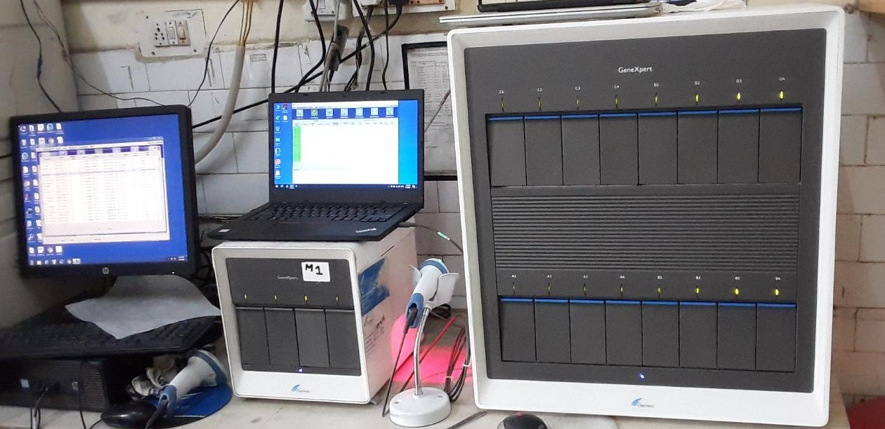

**Figure 6.****All district hospitals in India have been provided with Cartridge Based-Nucleic Acid Amplification Testing equipment under the RNTPC program. Picture of the equipment at Civil Hospital, Ludhiana (Picture courtesy- Dr Ashish Chawla, Civil Hospital, Ludhiana***)*

**Screening for Latent TB Among Patients with Diabetes**

As mentioned earlier, Identification and treatment of latent TB infection to prevent its progression to active disease is necessary to prevent morbidity, mortality, and spread of TB. The WHO AND USPSTF (US preventive services task force) have issued strong guidelines for the screening and treatment of latent TB infection in high risk adults aged more than 18 years in countries with low incidence of TB (38,39).The high risk groups include persons hailing from countries with high TB prevalence, persons residing in homeless shelters and correctional facilities, immunocompromised individuals (HIV, those on immunosuppressants including post-organ transplant), silicosis, those receiving dialysis, those receiving anti-TNF-alfa inhibitor treatment, previously treated TB, and persons who come in contact with those active TB (household contacts and health care workers). The Mantoux tuberculin skin test (TST) and interferon-gamma release assays (IGRAs) are the two screening tests used and they are moderately sensitive and highly specific (40,41). In the tuberculin test, purified protein derivative (PPD) is injected intradermally and assessed within 48 to 72 hours for the presence of induration which is a palpable hard swelling (a diameter of more than 10 mm is considered positive) over the injected area (42,43). In the IGRA a single venous blood sample is taken for the assay and the reports are available within a day. They are particularly useful in those who are unlikely to return for TST test reading and BCG vaccinees.

There is no consensus on the issue of screening for latent TB infection in DM as a high-risk group. The results of studies done previously have been inconsistent. Studies have shown a variable prevalence of latent TB infection and there are no randomized controlled trials demonstrating the benefits of screening. Similarly, there are no recommendations for chemoprophylaxis of latent TB infection in individuals with DM due to the lack of randomized controlled trials that show benefit. The small added risk of hepatotoxicity with chemoprophylactic drugs given for TB in latent TB infection has been the only concern arguing against such measures.

**Screening for Diabetes in Tuberculosis**

In geographical regions with a high prevalence of diabetes, screening for hyperglycemia in TB affected individuals is highly recommended (14). Detection and monitoring of hyperglycemia is an essential part of infection management in any patient with an infectious disease. Chronic infectious diseases like TB thrive in hyperglycemic individuals and the outcome is unfavorable in a hyperglycemic milieu. Recognition of hyperglycemia during the entire course of the illness in TB affected individuals implies either monitoring of pre-existing hyperglycemia or new onset of transient or permanent hyperglycemia. Transient hyperglycemia is a manifestation secondary to the insulin resistance induced by the inflammation of TB infection. There is evidence that hyperglycemic status improves during the course of anti-TB treatment. The optimal time to screen for DM in TB patients on anti-TB treatment is thus unresolved particularly when it is well known that transient hyperglycemia exists during the course of TB. Many groups have advocated for screening more than once during the course of illness i.e., once at the initiation of treatment and at least once again either during and at the time of completion of TB treatment.

In regions with high prevalence of diabetes, younger age of onset of DM is on the rise and this is an emerging problem. There is a three times higher risk for younger individuals to get TB and a two-to four-fold higher risk in diabetic individuals compared to non-diabetic individuals. Hence screening for DM in all individuals 18 years of age or older appears logical.

The type of tests for screening patients with TB for DM depends on the availability of the local health care facilities, cost of the tests, and the ability of patients to come back for additional or repeat tests. Symptom based screening for DM has a low sensitivity. Risk score-based screening also is marred by low sensitivity and specificity. Random plasma glucose test and HbA1c (glycosylated Hb) are convenient tests that can be done in non-fasting individuals as screening tests. Glycosylated Hb test which doesn’t require a fasting blood sample helps to differentiate stress induced hyperglycemia from spontaneous onset pre-existing diabetes. Oral glucose tolerance test (OGTT) with 75 gm helps in identifying impaired glucose tolerance (IGT) and frank DM. A FBG ≥126 mg/dL or random plasma glucose ≥200 mg/dl on two tests is diagnostic of diabetes; FBG 110to 125 mg/dL is considered as impaired fasting glucose and post glucose values between 141- to 199 mg/dl is taken as impaired glucose tolerance (43,44). In one study, the number of TB patients needed to screen (NNS) for detecting DM was on average 40. But in the same population it was lower among smear positive subjects (NNS = 23), in age less than 40 years (< 40 years vs. > 40 years NNS = 35 Vs 47), in males (male vs. female NNS = 31 vs. 116), smokers (smoker vs. non-smoker NNS = 27 vs. 68) and HIV positive (Positive vs. Negative 22 Vs 43) indicating that there are high risk individuals (46).

Currently, screening for DM in individuals with TB and screening for TB in patients with DM where the prevalence is > 100/1,00,000 population appears feasible. Once diagnosed as having diabetes, diet and drug therapy is initiated and the patients are followed up closely for assessing the glycemic response. Transient hyperglycemic situations improve either spontaneously or with minimal medical intervention. After completion of TB medications, regular follow-up with glycemic monitoring is recommended for all patients who had diabetes.

**MANAGEMENT OF DIABETES AND TUBERCULOSIS**

**Anti-Tuberculosis Therapy in Diabetes**

Management of DM should be according to the existing global guidelines with adaptations according to the regional needs. The treatment of TB in DM is not different from the general population. DOTs (Directly Observed Treatment, short-course) is a patient-centered WHO strategy adopted to treat individuals with active TB. A trained health worker provides drugs and observes in-person the patient taking the drug. It guarantees compliance, completion of the treatment course and prevents transmission, treatment failure and development of drug resistance. For newly detected TB, 2 months of intensive phase with 4 drugs (INH, Rifampicin, Pyrazinamide and Ethambutol) and 4 months of continuation phase with 3 drugs (except pyrazinamide) is the standard regimen. For those with a relapse 3 months of intensive therapy with 5 drugs (streptomycin in addition) followed by 4 months of continuation phase with 3 drugs (except pyrazinamide and streptomycin) is administrated.

**In Chronic Kidney Disease**

All four first line drugs (RIF, INH, PZA and EMB) can be used in patients with CKD. Up to 50% dose reduction for EMB and PZA may be needed in patients with creatinine clearance <10 ml/min. Regular monitoring is advised to ensure optimal therapy.

**Adverse Effects of Anti-TB Drugs**

INH induced peripheral neuropathy may worsen the underlying diabetic neuropathy. Pyridoxine is supplemented to prevent this. INH is also associated with hepatitis. Ethambutol is known to produce optic nerve toxicity which may confound diabetic retinopathy. Also, ethambutol and rifampicin are known to affect the kidneys. Rifampicin can induce immune-allergic reactions. Pyrazinamide is rarely associated with liver injury but its more common side effect is hyperuricemia induced joint pain. Streptomycin is potentially associated with renal and cochleo-vestibular toxicity

**Multi-Drug Resistant TB (MDR-TB)**

Multi-drug resistant TB (MDR-TB) is an added medical and economical burden as it is much more difficult to treat, involves therapy with atypical anti-TB drugs for a longer duration of time, and requires referral to specialty centers. Infections caused by mycobacterial strains which are resistant to INH and rifampicin are called multi-drug resistant TB infections. If there is additional resistance to one fluroquinolone and one of the additional inject able drugs (Kanamycin, Capreomycin or Amikacin) then it is called extensive drug resistant TB (XDR-TB). It is associated with poor outcomes and risk of continued transmission (47). Treatment outcome always has been poor due to the complex drug regimen, non-availability of all the drugs, and the possible occurrence of XDR-TB. The reason for resistance is multi-factorial including patient’s non-compliance to therapy, incomplete or inadequate treatment of susceptible TB, decision error by the treating community, etc. Resistance to drugs arises from mutations which are spontaneous and restricted to specific gene loci making it detectable without much difficulty.

There is inconsistent data on the incidence of TB-drug resistance in diabetes. Tegegne et al in their meta-analysis concluded that DM can increase the odds of developing MDR-TB. (47,48). Observational studies have shown delayed clearance of mycobacterium, failure of treatment, relapse and death in the presence of DM (49). The possible theoretical explanations pertaining to the influence of DM in developing resistance include lower drug concentrations, hyperglycemia induced acute and chronic effects of immune regulation, and the presence of more extensive disease in DM affected individuals (50).

Altered plasma concentrations of the anti-TB drug rifampicin has been demonstrated in the continuation phase (but not in the induction phase) of TB treatment in individuals with DM (51). The heavier body weight of insulin resistant individuals with DM is supposed to be one of the reasons because of the use of fixed-dose combination drugs. Giving an exact weight-based dose for a longer duration of time is suggested to overcome this hurdle (52). In addition, DM can influence the plasma concentrations of anti-TB drugs. The absorption, distribution, and metabolism of anti-TB drugs may be altered either due to local gastrointestinal causes (gastropathy, polypharmacy mediated interactions) or dysautonomia of DM predisposing to treatment failure.

After initiation of treatment all patients should be closely followed for evidence of resistance. Persistent sputum positivity at the end of 2-3 months of ATT therapy should prompt a look for evidence of drug resistance. CT chest features have been demonstrated to be different from non-DM subjects. Pulmonary segment consolidation and lobe consolidation seen as moth-eaten cavities without a wall and filled with fluid are the features mentioned in published data. They are accompanied by bronchial damage (53). Multiple moth-eaten cavities in chest CT while on ATT should prompt the suspicion of MDR-TB. Rapid molecular techniques like CB-NAAT or sputum culture for sensitivity should be used to look for drug resistance. All MDR-TB should be referred to specialized centers dealing with MDR-TB.

**Drug Therapy in Multi-Drug Resistant Tuberculosis**

The second line drugs are generally less efficacious and more toxic. In the presence of drug resistance second line agents are used in multiple combinations to address different pharmacological targets in the mycobacterium. In addition to one of the first line drugs to which there is retained susceptibility, an injectable agent, a fluroquinolone and class 4 and class 5 drugs are used in combination to combat MDR-TB (53). Bedaquiline and Delamanidare are new anti-TB drugs used in MDR-TB

**Bedaquiline** belongs to the diarylquinoline group. It inhibits mycobacterial ATP-synthase activity. A shorter time to sputum conversion compared to placebo has been demonstrated. The adverse effects include enzyme induction, electrolyte imbalance, QTc prolongation, and gastrointestinal toxicity (54).

**Delamanid** a dihydro-imidazooxazole that inhibits mycolic acid synthesis also has shown a shorter time period taken for sputum conversion while used in the regimen for MDR-TB. A dose dependent association with QT prolongation occurs (55).

**Linezolid** an oxazolidinone has demonstrated 87% sputum conversion but more than 80% of patients had adverse effects. Peripheral neuropathy, myelosuppression, optic neuropathy, and rhabdomyolysis have been documented in study subjects.

**ANTI-DIABETES THERAPY IN TUBERCULOSIS**

The outcome of TB in DM is also dependent on good glycemic control. The management of hyperglycemia in TB depends on many factors like age, duration of diabetes, presence of complications of DM and co-morbidities, existing drugs, patient support and preferences, economic background and access to medical facilities.

Changes in the lifestyle pattern is once again reiterated when starting ATT. Adequate nutrition with high quality protein without affecting glycemic control is the corner stone of managing nutrition associated glycemic status in TB. In the presence of nephropathy or liver disease, the protein intake has to be modified appropriately and spurious use of protein is avoided. Vitamins particularly pyridoxine (B6), methylcobalamine (B12), vitamin A and Vitamin D should be adequately replaced. Tobacco use and alcohol consumptions have to be stopped. Moderate intensity exercise can help weight lose and improve glycemic control in overweight individuals.

Drug regimen, monitoring and follow-up should be individualized to maximize benefit with minimal discomfort and side effects like hypoglycemia, arrhythmias etc. Monitoring of capillary blood glucose at home, dose adjustment, monitoring of renal and liver functions are required during follow-up.

Anti-TB drugs can influence the metabolism of anti-diabetic medications(Table 3). Rifampicin, by cytochrome p450 enzyme induction, increases the metabolism of most oral anti-diabetic drugs, which may worsen the hyperglycemia. INH on the other hand inhibits cytochrome P450 enzymes and prolongs the effect of anti-diabetic drugs.

|  |  |  |
| --- | --- | --- |
| **Table 3. Anti TB Drugs and Drug Metabolism (Ref 57-59)** | | |
| **Anti TB drug** | **Effect on Cytochrome P 450** | **Effect on anti- diabetic drugs** |
| **Rifampicin** | Induces the cytochrome enzymes thereby accelerating the elimination of drugs like sulphonylureas, thiazolidinediones, and meglitinides | Reduced effect of sulphonylureas by one-third due to CYP2C-mediated accelerated metabolism leading to hyperglycemia  Reduced effect of thiazolidinedione by half due to CYP2C8-mediated accelerated metabolism leading to hyperglycemia |
| **INH** | Inhibits | Reduced elimination through action on CYP2C9; persistent effect and risk of hypoglycemia |
| **Bedaquiline** | Enzyme inducer | Can reduce the effect of anti- diabetic drugs |

Aggressive therapy of DM is necessary for optimal response to TB therapy(Table 4). Insulin is the drug of choice in most illnesses including TB; insulin has the advantage of producing an anabolic effect, positive influence on appetite, and faster relief of hyperglycemic symptoms. It is the most suitable anti-hyperglycemic agent in cachexic and low BMI individuals. It is a mandatory therapeutic agent in Type 1 diabetes, pancreatic diabetes, severe DM and TB, coexisting renal or hepatic diseases, situations complicated by drug interactions and oral drug intolerance. Insulin is neutral in drug-to-drug interactions and achieves glycemic control faster than oral drugs. In the presence of fasting hyperglycemia of > 200 with ketonuria, Insulin is used to treat the hyperglycemia. It is also the preferred drug in renal impairment. The main disadvantage with insulin is that it has to be injected and more than twice a day in presence of infection/ stress. The indications for insulin use in patients with active TB and DM is summarized in Figure 7.

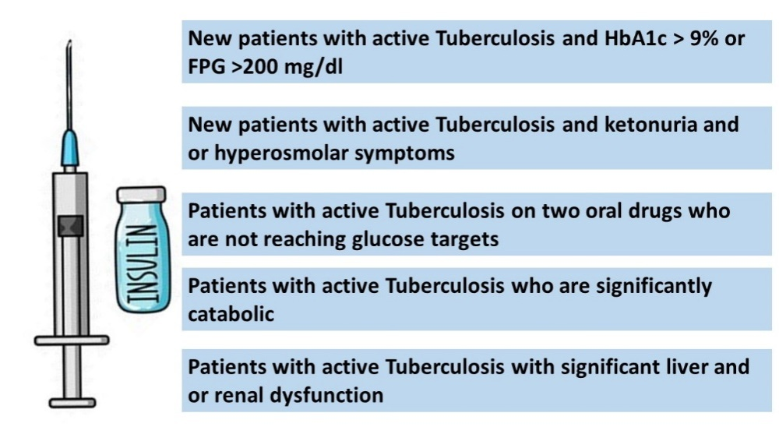

**Figure 7**. **Indications of Insulin Use in patients with Type 2 DM and Active TB**

Metformin has the advantage of not producing hypoglycemia when used alone. It can however reduce appetite and needs caution while being used in renal or hepatic dysfunction. It doesn’t interact much with ATT and doesn’t influence cytochrome enzyme induced metabolism. It can help to shorten the course of TB therapy. It modifies the immune response and inflammation. It acts on the mitochondrial respiratory chain and can reduce the intracellular growth by acting through AMPK pathway which has a negative impact on the inflammatory process.

|  |  |  |  |
| --- | --- | --- | --- |
| **Table 4. Anti-Diabetic Drug Use in Patients with Tuberculosis** | | | |
| **Drug** | **Advantages** | **Disadvantages** | **Comment** |
| **Insulin** | Increases appetite,  weight; anabolic effect; No drug interactions with ATT | Injectable  Needs supervision for change in requirement | Preferred in lean diabetes, secondary diabetes, severe DM with ketosis or hyperosmolar state |
| **Metformin** | Oral;  Cost-effective and easily available  Not influenced by ATT; positive anti-TB adjuvant action | Gastrointestinal disturbances;  Needs renal and hepatic function monitoring; Change in eGFR (< 35 ml/ min/l) or > 3 times raised liver enzymes necessitates stopping metformin;  Not suitable in hypoperfusion states (risk of lactic acidosis) | Not potent in severe hyperglycemic situations. Can be used in mild forms of hyperglycemia. |
| **Sulphonylureas** | Quick restoration of euglycemia | Long-acting drugs can induce hypoglycemia in anorexic people | Shorter acting sulphonylureas such as gliclazide and glipizide |
| **DPP4- inhibitors** | Less hypoglycemic potential | ? Risk of immune dysregulation – respiratory  Infection | Selective use |
| **Alpha glucosidase inhibitors** | No hypoglycemia | GI intolerance | In mild post meal elevation |
| **Thiazolidinediones** | Against insulin resistance | Hepatic | Selective use |
| **SGLT2**  **inhibitors** | No hypoglycemia | Dehydration, DKA | Selective use |

Metformin increases the host cell production of reactive oxygen species and acidification of mycobacterial phagosome (60). It has been found to downregulate oxidative phosphorylation, mammalian target of rapamycin (mTOR) signaling, and type I interferon response pathways (61). Sulphonylureas can be used for quick glycemic control. The long acting sulphonylureas like glibenclamide and glimepride have a risk of prolonged hypoglycemia particularly seen in anorexic individuals. Their plasma concentration and their duration of action are modified by drugs acting on cytochrome P450 system and hence monitoring of glycemic status is essential while on these drugs. Thiazolidinediones (pioglitazone) do not produce GI symptoms and are non-hypoglycemic when used as monotherapy. Monitoring of hepatic enzymes is required particularly when TB drugs are co-administered. Alpha-glucosidase inhibitors may be helpful in mild postprandial hyperglycemias. SGLT-2 inhibitors have the risk of further weight loss, euglycemic ketoacidosis, worsening of dehydration in sick patients, and urinary tract infections. They should not be used for glycemic control in patients who are sick and cachexic. In individuals who have no contra-indications they can be continued selectively under close follow-up (62, 63).

**CO-MORBIDITIES OF DIABETES**

**Cardiovascular Disease in Diabetes and Tuberculosis**

The commonest cause of mortality in DM is cardiovascular disease due to atherosclerosis manifesting as coronary heart disease (myocardial infarction /cardiac failure), stroke and peripheral vascular disease. TB also has a possible role in chronic vascular inflammation, autoimmunity and inhabitation of TB bacilli atheromatous plaque (64). It also affects the myocardium (65). After successful initiation of TB treatment which is done on a priority basis, DM and cardiovascular status should be assessed. In addition to hyperglycemia management, lifestyle modification, antihypertensive treatment, lipid-lowering therapy, and anti-platelet therapy are the corner stones of management of cardiovascular disease in DM irrespective of the presence or absence of TB. In the presence of hemoptysis anti-platelet drugs are withdrawn or held back. Cessation of smoking and moderation of alcohol has to be counselled about. Anti-hypertensive therapy is initiated during review visits and titrated. Anti-lipid therapy using statins are added gradually and the liver enzymes should be monitored during the course of therapy while on ATT.

**Renal Dysfunction in Diabetes and Tuberculosis**

More than a third of individuals with DM develop renal complications due to diabetes. This complicates TB in many ways including increased susceptibility to TB and difficulty in the management of TB (66). In patients with chronic renal failure and on dialysis there is a 6.9‐ to 52.5‐fold risk of developing TB (67). Peritoneal TB is another risk for CKD patients on peritoneal dialysis. The altered immune function in chronic renal impairment increases susceptibility to TB (68). CKD adversely affects TB and its treatment. The anti-TB drugs (ethambutol and pyrazinamide) require dose reduction by up to 50%. Insulin is preferred in most instances for glycemic control. Short acting sulphonylureas or repaglinide can be used as an alternative.

**Hepatic Dysfunction in Diabetes and Tuberculosis**

DM liver pathology includes fatty liver disease, NASH, and cirrhosis. In TB, drug induced hepatitis is a concern. In such cases the drugs are withdrawn until resolution of hepatotoxicity. Pyrazinamide is withdrawn completely. Quinolones, ethambutol, and ofloxacin can be used instead of the first line agents. Anti-TB drugs are restarted when the liver enzymes are normalized. Insulin is the drug of choice in severe chronic liver disease with diabetes. Metformin is preferred in fatty liver but withdrawn in cirrhosis.

**Tuberculosis and Diabetes in HIV – The Triangular Overlap**

DM and HIV are two independent risk factors for developing TB. The wider prevalence of DM makes DM a more important risk factor for developing TB than retroviral diseases. A significantly higher preponderance of DM over HIV has been reported in cases of pulmonary TB while extra-pulmonary TB was predominant in HIV-TB patients (69). DM is increasing in areas where TB and HIV are rampant. Literature reports on the influence of HIV-co infection on DM with TB have been contradictory. Studies have reported reduced odds of developing DM in HIV infected TB patients (70). A paradoxical protective effect of HIV on the development of TB was reported (71). However, they were cross-sectional single center studies of limited sample size and had used single random blood glucose tests for screening. But in a case-control study the association between DM and TB in HIV was found to be strong except when HbA1c was used for screening. This may be because of anemia of HIV compromising the true HbA1c value (72). HIV testing is mandatory in all presumptive TB and confirmatory assessment using Gene Xpert MTB/RIF assay for drug resistance.

**PREVENTIVE METHODS**

Aggressive DM screening among the population with TB and effective management of both TB and DM can improve outcome on an individual basis. The more effective approach to have an impact at the community level is to have a preventive strategy like vaccination against TB and aggressive prevention and management of DM (29).

**SUMMARY**

Epidemiological evidence for an uncharacteristic alliance between non-communicable disease like DM and a communicable disease like TB as a syndemic are overwhelming. A two-to four-fold higher risk of active TB in individuals with DM and twice the prevalence of DM in patients with TB explains the double burden. Ranked among the top ten mortal diseases, the geographical spread of both these diseases is unfortunately overlapping and the co-existence is progressive. They are increasing alarmingly in those regions where health care facilities are limited. DM impacts TB both from infection to disease stage and disease stage to progression stage. Chronic hyperglycemia compromises the alveolar defenses.

Latent TB infection is a dormant subclinical disease which lasts for weeks or decades. Immune deficiency either in absolute or relative quantities are sufficient for its re-activation. The clinical and radiological presentations of active TB have been reported to be pulmonary predominantly and atypical when DM co-exists with TB. DM increases the risk of treatment failure, death and relapse. The risk ratio for combined treatment failure and death was 1.69, unadjusted and adjusted risk ratios for death were 1.89 and 4.95 respectively and risk ratio for relapse was 3.89.

Bidirectional screening is recommended to improve the outcome in both diseases. Sputum microscopic examination, rapid molecular tests, random plasma glucose and glycosylated hemoglobin are the available among the screening tests with their own merits and limitations.

Anti-TB treatment has adverse impact on glycemic control and the complications of diabetes. The metabolism of some DM drugs is modified by ATT which affects glycemic control. Modifications of medications are required in co-morbid illnesses of DM like cardio-vascular diseases, renal, and hepatic dysfunction. Insulin is the drug of choice in lean diabetes, severe hyperglycemia, ketotic states, anorexic patients, and in drug intolerance. Metformin if tolerated has an advantage as a non-hypoglycemic agent with some favorable anti-TB activity.

Lifestyle modification, antihypertensive treatment, lipid-lowering therapy, and anti-platelet therapy are the cornerstones in the management of cardiovascular disease in DM and TB. Anti-platelet drugs are withdrawn in patients with hemoptysis. Chronic kidney diseases can predispose to TB and its management is complicated by drug toxicity and dose adjustment of ATT is required along with careful monitoring of response and renal functions. In case of ATT induced hepatotoxicity, ATT is withdrawn and second line agents are substituted. Once liver enzymes normalize the first line drugs are restarted cautiously.

Effective preventive strategies like vaccination against TB and aggressive prevention and management of DM will be the approach to be adopted till time throws new light on the means to fight these dual epidemics more effectively.

**REFERENCES**

1. Whiting DR, Guariguata L, Weil C, Shaw J. IDF diabetes atlas: global estimates of the prevalence of diabetes for 2011 and 2030. Diabetes Res Clin Pract. 2011; 94(3):311-321.

2. Jacob JJ, Paul PAM. Infections in Endocrinology: Tuberculosis. In: Feingold KR, Anawalt B, Boyce A, et al., eds. Endotext. South Dartmouth (MA): MDText.com, Inc.; March 14, 2021.

3. Lönnroth K, Castro KG, Chakaya JM, et al. Tuberculosis control and elimination 2010-50: cure, care, and social development. Lancet. 2010; 375(9728):1814-1829. doi:10.1016/S0140-6736(10)60483-7

4. World Health Organization. Global Tuberculosis Report 2020. https://apps.who.int/iris/bitstream/handle/10665/336069/9789240013131-eng.pdf (Accessed 28 Nov 2020)

5. Narasimhan P, Wood J, Macintyre CR, Mathai D. Risk factors for tuberculosis. Pulm Med. 2013; 2013:828939. doi:10.1155/2013/828939

6. Getahun H, Matteelli A, Abubakar I, et al. Management of latent Mycobacterium tuberculosis infection: WHO guidelines for low tuberculosis burden countries. Eur Respir J. 2015; 46(6):1563-1576. doi:10.1183/13993003.01245-2015

7. Lee RE, Li W, Chatterjee D, Lee RE. Rapid structural characterization of the arabinogalactan and lipoarabinomannan in live mycobacterial cells using 2D and 3D HR-MAS NMR: structural changes in the arabinan due to ethambutol treatment and gene mutation are observed. Glycobiology. 2005; 15(2):139-151. doi:10.1093/glycob/cwh150

8. Emerging Risk Factors Collaboration, Sarwar N, Gao P, et al. Diabetes mellitus, fasting blood glucose concentration, and risk of vascular disease: a collaborative meta-analysis of 102 prospective studies [published correction appears in Lancet. 2010 Sep 18;376(9745):958. Hillage, H L [corrected to Hillege, H L]]. Lancet. 2010; 375(9733):2215-2222. Doi: 10.1016/S0140-6736(10)60484-9.

9. International Diabetes Federation. IDF Diabetes Atlas, 8th edn. Brussels, Belgium:International Diabetes Federation, 2019. https://diabetesatlas.org/en/resources/ (Accessed 8 March 2021)

10. World Health Organization. Global tuberculosis report 2019: World Health Organization; 2019. https://www.who.int/tb/publications/global_report/en/ (Accessed 8 March 2021)

11. Dooley KE, Chaisson RE. Tuberculosis and diabetes mellitus: convergence of two epidemics. Lancet Infect Dis. 2009 Dec; 9(12):737-46. Doi: 10.1016/S1473-3099(09)70282-8. PMID: 19926034; PMCID: PMC2945809.

12. Viswanathan, V., Bajaj, S., Kalra, S. et al. RSSDI clinical practice recommendations for diagnosis, prevention, and control of the diabetes mellitus-tuberculosis double burden. Int J Diabetes Dev Ctries 2017; 37, 379–399

13. Goldhaber-Fiebert JD, Jeon CY, Cohen T, Murray MB. Diabetes mellitus and tuberculosis in countries with high tuberculosis burdens: individual risks and social determinants. Int J Epidemiology. 2011 Apr; 40(2):417-28. Doi: 10.1093/ije/dyq238. Epub 2011 Jan 20. PMID: 21252210; PMCID: PMC3621385.

14. World Health Organization/International Union Against Tuberculosis and Lung Disease. Provisional collaborative framework for care and control of tuberculosis and diabetes. WHO/HTM/TB/2011.15. Geneva, Switzerland: WHO, 2011.

15. Hayashi, S., &Chandramohan, D. (2018). Risk of active tuberculosis among people with diabetes mellitus: systematic review and meta-analysis. Tropical medicine & international health: TM & IH, 23(10), 1058–1070. https://doi.org/10.1111/tmi.13133

16. Workneh MH, Bjune GA, Yimer SA. Prevalence and associated factors of tuberculosis and diabetes mellitus co morbidity: A systematic review. PLoS One. 2017; 12(4):e0175925. Published 2017 Apr 21. doi:10.1371/journal.pone.0175925.

17. Odone A, Houben RM, White RG, Lönnroth K. The effect of diabetes and under nutrition trends on reaching 2035 global tuberculosis targets. Lancet Diabetes Endocrinol. 2014; 2(9):754-764. doi:10.1016/S2213-8587(14)70164-0

18. Jeon CY, Harries AD, Baker MA, et al. Bi-directional screening for tuberculosis and diabetes: a systematic review. Trop Med Int Health. 2010; 15(11):1300-1314. doi:10.1111/j.1365-3156.2010.02632.

19. Lönnroth K, Roglic G, Harries AD. Improving tuberculosis prevention and care through addressing the global diabetes epidemic: from evidence to policy and practice. Lancet Diabetes Endocrinol. 2014; 2(9):730-739. doi:10.1016/S2213-8587(14)70109-3

20. Noubiap JJ, Nansseu JR, Nyaga UF, et al. Global prevalence of diabetes in active tuberculosis: a systematic review and meta-analysis of data from 2·3 million patients with tuberculosis. Lancet Glob Health. 2019; 7(4):e448-e460. doi:10.1016/S2214-109X(18)30487

21. Collaborative framework for care and control of tuberculosis and diabetes. WHO/HTM/TB/2011.15

22. Viswanathan V, Kumpatla S, Aravindalochanan V, et al. Prevalence of diabetes and pre-diabetes and associated risk factors among tuberculosis patients in India. PLoS One. 2012;7(7):e41367.

23. Balakrishnan S, Vijayan S, Nair S, et al. High diabetes prevalence among tuberculosis cases in Kerala, India. PLoS One. 2012;7(10):e46502.

24. Manjareeka M, Palo SK, Swain S, Pati S, Pati S. Diabetes Mellitus among Newly Diagnosed Tuberculosis Patients in Tribal Odisha: An Exploratory Study. J Clin Diagn Res. 2016;10(10):LC06-LC08.

25. Singh SP, Singh SP, Kishan J, Kaur S, Ramana S. Association of tuberculosis and diabetes Mellitus: an analysis of 1000 consecutively admitted cases in a tertiary care hospital of North India. Pan Afr Med J. 2016;24:4

26. Kodiatte A, John M, Jacob JJ. Diabetes mellitus and prediabetes among patients with tuberculosis in a single north Indian tertiary care centre. J R Coll Physicians Edinb. 2020;50(3):242-246.

27. Noubiap JJ, Nansseu JR, Nyaga UF, Nkeck JR, Endomba FT, Kaze AD, Agbor VN, Bigna JJ. Global prevalence of diabetes in active tuberculosis: a systematic review and meta-analysis of data from 2·3 million patients with tuberculosis. Lancet Glob Health. 2019 Apr;7(4): e448-e460.

28. Alisjahbana B, Sahiratmadja E, Nelwan EJ, et al. The effect of type 2 diabetes mellitus on the presentation and treatment response of pulmonary tuberculosis. Clin Infect Dis. 2007; 45(4):428-435. doi:10.1086/519841

29. Crevel RV, Critchley JA. The Interaction of Diabetes and Tuberculosis: Translating Research to Policy and Practice. Trop Med Infect Dis. 2021; 6(1):8. Published 2021 Jan 8. doi:10.3390/tropicalmed6010008

30. Chiang CY, Lee JJ, Chien ST, et al. Glycemic control and radiographic manifestations of tuberculosis in diabetic patients. PLoS One. 2014; 9(4):e93397. Published 2014 Apr 3. doi:10.1371/journal.pone.0093397

31. Jiménez-Corona ME, Cruz-Hervert LP, García-García L, et al. Association of diabetes and tuberculosis: impact on treatment and post-treatment outcomes. Thorax. 2013; 68(3):214-220. Doi: 10.1136/thoraxjnl-2012-201756.

32. Riza AL, Pearson F, Ugarte-Gil C, et al. Clinical management of concurrent diabetes and tuberculosis and the implications for patient services. Lancet Diabetes Endocrinol. 2014; 2(9):740-753. doi:10.1016/S2213-8587(14)70110

33. Restrepo BI, Schlesinger LS. Impact of diabetes on the natural history of tuberculosis. Diabetes Res Clin Pract. 2014; 106(2):191-199. doi:10.1016/j.diabres.2014.06.011.

34. Baker MA Harries AD, Jeon CY, et al. The impact of diabetes on tuberculosis treatment outcomes: a systematic review. BMC Med. 2011; 9:81. Published 2011 Jul 1. doi:10.1186/1741-7015-9-81

35. Chang JT, Dou HY, Yen CL, et al. Effect of type 2 diabetes mellitus on the clinical severity and treatment outcome in patients with pulmonary tuberculosis: a potential role in the emergence of multidrug-resistance. J Formos Med Assoc. 2011; 110(6):372-381. doi:10.1016/S0929-6646(11)60055-7

36. Collaborative framework for care and control of tuberculosis and diabetes. WHO/HTM/TB/2011.15

37. Sreeramareddy CT, Panduru KV, Menten J, Van den Ende J. Time delays in diagnosis of pulmonary tuberculosis: a systematic review of literature. BMC Infect Dis. 2009; 9:91. Published 2009 Jun 11. doi:10.1186/1471-2334-9-91

38. Getahun H, Matteelli A, Abubakar I, et al. Management of latent Mycobacterium tuberculosis infection: WHO guidelines for low tuberculosis burden countries. Eur Respir J. 2015; 46(6):1563-1576. doi:10.1183/13993003.01245-2015]

39. US Preventive Services Task Force, Bibbins-Domingo K, Grossman DC, et al. Screening for Latent Tuberculosis Infection in Adults: US Preventive Services Task Force Recommendation Statement. JAMA. 2016; 316(9):962-969. doi:10.1001/jama.2016.11046

40. Mansilla Bermejo MJ, Sanz Gil MJ, Moraleda Velasco P, Alvárez Prado A, Carbayo García JJ, Mata Guijarro F. Lectura de la prueba de la tuberculinaenpacientesdiabéticos de un centro de salud [Tuberculin test in diabetic patients in a health centre]. Aten Primaria. 1995; 16(3):154-157.

41. Vega Torres RA, Conde JG, Díaz M. Prevalence of tuberculin reactivity and risk factors for the development of active tuberculosis upon admission to a nursing home. P R Health Sci J. 1996; 15(4):275-277

42. Nwabudike LC, Ionescu-Tîrgovişte C. Intradermal reactions to purified protein derivative in patients with diabetes mellitus. Rom J Intern Med. 2005; 43(1-2):127-132.

43. Dabhi PA, Thangakunam B, Gupta R, et al. Screening for prevalence of current TB disease and latent TB infection in type 2 diabetes mellitus patients attending a diabetic clinic in an Indian tertiary care hospital. PLoS One. 2020; 15(6):e0233385. Published 2020 Jun 5. doi:10.1371/journal.pone.0233385

44. Kumpatla S, Aravindalochanan V, Rajan R, Viswanathan V, Kapur A. Evaluation of performance of A1C and FPG tests for screening newly diagnosed diabetes defined by an OGTT among tuberculosis patients-a study from India. Diabetes Res Clin Pract. 2013; 102(1):60-64. doi:10.1016/j.diabres.2013.08.007]

45. Sariko ML, Mpagama SG, Gratz J, Kisonga R, Saidi Q, Kibiki GS, Heysell SK. Glycated haemoglobin screening identifies patients admitted for retreatment of tuberculosis at risk for diabetes in Tanzania. J Infect Dev Ctries. 2016 Apr 28; 10(4):423-6. Doi: 10.3855/jidc.7324. PMID: 27131008; PMCID: PMC4869164.

46. Naik B, Kumar AM, Satyanarayana S, et al. Is screening for diabetes among tuberculosis patients feasible at the field level? Public Health Action. 2013; 3(Suppl 1):S34-S37. doi:10.5588/pha.13.0022

47. Tegegne BS, Habtewold TD, Mengesha MM, Burgerhof JG. Association between diabetes mellitus and multi-drug-resistant tuberculosis: a protocol for a systematic review and meta-analysis. Syst Rev. 2017; 6(1):6. Published 2017 Jan 14. Doi: 10.1186/s13643-017-0407-9.

48. Pérez-Navarro LM, Fuentes-Domínguez F, Morales-Romero J, Zenteno-Cuevas R. Factoresasociados a tuberculosis pulmonarenpacientes con diabetes mellitus de Veracruz, México [Factors associated to pulmonary tuberculosis in patients with diabetes mellitus from Veracruz, México]. Gac Med Mex. 2011; 147(3):219-225.

49. Kang YA, Kim SY, Jo KW, et al. Impact of diabetes on treatment outcomes and long-term survival in multidrug-resistant tuberculosis. Respiration. 2013; 86(6):472-478. doi:10.1159/000348374

50. Ruslami R, Aarnoutse RE, Alisjahbana B, van der Ven AJ, van Crevel R. Implications of the global increase of diabetes for tuberculosis control and patient care. Trop Med Int Health. 2010; 15(11):1289-1299. doi:10.1111/j.1365-3156.2010.02625.

51. Nijland HM, Ruslami R, Stalenhoef JE, et al. Exposure to rifampicin is strongly reduced in patients with tuberculosis and type 2 diabetes. Clin Infect Dis. 2006; 43(7):848-854. doi:10.1086/507543

52. Van Ingen J, Aarnoutse RE, Donald PR, et al. Why Do We Use 600 mg of Rifampicin in Tuberculosis Treatment? Clin Infect Dis. 2011; 52(9):e194-e199. doi:10.1093/cid/cir184.

53. Song Q, Zhang G, Jiang H, Ren Y, Lu X. Imaging Features of Pulmonary CT in Type 2 Diabetic Patients with Multidrug-Resistant Tuberculosis. PLoS One. 2016; 11(3):e0152507. Published 2016 Mar 29. doi:10.1371/journal.pone.0152507

54. Kurz SG, Furin JJ, Bark CM. Drug-Resistant Tuberculosis: Challenges and Progress. Infect Dis Clin North Am. 2016; 30(2):509-522. doi:10.1016/j.idc.2016.02.010

55. U.S. Food and Drug Administration. SIRTURO Prescribing Information. http://www.accessdata.fda.gov/drugsatfda_docs/label/2012/204384s000lbl.

56. Shimokawa Y, Sasahara K, Yoda N, Mizuno K, Umehara K. Delamanid does not inhibit or induce cytochrome p450 enzymes in vitro. Biol Pharm Bull. 2014; 37(11):1727-1735. doi:10.1248/bpb.b14-00311 ]

57. Niemi M, Backman JT, Neuvonen M, Neuvonen PJ, Kivistö KT. Effects of rifampin on the pharmacokinetics and pharmacodynamics of glyburide and glipizide. Clin Pharmacol Ther. 2001;69(6):400-406. doi:10.1067/mcp.2001.115822

58. Niemi M, Backman JT, Neuvonen PJ. Effects of trimethoprim and rifampin on the pharmacokinetics of the cytochrome P450 2C8 substrate rosiglitazone. Clin Pharmacol Ther. 2004;76(3):239-249. doi:10.1016/j.clpt.2004.05.001

59. Boglou P, Steiropoulos P, Papanas N, Bouros D. Hypoglycaemia due to interaction of glimepiride with isoniazid in a patient with type 2 diabetes mellitus. BMJ Case Rep. 2013;2013:bcr2012008528. Published 2013 Apr 16. doi:10.1136/bcr-2012-008528

60. Singhal A, Jie L, Kumar P, et al. Metformin as adjunct antituberculosis therapy. Sci Transl Med. 2014; 6(263):263ra159.doi:10.1126/scitranslmed.3009885.

61. Yu X, Li L, Xia L, et al. Impact of metformin on the risk and treatment outcomes of tuberculosis in diabetics: a systematic review. BMC Infect Dis. 2019; 19(1):859. Published 2019 Oct 17. doi:10.1186/s12879-019-4548-4

62. Niazi AK, Kalra S. Diabetes and tuberculosis: a review of the role of optimal glycemic control. J Diabetes MetabDisord. 2012; 11(1):28. Published 2012 Dec 20. doi:10.1186/2251-6581-11-28

63. Hsia DS, Grove O, Cefalu WT. An update on sodium-glucose co-transporter-2 inhibitors for the treatment of diabetes mellitus. CurrOpin Endocrinol Diabetes Obes. 2017; 24(1):73-79. doi:10.1097/MED.0000000000000311

64. Huaman MA, Henson D, Ticona E, Sterling TR, Garvy BA. Tuberculosis and Cardiovascular Disease: Linking the Epidemics. Trop Dis Travel Med Vaccines. 2015; 1:10. doi:10.1186/s40794-015-0014-5

65. Liu A, Hu Y, Coates A. Sudden cardiac death and tuberculosis - how much do we know? Tuberculosis (Edinb). 2012; 92(4):307-313. doi:10.1016/j.tube.2012.02.002

66. CKD TB : Ates G, Yildiz T, Danis R, et al. Incidence of tuberculosis disease and latent tuberculosis infection in patients with end stage renal disease in an endemic region. Ren Fail. 2010; 32(1):91-95. doi:10.3109/08860220903367528

67. Hussein MM, Mooij JM, Roujouleh H. Tuberculosis and chronic renal disease. Semin Dial. 2003; 16(1):38-44. doi:10.1046/j.1525-139x.2003.03010.x

68. Levey AS, Atkins R, Coresh J, et al. Chronic kidney disease as a global public health problem: approaches and initiatives - a position statement from Kidney Disease Improving Global Outcomes. Kidney Int. 2007; 72(3):247-259. doi:10.1038/sj.ki.5002343

69. Gupta S, Shenoy VP, Bairy I, Srinivasa H, Mukhopadhyay C. Diabetes mellitus and HIV as co-morbidities in tuberculosis patients of rural south India. J Infect Public Health. 2011;4(3):140-144. doi:10.1016/j.jiph.2011.03.005

70. Faurholt-Jepsen D, Range N, Praygod G, et al. Diabetes is a risk factor for pulmonary tuberculosis: a case-control study from Mwanza, Tanzania. PLoS One. 2011;6(8):e24215. doi:10.1371/journal.pone.0024215

71. Kibirige D, Ssekitoleko R, Mutebi E, Worodria W. Overt diabetes mellitus among newly diagnosed Ugandan tuberculosis patients: a cross sectional study. BMC Infect Dis. 2013; 13:122. Published 2013 Mar 5. doi:10.1186/1471-2334-13-122

72. Boillat-Blanco N, Ramaiya KL, Mganga M, et al. Transient Hyperglycemia in Patients With Tuberculosis in Tanzania: Implications for Diabetes Screening Algorithms. J Infect Dis. 2016;213(7):1163-1172. doi:10.1093/infdis/jiv568