DIABETES MELLITUS AFTER SOLID ORGAN TRANSPLANTATION: AN OVERVIEW

Ashvin R Kamath. UCLA-Olive View Medical Center, Department of Medicine, Nephrology Division Sylmar, CA 91342

Phuong-Mai T. Pham. VA Greater Los Angeles Health Care System, Department of Medicine, North Hills, CA 91343
Basmah Abdalla. David Geffen School of Medicine at UCLA, Department of Medicine, Nephrology Division, Kidney Transplant Program, Los Angeles, CA 90095
Phuong-Thu T. Pham. David Geffen School of Medicine at UCLA, Department of Medicine, Nephrology Division, Kidney Transplant Program, Los Angeles, CA 90095.
Telephone: 310-267-2555. E-mail: ppham@mednet.ucla.edu

Received 4 April 2016

ABSTRACT

Posttransplantation diabetes mellitus (PTDM), also known as New Onset Diabetes After Transplantation, is a common and important complication following solid organ transplantation. PTDM may arise from both transplant-related and traditional risk factors and has variably been reported to be associated with decreased patient and graft survival and other adverse outcomes including increased cardiovascular disease risk, infection, and graft rejection. This chapter presents an overview of the nomenclature change for diabetes developing after transplantation, the diagnostic criteria for PTDM, its incidence after solid organ transplantation, risk factors, and its associated adverse effects. Screening for PTDM including pretransplant evaluation and early detection in the posttransplant period, and the unique aspects of diabetes management in the context of organ transplantation are also presented.

NOMENCLATURES AND DIAGNOSIS OF POSTTRANSPLANTATION DIABETES MELLITUS: HISTORICAL PERSPECTIVES

Nomenclatures

Posttransplantation diabetes mellitus (PTDM) was first described in kidney transplant recipients in 1964 (1). It was subsequently recognized as a complication of kidney transplantation in the 1970s. Over the years, PTDM has undergone changes in nomenclatures including steroid diabetes, posttransplantation diabetes mellitus (PTDM), new onset diabetes mellitus (NODM), transplant-associated hyperglycemia (TAH), and new onset diabetes after transplantation (NODAT) (2, 3, 4, 5, 6). In 2014, the International Expert Panel consisting of transplant nephrologists, diabetologists, and clinical scientists recommended changing the terminology NODAT back to PTDM, excluding transient posttransplantation hyperglycemia (7). Utilizing the term NODAT is thought to be misleading because it seemingly excludes patients with pretransplant diabetes. Pre-existing diabetes is often undiagnosed because of the effect of chronic kidney disease on insulin metabolism and clearance, and the lack of effective pretransplant screening. The term PTDM will be utilized for the remainder of this chapter.

Diagnosis

Historically, PTDM has been variably defined as having random glucose levels greater than 200 mg/dL, fasting glucose levels greater than 140 mg/dL, or the need for insulin or oral hypoglycemic agents in the posttransplant period (8). In 2003 the International Expert panel consisting of leaders from both the transplant and diabetes fields suggested that the definition and diagnosis of diabetes and impaired glucose tolerance should be based on the definition and diagnosis described by the World Health Organizations (WHO) (9). In 2011, the American Diabetes Association (ADA) incorporated hemoglobin A1C (HbA1C) > 6.5% as a diagnostic criterion for diabetes mellitus in the general population based on the observed association between HbA1C level and the risk for future development of retinopathy (10). In 2014, the International Expert Panel recommended expanding screening tests for PTDM using postprandial glucose monitoring and HbA1C. However, HbA1C test is not recommended early after transplantation (arbitrarily defined as within 45 days after transplantation) because of potential confounding factors (7). A normal HbA1C does not exclude the diagnosis of PTDM in the presence of early posttransplant anemia and/or dynamic kidney allograft function. Although not widely used in clinical practice, oral glucose tolerance (OGTT) remains the gold standard for diagnosing PTDM. It should be noted that the algorithmic approach to the screening and diagnosis of PTDM is largely based on published kidney transplantation literature. Similar studies in the settings of liver, heart, and lung transplants are lacking. However, it is speculated that the principles are relevant to all forms of solid organ transplantation (7). The ADA criteria for prediabetes and diabetes are shown in Table 1.
Table 1. The American Diabetes Association diagnostic criteria for prediabetes and diabetes.
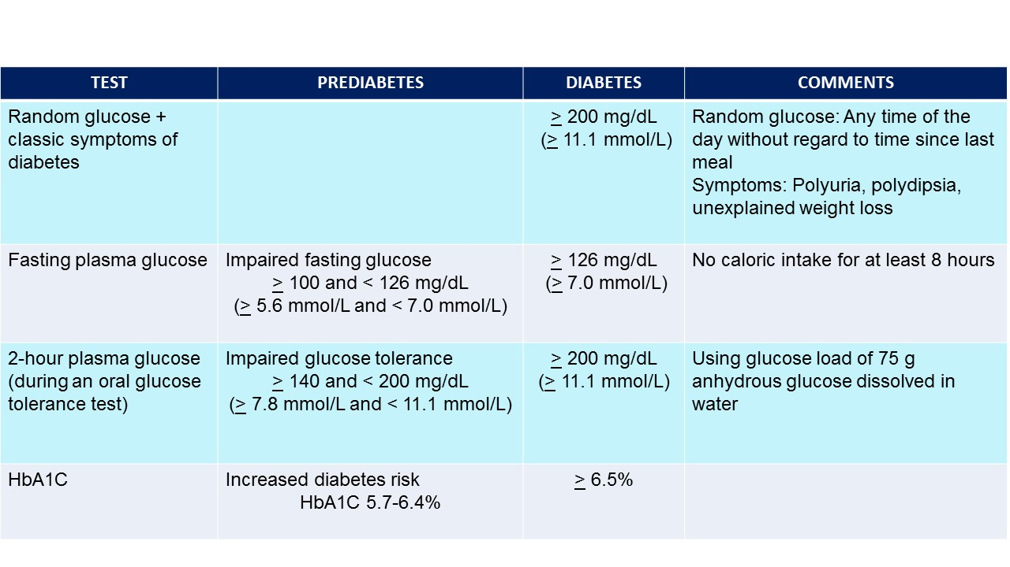

INCIDENCE

PTDM has been reported to occur in 4% to 25% of kidney transplant recipients, 2.5% to 25% of liver transplant recipients, 4% to 40% of heart transplant recipients, and 30% to 35% of lung transplant recipients (9, 11, 12, 13). The variation in the reported incidence may be due in part to the prior lack of a standard definition, duration of follow-up, the presence of both modifiable and non-modifiable risks factors, and the type of organ transplants. The Organ Procurement and Transplantation Network database demonstrated that one-year PTDM rates among kidney transplant recipients have steadily declined for all levels of body mass index (BMI) since 2004 (~8% for BMI > 35 kg/m2, ~5% for BMI 25 to < 35, ~4% for BMI < 25). A decline in the percentage of patients with PTDM at 1-, 3-, and 5 years was observed over the time period from 2005 and 2012. In 2008, approximately 18% developed PTDM at 5 year posttransplant (14). It is speculated that the decrease in the incidence of PTDM was due to adjustment in immunosuppression protocols.

RISK FACTORS FOR PTDM

PTDM may arise from both transplant-related and traditional risk factors. The diabetogenic effect of various immunosuppressive agents have been well-described. Corticosteroids may reduce peripheral insulin sensitivity, inhibit pancreatic production/secretion, and increase hepatic gluconeogenesis. The calcineurin inhibitors tacrolimus and cyclosporine decrease insulin secretion and synthesis. Sirolimus increases peripheral insulin resistance and impairs pancreatic beta-cell response. Transplant patients may have improved appetite and a more relaxed diet which can lead to obesity. Risk factors for PTDM can be loosely categorized into those that are non-modifiable, potentially modifiable, and modifiable (8, 15, 16, 17, 18). Suggested risk factors for the development of PTDM are presented in Table 2. A more extensive discussion of the studies evaluating PTDM risk factors is beyond the scope of this chapter. Interested readers are referred to reference Pham and colleagues (8).

Table 2. Risk factors for Posttransplant Diabetes Mellitus.
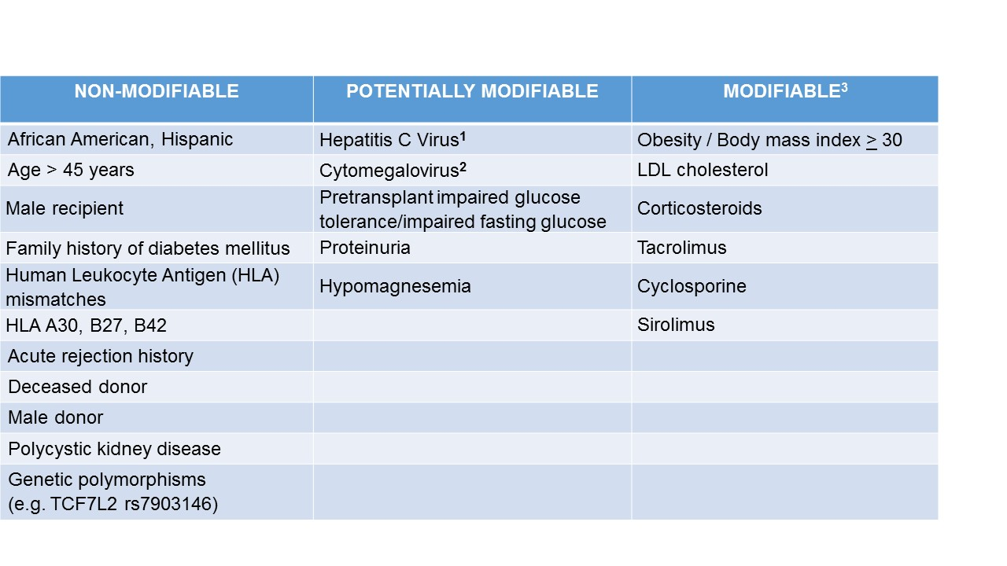
¹In appropriate candidates, curative therapy for chronic hepatitis C can now be achieved with the newer interferon-free direct acting antiviral-based regimen.
²Posttransplant CMV prophylactic therapy is preferred over preemptive therapy.
³Manipulation of immunosuppression should be weighed against the risk of acute rejection.

IMPACT OF PTDM ON OUTCOMES AFTER TRANSPLANTATION

Studies evaluating the association between PTDM and morbidity and mortality have yielded mixed results (19, 20, 21, 22, 23, 24,25). In an analysis of the United States Renal Data System consisting of more than 11,000 kidney transplant recipients, Kasiske et al. demonstrated that PTDM was associated with a strong, independent predictor of mortality (p < 0.0001), graft failure (p < 0.0001), and death-censored graft failure (p < 0.0001) (21). A single-center study consisting of more than 700 kidney transplant recipients similarly demonstrated worse 10-year actuarial patient survival among patients with PTDM compared with those without PTDM (22). In contrast, a retrospective analysis of the UNOS/OPTN database (n > 37,000) failed to demonstrate the negative impact of PTDM on transplant survival or cardiovascular mortality during a median follow up of 548 days (23). However, the study results were considered inconclusive because of the wide confidence intervals and relatively short duration of follow-up. Study with longer-term follow-up demonstrated similar 5- and 10-year graft survival rates among patients with PTDM and those without PTDM (22). Retrospective analysis of the UNOS/OPTN database consisting of > 13,000 liver transplant recipients demonstrated that the presence of both PTDM and acute rejection at 1 year posttransplant but not PTDM alone was associated with higher overall graft failure and mortality risk (25). Although the link between PTDM and decreased patient and/or graft survival has not been consistently demonstrated, patients with PTDM may develop many of the complications associated with diabetes similar to that observed in the general population. In a study of 4105 patients with PTDM, one or more diabetic complications arose in 58% including ketoacidosis (8%), hyperosmolarity (3%), renal complications (31%), ophthalmic complications (8%), neurological complications (16%), peripheral circulatory disorders (4%), and hypoglycemia/shock (7%). These complications occurred within a mean of 500-600 days of developing PTDM, indicating an accelerated pace for the development of complications (24). Moreover, PTDM patients had an increased rate of infections and sepsis compared with their non-diabetic counterparts (19).

DETECTION OF PTDM

Pretransplant Baseline Evaluation

Pretransplant Evaluation should include history of hyperglycemia, prediabetes, diabetes, and risk factors for PTDM including family history and hepatitis C virus. The 2004 International Consensus Guidelines suggest that a pretransplant baseline evaluation should include a complete medical and family history, including documentation of glucose history (26). Those with risk factors for metabolic syndrome can be screened further with laboratory testing. Patients with evidence of risk factors can be counseled of their risk for PTDM. Those with evidence of prediabetes can be counseled of lifestyle modifications including dietary modifications, thirty minutes of moderate intensity physical activity, and overall five to ten percent weight reduction (27). Pretransplant treatment of HCV-infected kidney transplant candidates should be considered. With the advent of the interferon-free direct acting antiviral-based regimen, treatment of hepatitis C in the post-transplant period is a reasonable alternative in selected prospective kidney transplant candidates (28). The choice of an immunosuppressive regimen should be tailored to each individual patient, weighing the risk of acute rejection against that for PTDM.

Early Detection of PTDM after Transplantation

New onset perioperative hyperglycemia is common and may develop in the context of high dose corticosteroid or as a consequence of posttransplant stress hyperglycemia, or both. Limited studies suggest that posttransplant stress hyperglycemia is an independent risk factor for subsequent diabetes (29). There are currently insufficient data to establish effective early screening guidelines for PTDM (30). The 2003 International consensus guidelines recommended weekly fasting plasma glucose the first month after transplantation, then at 3, 6, and 12 months, with OGTT reserved for patients with impaired fasting glucose as defined by the World Health Organization (i.e. FPG > 110 mg/dL and < 126 mg/dL) (9). However, more recent studies have questioned the utility of fasting plasma glucose level in the early posttransplant period. In a small single center prospective cohort study consisting of 26 patients on tacrolimus-based immunosuppression and moderate-dose prednisolone (16 + 4 mg/day), fasting plasma glucose at 6 weeks after transplantation was found to have low sensitivity for detecting PTDM compared with capillary blood glucose, HbA1C and OGTT profiles (p < 0.001). In contrast, afternoon (4:00pm) glucose monitoring outperformed both HbA1C and OGTT during that time period, seemingly because of the diurnal variation of the glycemic profile with morning nadir and afternoon peak (31). The 2014 International Consensus Expert Panel recommended incorporating postprandial glucose and HbA1C levels in the screening and diagnostic framework for PTDM. It is further suggested that the 2003 American Diabetes Association (ADA) criteria be used to define impaired fasting glucose (FPG > 100 mg/dL and < 126 mg/dL), and PTDM should not be diagnosed before 45 days after transplantation. While OGTT remains the gold standard for diagnosing PTDM, there is currently insufficient evidence to recommend OGTT for all kidney transplant recipients (7).

At the authors’ institution, fasting and postprandial home glucose monitoring is routinely recommended for patients with new-onset posttransplant hyperglycemia particularly those requiring insulin therapy in the immediate posttransplant period. Clinically stable patients with persistent posttransplant hyperglycemia for > 3 months are screened for PTDM using HbA1C test. Although OGTT is widely accepted as gold standard, screening all patients with OGTT may be impractical in clinical practice and should be individualized and reserved for those with multiple risk factors. Similar to the nontransplant setting, HbA1c can be monitored at three to six month intervals depending on the clinical course and individual risk factors (32).

REVENTION AND MANAGEMENT OF PTDM

Non-pharmacological preventive and management strategies

Studies in the general population demonstrated that lifestyle modification promoting reduced fat/energy diet, daily moderate intensity physical activity, and modest weight loss reduce the incidence of type 2 diabetes (33). Similar studies in the context of solid organ transplantation are lacking. In a small single center study consisting of 25 kidney transplant recipients with impaired glucose tolerance, reversal to normal glucose tolerance with lifestyle modification was observed in 13 patients after a median of 9 months with only one patient progressing to PTDM (34). Small single-center studies showed that posttransplant weight gain is associated with persistent PTDM (35). Pre- and post- transplant lifestyle modification including dietary changes with the guidance of a dietitian and regular moderate cardiovascular activity aiming at increasing muscle mass while decreasing fat mass may decrease the incidence of PTDM and warrants further exploration (29).

Pharmacological preventive and management strategies

In the immediate posttransplant period, the pancreatic β-cells are exposed to multiple hyperglycemic stressors including the transplant surgery itself, high-dose corticosteroids, and the introduction of cyclosporine or tacrolimus immunosuppression therapy. In a randomized controlled trial, Hecking et al. demonstrated that early basal insulin therapy following detection of early posttransplant hyperglycemia (defined as < 3 weeks) reduced the subsequent odds of developing PTDM within the first year after transplantation by 73% (35). It is conceivable that early basal insulin therapy decreases PTDM through insulin-mediated protection of pancreatic beta-cells (36, 37). However, the routine recommendation of early insulin therapy in the prevention of PTDM development awaits results of large randomized controlled clinical trials (ITP-NODAT, clinicaltrials.org:NTC01683331). Furthermore, the glucose threshold for starting insulin therapy remains to be defined.

Modification of immunosuppression

Although clinical trials comparing the incidence of PTDM in cyclosporine versus tacrolimus-treated patients have yielded variable results, tacrolimus has more consistently been shown to have a greater diabetogenic effect than cyclosporine (38). Modification of immunosuppression including cyclosporine to tacrolimus conversion therapy or steroid avoidance or withdrawal has variably been shown to improve glycemic control (8, 38, 39, 40). However, manipulation of immunosuppression is not without immunological risk. In a meta-analysis of controlled clinical trials to assess the safety and efficacy of early steroid withdrawal or avoidance, Pascual et al. showed that steroid avoidance or steroid withdrawal after a few days reduced PTDM incidence among cyclosporine but not tacrolimus-treated kidney transplant recipients (41). Furthermore, among cyclosporine-treated patients, acute rejection episodes were more frequently observed in steroid avoidance compared with conventional steroid treated groups. The same group of investigators demonstrated no significant beneficial effect of late steroid withdrawal (3 to 6 months after transplantation) on the incidence of PTDM (42). In the current era of immunosuppression, the beneficial effect of steroid avoidance or withdrawal on the incidence of PTDM has been questioned by experts in the field because rapid steroid taper and the use of lower target cyclosporine and tacrolimus levels are now common practice (7). Of interest, in a small single-center study consisting 22 nondiabetic kidney transplant recipients randomized to receive daily or twice daily prednisolone dosing, Yates et al. demonstrated that split corticosteroid dosing reduces glycemic variability and peak hyperglycemia in the early posttransplant period (43). Further studies are needed. The use of tacrolimus and mTOR inhibitor combination therapy may increase PTDM risk and should probably be avoided. Nonetheless, low dose calcineurin inhibitor (cyclosporine or tacrolimus) and mTOR inhibitor combination therapy seems justifiable in transplant recipients who have a history of malignancies (such as skin cancers, renal cell carcinoma, or Kaposi sarcoma). Due to the lack of well-defined guidelines, modification of immunosuppression to alleviate the incidence of PTDM should be tailored to each individual patient. Reduction in immunosuppression should be weighed against the risk of acute rejection.

Management of established PTDM in the late posttransplant period

Although there may be differences in the pathogenesis and presentation of PTDM compared to type 2 diabetes mellitus, management of established PTDM in the late posttransplant period should follow the conventional approach and clinical guidelines as established by well-recognized organizations. The American Diabetes Association and European Association for the Study of Diabetes generally recommend a HbA1c target of < 7% (44). Lifestyle modifications including weight reduction, dietary changes, and regular moderate cardiovascular activity should be employed. If glycemic control does not reach therapeutic targets, medical management with oral antidiabetic agents and ultimately insulin can be initiated. Metformin has not been widely used in the setting of transplantation due to the concern for lactic acidosis in the presence of dynamic kidney allograft function particularly in the early posttransplant period. In contrast, the potential beneficial effects of metformin including weight neutral or weight loss, cardioprotection, and lack of significant drug-drug interactions renders metformin an attractive treatment option for solid organ transplant recipients. Further clinical trials to assess the risk and benefit ratio of metformin are needed before it can be endorsed as the antihyperglycemic agent of choice in PTDM (7). Experimental studies suggest that sulfonylureas are associated with β-cell apoptosis and β-cell exhaustion (45), raising theoretical concern about their use in PTDM, particularly in the early posttransplant period. In contrast, the newer anti-hyperglycemic dipeptidyl peptidase-4 inhibitor (DPP-4) inhibitors have been shown to preserve pancreatic beta-cell function in diabetic animal models (46, 47). Limited clinical studies suggest that DPP-4 inhibitors are safe and effective in the treatment of PTDM (48, 49). In a single-center study consisting of 71 stable kidney transplant recipients with PTDM newly diagnosed by an oral glucose tolerance test, Haidinger et al. demonstrated that patients treated with vildagliptin at baseline had significantly reduced HbA1C levels at 3, 6,12, and 18 months, whereas no improvement in glycemic control was observed among their sulfonylurea-treated counterparts (48). In a randomized control trial comparing vildagliptin with placebo in the treatment of PTDM, the same group of investigators demonstrated that treatment with vildagliptin significantly improve A1C levels within 3 months compared with placebo (50). Evidence-based studies recommending one oral antidiabetic agent over the other in the context of transplantation are currently lacking. Hence, the choice of individual agents should be based on the potential advantages and disadvantages of different classes of agents. Failure to achieve glycemic control despite oral antihyperglycemic agent combination therapy necessitates initiation of basal-prandial insulin therapy. The potential advantages and disadvantages of various classes of antihyperglycemic agents are summarized in Table 3. The updated international consensus guidelines on the screening, diagnosis, and management of early posttransplant hyperglycemia and PTDM is shown in Figure 1.

Table 3. The potential advantages and disadvantages of various classes of antihyperglycemic agents
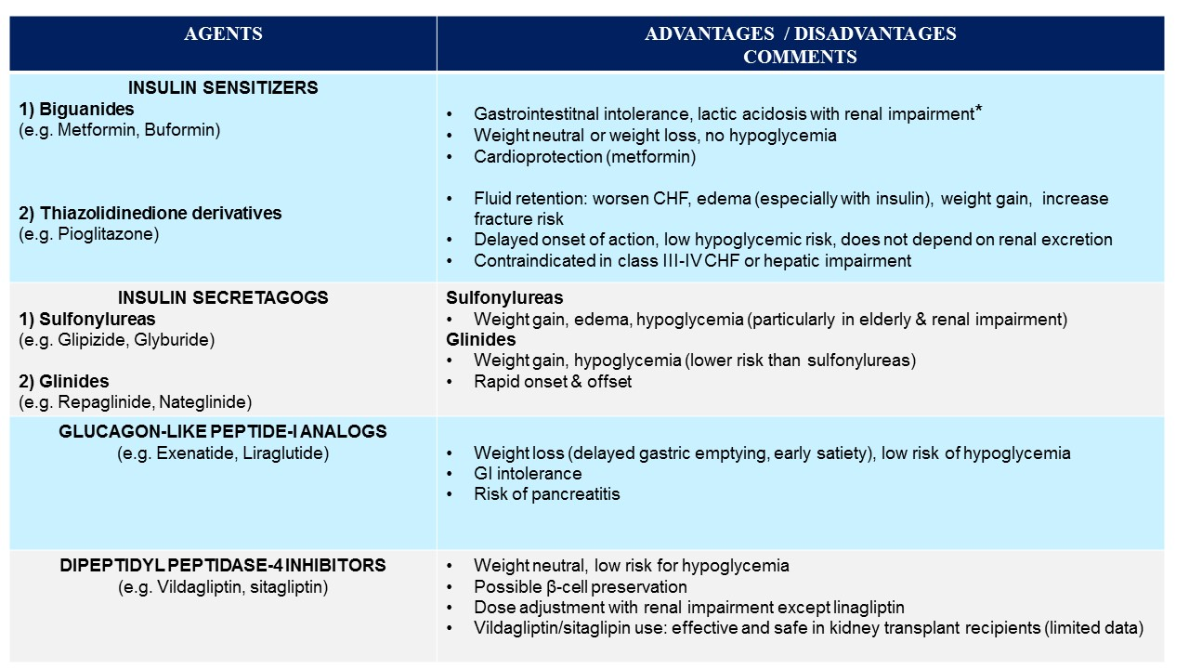
*KDIGO guidelines: Reduce dose if estimated glomerular filtration rate (eGFR) < 45 cc/min/1.73 m². Discontinue if eGFR < 30 cc/min/1.73m²

Figure 1. The 2014 International Consensus Guidelines on the Screening, Diagnosis, and Management of Early Posttransplant Hyperglycemia and PTDM.*
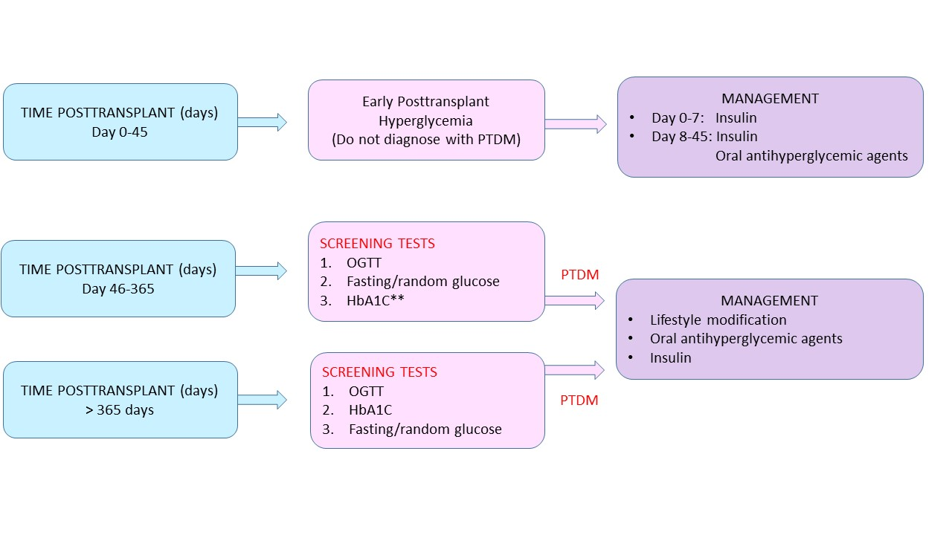* Although recommendations from the Expert Panel are largely based on published kidney transplantation literature, the principles are likely relevant to all forms of solid organ transplantation.
**HbA1C alone < 365 days may underestimate PTDM and require corroborating.

SUMMARY
PTDM is a common complication after solid organ transplantation and has variably been reported to be associated with increased morbidity and mortality. Risk stratification, intervention to minimize risk and early diagnosis may alleviate the incidence of PTDM and improve outcomes following solid organ transplantation. The 2014 International Consensus Guidelines suggest expanding screening tests for PTDM using postprandial glucose monitoring and HbA1C test. However, the latter should be used with caution in the early posttransplant period. A normal HbA1C does not exclude the diagnosis of PTDM in the presence of early posttransplant anemia and/or dynamic kidney allograft function. Insulin therapy in the immediate or perioperative period may prevent β-cell exhaustion and progression to overt PTDM. Further studies are needed. Management of established late PTDM should follow the conventional approach and guidelines established for the general population. When lifestyle modification fails to achieve glycemic control, medical intervention is often necessary. The choice of one oral antihyperglycemic agent over the other should be based on the potential advantages and disadvantages of individual agents. The use of metformin and incretin-based regimen in the setting of solid organ transplantation warrants further exploration. Similar to the general population, suboptimal glycemic control despite oral antihyperglycemic agent combination therapy necessitates initiation of insulin therapy.

REFERENCES
- Starlz TE. Experience in renal transplantation. Philadelphia: Saunders 1964:111.
- Gunnarsson R, Arner P, Lundgren G, et al. Steroid diabetes after renal transplantation. A preliminary report. Scan Urol Nephrol Suppl 1977; 42:191-194.
- Araki M, Flechner SM, Ismail HR, et al. Posttransplant diabetes mellitus in kidney transplant recipients receiving calcineurin or mTOR inhibitor drugs. Transplantation 2006; 81(3): 335-341.
- Crutchlow MF, Bloom RD. Transplant-associated hyperglycemia: a new look at an old problem. Clin J Am Soc Nephrol 2007; 2(2):343-355.
- Bloom RD, Crutchlow MF. New-onset diabetes mellitus in the kidney recipients: diagnosis and management strategies. Clinical J Am Soc Nephrol 2008; 3: S38-48.
- Pham PT, Pham PVC, Lipshutz G. New onset diabetes mellitus after solid organ transplantation. Endocrinol Metab Clin North Am 2007; 36(4): 873-890.
- Sharif A, Hecking M, de Vries AP, et al. Proceedings from an international consensus meeting on posttransplantation diabetes mellitus: recommendations and future directions. Am J Transplant. 2014; 14(9):1992-2000.
- Pham PT, Pham PM, Pham SV, Pham PA, Pham PC. New onset diabetes after transplantation (NODAT): an overview. Diabetes Metab Syndr Obes. 2011;4:175-86.
- Davidson J, Wilkinson AH, Dantal J, et al. New-onset diabetes after transplantation: 2003 International Consensus Guidelines. Transplantation. 2003;7:SS3–SS24.
- American Diabetes Association. Standards of Medical Care in Diabetes 2011. Diabetes Care 2011; 34:S11.
- Baid S, Cosimi AB, Farrell ML, et al. Posttransplant diabetes mellitus in liver transplant recipients: risk factors, temporal relationship with hepatitis C virus allograft hepatitis, and impact on mortality. Transplantation. 2001;72:1066–1072.
- Knobler H, Stagnaro-Green A, Wallenstein S, et al. Higher incidence of diabetes in liver transplant recipients with hepatitis C. J Clin Gastroenterol. 1998;26:30–33.
- Ye X, KuoH-T, Sampaio MS, Jiang Y, Bunnapradist S. Riskfactorsfor the development of new-onset diabetes mellitus after transplant in adult lung transplant recipients. Clin Transplant. 2010;DOI 10. 1111:1–7.
- Matas AJ, Smith JM, Skeans MA, et al. OPTN/SRTR 2013 Annual Data Report: kidney. Am J Transplant. 2015;15 Suppl 2:1.
- Cosio FG, Pesavento TE, Osei K, et al. Posttransplant diabetes mellitus: increasing incidence in renal allograft recipients transplanted in recent years. Kid Int 2001; 59(2): 732-737.
- Kasiske BL, Snyder JJ, Gilbertson D, et al. Diabetes mellitus after kidney transplantation in the United States. Am J transplant 2003;3(2): 178-185.
- Martinez-Castelao A, Hernandez MD, Pascual J, et al. Detection and treatment of post kidney transplant hyperglycemia: a Spanish multicenter cross-sectional study. Transplant Proc 2005;37: 3813-3816.
- Quaglia M1, Terrazzino S, Musetti C, et al. The Role of TCF7L2 rs7903146 in Diabetes After Kidney Transplant: Results From a Single-Center Cohort and Meta-Analysis of the Literature. Transplantation. 2015 Nov 21. [Epub ahead of print].
- Boudreaux JP, McHugh L, Canafax DM, et al. The impact of cyclosporine and combination immunosuppression on the incidence of post transplant diabetes in renal allograft recipients. Transplantation. 1987;44(3):376–381.
- Ojo AO. Cardiovascular complications after renal transplantation and their prevention. Transplantation. 2006;82(5):603–611.
- Kasiske BL, Snyder JJ, Gilbertson D, Maras AJ. Diabetes mellitus after kidney transplantation in the United States. Am J Transplant. 2003;3(2): 178–185.
- Joss N, Staatz CE, Thomson AH, et al. Predictors of new onset diabetes after renal transplantation 2007;21(1): 136-143.
- Kuo H-T, Sampaio MS, Vincenti F, et al. Associations of pretransplant diabetes mellitus, New-Onset Diabetes Mellitus after Transplant, and acute rejection with transplant outcomes: an analysis of trhe Organ Procurement and Transplant Network/United Network for Organ Sharing (OPTN/UNOS) database. 2010;56(6): 1026-1028.
- Burroughs TE, Swindle J, Takemoto S, et al. Diabetic complications associated with new-onset diabetes mellitus in renal transplant recipients. Transplantation. 2007;83(8):1027.
- Kuo HT, Lum E, Martin P, et al. Effect of diabetes and acute rejection on liver transplant outcomes, an analysis of the OPTN/UNOS database. Liver Transpl 2016; Epub ahead of print.
- Wilkinson AH, Davidson J, Dotta F, et al. Guidelines for the treatment and management of new-onset diabetes after transplantation. Clin Transplant. 2005;19:291–298.
- Nathan DM, Davidson MB, DeFronzo RA, et al. Impaired fasting glucose and impaired glucose tolerance. Diabetes Care 2007; 30:753.
- Sawinski D, Bloom RD. Novel hepatitis C treatment and the impact on kidney transplantation. Transplantation. 2015; 99(12): 2458-2466.
- Chakkera HA, Weil EJ, Pham PT, et al. Can new-onset diabetes after kidney transplant be prevented? Diabetes Care 2013; 36: 1406-1412.
- Suarez O, Pardo M, Gonzalez S, et al. Diabetes mellitus and renal transplantation in adults: is there enough evidence for diagnosis, treatment, and prevention of new-onset diabetes after renal transplantation? Transplant Proc. 2014 Nov;46(9):3015-20.
- Yates CJ, Fourlanos S, Colman PG, et al. Screening for new-onset diabetes after transplantation: Limitations of fasting glucose and advantages of afternoon glucose and glycated hemoglobin. Transplantation 2013; 96:726-731.
- Pham PT, Edling KL, Chakkera HA, et al. Screening strategies and predictive diagnostic tools for the development of new-onset diabetes mellitus after transplantation: an overview. Diabetes Metab Syndr Obes. 2012;5:379-87.
- Knowler WC, Barrett-Connor E, Fowler SE, et al. Diabetes Prevention Program Research Group. Reduction in the incidence of type 2 diabetes with lifestyle intervention or metformin. N Engl J Med 2002; 346: 393-403.
- Sharif A, Moore R, Baboolal K. Influence of lifestyle modification in renal transplant recipients with postprandial hyperglycemia. Transplantation 2008; 85: 353-358.
- Kim Y, Kim JR, Choi H, et al. Patients with persistent new-onset diabetes after transplantation have greater weight gain after kidney transplantation. J Korean Med Sci. 2013 Oct;28(10):1431-4.
- Hecking M, Haidinger M, Doller D, et al. Early basal insulin therapy decreases new-onset diabetes after transplantation. J Am Soc Nephrol 2012; 23: 739-749.
- Hecking M, Werzowa J, Haidinger M, et al. Novel views on new-onset diabetes after transplantation: development, prevention and treatment. Nephrol Dial Transplant. 2013 Mar;28(3):550-66.
- Heisel O, Heisel R, Balshaw R, et al. New onset diabetes in patients receiving calcineurin inhibitors: a systematic review and meta-analysis. Am J Transplant 2004; 4(4): 583-595.
- Vincenti F, Friman S, Scheuermann E, et al. Results of an international, randomized trial comparing glucose metabolism disorders and outcome with cyclosporine versus tacrolimus. Am J Transplant. 2007 Jun;7(6):1506-14.
- Rathi M, Rajkumar V, Rao N, et al. Conversion from tacrolimus to cyclosporine in patients with new-onset diabetes after renal transplant: an open-label randomized prospective pilot study. Transplant Proc. 2015 May;47(4):1158-61.
- Pascual J, Royuela A, Galeano C, et al. Very early steroid withdrawal or avoidance for kidney transplant recipients: A systematic review. Nephroll Dial Transplant 2012; 27: 825-832.
- Pascual J, Galeano C, Royuela A, et al. A systematic review on steroid withdrawal between 3 and 6 months after kidney transplantation. Transplantation 2010; 90: 343-349.
- Yates CJ, Fourlanos S, Colman PG, Cohney SJ. Divided dosing reduces prednisolone-induced hyperglycaemia and glycaemic variability: a randomized trial after kidney transplantation. Nephrol Dial Transplant. 2014 Mar;29(3):698-705.
- Nathan DM, Buse JB, Davidson MB, et al. Medical management of hyperglycemia in type 2 diabetes: a consensus algorithm for the initiation and adjustment of therapy: a consensus statement of the American Diabetes Association and the European Association for the Study of Diabetes. Diabetes Care. 2009;32(1):193.
- Maedler K, Carr RD, Bosco D, et al. Sulfonylurea induced beta-cell apoptosis in cultured human islets. The J of Clin End and Metab 2005; 90: 501-506.
- Mu J, Petrov A, Eiermann GJ, Woods J, et al. Inhibition of DPP-4 with sitagliptin improves glycemic control and restores islet cell mass and function in a rodent model of type 2 diabetes. Eur J Pharmacol 2009; 623(1-3): 148-154.
- Cho JM, Jang HW, Cheon H, et al. A novel dipeptidyl peptidase IV inhibitor DA-1229 ameliorates streptozocin-induced diabetes by increasing β-cell replication and neogenesis. Diabetes Res Clin Pract 2011; 91(1): 72-79.
- Halden TAS, Asberg A, Vik K, et al. Short-term efficacy and safety of sitagliptin treatment in long-term stable renal recipients with new-onset diabetes after transplantation. Nephrol Dial Transplant 2014; 14: 115-123.
- Haidinger M, Werzowa J, Hecking M, et al. Efficacy and safety of vildagliptin in new-onset diabetes after kidney transplantation. A randomized, double-blind, placebo-controlled trial. Am J Transplant 2014; 14: 115-123
- Werzowa J, Hecking M, Haidinger M, et al. Vildagliptin and pioglitazone in patients with impaired glucose tolerance after kidney transplantation: a randomized, placebo-controlled clinical trial. Transplantation 2013; 95(3): 456-462.

