**DIABETES MELLITUS AFTER SOLID ORGAN TRANSPLANTATION**

**Phuong-Thu Pham, D**avid Geffen School of Medicine at UCLA, Department of Medicine, Nephrology Division, Kidney Transplant Program, Los Angeles, CA 90095. PPham@mednet.ucla.edu

**Harpreet Singh Sidhu,** Olive View-UCLA Medical Center, Department of Medicine, Nephrology Division, Sylmar, CA 91345

**Phuong-Mai Pham,** VA Greater Los Angeles Health Care System, Department of Medicine, North Hills, CA 91343

**Phuong-Chi Pham,** Olive View-UCLA Medical Center, Department of Medicine, Nephrology Division, Sylmar, CA 91345

**Updated May 8, 2019**

**ABSTRACT**

Posttransplantation diabetes mellitus (PTDM), also known as New Onset Diabetes After Transplantation, is a common and important complication following solid organ transplantation.  PTDM may arise from both transplant-related and traditional risk factors and has variably been reported to be associated with decreased patient and graft survival and other adverse outcomes including increased cardiovascular disease risk, infection, and graft rejection. This chapter presents an overview of the nomenclature change for diabetes developing after transplantation, the diagnostic criteria for PTDM, its incidence after solid organ transplantation, risk factors, and its associated adverse effects. Screening for PTDM including pretransplant evaluation and early detection in the posttransplant period, and the unique aspects of diabetes management in the context of organ transplantation are also presented.

**NOMENCLATURES AND DIAGNOSIS OF POSTTRANSPLANTATION DIABETES MELLITUS: HISTORICAL PERSPECTIVES**

**Nomenclatures**

Posttransplantation diabetes mellitus (PTDM) was first described in kidney transplant recipients in 1964 (1). It was subsequently recognized as a complication of kidney transplantation in the 1970s. Over the years, PTDM has undergone changes in nomenclatures including steroid diabetes, posttransplantation diabetes mellitus (PTDM), new onset diabetes mellitus (NODM), transplant-associated hyperglycemia (TAH), and new onset diabetes after transplantation (NODAT) (2, 3, 4, 5, 6). In 2014, the International Expert Panel consisting of transplant nephrologists, diabetologists, and clinical scientists recommended changing the terminology NODAT back to PTDM, excluding transient posttransplantation hyperglycemia (7). Utilizing the term NODAT is thought to be misleading because it seemingly excludes patients with pretransplant diabetes. Pre-existing diabetes is often undiagnosed because of the effect of chronic kidney disease on insulin metabolism and clearance, and the lack of effective pretransplant screening. The term PTDM will be utilized for the remainder of this chapter.

**Diagnosis**

Historically, PTDM has been variably defined as having random glucose levels greater than 200 mg/dL, fasting glucose levels greater than 140 mg/dL, or the need for insulin or oral hypoglycemic agents in the posttransplant period (8). In 2003 the International Expert panel consisting of leaders from both the transplant and diabetes fields suggested that the definition and diagnosis of diabetes and impaired glucose tolerance should be based on the definition and diagnosis described by the World Health Organizations (9). In 2011, the American Diabetes Association (ADA) incorporated hemoglobin A1C (HbA1C) > 6.5% as a diagnostic criterion for diabetes mellitus in the general population based on the observed association between HbA1C level and the risk for future development of retinopathy (10). In 2014, the International Expert Panel recommended expanding screening tests for PTDM using postprandial glucose monitoring and HbA1C. However, HbA1C test is not recommended early after transplantation (arbitrarily defined as within 45 days after transplantation) because of potential confounding factors (7). A normal HbA1C does not exclude the diagnosis of PTDM in the presence of early posttransplant anemia and/or dynamic kidney allograft function. In a small single-center study consisting of 30 diabetic patients with CKD stage 3 b and 4, treatment with intravenous iron and erythropoietin stimulating agent (ESA) has been shown to result in a fall in A1C independent of glycemic changes (11). It is speculated that the fall in A1C level associated with either treatment is due to the formation of new erythrocytes in the circulation (causing a change in the proportion of young to old red blood cells), and an alteration in the red-cell glycation rates. A similar study in the transplant setting is lacking and warrants further exploration because intravenous iron and ESA therapy are commonly administered in the early posttransplant period. Although not widely used in clinical practice, oral glucose tolerance (OGTT) remains the gold standard for diagnosing PTDM. It should be noted that the algorithmic approach to the screening and diagnosis of PTDM is largely based on published kidney transplantation literature. Similar studies in the settings of liver, heart, and lung transplants are lacking. However, it is speculated that the principles are relevant to all forms of solid organ transplantation (7). The ADA criteria for prediabetes and diabetes are shown in Figure 1.

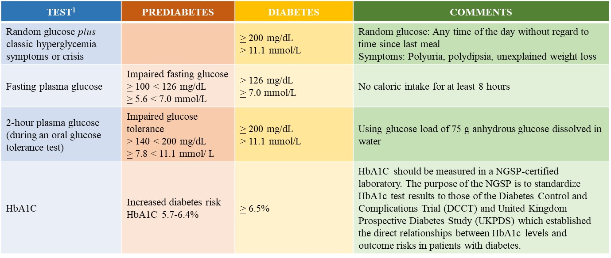

**Figure 1. The American Diabetes Association diagnostic criteria for prediabetes and diabetes. 1Results must be confirmed by repeat testing. HbA1C, hemoglobin A1C; NGSP, National Glycohemoglobin Standardization Program**

**INCIDENCE**

PTDM has been reported to occur in 4% to 25% of kidney transplant recipients, 2.5% to 25% of liver transplant recipients, 4% to 40% of heart transplant recipients, and 30% to 35% of lung transplant recipients (9, 12-15). Higher incidences have also been reported. The variation in the reported incidence may be due in part to the prior lack of a standard definition, the presence of both modifiable and non-modifiable risks factors, the type of organ transplants, and the duration of follow up (e.g. in one retrospective cohort study of 415 liver transplant recipients, PTDM occurred in 34.7%, 46.9%, and 56.2% of patients at 1, 3, and 5 year follow-up, respectively). In one study half of PTDM cases developed by 6 months and 75% by 12 months (15).

**RISK FACTORS FOR PTDM**

PTDM may arise from both transplant-related and traditional risk factors. The diabetogenic effect of various immunosuppressive agents have been well-described. Corticosteroids may reduce peripheral insulin sensitivity, inhibit pancreatic production/secretion, and increase hepatic gluconeogenesis. The calcineurin inhibitors tacrolimus and cyclosporine decrease insulin secretion and synthesis. Sirolimus increases peripheral insulin resistance and impairs pancreatic beta-cell response. The antimetabolites azathioprine and mycophenolic acid derivatives (mycophenolate mofetil and mycophenolate sodium) are not diabetogenic. Belatacept is a humanized fusion protein that inhibits the costimulatory pathway. Its use in kidney transplant recipients has not been shown to increase PTDM risk. Transplant patients may have improved appetite and a more liberal diet which can lead to obesity.

Risk factors for PTDM can be loosely categorized into those that are non-modifiable, potentially modifiable, and modifiable (8, 16-22). Solid organ transplant recipients with specific end-organ diagnosis such as end-stage kidney disease due to polycystic kidney disease, end stage liver disease due to hepatitis C infection, or end stage lung disease due to cystic fibrosis have been reported to be at increased risk for PTDM compared with those without such diagnosis (20). Suggested risk factors for the development of PTDM are presented in Figure 2. A more extensive discussion of the studies evaluating PTDM risk factors is beyond the scope of this chapter. Interested readers are referred to reference Pham and colleagues (8).

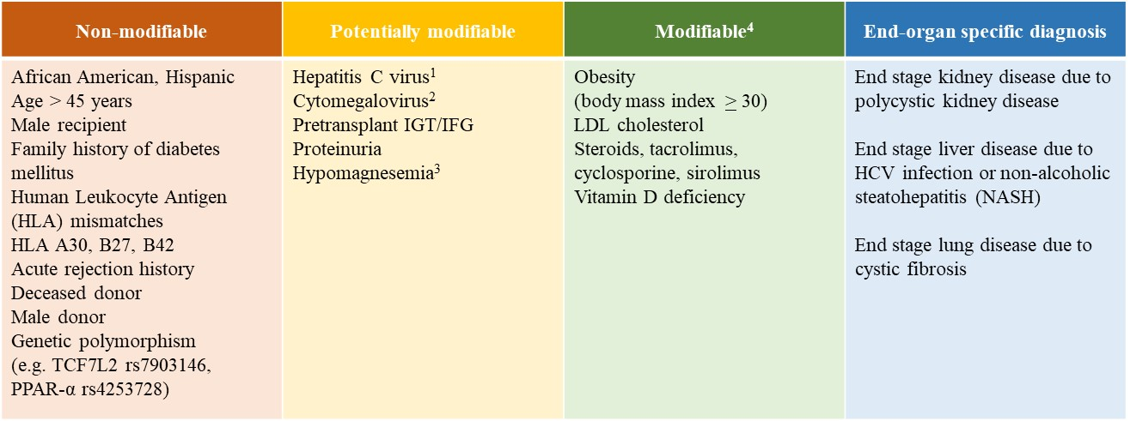

**Figure 2. Risk factors for Posttransplantation Diabetes Mellitus.**

1Curative therapy for chronic hepatitis C can be achieved with interferon-free direct acting antiviral-based regimen. Stable transplant recipients with HCV viremia by PCR should be referred to Hepatology for treatment. In HCV-positive kidney transplant candidate with a living donor, pretransplant treatment of HCV infection should be considered

2 Posttransplant CMV prophylaxis is preferred over preemptive therapy after heart and lung transplant. Either prophylaxis or preemptive therapy is recommended after kidney or liver transplant recipients. However, for programs or patients who are unable to meet the stringent logistic requirements required with preemptive therapy, prophylaxis therapy is recommended (23)

3Persistent hypomagnesemia can occasionally be seen despite aggressive replacement therapy because of ongoing calcineurin inhibitor-induced urinary magnesium wasting

4Manipulation of immunosuppression should be weighed against the risk of acute rejection

PPAR, peroxisome proliferators activated receptor; IGT, impaired glucose tolerance; IFG, impaired fasting glucose

**IMPACT OF PTDM ON OUTCOMES AFTER TRANSPLANTATION**

Studies evaluating the association between PTDM and morbidity and mortality have yielded mixed results (17, 24-29).

**PTDM After Kidney Transplantation**

In an analysis of the United States Renal Data System consisting of more than 11,000 kidney transplant recipients, Kasiske *et al.* demonstrated that PTDM was associated with a strong, independent predictor of mortality (p < 0.0001), graft failure (p < 0.0001), and death-censored graft failure (p < 0.0001) (17). A single-center study consisting of more than 700 kidney transplant recipients similarly demonstrated worse 10-year actuarial patient survival among patients with PTDM compared with those without PTDM (26). In contrast, a retrospective analysis of the UNOS/OPTN database (n > 37,000) failed to demonstrate the negative impact of PTDM on transplant survival or cardiovascular mortality during a median follow up of 548 days (27). However, the study results were considered inconclusive because of the wide confidence intervals and relatively short duration of follow-up. Studies with longer-term follow-up demonstrated similar 5- and 10-year graft survival rates among patients with PTDM and those without PTDM (26).

**PTDM After Liver Transplantation**

Retrospective analysis of the UNOS/OPTN database consisting of > 13,000 liver transplant recipients demonstrated that the presence of both PTDM and acute rejection at 1-year posttransplant but not PTDM alone was associated with higher overall graft failure and mortality risk (29). However, it should be noted that UNOS database did not distinguish transient posttransplantation hyperglycemia from established PTDM. A single-center retrospective cohort study (n=994) compared the incidence of major cardiovascular events (MCE) among four groups of liver transplant recipients 1) without diabetes (39%), 2) with pre-existing diabetes (24%), 3) with transient PTDM (16%), and 4) with sustained PTDM (20%). Sustained PTDM was found to be associated with a significant increase in mortality risk and a doubling of major cardiovascular events at a median follow up of 54.7 months (sub-distribution HR 1.95, 95% CI 1.20–3.18). A greater than threefold increased risk of death was observed among those who experienced MCE (sustained PTDM was defined as PTDM for at least 6 months after transplant). MCE was defined as a composite of cardiac arrest, fatal and nonfatal myocardial infarction, ischemic stroke, and symptomatic peripheral artery disease requiring a revascularization intervention) (30). In a retrospective cohort study of 415 adult liver transplant recipients, PTDM was found to be associated with higher rejection rates (31.9% vs. 21.8%, respectively; p=0.055) and a trend towards worse patient survival compared with no-PTDM at 5 year follow up (72.5% vs. 77.2%, respectively; p=0.460) (15).

**PTDM After Heart Transplantation**

Meta-analysis of observational studies in heart transplant recipients demonstrated that pre-existing diabetes was associated with a 37% increase in mortality risk (HR 1.37, CI 1.15-1.62) (31). Studies on the impact of PTDM on outcomes after heart transplantation are lacking. In one single-center South Korean study consisting of 391 isolated heart transplant recipients 1) without diabetes (n=257), 2) with pre-existing diabetes (n=46), and 3) with PTDM (n=88), the risk of death was found to be twofold higher among transplant recipients with pre-existing as well as posttransplantation diabetes compared with their non-diabetic counterparts (32).

**PTDM After Lung Transplantation**

The 27th International Society for Heart and Lung Transplantation Registry consisting of more than 32,000 lung transplant recipients demonstrated that pre-existing diabetes was associated with a 21% increase in 5-year mortality risk (RR 1.21, p=0.0023) (33). Limited studies suggest that PTDM similarly adversely affects survival among lung transplant recipients. In a single-center prospective observational Australian study consisting of 210 patients who underwent their first single, bilateral or heart-lung transplant between 2010-2013, hyperglycemia in both the early and late posttransplant periods (defined as first 4 months and beyond 4 months) was found to be associated with increased mortality risk. Of 210 patients, 80 had no DM, and 90 had persistent DM. Patients with pre-existing DM (n=45) and PTDM (n=45) were classified together as “persistent DM”. In the whole cohort, each 18 mg/dL increase in mean fasting blood glucose (FBG) and random blood glucose and each 1% increase in mean A1C were associated with 18% (p=0.006), 38% (p< 0.001), and 46% (p=0.002) increase in mortality risk, respectively (median follow up of 3 years). Of interest, random blood glucose correlated with mortality in both the persistent DM and no DM groups (35%, p=0.012 and 109%, p=0.041, respectively). It was concluded that glycemic control strongly correlated with survival after lung transplant (34). The same group of investigators previously demonstrated that DM conferred a nearly fourfold increase in mortality risk compared with no DM. When patients were classified into subgroups including 1) no diabetes, 2) pre-existing DM, 3) PTDM, 4) DM diagnosed within 2 weeks of death, and 5) DM developing after transplant but death within 90 days of transplant, pre-existing DM and PTDM were associated with a 65% (p=0.003) and a 90% (p< 0.001) increase in mortality risk, respectively (35).

Although studies on the impact of PTDM on outcomes after non-renal solid organ transplantation remain limited, it is tempted to speculate that PTDM adversely affects survival among recipients of various solid organ transplants. Patients with PTDM may also develop many of the complications associated with diabetes similar to that observed in the general population.  In a study of 4105 patients with PTDM, one or more diabetic complications arose in 58% including ketoacidosis (8%), hyperosmolarity (3%), renal complications (31%), ophthalmic complications (8%), neurological complications (16%), peripheral circulatory disorders (4%), and hypoglycemia/shock (7%).  These complications occurred within a mean of 500-600 days of developing PTDM, indicating an accelerated pace for the development of complications (28). Moreover, PTDM patients had an increased rate of infections and sepsis compared with their non-diabetic counterparts (24).

**DETECTION OF PTDM**

**Pretransplant Baseline Evaluation**

Pretransplant Evaluation should include history of hyperglycemia, prediabetes, diabetes, and risk factors for PTDM including family history and hepatitis C virus.  The 2004 International Consensus Guidelines suggest that a pretransplant baseline evaluation should include a complete medical and family history, including documentation of glucose history (36). Those with risk factors for metabolic syndrome can be screened further with laboratory testing.  Patients with evidence of risk factors can be counseled of their risk for PTDM.  Those with evidence of prediabetes can be counseled of lifestyle modifications including dietary modifications, thirty minutes of moderate intensity physical activity, and overall five to ten percent weight reduction (37).  In HCV-positive kidney transplant candidates with a living donor, pretransplant treatment of HCV infection should be considered. With the advent of the interferon-free direct acting antiviral-based regimen, treatment of hepatitis C in the post-transplant period is a reasonable alternative in selected prospective kidney transplant candidates without a living donor due to a considerably shorter waiting time for a deceased HCV-positive donor kidney (38). The choice of an immunosuppressive regimen should be tailored to each individual patient, weighing the risk of acute rejection against that for PTDM.

**Early Detection of PTDM After Transplantation**

New onset perioperative hyperglycemia is common and may develop in the context of high dose corticosteroid or as a consequence of posttransplant stress hyperglycemia, or both. Limited studies suggest that posttransplant stress hyperglycemia is an independent risk factor for subsequent diabetes (39). The 2014 International Consensus guidelines on PTDM screening is shown in Figure 3 (7). The expert panel suggested that patients with early posttransplant hyperglycemia (defined as hyperglycemia before 45 days after transplantation) should not be diagnosed as PTDM.

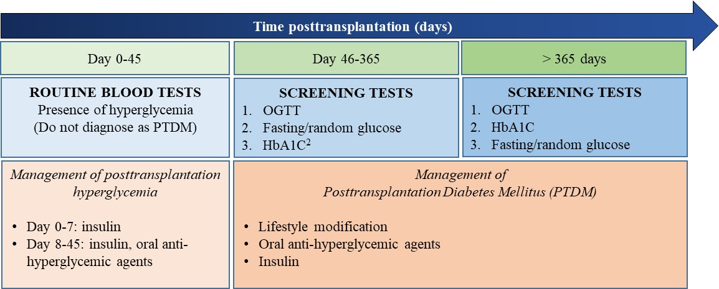

**Figure 3. The 2014 International Consensus Guidelines on the Screening, Diagnosis, and Management of Early Posttransplant Hyperglycemia and PTDM.1**

1Although recommendations from the Expert Panel are largely based on published kidney transplantation literature, the principles are likely relevant to all forms of solid organ transplantation.

2HbA1C alone < 365 days may underestimate PTDM and require corroborating.

At the authors’ institution, fasting and premeal home glucose monitoring is routinely recommended for patients with new-onset posttransplantation hyperglycemia particularly those requiring insulin therapy in the immediate posttransplantation period. Nonetheless, it should be noted that monitoring a 2-hour postprandial blood glucose may be a better indicator of diabetes and its control, particularly in steroid-treated patients. Clinically stable patients with persistent posttransplantation hyperglycemia for > 3 months should be screened for PTDM using HbA1C test. Although evidence-based screening guidelines for the early detection of PTDM are lacking, obtaining baseline A1C at 3 months after transplant, then at 6 months, 9 months, 12 months, and annually thereafter seems reasonable. If screening A1C is in the prediabetic range, patients should be counseled on dietary and lifestyle modification and A1C monitored every 3 months. While OGTT remains the gold standard for diagnosing PTDM, there remains insufficient evidence to recommend OGTT for all kidney transplant recipients (7). In addition, screening all patients with OGTT may be impractical in clinical practice and should be individualized and reserved for those with multiple risk factors (opinion-based) (38, 40).

**PREVENTION AND MANAGEMENT OF PTDM**

**Non-Pharmacological Preventive and Management Strategies**

Studies in the general population demonstrated that lifestyle modification promoting reduced fat/energy diet, daily moderate intensity physical activity, and modest weight loss reduce the incidence of type 2 diabetes (41). Similar studies in the context of solid organ transplantation are lacking. In a small single center study consisting of 25 kidney transplant recipients with impaired glucose tolerance, reversal to normal glucose tolerance with lifestyle modification was observed in 13 patients after a median of 9 months with only one patient progressing to PTDM (42). Small single-center studies showed that posttransplant weight gain is associated with persistent PTDM (43). Pre- and post- transplant lifestyle modification including dietary changes with the guidance of a dietitian and regular moderate cardiovascular activity aiming at increasing muscle mass while decreasing fat mass has been suggested to decrease the incidence of PTDM (39). Whether active lifestyle modification has a favorable effect on glycemic control in kidney transplant recipients remains speculative and awaits results of an ongoing prospective, randomized controlled trial comparing the glycemic benefits of active versus passive lifestyle intervention. Patients randomized to the former group receive active lifestyle modification intervention including dietician referral, cognitive behavior therapy, weight loss advice, and enrollment in graded exercise program. In the passive lifestyle intervention group, patients are counselled in clinic about the risks of glucose intolerance and are given leaflets outlining lifestyle modification including healthy eating, exercise and the importance of weight loss. However, there will be no dietician referral, psychosocial intervention or focused exercise or weight loss monitoring program (NCT02233491).

**Pharmacological Preventive and Management Strategies**

In the immediate posttransplant period, the pancreatic β-cells are exposed to multiple hyperglycemic stressors including the transplant surgery itself, high-dose corticosteroids, and the introduction of cyclosporine or tacrolimus immunosuppression therapy. In a randomized controlled trial, Hecking *et al.* demonstrated that early basal insulin therapy following detection of early posttransplantation hyperglycemia (defined as < 3 weeks) reduced the subsequent odds of developing PTDM within the first year after transplantation by 73% (44). It is conceivable that early basal insulin therapy decreases PTDM through insulin-mediated protection of pancreatic beta-cells (44-45). However, the routine recommendation of early initiation of insulin therapy in the prevention of PTDM development awaits results of randomized controlled clinical trials (ITP-NODAT, clinicaltrials.org: NTC01683331 and NCT03507829 –recruitment completed. Study results are pending at the time of this writing). The glucose threshold for starting insulin therapy remains to be defined.

Insulin tapering or withdrawal and transitioning to non-insulin-based regimen can be considered after the first 1-3 month after transplant when insulin requirement is less than 15-20 units a day (opinion-based). The choice of individual agents should be based on the potential advantages and disadvantages of different classes of agents at the discretion of the clinicians (Figure 4).

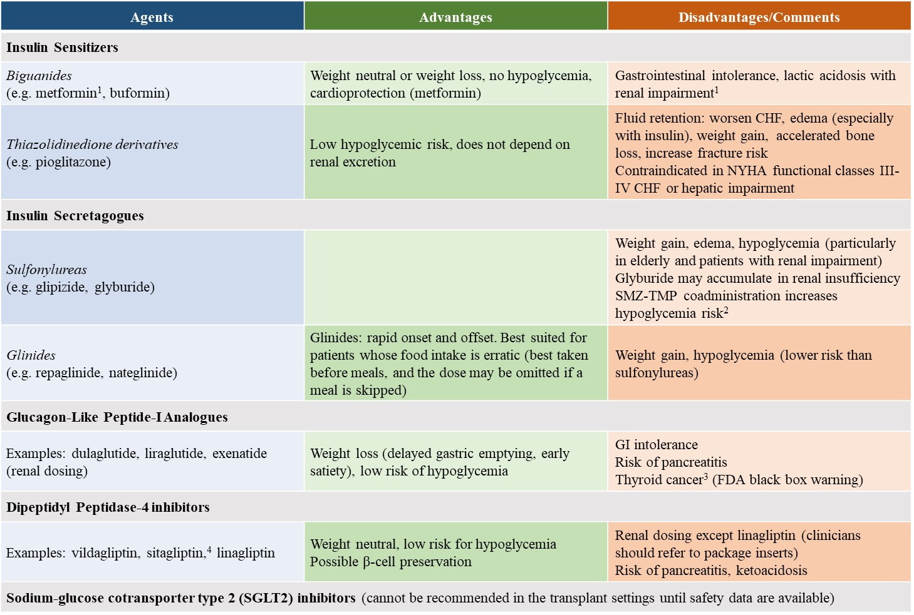

**Figure 4. The potential advantages and disadvantages of various classes of antihyperglycemic agents**

1KDIGO guidelines: Reduce dose if estimated glomerular filtration rate (eGFR) < 45 cc/min/1.73 m2. Discontinue if eGFR < 30 cc/min/1.73m2

2From Parekh TM, Raji M, Lin YL, et al. Hypoglycemia after antimicrobial drug prescription for older patients using sulfonylureas. *JAMA Intern Med*. 2014;174(10):1605-1612.

3Contraindicated in patients with personal history or family history of thyroid cancer or multiple endocrine neoplasia (MEN) type 2.

4Sitagliptin may prolong QT interval particularly when used with cyclosporine.

**Modification of Immunosuppression**

Although clinical trials comparing the incidence of PTDM in cyclosporine versus tacrolimus-treated patients have yielded variable results, tacrolimus has more consistently been shown to have a greater diabetogenic effect than cyclosporine (38). Modification of immunosuppression including cyclosporine to tacrolimus conversion therapy or steroid avoidance or withdrawal has variably been shown to improve glycemic control (8, 46-49). However, manipulation of immunosuppression is not without immunological risk. In a meta-analysis of controlled clinical trials to assess the safety and efficacy of early steroid withdrawal or avoidance, Pascual *et al.* showed that steroid avoidance or steroid withdrawal after a few days reduced PTDM incidence among cyclosporine but not tacrolimus-treated kidney transplant recipients (50). However, among cyclosporine-treated patients, acute rejection episodes were more frequently observed in steroid avoidance compared with conventional steroid treated groups. The same group of investigators demonstrated no significant beneficial effect of late steroid withdrawal (3 to 6 months after transplantation) on the incidence of PTDM (51). In the current era of immunosuppression, the beneficial effect of steroid avoidance or withdrawal on the incidence of PTDM has been questioned by experts in the field because rapid steroid taper and the use of lower target cyclosporine and tacrolimus levels are now common practice (7). The use of tacrolimus and mTOR inhibitor combination therapy may increase PTDM risk and should probably be avoided. Nonetheless, low dose calcineurin inhibitor (cyclosporine or tacrolimus) and mTOR inhibitor combination therapy seems justifiable in transplant recipients with a history of malignancies (such as skin cancers, renal cell carcinoma, or Kaposi sarcoma). Due to the lack of well-defined guidelines, modification of immunosuppression to alleviate the incidence of PTDM should be tailored to each individual patient. Reduction in immunosuppression should be weighed against the risk of acute rejection.

**Management of Established PTDM in the Late Posttransplant Period**

Although there may be differences in the pathogenesis and presentation of PTDM compared to type 2 diabetes mellitus, management of established PTDM in the late posttransplant period should follow the conventional approach and clinical guidelines as established by well-recognized organizations.  The American Diabetes Association and European Association for the Study of Diabetes generally recommend a HbA1c target of < 7% (52). Lifestyle modifications including weight reduction, dietary changes, and regular moderate cardiovascular activity should be employed. If glycemic control does not reach therapeutic targets, medical management with oral antidiabetic agents and ultimately insulin can be initiated.

Metformin has not been widely used in the setting of transplantation due to the concern for lactic acidosis in the presence of dynamic kidney allograft function particularly in the early posttransplant period. In contrast, the potential beneficial effects of metformin including weight neutral or weight loss, cardioprotection, and lack of significant drug-drug interactions renders metformin an attractive treatment option for solid organ transplant recipients. Further clinical trials to assess the risk and benefit ratio of metformin are needed before it can be endorsed as the antihyperglycemic agent of choice in PTDM (7). At the time of this writing, there has been only one randomized clinical trial assessing the efficacy of metformin in the prevention of PTDM in kidney transplant recipients –The Transplantation and Diabetes (Transdiab) study (53). The Transdiab study is an ongoing single-center, open label, randomized controlled trial designed to assess the feasibility, gastrointestinal tolerability, and efficacy of metformin in patients with posttransplantation impaired glucose tolerance. The latter is diagnosed using a 2-hour oral glucose tolerance test in the 4-12 weeks after transplant. Eligible patients with IFG are randomized to standard of care or standard of care and metformin 500 mg twice daily. The efficacy of metformin is assessed by measuring fasting blood glucose and A1C at 3, 6, 9, and 12-month follow up.

Experimental studies suggest that sulfonylureas are associated with β-cell apoptosis and β-cell exhaustion (54), raising theoretical concern about their use in PTDM, particularly in the early posttransplant period. In contrast, the anti-hyperglycemic dipeptidyl peptidase-4 inhibitor (DPP-4) inhibitors have been shown to preserve pancreatic beta-cell function in diabetic animal models (55, 56). Early clinical studies suggest that DPP-4 inhibitors are safe and effective in the treatment of PTDM in kidney transplant recipients (57-59). In a single-center study consisting of 71 stable kidney transplant recipients with PTDM newly diagnosed by an oral glucose tolerance test, Haidinger *et al.* demonstrated that patients treated with vildagliptin at baseline had significantly reduced HbA1C levels at 3, 6,12, and 18 months, whereas no improvement in glycemic control was observed among their sulfonylurea-treated counterparts (58). In a randomized controlled trial comparing vildagliptin with placebo in the treatment of PTDM, the same group of investigators demonstrated that treatment with vildagliptin significantly improved A1C levels within 3 months compared with placebo (60). Systematic review and meta-analysis of five studies demonstrated that DDP-4 inhibitors had a favorable glycemic effect (assessed by A1C) compared with either placebo or oral anti-hyperglycemic agent (A1C= -0.993, p=0.001) at 6-month follow-up. No significant changes in eGFR or tacrolimus levels were observed in DDP-4 inhibitor-treated patients (61).

Studies evaluating the safety and efficacy of DDP-4 inhibitors in non-renal solid organ transplant recipients remain lacking. In a small retrospective study of 30 stable heart transplant recipients with type 2 diabetes, vildagliptin was found to significantly reduce A1C level compared with their control counterparts. [mean A1C in the vildagliptin-treated patients was 7.4% ± 0.7% before versus 6.8% ± 0.8% after 8 months of therapy (P = 0.002 vs baseline). Mean A1C levels at baseline and at 8-month follow up in the control group were 7.0% ± 0.7% versus 7.3% ± 1.2%, respectively (P = 0.21)] (62). No statistically significant changes in body weight, total cholesterol or triglyceride levels were seen in vildagliptin-treated patients. Furthermore, no significant changes in immunosuppressive drug levels or dosages were observed in either group. Whether vildagliptin is safe and effective in the treatment of PTDM after orthotopic heart transplantation remains to be studied.

GLP-1 agonist therapy may confer a weight-loss benefit, counteracting the weight gain commonly seen in the setting of hyperglycemia and steroid therapy after transplantation (63, 64).

The new sodium-glucose cotransporter type 2 (SGLT2) inhibitor has been shown to increase urinary glucose excretion and improve hyperglycemia in type 2 diabetes. An experimental animal model of tacrolimus-induced diabetes demonstrated that empagliflozin improves hyperglycemia and suppressed the tacrolimus-induced twofold increase in the expression of SGLT2 receptors (65). Furthermore, empagliflozin was found to have a direct protective effect on tacrolimus-induced renal injury. This study suggests that a SGLT2 inhibitor is a suitable therapeutic option for transplant recipients with tacrolimus-induced PTDM. Nonetheless, it should be noted that SGLT2 has been reported to be associated with increased risk for urinary tract infections and genital candidiasis, potentially limiting its use in the immunosuppressed transplant population. The use of SGLT2 inhibitors in the transplant setting cannot be recommended until safety data are available. The empagliflozin in renal transplant recipients (EMPA-RenalTx) is an ongoing single-center, prospective, placebo-controlled, double blind randomized study evaluating the safety and efficacy of empagliflozin in the treatment of PTDM (NCT03157414).

Evidence-based studies recommending one antihyperglycemic agent over the other in the context of transplantation are currently lacking. An incretin-based regimen appears safe and effective in kidney transplant recipients. Nonetheless, the choice of individual agents should be based on the potential advantages and disadvantages of different classes of agents (Figure 4). Failure to achieve glycemic control despite multiple antihyperglycemic agent combination therapy generally requires initiation of insulin therapy. The 2014 international consensus guidelines on the screening, diagnosis, and management of early posttransplant hyperglycemia and PTDM is shown in Figure 1. The authors’ suggested protocol for screening, diagnosis, and management of early posttransplantation hyperglycemia and PTDM is shown in Figure 5 (practice varies among centers).

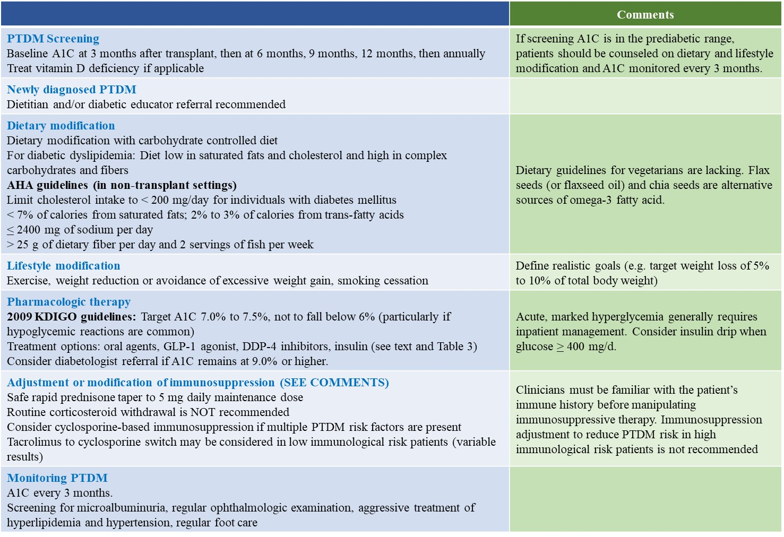

**Figure 5. Screening and management of PTDM (opinion-based)**

**SUMMARY**

PTDM is a common complication after solid organ transplantation and has variably been reported to be associated with increased morbidity and mortality. Risk stratification, intervention to minimize risk and early diagnosis may alleviate the incidence of PTDM and improve outcomes following solid organ transplantation. The 2014 International Consensus Guidelines suggest expanding screening tests for PTDM using postprandial glucose monitoring and HbA1C test. However, the latter should be used with caution in the early posttransplant period. A normal HbA1C does not exclude the diagnosis of PTDM in the presence of early posttransplant anemia and/or dynamic kidney allograft function. Whether intravenous iron therapy and/or the use of erythropoietin stimulating agent result in falsely low A1C levels remains to be studied. The routine recommendation of early initiation of insulin therapy in patients with new onset hyperglycemia during the first posttransplantation week to preserve β-cell function and progression to overt PTDM awaits results of randomized clinical trials. Management of established late PTDM should follow the conventional approach and guidelines established for the general population. When lifestyle modification fails to achieve glycemic control, medical intervention is often necessary. The choice of one antihyperglycemic agent over the other should be based on the potential advantages and disadvantages of individual agents. The use of metformin in the setting of solid organ transplantation should be individualized. Incretin-based regimen appears safe and effective in kidney transplant recipients. Similar to the general population, insulin therapy should be considered in individuals with suboptimal glycemic control despite multiple antihyperglycemic agent combination therapy.

**REFERENCES**

1. Starlz TE. Experience in renal transplantation. Philadelphia: Saunders 1964:111.
2. Gunnarsson R, Arner P, Lundgren G, et al. Steroid diabetes after renal transplantation. A preliminary report. Scan Urol Nephrol Suppl 1977; 42:191-194.
3. Araki M, Flechner SM, Ismail HR, et al. Posttransplant diabetes mellitus in kidney transplant recipients receiving calcineurin or mTOR inhibitor drugs. Transplantation 2006; 81(3): 335-341.
4. Crutchlow MF, Bloom RD. Transplant-associated hyperglycemia: a new look at an old problem. Clin J Am Soc Nephrol 2007; 2(2):343-355.
5. Bloom RD, Crutchlow MF. New-onset diabetes mellitus in the kidney recipients: diagnosis and management strategies. Clinical J Am Soc Nephrol 2008; 3: S38-48.
6. Pham PT, Pham PVC, Lipshutz G. New onset diabetes mellitus after solid organ transplantation. Endocrinol Metab Clin North Am 2007; 36(4): 873-890.
7. Sharif A, Hecking M, de Vries AP, et al. Proceedings from an international consensus meeting on posttransplantation diabetes mellitus: recommendations and future directions.  Am J Transplant. 2014; 14(9):1992-2000.
8. Pham PT, Pham PM, Pham SV, Pham PA, Pham PC. New onset diabetes after transplantation (NODAT): an overview.  Diabetes Metab Syndr Obes. 2011; 4:175-86.
9. Davidson J, Wilkinson AH, Dantal J, et al. New-onset diabetes after transplantation: 2003 International Consensus Guidelines. Transplantation. 2003;7: SS3–SS24.
10. American Diabetes Association. Standards of Medical Care in Diabetes 2011. Diabetes Care 2011; 34: S11.
11. [Ng JM](https://www.ncbi.nlm.nih.gov/pubmed/?term=Ng%20JM%5BAuthor%5D&cauthor=true&cauthor_uid=20798337), [Cooke M](https://www.ncbi.nlm.nih.gov/pubmed/?term=Cooke%20M%5BAuthor%5D&cauthor=true&cauthor_uid=20798337), [Bhandari S](https://www.ncbi.nlm.nih.gov/pubmed/?term=Bhandari%20S%5BAuthor%5D&cauthor=true&cauthor_uid=20798337), et al. The effect of iron and erythropoietin treatment on the A1C of patients with diabetes and chronic kidney disease. [Diabetes Care 2010; 33(11): 2310-2313.](https://www.ncbi.nlm.nih.gov/pubmed/?term=Jen+M.+Ng%2C+MRCP%2C+Michelle+Cooke%2C+BSC%2C+Sunil+Bhandari)
12. Baid S, Cosimi AB, Farrell ML, et al. Posttransplant diabetes mellitus in liver transplant recipients: risk factors, temporal relationship with hepatitis C virus allograft hepatitis, and impact on mortality. Transplantation. 2001; 72:1066–1072.
13. Knobler H, Stagnaro-Green A, Wallenstein S, et al. Higher incidence of diabetes in liver transplant recipients with hepatitis C. J Clin Gastroenterol. 1998; 26:30–33.
14. Ye X, KuoH-T, Sampaio MS, Jiang Y, Bunnapradist S. Risk factors for the development of new-onset diabetes mellitus after transplant in adult lung transplant recipients. Clin Transplant. 2010; DOI 10. 1111:1–7.
15. [Lieber SR](https://www.ncbi.nlm.nih.gov/pubmed/?term=Lieber%20SR%5BAuthor%5D&cauthor=true&cauthor_uid=30927288), [Lee RA](https://www.ncbi.nlm.nih.gov/pubmed/?term=Lee%20RA%5BAuthor%5D&cauthor=true&cauthor_uid=30927288), [Jiang Y](https://www.ncbi.nlm.nih.gov/pubmed/?term=Jiang%20Y%5BAuthor%5D&cauthor=true&cauthor_uid=30927288), et al. The Impact of Post-Transplant Diabetes Mellitus on Liver Transplant Outcomes. [Clin Transplant.](https://www.ncbi.nlm.nih.gov/pubmed/30927288) 2019 Mar 29: e13554. doi: 10.1111/ctr.13554. [Epub ahead of print].
16. Cosio FG, Pesavento TE, Osei K, et al. Posttransplant diabetes mellitus: increasing incidence in renal allograft recipients transplanted in recent years. Kid Int 2001; 59(2): 732-737.
17. Kasiske BL, Snyder JJ, Gilbertson D, et al. Diabetes mellitus after kidney transplantation in the United States. Am J transplant 2003;3(2): 178-185.
18. Martinez-Castelao A, Hernandez MD, Pascual J, et al. Detection and treatment of post kidney transplant hyperglycemia: a Spanish multicenter cross-sectional study. Transplant Proc 2005;37: 3813-3816.
19. Quaglia M1, Terrazzino S, Musetti C, et al. The Role of TCF7L2 rs7903146 in Diabetes After Kidney Transplant: Results From a Single-Center Cohort and Meta-Analysis of the Literature. Transplantation 2016; 100(8): 1750-1758.
20. Jenssen T, Hartmann A. Post-transplant diabetes mellitus in patients with solid organ transplants. Nat Rev Endocrinol 2019; 15(3): 172-188.
21. Elens L, Sombogaard F, Hesselink D, et al. Single-nucleotide polymorphism in P450 oxidoreductase and peroxisome proliferator-activated receptor are associated with the development of new onset diabetes after transplantation in kidney transplant recipients treated with tacrolimus. Pharmacogenet Genomics. 2013; 23:649-657 (21)
22. El Essawy B, Kandeel F. Pre, peri and posttransplant diabetes mellitus. Current opinion Nephrol Hypertens. 2018; 28: 47-57 (22)
23. Kotton CN, Kumar D, Caliendo AM, et al. The Transplantation Society International CMV Consensus Group. [The Third International Consensus Guidelines on the Management of Cytomegalovirus in Solid-organ Transplantation.](https://www.ncbi.nlm.nih.gov/pubmed/29596116) Transplantation. 2018 Jun;102(6):900-931.
24. Boudreaux JP, McHugh L, Canafax DM, et al. The impact of cyclosporine and combination immunosuppression on the incidence of post transplant diabetes in renal allograft recipients. Transplantation. 1987;44(3):376–381.
25. Ojo AO. Cardiovascular complications after renal transplantation and their prevention. Transplantation. 2006;82(5):603–611.
26. Joss N, Staatz CE, Thomson AH, et al. Predictors of new onset diabetes after renal transplantation 2007;21(1): 136-143.
27. Kuo H-T, Sampaio MS, Vincenti F, et al. Associations of pretransplant diabetes mellitus, New-Onset Diabetes Mellitus after Transplant, and acute rejection with transplant outcomes: an analysis of the Organ Procurement and Transplant Network/United Network for Organ Sharing (OPTN/UNOS) database. 2010;56(6): 1026-1028.
28. Burroughs TE, Swindle J, Takemoto S, et al.  Diabetic complications associated with new-onset diabetes mellitus in renal transplant recipients. Transplantation. 2007;83(8):1027.
29. Kuo HT, Lum E, Martin P, et al. Effect of diabetes and acute rejection on liver transplant outcomes, an analysis of the OPTN/UNOS database. Liver Transpl 2016; 22(16): 796-804
30. Roccaro GA, Goldberg DS, Hwang WT, et al. Sustained posttransplantation diabetes is associated with long-term major cardiovascular events following liver transplantation. Am J Transplant 2018; 18(1): 207-215
31. Foroutan F, Alba AC, Guyatt G, et al. [Predictors of 1-year mortality in heart transplant recipients: a systematic review and meta-analysis.](https://www.ncbi.nlm.nih.gov/pubmed/28855271) Heart. 2018 Jan;104(2):151-160.
32. Kim HJ, Jung SH, Kim JJ et al. New-onset diabetes mellitus after heart transplantation: incidence, risk factors, and impact on clinical outcome. Circ J 2017; 806-814
33. Christie JD, Edwards LB, Kucheryavaya AY, et al. The registry of the international society of heart and lung transplantation: twenty-seventh official adult transplant report 2010. J Heart Lung Transplant 2010; 1105-1118
34. Hackman KL, Snell GI, Bach LA. Poor glycemic control is associated with decreased survival in lung transplant recipients. Transplantation 2017; 2200-2205
35. Hackman KL, Bailey MJ, Snell GI. Diabetes is a major risk factor for mortality after lung transplant. Am J Transplant 2014; 14: 438-445
36. Wilkinson AH, Davidson J, Dotta F, et al. Guidelines for the treatment and management of new-onset diabetes after transplantation. Clin Transplant. 2005; 19:291–298.
37. Nathan DM, Davidson MB, DeFronzo RA, et al. Impaired fasting glucose and impaired glucose tolerance. Diabetes Care 2007; 30:753.
38. Pham PT, Pham SV, Lee M, et al. Evaluation of the potential kidney transplant candidates. In: Pham PT, Pham PC. Quick Guide to Kidney Transplantation: From Initial Evaluation to Long-Term Post-Transplant Care. First Edition. Lippincott, Williams and Wilkins 2019; pp 40-58.
39. Chakkera HA, Weil EJ, Pham PT, et al. Can new-onset diabetes after kidney transplant be prevented? Diabetes Care 2013; 36: 1406-1412.
40. Pham PT, Edling KL, Chakkera HA, et al. Screening strategies and predictive diagnostic tools for the development of new-onset diabetes mellitus after transplantation: an overview.  Diabetes Metab Syndr Obes. 2012; 5:379-87.
41. Knowler WC, Barrett-Connor E, Fowler SE, et al. Diabetes Prevention Program Research Group. Reduction in the incidence of type 2 diabetes with lifestyle intervention or metformin. N Engl J Med 2002; 346: 393-403.
42. Sharif A, Moore R, Baboolal K. Influence of lifestyle modification in renal transplant recipients with postprandial hyperglycemia. Transplantation 2008; 85: 353-358.
43. Kim Y, Kim JR, Choi H, et al. Patients with persistent new-onset diabetes after transplantation have greater weight gain after kidney transplantation.  J Korean Med Sci. 2013 Oct;28(10):1431-4.
44. Hecking M, Haidinger M, Doller D, et al. Early basal insulin therapy decreases new-onset diabetes after transplantation. J Am Soc Nephrol 2012; 23: 739-749.
45. Hecking M, Werzowa J, Haidinger M, et al. Novel views on new-onset diabetes after transplantation: development, prevention and treatment.  Nephrol Dial Transplant. 2013 Mar;28(3):550-66.
46. Heisel O, Heisel R, Balshaw R, et al. New onset diabetes in patients receiving calcineurin inhibitors: a systematic review and meta-analysis. Am J Transplant 2004; 4(4): 583-595.
47. Vincenti F, Friman S, Scheuermann E, et al. Results of an international, randomized trial comparing glucose metabolism disorders and outcome with cyclosporine versus tacrolimus.  Am J Transplant. 2007 Jun;7(6):1506-14.
48. Rathi M, Rajkumar V, Rao N, et al. Conversion from tacrolimus to cyclosporine in patients with new-onset diabetes after renal transplant: an open-label randomized prospective pilot study.  Transplant Proc. 2015 May;47(4):1158-61.
49. Wissing KM, Abramowicz D, Weekers L, et al. Prospective randomized study of conversion from tacrolimus to cyclosporine A to improve glucose metabolism in patients with posttransplant diabetes mellitus after renal transplantation. Am J Transplant. 2018;18(7):1726-1734.
50. Pascual J, Royuela A, Galeano C, et al. Very early steroid withdrawal or avoidance for kidney transplant recipients: A systematic review. Nephroll Dial Transplant 2012; 27: 825-832.
51. Pascual J, Galeano C, Royuela A, et al. A systematic review on steroid withdrawal between 3 and 6 months after kidney transplantation. Transplantation 2010; 90: 343-349.
52. Nathan DM, Buse JB, Davidson MB, et al. Medical management of hyperglycemia in type 2 diabetes: a consensus algorithm for the initiation and adjustment of therapy: a consensus statement of the American Diabetes Association and the European Association for the Study of Diabetes.  Diabetes Care. 2009;32(1):193.
53. Alnasrallah B, Pilmore H, Manley P. Protocol for a pilot randomized controlled trial of metformin in pre-diabetes after kidney transplantation: the transplantation and diabetes (Transdiab) study. BMJ Open 2017; 7, e016813
54. Maedler K, Carr RD, Bosco D, et al. Sulfonylurea induced beta-cell apoptosis in cultured human islets. The J of Clin End and Metab 2005; 90: 501-506.
55. Mu J, Petrov A, Eiermann GJ, Woods J, et al. Inhibition of DPP-4 with sitagliptin improves glycemic control and restores islet cell mass and function in a rodent model of type 2 diabetes. Eur J Pharmacol 2009; 623(1-3): 148-154.
56. Cho JM, Jang HW, Cheon H, et al. A novel dipeptidyl peptidase IV inhibitor DA-1229 ameliorates streptozocin-induced diabetes by increasing β-cell replication and neogenesis. Diabetes Res Clin Pract 2011; 91(1): 72-79.
57. Halden TAS, Asberg A, Vik K, et al. Short-term efficacy and safety of sitagliptin treatment in long-term stable renal recipients with new-onset diabetes after transplantation. Nephrol Dial Transplant 2014; 14: 115-123.
58. Haidinger M, Werzowa J, Hecking M, et al. Efficacy and safety of vildagliptin in new-onset diabetes after kidney transplantation. A randomized, double-blind, placebo-controlled trial. Am J Transplant 2014; 14: 115-123
59. [Boerner BP](https://www.ncbi.nlm.nih.gov/pubmed/?term=Boerner%20BP%5BAuthor%5D&cauthor=true&cauthor_uid=24817885), [Miles CD](https://www.ncbi.nlm.nih.gov/pubmed/?term=Miles%20CD%5BAuthor%5D&cauthor=true&cauthor_uid=24817885), [Shivaswamy V](https://www.ncbi.nlm.nih.gov/pubmed/?term=Shivaswamy%20V%5BAuthor%5D&cauthor=true&cauthor_uid=24817885). Efficacy and safety of sitagliptin for the treatment of new-onset diabetes after renal transplantation. [Int J Endocrinol.](https://www.ncbi.nlm.nih.gov/pubmed/24817885) 2014;2014:617638. doi: 10.1155/2014/617638. Epub 2014 Apr 10.
60. Werzowa J, Hecking M, Haidinger M, et al. Vildagliptin and pioglitazone in patients with impaired glucose tolerance after kidney transplantation: a randomized, placebo-controlled clinical trial. Transplantation 2013; 95(3): 456-462.
61. [Abdelaziz TS](https://www.ncbi.nlm.nih.gov/pubmed/?term=Abdelaziz%20TS%5BAuthor%5D&cauthor=true&cauthor_uid=30907326), [Ali AY](https://www.ncbi.nlm.nih.gov/pubmed/?term=Ali%20AY%5BAuthor%5D&cauthor=true&cauthor_uid=30907326)1, [Fatthy M](https://www.ncbi.nlm.nih.gov/pubmed/?term=Fatthy%20M%5BAuthor%5D&cauthor=true&cauthor_uid=30907326). Efficacy and safety of Dipeptidyl Peptidase-4 Inhibitors in kidney transplant recipients with Post-transplant diabetes mellitus (PTDM)-a systematic review and Meta-Analysis. [Curr Diabetes Rev.](https://www.ncbi.nlm.nih.gov/pubmed/?term=abdelaziz+ts%2C+ali+ay%2C+fatthy+m) 2019 Mar 21. doi: 10.2174/1573399815666190321144310. [Epub ahead of print]
62. [Gueler I](https://www.ncbi.nlm.nih.gov/pubmed/?term=Gueler%20I%5BAuthor%5D&cauthor=true&cauthor_uid=23630415), [Mueller S](https://www.ncbi.nlm.nih.gov/pubmed/?term=Mueller%20S%5BAuthor%5D&cauthor=true&cauthor_uid=23630415), [Helmschrott M](https://www.ncbi.nlm.nih.gov/pubmed/?term=Helmschrott%20M%5BAuthor%5D&cauthor=true&cauthor_uid=23630415), et al. Effects of vildagliptin (Galvus®) therapy in patients with type 2 diabetes mellitus after heart transplantation. [Drug Des Devel Ther.](https://www.ncbi.nlm.nih.gov/pubmed/?term=gueler+i%2C+mueller+s) 2013 Apr 8;7:297-303.
63. Pinelli NR, Patel A, Salinitri FD. [Coadministration of liraglutide with tacrolimus in kidney transplant recipients: a case series.](https://www.ncbi.nlm.nih.gov/pubmed/24065848) Diabetes Care. 2013 Oct;36(10): e171-172.
64. [Sadhu AR](https://www.ncbi.nlm.nih.gov/pubmed/?term=Sadhu%20AR%5BAuthor%5D&cauthor=true&cauthor_uid=25786557), [Schwartz SS](https://www.ncbi.nlm.nih.gov/pubmed/?term=Schwartz%20SS%5BAuthor%5D&cauthor=true&cauthor_uid=25786557), [Herman ME](https://www.ncbi.nlm.nih.gov/pubmed/?term=Herman%20ME%5BAuthor%5D&cauthor=true&cauthor_uid=25786557). The rationale for use of incretins in the management of New Onset Diabetes after Transplantation (NODAT). [Endocr Pract.](https://www.ncbi.nlm.nih.gov/pubmed/?term=sadhu+ar%2C+schwartz+ss) 2015 Jul;21(7):814-822.
65. [Jin J](https://www.ncbi.nlm.nih.gov/pubmed/?term=Jin%20J%5BAuthor%5D&cauthor=true&cauthor_uid=28422431), [Jin L](https://www.ncbi.nlm.nih.gov/pubmed/?term=Jin%20L%5BAuthor%5D&cauthor=true&cauthor_uid=28422431), [Luo K](https://www.ncbi.nlm.nih.gov/pubmed/?term=Luo%20K%5BAuthor%5D&cauthor=true&cauthor_uid=28422431), et al. Effect of Empagliflozin on Tacrolimus-Induced Pancreas Islet Dysfunction and Renal Injury. [Am J Transplant.](https://www.ncbi.nlm.nih.gov/pubmed/?term=jin+j+effect+of+empagliflozin+on+tacrolimus-induced) 2017;17(10):2601-2616.