DIABETIC KETOACIDOSIS AND HYPEROSMOLAR HYPERGLYCEMIC STATE

Kenneth R. Feingold MD, Emeritus Professor of Medicine, University of California San Francisco, San Francisco, CA. Kenneth.feingold@ucsf.edu

Ketan Dhatariya, MD, PhD, Professor, University of East Anglia; Consultant in General medicine, Endocrinology and Diabetes, Elsie Bertram Diabetes Centre, Norfolk and Norwich University Hospitals NHS Foundation Trust, Norwich, UK. ketan.dhatariya@nnuh.nhs.uk

Updated October 13, 2025

INTRODUCTION

Diabetic ketoacidosis (DKA) and hyperosmolar hyperglycemic state (HHS) are acute life-threatening emergencies resulting from severe metabolic decompensation. DKA more commonly affects individuals with type 1 diabetes (T1DM) whereas HHS primary affects people with type 2 diabetes (T2DM). DKA is relatively common and in the US; 240,000 patients had a primary diagnosis of DKA in 2020. Approximately 2/3 of adults admitted with DKA have T1DM, while almost 90% of the HHS patients have a known diagnosis of T2DM. HHS is less common but is associated with a higher mortality rate, ranging from 10% to 20%, which is about ten times higher than DKA. Institutionalized elderly patients with diminished thirst perception or inability to ambulate to get free water as needed are at high risk for HHS. Early diagnosis and management of DKA and HHS are essential to improve outcomes.

CLINICAL RECOGNITION

Diabetic Ketoacidosis

The diagnosis of diabetic ketoacidosis (DKA) is based on the following three criteria:

- Hyperglycemia ≥200 mg/dL (11.1 mmol/L) or a prior history of diabetes irrespective of the presenting glucose reading.
- Elevated ketone body concentration: venous or capillary β-hydroxybutyrate ≥3.0 mmol/L or in the early stages of DKA urine ketone 2+ or greater.
- Metabolic acidosis: pH<7.3 and/or bicarbonate concentration <18 mmol/L.

The clinical manifestations of DKA are shown in Table 1.

Table 1. Clinical Manifestations of Diabetic Ketoacidosis
Fatigue and malaise
Nausea, vomiting, and abdominal pain, which can mimic an acute abdomen
Polydipsia and polyuria
Unintentional weight loss preceding the diagnosis
Confusion, headache, lethargy, and coma
Kussmaul breathing (deep, labored breathing)
Fruity breath odor due to ketone production
Tachycardia and hypotension due to dehydration
Dry mucous membranes and decreased skin turgor

The classification of the severity of DKA is shown in Table 2.

Table 2. Severity of Diabetic Ketoacidosis
 | Mild | Moderate | Severe
b-Hydroxybutyrate | 3.0–6.0 mmol/L | 3.0–6.0 mmol/L | >6.0 mmol/L
Acidosis | pH >7.25 to <7.30 or  bicarbonate 15–18 mmol/L | pH 7.0–7.25 or  bicarbonate 10-15 mmol/L | pH <7.0 or  bicarbonate <10 mmol/L
Mental status | Alert | Alert/drowsy | Stupor/coma
Suggested level of care | Regular or observation nursing unit | Step-down unit or intermediate care unit | Intensive care unit
Modified from Umpierrez GE, et al. Hyperglycemic Crises in Adults With Diabetes: A Consensus Report. Diabetes Care. 2024 Aug 1;47(8):1257-1275

Hyperosmolar Hyperglycemic State

The diagnosis of the hyperosmolar hyperglycemic state (HHS) is based on the following criteria.

- Plasma glucose >600 mg/dL (33.3 mmol/L).
- Hyperosmolality defined as effective osmolality >300 mOsm/kg or total serum osmolality > 320 mOsm/kg.
- Absence of significant ketonemia: β-hydroxybutyrate <3.0 mmol/L or urine ketone < 2+.
- Absence of acidosis: pH≥7.3 and bicarbonate concentration ≥ 15 mmol/L.

The clinical manifestations of HSS are shown in Table 3. Altered mentation appears to correlate with the degree of hyperosmolality; hence significantly diminished mentation in the setting of an osmolality of <320 mOsm/kg should prompt a search for other causes.

Table 3. Clinical Manifestations of the Hyperosmolar Hyperglycemic State
Fatigue, lethargy, and weakness
Polyuria and polydipsia
Unintentional weight loss preceding the acute presentation
Confusion, focal neurological deficits, seizures, and coma
Severe dehydration and volume depletion causing tachycardia and severe hypotension
Blurry vision

The differences between DKA and HHS are shown in Table 4. Patients may manifest symptoms and laboratory studies of both DKA and HHS as DKA and HHS represent a spectrum of insulin deficiency disorders. Approximately 1/3 of hyperglycemic emergencies have a hybrid DKA/HHS presentation.

Table 4. DIFFERENCES BETWEEN DKA AND HHS
Clinical / Laboratory feature | DKA | HHS
Onset | Rapid (hours to 1-2 days) | Gradual (several days to weeks)
Blood glucose | 200-600 mg/dL (11.1-13.3 mmol/L) | >600 mg/dl (13.3 mmol/L)
Ketones | Ketonemia >3 mmol/L or ketonuria 2+ or higher | Absent or <3 mmol/L
pH (acidosis) | <7.3 | ≥7.3
Bicarbonate | <18 mmol/L | ≥ 15 mmol/L
Osmolality | Moderately elevated | Severely elevated (>320 mOsm/kg)
Neurological symptoms | Alert to moderate confusion | Severe confusion, seizures, coma
From the Endotext chapter entitled “Hyperglycemic Crises”.

PRECIPITATING FACTORS

DKA/HHS are usually precipitated by one of the following risk factors (Table 5).

Table 5. Precipitating Factors Leading to DKA/HSS

Lack of insulin due to omission or suboptimal treatment regimens

Infections such as urinary tract infections, pneumonia, skin infections

New diagnosis of diabetes

Psychological stress

Alcohol and substance use

Medical or surgical emergencies such as myocardial infarction, stroke, or trauma

Medications such as glucocorticoids, antipsychotic medications, SGLT2 inhibitors, immune checkpoint inhibitors

SGLT2 inhibitors may cause DKA without elevations of blood glucose (“euglycemic” DKA).

PATHOGENESIS

DKA results from severe insulin deficiency in the presence of increased counterregulatory hormones, including glucagon, cortisol, epinephrine, and growth hormone, which in turn leads to increased gluconeogenesis, accelerated glycogenolysis, and impaired peripheral glucose uptake resulting in hyperglycemia. The combination of insulin deficiency and heightened counterregulatory hormone activity stimulate lipolysis in adipose tissue resulting in the release of free fatty acids. Free fatty acids are metabolized in the liver, leading to increased ketone production, ketonemia, and metabolic acidosis. The primary distinction between DKA and HHS is the degree of insulin deficiency. In HHS, there is relative insulin deficiency and residual insulin is enough to suppress lipolysis and prevent ketogenesis, but inadequate to regulate hyperglycemia. Severe hyperglycemia leads to osmotic diuresis and subsequently to volume and electrolyte depletion. Increased thirst is often not sufficient to compensate for these losses and as a result osmolality rises, renal filtration declines, and as HHS progresses, severe dehydration ensues, frequently followed by cognitive impairment.

DIAGNOSTIC TESTS NEEDED

Plasma glucose, electrolytes, BUN, creatinine, phosphate, liver function tests, osmolality, plasma β-hydroxybutyrate, complete blood count with differential, urinalysis, and arterial or veinous pH. Depending upon the circumstances an electrocardiogram, chest X-ray, head CT, blood, sputum, and urine cultures, and HbA1c may be obtained. The use of urinary ketones is discouraged unless capillary ketones are unavailable.

An anion gap acidosis is calculated by subtracting the sum of Cl⁻ and HCO₃⁻ from measured (not corrected) Na⁺ concentration. An anion gap >12 mmol/L indicates the presence of a high anion gap metabolic acidosis consistent with DKA. However, the use of capillary point of care ketone testing renders the use of an anion gap unnecessary. Effective serum osmolality can be determined by the following formula: 2 x [measured Na⁺(mEq/L)] + glucose(mg/dl)/18. Leukocytosis is a common finding in patients with DKA or HHS and might be resulting from acute stress, but a white blood cell count > 25,000/μL may indicate an underlying infection and warrants further investigations. Hypertriglyceridemia is frequently seen in HHS and is nearly always present in DKA. Additionally, elevated amylase and lipase levels can occur in DKA.

DIFFERENTIAL DIAGNOSIS

DKA must be differentiated from the following conditions. As always, a thorough history needs to be taken to differentiate DKA from these other conditions, including euglycemic DKA.

- Alcoholic Ketoacidosis: it’s characterized by a high anion gap metabolic acidosis but with normal or low glucose levels.
- Starvation Ketoacidosis: Malnutrition or prolonged fasting can lead to ketosis and mild acidosis, but blood glucose levels are normal or low.
- Lactic Acidosis: Leads to metabolic acidosis with high lactate levels in the absence of ketonemia.
- Toxins: Substances such as methanol and ethylene glycol can lead to a high anion gap metabolic acidosis without elevated ketones.
- Renal Failure: Acute or chronic kidney disease is associated with metabolic acidosis and uremia without elevated ketones

COMPLICATIONS

- Hypoglycemia: A common complication of treatment.
- Hypokalemia: Due to intracellular shift of potassium with insulin treatment, hypokalemia is often seen during treatment of hyperglycemic emergencies.
- Hyperchloremic Non–Anion Gap Acidosis: This transient and typically self-resolving condition can result from excessive normal saline infusion or the metabolism of ketoanions to bicarbonate during DKA resolution.
- Cerebral Edema: This complication is more common in DKA, particularly in younger patients, but has also been reported in HHS. A declining level of consciousness, lethargy, and headache should raise suspicion.
- Hypoxemia and rarely non-cardiogenic pulmonary edema may be associated with a decrease in the colloid osmotic pressure leading to pulmonary edema.
- Thrombosis: Both DKA and HHS are prothrombotic states. An individual risk assessment for venous thromboembolism should be performed for all patients presenting with DKA or HHS to decide if prophylactic or therapeutic dose of anticoagulation should be prescribed.
- Acute kidney failure: A common complication of DKA and HHS, usually resulting from severe dehydration due to osmotic diuresis.

TREATMENT

Fluid

Administration of intravenous (IV) fluids restores circulating intravascular volume and organ perfusion, facilitating the excretion of glucose and ketone bodies. Additionally, it improves insulin sensitivity by reducing the effect of counterregulatory hormones. Normal saline 0.9% has been the standard fluid; however, concerns have been raised about its potential to cause hyperchloremic metabolic acidosis, particularly when administered in large volumes. Recent prospective and observational studies, as well as meta-analyses, have shown that using balanced crystalloid solutions such as Ringer’s lactate leads to faster resolution of DKA, shorter hospital stays, and lower incidence of hyperchloremic metabolic acidosis.

DIABETIC KETOACIDOSIS

In DKA, an infusion of 15-20 ml per Kg body weight within the first hour is usually appropriate in adults without renal or cardiac compromise. As a general rule, administration of isotonic saline or crystalloid solutions at a rate of 500–1,000 mL/h during the first 2–4 hours is recommended. Once intravascular volume is repleted, the fluid replacement rate and choice of fluid are guided by vital signs, fluid balance, and serum electrolyte levels. In hypernatremia, isotonic solutions are still the preferred choice due to lower risk of rapid correction of sodium levels and cerebral edema. Fluid replacement should restore estimated deficits within the first 24–48 h. Rapid replacement might not be appropriate in individuals with chronic cardiac failure, chronic kidney disease, frailty, and older age. If there are concerns about hyperchloremic metabolic acidosis, Ringer’s lactate solution can be used instead. When plasma glucose falls below 250 mg/dL (13.9 mmol/L), 5–10% dextrose in addition to the 0.9% sodium chloride is suggested to prevent hypoglycemia while insulin is used to correct ketonemia.

HYPEROSMOLAR HYPERGLYCEMIC STATE

In HHS, the goal of treatment is to replace approximately 50% of the fluid deficit within the first 12 h and the remainder in the following 12 h. Similarly to DKA, initial administration rate of isotonic saline is 500–1,000 mL/h during the first 2–4 h. Fluid replacement alone leads to reduction in glucose levels which in turn decreases serum osmolality due to the water shift into the intracellular space. This results in increasing sodium levels, but this is not necessarily an indication for hypotonic solutions unless the osmolality is not adequately decreasing. If the rise in serum sodium is much greater than 2.4 mmol/L for every 5.5 mmol/L fall in blood glucose, this suggests inadequate fluid replacement and requires a higher infusion rate. If fluid replacement is adequate but glucose and osmolality are not falling at the desired rate, then 0.45% sodium chloride solution should be considered. Overall, the goals of treatment are a decrease in osmolality between 3 and 8 mOsmol/kg per hour, a sodium reduction by no more than 10 mmol/L in 24 hours, and hourly glucose decrease by up to 90mg/dL (5mmol/L).

Insulin

DIABETIC KETOACIDOSIS

Insulin therapy is the mainstay of DKA treatment and should be started immediately after the diagnosis using a fixed-rate intravenous insulin infusion started at 0.1 units/kg/h. Short-acting insulin is the preferred choice. An insulin bolus (0.1 units/kg/hour) given subcutaneously (SC) or intramuscularly if a delay in obtaining venous access is expected, followed by the fixed rate infusion is suggested in some treatment protocols. When blood glucose falls below 250 mg/dL (13.9 mmol/L), the rate should be halved to 0.05 units/kg/h. Subsequently, the infusion continues until the ketoacidosis is resolved and rate adjustments are made depending on the glucose levels with a target glucose of 200 mg/dl (11.1 mmol/l). The same doses of insulin may be given subcutaneously (0.1unit/kg/hr or 0.2unit/kg/every 2 hours) in cases of ‘mild’ DKA.

For patients on long-acting insulin before admission, basal insulin can be continued during the administration of the IV insulin infusion, which will later enable the transition to a SC basal bolus regimen. In the newly diagnosed patients, basal insulin is initiated at 0.15–0.3 units/kg. Once DKA has resolved and oral intake is adequate, IV insulin can be discontinued, and rapid acting insulin is resumed with meals or initiated in the newly diagnosed. For patients who hadn’t been on simultaneous IV insulin and SC basal insulin during treatment, the infusion should be stopped at least 1-2 hours after the administration of SC insulin. If oral intake is poor, transition to variable rate insulin infusion along with glucose solutions is recommended. Criteria for resolution of DKA include:

- Blood glucose< 200 mg/dl (11.1 mmol/l).
- Venous pH > 7.3 and/or bicarbonate ≥18 mmol/L.
- Plasma ketone <0.6 mmol/L.

HYPEROSMOLAR HYPERGLYCEMIC STATE

In HHS, mild or moderate ketonemia (blood β-hydroxybutyrate ≥1.0 to <3.0 mmol/L or urine ketones <2+) in the absence of acidosis (pH ≥7.3 and bicarbonate ≥18 mmol/L) is treated with IV fluids and a fixed-rate IV insulin infusion is only started once the glucose stops falling; this is to prevent large osmotic shifts and subsequently neurological complications. If insulin is required, the recommended initial rate is also more conservative at 0.05 units/kg/h. The criteria for the resolution of HHS are an overall serum osmolality (total and effective) below 300 mOsm/kg, blood glucose below 250 mg/dL (13.9 mmol/L), urine output above 0.5 mL/kg/h, and an improved cognition.

MIXED DKA/HHS

Mixed DKA/HHS is defined as hyperosmolality (>320 mOsm/kg), β-hydroxybutyrate ≥3.0 mmol/L or ketonuria ≥2+ and presence of acidosis (pH <7.30, or bicarbonate <18 mmol/L) and has been reported in more than one-third of people with hyperglycemic crises. Similar to DKA, it requires higher doses of insulin (starting rate for fixed rate insulin infusion: 0.1 units/kg/h) and IV fluids with the goal to achieve a positive balance of 3–6 L during the first 12 h and the remaining replacement in the following 12 h, although complete resolution may take up to 72 h. Transition to SC insulin follows the same principles as DKA.

Potassium

Potassium replacement in patients with adequate renal function should be started when serum levels are below 5.5 mmol/L with a target range of 4–5 mmol/L. This is usually achieved with 20–30 mmol of potassium in each liter of intravenous solution. Potassium levels below 3.5 mmol/L require a higher rate of replacement (10 mmol/h) and insulin therapy should be deferred until the potassium level is above 3.5 mmol/L to reduce risk of lethal arrhythmias and respiratory muscle weakness. Cardiac monitoring may be required depending on local protocols.

Bicarbonate

Bicarbonate is not routinely administered since IV fluids and insulin usually suffice to correct the metabolic acidosis of DKA. Bicarbonate administration is limited to severe metabolic acidosis (i.e., pH <7.0) where 100 mmol of sodium bicarbonate (8.4% solution) in 400 mL of an isotonic solution can be administered every 2 h to achieve a pH >7.0.

Phosphate

Phosphate replacement is indicated in the presence of muscle weakness or respiratory/cardiac distress and phosphate levels below 1.0 mmol/L. In this case 20–30 mmol of potassium phosphate is added to the replacement fluids.

Figure 1 summarizes the treatment of patients with DKA and figure 2 summarizes the treatment of patients with HSS.

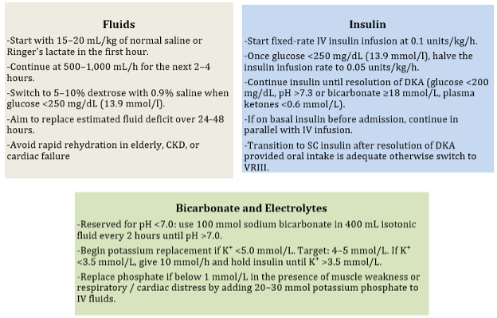

Figure 1. Treatment of patients with DKA. Figure from Endotext chapter entitled “Hyperglycemic Crises”.

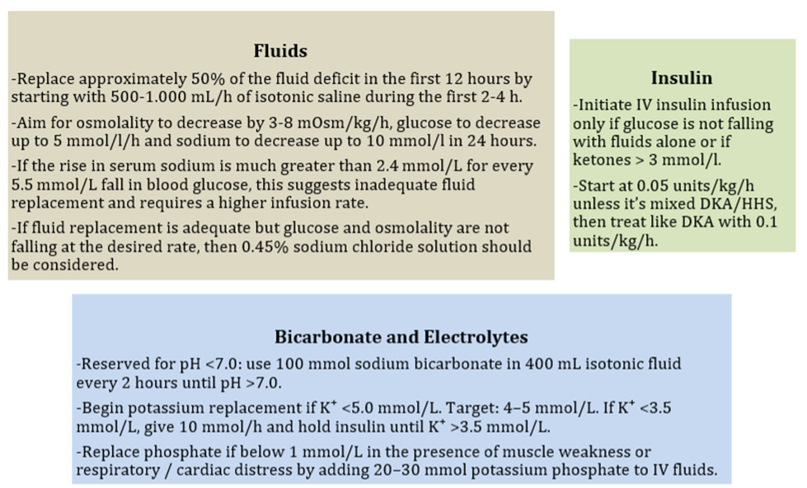
Figure 2. Treatment of patients with HSS. Figure from Endotext chapter entitled “Hyperglycemic Crises”.

It is important to closely monitor the patient’s response to therapy and plasma glucose, electrolytes, BUN, creatinine, osmolality, and plasma β-hydroxybutyrate levels and adjust therapy accordingly. The management of DKA/HSS is special situations such as pregnancy and chronic kidney disease are discussed in the Endotext chapter entitled “Hyperglycemic Crises”.

Evaluation for and treatment of potential precipitating factors is important, and mortality is frequently secondary to the precipitating factors. For this reason, appropriate evaluation and treatment are crucial.

FOLLOWUP

Preventing further episodes of DKA/HSS is essential as a substantial proportion of patients have recurrent events. Recurrent episodes of DKA occur more frequently in females, young age groups, ethnic minorities, low socioeconomic groups, individuals with substance abuse, and individuals with suboptimal glycemic control with the most frequent trigger insulin omission.

It is important to recognize the possibility of ketosis prone diabetes as these individuals often do not require long term insulin therapy. This disorder most frequently occurs in African, Asian, Indian, and Hispanic populations. It is estimated that it accounts for 25% to 50% of African Americans and Hispanics with a new diagnosis of DKA. These patients are negative for GAD and anti-islet cell antibodies, and the lack of beta cell insulin secretion returns towards normal with normoglycemia.

REFERENCES

- Dhatariya K, Mustafa O, Stathi D. Hyperglycemic Crises. 2025 Jun 10. In: Feingold KR, Ahmed SF, Anawalt B, Blackman MR, Boyce A, Chrousos G, Corpas E, de Herder WW, Dhatariya K, Dungan K, Hofland J, Kalra S, Kaltsas G, Kapoor N, Koch C, Kopp P, Korbonits M, Kovacs CS, Kuohung W, Laferrère B, Levy M, McGee EA, McLachlan R, Muzumdar R, Purnell J, Rey R, Sahay R, Shah AS, Singer F, Sperling MA, Stratakis CA, Trence DL, Wilson DP, editors. Endotext [Internet]. South Dartmouth (MA): MDText.com, Inc.; 2000–. PMID: 25905280
- Umpierrez GE, Davis GM, ElSayed NA, Fadini GP, Galindo RJ, Hirsch IB, Klonoff DC, McCoy RG, Misra S, Gabbay RA, Bannuru RR, Dhatariya KK. Hyperglycemic Crises in Adults With Diabetes: A Consensus Report. Diabetes Care. 2024 Aug 1;47(8):1257-1275. doi: 10.2337/dci24-0032. PMID: 39052901

