DIABETIC KETOACIDOSIS

Adair R. Gosmanov, M.D., Ph.D., F.A.C.E., Associate Professor of Medicine, Division of Endocrinology, Department of Medicine, Albany Medical College, Albany, NY and Endocrinology Section, Stratton VAMC, Albany, NY. agosmanov@gmail.com

Abbas E. Kitabchi, M.D., Ph.D., M.A.C.E., Professor of Medicine and Molecular Sciences Emeritus, Division of Endocrinology, Diabetes, and Metabolism, Department of Medicine, University of Tennessee Health Science Center, Memphis, TN

Updated May 16, 2022

CLINICAL RECOGNITION

Omission of insulin and infection are the two most common precipitants of diabetic ketoacidosis (DKA). Noncompliance may account for up to 44% of DKA presentations; while infection is less frequently observed.

Acute medical illnesses involving the cardiovascular system (myocardial infarction, stroke, acute thrombosis), gastrointestinal tract (bleeding, pancreatitis), endocrine axis (acromegaly, Cushing`s syndrome, hyperthyroidism) and recent surgical procedures can contribute to the development of DKA by causing dehydration, increase in insulin counterregulatory hormones, and worsening of peripheral insulin resistance.

Medications such as diuretics, beta-blockers, corticosteroids, second-generation anti-psychotics, anti-convulsants, sodium-glucose cotransporter-2 (SGLT-2) inhibitors, and/or immune checkpoint inhibitors may affect carbohydrate metabolism and volume status and, therefore, could precipitate DKA. SGLT-2 inhibitors have been associated with euglycemic DKA (glucose level < 250mg/dL)

Other factors leading to DKA include psychological problems, eating disorders, insulin pump malfunction, and drug abuse. It is well recognized that new onset T2DM can sometimes manifest with DKA. These patients are obese, mostly African Americans or Hispanics and have undiagnosed hyperglycemia, impaired insulin secretion, and impaired insulin action. A recent report suggests that cocaine abuse is an independent risk factor associated with DKA recurrence.

PATHOPHYSIOLOGY

Insulin deficiency, increased insulin counter-regulatory hormones (cortisol, glucagon, growth hormone, and catecholamines), and peripheral insulin resistance lead to hyperglycemia, dehydration, ketosis, and electrolyte imbalance which underlie the pathophysiology of DKA.

Hyperglycemia of DKA evolves through accelerated gluconeogenesis, glycogenolysis, and decreased glucose utilization – all due to absolute insulin deficiency. Of note, diabetes patients who developed DKA while treated with SGLT-2 inhibitors can present without hyperglycemia, i.e., with euglycemic DKA.

Due to increased lipolysis and decreased lipogenesis, abundant free fatty acids are converted to ketone bodies: β-hydroxybutyrate (β-OHB), acetoacetate, and acetone. Hyperglycemia-induced osmotic diuresis, if not accompanied by sufficient oral fluid intake, leads to dehydration, hyperosmolarity, electrolyte loss, and subsequent decrease in glomerular filtration. With decline in renal function, glycosuria diminishes and hyperglycemia/hyperosmolality worsens. With impaired insulin action and hyperosmolality, utilization of potassium by skeletal muscle is markedly diminished leading to intracellular potassium depletion. Also, potassium is lost via osmotic diuresis causing profound total body potassium deficiency. Therefore, DKA patients can present with broad range of serum potassium concentrations. Nevertheless, a “normal” plasma potassium concentration may indicate that potassium stores in the body are severely diminished and the institution of insulin therapy and correction of hyperglycemia will lead to hypokalemia.

DIAGNOSIS AND DIFFERENTIAL DIAGNOSIS

Diagnostic criteria for DKA are presented in Table 1.

Table 1. Criteria and Classification of DKA
DKA | Mild | Moderate | Severe
Plasma glucose (mg/dl) | >250 mg/dl | >250mg/dl | >250mg/dl
Arterial pH | 7.25-7.30 | 7.00-7.24 | <7.00
Serum bicarbonate (mEq/L) | 15-18 | 10- 15 | <10
Urine ketone* | + | + | +
Serum ketone* | + | + | +
Effective Serum Osmolality** | Variable | Variable | Variable
Anion Gap*** | >10 | >12 | >12
Mental Status | Alert | Alert/drowsy | Stupor/coma
*Nitroprusside reaction method
** Serum osmolality: 2[measured Na+ (mEq/L)] + glucose (mg/dl)/18 = mOsm/kg
*** Anion Gap: [ (Na+)– (Cl- + HCO3- (mEq/L)]

CLINICAL PRESENTATION

Polyuria, polydipsia, weight loss, vomiting, and abdominal pain usually are present in patients with DKA. Abdominal pain can be closely associated with acidosis and resolves with treatment. Physical examination findings such as hypotension, tachycardia, poor skin turgor, and weakness support the clinical diagnosis of dehydration in DKA. Mental status changes may occur in DKA and are likely related to degree of acidosis and/or hyperosmolarity. A search for symptoms of precipitating causes such as infection, vascular events, or existing drug abuse should be initiated in the emergency room. Patients with hyperglycemic crises can be hypothermic because of peripheral vasodilation and decreased utilization of metabolic substrates.

DIFFERENTIAL DIAGNOSIS

Hyperglycemic hyperosmolar state is not associated with ketosis. Starvation and alcoholic ketoacidosis are not characterized by hyperglycemia >200 mg/dl and bicarbonate level <18 meq/L. With hypotension, decreased renal function, and history of metformin use, lactic acidosis (lactic acid level >7 mmol/L) should be suspected. Ingestion of methanol, isopropyl alcohol, and paraldehyde can also alter anion gap and/or osmolality and need to be investigated.

Table 2. Laboratory Evaluation of Causes of Acidosis
Factor Studied | DKA | HHS | Starvation | Uremic acidosis
pH | ↓ | normal | normal | Mild↓
Plasma glucose | ↑ | >500 mg/dl | normal | normal
Glycosuria | + + | + + | 0 | 0
Total plasma ketones* | ↑↑ | 0 or ↑ | Mild↑ | 0
Anion gap | ↑ | Normal | Mild↑ | Mild↑
Osmolality | ↑ | >330 mOsm/kg | normal | Normal/↑
Other |  |  |  | BUN>200 mg/dl

HHS- hyperglycemic hyperosmolar state

BUN –blood urea nitrogen

*Acetest and Ketostix (Bayer; Leverkusen, Germany) measure acetoacetic acid only; thus, misleadingly low values may be obtained because the majority of “ketone bodies” are β-hydroxybutyrate.

DIAGNOSTIC TESTS NEEDED

Initial Necessary Tests

Basic metabolic panel, osmolality, ketones, β-hydroxybutyrate (β-OH), complete blood count with differential, urinalysis and urine ketones by dipstick, and arterial blood gases.

Additional Tests

Electrocardiogram, chest X-ray, and various tissue cultures, if indicated, and HbA1c.

Caveats to Diagnostic Tests

Anion gap acidosis is calculated by subtracting the sum of Cl and HCO3 from measured (not corrected) Na concentration and should be corrected for hypoalbuminemia. Usually, a HCO3 level of 18-20 meq/L rules out metabolic acidosis. Arterial blood gases with pH<7.30 support the diagnosis. β-OHB is early and abundant ketoacid and indicative of ketosis. Acetoacetate but not acetone, is a product of ketone body formation and is measured by a nitroprusside reaction that is widely used but may be negative in the blood in early DKA. Effective serum osmolality can be measured directly or derived from following formula: 2 x [measured Na+(meq/L)] + glucose/18. High measured Na indicates a significant degree of dehydration. A white blood cell count >25,000 should warrant a comprehensive search for infection. Serum creatinine can be falsely elevated because of acetoacetate interference with the colorimetric creatinine assay. When patients with DKA present with mixed acid-base disorder, measurement of serum β-OHB will be required to confirm that acidosis is due to ketoacidosis.

THERAPY

The therapeutic goals of management include optimization of:
- volume status,
- hyperglycemia and ketosis/acidosis,
- electrolyte abnormalities,
- potential precipitating factors.

Steps to follow in early stages of DKA management (Figures 1, 2, 3):
- Start IV fluids after blood sample for biochemistry was sent to laboratory (Fig. 1);
- Potassium level should be >3.3 meq/L before initiation of insulin therapy (supplement potassium intravenously if needed) (Fig. 3);
- Initiate insulin therapy only when steps 1-2 are executed (Fig. 2).

Resolution of DKA:
- Plasma glucose <200-250 mg/dl,
- Serum bicarbonate concentration >18 meq/L,
- Venous blood pH >7.3, and
- Anion gap <10

Fluid therapy: Replace fluid deficit in DKA (~6 L) within 24-36 hours with the goal of 50% volume replacement within first 12 hours.

Insulin Therapy: Transition to subcutaneous insulin by giving long-acting insulin 2 hours before the discontinuation of IV insulin.

Bicarbonate therapy: If pH is < 7.0 or bicarbonate level is < 5 meq/L, administer 100 mmol (2 ampules) of bicarbonate in 200 ml of water with 20 meq of potassium chloride over two hours.

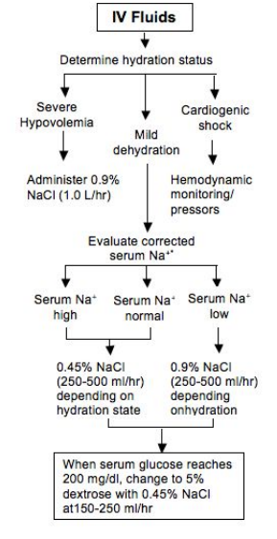
Figure 1. Fluid management in adult patients with DKA

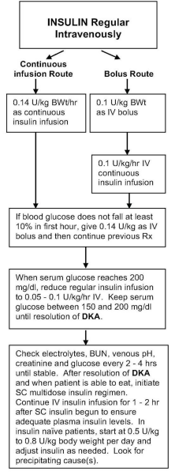
Figure 2. Insulin management in adult patients with DKA
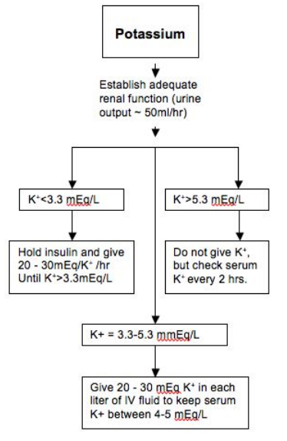
Figure 3. Potassium management in adult patients with DKA

FOLLOW UP: COMPLICATIONS AND DISCHARGE

Hypoglycemia and hypokalemia are the most frequent complications and can be prevented by timely adjustment of insulin dose and frequent monitoring of potassium levels.

Non-anion gap hyperchloremic acidosis occurs due to urinary loss of ketoanions which are needed for bicarbonate regeneration and preferential re-absorption of chloride in proximal renal tubule secondary to intensive administration of chloride-containing fluids and low plasma bicarbonate. The acidosis usually resolves and should not affect treatment course.

Cerebral edema is reported in young adult patients. This condition is manifested by appearance of headache, lethargy, papillary changes, or seizures. Mortality is up to 70%. Mannitol infusion and mechanical ventilation should be used to treat this condition.

Rhabdomyolysis is another possible complication due to hyperosmolality and hypoperfusion.

Pulmonary edema can develop from excessive fluid replacement in patients with CKD or CHF.

Discharge planning should include diabetes education, selection of appropriate insulin regimen that is understood and afforded by the patient, and preparation of set of supplies for the initial insulin administration at home.

- REFERENCES

- Kitabchi AE, Umpierrez GE, Fisher JN, Murphy MB, and Stentz FB. Thirty years of personal experience in hyperglycemic crises: diabetic ketoacidosis and hyperglycemic hyperosmolar state. The Journal of clinical endocrinology and metabolism 93: 1541-1552, 2008.http://www.ncbi.nlm.nih.gov/pubmed/18270259

- Kitabchi AE, Umpierrez GE, Miles JM, and Fisher JN. Hyperglycemic crises in adult patients with diabetes. Diabetes care 32: 1335-1343, 2009.

- Karslioglu French E, Donihi AC, Korytkowski MT. Diabetic ketoacidosis and hyperosmolar hyperglycemic syndrome: review of acute decompensated diabetes in adult patients.
- BMJ. 2019 May 29;365:l1114.

- Gosmanov AR, Gosmanova EO, Kitabchi AE. Hyperglycemic Crises: Diabetic Ketoacidosis and Hyperglycemic Hyperosmolar State. 2021 May 9. In: Feingold KR, Anawalt B, Boyce A, Chrousos G, de Herder WW, Dhatariya K, Dungan K, Hershman JM, Hofland J, Kalra S, Kaltsas G, Koch C, Kopp P, Korbonits M, Kovacs CS, Kuohung W, Laferrère B, Levy M, McGee EA, McLachlan R, Morley JE, New M, Purnell J, Sahay R, Singer F, Sperling MA, Stratakis CA, Trence DL, Wilson DP, editors. Endotext [Internet]. South Dartmouth (MA): MDText.com, Inc.; 2000–. PMID: 25905280

