**[WWW.ENDOTEXT.ORG](http://www.ENDOTEXT.ORG" \t "_blank)**

# CHAPTER 29 – DIABETIC RETINOPATHY

**Jay M. Stewart, M.D.**, jay.[stewart@ucsf.edu](mailto:stewartj@vision.ucsf.edu), Professor, Department of Ophthalmology, University of California San Francisco, San Francisco, CA 94143

**Marco Coassin, M.D., Ph.D**., marco.coassin@asmn.re.it, Department of Ophthalmology, Arcispedale Santa Maria Nuova - IRCCS, Reggio Emilia, Italy

**Daniel M. Schwartz, M.D.**, [Dan.Schwartz@ucsf.edu](mailto:Dan.Schwartz@ucsf.edu), Professor, Department of Ophthalmology, University of California San Francisco, San Francisco, CA

**Revised 4/1/2017**

## ABSTRACT

# Diabetic retinopathy is a significant life-altering complication affecting patients with diabetes. Understanding its pathogenesis, prevention, and treatment is critical to delivering effective and comprehensive care for patients with diabetes at all stages. This review discusses the risk factors, epidemiology, pathogenesis, clinical features, and treatment options for diabetic retinopathy, with an emphasis on practical information useful for endocrinologists and other non-ophthalmologists.

## INTRODUCTION

Diabetes is a leading cause of blindness in the U.S.[[1](http://www.endotext.org/diabetes_new/diabetes29/diabetesbiblio29.htm" \l "footnote-1" \o "Chew EY, Ferris III FL. â��Nonproliferative diabetic retinopathy,â�� in Ryan SJ, ed., Retina.  St. Louis:  Mosby, 2001.  pp. 1295-1308." \t "rbottom)] The same pathologic mechanisms that damage the kidneys and other organs affect the microcirculation of the eye. Often, by the time patients seek ophthalmologic examination and treatment, there are significant alterations of the retinal microvasculature.  Therefore a fundamental understanding of diabetic eye disease is important for non-ophthalmologists so that appropriate referral to eye-care specialists can be a part of their diabetes management.

## EPIDEMIOLOGY

The National Society to Prevent Blindness has estimated that 7.7 million persons with diabetes in the U.S. have diabetic retinopathy.[2]  In the Wisconsin Epidemiologic Study of Diabetic Retinopathy (WESDR), a population-based study, the prevalence of diabetic retinopathy was evaluated in patients diagnosed with diabetes before and after age 30.  In the younger group, in which all the patients received insulin therapy, retinopathy was present in 13% of patients whose diabetes had been present for less than 5 years, whereas over 90% of patients with diabetes for 10 to 15 years had retinopathy.  In the older group, 40% of patients using insulin and 24% of those not receiving insulin had retinopathy after less than 5 years of diabetes.  In older patients with diabetes for 15 or more years, 84% of patients on insulin and 53% of those not using insulin had retinopathy.[3]

The WESDR also showed that the rate of vision loss increased with the severity of retinopathy and with the duration of diabetes.[[3](http://www.endotext.org/diabetes_new/diabetes29/diabetesbiblio29.htm" \l "footnote-3" \o "Klein R and Klein BEK.  â��Epidemiology of eye disease in diabetes,â�� in Flynn HW and Smiddy WE, eds.,  Diabetes and Ocular Disease:  Past, Present, and Future Therapies.  American Academy of Ophthalmology, 2000.  pp.19-61." \t "rbottom)]  In patients diagnosed before age 30, 3% of those with diabetes for 15 to 19 years were blind, as were 12% of those with diabetes for 30 years or more.  In patients with diabetes aged 65 to 74 years old, 14% of males and 20% of females were legally blind.  Over a 10-year period, 9% of the younger-onset patients had doubling of the visual angle (e.g. a drop from 20/40 to 20/80 on Snellen acuity testing), compared with 32% of older patients on insulin and 21% of older patients not on insulin.[[4](http://www.endotext.org/diabetes_new/diabetes29/diabetesbiblio29.htm" \l "footnote-4" \o "Moss SE, Klein R, Klein BEK.  Ten-year incidence of visual loss in a diabetic population.  Ophthalmology 1994;101:1061-1070." \t "rbottom)]  Another study found that diabetes increased the rate of legal blindness by a factor of 50 to 80.[[5](http://www.endotext.org/diabetes_new/diabetes29/diabetesbiblio29.htm" \l "footnote-5" \o "Kostraba NJ, Klein R, Dorman JS, et al.  The epidemiology of diabetes complications study, IV:  correlates of diabetic background and proliferative retinopathy.  Am J Epidemiol 1991;133:381-391." \t "rbottom)] A recent study estimated that the prevalence of diabetic retinopathy was 28.5% among US adults with diabetes aged 40 years and older.[6]

In caring for patients with diabetes, therefore, health care providers must bear in mind the substantial risks of developing visual loss that these patients face.  For affected patients, diabetes-related visual loss decreases the quality of life and interferes with the performance of daily activities. On a larger scale, in 1992 it was estimated to cost the U.S. $500 million per year.[[7](http://www.endotext.org/diabetes_new/diabetes29/diabetesbiblio29.htm" \l "footnote-6" \o "Chiang YP, Bassi LJ, Javitt JC.  Federal budgetary costs of blindness.  Milbank Q 1992;70:319-340." \t "rbottom)] In 2007, the cost of diabetic retinopathy to the U.S. economy could be conservatively calculated as $5 billion (one tenth of the total financial burden of adult vision problems).[8] An understanding of the factors predisposing to the development and worsening of retinopathy can help practitioners delay or prevent its onset.

## RISK FACTORS

The principal factor related to the development or worsening of diabetic retinopathy is glucose control. The Diabetes Control and Complications Trial (DCCT), a randomized, controlled study of 1441 patients with type 1 diabetes found that an intensive glucose control regimen reduced the risk of developing retinopathy by 76%.[[9](http://www.endotext.org/diabetes_new/diabetes29/diabetesbiblio29.htm" \l "footnote-7" \o "Ferris III FL, Davis MD, Aiello LM, Chew EY.  â��Clinical studies on treatment for diabetic retinopathy,â�� in Flynn HW and Smiddy WE, eds., Diabetes and Ocular Disease:  Past, Present and Future Therapies.  American Academy of Ophthalmology, 2000.  pp. 81-99." \t "rbottom)] In patients with pre-existing retinopathy, intensive control slowed progression of the condition by 54%. An analysis of HbA1C levels revealed that a 10% decrease in HbA1C resulted in a 35% to 40% reduction in the risk of worsening of retinopathy.[[1](http://www.endotext.org/diabetes_new/diabetes29/diabetesbiblio29.htm" \l "footnote-8" \o "Chew EY, Ferris III FL. â��Nonproliferative diabetic retinopathy,â�� in Ryan SJ, ed., Retina.  St. Louis:  Mosby, 2001.  pp. 1295-1308." \t "rbottom)]

Patients with type 2 diabetes were evaluated in the United Kingdom Prospective Diabetes Study (UKPDS). The study found a 25% reduction in the risk of microvascular endpoints, including the need for diabetic retinal laser treatment, with intensive glucose control.[[1](http://www.endotext.org/diabetes_new/diabetes29/diabetesbiblio29.htm" \l "footnote-9" \o " Chew EY, Ferris III FL. â��Nonproliferative diabetic retinopathy,â�� in Ryan SJ, ed., Retina.  St. Louis:  Mosby, 2001.  pp. 1295-1308." \t "rbottom)]  Like the DCCT, the UKPDS also showed that decreasing the HbA1C lowered the risk of microvascular complications substantially.  Of note, during 10 years of follow-up in the UKPDS and 9 years in the DCCT, retinopathy could not be completely prevented, even in the intensive therapy groups.

Despite the well-established benefits of tight glucose control for achieving favorable outcomes with diabetic retinopathy, patients must be advised that an initial worsening of retinopathy can occur when a more intensive glycemic control regimen is implemented.  The DCCT and other smaller trials have found that in both type 1 and 2 diabetes, these changes can occur over the first 3 to 12 months after the glucose levels are controlled.  For many patients, the changes are not clinically significant, but for patients with mild to moderate levels of retinopathy at baseline, the worsening of the retinopathy potentially can result in a decline in visual acuity, requiring intervention.  In the DCCT, 19% of patients with moderate nonproliferative retinopathy experienced this early worsening effect.  The reasons for this phenomenon are not understood.  Observers agree that although these risks are outweighed by the long-term benefits in preventing severe vision loss from retinopathy, patients with retinopathy at baseline should be observed closely in the initial period following implementation of tighter glucose control.[[10](http://www.endotext.org/diabetes_new/diabetes29/diabetesbiblio29.htm" \l "footnote-10" \o "Davis MD, Blodi BA.  â��Proliferative diabetic retinopathy,â�� in Ryan SJ, ed., Retina.  St. Louis:  Mosby, 2001.  pp. 1309-1349." \t "rbottom)]

Other risk factors for progression of diabetic retinopathy include hypertension, hypercholesterolemia, and pregnancy.  Both the WESDR and the UKPDS have established relationships between hypertension and worsening of diabetic retinopathy.[[11](http://www.endotext.org/diabetes_new/diabetes29/diabetesbiblio29.htm" \l "footnote-11" \o "Klein R and Klein BEK.  â��Epidemiology of eye disease in diabetes,â�� in Flynn HW and Smiddy WE, eds.,  Diabetes and Ocular Disease:  Past, Present, and Future Therapies.  American Academy of Ophthalmology, 2000.  pp.19-61" \t "rbottom)]  Strict blood pressure control with either atenolol or captopril was found to reduce the need for laser treatment by 35% compared to less rigorous control.  Elevated cholesterol and triglycerides are also associated with retinopathy progression.  Finally, pregnancy is a significant risk factor for worsening; women with type 1 diabetes are twice as likely to progress to proliferative disease if they are pregnant.  Smoking, although a known risk factor for cardiovascular disease, did not correlate with increased likelihood of retinopathy progression in the UKPDS and WESDR.

## SCREENING

The American Academy of Ophthalmology has recommended screening for diabetic retinopathy 5 years after diagnosis in patients with type 1 diabetes, and at the time of diagnosis in patients with type 2 diabetes.  Patients without retinopathy should undergo dilated fundus examination annually.  If mild nonproliferative diabetic retinopathy (NPDR) is present, exams should be repeated every 9 months.  Patients with moderate NPDR should be examined every 6 months.  In severe NPDR, exams should be conducted every 3 months.  Patients with a new diagnosis of proliferative diabetic retinopathy should be examined every 2 to 3 months, until they are deemed stable, at which point examinations can be performed less frequently.  During pregnancy, patients should be examined every 3 months, since retinopathy can progress rapidly in this setting.[[12](http://www.endotext.org/diabetes_new/diabetes29/diabetesbiblio29.htm" \l "footnote-12" \o "Preferred Practice Patterns Committee, Retina Panel.  Diabetic Retinopathy.  American Academy of Ophthalmology, 1998." \t "rbottom)]

## PATHOGENESIS

Various mechanisms account for the features of diabetic retinopathy.  Histopathologic analysis shows thickening of capillary basement membranes, microaneurysm formation, loss of pericytes, capillary acellularity, and neovascularization.[[13](http://www.endotext.org/diabetes_new/diabetes29/diabetesbiblio29.htm" \l "footnote-13" \o "Frank RN, â��Etiologic mechanisms in diabetic retinopathy,â�� in Ryan SJ, ed., Retina.  St. Louis:  Mosby, 2001.  pp. 1259-1294." \t "rbottom)]  Microaneurysms, outpouchings of the capillary wall, serve as sites of fluid and lipid leakage, which can lead to the development of diabetic macular edema.  Theories on the biochemistry of these end-organ changes include toxic effects from sorbitol accumulation, vascular damage by excessive glycosylation with crosslinking of basement membrane proteins, and activation of protein kinase C-ß2 by vascular endothelial growth factor (VEGF), leading to increased vascular permeability and endothelial cell proliferation.  VEGF, produced by the retina in response to hypoxia, is believed to play a central role in the development of neovascularization.[[14](http://www.endotext.org/diabetes_new/diabetes29/diabetesbiblio29.htm" \l "footnote-14" \o "Gardner TW, Aiello LP.  â��Pathogenesis of diabetic retinopathy,â�� in Flynn HW and Smiddy WE, eds., Diabetes and Ocular Disease:  Past, Present and Future Therapies.  American Academy of Ophthalmology, 2000.  pp. 1-17." \t "rbottom)]

## CLINICAL FEATURES

### Nonproliferative Diabetic Retinopathy (NPDR)

Studies have found that retinopathy in both insulin-dependent and non-insulin-dependent diabetes occurs 3 to 5 years or more after the onset of diabetes.  In the WESDR, the prevalence of at least minimal retinopathy was almost 100% after 20 years.[[15](http://www.endotext.org/diabetes_new/diabetes29/diabetesbiblio29.htm" \l "footnote-15" \o " Frank RN, â��Etiologic mechanisms in diabetic retinopathy,â�� in Ryan SJ, ed., Retina.  St. Louis:  Mosby, 2001.  pp. 1259-1294." \t "rbottom)]  A more recent study has confirmed that at least 39% of young persons with diabetes developed retinopathy within the first 10 years.[[16](http://www.endotext.org/diabetes_new/diabetes29/diabetesbiblio29.htm" \l "footnote-16" \o "Henricsson M, Nystrom L, Blohme G, et al.  The incidence of retinopathy 10 years after diagnosis in young adult people with diabetes:  results from the nationwide population-based Diabetes Incidence Study in Sweden (DISS).  Diabetes Care 2003;26(2):349-354." \t "rbottom)] The earliest clinical sign of diabetic retinopathy is the microaneurysm, a red dot seen on ophthalmoscopy that varies from 15 to 60 microns in diameter (Figure 1).

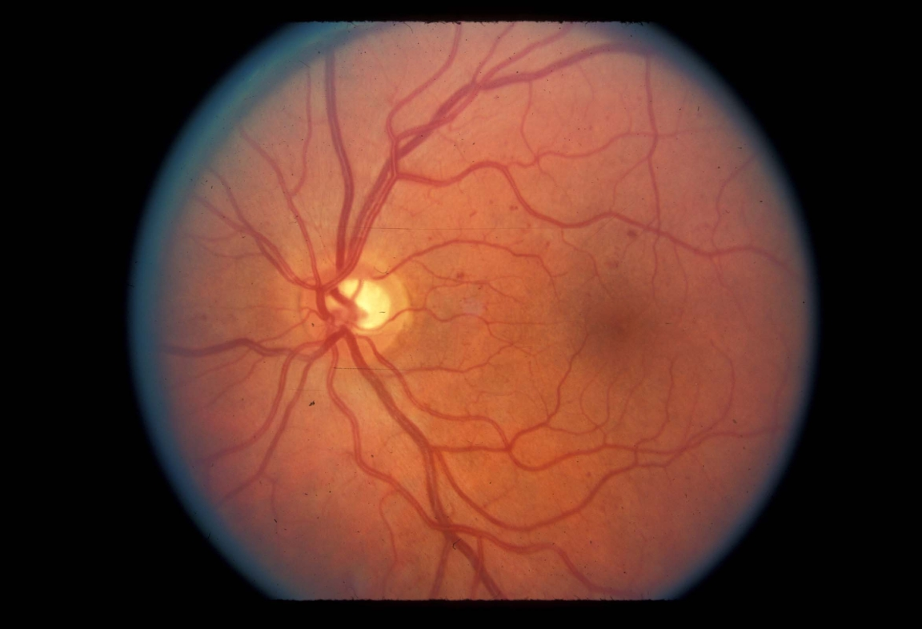

|  |
| --- |
| **Figure 1.** Microaneurysms and intraretinal hemorrhages in nonproliferative retinopathy.  (UCSF Department of Ophthalmology) |

The lesions can be difficult to distinguish from intraretinal hemorrhages on examination, but with fluorescein angiography microaneurysms can be identified easily as punctate spots of hyperfluorescence (Figure 2, 3).  By contrast, hemorrhages block the background fluorescence and therefore appear dark.

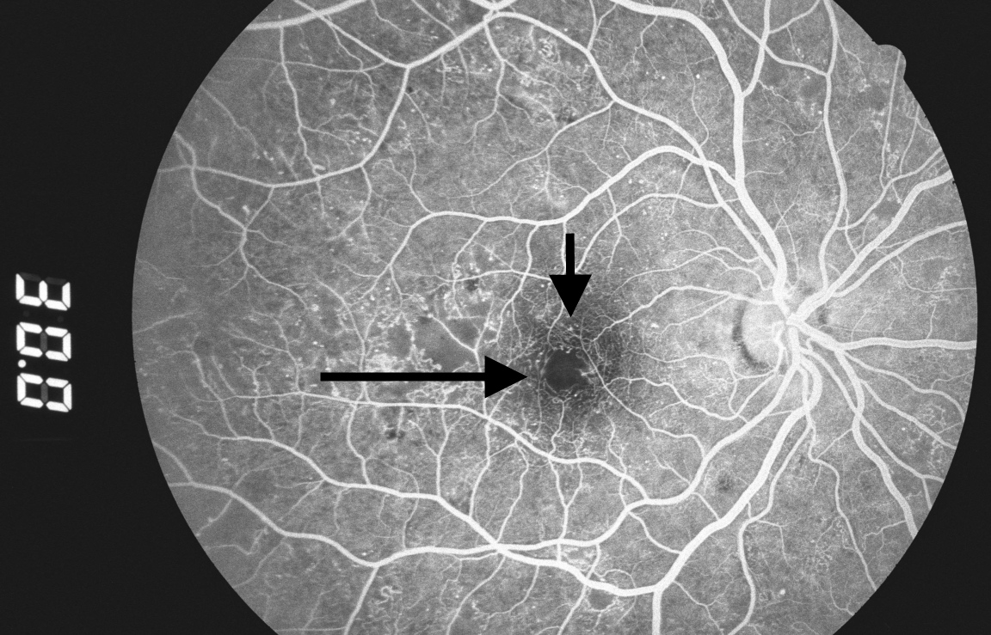

|  |
| --- |
| **Figure 2.** Microaneurysms:  hyperfluorescent dots in early phase of fluorescein angiogram (arrows).  (San Francisco General Hospital, Dept. of Ophthalmology) |

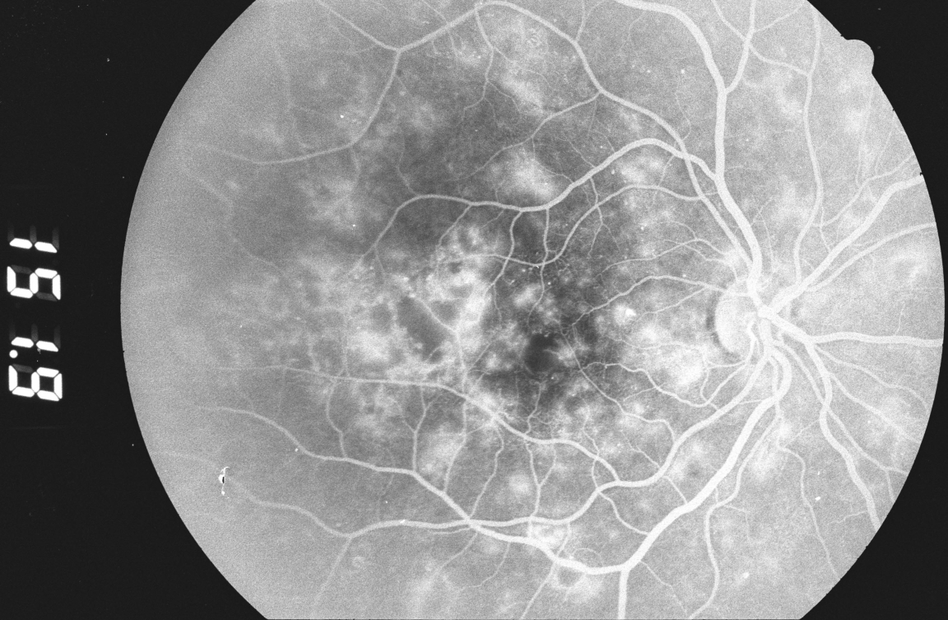

|  |
| --- |
| **Figure 3.** Two minutes later, fluorescein leakage from the microaneurysms gives them a hazy appearance.  (San Francisco General Hospital, Dept. of Ophthalmology) |

The severity of NPDR can be graded as mild, moderate, severe, or very severe.  In mild disease, microaneurysms are present with hemorrhage or hard exudates (lipid transudates).  In moderate NPDR, these findings are associated with cotton-wool spots (focal infarcts of the retinal nerve fiber layer or areas of axoplasmic stasis) or intraretinal microvascular abnormalities (vessels that may be either abnormally dilated and tortuous retinal vessels, or intraretinal neovascularization).  The “4-2-1 rule” is used to diagnose severe NPDR:  criteria are met if hemorrhages and microaneurysms are present in 4 quadrants, or venous beading (Figure 4) is present in 2 quadrants, or moderate intraretinal microvascular abnormalities are present in 1 quadrant.  In very severe NPDR, two of these features are present.

The correct evaluation and staging of NPDR is important as a means of assessing the risk of progression.  In the ETDRS, eyes with very severe NPDR had a 60-fold increased risk of developing high-risk proliferative retinopathy after 1 year compared with eyes with mild NPDR.[[17](http://www.endotext.org/diabetes_new/diabetes29/diabetesbiblio29.htm" \l "footnote-17" \o "Chew EY, Ferris III FL. â��Nonproliferative diabetic retinopathy,â�� in Ryan SJ, ed., Retina.  St. Louis:  Mosby, 2001.  pp. 1295-1308." \t "rbottom)]  For eyes with mild or moderate NPDR, early treatment with laser was not warranted, as the benefits in preventing vision loss did not outweigh the side effects.  By contrast, in very severe NPDR, early laser treatment was often helpful.

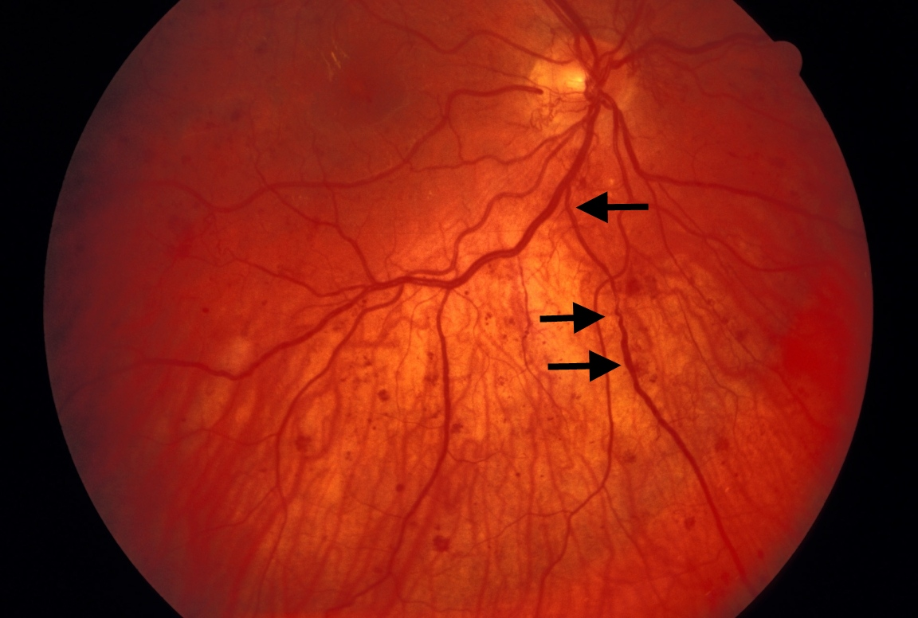

|  |
| --- |
| **Figure 4.** Venous beading (arrows) in a case of proliferative diabetic retinopathy.  (UCSF Department of Ophthalmology) |

Capillary closure can also result in macular ischemia, another cause of vision loss in NPDR.  This can be identified clinically as an enlargement of the normal foveal avascular zone on fluorescein angiography (Figure 5).

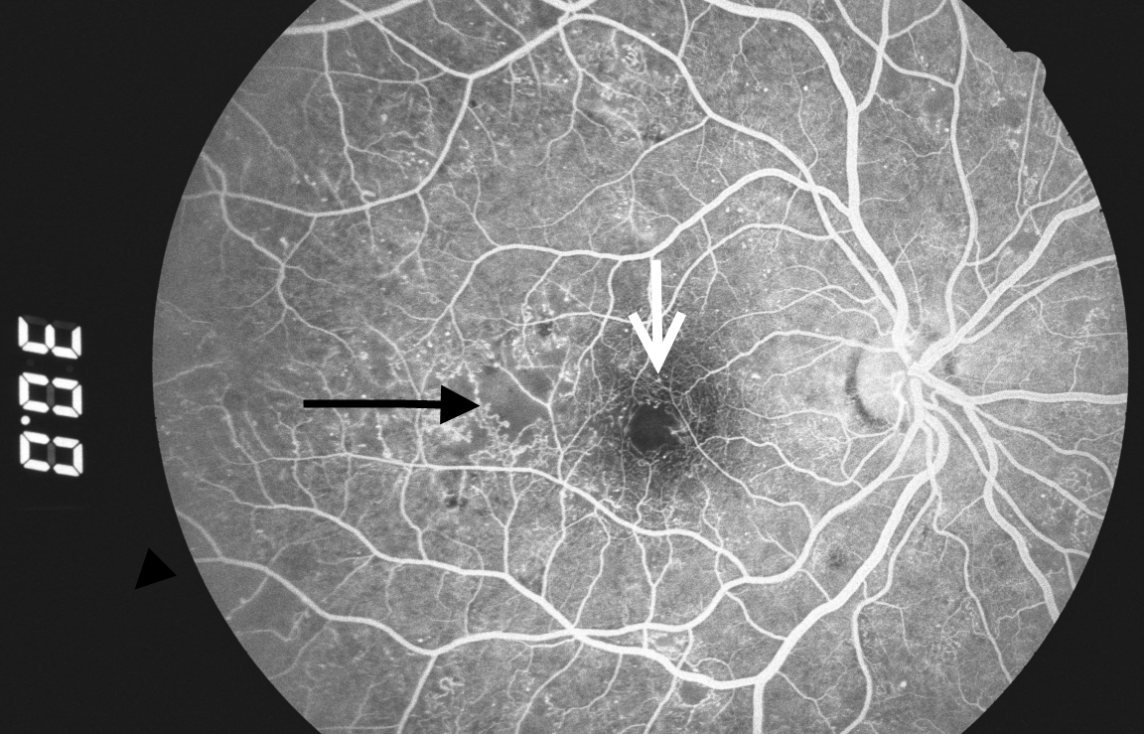

|  |
| --- |
| **Figure 5.** Capillary dropout around the fovea (white arrow) and in the temporal macula (black arrow).  (San Francisco General Hospital, Dept. of Ophthalmology) |

### Diabetic macular edema

Macular edema may be present at all the stages of diabetic retinopathy and is the most common cause of vision loss in nonproliferative diabetic retinopathy. Because of the increased vascular permeability and breakdown of the blood-retinal barrier, fluid and lipids leak into the retina and cause it to swell. This causes photoreceptor dysfunction, leading to vision loss when the center of the macula, the fovea, is affected. In the ETDRS, diabetic macular edema (DME) was characterized as "clinically significant" if any of the following were noted (Figure 6): retinal thickening within 500 microns of the fovea, hard exudates within 500 microns of the fovea if associated with adjacent retinal thickening, or an area of retinal thickening 1 disc diameter or larger if any part of it is located within 1 disc diameter of the fovea. [[18](http://www.endotext.org/diabetes_new/diabetes29/diabetesbiblio29.htm" \l "footnote-18" \o "Chew EY, Ferris III FL. â��Nonproliferative diabetic retinopathy,â�� in Ryan SJ, ed., Retina.  St. Louis:  Mosby, 2001.  pp. 1295-1308." \t "rbottom)]

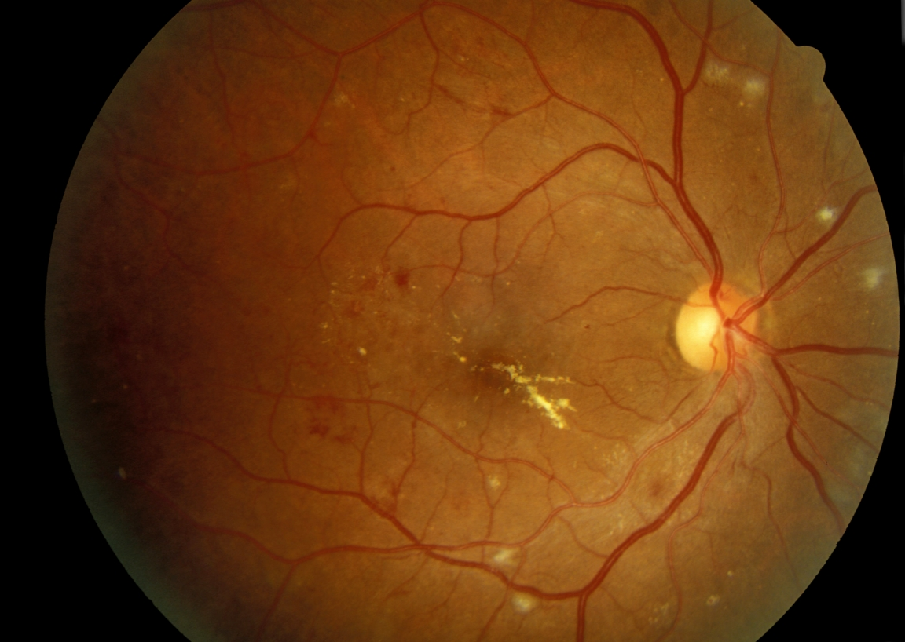

|  |
| --- |
| **Figure 6.** Clinically significant macular edema with hard exudates in the fovea.  Cotton-wool spots are present near the major retinal vessels.  (UCSF Dept. of Ophthalmology) |

Figure 6: Clinically significant macular edema with hard exudates in the fovea. Cotton-wool spots are present near the major vessels. (UCSF Department of Ophthalmology)

Although the cause of the microvascular changes in diabetes is not fully understood, the deficient oxygenation of the retina may induce an overexpression of vascular endothelial growth factor (VEGF), with a consequent increase in vascular leakage and retinal edema.[[19](http://www.endotext.org/diabetes_new/diabetes29/diabetesbiblio29.htm" \l "footnote-19" \o "Caldwell RB, Bartoli M, Behzadian MA, El-Remessy AE, Al-Shabrawey M, Platt DH, Liou GI, Caldwell RW. Vascular endothelial growth factor and diabetic retinopathy: role of oxidative stress. Curr Drug Targets 2005 Jun;6(4):511-24." \t "rbottom)] Besides ischemia, inflammation may also play a role in the development of macular edema in diabetic retinopathy. In fact, elevated levels of extracellular carbonic anhydrase have been discovered in the vitreous of patients with diabetic retinopathy.[[20](http://www.endotext.org/diabetes_new/diabetes29/diabetesbiblio29.htm" \l "footnote-20" \o "Gao BB, Clermont A, Rook S, Fonda SJ, Srinivasan VJ, Wojtkowski M, Fujimoto JG, Avery RL, Arrigg PG, Bursell SE, Aiello LP, Feener EP. Extracellular carbonic anhydrase mediates hemorrhagic retinal and cerebral vascular permeability through prekallikrein activation. Nat Med 2007;13(2):181-8." \t "rbottom)] Carbonic anhydrase may originate from retinal hemorrhages and erythrocyte lysis and may activate the kallikrein-mediated inflammatory cascade, contributing to the development of DME.

Optical Coherence Tomography (OCT) is a widely used imaging technique that provides high-resolution imaging of the retina (Figure 7) .[[21](http://www.endotext.org/diabetes_new/diabetes29/diabetesbiblio29.htm" \l "footnote-21" \o "Puliafito CA, Hee MR, Lin CP, Reichel E, Schuman JS, Duker JS, Izatt JA, Swanson EA, Fujimoto JG. Imaging of macular diseases with optical coherence tomography. Ophthalmology 1995;102(2):217-29." \t "rbottom)] Working as an “optical ultrasound,” OCT projects a light beam and then acquires the light reflected from the retina to provide a cross-sectional image. Most patients with DME have diffuse retinal thickening or cystoid macular edema (presence of intraretinal cystoid-like spaces). In some patients, DME may be associated with posterior hyaloidal traction, serous retinal detachment or traction retinal detachment. [[22](http://www.endotext.org/diabetes_new/diabetes29/diabetesbiblio29.htm" \l "footnote-22" \o "Kim BY, Smith SD, Kaiser PK. Optical coherence tomographic patterns of diabetic macular edema. Am J Ophthalmol 2006;142(3):405-12." \t "rbottom)] Cystoid macular edema and posterior hyaloid traction are significantly associated with worse visual acuity.[[23](http://www.endotext.org/diabetes_new/diabetes29/diabetesbiblio29.htm" \l "footnote-23" \o "Kim BY, Smith SD, Kaiser PK. Optical coherence tomographic patterns of diabetic macular edema. Am J Ophthalmol 2006;142(3):405-12." \t "rbottom)]

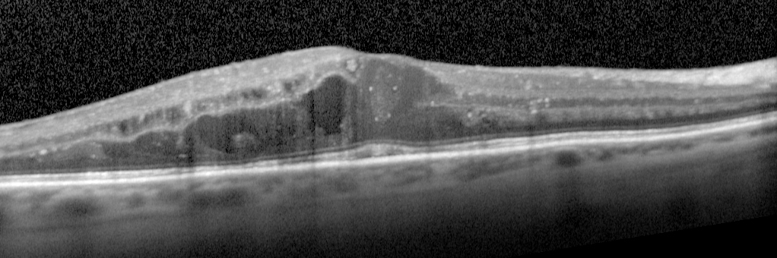

|  |
| --- |
| **Figure 7.** OCT image showing diabetic macular edema (UCSF Department of Ophthalmology). |

### Proliferative Diabetic Retinopathy (PDR)

In proliferative diabetic retinopathy, many of the changes seen in NPDR are present in addition to neovascularization that extends along the surface of the retina or into the vitreous cavity (Figure 8).  These vessels are in loops that may form a network of radiating spokes or may appear disorganized.  In many cases the vessels are first noted on the surface of the optic disc, although they can be easily missed due to their fine calibur.[[24](http://www.endotext.org/diabetes_new/diabetes29/diabetesbiblio29.htm" \l "footnote-24" \o " Folk JC and Oh KT.  â��Photocoagulation for diabetic macular edema and diabetic retinopathy,â�� in Flynn HW and Smiddy WE, eds., Diabetes and Ocular Disease:  Past, Present and Future Therapies.  American Academy of Ophthalmology, 2000.  pp. 115-153." \t "rbottom)]  Close inspection often reveals that these new vessels cross over both the normal arteries and the normal veins of the retina, a sign of their unregulated growth.

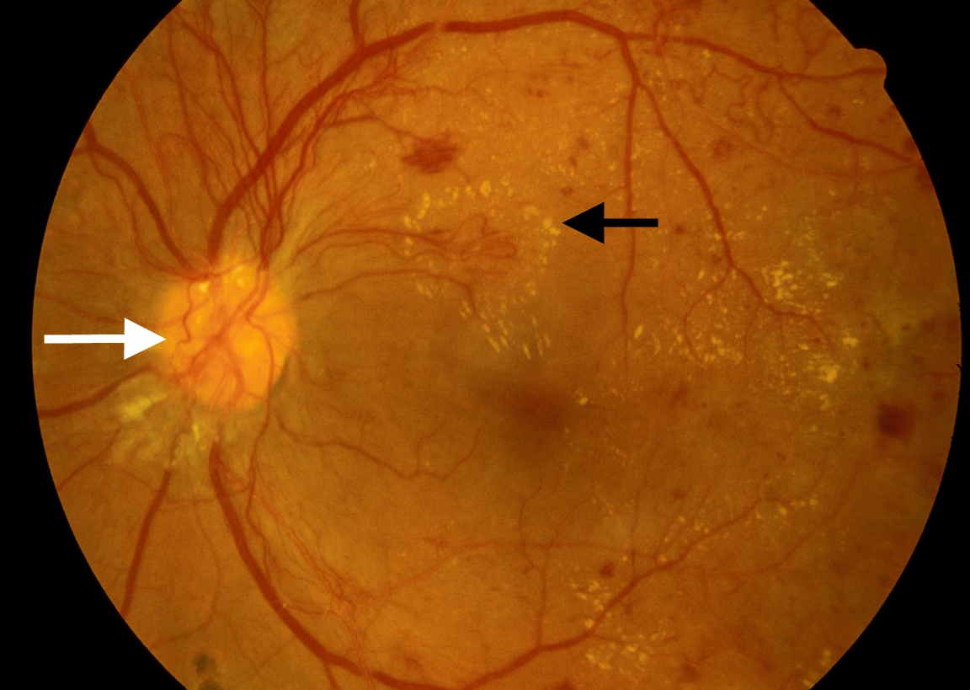

|  |
| --- |
| **Figure 8.** Active neovascularization in PDR.  Fibrovascular proliferation overlies the optic disc (white arrow).  Loops of new vessels are especially prominent superior to the disc and extending into the macula, where leakage of fluid has led to deposition of a ring of hard exudate around the neovascular net (black arrow).  (UCSF Department of Ophthalmology) |

New vessels can also appear on the iris, a condition known as rubeosis iridis (Figure 9).  When this occurs, careful inspection of the anterior chamber angle is essential, as growth of neovascularization in this location can obstruct aqueous fluid outflow and cause neovascular glaucoma.

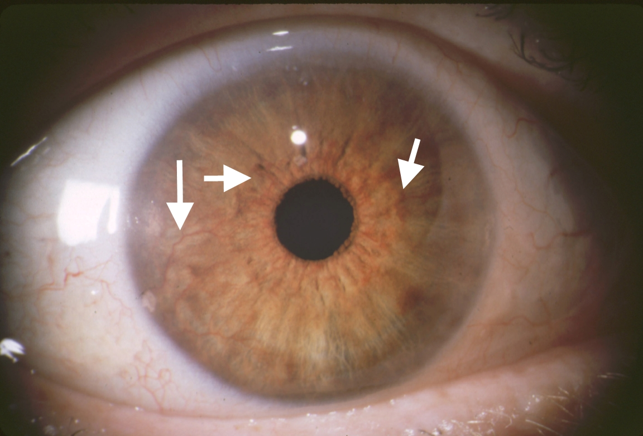

|  |
| --- |
| **Figure 9.** Rubeosis iridis in a case of PDR.  Abnormal new vessels are growing along the surface of the iris (arrows).  (UCSF Dept. of Ophthalmology) |

Neovascularization can remain relatively stable or it can grow rapidly; progression can be noted ophthalmoscopically over a period of weeks.  Preretinal new vessels often develop an associated white, fibrous tissue component that can increase in size as the vessels regress. The resulting fibrovascular membrane may then develop new vessels at its edges.  This cycle of growth and fibrous transformation of diabetic neovascularization is typical.[[25](http://www.endotext.org/diabetes_new/diabetes29/diabetesbiblio29.htm" \l "footnote-25" \o "Davis MD, Blodi BA.  â��Proliferative diabetic retinopathy,â�� in Ryan SJ, ed., Retina.  St. Louis:  Mosby, 2001.  pp. 1309-1349." \t "rbottom)] The proliferation occurs on the anterior surface of the retina, and the vessels extend along the posterior surface of the vitreous body.  Fibrous proliferation takes place on the posterior vitreous surface; when the vitreous detaches, the vessels can be pulled forward and the thickened posterior vitreous surface can be seen ophthalmoscopically, highlighted by areas of fibrovascular proliferation.

The severity of PDR can be classified as to the presence or absence of high-risk characteristics.  As determined in the Diabetic Retinopathy Study, eyes are classified as high-risk if they have 3 of the following 4 characteristics:  the presence of any neovascularization; neovascularization on or within 1 disc diameter of the optic disc; a moderate to severe amount of neovascularization (greater than 1/3 disc area neovascularization of the disc, or greater than 1/2 disc area if elsewhere), or vitreous hemorrhage.[[26](http://www.endotext.org/diabetes_new/diabetes29/diabetesbiblio29.htm" \l "footnote-26" \o "Davis MD, Blodi BA.  â��Proliferative diabetic retinopathy,â�� in Ryan SJ, ed., Retina.  St. Louis:  Mosby, 2001.  pp. 1309-1349." \t "rbottom)]

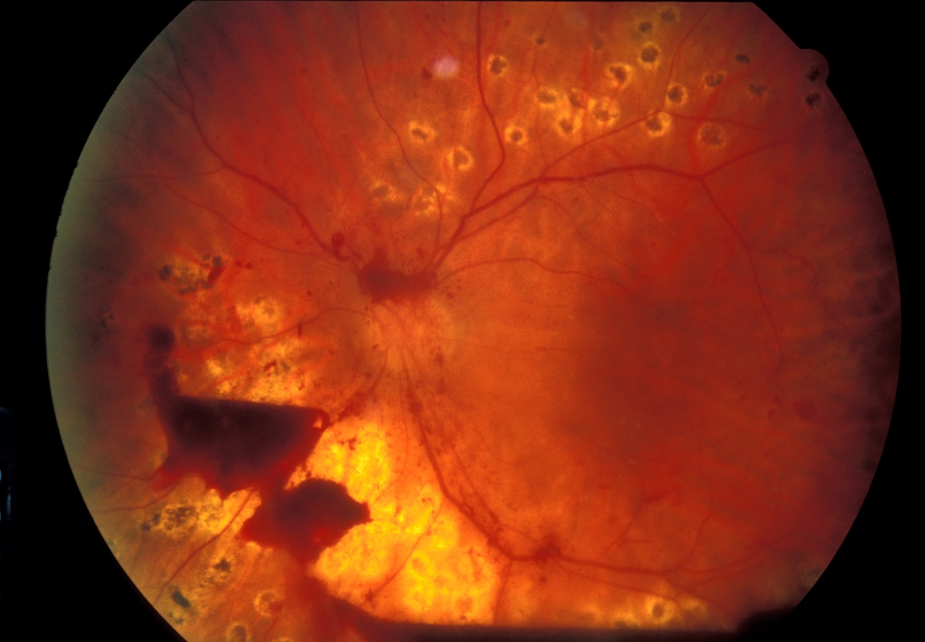Vision loss in proliferative diabetic retinopathy results from three main causes.  First, vitreous hemorrhage occurs because the neovascular tissue is subject to vitreous traction.  Coughing or vomiting may also trigger a hemorrhage.  Hemorrhage may remain in the preretinal space between the retina and the posterior vitreous surface, in which case it may not cause much vision loss if located away from the macula (Figure 10).  In other cases, though, hemorrhage can spread throughout the entire vitreous cavity, causing a diffuse opacification of the visual media with marked vision loss (Figure 11, 12).

|  |
| --- |
| **Figure 10.** Preretinal hemorrhage:  blood trapped between the retina and the vitreous in a case of incomplete vitreous detachment.  Visual acuity is unaffected.  (UCSF Department of Ophthalmology) |

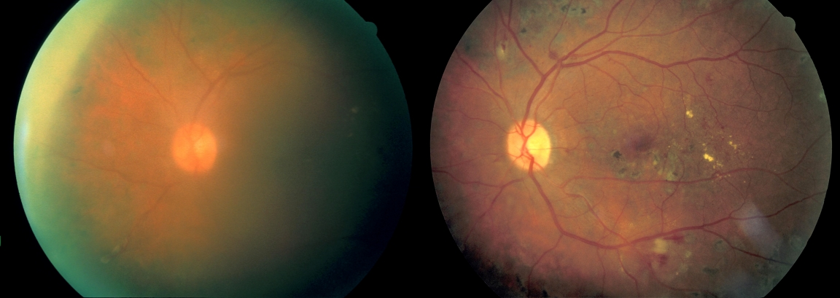

|  |
| --- |
| **Figure 11.** Left:  moderate vitreous hemorrhage; vision = 20/150.  Right:  1 year later after spontaneous clearing of the hemorrhage; vision = 20/30.  (San Francisco General Hospital, Dept. of Ophthalmology) |

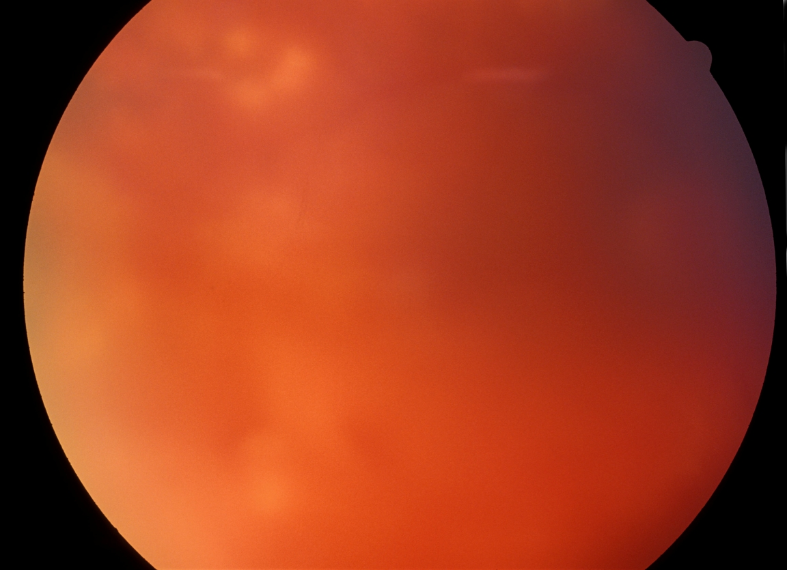

|  |
| --- |
| **Figure 12.** Dense vitreous hemorrhage almost completely obscuring the view of the fundus.   (San Francisco General Hospital, Dept. of Ophthalmology) |

Another cause of severe vision loss in PDR is retinal detachment.  As the fibrovascular membranes and vitreous contract, their attachments to the retina can cause focal elevations of the retina, resulting in a traction retinal detachment (Figure 13).  In other cases the retinal vessels can be avulsed or retinal holes may be created by this traction, leading to a combined traction-rhegmatogenous retinal detachment (Figure 14).

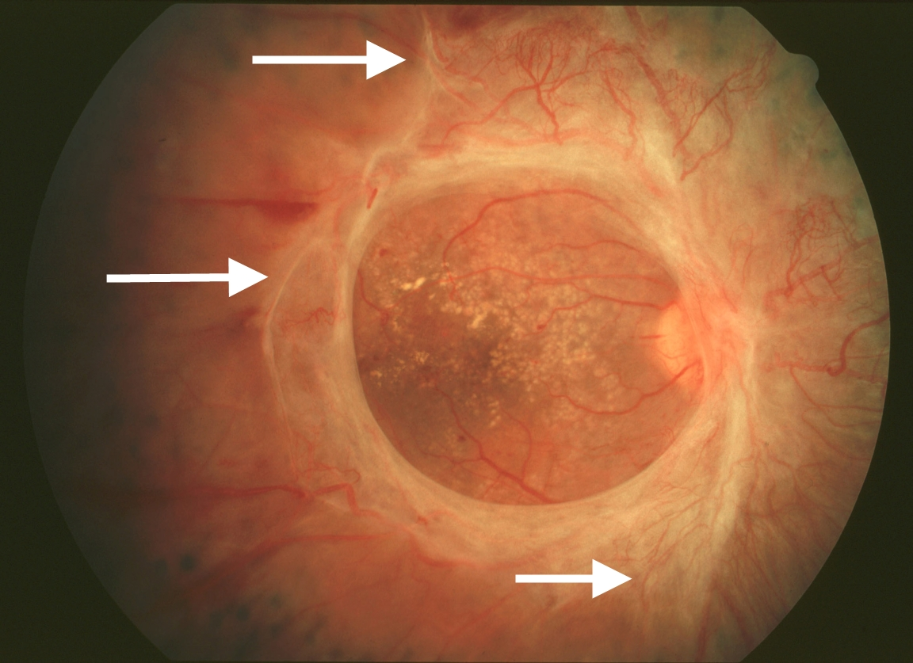

|  |
| --- |
| **Figure 13.** Marked fibrosis with traction exerted on the retina outside the central macula (arrows). The macula does not appear to be elevated centrally. (UCSF Dept. of Ophthalmology) |

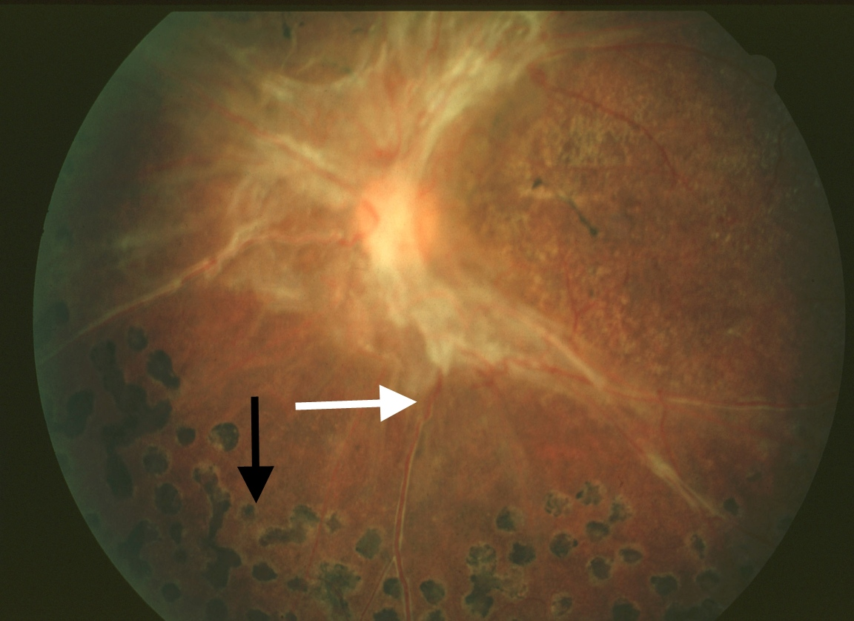

|  |
| --- |
| **Figure 14.** Traction retinal detachment outside the macula.  Note elevation of retinal vessel out of the plane of focus (white arrow).  Scatter photocoagulation scars are seen peripherally (black arrow).  (UCSF Dept. of Ophthalmology) |

Finally, patients with PDR may have macular nonperfusion or coexisting diabetic macular edema that causes vision loss through photoreceptor dysfunction.

## TREATMENT

Tight glucose and blood pressure control are critical systemic factors in controlling the progression of diabetic retinopathy. Ocular complications of diabetes are addressed directly through treatment with laser photocoagulation, intravitreal injections or surgery. Laser treatment has been the primary approach to vision-threatening diabetic retinopathy for decades. Recent randomized clinical trials demonstrated that intravitreal anti-VEGF agents are more effective than laser under certain conditions.

### Laser Photocoagulation for NPDR

Diabetic macular edema is believed to result from fluid and lipid transudation from microaneurysms and telangiectatic capillaries. Focal laser photocoagulation is used to heat and close the microaneurysms, causing them to stop leaking (Figure 15). Macular edema often improves following this form of treatment. Some clinicians apply laser burns in a grid pattern overlying areas of retinal edema without directing treatment to specific microaneurysms; this method can also be effective in reducing retinal thickening. The mechanism by which grid laser treatment achieves these results is not known.[27]

The ETDRS found that the risk of moderate visual loss in eyes with diabetic macular edema was reduced by 50% by photocoagulation. At 3 years, 24% of untreated eyes experienced a 3-line decrease in vision compared with 12% of treated eyes.[28] Eyes meeting the criteria for clinically significant macular edema in which the edema was closest to the center were most likely to benefit from treatment. Side effects of laser treatment can include scotomata, noticeable immediately after the procedure, if treatment is performed too close to the fovea. Late enlargement of laser scars can also occur, causing delayed visual loss. Inadvertent photocoagulation of the fovea is a risk of the procedure.[29] Since the amount of energy used is minimal, the treatment is performed under topical anesthesia.

In the ETDRS study, only a very small percentage of eyes improved with focal laser treatment, highlighting the fact that the goal of laser treatment is not to improve vision, but rather to stabilize it and prevent worsening. It is also true that inclusion criteria for that study were based on the presence of “clinically significant” macular edema threatening the macula, even if the visual acuity was not yet reduced. For this reason, it has been argued that the study enrolled patients with excellent visual acuity, making it difficult to demonstrate small improvements in vision after laser treatment. In line with these arguments, more recent data showed an improvement of 5 or more letters in more than half of patients 2 years after focal laser, with 20% of patients achieving an improvement of 15 or more letters.[1]

Due to the recent evidence on the efficacy and safety of anti-VEGF therapy for diabetic macular edema, different modalities of laser therapy have been proposed. Laser may be able to stabilize macular edema and reduce the need for multiple anti-VEGF injections. Modified ETDRS laser techniques include lower intensity laser burns, and they take particular care in maintaining a greater space from the center of the fovea.[30] Subthreshold laser therapy and minimalistic FA-guided treatment of microaneurysms may also induce less damage to the macula than the classic ETDRS approach.[31]

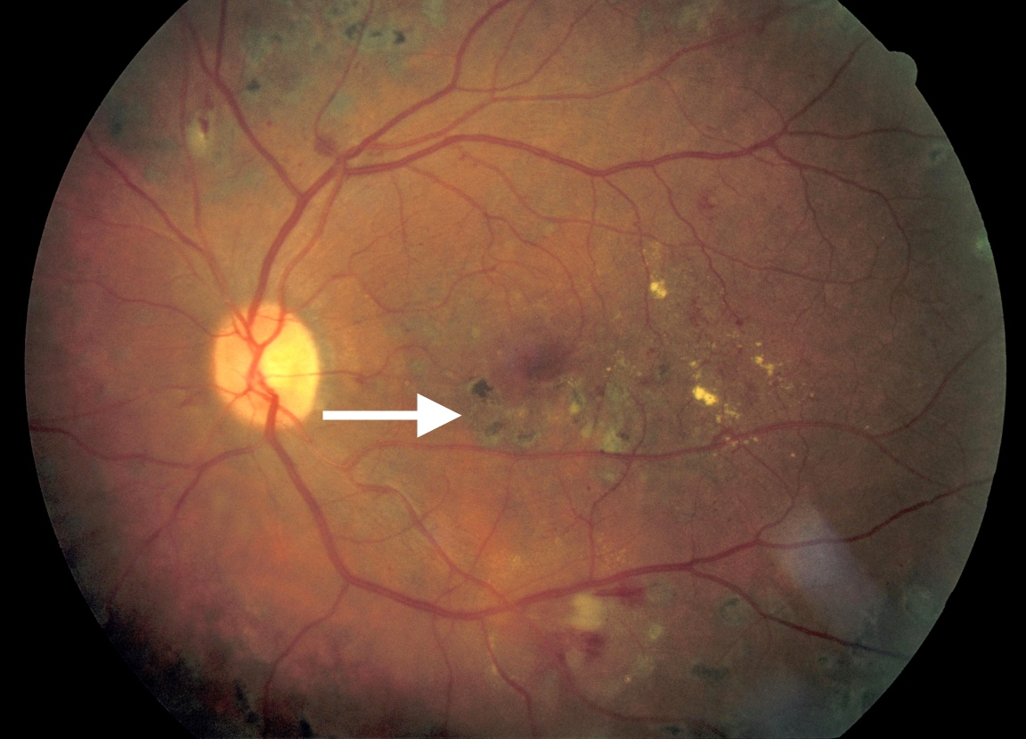

|  |
| --- |
| **Figure 15.** Focal laser scars in the macula following treatment for macular edema (arrow).  Edema has resolved.  (San Francisco General Hospital, Dept. of Ophthalmology) Laser Photocoagulation for PDR Scatter laser photocoagulation, also known as panretinal photocoagulation (PRP), is an important treatment modality for PDR and severe NPDR. Laser spots are placed from outside the major vascular arcades to the equator of the eye, with burns spaced approximately 1/2 to 1 burn width apart (Figure 16). Although the treatment destroys normal retina, the central vision is unaffected since all spots are placed outside the macula. The theory underlying this treatment is that photocoagulation of the ischemic peripheral retina decreases the elaboration of vasoproliferative factors contributing to PDR. Indeed, VEGF levels in the vitreous are increased in eyes with neovascularization, and they are lower after scatter photocoagulation.[32] Other factors such as insulin-like growth factor-1 are similarly elevated in the vitreous of eyes with PDR.[33]  Side effects of scatter photocoagulation can include decreased night vision and dark adaptation, and visual field loss. The procedure can be painful, so treatment may be divided into several sessions, and either topical or retrobulbar anesthesia may be used.  Scatter%20photocoagulation%20scars |

|  |
| --- |
| Scatter photocoagulation scars in an eye with active PDR.  Note that all scatter laser scars are located outside the macula.  (UCSF Department of Ophthalmology) |

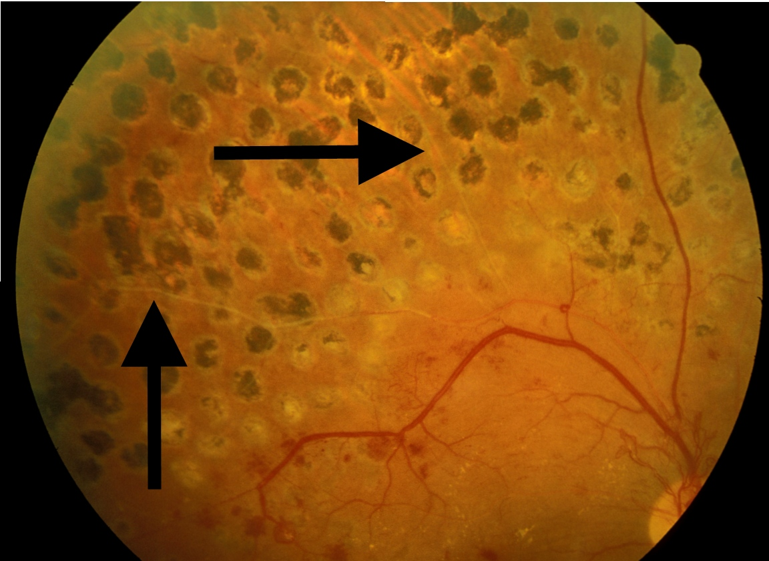

|  |
| --- |
| **Figure 16.** View of laser scars superior to the macula in the same eye.  Spots are approximately one-half burn width apart.  In the treated area, the retinal vessels are sclerotic (arrows).  (UCSF Department of Ophthalmology)  The Diabetic Retinopathy Study evaluated the effects of scatter photocoagulation in over 1700 patients with PDR or severe NPDR. Patients had one eye randomized to treatment and one eye to observation. Treatment was shown to reduce severe visual loss by 50%.[34] The ETDRS also found a positive risk-benefit ratio for early scatter treatment in patients with severe NPDR or early PDR.[9] Interestingly, a recent study demonstrated that scatter laser performed at a single sitting was not worse than treatment divided over four sessions in terms of inducing macular edema or decreasing visual acuity.[35]  Panretinal photocoagulation may induce or aggravate diabetic macular edema, reduce contrast sensitivity and affect the peripheral visual field.[36] Macular edema can be approached by focal laser or intravitreal injections before or at the time of panretinal photocoagulation. However, it is not recommended to delay panretinal photocoagulation in high-risk PDR.  Recently, the DRCR.net study protocol S has shown that intravitreal anti-VEGF agents may be a substitute for panretinal laser treatment.[37] This multicenter randomized clinical trial compared ranibizumab to PRP in patients with PDR. Mean visual acuity letter improvement at 2 years was +2.8 in the ranibizumab group vs +0.2 in the PRP group (P < 0.001). Mean peripheral visual field sensitivity loss was worse, vitrectomy was more frequent, and DME development was more common in the PRP group. Further studies are needed in order to evaluate the long-term implications of using anti-VEGF agents alone. Ranibizumab may be a reasonable treatment alternative to consider for patients with severe NPDR or non-high-risk PDR who can follow-up regularly. |

### Corticosteroids for DME

It has been demonstrated that corticosteroids stabilize the blood-retinal barrier, inhibiting leukostasis and modulating the expression of VEGF receptor.[38] On this basis, periocular and intraocular injections and sustained-release steroid implants have been utilized for the treatment of diabetic macular edema. It should be remembered that any of these different methods to deliver corticosteroids to the macula carry a potential risk of increasing the intraocular pressure (glaucoma) and inducing cataract.

The use of intravitreal triamcinolone acetonide has become accepted as a treatment option for diabetic macular edema. Several formulations are available: Kenalog-40, which has a black box warning against intraocular use, and the preservative-free Triesence. Preliminary data from a randomized clinical trial showed that intravitreal corticosteroids induced a noticeable improvement of visual acuity and foveal thickness in patients with severe, refractory DME.[39] However, intravitreal steroids do not appear to be more efficacious than laser treatment in giving a stable, sustained improvement in vision in the long run, as demonstrated by a recent large study.[40]

A peribulbar corticosteroid injection is of particular interest for eyes with DME that have good visual acuity where the risks of an intravitreal injection may not be justified. Any intravitreal injection through the pars plana, in fact, may directly damage the crystalline lens or cause a severe, sight-threatening infection of the eye (bacterial endophthalmitis). Unfortunately, in 2007 a randomized clinical trial showed that peribulbar triamcinolone, with or without focal photocoagulation, is not effective in cases of mild DME with good visual acuity.[41]

The fact that triamcinolone maintains measurable concentrations in the vitreous cavity for approximately 3 months stimulated further studies on sustained-release or biodegradable intraocular implants that can deliver steroids for a longer period of time.

A fluocinolone acetonide implant (Retisert) was investigated in a multicenter, randomized clinical trial for the treatment of diabetic macular edema. Although the efficacy of this surgically implanted material was demonstrated, it induced cataract in virtually all phakic patients and severe glaucoma needing surgery in 28% of eyes.[42, 43]

A biodegradable dexamethasone implant (Ozurdex), now approved for the treatment of DME, has demonstrated similar efficacy with more acceptable side effects. At day 90, a visual acuity improvement of 10 letters or more was seen in more eyes in the Ozurdex group (33.3%) than the observation group (12.3%; P = .007), but the statistical significance was lost at day 180.[44] The implant was generally well tolerated.

A smaller device releasing fluocinolone acetonide, implantable suturelessly with an office procedure thorough a 25-gauge needle, has been recently approved for DME in the USA (Iluvien). This implant has been evaluated in the FAME (Fluocinolone Acetonide in Diabetic Macular Edema) study where 956 patients were randomized worldwide.[45] At month 36, the percentage of patients who gained ≥15 in letter score was 28% compared with 19% (P = 0.018) in the sham group. In patients who reported duration of DME ≥3 years at baseline; the percentage who gained ≥15 in letter score at month 36 was 34.0% compared with 13.4%. Almost all phakic patients in the insert group developed cataract, but their visual benefit after cataract surgery was similar to that in pseudophakic patients. The rate of glaucoma surgery at month 36 was 5%.[46]

### Anti-VEGF drugs for DME

Vascular endothelial growth factor (VEGF) is an angiogenic factor that plays a key role in the breakdown of the blood–retina barrier and is significantly elevated in eyes with diabetic macular edema.[47] Antibody fragments that bind VEGF and inhibit angiogenesis were originally developed as intraocular injection for the treatment of exudative age-related macular degeneration. These anti-VEGF drugs have been tested for the treatment of DME with interesting results.

The first agent that became available was Pegaptanib 0.3 mg (Macugen).[48] A randomized trial demonstrated after 2 years of therapy a gain of 6.1 letters in the pegaptanib arm versus 1.3 letters for sham (P<0.01).[49] Since it is targeted to the isoform VEGF-165 only, it is generally considered very safe but possibly less effective than newer anti-VEGF drugs.

Bevacizumab (Avastin), directed to all the isoforms of VEGF, has been used off-label for the treatment of DME worldwide. The first evidence came from a study on 121 patients with DME followed over 3 months in a phase II randomized clinical trial.[50] Recently, the BOLT study demonstrated a mean gain of 8.6 letters for bevacizumab versus a mean loss of 0.5 letters when compared to classic macular laser. The patients received a mean of 13 injections over two years, and the treatment was well tolerated with no progression of macular ischemia.[51]

Ranibizumab (Lucentis) binds all isoforms of VEGF and is FDA approved for the treatment of diabetic macular edema. In the Ranibizumab for Edema of the Macula in Diabetes (READ-2) study, ranibizumab-only was superior to laser and to combined therapy.[52] The RESTORE study confirmed that ranibizumab monotherapy and combined with laser was superior to standard laser. At 1 year, no differences were detected between the ranibizumab and ranibizumab plus laser arms.[53] A larger DRCR study supported ranibizumab plus prompt or deferred photocoagulation as a mainstay of current therapy for patients with DME.[54] In the RESOLVE study, at month 12, mean visual acuity improved from baseline by 10.3±9.1 letters with ranibizumab and declined by 1.4±14.2 letters with sham (P<0.0001).[55] The RISE and RIDE studies confirmed the efficacy and the safety of intravitreal monthly injections of ranibizumab with similar results.[56]

Aflibercept (Eylea), active against all VEGF-A isoforms, is also FDA-approved for the treatment of DME. In the DA-VINCI study, the different dose regimens of aflibercept demonstrated a mean improvement in visual acuity of 10 to 13 letters versus -1.3 letters for the laser group with a large proportion of eyes (about 40%) gaining 15 or more ETDRS letters at week 52.[57]

More recently, The Diabetic Retinopathy Clinical Research Network Protocol T compared bevacizumab, ranibizumab and aflibercept in the treatment of center-involving CSME.[58] When the initial visual-acuity loss was mild, there were no significant differences among study groups. However, at worse levels of initial visual acuity (20/50 or worse), aflibercept was more effective than bevacizumab. The differences between bevacizumab and ranibizumab and between ranibizumab and aflibercept were not statistically significant.

Currently, on the basis of the above evidence, anti-VEGF therapy is first-line therapy for center-involving macular edema, with possible deferred focal laser treatment. It should be mentioned that adverse side effects associated with intravitreal injections are uncommon but severe and include infectious endophthalmitis, cataract formation, retinal detachment, and elevated IOP.

### Vitreous surgery for PDR

Surgery may be necessary for eyes in advanced PDR with either vitreous hemorrhage or retinal detachment. In the case of vitreous hemorrhage, many cases will clear spontaneously. For this reason, clinicians often wait 3 to 6 months or more before performing vitrectomy surgery. If surgery is indicated because of persistent nonclearing hemorrhage, retinal detachment involving the macula, or vitreous hemorrhage with neovascularization of the anterior chamber angle (a precursor of neovascular glaucoma), then vitrectomy is performed via a pars plana approach. The vitreous is removed, fibrovascular membranes are dissected away from the retina, retinal detachment is repaired, and scatter laser treatment is applied at the time of surgery via direct intraocular application.

The Diabetic Retinopathy Vitrectomy Study assessed the value of early vitrectomy in patients with severe PDR. The study found that early intervention increased the likelihood of obtaining 20/40 vision or better in eyes with recent severe vitreous hemorrhage or severe PDR. Compared with 15% of control eyes, 25% of treated eyes achieved this level of vision at 2 years.[47] In type 1 diabetes, the benefit of early surgery was even more pronounced, with 36% of treated eyes achieving 20/40 vision compared to 12% of control eyes. The importance of this study, performed between 1976 and 1983 when vitrectomy techniques were much less advanced than they are today, was that it showed conventional “watch and wait” management will not necessarily lead to the best visual outcomes in cases of severe PDR. In practice, clinicians evaluate the risks and benefits of each option before proceeding with scatter photocoagulation, vitrectomy, or observation in such cases.

Recently, the DRCR Protocol D evaluated the effects of pars plana vitrectomy in eyes with moderate vision loss from DME and vitreomacular traction. Although retinal thickness was generally reduced, visual acuity results were less consistent[59]. Vitrectomy for refractory, chronic diabetic macular edema in the absence of vitreomacular traction should be reserved to selected cases.

Intravitreal ocriplasmin (Jetrea) is able to induce enzymatic vitreolysis and posterior vitreous detachment and could have a role, eventually associated with vitrectomy, in the treatment of vitreomacular traction and macular edema in diabetic retinopathy.[60]

## NOVEL THERAPIES FOR DIABETIC RETINOPATHY

Current therapies are limited in their ability to reverse vision loss in diabetic retinopathy. For example, although focal laser photocoagulation can help stabilize vision by reducing macular edema, it rarely improves vision. Corticosteroids induce cataract progression and intraocular pressure elevation. Anti-VEGF agents do not increase cataract formation rates but they generally need more frequent intravitreal injections, carrying the risk of endophthalmitis; they can temporary increase IOP; they might have systemic adverse effects. For addressing these issues, new sustained-release devices are being designed, and studies are ongoing to test new intravitreal medications.

The development of new treatment modalities is being guided by an understanding of the mechanisms of the disease. From this perspective, researchers are now focusing on the role of inflammation on DME. NSAIDs, anti-TNF agents (Etanercept and Remicade), mecamylamine (an antagonist of nACh receptors) and intravitreal erythropoietin are currently under investigation for the treatment of refractory diabetic macular edema.[61]

In order to create a national taskforce to study and treat diabetic retinopathy, in 2002 the National Eye Institute instituted the Diabetic Retinopathy Clinical Research Network (www.drcr.net). DRCR is a collaborative network dedicated to design and carry out multicenter clinical trials on diabetic retinopathy and diabetic macular edema. The DRCR network currently includes over 150 participating sites with over 500 physicians throughout the United States.

The DRCR Network has an ongoing project to study genes involved in diabetic retinopathy. It is also currently enrolling patients with DME to evaluate the combination of intravitreal dexamethasone and ranibizumab (NCT01945866).

## CONCLUSION

Retinopathy remains a challenging complication of diabetes that can adversely affect a patient’s quality of life. Although ophthalmologists can often stabilize the condition or reduce vision loss, prevention and early detection remain the most effective ways to preserve good vision in patients with diabetes. Ensuring tight glucose and blood pressure control and referring patients for ophthalmologic examination are important ways in which internists and other clinicians can help to maximize their patients’ vision and therefore their quality of life. New treatments may offer greater hope for sustained visual improvement in patients with diabetic retinopathy.

## REFERENCES

1. Chew EY, Ferris III FL. “Nonproliferative diabetic retinopathy,” in Ryan SJ, ed., Retina. St. Louis: Mosby, 2006. pp. 1271-1285.

2. http://www.visionproblemsus.org/; last visited February 9, 2013.

3. Klein R and Klein BEK. “Epidemiology of eye disease in diabetes,” in Flynn HW and Smiddy WE, eds., Diabetes and Ocular Disease: Past, Present, and Future Therapies. American Academy of Ophthalmology, 2000. pp.19-61.

4. Moss SE, Klein R, Klein BEK. Ten-year incidence of visual loss in a diabetic population. Ophthalmology 1994;101:1061-1070.

5. Kostraba NJ, Klein R, Dorman JS, et al. The epidemiology of diabetes complications study, IV: correlates of diabetic background and proliferative retinopathy. Am J Epidemiol 1991;133:381-391.

6. Zhang X, Saaddine JB, Chou CF, Cotch MF, Cheng YJ, Geiss LS, et al. Prevalence of diabetic retinopathy in the United States, 2005-2008. JAMA. Aug 11 2010;304(6):649-56.

7. Chiang YP, Bassi LJ, Javitt JC. Federal budgetary costs of blindness. Milbank Q 1992;70:319-340.

8. http://www.preventblindness.net/site/DocServer/Impact\_of\_Vision\_Problems.pdf?docID=1321, last visited February 9, 2013.

9. Ferris III FL, Davis MD, Aiello LM, Chew EY. “Clinical studies on treatment for diabetic retinopathy,” in Flynn HW and Smiddy WE, eds., Diabetes and Ocular Disease: Past, Present and Future Therapies. American Academy of Ophthalmology, 2000. pp. 81-99.

10. Davis MD, Blodi BA. “Proliferative diabetic retinopathy,” in Ryan SJ, ed., Retina. St. Louis: Mosby, 2001. pp. 1309-1349.

11. Klein R and Klein BEK. “Epidemiology of eye disease in diabetes,” in Flynn HW and Smiddy WE, eds., Diabetes and Ocular Disease: Past, Present, and Future Therapies. American Academy of Ophthalmology, 2000. pp.19-61

12. Preferred Practice Patterns Committee, Retina Panel. Diabetic Retinopathy. American Academy of Ophthalmology, 1998.

13. Frank RN, “Etiologic mechanisms in diabetic retinopathy,” in Ryan SJ, ed., Retina. St. Louis: Mosby, 2001. pp. 1259-1294.

14. Gardner TW, Aiello LP. “Pathogenesis of diabetic retinopathy,” in Flynn HW and Smiddy WE, eds., Diabetes and Ocular Disease: Past, Present and Future Therapies. American Academy of Ophthalmology, 2000. pp. 1-17.

15. Frank RN, “Etiologic mechanisms in diabetic retinopathy,” in Ryan SJ, ed., Retina. St. Louis: Mosby, 2001. pp. 1259-1294.

16. Henricsson M, Nystrom L, Blohme G, et al. The incidence of retinopathy 10 years after diagnosis in young adult people with diabetes: results from the nationwide population-based Diabetes Incidence Study in Sweden (DISS). Diabetes Care 2003;26(2):349-354.

17. Chew EY, Ferris III FL. “Nonproliferative diabetic retinopathy,” in Ryan SJ, ed., Retina. St. Louis: Mosby, 2001. pp. 1295-1308.

18. Chew EY, Ferris III FL. “Nonproliferative diabetic retinopathy,” in Ryan SJ, ed., Retina. St. Louis: Mosby, 2001. pp. 1295-1308.

19. Caldwell RB, Bartoli M, Behzadian MA, El-Remessy AE, Al-Shabrawey M, Platt DH, Liou GI, Caldwell RW. Vascular endothelial growth factor and diabetic retinopathy: role of oxidative stress. Curr Drug Targets 2005 Jun;6(4):511-24.

20. Gao BB, Clermont A, Rook S, Fonda SJ, Srinivasan VJ, Wojtkowski M, Fujimoto JG, Avery RL, Arrigg PG, Bursell SE, Aiello LP, Feener EP. Extracellular carbonic anhydrase mediates hemorrhagic retinal and cerebral vascular permeability through prekallikrein activation. Nat Med 2007;13(2):181-8.

21. Puliafito CA, Hee MR, Lin CP, Reichel E, Schuman JS, Duker JS, Izatt JA, Swanson EA, Fujimoto JG. Imaging of macular diseases with optical coherence tomography. Ophthalmology 1995;102(2):217-29.

22. Kim BY, Smith SD, Kaiser PK. Optical coherence tomographic patterns of diabetic macular edema. Am J Ophthalmol 2006;142(3):405-12.

23. Kim BY, Smith SD, Kaiser PK. Optical coherence tomographic patterns of diabetic macular edema. Am J Ophthalmol 2006;142(3):405-12.

24. Folk JC and Oh KT. “Photocoagulation for diabetic macular edema and diabetic retinopathy,” in Flynn HW and Smiddy WE, eds., Diabetes and Ocular Disease: Past, Present and Future Therapies. American Academy of Ophthalmology, 2000. pp. 115-153.

25. Davis MD, Blodi BA. “Proliferative diabetic retinopathy,” in Ryan SJ, ed., Retina. St. Louis: Mosby, 2001. pp. 1309-1349.

26. Davis MD, Blodi BA. “Proliferative diabetic retinopathy,” in Ryan SJ, ed., Retina. St. Louis: Mosby, 2001. pp. 1309-1349.

27. Folk JC and Oh KT. “Photocoagulation for diabetic macular edema and diabetic retinopathy,” in Flynn HW and Smiddy WE, eds., Diabetes and Ocular Disease: Past, Present and Future Therapies. American Academy of Ophthalmology, 2000. pp. 115-153.

28. Chew EY, Ferris III FL. “Nonproliferative diabetic retinopathy,” in Ryan SJ, ed., Retina. St. Louis: Mosby, 2001. pp. 1295-1308.

29. Chew EY, Ferris III FL. “Nonproliferative diabetic retinopathy,” in Ryan SJ, ed., Retina. St. Louis: Mosby, 2001. pp. 1295-1308.

30. Fong DS, Strauber SF, Aiello LP, et al. Comparison of the modified Early Treatment Diabetic Retinopathy Study and mild macular grid laser photocoagulation strategies for diabetic macular edema. Arch Ophthalmol 2007;125:469-80.

31. Luttrull JK, Dorin G. Subthreshold diode micropulse laser photocoagulation (SDM) as invisible retinal phototherapy for diabetic macular edema: a review. Curr Diabetes Rev 2012;8:274-84.

32. Aiello LP, Avery RL, Arrigg PG, et al. Vascular endothelial growth factor in ocular fluid of patients with diabetic retinopathy and other retinal disorders. N Engl J Med 1994;331:1480-1487.

33. Simo R, Lecube A, Segura RM, et al. Free insulin growth factor-1 and vascular endothelial growth factor in the vitreous fluid of patients with proliferative diabetic retinopathy. Am J Ophthalmol 2002;134(3):376-382.

34. Davis MD, Blodi BA. “Proliferative diabetic retinopathy,” in Ryan SJ, ed., Retina. St. Louis: Mosby, 2001. pp. 1309-1349.

35. Diabetic Retinopathy Clinical Research Network, Brucker AJ, Qin H, Antoszyk AN, Beck RW, Bressler NM, Browning DJ, Elman MJ, Glassman AR, Gross JG, Kollman C, Wells JA 3rd. Observational study of the development of diabetic macular edema following panretinal (scatter) photocoagulation given in 1 or 4 sittings. Arch Ophthalmol. 2009 Feb;127(2):132-40

36. Early Treatment Diabetic Retinopathy Study Research Group. Early photocoagulation for diabetic retinopathy: ETDRS report number 9. Ophthalmology 1991;98:766-85.

37. Writing Committee for the Diabetic Retinopathy Clinical Research Network. Panretinal photocoagulation vs intravitreous ranibizumab for proliferative diabetic retinopathy: a randomized clinical trial. JAMA 2015;314:2137-46.

38. Cunningham MA, Edelman JL, Kaushal S. Intravitreal steroids for macular edema: the past, the present, and the future. Surv Ophthalmol 2008;53(2):139-49.

39. Gillies MC, Sutter FK, Simpson JM, Larsson J, Ali H, Zhu M. Intravitreal triamcinolone for refractory diabetic macular edema: two-year results of a double-masked, placebo-controlled, randomized clinical trial. Ophthalmology 2006;113(9):1533-8.

40. Diabetic Retinopathy Clinical Research Network (DRCR.net), Beck RW, Edwards AR, Aiello LP, Bressler NM, Ferris F, Glassman AR, Hartnett E, Ip MS, Kim JE, Kollman C. Three-year follow up of a randomized trial comparing focal/grid photocoagulation and intravitreal triamcinolone for diabetic macular edema. Arch Ophthalmol.2009 Mar;127(3):245-51

41. Diabetic Retinopathy Clinical Research Network, Chew E, Strauber S, Beck R, Aiello LP, Antoszyk A, Bressler N, Browning D, Danis R, Fan J, Flaxel C, Friedman S, Glassman A, Kollman C, Lazarus H. Randomized trial of peribulbar triamcinolone acetonide with and without focal photocoagulation for mild diabetic macular edema: a pilot study. Ophthalmology 2007;114(6):1190-6.

42. Pearson P, Levy B, Comstock T. Fluocinolone Acetonide Implant Study Group. Fluocinolone acetonide intravitreal implant to treat diabetic macular edema: 3-year results of a multicenter clinical trial [abstract]. Invest Ophthalmol Vis Sci 2006; 47:E-Abstract 5442.

43. Schwartz SG, Flynn HW Jr. Fluocinolone acetonide implantable device for diabetic retinopathy. Curr Pharm Biotechnol. 2011 Mar 1;12(3):347-51.

44. Haller JA, Kuppermann BD, Blumenkranz MS, Williams GA, Weinberg DV, Chou C, Whitcup SM; Dexamethasone DDS Phase II Study Group. Randomized controlled trial of an intravitreous dexamethasone drug delivery system in patients with diabetic macular edema. Arch Ophthalmol. 2010 Mar;128(3):289-96..

45. Campochiaro PA, Brown DM, Pearson A, Ciulla T, Boyer D, Holz FG, Tolentino M, Gupta A, Duarte L, Madreperla S, Gonder J, Kapik B, Billman K, Kane FE; FAME Study Group. Long-term benefit of sustained-delivery fluocinolone acetonide vitreous inserts for diabetic macular edema. Ophthalmology. 2011 Apr;118(4):626-635

46. Campochiaro PA, Brown DM, Pearson A, Chen S, Boyer D, Ruiz-Moreno J, Garretson B, Gupta A, Hariprasad SM, Bailey C, Reichel E, Soubrane G, Kapik B, Billman K, Kane FE, Green K; FAME Study Group. Sustained delivery fluocinolone acetonide vitreous inserts provide benefit for at least 3 years in patients with diabetic macular edema. Ophthalmology. 2012 Oct;119(10):2125-32.

47. Nguyen QD, Tatlipinar S, Shah SM, et al. Vascular endothelial growth factor is a critical stimulus for diabetic macular edema. Am J Ophthalmol 2006;142:961–969.

48. Cunningham ET Jr, Adamis AP, Altaweel M, et al. Macugen Diabetic Retinopathy StudyGroup. A phase II randomized double-masked trial of pegaptanib, an antivascular endothelial growth factor aptamer, for diabetic macular edema. Ophthalmology 2005;112:1747–1757.

49. Sultan MB, Zhou D, Loftus J, Dombi T, Ice KS; Macugen 1013 Study Group. A phase 2/3, multicenter, randomized, double-masked, 2-year trial of pegaptanib sodium for the treatment of diabetic macular edema. Ophthalmology. 2011 Jun;118(6):1107-18.

50. Scott IU, Edwards AR, Beck RW, et al., Diabetic Retinopathy Clinical Research Network. A phase II randomized clinical trial of intravitreal bevacizumab for diabetic macular edema. Ophthalmology 2007;114:1860–1867.

51. Rajendram R, Fraser-Bell S, Kaines A, Michaelides M, Hamilton RD, Esposti SD, Peto T, Egan C, Bunce C, Leslie RD, Hykin PG. A 2-year prospective randomized controlled trial of intravitreal bevacizumab or laser therapy (BOLT) in the management of diabetic macular edema: 24-month data: report 3. Arch Ophthalmol. 2012 Aug 1;130(8):972-9.

52. Nguyen QD, Shah SM, Khwaja AA, Channa R, Hatef E, Do DV, Boyer D, Heier JS, Abraham P, Thach AB, Lit ES, Foster BS, Kruger E, Dugel P, Chang T, Das A, Ciulla TA, Pollack JS, Lim JI, Eliott D, Campochiaro PA; READ-2 Study Group. Two-year outcomes of the ranibizumab for edema of the mAcula in diabetes (READ-2) study. Ophthalmology. 2010 Nov;117(11):2146-51.

53. Mitchell P, Bandello F, Schmidt-Erfurth U, Lang GE, Massin P, Schlingemann RO, Sutter F, Simader C, Burian G, Gerstner O, Weichselberger A; RESTORE study group. The RESTORE study: ranibizumab monotherapy or combined with laser versus laser monotherapy for diabetic macular edema. Ophthalmology. 2011 Apr;118(4):615-25.

54. Elman MJ, Bressler NM, Qin H, Beck RW, Ferris FL 3rd, Friedman SM, Glassman AR, Scott IU, Stockdale CR, Sun JK; Diabetic Retinopathy Clinical Research Network. Expanded 2-year follow-up of ranibizumab plus prompt or deferred laser or triamcinolone plus prompt laser for diabetic macular edema. Ophthalmology. 2011 Apr;118(4):609-14.

55. Massin P, Bandello F, Garweg JG, Hansen LL, Harding SP, Larsen M, Mitchell P, Sharp D, Wolf-Schnurrbusch UE, Gekkieva M, Weichselberger A, Wolf S. Safety and efficacy of ranibizumab in diabetic macular edema (RESOLVE Study): a 12-month, randomized, controlled, double-masked, multicenter phase II study. Diabetes Care. 2010 Nov;33(11):2399-405.

56. Nguyen QD, Brown DM, Marcus DM, Boyer DS, Patel S, Feiner L, Gibson A, Sy J, Rundle AC, Hopkins JJ, Rubio RG, Ehrlich JS; RISE and RIDE Research Group. Ranibizumab for diabetic macular edema: results from 2 phase III randomized trials: RISE and RIDE. Ophthalmology. 2012 Apr;119(4):789-801.

57. Do DV, Nguyen QD, Boyer D, Schmidt-Erfurth U, Brown DM, Vitti R, Berliner AJ, Gao B, Zeitz O, Ruckert R, Schmelter T, Sandbrink R, Heier JS; DA VINCI Study Group. One-year outcomes of the DA VINCI Study of VEGF Trap-Eye in eyes with diabetic macular edema. Ophthalmology. 2012 Aug;119(8):1658-65.

58. Wells JA, Glassman AR, Ayala AR, Jampol LM, Bressler NM, Bressler SB, Brucker AJ, Ferris FL, Hampton GR, Jhaveri C, Melia M, Beck RW; Diabetic Retinopathy Clinical Research Network. Aflibercept, Bevacizumab, or Ranibizumab for Diabetic Macular Edema: Two-Year Results from a Comparative Effectiveness Randomized Clinical Trial. Ophthalmology. 2016 Jun;123(6):1351-9.

59. Diabetic Retinopathy Clinical Research Network Writing Committee, J. A. Haller, and H. Qin. Vitrectomy outcomes in eyes with diabetic macular edema and vitreomacular traction. Ophthalmology. 2010 vol. 117, pp. 1087–1093.

60. Gandorfer A. Enzymatic vitreous disruption. Eye. 2008 Oct;22(10):1273-7.

61. Javey G, Schwartz SG, Flynn HW Jr. Emerging pharmacotherapies for diabetic macular edema. Exp Diabetes Res. 2012;2012:548732.