**ENDOCRINE HYPERTENSION IN CHILDHOOD AND ADOLESCENCE**

**Nicolas C. Nicolaides, MD, PhD,** Medical School, University of Cyprus, Nicosia, Cyprus. [nicolaides.nicolas@ucy.ac.cy](mailto:nicolaides.nicolas@ucy.ac.cy)

**Constantine A. Stratakis, MD, PhD,** NICHD, NIH, Bethesda, MD, & Hospital for Endocrine Surgery, HCA, Tampa, FL, USA; Human Genetics & Precision Medicine, IMBB, FORTH, Heraklion, Greece; Medical Genetics, H. Dunant Hospital & ASTREA Health Athens, Greece; European University of Cyprus, Medical School, Nicosia, Cyprus. [castratakis@verizon.net](mailto:castratakis@verizon.net)

**Updated March 1, 2025**

**ABSTRACT**

Hypertension in children and adolescents is defined as a blood pressure ≥ 95th percentile (stage 1) or a blood pressure ≥ 95th percentile + 12 mmHg (stage 2), according to the Clinical Practice Guidelines of American Academy of Pediatrics published in 2017. Hypertension may be primary or idiopathic or secondary due to renal disease (including renal vascular abnormalities), cardiovascular disorders, or endocrine conditions. Endocrine hypertension might be caused by excess amount of steroid (aldosterone, deoxycorticosterone, cortisol, and other) or non-steroid hormones (such as catecholamines for example). In addition, a number of renal genetic disorders mimic adrenal diseases leading to hypertension. In this chapter, we provide an overview of the clinical manifestations of several nosological entities causing endocrine hypertension in children and adolescents and present the diagnostic work up and therapeutic management of these conditions.

**INTRODUCTION**

Hypertension occurs in 3.5% of children and adolescence worldwide (1). Its prevalence has increased due to the epidemic of pediatric obesity (2). The 2017 Clinical Practice Guidelines of American Academy of Pediatrics (APP) suggested an updated definition of hypertension in children and adolescent using tables containing values of systolic and diastolic blood pressure adjusted for gender, age, and height. According to these guidelines, children or adolescents with a blood pressure ≥ 95th percentile are classified as stage 1 hypertensive, whereas those with a blood pressure ≥ 95th percentile + 12 mmHg are considered as stage 2 hypertensive (1).

Hypertension in children and adolescents might be primary or secondary. Causes of secondary hypertension include renal or renovascular diseases, heart diseases (e.g. aortic coarctation), or endocrine nosological entities (1, 2). Endocrine hypertension is defined as secondary hypertension caused by pathologies, such as various states of mineralocorticoid, glucocorticoid, or catecholamine excess, thyroid or pituitary hormone over-secretion, genetic disorders such as congenital adrenal hyperplasia (11β-hydroxylase deficiency and 17α-hydroxylase deficiency), and syndromes caused by molecular or chromosomal defects (3). Although the list of causes of endocrine hypertension is long, the prevalence of endocrine hypertension ranges between 0,05% to 6% among all causes of secondary hypertension (4). In addition to endocrine pathologies, the ever-increasing rates of obesity in childhood and adolescence have resulted in a dramatic increase of obesity-related hypertension with a prevalence of 25% ultimately leading to adverse cardiovascular outcomes (1, 2).

In this chapter, we review the most common causes of endocrine hypertension in children and adolescents.

**DISORDERS OF THE ADRENAL CORTEX**

**Syndromes of Aldosterone Excess**

PRIMARY ALDOSTERONISM

Less than 15% of cases in children and adolescents with hypertension have been attributed to primary aldosteronism, which is characterized by autonomous excessive biosynthesis and release of aldosterone by the *zona glomerulosa* of the adrenal cortex (5). Most cases of primary aldosteronism are sporadic due to a unilateral aldosterone-producing adenoma or bilateral adrenal hyperplasia. Less commonly, primary aldosteronism results from unilateral adrenal hyperplasia (6).

Children and adolescents with primary aldosteronism are often asymptomatic; however, the presence of resistant hypertension with hypokalemia or an adrenal lesion is highly suggestive of the diagnosis (7). Endocrinologic evaluation includes the measurement of plasma aldosterone concentrations (PAC) and plasma renin activity (PRA). The Aldosterone-to-Renin Ratio (ARR) remains the most reliable hormonal test (8). Indeed, patients with ARR above 27 ng/dL per ng/mL/h and PAC above 20 ng/dL (hyperaldosteronism) or with ARR within the normal range and PAC below 9 ng/dL (not hyperaldosteronism) on two serial measurements do not need to undergo dynamic tests (9). The dynamic tests include salt loading, saline infusion, or fludrocortisone administration, which all normally cause aldosterone suppression. The patients then undergo adrenal imaging with computerized tomography (CT) to identify any adrenal nodules or unilateral or bilateral adrenal hyperplasia (10).

In cases of lateralization of aldosterone overproduction, unilateral laparoscopic adrenalectomy is a therapeutic option; otherwise, medical treatment with a mineralocorticoid receptor antagonist (spironolactone or eplerenone) is highly recommended. In patients who do not tolerate mineralocorticoid receptor antagonists, an epithelial sodium channel blocker, such as amiloride, might be administered (11)

FAMILIAL HYPERALDOSTERONISM

*Familial Hyperaldosteronism Type I (FH-I) or Glucocorticoid Remediable Aldosteronism (GRA)*

FH-I or GRA is an autosomal dominant pathologic condition caused by the fusion of two genes, the cytochrome P450 family 11 subfamily B member 1 (*CYP11B1*) encoding for 11β-hydroxylase, and the *CYP11B2* that expresses aldosterone synthase (12). The chimeric gene consists of the adrenocorticotropic hormone (ACTH)-responsive promoter region of the *CYP11B1* gene and the coding region of *CYP11B2* gene resulting in the expression of aldosterone synthase under the control of ACTH. Therefore, aldosterone is produced ectopically in *zona fasciculata* in an ACTH-dependent fashion (Figures 1 and 2).

Patients younger than 20 years with primary aldosteronism or with a family member with primary aldosteronism or history of hemorrhagic stroke before the age of 40 years should be screened for FH-I (13). Hormonal evaluation includes measurements of PAC and PRA, dexamethasone suppression of aldosterone, and genetic testing. According to the protocol of dexamethasone suppression of aldosterone, aldosterone is measured before and following the administration of 0,5 mg dexamethasone every 6 hours for 4 days (14, 15).

The cornerstone of therapeutic management is dexamethasone or prednisone at physiologic and below physiologic dosing to suppress ACTH, thereby leading to decreased production and release of aldosterone (16). Second-line options are spironolactone or eplerenone or amiloride (17), as above. Most of the time, treatment needs to be titrated to the individual carefully and over time, to avoid overtreatment with glucocorticoids and to achieve normal blood pressure in the long term.

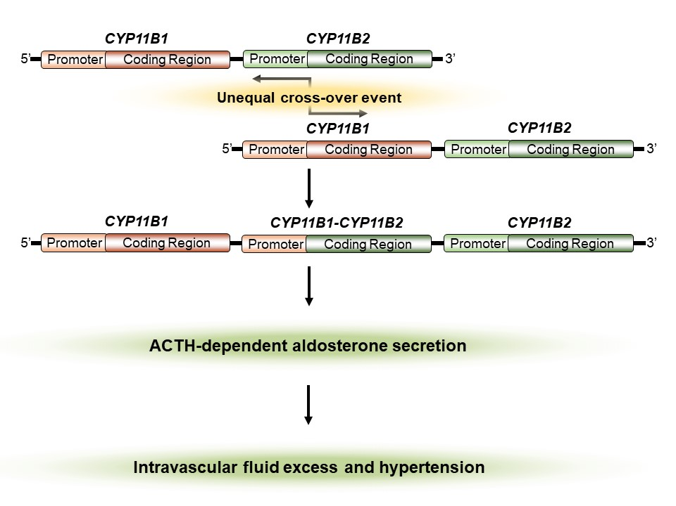

**Figure 1.** **Molecular events of Familial Hyperaldosteronism Type I (FH-I) or Glucocorticoid Remediable Aldosteronism (GRA). Fusion of *CYP11B1* encoding for 11β-hydroxylase, and the *CYP11B2* that expresses aldosterone synthase results in a chimeric gene leading to ACTH-dependent aldosterone secretion.**

*Familial Hyperaldosteronism Type II (FH-II)*

FH-II is the most frequent form of familial hyperaldosteronism found in 10% of children and adolescents with primary aldosteronism (18, 19). In contradistinction to FH-I or GRA, patients with this FH type do not respond to synthetic long-acting glucocorticoids and do not harbor the chimeric *CYP11B1/CYP11B2* gene (20). However, it remains difficult to distinguish FH-II from sporadic primary aldosteronism in terms of adrenal lesions found on CT. The molecular basis of FH-II has been attributed to gain-of-function mutations in the *CLCN2* gene which encodes for the chloride channel 2 (Figure 2) (21, 22). The increased efflux of chloride in the *zona glomerulosa* results in continuous aldosterone secretion. Patients with FH-II are treated with mineralocorticoid receptor antagonists (23).

*Familial Hyperaldosteronism Type III (FH-III)*

FH-III is an autosomal dominant form of FH caused by germline gain-of-function mutations in the potassium inwardly rectifying channel subfamily J member 5 (*KCNJ5*) gene that encodes for the potassium channel GIRK4 (Kir3.4) (Figure 2) (24). Patients with FH-III are characterized by early-onset severe to resistant hypertension, very high PAC, extremely high 18-oxocortisol and 18-hydroxycortisol concentrations, as well as marked bilateral adrenal hyperplasia (25). Treatment options include administration of mineralocorticoid receptor antagonists if the case is mild or bilateral adrenalectomy in severe cases (17).

*Familial Hyperaldosteronism Type IV (FH-IV)*

FH-IV should be suspected in children aged less than 10 years who present with early-onset hypertension and primary aldosteronism (13). Patients with FH-IV harbor mutations in the calcium voltage-gated channel subunit alpha 1H (*CACNA1H*) gene that encodes for the alpha subunit of the voltage-dependent T-type calcium channel Cav3.2 (Figure 2). These genetic defects resulted in increased calcium influx in the cytoplasm of cells within the *zona glomerulosa*, thereby facilitating continuous aldosterone secretion (26). Patients may respond to calcium channel blockers (4).

*Primary Aldosteronism with Seizures and Neurologic Abnormalities (PASNA) or* *Familial Hyperaldosteronism Type V? (FH-V?)*

Scholl and collaborators have described two children with primary aldosteronism, seizures, and neurologic abnormalities (27). The patients harbored mutations in the *CACNA1D* gene which encodes the alpha-1 subunit of the voltage dependent Ca2+ L-type Cav1.3 channel (27).

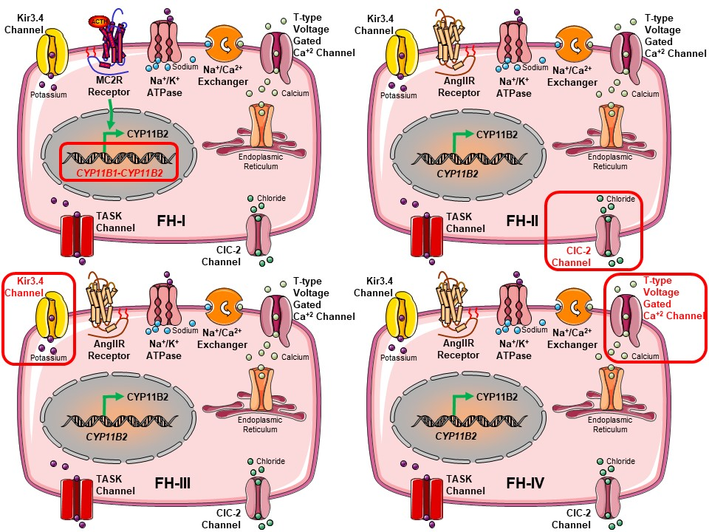

**Figure 2. Genetic defects of the types of Familial Hyperaldosteronism (FH). FH-I is caused by the fusion of *CYP11B1* encoding for 11β-hydroxylase, and the *CYP11B2* that expresses aldosterone synthase. The molecular basis of FH-II has been attributed to activating mutations in the *CLCN2* encoding for the chloride channel 2. FH-III is caused by germline activating mutations in the *KCNJ5* that expresses the potassium channel GIRK4 (Kir3.4). FH-IV has been associated with mutations in the *CACNA1H* that encodes for the alpha subunit of the voltage-dependent T-type calcium channel Cav3.2.**

**Syndromes of Deoxycorticosterone Excess**

CONGENITAL ADRENAL HYPERPLASIA

Congenital adrenal hyperplasia is a group of disorders characterized by defects in genes encoding for enzymes that participate in steroidogenesis (Figure 3). Two forms of congenital adrenal hyperplasia, 11β-hydroxylase deficiency and 17α-hydroxylase deficiency, both present with hypertension and hypokalemia (28).

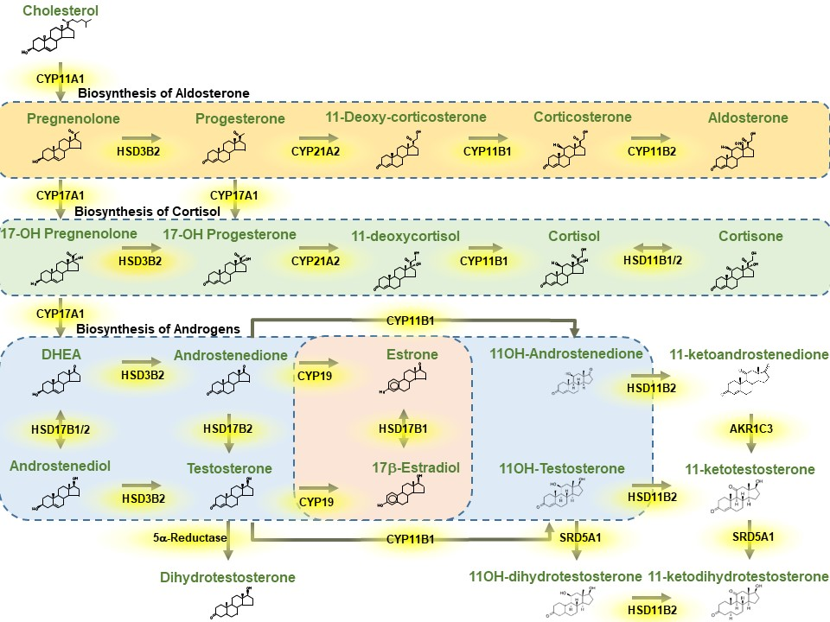

**Figure 3.** **Biochemical pathways of steroidogenesis.**

*11β-Hydroxylase Deficiency*

This is the second most common form of congenital adrenal hyperplasia (5%-8%) which is inherited in an autosomal recessive fashion. 11β-hydroxylase deficiency results from genetic defects in *CYP11B1* gene, and causes increased production of deoxycorticosterone, 11-deoxycortisol, and adrenal androgens (29). In addition, PRA is suppressed leading to decreased production of aldosterone in the *zonal glomerulosa* and hypokalemia. In girls, 11β-hydroxylase deficiency is a 46XX disorder of sex development (46XX DSD) leading to genital virilization. In boys, this form of congenital adrenal hyperplasia causes penile enlargement, precocious pubarche and puberty, as well as adrenal rests in the testicles (30). Hypertension may be present in up to 65% of patients (31). Treatment includes administration of synthetic glucocorticoids to decrease ACTH-mediated production of deoxycorticosterone and adrenal androgens.

*17α-Hydroxylase Deficiency*

This form of congenital adrenal hyperplasia is also inherited in an autosomal recessive fashion and is caused by defects in the *CYP17A* gene that encodes for 17α-hydroxylase. This enzyme catalyzes 17-hydroxylation of pregnenolone and progesterone and cleaves the side chain of the steroid molecule at position 17, 20; thereby displaying lyase activity (28). 17α-hydroxylase deficiency leads to insufficient production of glucocorticoids and sex steroids and concurrent accumulation of deoxycorticosterone and corticosterone. Patients with 17α-hydroxylase may present with 46XY disorder of sex development (DSD) and absent Müllerian structures (28), hypergonadotropic hypogonadism with lack of development of secondary sex characteristics, and primary amenorrhea in 46XX individuals (32-34). They also display hypokalemic hypertension. The treatment basis of 17α-hydroxylase deficiency is supplementation with synthetic glucocorticoids.

PRIMARY GENERALIZED GLUCOCORTICOID RESISTANCE (CHROUSOS SYNDROME)

Initially described by Chrousos and collaborators (35), primary generalized glucocorticoid resistance or Chrousos syndrome is a rare endocrinologic condition characterized by incomplete resistance of target tissues to glucocorticoids (36). This syndrome is caused by genetic defects in *NR3C1* gene which encodes for the human glucocorticoid receptor (37). The defective human glucocorticoid receptor (hGR) in both the hypothalamus and anterior pituitary causes impaired negative feedback loops leading to compensatory activation of the hypothalamus-pituitary-adrenal axis (Figure 4). The increased levels of CRH and AVP may cause depression and anxiety, while the elevated ACTH concentrations lead to adrenal hyperplasia, increased production of steroid precursors with mineralocorticoid activity (deoxycorticosterone, corticosterone), increased biosynthesis and release of adrenal androgens, and elevated concentrations of cortisol (38). Patients may be asymptomatic or display hypertension with hypokalemic alkalosis or present with ambiguous genitalia, peripheral precocious puberty, amenorrhea, oligoamenorrhea, and decreased fertility (Figure 4). As far as endocrinologic work-up is concerned, patients with Chrousos syndrome have increased urinary-free cortisol excretion, resistance of the hypothalamic-pituitary-adrenal axis to increasing concentrations of dexamethasone, without any stigmata of Cushing’s syndrome. Treatment consists of high doses of dexamethasone only in symptomatic patients to prevent the development of ACTH-dependent adrenal adenomas (39). Treatment needs to be titrated to the individual carefully and over time, to avoid overtreatment with glucocorticoids and achieve normal pressure in the long term.

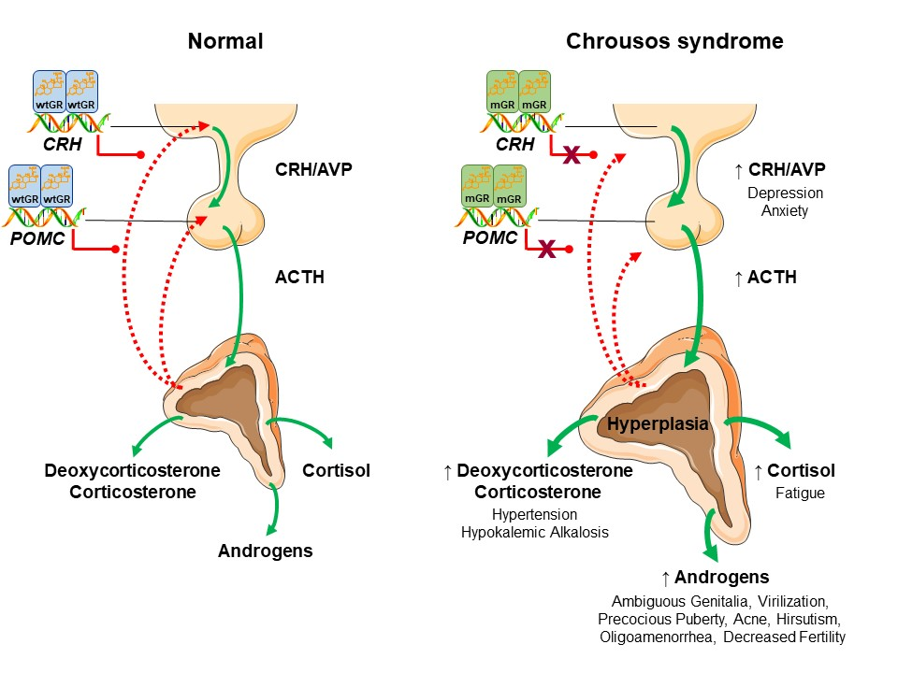

**Figure 4.** **Pathophysiology of Chrousos syndrome. ACTH: adrenocorticotropic hormone; AVP: arginine-vasopressin; CRH: corticotropin-releasing hormone; mGR: mutated Glucocorticoid Receptor; POMC: Pro-opiomelanocortin; wtGR: wild-type Glucocorticoid Receptor.**

**Syndromes of Cortisol Excess**

The most common cause of Cushing’s in children and adolescents is chronic exogenous administration of synthetic glucocorticoids. As far as endogenous causes are concerned, hypercortisolism may be ACTH-dependent (such as in Cushing’s disease from pituitary tumors or ACTH-dependent Cushing syndrome from ectopic, non-pituitary tumors) or ACTH-independent (Cushing’s syndrome) (Figure 5) (40). Hypertension in these patients might be attributed to several pathophysiological mechanisms that influence substantially peripheral vascular resistance, plasma volume, and cardiac output. Independently of etiology, 11β-hydroxysteroid dehydrogenase type 2 (11HSD2) is less capable of converting the active cortisol to the inactive cortisone; therefore, the increased cortisol in the renal tubules binds to the mineralocorticoid receptor and leads to hypertension (41).

ACTH-DEPENDENT CUSHING’S SYNDROME OR CUSHING’S DISEASE

Cushing’s disease remains the most common cause of endogenous hypercortisolism in children aged more than five years and adolescents (42, 43). Usually, an ACTH-producing corticotroph pituitary neuroendocrine tumor (PitNET) also termed as pituitary adenoma, leads to increased biosynthesis and secretion of cortisol by *zona fasciculata* and adrenal androgens by *zona reticularis* (44). Hyperandrogenism (testosterone, Δ4-androstenedione, DHEAS) results in virilization with pseudo precocious puberty. Hypokalemic hypertension is caused by the saturation of renal 11HSD2 due to increased cortisol concentrations. Another cause of ACTH dependent Cushing’s syndrome is the ectopic production and release of ACTH by carcinoid tumors in the thymus, bronchus, or pancreas; medullary carcinomas of the thyroid, small cell carcinoma of the lung, pheochromocytomas or other neuroendocrine tumors (45). Finally, pituitary blastomas, although extremely rare, represent a cause of Cushing’s disease in infants (46). The recommended therapy in patients with Cushing’s disease is transsphenoidal surgical excision of the adenoma with cure reaching the percentage of more than 75% in hands of high-volume surgeons (47). Up to 30% of ACTH-producing pituitary adenomas in children harbor somatic “hot-spot” mutations in the *USP8* gene that encodes for the ubiquitin-specific protease 8 (Figure 5) which may lead to targeted medical therapies in the future (48, 49).

ACTH-INDEPENDENT CUSHING’S SYNDROME

Cushing’s syndrome in childhood and adolescence is caused by autonomous (ACTH-independent) secretion of cortisol by the adrenal cortex is an extremely rare condition. It accounts for 10%-15% of hypercortisolemia and is caused by unilateral adrenal lesions, including adrenocortical adenomas or carcinomas (discussed below), or bilateral adrenocortical disorders (50). Bilateral adrenocortical hyperplasias (BAHs) account for less than 2% of all cases of Cushing’s syndrome in pediatric and adult patients (50). BAHs are classified as macronodular (nodules with diameter greater than 1 cm) or micronodular (nodules with diameter less than 1 cm) (51). In addition to the size of nodules identified on high-resolution computed tomography (CT), BAHs are classified based on the existence of pigmentation on pathologic examination. The most common type of BAH in children is micronodular adrenocortical disease, which is further classified in primary pigmented nodular adrenocortical disease (PPNAD) and isolated micronodular adrenocortical disease (iMAD). PPNAD is characterized by dark brown pigmented adrenal micronodules that are surrounded by an atrophic cortex and is due to *PRKAR1A* mutations; in contrast, iMAD is characterized by the absence of extensive pigmentation and lack of *PRKAR1A* defects (52). Another cause of Cushing’s syndrome is primary bilateral macronodular adrenal hyperplasia (PBMAH) or massive macronodular adrenal hyperplasia (MMAD), which is characterized by adrenal nodules with a diameter greater than 1 cm. The molecular basis of this condition has been ascribed to *ARMC5* gene mutations in about 50% of the cases (Figure 5) (53).

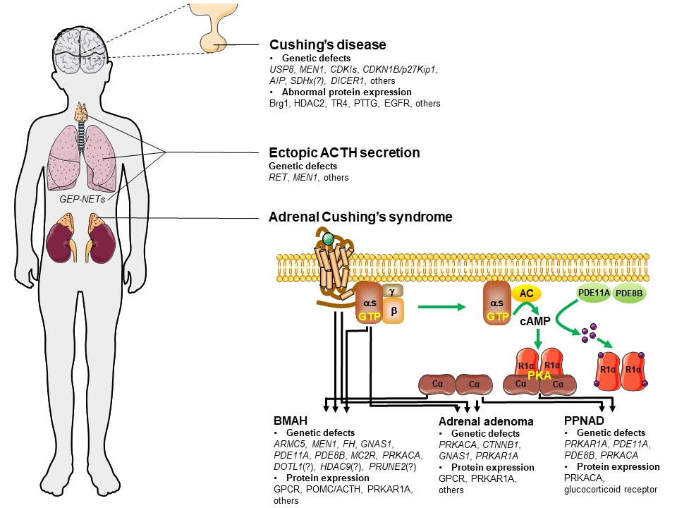

**Figure 5. Genetic defects of Cushing’s disease and Cushing’s syndrome. AC: adenylate cyclase; ACTH: adrenocorticotropic hormone; AIP: aryl-hydrocarbon receptor-interacting protein; ARMC5: armadillo repeat containing 5; BMAH: bilateral macronodular adrenal hyperplasia; Brg1: Brahma‐related gene 1; Cα: catalytic subunit of PKA; CDKI: cyclin-dependent kinase inhibitor; CDKN1B (also known as p27Kip1); CTNNB1: catenin beta 1; DOT1: Disruptor of telomeric silencing 1; EGFR: epidermal growth factor receptor; GNAS: Guanine Nucleotide binding protein; GPCR: G-protein-coupled receptor; HDAC2: Histone Deacetylase 2; MC2R: melanocortin 2 receptor; MEN1: multiple endocrine neoplasia 1; PDEs: phosphodiesterases; PKA: protein kinase A; POMC: Pro-opiomelanocortin; PPNAD: primary pigmented nodular adrenocortical disease; PRUNE2: prune homologue 2; PTTG: pituitary transforming gene; Rlα: type 1α regulatory subunit of PKA; SDH: succinate dehydrogenase subunit; TR4: testicular orphan receptor 4; USP8: ubiquitin-specific peptidase 8.**

ADRENOCORTICAL CARCINOMA

Adrenocortical carcinoma is a very rare pathologic condition which may occur at any age with a first peak before the age of 5 years and a second peak in adulthood between the fourth and fifth decades (54). It may be present in the context of Li-Fraumeni syndrome, which is caused by germline mutations in *TP53* gene, a tumor suppressor gene located on chromosome 17. In contradistinction to adrenocortical carcinomas found in adults, mutations in the *CTNNB1* gene that encodes for β-catenin are not frequently detected (55). Adrenocortical carcinoma in children usually presents with hypertension and increased concentrations of adrenal androgens, especially DHEAS, causing virilization, early pubarche, altered voice timber and irritability.

McCUNE-ALBRIGHT SYNDROME

This rare syndrome is characterized by the classic triad of cafe-au-lait skin macules, polyostotic fibrous dysplasia, and hyperfunctioning endocrinopathies (56). The molecular basis of this condition has been ascribed to postzygotic somatic activating mutations in the *GNAS1* gene encoding for the alpha subunit of Gs protein (57). Hypertension in McCune-Albright syndrome has been associated with Cushing syndrome, often seen in infancy, thyrotoxicosis, or hypersecretion of growth hormone (58).

CARNEY COMPLEX

Carney complex is inherited in an autosomal-dominant fashion and is caused by mutations in the *PRKAR1A* gene (17q22-24) encoding the regulatory subunit type I alpha of protein kinase A (59). The cardinal clinical manifestations often seen in patients with the complex include lentigines, cardiac and breast myxomas, and PPNAD that causes ACTH-independent Cushing’s syndrome (60, 61). The latter is responsible for hypertension in these patients.

**DISORDERS OF THE ADRENAL MEDULLA**

**Conditions with Catecholamine Excess**

PHEOCHROMOCYTOMA AND PARAGANGLIOMA

Pheochromocytomas and paragangliomas are rare tumors that produce and release excess amount of catecholamines into the systemic circulation. They both account for 0.5%-2% of hypertension in children and adolescents (62). According to Sarathi, 10% of pediatric pheochromocytomas and paragangliomas are malignant, 20% of them are synchronous bilateral, 30% are extra-adrenal, and 40% are familial (63). These tumors occur more frequently in boys (60%), present with hypertension (70%), and may be sporadic or in the context of specific syndromes, including neurofibromatosis type 1 caused by *NF1* gene mutations, Von Hippel-Lindau disease type 2 due to *VHL* genetic defects, and multiple endocrine neoplasia type 2 caused by mutations in the *RET* gene (64). Rarely, pheochromocytomas and paragangliomas may present in paragangliomas syndromes caused by germline mutations in genes encoding the subunits D, AF2, C, B, and A of succinate dehydrogenase (SDH), or in the Pacak-Zhuang syndrome due to activating genetic defects in hypoxia-inducible factor 2 alpha (HIF2A), or in familial pheochromocytomas characterized by Myc-associated protein X (MAX) and transmembrane protein 127 (TMEM127) gene mutations. Although an ever-increasing number of predisposing genes have been identified so far, it is worth mentioning that most genetic defects in patients with pheochromocytomas and paragangliomas remain unidentified (65). Clinical manifestations include hypertension in 70%-90% of pediatric patients, flushing, hyperhidrosis, palpitations, tremors, headaches, nausea and/or vomiting during exercise, hyperactivity, or worsening of school performance. According to the recently published international consensus statement on the diagnostic work-up and the therapeutic management of pheochromocytomas and paragangliomas (66), the laboratory evaluation includes plasma-free or urine (spot or 24-h) levels of normetanephrine and metanephrine using liquid chromatography. In those children and adolescents with elevated concentrations of catecholamines, either MRI or CT should be performed for tumor localization (66). In cases of multiple and/or metastatic lesions, functional imaging, including [68Ga]DOTATATE, [18F]fluorodopa (FDOPA), and [18F]fluorodeoxyglucose (FDG) PET–CT, as well as [123I]MIBG scintigraphy, should be considered. All children with pheochromocytomas or paragangliomas are highly recommended to undergo genetic testing for germline mutations (65, 66). Surgical resection remains the treatment of choice in specialized centers with a multidisciplinary team. It is worth mentioning that minimally invasive procedures are preferred in cases with abdominal and pelvic pheochromocytomas and paragangliomas. Finally, special attention should be focused on preoperative treatment of hypertension using α-adrenoceptor blockers or calcium channel blockers or beta-adrenoceptor blockers especially in patients with persistent tachycardia (66, 67).

**RENAL DISEASES MIMICKING ADRENAL DISORDERS**

**Syndromes of Inappropriate Salt Retention**

LIDDLE SYNDROME

Patients with Liddle syndrome present with hypertension starting at about two years of age, although the average age of hypertension onset was 15.5 ± 3.3 years, according to the large series of cases (68). In addition to early-onset hypertension, patients with this condition display hypokalemia, metabolic alkalosis, and suppressed PAC. The genetic basis of Liddle syndrome has been ascribed to activating mutations in the sodium channel epithelial 1 alpha, beta and gamma (*SCNN1A*, *SCNN1B*, and *SCNN1G*) genes that encode for the α, β, and γ subunits, respectively, of the epithelial sodium channel (ENaC) of the renal tubule, also known as the amiloride-sensitive channel (Figure 6) (69). ENaC inhibitors, such as amiloride or triamterene, with low salt diet remain the only effective treatment in patients with Liddle syndrome (70).

GORDON SYNDROME OR PSEUDOHYPOALDOSTERONISM TYPE 2 OR FAMILIAL HYPERKALEMIC HYPERTENSION

Gordon syndrome or type II pseudohypoaldosteronism (PHA II) is inherited in an autosomal dominant fashion and is characterized by hypertension, metabolic acidosis, hyperkalemia and hyperchloremia (71). Endocrinologic evaluation reveals low PRA and, usually, decreased serum aldosterone concentrations (71). Five subtypes of PHA II have been reported with distinct genetic defects (72). The genetic basis of PHA II-A is less known, since no genetic defect has been identified yet; however, this subtype has been associated with chromosome region 1q31-q42. PHA II-B has been linked to mutations in the with-no-lysine kinase (*WNK4*) gene (17q21), whereas genetic defects in the *WNK1* gene (12p12.3.) have been associated with PHA II-C (Figure 6). *WNK* genes encode WNK proteins, which function as serine-threonine protein kinases regulating the expression and action of cation-Cl− cotransporters (CCCs) such as the sodium chloride cotransporter (NCC), basolateral Na-K-Cl symporter (NKCC1), and potassium chloride cotransporter (KCC1) located within the distal nephron. Patients with PHA II-D and -E harbor variations in kelch-like 3 (*KLHL3*) gene (5q31.2) that encodes for the adaptor protein KLHL3, and cullin-3 (*CUL3*) gene (2q36) expressing the ubiquitin scaffold protein CUL3, respectively (Figure 6) (73, 74). Generally, patients with Gordon syndrome respond adequately to low sodium diet and thiazide diuretics (28).

GELLER SYNDROME (MR ACTIVATING MUTATION SYNDROME)

Geller syndrome is a rare autosomal dominant disorder characterized by hypertension, hypokalemia, low PRA, and low serum aldosterone concentrations (2). Patients with Geller syndrome harbor an activating mutation in the *NR3C2* gene that encodes for the mineralocorticoid receptor (MR) (Figure 6) (75, 76). This genetic defect leads to aberrant activation of the MR by cortisone, 11-DOC, and progesterone, all acting as antagonists of the wild-type MR; therefore, hypertension worsens during pregnancy due to increased progesterone concentrations. The therapeutic management includes administration of amiloride and finerenone (77).

APPARENT MINERALOCORTICOID EXCESS (AME) SYNDROME (11β-Hydroxysteroid Dehydrogenase Deficiency Type 2)

This syndrome is caused by inactivating genetic defects in the 11β-hydroxysteroid dehydrogenase type 2 (*HSD11B2*) gene that encodes for the enzyme 11β-hydroxysteroid dehydrogenase type 2 converting cortisol to inactive cortisone in aldosterone-responsive target tissues (Figure 6) (e.g., kidney) (78). The resultant high concentrations of cortisol bind to mineralocorticoid receptors which induce the expression of several responsive genes leading to hypertension, low renin and aldosterone concentrations, hypernatremia, hypokalemia, and metabolic alkalosis. In addition to hypertension, patients with AME syndrome may present with short stature, failure to thrive, polyuria, polydipsia, as well as hypercalciuria and nephrocalcinosis (78). To reach the diagnosis, a high ratio of 5b and 5a-tetrahydrocortisol steroids to tetrahydrocortisone in the urine should be confirmed, followed by sequencing of the *HSD11B2* gene. Treatment should begin early to prevent left ventricular hypertrophy and/or cerebrovascular events, and includes spironolactone to block mineralocorticoid receptor activation, restriction of dietary intake of sodium, and potassium supplementation. In cases of nephrocalcinosis, patients should also receive chlorothiazide or hydrochlorothiazide to minimize hypercalciuria (78). Dexamethasone might be also administered as monotherapy or in addition to spironolactone, since dexamethasone reduces the activity of the hypothalamic-pituitary-adrenal axis through negative feedback loops at the levels of hypothalamus and pituitary. Moreover, dexamethasone does not have any affinity to 11β-HSD2 (78).

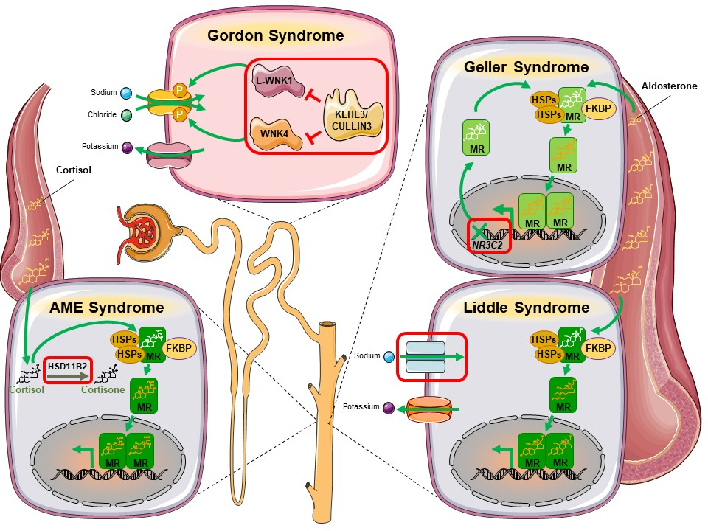

**Figure 6. Genetic defects of renal disorders mimicking adrenal diseases. Apparent Mineralocorticoid Excess (AME) syndrome is caused by inactivating genetic defects in the *HSD11B2* that encodes for the 11β-hydroxysteroid dehydrogenase type 2 converting cortisol to inactive cortisone. The molecular basis of Gordon syndrome has been ascribed to mutations in the *WNK* genes expressing proteins that function as serine-threonine protein kinases regulating the expression and action of cation-Cl− cotransporters, such as the sodium chloride cotransporter. Gordon syndrome is also caused by mutations in *KLHL3* that encodes for the adaptor protein KLHL3, as well as in *CUL3* expressing the ubiquitin scaffold protein CUL3. Geller syndrome has been associated with activating mutations in the *NR3C2* that encodes for the mineralocorticoid receptor. Liddle syndrome is caused by mutations in the *SCNN1A*, *SCNN1B*, and *SCNN1G* encoding for the α, β, and γ subunits, respectively, of the epithelial sodium channel (ENaC) of the renal tubule. HSD11B2: 11β-hydroxysteroid dehydrogenase type 2; HSPs: heat shock proteins; FKBP: immunophilin; KLHL3: kelch-like 3; MR: mineralocorticoid receptor; NR3C2: nuclear receptor subfamily 3 group C member 2; WNK: with-no-lysine kinase.**

**OTHER CAUSES OF ENDOCRINE HYPERTENSION**

**Acromegaly**

In children and adolescents, growth hormone (GH) excess is rare. Its prevalence is approximately 30 cases per million in children aged 0-17 years in United States without any differences between males and females (79). Acromegaly is usually caused by a GH-secreting pituitary adenoma, but other less common causes include pituitary hyperplasia, multiple adenomas, or extremely rare cases of tumors secreting growth hormone-releasing hormone (GHRH) (80). In 45% of cases, the molecular basis of GH-secreting adenomas or hyperplasia has been attributed to identifiable genetic defects, including mutations in the *AIP* gene (˃20%), duplications in the *GPR101* gene that cause X-LAG, post-zygotic mosaic *GNAS* mutations responsible for McCune-Albright syndrome (5%), whereas genetic defects in other genes, such as *MEN1*, *CDKN1B*, *PRKAR1A*, *PRKACB* and *SDH* contribute in less than 1% each (81). Typical clinical manifestations in children and adolescents with acromegaly include overgrowth and tall stature if excess secretion of GH occurs before epiphyseal closure, acral enlargement, rectangular face, prognathism, headache, visual filed defects, sweating, delayed puberty, left ventricular hypertrophy, diastolic dysfunction, sleep apnea, hypertension, as well as glucose intolerance or even diabetes (79). The biochemical diagnosis of GH excess relies on elevated age-adjusted serum IGF-1 concentrations and failure to suppress GH following an oral glucose tolerance test. Treatment options include surgery, medical therapy, and radiotherapy (79).

**Thyroid / Parathyroid Dysfunction**

Thyroid or parathyroid dysfunction has been associated with hypertension in children and adolescents. Hypothyroidism is usually associated with increased diastolic blood pressure, whereas hyperthyroidism with elevated systolic blood pressure (82). In addition to thyroid disorders, hypertension has also been reported in patients with parathyroid dysfunction, although there are no data on its prevalence (83).

**CONCLUSIONS**

Endocrine hypertension in children is most often caused by excess steroids, with other hormonal abnormalities far less frequent. The tremendous progress on endocrine genetics and molecular biology has enabled a deeper understanding of the genetic basis of several endocrine pathologic conditions leading to hypertension. A detailed medical history and physical examination, as well as a careful interpretation of laboratory and hormonal results may lead to an early and accurate diagnosis (Figure 7). The appropriate therapeutic management of these conditions is of paramount importance to prevent long term cardiovascular and other systemic complications.

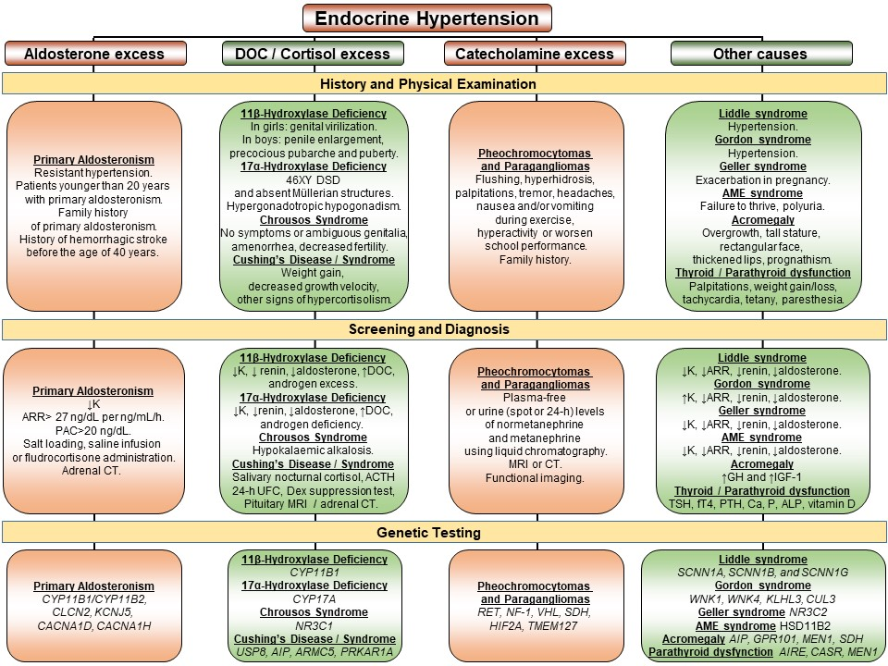

**Figure 7. Diagnostic approach to endocrine hypertension.**

**REFERENCES**

1. Flynn JT, Kaelber DC, Baker-Smith CM, Blowey D, Carroll AE, Daniels SR, de Ferranti SD, Dionne JM, Falkner B, Flinn SK, Gidding SS, Goodwin C, Leu MG, Powers ME, Rea C, Samuels J, Simasek M, Thaker VV, Urbina EM; SUBCOMMITTEE ON SCREENING AND MANAGEMENT OF HIGH BLOOD PRESSURE IN CHILDREN. Clinical Practice Guideline for Screening and Management of High Blood Pressure in Children and Adolescents. Pediatrics. 2017 Sep;140(3):e20171904.

2. Kotanidou EP, Giza S, Tsinopoulou VR, Vogiatzi M, Galli-Tsinopoulou A. Diagnosis and Management of Endocrine Hypertension in Children and Adolescents. Curr Pharm Des 2020;26(43):5591-5608.

3. Baracco R, Kapur G, Mattoo T, Jain A, Valentini R, Ahmed M, Thomas R. Prediction of primary vs secondary hypertension in children. J Clin Hypertens (Greenwich). 2012 May;14(5):316-21.

4. Gupta-Malhotra M, Banker A, Shete S, Hashmi SS, Tyson JE, Barratt MS, Hecht JT, Milewicz DM, Boerwinkle E. Essential hypertension vs. secondary hypertension among children. Am J Hypertens. 2015 Jan;28(1):73-80.

5. Pons Fernández N, Moreno F, Morata J, Moriano A, León S, De Mingo C, Zuñiga Á, Calvo F. Familial hyperaldosteronism type III a novel case and review of literature. Rev Endocr Metab Disord. 2019 Mar;20(1):27-36.

6. He X, Modi Z, Else T. Hereditary causes of primary aldosteronism and other disorders of apparent excess mineralocorticoid activity. Gland Surg. 2020 Feb;9(1):150-158.

7. Baguet JP, Steichen O, Mounier-Véhier C, Gosse P. SFE/SFHTA/AFCE consensus on primary aldosteronism, part 1: Epidemiology of PA, who should be screened for sporadic PA? Ann Endocrinol (Paris). 2016 Jul;77(3):187-91.

8. Li X, Goswami R, Yang S, Li Q. Aldosterone/direct renin concentration ratio as a screening test for primary aldosteronism: A meta-analysis. J Renin Angiotensin Aldosterone Syst 2016 Aug 17;17(3):1470320316657450.

9. Reznik Y, Amar L, Tabarin A. SFE/SFHTA/AFCE consensus on primary aldosteronism, part 3: Confirmatory testing. Ann Endocrinol (Paris). 2016 Jul;77(3):202-7.

10. Bardet S, Chamontin B, Douillard C, Pagny JY, Hernigou A, Joffre F, Plouin PF, Steichen O. SFE/SFHTA/AFCE consensus on primary aldosteronism, part 4: Subtype diagnosis. Ann Endocrinol (Paris). 2016 Jul;77(3):208-13.

11. Pechère-Bertschi A, Herpin D, Lefebvre H. SFE/SFHTA/AFCE consensus on primary aldosteronism, part 7: Medical treatment of primary aldosteronism. Ann Endocrinol (Paris) 2016 Jul;77(3):226-34.

12. Lifton RP, Dluhy RG, Powers M, et al. A chimaeric 11 beta-hydroxylase/aldosterone synthase gene causes glucocorticoid-remediable aldosteronism and human hypertension. Nature 1992;355:262-5.

13. Zennaro MC, Jeunemaitre X. SFE/SFHTA/AFCE consensus on primary aldosteronism, part 5: Genetic diagnosis of primary aldosteronism. Ann Endocrinol (Paris). 2016 Jul;77(3):214-9.

14. Stowasser M, Bachmann AW, Jonsson JR, et al. Clinical, biochemical and genetic approaches to the detection of familial hyperaldosteronism type I. J Hypertens 1995;13:1610-3.

15. Mulatero P, Veglio F, Pilon C, et al. Diagnosis of Glucocorticoid-Remediable Aldosteronism in Primary Aldosteronism: Aldosterone Response to Dexamethasone and Long Polymerase Chain Reaction for Chimeric Gene. J Clin Endocrinol Metab 1998;83:2573-5.

16. Nimkarn S, New M. Endocrine Hypertension in Childhood. Kenneth R Feingold, Bradley Anawalt, Marc R Blackman, Alison Boyce, George Chrousos, Emiliano Corpas, Wouter W de Herder, Ketan Dhatariya, Kathleen Dungan, Johannes Hofland, Sanjay Kalra, Gregory Kaltsas, Nitin Kapoor, Christian Koch, Peter Kopp, Márta Korbonits, Christopher S Kovacs, Wendy Kuohung, Blandine Laferrère, Miles Levy, Elizabeth A McGee, Robert McLachlan, Maria New, Jonathan Purnell, Rakesh Sahay, Amy S Shah, Frederick Singer, Mark A Sperling, Constantine A Stratakis, Dace L Trence, Don P Wilson, editors. In: Endotext [Internet]. South Dartmouth (MA): MDText.com, Inc.; 2000. 2017 Mar 3.

17. Funder JW, Carey RM, Mantero F, Murad MH, Reincke M, Shibata H, Stowasser M, Young WF Jr. The Management of Primary Aldosteronism: Case Detection, Diagnosis, and Treatment: An Endocrine Society Clinical Practice Guideline. J Clin Endocrinol Metab. 2016 May;101(5):1889-916.

18. Scholl UI, Stolting G, Schewe J, Thiel A, Tan H, Nelson-Williams C, et al. CLCN2 chloride channel mutations in familial hyperaldosteronism type II. Nat Genet. 2018;50(3):349-54.

19. Fernandes-Rosa FL, Daniil G, Orozco IJ, Goppner C, El Zein R, Jain V, et al. A gain-of-function mutation in the CLCN2 chloride channel gene causes primary aldosteronism. Nat Genet. 2018;50(3):355-61.

20. Mulatero P, Williams TA, Monticone S, Veglio F. Is familial hyperaldosteronism underdiagnosed in hypertensive children? Hypertension. 2011 Jun;57(6):1053-5.

21. Scholl UI, Stölting G, Schewe J, Thiel A, Tan H, Nelson-Williams C, Vichot AA, Jin SC, Loring E, Untiet V, Yoo T, Choi J, Xu S, Wu A, Kirchner M, Mertins P, Rump LC, Onder AM, Gamble C, McKenney D, Lash RW, Jones DP, Chune G, Gagliardi P, Choi M, Gordon R, Stowasser M, Fahlke C, Lifton RP. CLCN2 chloride channel mutations in familial hyperaldosteronism type II. Nat Genet. 2018 Mar;50(3):349-354.

22. Perez-Rivas LG, Williams TA, Reincke M. Inherited Forms of Primary Hyperaldosteronism: New Genes, New Phenotypes and Proposition of A New Classification. Exp Clin Endocrinol Diabetes. 2019 Feb;127(2-03):93-99.

23. Hassan-Smith Z, Stewart PM. Inherited forms of mineralocorticoid hypertension. Curr Opin Endocrinol Diabetes Obes. 2011 Jun;18(3):177-85.

24. Choi M, Scholl UI, Yue P, Björklund P, Zhao B, Nelson-Williams C, Ji W, Cho Y, Patel A, Men CJ, Lolis E, Wisgerhof MV, Geller DS, Mane S, Hellman P, Westin G, Åkerström G, Wang W, Carling T, Lifton RP. K+ channel mutations in adrenal aldosterone-producing adenomas and hereditary hypertension. Science. 2011 Feb 11;331(6018):768-72.

25. Geller DS, Zhang J, Wisgerhof MV, Shackleton C, Kashgarian M, Lifton RP. A novel form of human mendelian hypertension featuring nonglucocorticoid-remediable aldosteronism. J Clin Endocrinol Metab. 2008 Aug;93(8):3117-23.

26. Monticone S, Buffolo F, Tetti M, Veglio F, Pasini B, Mulatero P. GENETICS IN ENDOCRINOLOGY: The expanding genetic horizon of primary aldosteronism. Eur J Endocrinol. 2018 Mar;178(3):R101-R111.

27. Scholl UI, Goh G, Stolting G, de Oliveira RC, Choi M, Overton JD, et al. Somatic and germline CACNA1D calcium channel mutations in aldosterone-producing adenomas and primary aldosteronism. Nat Genet. 2013;45(9):1050-4.

28. Costa-Barbosa FA, Giorgi RB, Kater CE. Focus on adrenal and related causes of hypertension in childhood and adolescence: Rare or rarely recognized? Arch Endocrinol Metab. 2022 Nov 17;66(6):895-907.

29. Hinz L, Pacaud D, Kline G. Congenital adrenal hyperplasia causing hypertension: an illustrative review. J Hum Hypertens. 2018 Feb;32(2):150-157.

30. Bulsari K, Falhammar H. Clinical perspectives in congenital adrenal hyperplasia due to 11beta-hydroxylase deficiency. Endocrine. 2017;55(1):19-36.

31. Mimouni M, Kaufman H, Roitman A, Morag C, Sadan N. Hypertension in a neonate with 11 beta-hydroxylase deficiency. Eur J Pediatr. 1985;143(3):231-3.

32. Kater CE, Biglieri EG. Disorders of steroid 17 alpha-hydroxylase deficiency. Endocrinol Metab Clin North Am. 1994;23(2):341-57.

33. Biglieri EG, Kater CE, Brust N, Chang B, Hirai J. The mineralocorticoid hormone pathways in hypertension with hyperaldosteronism. Clin Exp Hypertens A. 1982;4(9-10):1677 -83.

34. Biglieri EG, Herron MA, Brust N. 17-hydroxylation deficiency in man. J Clin Invest. 1966;45(12):1946-54.

35. Chrousos GP, Vingerhoeds A, Brandon D, Eil C, Pugeat M, DeVroede M, Loriaux DL, Lipsett MB. Primary cortisol resistance in man. A glucocorticoid receptor-mediated disease. J Clin Invest. 1982 Jun;69(6):1261-9.

36. Nicolaides NC, Charmandari E. Primary Generalized Glucocorticoid Resistance and Hypersensitivity Syndromes: A 2021 Update. Int J Mol Sci. 2021 Oct 7;22(19):10839.

37. Nicolaides NC, Charmandari E. Novel insights into the molecular mechanisms underlying generalized glucocorticoid resistance and hypersensitivity syndromes. Hormones (Athens) 2017 Apr;16(2):124-138.

38. Nicolaides NC, Charmandari E. Chrousos syndrome: from molecular pathogenesis to therapeutic management. Eur J Clin Invest. 2015 May;45(5):504-14.

39. Nicolaides N, Lamprokostopoulou A, Sertedaki A, Charmandari E. Recent advances in the molecular mechanisms causing primary generalized glucocorticoid resistance. Hormones (Athens). 2016 Jan-Mar;15(1):23-34.

40. Guemes M, Murray PG, Brain CE, Spoudeas HA, Peters CJ, Hindmarsh PC, et al. Management of Cushing syndrome in children and adolescents: experience of a single tertiary centre. Eur J Pediatr. 2016;175(7):967-76.

41. Cicala MV, Mantero F. Hypertension in Cushing’s syndrome: from pathogenesis to treatment. Neuroendocrinology. 2010;92 Suppl 1:44-9.

42. Magiakou MA, Chrousos GP. Cushing’s syndrome in children and adolescents: current diagnostic and therapeutic strategies. J Endocrinol Invest. 2002;25(2):181-94.

43. Greening JE, Brain CE, Perry LA, Mushtaq I, Sales Marques J, Grossman AB, et al. Efficient short-term control of hypercortisolaemia by low-dose etomidate in severe paediatric Cushing’s disease. Horm Res. 2005;64(3):140-3.

44. Tatsi C, Stratakis CA. Aggressive pituitary tumors in the young and elderly. Rev Endocr Metab Disord 2020;21(2):213–223

45. Karageorgiadis AS, Papadakis GZ, Biro J, Keil MF, Lyssikatos C, Quezado MM, Merino M, Schrump DS, Kebebew E, Patronas NJ, Hunter MK, Alwazeer MR, Karaviti LP, Balazs AE, Lodish MB, Stratakis CA. Ectopic adrenocorticotropic hormone and corticotropin-releasing hormone co-secreting tumors in children and adolescents causing cushing syndrome: a diagnostic dilemma and how to solve it. J Clin Endocrinol Metab 2015;100(1):141-148.

46. Tatsi C, Stratakis CA. Neonatal Cushing syndrome: a rare but potentially devastating disease. Clin Perinatol 2018;45:103–118.

47. Chan LF, Storr HL, Grossman AB, Savage MO. Pediatric Cushing’s syndrome: clinical features, diagnosis, and treatment. Arq Bras Endocrinol Metabol. 2007;51(8):1261-71.

48. Faucz FR, Tirosh A, Tatsi C, Berthon A, Hernández-Ramírez LC, Settas N, Angelousi A, Correa R, Papadakis GZ, Chittiboina P, Quezado M, Pankratz N, Lane J, Dimopoulos A, Mills JL, Lodish M, Stratakis CA. Somatic USP8 Gene Mutations Are a Common Cause of Pediatric Cushing Disease. J Clin Endocrinol Metab. 2017;102(8):2836-2843.

49. Tatsi C, Flippo C, Stratakis CA. Cushing syndrome: Old and new genes. Best Pract Res Clin Endocrinol Metab. 2020 Mar;34(2):101418.

50. Stratakis CA. Cushing syndrome caused by adrenocortical tumors and hyperplasias (corticotropin-independent Cushing syndrome). Endocr Dev 2008;13:117–132.

51. De Venanzi A, Alencar GA, Bourdeau I, et al. Primary bilateral macronodular adrenal hyperplasia. Curr Opin Endocrinol Diabetes Obes 2014;21(3):177–184.

52. Powell AC, Stratakis CA, Patronas NJ, et al. Operative management of Cushing syndrome secondary to micronodular adrenal hyperplasia. Surgery 2008; 143(6):750-758.

53. Assie´ G, Libe´ R, Espiard S, et al. ARMC5 mutations in macronodular adrenal hyperplasia with Cushing’s syndrome. N Engl J Med 2013;369(22):2105–2114.

54. Pereira RM, Michalkiewicz E, Sandrini F, Figueiredo BC, Pianovski M, Franca SN, et al. [Childhood adrenocortical tumors]. Arq Bras Endocrinol Metabol. 2004;48(5):651-8.

55. Leal LF, Mermejo LM, Ramalho LZ, Martinelli CE Jr, Yunes JA, Seidinger AL, et al. Wnt/beta-catenin pathway deregulation in childhood adrenocortical tumors. J Clin Endocrinol Metab. 2011;96(10):3106-14.

56. Boyce AM, Collins MT. Fibrous Dysplasia/McCune-Albright Syndrome: A Rare, Mosaic Disease of Gα s Activation. Endocr Rev. 2020 Apr 1;41(2):345-370.

57. Weinstein LS, Shenker A, Gejman PV, Merino MJ, Friedman E, Spiegel AM. Activating mutations of the stimulatory G protein in the McCune-Albright syndrome. N Engl J Med. 1991 Dec 12;325(24):1688-95.

58. Ohata Y, Yamamoto T, Mori I, Kikuchi T, Michigami T, Imanishi Y, et al. Severe arterial hypertension: a possible complication of McCune-Albright syndrome. Eur J Pediatr. 2009;168(7):871-6.

59. Kirschner LS, Carney JA, Pack SD, Taymans SE, Giatzakis C, Cho YS, Cho-Chung YS, Stratakis CA. Mutations of the gene encoding the protein kinase A type I-alpha regulatory subunit in patients with the Carney complex. Nat Genet. 2000 Sep;26(1):89-92.

60. Carney JA, Gordon H, Carpenter PC, Shenoy BV, Go VL. The complex of myxomas, spotty pigmentation, and endocrine overactivity. Medicine (Baltimore). 1985 Jul;64(4):270-83.

61. Stratakis CA. Carney Complex. 2003 Feb 5 [updated 2023 Sep 21]. In: Adam MP, Feldman J, Mirzaa GM, Pagon RA, Wallace SE, Bean LJH, Gripp KW, Amemiya A, editors. GeneReviews® [Internet]. Seattle (WA): University of Washington, Seattle; 1993–2024.

62. Havekes B, Romijn JA, Eisenhofer G, Adams K, Pacak K. Update on pediatric pheochromocytomas. Pediatr Nephrol. 2009;24(5):943-950

63. Sarathi V. Characteristics of Pediatric Pheochromocytoma/paragangliomas. Indian J Endocrinol Metab. 2017;21(3):470-474.

64. Bholah R and Bunchman TE. Review of Pediatric Pheochromocytoma and Paraganglioma. Front Pediatr. 2017;5:155.

65. Pamporaki C, Casey RT. Current views on paediatric phaeochromocytoma and paraganglioma with a focus on newest guidelines. Best Pract Res Clin Endocrinol Metab 2024 Nov 14:101957.

66. Casey RT, Hendriks E, Deal C, Waguespack SG, Wiegering V, Redlich A, et al. International consensus statement on the diagnosis and management of phaeochromocytoma and paraganglioma in children and adolescents. Nat Rev Endocrinol. 2024 Dec;20(12):729-748.

67. Romero M, Kapur G, Baracco R, et al. Treatment of hypertension in children with catecholamine-secreting tumors: a systematic approach. J Clin Hypertens 2015;17(9):720-725.

68. Cui Y, Tong A, Jiang J, Wang F, Li C. Liddle syndrome: clinical and genetic profiles. J Clin Hypertens (Greenwich). 2017;19(5):524-9.

69. Tetti M, Monticone S, Burrello J, Matarazzo P, Veglio F, Pasini B, et al. Liddle Syndrome: Review of the Literature and Description of a New Case. Int J Mol Sci. 2018;19(3).

70. Enslow BT, Stockand JD, Berman JM. Liddle’s syndrome mechanisms, diagnosis and management. Integr Blood Press Control. 2019;12:13-22.

71. Gordon RD, Geddes RA, Pawsey CG, O'Halloran MW. Hypertension and severe hyperkalaemia associated with suppression of renin and aldosterone and completely reversed by dietary sodium restriction. Australas Ann Med. 1970 Nov;19(4):287-94.

72. Mabillard H, Sayer JA. The Molecular Genetics of Gordon Syndrome. Genes (Basel). 2019;10(12).

73. Casas-Alba D, Vila Cots J, Monfort Carretero L, Martorell Sampol L, Zennaro MC, Jeunemaitre X, et al. Pseudohypoaldosteronism types I and II: little more than a name in common. J Pediatr Endocrinol Metab. 2017;30(5):597-601.

74. Boyden LM, Choi M, Choate KA, Nelson-Williams CJ, Farhi A, Toka HR, et al. Mutations in kelch-like 3 and cullin 3 cause hypertension and electrolyte abnormalities. Nature. 2012;482(7383):98-102.

75. Ceccato F, Mantero F. Monogenic Forms of Hypertension. Endocrinol Metab Clin North Am. 2019;48(4):795-810.

76. Geller DS, Farhi A, Pinkerton N, Fradley M, Moritz M, Spitzer A, et al. Activating mineralocorticoid receptor mutation in hypertension exacerbated by pregnancy. Science. 2000;289(5476):119-23.

77. Zennaro MC, Boulkroun S, Fernandes-Rosa F. Inherited forms of mineralocorticoid hypertension. Best Pract Res Clin Endocrinol Metab. 2015 Aug;29(4):633-45.

78. Lu YT, Zhang D, Zhang QY, Zhou ZM, Yang KQ, Zhou XL, Peng F. Apparent mineralocorticoid excess: comprehensive overview of molecular genetics. J Transl Med. 2022;20(1):500.

79. Maiter D, Chanson P, Constantinescu SM, Linglart A. Diagnosis and management of pituitary adenomas in children and adolescents. Eur J Endocrinol. 2024 Sep 30;191(4):R55-R69.

80. Asa SL, Ezzat S. An update on pituitary neuroendocrine tumors leading to acromegaly and gigantism. J Clin Med. 2021;10(11): 2254.

81. Rostomyan L, Daly AF, Petrossians P, et al. Clinical and genetic characterization of pituitary gigantism: an international collaborative study in 208 patients. Endocr Relat Cancer. 2015;22(5):745-757.

82. Berta E, Lengyel I, Halmi S, Zrínyi M, Erdei A, Harangi M, Páll D, Nagy EV, Bodor M. Hypertension in Thyroid Disorders. Front Endocrinol (Lausanne). 2019 Jul 17:10:482.

83. de Freminville JB, Amar L, Azizi M, Mallart-Riancho J. Endocrine causes of hypertension: literature review and practical approach. Hypertens Res. 2023 Dec;46(12):2679-2692.