**ENDOCRINE HYPERTENSION IN CHILDHOOD**

**Saroj Nimkarn, MD** Bumrungrad Hospital, 33 Sukhumvit 3, Bangkok, 10110, Thailand [snimkarn@gmail.com](mailto:snimkarn@gmail.com)

**Kansuda Ariyawatkul MD** Panyananthaphikkhu Chonprathan Medical Center, Srinakharinwirot University, Nonthaburi, Thailand

**Maria New, MD** Professor of Pediatrics, Professor of Genetics and Genomic Sciences, Director, Adrenal Steroid Disorders Program, Department of Pediatrics, Icahn School of Medicine at Mount Sinai, New York, New York

**Revised 1/26/2017**

ABSTRACTHypertension in children is an important health issue and deserves a greater awareness among health care providers and the general population. When evaluating a suspected hypertensive child, it is essential that clinicians utilize proper tools to measure and interpret the blood pressure (BP) readings. The preferred method is auscultation using a mercury sphygmomanometer connected to the appropriate size cuff. Systolic blood pressure (BP) is determined by the onset of the "tapping" Korotkoff sounds (K1) while diastolic DBP is defined as the fifth Korotkoff sound (K5), or the disappearance of Korotkoff sounds. Automated devices can be used for BP measurement in newborns and young infants, in whom auscultation is difficult. An elevated BP reading obtained with an oscillometric device should be repeated with auscultation. To determine percentile of BP, the values are compared to normal BP in children and adults adjusted for age, sex and height. For complete coverage of this and related areas in Endocrinology, visit our free web-books, [www.endotext.org](http://www.endotext.org) and [www.thyroidmanager.org](http://www.thyroidmanager.org).

## INTRODUCTION

Hypertension is defined as average systolic BP and/or diastolic BP that is ≥95th percentile for gender, age, and height on ≥3 occasions (1, 2). Regulation of systemic BP is a function of three components: intravascular volume, cardiac output and peripheral resistance. The effect(s) of steroids on one or more of these components contribute to BP control. The binding of glucocorticoids (GCs) to its receptor enhances the vascular smooth muscle response to vasopressive agents. Activation of the mineralocorticoid (MC) receptor by the ligands leads to an increase in sodium resorption which results in water retention and intravascular volume expansion. These hemodynamic changes affect peripheral resistance and cardiac output, which in turn regulates systemic BP.

The human adrenal gland is composed of a cortex and a medulla. While adrenal medulla produces bioamines that act as vasopressors, the cortex secretes classes of steroids. In the cortices, there are three distinct zones, each having a characteristic steroid profile (figure 1). In the outer most unit, zona glomerulosa, MCs are produced. The main MC in a physiologic state is aldosterone. Principal regulators of aldosterone secretion are the renin-angiotensin system and the serum potassium concentration. Other regulators, such as the adrenocorticotropic hormone (ACTH), atrial natriuretic factors of cardiac origin and local dopamine secreted within the adrenal, play minor roles. Decreases in intravascular volume result in increased secretion of renin by the renal juxtaglomerular apparatus. Renin acts as a proteolytic enzyme by cleaving angiotensinogen, and changes it to angiotensin I. Angiotensin I is then cleaved and activated by angiotensin-converting enzyme (ACE) in the lung and in other peripheral sites. Angiotensin II and its metabolite, angiotensin III, possess vasopressor and potent aldosterone secretory activity (figure 2). Once bound to the mineralocortiocoid receptor (MR), aldosterone enhances sodium resorption and the subsequent osmotic reabsorption of water through sodium-permeable channels in the apical membranes of the epithelial cells lining the distal tubules and collection ducts of the kidney. This results in an expanded blood volume and suppression of renin secretion. Potassium excretion also occurs as an ion exchange from the aldosterone effect.

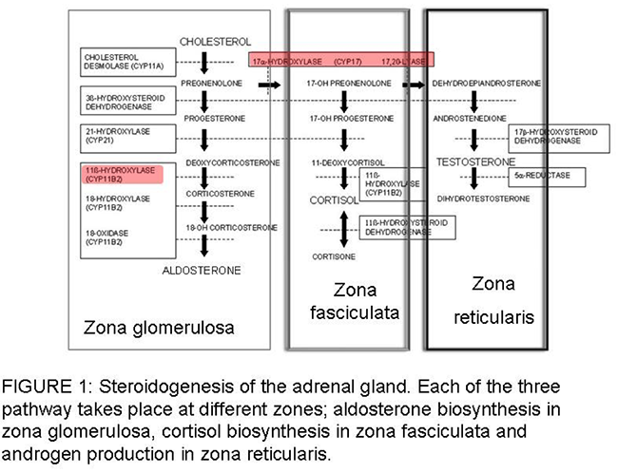

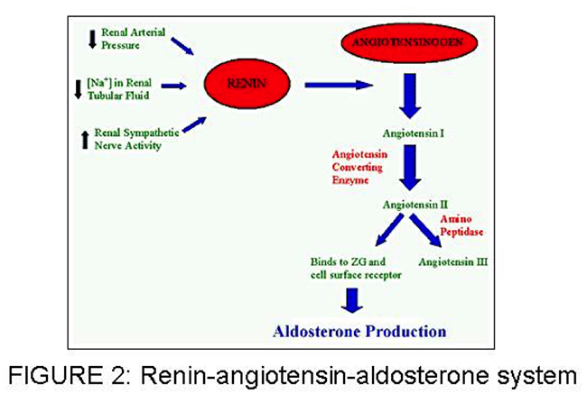

In the middle adrenal zone, zona fasiculata, GC are produced. The principal GC in humans is cortisol, which serves many physiologic roles including glucose homeostasis and vascular integrity. The hypothalamic pituitary-adrenal or HPA axis determines the threshold for circulating GC concentration.

The inner zone, or zona reticuralis, is where adrenal androgens are produced (see chapter 3 in the Adrenal Physiology and Disease section). The clinical significance of its overproduction is evident in 11β-hydroxylase deficiency (11β-OHD). In this deficiency, steroid precursors proximal to the block shunted to androgen pathways which leads to virilization of the affected individual (see below).

Endocrine hypertension in children is usually mediated by the MC activities of cortisol, aldosterone and adrenal steroidogenic precursors with MC activity. Frequently in these cases, elevated BP is associated with suppressed renin activity, indicating a form of hypertension related with volume-overload and salt-sensitivity.

In the past few decades, considerable progress has been made toward unraveling the molecular genetics of some rare, or extremely rare, monogenic forms of hypertension (1).

**CONGENITAL ADRENAL HYPERPLASIA (CAH); 11Β-OHD AND 17-OHD,**

These include the following well-characterized disorders: two forms of

-hydroxylase deficiencies, glucocorticoid-remediable hyperaldosteronism (familial hyperaldosteronism type I), apparent mineralocorticoid excess, and Liddle's Syndrome. This chapter describes the important causes of endocrine hypertension in children as

well as some conditions with a similar presentation (Fig. 3).

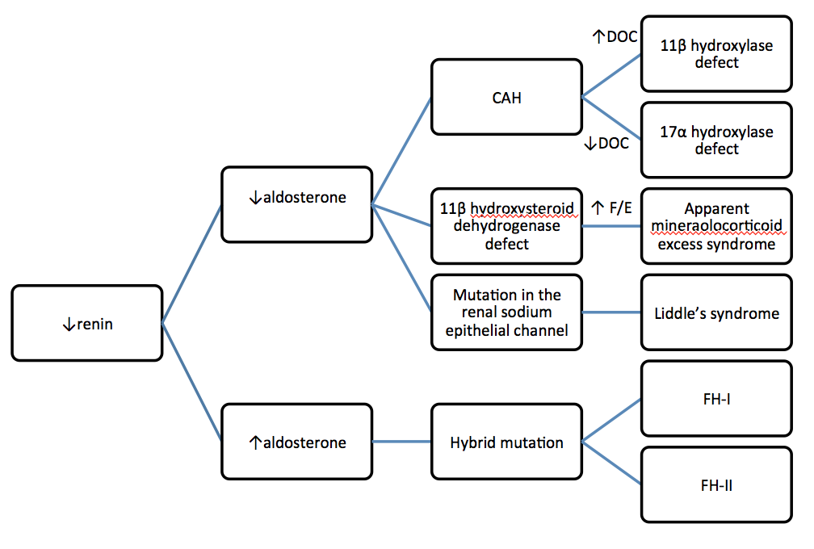

**Figure 3 Monogenetic mineralocorticoid hypertension syndromes. PRA = Plasma renin activity; FH = family hy- peraldosteronism; CAH = congenital adrenal hyperplasia; DOC = deoxycortisol; F/E = cortisol/cortisone ratio.**

## STEROID 11β- HYDROXYLASE DEFICIENCY CONGENTIAL ADRENAL HYPERPLASIA

CAH is a family of disorders characterized by enzymatic defects in one of the cortisol production steps. Steroid 11β-OHD is the second most common cause of CAH, accounting for 5-8% of all CAH cases (3). It occurs 1 in 100,00 live births (4) in the general population, but is more common in populations of North African origin (5).

Deficiency of 11β-hydroxylation causes a decrease in the conversion of 11-deoxycortisol (S) and 11-deoxycorticosterone (DOC) to cortisol and corticosterone, respectively (figure 1). Reduced cortisol feedback gives rise to an increase in ACTH secretion. Excessive ACTH secretion in turns leads to overproduction of precursors proximal to the enzyme block. These precursors serve as substrates for the unimpeded androgen pathways; therefore adrenal androgen secretion is increased. Virilization and hypertension are the salient clinical features of 11β-OHD.

The severity of in utero virilization of the external genitalia can vary from mild to severe, such that it is not uncommon to misassign an 11β-OHD affected female as a male (6,7). Males and females may manifest signs of androgen excess at any phase of postnatal development, including precocious pubic hair, advanced somatic and epiphyseal development, and central precocious puberty later in childhood. Without treatment, early epiphyseal maturation results in short stature.

Hypertension is a less consistent feature than virilization in 11β-OHD CAH. Despite failure of aldosterone production, upstream accumulation of deoxycorticosterone (DOC), a weak MC, causes salt retention and hypertension. Hypertension is usually not identified until later in childhood or in adolescence, although its appearance in an infant 3 months of age has been documented (8). In addition, hypertension correlates variably with biochemical values, or with the degree of virilization. Some of the severely virilized females were normotensive, whereas mildly virilized patients experienced severe hypertension, leading to fatal vascular accidents (9). An unusual presentation of neonatal salt wasting has also been reported (10). The complications of long standing uncontrolled hypertension, such as cardiomyopathy, retinal vein occlusion, and blindness have been reported in 11β-OHD patients (11,12). Potassium depletion develops concomitantly with sodium retention, but hypokalemia is variable.

Hormonal characteristics include elevation of compound S, DOC and androgens. Elevation of 17α-hydroxyprogesterone occurs, but not as greatly as in 21-hydroxylase deficiency (21OHD) CAH. Tetrahydro-11-deoxycortisol and tetrahydrodeoxycorticosterone, the principal metabolites of compound S and DOC, are significantly increased in the urine. Urinary 17-ketosteroids are elevated, reflecting the raised serum levels of adrenal androgens. Renin production is suppressed secondary to MC -induced sodium retention and volume expansion. Aldosterone production is low due to low serum potassium and low plasma renin.

Steroid 11β-OHD CAH is the result of autosomal recessive mutations in CYP11B1 gene. More than 50 mutations, including missense/nonsense, splicing, small/ gross deletions, insertions and complex rearrangement, which are responsible for 11β-OHD CAH have been described in CYP11B1 gene (14). A homozygous deletion of hybrid CYP11B2/CYP11B1, a reciprocal product of the recombination event as found in glucocorticoid remediable aldosteronism (GRA), leads to clinical phenotypes of neonatal salt wasting (due to diminished aldosterone synthase acitivity). This patient (10) also has 11β-OHD deficiency.

### Treatment

Cortisol administration provides cortisol replacement and normalizes ACTH. This in turn removes the drive for oversecretion of DOC and in most cases brings about remission of hypertension, if diagnosed early in life. The goal is to replace deficient steroids while minimizing adrenal sex hormone and GC excess. Serum DOC and androgens are thus the indices of the adequate hormonal control. Plasma renin activity is also useful as a therapeutic index. In poor control cases with 11β-OHD, plasma renin is suppressed.

Similar to 21OHD CAH, oral hydrocortisone is preferred, because it is identical to physiologic GC. Typical dosing is 10–15 mg/m2·d in divided doses. Long-acting GCs may be an option at or near the completion of linear growth. Titration of the dose should be aimed at maintaining androgen levels at age and sex-appropriate levels and normalization of renin. Concurrently, over-treatment should be avoided because it can lead to Cushing syndrome. Depending on the degree of stress, stress dose coverage may require doses of up to 50-100 mg/m2/day. Each family must be given injectable hydrocortisone for emergency use (at the dose of 25 mg for infants, 50 mg for young children and 100 mg for adolescents and adults, intramuscularly). In the event of surgical procedure, a total of 5-10 times the daily maintainance dose (depending on the nature of the surgical procedure) may be required over the first 24 hours. Hydrocortisone dosage can be tapered down to maintenance dose during the first few days postoperatively, provided that there is no complication. Stress dose should not be given in the form of dexamethasone because of the delayed onset of action.

In children with advanced bone age, initiation of therapy may precipitate central precocious puberty, requiring treatment with a GnRH agonist. Growth hormone therapy improves height deficit in patients with poor height prediction (13). In patients with long duration of hypertension before diagnosis, additional spironolactone, calcium channel blockers or amiloride may be necessary. Reconstructive surgery of external genitalia should be performed by experienced surgeons.

Prenatal diagnosis and treatment can be accomplished using extracted fetal DNA for CYP11B1 analysis (4,15,16). An established protocol of prenatal treatment in 21OHD CAH can be applied to 11β-OHD CAH (also see Chapter 8 – Congenital Adrenal Hyperplasia)

## STEROID -17 HYDROXYLASE DEFICIENCY CONGENTIAL ADRENAL HYPERPLASIA

17-OHD results from mutations in the cytochrome P450C17 enzyme which functions both as steroid 17α-hydroxylase and as 17, 20-lyase (17). The structural gene for cytochrome P450C17 (CYP17A1) has been mapped to chromosome 10q24.3 (18). Over 50 mutations in this gene have been described. Nucleotide substitution, causing missense or nonsense alterations, accounts for the majority of the patients reported (14). It is a rare disease identified in approximately 120 patients worldwide. The enzyme deficiency causes diminished production of cortisol and sex steroids, whose production requires the 17, 20-lyase function of the same 17α- hydroxylase enzyme (Figure 1). Because both adrenals and gonads share the enzyme defect, there is decreased biosynthesis of (i) androgens, results in an undervirilized phenotype in males (46,XY) at birth, and a failure of male pubertal development. (ii) estrogen, results in females at pubertal age presenting with primary amenorrhea and lack of development of secondary sex characteristics.

Reciprocal elevation of ACTH, due to low cortisol, increases synthesis of DOC and corticosterone via the unaffected 17-deoxy pathway. Therefore hypertension and hypokalemia may comprise the primary presentation at any age or can be associated with the abnormal sexual phenotype. As in 11β- OHD, the formation of aldosterone is reduced secondary to suppressed renin as a result of excess DOC.

### Treatment

Treatment strategy in this condition is similar to other forms of CAH in term of GC replacement therapy and stress dose (see chapter 8 Congenital Adrenal Hyperplasia). In addition to GC, sex hormone replacement that is appropriate to sex of rearing is indicated at a developmentally appropriate time to allow patients to resemble their peers. (See also treatment section in Chapter 11 – 46,XY Disorders of Sexual Development)

## GLUCOCORTICOID REMEDIABLE ALDOSTERONISM

GRA, also known as familial hyperaldosteronism type I (FH I), was first described by Sutherland et al. in 1966 (19). It is an autosomal dominant form of low renin hypertension characterized by hyperaldosteronism. Aldosterone secretion is controlled by ACTH rather than angiotensin II, and for this reason, the unique distinguishing feature of GRA is the complete and rapid suppression of aldosterone by exogenous GC (dexamethasone) administration.

GRA produces a volume expansion, salt-sensitive form of low renin hypertension. Variable presentation is not uncommon; hypertension is invariably present, but hypokalemia and metabolic alkalosis may be absent. The disease is characterized by early onset of moderate to severe hypertension with hyperaldosteronism and low renin values and by high incidence of premature cerebrovascular events. Additionally, children demonstrate normal growth and development, which distinguishes this disorder from 11β-OHD and apparent mineralocorticoid excess (AME) The serum aldosterone is elevated and plasma renin activity is suppressed, but the aldosterone-renin ratio is typically not as high as with primary aldosteronism (PA) caused by an aldosterone-producing adenoma.

Circadian measurement of plasma steroids in GRA patients has not only revealed excessive production of aldosterone following ACTH stimulation, but excessive secretion of two normally rare steroids: 18-hydroxycortisol and 18-oxocortisol (20). This can be explained by the molecular genetic finding of a chimeric gene between *CYP11B1* and *CYP11B2*--two genes that reside within a 30-kilobase stretch on chromosome 8 that results from an unequal crossing over during meiotic reduction. *CYP11B1* encodes 11β-hydroxylase, the enzyme that catalyzes the last step in cortisol synthesis in the zona fasiculata; *CYP11B2* encodes aldosterone synthase, the enzyme that catalyzes the last step in aldosterone synthesis in the zona glomerulosa. The product of this chimera thus carries aldosterone synthase enzymatic activity but is regulated by ACTH. Indeed, direct genetic screening for the presence of the chimeric gene can be performed by the long template PCR method with oligonucleotides specific for *CYP11B1* and *CYP11B2*. This test is 100% sensitive and specific, has a relatively low cost, and is more rapid and reliable, compared to conventional dexamethasone suppression test (21). However, both dexamethasone administration and genetic testing are of importance in making the diagnosis.

### Treatment

Children with GRA who are treated with GCs usually experience resolution of their hypertension within 2 weeks after initiation of therapy. The recommended doses are similar to CAH during childhood and adulthood (also see **Chapter 8 – Congenital Adrenal Hyperplasia)**, because the aim is to suppress ACTH secretion. Hydrocortisone is preferred during childhood period when dexamethasone is used in adults. A low sodium diet is recommended to lower BP because of the salt-sensitive volume expansion; this will also minimize potassium wasting. Typically, potassium supplement is not required. Normalization of urinary hybrid steroid levels and abolition of ACTH-regulated aldosterone production is not a requisite for hypertension control and, if used as a treatment goal, may unnecessarily increase the risk of Cushingoid side effects (22). The response to GCs is variable in adults, often requiring additional use of antihypertensive medications, such as spironolactone, amiloride and triamterene. It has been shown that even in the absence of hypertension, aldosterone excess is associated with increased left ventricular wall thicknesses and reduced diastolic function, initial changes that lead to cardiovascular morbidities. This leads to the recommendation to treat normotensive subjects diagnosed with FH I (23).

## APPARENT MINERALOCORTICOID EXCESS

AME is a rare inherited form of hypertension caused by 11 β-hydroxysteroid dehydrogenase type 2 (11 β-HSD) deficiency. The disorder was first described biochemically and hormonally in 1977 by New et al in a Native American girl with severe hypertension (24). The syndrome is caused by non functional mutations in HSD11B2 gene on chromosome16q22. More than 40 causative mutations have been described. (14) In the past 4 decades since the original description of the disease, published data only included less than 100 patients worldwide.

AME defined an important “pre-receptor” pathway in steroid hormone action and their specificities to the receptor. The exploration and elucidation of this disease opened a new area in receptor biology as a result of the demonstration that the specificity of the MR function depends on a metabolic enzyme (11ßHSD2) rather than the receptor itself (25,26). This enzyme functions to protect the MR by inactivating cortisol to its inactive metabolite cortisone, thereby enabling the mineralocorticoid aldosterone to occupy the MR in vivo (27,28). Aldosterone is not metabolized by 11ßHSD2 because it forms a C11–C18 hemi-ketal group in aqueous solution. The MR is non-selective *in vitro* and cannot distinguish between the glucocorticoid cortisol and its natural ligand, aldosterone (29,30). Therefore, lack of protection of the receptor owing to the enzyme defect allows cortisol, which has higher circulating levels than aldosterone, to bind to the MR and to act as a mineralocorticoid. Clinical manifestations of AME mimic those of excessive mineralocorticoid activity, but no elevation of known mineralocorticoids is present in the AME patients. Three metabolite ratios are calculated, each reflecting a different aspect of enzyme function: (1) tetrahydrocortisol (THF) + allo-THF/ tetrahydrocortisone (THE) (global function of HSD) (31) ; (2) allo-THF/THF ratio (defect in 5ß-reductase activity) (32,33) ; (3) urinary free cortisol (UFF)/urinary free cortisone (UFE) (kidney HSD function)(34). Originally AME was described through the plasma half-life of [11-3H] cortisol (which when metabolized by 11ß-HSD yields tritiated water and cortisone), which may more accurately reflect renal 11ß-HSD2 activity (35).

AME usually presents in early life with low birth weight and postnatal failure to thrive, hypertension, and persistent polyuria and polydipsia. The disorder is characterized by hypokalemic alkalosis, hyporeninemia and undetectable serum concentrations of aldosterone. End-organ damage secondary to hypertension is common, even at a young age. Thirteen out of

fourteen AME patients demonstrated damage of one or more organs (kidney, heart, retina or central nervous system) at the time of diagnosis. In addition, most had hypercalcuria with nephrocalcinosis (36).

### Treatment

The treatment of AME is primarily directed at the correction of hypokalemia and hypertension. Cortisol acts as the offending MC in AME, hence blockage of its binding to the MR reverses excess mineralocortocoidism. Spironolactone, an MR receptor antagonist, is the medication of choice: it binds competitively and protects the receptors against any MC in excess. The required dose of spironolactone in AME patients may go up to 3-5 mg/kg/day (or more than 400 mg per day in adults), to control blood pressure and to normalize renin. A reduction in dietary sodium and supplemental potassium are beneficial. Potassium supplement varies among patient to patient, range from 3-8 mEq/Kg/day. Patients with nephrocalcinosis require additional thiazide diuretic. In order to reduce urinary calcium and control blood pressure in these patients, either chlorothiazide at the dose of 20 mg/Kg/day or hydrochlorothiazide at the dose of 2 mg/Kg/day is recommended. Follow-up studies of AME patients treated with spironolactone revealed significant improvement in clinical symptoms. These outcomes demonstrate the importance of early diagnosis and adequate treatment (26,36). Another approach utilizing dexamethasone at the dose of 1.5-2.0 mg/day to suppress cortisol secretion demonstrated variable results. Normalization of BP occurred in approximately 60% of cases (37). Dexamethasone does not correct the hypokalemia and hypertension in all patients, and long-term therapy has excessive GC adverse effects. The low effectiveness of this treatment is not surprising based on theoretical grounds: in vitro data suggests that putative physiologic ligands to non-selective MR in the kidney include dexamethasone, as well as cortisol and other MCs (29). Therefore administering dexamethasone to suppress cortisol secretion, which is already lowered in AME, may supply an additional MR ligand to aggravate MC excess.

Additional antihypertensive medications, such as thiazides or amiloride, may be required during disease progression. Cure of AME was reported in one patient after kidney transplantation due to the normal 11β-HSD2 activity of the transplanted kidney (38,39). Advances in enhancing or inhibiting11βHSD2 activity by some medications may provide novel treatments for AME (40).

Although AME is very rare, mild or intermediate phenotypes of AME patients may be linked to common human disorders via alteration in cortisol-cortisone shuttle. These include several forms of hypertension, kidney failure, inflammatory processes (cirrhosis and cardiac fibrosis), low birth weight/ fetal programming of adult diseases and lately, carcinogenesis.

## PRIMARY ALDOSTERONISM

Primary aldosteronism (PA) is a group of disorders, originally described by J.W.Conn in 1954 (41), in which there is a non-suppressible secretion of aldosterone. The major presentations are hypertension and hypokalemia. However, hypokalemia does not occur in the majority of patients with primary aldosteronism, with the prevalence ranging from 9 to 37% in adults (42). Various symptoms associated with hypokalemia can be found, including muscle weakness with various types of paresthesias, tiredness, thirst, polyuria and nocturia.

PA occurs in greater than 10% of hypertensive adult patients (43)**.** Although it is considered rare in children, the high prevalence in the general adult population suggests that the disease

may develop in the pediatric population prior to its presentation of hypertension and vascular damage in adulthood [4]. Moderate to severe hypertension that does not respond to medication(s), spontaneous or diuretic induced hypokalemia and the presence of adrenal mass provide clues to diagnosis (43).

The major causes of PA are aldosterone-producing adenomas (often small tumors of less than 2 centimeters in diameter), bilateral or unilateral adrenal hyperplasia and rarely adrenal carcinoma. Plasma aldosterone-renin ratio (ARR) may be used as an initial screening test and should be repeated if the results are not conclusive or are difficult to interpret. Established ARR cut-offs in adults range between 20 to 40 (43). Further testing through suppressing aldosterone by oral sodium loading, saline infusion, and/or a challenge with either fludrocortisone or captopril can be used for diagnosis confirmation; however cut-off values and interpretation have only been established in adults. Adrenal computed tomography scan or an MRI image are used as the imaging study to identify the mass. The treatment options include unilateral adrenalectomy for unilateral diseases found on adrenal vein sampling and a MR antagonist such as spironolactone or eplerenone. (see details in Chapter 23 – Aldosterone Excess in ADRENAL PHYSIOLOGY AND DISEASES section)

## PHEOCHROMOCYTOMA

Pheochromocytomas are reported to account for hypertension in 1 to 2% of children (44). They are catecholamine-producing tumors that arise from the chromaffin cells of the adrenal medulla and the sympathetic ganglia and they present with signs and symptoms that are related to the action of catecholamines. (See Chapter 34 in Adrenal Physiology and Disease section). Although the peak incidence is in the third to fourth decades, 10% to 20% occur in children, with increased frequency in boys, and a median age at presentation between 9.5 and 12.5 years (45). Certain symptoms are reported as occurring more commonly in children than adults. These include sweating, visual disturbances, nausea, vomiting, loss of weight, polyuria and polydipsia (46). In comparison with adults in whom the hypertension is often paroxysmal, it is sustained in 70 to 90% of children (47). However, hypertension is not invariable and can be absent in up to 20% of children (48). Furthermore, many pheochromocytomas, especially associated with MEN 2 and VHL disease, can be clinically silent.

## OTHER CAUSES OF CHILDHOOD HYPERTENSION

Liddle’s syndrome is a rare autosomal dominant disease described by Liddle et al. in 1963 (49) causing arterial hypertension. Mutations in SCNN1B and SCNN1G, the genes that mapped to chromosome 16p12, have been described in Liddle’s syndrome patients (14). The clinical and biochemical findings other than elevated blood pressure are: chronic hypokalemia, increased urinary potassium excretion in conjunction with sodium retention, suppressed renin activity, aldosterone and angiotensin II. These presentations are similar to AME, but in contrast, Liddle’s syndrome is an autosomal dominant disorder that does not show a favorable response to spironolactone. (21)

Another rare cause is familial hyperaldosteronism type II (FHII), the first cases described by Gordon et al. in 1991 in three families with a familial variety of PA (50). It is distinguished from type I (GRA) by the failure of dexamethasone’s suppression of aldosterone and no hybrid gene mutation. FH-II is more common than FH-I, but their clinical presentations are indistinguishable from other forms of PA. Patients with FH II are older than those with FH I, perhaps owing to diagnosis of FH I at a younger age, made possible by genetic testing. No significance in age, sex, biochemical parameters, or aldosterone and renin levels was seen between patients with FH II and those with apparently sporadic PA. (21) It has been described both in families and in sporadic cases worldwide, with a range in age starting at 14 years and equal gender distribution (51). Although the inheritance in many families appears to be autosomal dominant, in sporadic cases it is still uncertain. Surgical treatment in the case of unilateral adrenal mass and medical treatment with MR antagonists can be effective (21).

### Acknowledgement:

The author would like to express a special gratitude to C. Joan Riesland, M.Ed., BSN, RN for her editorial work on this article.

## REFERENCES

1. Corvol P, Persu A, Gimenez-Roqueplo AP, Jeunemaitre X Seven lessons from two candidate genes in human essential hypertension: Angiotensinogen and Epithelial Sodium Channel. Hypertension 1999; 33:1324-31
2. The fourth report on the diagnosis, evaluation, and treatment of high blood pressure in children and adolescents. Pediatrics 2004;114(2 Suppl 4th Report):555-76.
3. Zachmann M, Tassinari D, Prader A 1983 Clinical and biochemical variability of congenital adrenal hyperplasia due to 11beta-hydroxylase deficiency. J Endocrinol Metab 56:222-229
4. Curnow KM, Slutsker L, Vitek J, et al. 1993 Mutations in the CYP11B1 gene causing congenital adrenal hyperplasia and hypertension cluster in exons 6, 7, and 8. Proc Natl Acad Sci (USA) 90:4552-6
5. Khemiri M, Ridane H, Bou YO, Matoussi N, Khaldi F 2006 [11 beta hydroxylase deficiency: a clinical study of seven cases]. Tunis Med 84:106-13
6. al-Jurayyan NA 1995 Congenital adrenal hyperplasia due to 11 beta-hydroxylase deficiency in Saudi Arabia: clinical and biochemical characteristics. Acta Paediatr 84:651-4
7. Rosler A, Leiberman E, Sack J 1982 Clinical variability of congenital adrenal hyperplaisa due to 11B-hydroxylase deficiency. Hormone Research 16:133
8. Mimouni M, Kaufman H, Roitman A, Morag C, Sadan N 1985 Hypertension in a neonate with 11 beta-hydroxylase deficiency. Eur J Pediatr 143:231-3
9. Rosler A, Leiberman E, Sack J 1982 Clinical variability of congenital adrenal hyperplaisa due to 11B-hydroxylase deficiency. Hormone Research 16:133
10. Ezquieta B, Luzuriaga C 2004 Neonatal salt-wasting and 11 beta-hydroxylase deficiency in a child carrying a homozygous deletion hybrid CYP11B2 (aldosterone synthase)- CYP11B1 (11 beta-hydroxylase). Clin Genet 66:229-35
11. Hague WM, Honour JW 1983 Malignant hypertension in congenital adrenal hyperplasia due to 11 beta-hydroxylase deficiency. Clin Endocrinol (Oxf) 18:505-10
12. Chabre O, Portrat-Doyen S, Chaffanjon P, et al. 2000 Bilateral laparoscopic adrenalectomy for congenital adrenal hyperplasia with severe hypertension, resulting from two novel mutations in splice donor sites of CYP11B1. J Clin Endocrinol Metab 85:4060-8
13. Quintos JB, Vogiatzi MG, Harbison MD, New MI 2001 Growth hormone therapy alone or in combination with gonadotropin-releasing hormone analog therapy to improve the height deficit in children with congenital adrenal hyperplasia. J Clin Endocrinol Metab 86:1511-7

14. Stenson et al (2009), The Human Gene Mutation Database

(HGMD®): 2008 Update. *Genome Med* 1(1):13

1. Geley S, Kapelari K, Johrer K, et al. 1996 CYP11B1 mutations causing congenital adrenal hyperplasia due to 11 beta-hydroxylase deficiency. J Clin Endocrinol Metab 81:2896-901
2. Cerame BI, Newfield RS, Pascoe L, et al. 1999 Prenatal diagnosis and treatment of 11beta-hydroxylase deficiency congenital adrenal hyperplasia resulting in normal female genitalia. J Clin Endocrinol Metab 84:3129-34
3. Nakajin S, Shinoda M, Haniu M, Shively JE, Hall PF. C21 steroid side chain cleavage enzyme from porcine adrenal microsomes. Purification and characterization of the 17 alpha-hydroxylase/C17,20-lyase cytochrome P-450. J Biol Chem 1984;259(6):3971-6.
4. Fan YS, Sasi R, Lee C, Winter JS, Waterman MR, Lin CC. Localization of the human CYP17 gene (cytochrome P450(17 alpha)) to 10q24.3 by fluorescence in situ hybridization and simultaneous chromosome banding. Genomics 1992;14(4):1110-1.
5. Sutherland D, Ruse J, Laidlaw J. Hypertension, increased aldosterone secretion and low plasma renin activity relieved by dexamethasone. Can Med Assoc J 1966;95(22): p1109-19.
6. Dluhy R, Lifton R. Glucocorticoid-remediable aldosteronism. J Clin Endocrinol Metab 1999;84(12): p4341-4.
7. New MI, Geller DS, Fallo F, Wilson RC. Monogenic low renin hypertension. Trends Endocrinol Metab 2005;16(3):92-7.
8. Stowasser M, Bachmann AW, Huggard PR, Rossetti TR, Gordon RD. Treatment of familial hyperaldosteronism type I: only partial suppression of adrenocorticotropin required to correct hypertension. J Clin Endocrinol Metab 2000;85(9):3313-8.
9. Stowasser M, Sharman J, Leano R, Gordon RD, Ward G, Cowley D, et al. Evidence for abnormal left ventricular structure and function in normotensive individuals with familial hyperaldosteronism type I. J Clin Endocrinol Metab 2005;90(9):5070-6.
10. New MI, Levine LS, Biglieri EG, Pareira J, Ulick S (1977) Evidence for an unidentified steroid in a child with apparent mineralocorticoid hypertension. J Clin Endocrinol Metab 44: 924-933
11. New MI (1994) The prismatic case of apparent mineralocorticoid excess. J Clin Endocrinol Metab 79: 1-3
12. Wilson RC, Nimkarn S, New MI (2001) Apparent mineralocorticoid excess. Trends Endocrinol Metab 12: 104-111
13. Edwards C, Stewart P, Burt D, et al. (1988) Localisation of 11 beta-hydroxysteroid dehydrogenase--tissue specific protector of the mineralocorticoid receptor. Lancet 2: p986-989
14. Funder J, Pearce P, Smith R, Smith A (1988) Mineralocorticoid action: target tissue specificity is enzyme, not receptor, mediated. Science 242: p583-585
15. Krozowski ZS, Funder JW (1983) Renal mineralocorticoid receptors and hippocampal corticosterone-binding species have identical intrinsic steroid specificity. Proc Natl Acad Sci (USA) 80: 6056-6060
16. Arriza JL, Weinberger C, Cerelli G, et al. (1987) Cloning of human mineralocorticoid receptor complementary DNA: structural and functional kinship with the glucocorticoid receptor. Science 237: 268-275
17. Palermo M, Quinkler M, Stewart PM (2004) Apparent mineralocorticoid excess syndrome: an overview. Arq Bras Endocrinol Metabol 48: 687-696
18. Monder C, Shackleton CH, Bradlow HL, et al. (1986) The syndrome of apparent mineralocorticoid excess: its association with 11 beta-dehydrogenase and 5 beta- reductase deficiency and some consequences for corticosteroid metabolism. J Clin Endocrinol Metab 63: 550-557
19. Shackleton CH, Rodriguez J, Arteaga E, Lopez JM, Winter JS (1985) Congenital 11 beta-hydroxysteroid dehydrogenase deficiency associated with juvenile hypertension: corticosteroid metabolite profiles of four patients and their families. Clin Endocrinol (Oxf) 22: 701-712
20. Palermo M, Shackleton CH, Mantero F, Stewart PM (1996) Urinary free cortisone and the assessment of 11 beta-hydroxysteroid dehydrogenase activity in man. Clin Endocrinol (Oxf) 45: 605-611
21. Ulick S, Levine LS, Gunczler P, et al. (1979) A syndrome of apparent mineralocorticoid excess associated with defects in the peripheral metabolism of cortisol. J Clin Endocrinol Metab 49: 757-764
22. Dave-Sharma S, Wilson RC, Harbison MD, Newfield R, Razzaghy-Azar M, Krozowski Z, et al. Extensive Personal Experience: Examination of genotype and phenotype relationships in 14 patients with apparent mineralocorticoid excess. J Clin Endo Metab 1998;83:2244-2254.
23. Cushing's disease of the kidney. Lancet 1988;2(8618):1002.
24. Palermo M, Cossu M, Shackleton CH. Cure of apparent mineralocorticoid excess by  kidney transplantation [letter]. N Engl J Med 1998;339(24):1787-8.

39. Palermo M, Delitala G, Sorba G, Cossu M, Satta R, Tedde R, et al. Does kidney transplantation normalise cortisol metabolism in apparent mineralocorticoid excess syndrome? J Endocrinol Invest 2000;23(7):457-62

1. Riddle MC, McDaniel PA. Acute reduction of renal 11 beta-hydroxysteroid  dehydrogenase activity by several antinatriuretic stimuli. Metabolism 1993;42(10):1370-  4.
2. Conn JW, Louis LH (1956) Primary aldosteronism, a new clinical entity. Ann Intern Med  44: 1-15
3. Mulatero P, Stowasser M, Loh KC, et al. (2004) Increased diagnosis of primary  aldosteronism, including surgically correctable forms, in centers from five continents. J  Clin Endocrinol Metab 89: 1045-1050
4. Funder JW, Carey RM, Fardella C, et al. (2008) Case detection, diagnosis, and  treatment of patients with primary aldosteronism: an endocrine society clinical practice guideline. J Clin Endocrinol Metab 93: 3266-3281
5. Dubois R, Chappuis J. [Pheochromocytoma: pediatric features]. Arch Pediatr 1997;4(12): p1217-25.
6. Mircescu H, Wilkin F, Paquette J, Oligny LL, Decaluwe H, Gaboury L, et al. Molecular characterization of a pediatric pheochromocytoma with suspected bilateral disease. J Pediatr 2001;138(2):269-73.
7. Fonseca V, Bouloux P. Phaeochromocytoma and paraganglioma. Baillieres Clin Endocrinol Metab 1993;7(2): p509-44.
8. Ross J. Pheochromocytoma. Special considerations in children. Urol Clin North Am 2000;27(3): p393-402.
9. Khafagi FA, Shapiro B, Fischer M, Sisson JC, Hutchinson R, Beierwaltes WH. Phaeochromocytoma and functioning paraganglioma in childhood and adolescence: role of iodine 131 metaiodobenzylguanidine. Eur J Nucl Med 1991;18(3):191-8.
10. Liddle GW, Bledsoe T, Coppage WS, Jr. A familial renal disorder simulating primary aldosteronism but with negligible aldosterone secretion. Trans. Assoc. Am. Phys. 1963;76:199-213.
11. Gordon R, Stowasser M, Tunny T, Klemm S, Finn W, Krek A. Clinical and pathological diversity of primary aldosteronism, including a new familial variety. Clin Exp Pharmacol Physiol 1991;18(5): p283-6.
12. Stowasser M, Gunasekera TG, Gordon RD. Familial varieties of primary aldosteronism. Clin Exp Pharmacol Physiol 2001;28(12):1087-90.