**ENVIRONMENTAL ENDOCRINOLOGY: AN EXPANDING HORIZON**

**Sanjay Kalra, MBBS, MD(Med), DM(Endo), FRCP (Edin),** Consultant Endocrinologist, Bharti Hospital, Karnal, India; Visiting Professor, Department of Endocrinology, All India Institute of Medical Sciences, Rishikesh, India, [brideknl@gmail.com](mailto:brideknl@gmail.com)

**Nitin Kapoor****, MBBS, MD,** Professor of Endocrinology, Department of Endocrinology, Diabetes and Metabolism, Christian Medical College & Hospital, Vellore, Tamil Nadu, India, 2Melbourne School of Population and Global Health, Faculty of Medicine, Dentistry and Health Science, The University of Melbourne, Australia. nitin.kapoor@cmcvellore.ac.in

**Received March 12, 2021**

**ABSTRACT**

Environment is an important determinant of endocrine health and certain endocrine disorders could also have a significant impact on the surroundings. Environmental endocrinology is an emerging field of medicine which encompasses the bidirectional impact of endocrine disorders and the physical, chemical, biological, and social environment of an individual. As we aim to improve endocrine health, it is also important to address the external environmental factors that may affect a given endocrine condition. As more data is emerging on this subject, it will help to formulate clinical practice guidelines and policies to optimize endocrine disorders in light of a given external environment.

**INTRODUCTION**

Environment with respect to health refers to all the physical, chemical and biological factors extrinsic to a person, even encompassing the related behavioral responses. The given surroundings can have a significant impact on an individual’s health and even health conditions can influence the environment over a period of time (1). Environmental health is an upcoming field and is referred to as the science and practice of preventing human illness while promoting wellbeing, by identifying and evaluating environmental changes. It further helps to identify and limit exposure to hazardous physical, chemical, and biological agents and thereby limiting their exposure to prevent adverse effects on human health (2). Multiple disciplines of medicine are involved in studying this field and research dealing with environmental health often has a direct impact on policy and practice. Amongst various organ systems that are impacted with environmental health, the endocrine system is maximally affected and very relevant in tropical countries (3, 4). This has been shown across different species and in humans across their life span (5-7). The environmental changes can even result in epigenetic alterations that may then transcend across generations (3, 8). In this chapter, we explore the bidirectional relationship of environment and the endocrine system and suggest a future road map for addressing the research gaps identified in this field (Figure 1).

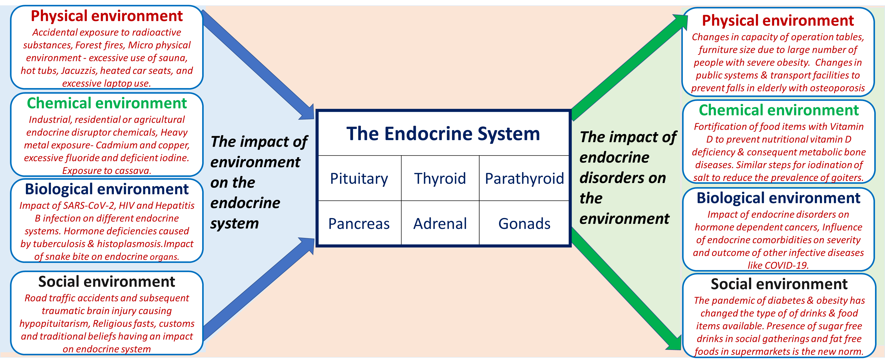

**Figure 1. Relationship of the environment and endocrine system**

**IMPACT OF ENVIRONMENT ON ENDOCRINOLOGY**

**The Influence of the Physical Environment on the Endocrine System**

In the last century several nuclear disasters have happened from time to time. The impact of these on the endocrine system has widely been reported and is a classic example as to how the physical environment can affect the endocrine system (9-11). The unfortunate incidents in Fukushima and Chernobyl have led to a large amount of exposure of radioactive substances that have been released into the environment. In addition to their adverse effects on reproductive health and carcinogenesis, a considerable impact has been noted on many endocrine glands including the pituitary, thyroid and gonads (12).

Following the Chernobyl accident in 1986, it was noted that individuals living in the surrounding areas had a 50% lower sympathetic activity and a 36% lower adrenal cortical activity including a significantly lower blood cortisol level. They also were noticed to have increased hypophyseal-thyroid system dysfunction, higher incidence of goiter, and autoimmune thyroiditis (13). An increased level of thyroxine-binding globulin, lower concentrations of free T3, and an increased risk of non-toxic single nodular and multinodular goiters have been reported (14). On the other extreme, an increased secretion of gonadotropic hormones and accelerated sexual development in women was documented. Higher rates of juvenile diabetes were also noticed in those exposed to the radioactive substances. Higher levels of prolactin and renin, with lower progesterone levels have been documented (14).

A similar incidence was repeated in Fukushima in 2011, following a tsunami which caused extensive damage to the nuclear reactor situated there. Though the radiation amount released into the environment was relatively less, the exposure was to a significantly larger population (12). Multiple endocrine effects have also been described secondary to the radiation exposure followed by non-accidental deliberate nuclear weapon testing (15). These effects need to be proactively followed and documented as they have strong policy implications.

Another important environmental health domain which has been of concern in recent times, is the health effects of forest fires. Apart from the multitude of environment related effects of vast forest fires, they also are known to affect the endocrine system (16). Polycyclic aromatic compounds (PACs), released during such forest fires are known endocrine disruptors with steroid like actions and their chronic exposure could affect the hypothalmo-pituitary-adrenal axis (17).

In addition to these the impact of built environment, limited areas for safe physical activity, and an increased number of fast-food outlets are responsible for an increasing prevalence of obesity in some developing countries (18).

Apart from these examples at the macro-environment level, the micro-environment could also have an impact on the endocrine system. A classic example to support this is hypogonadism in men caused by excessive use of sauna, hot tubs, Jacuzzis, heated car seats, and laptop use. The increased testicular temperature caused by excessive exposure to these activities can impair spermatogenesis (19, 20). Apart from direct effect of heat, excessive use of laptops and mobile phones also exposes the body to higher amount of radio frequency electromagnetic radiation, leading to multiple systemic effects including reduced spermatogenesis and increased blood pressure (21).

**The Effect of Changes in the Chemical Environment on Endocrinology**

Globally, the endocrine disruptor chemicals (EDCs) are the best-known examples of how the chemical environment can influence the endocrine system. EDCs are defined as exogenous chemicals that may alter any part of the endocrine system which may include interference in hormone synthesis, secretion, circulation, metabolism, receptor interaction, or elimination (22). Based on the site of their origin - EDC’s have been classified as industrial, residential, or agricultural. The common EDC’s used in industries include polychlorinated biphenyls (PCBs) and alkylphenols. Several pesticides, insecticide, herbicides, phytoestrogens, and fungicides that are used in farming are classified as agricultural and those used in household products like phthalates, polybrominated biphenyls, and bisphenol A are considered as residential (23). EDCs have gathered much interest in recent years and are known to affect several endocrine systems especially the gonadal axis (24). A brief summary has been provided in the table below.

|  |  |  |
| --- | --- | --- |
| **Table 1. Endocrine disruptors affecting different endocrine organs** | | |
| **Endocrine system** | **Endocrine disruptor chemical** | **Impact** |
| Pituitary | Phytoestrogens (i.e., isoflavonoids, cumestans, lignans, stilbens); pesticides (i.e., organophosphates, carbamates, organochlorines, synthetic pyrethroids); Polyvinyl chloride (PVC); phenols, dioxins, heavy metals, perfluorooctanoic acid. | Precocious puberty, delayed puberty, disruption of the circadian rhythm |
| Adrenal | Xenoestrogens, Hexachlorobenzene | Adrenal biosynthetic defects |
| Thyroid | Perchlorate, thiocyanates, nitrates | Hypothyroidism |
| Gonads | Phthalates, vinclozolin, acetaminophen, and polybrominated diphenyl ethers (PBDE)  Phthalates, diethylstilbestrol, bisphenol A (BPA)  PCB, phtalates, atrazine, genistein, BPA, parabens, triclosan, dichlorodiphenyltrichloroethane (DDT), and metoxychloride (MXC)  Phthalates, bisphenol A, biphenyls, and vinclozolin, | Testicular dysgenesis syndrome  Endometriosis  Female infertility  Male infertility |
| Endocrine gland cancer | PDBE, organochlorides, PCB, DDT, dichlorodiphenyldichloroethylene (DDE), arsenic, and cadmium  Triclocarban, PCB  PCB, dioxins, cadmium, phytoestrogens, DES, furans, ethylene oxide | Testicular Cancer  Thyroid Cancer  Breast Cancer |

In addition to EDC’s several other occupational exposures can also cause endocrine disorders. Exposure to cadmium in silversmiths, without proper personal protective equipment could lead to renal tubular acidosis and subsequent hypophosphatemic osteomalacia (25). Chronic exposure to fluoride through drinking water is known to produce a sclerotic bone disease associated with osteomalacia (26). Exposure to other heavy metals like copper has also been associated with different endocrine disorders as seen in Wilson’s disease (27, 28). Altered exposure to certain food items, may also lead to endocrine disorders. While exposure to cow milk and cassava has been associated with development of diabetes, deficiency of iodine containing sea foods in non-coastal areas is associated with the goiter (29, 30).

**The Impact of Biological Changes in the Environment on the Endocrine Milieu**

The most recent and a very lucid example of how the biological environment can affect the endocrine system, is that of COVID -19. It has been shown that COVID-19 can have a myriad of effects on different endocrine systems. However, the most pertinent of all has been its association with diabetes (31-33). Interestingly not only COVID-19 can affect diabetes control but presence of diabetes can also have a direct impact on the outcome of COVID-19 (Figure 2).

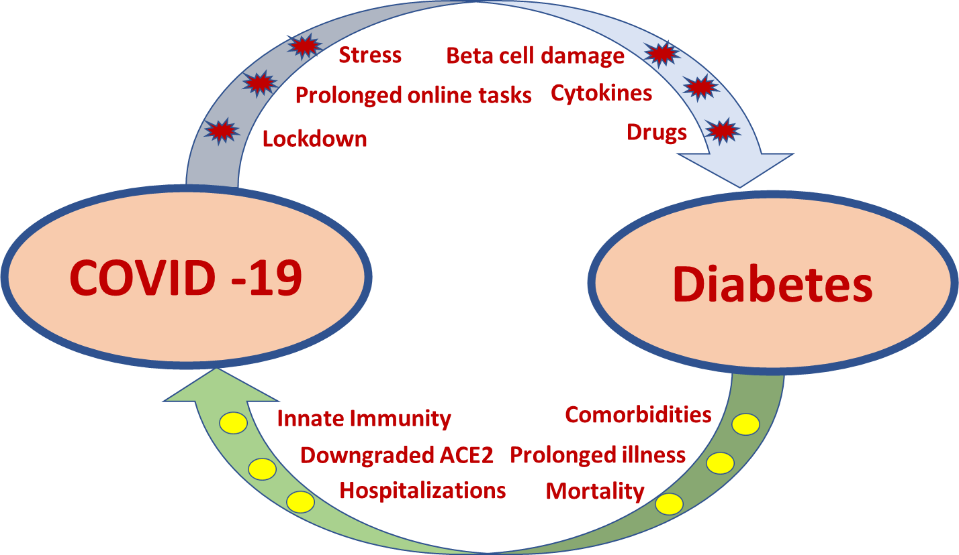

**Figure 2. The bidirectional relationship between COVID-19 and Diabetes**

Similar to COVID-19, there have been reports of other communicable diseases intersecting with non-communicable endocrine disorders. A few common examples that are cited in literature include presence of NAFLD (Nonalcoholic fatty liver disease) in individuals with HIV infection, the association of osteoporosis with Hepatitis B infection, cytomegalovirus associated with Paget’s disease of the bone etc. (34, 35).

Certain infections may also be responsible for hormonal deficiencies. An example is histoplasmosis that is predominantly spread by bat droppings can result in adrenal insufficiency. This along with adrenal tuberculosis is still the most common cause of primary Addison’s disease in tropical countries unlike the West where autoimmune adrenalitis is the foremost cause. Similar infective etiologies have also been described to cause hypophysitis and resulting hypopituitarism.

The after effects of a of vasculo-toxic snake bite on pituitary and other endocrine organs also comes under the domain of biological environment impacting the endocrine system.

**The Aftermath of Changing Social Environment on the Endocrine System**

The social environment can influence the endocrine system in several ways. One such impact that has been increasing in recent years, is an increase in road traffic accidents on highways with higher speed limits, leading to traumatic brain injury. This has been associated with both acute and chronic hypopituitarism. Though first described in 1918, it was initially thought to be a rare phenomenon, but over the years has been recognized with increasing frequency (36). It is currently reported in about one third of patients with a traumatic brain injury (37). However, in autopsy studies up to 86% have demonstrated pituitary injury following traumatic brain injury (38).

Social norms and religious customs may further have an impact on the endocrine system. From the impact of prolonged periods of fasting on glycemic control to being customarily clad in veils leading to vitamin D deficiency, several such examples have been cited in literature.

**IMPACT OF ENDOCRINE DISORDERS ON ENVIROMENT**

**The Influence of Endocrine Disorders on the Physical Environment**

Globally, a rapid increase in the prevalence of obesity has brought about changes in the physical environment ranging from furniture sizes in clinics to more weight friendly gymnasiums. Additionally, operation tables have now become more accommodative of higher weights (39).

Another endocrine disorder that has brought about significant changes in the physical environment is osteoporosis. With an increasing life expectancy and consequent increase in the aged population, there has been a remarkable increase in the prevalence and awareness of osteoporosis. Subsequent fall protective arrangements are in place in several public places and transport facilities (40). Separate priority lines have been made available in different areas where prolonged waiting may be required (41). Moreover, battery operated cars are provided for them in airports and railway stations.

**The Sequel of Endocrine Related Policies on the Chemical Environment**

The changes in the chemical environment secondary to endocrine disorders are predominantly due to deficiency of chemical substances leading to hormone deficiencies. Nutritional vitamin D deficiency and iodine deficiency thyroid disorders have led to a massive fortification campaign in several countries. The impact of both these supplementations have seen phenomenal success across different countries especially in the tropical region (42, 43).

In a recently published study from Ireland, it was found that almost two-thirds of the mean daily vitamin D intake of adults came from fortified foods like milk and bread. Though individually milk and bread only helped to meet about 30 and 50% of recommended daily allowance, fortifying both simultaneously could help in meeting 70% of the RDA. This shows the impact of how widespread vitamin D deficiency could be managed by altering the chemical environment of commonly available foods (42).

Along similar lines a high prevalence of iodine deficiency disorders a few decades ago, has driven the salt iodination movement in several countries. This is another example of how an endocrine disorder can lead to changes in the surrounding chemical environment. This has definitely resulted in a reduction in the prevalence of goiter in many countries (44, 45).

**The Effect of Endocrine Disorders on the Biological Environment**

The classic example of how endocrine disorders could change the biological environment of an individual is how presence of diabetes and obesity could alter the clinical course of COVID 19. It is now clear that the presence of these comorbidities could increase the severity, prolong hospitalization and even increase the mortality of COVID-19 infected individuals (31-33, 46).

Other biological disorders that could depend on the endocrine milieu of a person include hormone dependent cancers. Elevations of specific hormones that can increase the risk of certain cancers provide a good opportunity to provide novel therapeutic options that may help in the management the hormone sensitive tumors (47). The commonly cited examples of these hormone dependent tumors where the alteration in the hormone levels could affect the biological activity of these disorders include breast, ovarian, and prostate malignancies.

**The Footprint of Endocrine Diseases on the Social Environment**

The rapid increase in the prevalence of diabetes and obesity have changed the availability of different foods and beverages available in social gatherings and supermarkets. Now sugar free foods and drinks are available in every gathering, which was not commonly present a few decades ago. Moreover, fat free snacks, low calorie deserts, and high fiber food options have become the new norm in the current day society (48).

**SUMMARY**

Even though several examples of the bidirectional impact of environment and endocrine disorders are cited in this chapter, data on this subject are still emerging and more evidence is needed to precisely quantify its impact. This will enable future practice guidelines and polices to improve the quality of life of people affected with endocrine disorders by modifying their environment and also help in positively changing the physical, chemical, biological, and social environment with respect to a given endocrine disorder.

**REFERENCES**

1. Kalra S 2020. Environmental endocrinology: Expanding spectrum, evolving science. JPMA. The Journal of the Pakistan Medical Association 70:2302-2303

2. Meltzer GY, Watkins BX 2020 A Systematic Review of Environmental Health Outcomes in Selected American Indian and Alaska Native Populations. 7:698-739

3. Levitsky LL 2014 Endocrinology, epigenetics, and environment. Current opinion in endocrinology, diabetes, and obesity 21:28-29

4. Wingfield JC 2008 Comparative endocrinology, environment and global change. General and comparative endocrinology 157:207-216

5. 1989 Development of preimplantation embryos and their environment. Proceedings of a satellite symposium of the 8th International Congress of Endocrinology. Kyoto, Japan, July 14-16, 1988. Progress in clinical and biological research 294:1-474

6. Choi JH, Yoo HW 2013 Control of puberty: genetics, endocrinology, and environment. Current opinion in endocrinology, diabetes, and obesity 20:62-68

7. Wilson AE, Fair PA, Carlson RI, Houde M, Cattet M, Bossart GD, Houser DS, Janz DM 2019 Environment, endocrinology, and biochemistry influence expression of stress proteins in bottlenose dolphins. Comparative biochemistry and physiology. Part D, Genomics & proteomics 32:100613

8. Kenny NJ, Quah S, Holland PW, Tobe SS, Hui JH 2013 How are comparative genomics and the study of microRNAs changing our views on arthropod endocrinology and adaptations to the environment? General and comparative endocrinology 188:16-22

9. Goncharov NP, Katsiya GV, Kolesnikova GS, Dobracheva GA, Todua TN, Vax VV, Giwercman A, Waites GM 1998 Endocrine and reproductive health status of men who had experienced short-term radiation exposure at Chernobyl. International journal of andrology 21:271-276

10. Foley TP, Límanová Z, Potluková E 2015 Medical Consequences of Chernobyl with Focus on the Endocrine System - Part 2. Casopis lekaru ceskych 154:287-291

11. Foley TP, Jr., Límanová Z, Potluková E 2015 Medical consequences of Chernobyl with focus on the endocrine system: Part 1. Casopis lekaru ceskych 154:227-231

12. Niazi AK, Niazi SK 2011 Endocrine effects of Fukushima: Radiation-induced endocrinopathy. Indian J Endocrinol Metab 15:91-95

13. Vermiglio F, Castagna MG, Volnova E, Lo Presti VP, Moleti M, Violi MA, Artemisia A, Trimarchi F 1999 Post-Chernobyl increased prevalence of humoral thyroid autoimmunity in children and adolescents from a moderately iodine-deficient area in Russia. Thyroid : official journal of the American Thyroid Association 9:781-786

14. 2009 Chernobyl: Consequences of the Catastrophe for People and the Environment. Annals of the New York Academy of Sciences 1181:vii-xiii, 1-327

15. Simon SL, Bouville A 2015 Health effects of nuclear weapons testing. Lancet (London, England) 386:407-409

16. Wallace SJ, de Solla SR, Head JA, Hodson PV, Parrott JL, Thomas PJ, Berthiaume A, Langlois VS 2020 Polycyclic aromatic compounds (PACs) in the Canadian environment: Exposure and effects on wildlife. Environmental pollution (Barking, Essex : 1987) 265:114863

17. Wu WZ, Wang JX, Zhao GF, You L 2002 The emission soot of biomass fuels combustion as a source of endocrine disrupters. Journal of environmental science and health. Part A, Toxic/hazardous substances & environmental engineering 37:579-600

18. Dixon BN, Ugwoaba UA 2020 Associations between the built environment and dietary intake, physical activity, and obesity: A scoping review of reviews.

19. Sheynkin Y, Jung M, Yoo P, Schulsinger D, Komaroff E 2005 Increase in scrotal temperature in laptop computer users. Human reproduction (Oxford, England) 20:452-455

20. Shefi S, Tarapore PE, Walsh TJ, Croughan M, Turek PJ 2007 Wet heat exposure: a potentially reversible cause of low semen quality in infertile men. International braz j urol : official journal of the Brazilian Society of Urology 33:50-56; discussion 56-57

21. Adams JA, Galloway TS, Mondal D, Esteves SC, Mathews F 2014 Effect of mobile telephones on sperm quality: a systematic review and meta-analysis. Environment international 70:106-112

22. Kabir ER, Rahman MS, Rahman I 2015 A review on endocrine disruptors and their possible impacts on human health. Environmental toxicology and pharmacology 40:241-258

23. Monneret C 2017 What is an endocrine disruptor? Comptes rendus biologies 340:403-405

24. Giwercman A, Giwercman YL 2000 Epidemiology of male reproductive disorders. In: Feingold KR, Anawalt B, Boyce A, Chrousos G, de Herder WW, Dungan K, Grossman A, Hershman JM, Hofland HJ, Kaltsas G, Koch C, Kopp P, Korbonits M, McLachlan R, Morley JE, New M, Purnell J, Singer F, Stratakis CA, Trence DL, Wilson DP eds. Endotext. South Dartmouth (MA): MDText.com, Inc. Copyright © 2000-2020, MDText.com, Inc.

25. Paul J, Cherian KE, Thomas N, Paul TV 2020 Hypophosphataemic osteomalacia due to cadmium exposure in the silver industry. Occupational medicine (Oxford, England) 70:207-210

26. Shetty S, Nayak R, Kapoor N, Paul TV 2015 An uncommon cause for compressive myelopathy. BMJ case reports 2015

27. Kapoor N, Cherian KE, Sajith KG, Thomas M, Eapen CE, Thomas N, Paul TV 2019 Renal Tubular Function, Bone Health and Body Composition in Wilson's Disease: A Cross-Sectional Study from India. 105:459-465

28. Kapoor N, Shetty S, Thomas N, Paul TV 2014 Wilson's disease: An endocrine revelation. Indian J Endocrinol Metab 18:855-857

29. Gottlieb S Early exposure to cows' milk raises risk of diabetes in high risk children: BMJ. 2000 Oct 28;321(7268):1040.

30. Navarro S 2018 Chronic pancreatitis. Some important historical aspects. Gastroenterologia y hepatologia 41:474.e471-474.e478

31. Sathish T, Kapoor N 2020 Proportion of newly diagnosed diabetes in COVID-19 patients: a systematic review and meta-analysis.

32. Sathish T, Cao Y, Kapoor N 2020 Preexisting prediabetes and the severity of COVID-19. Primary care diabetes

33. Sathish T, Cao Y, Kapoor N 2020 Newly diagnosed diabetes in COVID-19 patients. Primary care diabetes

34. Kapoor N, Audsley J, Rupali P, Sasadeusz J, Paul TV, Thomas N, Lewin SR 2019 A gathering storm: HIV infection and nonalcoholic fatty liver disease in low and middle-income countries. Aids 33:1105-1115

35. Sajith KG, Kapoor N, Shetty S, Goel A, Zachariah U, Eapen CE, Paul TV 2018 Bone Health and Impact of Tenofovir Treatment in Men with Hepatitis-B Related Chronic Liver Disease. Journal of clinical and experimental hepatology 8:23-27

36. Cyran E 1918 Hypophysenschädigung durch schädelbasisfraktur. Dtsch Med Wochenschr 44:1261

37. Lieberman SA, Oberoi AL, Gilkison CR, Masel BE, Urban RJ 2001 Prevalence of neuroendocrine dysfunction in patients recovering from traumatic brain injury. The Journal of clinical endocrinology and metabolism 86:2752-2756

38. Richmond E, Rogol AD 2014 Traumatic brain injury: endocrine consequences in children and adults. Endocrine 45:3-8

39. DeMaria EJ, Carmody BJ 2005 Perioperative management of special populations: obesity. The Surgical clinics of North America 85:1283-1289, xii

40. Stevens JA, Olson S 2000 Reducing falls and resulting hip fractures among older women. MMWR. Recommendations and reports : Morbidity and mortality weekly report. Recommendations and reports 49:3-12

41. Tannenbaum C, Mayo N, Ducharme F 2005 Older women's health priorities and perceptions of care delivery: results of the WOW health survey. CMAJ : Canadian Medical Association journal = journal de l'Association medicale canadienne 173:153-159

42. McCourt A, McNulty BA, Walton J, O'Sullivan A 2020 Efficacy and safety of food fortification to improve vitamin D intakes of older adults. Nutrition (Burbank, Los Angeles County, Calif.) 75-76:110767

43. Wang Z, Zang J, Shi Z, Zhu Z, Song J, Zou S, Jin W, Jia X, Guo C, Liu S 2019 Iodine status of 8 to 10 years old children within 20 years following compulsory salt iodization policy in Shanghai, China. Nutrition journal 18:63

44. Gupta P, Raizada N, Giri S, Sharma AK, Goyal S, Jain N, Madhu SV 2020 Goiter Prevalence and Thyroid Autoimmunity in School Children of Delhi. Indian J Endocrinol Metab 24:202-205

45. Isiklar Ozberk D, Kutlu R, Kilinc I, Kilicaslan AO 2019 Effects of mandatory salt iodization on breast milk, urinary iodine concentrations, and thyroid hormones: is iodine deficiency still a continuing problem? Journal of endocrinological investigation 42:411-418

46. Sathish T, Kapoor N 2020 Normal weight obesity and COVID-19 severity: A poorly recognized link. Diabetes research and clinical practice:108521

47. Ulm M, Ramesh AV, McNamara KM, Ponnusamy S, Sasano H, Narayanan R 2019 Therapeutic advances in hormone-dependent cancers: focus on prostate, breast and ovarian cancers. Endocrine connections 8:R10-r26

48. de Oliveira Otto MC, Anderson CAM, Dearborn JL, Ferranti EP, Mozaffarian D, Rao G, Wylie-Rosett J, Lichtenstein AH 2018 Dietary Diversity: Implications for Obesity Prevention in Adult Populations: A Science Advisory From the American Heart Association. Circulation 138:e160-e168