**EVALUATION AND TREATMENT OF POLYCYSTIC OVARY SYNDROME**

**Richard S. Legro, MD,** Department of Obstetrics and Gynecology,

Penn State College of Medicine, 500 University Drive,Hershey, PA, USA

E-mail: [RSL1@psu.edu](mailto:RSL1@psu.edu)

Revised 12/20/2017

**Abstract**

Polycystic ovary syndrome (PCOS) is the most common endocrinopathy among adult women in the developed world and is characterized by anovulation, androgen excess (primarily ovarian, but also adrenal in origin) and the appearance of polycystic ovaries on ultrasound. Diagnostic criteria are expert-based and debated as they do not incorporate known metabolic abnormalities related to aberrant insulin action, such as glucose intolerance, diabetes, and dyslipidemia, that affect many women with the syndrome. Symptoms that are most troublesome to patients include hirsutism, obesity, infertility and menstrual disorders. Long-term sequelae of the syndrome, such as an increased risk for cardiovascular events based on risk factor profiling, are unclear from epidemiologic studies. The etiology of the syndrome is likely heterogeneous and genetic studies have been consistent with a complex genetic disease,. Interestingly, the candidate genes identified in multiple genome wide association studies that fit best into existing ideas of the pathophysiology are gonadotropin and gonadotropin receptor genes. Treatment tends to be symptom based, and the search for a single treatment that addresses both reproductive and metabolic abnormalities continues. Some of the most common treatments used for chronic management of PCOS include hormonal contraceptives, progestins and metformin. Treatment of infertility focuses on ovulation induction therapies which may involve drugs such as letrozole or clomiphene or gonadotropin therapy. Treatment of hirsutism often involves the combination of hormonal contraceptives and the adjuvant use of anti-androgens. Weight loss in obese women with PCOS may be beneficial for both the treatment of infertility and long term management.

**Introduction**

Polycystic ovary syndrome (PCOS) is an ovarian disorder characterized by hyperandrogenism, ovulatory dysfunction, and polycystic ovaries. It may be the most common female endocrinopathy in the developed world. However, it most likely represents a heterogeneous disorder and one whose pathophysiology and etiology are debated. PCOS affects young women with oligo-ovulation (which can lead to oligomenorrhea), infertility, acne and hirsutism. It also has notable metabolic sequelae, including an elevated risk of diabetes and cardiovascular risk factors, and long term treatment should also consider these factors. These multiple stigmata have led to a multi-pronged treatment approach, with most therapies targeting individual symptoms. The search for the single unifying theory to this disorder will hopefully yield the single best treatment, but this quest remains one of the Holy Grails of reproductive endocrinology. This chapter will discuss the diagnosis, clinical evaluation, pathophysiology, and treatment of women with PCOS.

**Diagnostic Criteria**

There is no universally accepted definition of PCOS and expert generated diagnostic criteria have proliferated in recent years (**Figure 1**). They share a common focus on PCOS as an ovarian disorder. The definition of PCOS has largely been dependent on the technology used to ascertain the condition. Thus the earliest definition of PCOS, or the Stein Leventhal Syndrome, was based on the triad of enlarged ovaries, hirsutism, and oligomenorrhea (1). As assays became available, first urinary and then serum, researchers noted gonadotropin abnormalities with elevated LH levels, and then as androgen assays evolved, elevation in androgen levels. However, these multiple tools to assess women with androgen excess and oligomenorrhea led to multiple diagnostic criteria (**Figure 1**) and often each investigative group had their own unique set, making the comparison of clinical studies often difficult if not impossible.

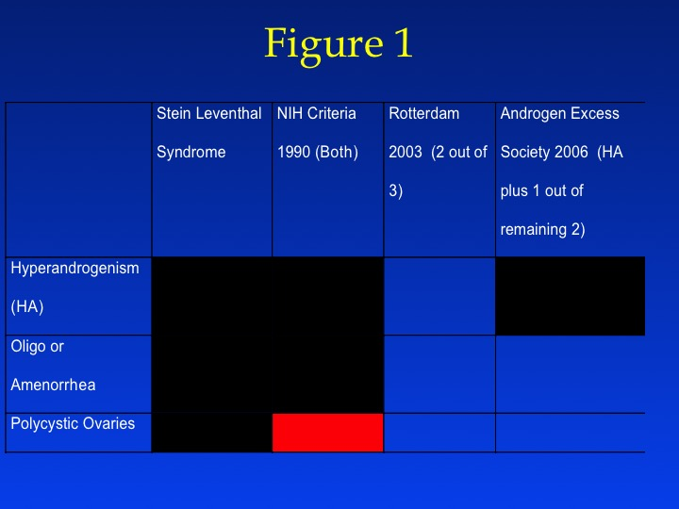

Figure 1: Recommended diagnostic schemes for PCOS by varying expert groups. All recommend excluding possible other etiologies of these signs/symptoms (See Differential Diagnosis) and more than one of the signs or symptoms must be present to make a diagnosis. Red box - not required for diagnosis; black box - mandatory criteria; white box - possible diagnostic criteria but not necessarily required to be present. Hyperandrogenism may be either the presence of hirsutism or biochemical hyperandrogenemia.

It was not until the early 1990s at an NIH-sponsored conference on PCOS that formal diagnostic criteria were proposed and afterwards were largely utilized (2). These criteria, often referred to colloquially as “the NIH criteria” were published in the conference proceedings and received large scale acceptance in the research and clinical communities. These criteria defined PCOS as unexplained hyperandrogenic anovulation. They required the presence of oligomenorrhea AND hyperandrogenism, either clinical or biochemical along with the exclusion of phenocopies. The enduring portion of these criteria accepted by all other criteria was the exclusion of phenocopies such that PCOS remains a diagnosis of exclusion.

The improved technology and utilization of ultrasound in women’s health led to the ultrasound definition of polycystic ovaries, defined primarily on the morphology and the number of small antral follicles (3) (**Figure 2**). The failure to recognize the polycystic ovary in the NIH definition of polycystic ovary syndrome led to the convening of an expert consensus conference to reconsider the NIH diagnostic criteria in Rotterdam in the Netherlands. The subsequent “Rotterdam criteria” incorporated the ultrasound determined size and morphology of the ovary into the diagnostic criteria (4,5). Ultrasound criteria for the diagnosis of polycystic ovaries were also decided by expert consensus (6), though the cutoff for antral follicles was recently raised again by expert opinion due to improvements in resolution allowing increased follicle detection (7) (**Table 1)**. Because of the limited availability of ultrasound and trained ultrasonographers in many practices (family practice, medical or pediatric endocrinology) as well as in low resource settings, there has been interest in using Anti-Mullerian Hormone (AMH) levels to diagnose polycystic ovaries in lieu of ultrasound.(8) AMH is produced by the granulosa cells of small antral follicles and correlates well with their count.(9) Currently, however, there is no accepted cutoff and there are similar concerns about the effects of age and hormonal contraception on this parameter as antral follicle counts. The Rotterdam criteria have been criticized for including more mild phenotypes, for example, the combination of polycystic ovaries with oligomenorrhea. These additional phenotypes may complicate the generalizability of clinical trials to treat PCOS, and may also elevate the prevalence of PCOS in the general population.

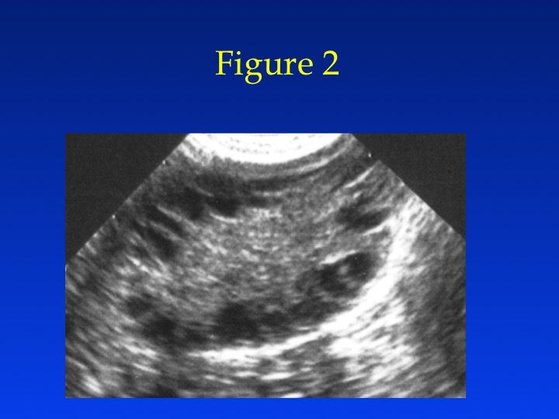

Figure 2: Transvaginal ultrasound of a polycystic ovary. Note the increased number of antral follicles ringing the outside of the ovary and the increased central stroma.

**Table 1:** Expert consensus recommendations for the ultrasound diagnosis of polycystic ovaries. The ultrasound exam assumes that if there is a follicle > 10 mm the scan should be repeated during a period of ovarian quiescence in order to calculate the ovarian volume.

|  |  |  |
| --- | --- | --- |
|  | 2003 ASRM/ESHRE Consensus | 2014 AE-PCOS Consensus |
| Follicles | 12 or more follicles measuring 2-9 mm in diameter | 25 or more follicles < 10 mm in diameter per ovary |
| Volume | > 10 Cm3 | > 10 Cm3 |

The Androgen Excess Society criteria subsequently attempted to establish hyperandrogenism as a *sine qua non* diagnostic factor in combination with other stigmata of the syndrome (10). The focus on hyperandrogenism was to eliminate milder phenotypes and based on evidence that hyperandrogenism tends to track with both reproductive (i.e., acne, hirsutism, and androgenic alopecia) and metabolic (i.e., insulin resistance, dyslipidemia, and elevated cardiovascular risk) stigmata of the syndrome.

Although the diagnostic criteria are still debated today, recent consensus statements such as the Endocrine Society’s clinical practice guidelines(11) and the NIH Evidence-Based Methodology Executive Summary recommended maintaining the Rotterdam Criteria for PCOS.(12) The latter group did suggest that re-naming the disorder would better focus interest on the diverse implications of the syndrome,(12) and some authors have advocated re-naming the syndrome based on its metabolic underpinnings.(13)

There are, however, unifying trends to all diagnostic criteria. Hyperandrogenism in all schemas can be established on the basis of clinical findings (e.g., hirsutism or acne) and/or serum hormone measurement (most commonly serum testosterone levels). All diagnostic schemes recommend that secondary causes (such as adult-onset congenital adrenal hyperplasia, hyperprolactinemia, and androgen-secreting neoplasms) should first be excluded (discussed below under differential diagnosis). All diagnostic schemes also require more than one sign or symptom. Polycystic ovaries alone, for example, are a nonspecific finding and also are frequently noted in women with no endocrine or metabolic abnormalities (14), especially among normal healthy younger women.(15) Insulin resistance has been noted consistently among many women with PCOS, especially in those with hyperandrogenism, but it is not included in any of the diagnostic criteria.

We can conclude that there is a thread of continuity between the varying diagnostic criteria. All agree that it is an ovarian disorder and diagnostic criteria revolve around ovarian determined stigmata, such as hyperandrogenism, oligo-ovulation, and polycystic-appearing ovaries. The utility of the varying diagnostic criteria is still being debated by experts, but will ultimately be answered by well-designed clinical studies. There are no diagnostic criteria that are accepted for diagnosing PCOS in pre-pubertal or peri-pubertal girls nor in menopausal women and the relative androgen excess and oligo/amenorrhea that characterize these states likely overlap too much to separate out groups of affected from unaffected women.

**Incidence of PCOS**

The incidence of PCOS varies according to the diagnostic criteria. Polycystic ovaries on ultrasound are noted in up to 25%-30% of reproductive aged women (14,16). Thus, the vast majority of women with polycystic ovaries do not have the syndrome. Women with unexplained hyperandrogenic chronic anovulation (i.e., NIH criteria) make up approximately 7% of reproductive aged women (17). There is debate as to whether minorities are disproportionately affected with PCOS (18). Other studies, for example, have shown higher rates of insulin resistance and type 2 diabetes in minorities, including Latino, Native American, and African-American populations. However, the evidence for this in women with PCOS is less certain. For example, in the best study of an unselected population in the U.S., i.e., women applying for jobs at an academic medical center, there were no significant differences in the prevalence of PCOS or stigmata of PCOS, such as hirsutism or elevated circulating androgen levels between white and black women (17). The broader Rotterdam criteria increase the prevalence of PCOS by 50% over the NIH criteria (19), and the prevalence according to the AES criteria is somewhere in between.

PCOS is increasingly associated with obesity, and the obesity epidemic worldwide has been linked to an increased prevalence of PCOS (20). There are still marked differences in the prevalence of obesity and morbid obesity among women with PCOS according to country of origin as noted in **Figure 3**. Obesity, and severe obesity appear to be less common in the European PCOS population (21) and in Asia.(22,23) It appears from the published literature that the U.S. tends to have the highest prevalence of severe obesity in its population and its PCOS population. Large multi-center trials of women with PCOS and infertility routinely report a mean BMI of 35 among study participants(24,25). While it is debated whether obesity per se can cause PCOS, there are mixed data supporting an increased population based prevalence of PCOS with increasing obesity.(26,27) Interestingly a European Genome Wide Association Study (GWAS) identified increasing BMI as a risk factor through Mendelian randomization analysis. (28)

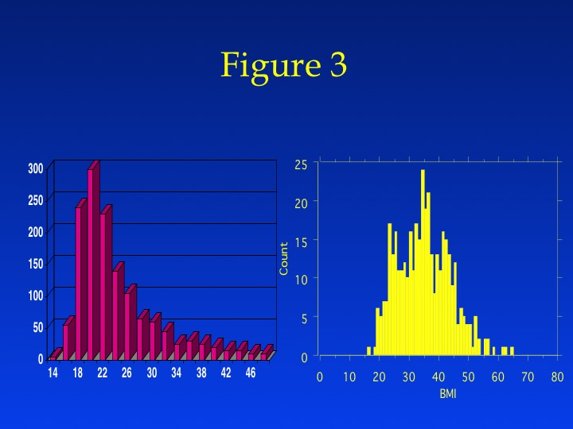

Figure 3: Distribution (counts on y axis) of BMI in women with PCOS from a large cohort of women diagnosed with PCOS in the United Kingdom ( N = 1741)(21) compared to that from a cohort in the United States ( N = 398) (Legro, unpublished data). Compare a mode of BMI of 20 for the UK women with a BMI of 35 for the U.S. women.

**Etiology and Pathophysiology**

The genetic contribution to PCOS has been closely studied in recent years with multiple Genome Wide Association Studies (GWAS) reporting results in European(28,29) and Han Chinese Cohorts (22,23). However, these GWAS’s have only identified candidate gene regions that explain a small proportion of the heritability of PCOS (i.e., less than 10%). There is currently no recommended genetic screening test for PCOS. While genes likely contribute to the PCOS phenotype, the GWAS findings support that PCOS is a complex genetic trait. Interestingly the GWASs from all groups have identified regions of the genome associated with gonadotropin production or action (i.e., gonadotropin receptors), supporting a primary hypothalamic-pituitary dysfunction in the etiology of the syndrome.

However, many of the significant GWAS genes or regions do not have a clear functional relationship to the clinical presentation of PCOS. An example is the DENND1A gene, which encodes a protein named connecdenn 1, which has a clathrin-binding domain and is thought to facilitate endocytosis and receptor mediated turnover, including of gonadotropin and insulin receptors. A variant of this gene over expressed in human thecal cells created excess androgen production and could be knocked down to restore a normoandrogenic phenotype.(30) There have not been studies to date on the effects of this variant on insulin action.

No specific environmental substance has been identified as causing PCOS, although certain medications such as valproate have been shown in vitro (31) or in clinical series in women with epilepsy to induce hyperandrogenism (32). Obesity, however, likely increases its prevalence (as noted above and discussed in pathophysiology below). There has been much interest and suspicion that environmental disrupting chemicals (EDCs) may also contribute to PCOS. However, the data are sparse, although there have been reports of an association between PCOS and elevated levels of Bisphenol A (BPA). However, such association studies are similar to the early genetic association studies examining single alleles with a disorder in which there was a high rate of false positive associations, not replicated in larger studies or studies of multiple variants. When multiple EDCs are measured, the associations become more difficult to interpret.(33)

There are three common theories for the etiology of PCOS: one that it is due to hypothalamic-pituitary dysfunction, the second that it is due to ovarian (and adrenal) hyperandrogenism, and the third that it is primarily a disorder of peripheral insulin resistance. We will address each theory in turn.

***Primary Disordered Gonadotropin Secretion.*** The first biochemical abnormality that was identified in women with PCOS was disordered gonadotropin secretion, with a preponderance of LH relative to FSH. As the two-cell theory of the ovary evolved, i.e., that thecal cells can only produce androgens under stimulation of LH whereas granulosa cells can only aromatize androgens from the theca cells into estrogens under the influence of FSH, this preponderance of LH was thought to be the primary etiology of the syndrome. Excess LH led to excess thecal cell development and androgen production, but in the face of inadequate FSH stimulation of granulosa cell development and aromatase production, these androgens were not converted to estrogen, leading to multiple abnormalities. The GWAS studies which have identified the FSH and LH/hCG receptor genes as potential contributors to the PCOS phenotype support this etiologic claim.

This theory explained the morphology of the ovary, hirsutism, and anovulation. Androgen excess led to ovarian follicular arrest in the preantral stage, as estrogen is critical to the development and selection of a dominant follicle. The ovary thus contained multiple small preantral follicles due to this ongoing process and increased central stroma due to excessive thecal and stromal hyperplasia from the disordered gonadotropin exposure. Secondarily this resulted in spillover of excess androgens into the circulating pool, resulting in inappropriate feedback to the hypothalamic-pituitary axis and a vicious feedback loop where excess LH leads to excess ovarian androgen production which in turn leads to further LH. Finally the excess circulating androgen led to stimulation of the pilosebaceous unit, increasing sebum production, inducing terminal hair differentiation, and in rare instances in the scalp leading to pilosebaceous unit atresia and androgenic alopecia.

Studies of gonadotropin secretion in women with PCOS have established that women have augmented release of LH in response to a GnRH challenge with appropriate increases in FSH secretion (34). This has led to the use of a GnRH challenge test to diagnose PCOS by some investigative groups (35); however, this requires blood tests up to 24h after the challenge and is unwieldy in a clinical setting. Similarly, random serum samples of LH tend to have poor sensitivity and specificity for diagnosing PCOS (36). This is because of the variability of serum levels due to the pulsatile secretion of the hormones and is also due to modifying factors such as concurrent medications and conditions, most importantly obesity.

Obesity tends to blunt baseline LH levels and GnRH stimulated levels in women with PCOS (37), although their responses remains elevated when compared to appropriate age and weight matched control women. The ontogeny of disordered gonadotropin secretion may lie in the hyperandrogenemia of puberty, as the GnRH pulse generator shows an insensitivity to progesterone feedback in hyperandrogenic obese adolescent girls, thus perpetuating the state of disordered gonadotropin secretion.(38,39)

**Primary Ovarian and Adrenal Hyperandrogenism.** Because most diagnostic criteria support the notion that PCOS is an ovarian disorder, it becomes therefore the prime target for the cause of the syndrome. Ovarian steroidogenesis is perturbed in the syndrome with increased circulating androgen levels frequently noted in women with stigmata of PCOS. Further intrafollicular androgen levels tend to be elevated in antral follicles, supporting a lack of adequate granulosa aromatase activity (40). As noted above, a primary defect in ovarian steroidogenesis could lead through the same feedback loop noted above to disordered gonadotropin secretion and stigmata of peripheral hyperandrogenism. including acne, hirsutism, and alopecia. Thecal cells from women with PCOS put into long term culture exhibit defects in steroidogenesis. including hyperproduction of androgens, implying this is a permanent and possibly genetic defect in the cells (41). Family studies also support a high prevalence of hyperandrogenemia and hyperandrogenism in first degree relatives of women with PCOS (42-44), further supporting a familial contribution to these stigmata. Finally, 20-30% of women with PCOS have evidence of adrenal hyperandrogenism, primarily based on elevated levels of DHEAS, an androgen marker of adrenal function (45), suggesting that the defect in steroidogenesis is primary and affects both androgen secreting glands, i.e., the ovary and the adrenal. Further there is familial clustering of elevated DHEAS levels in PCOS families in both female and male relatives, again supporting a heritable component to this trait (42,44,46).

However, to date, no specific genetic abnormality in the GWAS studies has been noted in steroidogenic enzymes or factors to explain the hyperandrogenism (47) (22,23,28,29). Further it is simplistic to imply that this defect is permanent. First, at least in terms of phenotype and androgen levels, it does not manifest till menarche and appears to resolve with menopause, implying this is not a constitutional phenotypic characteristic. Second, hyperandrogenism can be ameliorated by treatment with suppressive hormonal therapies or conversely with ovulation induction. Polycystic ovaries are a recognized risk factor for ovarian hyperstimulation characterized by multiple and excessive follicular development, elevated circulating levels, and after exposure to human chorionic gonadotropin, massive ovarian enlargement, vascular permeability, and accumulation of abdominal ascites. This response appears consistent more with baseline inhibition of certain aspects of steroidogenesis combined with exaggerated ovarian response to a given challenge than a primary defect in steroidogenesis *per se*.

Other ovarian factors than disordered steroidogenesis may contribute to PCOS. For example there appears to be an increased density of small preantral follicles in polycystic ovaries (48). This could result from increased numbers of germ cells in the fetal ovary, from decreased loss of oocytes with age, or from decreased rate of loss of oocytes during late gestation, childhood, and puberty. Indeed, there is evidence in vitro to support increased survival and diminished atresia of PCOS follicles (49).

**Primary Disorder of Insulin Resistance.** Women with PCOS show multiple abnormalities in insulin action. Dynamic studies of insulin action, including hyperinsulinemic euglycemic clamps and frequently sampled intravenous glucose tolerance tests, have shown that women with PCOS are more insulin resistant than weight-matched control women, a defect primarily present in skeletal muscle (50,51). Early in the ontogeny of the syndrome, as in the ontogeny of type 2 diabetes, this is characterized by increased pancreatic beta cell production of insulin to control ambient glucose levels. Thus many women with PCOS have fasting and meal-challenged hyperinsulinemia (52). However, this compensatory response by the pancreatic beta cell is often inadequate for the degree of peripheral insulin resistance leading initially to postpandrial hyperglycemia in these women and eventually to fasting hyperglycemia (51,53). Further the beta cell response appears to be dysschronous, implying a further beta cell defect in these women, and is responsive to treatment with insulin sensitizing agents such as thiazolidinediones (54).

Hyperinsulinemia and/or disordered insulin action may perturb the reproductive axis in multiple ways. First insulin may act at the hypothalamic-pituitary axis to stimulate gonadotropin production. Infusions of insulin tend to have little effect on gonadotropin production in human studies, and insulin is not required for glucose transport into the nervous system. In animal cell culture models, insulin has been found to enhance pituitary gonadotropin secretion (55). However, selective knock out of the insulin receptor in mouse models (the NIRKO mouse) exhibits increased food intake and fat mass, and an exaggerated response to GnRH stimulation (though their basal state in contrast to women with PCOS tends to be hypogonadotropic hypogonadism) (56). Thus, the evidence for a central action of insulin may be the weakest link in the insulin resistance PCOS hypothesis in humans, perhaps because it is the most difficult to investigate.

Hyperinsulinemia is linked to ovarian and adrenal hyperandrogenism in a number of disorders of inherited insulin resistance with compensatory hyperinsulinemia including leprechaunism, the Rabson Mendenhall syndrome, and the lipodystrophies (57). These syndromes are characterized by selective tissue atrophy due to inability to utilize the primary anabolic hormone, insulin, and by excess gonadal androgen production. A less severe insulin resistance syndrome, the HAIR-AN syndrome, was defined on the basis of hyperinsulinemia, hyperandrogenemia, and the presence of acanthosis nigricans (a hyperproliferative skin condition found in skin folds due to insulin excess) and is more common (58).

This link between hyperinsulinism and hypergonadism is thought to reflect the ability of insulin in certain conditions to stimulate gonadal and adrenal androgen production. Hyperandrogenism has been further linked to insulin resistance and stigmata of the insulin resistance syndrome in women with PCOS and in family studies of those with PCOS which have found increasing prevalence of the metabolic syndrome in family members with increasing androgen levels (59). Androgens also induce insulin resistance, best illustrated by the example of female-to-male transsexuals who have increased insulin resistance after supplementation with androgens (60). In vitro cultures of thecal cells from women with PCOS have been found to overproduce androgens in response to insulin supplementation (61). Further, as discussed below under therapeutic options, the use of insulin sensitizing agents, including both metformin and troglitazone have been associated with both lowering of circulating insulin levels and levels of both adrenal and ovarian androgens.

Finally, increased levels of insulin are associated with the peripheral availability of sex steroids through an impact on circulating sex hormone-binding globulin (SHBG). SHBG has been found to be partially regulated by circulating insulin levels with an inverse relationship (62). Decreasing levels of SHBG mean increasing levels of free and bioavailable androgens, especially since the preferred substrate of SHBG is androgens (as opposed to estrogen or progestin). Increased free androgens mean increased androgen action in the periphery, which can affect the pilosebaceous unit and the hypothalamic-pituitary axis. Some have recommended that low circulating SHBG levels may be a good marker for women with PCOS as hyperandrogemia can also suppress SHBG.(63) Thus insulin resistance can contribute to hyperandrogenism in many ways (64).

Obesity per se is associated with insulin resistance and compensatory hyperinsulinemia. Obese women may be ovulatory but have longer follicular phases and thus longer menstrual cycles which could cause them to be misdiagnosed as oligo-ovulatory.(65) Similarly, as noted above, obesity may suppress circulating SHBG levels, leading to higher levels of free or bioavailable testosterone and leading again to the potential misdiagnosis of PCOS.(66)

**Clinical Presentation**

Women with PCOS commonly present with menstrual disorders (from amenorrhea to dysfunctional uterine bleeding) and infertility, as they have since the syndrome was first described. The compilation of presenting symptoms by Goldzieher et al. from the 1960’s is still relevant today (**Figure 4**) (67), although obesity, as noted previously, is now much more prevalent in the U.S. population. Both due to the emphasis on menstrual history and the complaint of androgen excess (rare in children), PCOS classically presents at or after menarche. The phenotype in pubertal and pre-pubertal girls is debated; there is some evidence to suggest that premature pubarche places girls at increased risk for developing PCOS as they go through puberty. Premature pubarche presents in girls with hyperinsulinemia and elevated DHEAS levels. However, this can only account for a small fraction of women with PCOS, as the prevalence of premature pubarche is a small fraction of PCOS. A national registry of all children in Denmark estimated the prevalence of premature pubarche in the Danish population at 22 to 23 cases per 10,000 girls, i.e., 0.0002% (68). At the other end of the reproductive spectrum, both menstrual irregularity (69) and hyperandrogenemia (70) appear to normalize as women with PCOS approach the perimenopause and menopause. Whether these completely normalize is unknown; for instance, mothers of women with PCOS have elevated testosterone levels compared to controls, suggesting that mild elevations may be familial and persist (43).

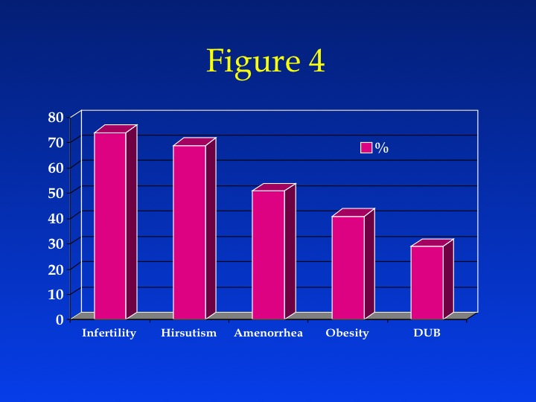

Figure 4: A classic reference indicating the prevalence of various presenting clinical symptoms and complaints among a large cohort of women with PCOS ( N = 1089) culled from 187 previously published papers (67). The frequency is still relevant to today’s population of women with PCOS.

Skin disorders, especially those due to peripheral androgen excess, such as hirsutism and acne, and to a lesser degree androgenic alopecia, are common in women with PCOS and frequently the presenting complaint. Obesity is frequently characterized by a centripetal distribution. This can be diagnosed by an elevated waist circumference (> 88 cm). A history of weight gain may sometimes precede the onset of oligomenorrhea and hirsutism, leading to the suspicion that this is an acquired form of PCOS secondary to obesity. All women with PCOS should have a BMI determined at baseline and at regular visits. Other complaints which must be elicited are screens for mood disorders and depression, as many women with PCOS suffer from low self-esteem due to obesity, disfiguring hirsutism, and infertility.

**Clinical Sequelae of PCOS:**

Although the endocrine and reproductive features of the disorder may improve with age, the associated metabolic abnormalities, particularly glucose intolerance, may actually worsen with age. We shall now discuss common sequelae of PCOS including infertility due to ovulatory dysfunction, abnormalities of the pilosebaceous unit, certain gynecological cancers, type 2 and gestational DM, and cardiovascular disease (CVD).

**Infertility due to Chronic Anovulation:**Women with PCOS are not generally sterile, but subfertile due to the infrequency and unpredictability of their ovulations. Some women with PCOS might tend to conceive later in life as ovulatory function improves (71), although many women now seek treatment earlier in their reproductive lives. As a rule, women with PCOS represent one of the most difficult groups in whom to induce ovulation both successfully and safely. Many women with PCOS are unresponsive or resistant to ovulation induction with clomiphene citrate. They may have an inappropriate or exaggerated response to the administration of human menopausal gonadotropins (menotropins) and are at increased risk for ovarian hyperstimulation syndrome (OHSS). OHSS is a syndrome of massive enlargement of the ovaries, development of rapid and symptomatic ascites, intravascular contraction, hypercoagulability, and systemic organ dysfunction. It can be life threatening and is best prevented. Increasing obesity may blunt the risk for developing the syndrome (72). These complications occur generally following treatment with menotropins, although ovarian hyperstimulation has even been reported in women with PCOS conceiving a singleton pregnancy spontaneously, or after clomiphene or pulsatile GnRH use (73).

In addition to anovulation, endometrial pathology such as hyperplasia may lead to implantation failure in women with PCOS.(74) Induced menstrual bleeding prior to ovulation induction may be associated with lower rates of subsequent pregnancy.(75)

**Skin Disorders:**Skin disorders in women with PCOS revolve primarily around abnormalities of the pilosebaceous unit. The development of hirsutism, acne or androgenic alopecia in PCOS has been attributed to the increased systemic and local production of androgens (see above) that activate abnormal development of the pilosebaceous unit. While insulin is essential for hair follicle growth *in vitro*, it is unclear whether the hyperinsulinemia of PCOS directly stimulates fine vellus hair to transform into thick, dark terminal hair with the development of hirsutism (76). Generally the ontogeny of abnormalities in the pilosebaceous unit tends to proceed from acne in the peri-pubertal period to hirsutism as a young adult to androgenic alopecia in the mature adult. Androgenic alopecia is luckily rare among women with PCOS and its etiology also is complex (77). Apparently similar factors which stimulate terminal midline hair in lower body regions also lead to follicular atresia in the scalp. For the most part, treatments for hirsutism are also relevant for androgenic alopecia (i.e., androgen suppression and androgen antagonism). However, local vasodilators administered in a crème or lotion, i.e., minoxidil, have been shown to be effective for both male and female androgenic alopecia, whereas they have no known benefit on hirsutism.

Other skin disorders that are common include acanthosis nigricans and an increased frequency of skin tags. Acanthosis nigricans is a dermatologic condition marked by velvety, mossy, verrucous, hyperpigmented skin. It has been noted on the back of the neck, in the axillae, underneath the breasts, and even on the vulva (**Figure 5**). The presence of acanthosis nigricans appears to be more a sign of insulin resistance than a distinct disease unto itself.

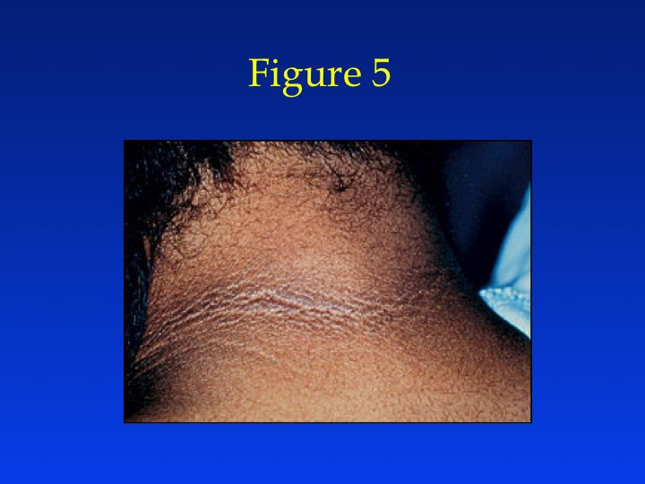

Figure 5: Acanthosis nigricans on the nape of the neck in a woman with PCOS.

**Gynecological Cancers:**Many gynecological cancers have been reported to be more common in women with PCOS including ovarian, breast, and endometrial carcinomas. However, the best case of an association between PCOS and cancer can be made for endometrial cancer, as many risk factors for this cancer are present in the PCOS patient, and the epidemiological evidence of an increased incidence in this group of women is growing stronger, with an approximate three-fold increased risk (78,79). In an analysis of 176 patients with endometrial cancer, hirsutism, increased body mass index (BMI) and hypertension were significantly more common in all patients, and nulliparity and infertility significantly were more common among younger patients compared to controls (80,81).

**Sleep Apnea** Multiple groups have documented an increased risk for sleep apnea and other sleep disorders, such as sleep disordered breathing in women with PCOS (82,83). This is notable as sleep apnea is relatively uncommon in women, especially premenopausal women (**Figure 6**). Increased risk for these disorders in women with PCOS has been associated with both hyperandrogenism and insulin resistance PCOS (82,83). Poor sleep may contribute to a vicious metabolic cycle of worsening insulin resistance and glucose tolerance in women with PCOS.(84) It is perhaps too early to recommend universal screening in obese women with PCOS, but it should be considered in women undergoing bariatric surgery, as it is a predictor of morbidity and mortality in patients undergoing bypass surgery (85). Women with sleep disorders often complain of daytime sleepiness and fatigue after sleeping and may snore. Interestingly the traditional treatment for sleep apnea, i.e., continuous positive airway pressure (CPAP), has been found to improve insulin sensitivity, decrease sympathetic output, and reduce diastolic blood pressure in women with PCOS and sleep apnea.(86)

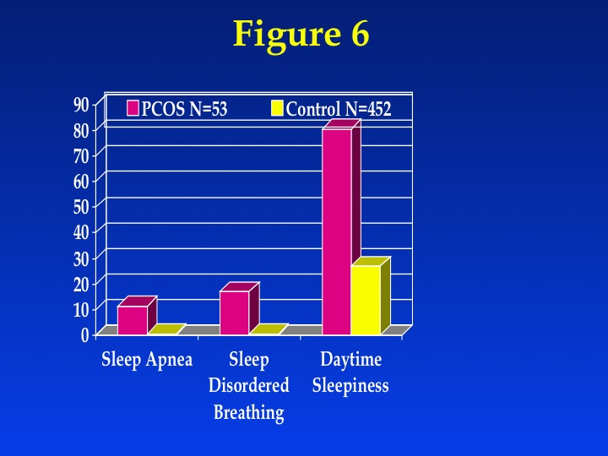

Figure 6: Prevalence of sleep apnea and other sleep disorders in a cohort of women with PCOS and an unselected control group of women. Women with PCOS had an OR of sleep apnea of 29 (95% CI 5-294) compared to this control group (82).

**Non-alchoholic fatty liver disease (NAFLD).** This disorder is fatty infiltration of the liver not due to alcohol abuse that is related to insulin resistance. Affected patients may have no symptoms or have mild, nonspecific symptoms such as fatigue or malaise. It is usually accompanied by elevated serum liver function tests, most commonly transaminases. Liver ultrasound may show steatosis, but liver biopsy remains the gold standard for diagnosis and shows evidence of inflammation and fibrosis. It may respond to weight loss and insulin sensitizing therapy. The prevalence of the disorder among women with PCOS is debated. A recent meta-analysis reported a nearly four-fold higher incidence of NAFLD among women with PCOS compared to controls.(87) While some reports have noted an increased prevalence, a recent multi-center trial that screened over 1,000 women with PCOS found that only a small fraction (~5%) had elevated liver transaminases (24). This prevalence is comparable to that found in the U.S. population in the NHANES survey. Routine screening is probably unnecessary at this time and is not recommended by practice guidelines.(11)

**Type 2 Diabetes Mellitus.**The inherent insulin resistance present in many with PCOS, aggravated by the high prevalence of obesity in these individuals, places these women at increased risk for impaired glucose tolerance and type 2 DM. About 30% to 40% of obese reproductive-aged PCOS women have been found to have impaired glucose tolerance (IGT), and about 10% have frank type 2 DM based on a 2-hour glucose level > 200mg/dL (72)(88,89). Of note is that only a small fraction of women with PCOS and with either IGT or type 2 DM display fasting hyperglycemia consistent with diabetes as defined by the American Diabetes Association criteria (fasting glucose ≥ 126 mg/dL) (**Figure 7**). In other PCOS populations with lower rates of obesity, the prevalence of impaired glucose tolerance is also lower, although higher than in control groups (90). The risk factors associated with glucose intolerance in women with PCOS—age, high body mass index (BMI), high waist–hip ratios, and family history of diabetes—are identical to those in other populations. The conversion rate to glucose intolerance varies depending on the population studied (91,92). However, because glucose tolerance tends to worsen with age, periodic rescreening every 3-5 years is recommended in patients with normal glucose tolerance. However, the level of insulin resistance found in women with PCOS based on dynamic measures of insulin action is comparable to that found in other populations (i.e., children of parents with diabetes) associated with a marked increased risk of developing type 2 DM. Recently there has been interest in substituting screening for dysglycemia with measurement of glycohemoglobin (HgbA1c) level rather than oral glucose challenge. However, HgbA1c will tend to miss most of the women with impaired glucose tolerance (close to three quarters(93)), and this is not recommended as it will miss most of the patients who may benefit from intervention to arrest or slow the progression to diabetes. Routine oral glucose tolerance screening has been recommended in populations such as the Chinese with lower risk factor profiles than the U.S. population.(94)

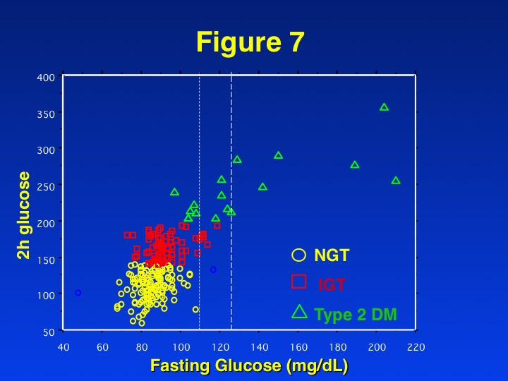

Figure 7: Distribution of glucose tolerance (NGT= normal glucose tolerance or 2h glucose < 140 mg/dL, IGT = impaired glucose tolerance or 2h glucose 140-199 mg/dL, Type 2 DM = 2h glucose ≥ 200 mg/dL) by fasting glucose level in a large cohort (N = 254) women with PCOS. The vertical lines at 110 mg/dL and 126 mg/dL on the fasting glucose x axis indicate the thresholds for impaired fasting glucose and type 2 diabetes by fasting levels (89).

**Cardiovascular Disease.**Many of the studies suggesting an increased incidence of CVD are inferential based on risk factor models, with little evidence of increased or premature onset of CVD events such as stroke or myocardial infarction (95). There is a lack of prospective studies showing increased risk of cardiovascular events in women with PCOS. However, several cohort studies, including the Nurse’s Health Study, have suggested an increased risk of CVD disease or events in the presence of increasing oligomenorrhea. In this study, there was no determination of hyperandrogenism, so many of the cases may have had another menstrual disorder (96). This is a key confounder as women with primary ovarian insufficiency and prolonged estrogen deficiency likely have higher premature CVD morbidity and all-cause mortality. In other older populations, a history of irregular menses and/or hyperandrogenism has been associated with increased CV events, though it must again be acknowledged there are no accepted criteria for diagnosing PCOS in the menopause.(97) Among postmenopausal women evaluated for suspected ischemia in the Women's Ischemia Syndrome Evaluation (WISE) study, clinical features of PCOS defined by a premenopausal history of irregular menses and current biochemical evidence of hyperandrogenemia were initially associated with more angiographic CAD and worsening CV event-free survival(98); however, this article was retracted and a subsequent re-analysis by the same group showed not only similar CVD morbidity but also overall equal mortality with long term follow up compared to controls.(99) Probably the best evidence for an increased onset of premature cardiovascular events comes from ICD-10 billing-based identification of PCOS in younger women with PCOS; this code has been associated with increased hospitalization rates (3-4 fold higher) for ischemic heart disease and cerebrovascular disease.(100)

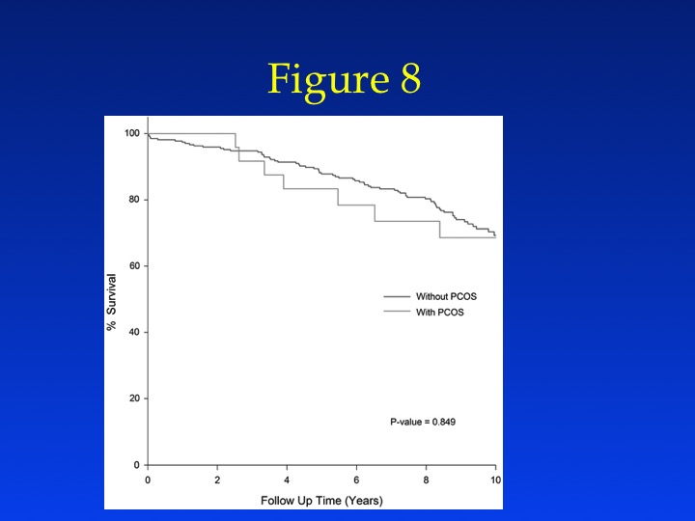

Figure 8: Longer-term mortality from the Women's Ischemia Syndrome Evaluation (WISE) study: by PCOS total *N* = 295, including 25 (8%) have clinical features of PCOS as defined, where 7 (28%) of the women with clinical features of PCOS died compared to 73 (27%) of the 270 without clinical features PCOS died (99).

The data are less robust in cohorts of women with better-characterized PCOS. Studies examining subclinical atherosclerosis in premenopausal women with PCOS have detected an increased prevalence compared to controls (ranging in women with PCOS from less than 10% with increased carotid intimal medial thickness (101) to 40% with coronary artery calcification (102,103)). Another newer marker of cardiovascular disease, cholesterol efflux, has also been noted to be elevated in women with PCOS.(104)

Many women with PCOS appear to form a subset of the metabolic syndrome first described by Reaven (i.e., Syndrome X or insulin resistance syndrome) consisting of insulin resistance, hypertension, dyslipidemia, glucose intolerance, and CVD (105). In fact, many women with PCOS have significant dyslipidemia, with lower HDL and higher triglyceride and LDL levels than age, sex, and weight-matched controls (106,107). The elevation in LDL levels is somewhat atypical for the insulin resistance syndrome. Women with PCOS, at least in later life, also appear to have a higher risk of developing hypertension (108,109). Metabolic syndrome appears very common among women with PCOS and in a report from the baseline cohort recruited to one large multi-center trial (including subjects with type 2 diabetes), the prevalence was 33.4% (59). The most common finding was a waist circumference greater than 88 cm in 80% followed by an abnormal high-density lipoprotein cholesterol of less than 50 mg/dl (**Figure 9**). Conversely what most protected against the metabolic syndrome was a normal waist circumference.

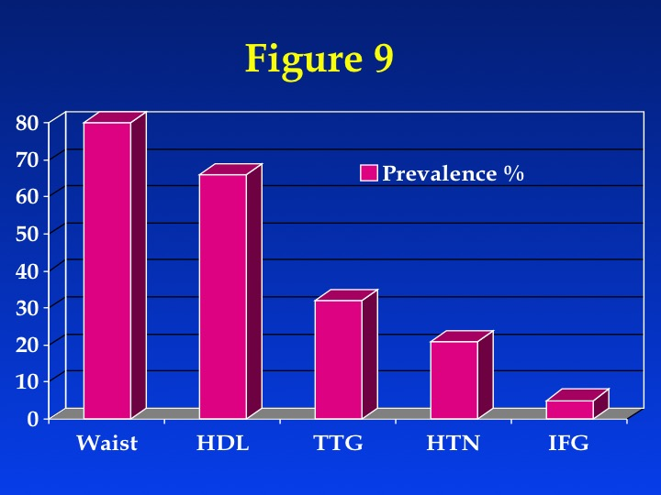

Figure 9: Prevalence of components of the metabolic syndrome among a large cohort of women with PCOS. HDL = high-density lipoprotein cholesterol less than 50 mg/dl; TTG= triglycerides greater than or equal to 150 mg/dl; HTN = blood pressure greater than or equal to 130/85 mm Hg; IFG = fasting glucose concentrations greater than or equal to 110 mg/dl (impaired fasting glucose).

**Mood Disorders.** Women with PCOS appear to be at increased risk for diminished quality of life and mood disorders (110). Specifically they suffer from increased rates of anxiety(111) and depression(112) compared to other women. The magnitude is significant as noted in one study in which women with PCOS were at an increased risk for depressive disorders (new cases) compared with controls (21% vs. 3%; odds ratio 5.11 [95% confidence interval (CI) 1.26-20.69]; P<0.03) (113) A validated quality of life (QoL) questionnaire has been developed for women with PCOS (PCOSQ) (114). Recently a large controlled study of over 100 women (N = 1359) found a high prevalence of low quality of life in women with PCOS (110). Women with PCOS had lower quality of life on all seven factors of the modified PCOSQ (emotional disturbance, weight, infertility, acne, menstrual symptoms, menstrual predictability and hirsutism). Weight was the largest contributor to poor quality of life for women on and off medication for their PCOS. Clinical studies to date have incorporated QoL measures into the trial design. A recent substudy of a clinical trial examining OCP and weight loss and the combination of the two in women found both weight loss and OCP use result in significant improvements in quality of life, depressive symptoms, and anxiety disorders with possible added benefit to the combined therapies.(115)

**Differential Diagnosis of PCOS**

The differential diagnosis of PCOS includes other causes of androgen excess (**Table 1**), and PCOS remains a diagnosis of exclusion. Because the work up for many of these disorders is expensive and tests have varying degrees of sensitivity and specificity, some clinical acumen must be applied in the selection of tests. Generally, every woman with signs and symptoms of PCOS should be screened for thyroid dysfunction, prolactin excess, and non-classical congenital adrenal hyperplasia. These diagnoses occur relatively more commonly among women with menstrual disorders, and there are good screening tests to diagnose them. Both hyper- and hypothyroidism have been associated with menstrual disturbances, although their link with hyperandrogenism is less proven. Mild elevations in prolactin are common in women with PCOS (116). A prolactin level can identify prolactinomas that secrete large amounts of prolactin which may stimulate ovarian androgen production, but this is an extremely rare cause of hyperandrogenic chronic anovulation. Evaluating serum levels of thyroid-stimulating hormone is also useful, given the protean manifestations and frequency of thyroid disease in women with menstrual disorders.

Non-classical congenital adrenal hyperplasia, often referred to as late-onset congenital adrenal hyperplasia, can present in adult women with anovulation and hirsutism and is due almost exclusively to genetic defects in the steroidogenic enzyme, 21 hydroxylase (CYP21). In Europe and the U.S., congenital adrenal hyperplasia occurs with the highest frequency among Ashkenazi Jews, followed by Hispanics, Yugoslavs, Native American Inuit in Alaska, and Italians (117). Increasingly mandatory postnatal genetic screening is diagnosing this in U.S. born infants. To screen for non-classical congenital adrenal hyperplasia due to CYP21 mutations, a fasting level of 17-hydroxyprogesterone should be obtained in the morning. A value less than 2 ng/mL is considered normal. If the sample is obtained in the morning and during the follicular phase, some investigators have proposed cutoffs as high as 4 ng/mL (118). Specificity decreases if the sample is obtained in the luteal phase due to increased progesterone production. High levels of 17-hydroxyprogesterone should prompt an adrenocorticotropic hormone (ACTH) stimulation test to confirm the diagnosis.

As Cushing syndrome is extremely rare (1 in 1,000,000) and screening tests are not 100% sensitive or specific (119), routine screening for Cushing syndrome in all women with hyperandrogenic chronic anovulation is not indicated. Those who have coexisting signs of Cushing syndrome, including a moon facies, buffalo hump, abdominal striae, centripetal fat distribution, or hypertension, should be screened. Proximal myopathies and easy bruising, not typically present in women with PCOS, may also help identify patients with Cushing syndrome.

Androgen-secreting tumors of the ovary or adrenal gland are invariably accompanied by elevated circulating androgen levels. However, there is no absolute level that is pathognomonic for a tumor, just as there is no minimum androgen level that excludes a tumor. In the past, testosterone levels above 2 ng/mL and dehydroepiandrosterone sulfate (DHEAS) levels greater than 700 µg/dL were regarded as suspicious for a tumor of, respectively, ovarian and adrenal etiology, but these cutoff levels have poor sensitivity and specificity (120).

**Evaluation of women with PCOS**

History and physical exam is important in evaluation of women with PCOS (**Table 2**). The history should focus on the onset (peri-pubertal vs acquired later in life) of oligomenorrhea, the onset and duration of the various signs of androgen excess, and concomitant medications, including the use of exogenous androgens. While many medications are associated with hypertrichosis, a generalized increase in body hair, few are associated with increased midline androgen-dependent terminal hair growth. A family history of diabetes and cardiovascular disease (especially first-degree relatives with premature onset of cardiovascular disease [male < 55 years and female < 65 years]) is important. Additionally, multiple studies have shown that PCOS clusters in families, such that a sister or mother with PCOS likely increases risk for the disorder or stigmata of the disorder in other family members. Lifestyle factors such as smoking, alcohol consumption, diet, and exercise are particularly important in these women. An astonishingly high number of women with PCOS are either current or past smokers. In one large multi-center trial, 17% were current smokers during the trial and 22% had a history of smoking (24). Further a history of recent smoking cessation may not be reliable when checked against urinary cotinine levels (a metabolite of nicotine).(121) Obviously for both fertility and prevention of cardiovascular disease, cessation should be a primary target of the treatment plan.

**Table 2:** Disorders to Consider in the Differential Diagnosis of PCOS

Androgen secreting tumor

Exogenous androgens

Cushing syndrome

Nonclassical congenital adrenal hyperplasia

Acromegaly

Genetic defects in insulin action (Leprechaunism, Rabson Mendenhall syndrome, Lipodystrophy)

HAIR-AN syndrome

Primary hypothalamic amenorrhea

Primary ovarian failure

Thyroid disease

Prolactin disorders

The physical examination should include evaluation of balding, acne, clitoromegaly, and body hair distribution, as well as pelvic examination to look for ovarian enlargement. The presence and severity of acne should be noted. Signs of insulin resistance such as hypertension, obesity, centripetal fat distribution, and the presence of acanthosis nigricans should be recorded. Other pathologic conditions associated with acanthosis nigricans should be considered, such as insulinoma and malignant disease, especially adenocarcinoma of the stomach.

The laboratory examination of patients should include tests at initial presentation to exclude other diagnoses as well as to evaluate circulating androgen (**Table 3**). The best measurement of circulating androgens to document unexplained androgen excess is a subject of debate, and recent expert consensus panels have recommended standardized testosterone assays and normative values for women and children (122). While mass spectrometry is increasingly becoming the gold standard for measurement of all sex steroids(123), studies have shown that even mass spectrometry has poor precision towards the lower levels seen in normal women.(124) Thus, there remains controversy about how to measure androgens in women.

**Table 3:** Focused History and Physical Exam components for Evaluation for PCOS

History

• Onset and Duration of Oligo-ovulation

• History of weight gain

• Family history for PCOS, Diabetes, CVD, Endometrial Cancer, etc

• Infertility (also screen for male and tubal factors)

• Smoking and substance abuse

Physical

• Blood pressure

• BMI (weight in kg divided by height in m2)

25–30 = overweight, > 30 = obese

• Waist circumference to determine body fat distribution

Value > 35 in = abnormal

• Presence of stigmata of hyperandrogenism/insulin resistance

Acne, hirsutism, androgenic alopecia, skin tags, acanthosis nigricans

Both the adrenal glands and ovaries contribute to the circulating androgen pool in women. The adrenal gland preferentially secretes weak androgens such as dehydroepiandrosterone (DHEA) or DHEAS (up to 90% of adrenal origin). These hormones, in addition to androstenedione, may serve as prohormones for more potent androgens such as testosterone and dihydrotestosterone. The ovary is the preferential source of testosterone, and it is estimated that 75% of circulating testosterone originates from the ovary (mainly through peripheral conversion of prohormones by liver, fat, and skin, but also through direct secretion). Androstenedione, largely of ovarian origin, is the only circulating androgen that is higher in premenopausal women than in men, yet its androgenic potency is only 10% of testosterone. Dihydrotestosterone is the most potent androgen, although it circulates in negligible quantities and results primarily from the intracellular 5α-reduction of testosterone.

Many studies attempting to identify the best circulating androgen for differentiating women with PCOS from control women have usually identified testosterone, androstenedione or both. (66,125) Each clinician should be familiar with the analytical performance and the normal ranges of local laboratories, as there is no standardized testosterone assay (and no accepted testosterone standard) in the U.S. and the sensitivity and reliability in the female ranges are often poor (122). Evaluation of DHEAS levels may be useful in cases of rapid virilization (as a marker of adrenal origin), but its utility in assessing common hirsutism is questionable.

The Rotterdam criteria have led to increasing use of ultrasound in the initial diagnosis and evaluation of women with PCOS (**Table 4**). In addition to ovarian size, ultrasound can exclude leiomyomas and most mullerian anomalies and the determine the thickness of the endometrium. Some studies have found very high asymptomatic rates of endometrial hyperplasia among amenorrheic women with PCOS (126). However. routine screening with ultrasound of the endometrium or routine endometrial biopsy is not recommended in the absence of abnormal uterine bleeding.

**Table 4**: Suggested Laboratory and Radiologic Examination of women with PCOS

Laboratory

• Documentation of biochemical hyperandrogenemia

Total testosterone and SHBGor bioavailable/free testosterone

• Exclusion of other causes of hyperandrogenism

Thyroid-stimulating hormone levels (thyroid dysfunction)

Prolactin (hyperprolactinemia)

17-hydroxyprogesterone (nonclassical congenital adrenal hyperplasia due to 21 hydroxylase deficiency)

Random normal level < 4 ng/mL or morning fasting level < 2 ng/mL

Consider screening for Cushing syndrome and other rare disorders such as acromegaly

• Evaluation for metabolic abnormalities

2-hour oral glucose tolerance test (fasting glucose < 110 mg/dL = normal, 110–125 mg/dL = impaired, >126 mg/dL = type 2 diabetes) followed by 75-g oral glucose ingestion and then 2-hour glucose level (< 140 mg/dL = normal glucose tolerance, 140–199 mg/dL = impaired glucose tolerance, >200 mg/dL = type 2 diabetes)

• Fasting lipid and lipoprotein level (total cholesterol, HDL < 50 mg/dL abnormal, triglycerides > 150 mg/dL abnormal

Ultrasound Examination

• Determination of polycystic ovaries

• Identify endometrial abnormalities

Optional Tests to Consider

• Gonadotropin determinations to determine cause of amenorrhea

• Fasting insulin levels in younger women, those with severe stigmata of insulin resistance and hyperandrogenism

• 24-hour urine test for urinary free cortisol with late onset of PCOS symptoms or stigmata of Cushing syndrome

The metabolic evaluation of women with PCOS has become a standard part of the evaluation. Exclusion of diabetes and identification of glucose intolerance can be obtained with a standard 75g oral glucose tolerance test. At the same time a fasting lipid profile can be obtained. The routine use of insulin levels in the diagnosis and management of women with PCOS is probably not indicated, as they are poor markers of insulin resistance if there is beta cell dysfunction and they have not been found to predict response to therapy. The identification of the metabolic syndrome is a better clinical marker of insulin resistance.

**Approach to TREATMENT OF WOMEN WITH PCOS**

Treatment of women with PCOS tends to be symptom based, as there are few therapies which address the multitude of complaints with which women with PCOS present. Arguably there are currently only two therapies that address the most common complaints, (i.e., infertility, hirsutism, menstrual disorders, and obesity) and these are either weight loss (as a result of lifestyle modification, medical or surgical therapy to reduce weight, or metformin therapy) (**Table 5**). It is often difficult to treat all complaints at once, with the greatest difficulty in treating both anovulatory infertility and hirsutism concurrently.(127) Some therapies can also be counterproductive and thus contraindicated in this situation, for instance the use of oral contraceptives because they block ovulation or the use of anti-androgens because they are potentially teratogenic in a male fetus. Because of these conundrums in clinical care, treatment tends to fall into two categories: either the treatment of anovulatory infertility or long-term maintenance treatment for PCOS-related symptoms (i.e., hirsutism, menstrual disorders, obesity, etc.)

**Table 5:** Commonly used or proposed treatments for PCOS or stigmata of PCOS. Many of these are used off label.

|  |  |  |  |  |
| --- | --- | --- | --- | --- |
|  | Anovulatory Infertility | Hirsutism (Alopecia) | Menstrual Disorders | Obesity |
| Lifestyle Intervention |  |  |  |  |
| Obesity Surgery |  |  |  |  |
| Metformin |  |  |  |  |
| Thiazolidinediones |  |  |  |  |
| Ovarian Surgery |  |  |  |  |
| GnRH analogue |  |  |  |  |
| Oral Contraceptives |  |  |  |  |
| Steroids (Dexamethasone) |  |  |  |  |
| Progestins |  |  |  |  |
| Statins |  |  |  |  |
| Letrozole |  |  |  |  |
| Clomiphene |  |  |  |  |
| Gonadotropins |  |  |  |  |
| IUD |  |  |  |  |
| Uterine Surgery |  |  |  |  |
| Eflornithine HCl creme |  |  |  |  |
| Spironolactone |  |  |  |  |
| Androgen Receptor Antagonists (Flutamide) |  |  |  |  |
| 5-alpha reductase inhibitor (Finasteride) |  |  |  |  |
| Mechanical/Laser Therapies for Hair Removal |  |  |  |  |

**Overview of Treatment of Anovulatory Infertility.** One important consideration before treating subjects with anovulatory infertility is to screen the couple for other infertility factors. One large multi-center trial found that 10% of male partners of women with PCOS had co-existing severe oligospermia and close to 5% of women had bilateral occlusion of the fallopian tubes or some uterine factor (128). Obviously, the presence of these factors would significantly alter therapy, and their high prevalence justifies pre-treatment screening. There is no evidence-based schema to guide the initial and subsequent choices of approaches to ovulation induction in women with PCOS. The ASRM/ESHRE sponsored conference recommended that before any intervention is initiated, preconceptual counseling should emphasize the importance of lifestyle, especially weight reduction and exercise in overweight women, smoking cessation, and reducing alcohol consumption (129,130).

The recommended ASRM/ESHRE first-line treatment for ovulation induction remains the anti-estrogen clomiphene citrate (CC), and this view has been upheld by other groups including the World Health Organization(131). However there is now increasing evidence that letrozole, an aromatase inhibitor, is more efficacious and equally safe to mother and fetus(132). Recommended second-line intervention, should be CC or the combination of metformin and CC if first line therapy fails to result in pregnancy. Third-line therapy is either exogenous gonadotropins or laparoscopic ovarian surgery (129,130). The caregiver must carefully assess the reproductive toxicity of all medications used in women with PCOS, because several may increase ovulatory frequency and result in unexpected and unintended pregnancy and possible fetal exposure. Recently the FDA eliminated the categorization of teratogenicity of medications into categories (i.e., Category A, B, C, D and X) and instead ruled that package inserts should provide specific data about teratogenic risks in animals and humans or acknowledge the lack of such data. Eventually all package inserts will be modified to reflect true risk as opposed to theoretical risk based on mechanism of action of the drug.

**Overview of Long Term Maintenance of PCOS.** There is no known cure for PCOS; rather therapy revolves around suppression of symptoms. Therapy tends to focus on the primary chief complaint. However often the triad of hirsutism, oligomenorrhea, and obesity forms the key presenting symptoms. In such cases, it may make sense to choose a primary metabolic parameter upon which to base initial treatment. Glucose intolerance is the strongest risk factor for diabetes and is also an independent risk factor for cardiovascular events in women(133) and is one potential factor to use in selecting initial treatment. A possible first-line strategy is found in **Figure 11**, which allows selection of the therapies that improve the triad of PCOS symptoms. Additional targeted therapies for hirsutism and/or oligomenorrhea could be added depending on response to the initial therapy. Obviously, contraception should be considered if the patient is trying to avoid pregnancy.

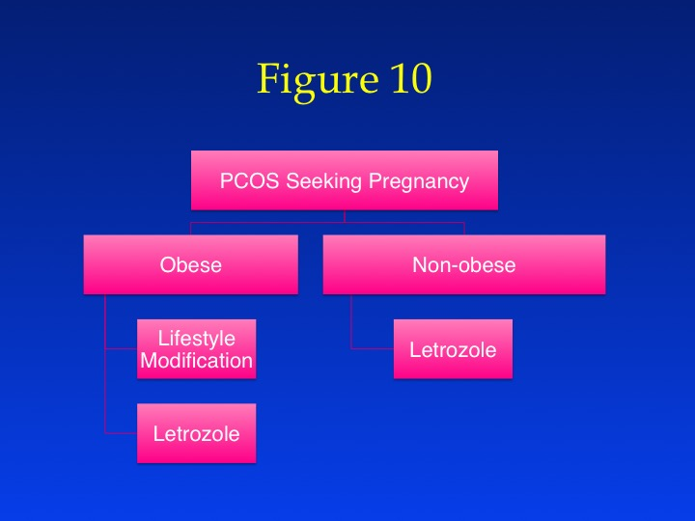

Figure 10: Suggested first-line treatment plan for infertile women with PCOS.

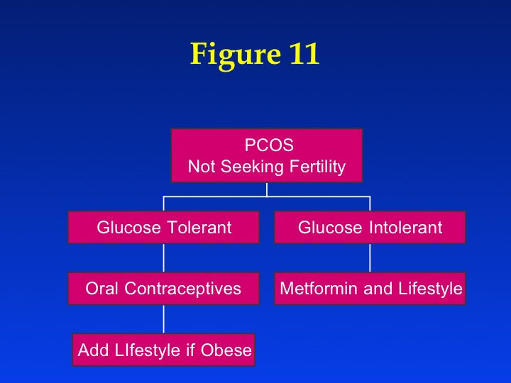

Figure 11: Suggested first line treatment plan for women with PCOS not seeking pregnancy.

**Review of Efficacy of Individual Therapies on PCOS**

**Aromatase Inhibitors** Aromatase inhibitors, specifically letrozole, may be a first-line therapy for ovulation induction in women with PCOS. While the mechanism of action of aromatase inhibitors is likely similar to clomiphene in that the target is the hypothalamic pituitary axis and the normalization of gonadotropin secretion, the site of action may be multifocal, i.e., in the hypothalamus, in peripheral fat tissues, and perhaps even in the ovary. The proposed benefits of letrozole include oral administration, a shorter half-life than clomiphene, more favorable effects on the endometrium, potentially higher implantation rates, and lower multiple pregnancy rates due to monofollicular ovulation.(134) A large multicenter study conducted by the Reproductive Medicine Network of letrozole versus clomiphene upheld many of these hypotheses and showed a 44% improvement in the live birth rate with letrozole over clomiphene.(25) The greatest benefit was in the moderately obese group, though a tertile analysis trended towards benefit of letrozole over clomiphene in all weight classes (**Figure 12**). Subsequent studies have replicated these results and the meta-analysis suggests a 50-60% live birth benefit with letrozole over clomiphene.(132) Although the trend in the Reproductive Medicine Network study was towards a lower multiple pregnancy rate with letrozole versus clomiphene (3.9% vs 6.8%), even larger studies will be necessary to confirm this trend.(135) Letrozole offers a higher per cycle and cumulative ovulation rate than clomiphene. Only 10% of women failed to ovulate at least once in the Reproductive Medicine Network study compared to close to 25% of women on clomiphene. There is also better fecundity per ovulated patient, suggesting a better quality of ovulation. When the results of a midluteal ovulation check (by both ultrasound and serum assays) are compared to baseline in the follicular phase, women with PCOS on letrozole have higher progesterone levels and lower estradiol levels, thus with a more physiologic hormonal milieu than with clomiphene. Women also have a relatively thinner endometrium on letrozole (against expectation) and lower antral follicle counts and AMH levels relative to clomiphene. Again, this suggests normalization of endometrial response and ovarian morphology with letrozole.

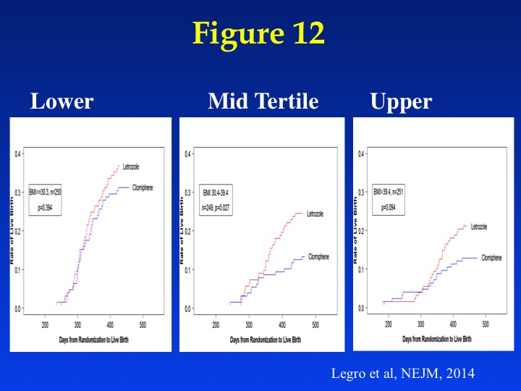

Figure 12: Tertile Analysis by BMI group of women with PCOS of live birth rate over time randomized to clomiphene or letrozole.

Safety has been closely studied in randomized trials of letrozole for ovulation induction in women with PCOS. Relative to clomiphene, letrozole is associated with significantly more fatigue and dizziness, but fewer episodes of hot flashes.(25) There is no increased incidence of serious adverse events with letrozole, and no clear pattern or relationship to the drug. Paramount to the use of letrozole is the concern about teratogenicity with letrozole relative to clomiphene. In two large studies using letrozole conducted by the Reproductive Medicine Network, the anomaly rates were comparable between clomiphene and letrozole.(25,136) In both studies they were under 5% with both drugs and within expected rates, especially when acknowledging that subfertile women have higher rates of fetal anomalies than women who conceive without assistance. Further there was no pattern to the reported anomalies, suggesting that a specific organ or organ system was altered by letrozole exposure. Case series have also supported the relative fetal safety of letrozole compared to clomiphene.(137-139) Finally such studies must consider that the underlying rate of congenital anomalies is higher among women with a history of subfertility or who have conceived through fertility treatments.(140) Although letrozole is not recommended as a fertility treatment agent in certain countries due to black box warnings, the source of this concern is unwarranted without supporting published data.

There are still many unanswered questions about letrozole including its use as an adjuvant agent with other medications used to treat PCOS, whether it is effective as a second-line solo treatment after clomiphene, and whether prolonged dosing would increase pregnancy rates. Of note is that anastrozole failed both as a high dose one-time administration to women with PCOS(141) and also as a lower dose multi-day therapy compared to clomiphene,(142) so all aromatase inhibitors are not alike.

**Clomiphene Citrate.** Clomiphene citrate (CC) has traditionally been the first-line treatment agent for anovulatory women, including those with PCOS, and several multi-center randomized controlled trials have upheld the use of clomiphene as first-line treatment. In fact, this may the area of study of PCOS with the largest and best designed studies. Clomiphene is a triphenylethylene derived nonsteroidal agent that is theorized to function at the level of the hypothalamus as an anti-estrogen to improve gonadotropin secretion. CC use is associated with hot flashes, mood changes, and rarely changes in vision thought due to pituitary swelling (thought to be a serious event and reason for discontinuing the drug). From a public health perspective, more concerning is the relatively high rate of multiple pregnancy after conception with clomiphene of 7.8%, although the majority are twins (143). However, there is nevertheless a high order (triplets or more) multiple pregnancy rate of 0.9% (143). Comparison of the multiple pregnancy rate after conception with clomiphene suggests that the multiple pregnancy rate may be slightly higher in women with unexplained infertility(136) than in women with PCOS (25), although the lower rate in women with PCOS may also be related to higher obesity rates. Six-month life birth rates range from 20-30%(25) and are higher over longer periods of observation (144). Half of all women who are going to conceive using clomiphene will do so at the 50-mg starting dose, and another 20% will do so at the 100-mg/d dose (145). Most pregnancies will occur within the first six ovulatory cycles, although constant monthly pregnancy rates were noted, suggesting there may be continued benefit to longer use (146). Prognostic clinical factors for live birth with clomiphene include decreased BMI, less hirsutism, younger age, and shorter duration of attempted conception(147,148).

Alternative clomiphene regimens have been developed, including prolonging the period of administration (149), pretreating with oral contraceptives (150) adding dexamethasone (151), and adding metformin (152). Dexamethasone as adjunctive therapy with clomiphene citrate has been shown to increase ovulation and pregnancy rates in clomiphene-resistant women with PCOS (153). Finally some groups have recommended using similar compounds to clomiphene, such as tamoxifen, in lieu of clomiphene (154).

Clomiphene is usually started at 50 mg a day for 5 days and increased by 50 mg a day in subsequent cycles if the patient remains anovulatory up to a maximum daily dose of 150 mg/d. As noted above, induced withdrawal bleeding in the face of continued anovulation may lower subsequent ovulation and pregnancy rates and certainly requires more time and resources. This has led to the adoption of a “stair step” approach where the dose is escalated based on ultrasound and serum determination of follicular development and/or ovulation.(155) The primary discomfiting side effect with clomiphene is hot flashes, likely due to its anti-estrogenic effects in the hypothalamus. Rare side effects that require immediate attention and discontinuation of medication are a sudden change in vision or loss in vision. There is currently thought to be no added risk of congenital anomalies to women who conceive on the medication as opposed to other therapies.

**Gonadotropins.** Gonadotropins are frequently used to induce ovulation in women with PCOS for whom clomiphene treatment has failed. Low-dose therapy with gonadotropins offers a higher rate of ovulation, monofollicular development, with a significantly lower risk of ovarian hyperstimulation syndrome (156). When given in controlled situations with strict cancellation policies for excessive follicular development, gonadotropins lead to higher pregnancy rates than does clomiphene with similar multiple pregnancy rates.(157) This has led some to recommend this as a first-line therapy, although the expense and higher complication rates in untrained hands remain major treatment considerations. A low-dose regimen is the ASRM/ESHRE (158) and WHO consensus recommendation (131) when using gonadotropins in women with PCOS.

**In Vitro Fertilization.** Women with PCOS who undergo IVF generally have a good prognosis for pregnancy and live birth compared to many other common indications for IVF. Data from the U.S. SART database suggest that women with PCOS have an increased chance for live birth compared to women with tubal disease.(159) Women with PCOS have a higher number of oocytes retrieved than women with tubal factor and live-birth rates were also increased in women with PCOS (34.8% vs. 29.1%; OR, 1.30; 95% CI, 1.24-1.35).(**Figure 13**) A similar rate of decline in clinical pregnancy and live-birth rates was noted in both groups with age (20-44 years) and live-birth rates were not significantly different for each year after age 40 in the two groups. Thus, women with PCOS appear to enjoy the greatest benefit in increased live-birth rates over tubal factor between the ages of 30 and 40 years.

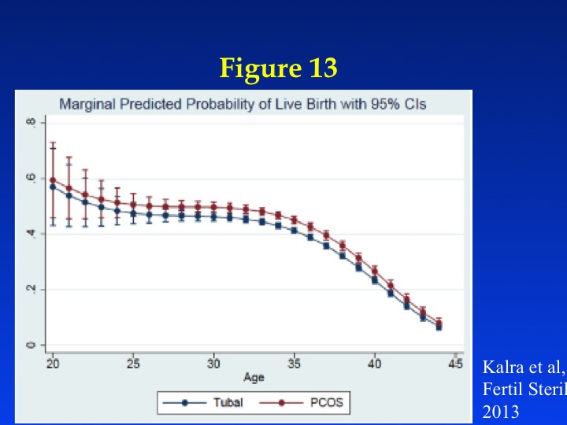

Figure 13: Adjusted analysis of outcomes in tubal factor infertility versus PCOS of live-birth rate by continuous age based on the SART age group data.

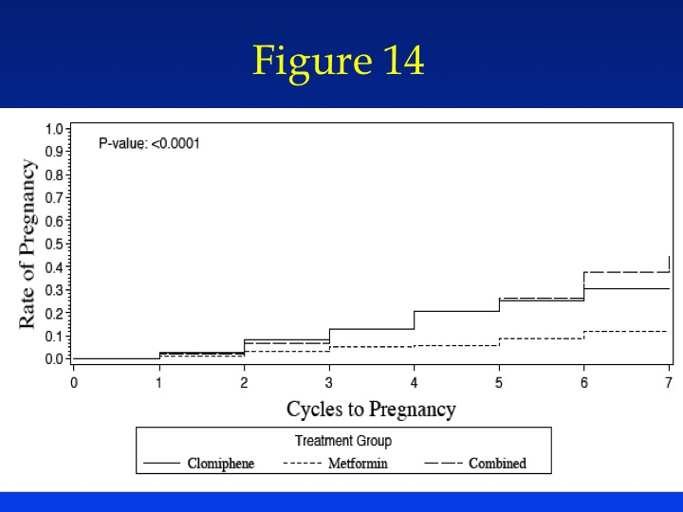

Figure 14: Kaplan Meier Curves of cumulative pregnancy rates in the six-month double-blind randomized trial of clomiphene, metformin, or the combination of both in treatment of anovulatory infertility in PCOS (Pregnancy in Polycystic Ovary Syndrome Study-PPCOS).

Women with PCOS are at increased risk for ovarian hyperstimulation syndrome as noted above. Recently a large multi-center trial from China examined the risk-benefit ratio of elective freezing of all embryos followed by frozen embryo transfer versus fresh embryo transfer in women with PCOS.(160) Frozen-embryo transfer resulted in a higher frequency of live birth after the first transfer than did fresh-embryo transfer (49.3% vs. 42.0%), for a rate ratio of 1.17 (95% confidence interval [CI], 1.05 to 1.31; P=0.004). This appeared to be largely mediated through reduced pregnancy loss after frozen-embryo transfer (22.0% vs. 32.7% in the fresh group), for a rate ratio of 0.67 (95% CI, 0.54 to 0.83; P<0.001), and of the ovarian hyperstimulation syndrome (1.3% vs. 7.1%), for a rate ratio of 0.19 (95% CI, 0.10 to 0.37; P<0.001), but a higher frequency of preeclampsia (4.4% vs. 1.4%), for a rate ratio of 3.12 (95% CI, 1.26 to 7.73; P=0.009). There were five neonatal deaths in the frozen-embryo group and none in the fresh-embryo group (P=0.06). These data suggest a mixed risk-benefit ratio of elective frozen embryo transfer in women with PCOS.

**Ovarian Surgery.** The value of laparoscopic ovarian drilling with laser or diathermy as a primary treatment for subfertile women with anovulation and PCOS is undetermined (161), and it is primarily recommended as second-line infertility therapy. Neither drilling by laser or diathermy has any obvious advantage, and there is insufficient evidence to suggest a difference in ovulation or pregnancy rates when drilling is compared with gonadotropin therapy as a secondary treatment (161). Multiple pregnancy rates are reduced in those women who conceive following laparoscopic drilling. In some cases, the fertility benefits of ovarian drilling may be temporary and adjuvant therapy after drilling with clomiphene may be necessary (162). Ovarian drilling does not appear to improve metabolic abnormalities in women with PCOS (163). Long term follow up of a Dutch cohort who underwent either laparoscopic drilling or gonadotropin therapy showed higher fecundity rates with laparoscopic drilling.(164) and greater cost effectiveness of the surgery.(165)

Ovarian drilling may also be used to restore menstrual cyclicity in women not seeking pregnancy, and there is evidence in some series of long term improvement in menses as a result of surgery (166). However, these series are uncontrolled and as noted above hyperandrogenism and oligomenorrhea tend to improve with age in women with PCOS regardless of any treatment.

**Metformin.** The use of metformin as first-line solo infertility therapy has not been supported by randomized trials, although there are emerging data about its utility as an adjuvant agent. In the largest trial to date, clomiphene was roughly three times more effective at achieving live birth compared to metformin alone (**Figure 12**)(146). Meta-analysis of metformin studies in women with PCOS has not found a benefit in terms of live birth, but clinical pregnancy rates were improved for metformin versus placebo (pooled OR 2.31, 95% CI 1.52 to 3.51, 8 trials, 707 women).(167) Metformin combined with clomiphene may be the best combination in obese women with PCOS as noted in several randomized trials. (146,168)

Metformin has no known human teratogenic risk or embryonic lethality in humans and appears safe in pregnancy. There is no solid evidence that metformin use early in pregnancy prevents pregnancy loss (169), and the randomized trials which stopped drug with pregnancy have shown similar miscarriage rates with metformin as with clomiphene (146,170). Similarly, the use of metformin throughout pregnancy in women with PCOS has not been associated with clear benefit beyond blunting gestational weight gain. (171) Surprisingly in this large multi-center trial, there was no prevention of gestational diabetes. In other populations, metformin has been found to have similar effects as insulin for the treatment of gestational diabetes yet is better tolerated by patients (172) and does not result in change in birth weights when given to obese women who are pregnant(173).

Metformin may be most useful in the long-term maintenance of PCOS. Metformin does lower serum androgen, increases ovulations, and improves menstrual frequency (174). While menstrual frequency is improved by roughly a third to a half from baseline, metformin does not always restore regular menstrual cycles in women with PCOS. There may also be favorable effects in preventing the progression to diabetes. The Diabetes Prevention Program demonstrated that metformin can prevent the development of diabetes in high-risk populations (e.g., those with impaired glucose tolerance) (175), and this result has been replicated for a number of anti-diabetic drugs in individuals at high risk. Metformin tends to be the drug of choice to treat glucose intolerance and elevated diabetes risk in women with PCOS because of its favorable safety profile and the familiarity a wide number of caregivers from varying specialties have with the medication. However, there are no adequately powered long term studies of metformin in women with PCOS to document diabetes prevention. Among women with PCOS who use metformin, glucose tolerance improves or stays steady over time (176). Metformin also may be associated with weight loss in women with PCOS, although the results in other populations are inconsistent (146,177). Metformin is often used in conjunction with lifestyle therapy to treat PCOS. Recent studies suggest that there is limited benefit to the addition of metformin above lifestyle therapy alone in PCOS (178-182).

Metformin carries a small risk of lactic acidosis, most commonly among women with poorly controlled diabetes and impaired renal function. Gastrointestinal symptoms (diarrhea, nausea, vomiting, abdominal bloating, flatulence, and anorexia) are the most common adverse reactions and may be ameliorated by starting at a small dose and gradually increasing the dose or by using the extended-release version. The dose is usually 1500-2000 mg/day given in divided doses. The effects of metformin and other anti-diabetic drugs on preventing endometrial hyperplasia/neoplasia in women with PCOS are largely unknown.

**Thiazolidinediones,** Smaller trials have shown some benefit to this class of drugs for the treatment of infertility, usually in conjunction with clomiphene (183,184). However, the concern about hepatotoxicity, cardiovascular risk, weight gain, and reproductive toxicity in animal studies have limited the use of these drugs in women with PCOS. One of the thiazolidinediones, troglitazone, was removed from the market due to hepatotoxicity, and there has been increasing scrutiny of rosiglitazone because of increased cardiovascular events and of pioglitazone because of breast cancer. Nonetheless, improving insulin sensitivity with these drugs is associated with a decrease in circulating androgen levels, improved ovulation rate, and improved glucose tolerance (54,185-187). However, given the restrictions on their use in patients with type 2 diabetes, the risk-benefit ratio appears very unfavorable for women with PCOS.

**GLP-1 agonists.** GLP-1 (Glucagon-Like Peptide) is an incretin secreted by the L cells of the intestine which increases pancreatic beta cell insulin production and insulin sensitivity. It also has CNS effects which lead to decreased appetite through a variety of mechanisms. GLP-1 agonists have been approved both for the treatment of type 2 diabetes and in higher doses (liraglutide) for the treatment of obesity in the U.S. These drugs thus offer a favorable dual treatment strategy for women with PCOS. Studies, however, have been limited, likely by two factors, the requirement for parenteral injection and the relative expense of the drugs compared to oral alternatives. Small observational studies do support that women with PCOS tend to lose weight and experience improvements in metabolic parameters related to insulin resistance. (188,189) Side effects of concern with this class of drugs include pancreatitis and an increased risk of thyroid cancer (medullary) and concerns about CNS interactions in patients with psychiatric disorders.

**Combination Oral Contraceptives.** Oral contraceptives have been the mainstay of long-term management of PCOS among gynecologists even though there are few well designed trials in women with PCOS. They offer benefit through a variety of mechanisms, including suppression of pituitary LH secretion, suppression of ovarian androgen secretion, increased circulating SHBG levels (and thus decreased peripheral androgen exposure) as well as potential antagonism of steroidogenic enzymes or steroid receptors (most commonly the androgen receptor). Estrogen may be the most potent stimulator of SHBG production. Individual OC preparations may have different doses and drug combinations and thus have varying risk–benefit ratios. For instance, various progestins have been shown to have different effects on circulating SHBG levels (190), but whether that translates into any clinical differences among preparations is uncertain. The “best” oral contraceptive for women with PCOS is unknown based on data, only on marketing hype. Oral contraceptives also are associated with a significant reduction in risk for endometrial cancer with a reduction of risk by 56% after four years of use and 67% after eight years in users compared to non-users (191), but the magnitude of the effect in women with PCOS is not known.

Because women with PCOS may have multiple risk factors for adverse effects and serious adverse events on oral contraceptives, they must be screened carefully for risk factors for these events including smoking history, presence of obesity and hypertension, and history of clotting diathesis to mention some of the important factors (**Table 6**). Studies based on insurance claims have suggested women with PCOS may have a higher risk of thromboembolic events on or off of OCP.(192) In the larger U.S. population, oral contraceptive use has not been associated with an increased risk of developing type 2 diabetes (193). There is no convincing evidence that use of oral contraceptives contributes to the risk of diabetes in women with PCOS, although there are often adverse effects on insulin sensitivity that may be dose dependent (194,195). Our own study showed a short-term (16 week) 25% deterioration in glucose tolerance on a low dose OCP compared to baseline in obese women with PCOS.(196) However, longer follow up studies are needed. A low dose oral contraceptive pill is therefore recommended. Concurrent lifestyle modification in obese women with PCOS may ameliorate the adverse metabolic effects of OCP.(196)

**Table 6**: Absolute and Relative Contraindications to Oral Contraceptive Use. Women with PCOS should be screened for these (common abnormalities in this group of women are underlined) and risk benefit ratios carefully discussed with them before initiating therapy.

**Absolute contraindications**

< 6 weeks postpartum if breastfeeding

Smoker over the age of 35 (≥ 15 cigarettes per day)

Hypertension (systolic ≥ 160mm Hg or diastolic ≥ 100mm Hg)

Current or past history of venous thromboembolism (VTE)

Ischemic heart disease

History of cerebrovascular accident

Complicated valvular heart disease

Migraine headache with focal neurological symptoms

Breast cancer (current)

Diabetes with retinopathy/nephropathy/neuropathy

Severe cirrhosis

Liver tumour (adenoma or hepatoma)

**Relative Contraindications**

Smoker over the age of 35 (< 15 cigarettes per day)

Adequately controlled hypertension

Hypertension (systolic 140–159mm Hg,diastolic 90–99mm Hg)

Migraine headache over the age of 35

Currently symptomatic gallbladder disease

Mild cirrhosis

History of combined oral contraceptive related cholestasis

Users of medications that may interfere with combined oral contraceptive metabolism

Oral contraceptives may also be associated with a significant elevation in circulating triglycerides as well as in HDL levels, although these increases do not appear to progress over time (197). There is no evidence to suggest that women with PCOS experience more cardiovascular events than the general population when they use oral contraceptives, although risk factors for adverse events such as hypertension, obesity, clotting history, and smoking must be considered. The effect of progestins alone on metabolic risk factors varies and is not well understood.

No oral contraceptive has been approved by the FDA for the treatment of hirsutism although many have been approved for treatment of acne. A number of observational or nonrandomized studies have noted improvement in hirsutism in women with PCOS who use oral contraceptives (198). Few studies have compared outcomes of different types of oral contraceptives, and no one type of pill has been shown definitively to be superior in treating hirsutism in women with PCOS. The largest randomized study out of India suggested a greater benefit at 12 months in treating hirsutism with a pill containing cyproterone acetate, a pill not available in the U.S., compared to ones containing desogestrel or drospirenone. (199) There was no difference among groups at 6 months. The take home message from this and other studies is that the improvement in hirsutism is slow and steady, and longer time frames are required to document improvement in hirsutism. A number of studies have found additive benefit when oral contraceptives are combined with other treatment modalities, most commonly spironolactone, to treat hirsutism.(200) If a woman is taking an oral contraceptive that contains drospirenone (brand name Yasmin and Yaz), a progestin with anti-mineralocorticoid properties, it may be necessary to reduce her dose of spironolactone if used as additional therapy, and evaluate her levels of potassium. There have been several epidemiologic studies that have linked newer progestins, including drospirenone with an increased risk of thromboembolic events. However, these studies have been criticized for potential prescribing or detection bias.

There is a theoretical benefit to treating hyperandrogenism with extended cycle formulations, as these are less likely to result in rebound ovarian function and more likely to lead to more consistently suppressed ovarian steroid levels, including androgens (201). However, there have been few studies to uphold this in practice, although these are increasingly utilized for other reasons, such as decreased vaginal bleeding and greater patient satisfaction.

**Progestins.** Both depot and intermittent oral medroxyprogesterone acetate(MP) (10 mg for 10 days) have been shown to suppress pituitary gonadotropins and circulating androgens in women with PCOS (202). Depot MPA has been associated with weight gain, mood changes and breakthrough bleeding, but provides effective contraception if needed. No studies have addressed the long-term use of these compounds to treat hirsutism. The regimen of cyclic oral progestin therapy that most effectively prevents endometrial cancer in women with PCOS is unknown. There is also a paucity of data to address the varying risk-benefit ratios of varying classes of progestins. Progestin-only oral contraceptives are an alternative for endometrial protection, but they are associated with a high incidence of breakthrough bleeding.

Cyproterone acetate is a progestin not available commercially in the U.S. with anti-androgenic properties. It is frequently combined in an oral contraceptive in other countries and is popular in the treatment of PCOS. A newer progestin from the same class, drospirenone, has been marketed in the U.S. as especially effective for the treatment of female hyperandrogenism, although the data suggesting this is superior to other formulations is not based on head-to-head randomized trials (203).

**Intrauterine Devices.** There is increasing literature supporting the benefit of IUDs, especially a progestin (levonorgestrel) containing IUD, in treating a variety of endometrial disorders, including menorrhagia (204,205), simple endometrial hyperplasia (206) and complex hyperplasia(207). A recent meta-analysis, based on a small number of high quality studies, concluded that a levonorgestel containing IUD may be more effective than oral progestins in treating simple endometrial hyperplasia.(208) Levonorgestrel containing IUDs have also been used to treat hyperplasia with atypia and even some local cases of endometrial adenocarcinoma in women desiring to preserve their uteruses for fertility.(209)

**Uterine Surgery.** In patients with intractable uterine bleeding who have completed their child-bearing, consideration may be given to either endometrial ablation or more definitive surgical therapy via hysterectomy. The long-term risk of endometrial cancer developing in isolated pockets of endometrium after ablation remains a theoretical concern without clear data in this group of women at high risk for endometrial cancer.

**Statins.** Another area where there is limited support in the literature for a cardiovascular and endocrine benefit in women with PCOS is with the use of statin(210). They have been shown to improve hyperandrogenemia, lipid levels, and reduce inflammation in women with PCOS (211,212). They have been studied in conjunction with both OCP and metformin with additive benefits noted.(213,214) However their long term effects in preventing cardiovascular disease in young women with PCOS is unknown, although a small but clinically significant preventive effect on CVD events was noted in a young population without dyslipidemia but with elevated C reactive protein levels.(215) There are theoretical concerns about teratogenicity with the use of this drug in reproductive aged women based primarily on its mechanism as a cholesterol synthesis inhibitor. The use of these drugs is still experimental in women with PCOS, and the comparative effects of varying statins in women with PCOS is unknown.

**Lifestyle Modification.** The gold standard for improving insulin sensitivity in obese PCOS women should be weight loss, diet, and exercise. It is recommended as the first-line of treatment in obese women who present with infertility as discussed above. Obesity has become epidemic in our society and contributes substantially to reproductive and metabolic abnormalities in PCOS. Unfortunately, there are no effective treatments that result in permanent weight loss, and it is estimated that 90-95% of patients who experience a weight decrease will relapse. In markedly obese individuals, the only treatment that results in sustained and significant weight reduction is bariatric surgery (216). However, only a fraction of eligible patients ever elect or are qualified to receive bariatric surgery. In the U.S., it is estimated that only 1% of eligible patients receive bariatric surgery for the treatment of obesity.

There is no miracle diet in women with PCOS despite claims to the contrary. Hypocaloric diets result in appropriate weight loss in women with PCOS (arguing against any special defect towards weight retention). There is no clear evidence that any particular dietary composition benefits weight loss or reproductive or metabolic changes in women with PCOS (217,218), although “subtle differences” between diets were noted in a recent systematic review.(219) A two-year study in the general population found comparable weight loss among three types of diets of varying macronutrient composition and found comparable weight loss and similar improvement in lipid and insulin levels (220). Thus, the consensus recommendations for women with PCOS is to utilize any type of hypocaloric diet that they can tolerate and maintain (129,130).

There have been unfortunately few studies on the effect of exercise alone on symptoms in PCOS women (221), although it is reasonable to assume that exercise would have the same beneficial effects in PCOS women as in women with type 2 DM. These benefits relate more to improved glycemic control and less to weight loss. In fact, exercise alone or in addition to caloric restriction adds only modestly to weight loss, in the range of 2-4% over a sustained period.(222) Exercise is thought to play a key role in weight maintenance after weight loss from caloric restriction.(223) However the exercise program must be tailored to the degree of obesity and the patient’s baseline fitness. Women with PCOS and morbid obesity may be poor candidates for weight bearing aerobic exercise due to musculoskeletal overload. Additionally, there may be medical contraindications to certain form of exercise.

**Bariatric Surgery.** Bariatric surgery is increasingly used in morbidly obese patients as a first-line obesity therapy. The current National Institutes of Health recommendations are to utilize bariatric surgery in patients with a BMI greater than 40 or with a BMI greater than 35 and serious medical co-morbidities (224). PCOS has been listed as a co-morbidity justifying bariatric surgery by some experts. Some women with PCOS appear to experience a dramatic improvement in symptoms after surgery (225,226). However, these studies are primarily case series and need further validation in prospective studies. Randomized studies have documented that bariatric surgery is superior to medical treatment in controlling type II diabetes induced hyperglycemia, as well as providing a lower body weight and improved quality of life up to three years after surgery.(227) Weight loss may result in resumed ovulation and pregnancy during the period of rapid weight loss (first 6-12 months after surgery), which has led to concern about the effects of malnutrition on the fetus and general recommendations to refrain from pregnancy for 12-24 months. Data support that women who conceive after bariatric surgery are at increased risk for small-for-gestational-age babies and shorter pregnancies.(228)

The ideal bariatric procedure for PCOS is unknown. Previously, it was thought that gastric banding was ideal, where the gastric band could be adjusted to accommodate larger caloric loads in case of pregnancy. However, there were long-term complications from band erosion. Roux-en-Y Gastric Bypass (RYGB) was until recently the most commonly performed procedure and results in significantly more weight loss than gastric banding (“lap banding”). However, this procedure is now being overtaken by Vertical Sleeve Gastrectomy (VSG), which has lower operative and long-term morbidity due to the lack of bowel re-anastomosis that characterizes RYGB. VSG offers long term weight loss slightly less than RYGB.(229)

**Pharmacologic treatment of obesity.** Because weight loss generally improves stigmata of PCOS, there have been a number of studies using medications for the treatment of obesity as primary treatments of PCOS. They appear in limited and small trials to offer some benefit (230-234). The current medications approved for the treatment of obesity in the U.S. and their risk/benefit ratio are summarized in **Table 7**. It is important to note that one medication, sibutramine (a sympathomimetic central appetite suppressant) was removed recently from the U.S. market by the FDA because of concerns of increased CVD events with its use. Similarly, rimonabant (a cannabinoid CB1 receptor antagonist central appetite suppressant) which was approved in Europe (but not in the U.S.) was removed from their market because of concerns about suicidal ideation and suicides on the drug. Currently there are insufficient data about the benefits of these drugs on signs and symptoms of PCOS to recommend them as a treatment for endocrine-related symptoms of PCOS, but they all have proven weight loss efficacy.

Table 7: Drugs Approved for the Treatment of Obesity in the U.S. (All are contraindicated during pregnancy or with known hypersensitivity to the drug).

| **Generic Name(s)** | **Mechanism of action** | **Relative Weight Loss compared to other drugs(239)** | **Contraindications and Cautions** | **Warnings about Rare Side Effects** | **Common Side Effects** |
| --- | --- | --- | --- | --- | --- |
| Orlistat | Gastric Lipase inhibitor-inhibits fat absorption | Less | 1. Reduced gallbladder function  3. Use with caution with pancreatic or liver disease | Some patients may develop increased levels of urinary oxalate and kidney stones | 1.steatorrhea  2. diarrhea  3. flatulence  4. increased stooling |
| Phentermine | Central appetite suppressant, sympathomimetic amine | Better  Intended as short term agent (< 6 mos), | 1. History of cardiovascular disease  2. During or within 2 weeks following the administration of monoamine oxidase inhibitors  3. Hyperthyroidism.  4. Glaucoma.  5. Agitated states.  6. History of drug abuse | 1. May impair the ability of the patient to engage in potentially hazardous activities such as operating machinery or driving a motor vehicle  2. Abuse or addiction | 1.feeling restless; 2.headache, 3.dizziness, 4. tremors; 5.poor sleep,  6. dry mouth |
| Lorcarserin | Central appetite suppressant, aserotonin 2C receptor agonist | Less | caution if  1. renal failure  2. CHF, bradycardia or heart block  3. diabetes mellitus  4, priapism  or penile deformities  5. depression | 1. valvular heart disease (symptoms: shortness of breath, edemas)  2. mental illness (depression, suicidal mood)  3. serotonin neuroleptic malignant syndrome (symptoms: excitement, nausea, sweating, tachycardia) | 1.hypoglycemia  2. mental issues  3. bradycardia  4.headache  5. dizziness  6.drowsiness  7.fatigue,  8. nausea  9.dry mouth  10.constipation  11. painful erections |
| Liraglutide | Central appetite suppressant, long-acting glucagon-like peptide-1 receptor agonist | Better | 1. Personal or family history of medullary thyroid carcinoma (MTC) or in patients with Multiple Endocrine Neoplasia syndrome type 2 (MEN 2).  2. Avoid in patients with history or pancreatitis  Caution  1. May | 1. Possible thyroid tumors including cancer  2. Pancreatitis | 1. nausea/ vomiting  2.hypoglycemia  3. diarrhea  4.constipation  5.headache  6. fatigue  7. dizziness  8. increased lipase |
| Phentermine/ Topiramate | Phentermine Central appetite suppressant, sympathomimetic amine  Topiramate is an anticonvulsant that has weight loss side effects | Best | 1. History of cardiovascular disease  2. During or within 2 weeks following the administration of monoamine oxidase inhibitors  3. Hyperthyroidism.  4. Glaucoma.  5. Agitated states.  6. History of drug abuse | 1. Suicidal behavior and ideation  2. Acute myopia and secondary angle glaucoma  3. Metabolic acidosis  4. Elevation in creatinine  5. CNS depression with concomitant CNS depressants including alcohol  6. Potential seizures with abrupt withdrawal of drug  7. Patients with renal impairment  8. Kidney stones  9. Oligohidrosis and hyperthermia  10.Hypokalemia | 1.mild dizziness 2.anxiety  3. fatigue or irritable  4. constipation  5. memory problems  6. poor sleep  7. numbness of tingly feeling  8. altered sense of taste  9.dry mouth |
| Naltrexone/ Buproprion | naltrexone, an opioid antagonist.  bupropion, a relatively weak inhibitor of the neuronal reuptake of dopamine and norepinephrine | Better | 1. History of seizures  2. History of an eating disorder  3. Taking opioid pain medicines, 4. Taking medicines to stop opioid addiction,  5. taking an MAOI within 2 weeks.  6.Abrupt termination of alcohol, benzodiazepines, barbiturates, or antiepileptic drugs | 1. Suicidal thoughts and behaviors  2. Neuropsychiatric reactions | 1.nausea  2.headache  3.vomiting  4.constipation  5.diarrhea  6.dizziness  7. Poor  8. dry mouth |

**Spironolactone.**  Spironolactone is primarily used to treat hirsutism and acne and appears effective, even though the evidence is limited (235). Spironolactone is a diuretic and aldosterone antagonist and also binds to the androgen receptor as an antagonist. It has other mechanisms of action, including inhibition of ovarian and adrenal steroidogenesis, competition for androgen receptors in hair follicles, and direct inhibition of 5α-reductase activity. The usual dose is 25–100 mg twice a day, and the dose is titrated to balance efficacy while avoiding side effects such as orthostatic hypotension. A full clinical effect may take 6 months or more. About 20% of women using spironolactone will experience increased menstrual frequency (236). Because it can cause and exacerbate hyperkalemia, spironolactone should be used cautiously in women with renal impairment. Because of its mechanism of action as an androgen receptor antagonist, it is contraindicated in women seeking or at risk for pregnancy due to potential teratogenic effects on the formation of male external genitalia. Rarely, however has exposure resulted in ambiguous genitalia in male infants. Concurrent use of an OCP with spironolactone will eliminate the risk of an unplanned pregnancy in compliant patients.

**Flutamide.** Flutamide, an androgen-receptor agonist, is another nonsteroidal anti-androgen that has been shown to be effective against hirsutism in smaller trials The most common side effect is dry skin, but its use has been associated with hepatitis in rare cases. The common dosage is 250 mg/d. The risk of teratogenicity with this compound is significant, and contraception should be used. Flutamide has also been combined with lifestyle and metformin therapy for treatment of PCOS and may have additive effects (237).

**5α-reductase inhibitors.** Finasteride inhibits two forms of the enzyme 5α-reductase, type 2 and 3 (type 1, predominantly found in the skin and scalp, and type 3, predominantly found in the prostate and reproductive tissues and type 3, widely expressed in adults). It is available as a 5-mg tablet for the treatment of prostate cancer and as a 1-mg tablet for the treatment of male alopecia. Finasteride is better tolerated than other anti-androgens, with minimal hepatic and renal toxicity; however, it has well-documented risk for teratogenicity in male fetuses, and adequate contraception should be used. Overall, randomized trials have found that spironolactone, flutamide and finasteride have similar efficacy in improving hirsutism (235). There are other newer and more comprehensive 5α-reductase inhibitors, including dutasteride that inhibits all isoforms of 5α-reductase, which have not been thoroughly studied for hirsutism or PCOS.

**Ornithine decarboxylase inhibitors.** These have been developed for the treatment of female hirsutism. Ornithine decarboxylase is necessary for the production of polyamines and is also a sensitive and specific marker of androgen action in the prostate. Inhibition of this enzyme limits cell division and function in the pilosebaceous unit. Recently a potent inhibitor of this enzyme, eflornithine, has been found to be effective as a facial crème for the treatment of unwanted facial hair (238) (Brand name Vaniqa). It is available as a 13.9% crème of eflornithine hydrochloride and is applied to affected areas twice daily. In clinical trials, 32% of patients had marked improvement after 24 weeks compared to 8% of placebo-treated women, and the benefit was first noted at eight weeks. It is a pregnancy category C drug. It appears to be well tolerated, with only about 2% of patients developing skin irritation or other adverse reactions.

**Mechanical and cosmetic means of hair reduction and destruction.** Mechanical hair removal (shaving, plucking, waxing, depilatory creams, electrolysis, and laser vaporization) can assist in controlling hirsutism, and often constitute the front-line of treatment used by women.

Electrolysis (i.e., electroepilation) results in long-term hair destruction, albeit slowly. The main objective of laser therapy for hair removal is to selectively cause thermal damage of the hair follicle without destroying adjacent tissues, a process termed selective photothermolysis. In general, laser hair removal is most successful in patients with lighter skin who have dark colored hairs, although therapies are being developed for those with darker skin. However, repeated therapies are necessary, and complete and permanent hair removal is rarely achieved. After laser-assisted hair removal, most patients experience erythema and edema lasting no more than 48 hours. Blistering or crusting may occur in some patients, as well as some changes in skin pigmentation.

**Conclusion**

PCOS is a heterogeneous disorder with varying diagnostic criteria. The core criteria are hyperandrogenism, either clinical (i.e., hirsutism) or biochemical (i.e., elevated free testosterone or free androgen index), oligomenorrhea reflective of oligo-ovulation, and polycystic ovaries. The Rotterdam criteria are increasingly accepted as the core diagnostic criteria. Women with PCOS tend to be insulin resistant, obese, and at risk for diabetes and an adverse cardiovascular risk profile. Treatment tends to be symptom based, with focused treatments for infertility, obesity, hirsutism, etc. Few therapies address all signs and symptoms of the syndrome. It is hoped that a deeper understanding of the genetics and pathophysiology of the syndrome will lead to more specific therapies.

# REFERENCES

**1.** Stein IF, Leventhal ML. Amenorrhea associated with polycystic ovaries. American journal of obstetrics and gynecology1935; 29:181-191

**2.** Zawadski JK, Dunaif A. Diagnostic criteria for polycystic ovary syndrome; towards a rational approach. In: Dunaif A, Givens JR, Haseltine FP, Merriam GR, eds. Polycystic Ovary Syndrome. Boston: Blackwell Scientific; 1992:377-384.

**3.** Adams J, Polson DW, Franks S. Prevalence of polycystic ovaries in women with anovulation and idiopathic hirsutism. British Medical Journal1986; 293:355-359

**4.** Revised 2003 consensus on diagnostic criteria and long-term health risks related to polycystic ovary syndrome. Fertility and Sterility2004; 81:19-25

**5.** group TREAsPcw. Revised 2003 consensus on diagnostic criteria and long-term health risks related to Polycystic Ovary Syndrome (PCOS). Hum Reprod2004; 19:41-47

**6.** Balen AH, Laven JS, Tan SL, Dewailly D. Ultrasound assessment of the polycystic ovary: international consensus definitions. Human reproduction update2003; 9:505-514

**7.** Dewailly D, Lujan ME, Carmina E, Cedars MI, Laven J, Norman RJ, Escobar-Morreale HF. Definition and significance of polycystic ovarian morphology: a task force report from the Androgen Excess and Polycystic Ovary Syndrome Society. Human reproduction update2014; 20:334-352

**8.** Pigny P, Jonard S, Robert Y, Dewailly D. Serum anti-Mullerian hormone as a surrogate for antral follicle count for definition of the polycystic ovary syndrome. The Journal of clinical endocrinology and metabolism2006; 91:941-945

**9.** Fanchin R, Schonauer LM, Righini C, Guibourdenche J, Frydman R, Taieb J. Serum anti-Mullerian hormone is more strongly related to ovarian follicular status than serum inhibin B, estradiol, FSH and LH on day 3. Hum Reprod2003; 18:323-327

**10.** Azziz R, Carmina E, Dewailly D, Diamanti-Kandarakis E, Escobar-Morreale HF, Futterweit W, Janssen OE, Legro RS, Norman RJ, Taylor AE, Witchel SF. Criteria for defining polycystic ovary syndrome as a predominantly hyperandrogenic syndrome: an androgen excess society guideline. The Journal of clinical endocrinology and metabolism2006; 91:4237-4245

**11.** Legro RS, Arslanian SA, Ehrmann DA, Hoeger KM, Murad MH, Pasquali R, Welt CK, Endocrine S. Diagnosis and treatment of polycystic ovary syndrome: an Endocrine Society clinical practice guideline. The Journal of clinical endocrinology and metabolism2013; 98:4565-4592

**12.** Executive Summary of National Institutes of Health Evidence-based Methodology Workshop on Polycystic Ovary Syndrome. 2012; <http://prevention.nih.gov/workshops/2012/pcos/docs/PCOS_Final_Statement.pdf>. Accessed September 13, 2013.

**13.** Dunaif A, Fauser BC. Renaming PCOS--a two-state solution. The Journal of clinical endocrinology and metabolism2013; 98:4325-4328

**14.** Polson DW, Adams J, Wadsworth J, Franks S. Polycystic ovaries--a common finding in normal women. Lancet1988; 1:870-872

**15.** Johnstone EB, Rosen MP, Neril R, Trevithick D, Sternfeld B, Murphy R, Addauan-Andersen C, McConnell D, Pera RR, Cedars MI. The polycystic ovary post-rotterdam: a common, age-dependent finding in ovulatory women without metabolic significance. The Journal of clinical endocrinology and metabolism2010; 95:4965-4972

**16.** Clayton RN, Ogden V, Hodgkinson J, Worswick L, Rodin DA, Dyer S. How common are polycystic ovaries in normal women and what is their significance for the fertility of the population? [see comments]. Clin Endocrinol1992; 37:127-134

**17.** Azziz R, Woods KS, Reyna R, Key TJ, Knochenhauer ES, Yildiz BO. The prevalence and features of the polycystic ovary syndrome in an unselected population. The Journal of clinical endocrinology and metabolism2004; 89:2745-2749

**18.** Coney P, Ladson G, Sweet S, Legro RS. Does polycystic ovary syndrome increase the disparity in metabolic syndrome and cardiovascular-related health for African-American women? Seminars in reproductive medicine2008; 26:35-38

**19.** Broekmans FJ, Knauff EA, Valkenburg O, Laven JS, Eijkemans MJ, Fauser BC. PCOS according to the Rotterdam consensus criteria: Change in prevalence among WHO-II anovulation and association with metabolic factors. BJOG : an international journal of obstetrics and gynaecology2006; 113:1210-1217

**20.** Ehrmann DA. Polycystic ovary syndrome. The New England journal of medicine2005; 352:1223-1236

**21.** Balen AH, Conway GS, Kaltsas G, Techatrasak K, Manning PJ, West C. Polycystic ovary syndrome: the spectrum of the disorder in 1741 patients. Hum Reprod1995; 10:2107-2111

**22.** Shi Y, Zhao H, Shi Y, Cao Y, Yang D, Li Z, Zhang B, Liang X, Li T, Chen J, Shen J, Zhao J, You L, Gao X, Zhu D, Zhao X, Yan Y, Qin Y, Li W, Yan J, Wang Q, Zhao J, Geng L, Ma J, Zhao Y, He G, Zhang A, Zou S, Yang A, Liu J, Li W, Li B, Wan C, Qin Y, Shi J, Yang J, Jiang H, Xu JE, Qi X, Sun Y, Zhang Y, Hao C, Ju X, Zhao D, Ren CE, Li X, Zhang W, Zhang Y, Zhang J, Wu D, Zhang C, He L, Chen ZJ. Genome-wide association study identifies eight new risk loci for polycystic ovary syndrome. Nature genetics2012; 44:1020-1025

**23.** Chen ZJ, Zhao H, He L, Shi Y, Qin Y, Shi Y, Li Z, You L, Zhao J, Liu J, Liang X, Zhao X, Zhao J, Sun Y, Zhang B, Jiang H, Zhao D, Bian Y, Gao X, Geng L, Li Y, Zhu D, Sun X, Xu JE, Hao C, Ren CE, Zhang Y, Chen S, Zhang W, Yang A, Yan J, Li Y, Ma J, Zhao Y. Genome-wide association study identifies susceptibility loci for polycystic ovary syndrome on chromosome 2p16.3, 2p21 and 9q33.3. Nature genetics2011; 43:55-59

**24.** Legro RS, Myers ER, Barnhart HX, Carson SA, Diamond MP, Carr BR, Schlaff WD, Coutifaris C, McGovern PG, Cataldo NA, Steinkampf MP, Nestler JE, Gosman G, Guidice LC, Leppert PC. The Pregnancy in Polycystic Ovary Syndrome study: baseline characteristics of the randomized cohort including racial effects. Fertility and sterility2006; 86:914-933

**25.** Legro RS, Brzyski RG, Diamond MP, Coutifaris C, Schlaff WD, Casson P, Christman GM, Huang H, Yan Q, Alvero R, Haisenleder DJ, Barnhart KT, Bates GW, Usadi R, Lucidi S, Baker V, Trussell JC, Krawetz SA, Snyder P, Ohl D, Santoro N, Eisenberg E, Zhang H, Network NRM. Letrozole versus clomiphene for infertility in the polycystic ovary syndrome. The New England journal of medicine2014; 371:119-129

**26.** Yildiz BO, Knochenhauer ES, Azziz R. Impact of obesity on the risk for polycystic ovary syndrome. The Journal of clinical endocrinology and metabolism2008; 93:162-168

**27.** Teede HJ, Joham AE, Paul E, Moran LJ, Loxton D, Jolley D, Lombard C. Longitudinal weight gain in women identified with polycystic ovary syndrome: results of an observational study in young women. Obesity (Silver Spring)2013; 21:1526-1532

**28.** Day FR, Hinds DA, Tung JY, Stolk L, Styrkarsdottir U, Saxena R, Bjonnes A, Broer L, Dunger DB, Halldorsson BV, Lawlor DA, Laval G, Mathieson I, McCardle WL, Louwers Y, Meun C, Ring S, Scott RA, Sulem P, Uitterlinden AG, Wareham NJ, Thorsteinsdottir U, Welt C, Stefansson K, Laven JS, Ong KK, Perry JR. Causal mechanisms and balancing selection inferred from genetic associations with polycystic ovary syndrome. Nat Commun2015; 6:8464

**29.** Hayes MG, Urbanek M, Ehrmann DA, Armstrong LL, Lee JY, Sisk R, Karaderi T, Barber TM, McCarthy MI, Franks S, Lindgren CM, Welt CK, Diamanti-Kandarakis E, Panidis D, Goodarzi MO, Azziz R, Zhang Y, James RG, Olivier M, Kissebah AH, Reproductive Medicine N, Stener-Victorin E, Legro RS, Dunaif A. Genome-wide association of polycystic ovary syndrome implicates alterations in gonadotropin secretion in European ancestry populations. Nat Commun2015; 6:7502

**30.** McAllister JM, Modi B, Miller BA, Biegler J, Bruggeman R, Legro RS, Strauss JF, 3rd. Overexpression of a DENND1A isoform produces a polycystic ovary syndrome theca phenotype. Proceedings of the National Academy of Sciences of the United States of America2014; 111:E1519-1527

**31.** Nelson-DeGrave VL, Wickenheisser JK, Cockrell JE, Wood JR, Legro RS, Strauss JFr, McAllister JM. Valproate potentiates androgen biosynthesis in human ovarian theca cells. Endocrinology2004 Feb; 145:799-808

**32.** Isojarvi JI, Laatikainen TJ, Pakarinen AJ, Juntunen KT, Myllyla VV. Polycystic ovaries and hyperandrogenism in women taking valproate for epilepsy. The New England journal of medicine1993; 329:1383-1388

**33.** Vagi SJ, Azziz-Baumgartner E, Sjodin A, Calafat AM, Dumesic D, Gonzalez L, Kato K, Silva MJ, Ye X, Azziz R. Exploring the potential association between brominated diphenyl ethers, polychlorinated biphenyls, organochlorine pesticides, perfluorinated compounds, phthalates, and bisphenol A in polycystic ovary syndrome: a case-control study. BMC Endocr Disord2014; 14:86

**34.** Rebar R, Judd HL, Yen SS, Rakoff J, Vandenberg G, Naftolin F. Characterization of the inappropriate gonadotropin secretion in polycystic ovary syndrome. The Journal of clinical investigation1976; 57:1320-1329

**35.** Barnes RB, Rosenfield RL, Burstein S, Ehrmann DA. Pituitary-ovarian responses to nafarelin testing in the polycystic ovary syndrome. The New England journal of medicine1989; 320:559-565

**36.** Taylor AE, McCourt B, Martin KA, Anderson EJ, Adams JM, Schoenfeld DH. Determinants of abnormal gonadotropin secretion in clinically defined women with polycystic ovary syndrome. The Journal of clinical endocrinology and metabolism1997; 82:2248-2256

**37.** Morales AJ, Laughlin GA, Butzow T, Maheshwari H, Baumann G, Yen SSC. Insulin, somatotropic, and luteinizing hormone axes in lean and obese women with polycystic ovary syndrome - common and distinct features. The Journal of clinical endocrinology and metabolism1996; 81:2854-2864

**38.** McCartney CR, Blank SK, Prendergast KA, Chhabra S, Eagleson CA, Helm KD, Yoo R, Chang RJ, Foster CM, Caprio S, Marshall JC. Obesity and sex steroid changes across puberty: evidence for marked hyperandrogenemia in pre- and early pubertal obese girls. The Journal of clinical endocrinology and metabolism2007; 92:430-436

**39.** McGee WK, Bishop CV, Bahar A, Pohl CR, Chang RJ, Marshall JC, Pau FK, Stouffer RL, Cameron JL. Elevated androgens during puberty in female rhesus monkeys lead to increased neuronal drive to the reproductive axis: a possible component of polycystic ovary syndrome. Hum Reprod2012; 27:531-540

**40.** Schneyer AL, Fujiwara T, Fox J, Welt CK, Adams J, Messerlian GM, Taylor AE. Dynamic changes in the intrafollicular inhibin/activin/follistatin axis during human follicular development: relationship to circulating hormone concentrations. The Journal of clinical endocrinology and metabolism2000; 85:3319-3330

**41.** Nelson VL, Legro RS, Strauss JF, III, McAllister JM. Augmented androgen production is a stable steroidogenic phenotype of propagated theca cells from polycystic ovaries. Molecular Endocrinology1999; 13:946-957

**42.** Kahsar-Miller MD, Nixon C, Boots LR, Go RC, Azziz R. Prevalence of polycystic ovary syndrome (PCOS) in first-degree relatives of patients with PCOS. Fertility and sterility2001; 75:53-58

**43.** Sam S, Legro RS, Essah PA, Apridonidze T, Dunaif A. Evidence for metabolic and reproductive phenotypes in mothers of women with polycystic ovary syndrome. Proceedings of the National Academy of Sciences of the United States of America2006; 103:7030-7035

**44.** Legro RS, Driscoll D, Strauss JF, 3rd, Fox J, Dunaif A. Evidence for a genetic basis for hyperandrogenemia in polycystic ovary syndrome. Proceedings of the National Academy of Sciences of the United States of America1998; 95:14956-14960

**45.** Kumar A, Woods KS, Bartolucci AA, Azziz R. Prevalence of adrenal androgen excess in patients with the polycystic ovary syndrome (PCOS). Clinical endocrinology2005; 62:644-649

**46.** Legro RS, Kunselman AR, Demers L, Wang SC, Bentley-Lewis R, Dunaif A. Elevated dehydroepiandrosterone sulfate levels as the reproductive phenotype in the brothers of women with polycystic ovary syndrome. The Journal of clinical endocrinology and metabolism2002; 87:2134-2138

**47.** Stewart DR, Dombroski B, Urbanek M, Ankener W, Ewens KG, Wood JR, Legro RS, Strauss JF, 3rd, Dunaif A, Spielman RS. Fine Mapping of Genetic Susceptibility to Polycystic Ovary Syndrome on Chromosome 19p13.2 and Tests for Regulatory Activity. The Journal of clinical endocrinology and metabolism2006;

**48.** Webber LJ, Stubbs S, Stark J, Trew GH, Margara R, Hardy K, Franks S. Formation and early development of follicles in the polycystic ovary. Lancet2003 Sep 27; 362:1017-1021

**49.** Webber LJ, Stubbs SA, Stark J, Margara RA, Trew GH, Lavery SA, Hardy K, Franks S. Prolonged survival in culture of preantral follicles from polycystic ovaries. The Journal of clinical endocrinology and metabolism2007; 92:1975-1978

**50.** Dunaif A, Segal KR, Futterweit W, Dobrjansky A. Profound peripheral insulin resistance, independent of obesity, in polycystic ovary syndrome. Diabetes1989; 38:1165-1174

**51.** Dunaif A, Finegood DT. Beta-cell dysfunction independent of obesity and glucose intolerance in the polycystic ovary syndrome. The Journal of clinical endocrinology and metabolism1996; 81:942-947

**52.** Chang RJ, Nakamura RM, Judd HL, Kaplan SA. Insulin resistance in nonobese patients with polycystic ovarian disease. The Journal of clinical endocrinology and metabolism1983; 57:356-359

**53.** O'Meara NM, Blackman JD, Ehrmann DA, Barnes RB, Jaspan JB, Rosenfield RL, Polonsky KS. Defects in beta-cell function in functional ovarian hyperandrogenism. The Journal of clinical endocrinology and metabolism1993; 76:1241-1247

**54.** Ehrmann DA, Schneider DJ, Sobel BE, Cavaghan MK, Imperial J, Polonsky KS. Troglitazone improves defects in insulin action, insulin secretion, ovarian steroidogenesis, and fibrinolysis in women with polycystic ovary syndrome. The Journal of clinical endocrinology and metabolism1997; 82:2108-2116

**55.** Adashi EY, Hsueh AJ, Yen SS. Insulin enhancement of luteinizing hormone and follicle-stimulating hormone release by cultured pituitary cells. Endocrinology1981; 108:1441-1449

**56.** Nandi A, Kitamura Y, Kahn CR, Accili D. Mouse models of insulin resistance. Physiol Rev2004; 84:623-647

**57.** Dunaif A. Insulin resistance and the polycystic ovary syndrome: mechanism and implications for pathogenesis. . Endocrine reviews1997; 18:774-800

**58.** Barbieri RL, Ryan KJ. Hyperandrogenism, insulin resistance, and acanthosis nigricans syndrome: a common endocrinopathy with distinct pathophysiologic features. [Review] [70 refs] American Journal of Obstetrics & Gynecology1983 Sep 1; 147:90-101

**59.** Ehrmann DA, Liljenquist DR, Kasza K, Azziz R, Legro RS, Ghazzi MN. Prevalence and predictors of the metabolic syndrome in women with polycystic ovary syndrome. The Journal of clinical endocrinology and metabolism2006; 91:48-53

**60.** Polderman KH, Gooren LJ, Asscheman H, Bakker A, Heine RJ. Induction of insulin resistance by androgens and estrogens. The Journal of clinical endocrinology and metabolism1994; 79:265-271

**61.** Willis D, Franks S. Insulin action in human granulosa cells from normal and polycystic ovaries is mediated by the insulin receptor and not the type-I insulin-like growth factor receptor. The Journal of clinical endocrinology and metabolism1995; 80:3788-3790

**62.** Nestler JE, Powers LP, Matt DW, Steingold KA, Plymate SR, RittmasterRS., Clore JN, Blackard WG. A direct effect of hyperinsulinemia on serum sex hormone-binding globulin levels in obese women with the polycystic ovary syndrome. The Journal of clinical endocrinology and metabolism1991; 72:83-89

**63.** Cumming DC, Wall SR. Non-sex hormone-binding globulin-bound testosterone as a marker for hyperandrogenism. The Journal of clinical endocrinology and metabolism1985; 61:873-876

**64.** Nestler JE. Metformin for the treatment of the polycystic ovary syndrome. The New England journal of medicine2008; 358:47-54

**65.** Legro RS, Dodson WC, Gnatuk CL, Estes SJ, Kunselman AR, Meadows JW, Kesner JS, Krieg EF, Jr., Rogers AM, Haluck RS, Cooney RN. Effects of Gastric Bypass Surgery on Female Reproductive Function. The Journal of clinical endocrinology and metabolism2012;

**66.** Stener-Victorin E, Holm G, Labrie F, Nilsson L, Janson PO, Ohlsson C. Are there any sensitive and specific sex steroid markers for polycystic ovary syndrome? The Journal of clinical endocrinology and metabolism2010; 95:810-819

**67.** Goldzieher JW, Axelrod LR. Clinical and biochemical features of polycystic ovarian disease. Fertility and sterility1963; 14:631-653

**68.** Teilmann G, Pedersen CB, Jensen TK, Skakkebaek NE, Juul A. Prevalence and incidence of precocious pubertal development in Denmark: an epidemiologic study based on national registries. Pediatrics2005; 116:1323-1328

**69.** Elting MW, Korsen TJ, Rekers-Mombarg LT, Schoemaker J. Women with polycystic ovary syndrome gain regular menstrual cycles when ageing. . Human Reproduction2000 Jan; 15:24-28

**70.** Winters SJ, Talbott E, Guzick DS, Zborowski J, McHugh KP. Serum testosterone levels decrease in middle age in women with the polycystic ovary syndrome. . Fertility & Sterility2000 Apr; 73:724-729

**71.** Elting MW, Kwee J, Korsen TJ, Rekers-Mombarg LT, Schoemaker J. Aging women with polycystic ovary syndrome who achieve regular menstrual cycles have a smaller follicle cohort than those who continue to have irregular cycles. Fertility and sterility2003 May; 79:1154-1160

**72.** Heijnen EM, Eijkemans MJ, Hughes EG, Laven JS, Macklon NS, Fauser BC. A meta-analysis of outcomes of conventional IVF in women with polycystic ovary syndrome. Human reproduction update2006; 12:13-21

**73.** Roland M. Problems of ovulation induction with clomiphene citrate with report of a case of ovarian hyperstimulation. Obstetrics and gynecology1970; 35:55-62

**74.** Giudice LC. Endometrium in PCOS: Implantation and predisposition to endocrine CA. Best Pract Res Clin Endocrinol Metab2006; 20:235-244

**75.** Diamond MP, Kruger M, Santoro N, Zhang H, Casson P, Schlaff W, Coutifaris C, Brzyski R, Christman G, Carr BR, McGovern PG, Cataldo NA, Steinkampf MP, Gosman GG, Nestler JE, Carson S, Myers EE, Eisenberg E, Legro RS. Endometrial shedding effect on conception and live birth in women with polycystic ovary syndrome. Obstetrics and gynecology2012; 119:902-908

**76.** Thiboutot D, Jabara S, McAllister JM, Sivarajah A, Gilliland K, Cong Z, Clawson G. Human skin is a steroidogenic tissue: steroidogenic enzymes and cofactors are expressed in epidermis, normal sebocytes, and an immortalized sebocyte cell line (SEB-1). J Invest Dermatol2003; 120:905-914

**77.** Legro RS, Carmina E, Stanczyk FZ, Gentzschein E, Lobo RA. Alterations in androgen conjugate levels in women and men with alopecia. Fertility and sterility1994; 62:744-750

**78.** Hardiman P, Pillay OS, Atiomo W. Polycystic ovary syndrome and endometrial carcinoma. Lancet2003 May 24; 361:1810-1812

**79.** Barry JA, Azizia MM, Hardiman PJ. Risk of endometrial, ovarian and breast cancer in women with polycystic ovary syndrome: a systematic review and meta-analysis. Human reproduction update2014; 20:748-758

**80.** Dahlgren E, Friberg LG, Johansson S, Lindstrom B, Oden A, Samsioe G. Endometrial carcinoma; ovarian dysfunction--a risk factor in young women. European Journal of Obstetrics,Gynecology,& Reproductive Biology1991; 41:143-150

**81.** Dahlgren E, Johansson S, Oden A, Lindstrom B, Janson PO. A model for prediction of endometrial cancer. Acta obstetricia et gynecologica Scandinavica1989; 68:507-510

**82.** Vgontzas AN, Legro RS, Bixler EO, Grayev A, Kales A, Chrousos GP. Polycystic ovary syndrome is associated with obstructive sleep apnea and daytime sleepiness: role of insulin resistance. . Journal of Clinical Endocrinology & Metabolism2001 Feb; 86:517-520

**83.** Fogel RB, Malhotra A, Pillar G, Pittman SD, Dunaif A, White DP. Increased prevalence of obstructive sleep apnea syndrome in obese women with polycystic ovary syndrome. The Journal of clinical endocrinology and metabolism2001; 86:1175-1180

**84.** Tasali E, Van Cauter E, Hoffman L, Ehrmann DA. Impact of obstructive sleep apnea on insulin resistance and glucose tolerance in women with polycystic ovary syndrome. The Journal of clinical endocrinology and metabolism2008; 93:3878-3884

**85.** Flum DR, Belle SH, King WC, Wahed AS, Berk P, Chapman W, Pories W, Courcoulas A, McCloskey C, Mitchell J, Patterson E, Pomp A, Staten MA, Yanovski SZ, Thirlby R, Wolfe B. Perioperative safety in the longitudinal assessment of bariatric surgery. The New England journal of medicine2009; 361:445-454

**86.** Tasali E, Chapotot F, Leproult R, Whitmore H, Ehrmann DA. Treatment of obstructive sleep apnea improves cardiometabolic function in young obese women with polycystic ovary syndrome. The Journal of clinical endocrinology and metabolism2011; 96:365-374

**87.** Ramezani-Binabaj M, Motalebi M, Karimi-Sari H, Rezaee-Zavareh MS, Alavian SM. Are women with polycystic ovarian syndrome at a high risk of non-alcoholic Fatty liver disease; a meta-analysis. Hepat Mon2014; 14:e23235

**88.** Ehrmann DA, Kasza K, Azziz R, Legro RS, Ghazzi MN. Effects of race and family history of type 2 diabetes on metabolic status of women with polycystic ovary syndrome. The Journal of clinical endocrinology and metabolism2005; 90:66-71

**89.** Legro RS, Kunselman AR, Dodson WC, Dunaif A. Prevalence and predictors of risk for type 2 diabetes mellitus and impaired glucose tolerance in polycystic ovary syndrome: a prospective, controlled study in 254 affected women. . Journal of Clinical Endocrinology & Metabolism1999; 84:165-169

**90.** Gambineri A, Pelusi C, Manicardi E, Vicennati V, Cacciari M, Morselli-Labate AM, Pagotto U, Pasquali R. Glucose intolerance in a large cohort of mediterranean women with polycystic ovary syndrome: phenotype and associated factors. Diabetes2004; 53:2353-2358

**91.** Legro RS, Gnatuk CL, Kunselman AR, Dunaif A. Changes in glucose tolerance over time in women with polycystic ovary syndrome: a controlled study. The Journal of clinical endocrinology and metabolism2005; 90:3236-3242

**92.** Celik C, Tasdemir N, Abali R, Bastu E, Yilmaz M. Progression to impaired glucose tolerance or type 2 diabetes mellitus in polycystic ovary syndrome: a controlled follow-up study. Fertility and sterility2014; 101:1123-1128 e1121

**93.** Lerchbaum E, Schwetz V, Giuliani A, Obermayer-Pietsch B. Assessment of glucose metabolism in polycystic ovary syndrome: HbA1c or fasting glucose compared with the oral glucose tolerance test as a screening method. Hum Reprod2013; 28:2537-2544

**94.** Li HW, Lam KS, Tam S, Lee VC, Yeung TW, Cheung PT, Yeung WS, Ho PC, Ng EH. Screening for dysglycaemia by oral glucose tolerance test should be recommended in all women with polycystic ovary syndrome. Hum Reprod2015; 30:2178-2183

**95.** Legro RS. Polycystic ovary syndrome and cardioivascular disease: A premature association? Endocrine Reviews2003; In Press

**96.** Solomon CG, Hu FB, Dunaif A, Rich-Edwards JE, Stampfer MJ, Willett WC, Speizer FE, Manson JE. Menstrual cycle irregularity and risk for future cardiovascular disease. Journal of Clinical Endocrinology & Metabolism2002 May; 87:2013-2017

**97.** Krentz AJ, von Muhlen D, Barrett-Connor E. Searching for polycystic ovary syndrome in postmenopausal women: evidence of a dose-effect association with prevalent cardiovascular disease. Menopause2007; 14:284-292

**98.** Shaw LJ, Bairey Merz CN, Azziz R, Stanczyk FZ, Sopko G, Braunstein GD, Kelsey SF, Kip KE, Cooper-Dehoff RM, Johnson BD, Vaccarino V, Reis SE, Bittner V, Hodgson TK, Rogers W, Pepine CJ. Postmenopausal women with a history of irregular menses and elevated androgen measurements at high risk for worsening cardiovascular event-free survival: results from the National Institutes of Health--National Heart, Lung, and Blood Institute sponsored Women's Ischemia Syndrome Evaluation. The Journal of clinical endocrinology and metabolism2008; 93:1276-1284

**99.** Merz CN, Shaw LJ, Azziz R, Stanczyk FZ, Sopko G, Braunstein GD, Kelsey SF, Kip KE, Cooper-DeHoff RM, Johnson BD, Vaccarino V, Reis SE, Bittner V, Hodgson TK, Rogers W, Pepine CJ. Cardiovascular Disease and 10-Year Mortality in Postmenopausal Women with Clinical Features of Polycystic Ovary Syndrome. J Womens Health (Larchmt)2016; 25:875-881

**100.** Hart R, Doherty DA. The potential implications of a PCOS diagnosis on a woman's long-term health using data linkage. The Journal of clinical endocrinology and metabolism2015; 100:911-919

**101.** Talbott EO, Guzick DS, Sutton-Tyrrell K, McHugh-Pemu KP, Zborowski JV, Remsberg KE, Kuller LH. Evidence for association between polycystic ovary syndrome and premature carotid atherosclerosis in middle-aged women. . Arteriosclerosis, Thrombosis & Vascular Biology2000 Nov; 20:2414-2421

**102.** Talbott EO, Zborowski JV, Rager JR, Boudreaux MY, Edmundowicz DA, Guzick DS. Evidence for an association between metabolic cardiovascular syndrome and coronary and aortic calcification among women with polycystic ovary syndrome. The Journal of clinical endocrinology and metabolism2004; 89:5454-5461

**103.** Christian RC, Dumesic DA, Behrenbeck T, Oberg AL, Sheedy PFn, Fitzpatrick LA. Prevalence and predictors of coronary artery calcification in women with polycystic ovary syndrome. Journal of Clinical Endocrinology & Metabolism2003 Jun; 88:2562-2568

**104.** Roe A, Hillman J, Butts S, Smith M, Rader D, Playford M, Mehta NN, Dokras A. Decreased cholesterol efflux capacity and atherogenic lipid profile in young women with PCOS. The Journal of clinical endocrinology and metabolism2014; 99:E841-847

**105.** Reaven GM. Banting lecture 1988. Role of insulin resistance in human disease. Diabetes1988; 37:1595-1607

**106.** Legro RS, Kunselman AR, Dunaif A. Prevalence and predictors of dyslipidemia in women with polycystic ovary syndrome. The American journal of medicine2001; 111:607-613

**107.** Talbott E, Clerici A, Berga SL, Kuller L, Guzick D, Detre K, Daniels T, Engberg RA. Adverse lipid and coronary heart disease risk profiles in young women with polycystic ovary syndrome: results of a case-control study. . Journal of clinical epidemiology1998; 51:415-422

**108.** Dahlgren E, Janson PO, Johansson S, Lapidus L, Oden A. Polycystic ovary syndrome and risk for myocardial infarction. Evaluated from a risk factor model based on a prospective population study of women. Acta obstetricia et gynecologica Scandinavica1992; 71:599-604

**109.** Holte J, Gennarelli G, Berne C, Bergh T, Lithell H. Elevated ambulatory day-time blood pressure in women with polycystic ovary syndrome: a sign of a pre-hypertensive state? Hum Reprod1996; 11:23-28

**110.** Barnard L, Ferriday D, Guenther N, Strauss B, Balen AH, Dye L. Quality of life and psychological well being in polycystic ovary syndrome. Hum Reprod2007; 22:2279-2286

**111.** Dokras A, Clifton S, Futterweit W, Wild R. Increased prevalence of anxiety symptoms in women with polycystic ovary syndrome: systematic review and meta-analysis. Fertility and sterility2011;

**112.** Dokras A, Clifton S, Futterweit W, Wild R. Increased risk for abnormal depression scores in women with polycystic ovary syndrome: a systematic review and meta-analysis. Obstetrics and gynecology2011; 117:145-152

**113.** Hollinrake E, Abreu A, Maifeld M, Van Voorhis BJ, Dokras A. Increased risk of depressive disorders in women with polycystic ovary syndrome. Fertility and sterility2007; 87:1369-1376

**114.** Cronin L, Guyatt G, Griffith L, Wong E, Azziz R, Futterweit W, Cook D, Dunaif A. Development of a health-related quality-of-life questionnaire (PCOSQ) for women with polycystic ovary syndrome (PCOS). The Journal of clinical endocrinology and metabolism1998; 83:1976-1987

**115.** Dokras A, Sarwer DB, Allison KC, Milman L, Kris-Etherton PM, Kunselman AR, Stetter CM, Williams NI, Gnatuk CL, Estes SJ, Fleming J, Coutifaris C, Legro RS. Weight Loss and Lowering Androgens Predict Improvements in Health-Related Quality of Life in Women With PCOS. The Journal of clinical endocrinology and metabolism2016; 101:2966-2974

**116.** Robinson S, Rodin DA, Deacon A, Wheeler MJ, Clayton RN. Which hormone tests for the diagnosis of polycystic ovary syndrome? [see comments]. British Journal of Obstetrics & Gynaecology1992; 99:232-238

**117.** New MI, Speiser PW. Genetics of adrenal steroid 21-hydroxylase deficiency. [Review] [115 refs]. Endocrine reviews1986; 7:331-349

**118.** Azziz R, Hincapie LA, Knochenhauer ES, Dewailly D, Fox L, Boots LR. Screening for 21-hydroxylase-deficient nonclassic adrenal hyperplasia among hyperandrogenic women: a prospective study. . Fertility & Sterility1999 Nov; 72:915-925

**119.** Nieman LK, Biller BM, Findling JW, Newell-Price J, Savage MO, Stewart PM, Montori VM. The diagnosis of Cushing's syndrome: an Endocrine Society Clinical Practice Guideline. The Journal of clinical endocrinology and metabolism2008; 93:1526-1540

**120.** Waggoner W, Boots LR, Azziz R. Total testosterone and dheas levels as predictors of androgen-secreting neoplasms: a populational study. . Gynecological Endocrinology1999 Dec; 13:394-400

**121.** Legro RS, Chen G, Kunselman AR, Schlaff WD, Diamond MP, Coutifaris C, Carson SA, Steinkampf MP, Carr BR, McGovern PG, Cataldo NA, Gosman GG, Nestler JE, Myers ER, Zhang H, Foulds J, Reproductive Medicine N. Smoking in infertile women with polycystic ovary syndrome: baseline validation of self-report and effects on phenotype. Hum Reprod2014; 29:2680-2686

**122.** Rosner W, Auchus RJ, Azziz R, Sluss PM, Raff H. Position statement: Utility, limitations, and pitfalls in measuring testosterone: an Endocrine Society position statement. The Journal of clinical endocrinology and metabolism2007; 92:405-413

**123.** Wierman ME, Auchus RJ, Haisenleder DJ, Hall JE, Handelsman D, Hankinson S, Rosner W, Singh RJ, Sluss PM, Stanczyk FZ. Editorial: The new instructions to authors for the reporting of steroid hormone measurements. The Journal of clinical endocrinology and metabolism2014; 99:4375

**124.** Legro RS, Schlaff WD, Diamond MP, Coutifaris C, Casson PR, Brzyski RG, Christman GM, Trussell JC, Krawetz SA, Snyder PJ, Ohl D, Carson SA, Steinkampf MP, Carr BR, McGovern PG, Cataldo NA, Gosman GG, Nestler JE, Myers ER, Santoro N, Eisenberg E, Zhang M, Zhang H. Total Testosterone Assays in Women with Polycystic Ovary Syndrome: Precision and Correlation with Hirsutism. The Journal of clinical endocrinology and metabolism2010;

**125.** O'Reilly MW, Taylor AE, Crabtree NJ, Hughes BA, Capper F, Crowley RK, Stewart PM, Tomlinson JW, Arlt W. Hyperandrogenemia predicts metabolic phenotype in polycystic ovary syndrome: the utility of serum androstenedione. The Journal of clinical endocrinology and metabolism2014; 99:1027-1036

**126.** Cheung AP. Ultrasound and menstrual history in predicting endometrial hyperplasia in polycystic ovary syndrome. Obstetrics and gynecology2001; 98:325-331

**127.** Roth LW, Huang H, Legro RS, Diamond MP, Coutifaris C, Carson SA, Steinkampf MP, Carr BR, McGovern PG, Cataldo NA, Gosman GG, Nestler JE, Myers ER, Zhang H, Schlaff WD. Altering hirsutism through ovulation induction in women with polycystic ovary syndrome. Obstetrics and gynecology2012; 119:1151-1156

**128.** McGovern PG, Legro RS, Myers ER, Barnhart HX, Carson SA, Diamond MP, Carr BR, Schlaff WD, Coutifaris C, Steinkampf MP, Nestler JE, Gosman G, Leppert PC, Giudice LC. Utility of screening for other causes of infertility in women with "known" polycystic ovary syndrome. Fertility and sterility2007; 87:442-444

**129.** Consensus on infertility treatment related to polycystic ovary syndrome. Hum Reprod2008; 23:462-477

**130.** Consensus on infertility treatment related to polycystic ovary syndrome. Fertility and sterility2008; 89:505-522

**131.** Balen AH, Morley LC, Misso M, Franks S, Legro RS, Wijeyaratne CN, Stener-Victorin E, Fauser BC, Norman RJ, Teede H. The management of anovulatory infertility in women with polycystic ovary syndrome: an analysis of the evidence to support the development of global WHO guidance. Human reproduction update2016; 22:687-708

**132.** Franik S, Kremer JA, Nelen WL, Farquhar C. Aromatase inhibitors for subfertile women with polycystic ovary syndrome. Cochrane Database Syst Rev2014; 2:CD010287

**133.** Lundblad D, Eliasson M. Silent myocardial infarction in women with impaired glucose tolerance: the Northern Sweden MONICA study. Cardiovascular diabetology2003; 2:9

**134.** Casper RF, Mitwally MF. Review: aromatase inhibitors for ovulation induction. The Journal of clinical endocrinology and metabolism2006; 91:760-771

**135.** Roque M, Tostes AC, Valle M, Sampaio M, Geber S. Letrozole versus clomiphene citrate in polycystic ovary syndrome: systematic review and meta-analysis. Gynecological endocrinology : the official journal of the International Society of Gynecological Endocrinology2015; 31:917-921

**136.** Diamond MP, Legro RS, Coutifaris C, Alvero R, Robinson RD, Casson P, Christman GM, Ager J, Huang H, Hansen KR, Baker V, Usadi R, Seungdamrong A, Bates GW, Rosen RM, Haisenleder D, Krawetz SA, Barnhart K, Trussell JC, Ohl D, Jin Y, Santoro N, Eisenberg E, Zhang H, Network NRM. Letrozole, Gonadotropin, or Clomiphene for Unexplained Infertility. The New England journal of medicine2015; 373:1230-1240

**137.** Tulandi T, Martin J, Al-Fadhli R, Kabli N, Forman R, Hitkari J, Librach C, Greenblatt E, Casper RF. Congenital malformations among 911 newborns conceived after infertility treatment with letrozole or clomiphene citrate. Fertility and sterility2006;

**138.** Sharma S, Ghosh S, Singh S, Chakravarty A, Ganesh A, Rajani S, Chakravarty BN. Congenital malformations among babies born following letrozole or clomiphene for infertility treatment. PloS one2014; 9:e108219

**139.** Tatsumi T, Jwa SC, Kuwahara A, Irahara M, Kubota T, Saito H. No increased risk of major congenital anomalies or adverse pregnancy or neonatal outcomes following letrozole use in assisted reproductive technology. Hum Reprod2016;

**140.** Davies MJ, Moore VM, Willson KJ, Van Essen P, Priest K, Scott H, Haan EA, Chan A. Reproductive technologies and the risk of birth defects. The New England journal of medicine2012; 366:1803-1813

**141.** Tredway D, Schertz JC, Bock D, Hemsey G, Diamond MP. Anastrozole single-dose protocol in women with oligo- or anovulatory infertility: results of a randomized phase II dose-response study. Fertility and sterility2011; 95:1725-1729 e1721-1728

**142.** Tredway D, Schertz JC, Bock D, Hemsey G, Diamond MP. Anastrozole vs. clomiphene citrate in infertile women with ovulatory dysfunction: a phase II, randomized, dose-finding study. Fertility and sterility2011; 95:1720-1724 e1721-1728

**143.** Asch RH, Greenblatt RB. Update on the safety and efficacy of clomiphene citrate as a therapeutic agent. [Review] [59 refs] Journal of Reproductive Medicine1976 Sep; 17:175-180

**144.** Imani B, Eijkemans MJ, te Velde ER, Habbema JD, Fauser BC. A nomogram to predict the probability of live birth after clomiphene citrate induction of ovulation in normogonadotropic oligoamenorrheic infertility. Fertility and sterility2002; 77:91-97

**145.** Gysler M, March CM, Mishell DR, Jr., Bailey EJ. A decade's experience with an individualized clomiphene treatment regimen including its effect on the postcoital test. Fertility and sterility1982; 37:161-167.

**146.** Legro RS, Barnhart HX, Schlaff WD, Carr BR, Diamond MP, Carson SA, Steinkampf MP, Coutifaris C, McGovern PG, Cataldo NA, Gosman GG, Nestler JE, Giudice LC, Leppert PC, Myers ER. Clomiphene, metformin, or both for infertility in the polycystic ovary syndrome. The New England journal of medicine2007; 356:551-566

**147.** Imani B, Eijkemans MJ, te Velde ER, Habbema JD, Fauser BC. Predictors of chances to conceive in ovulatory patients during clomiphene citrate induction of ovulation in normogonadotropic oligoamenorrheic infertility. The Journal of clinical endocrinology and metabolism1999; 84:1617-1622

**148.** Rausch ME, Legro RS, Barnhart HX, Schlaff WD, Carr BR, Diamond MP, Carson SA, Steinkampf MP, McGovern PG, Cataldo NA, Gosman GG, Nestler JE, Giudice LC, Leppert PC, Myers ER, Coutifaris C. Predictors of pregnancy in women with polycystic ovary syndrome. The Journal of clinical endocrinology and metabolism2009; 94:3458-3466

**149.** Lobo RA, Granger LR, Davajan V, Mishell DR, Jr. An extended regimen of clomiphene citrate in women unresponsive to standard therapy. Fertility and sterility1982; 37:762-766

**150.** Branigan EF, Estes MA. A randomized clinical trial of treatment of clomiphene citrate-resistant anovulation with the use of oral contraceptive pill suppression and repeat clomiphene citrate treatment. American journal of obstetrics and gynecology2003; 188:1424-1428; discussion 1429-1430

**151.** Lobo RA, Paul W, March CM, Granger L, Kletzky OA. Clomiphene and dexamethasone in women unresponsive to clomiphene alone. Obstetrics and gynecology1982; 60:497-501

**152.** Nestler JE, Jakubowicz DJ, Evans WS, Pasquali R. Effects of metformin on spontaneous and clomiphene-induced ovulation in the polycystic ovary syndrome. The New England journal of medicine1998; 338:1876-1880

**153.** Elnashar A, Abdelmageed E, Fayed M, Sharaf M. Clomiphene citrate and dexamethazone in treatment of clomiphene citrate-resistant polycystic ovary syndrome: a prospective placebo-controlled study. Hum Reprod2006; 21:1805-1808

**154.** Beck J, Boothroyd C, Proctor M, Farquhar C, Hughes E. Oral anti-oestrogens and medical adjuncts for subfertility associated with anovulation. Cochrane Database Syst Rev2005:CD002249

**155.** Hurst BS, Hickman JM, Matthews ML, Usadi RS, Marshburn PB. Novel clomiphene "stair-step" protocol reduces time to ovulation in women with polycystic ovarian syndrome. American journal of obstetrics and gynecology2009; 200:510 e511-514

**156.** Christin-Maitre S, Hugues JN. A comparative randomized multicentric study comparing the step-up versus step-down protocol in polycystic ovary syndrome. Hum Reprod2003; 18:1626-1631

**157.** Homburg R, Hendriks ML, Konig TE, Anderson RA, Balen AH, Brincat M, Child T, Davies M, D'Hooghe T, Martinez A, Rajkhowa M, Rueda-Saenz R, Hompes P, Lambalk CB. Clomifene citrate or low-dose FSH for the first-line treatment of infertile women with anovulation associated with polycystic ovary syndrome: a prospective randomized multinational study. Hum Reprod2012; 27:468-473

**158.** The Rotterdam ESHRE/ASRM sponsored PCOS consensus workshop group: Revised 2003 consensus on diagnostic criteria and long-term health risks related to polycystic ovary syndrome (PCOS). Hum Reprod2004; 19:41-47

**159.** Kalra SK, Ratcliffe SJ, Dokras A. Is the fertile window extended in women with polycystic ovary syndrome? Utilizing the Society for Assisted Reproductive Technology registry to assess the impact of reproductive aging on live-birth rate. Fertility and sterility2013; 100:208-213

**160.** Chen ZJ, Shi Y, Sun Y, Zhang B, Liang X, Cao Y, Yang J, Liu J, Wei D, Weng N, Tian L, Hao C, Yang D, Zhou F, Shi J, Xu Y, Li J, Yan J, Qin Y, Zhao H, Zhang H, Legro RS. Fresh versus Frozen Embryos for Infertility in the Polycystic Ovary Syndrome. The New England journal of medicine2016; 375:523-533

**161.** Farquhar C, Lilford RJ, Marjoribanks J, Vandekerckhove P. Laparoscopic 'drilling' by diathermy or laser for ovulation induction in anovulatory polycystic ovary syndrome. Cochrane Database Syst Rev2007:CD001122

**162.** Bayram N, van Wely M, Kaaijk EM, Bossuyt PM, van der Veen F. Using an electrocautery strategy or recombinant follicle stimulating hormone to induce ovulation in polycystic ovary syndrome: randomised controlled trial. Bmj2004; 328:192

**163.** Lemieux S, Lewis GF, Ben-Chetrit A, Steiner G, Greenblatt EM. Correction of hyperandrogenemia by laparoscopic ovarian cautery in women with polycystic ovarian syndrome is not accompanied by improved insulin sensitivity or lipid-lipoprotein levels. . Journal of Clinical Endocrinology & Metabolism1999 Nov; 84:4278-4282

**164.** Nahuis MJ, Kose N, Bayram N, van Dessel HJ, Braat DD, Hamilton CJ, Hompes PG, Bossuyt PM, Mol BW, van der Veen F, van Wely M. Long-term outcomes in women with polycystic ovary syndrome initially randomized to receive laparoscopic electrocautery of the ovaries or ovulation induction with gonadotrophins. Hum Reprod2011; 26:1899-1904

**165.** Nahuis MJ, Oude Lohuis E, Kose N, Bayram N, Hompes P, Oosterhuis GJ, Kaaijk EM, Cohlen BJ, Bossuyt PP, van der Veen F, Mol BW, van Wely M. Long-term follow-up of laparoscopic electrocautery of the ovaries versus ovulation induction with recombinant FSH in clomiphene citrate-resistant women with polycystic ovary syndrome: an economic evaluation. Hum Reprod2012; 27:3577-3582

**166.** Donesky BW, Adashi EY. Surgical ovulation induction: the role of ovarian diathermy in polycystic ovary syndrome. [Review]. Baillieres Clinical Endocrinology & Metabolism1996; 10:293-309

**167.** Tang T, Lord JM, Norman RJ, Yasmin E, Balen AH. Insulin-sensitising drugs (metformin, rosiglitazone, pioglitazone, D-chiro-inositol) for women with polycystic ovary syndrome, oligo amenorrhoea and subfertility. Cochrane Database Syst Rev2012; 5:CD003053

**168.** Morin-Papunen L, Rantala AS, Unkila-Kallio L, Tiitinen A, Hippelainen M, Perheentupa A, Tinkanen H, Bloigu R, Puukka K, Ruokonen A, Tapanainen JS. Metformin Improves Pregnancy and Live-Birth Rates in Women with Polycystic Ovary Syndrome (PCOS): A Multicenter, Double-Blind, Placebo-Controlled Randomized Trial. The Journal of clinical endocrinology and metabolism2012;

**169.** Palomba S, Falbo A, Orio F, Jr., Zullo F. Effect of preconceptional metformin on abortion risk in polycystic ovary syndrome: a systematic review and meta-analysis of randomized controlled trials. Fertility and sterility2009; 92:1646-1658

**170.** Moll E, Bossuyt PM, Korevaar JC, Lambalk CB, van der Veen F. Effect of clomifene citrate plus metformin and clomifene citrate plus placebo on induction of ovulation in women with newly diagnosed polycystic ovary syndrome: randomised double blind clinical trial. Bmj2006; 332:1485

**171.** Vanky E, Stridsklev S, Heimstad R, Romundstad P, Skogoy K, Kleggetveit O, Hjelle S, von Brandis P, Eikeland T, Flo K, Berg KF, Bunford G, Lund A, Bjerke C, Almas I, Berg AH, Danielson A, Lahmami G, Carlsen SM. Metformin versus placebo from first trimester to delivery in polycystic ovary syndrome: a randomized, controlled multicenter study. The Journal of clinical endocrinology and metabolism2010; 95:E448-455

**172.** Rowan JA, Rush EC, Obolonkin V, Battin M, Wouldes T, Hague WM. Metformin in gestational diabetes: the offspring follow-up (MiG TOFU): body composition at 2 years of age. Diabetes care2011; 34:2279-2284

**173.** Chiswick C, Reynolds RM, Denison F, Drake AJ, Forbes S, Newby DE, Walker BR, Quenby S, Wray S, Weeks A, Lashen H, Rodriguez A, Murray G, Whyte S, Norman JE. Effect of metformin on maternal and fetal outcomes in obese pregnant women (EMPOWaR): a randomised, double-blind, placebo-controlled trial. Lancet Diabetes Endocrinol2015; 3:778-786

**174.** Nestler JE, Jakubowicz DJ. Decreases in ovarian cytochrome P450C17-alpha activity and serum free testosterone after reduction of insulin secretion in polycystic ovary syndrome. The New England journal of medicine1996; 335:617-623

**175.** Knowler WC, Barrett-Connor E, Fowler SE, Hamman RF, Lachin JM, Walker EA, Nathan DM, Diabetes Prevention Program Research G. Reduction in the incidence of type 2 diabetes with lifestyle intervention or metformin. New England Journal of Medicine2002; 346:393-403

**176.** Moghetti P, Castello R, Negri C, Tosi F, Perrone F, Caputo M, Zanolin E, Muggeo M. Metformin effects on clinical features, endocrine and metabolic profiles, and insulin sensitivity in polycystic ovary syndrome: a randomized, double-blind, placebo-controlled 6-month trial, followed by open, long-term clinical evaluation. The Journal of clinical endocrinology and metabolism2000; 85:139-146

**177.** Lord JM, Flight IH, Norman RJ. Metformin in polycystic ovary syndrome: systematic review and meta-analysis. BMJ2003 Oct 25; 327:951-953

**178.** Hoeger KM, Kochman L, Wixom N, Craig K, Miller RK, Guzick DS. A randomized, 48-week, placebo-controlled trial of intensive lifestyle modification and/or metformin therapy in overweight women with polycystic ovary syndrome: a pilot study. Fertility and sterility2004; 82:421-429

**179.** Hoeger K, Davidson K, Kochman L, Cherry T, Kopin L, Guzick DS. The Impact of Metformin, Oral Contraceptives and Lifestyle Modification, on Polycystic Ovary Syndrome in Obese Adolescent Women in Two Randomized, Placebo-Controlled Clinical Trials. The Journal of clinical endocrinology and metabolism2008;

**180.** Tang T, Glanville J, Hayden CJ, White D, Barth JH, Balen AH. Combined lifestyle modification and metformin in obese patients with polycystic ovary syndrome. A randomized, placebo-controlled, double-blind multicentre study. Hum Reprod2006; 21:80-89

**181.** Ladson G, Dodson WC, Sweet SD, Archibong AE, Kunselman AR, Demers LM, Williams NI, Coney P, Legro RS. The effects of metformin with lifestyle therapy in polycystic ovary syndrome: a randomized double-blind study. Fertility and sterility2011; 95:1059-1066 e1051-1057

**182.** Ladson G, Dodson WC, Sweet SD, Archibong AE, Kunselman AR, Demers LM, Lee PA, Williams NI, Coney P, Legro RS. Effects of metformin in adolescents with polycystic ovary syndrome undertaking lifestyle therapy: a pilot randomized double-blind study. Fertility and sterility2011; 95:2595-2598 e2591-2596

**183.** Ghazeeri G, Kutteh WH, Bryer-Ash M, Haas D, Ke RW. Effect of rosiglitazone on spontaneous and clomiphene citrate-induced ovulation in women with polycystic ovary syndrome. Fertility and sterility2003; 79:562-566

**184.** Rouzi AA, Ardawi MS. A randomized controlled trial of the efficacy of rosiglitazone and clomiphene citrate versus metformin and clomiphene citrate in women with clomiphene citrate-resistant polycystic ovary syndrome. Fertility and sterility2006; 85:428-435

**185.** Dunaif A, Scott D, Finegood D, Quintana B, Whitcomb R. The insulin-sensitizing agent troglitazone improves metabolic and reproductive abnormalities in the polycystic ovary syndrome. The Journal of clinical endocrinology and metabolism1996; 81:3299-3306

**186.** Azziz R, Ehrmann D, Legro RS, Whitcomb RW, Hanley R, Fereshetian AG, O'Keefe M, Ghazzi MN, PCOS/Troglitazone Study G. Troglitazone improves ovulation and hirsutism in the polycystic ovary syndrome: a multicenter, double blind, placebo-controlled trial. . Journal of Clinical Endocrinology & Metabolism2001 Apr; 86:1626-1632

**187.** Baillargeon JP, Jakubowicz DJ, Iuorno MJ, Jakubowicz S, Nestler JE. Effects of metformin and rosiglitazone, alone and in combination, in nonobese women with polycystic ovary syndrome and normal indices of insulin sensitivity. Fertility and sterility2004; 82:893-902

**188.** Elkind-Hirsch K, Marrioneaux O, Bhushan M, Vernor D, Bhushan R. Comparison of single and combined treatment with exenatide and metformin on menstrual cyclicity in overweight women with polycystic ovary syndrome. The Journal of clinical endocrinology and metabolism2008; 93:2670-2678

**189.** Jensterle Sever M, Kocjan T, Pfeifer M, Kravos NA, Janez A. Short-term combined treatment with liraglutide and metformin leads to significant weight loss in obese women with polycystic ovary syndrome and previous poor response to metformin. European journal of endocrinology / European Federation of Endocrine Societies2014; 170:451-459

**190.** Vessey MP, Painter R. Endometrial and ovarian cancer and oral contraceptives--findings in a large cohort study. . British journal of cancer1995 Jun; 71:1340-1342

**191.** Schlesselman JJ. Risk of endometrial cancer in relation to use of combined oral contraceptives. A practitioner's guide to meta-analysis. Hum Reprod1997; 12:1851-1863

**192.** Bird ST, Hartzema AG, Brophy JM, Etminan M, Delaney JA. Risk of venous thromboembolism in women with polycystic ovary syndrome: a population-based matched cohort analysis. CMAJ : Canadian Medical Association journal = journal de l'Association medicale canadienne2013; 185:E115-120

**193.** Chasen-Taber L, Willett WC, Stampfer MJ, Hunter DJ, Colditz GA, Spielgelman D, Manson JE. A prospective study of oral contraceptives and NIDDM among U.S. women. Diabetes care1997; 20:330-335

**194.** Meyer C, McGrath BP, Teede HJ. Effects of medical therapy on insulin resistance and the cardiovascular system in polycystic ovary syndrome. Diabetes care2007; 30:471-478

**195.** Korytkowski MT, Mokan M, Horwitz MJ, Berga SL. Metabolic effects of oral contraceptives in women with polycystic ovary syndrome. The Journal of clinical endocrinology and metabolism1995; 80:3327-3334

**196.** Legro RS, Dodson WC, Kris-Etherton PM, Kunselman AR, Stetter CM, Williams NI, Gnatuk CL, Estes SJ, Fleming J, Allison KC, Sarwer DB, Coutifaris C, Dokras A. Randomized Controlled Trial of Preconception Interventions in Infertile Women With Polycystic Ovary Syndrome. The Journal of clinical endocrinology and metabolism2015; 100:4048-4058

**197.** Falsetti L, Pasinetti E. Effects of long-term administration of an oral contraceptive containing ethinylestradiol and cyproterone acetate on lipid metabolism in women with polycystic ovary syndrome. Acta obstetricia et gynecologica Scandinavica1995; 74:56-60

**198.** Costello MF, Shrestha B, Eden J, Johnson NP, Sjoblom P. Metformin versus oral contraceptive pill in polycystic ovary syndrome: a Cochrane review. Hum Reprod2007;

**199.** Bhattacharya SM, Jha A. Comparative study of the therapeutic effects of oral contraceptive pills containing desogestrel, cyproterone acetate, and drospirenone in patients with polycystic ovary syndrome. Fertility and sterility2012; 98:1053-1059

**200.** O'Brien RC, Cooper ME, Murray RM, Seeman E, Thomas AK, Jerums G. Comparison of sequential cyproterone acetate/estrogen versus spironolactone/oral contraceptive in the treatment of hirsutism. The Journal of clinical endocrinology and metabolism1991; 72:1008-1013

**201.** Legro RS, Pauli JG, Kunselman AR, Meadows JW, Kesner JS, Zaino RJ, Demers LM, Gnatuk CL, Dodson WC. Effects of continuous versus cyclical oral contraception: a randomized controlled trial. The Journal of clinical endocrinology and metabolism2008; 93:420-429

**202.** Anttila L, Koskinen P, Erkkola R, Irjala K, Ruutiainen K. Serum testosterone, androstenedione and luteinizing hormone levels after short-term medroxyprogesterone acetate treatment in women with polycystic ovarian disease. Acta obstetricia et gynecologica Scandinavica1994; 73:634-636

**203.** Palep-Singh M, Mook K, Barth J, Balen A. An observational study of Yasmin in the management of women with polycystic ovary syndrome. J Fam Plann Reprod Health Care2004; 30:163-165

**204.** Kriplani A, Singh BM, Lal S, Agarwal N. Efficacy, acceptability and side effects of the levonorgestrel intrauterine system for menorrhagia. International journal of gynaecology and obstetrics: the official organ of the International Federation of Gynaecology and Obstetrics2007;

**205.** Xiao B, Wu SC, Chong J, Zeng T, Han LH, Luukkainen T. Therapeutic effects of the levonorgestrel-releasing intrauterine system in the treatment of idiopathic menorrhagia. Fertility and sterility2003; 79:963-969

**206.** Tamaoka Y, Orikasa H, Sumi Y, Sakakura K, Kamei K, Nagatani M, Ezawa S. Treatment of endometrial hyperplasia with a danazol-releasing intrauterine device: a prospective study. Gynecologic and obstetric investigation2004; 58:42-48

**207.** Lin M, Xu X, Wang Y, Hu Y, Zhao Y. Evaluation of a levonorgestrel-releasing intrauterine system for treating endometrial hyperplasia in patients with polycystic ovary syndrome. Gynecologic and obstetric investigation2014; 78:41-44

**208.** Abu Hashim H, Ghayaty E, El Rakhawy M. Levonorgestrel-releasing intrauterine system vs oral progestins for non-atypical endometrial hyperplasia: a systematic review and metaanalysis of randomized trials. American journal of obstetrics and gynecology2015; 213:469-478

**209.** Laurelli G, Falcone F, Gallo MS, Scala F, Losito S, Granata V, Cascella M, Greggi S. Long-Term Oncologic and Reproductive Outcomes in Young Women With Early Endometrial Cancer Conservatively Treated: A Prospective Study and Literature Update. Int J Gynecol Cancer2016; 26:1650-1657

**210.** Sun J, Yuan Y, Cai R, Sun H, Zhou Y, Wang P, Huang R, Xia W, Wang S. An investigation into the therapeutic effects of statins with metformin on polycystic ovary syndrome: a meta-analysis of randomised controlled trials. BMJ Open2015; 5:e007280

**211.** Sathyapalan T, Kilpatrick ES, Coady AM, Atkin SL. The effect of atorvastatin in patients with polycystic ovary syndrome: a randomized double-blind placebo-controlled study. The Journal of clinical endocrinology and metabolism2009; 94:103-108

**212.** Raja-Khan N, Kunselman AR, Hogeman CS, Stetter CM, Demers LM, Legro RS. Effects of atorvastatin on vascular function, inflammation, and androgens in women with polycystic ovary syndrome: a double-blind, randomized, placebo-controlled trial. Fertility and sterility2011; 95:1849-1852

**213.** Banaszewska B, Pawelczyk L, Spaczynski RZ, Dziura J, Duleba AJ. Effects of simvastatin and oral contraceptive agent on polycystic ovary syndrome: prospective, randomized, crossover trial. The Journal of clinical endocrinology and metabolism2007; 92:456-461

**214.** Banaszewska B, Pawelczyk L, Spaczynski RZ, Duleba AJ. Effects of simvastatin and metformin on polycystic ovary syndrome after six months of treatment. The Journal of clinical endocrinology and metabolism2011; 96:3493-3501

**215.** Ridker PM, Danielson E, Fonseca FA, Genest J, Gotto AM, Jr., Kastelein JJ, Koenig W, Libby P, Lorenzatti AJ, MacFadyen JG, Nordestgaard BG, Shepherd J, Willerson JT, Glynn RJ. Rosuvastatin to prevent vascular events in men and women with elevated C-reactive protein. The New England journal of medicine2008; 359:2195-2207

**216.** Sjostrom L, Lindroos AK, Peltonen M, Torgerson J, Bouchard C, Carlsson B, Dahlgren S, Larsson B, Narbro K, Sjostrom CD, Sullivan M, Wedel H. Lifestyle, diabetes, and cardiovascular risk factors 10 years after bariatric surgery. The New England journal of medicine2004; 351:2683-2693

**217.** Moran LJ, Brinkworth G, Noakes M, Norman RJ. Effects of lifestyle modification in polycystic ovarian syndrome. Reproductive biomedicine online2006; 12:569-578

**218.** Moran LJ, Noakes M, Clifton PM, Wittert GA, Williams G, Norman RJ. Short-term meal replacements followed by dietary macronutrient restriction enhance weight loss in polycystic ovary syndrome. The American journal of clinical nutrition2006; 84:77-87

**219.** Moran LJ, Ko H, Misso M, Marsh K, Noakes M, Talbot M, Frearson M, Thondan M, Stepto N, Teede HJ. Dietary composition in the treatment of polycystic ovary syndrome: a systematic review to inform evidence-based guidelines. Journal of the Academy of Nutrition and Dietetics2013; 113:520-545

**220.** Sacks FM, Bray GA, Carey VJ, Smith SR, Ryan DH, Anton SD, McManus K, Champagne CM, Bishop LM, Laranjo N, Leboff MS, Rood JC, de Jonge L, Greenway FL, Loria CM, Obarzanek E, Williamson DA. Comparison of weight-loss diets with different compositions of fat, protein, and carbohydrates. The New England journal of medicine2009; 360:859-873

**221.** Vigorito C, Giallauria F, Palomba S, Cascella T, Manguso F, Lucci R, De Lorenzo A, Tafuri D, Lombardi G, Colao A, Orio F. Beneficial effects of a three-month structured exercise training program on cardiopulmonary functional capacity in young women with polycystic ovary syndrome. The Journal of clinical endocrinology and metabolism2007; 92:1379-1384

**222.** Hall KD, Sacks G, Chandramohan D, Chow CC, Wang YC, Gortmaker SL, Swinburn BA. Quantification of the effect of energy imbalance on bodyweight. Lancet2011; 378:826-837

**223.** Jensen MD, Ryan DH, Apovian CM, Ard JD, Comuzzie AG, Donato KA, Hu FB, Hubbard VS, Jakicic JM, Kushner RF, Loria CM, Millen BE, Nonas CA, Pi-Sunyer FX, Stevens J, Stevens VJ, Wadden TA, Wolfe BM, Yanovski SZ. 2013 AHA/ACC/TOS Guideline for the Management of Overweight and Obesity in Adults: A Report of the American College of Cardiology/American Heart Association Task Force on Practice Guidelines and The Obesity Society. Circulation2013;

**224.** Robinson MK. Surgical treatment of obesity--weighing the facts. The New England journal of medicine2009; 361:520-521

**225.** Escobar-Morreale HF, Botella-Carretero JI, Alvarez-Blasco F, Sancho J, San Millan JL. The polycystic ovary syndrome associated with morbid obesity may resolve after weight loss induced by bariatric surgery. The Journal of clinical endocrinology and metabolism2005; 90:6364-6369

**226.** Eid GM, Cottam DR, Velcu LM, Mattar SG, Korytkowski MT, Gosman G, Hindi P, Schauer PR. Effective treatment of polycystic ovarian syndrome with Roux-en-Y gastric bypass. Surgery for obesity and related diseases : official journal of the American Society for Bariatric Surgery2005; 1:77-80

**227.** Schauer PR, Bhatt DL, Kirwan JP, Wolski K, Brethauer SA, Navaneethan SD, Aminian A, Pothier CE, Kim ES, Nissen SE, Kashyap SR, Investigators S. Bariatric surgery versus intensive medical therapy for diabetes--3-year outcomes. The New England journal of medicine2014; 370:2002-2013

**228.** Johansson K, Cnattingius S, Naslund I, Roos N, Trolle Lagerros Y, Granath F, Stephansson O, Neovius M. Outcomes of pregnancy after bariatric surgery. The New England journal of medicine2015; 372:814-824

**229.** Coleman KJ, Huang YC, Hendee F, Watson HL, Casillas RA, Brookey J. Three-year weight outcomes from a bariatric surgery registry in a large integrated healthcare system. Surgery for obesity and related diseases : official journal of the American Society for Bariatric Surgery2014; 10:396-403

**230.** Lindholm A, Bixo M, Bjorn I, Wolner-Hanssen P, Eliasson M, Larsson A, Johnson O, Poromaa IS. Effect of sibutramine on weight reduction in women with polycystic ovary syndrome: a randomized, double-blind, placebo-controlled trial. Fertility and sterility2008; 89:1221-1228

**231.** Sabuncu T, Harma M, Nazligul Y, Kilic F. Sibutramine has a positive effect on clinical and metabolic parameters in obese patients with polycystic ovary syndrome. Fertility and sterility2003; 80:1199-1204

**232.** Panidis D, Farmakiotis D, Rousso D, Kourtis A, Katsikis I, Krassas G. Obesity, weight loss, and the polycystic ovary syndrome: effect of treatment with diet and orlistat for 24 weeks on insulin resistance and androgen levels. Fertility and sterility2008; 89:899-906

**233.** Diamanti-Kandarakis E, Piperi C, Alexandraki K, Katsilambros N, Kouroupi E, Papailiou J, Lazaridis S, Koulouri E, Kandarakis HA, Douzinas EE, Creatsas G, Kalofoutis A. Short-term effect of orlistat on dietary glycotoxins in healthy women and women with polycystic ovary syndrome. Metabolism: clinical and experimental2006; 55:494-500

**234.** Jayagopal V, Kilpatrick ES, Holding S, Jennings PE, Atkin SL. Orlistat is as beneficial as metformin in the treatment of polycystic ovarian syndrome. The Journal of clinical endocrinology and metabolism2005; 90:729-733

**235.** Swiglo BA, Cosma M, Flynn DN, Kurtz DM, Labella ML, Mullan RJ, Erwin PJ, Montori VM. Clinical review: Antiandrogens for the treatment of hirsutism: a systematic review and metaanalyses of randomized controlled trials. The Journal of clinical endocrinology and metabolism2008; 93:1153-1160

**236.** Helfer EL, Miller JL, Rose LI. Side-effects of spironolactone therapy in the hirsute woman. . Journal of Clinical Endocrinology & Metabolism1988 Jan; 66:208-211

**237.** Gambineri A, Patton L, Vaccina A, Cacciari M, Morselli-Labate AM, Cavazza C, Pagotto U, Pasquali R. Treatment with flutamide, metformin, and their combination added to a hypocaloric diet in overweight-obese women with polycystic ovary syndrome: a randomized, 12-month, placebo-controlled study. The Journal of clinical endocrinology and metabolism2006; 91:3970-3980

**238.** Wolf JES, D. Huber, F., Jackson, J. Lin, C.S., Mathes, B.M., Schrode, K. and the Eflornithine HCl Study Group. Randomized, double-blind clinical evaluation of the efficacy and safety of topical eflornithine HCL 13.9% cream in the treatment of women with facial hair. Int J Derm2007; 207:94-98

**239.** Khera R, Murad MH, Chandar AK, Dulai PS, Wang Z, Prokop LJ, Loomba R, Camilleri M, Singh S. Association of Pharmacological Treatments for Obesity With Weight Loss and Adverse Events: A Systematic Review and Meta-analysis. JAMA : the journal of the American Medical Association2016; 315:2424-2434