Chapter 7 – EVALUATION OF INFERTILITY, OVULATION INDUCTION AND ASSISTED REPRODUCTION
Katherine McKnight, M.D. Reproductive Endocrinologist, Houston IVF 929 Gessner Suite 2300 Houston Texas 77024
Laurie Jane McKenzie, M.D. Reproductive Endocrinologist, Houston IVF 929 Gessner Suite 2300 Houston Texas 77024
Updated 1 February 2016

TO OBTAIN A COMPLETE DOWNLOAD OF THIS CHAPTER IN PDF FORMAT, CLICK HERE
ABSTRACT
Infertility is a prevalent condition among men and women and can be emotionally devastating. The cause of a couple’s infertility may be female, male, a combination, or unexplained. This chapter serves to outline the evidence-based evaluation of infertility and treatments including ovulation induction and assisted reproductive technologies.
Reproduction is a mandate of nature. The continuity of species demands promulgation. However, as humans have attempted to control nature, reproduction has evolved into an option. But, preventing conception is quite often easier than reproduction on demand. Indeed, 12 months of intercourse without contraception and without conception is defined as infertility. Although infertility has plagued humans throughout history, its face has changed throughout by economics of large families, women’s role in the workplace, smaller families born later in life and effective contraception. Advanced technology has aided the diagnosis of infertility and revolutionized the treatment. This chapter reviews the history, diagnosis and therapy of infertility.

HISTORY
Sara was perhaps the earliest documented infertile woman. At age 90, after many years of marriage to Abraham, Sara’s first born was conceived only after God’s intervention (The Bible, Genesis 17:17-21:2). Fertility gods pepper hieroglyphic inscriptions on Egyptian temples. The ancient Egyptian god Seth was god of thunder and storms as well as the desert. Though married to Nephthys, Seth never fathered children, hence his association with the barren desert and infertility. In ancient Rome, infertility was an acceptable reason for a man to request divorce. Even English royalty was pressured to bear their kings’ heirs to the thrones, pressure so daunting that it often resulted in pseudocyesis (1,2).
Modern gynecologists wrote about infertility in the mid-20th century as a descriptive state induced by a certain personality type of the woman (3,4). As more data become known of the physical causes of infertility, the depression and anxiety thought to be a cause of infertility evolved into an effect of the disease.
The next significant advance in the diagnosis of infertility was laparoscopy. Laparoscopy enabled tubal factor infertility and endometriosis to be diagnosed in women without major abdominal surgery. It would be much later when surgical intervention was actually introduced through the laparoscope, but, nonetheless, diagnosis became more aggressive.
The first therapeutic breakthrough was probably the introduction of clomiphene citrate in the 1960s for ovulation induction in anovulatory women (5). This was followed by gonadotropin injections.
Most recently, the birth of Louise Brown in July of 1978, the world’s first child conceived after in vitro fertilization, altered the approach to therapy once again. Because of its technologic glamour, IVF was highlighted by the media in the last quarter of the 20th century as the Mecca of infertility therapy and the prime example of interfering with the intimacy of reproduction. The biologic fidelity of gametes from the married couple resulting in the wife’s gestation and delivery of their child was broken. Gestational parent, gamete donors, and surrogate mothers became the topic of heated ethical and legal battles.

DEMOGRAPHICS
In the United States approximately 16.6% of women ages 15-44 are infertile, and 11.9% (7.3 million) women have received fertility services (6). Infertility is not considered a disease by most third party payers, and medical diagnosis and treatment usually requires the couple to provide payment. Because infertility is not a life-threatening disease, choice of therapy often rests with the couple, which is frequently a choice of cost-consideration rather than cost-effectiveness. Couples frequently request therapy which is the least costly even though the efficacy may be low. The most important role of the physician in these cases is education and barring therapy whose risk-benefit ratio is too low for safety.
Thus, the evaluation and therapy of infertile couples is often dictated by the amount of funds available. This review, however, discusses the disease in an academic manner without emphasis on practicality. Studies available to evaluate the science rather than the art of medicine will be emphasized in order to provide readers with factual information, but this should not be interpreted as minimizing the practical and sensitive side so important in the clinical practice of medicine. Rather, armed with as much information as possible, each physician may be best able to tailor the evolution and therapy to the needs and resources of the individual.

EVALUATION
The evaluation of infertility assesses each component of reproductive physiology to identify an abnormality: the cervix, the uterus, the endometrium, the semen, the ovarian function, the fallopian tubes and the peritoneum. Of course, each evaluation begins with a history and physical. Often, historical evidence directs and streamlines subsequent laboratory evaluation, frequently eschewing other tests before beginning therapy. It follows, that each abnormality found should be treated to maximize fertility.

AGE EFFECTS
Infertility increases with age. The effect of the female’s age is more dramatic and earlier than that of the male, but an age effect is seen with advancing male age also.
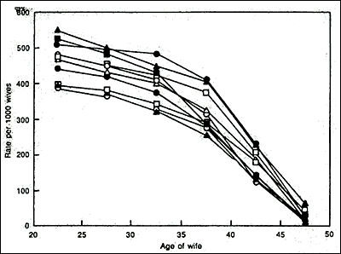
Figure 1: Graph of Births over Time as a Function of Maternal Age (7)

Fertility peaks when the woman is in her late teens and early twenties. It begins to decline at age thirty and drops more rapidly after age 35 years (8). It plummets after age 40 and pregnancy after age 45 is rare (7,9). This phenomenon is also reflected in the live birth rate and has been remarkably stable over time and geography as seen in figure 1. Miscarriages are also more frequent as maternal age rises (10). Although one may suggest that this is because of the well-known increase in aneuploid conceptions with maternal age (11), euploid pregnancies are also lost with higher frequency as the mother ages.
The effect of maternal age on fertility is theoretically an effect of a larger proportion of abnormal embryos with increasing maternal age. Data from in vitro fertilization in which normal appearing embryos were examined with fluorescent in situ hybridization (FISH), revealed 39% abnormal embryos from women who are greater or equal to 40 years of age compared to 5% from women who are 20 to 34 years of age (12). A more recent study utilizing comprehensive chromosomal screening through comparative genomic hybridization (CGH) illustrated a 51.3% aneuploidy rate in embryos from infertile women aged 30 – 43 years. Of these women, those with age 40 and older produced an average of 57% aneuploid embryos (13).
Frequently unaddressed, is the effect of the male’s age. Sperm count does drop with age, although the individual variation is wide as is the male’s sexual function. The decreasing fertility of the male roughly lags behind that of the female by 10 years. Significant infertility is seen after age 55 years, although this data is difficult to come by, because of the more impressive effect of maternal age. In order to gain firm figures, men at various ages older than 45, married to women younger than 30 would have to be surveyed for intercourse frequency and conception. The only data available are those from the Mormon genealogy registers (see Figure 2)(14).
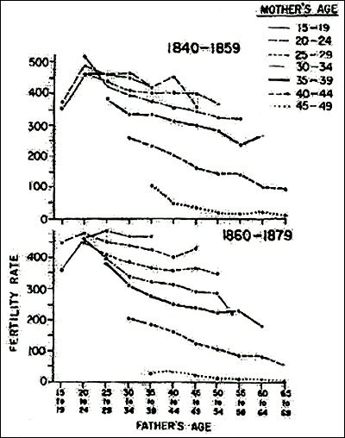
Figure 2: Data from Mormon Registries: Fertility as a Function of Maternal and Paternal Age (13)

Thus, men older than 55 married to women older than 35 may have a synergistic age effect on their fertility, but one which is difficult to quantify.
In vitro fertilization outcomes echo earlier trends between female age and pregnancy. While increasing female age leads to a decrease in live birth when using autologous oocytes, donor-oocyte-IVF cycle outcomes appear unaffected by increasing recipient age (Figure 3)(15).
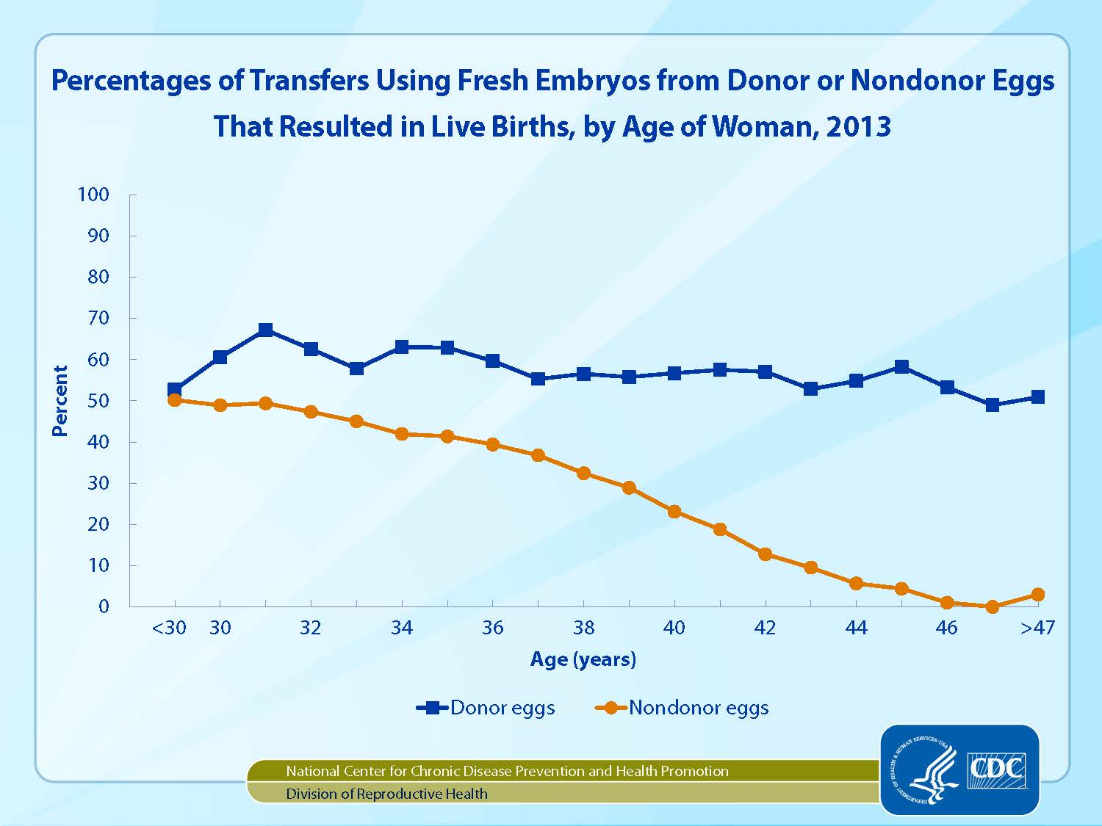

Figure 3: Live birth rates among IVF cycles performed in the United States in 2013 (15).

CERVICAL FACTOR
The nulliparous cervix is approximately 4 cm in length. Its columnar epithelium is pierced by the ducts of mucous secreting glands which spew forth their contents as a protective barrier preventing bacteria from entering the upper reproductive tract and as a welcome channel to lead sperm into the upper tract. Cervical mucus is comprised of hyaluronic acid micelles which are affected by the hormonal milieu exposed to the glands. Late in the follicular phase, as estrogen rises, the micelles align in a parallel arrangement forming channels to guide the sperm. Under the microscope this can be seen as the classic "fern" pattern of dried cervical mucus (Figure 4). The pH is alkaline and nourishing to the sperm. Indeed, sperm can live in normal cervical mucus for as long as 4 days. The abundant mucus frequent oozes from the cervical os into the vagina to lure the sperm from the ejaculate, while protecting them from the acidity of the vagina. At mid-cycle, just prior to and after ovulation the rising progesterone increases the salt content of the mucus, breaking the micelle channels and thickening the consistency of the mucus. The "fern" pattern is no longer seen; the mucus thickens and becomes hostile to sperm and bacteria alike.
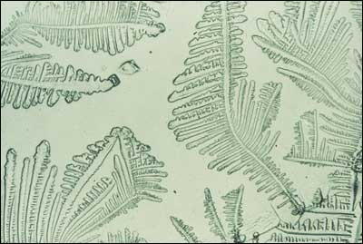
Figure 4: The classic fern pattern of dried cervical mucous.

History
Women with a history of cervical infections, surgery or cryotherapy may have damage to the cervical glands and lack mucus. This may result in the inability of the sperm to survive the harsh vaginal acidity and not make the assent to the uterus. However, a considerable amount of cervix must be removed or damaged for a true "cervical" factor to cause infertility.
Infections rarely result in infertility. Although gonorrhea and chlamydia have often been accused, it is difficult to prove that either of these actually destroys cervical glands and are more likely to result in tubal factor infertility (16). Acute infection may alter cervical pH, killing sperm, although this is not well documented.
Cervical conization which removes the cervical glands is the most likely cause of cervical factor infertility. Cryotherapy and laser vaporization may destroy the lower canal, but glands above the point of metaplasia usually provide enough mucus to retain fertility (17).

Physical Examination
The normal squamocolumar junction with clear cervical mucus almost always rules out a cervical factor. When the cervix is scarred with a narrow external os and almost flush with the vagina, the cervical glands are frequently absent.

Diagnosis
This diagnosis of cervical factor is based heavily of the history of cervical damage by surgery or infection. Nonetheless, the classic diagnosis of cervical factor infertility has been the post coital test (aka Sims Hauser test). The postcoital test was proposed to determine the adequacy of sperm and the receptivity of cervical mucus, however it has been the subject of debate over the last 10 years. In a randomized 24 month study female patients with abnormal post-coital tests were compared to those with normal tests, and importantly there was no difference in pregnancy rates between the two groups (18). In a literature review assessing use of the post coital test, the sensitivity of the test ranged from 0.09 to 0.71, specificity from 0.62 to 1.00, predictive value of abnormal from 0.56 to 1.00, and predictive value of normal from 0.25 to 0.75 (19). In light of problems of poor validity, lack of standard methodology, lack of a uniform definition of normal, and unknown reproducibility, the postcoital test in longer considered of significant value in infertility assessments. Without a history of cervical damage by infection or surgery, the diagnosis of cervical factor is largely circumstantial.

Treatment
A true cervical factor is best treated with intrauterine insemination as described below. Briefly, washed sperm is injected into the uterus at the time of ovulation. Because the sperm survive a limited time, it is probably best to time ovulation with urinary LH to narrow the insemination-ovulation interval.
In addition, prior cervical surgery may predispose to an incompetent cervix during pregnancy (20). Thus, the patient should be closely monitored for painless dilation of the cervix during pregnancy and evaluated for cervical cerclage.

ENDOMETRIAL FACTOR
A hostile endometrial environment will impede embryonic implantation as shown by the placement of an intrauterine device into the endometrial cavity for contraception. This hostile effect is postulated to be reproduced by endometrial polyps and submucous fibroids. In addition, hormonal, immune and biochemical factors have been postulated to result in a hostile endometrial environment.
Poor progesterone effect resulting in delayed maturation of the endometrial lining, commonly referred to as the luteal phase defect, has been considered as hostile to implantation. Indeed, luteal phase defect has been demonstrated in a case of trisomy 16, suggesting that the defect is a secondary phenomenon of an primary defect, namely, genetic abnormality of an oocytes and its follicular apparatus resulting in abnormally low hormonal stimulation and finally, poor endometrial maturation (21). Teleologically, this would prevent pregnancy with abnormal embryos. Theoretically, this mechanism may go astray during genetically normal cycles and result in failed implantation, but has never been proved to be a cause of infertility, per se.
Other factors, which have been implicated in the development of a hostile environment for implantation, are autoimmune factors such as lupus anticoagulant and Integrin IIIβ (22). It has been shown that antiphospholipid antibodies are not a factor in implantation, but the concentrations of Integrin III β are yet to be determined (23).

History
Patients with endometrial polyps and submucous fibroids may have premenstrual spotting or heavy menstrual bleeding. A luteal phase defect is not detected in any medical history.

Physical Examination
Endometrial factors cannot be diagnosed by physical examination.

Diagnosis
Endometrial polyps and submucous fibroids are detected by either hysterosalpingography, a saline sonohysterogram, or hysteroscopy (Figure 5). A dilation and curettage (D&C) may be performed and histology of the curettings will confirm the diagnosis. Submucous fibroids may be felt as an irregularity while curetting the endometrial cavity.

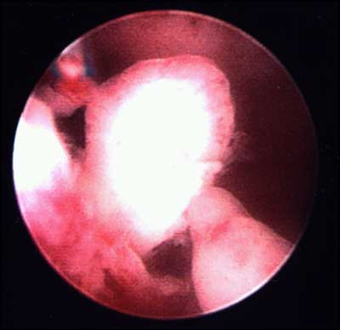
Figure 5: Hysteroscopic view of an endometrial polyp.

Abnormal autoimmune factors do not cause infertility and need not be diagnosed. Integrin IIIβ is still a research tool and diagnosis of an abnormal concentration should be left to research protocols.
The luteal phase defect is not a documented cause of infertility (24-26). The high prevalence of out-of-phase endometrial biopsies in fertile women makes histological dating of the endometrium of no use in the routine evaluation of infertility (26). Because its role in spontaneous abortion is not known, some physicians prefer to evaluate the endometrium in infertile patients. The diagnosis is made by performing an endometrial biopsy in the luteal phase. A histological dating lagging more than 2 days behind the actual postovulatory date diagnoses the defect.

Treatment
Endometrial polyps may be removed by operative hysteroscopy or uterine curettage. Submucous fibroids may be removed through hysteroscopic surgery. Depending upon the depth of myometrial invasion, laparoscopy or laparotomy may be necessary. Pritts et al performed a meta analysis of women undergoing hysteroscopic myomectomy and found a modest improvement in pregnancy outcome (relative risk of 1.72 with a confidence interval of 1.13-2.58)(27).
As mentioned, other causes of endometrial hostility have not been proven to be related to infertility and, thus, treatment is not warranted.

UTERINE FACTOR
In addition to the endometrium and cervix, the shape and competency of the uterine fundus must be considered. Anomalies of mullerian fusion and fibroids have been suggested to result in the inability of implantation or growth of the pregnancy. It is difficult to postulate how abnormalities of the uterus can cause infertility except through abnormal blood flow leading to poor implantation and a subsequent abnormality involving placentation. Indeed, evidence that does exist relates infertility to large fibroids suggesting tubal factor infertility. Mullerian fusion abnormalities resulting in a uterine septum or bicornuate uterus are largely associated with recurrent miscarriage rather than the ability to conceive.

History
Historical clues of an abnormal uterus are rare. Occasionally, patients with incomplete mullerian fusion may have dysmenorrhea, but the symptom itself is so nonspecific, that the physician is not likely to alter either diagnosis or therapeutic course.

Physical Examination
A bimanual pelvic examination will reveal large fibroids. The bicornuate uterus is typically unable to be palpated. A compete uterus didelphys will be revealed by a vaginal and cervical examination.

Diagnosis
Uterine fibroids may be diagnosed by ultrasound (Figure 6). Their imposition on the endometrial cavity may be illustrated by hysterosalpingogram and confirmed by hysteroscopy. Ultrasound is less valuable in diagnosing mullerian anomalies, but hysterosalpingogram will identify the abnormal uterus (Figures 7,8,9) . MRI is often helpful in identifying both fibroids and the type of mullerian anomaly found on hysterosalpingogram (Figure 10).
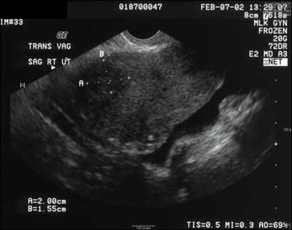
Figure 6: Transverse sonographic image of the uterus demonstrating overall enlargement and multiple leiomyomata.

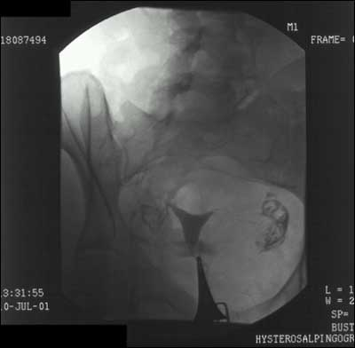
Figure 7: Hysterosalpingogram of a normal uterus. Note the normal appearing intrauterine cavity with bilateral tubal spillage of contrast.

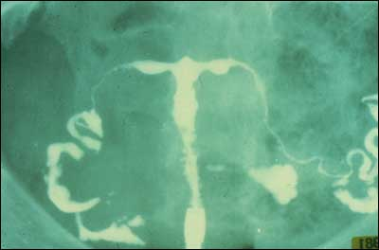
Figure 8: Hysterosalpingogram of a T-shaped uterus secondary to in utero DES exposure.

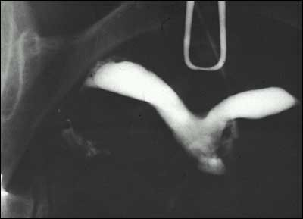
Figure 9: Hysterosalpingogram of a uterine anomaly. With HSG, a septum versus a bicornuate uterus cannot be distinguished.

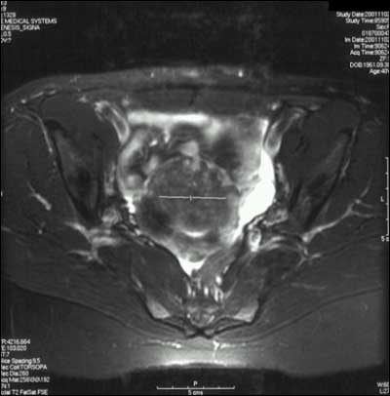
Figure 10: Transverse MRI image demonstrating multiple leiomyomata.

The septate uterus can be differentiated from the bicornuate uterus by laparoscopy and MRI. Both laparoscopy and hysteroscopy will identify fibroids and their location in the uterus and pelvis. If fibroids interfere with tubal pick-up of oocytes, mechanical infertility will result. Similarly, fibroids impinging on the endometrial cavity may interfere with implantation and placentation.

Treatment
Uterine fibroids may be treated by myomectomy. Depending on the location of the fibroid, hysteroscopic or laparoscopic removal may be possible. Otherwise laparotomy is necessary. Treatment of the fibroid with a GnRH agonist will shrink the fibroid, but as soon as the agonist is discontinued and estrogen activity resumes, the fibroid will return to at least its original size (28).
Myomectomy is indicated when the myomas result in bleeding severe enough to cause anemia, when pressure is placed on the on the bladder to cause urinary tract infections, or when pressure on the bowel results in constipation. It is less clear whether myomectomy improves fertility and, in fact, may even result in pelvic adhesions and lead to tubal factor infertility (29). Myomas which impinge or are present within the endometrial cavity may likely cause spontaneous abortion, but evidence proving this causation is difficult to find. Even harder to prove is the efficacy of myomectomy resulting in an increase in term pregnancy.

TUBAL FACTOR
The mechanical ability of the sperm to be conducted to the site of the oocyte or the fertilized oocyte to be propelled back into the uterus, demands patent fallopian tubes. Clearly, the tube must be open to allow fertility. Also important is the ability of the tube to freely move across the surface of the ovary in order to sweep the oocyte into the tube. If the tube is not able to pick up the oocyte from the surface of the ovary, no pregnancy will result.

History
Patients with tubal factor infertility often have a history of a pelvic infection, endometriosis, or previous abdominal or pelvic surgery. Frequently, however, patients are unable to clearly identify a source of their adhesions. For example, a patient who experienced a chlamydial infection may have attributed the lower abdominal pain, fever and cramping to a gastrointestinal viral infection and often cannot recollect the time of infection.
Adhesions may be asymptomatic or may result in pelvic pain. Normal movement of the bowel and ovaries across the visceral surfaces of the abdomen may be impeded by pelvic adhesions and results in these organs pulling on the abdominal wall. This may result in both pelvic and abdominal pain.

Physical Examination
Tubal disease significant enough to result in hydrosalpinges may result in adnexal masses. Similarly adhesions, which adhere the ovaries to uterus, may often be interpreted as a uterus with posterior fibroids on physical examination.

Diagnosis
Tubal adhesions or hydrosalpinges are suggested when contrast pools are seen on a hysterosalpingogram (Figure 11), but definitive diagnosis requires visualization at laparoscopy. Tubal occlusion may be diagnosed by hysterosalpingography or by laparoscopy. Most recently, fluid extravasation into the pelvis after flushing of an intrauterine cannula may be seen by an experienced ultrasonographer (30). However, this test is less reliable than the former and is dependent on the skill of the sonographer, patient’s factors such as weight and air in the bowel and resolution capabilities of the ultrasound machine.
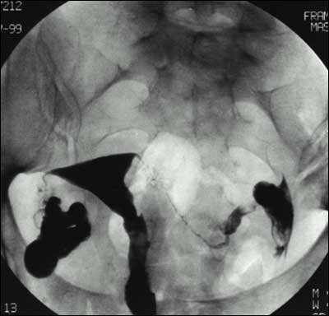
Figure 11: Hysterosalpingogram demonstrating hydrosalpinges. Note the marked dilation of the tubes and the pooling of contrast.

Treatment
In vitro fertilization results in the highest chances of pregnancy for the couple whose infertility is the result of pelvic adhesions or blocked Fallopian tubes. Surgical correction may increase the chances of fertility, however, unless the adhesions are filmy and their extent is limited, surgical lysis incurs a high likelihood of adhesion recurrence.

ENDOMETRIOSIS
Endometriosis is the abnormal development of endometrial glands and stroma outside of the uterus. It is associated with dysmenorrhea, dyspareunia, and infertility. The American Society of Reproductive Medicine (ASRM) developed a revised staging scheme in order to standardize communication between physicians regarding their patients, between investigators for research protocols and to follow effects of therapy (31).
The mechanism of action whereby endometriosis causes infertility is complex. Severe endometriosis with adhesions and adherent pelvic organs results in mechanical infertility. It is difficult to assign a mechanism to minimal and moderate endometriosis. Increased peritoneal fluid, increase peritoneal prostaglandin concentration, and interference with normal ovarian folliculogenesis have all been postulated (32). However, no direct evidence exists between mild and minimal endometriosis and resultant infertility (33). Indeed, some have postulated endometriosis is a result rather than a cause of infertility.

History
Patients with endometriosis experience a spectrum of symptoms ranging from incapacitating dysmenorrhea and severe dyspareunia to none at all. Although 30% of infertile patients have endometriosis (34), it is unknown how many patients who have endometriosis are infertile. Classically, patients have dysmenorrhea which begins during the menses and over the years extends to the prior luteal phase.
Cyclical hemoptysis and hematochezia may occur in patients with endometriosis implants in the lung; however, very few of patients with endometriosis have these remote implants.

Physical Examination
Endometriosis may be occasionally palpated on pelvic exam if there are implants on the uterosacral ligaments or the posterior surface of the uterus; however, physical examination is usually not helpful in the diagnosis of endometriosis.

Diagnosis
Endometriosis is diagnosed by visual inspection at the time of laparoscopy or laparotomy or if endometriomas are visualized on pelvic ultrasound. Endometrial implants over the pelvic organs may be biopsied for histological confirmation. Endometrial glands and stroma are seen microscopically. The American Society of Reproductive Medicine recommends using a standard staging system to document the severity of each patient’s disease. The system incorporates superficial and deep lesions, adhesions, and the location and size of each lesion. Standardized staging allows communication between physicians and evaluation of treatment efficacy.

Treatment
Endometriosis causing pain may be treated with surgical or medical therapy. Surgical extirpation of lesions and adhesions is successful in alleviating pain for endometriosis but is less effective in increasing fertility caused by endometriosis (35). Preventing menstruation with the use of continuous oral contraceptive or continuous progestin therapy may also relieve pain. Medical menopause induced by GNRH analogues has also been effective in reducing the implants of endometriosis. However, once normal cycles and hormones resume, the implants return. Medical therapy does not have much effect on the adhesions associated with endometriosis (36,37). Similarly, endometriomas of the ovary are decreased in size by medical therapy but are rarely completely treated. In vitro fertilization is more effective than either surgery or medicine in increasing fertility caused by endometriosis (32).

OVULATORY FUNCTION
Pregnancy is direct evidence of ovulation. Patients who do not ovulate cannot conceive without assisted reproductive technology. Ovulatory function requires the integration of many normally functioning systems. Normal thyroid function, normal insulin action, normal adrenal function and perhaps normal cerebral function are all required for ovulation. When these systems are disrupted, follicular function is altered and ovulation becomes disordered. This results in a series of endocrine events, which leads to elevated estrone production, elevated androgen production and altered insulin action. These events, in turn, prevent ovulation. This cycle of disordered events has become known as polycystic ovarian syndrome. This syndrome is discussed in detail in Chapter 6.

History
Normal, regular menstrual cycles usually reflect ovulatory cycles. Indeed, 95% of regular menstrual cycles are ovulatory (38). If cycles are irregular, the patient is most likely not ovulating, obviously a cause of infertility. Patients who do not ovulate and have polycystic ovarian disease may also have other associated findings of the disorder including insulin resistance, androgen excess, acanthosis nigricans and obesity.

Physical Examination
Anovulation alone is not associated with any physical findings. Patients will have abundant, thin cervical mucus most of the time. This is the result of continuous, unopposed estrogen. In those whose have elevated androgens, hirsutism may be present. Acanthosis nigricans may also be found at the neckline, in the axilla, and underneath the breasts.

Diagnosis
Anovulation is diagnosed by a serum progesterone measurement less than 4 ng/ml drawn at least 4 days prior to a menstrual bleed. Proliferative endometrium on an endometrial biopsy performed during the week prior to a menstrual cycle is also diagnostic of anovulation. Finally, a basal body temperature chart revealing no biphasic increase in temperature is diagnostic of anovulation in 80% of cases; 20% of women with a monophasic basal body temperature will actually ovulate (39,40).

Treatment
Ovulation may be stimulated by administering clomiphene citrate, letrozole, or gonadotropins. Clomiphene citrate is a serum estrogen receptor modulator, which increases pituitary secretion of LH and FSH. When given to anovulatory women, the gonadotropins stimulate follicular development. The follicle continues to develop normally and feeds back to signal the pituitary that the oocyte is mature and an LH surge is needed. The so-called "ovarian clock" is restored and ovulation may be timed by monitoring urinary LH concentrations. Clomiphene successfully induces ovulation in 85% of women, although pregnancy rates are lower than 65% (41,42). When clomiphene is unsuccessful, gonadotropins may directly stimulate the ovarian follicle to develop and chorionic gonadotropin may be administered to simulate the LH surge and result in ovulation.
Patients with polycystic ovarian disease have often been treated with insulin sensitizing agents, particularly metformin (43,44). Most recently however, a multicenter randomized placebo-controlled trial failed to show any superiority of metformin over clomid, and combining clomid with metformin was no better than clomid alone (45) Metformin use in PCOS should be restricted to women with glucose intolerance and the routine use of this drug in ovulation induction is not recommended (46,47).
Letrozole, an aromatase inhibitor, has also been used to induce ovulation in anovulatory women. The medication decreases peripheral aromatization of testosterone to estrogen leading to an increase in FSH secretion from the pituitary gland and resultant follicular maturation (48). The Reproductive Medicine Network performed a double-blind, multi-center study comparing pregnancy outcomes in women with PCOS using either clomiphene citrate or letrozole. Patients using letrozole had a higher cumulative live birth rate than those who used clomiphene citrate (27.5% vs. 19.1%, P=0.007) and a lower multiple pregnancy rate (P=0.03) (49).
Gonadotropins, FSH or a combination of FSH and LH can also be used to induce ovulation in anovulatory women. These medications are generally injected subcutaneously and lead to follicular growth. Recruitment of more than one dominant follicle is not uncommon during a gonadotropin stimulation, so patients are followed closely with ultrasound monitoring and serum estradiol levels. The treatment modality is associated with an increased risk of high-order-multiple pregnancy when compared to natural conception, clomiphene citrate, and letrozole.

CHRONIC DISEASE

History
A thorough menstrual history should be done with all infertile patients to detect chronic diseases such as severe anemia, autoimmune diseases, liver disease and renal disease. Debilitating disease and chronic malnutrition may also result in infertility (50). Chronic disease most likely interferes with ovulation by central mechanisms. Treatment of the disease rarely restores ovulation because such treatment is usually palliative.

Physical Examination
The exam findings may be subtle, and include clubbing of nailbeds, poor skin turgor, subcutaneous adiposity, conjunctival pallor, thinning of hair, jaundice, cushingoid features, recent weight loss, poor skin turgor, delayed capillary refill, gum bleeds, and cheilosis, Fatigue, exercise intolerance, dyspnea on exertion, peripheral edema, cardiac murmurs are consistent with underlying cardiac disease. Splenomegaly, dilated abdominal wall collateral vasculature, and ascites or signs of anemia may represent longstanding gastrointestinal disease. Pulmonary disease is manifested by a chronic cough, diminished breath sounds, wheezing, dyspnea or simply fatigue.

Diagnosis
In most instances, the diagnosis will already be established. Physical exam findings may indicate the patient’s overall health, and nonspecific studies may be helpful such as: CBC with peripheral smear, urine dipstick for proteinuria, hematuria, pyuria and microscopic evaluation (epithelial cells, WBC casts, etc.), liver functions, and serum chemistries to include electrolytes, creatinine, BUN, magnesium, phosphate, uric acid, and protein. A sedimentation rate is a nonspecific test of inflammation, and cardiac status may be initially assessed with an ECG, CXR, echocardiography, and stress test. Clearly, the diagnostic tests must be tailored to the individual.

Treatment
Treatment of infertility associated with chronic disease requires addressing the underlying health problem and optimizing the patient’s present state of health. This usually requires a multi-specialty effort, specific to the patient’s health needs. Special consideration should be taken to assess if a relative or absolute contraindication to pregnancy exists, as the pregnancy may well exacerbate an already tenuous medical condition. Maternal surrogacy is an option in patients who are unable to tolerate the physical stresses of pregnancy, such as patients with severe hypertension, significant structural cardiac anomalies, advanced multiple sclerosis, to name a few. If premature ovarian failure has occurred, either secondary to chronic disease, or to treatments such as chemotherapy or radiotherapy, donated oocytes are an option.

MALE FACTOR
Extensive discussion of male factor infertility is within Section: Endocrinology of the Male edited by Robert MacLachlan,M.D (www.endotext.org). A recent study performed by the Reproductive Medicine Network correlated semen parameters to fertility. The "new norms" by which fertility can now be defined are: a sperm density greater than 15 million/ml, motility greater than 32%, and a strict morphology greater than 4% (51). Abnormal semen parameters have a host of causes resulting from an absent vas deferens secondary to cystic fibrosis heterozygosity to a varicocele. Nonetheless, when the semen parameters are low, the number of competent sperm available to fertilize an oocyte is decreased and the monthly fecundity is lowered. It is more difficult to explain why male factor infertility occurs in the presence of normal semen parameters. Some have suggested that abnormal capacitation, decreased motility, abnormal morphology, chemical composition, or antibody presence compromise fertilization. These factors remain unproved.

History
Male factor infertility usually presents when the gynecologist orders a semen analysis in the initial infertility evaluation. Rarely does it present as symptoms in the male. The male partner may have a history of undescended testicles or testicular pain due to a varicocele, but this is usually elicited after the semen analysis is abnormal.

Physical Examination
Males with a varicocele will often have a palpable vessel in the scrotum. Otherwise no physical findings are abnormal in most infertile males.

Diagnosis
The diagnosis of male factor infertility begins with a semen analysis. Abnormal parameters include: sperm concentration of less than 15 x 10(6) per milliliter, less than 32% of sperm motility, with less than 4% with normal morphologic features (51). Tests such as the sperm penetration assay, antisperm antibodies, free oxygen radicals have been implicated as resulting in infertility, but the documentation is unconfirmed. Sonographic evaluation of the scrotum will confirm the presence of a varicocele.

Treatment
If the infertility is due to a mechanical issue, such as retrograde ejaculation, either pharamacologic or surgical correction of the bladder neck is feasible. In patients with neurological damage from spinal cord or pelvic trauma, multiple sclerosis, or retroperitoneal surgery, rectal electroejaculation or surgical sperm recovery may be utilized. If the male partner is azoospermic due to hypogonadotropic hypogonadism, the patient is treated with gonadotropin therapy. Obstructive azoospermia may be corrected surgically or sperm recovery techniques such as TESE (testicular sperm extraction)(Figure 12) or MESA (microsurgical epididymal sperm aspiration)(Figure13) may be used. Since the wide acceptance of ICSI (intracytoplasmic sperm injection)(Figure14), an oocyte is mechanically fertilized with a single sperm, a method which ameliorates all but the most severe male factor infertility. Clomiphene citrate is no better than placebo for increasing a low sperm count. Recently, sperm motility has been treated with carnitine supplements, but randomized trails are pending. (For a full discussion on male factor infertility, see Endocrinology of the Male edited by Robert McLachlan, M.D.at www.endotext.org).
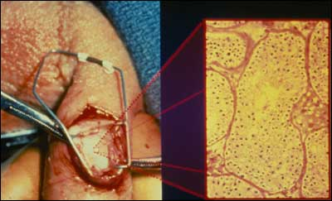
Figure 12: Testicular sperm extraction (TESE)

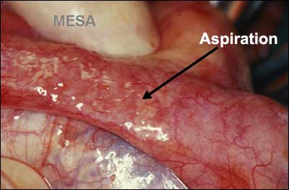
Figure 13: Microsurgical epididymal sperm aspiration (MESA)

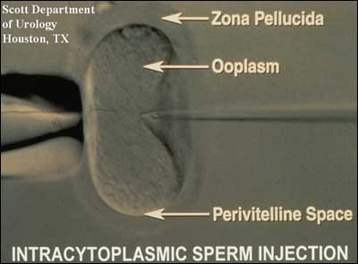
Figure 14: Intracytoplasmic sperm injection (ICSI)

UNEXPLAINED INFERTILITY
Approximately 15% of patients with infertility have an unidentifiable cause. Thus, unexplained infertility is a failure of both the couple to conceive and the physician to explain why. Perhaps even more psychologically difficult to accept than sterility, unexplained infertility poses impressive stress to the couple. Despite doing all they can correctly, the couple is unable to conceive and has no answer to their problem even after enduring expensive, painful testing. Their only recourse is empiric therapy.

History
Couples with unexplained infertility have routine intercourse, have regular menstrual cycles and normal infertility testing results.

Physical Examination
Inherent to the diagnosis, physical examination reveals no abnormalities.

Diagnosis
The diagnosis of unexplained infertility is made in couples who have intercourse regularly or well-timed intercourse and fail to conceive despite regular ovulatory cycles, a normal semen analysis, normal laparoscopy, and normal hysterosalpingography.

Treatment
Couples with unexplained infertility may conceive without therapy but it may take from 3 to 7 years (52). To decrease the waiting time, empiric therapy is instituted. Empiric therapy usually begins with ovulation induction with oral agents or gonadotropins combined with intrauterine insemination. This combined therapy increases the cyclic fecundity over either alone in couples with unexplained infertility (53, 54). After three or four unsuccessful cycles or alternatively, in vitro fertilization may be offered.

ASSISTED REPRODUCTIVE TECHNOLOGY
The birth of Louise Brown in 1978, the world’s first "test tube baby", revolutionized therapy for infertile patients. No longer were women without fallopian tubes unable to conceive and gestate. For the first time, medicine was able to view the first few human embryonic divisions and reproductive medical scientists learned better how to induce ovulation and handle gametes. Numerous "spin-off" technologies arose in the subsequent two decades: controlled ovarian hyperstimulation (COH-IUI), intracytoplasmic sperm injection (ICSI) and oocyte donation allowed pregnancy in couples without gametes. This section briefly describes the reproductive technologies available to infertile patients and referred to in treatment sections above in the chronological order of their introduction into the therapeutic armamentarium.

In Vitro Fertilization (IVF)
In Vitro Fertilization (IVF) was first successfully performed by Patrick Steptoe, MD and Robert Edwards, PhD in a woman with tubal factor infertility. The woman timed her ovulation and underwent laparotomy for oocyte retrieval. In the ensuing years, spontaneous cycles were replaced by first clomiphene citrate ovulation induction and then stimulation with gonadotropins. Ovulation stimulation allowed the retrieval of more than one mature oocyte, thus increasing the statistical chance of embryonic implantation during one cycle. The early pregnancy rates were approximately 8% per cycle and cancellation prior to oocyte retrieval was high. The introduction of GnRH analog allowed down regulation prior to ovarian stimulation and thwarted the numbers of cycles cancelled due to spontaneous premature LH surges. GnRH analog therapy was most likely the reason that IVF pregnancy rates jumped to about 15% per cycle in the late 1980s.
By the time IVF in the United States was introduced by the Jones in 1983, oocytes retrieval was primarily by laparoscopy. In 1983, Gleicher et al reported the first transvaginal ultrasound-directed oocyte aspiration, and currently, most aspirations are performed in this manner (55).

Indications
Initially, IVF was indicated in patients with tubal factor infertility. The relatively high success rates have allowed extension to couples with endometriosis, drug-resistant polycystic ovarian disease, and unexplained infertility. Additionally, IVF can be used with donor oocytes to treat women with age-related ovarian dysfunction, ovarian failure or surgically removed ovaries. Combined with ICSI (see below) IVF can also be used to treat couples with sperm disorders and immunologic infertility.

Procedure:
IVF begins with ovulation induction. Although it may be performed in natural cycles, removal of the oocytes requires intensive hormonal monitoring and the availably of the medical team too often to be practical. In addition, pregnancy rates are lower with natural cycle IVF.
A variety of ovulation induction regimens are available. Many programs in the United States administer ovarian down regulation with a GnRH agonist in the luteal phase prior to the cycle of stimulation. Oral contraceptives are often added prior to down-regulation. After spontaneous ovarian activity is suppressed, folliculogenesis is stimulated with gonadotropins. The regimen used is particular to each program, but those that have been tested in clinical trials all seem to result in similar pregnancy and delivery rates. Choices are made based on cost, availability, route of administration, and familiarity of the physician with the regimen.
GnRH antagonists are also used to thwart spontaneous LH surges during ovulation induction. Thus far, they have not proven superior to the GnRH agonists in pregnancy outcome and are more expensive on a mg per mg basis (56) but offer the advantage of fewer total injections to the patient. Another proposed advantage of GnRH antagonist cycles is a decreased risk of moderate and severe Ovarian Hyperstimulation Syndrome (OHSS) when combining this protocol with a GnRH-agonist induction of final oocyte maturation (57-59).
During ovulation induction, the ovaries are monitored for follicular growth by frequent transvaginal ultrasound examinations and serum estradiol concentrations. When clinical parameters suggest the presence of mature oocytes, human chorionic gonadotropin (hCG) is administered to mimic the LH surge and allow further progression of the oocytes through meiosis. Some IVF programs now use a GnRH agonist to trigger ovulation, as it appears that the incidence of moderate and severe ovarian hyperstimulation syndrome (OHSS) is reduced in high-risk patients when an agonist is used. Approximately 35 hours later, the patient undergoes a follicular aspiration. In the United States, most aspirations are performed transvaginally with ultrasound direction. Conscious sedation is typically used. Regional analgesia is not usually employed because the concentration of the local anesthesia in the follicular fluid has been shown to decrease the pH and affect the fertilization of the oocyte (60). Concomitant identification of the oocyte by nearby laboratory technicians informs the physician to proceed with aspiration of each sequential follicle (Figures 15,16).
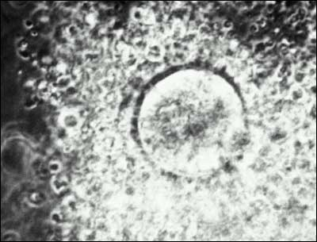
Figure 15: Human oocyte immediately following retrieval.

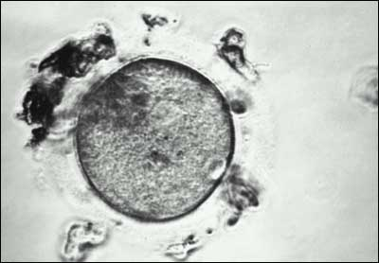
Figure 16: Human oocyte after the surrounding cumulus cells have been removed.

Between 4 and 6 hours after aspiration, the oocytes are mixed with 15,000-30,000 motile, previously prepared sperm. Human fertilization occurs in the next 18 hours and the first two cell divisions usually occur in the subsequent 24 hours (61). Embryos are then transferred into the uterine cavity typically three or five days later. The American Society of Reproductive Medicine (ASRM) recommends determining the number of embryos to be transferred by patient criteria, with favorable prognosis patients generally receiving no more than 1-2 embryos, and poor prognosis patients of advanced maternal age receiving no more than 5 embryos (ASRM Practice Committee Report: Guidelines on the Number of Embryos to Transfer, revised September, 2012). These guidelines were proposed to decrease the incidence of multiple pregnancies, yet still facilitate a favorable pregnancy rate.
The embryos are transferred through the vagina into the uterus. Approximately 2 weeks later a pregnancy test is performed. Because aspiration removes granulosa cells which would otherwise produce the progesterone necessary for endometrial development, many programs support the luteal phase with exogenous progesterone supplementation. This has never been shown to be necessary or effective, but is of low risk (62). If given, supplementation is continued for approximately 4 weeks after the positive pregnancy test.

Contraindications:
IVF is contraindicated in women in whom pregnancy is contraindicated.

Outcome:
Federal law requires that the outcome of all IVF cycles be reported to the national database kept by the CDC and ASRM/SART (www.cdc.gov/nccdphp/drh/art99/index99.htmwebsite and www.sart.org).
For the 87,089 IVF cycles performed nationally in 2013, there was a 40.1% live birth rate per initiated cycle for women younger than 35 years, 31.4% for women between ages 35 and 37, 21.2% for women between 38 and 40, and 11.2% for women over 40 years (SART www.sart.org).

Gamete Intrafallopian Transfer (GIFT)

Gamete Intrafallopian Transfer (GIFT) is a procedure developed in 1983 by Dr. Ricardo Asch in San Antonio (63). The procedure begins in a therapeutic manner similar to IVF, however, when the oocytes are aspirated, they are mixed with sperm and immediately replaced in the patient"s fallopian tubes. GIFT requires less laboratory services and expertise than does IVF, but does require the patient to incur the risks of general anesthesia and laparoscopy. With increasing training and availability of IVF laboratory personnel, GIFT is rarely utilized.

Indications:
GIFT requires at least one normal, patent fallopian tube. Patients with unexplained infertility are those who benefit most by this procedure. Additionally, because embryos are not formed in the laboratory, some religious groups may find GIFT more acceptable than IVF.

Procedure:
GIFT begins with ovulation induction in a manner similar as described above for IVF (see IVF). When the patient is ready for oocyte aspiration, the aspiration may be performed either transvaginally with ultrasound guidance, or transabdominally under laparoscopic guidance. The oocytes are immediately combined with previously prepared sperm and allowed to incubate for 10 minutes to allow sperm binding to the zona pellucida. Approximately 25,000 motile sperm and two oocytes are placed in each Fallopian tube through a catheter placed in the tube under laparoscopic vision. Luteal support with exogenous progesterone may be given. Two weeks after aspiration a pregnancy test is performed.

Contraindications:
Patients with abnormal Fallopian tubes are not eligible for GIFT treatment. Any contraindication to pregnancy is a contraindication to GIFT.

Outcome:
Federal law requires that the outcome of all GIFT cycles be reported to the national database kept by the CDC and ASRM/SART (www.cdc.gov/nccdphp/drh/art99/index99.htmwebsite).
Overall, GIFT was performed with less than 1% of the aspirations in the United States in 2011, and because of the small number of cases, clinic outcome data specific for GIFT is unavailable. In general, the outcome of GIFT is thought to be comparable to that of ovulation induction with gonadotropins and intrauterine insemination.

Controlled Ovarian Hyperstimulation and Intrauterine Insemination (COH-IUI)
Controlled Ovarian Hyperstimulation and Intrauterine Insemination (COH-IUI) was first introduced in 1983 by Dodson et al. as a direct spin-off of GIFT (64). These clinical investigators reasoned that if the cyclic fecundity rate may be increase by placing processed sperm into the normal fallopian tube with 4 oocytes, perhaps the physical placement can be replaced by the patient’s natural physiology. Their first series of 85 patients were stimulated with gonadotropins to develop 4 mature follicles and the normal fallopian tubes were entrusted with oocyte pick-up. After administering hCG, processed sperm were delivered into the intrauterine cavity and allowed to be propelled naturally to the site of the oocyte. Previous studies revealed that this transport occurred within two minutes. This therapy was applied to patients with unexplained infertility so rapidly that it resulted in a demand on the supply of urinary gonadotropins so large that a backlog of drugs in the United States occurred.

Indications:
Unexplained infertility was the initial indication for COH-IUI. This was later extended to include some patients with pelvic adhesions (but patent tubes) and also patients with male factor infertility.

Procedure:
Beginning early in the menstrual cycle, gonadotropins are administered daily to patients. After approximately 5 days of therapy, ultrasound folliculograms and serum estradiol measurements are performed every 1 to 2 days to determine the dose and frequency of further gonadotropin administration. When three to four mature follicles are detected, human chorionic gonadotropin (hCG) is administered to trigger ovulation. Between 24 and 48 hours after hCG administration, an intrauterine insemination (IUI) is performed.
The sperm is prepared for IUI in a manner similar to that first described for IVF. After liquification, the ejaculate is diluted with a buffered media and centrifuged. The sperm is thus separated from the seminal plasma when the supernatant is discarded and the sperm-rich pellet is re-suspended in media. Processing thereafter varies with the laboratory and sperm characteristics. The sperm suspension may be layered in a sephadex column (Percoll), recentrifuged with media, or allowed to "swim-up" into an overlying layer of media. These procedures are intended to remove non-motile sperm, debris, bacteria, and white cells before intrauterine insemination. They also remove 60-80% of the motile sperm. No technique has proved superior for pregnancy outcome.

Contraindications:
Blocked fallopian tubes are a contraindication to COH-IUI because the tubes are required to pick up the oocytes from the ovary and facilitate the mechanical apposition of sperm and oocyte.

Outcome:
Pregnancy rates and pregnancy outcome after COH-IUI depend upon diagnosis. Few randomized studies are available to assess accurate outcomes after this therapy because it is often attempted in patients who would otherwise be treated with IVF. For example, a patient with pelvic adhesions who cannot afford IVF may opt for a cycle of COH-IUI in hope that more ovulations may increase the chance of an oocyte being geographically close to the fimbrial opening and afford tubal pick-up. The more ovulated oocytes, the better statistical chance of an oocyte reaching the tubal opening. Nonetheless, patients such as this would be less likely to conceive that a patient with normal tube-egg pick-up.
Strict criteria for unexplained and male factor infertility were applied in the randomized trial conducted by the Reproductive Medicine Network (65). This study revealed that patients with truly unexplained infertility had a 33% pregnancy/cycle of COH-IUI, higher than couples treated with either COH or IUI alone, and higher than controls.
The multiple pregnancy rate was 13.4% overall and the spontaneous abortion rate was 19% overall (22.3% in the COH treated groups). Interestingly, this study treated couples with more than one motile sperm and no other infertility factors. In those couples with sperm counts less than 0.2-21.8 x 10-6, couples were found to have and higher pregnancy rate when treated with COH-IUI than either COH or IUI alone, and higher than controls.
Not all couples with unexplained infertility are optimal candidates for COH-IUI. Women with an elevated serum AMH or high basal antral follicle count may experience production of multiple dominant follicles, leading to a higher risk of high-order-multiple pregnancy and/or OHSS. These negative outcomes were noted to be more prevalent in the above study with 6 cases of OHSS, 3 sets of quadruplets, and 4 sets of triplets among the 186 total pregnancies in the COH-IUI group (65). Many argue the relatively low reported pregnancy rates in COH-IUI compared with risks do not justify its use after failure of CC-IUI since IVF success rates have improved greatly over the last decade (66).

OOCYTE AND EMBRYO DONATION
Oocytes used in IVF are not required to be from the female partner of the infertile couple. Indeed, these procedures allowed women to utilize donor gametes as their male counterparts have been doing for over a century. A fertile woman who agrees to donate her oocytes anonymously or to a known couple, undergoes ovulation induction, and the retrieved oocytes are fertilized. Of course, the sperm may also be from a sperm donor. After embryonic development, the embryos are replaced into the female partner of the infertile couple. She is treated with exogenous hormones to synchronize her cycle with the donor.
Similarly, a couple can use embryos donated from another person or couple to become pregnant. The hormonal preparation of the female partner’s uterus is similar to an oocyte-donation cycle. In the US, each state has a unique set of laws governing use of donated embryos and oocytes, so practitioners must stay updated on changes in reproductive laws in their state. Legal restrictions and variable costs associated with embryo and oocyte donation has led to reproductive “tourism” where couples travel to other states or countries for reproductive treatment.

Indications:
Oocytes or embryos obtained from a donor is indicated for patients with medical or surgical menopause or genetic disorders that may impact offspring. Oocyte donors must be physically and mentally healthy and without major genetic diseases in the family, have attained the state’s age of legal majority, and preferably be within 21-34 years of age. The donor must be screened for HIV, hepatitis B surface antigen, hepatitis C antibody, syphilis, chlamydia, and gonorrhea (American Society of Reproductive Medicine Practice Committee Report: Recommendations for gamete and embryo donation: 2012.)

Procedure:
Both oocyte donors and recipients are carefully selected, counseled and screened before being accepted into the program. Donors may be known to the patient, a volunteer that altruistically donates to an anonymous recipient (usually reimbursed for missed work and effort), or an individual that is undergoing IVF and donates her spare oocytes. Stimulation and transfer are performed as with routine IVF.

Contraindications:
Any contraindication to pregnancy, spontaneous or induced ovulation would preclude either donation of oocytes or use in an IVF cycle.

Outcome:
For the 8,921 fresh treatment donor-oocyte cycles initiated in 2013, the reported delivery rate was 49.6% per initiated cycle (www.SART.org). Neither recipient age nor diagnosis plays a substantial role in the success of oocyte donation (67).

INTRACYTOPLASMIC SPERM INJECTION (ICSI)
Advancements in IVF promulgated its extension to couples with male factor infertility since in vitro fertilization required fewer moving sperm than in vivo fertilization, even after IUI. Furthermore, in the early 1990’s the zona pellucida was incised (zona slitting) or treated with hyaluronic acid (zona drilling) to facilitate sperm transgression across it in cases of male factor infertility. Another technique injected sperm under the zona pellucida (SZI). Indeed, inadvertent penetration of the cytoplasm and injection of a sperm during a SZI procedure in resulted in a pregnancy and sired the best treatment of male factor infertility since donor sperm: Intracytoplasmic Sperm Injection (ICSI) (68).

Indications:
ICSI is indicated for male factor infertility in which the count, motility, or strict morphology is low. The definite parameters will depend upon each program; in general, a sperm density <5 x 106, motility <20% and strict morphology <5% are indications. In addition, patients with antisperm antibodies may be best treated with ICSI. For 2013, 67% of reported IVF cycles in the United States utilized ICSI as the means for fertilization (www.SART.org).
ICSI also enabled men without sperm in their ejaculate to sire a pregnancy. Sperm aspirated from the epididymis (MESA) and from the testicle (TESE) may be used for injection. It is important, however, to realize that men with azoospermia may have a genetic defect which may possibly be inherited and result in infertility in subsequent male offspring. Similarly, men with at least one vas deferens congenitally absent may be a carrier of cystic fibrosis. His wife should be screened for cystic fibrosis mutations to assure that she, too, is not a carrier, lest they have a child affected with the disease.
ICSI has been proposed in non-male-factor infertility, but current literature does not support routine use (69). A randomized, multi-center trial showed similar clinical pregnancy rates with conventional insemination and ICSI in non-male-factor patients (33% vs. 26%) and a higher rate of failed fertilization (5%) in the conventional insemination group. Based on these data, the number needed to treat (NNT) to prevent one failed fertilization with ICSI is 33 (70-71).

Procedure:
Patients treated with ICSI undergo the same procedures as with IVF except that 5 hours after aspiration, one sperm is injected into each oocyte. The sperm is pretreated to remove it from the seminal plasma and placed in poly vinyl propylpyrrhidol (PVPP) which slows its movement and allows a single sperm to be aspirated into a glass micropipette. The tail of the sperm is frequently broken off to prevent migration from the cytoplasm after injection.

Contraindications:
Contraindications to ICSI are those of IVF.

Outcome:
ICSI requires IVF and Federal law requires that the outcome of all IVF cycles be reported to the national database kept by the CDC and ASRM/SART.
PREIMPLANTATION GENETIC TESTING
Preimplantation genetic testing encompasses procedures involving the removal of polar bodies from oocytes,blastomeres from cleavage-stage embryos, and trophectoderm cells from day 5-6 embryos to test for mutations in gene sequence or chromosome number prior to embryo transfer. The term "preimplantation genetic diagnosis" (PGD) is used when one or both parents carry a specific gene mutation or chromosomal rearrangement and testing is performed to determine whether that genetic abnormality has been transmitted to the oocyte or embryo. The term "preimplantation genetic screening" (PGS) applies when the genetic parents are presumed to be chromosomally normal and their embryos are screened for
abnormalities in chromosome number.
In 1990, the first established pregnancies using this procedure were reported (72). In two couples known to be at risk of transmitting adrenoleukodystrophy and X-linked mental retardation, two female embryos were transferred after in vitro fertilization (IVF), biopsy of a single cell at the six to eight cells stage, and sexing by DNA amplification of a Y chromosome-specific repeated sequence. Both women were confirmed as carrying normal female twins.

Indication:
PGD is indicated for couples at risk for transmitting a specific genetic disease or abnormality to their offspring. Historically evidence did not currently support the routine use of PGS (aneuploidy screening) to increase live birth rates in women of advanced maternal age, with multiple miscarriages or multiple IVF failures (73), but emerging research with newer PGS techniques has shown a modest improvement in implantation rates. A meta-analysis of 11 studies illustrated a higher sustained implantation rate (IR) with pooled relative risk (RR) of 1.39 (95% CI 1.21 – 1.60) among the randomized trials and RR of 1.75 (95% CI 1.15 – 1.45) among observational studies (74). PGS technologies continue to evolve and improve, making elective single embryo transfer of the embryo with highest implantation potential more attainable.
Procedure:
Following oocyte recovery with IVF (see IVF) material from an oocyte or embryo is
extracted by creating a perforation in the zona pellucid via a laser, acid Tyrode’s
solution, or a sharpened glass needle. The polar body, blastomere(s) or trophectoderm cells are then extracted using a small suction pipette or by gently compressing the oocyte or embryo to
extrude material through the opening. To identify specific gene mutations, PGD employs techniques involving the polymerase chain reaction (PCR) to amplify a segment of the genome that contains the specific gene of interest. Fluorescence in situ hybridization (FISH) is a technique that uses DNA probes labeled with distinctly colored fluorochromes. These probes bind to specific DNA sequences unique to each chromosome and detect missing or excess chromosomal material. Where FISH limits the number of chromosomes able to be tested at once, newer technologies have combined DNA microarrays and comparative genomic hybridization (CGH) to screen more genetic loci in PGS. More recent PGS platforms utilize single-nucleotide polymorphism (SNP) microarray, quantitative polymerase chain reaction (qPCR), and next-generation sequencing (NGS) to screen day 5-6 embryos for genetic abnormalities. In order to utilize newer PGS technologies, IVF centers must have experience in trophectoderm biopsy, ability to grow embryos to the blastocyst stage, and a successful cryopreservation program.

Contraindications:
Contraindications to PGD/PGS are those of IVF.

Outcome:
The estimated risk of transferring an affected embryo mistakenly identified as normal by traditional single-gene PGD is approximately 2% for recessive disorders and 11% for dominant disorders (75). Prenatal diagnostic testing to confirm the results of PGD is encouraged strongly because
the methods used for PGD have technical limitations that include the possibility for a false negative result.
NGS involves embryonic DNA being divided into 100-200 base pair sequences and comparing these sequences to a reference genome, and both whole chromosome and segmental chromosome imbalances can be identified (76). However, with this technology, mosaic DNA will labelled “abnormal,” and many argue embryos with some mosaicism may actually be viable in vivo. NGS outcomes are being followed closely as the technology evolves.

FERTILITY PRESERVATION
An increasing number of women are delaying reproduction until their late 30s, 40s and even into their fifth decade of life. Many women understandably have an interest in preserving their fertility, and are seeking the option to cryopreserve their oocytes for later use. Oocyte cryopreservation however, is still considered an experimental procedure and data related to clinical outcomes are limited.
According to the American Society for Reproductive Medicine, the only established methods of fertility preservation for women are oocyte and embryo cryopreservation (77,78). Cryopreservation of embryos (as opposed to oocytes) is well established, with the first successful pregnancy from frozen human embryos reported in 1983. Women in committed relationships may elect to cryopreserve embryos with their partners’ sperm, and single women may elect to cryopreserve embryos utilizing donor sperm. Oocyte cryopreservation has become more prevalent in the last decade for fertility preservation in women facing cancer treatment as well as those planning to electively defer childbearing. The American Society for Reproductive Medicine (ASRM) now views elective oocyte cryopreservation as a viable, non-experimental treatment option for women (78). Currently in the US, employers such as Apple and Facebook offer to help offset costs associated with oocyte cryopreservation in attempt to help career-oriented women preserve fertility. Thawed oocytes appear to have similar fertilization and implantation rates as fresh oocytes (79) due to improved cell survival from newer vitrification techniques, and there does not appear to be an increase in congenital anomalies in babies born after this process (80).
In the past, retransplantation of cryopreserved ovarian tissue has been proposed as a mechanism for fertility preservation in cancer patients. With only a small number of live births in the United States to date, this methodology will not be discussed further (for a concise review, refer to citation 77 and 81).

Indications:
Fertility preservation is an option for women with cancer or other illnesses requiring treatment that may compromise their fertility. Fertility preservation is also an elective option for women who are interested in childbearing at a later time, but patients need to be informed of the potential benefits, limitations and risks of this developing technology.

Procedure:
Procedures for oocyte and embryo cryopreservation begin in a manner similar as described for IVF (see IVF). The oocytes are cryopreserved immediately upon
harvest, or oocytes are fertilized and the embryos are cryopreserved typically on day three, five or six of culture.

Contraindication:
Fertility preservation procedures are contraindicated in women in whom exposure to fertility medications or oocyte retrieval is contraindicated.

Outcome:
In the absence of clinic-specific out comes, there is an overall 2% live birth rate per oocyte thawed via traditional slow freeze techniques and 4% live birth rate per oocyte thawed via vitrification (82,83). For cryopreserved embryos transferred in 2013, the live birth rate was 44.4% for women under age 35, 40.6% for women ages 35-37, 36.1% for women ages 38-40, 31.6% for women 41 to 42 years (www.SART.org).
Oocyte Nuclear Transfer:
Research continues in ART among women who are carriers for mitochondrial disorders, a diverse group of maternally-derived mutations resulting in progressive and life-threatening diseases. Animal studies replacing the cytoplasm and mitochondrial DNA (mtDNA) from an affected oocyte with that of a healthy donor oocyte have shown promise. The FDA in the US currently does not support human clinical trials to confirm or refute animal studies due to unknown implications for the offspring (www.fda.gov).

Summary:
Advances in technology have dramatically altered the treatment of infertile couples and have improved pregnancy and live birth outcomes. However, the methodical approach beginning with a detailed medical history and physical examination is a mainstay. Avoiding empirical tests and treatments will afford couples the most economical and successful therapy for this emotionally devastating disease.
BIBLIOGRAPHY
1. Aldrich CK. A case of recurrent pseudocyesis. Perspect Biol Med. 1972;16:11-21.
2. Grossi, N. A little pregnant or not at all? Pharos Spring 1999; 16-19.
3. Dunbar HF. Emotions and bodily changes. 3rd Ed. New York:Columbia University Press.1946;341.
4. Hamilton GV. A research in marriage. New York: Lear Publishers Inc.1948
5. Kistner, R. Induction of ovulation with clomiphene citrate. Ob Gyn Survey. 1965. Dec (20)6;873-900.
6. Chandra A, Martinez GM, Mosher WD, Abma JC, Jones J. Fertility, family planning, and reproductive health: Data from the 2002 National Survey of Family Growth. Vital Health Statistics 23(25). 2005.
7. Menken J, Trussell J, Larsen U. Age and infertility. Science 1986:233: 1389-1394.
8. Schwartz D, Mayaux MJ. Female fecundity as a function of age: results of artificial insemination in 2193 nulliparous women with azoospermic husbands. NEJM 1982;306:404-410.
9. Teitze C. Reproductive span and rate of reproduction among Hutterite women.
Fert Steril. 1957;8(1): 89-97.
10. Wharburton D. Reproductive loss: how much is preventable? NEJM. 1987.316:158-160.
11. Hassold T, Chen N, Funkhouser J, Jooss T, Manuel B, Matsura J, Matsuyama A, Wilson C, Yamane LA, Jacobs PA. A cytogenetic study of 1000 spontaneous abortions. Ann Hum Genet London 1980;44:151-164.
12. Munne S, Alikani M, Tomkin G et al.,Embryo morphology, developmental rates and maternal age are correlated with chromosomal abnormalities. Fert Steril 1995;64(2):382-391.
13. Schoolcraft B, Fragouli E, Stevens S, Munne S, Katz-Jaffe M, Wells D. Clinical application of comprehensive chromosomal screening at the blastocyst stage. Fertil Steril 2010;94(5):1700-6.
14. Mineau G, Trussell J. A specification of marital fertility by parents age, age at marriage and marital duration. Demography.1982;19(3):335-349.
15. 2010 Assisted Reproductive Technology Report. Center for Disease Control. http://www.cdc.gov/art/ART2013/index.htm.
16. Ruijs GJ, Kauer FM, Jager S, Schroder FP, Schirm J, Kremer J. Further details on sequelae at the cervical and tubal level of Chlamydia trachomatis infection in infertile women. Fert Steril. 1991.Jul;56(1):20-6.
17.. Querleu D. Fertility after conization .Rev Fr Gynecol Obstet 1991 Feb 15;86(2):81-2
18. Oei SG, Helmerhorst FM, Keirse MJ. When is the post-coital test normal? Hum Repro 1995;10 (7):1711-1714.
19. Griffith CS, Grimes DA : The validity of the postcoital test.Am J Obstet Gynecol 1990 Mar;162(3):615-20.
20. Moinian M, Andersch B. Does cervix conization increase the risk of complications in subsequent pregnancies? Acta Obstet Gynecol Scand 1982;61(2):101-3
21. Wentz AC, Martens P, Wilroy RS Jr. Luteal phase inadequacy and a chromosomal anomaly in recurrent abortion. : Fertil Steril 1984 Jan;41(1):142-3
22. Choudhury SR, Knapp LA. Human reproductive failure I: Immunological factors. Hum Repro Update 2001 Mar-Apr;7(2):113-34.
23. Eldar-Geva T, Wood C, Lolatgis N, Rombauts L, Kovacs G, Fuscaldo J, Trounson AO. Cumulative pregnancy and live birth rates in women with antiphospholipid antibodies undergoing assisted reproduction. Hum Reprod 1999 Jun;14(6):1461-6.
24. Wentz AC, Kossoy LR, Parker RA. The impact of luteal phase inadequacy in an infertile population. Am J Obstet Gynecol 1990;162:937-45.
25. Peters AJ, Lloyd RP, Coulam CB. Prevalence of out of phase endometrial biopsy specimens. Am J Obstet Gynecol 1992;166:1738-46.
26. Coutifaris C, Myers ER, Guzick DS, Diamond MP, Carson SA, Legro RS, McGovern PG, Schlaff WD, Carr BR, Steinkampf MP, Silva S, Vogel DL, Leppert PC; NICHD National Cooperative Reproductive Medicine Network. Histological dating of timed endometrial biopsy tissue is not related to fertility status. Fertil Steril. 2004 Nov;82(5):1264-72
27. Pritts EA. Fibroids and infertility:A systematic review of the evidence. Obstet Gynecol Survey.2001;56(8):483-491.
28. Schlaff WD, Zerhouni EA, Huth JA, Chen J, Damewood MD, Rock JA. A placebo-controlled trial of a depot gonadotropin-releasing hormone analogue (leuprolide) in the treatment of uterine leiomyomata. : Obstet Gynecol 1989 Dec;74(6):856-62
29. Vercellini P, Maddalena S, DeGiorgi O, Aimi G, Crosignani PG. Abdominal myomectomy for infertility:a comprehensive review. Hum Repro 1998;13(4):873-879.
30. Sankpal RS, Confino E, Matel A, Cohen LS. Investigation of the uterine cavity and fallopian tubes using three-dimensional saline sonohysterosalpingography. Int J Gynecol Obstet 2001 (73):125-129.
31. ASRM. Revised American Society for Reproductive Medicine classification of endometriosis:1996. Fert Steril. 1997;67(5):817-821.
32. Adamson GD. Treatment of endometriosis-associated infertility. Seminars in Repro Endocrinol.1997;15(3)263-271.
33. Olive DL, Schwartz LB. Endometriosis. NEJM.1993;328(24):1759-1769
34. Witz CA, Burns WN. Endometriosis and infertility: is there a cause and effect relationship? Gynecol Obstet Invest 2002;53 Suppl 1:2-11
35. Parazzini, F and the Gruppo Italiano per lo Studio dell Endometriosi. Ablation of lesion or no treatment in minimal-mild endometriosis in infertile women:a randomized trial. Hum Repro.1999;14(5):1332-1334.
36. Wellbery C. Diagnosis and treatment of endometriosis. Am Fam Physician 1999;60:1753-62,1767-8.
37. Fabre V, Camus M, Devroey P. Endometriosis and sterility. Rev Prat 1999;49:279-81.
38. Guermandi E, Vegetti W, Bianchi M, Uglietti A, Ragni G, Crosignani P. Reliability of ovulation tests in infertile women. Obstet Gynecol.2001;97:92-6.
39. Moghissi KS, Syner FN, Evans TN. A composite picture of the menstrual cycle. Am J Obstet Gynecol 1972;114:405.
40. Bauman JE. Basal body temperature:Unreliable method of ovulation detection. Fert Steril 1981.36:729-733
41. Gorlitsky GA, Kase Ng, Speroff L. Ovulation and pregnancy rates with clomiphene citrate. Obstet Gynecol.1978;51:265.
42. Gysler M, March CM, Mishell jr DR, Bailey EJ. A decade’s experience with an individualized clomiphene citrate treatment regimen including its effect on the postcoital test. Fertil Steril. 1989;52:35.
43. Nardo LG, Rai R. Metformin therapy in the management of polycystic ovary syndrome: endocrine, metabolic and reproductive effects. Gynecol Endocrinol 2001 Oct;15(5):373-80
44. Heard MJ, Pierce A, Carson SA, Buster Je. Pregnancies following use of metformin for ovulation induction in patients with polycystic ovarian syndrome. Fertil Steril.2002;77(4):669-673.
45. Legro RS, Barnhart HX, Schlaff WD, Carr BR, Diamond MP, Carson SA, Steinkampf MP, Coutifaris C, McGovern PG, Cataldo NA, Gosman GG, Nestler JE, Giudice LC, Leppert PC, Myers ER; Cooperative Multicenter Reproductive Medicine Network. Clomiphene, metformin, or both for infertility in the polycystic ovary syndrome. N Engl J Med.2007 Feb 8;356(6):551-66.
46. Thessaloniki ESHRE/ASRM-Sponsored PCOS Consensus Workshop Group. Consensus on infertility treatment related to polycystic ovary syndrome. Hum Reprod. 2008 Mar;23(3):462-77.
47. Nestler JE, Jakubowicx DJ, Evans WS, Pasquali R. Effects of metformin on spontaneous and clomiphene-induced ovulation in the polycyctic ovarian syndrome. NEJM 1998;1876-80.
48. Casper RF, Mitwally MF. Review: aromatase inhibitors for ovulation induction. J Clin Endocrinol Metab 2006;91:760-771.
49. Legro RS, Brzyski RG, Diamond MP, Coutifaros C, et al. Letrozole versus clomiphene for infertility in the polycystic ovary syndrome. NEJM 2014;371(2)119-29.
50. Falcone T. What the internist needs to know about infertility.Cleve Clin J Med 2001 Jan;68(1):65-72; discussion 73.
51. Cooper TG, Noonan E, von Eckardstein S, et al. Hum Reprod Update 2010;16(3):231-45
52. Collins JA, Milner RA, Rowe TC. The effect of treatment on pregnancy among couples with unexplained infertility. Int J Fertil 1991 May-Jun;36(3):140-1, 145-52
53. Serhal PF, Katz M, Little V, Woronowski H. Unexplained infertility-the value of pergonal superovulation combined with intrauterine insemination.Fertil Steril 1988;49:602-605.
54. Guzick DS, Sullivan MW, Adamson GD, Cedars MI, Falk RJ, Peterson EP, Steinkampf MP. Efficacy of treatment for unexplained infertility. Fertil Steril 1998;70(2):207-13.
55. Gleicher N, Friberg J, Fullan N, Giglia RV, Mayden K, Kesky T, Siegel I. EGG retrieval for in vitro fertilization by sonographically controlled vaginal culdocentesis. Lancet 1983 Aug 27; 2(8348):508-9.
56. Del Gadillo JC, Siebzehnrubl E, Dittrich R, Wildt L, Lang N. Comparison of GnRH agonists and antagonists in unselected IVF/ICSI patients treated with different controlled ovarian hyperstimulation protocols: a matched study. Eur J Obstet Gynecol Reprod Biol 2002 May 10;102(2):179-83
57. Pundir J, Sunkara SK, El-Toukhy T, Khalaf Y. Meta-analysis of GnRH antagonist protocols: do they reduce the risk of OHSS in PCOS? Repro Biomed Online 2012;24(1):6-22.
58. Engmann L, DiLuigi A, Schmidt D, Nulsen J, Maier D, Benadiva C. The use of gonadotropin-releasing (GnRH) agonist to induce oocyte maturation after cotreatment with GnRH antagonist in high-risk patients undergoing in vitro fertilization prevents risk of ovarian hyperstimulation symdrome: a prospective randomized controlled study. Fertil Steril 2008;89(1):84-91.
59. Iliodromiti S, Blockeel C, Tremellen KP, Fleming R, Tournaye H, Humaidan P, Nelson SM. Consistent high clinical pregnancy rates and low ovarian hyperstimulation syndrome rates in high-risk patients after GnRH agonist triggering and modified luteal support: a retrospective multicenter study. Hum Reprod 2013;28(9):2529-36.
60. Schnell VL, Sacco AG, Savoy-Moore RT, Ataya KM, Moghissi KS. Effects of oocyte exposure to local anesthetics on in vitro fertilization and embryo development in the mouse. Reprod Toxicol 1992;6(4):323-7
61. Edwards RG, Steptoe PC, Purdy JM. Fertilization and cleavage of preovulatory human oocytes. Nature. 1970. 227: 1307-9.
62. Daya S. Efficacy of progesterone support in the luteal phase following in-vitro fertilization and embryo transfer: meta-analysis of clinical trials. Hum Reprod 1988 Aug;3(6):731-4
63. Asch RH, Balmaceda JP, Ellsworth LR, Wong PC. Preliminary experiences with gamete intrafallopian transfer (GIFT). Fertil Steril 1986 Mar;45(3):366-71
64. Dodson WC, Whitesides DB, Hughes CL, Easley HA, Haney AF. Superovulation with intrauterine insemination in the treatment of infertility:a possible alternative to gamete intrafallopian transfer and in vitro fertilization. Fertil Steril.1987;48(3):441-445.
65. Guzick DS, Carson SA, Coutifaris C, Overstreet JW, Factor-Litvak P, Steinkampf MP, et al. Efficacy of superovulation and intrauterine insemination in the treatment of infertility. National Cooperative Medicine Network. NEJM 1999;340(3):177-83.
66. Reindollar RH, Goldman MB. Gonadotropin therapy: a 20th century relic. Fertil Steril 2012;97(4):813-818.
67. Paulson RJ, Hatch IL, Lobo RA, Sauer MV. Cumulative conception and live birth rates after oocyte donation;implications regarding endometrial receptivity. Hum Repro.1997;12:835-9.
68. Van Steirteghem, A., Nagy, P., Joris, H. et al. The development of intracytoplasmic injection. Hum. Reprod.,1996. 11 (Suppl.1), 59-72
69. American Society for Reproductive Medicine Practice Committee Opinion: ICSI for non-male factor infertility. 2012.
70. Bukulmez O, Yarali H, Yucel A, Sari T, Gurgan T. Intracytoplasmic sperm injection versus in vitro fertilization for patients with a tubal factor as their sole cause of infertility: a prospective, randomized trial. Fertil Steril 2000;73:38-42.
71. Poehl M, Holagschwandtner M, Bichler K, Krischker U, Jurgen S, Feichtinger W. IVF patients with nonmale factor “to ICSI” or “not to ICSI” that is the question. J Assist Reprod Genet 2001;18:205-8.
72. A.H. Handyside, E.H. Kontogianni, K. Hardy and R.M. Winston, Pregnancies from biopsied human preimplantation embryos sexed by Y-specific DNA amplification, Nature 344 (April (6268)) 1990 68-770.
73. Preimplantation genetic testing: a Practice Committee Opinion. The Practice Committee of the Society for Assisted Reproductive Technology and the Practice Committee of the American Society for Reproductive Medicine Fertil Steril 2008;90:S136-43.
74. Dahdouh EM, Balayla J, Garcia-Velasco JA. Comprehensive chromosomal screening improves embryo selection: a meta-analysis. Fertil Steril 2015;104(6):1503-12.
75. Lewis CM, Pinel T, Whittaker JC, Handyside AH. Controlling misdiagnosis
errors in preimplantation genetic diagnosis: a comprehensive model encompassing extrinsic and intrinsic sources of error. Hum Reprod 2001;16:43-50.
76. Fiorentino F, Biricik A, Bono S, Spizzichino L, Cotroneo E, et al. Development and validation of a next-generation sequencing-based protocol for 24-chromosome aneuploidy screening of embryos. Fertil Steril 2014;101(5):1375-1382.
77. Ethics Committee of the American Society for Reproductive Medicine. Fertility Preservation and reproduction in cancer patients. Fertil Steril 2005;83(6):1622-1628.
78. Practice Committee of the American Society for Reproductive Medicine. Mature oocyte cryopreservation. January 2013.
79. Cobo A, Mesenguer M, Remohi J, Pellicer A. Use of cryo-banked oocytes in an ovum donation programme: a prospective, randomized, controlled, clinical trial. Hum Reprod 2010;25:2239-46.
80. Noyes N, Porcu E, Borini A. Over 900 oocyte cryopreservation babies born with no apparent increase in congenital anomalies. Reprod Biomed Online 2009;18(6)769-76.
81. Bromer JG, Patrizio P. Fertility preservation: the rationale for cryopreservation of the whole ovary. Semin Reprod Med. 2009 Nov;27(6):465-71.
82. Oktay K, Cil AP, Bang H. Efficiency of oocyte cryopreservation: a metaanalysis.Fertil Steril 2006;86:70-80.
83. Goldman KN, Noyes NL, Knopman JM, McCaffrey C, Grifo JA. Oocyte efficiency: does live birth rate differ when analyzing cryopreserved and fresh oocytes on a per-oocyte basis? Fertil Steril 2013;100(3):712-7.

