**FAMILIAL ISOLATED PITUITARY ADENOMA**

**Ana L. Carreira, MD,** Department of Endocrinology, Diabetes and Metabolism, Hospitais da Universidade de Coimbra, ULS Coimbra. 11720@chuc.min-saude.pt

**Márta Korbonits, MD, PhD, FRCP,** Member of the Hungarian Academy of Sciences,Department of Endocrinology, William Harvey Research Institute, Barts and the London School of Medicine, Queen Mary University of London, London, United Kingdom. [m.korbonits@qmul.ac.uk](mailto:m.korbonits@qmul.ac.uk)

**Updated March 5, 2024**

## 

## ABSTRACT

Familial Isolated Pituitary Adenoma (FIPA) is a term used to identify a genetic condition with pituitary tumors without other endocrine or other associated abnormalities. FIPA families contribute around 2% to the overall incidence of pituitary tumors. FIPA is a heterogeneous disease both in terms of the clinical phenotype as well as from the genetic background point of view. Some FIPA families have been identified to have germline mutations in the aryl hydrocarbon receptor interacting protein *(AIP)* gene leading to incomplete penetrance of young-onset, mostly growth hormone, mixed growth hormone/prolactin-secreting, or prolactin-secreting pituitary adenomas. Due to the low penetrance, almost half of the *AIP* mutation-positive patients do not have a positive family history. Duplication of the orphan G protein coupled receptor *GPR101* gene, located on Xq26.3, leads to high penetrance pituitary hyperplasia or adenoma resulting in infant-onset GH excess, usually with concomitant hyperprolactinemia, named X-linked acrogigantism (XLAG). The majority of the FIPA families, however, have no known genetic mutation. Their clinical picture includes various types of pituitary adenomas, either homogeneous (all affected family members have the same adenoma type) or heterogeneous (different adenoma types within the same family), presenting with low penetrance and an age of onset not significantly different from patients with sporadic pituitary adenomas. Here we review the clinical features, genetics and screening aspects of FIPA.

## INTRODUCTION

Familial Isolated Pituitary Adenoma (FIPA) is a relatively new term. Introduced by Professor Beckers in 1999, FIPA describes families with pituitary adenoma and no other associated symptoms (1, 2). As opposed to occurring in isolation, familial pituitary adenomas have been recognized in several syndromic diseases, such as the classical MEN1 syndrome or Carney complex or the most recently described, such as hereditary paraganglioma syndromes (3-5), MEN4, and DICER1 syndrome (6) (Figure 1). For additional information we refer the reader to other chapters within ENDOTEXT on syndromic familial pituitary adenomas.

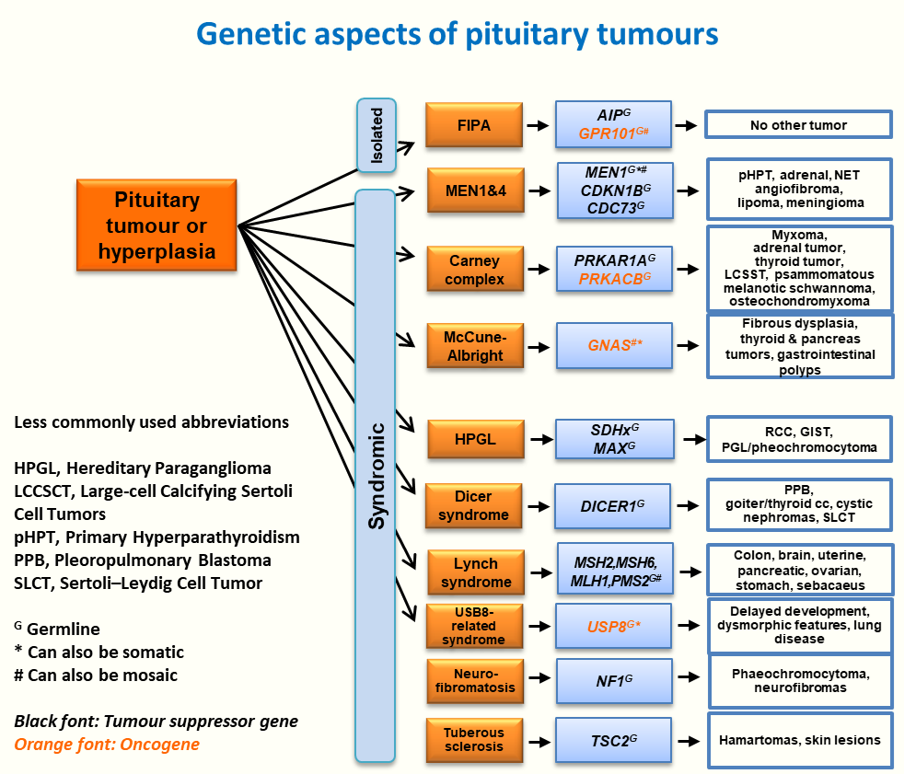

**Figure 1. Germline or Mosaic Mutations Causing Pituitary Tumors. Details for the syndromic forms can be found, among others, in the following sections** [**https://www.endotext.org/chapter/multiple-endocrine-neoplasia-type-i/**](https://www.endotext.org/chapter/multiple-endocrine-neoplasia-type-i/)**,** [**https://www.endotext.org/chapter/carney-complex/**](https://www.endotext.org/chapter/carney-complex/)**,** [**https://www.endotext.org/chapter/pituitary-adenomas-in-childhood/**](https://www.endotext.org/chapter/pituitary-adenomas-in-childhood/) **and in these references (6-10).**

Descriptions of familial pituitary adenoma families have been around for several hundreds of years, but only over the last decade has the clinical phenotype and, in some cases, the genetic abnormality been described. Interestingly, some of the patients with germline mutations present as simplex patients without any known family history, either due to low penetrance or due to *de novo* mutations.

**Figure 2. Family Trees Demonstrating Examples of the Various Types of FIPA Families. In some *AIP* mutation-negative FIPA families unaffected obligate carriers can be identified by their position in the family tree, while in other family’s possible carriers of the unidentified gene cannot be identified. AIP mutation-positive kindreds can be ‘families’ or simplex cases. Most XLAG kindreds are simplex cases with females having *de novo* germline mutations while males have somatic mosaic mutations.**

Previous data suggest that FIPA families contribute around 2% of the overall incidence of pituitary tumors, but this number may increase with increasing recognition of this clinical entity.

Around 10-20% of all FIPA families and 50% of familial isolated GH-producing Tumor families (11, 12) have been identified to have mutations within the aryl hydrocarbon receptor interacting protein (*AIP*) gene, located at 11q13. Germline mutations in *AIP* have also been identified in patients with young-onset pituitary adenomas, mostly GH-secreting or prolactin-secreting or silent GH/prolactin-producing adenomas with no apparent family history. These are called ‘simplex’ cases. Until recently, no somatic mutations had been described in the *AIP* gene in pituitary or other tumors (1). Duplication of the orphan G protein-coupled receptor *GPR101* causes X-linked acrogigantism (XLAG) (13).While most of the XLAG cases are due to *de novo* mutations (germline or somatic mosaicism (14, 15)), to date three families have also been described. The causative gene for the rest and therefore the vast majority (90% only considering kindreds with 2 or more affected subjects) of FIPA families is currently unknown (16). Recently, a microdeletion upstream the *GHRH* gene, on chromosome 20, has been identified as another possible cause of severe infant-onset gigantism (17). New candidate genes are under active investigation in somatic and familial cases of pituitary adenomas (18), but some need further validation. Representative examples of FIPA family trees are shown in Figure 2.

## CLINICAL FEATURES OF FIPA

Families with *AIP* mutations usually have a characteristic phenotype, which is usually substantially different from that of *AIP* mutation-negative phenotype. In this section, we compare characteristics of *AIP*-mutated and non-*AIP*-mutated FIPA. Germline chromosomal defects leading to gigantism, including XLAG and a recently described microdeletion in chromosome 20 that leads to GHRH overexpression, have a drastically different phenotype and are discussed separately below.

### 

### Tumor Types

FIPA families can be homologous (i.e. all affected family members have the same type of tumor) or heterologous (i.e. family members can have different type of tumor) (Figure 2). Therefore, pure acromegaly, pure prolactinoma, and pure non-functioning pituitary adenoma (NFPA) families have been identified, while also mixed families such as acromegaly-prolactinoma, acromegaly-NFPA, prolactinoma-NFPA, prolactin-corticotrophinoma or even acromegaly-prolactinoma-NFPA families have been described. Somato-mammotrophinomas occur commonly, but are not consistently reported, probably as a result of variations in the reporting of tumor histology type. Figure 3a, b and c demonstrate the distribution of histological tumor types in FIPA families.

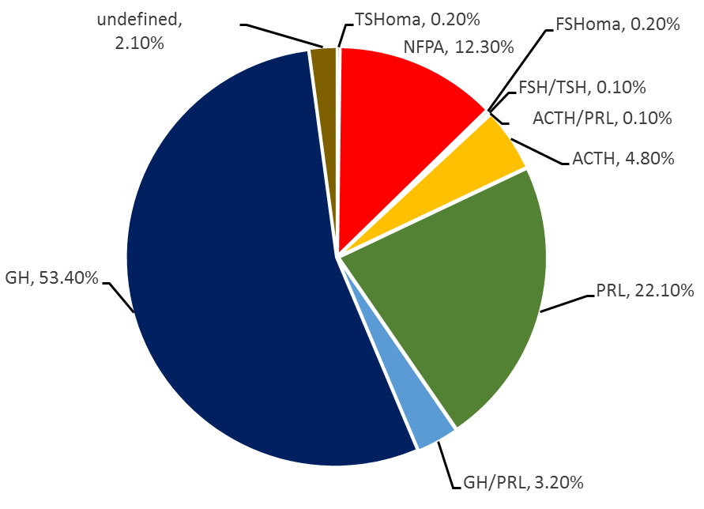

**Figure 3a. Proportion of histological tumor types in the AIP positive FIPA population in the International FIPA Consortium cohort (n=911) (19).**

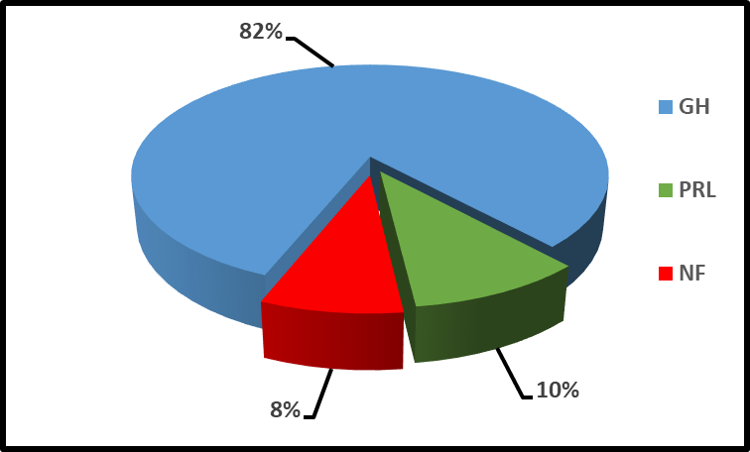

**Figure 3b. Proportion of tumor types in *AIP* mutation-positive FIPA families (12).**

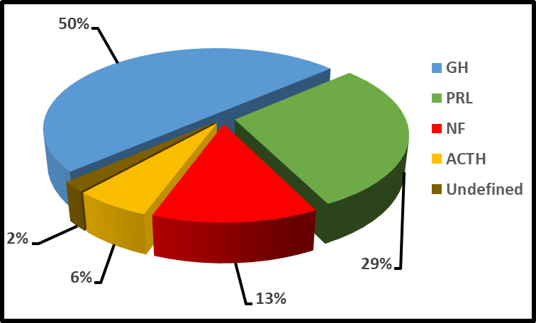

**Figure 3c. Proportion of tumor types in *AIP* mutation-negative FIPA families (12).**

In a study including familial as well as simplex (apparently sporadic) patients with germline *AIP* mutations, 78% of 96 patients developed GH-secreting adenomas (20) (half of the GH-secreting adenomas were somato-mammotrophinomas), 13.5% of patients developed prolactinomas, 7% developed non-functioning pituitary adenomas (NFPAs), and 1 patient developed a TSH-secreting adenoma. In another study, comprising 171 patients carrying *AIP* mutations, based on clinical diagnosis 70% had somatotrophinomas, 11% mixed GH/PRLomas, 12% had prolactinomas, and 8% had clinically non-functioning tumors (12). On histological testing some tumors show plurihormonal profile (Figure 3b). It is important to note that some non-functioning tumors are found to be somatotroph/lactotroph upon histological examination (21) – these are therefore ‘silent adenomas’. The distribution of tumors amongst 318 non-*AIP* mutated FIPA families (1310 patients) is represented in Figure 3c (12). Somatotrophinomas are the most common tumor type in both *AIP* mutation-positive and negative FIPA families (12, 19).

### 

### Gender Distribution

While higher numbers of males are identified with *AIP* mutations both in familial and simplex setting (12, 20), ascertainment bias due to physiological later puberty of boys and their normally taller stature cannot be ruled out (19), as in a carefully-studied large AIP mutation family equal number of affected males and females are present (22). There is a greater prevalence of females within *AIP* mutation-negative families, probably due to a higher number of prolactinomas (19).

### 

### Age of Onset

*AIP* gene mutation-positive FIPA patients have an earlier age of onset of diagnosis compared to those with *AIP* mutation-negative familial (23) or sporadic (20) pituitary adenomas. The age of onset of pituitary adenoma symptoms is 8 years earlier in the *AIP* mutation-positive group (mean age 19 years, SD ± 9.5, p<0.001), with diagnosis being made 6 years earlier (mean age of diagnosis 24.3, SD ± 11.9 vs 30, SD ± 13.5, p<0.001) than in the *AIP* mutation-negative population (12). In our international FIPA cohort, the familial cohort with *AIP* mutation-positive tumors had a peak age of onset during the 2nd and 3rd decades of life, with 65% of these patients’ developing symptoms aged ≤18 years (28.8% in the AIP mutation-negative group) and 87% by the age of 30 years (12). Previous work has shown that those families with *AIP* mutation-negative tumors demonstrate a more even spread of occurrence between the ages of 20 and 50, with a peak incidence around the age of 30 years old (19); the latest data suggests that the modal age group (42%) is 20-29 years (12).

Young (<30 years) onset simplex patients, the *AIP* mutation-positive group, also developed tumors at a younger age than the mutation-negative group, with median ages of 16 years (IQR 14.8-22.3) and 22 years (IQR 16-26) respectively (19).

In the Bart’s international cohort, over 80% of the families with *AIP* mutations have at least one affected patient with gigantism or disease onset before the age of 18 years, while only 3 out of 46 *AIP* mutation-negative families have an onset of pituitary adenoma before the age of 18 years (23). Interestingly, probably due to earlier recognition of symptoms in affected FIPA families, the age of tumor onset appeared to be earlier in the second generation than in the first (mean age 29 ±10.2 years vs. 50.5± 14.2 years p<0.0001) (24).

### 

### Disease Penetrance

Disease penetrance in FIPA is incomplete. As there is a clear natural bias of affected patient referral and the clinical and genetic data in the individual families are incomplete, the calculation of disease penetrance is difficult. Additionally, it is important that penetrance always be considered in the context of the subject’s age.

In *AIP* positive mutation families, current data suggests 12.5-30% penetrance, but ranges between 10-90%, also depending on available data (19, 20, 23). It seems that the nature of the *AIP* mutation (truncating or non-truncating) does not have any effect on penetrance (19).

In *AIP* mutation-negative families, penetrance calculations are even more difficult as carrier unaffected family members (other than obligate carriers) cannot be distinguished from non-carrier unaffected subjects. The current calculation based on affected subjects, obligate carriers and 50% of potential carriers suggest 38±16% (23), but this is obviously a very significant overestimate.

Another way to compare penetrance between *AIP* positive and negative families is to count the known affected subjects within families. Penetrance in *AIP* mutation-negative families is probably lower than in *AIP* mutation-positive families, as the mean number of patients with disease in *AIP* mutation-positive families is 3.2±1.8 and in *AIP* mutation-negative families 2.2±0.5, P<0.001 (23).

*De novo* *AIP* mutation has been described in two cases so far: in a child with prolactinoma (c.721A>T; p.Lys241*) where the *AIP* mutation was not found in the parents (paternity confirmed) or his sister (19, 25). A second case was with identical twin girls, where both of them carry a mutation in the leukocyte derived DNA (p.R304*), while their parents (paternity confirmed) were negative (26).

Phenocopies (patients who show manifestations of a disease that are usually associated with mutations of a particular gene but instead are, in this case, due to another etiology) (27) have been described in families with *AIP* mutations (16, 23) and are probably present in *AIP* negative families as well, therefore careful and cautious genetic studies and counselling need to be conducted in every family.

### Tumor Behavior

#### SIZE

FIPA patients in general have larger, more aggressive tumors and earlier onset of disease compared to sporadic pituitary adenomas (11, 20, 23, 28).

Macroadenomas predominate amongst *AIP* mutation-negative and positive FIPA groups. However, when compared to sporadic pituitary adenomas, *AIP* gene mutation-positive FIPA patients were more likely to have larger tumors (1, 11, 19, 28) and macroadenomas (19), and these tumors were more likely to invade the extrasellar region (19, 20).

There was no statistical difference between the *AIP* mutation-positive and negative groups in the occurrence of giant (>40mm) adenomas (19), nor in the incidence of macroadenomas (mutation-positive 83.2% vs 79.2% p=0.259) or cavernous sinus invasion (mutation-positive 36.7% vs 28.3%, p=0.122) (12). Suprasellar extension was more frequent in the pituitary adenomas of AIP mutation-positive FIPA patients (mutation-positive 54.3% vs 42.4%, p=0.043).

No correlation was observed between the presence of truncating and non-truncating *AIP* mutations and the size of the pituitary adenoma, the incidence of macroadenoma or the propensity to invade extrasellar structures (19).

#### APOPLEXY PROPENSITY

Pituitary apoplexy is a relatively rare event; incidence is variously estimated to be as high as 6.8% (in 560 adenoma cases) (29) to as low as 0.6% (in 664 adenoma cases) (30). In a previous study, it was shown that apoplexy occurred more commonly in individuals with *AIP* mutation-positive tumors than those with mutation-negative tumors (7.6% vs 1.3% of cases respectively) (19). No size difference was observed between tumors that did and those that did not undergo apoplexy in the *AIP* mutation-positive tumor group (19). Excluding simplex cases from these analyses (i.e. just considering patients with a family history of pituitary adenomas) demonstrated an even bigger disparity in apoplexy incidence with *AIP* mutation-positive tumors having an apoplexy rate of 10.6% vs 2.3% in mutation-negative families (19). The latest data from the international FIPA consortium has shown similar rates of apoplexy (8.2% vs 3.6% respectively, p=0.009) (12). Familial apoplexy has also been described in *AIP* mutation-positive families (19, 31). It was previously observed that GH-secreting tumors with *AIP* mutations were significantly more likely than their mutation-negative counterparts to undergo apoplexy (19) and this has been demonstrated once again (8.3% vs 2.8% p=0.005) (12). The mechanism for this observation is unclear.

### 

### Treatment Resistance

Many of the somatotrophinomas described in FIPA families have been described as sparsely granulated adenomas (1), a subtype which has been previously suggested to respond less well to somatostatin analogues and to be more aggressive (32, 33). Sparsely granulated adenomas occur more commonly in *AIP* mutation-positive GH-secreting adenomas than in their mutation-negative GH secreting counterparts (19). In one study (12), *all* of the AIP mutation-positive somatotrophinomas were sparsely granulated, compared to 68% in the AIP mutation-negative group (p<0.001).

There is speculation that somatostatin analogues mediate their anti-proliferative effects through *AIP* up-regulation, which in turn increases the expression of *ZAC1*, a tumor suppressor gene known to be upregulated by somatostatin analogues (34, 35), therefore, dysfunction at the *AIP* step would reduce the expression of *ZAC1* and so the usefulness of this class of drug (36). Another potential mechanism for this treatment resistance involving defective Gαi signaling has been postulated and is discussed in detail below.

It has previously been observed that *AIP* mutation-positive tumors are more difficult to treat − mutation-positive somatotrophinomas undergo less shrinkage and there is a smaller reduction in GH production with first generation somatostatin analogues than in the mutation-negative sporadic patients (1, 20, 28, 37). This may be accounted for by a relative paucity of expression of SSTR2 in the former (38); however, in human samples rather, a higher level of SSTR2 was found (36), and this is also seen in a pituitary *Aip*-knockout mouse model (39, 40). A greater need for re-operation after initial surgery and a greater use of multiple therapies and >2 types of therapy, including radiotherapy (12) and the failure of pegvisomant to control IGF-1 (20) have also been described. However, some studies (19) failed to demonstrate any difference in the number of therapeutic interventions between *AIP* positive and negative mutation tumors. Where primary surgery has failed to control the tumor’s GH production, there is some evidence that pegvisomant (37, 41), or pasireotide in patients whose tumor expresses the type 5 somatostatin receptor (38, 42), may reduce the IGF-1 burden. In some cases, drastic treatment is necessary: for example, in the youngest known case, who presented at the age of 4 years-old, surgery followed by first generation somatostatin analogue, temozolomide, bevacizumab, radiotherapy, pegvisomant, gamma knife therapy and somatostatin analogue combined with increasing dose of pegvisomant, was necessary (43).

No correlation was observed between the presence of truncating and non-truncating *AIP* mutation tumors and the number of treatment modalities required by these patients (19).

In addition to sparsely granulated histopathology, other well-known predictive factors of resistance to first generation somatostatin analogues are younger age at diagnosis, hyperintense T2 image on MRI, and low tumor expression of somatostatin receptor subtype 2 (44). Recently, a machine-learning based model accounting for age at diagnosis, sex, pretreatment GH and IGF-1 levels, tumor granulation pattern and expression of somatostatin receptor subtypes 2 and 5 was shown to predict therapeutic response to first generation somatostatin analogues with high negative and positive predictive values (45).

Currently, some experts already suggest that the first-line medical treatment for patients that show one or more of these features could be pegvisomant or pasireotide; and that pegvisomant could be preferred in patients with diabetes or low somatostatin receptor subtype 5, whilst pasireotide could be preferred in the presence of significant tumor volume (44). Therefore, in select cases, these two drugs could be considered early in postsurgical medical therapy in patients with persistent disease, especially in younger patients with ongoing uncontrolled height gain, as seen in patients with *AIP* mutations.

### 

### Hormone Secretion

When matched with acromegaly mutation-negative controls, *AIP* mutation-positive somatotrophinomas produce more growth hormone (GH) (20) but there was no difference in the levels of IGF-1 (12, 20). Prolactin co-secretion was more common in *AIP* mutation-positive GH secreting tumors than their non-*AIP* mutated counterparts (19).

Gigantism was observed to be more common among *AIP* mutation-positive patients (55.9% vs 18.2%, p=0.005) and was the most common clinical diagnosis (12) – which is predicted by their earlier onset of disease, with cases in males predominating in both *AIP* positive and negative patients (19): 60% of FIPA families in one study had at least one case of gigantism and instances of two cases of gigantism within the same family only occurred in *AIP* mutation-positive families (19).

No correlation was observed between the presence of truncating and non-truncating *AIP* mutations and the incidence of GH secreting tumors (19); however, there was a significantly greater prevalence of gigantism amongst the GH secreting tumor patients in those with truncating as opposed to non-truncating *AIP* mutations (54.7% vs 30%). There is also a suggestion that patients with GH-secreting adenomas and the truncating R304* mutation present more commonly at a very young age then rest of the described *AIP* mutation-positive population with GH secreting adenomas.

A previous case report described the co-existence of pituitary hyperplasia and pituitary adenoma in two *AIP* mutation-positive adenomas from a family. Loss of heterozygosity was seen in the adenoma tissue but not in the surrounding hyperplastic tissue and loss of AIP protein expression was seen in the adenoma tissue with preservation of *AIP* expression in the hyperplastic tissue (46). Villa and colleagues hypothesize that this may demonstrate that tumorigenesis is a multi-stage event starting with hyperplasia in haploinsufficient tissue and then the development of further genetic events (including loss of the one remaining wild-type *AIP* allele) leading to true adenoma formation. They suggest that this could explain the incomplete penetrance seen in pituitary disease in *AIP* mutation-positive subjects (46).

In GH-secreting non-*AIP* mutated sporadic pituitary tumors, an association was noted between the levels of AIP staining on histology and the aggressiveness of the adenoma. Low levels of AIP staining were associated with a more aggressive phenotype (higher Ki-67 index and a greater likelihood of suprasellar tumor extension) when compared to tumors with higher levels of AIP staining. In the same tumors, none of those with low AIP staining showed significant shrinkage despite pre-operative treatment with a somatostatin analogue. Tumors treated pre-operatively with somatostatin analogues that *did* shrink showed a higher level of AIP on immunohistochemistry (47).

No difference in rates of hypopituitarism was seen between AIP mutation-positive and negative patients with pituitary adenomas at diagnosis (12).

### 

### Other Tumors in Individuals with an *AIP* Mutation

In one study (19) involving 290 *AIP* mutation-positive individuals (some with pituitary adenomas), there were 10 cases of tumors occurring outside of the pituitary gland in 9 individuals. These included a gastrointestinal stromal tumor, glioma, meningioma, non-Hodgkin’s lymphoma, and spinal ependymoma. Parathyroid adenomas were excluded from this analysis due to the rare finding of *AIP* mutations in parathyroid adenomas (48), as were colonic polyps and thyroid nodules due to their frequent occurrence in patients with acromegaly (19). Four of the 9 individuals with extra-pituitary tumors had GH-secreting pituitary tumors, the other 5 were *AIP* mutation carriers without pituitary tumors.

While AIP acts as a tumor suppressor gene in the pituitary gland, and patients with pituitary tumors show heterozygous loss-of-function mutations of *AIP*, a possible role for AIP as an oncogene has been described in other tumor types. To date, increased expression of AIP was found in association with increased tumorigenic and metastatic properties of colorectal cancer cells (49), with increased survival of primary diffuse large B cell lymphoma (DLBCL) cells (50), and with a bad prognosis in cholangiocarcinoma (51). In colorectal cancer, increased AIP expression was associated with increased cell migration and epithelial-to-mesenchymal transition, possibly by the facilitation of N-cadherin expression and suppression of functional E-cadherin on the cell surface (49). On the other hand, for DLBCL, AIP promoted tumor survival by reducing ubiquitin-mediated proteasomal degradation of BCL6, a protein that reduces the transcription of pro-apoptotic genes such as *TP53* and that is frequently overexpressed in DLBCL (50).

Therefore, AIP behaves as a double agent, either as a tumor suppressor or as an oncogene, and further studies on AIP regulation mechanisms will be essential for a better understanding of AIP derived tumorigenesis and for unravelling new possible therapeutic targets (52).

## THE GENETICS OF FIPA

The currently known genes causing FIPA are *AIP* and *GPR101* and we will discuss the diseases associated with these genes in detail. Furthermore, there are some pituitary adenoma cases described with other germline mutations, that will be more briefly addressed, as they are still under investigation and require additional validation.

### AIP

There are over 100 heterozygous mutations identified in *AIP*, showing an autosomal dominant inheritance pattern with incomplete penetrance (53). Mutations that affect the *AIP* gene commonly lead to truncated or missing protein due to nonsense mutations, small deletions or large deletions, insertions, splicing or promoter mutations, while 21% result in full length mutated protein due to missense mutations or in-frame deletions or insertions (Figure 4). Large deletions cannot be identified with Sanger sequencing and other technologies, such as MLPA, or next generation sequencing methods are required to identify them.

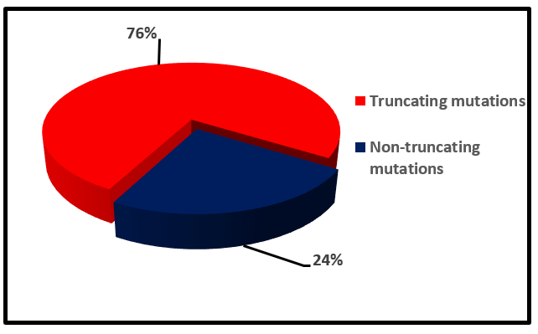

**Figure 4. Distribution of mutation types found within the *AIP* gene in the International FIPA consortium (12).**

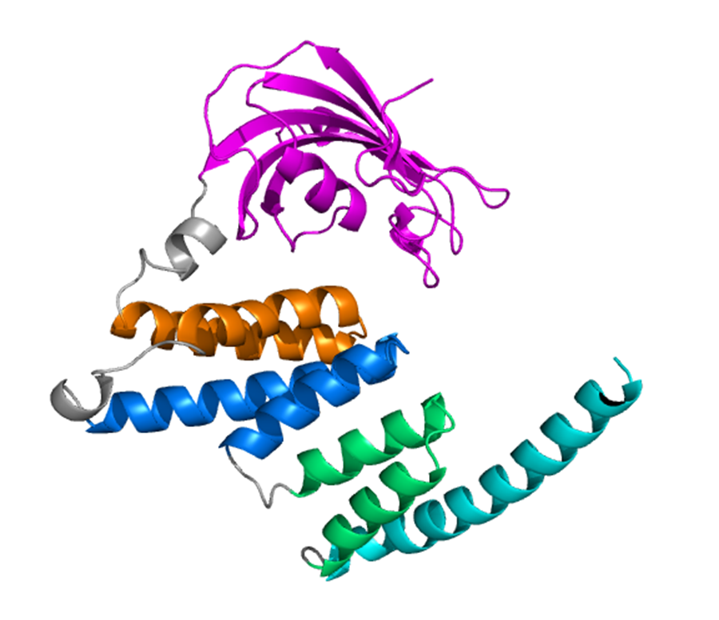

**Figure 5. The three-dimensional structure of the AIP protein. Three characteristic tetratricopeptide (TPR) domains, the A and B helices of the first TPR domain, orange, TPR2 blue. TPR3 green and the 7th C-terminal alpha helix with light blue (54, 55).**

The AIP protein is a well-conserved molecular chaperone, with multiple binding partners. It has three tetratricopeptide (TPR) repeats, conserved anti-parallel pair of alpha helices and a final 7th alpha helix at its carboxyl terminal end (Figure 5). This C-terminal section is known to be important for interaction with other proteins and therefore, it is postulated, that in the case of FIPA it loses its ability to bind its binding partners, such as the aryl hydrocarbon receptor (AHR) or phosphodiesterase (PDE) subtype 4A5, and therefore loses its activity as a tumor suppressor (56).

There are a few mutational hotspots, the majority affecting CpG sites, where a mutation has been identified in several independent patients or families (Table 1).

|  |  |
| --- | --- |
| **Table 1. A Few Examples of *AIP* Mutation ‘Hotspots’** | |
| **Variant** | **References (examples)** |
| c.910C>T; p.R304* | Cazabat et al. 2007 (57)  Daly et al. 2007 (11)  Georgitsi et al. 2007 (58)  Igreja et al. 2010 (23)  Leontinou et al. 2008 (28)  Variglou et al. 2009 (59)  Vierimaa et al. 2006 (16)  Chahal et al. 2011 (60)  Hernandez-Ramirez et al. 2015 (19)  Ramirez Rentaria et al. 2016 (26)  Marques et al. 2020 (12) |
| c.811C>T; p.R271W | Daly et al. 2007 (11)  Jennings et al. 2009 (61)  Hernandez-Ramirez et al. 2015 (19) |
| c.721A>T; p.R81* | Leontiou et al. 2008 (28)  Toledo et al. 2010 (62)  Hernandez-Ramirez et al. 2015 (19)  Marques et al. 2020 (12) |

### AIP Mouse Models

*AIP* knockout in mice is lethal *in utero*and is associated with ventricular septal defects, double outlet right ventricle and pericardial edema (63). The embryonic mice are also unable to undergo a crucial step in initiating adult erythropoiesis at E11-14, a step which is vital for embryonic survival beyond E13.5 (64). This suggests that *AIP* may have an important role to play in fetal growth signaling *in utero.*

Heterozygote *AIP* knockout mice invariably develop mostly GH-secreting pituitary tumors, with 100% penetrance by the age of 18 months, compared to wild-type mice where around 1/3 of mice spontaneously developed prolactin-secreting adenomas, but no GH adenomas are observed (65). *AIP* expression was lost in these GH-secreting tumors and this corresponded to higher tumor proliferation rates (65), compared to spontaneous pituitary adenomas in the wild-type littermates, with normal *AIP* expression. These data mirror the increased aggressiveness of tumors seen in mutation-positive FIPA families (11, 20, 23, 28). *ARNT* expression was also lost in the mouse tumors (65), reflecting a pattern observed in human mutation-positive tumors (66) and therefore suggesting a possible role for loss of *ARNT* in the development of pituitary tumors (65). Somatotroph-specific AIP deficient mice (s*Aip*KO) have also been created, using *Cre/Lox* and *Flp/Frt* technology (67). In keeping with the heterozygote AIP knockout mice described above, >80% of the s*Aip*KO mice developed GH secreting adenomas by 40 weeks of age, by 18 weeks they also displayed elevated IGF-1 and GH levels, increased body and organ size (compared to control animals) and glucose intolerance. Pituitary hyperplasia was consistently observed in the s*Aip*KO mice (on histology and on MRI imaging), suggesting (but not absolutely proving) a progression from hyperplasia to adenoma. The investigators point out that 40 weeks of age for a mouse represents ‘middle adulthood’ and so hypothesize that, in common with other tumors, additional somatic mutations are required on top of the AIP loss of function for somatotroph tumors to occur (67). A pituitary-specific *Aip* knockout using the Hesx1/Cre model has also developed gigantism with elevated IGF-1 levels (40).

*ARNT* knockout mice die *in utero* in early gestation (68, 69): the reasons for this are disputed, in one study it appeared that there was faulty angiogenesis in the yolk sac (69), whilst in another the embryos survived slightly longer and had a normally developed yolk sac vasculature but the placental vasculature failed to develop correctly. The embryos in the latter study also displayed a range or anomalies, including neural tube closure defects, brain hypoplasia and placental hemorrhage (68). It has been hypothesized, therefore, that *ARNT* plays a role in angiogenesis in response to hypoxia secondary to the increasing tissue mass in embryonic development (69).

*Ahr* knockout mice are viable, though they too suffer physiologic dysfunction, including cardiac hypertrophy (with cardiac myocyte enlargement but without the molecular signatures that would indicate cardiac overload) and subsequent cardiomyopathy (70). These mice also have hypertension (71), reduced body weight, reduced reproductive capabilities, smaller livers as a result of a patent ductus venosus, persistence of fetal vascular and liver parenchymal structures and aberrant vasculature in the kidneys. This underlines the importance of AhR signaling mechanisms in the development of a normal, mature vasculature (72). AhR protein-protein interactions were further characterized, with one of the most interesting interactions being with the mitochondrial protein MRPL40 (73), which codes for a mitochondrial ribosomal 39S subunit. Deletions in this gene have been associated with the 22q11.2 deletion syndromes Velo-cardial facial syndrome and Di George syndrome (OMIM #188400), both of which involve congenital cardiac malformations, further suggesting the importance of AhR in normal cardiac development.

It has been suggested that interplay between AhR and ARNT/HIF1α may govern normal vascular development (72).

### MECHANISM OF TUMORIGENESIS IN PITUITARY ADENOMAS WITH *AIP* MUTATIONS

In the pituitary, AIP is a tumor suppressor, and truncating mutations presumably lead to loss of function mutations. However, for missense mutations change in protein folding or loss of partner protein binding sites could explain the lack of function. Based on data from half-life studies, (74) it seems that a significant proportion of the missense mutations lead to unstable proteins and rapid degradation explaining the loss of function. Furthermore, *in vitro* measured half-life of missense proteins correlated well with age of onset of disease. (74)

AIP interacts with numerous other molecules (see Table 2), full details of each of these interactions has recently been summarized (56).

|  |  |
| --- | --- |
| **Table 2. A List of Factors that Have Been Demonstrated to Interact with the AIP Protein (56)** | |
| Viral Proteins | Hepatitis B Virus X protein (HBV X) |
| Epstein Barr Virus Nuclear Antigen 3 (EBNA3) |
| AIP-AHR-Hsp90 Complex | Aryl Hydrocarbon Receptor (AHR) |
| Heat Shock Protein 90 (Hsp90) |
| Heat Shock Cognate 70 (Hsc70) |
| Aryl Hydrocarbon Receptor Nuclear Translocator (ARNT) |
| p23 |
| AIP self-association |
| Cytoskeletal Proteins | Possible interaction with actin |
| Tubulin (75) |
| Phosphodiesterases | PDE4A5 |
| PDE2A3 |
| Nuclear Receptors | Estrogen Receptor α (ERα) |
| Glucocorticoid Receptor (GR) |
| Peroxisome Proliferator-Activated Receptor α (PPARα) |
| Thyroid Hormone Receptor β1 (TRβ1) |
| Transmembrane Receptors | RET |
| EGFR |
| G Proteins | |
| Translocase of the Outer Membrane of Mitochondria (TOMM20) Proteins (64) | |
| Survivin (64) | |
| Cardiac Troponin Interacting Kinase 3 (TNNI3K) | |
| Protein Kinase A (76) | |

The exact mechanism by which *AIP* mutations lead to pituitary tumor formation is unclear; however, several theories have been put forward. *AHR* is widely expressed in the body and binds numerous compounds, both endogenous and exogenous (77, 78). It is a nuclear transcription factor and prior to ligand binding it is found in the cellular cytoplasm, bound to *AIP* (77, 78). It is known that AHR is a receptor for environmental pollutants, such as dioxin – a known carcinogen. The binding of dioxin leads to increased AHR nuclear translocation, with activation of detoxification mechanisms (79), including increased expression of the enzyme CYP1A1, which has also been shown to bio-activate polycyclic aromatic hydrocarbon carcinogens (80, 81). Interestingly, an increase of acromegaly incidence (82) has been described in a heavily polluted industrial area. Pituitary adenoma incidence was also studied in an area heavily polluted with dioxin after a chemical factory accident, but data were not sufficient to draw appropriate conclusions (83). A recent follow-up study (84) examined links between the characteristics of patients with GH-secreting pituitary adenomas, residing in an area of high pollution and *AHR/AIP* variants. It was found that pituitary tumors were significantly larger and IGF-1 burden significantly greater in patients with *AHR/AIP* gene variants who lived in polluted areas compared to either those who had no gene variants and lived in the same highly polluted areas or those who had gene variants but lived in cleaner areas. Further, the use of somatostatin analogues in patients with GH-secreting pituitary adenomas, who also had *AHR*/*AIP* gene variants and lived in highly polluted areas, seemed to be less effective (IGF-1 only normalized in 14%). Overall, the reduction in GH/IGF-1 levels did not reach statistical significance. GH secreting pituitary patients with no *AHR/AIP* variants had a statistically significant reduction in GH/IGF-1, as did those without gene variants living in polluted areas (IGF-1 normalized in 54-56% of cases). These data need confirmation.

Fibroblasts with heterozygous *AIP* mutations taken from patients have lower AIP protein levels (probably through nonsense-mediated decay of truncated proteins (74)) compared to wild-type fibroblast controls, but AHR expression is unaffected. However, *AIP* mutation did result in altered regulation of the AHR transcriptional target CYP1B1, both with and without AHR ligand stimulation (85). The mechanism by which this happens and therefore the role of AHR in signaling in pituitary tumorigenesis is still to be elucidated.

It has been noted that the loss of function of the *AIP* gene allows dysregulated ERα mediated gene transcription by its disinhibition (86). Cumulatively, high levels of estrogen and therefore estrogen mediated gene transcription products have been associated with an increased risk of developing various tumors, including pituitary tumors (86, 87) and so this work provides a novel avenue for investigation into pituitary tumorigenesis.

In the previous years, the role of cAMP elevation in pituitary tumors has been further investigated - It had previously been noted that cAMP levels were elevated in a subset of pituitary tumors (88). cAMP is a mitogenic factor in somatotroph cells, this therefore suggests a link between its dysregulation and tumor growth (89, 90). AIP is known to be a binding partner of some of the phosphodiesterases. AIP binding to PDE4A appears to inhibit its phosphodiesterase activity; however, this did not appear to prevent the cell’s *in vitro* ability to reduce forskolin-induced cAMP driven transcription. Therefore, it was felt unlikely that AIP-phosphodiesterase was the mechanism for cAMP elevation in pituitary tumors (91). The same study also hypothesized that AIP’s interactions with other binding partners is vital in its role of reducing cAMP, as R304* mutant *AIP* transfected cells (which produces a truncated AIP protein, losing its protein-interacting C-terminal) were not able to reduce cAMP signaling in the same way that wild-type AIP transfected cells could (91). This correlated with reduced GH secretion after forskolin stimulation in the wild-type *AIP* cells, but not in the *AIP* mutant cells (91).

Disordered cAMP regulation is also seen in McCune Albright syndrome – where there is a mutation of the *GNAS1* gene which results in a constitutionally active Gαs and raised cAMP (92), and Carney complex (93) – where there is an inactivating mutation in the *PRKAR1A* gene, a subunit of Protein Kinase A (PKA), a cAMP dependent kinase (94).There is evidence that AIP interacts with some of the subfamily protein of Gα (95), providing a possible way through which AIP can influence intracellular cAMP levels. To investigate this further, Tuominen *et al.* (96) developed an immortalized fibroblast cell line from the embryos of an *AIP* knockout mouse. *AIP* knockout in the mouse embryonic fibroblasts (MEFs) cell line resulted in higher cAMP level with a 2-3 times increase the *AIP* knockout cells. This result was concordant with *AIP* knockdown in a rat pituitary tumor cell line, with an observed 20-30% rise in cAMP levels.

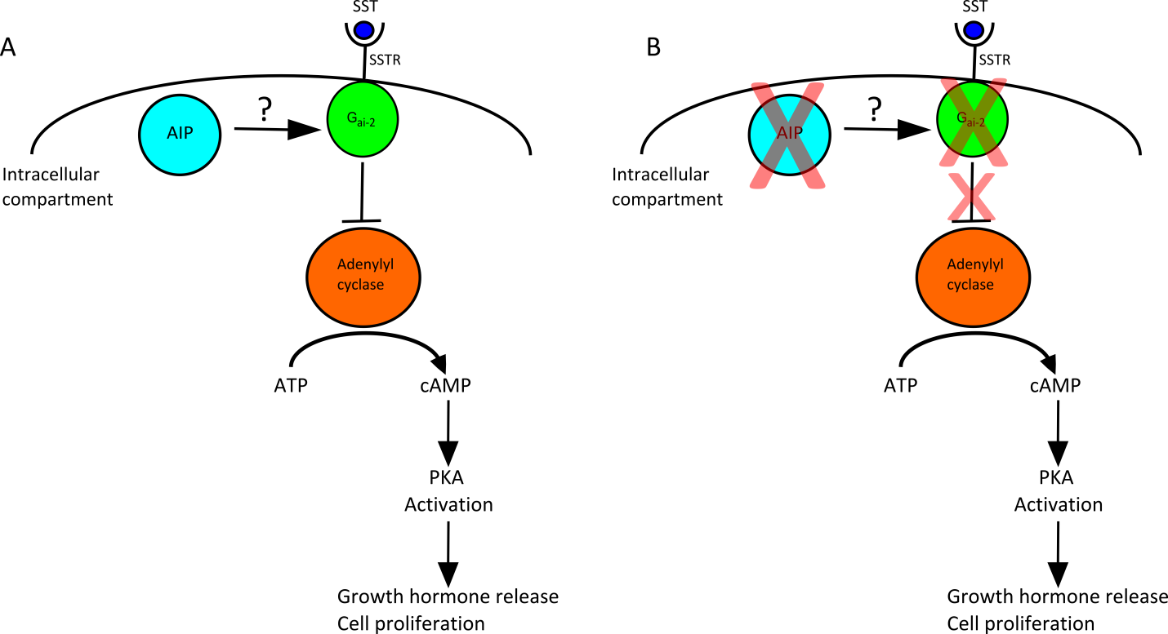

**Figure 6. Role of G alpha Inhibitory Protein. (A) - cells with normally functioning G alpha inhibitory protein (Gai-2) respond to stimulation of the somatostatin receptor (SSTR) by somatostatin (SST) by inhibiting the action of adenylyl cyclase, reducing the cell's secretory and proliferative capabilities. The role of AIP in this process is unknown, but cells with defective/absent AIP (B) also have a reduction in Gai-2 and so a lack of response from SST binding to SSTR with resulting disinhibition of adenylyl cyclase and increased GH secretion and cell proliferation.**

Sequential knockdown of the Ga subfamily of proteins (Ga12, Ga13, Ga11, Gaq, Ga14, Ga15, and Gas,) produced only a significant reduction in cAMP levels in *AIP* knockout mouse cells when Gas and Ga13 were knocked down, although this effect was not sufficient to explain the observed difference in cAMP levels between *AIP* knockout and wild-type cells (96). Sequential knockdowns of the Ga inhibitory subfamilies (Gai-1, Gai-2, and Gai-3)was also performed. Gai-2 and Gai-3 knockdown caused a rise in cAMP levels by 77% and 115% respectively in wild-type MEFs, but minimal changes in the cAMP levels in *AIP* knockout cells. This was interpreted as evidence of a pre-existing defect in the Gai system of the *AIP* knockout cells (96) (Figure 6).

Immunohistochemical staining was subsequently performed on human somatotrophinomas which showed a reduction in the Gai-2 expression in *AIP* mutation-positive tumors compared to mutation-negative tumors (96, 97). No difference was observed in the expression of Gai-3 between the two types of tumors (96).

These findings may also explain the observed phenomenon whereby *AIP* mutation-positive tumors appear to respond poorly to somatostatin analogue treatment, as somatostatin receptors mediate reduction in cAMP levels through the Gai system (98), particularly through Gai-2 and therefore defective Gai signaling in *AIP* mutation-positive tumors maybe abrogate the effect of these drugs (96).

There is also *in vitro* evidence that AIP may play a role in reducing PKA activity through binding to its subunits (catalytic Cα and regulatory R1α). It was shown that AIP is able to interact with these two subunits, either as part of the PKA complex or separately. Cα stabilizes AIP and alsoR1α. Overexpression of AIP lowered PKA activity, perhaps through inhibition of Cα or through the stabilization of the inactivating Cα-R1α complex. AIP overexpression also led to lower levels of Cα in the nucleus. Conversely, AIP silencing led to an increase in PKA activity. AIP’s interaction with these subunits is partly mediated by its c-terminal and so this may explain why common AIP truncation mutations (such as R304*), which affect this region, have a shorter protein half-life. It is hypothesized that this would then lead to lower intracellular AIP levels and may contribute to tumorigenesis through increased PKA activity (76).

The most recent and plausible mechanism relates to an interaction between AIP and the tyrosine kinase receptor RET. Although the first report on this interaction was over a decade ago (59), only recently there has been new insight about how this interaction affects tumorigenesis in the pituitary gland (99). RET is a dependent receptor in somatotroph cells: in the absence of its ligand GDNF, the monomeric RET receptor is processed intracellularly by caspase-3, leading to PIT1 accumulation and upregulation of the RET/PIT1/ARF/p53-apoptotic pathway (99). AIP was shown to be a key factor in the initial steps of this pathway, by forming a complex with RET/caspase-3/PKCδ, that allows for the intracellular processing of RET. In the absence of AIP or in the presence of pathological mutations in AIP, there is an inhibition of RET-induced apoptosis, that may be a key feature in somatotroph hyperplasia and adenoma formation (99). However, PIT1 is a transcription factor that is present in somatotroph, lactotroph and thyrotroph cells; therefore, despite previous studies focusing mostly in somatotroph tumors, the same pathway is probably involved in other tumor types, such as prolactinomas (99), and this seems to be the explanation for the tissue specificity of AIP mutations. In line with this finding, the reported pituitary tumors in patients with AIP mutations are mostly GH and/or prolactin secreting tumors, but also clinically non-functioning adenomas with positive GH and/or prolactin immunostaining and, in one case, thyrotropinoma (12, 20, 100). There have been no unequivocal cases of corticotrophinomas or gonadotroph adenomas in patients with pathological AIP mutations. This extraordinary finding may pave the way for new therapeutic options in sporadic and familial cases of pituitary tumors with AIP mutations.

The increased tendency of AIP mutation-positive tumors to invade locally may be a result of an altered tumor microenvironment. One study (40) observed markedly more infiltration of tumors by macrophages in human AIP mutation-positive adenomas compared to sporadic somatotroph tumors. There was also an upregulation in the tumor-derived cytokine, CCL5, which is chemotactic for leukocytes. The macrophages themselves may play an important role in breaching local structures with their secretion of matrix metalloproteinases (MMP2 & 9) (101). Gene expression profiling experiments comparing AIP mutation-positive human pituitary adenomas to sporadic human pituitary adenomas showed a partial epithelial to mesenchymal transition pattern in keeping with a tumor that invades locally but exceedingly rarely metastasizes (40). In recent years, intensive research on pituitary tumor microenvironment has expanded our knowledge on pituitary tumor behavior and tumorigenesis mechanisms and raised the possibility for immunotherapy in aggressive and refractory pituitary tumors (102).

In contrast, few studies have focused on the mechanisms of AIP regulation. miR-34, a microRNA that binds to the 3-UTR region of AIP, was shown to be overexpressed and to downregulate AIP at the protein level in sporadic somatotrophinomas with low AIP expression (103) and in somatotrophinomas due to germline AIP mutations (104). Additionally, the high expression of miR-34 is one of the mechanisms driving the increased intracellular cAMP levels seen in AIP mutation-positive tumors (104). Thus, overexpression of miR-34 promotes cell proliferation and migration and may be responsible for the invasive phenotype and typical resistance to first generation somatostatin analogues seen in these tumors (103, 104). Recently, a regulation of AIP at the transcription level was also proposed. GTF2B, a transcription factor that binds the 5-UTR region of AIP, was shown to promote AIP expression and inhibit somatotroph cell proliferation and invasion (105).

### AIP Mutations and Associations with Other Tumors

Germline *AIP* variants (R304Q, this variant is controversial, likely to be benign) were noted in sporadic parathyroid adenomas in 2 (unrelated) out of 136 patients in one study. One of these patients had a co-existent *MEN1* mutation; both had reduced AIP staining in their tumors at histology (48). Concomitant *AIP* and *MEN1* deletions through chromosomal translocations with a variety of partners are also associated with hibernomas (benign brown fat tumors). *AIP* transcription is down-regulated in these tumors (106) and its loss results in the upregulation of the brown fat marker UCP1 (107). Two patients from different FIPA kindreds, carriers of germline pathogenic mutations in *AIP* (Leu115Trpfs*41 and p.Q285*) with unaffected pituitary, were described to have follicular thyroid carcinomas showing loss of heterozygosity in the *AIP* locus in the tumor tissue (42, 108), raising the possibility for a role of *AIP* mutation as an initiating event in both pituitary and thyroid. However, differentiated thyroid carcinoma (DTC) is rare in acromegaly, and the most frequent tumor mutations found in patients with known pathogenic *AIP* mutations are very similar to the ones found in sporadic cases, mostly comprising mutations of *BRAF* and *NRAS* (108). Therefore, the potential role of *AIP* mutations as a possible rare initiating event on the pathogenesis of DTC, although unlikely, requires further investigation.

**OTHER POSSIBLE CANDIDATE GENES**

Currently, only two well-characterized genes have been implicated in the pathogenesis of FIPA: AIP, the most common one, and GPR101. However, they only account for a minority of patients with FIPA, while other genes remain largely unknown.

At present, the genetics of familial and apparently sporadic pituitary tumors is under active investigation and some new candidate genes have been identified, but additional data is required to convincingly support them as a possible cause of FIPA.

Recently, germline loss of function mutations in the peptidylglycine α-amidating monooxygenase (PAM) gene were described in one family with pituitary gigantism and in multiple sporadic cases of several types of pituitary adenomas (18). PAM plays an important role in post-translational processing and secretion of hormones and is highly expressed in all pituitary cells, but the mechanisms linking its altered function with hormone hypersecretion still require clarification. Also, the fact that some of the identified PAM variants were relatively common, and that no deleterious variants were identified in other familial cases from 17 FIPA kindreds in the validation cohort raises some reasonable doubts. Therefore, additional studies in FIPA kindreds are required to further explore and validate this new candidate gene.

Another gene, described in sporadic corticotrophinomas, is *CABLES1*. Heterozygous germline mutations in *CABLES1* appear to decrease the negative feedback response from glucocorticoids, resulting in increased corticotroph cell growth. They were identified in two young adults, two children with Cushing’s Disease, and in one unaffected parent (109); but, to date, there have been no reports of possible familial cases with this mutation. Cushing disease is only rarely described in FIPA families, mostly in kindreds with heterogeneous tumor types (19). In homogenous corticotroph adenoma families no *CABLES1* mutation has been identified (Korbonits unpublished observation). Corticotrophinomas have not been reported in kindreds with *AIP* mutation (19), and this is also in line with the recently described RET-derived AIP tissue specificity for PIT1 expressing cells (99).

A gain of function mutation in *PRLR* has been described in association with sporadic and familial prolactinomas (110), but additional data is needed to convincingly reinforce that association. Other germline mutations have also been associated with familial pituitary tumors (*RXRG, TH, CDH23)*(53, 111, 112), but lack functional validation studies as well as independent confirmation to support them as possible candidates involved in the pathogenesis of FIPA (113).

Additional conditions with excess GH in the absence of pituitary tumors have been described, and include germline mutations in genes such as *IGSF1* and *NF1*.

IGSF1 is a transmembrane glycoprotein that is highly expressed in the anterior pituitary and hypothalamus, and that is considered essential for normal hormone production (114-116). Loss-of-function mutations in *IGSF1* have been associated with an X-linked syndrome of central hypothyroidism and a variable prevalence of other endocrinopathies, including disharmonious pubertal development with delayed testosterone rise but normal or advanced testicular growth and postpubertal macroorchidism, hyperprolactinemia and GH dysregulation (114, 117). A minority of male children with such mutations show partial and transient GH deficiency, while adults more often show high IGF-1 levels, a 2- to 3-fold increase in GH pulsatile and basal secretion and mild acromegaloid features (117, 118). Similar features of GH excess were observed in mice (117). A potentially pathogenic variant in *IGSF1* was described in three individuals from the same family showing somato-mammotroph hyperplasia or tumor and gigantism (115), but, to date, most case series of patients with *IGSF1* mutations have consistently showed normal height and no evidence of pituitary tumors (116, 117, 119). It has been proposed that IGSF1 acts as a regulator of pituitary hormone synthesis, but the mechanism behind this is still poorly understood (114, 117).

Pathogenic mutations in the *NF1* gene lead to neurofibromin deficiency and neurofibromatosis type 1 (NF-1). NF-1 is an autosomal dominant condition with increased risk of several benign and malignant tumors, including optic pathway gliomas (OPG), that are frequently diagnosed at a young age. An association between NF-1 and increased growth velocity or tall stature due to GH excess has been described in several case series, with a prevalence ranging from 4.5% (120) to 46% (in large deletions of *NF1*) (121). Excess GH is diagnosed in children with NF-1 and OPG, with a prevalence of 10.9% in this patient group according to the largest series published (122). The most plausible and widely accepted mechanism to explain this association is an induced hypothalamic dysfunction from infiltrative OPG, with reduced somatostatinergic inhibition of GH secretion, corresponding to the fact that there is absence of other pituitary abnormalities in the majority of cases (123). Another suggestion is that GPR101 dysregulation may occur. However, there are some case reports of NF-1 with concomitant pituitary hyperplasia or tumor, with or without OPG, which leads to the hypothesis that GHRH overexpression may be another possible mechanism leading to excess GH (123). Nevertheless, the pathophysiology of GH excess in NF-1 remains to be clarified.

## GERMLINE CHROMOSOMAL DEFECTS PRESENTING WITH PITUITARY HYPERSECRETION/GIGANTISM- XLAG

This is a unique condition described in 2014 caused by a microduplication at Xq26.3 area containing the *GPR101* gene, resulting in the overexpression of the orphan G protein coupled receptor GPR101 (13). It may be familial or sporadic, and can be due to a germline or a mosaic somatic mutation (14, 15). It shows an X-linked dominant inheritance with complete penetrance. Most cases are *de novo* germline (female) or mosaic (males) cases, with, to date, only three kindreds described where affected mothers passed on the mutation to male offspring (124-126). It constitutes 8-10% of the cases with gigantism (125, 127), and practically all the non-syndromic infant-onset gigantism.

### 

### XLAG Characteristics

In addition to the most prominent symptom of very early-onset gigantism with significantly elevated growth velocity, acral enlargement and coarse facial features are also observed (37). Fasting hyperinsulinemia was noted in 1/3 of patients and around 20% had acanthosis nigricans (125). Elevated BMI is often observed, and up to 1/3 of patient with XLAG have increased appetite, something not noted previously in gigantism. Hyperprolactinemia accompanies the GH excess in over 80% of the cases. Three quarters of the patients are females. GHRH levels can be normal or slightly elevated, and in some patients a paradoxical response was seen to the TRH test (127).

### 

### Tumor Types

All *GPR101* duplication-related pituitary tumors described so far are GH producing, with the majority also secreting prolactin. There are a few cases of pure GH excess patients, some of these with hyperplasia rather than tumor (128). A rare *GPR101* germline variant (p.E308D) does not play a role in somatotrophinoma tumorigenesis based on human (127, 129, 130) and *in vitro* data (131).

### 

### Age of Onset

Accelerated growth has been reported as early as 2-3 months of age (125), and abnormal hormone levels started to develop soon after birth in a prenatally diagnosed case (126). The median age of onset of rapid growth is at 1 year (range 0.5-2) with a median age at diagnosis being 3 years old (range 1-22) (13, 132).

### 

### Somatic Mosaicism

It seems that male patients, except the few familial cases, in which a germline duplication is inherited from an affected mother (124-126), have mosaic *GPR101* duplication with pituitary tissue (and other tissues) showing the microduplication, while blood-derived DNA is negative or has a low level of mutation burden (14, 15, 127). The phenotype of somatic and germline *GPR101* duplication patients is the same (132).

### 

### Tumor Behavior

#### SIZE

The size of the pituitary is variable in XLAG cases ranges from large tumors (133) to pituitary hyperplasia (13, 14, 127). It is currently unclear why some patients develop tumors while others have hyperplasia, both have been described in males and females. While Ki-67 is low in the tumor samples in most cases and such tumors do not show any tendency to invasion or apoplexy (127), invasive growth and a high Ki-67 has also been described (126, 133).

#### HORMONE SECRETION

Xq26.3 microduplication tumors invariably secrete GH and frequently also prolactin (13, 125). Random levels of GH were markedly raised in one study of 18 XLAG patients with a median of 52.5 times the upper limit of normal (range 6-300 times upper limit of normal) (125).

#### TREATMENT

Treatment of XLAG is complex and the tumors may grow rapidly, producing not only local effects due to their size but also causing worsening systemic manifestations of gigantism through their hormone production if not treated promptly (133). Despite widespread expression of type 2 somatostatin receptors, it has proved difficult to control GH levels in XLAG with somatostatin analogues or prolactin with dopamine agonists, even at relatively high doses. Extensive neurosurgery is often needed and effective, but the rates of post-operative hypopituitarism are high (125). In contrast, radiation therapy typically does not lead to disease control (125, 133). First generation somatostatin analogues are also usually ineffective in controlling GH hypersecretion, even in the presence of high tumor expression of somatostatin receptor 2 (125). In patients not controlled by surgery, the GH antagonist pegvisomant has proven effective in controlling IGF-1 levels (14, 41, 125, 128), but radiotherapy may be used as an alternative for tumor control if radical surgery is not possible. Patients with pituitary hyperplasia have previously been treated with hypophysectomy (134), while now combined treatment with somatostatin analogue, cabergoline and pegvisomant provides appropriate control (14). If lesion control and prolactin is not an issue, then patients can be treated just with pegvisomant (135).

### 

### Mechanism of Tumorigenesis in XLAG

It is unclear what role the hypothalamus plays and what is the role of the pituitary tissue in this disease. As some patients do not have a tumor, but produce very high level of GH, abnormal hypothalamic regulation could play a key role. Indeed, some patients have elevated circulating GHRH levels and mutated cells respond strongly to GHRH (136). GPR101 is strongly expressed in the normal pituitary during fetal development, from 19 weeks of gestation onwards, with levels declining through to ‘very low’ in adult life, suggesting a role in pituitary maturation (137). It is strongly over-expressed (both mRNA and protein) in the pituitary lesions of XLAG patients (131, 138). A recent paper has identified the mechanism for this. The duplication disrupts the regulatory region borders around the *GPR101* gene (the so-called topologically associated domain or TAD) and this leads to overexpression of *GPR101* by regulatory elements that normally do not regulate the expression of this gene (139). Therefore, XLAG is the first endocrine TADopathy. GPR101 has been shown to strongly activate the cAMP pathway. This therefore suggests a mechanism by which its overexpression may lead to tumorigenesis. The transient overexpression of GPR101 in GH3 rat pituitary tumor cells produced increased cellular proliferation and an increase in GH secretion, supporting this hypothesis (13).

## MICRODELETION CAUSING GHRH OVEREXPRESSION

This novel condition, described for the first time in 2023 (17), is another genetic cause of severe non-syndromic infant-onset gigantism. It is caused by a heterozygous microdeletion upstream of the GHRH gene, in chromosome 20, that leads to aberrant splicing and produces a chimeric mRNA consisting of exon 1 of the TTI1 gene followed by all the coding exons of the GHRH gene. Since TTI1 is ubiquitously expressed and exon 1 has features of an active promotor, this fusion gene leads to constitutive GHRH overexpression and ectopic production of GHRH. There is only one case described so far, in a Japanese woman, that unfortunately already passed away. Her clinical phenotype was very similar to X-LAG, with significant weight gain starting a few months after birth and rapid growth diagnosed in the first years of life. She had marked GH elevation, prolactin elevation and no evidence of pituitary tumor in the MRI. She had no familial history of tall stature. Treatment with radiotherapy and bromocriptine did not ensure a complete biochemical response and the patient reached an adult height of 197.4 cm. Genome-edited mice with this mutation exhibited the same phenotype of prominent growth starting in the first weeks of life, pituitary hyperplasia and GHRH expression in several tissues besides the hypothalamus, validating the hypothesis that pituitary gigantism was driven by constitutive GHRH overexpression due to an acquired promoter.

## CLINICAL MANAGEMENT IN FIPA

Pituitary adenoma patients with family members also with pituitary adenoma need to be studied for signs and symptoms of MEN1 and Carney complex (Figure 7). If MEN1 and Carney complex are ruled out by the family history and biochemical and clinical assessment of the index patient and family members, the diagnosis of FIPA needs to be considered. These patients would benefit from referral to genetic counselling. Currently, patients can be offered screening for *AIP* mutations. Childhood-onset pituitary adenoma cases, even without family history, should also been offered genetic counselling and screening for *AIP* mutation, as a high percentage of young-onset GH-secreting adenomas show mutations in the *AIP* gene (20, 60, 140, 141). Around 12% of patients diagnosed with a pituitary tumor before the age of 30 years (and 20% of pediatric patients) were found to have a germline *AIP* mutation in one study (142) and so it has been recommended that *AIP* mutation screening be conducted in anyone diagnosed with a somatotroph or lactotroph adenoma or a macroadenoma (diameter >10mm) before the age of 30 years (143), and also in any cases of gigantism. One study which examined the incidence in apparently sporadic young-onset pituitary adenoma patients found 6.8% to have an AIP mutation, with a slightly lower incidence of 10.5% in those sporadic patients with somatotrophinomas. Reassuringly, the incidence of mutation in sporadic prolactinoma was only 1.5% (12).

Those diagnosed with a pituitary tumor after the age of 40 years are unlikely to have a germline mutation (none were found in a sample of 443 patient with pituitary adenomas of all histiotypes) (57) and so screening in this latter population is likely to be unrewarding.

The phenomenon of phenocopy needs to be kept in mind both in *AIP* mutation-positive and *AIP* mutation-negative families (16, 23).





**Figure 7.** **Proposed strategy for evaluating the patient with pituitary adenoma with (A) – negative family history and (B) – positive family history (*rare case report).**

It is suggested that family members of an *AIP* mutation-positive proband should undergo genetic testing (Figure 8 suggests a strategy for this process), though this testing may involve significant numbers of people from the affected family and is probably best carried out in genetic centers that are able to arrange testing and counselling of many people, have experience of discussing results of screening, and can maintain family registers (22). Salivary DNA testing is available for those that are needle-phobic.



**Figure 8. A proposed strategy for family screening in a family with an *AIP* mutation-positive proband. *Family member are first degree relatives of those with AIP mutations, or of obligate carriers. Further screening targets are then identified through genetic testing.**

*AIP* mutation carriers should be referred to an endocrine service (pediatric or adult) for baseline assessment (clinical examination, biochemical testing, and MRI) (141). MRI can be delayed for young children if clinical and biochemical results are normal (143). Children aged 4 years and older should be evaluated annually, with height and weight measurements, height velocity, and pituitary function testing (143). The frequency of imaging surveillance if biochemical and clinical findings are normal is difficult to judge with the available data: every 5 years was suggested until the age of 30 (143), with annual clinical assessment and basal hormone profiling (19). More recently, the emergence of an inverted-U shape pattern to the age of onset has led to the suggestion that if there is no evidence of disease at the age of 20 years, then surveillance protocols can be relaxed slightly (12).

The youngest case identified of *AIP* mutation-positive patient with a large macroadenoma with apoplexy was 4 years old with significant symptoms and rapid growth velocity already from age 3 years (43). Although only 15% of the AIP cases present symptoms before the age of 10 years (19), and the above mentioned patient is the single case known presenting before the age of 5 years, these data need to be taken into account when counselling *AIP* mutation-positive families for the timing of genetic screening and starting clinical follow-up (141, 143).

If AIP screening, which includes exons, exon-intron junction and promoter area sequencing as well as MLPA is negative, then currently no further genetic screening is possible. In *AIP* mutation-negative family’s potential carriers with a 50% chance inheriting the disease-causing mutation should be offered clinical assessment. The age of first clinical assessment of family members in *AIP*-negative families should be around early teenage years as the current youngest case was found at the age of 12 years (143).

We have already prospectively diagnosed several pituitary adenomas (both functioning macroadenomas and non-functioning microadenomas) in our cohort in both *AIP*-positive and *AIP* mutation-negative families (12, 60). Screening allows the early detection and treatment of those with adenomas, perhaps before the endocrine effects become apparent or before the local effects of tumor bulk are problematic. It is important to draw the attention of the family to the possible symptoms of pituitary disease, as awareness of symptoms results in earlier diagnosis of the disease in subsequent generations (1, 11). Data on long-term follow-up of asymptomatic carriers is currently being collected. In our clinic, we see asymptomatic young (<30 years old) carriers once a year and after a normal baseline MRI we will consider a repeat MRI in 5 years. We consider relaxing follow-up at 30 years and stopping follow-up at 50 years for *AIP* mutation-positive family members if no tumor has been detected by this time.

The relatively high frequency of pituitary incidentalomas in the general population (144) also needs to be carefully considered both in *AIP* positive and negative cases. One paper (22) has suggested repeating an MRI pituitary and hormone testing at 6 months after the discovery of a pituitary incidentaloma in *AIP* mutation-positive individual with normal biochemistry, with annual hormone testing thereafter if the MRI was unchanged.

Those with apparently cured *AIP* mutation-positive tumors (but without external beam radiotherapy) should be followed up carefully as any residual pituitary tissue will be heterozygous for the *AIP* mutation and so there is a risk of the occurrence of further pituitary adenomas (22).

**SUMMARY**

FIPA is a condition where there is an inherited propensity to the development of pituitary adenomas. The causative gene for the vast majority (76%) of kindreds is unknown: 21% of these have a mutation in the AIP gene, 3% have a duplication on the X chromosome (X-linked acrogigantism, XLAG).

There are significant phenotypic differences between these groups, with XLAG presenting with infant-onset gigantism (range 0.5-2 years) most often with prolactin co-secretion, AIP cases presenting with childhood-onset GH or prolactin-secreting tumors, while the spectrum of AIP-negative FIPA kindred represent the full spectrum of pituitary adenoma subtypes with age of onset between the ages of 20 and 50 years with a peak incidence around the age of 30 years.

FIPA patients are more likely to have larger (macroadenomas), more aggressive tumors, and an earlier onset of disease compared to sporadic pituitary adenomas. AIP mutation-positive tumors are more likely to be larger and invade the extrasellar region than sporadic adenomas. It has also been observed that the AIP mutated adenomas are more prone to undergoing apoplexy than AIP mutation-negative adenomas. All XLAG tumors described so far are GH producing, with a majority also secreting prolactin. XLAG can result in a spectrum of pituitary gland appearances, ranging from large adenomas to pituitary hyperplasia. The tumors tend not to invade or undergo apoplexy.

AIP mutated adenomas are more difficult to treat than their non-mutated counterparts, they are more likely to be resistant to somatostatin analogue therapy, more likely to require radiotherapy, and have higher rates of failure to gain control of IGF-1 with pegvisomant treatment.

Treatment of XLAG is also challenging. Tumors can grow rapidly and are difficult to control even with high doses of somatostatin analogue or dopamine agonists. Pegvisomant is effective in normalizing IGF-1, while tumor control may need radical surgery or radiotherapy.

**FIPA Diagnosis and Screening**

The first step in trying to establish a diagnosis in patients with pituitary adenomas and with a family history of pituitary adenoma should be to exclude MEN1 and Carney complex. This can be achieved through the taking of a thorough family history and through the clinical and biochemical assessment of the index patient, and if possible other affected family members. If these conditions are excluded then the diagnosis of FIPA should be considered, and these patients should be referred for genetic counselling. Additionally, any childhood onset pituitary adenoma case (irrespective of family history), any somatotroph or lactotroph adenoma, or any macroadenoma diagnosed before the age of 30 and any cases of gigantism should all be referred for genetic counselling. No cases of AIP germline mutation were found in a large study of patients diagnosed with a pituitary tumor after the age of 40 years – and for this reason, genetic screening in this population is unlikely to be rewarding.

AIP mutation carriers should be referred to an endocrine service (pediatric or adult) for baseline assessment (clinical examination, biochemical testing, and MRI). MRI can be delayed for young children if clinical and biochemical results are normal. Children aged 4 years and older should be evaluated annually, with height and weight measurements, height velocity, and pituitary function testing. If biochemical and clinical findings are normal then 5-yearly MRIs until the age of 30, with annual clinical assessment and basal hormone profiling, is the suggested follow-up protocol.

For AIP positive families we suggest starting genetic screening as soon as the family agrees as the youngest case identified was at the age of 4 years with 1-year history of symptoms, presenting with a large macroadenoma.

If AIP screening, which includes exons, exon-intron junction and promoter area sequencing as well as multiple ligation probe amplification (MLPA), is negative, then currently no further genetic screening is possible. In AIP mutation-negative families, potential carriers with a 50% chance of inheriting the disease-causing mutation should be offered clinical assessment. The age of first clinical assessment of family members in AIP negative families should be around early teenage years as the current youngest case was found at the age of 12 years.

Prospectively-diagnosed pituitary adenomas have been shown to have a better outcome. Screening allows the early detection and treatment of those with adenomas, perhaps before the endocrine effects become apparent or before the local effects of tumor bulk become problematic. It is important to draw the attention of the family to the possible symptoms of pituitary disease, as awareness of symptoms results in earlier diagnosis of the disease in subsequent generations. In unaffected AIP mutation carriers, follow-up can be relaxed at the age of 30 years if no tumor has been detected by this time, and follow-up can cease at 50 years, based on the available data. The relatively high frequency of pituitary incidentalomas in the general population also needs to be carefully considered both in AIP positive and negative family members. One strategy involves repeating an MRI pituitary and hormone testing at 6-12 months after the discovery of a pituitary incidentaloma in AIP mutation-positive individuals with normal biochemistry, with annual hormone testing thereafter if the MRI is unchanged.

**ACKNOWLEDGEMENT**

We are grateful for Dr Craig Stiles (Barts Health NHS Trust, London), who contributed to the previous version of this Endotext chapter.

## REFERENCES

1. Chahal HS, Chapple JP, Frohman LA, Grossman AB, Korbonits M. Clinical, genetic and molecular characterization of patients with familial isolated pituitary adenomas (FIPA). Trends Endocrinol Metab. 2010;21:419-27.

2. Verloes A, Stevenaert A, Teh BT, Petrossians P, Beckers A. Familial acromegaly: case report and review of the literature. Pituitary. 1999;1(3-4):273-7.

3. Xekouki P, Pacak K, Almeida M, Wassif CA, Rustin P, Nesterova M, et al. Succinate dehydrogenase (SDH) D subunit (SDHD) inactivation in a growth-hormone-producing pituitary tumor: a new association for SDH? J Clin Endocrinol Metab. 2012;97(3):E357-66.

4. Dénes J, Swords F, Rattenberry E, Stals K, Owens M, Cranston T, et al. Heterogeneous genetic background of the association of pheochromocytoma/paraganglioma and pituitary adenoma - results from a large patient cohort. J Clin Endocrinol Metab. 2015;100(3):E531-E41.

5. O'Toole SM, Denes J, Robledo M, Stratakis CA, Korbonits M. 15 YEARS OF PARAGANGLIOMA: The association of pituitary adenomas and phaeochromocytomas or paragangliomas. Endocr Relat Cancer. 2015;22(4):T105-22.

6. de Kock L, Sabbaghian N, Plourde F, Srivastava A, Weber E, Bouron-Dal SD, et al. Pituitary blastoma: a pathognomonic feature of germ-line DICER1 mutations. Acta Neuropathol. 2014;128:111-22.

7. Uraki S, Ariyasu H, Doi A, Furuta H, Nishi M, Sugano K, et al. Atypical pituitary adenoma with MEN1 somatic mutation associated with abnormalities of DNA mismatch repair genes; MLH1 germline mutation and MSH6 somatic mutation. Endocr J. 2017;64(9):895-906.

8. Voisin MR, Almeida JP, Perez-Ordonez B, Zadeh G. Recurrent Undifferentiated Carcinoma of the Sella in a Patient with Lynch Syndrome. World Neurosurg. 2019;132:219-22.

9. Bengtsson D, Joost P, Aravidis C, Askmalm Stenmark M, Backman AS, Melin B, et al. Corticotroph Pituitary Carcinoma in a Patient With Lynch Syndrome (LS) and Pituitary Tumors in a Nationwide LS Cohort. J Clin Endocrinol Metab. 2017;102(11):3928-32.

10. Nachtigall LB, Guarda FJ, Lines KE, Ghajar A, Dichtel L, Mumbach G, et al. Clinical MEN-1 Among a Large Cohort of Patients With Acromegaly. J Clin Endocrinol Metab. 2020;105(6).

11. Daly AF, Vanbellinghen JF, Khoo SK, Jaffrain-Rea ML, Naves LA, Guitelman MA, et al. Aryl hydrocarbon receptor-interacting protein gene mutations in familial isolated pituitary adenomas: analysis in 73 families. J Clin Endocrinol Metab. 2007;92(5):1891-6.

12. Marques P, Caimari F, Hernandez-Ramirez LC, Collier D, Iacovazzo D, Ronaldson A, et al. Significant Benefits of AIP Testing and Clinical Screening in Familial Isolated and Young-onset Pituitary Tumors. J Clin Endocrinol Metab. 2020;105(6).

13. Trivellin G, Daly AF, Faucz FR, Yuan B, Rostomyan L, Larco DO, et al. Gigantism and acromegaly due to Xq26 microduplications and GPR101 mutation. N Engl J Med. 2014;371:2363-74.

14. Rodd C, Millette M, Iacovazzo D, Stiles CE, Barry S, Evanson J, et al. Somatic GPR101 duplication causing X-linked acrogigantism (XLAG)-diagnosis and management. J Clin Endocrinol Metab. 2016;101(5):1927-30.

15. Daly AF, Yuan B, Fina F, Caberg JH, Trivellin G, Rostomyan L, et al. Somatic mosaicism underlies X-linked acrogigantism syndrome in sporadic male subjects. Endocr Relat Cancer. 2016;23(4):221-33.

16. Vierimaa O, Georgitsi M, Lehtonen R, Vahteristo P, Kokko A, Raitila A, et al. Pituitary adenoma predisposition caused by germline mutations in the AIP gene. Science. 2006;312(5777):1228-30.

17. Katoh-Fukui Y, Hattori A, Zhang R, Terao M, Takada S, Nakabayashi K, et al. Chromosomal microdeletion leading to pituitary gigantism through hormone-gene overexpression. Hum Mol Genet. 2023;32(14):2318-25.

18. Trivellin G, Daly AF, Hernández-Ramírez LC, Araldi E, Tatsi C, Dale RK, et al. Germline loss-of-function PAM variants are enriched in subjects with pituitary hypersecretion. medRxiv. 2023.

19. Hernandez-Ramirez LC, Gabrovska P, Denes J, Stals K, Trivellin G, Tilley D, et al. Landscape of Familial Isolated and Young-Onset Pituitary Adenomas: Prospective Diagnosis in AIP Mutation Carriers. J Clin Endocrinol Metab. 2015;100(9):E1242-54.

20. Daly AF, Tichomirowa MA, Petrossians P, Heliovaara E, Jaffrain-Rea ML, Barlier A, et al. Clinical characteristics and therapeutic responses in patients with germ-line AIP mutations and pituitary adenomas: an international collaborative study. J Clin Endocrinol Metab. 2010;95(11):E373-83.

21. Drummond J, Roncaroli F, Grossman AB, Korbonits M. Clinical and Pathological Aspects of Silent Pituitary Adenomas. J Clin Endocrinol Metab. 2019;104(7):2473-89.

22. Williams F, Hunter S, Bradley L, Chahal HS, Storr H, Akker SA, et al. Clinical experience in the screening and management of a large kindred with familial isolated pituitary adenoma due to an aryl hydrocarbon receptor interacting protein (AIP) mutation. J Clin Endocrinol Metab. 2014;99(4):1122-31.

23. Igreja S, Chahal HS, King P, Bolger GB, Srirangalingam U, Guasti L, et al. Characterization of aryl hydrocarbon receptor interacting protein (AIP) mutations in familial isolated pituitary adenoma families. Hum Mutat. 2010;31(8):950-60.

24. Daly AF, Jaffrain-Rea ML, Ciccarelli A, Valdes-Socin H, Rohmer V, Tamburrano G, et al. Clinical characterization of familial isolated pituitary adenomas. J Clin Endocrinol Metab. 2006;91(9):3316-23.

25. Stratakis CA, Tichomirowa MA, Boikos S, Azevedo MF, Lodish M, Martari M, et al. The role of germline AIP, MEN1, PRKAR1A, CDKN1B and CDKN2C mutations in causing pituitary adenomas in a large cohort of children, adolescents, and patients with genetic syndromes. Clin Genet. 2010;78(5):457-63.

26. Ramirez-Renteria C, Hernandez-Ramirez LC, Portocarrero-Ortiz L, Vargas G, Melgar V, Espinosa E, et al. AIP mutations in young patients with acromegaly and the Tampico Giant: the Mexican experience. Endocrine. 2016;53(2):402-11.

27. Turner JJ, Christie PT, Pearce SH, Turnpenny PD, Thakker RV. Diagnostic challenges due to phenocopies: lessons from Multiple Endocrine Neoplasia type1 (MEN1). Hum Mutat. 2010;31(1):E1089-E101.

28. Leontiou CA, Gueorguiev M, van der Spuy J, Quinton R, Lolli F, Hassan S, et al. The role of the aryl hydrocarbon receptor-interacting protein gene in familial and sporadic pituitary adenomas. J Clin Endocrinol Metab. 2008;93(6):2390-401.

29. Wakai S, Fukushima T, Teramoto A, Sano K. Pituitary apoplexy: its incidence and clinical significance. J Neurosurg. 1981;55(2):187-93.

30. Mohr G, Hardy J. Hemorrhage, necrosis, and apoplexy in pituitary adenomas. Surg Neurol. 1982;18(3):181-9.

31. Xekouki P, Mastroyiannis SA, Avgeropoulos D, de la Luz Sierra M, Trivellin G, Gourgari EA, et al. Familial pituitary apoplexy as the only presentation of a novel AIP mutation. Endocr Relat Cancer. 2013;20(5):L11-4.

32. Bhayana S, Booth GL, Asa SL, Kovacs K, Ezzat S. The implication of somatotroph adenoma phenotype to somatostatin analog responsiveness in acromegaly. J Clin Endocrinol Metab. 2005;90(11):6290-5.

33. Stefaneanu L, Kovacs K, Thapar K, Horvath E, Melmed S, Greenman Y. Octreotide effect on growth hormone and somatostatin subtype 2 receptor mRNAs of the human pituitary somatotroph adenomas. Endocr Pathol. 2000;11(1):41-8.

34. Theodoropoulou M, Zhang J, Laupheimer S, Paez-Pereda M, Erneux C, Florio T, et al. Octreotide, a somatostatin analogue, mediates its antiproliferative action in pituitary tumor cells by altering phosphatidylinositol 3-kinase signaling and inducing Zac1 expression. Cancer Res. 2006;66(3):1576-82.

35. Theodoropoulou M, Tichomirowa MA, Sievers C, Yassouridis A, Arzberger T, Hougrand O, et al. Tumor ZAC1 expression is associated with the response to somatostatin analog therapy in patients with acromegaly. Int J Cancer. 2009;125(9):2122-6.

36. Chahal HS, Trivellin G, Leontiou CA, Alband N, Fowkes RC, Tahir A, et al. Somatostatin analogs modulate AIP in somatotroph adenomas: the role of the ZAC1 pathway. J Clin Endocrinol Metab. 2012;97(8):E1411-20.

37. Korbonits M, Blair JC, Boguslawska A, Ayuk J, Davies JH, Druce MR, et al. Consensus guideline for the diagnosis and management of pituitary adenomas in childhood and adolescence: Part 2, specific diseases. Nat Rev Endocrinol. 2024.

38. Iacovazzo D, Carlsen E, Lugli F, Chiloiro S, Piacentini S, Bianchi A, et al. Factors predicting pasireotide responsiveness in somatotroph pituitary adenomas resistant to first-generation somatostatin analogues: an immunohistochemical study. Eur J Endocrinol. 2016;174(2):241-50.

39. Solomou A, Herincs M, Roncaroli F, Vignola ML, Gaston-Massuet C, Korbonits M, editors. Investigating the role of AIP in mouse pituitary adenoma formation. Endocrine Abstracts; 2017; Harrogate BES2017.

40. Barry S, Carlsen E, Marques P, Stiles CE, Gadaleta E, Berney DM, et al. Tumor microenvironment defines the invasive phenotype of AIP-mutation-positive pituitary tumors. Oncogene. 2019;38(27):5381-95.

41. Joshi K, Daly AF, Beckers A, Zacharin M. Resistant Paediatric Somatotropinomas due to AIP Mutations: Role of Pegvisomant. Horm Res Paediatr. 2018;90(3):196-202.

42. Daly AF, Rostomyan L, Betea D, Bonneville JF, Villa C, Pellegata NS, et al. AIP-mutated acromegaly resistant to first-generation somatostatin analogs: long-term control with pasireotide LAR in two patients. Endocr Connect. 2019;8(4):367-77.

43. Dutta P, Reddy KS, Rai A, Madugundu AK, Solanki HS, Bhansali A, et al. Surgery, octreotide, temozolomide, bevacizumab, radiotherapy, and pegvisomant treatment of an *AIP* mutation positive child. J Clin Endocrinol Metab. 2019;104(8):3539-44.

44. Lim DST, Fleseriu M. Personalized Medical Treatment of Patients With Acromegaly: A Review. Endocr Pract. 2022;28(3):321-32.

45. Wildemberg LE, da Silva Camacho AH, Miranda RL, Elias PCL, de Castro Musolino NR, Nazato D, et al. Machine Learning-based Prediction Model for Treatment of Acromegaly With First-generation Somatostatin Receptor Ligands. J Clin Endocrinol Metab. 2021;106(7):2047-56.

46. Villa C, Lagonigro MS, Magri F, Koziak M, Jaffrain-Rea ML, Brauner R, et al. Hyperplasia-adenoma sequence in pituitary tumorigenesis related to aryl hydrocarbon receptor interacting protein (AIP) gene mutation. Endocr Relat Cancer. 2011;18(3):347-56.

47. Jaffrain-Rea ML, Rotondi S, Turchi A, Occhi G, Barlier A, Peverelli E, et al. Somatostatin analogues increase AIP expression in somatotropinomas, irrespective of Gsp mutations. Endocr Relat Cancer. 2013;20(5):753-66.

48. Pardi E, Marcocci C, Borsari S, Saponaro F, Torregrossa L, Tancredi M, et al. Aryl hydrocarbon receptor interacting protein (AIP) mutations occur rarely in sporadic parathyroid adenomas. J Clin Endocrinol Metab. 2013;98(7):2800-10.

49. Solís-Fernández G, Montero-Calle A, Sánchez-Martínez M, Peláez-García A, Fernández-Aceñero MJ, Pallarés P, et al. Aryl-hydrocarbon receptor-interacting protein regulates tumorigenic and metastatic properties of colorectal cancer cells driving liver metastasis. Br J Cancer. 2022;126(11):1604-15.

50. Sun D, Stopka-Farooqui U, Barry S, Aksoy E, Parsonage G, Vossenkämper A, et al. Aryl Hydrocarbon Receptor Interacting Protein Maintains Germinal Center B Cells through Suppression of BCL6 Degradation. Cell Rep. 2019;27(5):1461-71.e4.

51. Zhu H, Zhao H, Wang J, Zhao S, Ma C, Wang D, et al. Potential prognosis index for m(6)A-related mRNA in cholangiocarcinoma. BMC Cancer. 2022;22(1):620.

52. Haworth O, Korbonits M. AIP: A double agent? The tissue-specific role of AIP as a tumour suppressor or as an oncogene. Br J Cancer. 127. England: © 2022. The Author(s), under exclusive licence to Springer Nature Limited.; 2022. p. 1175-6.

53. Loughrey PB, Korbonits M. Genetics of Pituitary Tumours. In: Igaz P, Patocs A, editors. Genetics of Endocrine Diseases and Syndromes. Exp Suppl. 111. 2019/10/08 ed2019. p. 171-211.

54. Morgan RM, Hernández-Ramírez LC, Trivellin G, Zhou L, Roe SM, Korbonits M, et al. Structure of the TPR domain of AIP: lack of client protein interaction with the C-terminal alpha-7 helix of the TPR domain of AIP is sufficient for pituitary adenoma predisposition. PLoS One. 2012;7(12):e53339.

55. Linnert M, Haupt K, Lin YJ, Kissing S, Paschke AK, Fischer G, et al. NMR assignments of the FKBP-type PPIase domain of the human aryl-hydrocarbon receptor-interacting protein (AIP). Biomol NMR Assign. 2012;6(2):209-12.

56. Trivellin G, Korbonits M. AIP and its interacting partners. J Endocrinol. 2011;210(2):137-55.

57. Cazabat L, Bouligand J, Salenave S, Bernier M, Gaillard S, Parker F, et al. Germline AIP mutations in apparently sporadic pituitary adenomas: prevalence in a prospective single-center cohort of 443 patients. J Clin Endocrinol Metab. 2012;97(4):E663-E70.

58. Georgitsi M, Raitila A, Karhu A, Tuppurainen K, Makinen MJ, Vierimaa O, et al. Molecular diagnosis of pituitary adenoma predisposition caused by aryl hydrocarbon receptor-interacting protein gene mutations. Proc Natl Acad Sci USA. 2007;104(10):4101-5.

59. Vargiolu M, Fusco D, Kurelac I, Dirnberger D, Baumeister R, Morra I, et al. The tyrosine kinase receptor RET interacts in vivo with aryl hydrocarbon receptor-interacting protein to alter survivin availability. J Clin Endocrinol Metab. 2009;94(7):2571-8.

60. Chahal HS, Stals K, Unterlander M, Balding DJ, Thomas MG, Kumar AV, et al. AIP mutation in pituitary adenomas in the 18th century and today. N Engl J Med. 2011;364(1):43-50.

61. Jennings JE, Georgitsi M, Holdaway I, Daly A, Tichomirowa M, Beckers A, et al. Aggressive pituitary adenomas occurring in young patients in a large Polynesian kindred with a germline R271W mutation in the AIP gene. Eur J Endocrinol. 2009;161(5):799-804.

62. Toledo RA, Mendonca BB, Fragoso MC, Soares IC, Almeida MQ, Moraes MB, et al. Isolated familial somatotropinoma: 11q13-loh and gene/protein expression analysis suggests a possible involvement of AIP also in non-pituitary tumorigenesis. Clinics (Sao Paulo). 2010;65(4):407-15.

63. Lin BC, Sullivan R, Lee Y, Moran S, Glover E, Bradfield CA. Deletion of the aryl hydrocarbon receptor-associated protein 9 leads to cardiac malformation and embryonic lethality. J Biol Chem. 2007;282(49):35924-32.

64. Kang BH, Xia F, Pop R, Dohi T, Socolovsky M, Altieri DC. Developmental control of apoptosis by the immunophilin aryl hydrocarbon receptor-interacting protein (AIP) involves mitochondrial import of the survivin protein. J Biol Chem. 2011;286(19):16758-67.

65. Raitila A, Lehtonen HJ, Arola J, Heliovaara E, Ahlsten M, Georgitsi M, et al. Mice with inactivation of aryl hydrocarbon receptor-interacting protein (Aip) display complete penetrance of pituitary adenomas with aberrant ARNT expression. Am J Pathol. 2010;177(4):1969-76.

66. Heliovaara E, Raitila A, Launonen V, Paetau A, Arola J, Lehtonen H, et al. The expression of AIP-related molecules in elucidation of cellular pathways in pituitary adenomas. Am J Pathol. 2009;175(6):2501-7.

67. Gillam MP, Ku CR, Lee YJ, Kim J, Kim SH, Lee SJ, et al. Somatotroph-Specific Aip-Deficient Mice Display Pretumorigenic Alterations in Cell-Cycle Signaling. J Endocr Soc. 2017;1(2):78-95.

68. Maltepe E, Schmidt JV, Baunoch D, Bradfield CA, Simon MC. Abnormal angiogenesis and responses to glucose and oxygen deprivation in mice lacking the protein ARNT. Nature. 1997;386(6623):403-7.

69. Kozak KR, Abbott B, Hankinson O. ARNT-deficient mice and placental differentiation. Dev Biol. 1997;191(2):297-305.

70. Vasquez A, Atallah-Yunes N, Smith FC, You X, Chase SE, Silverstone AE, et al. A role for the aryl hydrocarbon receptor in cardiac physiology and function as demonstrated by AhR knockout mice. Cardiovasc Toxicol. 2003;3(2):153-63.

71. Lund AK, Goens MB, Kanagy NL, Walker MK. Cardiac hypertrophy in aryl hydrocarbon receptor null mice is correlated with elevated angiotensin II, endothelin-1, and mean arterial blood pressure. Toxicol Appl Pharmacol. 2003;193(2):177-87.

72. Lahvis GP, Lindell SL, Thomas RS, McCuskey RS, Murphy C, Glover E, et al. Portosystemic shunting and persistent fetal vascular structures in aryl hydrocarbon receptor-deficient mice. Proc Natl Acad Sci USA. 2000;97(19):10442-7.

73. Tappenden DM, Hwang HJ, Yang L, Thomas RS, Lapres JJ. The Aryl-Hydrocarbon Receptor Protein Interaction Network (AHR-PIN) as Identified by Tandem Affinity Purification (TAP) and Mass Spectrometry. J Toxicol. 2013;2013:279829.

74. Hernandez-Ramirez LC, Martucci F, Morgan RM, Trivellin G, Tilley D, Ramos-Guajardo N, et al. Rapid Proteasomal Degradation of Mutant Proteins Is the Primary Mechanism Leading to Tumorigenesis in Patients With Missense AIP Mutations. J Clin Endocrinol Metab. 2016;101(8):3144-54.

75. Hernandez-Ramirez LC, Morgan RML, Barry S, D'Acquisto F, Prodromou C, Korbonits M. Multi-chaperone function modulation and association with cytoskeletal proteins are key features of the function of AIP in the pituitary gland. Oncotarget. 2018;9(10):9177-98.

76. Schernthaner-Reiter MH, Trivellin G, Stratakis CA. Interaction of AIP with protein kinase A (cAMP-dependent protein kinase). Hum Mol Genet. 2018.

77. Hillegass JM, Murphy KA, Villano CM, White LA. The impact of aryl hydrocarbon receptor signaling on matrix metabolism: implications for development and disease. Biol Chem. 2006;387(9):1159-73.

78. de Oliveira SK, Smolenski A. Phosphodiesterases link the aryl hydrocarbon receptor complex to cyclic nucleotide signaling. Biochem Pharmacol. 2008.

79. Kang BH, Altieri DC. Regulation of survivin stability by the aryl hydrocarbon receptor-interacting protein. J Biol Chem. 2006;281(34):24721-7.

80. Monteiro P, Gilot D, Le FE, Rauch C, Lagadic-Gossmann D, Fardel O. Dioxin-mediated up-regulation of aryl hydrocarbon receptor target genes is dependent on the calcium/calmodulin/CaMKIalpha pathway. Mol Pharmacol. 2008;73(3):769-77.

81. Barouki R, Coumoul X, Fernandez-Salguero PM. The aryl hydrocarbon receptor, more than a xenobiotic-interacting protein. FEBS Lett. 2007;581(19):3608-15.

82. Cannavo S, Ferraù F, Ragonese M, Curto L, Torre ML, Magistri M, et al. Increased prevalence of acromegaly in a highly polluted area. Eur J Endocrinol. 2010;163(4):509-13.

83. Pesatori AC, Baccarelli A, Consonni D, Lania A, Beck-Peccoz P, Bertazzi P, et al. Aryl hydrocarbon receptor interacting protein and pituitary adenomas: a population-based study on subjects exposed to dioxin after the Seveso, Italy, accident. Eur J Endocrinol. 2008;159(6):699-703.

84. Cannavo S, Ragonese M, Puglisi S, Romeo PD, Torre ML, Alibrandi A, et al. Acromegaly Is More Severe in Patients With AHR or AIP Gene Variants Living in Highly Polluted Areas. J Clin Endocrinol Metab. 2016;101(4):1872-9.

85. Lecoq AL, Viengchareun S, Hage M, Bouligand J, Young J, Boutron A, et al. AIP mutations impair AhR signaling in pituitary adenoma patients fibroblasts and in GH3 cells. Endocr Relat Cancer. 2016;23(5):433-43.

86. Cai W, Kramarova TV, Berg P, Korbonits M, Pongratz I. The immunophilin-like protein XAP2 is a negative regulator of estrogen signaling through interaction with estrogen receptor alpha. PLoS One. 2011;6(10):e25201.

87. Heaney AP, Horwitz GA, Wang Z, Singson R, Melmed S. Early involvement of estrogen-induced pituitary tumor transforming gene and fibroblast growth factor expression in prolactinoma pathogenesis. Nat Med. 1999;5(11):1317-21.

88. Landis CA, Masters SB, Spada A, Pace AM, Bourne HR, Vallar L. GTPase inhibiting mutations activate the a chain of Gs and stimulate adenylyl cyclase in human pituitary tumors. Nature. 1989;340:692-6.

89. Bertherat J, Chanson P, Montminy M. The cyclic adenosine 3',5'-monophosphate-responsive factor CREB is constitutively activated in human somatotroph adenomas. Mol Endocrinol. 1995;9(7):777-83.

90. Vallar L, Spada A, Giannattasio G. Altered Gs and adenylate cyclase activity in human GH-secreting pituitary adenomas. Nature. 1987;330(6148):566-8.

91. Formosa R, Xuereb-Anastasi A, Vassallo J. Aip regulates cAMP signalling and GH secretion in GH3 cells. Endocr Relat Cancer. 2013;20(4):495-505.

92. Vasilev V, Daly AF, Thiry A, Petrossians P, Fina F, Rostomyan L, et al. McCune-Albright syndrome: a detailed pathological and genetic analysis of disease effects in an adult patient. J Clin Endocrinol Metab. 2014;99(10):E2029-E38.

93. Tsang KM, Starost MF, Nesterova M, Boikos SA, Watkins T, Almeida MQ, et al. Alternate protein kinase A activity identifies a unique population of stromal cells in adult bone. Proc Natl Acad Sci USA. 2010;107(19):8683-8.

94. Robinson-White A, Hundley TR, Shiferaw M, Bertherat J, Sandrini F, Stratakis CA. Protein kinase-A activity in PRKAR1A-mutant cells, and regulation of mitogen-activated protein kinases ERK1/2. Hum Mol Genet. 2003;12(13):1475-84.

95. Nakata A, Urano D, Fujii-Kuriyama Y, Mizuno N, Tago K, Itoh H. G-protein signalling negatively regulates the stability of aryl hydrocarbon receptor. EMBO Rep. 2009;10(6):622-8.

96. Tuominen I, Heliovaara E, Raitila A, Rautiainen MR, Mehine M, Katainen R, et al. AIP inactivation leads to pituitary tumorigenesis through defective Galphai-cAMP signaling. Oncogene. 2015;34(9):1174-84.

97. Ritvonen E, Pitkanen E, Karppinen A, Vehkavaara S, Demir H, Paetau A, et al. Impact of AIP and inhibitory G protein alpha 2 proteins on clinical features of sporadic GH-secreting pituitary adenomas. Eur J Endocrinol. 2017;176(2):243-52.

98. Liu YF, Jakobs KH, Rasenick MM, Albert PR. G protein specificity in receptor-effector coupling. Analysis of the roles of G0 and Gi2 in GH4C1 pituitary cells. J Biol Chem. 1994;269(19):13880-6.

99. Garcia-Rendueles AR, Chenlo M, Oroz-Gonjar F, Solomou A, Mistry A, Barry S, et al. RET signalling provides tumorigenic mechanism and tissue specificity for AIP-related somatotrophinomas. Oncogene. 2021;40(45):6354-68.

100. Caimari F, Hernández-Ramírez LC, Dang MN, Gabrovska P, Iacovazzo D, Stals K, et al. Risk category system to identify pituitary adenoma patients with AIP mutations. J Med Genet. 2018;55(4):254-60.

101. Liu W, Matsumoto Y, Okada M, Miyake K, Kunishio K, Kawai N, et al. Matrix metalloproteinase 2 and 9 expression correlated with cavernous sinus invasion of pituitary adenomas. J Med Invest. 2005;52(3-4):151-8.

102. Marques P, Korbonits M. Tumour microenvironment and pituitary tumour behaviour. J Endocrinol Invest. 2023;46(6):1047-63.

103. Dénes J, Kasuki L, Trivellin G, Colli LM, Takiya CM, Stiles CE, et al. Regulation of aryl hydrocarbon receptor interacting protein (AIP) protein expression by MiR-34a in sporadic somatotropinomas. PLoS One. 2015;10(2):e0117107.

104. Bogner EM, Daly AF, Gulde S, Karhu A, Irmler M, Beckers J, et al. miR-34a is upregulated in AIP-mutated somatotropinomas and promotes octreotide resistance. Int J Cancer. 2020;147(12):3523-38.

105. Cai F, Chen S, Yu X, Zhang J, Liang W, Zhang Y, et al. Transcription factor GTF2B regulates AIP protein expression in growth hormone-secreting pituitary adenomas and influences tumor phenotypes. Neuro Oncol. 2022;24(6):925-35.

106. Nord KH, Magnusson L, Isaksson M, Nilsson J, Lilljebjorn H, Domanski HA, et al. Concomitant deletions of tumor suppressor genes MEN1 and AIP are essential for the pathogenesis of the brown fat tumor hibernoma. Proc Natl Acad Sci U S A. 2010;107(49):21122-7.

107. Magnusson L, Hansen N, Saba KH, Nilsson J, Fioretos T, Rissler P, et al. Loss of the tumour suppressor gene AIP mediates the browning of human brown fat tumours. J Pathol. 2017;243(2):160-4.

108. Coopmans EC, Muhammad A, Daly AF, de Herder WW, van Kemenade FJ, Beckers A, et al. The role of AIP variants in pituitary adenomas and concomitant thyroid carcinomas in the Netherlands: a nationwide pathology registry (PALGA) study. Endocrine. 2020;68(3):640-9.

109. Hernandez-Ramirez LC, Gam R, Valdes N, Lodish MB, Pankratz N, Balsalobre A, et al. Loss-of-function mutations in the CABLES1 gene are a novel cause of Cushing's disease. Endocr Relat Cancer. 2017;24(8):379-92.

110. Gorvin CM, Newey PJ, Rogers A, Stokes V, Neville MJ, Lines KE, et al. Association of prolactin receptor (PRLR) variants with prolactinomas. Hum Mol Genet. 2019;28(6):1023-37.

111. Zhang Q, Peng C, Song J, Zhang Y, Chen J, Song Z, et al. Germline Mutations in CDH23, Encoding Cadherin-Related 23, Are Associated with Both Familial and Sporadic Pituitary Adenomas. Am J Hum Genet. 2017;100(5):817-23.

112. Melo FM, Couto PP, Bale AE, Bastos-Rodrigues L, Passos FM, Lisboa RG, et al. Whole-exome identifies RXRG and TH germline variants in familial isolated prolactinoma. Cancer Genet. 2016;209(6):251-7.

113. Srirangam Nadhamuni V, Korbonits M. Novel Insights into Pituitary Tumorigenesis: Genetic and Epigenetic Mechanisms. Endocr Rev. 2020;41(6):821-46.

114. Bernard DJ, Brûlé E, Smith CL, Joustra SD, Wit JM. From Consternation to Revelation: Discovery of a Role for IGSF1 in Pituitary Control of Thyroid Function. J Endocr Soc. 2018;2(3):220-31.

115. Faucz FR, Horvath AD, Azevedo MF, Levy I, Bak B, Wang Y, et al. Is IGSF1 involved in human pituitary tumor formation? Endocr Relat Cancer. 2015;22(1):47-54.

116. Sun Y, Bak B, Schoenmakers N, van Trotsenburg AS, Oostdijk W, Voshol P, et al. Loss-of-function mutations in IGSF1 cause an X-linked syndrome of central hypothyroidism and testicular enlargement. Nat Genet. 2012;44(12):1375-81.

117. Joustra SD, Roelfsema F, van Trotsenburg ASP, Schneider HJ, Kosilek RP, Kroon HM, et al. IGSF1 Deficiency Results in Human and Murine Somatotrope Neurosecretory Hyperfunction. J Clin Endocrinol Metab. 2020;105(3):e70-84.

118. Kardelen AD, Karakılıç Özturan E, Poyrazoğlu Ş, Baş F, Ceylaner S, Joustra SD, et al. A Novel Pathogenic IGSF1 Variant in a Patient with GH and TSH Deficiency Diagnosed by High IGF-I Values at Transition to Adult Care. J Clin Res Pediatr Endocrinol. 2023;15(4):431-7.

119. Joustra SD, Heinen CA, Schoenmakers N, Bonomi M, Ballieux BE, Turgeon MO, et al. IGSF1 Deficiency: Lessons From an Extensive Case Series and Recommendations for Clinical Management. J Clin Endocrinol Metab. 2016;101(4):1627-36.

120. Carmi D, Shohat M, Metzker A, Dickerman Z. Growth, puberty, and endocrine functions in patients with sporadic or familial neurofibromatosis type 1: a longitudinal study. Pediatrics. 1999;103(6 Pt 1):1257-62.

121. Mautner VF, Kluwe L, Friedrich RE, Roehl AC, Bammert S, Högel J, et al. Clinical characterisation of 29 neurofibromatosis type-1 patients with molecularly ascertained 1.4 Mb type-1 NF1 deletions. J Med Genet. 2010;47(9):623-30.

122. Cambiaso P, Galassi S, Palmiero M, Mastronuzzi A, Del Bufalo F, Capolino R, et al. Growth hormone excess in children with neurofibromatosis type-1 and optic glioma. Am J Med Genet A. 2017;173(9):2353-8.

123. Hannah-Shmouni F, Trivellin G, Beckers P, Karaviti LP, Lodish M, Tatsi C, et al. Neurofibromatosis Type 1 Has a Wide Spectrum of Growth Hormone Excess. J Clin Med. 2022;11(8).

124. Glasker S, Vortmeyer AO, Lafferty AR, Hofman PL, Li J, Weil RJ, et al. Hereditary pituitary hyperplasia with infantile gigantism. J Clin Endocrinol Metab. 2011;96(12):E2078-E87.

125. Beckers A, Lodish MB, Trivellin G, Rostomyan L, Lee M, Faucz FR, et al. X-linked acrogigantism syndrome: clinical profile and therapeutic responses. Endocr Relat Cancer. 2015;22(3):353-67.

126. Wise-Oringer BK, Zanazzi GJ, Gordon RJ, Wardlaw SL, William C, Anyane-Yeboa K, et al. Familial X-Linked Acrogigantism: Postnatal Outcomes and Tumor Pathology in a Prenatally Diagnosed Infant and His Mother. J Clin Endocrinol Metab. 2019;104(10):4667-75.

127. Iacovazzo D, Caswell R, Bunce B, Jose S, Yuan B, Hernandez-Ramirez LC, et al. Germline or somatic GPR101 duplication leads to X-linked acrogigantism: a clinico-pathological and genetic study. Acta Neuropathol Commun. 2016;4(1):56.

128. Burren CP, Williams G, Coxson E, Korbonits M. Effective Long-term Pediatric Pegvisomant Monotherapy to Final Height in X-linked Acrogigantism. JCEM Case Reports. 2023;1(3).

129. Lecoq AL, Bouligand J, Hage M, Cazabat L, Salenave S, Linglart A, et al. Very low frequency of germline GPR101 genetic variation and no biallelic defects with AIP in a large cohort of patients with sporadic pituitary adenomas. Eur J Endocrinol. 2016;174(4):523-30.

130. Ferrau F, Romeo PD, Puglisi S, Ragonese M, Torre ML, Scaroni C, et al. Analysis of GPR101 and AIP genes mutations in acromegaly: a multicentric study. Endocrine. 2016;54(3):762-7.

131. Trivellin G, Bjelobaba I, Daly AF, Larco DO, Palmeira L, Faucz FR, et al. Characterization of GPR101 transcript structure and expression patterns. J Mol Endocrinol. 2016;57(2):97-111.

132. Iacovazzo D, Korbonits M. Gigantism: X-linked acrogigantism and GPR101 mutations. Growth Horm IGF Res2016.

133. Naves LA, Daly AF, Dias LA, Yuan B, Zakir JC, Barra GB, et al. Aggressive tumor growth and clinical evolution in a patient with X-linked acro-gigantism syndrome. Endocrine. 2016;51(2):236-44.

134. Moran A, Asa SL, Kovacs K, Horvath E, Singer W, Sagman U, et al. Gigantism due to pituitary mammosomatotroph hyperplasia. N Engl J Med. 1990;323(5):322-7.

135. Coxson E, Iacovazzo D, Bunce B, Jose S, Ellard S, Sampson J, et al., editors. Pegvisomant treatment for X-linked acrogigantism syndrome. Endocrine Abstracts; 2015.

136. Daly AF, Lysy PA, Desfilles C, Rostomyan L, Mohamed A, Caberg JH, et al. GHRH excess and blockade in X-LAG syndrome. Endocr Relat Cancer. 2016;23(3):161-70.

137. Trivellin G, Faucz FR, Daly AF, Beckers A, Stratakis CA. GPR101, an orphan GPCR with roles in growth and pituitary tumorigenesis. Endocr Relat Cancer. 2020.

138. Trivellin G, Hernandez-Ramirez LC, Swan J, Stratakis CA. An orphan G-protein-coupled receptor causes human gigantism and/or acromegaly: Molecular biology and clinical correlations. Best Pract Res Clin Endocrinol Metab. 2018;32(2):125-40.

139. Franke M, Daly AF, Palmeira L, Tirosh A, Stigliano A, Trifan E, et al. Duplications disrupt chromatin architecture and rewire GPR101-enhancer communication in X-linked acrogigantism. Am J Hum Genet. 2022;109(4):553-70.

140. Cazabat L, Bouligand J, Chanson P. AIP mutation in pituitary adenomas. N Engl J Med. 2011;364(20):1973-4.

141. Korbonits M, Blair JC, Boguslawska A, Ayuk J, Davies JH, Druce MR, et al. Consensus guideline for the diagnosis and management of pituitary adenomas in childhood and adolescence: Part 1, general recommendations. Nat Rev Endocrinol. 2024.

142. Tichomirowa MA, Barlier A, Daly AF, Jaffrain-Rea ML, Ronchi CL, Yaneva M, et al. High prevalence of AIP gene mutations following focused screening in young patients with sporadic pituitary macroadenomas. Eur J Endocrinol. 2011;165(4):509-15.

143. Korbonits M, Storr H, Kumar AV. Familial pituitary adenomas - Who should be tested for AIP mutations? Clin Endocrinol (Oxf). 2012;77(3):351-6.

144. Ezzat S, Asa SL, Couldwell WT, Barr CE, Dodge WE, Vance ML, et al. The prevalence of pituitary adenomas: a systematic review. Cancer. 2004;101(3):613-9.