GENETIC TESTING IN YOUTH – A PRIMER FOR PEDIATRIC LIPIDOLOGISTS

Luke Hamilton, MS, Department of Pediatric Endocrinology and Research, Cook Children’s Medical Center, Fort Worth, Texas, USA, luke.hamilton@cookchildrens.org
Don P. Wilson, MD, FNLA, Department of Pediatric Endocrinology and Diabetes, Cook Children's Medical Center, Fort Worth, TX, USA. Don.Wilson@cookchildrens.org

Updated June 28, 2024

ABSTRACT

The genetic causes of several dyslipidemias have been identified. Our knowledge of the role of genetics in disorders affecting lipid and lipoprotein metabolism continues to improve along with advancements in technology and access of testing. Genetic testing offers diagnostic confirmation of disease, risk stratification, the ability to identify at risk biologic relatives, and individualized treatment options. While currently underutilized, genetic testing will increasingly play a key role in the treatment and management of children with lipid disorders.

INTRODUCTION

In 2003, the cost of sequencing the first human genome was $2.7 billion. This pioneering work paved the way for genetic testing to become a practical tool in clinical practice. By 2016, the cost of genetic testing was under $1,000. With the cost continuing to decline, genetic testing is being utilized more frequently to help clinicians make informed decisions about clinical care. As genetic testing plays an increasingly important role in clinical management, it has become imperative of clinicians to understand the basic principles of genetic testing to provide appropriate care and accurate counseling, especially for youth with abnormalities of lipids and lipoproteins.

Although often underutilized, genetic testing helps to identify variants that play a causal role in disturbances of lipid and lipoprotein metabolism. Despite its benefits, the decision to perform a genetic test in youth requires a thorough understanding of the utility of genetic testing, as well as the nuances associated with testing of those under 18 years of age. Are youth able to understand the purpose of the test being recommended and the potential short- and long-term consequences associated with genetic test results? What rights do youth have in deciding whether to undergo testing? While many excellent and comprehensive publications are available on the genetic causes of lipid and lipoprotein disorders, the goal of this chapter is to discuss basic concepts of genetic testing and assist providers in its use, including the interpretation of test results, counseling and effective communication of results. Furthermore, this chapter will address unique aspects of genetic testing in youth and discuss future directions in the field of diagnostic genetics as it relates to the practice of pediatric lipidology.

WHY IS GENETIC TESTING IMPORTANT?

When correctly utilized and properly communicated, genetic testing has the potential to provide significant benefits for both clinical management and patient education (1). Correct diagnosis of a genetic disorder can accurately assess risk and help inform clinical decision-making for the child as well as family members.

For example, familial hypercholesterolemia (FH), a common condition (1:220), significantly increases an individual’s risk of premature cardiovascular disease (CVD) due to elevated levels of low-density lipoprotein cholesterol (LDL-C) (2). Although individuals with heterozygous FH have a variable phenotype, the presence of a genetic variant results in a significantly higher risk for development of CVD due to lifelong exposure of elevated levels of atherogenic LDL-C (3, 4). The CDC has designated FH as a Tier 1 genetic condition, with strong evidence and potential to improve public health, alongside international recommendations supporting implementation of genetic testing for FH (5). Because FH is inherited in an autosomal co-dominant manner, first degree family members of those identified with a causative FH variant have a 50% chance of being affected and are at increased risk for developing CVD prematurely. Genetic testing can assist in therapeutic decision-making for the index case and at-risk family members known to have hypercholesterolemia or identified through cascade screening (6, 7). A government funded cascade screening program in the Netherlands identified over 30,000 genetically confirmed cases of FH – similar programs in several European countries have been successfully implemented.

Value to Youth

When considering FH, unique benefits exist in identifying the genotype of those under 18 years of age. While CVD-related events typically occur in adulthood, the presence of persistently elevated cholesterol levels from an early age leads to atherosclerosis, beginning in childhood (8), and plays a key role in CVD risk and progression (9). By identifying an at-risk child, properly assessing risk and initiating treatment, including early introduction of a heart-healthy lifestyle and appropriate lipid-lowering medication, risk of future ASCVD-related events such as a heart attack or stroke can be dramatically reduced (9, 10).

Furthermore, when youth are identified with FH, reverse cascade screening has the potential of identifying other affected family members. Because of its mode of inheritance, 50% of first-degree relatives of a child with genetically confirmed heterozygous FH are also affected, often unaware of their condition and not receiving lipid lowering medications (Figure 1) (11).

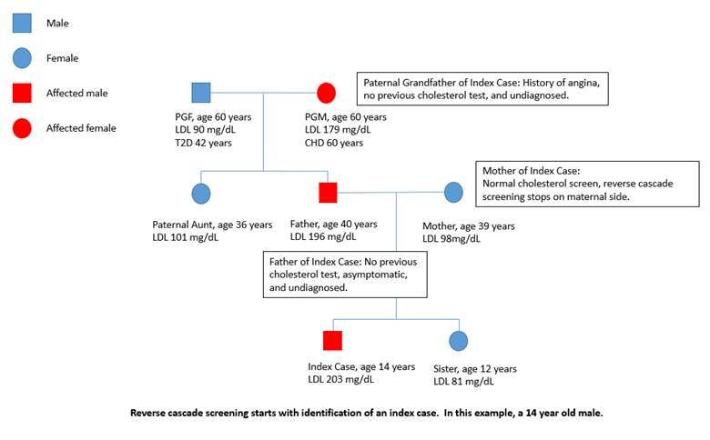
Figure 1. Sample pedigree from reverse cascade screening of proband. From Journal of Pediatric Nursing, 2019, with permission.

COMMON GENETIC TERMINOLOGY

Proper ordering and interpretation of a genetic test requires an understanding of commonly terms used. The following list of and diagram will help clinicians develop an understanding of some of the basic concepts of and visual image involved in genetic testing.

Coverage: Number of genes sequenced.
Depth: Number of times each nucleotide within a gene is sequenced.
Exome: Part of the genome that consists of exons. The exome accounts for roughly 1% of the genome.
Exon: A segment of a gene that encodes a protein.
Genome: A complete set of genetic information that provides all the necessary information required for a human to function.
Intron: A noncoding region of DNA, or a segment of DNA that does not encode a protein.
Single Nucleotide Polymorphism (SNP): A common (present in >1% of population), typically low effect variant, occurring at a single nucleotide in the genome.
Splicing: A process by which introns are removed from a transcript to produce mature RNA, made up of exons.
Variant: An alteration in the DNA nucleotide sequence. Variants can be benign, pathogenic, or of unknown significance.



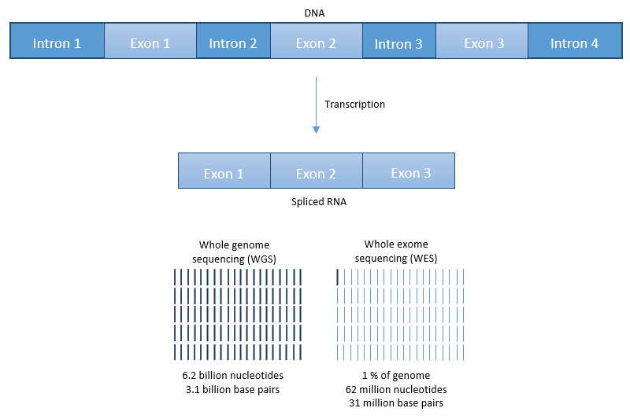
Figure 2. Visual depiction of a gene, nucleotide, introns and exons, splicing, and genome and exome sequencing.

AVAILABLE GENETIC TESTING

Targeted Panel

When considering conditions with known causal genetic loci, such as FH, targeted panels are often considered as a primary testing method. Four genes – LDLR, APOB, PCSK9, and LDLRAP1 – are principally considered when identifying pathogenic variants causing FH. While coverage is low (i.e., 4 genes), depth – depending on the performing laboratory – is high, often 100X or more, up to 1,000X.

Targeted panels are most accurate when used to identify variants in exons and smaller deletions or duplications. Using a combination of next generation sequencing technologies, Sanger sequencing, and deletion/duplication analysis, genetic variation often identified with >99% sensitivity and specificity. Introns are typically not sequenced beyond +/- 10 to 15 exon flanking base pairs.

Whole Exome Sequencing (WES)

As NGS technologies continue to evolve and cost declines, sequencing DNA of higher volume has become more feasible. WES allows for sequencing of all protein coding regions of a person’s genome—also known as the exome—along with flanking intronic regions. WES is often performed when the differential diagnosis is unclear or broad, or after a targeted genetic testing returns negative.

In the case of FH, WES can be helpful when no known variant is found in a traditional targeted panel. Several other conditions affecting lipid metabolism with known genetic variants – in APOE, ABCG5, ABCG8, LIPA, etc. – can produce a “FH phenotype,” in which conditions associated with variants in these genes create an overlap in elevated LDL-C levels with those seen in pathogenic FH variant carriers. Coverage in WES is high (i.e., 95 to >99% of the exome), while depth is often 20X up to 100X.

Secondary Findings

It is important to note that targeted panels inclusive of candidate genes and WES have the potential for identifying unintentional or secondary findings. For example, certain variants in APOE are associated with a FH phenotype; however, other APOE variants are associated with a predisposition for Alzheimer’s disease. When WES is performed, secondary findings for variants in gene sites unrelated to the condition under suspicion can occur. For example, WES ordered for suspicion of FH could identify variants in BRCA1/2 associated with a predisposition to develop breast or ovarian cancer, which carry implications for other potentially affected family members. When secondary findings are identified, it is helpful to refer the family to either to a geneticist or other qualified specialist. However, secondary findings can be excluded, directed by the preferences of family and provider. Concerns about secondary findings in WES and targeted panels can be alleviated by masking extraneous results.

Should Family Members Be Tested?

Low or no cost genetic testing is sometimes offered to family members to both identify additional at-risk family members and help inform genotype/phenotype correlations for more accurate classification of gene variants.

INTERPRETING TEST RESULTS

How Are Genetic Variants Classified?

Understanding the classification of an individual’s genetic variant can be a daunting task. No standardization of classification is uniformly adhered to, with each genomics laboratory offering their own definition or algorithm for classification. This ultimately results in the potential for one laboratory to define a variant as benign, while another may define the same variant as pathogenic. To further complicate matters, classification for each variant is subject to change as new and additional data about the variant is considered (12).

Interpretation of a pathogenic classification is the most straightforward. In the case of FH, the observed variant is considered to be the cause of the phenotype based on sufficient evidence of 1) the variant type, and 2) other individuals previously identified with the same variant.

Interpretation becomes more complicated in those with a variant of unknown significance (VUS) and for individuals in whom no mutation is identified. When faced with a VUS, it is important to consider how important additional data is in determining a causal link between a VUS and the clinical condition. Fortunately, many, but not all, genetic testing laboratories offer first degree relatives testing at low or no cost. Familial testing provides additional data to assist in more accurate classification of the finding in question, and guides health care decision-making.

In the case of a negative result, it is important to understand any limitations that exist with the test that was ordered. If a targeted panel for FH is performed and no mutation is found, 1) the test ordered may not cover all known variant sites; 2) additional potential variants exist; and 3) additional testing (WES) may be helpful.

COMMUNICATING TEST RESULTS

What Is The Role Of A Genetic Counselor?

Given the complex nature of genetic testing as a diagnostic tool, genetic testing plays a crucial role in youth and family members understanding of the risks and benefits of testing (13). However, genetic counseling is highly underutilized in current clinical practice (5). Counseling is a process that should begin prior to testing, and should continue after as a conversation with both the child, when appropriate, and their family.

Prior to testing, the child and family should be informed of: the suspected condition and how genetics may play a role, the possible benefits and risks of performing testing, and the potential of discovering uncertain or secondary findings.

After completion, test results and interpretation of their impact on both direct patient care and family members should be discussed. If necessary, counseling for family planning and any further testing should be provided.

What Is The Potential Impact Of Genetic Testing Upon The Child? The Family?

Proper communication of genetic test results and counseling provide the child and family information of high utility, usually with minimal adverse impact (14). In 2017, Hallowell et al. found during interviews of patients treated for FH who were the first to be genetically tested in their family, testing was considered beneficial, as it provided patients with an origin of their disease and assessed their own and their family members’ risk (15). The majority of parents of children with FH want their children to be tested (16) and children have been found to understand and articulate their understanding of testing being conducted (17). A majority of families do not report psychological problems due to a diagnosis of FH (18).

WHAT’S NEXT?

Progression of genetic testing has resulted in slowly changing the paradigm of clinical practice. Having most recently experienced the evolution of evidence-based medicine, we are entering an era of personalized medicine, and eventually, predictive medicine. In the coming years, existing methods and results will become better understood, and additional testing will likely become more affordable, accurate, and widely used, leading to a potential shift in the clinical focus from phenotype to genotype.

Genomic Medicine

The current focus of genetic testing involves sequencing of exomes, accounting for only 1% of the genome. In contrast, whole genome sequencing (WGS) offers sequencing of both exons – protein encoding regions – and introns, containing regulatory information which controls exon splicing, transcription, and translation. Deep intronic variants are currently associated with over 75 genetic conditions (19).

RNA testing also offers similar benefits to WGS without having to analyze such a large volume of data. RNA testing potentially identifies any errors, including intronic variants, leading to incorrect splicing or transcript sequence. In the realm of lipidology, those with FH caused by a variant affecting apolipoprotein B (apoB) may have the most to benefit from RNA testing. ApoB circulates in 2 forms: apoB48, produced by the small intestine, and apoB100, produced by the liver, the latter involved in LDL assembly and uptake of LDL-C by the LDL receptor. Both forms are encoded by a single APOB gene, which undergoes a RNA editing process, producing both forms (20). In the future, investigating transcription and translation of APOB may prove useful in determining etiology of disease in patients with a currently unidentified variant.

Predictive Medicine

A significant portion of the general population, including those with a monogenic cause of FH, contain variants in genes associated with elevated cholesterol and CVD risk other than LDLR, APOB, PCSK9, and LDLRAP1. These SNPs in “low effect genes,” or genetic locations that do not greatly affect the phenotype, when cumulatively expressed, alter both cholesterol and CVD risk. LDL and CAD polygenic risk scores have proven to be accurate and appear to be nearing their time in clinical care (21-25).

Screening and Preventive Medicine

Considering the future of current methodologies, genetic testing of youth and their parents has proven feasible and effective in the UK, and universal phenotypic screening of young children in the US is currently recommended (2, 26). The first successfully implemented universal pediatric FH screening initiative occurred in Slovenia in 1995, within which a two-step approach was utilized – conducting universal biochemical cholesterol testing at 5 years of age, followed by genetic testing for those with elevated total cholesterol (7). FH also has potential to be a target for prenatal testing (27). Bellow et al. combined UK Biobank whole exome data with NHANES survey data, creating a predictive model which would yield 3.7, 3.8, and 6.6 identified FH cases per 1,000 people through clinical criteria alone, genetic testing alone, and combining clinical criteria and genetic testing, respectively (28). By combining established universal phenotypic childhood screening²⁹ with reflex genetic and parental testing, the potential exists to identify every existing case of FH within one generation of testing. From then on, targeted testing of affected patient’s children would identify future cases.

SPECIAL CONSIDERATIONS FOR YOUTH

While benefits exist that are unique to a pediatric population, additional unique circumstances should be also be considered when testing a child for a condition in which the onset occurs during adulthood.

Should Children Be Given A Choice?

The American Academy of Pediatrics (AAP) advocates for youth to have an increasingly important role in their own health care decision-making as they age and mature. From a legal perspective, virtually no legal rights exist, nor are protections in place, to ensure a child possesses any autonomy in the decision-making process of their health care (30). The decision whether to include the child in the decision-making process is ultimately left to the child’s parents and health care provider.

Should Testing Be Deferred Until A Child Is 18 Years-Of-Age Or Older?

In 2013, the AAP and American College of Medical Genetics (ACMG) released a joint policy statement on the use of genetic testing and screening of children (31), agreeing that the principal factor in determining whether to offer genetic testing should be the best interest of the child. When considering FH, clear benefit exists in testing of children, as atherosclerosis can be reduced or prevented with early identification and treatment, ultimately reducing CVD risk.

Do The Results Of Genetic Testing Create The Potential For Discrimination?

Once a child has undergone testing, results are entered into the clinical record. The 2008 Genetic Information Nondiscrimination Act (GINA) protects individuals from discrimination in health insurance and employment based on genetic information; however, individuals are not protected against discrimination in life or disability insurance.

All of this must be weighed and discussed in the benefit-to-risk analysis when ordering a genetic testing involving a child. Whenever possible, the child should be provided age and developmentally appropriate information, allowed to participate in the discussion, encouraged to ask questions and share concerns, and help formulate the best course of action.

SUMMARY

Genetic testing offers 1) diagnostic confirmation; 2) enhanced risk assessment; 3) an ability to identify affected family members; and 4) the opportunity to individualized treatment options. Lipidologists are encouraged to use this emerging technology judiciously, mindful of the unique needs of youth. In the near future, genetic testing will likely be used on a wide scale to screen children and family members at-risk of CVD with the goal of prevention. Given its current trajectory, genetic testing is becoming increasingly critical in our ability to provide accurate risk assessment as well as age appropriate and timely intervention to help guide our efforts in educating and managing youth with disorders of lipid and lipoprotein metabolism.

RESOURCES

Select Laboratories Offering Genetic Testing For Dyslipidemias

Ambry Genetics: https://www.ambrygen.com/
Blueprint Genetics: https://blueprintgenetics.com/
GeneDx: https://www.genedx.com/
Invitae: https://www.invitae.com/en/

The Genetic Information Nondiscrimination Act (GINA) of 2008

https://www.eeoc.gov/laws/statutes/gina.cfm

ACKNOWLEDGEMENTS

The authors would like to acknowledge Ryan Lokkesmoe, MD, and Ariel Brautbar, MD, for their contributions in editing this manuscript.

REFERENCES

- W Burke. “Genetic testing.” New England Journal of Medicine, 2002.
- D Wald et al. “Child-parent familial hypercholesterolemia screening in primary care.” New England Journal of Medicine, 2016.
- A Sturm et al. “Clinical genetic testing for familial hypercholesterolemia.” Journal of the American College of Cardiology, 2018.
- A Khera et al. “Diagnostic yield and clinical utility of sequencing familial hypercholesterolemia genes in patients with severe hypercholesterolemia.” Journal of the American College of Cardiology, 2016.
- GF Watts et al. “International Atherosclerosis Society guidance for implementing best practice in the care of familial hypercholesterolemia.” Nature Reviews Cardiology, 2023.
- DM Kusters et al. “Carotid intima-media thickness in children with familial hypercholesterolemia.” Circulation Research, 2014.
- AM Medeiros et al. “Genetic testing in familial hypercholesterolemia: Is it for everyone?” Current Atherosclerosis Reports, 2024.
- DP Wilson et al. “Screening for genetic variants in children and adolescents with dyslipidemia: importance of early identification and implications of missed diagnoses.” Expert Opinions on Orphan Drugs, 2016.
- M Braamskamp et al. “Statin initiation during childhood in patients with familial hypercholesterolemia: consequences for cardiovascular risk.” Journal of the American College of Cardiology, 2016.
- A Wiegman et al. “Familial hypercholesterolemia in children and adolescents: gaining decades of life by optimizing detection and treatment.” European Heart Journal, 2015.
- A Vinson et al. “Reverse cascade screening for familial hypercholesterolemia.” Journal of Pediatric Nursing, 2018.
- S Aronson et al. “Communicating new knowledge on previously reported genetic variants.” Genetics in Medicine, 2012.
- A Brautbar et al. “Genetics of familial hypercholesterolemia.” Current Atherosclerosis Reports, 2015.
- N Jenkins et al. “How do index patients participating in genetic screening programmes for familial hypercholesterolemia (FH) interpret their DNA results? A UK-based qualitative interview study.” Patient Education and Counseling, 2013.
- N Hallowell et al. “A qualitative study of patients’ perceptions of the value of molecular diagnosis for familial hypercholesterolemia (FH).” Journal of Community Genetics, 2017.
- M Umans-Eckenhausen et al. “Parental attituate towards genetic testing for familial hypercholesterolemia in children.” Journal of Medical Genetics, 2002.
- E Smets et al. “Health-related quality of life of children with a positive carrier status for inherited cardiovascular diseases.” American Journal of Medical Genetics, Part A, 2008.
- S Tonstead. “Familial hypercholesterolaemia: a pilot study of parents’ and children’s concerns.” Acta Paediatrica, 1996.
- R Vaz-Drago et al. “Deep intronic variants and human disease.” Human Genetics, 2017.
- N Davidson et al. “Apolipoprotein B: mRNA editing, lipoprotein assembly, and presecretory degredation.” Annual Review of Nutrition, 2000.
- J Dron et al. “The evolution of genetic-based risk scores for lipids and cardiovascular disease.” Current Opinions in Lipidology, 2019.
- P Talmud et al. “Use of low-density lipoprotein cholesterol gene score to distinguish patients with polygenic and monogenic familial hypercholesterolaemia: a case-control study.” The Lancet, 2013.
- M Paquette et al. “Polygenic risk score predicts prevalence of cardiovascular disease in patients with familial hypercholesterolemia.” Journal of Clinical Lipidology, 2017.
- A Rao et al. “Polygenic risk scores in coronary artery disease.” Current Opinions in Caridiology, 2019.
- A Sarraju et al. “Genetic testing and risk scores: impact on familial hypercholesterolemia.” Frontiers in Cardiovascular Medicine, 2019.
- BK Bellows et al. “Estimated yield of screening for heterozygous familial hypercholesterolemia with and without genetic testing in US adults.” Journal of the American Heart Association, 2022.
- L Hamilton et al. “Implementation of cholesterol screening at 2 years of age.” Journal of Clinical Lipidology, 2019.
- J Vergotine et al. “Prenatal diagnosis of familial hypercholesterolemia: importance of DNA analysis in the high-risk South African population.” Genetic Counseling, 2001.
- “Expert panel on integrated guidelines for cardiovascular health and risk reduction in children and adolescents.” NHLBI, 2011.
- E Clayton. “How much control do children and adolescents have over genomic testing, parental access to their results, and parental communication of those results to others?” Journal of Law, Medicine & Ethics, 2016.
- “Ethical and policy issues in genetic testing and screening of children.” Pediatrics, 2013.

