GH AND IGF-1 PHYSIOLOGY IN CHILDHOOD

Dr Kavitha Rozario^{1,} Catrin Lloyd^{2,} Dr Fiona J Ryan¹

¹ Oxford University Hospitals NHS Foundation Trust, Oxford. ² Merton College, University of Oxford.
Email: Fiona.Ryan@ouh.nhs.uk

Published 20 November 2015

ABSTRACT
Growth hormone is a peptide hormone released from the anterior pituitary somatotroph cells, and acts to promote growth, cell division and regeneration.
Its actions are mediated directly through the GH receptor, as well as indirectly via IGF-1. The secretion of GH is pulsatile and under a variety of hormonal influences, such as stimulatory hypothalamic GHRH, ghrelin and sex steroids, and inhibitory somatostatin, IGF-1 and glucocorticoids.
GH stimulates production of IGF1, which binds to its receptors resulting in increased cell size by increasing protein synthesis. The liver is the major organ for IGF 1 synthesis. GH is the main regulator for IGF1 levels in plasma. Nutritional status and thyroid hormone also affect IGF1 levels.
GH is widely used to treat a number of conditions. In children with GH insensitivity and GH receptor mutations IGF1 injections can be effective. Both are now approved for clinical use.

INTRODUCTION

Childhood growth is a vital physiological process and is tightly regulated. Growth velocity is maximum in fetal life and infancy with a second phase of accelerated growth during puberty. Linear growth stops once the epiphyses are fused.

Growth potential is determined by a number of interrelated factors including nutrition, hormones, such as growth hormone (GH), thyroxine and insulin, physical and psychological environment, medication and the interaction of any intercurrent or chronic illness.

In this chapter we will concentrate on the physiology of GH, looking at the role in determining somatic growth and regulating body composition, intermediary muscle and bone metabolism, as well as acting to promote cell division and regeneration.

GH production begins in early fetal life. It is produced by the Somatotroph cells in the anterior pituitary and is secreted in a pulsatile fashion. The levels of GH vary during childhood and peak during pubertal growth. GH pulse frequency and magnitude is influenced by a number of factors including age, gender, sleep, nutrition, pubertal status and exercise.

GH acts both directly through the growth hormone receptor, via the activation of tyrosine kinases, and via IGF1 to increase linear growth in children. The epiphyseal plates of long bones are the primary sites of action of GH and IGF1. In addition, GH has metabolic actions including protein synthesis, lipolysis and lipid oxidation, water, phosphate and sodium retention and acts as an insulin antagonist.

GENETICS
The pituitary GH gene (GH-N) is located on chromosome 17q22 [1], along with four other genes that make up the human GH gene family. It is made up of 5 exons and 4 introns. 90% of circulating GH molecules are the 22 kDa GH molecule, whilst the remaining 10% are 20 kDa molecules, lacking amino acids 32 to 46. The two alternatively spliced mRNA products are both biologically active and arise from the GH-N gene.

The structure of the hormone itself is that of a single polypeptide chain of 191 amino acids with 2 disulphide bridges between amino acids 53-165 and 282-189. GH, prolactin and hCG share similar structure [2]. The other four members of the GH gene family code for prolactin, placental GH, lactogen and placental prolactin-related proteins.
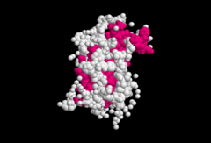

Figure 1: structure of GH (Wikipedia)

The regulation of the pituitary GH-N gene is complex, with hormonal, developmental and tissue-specific control [3]. The Pit1 transcription factor is a member of the POU family of transcription factors and is also called POU1F1. The Pit-1 transcription factor appears to be largely responsible for determining the tissue-specific development of somatotrophs and the expression of GH. [4].

Inherited isolated GH deficiency syndromes can, rarely, be associated with dominant-negative mutations in the GH gene [5]. The Prop-1 and POU1F1 (Pit-1) genes are necessary for the differentiation of the precursors to somatotroph, lactotroph, thyrotroph and gonadotroph cells. Mutations in these genes are responsible for rare cases of GH deficiency, usually accompanied by other pituitary hormone deficiencies [5-9].

GROWTH HORMONE IN FETAL LIFE

Following studies in anencephalic fetuses, it was thought that human fetal growth and development did not involve GH [12]. It is now suggested, by the fact that the expression of GHR has been shown in human fetuses of 14-16 weeks gestation [13], and in the growth plate chondrocytes of 15-20 week human fetuses [14], that this is not the case [13-16]. However, studies in GH knockout mice have shown that 80% of fetal size may receive no contribution from GH [17].

Fetal GH is produced by the pituitary gland from the end of the first trimester [19]. In the placenta, syncytiotrophoblast cells express the human GH variant (hGH-V) gene, producing a GH variant. This hGH-V protein has been shown to be equipotent with pituitary GH (hGH-N) as a ligand for the GHR [64]. HGH-V and hGH-N are both 22K, 191-amino acid, single-chain proteins but differ by 13 amino acids [65].

Maternal GH secretion declines during pregnancy, replaced by increasing levels of placental derived GH. Maternal placental growth hormone levels are increased in mothers of fetuses identified by ultrasound as having higher than average first-trimester growth rates [20]. Studies in pigs have shown that fetal growth is increased by maternal GH treatment, partly through enhancement of placental nutrient protein transporter expression, along with trophoblast proliferation and differentiation, and thus may be useful in treating intrauterine growth restriction [18].

It is thought that placental GH may influence fetal growth via IGF-1, as strong correlations of maternal serum concentrations of placentally derived growth hormoneand IGF-1 have been shown throughout gestation [21]. A prospective longitudinal study of normal pregnant women showed that placental GH levels rise from 5 weeks gestation to a peak at around 37 weeks, from which time they decreased until birth. Between 24.5 and 37.5 weeks gestation, fetal growth, weight, birth weight and IGF-1 levels were associated with the change in PGH levels [22].

SECRETION OF GH
GH is secreted in a pulsatile fashion and has a very short half-life of 14 minutes. In between pulses, the serum GH level is minimal to undetectable. Pulses occur up to 10 times a day, lasting 90 minutes and separated by 128 minutes [44]. A reduction in the tonic inhibition of GH by somatostatin is thought to lead to the pulsatile bursts of GH [24, 42].

GH release may be accurately assessed using 24-hour sampling. It has been found that GH secretion is lower in the elderly and obese, higher during puberty (without changes in pulse frequency) and neonates after correction for the increased body surface area in neonates [45, 46].

The peak daily GH secretion also varies with age and stage of growth and development. During puberty, the peak in daily GH secretory rate is around 150 mcg/kg. The augmentation of GH secretion that occurs during puberty has been attributed to changes in sex steroid levels that enhance the frequency and amplitude of GH pulses [53]. This decreases to around 25 mcg/kg by age 55 years, paralleling the age-related decline in body mass index [25]. The production of GH therefore falls by around 50% every seven years

GH secretion reaches its peak within an hour of deep sleep onset. It is also increased by physical activity, trauma and sepsis [47]. Women have higher integrated 24-hour GH secretion; this increases in postmenopausal women during oestrogen replacement [48]. Furthermore, glucose loading suppresses serum GH concentrations to <0.7 ng/mL in women compared to <0.07 ng/mL in men, although this is likely to reflect the lower basal concentrations in men. GH is more pulsatile in men than women, in whom secretion is more continuous; this is hypothesized to determine linear growth patterns, liver enzyme induction, and GH-signaling molecule (STAT 5b) activity [49, 50].

REGULATION OF GH SECRETION

The regulation of GH secretion is via hypothalamic and peripheral factors which act on somatotrophs [23]. GH secretion is stimulated by growth hormone-releasing hormone (GHRH) and inhibited by somatostatin (SRIH), both released from the hypothalamus [3, 24]. There are specific cell-surface receptors on the somatotroph cells to which these hormones bind. Figure 2 below summarises the hormonal regulation of GH secretion.

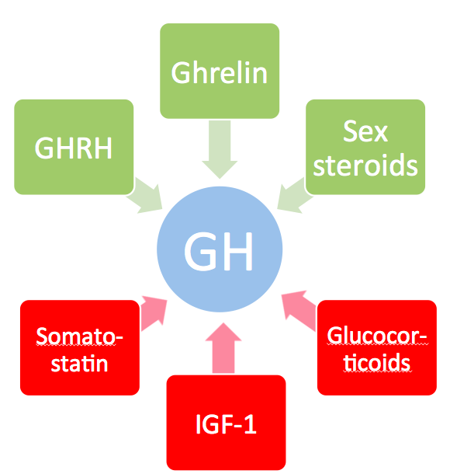

Stimulator of GH release | Inhibitor of GH release
GHRH | Somatostatin
Ghrelin | IGF-1
Sex steroids | Glucocorticoids

Figure 2: Hormonal regulation of GH secretion, with stimulators of GH secretion shown in green and inhibitors shown in red.

Stimulators of GH Secretion

GHRH:
The most well-known regulator of GH is GHRH. GHRH stimulates GH transcription and secretion, as well as somatotroph proliferation [26]. The GHRH receptor is a 7 transmembrane domain G-protein receptor (Gs) that stimulates cAMP production upon ligand-induced activation [27]. This increases GH gene transcription as well as GH release (28-30). Functional GHRH receptors have been identified in the fetal pituitary gland [66]. Molecular defects in the extracellular domain of the GHRH receptor are associated with GH deficiency and severe growth retardation [67. 68].

Ghrelin:
This is a gastrointestinal peptide hormone and acts as a specific nutritional positive regulator of GH secretion [31]. It was observed that morphine stimulates GH secretion, followed by isolation of the enkephalins and development of encephalin analogs that selectively stimulate secretion of GH. These are known as GH-secretagogues [GHS], It was subsequently found that Ghrelin, secreted by the stomach, stimulates GH secretion(36). Its receptor, the GH secretagogue receptor, is expressed on the anterior pituitary [32]. Ghrelin is synthesized in the stomach and regulates GH release in a dose-dependent manner. Levels of ghrelin in obese children are reduced compared to those in healthy lean children and healthy lean adults; the levels are independent of gender and pubertal status [34].

Sex steroids:
Studies have shown that when boys with hypopituitarism are given testosterone but not GH, they have a prolonged pubertal growth period [35]. This suggests that GH is needed to control the tempo and progression of puberty. There is a close relationship between rising serum androgen concentrations and increased GH peak amplitude in healthy pubertal boys [36]. The GH concentration also rises throughout puberty in females, in whom the increase is proportional to the increase in serum oestradiol concentration [37].

Nutritional factors:
Nutritional factors also influence GH secretion. Secretion is increased in malnourished or fasting individuals [25] and following high protein meals and intravenously administered amino acids [38]. Insulin-induced hypoglycemia is also a powerful stimulus to GH release. It is proposed that there is somatostatin withdrawal during hypoglycemia. Conversely, secretion is inhibited by hyperglycamia and leptin [39].

Others:
Additionally, GH secretion is stimulated by oestrogen, dopamine, apomorphine (a dopamine receptor agonist), alpha-adrenergic agonists and beta-adrenergic antagonists (which also increase responses to GHRH and insulin-induced GH hypoglycaemia).

Inhibitors Of Gh Secretion

Somatostatin:
Somatostatin’s existence was inferred in 1968 following experiments in which hypothalamic extracts were able to inhibit GH secretion [69]; it was isolated in 1973 [70]. It acts to inhibit GH release (but not synthesis). Somatostatin is released from the hypothalamus and binds to five distinct receptor subtypes (SSTR1-5) which are regulated in a tissue specific manner. These receptors inhibit adenyl cyclase via Gi, decreasing the net Ca influx [38]. All receptor types but SSTR-4 are expressed by somatotrophs, although pituitary GH is preferentially suppressed via SSTR2 and 5 [40, 41].

Insulin-like growth factor-1: I
nsulin-like growth factor-1 (discussed below) mediates most of GH’s peripheral actions, and acts to inhibit GH secretion.

Glucocorticoids:
GH secretion is inhibited by glucocorticoid excess [42]. In children exposed to excess cortisol secretion, GH secretion has been shown to decrease [25]. However, it has been shown that acute glucocorticoid administration in normal subjects leads to a transient increase in plasma GH [43].

GH RECEPTOR (GHR)

The GH receptor is a 70kd protein found in the cytokine/haematopoietin superfamily of receptors [1], and is mainly found in the liver. It is formed of an extracellular ligand-binding domain, a single membrane-spanning domain, and a cytoplasmic component [10], and was first cloned in 1987 [6]. A soluble GH binding protein identical to the extracellular domain of the full-length receptors has also been found using plasma aand radioactive hGH [71].

Activation of the GHR induces intercellular signaling via the JAK/STAT pathway, predominantly acting to stimulate the hepatic synthesis and secretion of insulin-like growth factor-1 [1]. Fluorescence resonance energy transfer studies suggest that the distance between box 1 motifs (see figure 3) increases between active and inactive states, which is thought to be important for the activation of JAK2 [51]. STAT proteins are cytoplasmic proteins which are phosphorylated by JAK2 and translocated to the nucleus where they bind to DNA and elicit GH specific target gene effects [1]. It has been found that STAT proteins 1 and 5 may also interact more directly with the GH receptor molecule [11]. Figure 3 shows how GH activates the GH receptor by binding to the extracellular domain, causing structural reorientation, transmission of which through the transmembrane domain causes the tyrosine kinases, which are bound to the cytoplasmic domain, to reposition.

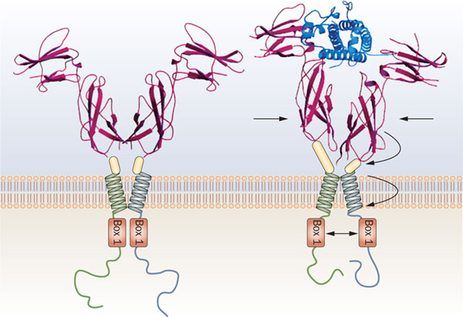

Figure 3: Activation of the GH receptor by GH [52].

INSULIN LIKE GROWTH FACTOR – 1 (IGF1)

Insulin-like growth factor 1 (IGF1) is secreted in response to activation of the GHR by GH. Evidence for the role of IGF1 in growth comes from the observation that longitudinal bone growth in mice is decreased by combined deficiency in acid-labile subunit and liver-specific IGF1 deficiency [76]. It is thought that GH may also have IGF1-independent effect on bone growth, since mice lacking both GHR and IGF1 have shorter bones than those lacking IGF1 alone [77]. Synthesis of IGF-1 mainly occurs in the liver, but some IGF1 synthesis also occurs in peripheral tissues like bone, cartilage and some solid organs.

Insulin like growth factors (IGFs) are proteins that share similarities to insulin. IGFs were previously known as Somatomedins. IGF2 is believed to be the major fetal growth factor while IGF1 is responsible for post natal growth. We will be concentrating on IGF1 here.

SYNTHESIS AND STRUCTURE OF IGF1

Various mesenchymal cells mainly in the liver secrete IGF1. Gene targeting studies have shown that the liver accounts for around 75% of circulating IGF1 (54). The synthesis and secretion from the liver is GH dependent and is important for balanced growth of tissues and organs. Autocrine or paracrine IGF1 secretion in peripheral tissues are responsible for unbalanced growth (e.g. in wound healing or growth of contralateral kidney in following nephrectomy.)

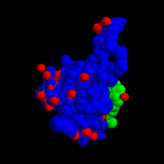 Figure 4: 3-D model of IGF1 (Wikipedia)

Figure 5: Three dimensional structure of IGF1 from Protein Data Bank (Wikipedia)
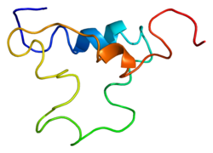

IGF1 IN PLASMA

At birth, plasma IGF1 levels are around 20 to 60 ng/ml. Studies have shown a seven fold rise in levels between birth and the peak at puberty [56].

By age 20, levels are around half of peak pubertal levels. By age 60, they are a quarter of peak pubertal levels [57]. This decrease of IGF1 levels is attributed to decrease in GH secretion with increasing age. Genetic factors are also thought to play a role in each individual’s IGF1 levels and are linked to final adult height.

Some IGF1 is also synthesized in peripheral tissues [59], local factors also contribute to this synthesis. Erythropoietin increases IGF1 synthesis in the erythroid cells. Similarly it is found that FSH increases IGF1 levels in the follicular fluid in the ovarian follicles. When there is injury to cells, IGF1 levels locally increase resulting in DNA synthesis and cell repair [60].

GH stimulates IGF1 secretion as well as increasing concentrations of IGFBinding Protein 3 and ALS levels. The ternary complex formed by the 3 proteins is a stable complex that mediates the actions of GH. Any factor that inhibits the increase in one of them will decrease the level of serum IGF 1.

Caloric intake can have an effect on IGF1 levels. Fasting for a week can halve plasma IGF1 levels. Hence lower levels of IGF1 are seen in malnutrition, anorexia, hepatic failure and renal failure. This decrease is thought to be due to decrease GH sensitivity and decrease in GH receptors in these protein deficient states.

Studies of IGF1 infusion in calorie-restricted individuals have shown that nitrogen balance returns to normal. This restoration is enhanced when both GH and IGF1 are injected. [61]

When IGF1 was given to individuals with type 2 diabetes, an improvement in insulin sensitivity was demonstrated. [62]. IGF1 is not yet licenced for treatment of type 2 diabetes although there are reports of use in insulin resistance syndromes.

IGF BINDING PROTEINS

IGF1 secreted by the liver is transported via the blood stream bound to proteins called IGF binding proteins (IGFBPs). 99% of IGF1 is in the bound form. There are six different IGFBPs, named IGFBP 1 – 6. Their main role is to transport IGF1.

IGFBP3 is the most abundant of all the IGFBPs. It has a very high affinity for IGF1 with 75% of bound IGF1 being bound to IGFBP3. Some of the IGFBP3 binds to a plasma protein called acid labile subunit (ALS). This ternary complex of IGF1, IGFBP3 and ALS is more stable in plasma and hence serves to increase the half-life of IGF1 to 16 hours.

IGFBP2 is the second most abundant IGFBP in the plasma. Although it’s affinity for IGF1 is high, this is lower than IGFBP3. IGFBP2 has a lower half life than IFGBP3 (90 minutes), which makes it important in regulating the amount of free IGF1 levels in plasma. IGFBP2 can cross capillary walls, hence acting as a carrier for IGF1 to exit the vascular space.

Levels of IGFBP1 fluctuate widely though the day. IGFBP1 levels are regulated by insulin. During fasting, the level of IGFBP1 increases and this inhibits insulin secretion. Food intake and insulin administration decreases IGFBP1 levels. As it has a lower affinity for IGF1, this binding protein can also release IGF1 more easily. In animal models, IGFPB 1 administration increased glucose concentrations. It has also been found that the level of IGFPB1 increases progressively in individuals who develop type 2 diabetes and in those with insulin resistance. [55]

IGFBP 4, 5 and 6 are present in much smaller concentration. Their roles are not fully understood.

GH secretion increases the plasma concentrations of IGF1, IGFBP3 and ALS. Thyroxine, Estrogen and Testosterone also increase IGFBP3 levels. In hypothyroidism and low testosterone or estrogen states, IGFBP3 concentrations are low. When these conditions are treated, levels of IGFBPs return to normal.

IGF1 RECEPTOR

IGF1 binds to its receptor, which then triggers a cascade of changes at cellular level, resulting in the final physiological actions of IGF1, which is to increase DNA and protein synthesis and increase cell size.

The binding of IGF1 to its receptor enables the activation of tyrosine kinase which in turn phosphorylates tyrosine. The phosphorylated tyrosine in turn activates various signalling proteins including Shc, Insulin receptor substrate 1 (IRS1) and IRS2. The now activated signalling proteins bind to p85 subunit of the P1-3 kinase. This leads to protein kinase activation resulting in stimulation of protein synthesis and inhibition of apoptosis.

IGF1 plays an important role in enabling cells that have entered the G1 phase of the cell cycle to progress to the next phase, which is the S phase (see Figure 6).

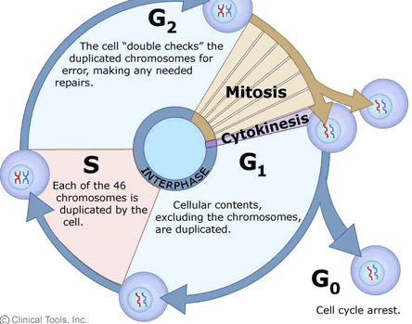

Figure 6: The cell cycle

11. Effects of GH and IGF1 on tissues and Growth plate

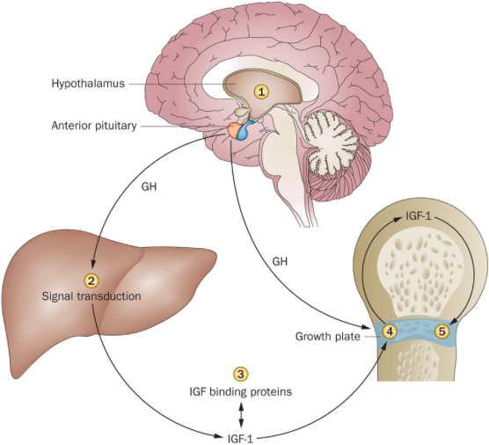
Figure 7: The regulation of growth by GH and IGF1 axis[63]
1-appetite centres in brain affecting calorie intake, 2- signal transduction in hepatocyte, 3 – release of IGF-1 from binding proteins , 4 –IGF-1 expression in growth plate, 5- proliferation of chondrocytes at growth plate

The main action of GH via IGF1 in children is increase in linear growth. The site of action is the epiphyseal plates of long bones, also known as the growth plates.

IGF1 secreted by the liver works alongside locally secreted IGF1 by the chondrocytes at the growth plate. This stimulates chondrocyte cell division resulting in bone growth and increase in linear growth in children.

Excess of growth hormone in the prepubertal children where the epiphyses are not fused results in gigantism with uncontrolled linear growth. Once the epiphyses are fused, the result of excess GH is acromegaly. Similarly, a deficiency of GH or an inability of GH to exert its actions, i.e. GH resistance, results in short stature or in severe cases dwarfism.

GROWTH PLATE

The growth plate is a thin layer of cartilage located between the epiphysis and the metaphysis, and is where the growth of long bones takes place. Such longitudinal bone growth occurs here via endochondral ossification, with formation of cartilage and then remodeling into bone tissue.

It consists of three layers: the stem cell (or reserve) zone, the proliferative zone and the hypertrophic zone. The process includes recruitment of chondrocytes in the stem cell zone to start active proliferation, followed by differentiation, apoptosis and finally mineralization. Amongst other hormones, GH and IGF-1 regulate this. See figure 8 below - Layers of the growth plate.

As previously stated, the effect of GH in stimulating longitudinal growth at the growth plate can be via IGF1. However, its effect may also be independent of IGF1. There is much recent research into the role of suppressor of cytokine signaling 2 (SOCS2) as a key modulator of GH at the growth plate.

SOCS proteins form a negative feedback circuit on cytokine activation, by binding to phosphorylated tyrosines in the cytokine receptor-JAK complex [72]. Experiments in mice have shown the role of SOCS2 in postnatal growth; Socs2 knockout mice demonstrate an overgrowth phenotype [73] whilst Socs2-/- mice showed increased body length, weight and augmented GH/IGF1 signaling. The proliferative and hypertrophic zones in the growth plate were wider [73, 74].

More recently, it is thought that SOCS2 may act to modulate GH signaling at the growth plate. Isolated chondrocytes From Socs2-/- mice show increased phosphorylation of STATs upon incubation with GH [75]; this was not the case in cells overexpressing SOCS2. In fetal metatarsals isolated from Socs2-/- mice, GH was able to stimulate growth; it was unable to do so in those from wild type mice, implying SOCS2 negatively regulates local GH action at the growth plate [75].

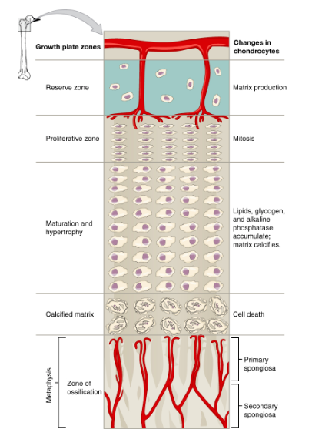

Figure 8: Layers of the Growth plate

CLINICAL ASPECTS OF GH AND IGF1

Faltering growth in children results from a number of potential causes, GH deficiency being one of them.

Growth hormone deficiency may be an isolated deficiency or occur in combination with other pituitary hormone deficiencies. The frequency increases in the presence of any anatomical defects in the pituitary/hypothalamic region (eg septo optic dysplasia, tumours) and those who have had cranial radiotherapy.

Investigations to establish deficiency of GH are widely used worldwide and GH treatment started before fusion of the epiphysis is expected to result in an increase in linear growth. It is recognised that growth hormone deficiency in adults results in poor muscle strength and fatigue and adult GH replacement is now common.

GH resistance and IGF-1 deficiency are now recognised as rare causes of poor growth and extreme short stature in childhood. IGF-1 replacement treatment is licenced for use in children but its use remains limited due to significant potential side effects.

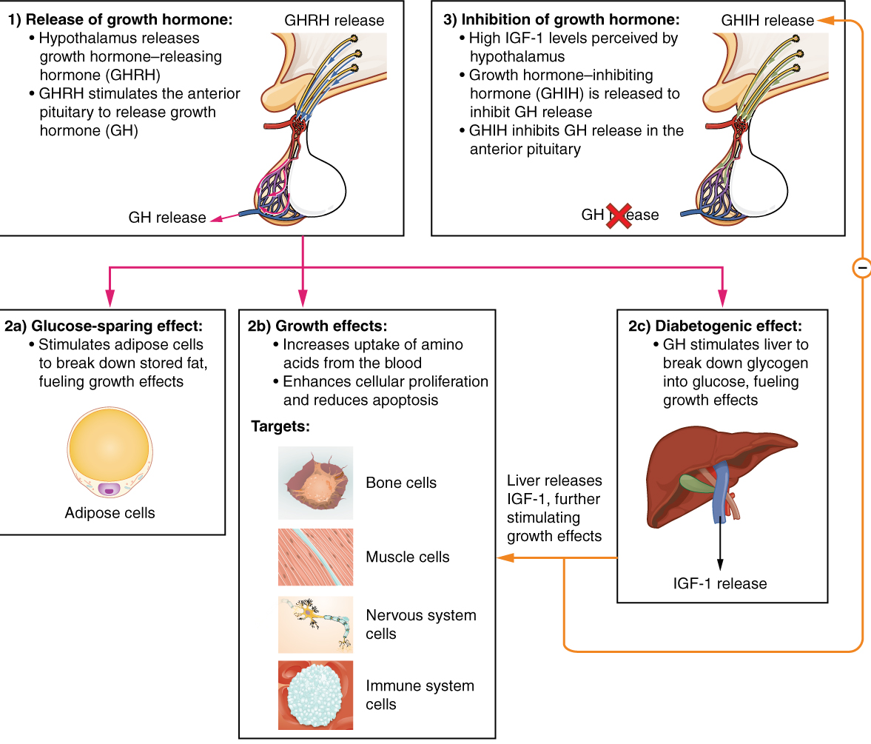

Figure 9: Summary of actions of GH and IGF1

REFERENCES

1. Herrington J, Carter-Su C. Signaling pathways activated by the growth hormone receptor. Trends Endocrinol Metab 2001; 12:252.

2. Baumann G. (1991) Growth hormone heterogeneity: genes, isohormones, variants and binding proteins. Endocrine Rev 12:424-449

3. Ho Y, Liebhaber SA, Cooke NE. Activation of the human GH gene cluster: roles for targeted chromatin modification. Trends Endocrinol Metab 2004; 15:40.

4. Voss JW, Rosenfeld MG. Anterior pituitary development: short tales from dwarf mice. Cell 1992; 70:527.

5. Procter AM, Phillips JA 3rd, Cooper DN. The molecular genetics of growth hormone deficiency. Hum Genet 1998; 103:255.

6. Wu W, Cogan JD, Pfäffle RW, et al. Mutations in PROP1 cause familial combined pituitary hormone deficiency. Nat Genet 1998; 18:147.

7. Pellegrini-Bouiller I, Bélicar P, Barlier A, et al. A new mutation of the gene encoding the transcription factor Pit-1 is responsible for combined pituitary hormone deficiency. J Clin Endocrinol Metab 1996; 81:2790.

8. Mullis PE. Genetics of GHRH, GHRH-receptor, GH and GH-receptor: its impact on pharmacogenetics. Best Pract Res Clin Endocrinol Metab 2011; 25:25.
9. Mullis PE. Genetics of growth hormone deficiency. Endocrinol Metab Clin North Am 2007; 36:17.

10. Barnard R, Waters MJ. The serum growth hormone binding protein: pregnant with possibilities. J Endocrinol 1997; 153:1.

11. Eugster EA, Pescovitz OH. New revelations about the role of STATs in stature. N Engl J Med 2003; 349:1110.
12. Honnebier WJ, Swaab DE. (1973). The influence of anencephaly upon intrauterine growth of the fetus and the placenta, and upon gestational length. J Obstet Gyneco Br Common 80:577-588
13. Hill DJ, Freemark M, Strain AJ et al. (1988) Placental lactogen and growth hormone receptors in human fetal tissues: relationship to fetal plasma hPL concentrations and fetal growth. J Clin Endocrinol Metab 66: 1283-1290.
14. Werther GA, Haynes K, Waters MJ. (1993) GH receptors are expressed on human fetal mesenchymal tissues-identification of mRNA and GH binding protein. J
Clin Endocrinol Metab 76:1638-1646
15. Leung DW, Spencer SA, Cachianes G, Hammondss RG, Collins C, Henzel WJ, Barnard R, Waters MJ, Wood WI. (1987) Growth hormone receptor and serum binding protein: purification, cloning and expression. Nature 330:537.
16. Godowski PJ, Leung DW, Meacham LR, Galgani JP, Hellmiss R, Keret R, Rotwein PS, Parks JS, Laron Z, Wood WI.(1989) Characterization of the human growth hormone receptor gene and demonstration of a partial gene deletion in two patients with Laron-type dwarfism. Proc Natl Acad Sci USA 86:8083-8087.
17. Waters MJ, Kaye PL. (2002). The role of growth hormone in fetal development. GH and IGF Res 12:137-146
18. Increased placental nutrient transporter expression at midgestation after maternal growth hormone treatment in pigs: a placental mechanism for increased fetal growth.
19. Kaplan SL, Grumbach MM, Shepard TH. (1972). The ontogenesis of human fetal hormones. I. Growth hormone and insulin. J Clin Invest 51:3080-3093

20. Maternal serum placental growth hormone, but not human placental lactogen or insulin growth factor-1, is positively associated with fetal growth in the first half of pregnancy.
21. Caufriez A, Frankenne F, Hennen G, Copinschi G. (1993) Regulation of maternal IGF-I by placental GH in normal and abnormal human pregnancies. Am J Physiol. 265:E572–E577.
22. Chellakooty M, Vangsgaard K, Larsen T, Scheike T, Falck-Larsen J, Legarth J, Andersson AM, Main KM, Skakkebaek NE, Juul A. (2004) A longitudinal study of intrauterine growth and the placental growth hormone (GH)-insulin-like growth factor I axis in maternal circulation: association between placental GH and fetal growth. J Clin Endocrinol Metab.89:384–91
23. Leung KC, Ho KK. Measurement of growth hormone, insulin-like growth factor I and their binding proteins: the clinical aspects. Clin Chim Acta 2001; 313:119.

24. Hartman ML, Veldhuis JD, Thorner MO. Normal control of growth hormone secretion. Horm Res 1993; 40:37.

25. Giustina A, Veldhuis JD. Pathophysiology of the neuroregulation of growth hormone secretion in experimental animals and the human. Endocr Rev 1998; 19:717.

26. Frohman LA, Jansson JO. Growth hormone-releasing hormone. Endocr Rev 1986; 7:223.

27.Chanson P, Cailleux-Bounacer A, Kuhn JM, et al. Comparative validation of the growth hormone-releasing hormone and arginine test for the diagnosis of adult growth hormone deficiency using a growth hormone assay conforming to recent international recommendations. J Clin Endocrinol Metab 2010; 95:3684.
28. Mayo KE, Vale W, Rivier J (1983) Expression, cloning and sequencing of a cDNA encoding human growth hormone-releasing factor. Nature 306:86-88
29. Barinaga M, Bilezikjian LM, Vale WW, Rosenfeld MG, Evans RM (1985) Independent effects of growth hormone releasing factor on growth hormone release and gene transcription. Nature 314:279-281
30. Grossman A, Savage MO, Lytras N (1984) response to analogues of growth hormone releasing hormone in normal subjects and in growth hormone deficient children and young adults. Clin Endocrinol (Oxf) 21:321-331
31. Kojima M, Hosoda H, Date Y, et al. Ghrelin is a growth-hormone-releasing acylated peptide from stomach. Nature 1999; 402:656.

32. Pong SS, Chaung LY, Dean DC, et al. Identification of a new G-protein-linked receptor for growth hormone secretagogues. Mol Endocrinol 1996; 10:57.

33. Zhao TJ, Liang G, Li RL, et al. Ghrelin O-acyltransferase (GOAT) is essential for growth hormone-mediated survival of calorie-restricted mice. Proc Natl Acad Sci U S A 2010; 107:7467.

34. Bellone S, Rapa A, Vivenza D, Castellino N et al. (2002) Circulating ghrelin levels as a function of gender, pubertal status and adiposity in childhood. J Clin Endocrinol Investigation 25:RC13-15.
35. Kerrigan JR, Rogol AD. (1992). The impact of gonadal steroid hormone action on growth hormone secretion during childhood and adolescence. Endocr Rev 13:281-298
36. Vandeer Werff ten Bosch JJ, Bot A (1990) Growth of males with idiopathic hypopituitarism without growth hormone treatment. Clin Endocrinol (Oxf) 32:707-717
37. Wennink JM, Delemarre-van der Waal HA, Schoemaker R, Blauw G, van den Brakern C, Shoemaker J. (1991) Growth hormone secretion patterns in relation to LH and estradiol administration throughout normal female puberty. Acta Endocrinol (Copenh) 124:129-135
38. Jaffe CA, DeMott-Friberg R, Barkan AL. Endogenous growth hormone (GH)-releasing hormone is required for GH responses to pharmacological stimuli. J Clin Invest 1996; 97:934.

39. Unger RH. The hyperleptinemia of obesity-regulator of caloric surpluses. Cell 2004; 117:145.

40. Shimon I, Taylor JE, Dong JZ, et al. Somatostatin receptor subtype specificity in human fetal pituitary cultures. Differential role of SSTR2 and SSTR5 for growth hormone, thyroid-stimulating hormone, and prolactin regulation. J Clin Invest 1997; 99:789.

41. Ben-Shlomo A, Melmed S. Pituitary somatostatin receptor signaling. Trends Endocrinol Metab 2010; 21:123.

42. Van Cauter E, Leproult R, Plat L. Age-related changes in slow wave sleep and REM sleep and relationship with growth hormone and cortisol levels in healthy men. JAMA 2000; 284:861.

43. Magiakow M, Mastorakos G, Gomez M, Rese S, Chrousos G. (1994) Suppressed spontaneous and stimulated growth hormone secretion in patients with Cushing’s disease before and after surgical cure. J Clin Endocrinol Metab 78:131-137.

44.Toogood AA, Nass RM, Pezzoli SS, et al. Preservation of growth hormone pulsatility despite pituitary pathology, surgery, and irradiation. J Clin Endocrinol Metab 1997; 82:2215.

45. Reutens AT, Veldhuis JD, Hoffman DM, et al. A highly sensitive growth hormone (GH) enzyme-linked immunosorbent assay uncovers increased contribution of a tonic mode of GH secretion in adults with organic GH deficiency. J Clin Endocrinol Metab 1996; 81:1591.

46. Goldenberg N, Barkan A. Factors regulating growth hormone secretion in humans. Endocrinol Metab Clin North Am 2007; 36:37.

47. Salvatori R. Growth hormone and IGF-1. Rev Endocr Metab Disord 2004; 5:15.

48.Chapman IM, Hartman ML, Straume M, et al. Enhanced sensitivity growth hormone (GH) chemiluminescence assay reveals lower postglucose nadir GH concentrations in men than women. J Clin Endocrinol Metab 1994; 78:1312.

49. Woelfle J, Chia DJ, Rotwein P. Mechanisms of growth hormone (GH) action. Identification of conserved Stat5 binding sites that mediate GH-induced insulin-like growth factor-I gene activation. J Biol Chem 2003; 278:51261.

50. Bidlingmaier M, Freda PU. Measurement of human growth hormone by immunoassays: current status, unsolved problems and clinical consequences. Growth Horm IGF Res 2010; 20:19.

51. Brooks, A. et al. Activation of growth hormone receptor by subunit realignment. ENDO 09; The US Endocrine Society Annual Meeting, June 10–13, Washington DC, USA (2009).

52. The growth hormone receptor: mechanism of activation and clinical implications Nature Reviews Endocrinology 6, 515-525 (September 2010)

53 Mauras et al; J Clin Endocrinol Metab. 1987 Mar; 64(3):596-601.

54. Murphy LJ. The role of the insulin-like growth factors and their binding proteins in glucose homeostasis. Exp Diabesity Res 2003; 4:213.

55. Kotronen A, Lewitt M, Hall K, et al. Insulin-like growth factor binding protein 1 as a novel specific marker of hepatic insulin sensitivity. J Clin Endocrinol Metab 2008; 93:4867.

56. Juul A. Serum levels of insulin-like growth factor I and its binding proteins in health and disease. Growth Horm IGF Res 2003; 13:113.

57. Brabant G, von zur Mühlen A, Wüster C, et al. Serum insulin-like growth factor I reference values for an automated chemiluminescence immunoassay system: results from a multicenter study. Horm Res 2003; 60:53.

59. Butler AA, Le Roith D. Control of growth by the somatropic axis: growth hormone and the insulin-like growth factors have related and independent roles. Annu Rev Physiol 2001; 63:141.

60. Philippou A, Halapas A, Maridaki M, Koutsilieris M. Type I insulin-like growth factor receptor signaling in skeletal muscle regeneration and hypertrophy. J Musculoskelet Neuronal Interact 2007; 7:208.

61. Kupfer SR, Underwood LE, Baxter RC, Clemmons DR. Enhancement of the anabolic effects of growth hormone and insulin-like growth factor I by use of both agents simultaneously. J Clin Invest 1993; 91:391.

62. Clemmons DR. Metabolic actions of insulin-like growth factor-I in normal physiology and diabetes. Endocrinol Metab Clin North Am 2012; 41:425.

63. Sanderson Growth problems in children with IBD. Nature Reviews Gastroenterology & Hepatology 11, 601–610 (2014)

64. Binding of human growth hormone (GH)-variant (placental GH) to GH-binding proteins in human plasma. Baumann G1, Dávila N, Shaw MA, Ray J, Liebhaber SA, Cooke NE; J Clin Endocrinol Metab. 1991 Dec;73(6):1175-9.

65. Large-scale preparation and in vitro characterization of biologically active human placental (20 and 22K) and pituitary (20K) growth hormones: Placental growth hormones have no lactogenic activity in humans
G. Solomon^{a, b}, S. Reicherª, E.E. Gussakovsky^{c}, J.-Baptiste Jomain^{d}, A. Gertlerª.

66. Shimon I, Yan X, Melmed S. (1998) Human fetal pituitary expresses functional growth hormone-releasing peptide receptors. J Clin Endocrinol Metab 58:212-214
67. Wajnrajch MP, Gertner JM, Harbison MD, Chua Jr SC, Leibel RL (1996) Nonsense mutation in the human growth hormone-releasing hormone receptor causes growth failure analogous to the little (lit) mouse. Nat Genet 12:88-90
68. Aguiar-Oliveira MH, Gill MS, Barreto de A E, et al. (1999) Effect of severe growth hormone deficiency due to a mutation in the GH-releasing hormone receptor on insulin-like growth factors (IGFs), IGF-binding proteins and ternary complex formation throughout life. J Clin Endocrinol Metab 84:4118-4126.
69. Krulich L, Dhariwal AP, McCann SM (1968) Stimulatory and inhibitory effects of purified hypothalamic extracts on growth hormone release from rat pituitary in vitro. Endocrinology 83:783-790
70. Brazeau P, Vale W, Burgus R, Ling N, Butcher M, Rivier, Guillemin R. (1973) Hypothalamic polypeptide that inhibits the secretion of immunoreactive pituitary growth hormone. Science 179:77-79.
71. Baumann G, Stolar MW, Amburn K, Barsano CP, Devries BC (1986) A specific growth hormone-binding protein in human plasma: initial characterization. J Clin endocrinol Metab 62:134-141
72. Krebs DL, Hilton DJ. SOCS proteins: negative regulators of cytokine signaling. Stem Cells. 2001; 19:378–387.
73. Metcalf D, Greenhalgh CJ, Viney E, Willson TA, Starr R, Nicola NA, Hilton DJ, Alexander WS. Gigantism in mice lacking suppressor of cytokine signalling-2. Nature. 2000;405:1069–1073.
74. MacRae VE, Horvat S, Pells SC, Dale H, Collinson RS, Pitsillides AA, Ahmed SF, Farquharson C. Increased bone mass, altered trabecular architecture and modified growth plate organization in the growing skeleton of SOCS2 deficient mice. J Cell Physiol. 2009; 218:276–284.
75. Pass C, MacRae VE, Huesa C, Faisal AS, Farquharson C. SOCS2 is the critical regulator of GH action in murine growth plate chondrogenesis. J Bone Miner.Res. 2012; 27:1055–1066.
76. Yakar S, Rosen CJ, Beamer WG, Ackert-Bicknell CL, Wu Y, Liu JL, Ooi GT, Setser J, Frystyk J, Boisclair YR, LeRoith D. Circulating levels of IGF-1 directly regulate bone growth and density. J Clin.Invest. 2002; 110:771–781.
77. Lupu F, Terwilliger JD, Lee K, Segre GV, Efstratiadis A. Roles of growth hormone and insulin-like growth factor 1 in mouse postnatal growth. Dev.Biol. 2001; 229:141–162.

