AN OVERVIEW OF GLUCOCORTICOID-INDUCED OSTEOPOROSIS

Ioannis Ilias, Department of Endocrinology, Elena Venizelou Hospital, Athens, GR-11521, Greece
Hans Ghayee, University of Florida College of Medicine, Gainesville, FL, USA

Revised 7 Jan 2015

INTRODUCTION
Glucocorticoid (GC)-induced osteoporosis (GCOP) is often the etiology of secondary osteoporosis (OP) . It is the most common cause of iatrogenic OP, and adults especially aged 20 to 45 years are mainly affected . Important bone loss may occur with or without other manifestations and its severity is dependent on both the dose and duration of GC treatment . From a retrospective study conducted in the United Kingdom the prevalence of chronic use of oral GCs in the general population was shown to be 0.5%; the prevalence was higher in women over 55 years (1.7%) and as high as 2.5% in subjects older than 70 years . It is of practical interest to note that only 4%-14% of patients taking oral steroids were receiving treatment for osteoporosis (mainly by reumatologists), indicating that GCOP is often underestimated and left untreated .

EPIDEMIOLOGY
The association between glucocorticoid (GC) excess and osteoporosis was first described nearly 80 years ago, but its importance in clinical practice has only recently been recognized . Although it shares some similarities with postmenopausal osteoporosis, glucocorticoid-induced osteoporosis (GCOP) has distinct characteristics, including the rapidity of bone loss early after initiation of therapy, the accompanying increase in fracture risk during this time and the combination of suppressed bone formation and increased bone resorption during the early phase of therapy .
Although awareness of GCOP amongst health-care professionals has increased over recent years, several studies indicate that its management remains suboptimal . Increased rates of diagnosis and treatment have been reported, possibly as a result of national guidelines, but overall these rates remain low .
There is clear epidemiological association between GC therapy and fracture risk . Oral GC therapy is prescribed in up to 2.5% of the elderly population (aged 70-79 years) for a wide range of medical disorders . Fractures may occur in 30-50% of patients on chronic GC therapy . The vertebrae and femoral neck of the hip are specifically involved, whereas risk at the forearm, a site of cortical bone, is not increased, confirming that GCs affect predominantly cancellous bone . Vertebral fractures associated with GC therapy may be asymptomatic . When assessed by X-ray-based morphometric measurements of vertebral bodies, more than 1/3 of postmenopausal women on chronic (> 6 months) oral GC treatment have sustained at least 1 vertebral fracture .
Along with the demonstration that fractures can occur early in the course of GC therapy, fracture incidence is also related to the dose and duration of GC exposure .
Doses as low as 2.5 mg of prednisone equivalents per day can be a risk factor for fracture, but the risk is clearly greater with higher doses. Chronic use is also associated with greater fracture risk . When daily amounts of prednisone or its equivalent exceed 10 mg on a continuous basis, and duration of therapy is greater than 90 days, the risk of fractures at the hip and vertebral sites is increased by 7- and 17-fold respectively . The risk of fractures declines after discontinuation of GCs although the recovery is gradual and often incomplete .
Most of the epidemiological data associating fracture risk with GC therapy come from the use of oral GCs. There is less data about risk associated with inhaled GCs , although it is suggested that a small but persistent and clinically significant growth retardation may be expected in children receiving inhaled GCs . It is also important to bear in mind that the underlying disorder for which inhaled or systemic GCs is used may also be a cause of bone loss . The systemic release of local bone-resorbing cytokines in some of these disorders could be stimulate a bone loss . There are also local factors to consider. In inflammatory bowel disease, bone loss may be due, in part, to malabpsortion of vitamin D, calcium and other nutrients . In chronic lung disease, hypoxia, acidosis, reduced physical activity, and smoking may all contribute to bone loss, independent on the use of inhaled GCs .

SECONDARY CAUSES/RISK FACTORS OF BONE LOSS
Various factors, such as advancing age, race, sex, menopausal status, family history of OP and fractures and secondary causes of OP, such as hyperthyroidism, hyperparathyroidism, renal failure and rheumatoid arthritis can add to the effects of GCOP . Some of the risk factors for GCOP are common to other forms of OP and can be modified; these include: low calcium and high sodium intake , high caffeine intake (when calcium intake is low) , tobacco and alcohol use, decreased physical activity, immobilization and medication use . Medications/treatments that are administered concomitantly with GCs (such as methotrexate, cyclosporine, heparin, medroxyprogesterone acetate, Gonadotropin releasing hormone (GnRH) analogs, levothyroxine, anticonvulsants or radiotherapy) may add to the disease burden of GCOP.
Apart from the more well-known endocrine disorders, including Cushing’s syndrome, hypogonadism, hyperthyroidism and hyperparathyroidism, the adverse effects of diabetes mellitus have just recently been acknowledged . In fact, patients with type 1 diabetes mellitus have a 12-fold higher risk of sustaining osteoporotic fractures, compared with non-diabetic controls, because of poor mineralization/low peak bone mass as well as visual impairement that may lead to falls
In addition, chronic inflammation present in inflammatory bowel disease and rheumatoid arthritis cause osteoporosis, in part because of the pro-inflammatory cytokine milieu and immunosuppressive regimens .
The emerging use of aromatase inhibitors , androgen-deprivation therapy in men with prostate cancer and the growing field of bariatric surgery have emerged as novel and important etiologies of secondary osteoporosis.
Patients with classical congenital adrenal hyperplasia (CAH) that are over-treated with long-term GC may show loss of BMD . The noted iatrogenic suppression of adrenal androgens production in women with CAH is associated with increased risk for bone loss . Young adult men on GCs apparently show more rapid bone loss compared to older men or postmenopausal or premenopausal women. Of note,, men are more susceptible to depression-associated bone loss, which may be in part, GC-mediated) . Postmenopausal women receiving GCs show higher fracture risk compared to premenopausal women (they have lower bone mass when starting GC therapy) . Patients with sarcoidosis and those taking steroids to prevent rejection of grafts after heart or kidney transplantation, are also more likely to experience rapid bone loss .

CELLULAR AND MOLECULAR MECHANISMS OF GCOP
The process of bone remodeling is complex, regulated by an intricate network of local and systemic factors. Quiescent bone is covered by bone-forming cells (osteoblasts) and bone-resorbing cells (osteoclasts). In response to bone-resorbing stimuli, osteoclastic migration and bone resorption are activated. Osteoclasts remove both the organic matrix and the mineral component of the bone, producing a pit. In the formation phase, osteoblasts deposit osteoid in the pit, which is then mineralized. Quiescence is restored at completion of the cycle . GCs can influence bone remodeling in a number of ways and at any stage of the remodeling cycle (Fig. 1).

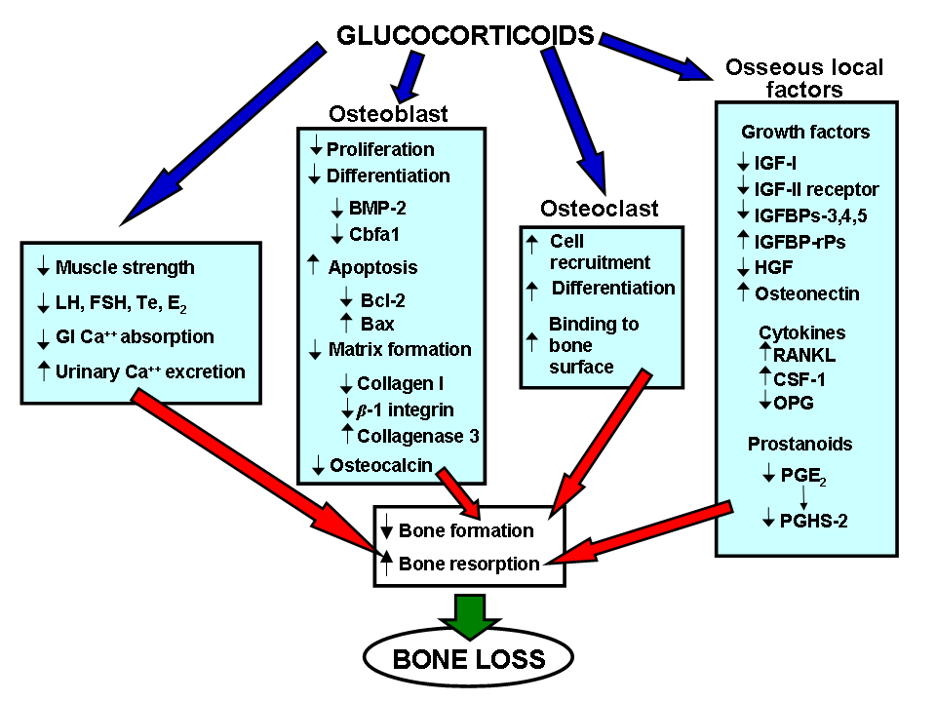
Fig. 1: Overview of the mechanisms of glucocorticoid-induced osteoporosis (GCOP). Osteoporosis results from an imbalance between osteoblast and osteoclast activity. BMP-2: bone morphogenic protein-2; Cbfa1: core binding factor a1; Bcl-2: B-cell leukemia/lymphoma-2 apoptosis regulator; Bax: BCL-2-associated X protein; IGF-I: insulin-like growth factor-I; IGFBP: IGF binding protein; IGFBP-rPs: IGFBP-related proteins; HGF: hepatocyte growth factor; RANKL: receptor activator of the nuclear factor-κB ligand ; CSF-1: colony-stimulating factor-1; OPG: osteoprotegerin; PGE2: : Prostaglandin E 2; PGHS-2 prostaglandin synthase-2

Bone histomorphometry under GCs
Trabecular bones and the cortical rim of vertebral bodies are more susceptible to the effects of GCs compared to the cortical component of long bones (radius, humerus) . Under GC treatment, lumbar BMD shows significantly greater bone loss compared to distal radius BMD. Bone loss is also observed in the proximal femur (particularly at Ward’s triangle, an area rich in trabecular bone) . Although bone remodeling is initially turned on with higher bone resorption, over time, resorption parameters fall and bone becomes quiescent . Thus, with prolonged GC administration, cortical bone becomes increasingly affected and long bones show increased fragility.
Bone biopsies of patients on GC therapy > 12 months show increased bone resorption, a decline in all aspects of bone formation and decreased trabecular volume. Histomorphometric studies on subjects with GCOP show increased osteoclasts and bone-resorbing sites. Bone loss is higher in the metaphyses compared to the diaphyses . GCOP differs from post-menopausal OP in terms of microanatomical appearance: In GCOP the number of trabeculae and their surface area are relatively preserved, and individual plates are very thin (trabecular attenuation), although still connected, whereas in post-menopausal OP, trabecular width is relatively preserved but the lamellae are perforated by resorption, with a loss of trabecular surface and continuity . Such changes may lead to lower mechanical strength of bone. The particular histology of GCOP may have important implications for pharmacologic intervention: the preservation of thinned trabeculae in GCOP may provide the foundation for new bone apposition.

Glucocorticoid receptors (GRs) and bone
GCs have genomic and non-genomic actions. Genomic actions result from the binding of GCs steroids to specific cytoplasmic receptors (of the nuclear receptors superfamily). The GC-GR complex can either activate or repress the expression of target genes. While activation requires binding of a dimerized receptor to GC-responsive elements (GREs) in the promoters of target genes, repression is mainly mediated by interaction between receptor monomers and transcription factors . Translation of GR mRNAs produces two GR isoforms, GRα, which is transcriptionally active and GRβ, which can heterodimerize with GRα, inhibiting its transcriptional activity . In humans, normal osteoblasts, and specific osteoblastic cell lines show GRα expression, whereas mature osteoclasts show no GRα expression. Osteoclasts, in contrast, predominatly show GRβ expressions. Osteoblasts and osteoclasts also express mineralocorticoid receptors (MRs) that bind to cortisol and form heterodimers with both GRα and GRβ . IL-6, in human osteoblasts, acts as an autocrine positive modulator that upregulates the number of GRs . Cortisol, even at physiologic concentrations, modulates negatively the secretion of IL-11, a cytokine that decreases GR expression . Consequently, this interplay of cytokines through autocrine/paracrine loops may modulate bone sensitivity to GCs .

GCs and osteoblast activity
GCs increase the apoptosis of osteoblasts and mature osteocyte via activation of caspase 3 . Apoptosis may involve decreased expression of the Bcl-2 gene and increased expression of the Bax gene . Furthermore, GCs reduce osteoblast proliferation and differentiation , possibly as a result of GC-induced repression of bone morphogenic protein-2 (BMP-2) and expression of core binding factor a1 (Cbfa1) . GCs also modify the expression of osteoblast specific genes, such as osteocalcin. Osteocalcin expression during the development of bone is tightly regulated by GCs, and multiple GREs have been identified on the human and rat osteocalcin promoter region . The osteocalcin gene also contains several activator protein-1 (AP-1) sites that apparently contribute to the basal activity of the promoter. Therefore, repression of osteocalcin promoter activity by GCs may also involve interaction between GR and components of the AP-1 complex, independently of DNA binding, as it has been postulated for the collagenase promoter .
The Wnt signaling pathway is important for osteoblast differentiation and function, bone development and level of peak bone mass . Mechanical loading results in increased bone mass in animals that carry activating mutations of LRP5 . Interestingly, Wnt signaling may be implicated in the response to mechanical loading and the observed inhibition of skeletal growth by GC may be mediated by effects that they exert on Wnt signaling , mainly by enhancing Dickkopf 1 expression (which is a Wnt antagonist) .
GCs are required for the differentiation of mesenchymal stem cells to bone cells; they may also be able to promote an osteoblastic phenotype (by inhibiting collagenases (MMPs) and lowering collagen type 1 breakdown) .

GCs and osteoclast activity
Compared to effects of GCs on osteoblasts, the effects of GCs on osteoclasts are less known due to the inherent difficulties of study: osteoclast isolation from bone is technically difficult to perform and bone marrow cultures, haematopoietic cell lines and cells derived from giant-cell tumors (used as model systems to study osteoclast differentiation and activity) have given varying results. In vitro studies on isolated osteoclasts and bone organ cultures had suggested that GCs may inhibit bone resorption , although more recent studies indicate that GCs may, in fact, stimulate bone resorption . It has been shown that GCs stimulate osteoclast differentiation and their capacity to bind to the bone surface by altering the expression of N-acetylglucosamine and N-acetylgalactosamine . GCs decrease apoptosis of mature osteoclasts but cannot affect directly their bone-resorbing activity, since these cells apparently do not have functional GRs . Higher expression of the GR gene in subjects with lower BMD may lead to higher sensitivity of their monocytes/macrophages to GCs to differentiate into osteoclasts . Cytokines are also implicated in these actions (see next section on regulation of bone local factors by GCs) .

GCs and local bone factors (cytokines, growth factos, prostanoids and kinases)

Cytokines: Interleukin-1 (IL-1) and interleukin-6 (IL-6) induce bone resorption and inhibit bone formation. GCs partially inhibit the production of IL-1 and –6 and inhibit the bone resorbing activity of these cytokines (GC therapy could paradoxically protect osseous tissue from IL-induced bone resorption) . TGF-β (which inhibits IL-1-induced bone resorption and stimulates osteoblast activity) is decreased by GCs. . Lower levels of TGF-β may increase the susceptibility of bone to the resorbing effects of IL-1. IL-1 suppression also inhibits the generation of nitric oxide, which modulates osteoclast activity . GCs interfere with the receptor activator of the nuclear factor-κB ligand (RANKL or TRANCE)-osteoprotegerin (OPG) axis. RANKL (which is expressed at high levels in pre-osteoblast/stromal cells) induces osteoclast differentiation in the presence of colony-stimulating factor-1 (CSF-1) by binding to the receptor activator of the nuclear factor-κB (RANK; a member of the TNF family on the surface of octeoclasts) . OPG is also produced by osteoblasts and is found on their surface. OPG acts as a decoy receptor of RANKL: it binds RANKL and prevents it from binding its osteoclast receptor, therefore inhibiting osteoclast differentiation. GCs enhance RANKL and CSF-1 expression , and lower OPG expression in human osteoblasts cells in vitro . Serum OPG concentrations are significantly reduced in patients undergoing systemic GC therapy . This decrease in OPG is more marked than the GC-induced increase in RANKL, leading to an increased RANKL/OPG ratio that may mediate GC-induced bone resorption .

Growth factors: Insulin-like growth factors (IGFs) have an anabolic effect on bone cells that affect IGF-I and IGF-II receptors. IGF-I and IGF-II are weak mitogens (they increase the replication of osteoblasts), they increase type I collagen synthesis and matrix apposition rates. and decrease collagenase-3 (metalloproteinase-13) expression by osteoblasts . Synthesis of IGF-I in osteoblasts is decreased by GCs via increased expression of the CAAT/enhancer binding protein (C/EBP) β and δ (transcription factors that bind to the IGF-I promoter and halt its transcription) . GCs inhibit IGF-II receptor expression in osteoblasts (while they have no effect on IGF-I receptor expression). Since the IGF-II receptor functions as an IGF-binding protein (IGFBP) its inhibition by GCs may result in higher levels of available growth factors although it may also lead to faster degradation of IGF-II. The activity of IGF-I and -II is regulated by at least six IGFBPs that are expressed by osteoblasts . IGFBPs in skeletal cells are considered to be local reservoirs and modulators of IGFs. GCs decrease the expression of IGFBP-3, -4, and -5 in osteoblasts . IGFBP-5 stimulates bone cell growth (and enhances the effects of IGF-I); its reduction in the bone microenvironment may be relevant to the inhibitory actions of GCs on bone formation and the process of GCOP . GCs also increase the synthesis of IGFBP-related proteins (IGFBP-rPs; a family of peptides related to IGFBPs that bind IGFs and are involved in cell growth) .
Bone cells express transforming growth factor-β (TGF-β) -1, -2, and -3 genes . TGF-β stimulates bone collagen synthesis and matrix apposition rates, modifies bone cell replication, stimulates growth and proliferation of osteoblasts but inhibits their differentiation and the expression of osteocalcin . TGF-β1 expression in osteoblasts is not modified by GCs. GCs, instead, induce activation of the latent form of TGF-β1 by increasing the levels of bone proteases . Two signal-transducing TGF-β receptors are expressed in osteoblasts. GCs shift the binding of TGF-β from these receptors to betaglycan (by increasing the synthesis of this proteoglycan) and oppose the effects of TGF-β osteoblastic cell replication .
Hepatocyte growth factor (HGF) is produced by both osteoblasts and osteoclasts. HGF is a potent stimulator of osteoblastic function and a potent suppressor of bone resorption in isolated rat osteoclasts . Osteoclast-produced HGF (in an autocrine fashion), may lead to changes in osteoclast shape and stimulate osteoclast migration and chemotaxis, while (in a paracrine fashion) may lead osteoblasts to enter the cell cycle, via DNA synthesis stimulation . GCs inhibit the release of HGF in vitro, which suggests that the inhibitory effects on bone resorption of GCs may be in part mediated via regulation of osteoblast-produced HGF .
Platelet-derived growth factor (PDGF) is a mitogen of bone cells . PDGF-A and PDGF–B are expressed in a limited fashion in osteoblasts, and neither the synthesis nor the binding of PDGF appear to be modified by GCs. Specific PDGF-A/B binding proteins are lacking, although SPARC (secreted protein acid rich in cysteine) and osteonectin (a protein abundant in bone matrix) bind and prevent the biologic actions of PDGF-B . Since GCs enhance osteonectin expression in osteoblastic cells they may also decrease the activity of PDGF-B in bone .

Prostanoids: Prostaglandins (PGs) are produced by bone cells and affect both bone formation and resorption. PGs (and PGE₂ in particular) stimulate bone collagen and non-collagen protein synthesis . PGs inhibit directly the activity of isolated osteoclasts and increase bone resorption in organ cultures, (probably by promoting osteoclastogenesis). GC-induced inhibition of collagen synthesis in bone, down-regulation of c-fos oncogene expression and reduced osteoblast proliferation are all reversed by exogenous PGE₂ in vitro, suggesting an important pathogenic role for this PG in GCOP . GCs interfere with the production of PGs in bone (especially of PGE₂) via the decreased expression of cyclooxygenases (the enzymes that convert arachidonic acid into PGs) . Osteoblasts express two cyclooxygenases: constitutive prostaglandin synthase-1 (PGHS-1) and inducible prostaglandin synthase-2 (PGHS-2). Apparently, GC-inhibited PG-production in bone is mediated through a decrease in agonist-induced PGHS-2 expression.

Kinases: GCs modulate intracellular kinases (ERKs, MAPK/JNK and Pyk2) with a proapoptotic effect on the osteoblastic lineage

EXTRASKELETAL MECHANISMS OF GCOP

Effects of GCs on calcium absorption and excretion: Although there is no consensus regarding the effect of GCs on calcium absorption they mainly appear to impair intestinal calcium absorption . GCs have no effect on the intestinal brush border membrane vesicles , but they decrease synthesis of calcium binding protein and deplete mitochondrial ATP (inhibiting calcium release by mitochondria) . Patients treated with GCs show increased renal calcium loss (ultimately leading in some patients to the development of secondary hyperparathyroidism) . In normal subjects receiving GCs the elevation of fasting urinary calcium proceeds the rise in immunoreactive parathyroid hormone (iPTH) . In patients on long-term GC therapy, hypercalciuria is most likely due to increased skeletal mobilization of calcium and decreased renal tubular reabsorption that occurs in spite of elevated PTH levels. The GC-induced decrease in bone formation lowers calcium uptake by newly formed bone and elevates the filtered load of calcium. High dietary sodium intake increases renal loss of calcium whereas sodium restriction and thiazide diuretics lower renal loss of this mineral .

Effects of GCs on the excretion of phosphorus: GCs acting directly on the kidney and indirectly, via induction of secondary hyperparathyroidism, lower tubular reabsorption of phosphate and lead to phosphaturia . Furthermore, GCs increase the amiloride-sensitive Na⁺/H⁺ exchange activity in the renal proximal tubule brush border vesicles and decrease the Na⁺ gradient-dependent phosphate uptake; increased acid secretion and phosphaturia follow .

GC effects on parathyroid hormone (PTH): A direct stimulatory effect of GCs on PTH secretion may exist . More particularly, GCs induce a negative calcium balance that leads to secondary hyperparathyroidism: in patients receiving GCs iPTH is increased (this increase is abrupt if the GCs are administered i.v.). The rise in iPTH can be suppressed with exogenous calcium and vitamin D . Chronic GC administration is accompanied by altered secretory dynamics of PTH; more particularly, it reduces its tonic secretion and increases its pulses . However, elevated iPTH levels can also be be suppressed by infusing calcium, suggesting that the elevation is more likely to be secondary to a negative calcium balance caused by GCs, rather than to direct stimulation of PTH secretion by these steroids . Responses to PTH may be increased by GCs: the rise in serum cyclic adenosine monophosphate (cAMP) stimulated by PTH infusion has shown to double after a three-day pretreatment with prednisone .

Effects of GCs on vitamin D metabolism: Low, normal, or increased circulating levels of 1,25-dihydroxyvitamin D (1,25-(OH)₂D) have been reported in subjects taking GCs . These differences may stem from variations in the dietary intake and absorption of vitamin D and in exposure to sunlight. The rate of synthesis and clearance of 1,25-(OH)₂D is normal in subjects receiving GCs . Although the administration in humans of 1,25-(OH)₂D improves calcium transport, it does not normalize it .

GC effects on sex hormones: GCs inhibit the secretion of gonadotropins and also show direct effects on the gonads and the target tissues of gonadal steroids. In rats, GCs reduce the action of follicle-stimulating hormone (FSH) on granulosa cells and inhibit the response of luteinizing hormone (LH) to gonadotropin-releasing hormone (GnRH) . In rats and primates, GCs also decrease GnRH secretion; furthermore, in rats, overexposure to GCs renders their pituitary insensitive to exogenously administered GnRH . In men and women given GCs the plasma concentrations of estradiol, estrone, dehydroepiandrosterone (DHEAS), androstenedione, and progesterone are decreased . High-dose GC therapy in women may lead to amenorrhea. Although the exact targets of GC inhibition of steroidogenesis in Leydig or granulosa-theca cells are not fully defined, recent studies have found a GC-responsive upstream promoter region of the cholesterol side-chain cleavage gene . In postmenopausal women an additive effect of GC treatment with estrogen deficiency on bone loss is observed .

GC effects on growth hormone (GH): GH is an important regulator of both bone formation and bone resorption. From in vitro studies it has been shown that the GH-induced increase in bone formation is twofold: by direct interaction with GH receptors on osteoblasts, and through induction of endocrine and autocrine/paracrine IGF-I . In contrast to the in vitro results, in animals high endogenous GCs (such as during stressful conditions) or exogenous (at pharmacological doses) can inhibit linear growth and GH secretion in animals. In patients with GCOP a lower GH response to growth hormone–releasing hormone (GHRH) and a positive correlation between GH increment and osteocalcin are observed. This inhibitory effect of GCs on the secretion of GH may be dependent on an increase in somatostatin synthesis and secretion, which would block pituitary GH secretion. Arginine, which decreases hypothalamic somatostatin tone, normalizes the GH response to GHRH . Bone sensitivity to GH may also reduce by GCs: an upregulatory effect on GH receptor expression may be implicated .

GC effects on connective tissue: Excess GCs hinder wound healing via suppression of DNA and protein synthesis in fibroblasts and impaired local macrophage recruitment .

GC effects on muscle: Common side effects of GC excess include muscle weakness and loss of muscle mass. Alterations of muscle biopsies of GC-treated patients include selective atrophy of type IIa muscle fibers, relative increase in the number of type IIb fibers and decrease in the number of type I fibers . The main mechanisms implicated in GC-induced myopathy are increased protein catabolism, inhibition of glycogen synthesis, and interference with the fatty acid β-oxidation. In fact, GCs stimulate ubiquitin-proteasome-dependent protein breakdown in skeletal muscle and regulate calcium-dependent proteolysis . Moreover, levels of glycogen synthase, beta-hydroxyacyl-CoA dehydrogenase and citric acid synthase, are lower in muscle from GC-treated patients compared to muscle from disease-matched controls . A strong association between steroid myopathy and OP has been described .

INDIVIDUAL SUSCEPTIBILITY TO GCOP
Some patients on a low GC dose show bone loss at a much higher rate than others on a higher GC dose . Genetics may play a role in determining this difference. Little is known about the mechanisms of cellular sensitivity to GCs. Individual factors are also important in determining the risk of fractures when GCs are used. The basis for such heterogeneity to GC-associated fracture risk may be associated with polymorphisms of the GC receptor gene: individuals that are heterozygous for a polymorphism at nucleotide 1,220 (resulting in an Asparagine-to-Serine change at codon 360), had increased BMI, increased blood pressure and lower spine BMD compared to control subjects .
Another explanation for inter-individual variability among those exposed to GCs is related to differential activity of peripheral enzymes that interconvert active to inactive GC molecules. 11β-hydroxysteroid dehydrogenase (11β-HSD) catalyzes the inter-conversion of biologically active cortisol (F), into inactive cortisone (E) . This enzyme system therefore plays a critical role in the regulation of GCs activity . Two distinct 11β-hydroxysteroid dehydrogenase enzymes have been described. Its isoenzymes 11β-HSD1 (converting E to F) and 11β-HSD2 (converting F to E) modulate GC and mineralocorticoid hormone action in target organs . 11β-hydroxysteroid dehydrogenase type-1 is primarily a GCs activator, converting cortisone to cortisol. This enzyme is widely expressed in GCs target tissues, including bone .
The reductase activity does not show a large inter-individual variability, whereas the oxidase activity of 11β-HSD2 has a large inter-individual variability. Subjects with higher oxidase activity at bone level may be at greater risk of developing GCOP .
The activity of 11β-hydroxysteroid dehydrogenase type-1 and the potential to generate cortisol from cortisone in human osteoblasts is increased by pro-inflammatory cytokines (TNFα, IL-1β and IL-6) and by GCs themselves . During inflammation pro-inflammatory cytokines may potentiate GC actions on the bone through an “intracrine” mechanism . An increase of 11β-hydroxysteroid dehydrogenase type 1 activity occurs with aging, possibly providing an explanation for the enhanced GC effects in the skeleton of elderly subjects .
In the future, the characterization of factors accounting for the variability to GC-related bone loss among individuals may identify subjects at higher risk of developing GCOP and, possibly, customize treatment.

Diagnosis of GCOP
Medical history and clinical evaluation
Table 1 summarizes elements from medical history suggestive of GCOP and the modalities available for its diagnosis. Any patient that is treated with long-term GCs should be suspected as suffering from GCOP. The risk for GCOP is higher in postmenopausal women, transplant recipients and patients with sarcoidosis . Bone loss depends on the dose, route and duration of GC administration .

Table 1. Clues and diagnostic means for GCOP

Medical history | - Sex and age  - History of OP and/or trauma fractures  - History of allergy, chronic inflammatory or autoimmune disease, hematologic, skin and renal disorders, transplantation  - Calcium and alcohol intake, smoking, physical activity  - Chronic use of anticonvulsants, heparin, immunosuppresants  - Menstrual, menopausal or fertility status
Clinical evaluation | - Truncal obesity, edemas, striae, skin atrophy and ecchymoses  - Myopathy (myalgias, weakness of the proximal muscles and pelvic girdle)
Clinical evaluation | - Assessment of temporal baldness, loss of body hair, gynecomastia, altered pubic hair pattern, decreased testicle and prostate size
Laboratory evaluation | - Complete blood cell count, liver and renal function, serum electrophoresis
Laboratory evaluation | - Serum calcium and phosphate, serum 25-OH-vitamin D, serum alkaline phosphatase, PTH
Laboratory evaluation | - Osteocalcin, bone-specific alkaline phosphatase, procollagen type I extension propeptides)  - Hydroxyproline, hydroxylysine glycosides, hydroxypyridinium cross-links, type I collagen telopeptides)
Laboratory evaluation | - Thyroid hormone profile, total and free testosterone, estradiol, luteinizing hormone, prolactin, ferritin
Bone mineral density assessment | - Lateral scan (vertebral bodies) and anteroposterior scans (spine, hip) with dual-energy X-ray absorptiometry (DXA)
Bone mineral density assessment | - Assessment of vertebral compression fractures with X-ray

Cushingoid clinical features of endogenous or exogenous GC excess may include truncal obesity, skin atrophy with increased fragility and ecchymoses, fluid retention, hyperglycemia, and symptoms of vertebral compression and myopathy. Myalgias or abrupt muscle weakness (focused initially on the proximal muscles and the pelvic girdle, with gradual spreading to the distal muscles) can be the hallmark of myopathy . Muscle strength needs to be assessed by a trained physician or specialized physical therapist, with special attention to the testing of proximal muscle groups. A brief exposure to GCs may trigger myopathy that is not always dose-dependent, and is often difficult to differentiate from inflammatory myopathy. However, GC myopathy is characterized by creatinuria and normal muscle enzymes, including aspartate aminotransferase, creatine kinase, and aldolase .
Men and women on chronic treatment with GCs often have symptoms of hypogonadism, such as decreased libido and sexual activity, and may show low rates of fertility or even infertility. In premenopausal women history taking should assess menstrual periods, since subtle changes, including less bleeding and shortened menstrual periods, may be indications of low estrogen levels. Menstrual irregularities are also common in women with endogenous GC excess.
Various respiratory, dermatologic, muskuloskeletal, neurologic and gastrointestinal disorders are frequently treated with GCs. Signs and symptoms of such disorders need to be evaluated.

Laboratory tests and markers of bone turnover
Laboratory evaluation for GCOP should include total blood cell count, markers of renal and liver function, serum electrophoresis, serum and 24-hr urine calcium, serum levels of 25-hydroxyvitamin D, alkaline phosphatase, thyroid-stimulating hormone and parathyroid hormone, estradiol in women and total and free testosterone in men .
In patients receiving GCs a dose-dependent decrease in serum osteocalcin is found; this is a good indicator of the degree of inhibition of osteoblastic activity . Other markers of bone formation, such as total and bone specific alkaline phosphatase and procollagen type I carboxy-propeptide are also lower in under GC therapy . In subjects on GC therapy baseline levels of osteocalcin do not always correlate with subsequent bone loss . In some, but not all, studies of patients treated with GCs, markers of bone resorption (like urinary collagen N-telopeptides [NTX]) are elevated . In view of such discrepancies, the measurement of serum markers of bone formation and resorption is considered to be of little clinical utility and it is not currently advocated for routine use .

Bone Mineral Density (BMD) Assessment
Changes in BMD early on during GC therapy can be detected by dual-energy X-ray absorptiometry (DXA) and quantitative computed tomography (QCT); classic X-ray studies are useful to detect vertebral compression fractures. Both QCT and DXA can measure cortical and trabecular bone density, however, the former is mostly used to evaluate trabecular bone density, whereas the latter is used to measure cortical and trabecular bone density . DXA also helps estimate the risk for fractures, and provides an objective measurement to judge the efficacy of treatment (with minimal irradiation burden) . BMD measurment techniques that focus on the vertebral body and exclude the cortical bone of posterior processes, such as lateral DXA scanning, are apt to be more sensitive in detecting GCOP . However, the selection of a BMD assessment method is influenced by the presence of vertebral deformities, osteophytes, or of calcifications in the aorta that may spuriously elevate spinal BMD values. If this is the case, lateral views of the vertebral bodies (particularly in the decubitus position) are considerably less precise than antero-posterior scans, and therefore less appropriate for following up changes in bone mass. When marked osteophytosis or scoliosis of the spine is seen, proximal femoral densitometry (in the femoral neck) should be chosen .
In patients under glucocorticoid treatment fractures tend to occur at BMD values that are lower than the conventional threshold T-score of -2.5 . A T-score threshold value of – 1.5 SD is usually the cutoff for GCOP in Europe , whereas the American College of Rheumatology (ACR) has defined the T-score cut off to – 1.0 SD to separate “normal” from “not normal” BMD . Furthermore, the ACR recommends BMD baseline measurements at the lumbar spine and/or hip before starting any GC treatment longer than 6 months . At 6 month intervals from the baseline assessment, or at 12 month intervals, if the patient is receiving therapy to prevent bone loss, follow-up measurements should be done . For the United States in particular, Medicare reimburses BMD evaluation for patients on chronic treatment with GC doses higher than 7.5 mg/day of prednisolone equivalent .
The Fracture Risk Assessment tool (FRAX) estimates the 10-year risk for osteoporotic fractures at the hip and other sites. FRAX is criticized since it uses hip BMD, whereas vertebral fractures may be more common than hip fractures in subjects receiving GCs . Recently simple adjustments for the calculated fracture risk have been presented that take into account glucocorticoid dosage (Table 2).

Table 2: FRAX fracture risk corrections according to glucocorticoid usage (modified from data in )
Dose (in prednisolone equivalent mg/day)
 | Hip fracture risk correction
Low: <2.5 | -35%
Medium: 2.5-7.5 | No change
High: >7.5 | +20%
 | Major osteoporotic fracture risk correction
Low: <2.5 | -20%
Medium: 2.5-7.5 | No change
High: >7.5 | +15%

PREVENTION AND TREATMENT OF GCOP
Guidelines for the prevention and treatment of GCOP have been put forth from the ACR in 2001 and more recently in 2010 , the UK Consensus group in Management of GCOP and the Belgian Bone Club , among others.

General preventive strategies
As soon as GCs are administered prevention of GCOP should start; bone loss is more rapid in the first months of therapy. The minimal effective GC dose should be used. Although alternate day therapy seems attractive it has not been proven to hasten bone loss in adults ; the persistent depression of adrenal androgen production may be the culprit [Avgerinos 1987].
The concept of “safe dose” for the treatment with oral GCs is controversial . More particularly, prednisone given at low doses (5-9 mg/d) may affect BMD whereas lower doses (1-4 mg/d) were reported to have very little or no skeletal effect . Intravenous high-dose (up to 1 g) methylprednisolone administration is not onerous to bone . Nevertheless, even a single oral dose of 2.5 mg of prednisone has an almost immediate negative effect on osteocalcin secretion . Alternate-day GC administration may prevent growth retardation in children but not bone loss .
Inhaled GCs may be better than oral or systemic GCs vis-à-vis bone health, but still have their osseous tissue complications . Newer inhaled GCs (such as budesonide), seem to have less adverse effects on the bone, as indicated by bone markers . Dosing of the inhaled GC is important: beclomethasone dipropionate or budesonide given at low doses for more then one year did not affect spine BMD in asthmatic subjects . However, patients treated with high doses of inhaled budesonide or beclomethasone (1.5 mg/day, for at least 12 months) and without prior oral GC treatment for more than 1 month, had a significant decrease in bone mineral density (BMD) and bone formation markers, with no changes in bone resorption markers . In another study, inhaled GCs in adults with chronic lung disease were not associated with increased fracture risk (and more in detail no dose-response curve was verified) . Moreover, in children treated with beclomethasone for bronchial asthma, analysis after adjustment for the severity of the underlying disease did not show any association between inhaled GCs and fracture risk . Thus, in children, other factors, such as excess body weight, low muscle mass and limited exercise capacity may predispose to low BMD .
Another factor that should be noted is the change in lifestyle for the prevention of GCOP. Diet should be rich in calcium and protein . Alcohol and sodium intake should be reduced, smoking should be stopped and a regular exercise program should be followed . Subjects on GCs may benefit if they are protected from falls .
An important, yet often neglected by most prescribing physicians , facet of GC-treatment is the need for proper patient information and acknowledgement regarding untoward effects. A signed relevant patient acknowledgement form should be included in medical charts/files to avoid malpractice litigation .

Therapeutic options
Therapy for GCOP aims to prevent and minimize bone loss, to increase BMD and, at least partially, to reverse the effects of GC excess. Therapy should be continued for as long as GC therapy is pursued.

Calcium and Vitamin D supplementation: Patients on GCs should receive supplementation with calcium and vitamin D; this is better than no supplementation or calcium alone . 1,500 mg/d of calcium and 800 IU/d of vitamin D (1 μg/day of α-calcidiol or 0.5 of μg/day calcitriol) effectively oppose negative calcium balance . A two-year randomized clinical trial demonstrated the efficacy of combined calcium and vitamin D supplementation in preventing bone loss in patients with rheumatoid arthritis treated with low doses of GCs . However, these encouraging findings were not replicated in a three-year follow-up study, where the same combination did not show any benefit . From randomized clinical trials and meta-analyses it was shown that active metabolites of vitamin D (α-calcidiol and calcitriol) are more effective than vitamin D in maintaining bone density during medium-to-high dose GC treatment . Treatment with active forms of vitamin D entails a risk of hypercalciuria and hypercalcemia, consequently periodic assessment of serum calcium and creatinine levels at the beginning of the therapy, after 2-4 weeks, and thereafter every 2-3 months is advised .
Thiazide diuretics lower urinary calcium excretion. Chronic treatment with thiazides decreased the incidence of hip fracture in elderly patients, and increased BMD in the general population . This evidence suggests that, together with sodium restriction, they may be useful in opposing calcium loss and secondary hyperparathyroidism caused by chronic GC therapy. However, there are currently no studies showing long-term effect of thiazide diuretics on BMD in patients treated with GCs.

Antiresorptive therapy: There are several antiresorptive agents available for the prevention and treatment of GCOP. Bisphosphonates are the most widely used.
Bisphosphonates decrease the resorptive activity of osteoclasts, increase osteoclast apoptosis and decrease osteoblast and osteocyte apoptosis . Their efficacy in preventing and treating GCOP has been clearly shown in large randomized controlled clinical trials . Treatment with alendronate for 18 months or two years increased total body BMD, and significantly decreased risk of vertebral fractures in patients taking GC . In a one-year study of patients on GCs having undergone cardiac transplantation subjects given alendronate had lower bone loss compared to subjects on calcitriol or no other treatment (-0.7%, -1.6% and -3.2% for the lumbar spine BMD and -1.7%, -2.1% and -6.2% for the femoral neck BMD, respectively); vertebral fracture rates were not different in the three groups though . Similarly, a one-year study with risedronate in patients taking prednisone (7.5 mg/day for at least 6 months) showed an increase in lumbar spine and femoral neck BMD and a 70% decrease in the relative risk of vertebral fractures . Cyclic etidronate (400 mg/day for 14 days every three months for one year) was proven to both prevent bone loss in patients taking GCs for rheumatoid arthritis and polymyalgia rheumatica, and reverse OP in patients on chronic treatment with prednisone . Both oral (150 mg/day) and intermittent i.v. (30 mg every three months for one year) pamidronate disodium increased BMD at the spine and the hip in patients starting long-term GC therapy . Clodronate increased BMD in asthmatic patients treated with GCs . Zoledronic acid (a long-acting potent bisphosphonate) given intravenously (4-10 mg once or twice a year) has excellent anti-OP results and has been assessed in GCOP. The HORIZON study lasted for one year and tested the effectiveness of 5 mg intravenous zoledronic acid (n=416) vs risedronate (n=417) in subjects with GCOP; the former led to greater increase in lumbar bone mineral density and greater decrease in bone turnover compared to the latter . The study did not show differences in fracture risk (possibly because of its short duration). Pyrexia (particularly in the first three days post-infusion) and worsening of rheumatoid arthritis were noted more often in the zoledronic acid group .
Currently, alendronate (5 and 10 mg/day or 70 mg/week) and risedronate (5 mg/day or 35 mg/week) and zolendronic acid are recommended to treat men and women receiving GC treatment (Figures 2a and 2b). Oral ibandronate given for GCOP in men and women has positive results – particularly regarding spine BMD and vertebral fractures .

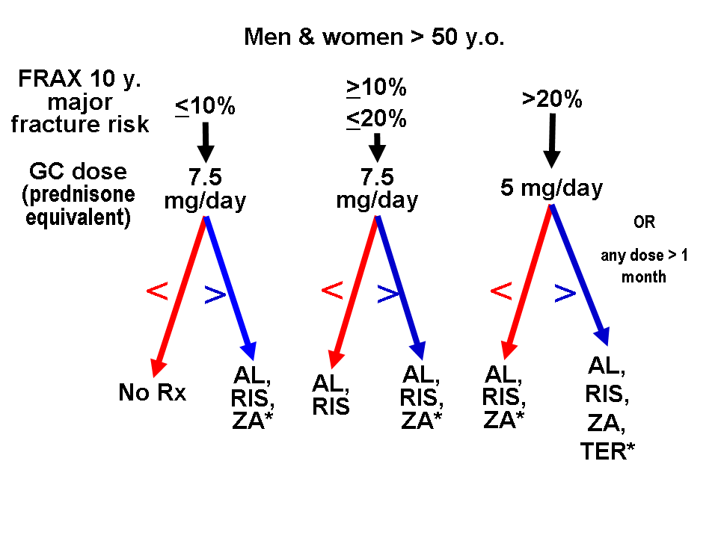

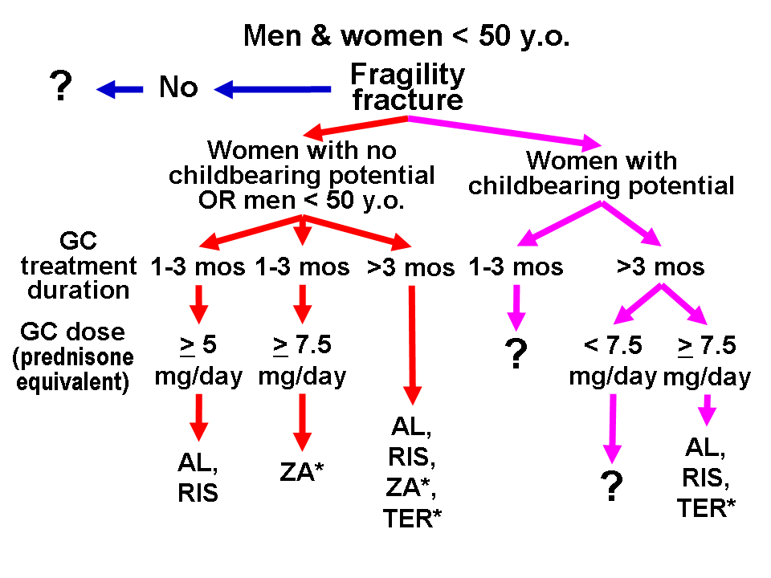
Fig. 2a, 2b: Proposed pharmacological treatment for subjects on GC treatment and/or GCOP; modified from the ACR guidelines ; AL: alendronate, RIS: risedronate, ZA: zoledronic acid, TER: teriparatide, Rx: treatment, mos: months, *: based on a single randomized clinical trial, **: based on consensus, ?: no consensus

Anabolic therapy: Anabolic medications enhance bone formation, therefore antagonizing the suppressive effect of GCs on osteoblast activities. However, much of the information on the use of these compounds to prevent or treat GCOP comes from small studies.
Sodium fluoride, in combination with either calcium and vitamin D, or cyclic etidronate, improved lumbar spine BMD and trabecular bone volume in GC-treated patients. However, no reduction in the incidence of fractures was observed. Moreover, fluoride induced bone loss at the femoral neck . Since most of the evidence indicates that sodium fluoride does not provide architecturally competent bone, its use is currently not recommended for GCOP .
Anabolic steroids have also been tested in GCOP. Cyclic nandrolone decanoate (50 mg i.m. every three weeks for six months) increased the forearm bone density in GC treated women, 10% of which developed virilizing side effects . The typical negative effects of steroids on bone are not present with nadrolone because it is not broken down to dihydrotestosterone (DHT). Instead, it is broken down to a weaker androgen. Similarly, cyclic medroxyprogesterone acetate (200 mg i.m. every 6 weeks for one year) augmented lumbar spine BMD in treated men . Currently, there is no recommendation for the use of anabolic steroids for GCOP.
Recombinant PTH administration (400 IU of PTH 1-34; teriparatide) to postmenopausal women on prolonged estrogen replacement, who had developed OP after chronic GC therapy, resulted in increased lumbar spine bone mass, assessed by both DXA and QCT, which was maintained after discontinuation of the teriparatide treatment . A 18-month long randomized double blind trial compared teriparatide vs alendronate in subjects with GCOP: the increase in lumbar BMD was higher with teriparatide (+4.6 to +8.1% vs +2.3 to +3.6% for alendronate at 18 months; better results were noted for those taking low than those taking high GC doses) and fewer vertebral fractures occurred with teriparatide compared to alendronate (0.6% vs 6.1%) whereas the non-vertebral fracture rate did not differ between treatment groups . Analogous results were noted when the trial was extended to 3 years: lumbar spine BMD increased by +11.0% for teriparatide vs +5.3% for alendronate whereas the respective femoral neck BMD change was +6.3% vs +3.4% . Thus teriparatide can be a first-choice therapy (20 microg/day sc) for patients on GC treatment and/or with GCOP, as proposed in the ACR guidelines (Figure 2). The combination of teriparatide and bisphosphonates is not advocated; the latter may lower the effectiveness of the former . Nevertheless, bisphosphonates given after stopping teriparatide therapy may help to maintain bone formed by teriparatide .

Gonadal hormone replacement: Sex hormone treatment should be considered whenever a patient with GC excess develops hypogonadism . A retrospective study in postmenopausal women taking GCs found an increased BMD in those who were taking estrogens, compared to increasing bone loss in those who were not . Moreover, in a randomized controlled clinical trial of postmenopausal women taking GCs for rheumathoid arthritis, a significant increase in lumbar spine BMD was observed in those receiving hormone therapy (HT) compared to those receiving placebo . This evidence suggests the potential benefit of HT in hypoestrogenic women treated with GCs. However, a large randomized clinical trial in postmenopausal women treated with a combination of estrogen and progestin planned to last 8.5 years was interrupted after 5 years, because the overall risks exceeded the benefits of the treatment . The ACR recommended oral contraceptives (unless contraindicated) in premenopausal women on GCs who develop oligo-amenorrhea but this option is no longer included in the more recent ACR guidelines . Similarly to women, adult men with GC excess who develop hypogonadism could benefit from testosterone replacement. In GC-treated asthmatic men with testosterone deficiency, i.m. testosterone injections increased lumbar spine BMD, but not hip BMD . There are no data on the potential benefit of testosterone therapy in GC- treated eugonadal men; such an option is not included in the recent ACR guidelines . However, since most studies have shown an increase in prostate size and prostate-specific antigen levels in older men on testosterone supplementation/therapy , testosterone administration should be monitored with yearly digital examinations and prostate-specific antigen measurements.

Future therapeutic options
In addition to different combinations of the treatments so far discussed, selective estrogen receptor modulators (SERMs) alone or conjugated estrogens/SERMs may become part of the pharmaceutic armamentarium against GCOP. SERMs, such as tamoxifen and raloxifen have positive effects on the bone. Tamoxifen reduces in vitro some of the deleterious effects of GC on the bone . Raloxifen, which is currently approved by the United States’ Food and Drug Administration (FDA) for the prevention and treatment of postmenopausal OP, might be a safer alternative to HT in the treatment of GCOP that develops in postmenopausal women, given its favorable effects on serum lipids, together with the lack of growth stimulation on endometrial and breast tissues .
Other newer agents that are tentatively evaluated for the treatment of osteoporosis either inhibit osteoclast resorption or stimulate osteoblast bone forming activity. These include antibodies against RANKL (RANKL inhibitors), recombinant osteoprotegrin, inhibitors of osteoclast enzymes, integrin antagonists and agonists to LRP5 . Although in patients with rheumatoid arthritis who are treated with the RANKL inhibitor denosumab lumbar spine BMD increases , this therapy is not yet approved for GCOP and is still at the time of writing undergoing clinical trials . It can be a therapeutic option in patients with renal insufficiency who cannot receive bisphosphonates or teriparatide .
Other promising future therapeutic options target GC therapy per se. These include the use of disease-modifying antirheumatic drugs or tumor-necrosis factor agents, which could lead to the need for lower GC dosage for autoimmune disease. Furthermore, deflazocort (a prednisone derivative) and liposomal prednisone may be less onerous to bone . SGRMs are selective ligands of the GR which maintain the transrepressive properties of GCs (usually associated with their beneficial anti-inflammatory effect) while they do not have their transactivating properties (usually associated with metabolic negative effects, including perhaps those on the bone). Some of these molecules may represent an alternative to traditional GCs in the chronic treatment of inflammatory disorders . Inhibitors to cathepsin K (which is involved in systemic bone resorption) and monoclonal antibodies to sclerostin (a Wnt signalling antagonist) hold promise for treating GCOP .

GLUCOCORTICOID DISCONTINUATION AND REVERSIBILITY OF GCOP
There is no consensus on the reversibility of GCOP. Bone mineral density increases after curative surgery for Cushing’s disease or interruption of exogenous GC treatment . A prospective study in patients with rheumatoid arthritis showed partial bone regain after discontinuation of low-dose GC therapy that was given for five months . In patients with sarcoidosis younger than 45 years full recovery of bone mass was reported two years after cessation of therapy . However, it is unlikely that the large (10% or more) bone mass that is lost during high-dose GC therapy can be completely regained, with full recovery of the mechanical properties of the bone. The likelihood of bone regain may be negatively correlated with the duration of treatment as well as unknown host-related factors. Most complications of osteoporotic fractures, such as vertebral deformities and chronic back pain, are permanent.

References

