Chapter 25 – HORMONES OF THE CARDIOVASCULAR SYSTEM

Michael E. Hall, MD, MS, Division of Cardiology, University of Mississippi Medical Center, Jackson, MS 39216
Licy L. Yanes, MD, Division of Endocrinology, University of Mississippi Medical Center, Jackson, MS 39216
Robert C. Long, MD, PharmD, Division of Cardiology, University of Mississippi Medical Center, Jackson, MS 39216
Christian A. Koch, MD, PhD, Division of Endocrinology, University of Mississippi Medical Center, Jackson, MS 39216

Updated February 2, 2015

ABSTRACT
Neurohormonal systems play a critical role in cardiovascular homeostasis as well cardiovascular pathophysiology and diseases such as congestive heart failure, coronary artery disease, hypertension and chronic kidney disease. Neurohormonal activation is an important cause and therefore an important therapeutic target to treat cardiovascular diseases. It is well established that activation of hormonal systems such as the renin-angiotensin-aldosterone system leads to increased cardiac injury and dysfunction which predispose to congestive heart failure. Obesity is also associated with neurohormonal activation and it is associated with multiple hemodynamic and metabolic factors which increase the risk of developing cardiovascular and renal diseases. In addition to direct hemodynamic effects, activation of hormonal systems may cause cardiovascular dysfunction through mechanisms including inflammation, oxidative stress, and mitochondrial dysfunction. In this chapter we briefly discuss the hemodynamic effects of several key cardiovascular hormones as well as their non-hemodynamic effects with a focus on inflammation, oxidative stress, and metabolic regulation.

INTRODUCTION
Neurohumoral stimulation is a key finding in syndromes such as chronic heart failure (CHF), type-2 diabetes mellitus (T2DM), and chronic kidney disease (CKD). Activation of cardiovascular hormonal systems such as the renin-angiotensin-aldosterone system (RAAS) translates into progression of the underlying disease and/or development of cardiovascular comorbidity associated with an increased risk for major adverse cardiac events. Figure 1 provides an overview of cardiovascular neurohormonal systems pertinent to clinical syndromes such as CHF, T2DM and CKD.

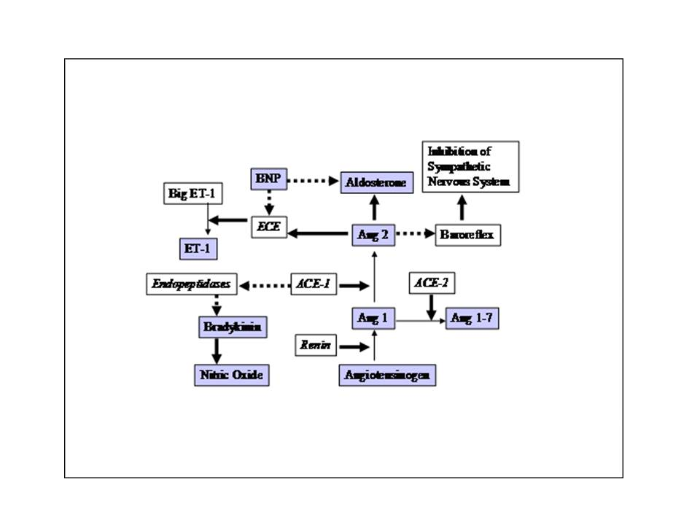
Figure 1. Regulation of hormones pertinent to cardiovascular syndromes: Angiotensin (Ang), Brain-natriuretic peptide (BNP), Endothelin-1 (ET-1) (Solid arrow: stimulation, non-solid arrow: inhibition).

Based on epidemiologic data there is evidence that plasma levels of norepinephrine [1] and brain-natriuretic peptide (BNP) [2] are markers for adverse patient outcomes in CHF. Landmark studies have shown that CHF patients benefit from antagonism of the renin-angiotensin system (angiotensin converting enzyme inhibitors (ACEIs) and angiotensin receptor blockers (ARBs), beta-adrenergic blockade, and mineralocorticoid-receptor blockade. Treatment with the ACEI enalapril reduced mortality in asymptomatic left ventricular dysfunction, moderate heart failure and advanced heart failure [3-5]. Based upon data from multiple randomized controlled trials, beta-blockers were associated with a 30% reduction in mortality and 40% reduction in hospitalizations in patients with class II and III heart failure [6]. In addition to beta-adrenergic and renin-angiotensin system antagonism, the addition of mineralocorticoid-receptor antagonists has conferred survival benefits in selected patients with CHF. Based upon data from the Randomized Aldactone Evaluation Study (RALES) [7], Eplerenone Post Acute Myocardial Infarction Efficacy and Survival Study (EPHESUS) [8], and Eplerenone in patients with systolic heart failure and mild symptoms Study (EMPHASIS-HF) [9], current CHF guidelines recommend adding mineralocorticoid receptor antagonists in patients with class II to IV CHF and reduced LV ejection fraction [10].

Beyond CHF, outcome-related research has tested the blockade of neurohumoral pathways in coronary artery disease (CAD) as well: the Heart Outcomes Prevention Evaluation Study (HOPE) has proven a 26% reduction in cardiovascular deaths in patients with coronary artery disease without signs of CHF when treated with an ACEI [11]. Therefore, a direct role for RAAS activation with regard to pathogenesis of CAD and disease progression has been suggested. Animal research suggests angiotensin II promotes aortic aneurysm formation [12]. A connection between angiotensin II and macrophage and T-lymphocyte infiltration of the arterial vessel wall has been established for aortic aneurysm formation [13].
Along with a decrease of renal function in CKD, the prevalence of cardiovascular comorbidity and incidence of major adverse cardiac events rises in a linear fashion [14]. There, RAAS activation appears to play a central role [15]. In addition, local hormone activation within the tubulo-interstitium, e.g. prostaglandin synthesis [16], may play a further role which remains to be elucidated. In addition, recent data suggest vitamin D supplementation reduces atherosclerosis in CKD [17], although blood pressure reduction by administering vitamin D is unlikely [18]. In that regard, vitamin D3 appears to control T-cells implicated in the atherosclerotic process [19].
Last, an emerging body of data points at specific states of neurohumoral activation in obesity. Close links between obesity and cardiovascular disease have been established [20]. Likely mechanisms by which obesity causes cardiovascular injury include hemodynamic effects (increased preload/hypervolemia and increased afterload/hypertension), inflammation, metabolic effects (hyperglycemia, dyslipidemia, insulin resistance) and lipotoxicity (Figure 2).

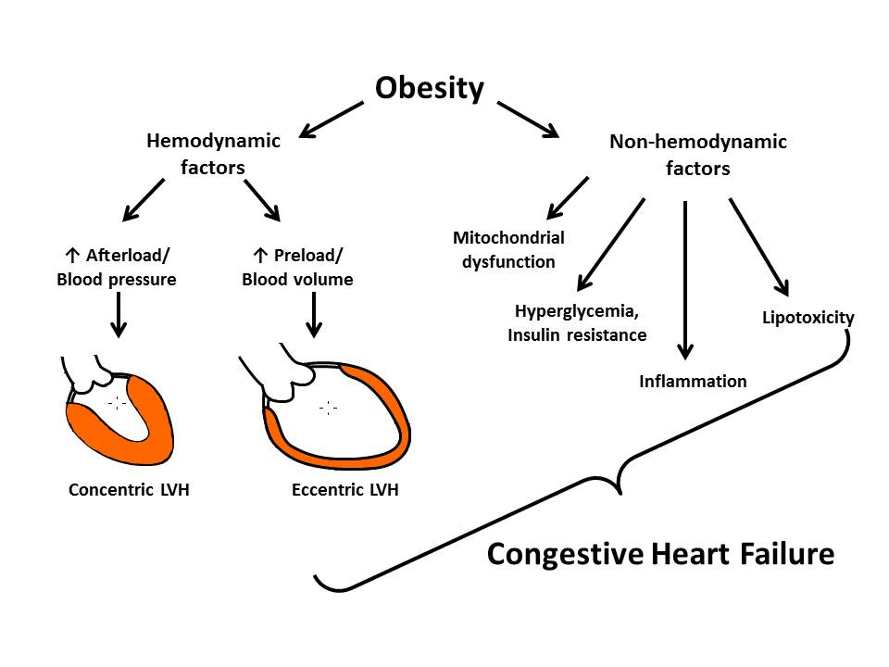
Figure 2. Mechanisms of obesity-induced cardiac dysfunction. (LVH= left ventricular hypertrophy)

The established diagnosis of metabolic syndrome predicts the risk for type-2 diabetes (24 fold increased) and for atherosclerosis (3-4 fold increased) [21, 22]. The metabolic syndrome is associated with a cascade of metabolic derangements which lead to cardiac and vascular injury, however, it is becoming evident that central/visceral obesity is the driving force behind many of these abnormalities [23-25]. In patients with CAD and normal BMI, central adiposity (measured by waist circumference and waist-to-hip ratio) was associated with increased mortality [25]. Besides non-pharmacologic interventions such as increased physical activity and a low-caloric diet, medical interventions influencing appetite and metabolic rate are investigated. Neurohumoral mechanisms may offer additional insights into evolution towards T2DM. Among hypertensives treated either with losartan or atenolol in the LIFE study, the losartan-treated branch had a greater benefit in terms of T2DM prevention when compared to the atenolol-treated group while blood pressure control was equal [26]. Furthermore, existing evidence strongly suggests that angiotensin II can promote insulin resistance and obesity. Consequently, specific neurohumoral mechanisms such as the RAAS may be intimately involved in diabetes evolution and RAAS blockade may ameliorate the deleterious effect of hyperglycemia.
Research issues remain to be solved regarding specific signal cascades involved in specific states of neurohumoral stimulation associated with CHF, CKD, or T2DM. A better understanding of neurohumoral compensatory responses to pathologies may help explain a number of clinical puzzles and provide novel and better therapeutic tools.
Overall, in this chapter, pertinent cardiovascular hormone actions are being highlighted with regard to hemodynamic actions as documented by alterations of systemic vascular resistance and cardiac output as well as non-hemodynamic effects such as inflammation, oxidative stress, and metabolic alterations.

ACTIONS OF CARDIOVASCULAR HORMONES

As an overview, cardiovascular effects are summarized for epinephrine, norepinephrine, B-type natriuretic peptide, renin, angiotensin II, aldosterone, endothelin and estrogen in Table 1. In addition to their hemodynamic effects, hormones affect the cardiovascular system through non-hemodynamic mechanisms including inflammation, oxidative stress, and metabolic effects. In this chapter, we will briefly discuss the hemodynamic and non-hemodynamic effects of several hormones that have significant cardiovascular effects.

Chronic inflammation as a result of cytokine activation may be monitored systemically by measuring C-reactive protein (CRP) released from the liver upon cytokine stimulation, by interleukin-6. An elevated CRP directly translates into a worse cardiovascular prognosis both in patients after myocardial infarction [27], and in apparently healthy persons without prior myocardial infarction, but with elevated CRP > 2 mg/l [28]. Therefore, cardiovascular hormone actions affecting interleukin pathways as detected by an increased CRP need to be regarded with scrutiny.

Oxidative stress adversely affects cell function either by direct effects on membranes, proteins or nucleic acids or, indirectly, by scavenging nitric oxide and thereby disturbing vasomotor function. Oxidative stress in disease states such as T2DM may primarily be the result of endogenous sources (Figure 3). Enzymes such as NADPH oxidase, xanthine oxidase, and uncoupled nitric oxidase are able to release reactive oxygen species. In addition, reactive oxygen species may leak from mitochondria. In cardiovascular high-risk patients, in-vitro antioxidants like ascorbic acid or tocopherol do not translate into cardiovascular endpoint reduction [29]. Alternatively, therapies addressing sources of oxidative stress have become focus of interest aiming to control the production of reactive oxygen species and to increase nitric oxide bioavailability. Medical interventions that lower endogenous oxidative stress include ACE-inhibition [30], beta blockade [31], or the use of statins [32, 33].

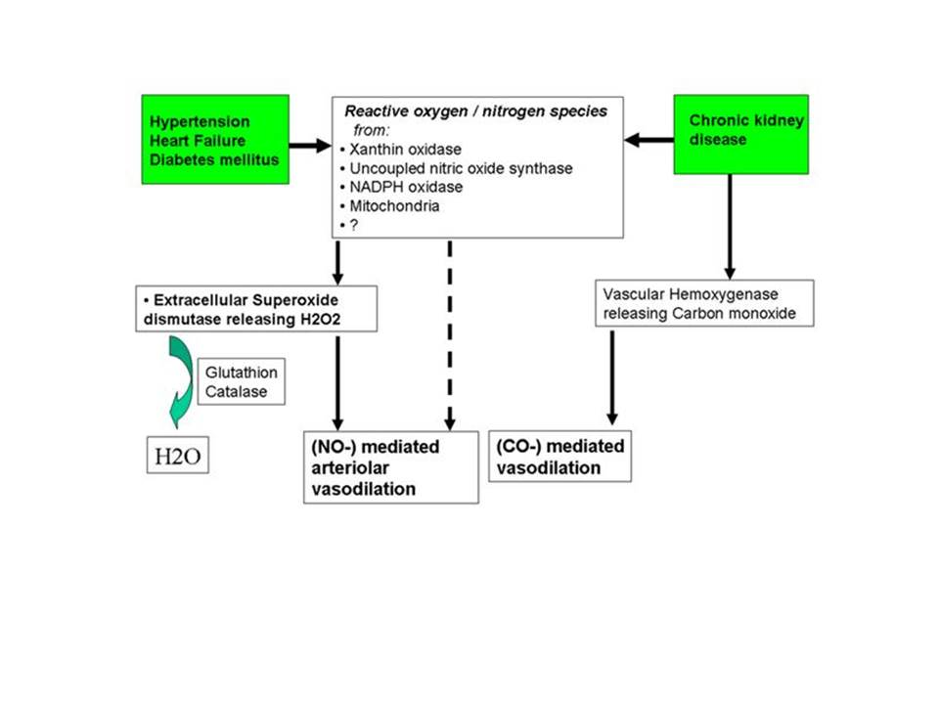

Figure 3. Consequences of disease-related oxidative - stress regarding arteriolar tone. (Solid arrow: stimulation, non-solid arrow: inhibition.)

Heart failure is associated with reduced cardiac energy production and impaired myocardial efficiency leading to an inability of the heart to meet the metabolic demands of the tissues. Neurohumoral activation in conjunction with perturbations in myocardial fatty acid and glucose metabolism lead to mitochondrial dysfunction and reduced myocardial ATP production [34]. AMP-kinase is considered as an energy-sensor in the heart and stimulates cardiac energy production though fatty acid oxidation and glucose utilization [35]. Several hormones including insulin and adipokines such as leptin and adiponectin have been linked to AMP-kinase activity and may be important targets for stimulating myocardial ATP production.

T2DM is associated with oxidative stress. Macro and microvascular complications of T2DM are closely related to elevated levels of oxidative stress. A recent study has shown that NADPH oxidase, a critical enzyme in oxidative stress cascade, is upregulated in vessels in patients with T2DM [36]. Low levels of adiponectin stimulate the activity of NADPH resulting in higher levels of oxidative stress.

Table 1: Effects of hormones on the circulatory system.
 | Target | SVR | HR | SNS | Oxidative Stress | CRP
Epinephrine | EC,VSMC | (↑↓) | ↑ | ↑ | (↑↓) | ↑
Norepinephrine | VSMC | ↑ | ↑ | ↑ | ↑ | ↓
BNP | EC,VSMC | ↓ | ↔ | ↓ | ND | ND
Angiotensin II | EC,VSMC | ↑ | (↑↓) | ↑ | ↑ | ↔
Aldosterone | EC,VSMC | ↑ | ↔ | ND | ↑ | ↔
Endothelin | VSMC | ↑ | (↑↓) | ↑ | ↑ | ↑
Estrogen | EC | ↓ | ↔ | ↓ | ↓ | ↑

SVR, systemic vascular resistance; HR, heart rate; SNS, sympathetic nervous system; CRP, C-reactive protein; EC, endothelial cells, VSMC, vascular smooth muscle cell. Autonomic changes are assessed via HR variability, sympathetic nervous system (SNS) activity, or norepinephrine plasma levels. Oxidative stress is assessed by isoprostane levels in serum. The state of inflammation is assessed by CRP levels

Catecholamines
Epinephrine stimulates α, β-1 and β-2 receptors nonselectively resulting in variable cardiovascular effects. Epinephrine causes vasoconstriction via activation of α-1 receptors and venoconstriction via α-2 actions [37]. Through β-1 mediated actions, epinephrine increases both ventricular contractility and heart rate thereby increasing myocardial workload and oxygen consumption. However, epinephrine dose-dependently leads to vasodilation in skeletal muscle arterioles as a first-line response to stress. Endothelial cells emerge as a target for epinephrine as well [38]. In addition to well characterized chronotropic and inotropic effects on the heart, epinephrine bears a certain antioxidant potential by increasing both intra- and extracellular superoxide dismutase, a major oxidant-stress defense. Hydrogen peroxide, the product of the reaction catalyzed by superoxide dismutase is a reactive oxygen species that is readily disposed of by both catalase and reduced glutathione. The induction of superoxide dismutase by epinephrine, e.g. during vigorous exercise, increases the amount of hydrogen peroxide that, in turn, is a known activator of the endothelial isoform of nitric oxide synthase (eNOS). Increased amounts of nitric oxide promote vasodilation, thereby increasing blood flow, tissue oxygenation and blood-based antioxidative stress defense [39, 40]. In addition, epinephrine increases plasma CRP in a dose-dependent manner, probably via a receptor mechanism [41, 42].
Norepinephrine is an agonist of α and β-1 adrenergic receptors mediating vasoconstriction. Sympathetic nervous system (SNS) activation leads to norepinephrine spillover from sympathetic nerve terminals and from adrenal medullary cells. Norepinephrine exerts positive inotropic and chronotropic effects on the heart as well as increased peripheral vascular resistance, thereby increasing blood pressure. However, increases in blood pressure may attenuate chronotropy via a baroreflex mechanism. On the level of adipocytes, norepinephrine mediates body-temperature increasing effects [43]. Norepinephrine also increases oxidative stress [44].
Interventions aimed at reducing renal sympathetic activity have been evaluated for chronic treatment of several cardiovascular diseases. Denervation of the renal sympathetic nerves is a novel treatment strategy for reducing blood pressure in individuals with resistant hypertension [45]. The Symplicity HTN-2 Study was a randomized controlled trial which demonstrated renal denervation (RDN) to be superior to medical management for office blood pressure control measured at 6 months (32/12 mmHg reduction in RDN group versus 1/0mmHg in medical therapy group) [46]. In addition to reductions in blood pressure, RDN denervation was associated with significant reductions in levels of pro-inflammatory cytokines CRP and IL-6 [47]. RDN in addition to pulmonary vein isolation may also reduce the recurrence of atrial fibrillation [48]. However, the long-term efficacy of this procedure is unknown. The Symplicity HTN-3 Study was the first prospective, multi-center study to evaluate RDN therapy in 535 resistant hypertensive patients from 88 centers in the US [49]. This study failed to demonstrate a significant reduction of office systolic blood pressure or 24-hour ambulatory blood pressure compared to sham controls. The debate over the effectiveness of this procedure continues and there are ongoing clinical trials evaluating several disease outcomes using this technique. Additionally, new procedures such as implantation of carotid sinus stimulators are being evaluated for treatment of resistant hypertension [50] and heart failure [51].
It has been shown that in T2DM there is an activation of sympathetic system [52]. Furthermore, insulin resistance improves following renal denervation for the treatment of resistant hypertension [53-55]. The effect of renal sympathetic denervation was evaluated in a sub-study of the Symplicity HTN-2 trial in 37 patients and 13 controls. Three months after renal denervation, fasting glucose, insulin, C-peptide levels and HbA1c were significantly reduced. Oral glucose tolerance and the sensitivity to insulin measured by the HOMA-IR (homeostasis model assessment-insulin resistance) were improved as well [46]. Further research is needed to elucidate the mechanism by which sympathetic activation promotes insulin resistance.
NATRIURETIC PEPTIDES
The natriuretic peptides have several important physiologic effects which benefit the heart, vasculature, and kidneys to maintain cardiovascular homeostasis. This peptide system is a family of at least 3 members: atrial natriuretic peptide (ANP), B-type natriuretic peptide (BNP), and C-type natriuretic peptide (CNP) that exert local and humoral effects on blood pressure and extracellular body-fluid volume via vasodilation and natriuresis [56]. BNP is a key cardiovascular peptide hormone that is derived mainly from the left ventricle upon increased wall stress [57]. BNP binds to Natriuretic Peptide Receptors (NPR A–C) evoking an intracellular increase of cyclic guanosine monophosphate (cGMP), a second messenger that is shared by substances like nitric oxide. NPR´s are found in vascular smooth muscle cells, endothelial cells, heart, adrenal gland, and in the kidney. Cleavage of BNP is widely maintained by neutral endopeptidases. BNP release is more pronounced in acute heart failure [58], and acute myocardial infarction [59]. For differentiating causes of dyspnea, BNP measurement was shown to be beneficial in the emergency setting [60]. In CHF, therapy may be optimized by serial BNP measurements aiming for the lowest level possible [61, 62]. Although BNP lowers blood pressure due to less systemic vascular resistance and cardiac filling pressures, no reflex increase of sympathetic activation occurs with resulting increases of heart rate. This is explained by a BNP-induced resetting of the baroreflex, by an antisympathetic mechanism, or both [63].
BNP promotes peripheral arteriolar vasodilation dose–dependently, thereby reducing cardiac filling pressures [64]. BNP antagonizes aldosterone [65] and blunts renin-angiotensin-aldosterone activation following furosemide in heart failure [66]. Plasma BNP can be a useful diagnostic tool in heart failure and can correlate with the NYHA class of dyspnea in CHF [67].
Nesiritide, a recombinant form of BNP, is approved for the treatment of acute heart failure. However, it has not been recommended for routine use in treatment of acute heart failure exacerbations, based on randomized controlled trial data demonstrating no difference in the rate of death or rehospitalization with nesiritide compared with placebo and its association with an increased risk of hypotension [68] Recently, inhibition of the neutral endopeptidase, neprilysin, in combination with the ARB (valsartan) was demonstrated to reduce the risk of death and hospitalization in patients with class II-IV CHF compared to patients on valsartan alone [69]. This may be related to beneficial effects of inhibiting neprilysin, subsequently preventing degradation of beneficial vasoactive peptides such as BNP and bradykinin which counter vasoconstriction, sodium retention and adverse myocardial remodeling in CHF.

RENIN-ANGIOTENSIN SYSTEM
Renin, an aspartyl protease synthesized by the precursor molecule (pro) renin, is able to cleave angiotensinogen to form angiotensin I at the origin of the angiotensin peptide cascade. Renin is released from renal juxtaglomerular cells into the circulation by SNS activation (via β-1 receptor agonism), dopamine, and low sodium concentrations. In addition, renin expression is inhibited by vitamin-D receptor activation [70]. Besides catalyzing angiotensin I formation, both (pro) renin and renin exert biological effects via receptors within the kidneys, and a mitogen activated protein-kinase (MAPK) pathway [71].
Direct renin inhibition with Aliskiren has been evaluated as a therapy for hypertension and in CHF. Treatment with ACEIs results in increased plasma renin activity potentially increasing angiotensin II production via non-ACE pathways. Theoretically, direct inhibition of renin would inhibit cleavage of angiotensinogen to form angiotensin I, the rate-limiting step in the RAAS. This would ultimately blunt the increase in renin release observed with blockade of angiotensin II with ACEIs or ARBs allowing for more complete blockade of the RAAS. In addition to ACEIs or ARBs, more comprehensive RAAS blockade can be achieved that allows for a more effective attenuation of proteinuria in chronic renal insufficiency both in an animal model [60] and in T2DM patients [72]. As one underlying reason, direct renin inhibition preserves renal podocyte function in T2DM [73]. While Aliskiren has been shown to lower blood pressure and reduce left ventricular hypertrophy, studies of its effectiveness in patients with CHF have demonstrated conflicting results [74-76].
Angiotensin II is a powerful vasoconstricting octapeptide cleaved from angiotensin I by ACE-1. Neutral endopeptidases favor the formation of angiotensin 1-7 and angiotensin 1-5. Both molecules exert ACE inhibition. In addition, angiotensin 1-7 mediates vasodilation through a receptor mechanism counteracting vasoconstriction mediated by angiotensin II [77, 78]. Angiotensin II has been linked to cardiac hypertrophy and fibrosis. Thus inhibiting substrate formation or directly blocking its receptor, the angiotensin II type 1 receptor, has become a hallmark of treatment in cardiovascular medicine. Angiotensin II effects including increased plasma CRP levels may be due to local activation of endothelin [79]. Angiotensin increases oxidative stress [44]. Central angiotensin II is considered to be a potent activator of the SNS [80].
Besides hypertension, blockade of angiotensin II either with ACEIs or ARBs, has become a corner-stone therapy in CHF, CAD, diabetes mellitus, and in CKD. In CKD, both ACEI and ARB monotherapy were demonstrated to be beneficial in the “Ongoing Telmisartan Alone and in Combination with Ramipril Global Endpoint Trial“(ONTARGET). However, combination therapy with ACEI and ARB were not superior to either monotherapy in CKD patients without proteinuria of more than 1 g per day [81].

ALDOSTERONE
Aldosterone is the major human mineralocorticoid produced in the adrenal cortex. In certain conditions, it may also be locally released in both heart and vasculature [82, 83] affecting myocytes in a paracrine way.
The adrenal secretion of aldosterone is stimulated mainly by angiotensin II, by potassium and, less potently, by corticotropin. An increase in serum potassium by 0.1mmol/L can elevate aldosterone by 35%, whereas a fall in serum potassium of 0.3 mmol/L can reduce plasma aldosterone by 46% [84, 85]. Chronically increased plasma corticotropin concentrations as in patients with congestive heart failure, may increase aldosterone secretion [86]. Aldosterone increases blood pressure via increased sodium reabsorption. ANP, BNP, and dopamine inhibit aldosterone secretion.
Aldosterone binds to the cytoplasmic and transmembrane mineralocorticoid receptor inducing both genomic and non-genomic actions in targets like endothelial cells, vascular smooth muscle cells, the kidney, colon, salivary glands, heart, and the brain [87]. Novel nonepithelial effects of aldosterone are mediated via a second messenger system which involves activation of the sodium/hydrogen antiporter [88]. Aldosterone regulates renal tubular sodium absorption and transcription of sodium-potassium ATPase. After a few days of extracellular fluid expansion by increased aldosterone levels, the individual is protected from continuous fluid expansion through an “escape” mechanism which denotes attaining a new sodium balance and the formation of a new steady state. Aldosterone-mediated effects include increased oxidative stress, apoptosis, cardiac fibrosis, as well as left-ventricular hypertrophy [89]. CRP is not affected by mineralocorticoid-receptor blockade [90].
Randomized clinical trials demonstrated aldosterone to play an important role in CHF. In RALES, treatment with the aldosterone antagonist spironolactone was shown to reduce mortality by 30% without affecting blood pressure in patients with NYHA class III and IV [7]. Similar positive outcome effects have been observed with eplerenone supplementation of standard therapy in patients with systolic heart failure and mild symptoms (NYHA class II) [9]. Likewise, for post-myocardial-infarction heart failure patients in EPHESUS, the more specific aldosterone antagonist eplerenone reduced total mortality by 26% [8]. In both studies, the CHF patients were receiving otherwise optimal medications including aspirin, statin, beta-blocker, ACEIs or ARBs as well as a reperfusion strategy within 14 days after the index acute coronary event in EPHESUS. Hypothetically, mineralocorticoid-receptor blockade helps prevent cardiac sudden death either by elevating potassium concentrations, thereby reducing the risk for incessant ventricular arrhythmias, or via direct effects on cardiac remodeling. Of note, mineralocorticoid receptor blockade had been shown to be efficacious in clinical trials in patients with hypertension and heart failure in spite of low/low normal plasma aldosterone [91].

ENDOTHELIN
The vasculature, namely the endothelium, is able to release the vasoconstrictor endothelin-1, thus determining vascular tone along with endothelial vasodilators such as nitric oxide, hyperpolarizing factor, and prostacyclin. Endothelin-1 (ET-1) is the most widely distributed member of the endothelin family (Figure 4). ET-1 generation depends on endopeptidase and endothelin converting enzyme (ECE) activity. Neutral endopeptidases also catalyze the generation of the vasodilator Angiotensin 1-7 as well as the cleavage of BNP, whereas ECE is activated by angiotensin II, thus demonstrating the close relationship between these vasoconstrictors. In addition to vasoconstriction, ET-1 is sympatho-excitatory in the central nervous system [92]. Moreover, ET-1 supports angiotensin 2-induced aldosterone activation [93]. Finally, endothelin-1 promotes interleukin-6 and CRP activation [94].
Figure 4. Regulation of Endothelin-1 synthesis, consequences of endothelin. (Solid arrow: stimulation, non-solid arrow: inhibition.)
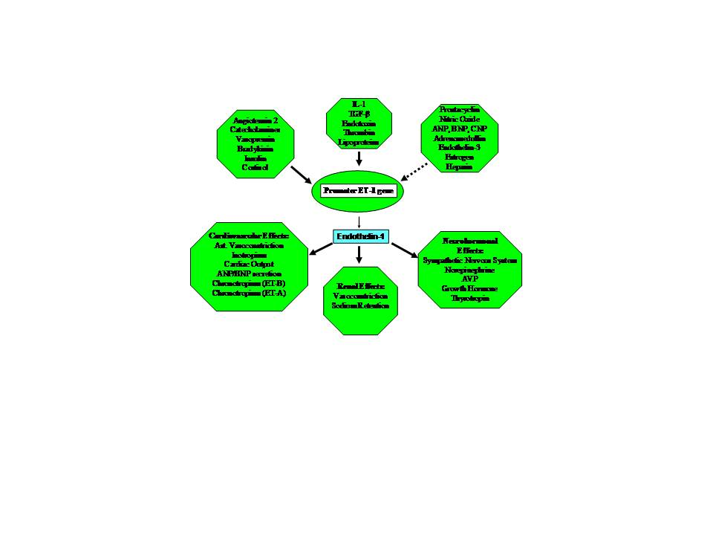
Figure 4. Regulation of Endothelin-1 synthesis, consequences of endothelin. (Solid arrow: stimulation, non-solid arrow: inhibition.)

SEX HORMONES
Acknowledging that gender differences in longevity and in the onset of cardiovascular disease may be due to sex hormone differences, hormone replacement therapy has been considered one option for women with early menopause either naturally occurring or surgically induced. In hysterectomized women estrogen therapy has been demonstrated to be more favorable in terms of lipid state than combined estrogen/progestin hormone substitution. However, estrogen therapy increased CRP as shown in the PEPI trial [95]. No effect has been found with regard to hemodynamics at rest [96]. Randomized clinical trials with postmenopausal women using either a combined hormone replacement therapy or unopposed estrogen replacement therapy both for secondary [97] and for primary [98] prevention of myocardial infarction were stopped prematurely due to the worse outcome in the treatment groups. However, the estrogen-alone hormone-replacement-therapy arm of the Women Health Initiative (hysterectomized women) showed promising data [99]. One of the theories behind the lack of protective effect of estrogen was timing of hormonal replacement. The average age in women in the WHI was 62 years, while the average menopause age in the U.S. is 51 years. Recently, the KEEPS study, where estradiol patches were administrated to postmenopausal women from the beginning of menopause, failed to show improvement in endothelial function compared to placebo [100]. At present, current guidelines restricting hormone replacement therapy to moderate or severe postmenopausal symptoms, will not be extended to primary or secondary cardiovascular protection [101]. More research is needed to elucidate the discrepancy observed with estrogen replacement between observational and randomized trials.
Testosterone can be converted peripherally and in fatty tissue to estradiol via aromatase which is especially important because of the current obesity epidemic. Obese men are often found to be type 2 diabetics and may concomitantly suffer from testosterone deficiency syndrome [102, 103]. As with many things, it is hard to find Aristotle’s middle, i.e. which testosterone level would be best for each individual patient. Testosterone replacement use has dramatically increased among men in the last few years [104]. Although testosterone exhibits many beneficial metabolic effect and as well increases in muscle strength. A clinical trial in which testosterone was given to elderly man was stopped early due to higher incidence of cardiovascular diseases [105]. A recent retrospective study by Vigen et al. showed that testosterone replacement in men with many comorbidities including CAD (more than 80%), prior myocardial infarction (20%), diabetes mellitus (50%), and others, was associated with increases in all cause-mortality [106]. These studies had major flaws [107]. Elucidating the mechanism(s) by which testosterone promotes cardiovascular diseases in some patients will shed light on advancing our understanding of the complex actions of testosterone in nonreproductive organs and exploit the beneficial effects of testosterone while avoiding its undesirable cardiovascular side effects. Of note, some mechanisms contributing to thrombosis have been reported by Virchow as the triad: hypercoagulability, hemodynamic changes (stasis, turbulence), and endothelial dysfunction/injury. Testosterone replacement therapy can increase blood viscosity. On the other hand, even if platelet counts are very low (which may not reflect platelet functionality), one can still develop a myocardial infarction [108], underscoring that in each individual patient with various comorbidities, one or more mechanism/s of thrombosis may be in effect. Similarly, both growth hormone excess and growth hormone deficiency may put individuals having either of these conditions at a higher cardiovascular risk [109].

VASOPRESSIN
Vasopressin, sometimes called antidiuretic hormone, is a hormone produced in the paraventricular and supraoptic nuclei of the hypothalamus and released by the posterior pituitary. It has powerful effects to regulate plasma osmolality. Vasopressin is also one of the most potent vasoconstrictors in the body, acting via activation of V1 receptors located on vascular smooth muscle cells. Vasopressin’s main function is to maintain plasma osmolality by increasing the permeability of the renal collecting tubules and collecting ducts to water, increasing body fluid volume [110]. Vasopressin is stimulated by hyperosmolality, hypovolemia, and hypotension. Vasopressin, due to its powerful vasoconstrictor action, has been used successfully in the setting of septic shock [111].
ADIPOKINES
Adipose tissue is now recognized as a biologically active hormonal system which interacts with both the brain and heart. Adipokines can exert either pro- or anti-inflammatory effects. Tumor necrosis factor α (TNF-α) is the classic pro-inflammatory cytokine and it has been associated with obesity and the metabolic syndrome [112, 113]. TNF-α levels predict the risk of coronary artery disease and heart failure and increased circulating levels are associated with mortality [114, 115]. One of the adipokines that is felt to be anti-inflammatory and therefore potentially beneficial is adiponectin. Adiponectin inhibits nuclear factor k-β activity after treatment with TNF-α, promotes M2 macrophage polarization, and increases clearance of apoptotic cells, thus exhibiting multiple anti-inflammatory effects [116-118]. Although adiponectin is produced by adipose tissue, there is an inverse relationship of its plasma levels and BMI in humans. Low plasma levels of adiponectin are associated with obesity, diabetes, and coronary artery disease and the risk for myocardial infarction and increased levels are associated with reduced cardiovascular risk.
Leptin is a hormone secreted by adipose tissue that has powerful effects to regulate body weight by reducing appetite and increasing metabolic activity via activation of the SNS. Leptin appears to prevent lipotoxic injury to the heart by increasing fatty acid oxidation [119, 120]. Stimulation of myocardial fatty acid oxidation and increased myocardial glucose utilization are proposed beneficial effects of leptin in settings of myocardial distress such as myocardial infarction or CHF [121]. Studies in rodent models have demonstrated that leptin’s beneficial metabolic effects may be mediated by augmented AMP-kinase activity [122, 123]. Leptin levels are elevated in patients with acute systolic heart failure. Animal studies have demonstrated that cardiac-specific deletion of the leptin receptor exacerbates myocardial injury in experimental myocardial infarction and worsened heart failure in cardiotoxic states [122, 123].

Summary
Cardiovascular hormones play an important role in homeostatic processes in the healthy organism and have become therapeutic targets in clinical syndromes such as CHF, coronary artery disease, CKD, or T2DM. Each of these clinical syndromes is characterized by specific states of neurohumoral stimulation arising from attempts to counteract pathophysiologic dysregulations. In everyday medicine, combinations of the aforementioned clinical entities/syndromes are often encountered. Even though therapies targeting hormone effects may not cure the underlying disease, exaggerated hemodynamic and non-hemodynamic hormone effects may be attenuated, thereby improving prognosis and/or quality of life.
Non-hemodynamic consequences of states of neurohumoral stimulation like inflammation and oxidative stress contribute to cardiac fibrosis and left ventricular hypertrophy. This, in turn, may lead to electrical instability and susceptibility for possibly life-threatening cardiac arrhythmias. Neurohumoral blockade may primarily achieve a more stable and economic cell metabolism by changes in oxygen demand, in prevalent oxidative stress and inflammation. This, in turn, may slow down disease evolution. However, the exact state of neurohumoral stimulation depends greatly on the underlying pathology. For both CKD [11] and CHF [124], neurohumoral activation may represent a final common pathophysiologic pathway. Therapies designed to attenuate neurohumoral activation in CHF actually counteract a vicious cycle, because the consequences of neurohumoral stimulation include increased oxidative stress, that in turn may aggravate neurohumoral stimulation [125]. Hormonal mechanisms promoting chronic inflammation [126] and oxidative stress [127] are involved in coronary artery disease progression

References
1. Cohn JN, Levine TB, Olivari MT, Garberg V, Lura D, Francis GS et al. Plasma norepinephrine as a guide to prognosis in patients with chronic congestive heart failure. N Engl J Med 1984; 311: 819-823.
2. Suzuki S, Yoshimura M, Nakayama M, Mizuno Y, Harada E, Ito T et al. Plasma level of B-type natriuretic peptide as a prognostic marker after acute myocardial infarction: a long-term follow-up analysis. Circulation 2004; 110: 1387-1391.
3. The SOLVD Investigators. Effect of enalapril on mortality and the development of heart failure in asymptomatic patients with reduced left ventricular ejection fractions. N Engl J Med 1992; 327: 685-691.

4. The SOLVD Investigators. Effect of enalapril on survival in patients with reduced left ventricular ejection fractions and congestive heart failure. N Engl J Med 1991; 325: 293-302.

5. The Consensus trial Study Group. Effects of enalapril on mortality in severe congestive heart failure. N Engl J Med; 1987:1429-1435

6. Foody JM, Farrell MH, Krumholz HM. Beta-Blocker therapy in heart failure: scientific review. JAMA 2002; 287:883-9.

7. Pitt B, Zannad F, Remme WJ, Cody R, Castaigne A, Perez A et al. The effect of spironolactone on morbidity and mortality in patients with severe heart failure. Randomized Aldactone Evaluation Study Investigators. N Engl J Med 1999; 341: 709-717.

8. Pitt B, Remme W, Zannad F, Neaton J, Martinez F, Roniker B et al. Eplerenone, a Selective Aldosterone Blocker, in Patients with Left Ventricular Dysfunction after Myocardial Infarction. N Engl J Med 2003; 348: 1309-1321.

9. Zannad F, McMurray JV, Krum H, van Veldhuisen DJ, Swedberg K, Shi H, et al. Eplerenone in patients with systolic heart failure and mild symptoms. N Engl J Med 2011; 364:11-21.

10. Yancy CW, Jessup M, Bozkurt B, Butler J, Casey DE Jr, Drazner MH, et al. 2013 ACCF/AHA guideline for the management of heart failure: executive summary: a report of the American College of Cardiology Foundation/American Heart Association Task Force on practice guidelines. Circulation 2013; 128:1810.

11. The Heart Outcomes Prevention Evaluation Study Investigators. Effects of an Angiotensin-Converting-Enzyme Inhibitor, Ramipril, on Cardiovascular Events in High-Risk Patients. N Engl J Med 2000; 342: 145-153.

12. Daugherty A, Rateri DL, Charo IF, Owens AP, Howatt DA, Cassis LA. Angiotensin II infusion promotes ascending aortic aneurysms: attenuation by CCR2 deficiency in apoE-/- mice. Clin Sci (Lond) 2010; 118: 681-689.
13. Tang EH, Shvartz E, Shimizu K, Rocha VZ, Zheng C, Fukuda D et al. Deletion of EP4 on Bone Marrow-Derived Cells Enhances Inflammation and Angiotensin II-Induced Abdominal Aortic Aneurysm Formation. Arterioscler Thromb Vasc Biol 2010;
14. Go AS, Chertow GM, Fan D, McCulloch CE, Hsu Cy: Chronic Kidney Disease and the Risks of Death, Cardiovascular Events, and Hospitalization. N Engl J Med 2004; 351: 1296-1305.
15. Siragy HM, Carey RM. Role of the intrarenal renin-angiotensin-aldosterone system in chronic kidney disease. Am J Nephrol 2010; 31: 541-550.
16. Jung O, Jansen F, Mieth A, Barbosa-Sicard E, Pliquett RU, Babelova A et al. Inhibition of the soluble epoxide hydrolase promotes albuminuria in mice with progressive renal disease. PLoS One 2010; 5: e11979.
17. Razzaque MS. The dualistic role of vitamin D in vascular calcifications. Kidney Int 2011; 79:708-714.
18. Ullah MI, Uwaifo GI, Nicholas WC, Koch CA. Does vitamin d deficiency cause hypertension? Current evidence from clinical studies and potential mechanisms. Int J Endocrinol 2010; 2010: 579640.
19. Bobryshev YV. Vitamin D3 suppresses immune reactions in atherosclerosis, affecting regulatory T cells and dendritic cell function. Arterioscler Thromb Vasc Biol 2010; 30: 2317-2319.
20. Pliquett RU, Fasshauer M, Bluher M, Paschke R. Neurohumoral stimulation in type-2-diabetes as an emerging disease concept. Cardiovasc Diabetol 2004; 3: 4.
21. Sattar N, Gaw A, Scherbakova O, Ford I, O'Reilly DS, Haffner SM et al. Metabolic Syndrome With and Without C-Reactive Protein as a Predictor of Coronary Heart Disease and Diabetes in the West of Scotland Coronary Prevention Study. Circulation 2003; 108: 414-419.
22. Cornier MA, Dabelea D, Hernandez TL, Lindstrom RC, Steig AJ, Stob NR et al. The metabolic syndrome. Endocr Rev 2008; 29: 777-822.

22. Sattar N, Gaw A, Scherbakova O, Ford I, O'Reilly DS, Haffner SM et al. Metabolic Syndrome With and Without C-Reactive Protein as a Predictor of Coronary Heart Disease and Diabetes in the West of Scotland Coronary Prevention Study. Circulation 2003; 108: 414-419.
23. Pischon T, Boeing H, Hoffmann K, Bergmann M, Schulze MB, Overvad K et al. General and Abdominal Adiposity and Risk of Death in Europe. New England Journal of Medicine 2008; 359: 2105-2120.

24. Alexopoulos N, Katritsis D, Raggi P. Visceral adipose tissue as a source of inflammation and promoter of atherosclerosis. Atherosclerosis 2014; 233:104-112.

25. Coutinho T1, Goel K, Corrêa de Sá D, Kragelund C, Kanaya AM, Zeller M, et al. Central obesity and survival in subjects with coronary artery disease: a systematic review of the literature and collaborative analysis with individual subject data. J Am Coll Cardiol 2011; 57:1877-1886.

26. Lindholm LH, Ibsen H, Borch J, Olsen MH, Wachtell K, Dahlof B et al. Risk of new-onset diabetes in the Losartan Intervention For Endpoint reduction in hypertension study. J Hypertens 2002; 20: 1879-1886.
27. Sabatine MS, Morrow DA, de L, Gibson CM, Murphy SA, Rifai N et al. Multimarker approach to risk stratification in non-ST elevation acute coronary syndromes: simultaneous assessment of troponin I, C-reactive protein, and B-type natriuretic peptide. Circulation 2002; 105: 1760-1763.

28. Ridker PM, Macfadyen JG, Nordestgaard BG, Koenig W, Kastelein JJ, Genest J et al. Rosuvastatin for primary prevention among individuals with elevated high-sensitivity c-reactive protein and 5% to 10% and 10% to 20% 10-year risk. Implications of the Justification for Use of Statins in Prevention: an Intervention Trial Evaluating Rosuvastatin (JUPITER) trial for "intermediate risk". Circ Cardiovasc Qual Outcomes 2010; 3: 447-452.

29. Heart Protection Study Collaborative Group. MRC/BHF Heart Protection Study of antioxidant vitamin supplementation in 20,536 high-risk individuals: a randomised placebo-controlled trial. Lancet 2002; 360: 23-33.
30. Zhang H, Schmeisser A, Garlichs CD, Plotze K, Damme U, Mugge A et al. Angiotensin II-induced superoxide anion generation in human vascular endothelial cells: role of membrane-bound NADH-/NADPH-oxidases. Cardiovasc Res 1999; 44: 215-222.
31. Kukin ML, Kalman J, Charney RH, Levy DK, Buchholz V, Ocampo ON et al. Prospective, randomized comparison of effect of long-term treatment with metoprolol or carvedilol on symptoms, exercise, ejection fraction, and oxidative stress in heart failure. Circulation 1999; 99: 2645-2651.

32. Parizadeh SM, Azarpazhooh MR, Moohebati M, Nematy M, Ghayour-Mobarhan M, Tavallaie S et al. Simvastatin Therapy Reduces Prooxidant-Antioxidant Balance: Results of a Placebo-Controlled Cross-Over Trial. Lipids 2011; 46:333-340.
33. Ota H, Eto M, Kano MR, Kahyo T, Setou M, Ogawa S et al. Induction of endothelial nitric oxide synthase, SIRT1, and catalase by statins inhibits endothelial senescence through the Akt pathway. Arterioscler Thromb Vasc Biol 2010; 30: 2205-2211.

34. Huss JM, Kelly DP. Mitochondrial energy metabolism in heart failure: a question of balance. J Clin Invest 2005; 115:547-555.

35. Kim TT, Dyck JR. Is AMPK the savior of the failing heart? Trends in Endocrinology and Metabolism 2015; 26:41-48.

36. Antonopoulos AS, Margaritis M, Coutinho P, Shirodaria C, Psarros C, HerdmanL, et al. Adiponectin as a link between type 2 diabetes mellitus and vascular NADPH-oxidase activity in the human arterial wall: the regulatory role of perivascular adipose tissue. Diabetes 2014, Epub ahead of print.

37. Attaran RR, Ewy GA. Epinephrine in resuscitation: curse or cure? Future Cardiol 2010; 6:473-482.

38. Vischer UM, Wollheim CB. Epinephrine induces von Willebrand factor release from cultured endothelial cells: involvement of cyclic AMP-dependent signalling in exocytosis. Thromb Haemost 1997; 77: 1182-1188.

39. Drummond GR, Cai H, Davis ME, Ramasamy S, Harrison DG. Transcriptional and posttranscriptional regulation of endothelial nitric oxide synthase expression by hydrogen peroxide. Circ Res 200; 86: 347-354.
40. Thomas SR, Chen K, Keaney JF. Hydrogen Peroxide Activates Endothelial Nitric-oxide Synthase through Coordinated Phosphorylation and Dephosphorylation via a Phosphoinositide 3-Kinase-dependent Signaling Pathway. Journal of Biological Chemistry 2002; 277: 6017-6024.
41. Aninat C, Seguin P, Descheemaeker PN, Morel F, Malledant Y, Guillouzo A. Catecholamines induce an inflammatory response in human hepatocytes. Crit Care Med 2008; 36: 848-854.
42. Schade R, Gohler K, Burger W, Hirschelmann R. Modulation of rat C-reactive protein serum level by dexamethasone and adrenaline--comparison with the response of alpha 2-acute phase globulin. Agents Actions 1987; 22: 280-287.
43. Bachman ES, Dhillon H, Zhang CY, Cinti S, Bianco AC, Kobilka BK et al. betaAR signaling required for diet-induced thermogenesis and obesity resistance. Science 2002; 297: 843-845.
44. Aizawa T, Ishizaka N, Usui S, Ohashi N, Ohno M, Nagai R. Angiotensin II and catecholamines increase plasma levels of 8-epi-prostaglandin F(2alpha) with different pressor dependencies in rats. Hypertension 2002; 39: 149-154.

45. Krum H, Schlaic M, Whitborn R, Sobotka, Sadowski J, Bartus K, et al. Catheter-based renal sympathetic denervation for resistant hypertension: a multicenter safety and proof-of-principle cohort study. Lancet 2009; 373:1275-1281.

46. Esler MD, Krum H, Sobotka PA, Schlaich MP, Schmieder RE, Böhm M. Renal sympathetic denervation in patients with treatment-resistant hypertension (The Symplicity HTN-2 Trial): a randomised controlled trial. Lancet 2010; 376:1903-1909.

47. Dörr O, Liebetrau C, Möllmann H, GaedeL, Troidl C, Wiebe J, et al. Influence of renal sympathetic denervation on vascular inflammation in essential hypertension. J Am Coll Cardiol 2014; 63: 61308-61305.

48. Pokushalov E, Romanov A, Corbucci G, Artyomenko S, Baranova V, Turov A, et al. A randomized comparison of pulmonary vein isolation with versus without concomitant renal artery denervation in patients with refractory symptomatic atrial fibrillation and resistant hypertension. J Am Coll Cardiol 2012; 60:1163-1170.

49. Bakris GL, Townsend RR, Liu M, Cohen SA, D'Agostino R, Flack JM, et al. Impact of renal denervation on 24-hour ambulatory blood pressure: results from SYMPLICITY HTN-3. J Am Coll Cardiol 2014; 64:1071-1078.

50. Bakris GL, Nadim MK, Haller H, Lovett EG, Schafer JE, Bisognano JD. Baroreflex activation therapy provides durable benefit in patients with resistant hypertension: results of long-term follow-up in the Rheos Pivotal Trial. J Am Soc Hypertens 2012; 6:152-158.

51. Georgakopoulos D, Little WC, Abraham WT, Weaver FA, Zile MR. Chronic baroreflex activation: a potential therapeutic approach to heart failure with preserved ejection fraction. J Card Fail 2011; 17:167-178.

52. Huggett RJ, Scott EM, Gilbey SG, Stoker JB, Mackintosh AF, Mary D. Impact of Type 2 Diabetes Mellitus on sympathetic neural mechanisms in hypertension. Circulation 2003; 108:3097-3101.

53. Mahfoud F, Schlaich M, Kindermann I, Ukena C, Cremers B, Brandt MC, et al. Effect of renal sympathetic denervation on glucose metabolism in patients with resistant hypertension: a pilot study. Circulation. 2011, 123:1940–1946.

54. Schlaich MP, Straznicky N, Grima M, Ika-Sari C, Dawood T, Mahfoud F, et al. Renal denervation: a potential new treatment modality for polycystic ovary syndrome? J Hypertens. 2011; 29:991–996.

55. Grassi G. Renal denervation in cardiometabolic disease: concepts, achievements and perspectives. Nutr Metab Cardiovasc Dis. 2013; 23: 77-83.
56. Yoshimura M, Yasue H, Morita E, Sakaino N, Jougasaki M, Kurose M et al. Hemodynamic, renal, and hormonal responses to brain natriuretic peptide infusion in patients with congestive heart failure. Circulation 1991; 84: 1581-1588.
57. Luchner A, Stevens TL, Borgeson DD, Redfield M, Wei CM, Porter JG et al. Differential atrial and ventricular expression of myocardial BNP during evolution of heart failure. Am J Physiol 1998; 274: H1684-H1689.
58. Yu CM, Sanderson JE. Plasma brain natriuretic peptide--an independent predictor of cardiovascular mortality in acute heart failure. Eur J Heart Fail 1999; 1: 59-65.
59. Mukoyama M, Nakao K, Obata K, Jougasaki M, Yoshimura M, Morita E et al. Augmented secretion of brain natriuretic peptide in acute myocardial infarction. Biochem Biophys Res Commun 1991; 180: 431-436.
60. Lam LL, Cameron PA, Schneider HG, Abramson MJ, M³ller C, Krum H. Meta-analysis: effect of B-type natriuretic peptide testing on clinical outcomes in patients with acute dyspnea in the emergency setting. Ann Intern Med 2010; 153: 728-735.
61. Lainchbury JG, Troughton RW, Strangman KM, Frampton CM, Pilbrow A, Yandle TG et al. N-terminal pro-B-type natriuretic peptide-guided treatment for chronic heart failure: results from the BATTLESCARRED (NT-proBNP-Assisted Treatment To Lessen Serial Cardiac Readmissions and Death) trial. J Am Coll Cardiol 2009; 55: 53-60.
62. Eurlings LW, van Pol PE, Kok WE, van Wijk S, Lodewijks-van der Bolt C, Balk AH et al. Management of chronic heart failure guided by individual N-terminal pro-B-type natriuretic peptide targets: results of the PRIMA (Can PRo-brain-natriuretic peptide guided therapy of chronic heart failure IMprove heart fAilure morbidity and mortality?) study. J Am Coll Cardiol 2010; 56: 2090-2100.
63. Morita H, Nishida Y, Motochigawa H, Kangawa K, Minamino N, Matsuo H et al. Effects of brain natriuretic peptide on renal nerve activity in conscious rabbits. Am J Physiol 1989; 256: R792-R796.
64. Kambayashi Y, Nakao K, Kimura H, Kawabata T, Nakamura M, Inouye K et al. Biological characterization of human brain natriuretic peptide (BNP) and rat BNP: species-specific actions of BNP. Biochem Biophys Res Commun 1990; 173: 599-605.
65. Ito T, Yoshimura M, Nakamura S, Nakayama M, Shimasaki Y, Harada E et al. Inhibitory effect of natriuretic peptides on aldosterone synthase gene expression in cultured neonatal rat cardiocytes. Circulation 2003; 107: 807-810.
66. Cataliotti A, Boerrigter G, Costello-Boerrigter LC, Schirger JA, Tsuruda T, Heublein DM et al. Brain natriuretic peptide enhances renal actions of furosemide and suppresses furosemide-induced aldosterone activation in experimental heart failure. Circulation 2004, 109: 1680-1685.
67. Lee SC, Stevens TL, Sandberg SM, Heublein DM, Nelson SM, Jougasaki M et al. The potential of brain natriuretic peptide as a biomarker for New York Heart Association class during the outpatient treatment of heart failure. J Card Fail 2002; 8: 149-154.

68. O'Connor CM, Starling RC, Hernandez AF, Armstrong PW, Dickstein K, Hasselblad V, et al. Effect of Nesiritide in Patients with Acute Decompensated Heart Failure. N Engl J Med 2011; 365: 32-43.

69. McMurray JJ, Packer M, Desai AS, Gong J, Lefkowitz MP, Rizkala AR, et al. Angiotensin-neprilysin inhibition versus enalapril in heart failure. N Engl J Med 2014; 371:993-1004.

70. Li YC, Kong J, Wei M, Chen ZF, Liu SQ, Cao LP. 1,25-Dihydroxyvitamin D(3) is a negative endocrine regulator of the renin-angiotensin system. J Clin Invest 2002; 110: 229-238.
71. Huang Y, Noble NA, Zhang J, Xu C, Border WA. Renin-stimulated TGF-[beta]1 expression is regulated by a mitogen-activated protein kinase in mesangial cells. Kidney Int 2007; 72: 45-52.
72. Parving HH, Persson F, Lewis JB, Lewis EJ, Hollenberg NK. Aliskiren combined with losartan in type 2 diabetes and nephropathy. N Engl J Med 2008; 358: 2433-2446.

73. Phillips LM, Wang Y, Dai T, Feldman DL, Lapage J, Adler SG. The Renin Inhibitor Aliskiren Attenuates High-Glucose Induced Extracellular Matrix Synthesis and Prevents Apoptosis in Cultured Podocytes. Nephron Exp Nephrol 2011; 118: e49-e59.

74. McMurray JJ, Pitt B, Latini R, Maggioni AP, Solomon SD, Keefe DL, et al. Effects of the oral direct renin inhibitor aliskiren in patients with symptomatic heart failure. Circ Heart Fail 2008; 1:17-24.

75. Solomon SD, Appelbaum E, Manning WJ, Verma A, Berglund T, Lukashevich V, et al. Effect of the direct Renin inhibitor aliskiren, the Angiotensin receptor blocker losartan, or both on left ventricular mass in patients with hypertension and left ventricular hypertrophy. Circulation 2009; 119:530-537.

76. Scirica BM, Morrow DA, Bode C, Ruzyllo W, Ruda M, Oude Ophuis AJ, et al. Patients with acute coronary syndromes and elevated levels of natriuretic peptides: the results of the AVANT GARDE-TIMI 43 Trial. Eur Heart J 2010; 31:1993-2005.
77. Roks AJ, van G, Pinto YM, Buikema H, Henning RH, de Z et al. Angiotensin-(1-7) is a modulator of the human renin-angiotensin system. Hypertension 1999; 34: 296-301.
78. Yamamoto K, Chappell MC, Brosnihan KB, Ferrario CM. In vivo metabolism of angiotensin I by neutral endopeptidase (EC 3.4.24.11) in spontaneously hypertensive rats. Hypertension 1992; 19: 692-696.
79. Barton M, Shaw S, Uscio LV, Moreau P, Luscher TF. Angiotensin II increases vascular and renal endothelin-1 and functional endothelin converting enzyme activity in vivo: role of ETA receptors for endothelin regulation. Biochem Biophys Res Commun 1997; 238: 861-865.
80. Gao L, Wang WZ, Wang W, Zucker IH. Imbalance of angiotensin type 1 receptor and angiotensin II type 2 receptor in the rostral ventrolateral medulla: potential mechanism for sympathetic overactivity in heart failure. Hypertension 2008; 52: 708-714.
81. Mann JF, Schmieder RE, McQueen M, Dyal L, Schumacher H, Pogue J et al. Renal outcomes with telmisartan, ramipril, or both, in people at high vascular risk (the ONTARGET study): a multicentre, randomised, double-blind, controlled trial. Lancet 2008; 372: 547-553.
82. Yoshimura M, Nakamura S, Ito T, Nakayama M, Harada E, Mizuno Y et al. Expression of aldosterone synthase gene in failing human heart: quantitative analysis using modified real-time polymerase chain reaction. J Clin Endocrinol Metab 2002; 87: 3936-3940.
83. Mizuno Y, Yoshimura M, Yasue H, Sakamoto T, Ogawa H, Kugiyama K et al. Aldosterone production is activated in failing ventricle in humans. Circulation 2001; 103: 72-77.
84. Linas SL, Peterson LN, Anderson RJ, Aisenbrey GA, Simon FR, Berl T Mechanism of renal potassium conservation in the rat. Kidney Int 1979; 15: 601-611.
85. Bauer JH, Gauntner WC: Effect of potassium chloride on plasma renin activity and plasma aldosterone during sodium restriction in normal man. Kidney Int 1979; 15: 286-293.
86. Weber KT: Aldosterone in congestive heart failure. N Engl J Med 2001; 345: 1689-1697.
87. Losel RM, Feuring M, Falkenstein E, Wehling M. Nongenomic effects of aldosterone: cellular aspects and clinical implications. Steroids 2002; 67: 493-498.

88. Rocha R, Williams GH. Rationale for the use of aldosterone antagonists in congestive heart failure. Drugs 2002; 62: 723-731.
89. Hayashi H, Kobara M, Abe M, Tanaka N, Gouda E, Toba H et al. Aldosterone nongenomically produces NADPH oxidase-dependent reactive oxygen species and induces myocyte apoptosis. Hypertens Res 2008; 31: 363-375.
90. Godfrey V, Farquharson CA, Macdonald JE, Yee KM, Struthers AD. Effect of spironolactone on C-reactive protein levels in patients with heart disease. Int J Cardiol 2007; 117: 282-284.
91. Funder JW, Mihailidou AS. Aldosterone and mineralocorticoid receptors: Clinical studies and basic biology. Mol Cell Endocrinol 2009; 301: 2-6.
92. Liu JL, Pliquett RU, Brewer E, Cornish KG, Shen YT, Zucker IH. Chronic endothelin-1 blockade reduces sympathetic nerve activity in rabbits with heart failure. Am J Physiol Regul Integr Comp Physiol 2001; 280: R1906-R1913.
93. Cozza EN, Gomez-Sanchez CE. Mechanisms of ET-1 potentiation of angiotensin II stimulation of aldosterone production. Am J Physiol 1993; 265: E179-E183.
94. Browatzki M, Schmidt J, Kubler W, Kranzhofer R. Endothelin-1 induces interleukin-6 release via activation of the transcription factor NF-kappaB in human vascular smooth muscle cells. Basic Res Cardiol 2000; 95: 98-105.
95. Effects of hormone replacement therapy on endometrial histology in postmenopausal women. The Postmenopausal Estrogen/Progestin Interventions (PEPI) Trial. The Writing Group for the PEPI Trial. JAMA 1996; 275: 370-375.
96. Hunt BE, Davy KP, Jones PP, DeSouza CA, Van P, Tanaka H et al. Systemic hemodynamic determinants of blood pressure in women: age, physical activity, and hormone replacement. Am J Physiol 1997; 273: H777-H785.
97. Grady D, Herrington D, Bittner V, Blumenthal R, Davidson M, Hlatky M et al. Cardiovascular disease outcomes during 6.8 years of hormone therapy: Heart and Estrogen/progestin Replacement Study follow-up (HERS II). JAMA 2002; 288: 49-57.
98. Writing Group for the Women's Health Initiative Investigators: Risks and Benefits of Estrogen Plus Progestin in Healthy Postmenopausal Women: Principal Results From the Women's Health Initiative Randomized Controlled Trial. JAMA 2002; 288: 321-333.
99. Manson JE, Allison MA, Rossouw JE, Carr JJ, Langer RD, Hsia J et al. Estrogen therapy and coronary-artery calcification. N Engl J Med 2007; 356: 2591-2602.
100. Kling JM, Lahr BA, Bailey KR, Harman SM, Miller VM, Mulvagh SL. Endothelial function in women of the Kronos Early Estrogen Prevention Study. Climacteric 2014; 22:1-26.

101. Santen RJ, Allred DC, Ardoin SP, Archer DF, Boyd N, Braunstein GD et al. Postmenopausal hormone therapy: an Endocrine Society scientific statement. J Clin Endocrinol Metab 2010; 95: s1-s66.

102. Singh SK, Goyal R, Pratyush DD. Is hypoandrogenemia a component of metabolic syndrome in males? Exp Clin Endocrinol Diabetes 2011; 119: 30-35.
103. Ullah MI, Washington T, Kazi M, Tamanna S, Koch CA. Testosterone deficiency as a risk factor for cardiovascular disease. Horm Metab Res 2011; 43:153-164.

104. Baillargeon J, Urban RJ, Ottenbacher KJ, Pierson KS, Goodwin JS. Trends in androgen prescribing in the United States, 2001 to 2011. JAMA Intern Med 2013; 173:1465-1466.

105. Basaria S, Coviello AD, Travison TG, Storer TW, Farwell WR, Jette AM, et al. Adverse events associated with testosterone administration. N Engl J Med 2010; 363:109-122.

106. Vigen R, O'Donnell CI, Barón AE, Grunwald GK, Maddox TM, Bradley SM, et al. Association of testosterone therapy with mortality, myocardial infarction, and stroke in men with low testosterone levels. JAMA 2013; 310, 1829-1836.

107. Riche DM, Baker WL, Koch CA. Deaths and cardiovascular events in men receiving testosterone. JAMA 2014; 311:963-9644.

108. Koch CA, Archer TP, Kraut EH. Myocardial ischemia in a patient with chronic refractory idiopathic thrombocytopenic purpura. Arch Intern Med 1997;157:2668.

109. Merriam DHP, Merriam GR. Hypertension in growth hormone excess and deficiency. In: Endocrine hypertension. Koch CA, Chrousos GP (eds). New York: Springer. 2013: 151-180

110. Hall JE, Guyton AC. Pituitary hormones andtheir control by the hypothalamus. In: Guyton and Hall Textbook of Medical Physiology, 12th ed. Philadelphia, PA: Saunders/Elsevier. 2011:904-905.

111. Serpa Neto A, Nassar AP, Cardoso SO, Manetta JA, Pereira VG, Espósito DC,et al. Vasopressin and terlipressin in adult vasodilatory shock: a systematic review and meta-analysis of nine randomized controlled trials. Crit Care 2012; 16:R154.

112. Hotamisligil GS, Spiegelman BM. Tumor Necrosis Factor α: A Key Component of the Obesity-Diabetes Link. Diabetes 1994; 43:1271-1278.

113. Emanuela F, Grazia M, Marco DR, Paola LM, Giorgio F, Marco B. Inflammation as a Link between Obesity and Metabolic Syndrome. J Nutr Metab 2012; 476380.

114. Feldman AM, Mann DL, She L, Bristow MR, Maisel AS, McNamara DM, et al. Prognostic significance of biomarkers in predicting outcome in patients with coronary artery disease and left ventricular dysfunction: results of the biomarker substudy of the Surgical Treatment for Ischemic Heart Failure trials. Circ Heart Fail 2013; 6:461-472.

115. Ridker PM, Rifai N, Pfeffer M, Sacks F, Lepage S, Braunwald E. Elevation of Tumor Necrosis Factor-α and Increased Risk of Recurrent Coronary Events After Myocardial Infarction. Circulation 2000; 101:2149-2153.

116. Aprahamian TR, Sam F. Adiponectin in cardiovascular inflammation and obesity. Int J Inflam 2011; 2011:376909.

117. Klöting N1, Blüher M. Adipocyte dysfunction, inflammation and metabolic syndrome. Rev Endocr Metab Disord 2014;15:277-287.

118. Shibata R, Ouchi N, Murohara T. Adiponectin and cardiovascular disease. Circ J 2009; 73:608-614.

119. Unger RH, Zhou YT, Orci L. Regulation of fatty acid homeostasis in cells: novel role of leptin. Proc Natl Acad Sci U S A. 1999; 96:2327-32.

120. Hall ME, Maready MW, Hall JE, Stec DE. Rescue of cardiac leptin receptors in db/db mice prevents myocardial triglyceride accumulation. Am J Physiol Endocrinol Metab. 2014; 307:E316-25.
121. Witham W, Yester K, O'Donnell CP, McGaffin KR. Restoration of glucose metabolism in leptin-resistant mouse hearts after acute myocardial infarction through the activation of survival kinase pathways. J Mol Cell Cardiol. 2012; 5:91-100.
122. Hall ME, Smith G, Hall JE, Stec DE. Cardiomyocyte-specific deletion of leptin receptors causes lethal heart failure in Cre-recombinase-mediated cardiotoxicity. Am J Physiol Regul Integr Comp Physiol. 2012; 303:R1241-50.
123. McGaffin KR, Witham WG, Yester KA, Romano LC, O'Doherty RM, McTiernan CF, et al. Cardiac-specific leptin receptor deletion exacerbates ischaemic heart failure in mice. Cardiovasc Res. 2011; 89:60-71.
124. Bolger AP, Sharma R, Li W, Leenarts M, Kalra PR, Kemp M et al. Neurohormonal activation and the chronic heart failure syndrome in adults with congenital heart disease. Circulation 2002, 106: 92-99.

125. Gao L, Wang W, Li YL, Schultz HD, Liu D, Cornish KG et al. Superoxide Mediates Sympathoexcitation in Heart Failure: Roles of Angiotensin II and NAD(P)H Oxidase. Circ Res 2004; 95: 937-944.
126. Ridker PM, MacFadyen J, Libby P, Glynn RJ. Relation of baseline high-sensitivity C-reactive protein level to cardiovascular outcomes with rosuvastatin in the Justification for Use of statins in Prevention: an Intervention Trial Evaluating Rosuvastatin (JUPITER). Am J Cardiol 2010; 106: 204-209.

127. Heitzer T, Schlinzig T, Krohn K, Meinertz T, Munzel T. Endothelial dysfunction, oxidative stress, and risk of cardiovascular events in patients with coronary artery disease. Circulation 2001; 104: 2673-2678.

