**IDIOPATHIC SHORT STATURE AND GROWTH FAILURE OF UNKNOWN ETIOLOGY**

**Mabel Yau, MD,** Assistant Professor, Division of Pediatric Endocrinology and Diabetes, Mount Sinai Kravis Children’s Hospital, New York, NY, [mabel.yau@mssm.edu](mailto:mabel.yau@mssm.edu)

**Jessica Lu, BA,** Division of Pediatric Endocrinology and Diabetes, Mount Sinai Kravis Children’s Hospital, New York, NY, [jlu34@nyit.edu](mailto:jlu34@nyit.edu)

**Robert Rapaport, MD,** Professor, Division of Pediatric Endocrinology and Diabetes, Mount Sinai Kravis Children’s Hospital, New York, NY, [robert.rapaport@mountsinai.org](mailto:robert.rapaport@mountsinai.org)

**Received October 23, 2023**

**ABSTRACT**

Idiopathic short stature (ISS) is defined by a height standard deviation score (SDS) ≤ -2.25 (≤1.2nd percentile) in pediatric patients for whom diagnostic evaluation has excluded other causes of short stature, and growth hormone levels are above 10 nanograms per milliliter in response to physiologic/pharmacologic stimulation. This definition, while comprehensive, is static and does not consider the importance of longitudinal follow up of growth, and consideration of evolving causes of growth hormone deficiency in these children. Using three illustrative cases, we highlight the importance of longitudinal evaluation of children with short stature to establish a growth pattern, identifying evolving causes of GH deficiency which may not be apparent on the initial work up, as well as exclusion of non-growth hormone related factors that affect growth including malabsorptive diseases, familial short stature, constitutional delay in puberty, Turner's syndrome, and SHOX Gene haploinsufficiency to accurately make a diagnosis of growth failure of unknown etiology (GFUE).

**INTRODUCTION**

In the 1980s, data on growth outcomes on patients who received growth hormone treatment were reported in an observational study (1); this included children who had a normal peak growth hormone response to stimulation, a group that was termed “constitutional short stature”. The term, idiopathic short stature (ISS), was later adopted to describe such patients (2). Guidelines for the use of growth hormone in children published by the Pediatric Endocrine Society defined ISS by a height standard deviation score (SDS) ≤-2.25 (≤1.2nd percentile) in pediatric patients for whom diagnostic evaluation excludes other causes of short stature, and with growth hormone levels above 10 nanograms per milliliter in response to physiologic/pharmacologic stimulation (3). The evaluation of children with short stature includes observation over a prolonged period to establish a growth pattern as well as the exclusion of non-growth hormone related factors that affect growth (4, 5). To monitor children's growth patterns in the United States, the Center for Disease Control (CDC) chart utilizes percentiles, with the 3rd and 95th percentiles serving as the defined limits. Across the globe, the World Health Organization (WHO) charts are used to track a child's growth progression, and the limits are set at 2.3rd and 97.7th percentiles (5). There are wide variations in normal growth patterns and an even greater variety of conditions that manifest with growth abnormalities. Various factors contribute to the etiology of short stature, and this includes normal variants of growth such as familial short stature, constitutional delay in growth and puberty, as well as systemic conditions such as malabsorptive diseases, Turner's syndrome, and SHOX Gene haploinsufficiency, among others (Table 1). Diagnostic tests at initial presentation by pediatric endocrinologists focus on elucidating the underlying cause of poor growth (Table 2). Globally, malnutrition remains the main cause of poor growth (5).

In 2003, the Food and Drug Administration (FDA) approved the use of growth hormone (GH) for children with ISS. Two decades later, growth hormone therapy for idiopathic short stature remains controversial. ISS is not universally accepted as an indication for treatment with GH. This medication was approved for ISS in US, Canada, and Latin America, but not in the European Union or Japan (6). Along with other investigators, we have expressed concerns about the definition of ISS (7). The Pediatric Endocrine Society consensus statement did not specifically exclude patients with normal variants of growth such as constitutional growth delay and familial short stature (3). The definition focuses on stature, rather than growth and growth failure, therefore making GH treatment of such patients open to criticism for its use as only a height enhancer. In addition, as we have previously argued, a child whose height decelerates from the 75 to the 25th percentile without any known cause would also be of concern even though the height would not fit the ISS definition (7). If no cause is found after clinical, appropriate biochemical and radiologic evaluation, such a patient may have what we would prefer to term idiopathic growth failure (IGF). In as much as those initials are already in use for Insulin Like Growth Factor, we prefer the term GFUE, or growth failure of unknown etiology, thereby emphasizing the concern about growth failure, not just stature.

To illustrate the potential dilemmas in diagnosis, we present three patients with similar patterns of growth and a normal response to initial growth hormone stimulation testing with 2 provocative agents; each of these children may have been called ISS but demonstrate radically different outcomes.

|  |  |
| --- | --- |
|  |  |
| **Table 1. Common Causes of Short Stature and Growth Failure** | |
| **Normal variants of growth** |  |
|  | Familial short stature |
|  | Constitutional delay in growth and puberty (CDGP) |
| **Systemic disorders** |  |
| Endocrine | Growth hormone deficiency |
|  | Hypothyroidism  Cortisol excess (endogenous or exogenous) |
| Non-endocrine | Malnutrition |
|  | Malabsorptive diseases |
|  | Genetic syndromes: Turner's syndrome, Noonan’s syndrome, Achondroplasia, SHOX gene haploinsufficiency |
|  | Chronic inflammatory conditions (e.g.: Inflammatory bowel diseases) |
|  | Chronic medical conditions (e.g.: asthma on inhaled steroids) |

|  |
| --- |
| **Table 2. Diagnostic Tests at Initial Investigation of Idiopathic Short Stature and Growth Failure of Unknown Etiology** |
| CBC, ESR |
| Urinalysis |
| Basic metabolic panel- BUN, creatinine, electrolytes |
| Celiac screen |
| Karyotype |
| TSH, Free T4 |
| IGF1, IGFBP3 |
| Bone age x ray |

**PATIENT 1**

A boy aged 12 years and 5 months was evaluated for poor growth; both the father and paternal uncle were “late bloomers”. The height was at the 6th percentile, weight at 9th percentile, and Body Mass Index or BMI (weight in Kg divided by the square of height in meters) was at 32nd percentile, and his growth velocity was 3.8 cm per year. Clinical examination indicated Tanner stage 1 pubertal development with testes volume of 2-3mL bilaterally. Laboratory tests performed by the referring pediatrician before endocrine consultation showed normal thyroid function tests, sedimentation rate, C-Reactive protein, and no thyroid autoantibodies. A radiological bone age study confirmed delayed skeletal maturation, with a bone age of 10 years. No additional tests were recommended at the Pediatric endocrinology clinic, and he was observed clinically.

At 14 years of age, the patient showed no signs of puberty. Figure 1 shows his longitudinal growth during follow up. His height was the 2nd percentile, weight at the 6th percentile, BMI at the 31st percentile, and growth velocity remained at 3.8 cm per year. Delayed puberty in males is defined as the absence of testicular growth at an age that is 2 to 2.5 SD later than the reference population, which usually is around 14 years of age. (7) Laboratory results revealed low IGF-1 levels (-1.8 SDS for age and gender), while LH levels were close to pubertal levels, and testosterone levels remained prepubertal. A growth hormone (GH) stimulation test with the provocative agents, arginine and clonidine, was conducted due to the declining growth velocity and the low IGF-1 levels. Upon stimulation, peak GH level was 15 ng/ml. At 14 years and 6 months old, the patient's height was at the1st percentile and growth velocity had decreased to 1.9 cm per year. The laboratory tests at that visit showed that IGF-1 levels had increased to 226 ng/mL and testosterone was now 45.7 ng/dL, consistent with Tanner stage 2 pubic hair, and 4 ml testicular volume noted on examination. A bone age study confirmed delayed skeletal maturation, with a bone age of 10 years and 6 months. Since the patient had not progressed in puberty at the age of 14 years and 6 months, testosterone priming at a dose of 100 mg intramuscularly, once in 4 weeks for 3 months was initiated. At 15 years of age, his growth velocity had accelerated to 16.4 cm per year and his height was at the 5th percentile. Laboratory tests performed at 15.5 years showed that testosterone level was 301 ng/dL with a LH of 0.57 mIU/ml and IGF-1 levels had increased to 340 ng/ml. A bone age study showed the bone age to be consistent with 14 years and 6 months old. At 16 years and 11 months of age, the patient's height had reached the 36th percentile. Pubertal development had advanced with Tanner stage 3-4 for pubic hair development and testicular volume of 15mL bilaterally.

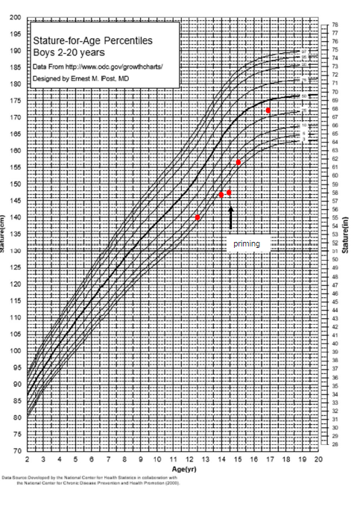

**Figure 1. Patient 1 growth chart: Longitudinal growth chart in patient 1 before and after sex hormone priming.**

**DISCUSSION PATIENT 1**

This patient’s height at presentation met the criteria for the diagnosis of Idiopathic Short Stature (ISS) since the patient's height was below -2.25 SD (8). However, with longitudinal follow-up, patient 1 ultimately proved to have constitutional growth delay (Figure 1). The diagnostic approach employed for this patient centered on monitoring. Once testosterone priming was employed, puberty progressed, and he reached his expected adult height. Through a targeted endocrine evaluation and longitudinal monitoring, the patient's condition was successfully managed without growth hormone treatment. This case underscores the importance of judicious use of testing.

The onset of puberty differs between boys and girls. In girls, 95% manifest at least one sign of puberty by 13 years of age whereas boys should begin signs of puberty by 14 years of age. In patients with delayed puberty and slow growth, a careful family history may be consistent with constitutional delay of growth and puberty. There often may be a history of a family member who also did not begin puberty until late into the teenage years, as in the case with the proband’s father and uncle. These patients can be difficult to diagnose because they may appear to be slowing in growth as they cross growth percentiles around the time of the anticipated pubertal growth spurt. Patients with constitutional growth delay fall behind their peers initially but have increased growth velocity later when puberty progresses and most reach adequate adult heights. Patients with constitutional growth delay have delayed bone ages and do not require treatment with growth hormone.

**PATIENT 2**

A boy presents at 12 years 9 months of age with growth failure and short stature. The patient's height had declined from 25th percentile to 10th percentile over 1.5 years, BMI was 40th percentile, growth velocity was 3.8 cm per year, and he was prepubertal. The parental target height was 176.7 cm (50th percentile). Laboratory tests showed that the testosterone level was 12 ng/dL, IGF-1 level was 125ng/mL (-2.06 SD), and bone age study was consistent with 12 years of age. Because of the low growth velocity and IGF1 level, the patient had a growth hormone (GH) stimulation test with provocative agents, arginine, and clonidine. The results showed a peak GH level of 16.9 ng/ml.At 13.5 years old, the patient’s height further declined to be at -2.25 SD and growth velocity was 2.84 cm per year. Figure 2 shows patient 2’s growth trajectory during follow-up. His testicular volume was 6mL bilaterally while tests showed IGF-1 to be114 ng/mL (-2.21 SD), thyroid function tests were normal, early morning cortisol level was 15.2 ug/dL, prolactin was 10 ng/ml, testosterone level 79 ng/dL, the luteinizing hormone was 3.2 mIU/mL, and the follicle-stimulating hormone was 2.1 mIU/mL, all consistent with pubertal progression. As puberty progressed, the growth velocity did not increase leading to a decline in height standard deviation. In the setting of this growth deceleration despite pubertal progression, a second growth hormone stimulation test with arginine and L-dopa was performed. The GH stimulation test revealed a peak GH level of 5.4 ng/ml. This low peak GH level is consistent with growth hormone deficiency (GHD). On pituitary magnetic resonance imaging, the pituitary gland appeared normal but small. The patient was treated with daily recombinant human growth hormone for 4.8 years. He reached an adult height at the 90th percentile (1.3 SDS), slightly above mid parental height (Figure 2).

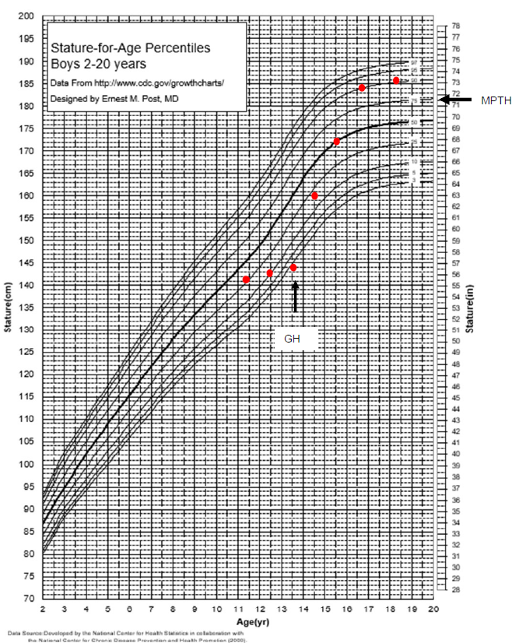

**Figure 2. Patient 2 growth chart: Longitudinal growth chart in patient 2 before and after growth hormone therapy. GH denotes growth hormone. MPTH denotes mid-parental target height.**

**DISCUSSION PATIENT 2**

This patient's referral to a pediatric endocrinologist stemmed from decline in height, subpar growth velocity considering stage of puberty, and low levels of insulin-like growth factor 1 (IGF-1). Based on his normal response to the first growth hormone (GH) stimulation test, the patient’s diagnosis was consistent with Idiopathic Short Stature (ISS). With continued monitoring, it was apparent that further growth deceleration occurred despite advent and progression of puberty. With an additional growth hormone (GH) stimulation test, the patient was ultimately diagnosed to have evolving growth hormone deficiency. GHD can be congenital or acquired, developing over time. The mechanism of idiopathic GHD might be due to a functional, transient decrease in somatomedin secretion insufficient to maintain growth as puberty sets in. Isolated GHD can be diagnosed using a combination of measuring growth factors, bone age X-rays, and growth hormone stimulation testing (9). Long-term monitoring as children progress into puberty is essential to uncover these instances of evolving GHD (9). It is imperative to emphasize the significance of prolonged follow-up and repeated testing to ensure the accurate diagnosis of GHD, rather than classifying the patient under the category of ISS or constitutional delay in growth and puberty (CDGP). In this case, physicians employed a meticulous approach of closely observing the decline in height and height velocity as puberty advanced, alongside screening tests such as IGF-1 measurement and multiple growth hormone stimulation tests. This comprehensive methodology allowed for the accurate diagnosis of GHD.

Despite the recognition of their many flaws, including poor reproducibility, non-physiologic assessment, and practical considerations, provocative tests remain part of the comprehensive evaluation of growth and are essential for the diagnosis of GHD (10). For GH stimulation testing, two agents that provoke GH secretion from the pituitary (L-dopa, clonidine, arginine, glucagon) are administered following an overnight fast. These provocative agents are not physiological and do not replicate normal secretory dynamics. In this patient with short stature, the clinical picture of low growth velocity as puberty progressed plus low IGF-1 levels are indicative of late, or evolving GHD.

**PATIENT 3**

A girl aged 13 years and 6 months was referred to a pediatric endocrinology clinic to evaluate her short stature. The patient had a medical history of ADHD diagnosed at the age of 7 years, and multiple surgeries for strabismus in both eyes. Her mid-parental height was at the 5th percentile. Axillary hair developed at 11 years of age and breast development started around 10-11 years. At age 13.5 years, the height was at the 1st percentile (-2.27 SD), weight was at <1 percentile, and BMI was at the 6th percentile. Tanner stage of breast development was 3 and pubic hair had been shaved. The patient had small hands and feet, bilateral fifth finger clinodactyly, brachydactyly, and a slightly increased carrying angle. The bone age was12.5 years old with shortening and broadening of the metacarpals which raised concerns for hypochondroplasia. Chromosomal analysis showed a normal female karyotype, 46XX. SHOX gene analysis did not reveal mutations or deletions. This patient had a normal response to growth hormone stimulation test with provocative agents, arginine, and clonidine; peak growth hormone level was 18 ng/ml. The patient was referred to a medical geneticist to undergo further genetic testing to explain her short stature. Repeated chromosome analysis counting 50 cells, had normal female karyotype of 46XX excluding mosaic Turner Syndrome. The microarray results found gain in a 1.5 Mb copy at 10p15.3. The Fragile X test was negative, it did not reveal FMR1 CGG repeat expansions. A genetic testing panel for skeletal dysplasia investigated twenty-nine genes associated with skeletal dysplasia and the results showed no mutations or deletions. Whole exome sequencing did not reveal any variant in disease genes possibly associated with a short stature phenotype. In this patient with height -3 SDS and low mid parental height, treatment with growth hormone resulted in modest gains in height SDS. Figure 3 shows this patient’s growth before and after growth hormone therapy.

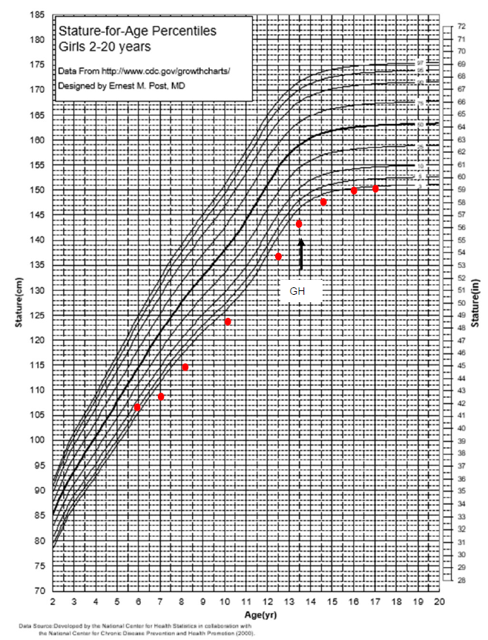

**Figure 3. Patient 3 growth chart: Longitudinal growth chart in patient 2 before and after growth hormone therapy. GH denotes growth hormone.**

**DISCUSSION PATIENT 3**

The cause of this patient’s short stature was not apparent despite extensive testing; thus, the diagnosis remains Growth Failure of Unknown Etiology, (GFUE) or Idiopathic short stature (ISS). After repeated genetic testing and thorough whole exome sequencing the etiology of the patient’s growth failure remained elusive. Case three presents the roadmap for a proper diagnosis of GFUE/ ISS using diagnoses of exclusion. The patient's height declined below >2.25 SD score below the mean height for a given age and sex, and through extensive genetic testing, there were no abnormalities found. Through a rigorous process of extensive evaluations and the systematic elimination of alternative causes for short stature, including malabsorptive diseases, familial short stature, constitutional delay in puberty, Turner syndrome, and SHOX Gene haploinsufficiency, the patient ultimately received a diagnosis of GFUE or idiopathic short stature.

ISS or GFUE may exist as a primary diagnosis alone or may be subcategorized to include ISS with familial short stature or constitutional delay of growth and puberty. Patients with ISS are often predicted to have an adult height below that expected based on mid parental height. It is thought that GH may increase the adult height of patients with ISS by 3.5 to 7.5 cm when compared with controls (11). GH-treated children with ISS have also been reported to achieve height gain similar to patients with isolated GHD (6). Additional considerations for treatment in conjunction with GH include gonadotropin- releasing hormone (GnRH) analogs and aromatase inhibitors. Both classes of medications seek to decrease bone age maturation while allowing the child to continue to grow. These agents are still considered experimental when used for improving growth and more studies are needed (12, 13). IGF-1 has received some attention recently as a potential treatment for ISS. Currently, IGF-1 is only approved for those patients with proven IGF-1 deficiency (IGF-1 levels –3 SD from the mean) with heights below –3 SD from the mean for age and normal stimulated GH levels. There is a lack of prospective studies that show clear benefit of IGF-1 for ISS. IGF-1 has also been associated with potential side effects, including hypoglycemia, headaches, lymphoid tissue hypertrophy, and coarsening of facial features (4). Further studies must be performed before IGF-1 can be considered a treatment option for GFUE/ISS.

The concept that short stature alone is a problem that must be treated often leads to patients seeking treatment for cosmetic, rather than medical reasons to attain an adult height the patient or family feel is appropriate. It is important to stress that short stature itself is not necessarily a medical problem. However, a pattern of growth consistent with growth failure (decreasing growth velocity, growth velocity consistently <50 percentile) regardless of height percentile should be evaluated further. If an underlying cause of growth failure cannot be found, we propose that it is appropriate to use a term such as “idiopathic growth failure” or “growth failure of unknown etiology” (GFUE) rather than “idiopathic short stature.” These terms take the focus off stature as the overriding problem, placing it into an element that all can agree needs investigation and, if persistent, needs intervention for its reversal. Height predictions always, but especially in the face of subnormal growth rates, are likely to be inaccurate and should be provided with a great deal of caution (5). We believe that familial short stature and constitutional delay of growth and puberty should be removed from the current overall category of “ISS” and placed under the category “normal variant.”

A child should be labeled as GFUE/ISS only after an in depth evaluation for other etiologies has been performed (7). As Next Generation Sequencing (NGS) and other diagnostic techniques become established, the number of patients with unidentified causes for growth failure is likely to diminish.

**CONCLUSION**

The three illustrative cases above help to show the significance of comprehensive testing, thorough evaluations, and rigorous longitudinal monitoring, to exclude currently known causes of short stature. Every effort should be made to avoid any bias in referral and evaluation of short stature based on gender, ethnic or racial differences (14).  With these guidelines, two of the three patients initially presented with features aligned with the diagnostic criteria for growth failure of unknown etiology (GFUE)/ISS. Through subsequent testing and prolonged monitoring, alternative underlying diagnoses were identified: constitutional growth delay, and acquired, idiopathic, isolated growth hormone deficiency. In the third case, we present the roadmap for a proper diagnosis of GFUE/ ISS that is based on specific phenotypic characteristics. The diagnosis of ISS/GFUE should only be assigned after an exhaustive exploration of all diagnostic possibilities, ensuring that patients are provided with precise diagnoses and subsequently, if indicated, appropriate medication-based treatments to achieve height gain.

**REFERENCES**

1. Gertner, J.M., et al., Prospective clinical trial of human growth hormone in short children without growth hormone deficiency. J Pediatr, 1984. 104(2): p. 172-6.

2. Hintz, R.L., Growth hormone treatment of idiopathic short stature. Horm Res, 1996. 46(4-5): p. 208-14.

3. Wilson, T.A., et al., Update of guidelines for the use of growth hormone in children: the Lawson Wilkins Pediatric Endocrinology Society Drug and Therapeutics Committee. J Pediatr, 2003. 143(4): p. 415-21.

4. Grimberg, A., et al., Guidelines for Growth Hormone and Insulin-Like Growth Factor-I Treatment in Children and Adolescents: Growth Hormone Deficiency, Idiopathic Short Stature, and Primary Insulin-Like Growth Factor-I Deficiency. Horm Res Paediatr, 2016. 86(6): p. 361-397.

5. Graber, E. and R. Rapaport, Growth and growth disorders in children and adolescents. Pediatr Ann, 2012. 41(4): p. e1-9.

6. Child, C.J., et al., Height Gain and Safety Outcomes in Growth Hormone-Treated Children with Idiopathic Short Stature: Experience from a Prospective Observational Study. Horm Res Paediatr, 2019. 91(4): p. 241-251.

7. Rapaport, R., J.M. Wit, and M.O. Savage, Growth failure: 'idiopathic' only after a detailed diagnostic evaluation. Endocr Connect, 2021. 10(3): p. R125-R138.

8. Cohen, P., et al., Consensus statement on the diagnosis and treatment of children with idiopathic short stature: a summary of the Growth Hormone Research Society, the Lawson Wilkins Pediatric Endocrine Society, and the European Society for Paediatric Endocrinology Workshop. J Clin Endocrinol Metab, 2008. 93(11): p. 4210-7.

9. Samuels, J.G., Chimatapu, S. N., Savage, M. O., Rapaport, R, Late-Onset Isolated Growth Hormone Deficiency. JCEM Case Reports, 2023. 1(2).

10. Yau, M. and R. Rapaport, Growth Hormone Stimulation Testing: To Test or Not to Test? That Is One of the Questions. Front Endocrinol (Lausanne), 2022. 13: p. 902364.

11. Allen DB, Cuttler L. Clinical practice. Short stature in childhood--challenges and choices. N Engl J Med. 2013 Mar 28;368(13):1220-8. doi: 10.1056/NEJMcp1213178. PMID: 23534561; PMCID: PMC5754004.

12. Mauras, N., et al., Randomized Trial of Aromatase Inhibitors, Growth Hormone, or Combination in Pubertal Boys with Idiopathic, Short Stature. J Clin Endocrinol Metab, 2016. 101(12): p. 4984-4993.

13. Carel, J.C., Management of short stature with GnRH agonist and co-treatment with growth hormone: a controversial issue. Mol Cell Endocrinol, 2006. 254-255: p. 226-33.

14. Beliard, K., et al., Identifying and addressing disparities in the evaluation and treatment of children with growth hormone deficiency. Front Endocrinol (Lausanne), 2022. 13: p. 989404.