LYSOSOMAL ACID LIPASE DEFICIENCY

Don P. Wilson, MD, Pediatric Endocrinology and Diabetes, Cook Children’s Medical Center, Ft. Worth, TX. don.wilson@cookchildrens.org
Nivedita Patni, MD, Pediatric Endocrinology, Department of Pediatrics, UT Southwestern Medical Center, Dallas, Texas. Nivedita.patni@utsouthwestern.edu

Updated March 15, 2023

ABSTRACT

Lysosomal acid lipase deficiency (LAL-D) is an autosomal recessive genetic disease with variable presentation which often leads to severe morbidity and mortality. More than 100 LIPA loss of function mutations have been identified, the most common reported mutation being a splice junction mutation in exon 8. The true prevalence of the disease is unknown, but is estimated to be between 1:40,000 to 1:300,000. Infantile-onset LAL-D is generally fatal within the first 12 months of life. Common presenting symptoms in the late-onset form include dyslipidemia (elevated LDL-C, low HDL-C), elevated liver transaminases, hepatomegaly, and splenomegaly. Prior to the availability of enzyme-replacement therapy, individuals with LAL-D were treated with lipid lowering medication, liver transplant, and stem cell transplant, none of which corrected the multisystem nature of the disorder. Sebelipase alfa (Kanuma®), a recombinant human lysosomal acid lipase, was approved by the FDA in 2015 to treat LAL-D. Phase 3 studies have shown an improvement in lipid parameters and liver enzymes. Long term studies demonstrating the safety and efficacy of sebelipase alfa in infants, children and adults are ongoing.

INTRODUCTION

Lysosomal acid lipase deficiency (LAL-D) is a rare, heterogeneous, autosomal recessive genetic disease, the manifestations of which include a clinical continuum. LAL-D is characterized by accumulation of cholesteryl esters and triglycerides primarily in the liver and spleen, but with involvement of other organs as well. Clinically, LAL-D is under-recognized, leading to a delay in diagnosis. It is often mistaken for more common conditions with similar clinical and laboratory findings, such as heterozygous familial hypercholesterolemia (FH) and non-alcoholic fatty liver disease (NAFLD) (1,2). Correct diagnosis and timely intervention are critical to prolonging life and improving outcomes.

Similar to other lysosomal storage disorders, LAL-D presents across a clinical spectrum from infancy to adulthood. Historically, affected infants who presented within the first year of life were known as Wolman Disease while those who symptoms were delayed until childhood were referred to as cholesteryl ester storage disease [CESD]. Wolman disease, which has a rapidly progressive course, was first described in 1956. Affected infants have severe malnutrition, adrenal calcifications, hepatosplenomegaly, and death within the first few months of life (3). In contrast, CESD is seen as having a variable clinical spectrum with recognition of the disorder occurring from childhood into adulthood. Fredrickson, Schiff, Langeron, and Infante were the first to describe CESD in individuals with presentation from the first to fourth decades of life, and noted them to be less severe than those described by Wolman (4-6).

INHERITANCE AND GENETICS

LAL-D is an autosomal recessive disease that arises from mutations at the LAL locus on chromosome 10q23.2. Affected individuals are either homozygous or compound heterozygous for LIPA mutations, with more than 100 LIPA mutations having been identified (7).

Lysosomal acid lipase (LAL) plays a central role in intracellular lipid metabolism (8,9). LAL is the only lipase contained within lysosomes that hydrolyzes cholesteryl esters and triglycerides. After cleavage by LAL, free cholesterol and fatty acids exit the lysosome to enter the cytosol (Figure 1). These cleaved products play an important role in cholesterol homeostasis. Free cholesterol interacts with transcription factors (sterol regulatory element binding proteins [SREBPs]) to modulate production of intracellular cholesterol. As intracellular free cholesterol increases, there is a down regulation of LDL receptors mediated by SREBP-2, resulting in less LDL entering the cell. Additionally, there is inhibition of hydroxymethylglutaryl coenzyme A (HMG-CoA) reductase, resulting in decreased cholesterol production, as well as stimulation of acyl-cholesterol acyltransferase (leading to increased cholesterol esterification). Finally, increased intracellular fatty acid leads to inhibition of triglyceride and phospholipid production and decreased fatty acid synthesis (10-12).

Deficiency of LAL results in diminished or absent hydrolysis of cholesteryl esters and triglycerides, trapping cholesterol esters and TG within the lysosome. This results in a decrease in cytosolic free cholesterol and a compensatory, upregulation in the cholesterol synthetic pathway (HMG CoA reductase activity) and endocytosis via increased LDL receptors. There is increased production of apolipoprotein B and very low-density lipoprotein (VLDL-C) (13-15). The dysregulated expression of the LDL-cholesterol-dependent ATP binding cassette transporter 1 (ABCA1), similar to that seen in Niemann-Pick type C1, results in decreased levels of HDL-C (16). The characteristic dyslipidemia seen in individuals with LAL-D includes elevated total cholesterol, elevated LDL-C, and low HDL-C (2).

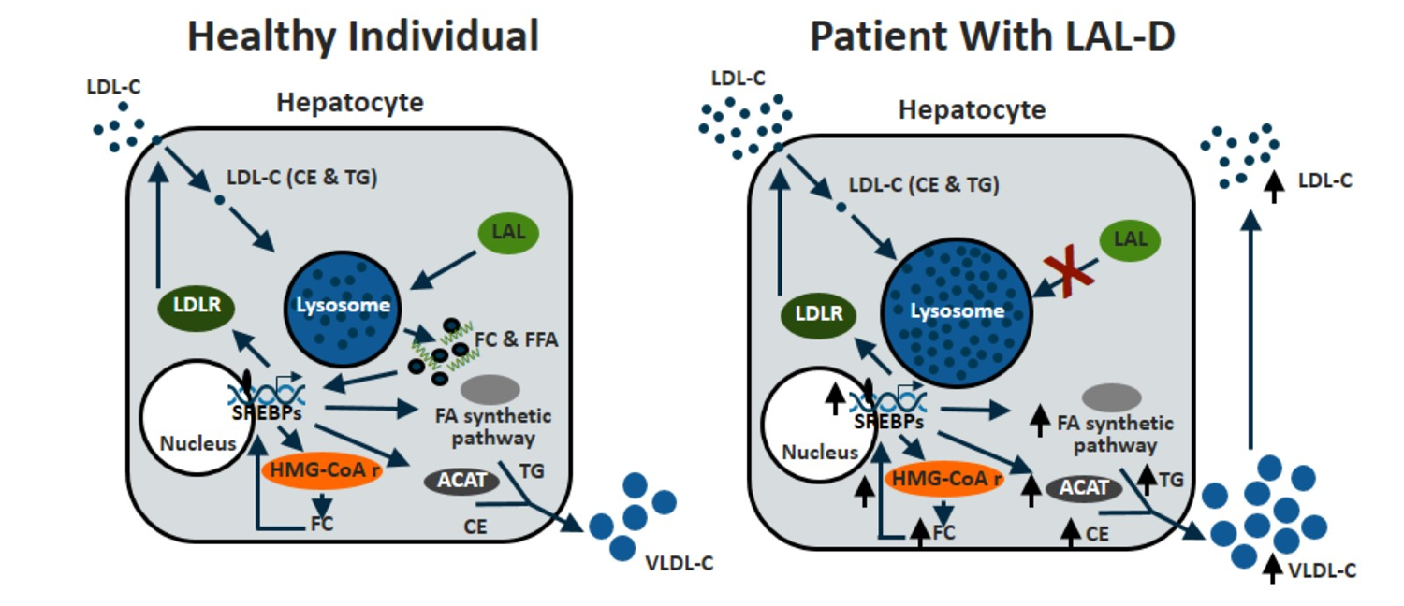
Figure 1. Cellular Cholesterol Homeostasis in Heathy Individuals and Patients with LAL-D

The true incidence of LAL-D is unknown. Estimates suggest overall disease prevalence between 1:40,000 to 1:300,000, depending on ethnicity and geographical location (1,2,17). The most commonly inherited defect is a splice junction mutation in exon 8, E8SJM (c.894G>A). It is assumed that 50-70% of adults and children with LAL-D have E8SJM (17,18). Studies in the general population have shown that the estimated frequency of E8SJM allele is 0.0013 in Caucasians, 0.0017 in US Hispanics, 0.0010 in US Ashkenazi Jews, and 0.0005 in Asians (19). Population screening for E8SJM among healthy West German individuals reveal a heterozygote frequency of ~ 1:200 individuals. Jewish infants of Iraqi or Iranian origin appear to be at high risk for LAL-D with an estimated incidence of 1:4,200 in the Los Angeles community (20).

A study attempting to identify the prevalence of LAL-D from patients with abnormal results in laboratory databases (elevated LDL-C and abnormalities on liver tests) identified a total of 1825 patients who subsequently underwent a dried blood spot sample for determination of LAL enzyme activity. No cases of LAL-D were identified. The results of this study demonstrate the potential of databases in helping to identify patients with specific patterns of results to allow targeted testing for possible causes of disease. Biochemical screening suggested that the gene frequency of LAL deficiency in adults is less than 1:100 (21). Additionally, histopathology databases of liver biopsies were analyzed searching for patients with features of 'microvesicular cirrhosis' or 'cryptogenic cirrhosis'. DNA was available from six patients and two were homozygous for LAL c.46A>C;p.Thr16Pro, an unclassified variant in exon 2 (21). The results of these studies suggest the potential of databases in helping to identify patients with specific laboratory results or those who had certain biopsy findings to allow targeted testing for possible causes of disease.

PRESENTATION

The symptoms of LAL-D are quite varied, and are related to the age that clinical manifestations first appear (Figure 2). Individuals who present within the first few days to first month of life often have vomiting, diarrhea, hepatosplenomegaly, abdominal distention, and severe failure to thrive. The first symptom observed is usually vomiting, which has been described as forceful and persistent. Accompanying these symptoms are usually watery diarrhea and low-grade fever. Symptoms generally persist despite multiple medical interventions and may lead to severe malnutrition. A hallmark of infantile-onset LAL-D is adrenal enlargement and calcification, often seen on imaging, but not required for diagnosis. Calcifications of the adrenal gland as well as adrenal insufficiency have been documented. Few patients survive beyond 12 months of age (2,3,22), with those that have growth failure often dying by four months of age (23).

In contrast, the clinical presentation and progression of LAL-D can be variable in older children and adults. However, there are common clinical manifestations that have been reported in this group of patients. In a review of 71 patients two thirds presented with their first symptoms before the age of 5 years. Hepatomegaly was present in all the patients; 86% had splenomegaly. Gastrointestinal symptoms were present in 30% and included vomiting and diarrhea [18%], failure to thrive [16%], abdominal pain [10%], gastrointestinal bleeding [8%], and gallbladder disease [4%]. Elevation of cholesterol was present in 90% (24). In a separate review of 135 patients, the median age of onset of symptoms was 5 years with a range from birth to 68 years. Hepatomegaly was present in 99.3% of patients. The most common extrahepatic findings were steatorrhea, poor growth, gallbladder dysfunction, and cardiovascular disease. Total cholesterol was elevated in all 110 patients (1).

The disease severity is likely dependent on the efficiency of alternative pathways, but not on the level of residual enzyme activity (25). In adults, the most frequent symptoms are abdominal pain, hepatomegaly, and laboratory abnormalities that include increased levels of transaminases and cholesterol. Differential diagnostic considerations include autoimmune hepatitis, NASH, alpha1-antitrypsin deficiency, and Wilson disease. Of concern is the potential for premature atherosclerosis in affected individuals. Although the occurrence of cardiovascular events has not been extensively studied, case reports and observational studies have documented the presence of arterial plaque and atheroma at a very early age (26-28). As a result, many patients with this disease have been prescribed lipid-lowering medications (1). While lipid lowering in the setting of LAL-A has been variable, statins increase hepatic uptake of LDL and, as a consequence, may worsen the lipid overload (29). It is important to note that seven asymptomatic adults, diagnosed in the third to sixth decade of life, have been reported. All were coincidently found to have confirmed LAL-D, yet none had detectable hepatomegaly (28).

The most consistent biochemical abnormalities seen in late onset LAL-D include elevated liver transaminases and plasma lipids. In a study of 49 patients designed to characterize clinical manifestations of LAL-D, mean ALT, AST, and GGT were 92.4, 87.8, and 52.2 U/L at the first measurement. In this study elevated GGT levels were uncommon (only 20% had values > 40 U/L) (30). In another study, liver dysfunction occurred in 100% of 135 patients and 73% of the 11 reported deaths were due to liver failure (1). Mean LDL-C at the time of first measurement was 202.9 mg/dL, and reported as abnormal in 64.4% of patients. Mean total cholesterol was 269.5 mg/dL and was abnormal in 62.5%. Mean HDL-C was 37.5 mg/dL and abnormal in 43.5% of patients (30). The lipid abnormalities seen most closely resemble type II-b dyslipidemia (31). Although elevated LDL-C seems to be a feature of LAL-D, it remains unclear whether or not LAL-D is a cause of early atherosclerosis. Case reports and several autopsy studies have noted aortic stenosis and found narrowing of the coronary artery secondary to atheromatous plaque in patients with LAL-D (2,32).

Figure 2. Clinical Presentation of LAL-D

On gross examination, the liver of patients with LAL-D is enlarged and appears greasy. Liver biopsies in paraffin sections have a predominance of microvesicular steatosis, which is uniform. Microvesicular steatosis, per se, is not pathognomonic of LAL-D, being found in other liver diseases as well. Foamy macrophages, containing lipid and ceroid, are present in the sinusoids and portal tracts (Figure 3). Staining for LAMP1, LAMP2, and LIMP2, or with a lysosomal luminal protein (cathepsin D), can assist identifying lipid accumulation as lysosomal, may help differentiate LAL-D from other causes of microvesicular steatosis. Another pathognomonic feature of LAL-D is birefringent cholesterol ester crystals in hepatocytes and Kupffer cells, using polarized light on electron microscopy. The liver disease generally progresses to fibrosis followed by micronodular cirrhosis (1,2,33).
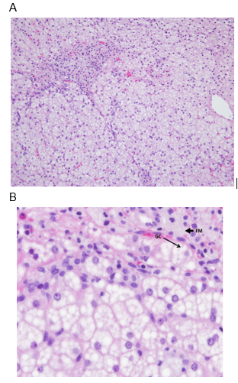
Figure 3. Liver Biopsies in Patients with LAL-D. A) Image of the portal tract and hepatocytes with mainly microvesicular steatosis. With microvesicular steatosis, the fat does not cause the nucleus to be pushed out to the side. B) Larger magnification of the portal tract. FM points to the foamy appearing cytoplasm, these are macrophages with something being stored in them. GC is pointing to a giant cell.

Diagnostic Tests

LAL-D can be diagnosed by demonstrating deficient LAL enzyme activity, as well as by genetic testing identifying mutations of the LIPA gene. Historically, enzyme activity was measured in cultured fibroblasts, peripheral leukocytes, or liver tissue. Various lipase substrates, which were not specific for LAL, were used. In the review by Bernstein, enzyme activities were reported in 114 patients and ranged from undetectable to 16% of normal, with values for most patients being between <1%-10%. However, given assay variability, residual enzyme activity is not predictive of disease severity nor can it be compared from one lab to another (1).

A newer method has been developed to determine LAL activity. This method measures LAL activity in dried blood spots (DBS), and uses Lalistat 2, a highly specific inhibitor of LAL. LAL activity is determined by comparing total lipase activity to lipase activity with Lalistat 2. This method is able to differentiate normal from affected individuals. This DBS technique has advantages over the fibroblast/peripheral leukocyte based test including small sample size, the ability to transport the specimen to the testing facility at ambient temperature, and sample stability (34). This blood test is available at a number of academic and commercial labs around the world.

LIPA gene analysis is also helpful in the diagnosis of LAL-D, with over 100 LIPA mutations having been identified in patients with LAL deficiency (7). Gene panels for associated diagnoses are becoming available and may allow diagnosis of LAL-D even when clinical awareness is low.

DIFFERENTIAL DIAGNOSIS

Given the clinical presentation of LAL-D, it is important to consider it in the differential diagnosis of patients presenting with characteristic lipid findings and liver disease. The lipid abnormalities of LAL-D are similar to patients with heterozygous familial hypercholesterolemia (HeFH) and familial combined hypercholesterolemia. A detailed family history may help differentiate the autosomal dominant HeFH from recessive LAL-D. Expert opinion recommends checking liver transaminases in all children and adults before initiating statin therapy (35). LAL-D should be considered in patients with elevated liver enzymes and lipid abnormalities.

LAL-D is often mistaken for non-alcoholic fatty liver disease (NAFLD); however, LAL-D is associated with mainly microvesicular steatosis and NAFLD with macrovesicular steatosis. LAL-D should be included the differential diagnosis of any non-obese patient with hepatic steatosis, as well as patients with unexplained ALT elevations.

MANAGEMENT

Disease specific therapy is now available to treat patients with LAL-D. However, prior to the approval of sebelipase alfa (Kanuma®, Alexion Pharmaceuticals, New Haven, CT), lipid lowering therapy, liver transplant, and stem cell transplant were often tried.

HMG-CoA reductase inhibitors have been used to lower LDL-C as well as reduce the risk of atherosclerotic heart disease. The first reported use in a patient with LAL-D was in a 9-year-old girl with elevated LDL-C, low HDL-C, and hepatomegaly with a liver biopsy that showed fibrosis and cirrhosis. During therapy with lovastatin, lipid parameters improved and the authors showed a reduction in cholesterol synthesis and decreased secretion of apo B-containing lipoproteins (36). However, in a report of three patients treated with lovastatin for 12 months, no significant changes were seen in lipid parameters and liver histology (37). In a review of cases in the literature, 12 patients with LAL-D were treated with HMG CoA reductase inhibitors with multiple liver biopsies. None of the 12 patients had improvement on liver histology, with all 12 patients having progressive liver disease (1).

Both hematopoietic stem cell transplant and liver transplant have been attempted to treat LAL-D, however, neither address the multi-system nature of the disease. Limited information is available about the long-term outcome of patients who have undergone liver transplant (1).

Sebelipase alfa, a recombinant human enzyme-replacement, is FDA approved for the treatment of LAL-D (38). The amino acid sequence for sebelipase alfa is the same as that of human LAL. A multicenter, double-blind, placebo controlled, randomized study in 66 patients analyzed the safety and effectiveness of sebelipase alfa (39). By week 20, patients treated with sebelipase alfa demonstrated a decrease in LDL-C of 28% versus 6% in the placebo group. The treatment group also demonstrated improvement in triglyceride and HDL-C level. Normalization of ALT occurred in 31% of patients in the treatment group versus 7% in the placebo group. This was accompanied by reduction in hepatic fat content assessed by multi-echo gradient echo MRI of 32% in the treatment group versus 4% in the placebo group

Table 1. Clinical Trials of Sebelipase Alfa
Study | Subjects | Age | Dose (per kg body weight) | Duration | Reference
LAL-CL01 | 9 | 31.6 ± 10.7 yrs (mean ± SD): | Escalating doses: 0.35, 1, or 3 mg weekly (given to cohort of 3 patients each) | 4 wks | (38)
LAL-CL02 | 66 | 50 <18 yrs, age range at randomization: 4-58 years | 1 mg every other week | Initial 20 wks, followed by an open-label treatment phase for 65 patients | (39)
LAL-CL03 | 9 | 3.0 months (median) | Weekly infusions: 0.35 mg x 2 weeks; then 1 mg, with dose increase to 3 mg* | 12 months | (40)
LAL-CL04 | 8 | 18 to 65 yrs | 1 or 3 mg every other week | Through to 52 wks | (41)
*Two infants had dose subsequently increased to 5 mg/kg weekly
Modified from Pastores GM, Hughes DA. Lysosomal Acid Lipase Deficiency: Therapeutic Options. Drug Des Devel Ther. 2020 Feb 11;14:591-601.

The frequency and distribution of adverse events were similar in the treatment and placebo group, and most adverse events were considered unrelated to the study drug (Table 2) (39). Clinical trials have shown that 3/106 patients experienced reactions consistent with anaphylaxis during infusion, occurring as early as the sixth infusion and as late as 1 year. Twenty percent (21/106) of patients experienced symptoms consistent with hypersensitivity reaction during or within 4 hours of completion of the infusion (38-41). The current dosing recommendation from the manufacturer for infantile-onset LAL-D is 1mg/kg IV weekly with escalation to 3mg/kg weekly in those who do not achieve appropriate clinical response. For child and adults presenting with LAL-D, the recommended dose is 1 mg/kg every other week (38). Further long-term follow-up studies are needed.

Table 2. Adverse Events with Sebelipase Alfa
Event | Sebelipase Alfa (N=36) | Placebo (N=30)
Any adverse event | 31 (86%) | 28 (93%)
Gastrointestinal events¹ | 18 (50%) | 12 (40%)
Headache | 10 (28%) | 6 (20%)
Fever | 7 (19%) | 6 (20%)
Oropharyngeal pain | 6 (17%) | 1 (3%)
Upper respiratory tract infection | 6 (17%) | 6 (20%)
Epistaxis | 4 (11%) | 3 (10%)
Asthenia | 3 (8%) | 1 (3%)
Cough | 3 (8%) | 3 (10%)
Adapted from Burton, et al., NEJM 2015
¹Gastrointestinal adverse events (diarrhea, abdominal pain, constipation, nausea, vomiting)

In contrast to survival rates of <12 months in infants with rapidly progressive LAL-D, results of two open-label studies of enzyme replacement therapy with sebelipase alfa, VITAL (NCT01371825) and CL08 (NCT02193867), in 19 infants reported prolonged survival to 12 months (79%) and 5 years of age (68%) in the combined population. The median age of surviving patients was 5.2 (VITAL) and 3.2 years (CL08). In both studies, median weight-for-age, length-for-age, and mid-upper arm circumference-for-age Z-scores increased from baseline to end of study, and decreases in median liver and spleen volume were observed. No patient discontinued treatment because of treatment-emergent adverse events. Infusion-associated reactions (94% in VITAL and 88% in CL08) were mild or moderate in severity (42).

In older children (>4 years) and adults with LAL-D, a phase III randomized study of sebelipase alfa (RISE, NCT01757184) included a 20-week, double-blind, placebo-controlled period; a 130-week, open-label, extension period; and a 104-week, open-label, expanded treatment period. 59/66 patients completed the study. The study found that early and rapid improvements in markers of liver injury and lipid abnormalities with sebelipase alfa were sustained, with no progression of liver disease, for up to 5 years (43).

CONCLUSION

Consensus recommendations for the initial assessment and ongoing monitoring of children and adults with LAL deficiency have been published to help improve the management of infants, children and adults with confirmed LAL-D (Figures 4 and 5) (44).

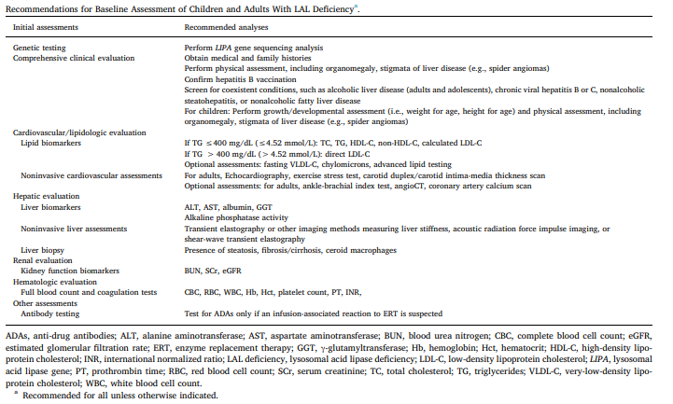
Figure 4. Recommendations for Baseline Assessment of Children and Adults with LAL Deficiency.

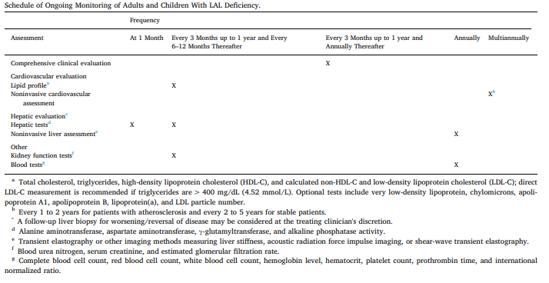
Figure 5. Schedule of Ongoing Monitoring of Adults and Children with LAL Deficiency.

REFERENCES

1. Bernstein DL, Hulkova H, Bialer MG, Desnick RJ. Cholesteryl ester storage disease: review of the findings in 135 reported patients with an underdiagnosed disease. J Hepatol 2013; 58:1230-1243
2. Gregory A. Grabowski LC, H Du. Acid lipase deficiency: Wolman disease and cholesteryl ester storage disease. New York: McGraw-Hill, Inc.
3. Abramov A, Schorr S, Wolman M. Generalized xanthomatosis with calcified adrenals. AMA J Dis Child 1956; 91:282-286
4. Fredrickson DS, Sloan HR, Ferrans VJ, Demosky SJ, Jr. Cholesteryl ester storage disease: a most unusual manifestation of deficiency of two lysosomal enzyme activities. Trans Assoc Am Physicians 1972; 85:109-119
5. Infante R, Polonovski J, Caroli J. [Cholesterolic polycoria in adults. II. Biochemical study]. Presse Med (1893) 1967; 75:2829-2832
6. Schiff L, Schubert WK, McAdams AJ, Spiegel EL, O'Donnell JF. Hepatic cholesterol ester storage disease, a familial disorder. I. Clinical aspects. Am J Med 1968; 44:538-546
7. Pisciotta L, Tozzi G, Travaglini L, Taurisano R, Lucchi T, Indolfi G, Papadia F, Di Rocco M, D'Antiga L, Crock P, Vora K, Nightingale S, Michelakakis H, Garoufi A, Lykopoulou L, Bertolini S, Calandra S. Molecular and clinical characterization of a series of patients with childhood-onset lysosomal acid lipase deficiency. Retrospective investigations, follow-up and detection of two novel LIPA pathogenic variants. Atherosclerosis 2017; 265:124-132
8. Kyriakides EC, Filippone N, Paul B, Grattan W, Balint JA. LIPID STUDIES IN WOLMAN'S DISEASE. Pediatrics 1970; 46:431-436
9. Yoshida H, Kuriyama M. Genetic lipid storage disease with lysosomal acid lipase deficiency in rats. Lab Anim Sci 1990; 40:486-489
10. Goldstein JL, Dana SE, Faust JR, Beaudet AL, Brown MS. Role of lysosomal acid lipase in the metabolism of plasma low density lipoprotein. Observations in cultured fibroblasts from a patient with cholesteryl ester storage disease. Journal of Biological Chemistry 1975; 250:8487-8495
11. Horton JD, Goldstein JL, Brown MS. SREBPs: activators of the complete program of cholesterol and fatty acid synthesis in the liver. Journal of Clinical Investigation 2002; 109:1125-1131
12. Jeon T-I, Osborne TF. SREBPs: metabolic integrators in physiology and metabolism. Trends Endocrinol Metab 2012; 23:65-72
13. Brown MS, Sobhani MK, Brunschede GY, Goldstein JL. Restoration of a regulatory response to low density lipoprotein in acid lipase-deficient human fibroblasts. Journal of Biological Chemistry 1976; 251:3277-3286
14. Cummings MH, Watts GF. Increased hepatic secretion of very-low-density lipoprotein apolipoprotein B-100 in cholesteryl ester storage disease. Clinical Chemistry 1995; 41:111-114
15. Sando GN, Ma GP, Lindsley KA, Wei YP. Intercellular transport of lysosomal acid lipase mediates lipoprotein cholesteryl ester metabolism in a human vascular endothelial cell-fibroblast coculture system. Cell Regul 1990; 1:661-674
16. Bowden KL, Bilbey NJ, Bilawchuk LM, Boadu E, Sidhu R, Ory DS, Du H, Chan T, Francis GA. Lysosomal acid lipase deficiency impairs regulation of ABCA1 gene and formation of high density lipoproteins in cholesteryl ester storage disease. J Biol Chem 2011; 286:30624-30635
17. Muntoni S, Wiebusch H, Jansen-Rust M, Rust S, Seedorf U, Schulte H, Berger K, Funke H, Assmann G. Prevalence of Cholesteryl Ester Storage Disease. Arteriosclerosis, Thrombosis, and Vascular Biology 2007; 27:1866-1868
18. Lohse P, Maas S, Lohse P, Elleder M, Kirk JM, Besley GTN, Seidel D. Compound heterozygosity for a Wolman mutation is frequent among patients with cholesteryl ester storage disease. Journal of Lipid Research 2000; 41:23-31
19. Reiner Ž, Guardamagna O, Nair D, Soran H, Hovingh K, Bertolini S, Jones S, Ćorić M, Calandra S, Hamilton J, Eagleton T, Ros E. Lysosomal acid lipase deficiency – An under-recognized cause of dyslipidaemia and liver dysfunction. Atherosclerosis 2014; 235:21-30
20. Valles-Ayoub Y, Esfandiarifard S, No D, Sinai P, Khokher Z, Kohan M, Kahen T, Darvish D. Wolman Disease (LIPA p.G87V) Genotype Frequency in People of Iranian-Jewish Ancestry. Genetic Testing and Molecular Biomarkers 2011; 15:395-398
21. Reynolds TM, Mewies C, Hamilton J, Wierzbicki AS, group PPC. Identification of rare diseases by screening a population selected on the basis of routine pathology results-the PATHFINDER project: lysosomal acid lipase/cholesteryl ester storage disease substudy. J Clin Pathol 2018; 71:608-613
22. Wolman M, Sterk VV, Gatt S, Frenkel M. PRIMARY FAMILIAL XANTHOMATOSIS WITH INVOLVEMENT AND CALCIFICATION OF THE ADRENALS. Pediatrics 1961; 28:742-757
23. Jones SA, Valayannopoulos V, Schneider E, Eckert S, Banikazemi M, Bialer M, Cederbaum S, Chan A, Dhawan A, Di Rocco M, Domm J, Enns GM, Finegold D, Gargus JJ, Guardamagna O, Hendriksz C, Mahmoud IG, Raiman J, Selim LA, Whitley CB, Zaki O, Quinn AG. Rapid progression and mortality of lysosomal acid lipase deficiency presenting in infants. Genet Med 2016; 18:452-458
24. Zhang B, Porto AF. Cholesteryl Ester Storage Disease. Journal of Pediatric Gastroenterology &amp; Nutrition 2013; 56:682-685
25. Tebani A, Sudrie-Arnaud B, Boudabous H, Brassier A, Anty R, Snanoudj S, Abergel A, Abi Warde MT, Bardou-Jacquet E, Belbouab R, Blanchet E, Borderon C, Bronowicki JP, Cariou B, Carette C, Dabbas M, Dranguet H, de Ledinghen V, Ferrieres J, Guillaume M, Krempf M, Lacaille F, Larrey D, Leroy V, Musikas M, Nguyen-Khac E, Ouzan D, Perarnau JM, Pilon C, Ratzlu V, Thebaut A, Thevenot T, Tragin I, Triolo V, Verges B, Vergnaud S, Bekri S. Large-scale screening of lipase acid deficiency in at risk population. Clin Chim Acta 2021; 519:64-69
26. Pericleous M, Kelly C, Wang T, Livingstone C, Ala A. Wolman's disease and cholesteryl ester storage disorder: the phenotypic spectrum of lysosomal acid lipase deficiency. Lancet Gastroenterol Hepatol 2017; 2:670-679
27. Maciejko JJ. Managing Cardiovascular Risk in Lysosomal Acid Lipase Deficiency. Am J Cardiovasc Drugs 2017; 17:217-231
28. Elleder M, Chlumska A, Hyanek J, Poupetova H, Ledvinova J, Maas S, Lohse P. Subclinical course of cholesteryl ester storage disease in an adult with hypercholesterolemia, accelerated atherosclerosis, and liver cancer. J Hepatol 2000; 32:528-534
29. Wilson DP, Friedman M, Marulkar S, Hamby T, Bruckert E. Sebelipase alfa improves atherogenic biomarkers in adults and children with lysosomal acid lipase deficiency. J Clin Lipidol 2018; 12:604-614
30. Burton BK, Deegan PB, Enns GM, Guardamagna O, Horslen S, Hovingh GK, Lobritto SJ, Malinova V, McLin VA, Raiman J, Di Rocco M, Santra S, Sharma R, Sykut-Cegielska J, Whitley CB, Eckert S, Valayannopoulos V, Quinn AG. Clinical Features of Lysosomal Acid Lipase Deficiency. J Pediatr Gastroenterol Nutr 2015; 61:619-625
31. Kostner GM, Hadorn B, Roscher A, Zechner R. Plasma lipids and lipoproteins of a patient with cholesteryl ester storage disease. Journal of Inherited Metabolic Disease 1984; 8:9-12
32. Ambler GK, Hoare M, Brais R, Shaw A, Butler A, Flynn P, Deegan P, Griffiths WJH. Orthotopic liver transplantation in an adult with cholesterol ester storage disease. JIMD Rep 2013; 8:41-46
33. Hůlková H, Elleder M. Distinctive histopathological features that support a diagnosis of cholesterol ester storage disease in liver biopsy specimens. Histopathology 2012; 60:1107-1113
34. Hamilton J, Jones I, Srivastava R, Galloway P. A new method for the measurement of lysosomal acid lipase in dried blood spots using the inhibitor Lalistat 2. Clinica Chimica Acta 2012; 413:1207-1210
35. Bays H, Cohen DE, Chalasani N, Harrison Stephen A. An assessment by the Statin Liver Safety Task Force: 2014 update. Journal of Clinical Lipidology 2014; 8:S47-S57
36. Ginsberg HN, Le NA, Short MP, Ramakrishnan R, Desnick RJ. Suppression of apolipoprotein B production during treatment of cholesteryl ester storage disease with lovastatin. Implications for regulation of apolipoprotein B synthesis. J Clin Invest 1987; 80:1692-1697
37. Di Bisceglie AM, Ishak KG, Rabin L, Hoeg JM. Cholesteryl ester storage disease: Hepatopathology and effects of therapy with lovastatin. Hepatology 1990; 11:764-772
38. Balwani M, Breen C, Enns GM, Deegan PB, Honzík T, Jones S, Kane JP, Malinova V, Sharma R, Stock EO, Valayannopoulos V, Wraith JE, Burg J, Eckert S, Schneider E, Quinn AG. Clinical effect and safety profile of recombinant human lysosomal acid lipase in patients with cholesteryl ester storage disease. Hepatology 2013; 58:950-957
39. Burton BK, Balwani M, Feillet F, Barić I, Burrow TA, Camarena Grande C, Coker M, Consuelo-Sánchez A, Deegan P, Di Rocco M, Enns GM, Erbe R, Ezgu F, Ficicioglu C, Furuya KN, Kane J, Laukaitis C, Mengel E, Neilan EG, Nightingale S, Peters H, Scarpa M, Schwab KO, Smolka V, Valayannopoulos V, Wood M, Goodman Z, Yang Y, Eckert S, Rojas-Caro S, Quinn AG. A Phase 3 Trial of Sebelipase Alfa in Lysosomal Acid Lipase Deficiency. New England Journal of Medicine 2015; 373:1010-1020
40. Jones SA, Rojas-Caro S, Quinn AG, Friedman M, Marulkar S, Ezgu F, Zaki O, Gargus JJ, Hughes J, Plantaz D, Vara R, Eckert S, Arnoux JB, Brassier A, Le Quan Sang KH, Valayannopoulos V. Survival in infants treated with sebelipase Alfa for lysosomal acid lipase deficiency: an open-label, multicenter, dose-escalation study. Orphanet J Rare Dis 2017; 12:25
41. Valayannopoulos V, Malinova V, Honzík T, Balwani M, Breen C, Deegan PB, Enns GM, Jones SA, Kane JP, Stock EO, Tripuraneni R, Eckert S, Schneider E, Hamilton G, Middleton MS, Sirlin C, Kessler B, Bourdon C, Boyadjiev SA, Sharma R, Twelves C, Whitley CB, Quinn AG. Sebelipase alfa over 52 weeks reduces serum transaminases, liver volume and improves serum lipids in patients with lysosomal acid lipase deficiency. Journal of hepatology 2014; 61:1135-1142
42. Vijay S, Brassier A, Ghosh A, Fecarotta S, Abel F, Marulkar S, Jones SA. Long-term survival with sebelipase alfa enzyme replacement therapy in infants with rapidly progressive lysosomal acid lipase deficiency: final results from 2 open-label studies. Orphanet J Rare Dis 2021; 16:13
43. Burton BK, Feillet F, Furuya KN, Marulkar S, Balwani M. Sebelipase alfa in children and adults with lysosomal acid lipase deficiency: Final results of the ARISE study. J Hepatol 2022; 76:577-587
44. Kohli R, Ratziu V, Fiel MI, Waldmann E, Wilson DP, Balwani M. Initial assessment and ongoing monitoring of lysosomal acid lipase deficiency in children and adults: Consensus recommendations from an international collaborative working group. Molecular Genetics and Metabolism 2020; 129:59-66

