**MINERALOCORTICOID DEFECTS IN CHILDREN**

**Allie Dayno, MD, MA,** Pediatric Endocrinology Fellow, Children’s Hospital of Philadelphia, PA 19104. daynoa@chop.edu

**Marissa J. Kilberg, MD, MSEd,** Assistant Professor of Pediatrics, Children’s Hospital of Philadelphia, Philadelphia, PA 19104. kilbergm@chop.edu

**Maria G. Vogiatzi, MD,** Professor of Pediatrics, Children’s Hospital of Philadelphia, Philadelphia, PA 19104. [vogiatzim@chop.edu](mailto:vogiatzim@chop.edu)

**Received April 19, 2025**

**ABSTRACT**

Isolated aldosterone deficiency in children related either to impaired secretion by the adrenal gland or to aldosterone resistance in target tissues is rare. The incidence is estimated to be <1:1,000,000 for congenital isolated primary hypoaldosteronism and 1:66,000 to 1:166,000 for congenital aldosterone resistance (1). Children may present with salt wasting, hyponatremia, hypotension, hyperkalemia, metabolic acidosis, and failure to thrive. There is a wide phenotypic spectrum based on the severity and etiology of aldosterone deficiency or action. In this chapter, we briefly discuss the physiology of mineralocorticoids in newborns, categorize the causes of isolated hypoaldosteronism, and review the etiologies to guide clinical and laboratory evaluation and treatment.

**INTRODUCTION**

Mineralocorticoids are a class of steroids produced in the zona glomerulosa in the adrenal cortex that regulate sodium, potassium and water balance; aldosterone is the primary mineralocorticoid. Its synthesis involves several enzymes within the adrenal, the final step regulated by aldosterone synthase (*CYP11B2*) (Figure 1). Aldosterone secretion involves an intricate feedback loop involving multiple organs including the adrenal glands, kidneys, liver, lungs, and blood vessels. The major regulators of aldosterone synthesis and secretion are the renin-angiotensin-aldosterone (RAA) axis and potassium (Figure 2). Aldosterone binds to the mineralocorticoid receptor at the kidney to activate specific amiloride-sensitive sodium (ENaC) channels and a Na-K- ATPase pump. Through these actions, aldosterone promotes sodium reabsorption and urinary potassium excretion (Figure 2).

Mineralocorticoid deficiency (also referred to as hypoaldosteronism) refers to compromised aldosterone secretion from the adrenal glands or its cellular action. Hypoaldosteronism is observed as part of global adrenal cortex dysfunction in both congenital and acquired disorders, such as primary adrenal insufficiency (PAI), adrenal hypoplasia congenita (AHC), and congenital adrenal hyperplasia (CAH). In these disorders, hypoaldosteronism occurs together with glucocorticoid deficiency (i.e., adrenal insufficiency) and/or other deficient or dysregulated adrenal steroid secretion. While rare in children, hypoaldosteronism may occur as an isolated condition, either congenital or acquired, and can be classified into 1) defective aldosterone biosynthesis 2) disturbances in stimulation of aldosterone secretion, and 3) impaired aldosterone action at the target tissue, mainly the kidneys (resistance) (2). The latter is also referred to as “pseudohypoaldosteronism” since circulating aldosterone levels are elevated despite clinical symptoms and signs of mineralocorticoid deficiency due to dysfunctional mineralocorticoid receptor or its downstream effects (2). In this chapter, we discuss isolated aldosterone-deficient conditions other than PAI, AHC, and CAH. In depth coverage of adrenal insufficiency can be found in Endotext.org chapter: Adrenal Insufficiency in Children (3).

Normal aldosterone production, regulation, and action are essential in neonates, infants, and children for salt balance and overall growth. If untreated, defects in aldosterone secretion or action in children may lead to salt wasting, hypotension, hyperkalemia, metabolic acidosis, and failure to thrive. Severe hyponatremia (salt wasting) and metabolic acidosis can be life-threatening in newborns and infants. In depth coverage of mineralocorticoid deficiency and resistance can be found in Endotext.org chapter: Aldosterone Deficiency and Resistance (4). Our chapter focuses on isolated aldosterone defects in the pediatric population.

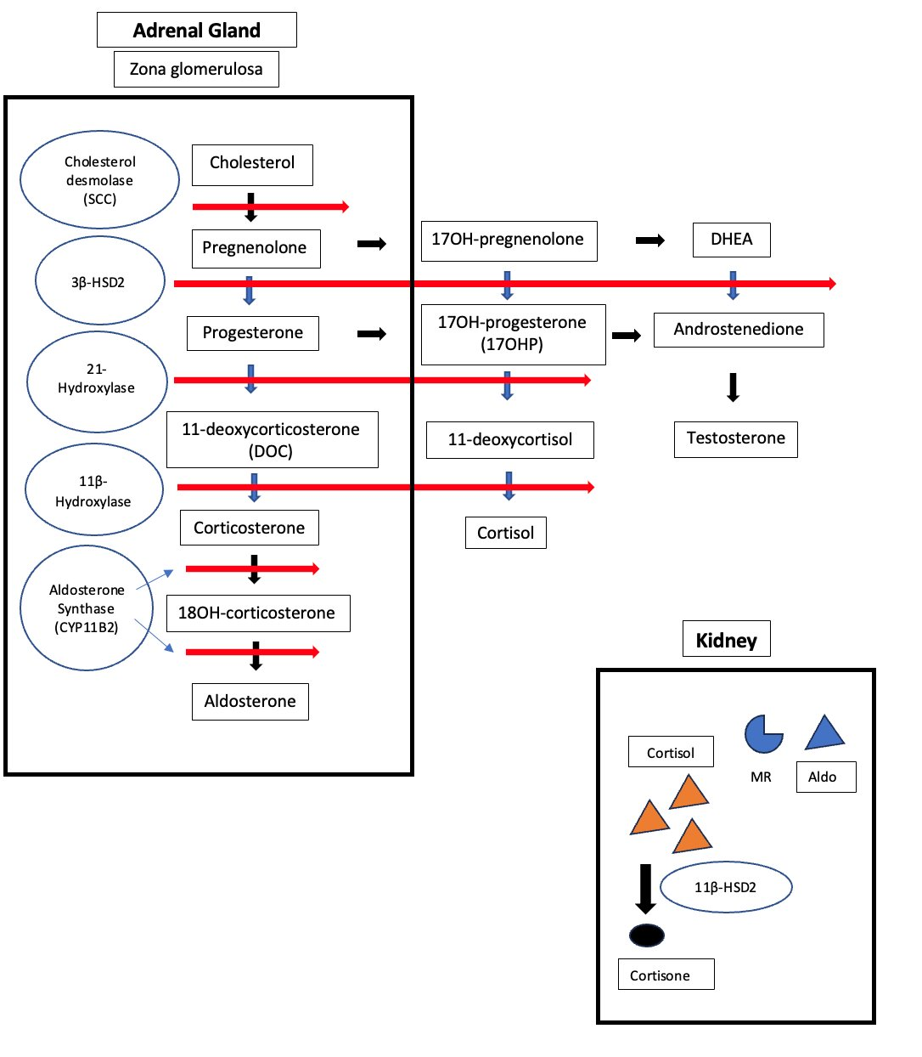

**Figure 1. Enzyme defects related to aldosterone synthesis. Schematic of adrenal steroidogenesis demonstrating the various enzymes involved in aldosterone synthesis (large black box). The red lines indicate the specific enzymatic defects that result in defects in aldosterone synthesis. Cortisol circulates in the bloodstream at higher concentrations than aldosterone and it also interacts with MR. However, within the kidney and target tissues, there is selectivity of MR by aldosterone due to the enzyme 11βHSD2 that converts active cortisol to inactive cortisone (small black box). SCC: side-chain cleavage. HSD: hydroxysteroid dehydrogenase. MR: mineralocorticoid receptor. DHEA: dehydroepiandrosterone. Aldo: aldosterone.**

**PATHOPHYSIOLOGY**

**Aldosterone Synthesis**

Aldosterone biosynthesis occurs at the zona glomerulosa, the outermost layer of the adrenal cortex, via the action of several enzymes: cholesterol desmolase [also known as cholesterol side-chain cleavage enzyme] (*CYP11A1*), 3β-hydroxysteroid dehydrogenase (*HSD3B2*), 21-hydroxylase (*CYP21A2*), 11-hydroxylase (*CYP11B1*) and aldosterone synthase (*CYP11B2*) (Figure1). The first four enzymes are also expressed in the zona fasciculata and are involved in cortisol biosynthesis. Defects in any of these enzymes may lead to combined aldosterone/cortisol deficiencies as part of the syndromes seen in Congenital Adrenal Hyperplasia. Aldosterone synthase encoded by *CYP11B2*, the last enzymatic step in aldosterone biosynthesis, is expressed only at the zona glomerulosa and genetic defects in this gene result in isolated aldosterone deficiency (Figure 1).

Aldosterone synthesis involves two steps. The first includes the 18-hydroxylation of corticosterone to form 18-hydroxycorticosterone (18OH corticosterone) and the second is the 18-oxidation of 18OH corticosterone to form aldosterone. Although it was previously considered that these two steps are catalyzed by two different enzymes, it is now known to involve the same enzyme, aldosterone synthase (5). Based on the two final steps in aldosterone synthesis, two subtypes of aldosterone synthase deficiency (ASD) have been described; however, with further clarification of the enzymatic process this is now thought to be an overlapping clinical spectrum, depending on the degree of enzyme deficiency (5).

**Aldosterone Regulation and Action**

Serum potassium concentrations and the Renin, Angiotensin, Aldosterone (RAA) axis are the main regulators of aldosterone synthesis. Hyperkalemia has a direct stimulating effect independent of RAA axis (2). The RAA axis is a feedback loop that regulates sodium, potassium, water, fluid volume, and blood pressure (2). The cells in the macula densa of the juxtaglomerular apparatus are triggered to release renin in response to a drop in perfusion. Angiotensinogen is a protein produced from the liver that is cleaved to angiotensin I (Ang I) by renin (2). Angiotensin-converting enzyme (ACE) in vascular endothelium rapidly converts Ang I to Angiotensin II (Ang II). Ang II is the most potent stimulus for aldosterone production and release (2). Of note, tissue and plasma peptidase inactivate angiotensin within minutes and circulating renin levels are the rate-limiting factor of this process (1).

Aldosterone mediates its effects by binding to the mineralocorticoid receptor (MR; aka *NR3C2*) at the distal convoluted tubules and collecting duct epithelial cells of the kidneys (Figure 2). The MR is a member of the nuclear receptor family, and along with the glucocorticoid and androgen receptors, forms the steroid receptor subfamily. In its unliganded state, the MR is located in the cytoplasm. Upon binding with its ligand, MR is translocated into the nucleus, where it modulates the transcription of several genes, such as those that encode the ENaC subunits (1). Mutations that inactivate the MR result in aldosterone resistance or pseudo-hypoaldosteronism type 1 (PHA1).

Aldosterone, 11-deoxycorticosterone (DOC), and cortisol are all endogenous [agonists](https://en.wikipedia.org/wiki/Agonist) of the MR. Specifically, cortisol and aldosterone have an equal affinity for the mineralocorticoid receptor (2); however, selectivity of MR receptor for aldosterone is ensured in epithelial target tissues by 11βHSD2 enzyme that converts active cortisol to inactive cortisone (1) (Figure 1). This is of particular importance as cortisol circulates at concentrations 100 to 1,000-fold higher than aldosterone. Loss-of-function mutations of the kidney 11βHSD2 result in excessive cortisol-dependent MR activation and cause an autosomal recessive form of familial hypertension called apparent mineralocorticoid excess (6).

After binding to MR, aldosterone activates ENaC gene transcription, decreases ENaC degradation, and activates Na-K ATPase pump. ENaC, located at the apical membrane of epithelial cells, plays a crucial role in sodium reabsorption, potassium secretion, and subsequent volume expansion. ENaC consists of 3 subunits (a, b, and g) that are encoded by unique genes (*SCNN1A*, *SCNN1B*, *SCNN1G*, respectively) (1). Defects in these genes can impair ENaC function and lead also to aldosterone resistance or pseudo hypoaldosteronism type Ib. In addition to the epithelial cells of the distal convoluted tubule, ENaC is expressed at the epithelial cells of other tissues that are involved in salt conservation, such as colon, sweat glands, and lungs. Dysfunction of ENaC, therefore, has systemic manifestations from muti-organ water and salt loss.

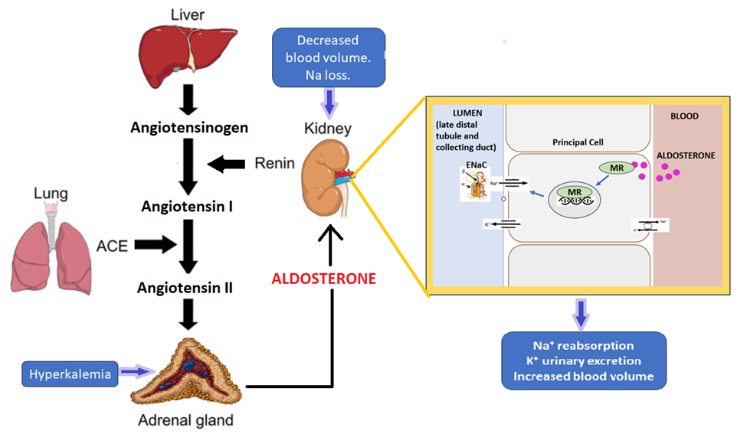

**Figure 2. Physiology of aldosterone secretion and action. The figure demonstrates the renin-angiotensin-aldosterone (RAA) system and its effects on sodium and potassium homeostasis, and blood pressure. Aldosterone secretion is regulated by decreased blood volume and hyponatremia via activation of the RAA axis, and indirectly, by hyperkalemia. Aldosterone then binds to the mineralocorticoid receptor (MR; aka NR3C2) at the distal convoluted tubules and collecting duct of the kidneys. Upon binding with aldosterone, MR translocate into the nucleus, where it modulates the transcription of the genes that encode the epithelial sodium channel (ENaC). ENaC is a sodium-selective ion channel that plays a crucial role in sodium reabsorption. Aldosterone action results in urinary potassium excretion and sodium reabsorption, and thus, increased blood volume.**

**Aldosterone Secretion in the Newborn**

There are limited studies in infants investigating the interaction between water, sodium, and the renin-angiotensin-aldosterone system. Various changes related to water turnover, sodium metabolism, and kidney adaptation to extrauterine life occur in the neonatal period (1). The immediate postnatal phase in the first week of life is characterized by oliguria followed by a diuretic phase with extracellular contraction and net loss of sodium and water (1). Maximum weight loss occurs during this period (up to 10% of birth weight is considered normal). Kidneys in the neonate exhibit tubular immaturity resulting in sodium wasting and impaired ability to reabsorb water (1). Additionally, aldosterone and renin concentrations are higher in the newborn period, whereas expression of renal MR is reduced, leading to transient renal resistance to aldosterone (7). In very preterm infants, there is decreased activity of 11β-hydroxylase (*CYP11B1*) and low aldosterone synthase (*CYP11B2*) activity, possibly due to immaturity of these enzymes in the fetal adrenal cortex, leading to deficient aldosterone secretion (8, 9). After the first week of life, water losses decrease, and positive sodium balance is important for growth (1). It is essential to acknowledge these physiologic changes when evaluating mineralocorticoid function in the neonatal period.

**CLINICAL PRESENTATION**

The clinical presentation of aldosterone deficiency is variable depending on the etiology. Broadly, the signs of hypoaldosteronism include hypotension, hyponatremia (salt wasting), hyperkalemia, and metabolic acidosis. The symptoms that can be seen in infants and children related to these electrolyte derangements are dehydration, vomiting, irritability, weakness, seizures, and failure to thrive.

**ETIOLOGY OF ISOLATED HYPOALDOSTERONISM**

Isolated aldosterone disorders can be classified into disorders of defective synthesis, aldosterone resistance and diminished stimulation (Table 1).

**Defective Aldosterone Synthesis**

This refers to hyperreninemic hypoaldosteronism in which the renin production is intact, and the defect is at the level of the adrenal gland. The etiology of defective aldosterone synthesis can be separated into congenital and acquired causes. It is important to note that aldosterone deficiency due to defect in synthesis can be the first presenting sign of adrenal cortex failure and later progress to involve insufficient cortisol production. For descriptions of disorders involving adrenal cortical failure such as congenital adrenal hyperplasia and Addison’s disease, see Endotext.org chapter: Adrenal Insufficiency in Children (3).

CONGENITAL CAUSES

*Prematurity*

Very preterm infants (<33 weeks’ gestation) have deficient aldosterone concentrations, thought to be related to both the general immaturity of the fetal adrenal cortex and specifically a defect in aldosterone production, perhaps due to low aldosterone synthase activity (10). This also aligns with other defects in adrenal steroidogenesis seen in preterm infants (e.g. low 11β-hydroxylation leading to high 17OHP and false positive on the newborn screening) (11).

*Aldosterone Synthase Deficiency*

Variants in the *CYP11B2* gene result in variable loss of enzyme activity and aldosterone deficiency. As seen in Figure 1, aldosterone synthase is responsible for the hydroxylation of corticosterone to 18-hydroxycorticosterone followed by oxidation from 18-hydroxycorticosterone to aldosterone. Previously, these steps were thought to be controlled by 2 different enzymes and this disorder was called corticosterone methyl-oxidase (CMO) deficiency with 2 subtypes described (CMOI and CMOII) based on the aldosterone and precursor relative concentrations. These subtypes are now thought to be a spectrum of severity (12). Due to continued production of DOC and corticosterone, there is some mineralocorticoid activity. However, this may be insufficient in the setting of aldosterone resistance of the neonate and salt loss may occur in infancy. Children are more affected than adults who may even have normal renin levels as the mineralocorticoid sensitivity improves and exogenous salt from table food intake increases.

ACQUIRED CAUSES

*Critical Illness*

Despite intact ACTH and renin secretion as well as angiotensin II production, a portion of critically ill patients may have low aldosterone levels (13, 14). This is considered to represent a shift in the adrenal cortex prioritizing cortisol production to aid in recovery.

*Adrenalectomy*

Typically, unilateral adrenalectomy would not be expected to lead to a glucocorticoid or mineralocorticoid defect; however, this may occur in the setting of a hyperfunctioning defect in one adrenal with contralateral atrophy. In the case of mineralocorticoid function, a patient with Conn’s syndrome (also known as primary hyperaldosteronism) who undergoes unilateral adrenalectomy can experience signs and symptoms of hypoaldosteronism including hyperkalemia, with reports indicating this occurrence in 6-62% of patients (15-17). Post surgical monitoring is recommended, although few patients require medical treatment.

*Medication Induced*

While other medications may lead to diminished aldosterone stimulation or resistance, heparin is known to reduce aldosterone synthesis leading to natriuresis and hyperkalemia without an impact on corticosteroid production (18).

**Aldosterone Resistance**

This refers to impaired action of aldosterone at the level of the target tissue and can further be categorized into congenital and acquired causes.

CONGENITAL CAUSES

*Pseudo-Hypoaldosteronism (PHA) Type 1*

The genetic form of aldosterone resistance occurs due to a mutation impacting the mineralocorticoid receptor (19). Despite the prevalent consideration of PHA1 as a genetic form of type IV renal tubular acidosis (RTA), the biochemical profile can differ. Hyperkalemia, hyponatremia, and acidosis are universal; however, while RTA type IV involves a hyperchloremic non-anion gap acidosis, there are descriptions of both hyper and hypochloremia as well as an anion gap acidosis in PHA1 (20). PHA can be either autosomal dominant or recessive. The autosomal recessive disease (PHA1b*)* occurs due to a mutation in the genes encoding one of the 3 ENaC subunits (*SCNN1A*, *SCNN1B*, *SCNN1G*) (21). The presentation of PHA1b is often severe given the systemic nature of ENaC outside of the kidney and in the epithelial cells of other tissues including colon, sweat glands, and lungs. The autosomal dominant disease (PHA1a)occurs due to a mutation in the gene encoding the mineralocorticoid receptor (*NR3C2)* and is restricted to the kidney (21, 22). This form is milder and tends to improve during childhood. However, despite its isolation to the kidney, the hyperkalemia that results can be devastating if not identified and treated early; cases are described involving cardiac arrest and hypoxic ischemic encephalopathy as an outcome (23).

Despite the classification of PHA1 based on mutation (PHA1a vs. PHA1b), some individuals with features of PHA1 do not have identifiable molecular defects.

ACQUIRED CAUSES

*Secondary Pseudo-Hypoaldosteronism (PHA Type 3)*

PHA Type 3 is often associated with urinary tract infections (UTI) and/or related to underlying urinary anomalies, primarily urinary tract obstruction, resulting in decreased aldosterone responsiveness (24). PHA Type 3 occurs frequently in male infants; a recent systematic review identified 80% of cases in male babies under 4 months of age (25). Presentation can include failure to thrive and vomiting and laboratory evaluation reveals hyperreninemic, hyperaldosteronism with impaired responsiveness, and hyponatremic, hyperkalemic metabolic acidosis. Early identification allows for prevention of electrolyte related morbidity and expedited resolution of urinary obstruction through surgical management in over 40% of cases (24, 25).

*Medication Related*

Medications that block the ENaC channel (amiloride) or MR (spironolactone) will cause aldosterone resistance. These medications are used therapeutically in resistant hypertension and to prevent hypokalemia seen with other diuretics. Spironolactone is also used for its anti-androgenic properties and the potential for dehydration and hyperkalemia should be considered and monitored. Other ENaC blockers include triamterene, trimethoprim, and pentamidine, while other aldosterone antagonists include synthetic progestins and calcineurin inhibitors.

**Diminished Stimulation**

Decreased renin or angiotensin II results in decreased aldosterone production due to diminished adrenal stimulation. When this hyporeninemic hypoaldosteronism occurs with hyperchloremia and non-anion gap metabolic acidosis, it is called Type 4 RTA. In adults, this is most often associated with nephropathy (diabetes, autonomic neuropathy, sickle cell disease, HIV, SLE) and medications (beta blockers, ACE inhibitors) (26). In children, Gordon Syndrome (Familial Hyperkalemic hypertension or pseudo-hypoaldosteronism type II [PHA2]) is rare and associated with low renin/low aldosterone (or inappropriately normal for degree of hyperkalemia) state with normal glomerular filtration. This is thought to be due to abnormal thiazide-sensitive sodium-chloride co-transporter in the distal nephron (mutations in WNK1, WNK4, CUL3, or KLHL3 genes) (27). The increased sodium and chloride reabsorption leads to hypertension, volume expansion, and decreased potassium and hydrogen excretion resulting in hyperkalemia and metabolic acidosis. In contrast to PHA1, PHA2 does have a biochemical profile that aligns with Type IV RTA including hyponatremic, hyperkalemic, and hyperchloremic non-anion gap metabolic acidosis (28). These causes of defective aldosterone stimulation are rare in the pediatric population, so when identified, affected children should be referred to the appropriate subspecialities such as nephrology for evaluation and treatment. Given the rare nature and lack of a primary endocrine etiology, these causes are not reviewed in the table below.

|  |  |  |  |
| --- | --- | --- | --- |
| **Table 1. CAUSES OF ISOLATED ALDOSTERONE DEFECTS IN CHILDREN** | | | |
|  | **Condition** | **Cause** | **Presentation** |
| Congenital – Aldosterone Synthesis | Prematurity (transient) | Immaturity of aldosterone synthase in very premature infants | **HYPER**reninemic, **HYPO**aldosteronism  Hyponatremia and hyperkalemia  Increased corticosterone |
| Aldosterone synthase deficiency  Formerly divided into:  CMO I deficiency (low 18-OH corticosterone)  -CMO II deficiency (high 18-OH corticosterone) | Autosomal recessive or autosomal dominant (mixed penetrance) variant in *CYP11B2* |
| Acquired – Aldosterone Synthesis | Critical illness | Thought to represent a shift in the adrenal cortex prioritizing cortisol production to aid in recovery |
| Adrenalectomy | Can occur in the setting of a hyperfunctioning lesion with contralateral atrophy |
| Medication induced | Heparin |
| Congenital – Aldosterone Resistance | Systemic Pseudo-hypoaldosteronism (PHA1b) | Autosomal recessive variant in ENaC gene (*SCNN1A*, *SCNN1B*, *SCNN1G)* | **HYPER**reninemic **HYPER**aldosteronism (*pseudo-hypoaldosteronism*)  Hyponatremia and hyperkalemia (electrolytes may be normal in mild cases) |
| Renal Pseudo-hypoaldosteronism (PHA1a) | Autosomal dominant variant in MR receptor gene (*NR3C2*) |
| Acquired – Aldosterone Resistance | Secondary Pseudo-hypoaldosteronism (type 3 PHA) | Associated with urinary tract infections |
| Secondary (medication induced) pseudo-hypoaldosteronism | Meds that block ENaC (amiloride, triamterene, trimethoprim, pentamidine), meds that block MR receptor (spironolactone, synthetic progestins, calcineurin inhibitors) |

**DIAGNOSTIC APPROACH**

Defects of aldosterone synthesis or action in children should be suspected in the setting of dehydration, hyponatremia (salt wasting), and hyperkalemia. The clinical phenotype varies depending on the etiology and some infants or children may present only with mild electrolyte abnormalities and failure to thrive. Additionally, the causes of hyponatremia in children are broad, and may include iatrogenic causes due to hypotonic fluid, central nervous system or lung disease causing syndrome of inappropriate antidiuretic hormone (SIADH), excess ingestion of free water, and high salt losses due to diarrhea. Determining volume status and urinary sodium content are starting points for refining the etiology of hyponatremia. Mineralocorticoid deficiency is characterized by hypovolemic hyponatremia with high urine sodium. The other causes of hyponatremia will not be discussed in this chapter.

**Differential Diagnosis and Laboratory Evaluation**

The first step in the evaluation of a child with suspected mineralocorticoid deficiency is to determine whether there is associated adrenal insufficiency (figure 3). The evaluation for adrenal insufficiency includes measurement of serum cortisol (ideally morning level depending on the clinical scenario and age of patient), ACTH, 17-hydroxyprogesterone (17OHP), and possible provocative testing (ACTH stimulation test). Plasma renin activity and serum aldosterone should be measured to evaluate for mineralocorticoid deficiency. If there is global adrenal dysfunction resulting in both cortisol and aldosterone deficiency, the differential diagnosis can be narrowed to causes of primary adrenal insufficiency (see Endotext: Adrenal Insufficiency in Children) (3). It is critical to identify primary adrenal insufficiency, especially in infants, and promptly treat with hydrocortisone to avoid adrenal crisis.

If an isolated aldosterone defect is considered, the second step is to evaluate whether the defect is at the level of the adrenal glands or kidneys. High renin and low aldosterone points to a defect at the level of the adrenal glands (defective aldosterone synthesis). High renin and high aldosterone points to a defect at the level of the kidneys causing resistance to aldosterone. The various causes of aldosterone resistance are detailed above in the section “Etiology”. Briefly, these include congenital (mutations in MR or ENaC channel) and acquired causes (medications, transient resistance in the setting of UTI, or renal tubular dysfunction). Low renin and low aldosterone states do not commonly occur in children, as they are often the consequence of chronic illness causing type IV RTA (i.e. in adults with diabetic nephropathy); however, there is also a genetic form, Gordon Syndrome or pseudo-hypoaldosteronism type 2 which is characterized by hypertension, hyperkalemia, and metabolic acidosis.

As stated above, measurement of renin and aldosterone at the time of hyponatremia and hyperkalemia are important biochemical markers to differentiate the etiology of hypoaldosteronism. Furthermore, if there is suspicion for aldosterone synthase deficiency, corticosterone and 18-hydroxycorticosterone measurements can be useful (see figure 1). Values need to be interpreted according to age of the patient. Hemolyzed lblood may result in a falsely elevated potassium level and must be repeated to ensure accuracy of test values.

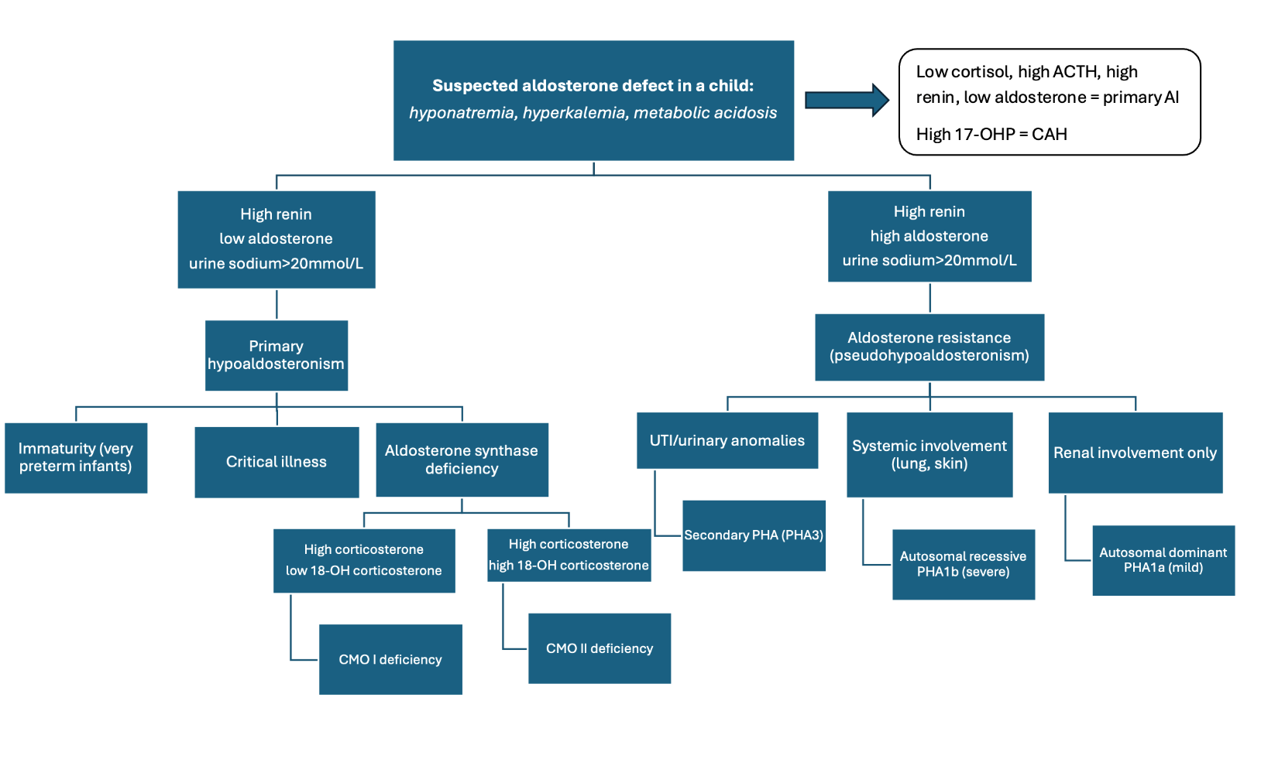

**Figure 3. A proposed approach in the differential and diagnostic evaluation of children with suspected aldosterone deficiency.**

**Genetic Testing**

In addition to biochemical evaluation, genetic testing is an invaluable tool to help guide treatment and prognosis, especially in infanta and children where the clinical manifestations of aldosterone defects vary widely (29). Genetic testing including whole exome sequencing or gene panels (for pseudo-hypoaldosteronism) may clarify the diagnosis, treatment, and prognosis. Genes associated with hypoaldosteronism and pseudo-hypoaldosteronism include *CYP11B2, NR3C2, SCNN1A, SCNN1B, SCNN1G, WNK1, WNK4, CUL3, KLHL3* (2).

**TREATMENT**

The initial management depends upon severity of presentation and etiology of the mineralocorticoid defect. Infants or children who are acutely ill with salt-wasting crisis must undergo fluid resuscitation to correct salt and water losses. It is essential to give stress dose corticosteroids (intramuscular or intravenous hydrocortisone 100mg/m2) if co-existing glucocorticoid deficiency exists. Hydrocortisone at high doses has mineralocorticoid effect, and fludrocortisone tablets may be added once hydrocortisone is weaned to be below about 50-60 mg/m2/day (3).

Oral treatment options for children with aldosterone defects include mineralocorticoid replacement (fludrocortisone), sodium chloride tablets, and sodium bicarbonate. The management plan depends on the underlying mineralocorticoid defect and is separated according to those children who are not able to produce aldosterone, and those who have resistance to its action.

**Primary Hypoaldosteronism**

Children with primary hypoaldosteronism (including those with adrenal insufficiency such as Addison’s Disease or CAH) should start mineralocorticoid replacement (fludrocortisone 0.05-0.2 mg/day). Infants and young children usually need higher doses of fludrocortisone in addition to sodium chloride supplementation due to renal resistance and general diet that is lower in salt. Sodium chloride is weaned over time as renin activity normalizes, and salt is incorporated into the diet. Fludrocortisone is continued for mineralocorticoid replacement and titrated based on normalization of blood pressure, electrolytes, and renin levels.

**Aldosterone Resistance**

Children with autosomal recessive (PHA1b) and autosomal dominant (PHA1a) pseudo-hypoaldosteronism are usually treated with high dose sodium chloride supplementation. Those who have PHA1a (mild form only affecting the kidneys) usually need lower doses of salt supplementation with gradual clinical improvement (typically no need for salt supplementation by 1-3 years of age) (30). Infants and children with the severe/systemic form (PHA1b) are more difficult to manage given the need for higher doses of salt supplementation, potassium lowering agents, and potential for recurrent pulmonary infections (31). Some of these children might need gastrostomy tubes to allow for consistent high dose salt supplementation which is not always tolerated by mouth. Sodium bicarbonate is another medication used to improve metabolic acidosis which can impact growth and development if acidosis persists. Given the rarity of pseudo-hypoaldosteronism, the doses of sodium chloride and sodium bicarbonate are not well established and must be titrated based on serum sodium and bicarbonate concentrations.

|  |  |  |
| --- | --- | --- |
| **Table 2. SUMMARY OF TREATMENT OPTIONS FOR CHILDREN WITH ALDOSTERONE DEFECTS:** | | |
| **Treatment** | **Dose** | **Considerations** |
| Fludrocortisone | 0.05-0.2 mg/day | Once or twice daily  Doses titrated based on blood pressure, electrolytes, and renin levels. |
| Sodium chloride (salt tablets) | 2 g/day or 2-5 mEq/kg daily | 1-gram NaCl tablets = 17mEq  Higher/more frequent doses in babies and weaned down as they get older.  Doses titrated based on sodium levels. |
| Sodium bicarbonate or sodium citrate/citric acid | 2-3 mEq/kg daily | Titrate based on bicarbonate levels |

**CONCLUSION**

Isolated defects in aldosterone synthesis or action are rare in children; however, it is important to identify these disorders to prevent life-threatening complications. Infants may present with salt wasting crisis while older children may present with failure to thrive, mild hyponatremia, and metabolic acidosis. The two major categories of isolated hypoaldosteronism include aldosterone synthesis defects and aldosterone resistance. There are several genes associated with isolated hypoaldosteronism, and genetic testing is an important diagnostic tool. Treatment and prognosis depend on the underlying etiology.

**REFERENCES**

1. Bizzarri C, Pedicelli S, Cappa M, Cianfarani S. Water Balance and ‘Salt Wasting' in the First Year of Life: The Role of Aldosterone-Signaling Defects. Hormone Research in Paediatrics. 2016;86(3):143-53.

2. Rajkumar V WM. Hypoaldosteronism. Treasure Island (FL): StatPearls Publishing; 2023.

3. Kilberg M, Vogiatzi M. Adrenal Insufficiency in Children. EndoText. 2024.

4. Arai K, Papadopoulou-Marketou N, Chrousos G. Aldosterone Deficiency and Resistance. EndoText. 2020.

5. White PC. Aldosterone synthase deficiency and related disorders. Mol Cell Endocrinol. 2004;217(1-2):81-7.

6. Carvajal CA, Tapia-Castillo A, Vecchiola A, Baudrand R, Fardella CE. Classic and Nonclassic Apparent Mineralocorticoid Excess Syndrome. J Clin Endocrinol Metab. 2020;105(4).

7. Martinerie L, Viengchareun S, Delezoide AL, Jaubert F, Sinico M, Prevot S, et al. Low renal mineralocorticoid receptor expression at birth contributes to partial aldosterone resistance in neonates. Endocrinology. 2009;150(9):4414-24.

8. Martinerie L, Pussard E, Yousef N, Cosson C, Lema I, Husseini K, et al. Aldosterone-Signaling Defect Exacerbates Sodium Wasting in Very Preterm Neonates: The Premaldo Study. The Journal of Clinical Endocrinology & Metabolism. 2015;100(11):4074-81.

9. Travers S, Martinerie L, Boileau P, Lombes M, Pussard E. Alterations of adrenal steroidomic profiles in preterm infants at birth. Arch Dis Child Fetal Neonatal Ed. 2018;103(2):F143-F51.

10. Martinerie L, Pussard E, Yousef N, Cosson C, Lema I, Husseini K, et al. Aldosterone-Signaling Defect Exacerbates Sodium Wasting in Very Preterm Neonates: The Premaldo Study. J Clin Endocrinol Metab. 2015;100(11):4074-81.

11. Kamrath C, Hartmann MF, Boettcher C, Wudy SA. Reduced activity of 11beta-hydroxylase accounts for elevated 17alpha-hydroxyprogesterone in preterms. J Pediatr. 2014;165(2):280-4.

12. Miller WL. MECHANISMS IN ENDOCRINOLOGY: Rare defects in adrenal steroidogenesis. Eur J Endocrinol. 2018;179(3):R125-R41.

13. Findling JW, Waters VO, Raff H. The dissociation of renin and aldosterone during critical illness. J Clin Endocrinol Metab. 1987;64(3):592-5.

14. Trimarchi T. Endocrine problems in critically ill children: an overview. AACN Clin Issues. 2006;17(1):66-78.

15. Starker LF, Christakis I, Julien JS, Schwarz K, Graham P, Grubbs EG, et al. Considering Postoperative Functional Hypoaldosteronism after Unilateral Adrenalectomy. Am Surg. 2017;83(6):598-604.

16. Queiroz NL, Stumpf MAM, Souza VCM, Maciel AAW, Fagundes GFC, Okubo J, et al. Renal Function Evolution and Hypoaldosteronism Risk After Unilateral Adrenalectomy for Primary Aldosteronism. Horm Metab Res. 2024;56(5):350-7.

17. Shariq OA, Bancos I, Cronin PA, Farley DR, Richards ML, Thompson GB, et al. Contralateral suppression of aldosterone at adrenal venous sampling predicts hyperkalemia following adrenalectomy for primary aldosteronism. Surgery. 2018;163(1):183-90.

18. Oster JR, Singer I, Fishman LM. Heparin-induced aldosterone suppression and hyperkalemia. Am J Med. 1995;98(6):575-86.

19. Tajima T, Morikawa S, Nakamura A. Clinical features and molecular basis of pseudohypoaldosteronism type 1. Clin Pediatr Endocrinol. 2017;26(3):109-17.

20. Adachi M, Nagahara K, Ochi A, Toyoda J, Muroya K, Mizuno K. Acid-Base Imbalance in Pseudohypoaldosteronism Type 1 in Comparison With Type IV Renal Tubular Acidosis. J Endocr Soc. 2022;6(12):bvac147.

21. Furgeson SB, Linas S. Mechanisms of type I and type II pseudohypoaldosteronism. J Am Soc Nephrol. 2010;21(11):1842-5.

22. Geller DS, Rodriguez-Soriano J, Vallo Boado A, Schifter S, Bayer M, Chang SS, et al. Mutations in the mineralocorticoid receptor gene cause autosomal dominant pseudohypoaldosteronism type I. Nat Genet. 1998;19(3):279-81.

23. Tauber KA, Ermacor K, Listman J. Cardiac arrest in a newborn: A case of pseudohypoaldosteronism. Clin Case Rep. 2024;12(2):e8265.

24. Moreno Sanchez A, Garcia Atares A, Molina Herranz D, Antonanzas Torres I, Romero Salas Y, Ruiz Del Olmo Izuzquiza JI. Secondary pseudohypoaldosteronism: a 15-year experience and a literature review. Pediatr Nephrol. 2024;39(11):3233-9.

25. Betti C, Lavagno C, Bianchetti MG, Kottanattu L, Lava SAG, Schera F, et al. Transient secondary pseudo-hypoaldosteronism in infants with urinary tract infections: systematic literature review. Eur J Pediatr. 2024;183(10):4205-14.

26. Mustaqeem R AA. Renal Tubular Acidosis. Treasure Island (FL): StatPearls Publishing. Available from: <https://www.ncbi.nlm.nih.gov/books/NBK519044/>.

27. Manas F, Singh S. Pseudohypoaldosteronism Type II or Gordon Syndrome: A Rare Syndrome of Hyperkalemia and Hypertension With Normal Renal Function. Cureus. 2024 Jan 19;16(1).

28. Adachi M, Motegi S, Nagahara K, Ochi A, Toyoda J, Mizuno K. Classification of pseudohypoaldosteronism type II as type IV renal tubular acidosis: results of a literature review. Endocr J. 2023;70(7):723-9.

29. Turan I, Kotan LD, Tastan M, Gurbuz F, Topaloglu AK, Yuksel B. Molecular genetic studies in a case series of isolated hypoaldosteronism due to biosynthesis defects or aldosterone resistance. Clin Endocrinol (Oxf). 2018;88(6):799-805.

30. Krishna S, Augustian M. Autosomal Dominant Pseudohypoaldosteronism Type 1 in a Newborn With Failure to Thrive. Cureus. 2024;16(4):e59356.

31. Karacan Küçükali G ÇS, Tunç G, Oğuz MM, Çelik N, Akkaş KY, Şenel S, Güleray Lafcı N, Savaş Erdeve Ş. Clinical Management in Systemic Type Pseudohypoaldosteronism Due to SCNN1B Variant and Literature Review. J Clin Res Pediatr Endocrinol. 2021;13(4):446-51.