Published in WWW.ENDOTEXT.ORG © 2018

MOLECULAR LINKS BETWEEN OBESITY AND DIABETES

Alexandra Chadt, Ph.D. German Diabetes Center (DDZ), Leibniz Center for Diabetes Research at the Heinrich Heine University, Institute for Clinical Biochemistry and Pathobiochemistry
Auf`m Hennekamp 65, 40225 Duesseldorf/ Germany
Stephan Scherneck, Ph.D. Technical University of Braunschweig, Institute of Pharmacology, Toxicology and Clinical Pharmacy, Mendelssohnstr. 1, 38106 Braunschweig/ Germany
Hans-Georg Joost, M.D., Ph.D, ³German Institute of Human Nutrition Potsdam-Rehbruecke (DIfE), Department of Pharmacology, Arthur-Scheunert-Allee 114-116, 14558 Nuthetal/ Germany
Hadi Al-Hasani, Ph.D. ¹German Diabetes Center (DDZ), Leibniz Center for Diabetes Research at the Heinrich Heine University, Institute for Clinical Biochemistry and Pathobiochemistry
Auf`m Hennekamp 65, 40225 Duesseldorf/ Germany. Hadi.Al-Hasani@DDZ.UNI-DUESSELDORF.DE

Updated: January 23, 2018

ABSTRACT

Severe obesity represents a major risk factor for the development of type 2 diabetes mellitus (T2DM). Due to the strong association of obesity and diabetes, the term “diabesity” was coined, suggesting a causal pathophysiological link between both phenomena. The majority of individuals with T2DM are obese, highlighting the pivotal role of increased adiposity as a risk factor for diabetes. However, only a relatively small fraction of obese individuals will develop T2DM. On a population level, the link between obesity and its secondary complications is well described. However, the molecular mechanisms underlying these complications are still poorly understood. Three main hypotheses have been developed in recent years to bridge the gap between epidemiology and pathobiochemistry: (1) The “inflammation hypothesis” asserts that obesity represents a state of chronic inflammation where inflammatory molecules produced by infiltrating macrophages in adipose tissue exert pathological changes in insulin-sensitive tissues and β-cells. (2) The “lipid overflow hypothesis” predicts that obesity may result in increased ectopic lipid stores due to the limited capacity of adipose tissue to properly store fat in obese subjects. Potentially harmful lipid components and metabolites may exert cytotoxic effects on peripheral cells. (3) The “adipokine hypothesis” refers to the principal feature of white adipose cells to function as an endocrine organ, and to secrete a variety of hormones with auto- and paracrine function. Expanding fat stores can cause dysfunctional secretion of such endocrine factors, thereby resulting in metabolic impairment of insulin target tissues and eventually failure of insulin producing β-cells. For complete coverage of all related areas of Endocrinology, please visit our on-line FREE web-text, WWW.ENDOTEXT.ORG.

INTRODUCTION

Severe obesity represents a major risk factor for the development of type 2 diabetes mellitus (T2DM), a disease characterized by insulin resistance, insulin hyposecretion and hyperglycaemia.¹⁻³ According to statistics, already 415 million people worldwide were affected by diabetes in 2015 (estimated) and this number is expected to rise to 642 million by 2040.⁴ Due to the strong association of obesity and diabetes, the term “diabesity” was coined, suggesting a causal pathophysiological link between both phenomena.

SIZE MATTERS (NOT ONLY)!

The majority (~80%) of individuals with T2DM are obese, highlighting the pivotal role of increased adiposity as a risk factor for diabetes. However, only a relatively small fraction of obese individuals develops T2DM.⁷ In fact, most obese, insulin-resistant individuals do not develop hyperglycemia, indicating that their pancreatic β-cells still produce and secrete sufficient amounts of insulin in order to compensate for the reduced efficiency of insulin action in the periphery. Thus, in addition to an increased adipose mass, additional factors are likely to determine the risk for β-cell dysfunction and the susceptibility for β-cell destruction and diabetes. Nevertheless, despite recent advances in the understanding of body weight regulation and insulin action, the risk factors that determine which obese, non-diabetic individuals will eventually develop diabetes still remain unknown.

ROLE OF FAT DISTRIBUTION

Obesity results from a period of a positive energy balance during which adipocytes store excess triglycerides, resulting in cell hypertrophy and hyperplasia. However, fat depots do not expand uniformly as they accumulate lipids, and the adverse effects of excess fat storage have been frequently attributed to intra-abdominal (i.e. visceral) fat tissue. Using a variety of measures (oral glucose tolerance test, intravenous glucose tolerance test, euglycemic hyperinsulinemic clamps), selective excess of visceral adipose tissue (visceral adiposity) has been linked to insulin resistance in humans.¹⁰⁻¹⁹ Interestingly, no relationship between visceral fat and impaired glucose metabolism has been observed in studies with non-obese individuals. On the other hand, other studies found that abdominal subcutaneous fat correlates with insulin sensitivity as well as visceral fat in euglycemic clamps, thus challenging a unique role for the visceral fat depot in modulating insulin sensitivity. However, in another study, Klein and coworkers reported that large-volume abdominal liposuction of subcutaneous fat did not improve insulin sensitivity of liver, skeletal muscle, and adipose tissue (as assessed by euglycemic-hyperinsulinemic clamps), at least not within 12 weeks post surgery.²⁴ In accordance to these results, removal of visceral fat has been found to improve insulin sensitivity in humans, supportive of a causal role of intra-abdominal fat for the insulin resistance in obese individuals. However, the relationship between the amount of visceral fat and insulin sensitivity has been controversially discussed throughout recent years and a number of clinical studies show that surgical removal of this fat depot (e.g. via omentectomy) did not lead to improved whole-body glycemia or even BMI of the patients.²⁷⁻³⁰ Interestingly, a number of adipose-tissue related sub-phenotypes have been identified, one of these the so-called “TOFI” (“thin on the outside, fat on the inside”) subjects. These patients present a normal BMI (< 25 kg/m²) but increased abdominal obesity and therefore exhibit an increased risk to develop insulin resistance and T2DM. In contrast to TOFI, the so-called “fat-fit” subjects show no gross impairments of glucose metabolism despite their elevated body adiposity (BMI ≥ 30 kg/m²).

Visceral fat is defined as adipose tissue located inside the peritoneal cavity—within the parietal peritoneum and transversalis fascia, excluding the spine and paraspinal muscles. As such, appropriate techniques for precise measurements of visceral fat, however, have been controversial. In humans, the amount of abdominal visceral fat is determined by a number of different techniques, including anthropomorphic measurements (waist-hip-ratio, waist circumference, abdominal sagittal diameter), computed tomography (CT), magnetic resonance imaging (MRI), and ultrasound. Comparative measurements using CT and MRI have revealed a fairly high correlation between both methods.³⁴⁻³⁶ In the recent years, Dual-energy X-ray absorptiometry (DXA) has emerged as reliable technique to measure body composition with high-precision, low X-ray exposure, and short-scanning time. In studies that included these imaging techniques and common clinical measurements, the abdominal sagittal diameter was found to be the most specific predictor of visceral adipose volume, but measurements of waist circumference and sagittal diameter are also highly correlated. Even though waist circumference varies considerably between sexes and among different ethnic groups, it has been proposed as a crude, but efficient, anthropomorphic readout for abdominal adiposity. And lastly, the amount of visceral fat is correlated to total body fat even though considerable variation in individual fat distribution has been reported,⁴¹⁻⁴⁴ Thus, despite the lack of a ”gold standard” for the quantitative assessment of regional fat distribution in humans, most of the evidence suggests a specific association between visceral fat with an increased risk for insulin resistance and diabetes.

TO BE (FAT) OR NOT TO BE

Interestingly, deficiency of fat tissue (lipodystrophy) predisposes to similar metabolic complications as an excess of fat in obesity, such as insulin resistance, T2DM, and hepatic steatosis (reviewed in Refs 45 and 46). Moreover, fat transplantation into lipodystrophic mice ameliorated the diabetic phenotype of the animals either partially or completely, implicating that the failure to properly store lipids in depots is causal for lipodystrophic diabetes.⁴⁷ Also in normal lean animals, fat transplantation has been shown to result in beneficial metabolic effects. Thus, adipose tissue may have both beneficial and adverse effects on whole-body metabolism, depending on where it accumulates.

OBESITY-INDUCED DIABETES: FACTORS AND MECHANISMS

On a population level, the link between obesity and its secondary complications is well described. However, the molecular mechanisms underlying these complications are still poorly understood.⁵⁰ Even though the evidence indicates a detrimental role of visceral fat in terms of insulin sensitivity, relatively little is known about distinct physiological and biochemical properties of fat tissue derived from different anatomic locations. On the one hand, transplantation experiments with fat tissue from different adipose depots in mice have not conclusively revealed intrinsic differences between subcutaneous and visceral fat. On the other hand, factors that have been attributed to confer differential metabolic effects of subcutaneous versus visceral fat include increased portal release of FFA and glycerol from omental/mesenteric fat directly to the liver, and also differences in endocrine and metabolic functions of fat depots.

Three main hypotheses have been developed in recent years to bridge the gap between epidemiology and pathobiochemistry:

(1) The “inflammation hypothesis” asserts that obesity represents a state of chronic inflammation where inflammatory molecules produced by infiltrating macrophages in adipose tissue exert pathological changes in insulin-sensitive tissues and β-cells.

(2) The “lipid overflow hypothesis”, also known as “Adipose Tissue Expandability Hypothesis” predicts that obesity may result in increased ‘ectopic’ lipid stores (lipid that accumulates outside the normal depots, such as in the organ tissue of the liver, muscle, and pancreas) due to the limited capacity of adipose tissue to properly store fat in obese subjects. Potentially harmful lipid components and metabolites may exert cytotoxic effects on peripheral cells, including liver and β-cells, thereby impairing function, survival, and regeneration.

(3) The “adipokine hypothesis” refers to the principal feature of white adipose cells to function as an endocrine organ, and to secrete a variety of hormones with auto- and paracrine function. It has been proposed that expanding fat stores in obesity cause dysfunctional secretion of such endocrine factors, thereby resulting in metabolic impairment of insulin target tissues and eventually failure of insulin producing β-cells.

In the following, these three hypotheses are briefly discussed.

The “Inflammation Hypothesis”

Inflammatory processes are thought to play a key role in the development of obesity-related insulin resistance and type 2-diabetes. In adiposity there are fundamental changes in adipose tissue secretory functions⁵¹. An excess of adipose tissue produces a number of pro-inflammatory cytokines leading to a state of chronic subclinical inflammation associated with both insulin resistance and type-2 diabetes.⁵² The term “metaflammation” describes this low-grade, chronic inflammation orchestrated by metabolic cells in response to excess nutrients and energy.⁵³

How does a spill-over of these inflammatory products into circulation finally lead to insulin resistance? Weisberg et al⁵⁴ described that macrophages accumulate in adipose tissue of obese subjects and suggested that these macrophages are derived from the circulation. Further studies indicated that adipose tissue macrophages (ATMs) that accumulate during diet-induced obesity (DIO) are not only an important source of adipose tissue inflammation but also mediate insulin resistance in adipocytes.⁵⁵ The amount of macrophages in adipose tissue correlates positively with two indices of adiposity: Body mass index (BMI) and adipocyte size. The exact mechanisms underlying ATM recruitment and activation are still not fully understood. One factor potentially responsible for obesity-induced inflammation by increasing ATM recruitment is Macrophage Migration Inhibitory Factor (MIF), a chemokine-like inflammatory regulator directly associated with the degree of peripheral insulin resistance.⁵⁶ Adipose tissue macrophages are considered to be a major reservoir of pro-inflammatory molecules in adipose tissue⁵⁴. These cytokines exert various functions in the pathogenesis of the disease progression (Figure 1). Some of the most important inflammatory factors are described below.

Figure 1. The “inflammation hypothesis.” Pathophysiology of obesity-induced chronic inflammation and peripheral insulin resistance.
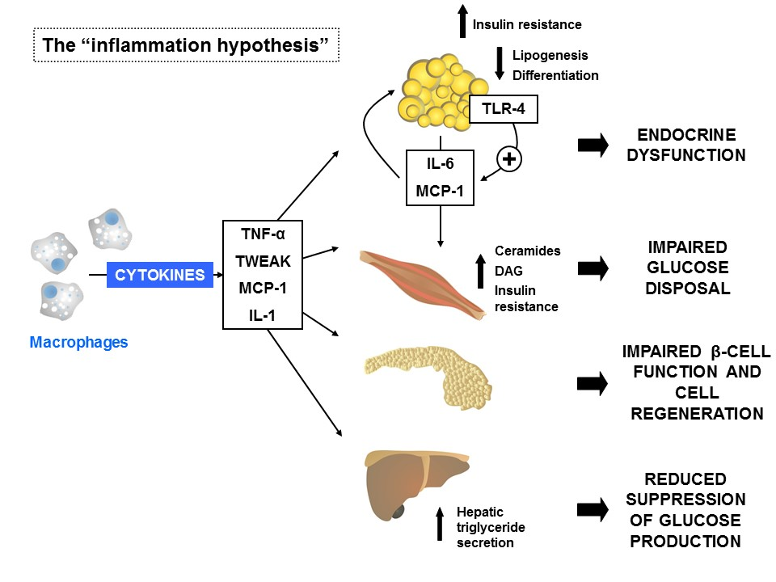
DAG, diacylglycerol; IL-1, interleukine-1; MCP-1, monocyte chemotactic protein-1; TNF, tumor necrosis factor alpha; Toll-like receptor 4, TLR-4; Details in the text.

Tumor Necrosis Factor Alpha:
Tumor necrosis factor alpha (TNF-α) is a pluripotent cytokine primarily produced from macrophages.⁵⁷ Its expression was shown to be elevated in different mouse and rat models of obesity and diabetes.⁵⁸ In vitro, TNF-α suppresses the expression of most adipose-specific genes in murine adipocytes, including the enzymes involved in lipogenesis.⁵⁹ It was also shown that TNF-α induces insulin resistance, in part through its ability to inhibit intracellular signaling from the insulin receptor.⁶⁰ Moreover, addition of TNF-α to cells in vivo increased the intracellular concentration of ceramides.⁶¹ Ceramides can directly induce DNA fragmentation and apoptosis. In skeletal muscle, diacylglycerols and ceramides operate as lipotoxic mediators engaging serine kinases that disrupt the insulin signaling cascade and diminish insulin sensitivity.⁶² Further, it was discovered that ceramides are able to induce lipoapoptosis in β-cells.⁶³ In addition, TNF-α was shown to induce the formation of reactive oxygen species (ROS).⁶⁴ Production of ROS increased selectively in adipose tissue of obese mice, causing dysregulated production of adipocytokines (fat-derived hormones), including adiponectin, plasminogen activator inhibitor-1, interleukin-6 (IL-6), and monocyte chemotactic protein-1.⁶⁵ However, clinical studies with Etanercept, a neutralizing protein for circulating TNF-α failed to demonstrate an improvement of insulin sensitivity in humans, indicating that acute reduction of systemic TNF-α may not be sufficient to induce metabolic benefits in the periphery.

TNF-Like Weak Inducer of Apoptosis:
TNF-like weak inducer of apoptosis (TWEAK) belongs to the TNF superfamily and was shown to have pro-inflammatory action in adipocytes mediated by the nuclear factor-κB (NFκB) and ERK but not JNK signaling pathways.⁶⁸ The cytokine promotes the secretion of MCP-1 and RANTES and up-regulates CCl21 and CCL19 expression. Whereas expression levels of membrane-bound TWEAK (mTWEAK) and its receptor Fn14 are increased during obesity, the amount of soluble TWEAK (sTWEAK) was decreased, thereby enhancing the pro-inflammatory activity elicited by TNF-α.

Monocyte Chemotactic Protein-1:
The pro-inflammatory chemokine monocyte chemotactic protein-1 (MCP-1) attracts leukocytes to inflamed sites and is regulated by NFκB. ⁷¹ Monocyte chemotactic protein-1 represents the first discovered and most extensively studied human CC chemokine and is also known as CCL2 (Chemokine (C-C motif) ligand 2). CC chemokines are characterized by the conserved position of four cysteine residues responsible for protein stabilization.⁵⁶ Insulin was found to induce expression and secretion of MCP-1 substantially both in vitro in insulin-resistant adipocytes and in vivo in insulin-resistant obese mice (ob/ob). It was suggested that elevated MCP-1 levels may induce adipocyte dedifferentiation and contribute to pathologic states associated with hyperinsulinemia and obesity, including type 2 diabetes.⁷² Expression and plasma concentration of MCP-1, however, were shown to be increased both in genetically obese diabetic (db/db) mice and in wildtype mice with high-fat diet-induced obesity, leading to the assumption that increased MCP-1 expression contributes to the macrophage infiltration of adipose tissue and, finally, to the development of insulin resistance.⁷³ Monocyte chemotactic protein-1 has been developed into one of the most important targets for a variety of therapeutic approaches to improve diabetic vascular conditions over the years.⁷⁴

Interleukin-6:
The role of the cytokine interleukin-6 (IL-6) in the regulation of lipid metabolism is controversial.⁷⁵ If produced in large amounts by adipose tissue, IL-6 causes insulin resistance in adipocytes and skeletal muscle.⁷⁶ Contrary to the expectations, IL-6-deficient mice develop obesity. However, excess body weight was only reported in very mature animals.⁷⁷ Interestingly, chronic exposure of IL-6 produces insulin resistance in skeletal muscle, whereas short-term exposure as consequence of exercise has beneficial effects on insulin sensitivity.⁷⁸ Thus, despite the evidence of IL-6 as a major player in the regulation of metabolism, the role of this cytokine in the pathogenesis of insulin resistance and diabetes remains incompletely understood.

Interleukin-1:
Interleukin-1 (IL-1) is a cytokine that is also secreted by stimulated macrophages and has many actions that overlap those of TNF-α. For instance, IL-1 increases hepatic triglyceride secretion and serum triglyceride levels.⁷⁹ Common polymorphisms of the IL-1 gene that influence IL-1 activity are also associated with fat mass in humans.⁸⁰ Pro-inflammatory pathways in adipose tissue have been shown to be directly activated by free-fatty acids (FFA). In turn, the inflammatory status of macrophages is linked to body fat content. In lean mice, macrophages in WAT are in their active M2 state and produce immunosuppressive factors. However, in obese mice, macrophages are in a pro-inflammatory M1 state (F4/80+, CD11b+, CD11c+), highly responsive to the pro-inflammatory effect of FFA that bind the Toll-Like Receptors (TLRs).⁸¹ Increased cytokine release via TLRs as a consequence of FFA binding was proposed as potential pathomechanism causing insulin resistance.⁸² Interestingly, in a clinical study, blockade of IL-1 receptor with Anakinra, a recombinant IL-1 receptor antagonist, improved HbA_{1c} levels and proinsulin-to-insulin ratio but had no effect on systemic insulin sensitivity.⁸³

Toll-Like Receptor-4:
Toll-like receptors are membrane-spanning, non-catalytic receptors that respond to different microbial antigens, therefore representing an important factor of the innate immunity.⁸⁴ Toll-like Receptor-4 (TLR-4) is thought to be another important factor in fatty acid-induced insulin resistance. Scherer and coworkers were the first ones that found it expressed on 3T3-L1 adipocytes and activated by lipopolysaccharides (LPS).⁸⁵ Characterization of TLR-4 as the main endogenous sensor for LPS in adipocytes supports the relevance of fat tissue in immune processes.⁸⁶ Additionally, TLR-4 was recently shown to be directly activated by dietary saturated fatty acids, thereby promoting inflammatory aspects of the metabolic syndrome and atherosclerosis.⁸⁷ In addition, stimulation of TLR-4 with activation of the Erk pathway was shown to upregulate IL-6 as well as MCP-1 release in adipose tissue. Therefore, it can be suggested that activation of TLR-4 in adipocytes induces inflammation and, as a consequence, promotes the progression towards diabetes. This mechanism provides new evidence for a coupling of visceral adipose dysfunction with the development insulin resistance and T2DM.⁸⁸

Summary:
Inflammation is thought to be a major factor in the development of insulin resistance and diabetes. Increased secretion of adipocyte-derived inflammatory cytokines and fatty acids are directly linked to impaired insulin sensitivity in obesity.⁸⁹ However, inflammatory processes do not account exclusively for the development of insulin resistance since there are studies showing subjects with T2D but without any alterations in inflammatory markers.⁹⁰ Inflammation alone can therefore not explain how obesity affects insulin sensitivity and certainly not why only a small fraction of obese individuals develop T2DM.

The “Lipid Overflow Hypothesis”

Healthy adipose tissue is characterized by the ability to expand passively to accommodate periods of nutrient excess. In contrast, adipose tissue in polygenic mouse models of obesity-induced diabetes, as well as in obese humans, may fail to fully accommodate excessive nutrient loads.⁹¹⁻⁹³ If the adipose tissue expansion limit is reached, lipids can no longer be stored appropriately in adipose tissue and consequently “overflow” to other peripheral tissues such as skeletal muscle, liver, and pancreas. Subcutaneous adipose tissue (SAT) represents the largest adipose tissue depot and, in addition, is considered the least metabolically harmful site for lipid storage. The SAT can expand either by increasing the size of the cells (hypertrophic obesity) and/or by recruiting new cells (hyperplastic obesity). In contrast to the hyperplastic response, which seems to be protective against SAT dysfunction, hypertrophic obesity is associated with increased T2D risk. The storage of this ectopic fat in non-SAT tissues is directly linked to the progression of insulin resistance and type-2-diabetes. Thus, fat accumulates in tissues that are not adequate for lipid storage, and as a consequence, lipid metabolites might accumulate within those tissues that inhibit insulin signal transduction (Figure 2).

Figure 2: The “lipid overflow hypothesis.” Pathophysiology of obesity-induced ectopic lipid stores that cause peripheral insulin resistance and impaired β-cell function.

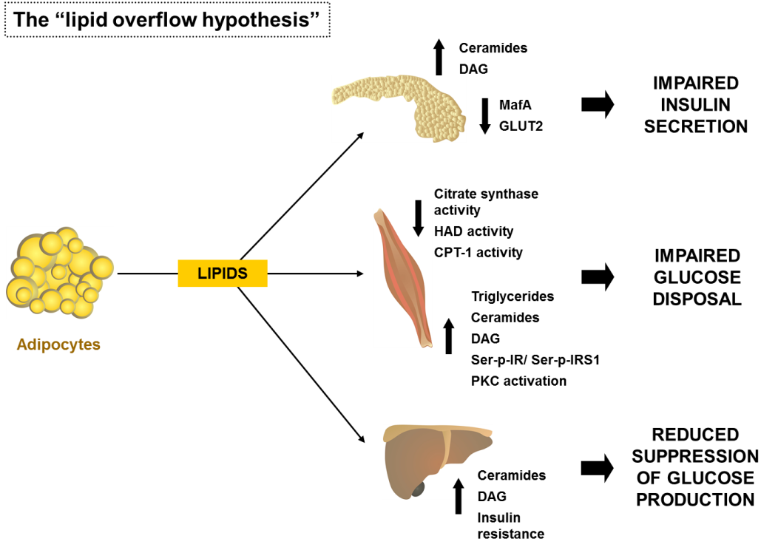

CPT-1, carnitine palmitoyltransferase 1; DAG, diacylglycerol; GLUT2, facilitated glucose transporter, member 2 (SLC2A2); HAD, β-hydroxyacyl dehydrogenase; IRS1, insulin receptor substrate 1; MafA, pancreatic beta-cell-specific transcriptional activator MafA; PKC, Protein kinase C; Details in the text.

This hypothesis is supported by several rodent models of lipodystrophy. These animals are extremely lean but often suffer from marked insulin resistance, diabetes, hypertriglyceridemia, hepatosteatosis, and low HDL (high-density lipoprotein)-cholesterol levels – a metabolic profile similar to that observed in obesity-related metabolic syndrome. Moreover, recent studies demonstrate a lipodystrophy-like phenotype also in the general human population since subjects who are of normal weight but metabolically unhealthy (∼20% of the normal weight adult population) have a greater than 3-fold higher risk of all-cause mortality and/or cardiovascular events.⁴⁶ Leptin replacement in patients with generalized lipodystrophy can serve as efficient therapy to improve insulin sensitivity by reducing ectopic fat accumulation, especially in the liver.¹⁰²⁻¹⁰⁴

Thus, an increased fatty acid flux from normal fat depots towards non-adipose tissues (NAT), e.g. skeletal muscle, heart, liver, and pancreatic β-cells appears to be a critical factor in mediating lipotoxicity. Among the substances known to impair insulin signaling, the most prominent examples include diacylglycerols (DAGs) and ceramides, which have both been shown to impair insulin action in a number of peripheral tissues.¹⁰⁵⁻¹⁰⁷

Lipotoxicity- Skeletal Muscle and Adipocytes:
Skeletal muscle insulin resistance is associated with high levels of stored lipids in skeletal muscle cells.¹⁰⁸ A high lipid accumulation and/or lower triglyceride turnover can induce lipotoxicity within the skeletal muscle cell.¹⁰⁹ Lipid infusion can induce peripheral and hepatic insulin resistance in rats and humans. There are multiple regulatory sites controlling the complex process of fatty acid (FA) metabolism in skeletal muscle. Long-chain FA (LCFA) oxidation involves lipolysis and LCFA release from the adipose tissue, delivery of FFA to the skeletal muscle, transport across the plasma membrane, lipolysis of intramuscular triacylglycerol (IMTG), activation with addition of a coenzyme A thioester (LCFA-CoA), transport across the mitochondrial membranes and ultimately oxidation.¹¹² Obese individuals display a disturbed lipid oxidation in skeletal muscle. This leads to accumulation of fatty acids and therefore to enhanced levels of triglycerides, fatty acyl CoA, diacylglycerols, and ceramides.¹¹³⁻¹¹⁵ Accumulation of these metabolites may be able to impair insulin signaling through different mechanisms, such as increased serine phosphorylation of the insulin receptor and insulin receptor substrate 1 by Protein kinase C (PKC) β and reduced serine phosphorylation of AKT. Besides disturbances in the insulin signaling cascade, several other factors could be involved in the direction of LCFA or LCA-CoA towards esterification rather than oxidation in obesity and type-2 diabetes. It has long been debated whether reduced mitochondrial function is the cause of, or secondary to, insulin resistance and T2D. Numerous studies, however, have shown that the activity of the key enzymes of fatty acid oxidation, citrate synthase (CS) and β-hydroxyacyl dehydrogenase (HAD) are significantly reduced in skeletal muscle in obesity and type 2 diabetes.¹¹⁸⁻¹²¹ Additionally, it has also been shown that the activity of carnitine palmitoyltransferase 1 (CPT1) in muscle was also reduced in association with obesity,¹²² and that mitochondrial oxidative capacity is low in insulin-resistant subjects.¹²³ Carnitine palmitoyltransferase 1 converts acyl-CoA molecules to their acyl carnitine derivatives prior transport of the mitochondrial inner membrane.¹²⁴

Plasma non-esterified free fatty acids (NEFAs) are suggested to contribute to the development of insulin resistance, since they have been shown to activate the inflammatory nuclear factor kappa-B (NFκB) pathway in human muscle biopsies. In humans, it was demonstrated that free fatty acids induce insulin resistance by inhibition of glucose transport.¹²⁷ In addition to the negative impact on insulin sensitivity, there is very recent evidence that lipid droplet (LD) formation is also impaired by an overflow of lipids. It has been shown that LD formation requires some of the same components of the machinery involved in regulated fusion of vesicles including the two soluble N-ethylmaleimide-sensitive-factor attachment protein receptor (SNARE) proteins SNAP23 and syntaxin-5. SNAP23 has been shown to be an essential factor for trafficking of GLUT4-containing vesicles to the plasma membrane, and a more recent study found that SNAP23 is also involved in LD formation in adipocytes.¹²⁸ Interestingly, the study reported that excessive LD formation inhibited GLUT4 translocation by competing for SNAP23 and that overexpression of Snap23 in these cells restored insulin sensitivity. Thus, SNAP23 might constitute a link between glucose and lipid metabolism, respectively.

Lipotoxicity- Pancreatic Beta Cell:
The development of type 2 diabetes is caused by a combination of insulin resistance and impaired pancreatic β-cell secretion.¹²⁹ With progression from euglycemia to type 2 diabetes, β-cells progressively fail to compensate for the increase insulin demand in peripheral tissues. The pathogenesis is thereby characterized by different stages, leading from compensatory insulin resistance to decompensated hyperglycemia.¹³⁰ In manifest type 2 diabetes, β-cells are exposed to both high doses of glucose (glucotoxicity) and lipids (lipotoxicity), respectively.¹³¹ Lipotoxicity, manifests as incorporation of large amounts of triglycerides in pancreatic islets, leading to β-cell death.¹³²

While rodents are often preferred models to study disease progression, polygenic mouse models more closely resemble human physiology and preferred over the monogenic models such as in defective leptin signaling (db, ob). New Zealand Obese (NZO) mice develop a polygenic disease pattern of obesity, insulin resistance, and type 2 diabetes. The onset of hyperglycemia is characterized by an elevated proliferation rate and hypertrophy of the β-cells¹³⁶ leading to β-cell failure in most of the male animals.¹³⁷ The disease progression is characterized by a gradual loss of glucose transporter 2¹³⁸ and the transcription factor v-maf musculoaponeurotic fibrosarcoma oncogene family, protein A (avian) (MafA).¹³⁹ Interestingly, NZO mice fed a carbohydrate-free high fat diet become obese and insulin resistant but are protected from β-cell failure.¹³⁹⁻¹⁴¹ In contrast mice fed a diet rich in both carbohydrates and fat rapidly develop diabetes, indicating that the additive toxicity of an overflow of carbohydrates and lipids is important for the progression of β-cell failure.

Summary:
Inability to store fat (lipodystrophy) or overflow of excess lipids from normal fat depots contributes to “ectopic” deposition of lipids and their metabolites in organs important for glucose metabolism, including muscle, liver, and the pancreas. Numerous studies have demonstrated involvement of these lipid metabolites in the development of insulin resistance and diabetes. Moreover, recent evidence indicates that hyperglycemia is a critical factor contributing to lipid-induced beta cell failure and diabetes. Thus, many leading scientists consider type 2 diabetes, a disorder with manifestations of abnormal glucose metabolism, to be at its most fundamental molecular level a disorder of lipid metabolism.

The “Adipokine Hypothesis”

Adipose tissue is not only a storage compartment for triglycerides but also a major endocrine and secretory organ, which releases a wide range of factors (adipokines) that signal through paracrine and hormonal mechanisms.¹⁴⁴ Some of these secreted molecules are involved in inflammatory processes, such as TNF-α, IL-1β, IL-6 and MCP-1 as described above. The expanding volume of adipose tissue during obesity raises circulating levels of these inflammatory markers and is therefore thought to contribute to insulin resistance¹⁴⁵ and the development of T2DM (Figure 3).

Figure 3: The “adipokine hypothesis.” Pathophysiology of obesity-induced dysfunction of adipokines in adipose cells contributing to peripheral insulin resistance.

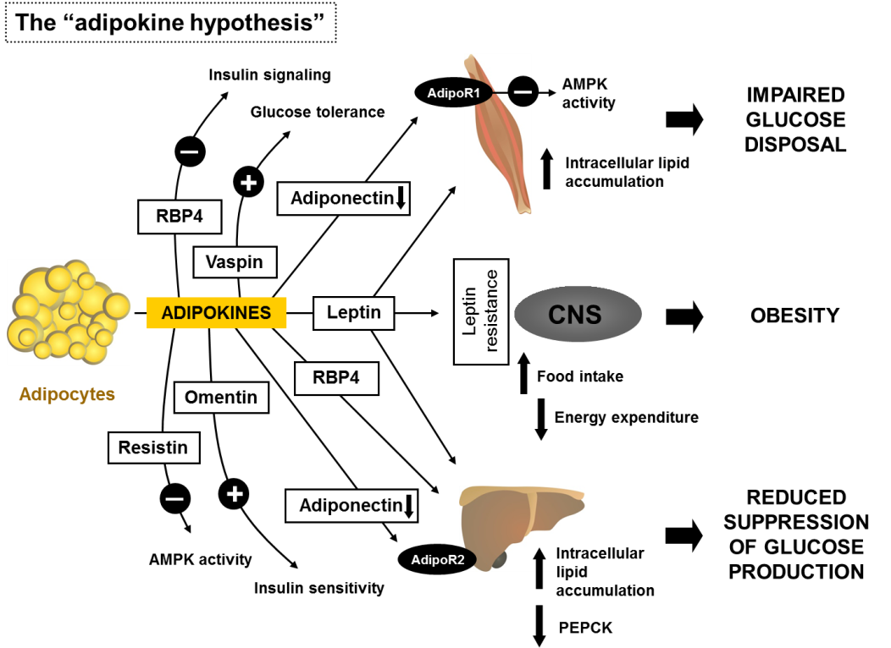

AdipoR2, adiponectin receptor 2; AMPK, AMP-activated protein kinase; PEPCK, phosphoenolpyruvate carboxykinase; RBP4, retinol binding protein 4; Details in the text.

More than 100 different factors secreted by adipocytes have been identified over the past years, and it seems likely that this number will increase further due to the progress in analytical chemistry.¹⁴⁶ Some of the prominent members of hormones produced by the adipose tissue are described below.

Leptin:
Leptin was the first adipokine discovered to influence body fat mass. It is predominantly secreted from white adipose tissue and exerts its main function by repressing food intake and promoting energy expenditure through sites of action in the central nervous system.¹⁴⁷ The leptin receptor is expressed in the arcuate, ventromedial, dorsomedial, and lateral hypothalamic nuclei, which are known to regulate food intake.¹⁴⁸ Mutation of both the leptin gene (ob) as well as the leptin receptor gene (db) leads to severe obesity, hyperphagia and insulin resistance in mice.¹⁴⁹ The ob mutation was first hypothesized in 1950, when animal caretakers of the Jackson Laboratory observed the spontaneous occurrence of an obese phenotype in a mouse.¹⁵⁰ but was not described as a non-sense mutation in the leptin gene until more than 40 years later.¹⁵¹

Expression and secretion of leptin is correlated with the amount of body fat and adipocyte size.¹⁵² Humans with mutations in both alleles of either leptin or the leptin receptor are obese, but these homozygous mutations are extremely rare.¹⁵³ To the contrary, the vast majority of obese individuals display high plasma leptin levels in proportion to their increased body fat. Consequently, attempts to treat obesity by leptin administration have been mostly unsuccessful due to an apparent leptin resistance of these patients.¹⁵⁴ Nevertheless, leptin improves insulin sensitivity by several mechanisms. In the liver and in skeletal muscle, leptin enhances glucose homeostasis by decreasing intracellular lipid accumulation¹⁵⁵ and, in skeletal muscle, by direct activation of AMP-activated protein kinase (AMPK)¹⁵⁶. In addition, leptin is able to inhibit insulin secretion by both, a direct effect on pancreatic β-cells, and an indirect mechanism via activation of the SNS (sympathetic nervous system) by the CNS (central nervous system).¹⁵⁷⁻¹⁶⁰

Adiponectin:
Adiponectin represents another important adipokine that has to be considered in the pathogenesis of insulin resistance and type 2 diabetes. Up-regulation of this collagen-like plasma protein secreted by adipocytes or its receptor is known to improve insulin sensitivity and endothelial function. Adiponectin has been closely linked to diseases such as obesity, the metabolic syndrome, type 2 diabetes mellitus, dyslipidemia and essential hypertension through its anti-inflammatory effects. In obesity and diabetes, adiponectin biosynthesis is impaired, and in vitro studies demonstrate suppression of adiponectin expression by various inflammatory and oxidative stress factors.

Adiponectin regulates glucose and lipid metabolism by targeting the liver and skeletal muscle through two transmembrane receptors (AdipoR1 and AdipoR2). While AdipoR1 is most abundant in skeletal muscle, AdipoR2 is predominantly expressed in the liver.¹⁶⁷ Improvement of insulin sensitivity is reached through activation of AMPK as well as increased expression of PPARα target genes.¹⁶⁸ Adiponectin also has a key role in differentiation of subcutaneous preadipocytes and in the central regulation of energy homeostasis.

Resistin:
Resistin expression and secretion differs between humans and rodents. In rodents, resistin is predominantly secreted from mature adipocytes with some weak expression in pancreatic islets and hypothalamus. In contrast, humans express resistin primarily in macrophages where it is thought to be involved in the recruitment of other immune cells, and in the secretion of pro-inflammatory factors.¹⁷⁰ Because of these interspecies differences, it may have a less important role in humans during the pathogenesis of insulin resistance and diabetes. However, insulin-resistant mice display increased resistin levels and treatment with a thiazolidinedione, which activates adipocyte PPAR receptors and improves insulin sensitivity, lowers plasma resistin levels. In addition, some studies describe a role for resistin in the regulation of hepatic glucose production.¹⁷²

Opposed to adiponectin, resistin decreases AMPK phosphorylation in liver, which leads to suppression of fatty acid oxidation and stimulation of glucose production.¹⁷³ In vitro data from cultured adipocytes demonstrated a decreased insulin-stimulated glucose transport and disturbed adipocyte differentiation after resistin treatment. In humans, resistin is thought to impair insulin signaling by upregulating expression of the lipid phosphatase PTEN.¹⁷⁰

Retinol Binding Protein 4:
Retinol binding protein 4 (RBP4) is predominantly expressed in adipose tissue and the liver and was first linked to the pathogenesis of insulin resistance when Abel and coworkers described that RBP4 was highly expressed in adipocytes of insulin resistant GLUT4-knockout mice.¹⁷⁶ In addition, injection or overexpression of RBP4 in mice led to impaired insulin sensitivity. On the molecular level, RBP4 was shown to induce hepatic expression of the gluconeogenic enzyme phosphoenolpyruvate carboxykinase (PEPCK) and to inhibit insulin signaling in skeletal muscle.¹⁷⁷ Thus, at least in rodents, increased serum RBP4 leads to impaired glucose uptake in skeletal muscle with concomitant increase of hepatic glucose production.¹⁷⁸

In humans, RBP4 influence on glucose homeostasis is less clear. Retinol binding protein 4 levels are elevated in plasma from obese and diabetic subjects.¹⁷⁹ However, in larger groups a definitive correlation between RBP4 and measures of insulin sensitivity could not be demonstrated.¹⁸⁰

Visfatin:
Visfatin, also known as nicotinamide phosphoribosyltransferase (NAMPT) and pre-B-cell colony enhancing factor 1 (PBEF1), is predominantly expressed in visceral adipose tissue, from which the name visfatin was derived. As an adipokine, the protein had been also found in the bloodstream where it has been shown to exert insulin-like functions. In mice, administration of visfatin was shown to lower blood glucose levels, whereas mice with a mutation in visfatin had increased levels of circulating glucose.¹⁸¹ However, subsequent studies have produced conflicting results regarding the association between visceral fat mass and plasma visfatin in humans. and the initial study was, in part, retracted.¹⁸⁴ Despite these inconsistencies, a positive correlation between visfatin gene expression in visceral adipose tissue and BMI was seen in some human studies, as well as a negative correlation between BMI and visfatin gene expression in subcutaneous fat. In summary, the provided evidence of a direct link between visfatin action and human type 2 diabetes mellitus is still weak and its role in obesity and insulin resistance remains to be elucidated.⁵²

Vaspin:
Visceral adipose tissue-derived serpin or serpinA12 (Vaspin) was originally identified as an adipokine predominantly secreted from visceral adipose tissue. In humans, obesity and T2DM are associated with elevated vaspin serum concentrations and expression levels in adipose tissue, suggesting a compensatory role in response to diminished insulin signaling in obesity. In obese mice, Vaspin administration improves glucose tolerance, insulin sensitivity, and reduces food intake. The exact cellular mechanisms of Vaspin action have yet to be elucidated, but a recent study demonstrated that Vaspin inhibited TNF-α- and IL-1-mediated activation of NF-κB and its downstream signaling molecules in a concentration-dependent manner and thereby protected endothelial cells from inflammation caused by pro-inflammatory cytokines.¹⁸⁸ Moreover, a single-nucleotide polymorphism (rs2236242) was described to be positively associated with type 2 diabetes in 2759 participants in the KORA F3 study bearing an increased risk of diabetes independent of obesity, suggesting a link between vaspin and glucose metabolism.¹⁸⁹

Omentin-1:
Omentin was described as a novel adipokine which is mainly produced by visceral adipose tissue and exhibits insulin-sensitizing action. Circulating levels of omentin are reduced in the obese state and in patients with T2DM. The beneficial effects of omentin are thought to be caused by a vasodilatation of blood vessels and attenuation of C-reactive protein-induced angiogenesis, potentially via the nuclear factor B signaling pathway, a potent pro-inflammatory signaling pathway.¹⁹⁰ In addition, omentin has been shown to block TNFα-induced JNK and NF-κB activation.¹⁹¹ As with adiponectin, circulating levels of omentin are lower in obesity and also inversely correlated with measures of insulin resistance (HOMA-IR) and lower serum omentin concentrations were found in individuals with impaired glucose tolerance and type 2 diabetes compared to healthy individuals.¹⁹² However, it has to be elucidated whether the association of circulating omentin levels with the risk of T2DM is independent of BMI or can entirely be explained by obesity. In addition, further studies are needed to distinguish entirely between adiponectin and omentin action and whether omentin also shows a counter-regulatory increase in pro-inflammatory conditions.¹⁹³

Apelin:
The peptide apelin is expressed among several tissues and secreted by adipocytes. Apelin gene expression levels are increased in adipose tissue from mouse models of obesity and hyperinsulinemia. Moreover, obese and hyperinsulinemic patients demonstrate elevated plasma levels of apelin. However, apelin plasma levels depend on several factors, including blood glucose levels and plasma triglyceride concentration.¹⁹⁴ Currently, apelin is being considered as a biomarker and drug target, but its role in the development of both obesity and type 2 diabetes needs to be clarified with convincing clinical studies.

Cardiotrophin-1:
Cardiotrophin-1 (Ctf1) is expressed in different tissues and secreted as an adipokine. Targeted disruption of cardiotrophin-1 in mice leads to obesity and insulin resistance.¹⁹⁷ However, studies in humans have yielded contradictory results regarding cardiotrophin-1 levels and its association with obesity.¹⁹⁸ The role of cardiothrophin-1 in the regulation of metabolic circadian rhythms is the focus of current research.¹⁹⁹

WNT1-Inducible Signaling Pathway Protein-1:
Wnt1-inducible signaling pathway protein-1 (Wisp1) was recently described as a new adipokine. Its expression and secretion are increased in the course of differentiation of human adipocytes. Changes in body weight regulate both expression of Wisp-1 in adipose tissue and plasma levels of secreted Wisp-1.²⁰⁰ Interestingly, Wisp-1 serum levels are elevated in obese patients affected with polycystic ovary syndrome (PCOS) and in patients with gestational diabetes mellitus.

Micro RNA (miRNA)- Containing Exosomes:
Micro RNA’s are small, noncoding sequences of RNAs that control a multiplicity of gene expression processes in diverse organs. In adipose tissue, miRNA’s are important regulators of cellular metabolism such as cell differentiation and lipid storage. Expression of miRNAs is altered in patients with obesity and type 2 diabetes. Interestingly, the action of miRNAs is not restricted to the cells of their original expression. Adipocyte-specific targeted disruption of the miRNA-processing enzyme Dicer in mice decreased the number of circulating exosomal miRNAs. Dicer (-/-) mice manifest glucose intolerance and insulin resistance, presumably mediated via increased fibroblast growth factor 21 (FGF21) plasma levels. There is evidence for a direct effect of circulating miRNAs derived from adipose tissue on FGF21 translation in the liver.²⁰⁵ In addition, a recent study showed that adipose tissue macrophages secrete miRNA-containing exosomes. Transfer of exosomes from obese to lean mice led to increased glucose intolerance and insulin resistance, and vice versa. The authors identified miRNA-155 as a potential target acting via the peroxisome proliferator-activated receptor gamma.²⁰⁶

Fatty Acid Esters Of Hydroxy Fatty Acids:
Recently, a novel family of lipids, the so-called fatty acid esters of hydroxy fatty acids (FAHFAs), has been identified. These branched fatty acid esters can be found in a variety of tissues with highest amounts in adipose tissues. A specific group of FAHFAs, the PAHSAs (Palmitic acid esters of hydroxy-stearic acids), have been shown to have beneficial metabolic effects. Circulating PAHSA levels are reduced in insulin resistant people, and serum levels correlate highly with insulin sensitivity. Moreover, treatment of obese mice with PAHSAs leads to improved glucose tolerance and increased insulin secretion. In adipocytes, PAHSAs signal through the omega-3 fatty acid receptor GPR120 to enhance insulin-stimulated glucose uptake.²⁰⁷ The production of FAHFAs in adipose tissue is tightly linked to the abundance of the insulin-responsive glucose transporter 4 (GLUT4) and the ability of adipocytes to transport glucose into the cell. Increased glucose uptake activates the nuclear transcription factor carbohydrate response element binding protein (CREBP), thereby enhancing lipogenesis and the synthesis of FAHFA’s.²⁰⁸ In addition, PAHSAs have been demonstrated to exert anti-inflammatory effects by repressing macrophage-induced tissue inflammation.²⁰⁹

Summary:
Adipocyte-derived factors such as adipokines and cytokines may provide direct links between obesity and the onset and progression of type 2 diabetes. Recent advancements in analytical technologies, in particular mass spectroscopy methods, may lead to further future discoveries of novel adipokines and cytokines that play roles in regulating intra-organ cross talk and metabolism.

GENETIC SUSCEPTIBILITY FOR OBESITY AND INSULIN RESISTANCE

Genetic Factors

Genetics clearly plays an important role in conferring the risk for the development of metabolic diseases. Variant genes determine the individual susceptibility towards known risk factors and may explain why only a fraction of obese individuals develop T2DM whereas the majority of diabetics are obese. In recent genome-wide association studies (GWAS’s), numerous variant genes were identified that predispose to diabetes or obesity. However, due to the relatively small contribution of the individual single nuclear polymorphisms (SNPs) to the overall disease risk, the predictive value of the gene variants is relatively small, and the pathophysiological relevance of many of these SNPs remains to be clarified. When combined, the genes identified so-far by GWAS explain only 15-20% of the heritable variance of metabolic diseases. An example of contradictory results of GWAS’s versus functional in vivo data represents the fat mass and obesity associated (FTO) gene. In different GWAS’s, SNPs located in the first intron of the FTO gene were associated with an altered body mass index, whereas Fto knockout mice develop postnatal growth retardation and exhibit a reduced body length.²¹⁶ In contrast, no association of FTO was detected for height in humans. Although new in vivo data exist that reflect the human pathophysiology more precisely, the discrepancies of the GWAS’s and functional approaches remain apparent.²¹⁸

Thus, even though many studies have confirmed FTO and TCF7L2 as two major genes implicated in obesity and diabetes in humans, respectively, GWAS’s have provided only limited mechanistic insights into the pathophysiology of these diseases. Novel approaches combining classical familial linkage analysis methods with whole-genome sequencing (WGS) are currently emerging as an important and powerful analysis method, especially since rare variants, which are not well interrogated by GWAS’s, could be responsible for a substantial proportion of complex human diseases.

Perspectives: Positional Cloning to Identify Novel Genes In (and Out) of the Adipocyte

Polygenic mouse models have proven to be important tools to investigate molecular mechanisms that link obesity and T2DM. Despite novel advancements in the sequencing technology, the most successful strategy to identify and characterize new risk alleles is represented by a positional cloning approach. This approach capitalizes on a combination of breeding of multiple recombinant congenic mouse lines and of expression profiling of critical genomic regions that confer the phenotype. Using this approach, nine gene variants were identified as candidates for type 2 diabetes and/ or obesity during the last years. Sorcs1 encodes for a protein of largely unknown function that binds to a transcription factor responsible for islet vascularization.²²⁶ Lisch-like factor was described to be responsible for reducing β-cell mass and β-cell replication rates.²²⁷ Zfp69, a zinc-finger transcription factor, was described as causal gene for the diabetogenic Nidd1 quantitative trait locus (QTL) derived from the lean SJL (Swiss Jim Lambert) mouse strain and responsible for the distribution of lipids between different organs. Recently, it was shown that Zfp69 modulates hepatic insulin sensitivity in mice. Ifi202b, a member of the Ifi200 family of interferon inducible transcriptional modulators modulates fat accumulation through expression of adipogenic genes such as 11β-HSD1. Syntaxin-binding protein 5-like (Stxbp5l) or tomosyn-2 was identified in an F2 intercross from the BTBR T (+) tf (BTBR) Lep(ob/ob) and C57BL/6 (B6) Lep(ob/ob) mouse strains as a key negative regulator of insulin secretion.²³² The same crossbreeding approach yielded Tsc2 as a gene underlying a QTL for nonalcoholic fatty liver disease (NAFLD) on chromosome 17. It was demonstrated that Tsc2(+/-) mice exhibited an increase in lipogenic gene expression levels in the liver in an insulin-dependent manner.²³³ The gene encoding the bile acid transporter Slco1a6 has been presented as a candidate gene for altered transport of taurocholic acid (TCA), resulting in broad gene regulation in pancreatic islets.²³⁴ In an NZO-based crossbreeding approach, one of the components of the KATP channel in pancreatic β-cells, Abcc8, was identified as causative factor in early-phase glucose-mediated insulin secretion.²³⁵ Lastly, Tbc1d1, a Rab-GAP protein that is presumably involved in GLUT4 vesicle sorting in skeletal muscle was identified as causal variant for the Nob1 obesity QTL derived from a crossbreeding of lean SJL with obese NZO (New Zealand obese) mice. Interestingly, both QTL, Nidd1 and Nob1 exhibit strong epistatic interaction as well as interaction with dietary fat in an outcross model of NZO and lean SJL mice. and both Zfp69 and Tbc1d1 genes are directly responsible for fat storage and fatty acid oxidation, respectively. This underscores the importance of altered lipid partitioning as a common denominator in the pathogenesis of obesity-driven diabetes.

All nine positionally cloned genes were located within consensus QTL regions, i.e. loci that have been linked to diabetes-related traits in multiple crossbreeding experiments. In fact, our meta-analyses of 77 published genome-wide linkage scans with hundreds of QTL strongly indicated the presence of consensus regions for metabolic traits in the mouse genome, and these hotspots could provide guidance for identifying novel gene variants involved in the development of the disease. Nevertheless, generation and refinement of novel polygenic mouse models is important since complex genetics seems to contribute significantly to the pathogenesis of the human disease ²⁴¹ Moreover, diverse genetic tools such as the generation of Chromosome Substitution Strains (CSSs) and combination of classical breeding approaches with high-throughput genotyping, sequencing and genetic engineering technologies, and information repositories highlight the power of the mouse for genetic, functional, and systems studies of complex traits and disease models.²⁴²

summary

Although immune system, ectopic fat, and macro/micronutrients all contribute in part to the susceptibility for diabetes in the obese state, most of the underlying molecular mechanisms are still poorly understood. The identification of susceptibility genes mediating the progression of type 2 diabetes is crucial to prevent the massive epidemics of the disease. Future research will be focused not only on gene-gene interactions but also on the interplay of genetic and environmental risk factors.

References

