**MONITORING TECHNOLOGIES – CONTINUOUS GLUCOSE MONITORING, MOBILE TECHNOLOGY, BIOMARKERS OF GLYCEMIC CONTROL**

**Kathleen Dungan, M.D.** , Associate Professor of Medicine, The Ohio State University,[Kathleen.dungan@osumc.edu](mailto:Kathleen.dungan@osumc.edu)

**Updated: 4/30/2014**

[[](http://www.endotext.org/wp-content/uploads/pdfs/monitoring-technologies-continuous-glucose-monitoring-biomarkers-of.pdf)Download PDF](http://www.endotext.org/wp-content/uploads/pdfs/monitoring-technologies-continuous-glucose-monitoring-biomarkers-of.pdf" \t "_blank)

**INTRODUCTION**

The current technology for self-monitoring of blood glucose levels has been well established since the 1980′s. This practice is beneficial to patients with diabetes from both a clinical and an economic standpoint. Knowledge of the blood glucose level can allow a patient to select an appropriate dose of insulin to regulate blood glucose. Several trends are emerging in self-monitoring of diabetes during the early 21st century. At this time we are seeing the increasing availability and use of:

* **Continuous glucose monitoring (CGM)**: CGM is the next step in glucose monitoring. This practice is not yet widely established, but evidence supporting its use is accumulating. The data available through continuous glucose monitoring can permit significantly more fine-tuned adjustments in insulin dosing and other therapies, than spot self-monitoring of blood glucose can provide. Continuous glucose monitoring technologies with automatic collection of data have spurred interest in noninvasive glucose monitoring as an additional tool for obtaining information about glucose levels.
* **Closed loop control:** Also known as an artificial pancreas, this technology will link continuous blood glucose measurement with automatically controlled insulin delivery, using mechanicalcomponents made of silicon, plastic, and metal. The first step toward closed loop control provides automatic suspension of basal insulin delivery from a continuous subcutaneous insulin infusion (CSII) device in response to prolonged unmitigated sensor detected hypoglycemia, and is now available.

**Key Points**  
1-Professional continuous glucose monitoring provides blinded glucose data retrospectively and is useful for patients with type 1 or type 2 diabetes who are not meeting glucose goals  
2-Personal continuous glucose monitoring provides real-time glucose data, glucose trends, and alarm features and is recommended for patients with type 1 diabetes who demonstrate nearly daily use.

3-Important incremental progress is being made toward a fully functional artificial pancreas, in which continuous glucose monitoring will play a vital role.

4-Utilization of mobile technologies facilitate interpretation of data, patient/provider decision support, and connectivity with providers

5-Alternate markers of glucose control may provide complementary information about glucose control.

* **Mobile Technology and Decision Support**: In recent years, increasing connectivity between glucose monitoring technologies and mobile devices has facilitated ongoing improvements in self-care and communication of data.
* **Alternate Markers of Glucose Control:** Finally, the use of additional analytes besides glucose is becoming established. Other biomarkers of glycemic control, both for home use and office use are increasingly available and the evidence for their utility is also increasing.

This chapter analyzes the technology, benefits, and problems with the use of continuous glucose monitoring, the artificial pancreas, mobile technology and decision support, and alternate biomarkers of glycemic control.

**CONTINUOUS GLUCOSE MONITORS**

Continuous Glucose Monitors (CGM) measure glucose levels continuously and update the glucose level display every 1 to 5 minutes. Most CGMs consist of 1) a monitor to display the information, 2) a sensor that is usually inserted into the subcutaneous tissue, and 3) a transmitter that transmits the sensor data to the monitor. Currently all devices are approved for adjunctive use only due to limitations in accuracy; therefore patients must still perform fingerstick glucose monitoring in order to guide therapy and perform calibrations. The accuracy of all commercially available continuous glucose monitors is the lowest in the hypoglycemic range, which is where the need for sensitivity and specificity is great in terms of serving as an alarm for hypoglycemia.

CGM can provide both retrospective as well as real-time information to detect: 1) hypoglycemic and hyperglycemic excursions; 2) predict impending hypoglycemia; and 3) wide fluctuations in glucose levels, also known as glycemic variability. 24 hour telephone support is available for all FDA approved CGM devices. Use of CGM can help both the patient and their medical provider make fine tune adjustments to medication therapy and provide insight to the patient on behavioral changes to achieve glycemic control. Additionally, current efforts to link continuous blood glucose measurement with automatically controlled insulin delivery, will lead to an artificial pancreas. Systems can be divided according to their intended use as professional CGM (which provide retrospective glucose data to a health professional) and personal CGM (which provides real-time glucose datato a patient).

**Professional CGM**

Professional CGM describes CGM data that are typically obtained via healthcare provider owned equipment. It does not provide the glucose results in real time, but rather downloads the readings after they have been collected, the way a 24-hour cardiac holter monitor provides information about cardiac rhythms after they have occurred. This allows the health care provider to obtain unbiased glucose patterns during typical everyday life. The Endocrine Society recommendations state that professional CGM may be of benefit in adults with diabetes to detect nocturnal hypoglycemia, dawn phenomenon, postprandial hyperglycemia and to assist in management of diabetes therapies.[1] Professional CGM is more readily reimbursed than personal CGM, and often can be repeated once or twice each calendar year.

Currently, several personal CGM systems can be operated in a blinded fashion in order to provide glucose data to a professional. These systems will be discussed in more detail later (see “Personal (Real-time) Continuous Glucose Monitoring”). The first device for reading blood glucose levels continuously was a professional CGM that was approved by the FDA in June 1999. This device was the Continuous Glucose Monitor System (CGMS) manufactured by Medtronic MiniMed (Medtronic Diabetes, Northridge, CA) [ [2](http://www.endotext.org/chapter/diabetes-treatment-strategies/monitoring-technologies-continuous-glucose-monitoring-biomarkers-of/diabetesbiblio22.htm#footnote-1) ]. Since then, newer models have shown improvements in accuracy and patient acceptance.

***i*Pro2**

The most recent version of CGMS is named the *i*Pro2, and was approved by the FDA in 2011 (Figure 1).[3] These devices measure interstitial fluid glucose continuously. They calculate and store glucose readings every five minutes over a 72-hour period, but have been used for longer periods (off-label use). The *i*Pro2, like many sensors, contains a wire with a supply of glucose oxidase at the tip, which is inserted subcutaneously into the anterior abdominal wall with a dedicated inserting device, the Senserter. This same enzyme for recognizing glucose molecules is used in many portable blood glucose monitors. Glucose oxidase catalyses a biochemical reaction in the presence of glucose and Oxygen that transfers electrons to a receiving molecule and creates an electronic current, and the magnitude of the current can converted into a glucose concentration. After 72 hours of measurements, the device is removed and plugged into a docking station to download its readings into a computer.

The *i*Pro2 is cordless and requires minimal patient interaction or training. It is activated, inserted, and downloaded in a few simple steps. While earlier models required patient entry of blood glucose values into the CGM, all calibrations of the *i*Pro2 are performed at the time the device is downloaded by the healthcare provider, either via downloading compatible meters or manual entry. The sensor is identical to that used in the Medtronic Guardian Realtime CGM and Paradigm Revel sensor augmented pump. However, both retrospective and prospective time-points are available for calibration with the *i*Pro2, potentially improving overall accuracy compared to real-time CGM. The mean absolute relative difference is reported to be 9.9-10.1% overall, with lower sensor-meter agreement in the hypoglycemic range (40-80 mg/dl).[4] The docking station can be connected to a computer that contains dedicated software, called Carelink *i*Pro Software, for use with the system. The computer will then print out a graph of several days’ blood glucose readings.

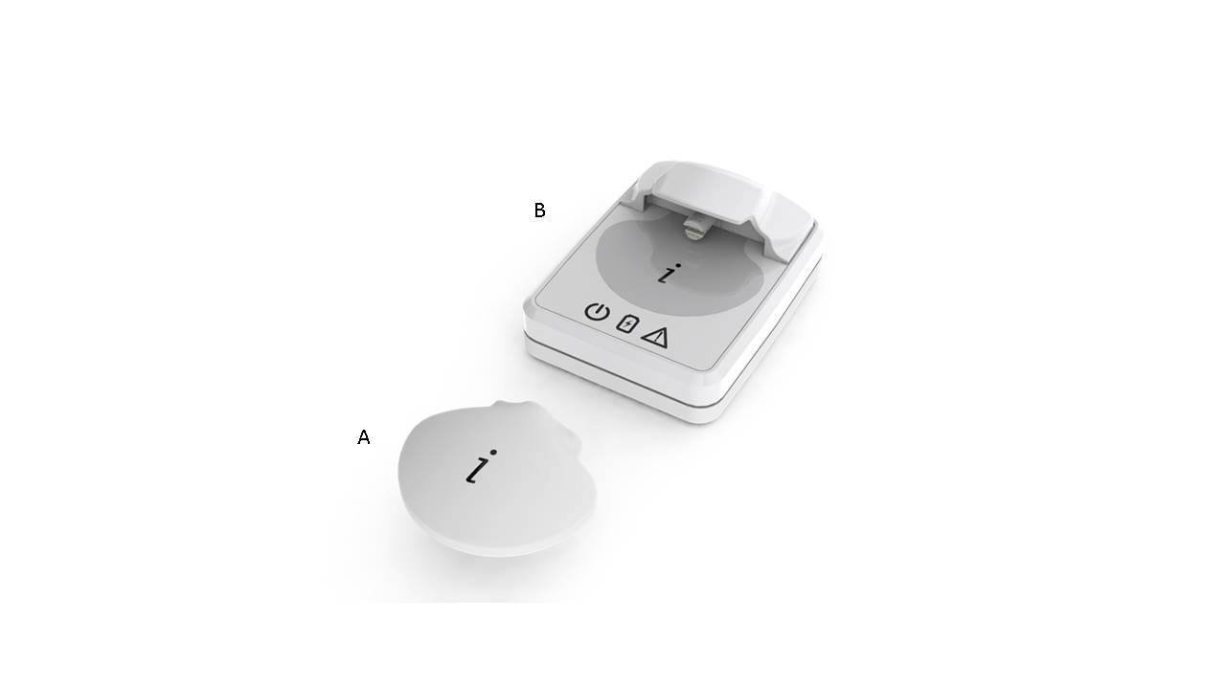

Figure 1. iPro2 Continuous Glucose Monitoring System. A –Monitor. B – Docking station.

**Analysis of retrospective data**

Data from all CGM devices can be studied retrospectively after downloading.[5] It is recommended that patients keep a separate diet, activity, symptom, and insulin diary during professional CGM to assist with interpretation. Three features of the continuous glucose data should be analyzed in particular. These are:

* **Overnight**: Out-of-target overnight glucose levels can be modified by adjusting the basal dose.
* **Pre-prandial Period**: Out-of-target preprandial glucose levels can be modified by adjusting the previous meal bolus, meal or exercise pattern.
* **Post-prandial period**: Out-of-target postprandial glucose levels can be modified by adjusting the immediate meal bolus, meal or exercise pattern.

In certain special situations, such as hypoglycemia unawareness, the target glucose levels must be raised, and during pregnancy the target glucose levels must be lowered. For patients at extremes of the age spectrum, target glucose levels may need to be raised. Other important elements of a professional CGM analysis are shown in Table 1. An example of a patient who used continuous monitoring (with a CGMS iPro2) is presented in Figure 2. The CGM demonstrated high glucose levels from 6:00 PM to

|  |
| --- |
| **Table 1. Elements of Professional Continuous Glucose Monitoring Analysis** |
| **Data Accuracy**  Frequency of Capillary Blood Glucose Monitoring  Sensor-meter agreement (MARD, correlation coefficient)  **Overall Control**  Mean Glucose  Glucose Variability (Standard Deviation, Coefficient of Variation, ADRR, MAGE)  **Daily Detail**  Diurnal Patterns: dawn phenomenon, overnight  Meal effects  Correction  Exercise effects  Other patterns (work days vs. weekend, menstrual cycles)  **Hypoglycemia**  Precipitating factors  Corresponding meter glucose (recognition)  **Recommendations**  Adherence (missed boluses, bolus calculator use, infrequent SMBG)  Medication dose adjustment  Diet (carbohydrate awareness or formal carbohydrate counting)  RT-CGM |

11:00 PM post-supper and low glucose levels from 12:00 AM to 2AM. Recognition of these patterns allowed appropriately timed treatment interventions.

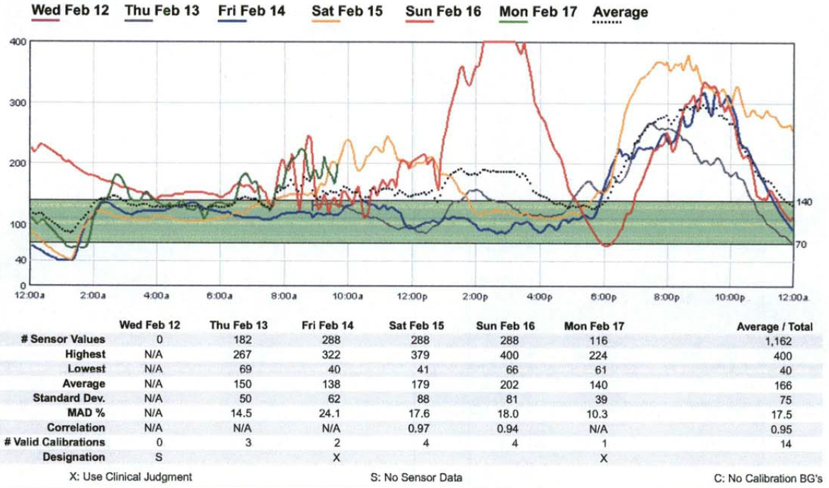

Figure 2. CGMS iPro2 tracing of a patient whose glucose levels were high from 6:00 PM to 11:PM post-supper and low from 12:00 AM to 2AM.

**Personal (Real-Time) Continuous Glucose Monitoring (RT-CGM)**

RT-CGM devices not only display the current glucose every few minutes, but may also alarm the patient for impending (projected alarm) or actual (threshold alarm) hyperglycemia or hypoglycemia. Over time, accuracy with RT-CGM has improved substantially, but remains an important limiting factor for widespread adoption of use.[6-8]The user will experience a tradeoff between a high alarm sensitivity and specificity for detecting hypoglycemic events (Figure 3). Current and recent glucose levels, trend information, and a visual alarm are all presented so that a patient can predict future low or high glucose excursions (Figures 4-6). Using this information will allow the patient to take actions to spend more time in the euglycemic range and less time in the hypoglycemic or hyperglycemic ranges. This potential decrease in glycemic variability will not necessarily be reflected in an improved Hemoglobin A1c value, which reflects mean glycemic levels. Much research is currently underway to express continuous glucose data in a useful way that describes the mean level of glycemia, the frequency and duration of hypoglycemia, the frequency and duration of hyperglycemia, and the overall variability. 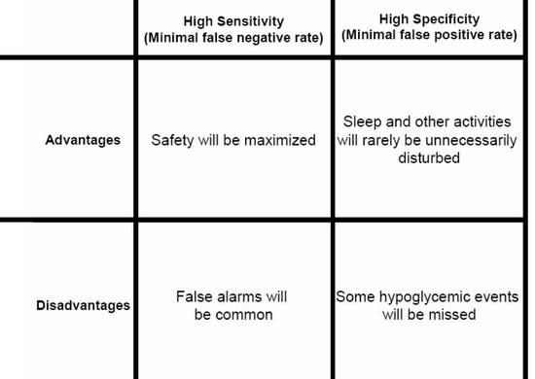

Figure 3. Tradeoffs between emphasis on high sensitivity compared to emphasis on high specificity in a hypoglycaemic alarm that is part of a continuous glucose monitor.

**Evidence**

An important multinational randomized controlled trial of the Guardian RT was reported in 2006. The seven-country GuardControl Study was the first randomized controlled trial to ever demonstrate statistically significant improvement in Hemoglobin A1c levels with the use of real-time continuous glucose monitoring. The Guardian RT was used either continuously or biweekly for three months and both regimens were compared to control treatment which did not include use of continuous glucose monitoring. At one month and at three months the continuous users had significantly lower A1c levels than the controls. The biweekly users had intermediate improvement which did not reach statistical significance compared to the outcomes in the control group. [9 ]

In 2008, the Juvenile Diabetes Research Foundation Continuous Glucose Monitoring Study Group published data on 322 adults and children with type 1 diabetes and HbA1c 7-10% randomized to either RT-CGM or usual care.[10] RT-CGM was associated with a 0.53% reduction in HbA1c compared to usual care (p<0.001), but was only significant among subjects over age 24 due to lack of consistent use in younger patients. Hypoglycemia was infrequent and was no different between groups.

In the largest study to date, the STAR3 study, 485 adults and children with HbA1c 7.4-9.5% were randomized to sensor-augmented pump therapy (Medtronic Paradigm Revel) or multiple daily injections per day.[11] Sensor-augmented pump therapy resulted in a between-group difference in HbA1c reduction of 0.6%, p<0.001. Hypoglycemia did not differ between groups, but only short-term CGM data were available for comparison and patients with a history of severe hypoglycemia were excluded.

A recent Cochrane review and another meta-analysis found more modest A1c reductions, particularly among patients who were not using insulin pumps, patients under age 18, and among patients with lower adherence.[12] The results were heavily influenced by the STAR3 trial, and the JDRF study did not report a difference between pump users and patients using multiple dose injection therapy. Severe hypoglycemia rates did not differ. However, the quality of most studies is limited due to small sample size, lack of blinding, lack of sufficient data to compare hypoglycemia rates. Meta-analyses may be hampered by the inclusion of studies with obsolete technology or lack of consideration for the intended use of the device in the study.[13-14]In another meta-analysis, studies that specifically enrolled patients at risk for hypoglycemia and used blinded CGM to assess it did show improvement in hypoglycemia.[15] In 2011, a randomized controlled trial among 120 children and adults on intensive therapy for type 1 diabetes and HbA1c <7.5% were randomly assigned to RT-CGM (Freestyle Navigator) or masked CGM every other week.[16] The time spent in hypoglycemia was reduced over 50% at 26 weeks, and patients spent more time in 70-180 mg/dl range. Moreover, preliminary data demonstrate that even 4 weeks of RT-CGM use improves the epinephrine response to hypoglycemia in patients with hypoglycemia unawareness.

Generic Quality of life scores generally do not improve with RT-CGM but treatment-specific measures, particularly fear of hypoglycemia and to a lesser extent, measures of convenience, efficacy and performance, may be improved.[13,17]

**Recommendations**

Patients should be adequately informed of the benefits and importantly the limitations of this technology. At a minimum, structured education programs encompassing concepts such as carbohydrate counting and active insulin time (insulin on board) should be completed prior to considering RT-CGM, and patients should demonstrate that they can reliably and consistently perform glucose self-monitoring.

The Endocrine Society recommends RT-CGM in adults with type 1 diabetes who have demonstrated that they can use the devices nearly daily.[1] Guidelines from the ADA recommend RT-CGM in selected adults over age 25 with type 1 diabetes on intensive insulin regimens in order to lower HbA1c, and in younger groups where adherence is demonstrated.[18] There was less evidence to support the use of RT-CGM for patients with hypoglycemia unawareness or severe hypoglycemia. The American Association of Clinical Endocrinologists recommendations for use include patients with type 1 diabetes and frequent hypoglycemia/hypoglycemia unawareness, elevated HbA1c, excessive glucose variability, during preconception and pregnancy, and younger patients who are highly motivated and can demonstrated near-daily use.[19] However, a recent study demonstrated that physician directed intermittent sensor use can provide similar HbA1c reduction as near continuous use, when compared to controls.[20] As additional trials using this technology for additional indications are completed in the future, the guidelines can be revisited and modified.

**Limitations of use**

It should be emphasized that most prospective randomized controlled trials enroll highly motivated patients. In the case of the STAR3 trial, access to a computer was required. It is less clear whether RT-CGM can be useful for patients in the real-world setting, where there are fewer resources for training, and less motivated patients may be overwhelmed with the additional data, particularly where complex algorithms in addition to existing smart pump features are required. Only 6% of patients in the Type 1 Diabetes Exchange Registry reported using RT-CGM in 2012. In a multi-national study of 263 patients, persistent sensor use for 12 months was only 30%. Improvement in HbA1c was associated with higher HbA1c at baseline, older age, and more frequent sensor use.[21] However, diabetes related hospital admissions were reduced following the initiation of sensor augmented pump therapy and fear of hypoglycemia (measured with the Hypoglycemia Fear Survey) improved. In the 6-month follow-up phase of the JDRF-CGM trial, RT-CGM was initiated in the control group in a manner that more closely approximates clinical practice.[22] Investigators found a significant reduction in CGM use in all age groups over time. However, increasing sensor use was associated with HbA1c reduction.

**Daily use**

Patients must be aware that sensor readings can deviate from actual blood glucose measurements, particularly during rapid glucose changes such as that which occurs post-meal or during exercise. Calibration should not be performed when trend arrows indicate rapid swings in glucose. While systems are becoming more reliable, patients should be instructed to verify sensor readings before taking action such as meal boluses or treatment of hypoglycemia.

Alarm thresholds should be set in order to maximize patient compliance, keeping in mind that the sensitivity for detecting hypoglycemia drops dramatically as the threshold is reduced below 70 mg/dl.[23] Conversely, specificity improves to a much smaller degree at lower thresholds, and thus false alarms may not be reduced substantially.

At least 2 algorithms have been published that provide specific guidance to patients for responding to trend arrows and alarms. The algorithm by Jenkins et al. provides tiered recommendations that are based upon the meter glucose and sensor trend arrows.[24] Patients who were randomly assigned to sensor augmented pump with the algorithm had lower HbA1c and reported better quality of life at 16 weeks compared to patients who did not get the algorithm. The effect on QOL persisted at the 32 week follow-up, and was associated with HbA1c reduction. Importantly, patients who received the algorithm at 16 weeks after initiating sensor augmented pump did not benefit. The JDRF study algorithm (for use with the Navigator system) recommended that patients increase or decrease the meal + correction bolus by 10-20% based upon the rate of change and provided specific instructions for responding to alarms.[25] Algorithm use was high in the first 3 weeks but dropped off by week 13, despite increasing insulin self-adjustments, suggesting patients became more independent over time. In addition, both algorithms advise patients how to review downloads of the data periodically (weekly) and make adjustments.

**Overview of available systems**

The first RT-CGM (Guardian, MedtronicR) was approved in 2004. Since then, additional models and other devices have entered the market, and accuracy and patient satisfaction have improved. Several personal continuous glucose monitors have been approved by the US Food and Drug Administration (FDA) for use in the United States or carry CE marking for use in Europe and are currently on the market. They are: 1) the Guardian RT (Medtronic Diabetes, Northridge, CA) [26 ]; 2) Dexcom G4 Platinum (Dexcom, San Diego, CA) [27-30 ]; 3) GlucoDay-S (A. Menarini Diagnostics, Florence, Italy) [32-34]; and 4) FreeStyle Navigator II (Abbott Diabetes Care, Alameda, California) [35,36]. GlucoDay and FreeStyle Navigator are available in Europe and elsewhere, but not the U.S.

Guardian RT

The Guardian RT was approved on June 11, 2005 for patients over 18 years of age. The sensor and monitor are connected through a wireless transmitter and displays real-time glucose results every five minutes. The continuous data can be stored up to 21 days and downloaded any time into a computer. The data can then be reviewed with proprietary software provided by the Guardian’s manufacturer.

The original Guardian and Guardian RT devices contained a large transmitter piece and were used primarily for research. A smaller data transmission system, known as the Minilink, to send glucose information from the sensor to the belt-attached monitor, was approved in 2007. This component was immediately incorporated into the Guardian RT. Sensors are FDA approved for 72 hours of use. The monitor is similar in appearance to the Paradigm Revel sensor augmented pump (discussed below). However, it functions only as a CGM and not as a pump.

Dexcom G4 Platinum

The Dexcom Continuous Glucose Monitoring Systems utilize a glucose oxidase sensor at the tip of a wire that is implanted in the subcutaneous space (Figure 4). The G4 sensor is inserted via a dedicated applicator by the user or clinician just under the skin where it is held in place by an adhesive to the skin. The transmitter is snapped into a platform located on top of the sensor. The data are transmitted wirelessly and are displayed on a separate receiver. This device is FDA approved to provide glucose readings for 168 hours or 7 days. The G4 comes with software called DexCom Studio for retrospective downloading and analysis of glucose data after the sensor has been removed. Dexcom devices can also be operated in blinded mode for professional CGM applications. The mean absolute relative difference for the Dexcom G4 has been reported to be 13% and the mean absolute difference in the hypoglycemia (<70 mg/dl) range was 11 mg/dl, which was a significant improvement over the previous generation.[28] There are no randomized controlled trials of the newest system. However, in a small prospective study of 60 patients with type 1 diabetes, use of an earlier generation device in real-time mode was associated with decreased time spent in both the hypoglycemic and hyperglycemic ranges, more time in the euglycemic zone, and less glucose variability compared to blinded use.[29] The subjects were issued no instructions on how to respond to glycemic fluctuations, and no significant improvement in Hemoglobin A1c was reported.

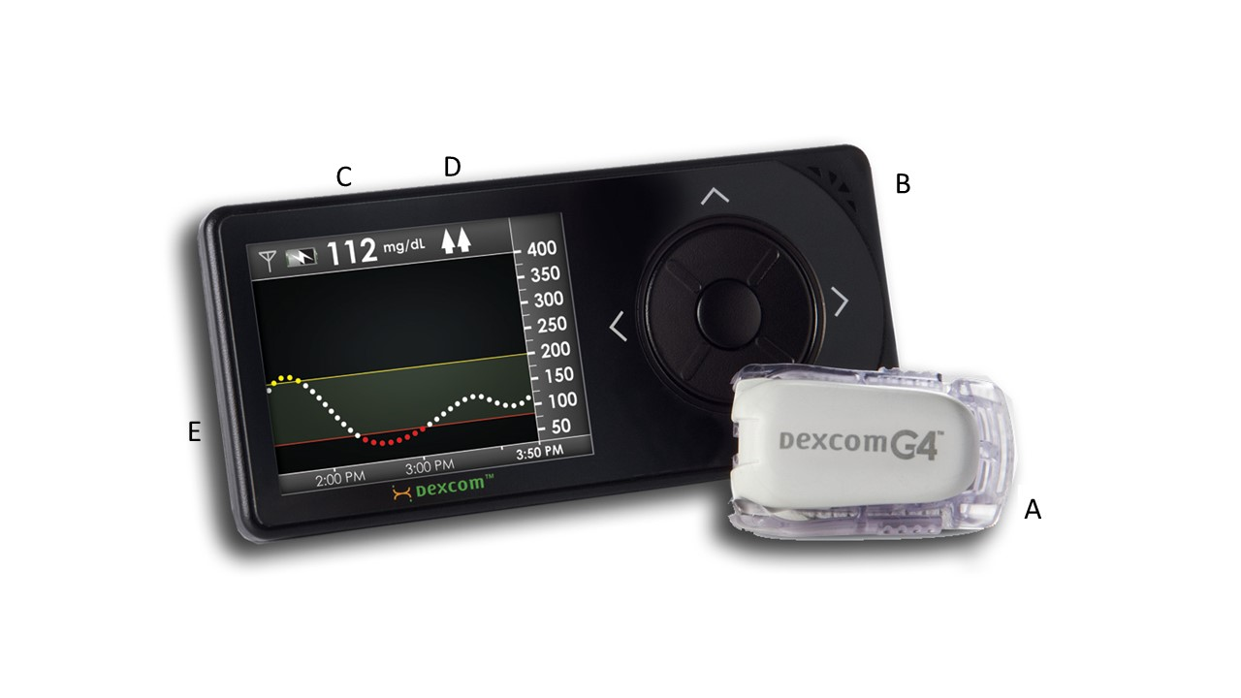

Figure 4. Dexcom G4 Platinum: (A) Transmitter which will be attached to the Sensor after insertion, (B) Receiver, (C) Glucose level, (D) Trend arrows, (E) Trend graph.

GlucoDay-S

The GlucoDay-S by Menarini, Inc. is the only currently available continuous glucose monitor that does not use an implanted sensor. This product is approved in Europe but not in the US. The device utilizes a microdialysis process to pump a continuous flow of perfusion fluid through a microdialysis system, which includes a microfiber that is inserted in the abdominal wall. This fluid, in effect, rinses the interstitial fluid of the abdominal wall. The device then measures the concentration of glucose in the effluent dialysis filtrate with an in line biosensor that generates a current signal proportionate to the glucose concentration. The patient wears two bags of crystalloid fluid fastened around the trunk. The perfusion bag contains the fluid before it is part of the dialysis process and the storage bag contains the fluid after it is part of the dialysis process. The device provides real time information. The microfiber must be removed and replaced every 48 hours. The next generation device, the GlucoMen® Day, has useful life of 100 hours.[33] This technology may be developed for intravenous glucose monitoring in hospitals.[34]

FreeStyle Navigator

The FreeStyle Navigator CGM device utilizes an implanted sensor wire. It is no longer available in the U.S., but a second generation device, the FreeStyle Navigator II is available in a few European countries (Figure 5). The sensor utilizes Wired Enzyme ™ technology, and the enzyme and mediator are co-immobilized on the sensor. The sensor is implanted into the skin at a 90 degree angle to the skin surface by a disposable insertion device. The implanted portion of the sensor is 5mm long and the attached transmitter can be detected by the wireless receiver 30 meters away. The second generation device has a one hour start-up time compared to 10 hours for the first generation device. It is currently the only CGM that offers glucose readings every minute and has a built-in blood glucose meter that allows ease of calibration. It is FDA approved for 5 days of use. Its software is the CoPilot Health Management System, available for downloading the glucose data. The mean and median relative absolute relative difference of the second generation device is 14.5 and 10.7% respectively.[35]

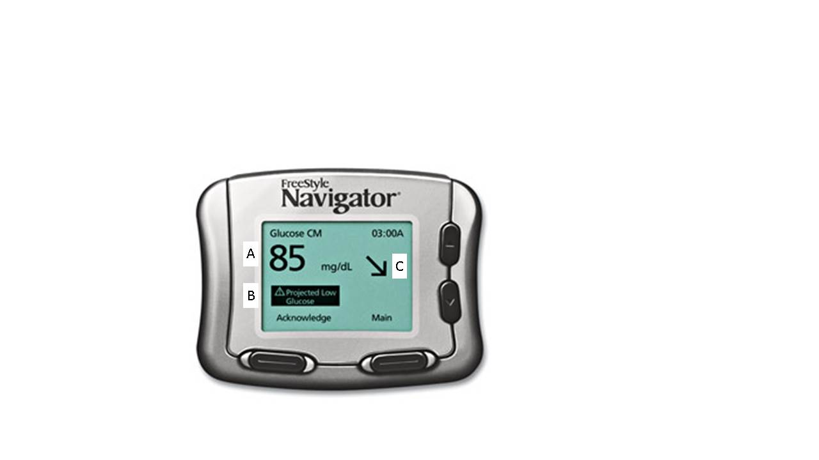

Figure 5. FreeStyle Navigator continuous glucose monitor. Display shows (A) glucose level, (B) Projected low alert, and (C) Trend arrow.

**Sensor Augmented Pump**

To date the largest HbA1c reductions have been observed when sensors are initiated with insulin pump technology. RT-CGM and the insulin pump have been combined into the Minimed Paradigm REAL-time Revel sensor-augmented pump system (Medtronic Diabetes, Northridge, CA) (Figure 6). When the Minilink transmitter component of the Guardian RT monitor was approved in 2007, the Medtronic Sensor Augmented Pump system was launched for marketing. In addition, Medtronic’s mySentry device allows for remote monitoring of RT-CGM up to 50 feet away and may have particular appeal for nighttime monitoring in children.[36]

Other sensor and pump manufacturers have been in discussions or held agreements to develop and market sensor augmented pumps. The Animas Vibe features integrated Dexcom G4 Platinum CGM and has been approved in Europe since 2011 [37], but is not yet approved for use in the U.S.

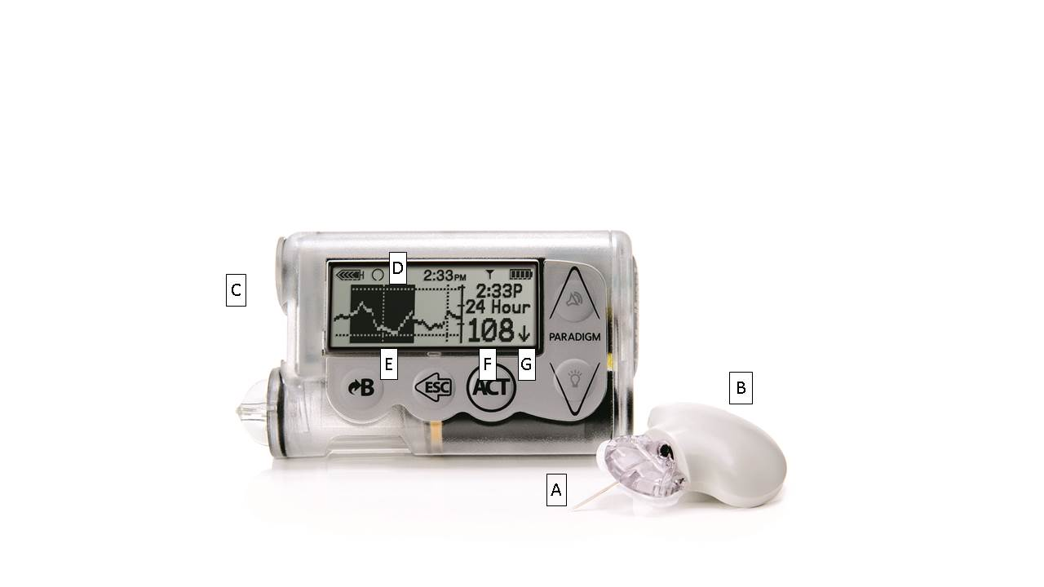

Figure 6. The Paradigm sensor augmented pump consisting of a sensor (A), which is attached to a Minilink transmitter (B) and communicating with an insulin infusion pump (C). Screen displays information about: (D) An alarm warning; (E) A trend graph portraying recent patterns of glycemia, (F) Glucose level, (G) Trend arrow for the direction and magnitude of trends in glycemia.

**Steps Toward An Artificial Pancreas**

Until recently, RT-CGM technology has operated completely independently of insulin delivery. By combining continuous basal insulin delivery during fasting periods with discrete bolus doses of insulin at mealtimes, insulin delivery can be crafted to mimic the natural pattern of pancreatic insulin release [38]. An artificial pancreas will consist of: 1) an automatic and continuous glucose monitor which may be inserted subcutaneously or intravascularly; 2) an implanted continuous insulin delivery system for intravascular or subcutaneous insulin administration; 3) a control processor to link the insulin delivery rate to the glucose level; and 4) a radio to send the glucose level to the body surface for continuous display onto a monitor. Limitations to full implementation include sensor accuracy and lag time, inadequate onset and offset of currently available rapid acting insulin analogs, meal challenges, and changes in insulin sensitivity due to circadian rhythms, exercise, menstrual cycles, and intercurrent illness.[39] However, even incremental advances are likely to expand access of this technology to more patients since they may improve glucose control without increasing the complexity of decision-making on the part of the patient. The safety, efficacy, cost, and cost-effectiveness of an artificial pancreas are unknown at this time.

**Low threshold suspend**

Progress is expected toward a fully functional closed loop system in incremental steps. The first step toward a fully automated “artificial pancreas”, the low glucose suspend feature, is now available. The Medtronic 530G system, containing the Veo insulin pump and Enlite sensor, is the first sensor augmented pump with low threshold suspend. The low threshold suspend feature suspends the pump for up to two hours in the event of sensor detected hypoglycemia in which the user does not respond to the alarm. Prior to suspension, a “siren” sounds which is distinct from other high or low alerts, and the suspension can be overridden at any time. A study enrolled 247 patients, with type 1 diabetes and documented nocturnal hypoglycemia, to sensor-augmented pump with or without a low-glucose threshold-suspend feature. It demonstrated similar HbA1c between groups at 3 months but lower frequency of nocturnal hypoglycemia.[40] Similar findings were demonstrated in an Australian study of 95 patients, in which the incidence rate ratio for hypoglycemia was 3.6 (95% CI 1.7-7.5, p<0.001).[41] There were no reports of DKA in either study.

**Incremental progress**

Additional steps toward closed loop insulin delivery require algorithmic insulin adjustments, which arguably present additional safety concerns. Steps include a hyperglycemia minimizer, in which microboluses are delivered in the event of hyperglycemia. Overnight closed loop insulin delivery is relatively straightforward, whereas post-meal control and exercise effects remain the most challenging of events to manage.

**Closed loop**

Trials of closed loop control are underway in multiple countries. Thus far, randomized studies have been small and reported only short-term outcomes (less than 24 hours), often in controlled settings. In one trial, a closed-loop control system used frequent measurements of BG concentration along with subcutaneous delivery of both the fast-acting insulin analog lispro and glucagon (to imitate normal physiology) as directed by a computer algorithm (Figure 7).[38] In a more recent study, 56 children and adolescents attending diabetes camps received sensor augmented pump or artificial pancreas (via fuzzy logic controller) on two separate nights in random order.[42] The artificial pancreas demonstrated markedly reduced hypoglycemic events (7 vs. 22 events in the artificial pancreas compared to the sensor augmented pump, p=0.003) and time in hypoglycemia, as well as better overall mean glucose and glycemic variability. 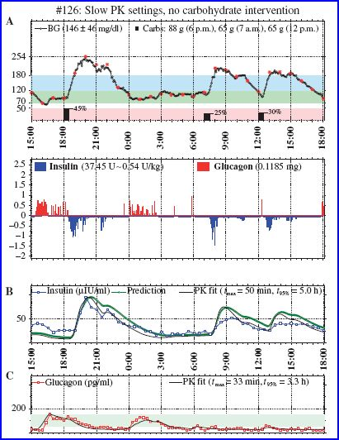

Figure 7. Closed Loop.

**Future Minimally Invasive Continuous Glucose Monitors**

Continuous hypoglycemia detection systems using current sensing technology must be either implanted (subcutaneously or into a blood vessel), or else wrapped around or attached to the body. Implantation is more secure, but may be associated with biocompatibility problems or local irritation. Wrapping around or attaching a monitor to the body avoids biocompatibility problems, but may be uncomfortable or cause an unpleasant sensation to the wearer of being constantly tethered to a device. Other continuous glucose monitoring devices are currently being developed that will wrap around the upper extremities, the trunk, or be in contact with the eye in the form of a contact lens. One recent high profile example is Google’s smart contact lens, which contains a tiny microchip, glucose sensor, and antenna embedded in its periphery.[43] Methods for harvesting interstitial fluid from the body to measure with an external non-implanted sensor, in addition to microdialysis, are being developed. Some disrupt the skin barrier and trap the fluid that rises to the surface. GlucoWatch G2 Biographer (“GlucoWatch”) (formerly Cygnus, Inc., Redwood City, CA) extracted glucose from the skin electrochemically, but was taken off the market in 2007. In one study, only 20% of participants were still using the device at 18 months.[44] The device suffered from inaccuracy, and 49% of wearers reported skin reactions as the reason for discontinuation. Aside from microdialysis methods, none are close to being marketed.

**Noninvasive Glucose Monitoring**

No monitor is currently approved by the FDA to measure blood glucose noninvasively [45]. Devices under development may take a measurement either intermittently or continuously. A large device that is not portable would have to be utilized on an intermittent basis, whereas a small monitoring device would have the potential to be wrapped around a body appendage or the waist to make continuous noninvasive readings. Noninvasive glucose monitoring depends upon (1) application of optical energy into tissue followed by measurement of the interaction of the optical energy with glucose in the intravascular, interstitial fluid, and intracellular compartments; or (2) measurement of a physiologic phenomenon which is proportional to the blood glucose level. The optical energy is typically applied to an appendage, such as a fingertip, an earlobe, or a forearm.

Noninvasive testing using infrared light spectroscopy to measure reflection of infrared light from the skin in proportion to the glucose concentration must distinguish the signal of water (which is very large) from that of glucose (which is much smaller), as well as other potential interferents in the skin. Interest has been expressed in applying optical energy to the buccal mucosa within the mouth because this region contains no stratum corneum, the outermost dead layer of skin, that absorbs the optical energy. In addition, the anterior chamber of the eye has been studied with various types of optical energy. Applications of light that interacts with ocular glucose must be carefully constructed to avoid excessive energy transmission and damage to the eyes. Optical measurement of glucose will avoid the problem of confounding analytes whose chemical properties resemble those of glucose. However, other analytes that are not a problem for existing invasive monitors can be confounding if their optical properties overlap those of glucose.

Another promising approach is the estimation of glucose from analysis of acetone and other metabolites in the breath, a process that would potentially bypass the interfering effects of skin components and microcirculation present with other methods.[46]

Any physiological phenomenon which becomes increasingly more abnormal as the blood glucose falls or rises from normal to hypoglycemic or hyperglycemic levels could be a physiological marker for indirect identification of blood glucose, by way of noninvasive measuring technology. During states of abnormal glycemia, decreased function of the brain, cranial nerves, or peripheral nerves might lead to declining performance in specific tests of neurologic performance. Progressively more severe hypoglycemia or hyperglycemia would likely be associated with increasingly abnormal physiological performance. In that case, either a depressed or an elevated glucose level would both lead to the same type of offset from the normal range of functioning. Decreased performance of this physiological marker could then indicate either elevated or depressed blood glucose levels.

The The HypoMon is a physiological qualitative test for hypoglycemia has been developed by an Australian company, Airmedics.[47] The system analyzes EKG information and sweat, obtained from 4 skin surface bio sensor electrodes, that are wirelessly transmitted to a receiver unit to determine whether physiological responses to hypoglycemia are present. An alarm will sound during severe hypoglycemia. This device has been in use in the United Kingdom and Australia but was recently recalled due to performance concerns.

**MOBILE TECHNOLOGY AND DECISION SUPPORT**

It has become increasingly clear that the isolated use of glucose monitoring technologies without a plan for using the data provides minimal benefit, particularly among patients with type 2 diabetes or who are not using insulin.[48] The use of pattern management software improves health care provider efficiency and accuracy in identifying needed therapeutic adjustments.[49-50]

**Mobile Technology**

The widespread use of mobile devices provides opportunities for data collection, analysis, and communication of results with health care providers. Manual recording of glucose data is fraught with inaccuracies.[51] Direct connectivity of blood glucose or CGM levels to cell phones or other devices not only improves data integrity but may also simplify the assimilation of glucose levels with other data such as insulin use, carbohydrate intake and activity levels for the purpose of facilitating insulin dose adjustments in real time or retrospectively. Cell phone connectivity may also improve communication with providers. Currently, many devices can be downloaded electronically, and more recently, the iBG Star glucometer (Sanofi Aventis) was the first glucose monitoring device with direct connectivity to a smart phone to be FDA approved.[52]

A variety of stand-alone smart phone applications are available. Most incorporate SMBG data, some allow insulin or other diabetes education, and a few provide an insulin dosing calculator. However, none of them connect directly with a glucose meter, and none have been evaluated by the FDA.[53] Hurdles to wider implementation include the need for additional education, unclear algorithms and risk of insulin stacking, as well as lack of outcomes or cost-effectiveness studies.

**Decision Support**

**Glucometers with integrated dosing calculators**

Insulin dosing calculators have been used for years as a means of incorporating glucose measures into routine practice. Currently only calculators that interface with continuous insulin infusion pumps are approved by the FDA, although calculators that interface with a glucometer are in development or are approved elsewhere. Bolus calculators are known to substantially improve dosing accuracy and glycemic control in outpatients with type 1 diabetes.[54-56] Subjects with diabetes feel more confident using the calculator and prefer it to manual calculations of insulin doses. Bolus calculators might be particularly helpful for patients with poor numeracy.[57] The Accuchek Aviva Expert system with integrated Accu-Chek Bolus Advisor (Roche) is under FDA review in the U.S. but is already available in other countries. The 26 week Accu-Chek Bolus Advisor Control and Usability Study (ABACUS) randomly assigned over 200 patients with diabetes to use of the bolus calculator or usual care.[58] Patients using the bolus advisor were more likely than controls to achieve >0.5% A1c reduction (56 vs. 34%, p<0.01). Another device, the Freestyle InsuLinx system (Abbott) has a touchscreen interface and contains a bolus calculator that is available in fixed meal or flexible meal dosing modes.[55] The bolus calculator incorporates correction dosing as well as an active insulin time. The device is only available outside of the U.S., but a simplified version without the bolus advisor, which allows the patient to record insulin and glucose data, is FDA approved. Currently available insulin dosing calculators also do not utilize data from prior glucose measurements to recommend ongoing adjustments in therapy.

**Integrated telemedicine approaches**

Integrated telemedicine approaches have received increasing attention as a means of providing cost-effective care.[59-60]. However, earlier results of telemonitoring studies have been somewhat disappointing, perhaps due to delayed or infrequent feedback to patients.[61-62] Systems in which real-time feedback is provided, such as through the use of text messages, have shown more promising result.[60] For example, the WellDoc system consists of patient coaching as well as provider clinical decision support. Patients view data via their mobile device through a web portal and receive automated text messaging responses that are tailored to the data. Diabetes educators or other providers may view the data and send periodic supplemental feedback as well. In a 12 month cluster randomized trial of patients with type 2 diabetes, the system was shown to reduce A1c by 1.2% vs. usual care.[63] The Diabeo system consists of smartphone software that serves as a bolus calculator, enables self-titration of insulin, and transmits data to health care providers.[64] In a 6 month randomized controlled trial of 180 patients with type 1 diabetes, the Diabeo system resulted in an A1c reduction of 0.91 and 0.67% when used with or without biweekly teleconsultation when compared to placebo.

**BIOMARKERS OF GLYCEMIC CONTROL**

**Hemoglobin A1c**

Hemoglobin A1c is the best biomarker indicator of glycemic control over the past 2-3 months, due to strong data predicting complications.[65] In addition, the American Diabetes Association has recommended its use for the diagnosis of diabetes.[66] The FDA has recently allowed the first HbA1c monitor (COBAS INTEGRA 800 Tina-quant HbA1cDx, Roche) to be labeled for diagnosis of diabetes. Two devices are approved by the FDA for measurement of Hemoglobin A1c by a patient at home. The Micromat II device (BioRad, Hercules, California; < [http://diabetes.bio-rad.com](http://diabetes.bio-rad.com/) >) was the first to be approved, but the product is intended primarily for use by healthcare professionals. The A1cNow+ device (formerly Metrika, Inc., Sunnyvale, California, now Bayer, Whippany, NJ) was the second to be approved, and it is intended for use by patients at home or by healthcare professionals The A1cNow+ device comes with a set of ten test cartridges to be used with one disposable monitor. [67]

An Organization with links to governmental regulatory agencies, the National Glycohemoglobin Standardization Program (NGSP) (< <http://www.missouri.edu/~diabetes/ngsp.html> >), evaluates every laboratory and home test for Hemoglobin A1c, sets accuracy standards, and certifies which methods meet their standards.[68] The trend in industry is for monitors to become increasingly more accurate and the trend in regulatory organizations is to require increasing accuracy for ongoing certification.

Hemoglobin A1c is an analyte found within red blood cells, comprised of glycated Hemoglobin. The glycation gap (formerly known as the glycosylation gap) (GG), based on fructosamine measurement, and the Hemoglobin Glycation Index (HGI), based on mean blood glucose, are two indices of between-individual differences in glycated hemoglobin adjusted for glycemia. GG is the difference between the measured A1C test and the A1C test result predicted from serum fructosamine testing based on a population regression equation of A1C on fructosamine [69], and HGI is the difference between the measured A1C test and A1C results predicted from the mean blood glucose level (calculated from self-monitored blood glucose tests) based on a population regression equation of A1C tests on mean blood glucose levels [70]. These two indices are consistent within an individual over time and reflect an inherent tendency for an individual’s proteins to glycate.[71-72] Patients with high GG and HGI indices might have falsely high A1C test results and might also be at increased risk of basement membrane glycosylation and development of microvascular complications. Whether between-individual biological variation in Hemoglobin A1c is an independent risk factor, distinct from that attributable to mean blood glucose or fructosamine levels, for diabetic microvascular complications is controversial. [73]

Because the A1C test is supposed to reflect the mean level of glycemia, attempts have been made to correlate this widely accepted measure with empirically measured mean blood glucose levels. Multiple glucose levels for making these types of comparisons can be obtained either through averaging many days of self-monitored glucose levels or by measuring the area under the glucose concentration curve obtained with a continuous monitor. It appears that an analysis of multiple glucose data points provides important information that is unavailable from an A1C measurement. Several lines of evidence support this disconnect from a tight correlation between mean glycemia and A1C levels. First, improvements in mean glycemia may not necessarily be reflected by improvements in A1C in intensively treated patients. [74] A1C does not reflect short-term changes in glucose control, and therefore can be misleading where there have been recent changes in the clinical condition. In addition, glucose fluctuations, compared to chronic sustained hyperglycemia, have been shown to exhibit a more specific triggering effect on oxidative stress and endothelial function. [75-76] Glycemic variability cannot be assessed by a global measure of mean glycemia, such as A1C, but requires multiple individual glucose values, such as those obtained from continuous glucose monitoring, or from seven-point-per-day (or greater) self-glucose testing. Third, A1C does not permit specific adjustments in therapy, particularly among patients requiring insulin titration. Finally, A1c reliability may be affected a number of conditions that alter red blood cell lifespan and its use in these circumstances can be misleading. Ethnic differences in HbA1c have been reported,[77] but recent NHANES data do not demonstrate an effect of ethnicity on the association between A1C and retinopathy.[78]

**Fructosamine**

A medium-term marker (defined as reflecting the average degree of control over the past few days or weeks) may be useful for determining control over a period of days to weeks since A1C does not reflect recent changes in glucose control. Alternate markers may also be useful in patients with discrepant A1C and self-monitored blood glucose readings as well as patients with other hematologic conditions known to affect A1c. Fructosamine is a term that refers to a family of glycated serum proteins. This family is comprised primarily of albumen and to a lesser extent, globulins, and to an even lesser extent, other circulating serum proteins. No product exists for home use that measures serum fructosamine. A home blood fructosamine monitor, Duet Glucose Control System, was marketed in the early 2000′s and then withdrawn from the market. No home fructosamine test has been available since then. Randomized controlled trials have reported inconsistent effects of frequent monitoring on A1C lowering, possibly due to differences in execution of therapeutic interventions.[79-80]

**Glycated Albumin**

The largest constituent of fructosamine is glycated albumin [81]. Several investigators and companies are developing portable assays for glycated albumin to assess overall control during periods of rapidly changing glucose levels. In these situations, an A1C test may change too slowly to capture a sudden increase or decrease in mean glycemia. The components of the necessary technology appear to be in place to build a commercial instrument for home testing of glycated albumin. Epinex received U.S. Discovery Grant funding to develop such a product (G1ATM) in 2010 but it is not currently available or FDA approved. The biggest obstacle to adoption of this test into routine clinical practice will be the extensive amount of education that will be necessary to convince physicians to adopt it. Whether the cost of this massive education program can be recouped by product sales remains to be seen.

Furthermore, there is no randomized controlled trial showing that the measurement of glycated albumin improves outcomes, but cohort data are accumulating. In in the Atherosclerosis Risk in Communities (ARIC) study, fructosamine, glycated albumin, and 1,5-AG levels predicted development of diabetes, even after adjustment for baseline HbA1c and fasting glucose.[82] In the Atherosclerosis Risk in Communities (ARIC) study, both fructosamine and glycated albumin levels predicted retinopathy and nephropathy, even after adjusting for A1C.[83] In the DCCT, glycated albumin had a similar association with retinopathy and nephropathy as A1C, but the combination of both markers provided even better prediction.[84]

**1,5-Anhyroglucitol**

The aforementioned biomarkers for measuring glycemic control, (A1C, fructosamine, and glycated albumin) only reflect mean levels of glycemia. These measures can fail to portray hyperglycemic excursions if they are balanced by hypoglycemic excursions. Plasma 1,5-anhydroglucitol (1,5-AG) is a naturally occurring dietary monosaccharide, with a structure similar to that of glucose. (Figure 8) This analyte has been proposed as a marker for postprandial hyperglycemia.[85] An automated laboratory grade assay named Glycomark is approved in the U.S. for measuring 1,5-AG as a short-term marker for glycemic control. A similar laboratory assay has been used in Japan for over ten years. During normoglycemia, 1,5-AG is maintained at constant steady-state levels because of a large body pool compared with the amount of intake and because this substance is metabolically inert. Normally, 1,5-AG is filtered and completely reabsorbed by the renal tubules. During acute hyperglycemia when the blood glucose levels exceed 180 mg/dl, which is the renal threshold for spilling glucose into the urine, serum 1,5-AG falls. This fall occurs due to competitive inhibition of renal tubular reabsorption by filtered glucose. The greater the amount of glucose in renal filtrate (due to hyperglycemia), the less 1, 5-AG is reabsorbed by the kidneys. The 1,5-AG levels respond sensitively and rapidly to rises in serum glucose and a fall in the serum level of this analyte can indicate transient elevations of serum glucose occurring over as short a period as a few days. Measurement of 1,5-AG can be useful in assessing the prior 1-2 weeks for: 1) the degree of postprandial hyperglycemia; and 2) the mean short-term level of glycemia. This assay might prove useful in assessing the extent of glycemic variability that is present in an individual with a close-to-normal A1C level, but who is suspected to be alternating between frequent periods of hyperglycemia and hypoglycemia. In such a patient, the 1,5-AG level would be low, which would indicate frequent periods of hyperglycemia, whereas in a patient with little glycemic variability, the 1,5-AG levels would not be particularly depressed because of a lack of frequent hyperglycemic periods.

In a cross-sectional study of 567 patients with type 2 diabetes, 1,5-AG was associated with retinopathy, but not nephropathy.[87] Other cross-sectional data from ARIC suggest an independent association between 1,5-AG and albuminuria, but not retinopathy or chronic kidney disease after adjustment for HbA1c and other variables.[88] Unfortunately, longitudinal studies with hard outcomes are not available.

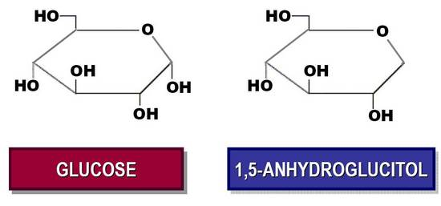

Figure 8. Structure of glucose (left) and 1,5-anhydroglucitol (right)

**CONCLUSIONS**

Many new types of technology are increasingly being developed and applied to fight diabetes and its complications. New technologies will improve the lives of people with diabetes by measuring glucose and other biomarkers of glycemic control and linking glucose levels with insulin delivery to improve the lives of people with diabetes.

**References**

1. Klonoff DC, Buckingham B, Christiansen JS, Montori VM, Tamborlane WV, Vigersky RA, Wolpert H; Endocrine Society. Continuous glucose monitoring: an Endocrine Society Clinical Practice Guideline. J Clin Endocrinol Metab. 2011 Oct;96(10):2968-79. doi: 10.1210/jc.2010-2756. PubMed PMID: 21976745.
2. Gross TM, Bode BW, Einhorn D, Kayne DM, Reed JH, White NH, Mastrototaro JJ: Performance evaluation of the MiniMed continuous glucose monitoring system during patient home use. Diabetes Technol Ther. 2000; 2: 49-56.
3. <https://professional.medtronicdiabetes.com/ipro2-professional-cgm>, site accessed 4/29/2014.
4. Welsh J, Kaufman FR, Lee SW. Accuracy of the Sof-Sensor Glucose Sensor with the iPro Calibration Algorithm. J Diabetes Sci Technol. 2012; 6(2): 475–476.
5. Miele A, Weiland K, Dungan KM. Clinical outcomes associated with referral-based continuous glucose monitoring using a central standardized interpretation strategy. Diabetes Technol Ther. 2012;14(9):765-71.
6. Keenan DB, Mastrototaro JJ, Zisser H, Cooper KA, Raghavendhar G, Lee SW, Yusi J, Bailey TS, Brazg RL, Shah RV: Accuracy of the Enlite 6-day glucose sensor with Guardian and Veo calibration algorithms. Diabetes Technol Ther 2012;14:225–231.
7. Christiansen M, Bailey T, Watkins E, Liljenquist D, Price D, Nakamura K, Boock R, Peyser T. [A new-generation continuous glucose monitoring system: improved accuracy and reliability compared with a previous-generation system.](http://www.ncbi.nlm.nih.gov/pubmed/23777402) Diabetes Technol Ther. 2013;15(10):881-8.
8. Luijf YM, Mader JK, Doll W, Pieber T, Farret A, Place J, Renard E, Bruttomesso D, Filippi A, Avogaro A, Arnolds S, Benesch C, Heinemann L, DeVries JH. AP@home consortium. [Accuracy and reliability of continuous glucose monitoring systems: a head-to-head comparison.](http://www.ncbi.nlm.nih.gov/pubmed/23650900) Diabetes Technol Ther. 2013;15(8):722-7
9. Deiss D, Bolinder J, Riveline JP, Battelino T, Bosi E, Tubiana-Rufi N, Kerr D, Phillip M. Improved glycemic control in poorly controlled patients with type 1 diabetes using real-time continuous glucose monitoring. Diabetes Care. 2006; 29 : 2730-2732.
10. Juvenile Diabetes Research Foundation Continuous Glucose Monitoring Study Group, Tamborlane WV, Beck RW, Bode BW, Buckingham B, Chase HP, Clemons R, Fiallo-Scharer R, Fox LA, Gilliam LK, Hirsch IB, Huang ES, Kollman C, Kowalski AJ, Laffel L, Lawrence JM, Lee J, Mauras N, O'Grady M, Ruedy KJ, Tansey M, Tsalikian E, Weinzimer S, Wilson DM, Wolpert H, Wysocki T, Xing D. Continuous glucose monitoring and intensive treatment of type 1 diabetes. N Engl J Med. 2008;359(14):1464-76.
11. Bergenstal RM, Tamborlane WV, Ahmann A, Buse JB, Dailey G, Davis SN, Joyce C, Peoples T, Perkins BA, Welsh JB, Willi SM, Wood MA; STAR 3 Study Group. Effectiveness of sensor-augmented insulin-pump therapy in type 1 diabetes. N Engl J Med. 2010 Jul 22;363(4):311-20.
12. Langendam M, Luijf YM, Hooft L, Devries JH, Mudde AH, Scholten RJ. Continuous glucose monitoring systems for type 1 diabetes mellitus. Cochrane Database Syst Rev. 2012 Jan 18;1:CD008101.
13. Yeh HC, Brown TT, Maruthur N, Ranasinghe P, Berger Z, Suh YD, Wilson LM, Haberl EB, Brick J, Bass EB, Golden SH. Comparative effectiveness and safety of methods of insulin delivery and glucose monitoring for diabetes mellitus: a systematic review and meta-analysis. Ann Intern Med. 2012;157(5):336-47.
14. Pickup JC. The evidence base for diabetes technology: appropriate and inappropriate meta-analysis. J Diabetes Sci Technol. 2013;7(6):1567-74.
15. Pickup JC, Freeman SC, Sutton AJ. Glycaemic control in type 1 diabetes during real time continuous glucose monitoring compared with self monitoring of blood glucose: meta-analysis of randomised controlled trials using individual patient data. BMJ. 2011;343:d3805.
16. Battelino T, Phillip M, Bratina N, Nimri R, Oskarsson P, Bolinder J. Effect of continuous glucose monitoring on hypoglycemia in type 1 diabetes. Diabetes Care. 2011;34(4):795-800.
17. Rubin RR, Peyrot M; STAR 3 Study Group. Health-related quality of life and treatment satisfaction in the Sensor-Augmented Pump Therapy for A1C Reduction 3 (STAR 3) trial. Diabetes Technol Ther. 2012;14(2):143-51.
18. American Diabetes Association Position Statement: Standards of Medical Care in *Diabetes Care* January 2014 37:(Suppl 1) S14-S80.
19. Blevins TC, Bode BW, Garg SK, Grunberger G, Hirsch IB, Jovanovič L, Nardacci E, Orzeck EA, Roberts VL, Tamborlane WV; AACE Continuous Glucose Monitoring Task Force, Rothermel C. Statement by the American Association of Clinical Endocrinologists Consensus Panel on continuous glucose monitoring. Endocr Pract. 2010 Sep-Oct;16(5):730-45.
20. Riveline JP, Schaepelynck P, Chaillous L, Renard E, Sola-Gazagnes A, Penfornis A, Tubiana-Rufi N, Sulmont V, Catargi B, Lukas C, Radermecker RP, Thivolet C, Moreau F, Benhamou PY, Guerci B, Leguerrier AM, Millot L, Sachon C, Charpentier G, Hanaire H; EVADIAC Sensor Study Group. Assessment of patient-led or physician-driven continuous glucose monitoring in patients with poorly controlled type 1 diabetes using basal-bolus insulin regimens: a 1-year multicenter study. Diabetes Care. 2012;35(5):965-71.
21. Nørgaard K, Scaramuzza A, Bratina N, Lalić NM, Jarosz-Chobot P, Kocsis G, Jasinskiene E, De Block C, Carrette O, Castañeda J, Cohen O; Interpret Study Group. Routine sensor-augmented pump therapy in type 1 diabetes: the INTERPRET study. Diabetes Technol Ther. 2013;15(4):273-80.
22. Juvenile Diabetes Research Foundation Continuous Glucose Monitoring Study Group. [Effectiveness of continuous glucose monitoring in a clinical care environment: evidence from the Juvenile Diabetes Research Foundation continuous glucose monitoring (JDRF-CGM) trial.](http://www.ncbi.nlm.nih.gov/pubmed/19837791) Diabetes Care. 2010;33(1):17-22.
23. Bay C, Kristensen PL, Pedersen-Bjergaard U, Tarnow L, Thorsteinsson B. Nocturnal continuous glucose monitoring: accuracy and reliability of hypoglycemia detection in patients with type 1 diabetes at high risk of severe hypoglycemia. Diabetes Technol Ther. 2013;15(5):371-7.
24. Jenkins AJ, Krishnamurthy B, Best JD, Cameron FJ, Colman PG, Hamblin PS, O'Connell MA, Rodda C, Teede H, O'Neal DN. An algorithm guiding patient responses to real-time-continuous glucose monitoring improves quality of life. Diabetes Technol Ther. 2011 Feb;13(2):105-9. doi: 10.1089/dia.2010.0139. PubMed PMID: 21284476.
25. Diabetes Research In Children Network (DirecNet) Study Group, Buckingham B, Xing D, Weinzimer S, Fiallo-Scharer R, Kollman C, Mauras N, Tsalikian E, Tamborlane W, Wysocki T, Ruedy K, Beck R. Use of the DirecNet Applied Treatment Algorithm (DATA) for diabetes management with a real-time continuous glucose monitor (the FreeStyle Navigator). Pediatr Diabetes. 2008;9(2):142-7.
26. Bode B, Gross K, Rikalo N, Schwartz S, Wahl T, Page C, Gross T, Mastrototaro J: Alarms based on real-time sensor glucose values alert patients to hypo- and hyperglycemia: the guardian continuous monitoring system. Diabetes Technol Ther. 2004; 6: 105-113.
27. Maran A, Crepaldi C, Tiengo A, Grassi G, Vitali E, Pagano G, Bistoni S, Calabrese G, Santeusanio F, Leonetti F, Ribaudo M, Di Mario U, Annuzzi G, Genovese S, Riccardi G, Previti M, Cucinotta D, Giorgino F, Bellomo A, Giorgino R, Poscia A, Varalli M: Continuous subcutaneous glucose monitoring in diabetic patients: a multicenter analysis. Diabetes Care 2002; 25: 347-352.
28. Christiansen M, Bailey T, Watkins E, Liljenquist D, Price D, Nakamura K, Boock R, Peyser T. A new-generation continuous glucose monitoring system: improved accuracy and reliability compared with a previous-generation system. Diabetes Technol Ther. 2013;15(10):881-8.
29. Garg SK, Voelmle MK, Beatson CR, Miller HA, Crew LB, Freson BJ, Hazenfield RM.Use of continuous glucose monitoring in subjects with type 1 diabetes on multiple daily injections versus continuous subcutaneous insulin infusion therapy: a prospective 6-month study. Diabetes Care 34:574–579, 2011.
30. Garg SK, Schwartz S, Edelman SV. Improved glucose excursions using an implantable real-time continuous glucose sensor in adults with type 1 diabetes. Diabetes Care. 2004; 27: 734-738.
31. Pleus S, Schmid C, Link M, Zschornack E, Klötzer HM, Haug C, Freckmann G. Performance evaluation of a continuous glucose monitoring system under conditions similar to daily life. J Diabetes Sci Technol. 2013;7(4):833-41.
32. Cosson E, Hamo-Tchatchouang E, Dufaitre-Patouraux L, Attali JR, Pariè**s** J, Schaepelynck-Bélicar P. Multicentre, randomised, controlled study of the impact of continuous sub-cutaneous glucose monitoring (GlucoDay) on glycaemic control in type 1 and type 2 diabetes patients. Diabetes Metab. 2009;35(4):312-8.
33. Valgimigli F, Lucarelli F, Scuffi C, Morandi S, Sposato I. Evaluating the clinical accuracy of GlucoMen®Day: a novel microdialysis-based continuous glucose monitor. J Diabetes Sci Technol. 2010 Sep 1;4(5):1182-92.
34. Mader JK, Lucarelli F, Scuffi C, Aberer F, Korsatko S, Valgimigli F, Pieber TR.Optimising the glucose sampling performance of an intravascular microdialysisbased continuous glucose monitoring device for use in hospital settings. Biomed Tech (Berl). 2013 Sep 7. doi: 10.1515/bmt-2013-4142. [Epub ahead of print].
35. Geoffrey M, Brazg R, Richard W. FreeStyle Navigator Continuous Glucose Monitoring System with TRUstart algorithm, a 1-hour warm-up time. J Diabetes Sci Technol. 2011;5(1):99-106.
36. Kaiserman K, Buckingham BA, Prakasam G, Gunville F, Slover RH, Wang Y, Nguyen X, Welsh JB.Acceptability and utility of the mySentry remote glucose monitoring system. J Diabetes Sci Technol. 2013;7(2):356-61.
37. <http://www.animascorp.co.uk/animasVibe/animas-vibe-and-cgm-system>, site accessed 4/29/2014.
38. DeSalvo D, Buckingham B. Continuous glucose monitoring: current use and future directions.Curr Diab Rep. 2013 Oct;13(5):657-62.
39. Kudva YC, Carter RE, Cobelli C, Basu R, Basu A. Closed-loop artificial pancreas systems: physiological input to enhance next-generation devices. Diabetes Care. 2014;37(5):1184-90.

Bergenstal RM, Klonoff DC, Garg SK, Bode BW, Meredith M, Slover RH, Ahmann AJ, Welsh JB, Lee SW, Kaufman FR; ASPIRE In-Home Study Group. Threshold-based insulin-pump interruption for reduction of hypoglycemia. N Engl J Med. 2013 Jul 18;369(3):224-32.

1. Ly TT, Nicholas JA, Retterath A, Lim EM, Davis EA, Jones TW. Effect of sensor-augmented insulin pump therapy and automated insulin suspension vs standard insulin pump therapy on hypoglycemia in patients with type 1 diabetes: a randomized clinical trial. JAMA. 2013;310(12):1240-7.
2. Phillip M, Battelino T, Atlas E, Kordonouri O, Bratina N, Miller S, Biester T, Stefanija MA, Muller I, Nimri R, Danne T. [Nocturnal glucose control with an artificial pancreas at a diabetes camp.](http://www.ncbi.nlm.nih.gov/pubmed/23445093) . N Engl J Med. 2013;368(9):824-33.

<http://googleblog.blogspot.com/2014/01/introducing-our-smart-contact-lens.html>. Site accessed 4/9/2014.

1. Cooke D, Hurel SJ, Casbard A, Steed L, Walker S, Meredith S, Nunn AJ, Manca A, Sculpher M, Barnard M, Kerr D, Weaver JU, Ahlquist J, Newman SP. Randomized controlled trial to assess the impact of continuous glucose monitoring on HbA(1c) in insulin-treated diabetes (MITRE Study). Diabet Med. 2009;26(5):540-7.
2. Ciudin A, Hernandez C, Simo R. Non-invasive methods of glucose measurement: current status and future perspectives. Curr Diabetes Rev. 2012;8(1):48-54.
3. Roberts K, Jaffe A, Verge C, Thomas PS. Noninvasive monitoring of glucose levels: is exhaled breath the answer? J Diabetes Sci Technol. 2012;6(3):659-64.
4. Skladnev VN, Ghevondian N, Tarnavskii S, Paramalingam N, Jones TW. Clinical evaluation of a noninvasive alarm system for nocturnal hypoglycemia. J Diabetes Sci Technol. 2010 Jan 1;4(1):67-74.
5. [Malanda UL](http://www.ncbi.nlm.nih.gov/pubmed?term=Malanda%20UL%5BAuthor%5D&cauthor=true&cauthor_uid=22258959), [Welschen LM](http://www.ncbi.nlm.nih.gov/pubmed?term=Welschen%20LM%5BAuthor%5D&cauthor=true&cauthor_uid=22258959), [Riphagen II](http://www.ncbi.nlm.nih.gov/pubmed?term=Riphagen%20II%5BAuthor%5D&cauthor=true&cauthor_uid=22258959), [Dekker JM](http://www.ncbi.nlm.nih.gov/pubmed?term=Dekker%20JM%5BAuthor%5D&cauthor=true&cauthor_uid=22258959), [Nijpels G](http://www.ncbi.nlm.nih.gov/pubmed?term=Nijpels%20G%5BAuthor%5D&cauthor=true&cauthor_uid=22258959), [Bot SD](http://www.ncbi.nlm.nih.gov/pubmed?term=Bot%20SD%5BAuthor%5D&cauthor=true&cauthor_uid=22258959). Self-monitoring of blood glucose in patients with type 2 diabetes mellitus who are not using insulin. Cochrane Database Syst Rev. 2012 Jan 18;1:CD005060. doi: 10.1002/14651858.CD005060.pub3.
6. Katz LB, Dirani RG, Li G, Randoll RA, Mahoney JJ. Automated glycemic pattern analysis can improve health care professional efficiency and accuracy. J Diabetes Sci Technol. 2013 Jan 1;7(1):163-6.
7. Parkin CG, Davidson JA. Value of self-monitoring blood glucose pattern analysis in improving diabetes outcomes. J Diabetes Sci Technol. 2009 May 1;3(3):500-8.
8. Given JE, O'Kane MJ, Coates VE, Moore A, Bunting BP. Comparing patient generated blood glucose diary records with meter memory in type 2 diabetes. Diabetes Res Clin Pract. 2014 Mar 11. pii: S0168-8227(14)00110-7. doi: 10.1016/j.diabres.2014.03.003. [Epub ahead of print]

<http://www.ibgstar.us/>. Accessed 4/22/2014.

1. Demidowich AP, Lu K, Tamler R, Bloomgarden Z. An evaluation of diabetes self-management applications for Android smartphones. J Telemed Telecare. 2012 Jun;18(4):235-8.

Shashaj B, Busetto E, Sulli N. Benefits of a bolus calculator in pre- and postprandial glycaemic control and meal flexibility of paediatric patients using continuous subcutaneous insulin infusion (CSII). Diabet Med. 2008;25(9):1036–42.

Sussman A, Taylor EJ, Patel M, Ward J, Alva S, Lawrence A, Ng R. Performance of a glucose meter with a built-in automated bolus calculator versus manual bolus calculation in insulin-using subjects.   J Diabetes Sci Technol. 2012;6(2):339-44.

Maurizi AR, Lauria A, Maggi D, Palermo A, Fioriti E, Manfrini S, Pozzilli P. A novel insulin unit calculator for the management of type 1 diabetes. Diabetes Technol Ther. 2011;13(4):425–8.

1. Klonoff DC. The current status of mHealth for diabetes: will it be the next big thing? J Diabetes Sci Technol. 2013;7(3):749-58.
2. Ziegler R, Cavan DA, Cranston I, Barnard K, Ryder J, Vogel C, Parkin CG, Koehler W, Vesper I, Petersen B, Schweitzer MA, Wagner RS. Use of an insulin bolus advisor improves glycemic control in multiple daily insulin injection (MDI) therapy patients with suboptimal glycemic control: first results from the ABACUS trial. Diabetes Care. 2013 Nov;36(11):3613-9.
3. Del Prato S, Nicolucci A, Lovagnini-Scher AC, Turco S, Leotta S, Vespasiani G; ELEONOR Study Group. Telecare Provides comparable efficacy to conventional self-monitored blood glucose in patients with type 2 diabetes titrating one injection of insulin glulisine-the ELEONOR study. Diabetes Technol Ther. 2012 Feb;14(2):175-82.

Wojcicki JM, Ladyzynski P, Foltynski P. What we can really expect from telemedicine in intensive diabetes treatment: 10 years later. Diabetes Tech Ther 2013;15(3):260-268.

Montori VM, Helgemoe PK, Guyart GH, Dean DS, Leung TW, Smith SA, Kudva YC. Telecare for patients with type 1 diabetes and inadequate glycemic control. A randomized controlled trial and meta-analysis. Diabetes Care 2004;27:1088-1094.

Polisena J, Tran K, Cimon K, Huton B, McGill S, Palmer K. Home telehealth for diabetes management: a systematic review and meta-analysis. Diabetes Obes Metab 2009;11: 913-930.

1. Quinn CC, Shardell MD, Terrin ML, Barr EA, Ballew SH, Gruber-Baldini AL. Cluster-randomized trial of a mobile phone personalized behavioral intervention for blood glucose control. Diabetes Care. 2011 Sep;34(9):1934-42.
2. Charpentier G, Benhamou PY, Dardari D, Clergeot A, Franc S, Schaepelynck-Belicar P, Catargi B, Melki V, Chaillous L, Farret A, Bosson JL, Penfornis A; TeleDiab Study Group. The Diabeo software enabling individualized insulin dose adjustments combined with telemedicine support improves HbA1c in poorly controlled type 1 diabetic patients: a 6-month, randomized, open-label, parallel-group, multicenter trial (TeleDiab 1 Study). Diabetes Care. 2011 Mar;34(3):533-9.
3. Gallagher EJ, Le Roith D, Bloomgarden Z. Review of hemoglobin A(1c) in the management of diabetes. J Diabetes. 2009;1(1):9-17.

American Diabetes Association. Standards of Medical Care in Diabetes Mellitus. Diabetes Care 2014;37(1):S14-S80.

Knaebel J, Irvin BR, Xie CZ. Accuracy and clinical utility of a point-of-care HbA1c testing device. Postgrad Med. 2013;125(3):91-8.

1. Miedema K. Standardization of HbA1c and Optimal Range of Monitoring. Scand J Clin Lab Invest Suppl. 2005;240:61-72.
2. Cohen RM, Snieder H, Lindsell CJ, Beyan H, Hawa MI, Blinko S, Edwards R, Spector TD, Leslie RD. Evidence for independent heritability of the glycation gap (glycosylation gap) fraction of HbA1c in nondiabetic twins. Diabetes Care. 2006; 29:1739-1743

Chalew SA, McCarter RJ, Thomas J, Thomson JL, Hempe JM. A comparison of the Glycosylation Gap and Hemoglobin Glycation Index in patients with diabetes. J Diabetes Complications. 2005;19:218-222.

Rodríguez-Segade S, Rodríguez J, García Lopez JM, Casanueva FF, Camina F. Estimation of the glycation gap in diabetic patients with stable glycemic control. Diabetes Care 2012;35:2447 –2450.

Nayak AU, Holland MR, Macdonald DR, Nevill A, Singh BM. Evidence for consistency of the glycation gap in diabetes. Diabetes Care. 2011;34(8):1712-6.

Sacks DB, Nathan DM, Lachin JM. Gaps in the glycation gap hypothesis. Clin Chem 2011;57:150–152.

1. Kilpatrick ES, Rigby AS, Atkin SL. Variability in the Relationship between Mean Plasma Glucose and HbA1c: Implications for the Assessment of Glycemic Control. Clin Chem. 2007;53(5):897-901.

Quagliaro L, Piconi L, Assaloni R, Martinelli L, Motz E, Ceriello A. Intermittent high glucose enhances apoptosis related to oxidatie stress in human umbilical vein endothelial cells: the role of protein kinase C and NAD(P)H-oxidase activation. Diabetes 2003;52(11):2795-2804.

Inhat M, Green D, Ross K, et al. Reduced antioxidant response of retinal and endothelial cells in response to chronic oscillating glucose levels. Diabetes 2005;54(Suppl. 1):2314A.

Herman WH, Cohen RM. Racial and ethnic differences in the relationship between HbA1c and blood glucose: implications for the diagnosis of diabetes. J Clin Endocrinol Metab. 2012;97(4):1067-72.

Bower JK, Brancati FL, Selvin E. No ethnic differences in the association of glycated hemoglobin with retinopathy: the national health and nutrition examination survey 2005-2008. Diabetes Care. 2013;36(3):569-73.

Lindsey CC, Carter AW, Mangum S, Greene D, Richardson A, Brown SJ, Essary JL, McCandless B. A prospective, randomized, multicentered controlled trial to compare the annual glycemic and quality outcomes of patients with diabetes mellitus monitored with weekly fructosamine testing versus usual care. Diabetes Technol Ther. 2004;6(3):370-7.

Edelman SV, Bell JM, Serrano RB, Kelemen D. [Home testing of fructosamine improves glycemic control in patients with diabetes.](http://www.ncbi.nlm.nih.gov.proxy.lib.ohio-state.edu/pubmed/11747282) Endocr Pract. 2001;7(6):454-8.

1. Takahashi S, Uchino H, Shimizu T, Kanazawa A, Tamura Y, Sakai K, Watada H, Hirose T, Kawamori R, Tanaka Y. Comparison of Glycated Albumin (GA) and Glycated Hemoglobin (HbA1c) in Type 2 Diabetic Patients: Usefulness of GA for Evaluation of Short-term Changes in Glycemic Control. Endocr J. 2007;54:139-1344.
2. Juraschek SP, Steffes MW, Miller ER 3rd, Selvin E. Alternative markers of hyperglycemia and risk of diabetes. Diabetes Care. 2012;35(11):2265-70.
3. Selvin E, Rawlings AM, Grams M, Klein R, Sharrett AR, Steffes M, Coresh J. Fructosamine and glycated albumin for risk stratification and prediction of incident diabetes and microvascular complications: a prospective cohort analysis of the Atherosclerosis Risk in Communities (ARIC) study. Lancet Diabetes Endocrinol. 2014;2(4):279-88.
4. Nathan DM, McGee P, Steffes MW, Lachin JM; DCCT/EDIC Research Group. Relationship of glycated albumin to blood glucose and HbA1c values and to retinopathy, nephropathy, and cardiovascular outcomes in the DCCT/EDIC study. Diabetes. 2014;63(1):282-90.
5. Dungan KM, Buse JB, Largay J, Kelly MM, Button EA, Kato S, Wittlin S. 1,5-anhydroglucitol and postprandial hyperglycemia as measured by continuous glucose monitoring system in moderately controlled patients with diabetes. Diabetes Care. 2006;29:1214-1219.
6. Kim WJ, Park CY, Park SE, Rhee EJ, Lee WY, Oh KW, Park SW, Kim SW, Park HS, Kim YJ, Song SJ, Ahn HY. Serum 1,5-anhydroglucitol is associated with diabetic retinopathy in Type 2 diabetes. Diabet Med. 2012 Feb 14. doi: 10.1111/j.1464-5491.2012.03613.x.
7. Selvin E, Francis LM, Ballantyne CM, Hoogeveen RC, Coresh J, Brancati FL, Steffes MW. [Nontraditional markers of glycemia: associations with microvascular conditions.](http://www.ncbi.nlm.nih.gov.proxy.lib.ohio-state.edu/pubmed/21335368) Diabetes Care. 2011;34(4):960-7.