THE ROLE OF NON-EXERCISE ACTIVITY THERMOGENESIS IN HUMAN OBESITY

C. von Loeffelholz, M.D.
Department of Clinical Nutrition, German Institute of Human Nutrition Potsdam-Rehbruecke, Nuthetal, Germany; and Integrated Research and Treatment Center, Center for Sepsis Control and Care (CSCC), Department of Anesthesiology and Intensive Care, Jena University Hospital, Jena, Germany

Revised June 5, 2014

ABSTRACT
Inactivity and positive energy balance over protracted time periods precede weight gain and promote increases in fat mass, resulting in obesity and associated disorders. Indeed, more than one billion subjects worldwide are overweight or obese. The percentage of individuals considered as obese and morbidly obese is continuously rising and developing countries are catching up quickly as compared to industrialized nations. Interestingly, although it is clear that obesity incidence has increased due to positive energy balance, poor diet cannot fully explain this development. Otherwise, physical activity levels have decreased in recent years and were paralleled by an increment of sedentary behavior. Given the technological advances in domestic, community and working places in the last century it is not uncommon for people in industrialized countries to spend one half of the day sitting. Moreover, for the majority of subjects voluntary physical exercise is of minor importance. All energy expenditure associated with spontaneous physical activity is called NEAT (Nonexercise Activity Thermogenesis). NEAT shows a wide range and can vary by up to 2000 kilocalories day⁻¹ between two individuals of similar size. These differences are related to complex interactions of environmental and biological factors, whereby people’s different occupations and leisure-time activities are of major significance. Data support the hypothesis that targeting NEAT could be an essential tool for body mass control.

INTRODUCTION
In 2011 Finucane et al. estimated international trends of mean age standardized body mass index (BMI) (1). Their results suggest that between 1980 and 2008 the prevalence of adulthood obesity has risen in every sub-region of the world except for central Africa and south Asia: Mean BMI worldwide increased by 0.4 kg/m² per decade for men and 0.5 kg/m² per decade for women (1). With respect to industrialized countries the most prominent increases of mean BMI have been observed in the United States, followed by the United Kingdom and Australia. Accordingly, recent NHANES data point out that more than 60% of the U.S. population is overweight or obese, although a stabilization of this development was observed between 1999 and 2008 (2,3). Moreover, populations of European and Eastern Mediterranean countries show an overweight prevalence of up to 50% (4). Otherwise, in Italy, France, Switzerland and Brunei the least increases of mean BMI have been found (1,4). Morbid obesity is one of the most important avoidable risk factors for various potentially life threatening diseases and for significant morbidity (5). This includes i.e. type 2 diabetes mellitus with related hyperglycemia and dyslipidemia, peripheral artery and cardiovascular disease, sleep apnea, as well as various sorts of cancer. Together, obesity can result in decreased life expectancy, a decline in quality of life and elevated disability rates (6,7,8).
Excess body fat mass results from a sustained net positive energy balance. The roles of diet and caloric intake have been the principal focus when examining the underlying mechanisms. In countries with high obesity prevalence, nutritional quality is mostly poor, but there is a controversy as to whether increased energy intake alone can explain the obesity epidemic. For instance, trends for improved dietary quality and reduced energy intake have been observed in recent decades in the United Kingdom and among parts of the U.S.-population (5,9,10,11). Therefore, rising attention has been paid to energy expenditure as the other side of the energy balance equation.

NONEXERCISE ACTIVITY THERMOGENESIS IS A COMPONENT OF DAILY ENERGY EXPENDITURE
Daily total energy expenditure (TEE) is the net amount of energy utilized by animals and men to maintain core physiological functions and to allow locomotion. Three main components of energy balance determine TEE: Basal metabolic rate (BMR), the thermic effect of food (TEF), which is also called diet induced thermogenesis, and the energy expended for physical activity (12). Additional components may exist (i.e. energy costs of emotion), but play a minor role with respect to energy balance (13,14,15). Multiple factors affect our daily energy needs whereby age, body composition, thyroid hormone status, catecholamine levels, sympathoadrenergic activity, ambient and body temperature, disease states and drug treatment regimens are among the most important determinants (12).

Basal Metabolic Rate
BMR represents the minimal amount of energy expended for homeostatic processes. BMR is essentially a function of lean body mass (LBM), as about 80% of BMR is accounted for by this variable within and across species (16,17,18,19,20,21). In free-living individuals BMR occupies the main percentage of TEE (see figure 1).

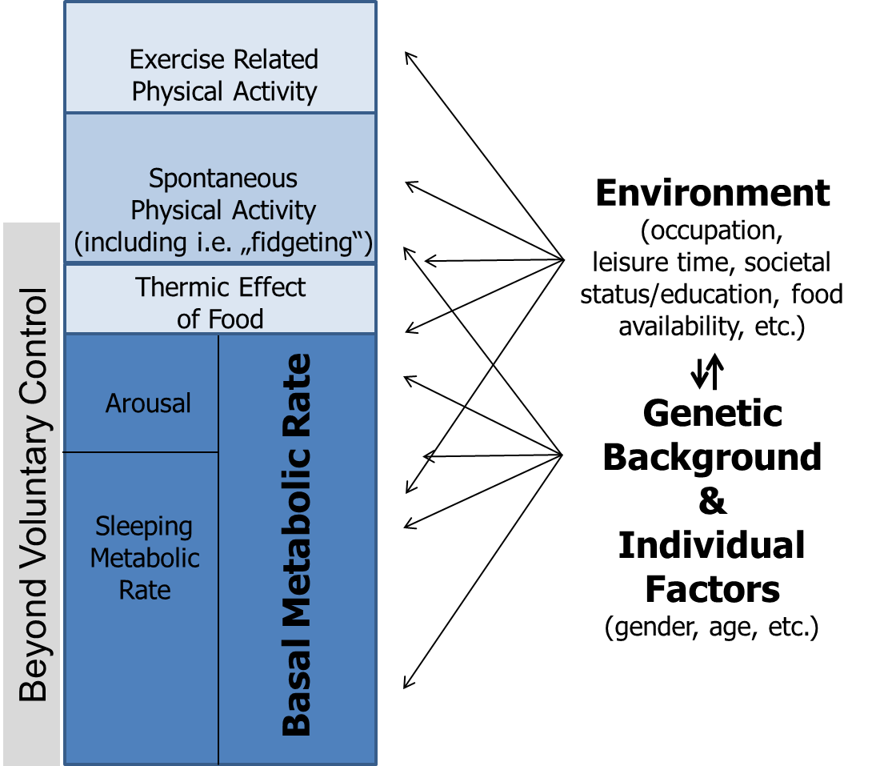
Figure 1: Model of human energy expenditure compartments (adapted from 23). Exercise related activity is complementary to exercise related activity thermogenesis (EAT), while spontaneous physical activity relates to nonexercise activity thermogenesis (NEAT; for further explanations see text). Note that parts of spontaneous physical activity are beyond voluntary control, i.e. “fidgeting”. Arrows symbolize the multiple and individually varying impacts of individual factors, genetic background and environment.

In healthy subjects with mainly sedentary occupations BMR predicts around 60% of TEE variance (15), while it is even larger in individuals with minimal physical activity, i.e. in ventilated patients on an intensive care unit (22). Some studies suggest a reduction of BMR in subjects prone to become obese (24,25,26). It is, however, a matter of debate as to whether a reduction of energy expenditure due to decreased BMR does sufficiently explain the positive net energy balance of the majority of obese subjects (27,28,29).
Of note, it is not uncommon that the term resting energy expenditure (REE) is synonymously interchanged with BMR. However, BMR is measured 12h postabsorptively, lying supine at complete rest under quiet ambient conditions, in a thermal neutral temperature setting and darkened lightning in the morning after 8h of sleep (12). By contrast, REE is equivalent to postabsorptive energy expenditure at complete rest at any time of the day and can vary as much as 10% within BMR.

Thermic Effect of Food

TEF is the increment of energy expenditure above REE following meal ingestion and is a relatively stable component (see figure 1). TEF lies in a range of 8-15% of TEE and is related to food digestion, absorption and storage. The variance of TEF has been associated with nutrient composition and energy content of consumed foods (30).

Physical Activity
Physical activity is the third main determinant of TEE (see figure 1). It is defined as the additional energy expenditure above REE and TEF, which is required for performing bodily activity. It can be categorized into exercise related activity thermogenesis (EAT) and nonexercise activity thermogenesis (NEAT). Both vary widely within and between individuals. For the majority of subjects in industrialized countries exercise is believed to be negligible (13,15). According to recent NHANES data 36.1% of the investigated population was categorized to be sedentary, while a further 47.6% was physically active at low levels (31). Remarkably, only around 16% of the studied NHANES subjects were objectively classifiable to meet physical activity guidelines or to be highly active, but the latter subjects did not necessarily exercise (31,32,33). Thus, it is reasonable to conclude that on a population level the percentage of subjects engaging in regular intense physical exercise is low. In those who habitually participate in purposeful physical training, EAT is believed to account for maximally 15-30% of TEE (12,34). Other authors suggest that the majority of subjects undergoing regular physical training, defined as ‘bodily exertion for the sake of developing and maintaining physical fitness’, do not exercise for more than 2h in a week, accounting for an average energy expenditure of maximally 100 kilocalories (kcal) day⁻¹ (35) or to contribute to 1-2% to the variance of TEE. Together, for most human subjects EAT seems to be not a major contributor to TEE variance.

NEAT by contrast represents the predominant component of daily activity thermogenesis, which is also true for most subjects undergoing regular physical training. It is important to note that both, NEAT and spontaneous physical activity are not interchangeable but represent complementary concepts (36): NEAT refers to energy expenditure, while spontaneous physical activity describes the types of bodily activity that are not defined as purposeful physical training and result in NEAT. Importantly, a certain percentage of spontaneous physical activity and therefore NEAT is beyond voluntary control, i.e. “fidgeting”. Accordingly, NEAT corresponds to all the energy expended with occupation, leisure time activity, sitting, standing, ambulation, toe-tapping, shoveling snow, playing the guitar, dancing, singing, washing, etc. (13,14,15). Some authors categorize NEAT into three main subcomponents comprising body posture, ambulation and all other movements including “fidgeting” (37).
The importance of NEAT arises when considering the following points: The variability in BMR between individuals of similar age, BMI and of equal gender ranges around 7-9% (38), while the contribution of TEF is maximally 15%. Thus, BMR and TEF are relatively fixed components and account for approximately three quarters of daily TEE variance. When EAT is believed to be negligible on a population level, NEAT consequently represents the most variable component of TEE within and across subjects. It is responsible for 6-10% of TEE in individuals with a mainly sedentary lifestyle and responsible for 50% or more in highly active subjects (13,18,36).

Taken together, with respect to body mass regulation and modification of energy balance NEAT must be considered as a factor with potentially major influence. This is of particular interest in terms of developing prevention and treatment strategies for obesity. These issues, including the environmental and biological modification of NEAT will be systematically focused in the following sections.

Measurement of NEAT
For a better understanding of the potential role of NEAT in the context of obesity it is essential to recognize the strengths and limitations of available techniques used for the quantification of NEAT. NEAT can be principally measured by two approaches: By assessing total NEAT and by using the factoral approach (for extensive reviews of available techniques see 13,39,40).

Total NEAT

Total NEAT can be calculated by subtracting BMR and TEF from TEE (13):

Equ. I.: NEAT = TEE – (BMR + TEF)

To complete equation I. TEE, BMR and TEF need to be available. Under free-living conditions TEE can be reliably measured by using the doubly labeled water method (13). This approach requires the application of stable isotopes (deuterium/²H₂ and O¹⁸) containing water (²H₂O¹⁸). The difference in the clearance rate of the two isotopes equals carbon dioxide (CO₂) production and thus represents a consistent quantification of TEE (41) (see figure 2).

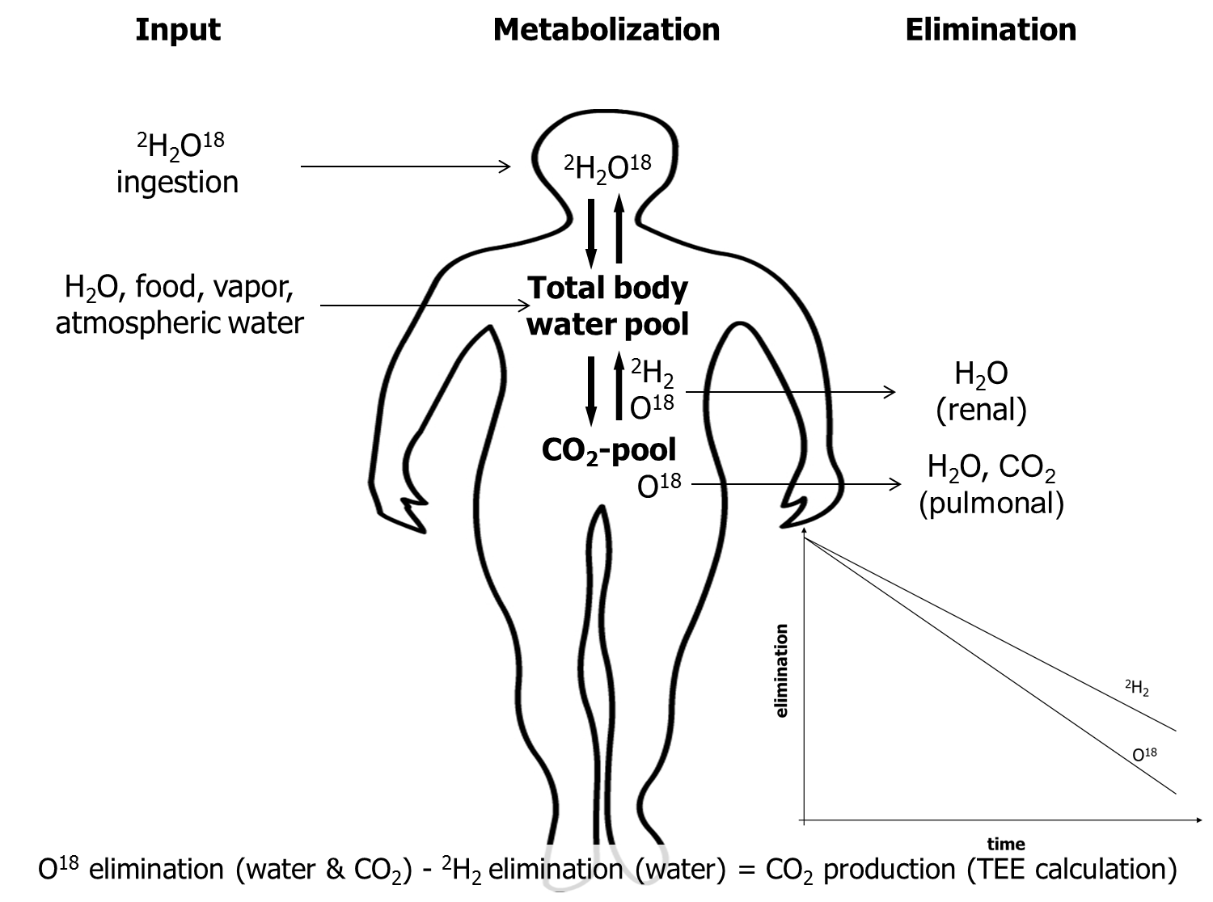

Figure 2: Schematic picture of the doubly labeled water method.

CO₂, carbon dioxide; ²H₂, deuterium; O¹⁸, labeled oxygen.

One necessary precondition of the doubly labeled water method is that the O₂ of expired CO₂ is in equilibrium with the O₂ in body water. Once ingested, O¹⁸ will be readily distributed in the systemic H₂O, H₂CO₃ and CO₂ pool. ²H₂ will be dispensed in body water and the H₂CO₃ pool (equation II.).

Equ. II.: CO₂ + H₂O ↔ H₂CO₃

The concentration of labeled O₂ in body water will then decrease over time due to a loss of CO₂ with expiration and via excreted body water, i.e. urine, respiration and perspiration. ²H₂ is mainly lost through excreted body fluids, yet a small percentage can be incorporated into body fat or protein. Since body water becomes tagged with known amounts of tracers at the same time at the beginning of the measurement period, the difference of elimination rates of both tracers equals CO₂ excretion. Doubly labeled water is usually administered at baseline after samples of blood, urine and saliva have been collected (13). Subsequent sample asservations occur within 7-21 days after administration, when the isotopes are completely dispensed within body compartments. Mass spectroscopy is the technique used to measure ²H₂ and O¹⁸ enrichments in collected samples, which are needed to finally calculate CO₂ production. Thereby, TEE can be ascertained with an error of about 6-8%. The latter can be minimized by repeatedly gathering samples over the measurement period rather than using two time points only.

It should be mentioned that the study of TEE classically relies on direct calorimetry (12,38). Direct calorimetry, i.e. direct measurement of heat loss from a subject is achieved by using well-controlled environmental chambers. However, due to the enormous variety of NEAT components in free-living individuals it is rather difficult to widely use this technique in the field of NEAT investigation (13).

By contrast, indirect calorimetry is an easily accessible method and commonly used to assess BMR, RMR and TEF. Indirect calorimetry is based on the fact that by measuring oxygen consumption (VO₂), CO₂ excretion (VCO₂) or both over a defined time span the metabolic conversion of macronutrients into energy can be calculated by using established formulae (12). The net released energy is typically expressed as kcal or kilojoule (kj). A small percentage of protein oxidation can be estimated by nitrogen excretion in urine or being neglected without adding a substantial error in subjects with stable nitrogen balance (12). Indirect calorimetry is accordingly one of the most commonly used approaches in clinical investigations, either in controlled or in field settings. For instance, Levine et al. in their study on human NEAT applied indirect calorimetry to measure BMR and TEF (42). For measuring TEF they provided participants with a meal containing a third of the subject’s daily weight maintenance energy needs. To yield TEF 24h⁻¹, the related energy expenditure was calculated from the area under the time versus energy expenditure curve and multiplied by three (13). Instead, study protocols can also ignore TEF as a non-substantial variable, or TEE is simply multiplied by 0.1 to yield a crude estimate.

When appropriate techniques are not available, BMR can be alternatively estimated by using validated age-, gender- and population-specific equations. For instance, the Harris-Benedict equation is one of the most widely used formulae in clinical settings (12). However, it was derived from healthy, normal-weight Caucasian adults between 1907 and 1917 and its application has therefore limitations (12). One could introduce a substantial error by applying it to an inappropriate collective, which is also true for other validated equations (12).

The physical activity level (PAL) is frequently used in studies to provide an index of bodily activity when measurement of total NEAT is not possible. It is calculated by expressing TEE relative to BMR (13). Sedentary subjects in industrialized countries typically have a PAL of approximately 1.5 (see table 1). The PAL rises to values of 2.0-2.4 with strenuous work and under certain conditions it can increase to values up to 3.5-4.5 (13).

Chair or bed bound | 1.2
Seated work with no option of moving around and little or no strenuous leisure activity | 1.4 – 1.5
Seated work with discretion and requirement to move around but little or no strenuous leisure activity | 1.6 – 1.7
Standing work (i.e., housewife, shop assistant) | 1.8 – 1.9
Strenuous work or highly active leisure | 2.0 – 2.4

Table 1: Physical activity levels (PAL) predicted from lifestyle (from 13).

Using the PAL, however, can also introduce significant bias in the assessment of NEAT, as under free-living conditions the cumulative error of PAL measurements can be as high as 7% (13).

The factoral Approach of NEAT Measurement

Measuring total NEAT or using PAL provides no information regarding the single components contributing to activity related energy expenditure. Therefore, the factoral approach is a widely used method to get an appropriate estimate of NEAT constituents. Accordingly, all physical activities of a subject of interest are recorded over a defined time span, which is typically 7 days. The energy equivalent of each activity is determined and the yielded equivalents are then related to the time spent by the individual with the respective activities. Finally, the data can be totaled to get an estimate of the energy costs of NEAT (13). Therefore, the first step when using the factoral approach is the quantification of a subject’s physical activities. Several methods are available to obtain such information, i.e. questionnaires, interviews or activity diaries. These approaches might be useful to get an estimate of particular activities, i.e. occupation. Otherwise, they have substantial limitations including inadequate or incomplete data recording, alteration of habits during assessment periods and others (13). Moreover, certain NEAT subcomponents, i.e. “fidgeting” might not be captured. Thus, various technical approaches have been developed. Among these are radar tracking, floor-pressure-pad displacement, cine photography, pedometers, accelerometers and GPS (13). Depending on the degree of sophistication, all of them have more or less limitations, whereby data obtained from triaxial accelerometers correspond in an acceptable fashion with measured energy expenditure and a combination of methods probably results in most appropriate estimates (13).

Energy costs of single NEAT components are typically measured by means of indirect calorimetry. Highly sophisticated portable systems are nowadays available. Using tables with listed energetic costs of NEAT activities represent an alternative approach. The latter method is convenient and inexpensive, but for similar reasons as pointed out for PAL substantial systematic errors can be introduced (13).

Principal problems arise with NEAT measurement per se, as little validated information is available concerning the time period necessary to representatively assess spontaneous physical activity. Otherwise, there is the attempt to extrapolate results from studies to an individual’s energy expenditure of days or longer time periods. Therefore, experienced investigators in this field emphasize that approximately 7 days likely provide a representative assessment regarding a 2-4 month time span (13).

Taken together, the difficulty of getting true estimates under free-living conditions is one major reason, why limited information is available on human NEAT physiology. Representative studies need to run over appropriate time spans and typically use a combination of the factoral approach and total NEAT measurement to overcome major limitations.

Due to Interactions of Environmental and Individual Determinants NEAT can vary by 2000 kcal day⁻¹
There is a close interplay between environmental factors and individual characteristics with respect to NEAT. The known and supposed issues contributing to this phenomenon will be addressed in the following sections.

Effects of Occupation and Gender
Physically highly active individuals expend up to three times more energy in 24h than subjects with negligible bodily activity (43). As pointed out, NEAT must account for a significant proportion of the observed differences at the population level. Thereby, occupation clearly represents the key determinant (35). Indeed, NEAT can vary by as much as 2000 kcal day⁻¹ when comparing two adult individuals of similar body size, LBM, age and gender. For an average worker spending most of her/his time in a seated position, occupational NEAT is relatively low and associated energy costs range at a maximum of 700 kcal day⁻¹ (see figure 3).

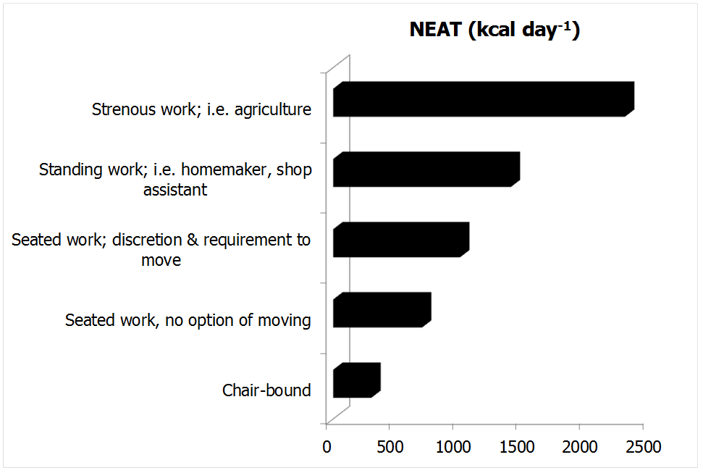
Figure 3: The effect of occupational intensity on NEAT (developed from 35). The data rely on an assumed BMR of 1600 kcal day⁻¹.

A comparable subject working mainly in a standing position can increase her or his occupational NEAT to up to 1400 kcal day⁻¹, while an agricultural occupation would theoretically result in NEAT categories ranging around 2000 kcal day⁻¹ and more (see figure 3;35). Thus, occupations relying on intense physical activity can expend 1500 kcal day⁻¹ more than a sedentary job. This observation becomes even more accentuated when considering research from non-industrialized countries (44,45). For instance, a study of Levine and colleagues included more than 5000 dwellers from agricultural regions of the Ivory Coast (see figure 4).

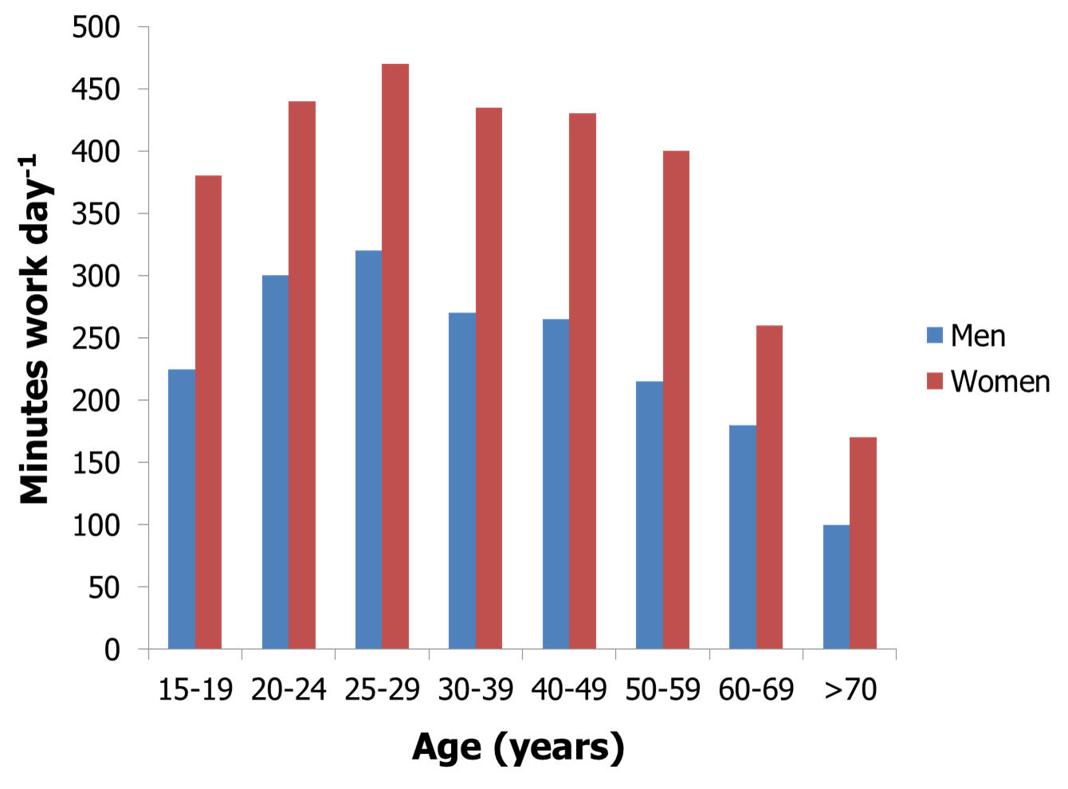
Figure 4: Gender and age dependent physical activities in agricultural communities in the Ivory Coast. Time engaged in work activities performed by women and men (developed from 45).

Each subject was investigated for a time span of 7 days and all of their daily tasks were recorded by a trained enumerator (45). Several lines of available evidence regarding NEAT arose from this study: First, a substantial effect of gender was observed as women apparently work more than men in these societal constructs. Females are responsible for more than 95% of domestic and for an additional 30% of agricultural tasks. Otherwise, men exclusively work in agriculture and have more leisure time, resulting in substantially higher NEAT in females (35). By contrast, in Canada, Australia or the United Kingdom men are reported to be up to 3 times more physically active than females, while data from the United States indicate comparable activity levels of genders (46,47). Even less data is available on NEAT in children, but in general boys seem to be reproducibly more active than girls (48,49).

Ageing
A second important aspect of the study of Levine et al. is the fact that decreased occupational NEAT was observed with ageing (see figure 4;45). An ageing related decline of NEAT has been earlier propagated across species (50). Interestingly, Harris et al. have recently underpinned the effect of ageing on NEAT in free-living humans, as they have shown a substantial decrease in elderly as compared to younger subjects (51). The effect was mainly attributable to the NEAT subcomponent of ambulation, since the elderly subjects walked less distance despite having a comparable number of walking bouts day⁻¹ as compared with their younger counterparts. Indeed, elderly subjects showed 29% less nonexercise activity, corresponding to 3 miles per day of less ambulation (51).

Industrialization and Societal Status
Industrialization and societal status are factors distinctively affecting NEAT. Urban environment and mechanization are associated with a decrease in physical activity and therefore in NEAT. For instance, it was shown that sales of labor-saving domestic machines (i.e. washing machines) and obesity rates show close correlations in the U.S. population, while such an association was not present with respect to energy intake (14). Furthermore, it is known that poverty and societal aspects comprising neighborhood and educational status are associated with obesity and preferred consumption of energy dense foods (52,53). Additionally, highly educated groups report more leisure-time physical activity. Consequently, these subjects are 3 times more likely to be physically active as compared to less educated individuals (14).

Seasonal Effects
Last but not least also seasonal variations play a role for NEAT since spending time in activity is twice as likely during the summer as compared to winter months and it seems intuitive that i.e. agricultural work or work in the constructional industry plays a greater role in the summer season (15).

Together, available data point to a close interplay regarding environmental conditions and biological aspects of NEAT. Evidence suggests that mainly depending on occupational activity NEAT can vary by 2000 kcal day⁻¹. By the law of conservation of energy the accumulation of excess body fat is a result of positive energy balance. Subtle perturbations of energy balance over sustained time periods are theoretically capable of inducing obesity. Otherwise, energy expenditure and energy intake need to be precisely matched to achieve a long term persistency of body mass, as an error of 1% would lead to a gain or loss of 1 kg year⁻¹ or some 40 kg between the age of 20-60 years (23). Therefore, small manipulations of energy balance by means of NEAT could theoretically result in significant effects with respect to obesity prevalence. Consequently, when considering to modulate NEAT as a strategy for the prevention or treatment of obesity one central question arises, namely as to whether and in which fashion NEAT interacts with another elementary environmental factor regarding energy balance, which is energy intake.

Alteration of NEAT with Varying Energy Availability from Foods

Manipulation of energy balance is followed by multiple adaptations, but few studies have addressed modulation of spontaneous physical activity and NEAT with altered energy intake. In general, the ability to adapt NEAT with dietary manipulations seems to be highly variable between subjects, particularly with respect to overfeeding. Individuals showing a significant upregulation of NEAT in the face of positive energy balance could be more able to fend off obesity (29).

NEAT under Conditions of Overfeeding and Caloric Deprivation

Using a combination of direct calorimetry and radar monitoring Ravussin et al. have shown that the inter-person variability of TEE is considerable and remains significant even after adjustment for LBM (18). A substantial percentage of this variability is explained by differences in spontaneous physical activity including “fidgeting”, as the latter accounted for 100-800 kcal day⁻¹ in investigated subjects (18). Interestingly, the researchers observed elevated spontaneous physical activity levels in obese as compared to lean subjects, indicating an increment with elevated body mass. However, the latter study was performed under eucaloric conditions and over a short observation period. Therefore, the importance of spontaneous physical activity for energy balance is principally underlined, but no answer was provided to the question as to whether acute variability in energy intake affects NEAT. By contrast, in their “weight clamping” study Leibel et al. (54) advocated weight stable lean and overweight or obese subjects to increase their body mass by 10% due to overfeeding with 5000-8000 kcal day⁻¹ over 4-10 weeks, followed by a defined weight maintenance period. Body composition, fecal caloric loss, TEE, REE, TEF and spontaneous physical activity were measured using multiple technical approaches including i.e. indirect calorimetry, the doubly labeled water method and radar detectors in a subgroup (54). It was shown that maintaining a 10% elevated body mass induced a significant increase of TEE by 9±7 kcal kg⁻¹ LBM day⁻¹ in previously non-obese, and by 8±4 kcal kg⁻¹ LBM day⁻¹ in previously obese subjects (54). The main percentage of this rise in TEE was attributable to non-resting energy expenditure, which accounted for a mean of 8-9 kcal kg⁻¹ LBM day⁻¹. The magnitude of this effect was comparable in previously non-obese versus overweight or obese subjects, indicating similar adaptation to overfeeding conditions (54). However, a related review remarked the large inter-individual variability regarding the capability to adjust energy expenditure with overfeeding in the “weight clamping” experiments (23). Complementarily, the latter authors emphasized that integrative examination of available human overfeeding studies suggests a wide range of individual variability in the amount of weight gain per unit of excessively consumed energy. Therefore, it can be proposed that some individuals show a remarkable capacity to increase energy expenditure in response to overfeeding, while others do not (23). It was further suggested that spontaneous physical activity and accordingly NEAT likely play an important role under such conditions
The group of Levine was the first to systematically investigate the effect of overfeeding on the individual ability to adapt NEAT in free-living subjects (42). Using sophisticated methods and by measuring NEAT over a representative time span, the latter authors overfed 16 volunteers (12 males, 4 females; age ranging from 25-36 years) by 1000 kcal day⁻¹ in excess of their weight maintenance requirements (20% of the calories came from protein, 40% from fat, 40% from carbohydrates). The energy surplus was paralleled by a mean TEE increment of 554 kcal day⁻¹. 14% of this increase was attributable to a rise in REE, approximating to 79 kcal day⁻¹. A further 25% of the TEE increment (136 kcal day⁻¹) corresponded to an increase in TEF. The most prominent effect was however attributable to enhanced physical activity thermogenesis, corresponding to around 336 kcal day⁻¹. As volitional exercise of the study subjects remained at a constant low level and since the authors did not detect changes in exercise efficiency, they concluded that about 60% of the increase in TEE due to overfeeding was attributable to NEAT (42). Thereby, an associated review emphasized that the change in NEAT varied remarkably between subjects, ranging from -98 to +692 kcal day⁻¹ (55). The maximal individual increase of NEAT constituted 69% of the excessively consumed 1000 kcal day⁻¹ in this study (55). Moreover, the change in NEAT was directly predictable of the individual vulnerability or resistance to body fat accumulation (15,42). This is in accordance with findings from a series of former overfeeding studies, showing that due to adaptations in thermogenesis some individuals seem to be particularly resistant to weight gain (reviewed in 55). Therefore, the data from Levine et al. provide one plausible explanation for the susceptibility of gaining body mass under standardized overfeeding conditions and identify the individual ability to specifically adapt NEAT as one critical determinant (15,29,42).
There is, however, a debate regarding the matter as to whether overeating is capable of systematically affecting physical activity levels (56), as some recent human short term overfeeding studies failed to detect compensatory increases in spontaneous physical activity and NEAT (57,58,59). However, as compared to Levine’s trial a number of remarkable differences particularly with respect to the study protocols have to be considered (42,57,58,59). Otherwise, Siervo et al. used state-of-the-art methods and applied a highly standardized 17 week protocol with progressive overfeeding from 20 to 60% energy in excess of maintenance needs (60). Lean, healthy men were challenged by 3 subsequent intervals of stepwise overfeeding separated by 1 week of ad libitum energy intake. Analogous to the findings presented above one striking finding of this study was the high between-subject variability concerning weight change during ad libitum phases (60). This underlines the highly individual compensatory response to overfeeding. However, in contrast to Levine’s study Siervo et al. failed to detect a significant systematic change in spontaneous physical activity (42,60). It was therefore concluded that systematic elevations in energy intake induce very limited autoregulatory mechanisms (60).

While evidence with respect to systematic NEAT upregulation under overfeeding conditions is somewhat controversial, TEE and spontaneous physical activity are clearly influenced under conditions of energy deprivation (56). For instance, Leibel et al. in a second arm of their “weight clamping” experiment evaluated the effect of a 10% body mass reduction, followed by weight maintenance at this level (54). However, while overfeeding was accompanied by a 16% increase of adjusted TEE, underfeeding related weight reduction induced a 15% decrement of the latter (54). Similar to overfeeding conditions, non-resting energy expenditure was the mostly affected variable under circumstances of energy deprivation (54). These findings are underscored by results from the so called Biosphere 2 experiment, where the authors have shown a major reduction of TEE and spontaneous physical activity with body mass reduction over a 2 year time period, which even persisted after 6 months of body weight regain (23,61). Thus, changes in TEE with underfeeding seem to occur in a direction tending to return subjects to their initial body mass (23). Striking evidence to support this hypothesis comes from one of the most popular semi-starvation experiments, the Minnesota Study (reviewed in 23,38). It is further confirmed by a recent review, suggesting that undereating systematically decreases physical activity levels, which also affects habitual physical activity and therefore NEAT (56).

Taken together, the integrative view on existing human overfeeding and slimming studies proposes that the magnitude of adaptations regarding energy expenditure varies largely between individuals. Concerning the predisposition to obesity, differences in the individual capability to adapt thermogenesis with positive energy balance are of importance. But while data on NEAT adaptation with overfeeding are somewhat controversial, NEAT is consistently reduced with underfeeding. In advance of developing anti-obesity strategies to systematically increase NEAT it is therefore essential to evaluate the mechanisms contributing to this regulatory effect.

Physiological and Molecular Determinants of NEAT

Principles of NEAT Regulation

The ability to adapt thermogenesis and specifically NEAT presupposes mechanisms in a direction to sense, accumulate and integrate internal and external signals with respect to energy balance (14). Figure 5 shows a model suggesting the principal regulation of spontaneous physical activity and correspondingly NEAT.

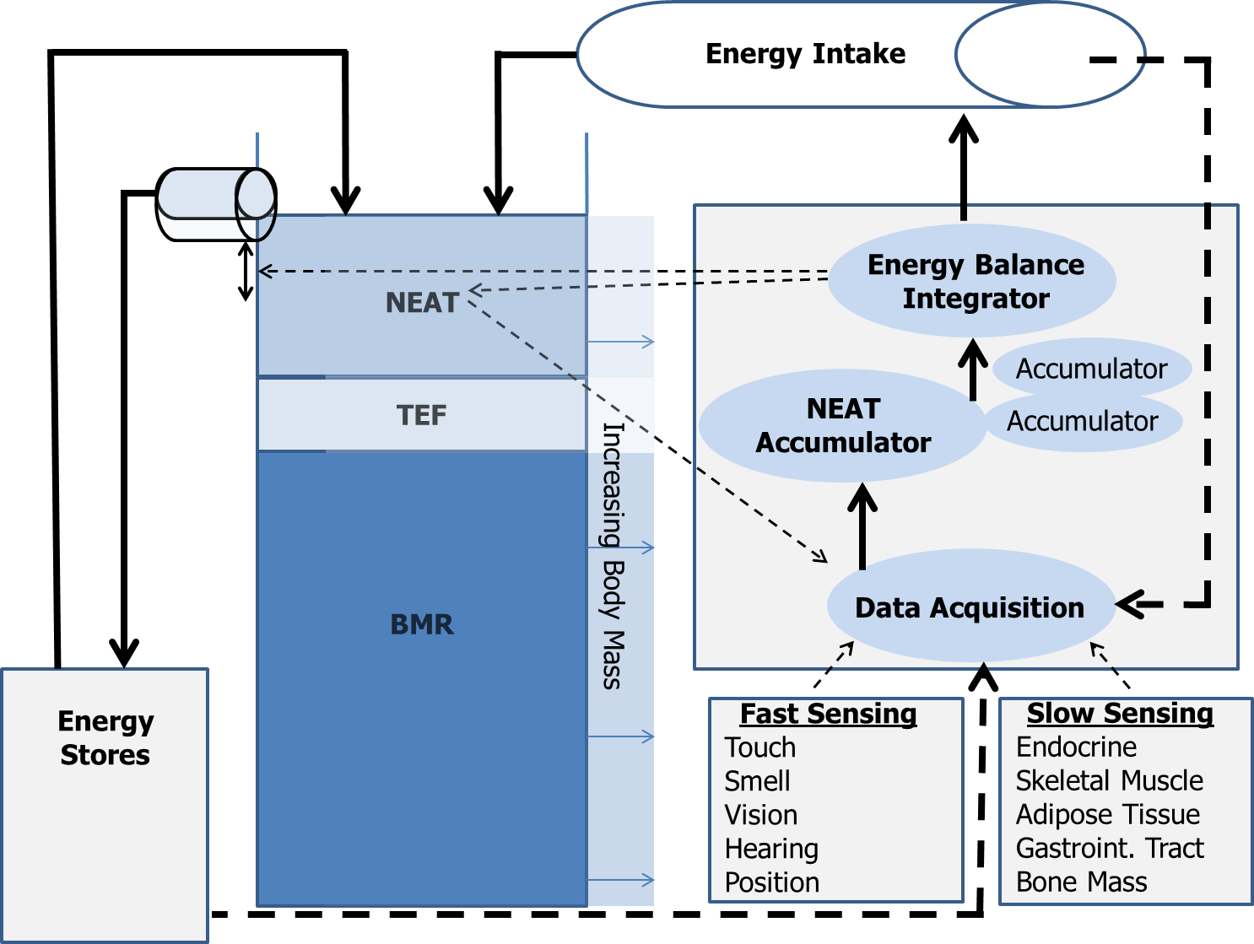

Figure 5: The NEAT hypothesis of energy balance (adapted from 14).

Continuous arrows represent energy flow through the system, broken arrows stand for putative signaling pathways.

BMR, basal metabolic rate; NEAT, non-exercise activity thermogenesis; TEF, thermic effect of food.

The model shown in figure 5 proposes that data acquisition comprises information regarding caloric intake, energy depots and energy expenditure. Thereby, the energy balance out of these 3 components is in constant flux. The acquired signals converge at the data acquisition center, are rectified to a common signal and directed to a NEAT accumulator, which is constantly summing the net amount of NEAT per unit of time. The latter constantly refers to the energy balance integrator, which may directly modulate NEAT in response to changes in energy intake. For instance, under circumstances of rising energy intake the energy balance integrator mediates either deposition of the caloric surplus in energy stores, i.e. mainly in fat cells. An alternative way represents dissipation of the excess energy as NEAT. More likely, while BMR is essentially fixed, some energy will be spent on food digestion and absorption (i.e. increased TEF), some will be deposited as body fat and the rest will be dissipated as NEAT (14). The latter model is supported by the fact that although BMI and energy balance are apparently oscillating under daily life conditions, body mass is remarkably stable in the long term. This is exemplarily evidenced by data coming from the Framingham Study and showing a mean body mass increase of only 10% over a 20 year time span in average adults (cited in 54). Thus, it appears that the regulation of energy balance and body mass is realized by a complex network of precisely working autoregulatory systems, which finally affect defined variables with one of them being spontaneous physical activity with resulting NEAT. However, there is lack of information concerning the biological mechanisms driving this system. It was suggested that abundance of available data describe the regulation of food intake (29). Certainly physical activity has an equal potential of impacting body mass and energy balance. Therefore, it is very likely that many of the biological systems involved in the regulation of energy intake can be used to gather information regarding how NEAT is adapted in humans (29).

Biological Sites and Central Regulatory Mechanisms

Overfeeding and slimming studies in identical twins suggest an important role of genes regarding the variability underlying body mass regulation (62,63). Moreover, Zurlo et al. have shown that spontaneous physical activity levels cluster in families and could prospectively help to explain the propensity for weight gain (36,64). Given the polygenetic nature of obesity (65) it seems likely that numerous pathways are involved in the regulation of NEAT, as the latter has multiple environmental cues and affects a multitude of behaviors.

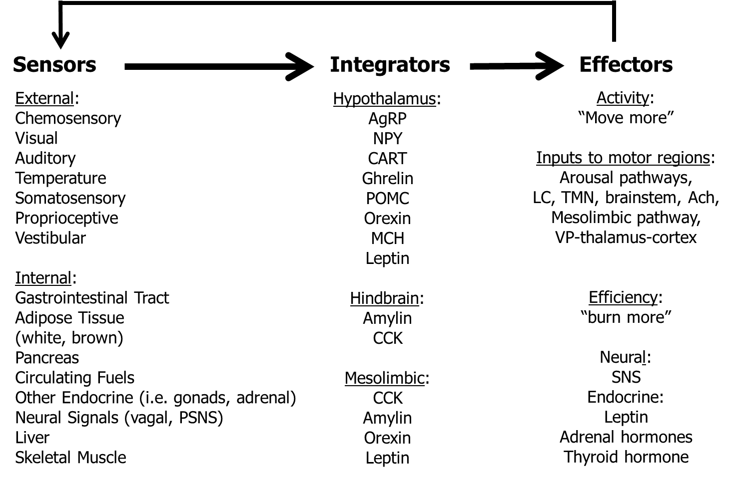

Figure 6: Model for the neuroendocrine regulation of NEAT in the service of energy balance (adapted from 29). Multiple external and internal signals are sensed and integrated, whereby defined structures in the brain (i.e. arcuate nucleus of the hypothalamus, area postrema and nucleus of the solitary tract of the hindbrain, dopamine pathway of the mesolimbic system) interprete a multitude of sensory cues of energy availability. The involved brain systems have multiple ascending and descending projections affecting the amount of physical activity through arousal and limbic pathways, and descending neural projections and endocrine signals to modulate the energy efficiency of physical activity. Thereby, the central nervous system could adapt NEAT to adjust energy balance under conditions of caloric excess or starvation.

Ach, acetylcholine; AgRP, agouti-related peptide; CART, cocaine- and amphetamine-regulated transcript; CCK, cholecystokinin; LC, locus coeruleus; MCH, melanin-concentrating hormone; NPY, neuropeptide Y; POMC, pro-opiomelanocortin; PSNS, parasympathetic nervous system; SNS, sympathetic nervous system; TMN, tuberomammilary nucleus; VP, ventral pallidum.

Figure 6 shows a model suggesting how NEAT could be regulated by involving several well described neuroendocrine systems and a variety of peripheral tissues/organs known to affect energy balance. Accordingly, defined brain regions are involved in NEAT regulation. The associated neural mechanisms involve a real multitude of neurotransmitters and neuropeptides (for extensive review see 29 and 66). While all of them are important, this section will briefly focus on the biological role of central orexin peptides as a promising and representative target with respect to the regulation of spontaneous physical activity (for extensive review see 36). Experimental data indicate that injections of orexin A into defined brain regions reproducibly induce a dose dependent increase in spontaneous physical activity along with significant increments in NEAT. Moreover, current knowledge suggests a role for the orexin system in the control of arousal and sleep, and for reward or stress reactions. This has led to extensive research showing that the orexins A and B become produced by cleavage from a single pro-peptide (reviewed in 36). The majority of orexin A is synthesized in the lateral hypothalamus and pernifornical region. Orexin A binds to two G protein coupled receptors, namely orexin receptor type 1 (OXR1) and 2 (OXR2). OXR1 has high affinity for orexin A, while OXR2 has equal affinity for the A and B peptide. Receptor binding of orexin A is associated with increased intracellular calcium levels and followed by enhanced neuronal firing (reviewed in 36). Physiologically, orexin A is capable of modulating spontaneous physical activity, food intake and sleep as evidenced by an obesity resistant rat model with high orexin A activity. These animals show more ambulatory and vertical movement, independent of age or food availability (29). Intriguingly, the latter rat model exhibits lower body weight gain when fed a high fat diet, although consuming significantly more kcal on a gram body mass level. It was concluded that orexin A enhances feeding behavior and induces physical activity at the same time, but the consumed calories are outweighed by those expended with spontaneous physical activity (29,36). The latter results are further confirmed by data coming from a mouse model with postnatal loss of orexin neurons (reviewed in 36). These mice show hypophagia, decreased spontaneous physical activity and develop spontaneous onset obesity under a regular diet regimen. Thus, modulation of spontaneous physical activity and resultant NEAT seems to be one of the main contributions of the orexin peptide system. Moreover, the latter signaling system has the potential to impact clinical endpoints, namely the development of obesity. This could be important for humans, since the orexin system has been shown to be defect in the sleep disorder narcolepsy, while obesity represents a recognized comorbidity of narcolepsy in both, animal models and humans (reviewed in 36).

It can be concluded that brain mechanisms involve a variety of neuropeptides to modulate spontaneous physical activity and accordingly NEAT. Thereby, the orexin A system could prospectively represent a promising target regarding the treatment or prevention of obesity, particularly with respect to subjects failing to spontaneously adapt thermogenesis while living in an environment that promotes long term positive net energy balance.

The Role of Peripheral Tissues for NEAT Regulation

As outlined in figure 6 peripheral tissues are believed to contribute to NEAT regulation. That NEAT can be influenced by over- and underfeeding has been discussed in earlier sections; but it is essential to reconsider that longitudinal studies on human fasting show significant decreases in thermogenesis with starvation, while refeeding can induce a marked elevation (reviewed in 23,38). These adaptations propose a feedback mechanism between thermogenesis regulation and energy depots, as suggested in figure 5. It can be further hypothesized that adaptations of thermogenesis in response to fasting or overfeeding result at least in part from an adipose tissue-specific impact on thermogenesis (reviewed in 23). Indeed, studies on white adipose tissue (WAT) have led to the recognition that the latter energy store represents an important endocrine organ communicating with the brain through secretion of so called adipokines. Importantly, adipokines could potentially play a role for NEAT regulation (see figure 8;67). One representative WAT signaling system concerns the adiposity indicator leptin. Leptin was first characterized in 1995 (68). Due to its role regarding the sensing of energy stores and regulation of food intake, it was also suggested as an important signal with respect to thermogenesis adaptation (reviewed in 29,69). For instance, Dauncey and Brown studied ob⁄ob mice and their lean littermates when they had comparable body weights (70). Leptin-deficient mice expended less energy and showed less motor activity as compared to control animals. The energy expended relative to metabolic size was greater in lean littermates, which were also more active than the ob⁄ob mice. It was calculated that activity related energy expenditure accounted for at least part of the differing body mass between ob⁄ob and wild-type mice (70). With respect to humans, Franks et al. have shown that fasting leptin levels were significantly associated with physical activity related energy expenditure (71).

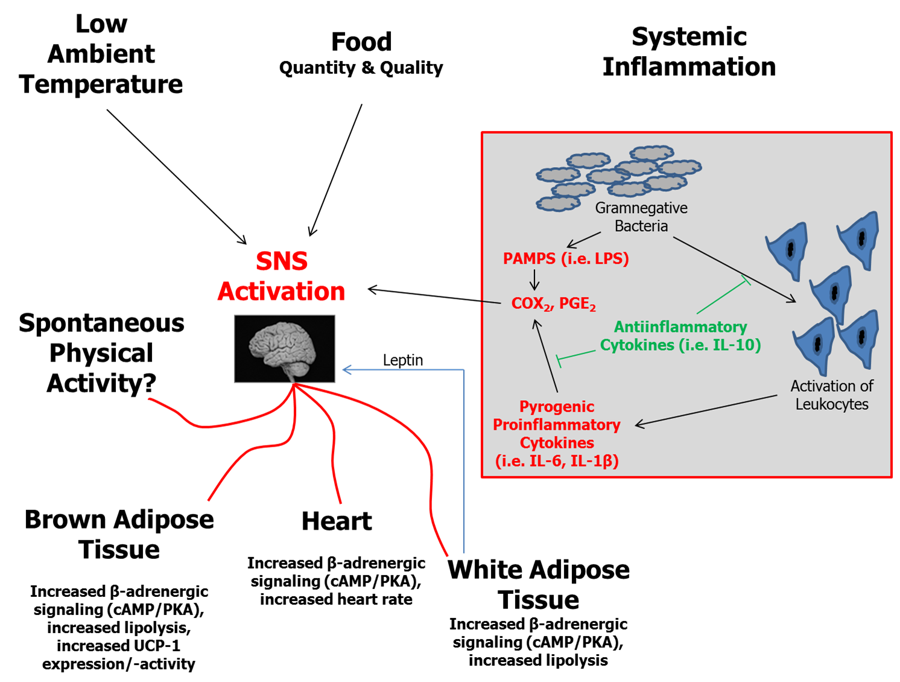

Figure 7: Essential elements in the regulation of thermogenesis including effects of white adipose tissue (WAT) (adapted from and developed according to 29,69).

Energy availability from food and internal energy stores, ambient and body temperature and systemic inflammation are main determinants of thermogenesis regulation. In WAT two relevant factors converge: WAT represents the principal energy depot and under conditions of significant obesity WAT is a site of low grade inflammatory activity with impact on systemic inflammation. In accordance with the model shown in figure 6, signals from WAT can induce enhanced SNS activity and prompt multiple downstream effects to adapt thermogenesis. Experimental data indicate that NEAT is one component affected by WAT signaling, i.e. through mediators like leptin. Related to the hypothesis of “adaptive thermogenesis”, Dulloo et al. in their review regarding human starvation and overfeeding complementarily suggest SNS as a key regulatory element (23). Of note, activation of brown adipose tissue, which has recently gained a lot of interest with respect to human obesity (72,73,74) is suggested as an additional site of “adaptive thermogenesis”.

BAT, brown adipose tissue; cAMP, cyclic 5’ adenosine monophosphate; COX, cyclooxygenase; IL, interleukin; LPS, lipopolysaccharide; PAMPs, pathogen associated molecular pattern; PGE, prostaglandin E; PKA, protein kinase A; SNS, sympathetic nervous system; UCP, uncoupling protein; WAT, white adipose tissue.

Thus, available data suggest that leptin acts not alone by reducing food intake, but also by increasing energy expenditure due to elevating physical activity (reviewed in 29). The potential role of leptin in human obesity is of particular interest given the phenomenon of leptin insensitivity under conditions of overfeeding and related obesity (75,76). However, it must be also kept in mind that the leptin system represents only one model of peripheral tissue signaling with impact on NEAT. For instance, thyroid hormone status has major influence on energy expenditure, as i.e. hyperthyroid rats have been shown to reveal significantly increased NEAT (77).

Together, evidence indicates that NEAT underlies a complex network regulation of central and peripheral systems. The latter involve a variety of redundantly organized fast and slow acting mechanisms, i.e. neuropeptides and signaling systems from peripheral tissues. Involvement of such biochemical signaling systems defines spontaneous physical activity and NEAT as a potential site for pharmaceutical targeting. Pharmaceutical manipulation would either aim at increasing the amounts of activities people undertake, or to elevate activity related energy expenditure.

NEAT-enhanced Living - Implications for the Prevention and Treatment of Obesity
From recent sections it became clear that NEAT must be taken into consideration as a factor with significant impact on daily energy balance. However, to transfer present knowledge into lives of free living individuals with the aim to counterbalance effects of an obesity promoting environment, some central questions need to be addressed:
- How can the amount of NEAT be increased?
- Which collectives could have the most prominent advantage of increasing NEAT with respect to body mass regulation; what are realistic goals for daily spontaneous physical activity and which are appropriate activities for increasing NEAT?

Environmental Re-engeneering versus Personalized Approaches for Promoting NEAT
When aiming at preventing or treating obesity it can be argued from a NEAT perspective that in a positive net energy balance promoting environment each person is responsible for itself to adequately increase physical activity levels (35). Alternatively, obesity can be interpreted as a population-wide problem that has emerged as a result of environmental pressures with decreasing necessity to be bodily active (35). Likewise, it could be claimed that the epidemic of obesity needs to be consequently addressed at the population level. For substantially increasing NEAT it can be helpful to reciprocally categorize both of the latter perspectives as the “individualized approach” versus the “environmental re-engineering approach” (35). Accordingly, Levine and Kotz have developed the egocentric and the geocentric model, as the latter concepts provide a theoretical framework to understand important environmental determinants of NEAT out of the two perspectives (15). The models may help to elucidate how NEAT can be effectively modulated.

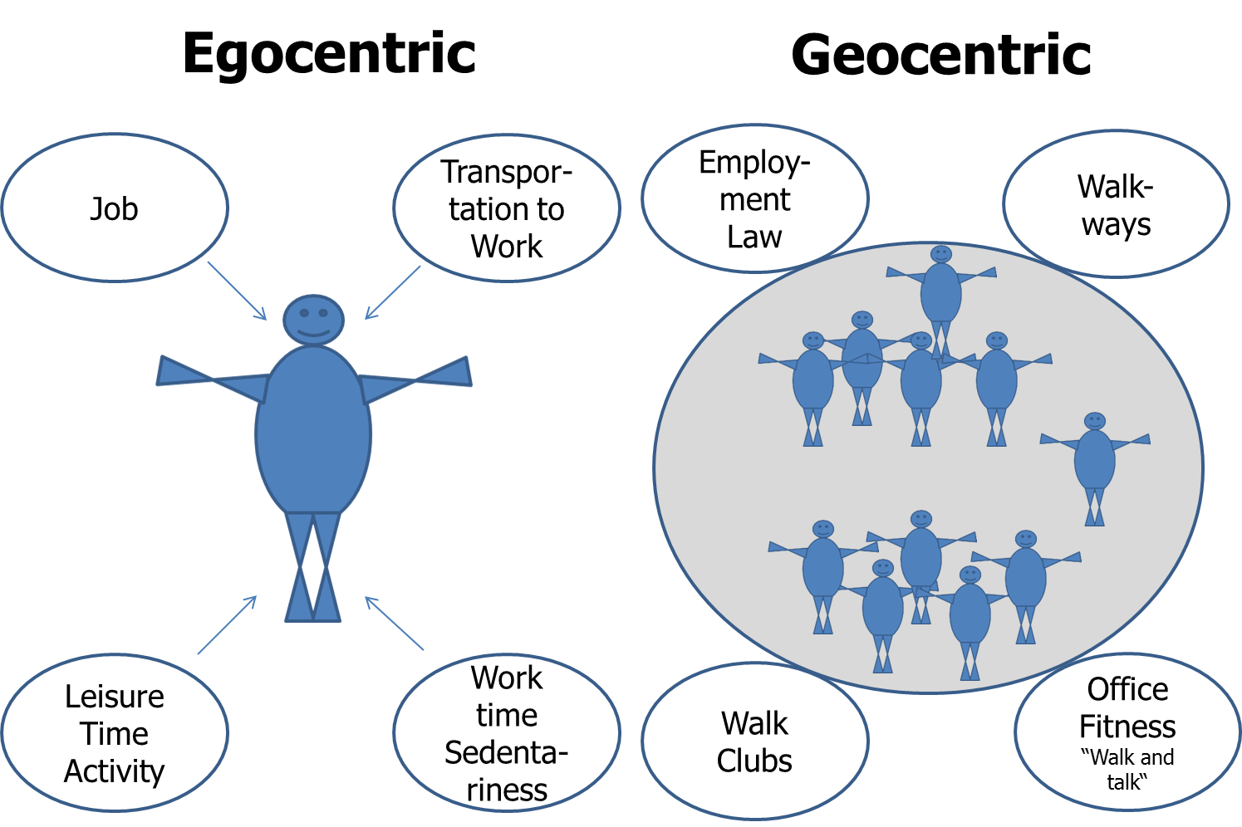

Figure 8: Environmental determinants of NEAT – the egocentric versus the geocentric model (adapted from 15).

In the egocentric model, a single person is considered as the focus. Accordingly, environmental factors that impact a particular person’s spontaneous physical activity levels are considered, i.e. “my occupation”, “my transportation to work”, or “my leisure time activities” (see figure 8;15). By contrast, in the geocentric model the ‘environment’ impacting NEAT of a multiple of subjects is focused, i.e. city planning to ensure walk-friendly or bike-accessible environments (see figure 8;15). Unfortunately there is no evidence showing as to whether the individualized or the population related approach is more effective in terms of increasing physical activity levels. Therefore, both have to be considered under daily life conditions (35).

Regarding the geocentric model, a variety of environmental factors negatively impact spontaneous physical activity. The most prominent are represented by urbanization and mechanization, which are largely a phenomenon of high- and middle-income countries. Examples for mechanization and urbanization with negative impact on NEAT include televisions, drive through restaurants, clothes’ washing machines, motorized walkways and many others (15). Accordingly, when comparing energetic costs of mechanized tasks with the same tasks performed manually a century ago, the difference in daily energy costs approximates 111 kcal or more than 40.000 kcal year⁻¹ (78). It was accordingly concluded that urbanization and mechanization likely have dramatic impact on energy balance (15). Hence, to enforce an increase NEAT on a population level, the deduced approach of environmental re-engineering claims to i.e. provide adequate walkways, to build schools within walking distance and to adapt employment laws for promoting office fitness. The problem with this argument is that it partially crosses traditional professional boundaries, since i.e. redesigning an office space for promoting NEAT is very costly and the standards that define success are unknown (35).

From the perspective of the individualized approach of increasing NEAT Levine and Kotz suggest, to divide a person’s NEAT-activities into those associated with occupation and those related to leisure time (15). Clearly, the major percentage of NEAT variance between subjects is associated with differences in occupation. Under daily life conditions the amount of spontaneous physical activity performed is commonly assessed by using PAL values (see table 1). This evidently defines occupation as a central target for behavior modification. By contrast, the impact of leisure-time on NEAT can profoundly vary. For illustration it was suggested to consider a sedentary office worker with total daily energy requirements of 2400 kcal day⁻¹, a BMR of 1500 kcal day⁻¹ and a PAL of 1.6 (15). Imagine this individual returns home from work by car at 5 pm. From then until bedtime at 11 pm the primary activity of this person is to operate the television remote control in a semi-recumbent position. For these 6h of leisure time, the average energy requirements above resting would approximate 8% and NEAT will accordingly approximate 30 kcal for the evening. Alternatively, the same subject could become aware of the unpainted bedroom, the weeds growing in the yard, at the possibility of cycling to work. When undertaking these tasks during leisure time NEAT would increase to 750–1125 kcal for the same evening (15).

Independent from key determining factors, i.e. leisure-time or occupation, it is self-evident that to intentionally increase NEAT over a protracted time period presupposes a significant amount of self-discipline. To facilitate behavior modification J.A. Levine has published approaches for promoting NEAT that focus on behavioral economic theory (for extensive review see 35): Behavioral economic theory is a framework for conceptualizing how people make behavioral choices based upon their perceived relative value. When applied to NEAT, behavioral economic theory is concerned with how people choose between various activity/inactivity options. Consequently, Levine proposes four key elements (35): At first, it is central to provide individuals with free-choice. By contrast, forcing a subject to choose a specific NEAT-promoting activity is likely to have the opposite to the intended effect. Otherwise, if an activity is self-selected, it is likely to be more reinforcing and consequently self-selected more often. Second, the delay between performing a NEAT-promoting behavior and the outcome needs to be minimized. While sedentary behaviors that people enjoy have immediately reinforcing consequences, health benefits of standing or ambulation may take longer to ensue. Therefore, it is important to choose NEAT-promoting physical activities that are pleasing, i.e. walk whilst listening to music or walk-and-talk with a friend. Third, behavioral ‘costs’ determine which sorts of activity/inactivity become selected. If a person has to work strenuously to participate in a given activity, the respective person is less likely to do it. For instance if the person has to drive 40 minutes to the gym before engaging in fitness training, it is not likely for a majority of subjects to do so on in the long term. People are more likely to choose physical activities that are easily accessible, i.e. a home- or even office-based activity that does not require changing location or clothes. Fourth, for an individual to choose a NEAT-promoting activity the latter has to be more attractive than available alternatives. For example behavior will change when providing a competing behavior that is more valued, i.e. a given person may prefer to surf the internet whilst seated rather than visiting the gym for a fitness workout. If, however, walk-and-talk with a friend was an option, the individual could choose that instead of internet-surfing. Finally, the latter behavioral components have been synthesized into a simplified approach termed, STRIPE (35): STRIPE is an acronym which represents S = Select a NEAT-activity that is enjoyed and start it; T = targeted, specific individual goals must be defined; R = rewards need to be identified for reaching the defined goals; I = identify barriers and remove them; P = plan NEAT-activity sessions; E=evaluate adherence and efficacy.

Overall, to increase NEAT for preventing or treating obesity both, egocentric and geocentric factors have to be considered, whereby environmental factors constantly play a key role in determining the amount of daily NEAT. Occupation and leisure time are the two principal time frames that have to be targeted for promoting individual NEAT. For increasing NEAT by means of changing behavior the STRIPE approach is considered as safe and well-grounded in conceptual evidence. However, it is not known whether this approach will help to become more active and/or to affect body mass.

Increasing NEAT: Realistic Goals, Appropriate Activities and Potential Limitations
When aiming at increasing NEAT, one central question arises, namely what goals have to be addressed for prevention or treatment of obesity? According to Levine et al. the amount of physical activity necessary for weight loss approximates 2000-2500 kcal week⁻¹ or about 2 ½h of additional daily ambulation (35). An additional energy expenditure of 2000-2500 kcal week⁻¹ is proposed to be a realistic goal for weight loss intentions (35). However, there is lack of evidence from controlled randomized studies, as to whether strategies to promote NEAT are effective in terms of obesity treatment. By contrast, existing evidence suggests a compensatory upregulation of energy intake by foods with rising energy expenditure due to increased physical activity, especially at higher workloads (reviewed in 56). Thus, it remains unclear whether substantially increasing NEAT for body mass control under free-living conditions (i.e. in an environment with high access to energy dense foods) will induce a compensatory rise in energy intake.
Dietary interventions, i.e. hypocaloric diets are capable of significantly reducing NEAT, as it has been shown in former sections that spontaneous physical activity becomes consistently downregulated under conditions of undernutrition. Consequently, reductions in NEAT due to hypocaloric dietary interventions could represent an important situation for targeting NEAT; particularly given the disproportionate recovery of body fat and overshooting body mass restoration, which is frequently observed after periods of underfeeding (reviewed in 23,38). Indeed, there is evidence that physical activity is essential for the prevention of weight regain after weight loss, and for weight maintenance (56). For instance, it was shown that low physical activity levels were related to significant weight regain at follow up after hypocaloric diets (79). Furthermore, subjects gaining weight under free-living conditions were compared to weight stable counterparts, whereby the “weight gainers” revealed markedly lower physical activity related energy expenditure and less muscle strength (80). Of note, after a 1 year period lower physical activity energy expenditure explained approximately 77% of the greater body mass increase in the “weight gainers” as compared to “weight maintainers” (80). Complementarily, a recent meta-analysis on weight loss maintenance favors physical activity to have a significant treatment effect ranging at around 1.6 kg in the short term (81). However, long term follow up data were negative, probably due to reduced compliance since effects of voluntary physical exercise were examined (81). Consequently, enhancing NEAT as a treatment option instead of promoting purposeful physical exercise could mitigate poor long term compliance and substantially contribute to body mass preservation, particularly after dietary weight loss interventions. The latter hypothesis is supported by the fact that studies on diet-plus-exercise versus diet-only interventions for weight loss show that it is difficult to overcome hypocaloric diet-induced reductions of physical activity, at least by means of purposeful exercise training (56). In a meta-analysis of 18 randomized controlled studies on weight loss, performed over a minimum period of 6 month, a non-significant difference of 0.25 kg between diet-plus-exercise versus diet-only interventions was observed (56,82). It was proposed that at negative energy balance due to hypocaloric diet and purposeful exercise is compensated for by a corresponding reduction of nonexercise activity (i.e. NEAT), resulting in decreased TEE (56,83). Therefore, promoting NEAT already during weight loss intervention can hypothetically be helpful to mitigate compensatory decreases in TEE. Thereby it could be of importance not to excessively increase NEAT activities, as one study has shown at least for purposeful exercise that inducing a mild instead of a marked negative energy balance could lessen compensatory effects and therefore enable weight loss (84). The hypothesis of targeting NEAT as a tool for body mass regulation is also supported by recent NHANES data, showing that only about 16% of investigated U.S. subjects meet physical activity guidelines (31,32,33). Promoting NEAT as an adjunct to dietary interventions or simply for weight maintenance could therefore be an effective strategy to address a majority of subjects in middle- and high-income countries revealing similar environmental properties as the United States.

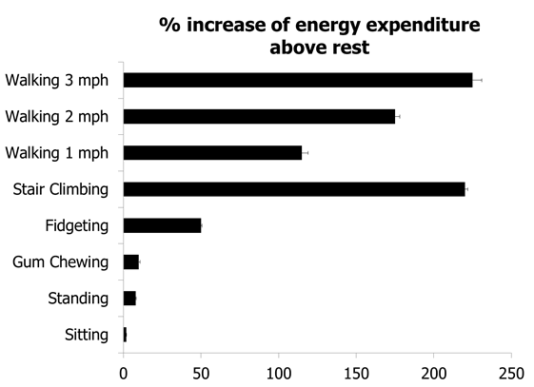

Figure 9: Energy expenditure above resting for a variety of activities (developed from 15).

In terms of appropriate activities it can be principally relatively easy to increase NEAT (see figure 9). Standing instead of sitting burns 3 times more kcal h⁻¹, gum chewing increases energy expenditure 4 times and stair climbing more than 40 times above resting levels (35). Particularly ambulation (i.e. “walking”) can considerably help to rise NEAT, as it can be easily performed at almost every place and at any time. But how can a goal like the proposed 2 ½h of additional daily ambulation/standing time realistically be integrated into daily routine? A key problem is that people’s occupations and personal lives regularly contribute to prohibit this degree of adaptation (35). Otherwise it was shown that occupation is the principal determinant of NEAT in adults and can represent an efficient means of promoting NEAT (35). Therefore, it should be examined how NEAT can be primarily integrated at the site of occupation. One important issue in this context addresses transportation to work. Similar to the NHANES data presented for the United States (31,32,33), recent results from the English and Welsh 2011 Census show that among the 23.7 million investigated adult commuters approximately 67% used private motorized transport as their usual main commute mode, while about 18% used public transport (85). By contrast, only 10.9% walked and 3.1% cycled (85). Thus, it seems that the majority of subjects rely on motorized transport. Promoting cycling or walking as a daily routine regarding i.e. transportation to work, but also with respect to covering daily distances could accordingly represent a promising and realistic way for a majority of subjects to increase individual NEAT levels.
When considering the presented hypothesis as a strategy for enhancing NEAT, potential limitations have to be addressed. At first, it is unknown whether intentionally increasing NEAT in a similar fashion to purposeful physical exercise is compensated for by increasing energy intake when reaching a pronounced negative net energy balance. Therefore, enhancing NEAT as a strategy for body mass control could be more effective for maintaining body weight rather than for inducing weight loss. Another aspect concerns the observation that skeletal muscle can increase fuel economy and work efficiency in response to loss of body mass and thus interfere with the targeted effects of NEAT on energy balance. Muscle fiber type distribution represents one determinant of fuel economy. However, in terms of obesity one study suggests that before and after a mean weight loss of 11kg, obese females did not develop changes in skeletal muscle fiber type distribution (86). Otherwise, concerning differences in work efficiency it was reported that under conditions of perturbed energy balance obese subjects oxidize proportionally more carbohydrates and less fat as compared to lean counterparts, and that differences in skeletal muscle metabolism and SNS activity underlie some of the observed differences between obese and non-obese subjects (reviewed in 14). Regular physical activity can increase work efficiency and thereby possibly reduce the energetic costs of NEAT (13). Whether, however, under free-living conditions this limits potential effects of NEAT on body mass is unknown. A review on NEAT (14) stated that it is unclear whether work efficiency varies with body composition, as no difference in weight-corrected work efficiency was shown in some trials (87,88,89,90), whereas other studies (91,92) found elevated work efficiency in obese subjects. Otherwise, it was recently shown in older women that moderate volumes of voluntary physical exercise over a 16 week time span improved body composition and increased NEAT, while large volumes of physical activity significantly decreased TEE, mainly by reducing NEAT (93). This study at first confirms data presented above, showing that inducing a marked negative net energy balance by means of large volume physical activity can reciprocally reduce NEAT and mitigate beneficial effects on body mass. Otherwise, physical activity at relatively low volumes comparably improved body composition while increasing NEAT at the same time (93). Furthermore, although not directly measured work efficiency was surly improved during the 4 month exercise period, as the participants had to be sedentary (i.e. untrained) to become included (93). Thus, the latter study might indicate that independent from potential adaptations in work efficiency moderate volumes of physical activity can have significant impact on body composition, which means i.e. loss of body fat.

Together, 2 ½h of additional ambulation and standing time per day are proposed as a realistic goal for inducing negative energy balance and consecutive weight loss. However, beneficial effects could be at least partially compensated for by increasing energy intake from food. Increasing NEAT as an adjunct to hypocaloric diets to prevent body mass regain, or for weight maintenance in general could overcome potential compensatory effects and hypothetically represent an alternative strategy for body mass control.

Conclusion
The epidemic of obesity has worldwide risen in past decades and relates to serious health concerns. Apart from poor diet, reduced physical activity and sedentary behavior contribute to the pathogenesis of obesity. Non-exercise Activity Thermogenesis is a highly variable component of daily total energy expenditure and essentially a function of a variety of environmental and individual factors. Whether caloric overfeeding systematically affects Non-exercise Activity Thermogenesis is a matter of debate, while a negative energy balance due to undernutrition and/or exercise can decrease it. As physical activity contributes to weight maintenance and prevention of body mass regain after hypocaloric dietary interventions, increasing Non-exercise Activity Thermogenesis could represent a promising tool for body mass control.

References
1. Finucane, M.M., et al., National, regional, and global trends in body-mass index since 1980: systematic analysis of health examination surveys and epidemiological studies with 960 country-years and 9.1 million participants. Lancet, 2011. 377(9765): p. 557-67.
2. Flegal, K.M., et al., Prevalence and trends in obesity among US adults, 1999-2008. JAMA, 2010. 303(3): p. 235-41.
3. Flegal, K.M., et al., Prevalence of obesity and trends in the distribution of body mass index among US adults, 1999-2010. JAMA, 2012. 307(5): p. 491-7.
4. Rodrigo, C.P., Current mapping of obesity. Nutricion Hospitalaria, 2013. 28: p. 21-31.
5. Prentice, A.M. and S.A. Jebb, Obesity in Britain - Gluttony or Sloth. British Medical Journal, 1995. 311(7002): p. 437-439.
6. Vita, A.J., et al., Aging, health risks, and cumulative disability. New England Journal of Medicine, 1998. 338(15): p. 1035-1041.
7. Heo, M., et al., Obesity and quality of life: Mediating effects of pain and comorbidities. Obesity Research, 2003. 11(2): p. 209-216.
8. Olshansky, S.J., et al., A potential decline in life expectancy in the United States in the 21st century. New England Journal of Medicine, 2005. 352(11): p. 1138-1145.
9. Popkin, B.M., A.M. SiegaRiz, and P.S. Haines, A comparison of dietary trends among racial and socioeconomic groups in the United States. New England Journal of Medicine, 1996. 335(10): p. 716-720.
10. Slining, M.M., K.C. Mathias, and B.M. Popkin, Trends in Food and Beverage Sources among US Children and Adolescents: 1989-2010. Journal of the Academy of Nutrition and Dietetics, 2013. 113(12): p. 1683-1694.
11. Johnston, R., J.M. Poti, and B.M. PoPkin, Eating and Aging: Trends in Dietary Intake among Older Americans from 1977-2010. Journal of Nutrition Health & Aging, 2014. 18(3): p. 234-242.
12. Psota, T. and K.Y. Chen, Measuring energy expenditure in clinical populations: rewards and challenges. Eur J Clin Nutr, 2013. 67(5): p. 436-42.
13. Levine, J.A., Non-exercise activity thermogenesis (NEAT). Nutr Rev, 2004. 62(7 Pt 2): p. S82-97.
14. Levine, J.A., Nonexercise activity thermogenesis (NEAT): environment and biology. Am J Physiol Endocrinol Metab, 2004. 286(5): p. E675-85.
15. Levine, J.A. and C.M. Kotz, NEAT--non-exercise activity thermogenesis--egocentric & geocentric environmental factors vs. biological regulation. Acta Physiol Scand, 2005. 184(4): p. 309-18.
16. Ravussin, E., et al., Twenty-four-hour energy expenditure and resting metabolic rate in obese, moderately obese, and control subjects. Am J Clin Nutr, 1982. 35(3): p. 566-73.
17. Ford, L.E., Some consequences of body size. Am J Physiol, 1984. 247(4 Pt 2): p. H495-507.
18. Ravussin, E., et al., Determinants of 24-hour energy expenditure in man. Methods and results using a respiratory chamber. J Clin Invest, 1986. 78(6): p. 1568-78.
19. Daan, S., et al., Intraspecific allometry of basal metabolic rate: relations with body size, temperature, composition, and circadian phase in the kestrel, Falco tinnunculus. J Biol Rhythms, 1989. 4(2): p. 267-83.
20. Donnelly, J.E., et al., Effects of a very-low-calorie diet and physical-training regimens on body composition and resting metabolic rate in obese females. Am J Clin Nutr, 1991. 54(1): p. 56-61.
21. Deriaz, O., et al., Lean-body-mass composition and resting energy expenditure before and after long-term overfeeding. Am J Clin Nutr, 1992. 56(5): p. 840-7.
22. Kreymann, G., M. Adolph, and M.J. Mueller, Energy expenditure and energy intake - Guidelines on Parenteral Nutrition, Chapter 3. Ger Med Sci, 2009. 7: p. Doc25.
23. Dulloo, A.G., J. Seydoux, and J. Jacquet, Adaptive thermogenesis and uncoupling proteins: a reappraisal of their roles in fat metabolism and energy balance. Physiol Behav, 2004. 83(4): p. 587-602.
24. Ravussin, E., et al., Reduced rate of energy expenditure as a risk factor for body-weight gain. N Engl J Med, 1988. 318(8): p. 467-72.
25. Saltzman, E. and S.B. Roberts, The role of energy expenditure in energy regulation: findings from a decade of research. Nutr Rev, 1995. 53(8): p. 209-20.
26. Roberts, S.B., et al., Energy expenditure and intake in infants born to lean and overweight mothers. N Engl J Med, 1988. 318(8): p. 461-6.
27. Weinsier, R.L., et al., Metabolic predictors of obesity. Contribution of resting energy expenditure, thermic effect of food, and fuel utilization to four-year weight gain of post-obese and never-obese women. J Clin Invest, 1995. 95(3): p. 980-5.
28. Weinsier, R.L., et al., Low resting and sleeping energy expenditure and fat use do not contribute to obesity in women. Obesity Research, 2003. 11(8): p. 937-44.
29. Novak, C.M. and J.A. Levine, Central neural and endocrine mechanisms of non-exercise activity thermogenesis and their potential impact on obesity. J Neuroendocrinol, 2007. 19(12): p. 923-40.
30. Kinabo, J.L. and J.V. Durnin, Thermic effect of food in man: effect of meal composition, and energy content. Br J Nutr, 1990. 64(1): p. 37-44.
31. Sisson, S.B., et al., Characteristics of Step-Defined Physical Activity Categories in US Adults. American Journal of Health Promotion, 2012. 26(3): p. 152-159.
32. Barreira, T.V., D.M. Harrington, and P.T. Katzmarzyk, Cardiovascular Health Metrics and Accelerometer-Measured Physical Activity Levels: National Health and Nutrition Examination Survey, 2003-2006. Mayo Clinic Proceedings, 2014. 89(1): p. 81-86.
33. Loprinzi, P.D., E. Smit, and S. Mahoney, Physical Activity and Dietary Behavior in US Adults and Their Combined Influence on Health. Mayo Clinic Proceedings, 2014. 89(2): p. 190-198.
34. Segal, K.R. and F.X. Pisunyer, Exercise and Obesity. Medical Clinics of North America, 1989. 73(1): p. 217-236.
35. Levine, J.A., Nonexercise activity thermogenesis - liberating the life-force. Journal of Internal Medicine, 2007. 262(3): p. 273-287.
36. Kotz, C., et al., Brain orexin promotes obesity resistance. Brain and Obesity, 2012. 1264: p. 72-86.
37. McManus, A.M., Physical activity - a neat solution to an impending crisis. Journal of Sports Science and Medicine, 2007. 6(3): p. 368-373.
38. Elia, M., R. Stratton, and J. Stubbs, Techniques for the study of energy balance in man. Proceedings of the Nutrition Society, 2003. 62(2): p. 529-537.
39. Levine, J., et al., Measurement of the components of nonexercise activity thermogenesis. American Journal of Physiology-Endocrinology and Metabolism, 2001. 281(4): p. E670-E675.
40. Levine, J.A., Measurement of energy expenditure. Public Health Nutrition, 2005. 8(7A): p. 1123-1132.
41. Diaz, E.O., et al., Metabolic Response to Experimental Overfeeding in Lean and Overweight Healthy-Volunteers. American Journal of Clinical Nutrition, 1992. 56(4): p. 641-655.
42. Levine, J.A., N.L. Eberhardt, and M.D. Jensen, Role of nonexercise activity thermogenesis in resistance to fat gain in humans. Science, 1999. 283(5399): p. 212-4.
43. Black, A.E., et al., Human energy expenditure in affluent societies: An analysis of 574 doubly-labelled water measurements. Eur J Clin Nutr, 1996. 50(2): p. 72-92.
44. Coward, W.A., Contributions of the doubly labeled water method to studies of energy balance in the Third World. American Journal of Clinical Nutrition, 1998. 68(4): p. 962s-969s.
45. Levine, J.A., et al., Sociology - The work burden of women. Science, 2001. 294(5543): p. 812-812.
46. Caspersen, C.J. and R.K. Merritt, Physical activity trends among 26 states, 1986-1990. Med Sci Sports Exerc, 1995. 27(5): p. 713-20.
47. Anonymous, Physical activity and health: a report of the Surgeon General, N.C.f.C.D.P.a.H.P. US Department of Health and Human Services, Editor 1996, DHHS: Atlanta, GA.
48. Pratt, M., C.A. Macera, and C. Blanton, Levels of physical activity and inactivity in children and adults in the United States: current evidence and research issues. Med Sci Sports Exerc, 1999. 31(11 Suppl): p. S526-33.
49. Livingstone, B., Epidemiology of childhood obesity in Europe. Eur J Pediatr, 2000. 159 Suppl 1: p. S14-34.
50. Westerterp, K.R., Daily physical activity and ageing. Curr Opin Clin Nutr Metab Care, 2000. 3(6): p. 485-8.
51. Harris, A.M., et al., Nonexercise movement in elderly compared with young people. Am J Physiol Endocrinol Metab, 2007. 292(4): p. E1207-12.
52. Drewnowski, A. and S.E. Specter, Poverty and obesity: the role of energy density and energy costs. Am J Clin Nutr, 2004. 79(1): p. 6-16.
53. Ludwig, J., et al., Neighborhoods, obesity, and diabetes--a randomized social experiment. N Engl J Med, 2011. 365(16): p. 1509-19.
54. Leibel, R.L., M. Rosenbaum, and J. Hirsch, Changes in energy expenditure resulting from altered body weight. N Engl J Med, 1995. 332(10): p. 621-8.
55. Vanltallie, T.B., Resistance to weight gain during overfeeding: a NEAT explanation. Nutr Rev, 2001. 59(2): p. 48-51.
56. Westerterp, K.R., Physical activity, food intake, and body weight regulation: insights from doubly labeled water studies. Nutr Rev, 2010. 68(3): p. 148-54.
57. He, J., et al., Measurement of ad libitum food intake, physical activity, and sedentary time in response to overfeeding. PLoS One, 2012. 7(5): p. e36225.
58. Schmidt, S.L., et al., The effects of overfeeding on spontaneous physical activity in obesity prone and obesity resistant humans. Obesity (Silver Spring), 2012. 20(11): p. 2186-93.
59. Apolzan, J.W., et al., Short-term overeating results in incomplete energy intake compensation regardless of energy density or macronutrient composition. Obesity (Silver Spring), 2014. 22(1): p. 119-30.
60. Siervo, M., et al., Efficiency of autoregulatory homeostatic responses to imposed caloric excess in lean men. Am J Physiol Endocrinol Metab, 2008. 294(2): p. E416-24.
61. Weyer, C., et al., Energy metabolism after 2 y of energy restriction: the biosphere 2 experiment. Am J Clin Nutr, 2000. 72(4): p. 946-53.
62. Bouchard, C., et al., The response to long-term overfeeding in identical twins. N Engl J Med, 1990. 322(21): p. 1477-82.
63. Hainer, V., et al., A twin study of weight loss and metabolic efficiency. Int J Obes Relat Metab Disord, 2001. 25(4): p. 533-7.
64. Zurlo, F., et al., Spontaneous physical activity and obesity: cross-sectional and longitudinal studies in Pima Indians. Am J Physiol, 1992. 263(2 Pt 1): p. E296-300.
65. McCarthy, M.I., Genomics, type 2 diabetes, and obesity. N Engl J Med, 2010. 363(24): p. 2339-50.
66. Teske, J.A., C.J. Billington, and C.M. Kotz, Neuropeptidergic mediators of spontaneous physical activity and non-exercise activity thermogenesis. Neuroendocrinology, 2008. 87(2): p. 71-90.
67. Trayhurn, P., C. Bing, and I.S. Wood, Adipose tissue and adipokines--energy regulation from the human perspective. J Nutr, 2006. 136(7 Suppl): p. 1935S-1939S.
68. Pelleymounter, M.A., et al., Effects of the obese gene product on body weight regulation in ob/ob mice. Science, 1995. 269(5223): p. 540-3.
69. Solinas, G., Molecular pathways linking metabolic inflammation and thermogenesis. Obes Rev, 2012. 13 Suppl 2: p. 69-82.
70. Dauncey, M.J. and D. Brown, Role of activity-induced thermogenesis in twenty-four hour energy expenditure of lean and genetically obese (ob/ob) mice. Q J Exp Physiol, 1987. 72(4): p. 549-59.
71. Franks, P.W., et al., Does physical activity energy expenditure explain the between-individual variation in plasma leptin concentrations after adjusting for differences in body composition? J Clin Endocrinol Metab, 2003. 88(7): p. 3258-63.
72. Virtanen, K.A., et al., Functional brown adipose tissue in healthy adults. N Engl J Med, 2009. 360(15): p. 1518-25.
73. Klingenspor, M., S. Herzig, and A. Pfeifer, Brown fat develops a brite future. Obes Facts, 2012. 5(6): p. 890-6.
74. Herzig, S. and C. Wolfrum, Brown and white fat: from signaling to disease. Biochim Biophys Acta, 2013. 1831(5): p. 895.
75. Wang, J., et al., Overfeeding rapidly induces leptin and insulin resistance. Diabetes, 2001. 50(12): p. 2786-91.
76. Levin, B.E. and A.A. Dunn-Meynell, Reduced central leptin sensitivity in rats with diet-induced obesity. Am J Physiol Regul Integr Comp Physiol, 2002. 283(4): p. R941-8.
77. Levine, J.A., et al., Effect of hyperthyroidism on spontaneous physical activity and energy expenditure in rats. J Appl Physiol (1985), 2003. 94(1): p. 165-70.
78. Lanningham-Foster, L., L.J. Nysse, and J.A. Levine, Labor saved, calories lost: the energetic impact of domestic labor-saving devices. Obesity Research, 2003. 11(10): p. 1178-81.
79. Schoeller, D.A., K. Shay, and R.F. Kushner, How much physical activity is needed to minimize weight gain in previously obese women? Am J Clin Nutr, 1997. 66(3): p. 551-6.
80. Weinsier, R.L., et al., Free-living activity energy expenditure in women successful and unsuccessful at maintaining a normal body weight. Am J Clin Nutr, 2002. 75(3): p. 499-504.
81. Johansson, K., M. Neovius, and E. Hemmingsson, Effects of anti-obesity drugs, diet, and exercise on weight-loss maintenance after a very-low-calorie diet or low-calorie diet: a systematic review and meta-analysis of randomized controlled trials. Am J Clin Nutr, 2014. 99(1): p. 14-23.
82. Wu, T., et al., Long-term effectiveness of diet-plus-exercise interventions vs. diet-only interventions for weight loss: a meta-analysis. Obes Rev, 2009. 10(3): p. 313-23.
83. Kempen, K.P., W.H. Saris, and K.R. Westerterp, Energy balance during an 8-wk energy-restricted diet with and without exercise in obese women. Am J Clin Nutr, 1995. 62(4): p. 722-9.
84. Van Etten, L.M., et al., Effect of an 18-wk weight-training program on energy expenditure and physical activity. J Appl Physiol (1985), 1997. 82(1): p. 298-304.
85. Goodman, A., Walking, cycling and driving to work in the English and Welsh 2011 census: trends, socio-economic patterning and relevance to travel behaviour in general. PLoS One, 2013. 8(8): p. e71790.
86. van Aggel-Leijssen, D.P., et al., Effect of exercise training at different intensities on fat metabolism of obese men. J Appl Physiol (1985), 2002. 92(3): p. 1300-9.
87. Bray, G.A., et al., Some respiratory and metabolic effects of exercise in moderately obese men. Metabolism, 1977. 26(4): p. 403-12.
88. Hanson, J.S., Exercise responses following production of experimental obesity. J Appl Physiol, 1973. 35(5): p. 587-91.
89. Poole, D.C. and L.C. Henson, Effect of acute caloric restriction on work efficiency. Am J Clin Nutr, 1988. 47(1): p. 15-8.
90. Whipp, B.J., G.A. Bray, and S.N. Koyal, Exercise energetics in normal man following acute weight gain. Am J Clin Nutr, 1973. 26(12): p. 1284-6.
91. Dempsey, J.A., et al., Work capacity determinants and physiologic cost of weight-supported work in obesity. J Appl Physiol, 1966. 21(6): p. 1815-20.
92. Maloiy, G.M., et al., Energetic cost of carrying loads: have African women discovered an economic way? Nature, 1986. 319(6055): p. 668-9.
93. Hunter, G.R., et al., Combined aerobic and strength training and energy expenditure in older women. Med Sci Sports Exerc, 2013. 45(7): p. 1386-93.

