**NON-INVASIVE TECHNIQUES IN PEDIATRIC DYSLIPIDEMIA**

**Damon B. Dixon, MD,** Division of Cardiology, Department of Pediatrics, Pediatric Cardiology, Phoenix Children’s Hospital-Heart Center, 1919 E. Thomas Rd, Phoenix, Arizona 85016. [ddixon1@phoenixchildrens.com](mailto:ddixon1@phoenixchildrens.com)

**Updated May 2, 2023**

**ABSTRACT**

Symptomatic and overt atherosclerosis in children is rare. The earliest lesion of atherosclerosis develops in childhood, but may not correlate with traditional markers of atherosclerosis. Children are considered low risk populations for atherosclerosis. The use of non-invasive imaging can have a role to identify early subclinical vascular changes. Imaging techniques are becoming useful adjuncts in conjunction with traditional lipid markers. These techniques have been extensively used in children and have provided indirect evidence for premature atherosclerosis, risk stratification, treatment effectiveness, and longitudinal tracking of adult cardiovascular risk. Use of imaging may be a useful adjunct in combination with traditional cardiovascular risk factors to assess dyslipidemia in children.

**INTRODUCTION**

Medical imaging is an important modality used to create visual representation of the body for clinical analysis and interventions. The use of imaging in children can play an important role identifying subclinical disease of dyslipidemia. Identification can be clinically useful for risk stratification and treatment intervention. The use of imaging in children was previously reserved for research but with improved methodologies have been shown to be a prospective clinical tool for children with dyslipidemia. The combination of imaging and traditional risk assessment has improved our knowledge of the natural history of atherosclerosis in children and adolescents.

Symptomatic atherosclerosis rarely occurs in children with the exception of children with homozygous familial hypercholesterolemia. Vascular progression in children with atherosclerosis is usually minor and clinically asymptomatic. Longitudinal studies have demonstrated that the atherosclerosis process can be accelerated in individuals with multiple risk factors or high-risk conditions. Early identification would allow for early intervention to delay the natural process of atherosclerosis.

Multiple non-invasive imaging modalities have been used in children for the assessment of subclinical vascular changes, such as vessel endothelium thickening (cIMT), mechanical changes (pulse wave velocity), physiological changes (flow-mediated dilation), and arterial structure changes (CT and MRI). Non-invasive techniques do not require radiation exposure and is preferred over imaging techniques that utilize radiation.

|  |  |  |  |  |
| --- | --- | --- | --- | --- |
| **Table 1.** **Imaging Modalities to Assess for Subclinical Atherosclerosis** | | | | |
| **Technique** | **Abbreviation** | **Principle** | **Invasive** | **Radiation** |
| Carotid intimal & medial thickness | cIMT | Arterial wall thickness | No | No |
| Pulse-waved velocity  Pulse-wave analysis | PWV  PWA | Stiffness in arteries | No | No |
| Flow mediated dilation | FMD | Endothelial function | No | No |
| Echocardiogram | ECHO | Anatomical changes | No | No |
| Ultrasound | U/S | Velocity, Size | No | No |
| Coronary artery calcification | CAC | Plaque composition | No | Yes |
| Computed Tomography | CT | Stenosis, composition | No | Yes |
| Magnetic Resonance Imaging | MRI | Stenosis, composition | No | No |
| Coronary Angiography | CA | Stenosis | Yes | Yes |

The use of non-invasive methods has improved our knowledge and ability to risk stratify children and track longitudinal vascular changes into adulthood. It has been established that children that enter adulthood with multiple risk factors will have premature progression of atherosclerosis as a young adults and adults. The i3C meta-analysis demonstrated the number of abnormal childhood CV risk factors was predictive of elevated adult cIMT measurements.

**SUBCLINICAL ATHEROSCLEROSIS IN CHILDREN**

Autopsy studies have demonstrated that atherosclerosis substrate begins in childhood (1). The initial process is microscopic lesions and transitions to macroscopic changes particularly in places that are prone to the development of atherosclerosis. Areas are predisposed to atherosclerosis include arterial bifurcation sites in the common carotid, coronaries, and abdominal aorta. The accumulation of lipid substrate is deposited in the intima of arteries and forms the fatty streak. These early lesions are generally non-occlusive lesions. The Bogalusa heart study demonstrated the prevalence of fatty streak in coronary arteries in children 2-15 years of age with 50% of surface vessel involvement (2). The degree of progression increased with greater number of risk factors in the Pathological Determinants of Atherosclerosis in Youth (PDAY) study (3).

Subclinical atherosclerotic changes in children can manifest as dysfunctional arterial vasodilation, alterations of arterial elasticity (compliance and distensibility), and thickening of arterial walls.

The arterial wall consists of three layers (figure 1). The *tunica externa* or *tunica adventitia* (outermost layer) is composed of connective tissue and collagen. The *tunica media* (middle layer) is made up of smooth muscle cells and elastic tissues. The pediatric arterial vessel is composed of more elastin than collagen. The *tunica intima* (innermost layer) consists of endothelial cells. The endothelium is a single cell layer lining the vascular lumen and has an important role in maintaining vascular integrity.

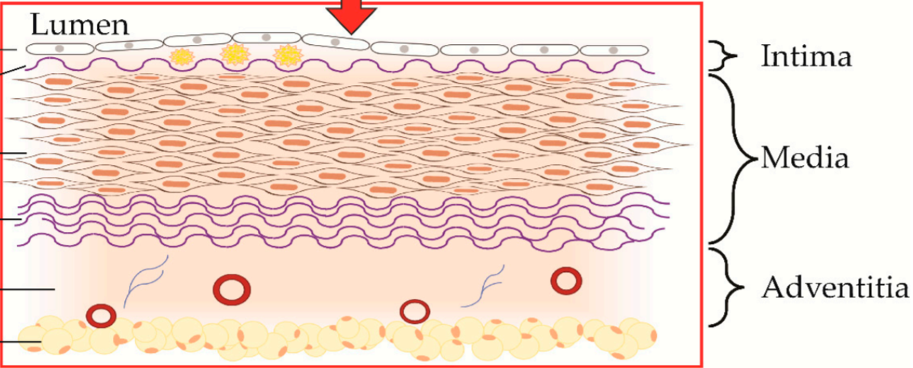

**Figure 1.** **Components of the endothelial arterial wall. (Reprinted): Reference 38.**

Atherosclerosis is characterized by the formation of lipid substrates, calcium, and other substances in the arterial wall that results in arterial wall thickening and progression to arterial plaques (figure 2). The pathological substrate for vascular dysfunction is mediated by endothelial dysfunction. Endothelial changes are a complex mechanism, but is composed of oxidative stress, loss of vasoactive substrates, inflammatory substances, and prothrombotic state. This cluster of harmful stimuli accelerates and compounds the mechanism of endothelial dysfunction. This process is the underlying mechanism of clinical myocardial infarctions and stroke.

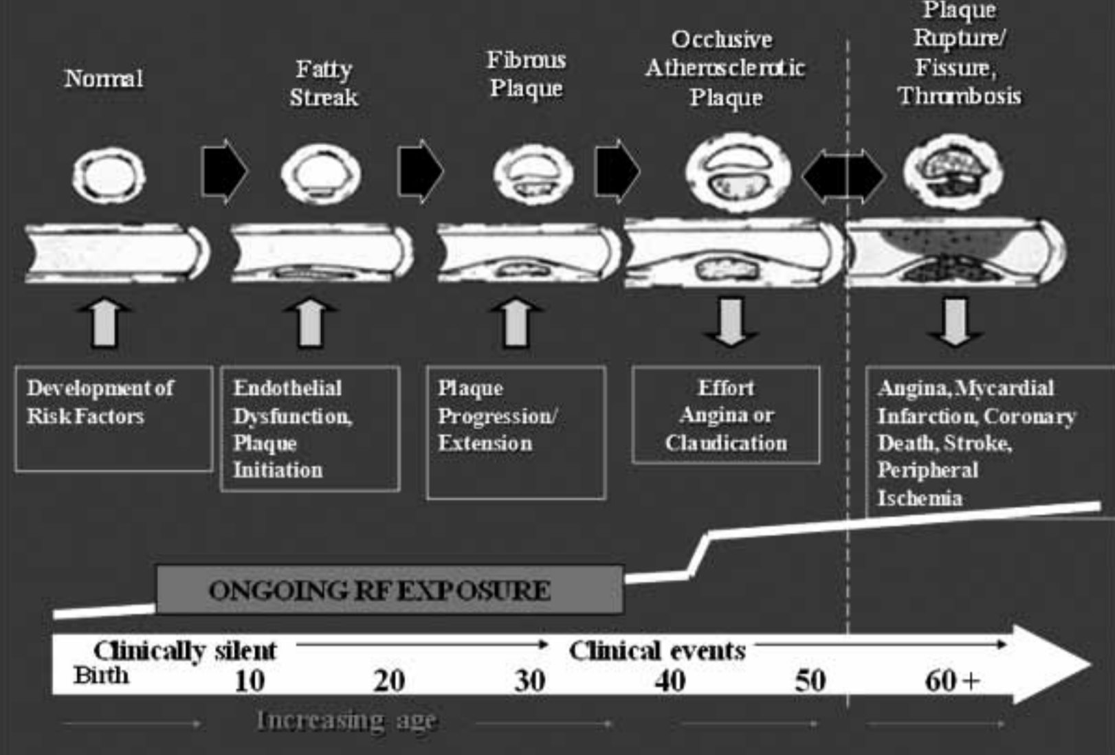

**Figure 2.** **Arterial progression model of atherosclerosis. Earliest substrate manifest as “fatty streak” in children. Further progression is accelerated by additional cardiac risk factors.**

The substrate of atherosclerosis develops in childhood as the fatty streak. Development of the fatty streak can be evident by 3 years of age. Premature progression can be accelerated by additional risk factors.

Our understanding of the atherosclerotic natural process in children is based on imaging studies in individuals with autosomal dominant Familial Hypercholesterolemia (FH). Familial hypercholesterolemia is a disease of increased LDL cholesterol plasma concentrations that accumulates in the arterial vessel wall. This process has been accelerated in children with homozygous FH. Children with homozygous FH manifest as early endothelial dysfunction and have been observed to have increased carotid intimal-media thickness. Carotid intimal thickness has been used as a surrogate end-point marker with statin intervention in children with FH.

**RISK FACTORS FOR PREMATURE ATHEROSCLEROSIS**

The prevalence of obesity in children has stabilized over the recent years. However, the rate of morbid obesity continues to increase (4). Obesity is associated with an increased metabolic demand. Arterial stiffness is impacted by increased blood volume (preload) and alterations of afterload. Previous studies have demonstrated a linear relationship between obesity in childhood and increased cIMT in young adults (5). Indirect measure of subclinical atherosclerosis measured by cIMT and FMD have been observed in obese adolescents and young adults (6). Individuals with the largest increase in BMI during childhood and adolescents that remained obese had greatest changes in cIMT (7).

Chronic elevated blood pressure has an important role in vascular changes. Elevated blood pressure is a complex relationship that is affected by several factors including the sympathetic nervous system, renin-angiotensin-aldosterone system, and stimulation of vascular smooth muscle proliferation. Children with hypertension have evidence of left ventricular hypertrophy (LVH), increased LV mass, carotid intima-medial thickening (CIMT), and vascular endothelial dysfunction. Increased LV mass is a prominent imaging marker for clinical evidence of target-organ damage (8). A left ventricular mass index above 51 g/m2.7 has been associated with a greater risk of adverse cardiovascular outcome (9).

The combination of insulin resistance and hyperglycemia are linked with endothelial dysfunction and mediators of inflammation. Children with diabetes compared with those without diabetes are at increased risk for other atherogenic factors, such as hypertension and dyslipidemia. Mixed dyslipidemia pattern is characterized by high Apo-B (increased small dense LDL particles and cholesterol ester rich VLDL remnants) and low Apo-A (low HDL particles) (11). The TG/HDL-c ratio is a surrogate atherogenic index of mixed dyslipidemia. TG/HDL-c ratio was shown to be an independent determinant of arterial stiffness in obese adolescents using brachial artery distensibility (BrachD) and carotid-femoral pulse wave velocity (PWV)(10).

Metabolic syndrome (MS) has been established as a cluster of CV risk factors including hypertension, overweight/obesity, dyslipidemia (high triglycerides, low HDL), and insulin resistance. However, the relationship between childhood metabolic syndrome and CVD events are not well characterized and there has been no consensus in the pediatric population (11). The components of MS are considered independent risk factors associated with vascular dysfunction (12).

**NON-INVASIVE IMAGING TECHNIQUES**

**Carotid Intima-Media Thickness (CIMT)**

The use of cIMT technique is a useful surrogate technique to assess vessel intimal thickness in children with dyslipidemia. Subclinical changes in children are manifested as diffuse thickening of the intima-media space rather than a discrete lipid core or an advance lipid lesion.

The imaging method utilizes high resolution B-mode 2-dimensional (2D) ultrasonography with a high-frequency (7 to 12-MHz) linear array transducer for assessment of carotid intimal and medial vessel. Imaging measurements are traditionally conducted on the common carotid artery at the far-wall of the vessel. Changes to the intimal-medial thickness in the far-wall have correlated with direct histological examination. Most pediatric studies have focused on assessment of the carotid artery far wall. The distance between the leading edge of the first echo-bright line (lumen-intima interface) and the leading edge of the second echo-bright line (media-adventitia interface) is defined as the carotid intimal-media interface (figure 3) (13). An abnormal cIMT is a thickened sub-intimal layer due to atherogenic particle deposition and inflammatory process.

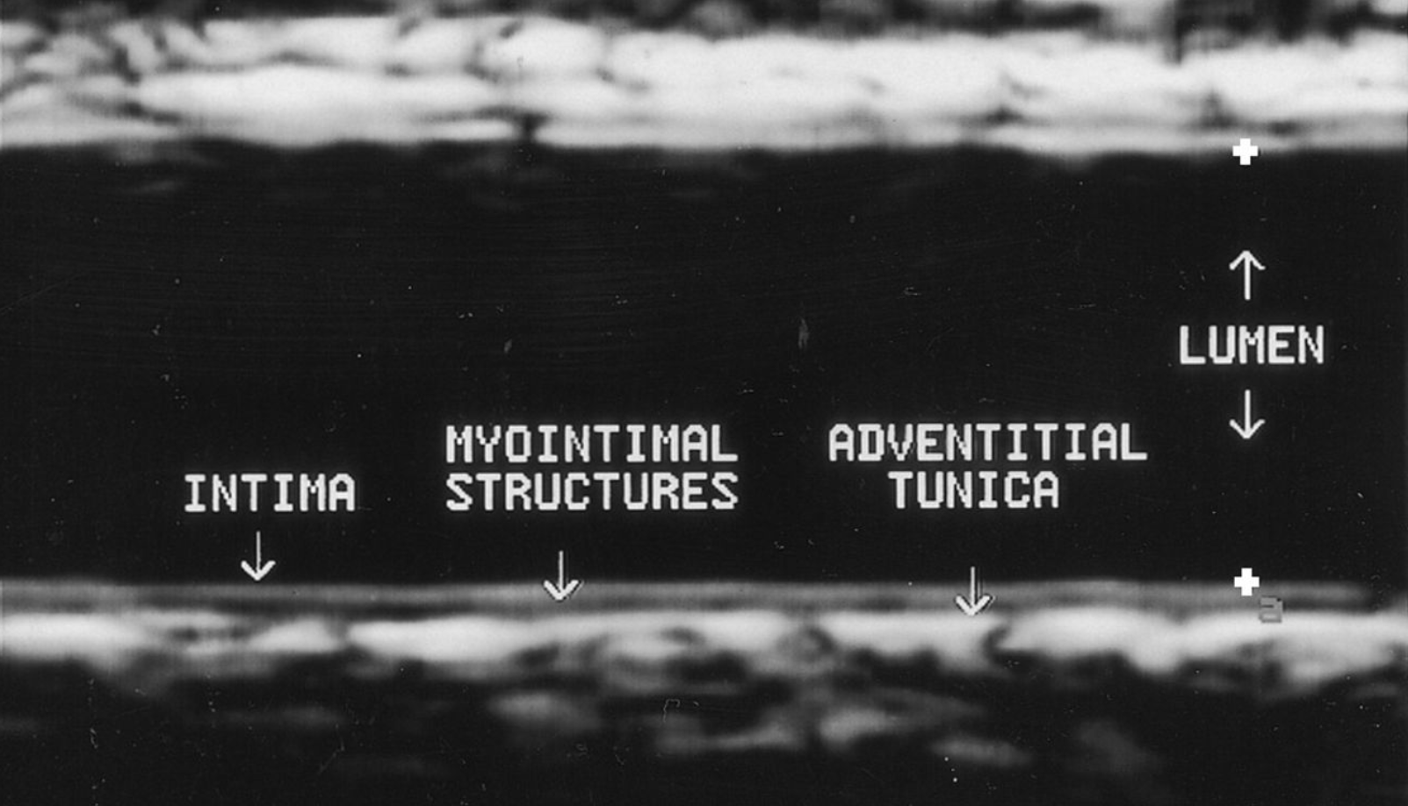

**Figure 3.** **Carotid endothelial structures by B-mode ultrasound.**

Imaging acquisition is obtained with 2D grayscale imaging along the longitudinal axis of the artery. Measurement values should be recorded at end diastole and calculated by mean IMT measurement. Reproducibility of the fall-wall in the carotid artery has been validated and reproducible in previous pediatric studies.

Several studies have demonstrated indirect evidence for early development of atherosclerosis in children. Increased cIMT has been demonstrated in pediatric patients with familial hypercholesterolemia (FH), hypertension, obesity, diabetes, and metabolic syndrome (14,15,16,17,18). The use of cIMT has been used to evaluate cardiovascular risk in pediatric populations with high-risk conditions and chronic medical conditions, such as juvenile rheumatoid arthritis, end-stage renal disease, and Kawasaki disease (19,20,21).

The use of cIMT has been utilized to show treatment effectiveness of statins in children with familial hypercholesterolemia. In a study of 214 children with heterozygous FH who were 8-18 years of age, were randomly assigned to the pravastatin treated group and compared with the placebo group. After 2 years of treatment with a statin, cIMT showed significant regression in the pravastatin group. Longitudinal follow-up of 186 children with early initiation of statin in children with FH after 4.5 years delayed the progression of cIMT changes. Data indicated that early treatment with a statin delayed the progression of atherosclerosis in adolescents and young adults (22). The CHARON study assessed the effect of 2-year treatment with rosuvastatin on cIMT in children with HeFH. The result of the study showed a significant reduction in the progression of atherosclerosis, as assessed by cIMT in children with HeFH compared with untreated, unaffected siblings (23).

Numerous longitudinal studies have demonstrated the association between CV risk factors developed in childhood and premature atherosclerotic changes into adulthood. In the Bogalusa study, childhood measurements of LDL-C levels and BMI positively predicted increased cIMT in a cohort of 486 adults aged 25-37 years (24). The Muscatine study demonstrated childhood total cholesterol levels and BMI predicted cIMT changes in a cohort of 725 adults (25). In a meta-analysis of i3C study (International Childhood Cardiovascular Cohort Consortium), a combined analysis of prospective studies showed the number of abnormal childhood CV risk factors (i.e., cholesterol, triglycerides, blood pressure, BMI) were longitudinally predictive of adult cIMT. This process was the greatest in children with risk factors developed at 9 years of age or greater (26).

**Arterial Stiffness**

There are several indices of arterial stiffness measurements. Functional measurement such as pulse wave velocity (PWV), pulse wave analysis (PWA), ambulatory arterial stiffness index (24-hour ambulatory blood pressure monitoring), and assessment of endothelial dysfunction (flow-mediated dilation).

Stiffer arterial vessels require greater force to expand and accommodate flow to perfuse tissues and organs. Arterial distensibility and compliance changes are a complex mechanism of hemodynamic factors, extrinsic factors and intraluminal influences.

Pulse wave velocity measures the speed of the pressure pulse from the heart as it circulates through the blood vessels. Measurement of the pulse wave (indicator of blood flow) to travel a given distance between 2 sites (carotid to femoral) in the arterial system is measured and recorded (figure 4**)**. A faster PWV is an indicatory of stiffer arterial vessel. PWA is an indirect measure of arterial stiffness that analyzes arterial waveform reflections. PWA is a supplement to PWV analysis. Augmentation index is a parameter derived from systolic peak differences. Risk factors associated with higher PWV include BMI, blood pressure, heart rate, dyslipidemia (27).

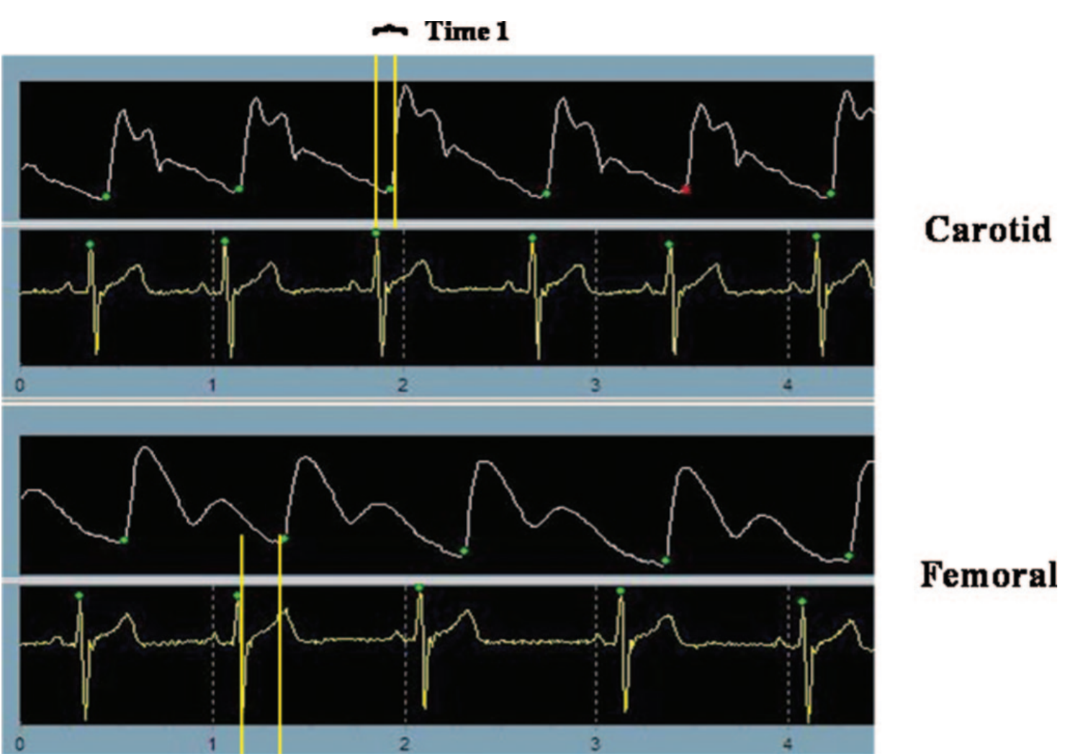

**Figure 4.** **Tonometric pulse wave velocity. The arterial time difference between two sites is calculated as the PWV.**

Arterial stiffness is associated with traditional CV risk factors and metabolic alterations including obesity, impaired glucose tolerance, and dyslipidemia. Risk stratification using triglyceride to high-density lipoprotein cholesterol ratio (TG/HDL-C) was tested as an independent predictor of arterial stiffness in obese children. The cohort of 893 subjects aged 10 to 26 years old that demonstrated higher TG/HDL-C ratio had the stiffest vessels measured by brachial artery distensibility (BrachD), augmentation index, and carotid-femoral pulse-wave velocity (28). In young individuals with T1DM with poor glycemic control, higher levels of traditional CV risk factors were independently associated with accelerated arterial aging using PWV and augmentation index (29).

Flow-mediated dilation (FMD) is a technique used to assess peripheral macrovascular endothelial function. Endothelial dysfunction is characterized by a complex imbalance of proatherogenic factors such as vasoconstriction, platelet alterations, cellular dysfunction, and inflammation. Endothelial changes are an early reversible stage in the progression of atherosclerosis.

The technique measures the nitric oxide-mediated vasodilation produced by increased blood flow after a period of ischemia (Reactive hyperemia). The method requires inflating upper extremity blood pressure at suprasystolic pressures for a short period of time that occludes blood flow. After a period of time, the occlusion is released and functional increased shear stress is generated as signal amplitude. Both diameter and blood velocity are assessed before and after occlusion with results being reported as a percent change from baseline. A lower index measurement indicated poor endothelial function. A lower artery reactivity has been identified in children with obesity, family history of premature coronary disease and type I DM (30, 31, 32). A study of 50 children (aged 9 to 18 years) with FH were randomized to simvastatin or placebo for 28 weeks. A control group of 19 non-FH children were matched. Baseline FMD was impaired in the children with FH compared to non-FH group. After treatment there was a significant improvement of endothelial dysfunction towards normal values after short term statin therapy (33).

**Echocardiography**

Traditionally transthoracic echocardiography is an image modality that utilizes an ultrasound beam to acquire anatomical images through m-mode imaging and 2D imaging. The use of echocardiogram can be useful to assess subclinical changes of epicardial fat mass, valvular changes, and aortic vessel stenosis.

Subclinical adipose changes to epicardial thickness may have a role in the development of cardiovascular disease. Studies in children with greater epicardial adipose tissue is associated with larger left ventricular mass, higher blood pressures, and atherogenic lipid profiles (34) Epicardial fat thickness can be visualized using standard parasternal long-axis and short-axis imaging planes of the right ventricle (figure 5). The epicardial fat is the echo-free space between the outer wall of the myocardium and visceral layer of the pericardium. The thickness is measured perpendicularly on the free wall of the right ventricle at end-systole. Echocardiographic measurement might serve as a simple tool for the assessment of cardio-metabolic risk stratification (35).

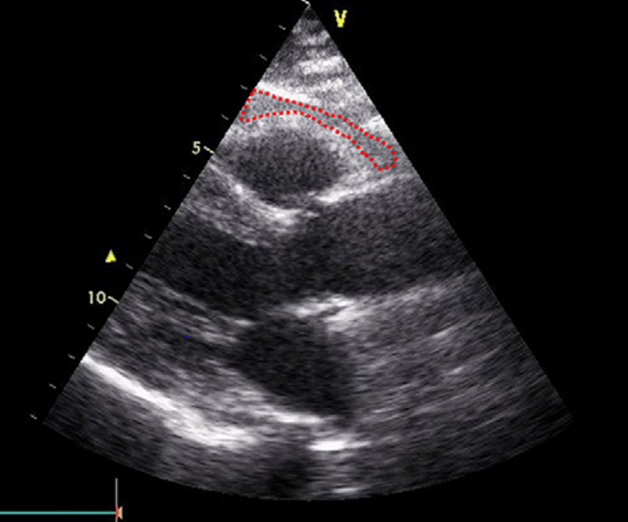

**Figure 5. Epicardial fat thickness by 2D echocardiogram in modified parasternal view.**

**(Dashed lines represent epicardial fat structure).**

A cohort of 33 young patients with homozygous FH were found to have subclinical FH valvulopathy present in 64% of patients (36). Most commonly on the aortic valve and mitral valve. The majority of the patients with valvular changes did not have valvular calcification. Isolated case studies in homozygous FH individuals have presented with heart failure and new systolic murmurs. Echocardiogram is useful in demonstrating supravalvular aortic stenosis due to endothelial dysfunction. Some cases required surgical aortic root replacement (37). Stenosis occurred despite patients receiving aggressive statin treatment and apheresis.

**Advance Imaging Modalities**

Advance imaging modalities such as cardiac magnetic resonance imaging (C-MRI) and computed tomography (CT) imaging are useful methods in understanding anatomical changes and tissue characterization. Clinical decision to utilize CT or MRI in pediatrics is debated on the risk of radiation exposure (CT imaging) and the imaging resolution limitations of each modality. The use of CT or MRI is generally not a useful tool to assess subclinical changes in the pediatric population with dyslipidemia. MRI has demonstrated abdominal aorta atheroma formation in adolescents with severe dyslipidemia (38). The use of MRI is being considered as potential research technique for assessment of subclinical abdominal aortic wall changes.

Coronary artery calcification with electron-beam computed tomography (CT) is used to assess the presence and extent of calcified plaque in the coronary arteries that is associated with atherosclerosis. The coronary artery calcium (CAC) score is a helpful prognostic tool and used as a method to assess risk classification for adult atherosclerosis cardiovascular disease (ASCVD). The use of CAD is not recommended as a subclinical technique since the development of calcification generally does not occur until the fourth decades of life. CAC has been utilized in a study of children with familial hypercholesterolemia (39). The use of CAC technique has been limited in pediatrics.

Myocardial perfusion imaging is reserved for adults with advanced cardiovascular risk and disease. The use of perfusion imaging in children is not recommended. Myocardial perfusion is helpful in children with Kawasaki (40) and congenital heart defects with coronary artery manipulation.

Invasive coronary angiography is the “gold standard” and direct assessment of coronary arterial stenosis. Utilization of angiography should be reserved to children with presumed advance atherosclerosis, such as homozygous FH or rare genetic dyslipidemia. Angiography technique is not a useful modality for subclinical evaluation in children.

**Ultrasound Imaging**

The use of sound waves is a useful non-invasive imaging modality in the evaluation of pediatric subclinical atherosclerosis. Ultrasound can contribute to early detection of renal artery changes and risk stratification attributed to atherosclerosis. Early atherosclerosis stress and inflammation affect the proximal renal arteries causing increased velocity shear stress and longitudinal narrowing. Long term pathological changes develop into atherosclerotic renal artery stenosis (ARAS) in the adult population. Arterial vascular changes are characterized by increased systolic blood pressure an indicator of preclinical atherosclerosis in children.

Renal size (length) is a marker of kidney mass and renal function. Carotid-IMT has been shown to be a surrogate maker for renal function. Ultrasound parameters in 515 prepubertal children (lean, overweight, obese) demonstrated renal size and associated carotid-IMT and systolic BP may play a role in the assessment of renal vascular function and early assessment of cardiovascular risk in children (41).

**SUMMARY**

Utilizing imaging techniques in children with dyslipidemia has been extensively used and a valuable tool in our understanding of atherosclerosis process in children. Imaging has been shown to be safe, reliable, and reproducible. With further developments and research, imaging may provide a useful practical tool in the general evaluation of children with dyslipidemia. In combination with family history, traditional CV risk factors, and biochemical markers the use of imaging techniques will refine our clinical awareness for better cardiovascular health metrics and promotion of ideal cardiovascular health in children.

**REFERENCES**

1. McGill HC Jr, McMahan CA, Zieske AW, Sloop GD, Walcott JV, Troxclair DA, Malcom GT, Tracy RE, Oalmann MC, Strong JP. Associations of coronary heart disease risk factors with the intermediate lesion of atherosclerosis in youth. The Pathobiological Determinants of Atherosclerosis in Youth (PDAY) Research Group. Arterioscler Thromb Vasc Bio. 2000;20(8):1998.
2. Li S, Chen W, Srinivasan SR, Bond MG, Tang R, Urbina EM, Berenson GS. Childhood cardiovascular risk factors and carotid changes in adulthood: the Bogalusa Heart Study. JAMA, 2003;290 (17):2271.
3. McGill HC Jr, McMahan CA. Determinants of atherosclerosis in the young. Pathobiological Determinants of Atherosclerosis in Youth (PDAY) Research Group. Am J Cardiol. 1998;82(10B):30T.
4. Kelly AS, Barlow SE, Rao G, et al. Severe obesity in children and adolescents: Identification, associated health risks, and treatment approaches: A scientific statement from the American Heart Association. Circulation. 2013:128: 00-00.
5. Davis, PH, Dawson JD, Riley WA, Lauer RM. Carotid intimal-medial thickness is related to cardiovascular risk factors measured from childhood through middle age: The Muscatine Study. Circulation. 2001;104(23):2815.
6. Ryder JR, Dengel DR, Jacobs DR Jr, Sinaiko AR, Kelly AS, Steinberger J. Relations among adiposity and insulin resistance with flow-mediated dilation, carotid intima-media thickness and arterial stiffness in children. J Pediatr. 2016 Jan;168-:205-11.
7. Dawson JD, Sonka M, Blecha MB, Lin W, Davis PH. Risk factors associated with aortic and carotid intima-media thickness in adolescents and young adults: the Muscatine Offspring Study. J AM Coll Cardiol. 2009;53(24):2273.
8. Armstrong AC, Gidding S, Gjesdal O, Wu C, Bluemke DA, Lima JA. LV mass assessed by echocardiography and CMR, cardiovascular outcomes and medical practice. JACC Cardiovasc Imaging. 2012:5(8);837-848
9. Lang RM, Bandano LP, Mor-Avi V, et al. Recommendations for cardiac chamber quantification by echocardiography in adults: an update from the American Society of Echocardiography and the European Association of Cardiovascular Imaging. J AM Soc Echocardiogr. 2015;28(1):1-39.e14
10. Urbina EM, Khoury PR, McCoy CE, Dollan LM, Daniels S, Kimball TR. Triglyceride to HDL-C ratio and increased arterial stiffness in children, adolescents, and young adults. Pediatrics. 2013:121(4): 1-7.
11. Steinberger J, Daniels SR, Eckel RH, Hayman L, Lustig RH, McCrindle B, Mietus-Synder ML. Progress and Challenges in metabolic syndrome in children and adolescents: a scientific statement from the American Heart Association Atherosclerosis, Hypertension and Obesity in the Young Committee of the Council on Cardiovascular Disease in the Young; Council on Cardiovascular Nursing; and Council on Nutrition, Physical Activity and Metabolism. Circulation. 2009;119(4):628.
12. Morrison JA, Friedman LA, Gray-McGuire C. Metabolic syndrome in children predicts adult cardiovascular disease 25 years later: the Princeton Lipid Research Clinics follow-up Study. Pediatrics. 2007;120(2):340.
13. Stein JH, Korcarz CE, Hurst RT. Use of carotid ultrasound to identify subclinical vascular disease and evaluate cardiovascular disease risk: a consensus statement from the American Society of Echocardiography Carotid Intima-Media Thickness Task Force. Endorsed by the Society for Vascular. Journal of the American Society of Echocardiography. 2008:21(2): 93-111.
14. Kusters DM, Weigman A, Kastelein JP, Hutten BA. Carotid intima-media thickness in children with familial hypercholesterolemia. Circulation Research. 2014;114:307-310.
15. Lande MB, Carson NL, Roy J, Meagher C. Effects of childhood primary hypertension on carotid intima media thickness. Hypertension. 2006;48:40-44.
16. Weberru H, Pirzer R, Bohm B, Pozza RD, Netz H, Oberhoffer R. Intima-media thickness and arterial function in obse and non-obese children. BMC Obesity. 2016;2.
17. Rad MP, Farrokh D, Vakili R, Omidbakhsh M, Mohammadi M. The association between carotid intima-media thickness and the duration of Type 1 diabetes in children. Iran J Pediatri. 2014;24(3):249-254.
18. Gooty V, Sinaiko A, Ryder J, Dengel D, Jacobs D, Steinberger J. Association between carotid intima media thickness, age, and cardiovascular risk factors in children and adolescents. Metab Syndr Relat Disorder. 2018;16(3):122-126.
19. Borh AH, Fuhlbrigge R. Pedersen FK, Ferranti SD, Muller K. Premature subclinical atherosclerosis in children and young adults with juvenile idiopathic arthritis. A review considering preventive measures. Pediatric Rheumatology. 2016;14;3.
20. Val ML et al. Cardiovascular risk in children and adolescents with end stage renal disease. Clinics. 2019:74:e859.
21. Meena RS, Rohit M, Gupta A, Singh S. Carotid intima-media thickness in children with Kawasaki disease. Rheumatol Int. 2014;34(8):1117-21
22. Rodenburg J, Vissers MN, Wiegman A, Trotsenburg AS, Van der Graff A, De Groot E, Wijburg FA, Kastelein JP, Hutten B. Statin treatment in children with familial hypercholesterolemia. Circulation. 2007;116:664-668.
23. Braamskamp M, et al. Effect of rosuvastatin on carotid intima-media thickness in children with heterozygous familial hypercholesterolemia: the CHARON study (Hypercholesterolemia in children and adolescents taking rosuvastatin open label). Circulation. 2017;136(4):359-366.
24. Li S, Chen W, Srinivasan SR, Bond MG, Tang R, Urbina EM, Berenson GS. Childhood cardiovascular risk factors and carotid vascular changes in adulthood: the Bogalusa Heart Study. JAMA. 2003;290(17)2271.
25. Davis PH, Dawson JD, Riely WA, Lauer RM. Carotid intimal-medial thickness is related to cardiovascular risk factors measured from childhood through middle age: the Muscatine study. Circulation. 2001(23):2815.
26. Juonala M, Magnussen CG, Venn A, Dwyer T, Burns TL, Davis PH, Chen W, Srinivasan SR, Daniels SR, Kahonen M, Laitinen T, Taittonen L, Berenson GS, Viikari JS, Raitakari OT. Influence of age on associations between childhood risk factors and carotid intima-media thickness in adulthood:the cardiovascular risk in the young finns study, the childhood determinants of adult health study, the Bogalusa heart study, and the muscatine study for the international childhood cardiovascular cohort (i3C) consortium. Circulation. 2010;122(24):2514.
27. Urbina EM, et al. Noninvasive assessment of subclinical atherosclerosis in children and adolescents: recommendations for standard assessment for clinical research: a scientific statement from the American heart association. Hypertension. 2009;54:919-950.
28. Urbina EM, Khoury PR, McCoy CE, Dollan LM, Daniels S, Kimball TR. Triglyceride to HDL-C ratio and increased arterial stiffness in children, adolescents, and young adults. Pediatrics. 2013;121(4):1-7.
29. Urbina EM, et al. Burden of cardiovascular risk factors over time and arterial stiffness in youth with type 1 diabetes mellitus: the SEARCH for diabetes in youth study. J Am Heart Assoc. 2019;8
30. Bruyndonckx L, Hoymans V, Craenenbroeck A, Vissers, D, Vrints C, Ramet J, Conraads V. Asessment of endothelial dysfunction in childhood obesity and clinical use. Oxid Med Cell Longev. 2013.
31. Clarkson P, Celermajer DS, Powe AJ, Donald AE, Henry AE, Deanfield JE. Endothelium-dependent dilatation is impaired in young healthy subjects with a family history of premature coronary disease. Circulation. 1997:96:3378-3383.
32. Nascimento AM, Sequeira IJ, Vasconcelos DF, Gandolfi L, Pratesi R, Nobrega YK. Endothelial dysfunction in children with type 1 diabetes mellitus. Arch Endocrinol Metab. 2017:61:2359-4295.
33. Jongh SD, Lilien MR, Roodt JO, Stroes ES, Dakker HD, Kastelein JJ. Early statin therapy restores endothelial function in children with familial hypercholesterolemia. JACC. 2002;(40):2117-21.
34. Manco M, Morandi A, Marigliano M, Rigotti F, Manfredi R, Maffeis C. Epicardial fat, abdominal adiposity and insulin resistance in obese pre-pubertal and early pubertal children. Atherosclerosis. 2013:226: 490-495.
35. Lacobellis G, Willens H. Echocardiographic Epicardial Fat: A review of research and clinical applications. State of the art review article. J Am Soc Echocardiogr. 2009:22: 1311-9.
36. Fahed AC, Shibbani K, Andary RR, Arabi MT, Habib RH, Nguyen DD, Haddad FF, Moubarak E, Nemer G, Azar S, Bitar FF. Premature valvular heart disease in homozygous familial hypercholesterolemia. Cholesterol. 2017.
37. Prajapati R, Agrawal V. Familial hypercholesterolemia supravalvular aortic stenosis and extensive atherosclerosis. Indian Heart J. 2018;(70):575-577.
38. Skilton MR, Celermajer DS, Cosmi E, Crispi F, Gidding SS, Raitakari OT, Urbina EM. Natural history of atherosclerosis and abdominal aortic intima-media thickness: rationale, evidence, and best practice for detection of atherosclerosis in the young. J Clin Med. 2019;(8):1201.
39. Gidding SS, Bookstein LC, Chomka EV. Usefulness of electron beam tomography in adolescents and young adults with heterozygous familial hypercholesterolemia. Circulation. 1998;(98):2580-2583.
40. Kashyap R, Mittal BR, Bhattachary A, Manojkumar R, Singh S. Exercise myocardial perfusion imaging to evaluate inducible ischemia in children with Kawasaki disease. Nucl Med Commun. 2011;(2):137-42.
41. Lizarraga-Mollinedo E, Martinez-Calcerrada JM,Padros-Fornieles C, Riera-Perez E, Prats-Puig A,de Zegher F, Ibanez L, Bassols J, Lopez-Bermejo A. Renal size and cardiovascular risk in prepuberal children. Sci Rep. 2019;9(1):5265