Published in WWW.ENDOTEXT.ORG © 2017

NORMAL PHYSIOLOGY OF ACTH AND GH RELEASE IN THE HYPOTHALAMUS AND ANTERIOR PITUITARY IN MAN
DR CHUNG THONG LIM, Cambridge University, Cambridge, UK

DR BERNARD KHOO, Division of Medicine, University College London, UK
Revised 10 24 2017

ABSTRACT
Adrenocorticotropic hormone (ACTH) and growth hormone (GH) are both tropic peptide hormones secreted from the anterior pituitary. ACTH is derived from cleavage of the precursor hormone pro-opiomelanocortin (POMC) by prohormone convertase enzymes. The role of ACTH in the hypothalamo-pituitary axis includes stimulating the release of cortisol from the adrenal glands (the HPA system). ACTH secretion is in pulses and under negative feedback control, as well as demonstrating a circadian rhythm pattern. It is under the influence of various hormones and factors secreted in the body. Physiological activities such as eating and stress response can also affect the release of ACTH. The HPA system is known to vary with ageing and gender differences.

GH is secreted mainly by somatotrophs in the anterior pituitary but it is also expressed in other parts of the brain. Similarly to ACTH, the release of GH is pulsatile with diurnal variation, under a negative feedback autoregulation loop and can be affected by various factors. Activities that affect secretion of GH include sleep, exercise, and physical stresses such as fasting and hypoglycaemia, hyperglycaemia, hypovolaemic shock and elective surgeries. GH secretion demonstrates differences between sexes, with male ‘pulsatile’ secretion versus female ‘continuous’ secretion. In addition, the level of secretion also declines with age, a phenomenon termed ‘somatopause’.

This chapter summarizes the intimate relationship between the hypothalamus and the anterior pituitary with respect to the secretion of ACTH and GH from the physiological viewpoint. Other chapters in endotext.com cover the hormones prolactin, LH, FSH, TSH and the posterior pituitary.

LINKS
- The functional anatomy of the hypothalamus and anterior pituitary is summarized in Lechan and Toni.
- The anatomy and physiology of the posterior pituitary is covered by Ball.
- Prolactin and excess prolactin secretion is discussed by Glezer and Bronstein.
- The physiology of the gonadotrophins is covered by Marques et al.
- The physiology of TSH is discussed by Mariotti and Beck-Peccoz.
- The physiology of GH in childhood is discussed by Rozario et al.
- Further information on GH physiology is available from Gunawardane et al.

THE HYPOTHALAMIC/PITUITARY INTERFACE

The hypothalamus and pituitary serves as the body’s primary interface between the nervous system and the endocrine system. This interface takes the form of:

- Amplification from femto (10⁻¹⁵) and pico (10⁻¹²)-molar concentrations of hypophysiotropic hormones to nano (10⁻⁹) molar concentrations of pituitary hormones;
- Temporal smoothing from ultradian pulsed secretion of hypophysiotropic hormones to circadian rhythms of pituitary hormone secretion .

The function of this interface is modified by feedback, usually negative, via the nervous system and via the endocrine system.

REGULATION OF ACTH

Cells of Origin
ACTH is released from corticotrophs in the human pituitary, constituting 15-20% of the cells of the anterior pituitary (see Larkin and Ansorge). They are distributed in the median wedge, anteriorly and laterally, and posteriorly adjacent to the pars nervosa. These cells are characteristically identified from their basophil staining and PAS-positivity due to the high glycoprotein content of the N-terminal glycopeptide of pro-opiomelanocortin (vide infra), as well as ACTH immunopositivity. Scattered ACTH-positive cells are also present in the human homologue of the intermediate lobe. Some of these appear to extend into the posterior pituitary, so-called “basophilic invasion” .

ACTH/POMC

POMC Gene Structure

ACTH is derived from a 266 amino acid precursor, pro-opiomelanocortin (POMC: Figure 1). POMC is encoded by a single-copy gene on chromosome 2p23.3 over 8 kb . It contains a 5′ promoter and three exons. Apart from the hydrophobic signal peptide and 18 amino-acids of the N-terminal glycopeptide, the rest of POMC is encoded by the 833 bp exon 3.

The POMC Promoter

The promoter of POMC has most extensively been studied in rodents . Common transcription elements such as a TATA box, a CCAAT box and an AP-1 site are found within the promoter . Corticotroph and melanotroph-specific transcription of POMC appears to be dependent on a CANNTG element motif synergistically binding corticotroph upstream transcription element-binding (CUTE) proteins . These include neurogenic differentiation 1 factor (NeuroD1) , pituitary homeobox 1 (Pitx1 or Ptx1) , and Tpit . NeuroD1 is a member of the NeuroD family and forms heterodimers with other basic-helix-loop-helix (bHLH) proteins, activating transcription of genes that contain an E-box, in this case POMC. This highly restricted pattern of expression in the nervous and endocrine systems is important during development. NeuroD1 is expressed in corticotrophs but not melanotrophs, thus indicating that there are some differences between the operations of the transcriptional mechanisms of these two POMC-expressing cell types . Tpit is a transcription factor of the T-box family and it plays an important role in late-stage cell determination of corticotrophs and melanotrophs . Pitx1 is a homeoprotein belonging to a class of transcription factors that are involved in organogenesis and cell differentiation. Both Tpit and Pitx1 bind to their respective responsive elements and are involved in controlling the late differentiation of POMC gene expression, maintaining a basal level of POMC transcription and participating in hormone-induced POMC expression . To summarise the respective roles of the CUTE proteins, Pitx1 confers pituitary specificity in the broadest sense, Tpit confers the POMC lineage identity common to corticotrophs and melanotrophs, whereas NeuroD1 expression confers corticotroph identity . However, CUTE proteins are not the only method by which POMC expression is differentiated between corticotrophs and melanotrophs. The Pax7 transcription factor has been shown to be a key determinant of melanotroph identity, and it works by remodelling chromatin prior to Tpit expression, opening key areas of chromatin to allow Tpit and other transcription factors access to enhancers, resulting in melanotroph specification .

Ikaros transcription factors, which had previously been characterized as being essential for B and T cell development, have been demonstrated to bind and regulate the POMC gene in mice. Moreover, Ikaros knockout mice demonstrate impaired corticotroph development in their pituitaries, as well as reduced circulating ACTH, MSH and corticosterone levels , suggesting a role in corticotroph development.

POMC transcription is positively regulated by corticotrophin releasing hormone (CRH). CRH acts via its G-protein coupled receptor to activate adenylate cyclase, increase intracellular cAMP and stimulate protein kinase-A . Transcription stimulation is mediated by an upstream element (PCRH-RE) binding a novel transcription factor (PCRH-REB) containing protein kinase-A phosphorylation sites . CRH also stimulates the transcription of c-Fos, FosB and JunB, as well as binding to the POMC AP-1 site . Another secondary messenger pathway that controls POMC expression involves intracellular Ca²⁺ ions . Both cAMP and intracellular Ca²⁺ pathways cross-talk with each other . These findings further support the importance of cAMP and Ca²⁺ in the intracellular signalling of corticotrophs and melanotrophs. Interestingly, there is a remarkable absence of cAMP-responsive elements (CRE) and Ca²⁺ responsive elements (CaRE) in the promoter region of POMC despite the demonstrated importance of cAMP and Ca²⁺ in the intracellular signalling of corticotrophs and melanotrophs. Other, more indirect strategies have evolved to translate cAMP signals into changes in POMC gene expression involving a CREB/c-Fos/AP-1 signalling cascade activating POMC transcription via an activator protein-1 (AP-1) site in exon 1. Similarly, intracellular Ca²⁺ may signal via the Ca²⁺ binding repressor DREAM (downstream response element-antagonist modulator) and modulation of c-Fos expression .

CRH also activates POMC expression through a Nur response element which binds the related orphan nuclear receptors Nur77, Nurr1 and NOR1 . The pituitary adenylate cyclase-activating peptide (PACAP) also stimulates cAMP synthesis and POMC transcription, presumably through a common pathway with CRH .

The effect of Nuclear transcription factor kappa B (NF-κB) on POMC expression is unclear. Although NF-κB is mostly associated with an activation of gene expression, it has been shown to inhibit POMC gene expression by binding to the promoter region . In keeping with this finding, CRH treatment is able to block this binding, leading to an increase in POMC expression. In contrary, it has also been shown that more pertinent high glucose (metabolic stress condition) elevates POMC transcription in AtT-20 cells through, or at least in part, the NF-κB responsive element and AP-1 sites .

POMC mRNA transcription in corticotrophs is negatively regulated by glucocorticoids , although glucocorticoids increase expression of POMC in the hypothalamus . The inhibitory effect of glucocorticoids on corticotroph POMC expression appears, in the rat POMC promoter, to be dependent on a glucocorticoid response element partially overlapping the CCAAT box . The element binds the glucocorticoid receptor as a homodimer plus a monomer on the other side of the DNA helix . Glucocorticoid regulation of corticotroph POMC transcription is also indirectly mediated via other mechanisms such as down-regulation of c-jun expression and direct protein-protein mediated inhibition of CRH-induced AP-1 binding , inhibition of CRH receptor transcription , inhibition of CRH/cAMP induced activation of Tpit/Pitx1, inhibition of CRH action via the Nur response element , and suppression of NeuroD1 expression which in turn inhibits the positive NeuroD1/E-box interaction in the POMC promoter .

Leukaemia Inhibitory Factor (LIF), a pro-inflammatory cytokine expressed in corticotrophs, has also been shown to stimulate POMC transcription, via activation of the Jak-STAT pathway . This stimulation is synergistic with CRH. Deletional analysis of the POMC promoter has identified a LIF-responsive region from –407 to –301. A STAT binding site that stimulates POMC transcription and which partly overlaps with the Nur response element has been identified within the POMC promoter . This pathway might form an interface between the immune system and regulation of the pituitary-adrenal axis, particularly during chronic inflammation, where pro-inflammatory cytokines such as LIF might stimulate STAT3 expression and therefore POMC transcription . Another interface between the immune system and POMC expression involves Toll-like receptor (most likely TLR4) mediated recognition of lipopolysaccharide, which is a component of the bacterial cell wall. This appears to act via activation of c-Fos and AP-1 expression .

The POMC promoter sits within a CpG island, defined as the regions in the genome which the G and C content exceeds 50%. These genomic regions are important controllers of gene expression as hypermethylation of the cytosine leads to silencing of gene expression via remodelling of the chromatin structure to favour heterochromatinization . Hypermethylation of the POMC promoter leads to repression of POMC expression in non-expressing tissues. In contrast, hypomethylation leads to de-repression of the POMC promoter in POMC expressing tissues (e.g. corticotrophs). Notably, a small cell lung carcinoma cell line, which expresses POMC and ACTH, possesses a hypomethylated POMC promoter, suggesting that ectopic ACTH secretion by tumours may be due to hypomethylation at a relatively early stage in carcinogenesis .

Biogenesis of ACTH
Prohormone convertase enzymes PC1 and PC2 process POMC at pairs of basic residues (Lys-Lys or Lys-Arg). This generates ACTH, the N-terminal glycopeptide, joining peptide, and beta-lipotropin (beta-LPH) – Figure 1. ACTH can be further processed to generate alpha-melanocyte stimulating hormone (alpha-MSH) and corticotropin-like intermediate lobe peptide (CLIP), whereas beta-LPH can be processed to generate gamma-LPH and beta-endorphin . In corticotrophs, POMC is mainly processed to the N-terminal glycopeptide, joining peptide, ACTH and beta-LPH; smaller amounts of the other peptides are present . Other post-translational modifications include glycosylation of the N-terminal glycopeptide , C-terminal amidation of N-terminal glycopeptide, joining peptide and alpha-MSH , and N-terminal acetylation of ACTH, alpha-MSH and beta-endorphin .

HYPOPHYSIOTROPIC HORMONES AFFECTING ACTH RELEASE

Corticotropin Releasing Hormone (CRH)

This 41 amino-acid neuropeptide is derived from a 196-amino acid prohormone . CRH is likely to be involved in all the three types of stress responses; behavioural, autonomic and hormonal. CRH immunoreactivity is mainly found in the paraventricular (PV) nuclei of the hypothalamus, often co-localised with arginine vasopressin .

CRH binds to a seven-transmembrane domain receptor , which is coupled to adenylate cyclase via G_{sα}, stimulating cAMP synthesis and PK-A activity. To date, two CRH receptor genes have been identified in humans . CRH-R1 mediates the action of CRH at the corticotroph by binding to both CRH and urocortin I. CRH-R2 also binds to both CRH and urocortin, but with over 20-fold higher affinity for the latter . This receptor has been implicated in vasodilation and blood pressure control. CRH secretion is regulated by a number of neurotransmitters and cytokines. These include acetylcholine, norepinephrine, histamine, serotonin, gamma-aminobutyric acid (GABA), interleukin-1β and tumour necrosis factor. All of these factors increase hypothalamic CRH expression, except for GABA which is inhibitory. Besides stimulating POMC transcription and ACTH biogenesis, CRH stimulates the release of ACTH, leading to a biphasic response with the fast release of a pre-synthesised pool of ACTH, and the slower and sustained release of newly synthesised ACTH . Figure 2 describes the stimulation of ACTH release by CRH .

Arginine Vasopressin (AVP)

In the anterior pituitary, AVP principally binds to the seven-transmembrane domain V1b receptor, also known as the V3 receptor . The receptor is coupled to phospholipase C, phosphatidyl inositol generation and activation of protein kinase-C and not via adenylate cyclase and cAMP . AVP stimulates ACTH release weakly by itself, but synergises with the effects of CRH on ACTH release . Downregulation of protein kinase C by phorbol ester treatment abolishes the synergistic effect of AVP on ACTH release by CRH . AVP does not stimulate POMC transcription either by itself or in synergism with CRH .

The association between AVP and ACTH release suggests that measurement of AVP levels might be useful for assessing anterior pituitary function. However, direct measurement of plasma AVP is technically difficult due to its small molecular size and binding to platelets. Copeptin is a 39-amino acid glycosylated peptide, which is derived from the C-terminal part of the AVP precursor at an equimolar amount to AVP. It remains stable for several days at room temperature in serum or plasma, and its measurement is reliable and reproducible, making it a biomarker of AVP release . The copeptin increment during glucagon stimulation testing correlates well with the ACTH increment in healthy controls, but not in patients with pituitary disease . Interestingly, there appears to be a sexual dimorphism in terms of the correlation between copeptin and ACTH/cortisol release under the conditions of insulin tolerance testing, with a positive correlation observed in women but no significant correlation in men, i.e. copeptin cannot be used as a universal marker of HPA axis stimulation .

Other Influences on ACTH Release

Oxytocin and AVP have been co-localised to the supraoptic and PV nuclei of the hypothalamus . Oxytocin controversially inhibits ACTH release in man by competing for AVP receptor binding , although it may potentiate the effects of CRH on ACTH release . A more recent study on monkeys demonstrated that intranasal oxytocin treatment led to a decrease in ACTH release following stress exposure . There were no differences observed in the cortisol levels between controls and treatment group, thus suggesting that the attenuation effect of oxytocin on stress response is mediated by ACTH.

Vasoactive intestinal peptide (VIP) and its relative, peptide histidine isoleucine (PHI), have been shown to activate ACTH secretion . This is most probably mediated indirectly via CRH .

Atrial natriuretic peptide (ANP) 1-28 has been localized to the supraoptic and PV nuclei . In healthy males, infusion of ANP 1-28 was reported to attenuate the ACTH release induced by CRH , but this only occurs under highly specific conditions and is not readily reproducible. In physiological doses, ANP 1-28 does not appear to affect CRH-stimulated ACTH release .

Opiates and opioid peptides inhibit ACTH release . There does not seem to be a direct action at the pituitary level. It is likely that these act by modifying release of CRH at the hypothalamic level . Opiate receptor antagonists such as naloxone or naltrexone cause ACTH release by blocking tonic inhibition by endogenous opioid peptides .

The endocannabinoid system has recently appeared as a key player in regulating the baseline tone and stimulated peaks of ACTH release. The seven-transmembrane cannabinoid receptor type 1 (CB1) is found on corticotrophs, and the endocannabinoids anandamide and 2-arachidonoylglycerol can be detected in normal pituitaries . Antagonism of CB1 causes a dose-dependent rise in corticosterone levels in mice . CB1^{-/-} knockout mice demonstrate higher corticosterone levels compared to wild-type CB1^{+/+} littermates, although the circadian rhythm is preserved. Treatment of the CB1^{-/-} mice with low-dose dexamethasone did not significantly suppress their corticosterone levels and surprisingly caused a paradoxical rise in ACTH levels when compared to the wild-type, although high-dose dexamethasone suppressed corticosterone and ACTH to the same degree in both CB1^{-/-} and CB1^{+/+} mice. These CB1^{-/-} mice have: (1) higher CRH mRNA expression in their PV nuclei; (2) lower glucocorticoid receptor mRNA expression in the CA1 hippocampal region, but not in the dentate gyrus or the PV nucleus; (3) significantly higher baseline ACTH secretion from primary pituitary cell cultures as well as augmented ACTH responses to stimulation with CRH or forskolin . It has also been known for some time that the administration of the cannabinoid agonist delta-9-tetrahydrocannabinol (THC) for 14 days suppresses the cortisol response to hypoglycaemia in normal humans . Thus, the endocannabinoids appear to negatively regulate basal and stimulated ACTH release at multiple levels of the hypothalamic-pituitary-adrenal axis.

Catecholamines act centrally via alpha₁-adrenergic receptors to stimulate CRH release. Peripheral catecholamines do not affect ACTH release at the level of the pituitary in humans .

GH secretagogues such as ghrelin and the synthetic GH secretagogue hexarelin stimulate ACTH release, probably via stimulating AVP release with a much lesser effect on CRH . GH releasing hormone (GHRH) has been shown to potentiate the ACTH and cortisol response to insulin-induced hypoglycaemia, but not to potentiate the ACTH and cortisol response after administration of CRH/AVP . GH-releasing peptide-2 (GHRP-2) has also been shown to cause ACTH release in humans .

Obestatin, a 23 amino acid amidated peptide, is derived from preproghrelin, which is the same precursor as ghrelin (Figure 3). Obestatin is found to suppress food intake and have opposing metabolic effects to ghrelin when administered intraperitoneally or intracerebrovascularly in mice . An early study showed that intravenous or intracerebroventricular obestatin had no effects on pituitary hormone release (GH, prolactin, ACTH and TSH) in male rats , consistent with the fact that the obestatin receptor GPR39 is not expressed in the pituitary . A study in mice and non-human primates (baboon) again showed no effects of obestatin on prolactin, LH, FSH and TSH expression and release. However, obestatin was shown to stimulate POMC expression and ACTH release in vitro and in vivo, and in this study the authors found GPR39 expression in pituitary tissue and primary pituitary cell cultures, contrary to the abovementioned studies. This effect was mediated by the adenylyl cyclase and MAPK pathways. The increase in ACTH release was also associated with an increase in pituitary CRF receptor expression. Interestingly, obestatin did not inhibit the stimulatory effect of ghrelin on ACTH release . Therefore, the effects of obestatin on pituitary hormone secretions remain controversial.

Angiotensin II (Ang II) is able to stimulate ACTH release in vitro from pituitary cells . Central Ang II is likely to stimulate CRH release via its receptors in the median eminence, as passive immunization with anti-CRH can abolish the effect of Ang II . Intraventricular Ang II can stimulate ACTH release in rats and is able to stimulate the synthesis of CRH and POMC mRNA . Conversely, blockade of Ang II subtype 1 (AT1) receptors with candesartan is able to decrease the CRH, ACTH and cortisol response to isolation stress in rats . There is some controversy as to whether peripheral Ang II can modulate ACTH secretion. It is likely that the ACTH rise seen after Ang II infusion into rats is mediated via circumventricular organ stimulation, as blockade of Ang II effects on the circumventricular organs with simultaneous infusion of saralasin blocks this rise .

In vitro studies have shown an inhibitory effect of somatostatin on ACTH release in AtT-20 pituitary cell lines from rats, which is mediated via somatostatin receptor (SSTR) subtypes 2 and 5 . This inhibitory effect is dependent on the absence of glucocorticoids in the culture medium, but is more prominent when somatostatin analogues targeting SSTR5 are used . In rodents, pasireotide, a somatostatin analogue capable of activating SSTR1, 2, 3, and 5 is capable of inhibiting the CRH-stimulated ACTH release in contrast to octreotide (selective for SSTR2 and 5), which was less efficacious . Early in vivo studies in humans showed no effect of somatostatin on basal or CRH-stimulated ACTH release , although somatostatin does decrease basal secretion in the context of Addison’s disease . It is unlikely, therefore, that somatostatin itself is an inhibitor of ACTH release in normal human physiology. Corticotroph adenomas do express SSTR5 and ACTH secretion from cultured corticotroph adenomas is inhibited by pasireotide . This is the basis for the use of pasireotide to treat Cushing’s disease . Octreotide is clinically ineffective in this context .

The role of TRH in ACTH release is in dispute. Although there is evidence that prepro-TRH 178-199 can inhibit both basal and CRH-stimulated ACTH release in AtT-20 cell lines and rat anterior pituitary cells , other investigators have not been able to confirm this . There has also been another study showing that TRH is able to induce ACTH release from AtT-20/NYU-1 cells , but no in vivo studies exist to substantiate a physiological role.

Tumour necrosis factor α (TNFα) is a macrophage-derived pleiotropic cytokine that has been shown to stimulate plasma ACTH and corticosterone secretion in a dose-dependent manner . The primary site of action of TNFα effect on the HPA axis is likely to be at the hypothalamic CRH-secreting neurons. The effects are abolished with CRH antiserum treatment, thus suggesting that CRH is a major mediator of the HPA axis response to TNFα.

Interleukins IL-1, IL-6 and possibly IL-2 appear to stimulate ACTH release , but most of the acute effects of these agents are almost certainly via the hypothalamus .

Leukaemia Inhibitory Factor is able to stimulate POMC synthesis, as noted above.

PHYSIOLOGY OF ACTH RELEASE

Pulsatility of ACTH Release

Frequent sampling of ACTH with deconvolution analysis reveals that it is secreted in pulses from the corticotroph with 40 pulses ± 1.5 measured per 24 hours, on analysis of 10 minute sampling data. These pulses temporally correlate with the pulsed secretion of cortisol, allowing for a 15 minute delay in secretion, and correlate in amplitude . Pulse concordance has been measured at 47% (ACTH to cortisol) and 60% (cortisol to ACTH) in one study , and 90% (ACTH to cortisol) in another . Although the pulsatility of ACTH secretion may result from pulsatile CRH release, there is evidence that isolated human pituitaries intrinsically release ACTH in a pulsatile fashion .

Circadian Rhythm
In parallel with cortisol, ACTH levels vary in an endogenous circadian rhythm, reaching a peak between 0600-0900h, declining through the day to a nadir between 2300h-0200h, and beginning to rise again at about 0200-0300h. An increase in ACTH pulse amplitude rather than frequency is responsible for this rhythm . The circadian rhythm in glucocorticoid secretion is a key mechanism for re-entraining behaviour in the face of external perturbations such as abrupt phase shift of light conditions, i.e. a model of ‘jet lag’ .

The circadian rhythm is mediated via a master oscillator in the supra-chiasmatic nucleus (SCN). A lesion in the SCN eliminates the glucocorticoid circadian rhythm . An autoregulatory negative transcription-translation loop feedback system involving cyclical synthesis of the period proteins Per1-3, Clock/BMAL1 and Cry1/2 acts as the basic molecular oscillator, where the Clock/BMAL1 heterodimer acts to activate the transcription of Per and Cry proteins (the so-called ‘positive limb’). In turn, the Per and Cry proteins complex together, translocate back into the nucleus and inhibit Clock/BMAL1-mediated transcription (the so-called ‘negative limb’). The system is reset by phosphorylation, ubiquitination and proteasomal degradation of the Per/Cry repressor complexes . Entrainment of the oscillator is achieved by light input from the retina, mediated via the retinohypothalamic tract. Light-activated transcription of immediate-early genes such as c-fos and JunB causes activation of PER1 gene transcription as well as modification of the acetylation pattern of histone tails. The latter are implicated in the control of chromatin structure and accessibility of genes to transcription . The impact of a period protein gene deletion on circulating glucocorticoid depends on which side of the clock feedback loop is affected . Knockout mice with mutations in the components of positive limb of the oscillator (Clock or BMAL1) suffer from hypocortisolism and lose circadian cyclicity . The deletion of Per2, which affects the negative limb of the oscillator, also results in hypocortisolism . However, Cry1 knockout (also affecting the negative limb) leads to hypercortisolism .

Is a circadian rhythm in CRH secretion responsible for the ACTH rhythm? Although there is a report of a circadian rhythm in CRH secretion , and in situ hybridization studies show that there is a circadian rhythm in CRH expression in the suprachiasmatic nucleus , other reports do not confirm this . Moreover, the circadian rhythm persists despite a continuous infusion of CRH, suggesting that other factors are responsible for the modulation of ACTH pulses . The most likely alternative candidate is AVP: immunocytochemical studies show a circadian rhythm in AVP expression and Clock knockout mice show a loss of the circadian rhythm in AVP RNA expression in the SCN .

However, rhythmic HPA axis activity is not the be-all and end-all of the circadian rhythm of glucocorticoid release. For example, the adrenal rhythm of cortisol secretion persists after hypophysectomy . Indeed, light pulses can induce glucocorticoid secretion independent of ACTH secretion. This HPA axis-independent pathway is mediated by the sympathetic nervous system innervation of the adrenals . The adrenal glands also possess an independent circadian oscillator: oscillatory Clock/BMAL1, Per1-3 and Cry1 expression is seen in the outer adrenal cortex (zona glomerulosa and zona fasciculata). This adrenal circadian clock appears to ‘gate’ the response to ACTH, i.e. it defines a time window during which ACTH is most able to stimulate glucocorticoid secretion . Exogenous ACTH is capable of phase-dependently resetting glucocorticoid rhythms , suggesting that the adrenal circadian clock can be entrained by the ACTH rhythm. This illustrates a general principle of circadian system organization, namely that there is a hierarchical system with the SCN master clock entraining and coordinating peripheral and non-SCN tissue clocks via endocrine and neuronal signals.

Stress
Stress, both physical and psychological, induces the release of ACTH and cortisol, particularly via CRH and AVP , and increases the turnover of these neurohypophysiotropic factors by increasing the transcription of CRH and AVP . Recent work has also characterised roles for endogenous nitric oxide (NO) and carbon monoxide (CO) in mediating the ACTH response to stress . Neuronal nitric oxide synthase co-localizes with AVP and to some extent CRH in paraventricular neurones . Knockout mice lacking wild-type and neuronal NO synthase have much reduced quantities of POMC immunoreactivity in their arcuate nuclei and pituitaries compared to wild-type mice . In general, inflammatory stressors appear to activate an endogenous inhibitory pathway whereby NO and CO attenuate the stimulated secretion of CRH and AVP. These effects can also be seen in terms of circulating AVP. However, the regulation of the pituitary-adrenal axis by other stressors may involve an activating role for these gaseous neurotransmitters.

During acute stress, an immediate activation of the autonomic nervous system takes place, followed by a delayed response via the HPA axis-mediated release of glucocorticoids . During the initial stage, there is an immediate increase of catecholamines via activation of the sympathetic preganglionic neurons in the spinal cord, which in turn stimulates adrenal medulla production of catecholamines via splanchnic nerve innervation. The catecholamines released will also collectively affect peripheral effector organs where they are translated into the classical fight-or-flight response. The delayed response of stress involves activation of the HPA axis, leading to an increase in glucocorticoid level, which in turn can terminate the effects of the sympathetic response together with the reflex parasympathetic activation. It is important to note that this neurohormonal stress response has an additional endocrine leg in the form of glucagon: together, one of the important effects of this trio is to enhance the release of glucose, amino acids and fatty acids, a coordinated catabolic response to stress .

Stress paradigms studied in humans include hypoglycaemia during the insulin tolerance test (Figure 4), and venepuncture . Elective surgery has also long been used as a paradigm of the stress response in humans : the magnitude of cortisol rise correlates positively with the severity of surgery . Experimentally, other stress paradigms such as haemorrhage, oxidative stress, intraperitoneal hypertonic saline, restraint/immobilization, foot shock, forced swimming, or shaking are used to study the stress responses in animals. Importantly, different stress paradigms can have differential effects on CRH and AVP. In situ hybridization with intronic and exonic probes can be used to study the transcription of heterogenous nuclear RNA (hnRNA), followed by its processing (including splicing, capping and polyadenylation) to messenger RNA (mRNA) within 1-2 hours. CRH and AVP hnRNA levels in rats subjected to restraint show significant increases at 1 and 2 hours after the induction of stress, followed by significant increases in mRNA levels at 4 hours . In contrast, intraperitoneal hypertonic saline causes a rapid 8.6-fold increase in CRH hnRNA and mRNA within 15 minutes, returning to basal levels by 1 hour. AVP hnRNA responses are slower, peaking at 11.5-fold increase by 2 hours, followed by a prolonged elevation of AVP mRNA levels from 4 hours onwards . As previously noted, serum copeptin can be used as a more stable biomarker of AVP secretion and copeptin increments correlate well with cortisol secretion in a glucagon stimulation test paradigm , but exhibit a sexual dimorphism in the context of the insulin tolerance test .

Repetitive stress causes variable effects, enhancement or desensitization, on ACTH responses, depending on the stress paradigm involved. This appears to be positively correlated with changes in AVP binding to V1b receptors, reflecting changes in the number of binding sites and not their affinities. It is at present unclear whether this is due to changes in transcription of the V1b gene, alterations in mRNA stability, translational control or recruitment of receptors from intercellular pools .

As noted above, circadian rhythms in adrenal ACTH responsiveness, controlled by local oscillator circuits ‘gate’ the glucocorticoid output in response to a certain level of ACTH. In the case of stress, this leads to markedly different glucocorticoid responses depending on when (during the active or inactive phase) the experimental stress is applied to experimental animals. Moreover, the timing of repetitive stress application can lead to differences in the behavioural and metabolic responses to repetitive/chronic stress. Lastly, it is also known that stress can influence clock function at the level of the SCN and also at the level of the adrenal circadian oscillator leading to phase shifts .

FEEDBACK REGULATION OF THE HPA AXIS

Glucocorticoid feedback occurs at multiple levels: at the pituitary, at the hypothalamus, and most importantly, centrally at the level of the hippocampus, which contains the highest concentration of glucocorticoid receptors in the central nervous system. Multiple effects mediate this feedback (Figure 5), including:
- inhibition of CRH and AVP synthesis and release in the PVN .
- inhibition of POMC transcription (as outlined above)
- inhibition of ACTH release induced by CRH and AVP .

Fast feedback occurs within seconds to minutes and involves inhibition of ACTH release by the corticosteroids, mediated through the glucocorticoid receptor (GR). For example, an injection of prednisolone inhibits ovine CRH-stimulated ACTH release within 20 minutes . In vitro this appears to involve inhibition of CRH-stimulated ACTH release, and CRH release, but basal secretion is not affected. Protein synthesis is not required, implying that the glucocorticoid effect is non-genomic . Cell membrane-associated GR has recently been shown to directly mediate fast feedback inhibition by inhibition of Src phosphorylation in corticotrophs , but other work implicates the GC-induced secretion of annexin 1/lipocortin1 from folliculostellate cells as a paracrine mechanism for inhibition of ACTH release . Intermediate feedback occurs within 4 hours’ time frame and involves inhibition of CRH synthesis and release from CRH neurones, not affecting ACTH synthesis . However, it is thought that this is a relatively minor contributor to negative feedback . Slow feedback occurs over longer timeframes and involves inhibition of POMC transcription , via GR antagonism of Nur response element activation of POMC transcription by CRH. The molecular mechanism involves a GR-dependent recruitment of the histone deacetylase HDAC2 to a trans-repressor complex with Brg1, histone H4 deacetylation and chromatin remodeling .

There is evidence that ACTH can inhibit CRH synthesis in the context of elevated CRH levels due to Addison’s disease or hypopituitarism, although not in the context of normal human subjects . Immunohistochemical studies of the paraventricular nuclei in adrenalectomised or hypophysectomised rats show a reduction of CRH and AVP positive cells when these rats are given ACTH infusions .

Glucocorticoids have also been shown to control the cell cycle in corticotrophs. This occurs via feedback repression of the positive cell-cycle regulators L-Myc, N-Myc and E2F2, plus activation of the negative cell-cycle regulators Gadd45β, GADD45γ and Cables1. In this way, glucocorticoids negatively regulate corticotroph proliferation, a key influence which appears to be lost in corticotroph adenomas .

Eating
Cortisol is well known to rise after eating . This rise is provoked by two mechanisms: (i) by direct stimulation of the HPA axis; and (ii) via regeneration of cortisone to cortisol by stimulation of 11-hydroxysteroid dehydrogenase type 1 (11βHSD1) . There appear to be key differences between the effects of individual macronutrients, where carbohydrates lead to equal stimulation of the HPA axis and 11βHSD1, and where fat and protein led to greater stimulation of the HPA axis compared to 11βHSD1.

Direct intravenous infusion of macronutrients such as Intralipid and amino acids does not stimulate cortisol secretion . The most likely candidates for the factors that mediate stimulation of the HPA axis after eating are the gut hormones which are released in response to enteral nutrients. For example, glucagon-like peptide-1₇₋₃₆ (GLP-1₇₋₃₆) has been shown to stimulate cortisol and ACTH secretion, suggesting a direct effect on the hypothalamus/pituitary . Gastric inhibitory peptide (GIP), however, has not been shown to stimulate cortisol secretion except in the special case of ectopic GIP receptors in bilateral adrenal hyperplasia, causing food-stimulated Cushing’s syndrome . 11HSD1 activity appears to be inhibited by GIP , therefore suggesting the GIP is not a key player in mediating the post-prandial rise in cortisol. Although ghrelin has been shown to increase cortisol secretion when given in infusion , ghrelin is suppressed after eating, making it an unlikely mediator of the post-prandial cortisol response.

AGING OF THE HPA AXIS

Studies in humans and experimental animals have shown evidence that hyperactivity of the HPA axis contributes to neuronal and peripheral deterioration associated with aging . Hyperactivity of the HPA axis can be caused by stress and is necessary as part of the physiological adaptation. However, there must be mechanisms to limit the stress response, especially during chronic stress, in order to avoid the damaging effects of prolonged exposure to stress hormones such as CRH and corticosterone.

High basal levels of glucocorticoids and loss of circadian rhythm have been associated with greater cognitive decline at a given age . Aging is associated with high basal levels of circulating corticosteroids, although there is not always a correlation between plasma ACTH and corticosteroids . In addition, there is also an alteration to the circadian rhythm of the HPA axis, as demonstrated by studies using a feeding-associated circadian rhythm paradigm. It was found that it took 1 week for young rats and 3 weeks for older rats to entrain the secretion of corticosterone in response to a restricted feeding schedule where they were fed for 2 hours per day. After the rats were shifted to a different pattern of feeding, the entrained circadian rhythm of corticosterone secretion persisted much longer in young rats than in older rats. This suggests that the aged HPA axis appears to take longer to adjust to changes in circadian rhythm, but such adjustments do not ‘stick’ as well as compared to the younger HPA axis .

When the expression of CRH in the SCN was examined using in situ hybridization, younger 3-4 month old Sprague-Dawley rats exposed to light from 0400h to 1800h have a clear diurnal rhythm with higher expression seen in samples taken at 0300h versus 2300h. This rhythm was lost in older 17-20 month old rats with equal expression seen in samples from 0300h and 2300h . Fetal grafts containing the suprachiasmatic nuclei have been shown to restore the circadian rhythm in old Sprague-Dawley rats, thereby suggesting that the altered diurnal variation of HPA axis probably involves alterations in the function of the suprachiasmatic nuclei .

Aging is also associated with increase in expression of 11HSD1 both in brain and peripheral tissues . Such changes could conceivably expose tissues to elevated levels of glucocorticoids and contribute to an aging process.

The effects of aging on CRH regulation and whether CRH influences the course of aging are still unclear. Studies have reported increased, unchanged or reduced hypothalamic CRH release and expression during aging .

GENDER DIFFERENCES IN THE HPA AXIS REGULATION

Endogenous glucocorticoid responses to stress are significantly elevated (in an oestrogen-dependent fashion) in females as compared with males . This oestrogen dependence is likely mediated through oestrogen-response elements within the promoter regions of CRH . As previously noted, there is also a sexual differential in the relationship between AVP release and the ACTH/cortisol response during insulin tolerance testing where the serum levels of copeptin (as a marker of AVP release) positively correlate to ACTH/cortisol release in women but not men . However, the sexual dimorphism of the stress response is not seen with exercise-induced stress nor acute psychological stress .

REGULATION OF THE GH RELEASE
Somatotroph Development and Differentiation
Somatotrophs make up approximately 50% of the cell population of the anterior pituitary and generally are concentrated in the lateral wings of the pituitary gland (see Larkin and Ansorge). These cells are characteristically acidophilic, polyhedral and immunopositive for GH and Pit-1. A smaller number of such cells are mammosomatotrophs, i.e. immunopositive for GH and prolactin .

During the process of cytodifferentiation in the Rathke’s pouch primordium, a cascade of transcription factors is activated to specify anterior pituitary cell types. The two factors particularly involved in differentiation of the lactotroph, somatotroph and thyrotroph lineages are Prop-1 (Prophet of Pit-1) and Pit-1. Prop-1 is a paired-like homeodomain transcription factor; mutations in this gene cause combined GH, prolactin and TSH deficiency. Mutations of Prop-1 will also give abnormalities of gonadotroph function and, occasionally, corticotroph reserve. Interestingly, these deficiciencies are often progressive over time. Pit-1, also known as GHF-1 and Pou1f1, is part of the POU homeodomain family of transcription factors that includes unc-86, Oct-1 and Oct-2 . Pit-1 is a key transcription factor that activates GH gene transcription in the somatotroph (vide infra).

The transcription factor Foxo1 (forkhead box transcription factor) is expressed in 40% of somatotropes. Foxo1 is involved in the development of various other tissues slow-twitch muscle fibres, bone and pancreas, and a global knockout is lethal. A pituitary-specific knockout of Foxo1 causes a delay in the terminal differentiation of somatotrophs but does not affect commitment of pituitary progenitor cells to the somatotroph lineage . Foxo1 exerts its effect via stimulation of NeuroD4 expression which is also important to the terminal differentiation of somatotrophs .

GROWTH HORMONE

GH Genomic Locus
Human GH was first isolated in 1956 and the structure of the peptide was elucidated fifteen years later . Human GH is a 191 amino acids single chain peptide with two disulphide bonds and molecular weight of 22,000 daltons. The GH locus, a 66 kb region of DNA, is located in chromosome 17q22-q24 and consists of 5 homologous genes, which appear to have been duplicated from an ancestral GH-like gene – Table I .
Gene | Product | Variant(s) | Expressed in | Notes
hGH-N or GH1 | Normal GH | 2 alternatively spliced variants (97):  22 kDa (full-length 191 aa);  20 kDa (lacking residues 32-46) | Anterior pituitary
hGH-V or GH2 | Variant GH detectable in pregnancy from mid-term to delivery | 20 kDa | Placental syncytiotrophoblast cells
CSH-1, CSH-2 | Chorionic somatotropin/human placental lactogen | 22 kDa | Placental syncytiotrophoblast cells
CSH-like gene CSHL-1 | Non-functional proteins | Many alternatively spliced variants
Table I: The five genes in the GH locus

Structure of the GH Promoter
Because of their origin from an ancestral GH-like gene, all five genes in the GH genomic locus share 95% sequence identity including their promoters : proximal elements in the promoter bind Pit-1/GHF-1 . Pit-1 plays a central role in controlling the expression of hGH-NN gene. Inactivation or lack of functional Pit-1 expression in both mice and human inhibits the differentiation and proliferation of the pituitary cells . Although Pit-1 is necessary for transcription of transfected GH1 genes in rat pituitary cells, it is not sufficient . Other transcription factors such as Sp1, CREB, and the thyroid hormone receptor are involved .

A placenta-specific enhancer found downstream of the CSH genes as well as pituitary-specific repressor sequences found upstream of GH2, CSH-1 and -2, and CSHL-1 may serve to limit transcription of these particular genes to the placenta .

A locus control region consisting of two DNase-I hypersensitive regions (HS), specifically HG-I site, 14.5 and 30 kb upstream of GH1 appears to be required for pituitary-specific GH1 expression . This region, which also binds Pit-1 , activates histone acetyltransferase, which controls chromatin structure and the accessibility of the GH locus to transcription factors . The acetylated histone domain potentiates GH transcription and more recently, HS-I was also shown to be crucial for establishing a domain of non-coding polymerase II transcription necessary for gene activation .

Pit-1 is mainly expressed in the pituitary somatotrophs, but it has also notably been demonstrated to be expressed in extrapituitary tissues. Pit-1 regulates local GH expression in the mammary gland and may be involved in mammary development and possibly the pathogenesis of breast carcinoma .

GROWTH HORMONE
This is a 191 amino-acid single chain polypeptide hormone that occurs in various modified forms in the circulation. During spontaneous pulses of secretion the majority full-length isoform of 22 kDa makes up 73%, the alternatively spliced 20 kDa isoform contributes 16%, while the ‘acidic’ desamido and N-alpha acylated isoforms make up 10%. During basal secretion between pulses other forms (30 kDa, 16 kDa and 12 kDa) can also be identified which consist of immunoreactive fragments of GH .

Higher molecular weight forms of GH exist in the circulation, representing GH bound to binding proteins or GHBP . The high-affinity GHBP consists of the extracellular domain of the hepatic GH receptor, and this binds the 22 kDa GH isoform preferentially . This high-affinity GHBP is released into circulation by proteolytic processing of the GH receptor by the metalloprotease TACE/ADAM-17 . The low-affinity GHBP binds the 20 kDa isoform preferentially . Binding of GH to GHBP prolongs the circulation time of GH as the complex is not filtered retained by the glomeruli . GH/GHBP interactions may also compete for GH binding to its surface receptors .

GH is also expressed in other areas of the brain, such as the cortex, hippocampus, cortex, caudate nucleus and retinal areas , as is the GH receptor, IGF-I and the IGF-I receptor, where it is thought that these mediate neuroprotective and regenerative functions

HYPOPHYSIOTROPIC HORMONES AFFECTING GH RELEASE

GHRH
GHRH was originally isolated from a pancreatic tumour taken from a patient that presented with acromegaly and somatotroph hyperplasia . GHRH is derived from a 108 amino-acid prepro-hormone to give GHRH(1-40) and (1-44) (Figure 6), which are both found in the human hypothalamus . The C-terminal 30-44 residues appear to be dispensable, as residues 1-29 show full bioactivity. GHRH binds to a seven-transmembrane domain G-protein coupled receptor that activates adenylate cyclase , which stimulates transcription of the GH gene as well as release of GH from intracellular pools . No other hormone is released by GHRH, although GHRH has homology to other neuropeptides such as PHI, glucagon, secretin and GIP .

Somatostatin
Somatostatin (a.k.a. somatotropin release inhibitory factor or SRIF) is derived from a 116 amino-acid prohormone to give rise to two principal forms, somatostatin-28 and -14 . Both of these are cyclic peptides due to an intramolecular disulphide bond (Figure 6). Somatostatin has multiple effects on anterior pituitary as well as pancreatic, liver and gastrointestinal function:

- It inhibits GH secretion directly from somatotrophs and antagonizes the GH secretagogue activity of ghrelin .
- It inhibits GH secretion indirectly via antagonizing GHRH secretion (see Lechan and Toni).
- It inhibits GH secretion indirectly via inhibiting the secretion of ghrelin from the stomach .
- It inhibits secretion of TSH, and TRH stimulation of TSH secretion from the pituitary .
- It inhibits the secretion of CCK, glucagon, gastrin, secretin, GIP, insulin and VIP from the pancreas .

Somatostatin binds to specific seven-transmembrane domain G-protein coupled receptors (SSTRs), of which there are at least 5 subtypes. SSTR2 and 5 are the most abundant in the pituitary . A immunohistochemical study on fetal pituitaries has shown that SSTR2 is present from 13 weeks gestation, mainly on thyrotrophs and gonadotrophs. SSTR5 is mainly found on somatotrophs and develops relatively late in gestation at 35-38 weeks of gestation, suggesting that SSTR2 regulates TSH, LH and FSH whereas SSTR5 regulates GH . The somatostatin receptors couple to various 2nd messenger systems such as adenylate cyclase, protein phosphatases, phospholipase C, cGMP dependent protein kinases, potassium, and calcium ion channels .

Ghrelin
Ghrelin is an orexigenic (appetite-stimulatory) peptide that was isolated from stomach and can stimulate the release of GH. It is derived from preproghrelin, a 117 amino-acid peptide, by cleavage and n-octanoylation at the third residue to give a 28 amino-acid active peptide (Figure 3 and Figure 6). Ghrelin is the endogenous ligand of the GH secretagogue receptor (GHS-R) 1a, another member of the seven-transmembrane receptor family G-protein coupled to the phospholipase C-phosphoinositide pathway . This variant of GHS-R has been shown to transduce the GH-releasing effect of synthetic growth hormone secretagogues (GHSs) as well as ghrelin, and also plays a role in neuroendocrine and appetite-stimulating activities centrally. Both ghrelin and GHS-R1a have corresponding widespread tissue expression . The other GHS-R variant, GHS-R1b, is a 289 amino acids G-protein coupled receptor with five transmembrane domains. The biological function of GHS-R1b is unclear. It has a widespread expression throughout the body but does not bind to ghrelin or other GHSs. However, it was shown to have counter-regulatory attenuating role on GHS-R1a signalling, possibly via the formation of heterodimers with GHS-R1a .

The majority of circulating ghrelin exists as the des-octanoylated (des-acyl) form: octanoylated ghrelin constitutes approximately 1.8% of the total amount of circulating ghrelin . Octanoylation appears to be essential for GH secretagogue activity, as des-acyl ghrelin is inactive for GH release . The enzyme that octanoylates ghrelin has recently been identified as ghrelin O-acyltransferase (GOAT) . GOAT is a porcupine-like enzyme belonging to the super-family of membrane-bound O-acyltransferase 4 (MBOAT4) and has widespread tissue expression corresponding to ghrelin . Historically, the earliest GH secretagogues discovered such as GHRP-1, GHRP-2, GHRP-6 and hexarelin were synthetic and derived from enkephalins .

In the circulation, ghrelin appears to be bound to a subfraction of HDL particles containing clusterin and the A-esterase paraoxonase. It has been suggested that paraoxonase may be responsible for catalyzing the conversion of ghrelin to des-acyl ghrelin . However, inhibition of paraoxonase in human serum does not inhibit the de-acylation of ghrelin, and there is a negative correlation in these sera between the paraoxonase activity and ghrelin degradation. Instead, it is more likely that butyrylcholinesterase and other B-esterases are responsible for this activity .

Ghrelin is present in the arcuate nucleus of the hypothalamus and in the anterior pituitary . Immunofluoresence studies show that ghrelin is localized in somatotrophs, thyrotrophs and lactotrophs but not in corticotrophs and gonadotrophs, suggesting that ghrelin may be acting in a paracrine fashion in the anterior pituitary . It stimulates GH release in vitro directly from somatotrophs and also when infused in vivo, although the latter action appears to require the participation of an intact GHRH system . Ghrelin stimulates GH secretion in a synergistic fashion when co-infused with GHRH . Both GHS and ghrelin have been shown to stimulate the release of GH in a dose-related pattern which is more marked in humans than in animals .

Besides its GH releasing activity, ghrelin has orexigenic activity , stimulates insulin secretion , ACTH and prolactin release . Knocking out the preproghrelin gene in mice does not seem to affect their size, growth rate, food intake, body composition and reproduction, indicating that proghrelin products (acyl- or desacyl-ghrelin, obestatin) are not dominantly and critically involved in mouse viability, appetite regulation and fertility , although subtle reductions in the amplitude of secretory GH peaks can be detected in these knockout mice during their youth: these differences recede with aging . Ghrelin null mice show an increased utilization of fat as an energy substrate when placed on a high-fat diet, which may indicate that ghrelin is involved in modulating the use of metabolic substrates . GHS-R knockout mice have the same food intake and body composition as their wild-type littermates, although their body weight is decreased in comparison. However, treatment of GHS-R null mice with ghrelin does not stimulate GH release or food intake, confirming that these properties of ghrelin are mediated through the GHS-R .

Although it is clear that acyl-ghrelin activates GH secretion when injected into mice and men, the specific contribution of acyl-ghrelin to physiological pulsatile GH release is less clear. This question has been studied by knocking out GOAT: these mice showed an overall decline in the amount of GH release compared to age matched wild-type mice. The alteration of the GH release observed did not coincide with alterations in the pituitary GH content and GHRH, somatostatin, neuropeptide Y or GHS-R mRNA expression. However, an increase in pulse number and greater irregularity of GH pulses was observed in these mice. Although other mutations that cause derangement of GH secretion have been previously associated with the ‘feminisation’ of the expression of GH-dependent sexually divergent liver genes in male animals, there was no evidence of this in the Goat^{-/-} mice. An increase in IGF-1 in the circulation, in the liver and also in the muscle was observed in the Goat^{-/-} mice, either as a result of the disordered GH pulse pattern, or because there was a failure of the elevated IGF-1 levels to feedback on GH release. Overall, the data suggest that acyl-ghrelin has a regulatory role in the patterning of GH secretion, but the absence of acyl-ghrelin does not fatally knock out GH production .

To complicate things further, des-acyl ghrelin may have biological effects of its own. It has been shown to inhibit apoptosis and cell death in primary cardiomyocyte and endothelial cell cultures , to have varying effects on the proliferation of various prostate carcinoma cell lines , to inhibit isoproterenol-induced lipolysis in rat adipocyte cultures , and to induce hypotension and bradycardia when injected into the nucleus tractus solitarii of rats . More controversially, intracerebroventricular or peripherally administered des-acyl ghrelin causes a decrease in food consumption in fasted mice and inhibits gastric emptying. Des-acyl ghrelin overexpression in transgenic mice causes a decrease in body weight, food intake, fat pad mass weight and decreased linear growth compared to normal littermates . These observations were not replicated by other researchers, who found no effect of des-acyl ghrelin on feeding . The effects of des-acyl ghrelin appear not to be mediated via the type 1a or 1b GHS-R . The effects of peripherally administered des-acyl ghrelin on stomach motility can be inhibited by intracerebrovascular CRH receptor type 2 antagonists, suggesting that CRH receptor type 2 is involved, but there is no direct evidence that des-acyl ghrelin binds this receptor

As noted above, the GH-stimulatory actions of ghrelin in vivo seem to require an intact GHRH system, as immunoneutralisation of GHRH blocks ghrelin-induced GH secretion . The actions of GH secretagogues are blocked by hypothalamo-pituitary disconnection, which suggests that in vivo ghrelin’s stimulatory actions are indirect and mediated by GHRH . However, GHRH cannot be the sole mediator of ghrelin’s actions as the GH response to ghrelin is greater than that to GHRH , and, as noted above, ghrelin synergistically potentiates GH release by a maximal dose of GHRH . There is no evidence to suggest that ghrelin decreases somatostatinergic tone as immunoneutralisation of somatostatin does not block ghrelin’s ability to release GH . There may therefore be another mediator, the so-called ‘U’ factor, released by ghrelin, which causes GH secretion .

Obestatin
As mentioned earlier, the effects of obestatin on pituitary hormones release remain controversial. Initial study has shown that intravenous or intracerebrovascular treatment of obestatin did not affect the release of growth hormone in male rats . However, a more recent study has shown that obestatin treatment inhibits both basal and ghrelin-induced GH release and expression, both in vitro and in vivo in non-human primates and in mice . This inhibitory effect is mediated by the adenylyl-cyclase and MAPK pathways. Obestatin treatment causes a reduction in Pit-1 and GHRH-R mRNA levels in the pituitary as well as a decrease in hypothalamic GHRH and ghrelin expression. Obestatin also reduces the expression of pituitary somatostatin receptors, namely SSTR subtypes 1 and 2 .

OTHER INFLUENCES ON GROWTH HORMONE RELEASE

Glucocorticoids and Sex Hormones
Glucocorticoid treatment has a biphasic effect on GH secretion: an initial acute stimulation in 3 hours, followed by suppression within 12 hours . The latter is the clinically important effect, as excess endogenous and exogenous glucocorticoids are well known to suppress growth in children . The inhibitory effect of glucocorticoids on GH release is possibly mediated by increase in expression of somatotropin releasing inhibiting factor (SRIF) .

Sex hormones are also involved in regulating GH release particularly during puberty and also later in life. They affect GH release by acting at hypothalamic, pituitary and peripheral levels. Both oestrogen and testosterone increase GH secretion in humans by amplifying secretory burst mass and reduce the orderliness of GH secretion . Oestrogen affects GH secretion mainly by interacting with the oestrogen receptor α expressed in the GHRH neurons and in the GH-secreting pituitary cells. The stimulatory effects of oestrogen on GH secretion are possibly mediated by the release of GHRH and/or by enhancing the sensitivity to ghrelin released from the hypothalamus . Oestrogen increases the irregularity in pulsatility and lowering total and free IGF-I. Although oestrogen increases the secretion of GH, it is also known to counter-regulate itself by reducing GH sensitivity in the liver, hence decreasing the secretion of IGF-I. GH deficient patients started on oestrogen therapy therefore require a higher dose of GH replacement therapy to achieve a particular target IGF-I level . The route of oestrogen replacement is an important influence on GH requirement and those on oral oestrogen are clearly more GH resistant than women using transdermal preparations . Testosterone, on the other hand, increases basal GH secretion and IGF-I concentrations, thus relieving the negative feedback on the GH secretion .

Leptin
Leptin is a 167 amino-acid anorexigenic peptide primarily produced by white adipose tissue , regulates body fat mass by feedback inhibition of the appetite centres of the hypothalamus . Leptin and its receptor have been detected both by RT-PCR and immunohistochemistry in surgical pituitary adenoma specimens and in normal pituitary tissue . However, pituitary adenoma cells in culture do not secrete GH in response to leptin treatment .

Leptin increases GH secretion in the short term, mainly via an increase in GHRH secretion and decrease in SRIF expression. In the long term, it leads to a decrease in GH secretion, probably reducing GHRH sensitivity . In obese subjects, in whom which plasma leptin levels are persistently elevated, GH secretion and responsiveness are reduced in both animals and humans . However, if leptin-deficient obese subjects are studied in parallel with sex and BMI-matched leptin-replete obese subjects, it is found that their GH responses to GHRH and GHRP-6 are equally blunted suggesting that the leptin is not influential in mediating the hyposomatotropinism of obesity .

Kisspeptin
Kisspeptin is a peptide hormone that binds to the G-protein coupled receptor GPR54. Although it was originally characterized as a ‘metastasis suppressor’ gene, its most well-characterised role in in stimulating the secretion of GnRH from GnRH neurones, in turn leading to gonadotropin production from pituitary gonadotrophs. In addition to this, kisspeptin stimulates GH release from somatotrophs . These positive effects of kisspeptin are seen when given in vivo to cows or sheep , but so far have not been seen when given intravenously in small studies in human volunteers , although this may be because the GH stimulatory effects are only observed with central administration.

Catecholamines
In general, alpha-adrenergic pathways stimulate GH secretion, by stimulation of GHRH release and inhibition of somatostatinergic tone, while beta-adrenergic pathways inhibit secretion by increasing somatostatin release . The alpha₂-adrenoceptor agonist clonidine can therefore be used as a provocative test of GH secretion although clinical experience suggests that this is an unreliable stimulatory test for GH secretion in practice. L-dopa stimulates GH secretion; however, this action does not appear to be mediated via dopamine receptors as specific blockade of these receptors with pimozide does not alter the GH response to L-dopa . Instead, L-dopa’s effects appear to depend on conversion to noradrenaline or adrenaline, as α-adrenoceptor blockade with phentolamine disrupts the GH response to L-dopa .

Acetylcholine
Muscarinic pathways are known to stimulate GH secretion, probably by modulating somatostatinergic tone . Pyridostigmine, an indirect agonist which blocks acetylcholinesterase, increases the 24 hour secretion of GH by selectively increasing GH pulse mass . On the other hand, the muscarinic antagonist atropine is able to blunt the GH release associated with slow wave sleep and that associated with GHRH administration . Passive immunization with anti-somatostatin antibodies abolishes the pyridostigmine induced rise in GH in rats, but not immunization with anti-GHRH antibodies, supporting the central role of somatostatinergic tone in mediating this response .

Dopamine

Continuous infusion of dopamine into normal healthy men leads to an increase in mean GH secretion comparable to that observed with GHRH. When given together, dopamine and GHRH have additive effects on GH secretion, and similarly the dopamine agonist bromocriptine augments the effects of GHRH .

Endogenous opioids
Endorphins and enkephalins are able to stimulate GH secretion in man , and blockade with opiate antagonists can attenuate the GH response to exercise . Passive immunization against GHRH in rats inhibits GH release in response to an enkephalin analogue, which argues for stimulation of GHRH in response to these compounds . In keeping with this, a recent study demonstrated close juxtapositions between the enkephalinergic/ endorphinergic/ dynorphinergic axonal varicosities and GHRH-immunoreactive perikarya in the human hypothalamus . Morphologically, majority of contacts between the GHRH perikarya and endogenous opiates were enkephalinergic while only few dynorphin- and endorphin-GHRH interactions were detected. Enkephalinergic-GHRH interactions and fibers are known to be densely populated in the infundibular nucleus and anterior periventricular area, thereby suggesting that enkephalin regulates not only the activity of GHRH- but also somatostatin-synthesizing neurons . The balance between the activation of GHRH and somatostatin neuronal systems may determine if enkephalin stimulates or inhibits or have no effect on pituitary GH secretion. Unfortunately, the study was unable to detect for presence of synapses between the enkephalinergic/ endorphinergic/ dynorphinergic and GHRH neurons because the immunocytochemistry was carried out under light microscope. Electron microscopy was not applied in the study due to the long post mortem period. Nevertheless, these findings demonstrated the presence of intimate associations between the endogenous opiate and the GHRH systems in the human hypothalamus, as well as indicated the significant differences between the regulatory roles of endogenous opiates on growth in human.

Stimulation of GHRH by endorphins and enkephalins cannot be the only mechanism increasing GH release, however, as the met-enkephalin analogue DAMME is able to increase GH release over and above the levels released during maximal stimulation by a GHRH analogue . It is possible that the actions of endogenous opioids occur via an interaction with the GHS-R, as the original GH secretagogues characterised were derived from the enkephalins .

Endocannabinoids
As with ACTH/cortisol, the endocannabinoids may also influence the release of GH. Somatotroph cells bear the CB1 receptor . The administration of THC for 14 days suppresses the GH secretion in response to hypoglycaemia in healthy human subjects . Oddly enough, THC and anandamide appear to have opposed effects on GH levels in ovariectomized rats: THC increases and anandamide decreases GH secretion in this context . However, the treatment of anterior pituitary cells in primary culture with THC does not seem to influence the release of GH and prolactin to GHRH and TRH, suggesting that the effects of THC are mediated via the hypothalamus and not directly on the anterior pituitary , perhaps by stimulating somatostatin release .

Ghrelin and the Endocannabinoid System
Ghrelin and the endocannabinoid system interact in a bidirectional fashion. The intraperitoneal administration of cannabinoids results in increased plasma ghrelin levels and stomach ghrelin expression in rats and CB1 receptor antagonism with rimonabant reduces ghrelin levels , suggesting that the orexigenic effects of cannabinoids may also be connected to an increase in ghrelin secretion from the gastric X/A-like cells. The effects of ghrelin on appetite were also abolished in CB1 knockout or in the presence of the CB1 antagonist rimonabant . In addition, the effects of cannabinoids are also abolished in the absence of the ghrelin receptor GHS-R1a . These findings confirm that both ghrelin and cannabinoid signaling pathways have to be intact to mediate the effects of these two systems on appetite. Interestingly, in vivo and in vitro GH release is intact in response to ghrelin in CB1-knockout animals . These findings are intriguing because they suggest that the effects of ghrelin on GH release are somehow modulated differently at the receptor-binding stage of the pathway compared to its orexigenic and metabolic effects. Moreover, it has also been proposed that the bidirectional relationship of the ghrelin and endocannabinoid system might be potentially mediated by the interaction (e.g. heterodimerisation) between GHS-R1a and CB1 receptors . However, further molecular and functional studies are needed to elucidate the exact mechanism of interaction between these two systems.

Other Neuropeptides and Factors Affecting GH Secretion
Many neuropeptides, including the ones in the following paragraphs, have been shown to influence GH secretion in various contexts. For the most part, however, their physiological role in man is not well characterised.

Infusion of galanin, a 29 amino-acid peptide originally isolated from the small intestine, causes stimulation of GH secretion when infused alone and also enhances GHRH-stimulated GH secretion .

Calcitonin, the 32 amino-acid peptide secreted from the C cells of the thyroid gland, appears to inhibit the stimulated secretion of GH by arginine and insulin-induced hypoglycaemia .

Neuropeptide Y (NPY) is an orexigenic peptide that has been shown to inhibit GH secretion in rats , from human somatroph tumour cells in culture , and from rat hypothalamic explants . When infused into patients with prolactin-secreting pituitary adenomas, 9 out of 15 patients showed a paradoxical rise in GH levels . However, when infused into healthy young men overnight, NPY did not have any significant effect on GH secretion .

Pituitary adenylate cyclase-activating polypeptide (PACAP) is a hypothalamic C-terminally amidated 38 residue peptide hormone originally characterised on the basis of its ability to stimulate cAMP accumulation from anterior pituitary cells . In rats, PACAP stimulates GH release from pituitary cell lines and also when infused in vivo . When infused into human volunteers, however, GH levels do not appear to be affected .

Klotho, a transmembrane protein that is classically known for its ‘co-receptor’ activity with fibroblast growth hormone receptors, has recently been characterized as a possible secretagogue for GH. Although it is usually attached to membranes, the extracellular region can be shed from the cell surface, and there is some evidence for endocrine activity. Klotho knockout mice exhibit reduced growth in the context of a ‘early aging’ phenotype, and histophatological examination of their somatotrophs demonstrate reduced numbers of secretory granules. Klotho treatment of somatotrophs in vitro has been demonstrated to increase GH secretion, but at present its physiological role is yet to be fully elucidated .

FEEDBACK LOOPS OF GH SECRETION
Multiple negative feedback loops exist to autoregulate the GH axis (Figure 7).
- Somatostatin auto-inhibits its own secretion .
- GHRH auto-inhibits its own secretion by stimulating somatostatin release .
- GH auto-regulates its own secretion in short term by stimulating somatostatin release and inhibiting GHRH-stimulated GH release . There is also a negative feedback on stomach ghrelin release by GH . More recently, it is demonstrated that in long term feedback situation, the inhibition of GH release is most likely due to feedback inhibition by IGF-I .
- IGF-I, whose production is stimulated by GH, inhibits GH release in a biphasic manner: (1) by stimulating hypothalamic somatostatin release early, and (2) by inhibiting GH release after 24 hours, probably by inhibiting GH mRNA transcription . Interestingly, IGF-I infusion suppresses GHRH induced GH release in males but not in females, suggesting a sexually dimorphic effect .

PHYSIOLOGY OF GH SECRETION

Pulsatility of GH Secretion
The secretory pattern of GH was first elucidated in rats . Circulating GH levels are pulsatile, with high peaks separated by valleys where the GH is undetectable by conventional RIAs or IRMAs (Figure 8). The recent development of sensitive chemiluminescent assays for GH with high frequency sampling and deconvolution analysis has allowed the detailed study of GH secretion. This shows that there are detectable levels of basal GH secretion in the ‘valleys’ . On average, there are 10 pulses of GH secretion per day lasting a mean of 96.4 mins with 128 mins between each pulse . The diurnal secretory pattern of GH in human is fully developed after puberty, demonstrating a major peak at late night/early morning which is associated with the REM-sleep, and a number of peaks during the light hours of the day, but with quite large individual difference .

There is a dynamic interplay of pulsatile GHRH and somatostatin secretion:
- Via crosstalk: GHRH neurones receive inhibitory inputs from somatostatin neurons, whilst somatostatin neurones receive direct stimulatory inputs from GHRH neurones (see Lechan and Toni).
- Via synergistic actions on somatotrophs: Pre-exposure to somatostatin enhances GHRH-stimulated secretion of GH .

Further studies in animals have revealed that somatotropin releasing inhibiting factor regulates the magnitude of the troughs of GH as well as the amplitude of the peaks, whereas GHRH functions as the main regulator of the pulsatile pattern . Interestingly, continuous GHRH administration in human volunteers does not affect the pulsatility of GH secretion . Moreover, patients with an inactivating mutation of the GHRH receptor continue to show pulsatile GH secretion, suggesting that somatostatin pulsatility is sufficient to determine GH pulsatility . These observations suggest that the mechanisms involved in human may differ from the animal models.

GH AND Sexual Dimorphism
The technical developments in sensitive detection of GH and deconvolution analysis referred to above have elucidated differences in secretion between men and women. Women have higher mean GH levels throughout the day than men due to higher incremental and maximal GH peak amplitudes (Figure 8), but show no significant difference in GH half-life, interpulse times or pulse frequency . The higher basal GH levels may underlie the higher nadir GH levels seen in normal women after GH suppression with oral glucose . Recent evidence suggests that there are sexual differences in the expression of somatostatin and somatostatin receptor subtypes in the rat pituitary, which would clearly cause differences in the physiological regulation of GH release .

Differences in GH secretion patterns between the sexes, with male ‘pulsatile’ secretion versus female ‘continuous’ secretion, can cause different patterns of gene activation in target tissues, e.g. induction of linear growth patterns, gain of body weight, induction of liver enzymes and STAT 5b signalling pathway activity .

GH and Aging
GH and IGF-I levels are known to decline continuously with age and to very low levels in those aged ≥60 years . This phenomenon, known as ‘somatopause’, is also seen in other mammals and has led to the speculation that GH treatment can be a potent anti-aging therapy . Conversely, decreased GH/IGF-I signaling has also been shown to extend longevity in a wide variety of species such as worms, fruit flies, mice and yeast , thus raising the question of whether decreased activity of GH/IGF-I axis might be beneficial for human longevity. Somatopause might therefore be nature’s way of sustaining the aging individual .

It is also suggested that the anorexia associated with aging is due to the decline in the level of acylated ghrelin in older adults. This is supported by a recent study that showed an age-dependent decline in both circulating acyl-ghrelin and growth hormone levels in older adults (aged 62-74 years, BMI range 20.9-29 kg/m²) compared to young adults (aged 18-28 years, BMI range 20.6-26.2 kg/m²) . By estimating the correlations between amplitudes of individual GH secretory events and the average acyl-ghrelin concentration in the 60-minute interval preceding each GH burst, the ghrelin/GH association was more than 3-fold lower in the older group compared with the young adults, thus suggesting that with normal aging, endogenous acyl-ghrelin levels are less tightly linked to the GH regulation. In addition, ghrelin mimetics have also been shown to be a potential treatment for the musculoskeletal impairment associated with aging .

Sleep
The secretion rate of GH shows a circadian pattern, with peak rates measured during sleep. These are approximately triple the daytime rate . GH secretion is especially associated with slow wave sleep (SWS – stages 3 and 4) . The decline in GH secretion during aging is paralleled by the decreasing proportion of time spent in SWS, although it is unclear which is cause and which is effect . In early data from a clinical trial, GH deficient patients have increased sleep fragmentation and decreased total sleep time, and it is conjectured that such alterations in sleep patterns may be responsible for excessive daytime sleepiness in such patients .

Sleep deprivation, in the laboratory or due to travel causing ‘jet lag’, causes two alterations in the GH secretory pattern: the magnitude of secretory spikes is augmented: the return to pre-travel levels takes at least 11 days and is slower to recover after westward travel. The major pulse of GH secretion occurring in early sleep is also shifted to late sleep .

Adminstration of a GHRH antagonist reduces the nocturnal GH pulsatility by 75% . Normal subjects remain sensitive to GHRH boluses during the night, however, and the lowering of somatostatinergic tone during the night may be responsible for the increase in GH secretion rate . Recent work, however, has also demonstrated that ghrelin levels rise through the night in lean men . It is likely, therefore, that a combination of increased GHRH, decreased somatostatin and increased ghrelin levels underlie the circadian variation in GH secretion.

Adminstration of GHRH augments the increased nocturnal GH release and promotes SWS. Somatostatin does not change nocturnal GH release, does not affect the proportion of SWS but may increase rapid eye movement (REM) sleep density . Ghrelin has been shown to promote slow wave sleep at the expense of REM sleep, accompanied by an increase in GH and prolactin release when administered exogenously .

Exercise
Exercise is a powerful stimulus to secretion of GH , which occurs by about 15 min from the start of exercise . The kinetics may vary between subjects, an effect which is likely to be related to differences in age, sex and body composition . Ten minutes of high-intensity exercise is required to stimulate a significant rise in GH . Anaerobic exercise causes a larger release of GH than aerobic exercise of the same duration . Acetylcholine, adrenaline, noradrenaline and endogenous opioids have been implicated in exercise-induced GH release . However, ghrelin levels do not rise in acute exercise, indicating that ghrelin may not have a role to play in exercise-induced GH release .

Hypoglycaemia
Insulin-induced hypoglycaemia is another powerful stimulus to GH secretion (Figure 9) . The peak GH levels achieved during insulin stress testing correlate well with those achieved during slow wave sleep . The hypoglycaemic response is mediated by ₂-adrenergic receptors to cause inhibition of somatostatin release , although other evidence argues for a role of stimulated GHRH release, as a GHRH receptor antagonist significantly suppressed hypoglycaemic GH release . Ghrelin is unlikely to be involved in the GH response to insulin-induced hypoglycaemia as ghrelin levels are suppressed by the insulin bolus .

Other stressors
Other physical stresses such as hypovolaemic shock and elective surgery cause increased GH release. α-adrenergic dependent mechanisms are thought to underly this, as blockade with phentolamine inhibits the response .

Hyperglycaemia
In contrast to hypoglycaemia, ingestion of an oral glucose load causes an initial suppression of plasma GH levels for 1-3 hours (Figure 10), followed by a rise in GH concentrations at 3-5 hours . The initial suppression could be mediated by increased somatostatin release as pyridostigmine, a postulated inhibitor of somatostatin release, blocks this suppression . Circulating ghrelin levels also fall following ingestion of glucose . The GH response to ghrelin and GHRH infusions is blunted by oral glucose, an effect that is probably mediated by somatostatin . The later rise in GH levels is postulated to be due to a decline in somatostatinergic tone plus a reciprocal increase in GHRH, leading to a ‘rebound’ rise .

In type I diabetes mellitus, GH dynamics are disordered, with elevated 24 hour release of GH . Deconvolution analysis shows that GH pulse frequencies and maximal amplitudes are increased. The latter is accounted for by higher ‘valley’ levels . Better glycaemic control appears to normalize these disordered dynamics . The pathophysiological mechanism appears to involve reduced somatostatinergic tone .

There is conflicting evidence for increased, decreased or normal GH dynamics in type II diabetics. It is likely that this reflects two factors acting in opposite directions: (1) the confounding factor of obesity in these patients, which leads to hyposecretion of GH; and (2) the hyperglycaemia, which leads to hypersecretion .

Dietary Restriction and Fasting
Dietary restriction and fasting lead to a significant increase in pituitary secretion of GH . A 5-day fast in normal healthy men resulted in a significant increase in the pulse frequency as well as pulse amplitude of GH release. This was coupled with a decrease in expression and secretion of IGF-I, which could explain the lack of feedback inhibitory effect on pituitary GH secretion in the fasting state.

Obesity and malnutrition
Chronic malnutrition states such as marasmus and kwashiorkor cause a rise in GH levels . On the other hand, obesity is known to be associated with lower GH levels, partially due to decreased levels of GH binding protein and partially due to decreased frequency of GH pulses . Visceral adiposity, as assessed by CT scanning and dual energy X-ray absorptiometry, seems to be especially important, and correlates negatively with mean 24 hour GH concentrations . The mechanism of decreased GH release in obesity has been ascribed to increased somatostatinergic tone, as pyridostigmine is able to reverse this, to some extent, by suppressing somatostatin release . However, this cannot be the full explanation, as pyridostigmine is not able to fully reverse the hyposomatotropinism of obesity, even when combined with GHRH and the GH secretagogue GHRP-6 .

The fasting induced elevation in secretion of GH is blunted in obesity . Nevertheless, fasting in obese volunteers still induces an appreciable increase in GH secretion, with accompanying increase in lipolysis and insulin resistance. Co-administration of pegvisomant (a GH receptor antagonist) abrogated this phenomenon, suggesting that the elevation in GH during fasting is responsible for the insulin resistance induced by fasting .

Although leptin has been shown to be influential on GH secretion in rats , this may not be so in humans. Leptin-deficient subjects have been compared with obese non-deficient control subjects in their GH responses when stimulated with GHRH plus GHRP-6. Both these groups have decreased GH peaks compared to non-obese control subjects, as expected. There was no significant difference in mean GH peaks between leptin-deficient and leptin-replete controls, suggesting that leptin does not play a significant role in the GH suppression seen in obese humans, and that the decreased GH secretion of obesity is mediated via other mechanisms .

Another candidate for the mechanism linking obesity to GH secretion is ghrelin. Its levels correlate negatively with body fat content . A comparative study between 5 lean and 5 obese men employed rapid sampling and pulse analysis of ghrelin levels over 24 hours. Ghrelin levels increased at night in the lean controls but did not in the obese group . Weight loss caused circulating ghrelin levels to rise in two studies . Contradicting this, however, Lindeman and colleagues found that ghrelin levels paradoxically correlated positively with visceral fat area, in contrast with 24 hour GH secretion, which correlated negatively. Moreover, in their study, weight loss increased GH secretion but did not affect ghrelin levels . The response of GH secretion to exogenous ghrelin is significantly blunted in obese patients and this response is restored early on after Roux-en-Y gastric bypass (prior to any major weight loss), suggesting that there is an intrinsic resistance to ghrelin in obesity which is reversed with gastric bypass, and which is not linked to weight loss . Therefore, there does not appear to be a simple relationship where obesity-induced reduction in ghrelin levels leads to the reduced secretion of GH.

Amino Acids
GH release is stimulated by a protein meal . L-arginine, an essential amino acid, can be used as a provocative test for GH secretion . Evidence that L-arginine acts through inhibition of somatostatin release includes the observation that L-arginine can still enhance the GH response to GHRH despite the use of maximal doses of GHRH . However, a specific GHRH antagonist blunted the GH response to L-arginine, an observation that supports the notion that L-arginine also acts through stimulation of GHRH secretion . Unlike oral glucose, L-arginine does not modify the GH response to ghrelin infusion .

REFERENCES

List of Figures

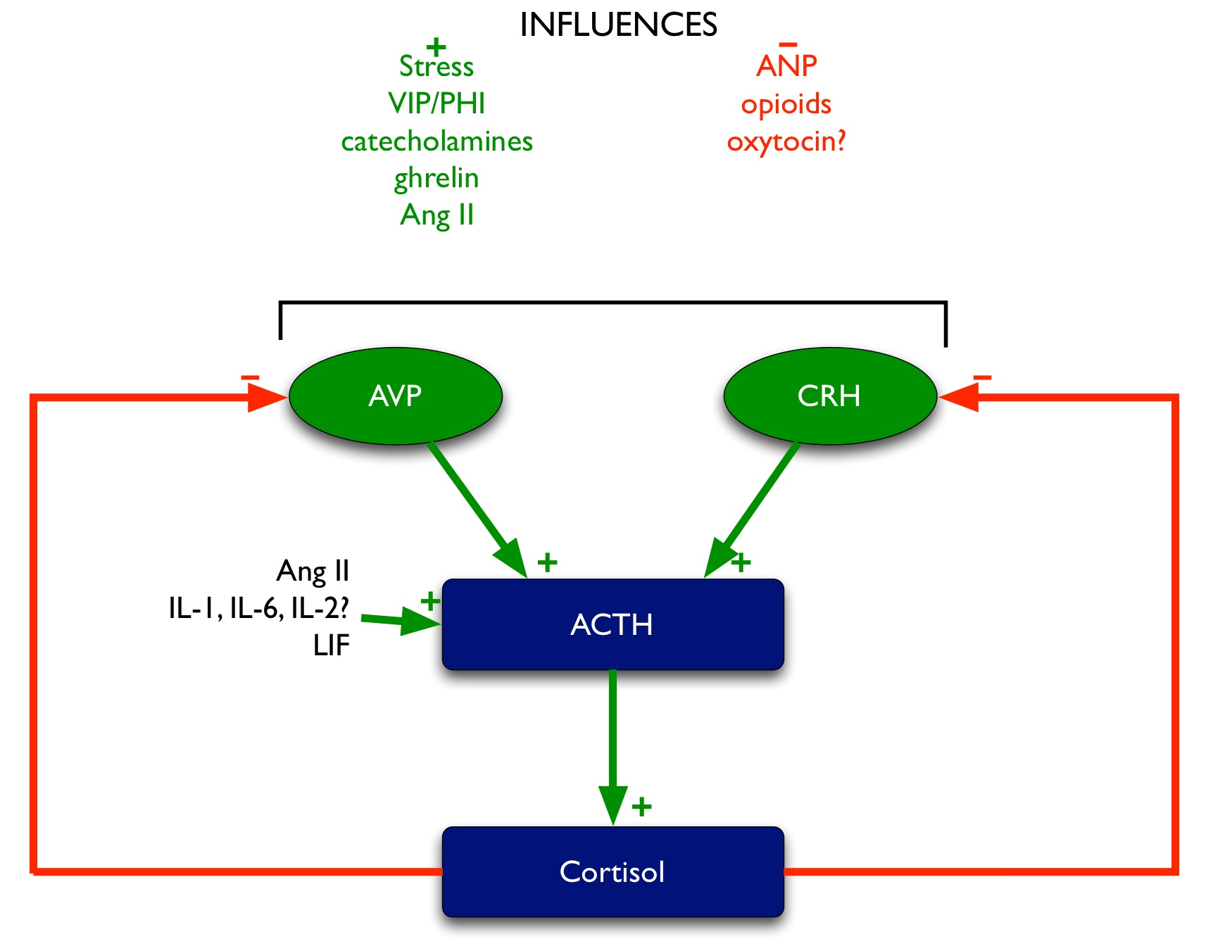
Figure 5: Regulation of ACTH. Green arrows denote stimulatory influences, red arrows denote inhibitory influences.

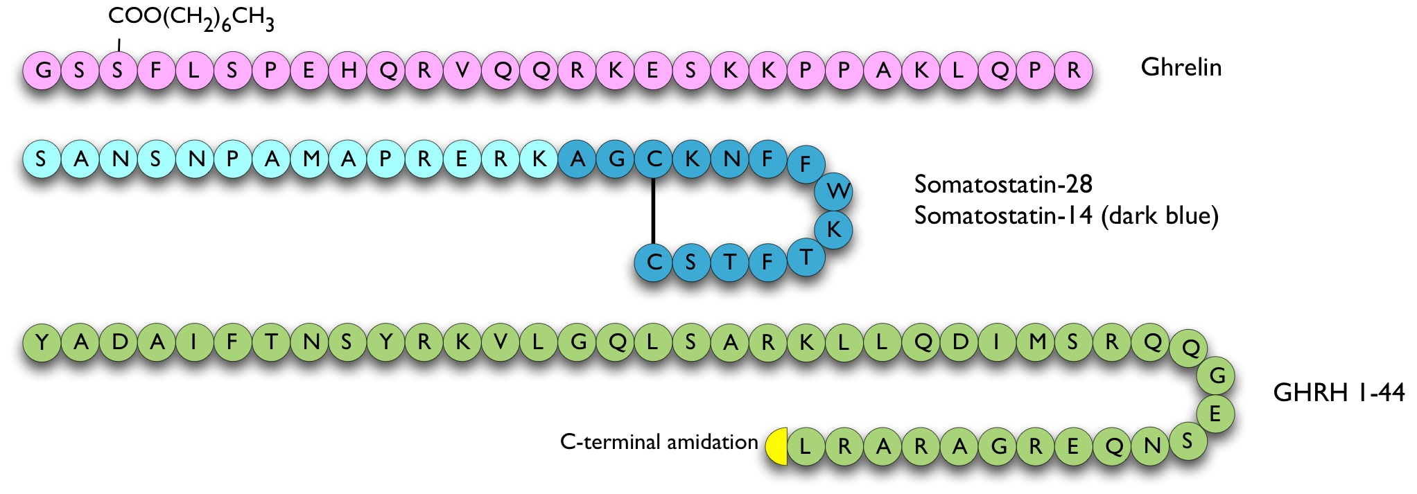
Figure 6: Hypophysiotrophic hormones influencing GH release.

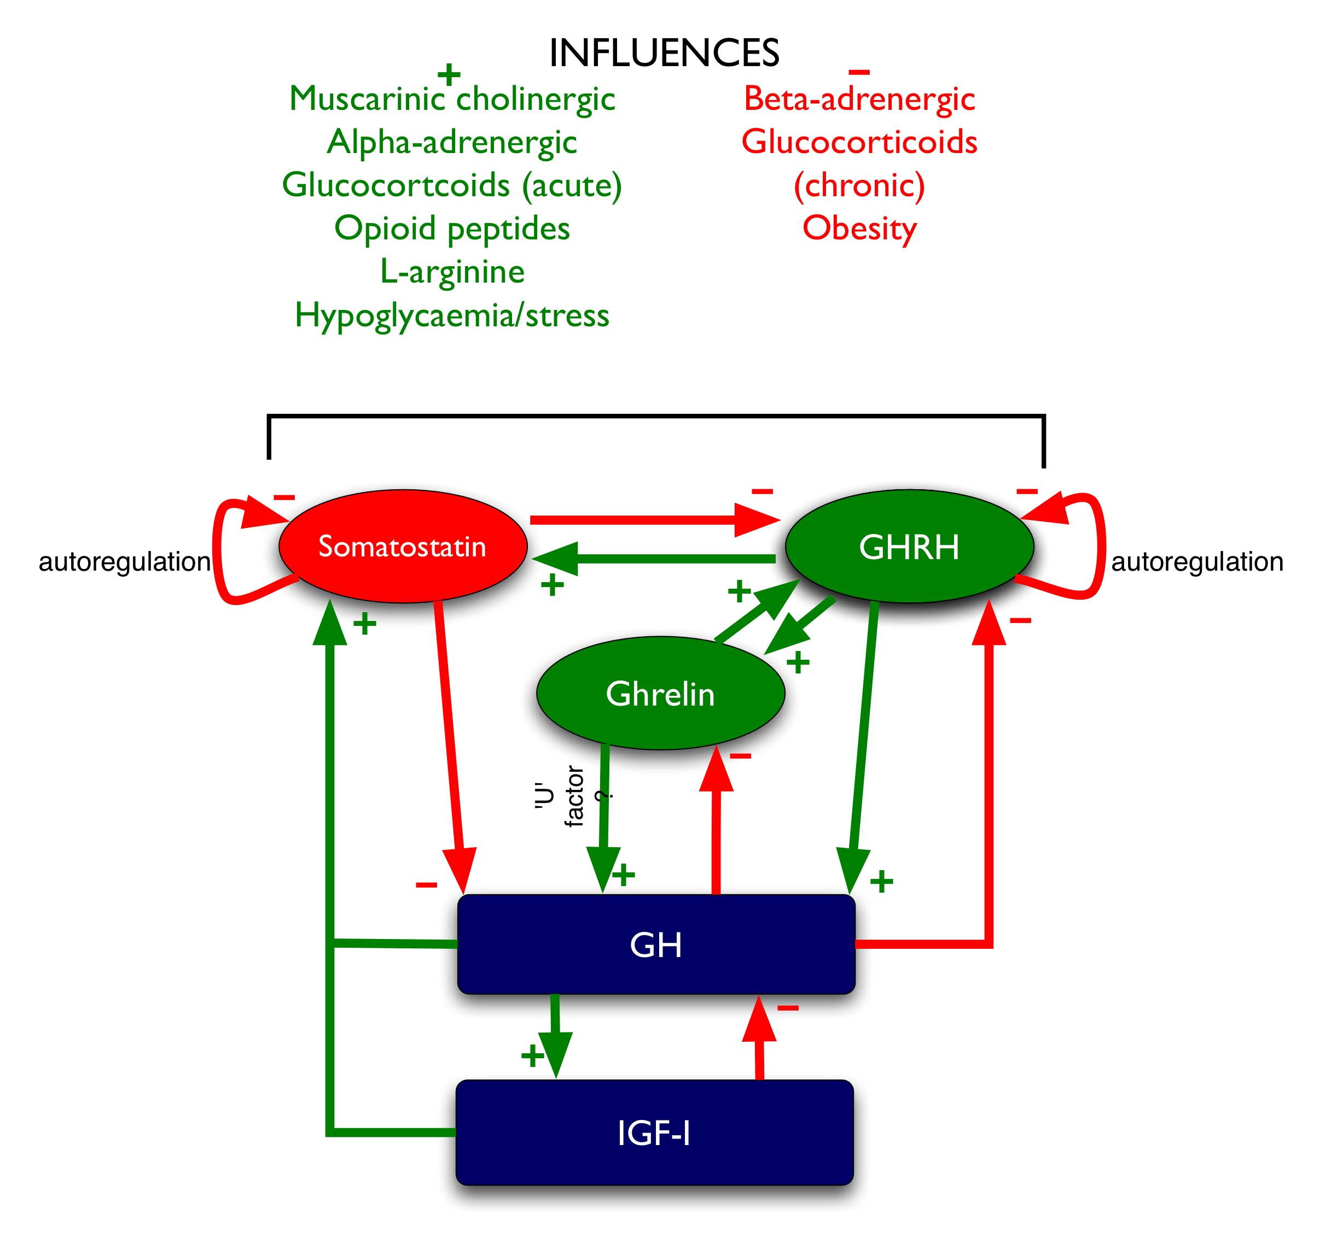
Figure 7: Regulation of GH. Green arrows denote stimulatory influences, red arrows denote inhibitory influences.

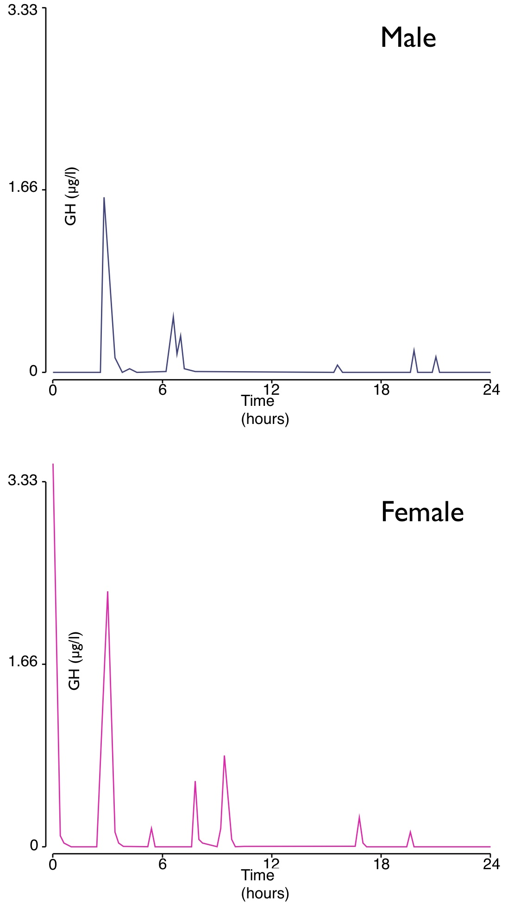
Figure 8: Pulsatility of circulating GH levels in adult men and women.
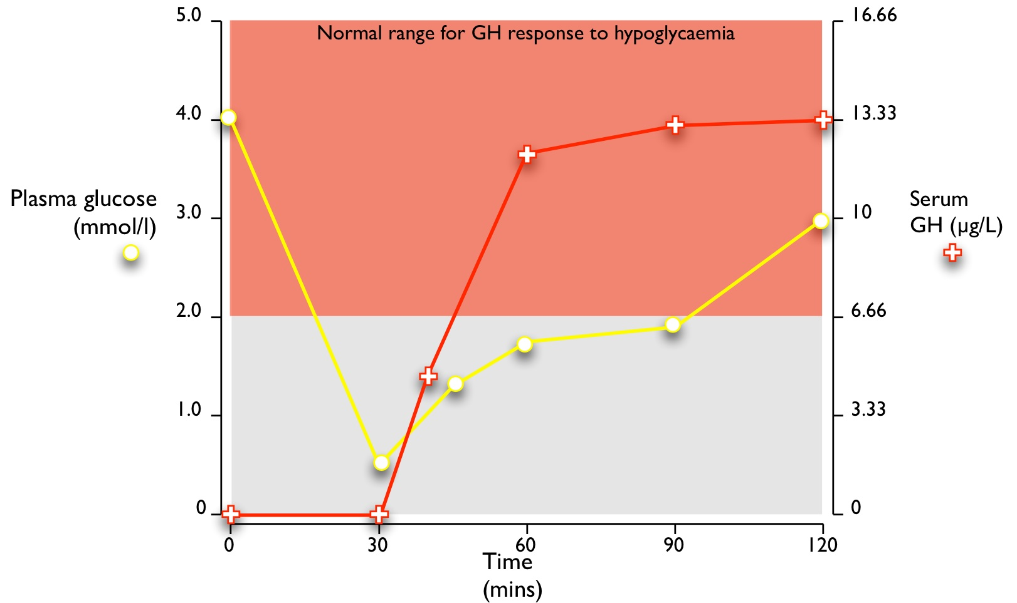
Figure 9: Normal response of GH to insulin-induced hypoglycaemia (≤2.2 mmol/l). Peak GH secreted is ≥6.66 µg/L.

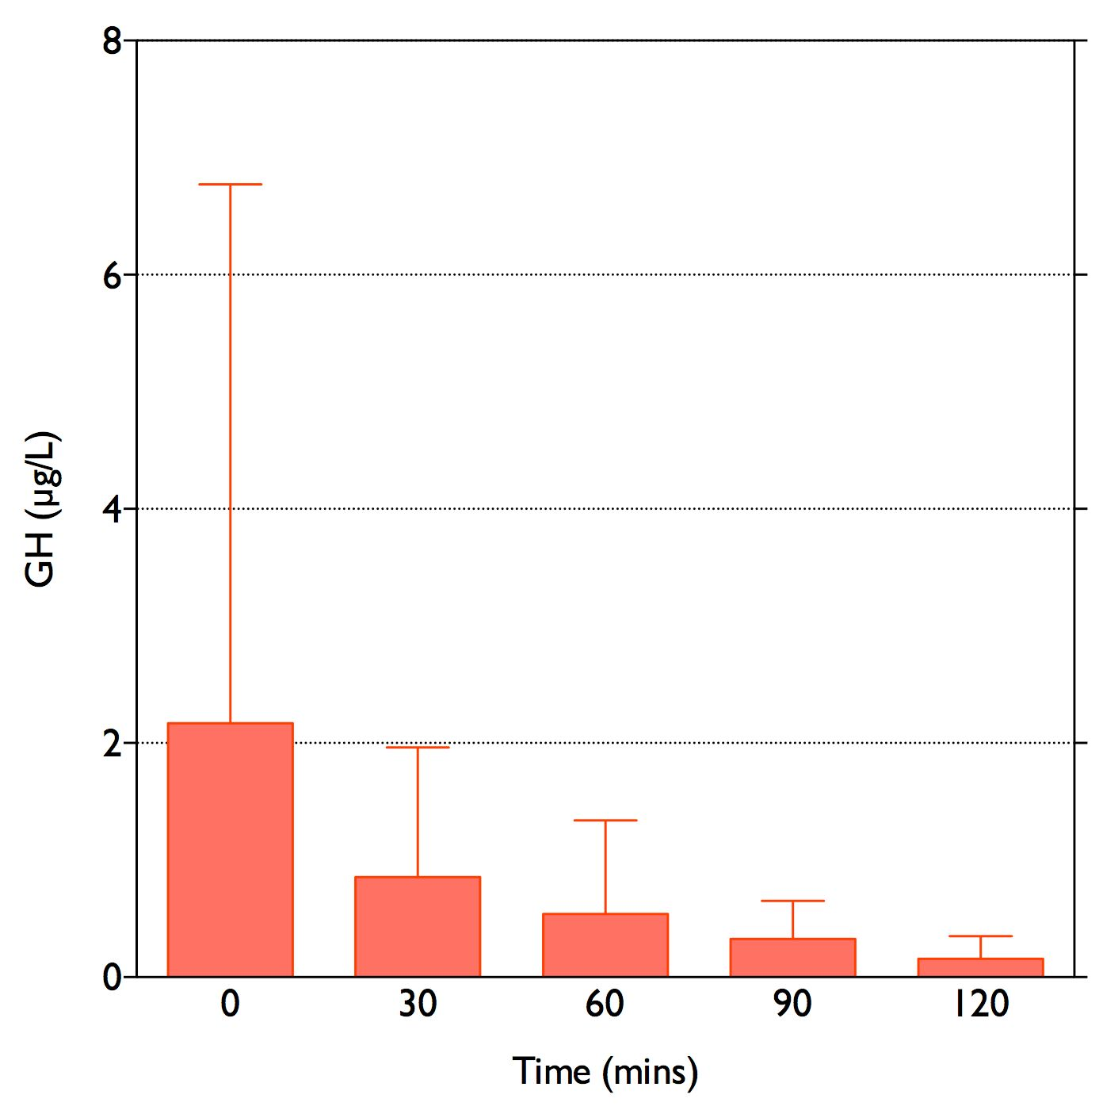
Figure 10: GH response to 75g oral glucose in 8 non-acromegalic, non-diabetic women, given at time 0. Error bars denote SD. Note the high variability of the baseline GH level due to the pulsatile nature of GH secretion. GH levels fall to <0.4 µg/L at 120 minutes.

