Normal Physiology of Growth Hormone in Adults

Nicoleta Cristina Olarescu MD, PhD, Section of Specialized Endocrinology, Department of Endocrinology, Oslo University Hospital, Oslo, Norway; email nicola@ous-hf.no
Kavinga Gunawardane MD, MRCP, Oxford Center for Diabetes, Endocrine and Metabolism, Oxford, UK and Ministry of Health, Sri Lanka; kavinga_g@yahoo.com

Troels Krarup Hansen MD, PhD, Steno Diabetes Center Aarhus, Aarhus University Hospital, Aarhus, Denmark
Niels Møller MD, DMSc, Department of Endocrinology and Internal Medicine, Aarhus University Hospital, Aarhus N, Denmark
Jens Otto Lunde Jørgensen, MD, DMSc, Department of Endocrinology and Internal Medicine, Aarhus University Hospital, Aarhus N, Denmark;

Updated October 15, 2019

ABSTRACT

Growth hormone (GH) is an ancestral hormone secreted episodically from somatotroph cells in the anterior pituitary. Since the recognition of its multiple and complex effects in the early 1960s, the physiology and regulation of GH has become a major area of research interest in the field of endocrinology. In adulthood, its main role is to regulate the metabolism. Pituitary synthesis and secretion of GH is stimulated by episodic hypothalamic secretion of GH releasing factor and inhibited by somatostatin. Insulin-like Growth Factor I (IGF-I) inhibits GH secretion by a negative loop at both hypothalamic and pituitary levels. In addition, age, gender, pubertal status, food, exercise, fasting, sleep and body composition play important regulatory roles. GH acts both directly through its own receptors and indirectly through the induced production of IGF-I. Their effects may be synergistic (stimulate growth) or antagonistic, as for the effect on glucose metabolism: GH stimulates lipolysis and promotes insulin resistance, whereas IGF-I acts as an insulin agonist. The bioactivity of IGF-I is tightly controlled by several IGF-I binding proteins. The mechanisms underlying the insulin antagonist effect of GH in humans are causally linked to lipolysis and the ensuing elevated levels of circulating free fatty acids. The nitrogen retaining properties of GH predominantly involve stimulation of protein synthesis, which could be either direct or mediated through IGF-I, insulin or lipid intermediates. In the present chapter, the normal physiology of GH secretion and the effects of GH on intermediary metabolism throughout adulthood, focusing on human studies, are presented.

INTRODUCTION

Harvey Cushing proposed in 1912 in his monograph "The Pituitary Gland" the existence of a "hormone of growth", and was thereby among the first to indicate that the primary action of growth hormone (GH) was to control and promote skeletal growth. In clinical medicine GH (also called (somatotrophin) was previously known for its role on promoting growth of hypopituitary children, and for its adverse effects in connection with hypersecretion as observed in acromegaly. The multiple and complex actions of human GH were, however, acknowledged shortly after the advent of a pituitary-derived preparation of the hormone in the late fifties - as reviewed by Raben in 1962 .

In the present chapter we will briefly review the normal physiology of GH secretion and the effects of GH on intermediary metabolism throughout adulthood. Other important physiological effects of GH are presented in the review on GH replacement in adults.

GROWTH HORMONE

GH is a single chain protein with 191 amino-acids and two disulfide bonds. The human GH gene is located on chromosome 17q22 as part of a locus that comprises five genes. In addition to two GH related genes (GH1 that codes for the main adult growth hormone, produced in the somatotrophic cells found in the anterior pituitary gland and, to a minor extent, in lymphocytes, and GH2 that codes for placental GH), there are three genes coding for chorionic somatomammotropin (CSH1, CSH2 and CSHL) (also known as placental lactogen) genes . The GH1 gene encodes two distinct GH isoforms (22 kDa and 20 kDa). The principal and most abundant GH form in the pituitary and blood is the monomeric 22K-GH isoform, representing also the recombinant GH available for therapeutic use (and subsequently for doping purposes) . Administration of recombinant 22K-GH exogenously leads to a decrease in the 20K-GH isoform, and thus testing both isoforms is used to detect GH doping in sports .

As already mentioned, GH is secreted by the somatotroph cells located primarily in the lateral wings of the anterior pituitary. A recent single cell RNA sequencing study performed in mice showed that GH-expressing cells, representing the somatotrophs, are the most abundant cell population in the adult pituitary gland . The differentiation of somatotroph cell is governed by the pituitary transcription factor 1 (Pit-1). Data in mice suggest that the pituitary holds regenerative competence, the GH-producing cells being regenerated form the pituitary’s stem cells in young animals after a period of 5 months .

Physiological Regulation of GH Secretion

The morphological characteristics and number of somatotrophs are remarkably constant throughout life, while their secretion pattern changes. GH secretion occurs in a pulsatile fashion, and in a circadian rhythm with a maximal release in the second half of the night. So, sleep is an important physiological factor that increases the GH release. Interestingly, the maximum GH levels occur within minutes of the onset of slow wave sleep and there is marked sexual dimorphism of the nocturnal GH increase in humans, constituting only a fraction of the total daily GH release in women, but the bulk of GH output in men .

GH secretion is also gender-, pubertal status- and age- dependent (Figure 1 and Figure 4) . Integrated 24h GH concentration is significantly greater in women than in men and greater in the young than in older adults. The serum concentration of free estradiol, but not free testosterone, correlates with GH, and when correcting for the effects of estradiol, neither gender nor age influence GH concentration. This suggests that estrogens play a crucial role in modulating GH secretion . During puberty, a 3-fold increase in pulsatile GH secretion occurs that peaks around the age of 15 years in girls and 1 year later in boys .

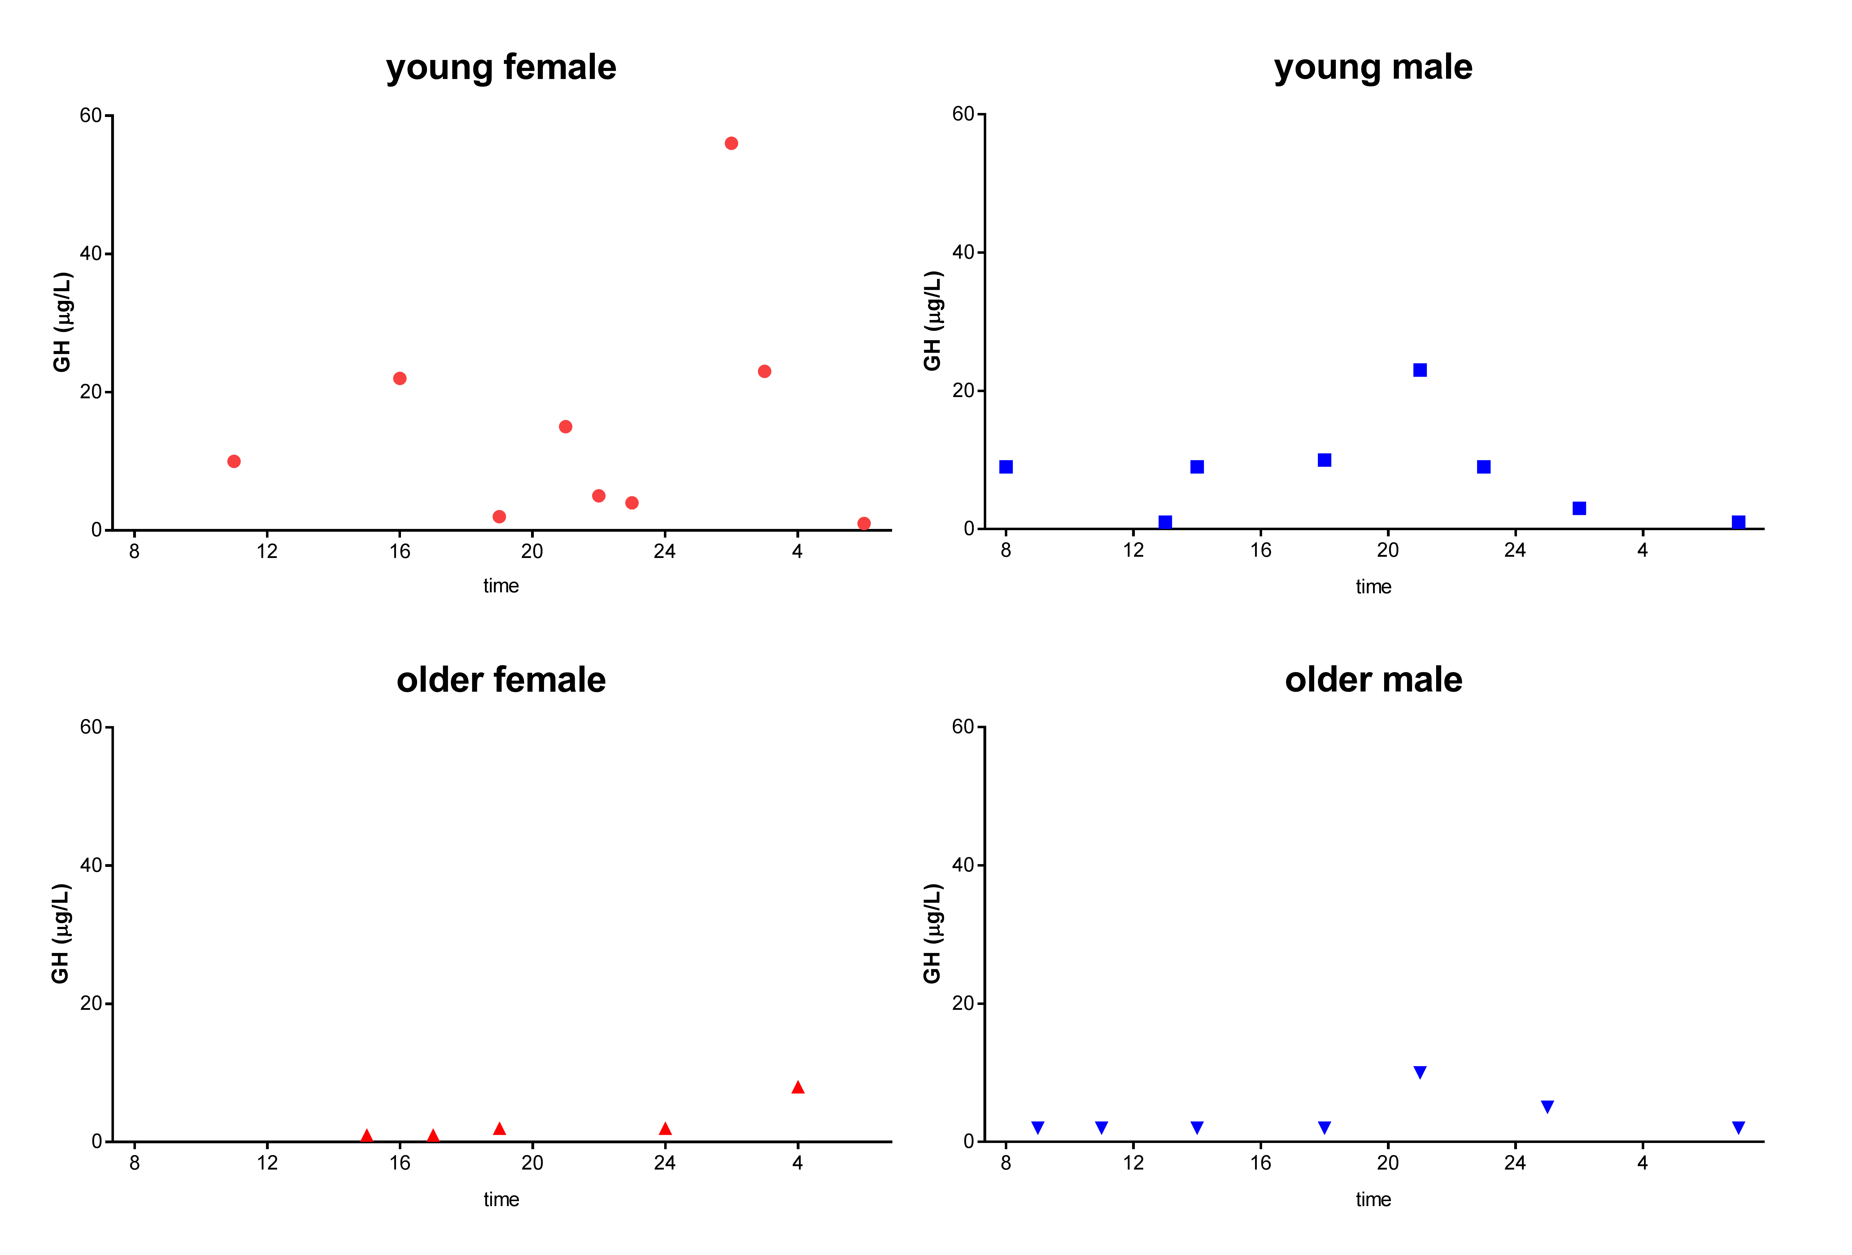
Figure 1 The secretory pattern of GH in young and old female and male. In young individuals the GH pulses are larger and more frequent and that female secrete more GH than men (modified from ).

Pituitary synthesis and secretion of GH is stimulated by episodic hypothalamic hormones. Growth hormone releasing hormone (GHRH) stimulates while somatostatin (SST) inhibits GH production and release. GH stimulates IGF-I production which in turn inhibits GH secretion at both hypothalamic and pituitary levels. The gastric peptide ghrelin is also a potent GH secretagogue, which acts to amplify hypothalamic GHRH secretion and synergize with its pituitary GH-stimulating effects (Figure 2) . Interestingly, recently germline or somatic duplication of GPR101 has been shown to constitutively activate the cAMP pathway in the absence of a ligand, leading to GH release. Although the precise physiology of GPR101 is unclear, it is worth mentioning it since it clearly has an effect on GH pathophysiology .

In addition, a multitude of other factors may impact the GH axis, most probably due to interaction with GRHR, somatostatin, and ghrelin. Estrogens stimulate the secretion of GH, but inhibit the action of GH on the liver by suppressing GH receptor (GHR) signaling. In contrast, androgens enhance the peripheral actions of GH . Exogenous estrogens potentiate pituitary GH responses to submaximal effective pulses of exogenous GHRH and mute inhibition by exogenous SST . Also, exogenous estrogen potentiates ghrelin’s action .

GH release correlates inversely with intraabdominal visceral adiposity via mechanisms that may depend on increased free fatty acids (FFA) flux, elevated insulin, or free IGF-I.

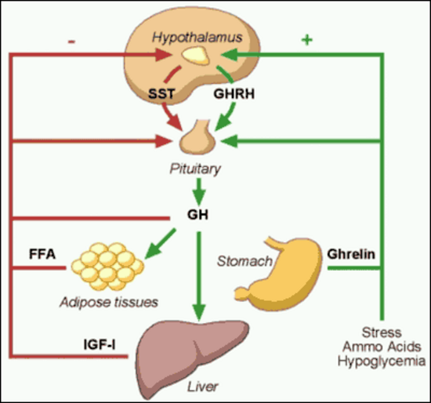
Figure 2. Factors that stimulate and suppress GH secretion under physiological conditions.

GROWTH HORMONE RELEASING HORMONE

GHRH is a 44 amino-acid polypeptide produced in the arcuate nucleus of the hypothalamus. These neuronal terminals secrete GHRH to reach the anterior pituitary somatotrophs via the portal venous system, which leads to GH transcription and secretion. Moreover, animal studies have demonstrated that GHRH plays a vital role in the proliferation of somatotrophs in the anterior pituitary, whereas the absence of GHRH leads to anterior pituitary hypoplasia . In addition, GHRH up-regulates GH gene expression and stimulates GH release . The secretion of GHRH is stimulated by several factors including depolarization, α2-adrenergic stimulation, hypophysectomy, thyroidectomy and hypoglycemia, and it is inhibited by SST, IGF-I, and activation of GABAergic neurons.

GHRH acts on the somatotrophs via a seven trans-membrane G protein-coupled stimulatory cell-surface receptor. This receptor has been extensively studied over the last decade leading to the identification of several important mutations. Point mutations in the GHRH receptors, as illustrated by studies done on the lit/lit dwarf mice, showed a profound impact on subsequent somatotroph proliferation leading to anterior pituitary hypoplasia . Unlike the mutations in the Pit-1 and PROP-1 genes, which lead to multiple pituitary hormone deficiencies and anterior pituitary hypoplasia, mutations in the GHRH receptor lead to profound GH deficiency with anterior pituitary hypoplasia. Subsequent to the first GHRH receptor mutation described in 1996 , an array of familial GHRH receptor mutations have been recognized over the last decade. These mutations account for almost 10% of familial isolated GH deficiencies. An affected individual will present with short stature and a hypoplastic anterior pituitary. However, they lack certain typical features of GH deficiency such as midfacial hypoplasia, microphallus, and neonatal hypoglycemia .

SOMATOSTATIN (SST)

SST is a cyclic peptide, encoded by a single gene in humans, which mostly exerts inhibitory effects on endocrine and exocrine secretions. Many cells in the body, including specialized cells in the anterior paraventricular nucleus and arcuate nucleus, produce SST. These neurons secrete SST into the adenohypophyseal portal venous system, via the median eminence, to exert effects on the anterior pituitary. SST has a short half-life of approximately 2 minutes as it is rapidly inactivated by tissue peptidase in humans.

SST acts via a seven trans-membrane, G protein coupled receptor and, thus far, five subtypes of the receptor have been identified in humans (SSTR1-5). Although all five receptor subtypes are expressed in the human fetal pituitary, the adult pituitary only expresses 4 subtypes (SSTR1, SSTR2, SSTR3, SSTR5). Of these four subtypes, somatotrophs exhibit more sensitivity to SSTR2 and SSTR5 ligands in inhibiting the secretion of GH in a synergistic manner . Somatostatin inhibits GH release but not GH synthesis.

GHRELIN

Ghrelin is a 28 amino-acid peptide that is the natural ligand for the GH secretagogue receptor. In fact, ghrelin and GHRH have a synergistic effect in increasing circulating GH levels . Ghrelin is primarily secreted by the stomach and may be involved in the GH response to fasting and food intake.

Clinical Implications

GH levels – influence of body composition, physical fitness and age

With the introduction of dependable radioimmunological assays, it was recognized that circulating GH is blunted in obese subjects, and that normal aging is accompanied by a gradual decline in GH levels . It has been hypothesized that many of the senescent changes in body composition and organ function are related to or caused by decreased GH , also known as "the somatopause".

Studies carried out in the late 90s have uniformly documented that adults with severe GH deficiency are characterized by increased fat mass and reduced lean body mass (LBM) . It is also known that normal GH levels can be restored in obese subjects following massive weight loss , and that GH substitution in GH-deficient adults normalizes body composition. What remains unknown is the cause-effect relationship between decreased GH levels and senescent changes in body composition. Is the propensity for gaining fat and losing lean mass initiated or preceded by a primary age-dependent decline in GH secretion and action? Alternatively, accumulation of fat mass secondary to non-GH dependent factors (e.g. life style, dietary habits) results in a feedback inhibition of GH secretion. Moreover, little is known about possible age-associated changes in GH pharmacokinetics and bioactivity.

Cross-sectional studies performed to assess the association between body composition and stimulated GH release in healthy subjects show that adult people (mean age 50 yr) have a lower peak GH response to secretagogues (clonidine and arginine), while females had a higher response to arginine when compared to males. Multiple regression analysis, however, reveal that intra-abdominal fat mass is the most important and negative predictor of peak GH levels, as previously mentioned . In the same population, 24-h spontaneous GH levels also predominantly correlated inversely with intra-abdominal fat mass (Figure 3) .

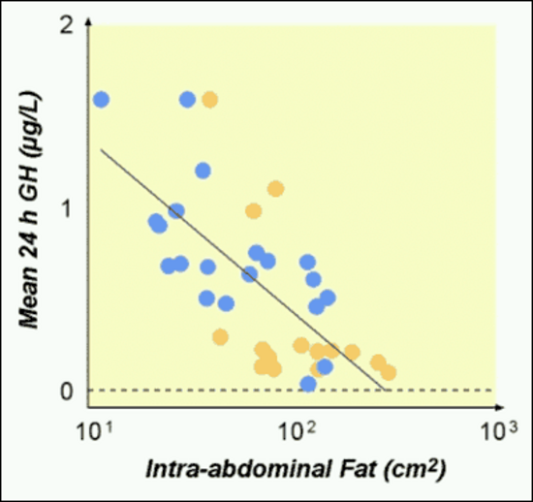
Figure 3. Correlation between intra-abdominal fat mass and 24-hour GH secretion.

A detailed analysis of GH secretion in relation to body composition in elderly subjects has, to our knowledge, not been performed. Instead, serum IGF-I has been used as a surrogate or proxy for GH status in several studies of elderly men . These studies comprise large populations of ambulatory, community-dwelling males aged between 50-90 yr. As expected, the serum IGF-I declined with age (Figure 4), but IGF-I failed to show any significant association with body composition or physical performance.

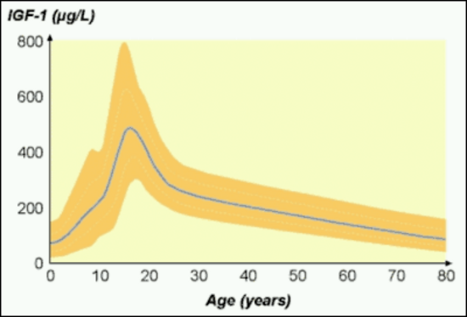
Figure 4. Changes in serum IGF-I with age; modified from .

GH action: Influence of age, sex and body composition

Considering the great interest in the actions of GH in adults, surprisingly few studies have addressed possible age-associated differences in the responsiveness or sensitivity to GH. In normal adults the senescent decline in GH levels is paralleled by a decline in serum IGF-I, suggesting a down-regulation of the GH-IGF-I axis. Administration of GH to elderly healthy adults has generally been associated with predictable, albeit modest, effects on body composition and side effects in terms of fluid retention and modest insulin resistance . Whether this reflects an unfavorable balance between effects and side effects in older people or the employment of excessive doses of GH is uncertain, but it is evident that older subjects are not resistant to GH. Short-term dose-response studies clearly demonstrate that older patients require a lower GH dose to maintain a given serum IGF-I level , and it has been observed that serum IGF-I increases in individual patients on long-term therapy if the GH dosage remains constant. Moreover, patients with GH deficiency older than 60 years are highly responsive to even a small dose of GH . Interestingly, there is a gender difference response to GH treatment with men being more responsive in terms of IGF-I generation and fat loss during therapy, most probably due to lower estrogen levels that negatively impact the GH effect on IGF-I generation in the liver .

The pharmacokinetics and short-term metabolic effects of a near physiological intravenous GH bolus (200μg) were compared in a group of young (30 year) and older (50 year) healthy adults . The area under the GH curve was significantly lower in older subjects, whereas the elimination half-life was similar in the two groups, suggesting both an increased metabolic clearance rate and apparent distribution volume of GH in older subjects. Both parameters showed a strong positive correlation with fat mass, although multiple regression analysis revealed age to be an independent positive predictor. The short-term lipolytic response to the GH bolus was higher in young as compared to older subjects. Interestingly, the same study showed that the GH binding proteins correlated strongly and positively with abdominal fat mass .

A prospective long-term study of normal adults with serial concomitant estimations of GH status and adiposity would provide useful information about the cause-effect relationship between GH status and body composition as a function of age. In the meantime, the following hypothesis is proposed (Figure 5): 1. Changes in life-style and genetic predispositions promote accumulation of body fat with aging; 2. The increased fat mass, leads to increased FFA availability, and induces insulin resistance and hyperinsulinemia; 3. High insulin levels suppress IGF binding protein (IGFBP)-1 resulting in a relative increase in free IGF-I levels; 4. Systemic elevations of FFA, insulin and free IGF-I suppress pituitary GH release, which further increases fat mass; 5. Endogenous GH is cleared more rapidly in subjects with a high amount of fat tissue.

At present it is not justified to treat the age-associated deterioration in body composition and physical performance with GH especially due to concern that the ensuing elevation of IGF-I levels may increase the risk for the development of neoplastic disease (For an extensive discussion of GH in the elderly see the chapter on this topic in the Endocrinology of Aging section of Endotext).

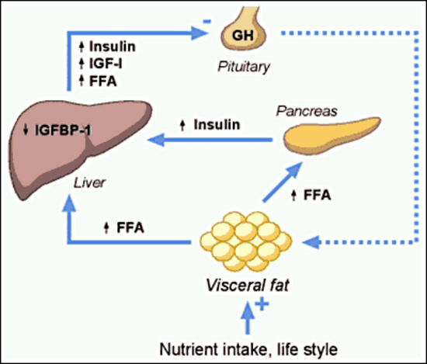
Figure 5. Hypothetical model for the association between low GH levels and increased visceral fat in adults.

Life-long GH deficiency

A real-life model for GH effects in human physiology is represented by patients with life-long severe reduction in GH signaling due to GHRH or GHRH receptor mutations, combined deficiency of GH, prolactin, and TSH, or global deletion of GHR. They show short stature, doll facies, high-pitched voices, and central obesity, and are fertile . Despite central obesity and increased liver fat, they are insulin sensitive, partially protected from cancer and present a major reduction in pro-aging signaling and perhaps increased longevity . The decrease of cancer risk in life-long GH deficiency together with reports on the permissive role of GH for neoplastic colon growth , pre-neoplastic mammary lesions , and progression of prostate cancer demands, at least, a careful tailoring of GH substitution dosage in the GH deficient patients.

GH and the immune system

Although the majority of data on the relation between GH and the immune system are from animal studies, it seems that GH may possess immunomodulatory actions. Immune cells, including several lymphocyte subpopulations, express receptors for GH, and respond to its stimulation . GH stimulates in vitro T and B-cell proliferation and immunoglobulin synthesis, enhances human myeloid progenitor cell maturation, and modulates in vivo Th1/Th2 (8) and humoral immune responses . It has been shown that GH can induce de novo T cell production and enhance CD4 recovery in HIV+ patients. Another study with possible clinical relevance showed that sustained GH expression reduced prodromal disease symptoms and eliminated progression to overt diabetes in mouse model of type 1 diabetes, a T-cell–mediated autoimmune disease. GH altered the cytokine environment, triggered anti-inflammatory macrophage (M2) polarization, maintained activity of the suppressor T-cell population, and limited Th17 cell plasticity . JAK/STAT signaling, the principal mediator of GHR activation, is well-known to be involved in the modulation of the immune system, so is tempting to assume that GH may have a role too, but clear data in humans are needed.

Growth Hormone Signaling in Humans

Growth hormone RECEPTOR (GHR) activation

GHR signaling is a separate and prolific research field by itself , so this section will focus on recent data obtained in human models.

GHRs have been identified in many tissues including fat, lymphocytes, liver, muscle, heart, kidney, brain and pancreas . Activation of receptor-associated Janus kinase (JAK)-2 is the critical step in initiating GH signaling. One GH molecule binds to two GHR molecules that exist as preformed homodimers. Following GH binding, the intracellular domains of the GHR dimer undergo rotation, which brings together the two intracellular domains each of them binding one JAK2 molecule. This, in turn, induces cross-phosphorylation of tyrosine residues in the kinase domain of each JAK2 molecule followed by tyrosine phosphorylation of the GHR . Phosphorylated residues on GHR and JAK2 form docking sites for different signaling molecules including signal transducers and activators of transcription (STAT) 1, 3, 5a and 5b. STATs bound to the activated GHR-JAK2 complex are subsequently phosphorylated on a single tyrosine by JAK2 allowing dimerization and translocation to the nucleus, where they bind to DNA and activate gene transcription. A STAT5b binding site has been characterized in the IGF-I gene promoter region . Attenuation of JAK2-associated GH signaling is mediated by a family of cytokine-inducible suppressors of cytokine signaling (SOCS) . SOCS proteins bind to phosphotyrosine residues on the GHR or JAK2 and suppress GH signaling by inhibiting JAK2 activity and competing with STATs. For example, it has been reported that the inhibitory effect of estrogen on hepatic IGF-I production seems to be mediated via up regulation of SOCS-2 .

Data on GHR signaling derive mainly from rodent models and experimental cell lines, although GH-induced activation of the JAK2/STAT5b and the mitogen activated protein kinase (MAPK) pathways have been recorded in cultured human fibroblasts from healthy human subjects . STAT5b in human subjects is critical for GH-induced IGF-I expression and growth promotion as demonstrated by the identification of mutations in the STAT5b gene of patients presenting with severe GH insensitivity in the presence of a normal GHR . Activation of GHR signaling in vivo has been reported in healthy young male subjects exposed to an intravenous GH bolus vs. saline . Significant tyrosine phosphorylation of STAT5b was recorded after GH exposure at 30-60 minutes in muscle and fat biopsies, but there was no evidence of GH-induced activation of PI 3-kinase, Akt/PKB, or MAPK .

GH and insulin signaling

GH impairs the insulin mechanism but the exact mechanisms in humans are still a matter of debate. There is no evidence of a negative effect of GH on insulin binding to the receptor , which obviously implies post-receptor metabolic effects.

There is animal and in vitro evidence to suggest that insulin and GH share post-receptor signaling pathways . Convergence has been reported at the levels of STAT5 and SOCS3 as well as on the major insulin signaling pathway: insulin receptor substrates (IRS) 1 and 2, PI 3-kinase (PI3K), Akt, and extracellular regulated kinases (ERK) 1 and 2 . Studies in rodent models suggest that the insulin-antagonistic effects of GH in adipose involve suppression of insulin-stimulated PI3-kinase activity . In 2001 it was demonstrated that GH induces cellular insulin resistance by uncoupling PI3K and its downstream signals in 3T3-L1 adipocytes ]. A follow up study has shown that GH increased p85α expression and decreased PI3K activity in adipose tissue of mice, supporting the previous report of a direct inhibitory effect of GH on PI3K activity . However, a study performed in healthy human skeletal muscle showed, as expected, that the infusion of GH induced a sustained increase in FFA levels and subsequently insulin resistance as assessed by the euglycemic clamp technique, but was not associated with any change in the insulin-stimulated increase in either IRS-1/PI3K or PKB/Akt activity . It was subsequently showed that insulin had no impact on GH-induced STAT5b activation or SOCS3 mRNA expression .

Because GH and insulin share some common intracellular substrates, a hypothesis arose claiming that competition for intracellular substrates explains the negative effect of GH on insulin signaling . Furthermore, studies have shown that SOCS proteins negatively regulate the insulin signaling pathway . Therefore, another possible mechanism by which GH alters the action of insulin is by increasing the expression of SOCS genes.

INSULIN-LIKE GROWTH FACTOR-I

Physiology of IGF-I

GH acts both directly through its own receptor and indirectly through the induced production of IGF-I. GH stimulates synthesis of IGF-I in the liver and many other target tissues (Figure 6); about 75% of circulating IGF-I is liver-derived. IGF-I is a 70 amino-acid peptide, found in the circulation, 99% bound to transport proteins (IGFBP) in the circulation.

Following the initial discovery of IGF-I, it was thought that GH governs somatic growth only by IGF-I produced by the liver . However, in the 1980s this hypothesis was challenged by the identification of IGF-I production in numerous tissues. IGF-I is known as a global and tissue-specific growth factor as well as an endocrine factor. In some tissues IGF-I acts as a potent inhibitor of cellular apoptosis.

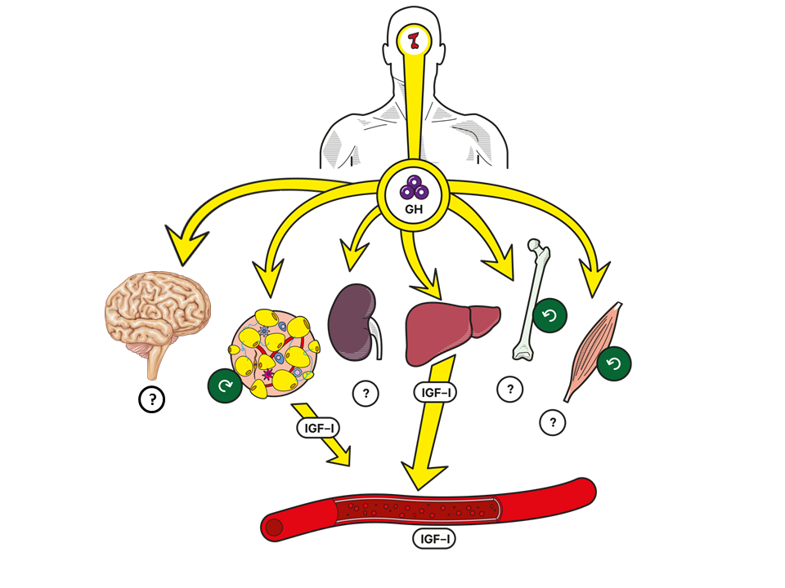
Figure 6. GH is produced in the pituitary gland. In the periphery, GH acts directly and indirectly through stimulation of IGF-I production. In the circulation, the liver is the most important source of IGF-I (75%) but other tissues (e.g. brain, adipose tissue, kidney, bone, and muscles) may contribute. Under GH stimulation the muscle, adipose tissue, and bone have been shown to secrete IGF-I that has a paracrine/autocrine effect.

Interestingly, insulin and IGF-I share many structural and functional similarities, implying that they originated from the same ancestral molecule. Both molecules could have been part of the cycle of food intake and consequent tissue growth. The IGF-I gene is a member of the insulin gene family and the IGF-I receptor is structurally similar to the insulin receptor in its tetrameric structure, with 2 alpha and 2 beta subunits . The alpha subunit binds IGF-I, IGF-II, and insulin; however, the subunit has a higher affinity towards IGF-I compared to IGF-II and insulin. Although insulin and IGF-I share many similarities, during evolution the functionality of the two molecules has become more divergent, where insulin plays a more metabolic role and IGF-I is more involved in cell growth.

The IGF-I receptor is expressed in many tissues in the body. However, the receptor number on each cell is strictly regulated by several systemic and tissue factors including circulating GH, iodothyronines, platelet-derived growth factor, and fibroblast growth factor. Following the binding of the IGF-I molecule, the receptor undergoes a conformational change which activates tyrosine kinase, leading to auto-phosphorylation of tyrosine. The activated receptor phosphorylates IRS-2, which in-turn activates the RAS activating protein SOS. This complex activates the MAPK pathway leading to the stimulation of cell growth .

The IGFBP family comprises six binding proteins (IGFBP 1-6) with a high affinity towards IGF-I and II. Apart from regulating the free plasma IGF fraction, IGFBPs also play an important role in the transport of IGF into different tissues and extravascular space. IGFBP-3 and IGFBP-2 are the most abundant forms seen in plasma and are saturated with IGF-I due to their high affinity: 75% of IGF-I is bound to IGFBP-3. Interestingly, similar to IGF-I, IGFBP-3 production is also regulated by GH. In the plasma, IGFBP-3 is bound to a protein called acid labile subunit (ALS), which stabilizes the “IGFBP3-IGF-I” complex, prolonging its half-life to approximately 16 hours . IGFBP-1, on the other hand, is present in lower concentration in plasma than IGFBP-2 and 3. However, due to lower affinity for IGF-I, IGFBP-1 is usually in an unsaturated state and changing plasma concentrations of IGFBP-1 become important in determining the unbound fraction of IGF-I. A recently new discovered player in the regulation of IGF-I bioavailability is the pregnancy-associated plasma protein-A2 (PAPP-A2) that cleaves IGFBP3 and 5 and releases IGF-I. Homozygous mutations in PAPP-A2 result in growth failure with elevated total but low free IGF-I . Low IGF-I bioavailability impairs growth and glucose metabolism in a mouse model of human PAPP-A2 deficiency and treatment with recombinant human IGF-I in PAPP-A2 deficient patients improves growth and bone mass and ameliorates glucose metabolism .

Effects of IGF-I

Studies on hypophysectomized animals overexpressing IGF-I demonstrate the independent anabolic effects of IGF-I . IGF-I plays a key role in growth, where it acts not only as a determinant of postnatal growth, but also as an intra-uterine growth promoter. Total inactivation of the IGF-I gene in mice produce a perinatal mortality of 80% with the surviving animal showing significant growth retardation compared to controls . Human IGF-I deficiency can be either due to GH deficiency, GHR inactivation, or IGF-I gene mutation. Interestingly, infants with congenital GH deficiency and GHR mutations present with only minor growth retardation, whereas the rare patient with IGF-I deficiency, secondary to a homozygous partial deletion of the IGF-I gene, presents with severe pre- and postnatal growth failure, mental retardation, sensorineural deafness and microcephaly . The differences in the clinical presentation are most likely due to the fact that some degree of IGF-I production is present in patients with GH deficiency, and GHR and GHRH defects. The important growth promoting role of IGF-I is further demonstrated by studies on transgenic mice. Only 6-8% postnatal growth retardation is presented in mice with liver-selective deletion of IGF-I gene showing low serum IGF-I concentrations, whereas animals with total IGF-I deletion or those with only peripherally produced IGF-I deletion showed marked growth retardation .

Both elevated and reduced levels of serum IGF-I are associated with excess mortality in human adults . In addition, it is well recognized in many species including worms, flies, rodents and primates that a reciprocal relationship exists between longevity and activation of the insulin/IGF axis . In this regard, it is noteworthy that calorie restriction is associated with increased longevity and reduced insulin/IGF activity in many species , albeit GH levels being increased by calorie restriction and fasting .

In the context of GH and IGF-I physiology it can be concluded that 1) during childhood and adolescence the combined actions of GH and IGF-I in the presence of sufficient nutrition promote longitudinal growth and somatic maturation, 2) continued excess IGF-I activity in adulthood increases the risk for cardiovascular and neoplastic diseases and hence reduces longevity, and 3) calorie restriction, which suppresses IGF-I activity and stimulates GH secretion, may promote longevity also in human adults .

METABOLIC EFFECTS OF GROWTH HORMONE

The nutritional status dictates the effects of GH. In the state of ‘feast’ and sufficient nutrient intake where insulin is increased in the liver and IGF-I production is stimulated, GH promotes protein anabolism. Whereas, in a state with decreased nutrient intake and during the sleep and exercise, the direct effects of GH are more predominant and this is mainly characterized by stimulation of lipolysis.

Glucose Homeostasis and Lipid Metabolism

The involvement of the pituitary gland in the regulation of substrate metabolism was originally detailed in the classic dog studies by Houssay . Fasting hypoglycemia and pronounced sensitivity to insulin were distinct features of hypophysectomized animals. These symptoms were readily corrected by administration of anterior pituitary extracts. It was also noted that pancreatic diabetes was alleviated by hypophysectomy. Finally, excess of anterior pituitary lobe extracts aggravated or induced diabetes in hypophysectomized dogs. Furthermore, glycemic control deteriorated following exposure to a single supraphysiological dose of human GH in hypophysectomized adults with type 1 diabetes mellitus . Somewhat surprisingly, only modest effects of GH on glucose metabolism were recorded in the first metabolic balance studies involving adult hypopituitary patients .

More recent studies on glucose homeostasis in GH deficient adults have generated results which at first glance may appear contradictory. Insulin resistance may be more prevalent in untreated GH deficient adults, whereas the impact of GH replacement on this feature seems to depend on the duration and the dose .

Below, some of the metabolic effects of GH in human subjects, with special reference to the interaction between glucose and lipid metabolism, will be reviewed.

Studies in Normal Adults

More than fifty years ago, it was shown that infusion of high-dose GH into the brachial artery of healthy adults reduced forearm glucose uptake in both muscle and adipose tissue, which was paralleled by increased uptake and oxidation of FFA . This pattern was opposite to that of insulin, and GH in the same model abrogated the metabolic actions of insulin.

Administration of a GH bolus in the post-absorptive state stimulates lipolysis following a lag time of 2-3 hours . Plasma levels of glucose and insulin, on the other hand, change very little. This is associated with small reductions in muscular glucose uptake and oxidation, which could reflect substrate competition between glucose and fatty acids (i.e. the glucose/fatty acid cycle) (Figure 7). In line with this, sustained exposure to high GH levels induces both hepatic and peripheral (muscular) resistance to the actions of insulin on glucose metabolism together with increased (or inadequately suppressed) lipid oxidation. Apart from enhanced glucose/fatty acid cycling, it has been shown that GH-induced insulin resistance is accompanied by reduced muscle glycogen synthase activity and diminished glucose dependent glucose disposal . However, insulin binding and insulin receptor kinase activity from muscle biopsies is not affected by GH .

Lessons from Acromegaly

Active acromegaly clearly unmasks the diabetogenic properties of GH. In the basal state plasma glucose is elevated despite compensatory hyperinsulinemia. In the basal and insulin-stimulated state (euglycemic glucose clamp) hepatic and peripheral insulin resistance is associated with enhanced lipid oxidation and energy expenditure . There is evidence to suggest that this hyper-metabolic state ultimately leads to beta cell exhaustion and overt diabetes mellitus , but it is also shown that the abnormalities are completely reversed after successful surgery . Conversely, it has been shown that administration of GH in supraphysiological doses for only two weeks induces comparable acromegaloid - and reversible - abnormalities in substrate metabolism and insulin sensitivity .

Interaction of Glucose and Lipid Metabolism

The effect of FFA on the partitioning of intracellular glucose fluxes was originally described by Randle et al. . According to this hypothesis (the glucose/fatty acid cycle), oxidation of FFA initiates an upstream, chain-reaction-like, inhibition of glycolytic enzymes, which ultimately inhibits glucose uptake (Figure 7).

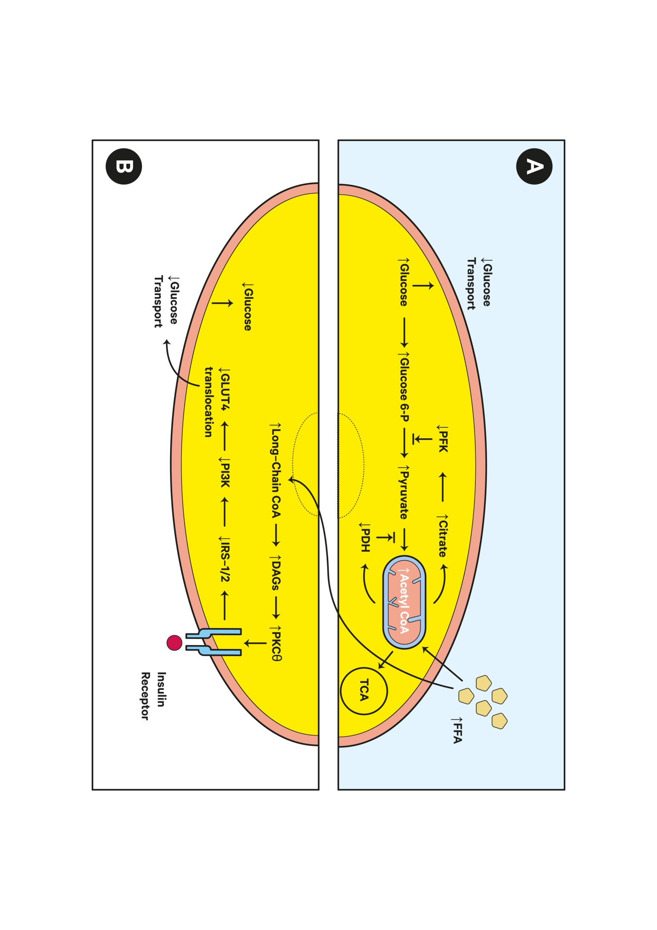
Figure 7. The glucose fatty-acid cycle. A. Randle proposed in 1963 that increased FFA compete with and displace glucose utilization leading to a decreased glucose uptake. The hypothesis stated that an increase in fatty acid oxidation in muscle and fat results in higher acetyl CoA in mitochondria leading to inactivation of two rate-limiting enzymes of glycolysis (i.e., phosphofructokinase (PFK) and pyruvate dehydrogenase (PDH) complex). A subsequent increase in intracellular glucose-6-phosphate (glucose 6-P) results in high intracellular glucose concentrations and decreased glucose uptake by muscle and fat. B. However, in contrast to the proposed hypothesis by Randle, studies using MR spectroscopy have shown reductions in intramyocellular glucose 6-P and glucose concentrations and have led to an alternative hypothesis. The new hypothesis proposes that a transient increase of intracellular diacylglycerol (DAG) activates the theta isoform of protein kinase C (PKCθ) that causes increased serine phosphorylation of IRS-1/2 and consecutively decrease PI3K activation and glucose-transport activity leading to decrease intracellular glucose concentrations.

The Randle hypothesis remains an appealing model to explain the insulin-antagonistic effects of GH when considering its pronounced lipolytic effects. To support this, experiments have shown that co-administration of anti-lipolytic agents and GH reverses GH-induced insulin resistance . Moreover it has been shown that GH-induced insulin resistance is associated with suppressed pyruvate dehydrogenase activity in skeletal muscle . However, according to the Randle hypothesis, the fatty acid-induced insulin resistance will result in elevated intracellular levels of both glucose and glucose-6-phosphate (Figure 7), whereas the muscle biopsies from GH deficient adults after GH treatment have revealed increased glucose but low-normal glucose-6-phosphate levels .

Implications for GH Replacement

Regardless of the exact mechanisms, the insulin antagonistic effects may cause concern when replacing adult GH deficient patients with GH, since some of these patients are insulin resistant in the untreated state. There is evidence to suggest that the direct metabolic effects on GH may be balanced by long-term beneficial effects on body composition and physical fitness, but some studies report impaired insulin sensitivity in spite of favorable changes in body composition. There is little doubt that these effects of GH are dose-dependent and may be minimized or avoided if an appropriately low replacement dose is used. Still, the pharmacokinetics of subcutaneous (s.c.) GH administration is unable to mimic the endogenous GH pattern with suppressed levels after meals and elevations only during post absorptive periods, such as during the night. This may be considered the natural domain of GH action, which coincides with minimal beta-cell challenge. This reciprocal association between insulin and GH and its potential implications for normal substrate metabolism was initially described by Rabinowitz & Zierler . The problem arises when GH levels are elevated during repeated prandial periods. The classic example is active acromegaly, but prolonged high dose s.c. GH administration may cause similar effects. Administration of GH in the evening probably remains the best compromise between effects and side effects , but it is far from physiological.

We know and understand that hypoglycemia is a serious and challenging side effect of insulin therapy as a consequence of inappropriately high insulin levels (during fasting). As a corollary, we must realize that hyperglycemia may result from GH therapy. It is therefore important to carefully monitor glucose metabolism and to use the lowest effective dose when replacing adults with GH.

Effects of GH on Muscle Mass and Function

The anabolic nature of GH is clearly evident in patients with acromegaly and vice versa in patients with GH deficiency. A large number of in vitro and animal studies throughout several decades have documented stimulating effects of GH on skeletal muscle growth. The methods employed to document in vivo effects of GH on muscle mass in humans have been exhaustive, including whole body retention of nitrogen and potassium, total and regional muscle protein metabolism using labeled amino-acids, estimation of LBM by total body potassium or dual x-ray absorptiometry, and direct calculation of muscle area or volume by computerized tomography and magnetic resonance imaging.

Effects of GH on Skeletal Muscle Metabolism in Vitro and in Vivo

The clinical picture of acromegaly and gigantism includes increased LBM of which skeletal muscle mass accounts for approximately 50%. Moreover, retention of nitrogen was one of the earliest observed and most reproducible effects of GH administration in humans . Thoroughly conducted studies with GH administration in GH deficient children, using a variety of classic anthropometric techniques, strongly suggested that skeletal muscle mass increased significantly during treatment . Indirect evidence of an increase in muscle cell number following GH treatment was also presented .

These early clinical studies were paralleled by experimental studies in rodent models. GH administration in hypophysectomized rats increased not only muscle mass, but also muscle cell number (i.e. muscle DNA content) . Interestingly, the same series of experiments revealed that work-induced muscle hypertrophy could occur in the absence of GH. The ability of GH to stimulate RNA synthesis and amino-acid incorporation into protein of isolated rat diaphragm suggested direct mechanisms of actions, whereas direct effects of GH on protein synthesis could not be induced in liver cell cultures . Another important observation of that period was that GH directly increases the synthesis of both sarcoplasmic and myofibrillar protein without affecting proteolysis in a rat model .

In a human study, the in vivo effects of systemic and local GH and IGF-I administration on total and regional protein metabolism revealed that GH administration for 7 days in normal adults increased whole body protein synthesis without affecting proteolysis , and comparable results have been obtained in other human studies .

Based on these studies it seems that the nitrogen-retaining properties of GH predominantly involve stimulation of protein synthesis without affecting (lowering) proteolysis. Theoretically, the protein anabolic effects of GH could be either direct or mediated through IGF-I, insulin, or lipid intermediates. GHR are present in skeletal muscle , which allows for direct GH effects; alternatively, GH may stimulate local muscle IGF-I release, which subsequently acts in an autocrine/paracrine manner. The effects of systemic IGF-I administration on whole body protein metabolism seem to depend on ambient amino-acid levels in the sense that IGF-I administered alone suppresses proteolysis whereas IGF-I in combination with an amino-acid infusion increase protein synthesis . It is therefore likely that the muscle anabolic effects of GH, at least to some extent, are mediated by IGF-I. By contrast, it is repeatedly shown that insulin predominantly acts through suppression of proteolysis and this effect(s) appears to be blunted by co-administration of GH . The degree to which mobilization of lipids contributes to the muscle anabolic actions of GH has so far not been specifically investigated.

An interesting discovery has been that infusion of GH and IGF-I into the brachial artery increases forearm blood flow several fold . This effect appears to be mediated through stimulation of endothelial nitric oxide release leading to local vasodilatation . Thus, it appears that an IGF-I mediated increase in muscle nitric oxide release accounts for some of the effects of GH on skeletal muscle protein synthesis. This increase in muscle blood flow may also contribute to the GH-induced increase in resting energy expenditure, since skeletal muscle metabolism is a major determinant of resting energy expenditure . Moreover, it is plausible that the reduction in total peripheral resistance seen after GH administration in adult growth hormone deficiency is mediated by nitric oxide .

Effects of GH Administration on Muscle Mass and Function in Adults without GH-Deficiency

As previously mentioned, the ability of acute and more prolonged GH administration to retain nitrogen in healthy adults has been known for decades, and more recent studies have documented a stimulatory effect on whole body and forearm protein synthesis.

Rudman et al. were the first to suggest that the senescent changes in body composition were causally linked to the concomitant decline in circulating GH and IGF-I levels . This concept has been recently reviewed , and a number of studies with GH and other anabolic agents for treating the sarcopenia of ageing are currently in progress.

Placebo-controlled GH administration in young healthy adults undergoing a resistance exercise program for 12 weeks showed a GH induced increase in LBM, whole body protein balance, and whole body protein synthesis, whereas quadriceps muscle protein synthesis rate and muscle strength increased to the same degree in both groups during training . In a similar study in older men, GH also increased LBM and whole body protein synthesis, without significantly amplifying the effects of exercise on muscle protein synthesis or muscle strength . An increase in LBM but unaltered muscle strength following 10 weeks of GH administration plus resistance exercise training was also recorded . A more recent study in older men observed a significant increase (4.4 %) in LBM with GH, but no significant effects on muscle strength . Finally, a meta-analysis of studies administering GH to healthy adult subjects showed that it increases LBM and reduces fat mass without improving muscle strength or aerobic exercise capacity .

Numerous studies have evaluated the effects of GH administration in chronic and acute catabolic illness. A comprehensive survey of the prolific literature within this field is beyond the scope of this review, but it is noteworthy that HIV-associated body wasting is a licensed indication for GH treatment in the USA. In these patients, GH treatment for 12 weeks has been associated with significant increments in LBM and physical fitness .

CONCLUSIONS

The GH/IGF-I axis is specifically regulated and is involved in a multitude of processes during all the aspects of life from intrauterine growth, to childhood and puberty, adulthood and lastly elderly stages of life. GH acts directly or via its principal metabolite, IGF-I, and has a wide range of physiological roles being a metabolic active hormone in adulthood. The nutritional status of an organism dictates the effects of GH, either an impairment of insulin action (fasting state) or promoting protein anabolism (fed state). As our knowledge of GH normal physiology increases, our ability to understand and specifically target the GH/IGF-I pathway for a diverse range of therapeutic purposes should also increase. Normal aging is associated with a gradual decline in serum IGF-I levels that run in parallel with reductions in muscle mass and function and other senescent changes in organ function. The cause-effect relationship is uncertain, but GH administration to elderly people without pituitary disease has not proven beneficial and sustained supra-physiological IGF levels and actions are likely to be harmful. On the other hand, a stimulation of endogenous GH secretion induced by exercise and calorie restriction may contribute to healthy aging.

REFERENCES

1. Raben MS. Growth hormone. 1. Physiologic aspects. N Engl J Med. 1962;266:31-35.
2. Petronella N, Drouin G. Gene conversions in the growth hormone gene family of primates: stronger homogenizing effects in the Hominidae lineage. Genomics. 2011;98(3):173-181.
3. Baumann GP. Growth hormone doping in sports: a critical review of use and detection strategies. Endocr Rev. 2012;33(2):155-186.
4. Holt RIG, Ho KKY. The Use and Abuse of Growth Hormone in Sports. Endocr Rev. 2019;40(4):1163-1185.
5. Cheung LYM, George AS, McGee SR, Daly AZ, Brinkmeier ML, Ellsworth BS, Camper SA. Single-Cell RNA Sequencing Reveals Novel Markers of Male Pituitary Stem Cells and Hormone-Producing Cell Types. Endocrinology. 2018;159(12):3910-3924.
6. Willems C, Fu Q, Roose H, Mertens F, Cox B, Chen J, Vankelecom H. Regeneration in the pituitary after cell-ablation injury: time-related aspects and molecular analysis. Endocrinology. 2015:en20151741.
7. Ribeiro-Oliveira A, Barkan AL. Growth Hormone Pulsatility and its Impact on Growth and Metabolism in Humans. in K Ho (ed), Growth Hormone Related Diseases and Therapy: A Molecular and Physiological Perspective for the Clinician, Contemporary Endocrinology. 2011:33-56.
8. Ho KY, Evans WS, Blizzard RM, Veldhuis JD, Merriam GR, Samojlik E, Furlanetto R, Rogol AD, Kaiser DL, Thorner MO. Effects of sex and age on the 24-hour profile of growth hormone secretion in man: importance of endogenous estradiol concentrations. J Clin Endocrinol Metab. 1987;64(1):51-58.
9. Leung KC, Johannsson G, Leong GM, Ho KK. Estrogen regulation of growth hormone action. Endocr Rev. 2004;25(5):693-721.
10. Kargi AY, Merriam GR. Diagnosis and treatment of growth hormone deficiency in adults. Nat Rev Endocrinol. 2013;9(6):335-345.
11. Iacovazzo D, Hernandez-Ramirez LC, Korbonits M. Sporadic pituitary adenomas: the role of germline mutations and recommendations for genetic screening. Expert Rev Endocrinol Metab. 2017;12(2):143-153.
12. Birzniece V, Ho KKY. Sex steroids and the GH axis: Implications for the management of hypopituitarism. Best Pract Res Clin Endocrinol Metab. 2017;31(1):59-69.
13. Veldhuis JD, Evans WS, Bowers CY, Anderson S. Interactive regulation of postmenopausal growth hormone insulin-like growth factor axis by estrogen and growth hormone-releasing peptide-2. Endocrine. 2001;14(1):45-62.
14. Bray MJ, Vick TM, Shah N, Anderson SM, Rice LW, Iranmanesh A, Evans WS, Veldhuis JD. Short-term estradiol replacement in postmenopausal women selectively mutes somatostatin's dose-dependent inhibition of fasting growth hormone secretion. J Clin Endocrinol Metab. 2001;86(7):3143-3149.
15. Anderson SM, Shah N, Evans WS, Patrie JT, Bowers CY, Veldhuis JD. Short-term estradiol supplementation augments growth hormone (GH) secretory responsiveness to dose-varying GH-releasing peptide infusions in healthy postmenopausal women. J Clin Endocrinol Metab. 2001;86(2):551-560.
16. Murray PG, Higham CE, Clayton PE. 60 YEARS OF NEUROENDOCRINOLOGY: The hypothalamo-GH axis: the past 60 years. J Endocrinol. 2015;226(2):T123-140.
17. Bonnefont X, Lacampagne A, Sanchez-Hormigo A, Fino E, Creff A, Mathieu MN, Smallwood S, Carmignac D, Fontanaud P, Travo P, Alonso G, Courtois-Coutry N, Pincus SM, Robinson IC, Mollard P. Revealing the large-scale network organization of growth hormone-secreting cells. Proc Natl Acad Sci U S A. 2005;102(46):16880-16885.
18. Le Tissier PR, Carmignac DF, Lilley S, Sesay AK, Phelps CJ, Houston P, Mathers K, Magoulas C, Ogden D, Robinson IC. Hypothalamic growth hormone-releasing hormone (GHRH) deficiency: targeted ablation of GHRH neurons in mice using a viral ion channel transgene. Mol Endocrinol. 2005;19(5):1251-1262.
19. Wajnrajch MP, Gertner JM, Harbison MD, Chua SC, Jr., Leibel RL. Nonsense mutation in the human growth hormone-releasing hormone receptor causes growth failure analogous to the little (lit) mouse. Nat Genet. 1996;12(1):88-90.
20. Alatzoglou KS, Dattani MT. Genetic causes and treatment of isolated growth hormone deficiency-an update. Nat Rev Endocrinol. 2010;6(10):562-576.
21. Ren SG, Taylor J, Dong J, Yu R, Culler MD, Melmed S. Functional association of somatostatin receptor subtypes 2 and 5 in inhibiting human growth hormone secretion. J Clin Endocrinol Metab. 2003;88(9):4239-4245.
22. Copinschi G, Wegienka LC, Hane S, Forsham PH. Effect of arginine on serum levels of insulin and growth hormone in obese subjects. Metabolism. 1967;16(6):485-491.
23. Rudman D, Kutner MH, Rogers CM, Lubin MF, Fleming GA, Bain RP. Impaired growth hormone secretion in the adult population: relation to age and adiposity. J Clin Invest. 1981;67(5):1361-1369.
24. Rudman D. Growth hormone, body composition, and aging. J Am Geriatr Soc. 1985;33(11):800-807.
25. Jorgensen JO, Vahl N, Hansen TB, Thuesen L, Hagen C, Christiansen JS. Growth hormone versus placebo treatment for one year in growth hormone deficient adults: increase in exercise capacity and normalization of body composition. Clin Endocrinol (Oxf). 1996;45(6):681-688.
26. Williams T, Berelowitz M, Joffe SN, Thorner MO, Rivier J, Vale W, Frohman LA. Impaired growth hormone responses to growth hormone-releasing factor in obesity. A pituitary defect reversed with weight reduction. N Engl J Med. 1984;311(22):1403-1407.
27. Vahl N, Jorgensen JO, Jurik AG, Christiansen JS. Abdominal adiposity and physical fitness are major determinants of the age associated decline in stimulated GH secretion in healthy adults. J Clin Endocrinol Metab. 1996;81(6):2209-2215.
28. Vahl N, Jorgensen JO, Skjaerbaek C, Veldhuis JD, Orskov H, Christiansen JS. Abdominal adiposity rather than age and sex predicts mass and regularity of GH secretion in healthy adults. Am J Physiol. 1997;272(6 Pt 1):E1108-1116.
29. Papadakis MA, Grady D, Tierney MJ, Black D, Wells L, Grunfeld C. Insulin-like growth factor 1 and functional status in healthy older men. J Am Geriatr Soc. 1995;43(12):1350-1355.
30. Goodman-Gruen D, Barrett-Connor E. Epidemiology of insulin-like growth factor-I in elderly men and women. The Rancho Bernardo Study. Am J Epidemiol. 1997;145(11):970-976.
31. Kiel DP, Puhl J, Rosen CJ, Berg K, Murphy JB, MacLean DB. Lack of an association between insulin-like growth factor-I and body composition, muscle strength, physical performance or self-reported mobility among older persons with functional limitations. J Am Geriatr Soc. 1998;46(7):822-828.
32. Juul A, Bang P, Hertel NT, Main K, Dalgaard P, Jorgensen K, Muller J, Hall K, Skakkebaek NE. Serum insulin-like growth factor-I in 1030 healthy children, adolescents, and adults: relation to age, sex, stage of puberty, testicular size, and body mass index. J Clin Endocrinol Metab. 1994;78(3):744-752.
33. Rudman D, Feller AG, Nagraj HS, Gergans GA, Lalitha PY, Goldberg AF, Schlenker RA, Cohn L, Rudman IW, Mattson DE. Effects of human growth hormone in men over 60 years old. N Engl J Med. 1990;323(1):1-6.
34. Jorgensen JO, Flyvbjerg A, Lauritzen T, Alberti KG, Orskov H, Christiansen JS. Dose-response studies with biosynthetic human growth hormone (GH) in GH-deficient patients. J Clin Endocrinol Metab. 1988;67(1):36-40.
35. Moller J, Jorgensen JO, Lauersen T, Frystyk J, Naeraa RW, Orskov H, Christiansen JS. Growth hormone dose regimens in adult GH deficiency: effects on biochemical growth markers and metabolic parameters. Clin Endocrinol (Oxf). 1993;39(4):403-408.
36. Toogood AA, Shalet SM. Growth hormone replacement therapy in the elderly with hypothalamic-pituitary disease: a dose-finding study. J Clin Endocrinol Metab. 1999;84(1):131-136.
37. Burman P, Johansson AG, Siegbahn A, Vessby B, Karlsson FA. Growth hormone (GH)-deficient men are more responsive to GH replacement therapy than women. J Clin Endocrinol Metab. 1997;82(2):550-555.
38. Vahl N, Moller N, Lauritzen T, Christiansen JS, Jorgensen JO. Metabolic effects and pharmacokinetics of a growth hormone pulse in healthy adults: relation to age, sex, and body composition. J Clin Endocrinol Metab. 1997;82(11):3612-3618.
39. Fisker S, Vahl N, Jorgensen JO, Christiansen JS, Orskov H. Abdominal fat determines growth hormone-binding protein levels in healthy nonobese adults. J Clin Endocrinol Metab. 1997;82(1):123-128.
40. Aguiar-Oliveira MH, Bartke A. Growth Hormone Deficiency: Health and Longevity. Endocr Rev. 2019;40(2):575-601.
41. Guevara-Aguirre J, Balasubramanian P, Guevara-Aguirre M, Wei M, Madia F, Cheng CW, Hwang D, Martin-Montalvo A, Saavedra J, Ingles S, de Cabo R, Cohen P, Longo VD. Growth hormone receptor deficiency is associated with a major reduction in pro-aging signaling, cancer, and diabetes in humans. Sci Transl Med. 2011;3(70):70ra13.
42. Chesnokova V, Zonis S, Zhou C, Recouvreux MV, Ben-Shlomo A, Araki T, Barrett R, Workman M, Wawrowsky K, Ljubimov VA, Uhart M, Melmed S. Growth hormone is permissive for neoplastic colon growth. Proc Natl Acad Sci U S A. 2016;113(23):E3250-3259.
43. Kleinberg DL, Wood TL, Furth PA, Lee AV. Growth hormone and insulin-like growth factor-I in the transition from normal mammary development to preneoplastic mammary lesions. Endocr Rev. 2009;30(1):51-74.
44. Slater MD, Murphy CR. Co-expression of interleukin-6 and human growth hormone in apparently normal prostate biopsies that ultimately progress to prostate cancer using low pH, high temperature antigen retrieval. J Mol Histol. 2006;37(1-2):37-41.
45. Bodart G, Farhat K, Charlet-Renard C, Salvatori R, Geenen V, Martens H. The Somatotrope Growth Hormone-Releasing Hormone/Growth Hormone/Insulin-Like Growth Factor-1 Axis in Immunoregulation and Immunosenescence. Front Horm Res. 2017;48:147-159.
46. Villares R, Kakabadse D, Juarranz Y, Gomariz RP, Martinez AC, Mellado M. Growth hormone prevents the development of autoimmune diabetes. Proc Natl Acad Sci U S A. 2013.
47. Lanning NJ, Carter-Su C. Recent advances in growth hormone signaling. Rev Endocr Metab Disord. 2006;7(4):225-235.
48. Dehkhoda F, Lee CMM, Medina J, Brooks AJ. The Growth Hormone Receptor: Mechanism of Receptor Activation, Cell Signaling, and Physiological Aspects. Front Endocrinol (Lausanne). 2018;9:35.
49. Kelly PA, Djiane J, Postel-Vinay MC, Edery M. The prolactin/growth hormone receptor family. Endocr Rev. 1991;12(3):235-251.
50. Brooks AJ, Dai W, O'Mara ML, Abankwa D, Chhabra Y, Pelekanos RA, Gardon O, Tunny KA, Blucher KM, Morton CJ, Parker MW, Sierecki E, Gambin Y, Gomez GA, Alexandrov K, Wilson IA, Doxastakis M, Mark AE, Waters MJ. Mechanism of activation of protein kinase JAK2 by the growth hormone receptor. Science. 2014;344(6185):1249783.
51. Woelfle J, Chia DJ, Rotwein P. Mechanisms of growth hormone (GH) action. Identification of conserved Stat5 binding sites that mediate GH-induced insulin-like growth factor-I gene activation. J Biol Chem. 2003;278(51):51261-51266.
52. Wormald S, Hilton DJ. Inhibitors of cytokine signal transduction. J Biol Chem. 2004;279(2):821-824.
53. Leung KC, Doyle N, Ballesteros M, Sjogren K, Watts CK, Low TH, Leong GM, Ross RJ, Ho KK. Estrogen inhibits GH signaling by suppressing GH-induced JAK2 phosphorylation, an effect mediated by SOCS-2. Proc Natl Acad Sci U S A. 2003;100(3):1016-1021.
54. Silva CM, Kloth MT, Whatmore AJ, Freeth JS, Anderson N, Laughlin KK, Huynh T, Woodall AJ, Clayton PE. GH and epidermal growth factor signaling in normal and Laron syndrome fibroblasts. Endocrinology. 2002;143(7):2610-2617.
55. Hwa V, Little B, Adiyaman P, Kofoed EM, Pratt KL, Ocal G, Berberoglu M, Rosenfeld RG. Severe growth hormone insensitivity resulting from total absence of signal transducer and activator of transcription 5b. J Clin Endocrinol Metab. 2005;90(7):4260-4266.
56. Jorgensen JO, Jessen N, Pedersen SB, Vestergaard E, Gormsen L, Lund SA, Billestrup N. GH receptor signaling in skeletal muscle and adipose tissue in human subjects following exposure to an intravenous GH bolus. Am J Physiol Endocrinol Metab. 2006;291(5):E899-905.
57. Bak JF, Moller N, Schmitz O. Effects of growth hormone on fuel utilization and muscle glycogen synthase activity in normal humans. Am J Physiol. 1991;260(5 Pt 1):E736-742.
58. Rosenfeld RG, Wilson DM, Dollar LA, Bennett A, Hintz RL. Both human pituitary growth hormone and recombinant DNA-derived human growth hormone cause insulin resistance at a postreceptor site. J Clin Endocrinol Metab. 1982;54(5):1033-1038.
59. Dominici FP, Argentino DP, Munoz MC, Miquet JG, Sotelo AI, Turyn D. Influence of the crosstalk between growth hormone and insulin signalling on the modulation of insulin sensitivity. Growth Horm IGF Res. 2005;15(5):324-336.
60. Emanuelli B, Peraldi P, Filloux C, Sawka-Verhelle D, Hilton D, Van Obberghen E. SOCS-3 is an insulin-induced negative regulator of insulin signaling. J Biol Chem. 2000;275(21):15985-15991.
61. Ridderstrale M, Degerman E, Tornqvist H. Growth hormone stimulates the tyrosine phosphorylation of the insulin receptor substrate-1 and its association with phosphatidylinositol 3-kinase in primary adipocytes. J Biol Chem. 1995;270(8):3471-3474.
62. Thirone AC, Carvalho CR, Saad MJ. Growth hormone stimulates the tyrosine kinase activity of JAK2 and induces tyrosine phosphorylation of insulin receptor substrates and Shc in rat tissues. Endocrinology. 1999;140(1):55-62.
63. Olarescu NC, Bollerslev J. The Impact of Adipose Tissue on Insulin Resistance in Acromegaly. Trends Endocrinol Metab. 2016;27(4):226-237.
64. del Rincon JP, Iida K, Gaylinn BD, McCurdy CE, Leitner JW, Barbour LA, Kopchick JJ, Friedman JE, Draznin B, Thorner MO. Growth hormone regulation of p85alpha expression and phosphoinositide 3-kinase activity in adipose tissue: mechanism for growth hormone-mediated insulin resistance. Diabetes. 2007;56(6):1638-1646.
65. Takano A, Haruta T, Iwata M, Usui I, Uno T, Kawahara J, Ueno E, Sasaoka T, Kobayashi M. Growth hormone induces cellular insulin resistance by uncoupling phosphatidylinositol 3-kinase and its downstream signals in 3T3-L1 adipocytes. Diabetes. 2001;50(8):1891-1900.
66. Jessen N, Djurhuus CB, Jorgensen JO, Jensen LS, Moller N, Lund S, Schmitz O. Evidence against a role for insulin-signaling proteins PI 3-kinase and Akt in insulin resistance in human skeletal muscle induced by short-term GH infusion. Am J Physiol Endocrinol Metab. 2005;288(1):E194-199.
67. Nielsen C, Gormsen LC, Jessen N, Pedersen SB, Moller N, Lund S, Jorgensen JO. Growth hormone signaling in vivo in human muscle and adipose tissue: impact of insulin, substrate background, and growth hormone receptor blockade. J Clin Endocrinol Metab. 2008;93(7):2842-2850.
68. Feng X, Tang H, Leng J, Jiang Q. Suppressors of cytokine signaling (SOCS) and type 2 diabetes. Mol Biol Rep. 2014;41(4):2265-2274.
69. Salmon WD, Jr., Daughaday WH. A hormonally controlled serum factor which stimulates sulfate incorporation by cartilage in vitro. J Lab Clin Med. 1957;49(6):825-836.
70. Werner H, Weinstein D, Bentov I. Similarities and differences between insulin and IGF-I: structures, receptors, and signalling pathways. Arch Physiol Biochem. 2008;114(1):17-22.
71. Denley A, Cosgrove LJ, Booker GW, Wallace JC, Forbes BE. Molecular interactions of the IGF system. Cytokine Growth Factor Rev. 2005;16(4-5):421-439.
72. Kim JJ, Accili D. Signalling through IGF-I and insulin receptors: where is the specificity? Growth Horm IGF Res. 2002;12(2):84-90.
73. Firth SM, Baxter RC. Cellular actions of the insulin-like growth factor binding proteins. Endocr Rev. 2002;23(6):824-854.
74. Cabrera-Salcedo C, Mizuno T, Tyzinski L, Andrew M, Vinks AA, Frystyk J, Wasserman H, Gordon CM, Hwa V, Backeljauw P, Dauber A. Pharmacokinetics of IGF-1 in PAPP-A2-Deficient Patients, Growth Response, and Effects on Glucose and Bone Density. J Clin Endocrinol Metab. 2017;102(12):4568-4577.
75. Fujimoto M, Andrew M, Liao L, Zhang D, Yildirim G, Sluss P, Kalra B, Kumar A, Yakar S, Hwa V, Dauber A. Low IGF-I Bioavailability Impairs Growth and Glucose Metabolism in a Mouse Model of Human PAPPA2 p.Ala1033Val Mutation. Endocrinology. 2019;160(6):1363-1376.
76. Behringer RR, Lewin TM, Quaife CJ, Palmiter RD, Brinster RL, D'Ercole AJ. Expression of insulin-like growth factor I stimulates normal somatic growth in growth hormone-deficient transgenic mice. Endocrinology. 1990;127(3):1033-1040.
77. Powell-Braxton L, Hollingshead P, Giltinan D, Pitts-Meek S, Stewart T. Inactivation of the IGF-I gene in mice results in perinatal lethality. Ann N Y Acad Sci. 1993;692:300-301.
78. Gluckman PD, Gunn AJ, Wray A, Cutfield WS, Chatelain PG, Guilbaud O, Ambler GR, Wilton P, Albertsson-Wikland K. Congenital idiopathic growth hormone deficiency associated with prenatal and early postnatal growth failure. The International Board of the Kabi Pharmacia International Growth Study. J Pediatr. 1992;121(6):920-923.
79. Savage MO, Blum WF, Ranke MB, Postel-Vinay MC, Cotterill AM, Hall K, Chatelain PG, Preece MA, Rosenfeld RG. Clinical features and endocrine status in patients with growth hormone insensitivity (Laron syndrome). J Clin Endocrinol Metab. 1993;77(6):1465-1471.
80. Woods KA, Camacho-Hubner C, Savage MO, Clark AJ. Intrauterine growth retardation and postnatal growth failure associated with deletion of the insulin-like growth factor I gene. N Engl J Med. 1996;335(18):1363-1367.
81. Lupu F, Terwilliger JD, Lee K, Segre GV, Efstratiadis A. Roles of growth hormone and insulin-like growth factor 1 in mouse postnatal growth. Dev Biol. 2001;229(1):141-162.
82. Bartke A, Sun LY, Longo V. Somatotropic signaling: trade-offs between growth, reproductive development, and longevity. Physiol Rev. 2013;93(2):571-598.
83. Fontana L, Partridge L, Longo VD. Extending healthy life span--from yeast to humans. Science. 2010;328(5976):321-326.
84. Moller N, Jorgensen JO. Effects of growth hormone on glucose, lipid, and protein metabolism in human subjects. Endocr Rev. 2009;30(2):152-177.
85. BA H. The hypophysis and metabolism. N Engl J Med. 1936;214:961-985.
86. Luft R, Ikkos D, Gemzell CA, Olivecrona H. Effect of human growth hormone in hypophysectomised diabetic subjects. Lancet. 1958;1(7023):721-722.
87. Raben MS, Hollenberg CH. Effect of growth hormone on plasma fatty acids. J Clin Invest. 1959;38(3):484-488.
88. Henneman DH, Henneman PH. Effects of human growth hormone on levels of blood urinary carbohydrate and fat metabolites in man. J Clin Invest. 1960;39:1239-1245.
89. Hew FL, Koschmann M, Christopher M, Rantzau C, Vaag A, Ward G, Beck-Nielsen H, Alford F. Insulin resistance in growth hormone-deficient adults: defects in glucose utilization and glycogen synthase activity. J Clin Endocrinol Metab. 1996;81(2):555-564.
90. Rabinowitz D, Klassen GA, Zierler KL. Effect of human growth hormone on muscle and adipose tissue metabolism in the forearm of man. J Clin Invest. 1965;44:51-61.
91. Moller N, Jorgensen JO, Schmitz O, Moller J, Christiansen J, Alberti KG, Orskov H. Effects of a growth hormone pulse on total and forearm substrate fluxes in humans. Am J Physiol. 1990;258(1 Pt 1):E86-91.
92. Orskov L, Schmitz O, Jorgensen JO, Arnfred J, Abildgaard N, Christiansen JS, Alberti KG, Orskov H. Influence of growth hormone on glucose-induced glucose uptake in normal men as assessed by the hyperglycemic clamp technique. J Clin Endocrinol Metab. 1989;68(2):276-282.
93. Moller N, Schmitz O, Joorgensen JO, Astrup J, Bak JF, Christensen SE, Alberti KG, Weeke J. Basal- and insulin-stimulated substrate metabolism in patients with active acromegaly before and after adenomectomy. J Clin Endocrinol Metab. 1992;74(5):1012-1019.
94. Sonksen PH, Greenwood FC, Ellis JP, Lowy C, Rutherford A, Nabarro JD. Changes of carbohydrate tolerance in acromegaly with progress of the disease and in response to treatment. J Clin Endocrinol Metab. 1967;27(10):1418-1430.
95. Moller N, Moller J, Jorgensen JO, Ovesen P, Schmitz O, Alberti KG, Christiansen JS. Impact of 2 weeks high dose growth hormone treatment on basal and insulin stimulated substrate metabolism in humans. Clin Endocrinol (Oxf). 1993;39(5):577-581.
96. Randle PJ, Garland PB, Hales CN, Newsholme EA. The glucose fatty-acid cycle. Its role in insulin sensitivity and the metabolic disturbances of diabetes mellitus. Lancet. 1963;1(7285):785-789.
97. Nielsen S, Moller N, Christiansen JS, Jorgensen JO. Pharmacological antilipolysis restores insulin sensitivity during growth hormone exposure. Diabetes. 2001;50(10):2301-2308.
98. Nellemann B, Vendelbo MH, Nielsen TS, Bak AM, Hogild M, Pedersen SB, Bienso RS, Pilegaard H, Moller N, Jessen N, Jorgensen JO. Growth hormone-induced insulin resistance in human subjects involves reduced pyruvate dehydrogenase activity. Acta Physiol (Oxf). 2014;210(2):392-402.
99. Christopher M, Hew FL, Oakley M, Rantzau C, Alford F. Defects of insulin action and skeletal muscle glucose metabolism in growth hormone-deficient adults persist after 24 months of recombinant human growth hormone therapy. J Clin Endocrinol Metab. 1998;83(5):1668-1681.
100. Rabinowitz D, Zierler KL. A METABOLIC REGULATING DEVICE BASED ON THE ACTIONS OF HUMAN GROWTH HORMONE AND OF INSULIN, SINGLY AND TOGETHER, ON THE HUMAN FOREARM. Nature. 1963;199:913-915.
101. Jorgensen JO. Human growth hormone replacement therapy: pharmacological and clinical aspects. Endocr Rev. 1991;12(3):189-207.
102. Tanner JM, Hughes PC, Whitehouse RH. Comparative rapidity of response of height, limb muscle and limb fat to treatment with human growth hormone in patients with and without growth hormone deficiency. Acta Endocrinol (Copenh). 1977;84(4):681-696.
103. DB C. Effect of growth hormone on cell and somatic growth. . In: Handbook of physiology (Eds Knobil and Sawyer)Washington DC. 1974:159-186.
104. Korner A. Growth hormone control of biosynthesis of protein and ribonucleic acid. Recent Prog Horm Res. 1965;21:205-240.
105. Goldberg AL. Protein turnover in skeletal muscle. I. Protein catabolism during work-induced hypertrophy and growth induced with growth hormone. J Biol Chem. 1969;244(12):3217-3222.
106. Horber FF, Haymond MW. Human growth hormone prevents the protein catabolic side effects of prednisone in humans. J Clin Invest. 1990;86(1):265-272.
107. Russell-Jones DL, Weissberger AJ, Bowes SB, Kelly JM, Thomason M, Umpleby AM, Jones RH, Sonksen PH. The effects of growth hormone on protein metabolism in adult growth hormone deficient patients. Clin Endocrinol (Oxf). 1993;38(4):427-431.
108. Fryburg DA, Barrett EJ. Growth hormone acutely stimulates skeletal muscle but not whole-body protein synthesis in humans. Metabolism. 1993;42(9):1223-1227.
109. Copeland KC, Nair KS. Acute growth hormone effects on amino acid and lipid metabolism. J Clin Endocrinol Metab. 1994;78(5):1040-1047.
110. Fryburg DA, Gelfand RA, Barrett EJ. Growth hormone acutely stimulates forearm muscle protein synthesis in normal humans. Am J Physiol. 1991;260(3 Pt 1):E499-504.
111. Turkalj I, Keller U, Ninnis R, Vosmeer S, Stauffacher W. Effect of increasing doses of recombinant human insulin-like growth factor-I on glucose, lipid, and leucine metabolism in man. J Clin Endocrinol Metab. 1992;75(5):1186-1191.
112. Russell-Jones DL, Umpleby AM, Hennessy TR, Bowes SB, Shojaee-Moradie F, Hopkins KD, Jackson NC, Kelly JM, Jones RH, Sonksen PH. Use of a leucine clamp to demonstrate that IGF-I actively stimulates protein synthesis in normal humans. Am J Physiol. 1994;267(4 Pt 1):E591-598.
113. Fryburg DA, Louard RJ, Gerow KE, Gelfand RA, Barrett EJ. Growth hormone stimulates skeletal muscle protein synthesis and antagonizes insulin's antiproteolytic action in humans. Diabetes. 1992;41(4):424-429.
114. Copeland KC, Nair KS. Recombinant human insulin-like growth factor-I increases forearm blood flow. J Clin Endocrinol Metab. 1994;79(1):230-232.
115. Fryburg DA. NG-monomethyl-L-arginine inhibits the blood flow but not the insulin-like response of forearm muscle to IGF- I: possible role of nitric oxide in muscle protein synthesis. J Clin Invest. 1996;97(5):1319-1328.
116. Boger RH, Skamira C, Bode-Boger SM, Brabant G, von zur Muhlen A, Frolich JC. Nitric oxide may mediate the hemodynamic effects of recombinant growth hormone in patients with acquired growth hormone deficiency. A double-blind, placebo-controlled study. J Clin Invest. 1996;98(12):2706-2713.
117. Bartke A, Darcy J. GH and ageing: Pitfalls and new insights. Best Pract Res Clin Endocrinol Metab. 2017;31(1):113-125.
118. Yarasheski KE, Campbell JA, Smith K, Rennie MJ, Holloszy JO, Bier DM. Effect of growth hormone and resistance exercise on muscle growth in young men. Am J Physiol. 1992;262(3 Pt 1):E261-267.
119. Yarasheski KE, Zachwieja JJ, Campbell JA, Bier DM. Effect of growth hormone and resistance exercise on muscle growth and strength in older men. Am J Physiol. 1995;268(2 Pt 1):E268-276.
120. Taaffe DR, Pruitt L, Reim J, Hintz RL, Butterfield G, Hoffman AR, Marcus R. Effect of recombinant human growth hormone on the muscle strength response to resistance exercise in elderly men. J Clin Endocrinol Metab. 1994;79(5):1361-1366.
121. Papadakis MA, Grady D, Black D, Tierney MJ, Gooding GA, Schambelan M, Grunfeld C. Growth hormone replacement in healthy older men improves body composition but not functional ability. Ann Intern Med. 1996;124(8):708-716.
122. Hermansen K, Bengtsen M, Kjaer M, Vestergaard P, Jorgensen JOL. Impact of GH administration on athletic performance in healthy young adults: A systematic review and meta-analysis of placebo-controlled trials. Growth Horm IGF Res. 2017;34:38-44.
123. Waters D, Danska J, Hardy K, Koster F, Qualls C, Nickell D, Nightingale S, Gesundheit N, Watson D, Schade D. Recombinant human growth hormone, insulin-like growth factor 1, and combination therapy in AIDS-associated wasting. A randomized, double-blind, placebo-controlled trial. Ann Intern Med. 1996;125(11):865-872.
124. Schambelan M, Mulligan K, Grunfeld C, Daar ES, LaMarca A, Kotler DP, Wang J, Bozzette SA, Breitmeyer JB. Recombinant human growth hormone in patients with HIV-associated wasting. A randomized, placebo-controlled trial. Serostim Study Group. Ann Intern Med. 1996;125(11):873-882.

