Paget’s Disease of Bone

Frederick R. Singer, MD. Director, Endocrine/Bone Disease Program, John Wayne Cancer Institute, 2200 Santa Monica Blvd, Santa Monica, CA 90404. Clinical Professor of Medicine, UCLA. singerf@jwci.org

Updated January 1, 2020

ABSTRACT

Sir James Paget described a skeletal disorder affecting one or more areas of the skeleton in 1876. It is most common in England and in countries to which the English migrated. In recent years the prevalence in most countries has decreased. A common feature is skeletal deformity which evolves over many years and is most visible in the skull and lower extremities. Pathological fractures are most likely to occur in the femurs. Pain is a common feature in patients with Paget’s disease and may be of skeletal, joint, neurologic, or muscle origin. The radiologic features begin with a localized area of osteolysis which advances very slowly in the absence of therapy. Over time the lesion becomes osteosclerotic and once an entire bone is affected the entire lesion is sclerotic with areas of osteolysis remaining. Bone scans utilizing technetium99m-labeled bisphosphonates exhibit markedly increased uptake in the untreated state. Histologic evaluation of early lesions reveals an increased number of osteoclasts advancing at the interface of normal bone. They are often larger than normal and contain many more nuclei than normal osteoclasts. Subsequently numerous osteoblasts are found to be producing a large amount of disorganized bone. Associated with the increase in osteoclasts and osteoblasts there is a highly vascular fibrocellular marrow replacing the hematopoietic marrow. The osteoclasts have an abnormal ultrastructure featuring nuclear inclusions, and sometimes, cytoplasmic inclusions resembling nucleocapsid-like structures of the Paramyxoviridae family. Measurement of serum or urine N- or C-telopeptides documents the degree of bone resorption and serum total alkaline phosphatase activity, serum bone specific alkaline phosphatase and serum procollagen type 1 amino-propeptide document bone formation. Serum total alkaline phosphatase activity is the least expensive and most widely used test. Patients may develop sarcomas or giant cell tumors in affected bone but this is rare. Metabolic complications include hypercalcemia associated with immobilization and hyperuricemia and gout in patients with more extensive disease. Increased cardiac output may occur in patients with extensive disease due to the vascularity of the lesions. The earliest effective treatment was calcitonin but with the increased efficacy of the more potent bisphosphonates calcitonin is seldom prescribed. The treatment of choice is presently an intravenous infusion of 5 mg zoledronate. This normalizes bone resorption and formation markers for up to six and a half years in most patients. Indications for treatment include bone pain, hypercalcemia, neurologic deficits with vertebral disease, congestive heart failure, preparation for orthopedic surgery, and prevention of complications such as hearing loss and deformity. Surgery most commonly is needed for lower extremity joint replacement and correction of deformities of the lower extremity. The etiology remains somewhat controversial with some studies indicating a role for measles virus. The observation that the prevalence of the disease has decreased could be explained by the introduction of measles vaccine in 1963. Clearly genetic factors also play a role. Mutations in the sequestosome 1 gene produce susceptibility to develop Paget’s disease but not all family members with the mutation develop Paget’s disease. Many other gene abnormalities may also increase disease susceptibility.

HISTORICAL ASPECTS

In 1876, Sir James Paget (Figure 1), a prominent English surgeon, described five men who had at least two deformed areas of the skeleton (1). His description of the disorder he called osteitis deformans included clinical features, and gross and histologic pathology. He believed he was describing a rare inflammatory disorder, but by the start of the new century, numerous publications describing similar patients appeared in England, France, and the United States. A small number of reports also came from Australia, Germany, Holland, Italy, and Sweden. By this time, the condition commonly became known as Paget's disease of bone.


Figure 1. The bust of Sir James Paget in the Museum of St. Bartholomew's Hospital.

Further realization that Paget's disease was not a rare disorder came about after the discovery of X-rays in 1895 by Roentgen. It was then possible to detect affected bones, which exhibited no external manifestations of the disease. The first X-ray report appeared in 1896 (2) and osteolytic disease was recognized by1901 (3).

The first biochemical marker of Paget's disease was recognized in 1929 by Kay (4). He reported elevated alkaline phosphatase activity in the patients' sera. Over time, it came to be appreciated that serum alkaline phosphatase activity could reach higher levels in Paget's disease than in any other disorder.

EPIDEMIOLOGY

The distribution of Paget's disease throughout the world is one of its most striking features. While commonly found in the population of England, the United States, Australia, New Zealand, Canada, South Africa, and France, it appears to be rare throughout Asia and Scandinavia. Estimates of the prevalence in individual British cities even suggest a striking variability within one country (5). Analysis of hospital radiographs indicated prevalence ranging from 2.3% in Aberdeen, Scotland to 8% in Lancaster, England. Recently analysis of 1000 CT scans of the abdomen revealed a striking decrease in prevalence to 0.8% in the Lancashire region (6). The most recent prevalence estimate in the United States is 1-2% (7), and in France is 1.1-1.8% (8). In many countries the prevalence of Paget’s disease appears to have decreased (9-13) although this has not been observed in Italy (14) or in the Salamanca province of Spain (15). It is particularly difficult to obtain a true estimate of prevalence in a population as serum alkaline phosphatase activity may be elevated in as few as 14% of individuals with x-ray evidence of Paget’s disease (16).

Paget's disease probably occurs equally often in men and women and clearly increases in prevalence with age (17). The diagnosis is nearly always determined in individuals over the age of 50 years. The prevalence in the past approached 10% by 90 years and affected individuals are rarely discovered before 20 years.

The occurrence of Paget's disease in more than one member of a family was first reported in 1883 (18). Analysis of numerous kindreds indicates an autosomal dominant mode of inheritance (19). A positive family history of Paget's disease was reported in nearly 15% of patients in two large studies (20,21). In a clinic in Spain, 40% of the patients had at least one first-degree relative with Paget's disease after screening with bone scans (22). Gene analysis of Paget's disease kindreds will be discussed subsequently.

CLINICAL FEATURES

Paget's disease is a localized disorder of the skeleton with a wide range of skeletal involvement. One bone was affected in 5% of patients whereas the average number of lesions was about 6.5 per patient in a series of 197 patients (23). In a more recent study younger patients had a 47% prevalence of monostotic disease while 28% of older patients had monostotic disease (24). In patients with familial disease there may be somewhat more bones affected than in patients with sporadic disease (25).

Deformity

A common feature of Paget's disease is skeletal deformity. This clearly evolves over a period of many years (probably decades) in most patients. The deformity is most visible in the skull and lower extremities.

Asymmetric enlargement of the cranium may first come to attention in those individuals who notice an increase in hat size. An increase in the size of superficial scalp veins, best appreciated over the frontal and temporal bones, is not uncommon. In patients with cranial enlargement, hearing loss is a common complication. Hearing loss correlates with loss of bone mineral density in the cochlear capsule (26). Inexplicably, despite the common skull involvement, Paget's disease is quite unusual in the facial bones. Facial disfigurement may be a consequence of enlargement of the maxilla and/or mandible and can be accompanied by spreading of the teeth, malocclusion, and loss of teeth (27).

One or, less often, two clavicles may become enlarged. An enlarged scapula is uncommonly appreciated perhaps because of its location.

The spine is a common source of morbidity from Paget's disease. The lumbar vertebrae and sacrum are most frequently affected. A single vertebra or multiple vertebrae may be involved. Over time, the vertebrae generally enlarge, but in some instances, vertebral compression may produce significant kyphosis.

Although Paget's disease is commonly found to affect the pelvis, only in its most severe form is it apparent on physical examination that the bone is thicker than normal. It is much easier to detect in the extremities, particularly when bowing of the femur and/or tibia is present (Figure 2). An increase in skin temperature is more readily detected over the tibia, a reflection of increased blood flow to the bone and surrounding soft tissue. Bowing of the upper extremity long bones is much less common than in the lower extremity, presumably because these are not weight-bearing bones.

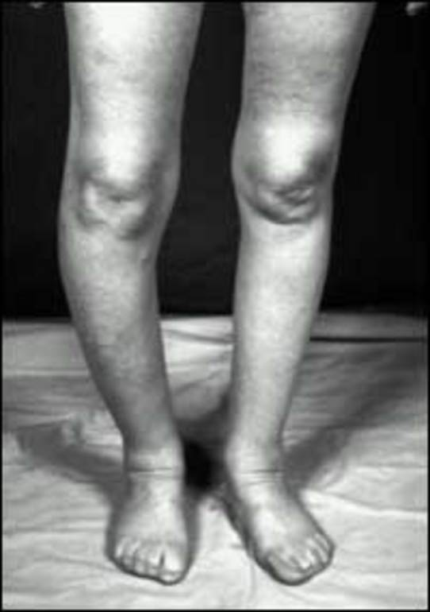
Figure 2. Typical bowing of the leg due to Paget's disease involving the right tibia.
Pathological fractures in the lower extremity are most likely to occur in the femur and typically are transverse in nature (Figure 3). They are much more likely to result in nonunion than are tibial fractures (28).
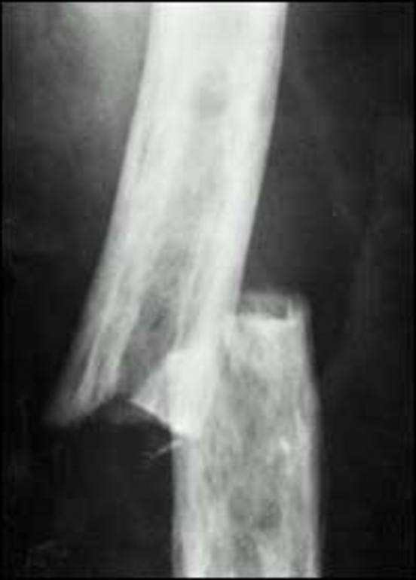
Figure 3. Transverse fracture of the left femur.

Pain

Pain is a quite common symptom in patients with Paget's disease. It may be of skeletal, joint, neurologic, or muscle origin. Surprisingly, bone pain is usually absent even in patients with extensive disease or, when present, is mild to moderate in severity. The pain is usually dull in quality and often persists during the night. Weight bearing seldom produces a significant increase in bone pain.

Severe pain in a patient with Paget's disease is most likely to be due to osteoarthritis. This commonly occurs in the hip joint. Deterioration of the cartilage can occur when Paget's disease affects the acetabulum alone (Figure 4), but is likely to be more severe when both the acetabulum and head of the femur are affected by Paget's disease. If the femoral head is the only site of the disease, osteoarthritis is a less likely complication. A major feature of the pain in these patients is a significant increase in severity with weight bearing. In some patients, the combination of pain and impaired motion of the joint severely limits mobility. Knee pain and joint effusion may be prominent features in patients with bowing of the tibia. Back pain due to osteoarthritis also occurs in association with Paget's disease (Figure 5). Pain from osteoarthritis of the shoulder joint is relatively uncommon.

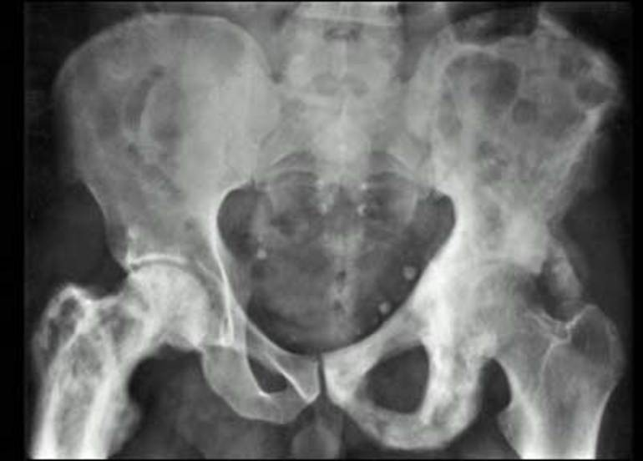
Figure 4. Paget's disease involving the left hemipelvis and right femur. There is severe osteoarthritis of the left hip but a relatively normal joint space in the right hip.

The most severe chronic pain in patients with Paget's disease is probably of neurologic origin. Pain from compression of the spinal cord or nerve roots may follow from enlargement of the vertebral bodies, pedicles, or laminae as well as from compression fractures. Pain from this source is more likely to arise from Paget's disease affecting the thoracic spine.
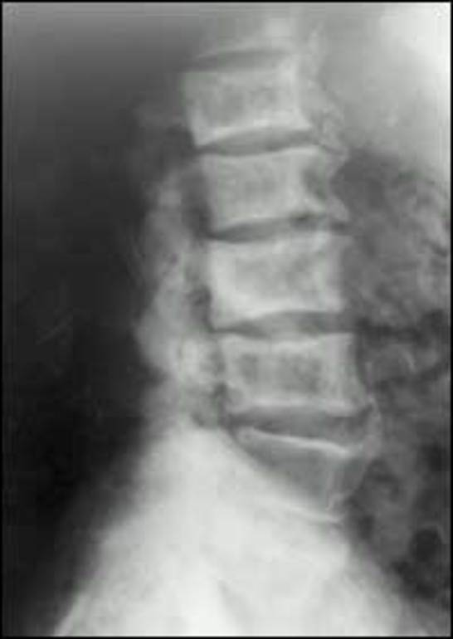
Figure 5. Patient with back pain who has multiple vertebrae affected by Paget's disease, large osteophytes, and narrowed disc spaces.

In a number of individuals, the weight of the skull may be so great that they have difficulty in keeping the head erect. This can produce neck pain and tension headaches due to muscle spasm. Deformity of the spine may also be associated with intermittent pain due to spasm of the paravertebral muscles.

RADIOLOGY

The radiologic features of Paget's disease include osteolytic, osteosclerotic, and mixed lesions.
The earliest lesions are osteolytic in character and are most readily appreciated in the skull (Figure 6). Circumscribed osteolytic skull lesions were called "osteoporosis circumscripta" by Schuller (29). These most often are seen in the frontal and occipital regions and with time may slowly coalesce. The other region where osteolytic lesions are commonly observed is the long bones of the lower extremity. The lesions usually arise at either end of the bone, seldom in the diaphysis. At the junction of the lesion with normal bone, the osteolytic lesion has the shape of a flame or inverted V (Figure 7). Such lesions have been noted to extend into normal bone at an average rate of about 1 cm per year (30).

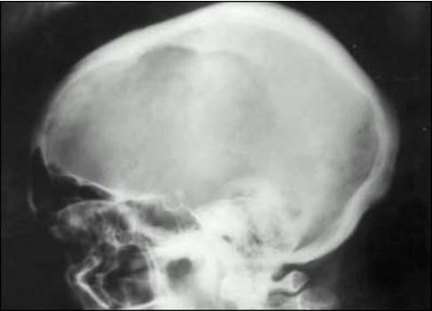
Figure 6. Large osteolytic lesion in the skull of a woman with Paget's disease.

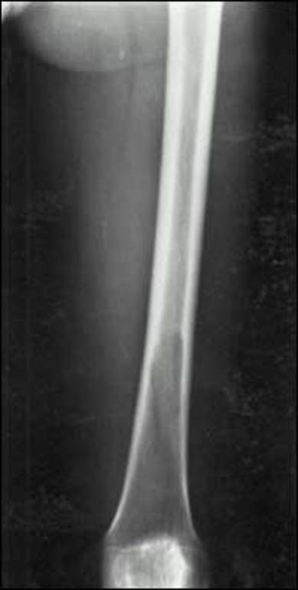
Figure 7. Osteolytic lesion of the distal left femur which is progressing proximally.

A heterogeneous region of osteosclerotic bone slowly develops in areas of the skeleton previously exhibiting a purely osteolytic character. This can be readily seen in long bones where the advancing front of osteolysis is trailed by patchy sclerosis superimposed on the earlier osteolytic process. With more time, the character of the bone may evolve into a dominant osteosclerotic appearance. This is often accompanied by periosteal new bone formation, which results in an increase in circumference of the bone. In the first observations reported by Paget, the thickness of the calvarium was fourfold greater than normal in one patient (1). The most severe skull involvement may be associated with basilar impression (Figure 8) which can produce compression of the structures in the posterior fossa resulting in ataxia, muscle weakness, and respiratory distress. With the evolution of the sclerotic phase of the disease, the lower extremity long bones often exhibit lateral and anterior bowing. Another radiologic feature in the long bones of the lower extremity is the presence of linear transverse radiolucencies in the cortex of the convex aspect of the bowed bone. These have been termed fissure fractures. Multiple fissure fractures may be seen. Although they usually remain stable, a small percent progress to complete transverse fractures.

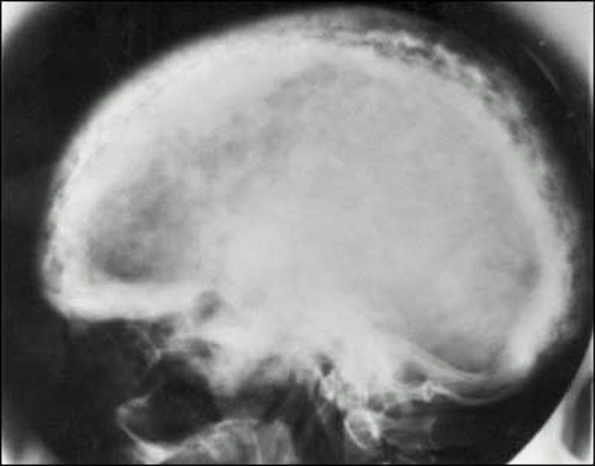
Figure 8. Far advanced Paget's disease of the skull. Note the thickened inner and outer tables, the chaotic new bone deposition termed cotton-wool patch, and basilar impression.

It has been observed that after a dominant sclerotic lesion has developed, there may be secondary osteolytic lesions superimposed upon the sclerotic bone. These are most readily seen as clefts in the cortex of the long bones.

Computerized tomography (CT) and magnetic resonance imaging (MRI) are generally not needed in the evaluation of most patients (31). CT may be needed to detect subtle fractures, spinal stenosis and secondary neoplasms. MRI may be particularly useful in evaluating spinal complications.

The commercial availability of a technetium99m-labeled bisphosphonate in 1974 ushered in the era of routine use of bone scans in clinical medicine (32). In patients with Paget's disease, the affected bone has increased nuclide activity five minutes after intravenous administration of the bone-seeking tracer when compared with normal bone. The nuclide activity is 3-5 times higher than in normal bone. A bone scan is a very effective means of determining the extent of the disease and is clearly more sensitive than X-rays in determining the presence of small osteolytic areas of the disease (Figure 9). Since occult fractures and bone metastases may mimic some lesions of Paget's disease, it is necessary to do X-rays or CT scans of areas of increased nuclide uptake to distinguish the nature of the lesions. Very seldom is it necessary to do a bone biopsy to ascertain the diagnosis.

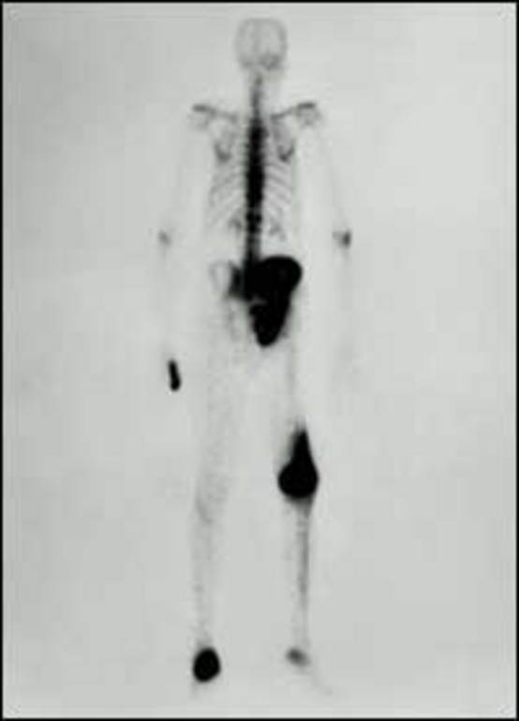
Figure 9. A technetium 99m-bisphosphonate bone scan of a patient with polyostotic Paget's disease.

In addition to the classical bone scan using a technetium-labeled bisphosphonate, gallium scans (33), fluorine-18-FDG PET scans (34), and Tl-201 scans (35) have been observed to delineate lesions of Paget's disease. In one study, the response to calcitonin treatment was more rapid with gallium scan than with a bone scan (33).

PATHOLOGY

Based on histological examinations of the interface of normal bone with an advancing osteolytic focus of Paget's disease, it has been concluded that the primary abnormality is a localized excess of osteoclastic bone resorption. An increased number of osteoclasts are present in Howship's lacunae in cortical and trabecular bone (Figure 10). They are frequently larger than normal and may have up to 100 nuclei in a single cross-section rather than the 3-10 found in normal osteoclasts (36). With progression of osteoclastic activity in the cortex, bone volume is reduced and individual osteons become confluent. The bone volume in trabecular bone of the medullary cavities is similarly reduced by osteoclastic activity. In association with the intense osteoclastic activity, the normal fatty or hematopoietic marrow is replaced by a fibrocellular stroma, which is highly vascular.

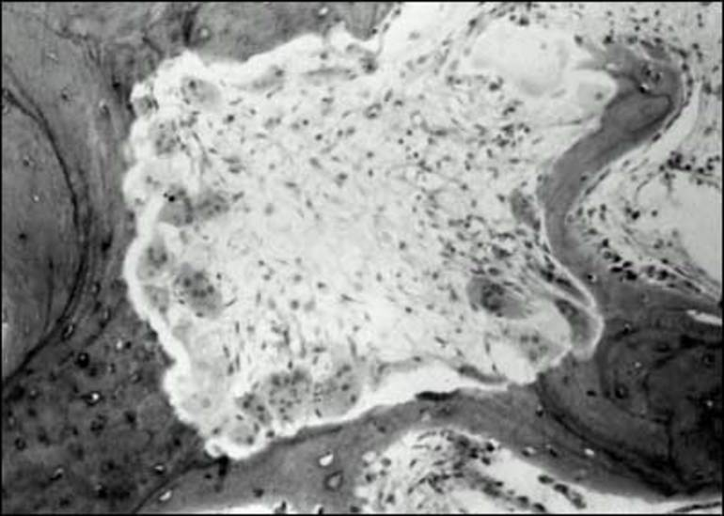
Figure 10. A bone biopsy of the iliac crest revealing an intense area of osteoclastic bone resorption. The osteoclasts are increased in size and have a greater number of nuclei than average.

In the mature lesion, there is a mixture of lamellar and woven bone, which transforms the matrix into a chaotic "mosaic" pattern of irregularly juxtaposed pieces of lamellar bone, interspersed with woven bone (Figure 11). The normal outer and inner circumferential lamellae and interstitial lamellae of the cortex are completely disrupted. Plump osteoblasts are found in large numbers on surfaces of new bone formation. There is an abundance of osteoid on bone surfaces but there is no increase in thickness of the osteoid seams (37). It has been noted that the size of the periosteocytic lacunae in the woven bone is greater than in the lamellar bone of Paget’s disease (37). Since this is also the finding in woven bone from non-pagetic individuals the relevance of this observation is unclear.
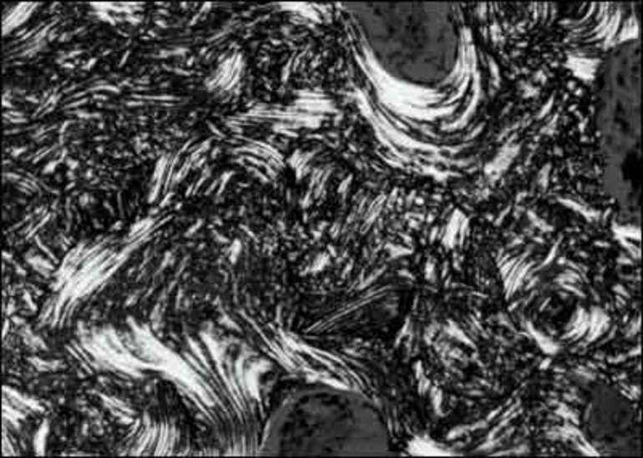
Figure 11. A bone biopsy demonstrating the "mosaic" pattern of bone matrix in Paget's disease. Note the chaotic lamellar pattern intermixed with woven bone as demonstrated with polarized light.

There is some evidence of a "burned out" phase of Paget's disease in which the abnormal matrix persists but cellular activity is nearly absent and the marrow space is mainly filled with fat. It is more likely that such a finding does not occur throughout an entire lesion, but is found with all stages of the disease in a single bone.

Studies of the ultrastructure of osteoclasts in Paget's disease have demonstrated that many of these cells harbor microfilaments in the nucleus and occasionally, in the cytoplasm (38,39) (Figure 12). The microfilaments have the same structural features as nucleocapsids of viruses of the Paramyxoviridae family, a family of RNA viruses known to cause childhood infections such as measles and pneumonia due to respiratory syncytial virus. The nucleocapsid-like structures have not been found in osteoblasts, osteocytes, or bone marrow cells in the same specimens containing the osteoclast microfilaments. Identical microfilaments have been found in a small percentage of the osteoclasts in giant cell tumors of bone and in the osteoclasts of some patients with osteopetrosis and pyknodysostosis (40).
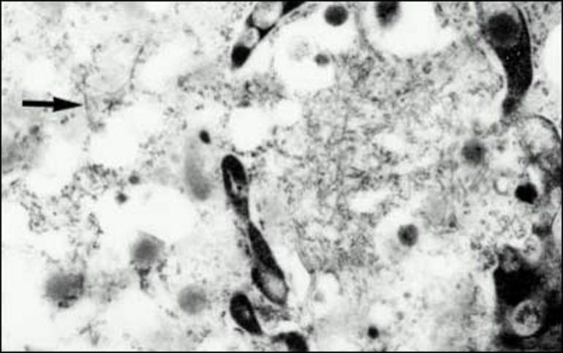
Figure 12. Electron microscopic examination of an iliac crest biopsy revealing microfilaments within remnants of a degenerating osteoclast nucleus. The arrow indicates microfilaments in adjacent cytoplasm. Magn. x 25,800

In addition to the structural evidence for the presence of viral nucleocapsids in the osteoclasts of Paget's disease, evidence of paramyxoviridae nucleocapsid proteins (41,42), and mRNA (43) has been reported, although not by all investigators (44). In one study addressing the identity of the osteoclast microfilaments, the full-length sequence for the measles virus nucleocapsid gene was delineated from the bone marrow of one patient as were more than 700 base pairs of the nucleocapsid gene in three additional patients (45).

BIOCHEMICAL ASSESSMENT

The radiologic and histologic evidence of increased bone resorption and formation in patients with Paget's disease is readily assessed by measuring biochemical markers of bone turnover. In general, these tests reflect the extent and activity of the disease.

Bone Resorption

Since the underlying cellular abnormality in Paget's disease seems to be increased bone resorption, one might expect that serum calcium and/or urinary calcium levels would be increased in some individuals with active Paget's disease. In the absence of fractures, immobilization, primary hyperparathyroidism, or bone metastases, this is not the case (46). Presumably, this is explained by a concomitant increase in bone formation, which has been defined by histopathology and by kinetic analysis of plasma disappearance rates and skeletal uptake of radiocalcium (46). Evidence of increased bone matrix resorption was first provided by the demonstration of increased urinary hydroxyproline excretion, a component of all types of collagen. Subsequently, more specific indices of bone resorption have been developed including pyridinoline, deoxypyridinoline, type I collagen N-telopeptide, and C-telopeptide. The latter two collagen components are the most specific markers of bone collagen resorption (47); serum and urine assays of the telopeptides are widely available for clinical use.

Bone Formation

Measurement of total serum alkaline phosphatase activity has been a means of evaluating Paget's disease for 90 years (4). The enzyme activity, which is localized in the plasma membrane of osteoblasts before extracellular release, correlates with the extent of the disease on skeletal surveys (48) and with parameters of bone resorption (48). The circulating enzyme activity usually increases gradually or does not change during long-term follow up of patients who are untreated (49). In patients with liver disease or who might be pregnant, it would be preferable to measure bone-specific alkaline phosphatase levels by immunoassay (50). Several of these assays have been developed which have little cross-reactivity with non-skeletal alkaline phosphatase. Measurement of serum procollagen type1-N-terminal peptide has proven to be valuable in assessing the response to teriparatide in osteoporosis patients. While these assays may have an advantage over the nonspecific total alkaline phosphatase activity with respect to specificity, no study has been done which indicates that they should replace this inexpensive assay for routine clinical use (51).

Other markers of bone formation such as serum osteocalcin or type I procollagen carboxyl-terminal peptide are not as sensitive as total or bone-specific alkaline phosphatase levels in assessing the response to therapy (47).

Sclerostin is an important protein produced by osteocytes which inhibits bone formation. Serum sclerostin has been noted to be elevated in patients with Paget’s disease (52) but is not correlated with serum C-telopeptide or serum procollagen type1-N-terminal peptide levels. The relevance of this finding remains to be established.

Calciotropic Hormones

Serum parathyroid hormone levels are generally normal in patients with Paget's disease (23). Elevated levels are found in the presence of concomitant primary hyperparathyroidism (53) and would be expected to also be increased in the presence of renal failure or vitamin D deficiency. Serum calcitonin levels are normal in Paget's disease (54) although there was prior speculation that low levels might contribute to the pathogenesis of the disease. In the absence of vitamin D deficiency, serum 25-hydroxy-vitamin D and 1, 25 dihydroxyvitamin D levels are normal. Inexplicably, 24,25-dihydroxyvitamin D levels have been reported to be low (55).

NEOPLASTIC COMPLICATIONS

Sarcoma

Sarcomas develop in the lesions of Paget's disease more often than in an age-matched normal population, although the incidence is less than 1% overall (56). However, in patients with extensive disease, the incidence has been estimated at 10% (57), although a subsequent study suggests this is not so (58). Rarely, sarcomas have been known to develop in multiple members of a family.

A sarcoma should be suspected when new pain and swelling develop in a bone previously affected by Paget's disease. The most common sites are in the pelvis, femur, humerus, skull, and facial bones.

There is a variable histology of the sarcomas of Paget's disease including osteosarcoma, fibrosarcoma, chondrosarcoma, and anaplastic sarcoma (57). Several types of histology may be present in a single tumor. Multinucleated giant cells (probably osteoclasts) may be scattered throughout a tumor. They may contain the nuclear microfilaments seen in the osteoclasts and are not thought to be neoplastic in nature (59).

Because of the underlying distortion of the pagetic bone, it is difficult to detect an early stage of a sarcoma. Typically, a radiolucent focus with speckled regions of calcification will be observed to disrupt the cortex of the bone (Figure 13). The best means of delineating the extent of the tumor mass is by CT or MRI.

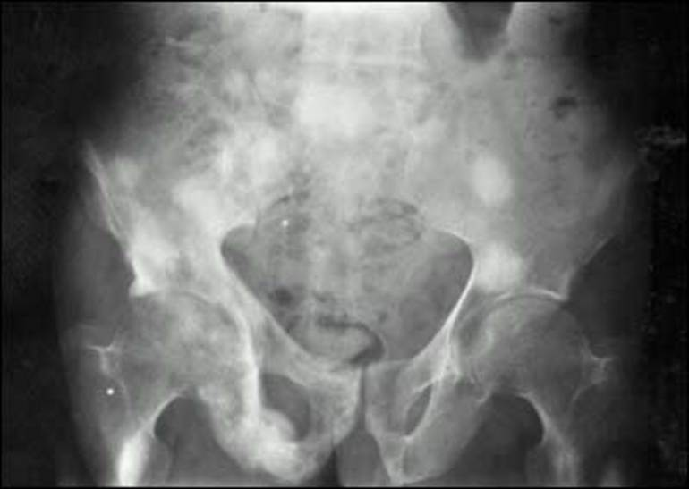
Figure 13. Multiple sites of osteogenic sarcoma in a patient with Paget's disease of the right hemipelvis. Note the extension of the tumor through the cortex of right ischium.

Perhaps because of a failure of early diagnosis in most patients with sarcoma arising in Paget's disease, survival is brief. Only 7.5%-10% of patients survive five years and despite the multiple modalities of therapy presently available, the prognosis remains poor (56,60).

Giant Cell Tumor

Giant cell tumors of bone may arise in lesions of Paget's disease, often in the skull and facial bones (61). They are nearly always benign and appear to be less common than sarcoma in Paget's disease. As is the case with sarcoma, they rarely may appear in multiple family members who have Paget's disease (62).

A prominent feature of the tumors is the presence of large numbers of multinucleated giant cells, a small percentage of which contain the nuclear microfilaments typical of the osteoclasts of Paget's disease (61). The neoplastic component of the giant cell tumor is a spindle-shaped cell with fusiform nuclei and clumped chromatin. These cells rarely have mitoses. There may be some difficulty in distinguishing these tumors from giant cell reparative granulomas, which commonly arise in the jaws (63).

Giant cell tumors in Paget's disease are usually successfully treated with surgery and radiation therapy. In a few patients, high doses of dexamethasone have been shown to shrink the tumors (64). Denosumab has been effective in treating patients with giant cell tumors (65) but has not been studied in patients with giant cell tumors arising in the lesions of Paget’s disease.

Other Neoplasia

Other neoplastic processes such as lymphoma (56), multiple myeloma (57), various carcinomas, and parathyroid tumors (53) have been reported in association with Paget's disease, but are probably chance occurrences. Metastatic cancers have been reported to metastasize to the highly vascular lesions of Paget's disease.

SYSTEMIC COMPLICATIONS AND ASSOCIATED DISEASES

Hypercalcemia

Hypercalcemia may occur as a consequence of immobilization in patients with Paget's disease (66), although this is an unusual clinical event. This is believed to occur because immobility results in increased bone resorption and decreased bone formation.

Hypercalcemia can also occur in association with a malignancy (67). More commonly hypercalcemia in Paget's disease occurs as a consequence of primary hyperparathyroidism (53). Correction of the hyperparathyroidism by surgery produced a decrease of 68% in plasma alkaline phosphatase in a series of 18 patients (53). The clinical features of these patients were quite similar to hyperparathyroid patients without Paget's disease, prompting the investigators to speculate that the two diseases were associated by chance.

Hyperuricemia and Gout

Hyperuricemia has been observed to be common in males with relatively severe Paget's disease (48). Clinical episodes of gouty arthritis occurred in almost half of these individuals. In a larger population of Paget's disease patients, hyperuricemia (20%) and gout (4%) were not felt to be increased in incidence (68). The differences in hyperuricemia and gout might be explained by the severity of the disease in the two study populations. With extensive skeletal involvement, a high turnover of nucleic acids in the lesions of Paget's disease could increase the urate pool enough to produce a clinical disturbance of urate metabolism (69).

Cardiovascular Dysfunction

A hallmark of the pathology of Paget's disease is the increased vascularity of affected bones. Further evidence for this has been documented by demonstration of an increase in blood flow to the extremities (70), although it has been suggested that this is mainly caused by cutaneous vasodilation (71). An echocardiographic study of cardiac function in Paget's disease found that patients with more severe disease had lower peripheral vascular resistance and higher stroke volume (72). These observations help account for the finding that patients with 15% or more of their skeleton affected by Paget's disease have increased cardiac output (73). High output congestive heart failure can occur.

It is possible that increased cardiac output in patients with Paget's disease accounts for an increased incidence in calcific aortic stenosis through causing turbulence across the valve. Patients with Paget's disease have a 4-6 times higher incidence of this lesion than control subjects (74,75). Calcification of the interventricular septum has also been reported in patients with Paget's disease and may be associated with complete heart block (75,76). It also has been reported that arterial calcification is more common in Paget’s disease than in control subjects in the aorta as well as in iliac, femoral, gluteal and pelvic arteries (77). The explanation for this is unknown.

A less certain consequence of an increase in vascularity of bone and surrounding soft tissues is a variety of vascular steal syndromes. Patients with marked enlargement of the skull have been noted to be withdrawn, somnolent, and weak. These findings might be explained by shunting of blood from brain vessels to the external carotid artery system (78). It has also been proposed that spinal cord dysfunction might be a consequence of shunting of blood flow from the spinal arteries to the bone (79).

TREATMENT

Prior to 1975, a number of nonspecific treatments were used to attempt to alleviate some of the manifestations of Paget's disease. With the exception of pain medications none were of value. With the development of salmon calcitonin, a new era of effective treatment began. Presently, there are a number of highly effective agents which make possible excellent control of the disease.

Pretreatment Evaluation

The initial goal of patient evaluation is to establish which bones are affected by Paget's disease and what symptoms the lesions produce. A search for skeletal deformity may indicate one or more bones are involved, but this should be confirmed by X-rays. The full extent of the disease would best be ascertained by full body bone scan followed by radiologic confirmation of the disease in areas of increased tracer uptake. The decision as to which patient requires a bone scan is an individual one. For example, a 90-year old asymptomatic patient who is found to have Paget's disease in the pelvis during an intravenous pyelogram probably does not need a scan.

There is now a considerable choice of bone resorption and bone formation parameters which could be used to determine the overall metabolic activity of the disease. For routine clinical purposes, in most patients, measurement of total serum alkaline phosphatase activity is an effective and inexpensive test.

Drug Therapy

Calcitonin

Calcitonin is a peptide hormone whose main pharmacologic effect is rapid inhibition of bone resorption. This is mediated by binding of the hormone to its receptor on the surface of osteoclasts.

Salmon calcitonin was the first calcitonin species approved by regulatory agencies for treatment of Paget's disease. A dose of 50 to 100 U given daily or three times a week produces relief of bone pain in most patients within 2-6 weeks. Following suppression of the metabolic activity of the disease cardiac output is reduced (80) as is the skin temperature over affected tibiae. In addition, some patients have had dramatic improvement of neurologic deficits (81). Stabilization of hearing loss has also been noted (82). Because the drug has been shown to reduce the vascularity of bone affected by Paget's disease, it has been given preoperatively to reduce the degree of hemorrhage in patients scheduled for orthopedic procedures (83).

A single injection results in an immediate decrease in urinary hydroxyproline reflecting an acute inhibition of bone resorption. A maximal effect occurs in several months. Serum alkaline phosphatase activity falls more slowly; a significant decrease is generally not seen for one month. Within 3-6 months, both hydroxyproline excretion and alkaline phosphatase activity decrease on average by 50%. If treatment is stopped, urinary hydroxyproline gradually increases over several months followed by an increase in alkaline phosphatase activity back to pretreatment levels. With chronic treatment osteolytic lesions generally are reversed (84). However, if treatment is not continuous, the osteolytic lesion will recur. Reduced uptake of radiolabeled bisphosphonate (85) and gallium (33) occurs during long term treatment. Bone biopsies exhibit a reduced number of bone cells, a decrease in marrow fibrosis, and a reduction of woven bone volume (86).

Since salmon calcitonin is a foreign protein, it is not surprising that more than half of patients on long-term treatment develop specific antibodies against the hormone in the circulation (87). High titers of these antibodies almost always impair the response to continuing treatment so that up to 26% of patients have become resistant to the drug. Although no longer available for clinical use, human calcitonin was effective in inducing remissions in salmon calcitonin-resistant patients. Presently, any of the bisphosphonates can be used to treat these patients.
Salmon calcitonin injections may cause nausea and facial flushing in 10-20% of patients. Vomiting, abdominal pain, diarrhea, and polyuria are much less common side effects. Rarely tetany and allergic reactions have been reported. Nasal spray salmon calcitonin is much less likely to cause side effects but has lower potency (88). At this time, salmon calcitonin is used much less frequently than in the past because of the development of potent bisphosphonates.

Bisphosphonates

The development of the bisphosphonates for the treatment of skeletal disorders associated with increased bone resorption has been a major advance in the management of Paget's disease (89). These drugs, initially known as diphosphonates, are analogues of inorganic pyrophosphonate, a factor believed to be a necessary component for the mineralization of bone. All bisphosphonates have a central P-C-P core, which was substituted for the naturally occurring P-O-P core of pyrophosphate, because unlike P-O-P, the P-C-P structure is impervious to metabolic degradation. The bisphosphonates have a profound influence on bone metabolism, in part, because they bind to hydroxyapatite. The primary effect of bisphosphonates is to inhibit osteoclastic bone resorption, which in vivo is followed by a secondary decrease in bone formation. The earliest bisphosphonates which were developed, etidronate and clodronate, appear to achieve their effects by generating nonhydrolyzable analogues of adenosine triphosphate, while the later generation of more potent aminobisphosphonates, such as pamidronate and risedronate, inhibit protein prenylation through inhibition of farnesyl pyrophosphate synthase, a key enzyme in the mevalonate pathway. Although it is generally believed that bisphosphonates act directly on the differentiation and function of osteoclasts, evidence has accumulated which indicates that some bisphosphonates regulate cell proliferation, differentiation, and gene expression in human osteoblasts in vitro (90). How such observations translate into in vivo actions of bisphosphonates is unclear.

In table I, the bisphosphonates presently approved for treatment of Paget's disease in the United States are listed with their recommended regimes. There are four oral bisphosphonates available whose recommended daily treatment courses range from two months to six months and two intravenous bisphosphonates.

Table 1. Bisphosphonates Approved for Treatment of Paget's Disease
Bisphosphonates available in U.S.A. | Administration and Dosage
Etidronate  Trade Name: Didronel®  FDA approval: 1977 | 1. Tablet  2. 200 to 400 mg once daily for 6 months  200-400 mg dose is approved; 400 mg dose is preferred  3. Must be taken with 6-8 ounces of water on an empty stomach (no food, beverages, or medications for 2 hours before and after dose).  4. Course of Didronel® should not exceed 6 months.  5. Repeat courses can be given after rest periods of 3-6 months duration.
Pamidronate  Trade Name: Aredia®  FDA approval: 1994  Generic available | 1. Intravenous  2. Approved regimen is 30 mg intravenous infusion over 4 hours on 3 consecutive days  3. A more commonly used regimen is a 60 mg or 90 mg intravenous infusion over 2-4 hours and repeated as clinically indicated.  4. A single infusion is sometimes effective in mild disease; 2-3 or more infusions may be required in more severe disease.  5. A course of Aredia® may be readministered at intervals as needed.
Alendronate  Trade Name: Fosamax®  FDA approval: 1995  Generic available | 1. Tablet  2. 40 mg once daily for 6 months· Must be taken on an empty stomach, with 6-8 ounces of water, in the morning.  3. Wait at least 30 minutes after taking Fosamax® before eating any food, drinking anything other than tap water, or taking any medication.  4. Do not lie down for at least 30 minutes after taking Fosamax®. (Patient may sit.)  5. Available by mail order to the general public.
Tiludronate  Trade Name: Skelid®  FDA approval: 1997 | 1. Tablet  2. 400 mg (two 200 mg tablets) once daily for 3 months  3. Must be taken on an empty stomach with 6-8 ounces of water.  4. Skelid® may be taken any time of day, as long as there is a period of 2 hours before and after resuming food, beverages, and medications.
Risedronate  Trade Name: Actonel®  FDA approval: 1998 | 1. Tablet  2. 30 mg once daily for 2 months  3. Must be taken on an empty stomach, with 6-8 ounces of water in the morning.  4. Wait at least 30 minutes after taking Actonel® before eating any food, drinking anything other than tap water, or taking any medication.  5. Do not lie down for at least 30 minutes after taking Actonel®. (Patient may sit.)
Zoledronic Acid  Trade Name: Reclast®  FDA approval: 2007 | 1. Intravenous  2. A 15 minute infusion of 5mg  3. Creatinine clearance must be >35 ml/min  4. Correct vitamin D deficiency and/or hypocalcemia before infusion  5. To reduce the risk of hypocalcemia after infusion, patients should receive 1500mg calcium and 1000 units vitamin D3 daily for two weeks
*Adapted from Information for Patients about Bisphosphonates, A Publication of the Paget Foundation for Paget's Disease of Bone and Related Disorders (2007).

The least potent bisphosphonate, etidronate, is similar to salmon calcitonin with respect to suppression of the metabolic activity of Paget's disease. The more potent aminobisphosphonates, pamidronate, alendronate, risedronate, and zoledronic acid can induce biochemical remissions in the majority of patients. In the past patients with extensive disease and markedly elevated biochemical parameters may have impressive reductions in serum alkaline phosphatase activity yet not reach normal levels (91). However, patients treated with zoledronic acid, no matter how high the baseline serum alkaline phosphatase activity, nearly always reach the normal range of enzyme activity (92). Most of the clinical benefits attributed to salmon calcitonin are produced by the aminobisphosphonates, yet it remains to be demonstrated whether long term biochemical remissions with any agent can reduce the incidence of future complications such as hearing loss and deformity.

The oral bisphosphonates are poorly absorbed and must be taken with water only. In clinical trials, side effects involving the gastrointestinal tract were not greater in patients receiving the drug than in the placebo group. However, some individuals experience abdominal distress or diarrhea. Patients receiving an oral aminobisphosphonate are advised to remain upright for at least 30 minutes after taking the drug to reduce the chance of esophageal irritation. A small percentage of patients may experience a transient increase in bone pain. The first infusion of pamidronate (93) or zoledronic acid (92) may produce an acute phase reaction in 30-50% of patients manifested by fever, myalgia, and elevation of circulating interleukin 6 levels (93). Subsequent infusions produce little or no side effects. The mechanism responsible for the acute phase reaction appears to be release of cytokines from gamma delta T cells (94), which is worsened by vitamin D deficiency (95). Vitamin D supplementation in patients with low levels is very effective in preventing acute phase reactions and all patients who will be receiving pamidronate or zoledronic acid should have normal levels of serum 25OHD prior to the infusion (96). Allergic reactions to bisphosphonates are rare and most commonly manifest as inflammatory eye reactions due to pamidronate (97). If etidronate is used at a dose greater than 5 mg/kg body weight, osteomalacia may be a consequence (98). Another disadvantage of etidronate use is that osteolytic lesions may progress despite evidence of biochemical improvement (99).

Treatment with a potent bisphosphonate may produce long remissions. This is the most likely to be seen after treatment with zoledronic acid. A single infusion restores biochemical markers of bone turnover into the normal range and this is maintained for up to six and a half years in most patients (100). This response is largely independent of pretreatment disease activity. However, with the older bisphosphonates induction of a remission correlates well with the extent and activity (alkaline phosphatase) of the disease (101). Patients with less extensive disease and lower alkaline phosphatase activity are more likely to achieve remission. With respect to the duration of a remission, this appears to be dose-dependent as well as correlated with the nadir value of serum alkaline phosphatase activity, the number of affected bones, and the number of previous therapies (101). Intravenous ibandronate may produce a prolonged response but is not an FDA-approved therapy for Paget’s disease (102).

Resistance to etidronate therapy is commonly seen after two six-month courses of the drug (103). There is also evidence that resistance to intravenous pamidronate (101) or clodronate (104) can occur. In pamidronate-resistant patients, treatment with alendronate was effective (104). In the clodronate-resistant patients, either risedronate or pamidronate was effective (105). There is no information which explains the mechanism responsible for apparent decreased efficacy of these agents with time. It is possible that an increase in the disease activity is responsible for these observations rather than a change in efficacy of the drugs.
Considerable publicity has been given to the development of osteonecrosis of the jaw in patients treated with bisphosphonates (106). This mainly is seen in cancer patients given monthly infusions and is rare in patients with Paget’s disease.

Miscellaneous Agents

Other inhibitors of bone resorption such as plicamycin and gallium nitrate, approved for treatment of hypercalcemia of malignancy, are effective in treating Paget's disease (107,108). In view of the safety and efficacy of the aminobisphosphonates, there is very little present use of these agents. The most potent antiresorptive agent, denosumab, has been reported to decrease disease activity in two patients with Paget’s disease (109, 110). In 1971 glucagon infusions were reported to markedly reduce of bone turnover parameters in four patients with Paget’s disease (111) but large trials have not been reported.

Treatment and Posttreatment Evaluation

Assessment of total serum alkaline phosphatase activity is generally sufficient to determine the success of treatment. The frequency of evaluation does not need to be more frequently than every 3 months after the onset of the treatment and can be extended to every 6-12 months after a nadir has been reached. Serial nuclear scans of the skeleton are more sensitive in defining no residual disease activity than biochemical results as reported in one study (112). Minimal to significant disease activity was found in two-thirds of patients who had normal biochemical parameters after zoledronic acid infusions. A second infusion produced complete remission. It is uncertain how clinically important it is to produce complete suppression of radioisotope uptake in patients with normal biochemistry after treatment. If a patient has a well- defined osteolytic lesion on X-ray, it can be assessed annually to assure the disease is well-controlled.

Indications for Treatment

Effective drug treatment for Paget's disease has evolved over 45 years, but there have been no large, randomized, long-term clinical trials, which can provide definitive guidelines for treatment. Nevertheless, in table 2, indications for drug treatment of Paget's disease are listed. These are based on a review of the literature and a large personal experience.

Table 2. Indications for Drug Treatment of Paget's Disease
1. Bone pain
2. Hypercalcemia due to immobilization
3. Neurologic deficit associated with vertebral disease
4. High-output congestive heart failure
5. Preparation for orthopedic surgery
6. Prevention of complications including hearing loss, deformity

Although bone pain is not a problem in the majority of patients, it is a clear indication for treatment. In patients in whom bone pain is difficult to distinguish from joint pain treatment of the Paget's disease will usually clarify the source of pain. Treatment should also correct hypercalcemia in an immobilized patient, a rare situation. Neurologic deficits may improve with treatment, also a very unusual complication. High output heart failure should respond favorably to a treatment which lowers the cardiac workload. Reducing the vascularity of the bone and surrounding soft tissue before elective orthopedic surgery should reduce perioperative bleeding.
A major indication for treatment could be the prevention of future complications. There is some evidence that progression of hearing loss is reduced by treating patients with cranial disease. Prevention of deformity of lower extremity long bones and secondary osteoarthritis is a reasonable possibility. Presumably, early treatment would reduce the incidence of future fractures. It would be more speculative as to whether the incidence of sarcoma or giant cell tumor formation would be influenced.

To achieve the long-term goals of therapy such as prevention of future complications, it may be necessary to maintain the serum alkaline phosphatase activity within the normal range. Future very long-term studies would be needed to determine if complications can be abolished.

Surgery

In table 3, the various surgical procedures which have been utilized in the management of Paget's disease are listed.

Table 3. Surgical Procedures for Management of Paget's Disease
1. Total hip replacement
2. Total knee replacement
3. Femoral osteotomy
4. Tibial osteotomy
5. Suboccipital craniectomy and upper cervical vertebral laminectomy for basilar impression
6. Ventricular shunting for hydrocephalus
7. Stapes mobilization or stapedectomy
8. Surgery for correction of spinal stenosis or nerve root compression

Total hip replacement is probably the most common elective orthopedic procedure in patients with Paget's disease (113,114). Pain relief and improved mobility occur in a high percentage of patients. Postoperatively, heterotopic ossification may be somewhat more common, but is seldom a significant problem. For patients with severe osteoarthritis of the knees, total knee replacement is an effective treatment (115). Knee pain and joint effusions associated with osteoarthritis and tibial bowing may be effectively treated by tibular and fibular osteotomy (83).

There is much less experience with neurosurgical procedures in treating Paget's disease. However, successful relief of symptoms is expected after surgery for spinal stenosis or nerve root compression (116). Percutaneous vertebroplasty might be considered in patients thought to have vertebral bone pain who do not respond to conservative therapy (117). Stapes mobilization or stapedectomy has not proven to be effective in improving hearing loss. One patient treated with cochlear implantation was reported to have improved speech perception (118).

ETIOLOGY

Slow Virus Infection

The possibility that Paget's disease fell into the category of a slow virus infection was suggested by the observation that the osteoclasts in this disorder harbored nuclear and cytoplasmic microfilaments which were essentially identical in structure to nucleocapsids of the Paramyxoviridae virus family (38,39). Immunochemical studies (40-42), and sequence analysis of nucleocapsid transcripts (43) have supported the initial hypothesis although not all studies have been positive with respect to a viral presence in the osteoclasts (44). Indirect support for the role of measles virus comes from a consideration of the availability of measles vaccine throughout the world (119). The vaccine was introduced in the United States in 1963, in Australia in 1967, in the United Kingdom and France in 1968, in New Zealand in 1969, in the Netherlands and Italy in 1976 and in Spain in 1978. Availability of the vaccine for more than 50 years in several countries might explain a decrease in prevalence whereas delayed availability might explain why other regions may not have had a decrease as yet.

Non-Viral Environmental Influences

A number of reports have suggested that toxins such as arsenic and lead and animal exposure to dogs and cattle may be factors in the pathogenesis of Paget’s disease (119). The most recent study indicates that exposure to woodburning during childhood, living near a mine, and hunting may be related to developing the disorder (120). Exactly how these factors might produce pagetic lesions is unknown.

Genetics

Since there is clearly a familial aggregation of Paget's disease in up to 40% of patients with Paget's disease (17,19), a search for a predisposition gene or genes has been undertaken by a number of investigators. The initial attempts to define genetic susceptibility in Paget's disease centered on chromosome 6 because of known associations between disease susceptibility and histocompatibility loci on this chromosome (121). Although there is some evidence for human leucocyte antigen linkage in families with Paget's disease no gene locus has yet been defined on chromosome 6.

The initial localization of a predisposition gene for Paget's disease came from linkage studies with chromosome 18 markers (122,123). Attention was given to chromosome 18 because of the discovery that mutations of receptor activator of nuclear factor kB (RANK), a critical osteoclastogenic factor, were responsible for the skeletal disorder, familial expansile osteolysis (124), a condition which bears some resemblance to Paget's disease (125). Although chromosome markers have indicated linkage to Paget's disease in the region of the RANK gene on chromosome 18, no RANK mutations have been found in families of typical Paget's disease.

A second susceptibility locus, not associated with RANK, has been identified on chromosome 18 in a large Australian kindred (126). A further finding of interest on chromosome 18 is that sarcomas arising in Paget's disease may harbor a tumor suppressor gene in the same region as the first locus to be described (127).

In 2002 Laurin and colleagues (128) reported that mutations in the sequestosome 1 gene on chromosome 5 were associated with Paget’s disease in 11/24 French Canadian families and in 18/112 apparently sporadic patients. Mutations of this gene were subsequently found in families in the United Kingdom, Australia, New Zealand, the United States, and The Netherlands. Mutations have also been found in a smaller percentage of patients with sporadic disease. More than 20 different mutations have been described, nearly all of which are clustered around the ubiquitin binding domain of the sequestosome 1 protein (128-131). This protein modulates activity of the NF-κβ pathway, an important mediator of osteoclast function, and has also been implicated in the process of autophagy in osteoclasts (132).

A second gene abnormality has been described in the rare syndrome of inclusion body myopathy, frontotemporal dementia, and Paget’s disease (133). More than 50 mutations have been identified in the VCP gene (134). Only about 50% of the individuals with a mutation have demonstrable Paget’s disease (135). VCP has a ubiquitin-binding domain as does sequestosome 1 and like sequestosome 1 is thought to play a role in autophagy (136). A search for VCP mutations in familial and sporadic Paget’s disease patients was negative in one study (137) and revealed a polymorphism associated with sporadic Paget’s disease in another study (138).

Further evidence of the heterogeneity of the genetics of Paget’s disease has come from studies reporting linkage of the disease with candidate loci at chromosome 5q31 and 5q35-qter (139), chromosome 2q36 (140), and chromosome 10p13 (140,141).

In a relatively small group of Paget’s disease patients, no mutations of the osteoprotegerin gene were found and a statistically significant increased frequency for the C allele in exon 2 was noted compared to control subjects (142). In a larger study a common polymorphism of the osteoprotegerin gene, G1181C, was found to predispose to the development of sporadic and familial Paget’s disease (143). Estrogen receptor-a and calcium-sensing receptor genotyping were significantly different in Paget’s disease versus control subjects in another study (144).
In the past 10 years 14 new susceptibility loci for Paget’s disease have been reported (145-158). Most of these are likely to influence bone metabolism (CSF1, TNFRSF11A, PML, TM7SF4, UCMA/GRP, DKK1, CTHRC1, OPTN, RIN3, hnRNPA2B7, FKBP5, ZNF687, BER, C9ORF72 hexanucleotide repeat expansion frequency). In one study single nucleotide polymorphisms were believed to amplify the effect of sequestosome 1 mutations and thereby magnify the severity of Paget’s disease (159).

In giant cell tumors arising in pagetic lesions H3F3A mutations have been detected and are associated with a higher number of osteoclast-like giant cells and an increased number of nuclei per cell (154) as compared with giant cell tumors occurring without Paget’s disease.

Clearly great progress has been made in studies of the genetics of Paget’s disease but the data suggest that an individual with a mutation has an increased susceptibility to develop particularly severe Paget’s disease but may not ever manifest evidence of the disorder. In a study of 84 offspring from 10 families whose Paget’s disease was associated with sequestosome 1 mutations, only 17% of the 23 offspring (mean age 45 years) who had mutations had evidence of the disease as indicated by bone scans (160). The offspring with normal scans had a mean age of 44 years and the mean age of the parents at the time of diagnosis was 48 years. There is incomplete penetrance of the Paget’s disease trait in these families although it is possible more offspring with aging will develop Paget’s disease in the future. In another study only 52% of patients with a VCP/p97 gene mutation were noted to have a lesion of Paget’s disease after extensive radiologic surveys (134). No assessment of viruses in the bone of these patients has been reported. In the most recent report from The Netherlands after 15.9 years of follow-up of sequestosome 1 mutation family members of pagetic patients only one individual (7.1%) was found to develop Paget’s disease (161). Fourteen individuals were followed and their ages ranged from 52 to 74 years.

Animal Models and In Vitro Models of Paget’s Disease

Transgenic mice have been utilized to investigate the potential roles of the measles virus nucleocapsid gene and the sequestosome1/p62 and VCP/p97 gene mutations in the pathogenesis of Paget’s disease. Targeting of the measles virus nucleocapsid gene into osteoclasts of transgenic mice produced lesions in some vertebrae which strongly resembled the lesions of Paget’s disease, increased osteoclastic activity with exuberant new bone formation often of woven character was observed (162). The same investigators targeted the most common sequestosome1/p62 mutation in familial Paget’s disease, P392L, into the osteoclasts of transgenic mice (163). They observed increased numbers of osteoclasts associated with bone loss but no increase in osteoblastic activity characteristic of Paget’s disease. Transduced osteoclast precursors isolated from the mice were hyperresponsive to receptor activator of NF-kappa B ligand (RANKL) and TNF-alpha but did not exhibit increased 1,25 (OH)2D3 responsivity, TAF(11)-17 expression, or increased number of nuclei per osteoclast, features found in osteoclast precursors isolated from individuals with Paget’s disease. In contrast to this study, Daroszewska and colleagues did find that targeting the P392L mutation into transgenic mice produced a Paget-like bone pathology predominantly in the lower limbs (164). They also found that osteoclast precursors had increased sensitivity to RANKL in vitro but did not examine 1,25(OH)2D3 sensitivity or TAF(11)-17 expression. They found nuclear inclusions also but it was not certain that they were identical to those found in patients. The explanation for the different results in these two studies is not apparent.

To examine the potential interaction of the measles virus nucleocapsid gene and the P392L mutation Kurihara and colleagues undertook studies of bone marrow specimens from patients with familial Paget’s disease who had the P392L mutation, utilizing specimens from pagetic and normal bone as well as from normal volunteers (165). The effects of antisense-measles virus nucleocapsid protein (MVNP) on osteoclast characteristics were different in marrow specimens from pagetic bone versus nonpagetic bone. The patient specimens which had MVNP expression responded to the antisense –MVNP with a reduction in osteoclast number, TATA box-binding protein associated factor 12 expression, 1,25 (OH)2D3 –stimulated IL-6 production and bone resorption, observations indicating a reversal of the usual features of osteoclasts generated from the marrow of sporadic or familial Paget’s disease patients. The results indicate an important role of measles virus in pagetic lesions. A contribution of the P392L mutation to the pathologic process was suggested by the fact that there was hyperresponsiveness to RANKL in both the pagetic and nonpagetic bone marrows obtained from the familial patients. These investigators then went on to carry out experiments in transgenic mice by cross breeding mice with MVNP and P392L mutations (165). The mice who harbored both MVNP and P392L had more severe Paget-like lesions than mice with MVNP alone. As expected zoledronic acid treatment of p62^{P394L} mice with a high rate of bone resorption produced marked suppression of bone resorption (166).

Two groups have generated transgenic mice expressing mutant forms of the VCP/p97 gene (167,168). In both studies increased osteoclastic activity appeared to be the dominant histologic feature with a modest amount of sclerotic bone being present. No studies evaluating the characteristics of the osteoclast precursors were reported.

In a mouse study it was discovered that osteoclasts obtained from optineurin mutant mice have an increase in NF-kB activation and a reduction in response to RANKL as compared to wild-type mice (169). Bone histology revealed increased osteoclastic activity and increased bone formation but the overall histology was not typical of Paget’s disease.

A model to explain the coupling of bone resorption to bone formation in Paget’s disease has been developed utilizing osteoclasts from pagetic patients and transgenic mice harboring a knock-in of p62^{P394L} (170). It was concluded that in Paget’s disease, measles virus nucleocapsid protein upregulates IL-6 and IGF1 in osteoclasts to increase ephrinB2-EphB4 coupling and thereby promotes bone formation. This is the first hypothesis to explain the masked level of bone formation in Paget’s disease.

REFERENCES

1. Paget J. On a form of chronic inflammation of bones. (Osteitis deformans). Med Chir Trans. 1877;60:37.
2. Leopold-Levi M, Londe A. Application des rayons de Roentgen a l'etude de la texture. N iconog. de la Salpetriere, Paris. 1897;X:198-201.
3. Beclere M. Radiographie d'un cas de maladie de Paget. Bull Mem Soc Med Hop Paris. 1901;18:929-931.
4. Kay H. Plasma phosphatase in osteitis deformans and in other diseases of bone. Brit J Exp Path. 1929;10:253.
5. Barker DJ, Chamberlain AT, Guyer PB, Gardner MJ. Paget's disease of bone: the Lancashire focus. Br Med J. 1980;280:1105-1107.
6. Abdulla O, Naqvi MJ, Shanshuddin S, Bukhari M, Proctor R. Prevalence of Paget’s disease of bone in Lancaster: Time for an update. Rheumatology. 2019 57:931-932
7. Altman RD, Bloch DA, Hochberg MC, Murphy WA. Prevalence of pelvic Paget's disease of bone in the United States. J Bone Miner Res. 2000;15:461-465.
8. Lecuyer N, Grados F, Dargent-Molina P, Deramond H, Meunier PJ, Fardellone P. Prevalence of Paget's disease of bone and spinal hemangioma in French women older than 75 years: data from the EPIDOS study. Joint Bone Spine. 2000;67:315-318.
9. Cundy HR, Gamble G, Wattie D, Rutland M, Cundy T. Paget’s disease of bone in New Zealand: Continued decline in disease severity. Calcif Tissue Int. 2004:75;358-364.
10. Poor G, Donath J, Fornet B, Copper C. Epidemiology of Paget’s disease in Europe: the prevalence is decreasing. J Bone Miner Res. 2006;21(10):1545-9.
11. Tiegs RD, Lohse CM, Wollan PC, Melton LJ. Long-term trends in the incidence of Paget's disease of bone. Bone. 2000;27:423-427.
12. Corral-Gudino, L, Borao-Cengotita-Bengos, M, Del Pino-Montes, J, Ralston, S. Epidemiology of Paget’s disease of bone: a systemic review and meta-analysis of secular changes. Bone. 2013;55:347-352.
13. Michou L, Orcel P. Has Paget’s bone disease become rare? Joint Bone Spine. 2019;86:538-541.
14. Gennari, L, Merlotti, D, Martini, G, Nuti, R. Paget’s disease of bone in Italy. J Bone Miner Res. 2006;21:14-21.
15. Corral-Gudino, L, Secular changes in Paget’s disease:contrasting changes in the number of new referrals and in disease severity in two neighboring regions of Spain. Osteoporosis Int. 2013;443-450.
16. Eekhoff ME, van der Klift M, Kroon HM, Cooper C, Hofman A, Pols HA, Papapoulos SE. Paget’s disease of bone in The Netherlands: a population-based radiological and biochemical survey—the Rotterdam Study. J Bone Miner Res. 2004:19;566-570.
17. Schmorl G. Uber Osteitis deformans Paget. Virchows Arch. 1932;283:694-751.
18. Pick. Osteitis deformans. Lancet. 1883;2:1125-1126.
19. McKusick V. Heritable Disorders of Connective Tissue. St. Louis: Mosby; 1972.
20. Sofaer JA, Holloway SM, Emery AE. A family study of Paget's disease of bone. J Epidemiol Community Health. 1983;37:226-231.
21. Siris ES, Ottman R, Flaster E, Kelsey JL. Familial aggregation of Paget's disease of bone. J Bone Miner Res. 1991;6:495-500.
22. Morales-Piga AA, Rey-Rey JS, Corres-Gonzalez J, Garcia-Sagredo JM, Lopez-Abente G. Frequency and characteristics of familial aggregation of Paget's disease of bone. J Bone Miner Res. 1995;10:663-670.
23. Kanis J. Pathophysiology and treatment of Paget's disease of bone. 1991; Fogelman I, ed. London: Martin Dunitz Ltd.
24. Haddaway MJ, Davie MW, McCall IW, Howdle S. Effect of age and gender on the number and distribution of sites in Paget’s disease of bone. Br J Radiol. 2007;80(955):532-6.
25. Visconti MR, Langston AL, Goodman K, Selby PL, Fraser WD, Ralston SH. Mutations of SQSTM1 are associated with severity and clinical outcome in Paget disease of bone. J Bone Miner Res 2010: 25: 2368-2373.
26. Monsell EM. The mechanism of hearing loss in Paget’s disease of bone. Laryngoscope. 2004;114;598-606.
27. Smith BJ, Eveson JW. Paget's disease of bone with particular reference to dentistry. J Oral Pathol. 1981;10:233-247.
28. Dove J. Complete fractures of the femur in Paget's disease of bone. J Bone Joint Surg Br. 1980;62-B:12-17.
29. Schuller A. Dysostosis hypophysaria. Brit. J Radiol. 1926;31:156-158.
30. Maldague B, Malghem J. Dynamic radiologic patterns of Paget's disease of bone. Clin Orthop. 1987; 217:126-151.
31. Theodorou DJ, Theodorou SJ, Kakitsubata Y. Imaging of Paget disease of bone and its musculoskeletal complications: Review. AJR Am J Roentgenol. 2011; (6 Suppl): 196: S64-75.
32. Miller SW, Castronovo FP, Jr., Pendergrass HP, Potsaid MS. Technetium 99m labeled diphosphonate bone scanning in Paget's disease. Am J Roentgenol Radium Ther Nucl Med. 1974;121:177-183.
33. Waxman AD, McKee D, Siemsen JK, Singer FR. Gallium scanning in Paget's disease of bone: effect of calcitonin. Am J Roentgenol. 1980;134:303-306.
34. Cook GJ, Maisey MN, Fogelman I. Fluorine-18-FDG PET in Paget's disease of bone. J Nucl Med. 1997;38:1495-1497.
35. Abamor E, Kitapci MT, Cila E, Gokcora N, Uluoglu O. Increased accumulation of Tl-201 in monostotic Paget's disease of the patella: evaluation with quantitative analysis. Clin Nucl Med. 2001;26:615-618.
36. Rubinstein M, Smelin A, Freedman A. Osteoblasts and osteoclasts in bone marrow aspiration. Arch Intern Med. 1953;92:684-696.
37. Meunier PJ, Coindre JM, Edouard CM, Arlot ME. Bone histomorphometry in Paget's disease. Quantitative and dynamic analysis of pagetic and nonpagetic bone tissue. Arthritis Rheum. 1980;23:1095-1103.
38. Rebel A, Malkani K, Basle M. Nuclear anomalies in osteoclasts in Paget's bone disease. Nouv Presse Med. 1974;3:1299-1301.
39. Mills BG, Singer FR. Nuclear inclusions in Paget's disease of bone. Science. 1976;194:201-202.
40. Singer FR, Mills BG, Gruber HE, Windle JJ, Roodman GD. Ultrastructure of bone cells in Paget’s disease of bone. J Bone Miner Res. 2006;21(Supp 2):51-54.
41. Rebel A, Basle M, Pouplard A, Kouyoumdjian S, Filmon R, Lepatezour A. Viral antigens in osteoclasts from Paget's disease of bone. Lancet. 1980;2:344-346.
42. Mills BG, Singer FR, Weiner LP, Suffin SC, Stabile E, Holst P. Evidence for both respiratory syncytial virus and measles virus antigens in the osteoclasts of patients with Paget's disease of bone. Clin Orthop.1984;183:303-311.
43. Reddy SV, Singer FR, Roodman GD. Bone marrow mononuclear cells from patients with Paget's disease contain measles virus nucleocapsid messenger ribonucleic acid that has mutations in a specific region of the sequence. J Clin Endocrinol Metab. 1995;80:2108-2111.
44. Helfrich MH, Hobson RP, Grabowski PS, Zurbriggen A, Cosby SL, Dickson GR, Fraser WD, Ooi CG, Selby PL, Crisp AJ, Wallace RG, Kahn S, Ralston SH. A negative search for a paramyxoviral etiology of Paget's disease of bone: molecular, immunological, and ultrastructural studies in UK patients. J Bone Miner Res. 2000;15:2315-2329.
45. Freidrichs WE, Reddy S, V., Bruder JM, Cundy T, Cornish J, Singer FR, Roodman GD. Sequence analysis of measles virus nucleocapsid transcripts in patients with Paget's disease. J Bone and Miner Res. 2002;17:145-151.
46. Nagant de Deuxchaisnes C, Krane S. Paget's disease of bone: Clinical and metabolic observations. Medicine. 1964;43:233-266.
47. Randall AG, Kent GN, Garcia-Webb P, Bhagat CI, Pearce DJ, Gutteridge DH, Prince RL, Stewart G, Stuckey B, Will RK, Retallack RW, Price RI, Ward L. Comparison of biochemical markers of bone turnover in Paget disease treated with pamidronate and a proposed model for the relationships between measurements of the different forms of pyridinoline cross-links. J Bone Miner Res. 1996;11:1176-1184.
48. Franck WA, Bress NM, Singer FR, Krane SM. Rheumatic manifestations of Paget's disease of bone. Am J Med. 1974;56:592-603.
49. Woodard HQ, Marcove RC. A comparison of the chemistry of blood from bone and peripheral veins. Clin Orthop. 1969;66:254-264.
50. Panigrahi K, Delmas PD, Singer F, Ryan W, Reiss O, Fisher R, Miller PD, Mizrahi I, Darte C, Kress BC, Christenson RH. Characteristics of a two-site immunoradiometric assay for human skeletal alkaline phosphatase in serum. Clin Chem. 1994;40:822-828.
51. Reid IR, Davidson JS, Wattie D, Wu F, Lucas J, Gamble GD, Rutland MD, Cundy T. Comparative responses of bone turnover markers to bisphosphonate therapy in Paget’s disease of bone. Bone. 2004;35:224-230.
52. Yavropoulou MP, van Lierop, AH, Hamdy NA, Rizzoli R, Papapoulos, SE. Serum sclerostin levels in Paget’s disease and prostate cancer with bone metastases with a wide range of bone turnover. Bone. 2012; 51:153-157.
53. Gutteridge DH, Gruber HE, Kermode DG, Worth GK. Thirty cases of concurrent Paget's disease and primary hyperparathyroidism: sex distribution, histomorphometry, and prediction of the skeletal response to parathyroidectomy. Calcif Tissue Int. 1999;65:427-435.
54. Kanis JA, Heynen G, Walton RJ. Plasma calcitonin in Paget's disease of bone. Clin Sci Mol Med. 1977;52:329-332.
55. Guillard-Cumming DF, Beard DJ, Douglas DL, Johnson SK, Lawson-Matthew PJ, Russell RG, Kanis JA. Abnormal vitamin D metabolism in Paget's disease of bone. Clin Endocrinol (Oxf). 1985;22:559-566.
56. Hadjipavlou A, Lander P, Srolovitz H, Enker IP. Malignant transformation in Paget disease of bone. Cancer. 1992;70:2802-2808.
57. Jaffe H. Metabolic, Degenerative, and Inflammatory Diseases of Bones and Joints. Philadelphia: Lea and Febiger; 1972.
58. Deyrup AT, Montag AG, Inwards CY, Xu Z, Swee RG, Krishnan Unni K. Sarcomas arising in Paget disease of bone: a clinicopathologic analysis of 70 cases. Arch Pathol Lab Med. 2007:131:942-6.
59. Seret P, Basle MF, Rebel A, Renier JC, Saint-Andre JP, Bertrans G, Audran M. Sarcomatous degeneration in Paget's bone disease. J Cancer Res Clin Oncol. 1987;113:392-399.
60. Huvos AG. Osteogenic sarcoma of bones and soft tissues in older persons. A clinicopathologic analysis of 117 patients older than 60 years. Cancer. 1986;57:1442-1449.
61. Singer FR, Mills BG. Giant cell tumor arising in Paget's disease of bone. Recurrences after 36 years. Clin Orthop. 1993:293-301.
62. Rendina D, Gennari L, DeFilippo G, Merlotti D, De Campora E, Fazioli F, Scarano G, Nuti R, Strazzullo P, Mossetti G. Evidence for increased clinical severity of familial and sporadic Paget’s disease of bone in Campania, southern Italy. J Bone Miner Res. 2006: 21: 1828-1838.
63. Upchurch KS, Simon LS, Schiller AL, Rosenthal DI, Campion EW, Krane SM. Giant cell reparative granuloma of Paget's disease of bone: a unique clinical entity. Ann Intern Med. 1983;98:35-40.
64. Ziambaras K, Totty WA, Teitelbaum SL, Dierkes M, Whyte MP. Extraskeletal osteoclastomas responsive to dexamethasone treatment in Paget bone disease. J Clin Endocrinol Metab. 1997;82:3826-3834.
65. Chawla S, Blay JY, Rutkowski P, Le Chesne A, Reichardt P, Gelderblom H, Grimer RJ, Choy E, Skubitz K, Seeger L, Schuetze SM, Henshaw R, Dai T, Jandial D, Palmerini E. Denosumab in patients with giant cell tumour of bone: a multicenter, open-label, phase 2 study. Lancet Oncol. 2019;20:1719-1729.
66. Reifenstein, EC Jr, Albright F. Paget's disease: Its pathologic physiology and the importance of this in the complications arising from fracture and immobilization. N Engl J Med. 1944;231:343-355.
67. Rosenkrantz J, Gluckman E. Coexistence of Paget's disease of bone and multiple myeloma. AJR. 1957;78:30-38.
68. Altman RD. Musculoskeletal manifestations of Paget's disease of bone. Arthritis Rheum. 1980;23:1121-1127.
69. Fennelly JJ, Hogan A. Pseudouridine excretion--a reflection of high RNA turnover in Paget's disease. Ir J Med Sci. 1972;141:103-107.
70. Edholm O, Howarth S. Studies on the peripheral circulation in osteitis deformans. Clin Sci. 1953;12:277-285.
71. Heistad DD, Abboud FM, Schmid PG, Mark AL, Wilson WR. Regulation of blood flow in Paget's disease of bone. J Clin Invest. 1975;55:69-74.
72. Morales-Piga AA, Moya JL, Bachiller FJ, Munoz-Malo MT, Benavides J, Abraira V. Assessment of cardiac function by echocardiography in Paget's disease of bone. Clin Exp Rheumatol. 2000;18:31-37.
73. Arnalich F, Plaza I, Sobrino JA, Oliver J, Barbado J, Pena JM, Vasquez JJ. Cardiac size and function in Paget's disease of bone. Int J Cardiol. 1984;5:491-505.
74. Strickberger SA, Schulman SP, Hutchins GM. Association of Paget's disease of bone with calcific aortic valve disease. Am J Med. 1987;82:953-956.
75. Hultgren HN. Osteitis deformans (Paget's disease) and calcific disease of the heart valves. Am J Cardiol. 1998;81:1461-1464.
76. Harrison C, Lennox B. Heart block in osteitis deformans. Br Heart J. 1948;10:167-176.
77. Laroche M, Delmotte A. Increased arterial calcification in Paget’s disease of bone. Calcif Tissue Int. 2005;77:129-33.
78. Blotman F, Blard JM, Labauge R, Simon L. [Ultrasonic study of the brain circulation in patients with Paget's disease. Preliminary results]. Rev Rhum Mal Osteoartic. 1975;42:647-651.
79. Douglas DL, Duckworth T, Kanis JA, Jefferson AA, Martin TJ, Russell RG. Spinal cord dysfunction in Paget's disease of bone. Has medical treatment a vascular basis? J Bone Joint Surg Br. 1981;4:495-503.
80. Woodhouse NJ, Crosbie WA, Mohamedally SM. Cardiac output in Paget's disease: response to long-term salmon calcitonin therapy. Br Med J. 1975;4:686.
81. Chen JR, Rhee RS, Wallach S, Avramides A, Flores A. Neurologic disturbances in Paget disease of bone: response to calcitonin. Neurology. 1979;29:448-457.
82. el Sammaa M, Linthicum FH, Jr., House HP, House JW. Calcitonin as treatment for hearing loss in Paget's disease. Am J Otol. 1986;7:241-243.
83. Meyers MH, Singer FR. Osteotomy for tibia vara in Paget's disease under cover of calcitonin. J Bone Joint Surg Am. 1978;60:810-814.
84. Nagant de Deuxchaisnes C, Maldague B, Malghem J, Devogelaer JP, Huax JP, Rombouts-Lindemans C. The action of the main therapeutic regimes on Paget's disease of bone with a note on the effect of vitamin D deficiency. Arthritis Rhem. 1980;23:1215-1234.
85. Waxman AD, Ducker S, McKee D, Siemsen JK, Singer FR. Evaluation of 99mTc bisphosphonate kinetics and bone scans in patients with Paget’s disease before and after calcitonin treatment. Radiology. 1977;125:761-764.
86. Fornasier VL, Stapleton K, Williams CC. Histologic changes in Paget's disease treated with calcitonin. Hum Pathol. 1978;9:455-461.
87. Singer FR, Fredericks RS, Minkin C. Salmon calcitonin therapy for Paget's disease of bone. The problem of acquired clinical resistance. Arthritis Rheum. 1980;23:1148-1154.
88. Nagant de Deuxchaisnes C, Devogelaer JP, Huaux JP, Dufour JP, Esselinckx W, Engelbeen JP, Stasse P, Hermans P, de Buisseret JP. New modes of administration of salmon calcitonin in Paget's disease. Nasal spray and suppository. Clin Orthop.1987;217:56-71.
89. Ebetino FH, Hogan AM, Sun S, Tsoumpra MK, Duan X, Triffitt JT, Kwaasi AA, Dunford JE, Barnett BL, Oppermann U, Lundy MW, Boyde A, Kashemirov BA, McKenna CE, Russell RG. The relationship between the chemistry and biological activity of the bisphosphonates. Bone. 2011;49:20-33.
90. Reinholz GG, Getz B, Pederson L, Sanders ES, Subramaniam M, Ingle JN, Spelsberg TC. Bisphosphonates directly regulate cell proliferation, differentiation, and gene expression in human osteoblasts. Cancer Res. 2000; 60:6001-6007.
91. Cundy T, Wattie D, King AR. High-dose pamidronate in the management of resistant Paget's disease. Calcif Tissue Int. 1996;58:6-8.
92. Reid IR, Miller P, Lyles K, Fraser W, Brown JP, Saidi Y, Mesenbrink P, Su G, Pak J, Zelenakas K, Luchi M, Richardson P, Hosking D. Comparison of a single infusion of zoledronic acid with risedronate for Paget’s disease. N Engl J Med. 2005;353:898-908.
93. Schweitzer DH, Oostendorp-van de Ruit M, Van der Pluijm G, Lowik CW, Papapoulos SE. Interleukin-6 and the acute phase response during treatment of patients with Paget's disease with the nitrogen-containing bisphosphonate dimethylaminohydroxypropylidene bisphosphonate. J Bone Miner Res. 1995;10:956-962.
94. Rossini M, Adami S, Viapiana O, Vella A, Fracassi E, Gatti D. Circulatin APDg gamma delta T cells and the risk of acute-phase response after zoledronic acid administration. J Bone Miner Res. 2011:
95. Bertoldo F, Pancheri S, Zenari S, Boldini S, Giovanazzi B, Zanatta M, Valenti MT, Dalle Carbonare L, Lo Cascio V. Serum 25-hydroxyvitamin D levels modulate the acute-phase response associated with the first nitrogen-containing bisphosphonate infusion. J Bone Miner Res. 2010;25:447-454.
96. Merlotti D, Rendina D, Muscariello, R, Picchoni T, Alessandri M, De Filippo M, Bianciardi S, Franci MB, Lucani B, Cenci S, Strazzullo P, Nuti R, Gennari L. Preventive role of vitamin D supplementation for acute phase reaction after bisphosphonate infusion in Paget’s disease. J Clin Endocrinol Metab . 2019 Oct 22 (Epub ahead of print).
97. Macarol V, Fraunfelder FT. Pamidronate disodium and possible ocular adverse drug reactions. Am J Ophthalmol. 1994;118:220-224.
98. Krane SM. Etidronate disodium in the treatment of Paget's disease of bone. Ann Intern Med. 1982;96:619-625.
99. Dodd GW, Ibbertson HK, Fraser TR, Holdaway IM, Wattle D. Radiological assessment of Paget’s disease of bone after treatment with the bisphosphonates EHDP and APD. Br J Radiol 1987; 60: 849-860.
100. Reid IR, Lyles K, Su G, Brown jp, Walsh jp, del Pino-Montes J, Miller PD, Fraser WD, Cafoncelli S, Bucci-Rechtweg C, Hosking DJ. A single infusion of zoledronic acid produces sustained remissions in Paget disease: data to 6.5 years. J Bone Miner Res. 2011:26: 2261-2270.
101. Eekhoff ME, Zwinderman AH, Haverkort DM, Cremers SC, Hamdy NA, Papapoulos SE. Determinants of induction and duration of remission of Paget’s disease of bone after bisphosphonate (olpadronate) therapy. Bone. 2003;33:831-838.
102. Reid IR, Wattie D, Gamble GD, Kalluru R, Cundy T. Long-term effects of intravenous ibandronate in Paget’s disease of bone. Calcif Tissue Int. 2017;100:250-254.
103. Meunier P, Ravault A. Treatment of Paget's disease with etidronate disodium. In Singer FR, Wallach S (eds): Paget's Disease of Bone, Clinical Assessment, Present and Future Therapy. New York: Elsevier; 1991:86-99.
104. Gutteridge DH, Ward LC, Stewart GO, et al. Paget's disease: acquired resistance to one aminobisphosphonate with retained response to another. J Bone Miner Res. 1999;14 Suppl 2:79-84.
105. Rendina D, Mossetti G, Viceconti R, Sorrentino M, Nunziata V. Risedronate and pamidronate treatment in the clinical management of patients with severe Paget’s disease of bone and acquired resistance to bisphosphonates. Calcif Tissue Int. 2004;75:189-196.
106. Murad OM, Arora S, Farag AF, Guber HA. Bisphosphates and osteonecrosis of the jaw: a retrospective study. Endocr Pract. 2007;13:232-8.
107. Ryan WG. Two decades of experience in the treatment of Paget's disease of bone with plicamycin (mithramycin). In Singer, FR, Wallach S (eds): Paget's Disease of Bone, Clinical Assessment, Present and Future Therapy. New York: Elsevier; 1991:176-190.
108. Warrell RP, Jr., Bosco B, Weinerman S, Levine B, Lane J, Bockman RS. Gallium nitrate for advanced Paget disease of bone: effectiveness and dose-response analysis. Ann Intern Med. 1990;113:847-851.
109. Schwarz P, Rasmussen AQ, Kvist TM, Andersen UB, Jorgenson NR. Paget’s disease of bone after treatment with denosumab: A case report. Bone. 2012;50:1023-1025.
110. Reid IR, Sharma S, Kalluru R, Eagleton C. Treatment of Paget’s disease of bone with denosumab: Case report and literature review. Calcif Tissue Int. 2016;99:322-325.
111. Condon JR. Glucagon in the treatment of Paget’s disease of bone. Brit Med J. 1971:4:719-721.
112. Reid IR, Maslowski K. Long-term bone scintigraphy results after intravenous zoledronate in Paget’s disease of bone. Calcif Tissue Int. 2017;101:43-49.
113. Hanna SA, Dawson-Bowling S, Millington S, Bhumbra R, Achan P. Total hip arthroplasty in patients with Paget’s disease of bone: A systematic review. World J Orthop. 2018; 8:357-363.
114. Wegrzyn J, Pibarot V, Chapurlat R, Carret J-P, Bejui-Hugues J, Guyen O. Cementless total hip arthroplasty in Paget’s disease of bone: a retrospective review. Int Orthop .2010; 34:1103-1109.
115. Popat R, Tsitskaris K, Millington S, Dawson-Bowling S, Hanna SA. Total knee arthroplasty in patients with Paget’s disease of bone: A systematic review. World J Orthop. 2018; 9:229-234.
116. Hartman JT, Dohn DF. Paget's disease of the spine with cord or nerve-root compression. J Bone Joint Surg Am. 1966;48:1079-1084.
117. Pedicelli A, Papacci F, Leone A, De Simone C, Meglio M, Bonomo L, Colosimo C. Vertebroplasty for symptomatic monostotic Paget disease. J Vasc Interv Radiol. 2011;22:400-403.
118. Wolfovitz A, Shihada R, Shpak T, Braun J, Luntz M. Cochlear implantation in a patient with Paget’s disease. Laryngoscope. 2011;121:358-360.
119. Singer FR. Paget’s disease of bone-genetic and environmental factors. Nat Rev Endocrinol. 2015;11:662-671.
120. Audet M-C, Jean S, Beaudain C, Guay-Belanger S, Dumont J, Brown JP, Michou L. Environmental factors associated with familial or nonfamial forms of Paget’s disease of bone. 2017;84:719-723.
121. Leach RJ, Singer FR, Roodman GD. The genetics of Paget's disease of the bone. J Clin Endocrinol Metab. 2001;86:24-28.
122. Cody JD, Singer FR, Roodman GD, Otterund B, Lewis TB, Leppert M, Leach RJ. Genetic linkage of Paget disease of the bone to chromosome 18q. Am J Hum Genet. 1997;61:1117-1122.
123. Haslam SI, Van Hul W, Morales-Piga A, Balemans W, San-Millan JL, Nakatsuka K, Willems P, Haites NE, Ralston SH. Paget's disease of bone: evidence for a susceptibility locus on chromosome 18q and for genetic heterogeneity. J Bone Miner Res. 1998;13:911-917.
124. Hughes AE, Ralston SH, Marken J, Bell C, MacPherson H, Wallace RG, van Hul W, Whyte MP, Nakatsuka K, Hovy L, Anderson DM. Mutations in TNFRSF11A, affecting the signal peptide of RANK, cause familial expansile osteolysis. Nat Genet. 2000;24:45-48.
125. Wallace RG, Barr RJ, Osterberg PH, Mollan RA. Familial expansile osteolysis. Clin Orthop. 1989;248:265-277.
126. Good DA, Busfield F, Fletcher BH, Duffy DL, Kesting JB, Andersen J, Shaw JT. Linkage of Paget Disease of Bone to a Novel Region on Human Chromosome 18q23. Am J Hum Genet. 2001;70:517-525.
127. Nellissery MJ, Padalecki SS, Brkanac Z, Singer FR, Roodman GD, Unni KK, Leach RJ, Hansen MF. Evidence for a novel osteosarcoma tumor-suppressor gene in the chromosome 18 region genetically linked with Paget disease of bone. Am J Hum Genet. 1998;63:817-824.
128. Laurin N, Brown JP, Morissette J, Raymond V. Recurrent mutation of the gene encoding sequestosome 1 (SQSTM1/p62) in Paget disease of bone. Am J Hum Genet. 2002; 70: 1582-1588.
129. Rea SL, Walsh JP, Ward L, Yip K, Kent GN, Steer JH, Xu J, Ratajczak T. A novel mutation (K378X) in the sequestosome 1 gene associated with increased NF-kappaB signaling and Paget’s disease of bone with a severe phenotype. J Bone Miner Res. 2006;21(7):1136-45.
130. Collet C, Michou L, Audran M, Chasseigneaux S, Hilliquin P, Bardin T, Lemaire I, Cornelis F, Launay JM, Orcel P, Laplanche JL. Paget’s disease of bone in the French population: novel SQSTM1 mutations, functional analysis, and genotype-phenotype correlations. J Bone Miner Res. 2007;22(2):310-317.
131. Michou L, Morrissette J, Gagnon ER, Marquis A, Dellabadia M, Brown JP, Siris ES. Novel SQSTM1 mutations in patients with Paget’s disease of bone in an unrelated multiethnic American population. Bone 2011:48:456-460.
132. Hocking LJ, Mellis DJ, McCabe PS, Helfrich MH, Rogers MJ. Functional interaction between sequestosome-1/p62 and autophagy-linked FYVE-containing protein WDFY3 in human osteoclasts. Biochem Biophys Res Commun. 2010;402;543-548.
133. Watts GD, Wymer J, Kovach MJ, Mehta SG, Mumm S, Darvish D, Pestronk A, Whyte MP, Kimonis VE. Inclusion body myopathy associated with Paget disease of bone and frontotemporal dementia is caused by mutant valosin-containing protein. Nature Genetics. 2004;36:377-381.
134. Plewa J, Surampalli A, Wencel M, Milad M, Donkerervoort S, Caiozzo VJ, Goyal N, Mozaffar T, Kimonis V. A cross-sectional analysis of clinical evaluation in 35 individuals with mutations of the valosin-conatining protein gene. Neuromuscul Disord. 2018;28:778-786.
135. Farpour F, Tehranzadeh J, Donkervoort S, Smith C, Martin B,, Vanjara P, Osann K, Kimonis VE. Radiological features of Paget disease of bone associated with VCP myopathy. Skeletal Radiol. 2012; 41:329-337.
136. Ju J-S, Weihl CC. Inclusion body myopathy, Paget’s disease of bone and fronto-temporal dementia: a disorder of autophagy. Hum Mol Genet. 2010;19: R38-R45.
137. Lucas GJ, Mehta SG, Hocking LJ, Stewart TL, Cundy T, Nicholson GC, Walsh JP, Fraser WD, Watts GD, Ralston SH, Kimonis VE. Evaluation of the role of valosin-containing protein in the pathogenesis of familial and sporadic Paget’s disease of bone. Bone. 2006;38:280-5.
138. Chung PY, Beyens G, de Freitas F, Boonen S, Geusens P, Vanhoenakker F, Verbruggen L, Van Offel J, Goemaere S, Zmierczak HG, Devogelaer JP, Van Hul W. Indications for a genetic association of a VCP polymorphism with the pathogenesis of sporadic Paget’s disease of bone, but not for TNFSF11 (RANKL) and IL-6 polymorphisms. Mol Genet Metab. 2011;103:287-292.
139. Laurin N, Brown JP, Lemainque A, Duchesne A, Huot D, Lacourciere Y, Drapeau G, Verrault J, Raymond V, Morissette J. Paget disease of bone: mapping of two loci at 5Q35-qter and 5q31. Am J Hum Genet. 2001;69:528-543.
140. Hocking LJ, Herbert CA, Nicholls RK, Williams F, Bennett ST, Cundy T, Nicholson GC, Wuyts W, Van Hul W, Ralston SH. Genomewide search in familial Paget disease of bone shows evidence of genetic heterogeneity with candidate loci on chromosomes 2q36, 10p13, and 5q35. Am J Hum Genet. 2001;69:1055-1061.
141. Lucas GJ, Riches PL, Hocking LJ, Cundy T, Nicholson GC, Walsh JP, Ralston SH. Identification of a major locus for Paget’s disease on chromosome 10p13 in families of british descent. J Bone Miner Res. 2008;23:58-63.
142. Wuyts W, Van Wesenbeeck L, Morales-Piga A, Ralston S, Hocking L, Vanhoenacker R, Westhovens R, Verbruggen L, Anderson D, Hughes A, Van Hul W. Evaluation of the role of RANK and OPG genes in Paget's disease of bone. Bone. 2001;28:104-107.
143. Daroszewska A, Hocking LJ, McGuigan FE, Langdahl B, Stone MD, Cundy T, Nicholson GC, Fraser WD, Ralston SH. Susceptibility to Paget’s disease of bone is influenced by a common polymorphic variant of osteoprotegerin. J Bone Miner Res. 2004;19:1506-1511.
144. Donath J, Speer G, Poor G, Gergely P Jr, Tabak A, Lakatos P. Vitamin D receptor, oestrogen receptor-alpha and calcium-sensing receptor genotypes, bone mineral density and biochemical markers in Paget’s disease of bone. Rheumatology (Oxford). 2004;43:692-695.
145. Chung PY, Beyens G, Boonen, S, Papapoulos S, Geusens P, Karperoen M, Vanhoenacker F, Verbruggen L, Fransen L, Van Offel J, Goemare S, Zmierczak HG, Westhovens R, Devogelaer JP, Van Hul W. The majority of the genetic risk for Paget’s disease of bone is explained by genetic variants close to the CSF1, OPTN, TMSF4, andTNFRSF11A genes. Hum Genet. 2010;128:615-626.
146. Albagha OM, Visconti MR, Alonso N, Langston AL, Cundy T, Dargie R, Dunlop MG, Fraser WD, Hooper MJ, Isaia G, Nicholson GC, del Pino Montes J, Gonzalez-Sarmiento R, diStefano M, Teresa A, Walsh JP, Ralston SH. Genome-wide association study identifies variants at CSF1, OPTN and TNFRSF11A as genetic risk factors for Paget’s disease of bone. Nat Genet. 2010;42:520-524.
147. Albagha OME, Wani SE, Visconti MR, Alonso N, Goodman K, Brandi ML, Cundy T, Chung PYJ, Dargie R, Devogelaer J-P, Falchetti A, Fraser WD, Gennari L, Gianfrancesco F, Hooper MJ, Van Hul W, Isaia G, Nicholson GC, Nuti R, Papapoulos S, del Pinto Morales J, Ratajczak T, Rea SL, Rendina D, Gonzalez-Sarmiento R, Di Stefano M, tifies Ward LC, Walsh JP. Genome-wide association identifies three new susceptibility loci for Paget’s disease of bone. Nat Genet. 2011;43:685-689.
148. Michou L, Conceicao N, Morissette J, Gagnon E, Miltenberger-Miltenyi G, Siris ES, Brown JP, Cancela ML. Genetic association study of UCMA/GRP and OPTN genes (PDB6 locus) with Paget’s disease of bone. Bone. 2012;51:720-728.
149. Beauregard M, Gagnon E, Guay-Belanger S, Morissette J, Brown JP, Michou l. Identification of rare genetic variants in novel loci associated with Paget’s disease of bone. Hum Genet. 2014;133:755-768.
150. Beauregard M, Gagnon E, Guay-Belanger S, Siris ES, Morissette, J, Brown JP, Michou l. Genetic association study of Dickkopf 1 and sclerostin genes with Paget disease of bone. Calcif Tissue Int. 2013;93:405-412.
151. Vallet M, Soares DC, Wani S, Sophocleus A, Warner J, Salter DM, Ralston SH, Albagha OME. Targeting sequencing of the Paget’s disease associated 14q32 locus identifies several missense coding variants in RIN3 that predispose to Paget’s disease of bone. Hum Mol Gen. 2015;24:3286-3295.
152. De Ridder R, Boudin E, Vandeweyer G, Devogelaer J-P, Fransen E, Mortier G, Van Hul W. Calcif Tissue Int. 2019;104:613-621.
153. Divisato G, Formicola D, Esposito T, Merlotti D, Pazzaglia L, Del Fattore A, Siris E, Orcel P, Brown JP, Nutti R, Strazzullo P, Benassi MS, Cancela ML, Michou L, Rendina D, Gennari L, Gianfrancesco F. ZNF687 mutations in severe Paget disease of bone associated with giant cell tumor, Am J Hum Gen. 2016;98:275-286.
154. Divisato G, Scotto di Carlo F, Pazzzaglia L, Rizzo, R, Coviello DA, Benassi MS, Picci P, Esposito T, Gianfresco F.The distinct clinical features of giant cell tumor of bone in pagetic and non-pagetic patients are associated with genetic, biochemical and histological differences. Oncotarget. 2017;8:63121-63131.
155. Qi X, Wang J, Zhao Z, Wang O, Xu L, Mao J, Jiang Y, Li M, Xing x, Yu W, Asan, Xia W. Familial early-onset Paget’s disease of bone associated with a novel hnRNPA2B1 mutation. Calcif Tissue Int. 2017;101:159-169.
156. Lu B, Jiao Y, Wang Y, Dong J, Wei M, Cui B, Sun Y, Wang L, Zhang B, Chen Z, Zhao Y. A FKBP5 mutation is associated with Paget’s disease of bone and enhances osteoclastogenesis. Exp Mol Med. 2017;49:
157. Usategui-Martin R, Gutierrez-Cerrajero C, Jimenez-Vazquez S, Calero-Paniagua I, Garcia-Aparicio J, Corral-Gudino L, DelPino-Montes J, Gonzalez-Sarmiento R. Polymorphisms in genes implicated in base excision repair (BER) pathway are associated with susceptibility to Paget’s disease of bone. Bone. 2018;112:19-23.
158. Rubino E, DiStefano M, Galimberti D, Serpente M, Scarpente M, Scarpini E, Fenoglio C, Bo M,Rainero I. C90RF72 hexanucleotide repeat expansion frequency in patients with Paget’s disease of bone. Neurobiol Aging. 2019;
159. Gianfrancesco F, Rendina D, DiStefano M, Mingione A, Esposito T, Merlotti D, Gallone S, Magliocca S, Goode A, Formicola D, Morello G, Layfield R, Frattini A, DeFilippo G, Nuti R, Searle M, Strazzullo P, Isaia G, Mossetti G, Gennari L. A nonsynonymous TNFRSF₁₁A variation increases NFkB activity and the severity of Paget’s disease. J Bone Miner Res. 2012;27:443-452.
160. Bolland MJ, Tong PC, Naot D, Callon KE, Wattie DJ, Gamble GD, Cundy T. Delayed development of Paget’s disease in offspring inheriting SQSTM1 mutations. J Bone Miner Res 2007; 22:411-415.
161. Peeters JMM, De Ridder R, Mamoen EC, Marelise E, Eckhoff W, Smit F, Boudin E, Van Hul W, Papapoulos SE, Appelman-Dijkstra, NM. Familial Paget’s disease of bone: Long-term fpllow-up of unaffected relatives with and without sequestome 1 mutations. Bone. 2019;Nov 1.
162. Kurihara N, Zhou H, Reddy SV, Garcia Palacios V, Subler MA, Dempster DW, Windle JJ, Roodman GD. Expression of measles virus nucleocapsid protein in osteoclasts induces Paget’s disease-like bone lesions in mice. J Bone Miner Res. 2006; 21:446-455.
163. Kurihara N, Hiruma Y, Zhou H, Subler MA, Dempster DW, Singer FR, Reddy SV, Gruber HE, Windle JJ, Roodman GD. Mutation of the sequestosome 1 (p62) gene increases osteoclastogenesis but does not induce Paget disease. J Clin Invest. 2007; 117: 133-142.
164. Daroszewska A, van’t Hof RJ, Rojas JA, Layfield R, Landao-Basonga E, Rose K, Ralston SH. A point mutation in the ubiquitin-associated domain of SQSMT1 is sufficient to cause a Paget’s disease-like disorder in mice. Hum Mol Genet. 2011; 20: 2734-2744.
165. Kurihara N, Hiruma Y, Yamana K, Michou L, Rousseau C, Morissette J, Galson DL, Teramachi J, Zhou H, Dempster DW, Windle JJ, Brown JP, Roodman GD. Contributions of the measles virus nucleocapsid gene and the SQSTM1/p62 (P392L) mutation to Paget’s disease. Cell Metab. 2011; 13: 23-34.
166. Daroszewska A, Rose L, Sarsam N, Charlesworth G, Prior A, Rose K, Ralston SH, van ‘t Hof RJ. Zoledronic acid prevents pagetic-like lesions and accelerated bone loss in the p62^{P394L} model of Paget’s disease. Dis Model Mech. 2018;Aug 23.
167. Custer SK, Neumann M, Lu H, Wright AC, Taylor JP. Transgenic mice expressing mutant forms VCP/p97 recapitulate the full spectrum of IBMPFD including degeneration in muscle, brain and bone. Hum Mol Genet. 2010; 19: 1741-1755.
168. Badadani M, Nalbandian A, Watts GD, Vesa J, Kitazawa M, Su H, Tanaja J, Dec E, Wallace DC, Mukherjee J, Caiozzo V, Warman M, Kimonis VE. VCP associated inclusion body myopathy and Paget disease of bone knock-in mouse model exhibits tissue pathology typical of human disease. PLoS ONE. 2010; 5:1-15.
169. Obaid R, Wani SE, Azfer A, Hurd T, Jones R, Cohen P, Ralston SH, Albagha OME. Optineurin negatively regulates osteoclast differentiation by modulating NF-kB and interferon signaling: Implications for Paget’s disease. Cell Reports. 2015;13:1096-1102.
170. Teramachi J, Nagata Y, Mohammad K, Inagaki Y, Ohata Y, Guise T, Michou L, Brown JP, Windle JJ, Kurihara N, Roodman GD. Measles virus nucleocapsid protein increases osteoblast differentiation in Paget’s disease. J Clin Invest. 2016;126:1012-1022.

