**PATHOGENESIS OF TYPE 1 DIABETES**

**Dana VanBuecken*, ARNP,** Benaroya Research Institute, Seattle, Washington, USA. [danavanbuecken@gmail.com](mailto:danavanbuecken@gmail.com)

**Sandra Lord*, MD,** Benaroya Research Institute, Seattle, Washington, USA. [slord@benaroyaresearch.org](mailto:slord@benaroyaresearch.org)

**Carla J Greenbaum, MD,** Benaroya Research Institute, Seattle, Washington, USA. [cjgreen@benaroyaresearch.org](mailto:cjgreen@benaroyaresearch.org)

**\*Contributed equally to submission**

**Updated June 21, 2023**

**ABSTRACT**

Type 1A diabetes (T1D) represents an autoimmune disorder that can affect individuals from within a year of birth until age 60. A number of genes strongly influence the development of disease, including genes found within the human lymphocyte antigen (HLA) complex. The role of non-HLA genes is being defined in recent studies, and we are beginning to identify pathways that lead to autoimmunity and eventually pancreatic islet cell destruction. Although genes can predispose one to type 1A diabetes, environmental factors may also play a significant role in the pathogenesis. These as-yet-undefined factors appear to have accelerated the onset and markedly increased the frequency of disease in many populations around the world over the last 30 years. The development of ever more sophisticated immunoassays to detect antibodies directed against pancreatic antigens have helped define the autoimmune nature of the disorder, but as importantly have also provided an opportunity to identify those individuals with prediabetes and to stratify their risk of developing overt hyperglycemia. Immunologic assays as well as intervention trials are allowing us to learn more about the immune pathways that are disordered and offer hope for future therapeutic approaches to prevent and reverse type 1A diabetes.

**INTRODUCTION**

In the U.S. alone, more than one million people are living with type 1 diabetes (TID) and approximately 80 people per day, or 30,000 individuals per year, are newly diagnosed (1, 2). Recent epidemiological studies demonstrate that the global T1D incidence is increasing at a rate of approximately 3-4% per year, notably among younger children (3, 4). Despite improvements in insulins, insulin delivery methods, and home glucose monitoring, the vast majority of those with T1D do not achieve recommended levels of glycemic control.  This is particularly true in childhood and adolescence, where a recent U.S. study reported mean HbA1c values exceeding 9.5%, and a high frequency of both DKA and severe hypoglycemia (5). In addition to the increased risk of morbidity and mortality, TID places significant emotional and financial burdens on individuals, families, and society. These realities highlight the need for both better TID therapies and the continued push towards the prevention of TID. In recent decades, research efforts have described the natural history of type 1 diabetes and expanded the ability to identify individuals at risk for the disease even before clinical onset, via the recognition of genetic markers or TID-specific autoantibodies. The increasing ability to identify the at-risk population affords researchers the opportunity to intervene at progressively earlier stages in the disease.  With the understanding that established islet autoimmunity, confirmed by the presence of multiple T1D autoantibodies, inevitably leads to clinical TID, investigative efforts are shifting towards the prevention or modification of autoimmunity.  Furthermore, with the mounting evidence that any amount of residual C-peptide improves long term clinical outcomes in TID, some therapies aim to preserve remaining beta cell function in those with clinical disease. In this chapter, we review the epidemiology of TID and the genetic and environmental risk factors for T1D.



**EPIDEMIOLOGY OF DIABETES**

T1D, or autoimmune diabetes, represents 5-10% of diabetes, and like autoimmunity in general, TID is increasing worldwide. The increase likely is attributable to environmental factors or epigenetic changes, as genetic changes don’t occur rapidly enough to explain such a dramatic increase. The SEARCH for Diabetes in Youth Study is a multicenter observational study investigating trends in incidence and prevalence of diabetes in American youth < age 20.  SEARCH data suggests that the prevalence of TID among non-Hispanic white youth is ~1/300 in the US by age 20 years (6). Between 2002 and 2009, the incidence of TID among non-Hispanic white youth < age 20 years increased by an average of 2.7% per year (7). Similarly, the EURODIAB study evaluated TID incidence trends in 17 European countries from 1989-2003 in youth < age 15 years, and found an average annual incidence increase of 3.9%. This trend predicts a 70% increase in TID prevalence between 2005-2020 among European youth < 15 years old (8) with the peak of diagnosis between ages 10-14 (9). While incidence and prevalence are well documented in children, TID occurs in adults as well, at a frequency that is less certain; estimates are that 25-50% of all TID cases are diagnosed in adulthood. The uncertainty likely is due to a less dramatic clinical presentation than is typically seen in children who present with TID. The incidence of TID varies tremendously by geographic location, with higher rates generally seen in countries located farther from the equator. Worldwide incidence data was reported in 2000 by the DIAMOND project (10), a WHO-sponsored effort to address the public health implications of TID. The incidence of TID between 1990 and 1994 in 50 countries is shown in Figure 1. Between 1990 and 1994, the incidence of TID in individuals aged 0-14 years in both Finland and Sardinia was 37/100,000 individuals, whereas the incidence in both China and Venezuela was 0.1/100,000 individuals, a 350-fold difference. The increased incidence coupled with reduced early mortality has contributed to the increasing prevalence of disease.

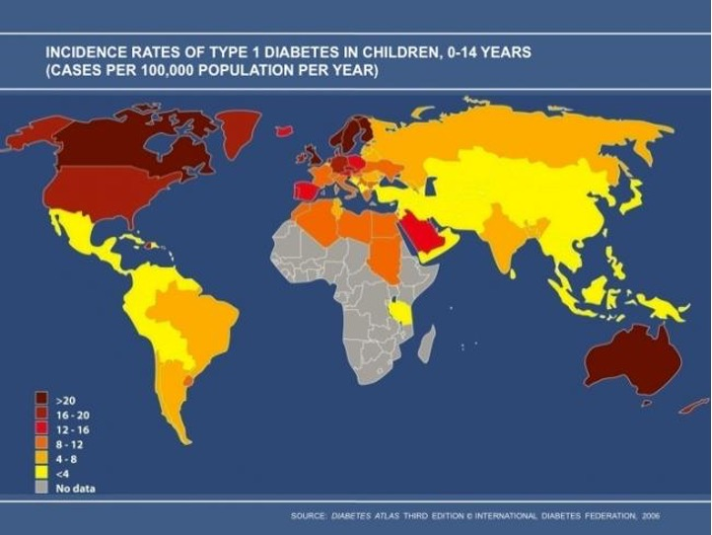

**Figure 1. Worldwide incidence of TID 1990-1994, used with permission from International Diabetes Federation.**

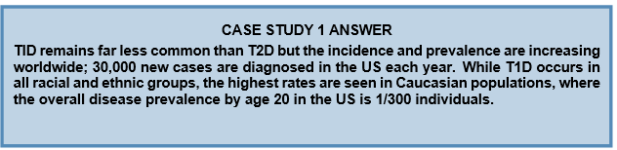

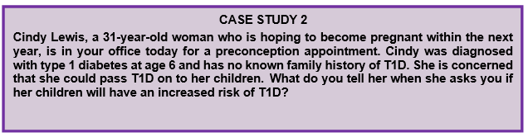

**WHAT IS THE RISK OF TYPE 1 DIABETES?**

As is true for Cindy, 85% of individuals who develop TID have no family history of TID; nonetheless, a family history of the disease does increase an individual’s relative risk.  The prevalence of TID in the US non-Hispanic white population by age 20 is ~0.3%, as compared with ~5% of those with a relative with TID, a 15-fold increase in relative risk.   This relative risk is depicted in Figure 2.

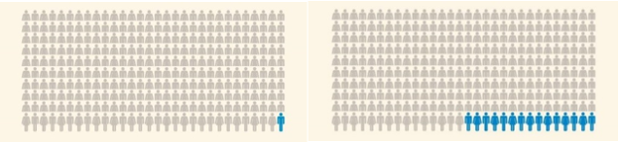

**Figure 2. Among 300 people without a family member with diabetes, 1 will have TID. Among 300 people with a family member with diabetes, 15 will have TID.**

The risk of TID among family members varies depending on who the affected family member is, as shown in Table 1.

|  |  |  |
| --- | --- | --- |
| **Table 1. Prevalence of TID in Individuals with a Family History of TID** | | |
| **Relative with TID** | **Prevalence at age 20** | **Reference** |
| Mother | 2% | (11, 12) |
| Father | 6% | (11, 12) |
| Non-twin sibling | 6% | (13) |
| Dizygotic (fraternal) twin | 10% | (13, 14) |
| Monozygotic (identical) twin | >50% | (15) |

The heritability pattern suggests that both genes and environment contribute to risk.  Curiously, the risk of TID in offspring is higher if the father has TID (~6%) as compared to if the mother has TID (~2%) (11, 12). Moreover, the risk to a dizygotic twin is slightly higher (~10%) than is the risk to a non-twin sibling with similar HLA risk genes (~6%) (13, 14) suggesting that the intrauterine environment and/or similar early life exposures may be important. Lastly, the risk to a monozygotic twin is upwards of ~50%; surprisingly the second twin’s diagnosis may occur many decades after the index twin, highlighting the complexities of gene and environmental interactions that underlie the disease (15).

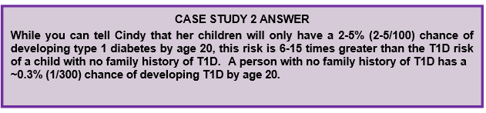

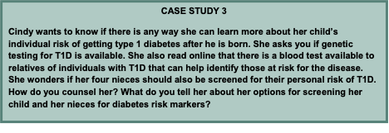

**THE NATURAL HISTORY TYPE 1 DIABETES**

It is now understood that TID is an immune-mediated disease that begins in the setting of genetic predisposition and then progresses along a predictable path: early islet autoimmunity (one autoantibody), established islet autoimmunity (two or more autoantibodies), abnormal glucose tolerance, clinical TID with some remaining beta cell function, and finally, little or no remaining beta cell function. This understanding comes from decades of effort by multiple investigators and from participation by thousands of patients with TID and their family members.  George Eisenbarth’s description of TID as a chronic autoimmune disease, manifested by autoimmunity and a gradual linear fall in beta cell function until there is insufficient beta cell mass to suppress symptomatic hyperglycemia, has served for decades as the TID natural history paradigm (16). The “Eisenbarth” model has undergone refinements in recent years; namely, although autoimmunity and beta cell dysfunction do appear prior to diagnosis, these changes are often step-wise and non-linear.  Furthermore, beta cell destruction may not be absolute.  Nonetheless, the paradigm is largely correct and serves as the underlying rationale for TID trials.

The long pre-symptomatic natural history of TID presents an opportunity to intervene earlier than is done currently. Diabetes-specific autoantibodies can appear many years before clinical diagnosis and may reliably be used to predict disease progression. In 2015, JDRF, the Endocrine Society, and the American Diabetes Association proposed a new TID staging system which underscores that TID begins with islet autoimmunity rather than with symptomatic hyperglycemia (17). Stage 1 TID is defined as the presence of 2 or more autoantibodies with normoglycemia; stage 2 TID is 2 or more autoantibodies, impaired glucose tolerance, and no symptoms; stage 3 TID is clinical disease. The staging system is depicted in figure 3.

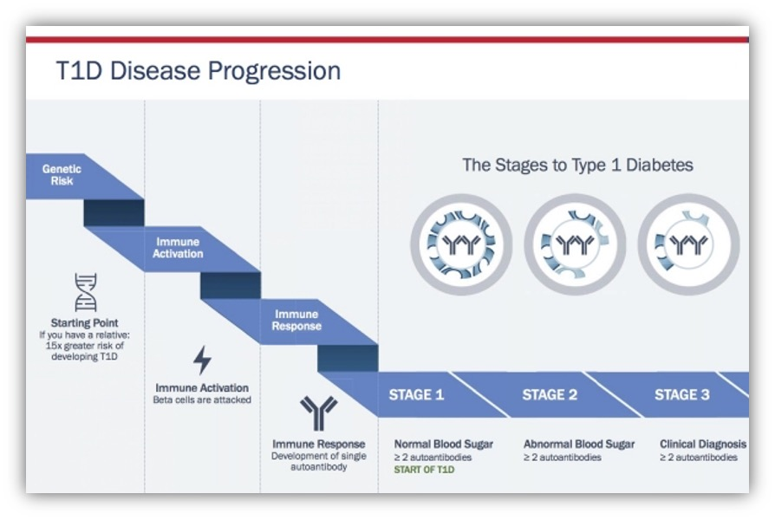

**Figure 3. New staging classification of Type 1 diabetes. Stages of Type 1 Diabetes. Adapted from internet image. https://beyondtype1.org/clinical-trials-and-the-type-1-diabetes-cure/final-trialnet-stages-of-diabetes-graph-2/ Used with permission.**

**HOW TO DETERMINE RISK OF TID**

Risk of TID may be determined by the identification of autoantibodies, usually in those identified as having genetic risk through HLA testing or by family history. Autoantibodies are detectable years before the onset of clinical TID.

**Determining Risk: Genes**

With the knowledge that TID runs in families and with advances in technology, investigators have described the genetic risk of TID.  TID risk is strongly linked to HLA class II DR3 and DR4 haplotypes, with the highest risk in those with the DR3/DR4 genotype.  The importance of HLA genes to TID risk highlights the role of the adaptive immune system in the development of autoimmunity.  Newer studies have discovered multiple other genes that also contribute to TID risk (18). They are largely genes known also to impact immune function; however, their contribution is dwarfed by the impact of HLA genes. Interestingly, recent work suggests that HLA genes primarily contribute to development of autoantibodies, while non-HLA genes and environmental factors may be more important in the progression from autoantibodies to clinically overt disease (19, 20). The description of non-HLA risk genes (such as the genes for insulin, a major TID autoantigen) highlights other potential pathways to disease and potential therapies.

Although the contribution of HLA class II risk genes overwhelms the contribution of non-HLA risk genes, the HLA contribution may be decreasing as the overall incidence of TID increases.  This suggests that in a population with non-HLA genetic susceptibility, the environment may have become more conducive to the development of TID. This was reported in a 2004 Lancet article by Gillespie, et al., in which the investigators compared the frequency of HLA class II haplotypes in a UK cohort of 194 individuals diagnosed with TID between 1922-1946 (the Golden Years cohort) to a cohort of 582 individuals diagnosed between 1985-2002 (the BOX cohort) (21). In this comparison, shown in Figure 4, 47% of individuals in the Golden Years cohort were positive for the highest risk genotype DR3-DQ2/DR4-DQ8, compared to 35% of individuals in the BOX cohort.

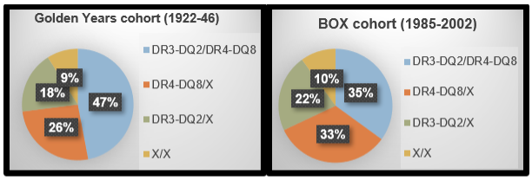

**Figure 4. Decreased contribution of high-risk HLA haplotypes over time. HLA class II haplotypes in Golden Years and BOX cohorts, adapted from Gillespie et.al Lancet 2004 (21).**

**Determining Risk: Family History And Islet Cell Autoantibodies**

Natural history studies of relatives such as Diabetes Prevention Trial (DPT-1) and Diabetes TrialNet Pathway to Prevention have helped define the risk of TID in those with a family history of TID.  Since 2000, Diabetes TrialNet has screened over 200,000 relatives of people with TID, aiming to enroll at-risk individuals in prevention trials.  Among relatives of people with TID, ~5% will have at least one of five islet autoantibodies (22). TrialNet screens for islet cell antibodies (ICA), autoantibodies to insulin (IAA or mIAA), antibodies to a tyrosine phosphatase (IA-2; previously ICA512), antibodies to glutamic acid decarboxylase (GAD), and antibodies to a zinc transporter (ZnT8).  With each additional autoantibody, the risk of TID increases predictably. Unsurprisingly, those with islet autoimmunity and abnormal glucose tolerance are at an even further increased risk of symptomatic T1D. The TrialNet strategy to identify islet autoimmunity among relatives of individuals with TID is shown in Figure 5. There are many other screening efforts ongoing outside of TrialNet. (23-25)

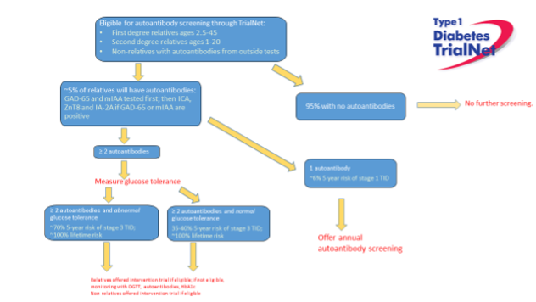

**Figure 5. Diabetes TrialNet process for identifying relatives with islet autoimmunity.**

Natural history studies have shown not only that islet autoimmunity predicts TID risk, but also that islet autoantibodies usually appear early in life; 64% of babies destined to develop T1D before puberty will have antibodies by age 2 and 95% by age 5 (26). Furthermore, the data from both prospective birth cohort studies (27) and cross-sectional studies (28-31) is remarkably consistent and suggests that the risk of progression from established autoimmunity to clinical TID is in the range of 40% after 5 years, 70% after 10 years, and 85% after 15 years. This risk over time is depicted in Figure 6. The key understanding from natural history studies is that essentially all individuals with confirmed islet autoimmunity will eventually develop clinical T1D at a rate of 11% per year.

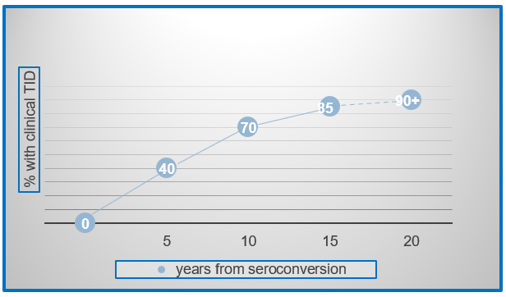

**Figure 6. Established islet autoimmunity inevitably progresses to clinical T1D. Extrapolated data from multiple studies in genetically at-risk individuals; Ziegler et al. JAMA 2013; DPT-1 Study Group Diabetes 1997; Sosenko et al. Diabetes Care 2014; Mahon et al. Pediatric Diabetes 2009.**

Identifying individuals with islet autoimmunity has two potential benefits; namely, the opportunity to monitor closely for disease progression, conferring a reduced risk of morbidity and mortality at the time of TID diagnosis, and the identification of individuals who are eligible for prevention trials.  It is perhaps underappreciated that there is potentially a direct clinical benefit to identifying those with islet autoimmunity.  Individuals with islet autoimmunity followed regularly until clinical diagnosis present with lower HbA1c and experience less DKA than those diagnosed in the community (Table 2) (32-36). For this reason, since 2009, the ADA has recommended that all individuals with a relative with T1D be counseled about the opportunity to be screened for diabetes autoantibodies in the context of a clinical research trial (37).

|  |  |  |  |  |
| --- | --- | --- | --- | --- |
| **Table 2.**  **Individuals Diagnosed with T1D While Enrolled in a Clinical Trial have Less Morbidity at the Time of Diagnosis. (32-36)** | | | | |
| **STUDY** | **HbA1c at time of TID diagnosis** | | **% with DKA at time of TID diagnosis** | |
|  | **Enrolled in study** | **Usual care** | **Enrolled in study** | **Usual care** |
| SEARCH |  |  |  | 25.5% |
| BABYDIAB | 8.6% | 11.0% | 3.3% | 29.1% |
| DPT-1 | 6.4% |  | 3.7% |  |
| DAISY | 7.2% | 10.9% | < 4% |  |
| TEDDY < age 5 |  |  | 13.1% |  |
| SEARCH < age 5 |  |  |  | 36.4% |
| BABYDIAB < age 5 |  |  |  | 32.3% |

**STRATEGIES TO BRING SCREENING FOR RISK TO CLINICAL PRACTICE**

Screening relatives does identify a population of those at risk for clinical T1D; however, at least 85% who get T1D have no relatives with disease.  Thus, to truly prevent all T1D, testing of the general population would have to occur. This could be done with current technology by testing all babies for genetic (HLA) risk at birth and then following with antibody testing. The Population Level Estimate of type 1 Diabetes risk Genes in children (PLEDGE) study enrolls newborns from the general population and offers one-time genetic testing and follow-up autoantibody testing at 2 and 4 years of age (38). The study aims to demonstrate feasibility and to develop evidence to support eventual inclusion of a T1D screening program in standard primary care.

Other studies, such as The Environmental Determinants of Diabetes in the Young (TEDDY) study, the Diabetes Autoimmunity Study in the Young (DAISY), and the Global Platform for the Prevention of Autoimmune Diabetes (GPPAD) are exploring similar methodologies to screen and monitor for risk (24, 39, 40).  However, with an increasing number of individuals developing T1D even without the high-risk HLA types, such approaches may still miss some destined to develop disease.

An alternative risk detection strategy for those without a family history may be to perform point-of-care antibody testing in a routine pediatric visit.  Since almost all who will develop diabetes before puberty will have antibodies by age 5; such testing could be done at age 4-5 and perhaps once again in the teenage years.  This method will still miss those who develop T1D before this age, but would likely be a cost-effective approach to finding those at risk.  If these at-risk subjects are monitored regularly until development of clinical disease they would benefit from reduced morbidity at time of diagnosis even if a prevention therapy were not yet available.

There are many ongoing projects aimed at screening members of the general population for diabetes autoantibodies even without prior HLA testing (23, 25, 41, 42).

As risk-screening programs employ varying assays and recruit from different populations, interpretation and translation of results is unclear. It is not yet known whether those found to be autoantibody positive through one program will experience the same rates of T1D progression and/or benefit from the same therapies as individuals who have participated in other screening and intervention efforts.

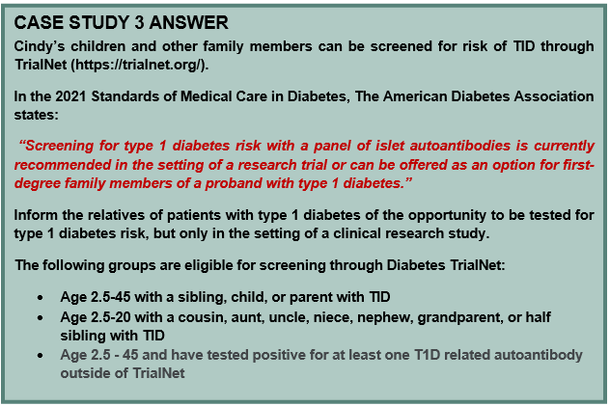

**Source: (37).**

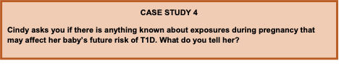

**PRENATAL INFLUENCES**

The prenatal environment can have profound effects on the developing fetus. With the recognition that antibodies often develop early in life and that essentially all those with established islet autoimmunity (two or more autoantibodies) will eventually develop TID, investigators have looked to the prenatal period to search for factors that could contribute to disease development in utero.  As shown in Table 3, decades of observational studies have yielded inconsistent results.  Yet this remains an important area of investigation and one that may lead to primary prevention strategies for T1D. The Environmental Determinants of Islet Autoimmunity (ENDIA) study is an ongoing prospective birth cohort study in Australia that enrolled infants and unborn infants of first degree relatives with T1D. Biologic samples including blood, stool, and saliva will be collected longitudinally for investigation of factors including viral exposures during pregnancy and early childhood, maternal and fetal microbiome, delivery method, maternal and early infant nutrition, pregnancy and early childhood body weight, and both innate and adaptive immune function. In 2018, the ENDIA study completed target enrollment of ~1500 subjects, who will be followed regularly until the development of islet autoimmunity (43).

|  |  |  |
| --- | --- | --- |
| **Table 3.  Potential Prenatal Influences on TID Ris**k | | |
| **Pre-natal or intrauterine exposure** | **Relative risk to offspring** | **Reference** |
| Maternal age | Inconsistent data | (44-46) |
| Birth weight > 2 SD above norm (~4000g) | Inconsistent data | (47-51) |
| Birth weight < 2 SD below norm (~2500g) | Inconsistent data | (49-51) |
| Birth order: second and later born | Inconsistent data | (46, 52, 53) |
| Birth interval < 3 years | Inconsistent data | (46, 54) |
| Caesarean delivery | Inconsistent data | (51, 55, 56) |
| Pre-eclampsia | Inconsistent data | (51, 57) |
| Pre-term delivery (<37 weeks gestation) | Inconsistent data | (51, 58) |
| Maternal vitamin D supplementation | Inconsistent data | (59-62) |
| Maternal antibiotic use | No association | (53, 63) |
| maternal BMI/pregnancy weight gain | No association | (51, 64) |
| Maternal omega 3 fatty acid supplementation | No association | (60, 65, 66) |

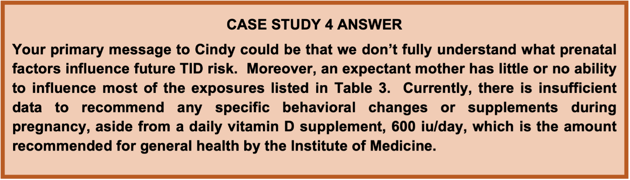

**Source: (67).**

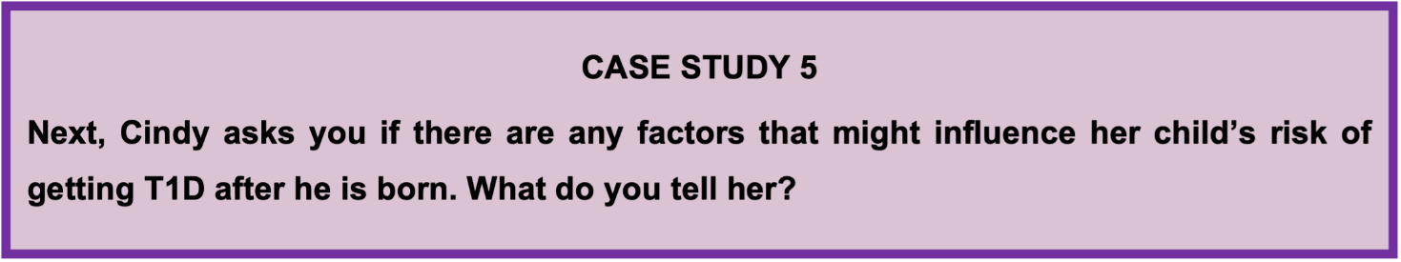

Investigators also have studied the early childhood period for clues to the causes of islet autoimmunity and TID; these have included both observational studies and randomized clinical trials. Such influences might be divided into early nutritional exposures and early microbial/infectious exposures, both of which can affect development of the normal immune system.

The inconsistent findings relating to environmental factors reported from observational studies and clinical trials led to the design and implementation of a large international comprehensive evaluation of genetically at-risk babies using cutting edge technologies to study genetics, genomics (gene function), metabolomics, and the microbiome. The Environmental Determinants of Diabetes in the Young (TEDDY) is an international prospective birth cohort study that recruited almost 8,000 babies at increased risk for TID (based on HLA and family history) from Finland, Germany, Sweden, and the US from 2004-2010.  Information on environmental exposures such as diet (including breastfeeding history), infections, vaccinations, and psychosocial stressors will be collected. Participants will be followed until the age of 15 for the development of islet autoimmunity or TID. The wealth of data from this study will provide a foundation for future randomized clinical trials (24). One interesting finding reported in December 2019 is that there are subtle differences in the gut microbiome—such as, persistent stool enterovirus B species--in children who develop islet autoimmunity compared to children who do not develop autoimmunity (68).

**EARLY NUTRITIONAL EXPOSURES**

**Breastfeeding**

The hypothesis that human breastmilk may protect against future TID development was presented as early as 1984 (69). Since then, there have been several prospective cohort studies to suggest that breastmilk lowers the risk of islet autoimmunity and TID, including the German BABYDIAB/BABYDIET study (70), the Colorado-based DAISY study (71), and the Norwegian MIDIA study (72), but others show no effect (73).  Although the data on whether breastmilk is protective against TID isn’t clear, it certainly isn’t harmful.  Given the well-established general benefits of breastfeeding, patients may safely be advised to follow the American Academy of Pediatrics’ guidelines related to infant feeding. The mechanism by which breastmilk may lower the risk of TID is uncertain, but one theory suggests that breastmilk has positive effects on the infant microbiome. The microbiome is discussed in greater detail below.

**Cow’s Milk And Bovine Insulin Exposure**

In contrast to considering breastfeeding as potentially beneficial in protecting against autoimmunity, it was hypothesized that early introduction of cow’s milk or cow protein might accelerate disease.  This concept was tested in the Trial to Reduce IDDM in the Genetically at Risk (TRIGR) which asked whether weaning to hydrolyzed casein (which is free of bovine proteins including insulin) formula (n=1081) instead of regular cow’s milk formula (n=1078) in genetically at-risk infants could prevent or delay TID.  Though the TRIGR pilot study was suggestive of benefit, no benefit was seen in the fully powered study (74) (75). Similarly, The Finnish Dietary Intervention Trial for the Prevention of Type 1 Diabetes of (FINDIA) suggested that weaning to hydrolyzed cow’s milk formula was not effective in reducing the appearance of autoantibodies, though they did report that a patented cow’s milk formula specifically removing bovine insulin appeared to be beneficial in this pilot study (76).  While additional studies may be informative, current data does not support that weaning to hydrolyzed cow’s milk formula is protective against islet autoimmunity.

**Gluten Exposure**

Both BABYDIAB (77) and DAISY (78) were observational studies that suggested an association between introduction of gluten and islet autoimmunity.  However, these studies had different results as to the timing of gluten introduction. Similarly, no effect was found in the BABYDIET study; a randomized controlled trial that asked whether delayed introduction of gluten to 6 vs 12 months would affect the risk of diabetes autoimmunity (79, 80).

**Vitamin D And/Or Omega 3 Fatty Acids**

Vitamin D is an important component of a normal immune response; moreover, the higher incidence of TID in northern climates suggests that vitamin D deficiency could contribute to autoimmunity and TID.  However, data from observational studies is mixed on whether vitamin D and/or omega 3 supplementation is beneficial or not (60, 81-86). A pilot randomized trial of omega 3 supplementation to pregnant mothers and infants failed to demonstrate a profound immunologic effect of treatment (87). With routine vitamin D supplementation recommended for infants (88), it is unlikely that a fully powered randomized trial would be feasible to assess the impact on autoimmunity.

**MICROBIAL EXPOSURES**

**The Hygiene Hypothesis**

Parallel to the rising incidence of TID and other autoimmune diseases, there has been a worldwide trend towards urbanization, increased standard of living, smaller family sizes, less crowded living conditions, safer water and food supplies, less cohabitation with animals, wide use of antibiotics, childhood vaccination, etc.  While these trends are generally considered improvements in human existence, the so-called “hygiene hypothesis,” proposed by Strachan in 1989 (89) suggests a possible downside; that is, that early microbial exposures might have a protective effect via the early education of the immune system and the development of normal tolerance to self-antigens. Data cited in support of the hygiene hypothesis comes from comparisons between eastern Finland and Russian Karelia (Figure 7) (90-92).



**Figure 7. Border between Finland and Russian Karelia, with a 6-fold difference in the incidence of TID, from "Karelia today”. The countries share a common border and ancestry and thus have similar geography, climate, vitamin D levels, and prevalence of HLA risk haplotypes. However, Finland has 6-fold higher incidence of TID. This markedly higher rate of TID is accompanied by a much lower rate of infectious disease. In Finland as compared to Karelia 2% vs 24% had hepatitis A; 5% vs 24% had toxoplasma gondii; and 5% vs. 73% for helicobacter pylori. There is an ongoing study aiming to better understand the mechanisms that may underlie these differences.**

**The Microbiome**

Another possible interface between microbial exposure and human disease is through the microbiome; that is the gut flora established within the first 3 years of life (93).  It has been hypothesized that perturbations in normal early microbiome development might pre-dispose to disease whether through direct modulation of innate immunity or via alteration of intestinal permeability and the downstream effects on adaptive immunity. Interestingly, it appears that the gut microbiome is less diverse and less “protective” in individuals with islet autoimmunity or recent onset TID (94-96).  Whether this difference is cause, effect, or correlation isn’t known. Nonetheless, multiple factors might affect the early intestinal microbiome, some of which also have been shown to correlate with risk of islet autoimmunity and TID.  For example, breastfeeding can alter the intestinal microbiome of the infant by increasing the number and diversity of beneficial microbiota (97, 98). As previously discussed, multiple prospective observational studies suggest that breastfeeding protects against future development of islet autoimmunity and TID, but there’s no evidence to connect this directly to the infant microbiome.

**Viral Infections**

A viral etiology for initiation of autoimmunity is an attractive idea; a beta cell trophic virus could contribute to disease by directly killing beta cells, by leading to a chronic infection which triggers an immune response, or by molecular mimicry in which self-antigens are erroneously recognized as viral epitopes targeted for destruction.  Notably, these possible mechanisms would not necessarily point to a particular virus; any virus widespread in a population could theoretically lead to autoimmunity in genetically susceptible individuals if encountered at a vulnerable time in immune system or beta cell development.  With the notable exception of congenital rubella which is associated with type 1 diabetes (99), other data relating viruses to initiation of autoimmunity is less conclusive.  While some studies have reported viral “footprints” in islets from individuals who have died from TID, these have not been consistently confirmed.  Similarly, many studies have focused on enteroviruses, including coxsackie B, due to observations suggesting seasonal variation in antibody development that is reminiscent of the timing of such infections (100) (101), yet this remains controversial.  Aside from a viral role in the initiation of autoimmunity, others have proposed that acute viral infections may impact the transition from islet autoimmunity to clinical TID due to increased insulin demand during infections.  Patients commonly report an acute viral illness preceding the diagnosis of TID, and the clinical onset of TID more commonly presents in the fall and winter months in both the northern and southern hemispheres (102); but this does not imply a causal relationship.

**Vaccinations**

In recent decades, an increasing number of parents in Western countries have declined routine childhood vaccination of their children, which has created a situation with significant personal and public health consequences.  Multiple high-quality studies have thoroughly investigated vaccinations and TID, and none have found any association with islet autoimmunity or TID (103-107)

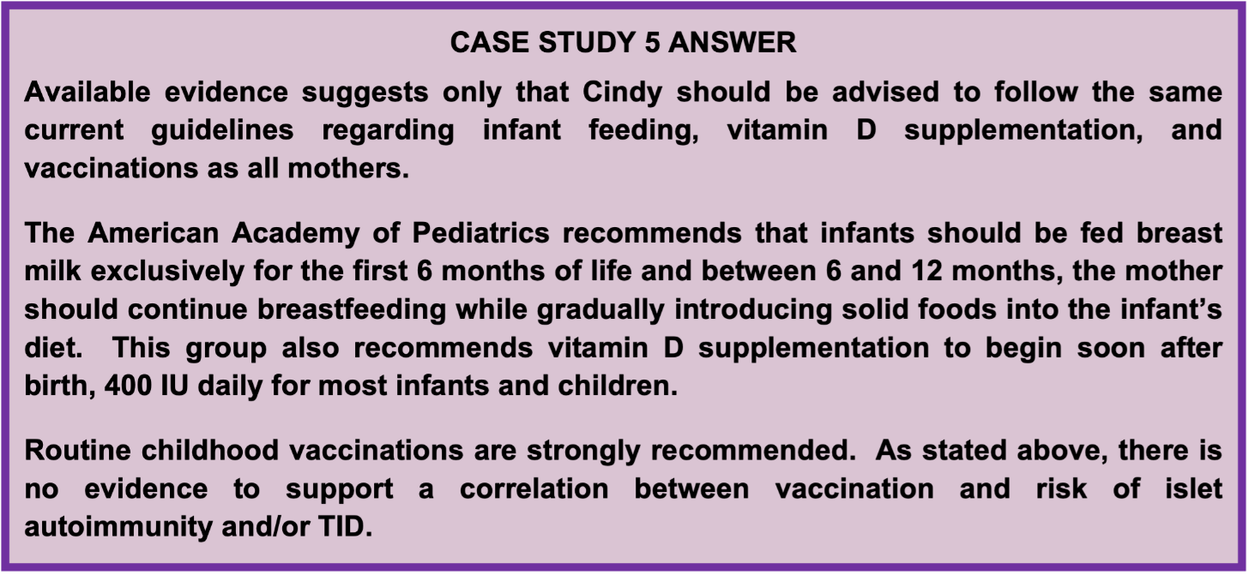

**Sources: (88, 103-108).**

**FUTURE CONSIDERATIONS**

Despite advances in glucose monitoring and insulin delivery, the daily psychological and financial burden of disease on individuals, their families, and society together with the persistence of complications and reduced life span demand a paradigm shift.

As of 2021, we know much about the natural history of disease. We know that antibodies can develop early in life and that essentially all of those with established islet autoimmunity will develop clinically overt disease. We also know that identifying these individuals is of significant clinical benefit. Those with islet autoimmunity followed carefully until diagnosis have markedly less morbidity at the time of diagnosis and lower HbA1c values. Family members of T1D probands should be made aware of their disease risk and should be offered autoantibody screening and enrollment in monitoring trials. Correspondingly, patients with TID should be informed of the opportunity to have their relatives screened for TID risk in the setting of a clinical research study.

While the interaction of humans with their environment must contribute to disease; how this occurs is still being elucidated. It is likely that there are many different paths by which individual gene/environment interactions result in T1D; suggesting that dissecting this heterogeneity will provide better insights and therapies.

**REFERENCES**

1. JDRF Fact Sheet (accessed 2021 Dec 14) Available from: https://www.jdrf.org/t1d-resources/about/facts/.

2. Centers for Disease Control and Prevention, National Diabetes Statistics Report, 2014. 2014; (accessed 2021 Dec 14) Available from: http://www.cdc.gov/diabetes/pubs/statsreport14/national- diabetes-report-web.pdf.

3. Patterson, C., et al., Trends in childhood type 1 diabetes incidence in Europe during 1989-2008: Evidence of non- uniformity over time in rates of increase. Diabetologia, 2012. 55(8): p. 2142-2147.

4. Bell, R., et al., Diabetes in non-Hispanic white youth:prevalence, incidence, and clinical characteristics: the SEARCH for diabetes in youth study. Diabetes Care, 2009. 32(Suppl 2): p. S102-S111.

5. Miller, K.M., et al., Current State of Type 1 Diabetes Treatment in the U.S.: Updated Data From the T1D Exchange Clinic Registry. Diabetes Care, 2015. 38(6): p. 971-978.

6. Liese, A.D., R.B. D'Agostino, Jr., and R. Hamman, The burden of diabetes mellitus among US youth; prevalence estimates from the SEARCH for diabetes in youth study. Pediatrics, 2006. 118(4): p. 1510-18.

7. Lawrence, J., et al., Trends in incidence of type 1 diabetes among non-Hispanic white youth in the U.S., 2002-2009 Diabetes, 2014. 63(11): p. 3938-3945.

8. Patterson, C., et al., Incidence trends for childhood type 1 diabetes in Europe during 1989-2003 and predicted new cases 2005-20: a multicentre prospective registration study. Lancet, 2009. 373(9680): p. 2027-2033.

9. Incidence and trends of childhood Type 1 diabetes worldwide 1990-1999. Diabet. Med, 2006. 23(8): p. 857-866.

10. Karvonen, M., et al., Incidence of childhood type 1 diabetes worldwide. Diabetes Mondiale (DiaMond) Project Group. Diabetes Care, 2000. 23(10): p. 1516-1526.

11. Warram, J.H., et al., Differences in risk of insulin- dependent diabetes in offspring of diabetic mothers and diabetic fathers. N Engl J Med, 1984. 311(3): p. 149-52.

12. Pociot, F., et al., A nationwide population-based study of the familial aggregation of type 1 (insulin-dependent) diabetes mellitus in Denmark. Danish Study Group of Diabetes in Childhood. Diabetologia, 1993. 36(9): p. 870-875.

13. Nistico, L., et al., Emerging effects of early environmental factors over genetic background for type 1 diabetes susceptibility: evidence from a Nationwide Italian Twin Study. J Clin Endocrinol Metab, 2012. 97(8): p. E1483- E1491.

14. Kyvik, K., A. Green, and H. Beck-Nielsen, Concordance rates of insulin dependent diabetes mellitus: a population based study of young Danish twins. BMJ, 1995. 311(7010): p. 913-917.

15. Redondo, M., et al., Concordance for islet autoimmunity among monozygotic twins. N Engl J Med, 2008. 359(26): p. 2849-2850.

16. Eisenbarth, G.S., Type I diabetes mellitus. A chronic autoimmune disease. N. Engl. J. Med, 1986. 314(21): p. 1360-1368.

17. Insel, R.A., et al., Staging presymptomatic type 1 diabetes: a scientific statement of JDRF, the Endocrine Society, and the American Diabetes Association. Diabetes Care, 2015. 38(10): p. 1964-74.

18. Concannon, P., S.S. Rich, and G.T. Nepom, Genetics of type 1A diabetes. N. Engl. J. Med, 2009. 360(16): p. 1646- 1654.

19. Knip, M., Can we predict type 1 diabetes in the general population? Diabetes Care, 2002. 25(3): p. 623-5.

20. Steck, A.K., et al., Predictors of Progression From the Appearance of Islet Autoantibodies to Early Childhood Diabetes: The Environmental Determinants of Diabetes in the Young (TEDDY). Diabetes Care, 2015. 38(5): p. 808-13.

21. Gillespie, K.M., et al., The rising incidence of childhood type 1 diabetes and reduced contribution of high-risk HLA haplotypes. Lancet, 2004. 364(9446): p. 1699-1700.

22. Mahon, J.L., et al., The TrialNet Natural History Study of the Development of Type 1 Diabetes: objectives, design, and initial results. Pediatr. Diabetes, 2008.

23. JDRF. T1Detect: Learn why you should be screened. (accessed 2021 Dec 14); Available from: https://www.jdrf.org/t1d-resources/t1detect/.

24. Hagopian, W.A., et al., TEDDY--The Environmental Determinants of Diabetes in the Young: an observational clinical trial. Ann N Y Acad Sci, 2006. 1079: p. 320-6.

25. Combined Antibody Screening for Celiac and Diabetes Evaluation (CASCADE). 2020.

26. Parikka V., N.-S.K., Saarinen M, Simell T, Ilonen J, Hyöty H, Veijola R, Knip M, Simell O., Early seroconversion and rapidly increasing autoantibody concentrations predict prepubertal manifestation of type 1 diabetes in children at genetic risk. Diabetologia, 2012. 55(7): p. 1926-36.

27. Vehik, K., et al., Methods, quality control and specimen management in an international multicentre investigation of type 1 diabetes: TEDDY. Diabetes Metab Res Rev, 2013. 29(7): p. 557-67.

28. Ziegler, A.G., et al., Seroconversion to Multiple Islet Autoantibodies and Risk of Progression to Diabetes in Children. Journal of the American Medical Association, 2013. 309(23): p. 2473-9.

29. DPT-1 Study Group, Demographics of relatives screened and ICA positive in the diabetes prevention trial-type 1 diabetes (DPT-1). Diabetes, 1997. 46 (Suppl 1): p. 142A.

30. Sosenko, J., et al., Use of the Diabetes Prevention Trial- Type 1 Risk Score (DPTRS) for improving the accuracy of the risk classification of type 1 diabetes. Diabetes Care, 2014. 37(4): p. 979-984.

31. Mahon, J., et al., The TrialNet Natural History Study of the Development of Type 1 Diabetes: Objectives, design, and initial results. Pediatr Diabetes, 2009. 10(2): p. 97-104.

32. Winkler, C., et al., Markedly reduced rate of diabetic ketoacidosis at onset of type 1 diabetes in relatives screened for islet autoantibodies. Pediatric Diabetes, 2012. 13(4): p. 308-313.

33. Triolo, T., et al., Diabetic subjects diagnosed through the Diabetes Prevention Trial-Type 1 (DPT-1) are often asymptomatic with normal A1C at diabetes onset. Diabetes Care, 2009. 32: p. 769-773.

34. Elding Larsson, H., et al., Reduced prevalence of diabetic ketoacidosis at diagnosis of type 1 diabetes in young children participating in longitudinal follow-up. Diabetes Care, 2011. 34(11): p. 2347-52.

35. Rewers, A., et al., Presence of diabetic ketoacidosis at diagnosis of diabetes mellitus in youth: the Search for Diabetes in Youth Study. Pediatrics, 2008. 121: p. e1258- e1266.

36. Barker, J., et al., Clinical characteristics of children diagnosed with type 1 diabetes through intensive screening and follow-up. Diabetes Care, 2004. 27(6): p. 1399-404.

37. American Diabetes Association, I., American Diabetes Association Standards of Medical Care in Diabetes- 2021. Diabetes Care, 2021. 44 (Supplement 1): p. S18.

38. General Population Level Estimation for Type 1 Diabetes Risk in Children 0-5 Years Old During Routine Care Delivery (PLEDGE). 2021 October 27, 2020 (accessed 2021 Dec 14); Available from: https://clinicaltrials.gov/ct2/show/NCT04477928?term=PL EDGE+study&cond=t1d&draw=2&rank=1.

39. Rewers, M., et al., Newborn screening for HLA markers associated with IDDM: diabetes autoimmunity study in the young (DAISY). Diabetologia, 1996. 39(7): p. 807-12.

40. Munchen, T.U., GPPAD-POInT (Global Platform of Autoimmune Diabetes - Primary Oral Insulin Trial).

41. Barbara Davis Center for Diabetes, Autoimmunity Screening for Kids. 2019, March 13 (accessed 2021 Dec 14); Available from: https://www.askhealth.org/.

42. Puff, R., et al., (Early diagnosis, early care--"Fr1da" screening of children for type 1 diabetes). MMW Fortschr Med, 2016. 158(4): p. 65-6.

43. Megan AS Penno, J.J.C., Maria E Craig, et al. ENDIA Study Group, Environmental determinants of islet autoimmunity (ENDIA): a pregnancy to early life cohort study in children at-risk of type 1 diabetes, BMC Pediatr, 2013. 13-124: p. 1471-2431.

44. Cardwell, C., et al., Maternal age at birth and childhood type 1 diabetes: a pooled analysis of 30 observational studies. Diabetes, 2010. 59(2): p. 486-494.

45. Flood, T., S. Brink, and R. Gleason, Increased incidence of type 1 diabetes in children of older mothers. Diabetes Care, 1982. 5(6): p. 571-573.

46. Warram, J.H., B.C. Martin, and A.S. Krolewski, Risk of IDDM in children of diabetic mothers decreases with increasing maternal age at pregnancy. Diabetes, 1991. 40(12): p. 1679-1684.

47. Cardwell, C., et al., Birthweight and the risk of childhood- onset type 1 diabetes: a meta-analysis of observational studies using individual patient data. Diabetologia, 2010. 53(4): p. 641-651.

48. Stene, L., et al., Birth weight and childhood onset type 1 diabetes: population-based cohort study. BMJ, 2001. 322(7291): p. 889-892.

49. Dahlquist, G., S. Bennich, and B. Kallen, Intrauterine growth pattern and risk of childhood onset insulin dependent (type 1) diabetes: population based case- control study. BMJ, 1996. 313(7066): p. 1174-1177.

50. Harder, T., et al., Birth weight, early weight gain, and subsequent risk of type 1 diabetes: systematic review and meta-analysis. Am J Epidemiol, 2009. 169(12): p. 1428-1436.

51. Robertson, L. and K. Harrild, Maternal and neonatal risk factors for childhood type 1 diabetes: a Matched case- control study. BMC Public Health, 2010. 10: p. 281.

52. Cardwell, C., et al., Birth order and childhood type 1 diabetes risk: a pooled analysis of 31 observational studies. Int J Epidemiol, 2011. 40(2): p. 363-374.

53. Virtanen, S.M., et al., Microbial exposure in infancy and subsequent appearance of type 1 diabetes mellitus- associated autoantibodies: a cohort study. JAMA Pediatr, 2014. 168(8): p. 755-63.

54. Cardwell, C., et al., Interbirth interval is associated with childhood type 1 diabetes risk. Diabetes, 2012. 61(3): p. 702-707.

55. Cardwell, C., et al., Caesarean section is associated with an increased risk of childhood-onset type 1 diabetes mellitus: a meta-analysis of observational studies. Diabetologia, 2008. 51(5): p. 726-735.

56. Khashan, A., et al., Mode of obstetrical delivery and type 1 diabetes: a sibling design study. Pediatrics, 2014. 134(3): p. e806-e813.

57. Dahlquist, G. and B. Kallen, Maternal-child blood goup incompatibility and other perinatal events increase the risk for early-onset type 1 (insulin-dependent) diabetes mellitus. Diabetologia, 1992. 35(7): p. 671-675.

58. Zhang, L., et al., Preterm birth and risk of type 1 and type 2 diabetes: systematic review and meta-analysis. Obes. Rev., 2014. 15(10): p. 804-811.

59. Granfors, M., et al., No association between use of multivitamin supplement containing vitamin D during pregnancy and risk of Type 1 Diabetes in the child. Pediatr Diabetes, 2016. 17(7): p. 525-530.

60. Stene, L.C. and G. Joner, Use of cod liver oil during the first year of life is associated with lower risk of childhood-onset type 1 diabetes: a large, population-based, case-control study. Am. J. Clin. Nutr, 2003. 78(6): p. 1128-1134.

61. Fronczak, C., et al., In utero dietary exposures and risk of islet autoimmunity in children. Diabetes Care, 2003. 26(12): p. 3237-3242.

62. Marjamaki, L., et al., Maternal intake of vitamin D during pregnancy and risk of advanced beta cell autoimmunity and type 1 diabetes in offspring. Diabetologia, 2010. 53(8): p. 1599-607.

63. Kikkinen, A., et al., Use of antimicrobials and risk of type 1 diabetes in a population-based mother-child cohort. Diabetalogia, 2006. 49(1): p. 66-70.

64. Arkkola, T., et al., Relationship of maternal weight status and weight gain rate during pregnancy to the development of advanced beta cell autoimmunity in the offspring: a prospective birth cohort study. Pediatr Diabetes, 2011. 12(5): p. 478-84.

65. Niinisto, S., et al., Fatty acid status in infancy is associated with the risk of type 1 diabetes-associated autoimmunity. Diabetologia, 2017. 60(7): p. 1223-1233.

66. Sorenson, I., et al., Serum long chain n-3 fatty acids (EPA and DHA) in the pregnant mother are independent of tisk of type 1 diabetes in the offspring. Diabetes Metab Res Rev, 2012. 28(5): p. 431-438.

67. Ross, A., et al., The 2011 report on dietary reference intakes for calcium and vitamin D from the Institute of Medicine: what clinicians need to know. J Clin Endocrinol Metab, 2011. 96(1): p. 53-38.

68. Vehik. Kendra; Lynch, K.W., Matthew; et al. TEDDY Study Group, Prospective virome analyses in young children at increased genetic risk for type 1 diabetes. Nature Medicine, 2019. 25(12):1865-1872.

69. Borch-Johnsen, K., et al., Relation between breast-feeding and incidence rates of insulin-dependent diabetes mellitus: A hypothesis. Lancet, 1984. 2(8411): p. 1083-1086.

70. Chimel, R., et al., Early infant feeding and risk of developing islet autoimmunity and type 1 diabetes. Acta Diabetol, 2015 Jun;52(3): p. 621-624.

71. Frederiksen, B., et al., Infant exposures and development of type 1 diabetes mellitus: The Diabetes Autoimmunity Study in the Young (DAISY). JAMA Pediatr, 2013. 167(9): p. 808-815.

72. Lund-Blix, N., et al., Infant feeding in relation to islet autoimmunity and type 1 diabetes in genetically susceptible children: the MIDIA Study. Diabetes Care, 2015. 38(2): p. 257-263.

73. Couper, J.J., et al., Lack of association between duration of breast-feeding or introduction of cow's milk and development of islet autoimmunity. Diabetes, 1999. 48(11): p. 2145-2149.

74. Knip, M., et al., Hydrolyzed infant formula and early beta- cell autoimmunity: a randomized clinical trial. JAMA, 2014. 311(22): p. 2279-87.

75. Knip, M., Writing group for teh TRIGR Study Group, Effect of Hydrolyzed Infant Formula vs Conventional Formula on Risk of Type 1 Diabetes. JAMA, 2018 Jan. 319(1): p. 38-48.

76. Vaarala, O., et al., Removal of Bovine Insulin From Cow's Milk Formula and Early Initiation of Beta-Cell Autoimmunity in the FINDIA Pilot Study. Arch Pediatr Adolesc Med, 2012. 166(7): p. 608-14.

77. Ziegler, A.G., et al., Early infant feeding and risk of developing type 1 diabetes-associated autoantibodies. JAMA, 2003. 290(13): p. 1721-1728.

78. Norris, J.M., et al., Timing of initial cereal exposure in infancy and risk of islet autoimmunity. JAMA, 2003. 290(13): p. 1713-1720.

79. Hummel S, P.M., Hummel M, Primary dietary intervention study to reduce the risk of islet autoimmunity in children at increased risk for type 1 diabetes: the BABYDIET study. Diabetes Care, 2011. 34(6): p. 1302-1305.

80. Beyerlein, A., et al., Timing of gluten introduction and islet autoimmunity in young children: updated results from the BABYDIET study. Diabetes Care, 2014. 37(9): p. e194- e195.

81. Brekke, H. and J. Ludvigsson, Vitamin D supplementation and diabetes-related autoimmunity in the ABIS study. Pediatr Diabetes, 2007. 8(1): p. 11-14.

82. Vitamin D supplement in early childhood and risk for Type I (insulin-dependent) diabetes mellitus. The EURODIAB Substudy 2 Study Group. Diabetologia, 1999. 42(1): p. 51-54.

83. Hypponen, E., et al., Intake of vitamin D and risk of type 1 diabetes: a birth-cohort study. Lancet, 2001. 358(9292): p. 1500-1503.

84. Zipitis, C. and A. Akobeng, Vitamin D supplementation in early childhood and risk of type 1 diabetes: a systematic review and meta-analysis. Arch Dis Child, 2008. 93(6): p. 512-517.

85. Simpson, M., et al., No association of vitamin D intake or 25-hydroxyvitamin D levels in childhood with risk of islet autoimmunity and type 1 diabetes: the Diabetes Autoimmunity Study in the Young (DAISY). Diabetologia, 2011. 54(11): p. 2779-2788.

86. Norris, J., et al., Omega-3 polyunsaturated fatty acid intake and islet autoimmunity in children at increased risk for type 1 diabetes. JAMA, 2007. 298(12): p. 1420-1428.

87. Chase, H., et al., Effect of docosahexaenoic acid supplementation on inflammatory cytokine levels in infants at high risk for type 1 diabetes. Pediatr Diabetes, 2014.

88. Wagner, C. and F. Greer, Prevention of rickets and vitamin D deficiency in infants, children, and adolescents. Pediatrics, 2008. 122(5): p. 1142-1152.

89. Strachan, D.P., Hay fever, hygiene, and household size. BMJ, 1989. 299(6710): p. 1259-1260.

90. Karelia map. 2015; (accessed 2021 Dec 14) Available from: https://commons.wikimedia.org/wiki/File:Karelia_today.pn g#/media/File:Karelia_today.png.

91. Kondrashova, A., et al., The 'Hygiene hypothesis' and the sharp gradient in the incidence of autoimmune and allergic diseases between Russian Karelia and Finland. APMIS, 2013. 121(6): p. 478-93.

92. Seiskari, T., et al., Allergic senstization and microbial load--a comparison between Finland and Russian Karelia. Clin Exp Immunol, 2007. 148(1): p. 47-52.

93. Yatsunenko, T., et al., Human gut microbiome viewed across age and geography. Nature, 2012. 486(7402): p. 222-227.

94. Giongo, A., et al., Toward defining the autoimmune microbiome for type 1 diabetes. ISME J, 2011. 5(1): p. 82-91.

95. Brown, C.T., et al., Gut microbiome metagenomics analysis suggests a functional model for the development of autoimmunity for type 1 diabetes. PLoS One, 2011. 6(10): p. e25792.

96. de Goffau, M.C., et al., Fecal microbiota composition differs between children with beta-cell autoimmunity and those without. Diabetes, 2013. 62(4): p. 1238-44.

97. Bezirtzoglou, E., A. Tsiotsias, and G.W. Welling, Microbiota profile in feces of breast- and formula-fed newborns by using flourescence in situ hybridization (FISH). Anaerobe, 2011. 2011(17): p. 6.

98. Stark, P. and A. Lee, The microbial ecology of the large bowel of breast-fed and formula-fed infants during the first year of life. J Med Microbiol, 1982. 15(2): p. 189-203.

99. Menser, M., J. Forrest, and R. Bransby, Rubella infection and diabetes mellitus. Lancet, 1978. 1: p. 57-60.

100. Oikarinen, S., et al., Enterovirus RNA in blood is linked to the development of type 1 diabetes. Diabetes, 2011. 60(1): p. 276-9.

101. Kimpimaki, T., et al., The first signs of beta-cell autoimmunity appear in infancy in genetically susceptible children from the general population: the Finnish Type 1 Diabetes Prediction and Prevention Study. J Clin Endocrinol Metab, 2001. 86(10): p. 4782-8.

102. Moltchanova, E., et al., Seasonal variation of diagnosis of type 1 diabetes mellitus in children worldwide. Diabet Med, 2009. 26(7): p. 673-678.

103. Duderstadt, S., et al., Vaccination and risk of type 1 diabetes mellitus in active component U.S. military,

2002-2008. Vaccine, 2012. 30(4): p. 813-819.

104. Graves, P., et al., Lack of association between early childhood immunizations and beta-cell autoimmunity. Diabetes Care, 1999. 22(10): p. 1694-1697.

105. DeStefano, F., et al., Childhood vaccinations, vaccination timing, and risk of type 1 diabetes mellitus. Pediatrics, 2001. 108(6): p. E112.

106. Hviid, A., et al., Childhood vaccination and type 1 diabetes. N Engl J Med, 2004. 350(14): p. 1398-1404.

107. Elding Larsson, H., et al., Pandemrix(R) vaccination is not associated with increased risk of islet autoimmunity or type 1 diabetes in the TEDDY study children. Diabetologia, 2018. 61(1): p. 193-202.

108. Breastfeeding and the use of human milk. Pediatrics, 2012. 129(3): p. e827-e841.

**ADDITIONAL INFORMATION** (From prior chapter by Aaron W. Michels, MD and Peter Gottlieb, MD)

**INTRODUCTION**

Type 1 diabetes mellitus is defined as immune mediated diabetes mellitus ([1-6](https://www.endotext.org/chapter/pathogenesis-of-diabetes/pathogenesis-of-type-1a-diabetes/#_ENREF_1)). It can become manifest with hyperglycemia presenting in the first days of life or in adults over the age of 60. Current estimates indicate that immune mediated diabetes represents approximately 5 to 10% of the diabetes developing in adults and that approximately as many individuals develop this form of diabetes as adults as do children ([7-9](https://www.endotext.org/chapter/pathogenesis-of-diabetes/pathogenesis-of-type-1a-diabetes/#_ENREF_7)). In the United States the great majority (>90%) of Caucasian children developing diabetes have type 1 diabetes; whereas, approximately 50% of African American and Hispanic American children developing diabetes lack the autoantibody and immunogenetic markers of typical type 1 diabetes ([10-12](https://www.endotext.org/chapter/pathogenesis-of-diabetes/pathogenesis-of-type-1a-diabetes/#_ENREF_10)). Most of these latter children appear to have variants of type 2 diabetes with a small number having specific characteristic genetic syndromes (e.g. MODY: Maturity Onset Diabetes of Youth) with identified mutations of genes such as glucokinase and HNF (Hepatic Nuclear Factors) ([13](https://www.endotext.org/chapter/pathogenesis-of-diabetes/pathogenesis-of-type-1a-diabetes/#_ENREF_13)). In addition, studies of the pathology of the pancreas of Hispanic and African American children who lack islet autoantibodies show that all islets have some beta cells, but in decreased numbers ([11](https://www.endotext.org/chapter/pathogenesis-of-diabetes/pathogenesis-of-type-1a-diabetes/#_ENREF_11)). In contrast, in the pancreas of patients with type 1 diabetes, there is lobular loss of beta cells (termed pseudoatrophic islets) ([11](https://www.endotext.org/chapter/pathogenesis-of-diabetes/pathogenesis-of-type-1a-diabetes/#_ENREF_11)).

When an individual presents with type 1 diabetes it indicates that they and their relatives have an increased risk of having or developing a series of autoimmune disorders (12). Celiac disease, hypothyroidism, hyperthyroidism, Addison's disease, and pernicious anemia are some of the most prominent associated diseases. For example, approximately 1/20 patients with type 1 diabetes have celiac disease (14,15). Most of these patients are asymptomatic and the disorder is only discovered if anti-transglutaminase autoantibodies are measured and individuals with positive antibodies biopsied. In that the therapy for celiac disease, namely gluten avoidance, is highly effective, and we routinely screen all type 1 diabetic patients. We also screen for thyroid disease, which has an incidence of approximately 20% in type 1 diabetes, with yearly TSH measurements and for Addison's disease (21-hydroxylase autoantibodies) (16).

**GENETIC SUSCEPTIBILITY**

Type 1 diabetes is itself heterogeneous, with several forms of immune mediated diabetes with known genetic causes as parts of autoimmune syndromes (thus likely to be classified as other Specific Forms of Diabetes). In particular, patients develop immune mediated diabetes when they have mutations of the AIRE (Autoimmune Regulator) gene (21). Mutations of the AIRE gene result in Autoimmune Polyendocrine Syndrome Type I (23,24). Most forms of type 1 diabetes are polygenic in etiology, and polymorphisms of genes within the major histocompatibility complex (HLA genes) play a major role in determining disease susceptibility (27,28).

The alleles of different HLA genes (e.g., DRB1 and DQB1) are non-randomly associated with each other, such that with DRB1*0401 one usually finds one of three DQ alleles (e.g., DQB1*0301, DQB1*0302, DQB1*0303) rather than any one of more than forty different DQB molecules. Such non-random association of alleles of different genes on the same chromosome is termed linkage disequilibrium. The histocompatibility complex is divided into three regions, class II, class III and class I. The most important determinants of type 1 diabetes are the HLA DQ and DR alleles. These molecules on the surface of antigen presenting cells (e.g., macrophages) bind and present short peptides that are recognized by T cell receptors of T lymphocytes (27,35,36). They are termed immune response genes in that the specific amino acid sequence of these molecules determines which peptides will be bound and to a large extent determine which peptides an individual will respond to. Each different amino acid sequence is given a number. For the DQ molecules both its alpha and beta chain gene are polymorphic, and thus to specify a DQ molecule one must specify both chains. For DR molecules only the DRB chain is polymorphic and thus only this chain is specified. Each number after the star indicates a specific amino acid sequence of the HLA allele and the letters and first number the gene (e.g., DRB1*0401, DR B chain gene number 1, allele 0401).

There is a tremendous spectrum of diabetes risk associated with different DR and DQ genotypes (37-39) (Figure 6). For Caucasians with type 1 diabetes the most common diabetes-associated haplotypes are DR3 and DR4. More than 90% of patients with type 1A diabetes have one or both of these alleles versus approximately 40% of the general U.S. population. With the finer sequence information that is now available, DR4 haplotypes are subdivided based on specific variants of DRB1 and DQB1. The highest risk DR4 haplotypes have DRB1*0401, DRB1*0402, DRB1*0405, while DRB1*0403 is moderately protective. The highest risk DR4 haplotypes have DQB1*0302, with DQB1*0301 and DQB1*0303 of lower risk. Thus, both DR and DQ alleles contribute to diabetes risk. DR3 haplotypes are almost always conserved with DRB1*03 combined with DQA1*0501, DQB1*0201 (40). The highest risk genotype has both DR4/DR3 DQB1*0302/DQB1*0201. This genotype occurs in 2.4% of newborns in Denver, Colorado, and between 30 and 50% of children developing type 1 diabetes. Approximately 50% of children developing type 1 diabetes early (i.e., less than age 5) are DR3/4 heterozygotes versus 30% of young adults presenting with type 1A diabetes.

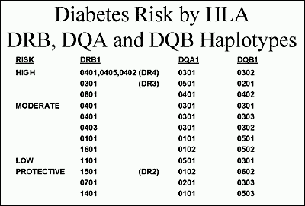

Figure 6. Hierarchy of diabetes risk with examples of haplotypes that lead to diabetes susceptibility, are neutral, or protective. Modified from teaching slides www.barbaradaviscenter.org

There are three HLA molecules that provide dominant protection. The most common is DQB1*0602 that occurs in approximately 20% of U.S. individuals (41-43). Protection is not absolute, but less than 1% of children with type 1 diabetes have this molecule. DQA1*0201 with DQB1*0303 and DRB1*1401 also provide dramatic protection, rarely being found in patients with type 1 diabetes and rarely transmitted from a parent with the alleles to their diabetic offspring (38,39). It is noteworthy that both DR and DQ alleles can protect. The specific mechanism underlying both susceptibility and protection are not fully understood. One attractive hypothesis is that protective alleles when expressed within the thymus lead to deletion of T cells with receptors that recognize a critical islet peptide (44). With deletion of such T cells, the risk of diabetes would be reduced. In addition, it is likely that high-risk HLA alleles present specific peptides of target islet molecules to T lymphocytes (28).

Multiple additional loci (Figure 7) have been implicated with estimates that approximately 50% of the familial aggregation of type 1 diabetes is attributable to the HLA region, perhaps 10% to the insulin locus, with all other loci contributing much less, though in aggregate their contribution is important. In the Cox analysis (Figure 7) of approximately 700 sibling pairs the only significant LOD score was for a locus on chromosome 16q that was not given an iddm designation with earlier genome screens. Several areas implicated in the past had suggestive scores, but there is overlap with the families from which the original evidence was generated. It is likely that contributing loci may differ between populations contributing to the initial difficulty of replicating putative loci in different studies (56,57). More than 40 genetic loci contributing to diabetes risk have been implicated (Figure 7). Polymorphisms of the insulin gene are well established as contributing to risk. A repeat sequence upstream (5') of the insulin gene termed a Variable nucleotide tandem repeat or VNTR, is divided into three general repeat sizes with the longest set of repeats associated with protection from diabetes (46-48). This set of alleles is also associated with greater thymic production of insulin messenger RNA (49), leading to the hypothesis that greater thymic message and presumably greater proinsulin production dampens anti-insulin autoimmunity (49-51). A functional polymorphism of the LYP gene (Lymphocyte Specific Phosphatase; PTPN22- Protein Tyrosine Phosphatase) has been associated with type 1 diabetes, rheumatoid arthritis, and lupus erythematosus (52-54). The R620W missense mutation (tryptophan replacing arginine) disrupts the binding of the phosphatase to the molecule Csk and this blocks its ability to down-regulate T cell receptor signaling. With an odds ratio of between 1.7 and 2.0 of the "autoimmunity” allele which is relatively common (5-10% allele frequency) there is a large genetic effect that is much greater than CTLA-4 polymorphisms associated with diabetes risk (55). Combining known diabetogenic polymorphisms of LYP, the insulin gene, alleles of DP, DQ, and DR class II immune response genes, as well all of the new loci account for approximately 48% of the familial aggregation of type 1A diabetes, with DR and DQ loci accounting for 41% of this 48% (45). A recent study suggests that for a major subset of individuals with the highest risk HLA genotype (DR3/4-DQ2/DQ8 heterozygotes) who share both HLA haplotypes with a diabetic sibling, risk of activating anti-islet autoimmunity is as high as 80% (33).

**AUTOIMMUNITY**

Insulin autoantibodies are usually the first autoantibody to appear in children followed from birth for the development of type 1 diabetes (84,85). These autoantibodies can appear in the first six months of life. Once insulin autoantibodies appear in such young children there is a high risk of development of additional anti-islet autoantibodies and progression to diabetes. More than 90% of children developing type 1 diabetes prior to age 5 have insulin autoantibodies while less than 50% of children developing diabetes after age 12 have such autoantibodies (86). Therapy with human insulin induces insulin antibodies that cannot at present be distinguished from insulin autoantibodies. Thus, if an individual has been treated with insulin for more than several weeks, positive insulin autoantibodies are not interpretable. For all autoantibodies measured in the first 9 months of life, the antibodies may be transplacental in origin, a particular problem if a mother has type 1 diabetes and is treated with insulin.

There are a number of important caveats in the utilization of anti-islet autoantibody assays. The field developed from the initial observation that patient's sera "stained” islets of cut sections of human pancreas, the cytoplasmic islet cell antibody (ICA) assay (83). This assay, given its utilization of human pancreas from cadaveric donation and subjective reading of slides, has proven the most difficult to standardize (69). The assay predominantly detects antibodies reacting with GAD65, IA-2 and ZnT8, but does not detect anti-insulin autoantibodies. Given the difficulty in standardization, reliability over time, and major overlap with defined autoantibody assays, a number of investigators no longer utilize this assay. For research purposes and potentially in older adults with what has been termed LADA (latent autoimmune diabetes of adults) the ICA assay may have utility in that there is evidence of one or more additional autoantibodies detected with this assay and not with GAD65, IA-2, ZnT8 and insulin autoantibody determination.

A single autoantibody, even when present on multiple occasions, is associated with only a modest risk of progression to diabetes: approximately 10% (87,88). Once two or more anti-islet autoantibodies are present in children, progression to diabetes is very high, approaching almost 100% after 15 years of follow-up (89). In addition, once multiple autoantibodies are present it is very unusual for an individual to lose all expression of autoantibodies prior to the development of overt diabetes. Following the development of diabetes, IA-2 and more slowly GAD65 (over decades) autoantibodies wane. Following islet or pancreatic transplantation expression of GAD65 and IA-2 autoantibodies can be induced in patients with long-standing diabetes (90).

The most specific of the autoantibodies react with the molecule IA-2, but IA-2 autoantibodies are usually detected following the appearance of insulin and/or GAD65 autoantibodies (84). Even with IA-2 autoantibodies, however, there are apparent "false” positives in terms of diabetes risk. We evaluated approximately 10 individuals with either transient IA-2 autoantibodies or normal controls with IA-2 autoantibodies. None of these individuals expressed an additional anti-islet autoantibody. In contrast to patients diagnosed with or developing type 1 diabetes, the ICA512/IA-2 autoantibodies of nine out of ten of these normal individuals did not recognize multiple ICA512 epitopes and did not react with the dominant ICA512 autoantigenic domain (91). This indicates that even with a highly specific radioassay, if one screens tens of thousands of sera, one can find sera that presumably by chance cross-react with some epitope of the IA-2 molecule. It is much less likely to find an individual with antibodies that by chance react with two different islet autoantigens using fluid phase radioassays set with specificity at the 99th percentile of controls.

**LOSS OF INSULIN SECRETION**

At present, beta cell mass is not readily measured over time in humans, so it is not possible to absolutely define progression of beta cell loss. There is however no doubt that measurable anti-islet autoimmunity precedes the development of diabetes in terms of anti-islet autoantibodies in humans, and autoantibodies and T cell invasion in animal models. In the NOD mouse there is evidence of some beta cell destruction and beta cell regeneration prior to the onset of diabetes (92). There is also evidence for a change in the immune system close to the time of onset of diabetes (i.e., Th2 to Th1) (93-96). This change is associated with more rapid disease progression, ability to transfer diabetes by T cells, and a time window during which a specific immunotherapy (monoclonal anti-CD3 antibodies) is effective (97). In humans the best evidence for progressive loss of beta cell function comes from studies of insulin and C-peptide secretion (98). C-peptide, the connecting peptide of proinsulin, is secreted in equimolar amount to insulin, but C-peptide is not present in insulin preparations utilized to treat diabetes. Thus, C-peptide has become an important indicator of remaining beta cell function. Following the onset of diabetes, it has long been appreciated that C-peptide secretion progressively declines, until for most patients with type 1 diabetes C-peptide becomes non-detectable, associated with true insulin dependence. In a similar manner, first phase insulin secretion following a bolus of glucose on intravenous glucose tolerance testing is progressively lost for relatives followed to the development of type 1 diabetes (99). Such metabolic abnormalities may result in part from functional inhibition of beta cell secretion, but pathologic studies indicate that beta cell mass is normal for identical twins of patients that have not activated anti-islet autoimmunity, and for new onset patients that bulk of beta cells are destroyed (100). Within the pancreas of a patient with type 1 diabetes there is heterogeneity of islet lesions, with most islets lacking all beta cells and with no lymphocytic infiltrates (pseudoatrophic islets), few normal islets with no infiltrates, and few islets with remaining beta cells and infiltrates. This is perhaps analogous to the progressive development of vitiligo in patients, with patches of skin with all melanocytes destroyed, whereas other skin is normal.

**OVERT DIABETES**

The development of type 1 diabetes is usually perceived as an abrupt event, and some individuals may rapidly manifest severe hyperglycemia. Now that we can follow individuals to the development of type 1 diabetes, we can see that anti-islet autoantibodies can precede hyperglycemia by years, and there is usually some deterioration in glucose tolerance more than one year prior to diabetes onset (particularly with intravenous glucose tolerance testing) (101). The majority of individuals identified to be diabetic following autoantibody testing are found to have a diabetic 2-hour glucose on oral glucose tolerance testing (>200mg/dl) rather than fasting hyperglycemia. The acute presentation with severe hyperglycemia and ketoacidosis is life threatening, and it is estimated that approximately 1/200 children die at the onset of type 1 diabetes (102,103). Such children typically have a medical history where the first health care providers have failed to make the diagnosis of diabetes; the child then presents again later and dies with cerebral edema. The classic symptoms of polyuria, polydipsia, and weight loss are usually present but the initial diagnosis is still missed. The alternative diagnosis of nausea and vomiting due to viral illness is the most common mistaken diagnosis, and with the ready availability of glucose determination from a finger or heel stick, there should be a low threshold in emergency rooms and physicians’ offices for ruling out diabetes. Though transient hyperglycemia can occur, such children obviously need close follow up. We usually arrange glucose monitoring for children thought to have transient hyperglycemia, and measure anti-islet autoantibodies (104). Of those with anti-islet autoantibodies and transient hyperglycemia, almost all progress to type 1 diabetes within several months.

At the onset of type 1 diabetes, almost all individuals have residual insulin secretion, and there is convincing evidence that residual insulin secretion as measured by C-peptide secretion is of clinical benefit (less hypoglycemia, less microvascular complications, and much easier diabetes management).

**REFERENCES**

1. Eisenbarth GS. Banting Lecture 2009: An unfinished journey: molecular pathogenesis to prevention of type 1A diabetes. Diabetes 2010; 59:759-774

2. Todd JA. Etiology of type 1 diabetes. Immunity 2010; 32:457-467

3. Stadinski B, Kappler J, Eisenbarth GS. Molecular targeting of islet autoantigens. Immunity 2010; 32:446-456

4. Skyler JS. Immunomodulation for type 1 diabetes mellitus. International journal of clinical practice Supplement 2010:59-63

5. Wong FS, Wen L. The study of HLA class II and autoimmune diabetes. Current molecular medicine 2003; 3:1-15

6. Atkinson MA, Eisenbarth GS, Michels AW. Type 1 diabetes. Lancet 2014; 383:69-82

7. Lorenzen T, Pociot F, Hougaard P, et al. Long-term risk of IDDM in first-degree relatives of patients with IDDM. Diabetologia 1994; 37:321-327

8. Janzon L, Bergentz SE, Ericsson BF, et al. The arm-ankle pressure gradient in relation to cardiovascular risk factors in intermittent claudication. Circulation 1981; 63:1339-1341

9. Zimmet P, Turner R, McCarty D, et al. Crucial points at diagnosis. Type 2 diabetes or slow type 1 diabetes. Diabetes care 1999; 22 Suppl 2:B59-64

10. Pinhas-Hamiel O, Dolan LM, Daniels SR, et al. Increased incidence of non-insulin-dependent diabetes mellitus among adolescents. The Journal of pediatrics 1996; 128:608-615

11. Gianani R, Campbell-Thompson M, Sarkar SA, et al. Dimorphic histopathology of long-standing childhood-onset diabetes. Diabetologia 2010; 53:690-698

12. Triolo TM, Armstrong TK, McFann K, et al. Additional Autoimmune Disease Found in 33% of Patients at Type 1 Diabetes Onset. Diabetes care 2011; 34:1211-1213

13. McCarthy MI, Hattersley AT. Learning from molecular genetics: novel insights arising from the definition of genes for monogenic and type 2 diabetes. Diabetes 2008; 57:2889-2898

14. Bao F, Yu L, Babu S, et al. One third of HLA DQ2 homozygous patients with type 1 diabetes express celiac disease-associated transglutaminase autoantibodies. Journal of autoimmunity 1999; 13:143-148

15. Hoffenberg EJ, Bao F, Eisenbarth GS, et al. Transglutaminase antibodies in children with a genetic risk for celiac disease. The Journal of pediatrics 2000; 137:356-360

16. Baker PR, Baschal EE, Fain PR, et al. Dominant suppression of Addison's disease associated with HLA-B15. The Journal of clinical endocrinology and metabolism 2011; 96:2154-2162

17. Atkinson MA, Eisenbarth GS. Type 1 diabetes: new perspectives on disease pathogenesis and treatment. Lancet 2001; 358:221-229

18. Eisenbarth GS. Type I diabetes mellitus. A chronic autoimmune disease. The New England journal of medicine 1986; 314:1360-1368

19. Diagnosis and classification of diabetes mellitus. Diabetes care 2004; 27 Suppl 1:S5-S10

20. Imagawa A, Hanafusa T, Miyagawa J, et al. A novel subtype of type 1 diabetes mellitus characterized by a rapid onset and an absence of diabetes-related antibodies. Osaka IDDM Study Group. The New England journal of medicine 2000; 342:301-307

21. Robles DT, Eisenbarth GS, Ikegami H, et al. Endocrinology and metabolism clinics of North America. Philadelphia: W.B. Saunders; 2002.

22. Patel DD. Escape from tolerance in the human X-linked autoimmunity-allergic disregulation syndrome and the Scurfy mouse. The Journal of clinical investigation 2001; 107:155-157

23. Bjorses P, Aaltonen J, Horelli-Kuitunen N, et al. Gene defect behind APECED: a new clue to autoimmunity. Human molecular genetics 1998; 7:1547-1553

24. Michels AW, Eisenbarth GS. Autoimmune polyendocrine syndrome type 1 (APS-1) as a model for understanding autoimmune polyendocrine syndrome type 2 (APS-2). Journal of internal medicine 2009; 265:530-540

25. Fontenot JD, Gavin MA, Rudensky AY. Foxp3 programs the development and function of CD4+CD25+ regulatory T cells. Nature immunology 2003; 4:330-336

26. Owen CJ, Jennings CE, Imrie H, et al. Mutational analysis of the FOXP3 gene and evidence for genetic heterogeneity in the immunodysregulation, polyendocrinopathy, enteropathy syndrome. The Journal of clinical endocrinology and metabolism 2003; 88:6034-6039

27. Klein J, Sato A. The HLA system. First of two parts. The New England journal of medicine 2000; 343:702-709

28. Lee KH, Wucherpfennig KW, Wiley DC. Structure of a human insulin peptide-HLA-DQ8 complex and susceptibility to type 1 diabetes. Nature immunology 2001; 2:501-507

29. Mordes JP, Greiner DL, Rossini AA. Animal models of autoimmune diabetes mellitus. . In: LeRoith D, Taylor SI, Olefsky JM, eds. Diabetes mellitus : a fundamental and clinical text. Philadelphia: Lippincott-Raven; 1996:349-360.

30. Martin AM, Maxson MN, Leif J, et al. Diabetes-prone and diabetes-resistant BB rats share a common major diabetes susceptibility locus, iddm4: additional evidence for a "universal autoimmunity locus" on rat chromosome 4. Diabetes 1999; 48:2138-2144

31. Yu B, Gauthier L, Hausmann DH, et al. Binding of conserved islet peptides by human and murine MHC class II molecules associated with susceptibility to type I diabetes. European journal of immunology 2000; 30:2497-2506

32. Redondo MJ, Jeffrey J, Fain PR, et al. Concordance for islet autoimmunity among monozygotic twins. The New England journal of medicine 2008; 359:2849-2850

33. Aly TA, Ide A, Jahromi MM, et al. Extreme genetic risk for type 1A diabetes. Proceedings of the National Academy of Sciences of the United States of America 2006; 103:14074-14079

34. Redondo MJ, Fain PR, Eisenbarth GS. Genetics of type 1A diabetes. Recent progress in hormone research 2001; 56:69-89

35. Kwon OJ, Brautbar C, Weintrob N, et al. Immunogenetics of HLA class II in Israeli Ashkenazi Jewish, Israeli non-Ashkenazi Jewish, and in Israeli Arab IDDM patients. Human immunology 2001; 62:85-91

36. Undlien DE, Lie BA, Thorsby E. HLA complex genes in type 1 diabetes and other autoimmune diseases. Which genes are involved? Trends in genetics : TIG 2001; 17:93-100

37. Lie BA, Ronningen KS, Akselsen HE, et al. Application and interpretation of transmission/disequilibrium tests: transmission of HLA-DQ haplotypes to unaffected siblings in 526 families with type 1 diabetes. American journal of human genetics 2000; 66:740-743

38. Redondo MJ, Kawasaki E, Mulgrew CL, et al. DR- and DQ-associated protection from type 1A diabetes: comparison of DRB1*1401 and DQA1*0102-DQB1*0602*. The Journal of clinical endocrinology and metabolism 2000; 85:3793-3797

39. Kawasaki E, Noble J, Erlich H, et al. Transmission of DQ haplotypes to patients with type 1 diabetes. Diabetes 1998; 47:1971-1973

40. Erlich H, Valdes AM, Noble J, et al. HLA DR-DQ haplotypes and genotypes and type 1 diabetes risk: analysis of the type 1 diabetes genetics consortium families. Diabetes 2008; 57:1084-1092

41. Baisch JM, Weeks T, Giles R, et al. Analysis of HLA-DQ genotypes and susceptibility in insulin-dependent diabetes mellitus. The New England journal of medicine 1990; 322:1836-1841

42. Pugliese A, Gianani R, Moromisato R, et al. HLA-DQB1*0602 is associated with dominant protection from diabetes even among islet cell antibody-positive first-degree relatives of patients with IDDM. Diabetes 1995; 44:608-613

43. Pugliese A, Kawasaki E, Zeller M, et al. Sequence analysis of the diabetes-protective human leukocyte antigen-DQB1*0602 allele in unaffected, islet cell antibody-positive first degree relatives and in rare patients with type 1 diabetes. The Journal of clinical endocrinology and metabolism 1999; 84:1722-1728

44. Barrett JC, Clayton DG, Concannon P, et al. Genome-wide association study and meta-analysis find that over 40 loci affect risk of type 1 diabetes. Nature genetics 2009; 41:703-707

45. Todd JA, Walker NM, Cooper JD, et al. Robust associations of four new chromosome regions from genome-wide analyses of type 1 diabetes. Nature genetics 2007; 39:857-864

46. Bell GI, Horita S, Karam JH. A polymorphic locus near the human insulin gene is associated with insulin-dependent diabetes mellitus. Diabetes 1984; 33:176-183

47. Undlien DE, Bennett ST, Todd JA, et al. Insulin gene region-encoded susceptibility to IDDM maps upstream of the insulin gene. Diabetes 1995; 44:620-625

48. Barratt BJ, Payne F, Lowe CE, et al. Remapping the insulin gene/IDDM2 locus in type 1 diabetes. Diabetes 2004; 53:1884-1889

49. Pugliese A, Brown D, Garza D, et al. Self-antigen-presenting cells expressing diabetes-associated autoantigens exist in both thymus and peripheral lymphoid organs. The Journal of clinical investigation 2001; 107:555-564

50. Pugliese A, Zeller M, Fernandez A, Jr., et al. The insulin gene is transcribed in the human thymus and transcription levels correlated with allelic variation at the INS VNTR-IDDM2 susceptibility locus for type 1 diabetes. Nature genetics 1997; 15:293-297

51. Bennett ST, Wilson AJ, Esposito L, et al. Insulin VNTR allele-specific effect in type 1 diabetes depends on identity of untransmitted paternal allele. The IMDIAB Group. Nature genetics 1997; 17:350-352

52. Bottini N, Musumeci L, Alonso A, et al. A functional variant of lymphoid tyrosine phosphatase is associated with type I diabetes. Nature genetics 2004; 36:337-338

53. Kyogoku C, Langefeld CD, Ortmann WA, et al. Genetic association of the R620W polymorphism of protein tyrosine phosphatase PTPN22 with human SLE. American journal of human genetics 2004; 75:504-507

54. Begovich AB, Carlton VE, Honigberg LA, et al. A missense single-nucleotide polymorphism in a gene encoding a protein tyrosine phosphatase (PTPN22) is associated with rheumatoid arthritis. American journal of human genetics 2004; 75:330-337

55. Ueda H, Howson JM, Esposito L, et al. Association of the T-cell regulatory gene CTLA4 with susceptibility to autoimmune disease. Nature 2003; 423:506-511

56. Noble JA, Valdes AM, Varney MD, et al. HLA class I and genetic susceptibility to type 1 diabetes: results from the Type 1 Diabetes Genetics Consortium. Diabetes 2010; 59:2972-2979

57. Burren OS, Adlem EC, Achuthan P, et al. T1DBase: update 2011, organization and presentation of large-scale data sets for type 1 diabetes research. Nucleic acids research 2011; 39:D997-1001

58. Abiru N, Maniatis AK, Yu L, et al. Peptide and major histocompatibility complex-specific breaking of humoral tolerance to native insulin with the B9-23 peptide in diabetes-prone and normal mice. Diabetes 2001; 50:1274-1281

59. Heath VL, Hutchings P, Fowell DJ, et al. Peptides derived from murine insulin are diabetogenic in both rats and mice, but the disease-inducing epitopes are different: evidence against a common environmental cross-reactivity in the pathogenicity of type 1 diabetes. Diabetes 1999; 48:2157-2165

60. Wen L, Chen NY, Tang J, et al. The regulatory role of DR4 in a spontaneous diabetes DQ8 transgenic model. The Journal of clinical investigation 2001; 107:871-880

61. Ellerman KE, Like AA. Susceptibility to diabetes is widely distributed in normal class IIu haplotype rats. Diabetologia 2000; 43:890-898

62. Ellerman KE, Richards CA, Guberski DL, et al. Kilham rat triggers T-cell-dependent autoimmune diabetes in multiple strains of rat. Diabetes 1996; 45:557-562

63. Wucherpfennig KW, Eisenbarth GS. Type 1 diabetes. Nature immunology 2001; 2:767-768

64. Stadinski BD, Zhang L, Crawford F, et al. Diabetogenic T cells recognize insulin bound to IAg7 in an unexpected, weakly binding register. Proceedings of the National Academy of Sciences of the United States of America 2010; 107:10978-10983

65. Michels AW. Targeting the trimolecular complex. Clin Immunol 2013; 149:339-344

66. Ginsberg-Fellner F, Witt ME, Yagihashi S, et al. Congenital rubella syndrome as a model for type 1 (insulin-dependent) diabetes mellitus: increased prevalence of islet cell surface antibodies. Diabetologia 1984; 27 Suppl:87-89

67. Shaver KA, Boughman JA, Nance WE. Congenital rubella syndrome and diabetes: a review of epidemiologic, genetic, and immunologic factors. American annals of the deaf 1985; 130:526-532

68. Rabinowe SL, George KL, Loughlin R, et al. Congenital rubella. Monoclonal antibody-defined T cell abnormalities in young adults. The American journal of medicine 1986; 81:779-782

69. Lonnrot M, Korpela K, Knip M, et al. Enterovirus infection as a risk factor for beta-cell autoimmunity in a prospectively observed birth cohort: the Finnish Diabetes Prediction and Prevention Study. Diabetes 2000; 49:1314-1318

70. Graves PM, Norris JM, Pallansch MA, et al. The role of enteroviral infections in the development of IDDM: limitations of current approaches. Diabetes 1997; 46:161-168

71. Rewers M, Norris JM. Epidemiology of type I diabetes. In: Eisenbarth GS, Lafferty KJ, eds. Type I diabetes : molecular, cellular, and clinical immunology. New York: Oxford University Press; 1996:172-208.

72. Martin JM, Trink B, Daneman D, et al. Milk proteins in the etiology of insulin-dependent diabetes mellitus (IDDM). Annals of medicine 1991; 23:447-452

73. Norris JM, Beaty B, Klingensmith G, et al. Lack of association between early exposure to cow's milk protein and beta-cell autoimmunity. Diabetes Autoimmunity Study in the Young (DAISY). Jama 1996; 276:609-614

74. Norris JM, Barriga K, Klingensmith G, et al. Timing of initial cereal exposure in infancy and risk of islet autoimmunity. Jama 2003; 290:1713-1720

75. Ziegler AG, Schmid S, Huber D, et al. Early infant feeding and risk of developing type 1 diabetes-associated autoantibodies. Jama 2003; 290:1721-1728

76. Yang Z, Wang K, Li T, et al. Childhood diabetes in China. Enormous variation by place and ethnic group. Diabetes care 1998; 21:525-529

77. Onkamo P, Vaananen S, Karvonen M, et al. Worldwide increase in incidence of Type I diabetes--the analysis of the data on published incidence trends. Diabetologia 1999; 42:1395-1403

78. Bach JF. The effect of infections on susceptibility to autoimmune and allergic diseases. The New England journal of medicine 2002; 347:911-920

79. Wenzlau JM, Moua O, Sarkar SA, et al. SlC30A8 is a major target of humoral autoimmunity in type 1 diabetes and a predictive marker in prediabetes. Annals of the New York Academy of Sciences 2008; 1150:256-259

80. Bonifacio E, Atkinson M, Eisenbarth G, et al. International Workshop on Lessons From Animal Models for Human Type 1 Diabetes: Identification of Insulin but Not Glutamic Acid Decarboxylase or IA-2 as Specific Autoantigens of Humoral Autoimmunity in Nonobese Diabetic Mice. Diabetes 2001; 50:2451-2458

81. Margolis DJ, Gupta J, Hoffstad O, et al. Lack of effectiveness of hyperbaric oxygen therapy for the treatment of diabetic foot ulcer and the prevention of amputation: a cohort study. Diabetes care 2013; 36:1961-1966

82. Miao D, Guyer KM, Dong F, et al. GAD65 autoantibodies detected by electrochemiluminescence assay identify high risk for type 1 diabetes. Diabetes 2013; 62:4174-4178

83. Bottazzo GF, Florin-Christensen A, Doniach D. Islet-cell antibodies in diabetes mellitus with autoimmune polyendocrine deficiencies. Lancet 1974; 2:1279-1283

84. Bonifacio E, Scirpoli M, Kredel K, et al. Early autoantibody responses in prediabetes are IgG1 dominated and suggest antigen-specific regulation. J Immunol 1999; 163:525-532

85. Yu L, Robles DT, Abiru N, et al. Early expression of antiinsulin autoantibodies of humans and the NOD mouse: evidence for early determination of subsequent diabetes. Proceedings of the National Academy of Sciences of the United States of America 2000; 97:1701-1706

86. Vardi P, Ziegler AG, Mathews JH, et al. Concentration of insulin autoantibodies at onset of type I diabetes. Inverse log-linear correlation with age. Diabetes care 1988; 11:736-739

87. Verge CF, Gianani R, Kawasaki E, et al. Prediction of type I diabetes in first-degree relatives using a combination of insulin, GAD, and ICA512bdc/IA-2 autoantibodies. Diabetes 1996; 45:926-933

88. Bingley PJ, Bonifacio E, Williams AJ, et al. Prediction of IDDM in the general population: strategies based on combinations of autoantibody markers. Diabetes 1997; 46:1701-1710

89. Ziegler AG, Rewers M, Simell O, et al. Seroconversion to multiple islet autoantibodies and risk of progression to diabetes in children. Jama 2013; 309:2473-2479

90. Bosi E, Braghi S, Maffi P, et al. Autoantibody response to islet transplantation in type 1 diabetes. Diabetes 2001; 50:2464-2471

91. Clark CM, Jr. How should we respond to the worldwide diabetes epidemic? Diabetes care 1998; 21:475-476

92. Sreenan S, Pick AJ, Levisetti M, et al. Increased beta-cell proliferation and reduced mass before diabetes onset in the nonobese diabetic mouse. Diabetes 1999; 48:989-996

93. Gazda LS, Charlton B, Lafferty KJ. Diabetes results from a late change in the autoimmune response of NOD mice. Journal of autoimmunity 1997; 10:261-270

94. Dilts SM, Lafferty KJ. Autoimmune diabetes: the involvement of benign and malignant autoimmunity. Journal of autoimmunity 1999; 12:229-232

95. Andre I, Gonzalez A, Wang B, et al. Checkpoints in the progression of autoimmune disease: lessons from diabetes models. Proceedings of the National Academy of Sciences of the United States of America 1996; 93:2260-2263

96. Shimada A, Charlton B, Taylor-Edwards C, et al. Beta-cell destruction may be a late consequence of the autoimmune process in nonobese diabetic mice. Diabetes 1996; 45:1063-1067

97. Chatenoud L, Primo J, Bach JF. CD3 antibody-induced dominant self tolerance in overtly diabetic NOD mice. J Immunol 1997; 158:2947-2954

98. Rosenbauer J, Herzig P, von Kries R, et al. Temporal, seasonal, and geographical incidence patterns of type I diabetes mellitus in children under 5 years of age in Germany. Diabetologia 1999; 42:1055-1059

99. Chase HP, Cuthbertson DD, Dolan LM, et al. First-phase insulin release during the intravenous glucose tolerance test as a risk factor for type 1 diabetes. The Journal of pediatrics 2001; 138:244-249

100. Foulis AK, McGill M, Farquharson MA, et al. A search for evidence of viral infection in pancreases of newly diagnosed patients with IDDM. Diabetologia 1997; 40:53-61

101. Srikanta S, Ganda OP, Rabizadeh A, et al. First-degree relatives of patients with type I diabetes mellitus. Islet-cell antibodies and abnormal insulin secretion. The New England journal of medicine 1985; 313:461-464

102. Laing SP, Swerdlow AJ, Slater SD, et al. The British Diabetic Association Cohort Study, II: cause-specific mortality in patients with insulin-treated diabetes mellitus. Diabetic medicine : a journal of the British Diabetic Association 1999; 16:466-471

103. Laing SP, Swerdlow AJ, Slater SD, et al. The British Diabetic Association Cohort Study, I: all-cause mortality in patients with insulin-treated diabetes mellitus. Diabetic medicine : a journal of the British Diabetic Association 1999; 16:459-465

104. Herskowitz RD, Wolfsdorf JI, Ricker AT, et al. Transient hyperglycemia in childhood: identification of a subgroup with imminent diabetes mellitus. Diabetes Res 1988; 9:161-167

105. Barker JM, Goehrig SH, Barriga K, et al. Clinical characteristics of children diagnosed with type 1 diabetes through intensive screening and follow-up. Diabetes care 2004; 27:1399-1404