PHYSIOLOGY OF THE HYPOTHALAMIC-PITUITARY-THYROID AXIS

Stefano Mariotti, MD, Full Professor of Endocrinology, Pisa, Italy, mariottistefano48@gmail.com
Paolo Beck-Peccoz, MD, Professor Emeritus of the University of Milan, Milan, Italy, paolo.beckpeccoz@unimi.it

Updated April 4, 2021

ABSTRACT

The activity of the thyroid gland is predominantly regulated by the concentration of the pituitary glycoprotein hormone, thyroid-stimulating hormone (TSH). In the absence of the pituitary or of thyrotroph function, hypothyroidism ensues. Thus, regulation of thyroid function in normal individuals is to a large extent determined by the factors which regulate the synthesis and secretion of TSH. Those factors are reviewed in this chapter and consist principally of thyrotropin-releasing hormone (TRH) and the feedback effects of circulating thyroid hormones at the hypothalamic and pituitary levels. The consequence of the dynamic interplay of these two dominant influences on TSH secretion, the positive effect of TRH on the one hand and the negative effects of thyroid hormones on the other, results in a remarkably stable morning concentration of TSH in the circulation and consequently little alteration in the level of circulating thyroid hormones from day to day and year to year. This regulation is so carefully maintained that an abnormal serum TSH in most patients is believed to indicate the presence of a disorder of thyroid gland function. The utility of TSH measurements has been recognized and its use has remarkably increased due to the development of immunometric methodologies for its accurate quantitation in serum, although the criteria to define a “normal range” still remain a matter of controversy. This chapter is organized into two general sections. The first portion reviews basic studies of TSH synthesis, post-translational modification, and release. The second deals with physiological studies in humans which serve as the background for the diagnostic use of TSH measurements and reviews the results of TSH assays in pathophysiological disorders.

The Regulation of Thyroid-Stimulating Hormone synthesis and
secretion: Molecular Biology and Biochemistry

The TSH Molecule

TSH is a heterodimer consisting of an alpha and a beta subunit that are tightly, but non-covalently, bound (1,2). While the molecular weight of the deduced amino-acid sequence of the mature alpha and beta subunits in combination is approximately 28,000 Da, additional carbohydrate (15% by weight) results in a significantly higher molecular weight estimate based on sizing by polyacrylamide gel electrophoresis. The alpha subunit (glycoprotein hormones, alpha polypeptide) is common to TSH, follicle-stimulating hormone (FSH), luteinizing hormone (LH), and chorionic gonadotropin (CG). The beta subunit confers specificity to the molecule since it interacts with the TSH receptor (TSH-R) expressed on the basolateral membrane of thyroid follicular cells, and is rate-limiting in the formation of the mature heterodimeric protein. However, the free beta subunit is inactive and requires noncovalent combination with the alpha subunit to express hormonal bioactivity. The linear sequence of the human alpha subunit consists of 92 amino acids including 10 cystine residues that form a total 5 bonds through disulfide linkage. The human TSH beta (hTSH beta) subunit contains 118 amino-acids, as predicted by complementary DNA sequences, but hTSH beta isolated from the pituitary gland has an apoprotein core of 112 amino-acids, due to carboxyl-terminal truncation during purification.

The production rate (PR) of human TSH is normally between 50 and 200 mU/day and increases markedly (up to >4000 mU/day) in primary hypothyroidism; the metabolic clearance rate (MCR) of the hormone is about 25 ml/min/m² in euthyroidism, while significantly higher in hyperthyroidism and lower in hypothyroidism (3). The PR of free alpha subunit is about 100 µg/day, increases increase approximately two-fold in primary hypothyroidism and in post-menopausal women, and decreases (about to one half) in hyperthyroidism (4). The PR of free TSH beta subunit is too low to be calculated in all hyperthyroid and in most euthyroid subjects, while is 25-30 ug/day in primary hypothyroidism (4). The MCR of the free subunits is 2-3 times faster than that of TSH, being about 68 ml/min/m² for alpha and 48 ml/min/m² for the beta subunit (4). The half-life of circulating TSH ranges from 50 to 80 minutes (4).

The gene coding for the alpha subunit (CGA) is located on chromosome 6 and the thyroid stimulating hormone subunit beta (TSHB) gene on chromosome 1 (5). The structure of CGA gene has been determined in several animal species (6,7). The genes of each species are approximately of the same size and similarly organized in four exons and three introns. The human gene is 9.4 kilobases (kb) in length, with three introns measuring 6.4 kb, 1.7 kb and 0.4 kb, respectively. The TSHB gene has been isolated in mouse (7), rat (8), and humans (9,10), among other species. In contrast to the CGA gene, the organization of the TSHB gene is somewhat variable between the different species. The rat and the human genes are organized in three exons, while the mouse gene contains two additional 5'-untranslated exons. The first exon is untranslated, the leader peptide and the first 34 amino-acids are encoded by the second exon, while the third exon represents the remaining coding region and 3'-untranslated sequences. A single transcription start has been identified in the hTSHB gene, while the rat and the mouse genes contain two starting sites separated by approximately 40 base pairs (bp); transcription begins predominantly from the downstream site, which corresponds to the location of the human transcriptional start. A schematic representation of the TSHB gene is shown in Figure 1.

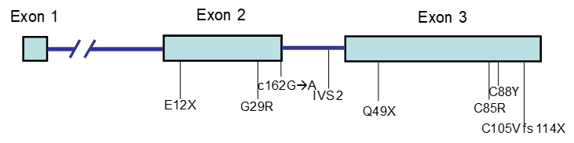
Figure 1. Thyrotropin β (TSHB) gene structure. Some mutations of the gene found in patients with congenital central hypothyroidism are also depicted (modified from McDermott et al. (11) and Baquedano et al. (12)).

The pre-translational regulation of TSH synthesis and secretion is a complex process, detailed in the next paragraphs. The formation of mature TSH involves several post-translational steps including the excision of signal peptides from both subunits and co-translational glycosylation with high mannose oligosaccharides (13,14). As the glycoproteins are successively transferred from the rough endoplasmic reticulum to the Golgi apparatus, the trimming of mannose and further addition of fucose, galactose and sialic acid occurs (15). The alpha subunit has two and the beta subunit has one asparagine (N)-linked oligosaccharide(s) showing a typical biantennary structure fully sulfated in bovine and half-sulfated in human TSH (2). The primary intracellular role of these glycosylation events may be to allow proper folding of the alpha and beta subunits permitting their heterodimerization and also preventing intracellular degradation (16,15). On the basis of crystallographic studies on hCG and other glycoprotein hormones, a homology model of the tridimensional structure of TSH has been proposed (17). This model (Fig. 2) predicts for both the alpha and the beta subunit the presence of two beta-hairpin loops (L1 and L3) on one side of a central "cystine knot" (pair of cysteine molecules) formed by three disulfide bonds, and a long loop (L2) on the other side. Both alpha and beta chains have functionally important domains involved in TSH-R binding and activation (Fig. 2) (18). Of particular relevance is the so-called “seat belt” region of the beta chain comprised between the 10th (C86) and the 12th (C105) cysteine residue (Fig. 2 and Fig. 3). The name “seat belt” derives from the conformational structure of the beta chain determined by the disulfide bridge (C39/C125) toward the C-terminal tail of the beta subunit that wraps the alpha subunit like a “seat belt” (Fig. 3), and stabilizes the heterodimerization of TSH (2,18).

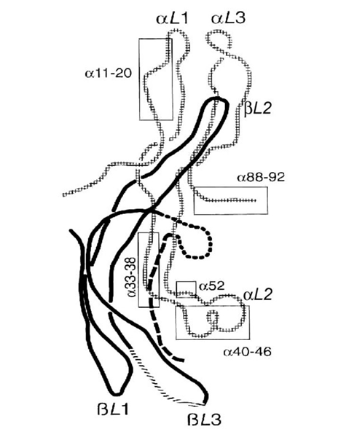
Figure 2. Schematic drawing of human TSH, based on a molecular homology model built on the template of a hCG model (17). The α-subunit is shown as checkered, and the β-subunit as a solid line. The two hairpin loops in each subunit are marked L1, L3; each subunit has also a long loop (L2), which extends from the opposite site of the central cystine knot. The functionally important α-subunit domains are boxed. Important domains of the β-subunit are marked directly within the line drawing (crossed line, beaded line and dashed line). Reproduced from Grossmann et al. (2) with permission, where further details can be found.

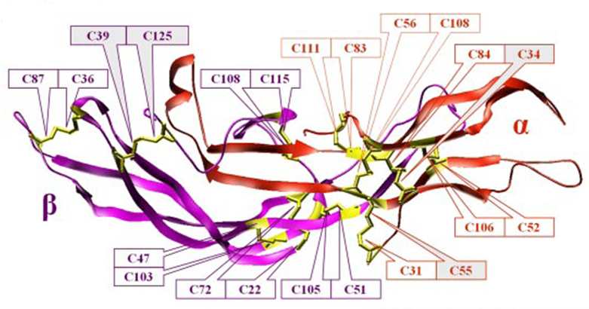
Figure 3. Structural model of TSH based on the FSH x-ray structure, which is the best available structural template for TSH. The boxed residue numbers represent cysteines residues, which form stabilizing disulfide bridges (yellow): 5 in α-subunit (red orange), and 6 in the β-subunit (magenta). The disulfide bridge (C39/C125) toward the C-terminal tail of the α-subunit of TSH that wraps around the β-subunit like a “seat belt” stabilizes the heterodimerization of TSH as well as that of FSH, LH, and HCG. (Reproduced from Kleinau et al. (18) with permission)

Proper TSH glycosylation is also necessary to attain normal bioactivity (19), a process which requires the interaction of the neuropeptide thyrotropin-releasing hormone (TRH) (Fig. 4), with its receptor on thyrotroph cells (20-22). The requirement for TRH in this process is illustrated by the fact that in patients with central hypothyroidism due to hypothalamic-pituitary dysfunction, normal or even slightly elevated levels of TSH are detected by radioimmunoassay, but biologically subpotent forms are found in the circulation together with reduced levels of free T4 (23-25). Chronic TRH administration to such patients normalizes the glycosylation process enhancing both its TSH-R binding affinity as well as its capacity to activate adenyl cyclase. This, in turn, can normalize thyroid function in such patients (26). On the other hand, enhanced TSH bioactivity is invariably found in sera from patients with thyroid hormone resistance (27). Moreover, variations of TSH bioactivity (mostly related to different TSH glycosylation) have been observed in normal subjects during the nocturnal TSH surge, in normal fetuses during the last trimester of pregnancy, in primary hypothyroidism, in patients with TSH-secreting pituitary adenomas, and in non-thyroidal illnesses (27,28). Glycosylation of the molecule can also influence the rapidity of clearance of TSH from the circulation. Taken together, these findings have led to a new concept of a qualitative regulation of TSH secretion, mainly achieved through both the transcriptional and post-transcriptional mechanisms involving not only TSH glycosylation (29), but also thyrocyte physiology and thyroid disorders (30).

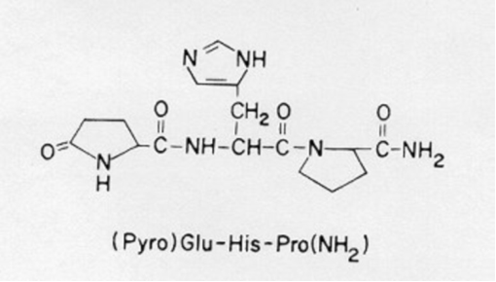
Figure 4. Structure of TRH

Specific amino-acid sequences in the common alpha and beta subunits are critical for the heterodimerization, secretion and bioactivity of mature TSH. These sequences include highly conserved segments which are essential for TSH-R binding and biological activity (see Refs (2,18) for an extensive review). The peptide sequence 27CAGYC31 (cysteine-alanine-glycine-tyrosine-cysteine) is highly conserved in the beta subunit of TSH, LH, hCG, as well as FSH, and is thought to be important in heterodimerization with the alpha subunit (31,32). Several inherited TSHB gene mutations are responsible for isolated familial central hypothyroidism and are listed in Table 1 and depicted in Fig. 1. The most frequent mutation is a homozygous single-base deletion in codon 105 that results in a substitution of cysteine 105 by valine and an additional 8 amino acid nonhomologous peptide extension on the mutant protein (C105V, 114X). The mutation destroys a disulfide bond essential for normal protein conformation and bioactivity and leads to an unstable heterodimer (33-38,11,39,40,12,41,42).

Table 1. Mutations in the Beta Subunit Gene Responsible for Congenital Isolated Central Hypothyroidism
Mutation of TSHB | Consequence of mutation on TSH heterodimer formation
G29R (31) | Prevents dimer formation modifying the CAGYC region
E12X (33) | Truncated TSH beta subunit unable to associate with alpha chain
C105V, 114X (41) | Destruction of a disulfide bond, non-homologous carboxyterminus. Change of amino acid sequence in the “seat belt” region leads to unstable heterodimer
Q49X (37) | Truncated TSH beta subunit forming a bio-inactive heterodimer with the alpha chain
IVS2+5→A (39) | Base substitution at intron 2 (position +5) with shift of the translational start point to an out of frame position of exon 3 resulting in a truncated transcript
C85R (43) | T to C transition at codon 85 of exon 3 resulting in a change of cysteine to arginine, preventing the formation of a functional heterodimer with the alpha subunit
C162G→A (12) | G to A change at the 5’ donor splice site of exon/intron 2 transition causing a (CGA→CGG) polymorphism, which although per se silent, disrupts the 5’ consensus sequence critical for splicing and causes complete skipping of exon 2
C88Y (12) | 323G>A transition resulting in a C88Y change. This cysteine residue is conserved among all pituitary and placental glycoprotein hormone-beta subunits and the loss alters the conformation and intracellular degradation

The understanding of the relationship between molecular structure and biological activity of TSH recently allowed the synthesis of TSH variants designed by site-directed mutagenesis with either antagonist (43) or superagonist (44) activity that potentially offer novel therapeutic alternatives. More recently, newly chemically modified compounds with low molecular-weight and able to antagonize the TSH receptor have been reported (45,46). These drugs may possess agonist or antagonist properties. Indeed, a non peptidic antagonist, therefore devoid of intrinsic immunogenicity, might be very useful in the treatment of Graves’ disease and other forms of hyperthyroidism, such as TSH-secreting pituitary adenomas, Graves’ orbitopathy, and activating mutations of the TSH receptor (47,48).

Other Thyrotropic Hormones

A second thyrotropic hormone formed by a heterodimer of two distinct glycoprotein subunits (glycoprotein hormone alpha 2-subunit - GPA2 and glycoprotein hormone beta 5-subunit - GPB5) has been identified in the human pituitary and called thyrostimulin (49-53). Thyrostimulin has a sequence similarity of 29% with the alpha and 43% with the beta subunit and is able to activate the TSH-R (54,18). Although it has been hypothesized that it could account for the residual stimulation of thyroid gland observed in patients with central hypothyroidism (55), its physiological role is still unknown. The GPA2/GPB5 heterodimer is localized in extrapituitary tissues such as the eye, testis, bone, and ovary (54,56,57), while the anterior pituitary expresses almost exclusively GPA2 (54). In the rat ovary, thyrostimulin activates the TSH-R expressed in granulosa cells suggesting a potential paracrine activity (56).

Regulation of TSH Synthesis and Secretion

The major regulators of TSH production are represented by the inhibitory effects of thyroid hormone (58) and by the stimulatory action of TRH. As shown in Fig. 5, T3 acts via binding to the nuclear thyroid hormone receptor β2 isoform present in thyrotrophs, and T4 mainly acts via its intra-pituitary or intra-hypothalamic conversion to T3, although a direct negative effect of T4 independent from local T3 generation on TSHB gene expression has been documented (59). Both thyroid hormones directly regulate the synthesis and release of TSH at the pituitary level and indirectly affect TSH synthesis via their effects on TRH and other neuropeptides. TRH is the major positive regulator of hTSHB gene expression and mainly acts by activating the phosphatidylinositol-protein kinase C pathway. Other hormones/factors are also implicated in the complex regulation of TSHB gene expression, as detailed below.

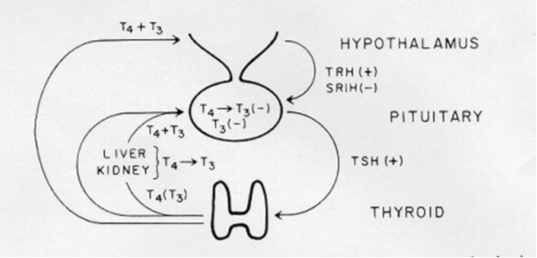
Figure 5. Basic elements in the regulation of thyroid function. TRH is a necessary tonic stimulus to TSH synthesis and release. TRH synthesis is regulated directly by thyroid hormones. T4 is the predominant secretory product of the thyroid gland, with peripheral deiodination of T4 to T3 in the liver and kidney supplying roughly 80% of the circulating T3. Both circulating T3 and T4 directly inhibit TSH synthesis and release independently, T4 after conversion to T3. SRIH, somatostatin

EFFECTS OF THYROID HORMONE ON TSH SYNTHESIS

In animal models, thyroid hormone administration is followed by a marked decrease of both alpha and TSHB subunit mRNA expression (60,61), but TSHB is suppressed more rapidly and more completely than the alpha subunit. In humans with primary hypothyroidism a paradoxical increase of serum TSH concentration has been observed shortly after beginning thyroid hormone replacement therapy, followed later by TSH suppression (62). The precise mechanism for this phenomenon has not been fully elucidated: it could be due to a generalized defect in protein synthesis as a consequence of hypothyroidism, or to the presence of a still unrecognized stimulatory thyroid hormone cis-acting element (see below). Thyroid hormone regulation of TSHB subunit transcription is complex and, at least in the rat and mouse, involves control of gene transcription at both start sites of the gene (Fig. 6) (62-69). Studies of the human, rat and mouse TSHB genes have demonstrated that they contain DNA hexamer half sites with strong similarity to the T3 response elements (TREs) found in genes which are positively regulated by thyroid hormone (70-72). The sequences in the TSHB gene are shown in Fig. 6 and their similarity to the typical hexamer binding sites in positively regulated genes and in the rat CGA gene is demonstrated by comparison to the TRE sequences from positively regulated genes (73). In keeping with this concept, T3 exerts similar negative activity on rat GH3 cells transfected with plasmids constructs containing the putative negative TRE of the rat TSHB gene or containing a half-site motif of the consensus positive TRE (74,75,73,69,76). The conserved TRE-like sequences are the best candidate sites in the TSHB gene to which the T3 receptor (TR) binds. The subsequent binding of T3 to TR-DNA complexes suppresses transcription of both the CGA and TSHB genes (77,66,73,69). The inhibitory effect of thyroid hormone is observed with all alpha and beta isoforms of TR, but TR-beta2 (a TR isoform with pituitary and central nervous system-restricted expression) is affected most substantially (78). This in vitro observation is in keeping with a series of in vivo data obtained in transgenic and knockout mice with generalized or pituitary-selective expression of mutated TR isoform genes. Knockout mice for TR-alpha 1 develop only minor abnormalities in circulating T4 and TSH concentration (79), while mice lacking both beta1 and beta2 isoforms (beta-null) develop increased serum T4 and TSH level, but retain partial TSH suppression by T3 administration (80,81). Mice selectively lacking the TR-beta2 isoform develop hormonal abnormalities similar to TR-beta-null animals, indicating a key role of TR-beta2 as a mediator of T3-dependent negative regulation (82). On the other hand, the residual T3-dependent TSH suppression observed in mice lacking TR-beta isoforms suggests that TR-alpha 1 may partially substitute for TR-beta in mediating T3 suppression: accordingly, mice lacking all (alpha and beta) TR isoforms develop dramatic increases in circulating T4 and TSH concentration, indicating that a complete expression of all TR isoforms is required for normal regulation of the hypothalamic-pituitary thyroid axis (83-85). Further studies have been carried out with models of mice expressing selectively at the pituitary (83,86) and hypothalamic (87) level different combinations of double homozygous or combined heterozygous deletions of both TR-alpha and TR-beta genes. These studies confirmed the key role of TR-beta integrity both at the pituitary and hypothalamic level for the inhibition of TSHB and TRH gene expression. TR-alpha however, may partially substitute for TR-beta in mediating a partial thyroid hormone dependent TSH suppression.

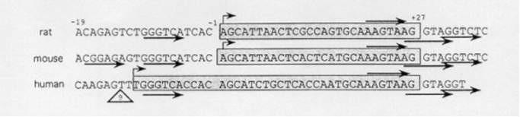
Figure 6. DNA sequences of the putative TREs in the rat, mouse, and human TSHB gene promoters. A comparison of the proximal promoter regions of the rat, mouse, and human TSHB genes is shown. The straight arrows denote TRE consensus half-sites identified by functional and TR binding assays. The first exons (relative to the downstream promoter for the rat and mouse genes) are shaded, and the bent arrows denote the sites of transcription initiation. Note a nine-nucleotide deletion in the human gene relative to the rodent genes indicated by the triangle just 5' of the transcriptional start site. (Reproduced from Chin et al. (69) with permission.)

The negative transcription conferred by TSH beta TRE sequences is retained even if they are transferred to a different gene or placed in a different position within a heterologous gene (88,89,73,90). This suggests that the negative transcriptional response to thyroid hormone is intrinsic to this TRE structure. In contrast with positive TREs, little is known about the mechanism of T3-dependent negative regulation of genes like TSHB. The data discussed above clearly show the crucial role of the TR-beta in the negative regulation of TSH synthesis. Like for positive TREs, it has been recently established that TR binding to DNA is required for negative gene regulation (91). Early experiments suggested that unliganded TR homodimers stimulate the expression of TSH beta (an effect that is a mirror image of the silencing effect on positive TREs), but the methodology employed was not adequate to study the low level of basal TSHB transcriptional activity. The use of CV1 cell lines containing the TSH beta CAT (chloramphenicol acetyltransferase) reporter allowed a more accurate study of the molecular mechanisms involved in the liganded TR suppression (92). In this experimental system, TSHB gene suppression was dependent on the amounts of T3 and TR, but unliganded TR did not stimulate TSH beta activity, suggesting that TR itself is not an activator. Moreover, recruiting of co-activators and co-repressors were shown to be not necessarily essential, but are required for full suppression of the TSHBa gene (92).

In contrast to the potentiating activity exerted on stimulatory TREs, retinoid X receptors (RXR) either unliganded or in combination with retinoic acid (RA) block thyroid hormone-mediated inhibition of the TSHB gene, possibly through competition with the TR-T3 complex binding to DNA (93,76,94,92). However, RA is also able to suppress TSHB gene expression when bound to RAR and RXR interacting with response elements separate from negative TREs (95,96). Taken together, these findings imply that distinct mechanisms are involved in thyroid hormone dependent inhibition and stimulation of TSH synthesis (97,98). Indirect support for this concept derives from the identification of patients with selective pituitary thyroid hormone resistance carrying TR mutations associated with normal or enhanced function on stimulatory TREs in peripheral tissues, but defective function on inhibitory TREs of the TSHB and TRH genes (99).

Another peculiar feature of the negative TSH beta TRE is that its 5' portion (Fig. 6) displays high homology with the consensus sequence of binding sites for c-Jun and c-Fos, which heterodimerize to form the transcription factor called AP-1. This makes the negative TSH beta TRE a "composite element" able to bind both thyroid hormone receptors and AP-1 (100,101,90,99). Since AP-1 antagonizes the inhibition exerted by thyroid hormone in vitro, it may act as a modulator of TRH-dependent regulation of the TSHB gene in vivo (90). The role of other important TSHB gene activity modulators (such as Pit-1 and its splice variants) will be discussed later. Other abnormalities of the mechanisms involved in the negative feed-back on TSH by thyroid hormones could be involved in rare pathological conditions of difficult identification and diagnosis.

Since unliganded TR does not behave as an activator of the TSHB gene, other mechanisms are involved in the increase in TSH production observed in hypothyroidism. In the hypothyroid rat TSH production is increased 15 to 20-fold over that in the euthyroid state. This can be attributed to the stimulatory effects of TRH (see below) unopposed by the negative effects of T3; moreover, besides the transcription rate per cell, there is a 3 to 4 fold increase in the absolute number of thyrotrophs in the hypothyroid pituitary (102). Electron microscopic studies have shown near total depletion of secretory granules in the thyrotrophs of hypothyroid animals, a change that is reversed soon after administration of thyroid hormone (103).

THYROID HORMONE EFFECTS ON RELEASE OF TSH

The acute administration of T3 to the hypothyroid rat causes a rapid and marked decrease in the level of serum TSH (58,104) (Fig. 7). This decrease occurs prior to the decrease in pituitary alpha and beta-TSH mRNAs (104,61,105). During the period that circulating TSH is falling, pituitary TSH content remains unchanged or increases slightly (106). The suppression of TSH release is rapid, beginning within 15 minutes of intravenous T3 injection, but is preceded by the appearance of T3 in pituitary nuclei (106). In the experimental setting in the rat, as the bolus of injected T3 is cleared and the plasma T3 level falls, nuclear T3 decreases followed shortly by a rapid increase in plasma TSH. Both the chronological and quantitative relationships between receptor bound T3 and TSH release are preserved over this time (106).

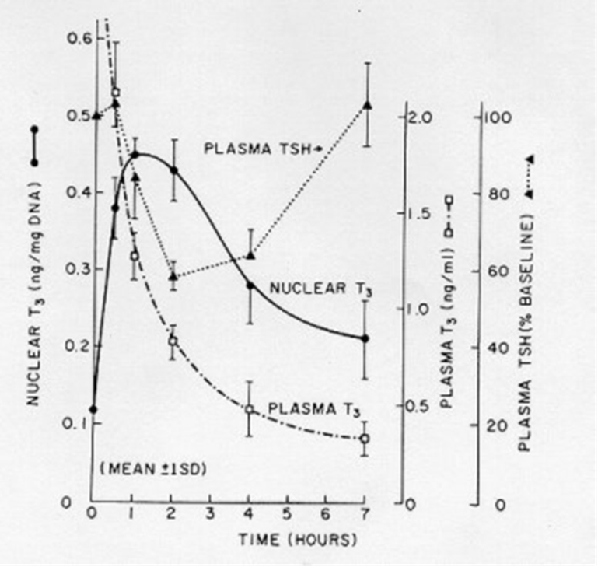
Figure 7. Time course of specific pituitary nuclear T3 binding and changes in plasma TSH in hypothyroid rats after a single intravenous injection of 70 ng T3 per 100 g of body weight. Since the maximal capacity of thyroid hormone binding in pituitary nuclear proteins is about 1 ng T3/mg DNA, the peak nuclear T3 content of 0.44 ng T3/mg corresponds to 44% saturation. The plasma level falls to about 55% of its initial basal level by 90 minutes after T3 injection demonstrating that there is both a chronological and a quantitative correlation between nuclear T3 receptor saturation and suppression of TSH release. (From Silva and Larsen (107) with permission).

The mechanism for this effect of T3 is unknown. As discussed before, suppression of basal TSH release is difficult to study in vitro. Accordingly, the T3 induced blockade of TRH-induced TSH release has been used as a model for this event. This T3 effect is inhibited by blockers of either protein or mRNA synthesis (108,109). The effect is not specific for TRH since T3 will also block the TSH release induced by calcium ionophores, phorbol ester, or potassium (110,111). Furthermore, T3 will also block the TRH-induced increase in intracellular calcium which precedes TSH release (112). Thus, T3 inhibits TSH secretion regardless of what agent is used to initiate that process.

T4 can cause an equally rapid suppression of TSH via its intrapituitary conversion to T3 (104) (Fig. 5). This T4 to T3 conversion process is catalyzed by the deiodinase type 2. An effect of T4 per se can be demonstrated if its conversion to T3 is blocked by a general deiodinase inhibitor such as iopanoic acid (113,104). In this case, the T4 in the cell rises to concentrations sufficient to occupy a significant number of receptor sites even though its intrinsic binding affinity for the receptor is only 1/10 compared to T3. A similar effect can be achieved by rapid displacement of T4 from its binding proteins by flavonoids (114). It seems likely, however, that under physiological circumstances the feedback effects of T4 on TSH secretion and synthesis can be accounted for by its intracellular conversion to T3.

The effect of suppressive doses of T3, T4 and triiodothyroacetic acid on serum TSH has been evaluated in humans by ultrasensitive TSH assays (115). TSH suppression was shown to be a complex, biphasic, nonlinear process, with three temporally distinct phases: phase 1, a rapid TSH suppression, starting after 1 h and lasting for 10-20 h; phase 2, slower suppression, starting between 10 and 20 h and lasting for 6-8 weeks; and phase 3, with stable low TSH level (<0.01 mU/L). This pattern of thyroid hormone suppression of TSH is reproducible and independent of the basal thyroid status or the thyroid hormone analog used.

Based on the analyses of the sources of nuclear T3 in the rat pituitary, one would predict that approximately half of the feedback suppression of TSH release in the euthyroid state can be attributed to the T3 derived directly from plasma; the remainder accounted for by the nuclear receptor bound T3 derived from intrapituitary T4 to T3 conversion (104). Various physiological studies in both rats and humans confirm this concept in that a decrease in either T4 or T3 leads to an increase in TSH. The effect of T4 is best illustrated in the iodine deficient rat model (Fig. 8).

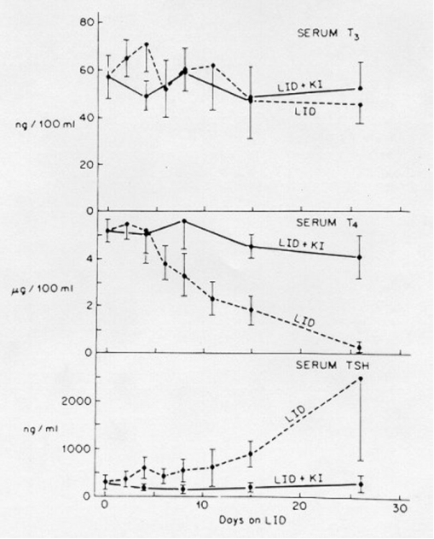
Figure 8. Serum T3, T4, and TSH concentrations (mean ± SD) in rats receiving a low iodine diet (LID), with or without potassium iodide (KI) supplementation in the drinking water. (From Riesco et al. (116) with permission)

In this paradigm, rats are placed on a low iodine diet and serum T3, T4, and TSH quantitated at frequent times thereafter (116). Even though serum T3 concentrations remain constant, there is a marked increase in TSH as the serum T4 falls. In humans, severe iodine deficiency produces similar effects (117). The most familiar example of the independent role of circulating T4 in suppression of TSH is found in patients in the early phases of primary hypothyroidism in whom serum T4 is slightly reduced, serum T3 is normal or even increased into the high normal range, but serum TSH is elevated (118,119) (Table 2).

Table 2 . Serum concentration of total thyroid hormones and TSH in patients with primary hypothyroidism of increasing severity
 |  |  | TSH (mU/L)
Group* | T4 ug/dl | T3 ng/dl | Basal | After 200 ug TRH
Control | 7.1±0.9 | 115±31 | 1.3±0.5 | 11±4.6
1 | 6-9 | 119±40 | 5.3±2.3 | 39±15
2 | 4-6 | 103±20 | 13±10 | 92±50
3 | 2-4 | 101±35 | 63±56 | 196±120
4 | <2 | 43±28 | 149±144 | 343±326
Results are mean ± SD. *Patients were categorized according to the severity of thyroid disease based on serum total T4 concentrations. (Adapted from Bigos et al. (118) with permission)

THE ROLE OF THYROTROPIN RELEASING HORMONE (TRH) IN TSH SECRETION

TRH is critical for the synthesis and secretion of TSH either in the presence or absence of thyroid hormones. Destruction of the parvo-cellular region of the rat hypothalamus, which synthesizes the TRH relevant for TSH regulation, causes hypothyroidism (120,121). Hypothalamic TRH synthesis is in turn regulated by thyroid hormones and thus TRH synthesis and release are an integral part of the feedback loop regulating thyroid status (see Fig. 5). TRH also interacts with thyroid hormone at the thyrotroph raising the set-point for thyroid hormone inhibition of TSH release (120). The data supporting these general concepts are reviewed in subsequent sections.

Control of Thyrotroph-Specific TRH Synthesis

TRH is synthesized as a large pre-pro-TRH protein in the hypothalamus and in several tissues, such as the brain, the beta cells of the pancreas, the C cells of the thyroid gland, the myocardium, reproductive organs including the prostate and testis, in the spinal cord, and in the anterior pituitary (122,123,120,124-127). Recent investigations employing sophisticated techniques such as fast atom bombardment mass spectrometry and gas phase sequence analysis showed that most TRH immunoreactivity found in extrahypothalamic tissues is actually accounted by TRH-immunoreactive peptides displaying different substitutions of the amino-acid histidine of authentic TRH, which could be active in autocrine/paracrine networks involving also extrapituitary TSH secretion (127). On the other hand, pituitary TSH production is dependent only on TRH synthesized in specific areas of the paraventricular nucleus (PVN) (Fig. 9), located at the dorsal limits of the third ventricle (128). In particular, TRH neurons are almost exclusively found in the parvicellular part of the PVN and, while TRH-synthesizing neurons are found in all parvicellular subdivisions of the PVN, hypophysiotropic TRH neurons are located exclusively in the periventricular and medial subdivisions (Fig. 9).

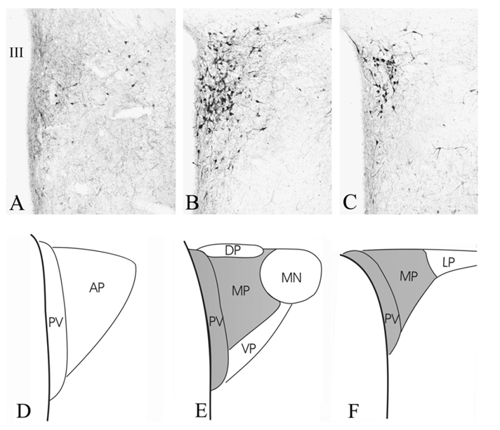
Figure 9. Distribution of TRH-synthesizing neurons in the PVN. Low power micrographs (A–C) illustrate the TRH neurons at three rostrocaudal levels of the PVN. Schematic drawings (D–F) illustrate the subdivisions of the PVN where hypophysiotropic TRH neurons are localized (gray). AP, anterior parvocellular subdivision; DP, dorsal parvocellular subdivision; LP, lateral parvocellular subdivision; MN, magnocellular part of PVN; MP, medial parvocellular subdivision, PV, periventricular parvocellular subdivision; III, third ventricle. (From Fekete & Lechan (128) with permission)

Hypophysiotropic TRH neurons project their axons to the median eminence, where TRH is released and drained to the anterior pituitary through the long portal veins (128). Although paracrine and autocrine activity has been recently described for TRH secreted in the anterior pituitary (129), the physiological relevance of pituitary TRH is unknown. The human pre-pro-TRH molecule is a protein of 29 kDa containing 6 progenitor sequences for TRH (130-132). These six peptides consist of a Gln-His-Pro-Gly peptide preceded and followed by Lys-Arg or Arg-Arg di-peptides. The basic di-peptides are the cleavage sites for release of the tetra-peptide progenitor sequence. The glycine residue is the source of the terminal amide for the proline residue of TRH (Fig. 4). In addition to the pro-TRH peptides which are released from the pre-pro TRH molecule, intervening non-TRH peptides which have potential physiological function are co-released (133). In particular, the prepro-TRH fragment 160-169, also known as hST10, TRH-enhancing peptide, and Ps4 (134,135) is able to stimulate TSHB gene expression and to enhance the TRH-induced release of TSH and prolactin (PRL) from the pituitary (136,137,134,138Ps4). Ps4 high affinity receptors have been shown within several extrapituitary neural tissues and other endocrine systems (mainly in the pancreas and the male reproductive system), and targeted pre-pro TRH gene disruption results in hyperglycemia besides the expected hypothyroidism (134). Another pre-proTRH peptide (fragment 178-199) (139,140). appears to be a modulator of ACTH secretion, although the physiological relevance of this phenomenon is unknown. The prepro-TRH processing is mostly mediated by the prohormone convertases PC1 and PC2, and takes place during axonal transport after removal of the signal peptide (138). Subsequent cleavages occur as the peptides move down the axon toward the nerve terminal, from which TRH is released into the hypothalamic-pituitary portal plexus (120,121).

Thyroid hormones exert strong negative regulation on TRH synthesis at the hypothalamic level (141-145). Increases in TRH mRNA levels occur during primary or central hypothyroidism and implantation of a small crystal of T3 adjacent to the PVN results in a decrease in TRH mRNA (143). This regulation is observed in vivo exclusively in the parvo-cellular division of the PVN (142,143) (whose neurons contain the functional TR isoforms alpha1, beta2 and beta1 (146)), while in tissues outside the central nervous system expressing the TRH gene, negative regulation by thyroid hormone is absent (147). TR beta2 is the key isoform responsible for T3-mediated feedback regulation by hypophysiotropic TRH neurons (148). Targeted disruption of TR beta2 expression results in increased TRH mRNA expression in the PVN, similar to that found in hypothyroidism. In contrast to the anterior pituitary, where ablation of TR beta2 or the entire TR beta allele produces only partial TH resistance (80,81), the lack of TR beta is associated with a complete resistance of the modulation of TRH synthesis exerted by severe hypo- or hyperthyroidism (148).

The physiological source of the T3 causing downregulation of TRH mRNA in the hypothalamus is the subject of ongoing investigations. Somewhat surprisingly, the PVN does not contain the type 2 5' iodothyronine deiodinase (D2) which is thought to be the source of at least 80% of the intracellular T3 in the central nervous system (104,149). However, studies with T3 containing mini-pumps implanted into thyroidectomized rats indicate that, for normalization of circulating TSH and hypothalamic pre-pro-TRH mRNA, T3 concentrations about twice normal have to be maintained in rat plasma (144). Thus, for both systems (TRH and TSH), feedback regulation requires a source of T3 in addition to that provided by the ambient levels of this hormone. While this T3 seems likely to be produced locally from T4, the main anatomical location of such a process has been identified only more recently in the specialized ependymal cells called tanycytes lining the floor and the infralateral wall of the third ventricle between the rostral and caudal poles of the median eminence and the infundibular recess (150,128). Tanycytes are one of the major sources of D2, with D2 mRNA expressed in the cell bodies, in the processes, and in their end feet (128). Originally believed to only serve as part of the blood-brain barrier, tanycytes have complex functions including an active role in endocrine regulation. In particular, T3 locally produced by tanycytes from circulating T4 represents the primary source of T3 involved in the feed-back regulation of hypophysiotropic neurons, unable to express D2 (128). The anatomical location of tanycytes places them in a strategic position to extract T4 from the bloodstream or from cerebrospinal fluid after T4 has traversed the choroid plexus (Fig. 10). Despite their lipophilic nature, the transport of thyroid hormone into the cells require an active processes involving a long list of transporters (151). Two transporter families have been shown to be important in the transport of thyroid hormones in the brain: the monocarboxylate transporter (MCT8)(152) and the organic anion transporting polypeptide (OATP1C1)(153). Several lines of evidence support an important role of MCT8, a member of the MTC family in central nervous system thyroid hormone transport expressed primarily in neurons and in tanycytes. Data from both MCT8 KO mice and from humans with MCT8 mutations indicate that lack of functional MCT8 result in hypothyroid TRH neurons, in spite of high circulating T3 concentration, suggesting that MCT8 is necessary for physiological feed-back regulation (128).

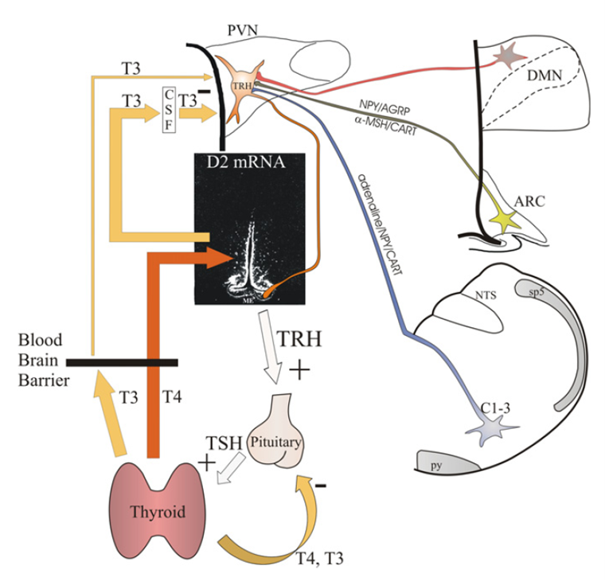
Figure 10. Schematic illustration of the feedback system regulating the hypothalamic-pituitary-thyroid axis. Thyroid hormones exert negative feedback effect at the level of hypothalamic TRH neurons and of pituitary gland. The central feedback effect of thyroid hormones depends on the circulating T4 levels. In the hypothalamus, T4 is converted to T3 by D2 in tanycytes. By volume transmission, T3 secreted from tanycytes reaches the hypophysiotropic TRH neurons, where T3 inhibits the proTRH gene expression via TR-β2 receptors. The set point of the feedback regulation can be altered by two mechanisms: (i) regulation of D2 activity in tanycytes may alter the hypothalamic T3 availability independently from the peripheral T4 concentration. (ii) Neuronal afferents can alter the PCREB concentration in the hypophysiotropic TRH neurons that can change the set point of feedback regulation through competition of PCREB and thyroid hormone receptors for the multifunctional binding site (Site 4) of the TRH promoter. ARC, hypothalamic arcuate nucleus; C1-3, C1-3 adrenergic area of the brainstem; CSF, cerebrospinal fluid; DMN, hypothalamic dorsomedial nucleus; ME, median eminence; NTS, nucleus tractus solitarius; PVN, hypothalamic paraventricular nucleus; py, pyramidal tract; sp5, spinal trigeminal tract. (From Fekete & Lechan (128) with permission)

The synthesis of TRH is under complex transcriptional control sharing several mechanisms, besides the negative regulation by thyroid hormone, with the TSHB gene. The human TRH gene (Fig. 11) is located on chromosome 3 (3q13.3→q21) (154); the 5' flanking sequence of the TRH gene has potential glucocorticoid and cyclic AMP response elements (GRE and CRE) (130). There are also potential negative TREs located in this portion of the gene which offer regulatory sites for thyroid hormone control of TRH gene transcription. The thyroid hormone negative regulatory elements of the TRH gene are localized in its 5' flanking element (-242 to +54 bp). Four sequences within this region exhibit a high degree of homology with the consensus sequences for TRE half-sites (AGGTCA) and two of them also show homology with elements implicated in negative regulation by thyroid hormone of the TSHB gene (147). In the absence of thyroid hormone, proTRH gene expression as well as prohormone convertase enzymes (PC1/3 and PC2) are increased in the PVN, while the content of TRH in the median eminence is decreased due to increased secretion of the mature hormone in the portal circulation (128). In contrast, hyperthyroidism is associated with decreased proTRH-mRNA in the PVN (128). The negative feed-back of thyroid hormones is exerted directly on hypophysiotropic TRH neurons of the PVN which express all thyroid hormone receptor isoforms. The recent availability of transgenic mice lacking either TRH, TR-beta isoforms, or both provided evidence for a pivotal role of TRH in the physiological TH feed-back on the hypothalamic pituitary-thyroid (HPT) axis (155). Double TSH and TR-beta knockout mice had reduced TH and TSH levels associated with low TSH content in pituitary thyrotrophs and both serum TSH and pituitary TSH content was increased by chronic exogenous TRH administration (156). Thus, the TRH neuron appears to be required for both TSH and TH synthesis and is the predominant locus of control of the HPT axis (155). However, studies carried out with different animal models of congenital hypothyroidism show that the thyrotrophs exhibit hyperplasia and hypertrophy along with increased TSH mRNA expression not only in the athyreotic Pax8-/- mice, but also in TRHR1-/- Pax8-/- double-knockout mice, which miss a functional thyroid gland and the TRH receptor at the pituitary level, suggesting that the stimulation of thyrotroph proliferation and TSH synthesis is rather a direct consequence of the continue here athyroidism of the animals (157). Further studies are therefore required to determine the relative contributions of TRH and TH for bioactive pituitary TSH release.

As shown in Fig. 11, the TRH gene promoter contains potential binding sites for cAMP response element (CRE) binding protein (CREB), and both human and rat TRH genes are positively regulated by cAMP (147). One of the potential CREs of TRH promoter is a sequence that has overlapping TRE/CRE bases –53 to –60 bp (TGACCTCA) (147). There is evidence for competitive interactions of TR beta1 and CREB at the overlapping TRE/CRE in the TRH promoter (147). Constructs of the TRH promoter with mutations in this overlapping site prevent both the inhibition by the TR-T3 complex and the basal activation in the presence of unliganded TR, underlining the relative importance of the TRE/CRE site in relation to the other TREs in the TRH promoter (147).

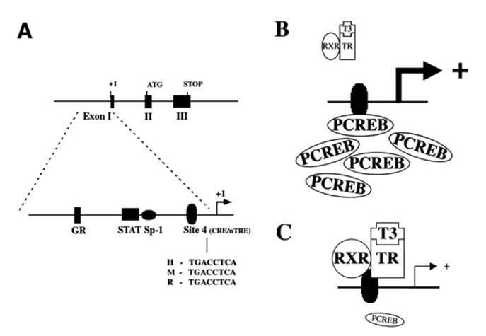
Figure 11. Genomic and promoter structure of the TRH gene. The murine, rat and human TRH genes are composed of three exons and two introns (A). The coding sequence for the precursor protein is present on exons 2 and 3. As depicted, the TRH promoter region precedes the transcription start site in exon 1. The proximal 250-bp sequences of the human, mouse and rat promoters are similar and share the indicated transcription factor binding sites. The location of the CREB binding site (Site 4) and sequences in human (H), mouse (M) and rat (R) are shown. (B, C) Hypothesized schematic representation of the interaction between PCREB and the thyroid hormone receptor at Site 4. (B) Illustrates that in the presence of abundant PCREB, there may be less availability for binding of the thyroid hormone receptor/T3 complex, hence, an increase in TRH gene transcription. When PCREB concentrations fall as shown in (C), increased binding of the thyroid hormone receptor/T3 complex reduces TRH gene transcription (From Fekete & Lechan (128) with permission)

A glucocorticoid-responsive element (GRE) is also present in the TRH gene promoter (130). and the glucocorticoid receptor has been identified on TRH neurons of the PVN (158). The role of corticosteroids in TRH gene expression is unclear, since both inhibitory and stimulatory effects have been reported (159,160). The direct effect of glucocorticoids on TRH gene expression is generally stimulatory in vitro, but in vivo this activity may be overridden by the complex neuroendocrine reactions following glucocorticoid excess or deficiency (159).

TRH INTERACTION WITH PITUITARY THYROTROPHS AND WITH THYROID HORMONE

Although TRH (either maternal or embryonic) is not required for the normal development of fetal pituitary thyrotrophs, and TRH-deficient mice are not hypothyroid at birth, TRH is required later for the postnatal maintenance of the normal thyrotroph function (161). TRH exerts its activity binding to a specific receptor in the plasma membrane of the thyrotroph to induce the release of TSH and to stimulate TSH synthesis. The TRH receptor of several animal species (including humans) has been cloned and has been identified as a G-protein-coupled receptor with seven highly conserved transmembrane domains (162-165). Biallelic inactivating mutations in the 5’-part of the TRH receptor gene are one of the molecular causes for central congenital hypothyroidism (166-169). TRH-receptor number and mRNA are increased by glucocorticoids and decreased by thyroid hormone, as well as by TRH itself (170,171). The second messenger for induction of the thyrotroph response to TRH is intracellular Ca²⁺ ([Ca2+]i) (172-174). TRH was previously believed to act also through stimulation of the adenyl cyclase-cAMP pathway (120), but this mechanism has not been confirmed by studies carried out with recombinant TRH-receptor transfected in different cell systems (175). TRH activates a complex [Ca²⁺]_{i} response pattern dependent upon both agonist concentration and cell context. The first phase of the TRH response is an acute increase of [Ca²⁺]_{i} within the thyrotrophs via release from internal stores. This is the consequence of increased inositol triphosphate concentrations from hydrolysis of phosphatidyl inositol (PI) in the cell membrane (176,173,177,178). The hydrolysis of PI is mediated by G protein activation of phospholipase C and also generates diacylglycerol, which in turn activates intracellular protein kinase C (PKC). Stimulation of extracellular calcium influx through verapamil-sensitive channels is also observed after TRH stimulation (172,179). Both TRH and increased [Ca²⁺]_{i} stimulate intracellular calcium efflux, which helps in terminating the agonist activity (177,179,180). In transfection systems in which the TSHB gene promoter has been linked to a reporter gene, both the calcium ionophore ionomycin and phorbol esters (a protein kinase C activator) stimulate TSH gene transcription, confirming the key role of these second messengers in mediating TRH activity (66). Both increased [Ca²⁺]_{i} and PKC appear to be independently operative in normal thyrotrophs (181).

The molecular mechanism(s) underlying the stimulation of TSHB gene expression by TRH have been partially elucidated. In GH3 cells transfected with hTSHB promoter constructs, two distinct regions of the human TSHB gene responding positively to stimulation by TRH were identified between -130 and +37 bp of the gene (182-184) (Fig. 12) The 3'-region corresponds to eight bp of the first exon; the 5'-region ranged between -128 to -60 bp of the 5'-flanking region (182,183).

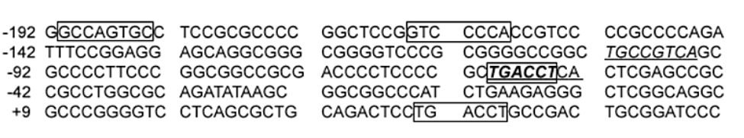
Figure 12. The 5’ flanking sequence of the human preproTRH gene between –192 and +58 bp. Four potential thyroid response element (TRE, boxed) and two potential CREB binding elements (CRE, underlined) are shown. One sequence (from –60 to –53 bp) consists of overlapping TRE/CRE sites (bold). (Modified from Wilber & Xu (147))

INACTIVATION OF TRH

TRH is rapidly inactivated within the central nervous system by a cell-surface peptidase called TRH-degrading ectoenzyme (TRH-DE) (185). TRH-DE is very specific, since there is no other ectopeptidase known capable of degrading TRH and TRH is the only known substrate of this unique enzyme (185). TRH-DE has been purified to homogeneity and cDNA encoding rat TRH-DE has been cloned. In rodents, pituitary TRH-DE mRNA and enzymatic activity are stringently positively regulated by thyroid hormones, and reduced by estrogens (185). This suggests that TRH-DE may act as a regulatory element modulating pituitary TSH secretion. The expression of TRH-DE in the brain is high and displays a distinct distribution pattern, but it is not influenced by peripheral hormones, supporting the concept that brain TRH-DE may act as a terminator of TRH signals (185).

OTHER FACTORS INVOLVED IN THE REGULATION OF TSH/TRH SYNTHESIS AND SECRETION

A number of other substances, including ubiquitous and pituitary or thyrotroph-specific transcription factors, hormones, neuropeptides and cytokines influence TSH synthesis and secretion of TRH (Table 3, Fig. 11&13).

Table 3. Predominant Effects of Various Agents on TSH Secretion
STIMULATORY | INHIBITORY
Thyrotropin-releasing hormone (TRH) | Thyroid hormones and analogues
Prostaglandins (?) | Dopamine
Alpha-adrenergic agonists (? Via TRH) | Somatostatin
Opioids (humans) | Gastrin
Arginine-vasopressin (AVP) | Opioids (rat)
Glucagon-like peptide 1 (GLP-1) | Glucocorticoids (in vivo)
Galanin | Serotonin
Leptin | Cholecystokinin (CCK)
Glucocorticoids (in vitro) | Gastrin-releasing peptide (GRP)
 | Vasopressin (AVP)
 | Neuropeptide Y (NPY)
 | Interleukin 1 beta and 6
 | Tumor necrosis factor alpha

Role of Pit-1 and its Splicing Variants in the Regulation of TSHB Gene Expression

Sequence analysis of the hTSHB promoter reveals three areas with high (75-80%) homology to the consensus sequence for the pituitary-specific transcription factor Pit-1 (182,183,186,184). These areas are localized between -128 and -58 bp of the 5'-flanking region. Selective mutation analysis revealed that the integrity of these areas was needed for the stimulatory effect of either TRH or forskolin (187). Expression of an inactive mutant of Pit-1 decreases TRH stimulation of hTSHB (183) and transfection of Pit-1 in cell lines lacking this factor restores cAMP induction of the hTSHB gene (186). Taken together, these results strongly support an important role of Pit-1 in the regulation of hTSHB gene expression. Phosphorylation markedly increases the stimulatory activity of Pit-1 in TSHB gene expression (187), and TRH stimulates transient phosphorylation of Pit-1 in GH3 pituitary cells (188).

Further support for a role of Pit-1 in the regulation of TSHB gene expression derives from animal models (dwarf mice) and from clinical syndromes of combined pituitary hormone deficiency (CPHD) (189,167). Snell and Jackson dwarf mice lack a functioning Pit-1 protein due to a point mutation and a gross structural rearrangement in the Pit-1 gene, respectively (190). Both species show low serum concentration of GH, prolactin and TSH associated with the loss of somato-, lacto- and thyrotropic pituitary cells. Several Pit-1 point mutations and a deletion of the entire coding sequence have been described in patients with CPHD: the effects on TSH secretion differ with the localization of the mutation, but generally result in central hypothyroidism (191-194,94,189,195,196). Finally, the important role of Pit-1 in the control of TSH synthesis and secretion has been documented by the finding that circulating Pit-1 antibodies are associated with combined GH, prolactin, and TSH deficiency, the so called “anti-PIT-1 antibody syndrome” (197-200).

Although important, the role of Pit-1 for cell-specific expression of TSHB is not as clear as with the GH and PRL genes (201,184). Attention has been focused on thyrotropin-specific transcription factors, including Pit-1 splicing variants. Of those, a variant called Pit-1T (containing a 14 amino-acid insertion in the transactivation domain) is found only in thyrotropic cells expressing TSHB and it increases TSHB promoter activity when transfected in non-thyrotropic cells expressing wild type Pit-1 (202,203). These results suggest that the combination of both Pit-1 and Pit-1T may have a synergistic stimulatory effect on TSHB promoter activity (204).

Other Transcription Factors Involved in TSHB Gene Expression

As stated above, the transcription factor AP-1 may be involved in modulating regulation of TSHB gene expression mediated by thyroid hormone (Fig. 13). Accordingly, a potential AP-1 binding site is present between -1 to +6 bp of the TSHB gene (184), and the integrity of this site is required for maximal stimulation of the hTSHB gene (205). Haugen et al. (206) described a new 50 kd thyrotroph-specific protein whose binding together with Pit-1 is needed for optimal basal expression of the mouse TSHB gene; this factor was subsequently identified as the transcription factor GATA-2 (207). GATA-2 stimulates the mouse TSHB promoter synergistically with Pit-1 and is needed for optimal TSHB gene basal activity. Another pituitary-specific protein (P-Lim), which binds and activates the common glycoprotein hormone alpha subunit promoter, also synergizes with Pit-1 in the transcriptional activation of the TSHB gene in mice (208). Moreover, characterization of the dwarfed Ames (df) mouse led to the cloning of the paired-like homeodomain factor Prop-1 (Prophet of Pit-1) (209). PROP-1 is necessary for Pit1 expression. Biallelic mutations in the human PROP-1 gene have been identified as a further cause of CPHD phenotype affecting somatotropes, lactotropes, and thyrotropes (210,189,167,211).

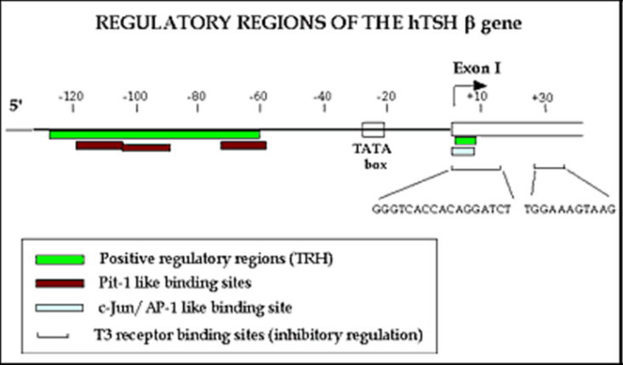
Figure 13. The regulatory region of human TSHB gene (see text for details)

cAMP

An increase in intracellular cAMP stimulates expression of both the common CGA and TSHB subunit genes (182). In contrast to the TRH gene, this action of cAMP is probably not mediated through direct binding of CREB to a CRE sequence, but by promoting Pit-1 phosphorylation with subsequent activation of the TSHB promoter (183,186).

Steroid Hormones

Steroid hormones including corticosteroids, estrogen and testosterone modulate TSHB gene expression. Dexamethasone in pharmacological doses decreases serum TSH concentrations in normal subjects (212), in patients (213), and rats (214) with TSH-secreting pituitary adenomas, but does not significantly change TSH subunit mRNA levels (214). This suggests that glucocorticoids may act on TSH biosynthesis at a translational or post-translational level. Furthermore, as discussed before for the TRH gene, several other neuroendocrine mechanisms may participate in vivo in the modulation of TSH synthesis and secretion by glucocorticoids. In keeping with this concept, it has been shown in humans that enhanced hypothalamic somatostatinergic and dopaminergic inhibitory activities are involved in the glucocorticoid-dependent blunting of the TSH response to TRH (215).

Estrogens and testosterone have limited direct effects on TSH synthesis and secretion in humans. Estrogens mildy reduce mRNA levels coding for the alpha and beta TSH subunits in hypothyroid rats (216), perhaps interacting with the same response elements involved in thyroid hormone regulation. Testosterone has similar effects, at least in part explained by its peripheral conversion to estrogen (217).

Other Hormones, Neuropeptides and Cytokines

Somatostatin, the major physiological inhibitor of GH secretion, is also an inhibitor of TSH secretion in rats and humans (218-220). The physiological relevance of this inhibition is suggested by studies carried out with antibodies to somatostatin whose administration in rats increases serum TSH in basal conditions and after TRH or cold-exposure (212). Indirect evidence for a physiological role of somatostatin in the regulation of TSH secretion has been obtained in humans by the demonstration that stimulation of the endogenous somatostatin tone by oral glucose inhibits TSH response to TRH (221). The TSH-inhibiting activity of somatostatin is an acute phenomenon, while long-term treatment with somatostatin analogues does not cause hypothyroidism in man (222,223), presumably because the effects of the initial decrease in serum thyroid hormone concentration overrides the inhibitory effects of somatostatin. Somatostatin binds to five distinct types of receptors expressed in the anterior pituitary and brain and differing in binding specificities, molecular weight, and linkage to adenylyl cyclase (224). Binding of somatostatin to its receptor causes activation of Gi proteins which in turn inhibit adenylyl cyclase. Somatostatin also induces cellular hyperpolarization via modulation of voltage-dependent potassium channels (225). This mechanism is cAMP-independent and leads to a fall of [Ca²⁺]_{i} by reducing extracellular calcium influx (226).

In animal models, TSH secretion is affected by other hypothalamic hormones: in particular, corticotropin-releasing hormone (CRH) stimulates TSH secretion in chickens (227) through an interaction with CRH-receptor-2 (228), and melanin-concentrating hormone (MCH) suppresses in vivo and in vitro TSH release in rats (229).

Neurotransmitters are important direct and indirect modulators in TSH synthesis and secretion. A complex network of neurotransmitter neurons terminates on cells bodies of hypophysiotropic neurons and several neurotransmitters (such as dopamine) are directly released into hypophysial portal blood exerting direct effects on anterior pituitary cells. Furthermore, many dopaminergic, serotoninergic, histaminergic, catecolaminergic, opioidergic, and GABAergic systems project from other hypothalamic/brain regions to the hypophysiotropic neurons involved in TSH regulation. These projections are important for a normal TSH circadian rhythm, response to stress, and cold exposure, while basal TSH secretion is mainly regulated by intrinsic hypothalamic activity (230-232). Despite the difficulty to precisely identify the relative contributions of different neurotransmitter systems in the regulation of TSH secretion, the role of some of them (particularly dopamine and catecholamines) has been rather well defined.

Dopamine, acting via the DA2 class of dopamine receptors, inhibits TSH synthesis and release; similarly, to somatostatin, this activity is exerted through a decrease in adenylate cyclase (233-235). Dopamine also inhibits mRNA coding for alpha and TSHB subunits and gene transcription in cultured rat anterior pituitary cells (77). In contrast, with its inhibitory activity at the thyrotroph level, dopamine at the hypothalamic levels stimulates both TRH and somatostatin release (236,237), with an opposite effect on TSH secretion.

In contrast to dopamine, adrenergic activation positively regulates TSH secretion. Central stimulation of alpha-adrenergic pathways increases TSH release in rats, presumably through stimulation of TRH secretion. Furthermore, alpha1 adrenergic agonists also enhance TSH release from pituitary cells in vitro by mechanisms which are independent of those activated by TRH (238,239,236,237). It is thought that alpha-adrenergic activity on thyrotrophs is linked to adenylate cyclase activation since agents increasing intracellular cyclic AMP in these cells can increase TSH release (240-242).

Opioids inhibit TSH secretion in rats and this action is blocked by the antagonist naloxone (243), while in humans they appear to exert a stimulatory effect, especially on the nocturnal TSH surge (244,232). Several other neuropeptides may affect TSH secretion in vivo or in vitro. Cholecystokinin (CCK) (245), gastrin-releasing peptide (GRP) (246), and neuropeptide Y (NPY) (247) exert inhibitory effects, while arginine-vasopressin (AVP) (248), glucagon-like peptide-1 (GLP-1) (249), galanin (250), and leptin (251,252) stimulate TSH secretion. Although the precise physiological role of these peptides remains to be clarified, it has been recently suggested that they may be important in connecting nutrition status and thyroid function (253), as discussed in more detail later.

Cytokines have recently been demonstrated to have important effects on TRH or TSH release. Both interleukin 1 beta (IL-1 beta) and tumor necrosis factor alpha (cachectin) inhibit TSH basal release (254-257), while no inhibition is observed on TSH response to TRH (258), and this effect is independent of thyroid hormone uptake or receptor occupancy. At the same time, IL-1 beta stimulates the release of corticotropin-releasing hormone and activates the hypothalamic-pituitary-adrenal axis (259). Interleukin-1 beta is produced in rat thyrotrophs, and this production is markedly increased by bacterial lipopolysaccharide (260,261). It could thus reduce TSH secretion by either autocrine or paracrine mechanisms. The IL-1 beta-dependent cytokine interleukin 6 (IL-6) exerts similar inhibitory effects on TSH secretion. Both IL-1 beta and IL-6 acutely inhibit TSH release from the thyrotrophs, while IL-1 beta (but not IL-6) also decreases hypothalamic TRH mRNA and gene expression (262,146,263). Both IL-1 beta and IL-6 stimulate 5’-deiodinase activity in cultured pituitary cells (264), suggesting that increased intrapituitary T4→T3 conversion may be involved in the inhibitory activity on TSH production. IL-6 is produced by the folliculo-stellate cells of the anterior pituitary (265,266), and, like IL-1 beta may regulate TSH release in a paracrine fashion (263,259). As discussed later, increased concentrations of circulating pro-inflammatory cytokines are involved in the alterations of hypothalamic-pituitary-thyroid axis observed in non-thyroidal illnesses.

SIRT1, a NAD-dependent deacetylase, has been proven to be important for TSH secretion by thyrotrophic cells by the SITR1-phosphatidylinositol-4-phosphate 5-kinase-gamma pathway (267).

In summary, an intricate set of relationships within and outside the central nervous system controls the TRH-producing neurons in the medial basal hypothalamus. Alterations in any of these mechanisms can influence TRH and consequently TSH release (Fig 13 and 14). The relative importance in human physiology of these neural pathways, which have been directly studied only in animal models, is unknown.

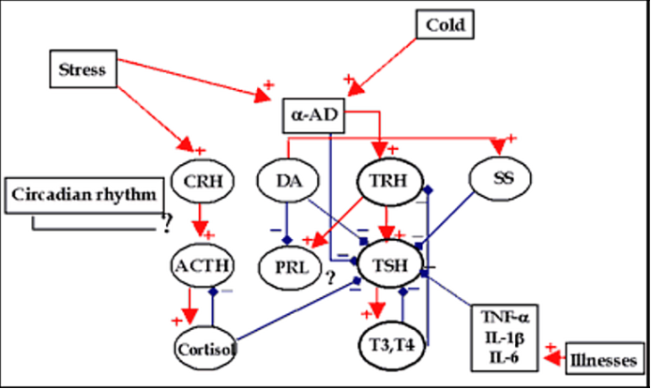
Figure 14. Schematic representation of the main factors interacting in the regulation of TSH synthesis and secretion (DA: dopamine; SS: somatostatin; α-AD: α adrenergic pathways). Red arrows: stimulation; blue blunted arrows: inhibition

SHORT AND ULTRA SHORT-LOOP FEEDBACK CONTROL OF TSH SECRETION

In additional to the classic negative feed-back of thyroid hormone on TSH and TRH secretion detailed in the above paragraphs, evidence is accumulating that pituitary TSH is able to inhibit TRH secretion at the hypothalamic level (short feedback) and TSH secretion at the pituitary level (ultra-short feedback) (268). Early observations of inhibition of TSH secretion by injection of pituitary extracts have been recently corroborated by the demonstration of TSH receptor expression (together with other pituitary hormone receptors) in the hypothalamus (269,270) and in the folliculo-stellate cells of the adenohypophysis (271). The precise physiological role of short and ultra-short feedback in controlling TRH/TSH secretion remains to be elucidated. It may be speculated that they concur in the fine tuning of the homeostatic control and in the generation of the pulsatility of TSH secretion. The possibility that thyroid-stimulating autoantibodies present in Graves’ disease recognize hypothalamic and pituitary TSH receptors has also been suggested to explain suppressed serum TSH levels in some euthyroid Graves’ patients (268).

Summary of the Main Steps Involved in the Hypothalamic-Pituitary-Thyroid (HPT) Axis

An attempt to summarize the main steps involved in the feedback regulation of the HPT axis is illustrated in Fig 14 (128). Thyroid hormones inhibit the effects of TRH on TSH release without interfering with TRH binding to its receptors, but exerting complex negative transcriptional and post-transcriptional activities on TSH synthesis and secretion discussed above. Several factors other than thyroid hormones are involved in the fine regulation of HPT axis as depicted in Fig. 13 and described in more detail in the following paragraphs.

PHYSIOLOGICAL REGULATION OF TSH SECRETION IN HUMANS

A number of experimental paradigms have been used to mimic clinical situations that affect the hypothalamic-pituitary thyroid axis in man. However, with the exception of the studies of thyroid status and iodine deficiency, such perturbations have limited application to humans due to differences in the more subtle aspects of TSH regulation between species. For example, starvation is a severe stress and markedly reduces TSH secretion in rats, but only marginally in humans. Cold stress increases TSH release in adult rats by alpha-adrenergic stimulation, while this phenomenon is usually not observed in the adult human. Thus, it is more relevant to evaluate the consequences of various pathophysiological influences on TSH concentrations in humans rather than to extrapolate from results in experimental animals. This approach has the disadvantage that, in many cases, the precise mechanism responsible for the alteration in TSH secretion cannot be identified. This deficit is offset by the enhanced relevance of the human studies for understanding clinical pathophysiology.

Table 4. Common Polymorphisms Related to Serum Thyroid Hormones and TSH Variation (270)
Gene | Polymorphism | Effect on serum
 |  | TSH | T4 | T4/T3 | T3 | rT3 | T3/rT3
TSHR | rs10149689 A/G* | ↑ | = | = | = | = | =
 | rs12050077 AG | ↑ | = | = | = | = | =
DIO1 | D1a-C/T | = |  |  | ↓ | ↑ | ↓
 | D1b-A/G | = |  |  | ↑ | ↓
 | rs2235544 C/A | = |  |  | ↑ | ↓ | ↑
DIO2 | D2-ORFa-Asp3 | = | ↑¹ | = | = | = | =
 | Thr92Ala | = | = | = | = | = | =²
 | rs225014 C/T | = | = | = | = | = | =³
THRB | TRHB-in9 A/G | (↑) | = | = | = | = | =
PDE8B | rs4704397 A/G | ↑ | = | = | = | = | =
* Alleles associated with the specified trait are reported in bold; ¹ Only in young subjects;
² Influence L-T4 dose needed to normalize serum TSH in hypothyroid patients; ³ Influence psychological well-being of hypothyroid patients on L-T4 therapy

Normal Physiology

The concentration of TSH can now be measured with exquisite sensitivity using immunometric techniques (see below). In euthyroid humans, this concentration ranges from 0.4-0.5 to 4.0-5.0 mU/L. This normal range is to some extent method-dependent in that the various assays use reference preparations of slightly varying biological potency. The glycosylation of circulating TSH is different from that of standard TSH, thus preventing the calculation of a precise molar equivalent for TSH concentrations (272,273). Recently, a narrower range (0.5-2.5 mU/L) has been proposed in order to exclude subjects with minimal thyroid dysfunction, particularly subclinical hypothyroidism (274), but the issue is still controversial (275). Moreover, data form large epidemiological studies mostly carried out in iodine sufficient countries like the USA, suggest that age together with racial/ethnic factors may significantly affect the respective “normal” TSH range, with higher levels for older Caucasian subjects (276,277). These data differ from the findings previously reported in selected small series of healthy elderly subjects (278) suggesting an age-associated trend to lower serum TSH concentrations (see below). The reason(s) for such discrepancies are still not understood. Independently from the “true” normal range of serum TSH, there is substantial evidence that this is genetically controlled, the heritability being estimated between 40-65% (279). As reported in Table 4, polymorphisms of several genes encoding potentially involved in the control of HPT axis show a significant association with serum TSH concentrations (280) and PDE8B, a gene encoding a high-affinity phosphodiesterase catalyzing the hydrolysis and inactivation of cAMP, has been shown by genome-wide association study to be one of the most important (281).

The free alpha subunit is also detectable in serum with a normal range of 1 to 5 µg/L, but free TSHB is not detectable (4,282). Both the intact TSH molecule and the alpha subunit increase in response to TRH. The alpha subunit is also increased in post-menopausal women; thus, the level of gonadal steroid production needs to be taken into account in evaluating alpha subunit concentrations in women. In most patients with hyperthyroidism due to TSH-producing thyrotroph tumors, there is an elevation in the ratio of the alpha subunit to total TSH (4,16,283,182,184). In the presence of normal gonadotropins, this ratio is calculated by assuming a molecular weight for TSH of 28,000 and of 13,600 Da for the alpha subunit. The approximate specific activity of TSH is 0.2 mU/mg. To calculate the molar ratio of alpha subunit to TSH, the concentration of the alpha subunit (in ug/L) is divided by the TSH concentration (in mU/L) and this result multiplied by 10. The normal ratio is <1.0 and it is usually elevated in patients with TSH-producing pituitary tumors but it is normal in patients with thyroid hormone resistance unless they are post-menopausal (284).

The volume of distribution of TSH in humans is slightly larger than the plasma volume, the half-life is about 1 hour, and the daily TSH turnover between 40 and 150 mU/day (283). Patients with primary hypothyroidism have serum TSH concentrations greater than 5 and up to several hundred mU/L (118). In patients with hyperthyroidism due to Graves' disease or autonomous thyroid nodules, TSH is suppressed with levels which are inversely proportional to the severity and duration of the hyperthyroidism, down to levels as low as <0.004 mU/L (285-287).

TSH secretion in humans is pulsatile (288-290). The pulse frequency is slightly less than 2 hours and the amplitude approximately 0.6 mU/L. The TSH pulse is significantly synchronized with PRL pulsatility: this phenomenon is independent of TRH and suggests the existence of unidentified underlying pulse generator(s) for both hormones (291). The frequency and amplitude of pulsations increases during the evening reaching a peak at sleep onset, thus accounting for the circadian variation in basal serum TSH levels (292,293). The maximal serum TSH is reached between 21:00 and 02:00 hours and the difference between the afternoon nadir and peak TSH concentrations is 1 to 3 mU/L. Sleep prevents the further rise in TSH as reflected in the presence of increases in TSH to 5-10 mU/ml during sleep deprivation (294,295). The circadian variation of TSH secretion is probably the consequence of a varying dopaminergic tone modulating the pulsatile TSH stimulation by TRH (296). Interestingly, TSH molecules secreted during the night are less bioactive and differently glycosylated than those circulating in the same individual during the day, thus explaining why thyroid hormone levels do not rise after the nocturnal TSH surge (296). There is convincing evidence seasonal change in basal TSH (297), but there are no gender-related differences in either the amplitude or frequency of the TSH pulses (290). The diurnal rhythmicity of serum TSH concentration is maintained in mild hyper- and hypothyroidism, but it is abolished in severe short-term primary hypothyroidism, suggesting that the complete lack of negative feedback to the hypothalamus or pituitary or both may override the central influences on TSH secretion (298).

Age may have a major effect on circulating serum TSH levels (278). There is a marked increase in serum TSH in neonates which peaks within the first few hours of delivery returning towards normal over the next few days. It is thought to be a consequence of the marked reduction in environmental temperature at birth. Serum TSH concentrations in apparently euthyroid patients over the age of 70 may be somewhat reduced (299,300). However, some studies show an increase of TSH in older adults (301).

TSH in Pathophysiological States

NUTRITION

In the rat, starvation causes a marked decrease in serum TSH and thyroid hormones. While there is an impairment of T4 to T3 conversion in the rat liver due to a decrease in both thiol co-factor and later in the Type 1 deiodinase (302-304), the decrease in serum T3 in the fasted rat is primarily due to the decrease in T4 secretion consequent to TSH deficiency (304,305). In humans, starvation and moderate to severe illness are also associated with a decrease in basal serum TSH, pulse amplitude and nocturnal peak (306-310). In the acutely-fasted man, serum TSH falls only slightly and TRH responsiveness is maintained, although blunted (311,312). This suggests that the thyrotroph remains responsive during short-term fasting and that the decrease in TSH is likely due to changes secondary to decreased TRH release. There is evidence to support this in animal studies, showing reduced TRH gene expression in fasted rats (313,314). Administration of anti-somatostatin antibodies prevents the starvation induced serum TSH falls in rats, suggesting a role for hypothalamic somatostatinergic pathways (315). However, fasting-induced changes in dopaminergic tone do not seem to be sufficient to explain the TSH changes (315,309).

Recent studies provide compelling evidence that the starvation-induced fall in leptin levels (Fig. 15) plays a major role in the decreased TSH and TSH secretion of fasted animals and, possibly, humans (251,316,317). This concept stems from the observation that administration of leptin prevents the starvation-induced fall of hypothalamic TRH (318). The mechanisms involved in this phenomenon include decreased direct stimulation by leptin of TRH production by neurons of the PVN (251,319), as well as indirect effects on distinct leptin-responsive neuroendocrine circuits communicating with TRH neurons (318,320). The direct stimulatory effects of leptin on TRH production are mediated by binding to leptin receptors, followed by STAT3 activation and subsequent binding to the TRH promoter (321,322). One of the latter circuits has been identified in the melanocortin pathway, a major target of leptin action. This pathway involves 2 ligands expressed in distinct populations of arcuate nucleus neurons in the hypothalamus [the alpha-MSH and the Agouti receptor protein (AgRP)] and the melanocortin 4 receptor (MC4R) on which these ligands converge, but exert antagonistic effects (stimulation by alpha-MSH; inhibition by AgRP). Leptin activates MC4R by increasing the agonist alpha-MSH and by decreasing the antagonist AgRP and this activation is crucial for the anorexic effect of leptin. The specific involvement of the melanocortin pathway in TRH secretion is suggested by the presence of alpha-MSH in nerve terminals innervating hypothalamic TRH neurons in rat (128) and human (323) brains and by the ability of alpha-MSH to stimulate and of AgRP to inhibit hypothalamus-pituitary thyroid axis both in vitro and in vivo (319). The activities of alpha-MSH and AgRP on the thyroid axis are fully mediated by MCR4, as shown by experiments carried out in MCR4 knock out mice (324). Fasting may inhibit the hypothalamic-pituitary-thyroid axis also via the orexigenic peptide NPY, which inhibits TRH synthesis by activation of Y1 and Y5 receptors in hypophysiotropic neurons of the hypothalamic paraventricular nucleus (325). At least two distinct populations of NPY neurons innervate hypophysiotropic TRH neurons (326), suggesting that NPY is indeed an important regulator of the hypothalamic-pituitary-thyroid axis.

A further contributing cause to the decreased TSH release in fasting may be an abrupt increase in the free fraction of T4 due to the inhibition of hormone binding by free fatty acids (327). This would cause an increase in pituitary T4 and, hence, in pituitary nuclear T3. Fasting causes a decrease in the amplitude of TSH pulses, not in their frequency (328).

Ingestion of food results in an acute decline of the serum TSH concentration: this is the consequence of meal composition, rather than stomach distension (329). Long-term overfeeding is associated to a transient increase of serum T3 concentration and a sustained increased response of TSH to TRH (330).

Taken together, the above data provide compelling evidence that the hypothalamic-pituitary-thyroid axis is tightly related to the mechanisms involved in weight control. In keeping with this concept, several epidemiological studies suggest that small differences in thyroid function may be important for the body mass index and the occurrence of obesity in the general population (331-334).

ILLNESS

The changes in circulating TSH which occur during fasting are more exaggerated during illness. In moderately ill patients, serum TSH may be slightly reduced but the serum free T4 does not fall and is often mildly increased (327,335-337). However, if the illness is severe and/or prolonged, serum TSH will decrease and both serum T4 (and of course T3) decrease during the course of the illness. This may be due to a decreased pulse amplitude and nocturnal TSH secretion (338-341). Since such changes are short-lived, they do not usually cause symptomatic hypothyroidism. They are often associated with an impaired TSH release after TRH (306). However, the illness-induced reductions in serum T4 and T3 will often be followed by a rebound increase in serum TSH as the patient improves. This may lead to a transient serum TSH elevation in association with the still subnormal levels of circulating thyroid hormones and thus be mistaken for primary hypothyroidism (342). On occasion, a transient TSH elevation occurs while the patient is still ill. The pathophysiology of this apparent resistance of the thyroid gland to TSH is not clear (343), although this phenomenon could be the consequence of reduced TSH bioactivity, possibly a consequence of abnormal sialylation (344). The transient nature of these changes is reflected in normalization of the pituitary-thyroid axis after complete recovery. It is currently not clearly established whether the above abnormalities in hypothalamic-pituitary-thyroid axis during critical illness reflect an adaptation of the organism to illness or instead a potentially harmful condition leading to hypothyroidism at the tissue level (345,346).

NEUROPSYCHIATRIC DISORDERS

Certain neuropsychiatric disorders may also be associated with alterations in TSH secretion. In patients with anorexia nervosa or depressive illness, serum TSH may be reduced and/or TRH-induced TSH release blunted (347). Such patients often have decreases in the nocturnal rise in TSH secretion (293). The etiology of these changes is not known although it has been speculated that they are a consequence of abnormal TRH secretion (348,349). The latter is supported by observations that TRH concentrations in cerebrospinal fluid of some depressed patients are elevated (350,351). There may be a parallel in such patients between increases in TRH and ACTH secretion (352). The increased serum T4 and TSH levels sometimes found at the time of admission to psychiatric units is in agreement with this concept (353,349).

MECHANISMS INVOLVED IN THE HYPOTHALAMIC-PITUITARY-THYROID AXIS SUPPRESSION IN NON-THYROIDAL ILLNESSES

The precise mechanism(s) underlying the suppression of the hypothalamic-pituitary-thyroid axis in severe illnesses are only partially known. Evidence for a direct involvement of TRH-producing neurons in humans has been recently provided by the demonstration of low levels of TRH mRNA in the PVN of patients who died of non-thyroidal disease (354). Alterations in neuroendocrine pathways including opioidergic, dopaminergic and somatostatinergic activity have been suggested, but in acutely ill patients the major role appears to be played by glucocorticoids (355) (See below for a more detailed discussion). Activation of pro-inflammatory cytokine pathways is another mechanism potentially involved in the suppression of TSH secretion in nonthyroidal illness. As discussed earlier, IL-1 beta, TNF-alpha and IL-6 exert in vivo and in vitro a marked inhibitory activity on TRH-TSH synthesis/secretion. High levels of pro-inflammatory cytokines (particularly IL-6 and TNF-alpha) have been described in sera of patients with non-thyroidal illnesses (356,357,262,358,359). Serum cytokine concentration is directly correlated with the severity of the underlying disease and to the extent of TSH and thyroid hormone abnormalities observed in these patients. Furthermore, cytokines also affect thyroid hormone secretion, transport and metabolism providing all the characteristics to be considered important mediators of thyroid hormone abnormalities observed in non-thyroidal illness (360-362).

EFFECTS OF HORMONES AND NEUROPEPTIDES

Dopamine and Dopamine Agonists

Dopamine and dopamine agonists inhibit TSH release by mechanisms discussed earlier. Dopamine infusion can overcome the effects of thyroid hormone deficiency in the severely ill patient, suppressing the normally elevated TSH of the patient with primary hypothyroidism nearly into the normal range (235,363). Dopamine causes a reduction of the amplitude of TSH pulsatile release, but not in its frequency (328). However, chronic administration of dopamine agonists, for example in the treatment of prolactinomas, does not lead to central hypothyroidism despite the fact that there is marked decrease in the size of the pituitary tumor and inhibition of prolactin secretion.

Glucocorticoids

The acute administration of pharmacological quantities of glucocorticoids will transiently suppress TSH (364-366). The mechanisms responsible for this effect may act both at the hypothalamic and pituitary level, as discussed above. Direct evidence of suppressed TRH synthesis was provided by an autopsy study showing reduced hypothalamic TRH mRNA expression in subjects treated with corticosteroids before death (367). TSH secretion recovers and T4 production rates are generally not impaired. In Cushing's syndrome, TSH may be normal or suppressed and, in general, there is a decrease in serum T3 concentrations relative to those of T4 (366). High levels of glucocorticoids inhibit basal TSH secretion slightly and may influence the circadian variation in serum TSH (222). Perhaps as a reflection of this, a modest serum TSH elevation may be present in patients with Addison's disease (368,369). TSH normalizes with glucocorticoid therapy alone if primary hypothyroidism is not also present. Similar to patients treated with long-acting somatostatin analogs, patients receiving long-term glucocorticoid therapy do not have a sustained reduction of serum TSH nor does hypothyroidism develop, because of the predominant effect of reduced thyroid hormone secretion in stimulating TSH secretion (370).

Gonadal Steroids

Aside from the well described effects of estrogen on the concentration of thyroxine-binding globulin (TBG), estrogen and testosterone have only minor influences on thyroid economy. In contrast with the mild inhibitory activity on alpha and beta TSH subunits expression described in rats(216), in humans TSH release after TRH is enhanced by estradiol treatment perhaps because estrogens increase TRH receptor number (371,372). Treatment with the testosterone analog, fluoxymesterone, causes a significant decrease in the TSH response to TRH in hypogonadal men (373), possibly due to an increase in T4 to T3 conversion by androgen (374). This and the small estrogen effect may account for the lower TSH response to TRH in men than in women although there is no difference in basal TSH levels between the sexes. This is one of the few instances where there is not a close correlation between basal TSH levels and the response to TRH (see below).

Growth Hormone (GH)

The possibility that central hypothyroidism could be induced by GH replacement in GH-deficient children was raised in early studies (375,376). However, these patients received human pituitary GH which in some cases was contaminated with TSH, perhaps inducing TSH antibodies. Nonetheless, in a cohort of children treated with recombinant hGH (rhGH) and affected with either idiopathic isolated GHD or MPHD, it was demonstrated that in the former the decrease in serum FT4 levels was not of clinical relevance, while in the latter a clear state of central hypothyroidism was seen in more than a half of the children (377). Concerning adults with GHD treated with rhGH, contradictory results have been reported. One study showed no significant changes in TSH concentrations during rhGH therapy of adults with GH deficiency (378). Later on, in two studies, thyroid function was evaluated in a large cohort of patients with adult or childhood onset of severe GHD. In 47% and 36% of euthyroid subjects, independently from rhGH dose, serum FT4 clearly fell into the hypothyroid range and some of these patients reported symptoms of hypothyroidism (375,376). Such results underline that, in adults as well as in children with organic GHD, rhGH therapy unmasks a state of central hypothyroidism, hidden by the condition of GHD itself.

In conclusion, GH does cause an increase in serum free T3, a decrease in free T4, and an increase in the T3 to T4 ratio in both T4-treated and T4 untreated patients. This suggests that the GH-induced increase in IGF-I stimulates T4 to T3 conversion. In keeping with this concept, IGF-I administration in healthy subjects is followed by a fall in serum TSH concentration (379).

Catecholamines

Different from the rat, there is scanty evidence of an adrenergic control of TSH secretion in humans. Acute infusions of alpha or beta adrenergic blocking agents or agonists for short periods of time do not affect basal TSH (380,381), although a small stimulatory activity for endogenous adrenergic pathways is suggested by other studies (382,383). Furthermore, there is no effect of chronic propranolol administration on TSH secretion even though there may be modest inhibition of peripheral T4 to T3 conversion if amounts in excess of 160 mg/day are given (384). Evidence of a tonic inhibition of TSH secretion mediated by endogenous catecholamines has been obtained in women during the early follicular phase of the menstrual cycle (385).

The Response of TSH to TRH in Humans and the Role of Immunometric TSH Assays

More than 4 decades ago, application of ultrasensitive TSH measurements to the evaluation of patients with thyroid disease has undergone a revolutionary change. This is due to the widespread application of the immunometric TSH assay. This assay uses monoclonal antibodies which bind one epitope of TSH and do not interfere with the binding of a second monoclonal or polyclonal antibody to a second epitope. The principle of the test is that TSH serves as the link between an immobilized antibody binding TSH at one epitope and a labelled (radioactive, chemiluminescent or other tag) monoclonal directed against a second portion of the molecule. This approach has improved both sensitivity and specificity by several orders of magnitude. Technical modifications have led to successive "generations" of TSH assays with progressively greater sensitivities (218,316). The first generation TSH assay was the standard radioimmunoassay which generally has lower detection limits of 1-2 mU/L. The "second" generation (first generation immunometric) assay improved the sensitivity to 0.1-0.2 mU/L and “third" generation assays further improved the sensitivity to approximately 0.005 mU/L. From a technical point-of-view, the American Thyroid Association recommendations are that third generation assays should be able to quantitate TSH in the 0.010 to 0.020 mU/L range on an interassay basis with a coefficient of variation of 20% or less (386). As assay sensitivity has improved, the reference range has not changed, remaining between approximately 0.5 and 5.0 mU/L in most laboratories. However, the TSH concentrations in the sera of patients with severe thyrotoxicosis secondary to Graves' disease have been lower with each successive improvement in the TSH assays: using a fourth-generation assay, the serum TSH is <0.004 mU/L in patients with severe hyperthyroidism (287,387).

The primary consequence of the availability of (ultra)sensitive TSH assays is to allow the substitution of a basal TSH measurement for the TRH test in patients suspected of thyrotoxicosis (388,285,389,286,287). Nonetheless, it is appropriate to review the results of TRH tests from the point-of-view of understanding thyroid pathophysiology, particularly in patients with hyperthyroidism or autonomous thyroid function. In healthy individuals, bolus i.v. injection of TRH is promptly followed by a rise of serum TSH concentration peaking after 20 to 30 minutes. The magnitude of the TSH peak is proportional to the logarithm of TRH doses between 6.25 up to ≥400 ug, is significantly higher in women than in men, and declines with age (390,391). The individual TSH response to TRH is very variable and declines after repeated TRH administrations at short time intervals (391). In the presence of normal TSH bioactivity and adequate thyroid functional reserve, serum T3 and T4 also increase 120-180 minutes after TRH injection (391). There is a tight correlation between the basal TSH and the magnitude of the TRH-induced peak TSH (Fig. 12) Using a normal basal TSH range of 0.5 to 5 mU/L, the TRH response 15 to 20 minutes after 500 ug TRH (intravenously) ranges between 2 and 30 mU/L. The lower responses are found in patients with lower (but still normal) basal TSH levels (287). These results are quite consistent with older studies using radioimmunoassays (392). When the TSH response to TRH of all patients (hypo-, hyper- and euthyroid) is analyzed in terms of a "fold" response, the highest response (approximately 20-fold) occurs at a basal TSH of 0.5 mU/L and falls to less than 5 at either markedly subnormal or markedly elevated basal serum TSH concentrations (Fig. 16) (287). Thus, a low response can have two explanations. The low response in patients with hyperthyroidism and a reduced basal TSH is due to refractoriness to TRH or depletion of pituitary TSH as a consequence of chronic thyroid hormone excess. In patients with primary hypothyroidism, the low fold-response reflects only the lack of sufficient pituitary TSH to achieve the necessary increment over the elevated basal TSH.

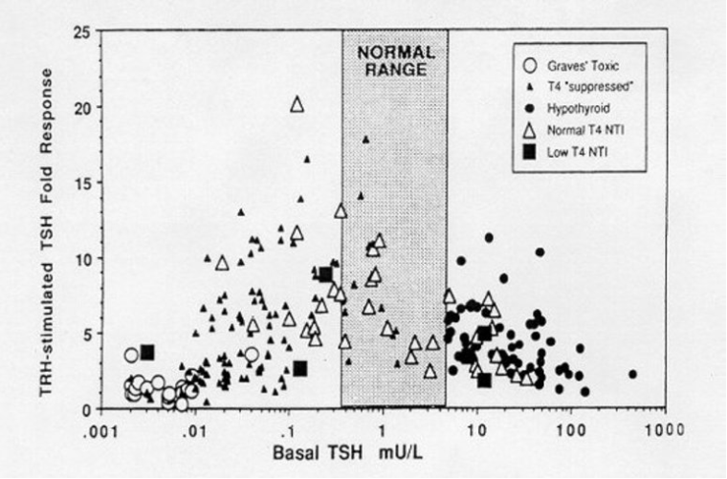
Figure 16. Relationship between basal and absolute (TRH stimulated-basal TSH) TRH-stimulated TSH response in 1061 ambulatory patients with an intact hypothalamic-pituitary (H-P) axis compared with that in untreated and T4-treated patients with central hypothyroidism. (From Spencer et al. (287) with permission)

Although, as stated before, the clinical relevance of the TRH test is presently limited, there are still some conditions in which the test may still be useful. These include subclinical primary hypothyroidism, central hypothyroidism (25), the syndromes of inappropriate TSH secretion (393) and non-thyroidal illnesses.

In patients with normal serum thyroid hormone concentrations and borderline TSH, an exaggerated TSH response to TRH not followed by an adequate increase in serum thyroid hormone levels may confirm the presence of subtle primary hypothyroidism (391).

An abnormal relationship between the basal TSH and the TRH-response is found in patients with central hypothyroidism. Here the fold TSH response to TRH is lower than normal (371,23,287). Again, however, TRH testing does not add substantially to the evaluation of such patients in that the diagnosis of central hypothyroidism is established by finding a normal or slightly elevated basal TSH in the presence of a significantly reduced free T4 concentration. While statistically (287) lower and sometimes delayed increments in TSH release after TRH infusion are found in patients with pituitary as opposed to hypothalamic hypothyroidism, the overlap in the TSH increments found in patients with these two conditions is sufficiently large (371,23,24,394), so that other diagnostic technologies, such as MRI, must be used to provide definitive localization of the lesion in patients with central hypothyroidism. It should be recalled that the TRH test may be useful in the diagnosis and follow-up of several pituitary disorders, but the discussion of this point is beyond the purpose of this chapter.

The TRH test still provides fundamental information in the differential diagnosis of hyperthyroidism due to TSH-secreting adenomas from syndromes with non-neoplastic TSH hypersecretion due to pituitary selective or generalized thyroid hormone resistance. In all the above conditions, increased or “inappropriately normal” serum TSH concentrations are observed in the presence of elevated circulating thyroid hormone levels. However, in most (>90%) of TSH-secreting adenomas serum TSH does not increase after TRH, while TRH responsiveness is observed in >95% of patients with nontumoral inappropriate TSH secretion (283,213,391).

Perhaps of most interest pathophysiologically is the response to TRH in patients with non-thyroidal illness and either normal or low free T4 indices (Fig. 12). Results from these patients fit within the normal distribution in terms of the relationship between basal TSH (whether suppressed or elevated) and the fold-response to TRH. Thus the information provided by a TRH infusion test adds little to that obtained from an accurate basal TSH measurement (395). With respect to the evaluation of sick patients, while basal TSH values are on average higher than in patients with thyrotoxicosis, there is still some overlap between these groups (396,337,287,397). This indicates that even with second or third generation TSH assays, it may not be possible to establish that thyrotoxicosis is present based on a serum TSH measurement in a population which includes severely ill patients.

CLINICAL APPLICATION OF TSH MEASUREMENTS AND SUMMARY

Table 5 lists conditions in which basal TSH values may be altered as practical examples of the pathophysiology of the hypothalamic-pituitary thyroid axis.

Table 5. Conditions which May be Associated with Abnormal Serum TSH Concentrations
 | Expected TSH (mU/L) | Thyroid  Status | FT4
TSH reduced
1. Hyperthyroidism | <0.1 | ↑ | ↑, T3
2. “Euthyroid” Graves’ disease | 0.2-0.5 | N (↑) | N(T3↑)
3. Autonomous nodules | 0.2-0.5 | N (↑) | N(T3↑)
4. Excess thyroid hormone treatment | 0.1-0.5 | N,↑ | N,↑
- Other forms of subclinical hyperthyroidism (including thyroiditis variants) | 0.1-0.5 | N,↑ | N,↑
6. Illness with or without dopamine | 0.1-5.0 | N | ↑, N,↓
7. First trimester pregnancy | 0.2-0.5 | N (↑) | N (↑)
8. Hyperemesis gravidarum | 0.2-0.5 | N (↑) | ↑(N)
9. Hydatidiform mole | 0.1-0.4 | ↑ | ↑
10. Acute psychosis or depression (rare) | 0.4-10 | N | N (↑)
11. Elderly (small fraction) | 0.2-0.5 | N | N
- Cushing’s syndrome and glucocorticoids excess (inconsistent) | 0.1-0.5 | N | N
13. Retinoid X receptor-selective ligands | 0.01-0.2 | ↓ | ↓
14. Various forms of central hypothyroidism | <0.1-0.4 | ↓ | ↓
- 15. Congenital TSH deficiency  a) Pit-1 mutations  b) PROP1 mutations  c) Mutations of TSHB gene in CAGYC region  d) Skipping of TSHB gene exon 2  e) Inactivating mutation of TRH receptor gene | 0  0  0  0  1-2 ↓ ↓ | ↓  ↓  ↓  ↓ | ↓  ↓  ↓  ↓
TSH Elevated
1. Primary hypothyroidism | 6-500 | ↓ | ↓
2. Resistance to TSH | 6->100 | N,↓ | N,↓
3. Recovery from severe illness | 5-30 | N | N,↓
4. Iodine deficiency | 6-150 | N,↓ | ↓
5. Thyroid hormone resistance | 1-15 | N (↓,↑) | ↑
6. Thyrotroph tumor | 3-30 | ↑ | ↑
7. Central (“tertiary”) hypothyroidism | 1-19 | ↓ | ↓
8. Psychiatric illness (especially bipolar disorders) | 0.4-10 | N | N
9. Test artifacts (endogenous anti-mouse gamma-globulin antibodies as well as “macroTSH”) | 10-500 | N | N
- 10. Addison’s disease | 5-30 | N | N

Clinical Situations Associated with Subnormal TSH Values

The most common cause of a reduced TSH in a non-hospitalized patient is thyroid hormone excess. This may be due to endogenous hyperthyroidism or excess exogenous thyroid hormone. The degree of suppression of basal TSH is in proportion to the degree and duration of the thyroid hormone excess. The reduced TSH is the pathophysiological manifestation of the activation of the negative feedback loop.

While a low TSH in the presence of elevated thyroid hormones is logical, it results from multiple causes. Prolonged excessive thyroid hormone levels cause physiological "atrophy" of the thyroid stimulatory limb of the hypothalamic-pituitary thyroid axis. Thus, TRH synthesis is reduced, TRH mRNA in the PVN is absent, TRH receptors in the thyrotroph may be reduced, and the concentration of TSH beta and alpha subunits and both mRNAs in the thyrotroph are virtually undetectable. Therefore, it is not surprising that several months are usually required for the re-establishment of TSH secretion after the relief of thyrotoxicosis. This is especially observed in patients with Graves' disease after surgery or radioactive iodine, in whom TSH remains suppressed despite a rapid return to a euthyroid or even hypothyroid functional status (398,399). Since TRH infusion will not increase TSH release in this situation, it is clear that the thyrotroph is transiently dysfunctional (400). A similar phenomenon occurs after excess thyroid hormone treatment is terminated, and after the transient hyperthyroidism associated with subacute or some variants of autoimmune thyroiditis, though the period of suppression is shorter under the latter circumstances (401). This cause of reduced circulating thyroid hormones and reduced or normal TSH should be distinguishable from central hypothyroidism by the history.

Severe illness is a common cause of TSH suppression although it is not often confused with thyrotoxicosis. Quantitation of thyroid hormones will generally resolve the issue (327). Patients receiving high-dose glucocorticoids acutely may also have suppressed TSH values although chronic glucocorticoid therapy does not cause sufficient TSH suppression to produce hypothalamic-pituitary hypothyroidism (see above).

Exogenous dopamine suppresses TSH release. Infusion of 5-7.5 mg/kg/min to normal volunteers causes an approximately 50% reduction in the concentrations of TSH and consequent small decreases in serum T4 and T3 concentrations (363). In critically ill patients, this effect of dopamine can be superimposed on the suppressive effects of acute illness on thyroid function, reducing T4 production to even lower levels (357). Dopamine is sufficiently potent to suppress TSH to normal levels in sick patients with primary hypothyroidism (363). This needs to be kept in mind when evaluating severely ill patients for this condition. Dopamine antagonists such as metoclopramide or domperidone cause a small increase in TSH in humans. However, somewhat surprisingly, patients receiving the dopamine agonist bromergocryptine do not become hypothyroid. Although L-dopa causes a statistically significant reduction in the TSH response to TRH, patients receiving this drug also remain euthyroid (370).

Studies in animals have suggested that pharmacological amounts of retinoids may decrease serum TSH concentration (see also paragraph “Effect of Thyroid Hormone on TSH Secretion”) (402,96). Severe central hypothyroidism associated with very low serum TSH concentration has been reported in patients with cutaneous T-cell lymphoma treated with high-dose bexarotene, a retinoid X receptor-selective ligand able to suppress TSH secretion (403).

hCG may function as a thyroid stimulator. During pregnancy, hCG stimulates the thyroid gland of the mother resulting in the typical transient decrease of the TSH levels during the first trimester (0.2 - 0.4 mU/L). Pathologic hCG secretion can result in frank, often mild, hyperthyroidism in patients with choriocarcinomas or molar pregnancies (404).

Patients with acute psychosis or depression and those with agitated psychoses may have high thyroid hormone levels and suppressed or elevated TSH values. The etiology of the alterations in TSH are not known. Those receiving lithium for bipolar illness may also have elevated TSH values due to impairment of thyroid hormone release. Patients with underlying autoimmune thyroid disease or multi-nodular goiter are especially susceptible (405). A small fraction of elderly patients, particularly males, have subnormal TSH levels with normal serum thyroid hormone concentrations. It is likely that this reflects mild thyrotoxicosis if it is found to be reduced on repeated determinations.

Congenital central hypothyroidism with low serum TSH may result from mutations affecting TSHB gene or the Pit-1 gene (see paragraphs “The Thyroid-Stimulating Hormone Molecule”, “Role of Pit-1 and its splicing variants in the regulation of TSHB gene expression” and “Other Transcription Factors Involved in TSHB Gene Expression”.

Causes of an Elevated TSH

Primary hypothyroidism is the most common cause of an elevated serum TSH. The serum free T4 is low normal or reduced in such patients but the serum free T3 values remain normal until the level of thyroid function has markedly deteriorated (118). Another common cause of an elevated TSH in an iodine-sufficient environment is the transient elevation which occurs during the recovery phase after severe illness (342,343). In such patients a "reawakening" of the hypothalamic-pituitary-thyroid axis occurs pari passu with the improvement in their clinical state. In general, such patients do not have underlying thyroid dysfunction. Iodine deficiency is not a cause of elevated TSH in Central and North America but may be in certain areas of Western Europe, South America, Africa and Asia.

The remainder of the conditions associated with an elevated TSH are extremely rare. Inherited (autosomal recessive) forms of partial (euthyroid hyperthyrotropinemia) or complete (congenital hypothyroidism) TSH resistance have been described associated with inactivating biallelic point mutations of the TSH receptor gene (406,407). Interestingly, inherited dominant forms of partial TSH resistance have also been described in the absence of TSH receptor gene mutations (408,409). The underlying molecular defect(s) remain(s) to be elucidated in such cases. More frequently, in a patient who has an elevated serum FT4, the presence of TSH at normal or increased levels should lead to a search for either resistance to thyroid hormone or a thyrotroph tumor. Hypothalamic-pituitary dysfunction may be associated with normal or even modest increases in TSH and are explained by the lack of normal TSH glycosylation in the TRH-deficient patient. The diagnosis is generally made by finding a serum free T4 index which is reduced to a greater extent than expected from the coincident serum TSH. Psychiatric illness may be associated with either elevated or suppressed TSH levels, but the abnormal values are not usually in the range normally associated with symptomatic thyroid dysfunction. The effect of glucocorticoids to suppress TSH secretion has already been mentioned. This is of relevance in patients with Addison's disease in whom TSH may be slightly elevated in the absence of primary thyroid disease.

Lastly, while most of the artifacts have been eliminated from the immunometric TSH assays, there remains the theoretical possibility of an elevated value due to the presence of endogenous anti-mouse gamma globulin antibodies (410,411). These heterophilic antibodies, like TSH, can complex the two TSH antibodies resulting in artificially elevated serum TSH assay results in euthyroid patients. Such artifacts can usually be identified by finding non-linear results upon assay of serial dilutions of the suspect serum with that from patients with a suppressed TSH. Moreover, the possible presence of “macro TSH” should be investigated in patients with high levels of TSH, normal circulating free thyroid hormones and absence of clinical signs and symptoms of hypothyroidism (410,411). Macro TSH is a large molecular-sized TSH that is mostly a complex of TSH and IgG. Precipitation of the serum with PEG and measurement of TSH in the supernatant is mandatory to confirm the presence of macro TSH, a procedure that is similar to that documenting the presence of macro PRL (412-415).

REFERENCES

