Published in WWW.ENDOTEXT.ORG © 2018

CHAPTER 3 – PITUITARY ADENOMAS IN CHILDHOOD
Annamaria Colao, MD, PhD Professor of Endocrinology, University Federico II of Naples via S. Pansini 5, 80131 Naples, Italy colao@unina.it

Revised 12/26/2017

ABSTRACT
Tumors in the pituitary region can be classified on the basis of topographic criteria as intra-, supra- para- or retrosellar. Intrasellar tumors are mostly represented by pituitary adenomas (more than 90% of all intrasellar lesions), while dys-embryogenetic lesions such as Rathke’s pouch cyst are less frequent. The suprasellar tumors are dys-embryogenetic lesions of the midline such as craniopharyngiomas, germinomas, dermoid or epidermoid cysts, lipomas, teratomas, hamartomas. Other tumors such as meningiomas or gliomas are uncommon during childhood or adolescence. Craniopharyngiomas, the most common cause of hypopituitarism in childhood, and adenomas are the most frequent lesions of the pituitary region in children and adolescents. The vast majority of pituitary tumors in children are benign lesions. For complete coverage of related aspects of Endocrinology, please see www.endotext.org.

INTRODUCTION

Pituitary function depends on the integrity of the hypothalamo-pituitary axis and the functionality of numerous differentiated cell lines in the anterior pituitary lobe that specialise in specific hormone production. The development of these cell lines is the result of events during pituitary organogenesis that are under the sequential control of transcription factors (1). Any abnormality occurring in the pituitary gland either congenital (congenital malformations, genetic abnormalities) or acquired (perinatal insults, tumors, infections) will cause profound alterations of the whole endocrine system.
Tumours in the pituitary region can be classified on the basis of topographic criteria as intra-, supra- para- or retrosellar (2). Intrasellar tumors are mostly represented by pituitary adenomas (more than 90% of all intrasellar lesions), while dys-embryogenetic lesions such as Rathke’s pouch cyst are less frequent. The suprasellar tumours are dys-embryogenetic lesions of the midline such as craniopharyngiomas, germinomas, dermoid or epidermoid cysts, lipomas, teratomas, hamartomas. Other tumours such as meningiomas or gliomas are uncommon during childhood or adolescence. Craniopharyngiomas, the most common cause of hypopituitarism in childhood, and adenomas are the most frequent lesions of the pituitary region in children and adolescents. Virtually all tumours of this region are benign.
This chapter aims at reviewing the most recent epidemiological, diagnostic and therapeutic knowledge on pituitary tumours in childhood and adolescence.

CRANIOPHARYNGIOMAS

Craniopharyngiomas are rare embryonic malformations of the sellar and parasellar area with an incidence of 0.5 to 2 cases per million persons per year, 30 to 50% of all cases presenting during childhood and adolescence (3-8). They originate from squamous rest cells of the remnant of Rathke’s pouch between the adenohypophysis and neurohypophysis in the region of the pars tuberalis. Rathke’s pouch is a cystic diverticulum from the roof of the embryonic mouth that gives rise to the adenohypophysis and determines the induction of the neurohypophysis. Craniopharyngiomas represent 1.2 to 4% of all childhood intracranial tumors (9-11) and show a bimodal distribution during the first-second decade of life and then in the fifth, apparently without any gender difference (3,12). The tumour generally originates in the suprasellar region (94-95%), purely suprasellar (20–41%) or both supra- and intrasellar (53–75%), whereas the purely intrasellar form (5-6%) are less frequent (3). Extremely rare are forms originating in the III ventricle, in the rhinopharynx, in the sphenoid or in other location (3). In their pure form, the adamantinomatous form and papillary form are clinicopathologically distinct. In childhood and adolescence, its histological type is usually adamantinomatous with cyst formation (3-8). Craniopharyngiomas are benign from a histological evaluation but they can be aggressive, invading surrounding bony structures and tissues; they commonly have cystic components that may be multiple and generally cause compression of adjacent neurological structures (3-8).

Clinical presentation and diagnosis

The diagnosis of craniopharyngioma is often made late, sometimes years after the initial appearance of symptoms. Neurological disturbances, such as headache and visual field defects, together with manifestations of endocrine deficiency such as stunted growth and delayed puberty are the common presenting symptoms of craniopharyngiomas (3-8). Among adult-onset craniopharyngioma patients, hormonal deficits at the time of diagnosis are much more pronounced when compared with childhood-onset craniopharyngioma patients (3). At diagnosis, endocrine dysfunction is found in up to 80% of patients (3-8). Reduced GH secretion is the most frequent finding, present in up to 75% of patients, followed by FSH/LH deficiency in 40%, and ACTH and TSH deficiency in 25% (3-8). Despite the fact that the tumour is frequently large at presentation, the pituitary stalk is usually not disrupted, and hyperprolactinaemia secondary to pituitary stalk compression is found in only 20% of patients (3-8). Diabetes insipidus is also relatively uncommon, occurring in ~17 % of patients (3-8,13). An increase in weight tends to occurs as a later manifestation, shortly before diagnosis (3-8). Then, the clinical combination of headache, visual impairment, decreased growth rate, and/or polydipsia/polyuria would be very suggestive of childhood craniopharyngioma in the differential diagnostic process (14).
To date, magnetic resonance imaging (MRI) before and after gadolinium application is the standard imaging for detection for craniopharyngiomas. The neuroradiological diagnosis of craniopharyngiomas is based on the features of the lesion itself and on its relations with the surrounding structures. Particularly, the diagnosis is mainly based on the three characteristic components of the tumor: cystic, solid and calcified (3,4,15-17). The cystic component (Fig.1) constitutes the most important tumoral part (up to the 70-75% of the total volume), and shows a variable signal depending on the chemical-physical properties of its content (18). A fluid content will appear hypointense in T1 and hyperintense in T2 while a lipid (due to cholesterol), methaemoglobin or protein content will appear as hyperintense in T1 and T2 sequences. The solid portion shows an isointense signal in T1 and a hyperintense signal in T2 with enhancement after gadolinium, at variance with the cystic component (Fig.2). However, enhancement after paramagnetic contrast is not a consistent feature (18). Computed tomography (CT) imaging is the only way to detect or exclude calcification, which is found in approximately 90% of tumours and therefore a crucial differentiating component for diagnosis (15-17). Calcification appears as areas of low signal in all sequences (17). The radiological appearance of non-homogeneous signal or a prevalent cystic component should not be regarded as a proof of a craniopharyngioma, since macroadenomas can also sometimes be characterised by patterns resembling craniopharyngiomas.
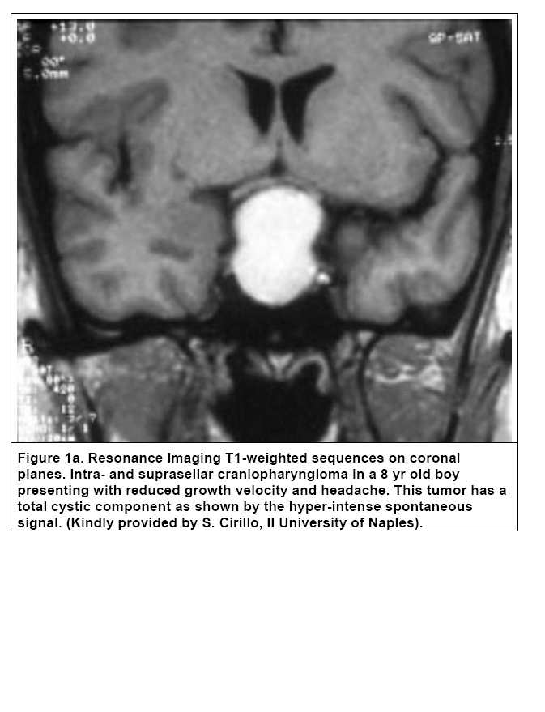

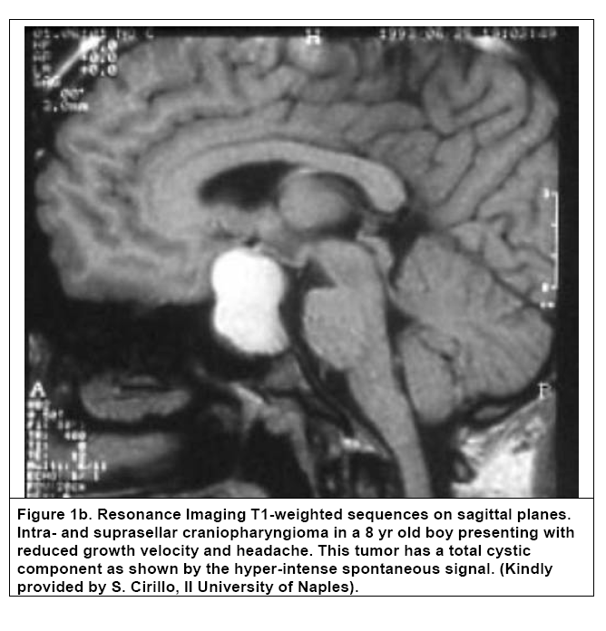
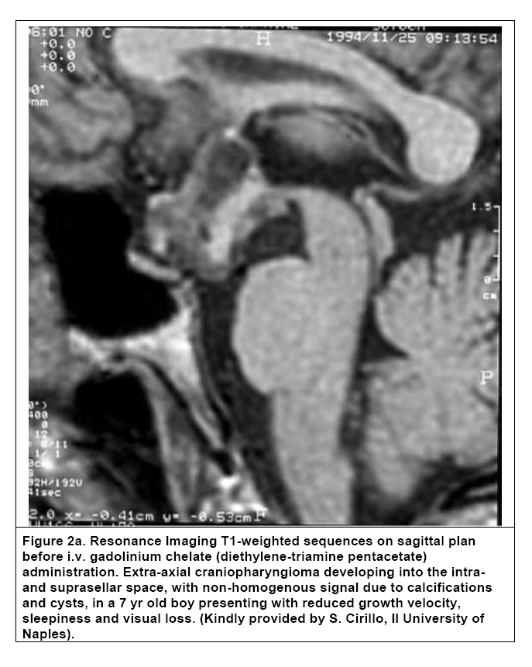
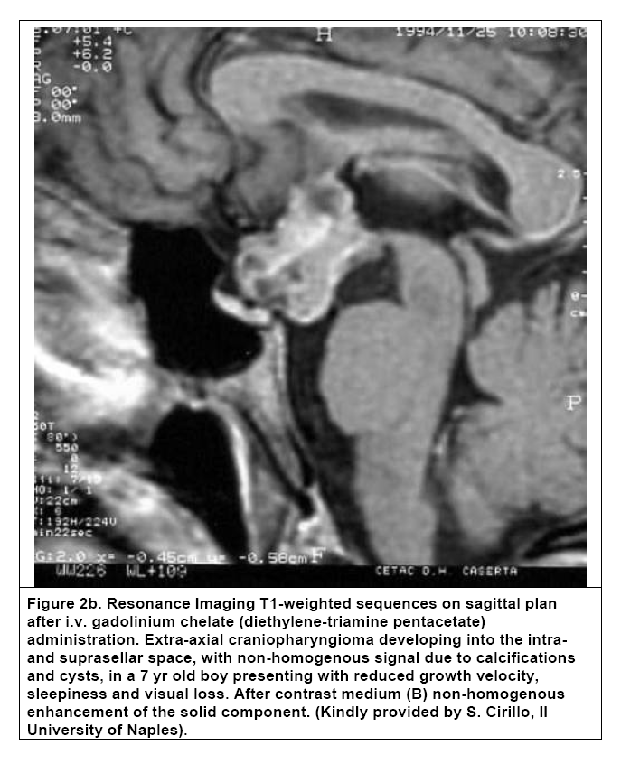

Treatment strategy

The clinical presentation of patients may be as an emergency with symptoms of raised intracranial pressure or rapid deterioration in visual function. Initial surgical treatment, for hydrocephalus or tumor cyst decompression, to relieve these symptom and prevent further visual deterioration, may be necessary prior to definitive treatment of the tumour (3-8). To date, surgery remains the first treatment option in paediatric craniopharyngiomas. Current concepts in the neurosurgical treatment of craniopharyngioma remain controversial. The operative approach is generally dictated by localisation and extent of the craniopharyngioma, with the primary goal of significant removal; radical resection and attempting total removal results in significantly impaired functional outcome (19,20), so currently many prefer subtotal removal and then radiotherapy. Purely infradiaphragmatic as well as supradiaphragmatic/infrachiasmatic tumors have a favorable surgical outcome with higher gross total resection rates in experienced hands, whereas lesions extending within the third ventricle and lesions beyond 3cm in diameter, independent of their localisation, remain a problem. Aside from the traditional microscopic approach via the subfrontal or pterional craniotomy, transsphenoidal approaches and other minimal invasive surgical methods, e.g., catheter implantation into cystic formations of the tumour, have become popular (19,20). Radiotherapy is required in case of incomplete tumour removal which is common for extra-sellar craniopharyngiomas and can effectively be added to avoid recurrences. In children, however, the benefit of any additional radiotherapic treatment should be balanced against the high risk of inducing hypopituitarism later in life. In a retrospective preliminary review aiming at evaluating the efficacy and toxicity of fractionated proton radiotherapy in the management of paediatric craniopharyngioma, local mass control was reported in 14 of 15 patients with few acute side effects and newly diagnosed panhypopituitarism, cerebrovascular accident (from which the patient recovered), and an out-of-proton-field meningioma in a single patient who received previous radiotherapy as long-term complications (9,21). Recently, the BRAFV600E mutation has been demonstrated in papillary variant of craniopharyngiomas and a therapeutic response has been reported in these tumours with genetically confirmed BRAFV600E mutation, following combination therapy with BRAF and MEK inhibitors (22,23).

PITUITARY ADENOMAS

Pituitary adenomas are the most common cause of pituitary disease in adults but they are less common in children, becoming increasingly more frequent during adolescent years (24-27). The estimated incidence of pituitary adenomas in childhood is still unknown since most published series included patients with onset of symptoms before the age of 20 yrs as paediatric patients (28). Pituitary adenomas constitute less than 3% of supra-tentorial tumours in children, and 2.3-6% of all pituitary tumours treated surgically (24,25,28-31). The average annual incidence of pituitary adenomas in childhood has been estimated to be 0.1/million children (32). Among all supra-tentorial tumours treated during a 25-year period, pituitary adenomas were diagnosed in only 1.2% of children (33). Pituitary carcinomas are rare in adults and extremely rare in children (34).
There is no consensus on the alleged greater invasiveness of pituitary adenomas in children than in adults, while a slightly greater prevalence in females has been reported (8,24-26,32). However, gender distribution reflects the relative contribution of the two main groups, PRL- and ACTH- secreting adenomas, which predominate in most series reported. Prolactinoma is indeed the most frequent adenoma histotype in children, followed by the corticotrophinoma and the somatotropinoma (35). Nonfunctioning pituitary adenomas, TSH-secreting, and gonadotrophin-secreting adenomas are very rare in children accounting for only 3-6% of all pituitary tumors (28). ACTH-secreting adenomas have an earlier onset and predominate in the pre-pubertal period while GH-secreting adenomas are very rare before puberty (8,28). Similar to adults, presenting symptoms are generally related to the endocrine dysfunction, such as growth delay and primary amenorrhoea, rather than to mass effects (33-39). Symptoms of pituitary tumor presentation differ according with the histotype as shown in Table 1 and detailed in the specific sections.

Table 1. Prevalence of clinical symptoms and signs in children/adolescents with pituitary adenomas. Data drawn from ref. 33-39

 | PRL-secreting  adenomas | ACTH-secreting  adenomas | GH-secreting  adenomas | TSH-secreting  adenomas | Clinically Non functioning  adenomas
Acne | – | + | – | – | –
Delayed/arrest growth | -/+ | + | – | ++ | ++
Delayed/Advanced bone age | – | + | + | –/+ | ++
Delayed puberty | ++ | + | + | + | ++
Early sexual development | – | ++ | – | – | –
Erytrosis | – | + | – | – | –
Fatigue or weakness | – | + | – | + | –
Galactorrhea | +++ | – | –/+ | – | –
Gigantism/Acromegaly | – | – | ++ | – | –
Glucose intolerance | – | + | + | + | –
Gynecomastia | + | – | –/+ | – | –
Headache | ++ | + | ++ | + | ++
High school performance | – | + | – | – | –
Hirsutism | – | + | – | – | –
Hypertension | – | + | –/+ | –/+ | –
Menstrual irregularities | ++ | + | ++ | + | ++
Mild hyperthyroidism | – | – | – | + | –
Osteoporosis | + | + | – | + | –
Premature telarche | ++ | –/+ | – | – | –
Primary amenorrhea | ++ | + | ++ | + | ++
Secondary hypopituitarism | +++ | +++ | +++ | +++ | +++
Sleep disturbances | – | + | – | ++ | –
Striae | – | + | – | – | –
Visual field defects | +++ | ––/+ | +++ | +++ | +++
Weight increase | + | + | – | – | –
–= Absent; –/+ rare; ––/+= very rare; +=present; ++=frequent; +++= frequent in macroadenomas.

PRL-SECRETING ADENOMAS

Prolactinomas are the most frequent pituitary tumours both in childhood and in adulthood, and their frequency varies with age and sex, occurring most frequently in females between 20-50 years (25, 35, 40-42).

Clinical presentation and diagnosis

PRL-secreting adenomas are usually diagnosed at the time of puberty or in the post-pubertal period and clinical manifestations vary in keeping with the age and sex of the child (24-26,35,41,42). Pre-pubertal children generally present with a combination of headache, visual disturbance, growth failure, and amenorrhoea (Table 1). Growth failure is not, however, a common symptom: in fact in two different retrospective studies, 4% of 25 patients (42) and 10% of 20 patients (43) were reported to have short stature at the diagnosis of prolactinoma. Weight gain has been reported to occur in patients with hyperprolactinaemia (44-46) but never described in children. In a re-evaluation of the young/adolescent patients with hyperprolactinaemia admitted to the University Federico II from January 1st 1995 to December 31st 2004 (35,47), short stature was found in 7 of 50 patients (14%), five girls and two boys, and another two patients, one girl and one boy, had their height below or at the 5° percentile and another 8 (3 girls) had their height between the 5° and 10° percentile. The height percentiles in the patients with extrasellar/invasive macroprolactinomas were lower than in those bearing smaller tumours (Fig.3). Additionally, all girls present with oligomenorrhoea or amenorrhoea; most also had galactorrhoea; gynaecomastia was present in 12 of 21 boys (57.1%) The most common symptoms of prolactinomas in peripubertal age are those associated with deficiency of the pituitary-gonadal axis. Menstrual irregularities in girls are common in all types of pituitary adenomas, except those causing Nelson’s syndrome (48). Galactorrhoea should be carefully investigated by expressing the breast, because teenagers may not spontaneously refer it as a symptom, and frequently it is not spontaneous. Headache and visual field defects predominate in patients bearing large adenomas (Table 2).
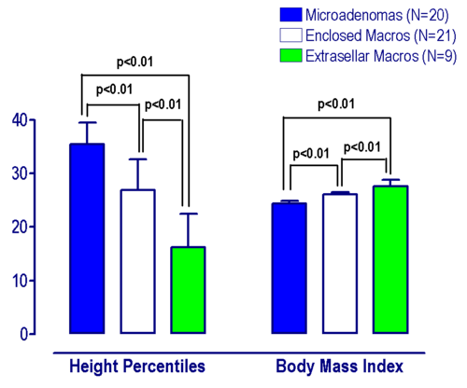
Figure 3. Height (shown as mean percentiles for age) and Body Mass Index in 50 patients with prolactinomas diagnosed before 20 years of age. The statistical analysis was performed by the Data drawn from ref. 47

Table 2. Presentation of prolactinomas in children and adolescents: the two-decade experience of the Department of Endocrinology and Oncology, University “Federico II” of Naples. Data drawn from reference 47.
 | Microadenomas | Enclosed Macroadenomas | Extrasellar and/or Invasive Macroadenomas
No. | 20 | 21 | 9
Girls/Boys | 15/5 | 11/10 | 3/6
Age at diagnosis (yrs) | 14.4±0.5 | 14.8±0.4 | 13.8±1.1
Basal PRL levels (μg/L) | 138.4±21.6 | 671.4±161.9 | 2123±279
Tumor volume on MRI (mm3) | 113.0±15.1 | 1145±145 | 2826±330
Symptoms (%)

Secondary or Primary Amenorrhea1 | 53.3% | 72.7% | 66.7%
Oligomenorrhea1 | 46.7% | 18.2% | 0%
Gynecomastia2 | 100% | 60% | 33.3%
Galactorrhea | 42.8% | 60% | 33.3%
Visual field defects | 0% | 50% | 66.7%
Headache | 33.2% | 80% | 66.7%
1= Calculated only in girls; 2=Calculated only in boys.

Impairment of other pituitary hormone secretion was reported to occur in a minority of patients at diagnosis (35,42,43,48) and in some patients hypopituitarism developed after surgery. In a more recent analysis (47), we can confirm that only the minority of patients bearing large adenomas had a severe degree of hypopituitarism, while a very few patients with either microadenomas or enclosed macroadenomas had isolated hormone deficiency (Fig.4). Macroadenomas at presentation are more likely in boys than in girls (27,30,35,43,49). In our series (47), microprolactinoma and enclosed macroadenomas were more frequent in females with a ratio of 1.7:1 while large macroprolactinomas were 2 times more frequent in males (Table 2).

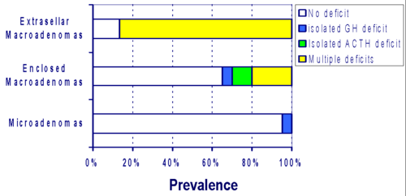
Figure 4. Prevalence of pituitary deficit according with prolactinoma size in 50 patients at diagnosis. Data drawn from ref. 47
Hyperprolactinaemic patients have a decrease in bone mineral density (BMD), and progressive bone loss has been demonstrated in untreated patients (50). Young hyperprolactinaemic men were shown to have a more severe impairment of BMD than patients in whom hyperprolactinaemia occurred at an older age (51). In 20 patients with diagnosis of hyperprolactinaemia during adolescence, we found (52) significantly lower BMD values in adolescents than in young adult patients with hyperprolactinaemia. This finding is confirmed in a large cohort of patients (47). In 22 patients all having a diagnosis of prolactinomas before the age of 18 yrs, the bone mineral density (BMD) at lumbar spine was significantly lower than in age-matched controls (Fig.5). The use of drugs to increase bone mass, such as amino-bisphosponates, has not been investigated.

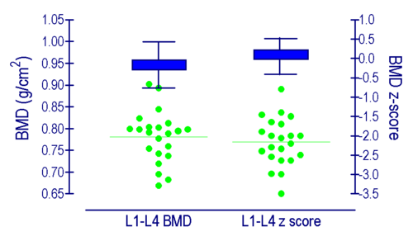

Figure 5. Bone density (BMD) measured as g/cm2 or z-score in 22 patients with prolactinoma (individual data shown as solid circles) and their sex- and age-matched controls (data shown as mean ± SD). Data drawn from ref. 52, modified form ref. 47

The diagnosis of prolactinoma is based on the measurement of serum PRL levels and neuroradiological imaging. The differential diagnosis of hyperprolactinaemia should consider any process interfering with dopamine (DA) synthesis, its transport to the pituitary gland or its action at lactotroph DA-receptors. A single measurement of PRL levels is unreliable since PRL secretion is markedly influenced by physical and emotional stress. Basal PRL levels greater than 200ng/l are diagnostic, whereas levels between 100 and 200ng/ml and the presence of a mass requires additional investigation to rule out mass effect versus a prolactinoma. Some peculiar conditions should, however, be remembered (53). Serial serum PRL measurements at 0, 30 and 60 min after the needle was inserted into an antecubital vein is a valuable and simple measure to identify stress- related hyperprolactinaemia in order to avoid diagnostic pitfalls and unnecessary treatments. It is important to exclude from the assay the monomeric PRL forms, big-prolactin (b-PRL) and big big- prolactin (bb-PRL); the latter may contain immunoglobulin (IgG) (54). These molecular complexes are seldom active but may be recorded by the PRL assay. The absence of a clinical syndrome of hyperprolactinaemia will suggest the presence of macroprolactin. The ‘high-dose hook effect’ could be a serious problem in the differential diagnosis between prolactinomas and nonfunctioning adenomas (NFPA): it is mandatory, in these cases and in every patient with pituitary mass and hyperprolactinaemia, to dilute PRL samples routinely (1:10 and 1:100 dilutions) or to use alternative methods to immunoradiometric assays. The difference between macroprolactinomas and ‘pseudoprolactinomas’ is essential to provide a correct treatment approach (55). This problem is, however, of little relevance in children and adolescents as non-functioning macroadenomas are very rare at this age.

Treatment strategy

Indications for therapy are: 1) to reduce tumour size, and 2) to control PRL excess. In the absence of complications needing immediate surgery, such as visual loss, hydrocephalus, or cerebrospinal fluid leak, pharmacotherapy with dopamine-agonists (e.g. bromocriptine, quinagolide, or cabergoline) should be considered the first treatment approach (24,28,35,42,43,47,49). Treatment with dopamine-agonists is effective in normalising PRL levels and shrinking tumour mass in the majority of adult patients with prolactinoma (24,28,35,42,43,47). In children and adolescents, bromocriptine has been used successfully by several investigators (42,56-59). In our series, bromocriptine at doses ranging from 2.5-20 mg/day orally, induced normoprolactinaemia in 38.5% of patients (42). In the remaining patients, 10 with macro (Fig.6) and 6 with microprolactinoma (Fig.7), PRL levels remained above the normal range despite a progressive increase of the dose of the drug. However, the possibility that some patients were indeed not taking bromocriptine appropriately cannot be ruled out as poor compliance to any chronic treatment is a well-known phenomenon in children and adolescents. In addition, some patients required drug discontinuation for intolerable side effects regarding the gastrointestinal tract. Both quinagolide, at doses ranging from 0.075-0.6 mg/day, or cabergoline, at doses ranging from 0.5-3.5 mg/week orally, two selective DA receptor subtype-2 selective agonists, have been reported to be effective in reducing PRL secretion and tumour size in most adult patients with prolactinoma, even in those previously shown to be poorly responsive or intolerant to bromocriptine (47). Cabergoline is more effective and often better tolerated than bromocriptine.
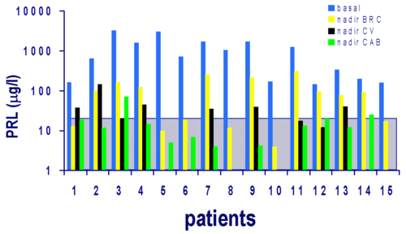

Figure 6. Serum PRL response to different dopaminergic drugs, namely bromocriptine (BRC), quinagolide (CV) and cabergoline (CAB) in 15 children with macroprolactinoma. The shaded area represents the normal PRL range. Data are shown as nadir PRL values at diagnosis and during treatment. Data drawn from ref. 42
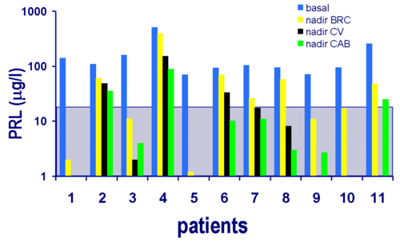
Figure 7. Serum PRL response to different dopaminergic drugs, namely bromocriptine (BRC), quinagolide (CV) and cabergoline (CAB) in 11 children with microprolactinoma. The shaded area represents the normal range. Data are shown as nadir PRL values at diagnosis and during treatment. Data drawn from ref. 42

Of our 50 cases (47), cabergoline induced normalisation of PRL levels in all but 3 cases. Two of the three patients had large extrasellar macroprolactinomas (tumour volume of 4579 mm3 and 1983 mm3 respectively) with baseline PRL levels of 3300 μg/L and 1700 μg/L, respectively that progressively decreased but did not normalise after 2-7 years of treatment. Tumour shrinkage by 93.2% and 54.5% was seen in both patients. The latter patient had a microprolactinoma (tumor volume=123.6 mm3) with a baseline PRL levels of 500 μg/L that progressively decreased up to 88 μg/L at the last follow-up after 6 years of treatment and achieved tumour shrinkage by 53.9% (47). Only one case of pituitary apoplexy following cabergoline treatment in a young patient has been reported so far (60). Twelve of our 50 patients (one with enclosed macroprolactinoma and 11 with microprolactinoma) achieved the disappearance of the tumour so that they were withdrawn from treatment (61). In our former series, tumour shrinkage was observed in most patients with macroadenomas and even in some with microprolactinomas (Fig.8). The easy weekly administration makes cabergoline an excellent therapeutic approach to children/adolescents with prolactinoma. Cabergoline has been reported to be tolerated, even at rather high doses (62). The only relevant safety issue to be considered in patients treated with cabergoline is a possible consequent cardiac valve derangement (63-65). This phenomenon appears in patients with Parkinson’s disease, who are older and require higher doses of the drug than the patients with prolactinomas. This aspect still deserves some attention and dedicated observational studies are ongoing. In patients with tumors resistant to dopamine agonists as well as in those showing severe neurological symptoms at diagnosis surgery is indicated; radiotherapy, should be limited to the cases with aggressive tumours, non-responsive to dopamine agonists, because of the risk of neurological damage and hypopituitarism later in the lives of these patients (28,35,42,43,47).

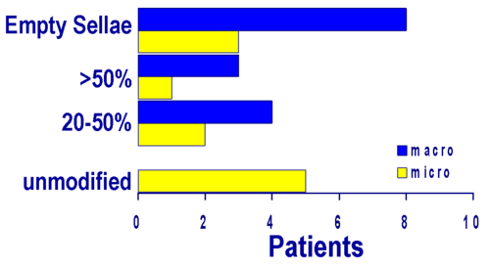

Figure 8. Tumor mass response after bromocriptine, quinagolide or cabergoline treatment in 15 children with macro- and 11 with microprolactinoma. Data are shown as number of cases with empty sella; greater than 50% tumor shrinkage; 20-50% tumor shrinkage or less than 20% tumor shrinkage shown as unmodified tumor volume. Data drawn from ref. 42

ACTH-SECRETING ADENOMAS

Cushing's disease (CD), caused by an ACTH-secreting pituitary corticotroph adenoma, is the commonest cause of Cushing syndrome in children over 5 years of age (66,67). CS can occur throughout childhood and adolescence; however, different aetiologies are commonly associated with particular age groups with CD being the commonest cause after the pre-school years. The peak incidence of paediatric CD is during adolescence (66).
A macroadenoma is rarely the cause of CD in children; paediatric CD is almost always caused by a pituitary microadenoma with diameter <5 mm with a significant predominance of males in pre- pubertal patients (66,67).

Clinical presentation and diagnosis

The clinical manifestations of CD are mostly the consequence of excessive cortisol production. The clinical presentation is highly variable, with signs and symptoms that can range from subtle to obvious (Table 1). The diagnosis is generally delayed since a decrease in growth rate may be the only symptom for a long time. Growth failure in CD may be due to a decrease of free IGF-I levels and/or a direct negative effect of cortisol on the growth plate (68,69). In a series of 50 children with CD, Magiakou et al. (69) found that obesity and growth retardation were the most frequent symptoms (in 90 and 83% of patients, respectively). Weight gain and stunted growth were the most frequent symptoms also in the series by Weber et al. (70) and Devoe et al. (71). The skin of the face is plethoric, and atrophic striae can be found in the abdomen, legs and arms. Muscular weakness, hypertension, and osteoporosis, especially of the spine, are common. Results on BMD or bone metabolism in children with CD have been reported only in some patients in a few studies (70,72). Consistent with the findings in adult patients, marked osteopenia was also found in affected children. The bone loss is more evident in trabecular than in cortical bone (73). As compared to patients with adult-onset disease, those with childhood-onset CD have a similar degree of bone loss at lumbar spine and similar increased bone resorption (74). In a study conducted in 10 patients with childhood-onset and 18 with adulthood-onset CD, BMD at lumbar spine was significantly lower than in sex and age-matched controls (Fig.9) (74). Osteoporosis was found in 16 patients (57.1%) [8 adolescent (80%) and 8 adult (44·4%) patients] while osteopenia was found in 12 patients (42.8%) [2 adolescent (20%) and 10 adult (55·6%) patients] (74). Additionally, we have recently reported that two years of cortisol normalization improved but did recover bone mass and turnover neither in children nor in adult patients with CD (75). This negative finding suggests that a longer period of time is necessary to restore bone mass after the cure of CD and, thus, other therapeutic approaches may be indicated to limit bone loss and/or accelerate bone recovery in these patients (71). In a recent study Lodish et al. (76) analysed retrospectively 35 children with CD; in this patients, vertebral BMD was more severely affected than femoral BMD and this effect was independent of degree or duration of hypercortisolism. BMD for the lumbar spine improved significantly after TSS; osteopenia in this group may be reversible. Complete reversal to normal BMD was not seen.

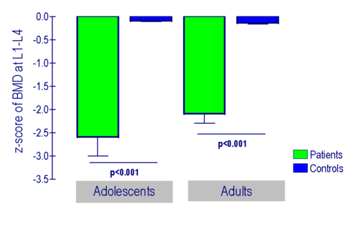

Figure 9. Z score of bone density at lumbar spine in 10 patients with childhood onset Cushing’s disease compared to 10 healthy adolescents of matched sex- and age and in 18 patients with adult-onset Cushing's disease compared to 18 healthy adults matched sex- and age. Data drawn from ref. 74

Hypercortisolism leads to decreased bone formation through direct or indirect inhibition of osteoblast function, while bone resorption is normal or increased in patients with CD (74,77,78). Hypercortisolism is known to be associated with loss of skeletal mass and can lead to increased vertebral fracture risk (79-80). It should also be noted that in children with CD the direct negative effect of hypercortisolism on bone formation is further worsened by concomitant hypogonadism and GH deficiency, both of which are associated with decreased BMD. Children with CD often have musculoskeletal weakness and can have decreased weight-bearing activity that may contribute to impaired BMD.
Children with CD may also have impaired carbohydrate tolerance, while overt diabetes mellitus is uncommon. Excessive adrenal androgens may cause acne and excessive hair growth, or premature sexual development in the first decade of life. On the other hand, hypercortisolism may cause pubertal delay in adolescent patients. Peculiarly, young patients with CD may present neuropsychiatric symptoms which differ from those of adult patients. Frequently, they tend to be obsessive and are high performers at school.
The differential diagnosis of CD includes adrenal tumours, ectopic ACTH production, and ectopic CRH-producing tumors. However, ectopic ACTH secretion is extremely rare in the paediatric age. In a child/adolescent with suspected CD the diagnosis is based on measurement of basal and stimulated levels of cortisol and ACTH. Measurement of 24-h urinary free cortisol is elevated, and a low dose of dexamethasone (15 μg/Kg) at midnight does not induce suppression of morning serum cortisol concentrations as in normal subjects (81). Loperamide, an opioid agonist, lowers cortisol secretion and has been proposed as a reliable screening test for hypercortisolism in children and adolescents (82). Suppression of the spontaneous circadian variations of serum cortisol is another feature of CD. Suppression of cortisol by more than 50% after high dose dexamethasone (150 μg/Kg) given at midnight will confirm that hypercortisolism is due to an ACTH-secreting pituitary adenoma (82). Midnight salivary cortisol measurements have been suggested as an alternative non-invasive screening test in the diagnosis of CS in adults (83) but is there is not much experience of its use in this age group.
All patients should undergo pituitary MRI with the administration of gadolinium, but since ACTH- secreting pituitary adenomas are significantly smaller than all other types of adenomas, often having a diameter of 2mm or less (84), pituitary MRI may fail to visualise the tumour. In most instances the diagnosis of CD can be made by initial clinical and laboratory data (Fig.10). Bilateral inferior petrosal sinus sampling has a high specificity, so that no patient with extra-pituitary Cushing's syndrome runs the risk of being submitted to transsphenoidal surgery, but it carries a significant number of false negative results (84). This procedure can also be technically difficult in children, and the risk of morbidity from surgery and/or anaesthesia must be considered.
Lateralization of the adenoma can be of better help for the surgeon than pituitary scanning (85). Therefore, bilateral venous sampling should only be performed in centres with wide experience in the technical procedure as well as in the interpretation of the results. If a patient without anomalous venous drainage patterns exhibits a lateralising ACTH gradient of 2:1 or greater (86,87), removal of the appropriate half of the anterior pituitary gland will be curative in 80% of cases (84). Kunwar and Wilson (84) reported that in the presence of a negative surgical exploration, a guide to the probable location of the adenoma is invaluable, and under the right circumstances, a hemi-hypophysectomy is appropriate and successful in most cases.
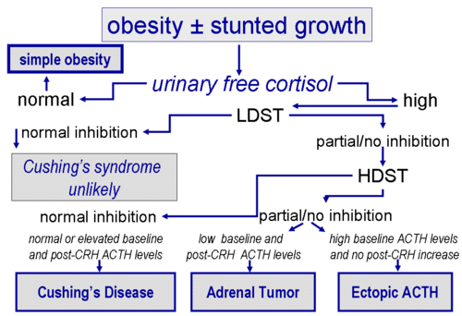
Figure 10. The diagnosis of Cushing’s syndrome. LDST, low dose suppression test; HDST, high dose suppression test; CRH, corticotropin releasing hormone. Data drawn from ref. 26

Treatment strategy

Transsphenoidal adenomectomy is the treatment of choice for ACTH-secreting adenomas in childhood and adolescence. Surgical excision is successful in the majority of children, with initial remission rates of 70-98% and long-term cure of 50-98% in most studies (30,31,37,66,67,69- 71,88-90). The success rate decreases when the patients are followed-up for more than 5 years (69-71), and the outcome cannot be predicted either by preoperative or immediate postoperative tests (71). The morbidity is low when the procedure is carried out by an experienced neurosurgeon. Surgical cure was found in 59% of 27 patients over a 21-year period, with a higher age favouring cure, as did an identifiable tumour seen at surgery and positive histology (91). Cure was also more likely to be achieved if the surgery is performed by an experienced neurosurgeon, by analogy with other studies performed in acromegaly (92). Transsphenoidal microsurgery is considered successful when it is followed by remission of signs and symptoms of hypercortisolism and by normalisation of laboratory values. Surgery is usually followed by adrenal insufficiency and patients require hydrocortisone replacement for 6-12 months. After normalisation of cortisol levels, resumption of normal growth or even catch-up growth can be observed. Generally, final height is compromised compared to target height (71,93). Johnston et al. (94) have, however, reported that some children do achieve a normal final stature. However, even if catch-up and favorable long- term growth can be achieved after treatment for Cushing's disease, post-treatment GH deficiency is frequent (95). Lebrethon et al. (95) demonstrated that early hGH replacement may contribute to a favorable outcome on final stature (Fig.11). A re-analysis of this series confirmed that paediatric Cushing’s disease patients achieve a normal final stature provided that replacement therapy including GH is correctly performed (96). Normal body composition is more difficult to achieve. Many patients remain obese and BMI SDS was elevated at mean interval of 3.9 years after cure in 14 patients (96).

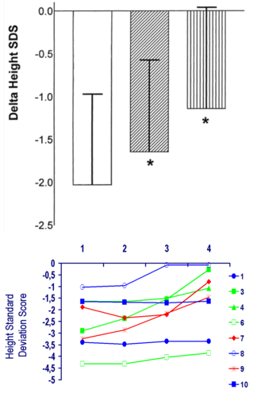

Figure 11. GH treatment in children with Cushing’s disease improves the height gain. Superscript graph: Evaluation of growth [change (D) in height SD score] in eight patients during hGH treatment. Bottom graph: Individual changes of height standard deviation score before and after GH replacement. 1= At diagnosis; 2= Before GH treatment; 3= After 1 year of GH treatment; 4= Final height. Data drawn from ref. 95

The treatment modality in patients who have relapses after transsphenoidal adenomectomy is still controversial. Some authors recommend repeat surgery (69,97), while others favour radiotherapy (98,99). Radiotherapy with or without concomitant mitotane treatment may be indicated in patients with macroadenoma (99). Rarely, surgery may induce panhypopituitarism, or permanent diabetes insipidus (37), while hypothalamo-pituitary dysfunction is an early and frequent complication of radiation (71). Bilateral adrenalectomy may be the last therapeutic option in case of failure of both surgery and radiotherapy. Pharmacotherapy is less successful and only a very few cases have been reported so far. In a 6.2-year-old male patient with severe hypercortisolaemia and life- threatening complications of Cushing's disease not responsive to metyrapone or ketoconazole, low-dose intravenous infusion of etomidate, with dose titration according to serum cortisol levels, induced normalisation of cortisol levels in (from 1,250 to 250 nmol/l) within 24 h (100). Greening et al. (100) thus suggested that combined etomidate and hydrocortisone therapy could be a potential safe approach in patients with very severe Cushing’s disease to be treated before bilateral adrenalectomy. Of note in paediatric Cushing’s disease patients, in contrast to adult patients, do not completely recover from cognitive function abnormalities despite rapid reversibility of cerebral atrophy (101). Experience with cabergoline in childhood and adolescence is also limited (102).

GH-SECRETING ADENOMAS

GH excess derives from a GH-secreting adenoma in over 98% of cases. In adulthood, these adenomas are relatively rare with a prevalence of 50-80 cases/million, and an incidence of 3-4 new cases/million per year (103-105), while gigantism is extremely rare with approximately 100 reported cases to date (106). In childhood, GH-secreting adenomas account for 5-15% of all pituitary adenomas (106,28). In less than 2% of the cases excessive GH secretion may depend on a hypothalamic or ectopic GH releasing hormone (GHRH)-producing tumor (gangliocytoma, bronchial or pancreatic carcinoid), which causes somatotroph hyperplasia or a well-defined adenoma (103-105). Recently, non-syndromic pituitary gigantism has been described due by aryl hydrocarbon receptor-interacting protein (AIP) gene mutation and Xq26.3 microduplication causing X-linked acrogigantism (XLAG) (107-110). AIP mutations occur in 29–50 % of gigantism cases. Typically, the disease manifests in the second decade of life, sporadically or in the setting of familial isolated pituitary adenoma (FIPA). The majority of the cases are GH- or mixed GH/prolactin-secreting pituitary adenomas (107,108). XLAG represents 8-10% of the cases of pre-pubertal gigantism. The disease often occurs during the first year of life, mostly in females and as sporadic disease. Generally, these patients present with pituitary hyperplasia or mixed somatotroph/lactotroph adenomas (109,110).

Clinical presentation and diagnosis

In adults, chronic GH and IGF-1 excess causes acromegaly, which is characterised by local bone overgrowth, while in children and adolescents it leads to gigantism. The associated secondary hypogonadism delays epiphysial closure, thus allowing continued long bone growth (Fig.12). However, the two disorders may be considered along a spectrum of GH excess, with principal manifestations determined by the developmental stage during which such excess originates (Table 1). Supporting this model has been the observation of clinical overlap between the two entities, with approximately 10% of acromegalics exhibiting tall stature (111), and the majority of giants eventually demonstrating features of acromegaly (112). In contrast to adults where there is an increased prevalence of cardiovascular, respiratory, neoplastic and metabolic complication (105,113,114), there is no report of similar complications in childhood. In our study, we did not find any patient with hypertension, arrhythmias, diabetes or glucose intolerance; as expected, however, some degree of insulin resistance and enhanced ß-cell function was observed in our patient at diagnosis (115). In a study conducted in six patients with gigantism, Bondanelli et al. (116) showed that 33% of giant patients had left ventricular hypertrophy and inadequate diastolic filling, 16.7% had isolated intraventricular septum thickening and impaired glucose metabolism. In acromegaly clinical features develop insidiously and progressively over many years and the average delay between the onset of symptoms and diagnosis is approximately 6 years (117), while the presentation of gigantism is usually dramatic and the diagnosis is straightforward. All growth parameters are affected although not necessarily symmetrically. Mild-to-moderate obesity occurs frequently (106), and macrocephaly has been reported to precede linear and weight acceleration in at least one patient (118). All patients also had coarse facial features, disproportionately large hands and feet with thick fingers and toes, frontal bossing and a prominent jaw (106). In girls menstrual irregularity can be present (119) while glucose intolerance and diabetes mellitus are rare. Tall stature and/or acceleration of growth velocity was observed in 10 of 13 patients. Some cases of ketoacidosis have been reported (120, 121).
The diagnosis of acromegaly and gigantism is usually clinical, and can be readily confirmed by measuring GH levels, which in more than 90% of patients are above 10 μg/l (103-105). The oral glucose tolerance test (OGTT) is the simplest and most specific dynamic test for both the diagnosis and the evaluation of the optimal control of GH excess (103-105). In healthy subjects, the OGTT (75-100 grams) suppresses GH levels below 1 μg/l after 2 hours, while in patients with GH- secreting adenoma such suppression is lacking, and a paradoxical GH increase is frequently observed. GH excess should be confirmed by elevated circulating IGF-I concentrations for age and gender (122,123). The assay of IGF-I binding protein-3 is conversely not useful for diagnosis nor for the follow-up of the patients (124,125). The presence of different GH isoforms in patients with gigantism/acromegaly may represent a diagnostic problem (126). A greater sensitivity of the GH assay may facilitate the distinction between patients and normal subjects, as shown by the use of a chemiluminescent GH assay (127). It might help in demonstrating the persistence of GH hypersecretion after surgery or during medical therapy. In cases of clinical and laboratory findings suggestive of a GH-producing adenoma, pituitary MRI must be performed to localise and characterise the tumour (103-105).
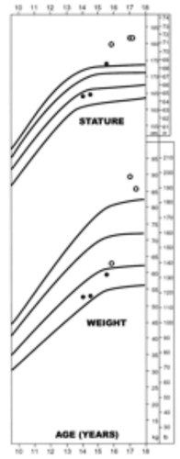

Figure 12a. The patient’s growth and weight chart with normal growth and weight curves (solid lines, 5th, 50th, 75th, and 95th percentile). (¡) Measurements subsequent to therapeutic intervention. Reproduced from Maheshwari HG, Prezant TR, Herman-Bonert V, Shahinian H, Kovacs K, Melmed S. Long-acting peptidomimergic control of gigantism caused by pituitary acidophilic stem cell adenoma J. Clin. Endocrinol. Metab. 2000 85: 3409-3416, with permission.

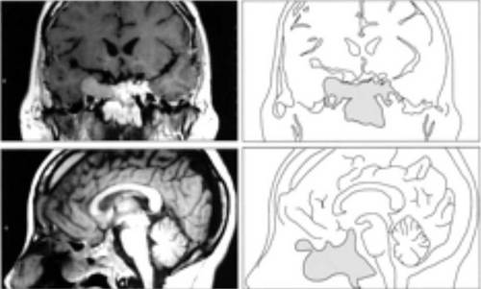

Figure 12b. The extent of tumor invasion as visualized with coronal and lateral MRI views and their outlinesReproduced from Maheshwari HG, Prezant TR, Herman-Bonert V, Shahinian H, Kovacs K, Melmed S. Long-acting peptidomimergic control of gigantism caused by pituitary acidophilic stem cell adenoma J. Clin. Endocrinol. Metab. 2000 85: 3409-3416, with permission.

Treatment strategy

The objectives of treatment of GH excess are tumour removal with resolution of its eventual mass effects, restoration of normal basal and stimulated GH secretion, relief of symptoms directly caused by GH and IGF-1 excess and prevention of progressive disfigurement, bone expansion, osteoarthritis and cardiomyopathy which are disabling long-term consequences, as well as prevention of hypertension, insulin resistance, diabetes mellitus and lipid abnormalities that are risk factors for vascular damage (103-105). The currently available treatment options for acromegaly include surgery, radiotherapy, and pharmacotherapeutic suppression of GH levels. Trans-sphenoidal adenomectomy is a cornerstone in the treatment of GH-secreting tumours. In patients with intrasellar microadenomas, surgical removal provides biochemical control with normalisation of IGF-I in 75–95% of patients (128,129). In case of macroadenomas, particularly when they exhibit extrasellar growth, persistent postoperative hypersecretion of GH occurs frequently. In most surgical series, only about 60% of acromegalic patients achieve circulating GH levels below 5 μg/l (130-134), but the success score improves when the surgeon is specialised in pituitary surgery (130,131). In paediatric patients with gigantism, transsphenoidal surgery was found to be as safe as in adults (135).
Treatment with somatostatin analogs is very effective in patients with GH excess (111,136,137), although limited data are available in adolescent patients. Octreotide given subcutaneously in two patients was shown to inhibit GH levels and reduce growth velocity (138,139). Of interest, in adolescents, as in adults, we observed tumour shrinkage by 30% on average after first-line treatment with somatostatin analogues. Whether this treatment has facilitated the subsequent surgical approach in this series could not be ruled out because of the limited number of cases studied. Treatment was tolerated very well by all patients (115).
Radiation therapy is rarely applied to paediatric patients, as radiation-induced damage of the surrounding normal pituitary tissue results in hypogonadism, hypoadrenalism or hypothyroidism in most patients within 10 years (140). Complications such as optic nerve damage, cranial nerve palsy, impaired memory, lethargy and local tissue necrosis have been reduced thanks to improved precise isocentric simulators and accurate dosing techniques. However, at least in adult patients conventional radiotherapy (conformal fractionated radiotherapy) can lower GH levels and normalise IGF-I in over 60% of patients, but a maximum response is achieved 10–15 yr after radiotherapy is administered (140,141). Additional pharmacological therapy consists of dopaminergic compounds such as bromocriptine, quinagolide or cabergoline (137,142). As most patients had concomitant hyperprolactinaemia, combined treatment with dopaminergic compounds such as bromocriptine or cabergoline, and somatostatin analogues, may be necessary. Long-term treatment with s.c. octreotide plus bromocriptine was tested in one child and was proven to be safe (143). In another case of a 15 yr-old girl with a mixed GH/PRL-secreting adenoma (144), octreotide-LAR (at the dose of 20 mg/28 days) combined with cabergoline (at the dose of 0.5 mg twice/week) normalised serum GH and IGF-I levels, and decreased growth rate from 12 cm/yr to nearly 2.5 cm/yr (Fig.14). In seven of the eight hyperprolactinaemic patients included in our study, combined treatment with octreotide plus bromocriptine or octrotide-LAR or lanreotide plus cabergoline was effective and well tolerated by all patients. Only two patients (15.4%) of the entire series still presented with active acromegaly after treatment with surgery and pharmacotherapy with somatostatin analogues plus dopamine-agonists (115). The GH receptor antagonist pegvisomant is a very potent drug which has been introduced in the clinical practice. In patients with resistant acromegaly, the use of the GH-receptor antagonist pegvisomant was followed by normalisation of IGF-I levels in more than 80% of patients (145-147). However, there are few data related to pediatric patients. In a 12-year-old girl with tall stature (178 cm), bearing a GH/PRL-secreting macroadenoma inoperable since tumour tissue was fibrous and adherent to the optical nerves, the GH receptor antagonist at a dose of 20 mg/day completely normalised IGF-I levels (148). In a 3.4-year-old girl with a GH/prolactin-secreting adenoma treatment with pegvisomant and cabergoline, was effective to normalise IGF-I levels and height velocity without side effects (149)

TSH-SECRETING ADENOMAS
This tumour type is rare in adulthood and even rarer in childhood and adolescence with only a few cases reported so far. It is frequently a macroadenoma presenting with mass effect symptoms such as headache, visual disturbance, together with variable symptoms and signs of hyperthyroidism (Table 1). TSH-secreting adenomas must be differentiated from the syndrome of thyroid hormone resistance (150). In most cases, the classical criteria of lack of TSH response to TRH stimulation, elevation of serum α-subunit levels, and a high α-subunit/TSH ratio along with a pituitary mass on MRI, are diagnostic of a TSH-secreting adenoma (150).

Treatment strategy

Transsphenoidal surgery is the first treatment approach to these tumours. However, since the majority of these adenomas are macroadenomas, which tend to be locally invasive, surgery alone fails to normalise TSH and thyroid hormone levels in most cases. In adults, radiotherapy is recommended as routine adjunctive therapy when surgery has not been curative (150). However, due to the high frequency of post-radiotherapy hypopituitarism, in children pharmacotherapy is the preferred second choice. There is very little success with dopamine agonists for treatment of these tumors (142). In contrast, therapy with somatostatin analogues normalises TSH levels in the majority of patients, and tumour shrinkage occurs in approximately half of cases (151-154). Chronic treatment with SR-lanreotide reduced plasma TSH and normalized fT4 and fT3 levels, suggesting its use in the long-term medical treatment of these adenomas (150,154).

CLINICALLY NONFUNCTIONING ADENOMAS

Clinically nonfunctioning adenomas in childhood are extremely rare, compared with adults (155). In addiction, FSH- and LH-secreting adenomas with a clinical picture of hormone hypersecretion also are rare tumor and the majority of these are clinically asymptomatic (156,157). Nonetheless, there is in vitro and in vivo evidence that almost all of these tumors synthesise glycoprotein hormones or their subunits (156,157). In adults, clinically nonfunctioning adenomas represent 33-50% of all pituitary tumours, while in paediatric patients they account for less than 4-6% of cases (30,32,35). In a study, 5 out of 2288 patients treated at Hamburg University between 1970-1996 were diagnosed to bear a clinically nonfunctioning adenoma (155). The clinical presentation included visual field defects, headache and some degree of pituitary insufficiency since invariably all patients had a macroadenoma (Table 1). In the paediatric population, these adenomas need to be differentiated from other sellar/para- sellar masses such as cysts, craniopharyngioma and dysgerminoma. Therefore, the MRI of the sella and parasellar structure is the basic step in the diagnosis. Other pituitary hormone deficiencies are commonly associated with this adenoma histotype, whereas diabetes insipidus occurs less frequently, if at all. A modest hyperprolactinaemia can also be present due to pituitary stalk compression (155). All these conditions should be diagnosed and treated appropriately.

Treatment strategy

The first approach to these adenomas is trans-sphenoidal surgery to remove tumour mass and decompress parasellar structures. As in the other adenoma histotypes, surgery has a low morbidity and leads to an improvement of visual symptoms in the majority of cases. Endoscopic endonasal unilateral transsphenoidal approach to the pituitary (158-161), which has the same indications as the conventional transsphenoidal microsurgery, overcomes many of the potential problems tied to the surgical route, thanks to its minimal invasiveness. This procedure involves no sublabial dissection nor any fracture of the facial bones with dental or naso-sinusal complications. Furthermore, a wider surgical vision of the operating field is obtained, which potentially improves the likelihood of a better and safer tumor removal. In addition, this procedure requires a shorter hospitalization, permits a rapid recovery of the child (162), and maintains neuroendocrine-pituitary integrity, with ensuing normal growth. This approach can also be safely used for the surgical removal of remnant pituitary tumours (160). After surgery these patients partially recover from hypopituitarism. Postoperative radiotherapy is applied in patients with subtotal tumor removal to prevent tumor re-growth and reduce residual tumors, but is burdened by a high prevalence of pan- hypopituitarism (163-165). Medical therapy has poor effects on clinically nonfunctioning adenomas (157,166). Positive effects of cabergoline were observed in some patients with α-subunit secreting adenomas, mostly in patients with tumours expressing high number of dopamine D2 receptors (167). A positive response to cabergoline associated with detection of dopamine receptors in vitro has been proven in clinically nonfunctioning adenomas (168). In vitro, chimeric dopamine/sstr agonists are effective in inhibiting cell proliferation in two-thirds of nonfunctioning adenomas (169). Somatostatin analogues and dopamine agonists have not been tested in children/adolescents with clinically nonfunctioning adenomas.

REFERENCES

1. Dattani MT, Robinson IC. The molecular basis for developmental disorders of the pituitary gland in man. Clin Genet. 2000;57:337-46
2. Jagannathan J, Kanter AS, Sheehan JP, Jane JA Jr, Laws ER Jr. Benign brain tumors: sellar/parasellar tumors. Neurol Clin. 2007 Nov;25(4):1231-49.
3. Müller HL. Craniopharyngioma. Endocr Rev. 2014 Jun;35(3):513-43.
4. Karavitaki N, Cudlip S, Adams CB and Wass JA. Craniopharyngiomas. Endocr.Rev 2006;27: 371–97.
5. Müller HL. Childhood craniopharyngioma. Pituitary 2013 Mar;16(1):56-67.
6. Larkin SJ, Ansorge O. Pathology and pathogenesis of craniopharyngiomas. Pituitary 2013 Mar;16(1):9-17.
7. Carmel PW, Antunes JL, Chang CH. Craniopharyngioma in children. Neurosurgery 1982;11:382-9.
8. Bunin GR, Surawicz TS, Witman PA, Preston-Martin S, Davis F, Bruner JM. The descriptive epidemiology of craniopharyngioma. J Neurosurg. 1998;89:547–51.
9. Matson DD, Crigler JF Jr. Management of craniopharyngioma in childhood. J Neurosurg. 1969;30:377–390.
10. Schoenberg BS, Schoenberg DG, Christine BW, Gomez MR. The epidemiology of primary intracranial neoplasms of childhood. A population study. Mayo Clin Proc. 1976;51:51–56.
11. Kuratsu J, Ushio Y. Epidemiological study of primary intracranial tumors in childhood. A population-based survey in Kumamoto Prefecture, Japan. Pediatr Neurosurg. 1996;25:240–47.
12. Bunin GR, Surawicz TS, Witman PA, Preston-Martin S, Davis F, Bruner JM. The descriptive epidemiology of craniopharyngioma. J Neurosurg. 1998;89:547–551.
13. Ghirardello S, Hopper N, Albanese A, Maghnie M. Diabetes insipidus in craniopharyngioma: postoperative management of water and electrolyte disorders. J Pediatr Endocrinol Metab. 2006 Apr;19 Suppl 1:413-21.
14. Müller HL. Childhood craniopharyngioma–current concepts in diagnosis, therapy and follow-up. Nat Rev Endocrinol. 2010;6:609–618.
15. Warmuth-Metz M, Gnekow AK, Müller H, Solymosi L. Differential diagnosis of suprasellar tumors in children. Klin Padiatr. 2004 Nov-Dec;216(6):323-30.

16. Pusey E, Kortman KE, Flannigan BD, Tsuruda J, Bradley WG. MR of craniopharyngiomas: tumor delineation and characterization. AJNR 1987;8:439-44.

17. Tsuda M, Takahashi S, Higano S, Kurihara N, Ikeda H, Sakamoto K. CT and MR imaging of craniopharyngioma. Eur Radiol 1997;7:464-69.

18. Braun IF, Pinto RS, Epstein F. Dense cystic craniopharyngiomas. AJNR 1982;3:139-41.

19. Flitsch J, Aberle J, Burkhardt T. Surgery for pediatric craniopharyngiomas – is less more? J Pediatr Endocrinol Metab 2015

20. Elliott RE, Jane JA Jr, Wisoff JH. Surgical management of craniopharyngiomas in children: meta-analysis and comparison of transcranial and transsphenoidal approaches. Neurosurgery. 2011 Sep;69(3):630-43; discussion 643. doi: 10.1227/NEU.0b013e31821a872d.21.

21. Luu QT, Loredo LN, Archambeau JO, Yonemoto LT, Slater JM, Slater JD. Fractionated proton radiation treatment for pediatric craniopharyngioma: preliminary report. Cancer J. 2006;12:155-9.

22. Aylwin SJ, Bodi I, Beaney R. Pronounced response of papillary craniopharyngioma to treatment with vemurafenib a BRAF inhibitor. Pituitary. 2016; 19(5): 544–546.

23. Rostami E, Witt Nyström P, Libard S, Wikström J, Casar-Borota O, Gudjonsson O. Recurrent papillary craniopharyngioma with BRAFV600E mutation treated with neoadjuvant-targeted therapy. Acta Neurochir (Wien). 2017 Nov;159(11):2217-2221.

24. Steele CA, MacFarlane IA, Blair J et al. Pituitary adenomas in childhood, adolescence and young adulthood: presentation, management, endocrine and metabolic outcomes. Eur J Endocrinol. 2010 Oct;163(4):515-22.

25. Webb C, Prayson RA. Pediatric pituitary adenomas. Arch Pathol Lab Med. 2008 Jan;132(1):77-80.

26. Odom GL, Davis CH, Woodhall B. Brain tumors in children: Clinical analysis in 164 cases. Pediatrics 1956;18:856-69.
27. Mindermann T, Wilson CB. Pediatric pituitary adenomas. Neurosurgery 1995;36:259-69.
28. Colao A, Loche S, Cappabianca P, de Divitiis E, Lombardi G. Pituitary adenomas in children and adolescents. Clinical presentation, diagnosis and therapeutical strategies. The Endocrinologist 2000;10:314-320.
29. Boop FA, Teo C, Pihoker K. Pediatric pituitary tumors. In: Krisht AF, Tindall GT (eds) Comprehensive management of pituitary disorders. Lippincott Williams & Wilkins, Hagerstown, 1999;315-26.
30. Partington MD, Dudley HD, Laws ER, Scheithauer BW. Pituitary adenomas in childhood and adolescence. Results of transsphenoidal surgery. J Neurosurg 1994;80:209-216.
31. Ludecke DK, Herrmann HD, Schulte FJ. Special problems with neurosurgical treatment of hormone-secreting pituitary adenomas in children. Prog Exp Tumor Res 1987;30:362-70.
32. Gold EB. Epidemiology of pituitary adenomas. Epidemiol Rev 1981;3:163-83.
33. Haddad SF, VanGilder JC, Menezes AH. Pediatric pituitary tumors. Neurosurgery 1991; 29:509-14.
34. Kane LA, Leinung MC, Scheithauer BW et al. Pituitary adenomas in childhood and adolescence. J Clin Endocrinol Metab 1994;79:1135-40.
35. Colao A, Loche S. Prolactinomas in children and adolescents. Endocr Dev. 2010;17:146-59.
36. Avramides A, Karapiperis A, Triantafyllidou E, Vayas S, Moshidou A, Vyzantiadis A. TSH- secreting pituitary macroadenoma in an 11-year-old girl. Acta Paediatr 1992;81:1058-60.
37. Dyer EH, Civit E, Visot A, Delalande O, Derome P. Transsphenoidal surgery for pituitary adenomas in children. Neurosurgery 1994; 34:207-12.
38. Maira G, Anile C. Pituitary adenomas in childhood and adolescence. Can J Neurol Sci 1990;17:83-7.
39. Richmond IL, Wilson CB. Pituitary adenomas in childhood and adolescence. J Neurosurg 1978;49:163-68.
40. Keil MF, Stratakis CA. Advances in the diagnosis, treatment, and molecular genetics of pituitary adenomas in childhood. US Endocinol.2009;4(2):81-85.
41. Catli G, Abaci A, Bober E, Buyukgebiz A. Clinical and diagnostic characteristics of hyperprolactinemia in childhood and adolescence. J Pediatr Endocrinol Metab JPEM 2013,26:1–11.
42. Colao A, Loche S, Cappa M et al. Prolactinomas in children and adolescents.. Prolactinomas in children and adolescents. Clinical presentation and long term follow-up. J Clin Endocrinol Metab 1998;83:2777-80.
43. Cannavò S, Venturino M, Curto L et al. Clinical presentation and outcome of pituitary adenomas in teenagers. Clin Endocrinol (Oxf). 2003;58(4):519-27.
44. Creemers LB, Zelissen PMJ, van’t Verlaat JW, Koppeschaar HPF. Prolactinoma and body weight: a retrospective study. Acta Endocrinol Scand 1991;125:392–96.
45. Delgrange E, Donkier J, Maiter D. Hyperprolactinemia as a reversible cause of weight gain in male patients?. Clin Endocrinol (Oxf) 1999;50:271–72.
46. Greenman Y, Torjman K, Stern N. Increased body weight associated with prolactin secreting pituitary adenomas: weight loss with normalization of prolactin levels. Clin Endocrinol (Oxf) 1998;48:547–53.
47. Gillam MP, Molitch ME, Lombardi G, Colao A. Advances in the treatment of prolactinomas. Endocr Rev. 2006 Aug;27(5):485-34.
48. Artese R, D'Osvaldo DH, Molocznik I et al. Pituitary tumors in adolescent patients. Neurol Res 1998;20:415-17.
49. Liu Y, Yao Y, Xing B et al. Prolactinomas in children under 14. Clinical presentation and long-term follow-up. Childs Nerv Syst. 2015;31(6):909-16.
50. Shibli-Rahhal A, Schlechte J. The effects of hyperprolactinemia on bone and fat. Pituitary. 2009;12(2):96-104.
51. Di Somma C, Colao A, Di Sarno A et al. Bone marker and bone density responses to dopamine agonist therapy in hyperprolactinemic males. J Clin Endocrinol Metab 1998;83:807-13.
52. Colao A, Di Somma C, Loche S et al. Prolactinomas in children and adolescents: persistent bone loss after 2 years of prolactin normalization. Clin Endocrinol 2000;52:319-28.
53. Di Sarno A, Rota F, Auriemma RS, De Martino MC, Lombardi G, Colao A. An evaluation of patients with hyperprolactinemia: have dynamic tests had their day?. J Endocrinol Invest 2003;26(7suppl):39–47.
54. Cavaco B, Leite V, Santos MA, Arranhado E, Sobrinho LG. Some forms of big big prolactin behave as a complex of monomeric with an immunoglobulin G in patients with macroprolactinoma or prolactinomas. J Clin Endocrinol Metab 1995;80:3507–12.
55. Colao A, Di Somma C, Pivonello R, Faggiano A, Lombardi G, Savastano S. Medical therapy for clinically non-functioning pituitary adenomas. Endocr Relat Cancer 2008;15:905–15.
56. Tyson D, Reggiardo D, Sklar C, David R. Prolactin-secreting macroadenomas in adolescents. Response to bromocriptine therapy. Am J Dis Child 1993;147:1057-61.
57. Blackwell RE, Younger BJ. Long-term medical therapy and follow up of pediatric adolescent patients with prolactin-secreting macroadenomas. Fertil Steril 1986;45:713-16.
58. Howlett TA, Wass JA, Grossman A et al. Prolactinomas presenting as primary amenorrhoea and delayed or arrested puberty: response to medical therapy. Clin Endocrinol. 1989; 30:131-40.
59. Dalzell GW, Atkinson AB, Carson PJ, Sheridan B. Normal growth and pubertal development during bromocriptine treatment for a prolactin-secreting pituitary macroadenoma. Clin Endocrinol 1987;26:169-72.
60. Knoepfelmacher M, Gomes MC, Melo ME, Mendonca BB. Pituitary apoplexy during therapy with cabergoline in an adolescent male with prolactin-secreting macroadenoma. Pituitary 2004;7(2):83-7.
61. Colao A, Di Sarno A, Cappabianca P, Di Somma C, Pivonello R, Lombardi G. Withdrawal of long-term cabergoline therapy for tumoral and nontumoral hyperprolactinemia. N Engl J Med 2003;349:2023-33.
62. Howell DL, Wasilewski K, Mazewski CM, Hudgins RJ, Meacham LR. The use of high-dose daily cabergoline in an adolescent patient with macroprolactinoma. J Pediatr Hematol Oncol 2005;27:326–29.
63. Colao A, Galderisi M, Di Sarno A et al. Increased prevalence of tricuspid regurgitation in patients with prolactinomas chronically treated with cabergoline. J Clin Endocrinol Metab 2008;93:3777–84.
64. Horvath J, Fross RD, Kleiner-Fisman G et al. Severe multivalvular heart disease: a new complication of the ergot derivative dopamine agonists. Mov Disord 2004;19:656–62.
65. Pinero A, Marcos-Alberca P, Fortes J. Cabergoline-related severe restrictive mitral regurgitation. N Engl J Med 2005;353:1976–77.
66. Storr HL, Chan LF, Grossman AB, Savage MO. Paediatric Cushing's Disease: Epidemiology, Investigation and Therapeutic Advances. Trends Endocrinol Metab. 2007;18:267–74.
67. Savage MO, Chan LF, Grossman AB, Storr HL. Work-up and management of paediatric Cushing's syndrome. Curr Opin Endocrinol Diabetes Obes. 2008 Aug;15(4):346-51.
68.Baron J, Klein KO, Colli MJ et al. Catch-up growth after glucocorticoid excess: a mechanism intrinsic to the growth plate. Endocrinology 1994; 135:1367-71.
69. Magiakou MA, Mastorakos G, Oldfield EH et al. Cushing’s syndrome in children and adolescents. Presentation, diagnosis, and therapy. N Engl J Med 1994; 331:629-36.
70. Weber A, Trainer PJ, Grossman AB et al. Investigation, management and therapeutic outcome in 12 cases of childhood and adolescent Cushing’s syndrome. Clin Endocrinol 1995; 43:19-28.
71. Devoe DJ, Miller WL, Conte FA et al. Long-term outcome in children and adolescents after transsphenoidal surgery for Cushing’s disease. J Clin Endocrinol Metab 1997; 82:3196-02.
72. Leong GM, Mercado-Asis LB, Reynolds JC, Hill SC, Oldfield EH, Chrousos GP. The effect of Cushing’s disease on bone mineral density, body composition, growth, and puberty: a report of an identical adolescent twin pair. J Clin Endocrinol Metab 1996; 81:1905-11.
73. Dempster D, Arlot M, Meunier P. Mean wall thickness and formation period of trabecular bone packets in corticosteroid-induced osteoporosis. Calcif Tissue Int 1983; 35:410-17.
74. Di Somma C, Pivonello R, Loche et al. Severe impairment of bone mass and turnover in Cushing’s disease: comparison between childhood-onset and adulthood onset disease. Clin Endocrinol 2002;56:153-8.
75. Di Somma C, Pivonello R, Loche S et al. Effect of 2 years of cortisol normalization on the impaired bone mass and turnover in adolescent and adult patients with Cushing’s disease. Clin Endocrinol 2003; 58(3):302-8.
76. Lodish MB, Hsiao HP, Serbis A et al. Effects of Cushing disease on bone mineral density in a pediatric population. J Pediatr. 2010 Jun;156(6):1001-5.
77. Bressot C, Meunier P, Chapuy M, Lejeune E, Edouard C, Darby A. Histomorphometric profile, pathophysiology and reversibility of corticosteroid-induced osteoporosis. Metab Bone Dis Relat Res 1979;1:303-11.
78. Canalis E. Mechanisms of glucocorticoid action in bone: implications to glucocorticoid-induced osteoporosis. J Clin Endocrinol Metab 1996; 81: 3441-47.
79. Khanine V, Fournier JJ, Requeda E, Luton JP, Simon F, Crouzet J. Osteoporotic fractures at presentation of Cushing’s disease: two case reports and a literature review. Joint Bone Spine 2000;67:341-5.
80. Mancini T, Doga M, Mazziotti G, Giustina A. Cushing's syndrome and bone. Pituitary. 2004;7(4):249-52.
81. Newell-Price J, Trainer P, Besser M, Grossman A. The diagnosis and differential diagnosis of Cushing’s syndrome and pseudo-Cushing’s states. Endocr Rev 1998;19:647-72.
82. Buzi F, Corna A, Pilotta A et al. Loperamide test: a simple and highly specific screening test for hypercortisolism in children and adolescents. Acta Paediatr 1997; 66:1177-80.
83. Yaneva M, Monsier-Pudar H, Dugue M, Grabar S, Fulla Y, Bertagna X. Midnight salivary cortisol for the initial diagnosis of Cushing’s syndrome of various causes. J Clin Endocrinol Metab 2004;89(7):3345-51.
84. Kunvar S, Wilson CB. Pediatric pituitary adenomas. J Clin Endocrinol Metab 1999; 84:4385-89.
85. Colao A, Faggiano A, Pivonello R, Pecori Giraldi F, Cavagnini F, Lombardi G, and The Study Group of the Italian Endocrinology Society on the Pathophysiology of the Hypothalamic-Pituitary- Adrenal Axis. Inferior petrosal sinus sampling in the differential diagnosis of Cushing’s syndrome: Results of an Italian multicentre study. Eur J Endocrinol 2001; 144: 499-507.
86. Lienhardt A, Grossman AB, Dacie JE et al. Relative contributions of inferior petrosal sinus sampling and pituitary imaging in the investigation of children and adolescents with ACTH-dependent Cushing’s syndrome. J Clin Endocrinol Metab 2001; 86:5711-14.
87. Oldfield EH, Doppman JL, Nieman LK et al. Petrosal sinus sampling with and without corticotropin-releasing hormone for the differential diagnosis of Cushing's syndrome. N Engl J Med 1991;325:897-905.
88. Styne DM, Grumbach MM, Kaplan SA, Wilson CB, Conte FA. Treatment of Cushing’s disease in childhood and adolescence by transphenoidal microadenomectomy. N Engl J Med 1984;310:889-93.
89. Fahlbush R, Honegger J, Buchfelder M. Neurosurgical management of Cushing’s disease in children. In: Savage MO, Bourguignon JP, Grossman AB (Eds), Frontiers in Pediatric Neuroendocrinology 1994;68-72.
90. Leinung MC, Kane LA, Scheithauer BW, Carpenter PC, Laws ER Jr, Zimmerman D. Long term follow-up of transsphenoidal surgery or the treatment of Cushing’s disease in childhood. J Clin Endocrinol Metab 1995; 80:2475-79.
91. Storr HL, Afshar F, Matson M et al. Factors influencing cure by trans-sphenoidal selective adenomectomy in paediatric Cushing’s disease. Eur J Endocrinol 2005;152:825-33.
92. Clayton RN, Stewart PM, Shalet SM, Wass JA. Pituitary surgery for acromegaly. Should be done by specialists. BMJ 1999;319:588-89.
93. Magiakou MA, Mastorakos G, Chrousos GP. Final stature in patients with endogenous Cushing’s syndrome. J Clin Endocrinol Metab 1994; 79:1082-85.
94. Johnston LB, Grossman AB, Plowman PN, Besser GM, Savage MO. Normal final height and apparent cure after pituitary irradiation for Cushing’s disease in childhood: long-term follow-up of anterior pituitary function. Clin Endocrinol 1998; 48:663-67.
95. Lebrethon MC, Grossman AB, Afshar F, Plowman PN, Besser GM, Savage MO. Linear growth and final height after treatment for Cushing's disease in childhood. J Clin Endocrinol Metab 2000;85:3262-5.
96. Davies JH, Storr HL, Davies K et al. Final adult height and body mass index after cure of paediatric Cushing's disease. Clin Endocrinol (Oxf). 2005;62:466-72.
97. Friedman RB, Oldfield EH, Nieman LK et al. Repeat trans-sphenoidal surgery for Cushing’s disease. J Neurosurg 1989;71:520-27.
98. Estrada J, Boronat M, Mielgo M et al. The long term outcome of pituitary irradiation after unsuccessful transsphenoidal surgery in Cushing’s disease. N Engl J Med 1997;336:172-77.
99. Jennings AS, Liddle GW, Orth DN. Results of treating childhood Cushing’s disease with pituitary irradiation. N Engl J Med 1977; 297:957-62.
100. Greening JE, Brain CE, Perry LA et al. Efficient short-term control of hypercortisolaemia by low-dose etomidate in severe paediatric Cushing's disease. Horm Res. 2005;64:140-43.
101. Merke DP, Giedd JN, Keil MF et al. Children experience cognitive decline despite reversal of brain atrophy one year after resolution of Cushing syndrome. J Clin Endocrinol Metab. 2005;90:2531-36.
102. Lila AR, Gopal RA, Acharya SV et al. Efficacy of cabergoline in uncured (persistent or recurrent) Cushing disease after pituitary surgical treatment with or without radiotherapy. Endocr Pract. 2010;16:968–76.
103. Colao A, Lombardi G. GH and PRL excess. Lancet 1998;352:1455-61.
104. Melmed S. Medical progress: acromegaly. N Engl J Med 2006;355:2558–73.
105. Chanson P, Salenave S. Acromegaly. Orphanet J Rare Dis. 2008 Jun 25;3:17.
106. Eugster EA, Pescovitz OH. Gigantism. J Clin Endocrinol Metab 1999;84:4379-84.
107. Igreja S, Chahal HS, King P et al. Characterization of aryl hydrocarbon receptor interacting protein (AIP) mutations in familial isolated pituitary adenoma families. Hum.Mutat. 2010;31:950-60.
108. Hérnandez-Ramírez LC, Gabrovska P, Denes J et al. Landscape of familial isolated and young onset pituitary adenomas: prospective diagnosis in AIP mutation carriers. J Clin Endocrinol Metab. 2015;100:E1242–54.
109. Beckers A, Lodish MB, Trivellin G et al. X-linked acrogigantism syndrome: clinical profile and therapeutic responses. Endocrine Related Cancer 2015;22:353-67.
110. Iacovazzo D, Caswell R, Bunce B et al. Germline or somatic GPR101 duplication leads to X-linked acrogigantism: a clinico-pathological and genetic study. Acta Neuropathol.Commun. 2016;4:56.
111. Sotos JF. Overgrowth, section II. Clin Pediatr. 1996; 5:579–90.
112. Whitehead EM, Shalet SM, Davies D, Enoch BA, Price DA, Beardwell CG. Pituitary gigantism: a disabling condition. Clin Endocrinol. 1982;17:271–77.
113. Clayton PE, Banerjee I, Murray PG, Renehan AG. Growth hormone, the insulin-like growth factor axis, insulin and cancer risk. Nat Rev Endocrinol. 2011.
114. Colao A, Ferone D, Marzullo P, Lombardi G. Systemic complications of acromegaly: epidemiology, pathogenesis, and management. Endocr Rev 2004;25:102-52.
115. Colao A, Pivonello R, Di Somma C, Tauchmanovà L, Savastano S, Lombardi G. Growth hormone excess with onset in adolescence: clinical appearance and long-term treatment outcome Clin Endocrinol (Oxf). 2007 May;66(5):714-22.
116. Bondanelli M, Bonadonna S, Ambrosio MR et al. Cardiac and metabolic effects of chronic growth hormone and insulin-like growth factor I excess in young adults with pituitary gigantism. Metabolism. 2005;54:1174-80.
117. Lamberts SWJ, van der Lely AJ, de Herder WW. Clinical and medical diagnosis of acromegaly. Metabolism 1995;44(suppl.1):15-17.
118. Blumberg DL, Sklar CA, David R, Rothenberg S, Bell J. Acromegaly in an infant. Pediatrics 1989;83:998-1002.
119. Kaltsas GA, Mukherjee JJ, Jenkins PJ et al. Mestrual irregularity in women with acromegaly. J Clin Endocrinol Metab 1999; 84: 2731-35.
120. Alvi NS, Kirk JM. Pituitary gigantism causing diabetic ketoacidosis. J Pediatr Endocrinol Metab 1999;12:907-9.
121. Ali O, Banerjee S, Kelly DF, Lee PD. Management of type 2 diabetes mellitus associated with pituitary gigantism. Pituitary. 2007;10(4):359-64.
122. Katznelson L, Atkinson JL, Cook DM, Ezzat SZ, Hamrahian AH, Miller KK; American Association of Clinical Endocrinologists.American Association of Clinical Endocrinologists medical guidelines for clinical practice for the diagnosis and treatment of acromegaly--2011 update. Endocr Pract. 2011 Jul-Aug;17 Suppl 4:1-44.
123. Giustina A, Barkan A, Casanueva FF, et al. 2000 Criteria for cure of acromegaly: a consensus statement. J Clin Endocrinol Metab 85:526-29.
124. de Herder WW, van der Lely AJ, Janssen JA, Uitterlinden P, Hofland LJ, Lamberts SW. IGFBP-3 is a poor parameter for assessment of clinical activity in acromegaly. Clin Endocrinol 1995;43:501-15.
125. Marzullo P, Di Somma C, Pratt KL et al. Usefulness of different biochemical markers of the insulin-like growth factor (IGF) family in diagnosing growth hormone excess and deficiency in adults. J Clin Endocrinol Metab 2001;86:3001-8.
126. Ng LL, Chasalow FI, Escobar O, Blethen SL. Growth hormone isoforms in a girl with gigantism. J Pediatr Endocrinol Metab 1999;12:99-106.
127. Bidlingmaier M, Strasburger CJ. Growth hormone assays: current methodologies and their limitations. Pituitary. 2007;10(2):115-9.
128. Ludecke DK, Abe T. Transsphenoidal microsurgery for newly diagnosed acromegaly: a personal view after more than 1,000 operations. Neuroendocrinology. 2006;83(3-4):230-9.
129. Nomikos P, Buchfelder M, Fahlbusch R. The outcome of surgery in 668patients with acromegaly using current criteria of biochemical ‘cure’. Eur JEndocrinol 2005;152:379–87.
130. Lissett CA, Peacey SR, Laing I, Tetlow L, Davis JR, Shalet SM. The outcome of surgery for acromegaly: the need for a specialist pituitary surgeon for all types of growth hormone (GH) secreting adenoma. Clin Endocrinol 1998;49: 653-57.
131. Ahmed S, Eldsheikh, Stratton IM, Page RC, Adams, CB, Wass JA. Outcome of transsphenoidal surgery for acromegaly and its relationship to surgical experience. Clin Endocrinol 1999; 0:561-67.
132. Yamada S, Aiba T, Takada K et al. Retrospective analysis of long-term surgical results in acromegaly: preoperative and post-operative factors predicting outcome. Clin Endocrinol 1996;45:291-98.
133. Sheaves R, Jenkins P, Blackburn P et al. Outcome of transsphenoidal surgery for acromegaly using strict criteria for surgical cure. Clin Endocrinol 1996;45:407-13.
134. Shimon I, Cohen ZR, Ram Z, Hadani M. Transsphenoidal surgery foracromegaly: endocrinological follow-up of 98 patients. Neurosurgery 2001;48: 1239–43.
135. Locatelli D, Massimi L, Rigante M et al. Endoscopic endonasal transsphenoidal surgery for sellar tumors in children. Int J Pediatr Otorhinolaryngol. 2010;74(11):1298-302.
136. Ferone D, Colao A, van der Lely A-J, Lamberts SWJ. Pharmacotherapy or surgery as primary treatment for acromegaly? Drugs 2000;17:81-92.
137. Melmed S, Colao A, Barkan A et al. Guidelines for acromegaly management: an update. Acromegaly Consensus Group. J ClinEndocrinolMetab. 2009 May;94(5):1509-17.
138. Gelber SJ, Heffez DS, Donohoue PA. Pituitary gigantism caused by growth hormone excess from infancy. J Pediatr 1992;120:931-4.
139. Yoshida T, Shimatsu A, Sakane N, Hizuka N, Horikawa R, Tanaka T. Growth hormone (GH) secretory dynamics in a case of acromegalic gigantism associated with hyperprolactinemia: nonpulsatile secretion of GH may induce elevated insulin-like growth factor-I (IGF-I) and IGF- binding protein-3 levels. J Clin Endocrinol Metab 1996;81:310-3.
140. Minniti G, Jaffrain-Rea ML, Osti M et al. The long-term efficacy of conventional radiotherapy in patients with GH- secreting pituitary adenomas. ClinEndocrinol (Oxf) 2005;62:210–16.
141. Jenkins PJ, Bates P, Carson MN, Stewart PM, Wass JA. Conventionalpituitary irradiation is effective in lowering serum growth hormone and insulin-like growth factor-I in patients with acromegaly. J Clin Endocrinol Metab 2006, 91:1239–45.
142. Bevan JS, Webster J, Burke CW, Scanlon MF. Dopamine agonists and pituitary tumor shrinkage. Endocr Rev 1992;13:221-35.
143. Moran A, Pescovitz OH. Long-term treatment of gigantism with combination octreotide and bromocriptine in a child with McCune-Albright syndrome. Endocr J 1994;2:111-13.
144. Maheshwari HG, Prezant TR, Herman-Bonert V, Shahinian H, Kovacs K, Melmed S. Long- acting peptidomimergic control of gigantism caused by pituitary acidophilic stem cell adenoma. J Clin Endocrinol Metab 2000;85:3409-16.
145. Trainer PJ, Drake WM, Katznelson L, et al. Treatment of acromegaly with the growth hormone-receptor antagonist pegvisomant. N Engl J Med 2000;342:1171-77.
146. van der Lely AJ, Hutson RK, Trainer PJ, et al. Long term treatment of acromegaly with pegvisomant, a growth hormone antagonist. Lancet 2001;358:1754-59.
147. Colao A, Pivonello R, Auriemma RS et al. Efficacy of 12-months of treatment with the GH receptor antagonist pegvisomant in patients with acromegaly resistant to long-term, high dose somatostatin analog treatment: effect on IGF-I levels, tumour mass, hypertension and glucose tolerance. European Journal of Endocrinology 2006;154,467–77.
148. Rix M, Laurberg P, Hoejberg AS, Brock-Jacobsen B. Pegvisomant therapy in pituitary gigantism: successful treatment in a 12-year-old girl. Eur J Endocrinol. 2005;153:195-201.
149. Bergamaschi S, Ronchi CL, Giavoli C et al. Eight-year follow-up of a child with a GH/prolactin-secreting adenoma: efficacy of pegvisomant therapy. Horm Res Paediatr. 2010;73(1):74-9.
150. Beck-Peccoz P, Persani L, Mannavola D, Campi I. Pituitary tumours: TSH-secreting adenomas. Best Pract Res Clin Endocrinol Metab. 2009 Oct;23(5):597-606.
151. Fukuda T, Yokoyama N, Tamai M et al. Thyrotropin secreting pituitary adenoma effectively treated with octreotide. Intern Med 1998;37:1027-30.
152. Chanson P, Weintraub BD, Harris AG. Octreotide therapy for thyroid-stimulating hormone- secreting pituitary adenomas. A follow-up of 52 patients. Ann Intern Med 1993;119:236-40.
153. Gancel A, Vuillermet P, Legrand A, Catus F, Thomas F, Kuhn JM. Effects of a slow-release formulation of the new somatostatin analogue lanreotide in TSH-secreting pituitary adenomas. Clin Endocrinol 1994;40:421-28.
154. Kuhn JM, Arlot S, Lefebvre H et al. Evaluation of the treatment of thyrotropin-secreting pituitary adenomas with a slow release formulation of the somatostatin analog lanreotide. J Clin Endocrinol Metab 2000;85:1487-91.
155. Abe T, Lüdecke DK, Saeger W. Clinically nonsecreting pituitary adenomas in childhood and adolescence. Neurosurgery 1998;42:744-51
156. Katnelson L, Alexander JM, Klibanski A. Clinically nonfunctioning pituitary adenomas. J Clin Endocrinol Metab 1993;76:1089-94.
157. Jaffe CA. Clinically non-functioning pituitary adenoma. Pituitary. 2006;9(4):317-21.
158. Laws ER Jr. Transsphenoidal approach to lesions in and about the sella turcica. In Schmidek HH, Sweet WH (eds): Operative neurosurgical techniques: indications, methods and results. Grune & Stratton, Orlando, 1,1995;283-92.
159. Cappabianca P, Alfieri A, Colao A, Ferone D, Lombardi G, de Divitiis E. Endoscopic endonasal transsphenoidal approach: an additional reason in support of surgery in the management of pituitary lesions. Skull Base Surg 1999;9:109-17.
160. Cappabianca P, Alfieri A, Colao A et al. Endoscopic endonasal transsphenoidal surgery in recurrent and residual pituitary adenomas: technical note. Minim Invasive Neurosurg 2000;43:38-43.
161. Cappabianca P, Cavallo LM, de Divitiis E. Endoscopic endonasal transsphenoidal surgery. Neurosurgery. 2004 Oct;55(4):933-40;discussion 940-1.
162. Cappabianca P, de Divitiis E, Alfieri A, Cavallo LM. The role of the endoscopic transsphenoidal approach in pediatric neurosurgery. Child’s Nervous Syst 2000;16:692-6.
163. Littley MD, Shalet SM, Beardwell CG, Ahmed SR, Applegate G, Sutton MI. Hypopituitarism following external radiotherapy for pituitary tumors in adults. QJ Med New Series. 1989; 70:145.
164. Colao A, Cerbone G, Cappabianca P et al. Effect of surgery and radiotherapy in visual and endocrine function in nonfunctioning pituitary adenomas. J Endocrinol Invest 1998;21:284-90.
165. Turner HE, Stratton IM, Byrne JV, Adams CB, Wass JA. Audit of selected patients with nonfunctioning pituitary adenomas treated without irradiation - a follow-up study. Clin Endocrinol (Oxf) 1999;51:281-84.
166. Colao A, Di Sarno A, Marzullo P et al. New medical approaches in pituitary adenomas. Horm Res 2000; 53:76-87.
167. Colao A, Ferone D, Lastoria S et al. Hormone levels and tumor size response to quinagolide and cabergoline in patients with prolactin-secreting and clinically nonfunctioning pituitary adenomas: predictive value of pituitary scintigraphy with 123I-Methoxybenzamide. Clin Endocrinol 2000; 52:437-45.
168. Pivonello R, Matrone C, Filippella M et al. Dopamine receptor expression and function in clinically nonfunctioning pituitary tumors: comparison with the effectiveness of cabergoline treatment. J Clin Endocrinol Metab. 2004;89:1674-83.
169. Florio T, Barbieri F, Spaziante R et al. Efficacy of a dopamine-somatostatin chimeric molecule, BIM-23A760, in the control of cell growth from primary cultures of human non-functioning pituitary adenomas: a multi-center study. EndocrRelat Cancer. 2008 Jun;15(2):583-96.

