**PITUITARY DISEASES IN THE TROPICS**

**Sandeep Kumar, MD,** Dept of Endocrinology, Army Hospital (Research & Referral), New Delhi. [sandeep.sapehia@gmail.com](mailto:sandeep.sapehia@gmail.com)

**KVS Hari Kumar, MD, DNB,** Consultant Endocrinologist, MAGNA Clinics, Hyderabad, INDIA. [hariendo@gmail.com](mailto:hariendo@gmail.com)

**Received March 11, 2021**

**ABSTRACT**

The pituitary gland is the master controller of the hormonal axes in the body and modulates its hormonal output based on the information received from the hypothalamus and the peripheral target organs. The traditional feedback hormonal loop involving the central and peripheral organs is termed the hypothalamo-pituitary-target organ axis. Pituitary disorders may present either due to the structural or hormonal manifestations. Pituitary disorders often have a long gestation period before their clinical identification. The commonest pituitary disorders include functional and non-functional adenomas and hypopituitarism. In this chapter, we shall discuss the pituitary disorders encountered in the tropical countries along with their unique features and management.

**INTRODUCTION**

The pituitary gland is the fulcrum of the entire hormonal axes in the human body and is located in the sella turcica of the temporal bone. The pituitary gland is divided into anterior and posterior portions connected by an intermediary lobe. The anterior pituitary secretes growth hormone (GH), thyroid stimulating hormone (TSH), adrenocorticotrophic hormone (ACTH), luteinizing hormone (LH), follicle stimulating hormone (FSH), and prolactin. Vasopressin and oxytocin are the two hormones released from the posterior pituitary. The common pituitary disorders in endocrine practice include prolactinoma, acromegaly, Cushing’s disease, non-functional pituitary adenoma (NFPA), and hypopituitarism. Hypopituitarism denotes either complete or partial deficiency of pituitary hormones. The etiologies that lead to hypopituitarism are classified as congenital, neoplastic, and inflammatory diseases (1). Pituitary dysfunction in tropical countries is observed due to specific etiologies as shown in table 1. In the subsequent sections, we shall discuss the individual disorders.

|  |
| --- |
| **Table 1. Pituitary Diseases of the Tropics** |
| **Gynecological**- Sheehan’s syndrome, Pseudocyesis |
| **Environmental**- Snake envenomation, Heat stroke, Traumatic brain injury |
| **Infections**- Tuberculosis, Toxoplasmosis, Pneumocystis, Cytomegalovirus, Aspergillosis, Candida |
| **Miscellaneous**- Hemochromatosis, Steroid abuse |

**SHEEHAN’S SYNDROME**

Harold Sheehan described this syndrome in 1937 as post-partum pituitary necrosis (2). It is a common cause of pituitary insufficiency in tropical countries where obstetric care is not well advanced. In a study from India, the prevalence of Sheehan’s syndrome (SS) is reported to be 3% in women above 20 years of age and according to this study two third of SS patients had undergone home delivery (3). This might be a tip of the iceberg as the majority of cases go unrecognized because of the long lag period between the primary insult and clinical presentation and the significant number of unreported home deliveries (4). Post-partum hemorrhage (PPH) is the initiating event which triggers the cascade of pituitary necrosis as shown in the figure 1.

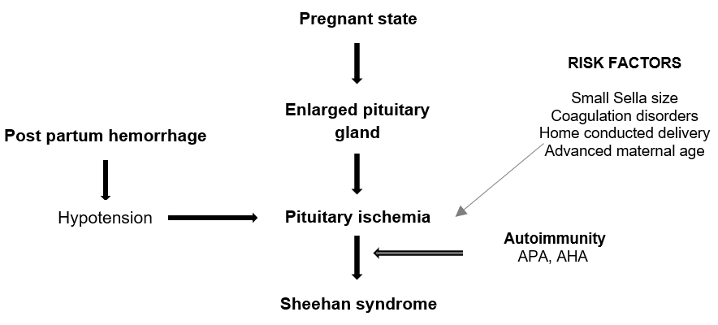

**Figure 1. Etiopathogenesis of Sheehan’s Syndrome**

**Pathogenesis**

The pituitary is a highly vascularized organ and is very vulnerable to ischemic insults secondary to a fall in mean arterial pressure. PPH is the primary insult which leads to hypotension and compromised blood flow to pituitary, leading to irreversible necrosis and deficiencies of various pituitary hormones. The pituitary gland increases in size during pregnancy and its location inside the sellar compartment makes it susceptible to ischemic insults. Other factors which aid in the progression of SS are disseminated intravascular coagulation, mutation in various coagulant factors like factor II and V, vasospasm, multiparity, advanced maternal age, and autoimmunity. Lactotrophs and somatotrophs are located laterally and are commonly affected in comparison to medially located corticotrophs and thyrotrophs (4). Anti-pituitary (APA) and anti-hypothalamus antibodies (AHA) are seen in patients with SS even many years after the primary insult. It is postulated that necrosed pituitary cells exposes various antigens to which these antibodies develop and subsequently leads to autoimmune damage (5). The various risk factors for the development of SS are summarized in the table 2.

|  |  |  |  |
| --- | --- | --- | --- |
| **Table 2. Predisposing Factors for Sheehan’s Syndrome** | | | |
| **Anatomical** | **Physiological** | **Obstetrical** | **Miscellaneous** |
| Small sella turcica  Pituitary enlargement | Coagulation disorders  Prothrombotic states  Vasospasm | Postpartum bleed  Home deliveries  Advanced age  Multiparity | Autoimmunity |

**Clinical Presentation**

Patients with SS can have an acute, subacute, or chronic presentation and symptoms in SS are related to the underlying pituitary hormone deficiencies. Usually a lag period between the primary insult to first presentation is in the range of 7-19 years. However, SS may present as an acute catastrophic event immediately after delivery which can be associated with a high mortality. Acute SS may present as emergency in the form of myxedema coma, severe hyponatremia, adrenal crisis, and hypoglycemia coma. Failure of lactation, inability to resume menstrual cycles, and loss of secondary sexual characteristics in the background of PPH should raise suspicion of SS. Figure 2 summarizes various clinical features of SS. It is also important to understand that about 10% of patients with SS may remain asymptomatic and about 50% of patients may have nonspecific signs and symptoms eluding clinical diagnosis. Diabetes Insipidus is a rare phenomenon in SS. In chronic SS, clinical examination reveals the loss of axillary and pubic hair, breast atrophy, wrinkling around the eyes and mouth, and features of hypothyroidism (4).

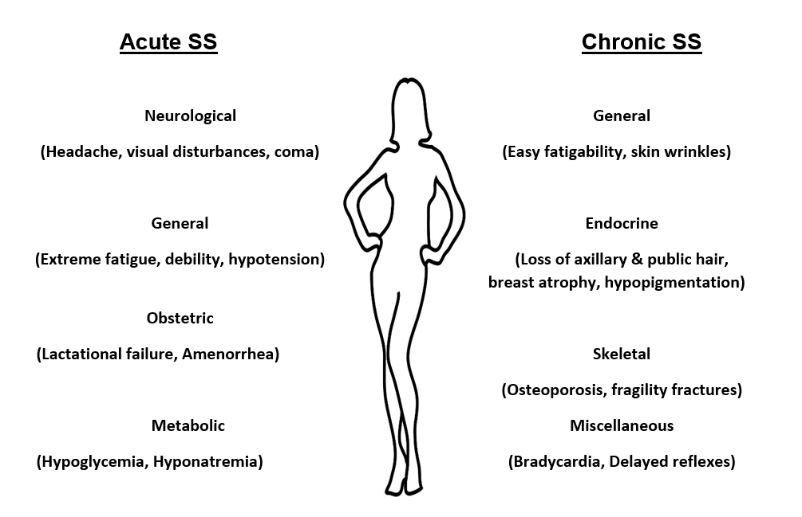

**Figure 2. Clinical Features of Sheehan’s Syndrome (SS)**

In appropriate clinical settings, SS syndrome is diagnosed by detecting variable degrees of pituitary hormone deficiencies. Dynamic stimulation testing might be required for diagnosing SS. Hyponatremia is commonly seen in SS and its occurrence is explained by multiple factors like hypothyroidism, hypocortisolemia, and increased anti-diuretic hormone secretion as a result of decreased mean arterial pressure. On sellar imaging an empty sella is a hallmark finding in SS. Complete and partial empty sellars is seen in about 70-75% and 20 – 25% of patients with SS respectively. In acute SS, pituitary might be enlarged with features suggestive of necrosis on neuroimaging. Rarely, patients with SS can have a normal pituitary on imaging (6). Lymphocytic hypophysitis may present similarly and the differentiating features between the two conditions are summarized in table 3.

|  |  |
| --- | --- |
| **Table 3. Differences Between Sheehan’s Syndrome and Lymphocytic Hypophysitis** | |
| **Sheehan’s syndrome** | **Lymphocytic hypophysitis** |
| Women in postpartum period affected | Women, men, & children can be affected |
| Post-partum hemorrhage common hence seen in developing countries | Common in affluent nations |
| Lactation failure present | No lactation failure |
| Other autoimmune disorders not common | Can be associated with other autoimmune disorders |
| PRL, TSH, GH  ACTH, FSH, LH are affected late | ACTH, TSH, PRL    Normal GH, FSH, LH |
| DI rare | DI common |
| Empty sella on imaging | Enhancing pituitary mass may progress to empty sella, thick stalk |

PRL, prolactin; TSH, thyroid stimulating hormone; GH, growth hormone; ACTH, adrenocorticotrophic hormone; FSH, follicular stimulating hormone; LH, luteinizing hormone; DI, diabetes insipidus

**Management**

In acute SS syndrome, intravenous glucocorticoids, thyroid hormone replacement, and fluid resuscitation constitutes the main treatment. It is important to keep in mind that thyroid hormone replacement should not be done without testing for the adequacy of the pituitary adrenal axis. Long term management is guided by diagnosing the specific endocrine deficits and replacement for these abnormalities. Besides glucocorticoid and thyroxine, the patient may require sex steroids, growth hormone, and desmopressin therapy. At appropriate intervals, patients should be screened for malignancies and bone health (7).

**SNAKE ENVENOMATION AND PITUITARY DYSFUNCTION**

The World Health Organization (WHO) has included snake bite in the priority list of neglected tropical diseases. About 85,000–138,000 deaths occur per year all over the world as a result of snake envenomation and more than 75 percent of these deaths happen in tropical countries. About 10 percent of people who survive snake envenomation develop pituitary dysfunction. Pituitary dysfunction is more common with vasculotoxic snakes like Russel’s viper (8). The exact prevalence of hypopituitarism following snake bite is not known because the majority of these bites occur in countries where the reporting system of snake bite is not robust. Somatotrophs and corticotrophs are frequently affected and patients may present in an acute or chronic stage with various signs and symptoms of hypopituitarism. Kidney injury and disseminated intravascular coagulation (DIC) are postulated to be predictors of hypopituitarism following snake bite. Pituitary imaging may show a spectrum of findings ranging between a completely normal pituitary to an empty sella (9).

Figure 3 illustrates the pathophysiology of hypopituitarism in snake bites. Vasculotoxic snake bites lead to a capillary leak syndrome which causes pituitary swelling and initiation of DIC. Increased capillary permeability also exposes various pituitary antigens and leads to the development of various antibodies which further damages pituitary cells. Vasculotoxic snake venom also has a direct stimulatory effect on pituitary cells and can result in damage. Circulatory collapse further leads to pituitary ischemia and finally hypopituitarism (10).

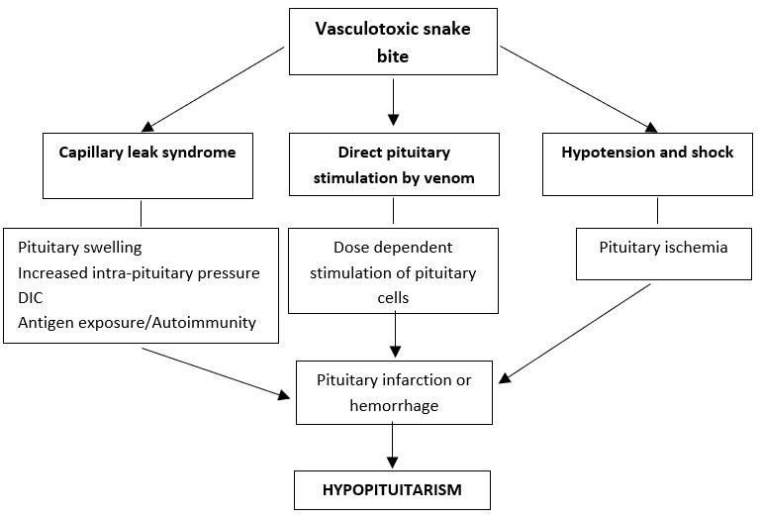

**Figure 3. Pathogenesis of Hypopituitarism in Snake Bites**

Hypopituitarism following snake bites can present as early as 24 hrs to as late as 24 years. Patients may present acutely with adrenal crisis or chronically with non-specific signs and symptoms. Deficiency of growth hormone and cortisol are common and central diabetes insipidus is rare after snake bite induced hypopituitarism (11). Appropriate hormonal replacement remains the mainstay of treatment.

**POST TRAUMATIC PITUTARY DYSFUNCTION**

In India it is reported that about 405 deaths and 1290 injuries happen as a result of road traffic accidents every day. Out of these accidents, two thirds occur in individuals between 15-44 years of age and a significant number of these patients are left with various disabilities (12). Post traumatic hypopituitarism is described after various injuries ranging from mild to severe or even with repeated injuries. Post traumatic hypopituitarism is believed to be responsible for about 7.2% of all causes of hypopituitarism and can develop after road traffic accidents, sports injuries, blast injuries, and other trauma. In the acute phase of post traumatic brain injury, pituitary dysfunction is seen in as high as two thirds of patients (13).

Events and pathogenesis of post traumatic hypopituitarism is described in figure 4. As described in the pathogenesis of SS, pituitary vasculature has a unique propensity for ischemic insult. Autoimmunity is also postulated to play a part in the pathogenesis of post traumatic hypopituitarism. It is believed that as a result of trauma there is disruptions of the blood brain barrier and there is exposure to various hypothalamic and pituitary antigens. Anti-pituitary antibodies and anti-hypothalamic antibodies have been demonstrated by various authors many years after the primary injury. It has also been reported that patients who does not have anti-pituitary antibodies have a higher chance of recovery of pituitary functions within 5 years (14). The role of varied expression of miRNA and the protective role of apolipoprotein E3 have also been described. Somatotrophs and gonadotrophs are first affected by ischemic damage and centrally located corticotrophs and thyrotropes are preserved (13).

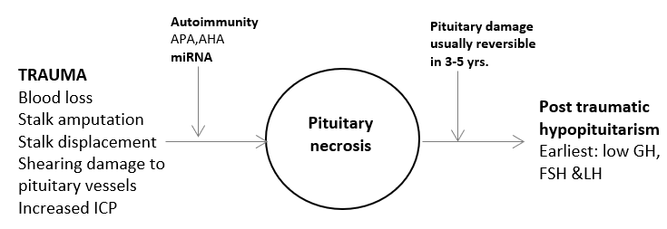

**Figure 4. Pathogenesis of Post Traumatic Hypopituitarism**

The diagnosis of post traumatic hypopituitarism can be difficult because of the non-specific signs and symptoms, impaired cognition, and difficulty to carry out dynamic tests. Patients may have varied presentations like neuropsychiatric manifestations, dementia, altered body fat distribution, and altered metabolic profile. Neuroimaging may show brain contusions, skull fractures, diffuse axonal injuries, diffuse brain swelling, decreased pituitary volume, and even empty sella. Various authors have reported that diffuse brain swelling, skull fractures, axonal injury are predictors of post traumatic hypopituitarism (13). Appropriate hormonal replacement is the mainstay of treatment and pituitary functions revert back to normal within 5 years in a significant number of patients (15).

**PITUITARY INFECTIONS**

Pituitary infections are considered to be a rare in usual practice. However, in tropical countries it can pose a great challenge especially when there is no clinical suspicion. Of all the infections, mycobacterium tuberculosis is a frontrunner in causing pituitary dysfunction. Pituitary insufficiency is reported in children with tubercular meningitis and hyperprolactinemia and adrenal insufficiency was common abnormalities (16). There are a large number of people living with human immunodeficiency virus (HIV) and pituitary infections with cytomegalovirus and toxoplasma gondii can be seen in some of these patients. Immunocompromised patients can also develop pituitary abscesses and the posterior pituitary is commonly affected as it receives its blood supply directly from the systemic circulation. Aspergillus, candida albicans, and pneumocystis jiroveci are common organisms incriminated in pituitary abscesses. The endocrine abnormalities seen most often are DI, hyperprolactinemia, and hypogonadism. On neuroimaging a pituitary abscess may present as parasellar mass (17). Tertiary syphilis can rarely infect the pituitary. The infected pituitary can develop pituitary dysfunction as result of chronic ischemia which leads to necrosis (1).

**MISCELLANEOUS CONDITIONS**

Pseudocyesis describes a clinical condition in which a woman who is not pregnant, presents with a strong conviction of being pregnant along with the associated signs and symptoms mimicking a true pregnancy state. Though pseudocyesis has been recognized since antiquity, the hormonal changes have been studied in the recent decades. The disease is rarely reported in developed countries but is fairly common in tropical countries, especially Africa, where childbearing is considered as essential for women to live with respect. A notable example of this condition was Mary Tudor, the first queen of England, who believed that God did not bless her with a child because of the harsh punishments given by her to the protestants. In this disorder women of child bearing age develops raised prolactin and LH levels (16). Quack therapies are commonly practiced in tropical countries and steroids are the main constituents of such forms of therapies which leads to suppression of the hypothalamic pituitary axis (18). Heat injuries are common in tropical countries and pituitary dysfunction has been reported in heat related injuries. Heat stress is considered to damage somatotrophs and corticotrophs (19). Hemochromatosis is a condition with excess deposition of iron in tissues leading to functional consequences. Hypopituitarism has been reported frequently in patients with hemochromatosis and this is often exaggerated in tropical countries due to poor chelation therapy (20).

**CONCLUSION**

Pituitary disorders in the tropics have certain unique etiologies that include Sheehan’s syndrome, snake-bite, and certain infectious disorders. A high index of clinical suspicion is required to identify the underlying condition in the absence of typical clinical features. The evaluation and management of the hypopituitarism is akin to other etiologies. Improved obstetric care has resulted in a reduced prevalence of Sheehan’s syndrome. Close monitoring and lifelong hormone replacement therapy as deemed necessary are the cornerstones of the therapy to reduce the associated morbidity and mortality.

**REFERENCES**

1. Hypopituitarism - Endotext [Internet]. [cited 2021 Feb 12]. Available from: https://www.endotext.org/chapter/hypopituitarism-2/

2. Sheehan HL. Post-partum necrosis of the anterior pituitary. J Pathol Bacteriol. 1937 Jul 1;45(1):189–214.

3. Zargar AH, Singh B, Laway BA, Masoodi SR, Wani AI, Bashir MI. Epidemiologic aspects of postpartum pituitary hypofunction (Sheehan’s syndrome). Fertil Steril. 2005 Aug;84(2):523–8.

4. Karaca Z, Laway BA, Dokmetas HS, Atmaca H, Kelestimur F. Sheehan syndrome. Nat Rev Dis Prim. 2016 Dec 22;2(1):1–15.

5. De Bellis A, Kelestimur F, Sinisi AA, Ruocco G, Tirelli G, Battaglia M, et al. Anti-hypothalamus and anti-pituitary antibodies may contribute to perpetuate the hypopituitarism in patients with Sheehan’s syndrome. Eur J Endocrinol. 2008 Feb 1;158(2):147–52.

6. Diri H, Tanriverdi F, Karaca Z, Senol S, Unluhizarci K, Durak AC, et al. Extensive investigation of 114 patients with Sheehan’s syndrome: A continuing disorder. Eur J Endocrinol. 2014 Sep 1;171(3):311–8.

7. Diri H, Karaca Z, Tanriverdi F, Unluhizarci K, Kelestimur F. Sheehan’s syndrome: new insights into an old disease. Vol. 51, Endocrine. Humana Press Inc.; 2016. p. 22–31.

8. Suraweera W, Warrell D, Whitaker R, Menon G, Rodrigues R, Fu SH, et al. Trends in snakebite deaths in India from 2000 to 2019 in a nationally representative mortality study. Elife. 2020 Jul 1;9:1–37.

9. Naik Bn, Bhalla A, Sharma N, Mokta J, Singh S, Gupta P, et al. Pituitary dysfunction in survivors of Russell’s viper snake bite envenomation: A prospective study. Neurol India. 2018 Sep 1;66(5):1351.

10. Bhattacharya S, Krishnamurthy A, Gopalakrishnan M, Kalra S, Kantroo V, Aggarwal S, et al. Review article endocrine and metabolic manifestations of snakebite envenoming. Vol. 103, American Journal of Tropical Medicine and Hygiene. American Society of Tropical Medicine and Hygiene; 2020. p. 1388–96.

11. Golay V, Roychowdhary A, Dasgupta S, Pandey R. Hypopituitarism in patients with vasculotoxic snake bite envenomation related acute kidney injury: A prospective study on the prevalence and outcomes of this complication. Pituitary. 2014 Apr 1;17(2):125–31.

12. Pal R, Ghosh A, Kumar R, Galwankar S, Paul S, Pal S, et al. Public health crisis of road traffic accidents in India: Risk factor assessment and recommendations on prevention on the behalf of the Academy of Family Physicians of India. J Fam Med Prim Care. 2019;8(3):775.

13. Hari Kumar KV, Swamy MN, Khan MA. Prevalence of hypothalamo pituitary dysfunction in patients of traumatic brain injury. Indian J Endocrinol Metab. 2016 Nov-Dec;20(6):772-778.

14. Gilis-Januszewska A, Kluczyński Ł, Hubalewska-Dydejczyk A. Traumatic brain injuries induced pituitary dysfunction: a call for algorithms. Endocr Connect. 2020 May;9(5):R112–23.

15. Tanriverdi F, De Bellis A, Ulutabanca H, Bizzarro A, Sinisi AA, Bellastella G, et al. A five year prospective investigation of anterior pituitary function after traumatic brain injury: Is hypopituitarism long-term after head trauma associated with autoimmunity? J Neurotrauma. 2013 Aug 15;30(16):1426–33.

16. Dhanwal DK, Vyas A, Sharma A, Saxena A. Hypothalamic pituitary abnormalities in tubercular meningitis at the time of diagnosis. Pituitary. 2010 Dec;13(4):304–10.

17. Yen SS, Rebar RW, Quesenberry W. Pituitary function in pseudocyesis. J Clin Endocrinol Metab. 1976 Jul;43(1):132-6.

18. Kalra S, Khadilkar V, Dhanwal D. Hypopituitarism in the tropics. Indian J Endocrinol Metab. 2011;15(7):151.

19. Mete F, Kilic E, Somay A, Yilmaz B. Effects of heat stress on endocrine functions & behaviour in the pre-pubertal rat. Indian J Med Res. 2012 Feb;135(2):233–9.

20. Marx JJ. Pathophysiology and treatment of iron overload in thalassemia patients in tropical countries. Adv Exp Med Biol. 2003;531:57-68.