skeletal dysplasias
Philippe M Campeau, MD, FRCPC, Assistant Professor, Department of Molecular and Human Genetics, Baylor College of Medicine

Alan E. Schlesinger, MD, Department of Pediatric Radiology, Texas Children’s Hospital, Houston, TX, USA
Received 3 Sep 2013
Introduction
Skeletal dysplasias form a complex group of more than 400 conditions with extraordinary clinical and molecular heterogeneity. Their classification changes as we learn about their molecular bases. After a brief introduction to the evaluation of the short child, this chapter is structured according to the 2010 nosology and classification of genetic skeletal disorders and is not intended to detail each rare skeletal dysplasia. Rather, it aims to familiarize the reader with this classification, so that the clinician will be able to determine in which category of conditions to place an affected individual and thus establish a differential diagnosis. We then describe the clinical and radiological manifestations of some of the more common skeletal dysplasias in each group. The table for each section lists, when available, the inheritance pattern, the gene, and the OMIM number. General references used include OMIM (www.omim.org), Genereviews (GR, www.ncbi.nlm.nih.gov/books/1116/), Orphanet (www.orpha.net), and chapters or manuscripts by Dr. Spranger and Dr. Lachman . For genetic testing, clinicians are encouraged to refer to the Genetic Testing Registry (http://www.ncbi.nlm.nih.gov/gtr/) and their local geneticist.

Evaluation of the short child
The first step is to analyze the growth curve of the child, compare it to an ethnicity-appropriate reference and the growth history of the parents. After a thorough familial and clinical history and examination, treatable endocrinological and common conditions should be considered. Namely, if there is proportionate short stature with increased weight-for-height ratio, one needs to consider growth hormone deﬁciency or insensitivity, hypothyroidism, or glucocorticoid excess. Work-up could include measuring bone age, IGF1, IGFBP3, T4, TSH. A karyotype, GH, GHBP, GHRH and ACTH may be indicated. If there is proportionate short stature with decreased weight-for-height ratio, one needs to consider undernutrition or malnutrition, malabsorption, or a chronic systemic disease. Work-up depends on history and physical examination, but may include a complete blood count with sedimentation rate (for inflammatory bowel disease) and serum tissue transglutaminase (for celiac disease), serum electrolytes and a first-void morning urinalysis (for renal tubular acidosis or nephrogenic diabetes insipidus). A more detailed discussion can be found in a review by Rose et al. and other chapters in Endotext.

Skeletal dysplasia classification
The first 8 groups of conditions in the 2010 nosology are separated according to the molecular basis of the disease: FGFR3, type 2 collagen, type 11 collagen, sulfation disorders, perlecan, aggrecan, filamin, and TRPV4. The other 32 groups are organized according to their clinical and radiographic presentation. The prefix acro- refers to the extremities (hands and feet), meso- to the middle portion (ulna and radius, tibia and fibula), rhizo- to the proximal portion (femur and humerus), spondylo- to the spine, epi- to the epiphyses, and meta- to the metaphyses. For example, if only the hands and feet are shorter, one would consult the acromelic group of conditions, whereas if the spine and metaphyses are affected, one would consult the spondylometaphyseal dysplasias. Listed below are the 40 groups of conditions to be detailed in this chapter.
Groups of conditions organized according to their molecular bases
1. FGFR3 chondrodysplasia group
2. Type 2 collagen group and similar disorders
3. Type 11 collagen group
4. Sulfation disorders group
5. Perlecan group
6. Aggrecan group
7. Filamin group and related disorders
8. TRPV4 group

Groups of conditions organized according to their clinical presentations
9. Short-ribs dysplasias (with or without polydactyly) group
10. Multiple epiphyseal dysplasia and pseudoachondroplasia group
11. Metaphyseal dysplasias
12. Spondylometaphyseal dysplasias (SMD)
13. Spondylo-epi-(meta)-physeal dysplasias (SE(M)D)
14. Severe spondylodysplastic dysplasias
15. Acromelic dysplasias (extremities of the limbs)
16. Acromesomelic dysplasias (extremities and middle portion of the limbs)
17. Mesomelic and rhizo-mesomelic dysplasias (proximal and middle portions of the limbs)
18. Bent bones dysplasias
19. Slender bone dysplasia group
20. Dysplasias with multiple joint dislocations
21. Chondrodysplasia punctata (CDP) group
22. Neonatal osteosclerotic dysplasias
23. Increased bone density group (without modification of bone shape)
24. Increased bone density group with metaphyseal and/or diaphyseal involvement
25. Osteogenesis imperfecta and decreased bone density group
26. Abnormal mineralization group
27. Lysosomal storage diseases with skeletal involvement (dysostosis multiplex group)
28. Osteolysis group
29. Disorganized development of skeletal components group
30. Overgrowth syndromes with skeletal involvement
31. Genetic inflammatory/rheumatoid-like osteoarthropathies
32. Cleidocranial dysplasia and isolated cranial ossification defects group
33. Craniosynostosis syndromes
34. Dysostoses with predominant craniofacial involvement
35. Dysostoses with predominant vertebral with and without costal involvement
36. Patellar dysostoses
37. Brachydactylies (with or without extraskeletal manifestations)
38. Limb hypoplasia—reduction defects group
39. Polydactyly-Syndactyly-Triphalangism group
40. Defects in joint formation and synostoses

1. FGFR3 chondrodysplasia group
Thanatophoric dysplasia (thus named because it often results in early death) is characterized by micromelia with bowed femurs, short ribs, narrow thorax, macrocephaly, distinctive facial features, brachydactyly, hypotonia. Radiographically, there is rhizomelic shortening of the long bones with irregular metaphyses, platyspondyly, small foramen magnum with brain stem compression, bowed femurs (TD type I) and cloverleaf skull (always in TD type II; sometimes in TD type I). CNS abnormalities include temporal lobe malformations, hydrocephaly, brain stem hypoplasia and neuronal migration abnormalities.

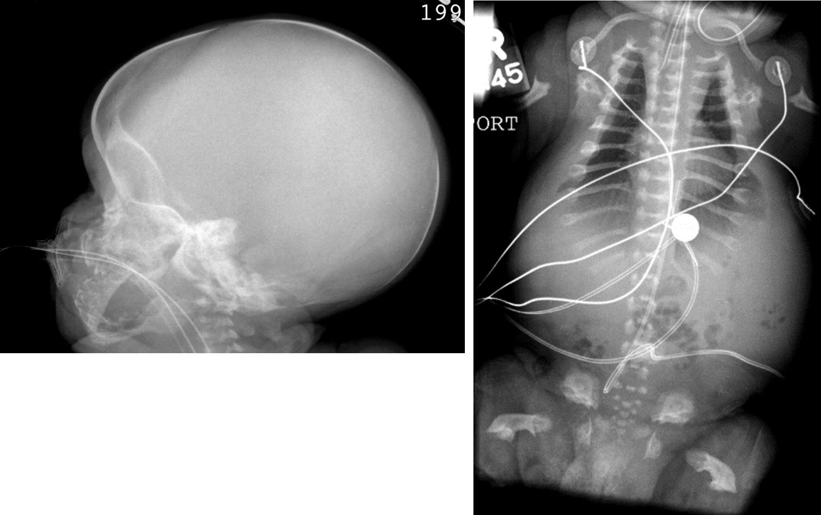
Figure 1. Thanatophoric dysplasia type 1. Severe platyspondyly, very short ribs narrow thorax, short broad pelvis, large skull, very short and bent long bones.

Achondroplasia is characterized by small stature with rhizomelia and redundant skin folds, limitation of elbow extension and genu varum, short fingers with trident configuration of the hands. Craniocervical junction compression is a major complication which may occur and requires surveillance for early detection and management. There is also thoracolumbar kyphosis, lumbar lordosis, and a large head with frontal bossing with midface hypoplasia. The radiographic findings include short tubular bones with metaphyseal flaring, narrowing of the interpediculate distance of the lumbar spine, rounded ilia and horizontal acetabula, narrow sacrosciatic notch and proximal femoral radiolucency. In hypochondroplasia, there are similar but milder clinical and radiological findings, the head is large but there is no midface hypoplasia.

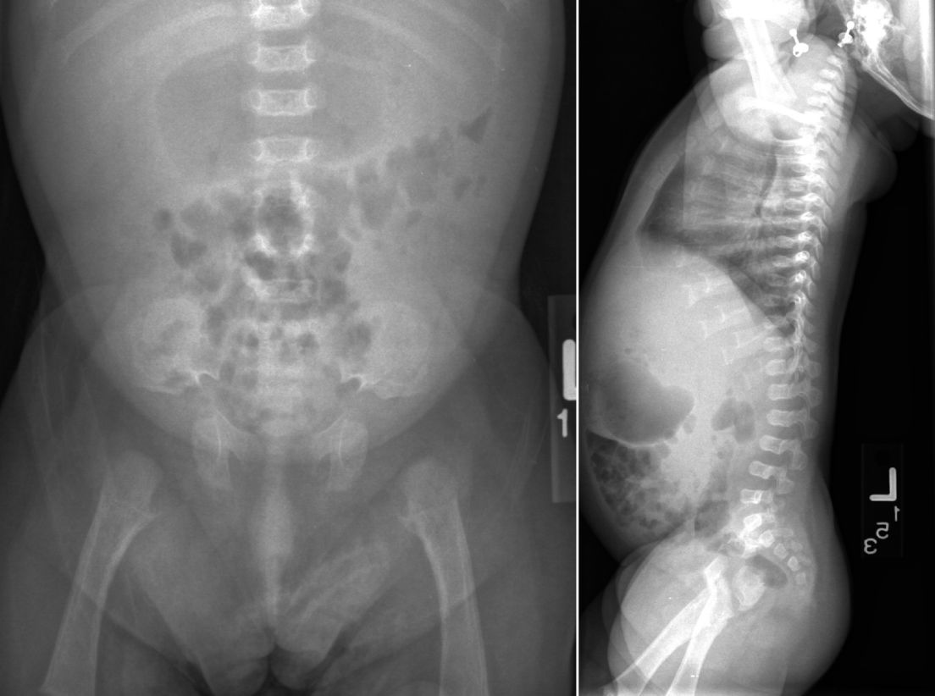
Figure 2. Achondroplasia. Small rounded iliac bones, horizontal acetabula, decreasing interpediculate distance, normal vertebral body height, short ribs.

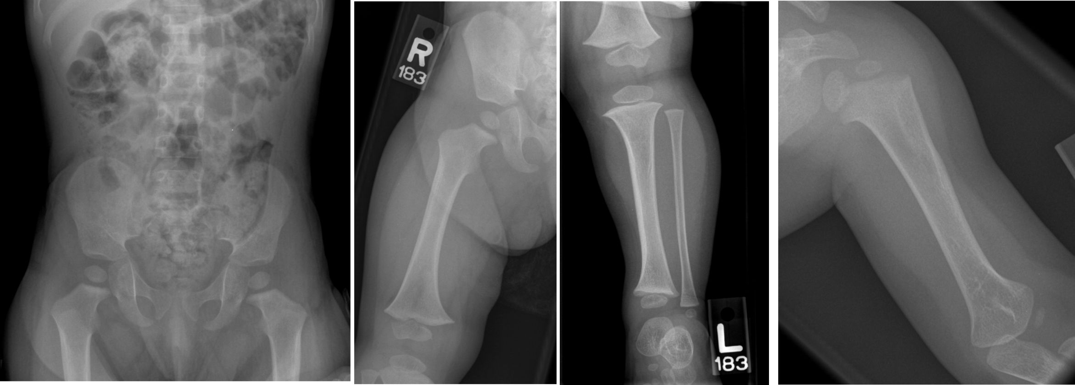
Figure 3. Hypochondroplasia. decreased interpediculate distance, short broad long bones , short wide femoral necks, relative elongation of the distal fibula compare to tibia.

Group/name of disorder | Inher. | OMIM | GR | Orpha | Gene
Thanatophoric dysplasia type 1 (TD1) | AD | 187600 | 1366 | 1860 | FGFR3
Thanatophoric dysplasia type 2 (TD2) | AD | 187601 | 1366 | 93274 | FGFR3
Severe achondroplasia with developmental delay and acanthosis nigricans (SADDAN) | AD | 187600 | 1455 | 85165 | FGFR3
Achondroplasia | AD | 100800 | 1152 | 15 | FGFR3
Hypochondroplasia | AD | 146000 | 1477 | 429 | FGFR3
Camptodactyly, tall stature, and hearing loss syndrome (CATSHL) | AD | 610474 |  |  | FGFR3

Please also refer to group 33 for craniosynostoses syndromes linked to FGFR3 mutations, as well as LADD syndrome in group 39 for another FGFR3-related phenotype.

2. Type 2 collagen group
Stickler syndrome is characterized by ocular findings of myopia, cataract, and retinal detachment, sensorineural and conductive hearing loss, flat mala and cleft palate (alone or as part of the Robin sequence), mild spondyloepiphyseal dysplasia and early-onset arthritis .

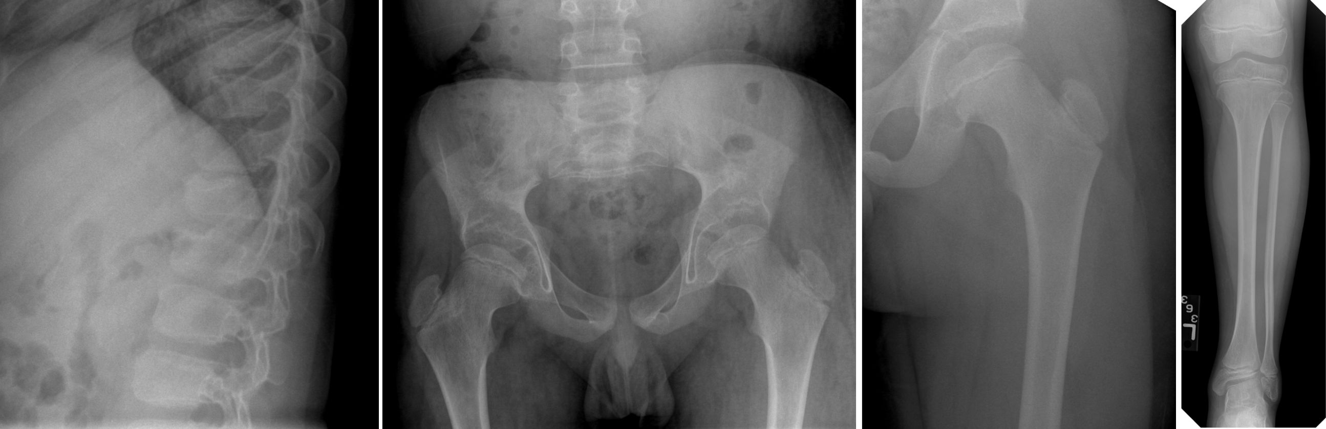
Figure 4. Stickler syndrome. small epiphyses, wide femoral neck, hypoplastic iliac wings, flat epiphyses, schmorl’s nodules.

Spondyloepiphyseal dysplasia congenita (SEDC) presents with disproportionate short stature (short trunk), abnormal epiphyses, and flattened vertebral bodies. Some features of Stickler syndrome include myopia and/or retinal degeneration with retinal detachment and cleft palate.

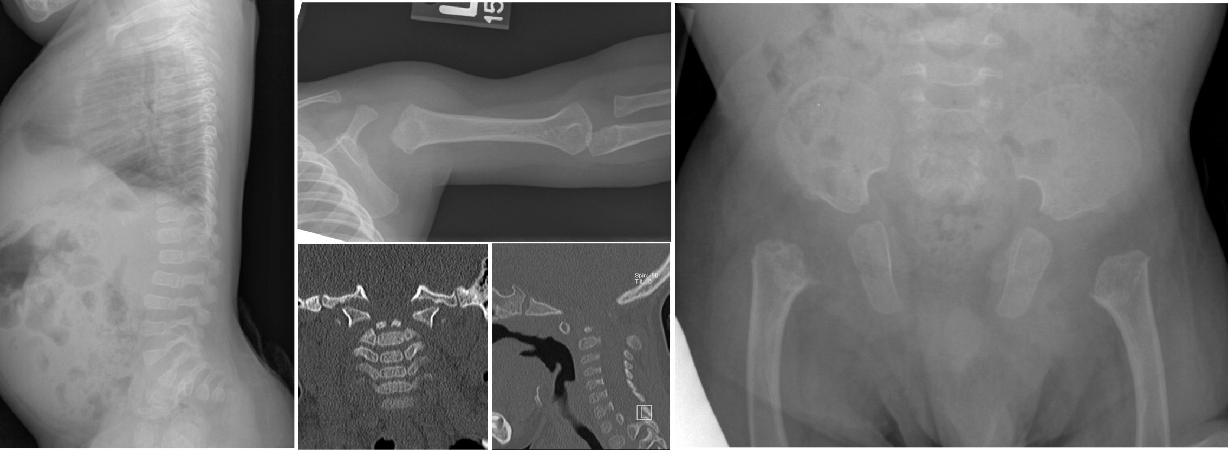
Figure 5. sed congenita. platyspondyly, delayed epiphyseal ossification (especially femoral heads), dens hypoplasia.

Group/name of disorder | Inher. | OMIM | GR | Orpha | Gene
Achondrogenesis type 2 (ACG2; Langer-Saldino) | AD | 200610 |  | 93296 | COL2A1
Platyspondylic dysplasia, Torrance type | AD | 151210 |  | 85166 | COL2A1
Hypochondrogenesis | AD | 200610 |  | 93296 | COL2A1
Spondyloepiphyseal dysplasia congenita (SEDC) | AD | 183900 |  | 94068 | COL2A1
Spondyloepimetaphyseal dysplasia (SEMD) Strudwick type | AD | 184250 |  | 93346 | COL2A1
Kniest dysplasia | AD | 156550 |  | 485 | COL2A1
Spondyloperipheral dysplasia | AD | 271700 |  | 1856 | COL2A1
Mild SED with premature onset arthrosis | AD |  |  |  | COL2A1
SED with metatarsal shortening (formerly Czech dysplasia) | AD | 609162 |  | 137678 | COL2A1
Stickler syndrome type 1 | AD | 108300 | 1302 | 828 | COL2A1

3. Type 11 collagen group
Marshall syndrome resembles Stickler syndrome but is characterized by a flat or retracted midface, thick calvaria, abnormal frontal sinuses with shallow orbits, intracranial calcifications, and ectodermal abnormalities including abnormal sweating and teeth.

Otospondylomegaepiphyseal dysplasia (OSMED) is characterized by sensorineural hearing loss, enlarged epiphyses, skeletal dysplasia with disproportionately short limbs, vertebral body anomalies, midface hypoplasia, a short nose with anteverted nares and a flat nasal bridge, a long philtrum, cleft palate/bifid uvula, micrognathia, and hypertelorism.

Group/name of disorder | Inher. | OMIM | GR | Orpha | Gene
Stickler syndrome type 2 | AD | 604841 | 1302 | 90654 | COL11A1
Marshall syndrome | AD | 154780 |  | 560 | COL11A1
Fibrochondrogenesis | AR | 228520 |  | 2021 | COL11A1
Otospondylomegaepiphyseal dysplasia (OSMED), recessive type | AR | 215150 |  | 1427 | COL11A2
Otospondylomegaepiphyseal dysplasia (OSMED), dominant type (Weissenbacher-Zweymüller syndrome, Stickler syndrome type 3) | AD | 215150 |  | 1427 | COL11A2

Please also refer to Stickler syndrome type 1 in group 2

4. Sulfation disorders group
Achondrogenesis type 1B (ACG1B) is characterized extremely short limbs with short fingers and toes, hypoplasia of the thorax, protuberant abdomen, and hydropic fetal appearance. There is a normal-sized skull with a flat facies. There is a lack of ossification of the vertebral bodies (except for pedicles), short and thin ribs, and ossification of the upper part of iliac bones giving crescent-shaped appearance. Shortening of the tubular bones with metaphyseal spurring ("thorn apple" appearance) is seen.

The clinical features of diastrophic dysplasia (DTD) include limb shortening with hitchhiker thumbs, ulnar deviation of the fingers, a gap between the first and second toes, clubfeet, contractures of large joints, early-onset osteoarthritis and radial dislocation. The skull is normal-sized. There is some trunk shortening, a small chest with a protuberant abdomen and spinal deformities (scoliosis, exaggerated lumbar lordosis, cervical kyphosis). Non-skeletal findings include a cleft palate, cystic ear swelling in the neonatal period, and flat hemangiomas of the forehead.

Group/name of disorder | Inher. | OMIM | GR | Orpha | Gene
Achondrogenesis type 1B (ACG1B) | AR | 600972 | 1516 | 93298 | SLC26A2
Atelosteogenesis type 2 (AO2) | AR | 256050 | 1317 | 56304 | SLC26A2
Diastrophic dysplasia (DTD) | AR | 222600 | 1350 | 628 | SLC26A2
MED, autosomal recessive type (rMED; EDM4) | AR | 226900 | 1306 | 93307 | SLC26A2
SEMD, PAPSS2 type | AR | 603005 |  | 93282 | PAPSS2
Chondrodysplasia with congenital joint dislocations, CHST3 type (recessive Larsen syndrome) | AR | 608637 | 62112 | 263463 | CHST3
Ehlers-Danlos syndrome, CHST14 type (“musculo-skeletal variant”) | AR | 601776 |  | 2953 | CHST14

Please also refer to groups 7 and 26 for other conditions with multiple dislocations

5. Perlecan group
Schwartz-Jampel syndrome manifests with myotonia (characteristic facies with blepharophimosis and a puckered facial appearance) and osteoarticular abnormalities with progressive joint stiffness. There is also a flattening of the vertebral bodies, short stature, hip dysplasia, bowing of the diaphyses and irregular epiphyses.

Group/name of disorder | Inher. | OMIM | Orpha | Gene
Dyssegmental dysplasia, Silverman-Handmaker type | AR | 224410 | 1865 | HSPG2
Dyssegmental dysplasia, Rolland-Desbuquois type | AR | 224400 | 156731 | HSPG2
Schwartz-Jampel syndrome (myotonic chondrodystrophy) | AR | 255800 | 800 | HSPG2

6. Aggrecan group
These conditions have been each described in one family and will not be discussed in detail here.
Group/name of disorder | Inher. | OMIM | Orpha | Gene
SED, Kimberley type | AD | 608361 | 93283 | ACAN
SEMD, Aggrecan type | AR | 612813 | 171866 | ACAN
Familial osteochondritis dissecans | AD | 165800 | 251262 | ACAN

7. Filamin group and related disorders
The otopalatodigital (OPD) spectrum disorders caused by FLNA mutations include Otopalatodigital syndromes type I and II, frontometaphyseal dysplasia, Melnick-Needles syndrome and terminal osseous dysplasia with pigmentary skin defects (TODPD). Manifestations include abnormal facial features (such as widely spaced eyes), hypoplasia of the thorax, scoliosis, shortened digits, bowed long bones and joint movement limitations.

Larsen syndrome is characterized by large-joint dislocations (hip, knee, and elbow) and characteristic craniofacial abnormalities (prominent forehead, depressed nasal bridge, flattened midface, and ocular hypertelorism). There can also be club feet (equinovarus or equinovalgus foot deformities); scoliosis and cervical kyphosis, cervical myelopathy; and spatula-shaped fingers, most marked in the thumb.

Group/name of disorder | Inher. | OMIM | GR | Orpha | Gene
Frontometaphyseal dysplasia | XLD | 305620 | 1393 | 1826 | FLNA
Osteodysplasty Melnick-Needles | XLD | 309350 | 1393 | 2484 | FLNA
Otopalatodigital syndrome type 1 (OPD1) | XLD | 311300 | 1393 | 90650 | FLNA
Otopalatodigital syndrome type 2 (OPD2) | XLD | 304120 | 1393 | 90652 | FLNA
Terminal osseous dysplasia with pigmentary defects (TODPD) | XLD | 300244 | 1393 | 88630 | FLNA
Atelosteogenesis type 1 (AO1) | AD | 108720 | 2534 | 1190 | FLNB
Atelosteogenesis type 3 (AO3) | AD | 108721 | 2534 | 56305 | FLNB
Larsen syndrome (dominant) | AD | 150250 | 2534 | 503 | FLNB
Spondylo-carpal-tarsal dysplasia | AR | 272460 | 2534 | 3275 | FLNB
Spondylo-carpal-tarsal dysplasia | AR | 272460 |  | 3275
Franck-ter Haar syndrome | AR | 249420 |  | 137834 | SH3PXD2B

Please also refer to group 4 for recessive Larsen syndrome and group 26 for conditions with multiple dislocations.

8. TRPV4 group
Metatropic dysplasia is a severe spondyloepimetaphyseal dysplasia characterized in infancy by a long trunk and short limbs with limitation and enlargement of joints and usually severe kyphoscoliosis. The term metatropic comes from the Greek metatropos, and refers to the changing pattern of the skeletal anomalies. Indeed, there is progressive kyphoscoliosis which leads to a shortened trunk. Radiologic features include platyspondyly, metaphyseal enlargement, and shortening of long bones.

Spondylometaphyseal dysplasia, Kozlowski type is characterized by short-trunked short stature, metaphyseal abnormalities in the femur (prominent in the femoral neck and trochanteric area) with coxa vara, scoliosis and platyspondyly.

Group/name of disorder | Inher. | OMIM | GR | Orpha | Gene
Metatropic dysplasia | AD | 156530 |  | 2635 | TRPV4
Spondyloepimetaphyseal dysplasia, Maroteaux type (Pseudo-Morquio syndrome type 2) | AD | 184095 |  | 263482 | TRPV4
Spondylometaphyseal dysplasia, Kozlowski type | AD | 184252 |  | 93314 | TRPV4
Brachyolmia, autosomal dominant type | AD | 113500 |  | 93304 | TRPV4
Familial digital arthropathy with brachydactyly | AD | 606835 |  | 85169 | TRPV4

9. Short-ribs dysplasias (with or without polydactyly) group
The short rib-polydactyly syndromes (SRPS) are ciliopathies characterized by short ribs, short limbs, polydactyly, and multiple anomalies of major organs, including heart, intestines, genitalia, kidney, liver, and pancreas. In SRPS I (Saldino-Noonan type), the long bones are torpedo-shaped; in SRPS III (Verma-Naumoff type) they are banana-peel shaped. In SRPS II (Majewski syndrome) the tibiae are short and oval, and in SRPS VI (Beemer type), the tibiae are not as short and polydactyly is rare .

In asphyxiating thoracic dystrophy (Jeune syndrome), there is a severely constricted thoracic cage, short-limbed short stature, polydactyly, retinal degeneration and pancreatic cysts.

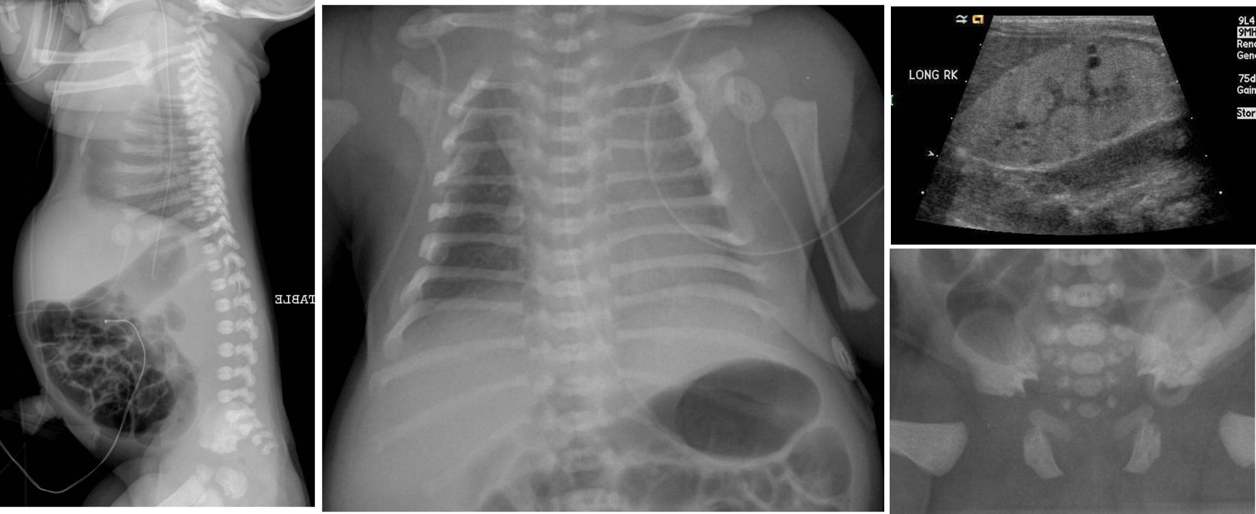
Figure 6. asphyxiating thoracic dystrophy. short ribs long and narrow chest, small pelvis, trident acetabula, no platyspondyly (helps differentiate from thanatophoric dysplasia), cystic renal disease.

Ellis-van Creveld syndrome is characterized by short limbs, short ribs, postaxial polydactyly, and dysplastic nails and teeth.

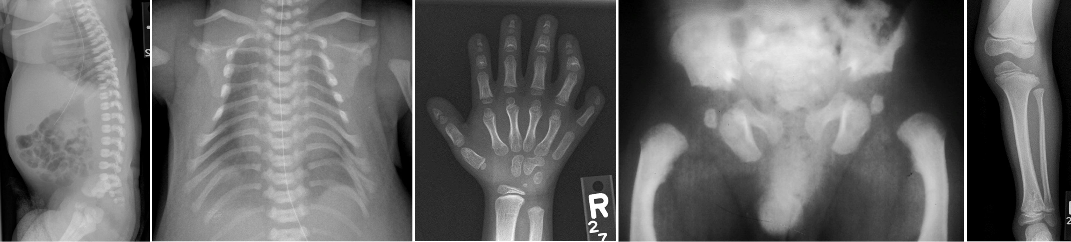
Figure 7. chondroectodermal dysplasia (or Ellis-van Creveld syndrome). short ribs, early ossification of femoral head, polydactyly cone-shaped epiphyses, no platyspondyly (helps differentiate from thanatophoric dysplasia), flatening of lateral aspect of proximal tibial epiphysis.

In uniparental disomy of paternal chromosome 14, there is a narrow, bell-shaped thorax with caudal bowing of the anterior ribs and cranial bowing of the posterior ribs (coat hanger appearance) , and flaring of the iliac wings. There are also joint contractures, dysmorphic facial features, and developmental delay/intellectual deficiency.

Group/name of disorder | Inher. | OMIM | Orpha | Gene
Chondroectodermal dysplasia (Ellis-van Creveld) | AR | 225500 | 289 | EVC1, ECV2, LBN
Short rib—polydactyly syndrome (SRPS) type 1/3 (Saldino-Noonan/Verma-Naumoff) | AR | 263510 | 93271 | DYNC2H1
SRPS type 1/3 (Saldino-Noonan) | AR | 263510 | 93271 | IFT80
SRPS type 2 A | AR | 263520 | 93269 | NEK1
SRPS type 2B | AR | 615087 | 93269 | DYNC2H1
SRPS type 3 Verma-Naumoff | AR | 263510 | 93271 | DYNC2H1
SRPS type 4 (Beemer) | AR | 269860 | 93268
SRPS type 5 | AR | 614091 |  | WDR35
Uniparental disomy of paternal chromosome 14 (UPD14) |  | 608149 | 96334 | Complete chromosome 14
Cerebrocostomandibular syndrome | AR/AD | 117650 | 1393
Oral-facial-digital syndrome type 4 (Mohr-Majewski) | AR | 258860 | 2753 | TCTN3
Asphyxiating thoracic dysplasia (ATD; Jeune) | AR | 208500 | 474 | TTC21B, IFT80, WDR19, DYNC2H1, ATD
Thoracolaryngopelvic dysplasia (Barnes) | AD | 187760 | 3317

10. Multiple epiphyseal dysplasia and pseudoachondroplasia group
Multiple epiphyseal dysplasia is usually not recognizable before 1-2 years of age . Then, joint pain at the hips and knees is noted after physical exercise. Mild to moderate short stature is seen by 5-6 years of age. Radiologically, there is bilateral necrosis of the femoral heads, and the epiphyses of tubular bones, (including metacarpals, metatarsals and phalanges) show maturational delay. Femoral and phalangeal epiphyses are rounded (COMP) or flat (SCL26A2, see group 4). Double-layered patellae can be seen (SCL26A2). The most frequently mutated genes are COMP and SCL26A2, then the genes encoding type 9 collagen and Matrillin 3.

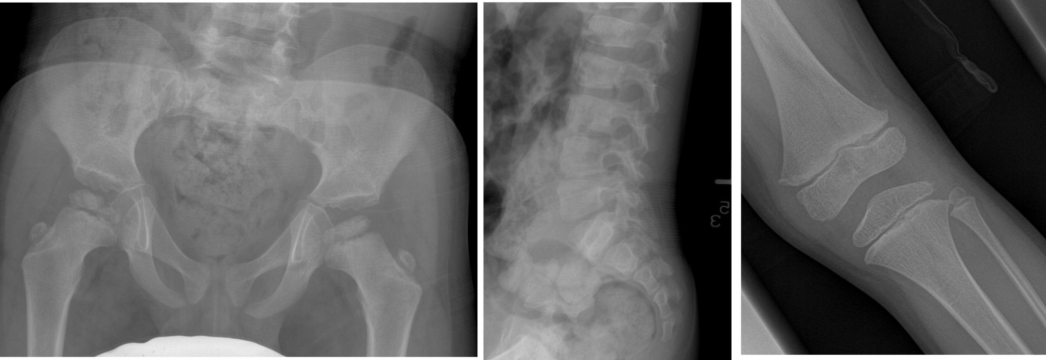
Figure 8. Multiple epiphyseal dysplasia. Flattened epiphyses, normal spine (no platyspondyly).

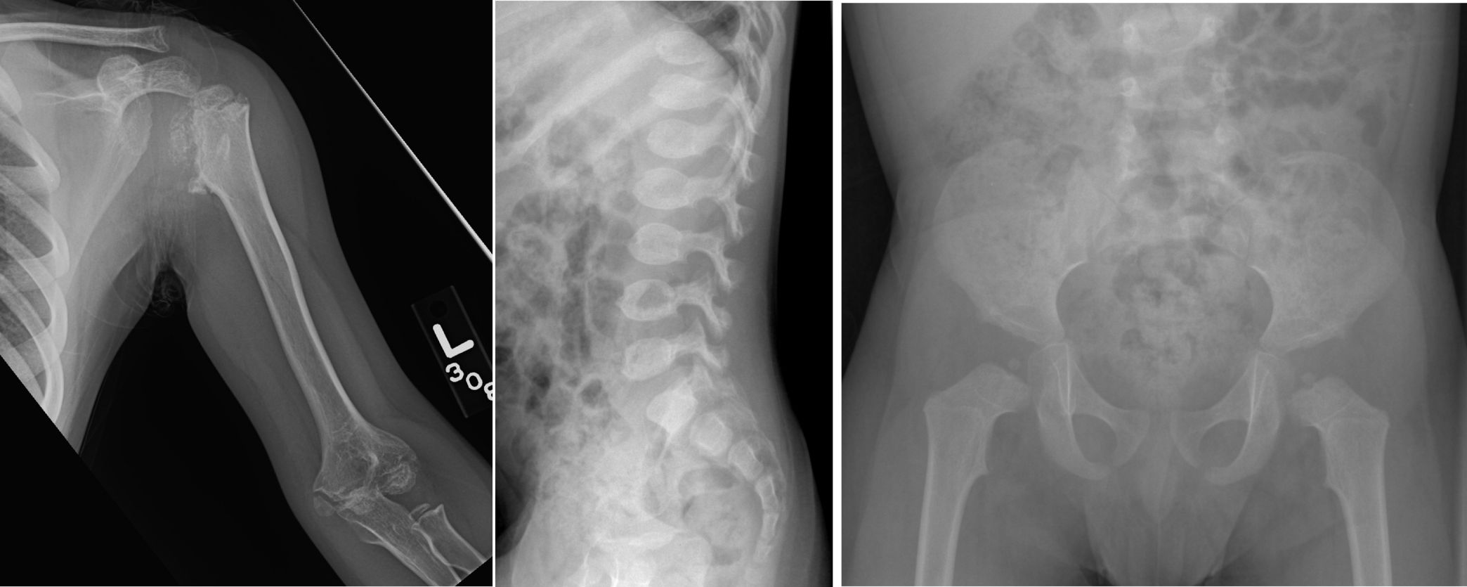
Figure 9. pseudoachondroplasia. small femoral head, irregular epiphyses, platyspondyly with anterior tongues of vertebral bodies, irregular acetabula.

Group/name of disorder | Inher. | OMIM | GR | Orpha | Gene
Pseudoachondroplasia (PSACH) | AD | 177170 | 1487 | 750 | COMP
Multiple epiphyseal dysplasia (MED) type 1 (EDM1) | AD | 132400 | 1123 | 93308 | COMP
Multiple epiphyseal dysplasia (MED) type 2 (EDM2) | AD | 600204 | 1123 | 166002 | COL9A2
Multiple epiphyseal dysplasia (MED) type 3 (EDM3) | AD | 600969 | 1123 | 166002 | COL9A3
Multiple epiphyseal dysplasia (MED) type 5 (EDM5) | AD | 607078 | 1123 | 93311 | MATN3
Multiple epiphyseal dysplasia (MED) type 6 (EDM6) | AD | 614135 | 1123 | 166002 | COL9A1
Multiple epiphyseal dysplasia (MED), other types |  |  | 1123
Stickler syndrome, recessive type | AR | 614134 | 1302 | 250984 | COL9A1
Familial hip dysplasia (Beukes) | AD | 142669 | 1123 | 2114
Multiple epiphyseal dysplasia with microcephaly and nystagmus (Lowry-Wood) | AR | 226960 |  | 1824
Please also refer to multiple epiphyseal dysplasia, recessive type (rMED; EDM4) in sulfation disorders (group 4), familial osteochondritis dissecans in the aggrecan group, as well as ASPED in the Acromelic group

11. Metaphyseal dysplasias
Cartilage-hair hypoplasia manifests with severe disproportionate short-limbed short stature with short hands, bowed femorae and tibiae, joint hypermobility and often metaphyseal dysplasia and large, round epiphyses during childhood, bullet-shaped middle phalanges and vertebral dysplasia. Non-skeletal findings include fine silky slow growing hair, immunodeficiency manifested by an increased rate of infections, anemia, gastrointestinal dysfunction, and an increased risk for malignancy.

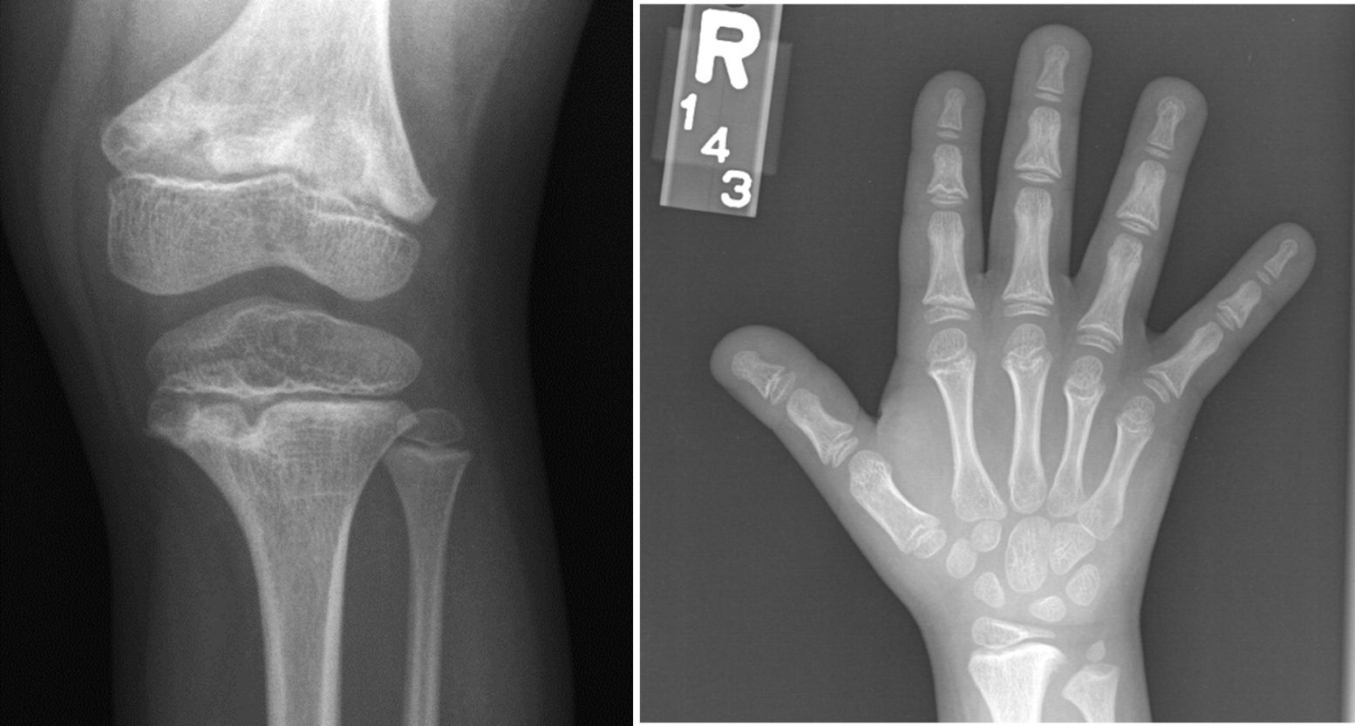
Figure 10. cartilage-hair hypoplasia. widening of the growth plate (often focal), metaphyseal cupping and irregularity with cyst-like lucencies, short metacarpals and phalanges with cupping and cone-shaped epiphyses.

Shwachman-Diamond syndrome manifests with exocrine pancreatic insufficiency with malabsorption, malnutrition, and growth failure, hematologic abnormalities, including increased risk of malignant transformation, and skeletal abnormalities which include short stature, generalized osteopenia, with delayed appearance of secondary ossification centers (delayed bone age) metaphyseal chondrodysplasia (metaphyses wide and irregular) and finally thickening and irregularity of the growth plates.

Schmid type of metaphyseal chondrodyplasia manifests with short stature, widened growth plates, bowing of the long bones and resembles a milder form of Jansen type metaphyseal chondrodysplasia. Radiological signs include enlarged capital femoral epiphysis in early childhood, coxa vara, greater involvement of the distal femoral metaphysis than the proximal (these disappear after epiphyseal fusion), anterior rib changes and a normal spine.

Group/name of disorder | Inher. | OMIM | GR | Orpha | Gene
Metaphyseal dysplasia, Schmid type (MCS) | AD | 156500 |  | 174 | COL10A1
Cartilage-hair hypoplasia (CHH; metaphyseal dysplasia, McKusick type) | AR | 250250 | 84550 | 175 | RMRP
Metaphyseal dysplasia, Jansen type | AD | 156400 |  | 33067 | PTHR1
Eiken dysplasia | AR | 600002 |  | 79106 | PTHR1
Metaphyseal dysplasia with pancreatic insufficiency and cyclic neutropenia (Shwachman-Diamond syndrome) | AR | 260400 | 1756 | 811 | SBDS
Metaphyseal anadysplasia type 1 | AD, AR | 602111 |  | 1040 | MMP13
Metaphyseal anadysplasia type 2 | AR | 613073 |  | 1040 | MMP9
Metaphyseal dysplasia, Spahr type | AR | 250400 |  | 2501
Metaphyseal acroscyphodysplasia (various types) | AR | 250215 |  | 1240
Genochondromatosis (type 1/type 2) | AD/SP | 137360 |  | 85197
Metaphyseal chondromatosis with d-2-hydroxyglutaric aciduria | AR/SP | 614875 |  | 99646 | IDH1

12. Spondylometaphyseal dysplasias (SMD)
SMD Sutcliffe type presents with proportional mild short stature. The spine shows odontoid hypoplasia, hyperconvex vertebral body endplates (lower thoracic and upper lumbar) with an appearance of anterior wedging and no platyspondyly or kyphoscoliosis. Hips show progressive coxa vara with short femoral necks leading to a waddling gait. Metaphyseal abnormalities include flakelike, triangular, or curvilinear ossification centers at the edges of the metaphyses simulating “corner fractures” of long tubular bones, distal tibial metaphyses on the ulnar aspect of the distal radius and in the proximal humerus. Some patients have been reported to have COL2A1 mutations.

Group/name of disorder | Inher. | OMIM | Orpha | Gene
Spondyloenchondrodysplasia (SPENCD) | AR | 271550 | 1855 | ACP5
Odontochondrodysplasia (ODCD) | AR | 184260 | 166272
Spondylometaphyseal dysplasia, Sutcliffe type or corner fractures type | AD | 184255 | 93315 | COL2A1
SMD with severe genu valgum | AD | 184253 | 93316
SMD with cone-rod dystrophy | AR | 608940 | 85167
SMD with retinal degeneration, axial type | AR | 602271 | 168549
Dysspondyloenchondromatosis | SP |  | 85198 | COL2A1
Cheiro-spondyloenchondromatosis | SP |  | 99647

Please also refer to SMD Kozlowski (group TRPV4) disorders in group 11 as well as SMD Sedaghatian type in group 12; there are many individual reports of SMD variants

13. Spondylo-epi-(meta)-physeal dysplasias (SE(M)D)
Spondyloepiphyseal dysplasia tarda manifests with disproportionately short stature and a short trunk. Affected males exhibit retarded growth from about six years of age. Progressive joint and back pain with osteoarthritis follows, involving the larger joints more than the small joints. Radiologically, there are multiple epiphyseal abnormalities, platyspondyly, narrow disc spaces, scoliosis, hypoplastic odontoid process, short femoral necks and coxa vara.

Group/name of disorder | Inher. | OMIM | GR | Orpha | Gene
Dyggve-Melchior-Clausen dysplasia (DMC) | AR | 223800 |  | 239 | DYM
Immuno-osseous dysplasia (Schimke) | AR | 242900 | 1376 | 1830 | SMARCAL1
SED, Wolcott-Rallison type | AR | 226980 |  | 1667 | EIF2AK3
SEMD, Matrilin type | AR | 608728 |  | 156728 | MATN3
SEMD, short limb—abnormal calcification type | AR | 271665 |  | 93358 | DDR2
SED tarda, X-linked (SED-XL) | XLR | 313400 | 1145 | 93284 | SEDL
Spondylo-megaepiphyseal-metaphyseal dysplasia (SMMD) | AR | 613330 |  | 228387 | NKX3-2
Spondylodysplastic Ehlers-Danlos syndrome | AR | 612350 |  | 157965 | SLC39A13
SPONASTRIME dysplasia | AR | 271510 |  | 93357
SEMD with joint laxity (SEMD-JL) leptodactylic or Hall type | AD | 603546 |  | 93360 | KIF22
SEMD with joint laxity (SEMD-JL) Beighton type | AR | 271640 |  | 93359
Platyspondyly (brachyolmia) with amelogenesis imperfecta | AR | 601216 |  | 2899
Late onset SED, autosomal recessive type | AR | 609223 |  | 93284
Brachyolmia, Hobaek type | AR | 271530 |  | 93301 | PAPSS2
Brachyolmia, Toledo type | AR | 271630 |  | 93303 | PAPSS2

Please also refer to Brachyolmia (group 8), Opsismodysplasia (group 14), SEMDs (group 11), mucopolysaccharidosis type 4 (Morquio syndrome) and other conditions in group 26, as well as PPRD (SED with progressive arthropathy) in group 31

14. Severe spondylodysplastic dysplasias
In opsismodysplasia, there is a large anterior fontanelle, anteverted nostrils, pelvic bone anomalies, metaphyseal cupping, delayed ossification, shortened digits, hypotonia, and early death.
Group/name of disorder | Inher. | OMIM | Orpha | Gene
Achondrogenesis type 1A (ACG1A) | AR | 200600 | 93299 | TRIP11
Schneckenbecken dysplasia | AR | 269250 | 3144 | SLC35D1
Spondylometaphyseal dysplasia, Sedaghatian type | AR | 250220 | 93317
Severe spondylometaphyseal dysplasia (SMD Sedaghatian-like) | AR |  |  | SBDS
Opsismodysplasia | AR | 258480 | 2746 | INPPL1

Please also refer to Thanatophoric dysplasia, types 1 and 2 (group 1); ACG2 and Torrance dysplasia (group 2); Fibrochondrogenesis (group 3); Achondrogenesis type 1B (ACG1B, group 4); and Metatropic dysplasia (TRPV4 group).

15. Acromelic dysplasias
In Trichorhinophalangeal syndromes, skeletal abnormalities include a short stature, cone-shaped epiphyses at the phalanges, hip malformations, and short stature. All phalanges, metacarpals and metatarsal bones are shortened. Non-skeletal features include sparse scalp hair, bulbous tip of the nose, long flat philtrum, thin upper vermilion border, and protruding ears.

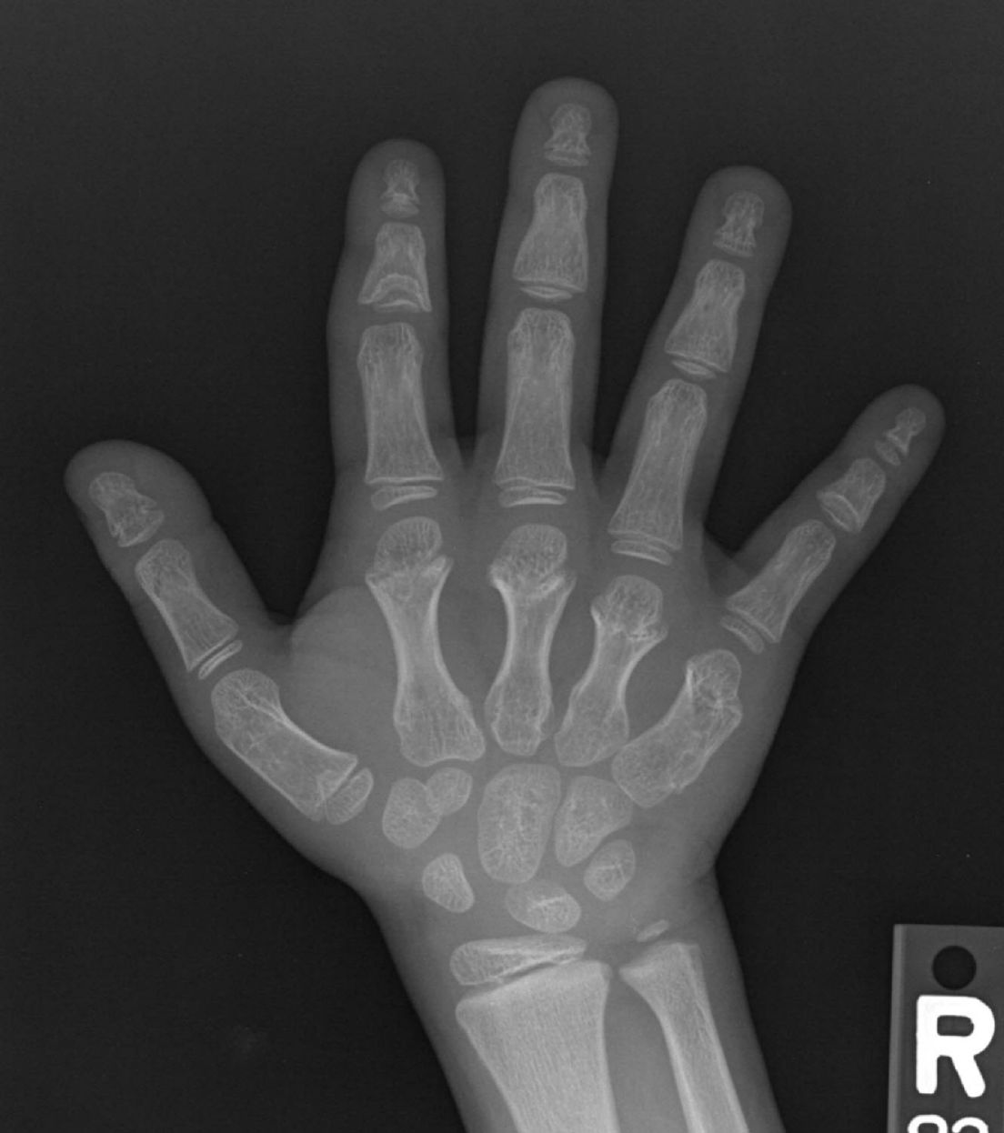
Figure 11. Trichorhinophalangeal syndrome. shortened phalanges and metacarpals, cone-shaped epiphyses.

In Geleophysic dysplasia, there is short stature, short hands and feet, progressive joint limitation and contractures, distinctive facial features ("smiling" round and full face, small nose with anteverted nostrils, a broad nasal bridge, hypertelorism, long flat philtrum, and a thin upper lip), progressive cardiac valvular disease, and thickened skin.

Group/name of disorder | Inher. | OMIM | GR | Orpha | Gene
Trichorhinophalangeal dysplasia types 1/3 | AD | 190350 |  | 77258 | TRPS1
Trichorhinophalangeal dysplasia type 2 (Langer-Giedion) | AD | 150230 |  | 502 | TRPS1 andEXT1
Acrocapitofemoral dysplasia | AR | 607778 |  | 63446 | IHH
Cranioectodermal dysplasia (Levin-Sensenbrenner) type 1 | AR | 218330 |  | 1515 | IFT122
Cranioectodermal dysplasia (Levin-Sensenbrenner) type 2 | AR | 613610 |  | 1515 | WDR35
Geleophysic dysplasia | AR | 231050 | 11168 | 2623 | ADAMTSL2
Geleophysic dysplasia, other types | AR | 614185 | 11168 | 2623 | FBN1
Acromicric dysplasia | AD | 102370 |  | 969 | SMAD4
Acrodysostosis type 1 | AD | 101800 |  | 950 | PRKAR1A
Acrodysostosis type 2 | AD | 614613 |  | 950 | PDE4D
Angel-shaped phalango-epiphyseal dysplasia (ASPED) | AD | 105835 |  | 63442
Saldino-Mainzer dysplasia | AR | 266920 |  | 140969 | IFT140
Myhre syndrome | AD | 139210 |  | 2588 | SMAD4
Weill-Marchesani syndrome type 1 | AR | 277600 | 1114 | 3449 | ADAMTS10
Weill-Marchesani syndrome type 2 | AD | 608328 | 1114 | 2084 | FBN1
Please also refer to the short rib dysplasias group

16. Acromesomelic dysplasias
In Acromesomelic dysplasia, type Maroteaux, there is disproportionate shortening the middle segments (forearms and forelegs) and distal segments (hands and feet) of the appendicular skeleton. There are short broad fingers, shortening of the middle long bones with a bowed radius, and wedging of vertebral bodies.

Group/name of disorder | Inher. | OMIM | Orpha | Gene
Acromesomelic dysplasia type Maroteaux (AMDM) | AR | 602875 | 40 | NPR2
Grebe dysplasia | AR | 200700 | 2098 | GDF5
Fibular hypoplasia and complex brachydactyly (Du Pan) | AR | 228900 | 2639 | GDF5
Acromesomelic dysplasia with genital anomalies | AR | 609441 |  | BMPR1B
Acromesomelic dysplasia, Osebold-Remondini type | AD | 112910 | 93382
Acromesomelic dysplasia, Hunter-Thomson type | AR | 201250 | 968 | GDF5

17. Mesomelic and rhizo-mesomelic dysplasias
Leri-Weill dyschondrosteosis is characterized by short stature, mesomelia, and Madelung wrist deformity (abnormal alignment of the radius, ulna, and carpal bones at the wrist - more common and severe in females).

Group/name of disorder | Inher. | OMIM | GR | Orpha | Gene
Dyschondrosteosis (Leri-Weill) | Pseudo-AD | 127300 | 1215 | 240 | SHOX
Langer type (homozygous dyschondrosteosis) | Pseudo-AR | 249700 | 1215 | 2632 | SHOX
Omodysplasia | AR | 258315 |  | 93329 | GPC6
Robinow syndrome, recessive type | AR | 268310 | 1240 | 1507 | ROR2
Robinow syndrome, dominant type | AD | 180700 |  | 3107 | WNT5A
Mesomelic dysplasia, Korean type | AD
Mesomelic dysplasia, Kantaputra type | AD | 156232 |  | 1836
Mesomelic dysplasia, Nievergelt type | AD | 163400 |  | 2633
Mesomelic dysplasia, Kozlowski-Reardon type | AR | 249710 |  | 2631
Mesomelic dysplasia with acral synostoses (Verloes-David-Pfeiffer type) | AD | 600383 |  | 2496 | SULF1, SLCO5A1
Mesomelic dysplasia, Savarirayan type (Triangular Tibia-Fibular Aplasia) | SP | 605274 |  | 85170

18. Bent bones dysplasias
Campomelic dysplasia is characterized by bowed, short and fragile long bones, clubfeet, pelvis and chest abnormalities and eleven pairs of ribs. Non-skeletal anomalies include a flat face, laryngotracheomalacia, Pierre Robin sequence with cleft palate, ambiguous genitalia in males, and brain, heart and kidney malformations.

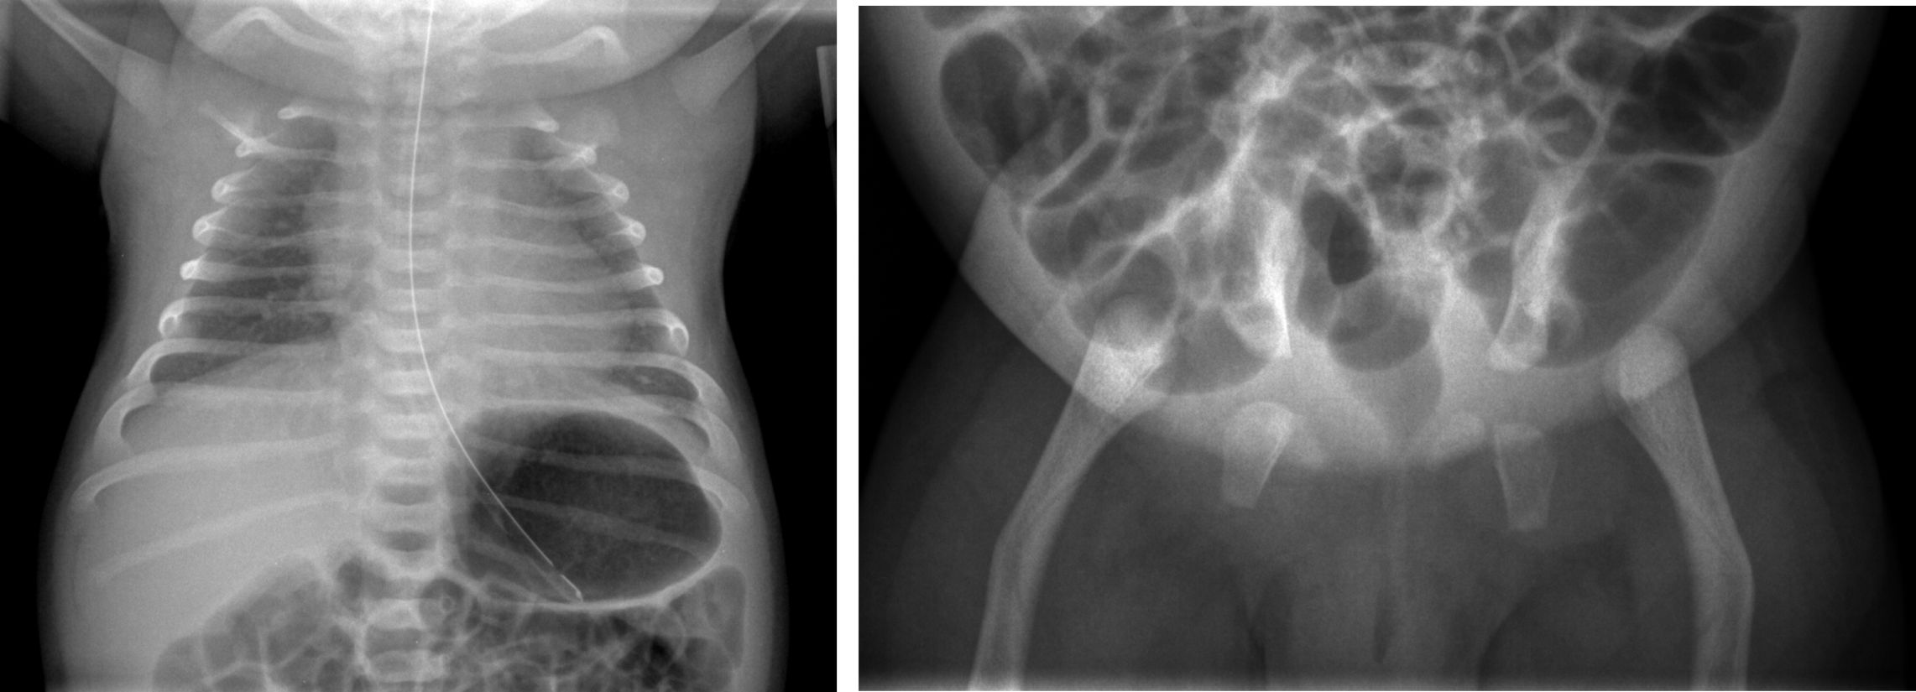
Figure 12. Campomelic dysplasia. bell-shaped thorax, hypoplastic scapula, bowed femurs, widely-spaced ischial bones.

Group/name of disorder | Inher. | OMIM | GR | Orpha | Gene
Campomelic dysplasia (CD) | AD | 114290 | 1760 | 140 | SOX9
Stüve-Wiedemann dysplasia | AR | 601559 |  | 3206 | LIFR
Kyphomelic dysplasia, several forms |  | 211350 |  | 1801

Bent bones at birth can be seen in osteogenesis imperfecta, Antley-Bixler syndrome, cartilage-hair hypoplasia, Cummings syndrome, hypophosphatasia, dyssegmental dysplasia, TD, ATD, and other conditions.

19. Slender bone dysplasia group
In Three M (3M) syndrome, there is severe prenatal and postnatal growth retardation, distinctive facial features (large head, triangular face, hypoplastic midface, full eyebrows, fleshy nose tip, long philtrum, prominent mouth and lips, and pointed chin), and normal mental development. The main skeletal anomalies are slender long bones and ribs, foreshortened vertebral bodies, and delayed bone age. Joint hypermobility, joint dislocation, winged scapulae, and pes planus can also be seen.

Group/name of disorder | Inher. | OMIM | GR | Orpha | Gene
3-M syndrome (3M1) | AR | 273750 | 1481 | 2616 | CUL7
3-M syndrome (3M2) | AR | 612921 | 1481 | 2616 | OBSL1
Kenny-Caffey dysplasia type 1 | AR | 244460 |  | 93324 | TBCE
Kenny-Caffey dysplasia type 2 | AD | 127000 |  | 93325 | FAM111A
Microcephalic osteodysplastic primordial dwarfism type 1/3 (MOPD1) | AR | 210710 |  | 2636 | RNU4ATAC
Microcephalic osteodysplastic primordial dwarfism type 2 (MOPD2; Majewski type) | AR | 210720 |  | 2637 | PCNT2
IMAGE syndrome (intrauterine growth retardation, metaphyseal dysplasia, adrenal hypoplasia, and genital anomalies) | XL/AD | 614732 |  | 85173 | CDKN1C
Osteocraniostenosis | SP | 602361 |  | 2763
Hallermann-Streiff syndrome | AR | 234100 |  | 2108 | GJA1

Please also see Cerebro-arthro-digital dysplasia.

20. Dysplasias with multiple joint dislocations
Desbuquois dysplasia is characterized by short stature of prenatal onset affecting the rhizomelic and mesomelic portion of the limbs, marked joint laxity, kyphoscoliosis and facial dysmorphisms (round flat face, prominent eyes, and midface hypoplasia)

Group/name of disorder | Inher. | OMIM | Orpha | Gene
Desbuquois dysplasia (with accessory ossification center in digit 2) | AR | 251450 | 1425 | CANT1
Desbuquois dysplasia with short metacarpals and elongated phalanges (Kim type) | AR | 251450 | 1425 | CANT1
Desbuquois dysplasia (other variants with or without accessory ossification center) | AR
Pseudodiastrophic dysplasia | AR | 264180 | 85174

Please also refer to SED with congenital dislocations, CHST3 type (group 4); Atelosteogenesis type 3 and Larsen syndrome (group 6); SEMDs with joint laxity (group 11)

21. Chondrodysplasia punctata (CDP) group
The more severe, classic rhizomelic chondrodysplasia punctata type 1 can manifest in neonates with cataracts, rhizomelia, metaphyseal abnormalities, and punctate calcifications in the epiphyseal cartilage at the knee, hip, elbow, and shoulder, involving the hyoid bone, larynx, costochondral junctions, and vertebrae (chondrodysplasia punctata). In addition, unossified cartilage in the vertebral bodies show as radiolucent coronal clefts.

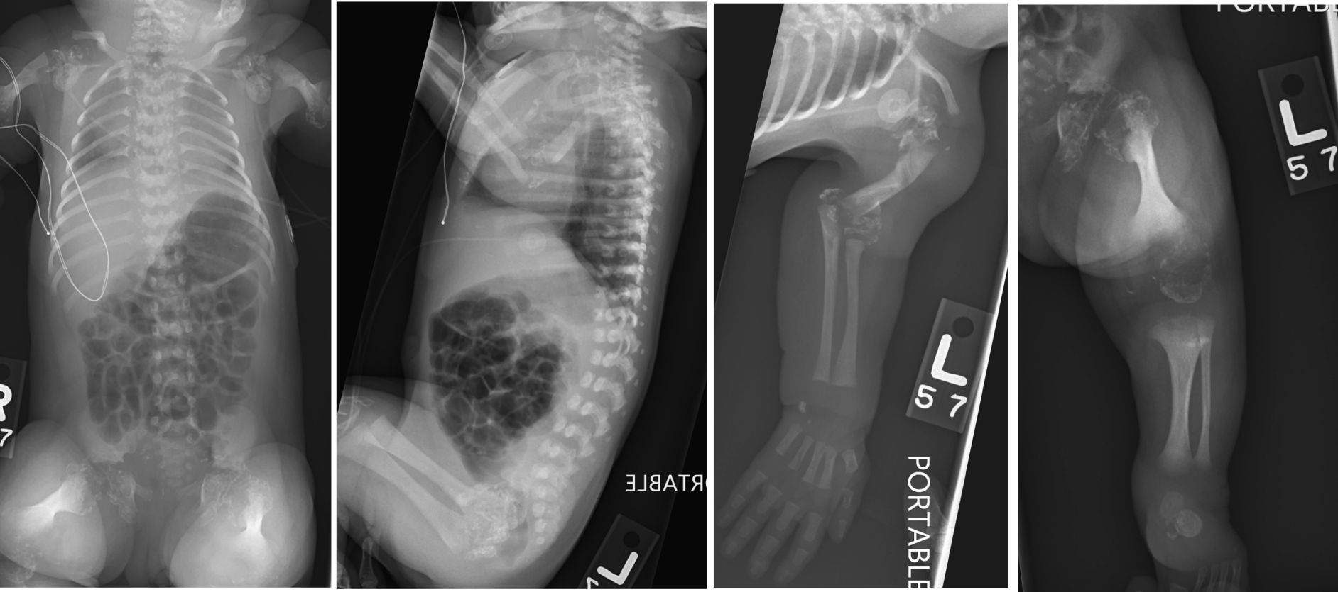
Figure 13. rhizomelic chondrodysplasia punctate type 1. punctate epitphyses, very small humeri less shortening of femurs, coronal clefts in vertebral bodies.

Group/name of disorder | Inher. | OMIM | GR | Orpha | Gene
CDP, X-linked dominant, Conradi-Hünermann type (CDPX2) | XLD | 302960 | 55062 | 35173 | EBP
CDP, X-linked recessive, brachytelephalangic type (CDPX1) | XLR | 302950 | 1544 | 79345 | ARSE
Congenital hemidysplasia, ichthyosis, limb defects (CHILD) | XLD | 308050 | 51754 | 139 | NSDHL
Congenital hemidysplasia, ichthyosis, limb defects (CHILD) | XLD | 308050 |  | 139 | EBP
Greenberg dysplasia | AR | 215140 |  | 1426 | LBR
Rhizomelic CDP type 1 | AR | 215100 | 1270 | 177 | PEX7
Rhizomelic CDP type 2 | AR | 222765 |  | 177 | DHPAT
Rhizomelic CDP type 3 | AR | 600121 |  | 177 | AGPS
CDP tibial-metacarpal type | AD/AR | 118651 |  | 79346
Astley-Kendall dysplasia | AR? |  |  | 85175

Note that stippling can occur in several syndromes such as Zellweger, Smith-Lemli-Opitz and others. Please also refer to desmosterolosis as well as SEMD short limb—abnormal calcification type in group 11.

22. Neonatal osteosclerotic dysplasias
Caffey disease manifests with subperiosteal new bone formation (long bones, ribs, mandible, scapulae, and clavicles) associated with fever, joint swelling and pain. Onset is around age two months and the episodes stop by age two years.

Group/name of disorder | Inher. | OMIM | GR | Orpha | Gene
Blomstrand dysplasia | AR | 215045 |  | 50945 | PTHR1
Desmosterolosis | AR | 602398 |  | 35107 | DHCR24
Caffey disease (including infantile and attenuated forms) | AD | 114000 | 99168 | 1310 | COL1A1
Caffey disease (severe variants with prenatal onset) | AR | 114000 | 99168 | 1310 | COL1A1
Raine dysplasia (lethal and non-lethal forms) | AR | 259775 |  | 1832 | FAM20C

Please also refer to Astley-Kendall dysplasia and CDPs in group 21

23. Increased bone density group (without modification of bone shape)
Osteopetrosis can manifest with increased bone density, diffuse and focal sclerosis, modelling defects at metaphyses, pathological fractures, osteomyelitis, tooth eruption defects and dental caries. Other complications include cranial nerve compression, hydrocephalus, pancytopaenia, extramedullary haematopoiesis, hepatosplenomegaly, and hypocalcaemia .

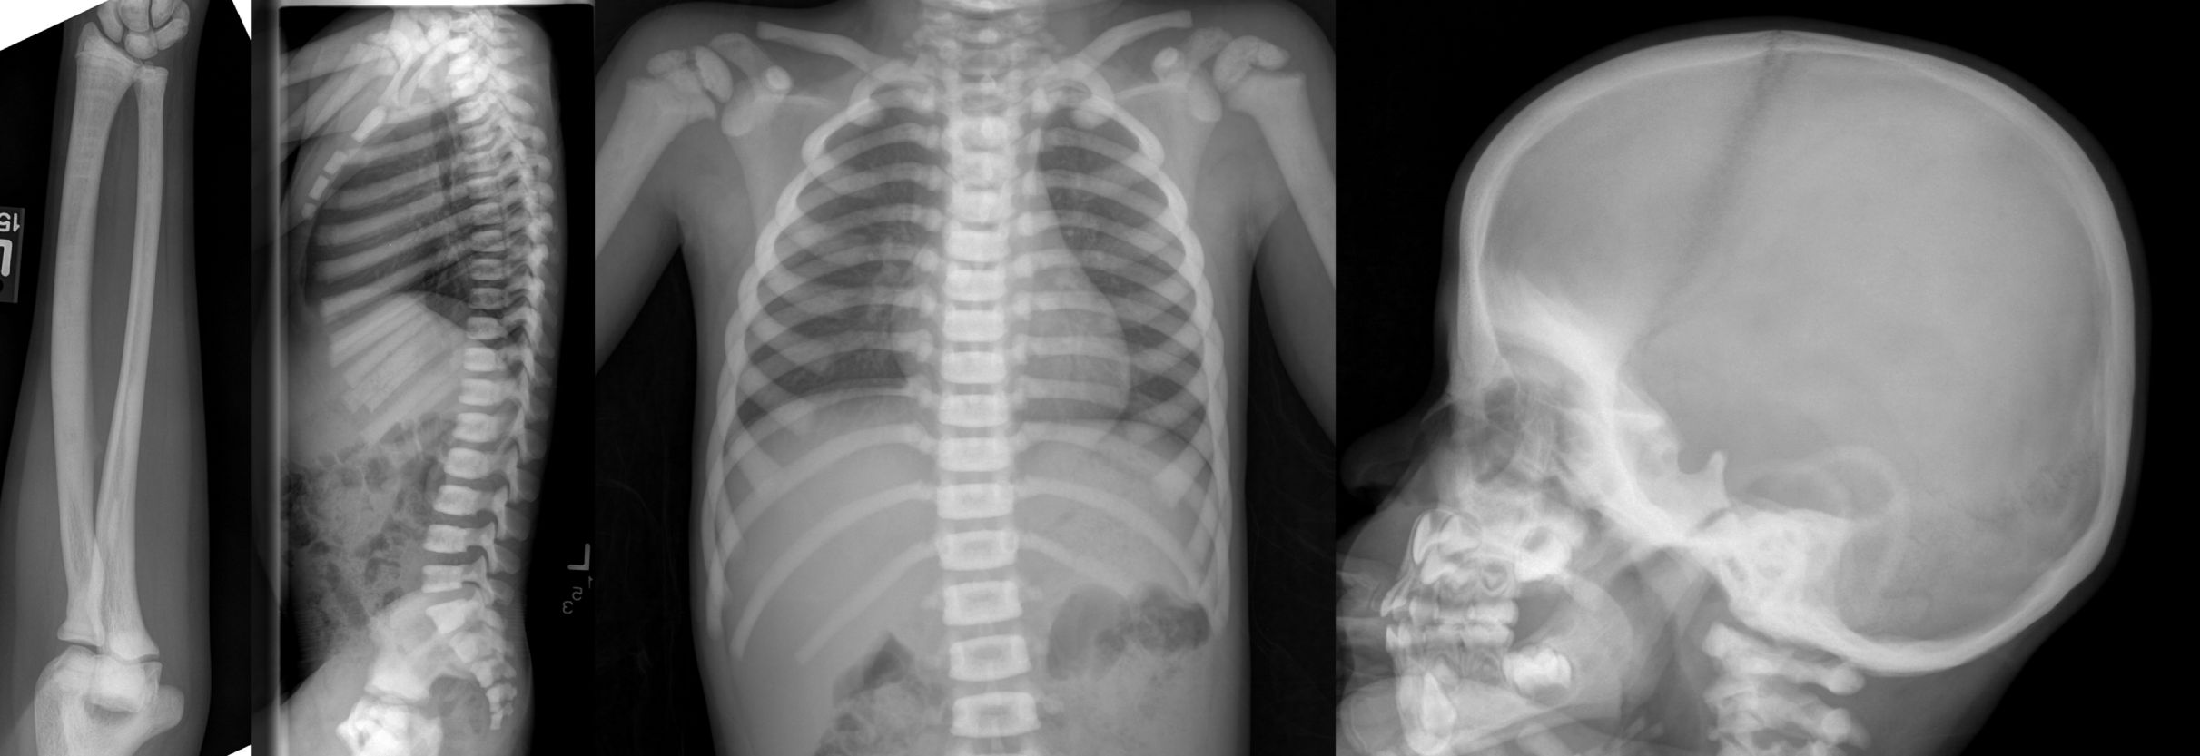
Figure 14. osteopetrosis. thick dense bones, alternating bands of sclerosis and normal density bone in long bones, rugger jersey spine, dense base of skull.

Group/name of disorder | Inher. | OMIM | GR | Orpha | Gene
Osteopetrosis, severe neonatal or infantile forms (OPTB1) | AR | 259700 |  | 667 | TCIRG1
Osteopetrosis, severe neonatal or infantile forms (OPTB4) | AR | 611490 | 1127 | 667 | CLCN7
Osteopetrosis, infantile form, with nervous system involvement (OPTB5) | AR | 259720 |  | 667 | OSTM1
Osteopetrosis, intermediate form, osteoclast-poor (OPTB2) | AR | 259710 |  | 667 | TNFSF11
Osteopetrosis, infantile form, osteoclast-poor with immunoglobulin deficiency (OPTB7) | AR | 612301 |  | 667 | TNFRSF11A
Osteopetrosis, intermediate form (OPTB6) | AR | 611497 |  | 210110 | PLEKHM1
Osteopetrosis, intermediate form (OPTA2) | AR | 259710 | 1127 | 667 | CLCN7
Osteopetrosis with renal tubular acidosis (OPTB3) | AR | 259730 |  | 2785 | CA2
Osteopetrosis, late-onset form type 1 (OPTA1) | AD | 607634 |  | 2783 | LRP5
Osteopetrosis, late-onset form type 2 (OPTA2) | AD | 166600 |  | 53 | CLCN7
Osteopetrosis with ectodermal dysplasia and immune defect (OLEDAID) | XL | 300301 |  | 69088 | IKBKG
Osteopetrosis, moderate form with defective leucocyte adhesion (LAD3) | AR | 612840 |  | 2968 | KIND3
Pyknodysostosis | AR | 265800 |  | 763 | CTSK
Osteopoikilosis | AD | 155950 |  | 2485 | LEMD3
Melorheostosis with osteopoikilosis | AD | 155950 |  | 2485 | LEMD3
Osteopathia striata with cranial sclerosis (OSCS) | XLD | 300373 |  | 2780 | WTX
Melorheostosis | SP | 155950 |  | 2485 | LEMD3
Dysosteosclerosis | AR | 224300 |  | 1782 | SLC29A3
Osteomesopyknosis | AD | 166450 |  | 2777
Osteopetrosis with infantile neuroaxonal dysplasia | AR? | 600329 |  | 85179

24. Increased bone density group with metaphyseal and/or diaphyseal involvement
Camurati-Engelmann manifests with bilateral cortical thickening (hyperostosis) of the diaphyses of the long bones starting with the femora and tibiae. The metaphyses and the skull base may be affected as well, but the epiphyses are spared. Limb pain, muscle weakness, a waddling gait, and easy fatigability can also occur.

Group/name of disorder | Inher. | OMIM | GR | Orpha | Gene
Craniometaphyseal dysplasia, autosomal dominant type | AD | 123000 | 1461 | 1522 | ANKH
Diaphyseal dysplasia Camurati-Engelmann | AD | 131300 | 1156 | 1328 | TGFB1
Hematodiaphyseal dysplasia Ghosal | AR | 231095 |  | 1802 | TBXAS1
Hypertrophic osteoarthropathy | AR | 259100 |  | 1525 | HPGD
Pachydermoperiostosis (hypertrophic osteoarthropathy, primary, autosomal dominant) | AD | 167100 |  | 2796
Oculodentoosseous dysplasia (ODOD) mild type | AD | 164200 |  | 2710 | GJA1
Oculodentoosseous dysplasia (ODOD) severe type | AR | 257850 |  | 2710 | GJA1
Osteoectasia with hyperphosphatasia (juvenile Paget disease) | AR | 239000 |  | 2801 | OPG
Sclerosteosis | AR | 269500 | 1228 | 3152 | SOST
Endosteal hyperostosis, van Buchem type | AR | 239100 | 1228 | 3416 | SOST
Trichodentoosseous dysplasia | AD | 190320 |  | 3352 | DLX3
Craniometaphyseal dysplasia, autosomal recessive type | AR | 218400 |  | 1522
Diaphyseal medullary stenosis with bone malignancy | AD | 112250 |  | 85182
Craniodiaphyseal dysplasia | AD | 122860 | 1228 | 1513 | SOST
Craniometadiaphyseal dysplasia, Wormian bone type | AR | 615118 |  | 85184
Endosteal sclerosis with cerebellar hypoplasia | AR | 213002 |  | 85186
Lenz-Majewski hyperostotic dysplasia | SP | 151050 |  | 2658
Metaphyseal dysplasia, Braun-Tinschert type | XL | 605946 |  | 85188
Pyle disease | AR | 265900 |  | 3005

25. Osteogenesis imperfecta and decreased bone density
Osteogenesis imperfect (OI) manifests with low bone mineral density and bone fragility with frequent fractures, bone deformities and short stature, dentinogenesis imperfecta (fragile grey or brown somewhat translucent teeth), and progressive hearing loss. In type I, stature is normal or slightly short, there is no bone deformity, the sclerae can be blue and there is no dentinogenesis imperfecta. Type II is the most severe with multiple rib and long bone fractures at or before birth, marked deformities, broad long bones, low density on skull X-rays, and dark sclera. OI type III presents with very short stature, a triangular face, severe scoliosis, gray sclera, and dentinogenesis imperfecta. In Type IV, the phenotype is milder with moderately short stature, mild to moderate scoliosis, grayish or white sclera, and dentinogenesis imperfecta. Type V is characterized by mild to moderate short stature, calcification of the forearm interosseous membrane, radial head dislocation and hyperplastic callus formation following fractures, and no dentinogenesis imperfecta.

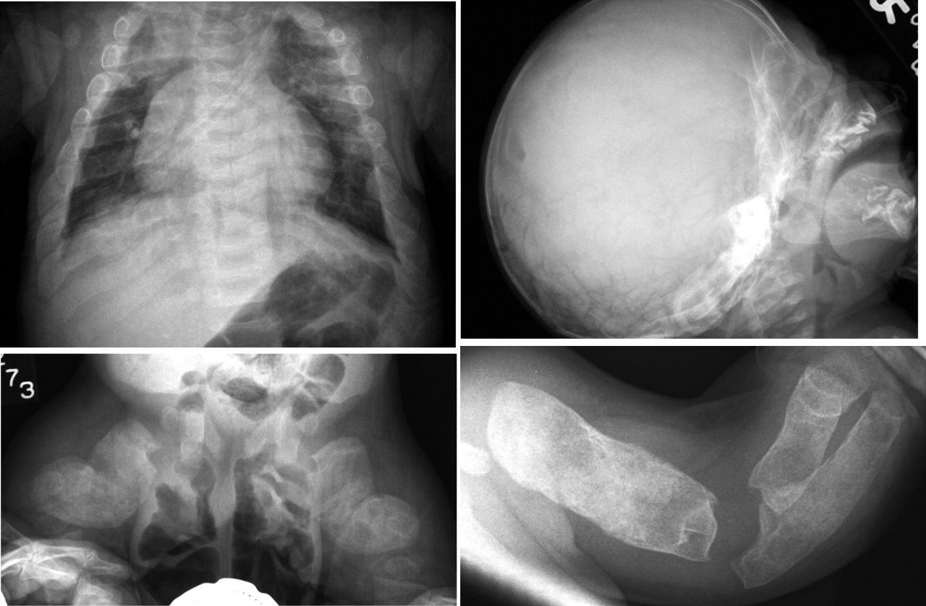
Figure 15. oi type ii. wormian bones, thick short crumpled long bones, rectangular wavy femora, thick beaded ribs.

Group/name of disorder | Inher. | OMIM | GR | Orpha | Gene
Osteogenesis imperfecta, non-deforming form (OI type I) | AD | 166200 | 1295 | 216796 | COL1A1,COL1A2
Osteogenesis imperfecta, perinatal lethal form (OI type II) | AD, AR | 166210 | 1295 | 216804 | COL1A1,COL1A2,CRTAP,LEPRE1,PPIB
Osteogenesis imperfecta, progressively deforming type (OI type III) | AD, AR | 259420 | 1295 | 216812 | COL1A1,COL1A2,CRTAP,LEPRE1,PPIB,FKBP10,SERPINH1 , WNT1, TMEM38B
Osteogenesis imperfecta, moderate form (OI type IV) | AD, AR | 166220 | 1295 | 216820 | COL1A1,COL1A2,CRTAP,FKBP10,SP7
Osteogenesis imperfecta with calcification of the interosseous membranes and/or hypertrophic callus (OI type V) | AD | 610967 |  | 216828 | IFITM5
Osteogenesis imperfecta, type VI | AR | 613982 |  | 216812 | SERPINF1
Osteogenesis imperfecta, type VII | AR | 610682 |  | 216804 | CRTAP
Bruck syndrome type 1 (BS1) | AR | 259450 |  | 2771 | FKBP10
Bruck syndrome type 2 (BS2) | AR | 609220 |  | 2771 | PLOD2
Osteoporosis-pseudoglioma syndrome | AR | 259770 |  | 2788 | LRP5
Calvarial doughnut lesions with bone fragility | AD | 126550 |  | 85192
Idiopathic juvenile osteoporosis | SP | 259750 |  | 85193
Cole-Carpenter dysplasia (bone fragility with craniosynostosis) | SP | 112240 |  | 2050
Spondylo-ocular dysplasia | AR | 605822 |  | 85194
Osteopenia with radiolucent lesions of the mandible | AD | 166260 |  | 53697 | ANO5
Ehlers-Danlos syndrome, progeroid form | AR | 130070 |  | 75496 | B4GALT7
Geroderma osteodysplasticum | AR | 231070 |  | 2078 | GORAB
Cutis laxa, autosomal recessive form, type 2B (ARCL2B) | AR | 612940 |  | 90350 | PYCR1
Cutis laxa, autosomal recessive form, type 2A (ARCL2A) (Wrinkly skin syndrome) | AR | 219200 | 5200 | 90350 | ATP6VOA2
Wrinkly skin syndrome | AR | 278250 | 5200 | 2834 | ATP6VOA2
Singleton-Merten dysplasia | AD | 182250 |  | 85191

26. Abnormal mineralization group
Hypophosphatasia results from low alkaline phosphatase (TNSALP) activity. Inorganic pyrophosphate (PPi), an inhibitor of mineralization, and pyridoxal 5′-phosphate (PLP), are substrates that accumulate. The types include the prenatal benign form which spontaneously improves, perinatal (lethal), infantile (respiratory complications, premature craniosynostosis, widespread demineralization and rachitic changes in the metaphyses), childhood (skeletal deformities, short stature, and waddling gait), and adult (stress fractures, thigh pain, chondrocalcinosis and marked osteoarthropathy). Two other forms include odontohypophosphatasia (no clinical changes in long bones are present, only biochemical and dental manifestations such as premature exfoliation of fully rooted primary teeth and/or severe dental caries) and pseudohypophosphatasia (indistinguishable from infantile hypophosphatasia, but serum alkaline phosphatase activity is normal). Enzyme replacement is now available.

Hypophosphatemic rickets is discussed in detail in the section on bone and mineral metabolism of Endotext. Rickets manifests with bowing of the weight bearing bones. Other frequent manifestations are growth failure with disproportionate short stature, frontal bossing, and swelling of wrists, knees, and ankles. A rachitic rosary arises due to expansion of the costo-chondral junctions, and an inward diaphragmatic pull of soft rib cage leads to Harrison's sulcus (groove). Dentition may be delayed and enamel development can be impaired.

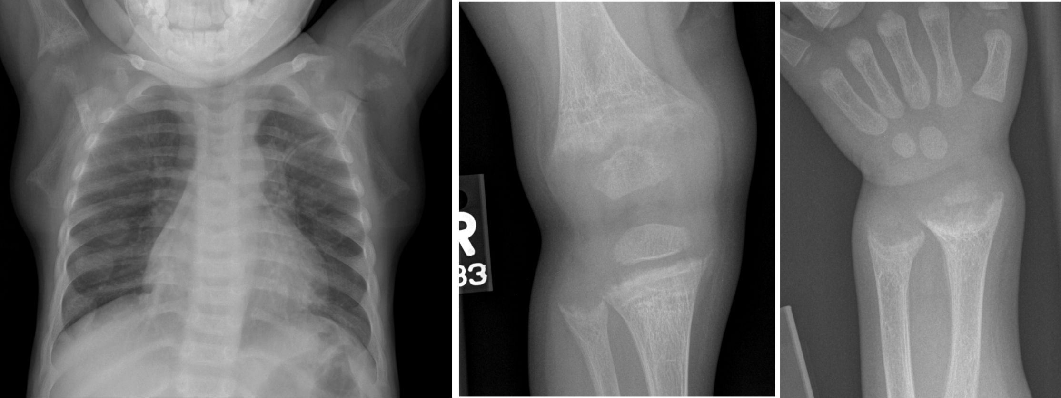
Figure 16. rickets. widened growth plates, cupping fraying of metaphyses, demineralization , widened anterior rib ends.

Group/name of disorder | Inher. | OMIM | GR | Orpha | Gene
Hypophosphatasia, perinatal lethal and infantile forms | AR | 241500 | 1150 | 436 | ALPL
Hypophosphatasia, adult form | AD | 146300 | 1150 | 436 | ALPL
Hypophosphatemic rickets, X-linked dominant | XLD | 307800 | 83985 | 89936 | PHEX
Hypophosphatemic rickets, autosomal dominant | AD | 193100 |  | 89937 | FGF23
Hypophosphatemic rickets, autosomal recessive, type 1 (ARHR1) | AR | 241520 |  | 289176 | DMP1
Hypophosphatemic rickets, autosomal recessive, type 2 (ARHR2) | AR | 613312 |  | 289176 | ENPP1
Hypophosphatemic rickets with hypercalciuria, X-linked recessive | XLR | 300554 |  | 1652 | ClCN5
Hypophosphatemic rickets with hypercalciuria, autosomal recessive (HHRH) | AR | 241530 |  | 157215 | SLC34A3
Neonatal hyperparathyroidism, severe form | AR | 239200 |  | 417 | CASR
Familial hypocalciuric hypercalcemia with transient neonatal hyperparathyroidism | AD | 145980 |  | 405 | CASR
Calcium pyrophosphate deposition disease (familial chondrocalcinosis) type 2 | AD | 118600 |  | 1416 | ANKH

27. Lysosomal storage diseases with skeletal involvement (dysostosis multiplex group).
Several lysosomal storage diseases manifest with dysostosis multiplex . Clinically, there is evolving joint contractures without inflammation. Radiologically, the skull shows an abnormal J-shaped sella turcica and a thickened diploic space. The ribs are oar-shaped ribs (widened anteriorly and tapered posteriorly) and clavicles are short and thickened. The spine shows multiple superiorly notched (inferiorly beaked) vertebrae and posterior scalloping. The pelvis shows rounded iliac wings and inferior tapering of the ilea. The long bones can have mildly hypoplastic epiphyses. The capital femoral epiphyses can be fragmented, and there can be proximal humeral notching, long and narrow femoral necks, hypoplastic distal ulnae, and thickened short diaphyses. In the hands, proximally pointed metacarpals are short and thick with thin cortices.

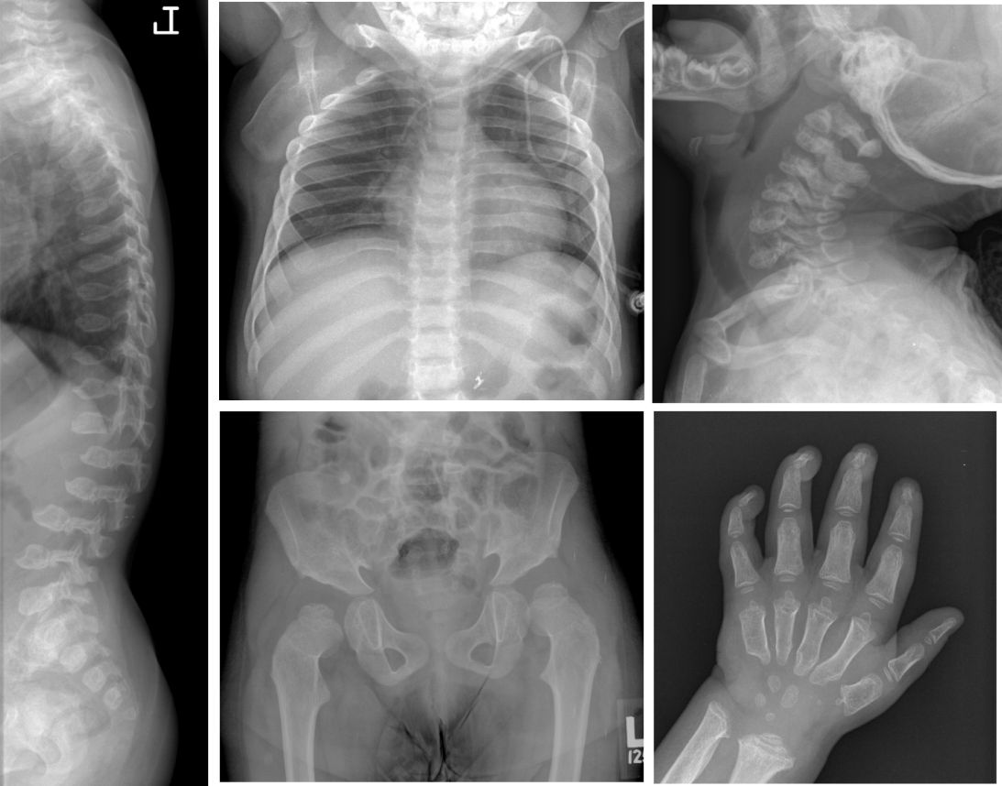
Figure 17. mucopolysaccharidoses. wide ribs, glenoid hypoplasia, steep acetabula with constricted iliac wings, flat/irregular femoral head , spearhead metacarpals, platyspondyly, central anterior vertebral body beaking, hypoplastic odontoid.

Group/name of disorder | Inher. | OMIM | GR | Orpha | Gene
Mucopolysaccharidosis type 1H/1S | AR | 607014 | 1162 | 93473 | IDUA
Mucopolysaccharidosis type 2 | XLR | 309900 | 1274 | 580 | IDS
Mucopolysaccharidosis type 3A | AR | 252900 |  | 581 | SGSH
Mucopolysaccharidosis type 3B | AR | 252920 |  | 581 | NAGLU
Mucopolysaccharidosis type 3C | AR | 252930 |  | 581 | HSGNAT
Mucopolysaccharidosis type 3D | AR | 252940 |  | 581 | GNS
Mucopolysaccharidosis type 4A | AR | 253000 | 148668 | 582 | GALNS
Mucopolysaccharidosis type 4B | AR | 253010 |  | 582 | GLB1
Mucopolysaccharidosis type 6 | AR | 253200 |  | 583 | ARSB
Mucopolysaccharidosis type 7 | AR | 253220 |  | 584 | GUSB
Fucosidosis | AR | 230000 |  | 349 | FUCA1
alpha-Mannosidosis | AR | 248500 | 1396 | 61 | MAN2B1
beta-Mannosidosis | AR | 248510 |  | 118 | MANBA
Aspartylglucosaminuria | AR | 208400 |  | 93 | AGA
GMI Gangliosidosis, several forms | AR | 230500 |  | 354 | GLB1
Sialidosis, several forms | AR | 256550 |  | 812 | NEU1
Sialic acid storage disease (SIASD) | AR | 269920 |  | 834 | SLC17A5
Galactosialidosis, several forms | AR | 256540 |  | 351 | CTSA
Multiple sulfatase deficiency | AR | 272200 |  | 585 | SUMF1
Mucolipidosis II (I-cell disease), alpha/beta type | AR | 252500 | 1828 | 576 | GNPTAB
Mucolipidosis III (Pseudo-Hurler polydystrophy), alpha/beta type | AR | 252600 | 1875 | 577 | GNPTAB
Mucolipidosis III (Pseudo-Hurler polydystrophy), gamma type | AR | 252605 | 24701 | 577 | GNPTG

28. Osteolysis group
Hajdu-Cheney syndrome is characterized by short stature, bowing of the long bones, vertebral anomalies, progressive focal bone destruction, acroosteolysis and generalized osteoporosis. Facial features are coarse and can include hypertelorism, bushy eyebrows, micrognathia, a small mouth with dental anomalies, low-set ears, and short neck.

Group/name of disorder | Inher. | OMIM | GR | Orpha | Gene
Familial expansile osteolysis | AD | 174810 |  | 85195 | TNFRSF11A
Mandibuloacral dysplasia type A | AD | 248370 |  | 90153 | LMNA
Mandibuloacral dysplasia type B | AR | 608612 |  | 90154 | ZMPSTE24
Progeria, Hutchinson-Gilford type | AD | 176670 | 1121 | 740 | LMNA
Torg-Winchester syndrome | AR | 259600 |  | 3460 | MMP2
Hajdu-Cheney syndrome | AD | 102500 |  | 955 | NOTCH2
Multicentric carpal-tarsal osteolysis with and without nephropathy | AD | 166300 |  | 2774 | MAFB
Lipomembraneous osteodystrophy with leukoencephalopathy (presenile dementia with bone cysts; Nasu-Hakola) | AR | 221770 | 1197 | 2770 | TREM2
Lipomembraneous osteodystrophy with leukoencephalopathy (presenile dementia with bone cysts; Nasu-Hakola) | AR | 221770 | 1197 | 2770 | TYROBP

Please also refer to Pycnodysostosis, cleidocranial dysplasia, and Singleton-Merten syndrome. Note: several neurologic conditions may cause acroosteolysis

29. Disorganized development of skeletal components group
Multiple hereditary exostoses are characterized by projections of bone capped by cartilage, in the metaphyses and the diaphyses of long bones.

Fibrodysplasia ossificans progressiva (FOP) is characterized by malformation of the hallux during embryonic skeletal development and by progressive heterotopic endochondral ossification later in life. In the first decade, episodes of painful soft tissue swellings precipitated by soft tissue injury, intramuscular injections, viral infection, muscular stretching, falls or fatigue lead to heterotopic bone formation. The heterotopic bone forms in the skeletal muscles, tendons, ligaments, fascia, and aponeuroses. This phenomenon is seen first in the dorsal, axial, cranial and proximal regions of the body, and later in the ventral, appendicular, caudal and distal regions.

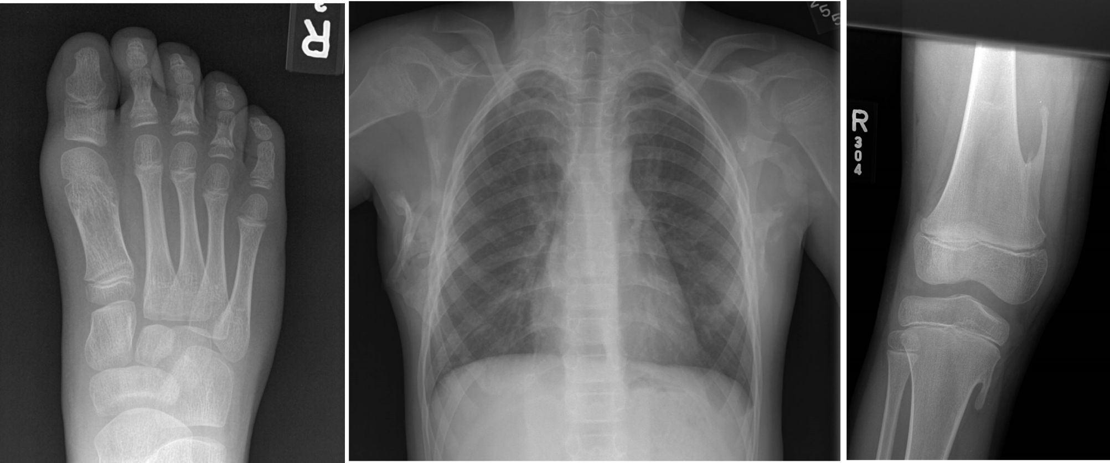
Figure 18. fibrodysplasia ossificans progressive. trapezoid-shaped proximal phalanx of the great toe, soft tissue ossification, exostosis-like structures at sites of ligamentous attachment.

Fibrous dysplasia, polyostotic form, or McCune-Albright syndrome is characterized by polyostotic fibrous dysplasia, cafe au lait cutaneous spots and endocrinopathies (peripheral precocious puberty, thyroidopathies, acromegaly, etc.). The skeletal manifestations are asymmetric fibrous dysplasia affecting any bone. Pathologic fracture, pseudarthrosis, bone deformity such as the shepherd's crook of the proximal femurs are characteristic.

Group/name of disorder | Inher. | OMIM | GR | Orpha | Gene
Multiple cartilaginous exostoses 1 | AD | 133700 | 1235 | 321 | EXT1
Multiple cartilaginous exostoses 2 | AD | 133701 | 1235 | 321 | EXT2
Multiple cartilaginous exostoses 3 | AD | 600209 |  | 321
Cherubism | AD | 118400 | 1137 | 184 | SH3BP2
Fibrous dysplasia, polyostotic form,  McCune-Albright syndrome | SP | 174800 |  | 562 | GNAS
Progressive osseous heteroplasia | AD | 166350 |  | 2762 | GNAS
Gnathodiaphyseal dysplasia | AD | 166260 |  | 53697 | TMEM16E
Metachondromatosis | AD | 156250 |  | 2499 | PTPN11
Osteoglophonic dysplasia | AD | 166250 | 1455 | 2645 | FGFR1
Fibrodysplasia ossificans progressiva (FOP) | AD, SP | 135100 |  | 337 | ACVR1
Neurofibromatosis type 1 (NF1) | AD | 162200 | 1109 | 636 | NF1
Carpotarsal osteochondromatosis | AD | 127820 |  | 2767
Cherubism with gingival fibromatosis (Ramon syndrome) | AR | 266270 |  | 3019
Dysplasia epiphysealis hemimelica (Trevor) | SP | 127800 |  | 1822
Enchondromatosis (Ollier) | SP | 166000 |  | 296 | IDH1, IDH2, and PTH1R
Enchondromatosis with hemangiomata (Maffucci) | SP | 166000 |  | 296 | DH1, IDH2, and PTH1R
Please also refer to Proteus syndrome in group 30.

30. Overgrowth syndromes with skeletal involvement
Marfan syndrome manifests with skeletal, ocular and cardiovascular features. Skeletal features include joint laxity, scoliosis and extremities that are disproportionately long for the size of the trunk. Overgrowth of the ribs can cause pectus excavatum or carinatum. Ocular features include myopia and displacement of the lens from the center of the pupil. Cardiovascular features include dilatation of the aorta, susceptibility to aortic tear and rupture, mitral or tricuspid valve prolapse, and enlargement of the proximal pulmonary artery.

Group/name of disorder | Inher. | OMIM | GR | Orpha | Gene
Weaver syndrome | SP/AD | 277590 |  | 3447 | EZH2
Sotos syndrome | AD | 117550 | 1479 | 821 | NSD1
Marshall-Smith syndrome | SP | 602535 |  | 561 | NFIX
Proteus syndrome | SP | 176920 | 99495 | 744 | AKT1
Marfan syndrome | AD | 154700 | 1335 | 558 | FBN1
Congenital contractural arachnodactyly | AD | 121050 | 1386 | 115 | FBN2
Loeys-Dietz syndrome types 1A and 2A | AD | 609192,610168, | 1133 |  | TGFBR1
Loeys-Dietz syndrome types 1B and 2B | AD | 608967, 610380 | 1133 |  | TGFBR2
Loeys-Dietz syndrome, type 3 | AD | 613795 | 1133 | 284984 | SMAD3
Loeys-Dietz syndrome, type 4 | AD | 614816 | 1133 | 91387 | TGFB2
Overgrowth syndrome with 2q37 translocations | SP |  |  |  | NPPC
Overgrowth syndrome with skeletal dysplasia (Nishimura-Schmidt, endochondral gigantism) | SP?

Please also refer to Shprintzen-Goldberg syndrome in Craniosynostosis group

31. Genetic inflammatory/rheumatoid-like osteoarthropathies
Familial hyperphosphatemic tumoral calcinosis is characterized by the progressive deposition of calcium phosphate crystals in periarticular spaces, soft tissues, and bones (periosteal reaction and cortical hyperostosis). It is caused by increased renal absorption of phosphate secondary to loss-of-function mutations in FGF23 or GALNT3.

Group/name of disorder | Inher. | OMIM | GR | Orpha | Gene
Progressive pseudorheumatoid dysplasia (PPRD; SED with progressive arthropathy) | AR | 208230 |  | 1159 | WISP3
Chronic infantile neurologic cutaneous articular syndrome (CINCA)/neonatal onset multisystem inflammatory disease (NOMID) | AD | 607115 |  | 1451 | CIAS1
Sterile multifocal osteomyelitis, periostitis, and pustulosis (CINCA/NOMID-like) | AR | 612852 |  | 210115 | IL1RN
Chronic recurrent multifocal osteomyelitis with congenital dyserythropoietic anemia (CRMO with CDA; Majeed syndrome) | AR | 609628 | 1974 | 77297 | LPIN2
Tumoral calcinosis, hyperphosphatemic, familial | AR | 211900 |  | 53715 | GALNT3, FGF23, KL
Infantile systemic hyalinosis/Juvenile hyaline fibromatosis (ISH/JHF) | AR | 236490 | 1525 | 2176 | ANTXR2
camptodactyly-arthropathy-coxa vara-pericarditis syndrome (non-inflammatory) | AR | 208250 |  | 2848 | PRG4

32. Cleidocranial dysplasia and isolated cranial ossification defects group
Cleidocranial dysplasia manifests with large, wide-open fontanels at birth which may remain open with bulging calvaria, mid-face hypoplasia, hypoplasia or aplasia of the clavicles permitting apposition of the shoulders, wide pubic symphysis, brachydactyly, tapering fingers, and short, broad thumbs, dental anomalies (delayed eruption of secondary dentition, failure to shed the primary teeth, supernumerary teeth with dental crowding, and malocclusion).

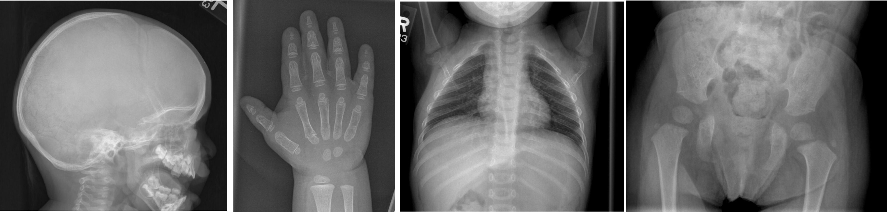
Figure 19. Cleidocranial dysplasia. wormian bones, partial (or rarely complete) absence of clavicle, widened symphysis pubis, tall femoral head ossification centers, cone-shaped epiphyses.

Group/name of disorder | Inher. | OMIM | GR | Orpha | Gene
Cleidocranial dysplasia | AD | 119600 | 1513 | 1452 | RUNX2
CDAGS syndrome (craniosynostosis, delayed fontanel closure, parietal foramina, imperforate anus, genital anomalies, skin eruption) | AR | 603116 |  | 85199
Yunis-Varon syndrome | AR | 216340 |  | 3472 | FIG4
Parietal foramina (isolated) | AD | 168500 | 1128 | 60015 | ALX4
Parietal foramina (isolated) | AD | 168500 | 1128 | 60015 | MSX2
Please also refer to pycnodysostosis, wrinkly skin syndrome, and several others

33. Craniosynostosis syndromes
Craniosynostosis is often secondary to mutations in one of the FGFR genes . In Apert syndrome (FGFR2) there is midface hypoplasia and symmetrical syndactyly of hands and feet. In Crouzon syndrome there is maxillary hypoplasia, shallow orbits, ocular proptosis, and normal extremities. It is caused by FGFR2 mutations unless there is acanthosis nigricans (FGFR3). In Muenke syndrome (FGFR3), there is unilateral or bilateral coronal synostosis, and absent or minimal hand/foot anomalies. In Pfeiffer syndrome there is high forehead, maxillary hypoplasia, mild syndactyly of hands and/or feet, broad thumbs and/or great toe (FGFR2, rarely FGFR1). In Saethre-Chotzen syndrome there is brachycephaly/plagiocephaly, a high forehead, facial asymmetry, maxillary hypoplasia, brachydactyly, partial cutaneous syndactyly in some cases, and thumb/great toe anomalies (TWIST gene, occasionally FGFR3).

Group/name of disorder | Inher. | OMIM | GR | Orpha | Gene
Pfeiffer syndrome (FGFR1-related) | AD | 101600 | 1455 | 710 | FGFR1
Pfeiffer syndrome (FGFR2-related) | AD | 101600 | 1455 | 710 | FGFR2
Apert syndrome | AD | 101200 | 1455 | 87 | FGFR2
Craniosynostosis with cutis gyrata (Beare-Stevenson) | AD | 123790 | 1455 | 1555 | FGFR2
Crouzon syndrome | AD | 123500 | 1455 | 207 | FGFR2
Crouzon-like craniosynostosis with acanthosis nigricans (Crouzonodermoskeletal syndrome) | AD | 612247 | 1455 | 93262 | FGFR3
Craniosynostosis, Muenke type | AD | 602849 | 1455 | 53271 | FGFR3
Antley-Bixler syndrome | AR | 201750 | 1419 | 63269 | POR
Craniosynostosis Boston type | AD | 604757 |  | 1541 | MSX2
Saethre-Chotzen syndrome | AD | 101400 | 1189 | 794 | TWIST1
Shprintzen-Goldberg syndrome | AD | 182212 | 1277 | 2462 | SKI
Baller-Gerold syndrome | AR | 218600 | 1204 | 1225 | RECQL4
Carpenter syndrome | AR | 201000 |  | 65759 | RAB23
Please also refer to Cole-Carpenter syndrome in group 24, CDAGS syndrome in group 29, and Craniofrontonasal syndrome in group 34

34. Dysostoses with predominant craniofacial involvement
Treacher Collins syndrome manifests with fdownslanting eyes, coloboma of the eyelids, micrognathia, microtia and other deformity of the ears, hypoplastic zygomatic arches, macrostomia, conductive hearing loss and cleft palate.

Group/name of disorder | Inher. | OMIM | GR | Orpha | Gene
Mandibulo-facial dysostosis (Treacher Collins, Franceschetti-Klein) | AD | 154500 | 1532 | 861 | TCOF1
Mandibulo-facial dysostosis (Treacher-Collins, Franceschetti-Klein) | AD | 154500 | 1532 | 861 | POLR1D
Mandibulo-facial dysostosis (Treacher-Collins, Franceschetti-Klein) | AR | 154500 | 1532 | 861 | POLR1C
Oral-facial-digital syndrome type I (OFD1) | XLR | 311200 |  | 2750 | CXORF5
Weyer acrofacial (acrodental) dysostosis | AD | 193530 |  | 952 | EVC1
Endocrine-cerebro-osteodysplasia (ECO) | AR | 612651 |  | 199332 | ICK
Craniofrontonasal syndrome | XLD | 304110 |  | 1520 | EFNB1
Frontonasal dysplasia, type 1 | AR | 136760 |  | 250 | ALX3
Frontonasal dysplasia, type 2 | AR | 613451 |  | 228390 | ALX4
Frontonasal dysplasia, type 3 | AR | 613456 |  | 306542 | ALX1
Hemifacial microsomia | SP/AD | 164210 | 5199 | 374
Miller syndrome (postaxial acrofacial dysostosis) | AR | 263750 |  | 246 | DHODH
Acrofacial dysostosis, Nager type | AD/AR | 154400 |  | 245 | SF3B4
Acrofacial dysostosis, Rodriguez type | AR | 201170 |  | 1788
Please also refer to Oral-facial-digital syndrome type IV in the Short Rib Dysplasias group

35. Dysostoses with predominant vertebral with and without costal involvement
In spondylocostal dysostosis, there are multiple segmentation defects of the vertebrae, malalignment of the ribs with variable points of intercostal fusion, and a reduction in rib number. Clinically there is scoliosis, a short neck and trunk.

Group/name of disorder | Inher. | OMIM | GR | Orpha | Gene
Currarino triad | AD | 176450 |  | 1552 | HLXB9
Spondylocostal dysostosis type 1 (SCD1) | AR | 277300 | 8828 | 2311 | DLL3
Spondylocostal dysostosis type 2 (SCD2) | AR | 608681 | 8828 | 2311 | MESP2
Spondylocostal dysostosis type 3 (SCD3) | AR? | 609813 | 8828 | 2311 | LFNG
Spondylocostal dysostosis type 4 (SCD4) | AR | 613686 | 8828 | 2311 | HES7
Spondylothoracic dysostosis | AR | 122600 | 8828 | 1797 | MESP2
Klippel-Feil anomaly with laryngeal malformation | AD | 118100 |  | 2345 | GDF6
Spondylocostal/thoracic dysostosis, other forms | AD/AR
Cerebro-costo-mandibular syndrome (rib gap syndrome) | AD/AR | 117650 |  | 1393
Cerebro-costo-mandibular-like syndrome with vertebral defects | AR | 611209 |  | 263508 | COG1
Diaphanospondylodysostosis | AR | 608022 |  | 66637 | BMPER
Please also refer to Spondylocarpotarsal dysplasia in group 7 and spondylo-metaphyseal-megaepiphyseal dysplasia in group 13

36. Patellar dysostoses
Nail-patella syndrome presents with patella hypoplasia, nail hypoplasia or dystrophy, elbow and knee deformities (limitation of elbow extension, pronation, and supination; cubitus valgus; and antecubital pterygia), iliac horns (bilateral, conical bony processes projecting posteriorly and laterally from the central part of the iliac bones of the pelvis), nephropathy (nephrotic syndrome which may progress to end-stage renal disease), and ocular defects (cloverleaf appearance of the iris, primary open angle glaucoma).

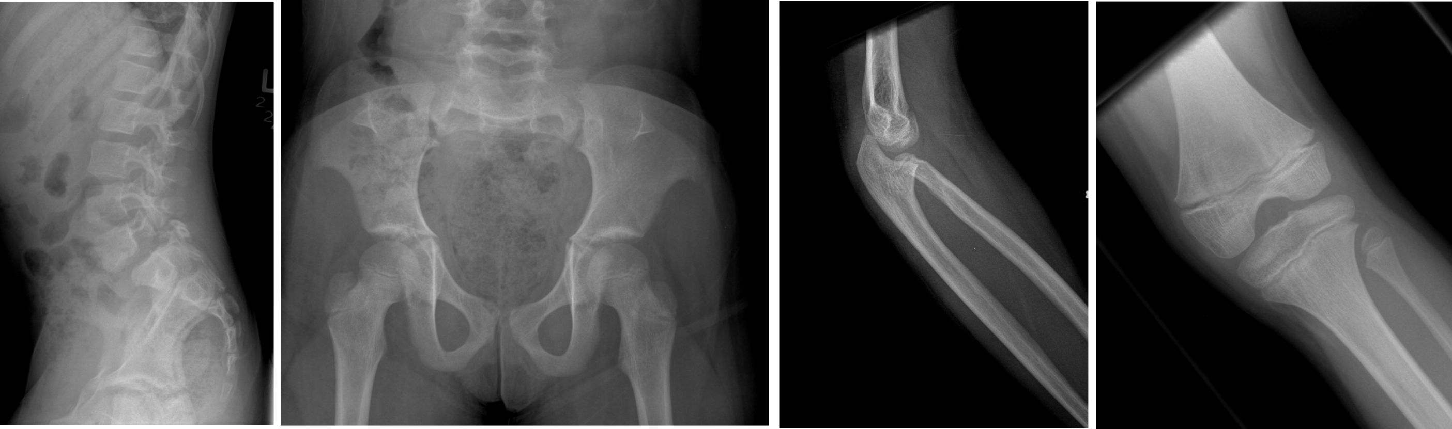
Figure 20. Nail-patella syndrome. absent patella, iliac horns, radial head dislocation, spondylolysthesis.

Group/name of disorder | Inher. | OMIM | GR | Orpha | Gene
Ischiopatellar dysplasia (small patella syndrome) | AD | 147891 |  | 1509 | TBX4
Small patella—like syndrome with clubfoot | AD | 119800 |  | 293150 | PITX1
Nail-patella syndrome | AD | 161200 | 1132 | 2614 | LMX1B
Genitopatellar syndrome | AR? | 606170 | 114806 | 85201 | KAT6B
Ear-patella-short stature syndrome (Meier-Gorlin) | AR | 224690 |  | 2554 | ORC1, ORC1L, ORC4, ORC4L, ORC6, ORC6L, CDT1, CDC6, CDC18L
Please also refer to MED group for conditions with patellar changes as well as ischio-pubic-patellar dysplasia as mild expression of campomelic dysplasia
37. Brachydactylies (with or without extraskeletal manifestations)
Coffin-Siris syndrome (CSS) is characterized by aplasia or hypoplasia of the distal phalanx or nail of the fifth digit (or more digits), distinctive facial features (wide mouth with thick, everted upper and lower lips, broad nasal bridge with broad nasal tip, thick eyebrows and long eyelashes), and moderate to severe developmental/cognitive delay.

Thorough discourses on the genes involved in each condition can be found in papers by Schwabe and Mundlos , Temtamy and Aglan , and Mundlos .

Group/name of disorder | Inher. | OMIM | GR | Orpha | Gene
Brachydactyly type A1 | AD | 112500 |  | 93388 | IHH
Brachydactyly type A1 | AD |  |  |  | 5p13.3-p13.2
Brachydactyly type A2 | AD | 112600 |  | 93396 | BMPR1B
Brachydactyly type A2 | AD | 112600 |  | 93396 | BMP2
Brachydactyly type A2 | AD | 112600 |  | 93396 | GDF5
Brachydactyly type A3 | AD | 112700 |  | 93393
Brachydactyly type B | AD | 113000 |  | 93383 | ROR2
Brachydactyly type B2 | AD | 611377 |  | 140908 | NOG
Brachydactyly type C | AD, AR | 113100 |  | 93384 | GDF5
Brachydactyly type D | AD | 113200 |  | 93385 | HOXD13
Brachydactyly type E | AD | 113300 |  | 93387 | PTHLH
Brachydactyly type E | AD | 113300 |  | 93387 | HOXD13
Brachydactyly—mental retardation syndrome | AD | 600430 |  | 1001 | HDAC4
Hyperphosphatasia with mental retardation, brachytelephalangy, and distinct face | AR | 239300 |  | 247262 | PIGV
Brachydactyly-hypertension syndrome (Bilginturian) | AD | 112410 |  | 1276
Brachydactyly with anonychia (Cooks syndrome) | AD | 106995 |  | 1487 | SOX9
Microcephaly-oculo-digito-esophageal-duodenal syndrome (Feingold syndrome) | AD | 164280 | 7050 | 1305 | MYCN
Hand-foot-genital syndrome | AD | 140000 | 1423 | 2438 | HOXA13
Brachydactyly with elbow dysplasia (Liebenberg syndrome) | AD | 186550 |  | 1275 | PITX1
Keutel syndrome | AR | 245150 |  | 85202 | MGP
Albright hereditary osteodystrophy (AHO) | AD | 103580 |  | 665 | GNAS1
Rubinstein-Taybi syndrome | AD | 180849 | 1526 | 783 | CREBBP
Rubinstein-Taybi syndrome | AD | 180849 | 1526 | 783 | EP300
Catel-Manzke syndrome | XLR? | 302380 |  | 1388
Brachydactyly, Temtamy type | AR | 605282 |  |  | CHSY1
Christian type brachydactyly | AD | 112450 |  | 1278
Coffin-Siris syndrome | AR | 135900 | 131811 | 1465 | SMARCA2, SMARCA4, SMARCB1, SMARCE1, ARID1A, ARID1B
Mononen type brachydactyly | XLD? | 301940 |  | 2565
Poland anomaly | SP | 173800 |  | 2911

Please also refer to group 20 for other conditions with brachydactyly as well as brachytelephalangic CDP

38. Limb hypoplasia—reduction defects group
Fanconi anemia can present with bone marrow failure, developmental delay and central nervous system malformation, short stature, skeletal anomalies often involving the radial ray, anomalies of the eyes, kidneys and urinary tract, ears (including deafness), heart, gastrointestinal system, abnormal skin pigmentation, and hypogonadism. There is an increased risk of malignancy.

Group/name of disorder | Inher. | OMIM | GR | Orpha | Gene
Ulnar-mammary syndrome | AD | 181450 |  | 3138 | TBX3
de Lange syndrome | AD | 122470 | 1104 | 199 | NIPBL
Fanconi anemia | AR | 227650 | 1401 | 84 | Several genes, see OMIM
Thrombocytopenia-absent radius (TAR) | AR?/AD? | 274000 | 23758 | 3320 | Several
Thrombocythemia with distal limb defects | AD |  |  | 329319 | THPO
Holt-Oram syndrome | AD | 142900 | 1111 | 392 | TBX5
Okihiro syndrome (Duane—radial ray anomaly) | AD | 607323 | 1373 | 959 | SALL4
Cousin syndrome | AR | 260660 |  | 93333 | TBX15
Roberts syndrome | AR | 268300 | 1153 | 3103 | ESCO2
Split-hand-foot malformation with long bone deficiency (SHFLD1) | AD | 119100 |  | 3329
Split-hand-foot malformation with long bone deficiency (SHFLD2) | AD | 610685 |  | 3329
Split-hand-foot malformation with long bone deficiency (SHFLD3) | AD | 612576 |  | 3329
Tibial hemimelia | AR | 275220 |  | 93322
Tibial hemimelia-polysyndactyly-triphalangeal thumb | AD | 188770 |  | 3332
Acheiropodia | AR | 200500 |  | 931 | LMBR1
Tetra-amelia | XL | 301090 | 1276 | 3301
Tetra-amelia | AR | 273395 | 1276 | 3301 | WNT3
Ankyloblepharon-ectodermal dysplasia-cleft lip/palate (AEC) | AD | 106260 | 43797 | 1071 | TP63
Ectrodactyly-ectodermal dysplasia cleft-palate syndrome Type 3 (EEC3) | AD | 604292 |  | 1896 | TP63
Ectrodactyly-ectodermal dysplasia cleft-palate syndrome type 1 (EEC1) | AD | 129900 |  | 1896
Ectrodactyly-ectodermal dysplasia-macular dystrophy syndrome (EEM) | AR | 225280 |  | 1897 | CDH3
Limb-mammary syndrome (including ADULT syndrome) | AD | 603543 | 43797 | 69085 | TP63
Split hand-foot malformation, isolated form, type 4 (SHFM4) | AD | 605289 | 43797 | 2440 | TP63
Split hand-foot malformation, isolated form, type 1 (SHFM1) | AD | 183600 |  | 2440
Split hand-foot Malformation, isolated form, type 2 (SHFM2) | XL | 313350 |  | 2440
Split hand-foot malformation, isolated form, type 3 (SHFM3) | AD | 246560 |  | 1307 | FBXW4
Split hand-foot malformation, isolated form, type 5 (SHFM5) | AD | 606708 |  | 2440
Split-hand/foot malformation 1 with sensorineural hearing loss | AR | 220600 |  | 71271 | DLX5
Split-hand/foot malformation 6 | AR | 225300 |  | 2440 | WNT10B
Al-Awadi Raas-Rothschild limb-pelvis hypoplasia-aplasia | AR | 276820 |  | 2879 | WNT7A
Fuhrmann syndrome | AR | 228930 |  | 2854 | WNT7A
RAPADILINO syndrome | AR | 266280 | 1204 | 3021 | RECQL4
Adams-Oliver syndrome | AD/AR | 100300 |  | 974 | ARHGAP31, DOCK6, RBPJ, EOGT
Femoral hypoplasia-unusual face syndrome (FHUFS) | SP/AD? | 134780 |  | 1988
Femur-fibula-ulna syndrome (FFU) | SP? | 228200 |  | 2019
Hanhart syndrome (hypoglossia-hypodactylia) | AD | 103300 |  | 989
Scapulo-iliac dysplasia (Kosenow) | AD | 169550 |  | 2839
Please also refer to CHILD in group 20 and the mesomelic and acromesomelic dysplasias

39. Polydactyly-Syndactyly-Triphalangism group
Pallister-Hall syndrome manifests with hypothalamic hamartoma, pituitary dysfunction, bifid epiglottis, laryngotracheal cleft, central polydactyly, and visceral malformations.

Meckel syndrome presents with variable combinations of renal cysts, developmental anomalies of the central nervous system (occipital encephalocele), hepatic ductal dysplasia and cysts, and polydactyly.

Group/name of disorder | Inher. | OMIM | GR | Orpha | Gene
Preaxial polydactyly type 1 (PPD1) | AD | 174400 |  | 93339 | SHH
Preaxial polydactyly type 1 (PPD1) | AD | 174400 |  | 93339 | Other locus
Preaxial polydactyly type 2 (PPD2)/triphalangeal thumb (TPT) | AD | 174500 |  | 2950 | SHH
Preaxial polydactyly type 3 (PPD3) | AD | 174600 |  | 93337 | Other locus
Preaxial polydactyly type 4 (PPD4) | AD | 174700 |  | 93338 | GLI3
Greig cephalopolysyndactyly syndrome | AD | 175700 | 1446 | 380 | GLI3
Pallister-Hall syndrome | AD | 146510 | 1465 | 672 | GLI3
Synpolydactyly (complex, fibulin1—associated) | AD | 608180 |  | 295197 | FBLN1
Synpolydactyly | AD | 186000 |  | 295195 | HOXD13
Townes-Brocks syndrome (Renal-Ear-Anal-Radial syndrome) | AD | 107480 | 1445 | 857 | SALL1
Lacrimo-auriculo-dento-digital syndrome (LADD) | AD | 149730 |  | 2363 | FGFR2, FGFR3, FGF10
Acrocallosal syndrome | AR | 200990 |  | 36 | KIF7
Acro-pectoral syndrome | AD | 605967 |  | 85203
Acro-pectoro-vertebral dysplasia (F-syndrome) | AD | 102510 |  | 957
Mirror-image polydactyly of hands and feet (Laurin-Sandrow syndrome) | AD | 135750 |  | 2378 | SHH
Mirror-image polydactyly of hands and feet (Laurin-Sandrow syndrome) |  |  |  |  | Other locus
Cenani-Lenz syndactyly | AR | 212780 |  | 3258 | LRP4
Cenani-Lenz like syndactyly | SP (AD?) |  |  |  | GREM1, FMN1
Oligosyndactyly, radio-ulnar synostosis, hearing loss, and renal defects syndrome | SP (AR?) |  |  |  | FMN1
Syndactyly, Malik-Percin type | AD | 609432 |  | 157801
STAR syndrome (syndactyly of toes, telecanthus, ano-, and renal malformations) | XL | 300707 |  | 140952 | FAM58A
Syndactyly type 1 (III-IV) | AD | 185900 |  | 93402
Syndactyly type 3 (IV-V) | AD | 185900 |  | 93402 | GJA1
Syndactyly type 4 (I-V) Haas type | AD | 186200 |  | 93405 | SHH
Syndactyly type 5 (syndactyly with metacarpal and metatarsal fusion) | AD | 186300 |  | 93406 | HOXD13
Syndactyly with craniosynostosis (Philadelphia type) | AD | 601222 |  | 1527
Syndactyly with microcephaly and mental retardation (Filippi syndrome) | AR | 272440 |  | 3255
Jawad syndrome | AR | 251255 |  | 313795 | RBBP8
Meckel syndrome type 1 | AR | 249000 |  | 564 | MKS1
Meckel syndrome type 2 | AR | 603194 |  | 564 | TMEM216
Meckel syndrome type 3 | AR | 607361 |  | 564 | TMEM67
Meckel syndrome type 4 | AR | 611134 |  | 564 | CEP290
Meckel syndrome type 5 | AR | 611561 |  | 564 | RPGRIP1L
Meckel syndrome type 6 | AR | 612284 |  | 564 | CC2D2A
Note: the Smith-Lemli-Opitz syndrome can present with polydactyly and/or syndactyly. Please also refer to the SRPS group.

40. Defects in joint formation and synostoses
Proximal symphalangism is characterized by fusion of the proximal interphalangeal joints, but can also involve the elbows, ankles and wrists leading to ankylosis. Conductive deafness secondary to fusion of the ossicles is also seen.

Group/name of disorder | Inher. | OMIM | Orpha | Gene
Multiple synostoses syndrome type 1 | AD | 186500 | 3237 | NOG
Multiple synostoses syndrome type 2 | AD | 186500 | 3237 | GDF5
Multiple synostoses syndrome type 3 | AD | 612961 | 3237 | FGF9
Proximal symphalangism type 1 | AD | 185800 | 3250 | NOG
Proximal symphalangism type 2 | AD | 185800 | 3250 | GDF5
Radio-ulnar synostosis with amegakaryocytic thrombocytopenia | AD | 605432 | 71289 | HOXA11

Please also refer to Spondylo-Carpal-Tarsal dysplasia; mesomelic dysplasia with acral synostoses; and others.

References

1. M. L. Warman et al., Nosology and classification of genetic skeletal disorders: 2010 revision. American journal of medical genetics. Part A 155A, 943 (May, 2011).
2. R. E. Stevenson, J. G. Hall, R. M. Goodman, Human malformations and related anomalies. (Oxford University Press, New York, 1993).
3. J. r. W. Spranger, Bone dysplasias : an atlas of genetic disorders of skeletal development. (Oxford University Press, Oxford ; New York, ed. 3rd, 2012), pp. xxiii, 802 p.
4. Y. Alanay, R. S. Lachman, A review of the principles of radiological assessment of skeletal dysplasias. Journal of clinical research in pediatric endocrinology 3, 163 (2011).
5. S. R. Rose, M. G. Vogiatzi, K. C. Copeland, A general pediatric approach to evaluating a short child. Pediatrics in review / American Academy of Pediatrics 26, 410 (Nov, 2005).
6. J. Spranger, A. Winterpacht, B. Zabel, The type II collagenopathies: a spectrum of chondrodysplasias. European journal of pediatrics 153, 56 (Feb, 1994).
7. N. H. Elcioglu, C. M. Hall, Diagnostic dilemmas in the short rib-polydactyly syndrome group. American journal of medical genetics 111, 392 (Sep 1, 2002).
8. S. Naik, I. K. Temple, Coat hanger appearances of the ribs: a useful diagnostic marker of paternal uniparental disomy of chromosome 14. Archives of disease in childhood 95, 909 (Nov, 2010).
9. S. Unger, L. Bonafe, A. Superti-Furga, Multiple epiphyseal dysplasia: clinical and radiographic features, differential diagnosis and molecular basis. Best practice & research. Clinical rheumatology 22, 19 (Mar, 2008).
10. Z. Stark, R. Savarirayan, Osteopetrosis. Orphanet journal of rare diseases 4, 5 (2009).
11. R. Lachman et al., Radiologic and neuroradiologic findings in the mucopolysaccharidoses. Journal of pediatric rehabilitation medicine 3, 109 (2010).
12. K. Chun, A. S. Teebi, C. Azimi, L. Steele, P. N. Ray, Screening of patients with craniosynostosis: molecular strategy. American journal of medical genetics. Part A 120A, 470 (Aug 1, 2003).
13. G. C. Schwabe, S. Mundlos, Genetics of congenital hand anomalies. Handchirurgie, Mikrochirurgie, plastische Chirurgie : Organ der Deutschsprachigen Arbeitsgemeinschaft fur Handchirurgie : Organ der Deutschsprachigen Arbeitsgemeinschaft fur Mikrochirurgie der Peripheren Nerven und Gefasse 36, 85 (Apr-Jun, 2004).
14. S. A. Temtamy, M. S. Aglan, Brachydactyly. Orphanet journal of rare diseases 3, 15 (2008).
15. S. Mundlos, The brachydactylies: a molecular disease family. Clinical genetics 76, 123 (Aug, 2009).

