THE MANAGEMENT OF TYPE 1 DIABETES

Savitha Subramanian M.D. University of Washington School of Medicine, 4245 Roosevelt Way NE, Suite 101, Seattle, WA 98105 email: ssubrama@uw.edu
David Baidal, M.D. Assistant Professor of Medicine, Division of Endocrinology, Diabetes and Metabolism, University of Miami email: dbaidal@med.miami.edu
Jay S. Skyler, M.D. University of Miami School of Medicine
Irl B. Hirsch, M.D., University of Washington School of Medicine, 4245 Roosevelt Way NE, 3rd Floor, Seattle, WA 98105

Received 13 November 2016

ABSTRACT

Type 1 diabetes (T1D) is an autoimmune disease characterized by progressive pancreatic beta-cell loss resulting in insulin deficiency and hyperglycemia. Exogenous insulin therapy is essential to prevent fatal complications from hyperglycemia. The Diabetes Control and Complications Trial and its long-term follow up, the Epidemiology of Diabetes and its Complications study, demonstrated that stringent glycemic control with intensive insulin therapy can prevent or postpone progression of microvascular disease and reduce risk for macrovascular disease and all-cause mortality. In addition, data obtained from the T1D Exchange, a registry of T1D patients founded in 2010, has become an invaluable resource for scientists worldwide, facilitating collaboration and accelerating understanding of prevailing diabetes practices.
Insulin therapy using rapid- and long-acting insulin analogues is the mainstay of management of T1D. Insulin delivery is achieved subcutaneously using multiple daily injections or subcutaneous insulin infusion using insulin pumps. Effective management also involves use of self-monitoring of blood glucose using improved blood glucose meters, continuous glucose monitoring (CGM) devices, and newer insulin pumps with integrated sensor-augmented systems. Addressing psychosocial aspects of T1D plays a crucial role in effective disease management. Strategies to manage T1D are rapidly evolving. In addition to newer insulins, adjunctive non-insulin therapies such as use of incretin agents and SGLT-2 and combination SGLT-1/2 inhibitors are being actively pursued. CGM technology combined with glucose prediction algorithms has allowed for the development of artificial pancreas delivery systems which are actively being tested in clinical trials. Cellular replacement options include pancreas and islet cell transplantation which can restore euglycemia but are limited by donor availability and the need for chronic immunosuppression. Newer strategies under development include islet cell encapsulation techniques, which might obviate the need for immunosuppression. Smart-insulin delivery systems, capable of releasing insulin depending on ambient glucose, are also being evaluated.
HISTORY OF TYPE 1 DIABETES TREATMENTS

Insulin Therapy

The discovery of insulin in 1921-22 was one of the greatest medical breakthroughs in history [1] (Figure 1). Individuals, mostly children with type 1 diabetes (T1D), whose life expectancies were measured in months were now able to prevent fatal ketoacidosis by taking injections of crude “soluble” (later known as regular) insulin. However, new problems were soon noted. Hypoglycemia, occasionally life-threatening, was encountered as diabetes monitoring by urine testing for glycosuria was crude at best during those first decades after the discovery of insulin. The insulin itself was often impure and varied in potency from lot to lot. Allergic reactions were common and occasionally anaphylaxis would occur. Even more concerning was the appreciation that these patients often succumbed to chronic vascular complications which either dramatically reduced quality of life or resulted in a fatal cardiovascular event.

Tools to manage individuals with T1D improved over the decades since the discovery of insulin. Initial insulins were manufactured from bovine or porcine pancreata and production techniques became more efficient. Insulins with longer duration of action were first introduced in the 1930s, and over time purity and consistency of potency of these insulins improved [2]. Nevertheless, “standard” animal insulins prior to 1980 contained 300-10000 parts per million of impurities, and elicited local and systemic effects when injected. Present day insulins sold in the United States today all contain less than 1 part per million of impurities.

Major improvements in the tools to manage T1D were developed in the late 1970s and early 1980s. First, not only was “purified” insulin introduced, but in 1982 the first human insulin was marketed both by Eli Lilly (recombinant DNA technology) and Novo (semi-synthetic methodology). These insulins were available as short-acting (regular) and longer-acting [Neutral protamine Hagedorn (NPH), lente, and ultralente] preparations. The other major advance with insulin therapy was with the delivery by the first continuous subcutaneous insulin infusion (CSII) pumps. While pumps were initially touted as providing less variable insulin absorption, the use of CSII had a greater impact: both patients and clinicians used this tool to teach themselves how to best use “basal bolus” therapy, a strategy that would become a standard of care after the beginning of the next century with the development of insulin analogues.

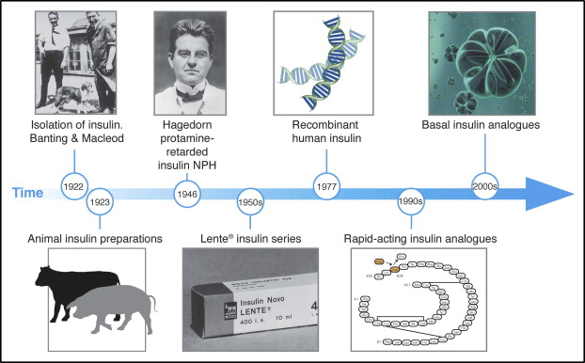

Figure 1. Time line of the evolution of insulin therapy. Figure source ref 3.

Monitoring Tools

At the same time as the development of human insulin and insulin pumps, improvements in glucose monitoring were introduced. Although there was initial skepticism if home blood glucose monitoring would be accepted by patients with diabetes, history has confirmed that this technology has revolutionized diabetes management and has allowed patients to titrate blood glucose to normal or near-normal levels. While self-monitoring of blood glucose (SMBG) allowed immediate evaluation of diabetes management, the introduction of hemoglobin A1c (HbA1c, or glycated hemoglobin, A1C) around the same time was used as a marker of objective longer-term (about 90 days) glucose control. When hemoglobin is exposed to glucose in the bloodstream, the glucose slowly becomes nonenzymatically bound to the hemoglobin in a concentration-dependent manner. The percentage of hemoglobin molecules that are glycated (have glucose bound to it) indicates what the average blood glucose concentration has been over the life of the cell. Perhaps as importantly, A1C made it possible for researchers to study the effects of long-term glucose control and the development of vascular complications. New students of diabetes may now find it difficult to appreciate that one of the greatest medical controversies between the discovery of insulin and the early 1990s was the relationship between glucose control and diabetes complications. Improved insulins, pumps, SMBG, and A1C finally allowed this question to be properly studied.

THE DIABETES CONTROL AND COMPLICATIONS TRIAL

In 1993, all controversy regarding the impact of glucose control and vascular complications was dramatically answered with the publication of the Diabetes Control and Complications Trial (DCCT)[4]. The trial showed definitively that stringent blood glucose control (for an average of 6.5 years) could slow or postpone the progression of retinal, renal, and neurological complications in individuals with T1D (Figure 2). In patients treated with “intensive therapy”—that is, therapy aimed at maintaining blood glucose levels as close to normal as possible—the risk of developing diabetic retinopathy was reduced by 76%, diabetic neuropathy by 60%, and diabetic nephropathy by 54%, compared with conventionally treated patients. Other benefits of intensive diabetes management include improved lipid profiles, reduced risk factors for macrovascular disease, and better maternal and fetal health.

Since the DCCT was completed in 1993, the research subjects have been followed in an observational study called Epidemiology of Diabetes and its Complications (EDIC) [5]. It was soon observed that the impact of this improved diabetes therapy for an average of 6.5 years (maintaining a A1C of approximately 7% with multiple injections or CSII compared to once or twice daily insulin and a A1C of approximately 9%) had long-lasting effects. Termed “metabolic memory”, there continued to be improvements in microvascular complications four years after the DCCT ended (Figure 3) [6-8]. Despite the fact that A1C levels remained about 8% for both groups after the DCCT, the risk reduction for nonfatal myocardial infarction, stroke, or death were reduced by 57% eleven years after the conclusion of the formal study. The conclusions of this are profound since this was the first study to report a reduction of macrovascular disease with glucose control. Furthermore, these data confirmed the need to control blood glucose as meticulously as possible early in the course of the disease [9].

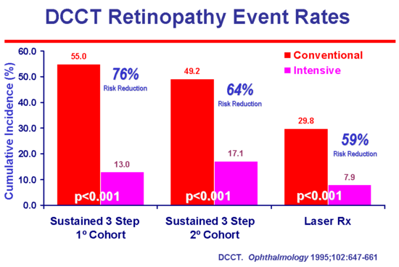
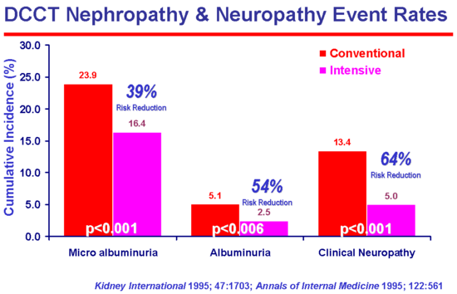

Figure 2: Relationship between microvascular complications and A1C in T1D

Figure 2: Relationship between microvascular complications and A1C in T1D

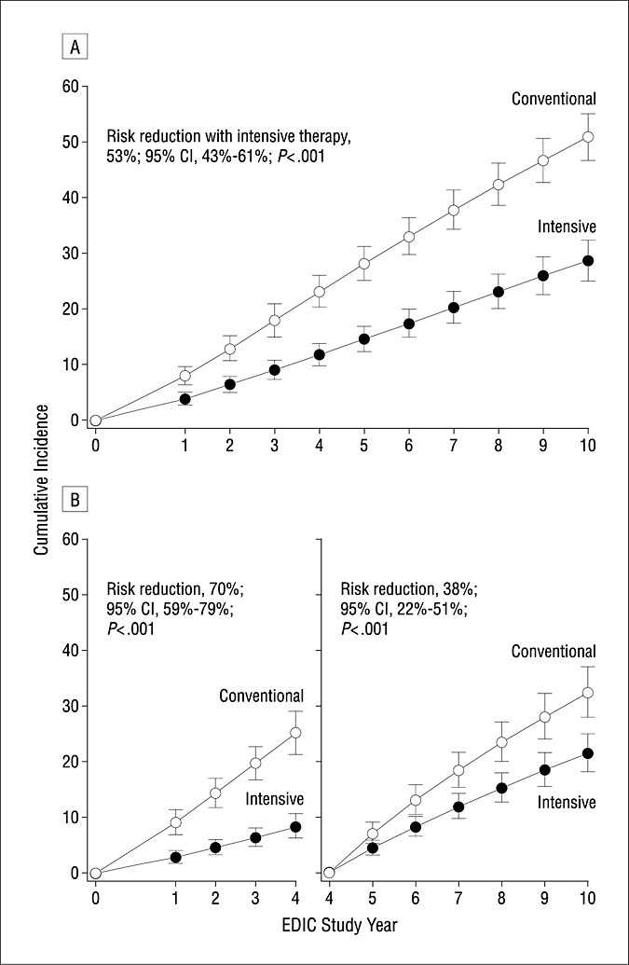

Figure 3. Cumulative incidence of further 3-step progression of retinopathy from DCCT closeout to EDIC study year 10 (adjusted for retinopathy level at DCCT end, cohort, entry HbA1c, baseline diabetes duration). From reference [10].

TYPE 1 DIABETES EXCHANGE

Compared with treatment methods used in the DCCT over 20 years ago, many new tools and technologies have now become available that enable patients and clinicians to attain target A1C levels more safely. Rapid- and long-acting insulin analogues, improved blood glucose meters, newer insulin pumps with integrated sensor-augmented systems and with automatic threshold suspend capabilities and continuous glucose monitoring (CGM) devices now play an integral part of T1D management. To evaluate how these advances in diabetes technology have impacted glycemic control in T1D, a broad-based, large-scale, multisite registry that includes patients at all ages across the life span in the U.S. was established in 2010 through a grant from the Leona M. and Harry B. Helmsley Charitable Trust. Called the T1D Exchange, this registry aims to provide an expansive data set to address important clinical and public health issues related to T1D. It comprises of three complementary sections: i) a clinic network of adult and pediatric diabetes clinics; ii) a Web site called Glu, serving as an online community for patients; and iii) a biobank to store biological human samples for use by researchers. A statistical resource center provides statistical support to the Exchange as well as other T1D mellitus researchers. Thus, this exchange has the potential to address many aspects of T1D across the lifespan than can eventually improve clinical management and outcomes in these individuals. Current available data from the clinic registry, the first initiative of the T1D exchange project, is summarized below.

Currently there are over 16,000 patients enrolled in the registry, ranging in age from 2 - 93 years, with a duration of diabetes ranging from 1.5 to 83 years. Recent data from the registry suggests that mean A1C in adults over age 30 is about 7.5%, which is lower than the value of 8% observed in the DCCT [11]. On the other hand, glycemic control appears to be worsened in patients between 8-18 years of age. 64% of individuals in the T1D exchange were using insulin pumps while CGM was used by 17% of participants. CGM use was higher in adults over 26 years of age, and was more likely in participants with higher education level, higher household income, private insurance, longer duration of diabetes, and use of an insulin pump. CGM use was lowest in the pediatric population. Many patients in the registry were able to achieve target A1C levels without an increase in the frequency of serious hypoglycemia as was observed in the DCCT. Use of adjunctive pharmacologic therapies, primarily metformin, occurred in 5% of adult participants.

CURRENT TECHNOLOGY IN TYPE 1 DIABETES

Glucose Meters

Current blood glucose monitoring systems (BGMS) are small electronic devices capable of analyzing glucose levels in whole blood. To test blood glucose levels, patients are required to prick a finger using a lancing device to obtain a small drop of blood. The patient then places the drop of blood onto a glucose test strip, which has been previously inserted into the glucose meter. Typically, just a few seconds are required for the device to provide a blood glucose value.

BGMS use enzymatic reactions to provide estimates of blood glucose levels and the enzymes utilized include glucose oxidase, glucose dehydrogenase and hexokinase. The specific enzyme is usually packaged in a dehydrated form in a glucose test strip. Once blood is applied to the test strip, glucose in the patient’s blood sample rehydrates the enzyme activating a reaction. The product of this reaction can then be detected and measured by the glucose meter.[12]

Notably, the advent of point-of-care BGMS has revolutionized diabetes care by allowing patients and practitioners to obtain real-time estimates of blood glucose values. These portable devices enabled patients to perform self-monitoring of blood glucose (SMBG), an integral component of effective diabetes management. The benefits of SMBG were confirmed during the DCCT which showed that intensive insulin therapy, requiring SMBG≥4 times/day with concomitant insulin dose titration, delayed the onset and slowed the progression of microvascular complications [4]. Later, it was shown in the T1D Exchange that a higher frequency of testing (up to 10 times daily) is inversely associated with A1C levels in all age groups [13].

SMBG allows patients to guide management decisions (e.g. adjusting food intake, insulin therapy, and exercise) and determine whether glucose targets are being achieved. Further, it can help patients in monitoring and preventing asymptomatic hypoglycemia [14].

Patients with T1D should perform SMBG at a minimum of 4 times a day (before meals and at bedtime), as this will allow adjustments to prandial and basal insulin doses. In addition, SMBG should be considered prior to snacks, before and at completion of exercise, in the event of symptoms suggestive of hypoglycemia, and after treating hypoglycemia until blood glucose levels have normalized. Lastly, patients should test their blood glucose before performing critical tasks such as driving a motor vehicle or operating heavy machinery. Ultimately, frequency of SMBG will largely depend on patients’ individual needs [14].

An important point to make, however, is that patients should also be educated on avoiding “overuse” of SMBG. Testing too frequently may lead to administration of multiple correction doses within short periods of time, particularly if patients are anxious about their glucose levels not returning to target “fast enough”, leading to insulin “stacking” and resulting in iatrogenic hypoglycemia.

The technology of BGMS has evolved over the years and current devices are relatively easy to use and require minimal amounts of blood. Some instruments are able to capture events affecting glucose control (e.g., exercise, meals, insulin administration), provide customized reports, and calculate insulin bolus needs according to glycemia and intake of carbohydrate based on pre-established settings (i.e. insulin sensitivity factor and insulin-to-carbohydrate ratios). However, despite these unique advances in self-monitoring of blood glucose, independent analytic testing has shown that various BGMS do not fulfill the accuracy requirements set by the International Organization for Standardization (ISO) 151917 which requires for ≥95% of results to fall within ± 15 mg/dL of the reference result for samples with glucose concentrations <100 mg/dL and ±15% for samples with glucose concentrations ≥100 mg/dL [15]. Thus, there is a pressing need for high quality standards to ensure improved accuracy and precision from BGMS.

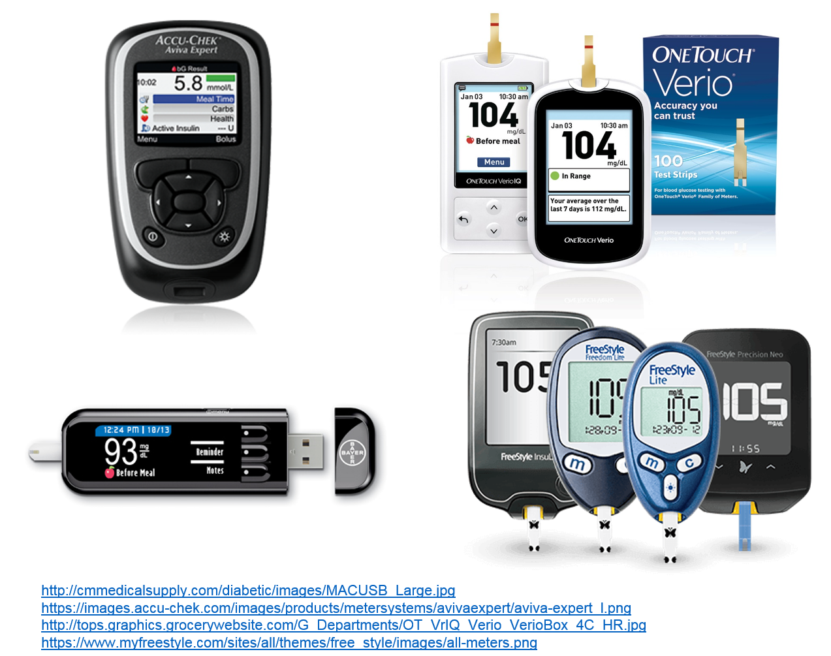
Figure 4: Examples of a few blood glucose monitoring systems.

Glucose Downloads

The vast majority of currently available BGMS allow the generation of downloadable reports. These reports are a unique component of the patients’ evaluation allowing the identification of areas that require special attention in diabetes management. However, technical difficulties often compromise the usefulness of these data. For instance, it is not unusual for the date and/or time of the glucose meters to be inaccurate. Simple errors such as these have a huge impact on patient management as the data downloaded becomes largely uninterpretable. In addition, as each glucose meter usually has its own proprietary software, if a clinic does not have the specific software installed on their local computers, then the data may not be downloaded. The clinician is left with trying to review the data directly from the device, which is time consuming and does not offer the detailed overview from a customized printable report. There are platforms that are currently available which allow downloading various glucose meters, insulin pumps and continuous glucose monitor (CGM) data and provide standardized reports (e.g. Clinipro®, Diasend®, Carelink®, Glooko®). However, there needs to be a unified effort by BGMS, insulin pump and CGM companies in order to generate a universal download protocol as this would simplify data analysis and interpretation by practitioners [16].

Continuous Glucose Monitoring

Perhaps the most innovative recent technology for the treatment of T1D is the introduction of continuous glucose monitoring (Figure 4). As differs from SMBG, CGM technology allows for the measurement of glucose concentrations in the interstitial fluid (ISF) which correlates with plasma glucose values. However, when interpreting CGM values it is important to understand that ISF glucose consistently lags plasma glucose. A study in healthy adults analyzing glucose tracers following an overnight fast showed that it takes 5-6 minutes for glucose to be transported from the vascular to the interstitial space (physiological delay) [17]. This is particularly relevant when glucose levels are trending up or down quickly as CGM data will not be as reliable in such scenarios and thus patients should confirm the direction of their glucose concentration by SMBG.

In 1999, the FDA approved the MiniMed CGM system, the first CGM device in the United States [18]. Through the use of a subcutaneously implanted sensor, glucose values would be recorded every 5 minutes into a receiver device over a period of 3 days and then analyzed retrospectively once the sensor had been removed and the data in the device downloaded. In 2001, the FDA approved the first CGM for prospective patient use, the GlucoWatch G2 biographer.[18,19]. This device resembled a watch that could be worn on the wrist and provided non-invasive glucose measurements. An iontophoretic current was used to extract the glucose sample through the intact skin. A biosensor would then allow for the generation of an enzymatic reaction and an electric current that could be read by the biographer and translated into a glucose measurement. However, the device took several minutes to provide a reading and values were estimated to be approximately 15 minutes behind the actual blood glucose measurement. Also, heavy perspiration and dislodgement of the device from the skin affected glucose measurements. These significant technical limitations eventually led to discontinuation of this device.

Further advancements in CGM technology led to the FDA approval of the DEXCOM™ STS™ CGM in 2006 [20]. This was a first generation device allowing for prospective glucose monitoring over a 3-day period with the use of a disposable sensor. Several CGM devices for retrospective and prospective use followed but an important limitation was the accuracy of the glucose measurements, which was significantly lower than capillary blood glucose measurements [21]. CGM technology has largely evolved over time and current devices are wireless, may be worn up to a week, and can measure glucose up to every minute allowing for a glucose tracing to be generated and displayed in real-time (RT-CGM) on a receiver device greatly improving the understanding of patients’ glucose profiles. Accuracy of glucose measurements has also greatly improved resulting in several CGM devices being approved in Europe for non-adjunct use in patients with diabetes when glucose levels are not changing rapidly. That is, patients can rely on their CGM values in order to guide management decisions [22].

The components of CGM consist of a sensor that is inserted subcutaneously, a small electronic device that serves as the platform for the sensor, a transmitter (attached to the sensor), and a receiver device, which for some CGM devices can be a smartphone (Figure 5). Patients can customize alarms to activate for hypoglycemia or hyperglycemia. Understanding the trend allows patients to decide whether an increase or decrease in mealtime insulin dose is necessary. CGM thus also allows patients to intercept hypoglycemia (or hyperglycemia) prior to it occurring. Patients can also “flag” events thereby improving interpretation of glucose control associated with meals, insulin administration, and exercise. Also, some CGM devices allow users to share their RT- CGM data with others (e.g. family members or friends) which can then be monitored on a smartphone or other internet-enabled devices. This is of particular interest in the pediatric population as it allows parents to remotely monitor their child’s glucose profile when away from home or while exercising (e.g. participating in sports).

In order to maintain sensor accuracy over time, patients are required to enter blood glucose readings into the CGM receiver for calibrations (typically every 12 hours). However, further improvements in in vivo sensor-to-sensor differences will eventually allow for factory calibration of these devices [23]. Abbott’s FreeStyle Libre Flash Glucose monitoring system (Abbott Diabetes Care, Alameda, CA) launched in Europe in 2015 providing the first consumer available interstitial glucose monitoring technology with factory calibration [23]. This feature allows users to wear the sensor for 14 days without the need for entering blood glucose values for calibrations. The FreeStyle Libre is essentially an “on demand” glucose monitor since the user needs to hold a reader device close to the subcutaneously inserted sensor (the patient “scans” the sensor with the reader) in order to have the real-time interstitial glucose value displayed. During a scan, the reader displays the real time glucose value, glucose alerts, an 8hr historic glucose trend of values recorded at a 15 min frequency and a trend arrow indicating the glucose direction [24]. However, limitations of this device include the lack of alarms, the need for users to take action to see both the current glucose and previous glucose trends and the inability to share the data with others. Nonetheless, this device may be appealing to those patients who want to minimize capillary blood glucose measurements and complain of CGM sensor alarm fatigue [25, 26].

Another advantage of CGM is the amount of data that can be generated and downloaded in customizable reports (Figure 6). Health care professionals are not only able to download daily glucose profiles in a graphic display but can also obtain several statistics including means, medians, standard deviations, interquartile ranges, and minimum and maximum values. This provides a better assessment of glycemic variability (Figure 7). Most importantly, time spent as well as segments spent in the hypoglycemic range can be identified and evaluated. This is particularly helpful in patients who have hypoglycemia unawareness and allows for making adjustments to the treatment plan by both the patient and practitioners to eliminate occurrence of hypoglycemia.

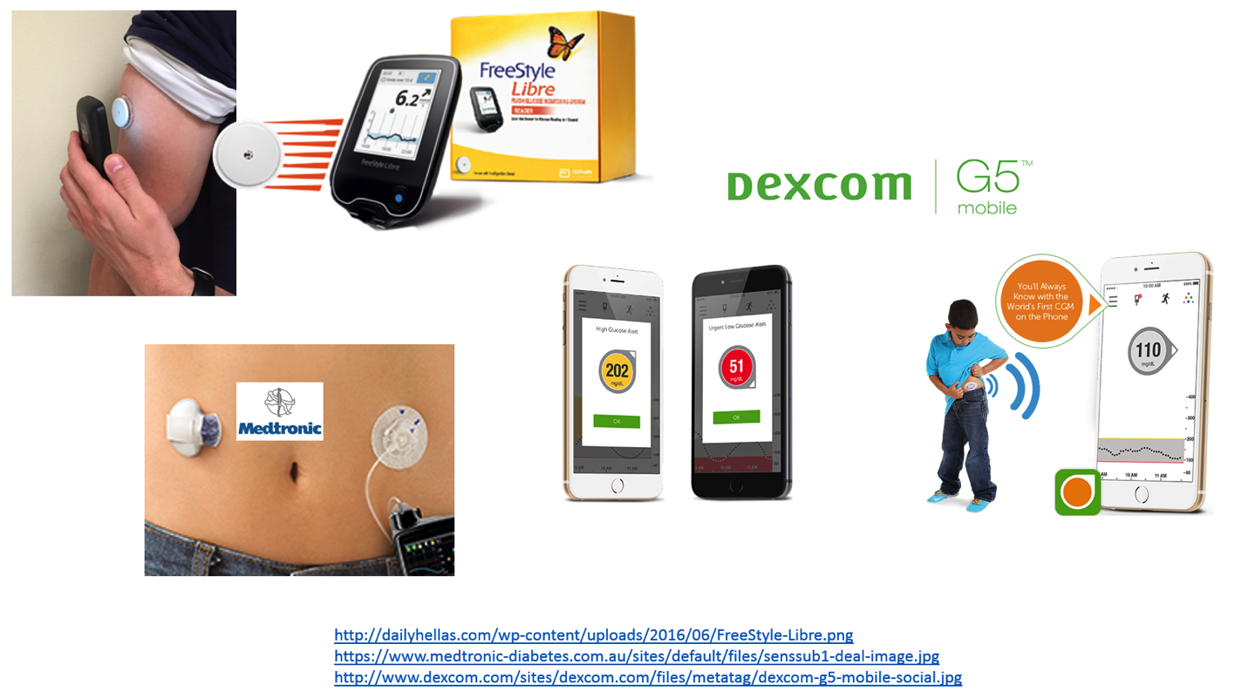
Figure 5: examples of real-time continuous glucose monitoring systems.

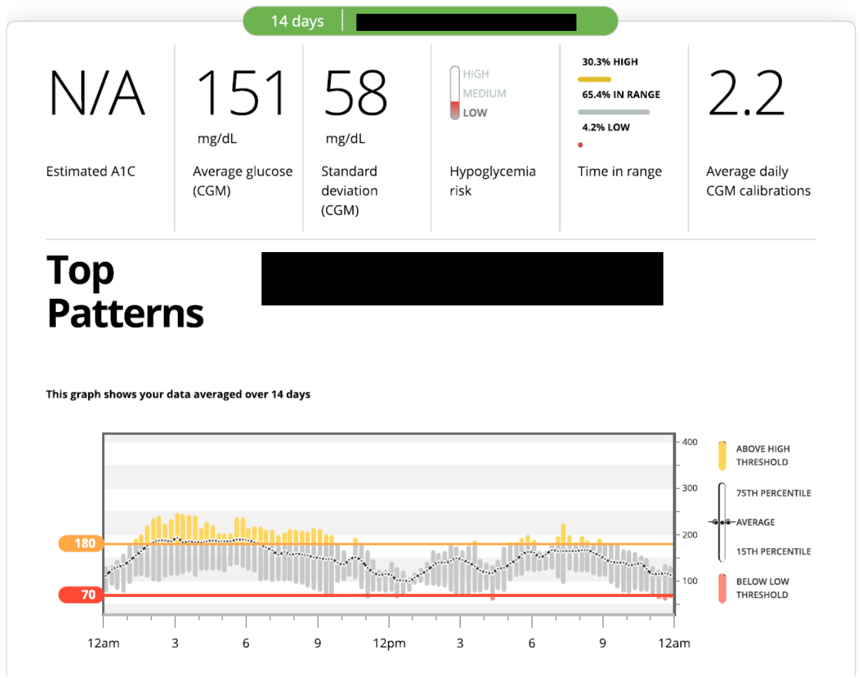

Figure 6. A 14 day DEXCOM CGM overview report showing glucose data over a 24 hour period including mean (dotted line), standard deviation, interquartile range (grey bars), upper and lower thresholds (orange and red lines, set by the user), hypoglycemia risk (high, medium or low), percent time in range and average daily calibrations.

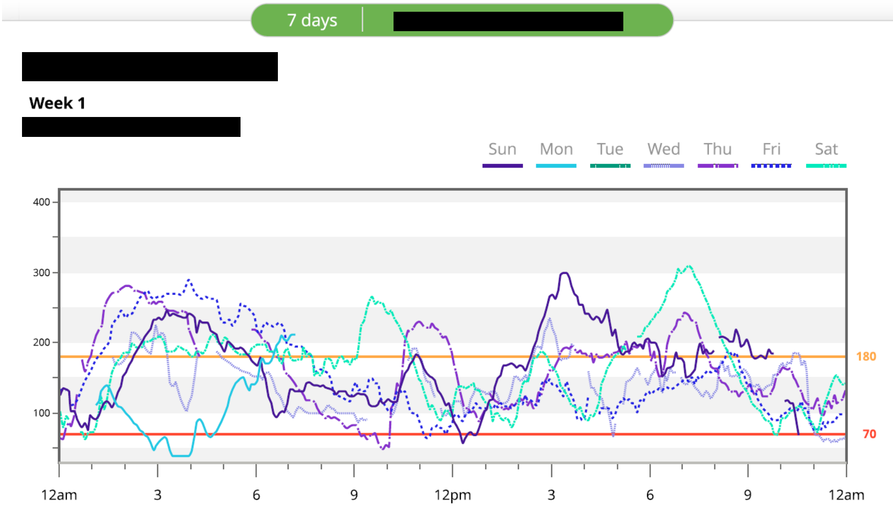
Figure 7. A 7 day DEXCOM CGM overlay report showing daily profiles allowing for the identification of trends and patterns.

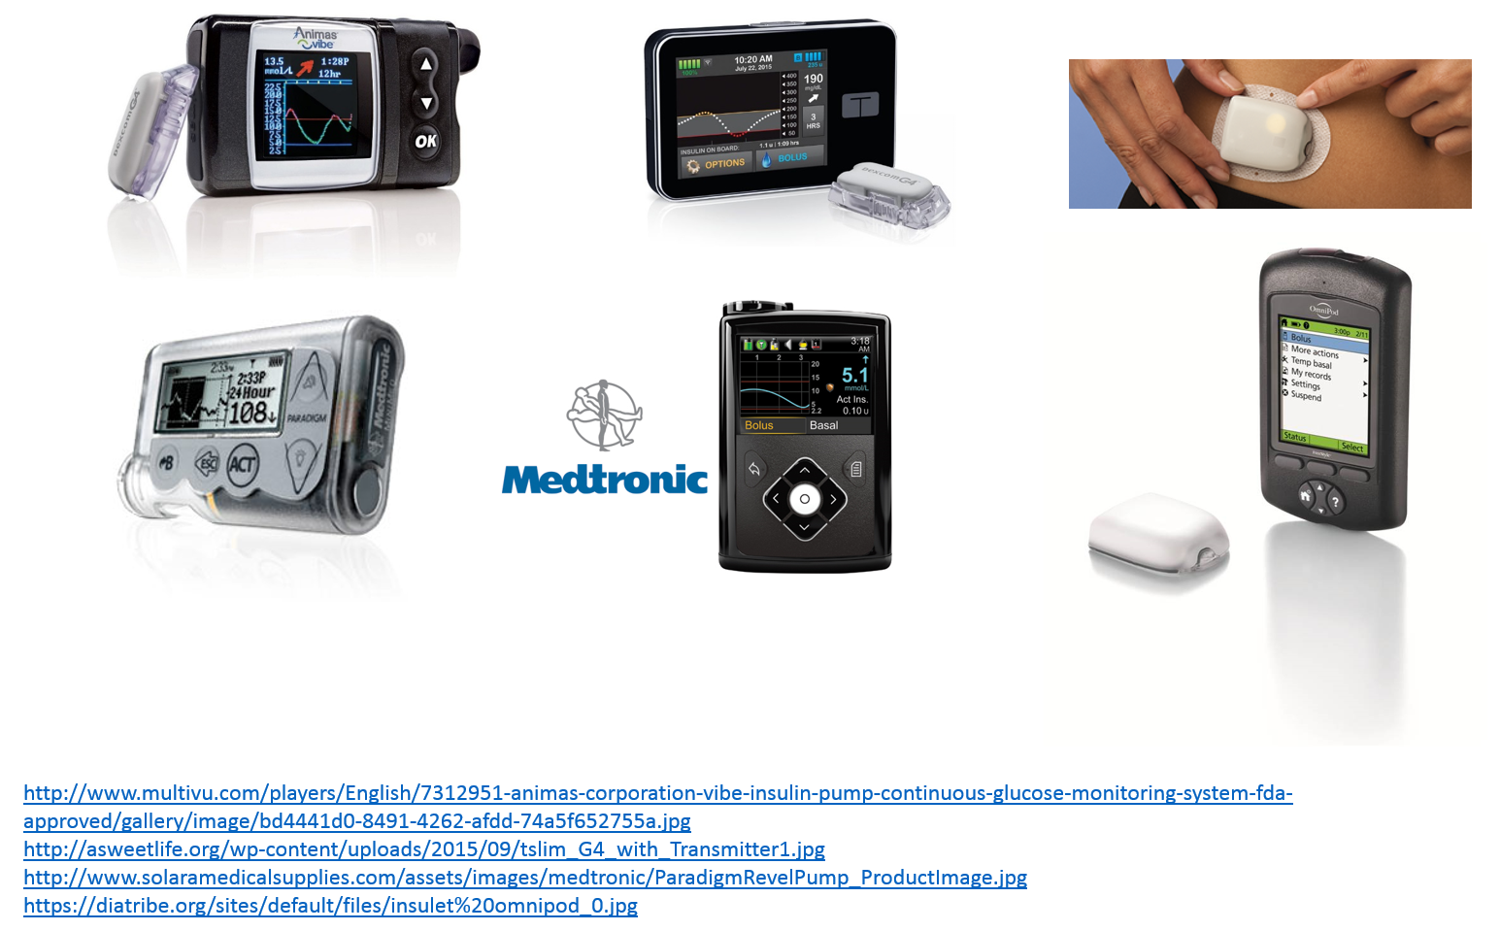

Figure 8: Examples of modern-day insulin pumps.

As seen in Figure 8, some sensors are already integrated with insulin pumps (“sensor-augmented pumps”) so that the pump and receiver are in the same device. In addition, development of an integrated sensor and infusion set is currently being pursued, as this will simplify the incorporation of sensor technology into insulin pumps. Eventually, all insulin pumps will be integrated with sensors. Yet, it should be appreciated that CGM is an equally important tool for MDI patients, and probably a more important diabetes management tool than using an insulin pump [22]. Even after short periods of time, many patients can learn how to best use this technology to improve both mean glucose and glycemic variability (Figure 12). In a meta-analysis, comparing SMBG with RT-CGM, the latter achieved a lower A1C (between-group difference of change, -0.26%, [95% CI, -0.33% to -0.19%]) without increasing hypoglycemia [27]. In the Juvenile Diabetes Research Foundation’s CGM trial, those individuals starting with baseline A1C levels under 7% overall had less hypoglycemia with CGM [28]. A recent analysis of the T1D registry data suggests that CGM users, irrespective of insulin delivery method – i.e. multiple daily injections vs. pump therapy – had lower A1C levels than non-CGM users even after adjustment for confounding factors [29].

The American Association of Clinical Endocrinologists and American College of Endocrinology recommend the use of CGM for patients with T1D particularly for those with a history of severe hypoglycemia, hypoglycemia unawareness, and to assist in correction of hyperglycemia in patients not at goal. It may also be considered in pregnancy as it can help fine-tune insulin dosing, monitor for overnight hypoglycemia or hyperglycemia, and assess occurrence of postprandial hyperglycemia [18]. The Endocrine Society also recently published guidelines on CSII Therapy and Continuous Glucose Monitoring in Adults and recommend the use of RT-CGM for adult patients with T1D who either have A1C levels above target or well-controlled T1D and are willing and able to use these devices on a nearly daily basis [30].

In the United States, current CGM devices are labeled for use as adjunctive therapy with routine SMBG. However, the improved accuracy demonstrated by current CGM sensors is expected to result in the FDA approving the use of CGM for non-adjunct use in diabetes management. Indeed, in July 2016, an FDA advisory panel voted in favor of recommending use of the DEXCOM G5 CGM for making treatment decisions without the need of a confirmatory capillary blood glucose value. Formal approval of this new labeling by the FDA is pending.

OVERVIEW OF THERAPY FOR TYPE 1 DIABETES

Glycemic Targets

A1C is a measure of average glycemia over ~3 months and is a strong predictor of complications of diabetes [31]. Current glycemic targets for adults from the American Diabetes Association (ADA) include a target A1C of <7%. However, it should be noted that this recommendation is a general target and the goal for the individual patient is as close to normal as possible (A1C of < 6%) without significant hypoglycemia. In addition, patients with T1D and hypoglycemia unawareness, long duration (> 25-30 years) of disease, limited life expectancies, very young children, or those with co-morbid conditions will require higher A1C targets. Individualized A1C targets need to be reviewed with each patient [14].

Thus, A1C testing should be performed routinely in all patients with diabetes as part of ongoing care. Frequency of A1C testing is determined based on the clinical situation, the treatment regimen used, and the clinician’s judgment. A1C measurements every 3 months help in the assessment of whether a patient’s glycemic targets have been reached. Although convenient, there are drawbacks to A1C measurements, as glycation rates may vary with patients’ race/ethnicity. Similarly, in patients with hemoglobinopathies, hemolytic anemia or other conditions that shorten the red blood cell life span, the A1C may not accurately reflect glycemic control or correlate with SMBG testing results. In such conditions, fructosamine may be considered as a substitute measure of long-term (average over 2 weeks) glycemic control. Clinicians should routinely compare downloaded SMBG or CGM averages with A1C as there are many reasons A1C may be altered due to a non-glycemic etiology and thus fructosamine or the downloaded glucose data itself would be a better metric to follow [32].

Non-glycemic treatment targets

It should also be pointed out that in addition to glycemic targets, specific non-glycemic targets have also been recommended [33]. Non-glycemic targets should also be tailored according to the individual with less stringent treatment goals for individuals with multiple coexisting illnesses and/or poor health and limited life expectancy.

Blood pressure: For blood pressure, the ADA recommends treatment to a goal of <140/90mmHg. Lower targets of < 130/80 mmHg, should be considered in younger patients and if albuminuria is present.

Lipids: Very limited data exists for lipid targets in patients with T1D of any age [34]. The ADA has adopted the approach of the recent American Heart Association guidelines and recommends similar statin approaches for individuals with T1D [33]. All patients with diabetes and cardiovascular disease should be treated with high intensity statins (LDL-C reduction ≥50% baseline). If the individual has no atherosclerotic cardiovascular disease but has additional cardiovascular risk factors, moderate intensity statin therapy is recommended. Recently, a prediction model for CVD events in T1D to help decision making for primary prevention that has been developed shows promise but needs further validation [35].

INSULIN THERAPY

Insulin therapy is the cornerstone of management of T1D as beta cell dysfunction or destruction progressively leads to absolute insulin deficiency. Physiologic insulin replacement that aims to mimic normal pancreatic insulin secretion is the preferred method of treatment of T1D patients. Basal insulin is the background insulin required to suppress hepatic glucose production overnight and between meals. Prandial (bolus or meal-time) insulin replacement, provides enough insulin to dispose of glucose after eating. Such a therapeutic insulin regimen providing both basal and bolus insulin allows flexibility of dosing. Older twice-daily combination of regular and NPH regimens generally should not be used in T1D as they are less effective since the time-action profile of these two standard insulins do not readily allow for the clear separation of basal and prandial insulin action. However, it may be necessary to use such regimens in patients who cannot otherwise afford insulin. It also should be pointed out that for newly diagnosed patients with T1D, transient use of once- or twice-daily basal injections is sometimes adequate.

Principles of Management of T1DM

Management of T1D involves a multidisciplinary framework that includes the following:

- Physiologic insulin replacement using basal-bolus therapy, either as MDI or CSII
- Blood glucose monitoring with SMBG and/or CGM with development of individualized A1c goals
- Patient education
- A supportive team of providers including endocrinologists, nurses, CDEs, psychologists, dietitians, social workers, other specialists such as cardiologists, nephrologists, psychiatrists as well as family members, social support groups etc.

Types of Insulin

Selecting the appropriate insulin depends largely on the desired time course of insulin action. Table 1 shows the pharmacokinetic characteristics—time to onset of action, time of peak action, effective duration of action, and maximum duration of action—of currently available insulins; however, these can vary considerably among individuals.

Insulin products are categorized according to their action profiles:

- Rapid-acting: e.g., insulin lispro, insulin aspart, and insulin glulisine (genetically engineered insulin analogues)
- Short-acting: regular (soluble) insulin
- Intermediate-acting: NPH (isophane)
- Long-acting, e.g., insulin glargine, insulin detemir, and insulin degludec (genetically engineered insulin analogues)
- Pre-mixed insulin
- Inhaled insulin

A general principle to bear in mind is the longer the time to peak, the broader the peak and the longer the duration of action. Additionally, the breadth of the peak and the duration of action will be extended with increasing dose. Figures 9 and 10 should therefore be considered a conceptual representation of insulin action curves.

Rapid-Acting Insulin: The genetically engineered insulin analogues have a rapid onset in 15-30 minutes, peak in 30-90 minutes, and an effective duration of 4 to 5 hours when injected subcutaneously because they do not self-aggregate in solution as human (regular) insulin does. Insulin lispro differs from human insulin by an amino acid exchange of lysine and proline at positions B28 and B29 [36]. The substitution of aspartic acid for proline at position B28 characterizes insulin aspart [37]. Insulin glulisine differs from human insulin in that the B3 asparagine is replaced by lysine, and B29 lysine is replaced by glutamic acid [38]. These modifications in the primary structure of human insulin increase the rapidity of breakdown of insulin hexamers in the analogues and thus result in more rapid absorption. When administered before meals, rapid-acting insulins used as part of multiple daily injections (Figure 10) or with CSII, resemble physiologic insulin increases stimulated by food. Doses can be adjusted proportionate to food consumed; in patients with gastroparesis or poor appetite, insulin can be injected halfway through or after the meal.

Short-Acting Insulin: Regular insulin is structurally similar to endogenous human insulin. It consists of dissolved zinc-insulin crystals which self aggregate in the subcutaneous tissue and results in a delayed onset of action of 30 to 60 minutes, a peak of 2 to 3 hours, and an effective duration of 6 to 8 hours. Proper use requires injection at least 20 to 30 minutes prior to meals to match insulin availability and carbohydrate absorption. Use of regular insulin is associated with greater hypoglycemia risk [39]. Regular insulin acts almost instantly when injected intravenously.

Intermediate-Acting Insulin: Neutral protamine Hagedorn (NPH) insulin, developed in the 1950s, is a combination of recombinant human insulin with protamine which results in crystal formation. When injected subcutaneously, precipitated crystals of NPH insulin are released slowly resulting in a longer duration of action compared to regular insulin. Action of NPH varies quite widely within the same patient as well as between patients. Its onset of action occurs 2 to 4 hours from the time of injection, with a peak effect lasting 6 to 10 hours, and an effective duration of 10 to 16 hours. Due to this peak effect, NPH insulin acts as a basal and a prandial insulin, necessitating that patients eat a meal at the time the insulin is peaking. NPH typically requires twice a day dosing [40].

Long-Acting or Basal Insulin: Long acting insulin analogues were created by modifying the amino acid sequence on the beta chain of insulin [41]. They exhibit much improved pharmacokinetics and pharmocodynamics without a peak effect and maintain a longer duration of action. Improved absorption rates result in significantly decreased inter-individual and intra-individual variability with improvement in glycemic control and reduced hypoglycemia risk.

Insulin glargine (U-100): Insulin glargine is a modified human insulin produced by the substitution of glycine for asparagine at position A21 of the insulin molecule and by the addition of two arginine molecules at position B30 [40]. These changes result in an insulin molecule that is less soluble at the injection site forming a precipitate in the subcutaneous tissue to form a depot from which insulin is slowly released after injection and is slowly released into the circulation. It has no pronounced peak and a longer duration of action of about 20 to 24 hours in most patients, allowing for once daily dosing. In clinical practice, many patients with T1DM may benefit from twice-daily injections. Insulin glargine is solubilized in acidic pH and should not be mixed with rapid-acting insulins as the kinetics of both insulins will be altered. Insulin glargine shows a greater reduction in A1C and decreased hypoglycemia in patients with T1DM [42].

U-300 glargine (Gla-300) is a new formulation of insulin glargine that delivers the same number of insulin units as insulin glargine 100 units/mL (Gla-100), but in a third of the volume. The compact depot renders a smaller surface area of insulin glargine for a given dose, leading to a slower release of insulin glargine over time. This translates into a more constant PK/PD profile, with a prolonged duration of action (up to 30 hours) with Gla-300 compared with Gla-100 in patients with T1DM [43]. Gla-300 has been shown to provide similar glucose control compared to Gla-100 with lesser weight gain and hypoglycemia [44].

Insulin detemir is a soluble basal insulin analogue. It is covalently acylated with fatty acids on the lysine at position B29, which allows for reversible binding to albumin [45]. This delays its absorption from subcutaneous tissue and prolongs its time in the circulation. Although the mean duration of action of insulin detemir has been shown to be 24h, one study showed shorter duration of action (about 17h), which suggests that most patients require twice-daily dosing of insulin detemir [46].

Insulin degludec is an ultra-long acting basal insulin recently available in the US that has the same amino acid sequence as human insulin, apart from the deletion of the threonine amino acid residue at B30 and the addition of a fatty acid to the lysine at B29 [47]. The fatty acid moiety causes self-aggregation of insulin molecules into soluble multihexamers. Slow dissociation of zinc from the insulin allows for gradual and stable absorption of insulin monomers resulting in a long half-life and a duration of action asserted to be 42 hours. In patients with T1DM, similar A1C reduction with lower rates of nocturnal hypoglycemia have been reported with insulin degludec compared with insulin glargine [48, 49]. The extended duration of insulin degludec may allow for more flexibility of day-to-day dose timing.

Pre-mixed insulins: Premixed insulins are mixtures of prandial and intermediate acting insulins (the same prandial insulin attached to protamine so that it becomes intermediate acting). In the US, insulin lispro protamine mixtures are available in two forms: 75% insulin lispro protamine suspension and 25% insulin lispro injection (75/25) and 50% insulin lispro protamine suspension and 50% insulin lispro injection (50/50). Available preparations of insulin aspart protamine mixtures include 50/50 and 70/30 suspensions. A variety of other ratios are available in Europe. These insulins are typically administered before breakfast and dinner. This alleged twice daily dosing is the primary advantage of these insulins. In general, use of premixed insulins restricts adjustment of doses and meal timing. Therefore, premixed insulins are not recommended for adult patients with T1D, where intensive regimens with ability to make adjustments in the premeal short-acting insulin bolus are better suited for glycemic control. Premixed insulin in T1D could have benefit for some patients who do not adhere to an intensive insulin regimen.

U-500 insulin: U-500 insulin is highly concentrated regular insulin, administered 2-3 times a day without basal insulin. Due to its concentration, the action is prolonged and variable. In T1D, use is primarily limited to individuals with significant insulin resistance (requiring >200 units of insulin a day). Caution should be used while prescribing this insulin as confusion may occur among clinicians, pharmacists, nurses, and patients who are unfamiliar with its use. Recently, U-500 insulin became available in a pen delivery system allowing patients to administer insulin by 5 units increments up to a maximum of 300 units at a time. Units to be delivered are clearly readable through the pen “dose window” which should minimize or eliminate confusion when administering this highly concentrated insulin formulation.

Inhaled insulin: Currently, one form of inhaled insulin is available in the market. Afrezza was approved by the FDA in 2014. This is a drug-device combination that contains powdered human insulin in single use dose cartridges delivered via a small inhaler. When inhaled, it dissolves immediately on contact with the alveolar surface of the lung and is rapidly absorbed into the systemic circulation, reaching a peak within 15 minutes. Thus Afrezza acts similar to rapid-acting insulin analogues but with a much faster peak of action, and shorter duration of action. Prior to initiation of its use, patients should be screened for underlying lung disease with spirometry. Follow-up spirometry is recommended after 6 months’ use, and annually thereafter. The main advantages of inhaled insulin are avoidance of injections, faster onset of action, less weight gain and less hypoglycemia [50]. Dosing is not flexible as cartridges are available in fixed doses (4, 8 and 12 units). Afrezza is contraindicated in patients with chronic lung disease such as asthma or chronic obstructive pulmonary disease (COPD).

Table 1 Currently Available Insulin Preparations

Insulin Preparation | Onset of action (h) | Peak Action (h) | Effective duration of action (h) | Maximum duration(h)
Rapid-acting analogues
Insulin lispro (Humalog) | ¼ - ½ | ½-1 ½ | 3-4 | 4-6
Insulin aspart (NovoLog) | ¼ - ½ | ½ -1 ¼ | 3-4 | 4-6
Insulin glulisine (Apidra | ¼ - ½ | ½ -1 ¼ | 3-4 | 4-6
Inhaled insulin (Afrezza) | seconds | 12-17 min | 2-3 | 2-3
Short-acting
Regular (soluble) | ½ - 1 | 2-3 | 3-6 | 6-8
Intermediate-acting
NPH (isophane | 2-4 | 6-10 | 10-16 | 14-16
Long-acting analogue
Insulin glargine (Lantus) | 0.5-1.5 | 8-16 | 18-20 | 20-24
Insulin glargine U-300 (Toujeo) | 0.5-1.5 | none | 24 | 30
Insulin detemir (Levemir) | 0.5-1.5 | 6-8 | 14 | ~20
Insulin degludec (Tresiba) | 0.5-1.5 | none | 24 | 40

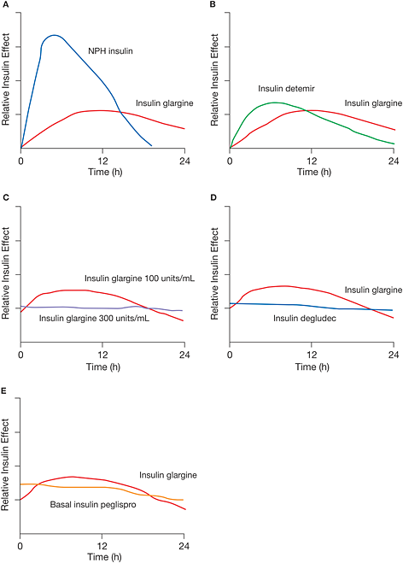

Figure 9. Available basal insulins and duration of action. Figure source Ref [51].

Factors Influencing Insulin Absorption

Insulin absorption variability is one of the greatest obstacles to replicating physiologic insulin secretion. Among the many factors that affect insulin absorption and availability (Table 2) are injection site, the timing, type or dose of insulin used, and physical activity. Day-to-day intra-individual variation in insulin absorption is approximately 25%, and the variation between patients may be as high as 50%. This occurs more commonly with larger doses of human insulin which form a depot and can unpredictably prolong duration of action; however, this is less of an issue with rapid-acting insulin analogues. In general, any strategy that increases the consistency of delivery should decrease glucose fluctuations; and insulin regimens that emphasize rapid-acting insulin are more reproducible in their effects on blood glucose levels. Insulin pumps using a rapid-acting insulin analogue can significantly reduce glucose variability. Like multiple-injection regimens, use of an insulin pump requires frequent blood glucose monitoring. In addition, pump users need a back-up method of insulin administration, and attention to mechanical and injection site issues.

Reducing variability of insulin absorption

Injection sites: Subcutaneous insulin is absorbed most rapidly when injected into the abdomen, followed by the arms, buttocks and thighs. These differences are likely due to variations in regional blood flow. A single region should be utilized for injections without rotation between regions, as this may result in day-to-day variation of insulin absorption. However, while using a region, site rotation (i.e. – rotating injections systematically within the abdomen) is important to avoid development of lipohypertrophy or atrophy due to repeated injections at the same site. Injection into lipohypertrophic areas results in erratic, slower absorption of insulin. Exercise increases the rate of absorption from injection sites, likely by increasing blood flow to the skin; local effects may also be involved.

Timing of Pre-meal Injections: Gauging the appropriate interval between preprandial injections and eating, known as the “lag time,” is essential for coordinating insulin availability with glycemic excursions following meals. The timing of the injections should also be adapted to the level of premeal glycemia. Insulin lispro, insulin aspart, and insulin glulisine have rapid onset of action and, ideally, should be given approximately 10-20 minutes before mealtime when blood glucose is in the target range, keeping in mind that if the meal is delayed, hypoglycemia may ensue. When blood glucose levels are above a patient’s target range, the lag time should be increased to permit the insulin to begin to have an effect sooner. In this case, rapid-acting acting insulin analogues can be given 20-30 minutes before the meal, depending upon the degree of hyperglycemia. If premeal blood glucose levels are below target range, administration of rapid-acting insulin should be postponed until after some carbohydrates have been consumed. Use of frequent home glucose monitoring or CGM can assist in determining appropriate lag times. It is important to emphasize the effect of administering prandial insulin up to 20 minutes before a meal. Pre-bolusing has been shown to reduce post-prandial glucose spike by up to 50mg/dL.

Other factors: Exercise, as discussed earlier, results in increased blood flow to muscle groups and can increase rate of insulin absorption. Heat can also increase the rate at which insulin is absorbed from the skin. For example, being out in the sun or injection before going into a hot tub may lead to hypoglycemia. Intra-muscular injections result in a more rapid onset of action compared to subcutaneous tissue. This route can be utilized under certain situations such as ketoacidosis, insulin pump failure or in the event of profound hyperglycemia.

Table 2. Factors Affecting the Bioavailability and Absorption Rate of Subcutaneously Injected Insulin
Factor | Effects
Site of injection | Abdominal injection (particularly if above the umbilicus) results in the quickest absorption; arm injection results in quicker absorption than thigh  or hip injection.
Depth of injection | Intramuscular injections are absorbed more rapidly than subcutaneous  injections.
Insulin concentration | U-40 insulin (40 units per mL) is absorbed more rapidly than U-100 insulin (100 units per mL).  U-40 insulin is an old insulin formulation not available in the United States for patient use. Currently, it is used for treating canine and feline diabetes mellitus
Insulin dose | Higher doses have prolonged duration of action compared with lower doses.
Insulin mixing | Regular insulin maintains its potency and time-action profile when it is  mixed with NPH insulin
Exercise | Exercising a muscle group before injecting insulin into that area  Increases the rate of insulin absorption.
Heat application or  Massage | Local application of heat or massage after an insulin injection increases  the rate of insulin absorption.

Role of Insulin Analogues in Management of T1D

Most of the problems of insulin replacement in T1D arise from the fact that subcutaneous injection or pump infusion remains a relatively poor route of administration. From the subcutaneous site of injection, insulin is absorbed into the systemic, not portal circulation. More importantly, subcutaneous injection leads to variable absorption from one injection to another, due largely to the non-physiologic pharmacokinetics of standard insulins. Insulin analogues were developed to overcome this problem.

Currently there are three rapid-acting insulin analogues: insulin lispro, insulin aspart, and insulin glulisine, all of which have a rapid onset of action and peak, thereby improving 1- to 2-hour postprandial blood glucose control compared with regular insulin. These rapid-acting analogues must be used in conjunction with a basal insulin to improve overall glycemic control (Figure 10). Importantly, the rapid-acting analogues have consistently outperformed regular insulin in terms of post-absorptive hypoglycemia. This finding should not be surprising since the long duration of regular insulin is much longer than the gut absorption of a typical mixed meal.
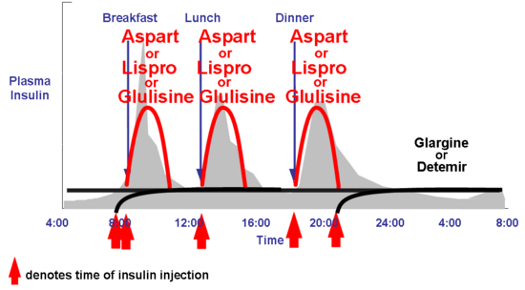

Figure 10: Idealized insulin curves for prandial insulin with a rapid-acting analogue (RAA) with basal insulin glargine or insulin detemir. Each insulin preparation is responsible for either the prandial or basal component. Many patients find the basal insulins do not last the entire 24 hours and they give the basal insulin twice daily. B=breakfast; L=lunch; S=supper; HS=bedtime

Clinical trials have demonstrated lower fasting glucose levels and less nocturnal hypoglycemia with insulin glargine than with NPH insulin, advantages that are especially relevant in patients aiming for meticulous control (A1C <7%) or those with hypoglycemia unawareness. Trials with T1D have shown similar results with insulin detemir which compared with NPH insulin was equally effective in maintaining glycemic control, although detemir was administered at a higher molar dose. The newest basal insulin preparations, insulin degludec and U-300 insulin glargine are claimed to show less nocturnal hypoglycemia than insulin glargine or insulin detemir. In general, hypoglycemia is reduced with any of these basal analogue insulins compared to NPH insulin. Since hypoglycemia is clearly one of the treatment-limiting aspects of T1D therapy, the use of these analogues has gained wide-spread acceptance.

Multiple Daily Injection Insulin Therapy

A simpler conceptual approach preferred by most patients with T1D is using a prandial insulin analogue for each meal (i.e., insulin lispro, insulin aspart, or insulin glulisine) and a separate basal insulin analogue [ie, insulin glargine, insulin detemir, or insulin degludec]. Although these true basal-prandial regimens require more shots than conventional twice-daily regimens, they are considerably more flexible, allowing greater freedom to skip meals or change mealtimes. Moreover, use of the long-acting basal and rapid-acting insulin analogues, allows strategies to achieve individual, defined blood glucose targets easier. Such modifications might include changing the timing of insulin injections in relation to meals, changing the portions or content of food to be consumed, or adjusting insulin doses or supplements for premeal hyperglycemia.

The basic treatment principles of insulin dosing include establishing a total daily dose, an insulin to carbohydrate ratio and an insulin sensitivity or correction factor.

Establishing a Total Daily Dose (TDD) of Insulin

This is the first step in starting treatment in a patient with newly diagnosed diabetes. This dose can vary based on the individual and can range from 0.3- 1.5 units/kg/day. A good starting dose is ~0.5 units/kg/day. Once the TDD is determined, this number is divided by half to establish the basal and bolus requirements. As a general rule of thumb, half the insulin is used as basal insulin, while the other half is used as prandial or mealtime insulin. For example, in a person weighing 75 kg, a typical total daily insulin dose might be 75 kg X 0.7 units/kg = roughly 37 units/day. The basal insulin dose would be roughly 18 units and bolus insulin total would be 18 units (divided amongst meals, see below).

Long-acting insulin analogues U-100 glargine and detemir can be administered once or twice daily. Insulin degludec or U-300 insulin glargine can be administered once a day.

Using Prandial Insulin

Establishing an insulin to carbohydrate (carb) ratio: Patients with T1D derive the greatest therapeutic benefit when basal and prandial analogues are used together, because the physiologic pharmacokinetics and pharmacodynamics of these analogues make separating the basal and prandial components of insulin replacement easier. In general, administering the appropriate amount of pre-meal insulin requires that the patient know at least their current blood glucose level and the estimated amount of carbohydrates for a meal. Initially, the amount of prandial insulin can be determined by approximating the percentage of calories consumed at each meal. As patients become more educated, however, they may alter the prandial dose by estimating the carbohydrate component of each meal or snack.

The carb ratio provides the dose of rapid acting insulin (lispro, aspart, glulisine) to cover the carbohydrate content of a meal. A typical starting point in patients with T1D is to give 1 unit of rapid acting insulin for every 15 grams of carbohydrates. This ratio is variable ranging from 1 unit for every 5g to 30 g of carbohydrate. To estimate the carb ratio, the “500 rule” can be used:

500/total daily dose (TDD) = grams of carbohydrate covered by 1 unit of insulin.

Example: A person who takes a total of 50 units of insulin per day (both basal and prandial combined) will need 1 unit of rapid acting prandial insulin for every 10g carbohydrate (500/50 = 10g of carbohydrate covered by 1 unit of insulin, using above formula).

Alternative way to calculate the carb ratio – Add all carbohydrates consumed in a day and divide this by the total units of prandial insulin taken that day, using an average over 3 days.

Prandial insulin may be reduced/skipped when:

- Extra carbohydrates are used to raise low blood sugars or cover increased physical activity
- Recent dose of correction insulin within past 1-2 h
- Nausea or vomiting preventing oral intake

Determining the correction dose or “insulin sensitivity factor” (ISF): In addition to covering the carbohydrate load of a meal, individuals will also need to correct hyperglycemia, called the “correction dose”. The method commonly used for this is the “1800 Rule”. This estimates the point drop in glucose for every unit of rapid-acting insulin administered:

1800/TDD = Point drop in glucose for 1 unit of rapid-acting insulin
This ISF (also called the correction factor) can be used for between-meal elevations in blood glucose. Thus, in general this correction dose can be utilized anytime provided the patient has not taken an injection of rapid acting insulin over the past 2-4 hours (insulin on board, Figure 11).

Target glucose: The ISF enables achieving appropriate individualized blood glucose targets.

For example: A person who takes a total of 60 units of insulin per day will require 1 unit of rapid acting insulin to drop the glucose by 30 points. If the patient’s glucose is 180 mg/dL and the glucose target has been set at 120 mg/dL, a correction dose of 2 units would be required to bring the glucose down to target:

- ISF = 1800/60 (TDD) = 30; 1 unit of rapid-acting insulin will decrease glucose by 30 points
- 180 mg/dL (actual glucose level) – 120 mg/dL (target glucose level) = 60; this is the excess glucose, that is, the value that is above target and that needs to be corrected
- 60/30 (ISF) = 2; dividing the excess glucose by the ISF will provide the amount of correction insulin units that are required to bring down the glucose to target, in this case it will be 2 units.

Putting it all together - combining the carb ratio and ISF:
Combining the carbohydrate load and ISF will enable patients to appropriately target their pre-meal glucose.

For example: An individual with a carb ratio of 1:15 and ISF of 1 unit/50mg/dL, prior to a meal of 60g carbohydrates and a pre-meal blood glucose of 220mg/dL and target of 120mg/dL would take the following steps to administer the appropriate amount of prandial insulin as follows:

- To cover carbohydrate intake: 60g/15g per unit =4 units
- Correction dose: 220 mg/dL (actual glucose)– 120mg/dL (target glucose) = 100mg/dL. ISF is 100/50 = 2 units to correct.
- Total amount of prandial insulin: 4+2= 6 units

Insulin titration and pattern adjustments: Reviewing blood glucoses and recognizing patterns is one of the most important aspects of diabetes management, allowing for timely and appropriate adjustments in insulin dose, food intake and managing physical activity. Pattern management is aided by valuable tools such as SMBG with information obtained through download software (see above) or logbooks and CGM data. These tools can be used in order of priority, for assessment of hypoglycemia, hyperglycemia, glycemic variability, frequency of SMBG readings etc.

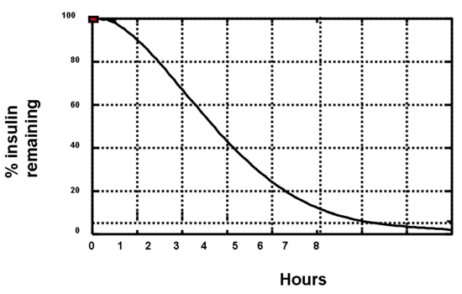
Figure 11: The appearance of insulin into the blood stream (pharmacokinetics) is different than the measurement of insulin action (pharmacodynamics). This figure is a representation of timing of insulin action for insulin aspart from euglycemic clamp data(0.2 U/kg into the abdomen). Using this graph assists patients to avoid “insulin stacking”. For example, 3 hours after administration of 10 units of insulin aspart, one can estimate that there is still 40% X 10 units, or 4 units of insulin remaining. By way of comparison, the pharmacodynamics of regular insulin is approximately twice that of insulin aspart or insulin lispro. Currently used insulin pumps keep track of this “insulin-on-board” to avoid insulin stacking. Adapted from reference [37].

USE OF CSII FOR T1D

While not a new tool, insulin pump therapy remains the gold standard of insulin delivery for T1D (Figure 8). CSII is the most precise way to mimic normal insulin secretion because basal insulin infusion rates can be programmed throughout a 24-hour period. Essentially, the CSII pump may be thought of as a computerized mechanical syringe automatically delivering insulin in physiologic fashion. Patients can accommodate metabolic changes related to eating, exercise, illness, or varying work and travel schedules by modifying insulin availability. Basal rates can be adjusted to match lower insulin demands at night (between approximately 11 PM and 4 AM) and higher requirements between 3 AM or 4 AM and 9 AM.

Various studies comparing glycemic control during CSII versus intensive insulin injection regimens have been published. A meta-analysis of 12 randomized controlled trials of CSII versus multiple injection regimens showed a weighted mean difference in blood glucose concentration of 16 mg/dL (95% CI 9-22) and a difference in A1C of 0.5% (0.2-0.7) favoring CSII [52]. The slightly but significantly better control in patients on CSII was accomplished with a 14% average reduction in daily insulin dose.

A meta-analysis funded by the Agency for Healthcare Research and Quality showed that in adults with T1D A1C levels decreased more with CSII than multiple injections but one study heavily influenced this finding [27]. For both children and adults, there was no difference in severe hypoglycemia. The common misconception that CSII leads to more hypoglycemia is not valid.

Modern insulin pumps are much smaller and easier to use than the pumps of the past. Most weigh around 115 grams (4 oz), and are approximately the size of a small cellular phone (Figure 8). Many pumps actually house an insulin-filled cartridge or syringe connected to an 18-inch, 23- to 24-inch, 31-32 inch, or 42- 43-inch length of plastic tubing. At the end of the tubing is a 25- or 27-gauge needle or a soft Teflon cannula that can be inserted into the subcutaneous tissue at a 30- to 45- or 90-degree angle, depending on the type of infusion set used. The abdomen is the preferred infusion site because placement of the catheter there is convenient and comfortable and insulin absorption is most consistent in this region. However, the upper outer quadrant of the buttocks, upper thighs, and triceps fat pad of the arms may also be used.

Infusion sets allow removal of the insertion needle, leaving only the soft cannula in place subcutaneously. Patients who experience frequent soft cannula kinking or those with Teflon allergies can opt for infusion sets that use a small stainless steel needle to infuse insulin instead of a Teflon cannula. Early adapters of CSII were required to use straight or bent needles but those have for the most part disappeared. After the syringe is placed in the pump, a lever mechanically pushes down the plunger of the syringe, and the insulin travels through the infusion tube, entering the subcutaneous tissue through the soft, flexible catheter. In current models, infusion lines have a quick-release mechanism, allowing them to be temporarily disconnected from the insertion site. This quick-release feature makes dressing, swimming, showering, and other activities more convenient. Newer versions consist of disposable “pods” which are discarded every three days. The insulin is infused directly from the pod through a catheter without the use of any tubing. Both basal and bolus insulin dosing is communicated to the pod though radio frequency via a separate “personal diabetes manager”. Choices of CSII continue to grow for patients with T1D.

All three rapid-acting analogues are approved in the United States for use in pumps. The basal rate of the insulin pump replaces the use of insulin NPH, insulin glargine, insulin detemir, or insulin degludec. The boluses given before each meal are essentially the same as normal insulin injections of insulin lispro, insulin aspart, or insulin glulisine. The pump allows programming of several different basal infusion rates at increments that can range from 0.025 up to 35.0 units/hour (usually ranging from 0.4 to 2.0 units/hour) to meet non-prandial insulin demands, though it is unlikely that the average patient will require more than 2 or 3 different rates (Figure 12). As with MDI, correction doses can be provided before or between meals. Figures 13 and 14 show data that is typically downloaded from a pump.

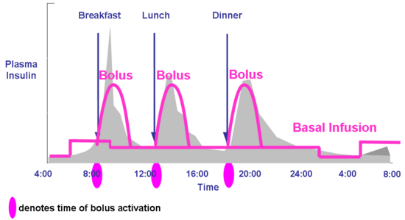

Figure 12: Idealized insulin curves for CSII with either insulin lispro, insulin aspart, or insulin glulisine. Note the basal insulin component can be altered based on changing basal insulin requirements. Typically, insulin rates need to be lowered between midnight and 0400 h (predawn phenomenon) and raised between 0400 h and 0800 h (dawn phenomenon). The basal rate the rest of the day is usually intermediate to the other two. Modern-day pumps can calculate prandial insulin dose by the patient entering into the pump the blood glucose concentration and the anticipated amount of carbohydrate to be consumed. The pump calculates how much previous prandial insulin is still active, and provides the patient a final suggested dose which the patient may activate or override.

There are many fundamental differences between CSII and MDI. These include:

Titration of Basal Rates

From a practical point of view, the first and most important insulin dose to provide in a correct amount is the basal rate. If the basal dose is set incorrectly, neither the bolus doses nor the correction doses will be appropriate. A common mistake observed in CSII therapy is that the basal dose is set too high, making the administration of even small insulin correction doses result in hypoglycemia. The greatest advantage of CSII is it allows more flexibility and titration of the basal doses.
The basal dose can be titrated throughout the day to meet patients’ individual needs and this should be done in a systematic manner by performing “basal checks.” Prior to starting a basal rate assessment (basal check), the following conditions should be met for the day of the test: last meal and/or insulin bolus should have occurred at least 4 hours prior to starting the assessment; last meal should preferentially be low in fat and not have too much protein; avoid exercise and alcohol; do not perform the assessment if hypoglycemia has occurred earlier in the day or there is an inter-current illness.

Nighttime basal rate: It is usually best to start by addressing the overnight basal rate.
An overnight basal assessment is performed on a night the patient has a bedtime glucose level within target. The patient is asked not to have anything to eat during the assessment. The patient then measures glucose levels at bedtime, midnight, 3AM and upon awakening to assess for changes in glucose profile (the use of a continuous glucose monitor obviously makes this exercise much easier). Glucose should also be checked in case of hypoglycemic symptoms. If hypoglycemia ensues or glucose level rises above target, the assessment is stopped and the patient treats the glucose level accordingly. Rises or falls of ≤ 30 mg/dl from bedtime to morning (upon awakening) are usually acceptable. By contrast, glucose changes > 30 mg/dl will require adjustments in basal rates usually consisting of 10-20% changes in insulin dose (as deemed clinically appropriate) starting 2 hours before the observed rise or fall in glucose levels. In general, a change in a basal dose takes two to four hours to result in a change in blood glucose.

Daytime basal rates: Daytime basal rates are checked by assessing the glucose profile across a skipped-meal time segment (i.e., pre-breakfast to pre-lunch, pre-lunch to pre-dinner, and pre-dinner to bedtime). To check the “pre-breakfast to pre-lunch” time segment, breakfast is skipped and glucose level is checked at 1-2 hour intervals for the duration of the time segment (prior to lunch). Glucose levels should also be checked in the event of hypoglycemic symptoms. The same recommendations regarding changes in glycemic levels requiring insulin dose adjustments described for the overnight basal assessment apply here.

Tracking of Insulin-On-Board

Another major difference between CSII and MDI is the pump can accurately track the insulin-on-board for safer use of correction doses (Figure 11). As noted above, doing this accurately can have a major impact in preventing insulin stacking.

Insulin Dose Calculator

Insulin-to-carbohydrate ratios and insulin sensitivity factors with corresponding target glucose values can be set and modified as needed in insulin pumps. Patients are only required to enter their glucose level and/or anticipated carbohydrate amount to be consumed and the insulin pump will calculate the insulin dose and recommend a bolus dose. So the complicated mathematics to best utilize MDI are done automatically with CSII.

Modifications to Bolus Delivery

Pumps can be programmed for individual boluses to be administered over an extended period of time (“extended” or “square wave” bolus). This feature may be particularly helpful for very high-fat meals or those patients with delayed gastric emptying, seen with gastroparesis or in those receiving pramlintide (see below).

Temporary Basal Rates

The other major advantage of CSII is that it allows the use of “temporary basal rates.” This is extremely helpful in situations where metabolic demands have “temporarily” changed such as during illness (requiring an increase in insulin dose) or during exercise (requiring a dose reduction). Again, due to the time action of the rapid-acting analogues, sufficient time must be incorporated when using a temporary basal rate. For example, we find that for exercise, the insulin rate must be decreased one to two hours prior to the activity and may need to be extended for 1-2 hour after completion of the activity.

Download Capability

Pump data can be downloaded and the data obtained is extremely helpful in understanding patients’ glycemic responses to an established insulin regimen (Figure 13). Also, it can assist in evaluating patients’ behaviors pertaining to their glucose management. Downloads provide information regarding the total daily insulin use broken down into percentages corresponding to basal and bolus delivery. This allows determining if patients are consistently administering boluses or whether they are essentially “running on basal.” Some of the additional data that can be downloaded includes average glucose levels, frequency of glucose monitoring, days between site changes, amount of time patients are suspending the pump or using temporary basal rates, frequency of boluses (which allows to identify non-compliance or insulin stacking behaviors), and average daily carbohydrates consumed (Figure 14).

Figure 13. A patient’s insulin pump download showing comprehensive data for one day including basal rates, boluses and use of bolus calculator, glucose monitoring, carbohydrate intake, and percentage of glucose at target.

Figure 14. A patient’s pump download showing glucose measurements, bolus events, fill events (denoting frequency of site and set changes), as well as insulin pump suspension duration for a 14 day period).

However, despite the multiple benefits of CSII therapy there are also several risks. The first is an abrupt stoppage of insulin delivery either from an occlusion or dislodging of the catheter. For most patients who measure glucose levels at least 4 times daily the problem can be discovered and rectified quickly. However, for the occasional patient who tests infrequently or misses several glucose tests the discontinuation of the insulin infusion can result in ketoacidosis. Fortunately, this is rare. When glucose levels are found to be elevated for no apparent reason, it is appropriate to bolus the appropriate correction dose and if after 1 to 2 hours glucose levels are not improved, an injection of insulin is recommended and the infusion site should be changed.

Another potential complication is infection, often an abscess, at the infusion site. This is also rare and can be minimized with meticulously cleaning the pump site prior to insertion. Although not as severe, inflammation from pump sites can be problematic. This can be improved by changing the infusion set every 24 to 72 hours and rotating pump sites. Similarly, some patients develop lipohypertrophy from infusing the insulin in the same area. This can result in extreme variability in insulin absorption. Again, frequent rotation of pump sites can alleviate this problem which is under-reported. Clinicians should therefore make pump site observation a part of every clinic visit.

ADJUNCTIVE NON-INSULIN THERAPIES IN TYPE 1 DIABETES

Intensive insulin therapy for T1D is associated with increased risk of hypoglycemia. Additionally, glycemic variability and weight gain with resultant non-adherence to insulin are commonly encountered. Weight gain also contributes to increased cardiometabolic risk such as hypertension, dyslipidemia and atherosclerotic cardiovascular disease. Insulin therapy also does not address glucagon excess and altered gastric emptying that is seen in patients with T1D. Hence adjunctive therapies could be of potential benefit in management of T1D.

Amylin Analogues

Amylin is a neuroendocrine hormone co-secreted with insulin by the pancreatic beta cells [53]. Amylin reduces postprandial hyperglycemia by reduction of mealtime glucagon secretion. Other effects include a delay of gastric emptying, thereby reducing satiety and enabling weight loss. Overall, amylin complements the action of insulin by targeting postprandial hyperglycemia; thus T1D is a state of deficiency of both amylin and insulin.

Pramlintide is an injectable amylin analogue approved for use in T1D as an adjunct to prandial insulin. Pramlintide has similar physiological effects as amylin, such as reduction of food intake, and decreases mean A1C by 0.3-0.5% with modest weight loss [54]. Pramlintide is injected just prior to meals at an initial dose of 15 mcg and increased as tolerated to a final dose of 60 mcg. It should be administered only prior to major meals consisting of 250 calories or 30 grams of carbohydrate. Prandial insulin doses of insulin (in MDI or CSII therapy) should be reduced as food intake decreases and gastric emptying is delayed. For those receiving insulin via a pump, using an “extended bolus” (see above) works best to avoid postprandial hypoglycemia. For those using MDI, some patients administer their insulin just prior to eating (without a lag time, see above) or after eating. Pramlintide use is typically associated with weight loss. It has a negligible effect on fasting blood glucose concentrations and does not alter the counter-regulatory hormone responses, or glycemic recovery time after hypoglycemia.

Use of pramlintide is limited by nausea, often mild and self-limited. Severe insulin-induced hypoglycemia has also been noted with the use of pramlintide if insulin doses are not sufficiently reduced on initiation of pramlintide therapy. Thus far, no cardiac, hepatic, or renal adverse events have been reported with use of pramlintide.

Incretin Therapies

Endogenous glucagon-like peptide-1 (GLP-1) is secreted from L cells (present in the small and large intestine) in response to food ingestion. GLP-1 enhances glucose-induced insulin secretion, inhibits glucagon secretion, delays gastric emptying, and induces satiety. GLP-1 secretion in T1D patients is similar to that seen in healthy individuals. In vitro studies suggest that incretin based therapies can expand beta cell mass, stimulate beta cell proliferation and inhibit beta cell apoptosis, although this has not been demonstrated in humans. Thus, due to their putative effects on beta cell integrity and function, GLP-1 receptor agonists and oral dipeptidyl peptidase-4 (DPP-4) inhibitors are increasingly being studied in individuals with T1D, (not currently approved by the FDA for this indication). GLP-1 receptor agonists delay gastric emptying, suppress postprandial glucagon secretion, and increase satiety. Recent studies suggest that these agents may decrease insulin requirements and facilitate weight loss [55, 56]. Effects on glycemic control are inconsistent. Further long-term clinical trials with GLP-1 analogues in T1D patients are needed. Ongoing trials are investigating the effects of various GLP-1 analogues in T1D. At this time, GLP-1 receptor agonists are not a recommended treatment option in T1D.

DPP-4 enzyme degrades endogenous GLP-1 and removes it from the circulation. DPP-4 inhibitors lower blood glucose by preventing breakdown of endogenous GLP-1, thereby increasing concentration in the circulation. In patients with type 2 diabetes, DPP-4 inhibitors potentiate glucose-dependent insulin secretion and inhibit glucagon release without effect on gastric emptying or bodyweight. Patients with T1D have inappropriately raised glucagon secretion and DPP-4 inhibitors added to insulin could potentially enhance insulin secretion in patients with residual endogenous insulin secretion and improve glycemic control. However, observed effects in patients with T1D are limited with modest improvements in A1C that are short-term and not sustained [57]. Cardiovascular safety has not been established and studies are ongoing.

Metformin

Metformin, a biguanide, is used as first-line therapy in patients with type 2 diabetes. It decreases hepatic gluconeogenesis and improves insulin sensitivity [58]. Metformin may have some benefit in reducing insulin doses and possibly improve metabolic control in obese/overweight individuals as observed in small studies in patients with T1D. A meta-analysis of 5 studies suggested that addition of metformin resulted in a decrease in insulin requirement (6.6 units/day), and a decrease in weight with minimal change in A1c [59]. Metformin was well tolerated, although a trend towards increased rates of hypoglycemia was noted. A recent randomized placebo-controlled trial in 140 overweight adolescents with T1D evaluated the addition of metformin to insulin [60]. There was no improvement in glycemic control after 6 months but use of metformin resulted in decreased insulin dose and improved measures of adiposity, despite increased gastrointestinal adverse events. Although metformin has been shown to decrease CVD morbidity in type 2 diabetes, data in T1D is lacking. Effect of metformin on carotid intima-media thickness is being addressed in an ongoing clinical trial (REMOVAL) [61]. Concomitant use of metformin in patients with T1D is not recommended in current published guidelines.

Sodium Glucose Cotransporter 2 (SGLT-2) Inhibitors

SGLT2 is a protein expressed in the proximal convoluted tubule (PCT) of the kidney and is responsible for re-absorption of filtered glucose. Inhibition of SGLT2 prevents glucose reabsorption in the PCT and increases glucose excretion by the kidney. SGLT1 is the major intestinal glucose transporter. SGLT1 inhibition also increases postprandial release of the gastrointestinal hormones GLP-1 and polypeptide YY, probably by increasing delivery of glucose to the distal small intestine, thereby regulating glucose and appetite control. Notably, the action of these agents is insulin-independent, therefore this class of drugs has potential as adjunctive therapy for T1D. Some small scale studies of SGLT2 inhibitors in T1D have shown promising results with evidence of decreased total daily insulin dosage, improvement in fasting glucose and A1C, measures of glycemic variability, rates of hypoglycemia and body weight [62-64]. There is also limited evidence that these agents are beneficial in diabetic kidney disease.

Common side effects associated with this class of drugs include genital and urinary infections. Euglycemic diabetic ketoacidosis has been described in a series of patients with T1D due to glycosuria masking hyperglycemia but with a catabolic state (due to insulin deficiency and hyperglucagonemia) with ketonemia [65]. Currently SGLT2 inhibitors are approved for use in type 2 diabetes only. A dual inhibitor of SGLT1 and 2 sotagliflozin is under development and shows promise in T1D patients [66]. Long-term and large-scale studies with SGLT2 inhibitors and dual SGLT1/2 inhibitors are necessary before these agents can be safely prescribed in T1D patients.

Bariatric Surgery

Bariatric and other metabolic surgeries are effective weight loss treatments in severe obesity. In T1D individuals with morbid obesity, bariatric surgery has been shown to result in significant weight loss, decrease in insulin requirements and an overall improvement in metabolic profile. However, DKA and hypoglycemia occur in the post-operative period. Longer term and larger studies are required to further evaluate the role of bariatric surgery in T1D [67].

OTHER ASPECTS OF MANAGEMENT

Psychosocial aspects

Assessment and management of psychosocial issues are an important component of care in individuals with T1D throughout their life span [68]. While the individual patient is the focus of care, family support should be encouraged when appropriate. Evaluation and discussion of psychosocial issues and screening for depression screening should be included as part of each clinic visit. Many patients experience “diabetes distress” related to the multitude of self-care responsibilities to optimize glycemic control. Diabetes distress is frequently associated with suboptimal glycemic control, low self-efficacy and reduced self-care. Depression, anxiety from fear of hypoglycemia, and eating disorders can develop and are associated with poor glycemic control. In young adults, comprehensive management of diabetes that addresses these psychosocial issues can improve glycemic control and reduce hospitalization due to diabetic ketoacidosis. Strategic interventions such as cognitive restructuring, goal setting and problem solving can help individuals particularly adolescents and young adults reduce diabetes distress [69]. Thus early identification and treatment including referral to a mental health specialist can help aid management of diabetes.

Management of Special Populations

Older Adults: Adults with T1D now span a very large age spectrum—from 18 to 100 years of age and beyond. These individuals are unique in that they usually have lived with a complex disease for many years [68]. An understanding of each individual’s circumstances is vital and management often requires assessment of medical, functional, mental, and social domains. The ADA emphasizes that glycemic targets should be individualized with the goal of achieving the best possible control while minimizing the risk of severe hyperglycemia and hypoglycemia [70].

Glycemic goals in older adults: Most older adults with T1D have long-standing disease (unlike individuals with T2DM where diabetes can be long-standing or new onset). Additionally, there is a wide range of health in older individuals, with some patients enjoying good functional status and no comorbid conditions, while others are limited by multiple comorbidities as well as physical or cognitive impairments. Older T1D patients may develop diabetes related complications which pose a challenge in disease management. Insulin dosing errors, hypoglycemia unawareness, and inability to manage hypoglycemia when it occurs may result from physical and cognitive decline. Special attention should be focused on meal planning and physical activities in this population. Severe hyperglycemia can lead to dehydration and hyperglycemic crises [68]. Issues related to self-care capacity, mobility, and autonomy should be promptly addressed.

Thus treatment goals should be reassessed and individualized based on patient factors. Older patients with long life expectancy and little comorbidity should have treatment targets similar to those of middle-aged or younger adults. In patients with multiple comorbid conditions, treatment targets may be relaxed, while avoiding symptomatic hyperglycemia or the risk of diabetic ketoacidosis [68]. Therefore, it is important to assess the clinical needs of the patient, setting specific goals and expectations that may differ quite significantly between a healthy 24-year-old and a frail 82-year-old with retinopathy and cardiovascular disease.

There are few long-term studies in older adults demonstrating the benefits of intensive glycemic, blood pressure, and lipid control [70]. As with younger adults, glycemic control should be assessed based on frequent SMBG levels (and CGM data, if available) as well as A1C to help direct changes in therapy. More stringent A1C goals (~6.5-7%) can be recommended in select older adults if this can be achieved without hypoglycemia or other adverse effects. This is appropriate for older individuals with anticipated long life expectancy, hypoglycemia awareness and no CVD. Less stringent A1C goals (for example A1C<8.5%) may be appropriate for patients with a history of severe hypoglycemia, hypoglycemia unawareness, limited life expectancy, advanced microvascular/macrovascular complications, or extensive comorbid conditions [68, 71].

Inpatient Management and Outpatient Procedures

The challenges involved in management of individuals with T1D in the hospital and in preparation for scheduled outpatient procedures include difficulties associated with fasting, maintaining a consistent source of carbohydrate, and facilitating inpatient blood glucose management while modifying scheduled insulin therapy. Individuals with T1D may have difficulty fasting for long periods of time (more than 10 h) prior to a procedure. Patients with T1D should be prepared with a treatment plan for insulin dose adjustments and oral glucose intake prior to any procedure that requires alterations in dietary intake and/or fasting.

In general, goals for blood glucose levels in individuals with T1D are the same as for people with type 2 diabetes or hospital-related hyperglycemia [72]. It is imperative that the entire health care team, including anesthesiologists and surgeons as well as other specialists who perform procedures, understands T1D and how it factors into the comprehensive delivery of care. First, the diagnosis of T1D should be clearly identified in the patient’s record. Second, the awareness that people with T1D will be at high risk for hypoglycemia during prolonged fasting and are at risk for ketosis if insulin is inappropriately withheld. Under anesthesia, individuals with T1D must be carefully monitored for hypoglycemia and hyperglycemia. Third, a plan for preventing and treating hypoglycemia should be established for each patient.

SMBG should be ordered to fit the patient’s usual insulin regimen with modifications as needed based on clinical status. Self-management in the hospital may be appropriate for some individuals with T1D including those who successfully manage their disease at home, have cognitive skills to perform necessary tasks such as administer insulin and perform SMBG, count carbohydrates and have a good understanding of their condition [72]. For some individuals, once the most acute phase of an illness has resolved or improved, patients may be able to self-administer their prior multiple-dose or CSII insulin regimen under the guidance of hospital personnel who are knowledgeable in glycemic management. Individuals managed with insulin pumps and/or multiple-dose regimens with carbohydrate counting and correction dosing may be allowed to manage their own diabetes if this is what they desire, once they are capable of doing so.

The need for uninterrupted basal insulin to prevent hyperglycemia and ketoacidosis is important to recognize. Insulin dosing adjustments should also be made in the perioperative period and inpatient setting with consideration of oral intake and blood glucose trends.

The use of CGM in the inpatient setting is an area of ongoing research. Currently, the Endocrine Society recommends against the use of real-time CGM (RT-CGM) alone in the intensive care unit or operating room settings due to limited available data on accuracy [73]. A study in type 2 diabetes patients on basal bolus insulin therapy admitted to the general ward evaluated the use of retrospective CGM versus point of care capillary glucose testing for inpatient glycemic control [74]. Although average daily glucose levels were comparable between CGM and capillary blood glucose testing, CGM detected a higher number of hypoglycemic episodes (55 vs 12, P < 0.01) suggesting that CGM may be beneficial for identification of hypoglycemia in the general ward particularly in patients with hypoglycemia unawareness. We feel it is reasonable to allow T1D patients who already benefit from use of RT-CGM to continue the use of this technology in the non-ICU inpatient setting under the supervision of the care team. Large prospective randomized trials will be required to establish benefit or lack thereof of RT-CGM use on inpatient glycemic control.

BETA-CELL REPLACEMENT STRATEGIES

Pancreas Transplantation

Pancreas transplantation is a currently available therapeutic option for patients with diabetes who meet specific clinical criteria. Patients with end-stage renal disease are eligible to undergo simultaneous pancreas kidney (SPK) transplantation. Also, pancreas transplantation may be offered as a separate procedure after a patient has already received a kidney transplant (pancreas after kidney [PAK]). In addition, solitary pancreas transplantation may also be offered to those individuals presenting with severe metabolic complications attributed to poor glycemic control (pancreas transplant alone [PTA]). Pancreas transplantation procedures have been performed since the 1960’s. A 2011 update on Pancreas Transplantation from the International Pancreas Transplant Registry reported improvements in patient survival and graft function over a course of 24 years of pancreas transplantation [75]. These improved outcomes were related to changes in surgical technique and immunosuppressive regimens as well as tighter donor selection criteria. At 5-years post-transplantation, pancreas graft survival is now reported at ~70% for SPK and at ~ 50% for PAK and PTA. Further, patient survival at 10 years exceeds 70% with the highest survival rate observed in PTA recipients (82%).

Islet Transplantation

Islet transplantation provides a less invasive surgical alternative for beta-cell replacement in patients with labile diabetes and has the potential to restore normoglycemia, eliminate severe hypoglycemia and restore hypoglycemia awareness. However, this procedure is still considered experimental in the United States. Marked improvements have also been noted in the field of islet transplantation over the past decade which have led to insulin independence rates at 5 years being comparable to pancreas transplantation outcomes [76]. A recently published pivotal study of islet transplantation in patients with T1D showed that at 1-year post transplant, 87% of study participants achieved the primary endpoint of a A1C <7.0% and freedom from severe hypoglycemia (from day 28 to 365) [77]. Results from this study may pave the way for the FDA to approve islet transplantation as a therapeutic option for a subset of patients with labile T1D. Further details about islet transplantation can be found in the dedicated Endotext chapter.

FUTURE DIRECTIONS IN MANAGEMENT OF TYPE 1 DIABETES

Artificial Pancreas Device Systems - Closed Loop Systems

Improvements in CGM sensor technology have allowed the integration of CGM systems with insulin pumps and the development of artificial pancreas device systems (APDS), also known as closed-loop (CL) systems. An APDS consists of an insulin pump, a CGM device, and algorithms designed for safety and glucose control optimization. The first APDS approved by the FDA was the Medtronic MiniMed 530G, which includes their proprietary “Threshold Suspend” feature. This feature allows users to set a glucose threshold (based on CGM reading) to automatically suspend insulin delivery (for a period of 2 hours) to prevent hypoglycemia unless the patient responds to an alert to take a corrective action. Although far from being a full CL system, this was a significant step in the automation of insulin delivery.

Newer more complex algorithms with glucose predictive capabilities are currently being utilized and tested in several APDS clinical studies. Some of these algorithms provide a full-CL system in which there is essentially no user input while others, termed hybrid-CL systems, require input for food intake and/or exercise activity. In 2015, the Medtronic MiniMed 640G became available in Europe providing significant improvement over its 530G predecessor. This model incorporates predictive low glucose suspend (PLGS) technology which suspends insulin delivery if the sensor glucose value is expected to fall below a determined threshold within 30 min and is able to resume insulin once the glucose level returns above the low threshold.

Most recently, Medtronic received FDA approval for its MiniMed 670G system following results from a 3-month duration pivotal study in adult patients with T1D aged 14-75 years [78]. The Medtronic MiniMed 670G is a fully integrated, insulin-only, hybrid-CL (HCL) system. It incorporates an “Auto Mode” feature, which automatically adjusts basal insulin delivery by either increasing or decreasing the amount of insulin delivered based on CGM sensor blood glucose values. This is a hybrid system, and patients are still required to manually enter boluses for meals. A similar study assessing the safety of this HCL in children aged 7 to 13 years is ongoing.

In addition to insulin-only CL-systems, bi-hormonal closed loop systems are also being actively explored. Additional manufacturers utilizing insulin-only CL-systems are expected to lunch their devices in the near future. The introduction of faster-acting insulins (biochaperone lispro and faster-acting insulin aspart [FIAsp]) could potentially make these strategies more effective. As this technology advances we are getting closer to the goal of a fully automated device which will be able to predict with high accuracy changes in glucose profiles and respond accordingly with stringent modulation of infusion of hormones (e.g. insulin, glucagon, amylin) to maintain glycemia within normal ranges.

Implantation of Encapsulated Islets

Some of the limitations of islet transplantation currently include the limited availability of donors and the need for long term immunosuppression to prevent rejection of the transplanted graft. Protecting the islets from the immunologic environment may allow both the use of non-human islets for transplantation and minimize or eliminate the need for systemic immunosuppression. Thus, the encapsulation of islets to attain these goals has been sought for several years but unfortunately this technology is still to make it to the clinical arena. Although initial attempts at encapsulation of islets resulted in damage of the capsule by local tissue responses, newer techniques allowing for conformal coating of human islets have shown promising results in pre-clinical models and are currently being explored [79].

Islet Xenotransplantation

An alternative to human pancreas and islet transplantation which is currently being explored is the use of pig islets. Pig islets have major physiologic similarities to human islets. Notably, pig insulin differs from human insulin by only one aminoacid. Donor pigs may be genetically engineered to be protected from the human immune system thus reducing the need for potent immunosuppression. Studies in non-human primates using encapsulated pig islets have resulted in graft survival for more than 6 months [80]. Research in this field in actively ongoing and funding is currently being pursued for a first clinical trial.
Stem Cell Based Therapies

Stem cell research has allowed the generation of insulin-producing pancreatic β-cells from human pluripotent stem cells [81]. Further, scientists can now also generate alpha and delta cells from stem cells therefore more closely mimicking a fully functional human islet. This technology has the potential to generate vast amounts of glucose-responsive β-cells and allow for the development of customizable islets containing predetermined amounts of specific cell lines. Results in preclinical models are encouraging but this technology is still to make to clinical trials.
Glucose Responsive Insulins (Smart Insulins)

Another area of ongoing research is the development of “smart” drug delivery systems able to respond to environmental or external triggers greatly improving therapeutic performance. Conceptually, “smart” insulins should be able to respond to changes in ambient glucose which would dictate activation or cessation of insulin delivery. Several efforts have been made to generate glucose-responsive insulin delivery systems and some have shown promising results in pre-clinical studies including the utilization of enzymatic triggers, glucose-binding proteins, and synthetic molecules able to bind to glucose. However, current limitations include the potential for immunogenicity and poor glucose selectivity [82].

CONCLUSIONS

No disease has had such an evolution of therapy in the past 95 years as T1D. From certain death to the discovery of insulin, from impure animal insulin preparations to purified human insulins, from once daily long-acting insulin to CSII, from urine glucose testing to real-time continuous glucose sensors, treatments continue to emerge that improve the lives of people with T1D. Our current challenges remain teaching the providers how to best use these new tools, directing our medical systems to allow us to best utilize these therapies, and perhaps most importantly, transferring these new technologies to the patients who can best apply them. Although the future is exciting, we need to first master the use of our current tools before we can successfully move forward. Hopefully, in the near future the successful management of T1D will become a reality for all with this disease.

REFERENCES

1. Rosenfeld, L., Insulin: discovery and controversy. Clin Chem, 2002. 48(12): p. 2270-88.
2. Lauritzen, T., O.K. Faber, and C. Binder, Variation in 125I-insulin absorption and blood glucose concentration. Diabetologia, 1979. 17(5): p. 291-5.
3. Tibaldi, J.M., Evolution of insulin: from human to analog. Am J Med, 2014. 127(10 Suppl): p. S25-38.
4. The effect of intensive treatment of diabetes on the development and progression of long-term complications in insulin-dependent diabetes mellitus. The Diabetes Control and Complications Trial Research Group. N Engl J Med, 1993. 329(14): p. 977-86.
5. Nathan, D.M., et al., Intensive diabetes treatment and cardiovascular disease in patients with type 1 diabetes. N Engl J Med, 2005. 353(25): p. 2643-53.
6. Martin, C.L., et al., Neuropathy among the diabetes control and complications trial cohort 8 years after trial completion. Diabetes Care, 2006. 29(2): p. 340-4.
7. Retinopathy and nephropathy in patients with type 1 diabetes four years after a trial of intensive therapy. The Diabetes Control and Complications Trial/Epidemiology of Diabetes Interventions and Complications Research Group. N Engl J Med, 2000. 342(6): p. 381-9.
8. Writing Team for the Diabetes, C., I. Complications Trial/Epidemiology of Diabetes, and G. Complications Research, Sustained effect of intensive treatment of type 1 diabetes mellitus on development and progression of diabetic nephropathy: the Epidemiology of Diabetes Interventions and Complications (EDIC) study. JAMA, 2003. 290(16): p. 2159-67.
9. Genuth, S., Insights from the diabetes control and complications trial/epidemiology of diabetes interventions and complications study on the use of intensive glycemic treatment to reduce the risk of complications of type 1 diabetes. Endocr Pract, 2006. 12 Suppl 1: p. 34-41.
10. White, N.H., et al., Prolonged effect of intensive therapy on the risk of retinopathy complications in patients with type 1 diabetes mellitus: 10 years after the Diabetes Control and Complications Trial. Arch Ophthalmol, 2008. 126(12): p. 1707-15.
11. Miller, K.M., et al., Current state of type 1 diabetes treatment in the U.S.: updated data from the T1D Exchange clinic registry. Diabetes Care, 2015. 38(6): p. 971-8.
12. Tonyushkina, K. and J.H. Nichols, Glucose meters: a review of technical challenges to obtaining accurate results. J Diabetes Sci Technol, 2009. 3(4): p. 971-80.
13. Miller, K.M., et al., Evidence of a strong association between frequency of self-monitoring of blood glucose and hemoglobin A1c levels in T1D exchange clinic registry participants. Diabetes Care, 2013. 36(7): p. 2009-14.
14. American Diabetes, A., 5. Glycemic Targets. Diabetes Care, 2016. 39 Suppl 1: p. S39-46.
15. Freckmann, G., et al., System accuracy evaluation of 43 blood glucose monitoring systems for self-monitoring of blood glucose according to DIN EN ISO 15197. J Diabetes Sci Technol, 2012. 6(5): p. 1060-75.
16. Bergenstal, R.M., et al., Recommendations for standardizing glucose reporting and analysis to optimize clinical decision making in diabetes: the Ambulatory Glucose Profile (AGP). Diabetes Technol Ther, 2013. 15(3): p. 198-211.
17. Basu, A., et al., Time lag of glucose from intravascular to interstitial compartment in humans. Diabetes, 2013. 62(12): p. 4083-7.
18. Bailey, T.S., et al., American Association of Clinical Endocrinologists and American College of Endocrinology 2016 Outpatient Glucose Monitoring Consensus Statement. Endocr Pract, 2016. 22(2): p. 231-61.
19. Potts, R.O., J.A. Tamada, and M.J. Tierney, Glucose monitoring by reverse iontophoresis. Diabetes Metab Res Rev, 2002. 18 Suppl 1: p. S49-53.
20. DexCom™ STS™ Continuous Glucose Monitoring System - P050012. 2006 9/5/2013 [cited 2016 October 10].
21. Liebl, A., et al., Continuous glucose monitoring: evidence and consensus statement for clinical use. J Diabetes Sci Technol, 2013. 7(2): p. 500-19.
22. Castle, J.R. and P.G. Jacobs, Nonadjunctive Use of Continuous Glucose Monitoring for Diabetes Treatment Decisions. J Diabetes Sci Technol, 2016. 10(5): p. 1169-73.
23. Kropff, J. and J.H. DeVries, Continuous Glucose Monitoring, Future Products, and Update on Worldwide Artificial Pancreas Projects. Diabetes Technol Ther, 2016. 18 Suppl 2: p. S253-63.
24. Bailey, T., et al., The Performance and Usability of a Factory-Calibrated Flash Glucose Monitoring System. Diabetes Technol Ther, 2015. 17(11): p. 787-94.
25. New, J.P., et al., Continuous glucose monitoring in people with diabetes: the randomized controlled Glucose Level Awareness in Diabetes Study (GLADIS). Diabet Med, 2015. 32(5): p. 609-17.
26. Shivers, J.P., et al., "Turn it off!": diabetes device alarm fatigue considerations for the present and the future. J Diabetes Sci Technol, 2013. 7(3): p. 789-94.
27. Yeh, H.C., et al., Comparative effectiveness and safety of methods of insulin delivery and glucose monitoring for diabetes mellitus: a systematic review and meta-analysis. Ann Intern Med, 2012. 157(5): p. 336-47.
28. Juvenile Diabetes Research Foundation Continuous Glucose Monitoring Study, G., et al., The effect of continuous glucose monitoring in well-controlled type 1 diabetes. Diabetes Care, 2009. 32(8): p. 1378-83.
29. Foster, N.C., et al., Continuous Glucose Monitoring in Patients With Type 1 Diabetes Using Insulin Injections. Diabetes Care, 2016. 39(6): p. e81-2.
30. Peters, A.L., et al., Diabetes Technology-Continuous Subcutaneous Insulin Infusion Therapy and Continuous Glucose Monitoring in Adults: An Endocrine Society Clinical Practice Guideline. J Clin Endocrinol Metab, 2016: p. jc20162534.
31. Sacks, D.B., et al., Position statement executive summary: guidelines and recommendations for laboratory analysis in the diagnosis and management of diabetes mellitus. Diabetes Care, 2011. 34(6): p. 1419-23.
32. Rubinow, K.B. and I.B. Hirsch, Reexamining metrics for glucose control. JAMA, 2011. 305(11): p. 1132-3.
33. American Diabetes, A., 8. Cardiovascular Disease and Risk Management. Diabetes Care, 2016. 39 Suppl 1: p. S60-71.
34. de Ferranti, S.D., et al., Type 1 diabetes mellitus and cardiovascular disease: a scientific statement from the American Heart Association and American Diabetes Association. Diabetes Care, 2014. 37(10): p. 2843-63.
35. Vistisen, D., et al., Prediction of First Cardiovascular Disease Event in Type 1 Diabetes Mellitus: The Steno Type 1 Risk Engine. Circulation, 2016. 133(11): p. 1058-66.
36. Howey, D.C., et al., [Lys(B28), Pro(B29)]-human insulin. A rapidly absorbed analogue of human insulin. Diabetes, 1994. 43(3): p. 396-402.
37. Mudaliar, S.R., et al., Insulin aspart (B28 asp-insulin): a fast-acting analog of human insulin: absorption kinetics and action profile compared with regular human insulin in healthy nondiabetic subjects. Diabetes Care, 1999. 22(9): p. 1501-6.
38. Garg, S.K., S.L. Ellis, and H. Ulrich, Insulin glulisine: a new rapid-acting insulin analogue for the treatment of diabetes. Expert Opin Pharmacother, 2005. 6(4): p. 643-51.
39. Borgono, C.A. and B. Zinman, Insulins: past, present, and future. Endocrinol Metab Clin North Am, 2012. 41(1): p. 1-24.
40. Hirsch, I.B., Insulin analogues. N Engl J Med, 2005. 352(2): p. 174-83.
41. Switzer, S.M., et al., Intensive insulin therapy in patients with type 1 diabetes mellitus. Endocrinol Metab Clin North Am, 2012. 41(1): p. 89-104.
42. Ratner, R.E., et al., Less hypoglycemia with insulin glargine in intensive insulin therapy for type 1 diabetes. U.S. Study Group of Insulin Glargine in Type 1 Diabetes. Diabetes Care, 2000. 23(5): p. 639-43.
43. Dailey, G. and F. Lavernia, A review of the safety and efficacy data for insulin glargine 300 units/ml, a new formulation of insulin glargine. Diabetes Obes Metab, 2015. 17(12): p. 1107-14.
44. Home, P.D., et al., New Insulin Glargine 300 Units/mL Versus Glargine 100 Units/mL in People With Type 1 Diabetes: A Randomized, Phase 3a, Open-Label Clinical Trial (EDITION 4). Diabetes Care, 2015. 38(12): p. 2217-25.
45. Havelund, S., et al., The mechanism of protraction of insulin detemir, a long-acting, acylated analog of human insulin. Pharm Res, 2004. 21(8): p. 1498-504.
46. Heller, S., C. Koenen, and B. Bode, Comparison of insulin detemir and insulin glargine in a basal-bolus regimen, with insulin aspart as the mealtime insulin, in patients with type 1 diabetes: a 52-week, multinational, randomized, open-label, parallel-group, treat-to-target noninferiority trial. Clin Ther, 2009. 31(10): p. 2086-97.
47. Keating, G.M., Insulin degludec and insulin degludec/insulin aspart: a review of their use in the management of diabetes mellitus. Drugs, 2013. 73(6): p. 575-93.
48. Mathieu, C., et al., Efficacy and safety of insulin degludec in a flexible dosing regimen vs insulin glargine in patients with type 1 diabetes (BEGIN: Flex T1): a 26-week randomized, treat-to-target trial with a 26-week extension. J Clin Endocrinol Metab, 2013. 98(3): p. 1154-62.
49. Russell-Jones, D., et al., Insulin degludec results in lower rates of nocturnal hypoglycaemia and fasting plasma glucose vs. insulin glargine: A meta-analysis of seven clinical trials. Nutr Metab Cardiovasc Dis, 2015. 25(10): p. 898-905.
50. Bode, B.W., et al., Inhaled Technosphere Insulin Compared With Injected Prandial Insulin in Type 1 Diabetes: A Randomized 24-Week Trial. Diabetes Care, 2015. 38(12): p. 2266-73.
51. Pettus, J., et al., The past, present, and future of basal insulins. Diabetes Metab Res Rev, 2016. 32(6): p. 478-96.
52. Hirsch, I.B., et al., Continuous subcutaneous insulin infusion (CSII) of insulin aspart versus multiple daily injection of insulin aspart/insulin glargine in type 1 diabetic patients previously treated with CSII. Diabetes Care, 2005. 28(3): p. 533-8.
53. Lebovitz, H.E., Adjunct therapy for type 1 diabetes mellitus. Nat Rev Endocrinol, 2010. 6(6): p. 326-34.
54. Edelman, S., et al., A double-blind, placebo-controlled trial assessing pramlintide treatment in the setting of intensive insulin therapy in type 1 diabetes. Diabetes Care, 2006. 29(10): p. 2189-95.
55. Ahren, B., et al., Efficacy and Safety of Liraglutide Added to Capped Insulin Treatment in Subjects With Type 1 Diabetes: the ADJUNCT TWO Randomized Trial. Diabetes Care, 2016.
56. Dejgaard, T.F., et al., Efficacy and safety of liraglutide for overweight adult patients with type 1 diabetes and insufficient glycaemic control (Lira-1): a randomised, double-blind, placebo-controlled trial. Lancet Diabetes Endocrinol, 2016. 4(3): p. 221-32.
57. Ellis, S.L., et al., Effect of sitagliptin on glucose control in adult patients with Type 1 diabetes: a pilot, double-blind, randomized, crossover trial. Diabet Med, 2011. 28(10): p. 1176-81.
58. Schimmack, G., R.A. Defronzo, and N. Musi, AMP-activated protein kinase: Role in metabolism and therapeutic implications. Diabetes Obes Metab, 2006. 8(6): p. 591-602.
59. Vella, S., et al., The use of metformin in type 1 diabetes: a systematic review of efficacy. Diabetologia, 2010. 53(5): p. 809-20.
60. Libman, I.M., et al., Effect of Metformin Added to Insulin on Glycemic Control Among Overweight/Obese Adolescents With Type 1 Diabetes: A Randomized Clinical Trial. JAMA, 2015. 314(21): p. 2241-50.
61. REducing With MetfOrmin Vascular Adverse Lesions in Type 1 Diabetes (REMOVAL). Identifier NCT01483560. http://clinicaltrials.gov/show/NCT01483560.
62. Henry, R.R., et al., Efficacy and Safety of Canagliflozin, a Sodium-Glucose Cotransporter 2 Inhibitor, as Add-on to Insulin in Patients With Type 1 Diabetes. Diabetes Care, 2015. 38(12): p. 2258-65.
63. Perkins, B.A., et al., Sodium-glucose cotransporter 2 inhibition and glycemic control in type 1 diabetes: results of an 8-week open-label proof-of-concept trial. Diabetes Care, 2014. 37(5): p. 1480-3.
64. Pieber, T.R., et al., Empagliflozin as adjunct to insulin in patients with type 1 diabetes: a 4-week, randomized, placebo-controlled trial (EASE-1). Diabetes Obes Metab, 2015. 17(10): p. 928-35.
65. Bode, B.W. and S.K. Garg, The Emerging Role of Adjunctive Noninsulin Antihyperglycemic Therapy in the Management of Type 1 Diabetes. Endocr Pract, 2016. 22(2): p. 220-30.
66. Sands, A.T., et al., Sotagliflozin, a Dual SGLT1 and SGLT2 Inhibitor, as Adjunct Therapy to Insulin in Type 1 Diabetes. Diabetes Care, 2015. 38(7): p. 1181-8.
67. Kirwan, J.P., et al., Bariatric Surgery in Obese Patients With Type 1 Diabetes. Diabetes Care, 2016. 39(6): p. 941-8.
68. Chiang, J.L., et al., Type 1 diabetes through the life span: a position statement of the American Diabetes Association. Diabetes Care, 2014. 37(7): p. 2034-54.
69. Hagger, V., et al., Diabetes Distress Among Adolescents with Type 1 Diabetes: a Systematic Review. Curr Diab Rep, 2016. 16(1): p. 9.
70. American Diabetes, A., 10. Older Adults. Diabetes Care, 2016. 39 Suppl 1: p. S81-5.
71. Kirkman, M.S., et al., Diabetes in older adults. Diabetes Care, 2012. 35(12): p. 2650-64.
72. American Diabetes, A., 13. Diabetes Care in the Hospital. Diabetes Care, 2016. 39 Suppl 1: p. S99-104.
73. Gomez, A.M. and G.E. Umpierrez, Continuous glucose monitoring in insulin-treated patients in non-ICU settings. J Diabetes Sci Technol, 2014. 8(5): p. 930-6.
74. Gomez, A.M., et al., Continuous Glucose Monitoring Versus Capillary Point-of-Care Testing for Inpatient Glycemic Control in Type 2 Diabetes Patients Hospitalized in the General Ward and Treated With a Basal Bolus Insulin Regimen. J Diabetes Sci Technol, 2016. 10(2): p. 325-9.
75. Gruessner, A.C., 2011 update on pancreas transplantation: comprehensive trend analysis of 25,000 cases followed up over the course of twenty-four years at the International Pancreas Transplant Registry (IPTR). Rev Diabet Stud, 2011. 8(1): p. 6-16.
76. Bellin, M.D., et al., Potent induction immunotherapy promotes long-term insulin independence after islet transplantation in type 1 diabetes. Am J Transplant, 2012. 12(6): p. 1576-83.
77. Hering, B.J., et al., Phase 3 Trial of Transplantation of Human Islets in Type 1 Diabetes Complicated by Severe Hypoglycemia. Diabetes Care, 2016. 39(7): p. 1230-40.
78. Bergenstal, R.M., et al., Safety of a Hybrid Closed-Loop Insulin Delivery System in Patients With Type 1 Diabetes. JAMA, 2016. 316(13): p. 1407-1408.
79. Tomei, A.A., et al., Device design and materials optimization of conformal coating for islets of Langerhans. Proc Natl Acad Sci U S A, 2014. 111(29): p. 10514-9.
80. Park, C.G., R. Bottino, and W.J. Hawthorne, Current status of islet xenotransplantation. Int J Surg, 2015. 23(Pt B): p. 261-6.
81. Pagliuca, F.W., et al., Generation of functional human pancreatic beta cells in vitro. Cell, 2014. 159(2): p. 428-39.
82. Webber, M.J. and D.G. Anderson, Smart approaches to glucose-responsive drug delivery. J Drug Target, 2015. 23(7-8): p. 651-5.

