**THE ROLE OF PARENTS IN THE CARE OF CHILDREN WITH DYSLIPIDEMIA**

**Gabriella Webster, MS,** Texas A&M Health Sciences Center, College of Medicine, Baylor/Scott and White, Dallas, Texas, [gabriellawebster99@gmail.com](mailto:gabriellawebster99@gmail.com)

**Melissa Scarcelli, RN,** Department of Pediatric Endocrinology and Diabetes, Cook Children’s Medical Center, Fort Worth, Texas, USA, [melissa.scarcelli@cookchildrens.org](mailto:melissa.scarcelli@cookchildrens.org)

**Brenda Sonnier, CCLS,** Department of Pediatric Endocrinology and Diabetes, Cook Children’s Medical Center, Fort Worth, Texas, USA, [brenda.sonnier@cookchildrens.org](mailto:brenda.sonnier@cookchildrens.org)

**Luke Hamilton, MS,** Department of Pediatric Endocrinology and Research, Cook Children’s Medical Center, Fort Worth, Texas, USA, [luke.hamilton@cookchildrens.org](mailto:luke.hamilton@cookchildrens.org)

**Don P. Wilson,** **MD, FNLA,** Department of Pediatric Endocrinology and Diabetes, Cook Children’s Medical Center, Fort Worth, Texas, USA, [don.wilson@cookchildrens.org](mailto:don.wilson@cookchildrens.org)

**Received May 21, 2024**

**ABSTRACT**

Parents should be viewed as an integral part of the child’s healthcare team, being both legally and morally responsible for providing proper care to the child. In this paper, we discuss the role of parents as critical members of the healthcare team in caring for youth with dyslipidemia and how clinicians can best leverage this important resource.

**INTRODUCTION**

Providing healthcare to a child with a chronic medical condition requires a multidisciplinary team of specially trained and experienced healthcare professionals. Cooperation, empathy, and effective communication between the child, caregivers, and the healthcare team all play key roles in achieving success. This unique model, consistently applied in the healthcare setting, is a cornerstone in promoting physical and emotional wellbeing, and improving outcomes. The development of effective communication takes time and practice, with the goal of developing trust, enhancing bidirectional understanding, and facilitating shared decision-making. Parents should be viewed as an integral part of the child’s healthcare team, being both legally and morally responsible for providing proper care to the child. In this paper, we discuss the role of parents as critical members of the healthcare team in caring for youth with dyslipidemia and how clinicians can best leverage this important resource.

**THE CLINICIAN-CHILD-PARENT RELATIONSHIP**

In contrast to adult healthcare, the treatment of children (<18 years-old) is triangulated between the child, parent, and clinician (1). As in all medical encounters, clinicians are provided intimate details about the child and family, based upon perceptions of respect for their autonomy and assurances of confidentiality.

Pediatric healthcare professionals routinely consider a child’s age, developmental level, and likes/interests in their clinical interactions and recommendation for care. Their approach is modified as the child grows and matures, building upon a foundation of trust and mutual respect. Yet, given their pivotal role, few clinicians are trained to assess the best way to communicate with the parent based upon the latter’s communication and parenting style. Establishing trust in clinical encounters takes time and a conscious effort by the clinician, and includes getting to know the child and family, providing factual information in a timely manner, use of simple language and examples, and most importantly, the clinician’s willingness to listen. Parents need to feel included and assured that the healthcare team is there to support them in providing for their child’s health and wellbeing. Thus, it is the clinician’s responsibility to find ways to build trust, facilitate effective communication, and identify barriers to success that best serve the needs of the child and their parents.

**THE “PERSONALIZED “CLINIC NOTE**

*“Parents don’t care how much you know, until they know how much you care.”* High quality healthcare is more than addressing a child’s chief complaint. During the initial clinical encounter, a clinician should strive to get to know the child and the family, developing an understanding of who they are, where they come from, what they do for a living, personal interests, and healthcare beliefs. Inclusion of personal information in a child’s clinic note can provide insight into the social determinants of health that may affect the child’s care and the parent’s resources in providing for their child’s needs. Such information can provide clues as to how best to assist the family and what additional services and resources may be needed (2). The following are two brief examples of a “personalized” clinic note:

*Eric is a 12-year-old boy who is homeschooled, plays soccer, and has a schnauzer named “Ringo”. His father is a minister, the mother a CPA. There are 2 siblings, one of whom is autistic. Eric was referred by his primary care physician for high cholesterol noted following a routine screening test.*

*Julie is a 16-year-old girl who attends a public school and wants to become a beautician. Her mother is a single parent who works in retail and has 3 other children. Julie is concerned about her weight and has combined dyslipidemia.*

Personal details included in clinic notes may provide a nonthreatening context to discuss potentially sensitive topics such as diet, physical activity, weight, healthcare beliefs and practices, and potential barriers to achieving goals (3). This information can be invaluable in helping guide the healthcare team’s approach to patient education and treatment.

**THE ROLE OF THE PARENT**

In addition to their many roles, parents of children with dyslipidemia have extended responsibilities, including but not limited to:

1. Modeling healthy behaviors.
2. Educating themselves and their child about the child’s condition.
3. Overseeing the child’s medical care, including:
   1. Scheduling and attending clinic visits.
   2. Completing laboratory tests and procedures.
   3. Overseeing medication(s), if prescribed.
   4. Helping implement recommendations such as therapeutic lifestyle changes.
   5. Managing healthcare costs.

As such, parents play an integral role in the successful outcome of the child with a chronic health condition. By engaging parents in their child’s care, clinicians can increase the likelihood of the child’s compliance with lifestyle changes and treatment recommendations (4).

**PARENTING STYLES**

Psychologists suggest that there is a close relationship between a parent’s parenting style and their child’s behavior. Different parenting styles can also contribute to a child’s short- and long-term health outcomes (5).

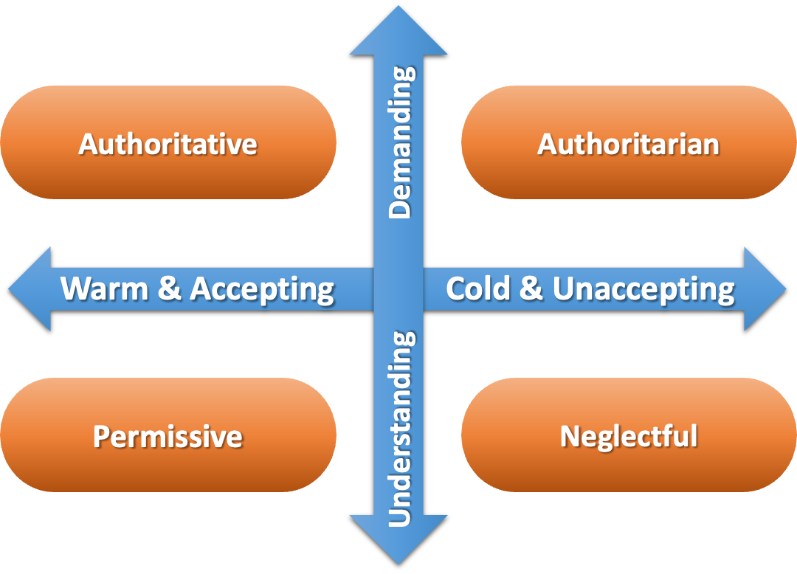

**Figure 1. Parenting styles.**

As clinicians get to know the child and family through clinical interviews, certain questions can be used to gauge a caregiver’s parenting style, which are summarized below.

|  |  |  |  |
| --- | --- | --- | --- |
| **Table 1. Characteristics of Various Parenting Style** | | | |
| **AUTHORITATIVE** | **AUTHORITARIAN** | **PERMISSIVE** | **NEGLECTFUL** |
| Warm and Receptive | Unresponsive | Warm/Responsive | Cold/Unresponsive |
| Clear Rules | Strict Rules | Few or No Rules | No Rules |
| High Expectations | High Expectations | Indulgent | Uninvolved |
| Supportive  Value Independence | Expected Blind Obedience | Lenient | Indifferent |

During a clinic visit, a few simple questions can often provide insight about parenting styles. For example, you may ask the child:

*Do you have any household chores? If so, what happens if you fail to do them?* The interpretation of the answers is shown in table 2.

|  |  |  |  |
| --- | --- | --- | --- |
| **Table 2. Examples of a Child’s Response Based Upon Parenting Style** | | | |
| **AUTHORITATIVE** | **AUTHORITARIAN** | **PERMISSIVE** | **NEGLECTFUL** |
| *“Yes”* | *“Yes”* | *“Sometimes”* | *“No”* |
| *“My mom helps me.”* | *“I can’t play video games for a week.”* | *“I do them if I remember or have time.”* | *“Nothing."* |

Based on the parenting style, a clinician can determine how best to engage the parent in the child’s care. The following is an example of a common clinical scenario and how caregivers with different parenting styles might respond.

*Arturo is a 14-year-old boy with familial hypercholesterolemia (FH). He has a confirmed pathologic variant in the low-density lipoprotein (LDL) receptor. He plays the trombone in the school band. His father had a fatal MI at 42 years-of-age; the mother, who has T2D, works as a bank teller and has one other child. His current medications include atorvastatin 20 mg + ezetimibe 10 mg daily.*

Laboratory test results are shown in table 3.

|  |  |  |  |  |
| --- | --- | --- | --- | --- |
| **Table 3. Laboratory Test Results** | | | | |
| ***Visit*** | ***TC*** | ***TG*** | ***HDL-C*** | ***LDL-C*** |
| *Visit #1* | ***273*** | *54* | *59* | ***203*** |
| *Visit #2* | *179* | *81* | *56* | *107* |
| *Visit #3* | *159* | *52* | *60* | *89* |
| *Visit #4* | ***196*** | *91* | *43* | ***135*** |
| *Visit #5* | *161* | *82* | *51* | *94* |
| ***Today*** | ***220*** | *62* | *46* | ***162*** |
| Goal | <170 mg/dl | <150 mg/dl | >40 mg/DL | <100 ng/dL |

Based on Arturo’s lab results, the clinician tells the mother, *“I am concerned Arturo may have been inconsistent in taking his statin.”*

A questionnaire, completed independently by both the child and parent prior to the visit, can provide valuable insight into perceptions of compliance. Responses can help guide the clinician’s approach during the visit, addressing concerns about side effects, proper medication administration, financial barriers, and the importance of compliance(Figure 2).

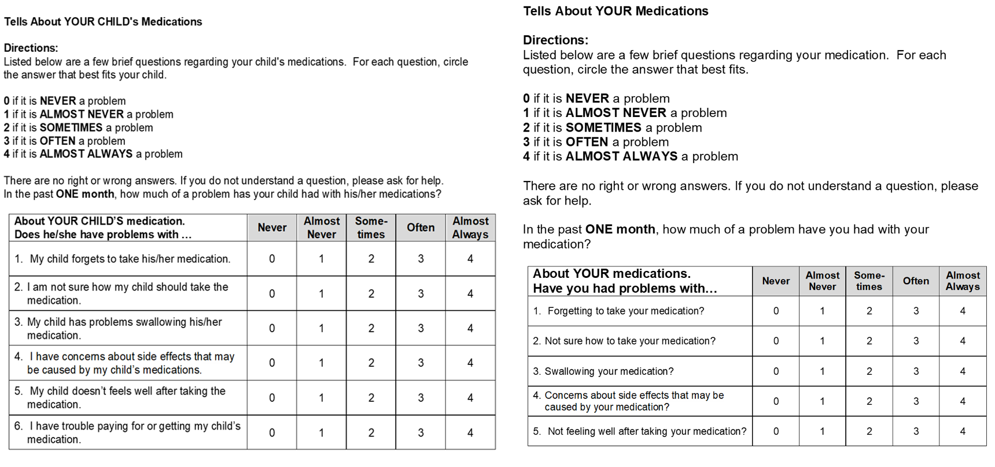

**Figure 2. Self-Reported Medication Questionnaires**

When confronting a parent about a child’s inadequate adherence to medical management, the caregiver’s parenting style may dictate their response (figure 3).

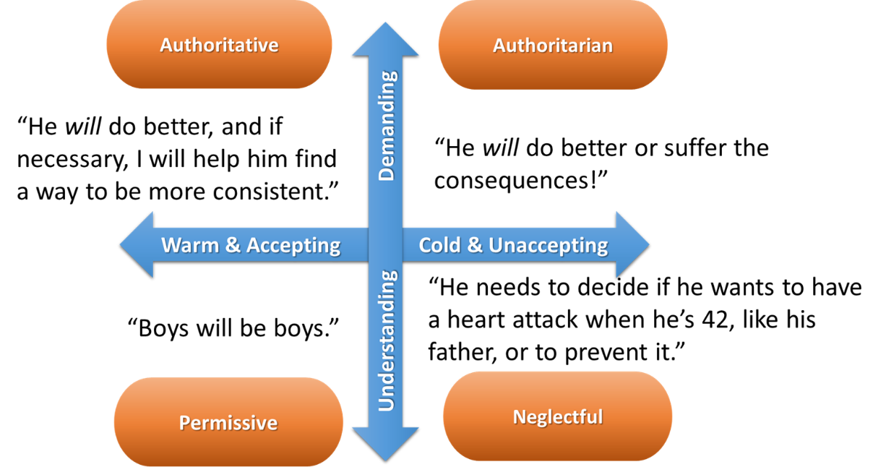

**Figure 3. Example of responses based upon parenting style.**

**THE CLINICIAN’S PERSONALITY**

A clinician’s personality type helps define their style of communication. One commonly used tool to assess an individual’s personality type is the Myers-Briggs Type Indicator (MBTI), a psychometric questionnaire designed to help understand how people perceive the world and make decisions (figure 4) (6).

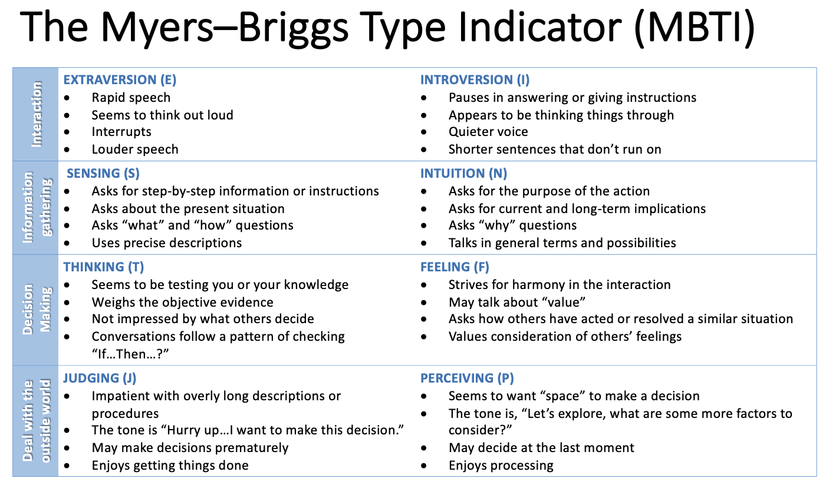

**Figure 4. The Briggs Myers Type Indicator (MBT I).**

To improve communication and help build trust, it is often useful for clinicians to adapt their style of communication based upon the personality type of the parent. The following is an example of a clinical scenario in which a parent’s personality type may impact their response to a clinician:

Clinician recommendation: *“I think your child would benefit from a statin.”* Possible parent responses are shown in figure 5.

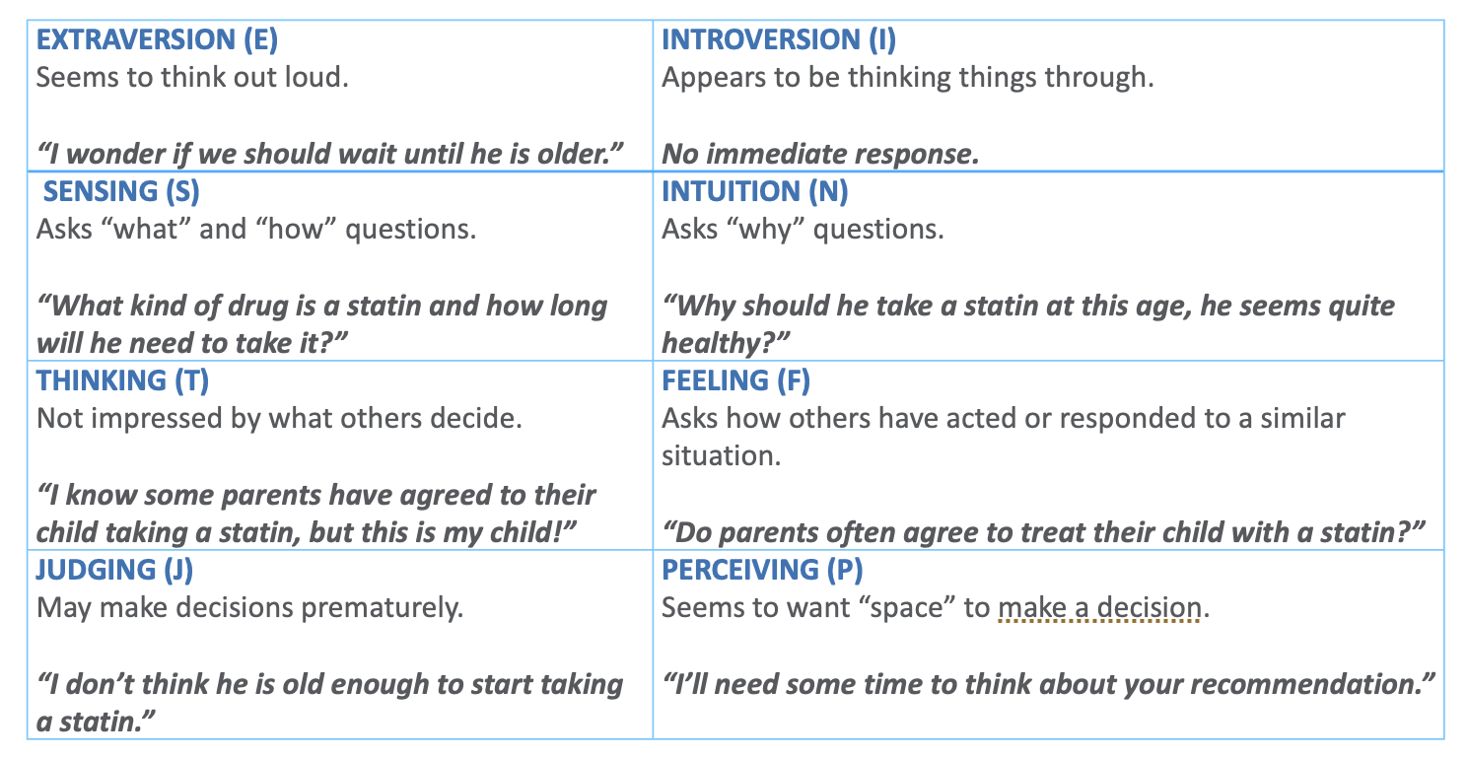

**Figure 5. Parent Responses.**

Knowing the parent’s personality style, a clinician can modify their language to facilitate understanding and help the parent intensify strategies which are likely to be successful.

**DETERMINANTS OF CLINICAL BEHAVIOR**

Psychologists have identified two basic dimensions of clinician behavior during a clinic visit.

1. Control - For most clinician's this is the dominant form of behavior, such as frequent interruptions or a louder voice often used to:
   1. Obtain “pertinent information.”
   2. Control the direction and tempo of the interview; and
   3. Stay within the time allocated for the visit.
2. Affiliation - This behavior reflects friendliness and psychosocial orientation (e.g., showing concern, smiling, offering help).

It comes as no surprise that there is a positive association between a clinician’s affiliative behavior and parental perception. But what about clinicians who focus on control? Studies of clinician speech complexity and interruptions have shown that interrupting behavior is negatively associated with recall of medical information and parental satisfaction, especially when used by male clinicians, and that parents report lower satisfaction when clinicians employ more complex language (7).

Some forms of interruption, however, may be perceived as positive, such as when clinicians employ them to enhance understanding, provide assistance, communicate support, or ask for clarification. Here are some examples:

*“Pardon me for interrupting, [respect] but I want to be clear on what you just shared with me.” [interest, asking for clarification]*

*“I can understand how difficult it must be talking about the loss of your husband. [empathy] If you would like, we can talk about this later”. [concern, compassion]*

**EFFECTIVE CLINICIAN COMMUNICATION**

Communication during a clinic visit is often facilitated by asking the parents open-ended questions, such as the following.

* What concerns, if any, do you have about your child’s cholesterol?
* What has been your experience with medications to lower cholesterol?
* How would you feel about treating your child with medication to lower his/her cholesterol?

During follow-up clinic visits, it is often informative to ask children and parents to share what they have learned about their condition at previous visits. For example, ask the child or parent:

1. What they remember about their last clinic visit.
2. To explain their understanding of cholesterol and triglycerides, and what effects high levels may have on their health.
3. What medication the child is taking and the proper way to take it.
4. The likelihood early treatment can prevent heart disease in adulthood.

Another way to assess understanding is to ask the child or parent to explain the child’s medical condition and need for medication and monitoring to a medical student or resident present during the clinic visit.

Some children and parents may be more comfortable answering theoretical questions or discussing 3rd person examples. For example, you may ask a parent:

*“Before we talk about your son, John, today, I would appreciate your advice. I saw a 10-year-old boy this morning whose 42-year-old father recently survived a heart attack. Like his father, the son has a very high blood cholesterol level. Having experienced something similar in your family, do you have any advice as to how I can best help this family? What do you feel would be the mother’s main concerns and how should they be addressed?”*

**TRANSITIONAL CARE**

As they become young adults, the roles and responsibilities of the child verses those of the parents change, necessitating a change by the treating physician.

Children are considered adults when they are 18 years-of-age and older. Unless declared incompetent, they have the legal right to make medical decisions for themselves. At 18, health care providers and clinic staff are not legally permitted to disclose a young adult’s medical information or discuss his/her health status or treatment with anyone - even the parent - although the young adult may still be covered by their parent’s health insurance plan. Thus, at 18, it is the responsibility of the young adult to decide who can be involved in and have information pertaining to their care, as well as whether they consent to treatment. According to the Affordable Care Act (ACA), which expanded health care coverage up to 26 years-of-age, as the primary insurance policy holder, a parent may receive a detailed explanation of benefits (EOB) from private insurers, which includes what doctor(s) the young adult visited, what type(s) of procedure(s) took place, and if specimens were sent to a lab for analysis (8). Therefore, one of the unintended consequences of the ACA is that it provides parents access to their adult child’s health information, if that child is still using their parents’ health insurance, which could inherently violate a young adult’s privacy. Information related to sexual or mental health are sensitive topics in many families, and revealing a young adult’s information regarding sexual or mental healthcare could cause relational issues within a family (9).

When planning transition into adult health care, it is helpful to review the family’s knowledge of the child’s diagnosis, key findings (e.g., pre- and post-treatment test results, pertinent family history, treatment goals, and risk enhancers such as lipoprotein(a) and genetic test results), reproductive health, family planning, and genetic transmission. Provide recommendations for appropriate future healthcare, discuss how long prescription refills will be available, and review how to access healthcare records. Discuss the importance of timely follow-up, healthcare costs, health insurance, and legal responsibilities and restrictions. Suggest the young adult/parent investigate the potential benefits of:

* HIPAA waiver - Granting the parents (or another trusted adult) access to their records; and their health care provider permission to talk with the parents and other health care providers about their care.
* Medical power of attorney - Appoint an individual to make health care decisions on their behalf should they become incapacitated due to serious injury or illness.
* Durable power of attorney - Enables the parent to handle their child’s financial affairs if they were to become incapacitated.
* Living will - Specifies personal choices about life-extending medical treatment in the event that a person cannot communicate their wishes themselves.

**CONCLUSION**

In partnering with parents, clinicians should always strive to treat them with dignity and respect. Listen to their point of view and consider the family’s values, beliefs, and cultural background when discussing your recommendations, and respect their choices. When sharing information, explain all options, treatments, and results in an informative, unbiased, and timely manner. Encourage and empower the parents to participate in all decisions regarding their child and prepare the young adult to do so in the future. Ultimately, by including parents in their child’s care, clinicians can equip children and their families to optimally manage their chronic medical condition both now and in the future.

**REFERENCES**

1. Tates K, Meeuwesen L. Doctor–parent–child communication. A (re)view of the literature. Soc Sci Med. 2001;52(6):839-851. doi:10.1016/s0277-9536(00)00193-3

2. Andermann A. Taking action on the social determinants of health in clinical practice: a framework for health professionals. CMAJ. 2016;188(17-18):E474-E483. doi:10.1503/cmaj.160177

3. McBride R. Talking to patients about sensitive topics: Communication and screening techniques for increasing the reliability of patient self-report. MedEdPORTAL. Published online 2012. doi:10.15766/mep_2374-8265.9089

4. Dalton WT 3rd, Kitzmann KM. Broadening parental involvement in family-based interventions for pediatric overweight: implications from family systems and child health. Fam Community Health. 2008;31(4):259-268. doi:10.1097/01.FCH.0000336089.37280.f8

5. Park H, Walton-Moss B. Parenting style, parenting stress, and childrenʼs health-related behaviors. J Dev Behav Pediatr. 2012;33(6):495-503. doi:10.1097/dbp.0b013e318258bdb8

6. Woods RA, Hill PB. Myers Brigg. Published online 2023. Accessed September 5, 2023. https://pubmed.ncbi.nlm.nih.gov/32119483/

7. Gemmiti M, Hamed S, Wildhaber J, Pharisa C, Klumb PL. Physicians’ speech complexity and interrupting behavior in pediatric consultations. Health Commun. 2022;37(6):748-759. doi:10.1080/10410236.2020.1868063

8. Read the Affordable Care Act. Healthcare.gov. Accessed September 5, 2023. https://www.healthcare.gov/where-can-i-read-the-affordable-care-act/

9. Campbell-Salome G. “Yes they have the right to know, but…”: Young Adult Women Managing Private Health Information as Dependents. Health Commun. 2019;34(9):1010-1020. doi:10.1080/10410236.2018.1452092