THERMAL ABLATION FOR THYROID NODULES

Jung Hwan Baek, MD, PhD, Professor, Department of Radiology and Research Institute of Radiology, Asan Medical Center, University of Ulsan College of Medicine, Seoul, Republic of Korea. radbaek@naver.com
So Yeong Jeong, MD, PhD, Assistant Professor, Department of Radiology, Seoul National University Bundang Hospital, Seoul National University College of Medicine, Seongnam, Republic of Korea. syjeong1005@gmail.com

Submitted October 1, 2025

ABSTRACT

Thermal ablation (TA) of thyroid lesions has revolutionized the management of thyroid nodules over the past two decades. TA has emerged as an innovative, minimally invasive treatment modality for benign thyroid nodules and recurrent thyroid cancers. More recently, TA has been proposed as an alternative therapeutic option for selected cases of primary thyroid microcarcinomas. TA techniques, including radiofrequency ablation (RFA), laser ablation (LA), microwave ablation (MWA), and high-intensity focused ultrasound (HIFU), can significantly reduce nodule size while preserving normal thyroid tissue and function. This makes them valuable treatments for symptomatic benign nodules, autonomously functioning nodules (AFTN), and select cases of recurrent or small thyroid malignancies. Although TA procedures are generally well tolerated, they require dedicated techniques, an understanding of anatomy, and specialized training for the operators. Also, it is essential to inform patients about the potential complications associated with these procedures. Successful TA necessitates a thorough understanding of thyroid and perithyroidal anatomy due to the proximity of critical structures that must be protected to avoid adverse events. Specific TA techniques, such as the ‘moving-shot’ technique, trans-isthmic approach, hydrodissection, and vascular ablation techniques, have been developed to optimize safety and efficacy by minimizing collateral tissue injury. Therefore, this chapter aims to provide a comprehensive and evidence-based overview of the indications, techniques, anatomical considerations, pre- and post-procedure assessments, and complications, focusing on RFA of the benign thyroid nodules in clinical practice.

INDICATIONS FOR THYROID ABLATION

Thyroid ablation (TA), including radiofrequency ablation (RFA), was first introduced in the early 2000s and has since become an effective minimally invasive alternative to surgery for treating benign thyroid nodules and selected malignant lesions (1, 2). Since their introduction, RFA has been widely adopted, with numerous studies and meta-analyses consistently demonstrating the efficacy and safety for treating benign thyroid nodules. Multiple national and international organizations have issued guidelines on the application of RFA in managing benign and malignant thyroid nodules. Although many guidelines exist worldwide, here we focus on major representative guidelines from the Korean Society of Thyroid Radiology (KSThR), the American Thyroid Association (ATA), and the European Thyroid Association (ETA), specifically addressing benign thyroid nodules.

Korean Society of Thyroid Radiology (KSThR)

The KSThR guidelines for thyroid RFA were initially developed in 2012 (3) and subsequently revised in 2017 (4). For benign thyroid nodules, RFA is indicated in patients presenting with symptomatic or cosmetic concerns, including pressure-related symptoms such as pain, dysphagia, foreign body sensation, discomfort, neck bulging, and cough. There are no established definitive size or volume criteria. For autonomously functioning nodules (AFTN), RFA can be performed in both toxic and pre-toxic cases, especially when patients present with compression of adjacent structures, cosmetic complaints, or hyperthyroid symptoms. In recurrent thyroid cancers, RFA serves as a curative or palliative treatment for lesions at the thyroidectomy bed and cervical lymph nodes in patients who are at high surgical risk or refuse surgery.

American Thyroid Association (ATA)

The ATA’s 2015 guidelines for management of thyroid nodules and differentiated thyroid cancer discussed the use of RFA for locally recurrent thyroid cancer (5). In 2023, the ATA released a statement entitled 'General Principles for the Safe Performance, Training, and Adoption of Ablation Techniques for Benign Thyroid Nodules', providing key recommendations (6). TA is indicated for benign thyroid nodules causing compressive symptoms or cosmetic concerns attributable to a single or dominant nodule, as well as AFTNs causing subclinical or overt hyperthyroidism. A confident diagnosis of benignity is essential, as histologic confirmation is impossible after ablation. Generally, TA is indicated for benign nodules measuring ≥2–3 cm; smaller nodules (<1.5 cm) rarely require treatment, while very large nodules (>20–30 mL) may need multiple sessions. In AFTNs, a smaller baseline volume (<10–12 mL) correlates with better outcomes. Careful ultrasound evaluation ensures complete lesion visualization and confirms the absence of surgical indications. Multinodular goiters, substernal extension, airway compression, and certain implanted devices require caution. Surgery is preferred for large symptomatic goiters unless contraindicated.

European Thyroid Association (ETA)

ETA guidelines, published in 2020, primarily focus on benign thyroid nodules (7). In adult patients with benign thyroid nodules causing pressure symptoms and/or cosmetic concerns who decline surgery. Image-guided TA should be considered a cost-effective and less risky alternative to surgery or observation. Based on direct comparison studies, laser ablation (LA) and RFA are recommended as first-line TA modalities. Microwave ablation (MWA) and high-intensity focused ultrasound (HIFU) are considered second-line techniques. For AFTN, the ETA recommends TA for young patients with small AFTNs and incomplete suppression of perinodular thyroid tissue due to the higher probability of normalizing thyroid function, and the advantage of avoiding radiation and the risk of late hypothyroidism.

THERMAL ABLATION, BASIC INFORMATION

Various TA techniques are available, including MWA, LA, RFA, and HIFU. In recent years, the use of HIFU and LA has gradually declined, whereas RFA and MWA have become predominant modalities. The main characteristics and technical principles of each ablation method are described below.

Radiofrequency Ablation (RFA)

RFA utilizes high-frequency alternating electrical current to generate thermal energy. As radiofrequency waves cause tissue ions to oscillate, their motion under the influence of alternating current generates frictional heat, resulting in local temperatures of 60-100°C that dehydrate cells and denature proteins, causing coagulative necrosis (8, 9). Heat is immediately generated by friction within a few millimeters of the electrode tip, and subsequent heat conduction leads to additional thermal damage to surrounding tissue further from the electrode. The efficacy of RFA may be limited by carbonization of target tissue and by the heat sink effect, which occurs when adjacent blood flow or cystic components cool the tissue, reducing ablation effectiveness (10). The procedure requires percutaneous needle insertion under ultrasound guidance, and several standard techniques have been developed to optimize ablation coverage while minimizing complications. Further technical details are discussed in later sections.

Laser Ablation (LA)

LA delivers a focused beam of light energy through an optical fiber directly to the target lesion. The light energy is converted to thermal energy through photon scattering, rapidly increasing local temperatures to ~100°C and causing coagulation necrosis. The most frequently used laser sources for thyroid nodules are Nd:YAG or diode lasers, typically with a wavelength of 1064 nm, though other wavelengths and optical fibers are also applied (10). Among TA techniques, LA generally provides the lowest total delivered energy, which may confer greater safety and control in critical anatomic locations (7). However, treatment of larger nodules may necessitate multiple fiber insertions.

Microwave Ablation (MWA)

MWA generates an electromagnetic field that causes oscillation of polarized molecules within the tissue, creating thermal energy as molecular collisions convert kinetic energy into heat (11). The continuous energy emission at high frequency results in extensive thermal deposition in a short period, often producing higher final tissue temperatures that are less affected by tissue charring or heat-sink phenomena (11). This property makes MWA advantageous in treating larger tumors. However, because the thyroid and cervical region are relatively confined and surrounded by critical structures, the application of high-power MWA may pose greater risks in these sensitive areas (9).

High-Intensity Focused Ultrasound (HIFU)

HIFU is a truly non-invasive technique that employs concentrated acoustic waves to ablate targeted tissue areas without requiring surgical incisions or needle puncture (9). Multiple high-energy ultrasound beams are directed from various angles to a single focal point within the target, where acoustic energy is converted into intense mechanical vibrations and friction, rapidly generating temperatures exceeding 85°C within seconds (12). This intense heat triggers several destructive mechanisms, including tissue evaporation, the formation and violent collapse of microscopic gas bubbles, and ultimately irreversible cell death. The precision of this focusing technique ensures that surrounding healthy tissues, which receive only negligible acoustic energy exposure, remain undamaged throughout the treatment process (12). However, HIFU generally requires longer treatment sessions and may be limited by nodule location and patient anatomy.

PERITHYROIDAL ANATOMY

For a safe and effective RFA for thyroid tumors in the neck, detailed knowledge of neck anatomy, particularly nerves, vessels, and other critical structures, is essential. This section focuses on the perithyroidal critical anatomic structures related to the complications during RFA of benign thyroid nodules (13). The relationship of major neck nerves to adjacent anatomic landmarks is shown in Figure 1.

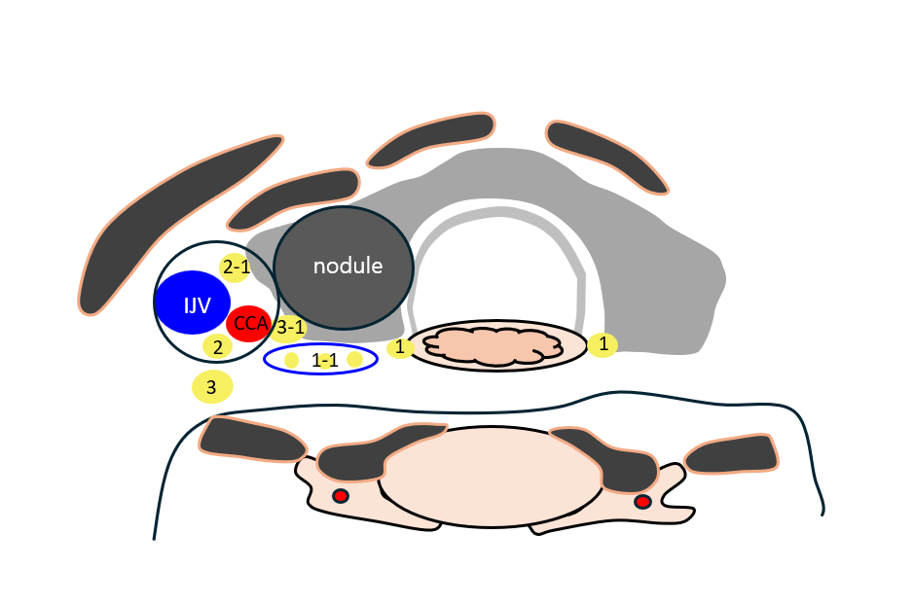
Figure 1. Schematic illustration of a transverse section of the neck showing nerve structures. 1. Recurrent laryngeal nerve; 1-1. Recurrent laryngeal nerve variation; 2. Vagus nerve; 2-1. Vagus nerve variation (anterior and medial variation); 3. Middle cervical sympathetic ganglion (lateral type); 3-1 Middle cervical sympathetic ganglion variation (medial type). The posterior aspect of the anterior and medial variation of the vagus nerve (2-1) represents an area requiring special caution during thermal ablation.

Vagus Nerve (Cranial Nerve X)

The vagus nerve is the longest cranial nerve, extending from the brainstem to the abdomen. In the neck, it courses within the carotid sheath alongside the common carotid artery (CCA) and internal jugular vein. The vagus nerve typically lies in the posterior portion of the carotid sheath between the CCA and internal jugular vein (14, 15). Variations in its cervical course relative to the CCA have been previously reported (16, 17). Notably, the anterior and medial variation of the vagus nerve lies close to the thyroid gland and is at risk of injury during RFA of benign thyroid nodules. Thermal injury to the vagus nerve can induce cardiovascular instability, such as bradycardia, hypotension, and arrhythmia. Voice changes may occur due to parasympathetic denervation. The vagus nerve appears on ultrasound as a hypoechoic, oval structure measuring 2-3 mm in diameter within the carotid sheath and situated between the CCA and the internal jugular vein. Careful identification and protection of the vagus nerve during RFA is imperative.

Recurrent Laryngeal Nerve (RLN)

The RLN is a branch of the vagus nerve that provides motor innervation to all intrinsic laryngeal muscles except the cricothyroid muscle, and sensory innervation to the larynx below the vocal cords. At the thyroid gland level, the RLN travels within the tracheoesophageal groove and enters the larynx beneath the inferior cornu of the thyroid cartilage. The RLN is the most critical nerve at risk during RFA; injury may cause vocal cord paralysis, leading to hoarseness, voice changes, and risk of aspiration. Bilateral RLN injury may result in airway obstruction necessitating urgent intervention. Due to its small caliber, the RLN is difficult to visualize directly on ultrasound and is therefore identified indirectly by its anatomical location in the tracheoesophageal groove. In the lower neck, the RLN courses more laterally (notably on the right), hence the concept of a ‘danger area’ or ‘danger triangle’ encompassing the posterior thyroid capsule should be applied (Figure 2).

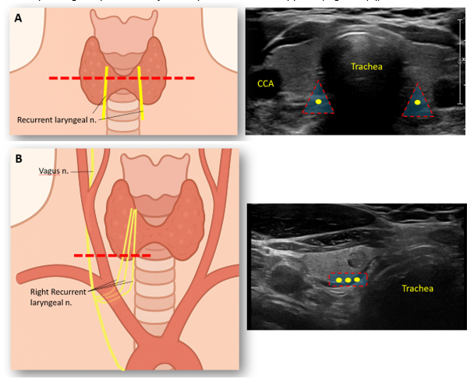
Figure 2. Danger area for recurrent laryngeal nerve (RLN). (A) In the upper neck, the RLN is positioned posteromedially within the ‘danger triangle’ along the tracheoesophageal groove. (B) In the lower neck, the RLN courses more laterally, especially on the right, and the location of the RLN is more variable (three yellow lines suggest variations of the right recurrent laryngeal nerve) at the inferior pole of the right thyroid gland. Therefore, the concept of a ‘danger area’ in the region of the posterior medial thyroid is of utmost importance.

Middle Cervical Sympathetic Ganglion (MCSG)

The MCSG is part of the cervical sympathetic chain, usually located at the level of the C6 vertebra near the thyroid gland. The MCSG lies anterior to the longus colli muscle and medial to the carotid sheath at the level of the thyroid gland. The relationship and the position of the MCSG with that of the CCA is classified into 2 types, lateral type (88% prevalence) or medial type (12%) (18). The medial type places the MCSG at risk during RFA of benign nodules, requiring special caution. Thermal injury to the MCSG can cause Horner’s syndrome, characterized by ptosis, miosis, and anhidrosis.

PREPROCEDURE WORK-UP

Table 1 summarizes the recommended preprocedural checklist for RFA of benign thyroid nodules based on the KSThR 2017 guidelines. The components of this checklist are described in detail below.

Table1. Pre-Procedural Checklist Before RFA Recommended by the KSThR 2017 Guidelines
Pathologic diagnosis
- Benign diagnosis confirmed by at least two US-guided FNA or CNB
- Benign diagnosis confirmed by at least one US-guided FNA or CNB in AFTN
- Benign diagnosis confirmed by at least 1 US-guided FNA or CNB in thyroid nodules with highly specific benign US features
Ultrasound
- Assessment of nodule characteristics and surrounding critical structures
- Measurement of nodule size and volume
Symptom score
Cosmetic score
Laboratory tests
Complete blood count
Coagulation panel
Thyroid function test (Serum TSH, serum T3, serum fT4)
CT or MRI*
99mTc pertechnetate or ¹²³I thyroid scan†
* Selectively indicated for patients with intrathoracic goiter, † Indicated for AFTN.

Pathologic Diagnosis

All major guidelines recommend using fine-needle aspiration (FNA) or core-needle biopsy (CNB) to confirm benign cytology before RFA. In most cases, thyroid nodules should be confirmed as benign by at least two separate ultrasound-guided FNA or CNB prior to TA (4, 19, 20). The malignancy rate of thyroid nodules after confirmation of benignity with two separate FNAs is very low (21). However, some guidelines accept a single benign biopsy result if the nodule has highly specific benign ultrasound features or if the lesion is an AFTN (4, 6).

Imaging Studies (US, CT, MRI)

Ultrasound is fundamental for lesion characterization and for assessing the proximity to critical structures. Ultrasound should be performed to measure the size and volume of the index lesion using three orthogonal diameters: the largest diameter and two perpendicular diameters. The nodule’s volume is calculated with the equation V = πabc/6, where V is the volume, and where a, b, and c are the orthogonal diameters. This volume measurement is repeated at follow-up visits, and treatment outcome is assessed by the volume reduction ratio (VRR).

The VRR is defined as follows:
VRR = ((Baseline Volume – Final Volume) / Baseline Volume) × 100

Cross-sectional imaging using CT or MRI may be helpful for evaluation of intrathoracic extension in large nodules or for detailed assessment in cases where US visualization is limited (beyond the ultrasound window or assessing the relationship between malignancy and surrounding structures). Additionally, in the evaluation of recurrent thyroid cancer, metastatic lymph nodes can occur at any location, and CT is useful as a thorough evaluation is often needed, especially for areas beyond the US window. However, routine pre-ablation CT or MRI is not recommended for all benign nodules.

Symptom and Cosmetic Scores

Symptom scores are measured using a visual analogue scale from 0 (no symptoms) to 10 (maximal symptoms), as determined by the patient. A physician also records a cosmetic score, graded as follows (4): 1= no palpable mass; 2 = no cosmetic problem but a palpable mass; 3 = cosmetic problem on swallowing only; and 4 = readily and always detected cosmetic problem.

Biochemical Analyses

Laboratory tests typically involve a complete blood count, coagulation profiles (platelet count, prothrombin test, activated partial thromboplastin time), and thyroid function tests (TSH (thyrotropin), triiodothyronine (T3), and free thyroxine (fT4)) (22, 23).

PROCEDURE

Anesthesia

For pain control during the procedure, local anesthesia is recommended over general anesthesia or deep sedation, as it provides adequate anesthesia for thyroid procedures while permitting early detection of complications (especially voice problems) (4, 6). The use of general anesthesia or deep sedation increases procedural risk and may delay recognition of adverse events such as nerve injury, skin burn, or airway compromise. Several serious complications (severe skin burn, tracheal necrosis) associated with general anesthesia during thyroid ablation have been reported (24, 25).

Device

As the thyroid gland is relatively small and superficially located, thyroid-dedicated electrodes have been developed (26). Compared to conventional electrodes used for other organs, thyroid RFA employs a specially designed internally cooled electrode that is shorter (typically 7 cm) to improve maneuverability and thinner (18~19-gauge) to minimize trauma to normal thyroid tissue (26-28). Various sizes of active tips have been used (5, 7, 10, and 15 mm) for varying nodule sizes (29), and for treating smaller recurrent cancers; a 3.8 mm tip is commonly employed. Smaller active tips enable precise ablation with minimal collateral thermal injury to the adjacent critical structures. Recommended RF power settings according to the electrode tip size are described in Table 2 (6). A thinner 19-gauge electrode is useful for puncturing small recurrent cancers or parathyroid lesions (30).

A newly developed adjustable electrode features an internally cooled 18-gauge design with a slider mechanism to change the active tip length from 5 mm to 30 mm, allowing flexible and efficient treatment of nodules of various sizes in a single session (31, 32). A bipolar electrode is useful to treat thyroid lesions for pregnant women or for patients with cardiac pacemakers (4).

Table 2. Various active tip sizes and recommended power settings according to active tip size
Active tip size (cm) | RF power (W)
0.38 | 5 – 15
0.5 | 10 – 30
0.7 | 20 – 40
1.0 | 50 – 80
1.25 | 100-120
1.5 | 120-150

Technique

Among the various TA modalities, RFA has emerged as the mainstay, owing to its favorable efficacy and safety. This section focuses on the key RFA techniques that optimize treatment outcomes while minimizing complications (Table 3).

MOVING-SHOT TECHNIQUE

The thyroid gland is smaller compared to other organs, and thyroid nodules are usually ellipsoid rather than round in shape. Therefore, ablation of thyroid nodules with a prolonged fixed electrode —traditionally employed for treating tumors in larger organs such as the liver— can cause thermal damage to adjacent structures. Instead, the "moving-shot" technique has become standard for thyroid lesion ablation (3, 29, 33). The thyroid nodule is conceptually divided into several ablation units of varying sizes: peripheral or adjacent-border units are smaller, while central units are larger. RFA is conducted unit by unit, advancing or retracting the electrode as each region is treated; hence the name: “moving-shot technique” (34). The electrode tip is placed first in the deepest, most remote part of the nodule, allowing continuous visualization under ultrasound. As a transient echogenic area appears, indicating ablation, the electrode is slowly withdrawn to treat remaining units sequentially.

HYDRODISSECTION

Hydrodissection is a technique used to create a safe margin by injecting fluid around the thyroid capsule to separate the target lesion from adjacent critical structures. This approach reduces the risk of thermal injury during ablation. Various hydrodissection techniques exist, with four main approaches based on tumor location: anterolateral, posterior, pre-tracheal, and within the danger triangle (35). The anterolateral approach is most commonly employed (Figure 3). In case of anterolateral hydrodissection, a 21-G spinal needle with a three-way stopcock is used, enabling both hydrodissection and local anesthesia through a single skin puncture site. Cold (0°C to 4°C) 5% dextrose solution is used for hydrodissection, as it does not conduct electricity and provides cooling.

During the procedure, the injection of fluid is carefully monitored with ultrasound to maintain an adequate separation—typically ≥5 mm—from critical structures such as nerves, the esophagus, and pain-sensitive tissues, including the strap muscles and skin. The hydrodissection technique is useful not only for securing sufficient safety margins from critical structures but also for controlling pain, reducing the total amount of lidocaine required during the procedure (36).

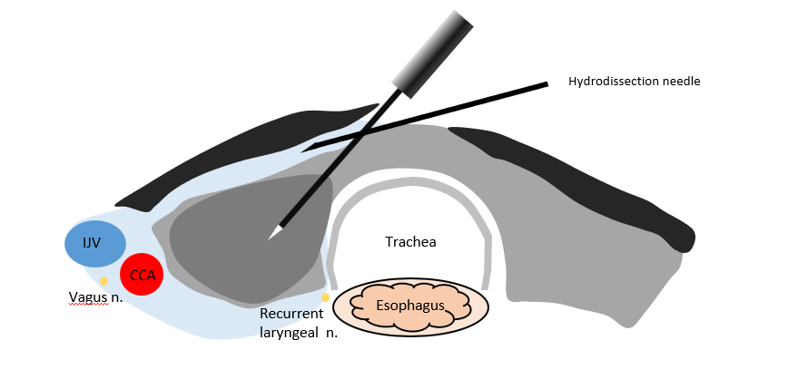
Figure 3. Anterolateral hydrodissection covers the anterior and posterolateral thyroid. This hydrodissection technique creates a sufficient safety margin by injecting a cold 5% dextrose solution around the thyroid capsule to separate the target ablation area from adjacent critical structures. Hydrodissection also reduces pain during ablation.

VASCULAR ABLATION

Vascular ablation techniques have recently been developed to improve the efficacy of thyroid nodule ablation by addressing the heat-sink effect caused by blood flow. There are two primary vascular ablation methods: artery-first ablation and marginal venous ablation.

Artery-First Ablation Technique

Benign thyroid nodules are sometimes hypervascular, and the heat-sink effect reduces RFA efficacy in such cases (1, 37). Several strategies have been proposed to minimize the heat-sink effect during RFA in thyroid nodules. The artery-first ablation technique is applied primarily to hypervascular nodules that have a prominent feeding artery, especially in the isthmic area. This technique ablates the main feeding artery (prominent at the isthmus) as the first step and can be easily applied to a nodule with a feeding artery entering through the isthmus. Doppler ultrasound is used to identify the nodule’s arterial feeder. As a result, this method not only enhances the efficacy of ablation by reducing blood flow but also minimizes hemorrhagic risk during the procedure, such as blood oozing along the electrode. In some cases, wedge-shaped hypoechoic changes are observed after ablating the main feeding artery, which may represent infarction in the area supplied by that feeding artery. However, this phenomenon does not occur in every ablation, as hypervascular thyroid nodules often have multiple bypassing feeding arteries.

Marginal Venous Ablation Technique

Most thyroid nodules exhibit prominent draining veins along the nodule margin, which can contribute to the heat-sink effect and impede complete ablation at the nodule’s periphery, potentially leading to marginal recurrence during follow-up periods. Therefore, this technique involves ablating the marginal veins by directly puncturing them with the electrode tip and delivering energy to occlude venous drainage. When the vein is ablated, echogenic air bubbles fill the marginal vein of the nodule. At the beginning of marginal vein ablation, rapid flow of air bubbles along the marginal vein can be seen; however, when venous flow gradually decreases and eventually ceases, the air bubbles remain inside the veins, indicating a complete ablation of the marginal vein. The ultrasound feature is called ‘venous staining’. Marginal venous ablation may prevent recurrences by ensuring thorough treatment of the nodule margin. However, it is associated with the risk of thermal injury to adjacent critical structures, such as the recurrent laryngeal nerve, vagus nerve (anterior and medial variations), and MCSG (medial variation). Therefore, careful monitoring of nerves before ablation is essential, and the use of hydrodissection can provide additional protection by physically separating these structures and alleviating pain.

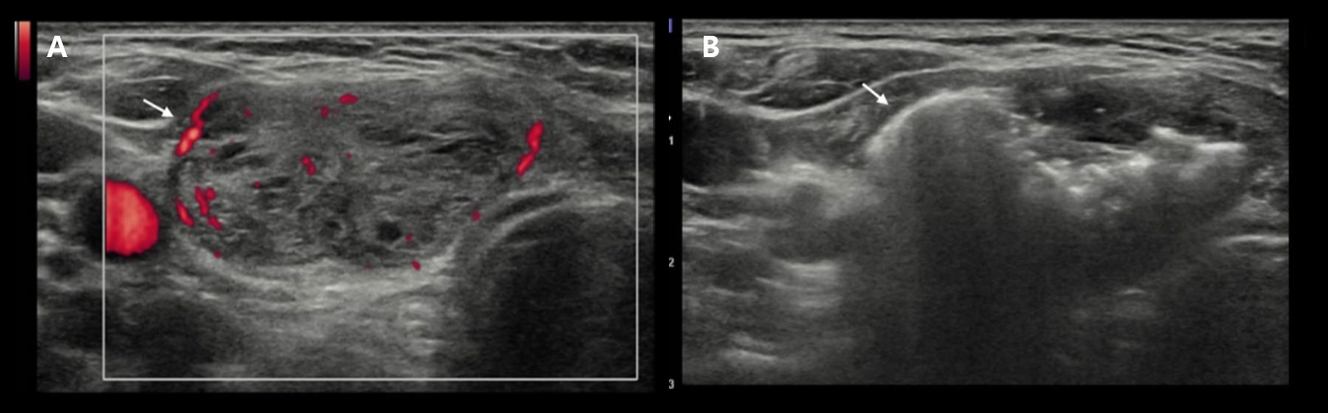
Figure 4. Venous ablation technique: A. Before RFA, marginal veins (arrow) are visible on Doppler ultrasound. B. During and after the venous ablation, linear marginal echogenic lines, named “venous staining” (arrow) represent microbubbles filling the marginal vein. This ultrasound feature guarantees minimizing marginal recurrences by the destruction of peripheral venous structures of the target nodule.

Table 3. Summary of Techniques
Technique | Clinical Impact
Moving-shot technique | Enhances safety by minimizing heat damage to surrounding critical structures and improves clinical outcomes
Hydrodissection | Effective in pain control and preventing thermal damage by separating the thyroid gland from adjacent critical structures
Vascular ablation techniques
- Artery-first ablation | Ablation of feeding arteries located near the isthmus, especially for hypervascular nodules  Reducing the heat sink effect that makes RFA convenient
- Marginal venous ablation | Ablation of marginal draining veins along the nodule margin  Helpful in preventing marginal tumor recurrences

POST PROCEDURE

Immediate Post-Procedure

RFA of thyroid lesions is generally performed as an outpatient procedure. Following the ablation, all patients should be monitored for at least 30 minutes to observe for early complications. Vital signs, including heart rate, blood pressure, and oxygen saturation, must be closely tracked. Assessment of the patient’s breathing and voice is essential to ensure no deviation from pre-procedure baseline, as injury to the recurrent laryngeal or vagus nerves may present with hoarseness or compromised voice projection.

Follow-Up

Patients generally undergo follow-up evaluation at 1-, 3-, 6-, and 12-month post-procedure, and then annually thereafter. Table 4 summarizes the post-procedural checklist, which includes assessment of nodule-related symptoms and cosmetic scores. Follow-up thyroid ultrasound is routinely recommended to monitor volume change and evaluate under-ablated residual viable portions with vascularity on color-Doppler ultrasound. Common post-ablation ultrasonographic features include hypoechogenicity, irregular margins, and intranodular echogenic foci. The VRR is calculated to quantify treatment response.

In cases of AFTN, thyroid function tests, including serum TSH, T3, and fT4, should be monitored during follow-up visits to guide the adjustment or discontinuation of anti-thyroid medications. After the procedure, some patients may develop subclinical hypothyroidism. Radionuclide thyroid scanning can be helpful to assess the efficacy of ablation in AFTN.

Table 4 Post-Procedural Checklist after RFA
 | Benign thyroid nodule | Autonomously functioning thyroid nodules
US (Features of ablated zone to detect under-ablated portion with vascularity on color-Doppler US) | P | P
Volume Measurement | P | P
Symptom score | P | P
Cosmetic score | P | —
Laboratory tests
Thyroid function tests | Selectively | P
Serum Tg, anti-Tg antibody | — | Selectively
CT or MRI | Selectively | Selectively
PET | — | —
¹²³I thyroid scan | — | P

CLINICAL OUTCOME

Recent meta-analyses and systematic reviews have established TA, including RFA, MWA, and LA as effective and safe treatments for benign thyroid nodules. Here we summarize clinical outcomes based on the latest evidence, with a focus on long-term efficacy, volume reduction, symptom/cosmetic improvement, and regrowth rate.

Recent meta-analyses with ≥3 years of follow-up report a significant reduction in nodule size after TA. One large-population study reported an overall VRR of 71.6% at 3 years (95% CI: 64.4–78.8%), with variability by modality: LA (53.3%), RFA (79.5%), and MWA (89.7%) (38). In the study, all modalities led to significant improvements in both symptom and cosmetic scores, sustained over multiple years (38). In comparison of RFA and MWA, RFA achieved a VRR of 83.3% at 12 months, superior to MWA (76.9%), especially with superior outcomes in less experienced (<10 years) investigators (39).

The available data on the effectiveness of TA for treating hyperthyroidism associated with AFTN is limited. A systematic review and meta-analysis of TA for AFTNs reported a TSH normalization rate of 71.2% and the VRR of 69.4% at a mean follow-up period of 12.8 months (40).

Comparative systematic review of long-term studies of TA shows that RFA achieves superior VRR at 12 months (83.3%) compared to MWA (76.9%), notably in less experienced operators. For the treatment of AFTN, data remain limited but suggest a 71.2% normalization rate of TSH, and a mean VRR of 69.4% at 12.8 months post-ablation (41).

However, with longer follow-up, as follow-up periods extend, long-term clinical outcomes have revealed several issues, and ‘regrowth’ is one of the major problems. Reported regrowth rates range widely from as low as 0.7% up to 37.5% (41). Definitions of regrowth differ but commonly refer to a volume increase >50% relative to the nadir volume post-treatment.

A major concern associated with regrowth is delayed surgery. Delayed surgery rates due to regrowth range from 0.7% to 37.5%. Regrowth often originates from undertreated peripheral tissue, emphasizing the importance of complete nodule ablation, including margins. Vascular ablation combined with hydrodissection is recommended to improve complete treatment rates (30).

COMPLICATIONS

Although the overall complication rate of TA is low, various complications may occur (Table 5). A large retrospective series including 1459 patients who underwent RFA of 1543 thyroid nodules reported an overall complication rate of 3.3% with a major complication rate of 1.4 (42). Major complications include voice changes, Horner syndrome, brachial plexus injury, nodule rupture, and permanent hypothyroidism. Minor complications included hematoma, skin burns, and nausea/vomiting.

Table 5. Complications and Side Effects Resulting from Thyroid Radiofrequency Ablation and their Reported Incidence
Complication or side effect | Incidence of complications (%)
Overall | 3.3
Major | 1.47
Voice change | 0.00 – 1.02
Nodule rupture | 0.19 – 2.5
Permanent hypothyroidism | 0.07
Brachial plexus injury | 0.07
Horner syndrome | 0.13
Minor | 1.72
Hematoma | 0.9 – 2.1
Vomiting | 0.62
Skin burn | 0.27
Side effect
Pain | 0.8 – 15.7
Vasovagal reaction | 0.34
Cough | 1.26

Major Complications

Major complications are defined by the Society of Interventional Radiology as those complications that can lead to substantial morbidity and disability, may increase the level of care, result in hospital admission, or lengthen hospital stay (43).

VOICE CHANGES

Voice change is one of the most concerning complications of TA. Voice change is caused primarily by thermal injury to the RLN, which is different from mechanical injury during surgery. Although most patients show complete voice recovery usually within 60 to 90 days, severe injury can result in permanent RLN palsy. Knowledge of the ‘danger triangle’ and ‘danger area’, where the RLN can be located, is important to prevent this complication. The ‘danger triangle’ is the area that encompasses the esophagus, trachea, and medial thyroid gland. On the right side, a “danger area” concept applies to the area from the tracheoesophageal groove medially to the carotid sheath laterally that encompasses the right RLN and its variable location, in combination with the vagus nerve and the MCSG (Figure 1).

Typically, voice changes are noticed during or immediately after the ablation. Therefore, regular monitoring of voice changes during and after the procedure is important. If voice changes are detected during the procedure, a ‘bolus injection of cold 5% dextrose is useful to improve the voice problem (44, 45). Specifically, to decrease damage to the nerve, a cold (~ 4°C) 5% dextrose solution is injected continuously into the area surrounding the damaged nerve using a 21-G spinal needle. A 5% dextrose solution is recommended rather than normal saline or distilled water because it is isotonic and does not conduct electricity. Immediate symptom relief associated with dextrose solution injection may be due to the cooling of the damaged nerve and a reduction of additional conductive heat transfer to the nerve. This management strategy can be applied not only to voice changes involving the RLN injury but also to other nerves.

HORNER SYNDROME

Damage to the MCSG (medial variation) can result in Horner syndrome (ptosis, miosis, anhidrosis). Conjunctival injection can be an early sign due to vasodilation, warranting immediate evaluation.

NODULE RUPTURE

Thyroid nodule rupture after TA is thought to result from disruption of the thyroid capsule, leading to leakage of nodule contents, most often into the anterior neck soft tissues. Patients typically present with sudden neck swelling and pain (7-50 days) (46). The underlying mechanism is thought to involve delayed hemorrhage secondary to microvascular leakage, as CT frequently demonstrates high-density materials with volume expansion, ultimately causing tearing of the capsule. Excessive post-procedural massaging or neck movement has also been suggested as a possible contributing factor. Standard treatment consists in the administration of oral steroids rather than surgical intervention. Gentle compression of the affected area can be useful to stop blood oozing.

HYPOTHYROIDISM

Although uncommon, a few cases of hypothyroidism have been reported following RFA. In a large study of 1,459 patients, only one developed permanent hypothyroidism, and laboratory results before and after the procedure showed elevated anti-TPO antibodies, suggesting an underlying autoimmune condition (42). Similarly, another study found that 1 out of 875 patients experienced transient hypothyroidism within 24 hours after RFA (47). While the exact cause is uncertain, both studies indicate that autoimmune thyroiditis may play a contributing role. Therefore, preoperative antibody status may confer a higher risk for post-RFA hypothyroidism. Therefore, it is recommended that patients undergo thyroid function testing, including assessment for anti-thyroid antibodies. If hypothyroidism does occur, it can be managed with postoperative levothyroxine therapy.

Minor Complications

HEMATOMA

Postoperative hematoma is a recognized complication following TA of thyroid nodules, with a reported incidence of approximately 0.9–2.1%. Hematomas are most commonly located in the perithyroidal, subcapsular, or intranodular regions, typically resulting from injury to the anterior jugular vein or perithyroidal vessels. Management is generally conservative, consisting of gentle neck compression for 5–10 minutes, with gradual resolution expected within 1–2 weeks. Precautions include thorough knowledge of cervical anatomy and careful evaluation of perithyroidal vessels and the anterior jugular veins before and during RFA.

NAUSEA, VOMITING

Postoperative nausea is a common adverse effect and is typically transient. In one study, 9 out of 1,459 patients experienced vomiting following RFA, but symptoms resolved within 1–2 days (42). In such cases, antiemetic medications may be administered for symptom relief.

SKIN BURN

Most burns described in the literature are superficial, limited to first-degree injuries, and typically self-limiting, resolving without sequelae within 7–10 days after RFA (42). However, a rare case of a full-thickness burn has been reported, which required 3 weeks to heal and resulted in scarring (24). In this patient, conscious sedation was used; therefore, the patient did not perceive or complain of pain during the skin injury. In case of skin burns, careful assessment of burn severity and appropriate clinical follow-up should be done. Notably, local anesthesia (rather than sedation or general anesthesia) is a standard method to minimize complications during TA, and the use of bipolar electrodes can reduce the risk of skin burns.

REFERENCES

1. Jeong WK, Baek JH, Rhim H, Kim YS, Kwak MS, Jeong HJ, Lee D. Radiofrequency ablation of benign thyroid nodules: safety and imaging follow-up in 236 patients. European radiology. 2008;18(6):1244-1250.
2. Papini E, Guglielmi R, Bizzarri G, Graziano F, Bianchini A, Brufani C, Pacella S, et al. Treatment of benign cold thyroid nodules: a randomized clinical trial of percutaneous laser ablation versus levothyroxine therapy or follow-up. Thyroid. 2007;17(3):229-235.
3. Na DG, Lee JH, Jung SL, Kim J-h, Sung JY, Shin JH, Kim E-K, et al. Radiofrequency ablation of benign thyroid nodules and recurrent thyroid cancers: consensus statement and recommendations. Korean journal of radiology. 2012;13(2):117-125.
4. Kim J-h, Baek JH, Lim HK, Ahn HS, Baek SM, Choi YJ, Choi YJ, et al. 2017 thyroid radiofrequency ablation guideline: Korean Society of Thyroid Radiology. Korean journal of radiology. 2018;19(4):632-655.
5. Haugen BR, Alexander EK, Bible KC, Doherty GM, Mandel SJ, Nikiforov YE, Pacini F, et al. 2015 American Thyroid Association Management Guidelines for Adult Patients with Thyroid Nodules and Differentiated Thyroid Cancer: The American Thyroid Association Guidelines Task Force on Thyroid Nodules and Differentiated Thyroid Cancer. Thyroid®. 2015;26(1):1-133.
6. Sinclair CF, Baek JH, Hands KE, Hodak SP, Huber TC, Hussain I, Lang BH, et al. General Principles for the Safe Performance, Training, and Adoption of Ablation Techniques for Benign Thyroid Nodules: An American Thyroid Association Statement. Thyroid. 2023;33(10):1150-1170.
7. Papini E, Monpeyssen H, Frasoldati A, Hegedüs L. 2020 European Thyroid Association clinical practice guideline for the use of image-guided ablation in benign thyroid nodules. European thyroid journal. 2020;9(4):172-185.
8. Fuller CW, Nguyen SA, Lohia S, Gillespie MB. Radiofrequency ablation for treatment of benign thyroid nodules: systematic review. The Laryngoscope. 2014;124(1):346-353.
9. Hu QL, Kuo JH. Choice in ablative therapies for thyroid nodules. Journal of the Endocrine Society. 2023;7(7):bvad078.
10. Baek JH, Lee JH, Valcavi R, Pacella CM, Rhim H, Na DG. Thermal ablation for benign thyroid nodules: radiofrequency and laser. Korean Journal of Radiology. 2011;12(5):525-540.
11. Simon CJ, Dupuy DE, Mayo-Smith WW. Microwave ablation: principles and applications. Radiographics. 2005;25(suppl_1):S69-S83.
12. Esnault O, Franc B, Ménégaux F, Rouxel A, De Kerviler E, Bourrier P, Lacoste F, et al. High-intensity focused ultrasound ablation of thyroid nodules: first human feasibility study. Thyroid. 2011;21(9):965-973.
13. Ha EJ, Baek JH, Lee JH. Ultrasonography-Based Thyroidal and Perithyroidal Anatomy and Its Clinical Significance. Korean J Radiol. 2015;16(4):749-766.
14. Giovagnorio F, Martinoli C. Sonography of the cervical vagus nerve: normal appearance and abnormal findings. American Journal of Roentgenology. 2001;176(3):745-749.
15. Knappertz VA, Tegeler CH, Hardin SJ, McKinney WM. Vagus nerve imaging with ultrasound: anatomic and in vivo validation. Otolaryngology--Head and Neck Surgery. 1998;118(1):82-85.
16. Ha EJ, Baek JH, Lee JH, Kim JK, Shong YK. Clinical significance of vagus nerve variation in radiofrequency ablation of thyroid nodules. European radiology. 2011;21(10):2151-2157.
17. Park J, Jeong S, Lee J-H, Lim G, Chang J. Variations in the course of the cervical vagus nerve on thyroid ultrasonography. American journal of neuroradiology. 2011;32(7):1178-1181.
18. Shin JE, Baek JH, Ha EJ, Choi YJ, Choi WJ, Lee JH. Ultrasound features of middle cervical sympathetic ganglion. The Clinical Journal of Pain. 2015;31(10):909-913.
19. Shin JH, Baek JH, Chung J, Ha EJ, Kim J-h, Lee YH, Lim HK, et al. Ultrasonography diagnosis and imaging-based management of thyroid nodules: revised Korean Society of Thyroid Radiology consensus statement and recommendations. Korean journal of radiology. 2016;17(3):370.
20. Orlandi A, Puscar A, Capriata E, Fideleff H. Repeated fine-needle aspiration of the thyroid in benign nodular thyroid disease: critical evaluation of long-term follow-up. Thyroid. 2005;15(3):274-278.
21. Oh H-S, Ha J, Kim HI, Kim TH, Kim WG, Lim D-J, Kim TY, et al. Active surveillance of low-risk papillary thyroid microcarcinoma: a multi-center cohort study in Korea. Thyroid. 2018;28(12):1587-1594.
22. Baek JH, Kim YS, Lee D, Huh JY, Lee JH. Benign predominantly solid thyroid nodules: prospective study of efficacy of sonographically guided radiofrequency ablation versus control condition. American Journal of Roentgenology. 2010;194(4):1137-1142.
23. Ahn HS, Kim SJ, Park SH, Seo M. Radiofrequency ablation of benign thyroid nodules: evaluation of the treatment efficacy using ultrasonography. Ultrasonography. 2016;35(3):244-252.
24. Bernardi S, Lanzilotti V, Papa G, Panizzo N, Dobrinja C, Fabris B, Stacul F. Full-thickness skin burn caused by radiofrequency ablation of a benign thyroid nodule. Thyroid. 2016;26(1):183-184.
25. Morvan JB, Maso V, Pascaud D, Marcy PY. Tracheal necrosis following thyroid radiofrequency ablation. Eur Ann Otorhinolaryngol Head Neck Dis. 2022;139(1):29-32.
26. Baek JH, Moon W-J, Kim YS, Lee JH, Lee D. Radiofrequency ablation for the treatment of autonomously functioning thyroid nodules. World journal of surgery. 2009;33(9):1971-1977.
27. Turtulici G, Orlandi D, Corazza A, Sartoris R, Derchi LE, Silvestri E, Baek JH. Percutaneous radiofrequency ablation of benign thyroid nodules assisted by a virtual needle tracking system. Ultrasound in medicine & biology. 2014;40(7):1447-1452.
28. Deandrea M, Sung JY, Limone P, Mormile A, Garino F, Ragazzoni F, Kim KS, et al. Efficacy and safety of radiofrequency ablation versus observation for nonfunctioning benign thyroid nodules: a randomized controlled international collaborative trial. Thyroid. 2015;25(8):890-896.
29. Lim HK, Baek JH, Lee JH, Kim WB, Kim TY, Shong YK, Hong SJ. Efficacy and safety of radiofrequency ablation for treating locoregional recurrence from papillary thyroid cancer. European radiology. 2015;25(1):163-170.
30. Park HS, Baek JH, Park AW, Chung SR, Choi YJ, Lee JH. Thyroid radiofrequency ablation: updates on innovative devices and techniques. Korean journal of radiology. 2017;18(4):615-623.
31. Shin JH, Seo M, Lee MK, Jung SL. Comparison of the Therapeutic Efficacy and Technical Outcomes between Conventional Fixed Electrodes and Adjustable Electrodes in the Radiofrequency Ablation of Benign Thyroid Nodules. Korean J Radiol. 2024;25(2):199-209.
32. Lee J, Shin JH, Hahn SY, Park KW, Choi JS. Feasibility of Adjustable Electrodes for Radiofrequency Ablation of Benign Thyroid Nodules. Korean J Radiol. 2020;21(3):377-383.
33. Kim J-h, Baek JH, Sung JY, Min HS, Kim KW, Hah JH, Park DJ, et al. Radiofrequency ablation of low-risk small papillary thyroidcarcinoma: preliminary results for patients ineligible for surgery. International Journal of Hyperthermia. 2017;33(2):212-219.
34. Ha EJ, Baek JH, Lee JH. Moving-shot versus fixed electrode techniques for radiofrequency ablation: comparison in an ex-vivo bovine liver tissue model. Korean journal of radiology. 2014;15(6):836-843.
35. Chung SR, Baek JH, Choi YJ, Lee JH. Thermal ablation for the management of papillary thyroid microcarcinoma in the era of active surveillance and hemithyroidectomy. Current Oncology Reports. 2022;24(8):1045-1052.
36. Jeong SY, Baek JH, Chung SR, Choi YJ, Chung K-W, Kim TY, Lee JH. Radiofrequency ablation of benign thyroid nodules: the value of anterolateral hydrodissection. Ultrasonography. 2023;42(3):432-439.
37. Pillai K, Akhter J, Chua TC, Shehata M, Alzahrani N, Al-Alem I, Morris DL. Heat sink effect on tumor ablation characteristics as observed in monopolar radiofrequency, bipolar radiofrequency, and microwave, using ex vivo calf liver model. Medicine. 2015;94(9):e580.
38. Zhao X, Xue J, Yu W, Dong R, Liu S, Wang P, Wang J, et al. The long-term effects of thermal ablation for benign thyroid nodules: a systematic review and meta-analysis. Eur Radiol. 2025.
39. Lim H, Cho SJ, Baek JH. Comparative efficacy and safety of radiofrequency ablation and microwave ablation in benign thyroid nodule treatment: a systematic review and meta-analysis. Eur Radiol. 2025;35(2):612-623.
40. Kim HJ, Cho SJ, Baek JH, Suh CH. Efficacy and safety of thermal ablation for autonomously functioning thyroid nodules: a systematic review and meta-analysis. European radiology. 2021;31(2):605-615.
41. Jeong SY, Baek JH. Long-term clinical outcomes of thermal ablation for benign thyroid nodules and unresolved issues: a comprehensive systematic review. La radiologia medica. 2025;130(1):111-120.
42. Baek JH, Lee JH, Sung JY, Bae J-I, Kim KT, Sim J, Baek SM, et al. Complications encountered in the treatment of benign thyroid nodules with US-guided radiofrequency ablation: a multicenter study. Radiology. 2012;262(1):335-342.
43. Sacks D, McClenny TE, Cardella JF, Lewis CA. Society of Interventional Radiology clinical practice guidelines. J Vasc Interv Radiol. 2003;14(9 Pt 2):S199-202.
44. Chung SR, Baek JH, Choi YJ, Lee JH. Management strategy for nerve damage during radiofrequency ablation of thyroid nodules. Int J Hyperthermia. 2019;36(1):204-210.
45. Lee MK, Baek JH, Chung SR, Choi YJ, Lee YM, Kim TY, Lee JH. Effectiveness of Injecting Cold 5% Dextrose into Patients with Nerve Damage Symptoms during Thyroid Radiofrequency Ablation. Endocrinol Metab (Seoul). 2020;35(2):407-415.
46. Chung SR, Suh CH, Baek JH, Park HS, Choi YJ, Lee JH. Safety of radiofrequency ablation of benign thyroid nodules and recurrent thyroid cancers: a systematic review and meta-analysis. International journal of hyperthermia. 2017;33(8):920-930.
47. Kim C, Lee JH, Choi YJ, Kim WB, Sung TY, Baek JH. Complications encountered in ultrasonography-guided radiofrequency ablation of benign thyroid nodules and recurrent thyroid cancers. European radiology. 2017;27(8):3128-3137.

