**THIN FAT OBESITY: THE TROPICAL PHENOTYPE OF OBESITY**

**Nitin Kapoor, MBBS, MD,** Professor of Endocrinology, Department of Endocrinology, Diabetes and Metabolism, Christian Medical College & Hospital, Vellore, Tamil Nadu, India, Melbourne School of Population and Global Health, Faculty of Medicine, Dentistry and Health Science, The University of Melbourne, Australia. nitin.endocrine@gmail.com

**Received March 12, 2021**

**ABSTRACT**

Disorders like diabetes and obesity have reached pandemic proportions globally. However, this problem is a little different in some tropical countries especially in the south Asian region. Countries like India and China have the leading number of people living with type 2 diabetes mellitus but paradoxically a much lower number of people with obesity (as defined by body mass index). This paradox is partly explained by the unique thin-fat phenotype prevalent in this region. Though this concept was described about 15 years ago, further evidence regarding its prevalence, pathophysiology, diagnosis, cardiometabolic risks, treatment, and implications for policy change are still emerging. The thin-fat phenotype is known by several other names in the scientific literature including normal weight obesity, metabolic obesity, metabolically unhealthy non-obese, etc. It is defined as an individual who has normal body weight (as measured by body mass index) but a disproportionately high body fat percentage (based on ethnicity and gender specific cutoffs). This phenotype is found to be very common in tropical countries and associated with a high cardiometabolic risk, which is similar to individuals with overt obesity. Moreover, the mortality associated with this phenotype is also significantly higher than nonobese subjects and thus this phenotype needs to be identified as a distinct entity. While evidence for the best therapeutic protocols is still emerging, an improvement in lifestyle intervention shows a slow but a positive trend in improving the cardiometabolic risk of this phenotype. The role of examining the underlying genetic makeup and the use of surrogate measures to estimate body fat could be useful adjuncts in the further characterization of this unique phenotype. In this chapter we summarize the current existing literature of this unique disorder and its importance in tropical countries.

**INTRODUCTION**

Developing countries in the south Asian region are undergoing a rapid transition towards an increasing prevalence of non-communicable diseases but at the same time still grappling with undernutrition and infectious diseases. This dual burden of disease may appear as a transient phenomenon but may have deeper implications in determining the phenotype of cardiometabolic diseases in this population (1). One such example is of obesity and diabetes (2, 3). Though countries like India and China are the leading countries with the largest number of people with diabetes there is paradoxically a much smaller number of people with obesity in these countries (4). This paradox is largely due to the altered body composition with increased visceral adipose tissue and decreased lean mass leading to this unique thin fat phenotype that has been described in individuals of south Asian descent (5).

Moreover, this problem is further compounded by a younger age of development of these cardiometabolic disorders, a rapidly increasing prevalence, and significant financial constraints for most people to afford good healthcare in these countries (6). This complex situation highlights the need to appropriately identify at risk individuals and intervene in those who have a high cardiometabolic risk irrespective of their apparently lean phenotype. In this review, we discuss this unique thin fat phenotype seen in tropical countries, its prevalence, pathogenesis, clinical implications, and discuss the current evidence-based management.

This unique south Asian phenotype was classically described in a seminal paper published in the Lancet in the year 2004 called the YY Paradox (7). This pictorial abstract compared the body mass index and body composition of a Caucasian and an Indian physician. It showed how despite both having a similar normal body mass index (22.3 kg/m2), the body fat content was much higher in the Indian doctor. (21.2% vs 9.1%). Following this, several studies have examined the underlying pathophysiology of this phenotype (8, 9); however, better understanding of the utility and role of the conventional obesity indicators in this phenotype is needed. Furthermore, there is also a need to validate novel clinical and genetic indicators that can be used for mass screening such that the burden of non-communicable disorders in this region can be decreased (10).

**DEFINITION OF THIN FAT OBESITY**

Thin fat obesity has been known by several names in the scientific literature. Names such as normal weight obesity, metabolic obesity, metabolically unhealthy non-obese, skinny fat, and sarcopenic obesity(especially in elderly) have been used in the past (5, 11). However, the term normal weight obesity was first described in 2006, by De Lorenzo as an individual with a high body fat despite normal weight (12). Simultaneously it was also observed that the Asian phenotype was very different from the West and the “thin fat phenotype” was commonly found in the Indian ethnicity, both those residing in India and overseas (7, 13).

Normal weight obesity or the thin fat phenotype is defined as the presence of an increased body fat percentage in an individual with normal body mass index (5, 14, 15). Though there has been a consensus to use a lower body mass index cutoff for the south Asian population(≥ 25 kg/m2 defined asobesity instead of ≥ 30 kg/m2 as proposed for Western populations), there has been a significant differences in the defining the thresholds for body fat percentages to overall define this phenotype (16). The most widely used cutoff for body fat percentage in the Asian population is ≥ 20.6 kg/m2 for men and 33.4% in women, which has been rounded to the closest decimal in the table below (4). It is thus important to note, that in addition to the type of obesity indicator used for defining obesity, it is equally critical to use an appropriate ethnicity specific threshold of a given indicator. The cut points for different obesity indicators in India compared to that for Western population is summarized in Table 1.

|  |  |  |
| --- | --- | --- |
| **Table 1. Cutpoints Used for Different Obesity Indicators in South Asian and Western Populations** | | |
|  | **South Asians** | **Western Population** |
| **Body Mass Index**   * Underweight * Normal Weight * Overweight * Obese I * Obese II * Obese III | < 18.5 kg/m2  18.5 to 22.9 kg/m2  23 to 24.9 kg/m2  25 to 29.9 kg/m2  30 to 34.9 kg/m2  35 to 39.9 kg/m2 | < 18.5 kg/m2  18.5 to 24.9 kg/m2  25 to 29.9 kg/m2  30 to 34.9 kg/m2  35 to 39.9 kg/m2  > 40 kg/m2 |
| **Waist Circumference:**   * Men * Women | > 90cm  > 80cm | > 102cm  > 88cm |
| **Waist Hip Ratio:**   * Men   Women | > 0.9  > 0.8 | > 0.9  > 0.8 |
| **Body Fat percentage:**   * Men   Women | > 20%  > 33% | > 25%  > 35 % |

**UTILITY OF ETHNICITY SPECIFIC OBESITY INDICATORS**

Assessment of obesity in any given patient would depend on two factors. The obesity indicator chosen to assess the obesity status and the cut-off used to define the threshold of obesity (17). Though several obesity indicators have been used for the evaluation of obesity, over the year’s focus had changed to use ethnicity specific cut-offs (10). In addition to the conventionally used indicators like body mass index, waist circumference, and waist hip ratio, more recently neck circumference, waist height ratio, and body fat estimation have been added to the diagnostic armamentarium (18, 19). If more sophisticated imaging is available, visceral fat estimation is now considered the most reliable obesity indicator that may accurately predict underlying cardiometabolic risk factors (19, 20).

The key merits and disadvantages of different clinical/ imaging-based obesity indicators are summarized in Table 2. In addition to these other methods such as bio-electrical impedance, potassium counter, and underwater weighing have also been used. Data is still emerging with respect to ethnicity specific cutoffs for these indicators and no universally acceptable thresholds have been defined for different ethnicities.(21)

|  |  |  |
| --- | --- | --- |
| **Table 2. Comparison of Different Clinical/Imaging Based Obesity Indicators** | | |
| **Obesity Indicators** | **Advantages** | **Disadvantages** |
| Body Mass Index | Easy to measure  Inexpensive  Strongly correlated with body fat levels.  Conventionally used for many years. | Does not distinguish between body fat and lean body mass  Not a good predictor of body fat in the elderly  Gender and ethnicity-based differences are not detected. |
| Waist circumference | Easy to measure  Inexpensive  Strongly correlated with body fat in adults  Shown to predict mortality | Measurement procedure not standardized  Lack of good reference data for children  Difficult to measure in individuals with morbid obesity. |
| Skin fold thickness | Convenient  Safe  Inexpensive  Portable  Fast and easy | Not as accurate or reproducible as other methods  Very hard to measure in individuals with a BMI of 35 or higher |
| Dual Energy X-ray Absorptiometry (DXA) | Accurate  Can measure visceral adiposity  Very low radiation exposure  Can precisely estimate lean mass and fat. | Expensive and currently used in research settings  Not portable  Limited availability  Cannot be used with pregnant women |
| Magnetic Resonance Imaging (MRI) | Accurate  Allows for measurement of specific body fat compartments, such as Visceral fat and subcutaneous fat | This is expensive and only used in research settings.  Equipment is very heavy and cannot be moved. |

In a recent study from southern India, we found that waist circumference, waist height ratio, and waist hip ratio were the best indicators to detect underlying type 2 diabetes mellitus in the Indian population (18). More importantly, body mass index. which is the most common obesity indicator used in many south Asian countries, did not perform well in detecting undiagnosed type 2 diabetes mellitus. Though waist circumference is now advocated as a good indicator of centripetal obesity and an indirect measure of visceral adipose tissue, its widespread use in clinical practice is still not routine (22). Furthermore, in recent guidelines assessment of obesity is now advocated to be measured beyond the lens of mere calculated numbers but rather to focus on a more holistic assessment of comorbidities, mental health, and quality of life (23-25).

**PROBLEM STATEMENT**

Globally, there is limited data on the prevalence of normal weight obesity and this is further compounded by the different diagnostic cutoffs that have been used to define it. Furthermore, the method of body fat estimation may further augment the problem. Table 3 summarizes the prevalence of normal weight obesity in different tropical countries and the cutoffs used.

|  |  |  |  |  |
| --- | --- | --- | --- | --- |
| **Table 3. Prevalence of Normal Weight Obesity** **in Different Tropical Countries** | | | | |
| **Study** | **Body fat assessment** | **Body fat % - criteria** | **Prevalence** | **Country** |
| Kapoor et al  2020(14) | Bio impedance | ≥ 20.6% in men;  ≥ 33.4% in women | 32% [95% confidence interval (CI) 29.1-34.5]. | India |
| Kim et al 2014 (26) | Bio impedance | ≥ 20.6% in men;  ≥ 33.4% in women | In normal BMI Subjects - 36% in men; 29% in women | Korea |
| Madeira et al.  2013(27) | Skin fold thickness | TSF + þSSF ≥ P90 ~ 23.1% in men; 33.3% in women | 9.2% in men; 9.0% in women | Brazil |
| Marques-Vidal et al.  2010 (28) | Bio impedance | ≥ 30% overall | 3.2% in men; 10.1% in women | Caucasians |
| Romero-Corral et al.  2010(29) | Bio impedance | ≥ 20.6% in men;  ≥ 33.4% in women | Among normal-BMI subjects: 33.4% | North Americans |
| Ramsaran C et al 2017(30) | Bio impedance | ≥23.1% males, ≥33.3% females | 19.9% [95% confidence interval (CI) 15.1-25.7]. | Trinidad and Tobago |
| Ji T et al  2020 (31) | Bio impedance | male ≥25% and female ≥35%) | 10.7% | China |

In a recently published study from southern India, it was found that about two third of participants who had a non-obese BMI (< 25 k/m2), actually had a high body fat percentage. These individuals with normal weight obesity, accounted for about one third of the entire study population. (14)

As shown in table 3 there is a wide variation in the prevalence of normal weight obesity across different tropical countries but appears to higher than observed in North America. The key reasons for the wide variation in the prevalence of normal weight obesity across the world are multifactorial. In addition to the role played by the genetic background and ethnicity, the method of body fat assessment, the body fat thresholds used to define obesity, the prevalence of overt obesity in that community, and other factors like low birth weight may be responsible for the variation (32). These are discussed in greater detail in the pathophysiology section of this chapter.

The high prevalence of normal weight obesity, across different continents calls for better screening and early identification of this poorly recognized phenotype. Many of these patients may go unnoticed by the treating physician and the high risk of metabolic abnormalities such as type 2 diabetes mellitus and hypertension that may lead to severe complications not appreciated. Moreover, a unified diagnostic criterion for establishing a diagnosis of normal weight obesity is needed for being able to compare the prevalence of this phenotype across different populations. However, there a need for ethnicity specific cutoffs and recently countries from the south Asian region have used the body fat percentage cutoff as ~20% for men and 33% for women (4, 5, 10) (Table 1).

**INSIGHTS INTO THE PATHOPHYSIOLOGY**

Several factors have been implicated in the pathogenesis of the thin fat phenotype in the south Asian population. (Figure 1). Though overall, there has been in an increase in the prevalence of overt obesity in south Asian countries, which could be attributed to the increased urbanization and reduced physical activity, there still remains a paradox between the disproportionately large number of people with type 2 diabetes and the relatively small number of individuals with overt obesity. The intake of high fat - high sugar meals, easy access to energy dense foods, and limited physical activity have been further compounded by the occurrence of the COVID-19 pandemic (Figure 2) (33-35). Overall, a rapid economic transition in many tropical countries has led to an increased availability of processed foods, more environmental pollution, mechanization of lifestyle and limited time to do physical activity contributing to a rapid increase in the prevalence of obesity in these countries. (36-38).

Though urbanization is known to increase the risk of obesity, for the development of the thin-fat phenotype there have been speculations that migration of people from a rural to the urban setting may play a significant role especially in the Indian setting. In a study by Kinra et al, it was found that body fat percentage increased rapidly in the first decade following migration unlike many other cardiometabolic parameters which changed more gradually (39).

Low birth weight has also been implicated in the development of this “thin fat” phenotype described in the Indian population. In 2003, Yajnik et al, published findings to support that the thin fat Indian phenotype is present even in newborns. Neonates from Indian origin were compared to those born from a European ancestry in the United Kingdom (40). The authors found the Indian newborn babies were thin in terms of their skeletal mass but had a relatively high amount of subcutaneous fat. This led to term “thin fat neonate” and was in line with the previous thrifty phenotype suggested by Barker (41). These findings provided further impetus to ongoing studies of nutritional programming as a basis for Developmental Origins of Health and Disease (DOHaD).

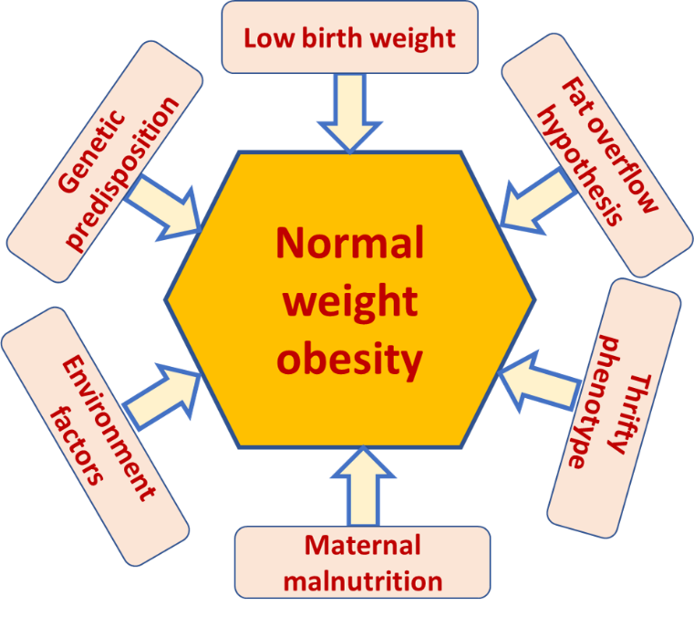

**Figure 1: The key factors implicated in the pathogenesis for the development of the thin-fat phenotype in the south Asian population**

Stress associated with maternal malnutrition and a consequent maternal glucocorticoid surge could lead to intrauterine growth retardation and subsequent changes in the fetal hypothalamic pituitary adrenal axis could cause altered ectopic fat deposits, including in the pancreas (42). There is also a possible role of maternal vitamin B12 in influencing fetal growth and programming for chronic diseases, explained through several interlinking metabolic pathways involving methionine and folate cycles collectively called the once carbon hypothesis (43).

In a previously published study from our center, we found that individuals with a low birth weight showed trends towards an unhealthy body fat distribution, lower lean body mass, impaired glucose tolerance, and an elevated diastolic blood pressure, even while they were just in their second decade of life (44). More recent evidence from basic science experiments have revealed that not only the birthweight but even the post-natal diet could play an important role in developing normal weight obesity (45).

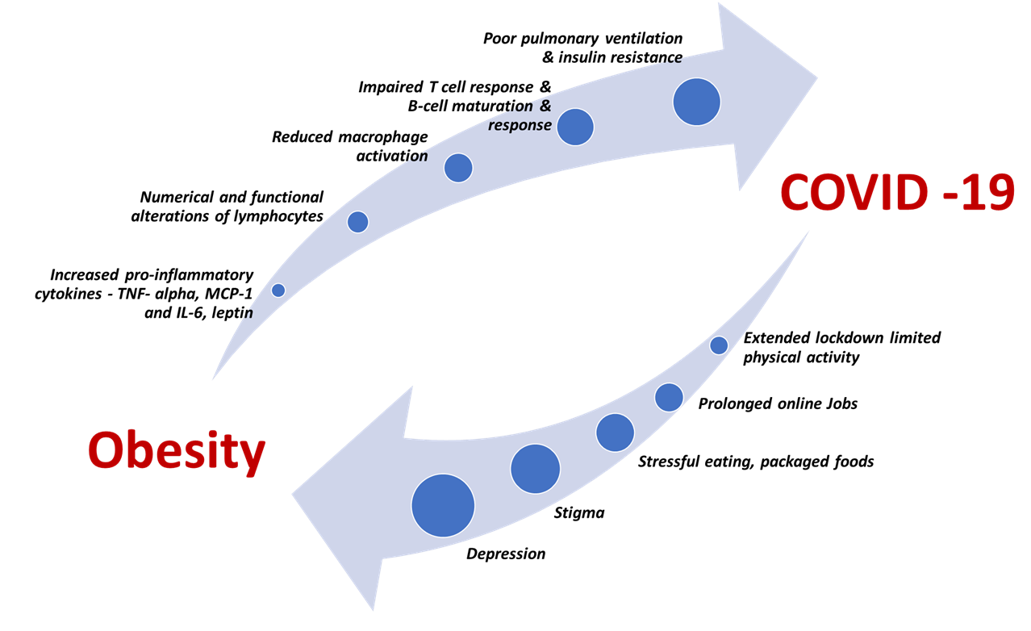

**Figure 2: The bidirectional impact of obesity and COVID-19**

A higher visceral adipose tissue content which is now considered the most important predictor of cardiometabolic disorders is also said to be higher in individuals from the south Asian region (46). The classical thin fat phenotype is also well explained in this population by the fat overflow hypothesis. This states that south Asians have a much lower capacity of storing fat in the subcutaneous region. Thereby when exposed to high calorie intake the subcutaneous tissue is overwhelmed and the extra fat content then spills into ectopic sites. The classic ectopic sites include the omentum (visceral adipose tissue), kidney, heart, intestine and liver. This then leads to higher amount of VAT despite similar total body fat compared to the European population and therefore the development of normal weight obesity (47).

Several genetic variations have also been studied to understand the origins of the thin fat phenotype in the Indian population. Several variants of the FTO and MC4R gene have been implicated in development of this phenotype but further studies are needed in this regard (48). Moreover, the presence of monogenic causes of obesity is higher in the south Asian population due to a higher prevalence of consanguinity (49, 50).

**CLINICAL IMPLICATIONS**

This poorly recognized thin fat phenotype is not only common in the south Asian region but also has significant clinical implications with respect to cardio metabolic risk. This is important not only for health care providers practicing in south Asia but is also applicable to the health care of south Asian individuals who have migrated to different countries (51).

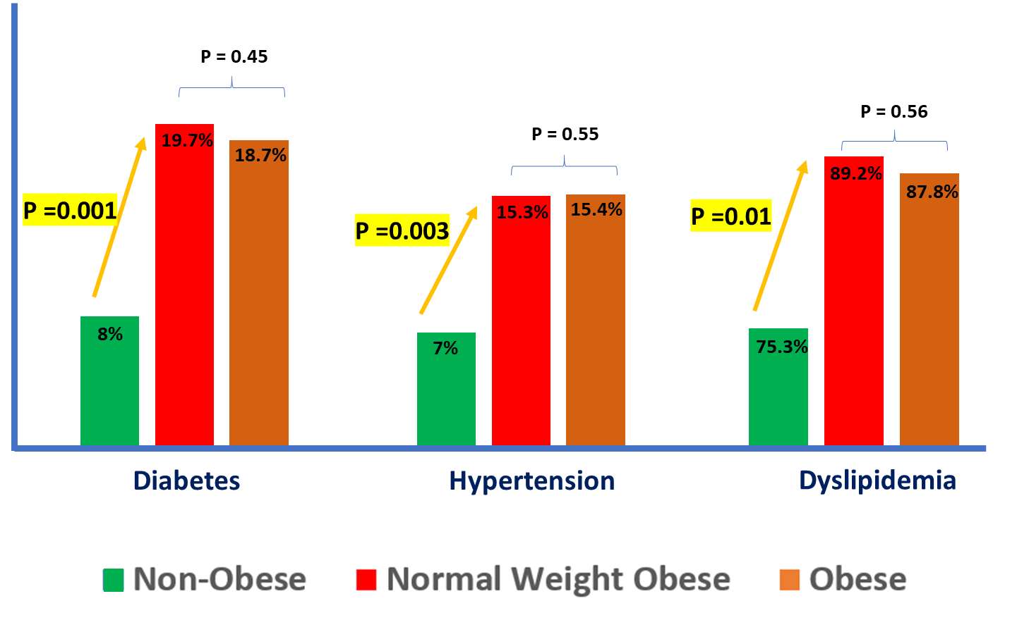

**Figure 3. Prevalence of diabetes, hypertension, and dyslipidemia in individuals with normal weight obesity as compared to non-obese and overtly obese individuals**

In a recent study done in south India it was found that individuals with normal weight obesity had a significantly higher prevalence of diabetes, hypertension, and dyslipidemia (defined by the NCEP-ATP III guidelines (52)) as compared to those without obesity. More importantly, the prevalence of these cardiometabolic risk factors were similar to individuals with obesity (Figure 3). After adjusting for other risk factors the odds of normal weight obese individuals having type 2 diabetes mellitus was found to be 2.72 (95% CI:1.46-5.08) as compared to non-obese individuals (53). A similar study from China found that individuals with normal weight obesity also had a significantly higher prevalence of metabolic syndrome when compared to non-obese individuals (54).

In the Women's Health Initiative study including 161,808 postmenopausal women between 50 to 74 years, it was found that women with normal weight obesity had a twofold higher risk of developing type 2 diabetes mellitus (55). When compared to non-obese individuals, those with normal weight obesity have not only been found to have a higher risk of atherosclerosis but normal weight obesity has been found to be an independent risk predictor for presence of soft plaques in blood vessels after adjustment for blood pressure, blood glucose, lipid level, c-reactive protein, medications, smoking status, and physical activity (56). In another study involving 23,748 individuals, people with normal weight obesity had a significantly higher odds of having a high Framingham risk score for cardiovascular disease (OR 1.973, 95% CI 1.596-2.439) as compared to normal individuals (57). Similar findings have been found in either sex and even in children, adolescents, and younger adults (58-60).

Another important clinically relevant subject related to the thin fat phenotype especially in tropical countries comes with the intersection of non-communicable diseases with chronic cachectic infectious disease. A classic example of this would be the presence of cardiometabolic disorders with an infectious disease like AIDS. We recently reviewed the association of HIV-AIDS with nonalcoholic fatty liver disease in south Asian countries (61). With better treatment of HIV infected individuals, the life expectancy and morbidity due to the virus per se has greatly improved. However, in most tropical countries there is limited screening facilities, widespread use of non-metabolic friendly antiviral drugs, and an existing thin fat phenotype making the prevalence of NAFLD much higher and yet very obscure.

In the recent ongoing COVID-19 pandemic, obesity has been considered as one of the key risk factors for increased mortality in the younger population. However, there is emerging evidence that individuals with normal weight obesity especially in the south Asian countries are also more likely to develop severe disease (35). There are several risk factors that have been described to associate the bidirectional relationship between COVID 19 and normal weight obesity (Figure 2).

**Mortality Associated with Normal Weight Obesity**

Individuals with normal weight obesity have been found to have a higher all-cause mortality and major adverse cardiac and cerebrovascular events after an acute coronary syndrome when compared to those without normal weight obesity (adjusted (HR 1.83; 95% CI: 1.04-3.31) (62). In another recent study from the Women’s Health Initiative study cohort, which involved 156,624 women followed for a total of 2,811,187 patient years, it was found that women with normal weight obesity were found to have a higher all-cause mortality (HR 1.31; 95% CI, 1.20-1.42) and higher cardiovascular mortality (HR 1.25; 95% CI, 1.05-1.46). There was no difference in the mortality risk between women who had normal weight obesity as compared to those who had overt obesity. Moreover, this is the first study to show that cancer related mortality was also higher in women with normal weight obesity as compared to those who were normal weight without centripetal obesity (HR 1.20; 95% CI, 1.01-1.43) (63).

Considering the higher risk of cardiometabolic disease and the higher mortality in people with normal weight obesity, there has been a recent concern in army recruits as they are predominantly deemed fit from an obesity perspective based only on body mass index measurements (64).

**BODY FAT ESTIMATION**

Accurate assessment of body fat is one of the key methods of identifying at-risk individuals in the south Asian population. More specifically detection of visceral adipose tissue is clinically more relevant. However, the gold standard for assessment of total body fat and ectopic fat depots is by using a magnetic resonance imaging (MRI), which is limited by the cost, availability, and the expertise required in tropical countries. Several other methods of assessing body fat have been described in literature. These include Dual energy x ray absorptiometry (DXA) scan, bio-electrical impedance, computed tomography (CT), body plethysmography, skin fold thickness, etc. (4, 10). The advantages of using DXA scans is that there is minimal radiation exposure, provides estimates of visceral adipose tissue, and is relatively easy to interpret. However, it is still costly and not widely available in many south Asian countries. DXA scans also cannot be used in community-based studies due to the large size of the DXA scanner compared to other portable machines that estimate fat such as bio-electrical impedance. Though there has been a good concordance between the fat estimation between bio-impedance and DXA scan, it is important to note that this concordance has been seen in normal ranges of body fat. Bio-impedance tends to over-estimate lower body fat percentages and under estimate higher values of body fat percentage (65). Nevertheless, its safe, rapid, and inexpensive. It is important to standardize for the variables that can modify the impedance values. These include room temperature, body position, electrode placement, quantity of urine in the bladder, food and water consumption, and proximity of exercise to time of evaluation.

In a large study from rural China involving more than 7000 participants waist circumference was found to be a better tool than body adiposity index to predict body fat percentage (measured by DXA), however the correlation coefficients between waist circumference and body fat percentage ranged between 0.24 to 0.66 in men and 0.12 to 0.77 in women, across different age groups. (66)

Apart from the method of estimation, it is also important to use the appropriate threshold for diagnosing abnormal body fat percentage. The impact of using different cut points for the diagnosis of normal weight obesity has been mentioned before. As per the American Association of Clinical Endocrinology guidelines a body fat percentage of more than 35% for women and 25% for men was set as a threshold for the diagnosis of obesity. However, for Asian countries a cut off of 33.4% for women and 20.6% for men, has been commonly used (4, 10).

Though measures of body fat estimation are helpful in clinical practice their widespread use in low -middle income countries may not be possible and good surrogate measures of visceral fat estimation may be the better way forward in such cost restrained settings. We recently studied the utility of using METS-VF, a novel surrogate measure to estimate visceral adipose tissue in Indian subjects with morbid obesity. This performed better than all other common clinically used obesity indicators and had the highest area under the curve 0.78 (95% CI: 0.72-0.85) for predicting VAT. At a cutoff of 7.3, METS-VF was found to have a good sensitivity and reasonable specificity in predicting high visceral adipose tissue in this population (6). Other surrogate measures of FAT assessment that have been used include ‘VAT=TAAT-SAAT model and ap VAT (anthropometrically predicted VAT). Though they have been shown to be useful in selected populations, they have not been validated in many tropical countries (6).

While METS-VF uses simple clinical and biochemical parameters, including - waist-height ratio (WHtr), age and sex. LDL cholesterol, serum triglycerides and fasting glucose the VAT=TAAT-SAAT model uses only clinical variables like Waist Circumference, proximal thigh circumference, age and body mass index. Ap VAT is derived from a regression-based model including height, body mass index, and circumferences of the waist and thigh (67-69).

**MANAGEMENT**

At this point there is only limited information with respect to the management of the thin fat phenotype, which is widely prevalent in the south Asian population. Only a few intervention studies are available in the literature, and this is an important area of future research. The currently available literature is only based on life-style interventions.

A very recently published study exploring the effect of a 12 weeks eu-energetic but high protein diet in women with normal weight obesity in a randomized controlled fashion, revealed no change in body weight at 12 weeks but a favorable change in body composition was noted. The eu-energetic was defined as equal amount of energy content in both groups according to the resting metabolic rate based on the Harris–Benedict predictive formula. (70). In another exercise based intervention, It was found that interval exercise and short duration accumulated exercises (10 minutes x 3 times of cycling) were more favorable in individuals with normal weight obesity as compared to continuous exercises (1 cycling session of 30 minutes) (71).

We recently studied the impact of peer led Lifestyle based intervention in an unselected group of individuals including individuals with normal weight obesity at two years of follow-up. The intervention was based on specific targets in diet, physical activity, reduced tobacco and alcohol consumption, and was delivered through multiple sessions by trained peer leaders. Though there has been a significant improvement in reducing the overall cardiovascular risk of the entire study population and benefit in preventing diabetes in certain subgroups in the intervention arm, there was only a minimal improvement noted in the cardiometabolic parameters of individuals with normal weight obesity. The failure in this study to see benefit in patients with normal weight obesity was disappointing (53).

The clinical and policy implications of the normal weight obese phenotype are challenging and are summarized in Figure 4. With the limited information that it is currently available, it seems that this phenotype is either more resistant to change than the conventional obesity phenotype or requires more time to show significant improvement in metabolic parameters. The current practice recommendations may only be based on existing literature on overall populations where this phenotype is commonly prevalent. The Indian diabetes prevention study is one such example where individuals with prediabetes were randomized to an intensive lifestyle program targeting a weight reduction of about 7-10% of the original weight along with physical activity of at least 150 minutes per week to the intensity of brisk walking. The relative risk reduction to prevent diabetes was only 29% in this population as compared to 58% in the US based, Diabetes prevention Program (72). Furthermore, addition of Metformin did not add a huge benefit in reducing the risk in this study population but bariatric surgery has been shown to be effective in achieving diabetes remission in another study including individuals with BMI between 22-35 Kg/m2 individuals (73).

Thus, with existing literature it may be prudent to evaluate all individuals with normal weight obesity for underlying cardiometabolic risk factors like diabetes, hypertension and dyslipidemia. Treatment for these conditions could be started based on standard guidelines but probably warrant a closely monitored approach and long-term follow-up. It is of paramount importance to educate these patients about their potential cardiometabolic risks which may otherwise be overlooked due to an obscure phenotype. Further research is needed to study the impact of long-term lifestyle changes and other medications on cardiometabolic risk factors, in individuals with normal weight obesity.

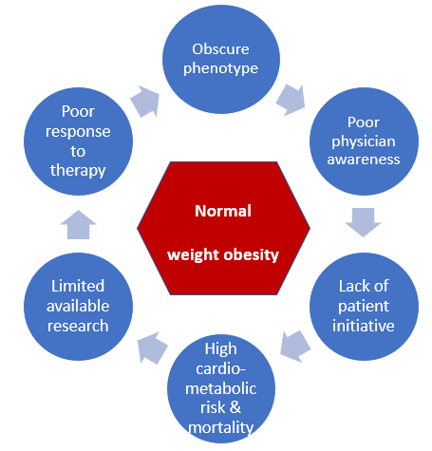

**Figure 4:** **The clinical and policy implications of the normal weight obese phenotype**

**SUMMARY**

To conclude the obesity phenotype in many tropical countries including several south Asian countries is very different from other populations. Given the large prevalence and significantly higher associated cardiometabolic disorders with the thin fat phenotype, it needs to be recognized as a distinct entity such that it can be identified and managed appropriately. While evidence for the best therapeutic protocols is still emerging, a good life style intervention focusing on healthy dietary practices, regular exercise, and reducing tobacco and alcohol consumption shows a positive trend in improving the cardiometabolic risk of this phenotype. The role of examining the underlying genetic makeup and use of surrogate measures to estimate body fat could be useful adjuncts in the further characterization of this unique phenotype.

**REFERENCES**

1. Kyrou I, Randeva HS, Tsigos C, Kaltsas G, Weickert MO 2000 Clinical Problems Caused by Obesity. In: Feingold KR, Anawalt B, Boyce A, Chrousos G, de Herder WW, Dungan K, Grossman A, Hershman JM, Hofland HJ, Kaltsas G, Koch C, Kopp P, Korbonits M, McLachlan R, Morley JE, New M, Purnell J, Singer F, Stratakis CA, Trence DL, Wilson DP eds. Endotext. South Dartmouth (MA): MDText.com, Inc. Copyright © 2000-2020, MDText.com, Inc.

2. Chadt A, Scherneck S, Joost HG, Al-Hasani H 2000 Molecular links between Obesity and Diabetes: “Diabesity”. In: Feingold KR, Anawalt B, Boyce A, Chrousos G, de Herder WW, Dungan K, Grossman A, Hershman JM, Hofland HJ, Kaltsas G, Koch C, Kopp P, Korbonits M, McLachlan R, Morley JE, New M, Purnell J, Singer F, Stratakis CA, Trence DL, Wilson DP eds. Endotext. South Dartmouth (MA): MDText.com, Inc. Copyright © 2000-2020, MDText.com, Inc.

3. Hardikar AA, Satoor SN, Karandikar MS, Joglekar MV, Puranik AS, Wong W, Kumar S, Limaye A, Bhat DS, Januszewski AS, Umrani MR, Ranjan AK, Apte K, Yajnik P, Bhonde RR, Galande S, Keech AC, Jenkins AJ, Yajnik CS 2015 Multigenerational Undernutrition Increases Susceptibility to Obesity and Diabetes that Is Not Reversed after Dietary Recuperation. Cell metabolism 22:312-319

4. Kapoor N, Furler J, Paul TV, Thomas N, Oldenburg B 2019 The BMI-adiposity conundrum in South Asian populations: need for further research. Journal of biosocial science:1-3

5. Kapoor N, Furler J, Paul TV, Thomas N, Oldenburg B 2019 Normal Weight Obesity: An Underrecognized Problem in Individuals of South Asian Descent. Clinical therapeutics 41:1638-1642

6. Kapoor N, Jiwanmall SA, Nandyal MB, Kattula D, Paravathareddy S, Paul TV, Furler J, Oldenburg B, Thomas N 2020 Metabolic Score for Visceral Fat (METS-VF) Estimation - A Novel Cost-Effective Obesity Indicator for Visceral Adipose Tissue Estimation. Diabetes, metabolic syndrome and obesity : targets and therapy 13:3261-3267

7. Yajnik CS, Yudkin JS 2004 The Y-Y paradox. Lancet (London, England) 363:163

8. Kurpad AV, Varadharajan KS, Aeberli I 2011 The thin-fat phenotype and global metabolic disease risk. Current opinion in clinical nutrition and metabolic care 14:542-547

9. Saxena A, Tiwari P, Wahi N, Kumar A, Mathur SK 2020 The common pathophysiologic threads between Asian Indian diabetic's 'Thin Fat Phenotype' and partial lipodystrophy: the peripheral adipose tissue transcriptomic evidences. Adipocyte 9:253-263

10. Kapoor N, Furler J, Paul TV, Thomas N, Oldenburg B 2019 Ethnicity-specific cut-offs that predict co-morbidities: the way forward for optimal utility of obesity indicators. Journal of biosocial science:1-3

11. Batsis JA, Villareal DT 2018 Sarcopenic obesity in older adults: aetiology, epidemiology and treatment strategies. Nature reviews. Endocrinology 14:513-537

12. De Lorenzo A, Martinoli R, Vaia F, Di Renzo L 2006 Normal weight obese (NWO) women: an evaluation of a candidate new syndrome. Nutrition, metabolism, and cardiovascular diseases : NMCD 16:513-523

13. Shelgikar KM, Hockaday TD, Yajnik CS 1991 Central rather than generalized obesity is related to hyperglycaemia in Asian Indian subjects. Diabetic medicine : a journal of the British Diabetic Association 8:712-717

14. Kapoor N, Lotfaliany M, Sathish T, Thankappan KR, Thomas N, Furler J, Oldenburg B, Tapp RJ 2020 Prevalence of normal weight obesity and its associated cardio-metabolic risk factors - Results from the baseline data of the Kerala Diabetes Prevention Program (KDPP). PloS one 15:e0237974

15. Wang J, Thornton JC, Russell M, Burastero S, Heymsfield S, Pierson RN, Jr. 1994 Asians have lower body mass index (BMI) but higher percent body fat than do whites: comparisons of anthropometric measurements. The American journal of clinical nutrition 60:23-28

16. Marques-Vidal P, Pécoud A, Hayoz D, Paccaud F, Mooser V, Waeber G, Vollenweider P 2008 Prevalence of normal weight obesity in Switzerland: effect of various definitions. European journal of nutrition 47:251-257

17. Purnell JQ 2000 Definitions, Classification, and Epidemiology of Obesity. In: Feingold KR, Anawalt B, Boyce A, Chrousos G, de Herder WW, Dungan K, Grossman A, Hershman JM, Hofland HJ, Kaltsas G, Koch C, Kopp P, Korbonits M, McLachlan R, Morley JE, New M, Purnell J, Singer F, Stratakis CA, Trence DL, Wilson DP eds. Endotext. South Dartmouth (MA): MDText.com, Inc. Copyright © 2000-2020, MDText.com, Inc.

18. Kapoor N, Lotfaliany M, Sathish T, Thankappan K, Thomas N, Furler J, Oldenburg B, Tapp RJ 2020 Obesity indicators that best predict type 2 diabetes in an Indian population: insights from the Kerala Diabetes Prevention Program. Journal of Nutritional Science 9

19. Kalra S, Kapoor N, Kota S, Das S 2020 Person-centred Obesity Care - Techniques, Thresholds, Tools and Targets. Eur Endocrinol 16:11-13

20. Kapoor N, Kalra S, Kota S, Das S, Jiwanmall S, Sahay R 2020 The SECURE model: A comprehensive approach for obesity management. JPMA. The Journal of the Pakistan Medical Association 70:1468-1469s

21. Kapoor N, Furler J, Paul TV, Thomas N, Oldenburg B 2019 Ethnicity-specific cut-offs that predict co-morbidities: the way forward for optimal utility of obesity indicators. Journal of biosocial science 51:624-626

22. Atri A, Jiwanmall SA, Nandyal MB, Kattula D, Paravathareddy S, Paul TV, Thomas N, Kapoor N 2020 The Prevalence and Predictors of Non-alcoholic Fatty Liver Disease in Morbidly Obese Women - A Cross-sectional Study from Southern India. Eur Endocrinol 16:152-155

23. Wharton S, Lau DCW, Vallis M, Sharma AM, Biertho L, Campbell-Scherer D, Adamo K, Alberga A, Bell R, Boulé N, Boyling E, Brown J, Calam B, Clarke C, Crowshoe L, Divalentino D, Forhan M, Freedhoff Y, Gagner M, Glazer S, Grand C, Green M, Hahn M, Hawa R, Henderson R, Hong D, Hung P, Janssen I, Jacklin K, Johnson-Stoklossa C, Kemp A, Kirk S, Kuk J, Langlois MF, Lear S, McInnes A, Macklin D, Naji L, Manjoo P, Morin MP, Nerenberg K, Patton I, Pedersen S, Pereira L, Piccinini-Vallis H, Poddar M, Poirier P, Prud'homme D, Salas XR, Rueda-Clausen C, Russell-Mayhew S, Shiau J, Sherifali D, Sievenpiper J, Sockalingam S, Taylor V, Toth E, Twells L, Tytus R, Walji S, Walker L, Wicklum S 2020 Obesity in adults: a clinical practice guideline. CMAJ : Canadian Medical Association journal = journal de l'Association medicale canadienne 192:E875-e891

24. Ramasamy S, Joseph M, Jiwanmall SA, Kattula D, Nandyal MB, Abraham V, Samarasam I, Paravathareddy S, Paul TV, Rajaratnam S, Thomas N, Kapoor N 2020 Obesity Indicators and Health-related Quality of Life - Insights from a Cohort of Morbidly Obese, Middle-aged South Indian Women. Eur Endocrinol 16:148-151

25. Jiwanmall SA, Kattula D, Nandyal MB, Devika S, Kapoor N, Joseph M, Paravathareddy S, Shetty S, Paul TV, Rajaratnam S 2018 Psychiatric burden in the morbidly obese in multidisciplinary bariatric clinic in South India. Indian Journal of Psychological Medicine 40:129

26. Kim MK, Han K, Kwon HS, Song KH, Yim HW, Lee WC, Park YM 2014 Normal weight obesity in Korean adults. Clin Endocrinol (Oxf) 80:214-220

27. Madeira FB, Silva AA, Veloso HF, Goldani MZ, Kac G, Cardoso VC, Bettiol H, Barbieri MA 2013 Normal weight obesity is associated with metabolic syndrome and insulin resistance in young adults from a middle-income country. PloS one 8:e60673

28. Marques-Vidal P, Pécoud A, Hayoz D, Paccaud F, Mooser V, Waeber G, Vollenweider P 2010 Normal weight obesity: relationship with lipids, glycaemic status, liver enzymes and inflammation. Nutrition, metabolism, and cardiovascular diseases : NMCD 20:669-675

29. Romero-Corral A, Somers VK, Sierra-Johnson J, Korenfeld Y, Boarin S, Korinek J, Jensen MD, Parati G, Lopez-Jimenez F 2010 Normal weight obesity: a risk factor for cardiometabolic dysregulation and cardiovascular mortality. European heart journal 31:737-746

30. Ramsaran C, Maharaj RG 2017 Normal weight obesity among young adults in Trinidad and Tobago: prevalence and associated factors. International journal of adolescent medicine and health 29

31. Ji T, Zhang L, Tang Z, Sun F, Li Y, Ma L 2020 Prevalence of Normal-Weight Obesity in Community-Dwelling Chinese Older Adults: Results from the Beijing Longitudinal Study of Aging. 13:1611-1617

32. Must A, McKeown NM 2000 The Disease Burden Associated with Overweight and Obesity. In: Feingold KR, Anawalt B, Boyce A, Chrousos G, de Herder WW, Dungan K, Grossman A, Hershman JM, Hofland HJ, Kaltsas G, Koch C, Kopp P, Korbonits M, McLachlan R, Morley JE, New M, Purnell J, Singer F, Stratakis CA, Trence DL, Wilson DP eds. Endotext. South Dartmouth (MA): MDText.com, Inc. Copyright © 2000-2020, MDText.com, Inc.

33. Lee A, Cardel M, Donahoo WT 2000 Social and Environmental Factors Influencing Obesity. In: Feingold KR, Anawalt B, Boyce A, Chrousos G, de Herder WW, Dungan K, Grossman A, Hershman JM, Hofland HJ, Kaltsas G, Koch C, Kopp P, Korbonits M, McLachlan R, Morley JE, New M, Purnell J, Singer F, Stratakis CA, Trence DL, Wilson DP eds. Endotext. South Dartmouth (MA): MDText.com, Inc. Copyright © 2000-2020, MDText.com, Inc.

34. Sathish T, Cao Y, Kapoor N 2020 Newly diagnosed diabetes in COVID-19 patients. Primary care diabetes

35. Sathish T, Kapoor N 2020 Normal weight obesity and COVID-19 severity: A poorly recognized link. Diabetes research and clinical practice:108521

36. Deshpande NR, Patankar N, Kapoor N, Aman S, Kalpekar R, Dahiya L 2010 Effect of Altering the Dietary Carbohydrate to Protein Ratio on Body Composition and Glycemic Control in Type 2 Diabetes. OBESITY, 2010, pp S214-S215

37. Joseph M, Kapoor N, Ramasamy S, Jiwanmall SA, Kattula D, Abraham V, Samarasam I, Paul T, Thomas N 2017 Nutritional profile of the morbidly obese patients attending a bariatric clinic in a South Indian tertiary care centre. Obesity and metabolism 14:41-47

38. Lao XQ, Ma WJ, Sobko T, Zhang YH, Xu YJ, Xu XJ, Yu DM, Nie SP, Cai QM, Xia L, Thomas GN, Griffiths SM 2015 Overall obesity is leveling-off while abdominal obesity continues to rise in a Chinese population experiencing rapid economic development: analysis of serial cross-sectional health survey data 2002-2010. International journal of obesity (2005) 39:288-294

39. Kinra S, Andersen E, Ben-Shlomo Y, Bowen L, Lyngdoh T, Prabhakaran D, Reddy KS, Ramakrishnan L, Bharathi A, Vaz M, Kurpad A, Smith GD, Ebrahim S 2011 Association between urban life-years and cardiometabolic risk: the Indian migration study. American journal of epidemiology 174:154-164

40. Yajnik CS, Fall CH, Coyaji KJ, Hirve SS, Rao S, Barker DJ, Joglekar C, Kellingray S 2003 Neonatal anthropometry: the thin-fat Indian baby. The Pune Maternal Nutrition Study. International journal of obesity and related metabolic disorders : journal of the International Association for the Study of Obesity 27:173-180

41. Hales CN, Barker DJ 1992 Type 2 (non-insulin-dependent) diabetes mellitus: the thrifty phenotype hypothesis. Diabetologia 35:595-601

42. Reynolds RM 2010 Corticosteroid-mediated programming and the pathogenesis of obesity and diabetes. The Journal of steroid biochemistry and molecular biology 122:3-9

43. Rush EC, Katre P, Yajnik CS 2014 Vitamin B12: one carbon metabolism, fetal growth and programming for chronic disease. European journal of clinical nutrition 68:2-7

44. Thomas N, Grunnet LG, Poulsen P, Christopher S, Spurgeon R, Inbakumari M, Livingstone R, Alex R, Mohan VR, Antonisamy B, Geethanjali FS, Karol R, Vaag A, Bygbjerg IC 2012 Born with low birth weight in rural Southern India: what are the metabolic consequences 20 years later? European journal of endocrinology 166:647-655

45. Maejima Y, Yokota S, Horita S, Shimomura K 2020 Early life high-fat diet exposure evokes normal weight obesity. Nutrition & metabolism 17:48

46. Lear SA, Humphries KH, Kohli S, Chockalingam A, Frohlich JJ, Birmingham CL 2007 Visceral adipose tissue accumulation differs according to ethnic background: results of the Multicultural Community Health Assessment Trial (M-CHAT). The American journal of clinical nutrition 86:353-359

47. Anand SS, Tarnopolsky MA, Rashid S, Schulze KM, Desai D, Mente A, Rao S, Yusuf S, Gerstein HC, Sharma AM 2011 Adipocyte hypertrophy, fatty liver and metabolic risk factors in South Asians: the Molecular Study of Health and Risk in Ethnic Groups (mol-SHARE). PloS one 6:e22112

48. Vasan SK, Fall T, Neville MJ, Antonisamy B, Fall CH, Geethanjali FS, Gu HF, Raghupathy P, Samuel P, Thomas N, Brismar K, Ingelsson E, Karpe F 2012 Associations of variants in FTO and near MC4R with obesity traits in South Asian Indians. Obesity (Silver Spring, Md.) 20:2268-2277

49. Kapoor N, Chapla A, Furler J, Paul TV, Harrap S, Oldenburg B, Thomas N 2019 Genetics of obesity in consanguineous populations - A road map to provide novel insights in the molecular basis and management of obesity. EBioMedicine 40:33-34

50. Farooqi IS, O'Rahilly S 2000 The Genetics of Obesity in Humans. In: Feingold KR, Anawalt B, Boyce A, Chrousos G, de Herder WW, Dungan K, Grossman A, Hershman JM, Hofland HJ, Kaltsas G, Koch C, Kopp P, Korbonits M, McLachlan R, Morley JE, New M, Purnell J, Singer F, Stratakis CA, Trence DL, Wilson DP eds. Endotext. South Dartmouth (MA): MDText.com, Inc. Copyright © 2000-2020, MDText.com, Inc.

51. Thomas N, Kapoor N, Velavan J, K SV 2018 A Practical Guide to Diabetes Mellitus: Jaypee Brothers,Medical Publishers Pvt. Limited

52. 2002 Third Report of the National Cholesterol Education Program (NCEP) Expert Panel on Detection, Evaluation, and Treatment of High Blood Cholesterol in Adults (Adult Treatment Panel III) final report. Circulation 106:3143-3421

53. Kapoor N, Lotfaliany M, Sathish T, Thankappan KR, Tapp RJ, Thomas N, Furler J, Oldenburg B Effect of a Peer-led Lifestyle Intervention on Individuals With Normal Weight Obesity: Insights From the Kerala Diabetes Prevention Program. Clinical therapeutics

54. Liu PJ, Ma F, Lou HP, Zhu YN 2017 Normal-weight central obesity is associated with metabolic disorders in Chinese postmenopausal women. Asia Pacific journal of clinical nutrition 26:692-697

55. Hsu ARC, Ames SL, Xie B, Peterson DV, Garcia L, Going SB, Phillips LS, Manson JE, Anton-Culver H, Wong ND 2020 Incidence of diabetes according to metabolically healthy or unhealthy normal weight or overweight/obesity in postmenopausal women: the Women's Health Initiative. Menopause (New York, N.Y.) 27:640-647

56. Kim S, Kyung C, Park JS, Lee SP, Kim HK, Ahn CW, Kim KR, Kang S 2015 Normal-weight obesity is associated with increased risk of subclinical atherosclerosis. Cardiovascular diabetology 14:58

57. Jia A, Xu S, Xing Y, Zhang W, Yu X, Zhao Y, Ming J, Ji Q 2018 Prevalence and cardiometabolic risks of normal weight obesity in Chinese population: A nationwide study. Nutrition, metabolism, and cardiovascular diseases : NMCD 28:1045-1053

58. Shirasawa T, Ochiai H, Yoshimoto T, Nagahama S, Kobayashi M, Ohtsu I, Sunaga Y, Kokaze A 2019 Associations between normal weight central obesity and cardiovascular disease risk factors in Japanese middle-aged adults: a cross-sectional study. Journal of health, population, and nutrition 38:46

59. García-Hermoso A, Agostinis-Sobrinho C 2020 Normal-Weight Obesity Is Associated with Poorer Cardiometabolic Profile and Lower Physical Fitness Levels in Children and Adolescents. 12

60. Correa-Rodriguez M, Gonzalez-Ruiz K, Rincon-Pabon D, Izquierdo M, Garcia-Hermoso A, Agostinis-Sobrinho C, Sanchez-Capacho N, Roa-Cubaque MA, Ramirez-Velez R 2020 Normal-Weight Obesity Is Associated with Increased Cardiometabolic Risk in Young Adults. Nutrients 12

61. Kapoor N, Audsley J, Rupali P, Sasadeusz J, Paul TV, Thomas N, Lewin SR 2019 A gathering storm: HIV infection and nonalcoholic fatty liver disease in low and middle-income countries. Aids 33:1105-1115

62. Wan J, Zhou P, Wang D, Liu S, Yang Y, Hou J, Li W, Wang P 2019 Impact of Normal Weight Central Obesity on Clinical Outcomes in Male Patients With Premature Acute Coronary Syndrome. 70:960-968

63. Sun Y, Liu B, Snetselaar LG, Wallace RB, Caan BJ, Rohan TE, Neuhouser ML, Shadyab AH, Chlebowski RT, Manson JE, Bao W 2019 Association of Normal-Weight Central Obesity With All-Cause and Cause-Specific Mortality Among Postmenopausal Women. JAMA network open 2:e197337

64. Foulis SA, Hughes JM, Friedl KE 2020 New Concerns About Military Recruits with Metabolic Obesity but Normal Weight ("Skinny Fat"). Obesity (Silver Spring, Md.) 28:223

65. Ling CH, de Craen AJ, Slagboom PE, Gunn DA, Stokkel MP, Westendorp RG, Maier AB 2011 Accuracy of direct segmental multi-frequency bioimpedance analysis in the assessment of total body and segmental body composition in middle-aged adult population. Clinical nutrition (Edinburgh, Scotland) 30:610-615

66. Yu Y, Wang L, Liu H, Zhang S, Walker SO, Bartell T, Wang X 2015 Body mass index and waist circumference rather than body adiposity index are better surrogates for body adiposity in a Chinese population. Nutrition in clinical practice : official publication of the American Society for Parenteral and Enteral Nutrition 30:274-282

67. Brown JC, Harhay MO, Harhay MN 2019 The Value of Anthropometric Measures in Nutrition and Metabolism: Comment on Anthropometrically Predicted Visceral Adipose Tissue and Blood-Based Biomarkers: A Cross-Sectional Analysis. Nutrition and metabolic insights 12:1178638819831712

68. Samouda H, Dutour A, Chaumoitre K, Panuel M, Dutour O, Dadoun F 2013 VAT=TAAT-SAAT: innovative anthropometric model to predict visceral adipose tissue without resort to CT-Scan or DXA. Obesity (Silver Spring, Md.) 21:E41-50

69. Bello-Chavolla OY, Antonio-Villa NE, Vargas-Vázquez A, Viveros-Ruiz TL, Almeda-Valdes P, Gomez-Velasco D, Mehta R, Elias-López D, Cruz-Bautista I, Roldán-Valadez E, Martagón AJ, Aguilar-Salinas CA 2020 Metabolic Score for Visceral Fat (METS-VF), a novel estimator of intra-abdominal fat content and cardio-metabolic health. Clinical nutrition (Edinburgh, Scotland) 39:1613-1621

70. Haghighat N, Ashtary-Larky D, Bagheri R, Mahmoodi M, Rajaei M, Alipour M, Kooti W, Aghamohammdi V, Wong A 2020 The effect of 12 weeks of euenergetic high-protein diet in regulating appetite and body composition of women with normal-weight obesity: a randomised controlled trial. The British journal of nutrition 124:1044-1051

71. Jung WS, Hwang H, Kim J, Park HY, Lim K 2019 Comparison of excess post-exercise oxygen consumption of different exercises in normal weight obesity women. Journal of exercise nutrition & biochemistry 23:22-27

72. Ramachandran A, Snehalatha C, Mary S, Mukesh B, Bhaskar AD, Vijay V 2006 The Indian Diabetes Prevention Programme shows that lifestyle modification and metformin prevent type 2 diabetes in Asian Indian subjects with impaired glucose tolerance (IDPP-1). Diabetologia 49:289-297

73. Shah SS, Todkar JS, Shah PS, Cummings DE 2010 Diabetes remission and reduced cardiovascular risk after gastric bypass in Asian Indians with body mass index <35 kg/m(2). Surgery for obesity and related diseases : official journal of the American Society for Bariatric Surgery 6:332-338