THYROID STORM

Leslie J. De Groot, MD, Research Professor, University of Rhode Island, Providence, RI
Luigi Bartalena, MD, Professor of Endocrinology, University of Insubria, Ospedale di Circolo, Viale Borri, 57, 21100 Varese, Italy.
Kenneth R. Feingold, MD, Emeritus Professor of Medicine, University of California- San Francisco, kenneth.feingold@ucsf.edu

Updated April 14, 2025

CLINICAL RECOGNITION
Thyroid (or thyrotoxic) storm is an acute, life-threatening syndrome due to an exacerbation of thyrotoxicosis. It is now an infrequent condition because of earlier diagnosis and treatment of thyrotoxicosis and better pre- and postoperative medical management. In the United States the incidence of thyroid storm ranged between 0.57 and 0.76 cases/100,000 persons per year. Thyroid storm may be precipitated by a number of factors including intercurrent illness, especially infections (Table 1). Pneumonia, upper respiratory tract infection, enteric infections, or any other infection can precipitate thyroid storm. Thyroid storm in the past most frequently occurred after surgery, but this is now unusual. Occasionally it occurs as a manifestation of untreated or partially treated thyrotoxicosis without another apparent precipitating factor. In the Japanese experience approximately 20% of patients developed thyroid storm before they received anti-thyroid drug treatment. Finally, if patients are not compliant with anti-thyroid medications thyroid storm may occur and this is a relatively common cause. Thyroid storm is typically associated with Graves' disease, but it may occur in patients with toxic nodular goiter or any other cause of thyrotoxicosis.

Table 1. Factors That May Precipitate Thyroid Storm
Infections
Acute Illness such as acute myocardial infarction, stroke, congestive heart failure, trauma, etc.
Non-thyroid surgery in a hyperthyroid patient
Thyroid surgery in a patient poorly prepared for surgery
Discontinuation of anti-thyroid medications
Radioiodine therapy
Recent use of iodinated contrast
Pregnancy particularly during labor and delivery

Classic features of thyroid storm include fever, marked tachycardia, heart failure, tremors, nausea and vomiting, diarrhea, dehydration, restlessness, extreme agitation, delirium or coma (Table 2). Fever is typical and may be higher than 105.8 F (41 C). Patients may present with a true psychosis or a marked deterioration of previously abnormal behavior. Rarely thyroid storm takes a strikingly different form, called apathetic storm, with extreme weakness, emotional apathy, confusion, and absent or low fever.

Signs and symptoms of decompensation in organ systems may be present. Delirium is one example. Congestive heart failure may also occur with peripheral edema, congestive hepatomegaly, and respiratory distress. Marked sinus tachycardia or tachyarrhythmia, such as atrial fibrillation, are common. Liver damage and jaundice may result from congestive heart failure or the direct action of thyroid hormone on the liver. Fever and vomiting may produce dehydration and prerenal azotemia. Abdominal pain may be a prominent feature. The clinical picture may be masked by a secondary infection such as pneumonia, a viral infection, or infection of the upper respiratory tract.

Table 2. Clinical Manifestations of Thyroid Storm
History of thyroid disease
Goiter/thyroid eye disease
High fever
Marked tachycardia, occasionally atrial fibrillation
Heart Failure
Tremor
Sweating
Nausea and vomiting
Agitation/psychosis
Delirium/coma
Jaundice
Abdominal pain

Death from thyroid storm is not as common as in the past if it is promptly recognized and aggressively treated in an intensive care unit, but is still approximately 10-25%. In recent nationwide studies from Japan the mortality rate was >10%. Death may be from cardiac failure, shock, hyperthermia, multiple organ failure, or other complications. Additionally, even when patients survive, some have irreversible damage including brain damage, disuse atrophy, cerebrovascular disease, renal insufficiency, and psychosis.

PATHOPHYSIOLOGY

Thyroid storm classically began a few hours after thyroidectomy performed on a patient prepared for surgery by potassium iodide alone. Many such patients were not euthyroid and would not be considered appropriately prepared for surgery by current standards. Exacerbation of thyrotoxicosis is still seen in patients sent to surgery before adequate preparation, but it is unusual in the anti-thyroid drug-controlled patient. Thyroid storm occasionally occurs in patients operated on for some other illness while severely thyrotoxic. Severe exacerbation of thyrotoxicosis is rarely seen following 131-I therapy for hyperthyroidism; but some of these exacerbations may be defined as thyroid storm.

Thyroid storm appears most commonly following infection, which seems to induce an escape from control of thyrotoxicosis. Pneumonia, upper respiratory tract infections, enteric infections, or any other infection can cause this condition. Interestingly, serum free T4 concentrations were higher in patients with thyroid storm than in those with uncomplicated thyrotoxicosis, while serum total T4 levels did not differ in the two groups, suggesting that events like infections may decrease serum binding of T4 and cause a greater increase in free T4 responsible for storm occurrence. Another common cause of thyroid storm is a hyperthyroid patient suddenly stopping their anti-thyroid drugs.

DIAGNOSIS AND DIFFERENTIAL

Diagnosis of thyroid storm is made on clinical grounds and involves the usual diagnostic measures for thyrotoxicosis. A history of hyperthyroidism or physical findings of an enlarged thyroid or hyperthyroid eye findings is helpful in suggesting the diagnosis. The central features are thyrotoxicosis, abnormal CNS function, fever, tachycardia (usually above 130bpm), GI tract symptoms, and evidence of impending or present CHF. There are no distinctive laboratory abnormalities. Free T4 and, if possible, free T3 should be measured. Note that T3 levels may be markedly reduced in relation to the severity of the illness, as part of the associated “non-thyroidal illness syndrome”. As expected, TSH levels are suppressed. Electrolytes, blood urea nitrogen (BUN), blood sugar, liver function tests, and plasma cortisol should be monitored. While the diagnosis of thyroid storm remains largely a matter of clinical judgment, there are two scales for assessing the severity of hyperthyroidism and determining the likelihood of thyroid storm (Figures 1 and 2). Recognize that these scoring systems are just guidelines and clinical judgement is still crucial. Data comparing these two diagnostic systems suggest an overall agreement, but a tendency toward underdiagnosis using the Japanese criteria. Unfortunately, there are no unique laboratory abnormalities that facilitate the diagnosis of thyroid storm.

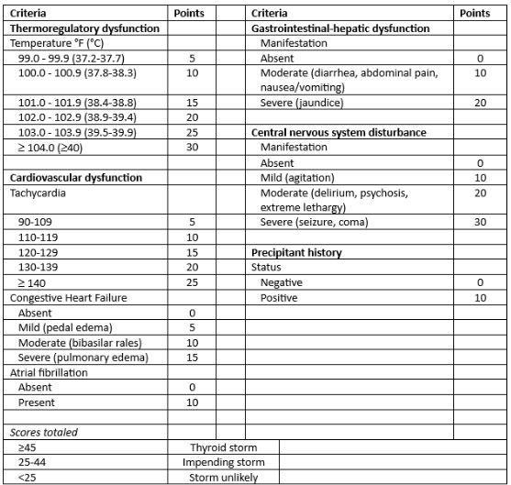

Figure 1. Burch-Wartofsky Point Scale for the Diagnosis of Thyroid Storm. When it is not possible to distinguish the effects of an intercurrent illness from those of severe thyrotoxicosis per se, points are awarded such as to favor the diagnosis of storm and hence, empiric therapy. Endocrinol Metab Clin North Am 22:263–277.

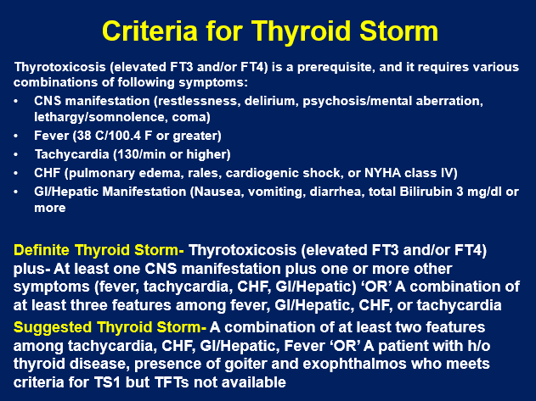

Figure 2. Japanese Thyroid Association Criteria for Thyroid Storm

THERAPY

Thyroid storm is a medical emergency that has to be recognized and treated immediately (Table 3). Admission to an intensive care unit is usually required. Besides treatment for thyroid storm, it is essential to treat precipitating factors such as infections. As would be expected given the rare occurrence of thyroid storm there are very few randomized controlled treatment trials and therefore much of what is recommended is based on expert opinion.

Table 3. Treatment of Thyroid Storm
Supportive Measures
1. Rest
2. Mild sedation
3. Fluid and electrolyte replacement
4. Nutritional support and vitamins as needed
5. Oxygen therapy
6. Nonspecific therapy as indicated
7. Antibiotics
8. Cardio-support as indicated
9. Cooling, aided by cooling blankets and acetaminophen
Specific therapy
1. Beta-blocking agents. Propranolol (60 to 80 mg orally every 4 hours, or 1 to 3 mg intravenously every 4 to 6 hours), Start with low doses. Esmolol in ICU setting (loading dose of 250 mcg/kg to 500 mcg/kg followed by 50 mcg/kg to 100 mcg/kg/minute).
2. Antithyroid drugs (PTU 500–1000mg load, then 250mg every 4 hours or Methimazole 60-80mg/day), then taper as condition improves
3. Potassium iodide (one hour after first dose of antithyroid drugs):
250mg orally every 6 hours
4. Hydrocortisone 300mg intravenous load, then 100mg every 8 hours.
Second Line Therapy
1. Plasmapheresis
2. Oral T4 and T3 binding resins- colestipol or cholestyramine
3. Dialysis
4. Lithium in patients who cannot take iodine
5. Thyroid surgery

It should be noted that if any possibility is present that orally given drugs will not be appropriately absorbed (e.g., due to stomach distention, vomiting, diarrhea or severe heart failure), the intravenous route should be used. If the thyrotoxic patient is untreated, an antithyroid drug should be given. PTU, 500–1000mg load, then 250mg every 4 hours, should be used if possible, rather than methimazole, since PTU also prevents peripheral conversion of T4 to T3, thus it may more rapidly reduce circulating T3 levels. Methimazole (60–80mg/day) can be given orally, or if necessary, the pure compound can be made up in a 10 mg/ml solution for parenteral administration. Methimazole is also absorbed when given rectally in a suppository. After initial stabilization, one should taper the dose and treat with Methimazole if PTU was started at the beginning as the safety profile of Methimazole is superior. If the thyroid storm is due to thyroiditis neither PTU nor Methimazole will be effective and should not be used.

An hour after PTU or Methimazole has been given, iodide should be administered. A dosage of 250 mg every 6 hours is more than sufficient. The iodine is given after PTU or Methimazole because the iodine could stimulate thyroid hormone synthesis. Unless congestive heart failure contraindicates it, propranolol or other beta-blocking agents should be given at once, orally or parenterally, depending on the patient's clinical status. Beta-blocking agents control tachycardia, restlessness, and other symptoms. Additionally, propranolol inhibits type 1 deiodinase decreasing the conversion of T4 to T3. Probably lower doses should be administered initially, since the administration of beta-blockers to patients with severe thyrotoxicosis has been associated with vascular collapse. Esmolol, a short-acting beta blocker, at a loading dose of 250 mcg/kg to 500 mcg/kg followed by 50 mcg/kg to 100 mcg/kg/minute can be used in an ICU setting. For patients with reactive airway disease, a cardioselective beta blocker like atenolol or metoprolol can be employed.

Permanent correction of thyrotoxicosis by either 131-I or thyroidectomy should be deferred until euthyroidism is restored. Other supporting measures should fully be exploited, including sedation, oxygen, treatment for tachycardia or congestive heart failure, rehydration, multivitamins, occasionally supportive transfusions, and cooling the patient to lower body temperature down. Antibiotics may be given on the presumption of infection while results of cultures are awaited.

The adrenal gland may be limited in its ability to increase steroid production during thyrotoxicosis. Therefore, hydrocortisone (100-300 mg/day) or dexamethasone (2mg every 6 hours) or its equivalent should be given. The dose can rapidly be reduced when the acute process subsides. Pharmacological doses of glucocorticoids (2 mg dexamethasone every 6 h) acutely depress serum T3 levels by reducing T4 to T3 conversion. This effect of glucocorticoids is beneficial in thyroid storm and supports their routine use in this clinical setting.

Usually rehydration, repletion of electrolytes, treatment of concomitant disease, such as infection, and specific agents (antithyroid drugs, iodine, propranolol, and corticosteroids) produce a marked improvement within 24 hours. A variety of additional approaches have been reported and may be used if the response to standard treatments is not sufficient. For example, plasmapheresis can remove circulating thyroid hormone and rapidly decrease thyroid hormone levels. Orally administered bile acid sequestrants (20-30g/day Colestipol-HCl or Cholestyramine) can trap thyroid hormone in the intestine and prevent recirculation. In most cases these therapies are not required but in the occasion patient that does not respond rapidly to initial therapy these modalities can be effective. Finally, in rare situations where medical therapy is ineffective, or the patient develops side effects and contraindications to the available therapies’ thyroid surgery may be necessary.

FOLLOW-UP
Antithyroid treatment should be continued until euthyroidism is achieved, when a decision regarding definitive treatment of the hyperthyroidism with antithyroid drugs, surgery, or 131-I therapy can be made. Rarely urgent thyroidectomy is performed with antithyroid drugs, iodide, and beta blocker preparation.

Prevention of thyroid storm is key and involves recognizing and actively avoiding common precipitants, educating patients about avoiding abrupt discontinuation of anti-thyroid drugs, and ensuring that patients are euthyroid prior to elective surgery and labor and delivery.

GUIDELINES
Ross DS, Burch HB, Cooper DS, Greenlee MC, Laurberg P, Maia AL, Rivkees SA, Samuels M, Sosa JA, Stan MN, Walter MA. 2016 American Thyroid Association Guidelines for Diagnosis and Management of Hyperthyroidism and Other Causes of Thyrotoxicosis. Thyroid. 2016 Oct;26(10):1343-1421.

Satoh T, Isozaki O, Suzuki A, Wakino S, Iburi T, Tsuboi K, Kanamoto N, Otani H, Furukawa Y, Teramukai S, Akamizu T. 2016 Guidelines for the management of thyroid storm from The Japan Thyroid Association and Japan Endocrine Society (First edition). Endocr J. 2016 Dec 30;63(12):1025-1064

REFERENCES
Bartalena L. Graves’ Disease: Complications. 2018 Feb 20. In: Feingold KR, Anawalt B, Boyce A, Chrousos G, de Herder WW, Dhatariya K, Dungan K, Hershman JM, Hofland J, Kalra S, Kaltsas G, Koch C, Kopp P, Korbonits M, Kovacs CS, Kuohung W, Laferrère B, Levy M, McGee EA, McLachlan R, Morley JE, New M, Purnell J, Sahay R, Singer F, Sperling MA, Stratakis CA, Trence DL, Wilson DP, editors. Endotext [Internet]. South Dartmouth (MA): MDText.com, Inc.; 2000–

Akamizu T¹, Satoh T, Isozaki O, Suzuki A, Wakino S, Iburi T, Tsuboi K, Monden T, Kouki T, Otani H, Teramukai S, Uehara R, Nakamura Y, Nagai M, Mori M Diagnostic criteria, clinical features, and incidence of thyroid storm based on nationwide surveys. Thyroid. 2012 Jul;22(7):661-79.

Swee du S, Chng CL, Lim A. Clinical characteristics and outcome of thyroid storm: a case series and review of neuropsychiatric derangements in thyrotoxicosis. Endocr Pract. 2015 Feb;21(2):182-9.
Angell TE, Lechner MG, Nguyen CT, Salvato VL, Nicoloff JT, LoPresti JS. Clinical features and hospital outcomes in thyroid storm: a retrospective cohort study. J. Clin. Endocrinol. Metab. 2015 Feb;100(2):451-9.

Chiha M, Samarasinghe S, Kabaker AS. Thyroid storm: an updated review. J Intensive Care Med. 2015 Mar;30(3):131-40

Akamizu T. Thyroid Storm: A Japanese Perspective. Thyroid. 2018 Jan;28(1):32-40

Galindo RJ, Hurtado CR, Pasquel FJ, García Tome R, Peng L, Umpierrez GE. National Trends in Incidence, Mortality, and Clinical Outcomes of Patients Hospitalized for Thyrotoxicosis With and Without Thyroid Storm in the United States, 2004-2013. Thyroid. 2019 Jan;29(1):36-43.

